Downsizing NiCoS Pentlandite by Laser Fragmentation in Liquids for Enhanced HER Performance
Philipp Lemm¹, Janna Wierper^{2,4}, Oleg Prymak³, Kateryna Loza³, Julian Kleinhaus⁴, Ulf-Peter Apfel^{2,4} and Benjamin Mockenhaupt^{1*}

[1] Technical Chemistry I, University of Duisburg-Essen and Center for Nanointegration Duisburg-Essen (CENIDE), Universitätsstraße 7, 45141 Essen, Germany.
[2] Department Power to Chemicals, Fraunhofer Institute for Environmental, Safety and Energy Technology UMSICHT, Osterfelder Str. 3, 46047 Oberhausen, Germany.
[3] Inorganic Chemistry, University of Duisburg-Essen, Universitätsstraße 7, Essen 45141, Germany
[4] Activation of Small Molecules/ Technical Electrochemistry, Ruhr University Bochum, Universitätsstraße 150, 44801 Bochum, Germany.

Section 1: Calculation of Pulses per Volume and Laser Fluence

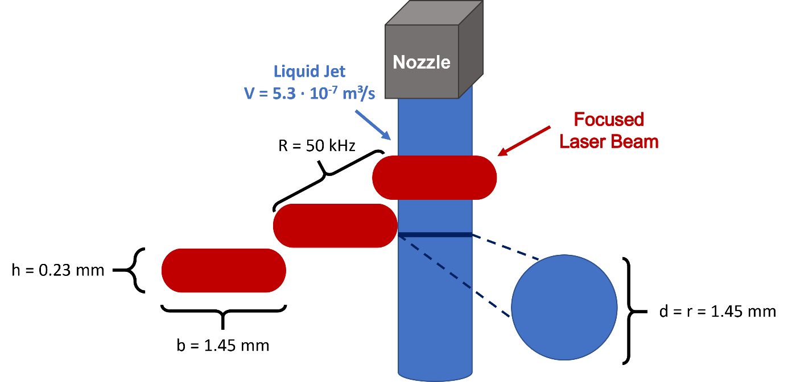
Figure S1: Schematic representation of the fragmentation process.

Table S1: Parameters and values used for the liquid jet characterization: 1,2: liquid jet width and thickness, determined from the dimensions of the aperture, 3,4: beam height and width were determined via beam camera, 5: volumetric flow rate, obtained from triplicate measurements of the jet volume collected over 1 min.
Parameter | Experimental value | Symbol
Width_{(liquid jet)}¹ | 1.05 mm | d
Thickness _{(liquid jet)}² | 1.05 mm | r
Height_{(laser pulse)}³ | 0.23 mm | h
Width _{(laser pulse)}⁴ | 1.45 mm | b
Volume flow rate⁵ | 5.3 10⁻⁷ m³/s | V
Output repetition rate | 50 kHz | R
Laser Power | 26.5/52.5/78.5/104.5 W | P
Laser Fluence | 200/400/600/800 mJ/cm² | F

$PPV= \frac{h}{\frac{V}{d∙r}}∙R=\frac{2.3∙{10}^{-4} m}{\frac{5.3∙{10}^{-7}\frac{m^{3}}{s}}{{(1.05∙{10}^{-3}m)}^{2}}}∙50000\frac{1}{s}=23.92$ (Eq. 1)

$F_{800 mJ/cm²}= \frac{P}{R∙π∙h∙b}= \frac{104.5 W}{5∙{10}^{4}s^{-1} ∙π∙0.023 cm∙0.145 cm}=800 mJ/cm²$ (Eq. 2)
Section 2: Picosecond IR Laser Intensity Profile

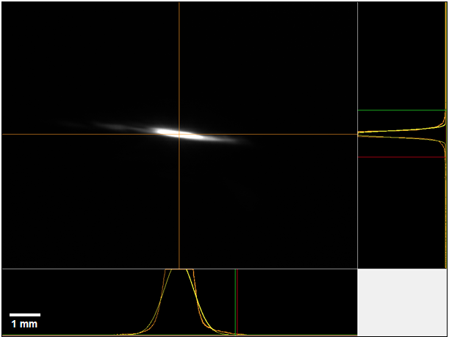
Figure S2: Intensity profile of the focused picosecond IR laser induced on the liquid jet.

Section 3: TEM Particle Size Distributions
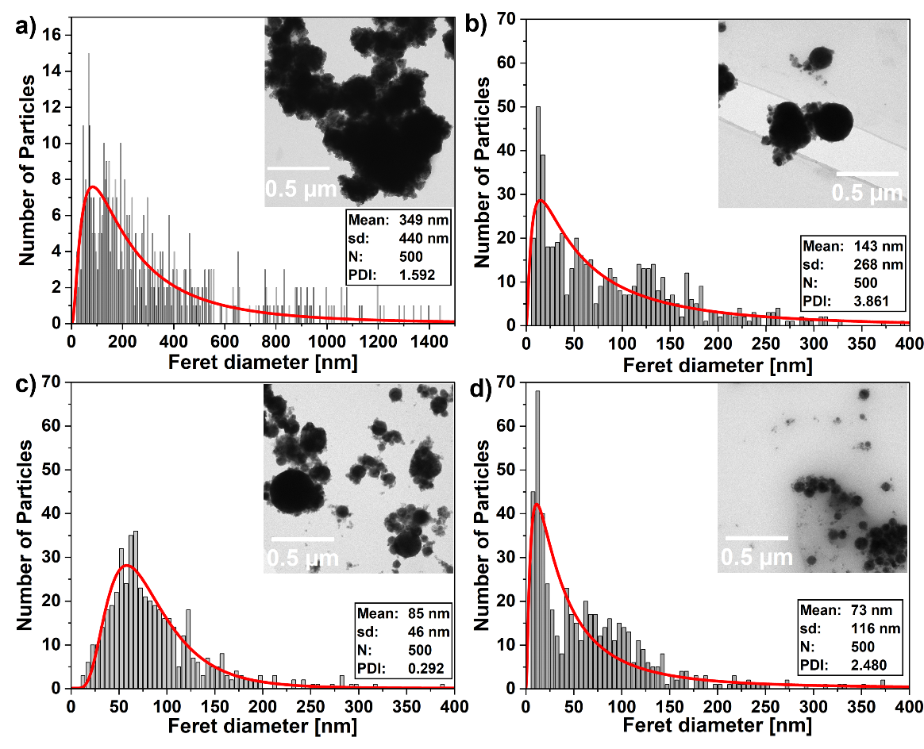
Figure S3: TEM-derived particle size distributions of a) Ni_{2.25}Co_{6.75}S₈ pentlandite particles processed at a laser fluence of 200 mJ/cm² using b) 24, c) 48, and d) 72 pulses per volume (PPV).
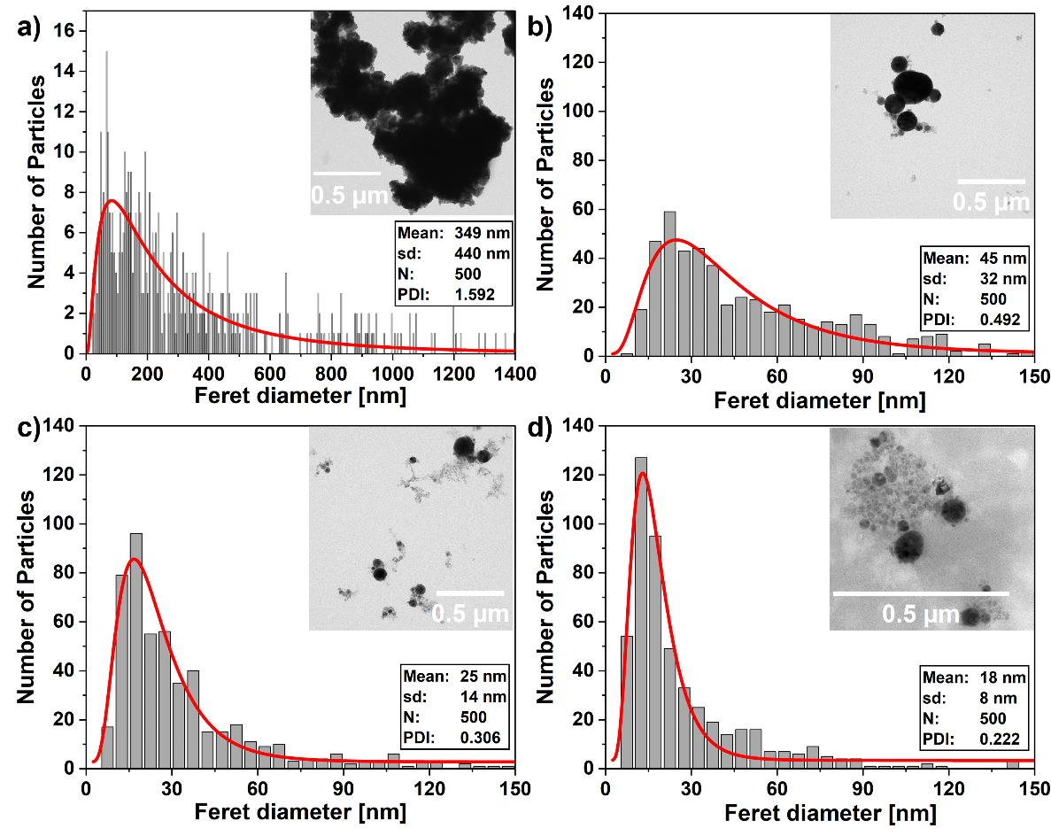
Figure S4: TEM-derived particle size distributions of a) Ni_{2.25}Co_{6.75}S₈ pentlandite particles processed at a laser fluence of 400 mJ/cm² using b) 24, c) 48, and d) 72 pulses per volume (PPV).
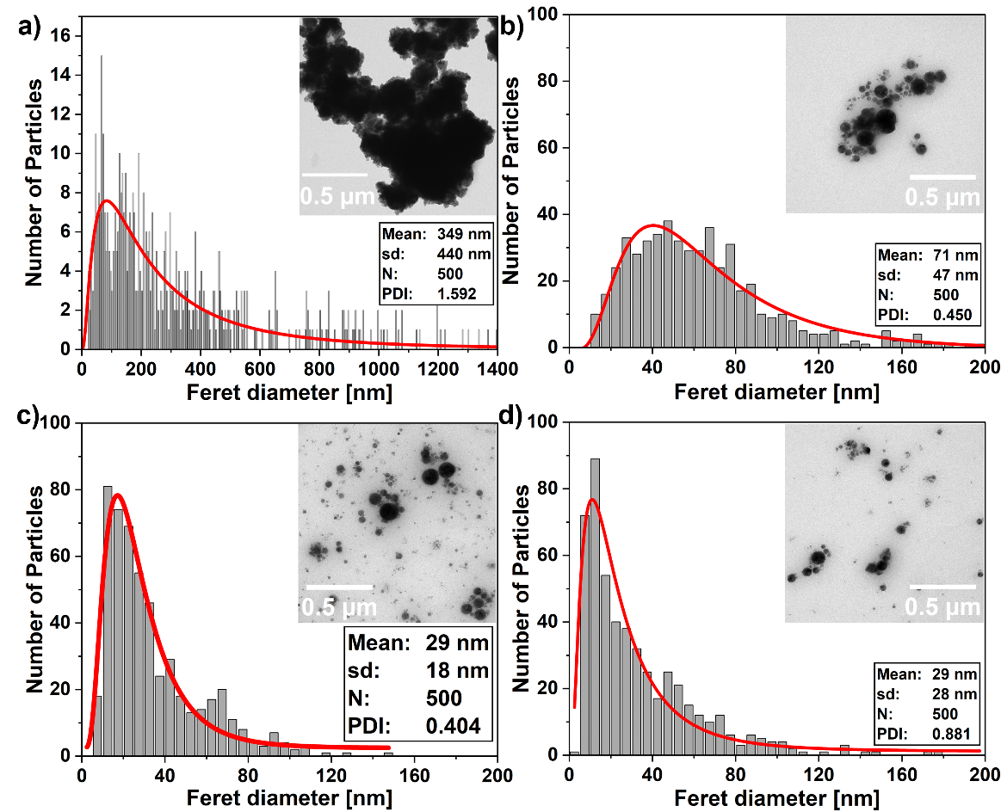
Figure S5: TEM-derived particle size distributions of a) Ni_{2.25}Co_{6.75}S₈ pentlandite particles processed at a laser fluence of 600 mJ/cm² using b) 24, c) 48, and d) 72 pulses per volume (PPV).
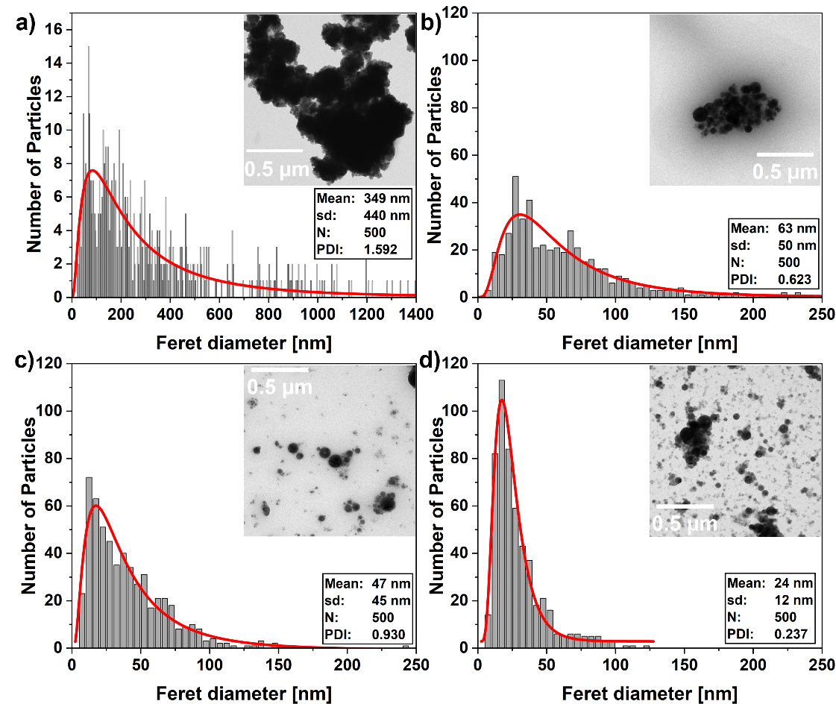
Figure S6: TEM-derived particle size distributions of Ni_{2.25}Co_{6.75}S₈ pentlandite particles processed at a laser fluence of 800 mJ/cm² using 24, 48, and 72 pulses per volume (PPV).

Section 4: Hydrogen Evolution Reaction (HER) Measurements
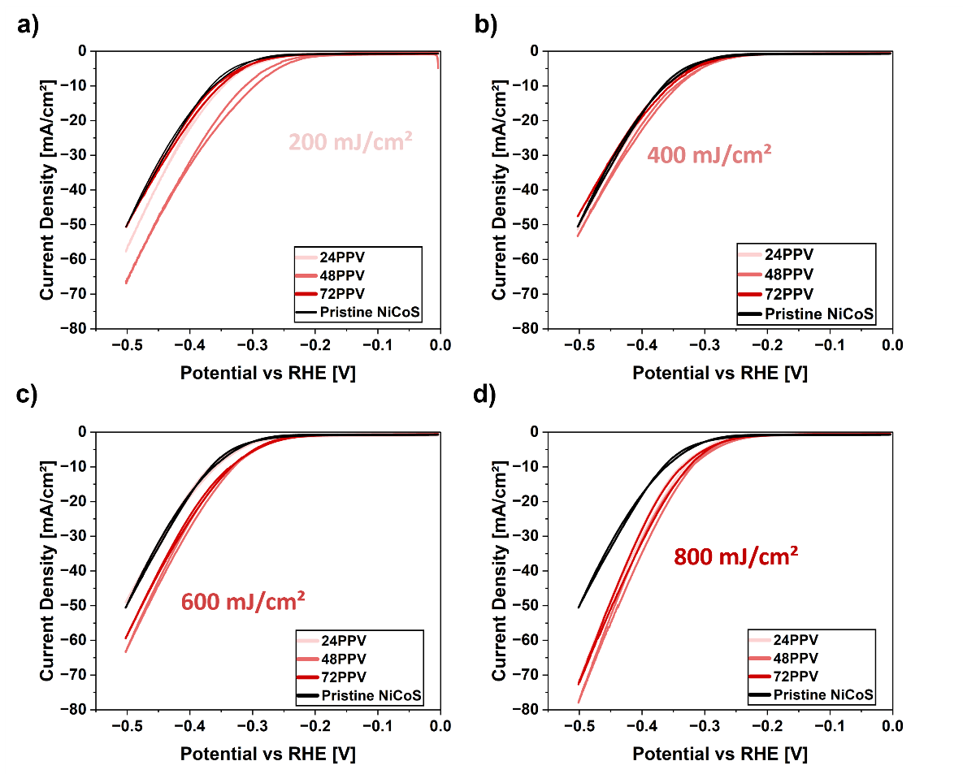
Figure S7: HER polarization curves recorded on a rotating disk electrode (RDE) for Ni_{2.25}Co_{6.75}S₈ pentlandite particles processed at laser fluences of 200, 400, 600, and 800 mJ/cm² using 24, 48, and 72 pulses per volume (PPV).
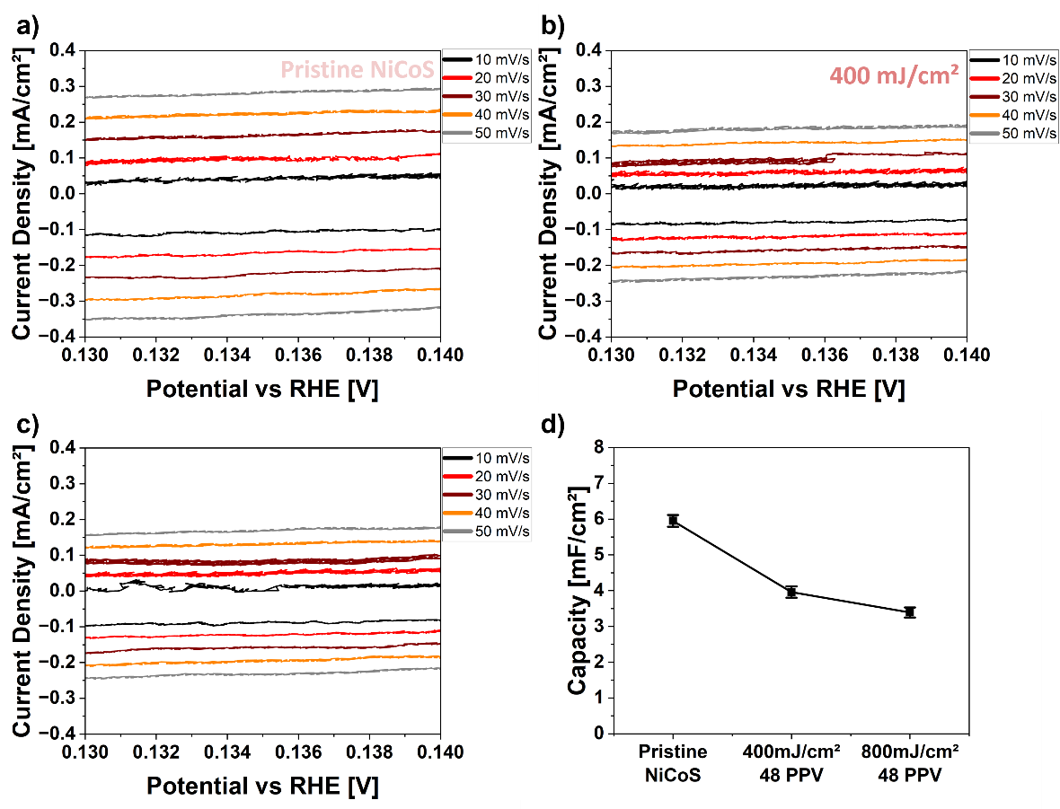
Figure S8: Cyclic voltammograms recorded in the non-faradaic double-layer region at different scan rates for (a) pristine Ni_{2.25}Co_{6.75}S₈ microparticles and Ni_{2.25}Co_{6.75}S₈ nanoparticles obtained by laser fragmentation at (b) 400 mJ/cm² and (c) 800 mJ/cm² 48 PPV. (d) Comparison of the determined double-layer capacitances (Cdl) of the three samples.
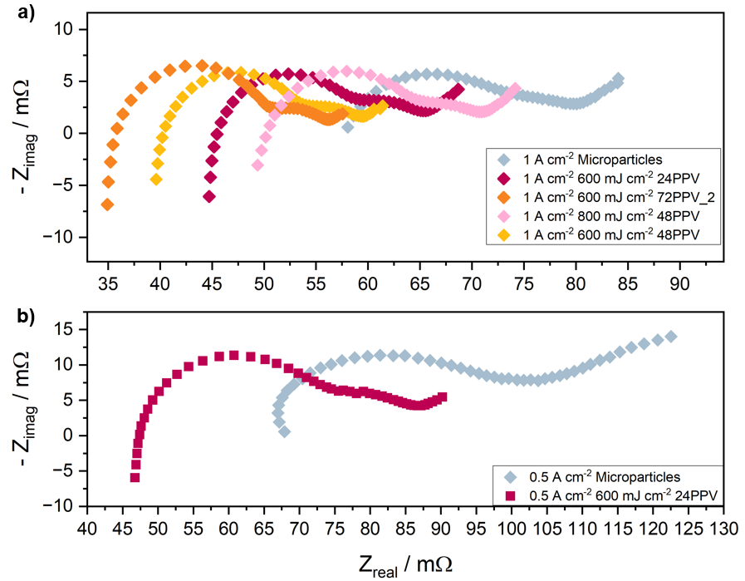
Figure S9: Zero-gap electrolyzer performance of selected Ni_{2.25}Co_{6.75}S₈ pentlandite samples exhibiting enhanced HER activity in the RDE measurements. (a) Electrochemical impedance spectra recorded at 1.0 A/cm², (b) electrochemical impedance spectra recorded at 0.5 A/cm²

Section 5: X-Ray Diffraction (XRD) Analysis

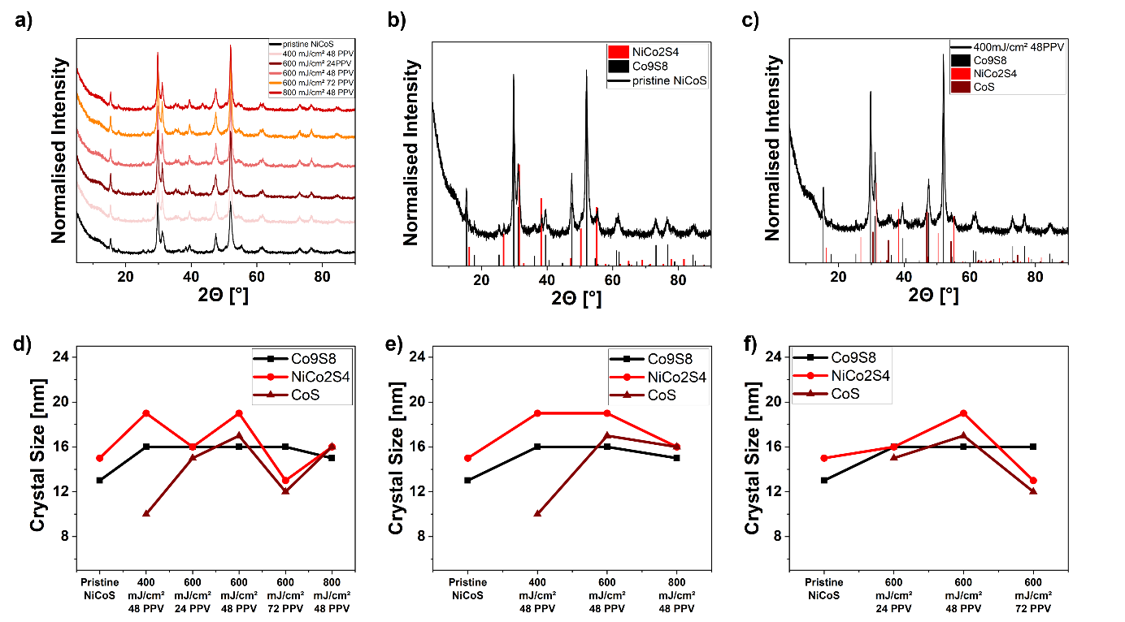
Figure S10: XRD analysis of pristine and laser-fragmented Ni_{2.25}Co_{6.75}S₈ pentlandite particles. (a) XRD patterns of all selected and investigated samples. (b) XRD pattern of pristine Ni_{2.25}Co_{6.75}S₈ together with the reference powder diffraction files (PDF) of Co₉S₈ and NiCo₂S₄. (c) XRD pattern of the sample processed at 400 mJ/cm² and 48 PPV together with the reference powder diffraction files of Co₉S₈, NiCo₂S₄ and CoS. (d) Crystallite sizes determined from Rietveld refinement for all investigated samples. (e) Crystallite size as a function of laser fluence for samples processed at 48 PPV. (f) Crystallite size as a function of pulses per volume (PPV) for samples processed at a laser fluence of 600 mJ/cm².
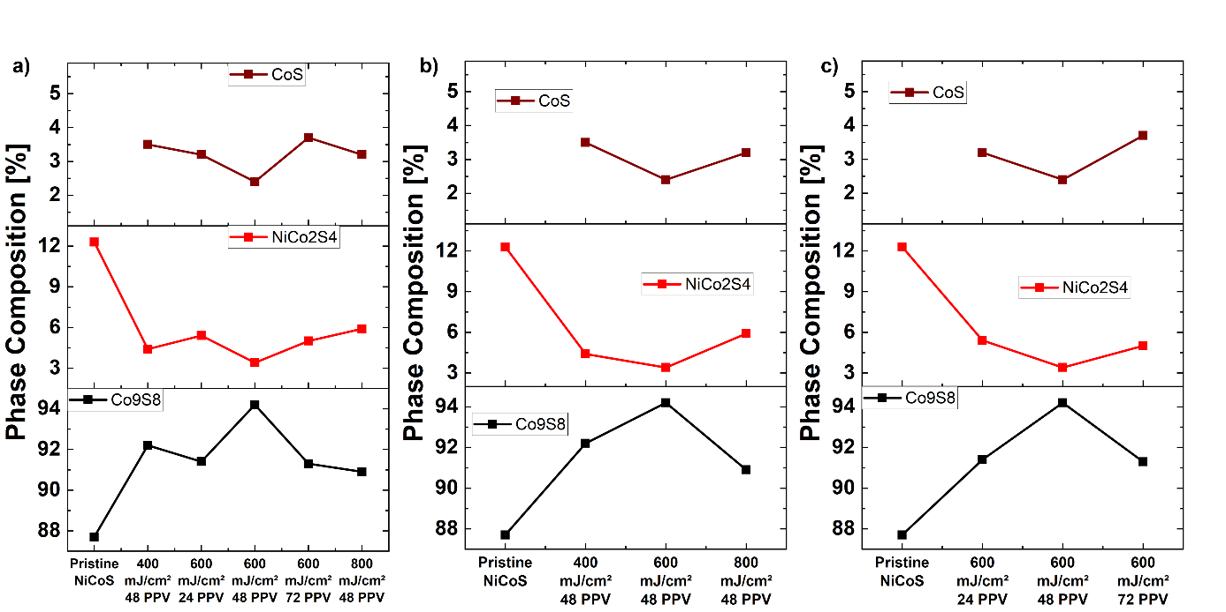
Figure S11: Phase composition determined by Rietveld refinement of selected Ni_{2.25}Co_{6.75}S₈ pentlandite samples. (a) Relative phase fractions of Co₉S₈, NiCo₂S₄ and CoS for all investigated samples. (b) Phase composition as a function of laser fluence for samples processed at 48 PPV. (c) Phase composition as a function of PPV for samples processed at a laser fluence of 600 mJ/cm².

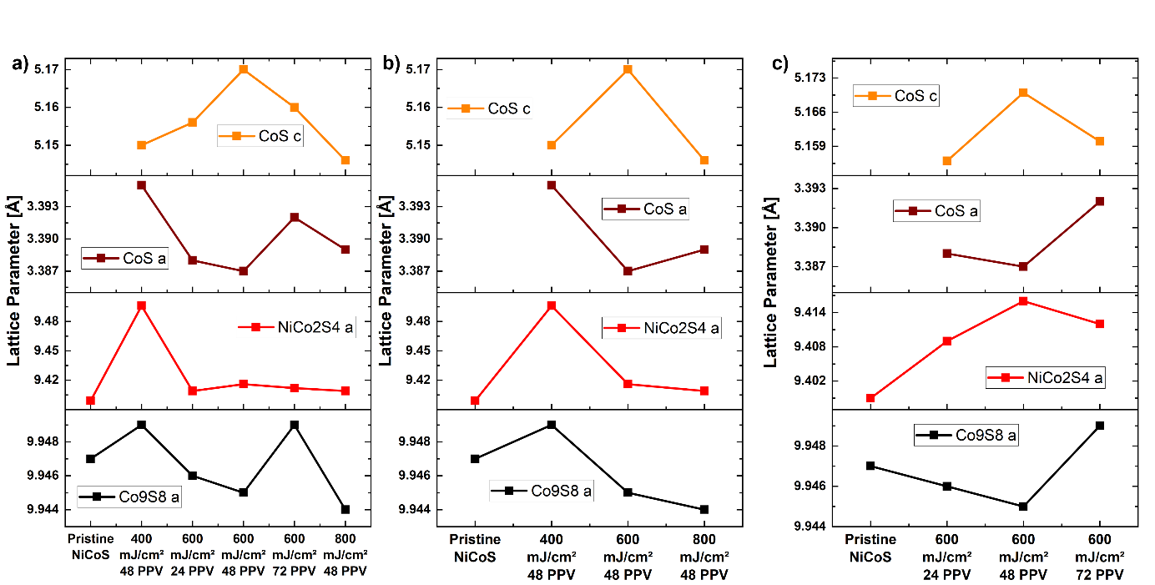
Figure S12: Lattice parameters of the Co₉S₈, NiCo₂S₄ and CoS phases determined by Rietveld refinement of selected Ni_{2.25}Co_{6.75}S₈ pentlandite samples. (a) Lattice parameters for all investigated samples. (b) Lattice parameters as a function of laser fluence for samples processed at 48 PPV. (c) Lattice parameters as a function of PPV for samples processed at a laser fluence of 600 mJ/cm².

Section 6: Elemental Composition Analysis by SEM-EDS
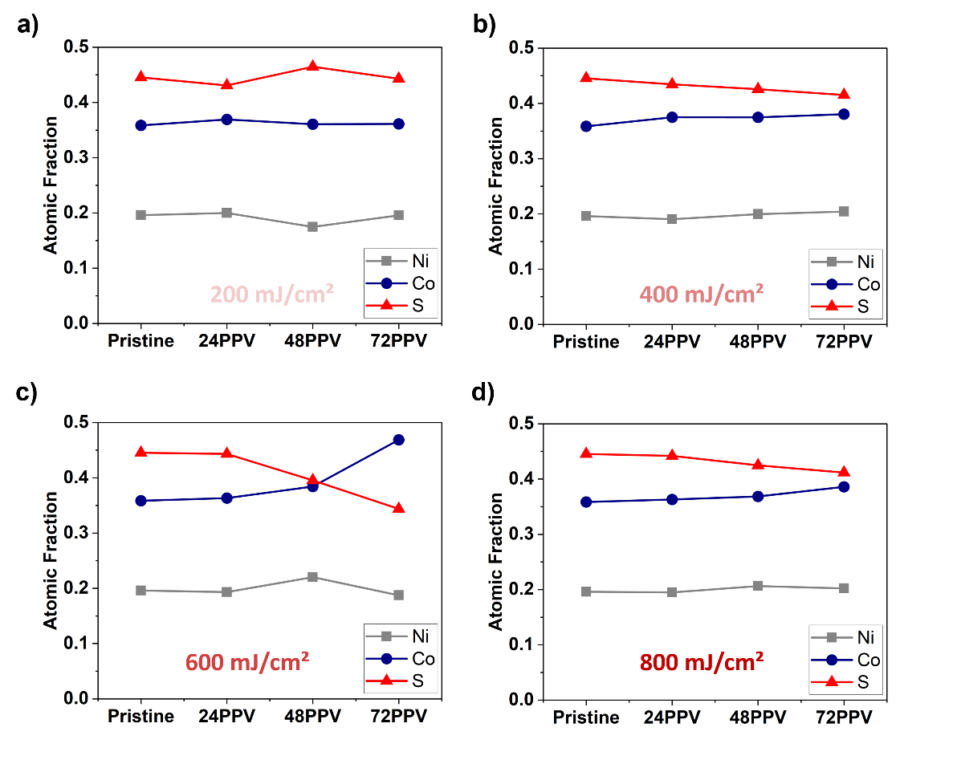
Figure S13: Relative atomic fractions of Ni, Co, and S determined by SEM-EDS for Ni_{2.25}Co_{6.75}S₈ pentlandite particles processed at laser fluences of (a) 200, (b) 400, (c) 600, and (d) 800 mJ/cm² as a function of PPV.
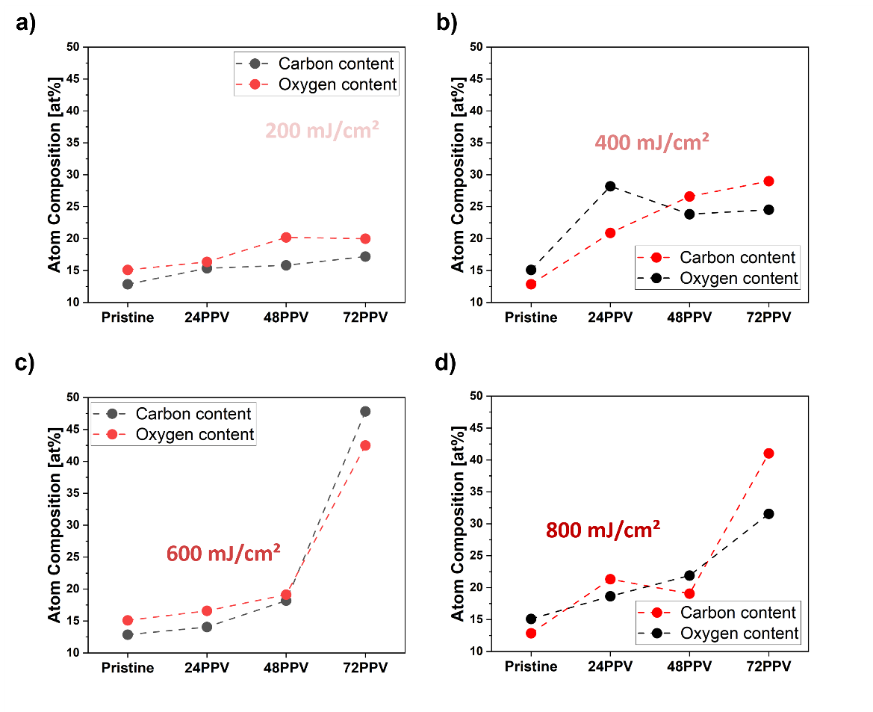
Figure S14: Atomic percentages (at.%) of carbon and oxygen determined by SEM-EDS for Ni_{2.25}Co_{6.75}S₈ pentlandite particles processed at laser fluences of (a) 200, (b) 400, (c) 600, and (d) 800 mJ/cm² as a function of PPV.
Section 7: Identification of Pyrolysis Products by TGA-ATD-GC-MS

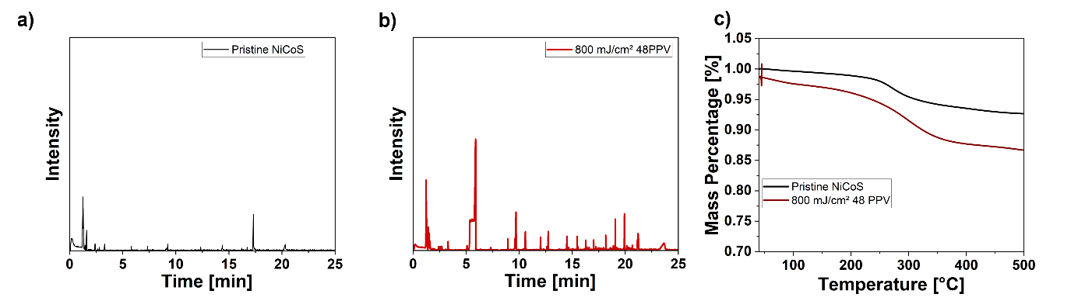
Figure S15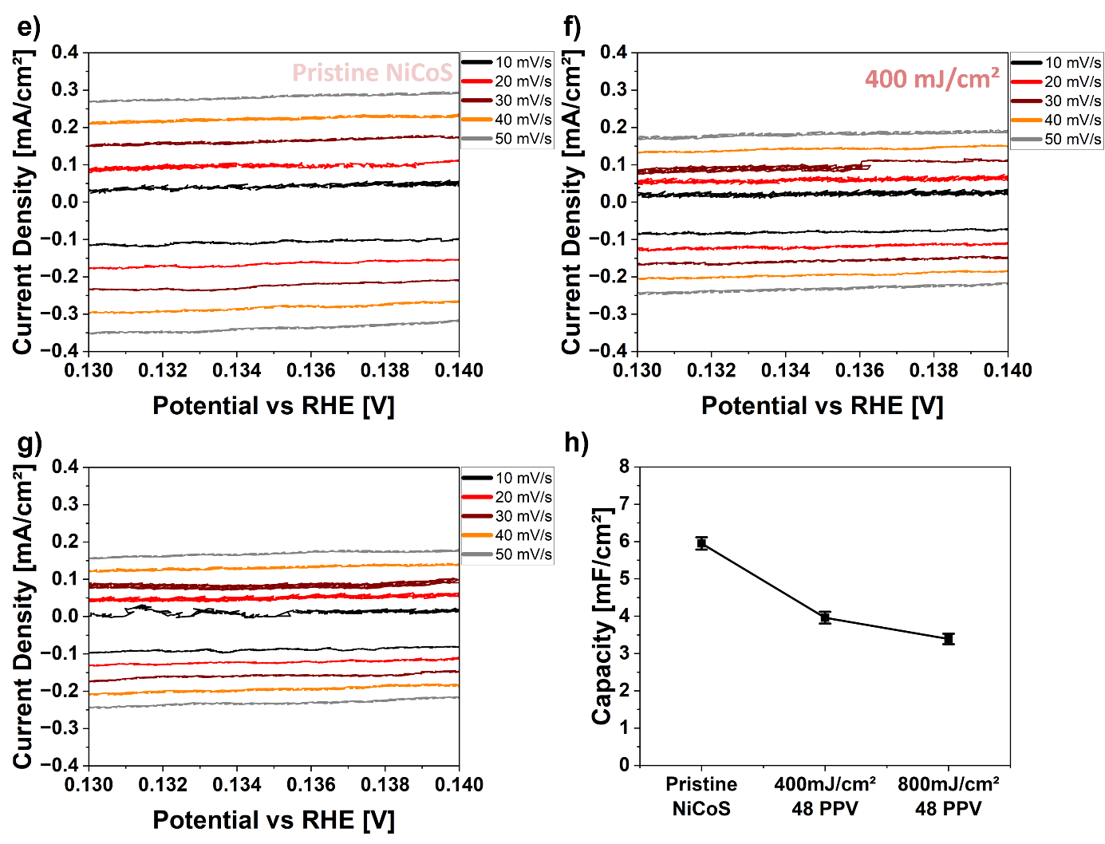: (a+b) ATD-GC-MS analysis of the pyrolysis products formed during laser processing of pentlandite in isopropanol and (c) corresponding TGA curves used to determine the temperature for thermal desorption analysis.

Tabel S2: Pyrolysis products detected by GC-MS in the investigated laser-treated Ni_{2.25}Co_{6.75}S₈ pentlandite samples.
Retention Time [min] | Related Compound
3.10 | E-1-Methylthio-1-propene
6.07 | Hexamethylcyclotrisiloxane
6.40 | Methylthio-2-propanone
7.45 | 2,4-Dithiapentane
8.96 | 2-Ethylhexanal
9.80 | Hexamethyltrisiloxane
10.61 | 2-Ethyl-1-hexanol
11.63 | Hexamethylcyclotrisiloxane
12.08 | Fumaric acid
12.79 | 3,3-Diphenyl-1-trismethylsilylcyclopropene
14.53 | Hexamethyldisilathiane
15.49 | Oxalic acid, TMS Derivative
16.31 | Oxalic acid, TMS Derivative
18.18 | Thioglycolic acid, TMS Derivative
19.08 | Thioglycolic acid, TMS Derivative
19.94 | Thioglycolic acid, TMS Derivative
23.36 | Thioglycolic acid, TMS Derivative

