Sustainable fabrication of 2D-based devices through reuse of substrates with microfabricated electrodes
Ying Zhang^{1,2}, Yigit Sozen^{1,2}, Esteban Zamora-Amo^{1,2}, Thomas Pucher^{1,2}, Nuria Jiménez-Arévalo¹, Zdenek Sofer³, Yong Xie*^{1, 4}, Andres Castellanos-Gomez*¹

Address: ¹2D Foundry research group. Instituto de Ciencia de Materiales de Madrid (ICMM-CSIC), Madrid, 28049, Spain and ²Universidad Autónoma de Madrid, Escuela de Doctorado, Madrid, 28049, Spain and ³Department of Inorganic Chemistry, University of Chemistry and Technology, Prague, Prague, Czech Republic and ⁴School of Advanced Materials and Nanotechnology, Xidian University, 710071 Xi’an, China

Email: Yong Xie - yxie@xidian.edu.cn; Andres Castellanos-Gomez - andres.castellanos@csic.es

The mechanistic exploration was conducted under the optimized cleaning condition of ultrasonic treatment in NMP at 50 °C. To validate this choice and establish it as the standard cleaning protocol for this work, we used MoS₂ films on SiO₂/Si prepared by high-throughput mechanical exfoliation as a model system and systematically compared the cleaning performance of three commonly used organic solvents-NMP, dimethyl sulfoxide (DMSO), and acetone (ACE)-at different temperatures (Figure S1). All cleaning experiments were performed approximately 24 h after transferring the material onto the substrates. For NMP, most MoS₂ flakes were removed at room temperature; when the temperature was increased to 50 °C, a 15 min ultrasonic treatment was sufficient to completely remove the MoS₂ film, leaving virtually no visible residues. The cleaning efficiency of DMSO also improved markedly with increasing temperature, and only a small amount of residue remained at 50 °C. In contrast, the performance of ACE showed only limited enhancement upon heating: even at the highest tested temperature, clear MoS₂ residues were still visible on the substrate surface.
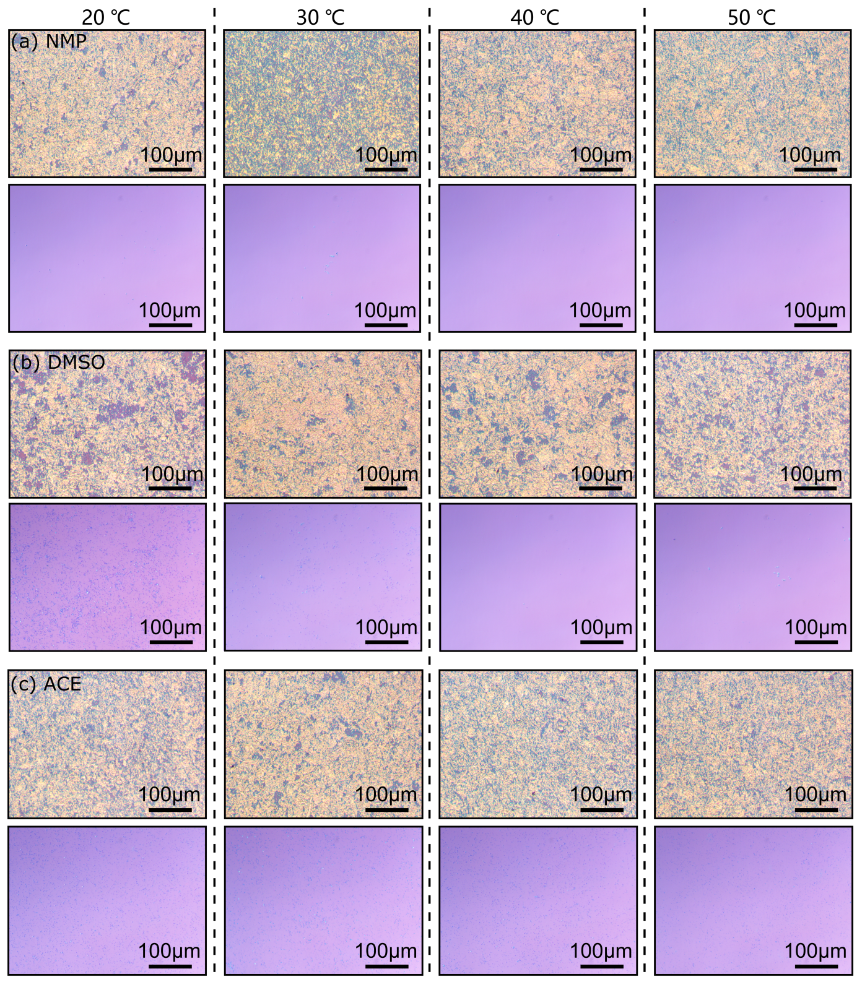
Supplementary Figure 1: Temperature-dependent cleaning performance of different organic solvents on high-coverage MoS₂ network films. Optical micrographs of high-coverage MoS₂ network films on SiO₂/Si substrates prepared by high-throughput mechanical exfoliation, before and after ultrasonic cleaning at different temperatures using (a) NMP, (b) dimethyl sulfoxide (DMSO), and (c) acetone (ACE), illustrating the solvent- and temperature-dependent evolution of the film morphology.
In subsequent experiments, we further evaluated the behaviour of these solvents under more practical conditions by performing two consecutive MoS₂ transfer-cleaning cycles on the same pair of electrodes, in order to probe the effect of cross-usage and residence time. The first cleaning step was carried out on the day of MoS₂ transfer, while the second after a second transfer followed by three days of storage. The corresponding optical comparisons before and after cleaning are shown in Figure S2 (DMSO as the initial solvent) and Figure S3 (ACE as the initial solvent). When MoS₂ was cleaned on the day of transfer (“fresh” flakes), both DMSO and ACE removed the film reasonably well, leaving only minor residues. However, cross-cleaning did not provide any noticeable improvement in removing the remaining MoS₂ (ACE after DMSO and DMSO after ACE). For samples left on the electrodes for three days, the cleaning efficiency of both DMSO and ACE decreased significantly, and even an additional cleaning step in NMP could not achieve complete removal of the residual MoS₂, indicating that DMSO and ACE are markedly less effective for “non-fresh” flakes. In contrast, the high-coverage MoS₂ film shown in Figure 1(c) was cleaned directly using NMP after the sample had been left for a certain period, and a nearly residue-free surface was still obtained, demonstrating that NMP maintains high cleaning efficiency regardless of residence time. Therefore, despite their partial effectiveness, the cleaning capability of DMSO and ACE are overall inferior to that of NMP. Based on these results, unless otherwise specified, all subsequent experiments employ ultrasonic cleaning in NMP at 50 °C as the standard protocol.

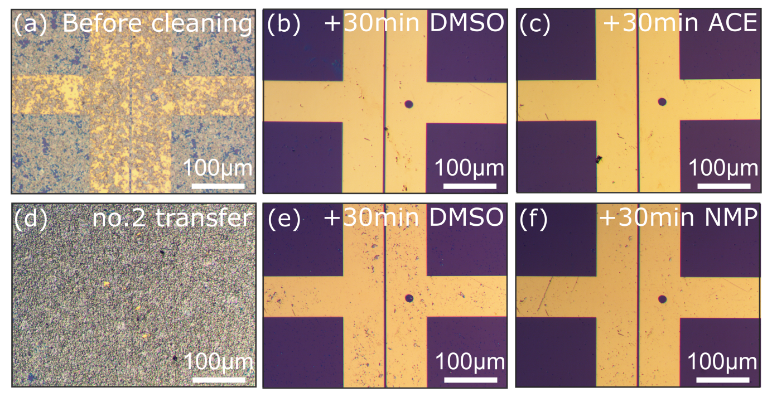
Supplementary Figure 2: Optical microscope images comparing the electrode surface before and after ultrasonic cleaning with dimethyl sulfoxide (DMSO) on an electrode with transferred MoS₂. (a) Electrode image before cleaning after the first MoS₂ transfer; channel width is 5 μm. (b) Electrode image after 30 minutes of ultrasonic cleaning with DMSO on the day of transfer. (c) Electrode image following an additional 30-minute ultrasonic cleaning with acetone (ACE). (d) Electrode image before cleaning after the second MoS₂ transfer. (e) Electrode image after 30 minutes of ultrasonic cleaning with DMSO performed 3 days post-transfer. (f) Electrode image after a subsequent 30-minute ultrasonic cleaning with NMP. Elongated scratches visible in the images are attributed to the ultrasonic cleaning process.

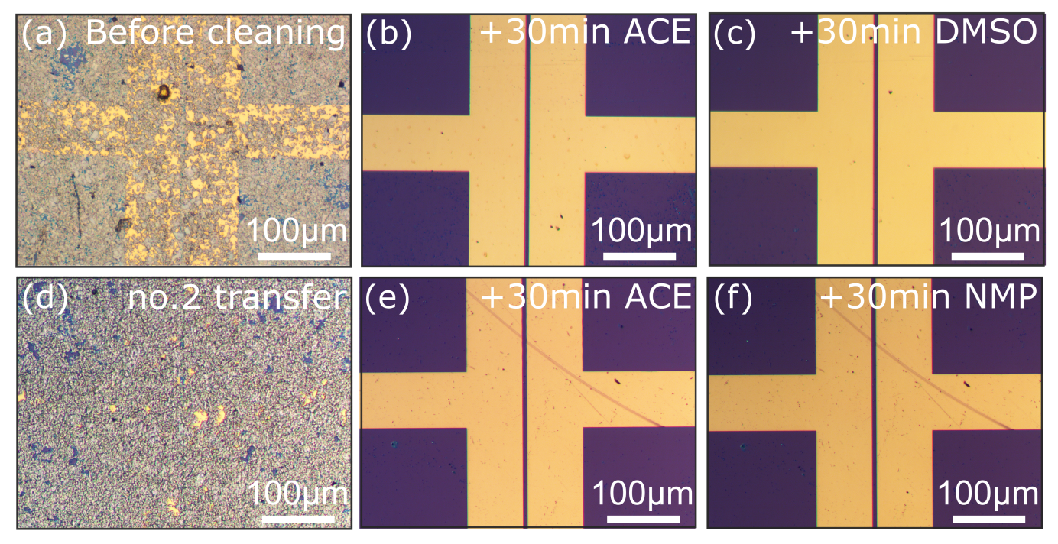
Supplementary Figure 3: Optical microscope images showing the electrode surface before and after ultrasonic cleaning with ACE on an electrode with transferred MoS₂. (a) Electrode image before cleaning following the first MoS₂ transfer; channel width is 7 μm. (b) Electrode image after 30 minutes of ultrasonic cleaning with ACE on the day of transfer. (c) Electrode image after an additional 30 minutes of ultrasonic cleaning with DMSO. (d) Electrode image before cleaning following the second MoS₂ transfer. (e) Electrode image after 30 minutes of ultrasonic cleaning with ACE performed 3 days post-transfer. (f) Electrode image after a subsequent 30 minutes of ultrasonic cleaning with NMP. Elongated scratches visible in the images are attributed to the ultrasonic cleaning process.

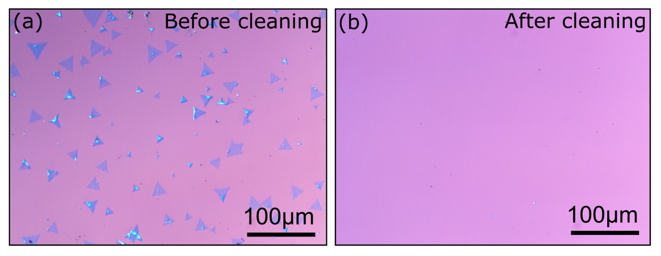
Supplementary Figure 4: Macroscopic images of CVD-grown monolayer MoS₂ flakes before and after cleaning.

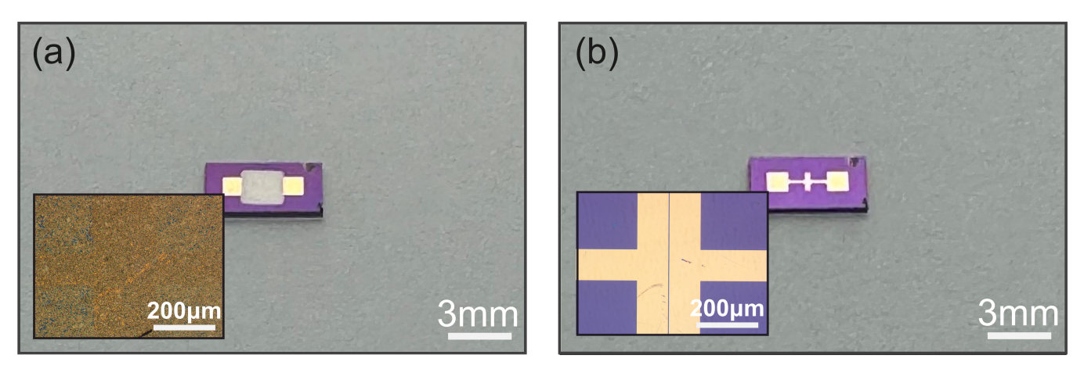
Supplementary Figure 5: Macroscopic and optical microscopy images of the electrode-patterned SiO₂/Si substrate used for electrical characterization in the main text, shown before and after the cleaning process. The material used in this case is WSe₂.

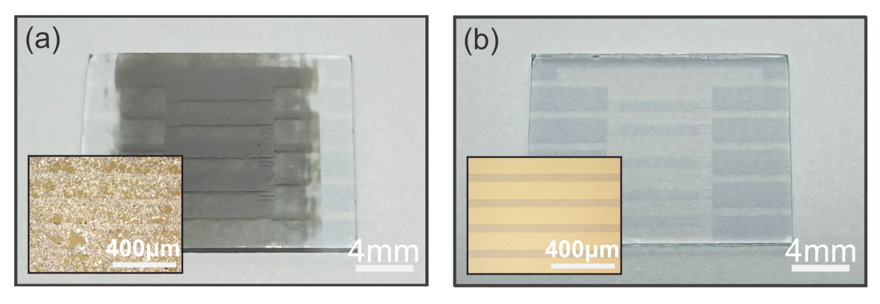
Supplementary Figure 6: The macroscopic and optical microscopy images of indium tin oxide (ITO) substrates before and after cleaning. The case of MoS₂ is presented here as a representative example.

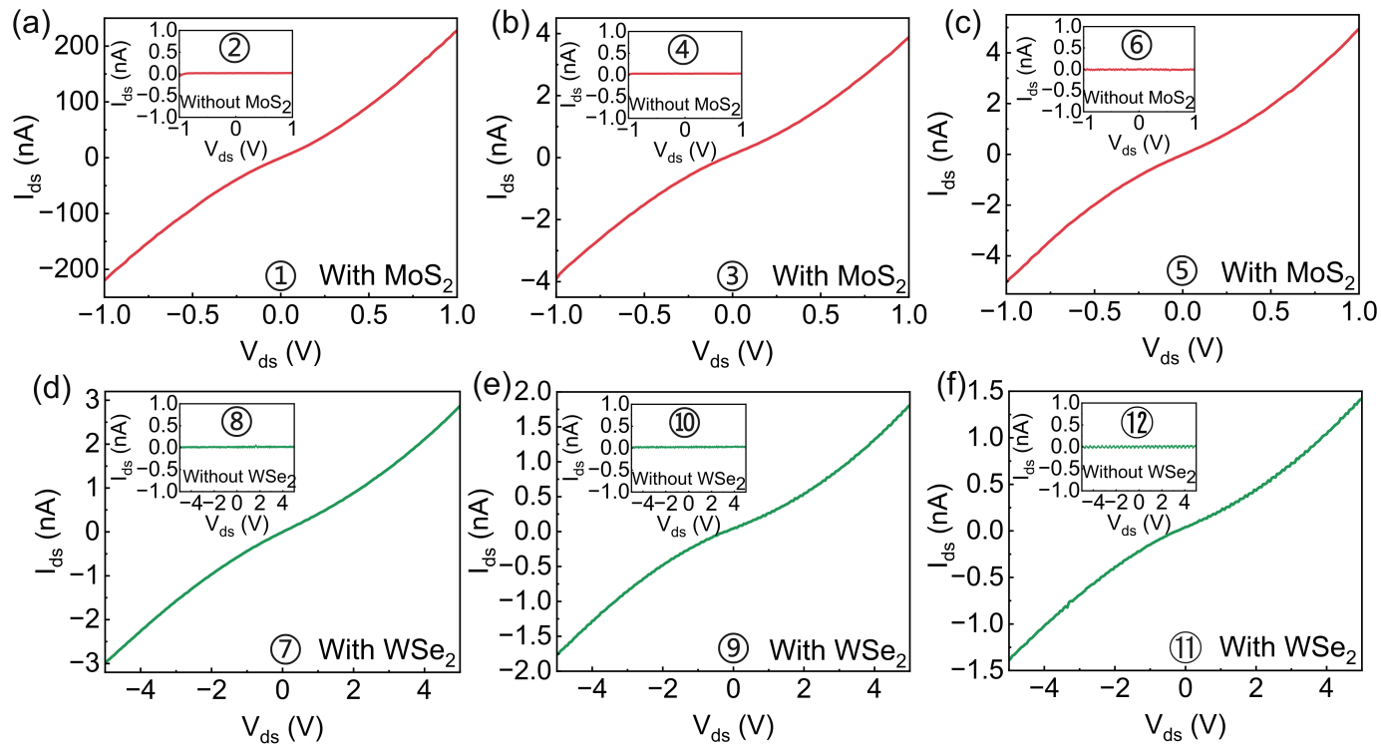
Supplementary Figure 7: The output characteristics of repeatedly transferring MoS₂ and WSe₂ samples onto the same ITO substrate. (a-c) The main panels present the output characteristics of the MoS₂ device after the first, second, third transfer. (Insets) The output characteristics of the substrate after cleaning the device shown in (a-c), respectively. (d-f) The output characteristics of the WSe₂ device after the first, second, third transfer cycles, following three successful MoS₂ transfers. (Insets) The output characteristics of the cleaned substrate corresponding to the devices shown in (d-f), respectively.

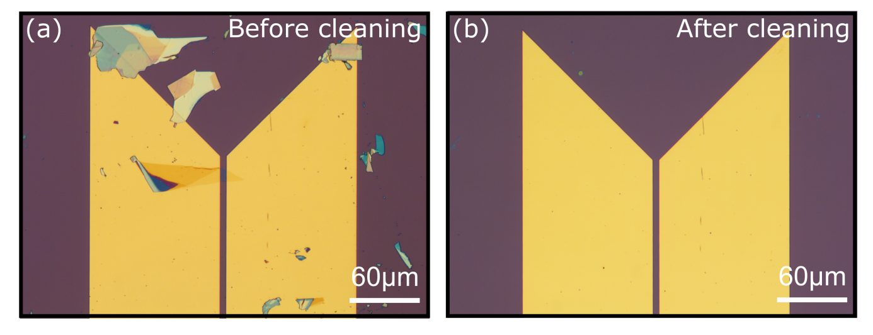
Supplementary Figure 8: Macroscopic images of a monolayer MoS₂ flake transferred onto pre-patterned electrodes without annealing, before and after ultrasonic cleaning.

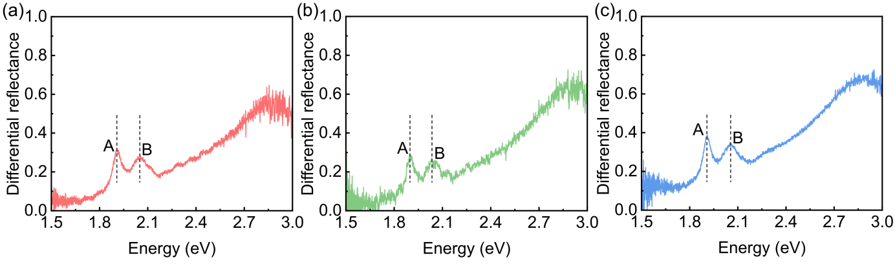
Supplementary Figure 9: Differential reflectance spectra of monolayer MoS₂ flakes.
Differential reflectance spectra of the monolayer MoS₂ flakes shown in Figures 4a, 4c, and S7 (panels a-c, respectively). All spectra exhibit the characteristic A and B exciton peaks, with the A exciton located around 1.90 eV.
Table 1: Field-effect mobility and ON/OFF ratio of monolayer MoS₂ FETs.
Devices | $W_{eff}$ (μm) | $g_{m}$(20-40V) Forward (A/V) | $g_{m}$(20-40V) Backward (A/V) | $μ_{FE}$ Forward (cm²/V·s) | $μ_{FE}$ Backward (cm²/V·s) | ON/OFF Forward | ON/OFF Backward
Fig.4a | 17.28 | 1.779×10⁻⁶ | 1.858×10⁻⁷ | 43.2 | 45.2 | 7.5×10⁶ | 3.4×10⁻⁶
Fig.4c | 8.37 | 4.112×10⁻⁷ | 4.520×10⁻⁷ | 22.0 | 22.7 | 8.5×10⁵ | 1.1×10⁻⁶
Field-effect mobility ($μ_{FE}$) was extracted from the transfer characteristics in the linear regime according to
$$μ_{FE}=\frac{L}{W}∙\frac{g_{m}}{C_{ox}V_{ds}}$$
$$g_{m}=\frac{{dI}_{ds}}{{dV}_{g}}$$
All devices were measured at $V_{ds}$=1 V using a SiO₂_back gate with oxide thickness $t_{ox}$= 290 nm. The gate-oxide capacitance per unit area was calculated as $C_{ox}$= ${ε_{0}ε_{r}}/{t_{ox}}$=1.19×10⁻⁸ F/cm². The channel length is $L$= 5 μm. The effective channel width $W_{eff}$ was determined from optical micrographs by measuring the MoS₂ flake overlap across the channel region at multiple positions along the channel and taking the harmonic mean. The transconductance $g_{m}$ was obtained from a linear fit of the $I_{ds}$ -$V_{g}$ curve over $V_{g}$= 20-40 V using the high-current-range data. Forward and backward sweeps were analyzed separately, and a conservative single-value mobility was defined as the lower value between the two sweep directions.
The ON/OFF current ratio was calculated as $ON/OFF=I_{on}/I_{off}$ from the transfer curves. To ensure reliable values over the full dynamic range, stitched measurements were used: $I_{on}$ was taken from the high-current-range data, while $I_{off}$ was taken from the low-current-range data. ON/OFF ratios were reported for both sweep directions, and a conservative single-value ON/OFF ratio was defined as the lower value between forward and backward sweeps.

