Support Information
Azonanes from pyrrolidine: a double application of Hofmann-type two-carbon ring expansion sequence

Yulia V. Khoroshunova^{*1}, Sergey A. Dobrynin^{1,2}, Tatyana V. Rybalova¹, and Igor A. Kirilyuk¹

Address: ¹N.N. Vorozhtsov Institute of Organic Chemistry SB RAS, Academician Lavrentiev Ave. 9, Novosibirsk, 630090, Russian Federation and ²Novosibirsk State University, Pirogova Str. 2, Novosibirsk, 630090, Russian Federation

Email: Yulia Vladislavovna Khoroshunova - horoshunova@nioch.nsc.ru
* Corresponding author

Experimental section and characterization data of synthesized compounds
Experimental protocols, copies of the IR, ¹H, ¹³C NMR spectra and X-ray analysis data

Table of Content
1. Experimental 5
1.1. Materials and methods 5
1.2. Synthesis 6
(3aS(R),6aR(S),9aR(S),11aS(R))-decahydro-1H,6H-biscyclopenta[2,3]azeto[1,2-a:2’1’-e]pyrrolium bromide (8) 6
(3aS(R),6aR(S),11aR(S))-2,3,3a,4,6,6a,7,8,10,11-Decahydro-1H-cyclopenta[e]cyclopenta[2,3]azeto[1,2-a]azepine (9) 7
(3aS(R),6aR(S),11aR(S))-2,3,3a,4,6,6a,7,8,10,11-Decahydro-1H-cyclopenta[2,3]azeto[1,2-a]cyclopenta[e]azepin-5-ium chloride (9*HCl) 8
(3aS(R),6aR(S),11aR(S))-5-Methyl-2,3,3a,4,6,6a,7,8,10,11-decahydro-1H-cyclopenta[e]cyclopenta[2,3]azeto[1,2-a]azepinium iodide (10) 9
Reaction of (3aS(R),6aR(S),11aR(S))-5-methyl-1,2,3,3a,4,5,6,6a,7,8,10,11-Dodecahydrocyclopenta[2,3]azeto[1,2-a]cyclopenta[e]azepin-5-ium iodide (10) with wet silver (I) oxide followed by heating 10
General procedure of the reaction of (3aR(S),6aR(S))-5-methyl-3,3a,4,5,6,6a,7,8,10,11-decahydro-2H-dicyclopenta[c,g]azonine (11) and (3aR(S),6aR(S))-5-methyl-2,3,3a,4,5,6,6a,7,8,10-decahydro-1H-dicyclopenta[c,g]azonine (12) with methyl iodide 12
2. IR Spectral data 15
2.1 (2aR(S),5aS(R),8aS(R),11aR(S))-dodecahydrocyclopenta[2,3]azeto[1,2-a]cyclopenta[2,3]azeto[1,2-e]pyrrol-7-ium (8) 15
2.2. (3aS(R),6aR(S),11aR(S))-1,2,3,3a,4,5,6,6a,7,8,10,11-dodecahydrocyclopenta[2,3]azeto[1,2-a]cyclopenta[e]azepin-5-ium (9*HCl) 15
2.3. (3aS(R),6aR(S),11aR(S))-5-Methyl-1,2,3,3a,4,5,6,6a,7,8,10,11-dodecahydrocyclopenta[2,3]azeto[1,2-a]cyclopenta[e]azepin-5-ium iodide (10) 16
2.4. (3aR(S),6aR(S),Z)-5-Methyl-2,3,3a,4,5,6,6a,7,8,10-decahydro-1H-dicyclopenta[c,g]azonine (12) 16
2.5. 5,5-Dimethyl-3,3a,4,5,6,6a,7,8,10,11-decahydro-2H-dicyclopenta[c,g]azonin-5-ium iodide (13) 17
2.6. (Z)-5,5-Dimethyl-2,3,3a,4,5,6,6a,7,8,10-decahydro-1H-dicyclopenta[c,g]azonin-5-ium iodide (14) 17
3. ¹H and ¹³C NMR spectral data 18
3.1. (2aR(S),5aS(R),8aS(R),11aR(S))-Dodecahydrocyclopenta[2,3]azeto[1,2-a]cyclopenta[2,3]azeto[1,2-e]pyrrol-7-ium bromide (8) 18
3.2. (3aS(R),6aR(S),11aR(S))-2,3,3a,4,6,6a,7,8,10,11-Decahydro-1H-cyclopenta[2,3]azeto[1,2-a]cyclopenta[e]azepine (9) 19
3.3. (3aS(R),6aR(S),11aR(S))-1,2,3,3a,4,5,6,6a,7,8,10,11-Dodecahydrocyclopenta[2,3]azeto[1,2-a]cyclopenta[e]azepin-5-ium chloride (9*HCl) 20
3.4. (3aS(R),6aR(S),11aR(S))-5-Methyl-1,2,3,3a,4,5,6,6a,7,8,10,11-dodecahydrocyclopenta[2,3]azeto[1,2-a]cyclopenta[e]azepin-5-ium iodide (10) 21
3.5. (3aR(S),6aR(S))-5-Methyl-3,3a,4,5,6,6a,7,8,10,11-decahydro-2H-dicyclopenta[c,g]azonine (11) 22
3.6. (3aR(S),6aR(S),Z)-5-Methyl-2,3,3a,4,5,6,6a,7,8,10-decahydro-1H-dicyclopenta[c,g]azonine (12) 23
3.7. 5,5-Dimethyl-3,3a,4,5,6,6a,7,8,10,11-decahydro-2H-dicyclopenta[c,g]azonin-5-ium iodide (13) 24
3.8. (Z)-5,5-Dimethyl-2,3,3a,4,5,6,6a,7,8,10-decahydro-1H-dicyclopenta[c,g]azonin-5-ium iodide (14) 25
4. 2D NMR spectral data 26
4.1 (2aR(S),5aS(R),8aS(R),11aR(S))-Dodecahydrocyclopenta[2,3]azeto[1,2-a]cyclopenta[2,3]azeto[1,2-e]pyrrol-7-ium (8) 26
4.2. (3aS(R),6aR(S),11aR(S))-1,2,3,3a,4,5,6,6a,7,8,10,11-Dodecahydrocyclopenta[2,3]azeto[1,2-a]cyclopenta[e]azepin-5-ium (9*HCl) 27
4.3. (3aR(S),6aR(S),Z)-5-Methyl-2,3,3a,4,5,6,6a,7,8,10-decahydro-1H-dicyclopenta[c,g]azonine (12) 29
4.4. 5,5-Dimethyl-3,3a,4,5,6,6a,7,8,10,11-decahydro-2H-dicyclopenta[c,g]azonin-5-ium iodide (13) 30
4.5. (3aR(S),6aR(S))-5,5-Dimethyl-2,3,3a,4,5,6,6a,7,8,10-decahydro-1H-dicyclopenta[c,g]azoninium iodide (14) 32
5. X-ray crystallographic analysis 34

1. Experimental

1.1. Materials and methods
All commercially available solvents and reagents were of highest quality and used without further purification. The IR spectra were recorded on a Bruker Vector 22 FT-IR spectrometer (Bruker, Billerica, MA, USA) in KBr pellets (1:150 ratio) or in neat samples (for oily compounds) (see Fig. SI1–SI6). ¹H NMR spectra were recorded at 300, 400 or 600 MHz on Bruker Avance AV 300, AV 400, AV 600 spectrometers. ¹³C NMR spectra were recorded at 75, 100 or 150 MHz on Bruker Avance AV 300, AV 400, AV 600 spectrometers, as indicated next to each NMR analysis (see Fig. SI7–SI37). All the NMR spectra were acquired for 5–10% solutions in CDCl₃, CD₃OD, DMSO-d₆ or CDCl₃-CD₃OD mixture at 300 K using the signal of the solvent as a standard. The J-constant values in ¹H NMR spectra are given in Hz. HRMS analyses were performed with High Resolution Mass Spectrometer DFS (Thermo Electron, Germany).
The progress of the reactions was monitored by thin layer chromatography (TLC) on Merck TLC Silica gel 60 F254 plates using Dragendorff’s reagent or iodine vapor as visualizing agents. Column chromatography was performed on Silica gel 60 (0.063-0.2 mm, Merck, Germany).
Compound 7 was previously obtained according to a literature procedure described earlier [S1].
S1. Khoroshunova, Yu. V.; Morozov, D. A.; Kuznetsov, D. A.; Rybalova, T. V.; Glazachev, Yu. I.; Bagryanskaya, E. G.; Kirilyuk, I. A. Int. J. Mol. Sci. 2023, 24, 11498. doi:10.3390/ijms241411498

1.2. Synthesis

(3aS(R),6aR(S),9aR(S),11aS(R))-decahydro-1H,6H-biscyclopenta[2,3]azeto[1,2-a:2’1’-e]pyrrolium bromide (8)
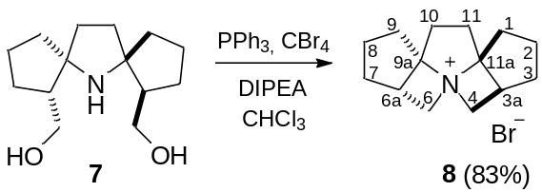
DIPEA (1.09 g; 8.44 mmol), PPh₃ (2.21 g; 8.44 mmol) and CBr₄ (2.73 g; 8.22 mmol) were added to a solution of amino alcohol 7 (0.50 g; 2.11 mmol) in dry CHCl₃ (20 ml). The reaction mixture was stirred for 12 hours until the reaction was complete. The progress of the process was monitored by TLC (SiO₂, CHCl₃:CH₃OH = 2:1; R_{f}(7)=0.3; visualized with Dragendorff’s reagent, iodine vapor). The reaction mass was evaporated under reduced pressure, then a saturated aqueous solution of Na₂CO₃ was added to the residue until pH=9-10. The mixture was triturated, and the insoluble precipitate of triphenylphosphine oxide was filtered off. The filtrate was washed with Et₂O (3×10 mL), and the phases were separated. The pH of aqueous phase was adjusted to 3-4 with 5% HBr solution, and it was evaporated to dryness. A mixture of CHCl₃:CH₃OH = 100:1 was added to the solid residue and the mixture was triturated. The insoluble inorganic precipitate was filtered off, the filtrate was evaporated, the residue was purified by column chromatography (SiO₂, from CHCl₃:CH₃OH = 6:1 to 4:1) and recrystallized from CHCl₃ to give 8 as a colorless crystals. Yield 0.49 g (83%). M.p. 213.0-213.5 °C (CHCl₃). IR spectrum (KBr), ν, cm⁻¹: 2999, 2951, 2928, 2868, 2858 (C-H sp³). Elemental analysis, found, %: C 59.33, H 7.91, N 4.96, Br 27.53; calculated for C₁₄H₂₂BrN %: C 59.16, H 7.80, N 4.93, Br 27.90. High-resolution mass spectrum (EI/DFS), found: m/z 283.0928 [M]⁺; calculated for C₁₄H₂₂⁷⁹BrN: 283.0930. ¹H NMR spectrum (400 MHz, CDCl₃+CD₃OD, δ, ppm): 1.62-1.75 (m, 2Н)(one hydrogen atom each from ³CH₂ and ⁷CH₂); 1.77-1.87 (m, 2Н)(one hydrogen atom each from ³CH₂ and ⁷CH₂); 1.90-2.10 (m, 6Н)(one hydrogen atom each from ¹CH₂ and ⁹CH₂, both hydrogen atoms from ²CH₂ and ⁸CH₂); 2.22-2.35 (m, 2Н)(¹⁰CH₂ and ¹¹CH₂); 2.41-2.60 (m, 4Н)(one hydrogen atom each from ¹⁰CH₂ and ¹¹CH₂, one hydrogen atom each from ¹CH₂ and ⁹CH₂); 2.94-3.02 (m, 2Н)(^{3a}CH and ^{6a}CH); 3.60 (dd, J_{d1}=7.4 J_{d2}=12.4, 2Н)(one hydrogen atom each from ⁴CH₂ and ⁶CH₂); 4.01 (dd, J_{d1}=8.5 J_{d2}=12.4, 2Н)(one hydrogen atom each from ⁴CH₂ and ⁶CH₂). ¹³C{¹H} NMR spectrum (100 MHz, CDCl₃+CD₃OD, δ, ppm): 23.27 (²CH₂ and ⁸CH₂), 29.67 (³CH₂ and ⁷CH₂), 32.50 (¹CH₂ and ⁹CH₂), 33.96 (¹⁰CH₂ and ¹¹CH₂), 38.27 (^{3a}CH and ^{6a}CH), 52.75 (⁴CH₂ and ⁶CH₂), 95.27 (^{9a}C and ^{11a}C).

(3aS(R),6aR(S),11aR(S))-2,3,3a,4,6,6a,7,8,10,11-Decahydro-1H-cyclopenta[e]cyclopenta[2,3]azeto[1,2-a]azepine (9)
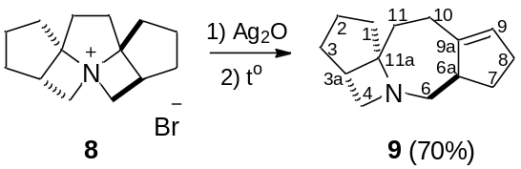
The salt 8 (2.40 g; 8.45 mmol) was added to a suspension of silver (I) oxide, prepared from AgNO₃ (8.62 g; 50.7 mmol) and NaOH (2.03 g; 50.7 mmol), in distilled water (15 ml), and the mixture was stirred in the darkness for 12 h. The precipitate was filtered off, the filtrate was concentrated to 2 ml under reduced pressure. NaOH (1.70 g; 42.4 mmol) was added to the concentrated residue, and the mixture was heated in a water bath (T=80-85 °C) for 40 minutes, then it was extracted with Et₂O (3×10 ml). The extract was evaporated in vacuo, and the residue was purified by column chromatography (SiO₂, from CHCl₃:CH₃OH:NH_{3(aq)} = 100:10:2 to 50:10:2). The major fraction (TLC on SiO₂; CHCl₃:CH₃OH:NH_{3(aq)} = 70:10:2; visualized with iodine vapor, R_{f}(9)=0.45) was collected to give 9 as a yellowish oil. Yield 1.20 g (70%). ¹H NMR spectrum (400 MHz, CDCl₃, δ, ppm): 1.08 (dt, J_{d}=6.5 J_{t}=12.4, 1H); 1.22-1.39 (m, 2H); 1.39-1.50 (m, 1H); 1.58 (dd, J_{d1}=6.8 J_{d2}=13.0. 1H); 1.73-1.84 (m, 2H); 2.02-2.21 (m, 5H); 2.21-2.33 (m, 2H); 2.45-2.60 (m, 3H); 2.63 (d, J_{d}=9.7, 1H); 3.03 (d, J_{d}=6.5, 2H); 5.20-5.29 (m, 1H). ¹³C{¹H} NMR spectrum (100 MHz, CDCl₃, δ, ppm): 25.07, 28.27, 30.08, 30.58, 30.70, 31.60, 38.99, 40.04, 47.09, 55.92, 61.28, 76.60, 124.24, 147.74.

The compound was characterized as a hydrochloride:

(3aS(R),6aR(S),11aR(S))-2,3,3a,4,6,6a,7,8,10,11-Decahydro-1H-cyclopenta[2,3]azeto[1,2-a]cyclopenta[e]azepin-5-ium chloride (9*HCl)
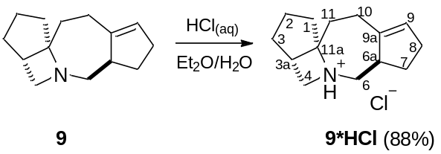
A mixture of 9 (0.12 g; 0.59 mmol), Et₂O (5 mL) and water (3 mL) was carefully acidified to pH=3 with 5% aqueous HCl upon vigorous stirring. The organic layer was separated, the aqueous phase was evaporated to dryness under reduced pressure, the residue was purified by column chromatography (SiO₂, CHCl₃:CH₃OH=7:1). The fractions with R_{f} = 0.45 (TLC on SiO₂; CHCl₃:CH₃OH=7:1; visualized with iodine vapor) were collected, dried and triturated with Et₂O to give 9×HCl as a white powder. Yield 0.12 g (88%). M.p 173.3-173.7 °C (Et₂O). IR spectrum (KBr), ν, cm⁻¹: 3039 (C-H sp²), 2997, 2972, 2953, 2937, 2895, 2852, 2756 (C-H sp³), 1651 (C=C). Elemental analysis, found, %: C 69.96, H 9.18, N 5.87, Cl 14.08; calculated for C₁₄H₂₂ClN %: C 70.13, H 9.25, N 5.84, Cl 14.39. ¹H NMR spectrum (400 MHz, CDCl₃, δ, ppm): 1.22-1.35 (m, 1H)(⁷CH₂); 1.35-1.47 (m, 1H)(¹CH₂); 1.58 (dddd, J_{d1}=6.5 J_{d2}=7.3 J_{d3}=12.8 J_{d4}=13.7, 1H)(³CH₂); 1.69 (ddd, J_{d1}=1.3 J_{d2}=6.3 J_{d3}=15.0, 1H)(³CH₂); 1.73 (dd, J_{d1}=6.2 J_{d2}=13.7, 1H)(¹¹CH₂); 1.99 (ddd, J_{d1}=6.7 J_{d2}=7.3 J_{d3}=13.3, 1H)(²CH₂); 2.05-2.25 (m, 4H)(both hydrogen atoms from ¹⁰CH₂, one hydrogen atom each from ⁸CH₂ and ⁷CH₂); 2.42 (ddd, J_{d1}=1.7 J_{d2}=13.1 J_{d3}=15.0, 1H)(¹¹CH₂); 2.53-2.80 (m, 4H)(one hydrogen atom each from ²CH₂, ⁸CH_{2,} ¹CH₂ and ^{3a}CH); 2.91 (dd, J_{d1}=11.7 J_{d2}=12.1, 1H)(⁶CH₂); 3.06-3.18 (m, 2H)(⁶CH₂ and ^{6a}CH); 3.48 (dd, J_{d1}=9.6 J_{d2}=11.4, 1H)(⁴CH₂); 3.77 (dd, J_{d1}=5.4 J_{d2}=11.4, 1H)(⁴CH₂), 5.32-5.38 (m,1H)(⁹CH=). ¹³C{¹H} NMR spectrum (100 MHz, CDCl₃, δ, ppm): 24.38 (²CH₂), 27.09 (⁸CH₂), 29.29 (⁷CH₂), 30.34 (³CH₂₋), 30.53 (¹⁰CH₂), 33.30 (¹¹CH₂), 37.06 (¹CH₂), 39.15 (^{3a}CH), 44.73 (^{6a}CH), 53.47 (⁴CH₂), 57.62 (⁶CH₂), 84.79 (^{11a}C), 127.74 (⁹CH=), 142.95 (^{9a}C=).

(3aS(R),6aR(S),11aR(S))-5-Methyl-2,3,3a,4,6,6a,7,8,10,11-decahydro-1H-cyclopenta[e]cyclopenta[2,3]azeto[1,2-a]azepinium iodide (10)
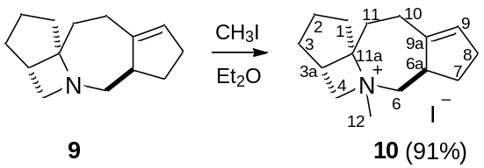
Methyl iodide (1.31g, 9.22 mmol) was added to a solution of 9 (0.53 g, 1.54 mmol) in dry Et₂O (4 mL) and the reaction mass was left at room temperature for 48 h. Then the precipitate formed was filtered off, washed with Et₂O and recrystallized from the mixture of ^{i}PrOH:CH₃OH = 1:1 to give 10 as a white powder. Yield 0.82 g (91%). M.p. 197.3-197.5 °С (^{i}-PrOH:CH₃OH = 1:1). IR spectrum (KBr), ν, cm⁻¹: 3039 (C-H sp²), 2989, 2953, 2883, 2849, 2768 (C-H sp³), 1647 (C=C). Elemental analysis, found, %: C 52.22, H 6.99, N 4.06, I 36.74; calculated for C₁₅H₂₄IN %: C 52.18, H 7.01, N 4.06, I 36.76. High-resolution mass spectrum (EI/DFS), found: m/z 218.1900 [M-I]⁺; calculated for C₁₅H₂₄N: 218.1903. ¹H NMR spectrum (500 MHz, CDCl₃+CD₃OD, δ, ppm): 1.53 (dddd, J_{d1}=9.0 J_{d2}=9.4 J_{d3}=9.6 J_{d4}=12.8, 1H); 1.71-1.89 (m, 3H); 2.00 (dd, J_{d1}=8.1 J_{d2}=15.5, 1H); 2.10 (t, J_{t}=13.5, 1H); 2.14-2.28 (m, 1H); 2.28-2.39 (m, 2H); 2.57 (dd, J_{d1}=12.1 J_{d2}=15.5, 1H); 2.70 (dd, J_{d1}=8.2 J_{d2}=15.2, 1H); 2.74 (ddd, J_{d1}=2.6 J_{d2}=5.6, J_{d3}=15.7, 1H); 3.04-3.14 (m, 2H); 3.19 (s, 3H); 3.43 (dd, J_{d1}=3.0 J_{d2}=13.4, 1H); 3.83 (dd, J_{d1}=7.2 J_{d2}=12.0, 1H); 3.97 (dd, J_{d1}=12.2 J_{d2}=13.4, 1H); 4.36 (dd, J_{d1}=9.7 J_{d2}=12.0, 1H); 5.48-5.53 (м, 1H).¹³C{¹H} NMR spectrum (125 МГц, CDCl₃+CD₃OD, δ, ppm): 25.31, 25.62, 28.68, 29.18, 30.23, 34.86, 37.13, 38.89, 42.51, 45.36, 67.54, 67.58, 94.82, 127.76, 141.98.

Reaction of (3aS(R),6aR(S),11aR(S))-5-methyl-1,2,3,3a,4,5,6,6a,7,8,10,11-Dodecahydrocyclopenta[2,3]azeto[1,2-a]cyclopenta[e]azepin-5-ium iodide (10) with wet silver (I) oxide followed by heating
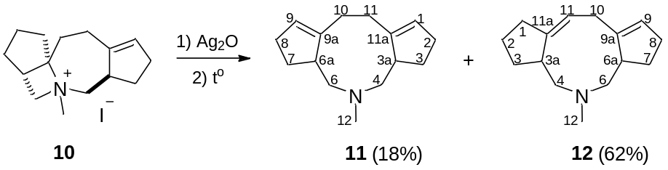
The salt 10 (0.31 g; 0.90 mmol) was added to a suspension of silver (I) oxide, prepared from AgNO₃ (0.53 g; 3.06 mmol) and NaOH (0.12 g; 3.0 mmol), in distilled water (8 ml), and the mixture was stirred in the darkness for 36 h. The precipitate was filtered off, the filtrate was concentrated to 1.5 ml under reduced pressure. NaOH (0.18 g; 4.5 mmol) was added to the concentrated residue, and the mixture was heated in a water bath (T=80-85 °C) for 40 minutes, then it was extracted with Et₂O (3×5 ml). The extract was evaporated in vacuo, and the residue was purified by column chromatography (SiO₂, from CHCl₃:CH₃OH:NH_{3(aq)} = 400:1:10 to 200:1:10) to give 11 (TLC on SiO₂; CHCl₃:CH₃OH:NH_{3(aq)} = 200:1:10; R_{f}=0.65; visualized with iodine vapor) and 12 (TLC on SiO₂; CHCl₃:CH₃OH:NH_{3(aq)} = 200:1:10; R_{f}=0.5; visualized with iodine vapor).

(3aR(S),6aR(S))-5-Methyl-3,3a,4,5,6,6a,7,8,10,11-decahydro-2H-dicyclopenta[c,g]azonine (11):
Yellowish oil. Yield 0.035 g (18%). ¹H NMR spectrum (300 MHz, CDCl₃, δ, ppm): 1.30 (ddt, J_{d1}=8.3 J_{d2}=12.2 J_{t}=4.0, 2H); 1.89 (dddd, J_{d1}=6.8 J_{d2}=8.3 J_{d3}=8.8 J_{d4}=12.4, 2H); 2.01-2.15 (m, 2Н); 2.15-2.29 (m, 4Н); 2.29-2.38 (m, 4Н); 2.32 (s, 3Н); 2.53-2.66 (m, 2Н); 2.70-2.82 (m, 2Н); 5.30-5.38 (m, 2Н).¹³C{¹H} NMR spectrum (75 МГц, CDCl₃, δ, ppm): 29.97, 30.68, 31.54, 45.93, 46.49, 62.96, 125.43, 151.15.

(3aR(S),6aR(S))-5-Methyl-2,3,3a,4,5,6,6a,7,8,10-decahydro-1H-dicyclopenta[c,g]azonine (12):
Yellowish oil. Yield 0.12 g (62%). IR spectrum (neat), ν, cm⁻¹: 3037 (C-H sp²), 2931, 2858, 2843, 2781, 2762 (C-H sp³), 1680, 1635 (C=C). High-resolution mass spectrum (EI/DFS), found: m/z 217.1826 [M]⁺; calculated for C₁₅H₂₃N: 217.1825. ¹H NMR spectrum (400 MHz, CDCl₃, δ, ppm): 1.33-1.41 (m, 1H)(³CH₂); 1.44-1.51 (m, 1H)(⁷CH₂); 1.58-1.67 (m, 1H)(²CH₂); 1.68-1.86 (m, 2H)(one hydrogen atom each from ²CH₂ and ³CH₂); 1.90-2.06 (m, 2H)(one hydrogen atom each from ⁷CH₂ and ⁸CH₂); 2.10-2.25 (m, 3H)(one hydrogen atom each from ⁸CH₂ ¹CH₂ and ⁴CH₂); 2.25-2.33 (m, 2H)(one hydrogen atom from ¹CH₂ and ^{6a}CH); 2.35 (s, 3H)(¹²CH₃); 2.42-2.56 (m, 4H)(^{3a}CH, both hydrogen atoms from ⁶CH₂ and one hydrogen atom from ⁴CH₂); 2.81-2.91 (m, 1H)(¹⁰CH₂); 3.01 (dd, J_{d1}=4.1 J_{d2}=13.6, 1H)(¹⁰CH₂); 5.24-5.32 (m, 1H)(¹¹CH=); 5.35-5.40 (m, 1H)(⁹CH=). ¹³C{¹H} NMR spectrum (100 МГц, CDCl₃, δ, ppm): 24.55 (²CH₂), 29.53 (¹CH₂), 30.14 (⁸CH₂), 30.54 (³CH₂), 33.03 (¹⁰CH₂), 33.34 (⁷CH₂), 45.08 (^{3a}CH), 46.99 (¹²CH₃), 48.44 (^{6a}CH), 63.95 (⁴CH₂), 68.78 (⁶CH₂), 120.34 (¹¹CH=), 124.87 (⁹CH=), 144.71 (^{11a}C=), 149.91 (^{9a}C=).

Amines 11 and 12 were alkylated with methyl iodide for full characterization.

General procedure of the reaction of (3aR(S),6aR(S))-5-methyl-3,3a,4,5,6,6a,7,8,10,11-decahydro-2H-dicyclopenta[c,g]azonine (11) and (3aR(S),6aR(S))-5-methyl-2,3,3a,4,5,6,6a,7,8,10-decahydro-1H-dicyclopenta[c,g]azonine (12) with methyl iodide
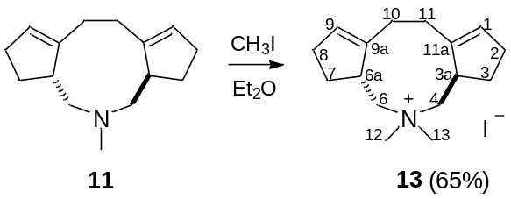
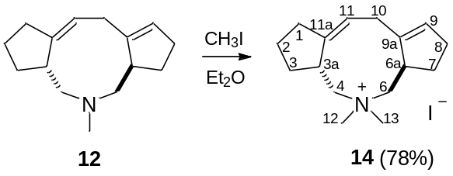
Methyl iodide (0.23 g, 1.61 mmol) was added to a solution of 11, 12 (0.27 mmol) in dry Et₂O (1.5 mL) and the reaction mass was left at room temperature for 48 h. Then the precipitate formed was filtered off, washed with Et₂O and recrystallized from the mixture of CHCl₃:CH₃OH = 20:1 to give 13, 14.

(3aR(S),6aR(S))-5,5-Dimethyl-3,3a,4,5,6,6a,7,8,10,11-decahydro-2H-dicyclopenta[c,g]azoninium iodide (13):
Colorless crystalls. Yield 0.063 g (65%). M.p. 234.6-234.8 °С (CHCl₃:CH₃OH = 20:1). IR spectrum (KBr), ν, cm⁻¹: 3039 (C-H sp²), 2999, 2929, 2887, 2843, 2773 (C-H sp³), 1649 (C=C). Elemental analysis, found, %: C 53.40, H 7.05, N 3.90, I 35.41; calculated for C₁₅H₂₄IN %: C 53.49, H 7.29, N 3.90, I 35.32. High-resolution mass spectrum (EI/DFS), found: m/z 359.1102 [M]⁺; calculated for C₁₆H₂₆N¹²⁷I: 359.1104. ¹H NMR spectrum (400 MHz, CDCl₃+CD₃OD, δ, ppm): 1.75 (dddd, J_{d1}=7.3 J_{d2}=7.3 J_{d3}=8.9 J_{d4}=12.7, 2H)(one hydrogen atom each from ³CH₂ and ⁷CH₂); 2.10-2.20 (m, 2Н)(one hydrogen atom each from ¹⁰CH₂ and ¹¹CH₂); 2.22-2.39 (m, 4H)(²CH₂ and ⁸CH₂); 2.52 (dddd, J_{d1}=3.9 J_{d2}=8.2 J_{d3}=8.5 J_{d4}=12.7, 2H)(one hydrogen atom each from ³CH₂ and ⁷CH₂); 2.61-2.74 (m, 2H)(one hydrogen atom each from ¹⁰CH₂ and ¹¹CH₂); 3.22 (s, 6H)(¹²CH₃ and ¹³CH₃); 3.18-3.34 (m, 4H)(^{3a}CH and ^{6a}CH, one hydrogen atom each from ⁴CH₂ and ⁶CH₂); 3.91 (dd, J_{d1}=2.5 J_{d2}=14.2, 2H)(one hydrogen atom each from ⁴CH₂ and ⁶CH₂); 5.47-5.53 (m, 2H)(¹CH= and ⁹CH=). ¹³C{¹H} NMR spectrum (100 МГц, CDCl₃+CD₃OD, δ, ppm): 26.19 (¹⁰CH₂ and ¹¹CH₂), 31.13 (²CH₂ and ⁸CH₂), 34.56 (³CH₂ and ⁷CH₂), 39.49 (^{3a}CH and ^{6a}CH), 52.38 (J_{C-N}=4.0 Hz) (¹²CH₃ and ¹³CH₃), 66.02, (J_{C-N}=2.1 Hz) (⁴CH₂ and ⁶CH₂), 128.91 (¹CH= and ⁹CH=), 143.61 (^{9a}C= and ^{11a}C=).

(3aR(S),6aR(S))-5,5-Dimethyl-2,3,3a,4,5,6,6a,7,8,10-decahydro-1H-dicyclopenta[c,g]azoninium iodide (14):
Colorless crystals. Yield 0.075 g (78%). M.p. 252.2 °С (CHCl₃:CH₃OH = 20:1) (with decomposition). IR spectrum (KBr), ν, cm⁻¹: 3047 (C-H sp²), 3001, 2953, 2933, 2866, 2848, 2781, 2727 (C-H sp³), 1672, 1641 (C=C). Elemental analysis, found, %: C 53.07, H 7.03, N 3.68, I 35.02; calculated for C₁₆H₂₆IN %: C 53.45, H 7.29, N 3.90, I 35.32. High-resolution mass spectrum (EI/DFS), found: m/z 359.1099 [M]⁺; calculated for C₁₆H₂₆N¹²⁷I: 359.1104. ¹H NMR spectrum (600 MHz, DMSO-d6, δ, ppm): 1.35-1.43 (m, 1H)(³CH₂); 1.64-1.74 (m, 2H)(²CH₂ и ⁷CH₂); 1.74-1.85 (m, 2H)(²CH₂ и ³CH₂); 1.96 (dddd, J_{d1}=8.1, J_{d2}=9.4, J_{d3}=9.7, J_{d4}=12.8, 1H)(⁷CH₂); 2.09-2.16 (m, 1H)(⁸CH₂); 2.18-2.25 (m, 1H)(¹CH₂); 2.31-.2.39 (m, 1H)(⁸CH₂); 2.42-.2.49 (m, 1H)(¹CH₂); 2.24-2.58 (m, 1H)(^{6a}CH); 2.86-2.94 (m, 1H)(¹⁰CH₂); 2.97 и 3.08 (s, по 3H)(¹²CH₃ и ¹³CH₃); 3.00 (dd, J_{d1}=1.9, J_{d2}=14.1, 1H)(⁴CH₂); 3.07-3.16 (m, 3H)(^{3a}CH, ⁶CH₂, ¹⁰CH₂); 3.30 (dd, J_{d1}=11.5, J_{d2}=14.1, 1H)(⁴CH₂); 3.70 (d, J_{d}=14.1, 1H)(⁶CH₂); 5.56-5.59 (m, 1H)(⁹CH=); 5.60-5.65 (m, 1H)(¹¹CH=). ¹³C{¹H} NMR spectrum (150 МГц, DMSO-d₆, δ, ppm): 22.00 (²CH₂), 26.09 (¹CH₂), 29.50 (³CH₂), 31.23 (⁸CH₂), 31.74 (⁷CH₂), 32.62 (¹⁰CH₂), 41.16 (^{6a}CH), 43.19 (^{3a}CH), 54.01 and 54.68 (¹²CH₃ and ¹³CH₃), 64.98 (⁴CH₂), 68.97 (⁶CH₂), 123.43 (¹¹CH=), 129.02 (⁹CH=), 143.70 (^{9a}C=), 144.98 (^{11a}C=).

2. IR Spectral data

2.1 (2aR(S),5aS(R),8aS(R),11aR(S))-dodecahydrocyclopenta[2,3]azeto[1,2-a]cyclopenta[2,3]azeto[1,2-e]pyrrol-7-ium (8)
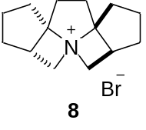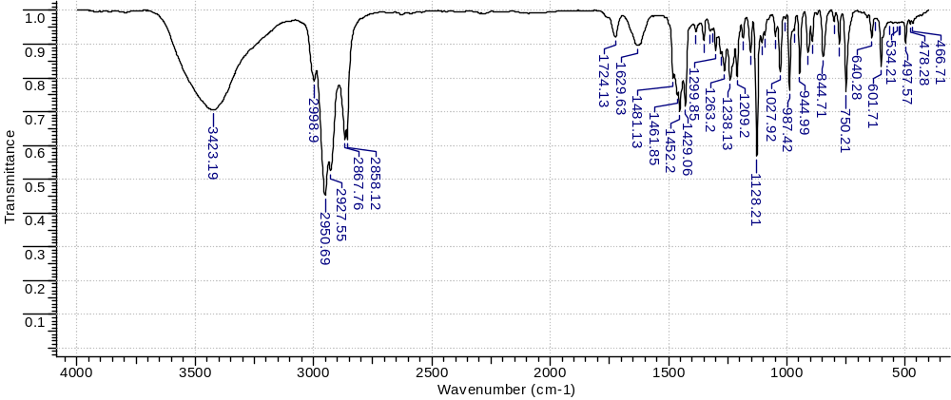
Fig. SI1. IR spectrum of 8 (KBr).

2.2. (3aS(R),6aR(S),11aR(S))-1,2,3,3a,4,5,6,6a,7,8,10,11-dodecahydrocyclopenta[2,3]azeto[1,2-a]cyclopenta[e]azepin-5-ium (9*HCl)
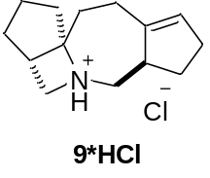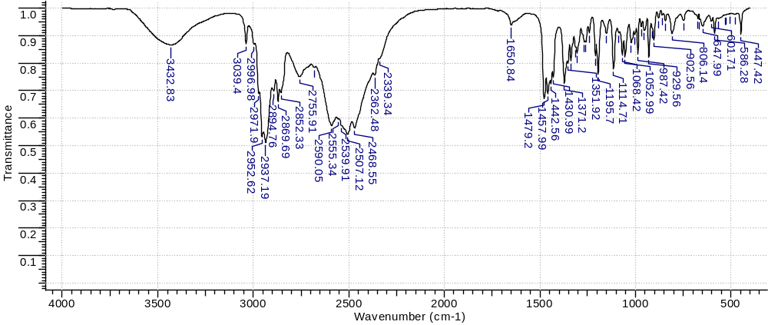
Fig. SI2. IR spectrum of 9*HCl (KBr).

2.3. (3aS(R),6aR(S),11aR(S))-5-Methyl-1,2,3,3a,4,5,6,6a,7,8,10,11-dodecahydrocyclopenta[2,3]azeto[1,2-a]cyclopenta[e]azepin-5-ium iodide (10)
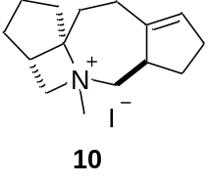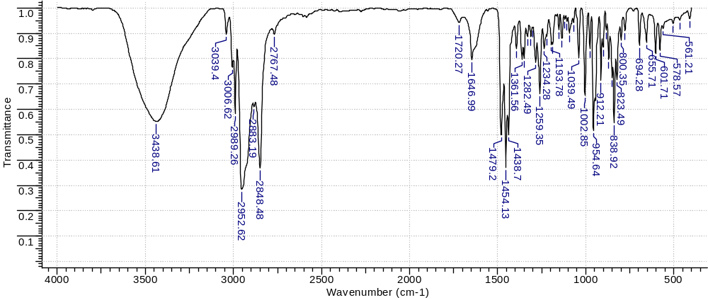
Fig. SI3. IR spectrum of 10 (KBr).

2.4. (3aR(S),6aR(S),Z)-5-Methyl-2,3,3a,4,5,6,6a,7,8,10-decahydro-1H-dicyclopenta[c,g]azonine (12)
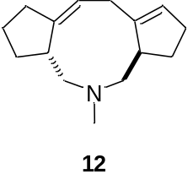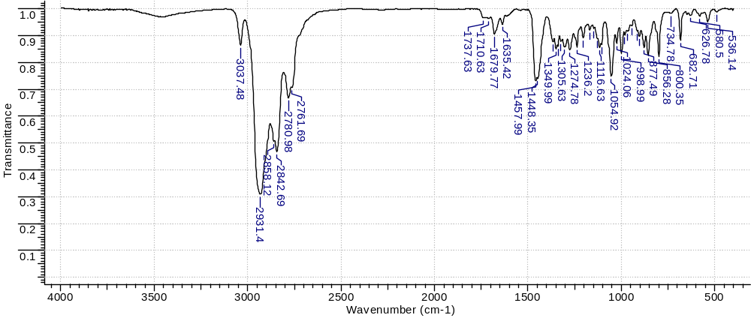
Fig. SI4. IR spectrum of 12 (neat).

2.5. 5,5-Dimethyl-3,3a,4,5,6,6a,7,8,10,11-decahydro-2H-dicyclopenta[c,g]azonin-5-ium iodide (13)
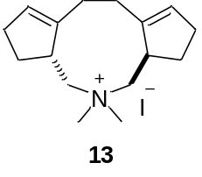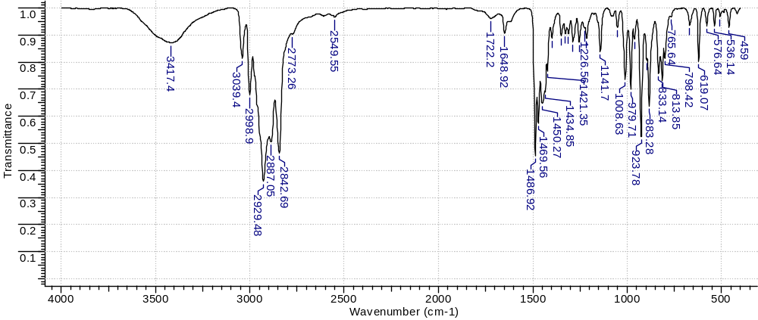
Fig. SI5. IR spectrum of 13 (KBr).

2.6. (Z)-5,5-Dimethyl-2,3,3a,4,5,6,6a,7,8,10-decahydro-1H-dicyclopenta[c,g]azonin-5-ium iodide (14)
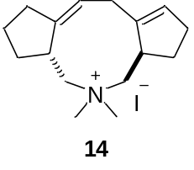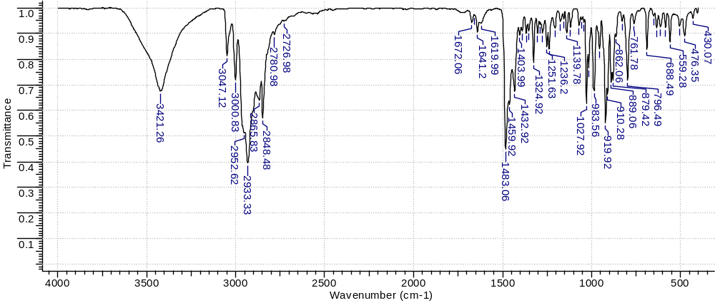
Fig. SI6. IR spectrum of 14 (KBr).

3. ¹H and ¹³C NMR spectral data

3.1. (2aR(S),5aS(R),8aS(R),11aR(S))-Dodecahydrocyclopenta[2,3]azeto[1,2-a]cyclopenta[2,3]azeto[1,2-e]pyrrol-7-ium bromide (8)
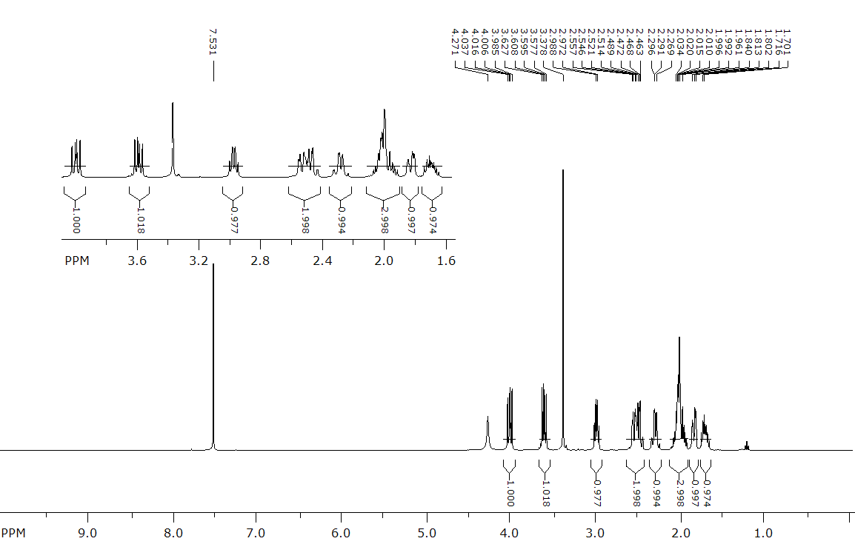
Fig. SI7. ¹H NMR spectrum of 8 in CDCl₃+CD₃OD at 400 MHz.
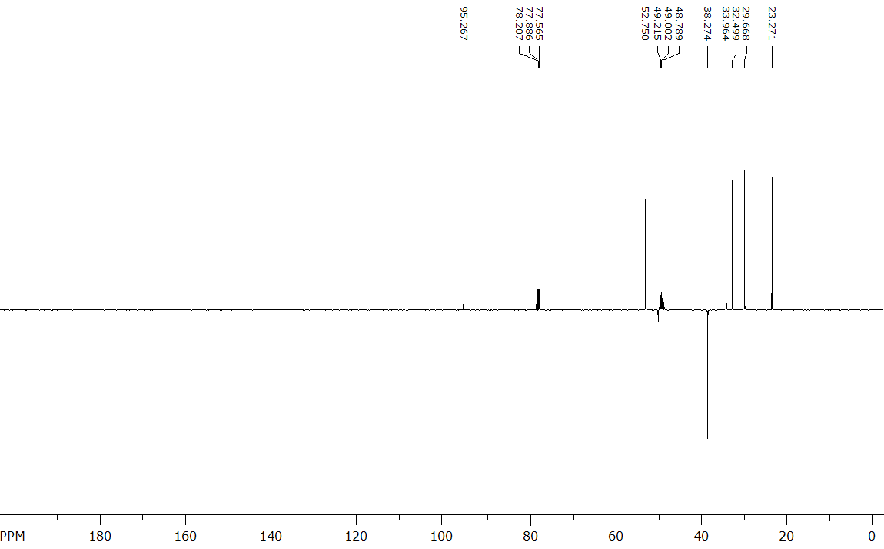
Fig. SI8. ¹³C NMR spectrum of 8 in CDCl₃+CD₃OD at 100 MHz.

3.2. (3aS(R),6aR(S),11aR(S))-2,3,3a,4,6,6a,7,8,10,11-Decahydro-1H-cyclopenta[2,3]azeto[1,2-a]cyclopenta[e]azepine (9)
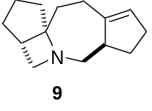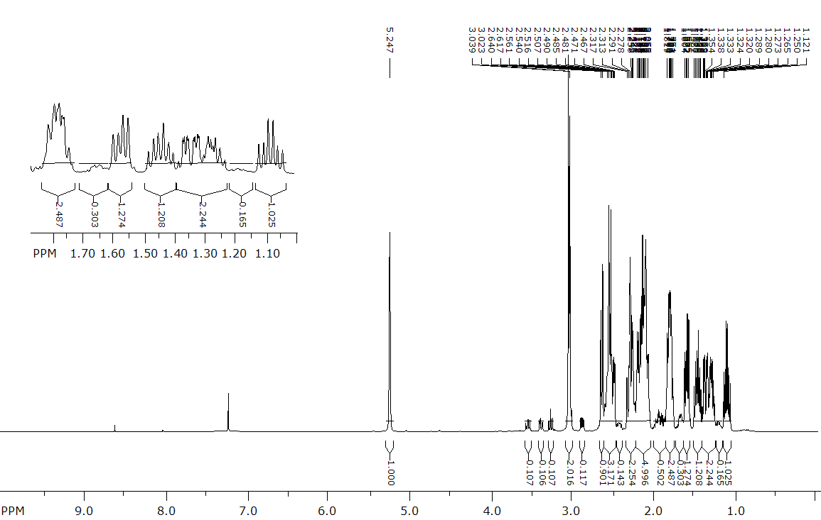
Fig. SI9. ¹H NMR spectrum of 9 with an inseparable impurity 9a in CDCl₃ at 400 MHz.
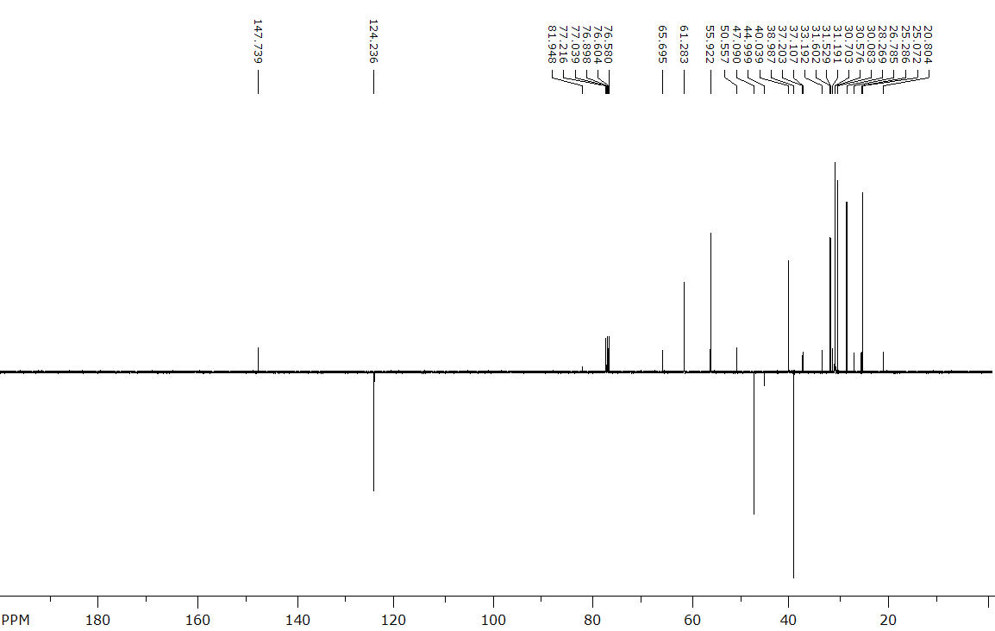
Fig. SI10. ¹³C NMR spectrum of 9 with an inseparable impurity 9a in CDCl₃ at 100 MHz.

3.3. (3aS(R),6aR(S),11aR(S))-1,2,3,3a,4,5,6,6a,7,8,10,11-Dodecahydrocyclopenta[2,3]azeto[1,2-a]cyclopenta[e]azepin-5-ium chloride (9*HCl)
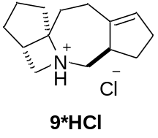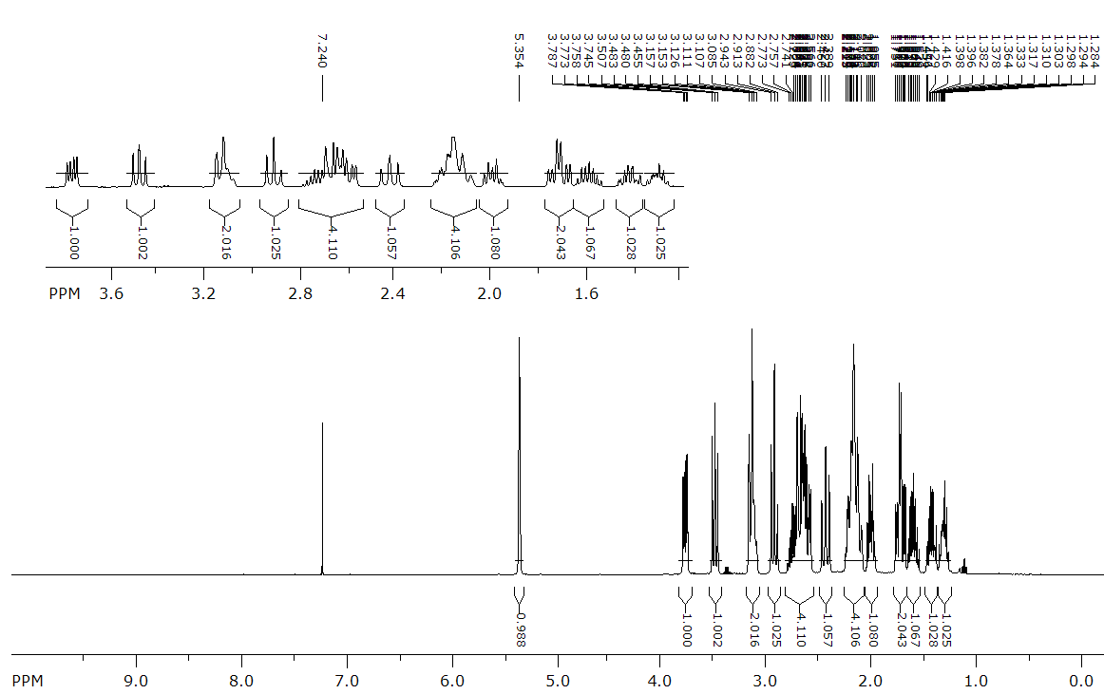
Fig. SI11. ¹H NMR spectrum of 9*HCl in CDCl₃ at 400 MHz.
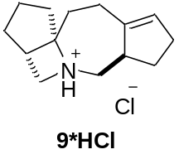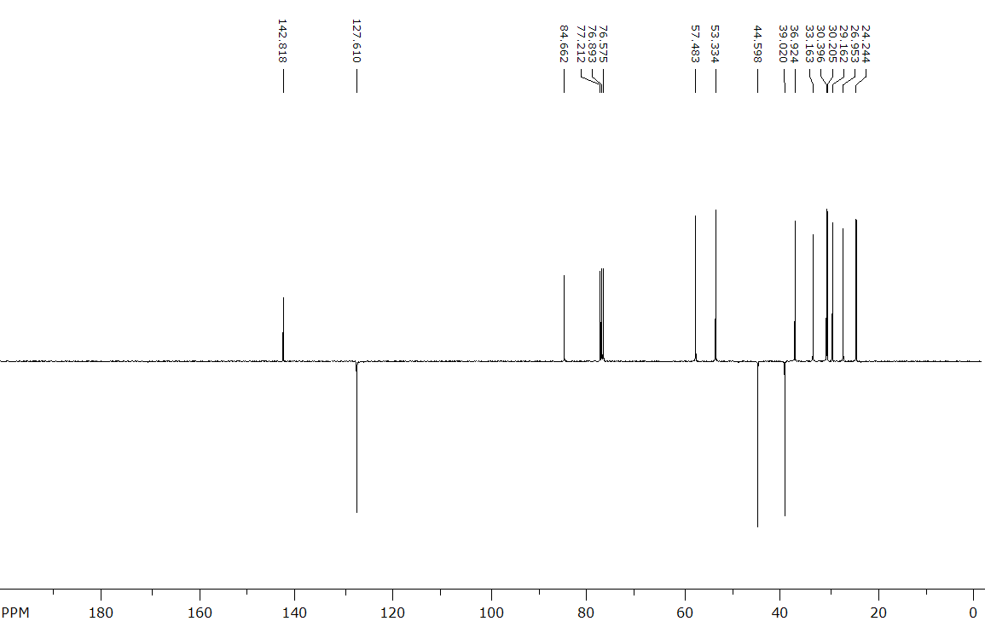
Fig. SI12. ¹³C NMR spectrum of 9*HCl in CDCl₃ at 100 MHz.

3.4. (3aS(R),6aR(S),11aR(S))-5-Methyl-1,2,3,3a,4,5,6,6a,7,8,10,11-dodecahydrocyclopenta[2,3]azeto[1,2-a]cyclopenta[e]azepin-5-ium iodide (10)
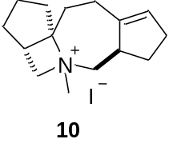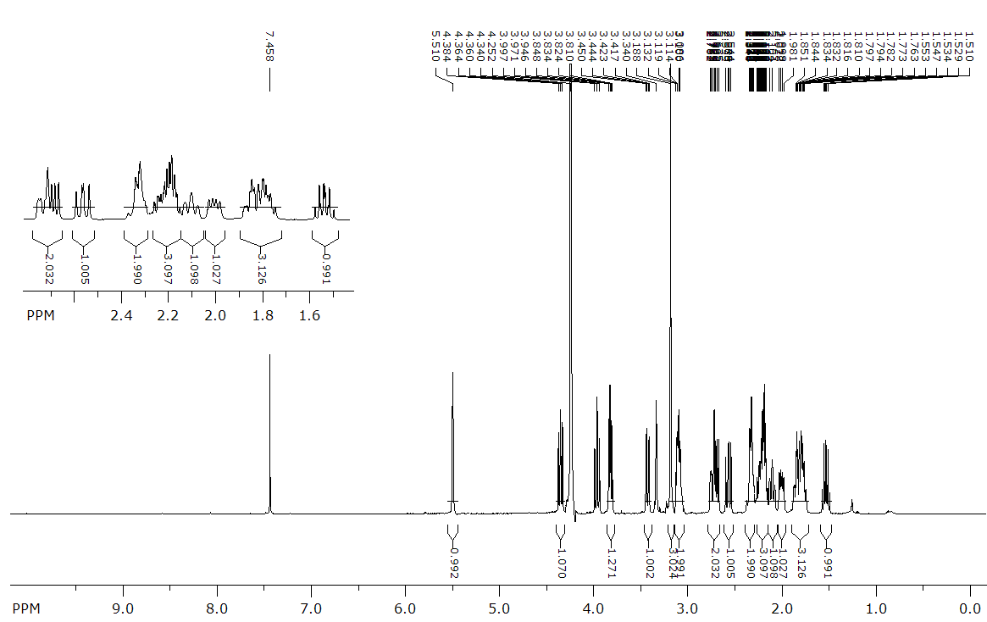
Fig. SI13. ¹H NMR spectrum of 10 in CDCl₃+CD₃OD at 400 MHz.
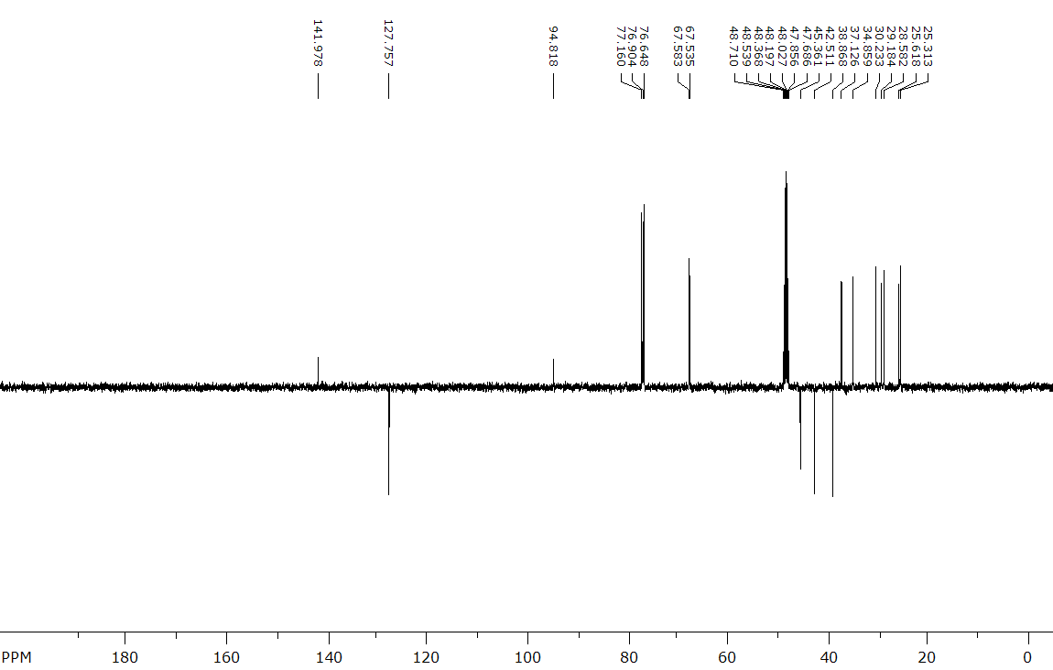
Fig. SI14. ¹³C NMR spectrum of 10 in CDCl₃+CD₃OD at 100 MHz.

3.5. (3aR(S),6aR(S))-5-Methyl-3,3a,4,5,6,6a,7,8,10,11-decahydro-2H-dicyclopenta[c,g]azonine (11)
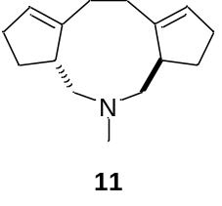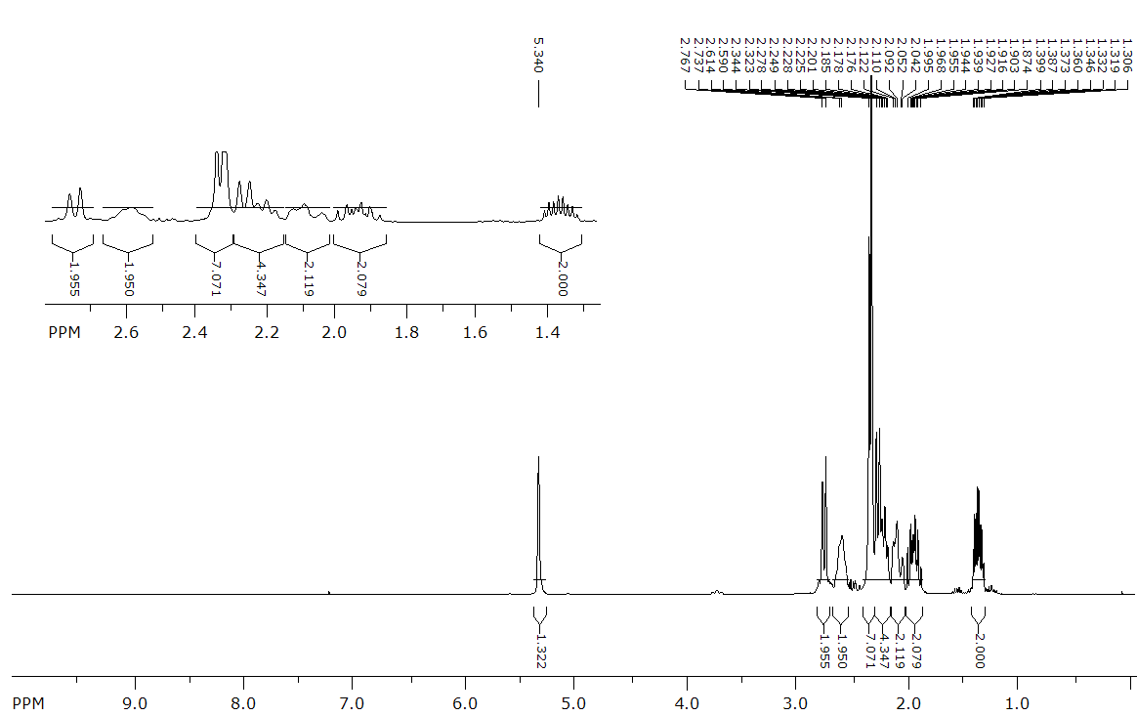
Fig. SI15. ¹H NMR spectrum of 11 in CDCl₃ at 300 MHz.
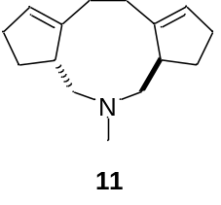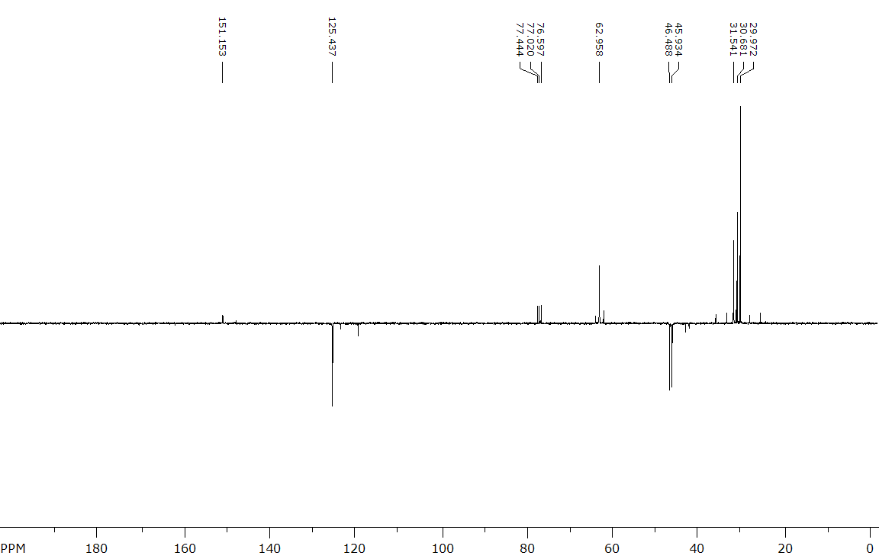
Fig. SI16. ¹³C NMR spectrum of 11 in CDCl₃ at 75 MHz.

3.6. (3aR(S),6aR(S),Z)-5-Methyl-2,3,3a,4,5,6,6a,7,8,10-decahydro-1H-dicyclopenta[c,g]azonine (12)
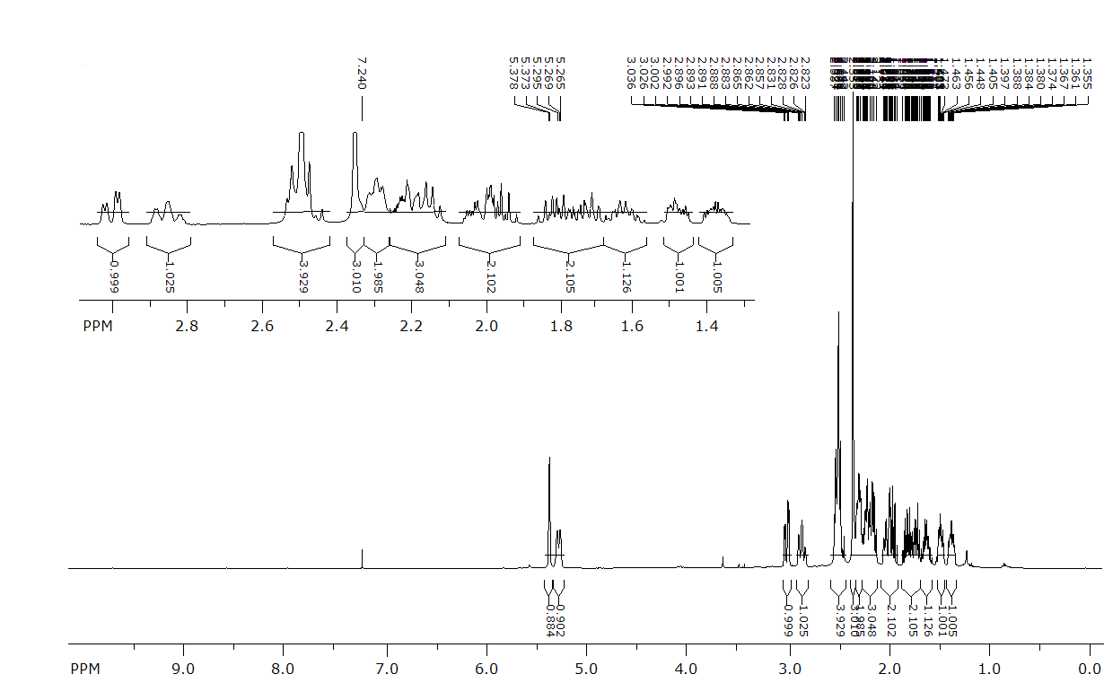
Fig. SI17. ¹H NMR spectrum of 12 in CDCl₃ at 400 MHz.
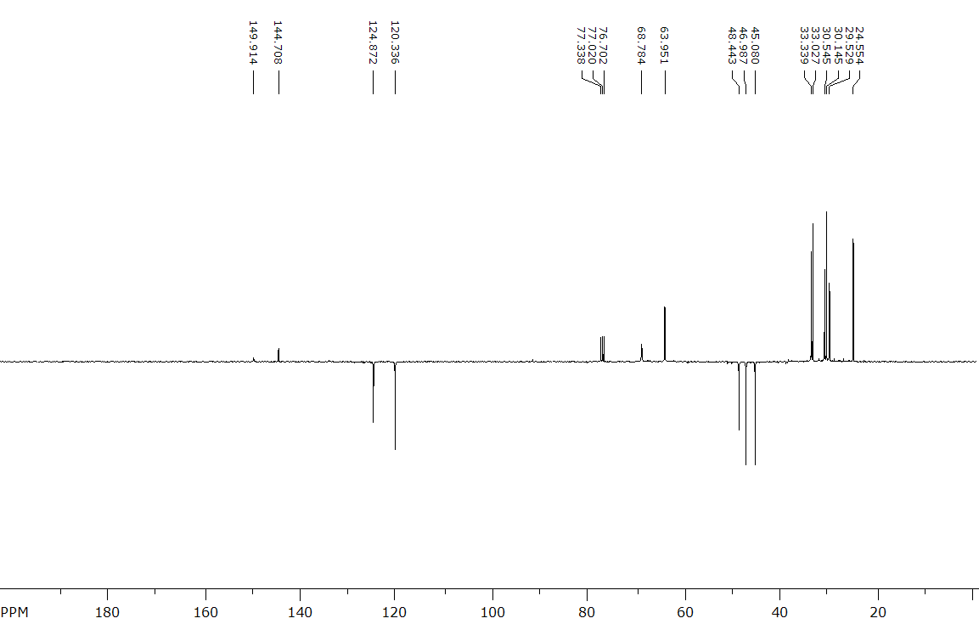
Fig. SI18. ¹³C NMR spectrum of 12 in CDCl₃ at 100 MHz.

3.7. 5,5-Dimethyl-3,3a,4,5,6,6a,7,8,10,11-decahydro-2H-dicyclopenta[c,g]azonin-5-ium iodide (13)
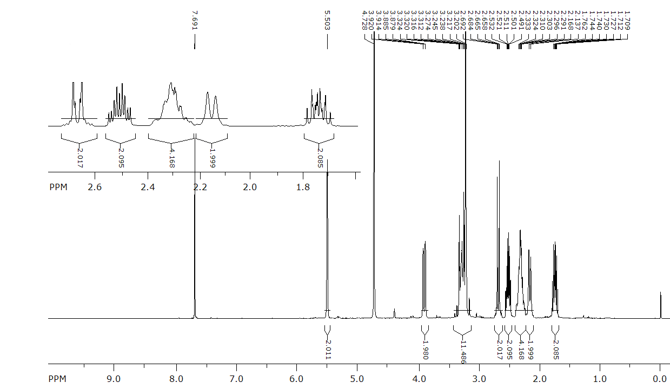
Fig. SI19. ¹H NMR spectrum of 13 in CDCl₃+CD₃OD at 400 MHz.
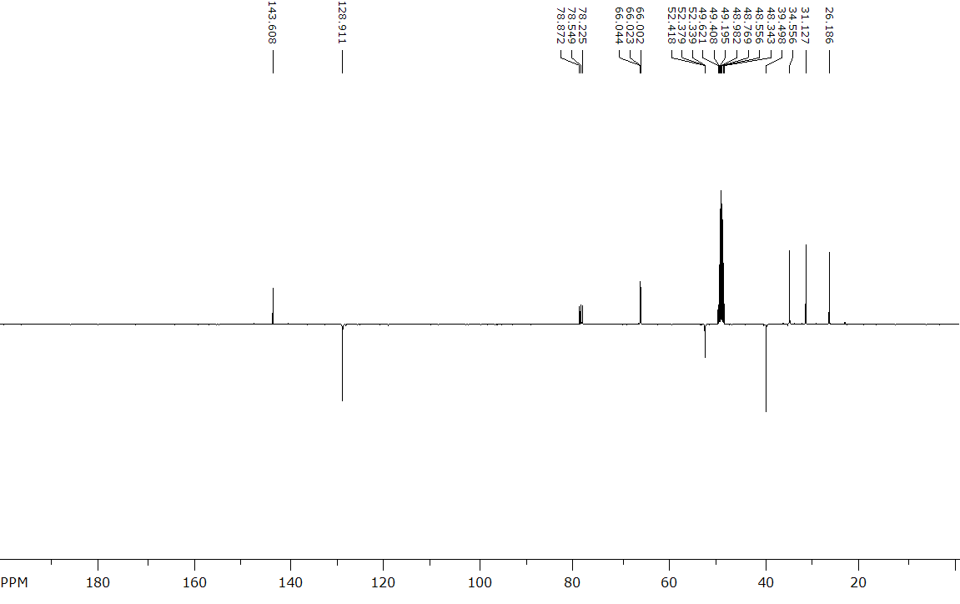
Fig. SI20. ¹³C NMR spectrum of 13 in CDCl₃+CD₃OD at 100 MHz.

3.8. (Z)-5,5-Dimethyl-2,3,3a,4,5,6,6a,7,8,10-decahydro-1H-dicyclopenta[c,g]azonin-5-ium iodide (14)
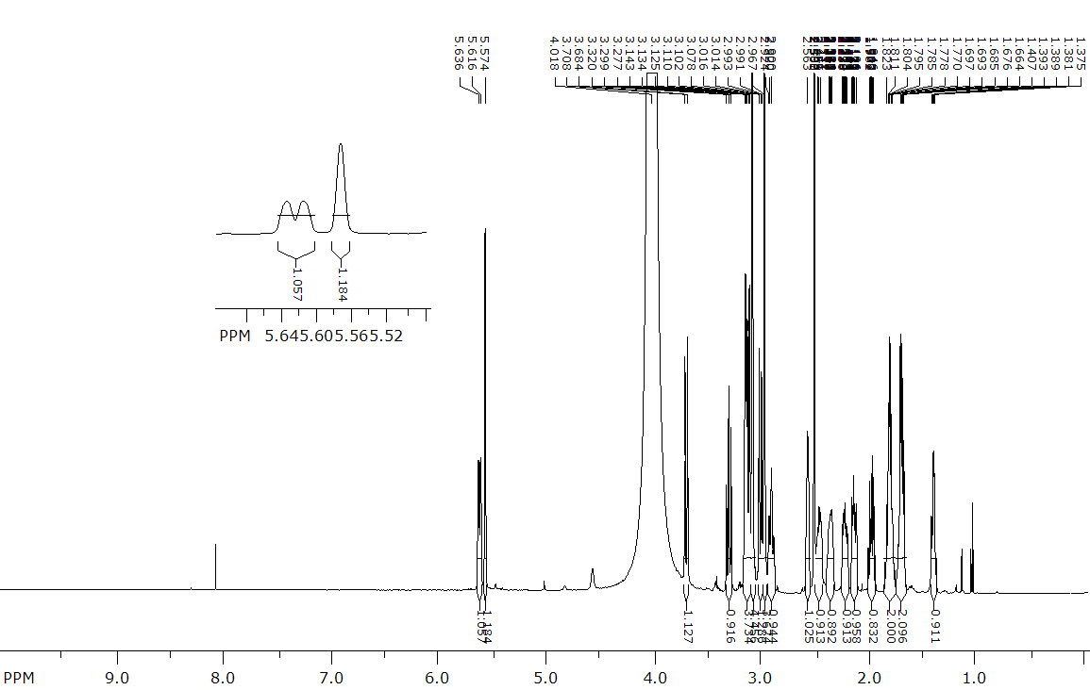
Fig. SI21. ¹H NMR spectrum of 14 in DMSO-d₆ at 600 MHz.

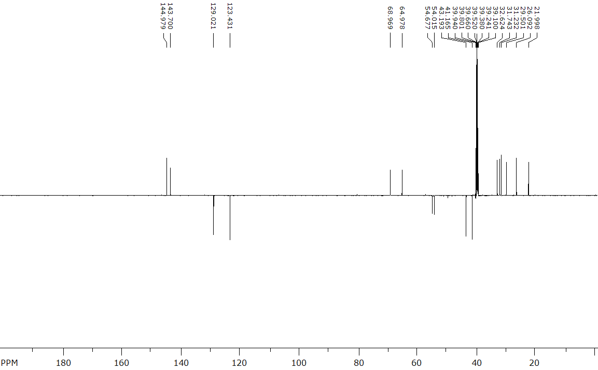
Fig. SI22. ¹³C NMR spectrum of 14 in DMSO-d₆ at 150 MHz.

4. 2D NMR spectral data

4.1 (2aR(S),5aS(R),8aS(R),11aR(S))-Dodecahydrocyclopenta[2,3]azeto[1,2-a]cyclopenta[2,3]azeto[1,2-e]pyrrol-7-ium (8)
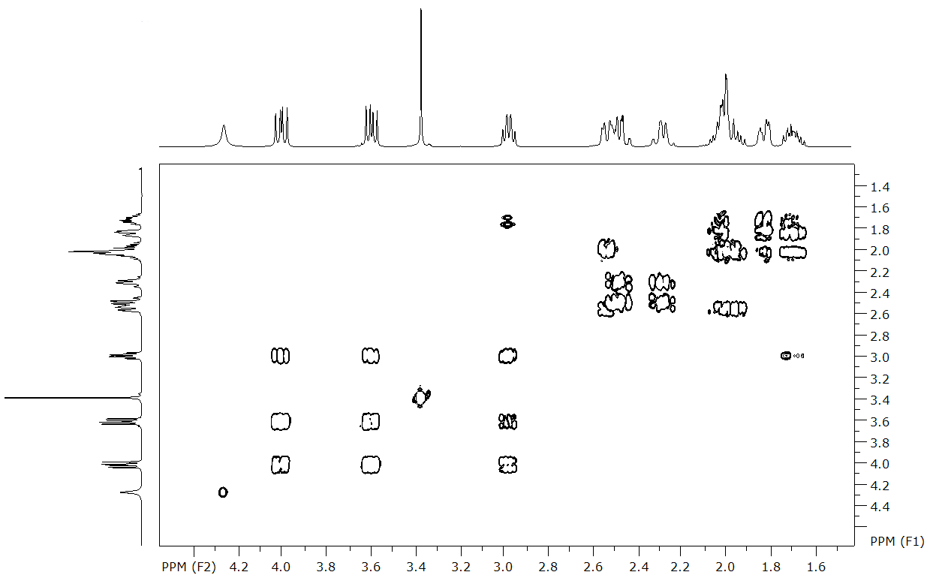
Fig. SI23. ¹H-¹H COSY NMR spectrum of 8 in CDCl₃+CD₃OD.
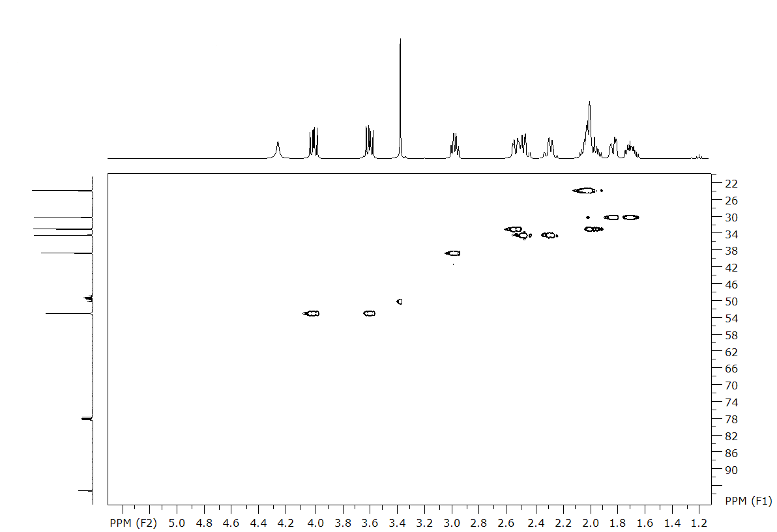
Fig. SI24. ¹H-¹³C HSQC NMR spectrum of 8 in CDCl₃+CD₃OD.
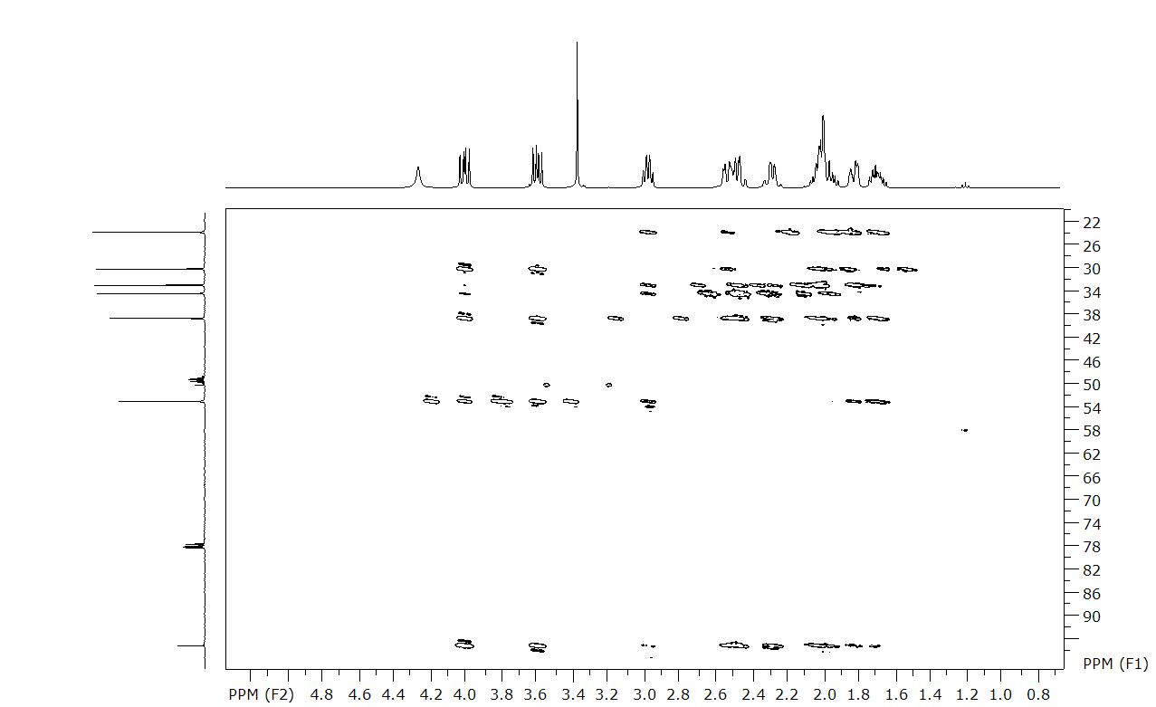
Fig. SI25. ¹H-¹³C HMBC NMR spectrum of 8 in CDCl₃+CD₃OD.

4.2. (3aS(R),6aR(S),11aR(S))-1,2,3,3a,4,5,6,6a,7,8,10,11-Dodecahydrocyclopenta[2,3]azeto[1,2-a]cyclopenta[e]azepin-5-ium (9*HCl)
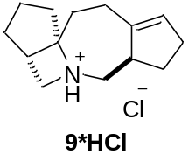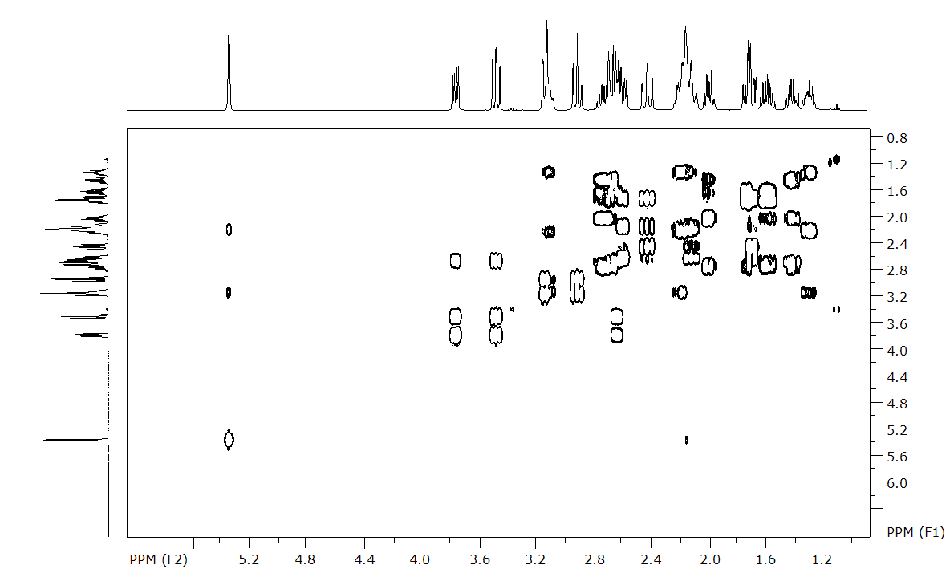
Fig. SI26. ¹H-¹H COSY NMR spectrum of 9*HCl in CDCl₃.
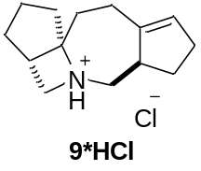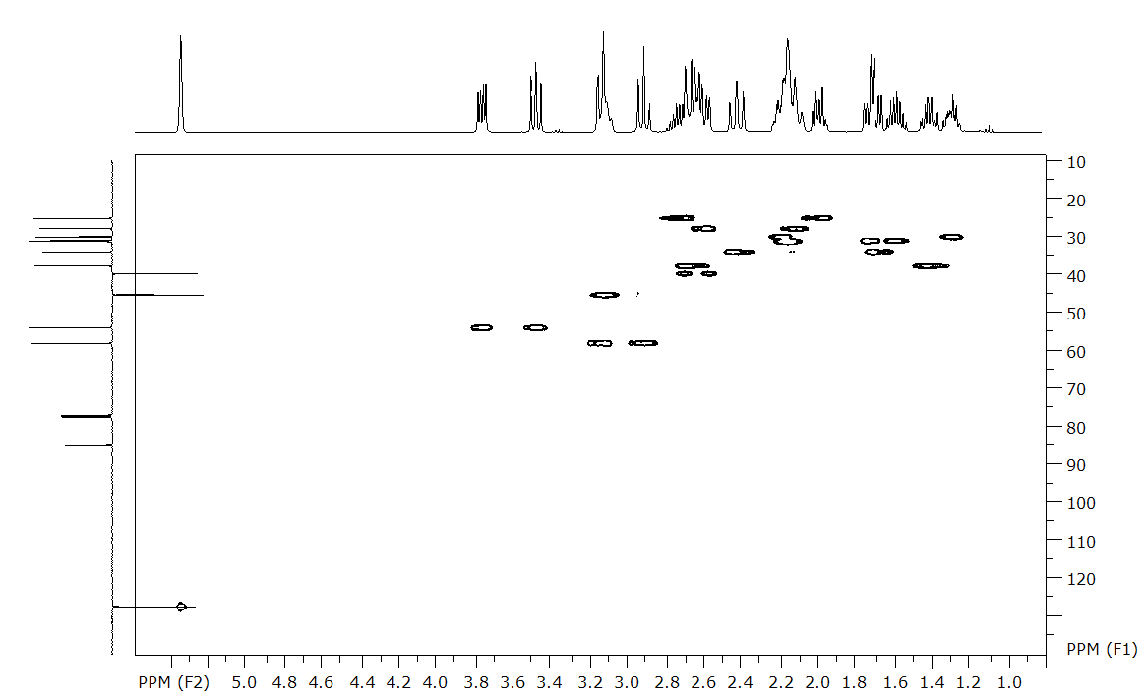
Fig. SI27. ¹H-¹³C HSQC NMR spectrum of 9*HCl in CDCl₃.

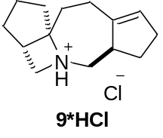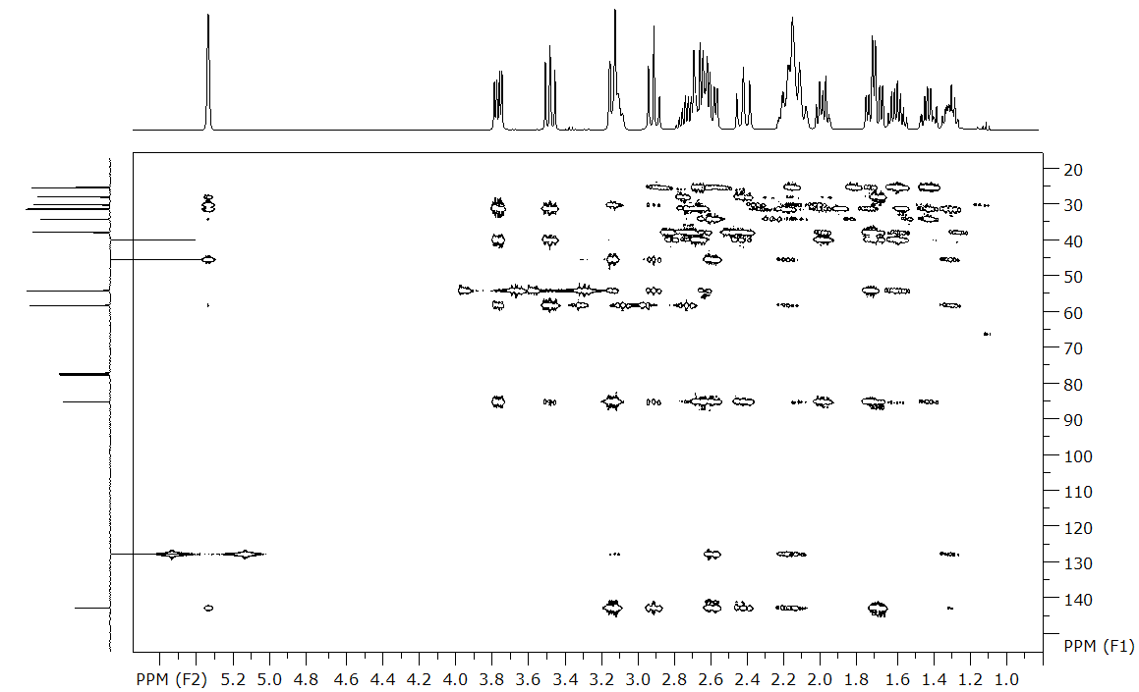
Fig. SI28. ¹H-¹³C HMBC NMR spectrum of 9*HCl in CDCl₃.

4.3. (3aR(S),6aR(S),Z)-5-Methyl-2,3,3a,4,5,6,6a,7,8,10-decahydro-1H-dicyclopenta[c,g]azonine (12)
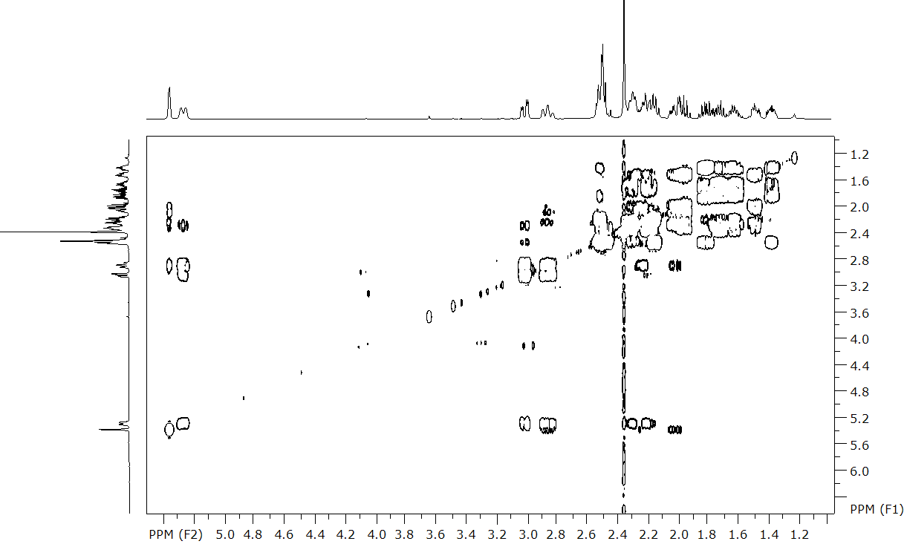
Fig. SI29. ¹H-¹H COSY NMR spectrum of 12 in CDCl₃.

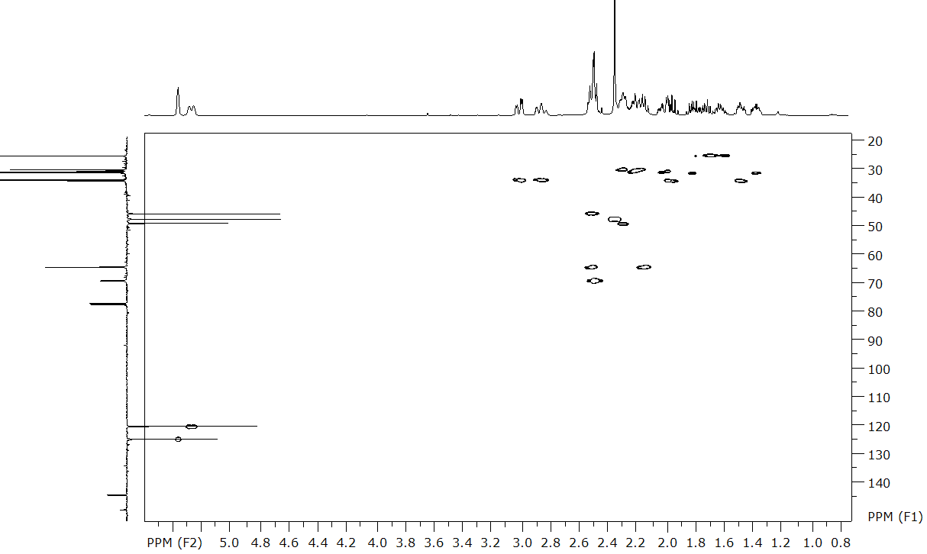
Fig. SI30. ¹H-¹³C HSQC NMR spectrum of 12 in CDCl₃.
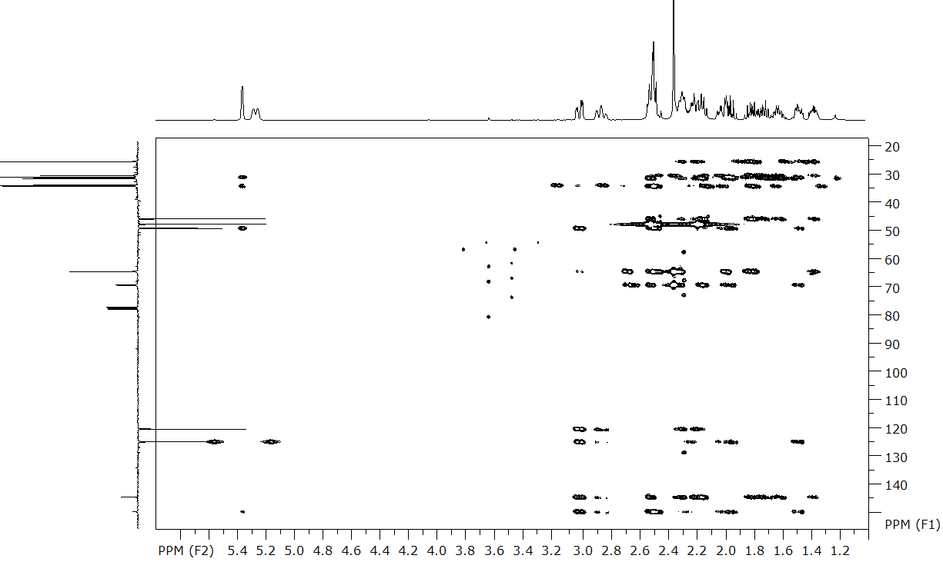
Fig. SI31. ¹H-¹³C HMBC NMR spectrum of 12 in CDCl₃.

4.4. 5,5-Dimethyl-3,3a,4,5,6,6a,7,8,10,11-decahydro-2H-dicyclopenta[c,g]azonin-5-ium iodide (13)
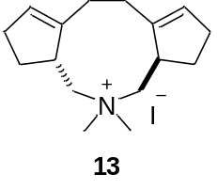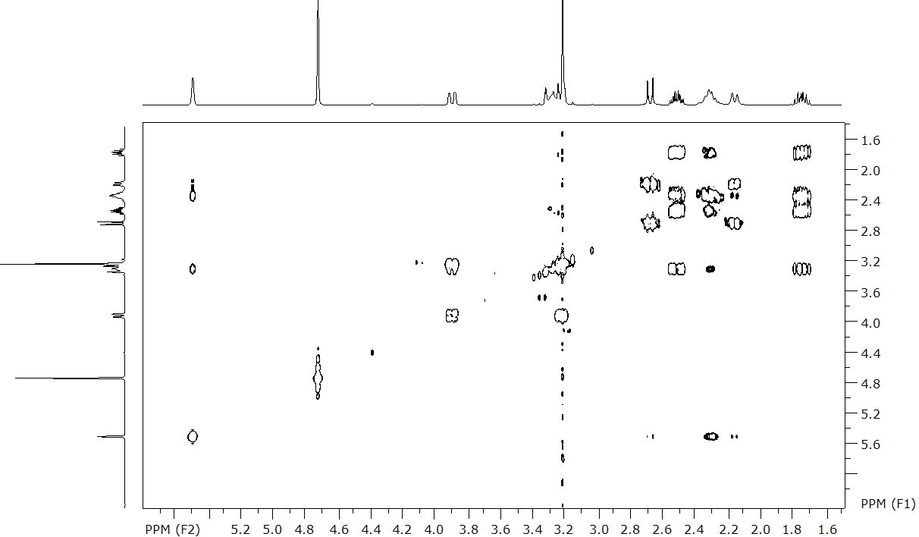
Fig. SI32. ¹H-¹H COSY NMR spectrum of 13 in CDCl₃+CD₃OD.
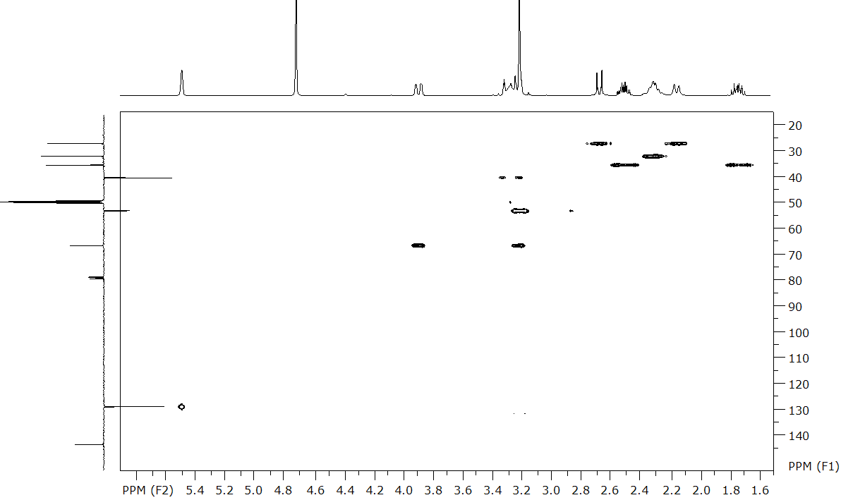
Fig. SI33. ¹H-¹³C HSQC NMR spectrum of 13 in CDCl₃+CD₃OD.

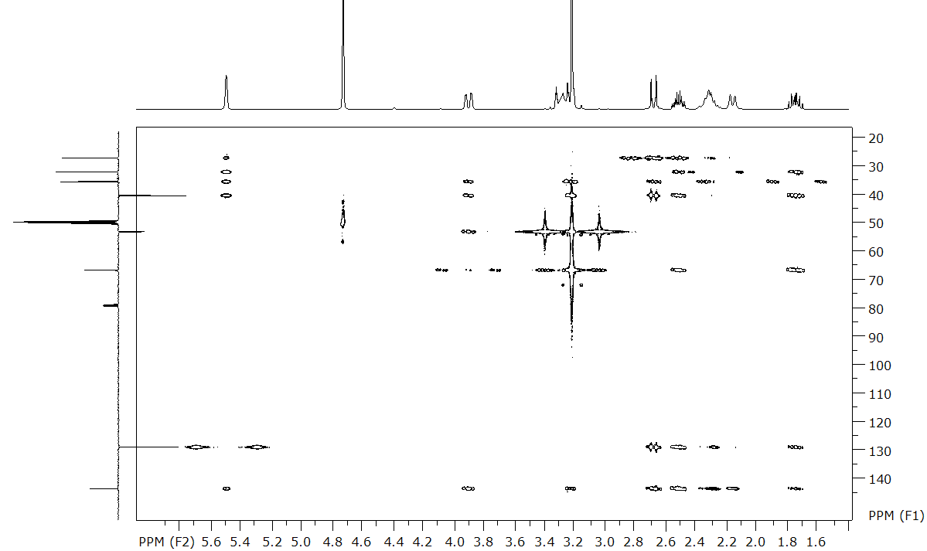
Fig. SI34. ¹H-¹³C HMBC NMR spectrum of 13 in CDCl₃+CD₃OD.

4.5. (3aR(S),6aR(S))-5,5-Dimethyl-2,3,3a,4,5,6,6a,7,8,10-decahydro-1H-dicyclopenta[c,g]azoninium iodide (14)
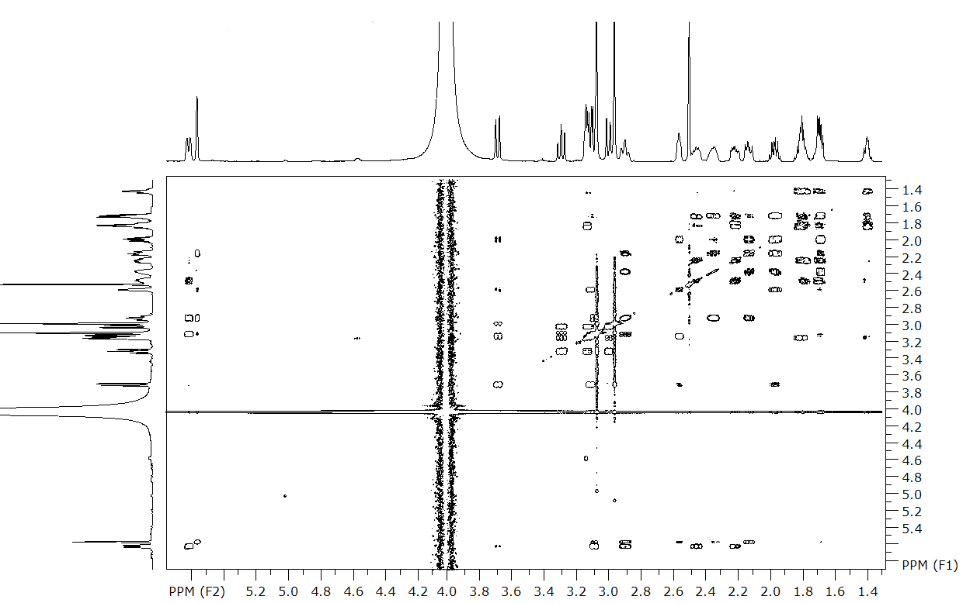
Fig. SI35. ¹H-¹H COSY NMR spectrum of 14 in DMSO-d₆.
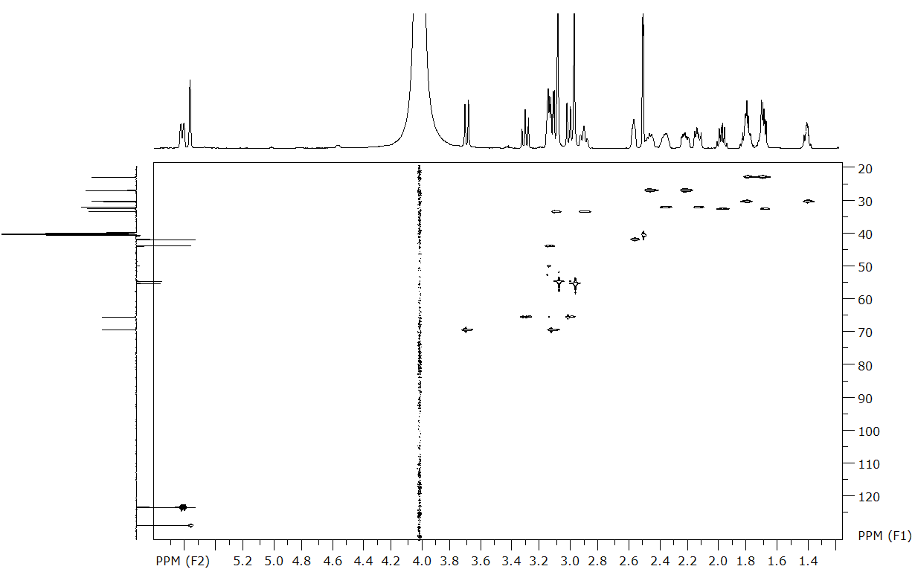
Fig. SI36. ¹H-¹³C HSQC NMR spectrum of 14 in DMSO-d₆.
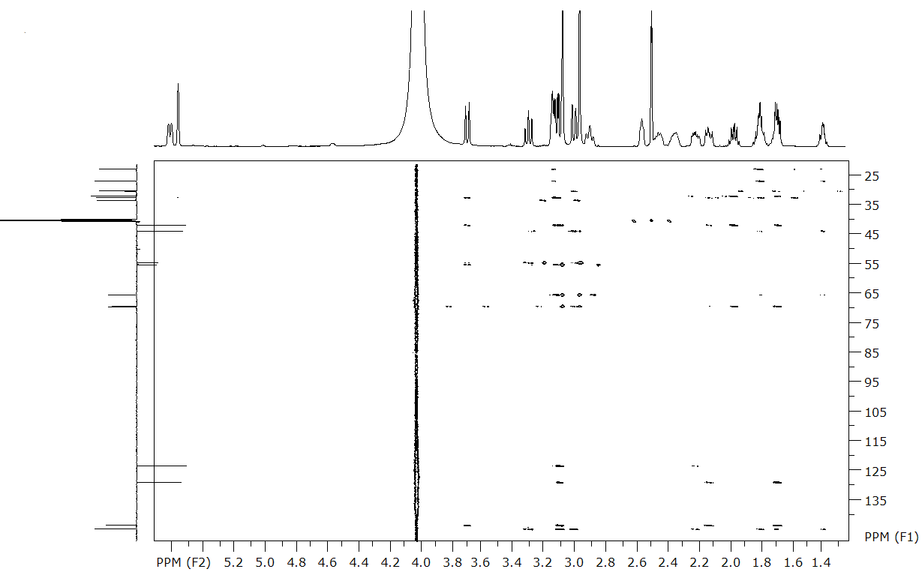
Fig. SI37. ¹H-¹³C HMBC NMR spectrum of 14 in DMSO-d₆.

5. X-ray crystallographic analysis
The X-ray diffraction experiments for 8 was carried out at 296(2) K on a Bruker KAPPA APEX II CCD diffractometer (graphite-monochromated Mo Kα radiation). Reflection intensities were corrected for absorption by multi-scan method with SADABS2016/2 program [S2]. The X-ray diffraction experiments for compounds 13-14 were carried out on a Tongda 5000 diffractometer at 293(2) K with ω-scan method, using Mo-Kα radiation. CrysAlis PRO 1.171.41.120a (Rigaku OD, 2021) [S3] was used for data reduction, including the absorption correction by multi-scan methods with SCALE3 ABSPACK program [S4]. The structures were solved by direct methods using the SHELXT2014/5 [S5] and refined by anisotropic (isotropic for all H atoms) full-matrix least-squares method against F² of all reflections by SHELXL2018/3 [S6]. The positions of the hydrogen atoms were calculated geometrically and refined in riding model. As for 13, free solvent accessible volume derived from PLATON [S7] routine analysis was found to be ~33% (701 Å³). This volume is occupied by highly disordered solvent molecules that could not be modeled as a set of discrete atomic sites. We employed PLATON/SQUEEZE procedure to calculate the contribution to the diffraction from the solvent region and thereby produced a set of solvent-free diffraction intensities. The detail of experiment and structure refinement are given in Table 1.
Crystallographic Data Centre as supplementary publication no. CCDC 2591580 for 8, 2591581 for 13, 2591582 for 14. Copy of the data can be obtained, free of charge, on application to CCDC, 12 Union Road, Cambridge CB21EZ, UK (fax: +44 122 3336033 or e-mail: deposit@ccdc.cam.ac.uk; internet: www.ccdc.cam.ac.uk).
Table 1: Experimental and structure refinement details
 | 8 | 13 | 14
Chemical formula | C₁₄H₂₀BrN | C₁₆H₂₆N·I[+solvent] | C₁₆H₂₆N·I
M_{r} | 282.21 | 357.26 | 359.28
Crystal system, space group | Orthorhombic, Pnma | Monoclinic, P2₁/c | Monoclinic, P2₁/c
Temperature (K) | 296 | 293 | 293
a, b, c (Å) | 14.5054 (9), 9.3571 (5), 10.0830 (7) | 10.9305 (6), 11.3225 (5), 17.5399 (7) | 12.6533 (4), 13.4901 (5), 9.3387 (3)
α, β, γ (°) | 90, 90, 90 | 90, 98.498 (4), 90 | 90, 94.152 (3), 90
V (Å³) | 1368.55 (15) | 2146.92 (18) | 1589.88 (9)
Z | 4 | 4 | 4
F(000) | 584 | 728 | 728
D_{x} (Mg m⁻³) | 1.370 | 1.112 | 1.501
μ(mm⁻¹) | 2.98 | 1.48 | 2.00
Crystal size (mm) | 0.50 × 0.18 × 0.06 | 1.00 × 0.80 × 0.60 | 0.60 × 0.15 × 0.04
Diffractometer | Bruker APEX-II CCD | Tongda 5000 | Tongda 5000
T_{min}, T_{max} | 0.265, 0.376 | 0.117, 1.000 | 0.593, 1.000
No. of measured, independent and observed [I > 2σ(I)] reflections | 16017, 1292, 1095 | 44182, 4898, 3704 | 20490, 3176, 2896
R_{int} | 0.038 | 0.065 | 0.044
θ values (°) | _{θmax} = 25.0, θ_{min} = 2.5 | θ_{max} = 27.5, θ_{min} = 2.7 | θ_{max} = 26.4, θ_{min} = 2.7
Range of h, k, l | h = -16→17,  k = -11→11,  l = -12→12 | h = -14→14,  k = -13→14,  l = -22→22 | h = -15→15,  k = -15→15,  l = -11→11
R[F² > 2σ(F²)], wR(F²), S | 0.042, 0.123, 1.11 | 0.038, 0.114, 1.02 | 0.027, 0.073, 1.02
No. of reflections | 1292 | 4898 | 3176
No. of parameters | 91 | 165 | 165
No. of restraints | 2 | 0 | 0
Δρ_{max}, Δρ_{min} (e Å⁻³) | 0.78, -0.45 | 0.62, -0.73 | 0.63, -0.66
CCDC number | 2591580 | 2591581 | 2591582

S2. SADABS, v. 2008-1, Bruker AXS, Madison, WI, USA.
S3. CrysAlis Pro: Data Collection and Data Reduction Software Package. Agilent Technologies. http://www.selectscience.net/products/crysalispro/?prodID=197116.
S4. CrysAlis RED, Oxford Diffraction Ltd., Version 1.171.35.11 (2011). Oxford Diffraction (2006). CrysAlis RED. Oxford Diffraction Ltd, Abingdon, Oxfordshire, England.
S5. Sheldrick, G.M. SHELXT – Integrated space-group and crystal-structure determination. Acta Crystallogr., Sect. A, 2015, A71, 3-8.
S6. Sheldrick, G.M. Crystal Structure Refinement with SHELXL. Acta Crystallogr. Sect. C, 2015, C71, 3-8.
S7. Spek, A.L. Acta Crystallogr. Sect. C, 2015, C71, 9-18.

