Supporting Information

Exploring combinations of spatial laser beam shaping for advancing nanoparticle synthesis by ablation in liquids
Rémi Bérard ^{a,*}, Abdel Rahman Altakroury ^{b}, Oleksandr Gatsa ª, Zongwen Fu ^{b},
Bilal Gökce ^{b}, Alexander V. Bulgakov ^{a,*}

ª FZU - Institute of Physics of the Czech Academy of Sciences, Na Slovance 1999/2, 18200 Prague 8, Czech Republic
^{b} Chair of Materials Science and Additive Manufacturing, School of Mechanical Engineering and Safety Engineering, University of Wuppertal, 42119 Wuppertal, Germany

* Corresponding authors:
Rémi Bérard, e-mail address: remi.berard@fzu.cz
Alexander V. Bulgakov, e-mail address: alexander.bulgakov@fzu.cz

S1 : Details of size distribution fitting procedure and calculated parameters
This section describes the statistical analysis and fitting procedure used for the nanoparticle size distributions. Particle diameters were extracted from SEM images using ImageJ, yielding for each sample a list of individual particle sizes, hereafter denoted as “data” throughout this section. The analysis was performed in two steps. First, the median, median absolute deviation (MAD), and robust coefficient of variation (RCV) were calculated directly from the experimental particle-size data. Second, the particle-size distributions were fitted with lognormal functions to determine the fitted median and mode. A single lognormal distribution was used for HEA and FeNi NPs, whereas a two-component lognormal model was used for the bimodal Au NP distributions to determine the characteristics and relative fractions of the two populations.
- Direct statistical analysis of data:
The statistical parameters were calculated directly from the raw particle-size data using Python. The commands used are summarized below.

Parameter | Python command
Median (m) | numpy.median(data)
Median absolute deviation (MAD) | scipy.stats.median_abs_deviation(data)
Mean(d) | numpy.mean(data)
Standard deviation (std) | numpy.std(data)

The median is less sensitive to the outliers than the mean and was therefore consider as the most representative descriptor of nanoparticles diameter. This is particularly relevant for lognormal distributions where the mean can be strongly influenced by sporadic measured nanopaticles located in the tails of the distribution. The width of the distribution was then characterized using the median absolute deviation (MAD). For comparison between samples, the robust coefficient of variation (RCV) was calculated as:
$$RCV= \frac{MAD}{m}$$
Althougth some studies use polydispersity index (std²/mean²), the RCV was preferred because it is consistent with the use of the median. The MAD values reported in Table 3 and Figures 2–4 of the manuscript, and the RCV values reported in Figures 2–4 and 9, were calculated directly from the experimental particle-size data. This approach facilitates comparison between samples regardless of the fitting model used.
- Selection of the fitting model:
Based on the calculated parameters, theoretical Gaussian distributions and lognormal distributions were calculated through their analytical expressions:
Gaussian : $G\left(x\right)=\frac{1}{Std×\sqrt{2π}}e^{-\frac{1}{2}×{\left(\frac{x-d}{std}\right)}^{2}}$
Lognormal : $N\left(x\right)= \frac{1}{xσ\sqrt{2π}}e^{\left(-\frac{1}{2}{\left(\frac{\ln{x} - μ}{σ}\right)}^{2}\right)}$
where x is the nanoparticle diameter, $μ$ and $σ$ are the mean and the standard deviation.
Histograms were constructed from the experimental data and normalized by the total bin area in order to obtain probability density values. The resulting histograms were compared with the calculated Gaussian and log-normal distributions (Figure S1-1).
The log-normal model showed better agreement with the experimental diameter distributions than the Gaussian model. Consequently, only log-normal fitting results are discussed in the following sections. Additionally, the log-normal distribution obtained from histogram fitting was compared with the distribution calculated directly from the raw data to confirm the suitability of the model for describing the experimental data.
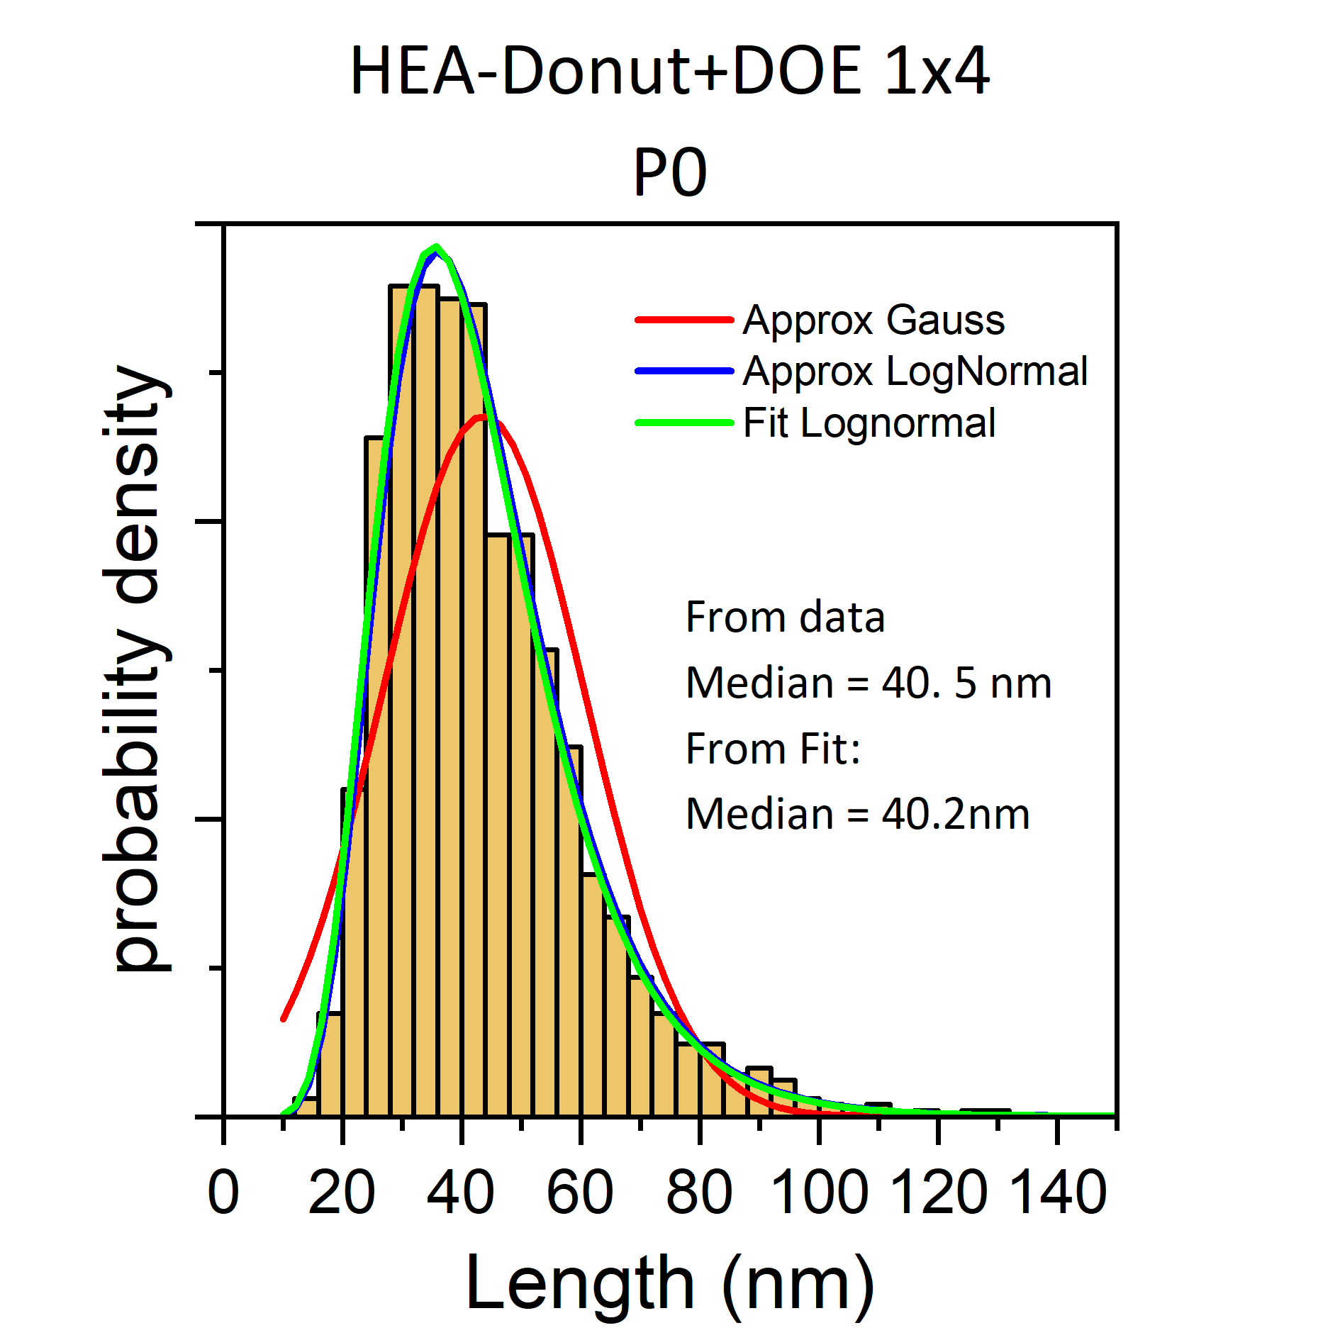
Figure S1-1: Selected NP size distribution histogram and comparison with calculated Gaussian and lognormal distributions and the fitted lognormal model.
- Lognormal fitting procedure
In some cases, for AuNps samples, the fit the histogram with a single lognormal distribution differs from the calculate lognormal from the raw data. This is attributed to the presnece of a bimodal distribution. Therefore the fitting procedure was extend to a bimodal lognormal model:
Bimodal Log-Normal Distribution
$$f\left(x\right) = \frac{C}{xσ\sqrt{2π}}\exp\left(-\frac{1}{2}{\left(\frac{\ln{x} - μ}{σ}\right)}^{2}\right) + \frac{\left(1 - C\right)}{xσ_{2}\sqrt{2π}}\exp\left(-\frac{1}{2}{\left(\frac{\ln{x} - \left(μ + Δμ\right)}{σ_{2}}\right)}^{2}\right)$$
Parameters:
C — mixing weight (0 ≤ C ≤ 1)
μ — mean of the log of the first component
Δμ — shift in mean for the second component (Δμ >0)
σ — standard deviation of the first component
σ₂ — standard deviation of the second component
For unimodal distribution C = 1 (fixed). Once the fitting is completed, the median is calculated using:
$$m_{fit}= e^{μ_{fit}}$$
The fitted median values reported in Table 3 and Figure 8 were obtained from the log-normal fits, whereas MAD and RCV (Figure 9) were calculated directly from the experimental particle-size data. For the bimodal Au NP distributions, the reported fitted median corresponds to the dominant small-particle population, while the mixing parameter C describes its relative fraction. Figure S 1-2 summarizes the obtained statistical data and their use througthout the article.

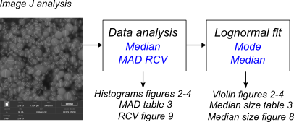

Figure S1-2: Summary of the statistical analysis and reported values.

S2 : Details of size distributions figures
In this Supplentary Information, we present the size distributions of all the obtained colloidal samples presented in the articles.

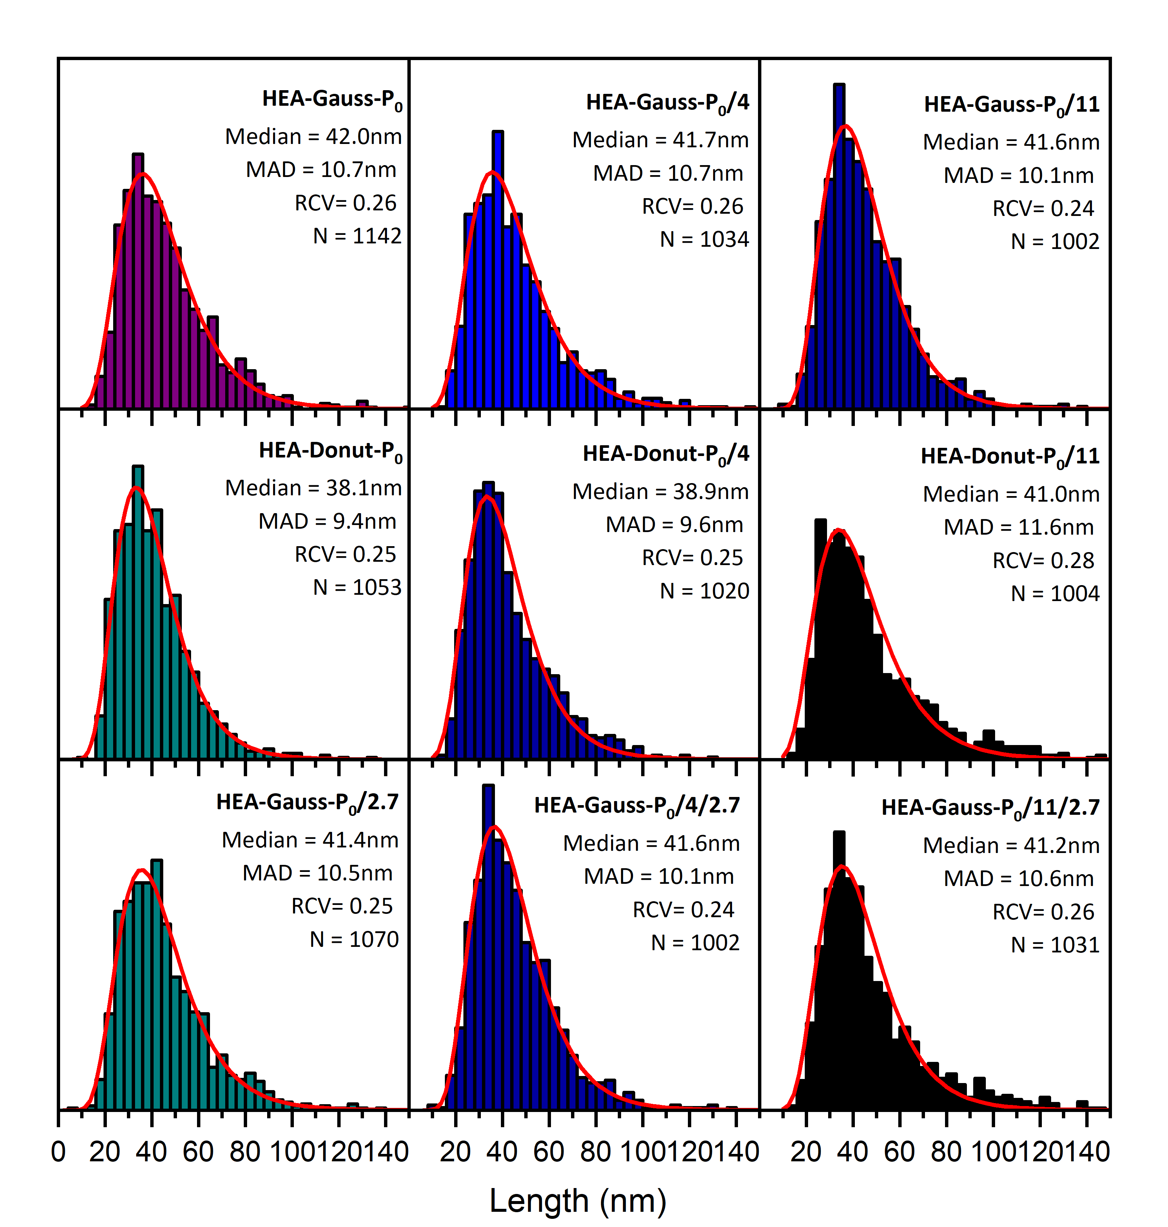

Figure S2-1: Size distributions of HEA NPs for single-beam PLAL (Gauss and donut) shown in Figure 2 of the article by violin plots. The statistical values indicated in each panel (median, MAD, and RCV) were calculated directly from the experimental particle-size data as described in Section S1. For comparison convenience, one regime with Gaussian pulses is shown twice as P0/4/2.7 and as P0/11.

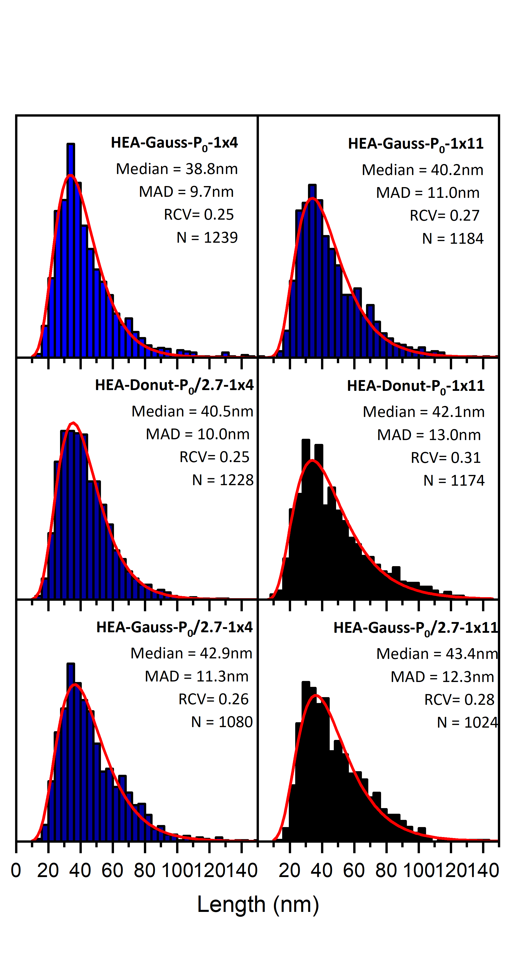
Figure S2-2: Size distributions of HEA NPs for multiple beams (Gauss and donut) shown in Figure 2 of the article by violin plots. The statistical values indicated in each panel (median, MAD, and RCV) were calculated directly from the experimental particle-size data as described in Section S1.

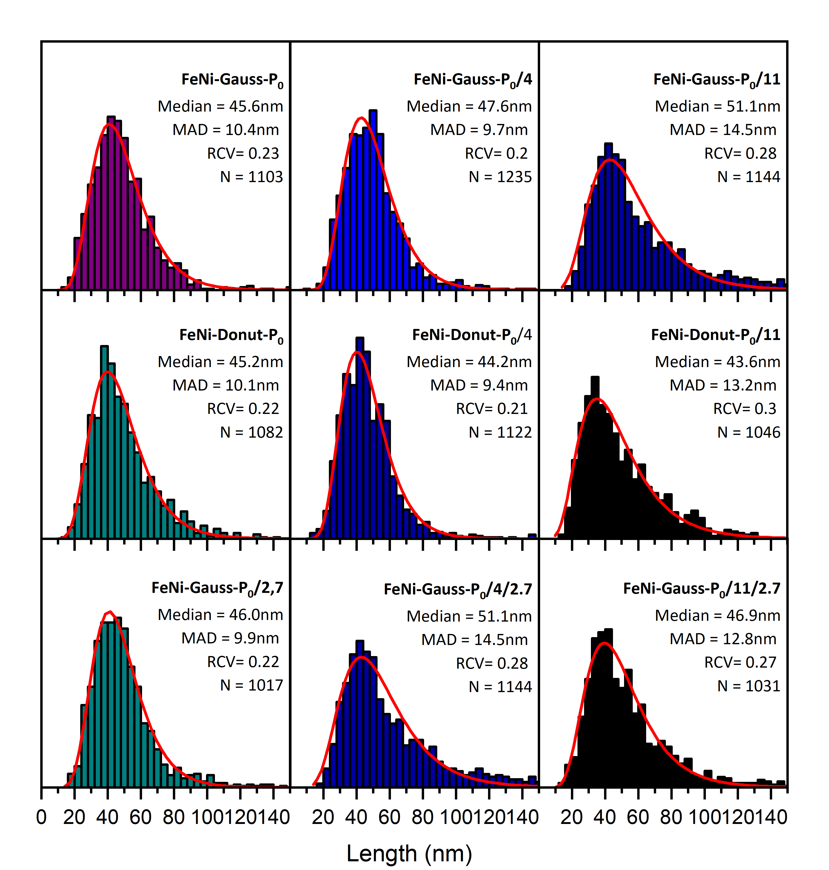

Figure S2-3: Same as Figure S2-1 for FeNi NPs (corresponding to Figure 3 in the paper).

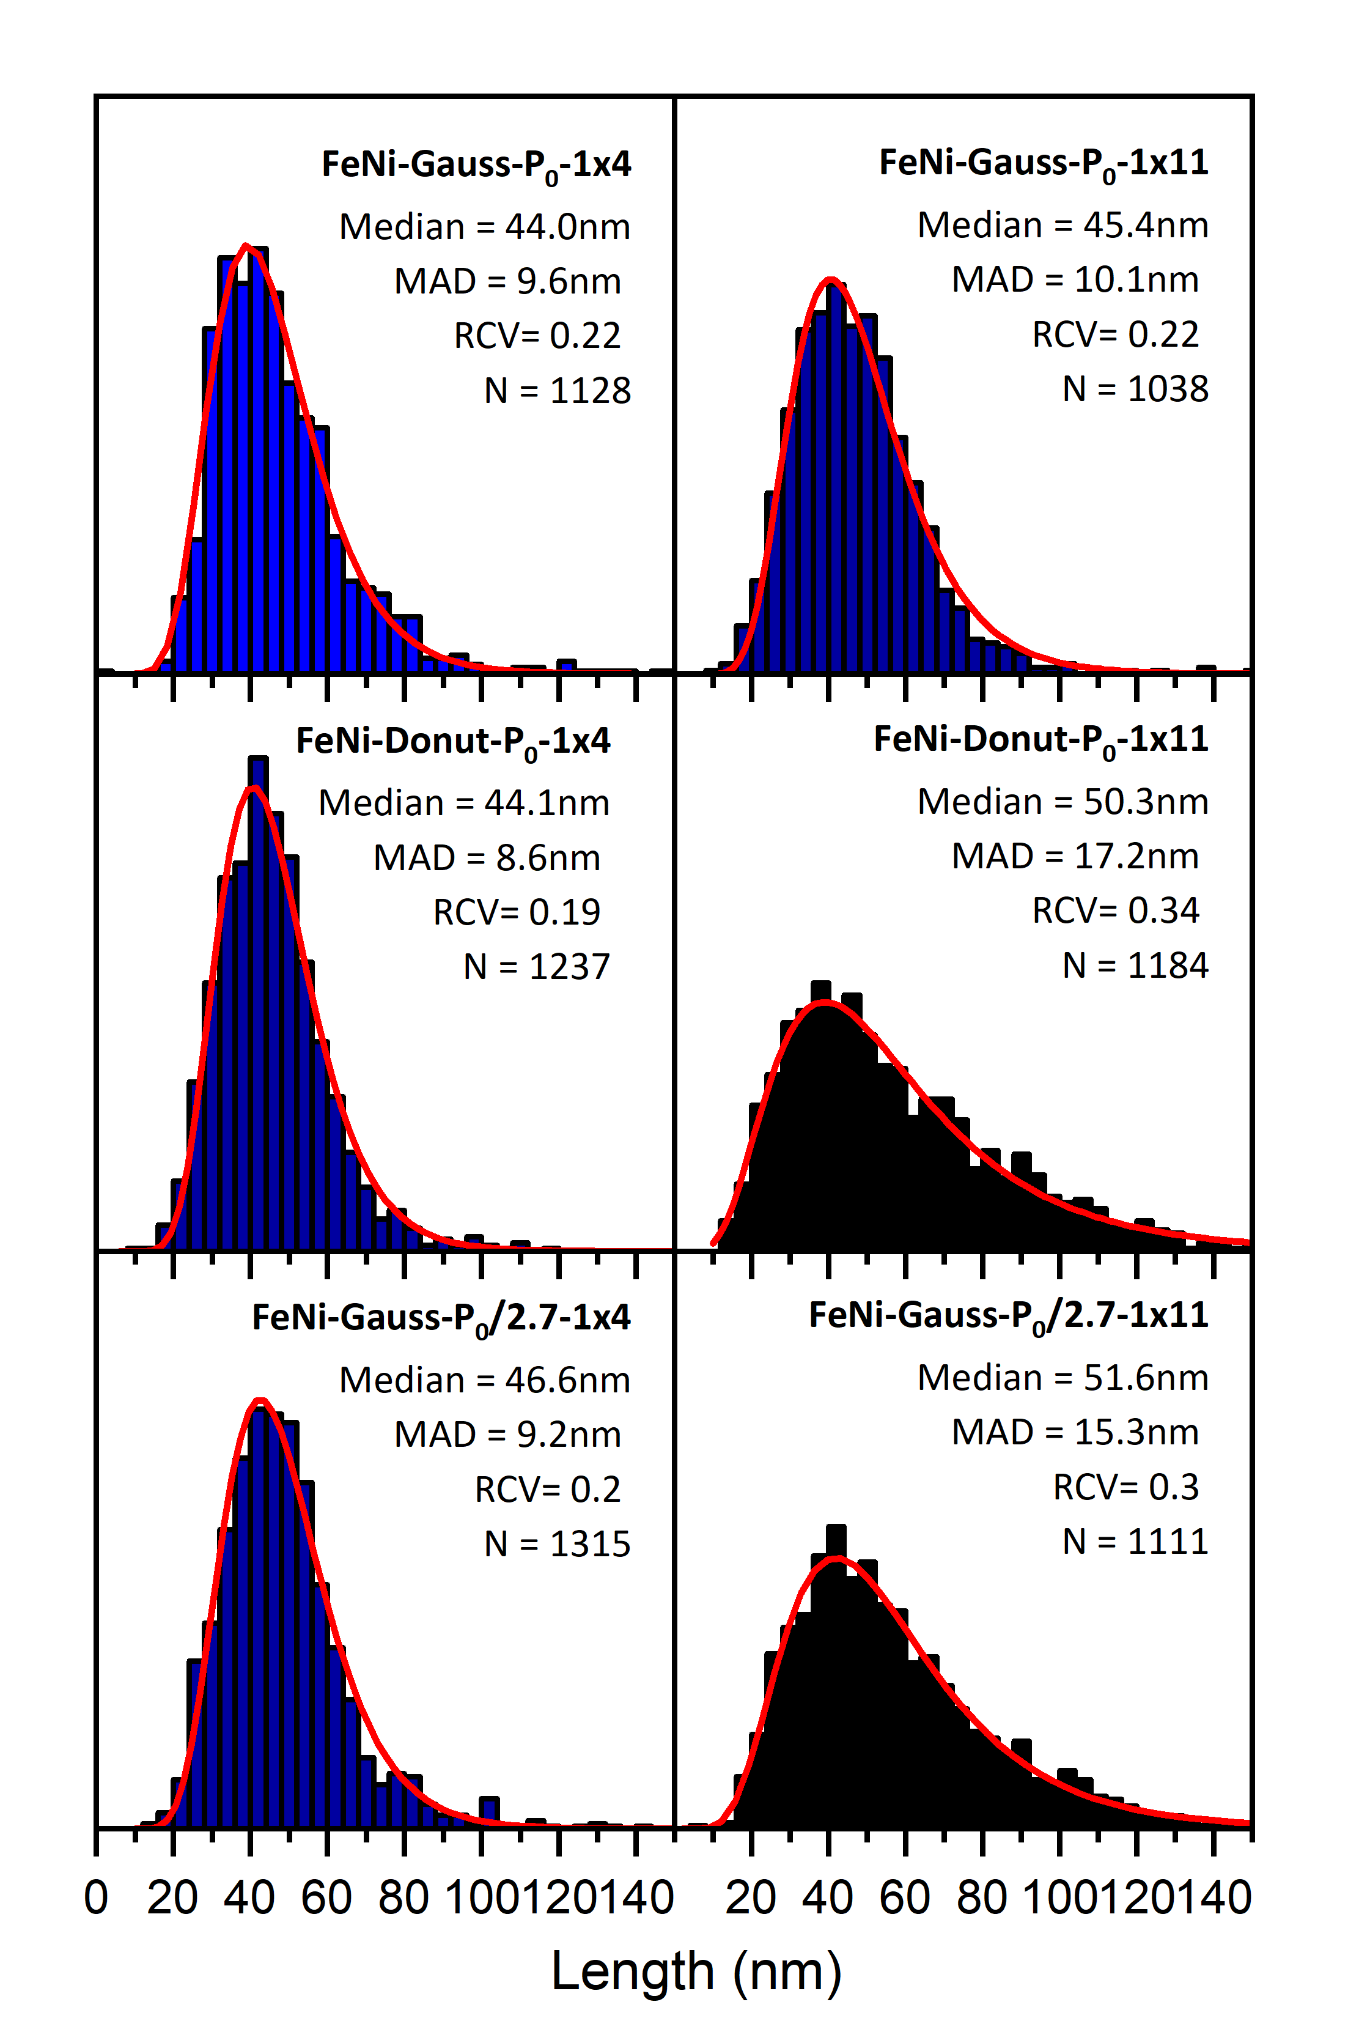

Figure S2-4: Same as Figure S2-2 for FeNi NPs (corresponding to Figure 3 in the paper).

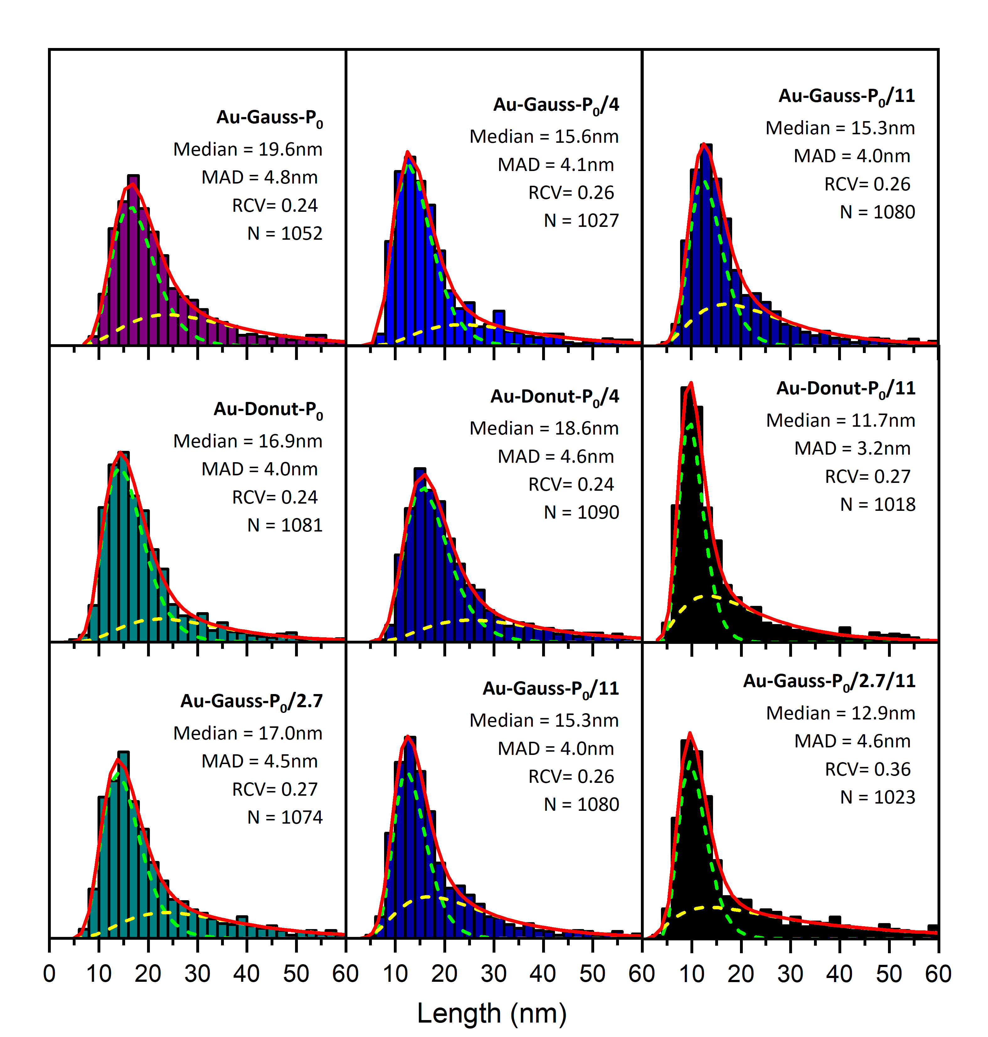
Figure S2-5: Same as Figure S2-1 for Au NPs (corresponding to Figure 4 in the paper).

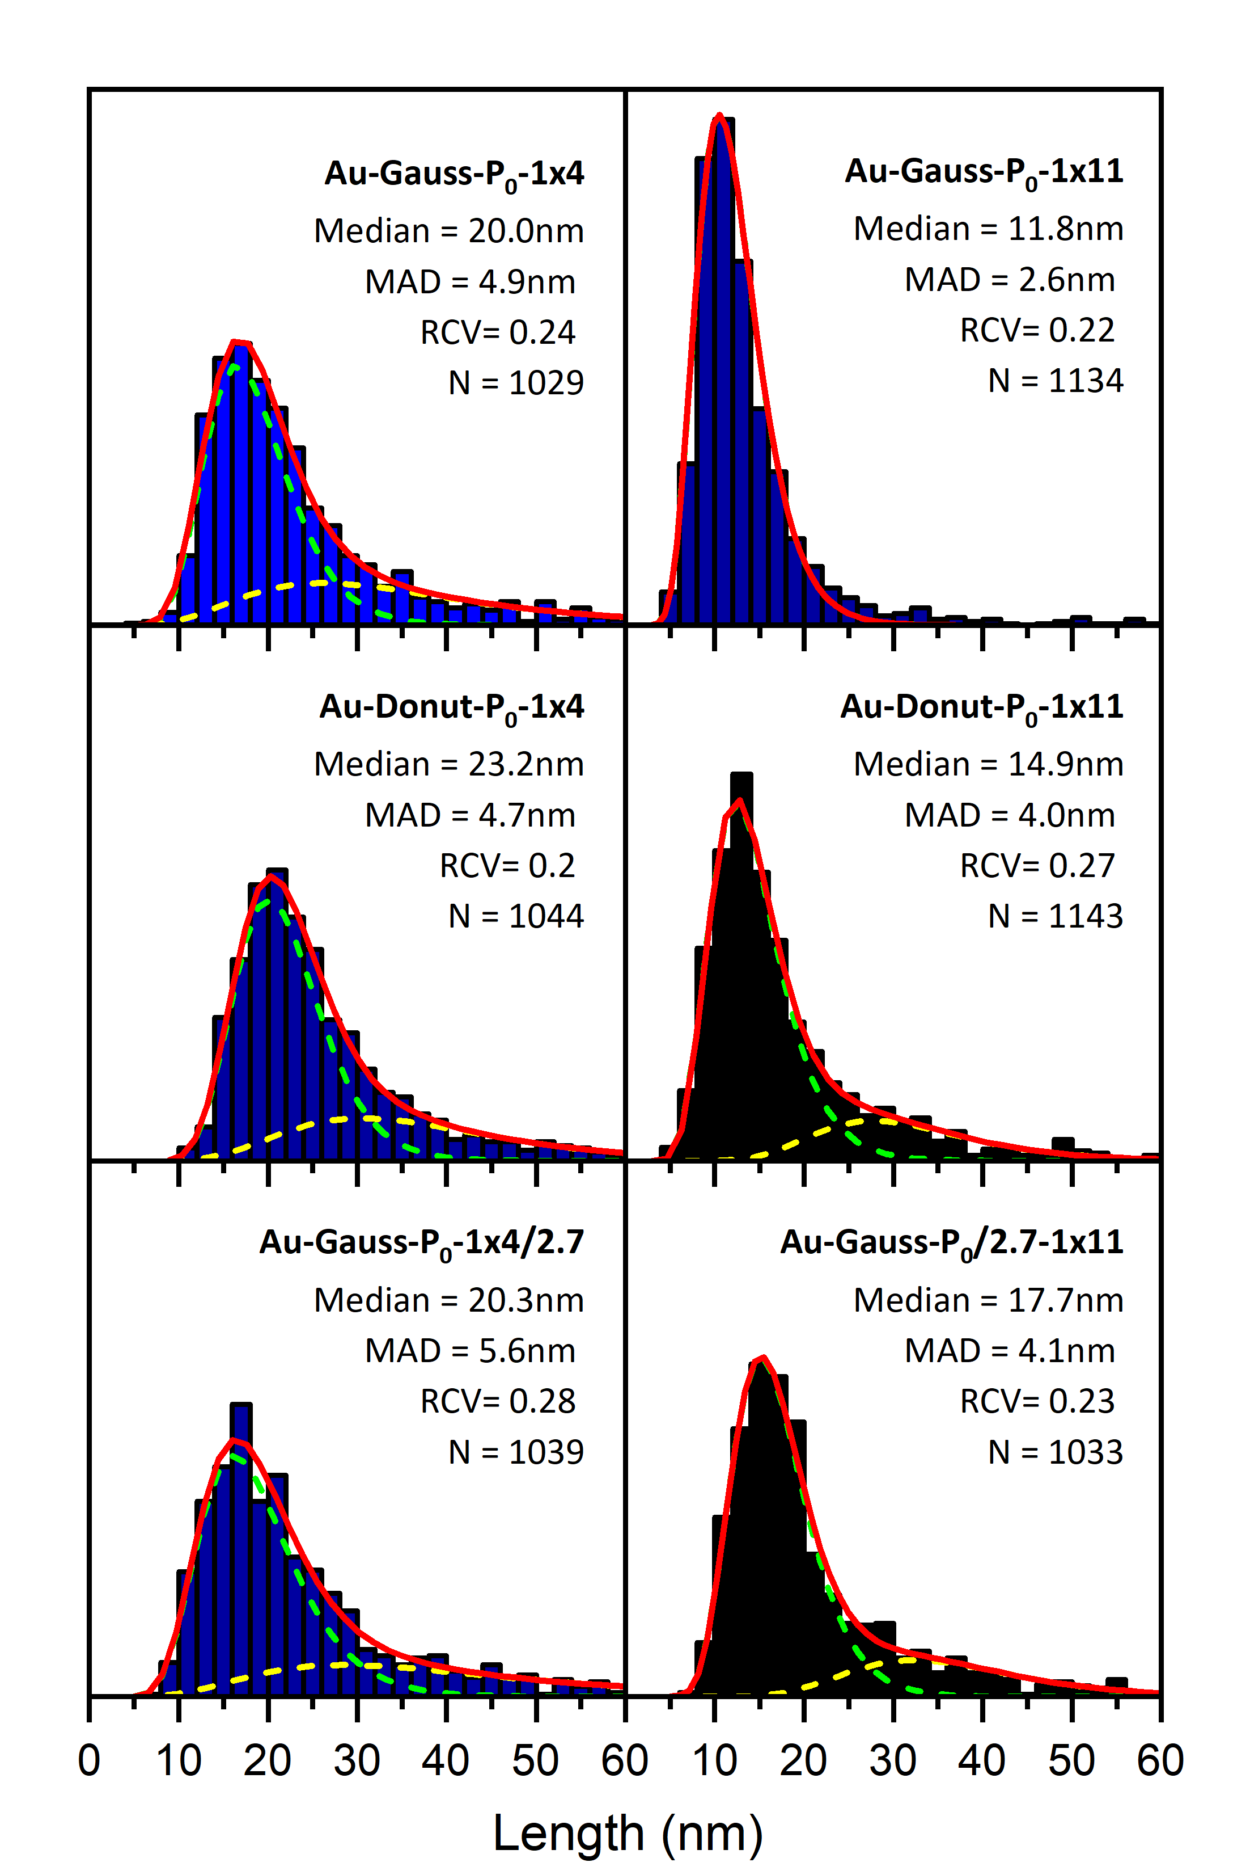

Figure S2-6: Same as Figure S2-2 for Au NPs (corresponding to Figure 4 in the paper).

S3 : Impact of the system geometry on laser reprocessing of nanoparticles

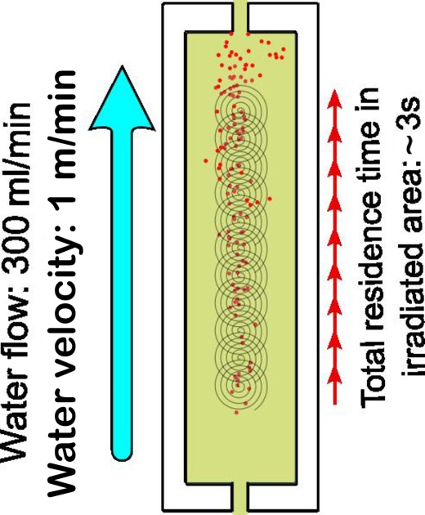

Figure S3: Schematic of the water flow and 11-beam spiral pattern illustrating how the irradiation geometry can promote repeated laser exposure of the produced nanoparticles and thereby favor their laser-induced fragmentation.

S4 : High-mass cut-off size

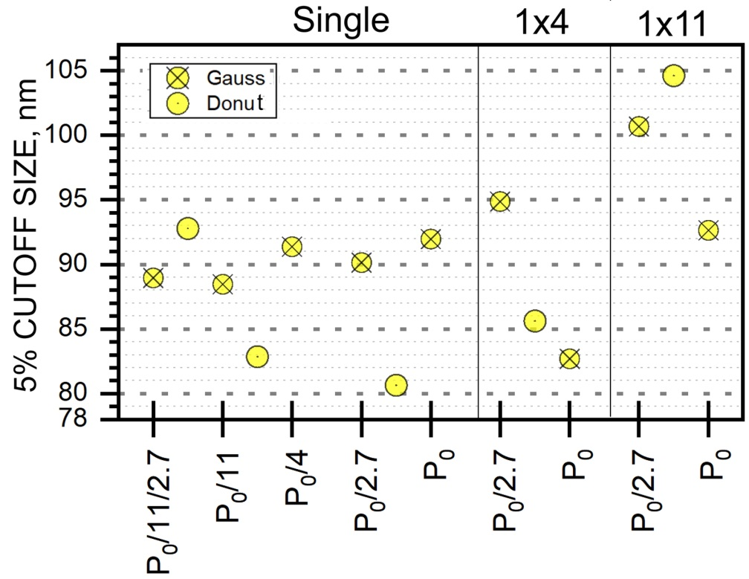
Figure S4: High-mass cut-off size of HEA NPs produced under different PLAL conditions with Gaussian and donut-shaped pulses. The cut-off is determined at a 5% of the NP probability density at the distribution tail from log-normal fittings. For convenience, the results for donut-shaped pulses obtained at a P power are placed between P and P/2.7 (the latter corresponds to the same fluence of a Gaussian pulse at P).

