Supporting Information
Synthesis of Flavones from Chalcones Mediated by Copper(I) Iodide and Azides: Mechanistic Insights

Sheng-Xiang Chen¹, Yu-Jui Su¹, Hsin-Ying Wu¹, Sy-Chyi Cheng^{2,3}, Tzenge-Lien Shih¹*
- Department of Chemistry, Tamkang University, 251301 Tamsui Dist., New Taipei City, Taiwan.
- Academia Sinica Biotechnology Center in Southern Taiwan, Tainan, 711010, Taiwan
- Agricultural Biotechnology Research Center, Academia Sinica, Taipei, 115201, Taiwan

¹H NMR spectrum of compound 4a (300 MHz, CDCl₃)………………….9
¹³C NMR spectrum of compound 4a (75 MHz, CDCl₃)…………………10
¹H NMR spectrum of compound 4b (600 MHz, CDCl₃)………………..11
¹³C NMR spectrum of compound 4b (150 MHz, CDCl₃)………………..12
¹H NMR spectrum of compound 4c (300 MHz, CDCl₃)…........................13
¹³C NMR spectrum of compound 4c (75 MHz, CDCl₃)…………………14
¹H NMR spectrum of compound 4d (600 MHz, CDCl₃)………………..15
¹³C NMR spectrum of compound 4d (150 MHz, CDCl₃)………………..16
¹H NMR spectrum of compound 4e (300 MHz, CDCl₃)………………....17
¹³C NMR spectrum of compound 4e (150 MHz, CDCl₃)………………..18
¹H NMR spectrum of compound 4f (300 MHz, CDCl₃)…………………19
¹³C NMR spectrum of compound 4f (150 MHz, CDCl₃)............................20
¹H NMR spectrum of compound 4g (300 MHz, CDCl₃)............................21
¹³C NMR spectrum of compound 4g (75 MHz, CDCl₃)…………………22
¹H NMR spectrum of compound 4h (300 MHz, CDCl₃)………………...23
¹³C NMR spectrum of compound 4h (150 MHz, CDCl₃)………………..24
¹H NMR spectrum of compound 4i (300 MHz, CDCl₃)…………………25
¹³C NMR spectrum of compound 4i (75 MHz, CDCl₃)..............................26
¹H NMR spectrum of compound 4j (300 MHz, CDCl₃)…………………27
¹³C NMR spectrum of compound 4j (150 MHz, CDCl₃)............................28

2-Phenyl-4H-chromen-4-one (4a)^{[1]}
A white solid. Mp 100.5-103.6 ºC (lit.^{[1]} 95-96 ºC). ¹H NMR (300 MHz, CDCl₃) δ 8.22 (dd, J = 7.8, 1.8 Hz, 1H), 7.94-7.89 (m, 2H), 7.70 (ddd, J= 8.7, 7.2, 1.8 Hz, 1H), 7.56 (dd, J = 7.8, 0.9 Hz, 1H), 7.54-7.49 (m, 3H), 7.42 (ddd, J = 8.1, 7.5, 1.2 Hz, 1H), 6.85 (s, 1H). ¹³C NMR (75 MHz, CDCl₃) δ 178.4, 163.4, 156.2, 133.7, 131.6, 131.5, 129.0, 126.2, 125.6, 125.2, 123.8, 118.0, 107.4. HRMS (ESI) calculated for C₁₅H₁₁O₂ [M + H]⁺ 223.0759. Found: 223.0754.
2-(2-Fluorophenyl)-4H-chromen-4-one (4b)^{[1]}
A pale-yellow solid. Mp 99.2-102.6 ºC (lit.^{[1]} 95-97 ºC). ¹H NMR (600 MHz, CDCl₃) δ 8.21 (dd, J = 7.8, 1.2 Hz, 1H), 7.91 (td, J = 7.8, 1.2 Hz, 1H), 7.68 (t, J = 7.2 Hz, 1H), 7.53 (dd, J = 8.4 Hz, H), 7.49 (dd, J = 13.8, 7.2 Hz, 1H), 7.41 (t, J = 7.8 Hz, 1H), 7.30 (t, J = 7.8 Hz, 1H), 7.21 (dd, J = 11.4, 8.4 Hz, 1H), 6.94 (s, 1H). ¹³C NMR (150 MHz, CDCl₃) δ δ 178.3, 160.5 (¹J_{C-F} = 252.0 Hz), 158.7 (⁴J_{C-F} = 3.0 Hz), 156.3, 133.8, 132.8 (³J_{C-F} = 9.0 Hz), 129.0, 125.6, 125.2, 124.5 (⁴J_{C-F} = 3.0 Hz), 123.7, 120.2 (²J_{C-F} = 10.5 Hz), 118.0, 116.9 (²JC-F = 22.5 Hz), 112.3 (³J_{C-F} = 8.0 Hz). HRMS (ESI) calculated for C₁₅H₁₀FO₂ [M + H]⁺ 241.0665. Found: 241.0659.
2-(2-Chlorophenyl)-4H-chromen-4-one (4c)^{[1]}
A pale-yellow solid. Mp 117.4-119.5 ºC (lit.^{[1]} 121-123 ºC). ¹H NMR (300 MHz, CDCl₃) δ 8.26 (dd, J = 7.8, 1.8 Hz, 1H), 7.71 (ddd, J = 8.7, 7.2, 1.8 Hz, 1H), 7.65 (dd, J = 7.2, 1.8 Hz, 1H), 7.56-7.48 (m, 2H), 7.47-7.38 (m, 3H), 6.67 (s, 1H). ¹³C NMR (75 MHz, CDCl₃) δ 178.2, 162.7, 156.6, 133.9, 132.9, 131.9, 131.8, 130.8, 130.6, 127.1, 125.7, 125.3, 123.8, 118.2, 113.0. HRMS (ESI) calculated for C₁₅H₁₀ClO₂ [M + H]⁺ 257.0369. Found: 257.0364.
2-(2-Bromophenyl)-4H-chromen-4-one (4d)^{[1]}
A pale-yellow solid. Mp 133.2-135,7 ºC (lit^{[1]} 133-135 ºC). ¹H NMR (600 MHz, CDCl₃) δ 8.26 (dd, J = 7.8, 1.2 Ηz, 1Η), 7.74 (d, J = 8.4 Hz, 1H), 7.71 (td, J = 7.2, 1.8 Hz, 1H), 7.59 (dd, J = 7.8, 1.2 Hz, 1H), 7.53 (d, J = 8.4 Hz, 1H), 7.47 (d, J = 7. 2 Hz, 1H), 7.44 (d, J = 7.2 Hz, 1H), 7.38 (td, J = 7.8, 1.2 Hz, 1H), 6.59 (s, 1H). ¹³C NMR (150 MHz, CDCl₃) δ 178.2, 164.0, 156.6, 134.1, 134.0, 131.9, 130.9, 127.6, 125.8, 125.4, 123.9, 121.9 (x2), 118.2, 112.9. HRMS (ESI) calculated for C₁₅H₁₀BrO₂ [M + H]⁺ 300.9864. Found: 300.9859.
2-(3-Fluorophenyl)-4H-chromen-4-one (4e)^{[2]}
A pale-yellow solid. Mp 102.4-104.8 ºC (lit.^{[2]} 96-98 ºC). ¹H NMR (300 MHz, CDCl₃) δ 8.22 (d, J = 7.8, 1.5 Hz, 1H), 7.75-7.68 (m, 2H), 7.64 (dt, J = 9.6, 1.8 Hz, 1H), 7.57 (dd, J = 8.7, 0.9 Hz, 1H), 7.49 (ddd, J = 10.2, 8.1, 5.7 Hz, 1H), 7.43 (td, J = 8.1, 0.9 Hz, 1H), 6.84 (s, 1H). ¹³C NMR (150 MHz, CDCl₃) δ 178.2, 163.0 (¹J_{C-F} = 246.0 Hz), 161.9, 156.1, 134.0, 133.9, 130.7 (³J_{C-F} = 9.0 Hz), 125.7, 125.4, 123.9, 122.0, 118.6, 118.3 (²J_{C-F} = 24.0 Hz), 113.4 (²J_{C-F} = 24.0 Hz), 108.1. HRMS (ESI) calculated for C₁₅H₁₀FO₂ [M + H]⁺ 241.0665. Found: 241.0659.
2-(3-Chlorophenyl)-4H-chromen-4-one (4f)^{[1]}
A pale-yellow solid. Mp 125.4-128.7 ºC (lit.^{[1]} 126-128 ºC). ¹H NMR (300 MHz, CDCl₃) δ 8.21 (dd, J = 7.8, 1.5 Hz, 1H), 7.91 (t, J = 1.5 Hz, 1H), 7.78 (d, J = 7.5, 1.8 Hz, 1H), 7.71 (ddd, J = 8.7, 7.2, 1.8 Hz, 1H), 7.56 (dd, J = 8.7, 0.9 Hz, 1H), 7.50 (dt, J = 8.1, 1.8 Hz, 1H), 7.45 (dd, J = 6.9, 0.9 Hz, 1H), 7.41 (dd, J = 6.9, 1.2 Hz, 1H), 6.82 (s, 1H). ¹³C NMR (150 MHz, CDCl₃) δ 178.2, 161.8, 156.1, 135.3, 134.0, 133.5, 131.5, 130.3, 126.3, 125.7, 125.4, 124.4, 123.8, 118.1, 108.1. HRMS (ESI) calculated for C₁₅H₁₀ClO₂ [M + H]⁺ 257.0369. Found: 257.0364.

2-(3-Bromophenyl)-4H-chromen-4-one (4g)^{[2]}
A pale-yellow solid. Mp 109.4-112.2 ºC (lit.^{[2]} 86-88 ºC). ¹H NMR (300 MHz, CDCl₃) δ 8.23 (dd, J = 7.8, 1.2 Hz, 1H), 8.09 (t, J = 1.8 Hz, 1H), 7.84 (ddd, J = 7.8, 1.5, 0.9 Hz, 1H), 7.73 (ddd, J = 8.7, 6.9, 1.5 Hz, 1H), 7.67 (ddd, J = 8.1, 2.1, 1.2 Hz, 1H), 7.59 (dd, J = 8.4, 0.9 Hz, 1H), 7.44 (ddd, J = 8.1, 6.9, 1.2 Hz, 1H), 6.82 (s, 1H). ¹³C NMR (75 MHz, CDCl₃) δ 178.3, 161.8, 156.2, 134.5, 134.1, 133.7, 130.6, 129.3, 125.8, 125.5, 124.9, 123.8, 123.2, 118.1, 108.8. HRMS (ESI) calculated for C₁₅H₁₀BrO₂ [M + H]⁺ 300.9864. Found: 300.9859.
2-(4-Fluorophenyl)-4H-chromen-4-one (4h)^{[3]}
A white solid. Mp 134.5-136.7 ºC (lit.^{[3]} 135-137 ºC). ¹H NMR (300 MHz, CDCl₃) δ 8.22 (dd, J = 8.1, 1.8 Hz, 1H), 7.94 (ddd, J = 9.0, 7.2, 2.1 Hz, 2H), 7.71 (ddd, J = 8.4, 6.9, 1.5 Hz, 1H), 7.57 (dd, J = 8.4, 0.9 Hz, 1H), 7.43 (td, J = 8.1, 1.2 Hz, 1H), 7.26-7.18 (m, 2H), 6.83 (s, 1H). ¹³C NMR (150 MHz, CDCl₃) δ 178.3, 163.8 (¹J_{C-F} = 252.0 Hz), 162.5, 156.2, 133.9, 128.5 (³J_{C-F} = 9.0 Hz), 127.9, 125.7, 125.4, 123.8, 118.0, 116.2 (²J_{C-F} = 22.5 Hz), 107.3. HRMS (ESI) calculated for C₁₅H₁₀FO₂ [M + H]⁺ 241.0665. Found: 241.0659.
2-(4-Chlorophenyl)-4H-chromen-4-one (4i)^{[1]}
A white solid. Mp 187.6-190.3 ºC (lit.^{[1]} 169-171 ºC). ¹H NMR (300 MHz, CDCl₃) δ 8.21 (dd, J = 7.8, 1.5 Hz, 1H), 7.85 (t, J = 9.0, 2.4 Hz, 2H), 7.70 (ddd, J = 8.7, 8.7, 1.8 Hz, 1H), 7.56 (dd, J = 8.4, 0.6 Hz, 1H), 7.48 (dt, J = 9.0, 2.4 Hz, 2H), 7.42 (ddd, J = 9.0, 8.1, 1.2 Hz, 1H), 6.82 (s, 1H). ¹³C NMR (75 MHz, CDCl₃) δ 178.2, 162.2, 156.1, 137.8, 1336.9, 130.1, 129.3, 127.5, 125.7, 125.3, 123.8, 118.0, 107.6. HRMS (ESI) calculated for C₁₅H₁₀ClO₂ [M + H]⁺ 257.0369. Found: 257.0364.
2-(4-Bromophenyl)-4H-chromen-4-one (4j)^{[3]}
A white solid. Mp 168.4-170.1 ºC (lit.^{[3]} 148-152 ºC). ¹H NMR (300 MHz, CDCl₃) δ 8.22 (dd, J = 7.8, 1.5 Hz, 1H), 7.80 (dt, J = 9.3, 2.4 Hz, 2H), 7.71 (ddd, J = 8.7, 7.2, 1.8 Hz, 1H), 7.69-7.62 (m, 2H), 7.55 (dd, J = 7.2, 0.9 Hz, 1H), 7.43 (td, J = 7.8, 0.9 Hz, 1H), 6.83 (s, 1H). ¹³C NMR (150 MHz, CDCl₃) δ 1781.3, 162.4, 156.2, 138.3, 134.0, 132.3, 127.6, 126.3, 125.7, 125.4, 123.9, 118.0, 107.6. HRMS (ESI) calculated for C₁₅H₁₀BrO₂ [M + H]⁺ 300.9864. Found: 300.9859.

1.Mou, M.-J.; Guo, M.-Z.; Li, Q.-X.; Ni, S.-F.; Lv, J.; Guo, W.; Wen, L.-R.; Zhang, L.-B. Org. Lett. 2024, 26, 9547-9552. https://doi.org/10.1021/acs.orglett.4c03574
2. Kim, D.; Ham, K.; Hong, S. Org. Biomol. Chem. 2012, 10, 7305-7312. https://doi.org/10.1039/c2ob26061a
3. Banerjee, D.; Kayal, U.; Maiti, G. Tetrahedron Lett. 2016, 57, 1667-1671. https://doi.org/10.1016/j.tetlet.2016.03.006

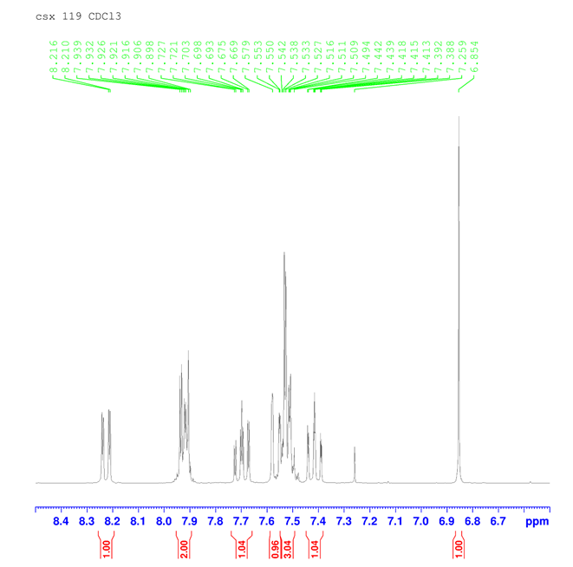
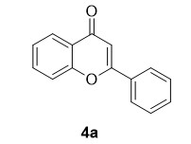
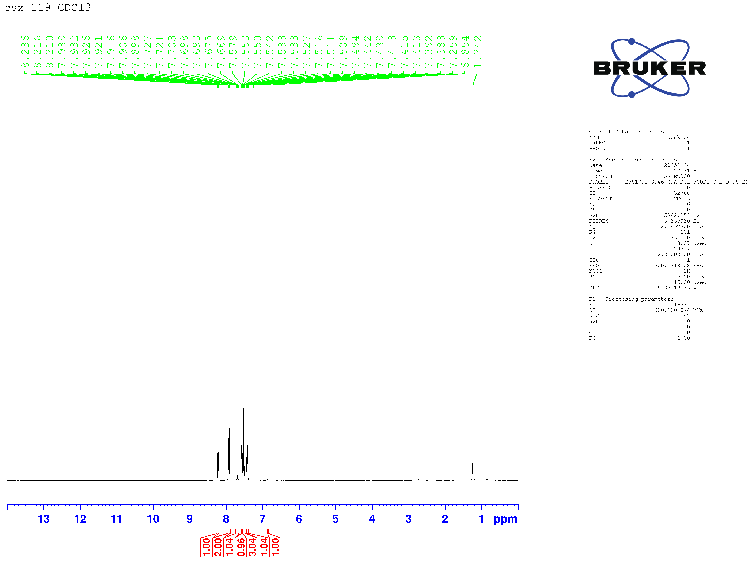

¹H NMR spectrum of compound 4a (300 MHz, CDCl₃)
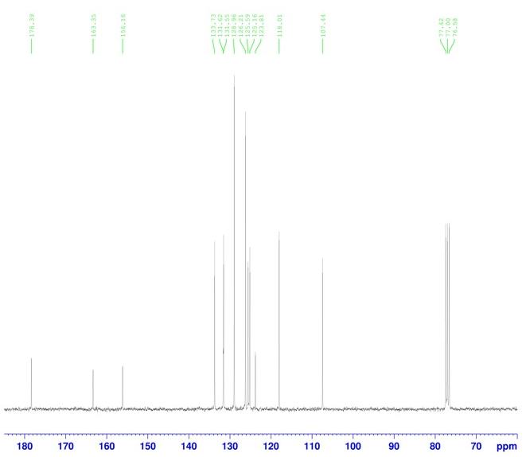
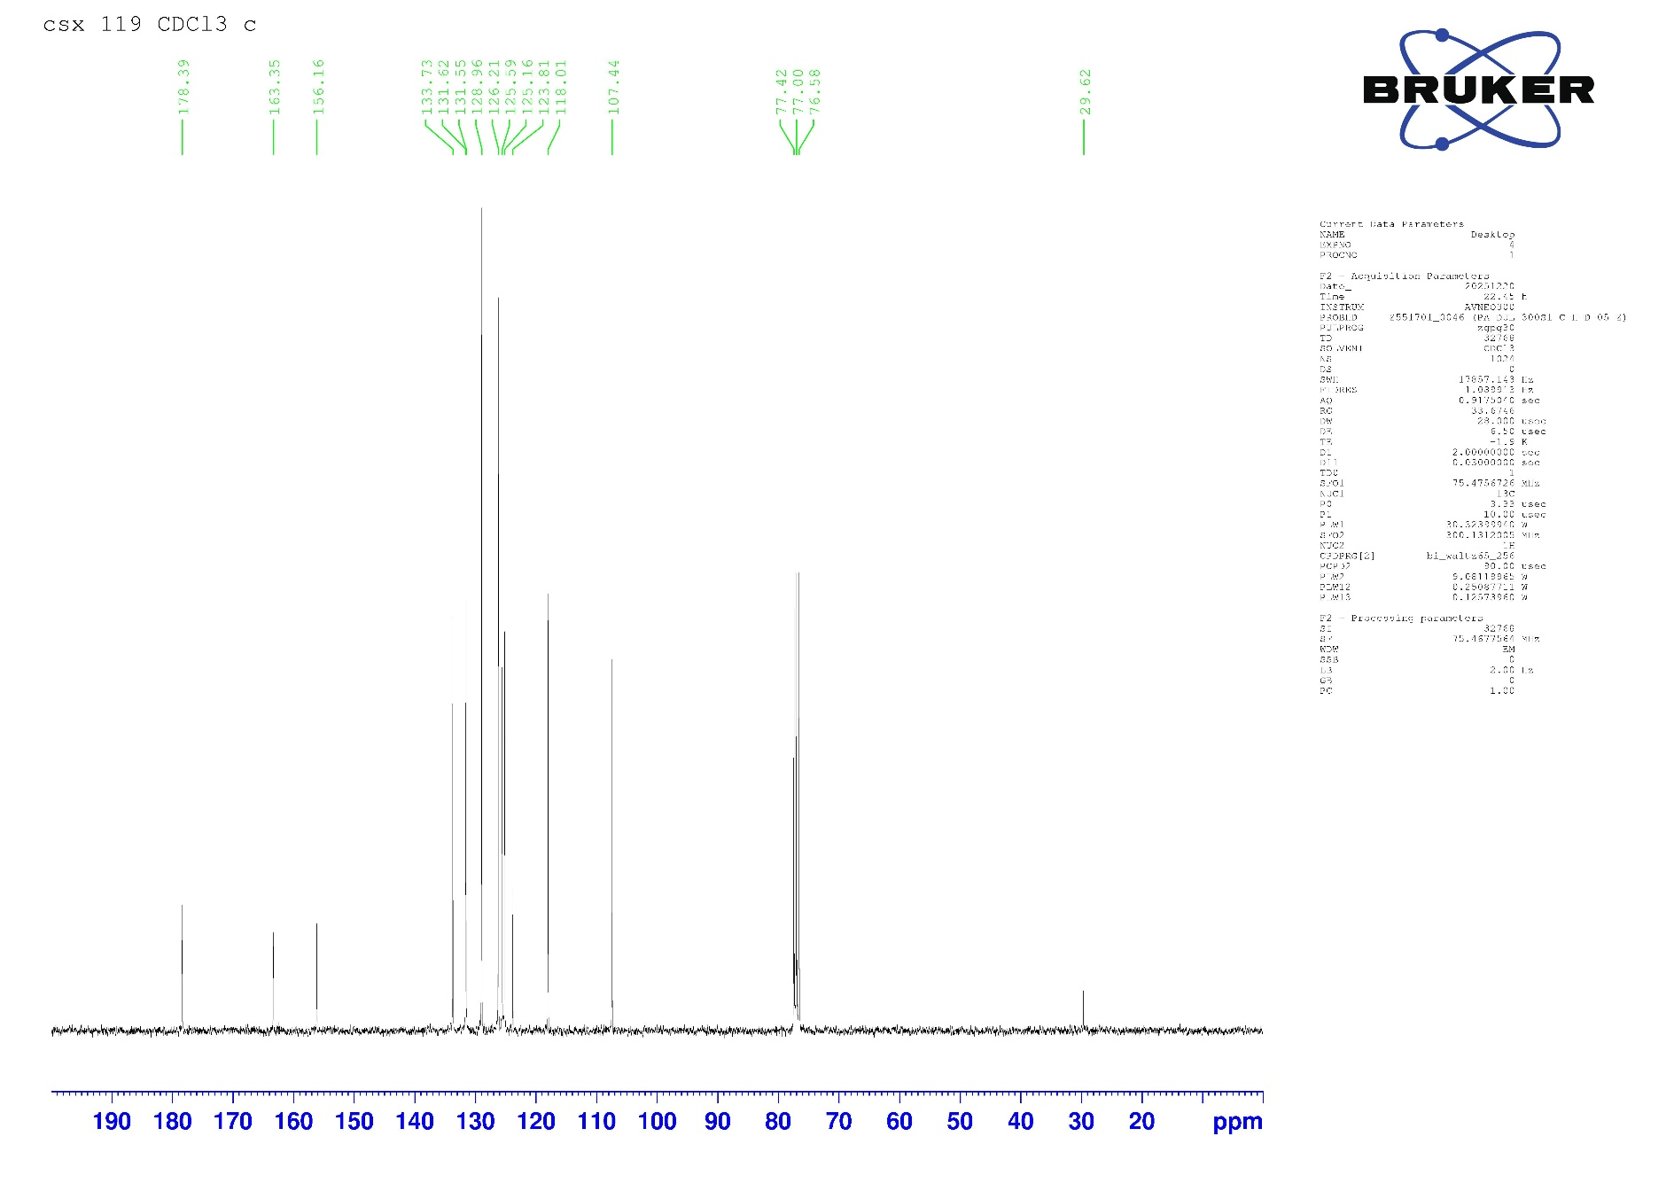

¹³C NMR spectrum of compound 4a (75 MHz, CDCl₃)
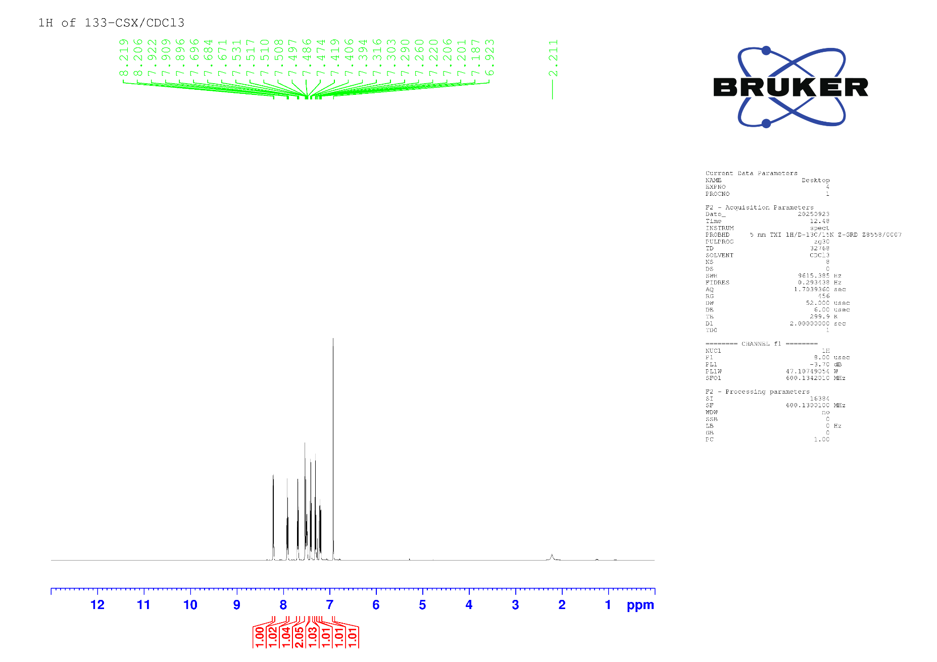
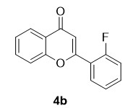

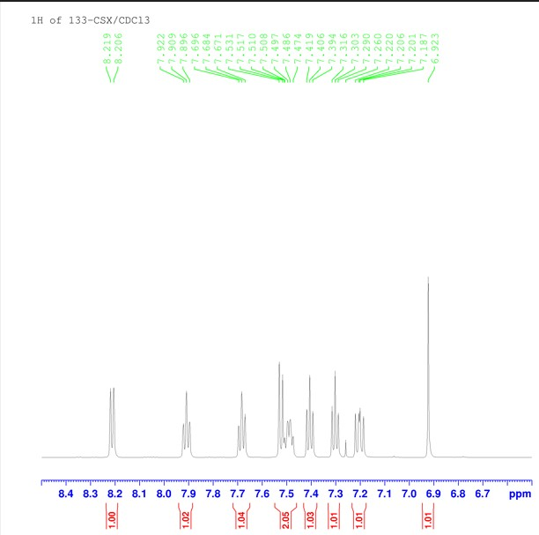

¹H NMR spectrum of compound 4b (600 MHz, CDCl₃)
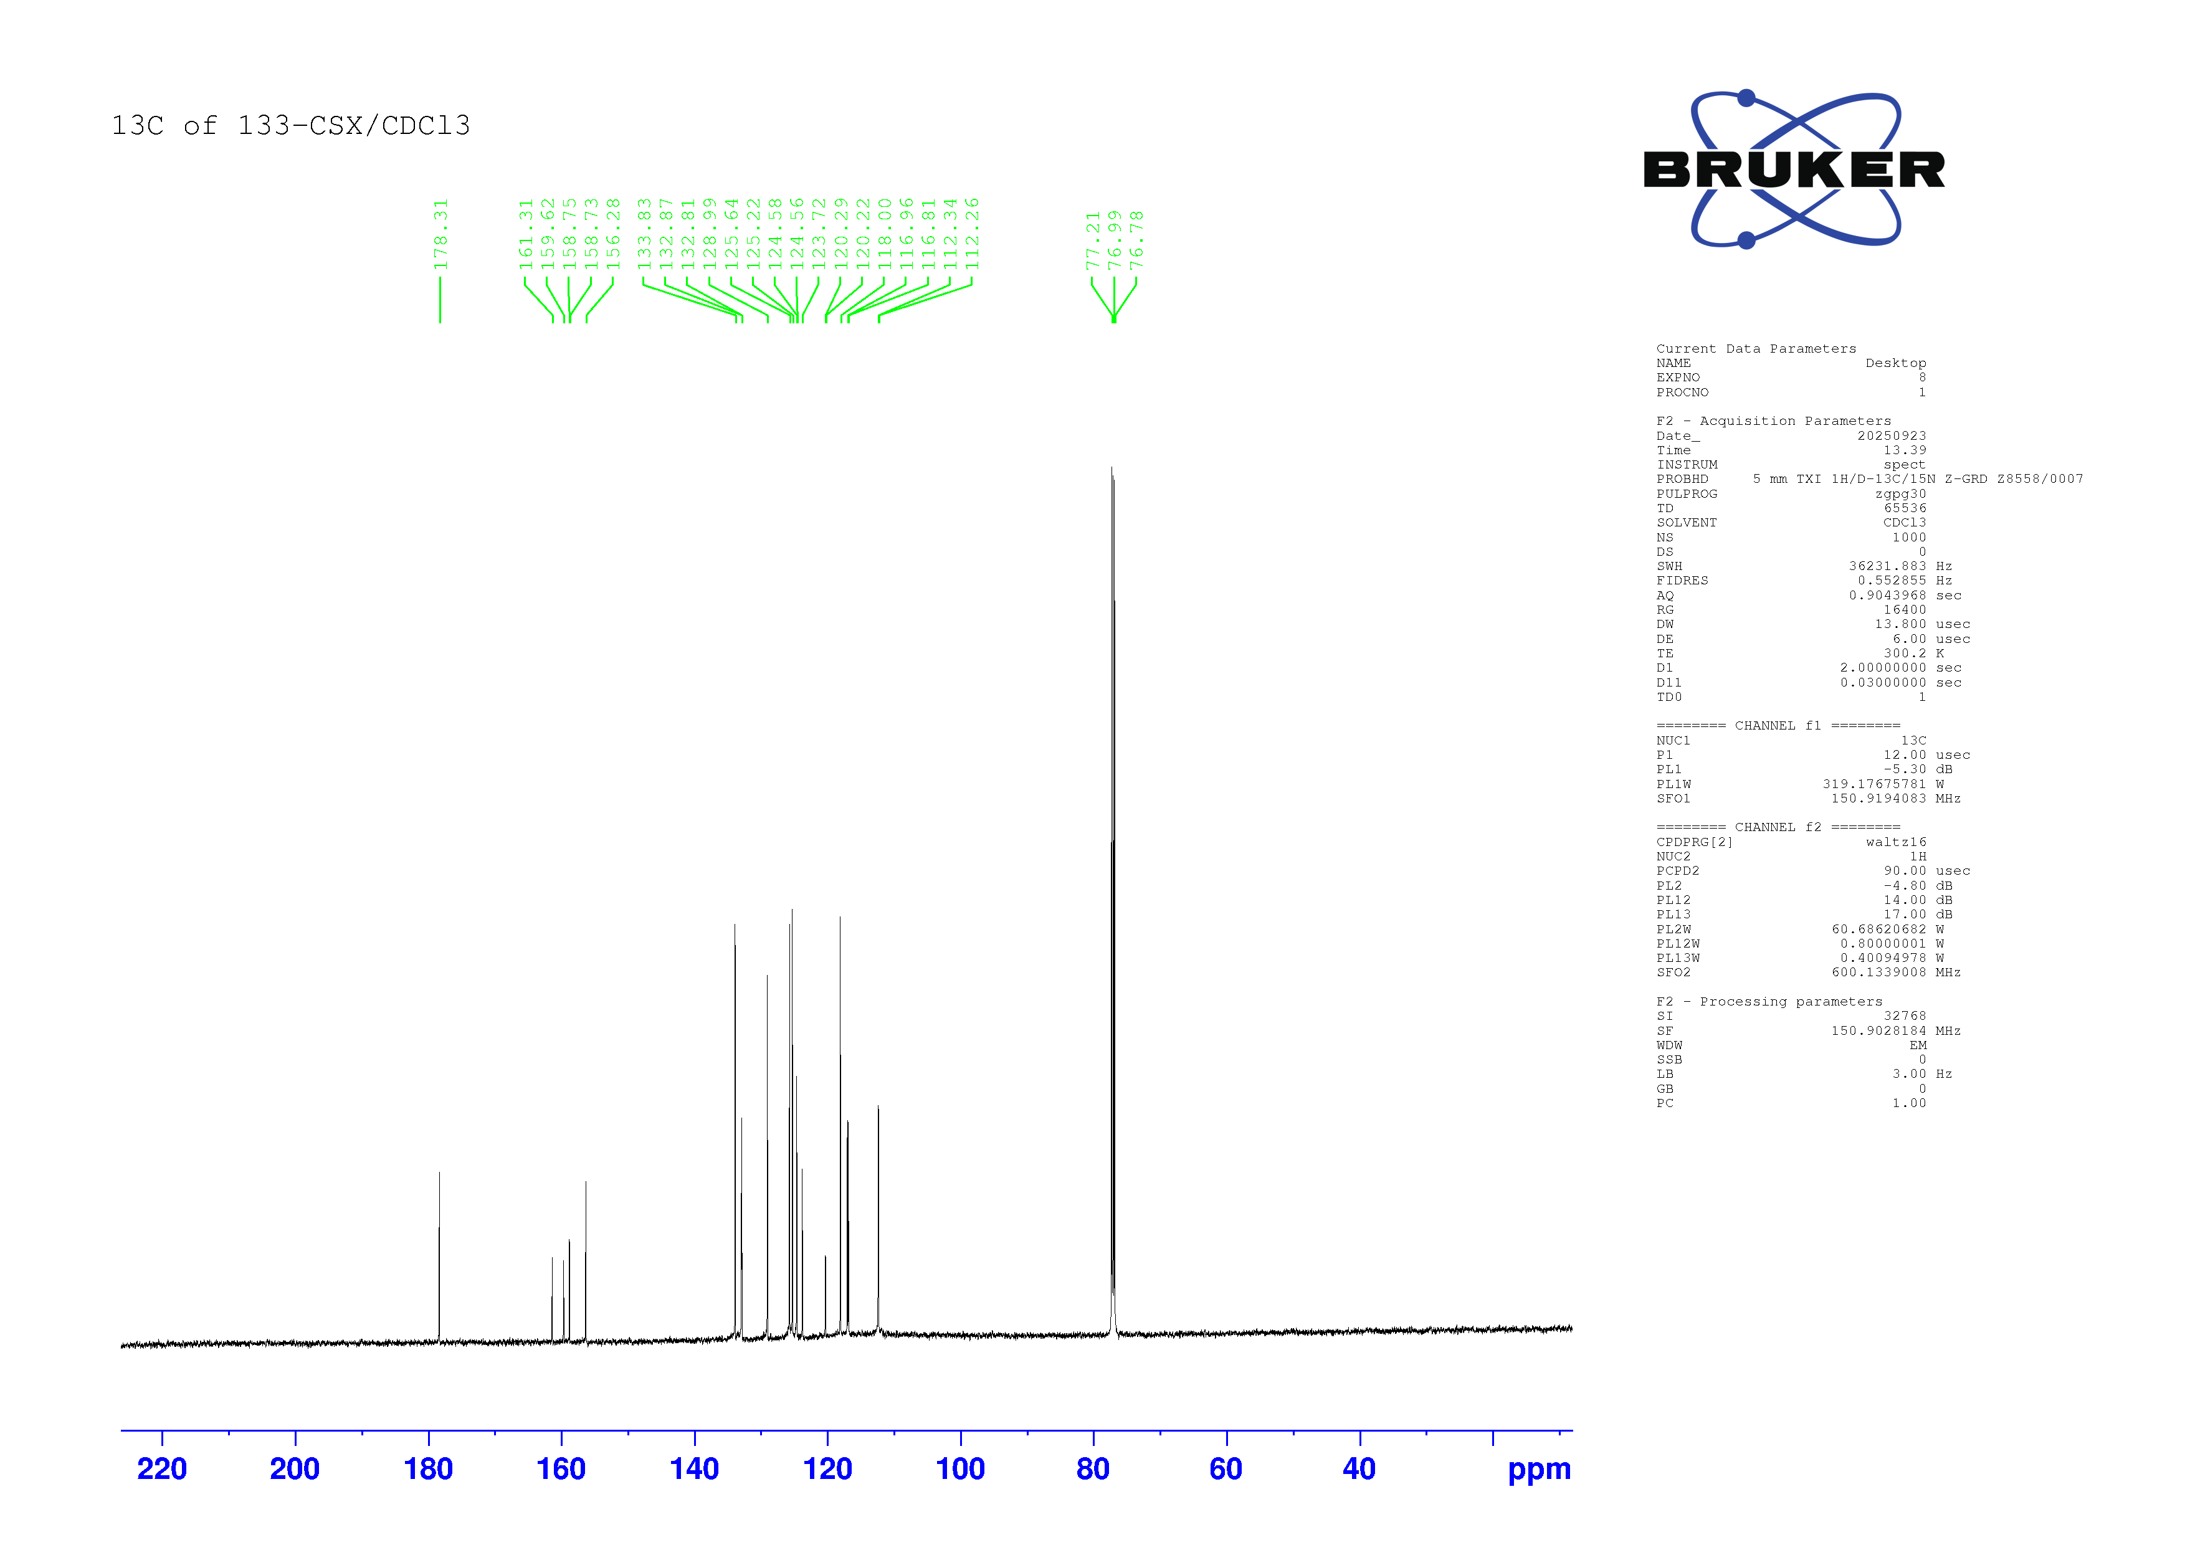
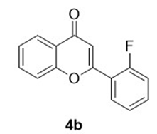

¹³C NMR spectrum of compound 4b (150 MHz, CDCl₃)
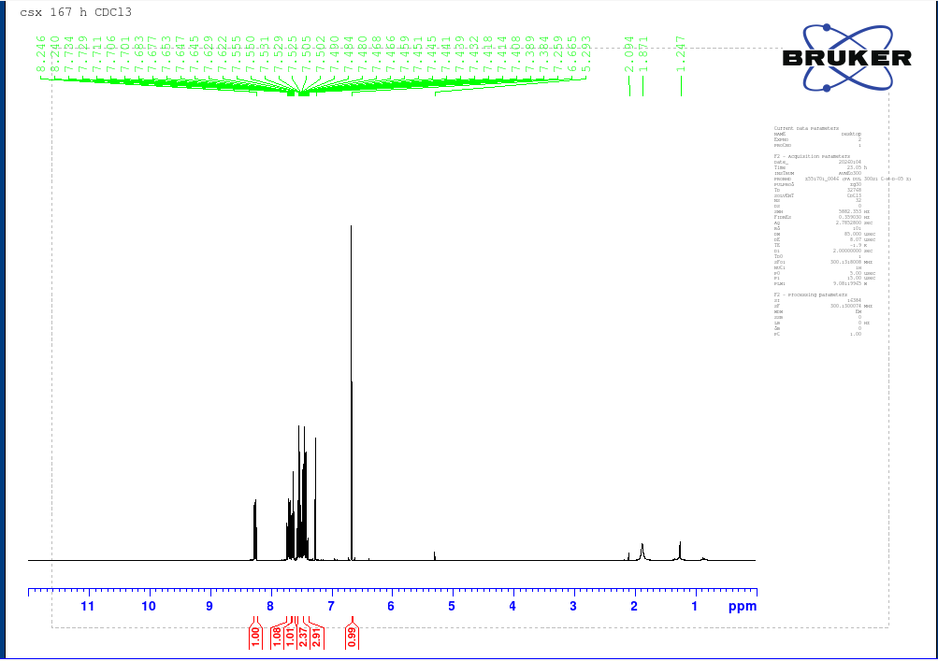
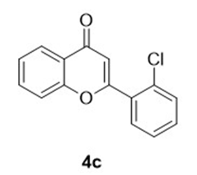

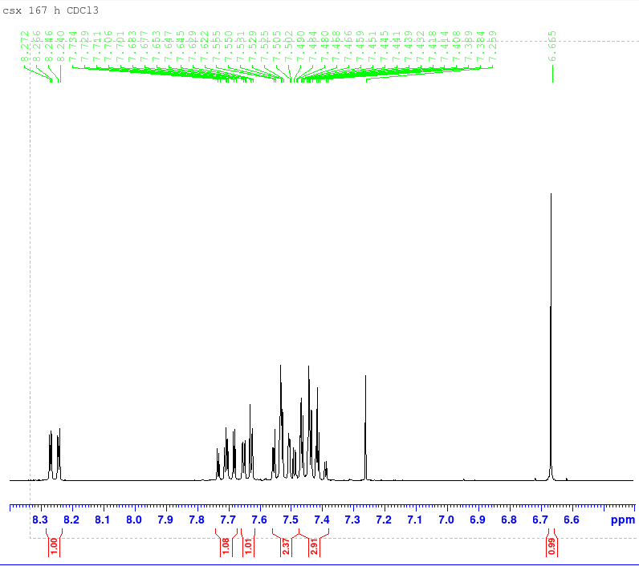

¹H NMR spectrum of compound 4c (300 MHz, CDCl₃)
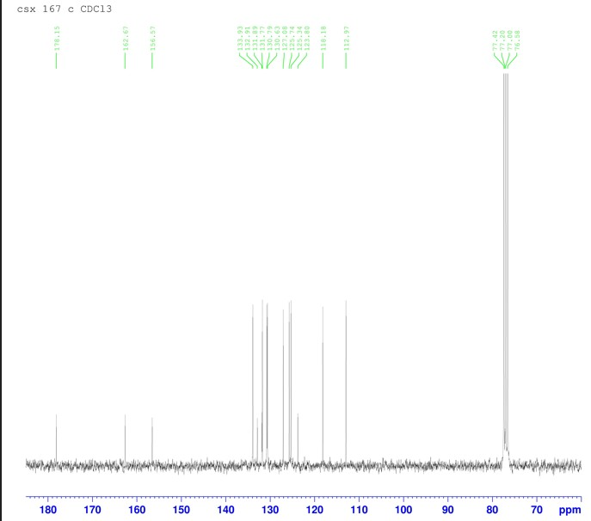
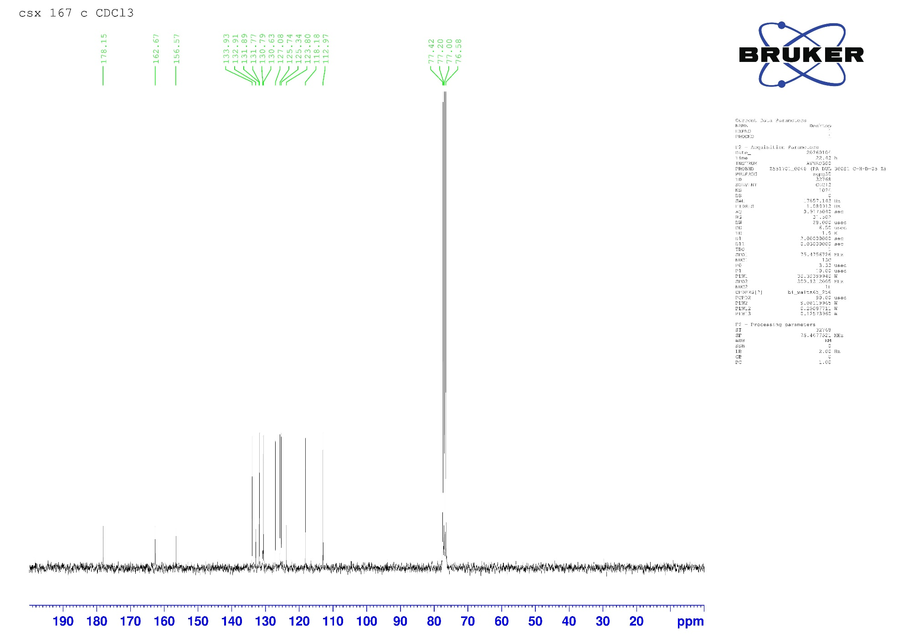

¹³C NMR spectrum of compound 4c (75 MHz, CDCl₃)
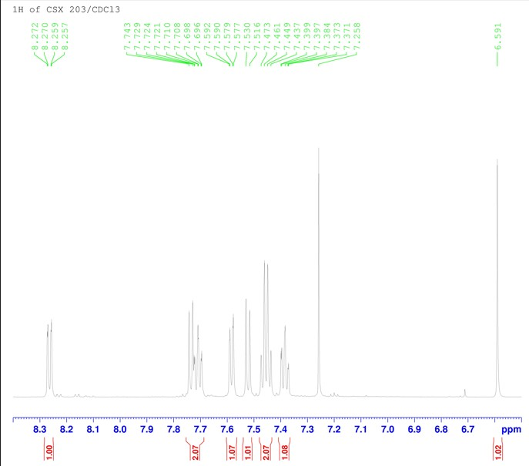
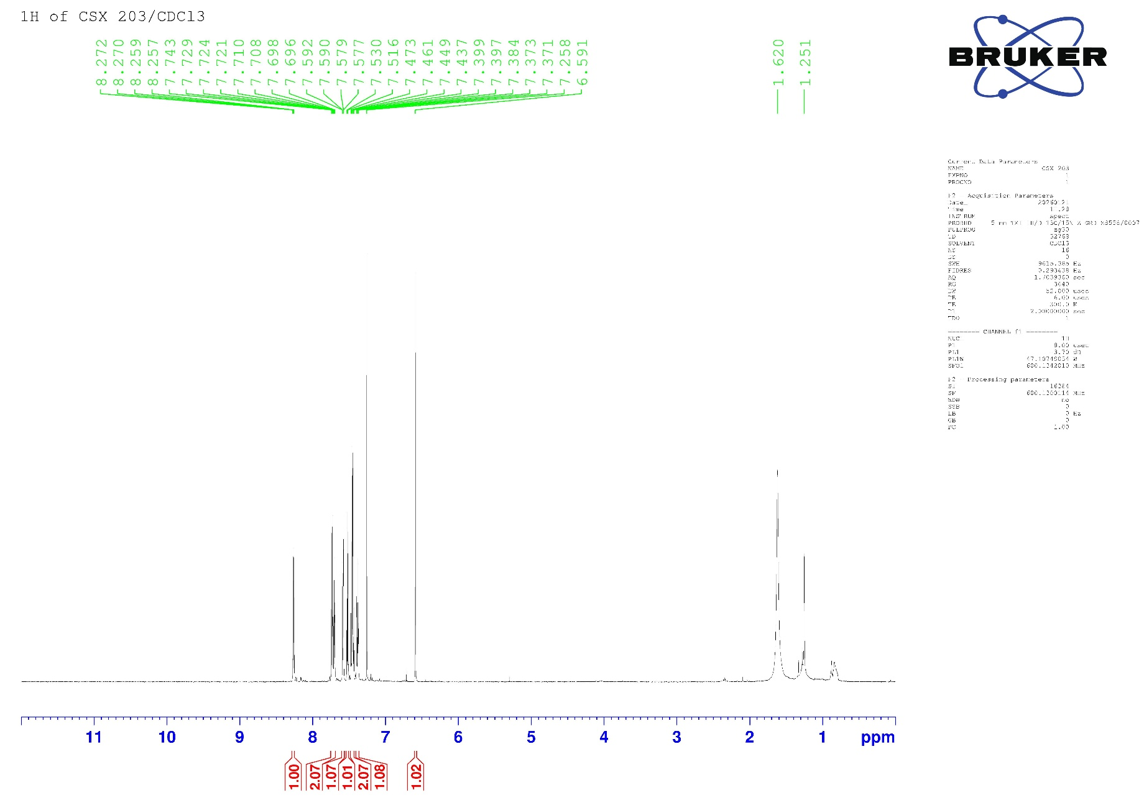
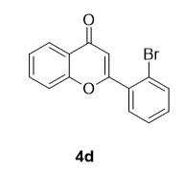

¹H NMR spectrum of compound 4d (600 MHz, CDCl₃)
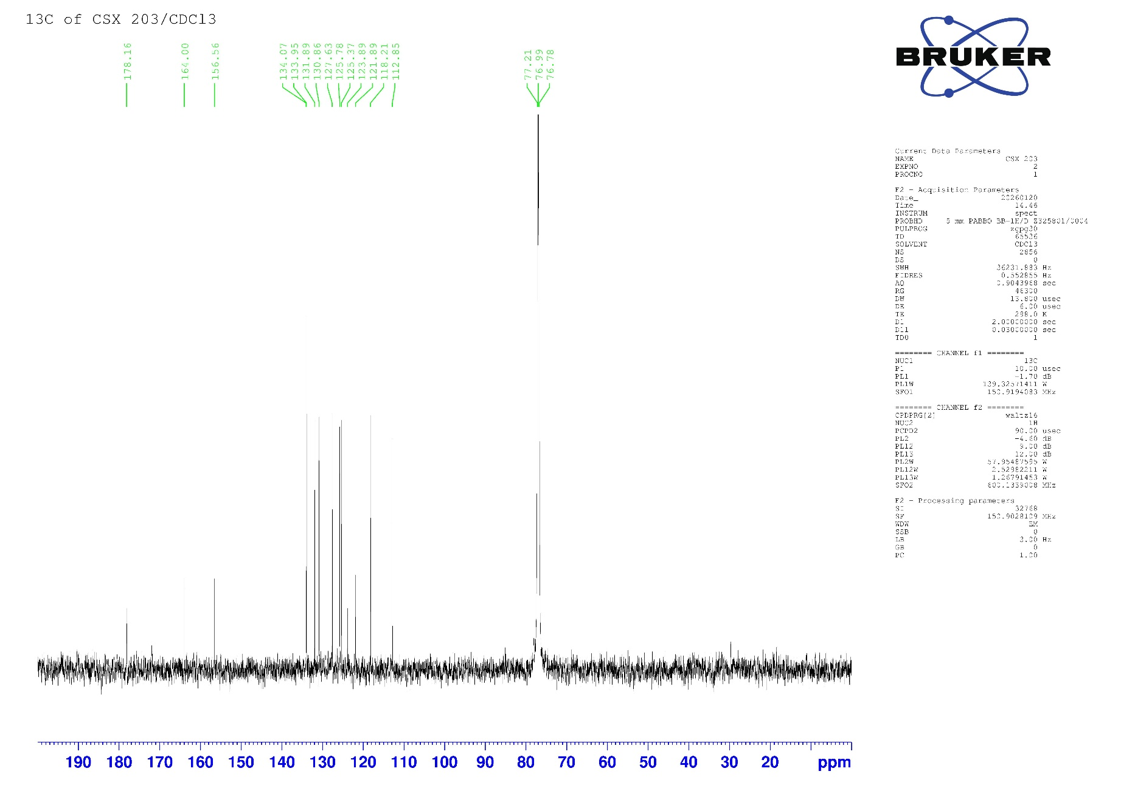
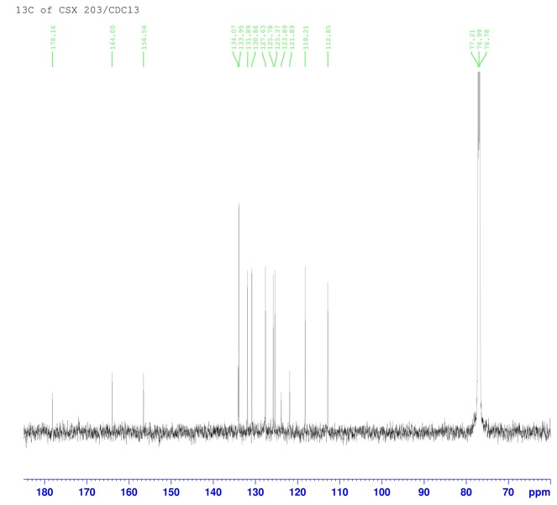

¹³C NMR spectrum of compound 4d (150 MHz, CDCl₃)
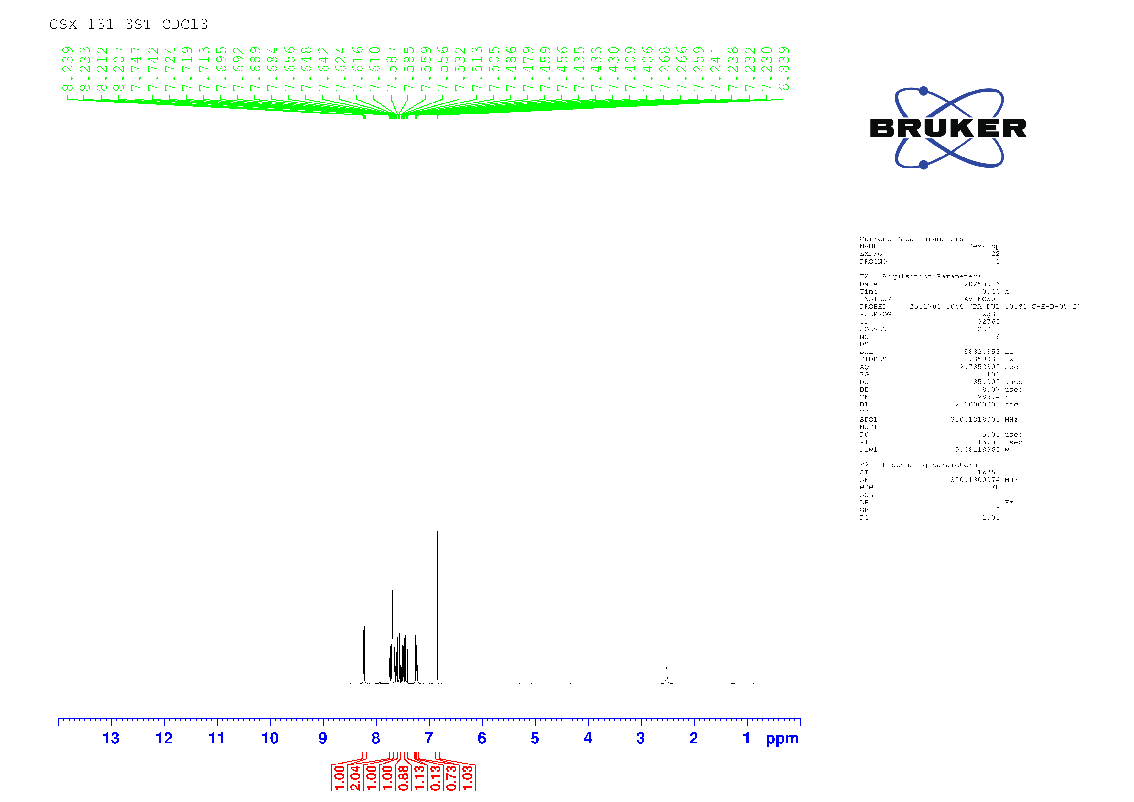
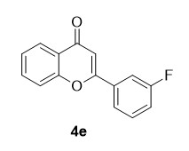

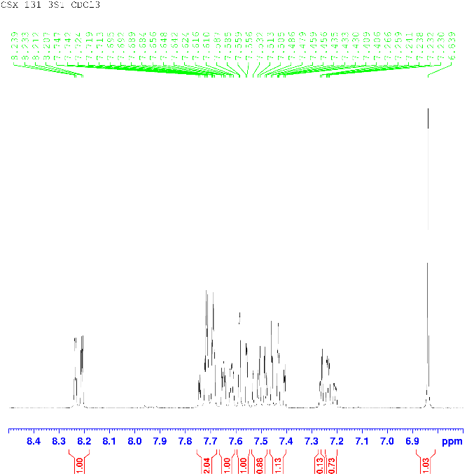
¹H NMR spectrum of compound 4e (300 MHz, CDCl₃)
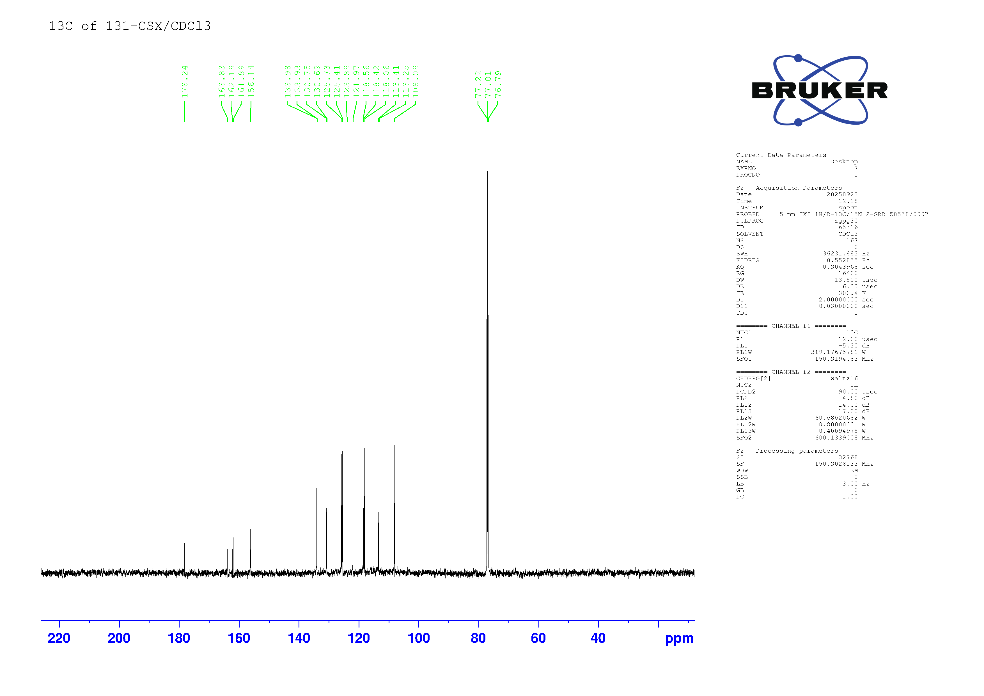

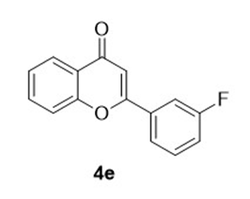

¹³C NMR spectrum of compound 4e (150 MHz, CDCl₃)
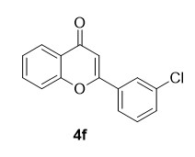
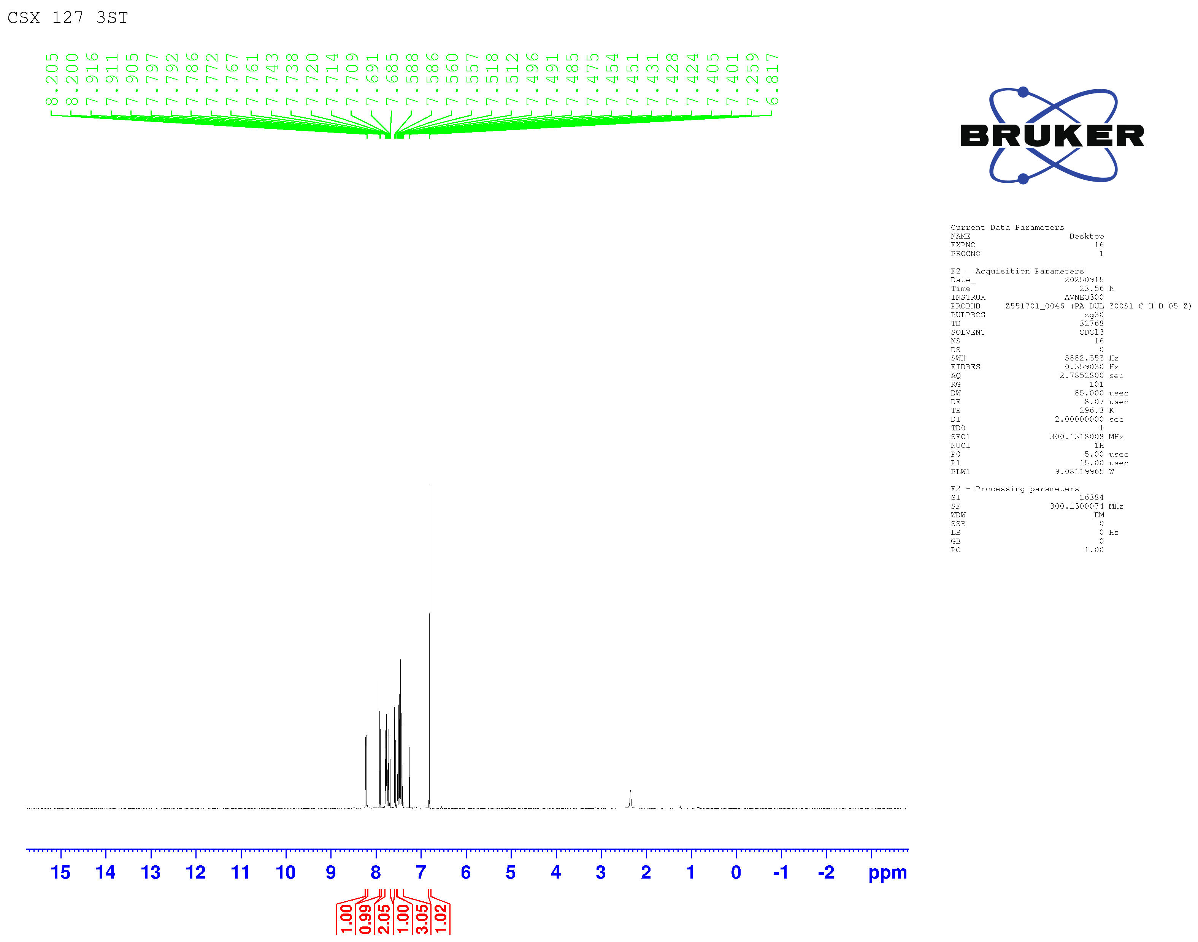

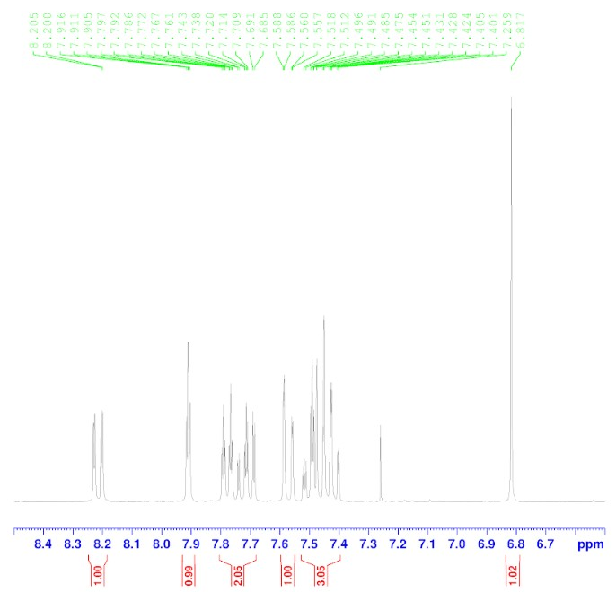

¹H NMR spectrum of compound 4f (300 MHz, CDCl₃)
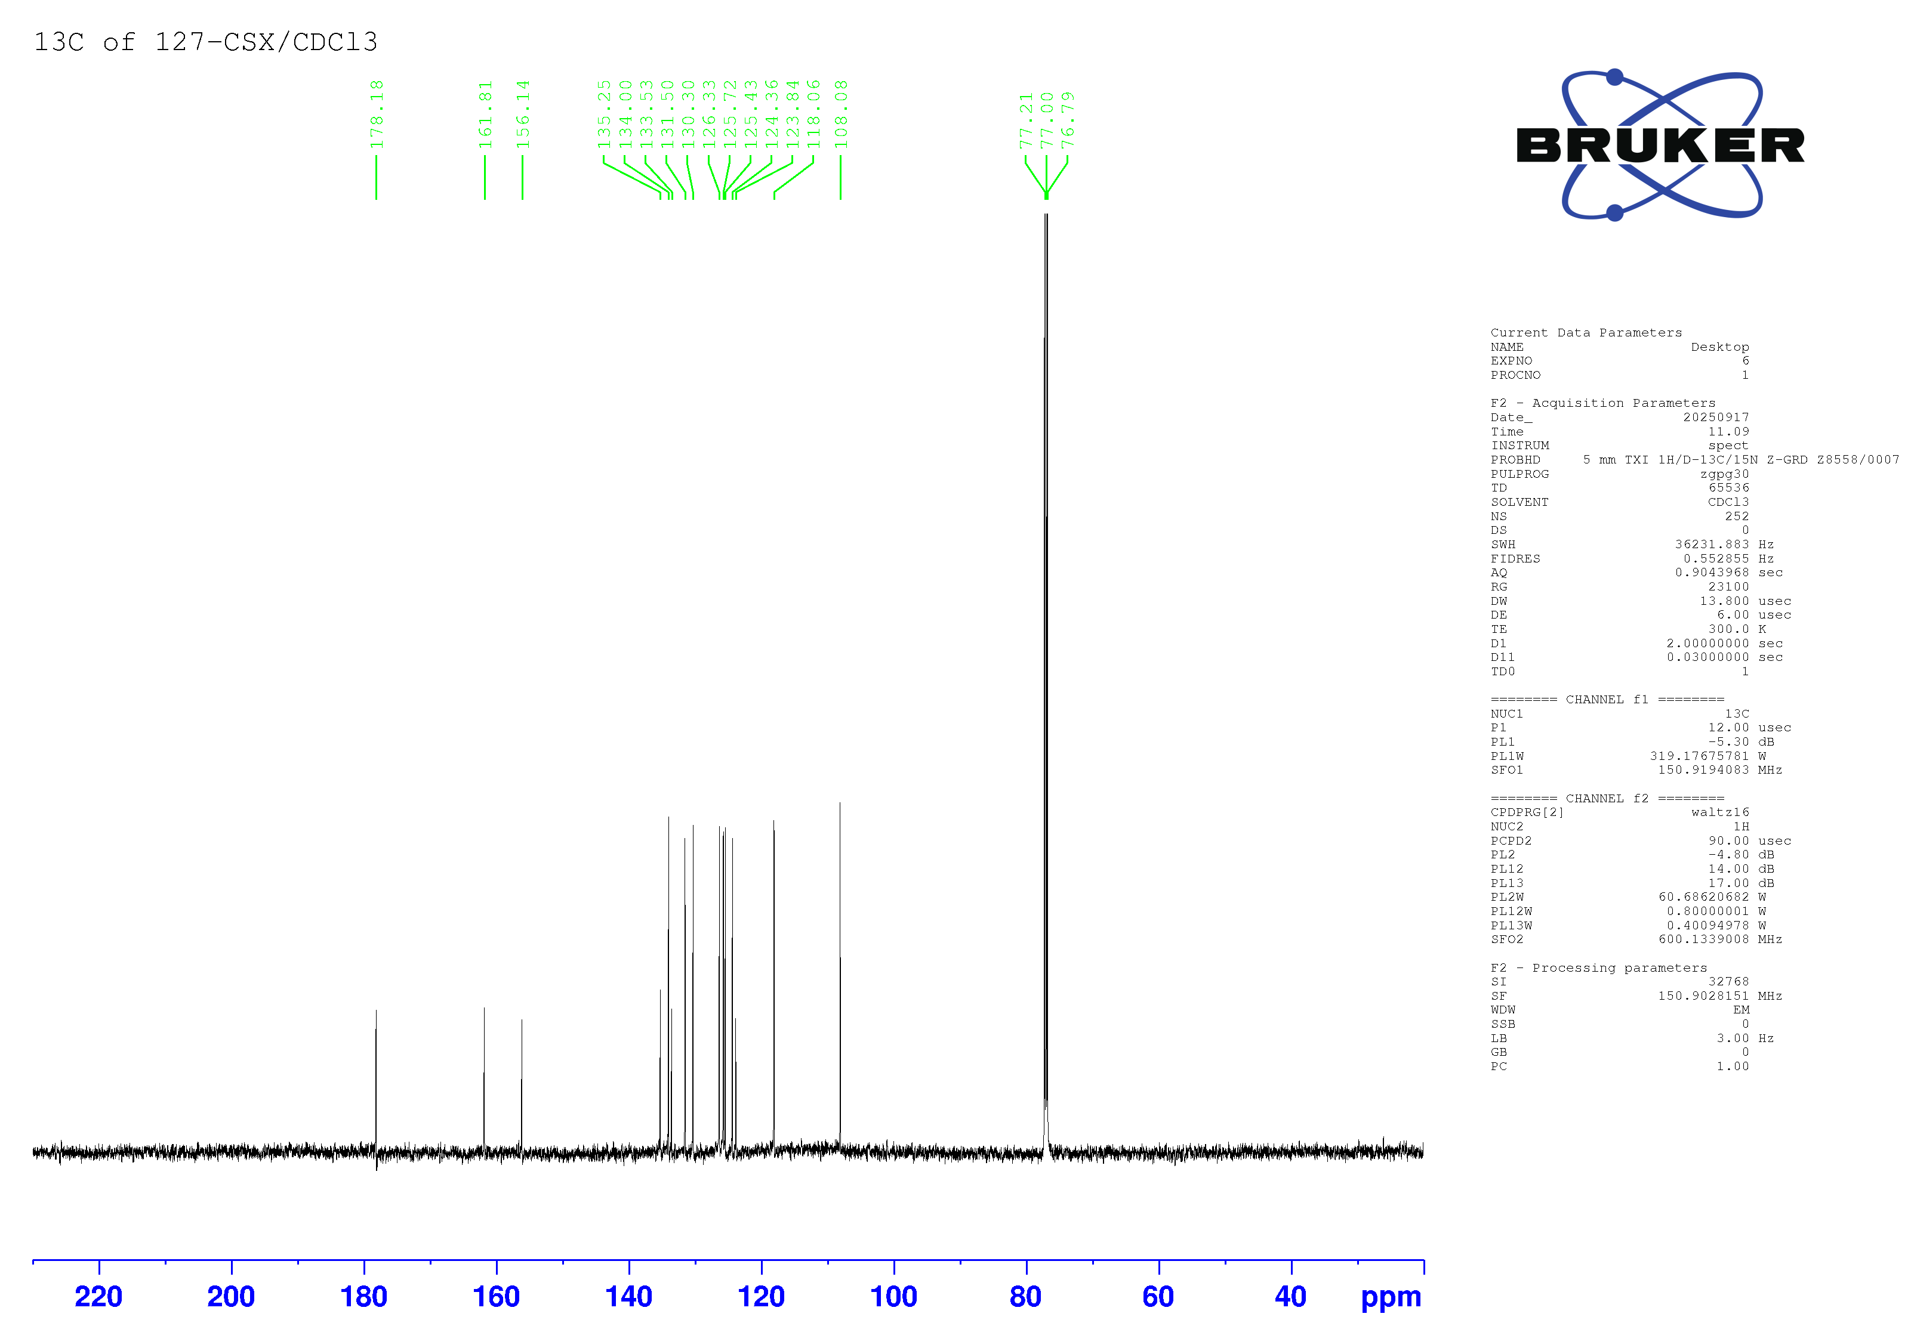

¹³C NMR spectrum of compound 4f (150 MHz, CDCl₃)
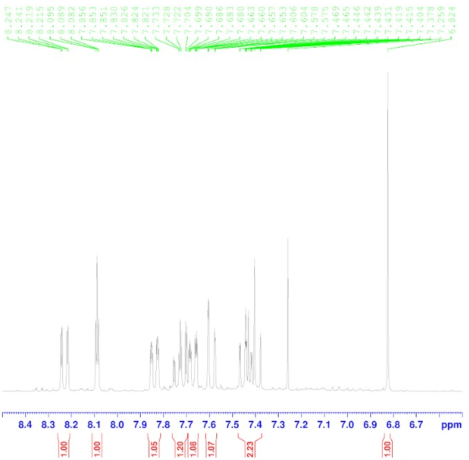
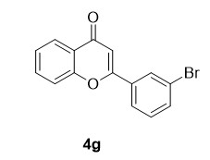
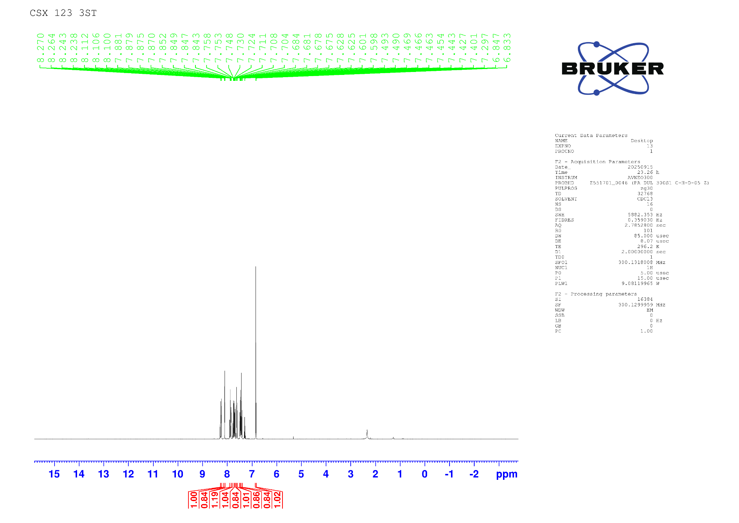

¹H NMR spectrum of compound 4g (300 MHz, CDCl₃)
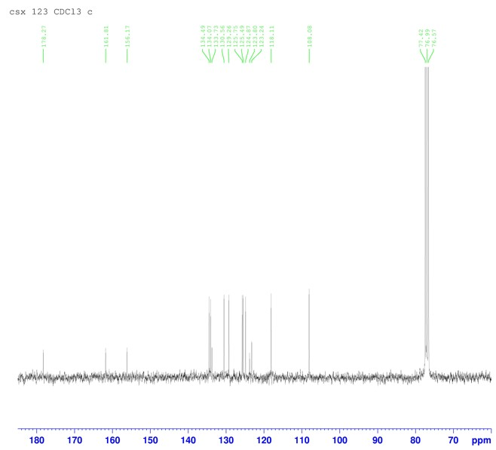
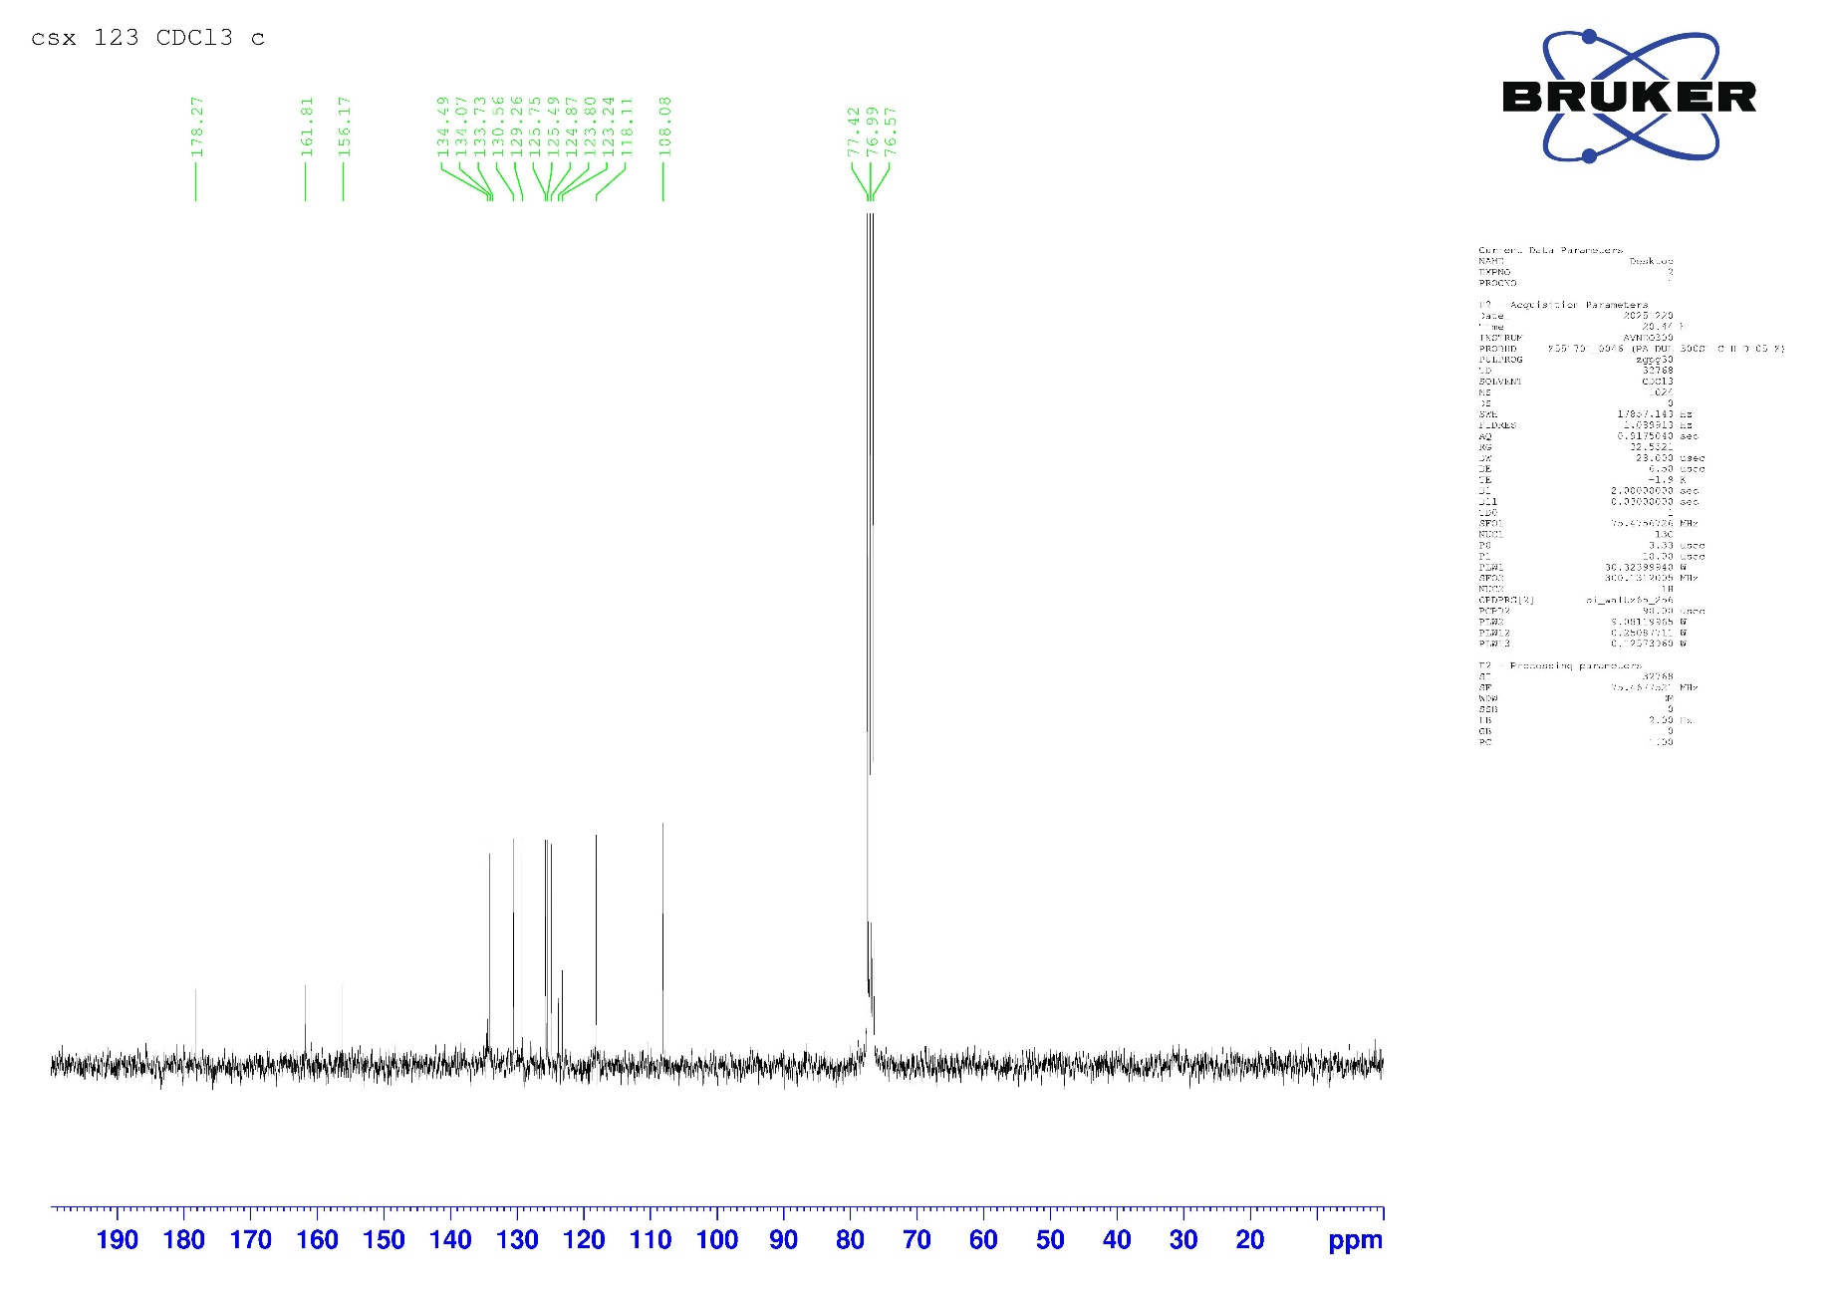

¹³C NMR spectrum of compound 4g (75 MHz, CDCl₃)
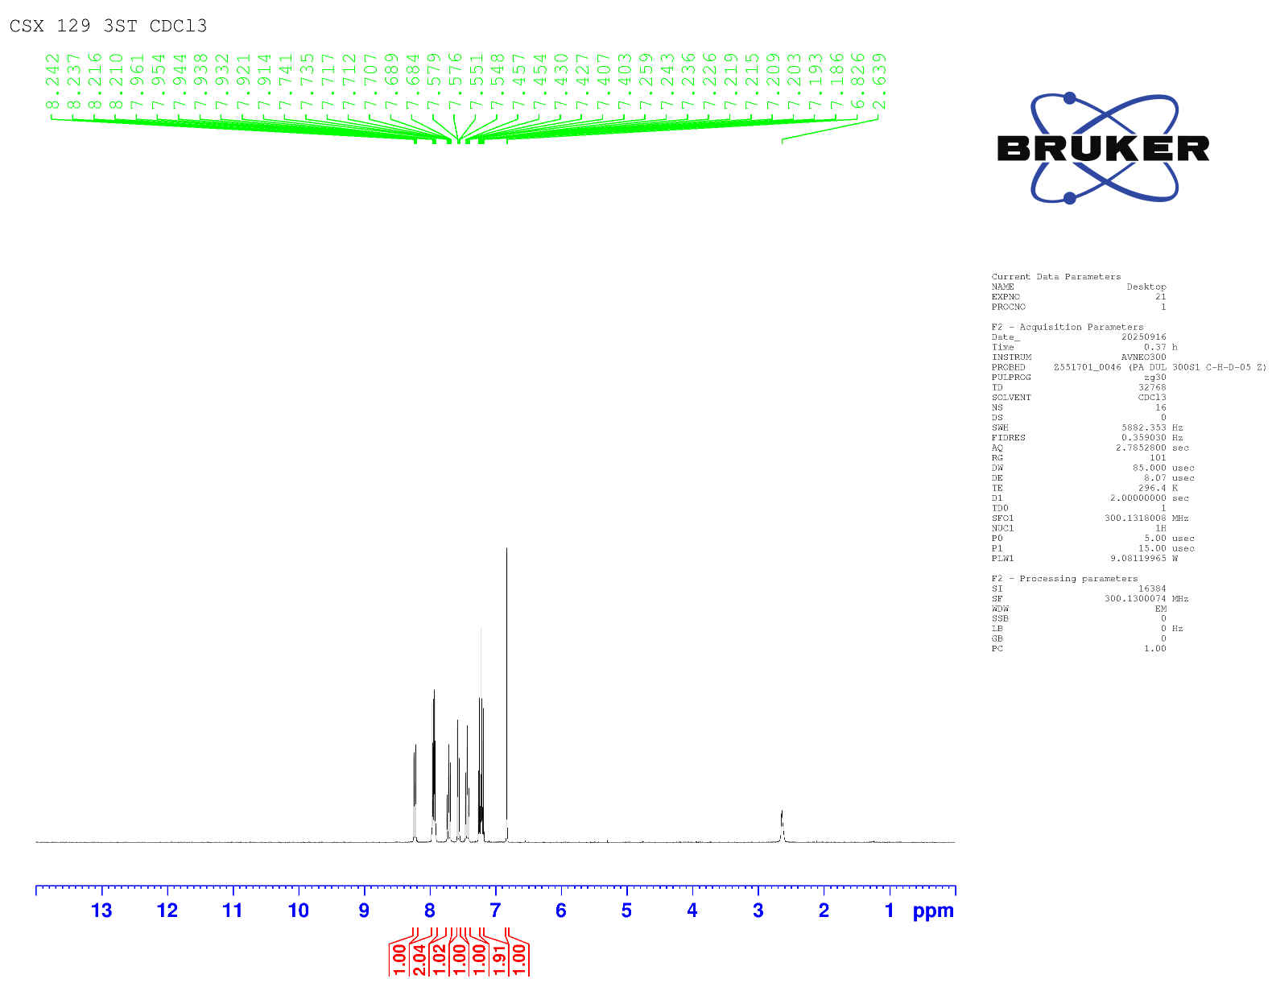
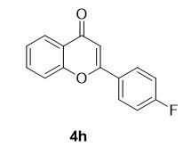

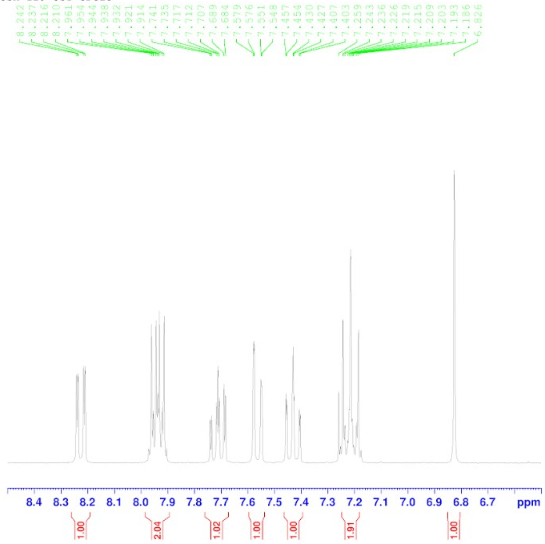

¹H NMR spectrum of compound 4h (300 MHz, CDCl₃)
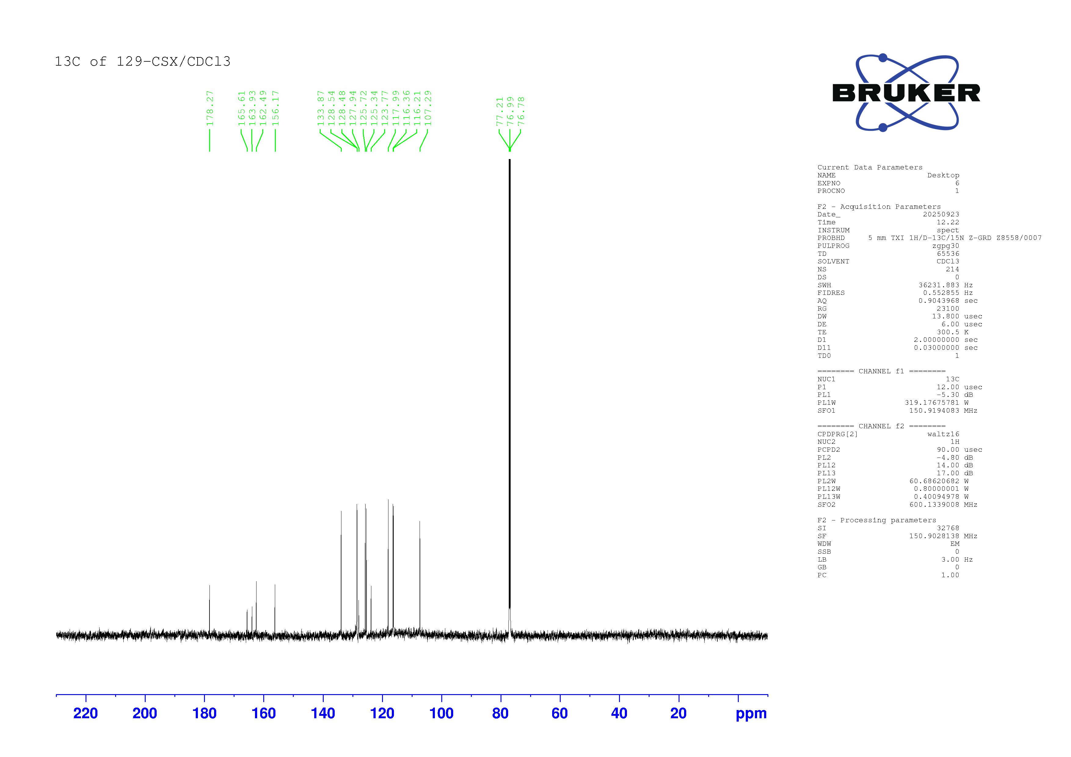

¹³C NMR spectrum of compound 4h (150 MHz, CDCl₃)
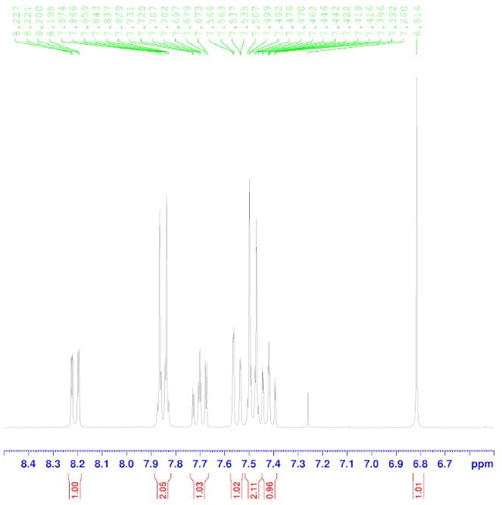
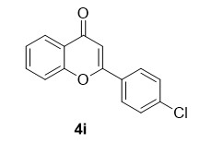
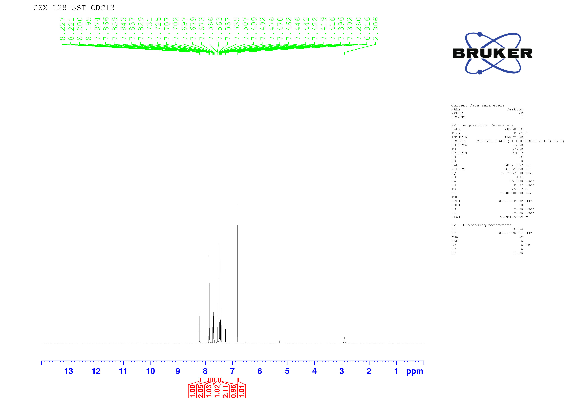

¹H NMR spectrum of compound 4i (300 MHz, CDCl₃)
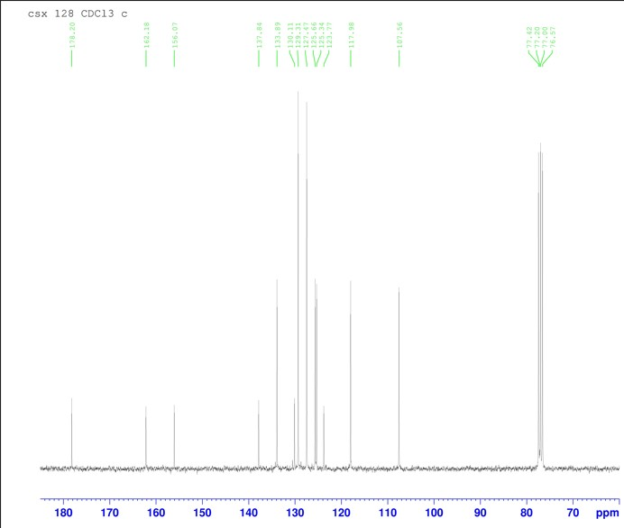
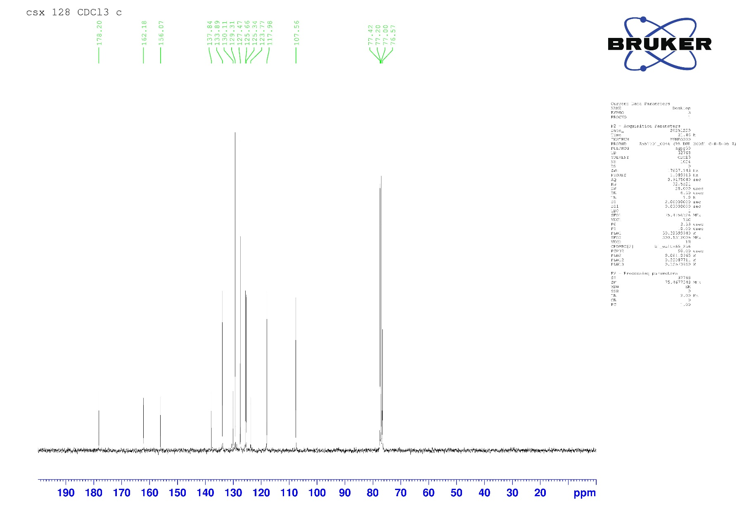

¹³C NMR spectrum of compound 4i (75 MHz, CDCl₃)
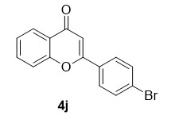
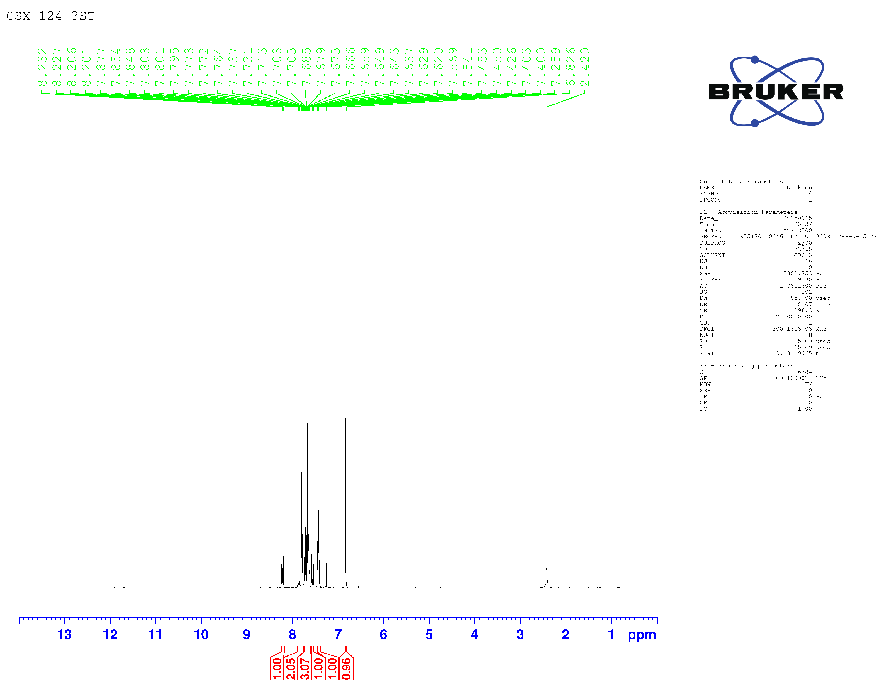

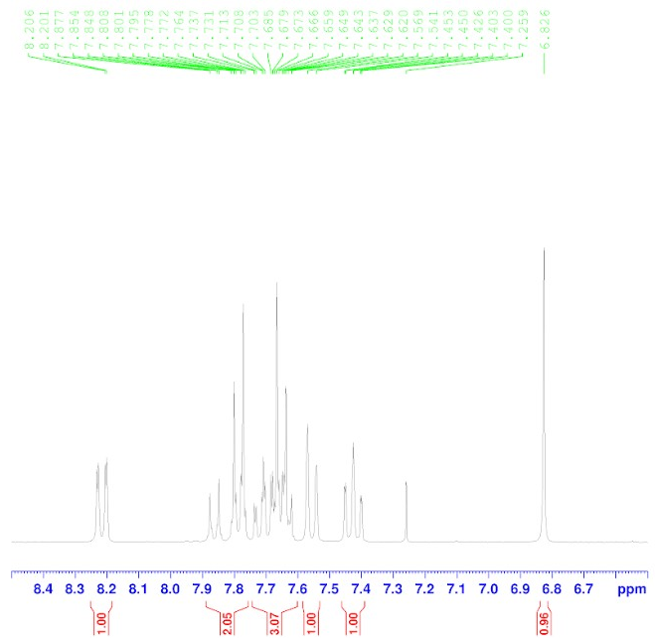

¹H NMR spectrum of compound 4j (300 MHz, CDCl₃)

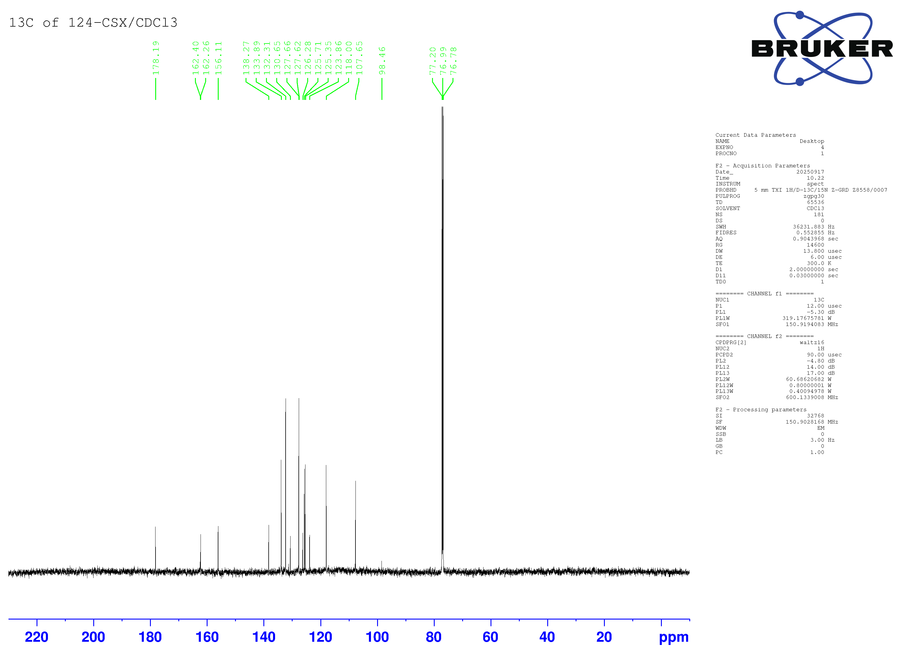

¹³C NMR spectrum of compound 4j (150 MHz, CDCl₃)

