Supplemantary Material

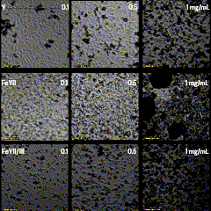

Figure S1: Morphological evaluation of cells cultured in the presence of Y, FeYII and FeYII/III at concentrations of 0.1, 0.5 and 1 mg/mL. Micrographs show the adhesion, distribution, and apparent viability of cells after the incubation period. The preservation of cell morphology indicates an adequate cytocompatibility of the materials at the concentrations evaluated, with alterations observable in some treatments at 1 mg/mL.

