Synthesis of tricyclic fused pyrrolidine nitroxides from 2-alkynylpyrrolidine-1-oxyles.
Mark M. Gulman,^{1,2} Yulia F. Polienko,¹ Sofia Yu. Trakhininа,¹ Yuri V. Gatilov,¹ Tatyana V. Rybalova,¹ Sergey. A. Dobrynin,^{1,2} Igor A.Kirilyuk¹

¹N. N. Vorozhtsov Novosibirsk Institute of Organic Chemistry SB RAS, Lavrentiev Ave. 9, Novosibirsk, 630090, Russia; dobrynin@nioch.nsc.ru
²Novosibirsk State University, PirogovaStr. 2, Novosibirsk, 630090, Russia
Supporting information
Table of contents
Experimental procedures 8
General method of synthesis nitroxides 2d,e via reaction nitrone with alkynylmagnesium bromide 8
2,2,5-Triethyl-3,4-bis(hydroxymethyl)-5-((trimethylsilyl)ethynyl)pyrrolidin-1-oxyl (2d) 9
2-(3-(Benzyloxy)prop-1-yn-1-yl)-2,5,5-triethyl-3,4-bis(hydroxymethyl)pyrrolidin-1-oxyl (2e) 9
2-(3-(Dimethylamino)prop-1-yn-1-yl)-2,5,5-triethyl-3,4-bis(hydroxymethyl)pyrrolidin-1-oxyl (2f) 9
General method of mesylation of nitroxides 10
2,2,5-Triethyl-5-ethynyl-3,4-bis(((methylsulfonyl)oxy)methyl)pyrrolidin-1-oxyl (3a) 10
2,2,5-Triethyl-3,4-bis(((methylsulfonyl)oxy)methyl)-5-(phenylethynyl)pyrrolidin-1-oxyl (3b) 11
2,2,5-Triethyl-3,4-bis(((methylsulfonyl)oxy)methyl)-5-(3-((methylsulfonyl)oxy)prop-1-yn-1-yl)pyrrolidin-1-oxyl (3c) 11
2,2,5-Triethyl-3,4-bis(((methylsulfonyl)oxy)methyl)-5-((trimethylsilyl)ethynyl)pyrrolidin-1-oxyl (3d) 11
2-(3-(Benzyloxy)prop-1-yn-1-yl)-2,5,5-triethyl-3,4-bis(((methylsulfonyl)oxy)methyl)pyrrolidin-1-oxyl (3e) 12
2-(3-(Dimethylamino)prop-1-yn-1-yl)-2,5,5-triethyl-3,4-bis(((methylsulfonyl)oxy)methyl)pyrrolidin-1-oxyl (3f) 12
General method synthesis of tricyclic fused triazole derivatives 12
6-(Azidomethyl)-3b,5,5-triethyl-3b,4,5,6,6a,7-hexahydropyrrolo[2',3':3,4]pyrrolo[1,2-c][1,2,3]triazol-4-oxyl (4a) 13
6-(Azidomethyl)-3b,5,5-triethyl-3-phenyl-3b,4,5,6,6a,7-hexahydropyrrolo[2',3':3,4]pyrrolo[1,2-c][1,2,3]triazol-4-oxyl (4b) 13
3,6-Bis(azidomethyl)-3b,5,5-triethyl-3b,4,5,6,6a,7-hexahydropyrrolo[2',3':3,4]pyrrolo[1,2-c][1,2,3]triazol-4-oxyl (4c) 13
6-(Azidomethyl)-3b,5,5-triethyl-3-(trimethylsilyl)-3b,4,5,6,6a,7-hexahydropyrrolo[2',3':3,4]pyrrolo[1,2-c][1,2,3]triazol-4-oxyl (4d) 13
6-(Azidomethyl)-3-((benzyloxy)methyl)-3b,5,5-triethyl-3b,4,5,6,6a,7-hexahydropyrrolo[2',3':3,4]pyrrolo[1,2-c][1,2,3]triazol-4-oxyl (4e) 14
6-(Azidomethyl)-3-((dimethylamino)methyl)-3b,5,5-triethyl-3b,4,5,6,6a,7-hexahydropyrrolo[2',3':3,4]pyrrolo[1,2-c][1,2,3]triazol-4-oxyl (4f) 14
3,4-Bis(acetoxymethyl)-2,2,5-triethyl-5-ethynylpyrrolidin-1-oxyl (5) 14
General method synthesis of alkynones 14
3,4-Bis(acetoxymethyl)-2,2,5-triethyl-5-(3-oxo-3-phenylprop-1-yn-1-yl)pyrrolidin-1-oxyl (6a) 15
3,4-Bis(((methylsulfonyl)oxy)methyl)-2,2,5-triethyl-5-(3-oxo-3-phenylprop-1-yn-1-yl)pyrrolidin-1-oxyl (6b) 15
2,2,6a-Triethyl-3-(hydroxymethyl)-1-6-(2-oxoethylidene)hexahydro-1H-furo[3,4-b]pyrrol-1-oxyl (8) 15
2,2,5-Triethyl-3,4-bis(hydroxymethyl)-5-(5-phenyl-1H-pyrazol-3-yl)pyrrolidin-1-oxyl (9a) 15
Annulated tricyclic pyrazole derivatives synthesis 16
3b,5,5-Triethyl-6-(((methylsulfonyl)oxy)methyl)-2-phenyl-3b,4,5,6,6a,7-hexahydropyrrolo[2',3':3,4]pyrrolo[1,2-b]pyrazol-4-oxyl (9b) 17
3b,5,5-Triethyl-6-(hydroxymethyl)-2-phenyl-3b,4,5,6,6a,7-hexahydropyrrolo[2',3':3,4]pyrrolo[1,2-b]pyrazol-4-oxyl (9c) 17
NMR spectra 19
Figure S1. ¹H NMR (300 MHz, CD₃OD, Zn/CF₃COOH) of 2,2,5-triethyl-3,4-bis(hydroxymethyl)-5-((trimethylsilyl)ethynyl)pyrrolidin-1-oxyl (2d) 19
Figure S2. ¹H NMR (300 MHz, CD₃OD, Zn/CF₃COOH) of 2-(3-(benzyloxy)prop-1-yn-1-yl)-2,5,5-triethyl-3,4-bis(hydroxymethyl)pyrrolidin-1-oxyl (2e) 19
Figure S3. ¹H NMR (500 MHz, CD₃OD, Zn/CF₃COOH) of 2-(3-(dimethylamino)prop-1-yn-1-yl)-2,5,5-triethyl-3,4-bis(hydroxymethyl)pyrrolidin-1-oxyl (2f) 20
Figure S4. ¹H NMR (300 MHz, CD₃OD, Zn/CF₃COOH) of 2,2,5-triethyl-5-ethynyl-3,4-bis(((methylsulfonyl)oxy)methyl)pyrrolidin-1-oxyl (3a) 20
Figure S5. ¹H NMR (300 MHz, CD₃OD, Zn/CF₃COOH) of 2,2,5-triethyl-3,4-bis(((methylsulfonyl)oxy)methyl)-5-(phenylethynyl)pyrrolidin-1-oxyl (3b) 21
Figure S6. ¹H NMR (300 MHz, CD₃OD, Zn/CF₃COOH) of 2,2,5-triethyl-3,4-bis(((methylsulfonyl)oxy)methyl)-5-((trimethylsilyl)ethynyl)pyrrolidin-1-oxyl (3d) 21
Figure S7. ¹H NMR (300 MHz, CD₃OD, Zn/CF₃COOH) of 2-(3-(dimethylamino)prop-1-yn-1-yl)-2,5,5-triethyl-3,4-bis(((methylsulfonyl)oxy)methyl)pyrrolidin-1-oxyl (3e) 22
Figure S8. ¹H NMR (400 MHz, CD₃OD, Zn/CF₃COOH) of 2-(3-(dimethylamino)prop-1-yn-1-yl)-2,5,5-triethyl-3,4-bis(((methylsulfonyl)oxy)methyl)pyrrolidin-1-oxyl (3f) 22
Figure S9. ¹H NMR (400 MHz, CD₃OD, Zn/CF₃COOH) of 3,4-bis(acetoxymethyl)-2,2,5-triethyl-5-ethynylpyrrolidin-1-oxyl (5) 23
Figure S10. ¹H NMR (300 MHz, CD₃OD, Zn/CF₃COOH) of 2,2,5-triethyl-3,4-bis(hydroxymethyl)-5-(3-phenyl-1H-pyrazol-5-yl)pyrrolidin-1-oxyl (9a) 23
Figure S11. ¹H NMR (300 MHz, CD₃OD, Zn/CF₃COOH) of 3b,5,5-triethyl-6-(((methylsulfonyl)oxy)methyl)-2-phenyl-3b,4,5,6,6a,7-hexahydropyrrolo[2',3':3,4]pyrrolo[1,2-b]pyrazol-4-oxyl (9b) 24
Figure S12. ¹H NMR (300 MHz, CD₃OD, Zn/CF₃COOH) of 3b,5,5-triethyl-6-(hydroxymethyl)-2-phenyl-3b,4,5,6,6a,7-hexahydropyrrolo[2',3':3,4]pyrrolo[1,2-b]pyrazol-4-oxyl (9c) 24
IR spectra 25
Figure S13. IR (KBr) of 2,2,5-triethyl-3,4-bis(hydroxymethyl)-5-((trimethylsilyl)ethynyl)pyrrolidin-1-oxyl (2d) 25
Figure S14. IR (neat) of 2-(3-(benzyloxy)prop-1-yn-1-yl)-2,5,5-triethyl-3,4-bis(hydroxymethyl)pyrrolidin-1-oxyl (2e) 25
Figure S15. IR (neat) of 2-(3-(dimethylamino)prop-1-yn-1-yl)-2,5,5-triethyl-3,4-bis(hydroxymethyl)pyrrolidin-1-oxyl (2f) 26
Figure S16. IR (KBr) of 2,2,5-triethyl-5-ethynyl-3,4-bis(((methylsulfonyl)oxy)methyl)pyrrolidin-1-oxyl (3a) 26
Figure S17. IR (neat) of 2,2,5-triethyl-3,4-bis(((methylsulfonyl)oxy)methyl)-5-(phenylethynyl)pyrrolidin-1-oxyl (3b) 26
Figure S18. IR (neat) of 2,2,5-triethyl-3,4-bis(((methylsulfonyl)oxy)methyl)-5-(3-((methylsulfonyl)oxy)prop-1-yn-1-yl)pyrrolidin-1-oxyl (3c) 27
Figure S19. IR (neat) of 2,2,5-triethyl-3,4-bis(((methylsulfonyl)oxy)methyl)-5-((trimethylsilyl)ethynyl)pyrrolidin-1-oxyl (3d) 27
Figure S20. IR (neat) of 2-(3-(benzyloxy)prop-1-yn-1-yl)-2,5,5-triethyl-3,4-bis(((methylsulfonyl)oxy)methyl)pyrrolidin-1-oxyl (3e) 27
Figure S21. IR (neat) of 2-(3-(dimethylamino)prop-1-yn-1-yl)-2,5,5-triethyl-3,4-bis(((methylsulfonyl)oxy)methyl)pyrrolidin-1-oxyl (3f) 28
Figure S22. IR (KBr) of 6-(azidomethyl)-3b,5,5-triethyl-3b,4,5,6,6a,7-hexahydropyrrolo[2',3':3,4]pyrrolo[1,2-c][1,2,3]triazol-4-oxyl (4a) 28
Figure S23. IR (KBr) of 6-(azidomethyl)-3b,5,5-triethyl-3-phenyl-3b,4,5,6,6a,7-hexahydropyrrolo[2',3':3,4]pyrrolo[1,2-c][1,2,3]triazol-4-oxyl (4b) 28
Figure S24. IR (KBr) of 3,6-bis(azidomethyl)-3b,5,5-triethyl-3b,4,5,6,6a,7-hexahydropyrrolo[2',3':3,4]pyrrolo[1,2-c][1,2,3]triazol-4-oxyl (4c) 29
Figure S25. IR (KBr) of 6-(azidomethyl)-3b,5,5-triethyl-3-(trimethylsilyl)-3b,4,5,6,6a,7-hexahydropyrrolo[2',3':3,4]pyrrolo[1,2-c][1,2,3]triazol-4-oxyl (4d) 29
Figure S26. IR (neat) of 6-(azidomethyl)-3-((benzyloxy)methyl)-3b,5,5-triethyl-3b,4,5,6,6a,7-hexahydropyrrolo[2',3':3,4]pyrrolo[1,2-c][1,2,3]triazol-4-oxyl (4e) 29
Figure S27. IR (neat) of 6-(azidomethyl)-3-((dimethylamino)methyl)-3b,5,5-triethyl-3b,4,5,6,6a,7-hexahydropyrrolo[2',3':3,4]pyrrolo[1,2-c][1,2,3]triazol-4-oxyl (4f) 30
Figure S28. IR (neat) of 3,4-bis(acetoxymethyl)-2,2,5-triethyl-5-ethynylpyrrolidin-1-oxyl (5) 30
Figure S29. IR (neat) of 3,4-bis(acetoxymethyl)-2,2,5-triethyl-5-(3-oxo-3-phenylprop-1-yn-1-yl)pyrrolidin-1-oxyl (6a) 30
Figure S30. IR (neat) of 2,2,5-triethyl-3,4-bis(((methylsulfonyl)oxy)methyl)-5-(3-oxo-3-phenylprop-1-yn-1-yl)pyrrolidin-1- oxyl (6b) 31
Figure S31. IR (KBr) of (Z)-2,2,6a-triethyl-3-(hydroxymethyl)-6-(2-oxoethylidene)hexahydro-1H-furo[3,4-b]pyrrol-1-oxyl (8) 31
Figure S32. IR (neat) 2,2,5-triethyl-3,4-bis(hydroxymethyl)-5-(3-phenyl-1H-pyrazol-5-yl)pyrrolidin-1-oxyl (9a) 31
Figure S33. IR (neat) 3b,5,5-triethyl-6-(((methylsulfonyl)oxy)methyl)-2-phenyl-3b,4,5,6,6a,7-hexahydropyrrolo[2',3':3,4]pyrrolo[1,2-b]pyrazol-4-oxyl (9b) 32
Figure S34. IR (KBr) 3b,5,5-triethyl-6-(hydroxymethyl)-2-phenyl-3b,4,5,6,6a,7-hexahydropyrrolo[2',3':3,4]pyrrolo[1,2-b]pyrazol-4-oxyl (9c) 32
EPR measurements 33
X-ray crystallographic analysis 41

Experimental procedures
All commercially available solvents and reagents were of highest quality and used without further purification. Nitrone 1 and nitroxides 2a-c was prepared according to the literature protocols [1]. NMR spectra for nitroxides were recorded after reduction by Zn/CF3COOH system in CD3OD as describe [S1, S2]. ¹H NMR spectra were recorded at 300, 400 or 500 MHz on BRUKER Avance AV 300, AV 400 and DRX 500 spectrometers, as indicated next to each NMR analysis. ¹H chemical shifts (δ) were internally referenced to the residual solvent peak. The J values in ¹H NMR spectra are given in Hz. The IR spectra were acquired on a FTIR spectrometer in KBr or neat. The UV spectra were recorded in EtOH (10⁻⁴ M solutions). The progress of the reactions was monitored by TLC and carried out using UV light at 254 nm, 10% solution of phosphomolybdic acid in ethanol, and/or Dragendorff reagent as visualizing agents. Column chromatography was performed on silica gel 60 (70−230 mesh). HRMS were recorded on double-focusing, high-resolution mass spectrometer equipped with a high-performance toroidal ESA and quadrupole time-of-flight mass spectrometer\
S1. Dobrynin, S. A.; Gulman, M. M.; Morozov, D. A.; Zhurko, I. F.; Taratayko, A. I.; Sotnikova, Y. S.; Glazachev, Y. I.; Gatilov, Y. V.; Kirilyuk, I. A. Synthesis of Sterically Shielded Nitroxides Using the Reaction of Nitrones with Alkynylmagnesium Bromides. Molecules 2022, 27 (21), 7626–7626. https://doi.org/10.3390/molecules27217626.
S2. Dobrynin, S. A.; Usatov, M. S.; Zhurko, I. F.; Morozov, D. A.; Polienko, Y. F.; Glazachev, Y. I.; Parkhomenko, D. A.; Tyumentsev, M. A.; Gatilov, Y. V.; Chernyak, E. I.; Bagryanskaya, E. G.; Kirilyuk, I. A. A Simple Method of Synthesis of 3-Carboxy-2,2,5,5-Tetraethylpyrrolidine-1-Oxyl and Preparation of Reduction-Resistant Spin Labels and Probes of Pyrrolidine Series. Molecules 2021, 26 (19), 5761–5761. https://doi.org/10.3390/molecules26195761.

General method of synthesis nitroxides 2d,e via reaction nitrone with alkynylmagnesium bromide
A solution of corresponding terminal alkyne (trimethylsilylacetylene or benzyl propargyl ether) (0.14 mol) in dry THF (30 mL) was added dropwise to a solution of EtMgBr (2 M in THF, 70 mL). The mixture was stirred at room temperature for 30 min. A solution of nitrone 1 (5 g, 13.4 mmol) in dry THF (50 mL) was added to reaction mixture, and stirred for 3 days at room temperature, monitored by TLC (SiO₂, MeOH:ethyl acetate = 1:9, UV light for visualization). Upon completion, reaction mixture was quenched with water (10–15 mL). The precipitate was washed with ether (4 × 15 mL), and the combined organic phase was evaporated under reduced pressure The residue was dissolved in a mixture of methanol (50 mL) and water (10 mL). Pyridinium p-toluenesulfonate ( 2 g, 8 mmol) was then added. The mixture stirred in air for oxidation (8 h). The reaction was monitored by TLC (SiO₂, MeOH:ethyl acetate = 1:9, Dragendorff reagent for visualization). After deprotection and oxidation, the reaction mixture was basified with 10 mL of 1 M aqueous solution of Na₂CO₃, and the methanol was removed in vacuum. The aqueous layer was extracted with ether (3 × 15 mL), dried over (Na₂CO₃), and evaporated in vacuum. The residue was purified by column chromatography (SiO₂, mixture of hexane and ethyl acetate).

2,2,5-Triethyl-3,4-bis(hydroxymethyl)-5-((trimethylsilyl)ethynyl)pyrrolidin-1-oxyl (2d)
Yield 2.9 g (64%), yellow crystals, m.p. 69-74 °C. IR (KBr) ν_{max} (cm⁻¹): 3473 (O-H), 3363 (O-H), 2968 (C-H), 2941 (C-H), 2881 (C-H), (C-H). 2171 (C≡C), 1247 (Si-CH₃); Anal. Calcd for C₁₇H₃₂NO₃Si: C, 62.53; H, 9.88; N, 4.29; SiO₂, 18.40; found: C, 62.40; H, 9.98; N, 4.57. SiO₂, 18.45; HRMS (EI/DFS) m/z [M]⁺ Calcd. for C₁₇H₃₂NO₃²⁸Si: 326.2146; found: 326.2141; ¹H NMR (300 МHz, CD₃OD, Zn/CF₃COOH, δ (ppm)): 0.21 (s, 9H), 0.97 (t, J_{t}=7.4 Hz, 3H), 0.97 (t, J_{t}=7.4 Hz, 3H), 1.19 (t, J_{t}=7.2 Hz, 3H), 1.85 (dq, J_{d}=-14.0 Hz, J_{q}=7.4 Hz, 1H), 1.94 (dq, J_{d}=-14.0 Hz, J_{q}=7.4 Hz, 1H), 2.00 (dq, J_{d}=-13.6 Hz, J_{q}=7.4 Hz, 1H), 2.11 (dq, J_{d}=-13.6 Hz, J_{q}=7.4 Hz, 1H), 2.14 (dq, J_{d}=-13.2 Hz, J_{q}=7.2 Hz, 1H), 2.23 (dq, J_{d}=-13.2 Hz, J_{q}=7.2 Hz, 1H), 2.29 (dd, J_{d1}=2.3 Hz, J_{d2}=2.3 Hz, 1H), 3.29 (ddd, J_{d1}=6.0 Hz, J_{d2}=4.2 Hz, J_{d3}=4.2 Hz, 1H), 3.71 (d, J_{d}=4.2 Hz, 2H), 3.81 (dd, J_{d1}=2.3 Hz, J_{d2}=-12.1 Hz, 1H), 3.89 (dd, J_{d1}=2.3 Hz, J_{d2}=-12.1 Hz 1H).

2-(3-(Benzyloxy)prop-1-yn-1-yl)-2,5,5-triethyl-3,4-bis(hydroxymethyl)pyrrolidin-1-oxyl (2e)
Yield 3.3g (66%), yellow oil, IR (neat) ν_{max} (cm⁻¹): 3375 (O-H), 3089 (=C-H), 3064 (=C-H), 3031 (=C-H), 2970 (C-H), 2939 (C-H), 2881 (C-H). Anal. Calcd for C₂₂H₃₂NO₄: C, 70.56; H, 8.61; N, 3.74; Found: C, 70.70; H, 8.84; N, 3.46. HRMS (EI/DFS) m/z [M]⁺ Calcd. for C₂₂H₃₂NO₄: 374.2326; found: 374.2324. ¹H NMR (300 МHz, CD₃OD, Zn/CF₃COOH, δ (ppm)): 0.96 (t, J_{t}=7.5 Hz, 3H), 0.99 (t, J_{t}=7.4 Hz, 3H), 1.21 (t, J_{t}=7.1 Hz, 3H), 1.89 (dq, J_{d}=-14.7 Hz, J_{q}=7.5 Hz, 1H), 1.97 (dq, J_{d}=-14.2 Hz, J_{q}=7.1 Hz, 1H), 2.03 (dq, J_{d}=-14.2 Hz, J_{q}=7.2 Hz, 1H), 2.10 (dq, J_{d}=-14.0 Hz, J_{q}=7.4 Hz, 1H), 2.13 (dq, J_{d}=-14.0 Hz, J_{q}=7.4 Hz, 1H), 2.28 (dq, J_{d}=-14.7 Hz, J_{q}=7.5 Hz, 1H), 2.28 (ddd, J_{d1}=4.3 Hz, J_{d2}=4.7 Hz, J_{d3}=9.9 Hz, 1H), 2.34 (ddd, J_{d1}=5.8 Hz, J_{d2}=7.0 Hz, J_{d3}=9.9 Hz, 1H), 3.72 (d, J_{d}=4.7 Hz, 2H), 3.85 (dd, J_{d1}=5.8 Hz, J_{d2}=-11.5 Hz, 1H), 3.90 (dd, J_{d1}=7.0 Hz, J_{d2}=-11.5 Hz, 1H), 4.33 (s, 2H), 4.62 (s, 2H); 7.30-7.40 (m, 5H).

2-(3-(Dimethylamino)prop-1-yn-1-yl)-2,5,5-triethyl-3,4-bis(hydroxymethyl)pyrrolidin-1-oxyl (2f)
Copper (II) acetate monohydrate (0.2 g, 1 mmol) was added to a mixture of nitroxide 2a (4.0 g, 15.7 mmol), 20% aqueous solution of formaldehyde (9.3 g, 62 mmol), 33% aqueous solution of dimethylamine (6.4 g, 47 mmol) in THF (350 mL) and heated under reflux for 24 h. The reaction was monitored by TLC (SiO₂, MeOH:ethyl acetate = 1:9, UV light for visualization). After cooling, the mixture was diluted with water (100 mL), and the THF was removed under reduced pressure. The resulting aqueous suspension was extracted with EtOAc (4 × 50 mL). The combined organic extracts were washed with water (50 mL) and then back-extracted with a 1 M aqueous solution of monosodium phosphate (2 × 100 mL). The combined water extract was basified with Na₂CO₃ to pH > 11 and extracted with ethyl acetate. The organic phase was dried over Na₂CO₃, filtered and concentrated under reduced pressure. The residue was purified by column chromatography (SiO₂, hexane:ethyl acetate = 2:1).
Yield 4.67 g (95%), orange oil. IR (neat) ν_{max} (cm⁻¹): 3367 (O-H), 2968 (C-H), 2937 (C-H), 2879 (C-H), 2780 (C-H), 1043 (C-O). HRMS (EI/DFS) m/z [M]+ Calcd. for C₁₇H₃₁N₂O₃: 311.2379; found: 311.2382. ¹H NMR (500 MHz, CD₃OD, Zn/CF₃COOH, δ (ppm)): 0.98 (t, J_{t}=7.4 Hz, 3H), 1.02 (t, J_{t}=7.4 Hz, 3H), 1.21 (t, J_{t}=7.4 Hz, 3H), 1.97 (dq, J_{d}=-15.1 Hz, J_{q}=7.4 Hz, 1H), 1.98 (dq, J_{d}=-15.1 Hz, J_{q}=7.4 Hz, 1H), 2.06 (dq, J_{d}=-14.7 Hz, J_{q}=7.4 Hz, 1H), 2.08 (dq, J_{d}=-9.8 Hz, J_{q}=7.4 Hz, 1H), 2.11 (dq, J_{d}=-9.8 Hz, J_{q}=7.4 Hz, 1H), 2.32 (dq, J_{d}=-14.7 Hz, J_{q}=7.4 Hz, 1H), 2.30 (ddd, J_{d1}=4.8 Hz, J_{d2}=5.1 Hz, J_{d3}=9.6 Hz, 1H), 2.46 (ddd, J_{d1}=6.0 Hz, J_{d2}=6.9 Hz, J_{d3}=9.4 Hz, 1H), 3.01 (s, 6H); 3.73 (d, J_{d}=4.8 Hz, 1H), 3.73 (d, J_{d}=5.1 Hz, 1H), 3.89 (d, J_{d}=6.0 Hz, 1H), 3.89 (d, J_{d}=6.9 Hz, 1H), 4.28 (s, 2H).

General method of mesylation of nitroxides
A mixture of corresponding nitroxide 2a-f* (2 mmol), DIPEA (6 mmol), MsCl (5 mmol) and dry chloroform (50 mL) was heated under reflux for 30 min. The reaction was monitored by TLC (SiO₂, mixtures of hexane and ether, 10% solution of phosphomolybdic acid for visualization). The mixture was washed with hot water. The organic layer was dried over Na₂CO₃, filtered and concentrated under reduced pressure. The residue was purified by column chromatography (SiO₂, hexane: ethyl acetate).
* Note: For nitroxide 2c, the amounts of reagents were adjusted: DIPEA (8.5 mmol) and MsCl (7.5 mmol) were used.

2,2,5-Triethyl-5-ethynyl-3,4-bis(((methylsulfonyl)oxy)methyl)pyrrolidin-1-oxyl (3a)
Yield (91%) from compound 2a, yellow crystals, m.p. 72-76 °C. IR (KBr) ν_{max} (cm⁻¹): 3272 (≡C-H), 3031 (C-H), 2972 (C-H), 2941 (C-H), 2881 (C-H), 2112 (C≡C), 1357 (S=O), 1174 (S=O). Anal. Calcd for C₁₆H₂₈NO₇S₂: C, 46.81; H, 6.87; N, 3.41; S, 15.62; found: C, 47.06; H, 6.73; N, 3.53; S, 15.57. HRMS (EI/DFS) m/z [M]⁺ Calcd for C₁₆H₂₈NO₇³²S₂: 410.1300; found: 410.1302. ¹H NMR (300 MHz, CD₃OD, Zn/CF₃COOH, δ (ppm)): 0.99 (t, J_{t}=7.4 Hz, 3H), 1.02 (t, J_{t}=7.3 Hz, 3H), 1.23 (t, J_{t}=7.4 Hz, 3H), 1.92 (dq, J_{d}=-15.0 Hz, J_{q}=7.3 Hz, 1H), 1.97 (dq, J_{d}=-15.0 Hz, J_{q}=7.3 Hz, 1H), 2.07 (dq, J_{d}=-14.6 Hz, J_{q}=7.4 Hz, 1H), 2.17 (dq, J_{d}=-13.5 Hz, J_{q}=7.4 Hz, 1H), 2.21 (dq, J_{d}=-13.5 Hz, J_{q}=7.4 Hz, 1H), 2.22 (dq, J_{d}=-14.6 Hz, J_{q}=7.4 Hz, 1H), 2.73 (ddd, J_{d1}=3.7 Hz, J_{d2}=5.5 Hz, J_{d3}=10.8 Hz, 1H), 2.75 (ddd, J_{d1}=4.7 Hz, J_{d2}=7.2 Hz, J_{d3}=10.8 Hz, 1H), 3.16 (s, 3H), 3.17 (s, 3H), 3.65 (s, 1H), 4.42 (dd, J_{d1}=3.8 Hz, J_{d2}=-11.3 Hz, 1H), 4.51 (dd, J_{d1}=5.5 Hz, J_{d2}=-11.3 Hz, 1H), 4.58 (dd, J_{d1}=7.2 Hz, J_{d2}=-11.0 Hz, 1H), 4.60 (dd, J_{d1}=4.7 Hz, J_{d2}=-11.0 Hz, 1H);

2,2,5-Triethyl-3,4-bis(((methylsulfonyl)oxy)methyl)-5-(phenylethynyl)pyrrolidin-1-oxyl (3b)
Yield (84%) from compound 2b, yellow oil. IR (neat) ν_{max} (cm⁻¹): 3024 (=C-H), 2974 (C-H), 2939 (C-H), 2883 (C-H), 1358 (S=O), 1176 (S=O). Anal. Calcd for C₂₂H₃₂NO₇S₂: C, 54.30; H, 6.63; N, 2.88; S, 13.18; Found: C, 53.97; H, 6.69; N, 2.80; S, 13.42. HRMS (EI/DFS) m/z [M]⁺ Calcd for C₂₂H₃₂NO₇³²S₂: 489.1615; found: 489.1609. ¹H NMR (300 MHz, CD₃OD, Zn/CF₃COOH, δ (ppm)): 1.00 (t, J_{t}=7.3 Hz, 3H), 1.05 (t, J_{t}=7.1 Hz, 3H), 1.30 (t, J_{t}=7.3 Hz, 3H), 1.99 (q, J_{q}=7.3 Hz, 2H), 2.18 (dq, J_{d}=-14.1 Hz, J_{q}=7.3 Hz, 1H), 2.26 (dq, J_{d}=-14.1 Hz, J_{q}=7.1 Hz, 1H), 2.28 (dq, J_{d}=-14.1 Hz, J_{q}=7.1 Hz, 1H), 2.31 (dq, J_{d}=-14.5 Hz, J_{q}=7.3 Hz, 1H), 2.82 (ddd, J_{d1}=4.4 Hz, J_{d2}=5.7 Hz, J_{d3}=10.0 Hz, 1H), 2.83 (ddd, J_{d1}=4.3 Hz, J_{d2}=7.0 Hz, J_{d3}=10.0 Hz, 1H), 3.09 (s, 3H), 3.14 (s, 3H), 4.45 (dd, J_{d1}=4.4 Hz, J_{d2}=-11.1 Hz, 1H), 4.54 (dd, J_{d1}=5.7 Hz, J_{d2}=-11.1 Hz, 1H), 4.64 (dd, J_{d1}=4.3 Hz, J_{d2}=-10.7 Hz, 1H), 4.67 (dd, J_{d1}=7.0 Hz, J_{d2}=-10.7 Hz, 1H), 7.36 (dddd, J_{d1}=0.8 Hz, J_{d2}=1.6 Hz, J_{d3}=7.6 Hz, J_{d4}=7.7 Hz, 1H), 7.36 (dddd, J_{d1}=0.8 Hz, J_{d2}=1.6 Hz, J_{d3}=7.6 Hz, J_{d4}=7.7 Hz, 1H), 7.41 (dddd, J_{d1}=1.3 Hz, J_{d2}=1.3 Hz, J_{d3}=7.6 Hz, J_{d4}=7.6 Hz, 1H), 7.52 (dddd, J_{d1}=0.8 Hz, J_{d2}=1.3 Hz, J_{d3}=2.2 Hz, J_{d4}=7.7 Hz, 1H), 7.52 (dddd, J_{d1}=0.8 Hz, J_{d2}=1.3 Hz, J_{d3}=2.2 Hz, J_{d4}=7.7 Hz, 1H).

2,2,5-Triethyl-3,4-bis(((methylsulfonyl)oxy)methyl)-5-(3-((methylsulfonyl)oxy)prop-1-yn-1-yl)pyrrolidin-1-oxyl (3c)
Yield (83%) from compound 2c, yellow oil. IR (neat) ν_{max} (cm⁻¹): 2976 (C-H), 2941 (C-H), 2885 (C-H), 1354 (S=O), 1176 (S=O). Anal. Calcd for C₁₈H₃₂NO₁₀S₃: C, 41.69; H, 6.22; N, 2.70; S, 18.54, found: C, 41.35; H, 6.34; N, 2,57; S, 18,63.

2,2,5-Triethyl-3,4-bis(((methylsulfonyl)oxy)methyl)-5-((trimethylsilyl)ethynyl)pyrrolidin-1-oxyl (3d)
Yield (91%) from compound 2d, yellow oil. IR (neat) ν_{max} (cm⁻¹): 2970 (C-H), 2941 (C-H), 2902 (C-H), 2885 (C-H), 2165 (C≡C), 1357 (S=O), 1178 (S=O). Anal. Calcd for C₁₉H₃₆NO₇S₂Si: C, 47.28; H, 7.52; N, 2.90; S, 13.29; Found: C, 47.52; H, 7.50; N, 3.05; S, 13.65. HRMS(EI/DFS) m/z [M]⁺ Calcd for C₁₉H₃₆NO₇³²S₂Si: 482.1697, found: 482.1700. ¹H NMR (300 MHz, CD₃OD, Zn/CF₃COOH, δ (ppm)): 0.24 (s, 9H), 0.99 (t, J_{t}=7.4 Hz, 3H), 1.01 (t, J_{t}=7.3 Hz, 3H), 1.22 (t, J_{t}=7.4 Hz, 3H), 1.93 (dq, J_{d}=-16.6 Hz, J_{q}=7.3 Hz, 1H), 1.93 (dq, J_{d}=-15.8 Hz, J_{q}=7.3 Hz, 1H), 2.03 (dq, J_{d}=-14.3 Hz, J_{q}=7.4 Hz, 1H), 2.18 (dq, J_{d}=-16.6 Hz, J_{q}=7.3 Hz, 1H), 2.20 (dq, J_{d}=-14.3 Hz, J_{q}=7.4 Hz, 1H), 2.21 (dq, J_{d}=-15.8 Hz, J_{q}=7.4 Hz, 1H), 2.70 (ddd, J_{d1}=4.1 Hz, J_{d2}=6.0 Hz, J_{d3}=10.9 Hz, 1H), 2.71 (ddd, J_{d1}=3.7 Hz, J_{d2}=7.8 Hz, J_{d3}=10.9 Hz, 1H), 3.14 (s, 3H), 3.15 (s, 3H), 4.40 (dd, J_{d1}=4.1 Hz, J_{d2}=-11.2 Hz, 1H), 4.50 (dd, J_{d1}=6.0 Hz, J_{d2}=-11.2 Hz, 1H), 4.56 (dd, J_{d1}=7.8 Hz, J_{d2}=-12.4 Hz, 1H), 4.57 (dd, J_{d1}=3.7 Hz, J_{d2}=-12.4 Hz, 1H).

2-(3-(Benzyloxy)prop-1-yn-1-yl)-2,5,5-triethyl-3,4-bis(((methylsulfonyl)oxy)methyl)pyrrolidin-1-oxyl (3e)
Yield (75%) from 2e, yellow oil. IR (neat) ν_{max} (cm⁻¹): 3027 (C-Н), 2972 (C-Н), 2939 (C-Н), 2883 (C-Н), 1358 (S=O), 1176 (S=O). Anal. Calcd for C₂₄H₃₆O₈NS₂: C, 54.32; H, 6.84; N, 2.64; S, 12.08, found: C, 54.52; H, 6.99; N, 2.78; S, 11.58. HRMS (EI/DFS) m/z [M]⁺ Calcd for C₂₄H₃₆O₈N³²S₂: 530.1877; found: 530.1878. ¹H NMR (400 MHz, CD₃OD, Zn/CF₃COOH, δ (ppm)): 0.62 (t, J_{t}=7.5 Hz, 3H), 0.81 (t, J_{t}=7.4 Hz, 3H), 1.34 (t, J_{t}=7.4 Hz, 3H), 1.14-1.77 (m, 6H), 2.07-2.23 (m, 2H), 2.78 (s, 3H), 2.81 (s, 3H), 3.97 (s, 2H), 4.25 (s, 2H), 4.03 (dd, J_{d1}=5.1 Hz, J_{d2}=-10.1 Hz, 1H), 4.11 (dd, J_{d1}=5.0 Hz, J_{d2}=-10.1 Hz, 1H), 4.18 (dd, J_{d1}=5.3 Hz, J_{d2}=-10.1 Hz, 1H), 4.21 (dd, J_{d1}=5.7 Hz, J_{d2}=-10.1 Hz, 1H), 7.00-7.10 (m, 5H).

2-(3-(Dimethylamino)prop-1-yn-1-yl)-2,5,5-triethyl-3,4-bis(((methylsulfonyl)oxy)methyl)pyrrolidin-1-oxyl (3f)
Yield (77%) from compound 2f, yellow oil. IR (neat) ν_{max} (cm⁻¹): 2974 (C-Н), 2941 (C-Н), 2988 (C-Н), 2883 (C-Н), 2825 (C-Н), 2779 (C-Н), 1356 (S=O), 1176 (S=O). Anal. Calcd for C₁₉H₃₅O₇NS₂: C, 48.80; H, 7.54; N, 5.99; S, 13.71, found: C, 49.22; H, 7.54; N, 5.77; S, 14.10. HRMS (EI/DFS) m/z [M+1]⁺ Calcd for C₁₉H₃₆O₇N³²S₂: 468.1958; found: 468.1957. ¹H NMR (400 MHz, CD₃OD, Zn/CF₃COOH, δ (ppm)): 1.01 (t, J_{t}=7.3 Hz, 3H), 1.05 (t, J_{t}=7.2 Hz, 3H), 1.25 (t, J_{t}=7.3 Hz, 3H), 1.96 (dq, J_{d}=-15.3 Hz, J_{q}=7.2 Hz, 1H), 1.99 (dq, J_{d}=-15.3 Hz, J_{q}=7.2 Hz, 1H), 2.08 (dq, J_{d}=-14.6 Hz, J_{q}=7.3 Hz, 1H), 2.16 (dq, J_{d}=-14.6 Hz, J_{q}=7.3 Hz, 1H), 2.19 (dq, J_{d}=-15.2 Hz, J_{q}=7.3 Hz, 1H), 2.29 (dq, J_{d}=-15.2 Hz, J_{q}=7.3 Hz, 1H), 2.79 (ddd, J_{d1}=4.7 Hz, J_{d2} =5.7 Hz, J_{d3}=10.8 Hz, 1H), 2.81 (ddd, J_{d1}=5.7 Hz, J_{d2} =6.5 Hz, J_{d3}=10.8 Hz, 1H), 3.01 (s, 3H), 3.19 (s, 3H), 4.30 (d, J_{d}=-16.4 Hz, 1H), 4.32 (d, J_{d}=-16.4 Hz, 1H), 4.43 (dd, J_{d1}=4.7 Hz, J_{d2}=-11.3 Hz, 1H), 4.53 (dd, J_{d1}=5.7 Hz, J_{d2}=-11.3 Hz, 1H), 4.62 (dd, J_{d1}=5.7 Hz, J_{d2}=-11.7 Hz, 1H), 4.64 (dd, J_{d1}=6.4 Hz, J_{d2}=-11,7 Hz, 1H).

General method synthesis of tricyclic fused triazole derivatives
A mixture of corresponding nitroxide 3a-f* (1mmol), sodium azide (4 mmol) and DMSO (10 mL) was stirred at 60 °C for 8 hours. The reaction was monitored by TLC (SiO₂, hexane:ethyl acetate mixtures, UV light for visualization). After cooling to room temperature, the mixture was diluted with water (50 mL) and extracted with ether (3×20 mL). The combined organic phase was evaporated under reduced pressure. The residue was purified by column chromatography (SiO₂, hexane:ethyl acetate mixtures).
* Note: For nitroxide 3c 6 mmol of sodium azide was used.

6-(Azidomethyl)-3b,5,5-triethyl-3b,4,5,6,6a,7-hexahydropyrrolo[2',3':3,4]pyrrolo[1,2-c][1,2,3]triazol-4-oxyl (4a)
Yield (97%) from compound 3a, yellow crystals, m.p. 126-128 °C. IR(KBr) ν_{max} (cm⁻¹): 2966 (C-H), 2879 (C-H), 2102 (N≡N). Anal. Calcd for C₁₄H₂₂N₇O: C, 55.25; H, 7.29; N, 32.21; found: C, 55.17; H, 7.29; N, 32.57. HRMS (EI/DFS) m/z [M]⁺ Calcd for C₁₄H₂₂N₇O: 304.1880; found: 304.1884.

6-(Azidomethyl)-3b,5,5-triethyl-3-phenyl-3b,4,5,6,6a,7-hexahydropyrrolo[2',3':3,4]pyrrolo[1,2-c][1,2,3]triazol-4-oxyl (4b)
Yield (62%) from compound 3b, yellow crystals, m.p. 108-109 °C. IR(KBr) ν_{max} (cm⁻¹): 3063 (=C-H), 3034 (=C-H), 2983 (C-H), 2980 (C-H) ,2937 (C-H), 2879 (C-H), 2112 (N≡N). Anal. Calcd for C₂₀H₂₆N₇O: C, 63.14; H, 6.89; N, 25.77; found: C, 63.03; H, 6.87; N, 25.78. HRMS (EI/DFS) m/z [M]⁺ Calcd for C₂₀H₂₆N₇O: 380.2193; found: 380.2190.

3,6-Bis(azidomethyl)-3b,5,5-triethyl-3b,4,5,6,6a,7-hexahydropyrrolo[2',3':3,4]pyrrolo[1,2-c][1,2,3]triazol-4-oxyl (4c)
Yield (65%) from compound 3c. yellow crystals, m.p. 85-86 °C. IR(KBr) ν_{max} (cm⁻¹): 2976 (C-H), 2964 (C-H), 2937 (C-H), 2924 (C-H), 2881 (C-H), 2116 (N=N=N), 2081 (N=N=N). Anal. Calcd for C₁₅H₂₃N₁₀O: C, 50.13; H, 6.45; N, 38.97; found: C, 50.38; H, 6.44; N, 38.95. HRMS(EI/DFS) m/z [M]⁺ Calcd for C₁₅H₂₃N₁₀O: 359.2051; found: 359.2045.

6-(Azidomethyl)-3b,5,5-triethyl-3-(trimethylsilyl)-3b,4,5,6,6a,7-hexahydropyrrolo[2',3':3,4]pyrrolo[1,2-c][1,2,3]triazol-4-oxyl (4d)
Yield (45%) from 3d, yellow crystals, m.p. 65-70 °C. IR(KBr) ν_{max} (cm⁻¹): 2968 (C-H), 2935 (C-H), 2877 (C-H), 2104 (N≡N). Anal. Calcd for C₁₇H₃₀N₇OSi: C, 54.22; H, 8.03; N, 26.04; found: C, 53.88; H, 8.08; N, 26.30. HRMS (EI/DFS) m/z [M]⁺ Calcd for C₁₇H₃₀N₇OSi: 376.2276; found: 376.2271.

6-(Azidomethyl)-3-((benzyloxy)methyl)-3b,5,5-triethyl-3b,4,5,6,6a,7-hexahydropyrrolo[2',3':3,4]pyrrolo[1,2-c][1,2,3]triazol-4-oxyl (4e)
Yield (65%) from 3e. yellow oil. IR(neat) ν_{max} (cm⁻¹): 3087 (=C-H), 3064 (=C-H), 3032 (=C-H), 2972 (C-H), 2937 (C-H), 2937 (C-H), 2881 (C-H), 2102 (N≡N). Anal. Calcd for C₂₂H₃₀N₇O₂: C, 62.24; H, 7.12; N, 23.10; found: C, 62.03; H, 6.87; N, 22.78. HRMS (EI/DFS) m/z [M]⁺ Calcd for C₂₂H₃₀N₇O₂: 424.2456; found : 424.2446.

6-(Azidomethyl)-3-((dimethylamino)methyl)-3b,5,5-triethyl-3b,4,5,6,6a,7-hexahydropyrrolo[2',3':3,4]pyrrolo[1,2-c][1,2,3]triazol-4-oxyl (4f)
Yield (66%) from compound 3f. yellow oil. IR(neat) ν_{max} (cm⁻¹): 2972 (C-H), 2939 (C-H), 2881 (C-H), 2823 (C-H), 2777 (C-H), 2100 (N≡N). Anal. Calcd for C₁₇H₂₉N₈O: C, 56.49; H, 8.09; N, 31.00. found: C, 56.49; H, 8.06; N, 30.82. HRMS (EI/DFS) m/z [M]⁺ Calcd for C₁₇H₂₉N₈O: 361.2459; found: 361.2456.

3,4-Bis(acetoxymethyl)-2,2,5-triethyl-5-ethynylpyrrolidin-1-oxyl (5)
A mixture of nitroxide 2a (1.5 g, 6 mmol), acetic anhydride (15 mL, 150 mmol), and sodium acetate (2.0 g, 25 mmol) in chloroform (15 mL) was stirred for 24 hours at room temperature. The reaction progress was monitored by TLC (SiO₂, hexane/ethyl acetate = 1:1, UV light for visualization). The precipitate was removed by filtration, and the filtrate was concentrated under reduced pressure. The residue was separated using column chromatography (SiO₂, hexane:ethyl acetate = 1:1) to afford the product as a yellow oil 1.7 g (84%). IR (neat) ν_{max} (cm⁻¹): 3259 (≡C-H), 2972 (C-H), 2939 (C-H), 2883 (C-H), 2107 (C≡C), 1743 (C=O), 1241 (C(O)-O), 1039 (C-O). Anal. Calcd. for C₁₈H₂₈O₅N: C, 63.88; H, 8.34; N, 4.14; found: C, 63.94; H, 8.40; N, 4.15; HRMS (EI/DFS) m/z [M]⁺ Calcd. for C₁₈H₂₈O₅N: 338.1962; found: 338.1961; ¹H NMR (300 MHz, CD₃OD, Zn/CF₃COOH, δ) 0.98 (t, J_{t}=7.3 Hz, 3H), 1.01 (t, J_{t}=7.2 Hz, 3H), 1.23 (t, J_{t}=7.3 Hz, 3H); 1.90 (q, J_{q}=7.3 Hz, 2H), 2.06 (q, J_{q}=7.3 Hz, 2H), 2.19 (q, J_{q}=7.2 Hz, 2H); 2.05 (s, 3H), 2.07 (s, 3H); 2.53 (ddd, J_{d1}=4.7 Hz, J_{d2}=7.0 Hz, J_{d3}=11.4 Hz, 1H), 2.62 (ddd, J_{d1}=4.1 Hz, J_{d2}=6.4 Hz, J_{d3}=11.4 Hz, 1H); 3.48 (s, 1H); 4.26 (dd, J_{d1}=4.1 Hz, J_{d2}=-12.2 Hz, 1H), 4.32 (dd, J_{d1}=6.4 Hz, J_{d2}=-12.2 Hz, 1H), 4.34 (dd, J_{d}=7.0 Hz, J_{d2}=-11.9 Hz, 1H), 4.48 (dd, J_{d1}=4.7 Hz, J_{d2}=-11.9 Hz, 1H).

General method synthesis of alkynones
The reaction was performed under an argon atmosphere. To a stirred mixture of terminal alkyne (5 or 3a) ( 0.6 mmol), Pd(PPh₃)₂Cl₂ (17 mg, 0.024 mmol), CuI (5 mg, 0.024 mmol), PPh₃ (6 mg, 0.024 mmol), and NEt₃ (182 mg, 1.8 mmol) in toluene (15 mL) was added benzoyl chloride (168 mg, 1.2 mmol). The solution was heated under reflux for 4 hours, and monitored by TLC (SiO₂, hexane/ethyl acetate = 3:1, UV light for visualization). The solvent was evaporated under reduced pressure, and the residue was taken up in diethyl ether. The precipitate was removed by filtration, and the filtrate was concentrated under reduced pressure. The crude product was separated using column chromatography (SiO₂, hexane:ethyl acetate = 2:1, UV light for visualization) to afford the title compound.

3,4-Bis(acetoxymethyl)-2,2,5-triethyl-5-(3-oxo-3-phenylprop-1-yn-1-yl)pyrrolidin-1-oxyl (6a)
Yield 230 mg, (89%) from 5. IR (neat) ν_{max} (cm⁻¹): 3026 (=C-H), 2974 (C-H), 2939 (C-H), 2883 (C-H), 2214 (C≡C), 1645 (C=O), 1265 (C(O)-O), 1358, 1176, 958, 831(C-O); Anal. Calcd. for C₂₅H₃₂O₆N: C, 67.85; H, 7.29; N, 3.17 found: C, 67.42; H, 7.17; N, 3.25; HRMS (EI/DFS) m/z [M]⁺ Calcd. for C₂₅H₃₂O₆N: 442.2224; found: 442.2223.

3,4-Bis(((methylsulfonyl)oxy)methyl)-2,2,5-triethyl-5-(3-oxo-3-phenylprop-1-yn-1-yl)pyrrolidin-1-oxyl (6b)
Yield 136 mg (44%) from compound 3a. yellow oil. IR (neat) ν_{max} (cm⁻¹): 3064 (=C-H), 2974 (C-H), 2939 (C-H), 2883 (C-H), 2212 (C≡C), 1745 (C=O), 1647 (C=O), 1243 (C(O)-O), 1041 (C-O); HRMS (EI/DFS) m/z [M]⁺ Calcd. for C₂₃H₃₂O₈N³²S₂: 514.1564; found: 514.1560.

2,2,6a-Triethyl-3-(hydroxymethyl)-1-6-(2-oxoethylidene)hexahydro-1H-furo[3,4-b]pyrrol-1-oxyl (8)
To a solution of compound 2c (0.5 g, 2 mmol) in tetrahydrofuran was added manganese (IV) oxide (MnO₂, 5 g, 60 mmol). The reaction mixture was stirred at room temperature for 3 days and monitored by monitored by TLC (SiO₂, ethyl acetate). Upon completion of the reaction, the solid was removed by filtration, and the filtrate was concentrated under reduced pressure. The residue was triturated with ether and the product was collected 0.28 g (50% yield) as yellow crystals, m.p. 100–103 °C. IR (KBr) ν_{max} (cm⁻¹): 3387 (O-H), 2976 (C-H), 2939 (C-H), 2908 (C-H), 2881 (C-H), 2864 (C-H) 1639 (C=O), 1614 (C=C), 1157 (C-O); Anal. Calcd for C₁₅H₂₄O₄N: C, 63.81; H, 8.57; N, 4.96; found: C, 63.68; H, 8.39; N, 4.92; HRMS (EI/DFS) m/z [M]⁺ Anal. Calcd for C₁₅H₂₄O₄N: 282.3629; found: 282.3625.

2,2,5-Triethyl-3,4-bis(hydroxymethyl)-5-(5-phenyl-1H-pyrazol-3-yl)pyrrolidin-1-oxyl (9a)
The mixture nitroxide 6a (200 mg, 0.5 mmol) and hydrazine hydrate (600 mg, 12.0 mmol)in diethyl ether (50 mL) was stirred vigorously at room temperature for 3 days and monitored by monitored by TLC (SiO₂, hexane/EtOAc, 1:1, UV light for visualization). The mixture was washed with 1 M aquous soluton of monosodium phosphate (3 × 15 mL). The organic layer was dried over anhydrous Na₂SO₄, filtered, and concentrated under reduced pressure. The residue was dissolved in methanol (20 mL), and a 2.5 M aqueous NaOH solution (10 mL) was added. After stirring for 2 days, the mixture was diluted with water (50 mL). Methanol was removed in vacuo, and the aqueous layer was extracted with ethyl acetate (3 × 15 mL). The combined organic extracts were dried over Na₂SO₄, filtered, and concentrated under reduced pressure.The residue was triturated with ether and the product 57 mg (33%) was collected as yellow crystals. m.p. 184–186 °C. IR (KBr) ν_{max} (cm⁻¹): 3240 (O-H), 3130 (O-H), 3070 (=C-H), 3053 (=C-H), 3037 (=C-H), 3018 (=C-H), 2966 (C-H), 2939 (C-H), 2881 (C-H); Anal. Calcd. for C₂₁H₃₀O₃N₃: C, 67.71; H, 8.12; N, 11.28; found: C, 67.75; H, 8.28; N, 11.26; HRMS (EI/DFS) m/z [M]⁺ Calcd. for C₂₁H₃₀O₃N₃: 372.2282; found: 372.2280; ¹H NMR (300 MHz, CD₃OD, Zn/CF₃COOH, δ): 0.98 (t, J_{t}=7.3 Hz, 3H), 1.12 (t, J_{t}=7.5 Hz, 3H), 1.13 (t, J_{t}=7.3 Hz, 3H); 1.94 (dq, J_{d}=-15.7 Hz, J_{q}=7.3 Hz, 1H), 2.00 (dq, J_{d}=-15.7 Hz, J_{q}=7.3 Hz, 1H), 2.16 (dq, J_{d}=-14.3 Hz, J_{q}=7.5 Hz, 1H), 2.22 (dq, J_{d}=-9.2 Hz, J_{q}= 7.3 Hz, 1H), 2.35 (dq, J_{d}=-14.3 Hz, J_{q}=7.5 Hz, 1H), 2.57 (dq, J_{d}=-9.2 Hz, J_{q}=7.3 Hz, 1H), 2.63; 2.22 (ddd, J_{d1} =6.5 Hz, J_{d2}=7.0 Hz, J_{d3}=11.9 Hz, 1H), 2.63 (ddd, J_{d1}=5.1 Hz, J_{d2}=6.3 Hz, J_{d3}=11.9 Hz, 1H); 3.61 (dd, J_{d1}=7.0 Hz, J_{d2}=-11.4 Hz, 1H), 3.70 (dd, J_{d1}=6.5 Hz, J_{d2}=-11.4 Hz, 1H), 3.73 (dd, J_{d1}=6.3 Hz, J_{d2}=-11.6 Hz, 1H), 3.80 (dd, J_{d1}=5.1 Hz, J_{d2}=-11.6 Hz, 1H); 6.73 (s, 1H); 7.39 (dddd, J_{d1}=1.2 Hz, J_{d2}=1.2 Hz, J_{d3}=7.4 Hz, J_{d4}=7.4 Hz, 1H), 7.47 (dddd, J_{d1}=0.6 Hz, J_{d2}=1.0 Hz, J_{d3}=7.5 Hz, J_{d4}=7.8 Hz, 1H), 7.47 (dddd, J_{d1}=0.6 Hz, J_{d2}=1.0 Hz, J_{d3}=7.4 Hz, J_{d4}=7.8 Hz, 1H), 7.72 (dddd, J_{d1}=0.6 Hz, J_{d2}=1.2 Hz, J_{d3}=1.7 Hz, J_{d4}=7.8 Hz, 1H), 7.72 (dddd, J_{d1}=0.6 Hz, J_{d2}=1.2 Hz, J_{d3}=1.7 Hz, J_{d}=7.8 Hz, 1H).

Annulated tricyclic pyrazole derivatives synthesis
Method A: A mixture of nitroxide 9a (2.0 g, 5.4 mmol), N,N-diisopropylethylamine (2.1 g, 16.0 mmol) and methanesulfonyl chloride (2.3 g, 16.0 mmol) in dry CHCl₃ (50 mL) was heated under reflux for 30 min. The reaction was monitored by TLC (SiO₂, hexane:diethyl ether 1:1, UV light for visualization). The mixture was washed with hot water (60 °C, 3 × 50 mL). The organic phase was evaporated under reduced pressure, and the crude residue was purified by column chromatography (SiO₂ hexane:diethyl ether = 1:4) to afford the two productes 9b (1.0 g, 43%) and 9c (0.5 g, 26%).
Method B: A mixture of nitroxide 9a (2.0 g, 5.4 mmol), N,N-diisopropylethylamine (4.2 g, 32.0 mmol) and methanesulfonyl chloride (3.9 g, 27.0 mmol) in dry CHCl3 (50 mL) was heated under reflux for 30 min. The reaction was monitored by TLC (SiO₂, hexane:diethyl ether 1:1, UV light for visualization). The mixture was washed with hot water (60 °C, 3 × 50 mL). The organic phase was evaporated under reduced pressure, and the crude residue was purified by column chromatography (SiO₂ hexane:diethyl ether = 1:4) to afford 1.5 g (65%) of nitroxide 9b.
Method C.
The mixture nitroxide 6b (200 mg, 0.4 mmol) and hydrazine hydrate (250 mg, 5.0 mmol) in diethyl ether (10 mL) was stirred vigorously at room temperature for 1 days and monitored by monitored by TLC ( SiO₂, hexane/ether, 1:4, UV light for visualization). The mixture was washed with 1 M aquous soluton of monosodium phosphate (3 × 5 mL). The organic layer was dried over anhydrous Na2SO4, filtered, and concentrated under reduced pressure. The residue was dissolved in methanol (20 mL) and stirred under an ambient atmosphere for 24 hours to oxidation. The solvent was evaporated under reduced pressure, and the crude residue was purified by column chromatography (SiO₂, hexane: diethyl ether = 1:4) to afford the product as an oily substance 9b (73 mg, 42%).

3b,5,5-Triethyl-6-(((methylsulfonyl)oxy)methyl)-2-phenyl-3b,4,5,6,6a,7-hexahydropyrrolo[2',3':3,4]pyrrolo[1,2-b]pyrazol-4-oxyl (9b)
Yellow oil. IR (neat) ν_{max} (cm⁻¹): 3135 (=C-H), 3018 (=C-H), 2976 (C-H), 2939 (C-H), 2883 (C-H), 1352 (S=O), 1176 (S=O); HRMS (EI/DFS) m/z [M]⁺ Calcd for C₂₂H₃₀O₄N₃³²S: 432.1952; found: 432.1953; ¹H NMR (300 MHz, CD₃OD, Zn/CF₃COOH, δ) 0.91 (t, J_{t}=7.3 Hz, 3H), 0.95 (t, J_{t}=7.3 Hz, 3H), 1.09 (t, J_{t}=7.3 Hz, 3H); 1.23 (dq, J_{d}=-14.5 Hz, J_{q}=7.3 Hz, 1H), 1.68 (dq, J_{d}=-14.5 Hz, J_{q}=7.3 Hz, 1H), 1.98 (dq, J_{d}=-15.3 Hz, J_{q}=7.3 Hz, 1H), 2.03 (dq, J_{d}=-15.3 Hz, J_{q}=7.3 Hz, 1H), 2.20 (dq, J_{d}=-13.7, Hz, J_{q}=7.3 Hz, 1H), 2.36 (dq, J_{d}=-13.7, Hz, J_{q}=7.3 Hz, 1H); 2.81 (ddd, J_{d}=5.8 Hz, J_{d}=5.3 Hz, J_{d}=4.9 Hz, 1H), 3.65 (ddd, J_{d}=7.7 Hz, J_{d}=5.8 Hz, J_{d}=1.9 Hz, 1H); 3.23 (s, 3H); 4.40 (dd, J_{d1}=-11.9 Hz, J_{d2}=1.9 Hz, 1H), 4.51 (dd, J_{d1} =-10.8 Hz, J_{d2}=4.9 Hz, 1H), 4.58 (dd, J_{d1}=-10.8 Hz, J_{d2}=5.3 Hz, 1H), 4.60 (dd, J_{d1}=-11.9 Hz, J_{d2}=7.7 Hz, 1H); 6.80 (s, 1H); 7.35 (dddd, J_{d1}=7.1=4 Hz, J_{d2}=7.4 Hz, J_{d3}=1.1 Hz, J_{d4}=1.1 Hz, 1H), 7.42 (dddd, J_{d1}=7.8 Hz, J_{d2}=7.4 Hz, J_{d3}=1.1 Hz, J_{d4}=0.6 Hz, 1H), 7.42 (dddd, J_{d1}=7.8 Hz, J_{d2}=7.4 Hz, J_{d3}=1.1 Hz, J_{d4}=0.7 Hz, 1H), 7.80 (dddd, J_{d1}=7.8 Hz, J_{d2}=1.7 Hz, J_{d3}=1.1 Hz, J_{d4}=0.6 Hz, 1H), 7.80 (dddd, J_{d1}=7.8 Hz, J_{d2}=1.7 Hz, J_{d3}=1.1 Hz, J_{d4}=0.6 Hz, 1H).

3b,5,5-Triethyl-6-(hydroxymethyl)-2-phenyl-3b,4,5,6,6a,7-hexahydropyrrolo[2',3':3,4]pyrrolo[1,2-b]pyrazol-4-oxyl (9c)
Yellow crystals, m.p. 56-59 °C. IR (KBr) ν_{max} (cm⁻¹): 3356 (O-H), 3062 (=C-H), 3037 (=C-H), 2970 (C-H), 2937 (C-H), 2881 (C-H); HRMS (EI/DFS) m/z [M]⁺ Calcd for C₂₁H₂₈O₂N₃: 354.2176; found: 354.2171; ¹H NMR (300 MHz, CD₃OD, Zn/CF₃COOH, δ) 0.87 (t, J_{t}=7.3 Hz, 3H), 0.94 (t, J_{t}=7.3 Hz, 3H), 1.05 (t, J_{t}=7.3 Hz, 3H); 1.18 (dq, J_{d}=-14.4 Hz, J_{q}=7.3 Hz, 1H), 1.49 (dq, J_{d}=-14.4 Hz, J_{q}=7.3 Hz, 1H), 2.00 (dq, J_{d}=-15.1 Hz, J_{q}=7.3 Hz, 1H), 2.10 (dq, J_{d}=-15.1 Hz, J_{q}=7.3 Hz, 1H), 2.27 (dq, J_{d}=-13.5, Hz, J_{q}=7.3 Hz, 1H), 2.34 (dq, J_{d}=-13.5, Hz, J_{q}=7.3 Hz, 1H); 2.49 (ddd, J_{d}=3.5 Hz, J_{d}=3.5 Hz, J_{d}=3.7 Hz, 1H), 3.65 (ddd, J_{d}=2.5 Hz, J_{d}=3.7 Hz, J_{d}=8.8 Hz, 1H); 3.81 (dd, J_{d1}=-10.8 Hz, J_{d2}=3.5 Hz, 1H), 3.88 (dd, J_{d1} =-10.8 Hz, J_{d2}=3.5 Hz, 1H), 4.33 (dd, J_{d1}=-12.1 Hz, J_{d2}=2.5 Hz, 1H), 4.62 (dd, J_{d1}=-12.1 Hz, J_{d2}=8.7 Hz, 1H); 6.75 (s, 1H); 7.34 (dddd, J_{d1}=7.1=4 Hz, J_{d2}=7.4 Hz, J_{d3}=1.2 Hz, J_{d4}=1.2 Hz, 1H), 7.42 (dddd, J_{d1}=7.8 Hz, J_{d2}=7.4 Hz, J_{d3}=1.0 Hz, J_{d4}=0.6 Hz, 1H), 7.42 (dddd, J_{d1}=7.8 Hz, J_{d2}=7.4 Hz, J_{d3}=1.0 Hz, J_{d4}=0.6 Hz, 1H), 7.80 (dddd, J_{d1}=7.8 Hz, J_{d2}=1.8 Hz, J_{d3}=1.2 Hz, J_{d4}=0.6 Hz, 1H), 7.80 (dddd, J_{d1}=7.8 Hz, J_{d2}=1.8 Hz, J_{d3}=1.2 Hz, J_{d4}=0.6 Hz, 1H).

NMR spectra
- ¹H NMR (300 MHz, CD₃OD, Zn/CF₃COOH) of 2,2,5-triethyl-3,4-bis(hydroxymethyl)-5-((trimethylsilyl)ethynyl)pyrrolidin-1-oxyl (2d)
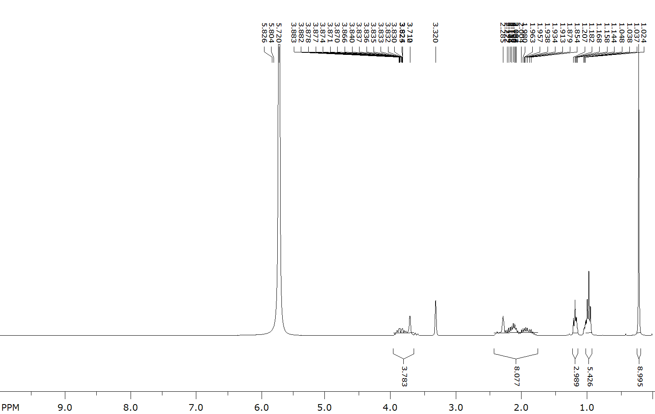
- ¹H NMR (300 MHz, CD₃OD, Zn/CF₃COOH) of 2-(3-(benzyloxy)prop-1-yn-1-yl)-2,5,5-triethyl-3,4-bis(hydroxymethyl)pyrrolidin-1-oxyl (2e)
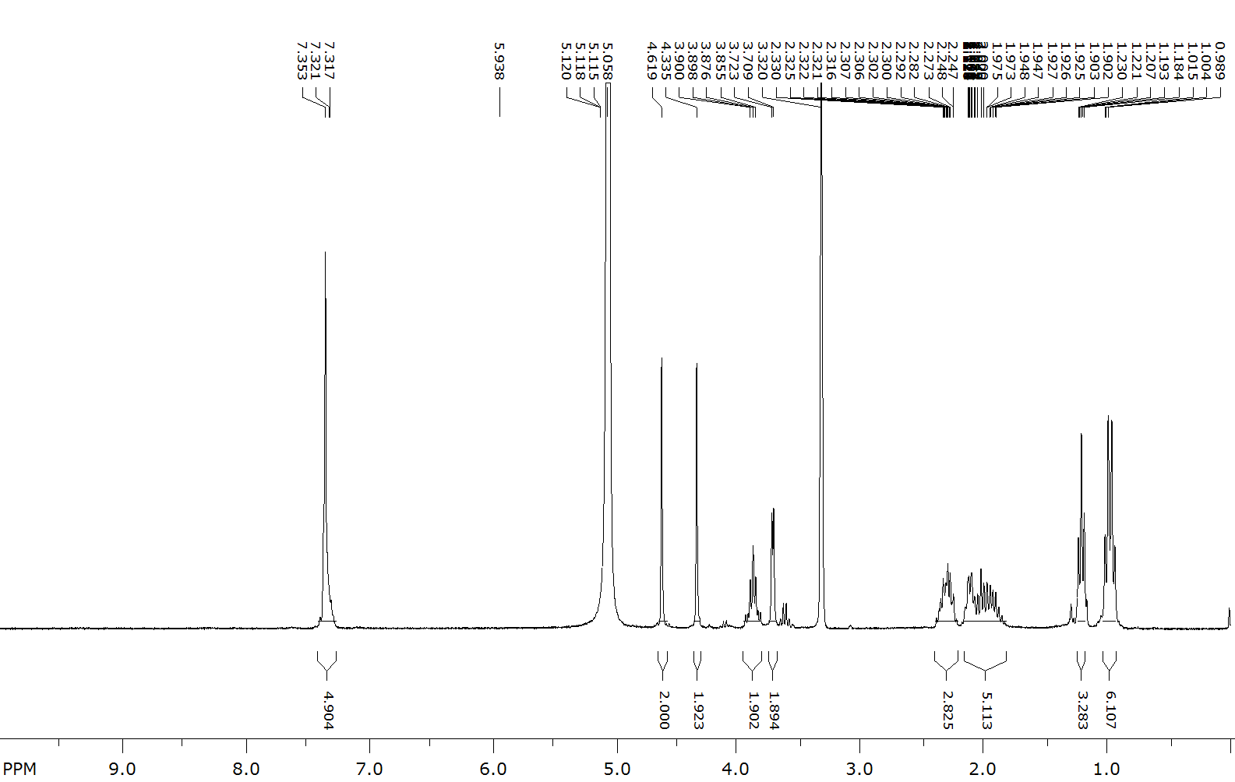
- ¹H NMR (500 MHz, CD₃OD, Zn/CF₃COOH) of 2-(3-(dimethylamino)prop-1-yn-1-yl)-2,5,5-triethyl-3,4-bis(hydroxymethyl)pyrrolidin-1-oxyl (2f)
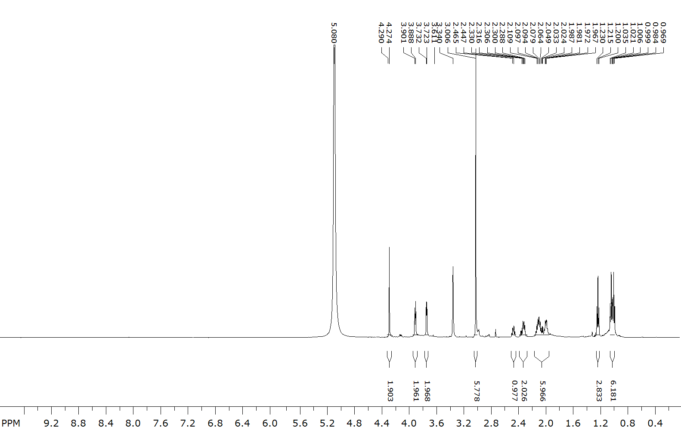
- ¹H NMR (300 MHz, CD₃OD, Zn/CF₃COOH) of 2,2,5-triethyl-5-ethynyl-3,4-bis(((methylsulfonyl)oxy)methyl)pyrrolidin-1-oxyl (3a)
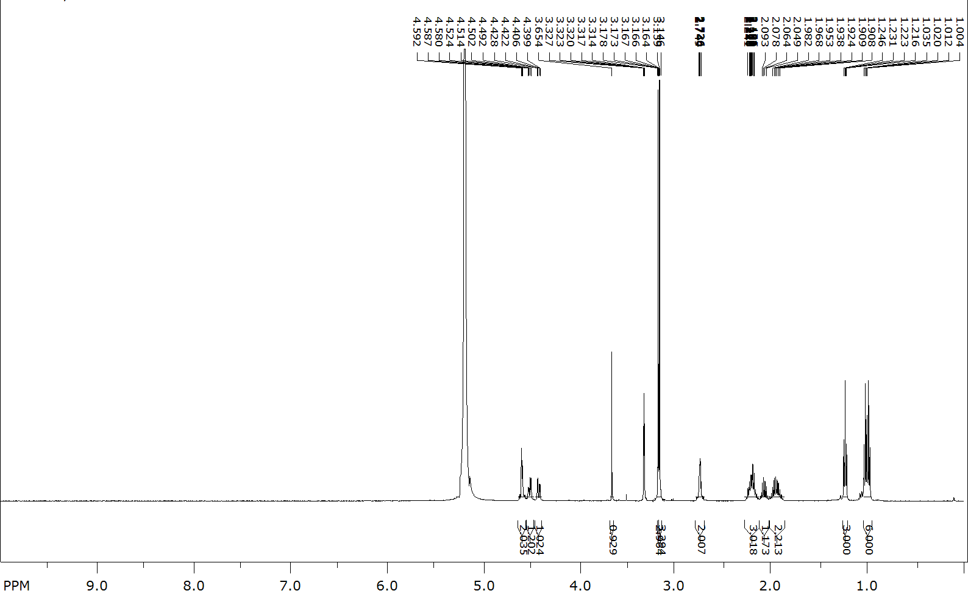
- ¹H NMR (300 MHz, CD₃OD, Zn/CF₃COOH) of 2,2,5-triethyl-3,4-bis(((methylsulfonyl)oxy)methyl)-5-(phenylethynyl)pyrrolidin-1-oxyl (3b)
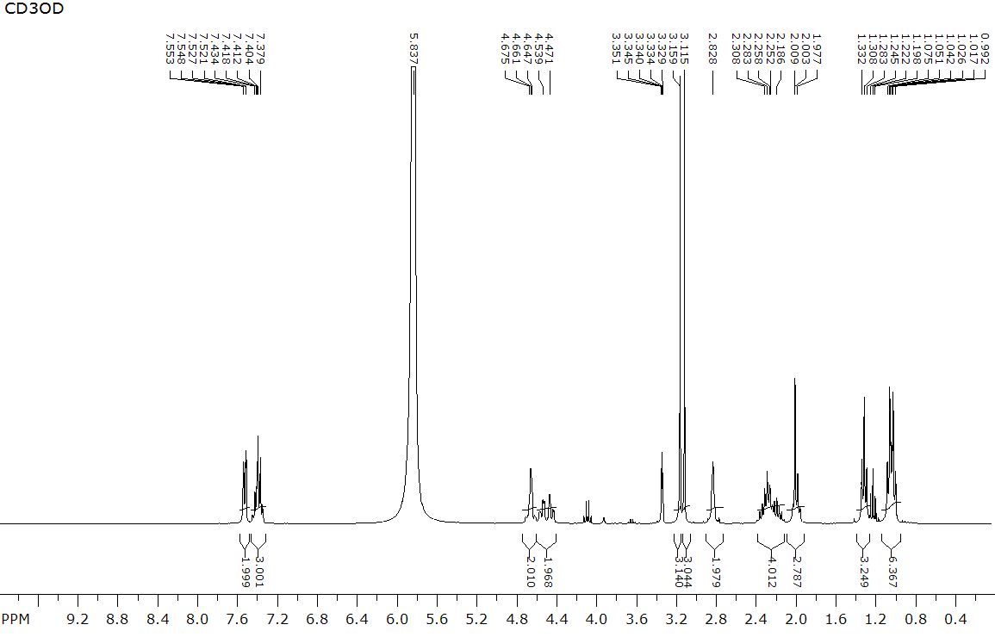
- ¹H NMR (300 MHz, CD₃OD, Zn/CF₃COOH) of 2,2,5-triethyl-3,4-bis(((methylsulfonyl)oxy)methyl)-5-((trimethylsilyl)ethynyl)pyrrolidin-1-oxyl (3d)
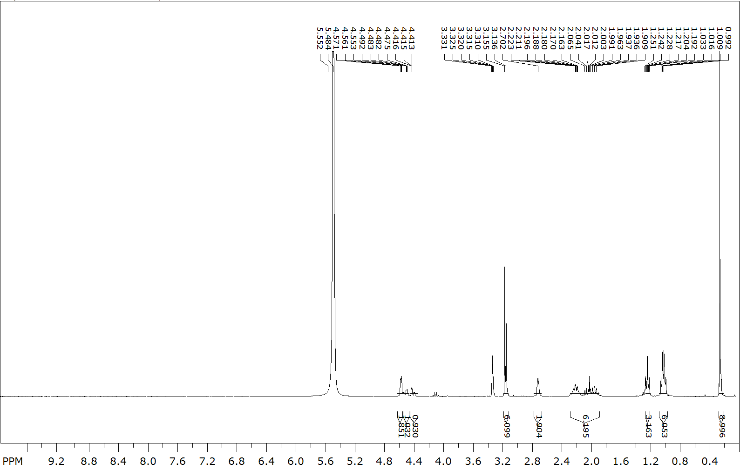
- ¹H NMR (300 MHz, CD₃OD, Zn/CF₃COOH) of 2-(3-(dimethylamino)prop-1-yn-1-yl)-2,5,5-triethyl-3,4-bis(((methylsulfonyl)oxy)methyl)pyrrolidin-1-oxyl (3e)
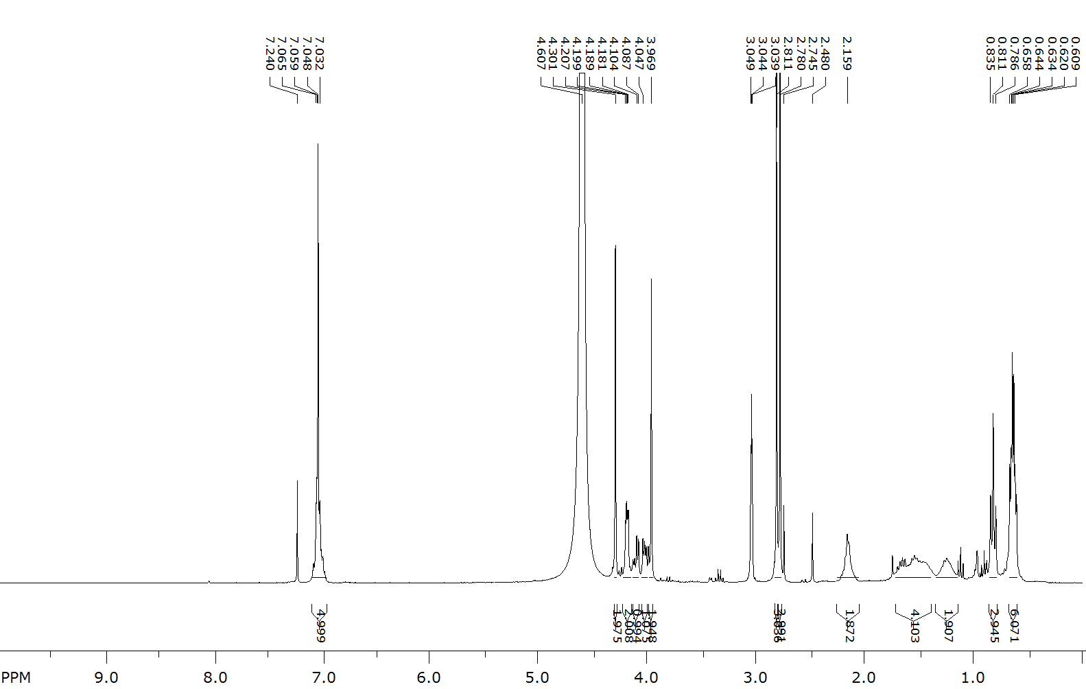
- ¹H NMR (400 MHz, CD₃OD, Zn/CF₃COOH) of 2-(3-(dimethylamino)prop-1-yn-1-yl)-2,5,5-triethyl-3,4-bis(((methylsulfonyl)oxy)methyl)pyrrolidin-1-oxyl (3f)
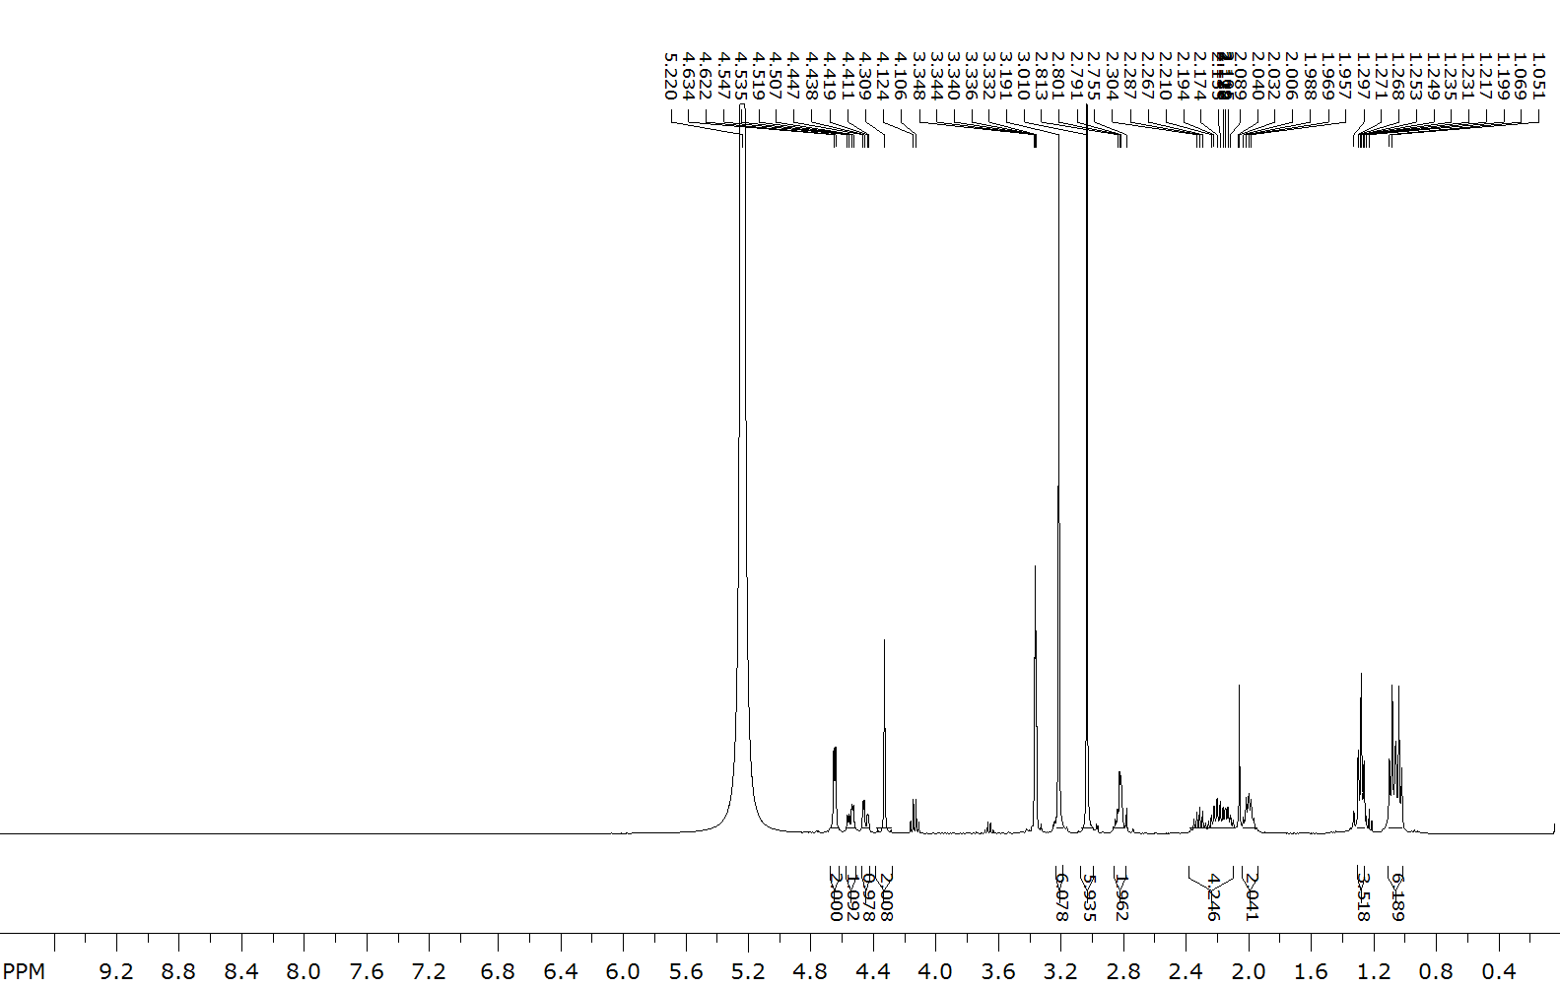
- ¹H NMR (400 MHz, CD₃OD, Zn/CF₃COOH) of 3,4-bis(acetoxymethyl)-2,2,5-triethyl-5-ethynylpyrrolidin-1-oxyl (5)
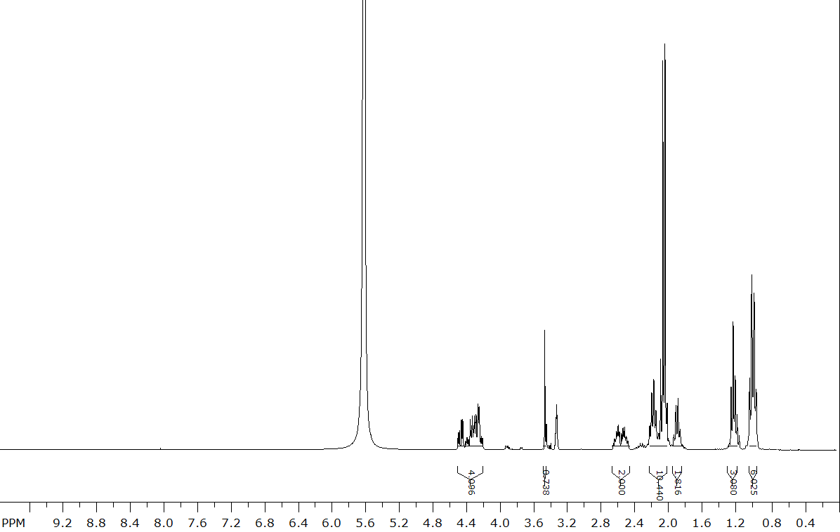
- ¹H NMR (300 MHz, CD₃OD, Zn/CF₃COOH) of 2,2,5-triethyl-3,4-bis(hydroxymethyl)-5-(3-phenyl-1H-pyrazol-5-yl)pyrrolidin-1-oxyl (9a)
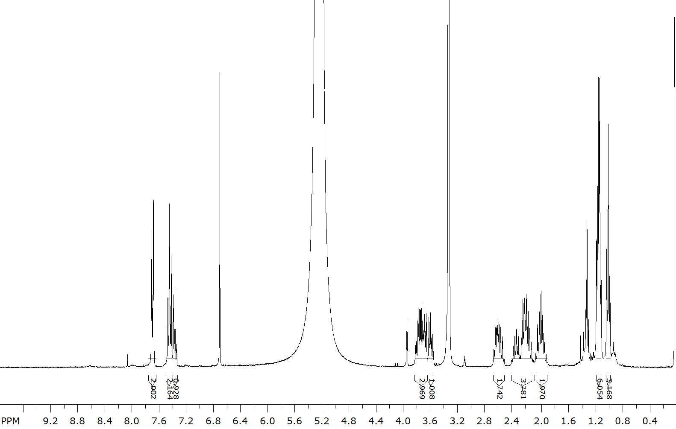
- ¹H NMR (300 MHz, CD₃OD, Zn/CF₃COOH) of 3b,5,5-triethyl-6-(((methylsulfonyl)oxy)methyl)-2-phenyl-3b,4,5,6,6a,7-hexahydropyrrolo[2',3':3,4]pyrrolo[1,2-b]pyrazol-4-oxyl (9b)
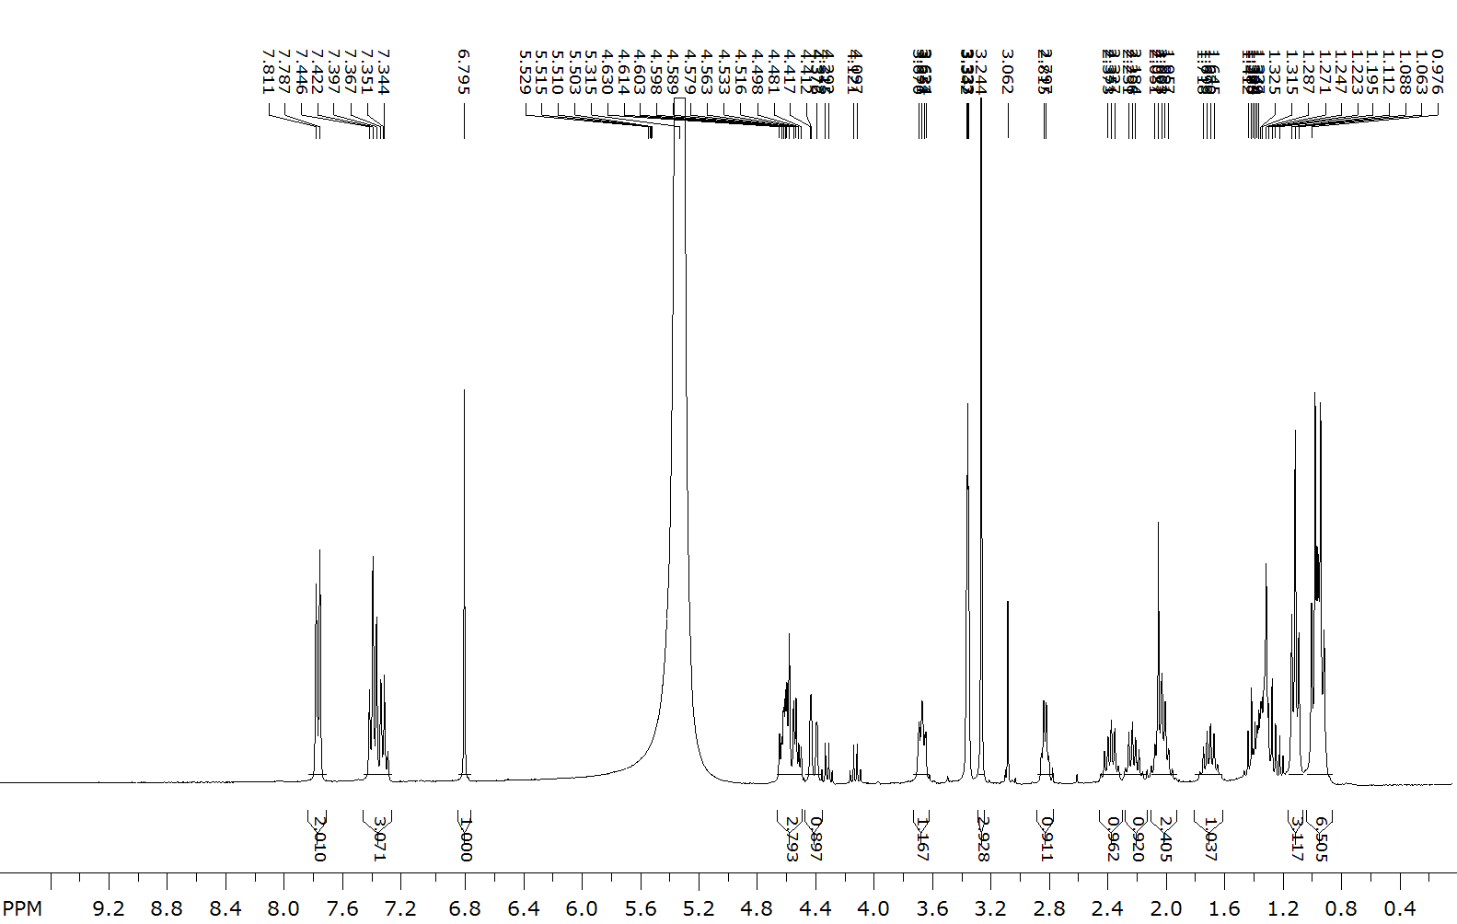
- ¹H NMR (300 MHz, CD₃OD, Zn/CF₃COOH) of 3b,5,5-triethyl-6-(hydroxymethyl)-2-phenyl-3b,4,5,6,6a,7-hexahydropyrrolo[2',3':3,4]pyrrolo[1,2-b]pyrazol-4-oxyl (9c)
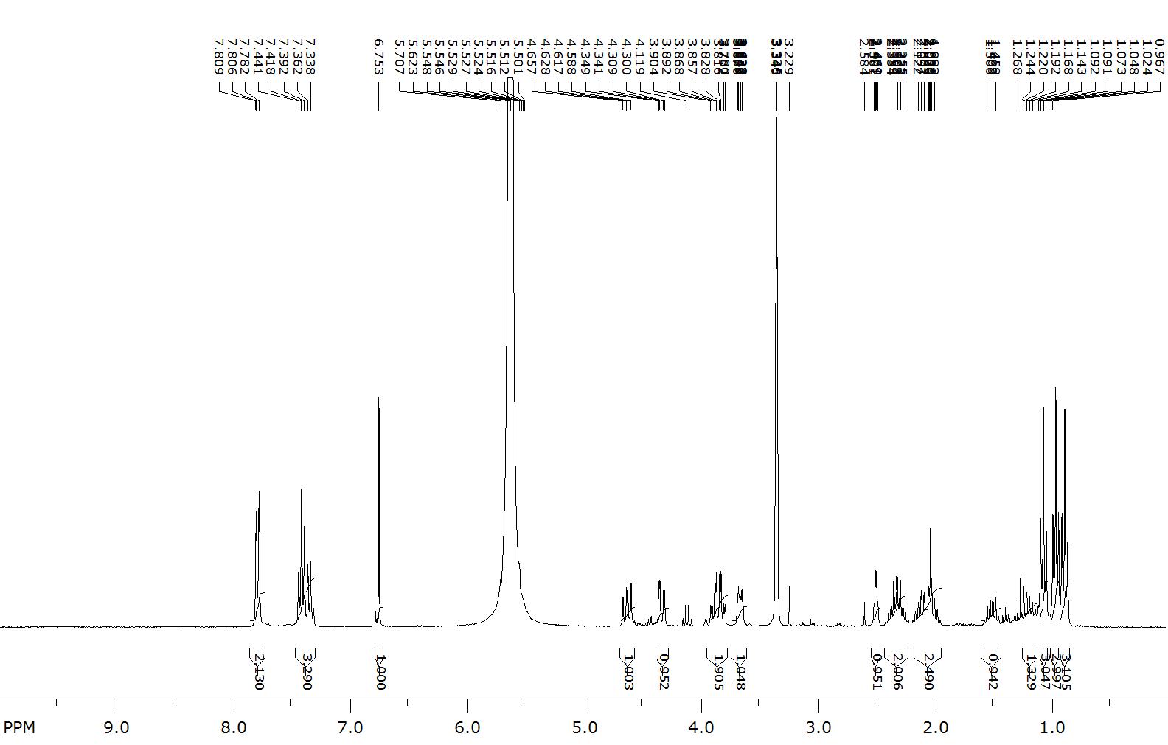

IR spectra
- IR (KBr) of 2,2,5-triethyl-3,4-bis(hydroxymethyl)-5-((trimethylsilyl)ethynyl)pyrrolidin-1-oxyl (2d)
- IR (neat) of 2-(3-(benzyloxy)prop-1-yn-1-yl)-2,5,5-triethyl-3,4-bis(hydroxymethyl)pyrrolidin-1-oxyl (2e)
- IR (neat) of 2-(3-(dimethylamino)prop-1-yn-1-yl)-2,5,5-triethyl-3,4-bis(hydroxymethyl)pyrrolidin-1-oxyl (2f)
- IR (KBr) of 2,2,5-triethyl-5-ethynyl-3,4-bis(((methylsulfonyl)oxy)methyl)pyrrolidin-1-oxyl (3a)
- IR (neat) of 2,2,5-triethyl-3,4-bis(((methylsulfonyl)oxy)methyl)-5-(phenylethynyl)pyrrolidin-1-oxyl (3b)
- IR (neat) of 2,2,5-triethyl-3,4-bis(((methylsulfonyl)oxy)methyl)-5-(3-((methylsulfonyl)oxy)prop-1-yn-1-yl)pyrrolidin-1-oxyl (3c)
- IR (neat) of 2,2,5-triethyl-3,4-bis(((methylsulfonyl)oxy)methyl)-5-((trimethylsilyl)ethynyl)pyrrolidin-1-oxyl (3d)
- IR (neat) of 2-(3-(benzyloxy)prop-1-yn-1-yl)-2,5,5-triethyl-3,4-bis(((methylsulfonyl)oxy)methyl)pyrrolidin-1-oxyl (3e)
- IR (neat) of 2-(3-(dimethylamino)prop-1-yn-1-yl)-2,5,5-triethyl-3,4-bis(((methylsulfonyl)oxy)methyl)pyrrolidin-1-oxyl (3f)
- IR (KBr) of 6-(azidomethyl)-3b,5,5-triethyl-3b,4,5,6,6a,7-hexahydropyrrolo[2',3':3,4]pyrrolo[1,2-c][1,2,3]triazol-4-oxyl (4a)
- IR (KBr) of 6-(azidomethyl)-3b,5,5-triethyl-3-phenyl-3b,4,5,6,6a,7-hexahydropyrrolo[2',3':3,4]pyrrolo[1,2-c][1,2,3]triazol-4-oxyl (4b)
- IR (KBr) of 3,6-bis(azidomethyl)-3b,5,5-triethyl-3b,4,5,6,6a,7-hexahydropyrrolo[2',3':3,4]pyrrolo[1,2-c][1,2,3]triazol-4-oxyl (4c)
- IR (KBr) of 6-(azidomethyl)-3b,5,5-triethyl-3-(trimethylsilyl)-3b,4,5,6,6a,7-hexahydropyrrolo[2',3':3,4]pyrrolo[1,2-c][1,2,3]triazol-4-oxyl (4d)
- IR (neat) of 6-(azidomethyl)-3-((benzyloxy)methyl)-3b,5,5-triethyl-3b,4,5,6,6a,7-hexahydropyrrolo[2',3':3,4]pyrrolo[1,2-c][1,2,3]triazol-4-oxyl (4e)
- IR (neat) of 6-(azidomethyl)-3-((dimethylamino)methyl)-3b,5,5-triethyl-3b,4,5,6,6a,7-hexahydropyrrolo[2',3':3,4]pyrrolo[1,2-c][1,2,3]triazol-4-oxyl (4f)
- IR (neat) of 3,4-bis(acetoxymethyl)-2,2,5-triethyl-5-ethynylpyrrolidin-1-oxyl (5)
- IR (neat) of 3,4-bis(acetoxymethyl)-2,2,5-triethyl-5-(3-oxo-3-phenylprop-1-yn-1-yl)pyrrolidin-1-oxyl (6a)
- IR (neat) of 2,2,5-triethyl-3,4-bis(((methylsulfonyl)oxy)methyl)-5-(3-oxo-3-phenylprop-1-yn-1-yl)pyrrolidin-1- oxyl (6b)
- IR (KBr) of (Z)-2,2,6a-triethyl-3-(hydroxymethyl)-6-(2-oxoethylidene)hexahydro-1H-furo[3,4-b]pyrrol-1-oxyl (8)
- IR (neat) 2,2,5-triethyl-3,4-bis(hydroxymethyl)-5-(3-phenyl-1H-pyrazol-5-yl)pyrrolidin-1-oxyl (9a)
- IR (neat) 3b,5,5-triethyl-6-(((methylsulfonyl)oxy)methyl)-2-phenyl-3b,4,5,6,6a,7-hexahydropyrrolo[2',3':3,4]pyrrolo[1,2-b]pyrazol-4-oxyl (9b)
- IR (KBr) 3b,5,5-triethyl-6-(hydroxymethyl)-2-phenyl-3b,4,5,6,6a,7-hexahydropyrrolo[2',3':3,4]pyrrolo[1,2-b]pyrazol-4-oxyl (9c)

EPR measurements
CW EPR spectra were recorded in the X-band (~ 9.87 GHz) using commercial Bruker Elexsys E 540 spectrometer (Bruker Corporation, Billerica, MA, USA). The measurements were performed in glass capillaries (100 μL) with the following spectrometer settings: modulation amplitude – 1 G; microwave power – 2 mW. Simulations of solution electron spin resonance lines were carried out in the EasySpin software (6.0.0), which is available at http://www.easyspin.org. EPR spectra were recorded for 0.4 mM buffer solutions of nitroxyl radicals.
The kinetics measurements were carried out using following general procedure. Fresh stock solutions of ascorbic acid (40, 80, 120 mM), glutathione (GSH) (8.0 mM), and a nitroxide (0.4 mM) in 10 mM phosphate buffer were prepared. The pH of the solutions was adjusted to 7.5 with NaOH (0.1 M solution). The stock solutions were carefully and quickly mixed using a stirrer Vortex V-1 Plus to achieve a concentrations 0.2 mM of a nitroxide, 10, 20 and 30 mM of ascorbate and 2mM of glutathione, the mixture was taken into EPR glass capillary. The sample was immediately placed into the resonator of the X-band CW EPR spectrometer and a series of spectra were recorded automatically one after another at equal intervals. Double integrals of the whole spectra were used to follow the nitroxide reduction. The data are plotted in the Tables S1 (see below). The analysis of the data was performed on the basis of previously published data on kinetics and mechanism of reduction of similar sterically shielded nitroxides in ascorbate-glutathione mixtures [S3]. The large excess of ascorbate allowed to process EPR signal decay rate as pseudo-first order reaction kinetics. The rate constants of the second-order reaction were determined by extracting the slope from the plot of the rate constant k₁ versus concentration of ascorbate. The measurement error was calculated based on the three kinetic points.

S3. Bobko, A. A.; Kirilyuk, I. A.; Grigor’ev, I. A.; Zweier, J. L.; Khramtsov, V. V. Reversible reduction of nitroxides to hydroxylamines: Roles for ascorbate and glutathione. Free Radical Biol. Med. 2006, 42 (3), 404–412. https://doi.org/10.1016/j.freeradbiomed.2006.11.007.
Table S1. Reduction rate constants of nitroxide 2a-f, 4a-f, 7c
Nitroxide | k₂∙10³, M⁻¹s⁻¹ | Kinetic curves | k₁
2a | 238.1±10 | 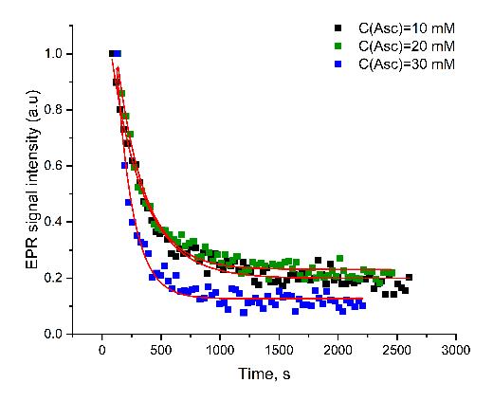 | 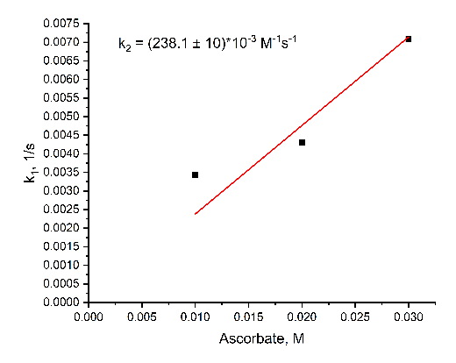
2b | 185.6±5 | 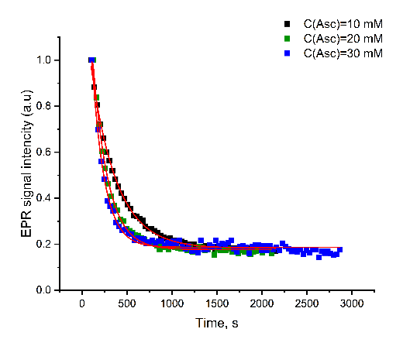 | 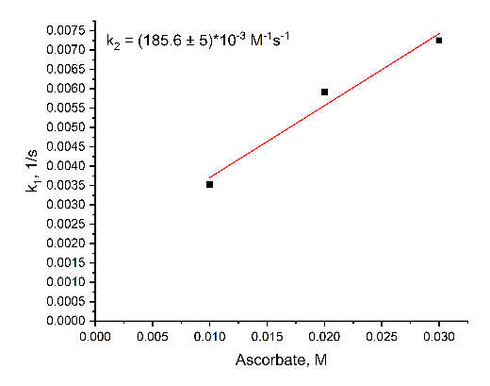
2c | 135.7±5 | 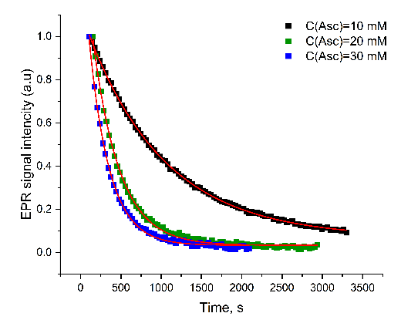 | 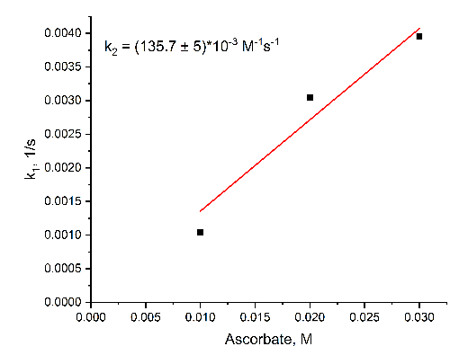
2d | 250.0±5 | 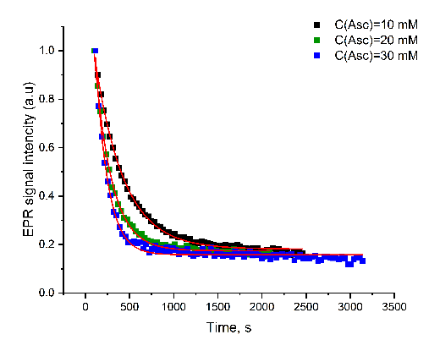 | 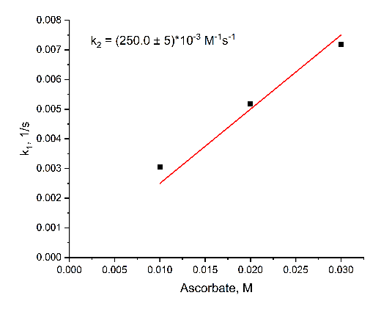
2e | 146.0±6 | 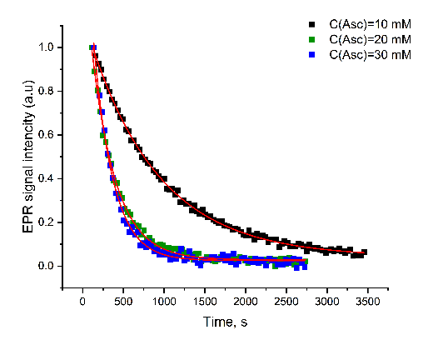 | 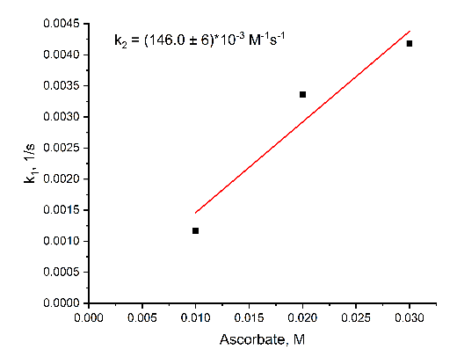
2f | 210.6±5 | 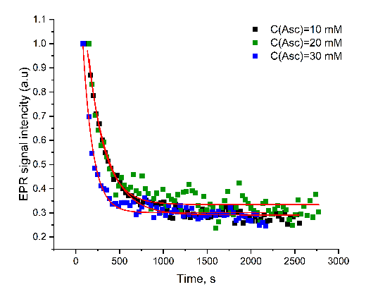 | 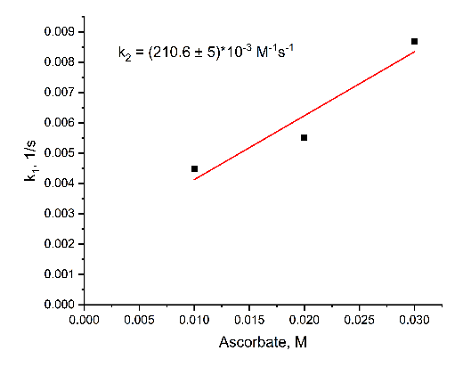
4a | 313.1±2 | 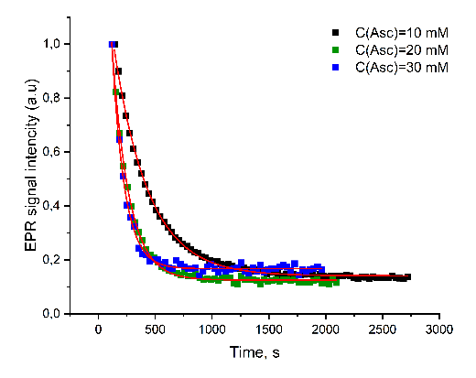 | 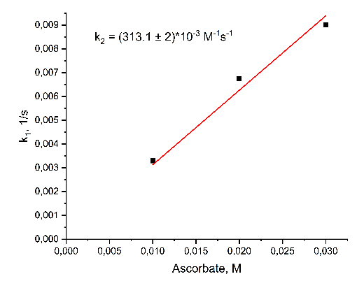
4b | 171.1±6 | 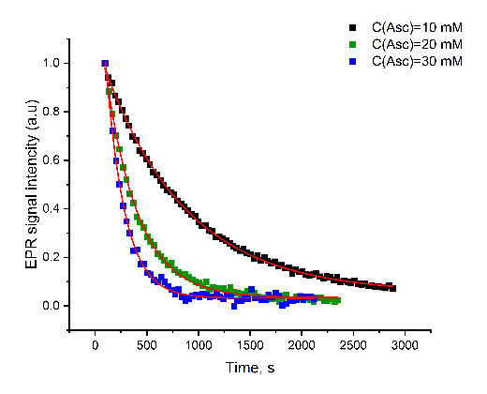 | 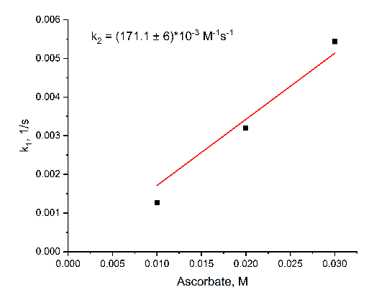
4c | 439.2±10 | 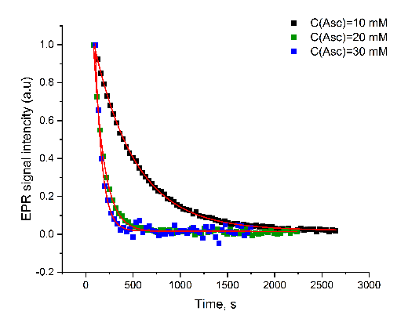 | 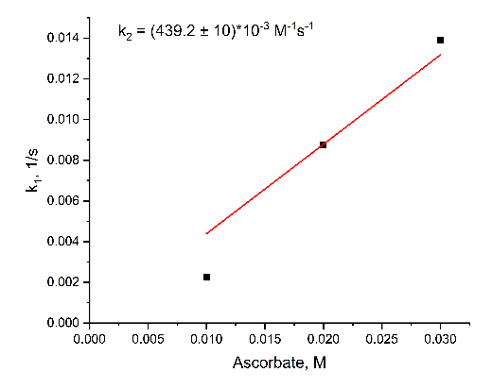
4d | 353.3±5 | 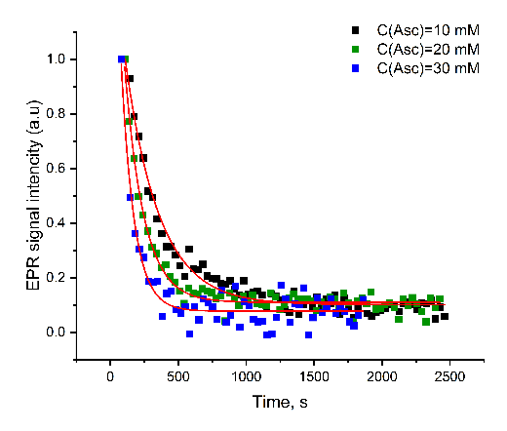 | 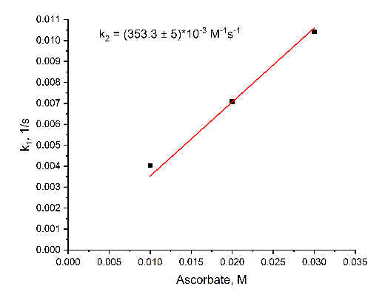
4e | 81.4±1 | 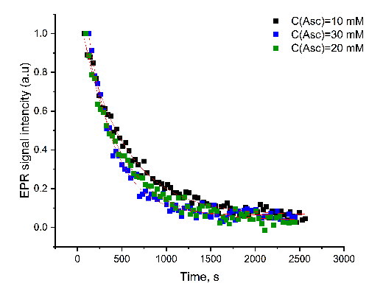 | 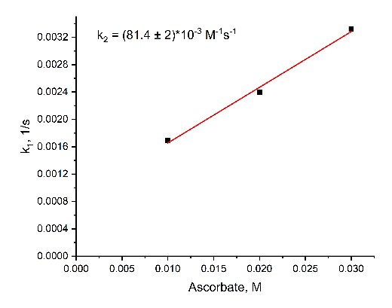
4f | 104.8±5 | 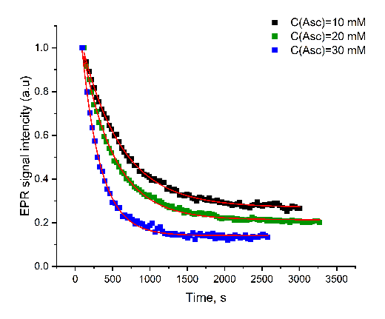 | 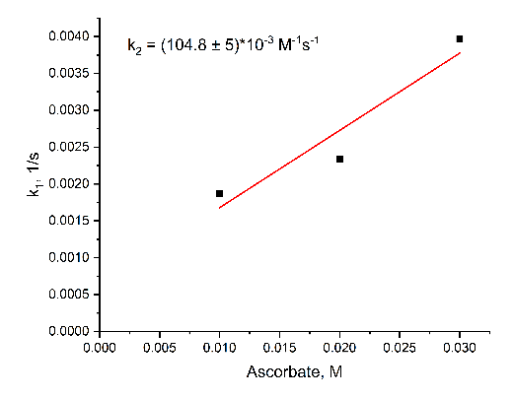
9c | 85.2±1 | 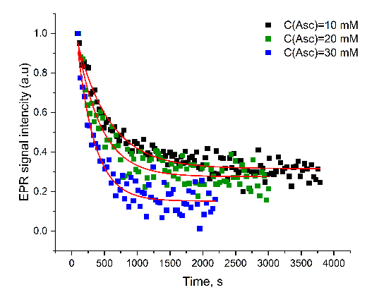 | 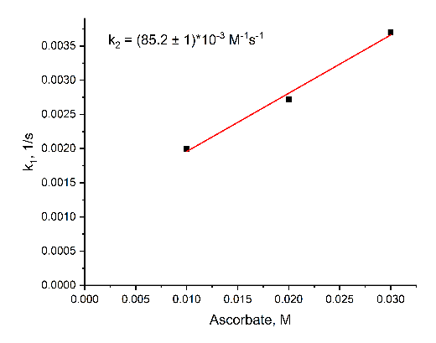
Table S2. EPR spectral parameters of nitroxides 2a-f, 4a-f, 9a-c
Nitroxide | a_{N}, mT  (±0.005) | a_{H}, mT  (±0.005) | Line width, mT  (±0.001) | Spectrum
2a | 1.53 | 0.23 | 0.006 | 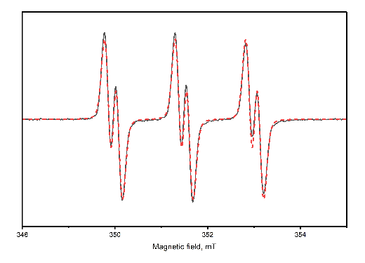
2b | 1.53 | 0.21 | 0.006 | 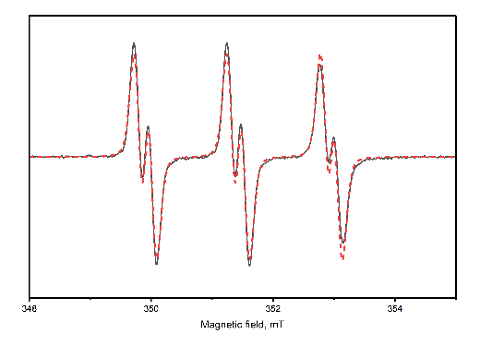
2c | 1.54 | 0.21 | 0.006 | 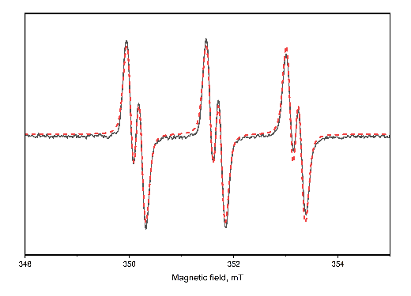
2d | 1.53 | 0.21 | 0.006 | 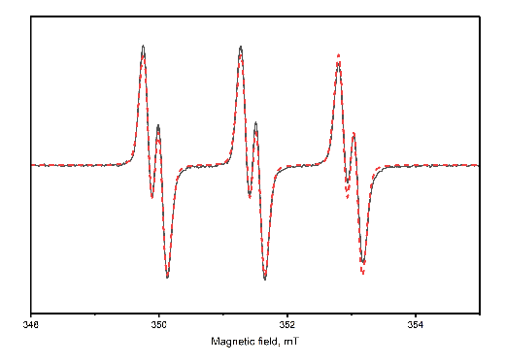
2e | 1.53 | 0.21 | 0.006 | 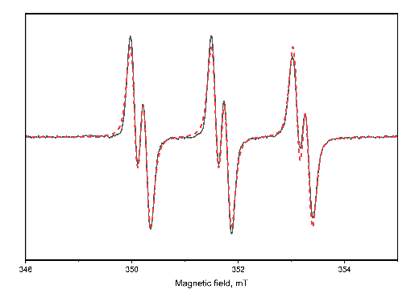
2f | 1.53 | 0.23 | 0.006 | 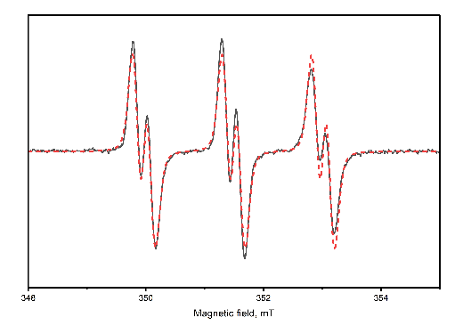
4a | 1.47 | 0.26 | 0.007 | 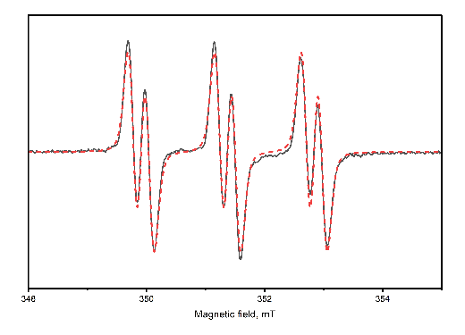
4b | 1.45 | 0.22 | 0.007 | 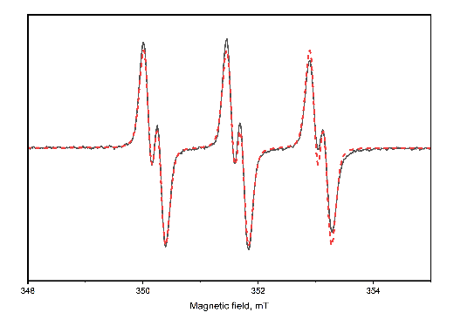
4c | 1.45 | 0.27 | 0.007 | 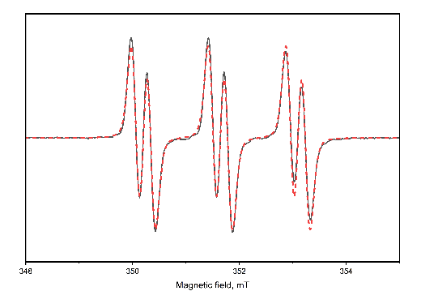
4d | 1.45 | 0.26 | 0.007 | 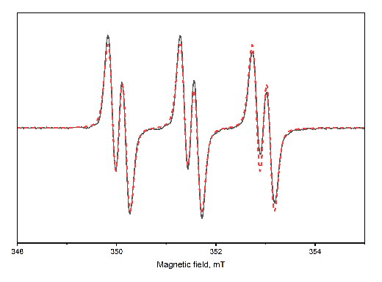
4e | 1.43 | 0.26 | 0.007 | 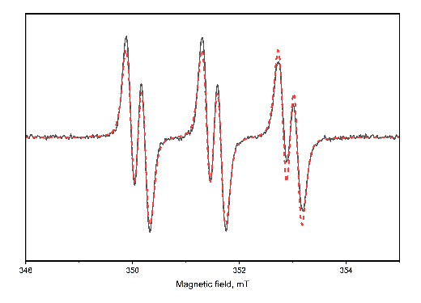
4f | 1.46 | 0.31 | 0.006 | 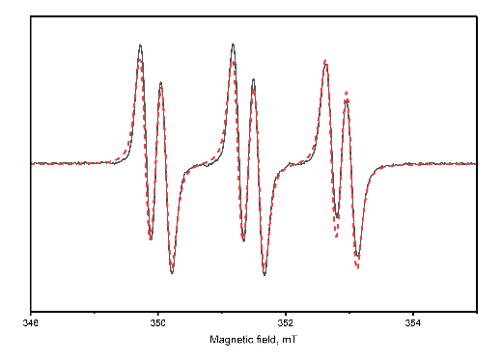
9a | 1.50 | 0.28 | 0.007 | 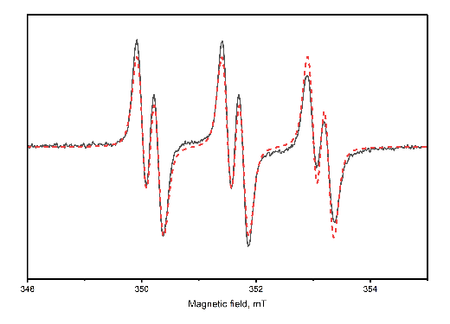
9b | 1.47 | 0.26 | 0.007 | 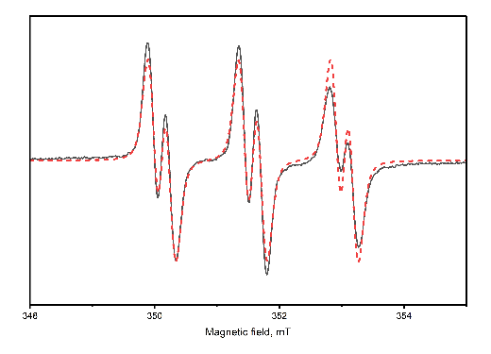
9с | 1.49 | 0.25 | 0.007 | 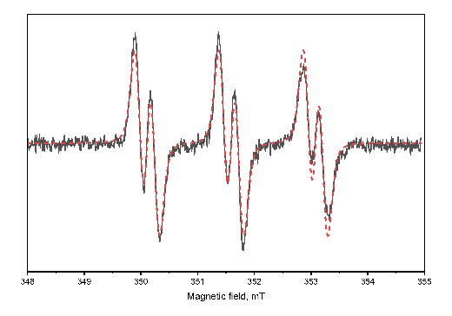

X-ray crystallographic analysis
The X-ray diffraction experiments were carried out on a Bruker KAPPA APEX II diffractometer (graphite-monochromated Mo Kα radiation). Reflection intensities were corrected for absorption by SADABS2016/2 program [S4]. The structure was solved by direct methods using the SHELXT2014/5 [S5] and refined by anisotropic (isotropic for all H atoms) full-matrix least-squares method against F² of all reflections by SHELXL2018/3[S6]. The positions of the hydrogen atoms were calculated geometrically and refined in riding model except for 2d, 8 and 9. Asymmetric unit of 2d includes four independent molecules and for one of them hydroxyl hydrogens were localized from d-map and refined independently with O-H bond lengths restriction to 0.82 Å. The same procedure was done for hydroxyls of 6 and 9a without any restriction of bond lengths. The details of experiment and structure refinement are given in Table S3
Crystallographic data for 2d, 4a-c, 8, 9a have been deposited at the Crystallographic Data Centre as supplementary publication no. CCDC 2512649-2512654. Copy of the data can be obtained, free of charge, on application to CCDC, 12 Union Road, Cambridge CB21EZ, UK (fax: +44 122 3336033 or e-mail: deposit@ccdc.cam.ac.uk; internet: www.ccdc.cam.ac.uk).
Table S3. Experimental and structure refinement details for 2d, 4a-c, 8, 9a
 | 2d | 4a | 4b | 4c | 8 | 9a
Chemical formula | C₁₇H₃₂NO₃Si | C₁₄H₂₂N₇O | C₂₀H₂₆N₇O | C₁₅H₂₃N₁₀O | C₁₅H₂₄NO₄ | C₂₁H₃₀N₃O₃
M_{r} | 326.52 | 304.38 | 380.48 | 359.43 | 282.35 | 372.48
Crystal system, space group | Triclinic, P¯1 | Monoclinic, P2₁ | Monoclinic, P2₁/n | Monoclinic, P2₁/c | Monoclinic, P2₁/n | Monoclinic, P2₁/n
Temperature (K) | 296 | 296 | 296 | 296 | 296 | 200
a, b, c (Å) | 12.4707(5) 17.5991(8) 19.5933(9) | 7.4655(5) 11.8859(6) 9.1833(5) | 8.403(3) 8.881(3)  27.00(1) | 12.2895(7), 9.5375(4), 15.8665(7) | 8.0418(7), 12.055(1), 15.989(2) | 14.501(3), 10.311(2), 14.717(3)
α, β, γ (°) | 82.553(2) 79.474(2) 71.963(2) | 90, 95.219(2), 90 | 90, 93.113(10), 90 | 90, 98.802(2), 90 | 90, 102.711(4), 90 | 90, 115.511(6), 90
V (Å³) | 4007.8 (3) | 811.49 (8) | 2012.0 (13) | 1837.83 (15) | 1512.0(3) | 1985.9(7)
Z | 8 | 2 | 4 | 4 | 4 | 4
F(000) | 1432 | 326 | 812 | 764 | 612 | 804
D_{x} (Mg m⁻³) | 1.082 | 1.246 | 1.256 | 1.299 | 1.240 | 1.246
μ(mm⁻¹) | 0.13 | 0.09 | 0.08 | 0.09 | 0.09 | 0.08
Crystal size (mm) | 0.80 × 0.40 × 0.20 | 0.72 × 0.41 × 0.31 | 0.41 × 0.24 × 0.07 | 0.68 × 0.58 × 0.25 | 0.29 × 0.13 × 0.04 | 0.40 × 0.10 × 0.06
T_{min}, T_{max} | 0.707, 0.745 | 0.877, 0.928 | 0.909, 0.959 | 0.897, 0.937 | 0.883, 0.958 | 0.901, 0.971
No. of measured, independent and  observed [I > 2σ(I)] reflections | 56190, 15904, 10265 | 14376, 4103, 3584 | 43855, 4848, 3551 | 30287, 4221, 3182 | 9999, 2661, 1428 | 23165, 3507, 2299
R_{int} | 0.035 | 0.045 | 0.069 | 0.060 | 0.079 | 0.091
θ range (°) | 1.6 - 26.1 | 2.7 - 28.5 | 2.8 - 28.0 | 2.9 - 27.5 | 3.1 - 25.1 | 3.3 - 25.1
Range of h, k, l | h = -15→15  k = -21→21  l = -24→24 | h = -9→10  k = -15→15  l = -12→12 | h = -11→11  k = -11→11  l = -35→35 | h = -15→15  k = -12→12  l = -20→20 | h = -8→9  k = -14→13  l = -18→19 | h = -17→17  k = -12→12  l = -17→17
R[F² > 2σ (F²)], wR(F²) | 0.064, 0.215 | 0.049, 0.140 | 0.049, 0.139 | 0.051, 0.165 | 0.077, 0.230 | 0.045, 0.111
Goof | 1.00 | 1.05 | 1.02 | 1.02 | 1.00 | 1.00
No. of reflections | 15904 | 4103 | 4848 | 4221 | 2661 | 3507
No. of parameters | 840 | 202 | 253 | 238 | 188 | 259
No. of restraints | 1 | 1 | 0 | 0 | 0 | 0
ρ_{max}, ρ_{min} (e Å⁻³) | 1.57, -0.49 | 0.29, -0.20 | 0.25, -0.18 | 0.35, -0.28 | 0.46, -0.18 | 0.18, -0.24
Flack parameter | – | 0.0 (6) | – | – | – | –
CCDC number | 2512649 | 2512650 | 2512651 | 2512652 | 2512653 | 2512654

S4. SADABS, v. 2008-1, Bruker AXS, Madison, WI, USA
S5. Sheldrick, G. M. SHELXT– Integrated Space-Group and Crystal-Structure Determination. Acta Crystallogr., Sect. A, 2015, 71 (1), 3–8. https://doi.org/10.1107/s2053273314026370.
S6. Sheldrick, G. M. Crystal Structure Refinement WithSHELXL. Acta Crystallogr. Sect. C. 2015, 71 (1), 3–8. https://doi.org/10.1107/s2053229614024218.

