Table of Contents
1. Experimental procedures and characterization data 2
2. Crystallographic data for compound 3z. 15
3. Copies of ¹H, ¹³C, ¹⁹F NMR spectra 16
4. Computational details 60
5. References 77

Experimental procedures and characterization data
General considerations. All reagents were used as purchased from commercial suppliers without further purification. Dichloromethane (DCM) was freshly distilled over P₂O₅. NMR spectra were recorded using Bruker Avance III spectrometer in CDCl₃ or DMSO-d₆ (¹H: 400.13 MHz; ¹³С: 100.61 MHz; ¹⁹F 376.50 MHz); chemical shifts are reported as parts per million (δ, ppm); the residual solvent peaks were used as internal standard: 7.26 or 2.5 for ¹H and 77.16 or 39.7 ppm for ¹³C in CDCl₃ or DMSO-d₆, respectively; multiplicities are abbreviated as follows: s = singlet, d = doublet, t = triplet, q = quartet, m = multiplet, dd = doublet of doublets, dt = doublet of triplets, ddd = doublet/doublets of doublets; coupling constants, J, are reported in Hz. Mass spectra were recorded using Bruker microTOF spectrometer (ionization by electrospray, positive ions detection). Melting points were determined in open capillary tubes on Stuart SMP50 Automatic Melting Point Apparatus. Analytical thin-layer chromatography was carried out on UV-254 silica gel plates using appropriate eluents. Compounds were visualized with short-wavelength UV light. Column chromatography was performed using silica gel Merk grade 60 (0.040−0.063 mm) 230−400 mesh. Preparative HPLC was carried out on a Shimadzu LC-20AP chromatograph, equipped with a spectrophotometric detector. Column: Agilent Zorbax prepHT XDB-C18, 5 μm, 21.2 × 150 mm. Eluent: (A) 0.1% TFA in water, (B) 0.1% TFA in acetonitrile. Flow rate 12 mL/min, temperature − 40 °C, detection UV at 214 and 254 nm. Injection volume − 500 μL.
Synthesis of starting materials
All tetrazoles (Fig. S1) and diazo compounds (Fig. S2) were synthesized according to the well-known procedures as described in our previous work [1]. Compound 1i was synthesized according to alternative procedure [2].
Figure S1. Scope of tetrazoles used.

Figure S2. Scope of diazo reagents used.
5-(Benzylsulfonyl)-1H-tetrazole (1o). Prepared from the appropriate sulfide 1p following the established method [3], using KMnO₄ as an oxidant. The spectral data are identical to those recently reported [4].
Preparation of N-H insertion products 3 and 4
General procedure GP1 for the preparation of compounds 3a/4a-3y/4y
To a solution/suspension of the corresponding NH-substrate 1 (0.5 mmol, 1 equiv.) in dry DCM (1 mL) was added the solution of diazo reagent 2 (0.6 mmol, 1.2 equiv.) in dry DCM (1 mL). The reaction mixture was stirred at room temperature under blue light irradiation (λ=425 nm) for 16 h (using one LED lamp HeptaChem HCK1012–01-012 P207–18-1 425nm, displaced at approximate distances of 5 cm each from the reaction vessel). Upon full conversion of diazo regent (controlled by TLC), the reaction mixture was directly subjected to column chromatography on silica gel to afford pure product.
General procedure GP2 for the preparation of compounds 3y/4y, 3z/4z
To a suspension of the NH-substrate 1o (0.5 mmol, 1 equiv.) in dry DCM (1 mL) was added the solution of diazo reagent 2 (0.6 mmol, 1.2 equiv.) in dry DCM (1 mL). When mixing the reagents, gas evolution was observed. The reaction mixture was stirred at room temperature until full consumption of starting material (controlled by TLC). Upon full conversion of diazo regent, the reaction mixture was directly subjected to column chromatography on silica gel to afford pure product.
Ethyl 2-(5-methyl-1H-tetrazol-1-yl)-2-phenylacetate (3a). Prepared according to GP1 using 1a as NH-substrate and 2a as diazo reagent; eluent – n-hexane–acetone (2% to 30% of acetone). Yield: 73 mg (59%). Colorless viscous oil ¹H NMR (400 MHz, CDCl₃) δ 7.48 – 7.37 (m, 3H), 7.35 – 7.28 (m, 2H), 6.53 (s, 1H), 4.39 – 4.29 (m, 2H), 2.33 (s, 3H), 1.34 – 1.23 (m, 3H) ppm. ¹³C{¹H} NMR (101 MHz, CDCl₃) δ 166.4, 152.4, 131.3, 129.9, 129.3, 128.5, 64.1, 63.1, 14.0, 9.8 ppm. HRMS (ESI), m/z calcd for C₁₂H₁₃N₄O₂ [M-H]⁻ 245.1044 found 245.1046.
Ethyl 2-(5-methyl-2H-tetrazol-2-yl)-2-phenylacetate (4a). Prepared according to GP1 using 1a as NH-substrate and 2a as diazo reagent; eluent – n-hexane–acetone (2% to 30% of acetone). Yield: 46 mg (37%). Colorless viscous oil. The spectral data are identical to those reported previously [1].

Ethyl 2-phenyl-2-(1H-tetrazol-1-yl)acetate (3b). Prepared according to GP1 (1.8 mmol of NH-substrate was used) using 1b as NH-substrate and 2a as diazo reagent; eluent – n-hexane–diethyl ether (2% to 30% of ether). Yield: 39 mg (34%). Yellow viscous oil. ¹H NMR (400 MHz, CDCl₃) δ 8.79 (s, 1H), 7.53 – 7.39 (m, 3H), 7.44 – 7.36 (m, 2H), 6.58 (s, 1H), 4.40 – 4.24 (m, 2H), 1.33 – 1.23 (m, 3H) ppm. ¹³C{¹H} NMR (101 MHz, CDCl₃) δ 166.8, 142.4, 131.9, 130.4, 129.8, 128.0, 64.7, 63.2, 13.9 ppm. HRMS (ESI), m/z calcd for C₁₁H₁₁N₄O₂ [M-H]⁻ 231.0887 found 231.0880.
Ethyl 2-phenyl-2-(2H-tetrazol-2-yl)acetate (4b). Prepared according to GP1 (1.8 mmol of NH-substrate was used) using 1b as NH-substrate and 2a as diazo reagent; eluent – n-hexane–diethyl ether (2% to 30% of ether). Yield: 35 mg (30%). ¹H NMR (400 MHz, CDCl₃) δ 8.56 (s, 1H), 7.64 – 7.54 (m, 2H), 7.52 – 7.40 (m, 3H), 6.73 (s, 1H), 4.39 – 4.22 (m, J = 7.1 Hz, 2H), 1.26 (t, J = 7.1 Hz, 3H) ppm. ¹³C{¹H} NMR (101 MHz, CDCl₃) δ 166.3, 153.0, 131.4, 130.0, 129.4, 129.1, 68.9, 63.0, 13.9 ppm. HRMS (ESI), m/z calcd for C₁₁H₁₁N₄O₂ [M-H]⁻ 231.0887 found 231.0888.
Ethyl 2-(5-ethyl-1H-tetrazol-1-yl)-2-phenylacetate (3c). Prepared according to GP1 using 1c as NH-substrate and 2a as diazo reagent; eluent – n-hexane–acetone (5% to 50% of acetone). Yield: 66 mg (51%). Colorless viscous oil. ¹H NMR (400 MHz, CDCl₃) δ 7.47 – 7.39 (m, 3H), 7.37 – 7.31 (m, 2H), 6.45 (s, 1H), 4.39 – 4.26 (m, 2H), 2.79 (dq, J = 15.3, 7.6 Hz, 1H), 2.54 (dq, J = 14.9, 7.5 Hz, 1H), 1.28 (t, J = 7.2 Hz, 3H), 1.24 (t, J = 7.5 Hz, 3H) ppm. ¹³C{¹H} NMR (101 MHz, CDCl₃) δ 166.4, 156.6, 131.6, 129.8, 129.2, 128.5, 63.9, 63.0, 17.5, 14.0, 11.1 ppm. HRMS (ESI), m/z calcd for C₁₃H₁₆N₄O₂Na [M+Na]⁺ 283.1166 found 283.1167.
Ethyl 2-(5-ethyl-2H-tetrazol-2-yl)-2-phenylacetate (4c). Prepared according to GP1 using 1c as NH-substrate and 2a as diazo reagent; eluent – n-hexane–acetone (5% to 50% of acetone). Yield: 31 mg (24%). Colorless viscous oil. Spectral data are identical to reported before [1].

Ethyl 2-(5-isopropyl-1H-tetrazol-1-yl)-2-phenylacetate (3d). Prepared according to GP1 using 1d as NH-substrate and 2a as diazo reagent; eluent – n-hexane–acetone (5% to 50% of acetone). Yield: 71 mg (52%). Colorless viscous oil. The spectral data are identical to those reported previously [1].

Ethyl 2-(5-isopropyl-2H-tetrazol-2-yl)-2-phenylacetate (4d). Prepared according to GP1 using 1d as NH-substrate and 2a as diazo reagent; eluent – n-hexane–acetone (5% to 50% of acetone). Yield: 41 mg (30%). Yellow viscous oil. The spectral data are identical to those reported previously [1].

Ethyl 2-(5-cyclopropyl-1H-tetrazol-1-yl)-2-phenylacetate (3e). Prepared according to GP1 using 1e as NH-substrate and 2a as diazo reagent; eluent – n-hexane–acetone (5% to 50% of acetone). Yield: 57 mg (42%). Colorless viscous oil. ¹H NMR (400 MHz, CDCl₃) δ 7.46 – 7.41 (m, 3H), 7.40 – 7.34 (m, 2H), 6.56 (s, 1H), 4.41 – 4.28 (m, 2H), 1.72 (tt, J = 8.3, 4.9 Hz, 1H), 1.30 (t, J = 7.2 Hz, 3H), 1.29 – 1.19 (m, 1H), 1.15 – 1.04 (m, 1H), 1.02 – 0.94 (m, 1H), 0.97 – 0.85 (m, 1H) ppm. ¹³C{¹H} NMR (101 MHz, CDCl₃) δ 166.5, 157.5, 131.7, 129.7, 129.2, 128.6, 63.9, 63.0, 14.0, 9.0, 8.6, 4.7 ppm. HRMS (ESI), m/z calcd for C₁₄H₁₆N₄O₂Na [M+Na]⁺ 295.1166 found 295.1165.
Ethyl 2-(5-benzyl-1H-tetrazol-1-yl)-2-phenylacetate (3f). Prepared according to GP1 using 1f as NH-substrate and 2a as diazo reagent; eluent – n-hexane–acetone (5% to 40% of acetone). Yield: 55 mg (34%). White solid. ¹H NMR (400 MHz, CDCl₃) δ 7.47 – 7.25 (m, 6H), 7.23 – 7.16 (m, 2H), 7.14 – 7.04 (m, 2H), 6.13 (s, 1H), 4.49 – 3.80 (m, 4H), 1.21 (t, J = 7.1 Hz, 3H) ppm. ¹³C{¹H} NMR (101 MHz, CDCl₃) δ 166.2, 154.0, 133.6, 131.5, 129.7, 129.1, 129.1, 128.8, 128.6, 127.7, 63.9, 63.0, 29.8, 13.9 ppm. HRMS (ESI), m/z calcd for C₁₈H₁₉N₄O₂ [M+H]⁺ 323.1503 found 323.1507.
Ethyl 2-(5-benzyl-2H-tetrazol-2-yl)-2-phenylacetate (4f). Prepared according to GP1 using 1f as NH-substrate and 2a as diazo reagent; eluent – n-hexane–acetone (5% to 40% of acetone). Yield: 36 mg (22%). Yellow viscous oil. The spectral data are identical to those reported previously [1].

Ethyl 2-((5-adamantan-1-yl)-1H-tetrazol-1-yl)-2-phenylacetate (3g). Prepared according to GP1 using 1g as NH-substrate and 2a as diazo reagent; eluent – n-hexane–acetone (5% to 50% of acetone). Yield: 51 mg (28%). White solid. ¹H NMR (400 MHz, CDCl₃) δ 7.51 – 7.37 (m, 5H), 6.48 (s, 1H), 4.37 – 4.20 (m, 2H), 2.16 (s, 9H), 1.89 – 1.77 (m, 6H), 1.24 (t, J = 7.1 Hz, 3H) ppm. ¹³C{¹H} NMR (101 MHz, CDCl₃) δ 166.7, 160.4, 132.7, 129.5, 129.0, 129.0, 65.0, 63.0, 40.3, 36.2, 33.9, 27.9, 14.0 ppm. HRMS (ESI), m/z calcd for C₂₁H₂₆N₄O₂Na [M+Na]⁺ 389.1948 found 389.1949.

Ethyl 2-(5-adamantan-1-yl)-2H-tetrazol-2-yl)-2-phenylacetate (4g). Prepared according to GP1 using 1g as NH-substrate and 2a as diazo reagent; eluent – n-hexane–acetone (5% to 50% of acetone). Yield: 18 mg (10%). Colorless viscous oil. The spectral data are identical to those reported previously [1].

Ethyl 2-(5-(chloromethyl)-1H-tetrazol-1-yl)-2-phenylacetate (3h). Prepared according to GP1 using 1h as NH-substrate and 2a as diazo reagent; eluent – n-hexane–acetone (5% to 50% of acetone). Yield: 63 mg (45%). Colorless viscous oil. The spectral data are identical to those reported previously [1].
Ethyl 2-(5-(chloromethyl)-2H-tetrazol-2-yl)-2-phenylacetate (4h). Prepared according to GP1 using 1h as NH-substrate and 2a as diazo reagent; eluent – n-hexane–acetone (5% to 50% of acetone). Yield: 59 mg (42%). Colorless viscous oil. The spectral data are identical to those reported previously [1].

Ethyl 2-(5-(3-chloropropyl)-1H-tetrazol-1-yl)-2-phenylacetate (3i). Prepared according to GP1 using 1i as NH-substrate and 2a as diazo reagent; reaction time ‒ 8 h; eluent – n-hexane–acetone (5% to 50% of acetone). Yield: 48 mg (31%). Colorless viscous oil. ¹H NMR (400 MHz, CDCl₃) δ 7.48 – 7.41 (m, 3H), 7.44 – 7.30 (m, 2H), 6.53 (s, 1H), 4.36 (q, J = 7.2 Hz, 2H), 3.57 (ddt, J = 6.7, 5.2, 2.6 Hz, 2H), 2.95 (ddd, J = 16.1, 8.1, 6.4 Hz, 1H), 2.70 (ddd, J = 16.0, 7.9, 6.6 Hz, 1H), 2.30 – 2.06 (m, 2H), 1.31 (t, J = 7.1 Hz, 3H) ppm. ¹³C{¹H} NMR (101 MHz, CDCl₃) δ 166.4, 154.6, 131.4, 129.9, 129.4, 128.6, 64.1, 63.2, 43.7, 29.2, 21.0, 14.0 ppm. HRMS (ESI), m/z calcd for C₁₄H₁₈ClN₄O₂ [M+H]⁺ 309.1113 found 309.1112.
Ethyl 2-phenyl-2-(5-phenyl-1H-tetrazol-1-yl)acetate (3j). Prepared according to GP1 using 1j as NH-substrate and 2a as diazo reagent; reaction was performed in dry acetonitrile; eluent – n-hexane–acetone (5% to 50% of acetone). Yield: 46 mg (30%). Colorless viscous oil. ¹H NMR (400 MHz, CDCl₃) δ 7.66 – 7.50 (m, 5H), 7.49 – 7.35 (m, 5H), 6.25 (s, 1H), 4.32 – 4.20 (m, 2H), 1.22 (t, J = 7.1 Hz, 3H) ppm. ¹³C{¹H} NMR (101 MHz, CDCl₃) δ 166.4, 155.0, 132.1, 131.5, 129.7, 129.3, 129.1, 129.1, 129.0, 123.7, 64.3, 63.1, 13.9 ppm. HRMS (ESI), m/z calcd for C₁₇H₁₆N₄O₂Na [M+Na]⁺ 331.1166 found 331.1158.
Ethyl 2-phenyl-2-(5-phenyl-2H-tetrazol-2-yl)acetate (4j). Prepared according to GP1 using 1j as NH-substrate and 2a as diazo reagent; eluent – n-hexane–acetone (5% to 50% of acetone). Yield: 14 mg (9%). Yellow viscous oil. Spectral data are identical to reported before [1].

Methyl 2-(4-fluorophenyl)-2-(5-(4-methoxyphenyl)-1H-tetrazol-1-yl)acetate (3k). Prepared according to GP1 using 1k as NH-substrate and 2d as diazo reagent; reaction was performed in dry acetonitrile; reaction time ‒ 16 h; eluent – n-hexane–acetone (5% to 40% of acetone). Yield: 86 mg (50%). Colorless viscous oil. ¹H NMR (400 MHz, CDCl₃) δ 7.57 – 7.49 (m, 2H), 7.49 – 7.40 (m, 2H), 7.16 – 7.04 (m, 4H), 6.21 (s, 1H), 3.92 (s, 3H), 3.82 (s, 3H) ppm. ¹³C{¹H} NMR (101 MHz, CDCl₃) δ 166.9, 163.3 (d, J = 250.1 Hz), 162.1, 154.9, 131.1 (d, J = 8.6 Hz), 130.6, 128.1 (d, J = 3.5 Hz), 116.2 (d, J = 22.0 Hz), 115.2, 114.9, 63.2, 55.5, 53.8 ppm. ¹⁹F{¹H} NMR (376 MHz, CDCl₃) δ -110.84 ppm. HRMS (ESI), m/z calcd for C₁₇H₁₆FN₄O₃ [M+H]⁺ 343.1201 found 343.1202.
Methyl 2-(4-fluorophenyl)-2-(5-(4-methoxyphenyl)-2H-tetrazol-2-yl)acetate (4k). Prepared according to GP1 using 1k as NH-substrate and 2d as diazo reagent; reaction was performed in dry acetonitrile; reaction time ‒ 16 h; eluent – n-hexane–acetone (5% to 40% of acetone). Yield: 46 mg (27%). Colorless viscous oil. ¹H NMR (400 MHz, CDCl₃) δ 8.14 – 8.06 (m, 2H), 7.69 – 7.59 (m, 2H), 7.22 – 7.09 (m, 2H), 7.07 – 6.96 (m, 2H), 6.68 (s, 1H), 3.87 (s, 3H), 3.84 (s, 3H) ppm. ¹³C{¹H} NMR (101 MHz, CDCl₃) δ 166.9, 165.3, 163.5 (d, J = 250.1 Hz), 161.4, 131.5 (d, J = 8.6 Hz), 128.6, 127.5 (d, J = 3.5 Hz), 119.7, 116.1 (d, J = 22.0 Hz), 114.3, 68.0, 55.4, 53.6 ppm. ¹⁹F{¹H} NMR (376 MHz, CDCl₃) δ -110.69 ppm. HRMS (ESI), m/z calcd for C₁₇H₁₆FN₄O₃ [M+H]⁺ 343.1201 found 343.1200.
Ethyl 2-(5-(2-ethoxy-2-oxoethyl)-1H-tetrazol-1-yl)-2-phenylacetate (3l). Prepared according to GP1 using 1l as NH-substrate and 2a as diazo reagent; eluent – n-hexane–acetone (2% to 30% of acetone). Yield: 70 mg (44%). Colorless viscous oil. ¹H NMR (400 MHz, CDCl₃) δ 7.42 (m, 5H), 6.53 (s, 1H), 4.32 (q, J = 7.1 Hz, 2H), 4.07 (q, J = 7.1 Hz, 2H), 3.97 (d, J = 17.2 Hz, 1H), 3.92 (d, J = 17.1 Hz, 1H), 1.28 (t, J = 7.2 Hz, 2H), 1.19 (t, J = 7.2 Hz, 2H) ppm. ¹³C{¹H} NMR (101 MHz, CDCl₃) δ 166.5, 166.3, 149.5, 131.4, 129.9, 129.2, 128.9, 64.4, 63.1, 62.2, 30.3, 14.0, 13.9 ppm. HRMS (ESI), m/z calcd for C₁₅H₁₉N₄O₄ [M+H]⁺ 319.1401 found 319.1406.
Ethyl 2-(5-(2-ethoxy-2-oxoethyl)-2H-tetrazol-2-yl)-2-phenylacetate (4l). Prepared according to GP1 using 1l as NH-substrate and 2a as diazo reagent; eluent – n-hexane–acetone (2% to 30% of acetone). Yield: 33 mg (21%). Colorless viscous oil. ¹H NMR (400 MHz, CDCl₃) δ 7.62 – 7.53 (m, 2H), 7.49 – 7.42 (m, 3H), 6.65 (s, 1H), 4.39 – 4.23 (m, 2H), 4.21 (q, J = 7.1 Hz, 2H), 4.00 (s, 2H), 1.31 – 1.22 (m, 6H) ppm. ¹³C{¹H} NMR (101 MHz, CDCl₃) δ 168.1, 166.3, 160.3, 131.3, 129.9, 129.4, 129.1, 69.0, 62.9, 61.6, 32.0, 14.0, 13.9 ppm. HRMS (ESI), m/z calcd for C₁₅H₁₉N₄O₄ [M+H]⁺ 319.1401 found 319.1404.
Ethyl 1-(2-ethoxy-2-oxo-1-phenylethyl)-1H-tetrazole-5-carboxylate (3m). Prepared according to GP1 using 1m as NH-substrate and 2a as diazo reagent; eluent – n-hexane–diethyl ether (5% to 70% of ether). Yield: 81 mg (53%) Colorless viscous oil. Spectral data are identical to reported before [1].
Ethyl 2-(2-ethoxy-2-oxo-1-phenylethyl)-2H-tetrazole-5-carboxylate (4m). Prepared according to GP1 using 1m as NH-substrate and 2a as diazo reagent; eluent – n-hexane–diethyl ether (5% to 70% of ether). Yield: 26 mg (17%). Colorless viscous oil. Spectral data are identical to reported before [1].

Prop-2-yn-1-yl 2-(5-(furan-2-yl)-1H-tetrazol-1-yl)-2-phenylacetate (3n). Prepared according to GP1 using 1n as NH-substrate and 2k as diazo reagent; reaction time ‒ 24 h; eluent – n-hexane–acetone (5% to 50% of acetone). Yield: 42 mg (27%). Colorless viscous oil. ¹H NMR (400 MHz, CDCl₃) δ 7.72 (m, 1H), 7.54 (m, 2H), 7.48 – 7.40 (m, 3H), 7.39 – 7.27 (m, 1H), 6.85 (s, 1H), 6.67 (m, 1H), 4.89 – 4.73 (m, 2H), 2.51 (t, J = 2.5 Hz, 1H) ppm. ¹³C{¹H} NMR (101 MHz, CDCl₃) δ 166.2, 146.5, 145.7, 139.5, 131.2, 130.0, 129.5, 129.1, 115.6, 112.6, 76.2, 76.1, 64.8, 53.9 ppm. HRMS (ESI), m/z calcd for C₁₆H₁₂N₄O₃Na [M+Na]⁺ 331.0802 found 331.0800.
Methyl 2-(4-methoxyphenyl)-2-(5-methyl-1H-tetrazol-1-yl)acetate (3p). Prepared according to GP1 using 1a as NH-substrate and 2c as diazo reagent; eluent – n-hexane–acetone (5% to 50% of acetone). Yield: 67 mg (51%). Yellowish solid. ¹H NMR (400 MHz, CDCl₃) δ 7.29 – 7.21 (m, 2H), 6.96 – 6.87 (m, 2H), 6.47 (s, 1H), 3.84 (s, 3H), 3.80 (s, 3H), 2.34 (s, 3H) ppm. ¹³C{¹H} NMR (101 MHz, CDCl₃) δ 167.3, 160.6, 152.3, 130.0, 123.0, 114.6, 63.6, 55.4, 53.5, 9.7 ppm. HRMS (ESI), m/z calcd for C₁₂H₁₄N₄O₃Na [M+Na]⁺ 285.0958 found 285.0956.
Methyl 2-(4-methoxyphenyl)-2-(5-methyl-2H-tetrazol-2-yl)acetate (4p). Prepared according to GP1 using 1a as NH-substrate and 2c as diazo reagent; eluent – n-hexane–acetone (5% to 50% of acetone). Yield: 63 mg (48%). Colorless viscous oil. ¹H NMR (400 MHz, CDCl₃) δ 7.53 – 7.46 (m, 2H), 6.99 – 6.91 (m, 2H), 6.58 (s, 1H), 3.82 (s, 3H), 3.80 (s, 3H), 2.54 (s, 3H) ppm. ¹³C{¹H} NMR (101 MHz, CDCl₃) δ 167.3, 163.1, 160.7, 130.8, 123.5, 114.4, 68.2, 55.3, 53.4, 11.0 ppm. HRMS (ESI), m/z calcd for C₁₂H₁₄N₄O₃Na [M+Na]⁺ 285.0958 found 285.0957.
Methyl 2-(4-fluorophenyl)-2-(5-methyl-1H-tetrazol-1-yl)acetate (3q). Prepared according to GP1 using 1a as NH-substrate and 2d as diazo reagent; eluent – n-hexane–acetone (5% to 50% of acetone). Yield: 63 mg (50%). Colorless viscous oil. ¹H NMR (400 MHz, CDCl₃) δ 7.41 – 7.33 (m, 2H), 7.17 – 7.06 (m, 2H), 6.44 (s, 1H), 3.86 (s, 3H), 2.40 (s, 3H) ppm. ¹³C{¹H} NMR (101 MHz, CDCl₃) δ 166.8, 163.3 (d, ¹J_{C‒F} = 250.8 Hz), 152.2, 130.8 (d, ³J_{C‒F} = 8.6 Hz), 127.2 (d, ⁴J_{C‒F} = 3.5 Hz), 116.4 (d, ²J_{C‒F} = 22.1 Hz), 63.2, 53.7, 9.6 ppm. ¹⁹F{¹H} NMR (376 MHz, CDCl₃) δ -110.31 ppm. HRMS (ESI), m/z calcd for C₁₁H₁₁FN₄O₂Na [M+Na]⁺ 273.0758 found 273.0762.

Methyl 2-(4-fluorophenyl)-2-(5-methyl-2H-tetrazol-2-yl)acetate (4q). Prepared according to GP1 using 1a as NH-substrate and 2d as diazo reagent; eluent – n-hexane–acetone (5% to 50% of acetone). Yield: 48 mg (38%). Colorless viscous oil. ¹H NMR (400 MHz, CDCl₃) δ 7.64 – 7.52 (m, 2H), 7.18 – 7.08 (m, 2H), 6.61 (s, 1H), 3.82 (s, 3H), 2.55 (s, 3H) ppm. ¹³C{¹H} NMR (101 MHz, CDCl₃) δ 166.9, 163.5 (d, ¹J_{C‒F} = 250.2 Hz), 163.3, 131.4 (d, ³J_{C‒F} = 8.6 Hz), 127.4 (d, ⁴J_{C‒F} = 3.5 Hz), 116.2 (d, ²J_{C‒F} = 22.1 Hz), 67.8, 53.6, 11.0 ppm. ¹⁹F{¹H} NMR (376 MHz, CDCl₃) δ -110.65 ppm. HRMS (ESI), m/z calcd for C₁₁H₁₁FN₄O₂Na [M+Na]⁺ 273.0758 found 273.0756.
Methyl 2-(4-chlorophenyl)-2-(5-methyl-1H-tetrazol-1-yl)acetate (3r). Prepared according to GP1 using 1a as NH-substrate and 2e as diazo reagent; eluent – n-hexane–acetone (2% to 40% of acetone). Yield: 58 mg (43%). Yellow viscous oil. ¹H NMR (400 MHz, CDCl₃) δ 7.44 – 7.37 (m, 2H), 7.35 – 7.27 (m, 2H), 6.43 (s, 1H), 3.86 (s, 3H), 2.40 (s, 3H) ppm. ¹³C{¹H} NMR (101 MHz, CDCl₃) δ 166.6, 152.2, 136.2, 130.0, 129.7, 129.5, 63.2, 53.8, 9.6 ppm. HRMS (ESI), m/z calcd for C₁₁H₁₂ClN₄O₂ [M+H]⁺ 267.0643 found 267.0642.
Methyl 2-(4-chlorophenyl)-2-(5-methyl-2H-tetrazol-2-yl)acetate (4r). Prepared according to GP1 using 1a as NH-substrate and 2e as diazo reagent; eluent – n-hexane–acetone (2% to 40% of acetone). Yield: 45 mg (34%). Colorless viscous oil. ¹H NMR (400 MHz, CDCl₃) δ 7.57 – 7.48 (m, 2H), 7.46 – 7.38 (m, 2H), 6.60 (s, 1H), 3.82 (s, 3H), 2.56 (s, 3H) ppm. ¹³C{¹H} NMR (101 MHz, CDCl₃) δ 166.7, 163.4, 136.2, 130.7, 130.0, 129.3, 67.8, 53.6, 11.0 ppm. HRMS (ESI), m/z calcd for C₁₁H₁₂ClN₄O₂ [M+H]⁺ 267.0643 found 267.0641.
Ethyl 2-(3,4-dimethoxyphenyl)-2-(5-methyl-1H-tetrazol-1-yl)acetate (3s). Prepared according to GP1 using 1a as NH-substrate and 2f as diazo reagent; eluent – n-hexane–acetone (2% to 30% of acetone). Yield: 78 mg (51%). Colorless viscous oil. ¹H NMR (400 MHz, CDCl₃) δ 6.90 (m, 2H), 6.82 (m, 1H), 6.45 (s, 1H), 4.36 (q, J = 7.1 Hz, 2H), 3.91 (s, 3H), 3.85 (s, 3H), 2.37 (s, 3H), 1.33 (t, J = 7.1 Hz, 3H) ppm. ¹³C{¹H} NMR (101 MHz, CDCl₃) δ 166.6, 152.3, 150.3, 149.6, 123.3, 121.2, 111.4, 111.1, 56.1, 56.0, 14.1, 9.9 ppm. HRMS (ESI), m/z calcd for C₁₄H₁₉N₄O₄ [M+H]⁺ 307.1401 found 307.1404.
Ethyl 2-(3,4-dimethoxyphenyl)-2-(5-methyl-2H-tetrazol-2-yl)acetate (4s). Prepared according to GP1 using 1a as NH-substrate and 2f as diazo reagent; eluent – n-hexane–acetone (2% to 30% of acetone). Yield: 69 mg (45%). Colorless viscous oil. ¹H NMR (400 MHz, CDCl₃) δ 7.16 – 7.08 (m, 2H), 6.95 – 6.88 (m, 1H), 6.53 (s, 1H), 4.30 (m, 2H), 3.91 (s, 6H), 2.56 (s, 3H), 1.27 (t, J = 7.1 Hz, 3H) ppm. ¹³C{¹H} NMR (101 MHz, CDCl₃) δ 166.7, 163.1, 150.3, 149.2, 123.8, 122.3, 112.2, 111.1, 68.5, 62.8, 56.0, 55.9, 14.0, 11.0 ppm. HRMS (ESI), m/z calcd for C₁₄H₁₉N₄O₄ [M+H]⁺ 307.1401 found 307.1400.

Methyl 2-(3,4-dichlorophenyl)-2-(5-methyl-1H-tetrazol-1-yl)acetate (3t). Prepared according to GP1 using 1a as NH-substrate and 2g as diazo reagent; eluent – n-hexane–acetone (2% to 30% of acetone). Yield: 47 mg (31%). Colorless viscous oil. ¹H NMR (400 MHz, CDCl₃) δ 7.58 – 7.48 (m, 2H), 7.24 (m, 1H), 6.33 (s, 1H), 3.90 (s, 3H), 2.48 (s, 3H) ppm. ¹³C{¹H} NMR (101 MHz, CDCl₃) δ 166.0, 152.1, 134.7, 133.7, 131.3, 131.1, 130.7, 127.9, 62.6, 54.0, 9.6 ppm. HRMS (ESI), m/z calcd for C₁₁H₁₁Cl₂N₄O₂ [M+H]⁺ 301.0254 found 301.0253.
Methyl 2-(3,4-dichlorophenyl)-2-(5-methyl-2H-tetrazol-2-yl)acetate (4t). Prepared according to GP1 using 1a as NH-substrate and 2g as diazo reagent; eluent – n-hexane–acetone (2% to 30% of acetone). Yield: 35 mg (23%). Colorless viscous oil. ¹H NMR (400 MHz, CDCl₃) δ 7.70 (m, 1H), 7.54 (m, 1H), 7.43 (m, 1H), 6.57 (s, 1H), 3.85 (s, 3H), 2.58 (s, 3H) ppm. ¹³C{¹H} NMR (101 MHz, CDCl₃) δ 166.2, 163.5, 134.6, 133.4, 131.4, 131.4, 131.1, 128.6, 67.3, 53.8, 11.0 ppm. HRMS (ESI), m/z calcd for C₁₁H₁₁Cl₂N₄O₂ [M+H]⁺ 301.0254 found 301.0253.
Methyl 2-(2-chlorophenyl)-2-(5-methyl-1H-tetrazol-1-yl)acetate (3u). Prepared according to GP1 using 1a as NH-substrate and 2h as diazo reagent; eluent – n-hexane–acetone (2% to 40% of acetone). Yield: 33 mg (25%). Colorless viscous oil. ¹H NMR (400 MHz, CDCl₃) δ 7.53 – 7.43 (m, 2H), 7.45 – 7.33 (m, 2H), 6.72 (s, 1H), 3.86 (s, 3H), 2.52 (s, 3H) ppm. ¹³C{¹H} NMR (101 MHz, CDCl₃) δ 166.5, 152.2, 134.3, 131.4, 130.6, 130.1, 129.6, 127.7, 60.4, 53.8, 9.2 ppm. HRMS (ESI), m/z calcd for C₁₁H₁₂ClN₄O₂ [M+H]⁺ 267.0643 found 267.0646.
Methyl 2-(2-chlorophenyl)-2-(5-methyl-2H-tetrazol-2-yl)acetate (4u). Prepared according to GP1 using 1a as NH-substrate and 2h as diazo reagent; eluent – n-hexane–acetone (2% to 40% of acetone). Yield: 25 mg (19%). White solid. ¹H NMR (400 MHz, CDCl₃) δ 7.62 – 7.53 (m, 1H), 7.53 – 7.45 (m, 1H), 7.45 – 7.34 (m, 2H), 7.19 (s, 1H), 3.86 (s, 3H), 2.57 (s, 3H) ppm. ¹³C{¹H} NMR (101 MHz, CDCl₃) δ 166.7, 163.2, 134.6, 131.2, 130.5, 130.0, 129.8, 127.5, 65.1, 53.7, 11.0 ppm. HRMS (ESI), m/z calcd for C₁₁H₁₂ClN₄O₂ [M+H]⁺ 267.0643 found 267.0640.
Methyl 2-(5-methyl-1H-tetrazol-1-yl)-2-(naphthalen-2-yl)acetate (3v). Prepared according to GP1 using 1a as NH-substrate and 2i as diazo reagent; eluent – n-hexane–acetone (5% to 80% of acetone). Yield: 39 mg (28%). Yellowish solid. ¹H NMR (400 MHz, CDCl₃) δ 7.95 – 7.79 (m, 4H), 7.63 – 7.52 (m, 2H), 7.42 – 7.35 (m, 1H), 6.71 (s, 1H), 3.94 (s, 3H), 2.37 (s, 3H) ppm. ¹³C{¹H} NMR (101 MHz, CDCl₃) δ 167.0, 152.5, 133.5, 132.8, 129.5, 128.4, 128.3, 128.2, 127.8, 127.6, 127.2, 125.1, 64.3, 53.7, 9.8 ppm. HRMS (ESI), m/z calcd for C₁₅H₁₅N₄O₂ [M+H]⁺ 283.1190 found 283.1191.

4-(5-Methyl-1H-tetrazol-1-yl)isochroman-3-one (3w). Prepared according to GP1 using 1a as NH-substrate and 2j as diazo reagent; eluent – n-hexane–acetone (0% to 40% of acetone). Yield: 8 mg (7%). Yellow viscous oil. ¹H NMR (400 MHz, CDCl₃) δ 7.55 – 7.46 (m, 1H), 7.47 – 7.38 (m, 2H), 6.72 (s, 1H), 6.63 – 6.57 (m, 1H), 5.63 (d, J = 14.4 Hz, 1H), 5.55 (d, J = 14.3 Hz, 1H), 2.39 (s, 3H) ppm. ¹³C{¹H} NMR (101 MHz, CDCl₃) δ 164.7, 152.9, 130.5, 129.9, 129.6, 128.1, 125.5, 123.8, 69.6, 59.0, 10.1 ppm. HRMS (ESI), m/z calcd for C₁₁H₁₁N₄O₂ [M+H]⁺ 231.0877 found 231.0876.
4-(5-Methyl-2H-tetrazol-2-yl)isochroman-3-one (4w). Prepared according to GP1 using 1a as NH-substrate and 2j as diazo reagent; eluent – n-hexane–acetone (0% to 40% of acetone). Yield: 15 mg (13%). Yellow viscous oil. ¹H NMR (400 MHz, CDCl₃) δ 7.53 – 7.34 (m, 3H), 7.04 – 6.96 (m, 1H), 6.72 (s, 1H), 5.69 (d, J = 14.4 Hz, 1H), 5.55 (d, J = 14.3 Hz, 1H), 2.62 (s, 3H) ppm. ¹³C{¹H} NMR (101 MHz, CDCl₃) δ 164.3, 164.1, 130.9, 129.7, 129.5, 128.6, 126.4, 125.1, 70.2, 62.9, 11.1 ppm. HRMS (ESI), m/z calcd for C₁₁H₁₁N₄O₂ [M+H]⁺ 231.0877 found 231.0878.
Prop-2-yn-1-yl 2-(5-methyl-1H-tetrazol-1-yl)-2-phenylacetate (3x). Prepared according to GP1 using 1a as NH-substrate and 2k as diazo reagent; reaction time ‒ 4 days; eluent – n-hexane–acetone (5% to 50% of acetone). Yield: 68 mg (53%). Red viscous oil. ¹H NMR (400 MHz, CDCl₃) δ 7.49 – 7.38 (m, 3H), 7.38 – 7.29 (m, 2H), 6.60 (s, 1H), 4.94 – 4.78 (m, 2H), 2.58 (t, J = 2.5 Hz, 1H), 2.33 (s, 3H) ppm. ¹³C{¹H} NMR (101 MHz, CDCl₃) δ 165.9, 152.4, 130.8, 130.1, 129.4, 128.5, 76.5, 76.1, 63.8, 54.0, 9.8 ppm. HRMS (ESI), m/z calcd for C₁₃H₁₂N₄O₂Na [M+Na]⁺ 279.0853 found 279.0849.
Prop-2-yn-1-yl 2-(5-methyl-2H-tetrazol-2-yl)-2-phenylacetate (4x). Prepared according to GP1 using 1a as NH-substrate and 2k as diazo reagent; reaction time ‒ 4 days; eluent – n-hexane–acetone (5% to 50% of acetone). Yield: 42 mg (33%). Red viscous oil. ¹H NMR (400 MHz, CDCl₃) δ 7.63 – 7.52 (m, 2H), 7.52 – 7.40 (m, 3H), 6.68 (s, 1H), 4.83 (dd, J = 15.6, 2.5 Hz, 1H), 4.79 (dd, J = 15.4, 2.5 Hz, 1H), 2.56 (s, 3H), 2.52 (t, J = 2.5 Hz, 1H) ppm. ¹³C{¹H} NMR (101 MHz, CDCl₃) δ 165.9, 163.3, 131.1, 130.0, 129.4, 129.1, 76.2, 76.2, 68.4, 53.9, 11.0 ppm. HRMS (ESI), m/z calcd for C₁₃H₁₂N₄O₂Na [M+Na]⁺ 279.0853 found 279.0851.
Ethyl 2-(5-(benzylsulfonyl)-1H-tetrazol-1-yl)-2-phenylacetate (3y). Prepared according to GP1 using 1o as NH-substrate and 2a as diazo reagent; reaction time ‒ 16 h; eluent – n-hexane–acetone (5% to 40% of acetone). Yield: 112 mg (58%). White crystals; m.p. 124.8‒125.6 °C. ¹H NMR (400 MHz, CDCl₃) δ 7.48 – 7.32 (m, 6H), 7.30 – 7.21 (m, 4H), 6.52 (s, 1H), 4.88 (d, J = 14.1 Hz, 1H), 4.81 (d, J = 14.2 Hz, 1H), 4.34 – 4.17 (m, 2H), 1.23 (t, J = 7.1 Hz, 3H) ppm. ¹³C{¹H} NMR (101 MHz, CDCl₃) δ 166.1, 152.1, 131.4, 130.6, 130.1, 129.9, 129.8, 129.3, 129.1, 124.6, 65.7, 63.3, 62.6, 13.9 ppm. HRMS (ESI), m/z calcd for C₁₈H₁₉N₄O₄S [M+H]⁺ 387.1122 found 387.1121.
Ethyl 2-(5-(benzylsulfonyl)-2H-tetrazol-2-yl)-2-phenylacetate (4y). Prepared according to GP1 using 1o as NH-substrate and 2a as diazo reagent; reaction time ‒ 16 h; eluent – n-hexane–acetone (5% to 40% of acetone). Yield: 46 mg (24%). White solid; ¹H NMR (400 MHz, CDCl₃) δ 7.57 – 7.43 (m, 5H), 7.34 – 7.24 (m, 3H), 7.24 – 7.16 (m, 2H), 6.68 (s, 1H), 4.67 (s, 2H), 4.40 – 4.23 (m, 2H), 1.27 (t, J = 7.1 Hz, 3H) ppm. ¹³C{¹H} NMR (101 MHz, CDCl₃) δ 165.4, 163.7, 131.1, 130.5, 130.3, 129.5, 129.3, 129.3, 128.9, 125.6, 70.2, 63.4, 61.9, 13.9 ppm. HRMS (ESI), m/z calcd for C₁₈H₁₈N₄O₄SNa [M+Na]⁺ 409.0941 found 409.0943.
Regioisomers 3y and 4y were also prepared according to GP2 with no light irradiation using 1o as NH-substrate and 2a as diazo reagent; reaction time ‒ 16 h; eluent – n-hexane–acetone (5% to 40% of acetone). Yields: compound 3y 124 mg (64%), compound 4y 37 mg (19%). The NMR data for both regioisomers are identical to those reported above.
Methyl 2-(5-(benzylsulfonyl)-1H-tetrazol-1-yl)-2-(4-chlorophenyl)acetate (3z). Prepared according to GP2 using 1o as NH-substrate and 2e as diazo reagent; reaction time ‒ 16 h; eluent – n-hexane–acetone (10% to 60% of acetone). Yield: 113 mg (56%). White crystals; m.p. 157.2‒158.0 °C. ¹H NMR (400 MHz, CDCl₃) δ 7.45 – 7.30 (m, 5H), 7.26 – 7.18 (m, 4H), 6.53 (s, 1H), 4.89 (d, J = 14.3 Hz, 1H), 4.81 (d, J = 14.2 Hz, 1H), 3.77 (s, 3H) ppm. ¹³C{¹H} NMR (101 MHz, CDCl₃) δ 166.1, 151.9, 136.5, 131.3, 131.0, 129.9, 129.4, 129.3, 129.0, 124.6, 64.6, 62.6, 53.9 ppm. HRMS (ESI), m/z calcd for C₁₇H₁₅ClN₄O₄SNa [M+Na]⁺ 429.0395 found 429.0402.
Methyl 2-(5-(benzylsulfonyl)-2H-tetrazol-2-yl)-2-(4-chlorophenyl)acetate (4z). Prepared according to GP2 using 1o as NH-substrate and 2e as diazo reagent; reaction time ‒ 16 h; eluent – n-hexane–acetone (10% to 60% of acetone). Yield: 45 mg (22%). White solid; ¹H NMR (400 MHz, CDCl₃) δ 7.51 – 7.41 (m, 4H), 7.36 – 7.30 (m, 1H), 7.29 – 7.23 (m, 2H), 7.22 – 7.15 (m, 2H), 6.69 (s, 1H), 4.67 (s, 2H), 3.83 (s, 3H) ppm. ¹³C{¹H} NMR (101 MHz, CDCl₃) δ 165.6, 163.8, 136.9, 131.1, 130.9, 129.6, 129.4, 128.9, 128.6, 125.6, 69.2, 61.9, 54.1 ppm. HRMS (ESI), m/z calcd for C₁₇H₁₅ClN₄O₄SNa [M+Na]⁺ 429.0395 found 429.0390.
Ethyl 2-(5-(benzylthio)-1H-tetrazol-1-yl)-2-phenylacetate (3aa). Prepared according to GP1 using 1p as NH-substrate and 2a as diazo reagent; reaction time ‒ 16 h; eluent – n-hexane–acetone (5% to 40% of acetone). For additional purification preparative HPLC was used. Eluting with H₂O−MeCN (with addition 0.1% TFA); gradient: 20% of MeCN (0−5 min), 20−90% of MeCN (5−40 min), 90−95% of MeCN (40−50 min). Yield: 28 mg (16%). Colorless viscous oil. ¹H NMR (400 MHz, CDCl₃) δ 7.51 – 7.10 (m, 10H), 6.17 (s, 1H), 4.54 (d, J = 12.9 Hz, 1H), 4.50 (d, J = 12.8 Hz, 1H), 4.38 – 4.15 (m, 2H), 1.26 (t, J = 7.1 Hz, 3H) ppm. ¹³C{¹H} NMR (101 MHz, CDCl₃) δ 166.0, 154.1, 135.4, 131.1, 129.8, 129.2, 129.1, 129.0, 128.8, 128.1, 64.0, 63.1, 38.3, 14.0 ppm. HRMS (ESI), m/z calcd for C₁₈H₁₉N₄O₂S [M+H]⁺ 355.1223 found 355.1225.

Ethyl 2-(5-(benzylthio)-2H-tetrazol-2-yl)-2-phenylacetate (4aa) [5]. Prepared according to GP1 using 1p as NH-substrate and 2a as diazo reagent; reaction time ‒ 16 h; eluent – n-hexane–acetone (5% to 40% of acetone). Yield: 23 mg (13%). Colorless viscous oil. ¹H NMR (400 MHz, CDCl₃) δ 7.61 – 7.53 (m, 2H), 7.50 – 7.43 (m, 3H), 7.40 – 7.33 (m, 2H), 7.30 – 7.26 (m, 3H), 6.60 (s, 1H), 4.44 (d, J = 13.1 Hz, 1H), 4.40 (d, J = 13.1 Hz, 1H), 4.37 – 4.24 (m, 2H), 1.26 (t, J = 7.1 Hz, 3H) ppm. ¹³C{¹H} NMR (101 MHz, CDCl₃) δ 166.2, 164.1, 136.6, 131.3, 129.9, 129.4, 129.1, 129.0, 128.6, 127.6, 69.2, 62.9, 36.5, 14.0 ppm. HRMS (ESI), m/z calcd for C₁₈H₁₉N₄O₂S [M+H]⁺ 355.1223 found 355.1226.
Procedure for the preparation of compounds 5a/6a
To a suspension of the NH-substrate 1p (0.5 mmol, 1 equiv.) in dry DCM (1 mL) was added the catalyst Rh₂(OAc)₄ (1 mol. %). To the vigorously stirred mixture the solution of diazo reagent 2a (0.6 mmol, 1.2 equiv.) in dry DCM (1 mL) was added. The reaction mixture was stirred at ambient temperature until full consumption of starting material (controlled by TLC). Upon full conversion of diazo regent, the reaction mixture was directly subjected to column chromatography on silica gel to afford pure product.
Ethyl 2-((2-benzyl-2H-tetrazol-5-yl)thio)-2-phenylacetate (5a). Prepared according the procedure described above; reaction time ‒ 16 h; eluent – n-hexane–EtOAc (5% to 20% of EtOAc). Yield: 50 mg (28%). Colorless viscous oil. ¹H NMR (400 MHz, CDCl₃) δ 7.53 – 7.43 (m, 2H), 7.42 – 7.27 (m, 8H), 5.70 (s, 2H), 5.50 (s, 1H), 4.27 – 4.07 (m, 2H), 1.20 (t, J = 7.1 Hz, 3H) ppm. ¹³C{¹H} NMR (101 MHz, CDCl₃) δ 169.5, 162.8, 134.7, 132.9, 129.0, 129.0, 128.9, 128.7, 128.4, 128.4, 62.2, 57.0, 53.7, 13.9 ppm. HRMS (ESI), m/z calcd for C₁₈H₁₉N₄O₂S [M+H]⁺ 355.1223 found 355.1225.
Ethyl 2-((1-benzyl-1H-tetrazol-5-yl)thio)-2-phenylacetate (6a). Prepared according the procedure described above; reaction time ‒ 16 h; eluent – n-hexane–EtOAc (5% to 20% of EtOAc). Yield: 34 mg (19%). Colorless viscous oil. ¹H NMR (400 MHz, CDCl₃) δ 7.50 – 7.43 (m, 2H), 7.39 – 7.32 (m, 6H), 7.27 – 7.20 (m, 2H), 5.68 (s, 1H), 5.40 (s, 2H), 4.34 – 4.09 (m, 2H), 1.23 (t, J = 7.2 Hz, 3H) ppm. ¹³C{¹H} NMR (101 MHz, CDCl₃) δ 168.9, 152.3, 134.0, 132.8, 129.2, 129.1, 129.1, 129.0, 128.4, 128.1, 62.7, 55.4, 51.1, 13.9 ppm. HRMS (ESI), m/z calcd for C₁₈H₁₉N₄O₂S [M+H]⁺ 355.1223 found 355.1227.
Procedure for the preparation of compound 7
To a solution of 3h (57 mg, 0.2031 mmol) in chlorobenzene (3 mL) isobutylamine (1.8 equiv., 0.3655 mmol, V=36.32 μL, ρ=736 mg⋅mL⁻¹) was added. The mixture was vigorously stirred at 100°C under microwave irradiation for 3 hours in a sealed vessel. After cooling to room temperature, the solvent was evaporated and the residue was purified by column chromatography to obtain the desired product.
7-Isobutyl-5-phenyl-7,8-dihydrotetrazolo[1,5-a]pyrazin-6(5H)-one (7). Prepared according the procedure described above; reaction time ‒ 3 h; eluent – n-hexane–acetone (5% to 50% of acetone). Yield: 35 mg (64%). White solid. ¹H NMR (400 MHz, CDCl₃) δ 7.42 – 7.33 (m, 3H), 7.17 – 7.07 (m, 2H), 6.30 (s, 1H), 4.94 (d, J = 16.9 Hz, 1H), 4.89 (d, J = 17.1 Hz, 1H), 3.56 (dd, J = 13.6, 8.2 Hz, 1H), 3.30 (dd, J = 13.6, 7.2 Hz, 1H), 2.10 (m, 1H), 0.95 (d, J = 6.6 Hz, 3H), 0.87 (d, J = 6.6 Hz, 3H) ppm. ¹³C{¹H} NMR (101 MHz, CDCl₃) δ 162.8, 147.2, 133.9, 129.6, 129.3, 126.5, 62.9, 55.0, 42.4, 26.4, 20.1, 19.7 ppm. HRMS (ESI), m/z calcd for C₁₄H₁₈N₅O [M+H]⁺ 272.1506 found 272.1507.

Crystallographic data for compound 3z
X-ray Single Crystal analysis was performed on SuperNova, Single source at offset/far, HyPix3000 diffractometer. Crystal growth was performed by slow evaporation at 5°C of solution in n-hexane/acetone (1:1) mixture. The crystals were kept at 100 K during data collection. Using Olex2⁶, the structures were solved with the ShelXT⁷ structure solution program using intrinsic phasing and refined with the ShelXL⁸ refinement package using least-square minimization. Hydrogen atoms in all structures were placed in ideally calculated positions according to neutron diffraction statistical data⁹ and refined as colliding atoms with the parameters of relative isotropic displacement. The main data of crystallography and details of refinement are presented in Table S1 in Supporting Information. CCDC numbers XX contain all supporting structural and refinement data via https://www.ccdc.cam.ac.uk/.
Table S1. Crystal data and ORTEP representation for 3z (2493260)
CCDC No. | 2493260
Empirical formula | C₁₇H₁₅ClN₄O₄S
M_{W}, g·mol^{–1} | 406.84
T, K | 100(2)
Radiation | Cu Kα (λ = 1.54184 Å)
Crystal color, shape | colourless, prism
Crystal size, mm³ | 0.13 × 0.11 × 0.11
Crystal system | triclinic
Space group | P-1
a, Å | 8.0723(2)
b, Å | 8.8820(2)
c, Å | 13.9527(2)
α, ° | 91.902(2)
β, ° | 102.776(2)
γ, ° | 112.267(2)
V, Å³ | 895.24(4)
Z | 2
ρ_{c}, g·cm^{–3} | 1.509
μ, mm^{–1} | 3.274
F(000) | 420.0
2Θ range, ° | 6.55 to 159.534
Reflections collected | 18523
Independent reflections | 3732 [R_{int} = 0.0506 , R_{sigma} = 0.0394]
Data/restraints/parameters | 3732/0/245
Goodness-of-fit on F² | 1.069
Final R indexes [I≥2σ (I)] | R₁ = 0.0395, wR₂ = 0.1042
Final R indexes [all data] | R₁ = 0.0427, wR₂ = 0.1070
Largest diff. peak/hole, e·Å^{–3} | 0.32/-0.45
Figure S1. ORTEP representation of compound 3z (thermal ellipsoids are shown at 50% probability)

Copies of ¹H, ¹³C, ¹⁹F NMR spectra
Copies of ¹H (400.13 MHz, CDCl₃), ¹³C{¹H} (100.61 MHz, CDCl₃) spectra of 3a
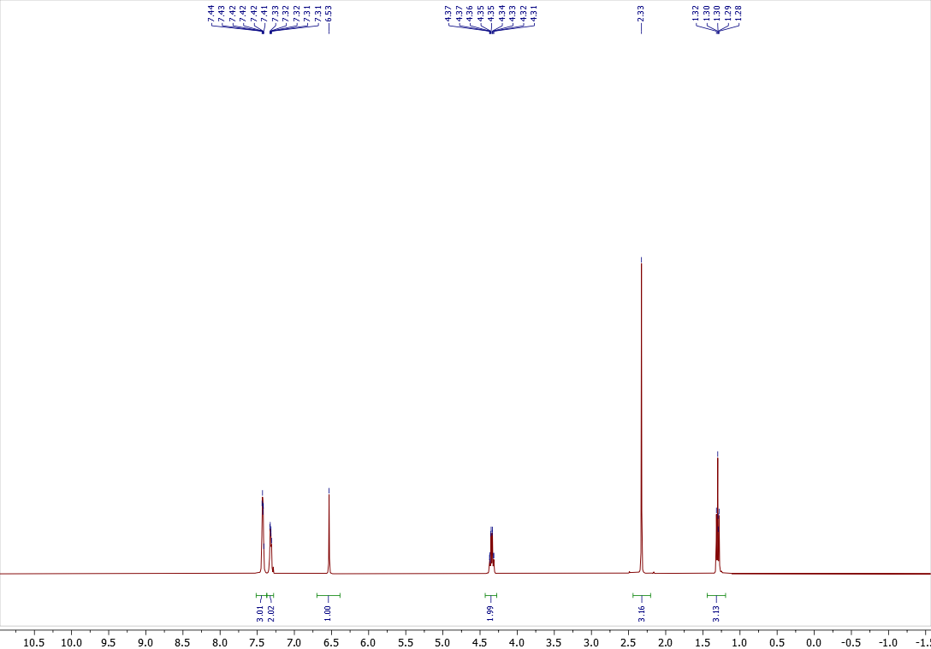
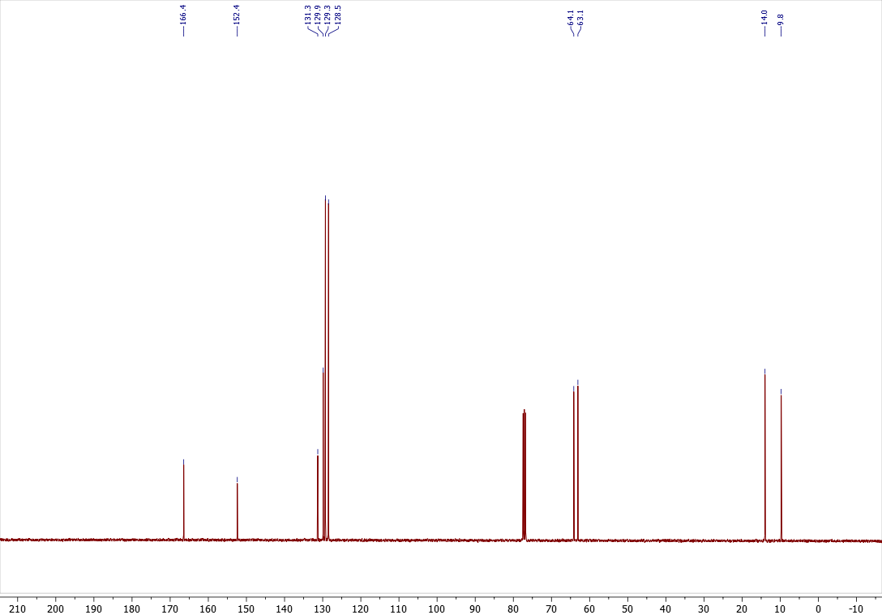

Copies of ¹H (400.13 MHz, CDCl₃), ¹³C{¹H} (100.61 MHz, CDCl₃) spectra of 3b
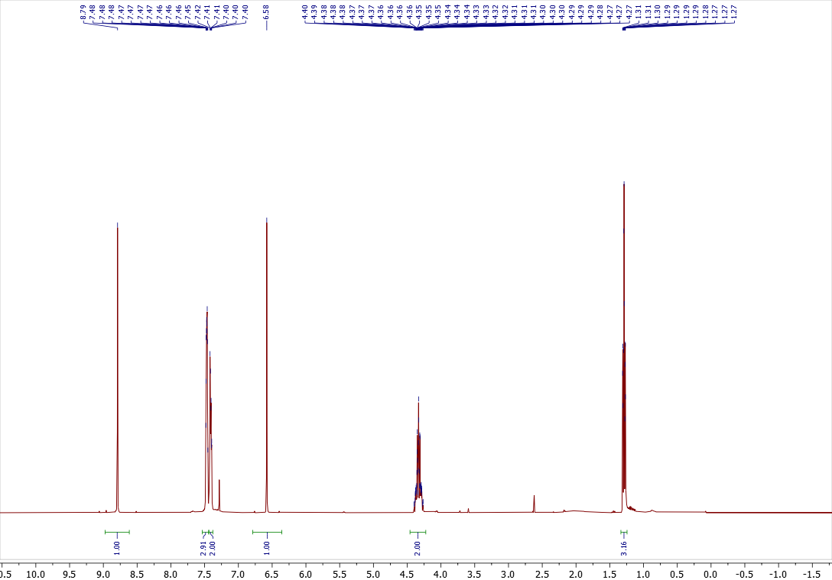

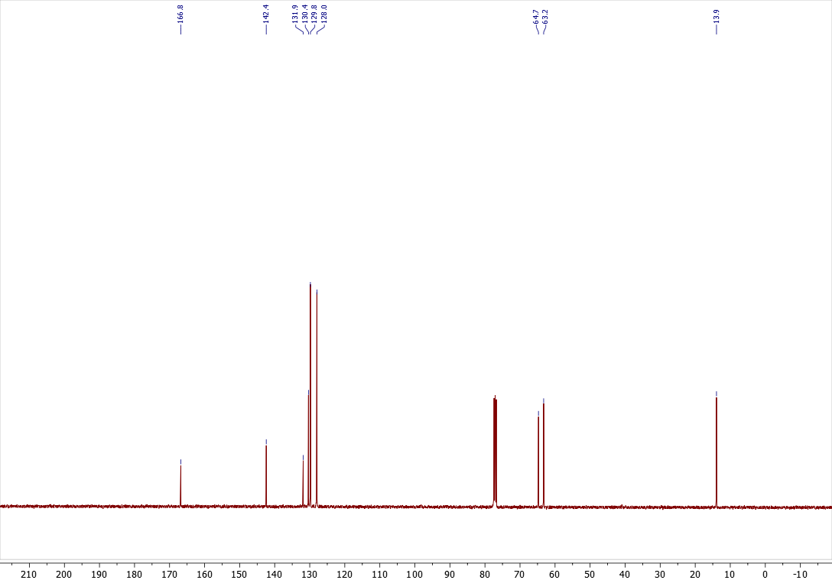

Copies of ¹H (400.13 MHz, CDCl₃), ¹³C{¹H} (100.61 MHz, CDCl₃) spectra of 4b
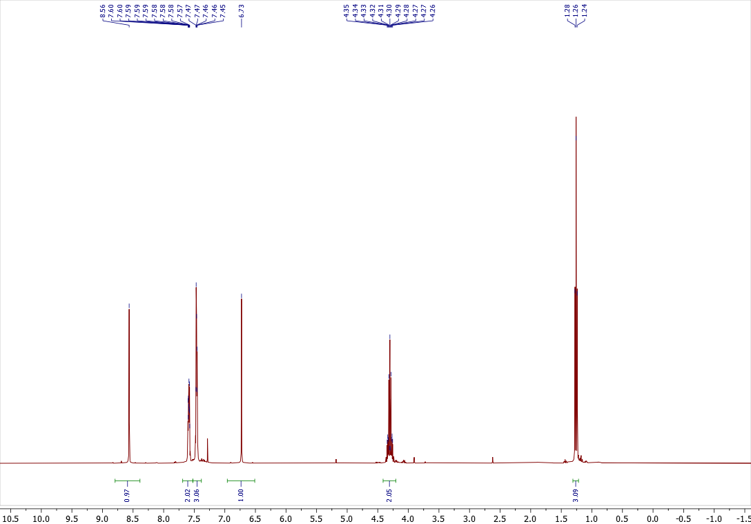

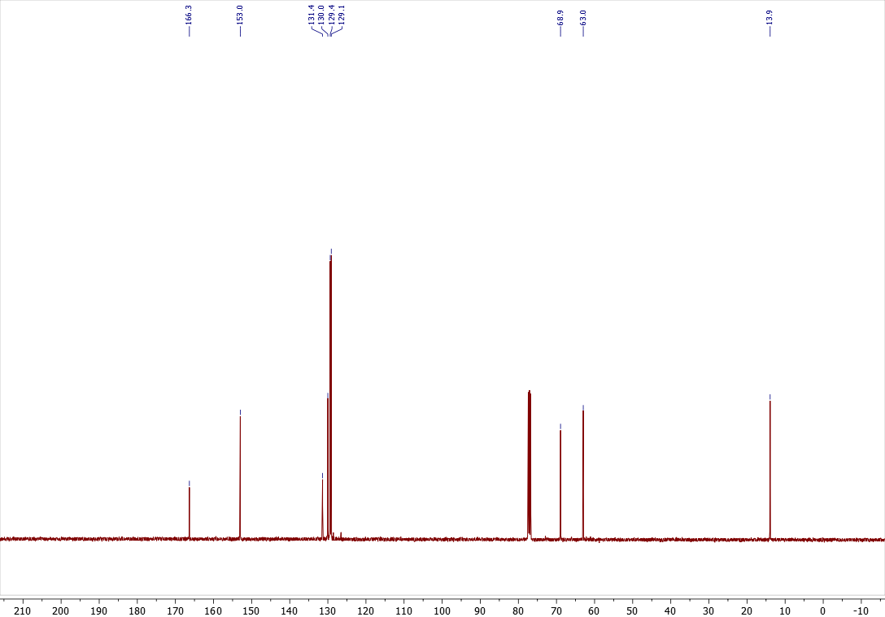

Copies of ¹H (400.13 MHz, CDCl₃), ¹³C{¹H} (100.61 MHz, CDCl₃) spectra of 3c
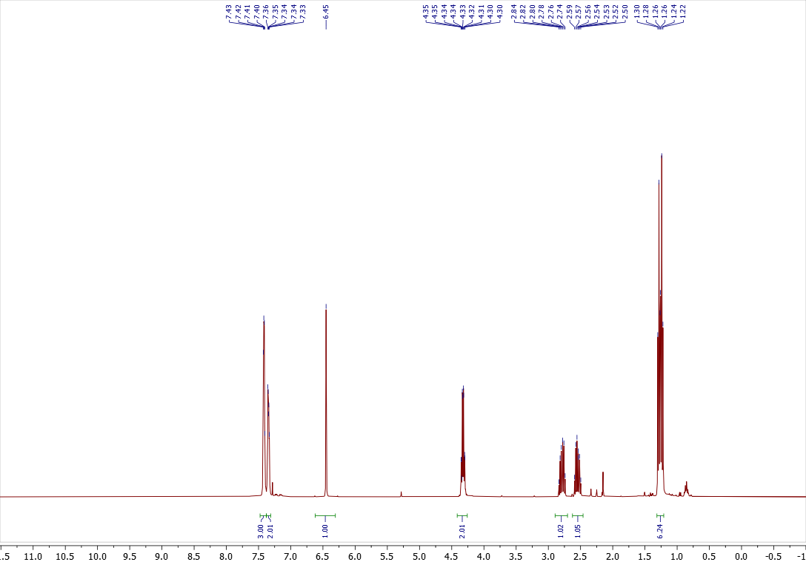

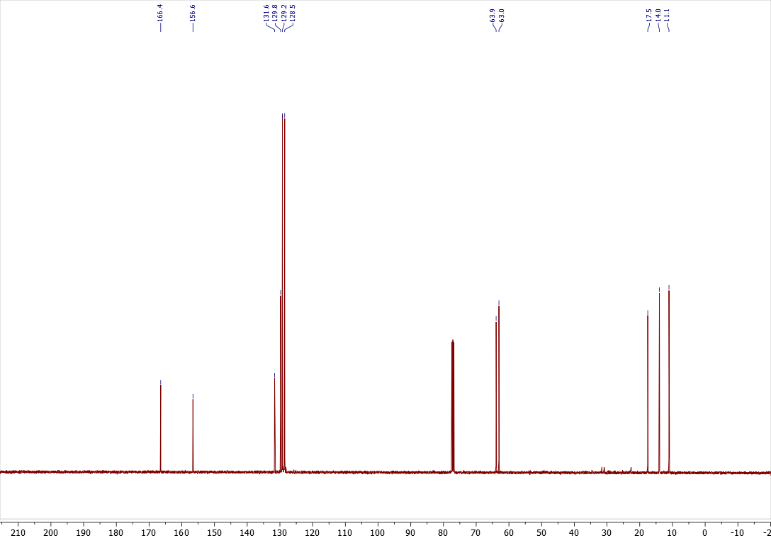

Copies of ¹H (400.13 MHz, CDCl₃), ¹³C{¹H} (100.61 MHz, CDCl₃) spectra of 3e
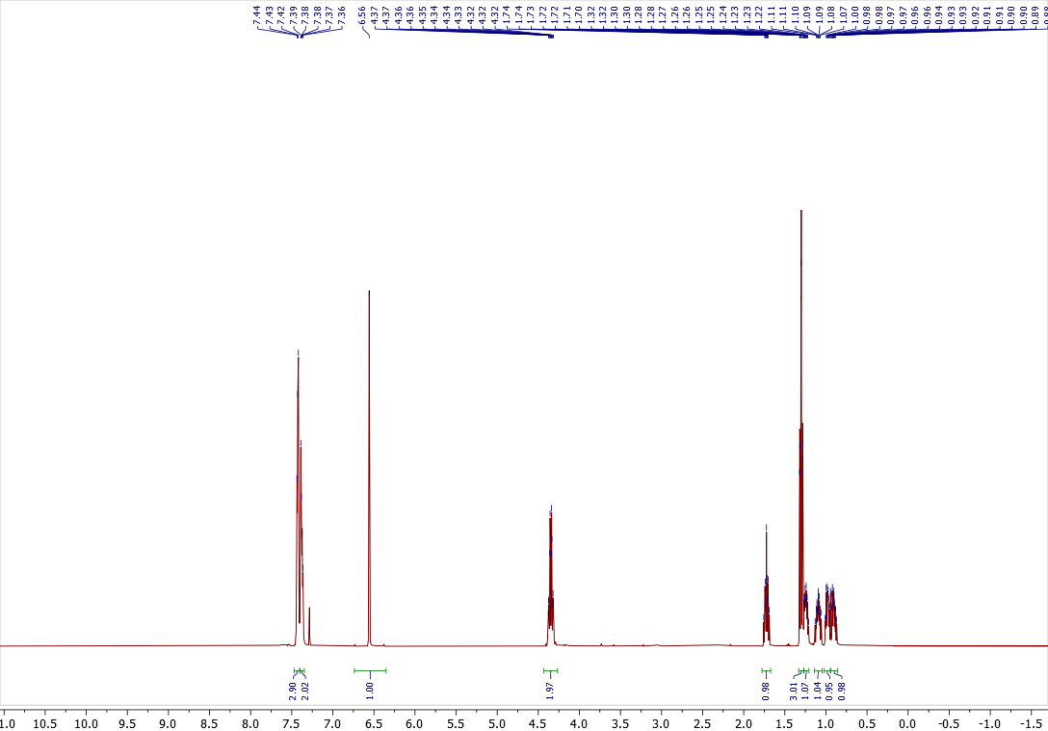

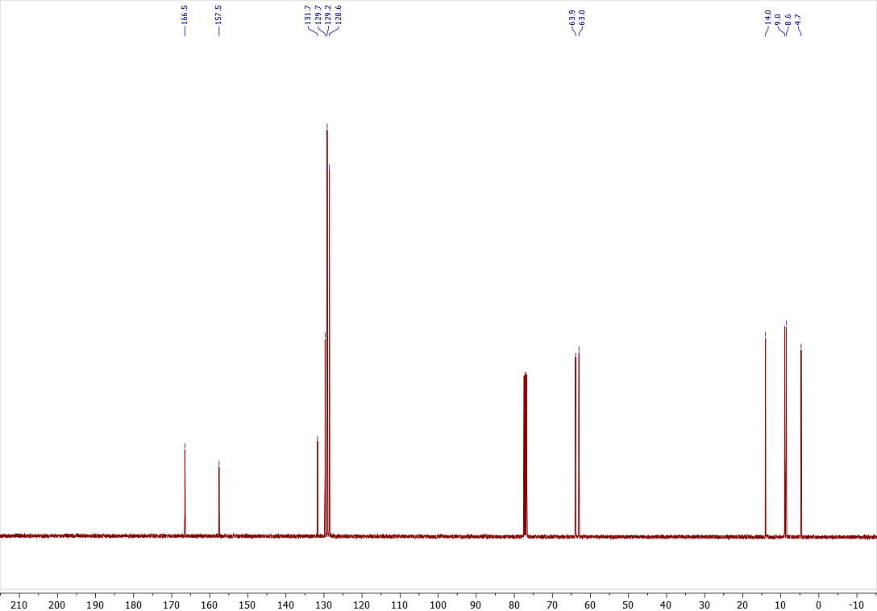

Copies of ¹H (400.13 MHz, CDCl₃), ¹³C{¹H} (100.61 MHz, CDCl₃) spectra of 3f
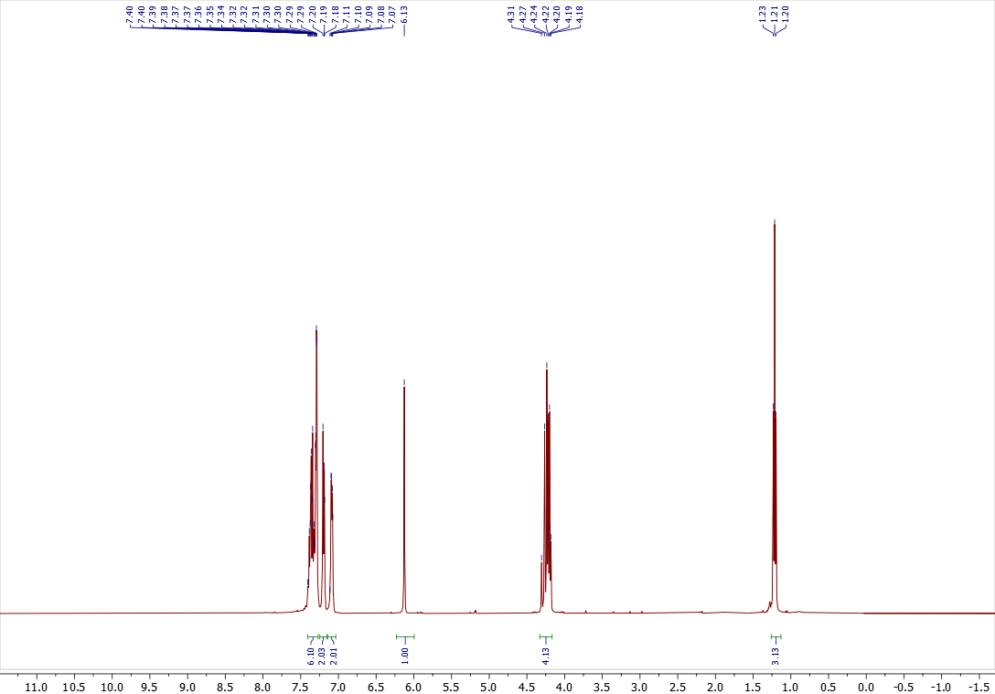

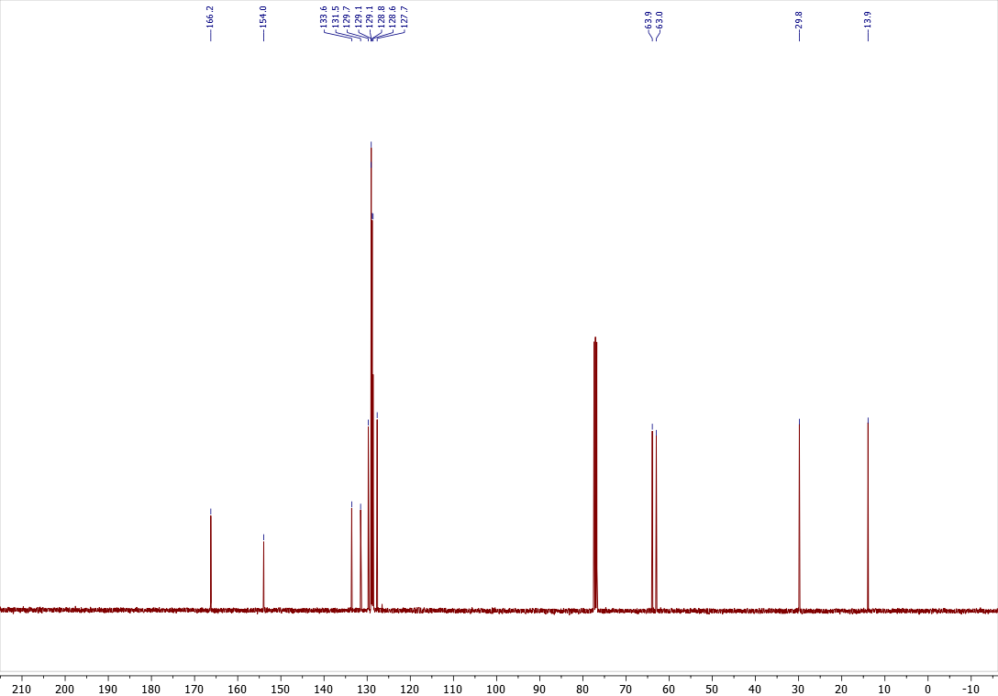

Copies of ¹H (400.13 MHz, CDCl₃), ¹³C{¹H} (100.61 MHz, CDCl₃) spectra of 3g
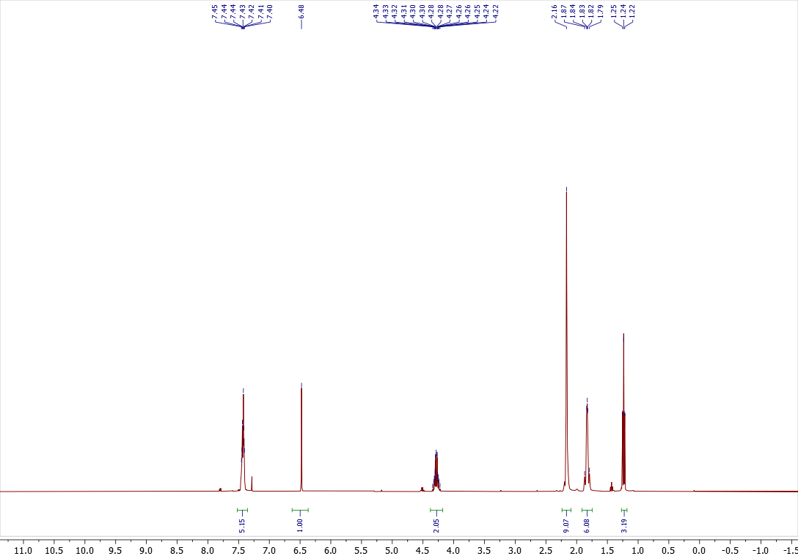

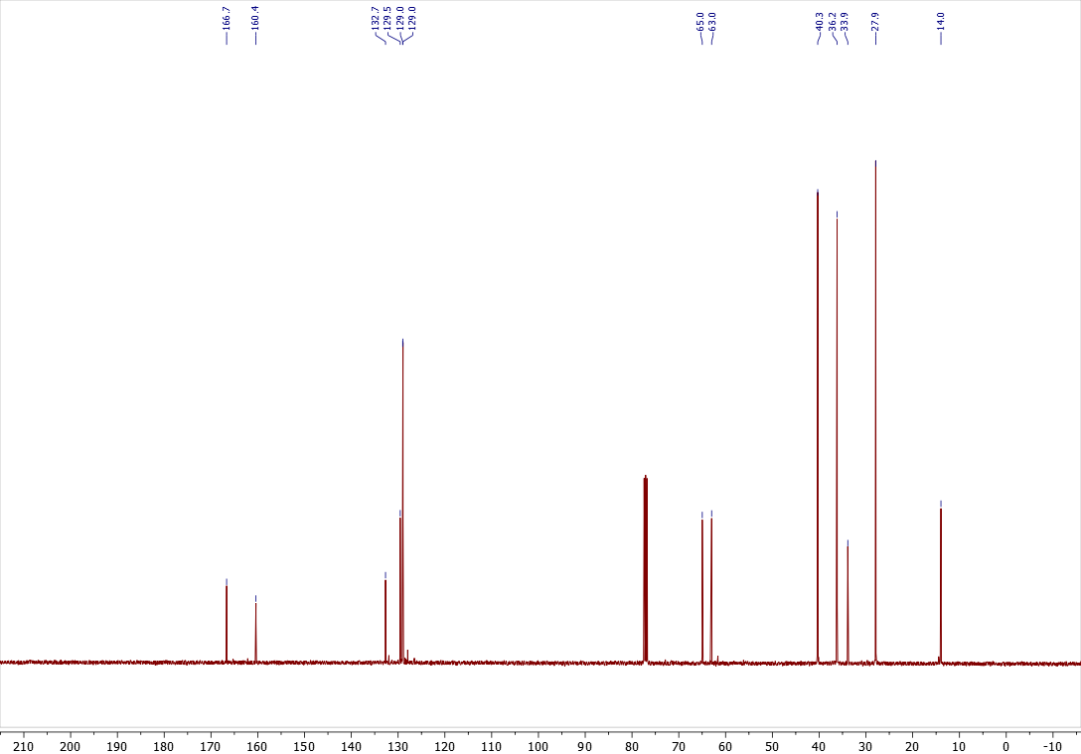

Copies of ¹H (400.13 MHz, CDCl₃), ¹³C{¹H} (100.61 MHz, CDCl₃) spectra of 3i
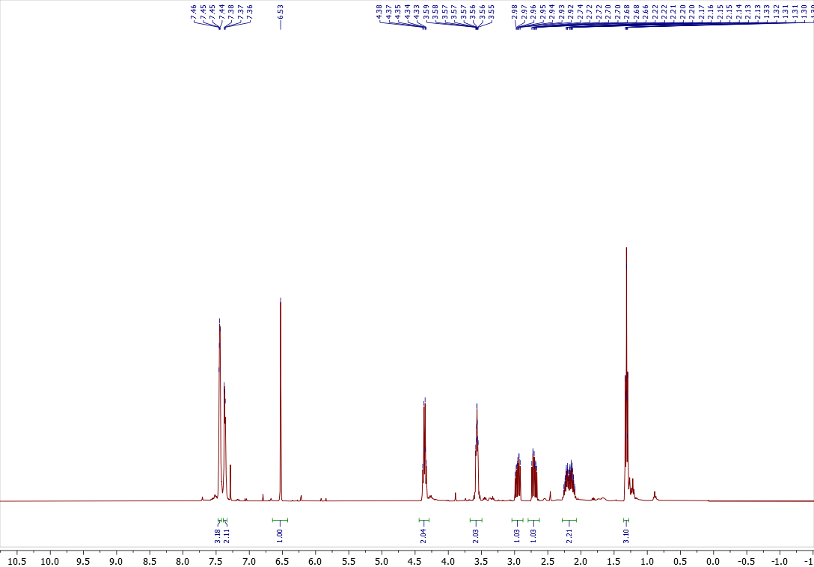

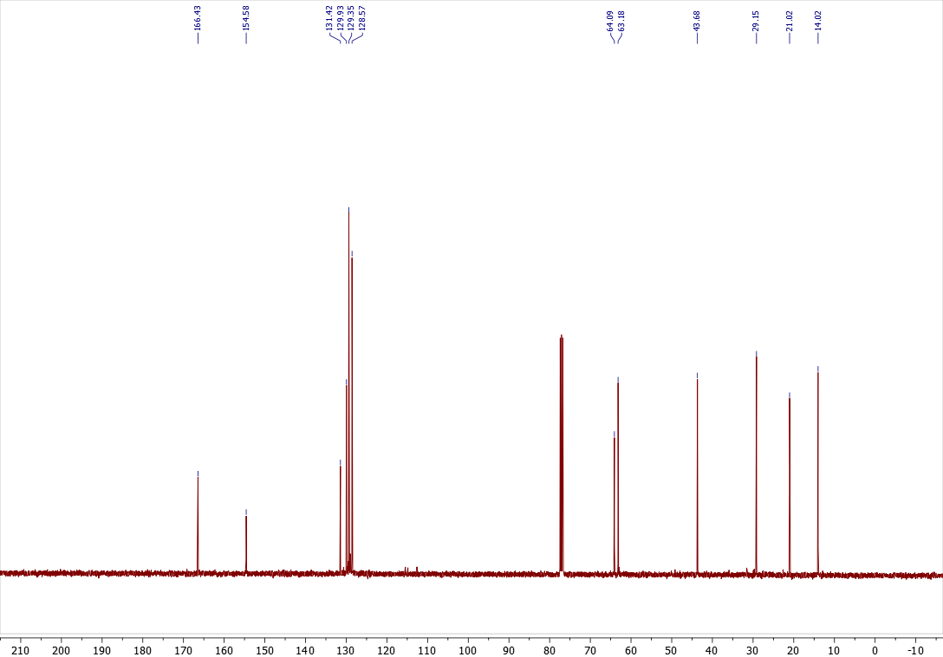

Copies of ¹H (400.13 MHz, CDCl₃), ¹³C{¹H} (100.61 MHz, CDCl₃) spectra of 3j
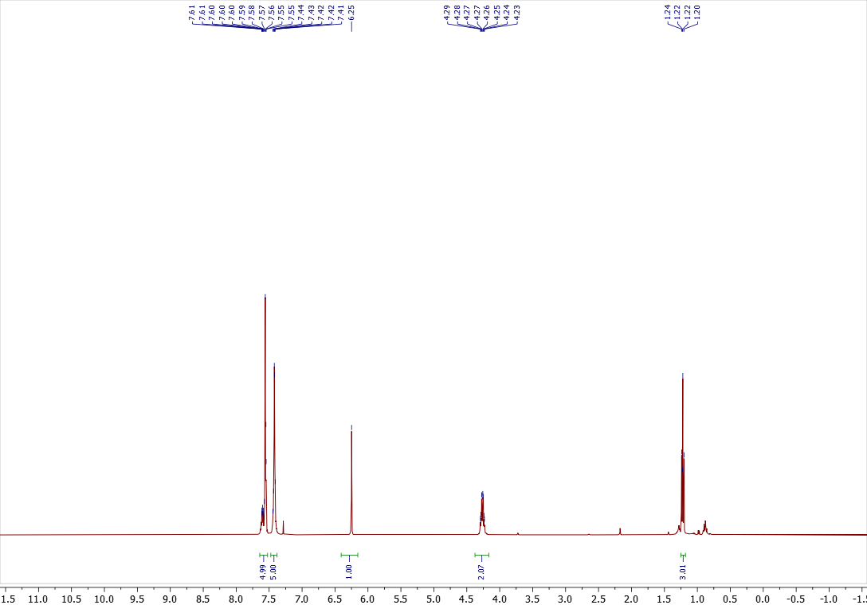

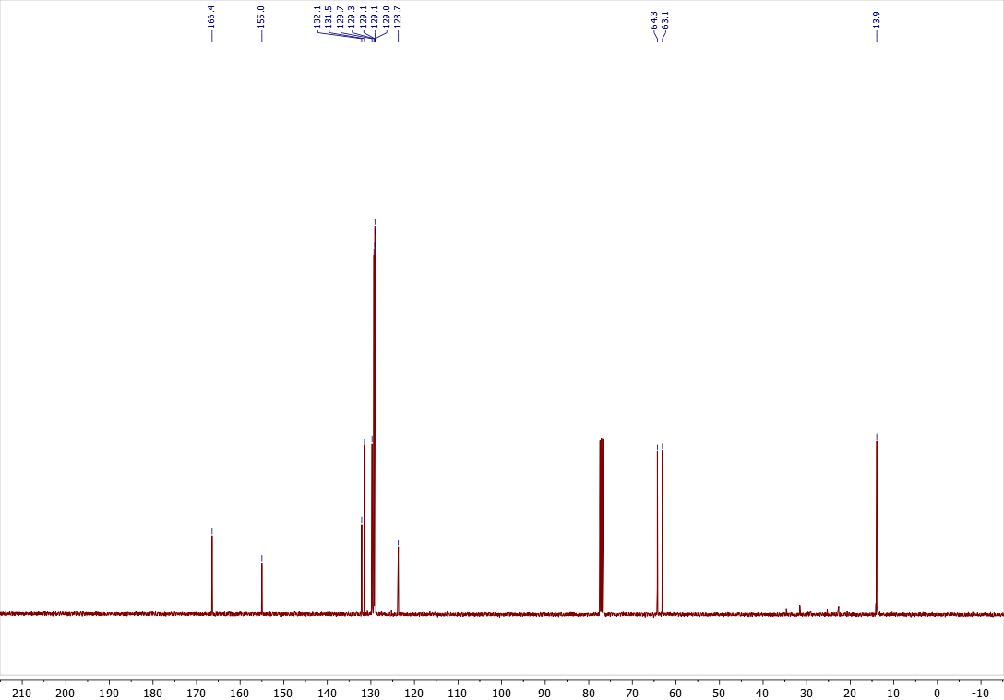

Copies of ¹H (400.13 MHz, CDCl₃), ¹³C{¹H} (100.61 MHz, CDCl₃), ¹⁹F{¹H} (376.50 MHz, CDCl₃) spectra of 3k
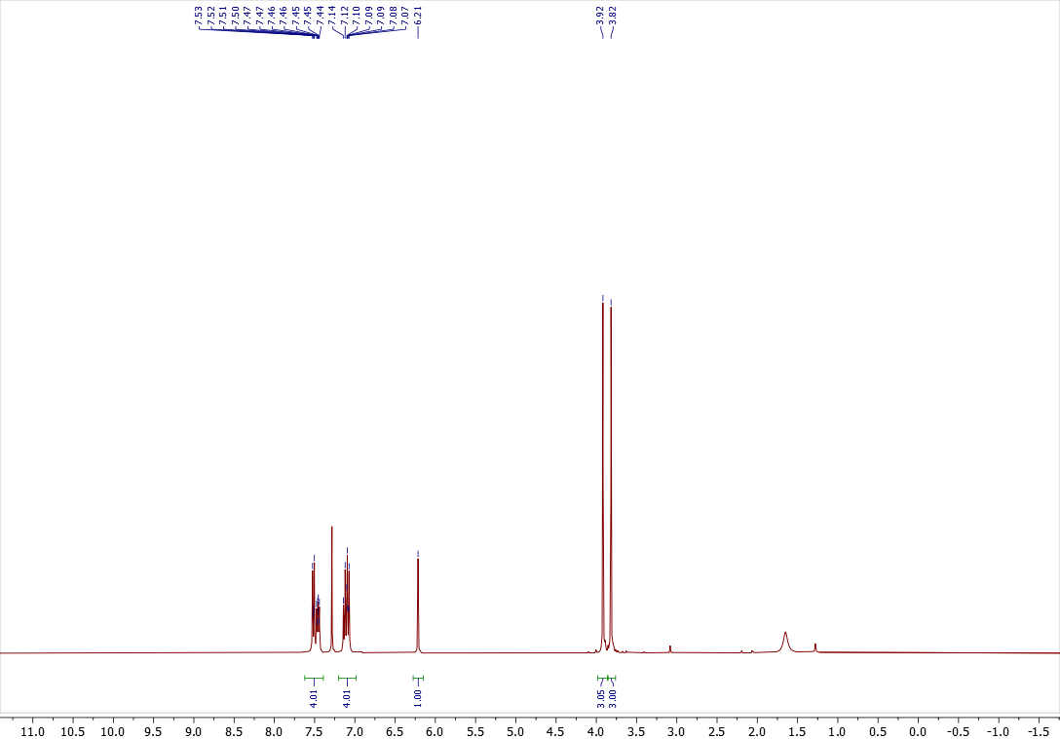

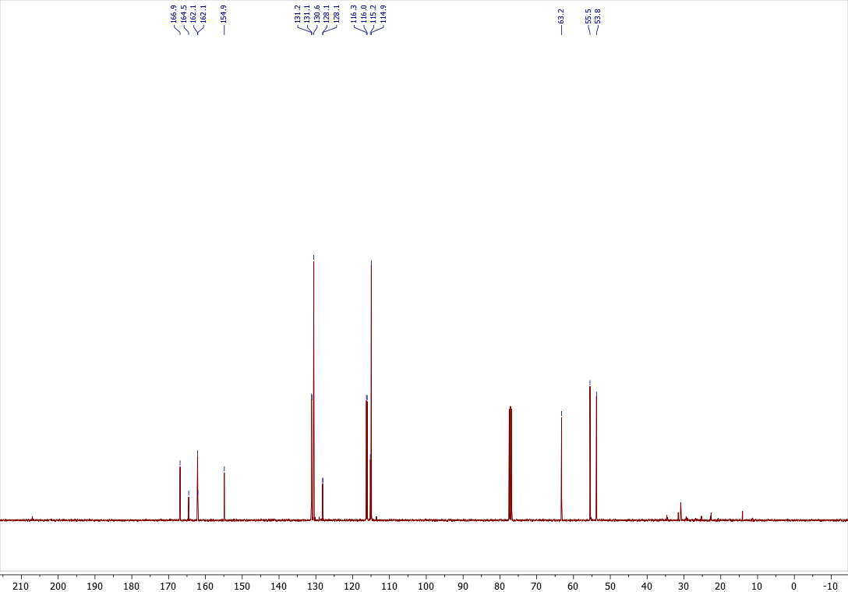
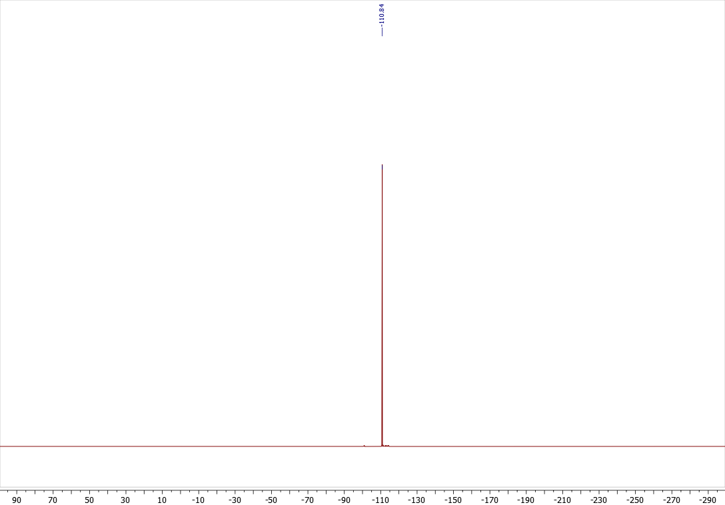
Copies of ¹H (400.13 MHz, CDCl₃), ¹³C{¹H} (100.61 MHz, CDCl₃), ¹⁹F{¹H} (376.50 MHz, CDCl₃) spectra of 4k
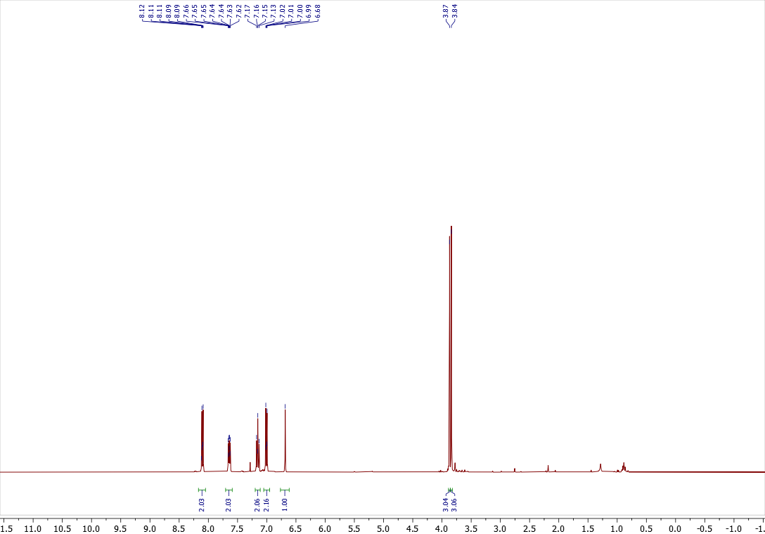

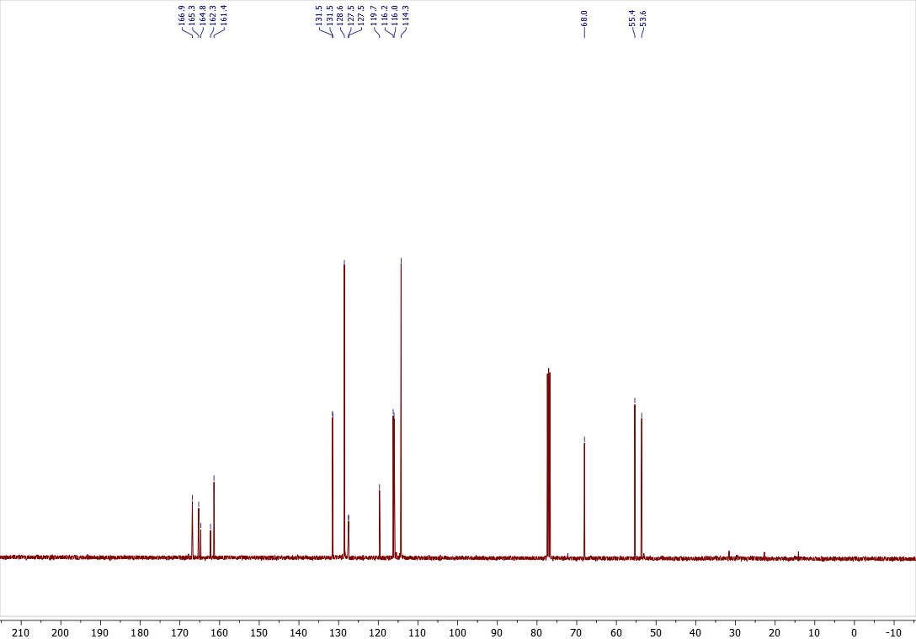
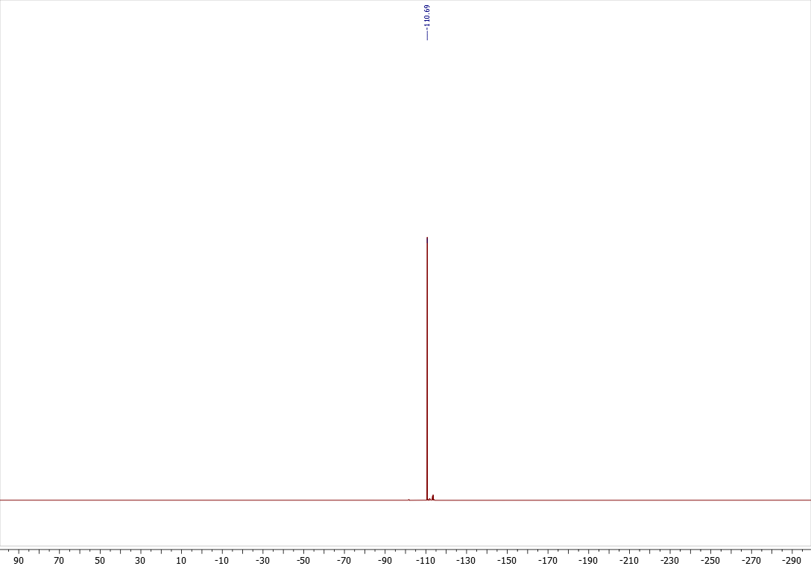
Copies of ¹H (400.13 MHz, CDCl₃), ¹³C{¹H} (100.61 MHz, CDCl₃), spectra of 3l
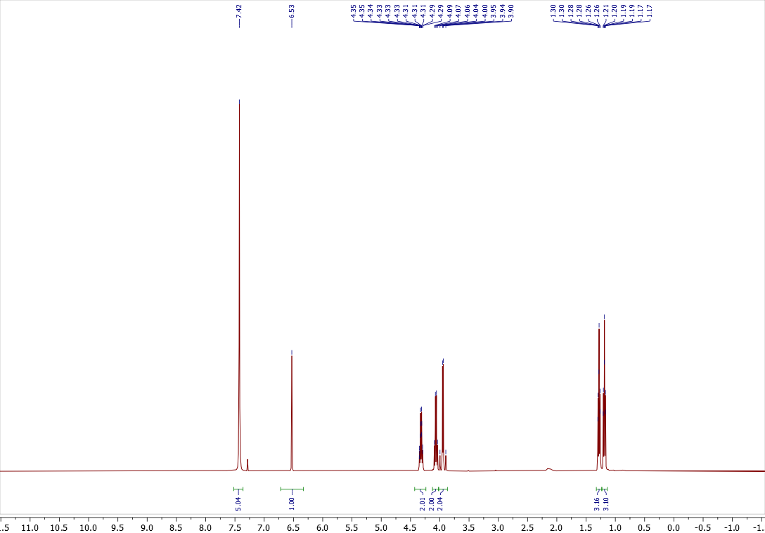

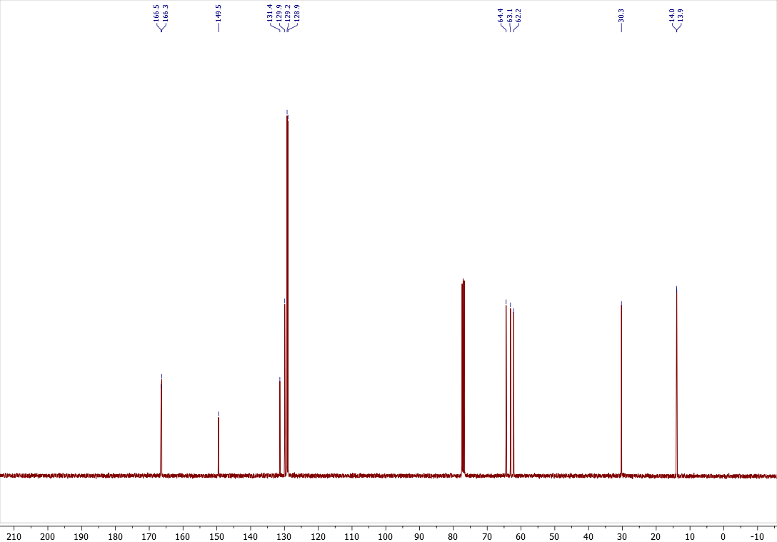

Copies of ¹H (400.13 MHz, CDCl₃), ¹³C{¹H} (100.61 MHz, CDCl₃), spectra of 4l
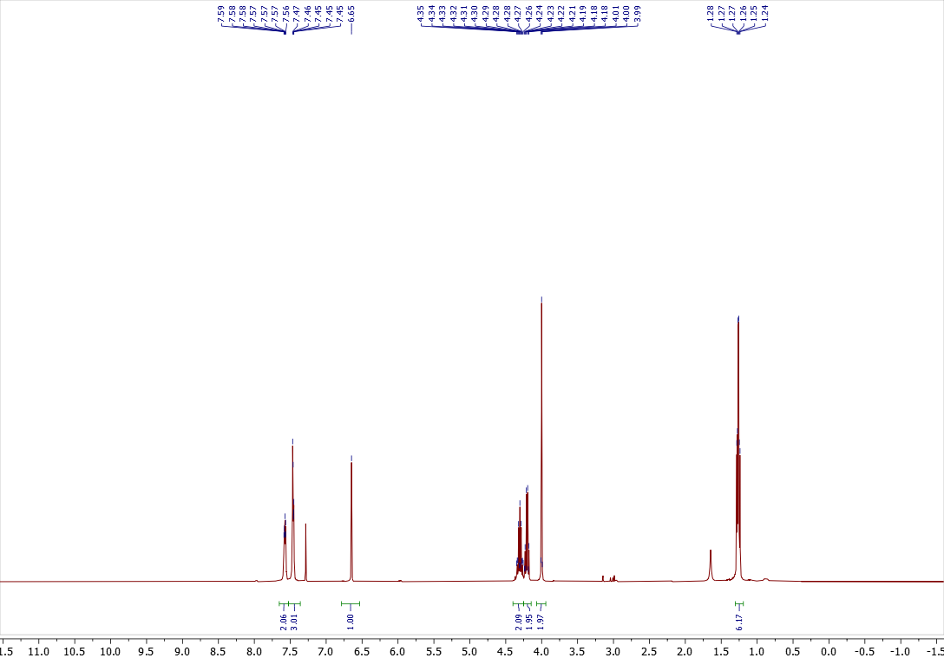

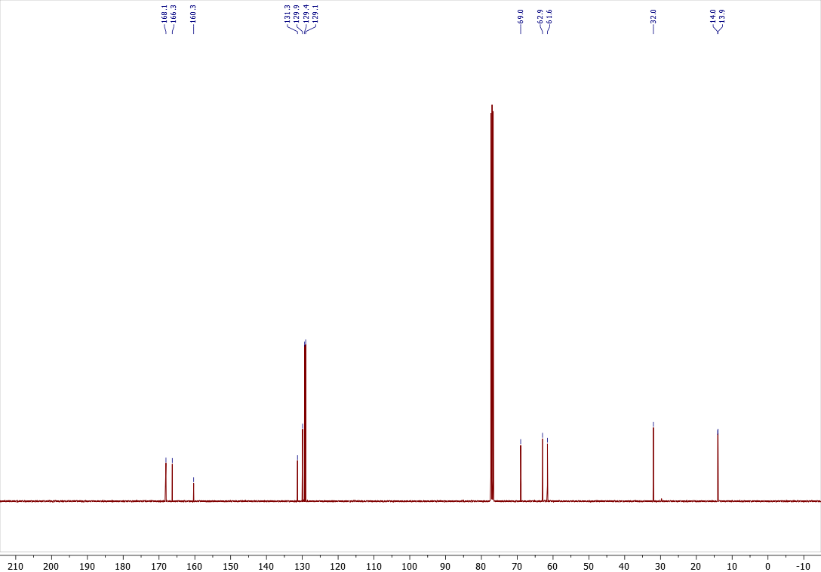

Copies of ¹H (400.13 MHz, CDCl₃), ¹³C{¹H} (100.61 MHz, CDCl₃), spectra of 3n
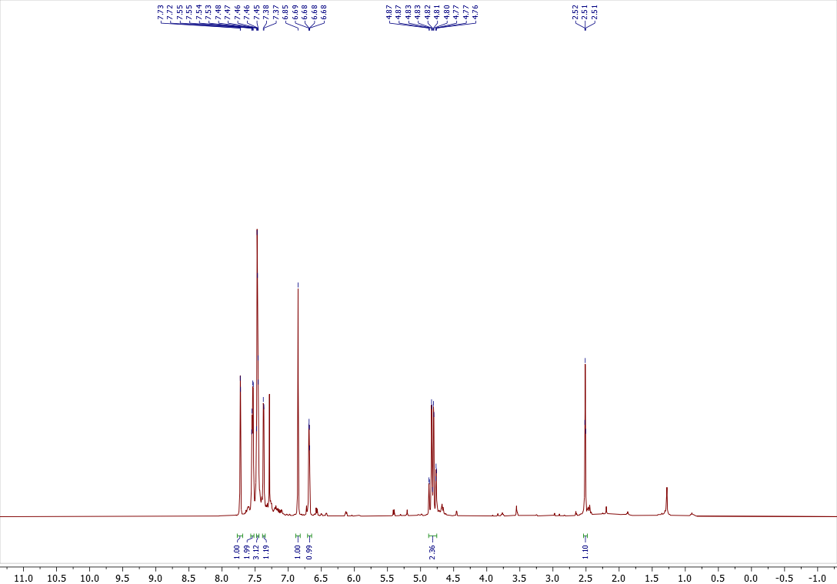

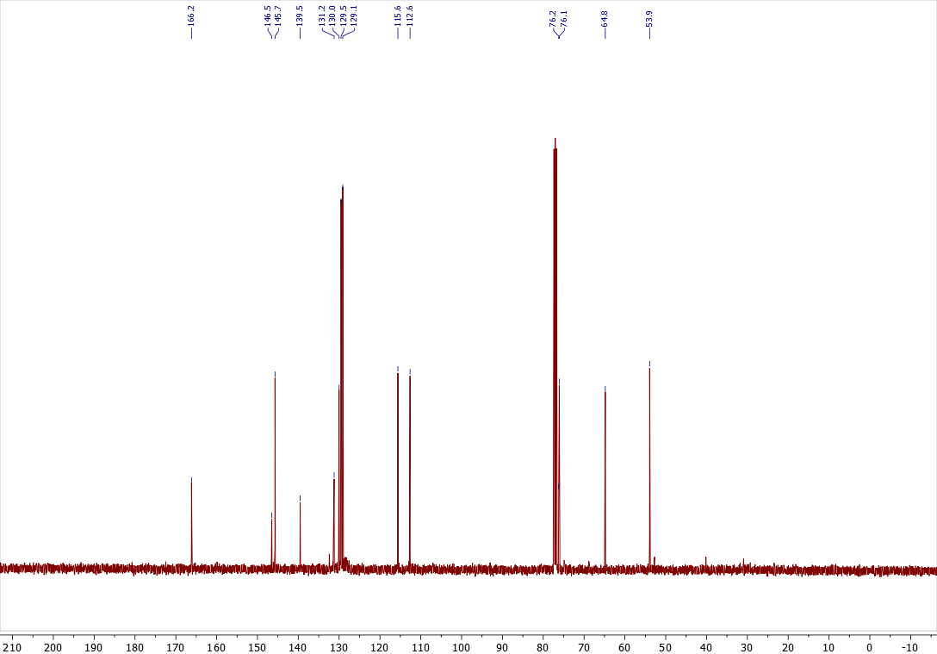

Copies of ¹H (400.13 MHz, CDCl₃), ¹³C{¹H} (100.61 MHz, CDCl₃), spectra of 3p
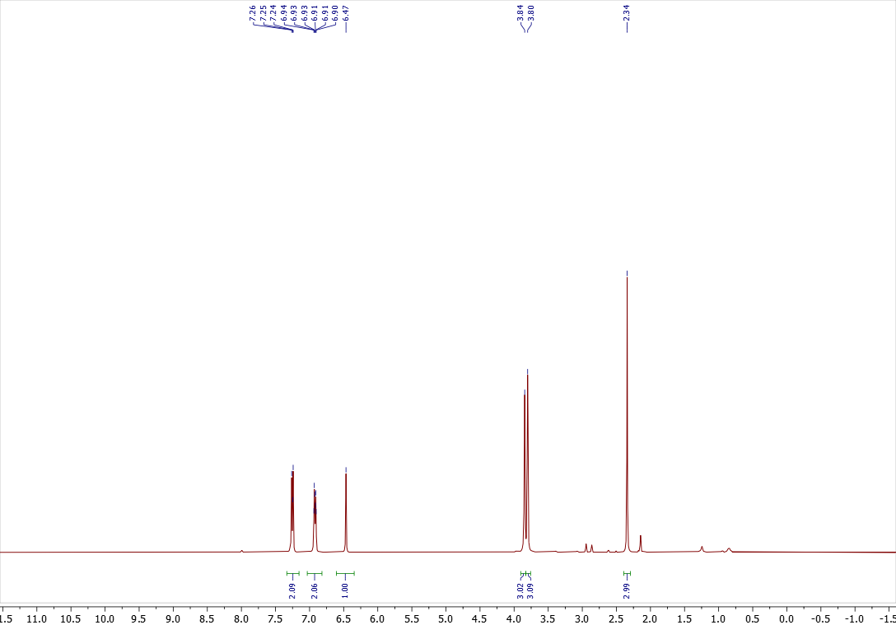

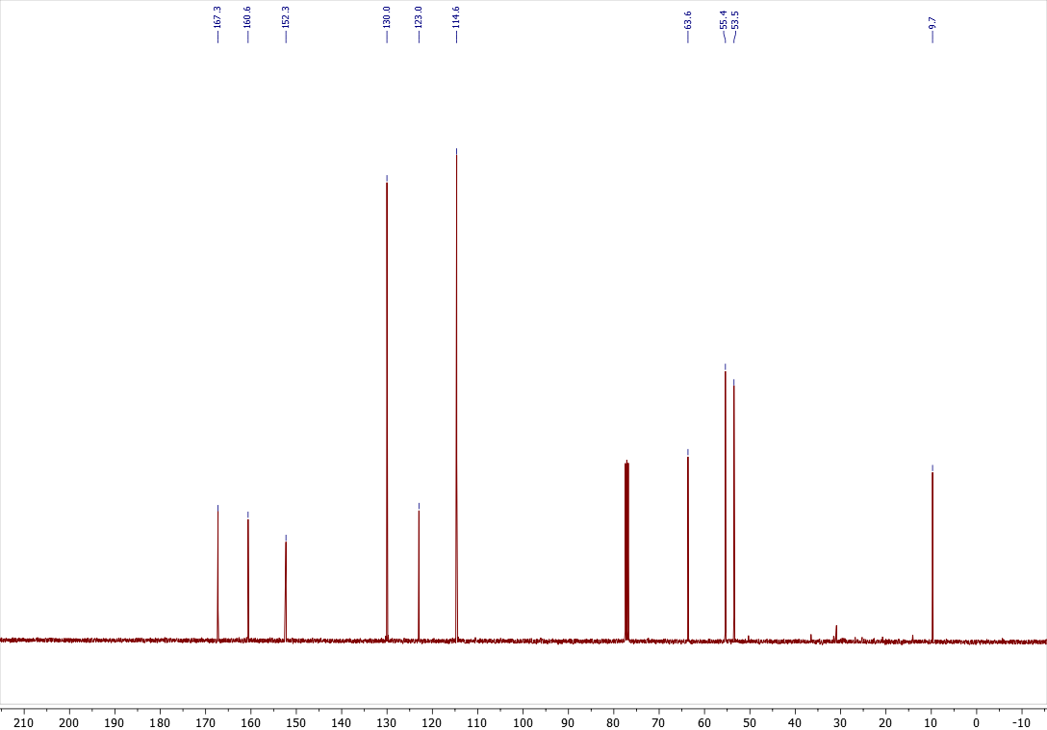

Copies of ¹H (400.13 MHz, CDCl₃), ¹³C{¹H} (100.61 MHz, CDCl₃), spectra of 4p
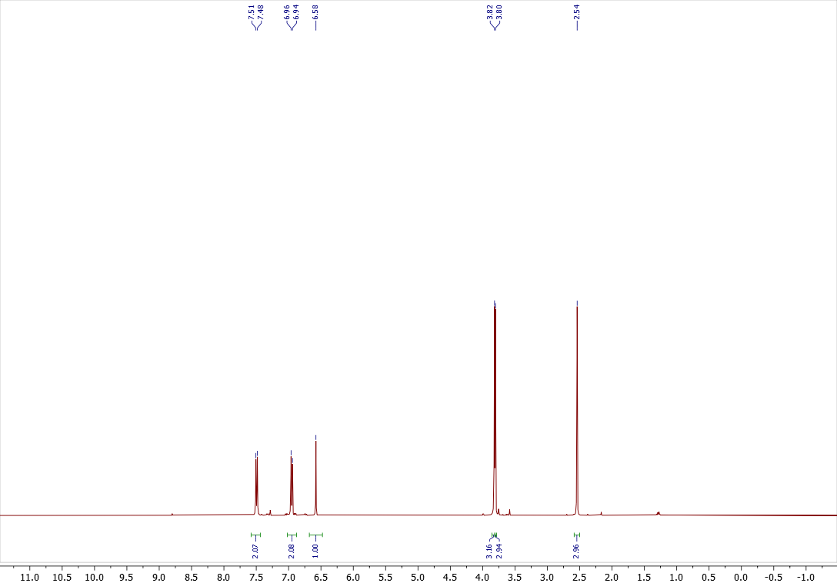

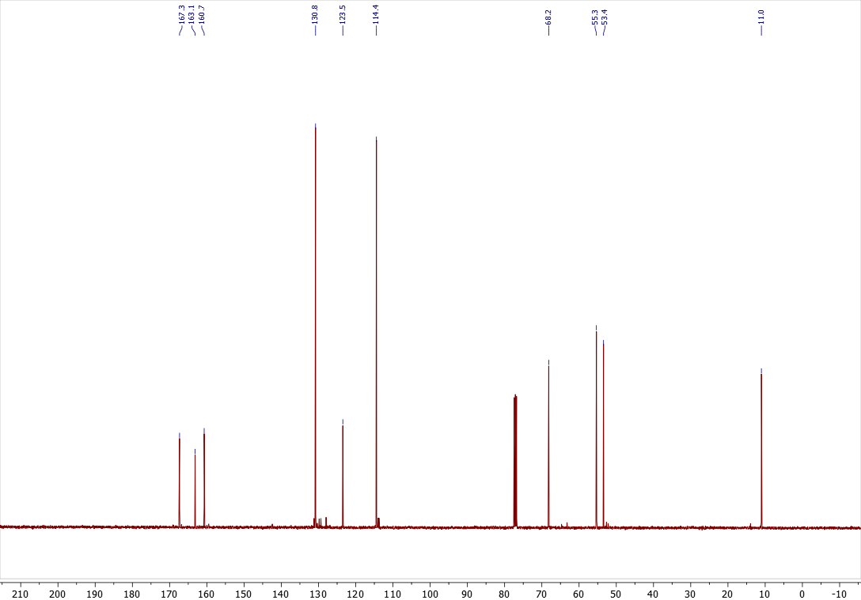

Copies of ¹H (400.13 MHz, CDCl₃), ¹³C{¹H} (100.61 MHz, CDCl₃), ¹⁹F{¹H} (376.50 MHz, CDCl₃) spectra of 3q
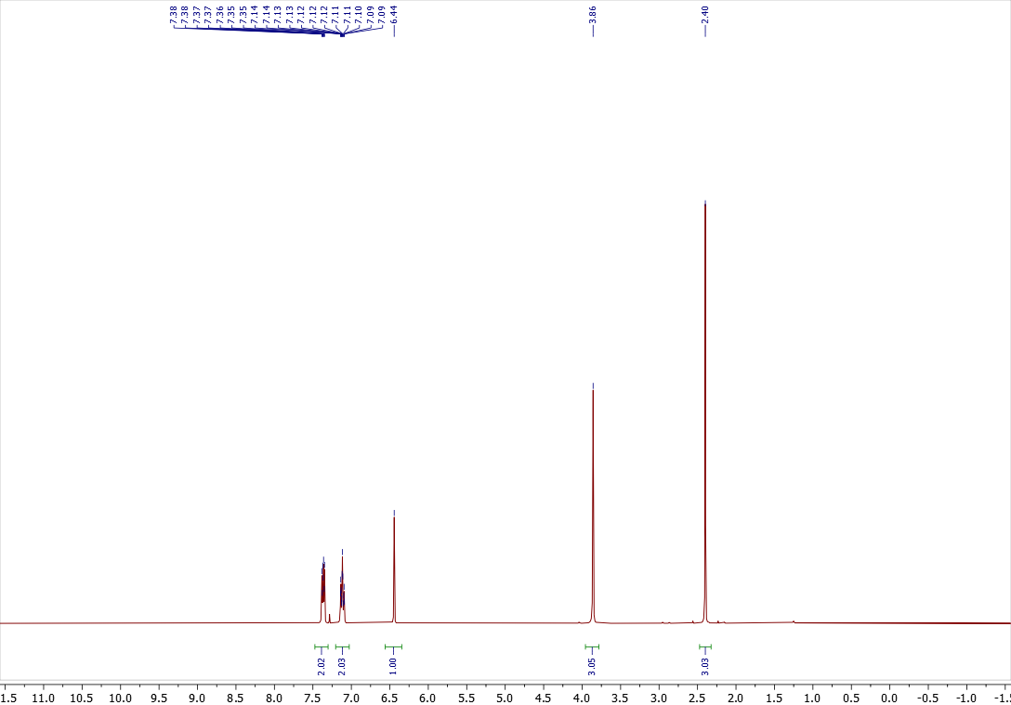

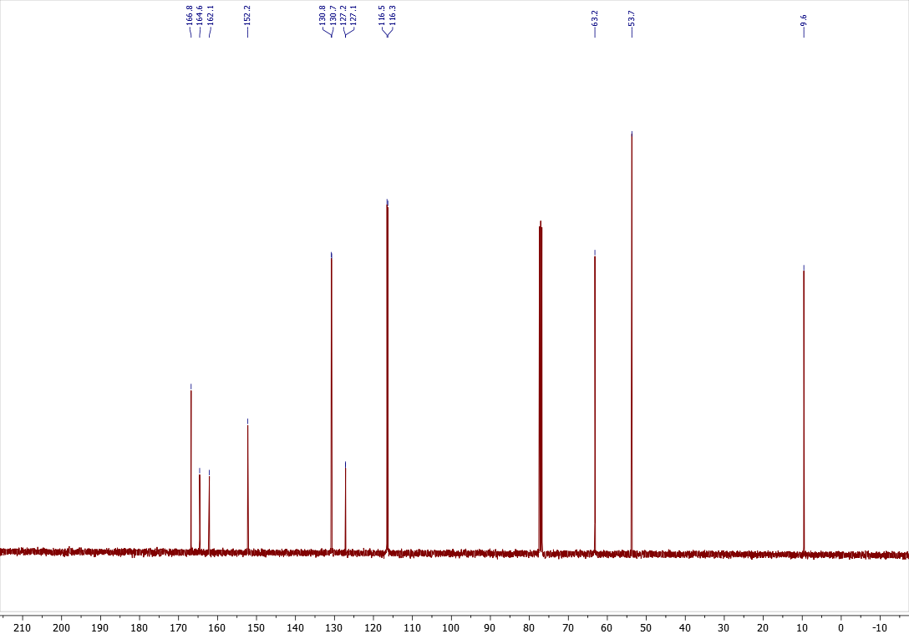
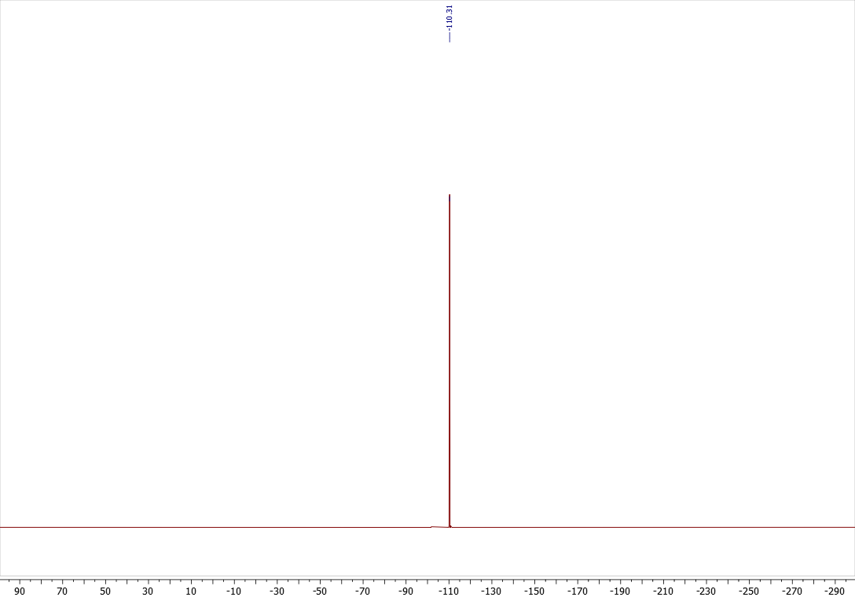
Copies of ¹H (400.13 MHz, CDCl₃), ¹³C{¹H} (100.61 MHz, CDCl₃), ¹⁹F{¹H} (376.50 MHz, CDCl₃) spectra of 4q
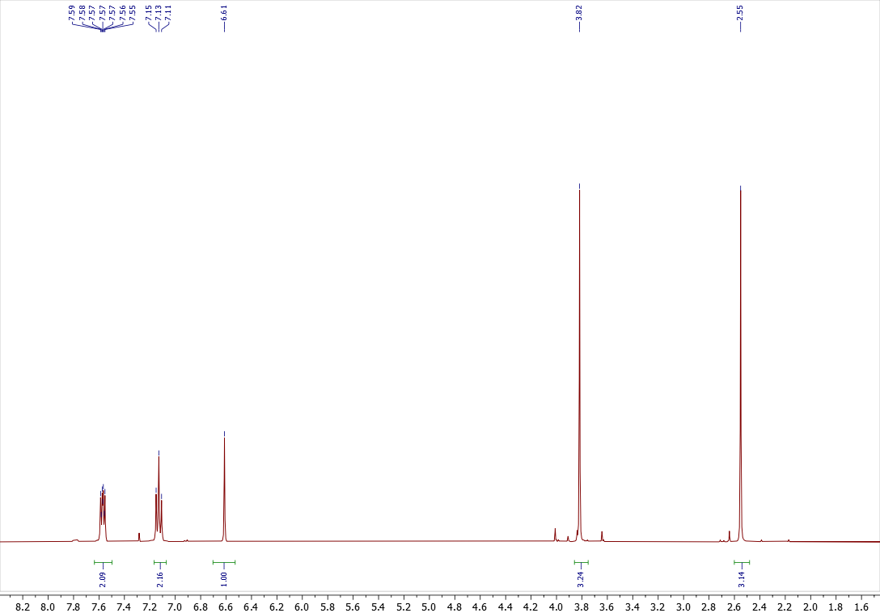

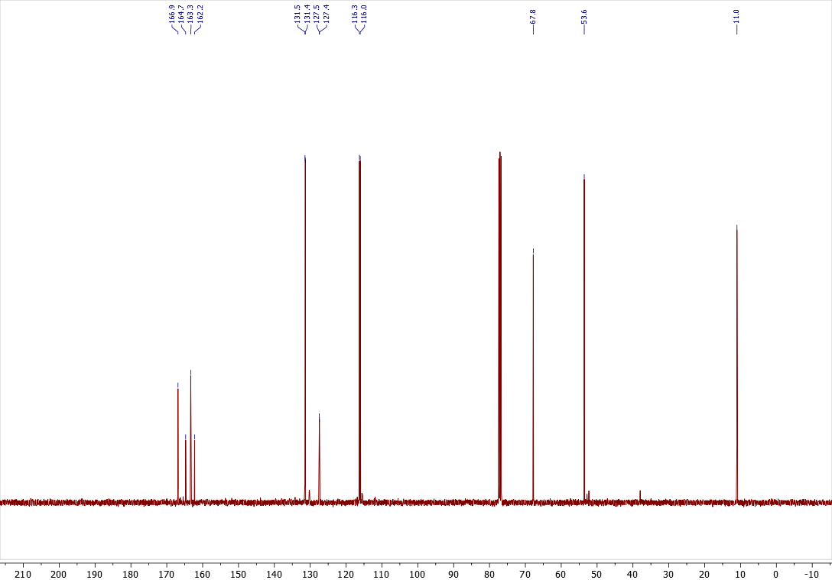
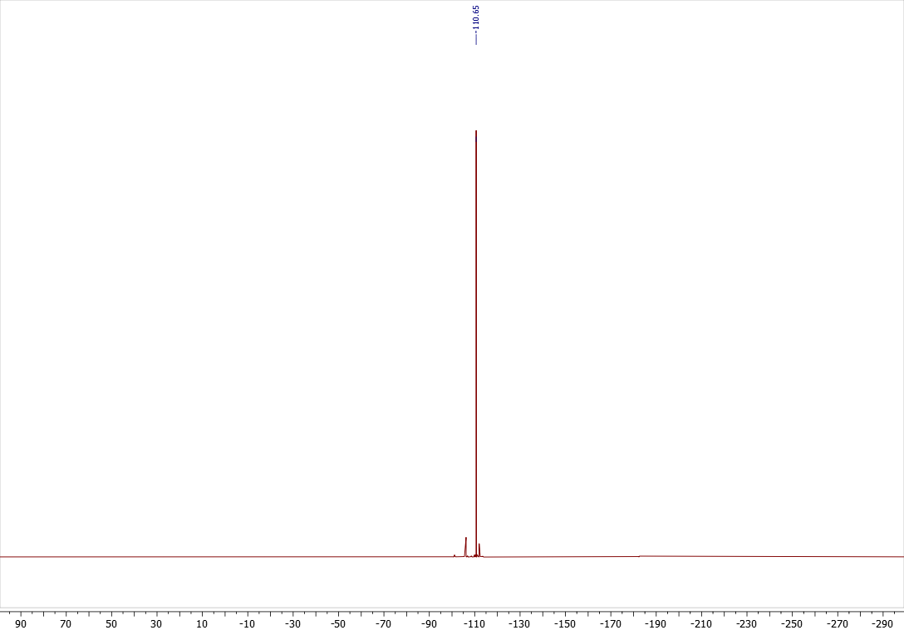
Copies of ¹H (400.13 MHz, CDCl₃), ¹³C{¹H} (100.61 MHz, CDCl₃), spectra of 3r
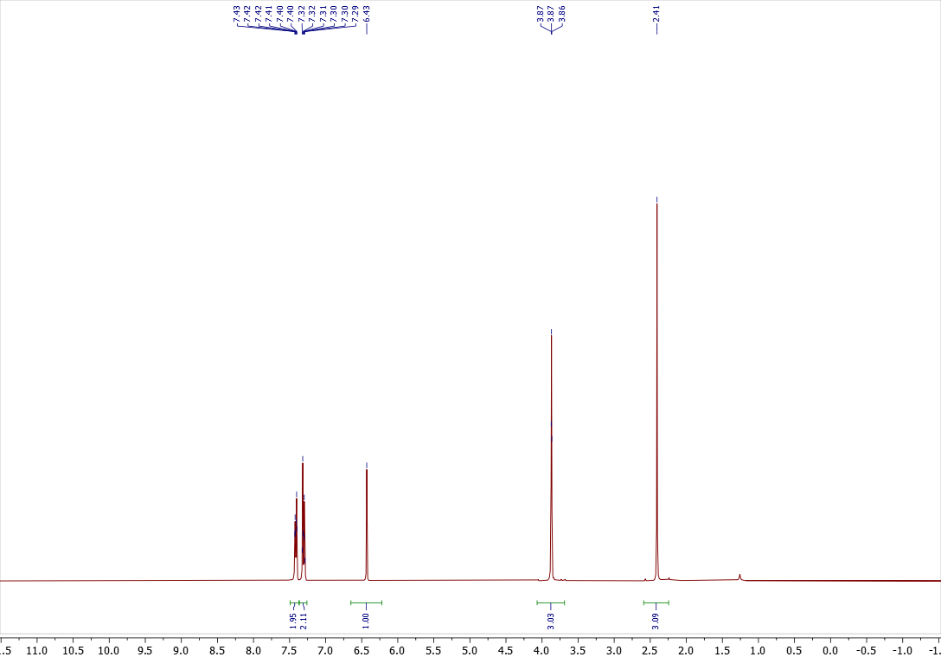

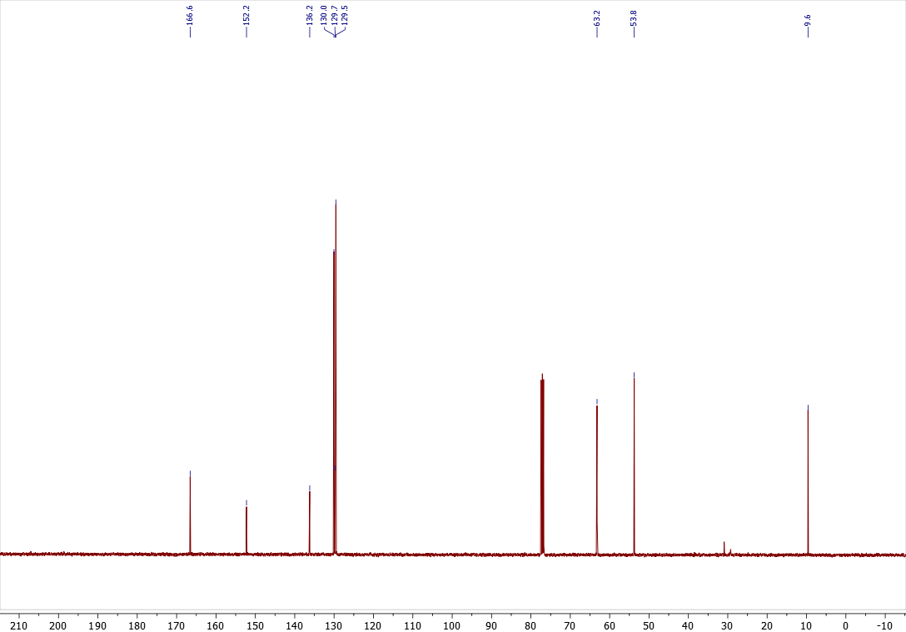

Copies of ¹H (400.13 MHz, CDCl₃), ¹³C{¹H} (100.61 MHz, CDCl₃), spectra of 4r
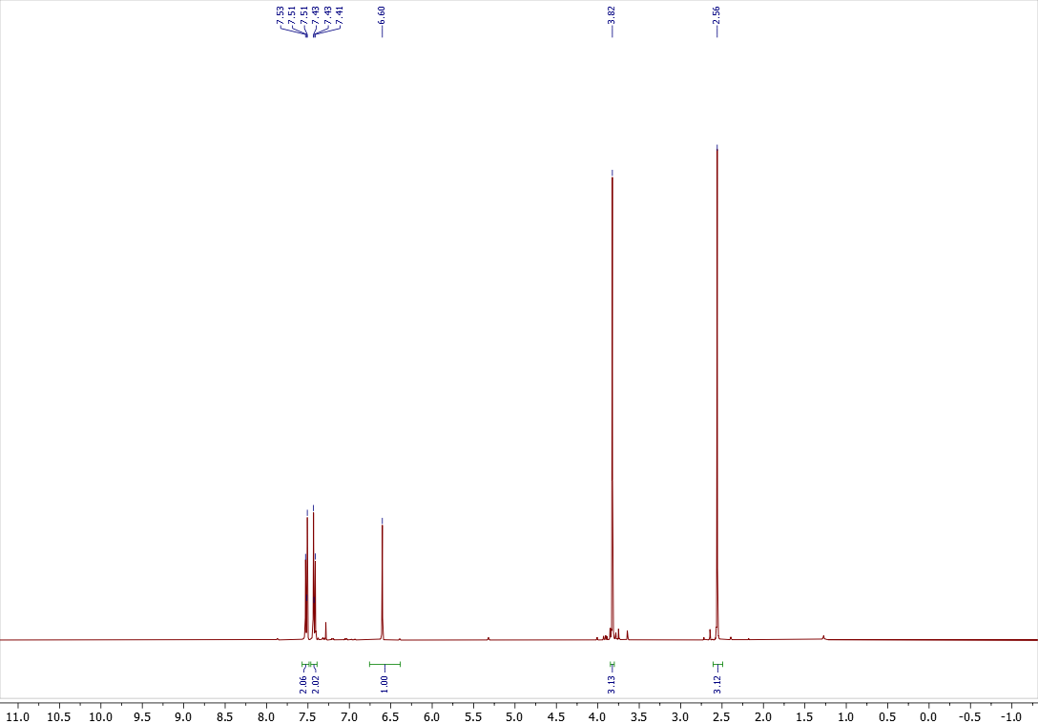

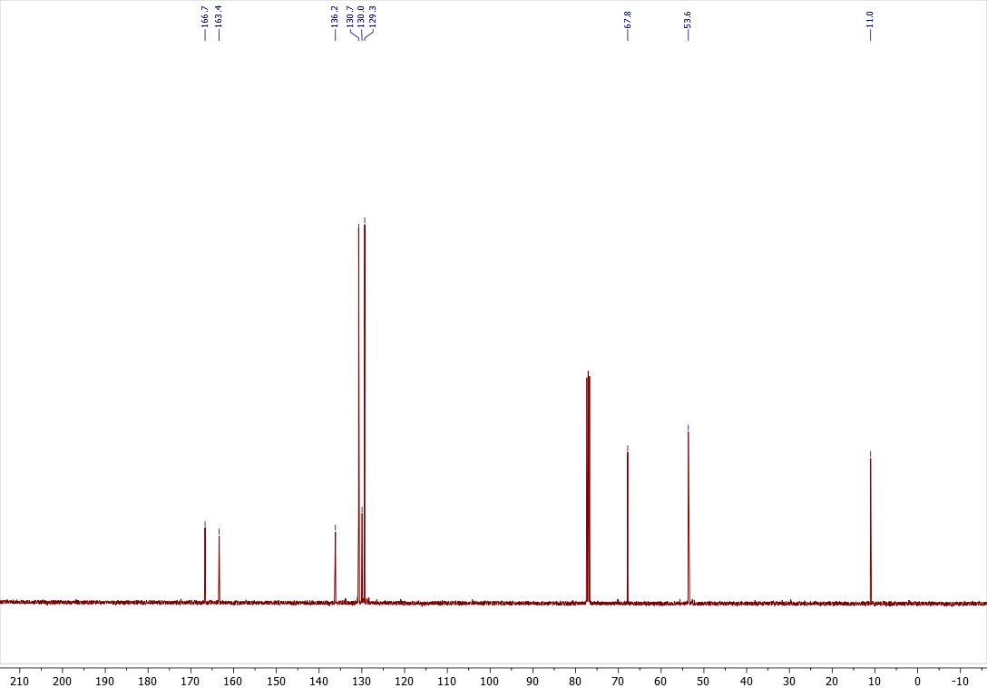

Copies of ¹H (400.13 MHz, CDCl₃), ¹³C{¹H} (100.61 MHz, CDCl₃), spectra of 3s
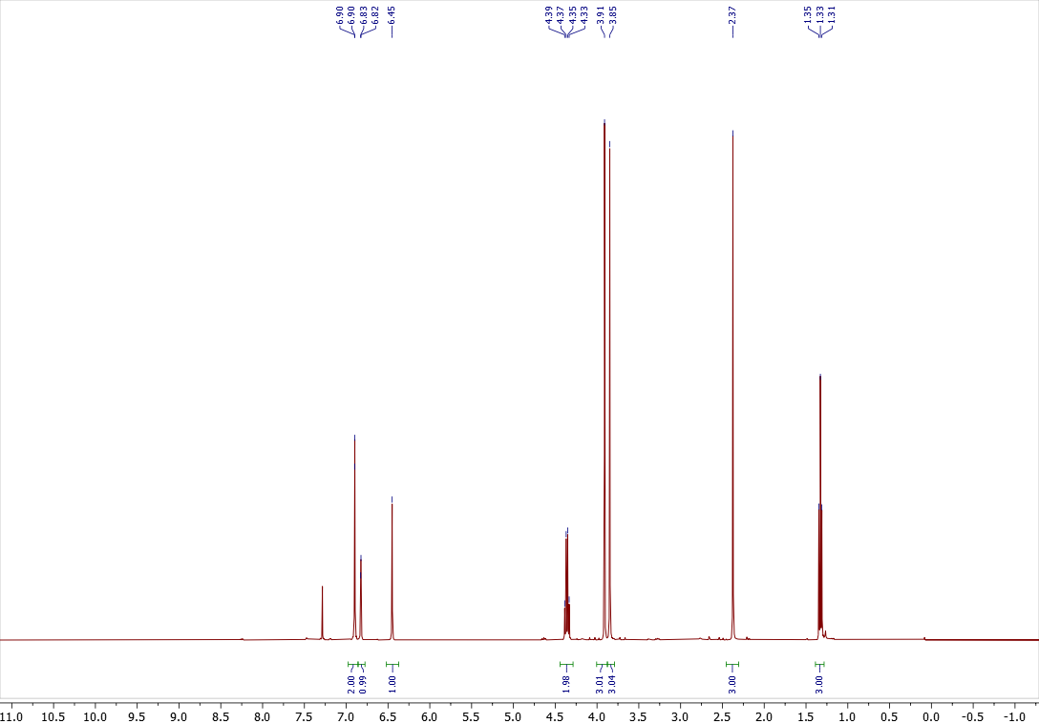

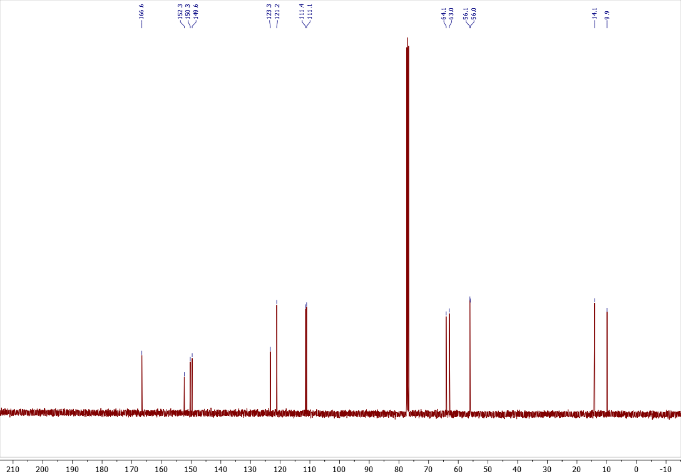

Copies of ¹H (400.13 MHz, CDCl₃), ¹³C{¹H} (100.61 MHz, CDCl₃), spectra of 4s
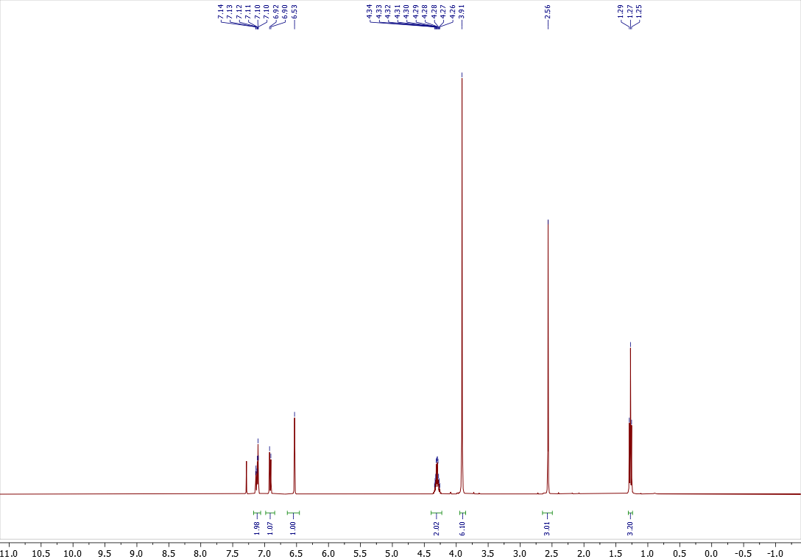

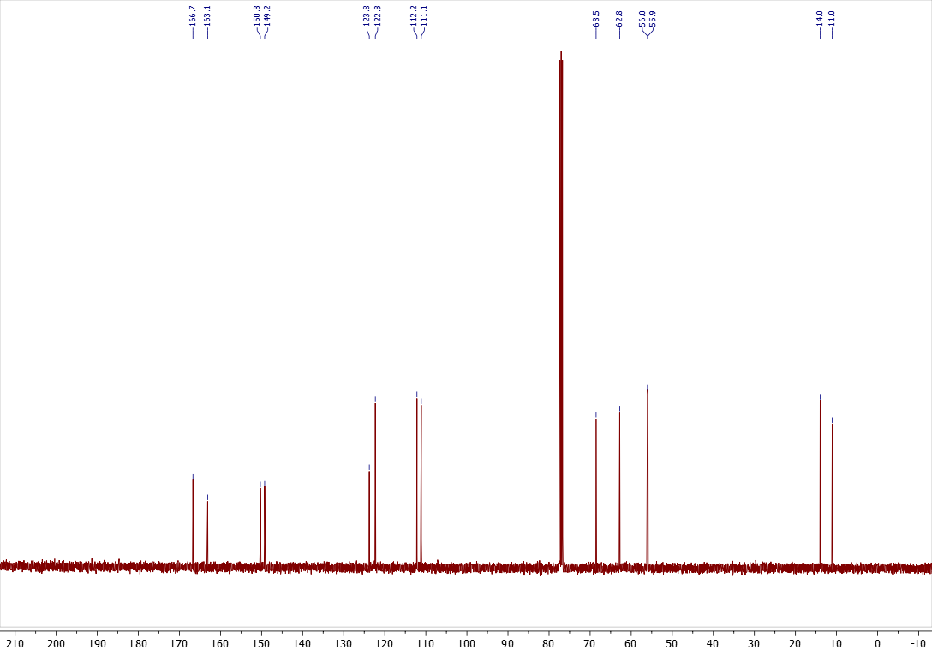

Copies of ¹H (400.13 MHz, CDCl₃), ¹³C{¹H} (100.61 MHz, CDCl₃), spectra of 3t
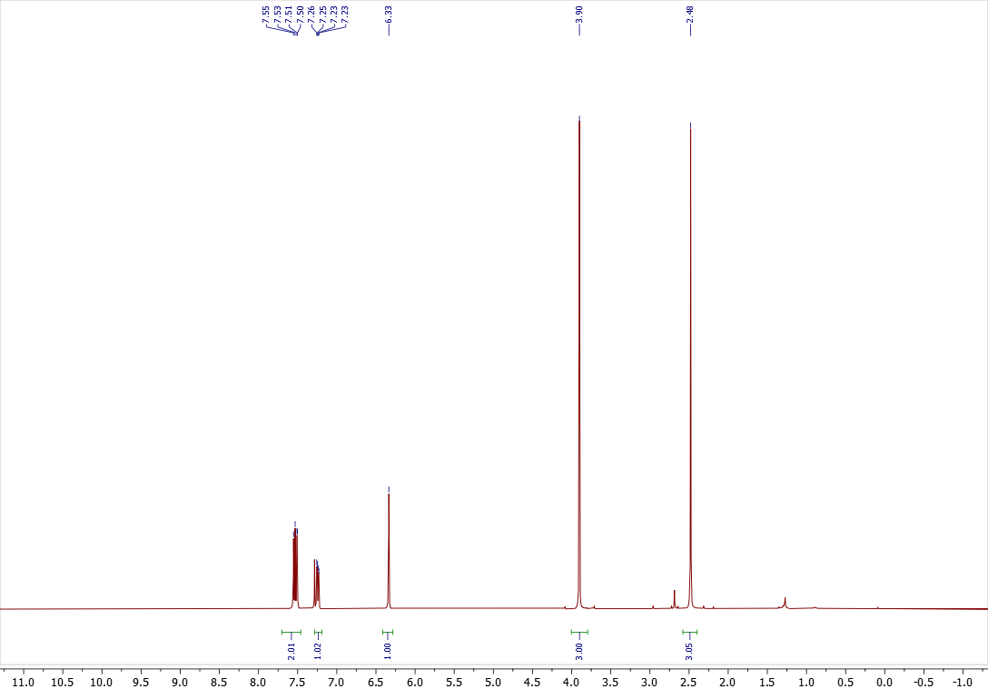

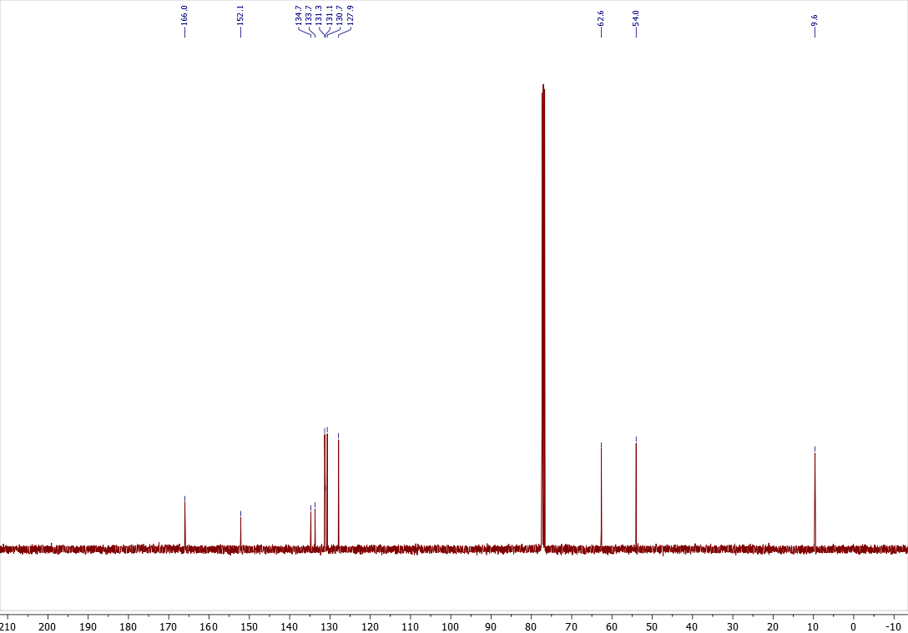

Copies of ¹H (400.13 MHz, CDCl₃), ¹³C{¹H} (100.61 MHz, CDCl₃), spectra of 4t
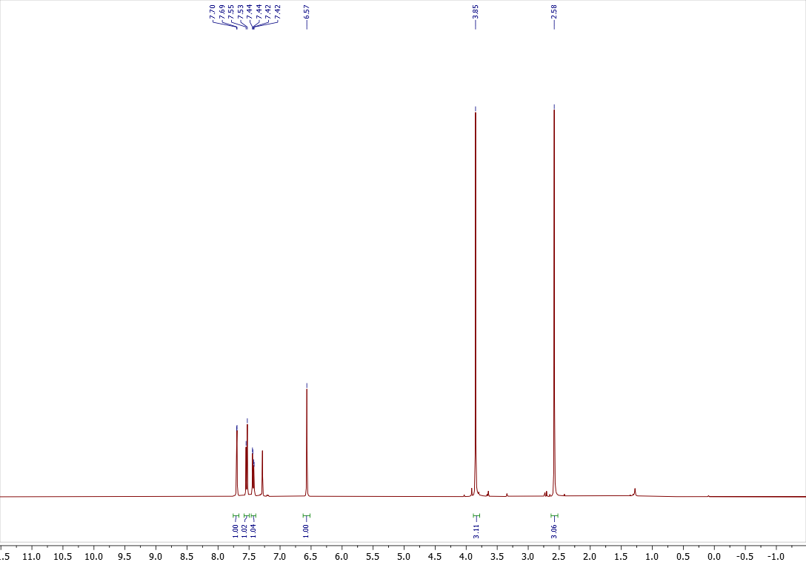

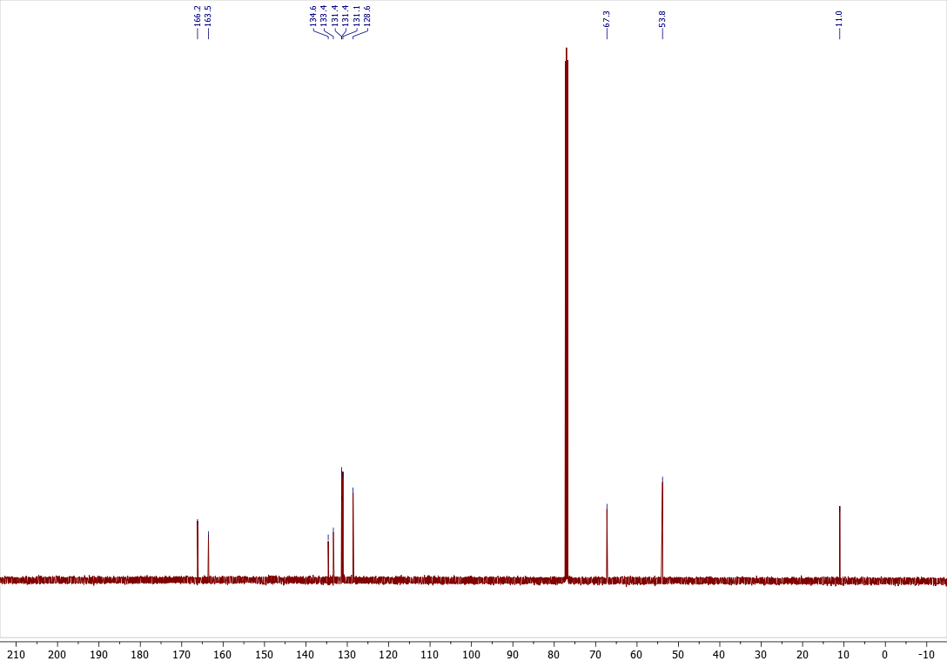

Copies of ¹H (400.13 MHz, CDCl₃), ¹³C{¹H} (100.61 MHz, CDCl₃), spectra of 3u
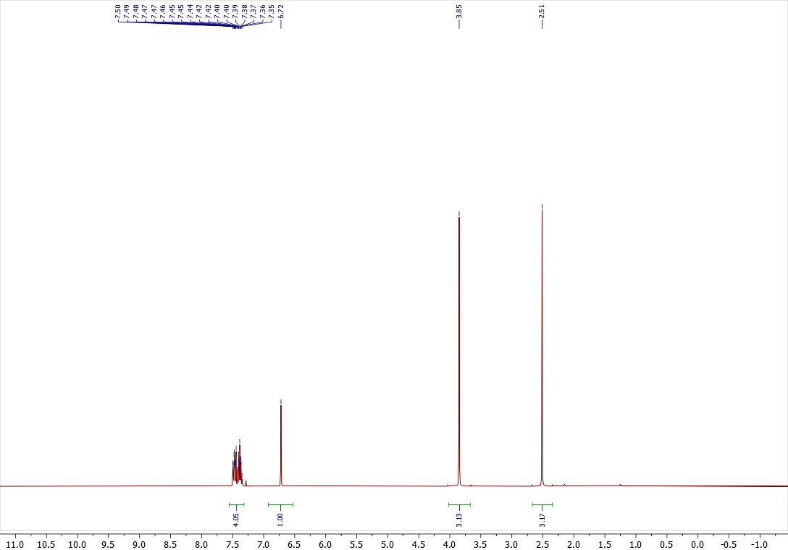

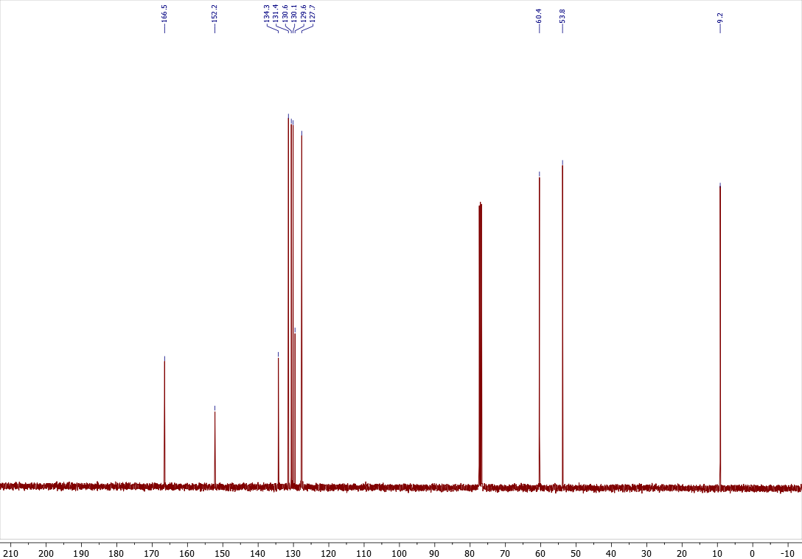

Copies of ¹H (400.13 MHz, CDCl₃), ¹³C{¹H} (100.61 MHz, CDCl₃), spectra of 4u
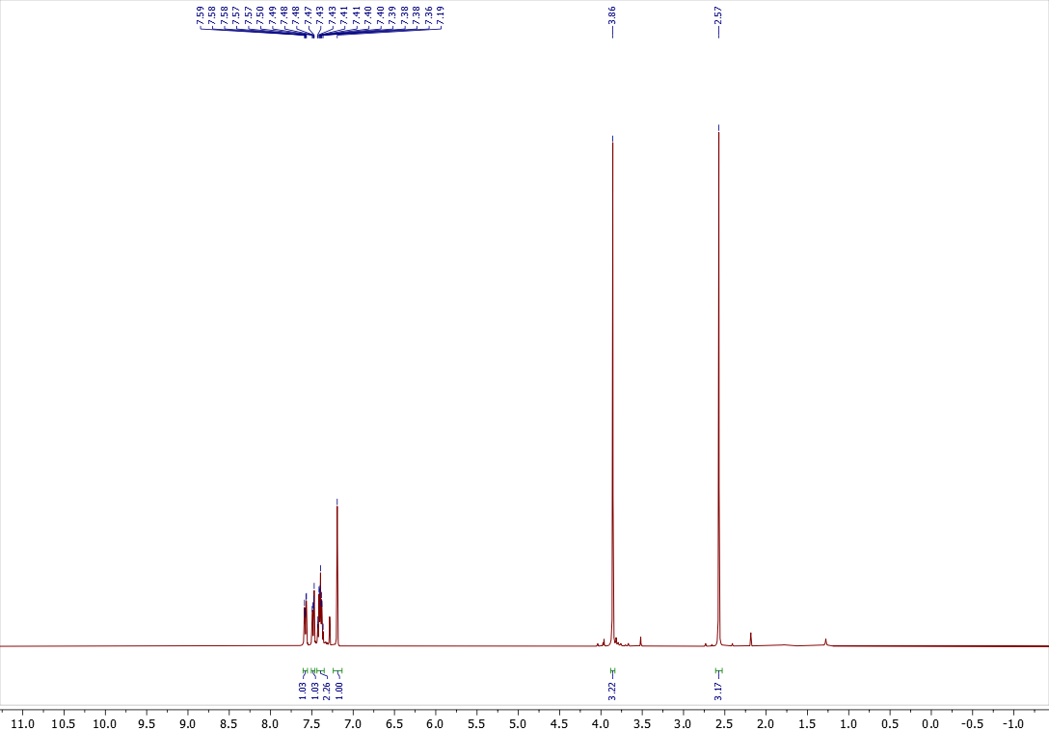

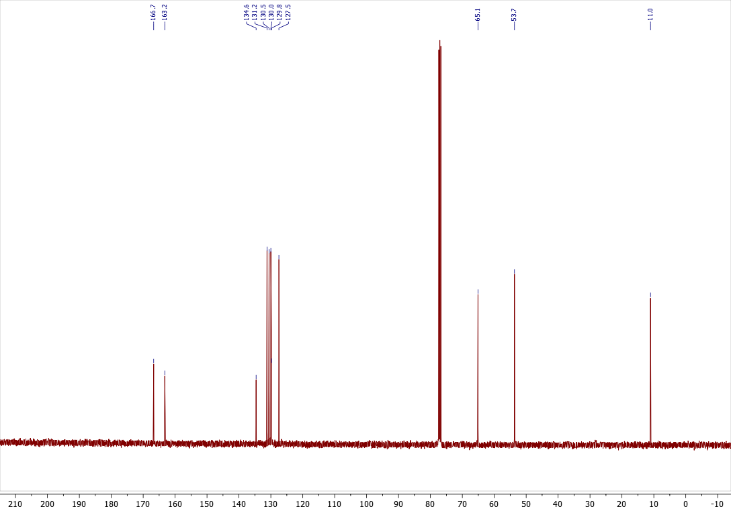

Copies of ¹H (400.13 MHz, CDCl₃), ¹³C{¹H} (100.61 MHz, CDCl₃), spectra of 3v
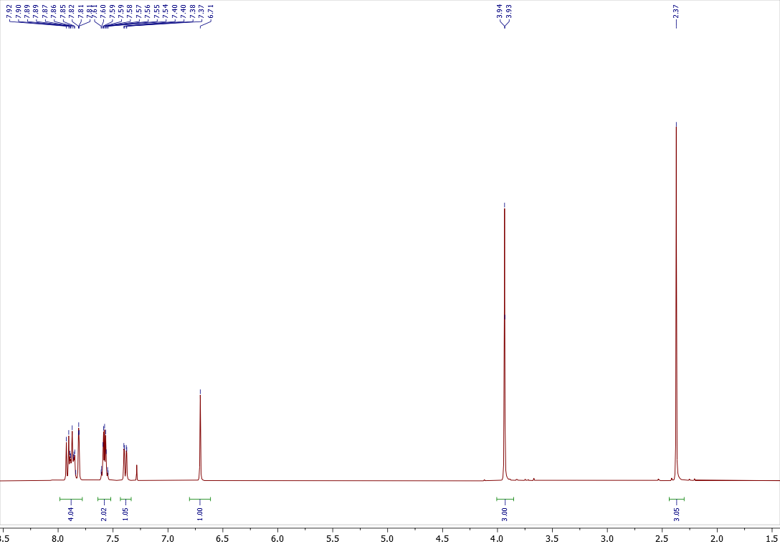

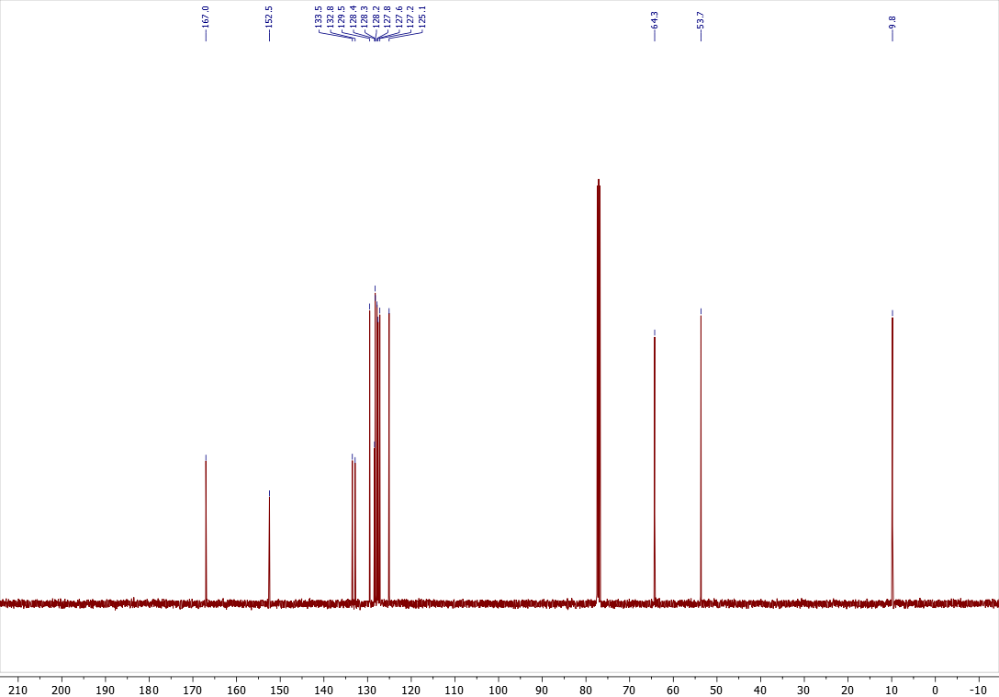

Copies of ¹H (400.13 MHz, CDCl₃), ¹³C{¹H} (100.61 MHz, CDCl₃), spectra of 3w
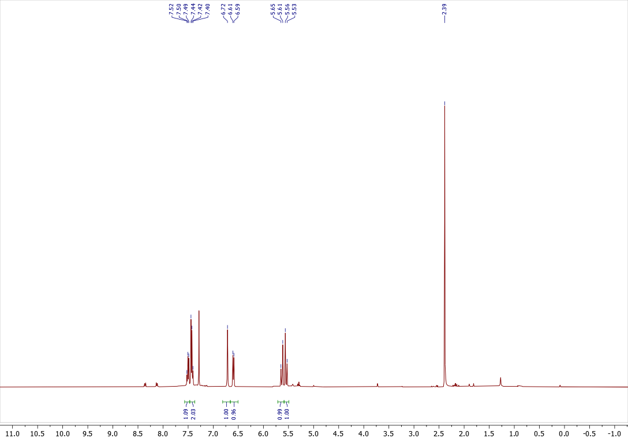

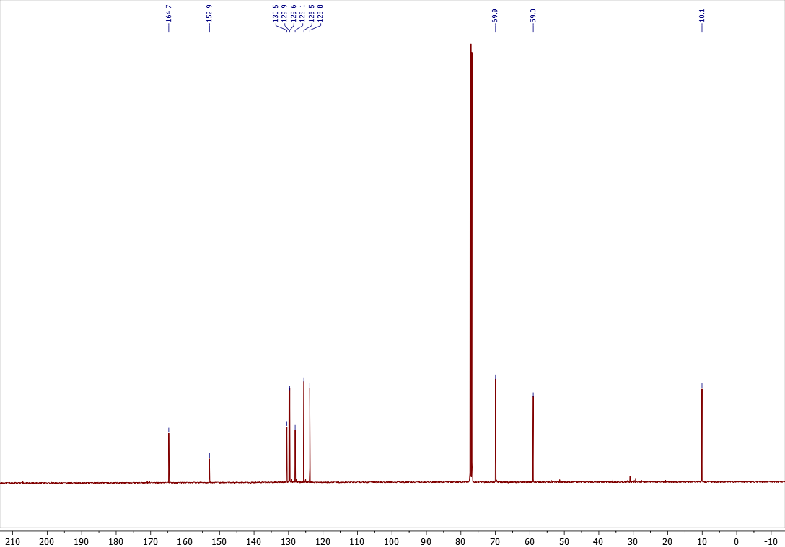

Copies of ¹H (400.13 MHz, CDCl₃), ¹³C{¹H} (100.61 MHz, CDCl₃), spectra of 4w
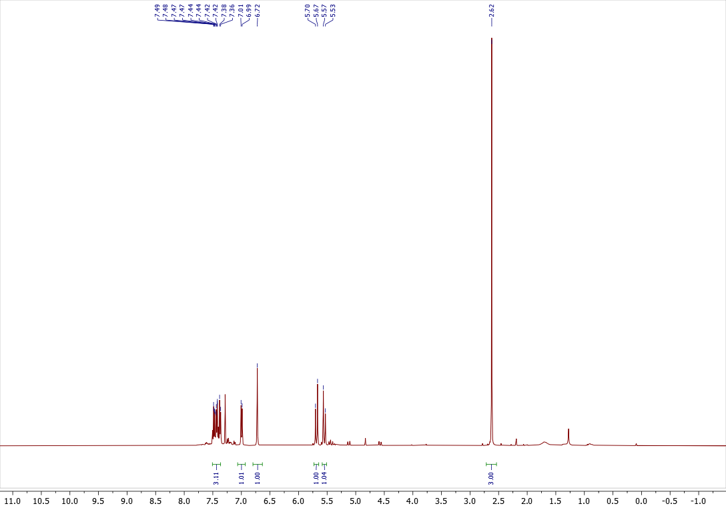

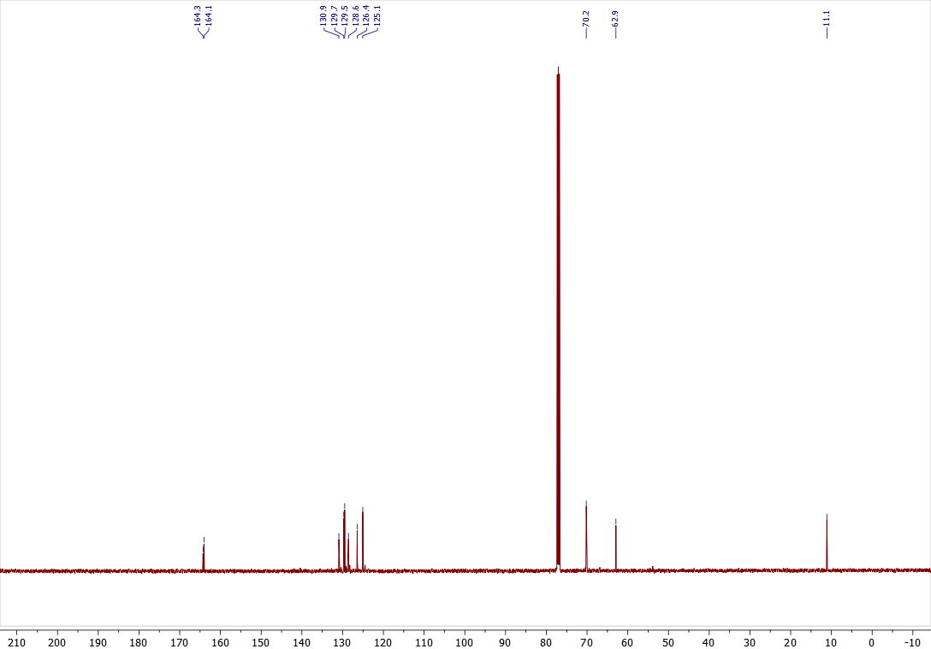

Copies of ¹H (400.13 MHz, CDCl₃), ¹³C{¹H} (100.61 MHz, CDCl₃), spectra of 3x
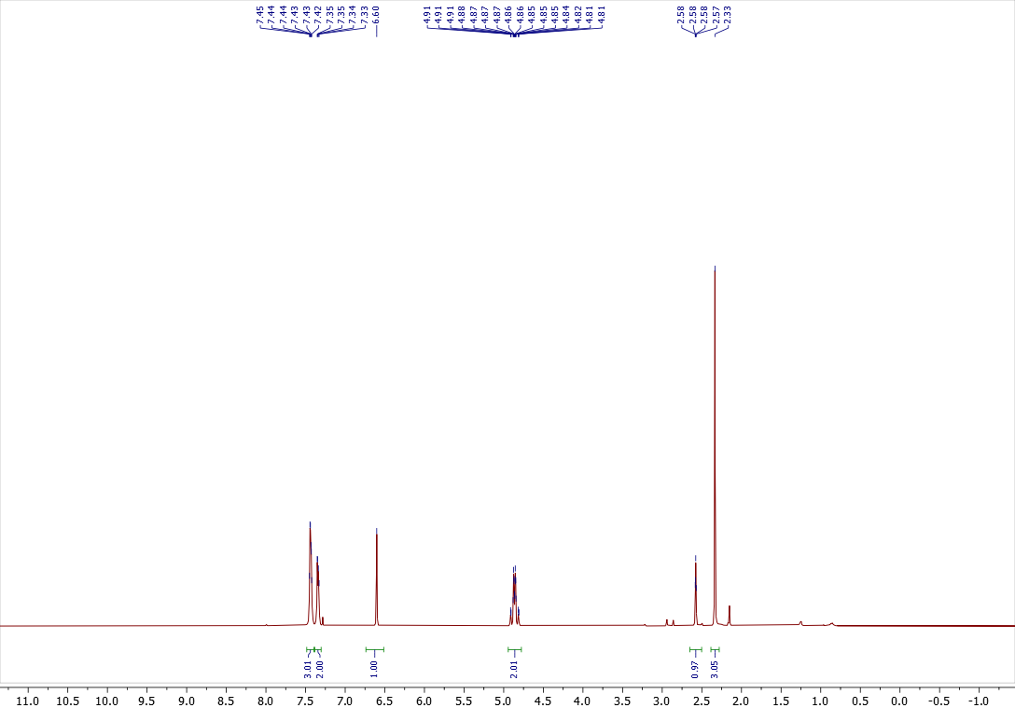

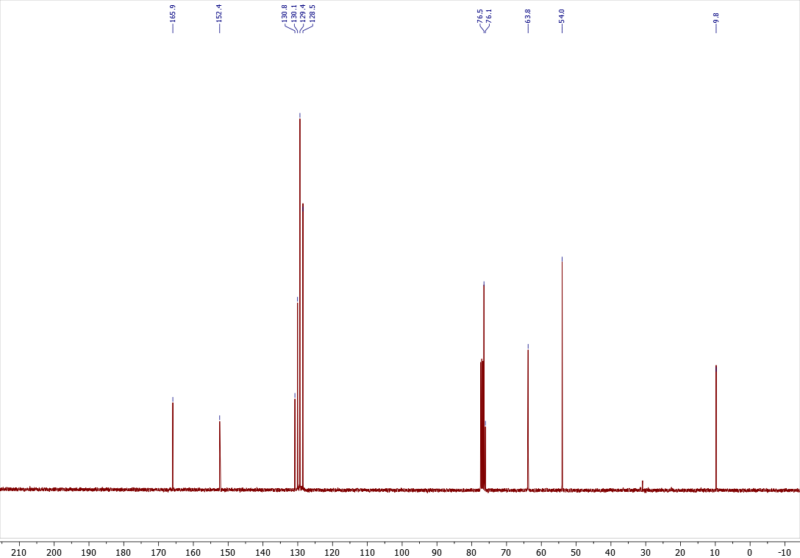

Copies of ¹H (400.13 MHz, CDCl₃), ¹³C{¹H} (100.61 MHz, CDCl₃), spectra of 4x
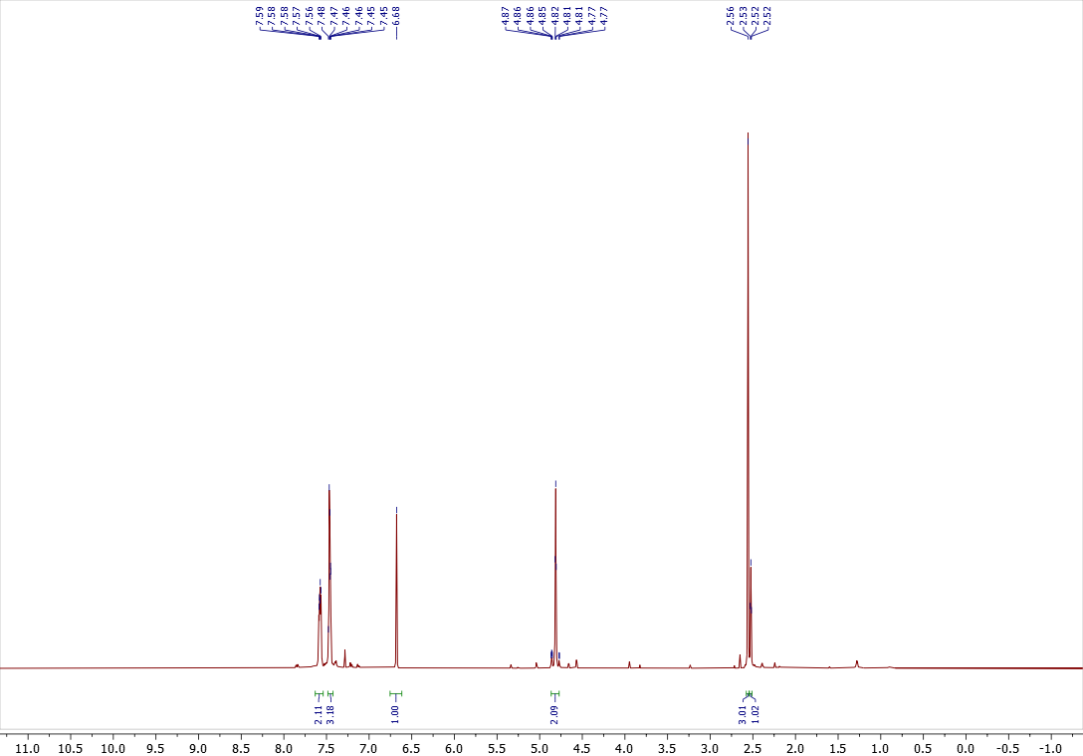

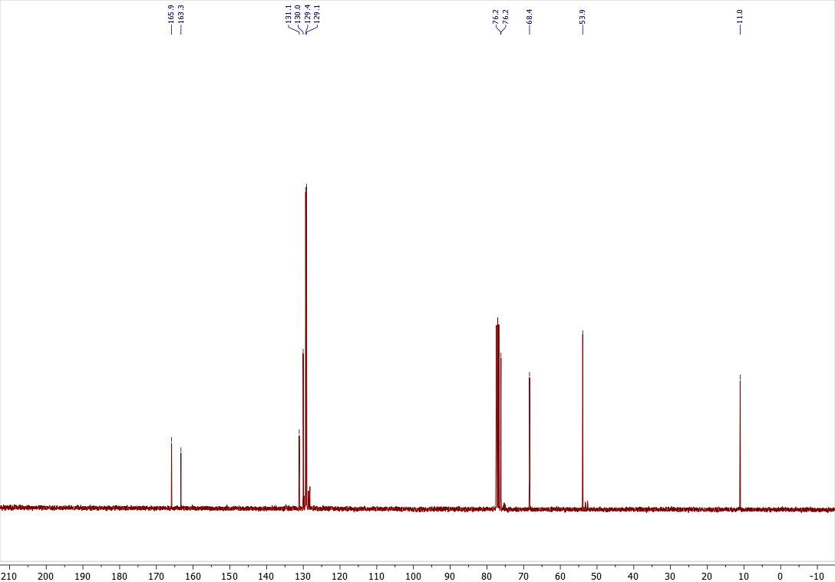

Copies of ¹H (400.13 MHz, CDCl₃), ¹³C{¹H} (100.61 MHz, CDCl₃), spectra of 3y
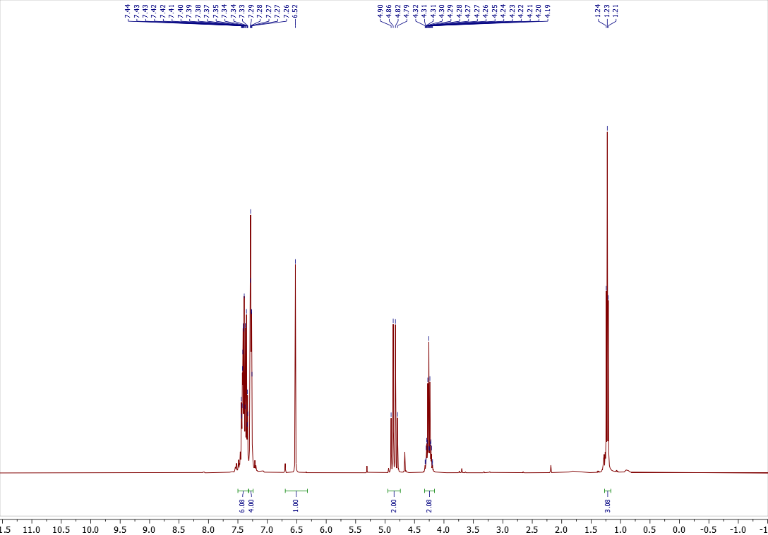

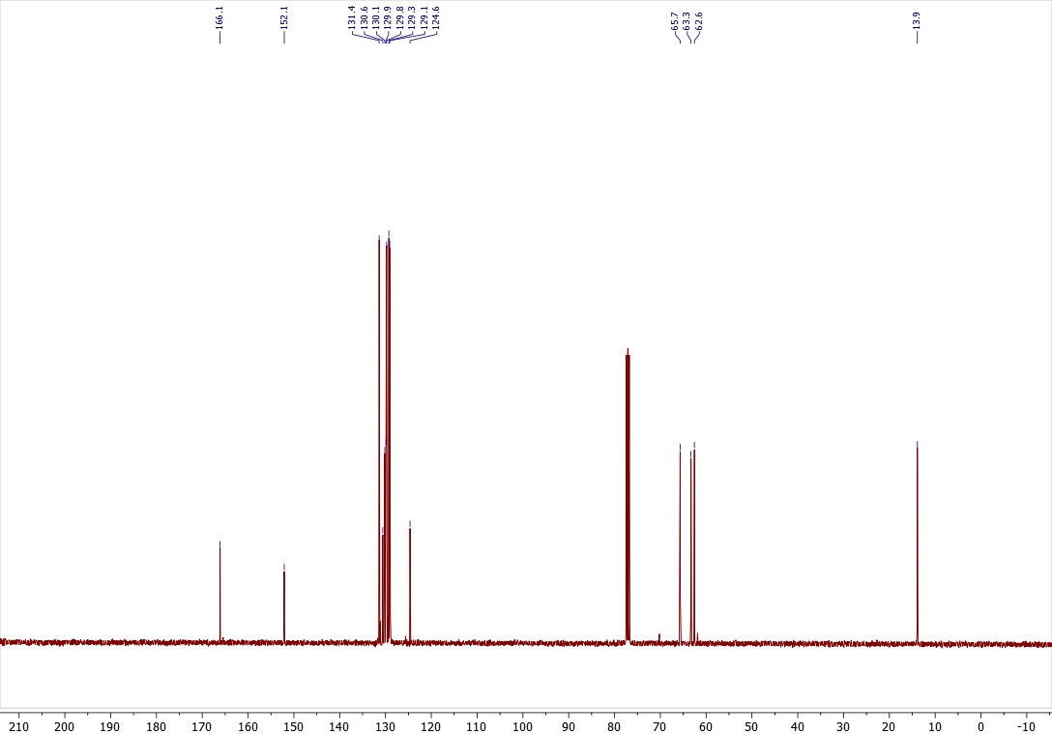

Copies of ¹H (400.13 MHz, CDCl₃), ¹³C{¹H} (100.61 MHz, CDCl₃), spectra of 4y
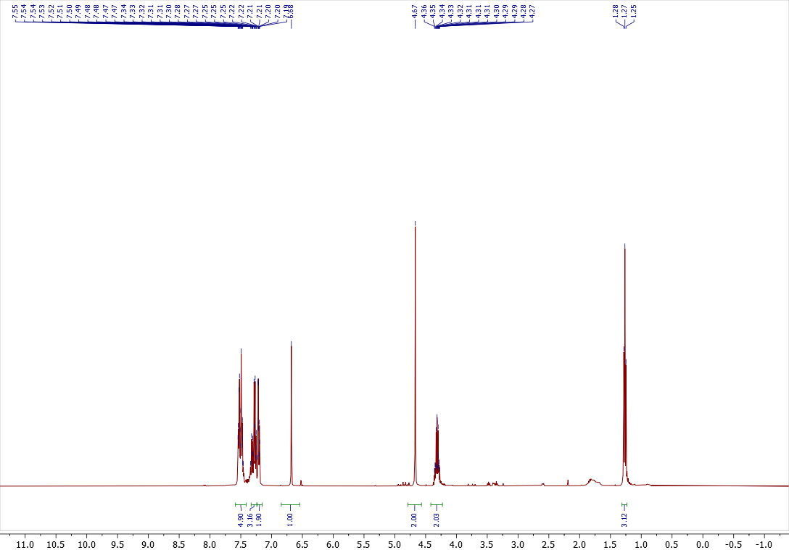

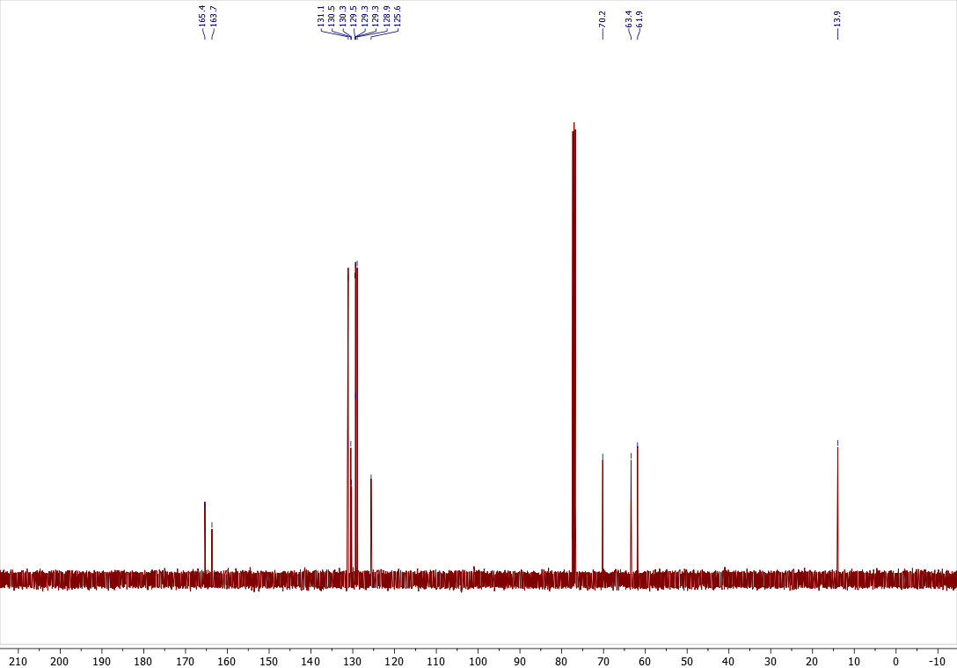

Copies of ¹H (400.13 MHz, CDCl₃), ¹³C{¹H} (100.61 MHz, CDCl₃), spectra of 3z
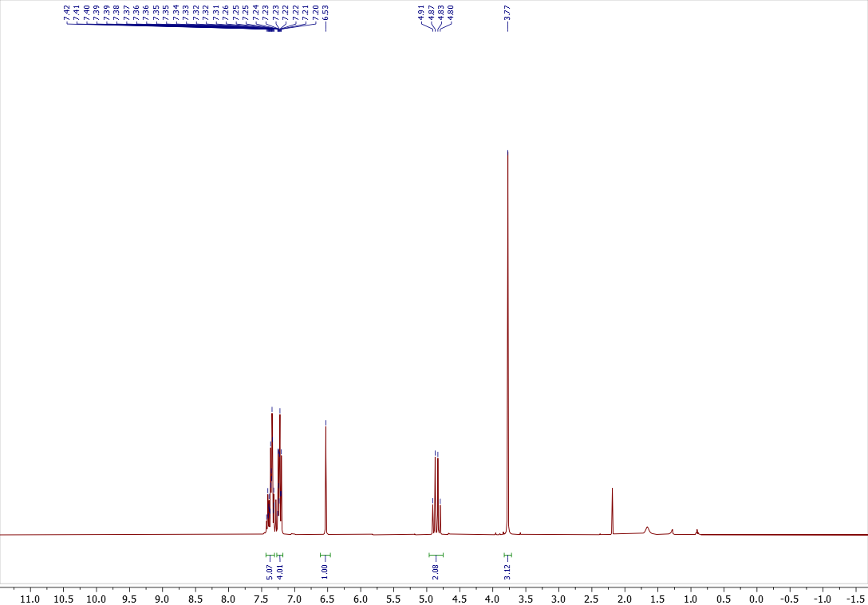

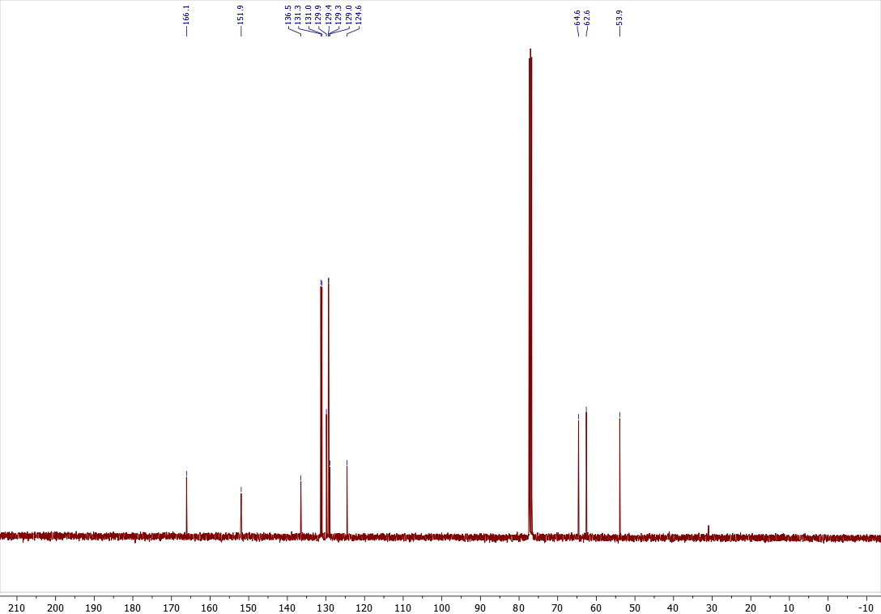

Copies of ¹H (400.13 MHz, CDCl₃), ¹³C{¹H} (100.61 MHz, CDCl₃), spectra of 4z
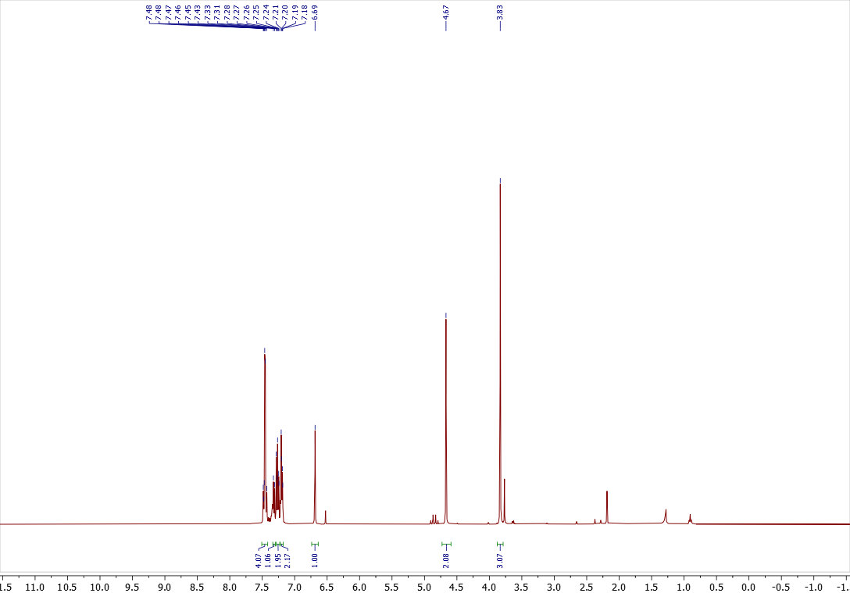

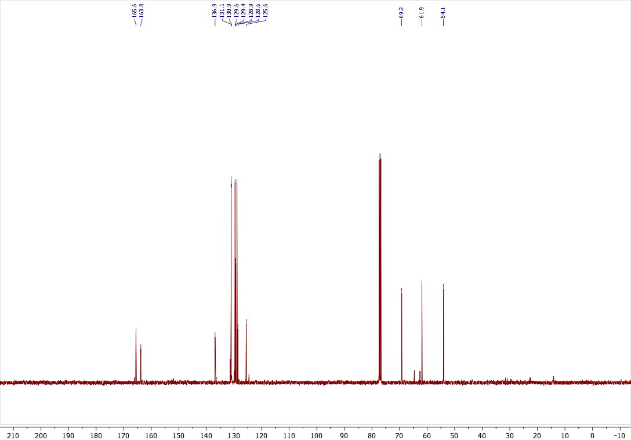

Copies of ¹H (400.13 MHz, CDCl₃), ¹³C{¹H} (100.61 MHz, CDCl₃), spectra of 3aa
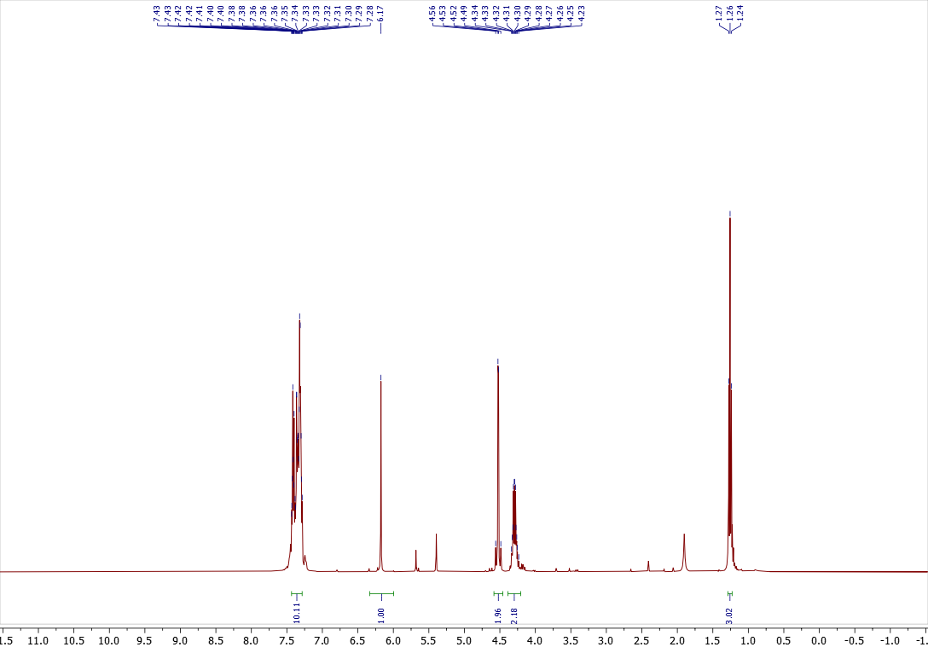

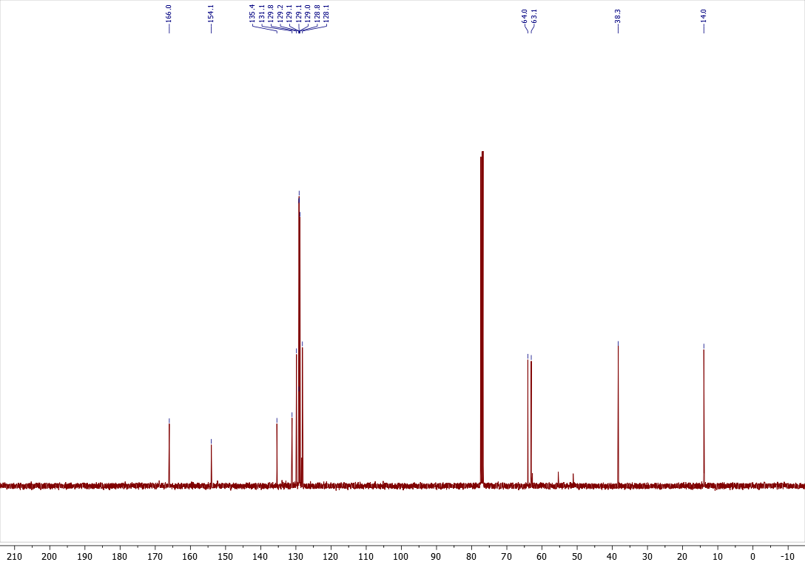

Copies of ¹H (400.13 MHz, CDCl₃), ¹³C{¹H} (100.61 MHz, CDCl₃), spectra of 4aa
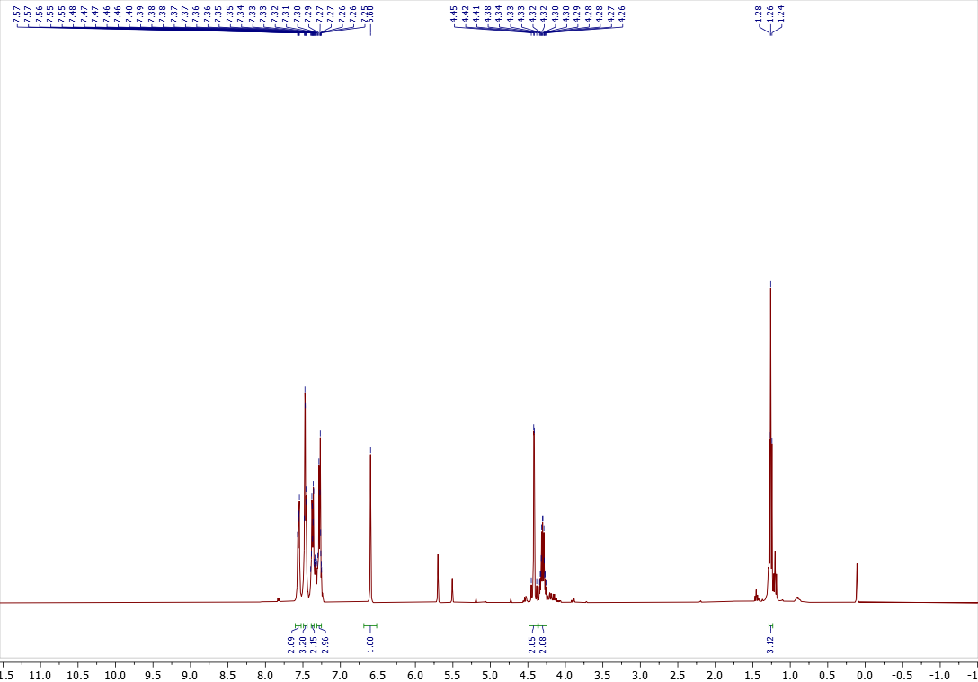

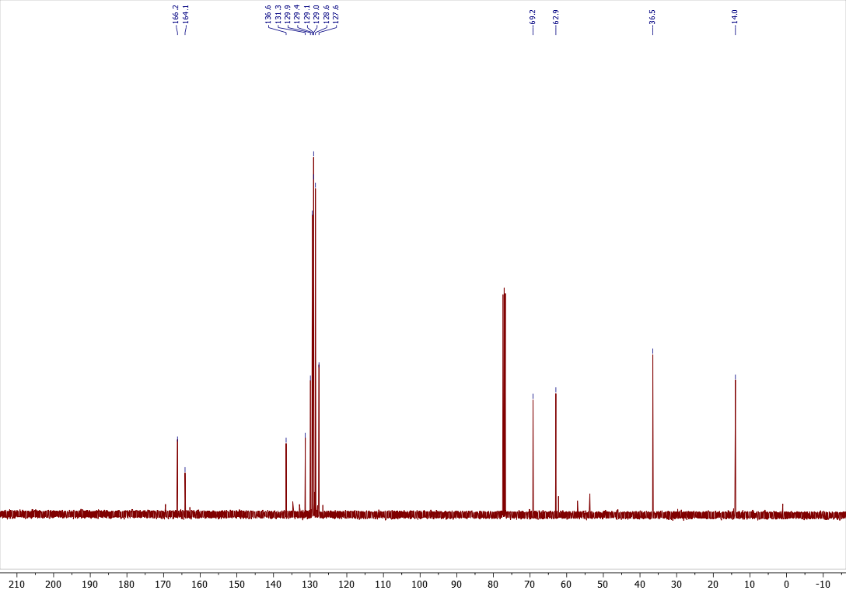

Copies of ¹H (400.13 MHz, CDCl₃), ¹³C{¹H} (100.61 MHz, CDCl₃), spectra of 5a
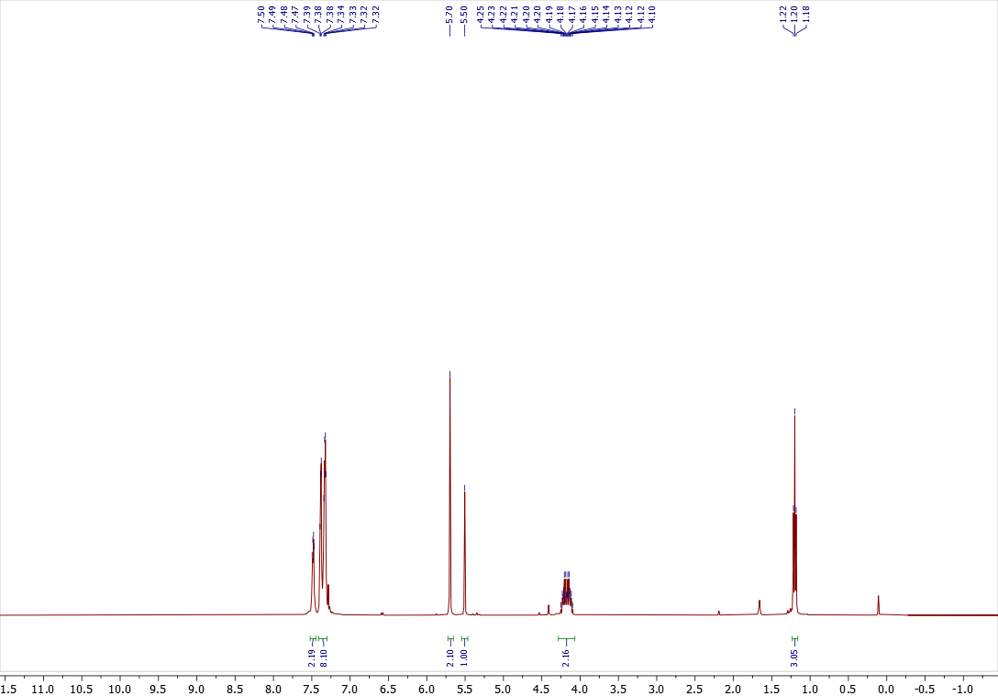

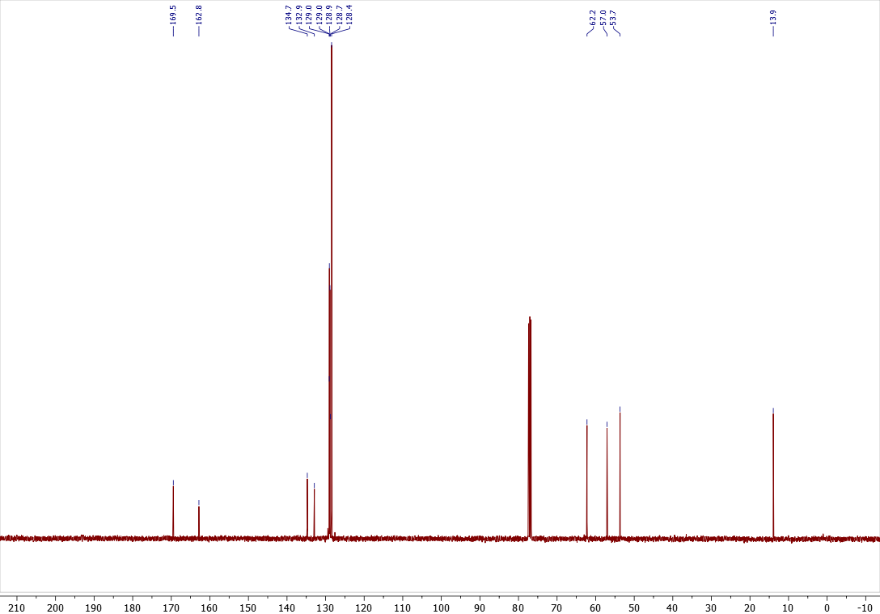

Copies of ¹H (400.13 MHz, CDCl₃), ¹³C{¹H} (100.61 MHz, CDCl₃), spectra of 6a
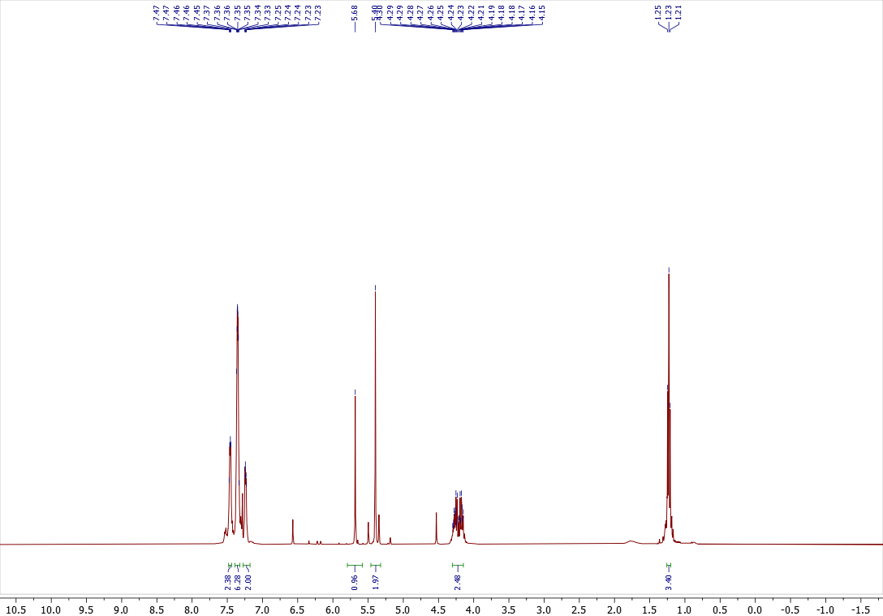

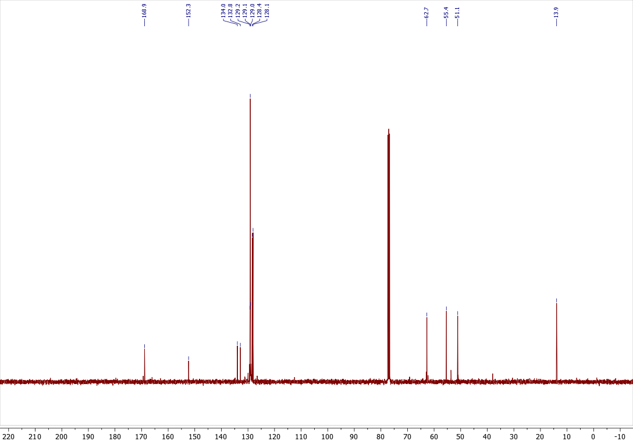

Copies of ¹H (400.13 MHz, CDCl₃), ¹³C{¹H} (100.61 MHz, CDCl₃), spectra of 7
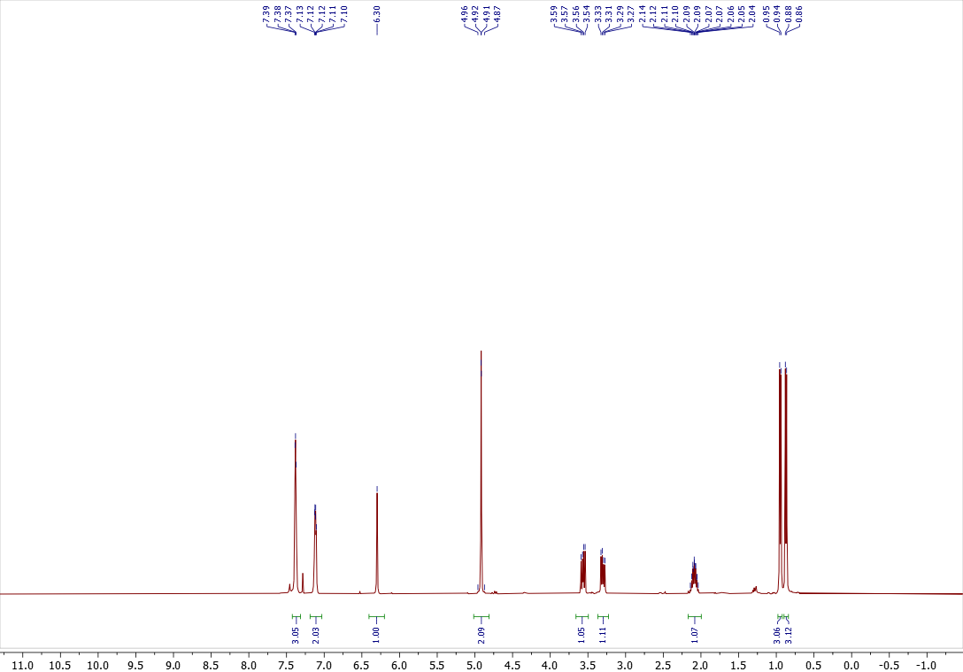

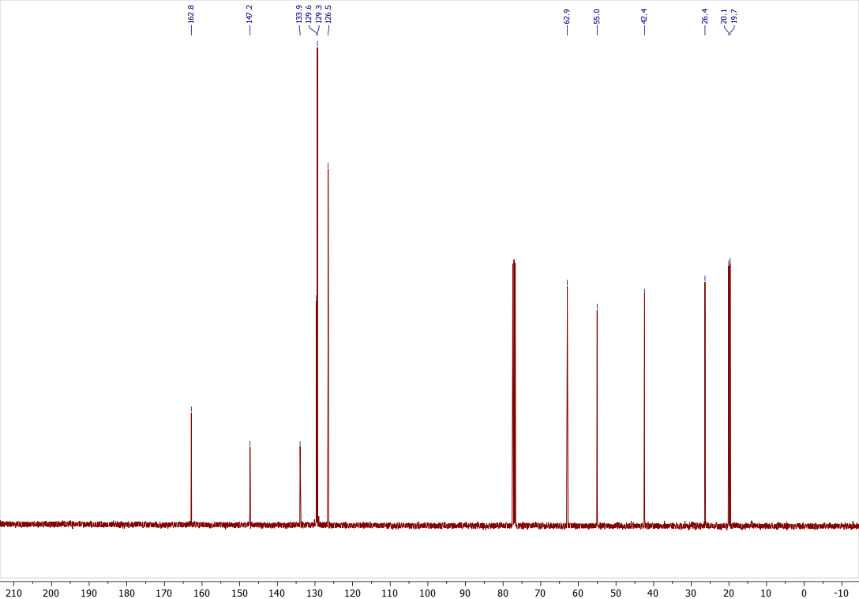

Computational details
The calculations were performed using the Gaussian16 C.01 software package. Geometry optimizations with standard convergence criteria and vibrational harmonic frequencies calculation were performed at the B3LYP-GD3BJ/6-311++G(d,p) level of theory. The Grimme dispersion correction D3 with zero damping was included. Implicit solvent effects were modeled with the IEFPCM continuum approach using dielectric constants corresponding to dichloromethane as appropriate. All structures were checked on the absence of imaginary vibrational frequencies.
Optimized geometries
22
2a (carben), IEFPCM (CH₂Cl₂)

Number of imaginary frequencies = 0

Zero-point correction= 0.174168 (Hartree/Particle)
Thermal correction to Energy= 0.185599
Thermal correction to Enthalpy= 0.186543
Thermal correction to Gibbs Free Energy= 0.135053
Sum of electronic and zero-point Energies= -537.457079
Sum of electronic and thermal Energies= -537.445647
Sum of electronic and thermal Enthalpies= -537.444703
Sum of electronic and thermal Free Energies= -537.496193

HF = -537.631246

C 2.448980000 1.402284000 0.695325000
C 1.252502000 0.720145000 0.587789000
C 1.170712000 -0.489549000 -0.161076000
C 2.350394000 -0.973502000 -0.789286000
C 3.546104000 -0.284420000 -0.682229000
C 3.592001000 0.899429000 0.059704000
H 2.508475000 2.321438000 1.264716000
H 0.363102000 1.100635000 1.075657000
H 2.282233000 -1.894565000 -1.354306000
H 4.440985000 -0.656005000 -1.165231000
H 4.528263000 1.438849000 0.145832000
C -0.023653000 -1.225128000 -0.330827000
C -1.227992000 -0.812268000 0.330533000
O -1.515906000 -1.250859000 1.441030000
O -2.027593000 -0.021183000 -0.404971000
C -3.352364000 0.262254000 0.130437000
C -4.071606000 1.125847000 -0.881832000
H -3.238724000 0.768630000 1.090312000
H -3.866149000 -0.685849000 0.298374000
H -5.072585000 1.361115000 -0.511841000
H -3.536862000 2.064003000 -1.045406000
H -4.171218000 0.607525000 -1.837811000

10
1H-1a, IEFPCM (CH₂Cl₂)

Number of imaginary frequencies = 0

Zero-point correction= 0.074612 (Hartree/Particle)
Thermal correction to Energy= 0.079766
Thermal correction to Enthalpy= 0.080710
Thermal correction to Gibbs Free Energy= 0.045773
Sum of electronic and zero-point Energies= -297.612346
Sum of electronic and thermal Energies= -297.607191
Sum of electronic and thermal Enthalpies= -297.606247
Sum of electronic and thermal Free Energies= -297.641184

HF = -297.686957

C 0.597192000 -0.060595000 -0.000022000
N -0.217448000 1.012001000 0.000026000
H 0.007638000 1.997540000 0.000052000
N -1.500144000 0.600328000 0.000007000
N -1.458690000 -0.687664000 -0.000007000
N -0.174106000 -1.135318000 -0.000016000
C 2.081186000 -0.020381000 -0.000004000
H 2.453983000 0.500943000 -0.884178000
H 2.453962000 0.500020000 0.884726000
H 2.466861000 -1.038079000 -0.000519000

32
2a (carben)+ 1H-1a, IEFPCM (CH₂Cl₂)

Number of imaginary frequencies = 0

Zero-point correction= 0.249313 (Hartree/Particle)
Thermal correction to Energy= 0.267706
Thermal correction to Enthalpy= 0.268650
Thermal correction to Gibbs Free Energy= 0.197037
Sum of electronic and zero-point Energies= -835.087679
Sum of electronic and thermal Energies= -835.069287
Sum of electronic and thermal Enthalpies= -835.068343
Sum of electronic and thermal Free Energies= -835.139956

HF = -835.336993

C 4.093696000 -1.060626000 0.045229000
C 3.002442000 -0.238683000 0.236851000
C 1.677904000 -0.757690000 0.128407000
C 1.510925000 -2.138573000 -0.179613000
C 2.610049000 -2.954455000 -0.375160000
C 3.895085000 -2.414602000 -0.261330000
H 5.099285000 -0.668209000 0.127642000
H 3.142569000 0.808971000 0.474347000
H 0.504873000 -2.532097000 -0.260198000
H 2.481797000 -4.002704000 -0.612406000
H 4.756412000 -3.054957000 -0.412547000
C 0.523294000 0.026878000 0.287440000
C 0.608108000 1.421525000 0.656232000
O 0.589069000 1.752382000 1.834206000
O 0.581965000 2.265942000 -0.380036000
C 0.470133000 3.690137000 -0.075711000
C 0.389090000 4.425677000 -1.393958000
H 1.344023000 3.986057000 0.506325000
H -0.421535000 3.839426000 0.535006000
H 0.307020000 5.498544000 -1.204017000
H 1.283663000 4.250813000 -1.995267000
H -0.486063000 4.109626000 -1.965373000
C -3.346944000 -0.450110000 0.088195000
N -2.147572000 -1.048977000 0.007311000
H -1.168419000 -0.646941000 0.126494000
N -2.330360000 -2.344392000 -0.295810000
N -3.609293000 -2.524071000 -0.393357000
N -4.275362000 -1.364520000 -0.161066000
C -3.567162000 0.982999000 0.416484000
H -3.347550000 1.174741000 1.469599000
H -2.919579000 1.623978000 -0.184978000
H -4.606383000 1.245031000 0.224064000

32
Intermediate_1H-tautomer(N2), IEFPCM (CH₂Cl₂)

Number of imaginary frequencies = 0

Zero-point correction= 0.252336 (Hartree/Particle)
Thermal correction to Energy= 0.269343
Thermal correction to Enthalpy= 0.270287
Thermal correction to Gibbs Free Energy= 0.205253
Sum of electronic and zero-point Energies= -835.133326
Sum of electronic and thermal Energies= -835.116319
Sum of electronic and thermal Enthalpies= -835.115375
Sum of electronic and thermal Free Energies= -835.180409

HF = -835.385662

C 3.946711000 -0.758784000 -0.891755000
C 2.556234000 -0.840266000 -0.910413000
C 1.784707000 -0.117744000 0.008312000
C 3.830432000 0.779687000 0.959200000
C 4.589676000 0.052927000 0.041182000
H 4.526833000 -1.326383000 -1.610367000
H 2.061530000 -1.472991000 -1.636123000
H 4.320776000 1.410256000 1.692025000
H 5.671382000 0.119364000 0.054117000
C -0.307341000 -1.530532000 0.077955000
O 0.292709000 -2.595747000 0.150354000
O -1.692084000 -1.505795000 0.072636000
C -2.370159000 -2.786919000 0.140781000
C -3.858466000 -2.512301000 0.143761000
H -2.047897000 -3.301158000 1.046953000
H -2.066525000 -3.383903000 -0.720175000
H -4.401705000 -3.458821000 0.192882000
H -4.145285000 -1.910833000 1.009747000
H -4.164728000 -1.991146000 -0.766364000
C 0.312247000 -0.244727000 0.004358000
N -0.417786000 0.924440000 -0.076259000
C -2.064837000 2.345869000 -0.128665000
N 0.088187000 2.141513000 -0.255648000
N -0.943346000 3.012707000 -0.281892000
N -1.763683000 1.030512000 0.016447000
H -2.302173000 0.166245000 0.095876000
C -3.442977000 2.892194000 -0.107900000
H -3.393639000 3.972580000 -0.231002000
H -4.041014000 2.469042000 -0.918309000
H -3.938705000 2.663622000 0.838325000
C 2.442203000 0.692810000 0.944406000
H 1.861970000 1.258974000 1.662626000

32
Intermediate_1H-tautomer(N3), IEFPCM (CH₂Cl₂)

Number of imaginary frequencies = 0

Zero-point correction= 0.253135 (Hartree/Particle)
Thermal correction to Energy= 0.270126
Thermal correction to Enthalpy= 0.271070
Thermal correction to Gibbs Free Energy= 0.205833
Sum of electronic and zero-point Energies= -835.133047
Sum of electronic and thermal Energies= -835.116056
Sum of electronic and thermal Enthalpies= -835.115111
Sum of electronic and thermal Free Energies= -835.180349

HF = -835.386182

C 3.508733000 -1.765803000 -0.712599000
C 2.125869000 -1.610585000 -0.682301000
C 1.529129000 -0.579841000 0.064894000
C 3.761285000 0.134132000 0.739240000
C 4.338239000 -0.894575000 -0.006864000
H 3.940648000 -2.569316000 -1.299037000
H 1.496959000 -2.294499000 -1.234591000
H 4.389434000 0.815658000 1.302217000
H 5.414797000 -1.015924000 -0.034825000
C -0.835265000 -1.526543000 0.101537000
O -0.490213000 -2.706873000 0.153350000
O -2.149273000 -1.182294000 -0.029956000
C -3.095719000 -2.268240000 -0.084465000
C -4.480031000 -1.658619000 -0.166820000
H -2.980386000 -2.887552000 0.807633000
H -2.878279000 -2.891058000 -0.955571000
H -5.228972000 -2.453284000 -0.214211000
H -4.688266000 -1.042270000 0.710710000
H -4.581718000 -1.038258000 -1.060470000
C 0.072505000 -0.416477000 0.120391000
N -1.471137000 1.272562000 0.848210000
C -0.562453000 2.953507000 -0.279107000
N -0.412409000 0.884238000 0.169471000
N 0.190934000 1.904924000 -0.524816000
N -1.582165000 2.569184000 0.515568000
H -2.348647000 3.112352000 0.888891000
C -0.341551000 4.325769000 -0.797820000
H 0.499144000 4.317004000 -1.488405000
H -1.230742000 4.685091000 -1.318868000
H -0.122417000 5.011559000 0.023338000
C 2.379958000 0.284768000 0.779135000
H 1.953587000 1.082529000 1.375678000

32
Intermediate_1H-tautomer(N4), IEFPCM (CH₂Cl₂)

Number of imaginary frequencies = 0

Zero-point correction= 0.253619 (Hartree/Particle)
Thermal correction to Energy= 0.270290
Thermal correction to Enthalpy= 0.271234
Thermal correction to Gibbs Free Energy= 0.207789
Sum of electronic and zero-point Energies= -835.138802
Sum of electronic and thermal Energies= -835.122131
Sum of electronic and thermal Enthalpies= -835.121187
Sum of electronic and thermal Free Energies= -835.184632

HF = -835.392421

C -3.787669000 -1.544729000 -0.003858000
C -2.399305000 -1.532784000 -0.079427000
C -1.676858000 -0.316655000 -0.053399000
C -3.822213000 0.848694000 0.125796000
C -4.518140000 -0.359643000 0.098727000
H -4.306006000 -2.497690000 -0.027924000
H -1.851165000 -2.459945000 -0.154337000
H -4.363276000 1.785539000 0.206068000
H -5.600046000 -0.377235000 0.155183000
C 0.662867000 -1.381019000 -0.085604000
O 0.372152000 -2.575563000 0.015439000
O 1.989409000 -0.986064000 -0.182260000
C 2.975023000 -2.033979000 -0.164819000
C 4.337313000 -1.374211000 -0.238871000
H 2.807410000 -2.700816000 -1.014046000
H 2.862598000 -2.621581000 0.749245000
H 5.118824000 -2.138222000 -0.235954000
H 4.436870000 -0.785502000 -1.153918000
H 4.500697000 -0.715535000 0.617874000
C -0.228177000 -0.280903000 -0.114306000
N 1.002990000 2.821112000 -1.181540000
C 1.129002000 1.633164000 0.681363000
N 0.324307000 1.765889000 -1.372082000
N 0.379564000 1.000117000 -0.226038000
C 1.447852000 1.169694000 2.041369000
H 0.617072000 0.566412000 2.409119000
H 2.334688000 0.532728000 2.000471000
H 1.633649000 2.012417000 2.705870000
C -2.433623000 0.873601000 0.053096000
H -1.936579000 1.835384000 0.078748000
N 1.524740000 2.749537000 0.067937000
H 2.115131000 3.493103000 0.419832000

32
Intermediate_2H-tautomer(N3), IEFPCM (CH₂Cl₂)

Number of imaginary frequencies = 0

Zero-point correction= 0.252905 (Hartree/Particle)
Thermal correction to Energy= 0.269796
Thermal correction to Enthalpy= 0.270741
Thermal correction to Gibbs Free Energy= 0.206892
Sum of electronic and zero-point Energies= -835.135219
Sum of electronic and thermal Energies= -835.118328
Sum of electronic and thermal Enthalpies= -835.117383
Sum of electronic and thermal Free Energies= -835.181232

HF = -835.388124

C -3.484776000 -1.666461000 -0.905393000
C -2.111607000 -1.433233000 -0.916941000
C -1.523971000 -0.579078000 0.024522000
C -3.718616000 -0.191964000 0.986338000
C -4.294211000 -1.045764000 0.044488000
H -3.921937000 -2.330473000 -1.642257000
H -1.487292000 -1.918910000 -1.655736000
H -4.338646000 0.291174000 1.732774000
H -5.363015000 -1.225226000 0.052412000
C 0.835755000 -1.488988000 0.054998000
O 0.487457000 -2.660871000 0.082504000
O 2.169326000 -1.146438000 0.055714000
C 3.128431000 -2.237063000 0.073918000
C 4.510881000 -1.622223000 0.094440000
H 2.966511000 -2.852153000 -0.812302000
H 2.938228000 -2.847724000 0.957304000
H 5.260495000 -2.416819000 0.105634000
H 4.680859000 -1.006220000 -0.791699000
H 4.654390000 -1.006751000 0.985669000
C -0.061604000 -0.368210000 0.025008000
N 1.756890000 2.672933000 -0.015008000
N 0.394717000 0.925447000 -0.007438000
C -2.346570000 0.036562000 0.978193000
H -1.908357000 0.698622000 1.714699000
N 1.671779000 1.343420000 0.128619000
H 2.426760000 0.661645000 0.108191000
N -0.374752000 2.002162000 -0.174387000
C 0.495739000 3.041700000 -0.171340000
C 0.051958000 4.451428000 -0.332539000
H -0.576735000 4.751252000 0.508717000
H 0.919014000 5.108565000 -0.378807000
H -0.533423000 4.563528000 -1.246981000

32
Intermediate_2H-tautomer(N1), IEFPCM (CH₂Cl₂)

Number of imaginary frequencies = 0

Zero-point correction= 0.253010 (Hartree/Particle)
Thermal correction to Energy= 0.269786
Thermal correction to Enthalpy= 0.270730
Thermal correction to Gibbs Free Energy= 0.207217
Sum of electronic and zero-point Energies= -835.124963
Sum of electronic and thermal Energies= -835.108188
Sum of electronic and thermal Enthalpies= -835.107243
Sum of electronic and thermal Free Energies= -835.170756

HF = -835.377973

C -3.728905000 -1.619128000 -0.161791000
C -2.339798000 -1.566886000 -0.211062000
C -1.650635000 -0.355161000 0.010583000
C -3.819672000 0.728391000 0.326374000
C -4.485092000 -0.476415000 0.101089000
H -4.225949000 -2.567205000 -0.336842000
H -1.770782000 -2.462674000 -0.410327000
H -4.383206000 1.628729000 0.545095000
H -5.566914000 -0.524118000 0.134658000
C 0.718556000 -1.368124000 0.007139000
O 0.434029000 -2.554089000 0.169402000
O 2.023662000 -0.968499000 -0.178708000
C 3.027260000 -2.003326000 -0.133554000
C 4.369700000 -1.344187000 -0.374906000
H 2.804146000 -2.750441000 -0.898080000
H 2.988977000 -2.496840000 0.840341000
H 5.157696000 -2.101296000 -0.362089000
H 4.390022000 -0.844506000 -1.346193000
H 4.593234000 -0.606804000 0.399712000
C -0.195385000 -0.277447000 -0.030090000
N 0.722429000 2.975417000 -1.096974000
C 1.208263000 1.728934000 0.597735000
N 0.367754000 1.009440000 -0.173291000
C 1.760375000 1.268525000 1.883599000
H 1.027977000 0.640997000 2.395248000
H 2.651999000 0.663349000 1.707811000
H 2.020220000 2.129006000 2.497603000
C -2.431069000 0.789396000 0.288126000
H -1.952146000 1.739648000 0.494302000
N 1.427640000 2.922255000 0.012707000
N 0.127776000 1.824711000 -1.232166000
H -0.517584000 1.582666000 -1.978174000

32
Intermediate_2H-tautomer(N4), IEFPCM (CH₂Cl₂)

Number of imaginary frequencies = 0

Zero-point correction= 0.253845 (Hartree/Particle)
Thermal correction to Energy= 0.270486
Thermal correction to Enthalpy= 0.271430
Thermal correction to Gibbs Free Energy= 0.208155
Sum of electronic and zero-point Energies= -835.133197
Sum of electronic and thermal Energies= -835.116556
Sum of electronic and thermal Enthalpies= -835.115611
Sum of electronic and thermal Free Energies= -835.178886

HF = -835.387041

C -3.755939000 -1.593339000 -0.069630000
C -2.367314000 -1.554209000 -0.144162000
C -1.664835000 -0.331630000 -0.046123000
C -3.826913000 0.786805000 0.204977000
C -4.504137000 -0.428710000 0.103458000
H -4.258732000 -2.551286000 -0.151435000
H -1.806034000 -2.467706000 -0.270498000
H -4.382159000 1.708079000 0.345175000
H -5.585572000 -0.466244000 0.158583000
C 0.685639000 -1.372018000 -0.062398000
O 0.402837000 -2.562988000 0.084307000
O 2.001959000 -0.975542000 -0.226451000
C 2.999246000 -2.011961000 -0.158630000
C 4.352649000 -1.349819000 -0.320262000
H 2.813540000 -2.741229000 -0.950410000
H 2.916881000 -2.530044000 0.799817000
H 5.139790000 -2.107276000 -0.286562000
H 4.419964000 -0.827828000 -1.277705000
H 4.537088000 -0.630272000 0.481200000
C -0.213099000 -0.276594000 -0.099426000
C 1.187169000 1.668971000 0.674611000
C 1.595623000 1.133363000 1.986615000
H 0.769907000 0.567296000 2.421144000
H 2.438181000 0.451372000 1.859900000
H 1.882510000 1.951432000 2.644562000
C -2.439584000 0.837268000 0.133546000
H -1.958318000 1.803337000 0.223126000
N 1.500057000 2.849037000 0.169961000
N 0.384676000 1.007658000 -0.226469000
N 0.201983000 1.780050000 -1.293749000
N 0.865360000 2.855496000 -0.999729000
H 0.879025000 3.654178000 -1.625306000

32
3a, IEFPCM (CH₂Cl₂)

Number of imaginary frequencies = 0

Zero-point correction= 0.254250 (Hartree/Particle)
Thermal correction to Energy= 0.271029
Thermal correction to Enthalpy= 0.271973
Thermal correction to Gibbs Free Energy= 0.206647
Sum of electronic and zero-point Energies= -835.176798
Sum of electronic and thermal Energies= -835.160019
Sum of electronic and thermal Enthalpies= -835.159074
Sum of electronic and thermal Free Energies= -835.224400

HF = -835.431048

C 3.166820000 1.092360000 -1.145543000
C 1.859843000 0.886550000 -0.715139000
C 1.599623000 -0.003780000 0.328613000
C 3.962631000 -0.478284000 0.505463000
C 4.220070000 0.409538000 -0.536984000
H 3.363028000 1.783198000 -1.956678000
H 1.044692000 1.410412000 -1.199439000
H 4.777149000 -1.008560000 0.984088000
H 5.237316000 0.571182000 -0.873465000
C -0.586809000 1.069927000 0.957091000
O -0.396646000 1.822832000 1.882058000
O -1.439866000 1.267838000 -0.040353000
C -2.212386000 2.508147000 -0.024327000
C -3.108596000 2.491535000 -1.240596000
H -1.508732000 3.341530000 -0.035697000
H -2.776799000 2.539905000 0.908498000
H -3.705184000 3.406473000 -1.260485000
H -2.520472000 2.443846000 -2.159111000
H -3.788476000 1.637700000 -1.213286000
N -1.099653000 -2.268666000 -1.772619000
C -1.651568000 -1.910318000 0.268101000
N -0.535110000 -1.209182000 -0.034376000
C -2.341414000 -1.896883000 1.581412000
H -1.666636000 -2.199259000 2.385685000
H -2.719629000 -0.897699000 1.812467000
H -3.181426000 -2.588021000 1.549636000
C 2.654094000 -0.682455000 0.939038000
H 2.453519000 -1.370482000 1.752537000
N -2.009295000 -2.581600000 -0.812061000
N -0.216138000 -1.444761000 -1.325400000
C 0.183944000 -0.250200000 0.811521000
H 0.227599000 -0.682944000 1.810896000

32
4a, IEFPCM (CH₂Cl₂)

Number of imaginary frequencies = 0

Zero-point correction= 0.253996 (Hartree/Particle)
Thermal correction to Energy= 0.270985
Thermal correction to Enthalpy= 0.271929
Thermal correction to Gibbs Free Energy= 0.204948
Sum of electronic and zero-point Energies= -835.177353
Sum of electronic and thermal Energies= -835.160364
Sum of electronic and thermal Enthalpies= -835.159420
Sum of electronic and thermal Free Energies= -835.226401

HF = -835.431349

C -4.049719000 0.157541000 0.641613000
C -2.754829000 0.025232000 1.140446000
C -1.699767000 -0.287427000 0.283428000
C -3.238911000 -0.336946000 -1.577251000
C -4.292663000 -0.022957000 -0.718066000
H -4.864276000 0.397395000 1.314505000
H -2.565901000 0.164943000 2.198928000
H -3.424606000 -0.480571000 -2.634989000
H -5.298752000 0.077045000 -1.108009000
C 0.468529000 -1.628319000 0.362095000
O -0.051741000 -2.715432000 0.290784000
O 1.742344000 -1.363946000 0.102736000
C 2.584203000 -2.484508000 -0.306432000
C 3.966822000 -1.933370000 -0.567432000
H 2.139946000 -2.931465000 -1.196721000
H 2.575157000 -3.222907000 0.496483000
H 4.626611000 -2.747393000 -0.876607000
H 3.945400000 -1.186294000 -1.363356000
H 4.382219000 -1.476949000 0.333202000
N 0.464512000 0.842889000 0.626605000
C 1.439078000 2.432841000 -0.270957000
N 1.088006000 1.470665000 1.610931000
N 1.708556000 2.484662000 1.061545000
N 0.655153000 1.399790000 -0.564612000
C 1.951725000 3.410989000 -1.266916000
H 3.043179000 3.437190000 -1.248916000
H 1.620135000 3.135431000 -2.267135000
H 1.588519000 4.415260000 -1.038161000
C -1.946676000 -0.469652000 -1.078962000
H -1.132695000 -0.712104000 -1.750914000
C -0.298297000 -0.386595000 0.845200000
H -0.350323000 -0.481572000 1.931642000

References
1. Radiupov, V.; Kantin, G.; Dar'in, D., Facile N‐Modification of NH‐Tetrazoles via Rh(II)‐Catalyzed N−H Insertion Involving Structurally Diverse Diazo Reagents. European Journal of Organic Chemistry 2024, 28 (4), e202401138. doi:10.1002/ejoc.202401138.
2. Matthews, D. P.; Green, J. E.; Shuker, A. J., Parallel Synthesis of Alkyl Tetrazole Derivatives Using Solid Support Chemistry. Journal of Combinatorial Chemistry 1999, 2 (1), 19–23. doi:10.1021/cc990035z.
3. Alam, L. V., Koldobskii, G. I. Russ. J. Org. Chem. (Engl. Transl.), 1997, 33 (8), 1149.
4. Tishchenko, E. A.; Lukina, V. A.; Niyazov, M. G.; Myznikov, L. V., Synthesis and Some Properties of 5-Alkylsulfinyl- and 5-Alkylsulfonyl-1H-tetrazoles. Russian Journal of General Chemistry 2025, 95 (5), 1192–1198. doi:10.1134/s1070363225601322.
5. Zhou, S.; Li, C.; Zeng, J.; Lv, J.; Liao, J.; Wang, H.; Yan, Q.; Gu, S., Al(OTf)3-Catalyzed Regioselective N2–Arylation of Tetrazoles with Diazo Compounds. The Journal of Organic Chemistry 2024, 89 (11), 7859‒7864. doi:10.1021/acs.joc.4c00531.
6. O. V. Dolomanov, L. J. Bourhis, R. J. Gildea, J. A. Howard, H. Puschmann, J. App. Cryst. 2009, 42, 339–341.
7. G. M. Sheldrick, Acta Cryst. Sec. A Foundations and Advances 2015, 71, 3–8.
8. G. M. Sheldrick, Acta Cryst. Sec. C Structural Chemistry 2015, 71, 3–8.
9. F. H. Allen, I. J. Bruno, Acta Cryst. Sec. B Structural Science 2010, 66, 380–386.

