Supporting Information

Highly electophilic, gem- and spiro-activated trichloromethylnitrocyclopropanes: synthesis and structure

Ilia A. Pilipenko, Mikhail V. Grigoriev, Olga Yu. Ozerova, Igor A. Litvinov, Darya V. Spiridonova, Aleksander V. Vasilyev, Sergey V. Makarenko*

Department of Chemistry, Saint Petersburg State Forest Technical University, Saint-Petersburg 194021, Russia; Department of Organic Chemistry, Institute of Chemistry, Saint-Petersburg State University, Saint-Petersburg 199034, Russia; Department of Organic Chemistry, Herzen State Pedagogical University of Russia, Saint-Petersburg 191186, Russia

Table of Contents
1. | Experimental part………………………..…………………………………………………. | 3
2. | Figure S1. IR spectrum of 2-nitro-3-(trichloromethyl)cyclopropane-1,1-dicarbonitrile 2 in KBr………………………………………………………………………………………. | 9
3. | Figure S2. ¹Н NMR spectrum of 2-nitro-3-(trichloromethyl)cyclopropane-1,1-dicarbonitrile 2 in CDCl₃…………………………………………………………………..... | 9
4. | Figure S3. ¹³C{H} NMR spectrum of 2-nitro-3-(trichloromethyl)cyclopropane-1,1-dicarbonitrile 2 in CDCl₃……………………………………………………………………. | 10
5. | Figure S4. ¹H-¹H dqfCOSY NMR spectrum of 2-nitro-3-(trichloromethyl)cyclopropane-1,1-dicarbonitrile 2 in CDCl₃……………………………. | 10
6. | Figure S5. ¹H-¹³C HMQC NMR spectrum of 2-nitro-3-(trichloromethyl)cyclopropane-1,1-dicarbonitrile 2 in CDCl₃……………………………………………………………..… | 11
7. | Figure S6. ¹H-¹³C HMBC NMR spectrum of 2-nitro-3-(trichloromethyl)cyclopropane-1,1-dicarbonitrile 2 in CDCl₃…………………………………………………………..…… | 11
8. | Figure S7. IR spectrum of methyl 1-cyano-2-nitro-3-(trichloromethyl)cyclopropanecarboxylate 3 in KBr…………………………………..…. | 12
9. | Figure S8. ¹Н NMR spectrum of methyl 1-cyano-2-nitro-3-(trichloromethyl)cyclopropanecarboxylate 3 in CDCl₃……………….………………….. | 12
10. | Figure S9. ¹³C{H} NMR spectrum of methyl 1-cyano-2-nitro-3-(trichloromethyl)cyclopropanecarboxylate 3 in CDCl₃……………….……………..…… | 13
11. | Figure S10. ¹H-¹³C HMQC NMR spectrum of methyl 1-cyano-2-nitro-3-(trichloromethyl)cyclopropanecarboxylate 3 in CDCl₃…………………….…………….. | 13
12. | Figure S11. ¹H-¹³C HMBC NMR spectrum of methyl 1-cyano-2-nitro-3-(trichloromethyl)cyclopropanecarboxylate 3 in CDCl₃…………………….……..……… | 14
13. | Figure S12. IR spectrum of ethyl 1-cyano-2-nitro-3-(trichloromethyl)cyclopropanecarboxylate 4 in KBr…………………..…………………. | 14
14. | Figure S13. ¹Н NMR spectrum of ethyl 1-cyano-2-nitro-3-(trichloromethyl)cyclopropanecarboxylate 4 in CDCl₃……………………………….….. | 15
15. | Figure S14. ¹³C{H} NMR spectrum of ethyl 1-cyano-2-nitro-3-(trichloromethyl)cyclopropanecarboxylate 4 in CDCl₃………………………………...… | 15
16. | Figure S15. ¹H-¹³C HMQC NMR spectrum of ethyl 1-cyano-2-nitro-3-(trichloromethyl)cyclopropanecarboxylate 4 in CDCl₃…………………………….…….. | 16
17. | Figure S16. ¹H-¹³C HMBC NMR spectrum of ethyl 1-cyano-2-nitro-3-(trichloromethyl)cyclopropanecarboxylate 4 in CDCl₃……………………………...…… | 16
18. | Figure S17. ¹H-¹H NOESY NMR spectrum of ethyl 1-cyano-2-nitro-3-(trichloromethyl)cyclopropanecarboxylate 4 in CDCl₃……………………………...…… | 17
19. | Figure S18. ¹Н NMR spectrum of 1-benzoyl-2-nitro-3-(trichloromethyl)cyclopropane-1-carbonitrile 5 in CDCl₃…...……………………………….……………………………… | 17
20. | Figure S19. ¹³C{H} NMR spectrum of 1-benzoyl-2-nitro-3-(trichloromethyl)cyclopropane-1-carbonitrile 5 in CDCl₃………………………………... | 18
21. | Figure S20. IR spectrum of 6,6-dimethyl-1-nitro-2-(trichloromethyl)-5,7-dioxaspiro[2.5]octane-4,8-dione 6 in KBr…………………………………………..…….. | 18
22. | Figure S21. ¹Н NMR spectrum of 6,6-dimethyl-1-nitro-2-(trichloromethyl)-5,7-dioxaspiro[2.5]octane-4,8-dione 6 in CDCl₃.…... …………………………………….…. | 19
23. | Figure S22. ¹³С{¹H} NMR spectrum of 6,6-dimethyl-1-nitro-2-(trichloromethyl)-5,7-dioxaspiro[2.5]octane-4,8-dione 6 in CDCl₃….…..…………………………….………... | 19
24. | Figure S23. ¹H-¹³C HMQC NMR spectrum of 6,6-dimethyl-1-nitro-2-(trichloromethyl)-5,7-dioxaspiro[2.5]octane-4,8-dione 6 in CDCl₃………..……………. | 20
25. | Figure S24. ¹H-¹³C HMBC NMR spectrum of 6,6-dimethyl-1-nitro-2-(trichloromethyl)-5,7-dioxaspiro[2.5]octane-4,8-dione 6 in CDCl₃……………..………. | 20
26. | Figure S25. IR spectrum of 5,7-dimethyl-1-nitro-2-(trichloromethyl)-5,7-diazaspiro[2.5]octane-4,6,8-trione 7 in KBr…………………………………….………... | 21
27. | Figure S26. ¹H NMR spectrum of 5,7-dimethyl-1-nitro-2-(trichloromethyl)-5,7-diazaspiro[2.5]octane-4,6,8-trione 7 in CDCl₃…………………………..…….…………. | 21
28. | Figure S27. ¹³С{¹H} NMR spectrum of 5,7-dimethyl-1-nitro-2-(trichloromethyl)-5,7-diazaspiro[2.5]octane-4,6,8-trione 7 in CDCl₃……………………………….…………... | 22
29. | Figure S28. ¹H-¹³C HMQC NMR spectrum of 5,7-dimethyl-1-nitro-2-(trichloromethyl)-5,7-diazaspiro[2.5]octane-4,6,8-trione 7 in CDCl₃…………………... | 22
30. | Figure S29. ¹H-¹³C HMBC NMR spectrum of 5,7-dimethyl-1-nitro-2-(trichloromethyl)-5,7-diazaspiro[2.5]octane-4,6,8-trione 7 in CDCl₃…………………... | 23
31. | Figure S30. IR spectrum of 1',3'-dimethylidene-2-nitro-3-(trichloromethyl)-1',3'-dihydrospiro[cyclopropane-1,2'-indene] 8 in KBr…………………………..……………. | 23
32. | Figure S31. ¹H NMR spectrum of 1',3'-dimethylidene-2-nitro-3-(trichloromethyl)-1',3'-dihydrospiro[cyclopropane-1,2'-indene] 8 in CDCl₃………………………….…….. | 24
33. | Figure S32. ¹³С{¹H} NMR spectrum of 1',3'-dimethylidene-2-nitro-3-(trichloromethyl)-1',3'-dihydrospiro[cyclopropane-1,2'-indene] 8 in CDCl₃…..……….. | 24
34. | Figure S33. ¹H-¹³C HMQC NMR spectrum of 1',3'-dimethylidene-2-nitro-3-(trichloromethyl)-1',3'-dihydrospiro[cyclopropane-1,2'-indene] 8 in CDCl₃……………. | 25
35. | Figure S34. ¹H-¹³C HMBC NMR spectrum of 1',3'-dimethylidene-2-nitro-3-(trichloromethyl)-1',3'-dihydrospiro[cyclopropane-1,2'-indene] 8 in CDCl₃……………. | 25
36. | Figure S35. IR spectrum of 7-methyl-1-nitro-5-phenyl-2-(trichloromethyl)-5,6-diazaspiro[2.4]hept-6-en-4-one 9a in KBr……………………………………………..…. | 26
37. | Figure S36. ¹H NMR spectrum of 7-methyl-1-nitro-5-phenyl-2-(trichloromethyl)-5,6-diazaspiro[2.4]hept-6-en-4-one 9a in CDCl₃…………………………………………..…. | 26
38. | Figure S37. ¹³С{¹H} NMR spectrum of 7-methyl-1-nitro-5-phenyl-2-(trichloromethyl)-5,6-diazaspiro[2.4]hept-6-en-4-one 9a in CDCl₃……………………………………..….. | 27
39. | Figure S38. ¹H-¹³C HMQC NMR spectrum of 7-methyl-1-nitro-5-phenyl-2-(trichloromethyl)-5,6-diazaspiro[2.4]hept-6-en-4-one 9a in CDCl₃…………………….. | 27
40. | Figure S39. ¹H-¹³C HMBC NMR spectrum of 7-methyl-1-nitro-5-phenyl-2-(trichloromethyl)-5,6-diazaspiro[2.4]hept-6-en-4-one 9a in CDCl₃…………………….. | 28
41. | Figure S40. ¹H-¹H NOESY NMR spectrum of 7-methyl-1-nitro-5-phenyl-2-(trichloromethyl)-5,6-diazaspiro[2.4]hept-6-en-4-one 9a in CDCl₃………………….…. | 28
42. | Figure S41. IR spectrum of 7-methyl-1-nitro-5-phenyl-2-(trichloromethyl)-5,6-diazaspiro[2.4]hept-6-en-4-one 9b in KBr……………………………………..…………. | 29
43. | Figure S42. ¹H NMR spectrum of 7-methyl-1-nitro-5-phenyl-2-(trichloromethyl)-5,6-diazaspiro[2.4]hept-6-en-4-one 9b in CDCl₃…………………………………………..…. | 29
44. | Figure S43. ¹³С{¹H} NMR spectrum of 7-methyl-1-nitro-5-phenyl-2-(trichloromethyl)-5,6-diazaspiro[2.4]hept-6-en-4-one 9b in CDCl₃………………………………...………. | 30
45. | Figure S44. ¹H-¹³C HMQC NMR spectrum of 7-methyl-1-nitro-5-phenyl-2-(trichloromethyl)-5,6-diazaspiro[2.4]hept-6-en-4-one 9b in CDCl₃…………………….. | 30
46. | Figure S45. ¹H-¹³C HMBC NMR spectrum of 7-methyl-1-nitro-5-phenyl-2-(trichloromethyl)-5,6-diazaspiro[2.4]hept-6-en-4-one 9b in CDCl₃…………………….. | 31
47. | Figure S46. ¹H-¹H NOESY NMR spectrum of 7-methyl-1-nitro-5-phenyl-2-(trichloromethyl)-5,6-diazaspiro[2.4]hept-6-en-4-one 9b in CDCl₃…………………….. | 31
48. | Table S1. Principal crystallographic parameters of compound 2, 3, 9a, 9b based on X-ray diffraction data……………………………………………………………………….. | 32
 | Table S2. Bond Lengths for 2………………….………………………………………….. | 33
 | Table S3. Bond Angles for 2………………….……..…………………………………….. | 33
 | Table S4. Torsion Angles for 2………………….…………………..…………………….. | 34
 | Table S5. Bond Lengths for 3………………….………………………………………….. | 34
 | Table S6. Bond Angles for 3……………..…….………………………………………….. | 35
 | Table S7. Torsion Angles for 3………………….……..………………………………….. | 35
 | Table S8. Bond Lengths for 9a………………….…………..…………………………….. | 36
 | Table S9. Bond Angles for 9a………………….……..…………..……………………….. | 36
 | Table S10. Torsion Angles for 9a………………….……………..…..….……………….. | 37
 | Table S11. Bond Lengths for 9b………………….…………..……….………………….. | 39
 | Table S12. Bond Angles for 9b……………..…….…………………….…..…………….. | 39
 | Table S13. Torsion Angles for 9b………………….………………………..…………….. | 40
49. | Figure S47. Geometry of 2 independent molecules (A and B) 2 in crystal ……... | 42
50. | Figure S48. System of short contacts in crystal 2………………....……………….... | 42
51. | Figure S49. Crystal packaging of 2……………..….……………………………….… | 43
52. | Figure S50. Geometry of 2 independent molecules (A and B) 3 in crystal ……... | 43
53. | Figure S51. Crystal packaging of 3……………..….……………………………….… | 44
54. | Figure S52. Geometry of 2 independent molecules 9a in crystal ………………... | 44
55. | Figure S53. System of short contacts in crystal 9a ….………………………...….... | 44
56. | Figure S54. Fragment of 9а crystal packaging .…………………………………...… | 45
57. | Figure S55. Geometry of 2 independent molecules 9b in crystal ……….……….. | 45
58. | Figure S56. System of short contacts in crystal 9b ….………………...………….... | 46
59. | Figure S57. Fragment of 9b crystal packaging….………………………………...… | 46
60. | References…………………………………………………………………………………. | 47

Experimental part
Physicochemical studies were performed using the equipment of the Center for Collective Use "Physicochemical methods for the study of nitro compounds, coordination, biologically active substances and nanostructured materials" of the Interdisciplinary Resource Center for collective use "Modern physicochemical methods for the formation and study of materials for the needs of industry, science and education" Herzen State Pedagogical University of Russia.
Some spectral studies were performed at the Center for Magnetic Resonance, the Center for Chemical Analysis and Materials Research, and the Research Center for X-ray Diffraction Studies of Saint Petersburg State University, Saint Petersburg, Russia.
The X-ray diffraction study was performed at the Department of X-ray Diffraction Research of the Multiple-Access Center on the basis of the Laboratory of Diffraction Research Methods of the A. E. Arbuzov Institute of Organic and Physical Chemistry, the Kazan Scientific Center of the Russian Academy of Sciences.
The ¹H, ¹³C{¹H}, ¹H–¹H dqfCOSY, ¹H–¹H NOESY, ¹H–¹³C HMQC, ¹H–¹³C HMBC NMR spectra were recorded on a Jeol ECX400A spectrometer operating at 399.78 MHz (¹H), 100.53 MHz (¹³C) in CDCl₃ using residual signals of the nondeuterated solvent (δH 7.26, δC 77.16) as the references. The vibrational spectra were measured on a Shimadzu IR-Prestige-21 Fourier-transform IR spectrometer in CHCl₃ solutions (c = 20 mg/mL) and KBr pellets over 400–4000 cm⁻¹ range (resolution was 2 cm⁻¹). Mass spectra were obtained using a MaXis mass spectrometer (Bruker Daltonik GmbH) equipped with an electrospray ionization source (4.5 eV) and a quadrupole time-of-flight analyzer (ESI-QTOF) in the positive ions detection mode, with methanol (0.1% FA [formic acid]) as solvent.
Isolation of individual diastereomers was carried out by column chromatography on silica gel MN Kieselgel 60 Mecherey-Negel 140-270, eluent was a mixture of solvents hexane–EtOAc, 3:1. The reaction progress and purity of the obtained compounds were controlled by TLC on Silufol UV-254 plates with 3:1 hexane–EtOAc mobile phase. Visualization under UV light (λ 254 nm).
Reagents were obtained from commercial supplier and used without further purification unless otherwise noted.
X-Ray Crystallography. X-ray diffraction analysis of the structure 2, 3, 9a, 9b was performed on a Rigaku 'SuperNova, Single source at offset/far, HyPix3000' automatic four-circle diffractometer with a Hybrid Pixel Array two-dimensional detector and a micro-focus sealed X-ray tube (λ [Cu Kα] = 1.54184 Å) at cooling conditions (100 K). Data collection and processing of diffraction data were performed using an CrysAlisPro 1.171.41.103a (Rigaku OD, 2021) software package. All of the structures were solved by the direct method using the SHELXT program [1] and refined by the full-matrix least squares method over F² using the SHELXL program [2]. All of the calculations were performed in the WinGX software package [2], the calculation of the geometry of the molecules and the intermolecular interactions in the crystals was carried out using the PLATON program [3] and the drawings of the molecules were performed using the MERCURY [4] programs. The non-hydrogen atoms were refined in the anisotropic approximation. The hydrogen atoms were placed in geometrically calculated positions and included in the refinement in the “riding” model.
Crystal 2, C₆H₂Cl₃N₃O₂, M = 254.46, monoclinic, space group P2₁, at 100.4(5) K: a = 11.6233(2), b = 6.39530(10), c = 13.1586(2) Å, β = 96.5730(10), V = 971.71(3) Å³, Z = 4 (two independent molecules), D_{calc} = 1.739 g·cm⁻³, μ(MoKα) 8.393 mm⁻¹, F(000) = 504, 9545 reflections measured (6.762° ≤ 2Θ ≤ 139.896°), 3676 unique (R_{int}° = 0.0391, R_{sigma}° = 0.0425) which were used in all calculations. Flack parameter 0.299(14), crystal is a racemic twin, and final refinement of this structure was completed as racemic twin. The final R₁ was 0.0260 (I > 2σ(I)) and wR₂ was 0.0655 (all data).
Crystal 3, C₇H₅Cl₃N₂O₄, M = 287.48, monoclinic, space group P2₁/n, at 100.00(10) K: a = 8.3468(3), b = 6.1819(2), c = 21.2056(6) Å, α = 90, β = 93.234(3), γ = 90º, V = 1092.45(6) Å³, Z = 4, D_{calc} = 1.748 g·cm⁻³, μ(MoKα) 7.658 mm⁻¹, F(000) = 576.0, 3763 reflections measured (8.352° ≤ 2Θ ≤ 139.956°), 2056 unique (R_{int} = 0.0223, R_{sigma} = 0.0260) which were used in all calculations. The final R₁ was 0.0321 (I > 2σ(I)) and wR₂ was 0.0844 (all data).
Crystal 9а, C₁₃H₁₀Cl₃N₃O₃, M = 362.60, monoclinic, space group P2₁/n, at 100(2) K: a = 11.4834(6), b = 11.0564(5), c = 23.7834(10) Å, α = 90, β = 91.057(4), γ = 90º, V = 3019.1(2) Å³, Z = 8 (two independent molecules), D_{calc} = 1.595 g·cm⁻³, μ(MoKα) 5.651 mm⁻¹, F(000) = 1485.2, 21310 reflections measured (7.44° ≤ 2Θ ≤ 139.94°), 5708 unique (R_{int}° = 0.0984, R_{sigma}° = 0.0556) which were used in all calculations. The final R₁ was 0.0696 (I>=2u(I)) and wR₂ was 0.2072 (all data).

Crystal 9b, C₁₃H₁₀Cl₃N₃O₃, M = 362.59, monoclinic, space group P2₁/n, at 100(2) K: a = 16.6097(2), b = 9.76570(10), c = 19.4325(2) Å, α = 90, β = 102.7570(10), γ = 90º, V = 3074.25(6) Å³, Z = 8 (two independent molecules), D_{calc} = 1.567 g·cm⁻³, μ(MoKα) 5.550 mm⁻¹, F(000) = 1472.0, 25819 reflections measured (6.346° ≤ 2Θ ≤ 140°), 5821 unique (R_{int}° = 0.0567, R_{sigma}° = 0.0359) which were used in all calculations. The final R₁ was 0.0378 (I > 2σ(I)) and wR₂ was 0.0979 (all data).
1-Bromo-1-nitro-3,3,3-trichloropropene 1 was obtained by the literature method [5].

2-Nitro-3-(trichloromethyl)cyclopropane-1,1-dicarbonitrile 2
Method A.
A solution of 1-bromo-1-nitro-3,3,3-trichloropropene 1 (190.3 mg, 0.71 mmol) in anhydrous MeOH (5 ml) was added to a solution of malononitrile (46.86 mg, 0.71 mmol) and AcOK (69.58 mg, 0.71 mmol) in anhydrous MeOH (15 ml). The mixture was stirred at room temperature for 15 min, poured into the crushed ice, extracted with chloroform (3x20 ml), the organic phase was dried over MgSO₄. After removal of chloroform the tarred residue was crystallized with EtOH treatment. The yield of compound 2 is 32.33 mg (18%), a light yellow solid, m.p. 98-99°C (EtOH).
Method C.
A solution of 1-bromo-1-nitro-3,3,3-trichloropropene 1 (190.3 mg, 0.71 mmol) in anhydrous THF (5 ml) was added to a solution of malononitrile (46.86 mg, 0.71 mmol) and AcOK (69.58 mg, 0.71 mmol) in anhydrous THF (15 ml). The mixture was stirred at room temperature for 2 h and poured into the crushed ice, extracted with chloroform (3x20 ml), the organic phase was dried over MgSO₄. After removal of chloroform the tarred residue was crystallized with EtOH treatment. The yield of compound 2 is 35.93 mg (20%), a light yellow solid, m.p. 97-99°C (EtOH).
Method E.
A solution of 1-bromo-1-nitro-3,3,3-trichloropropene 1 (190.3 mg, 0.71 mmol) in anhydrous THF (5 ml) was added to a solution of malononitrile (77.7 mg, 1.18 mmol) and triethylamine (79.2 mg, 0.78 mmol) in anhydrous THF (15 ml). The mixture was stirred at room temperature for 1 h, the precipitate (triethylammonium bromide) was filtered out, the filtrate was poured into the crushed ice, extracted with chloroform (3x20 ml), the organic phase was dried over MgSO₄. After removal of chloroform the tarred residue was crystallized with EtOH treatment. The yield of compound 2 is 113 mg (64%), a light yellow solid, m.p. 98-100°C (EtOH).
A test of mixing samples obtained by methods A, C and E did not result in melting point depression.
¹H NMR (400 MHz, CDCl₃) δ, ppm: 4.25 d (1H, ³J 6.2 Hz, C³H), 5.42 d (1H, ³J 6.2 Hz, C²H).
¹³C NMR (100 MHz, CDCl₃) δ, ppm: 14.84 (C¹), 48.67 (C³), 65.35 (C²), 88.39 (CCl₃), 106.61 (CN), 107.39 (CN).
IR (KBr) ν, cm⁻¹: 616, 651, 732, 761, 796 (νCCl₃), 807, 828, 969, 1006, 1016, 1061, 1106, 1195, 1220, 1300, 1370 (ν_{s}NO₂), 1406 (δCH), 1569, 1577 (ν_{as}NO₂), 2262 (νCN), 2850, 2925, 3011, 3091 (νCH).
HRMS (ESI): m/z calc. C₆H₃Cl₃N₃O₂ [M+H] 253.9285, found 253.9291.
X-ray: CCDC – 2237758.

Methyl 1-cyano-2-nitro-3-(trichloromethyl)cyclopropanecarboxylate 3
Method E.
A solution of 1-bromo-1-nitro-3,3,3-trichloropropene 1 (184.3 mg, 0.68 mmol) in anhydrous THF (5 ml) was added to a solution of methyl cyanoacetate (112.8 mg, 1.14 mmol) and triethylamine (76.7 mg, 0.76 mmol) in anhydrous THF (15 ml). The mixture was stirred at room temperature for 2 h, the precipitate (triethylammonium bromide) was filtered out, the filtrate was poured into the crushed ice, extracted with chloroform (3x20 ml), the organic phase was dried over MgSO₄. After removal of chloroform the tarred residue was crystallized with EtOH treatment. The yield of compound 3 is 121.7 mg (62%), a light yellow solid, m.p. 106-108°C (EtOH).
¹H NMR (400 MHz, CDCl₃) δ, ppm: 3.96 s (3H, CH₃), 4.26 d (1H, ³J 6.4 Hz, C³H), 5.31 d (1H, ³J 6.4 Hz, C²H).
¹³C NMR (100 MHz, CDCl₃) δ, ppm: 28.94 (C¹), 48.40 (C³), 55.80 (CH₃), 67.12 (C²), 90.17 (CCl₃), 110.04 (CN), 160.56 (C=O).
IR (KBr) ν, cm⁻¹: 716, 751, 799 (νCCl₃), 807, 828, 969, 1006, 1016, 1061, 1106, 1195, 1220, 1308, 1357 (ν_{s}NO₂), 1437 (δCH), 1572 (ν_{as}NO₂), 1759 (С=О) 2255 (νCN), 3029 (νCH).
HRMS (ESI): m/z calc. C₇H₅Cl₃N₂O₄ [M-H] 284.9237, found 284.9242.
X-ray: CCDC – 2481941.

Ethyl 1-cyano-2-nitro-3-(trichloromethyl)cyclopropanecarboxylate 4
Method E.
A solution of 1-bromo-1-nitro-3,3,3-trichloropropene 1 (219.1 mg, 0.81 mmol) in anhydrous THF (5 ml) was added to a solution of ethyl cyanoacetate (122.5mg, 1.08 mmol) and triethylamine (91.2 mg, 0.90 mmol) in anhydrous THF (15 ml). The mixture was stirred at room temperature for 2 h, the precipitate (triethylammonium bromide) was filtered out, the filtrate was poured into the crushed ice, extracted with chloroform (3x20 ml), the organic phase was dried over MgSO₄. After removal of chloroform the tarred residue was kept in a vacuum desiccator for 24 hours. The yield of compound 4 is 174 mg (72%), an yellow oil (Rf 0.60, hexane/ethyl acetate 3:2).
¹H NMR (400 MHz, CDCl₃) δ, ppm: 1.38 t (3H, ³J 7.2 Hz, CH₃), 4.25 d (1H, ³J 6.4 Hz, C³H), 4.37 dq (1H, ²J 10.7, ³J 7.2 Hz, CH'), 4.41 dq (1H, ²J 10.7, ³J 7.2 Hz, CH''), 5.30 d (1H, J 6.4 Hz, C²H).
¹³C NMR (100 MHz, CDCl₃) δ, ppm: 13.88 (CH₃), 29.12 (C¹), 48.24 (C³), 65.77 (CH₂), 67.10 (C²), 90.21 (CCl₃), 110.15 (CN), 159.92 (C=O).
IR (KBr) ν, cm⁻¹: 675, 715, 732, 754 (νCCl₃), 800, 810, 853, 1000, 1159, 1221, 12,61, 1306, 1357, 1371 (ν_{s}NO₂), 1406 (δCH), 1571 (ν_{as}NO₂), 1754 (C=O) 2262 (νCN), 3028 (νCH).
HRMS (ESI): m/z calc. C₈H₇Cl₃N₂O₄ [M-H] 298.9393, found 298.9399.

1-Benzoyl-2-nitro-3-(trichloromethyl)cyclopropane-1-carbonitrile 5
Method E.
A solution of 1-bromo-1-nitro-3,3,3-trichloropropene 1 (92 mg, 0.34 mmol) in anhydrous THF (2 ml) was added to a solution of 3-oxo-3-phenylpropannitrile (47 mg, 0.32 mmol) and triethylamine (38 mg, 0.38 mmol) in anhydrous THF (6 ml). The mixture was stirred at room temperature for 1 h. Then it was poured into water (20 ml), extracted with dichloromethane (3×20 ml), the organic phase was dried over Na₂SO₄. After removal of chloroform the tarred residue was purified by preparative TLC (EtOAc/petroleum ether, 1/9). The yield of compound 5 is 40 mg (37%), a light yellow oil (R_{f} 0.57, hexane/ethyl acetate 3:2).
¹H NMR (400 MHz, CDCl₃) δ, ppm: 4.43 d (1H, ³J 5.8 Hz, C³H), 5.61 d (1H, ³J 5.8 Hz, C²H), 7.58 m (2H, H-o), 7.73 m (1H, H-p), 8.05 m (2H, H-m).
¹³C NMR (100 MHz, CDCl₃) δ, ppm: 33.29 (C¹), 46.28 (C³), 67.42 (C²), 90.67 (CCl₃), 111.25 (CN), 129.40, 129.47, 131.87, 135.89 (Ph), 180.32 (C=O).
HRMS (ESI): m/z calc. C₁₂H₈Cl₃N₃O₂ [M+H] 332.9595, found 332.9598.

6,6-dimethyl-1-nitro-2-(trichloromethyl)-5,7-dioxaspiro[2.5]octane-4,8-dione 6
Method A.
A solution of fused potassium acetate (105.7 mg, 1.079 mmol) in anhydrous MeOH (5 ml) was added to a suspension of Meldrum’s acid (103.6 mg, 0.719 mmol) in anhydrous MeOH (5 ml), followed by a solution of 1-bromo-1-nitro-3,3,3-trichloropropene 1 (193.9 mg, 0.719 mmol) in anhydrous methanol (5 ml). The mixture was stirred at room temperature for 24 h. Then it was poured into crushed ice, extracted with chloroform (3x20 ml), the organic phase was dried with MgSO₄. The solvent was evaporated on a rotary evaporator. After removal of chloroform the tarred residue was crystallized with EtOH treatment. The yield of compound 6 is 43.8 mg (19%), a colorless solid, m.p. 123-125°C (EtOH).
¹H NMR (400 MHz, CDCl₃) δ, ppm: 1.89 s (3H, CH₃), 1.96 s (3H, CH₃), 4.57 d (1H, J 7.4 Hz, C³H), 5.82 d (1H, J 7.4 Hz, C²H).
¹³C NMR (100 MHz, CDCl₃) δ, ppm: 28.04 (CH₃), 28.57 (CH₃), 39.81 (C¹), 56.03 (C³), 70.62 (C²), 90.83 (CCl₃), 107.45 (C⁶), 158.34 (C=O), 161.64 (C=O).
IR (KBr) ν, cm⁻¹: 689, 702, 780, 794 (νCCl₃), 808, 849, 914, 952, 1003, 1056, 1069, 1083, 1166, 1208, 1249, 1302, 1328, 1364 (ν_{s}NO₂), 1387, 1398, 1423, 1443 (δCH), 1573 (ν_{as}NO₂), 1751, 1779 (νC=O), 2851, 2924, 2956, 3029, 3048 (νCH).
HRMS (ESI): m/z calc. C₉H₈Cl₃NO₆ [M-H] 329.9339, found 329.9344.
5,7-Dimethyl-1-nitro-2-(trichloromethyl)-5,7-diazaspiro[2.5]octane-4,6,8-trione 7
Method A.
A solution of fused potassium acetate (109.1 mg, 1.113 mmol) in anhydrous MeOH (3 ml) was added to a suspension of N,N'-dimethylbarbituric acid (115.8 mg, 0.742 mmol) in anhydrous methanol (4 ml), followed by a solution of 1-bromo-1-nitro-3,3,3-trichloropropene 1 (200 mg, 0.742 mmol) in anhydrous methanol (3 ml). The mixture was stirred at room temperature for 3 h. Then it was poured into crushed ice, the brine was added and the precipitate was filtered out. The yield of compound 7 is 117.8 mg (47%), a white solid, m.p. 147-149 °C (EtOH).
¹H NMR (400 MHz, CDCl₃) δ, ppm: 3.36 s (3H, CH₃), 3.39 s (3H, CH₃), 4.46 d (1H, ³J 7.2 Hz, C³H), 5.92 d (1H, ³J 7.2 Hz, C²H).
¹³C NMR (100 MHz, CDCl₃) δ, ppm: 29.69 (CH₃), 29.83 (CH₃), 42.40 (C¹), 58.18 (C³), 70.94 (C²), 91.01 (CCl₃), 150.12 (C=O), 160.16 (C=O), 162.47 (C=O).
IR (KBr) ν, cm⁻¹: 632, 688, 705, 736, 751, 779 (νCCl₃), 801, 816, 840, 965, 1009, 1026, 1037, 1079, 1089, 1140, 1198, 1258, 1282, 1315, 1340, 1367 (ν_{s}NO₂), 1375, 1383, 1419, 1430, 1448, 1452, 1459 (δCH), 1507, 1528, 1534, 1545, 1555, 1564 (ν_{as}NO₂), 1631, 1643, 1649, 1681, 1684, 1751 (νC=O), 2967, 3023, 3045 (νCH).
HRMS (ESI): m/z calc. C₉H₈Cl₃N₃O₅ [M-H] 341.9451, found 341.9457.
1',3'-dimethylidene-2-nitro-3-(trichloromethyl)-1',3'-dihydrospiro[cyclopropane-1,2'-indene] 8
Method A.
A solution of fused potassium acetate (163.6 mg, 1.67 mmol) in anhydrous MeOH (4 ml) was added dropwise to a mixture of 1,3-indanedione (162.5 mg, 1.113 mmol) and 1-bromo-1-nitro-3,3,3-trichloropropene 1 (300 mg, 1.113 mmol) in anhydrous MeOH (8 ml). The mixture was stirred at room temperature for 3 h. Then it was poured into crushed ice, the brine was added and the precipitate was filtered out. The yield of compound 8 is 249.6 mg (67%), a pale brown solid, m.p. 160-162 ° C (EtOH).
¹H NMR (400 MHz, CDCl₃) δ, ppm: 4.50 d (1H, ³J 6.4 Hz, C³H), 5.74 d (1H, J 6.4 Hz, C²H), 7.94 m (2H, C^{8,9}H), 8.07 m (2H, C^{7,10}H).
¹³C NMR (100 MHz, CDCl₃) δ, ppm: 46.33 (C¹), 55.11 (C³), 70.30 (C²), 91.27 (CCl₃), 124.10, 124.27 (C^{7,10}), 136.54, 136.73 (C^{8,9}), 141.09, 142.65 (C^{6,11}), 188.53 (C=O), 189.52 (C=O).
IR (KBr) ν, cm⁻¹: 587, 640, 750, 769, 784, 793 (νCCl₃), 809, 853, 874, 917, 956, 985, 1031, 1081, 1112, 1157, 1210, 1259, 1289, 1317, 1326, 1354, 1367 (ν_{s}NO₂), 1568 (ν_{as}NO₂), 1592 (νAr), 1716, 1744, 1759 (νC=O), 3020, 3071 (νCH).
HRMS (ESI): m/z calc. C₁₂H₆Cl₃NO₄ [M+H] 333.9441, found 333.9435.

7-methyl-1-nitro-5-phenyl-2-(trichloromethyl)-5,6-diazaspiro[2.4]hept-6-en-4-one
9а (rel-1S,2R,3S), 9b (rel-1S,2R,3R)
Method A.
A solution of fused potassium acetate (109.1 mg, 1.113 mmol) in anhydrous methanol (3 ml) was added to a suspension of 3-methyl-1-phenyl-5-pyrazolone (129.1 mg, 0.742 mmol), followed by a solution of 1-bromo-1-nitro-3,3,3-trichloropropene 1 (0.2 g, 0.742 mmol) in anhydrous methanol (3 ml). The mixture was stirred at room temperature for 3 h. Then it was poured into crushed ice, extracted with chloroform (3x20 ml), the organic phase was dried with MgSO₄. After removal of chloroform the tarred residue was chromatographed on a silica gel column with (hexane/EtOAc, 3/1). The yield of diastereomer 9a was 60 mg (23%), a colorless solid, m.p. 110-112 °C (EtOH), diastereomer 9b – 48.9 g (19%), a colorless solid, m.p. 154-157 °C (EtOH).
9а ¹H NMR (400 MHz, CDCl₃) δ, ppm: 2.15 s (3H, CH₃), 4.44 d (1H, ³J 6.7 Hz, C³H), 5.75 d (1H, J 6.7 Hz, C²H), 7.25 m (1H, H-p), 7.42 m (2H, H-m), 7.85 m (2H, H-o).
¹³C NMR (100 MHz, CDCl₃) δ, ppm: 14.67 (CH₃), 47.78 (C¹), 52.85 (C³), 73.36 (C²), 90.79 (CCl₃), 119.11 (C^{8,12}), 126.13 (C¹⁰), 129.13 (C^{9,11}), 137.46 (C⁷), 151.07 (C=O), 163.48 (C=O).
IR (KBr) ν, cm⁻¹: 786, 792, 799 (νCCl₃), 958, 1177, 1314, 1371 (ν_{s}NO₂), 1491 (δCH), 1502 (δPhN), 1573 (ν_{as}NO₂), 1596 (νAr), 1712 (νC=O), 3033, 3064 (νCH).
HRMS (ESI): m/z calc. C₁₃H₁₀Cl₃N₃O₃ [M+H] 361.9866, found 361.9861.
X-ray: CCDC – 2450586.
9b ¹H NMR (400 MHz, CDCl₃) δ, ppm: 2.38 s (3H, CH₃), 4.36 d (1H, ³J 6.6 Hz, C³H), 5.54 d (1H, ³J 6.6 Hz, C²H), 7.25 m (1H, H-p), 7.42 m (2H, H-m), 7.88 m (2H, H-o).
¹³C NMR (100 MHz, CDCl₃) δ, ppm: 18.04 (CH₃), 45.31 (C¹), 56.01 (C³), 69.60 (C²), 91.53 (CCl₃), 118.90 (C^{8,12}), 126.11 (C¹⁰), 129.15 (C^{9,11}), 137.40 (C⁷), 151.07 (C=O), 164.38 (C=O).
IR (KBr) ν, cm⁻¹: 686, 691, 724, 761, 786, 792, 799 (νCCl₃), 959, 1058, 1094, 1125, 1168, 1177, 1314, 1335, 1371 (ν_{s}NO₂), 1402, 1434, 1460, 1491 (δCH), 1501 (δPhN), 1564, 1573 (ν_{as}NO₂), 1597 (νAr), 1712 (νC=O), 2849, 2920, 2955, 3033, 3065 (νCH).
HRMS (ESI): m/z calc. C₁₃H₁₀Cl₃N₃O₃ [M-H] 359.9715, found 359.9709.
X-ray: CCDC – 2450587.

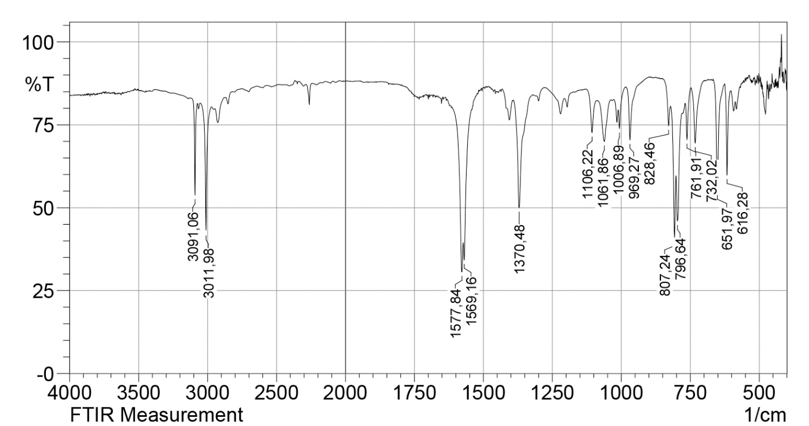
Figure S1. IR spectrum of 2-nitro-3-(trichloromethyl)cyclopropane-1,1-dicarbonitrile 2 in KBr.
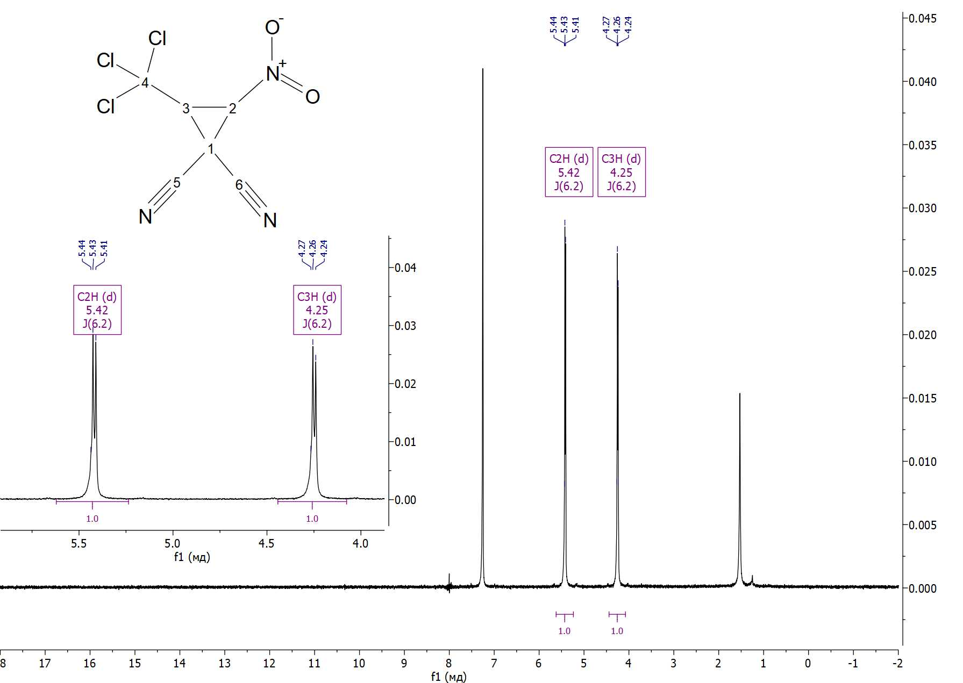
Figure S2. ¹Н NMR spectrum of 2-nitro-3-(trichloromethyl)cyclopropane-1,1-dicarbonitrile 2 in CDCl₃.
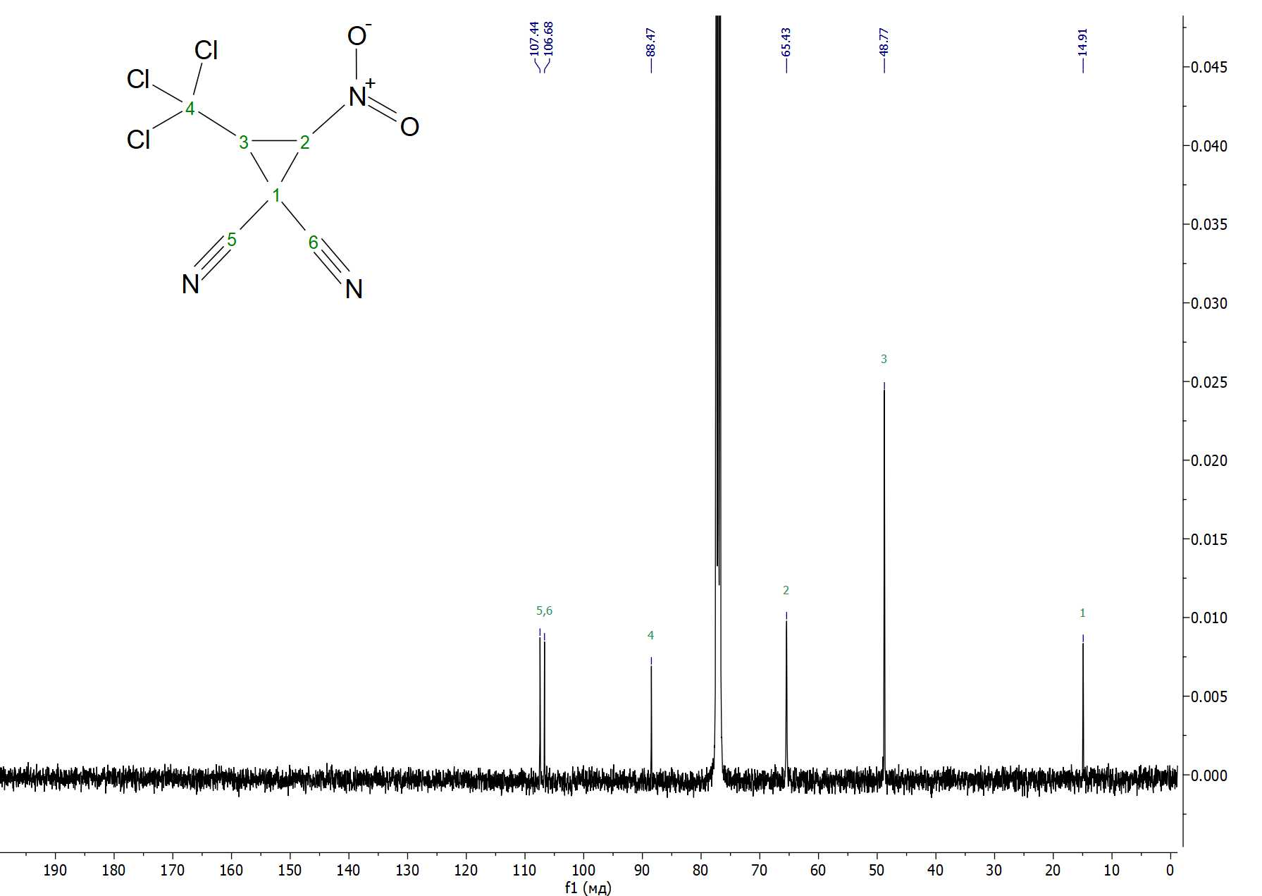
Figure S3. ¹³C{H} NMR spectrum of 2-nitro-3-(trichloromethyl)cyclopropane-1,1-dicarbonitrile 2 in CDCl₃.
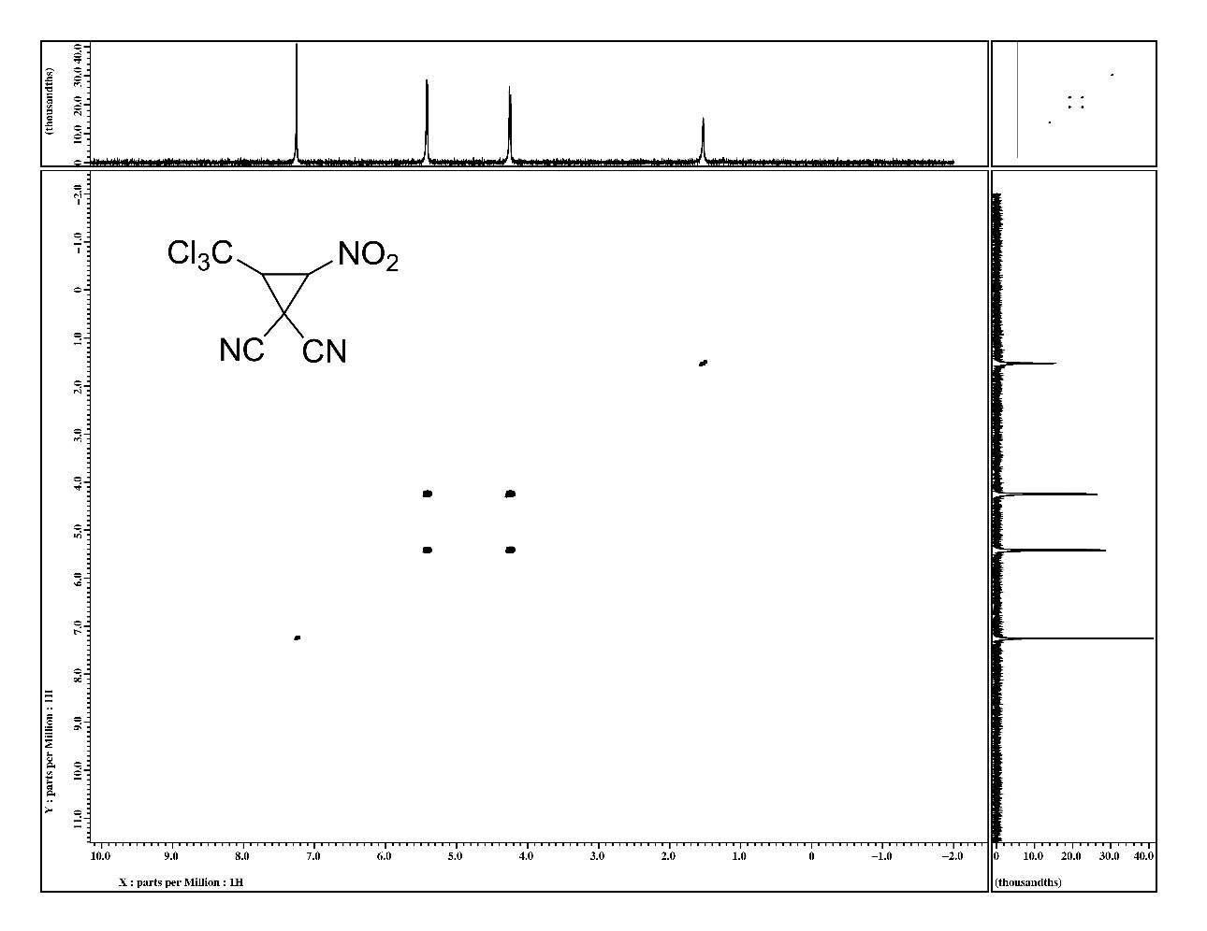
Figure S4. ¹H-¹H dqfCOSY NMR spectrum of 2-nitro-3-(trichloromethyl)cyclopropane-1,1-dicarbonitrile 2 in CDCl₃.
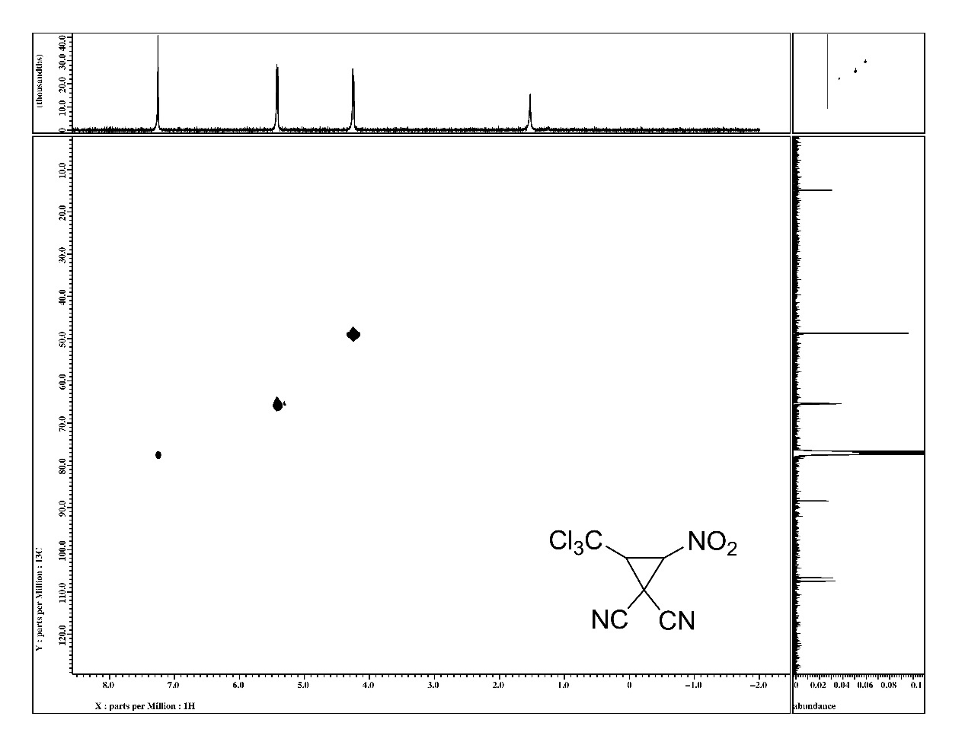
Figure S5. ¹H-¹³C HMQC NMR spectrum of 2-nitro-3-(trichloromethyl)cyclopropane-1,1-dicarbonitrile 2 in CDCl₃.
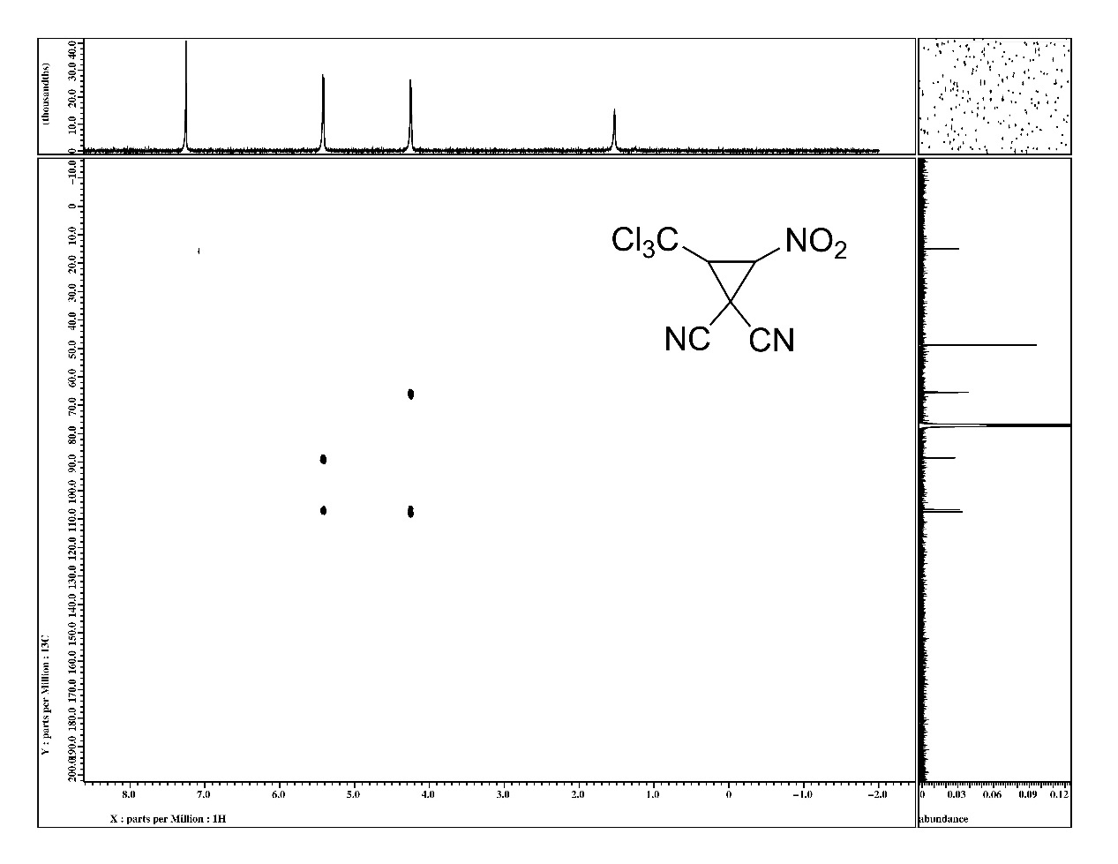
Figure S6. ¹H-¹³C HMBC NMR spectrum of 2-nitro-3-(trichloromethyl)cyclopropane-1,1-dicarbonitrile 2 in CDCl₃.
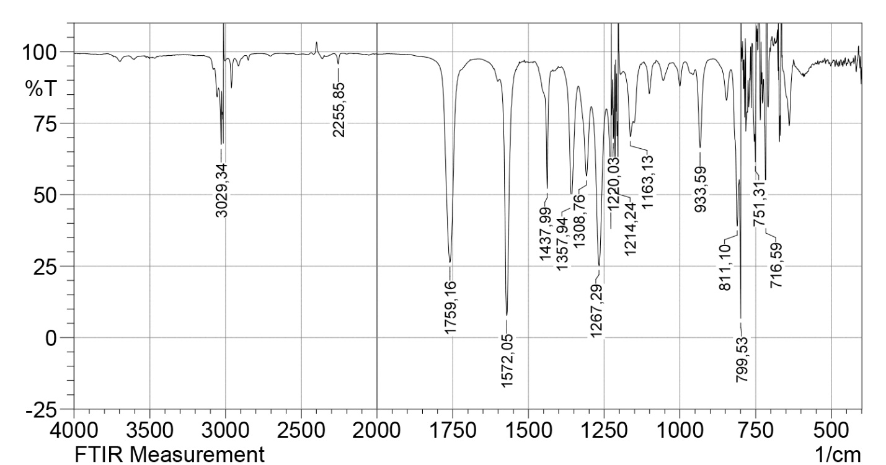
Figure S7. IR spectrum of methyl 1-cyano-2-nitro-3-(trichloromethyl)cyclopropanecarboxylate 3 in CHCl₃
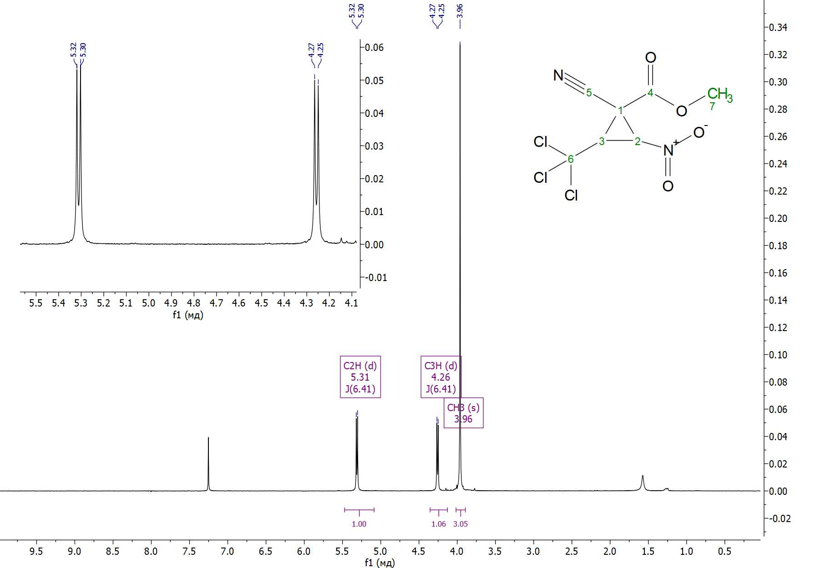
Figure S8. ¹H NMR spectrum of methyl 1-cyano-2-nitro-3-(trichloromethyl)cyclopropanecarboxylate 3 in CHCl₃
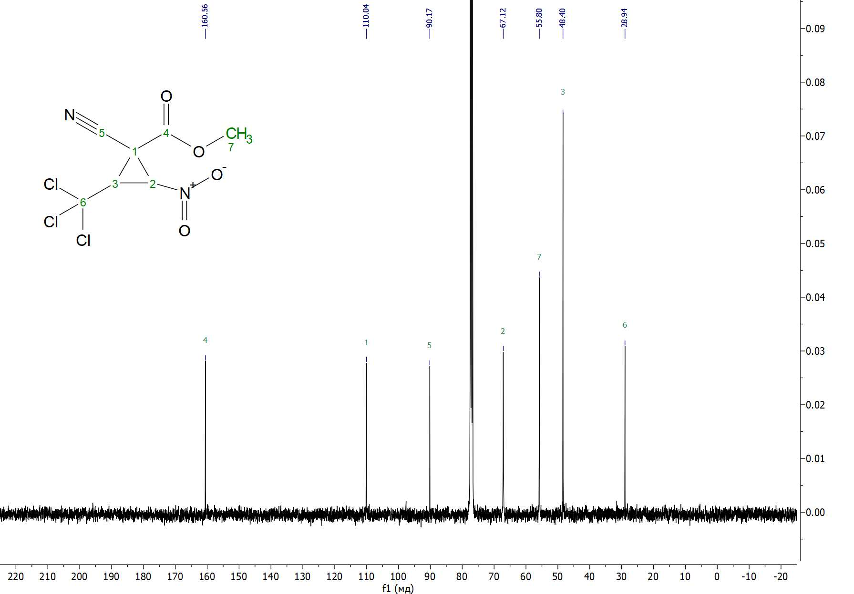
Figure S9. ¹³C{H} NMR spectrum of methyl 1-cyano-2-nitro-3-(trichloromethyl)cyclopropanecarboxylate 3 in CHCl₃
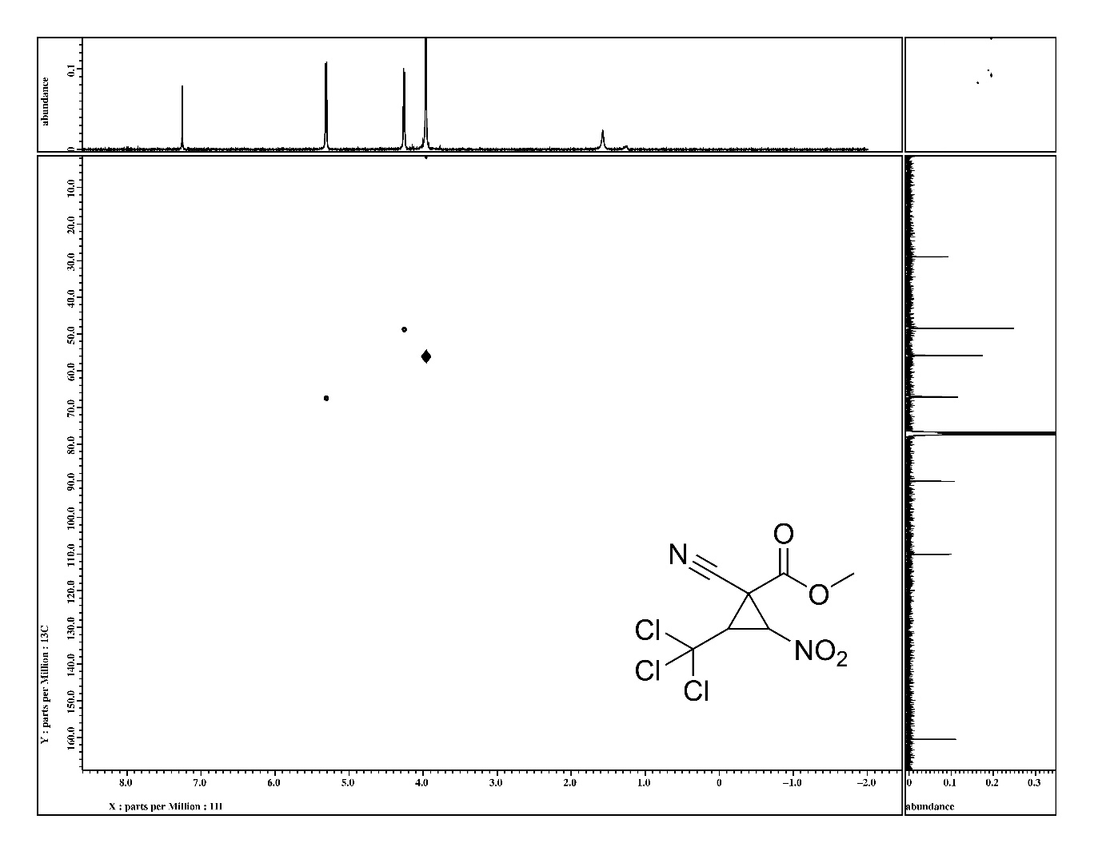
Figure S10. ¹H-¹³C HMQC NMR spectrum of methyl 1-cyano-2-nitro-3-(trichloromethyl)cyclopropanecarboxylate 3 in CHCl₃
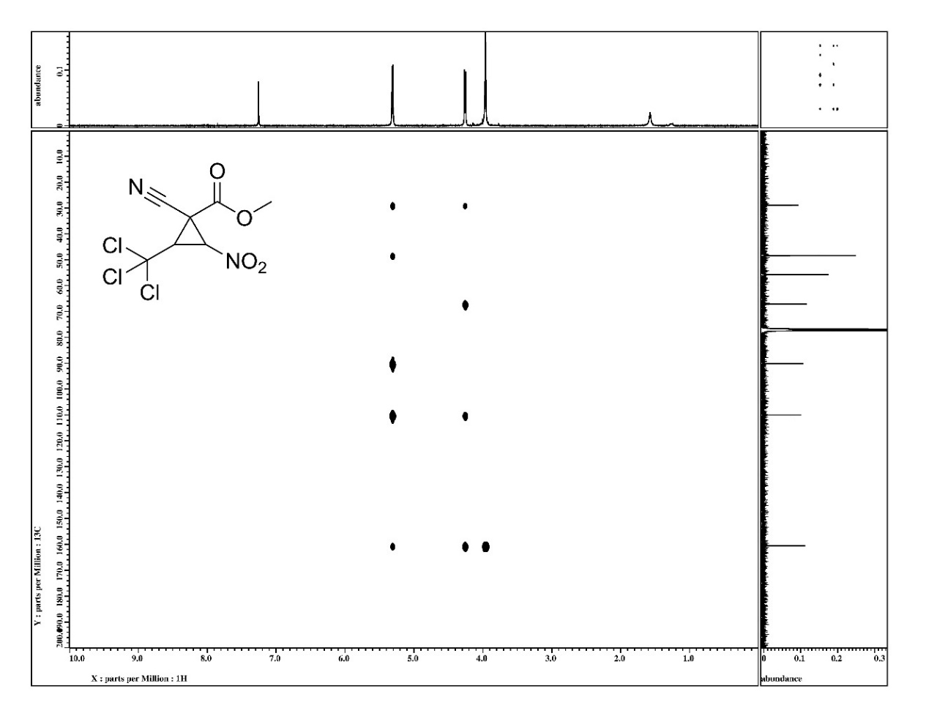
Figure S11. ¹H-¹³C HMBC NMR spectrum of methyl 1-cyano-2-nitro-3-(trichloromethyl)cyclopropanecarboxylate 3 in CHCl₃
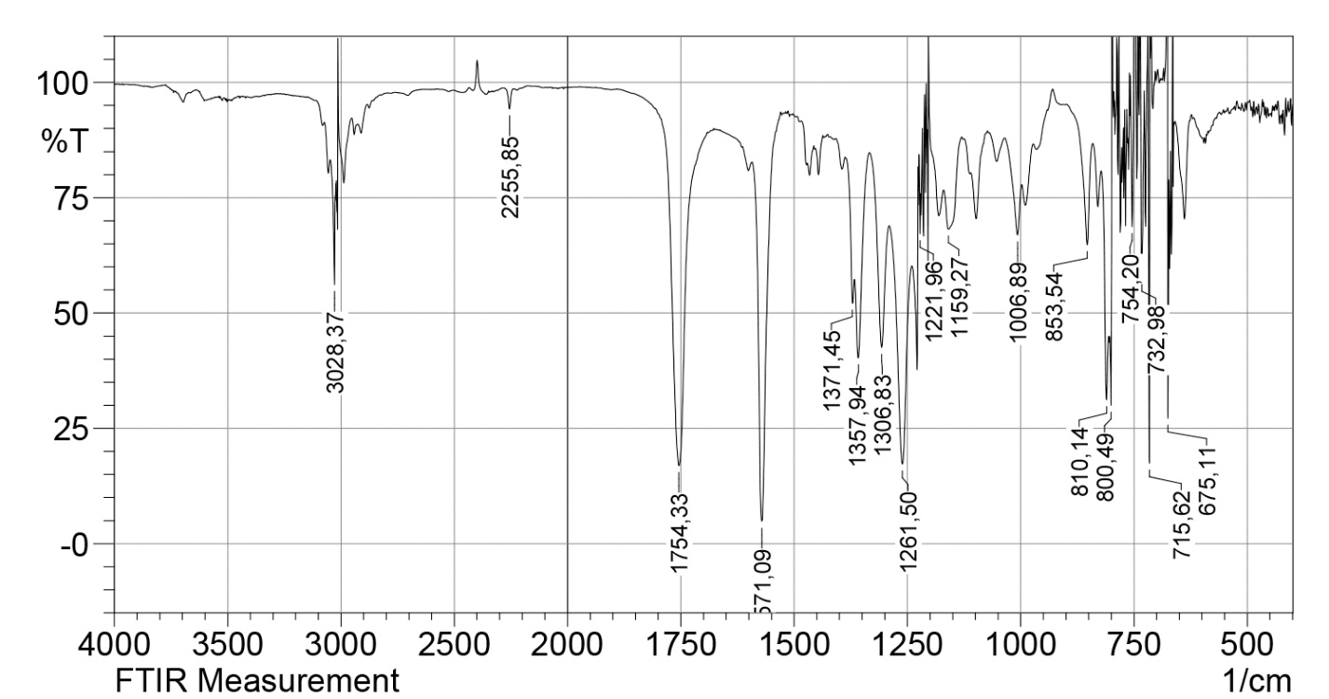
Figure S12. IR spectrum of ethyl 1-cyano-2-nitro-3-(trichloromethyl)cyclopropanecarboxylate 4 in CHCl₃
'
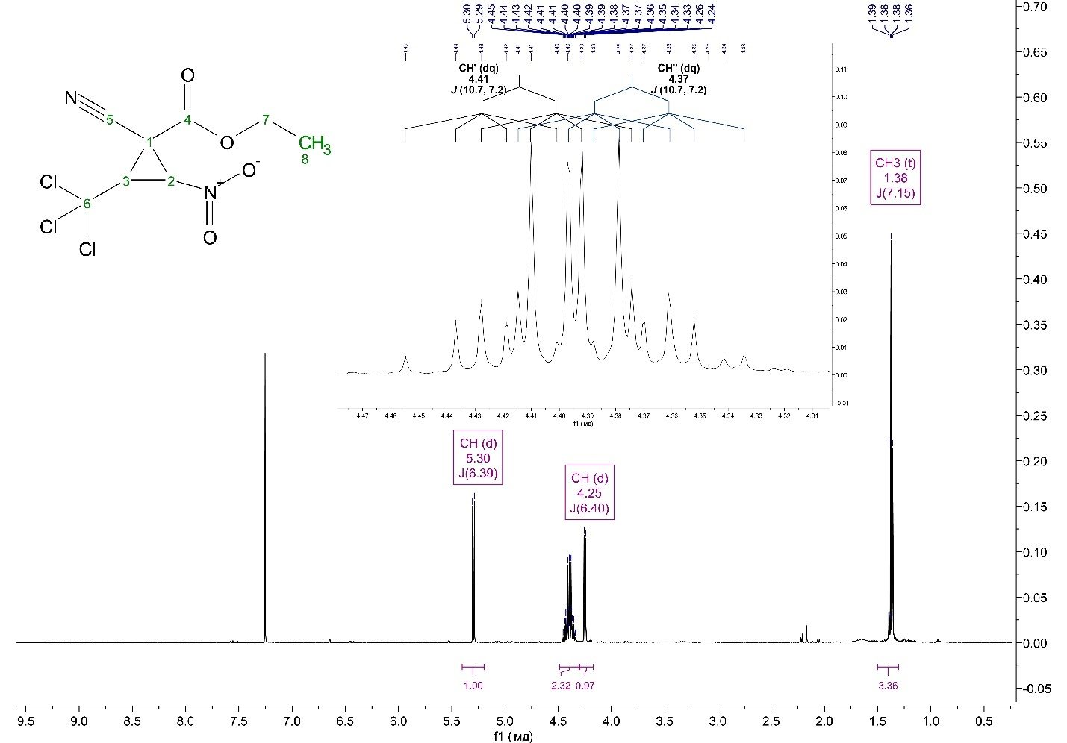
Figure S13. ¹H NMR spectrum of ethyl 1-cyano-2-nitro-3-(trichloromethyl)cyclopropanecarboxylate 4 in CHCl₃
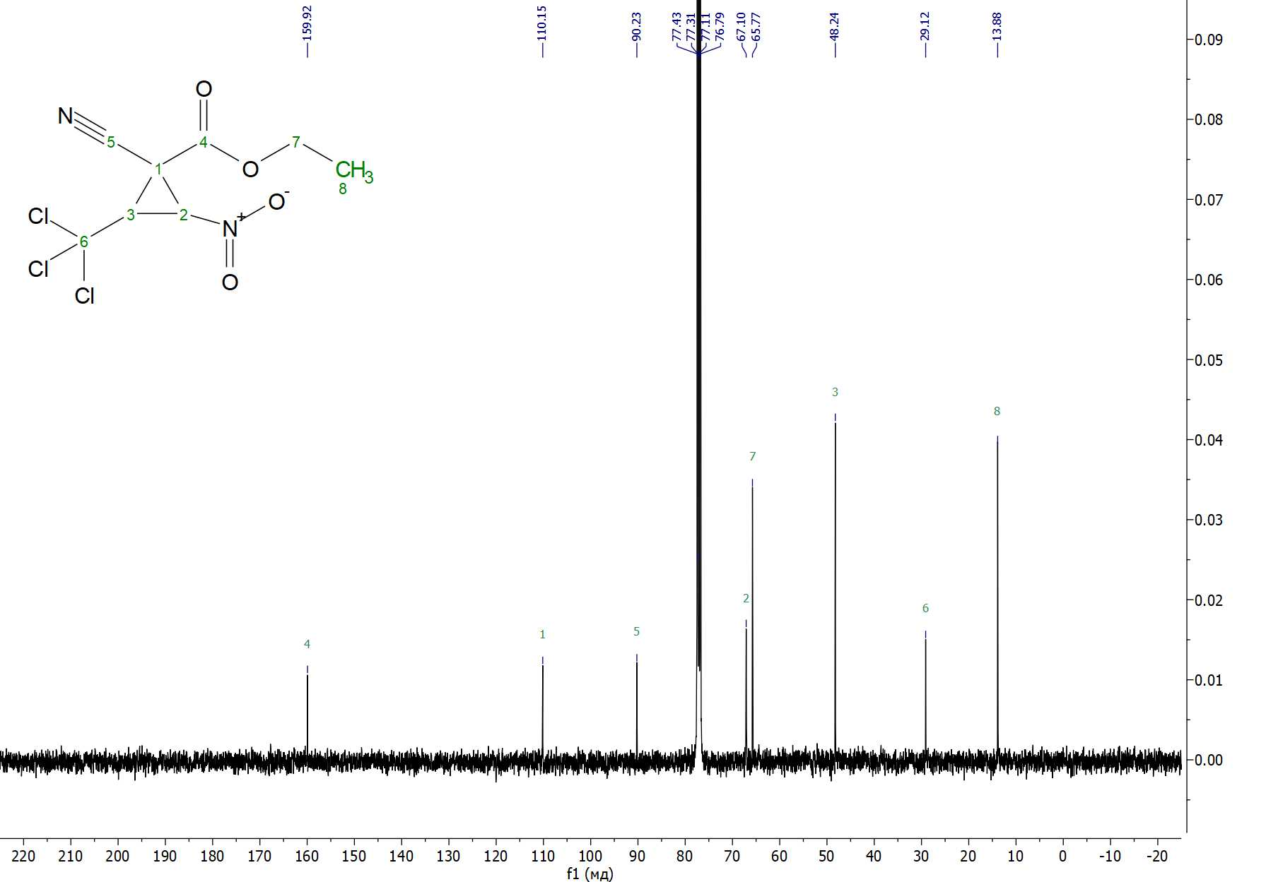
Figure S14. ¹³C{H} NMR spectrum of ethyl 1-cyano-2-nitro-3-(trichloromethyl)cyclopropanecarboxylate 4 in CHCl₃
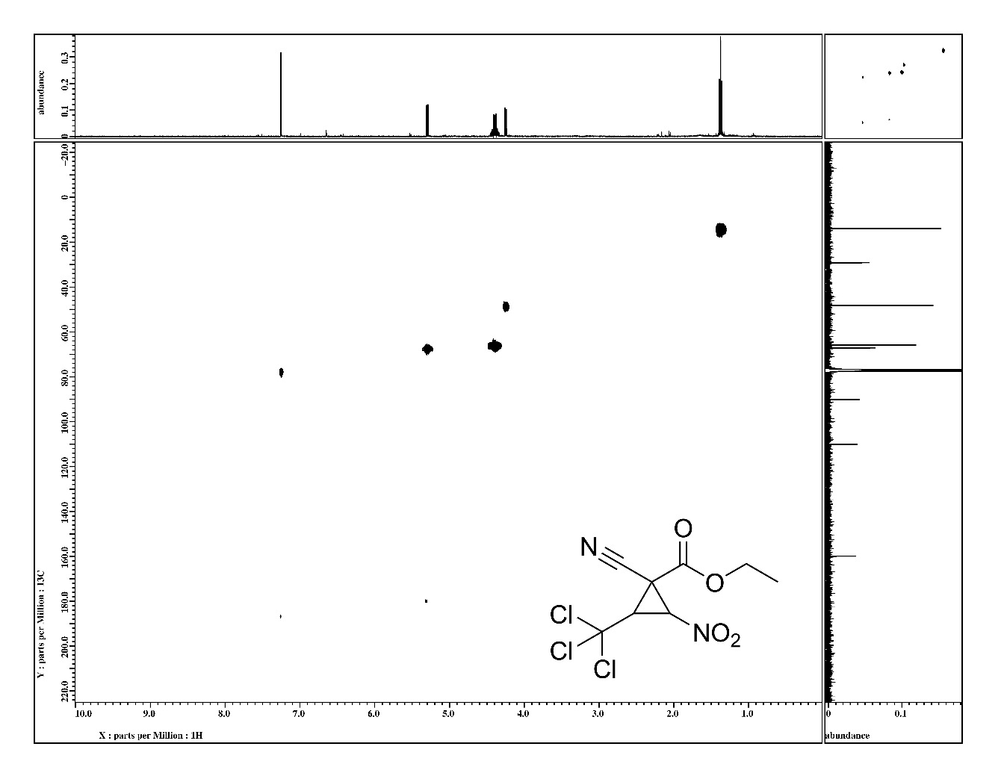
Figure S15. ¹H-¹³C HMQC NMR spectrum of ethyl 1-cyano-2-nitro-3-(trichloromethyl)cyclopropanecarboxylate 4 in CHCl₃
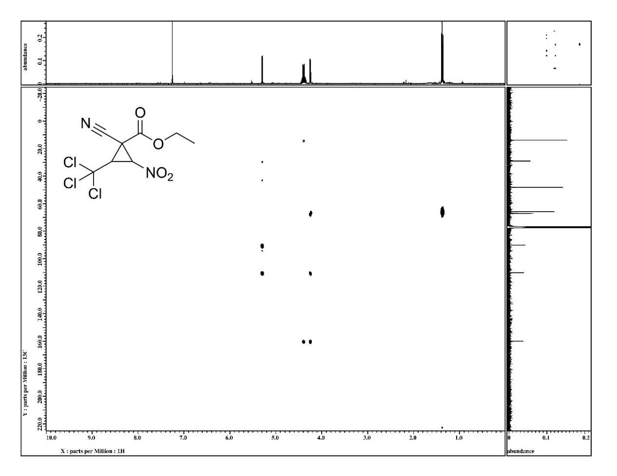
Figure S16. ¹H-¹³C HMBC NMR spectrum of ethyl 1-cyano-2-nitro-3-(trichloromethyl)cyclopropanecarboxylate 4 in CHCl₃
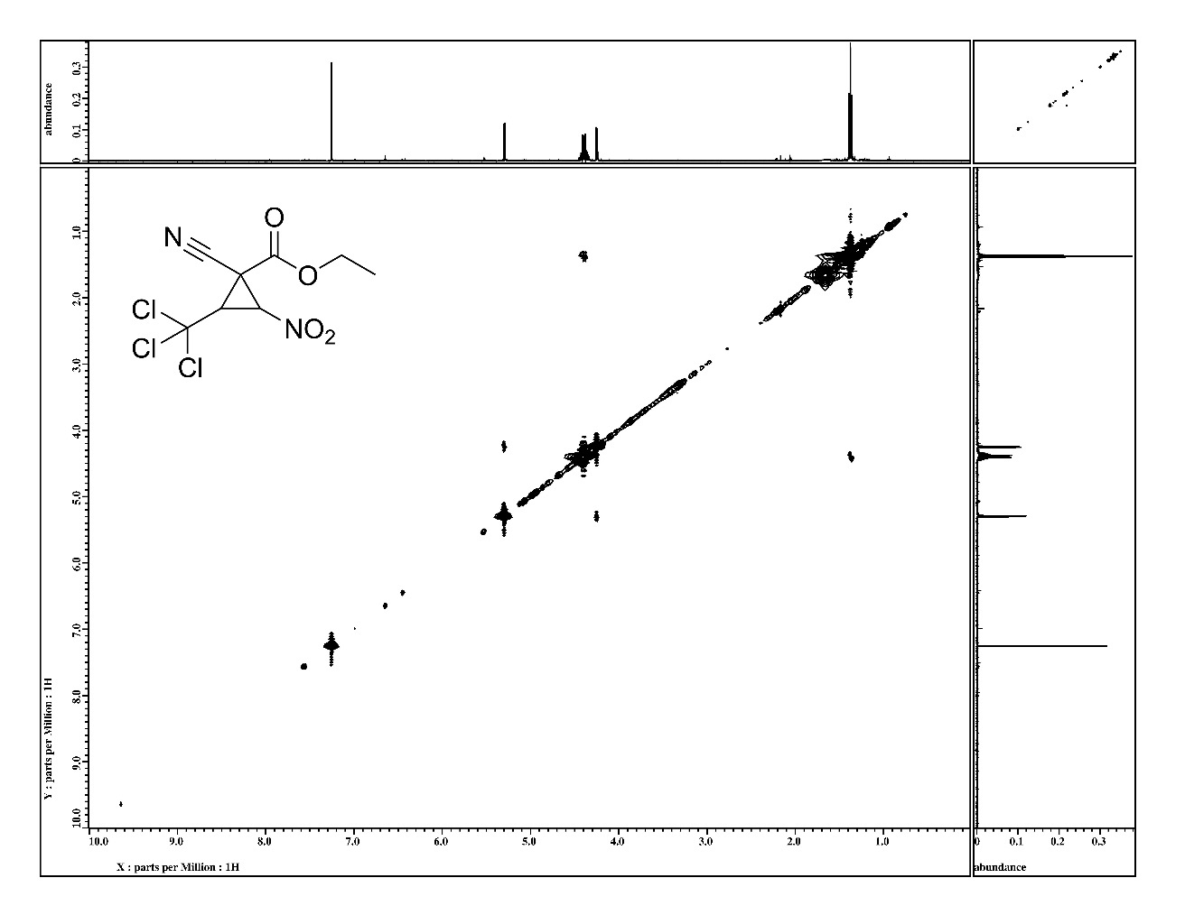
Figure S17. ¹H-¹H NOESY NMR spectrum of ethyl 1-cyano-2-nitro-3-(trichloromethyl)cyclopropanecarboxylate 4 in CHCl₃

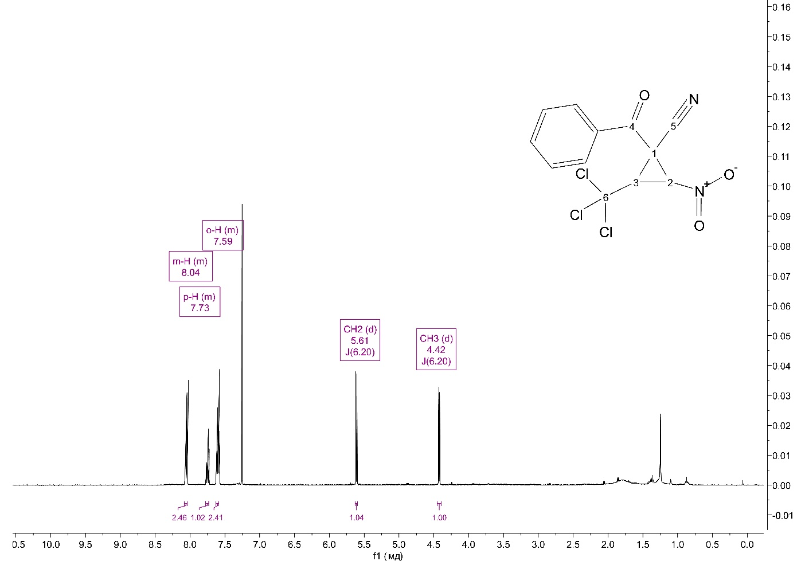
Figure S18. ¹H NMR spectrum of 1-benzoyl-2-nitro-3-(trichloromethyl)cyclopropane-1-carbonitrile 5 in CDCl₃.
Figure S19. ¹³C{H} NMR spectrum of 1-benzoyl-2-nitro-3-(trichloromethyl)cyclopropane-1-carbonitrile 5 in CDCl₃.
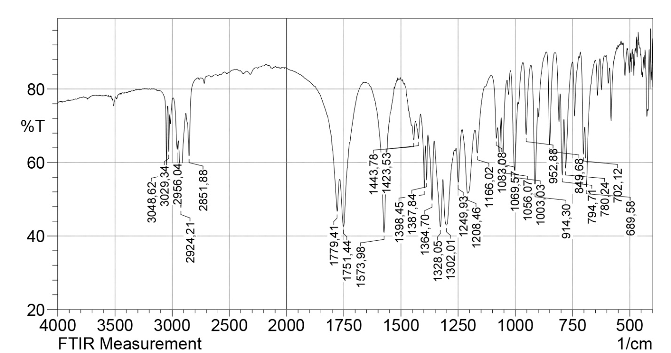
Figure S20. IR spectrum of 6,6-dimethyl-1-nitro-2-(trichloromethyl)-5,7-dioxaspiro[2.5]octane-4,8-dione 6 in KBr.
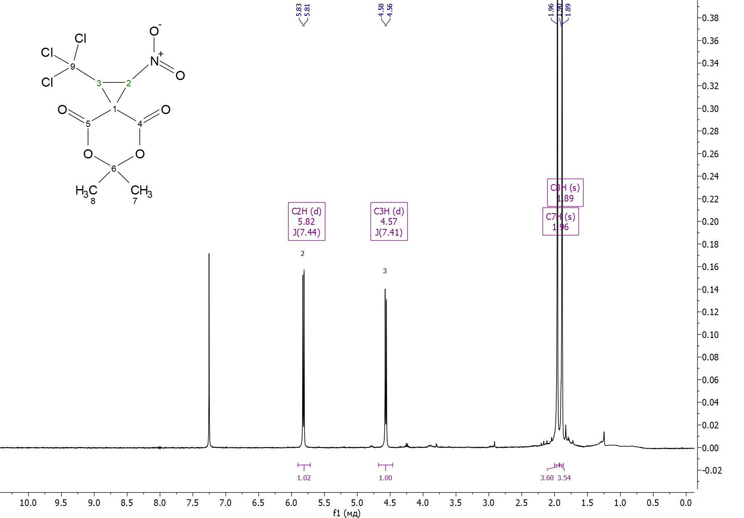
Figure S21. ¹Н NMR spectrum of 6,6-dimethyl-1-nitro-2-(trichloromethyl)-5,7-dioxaspiro[2.5]octane-4,8-dione 6 in CDCl₃.
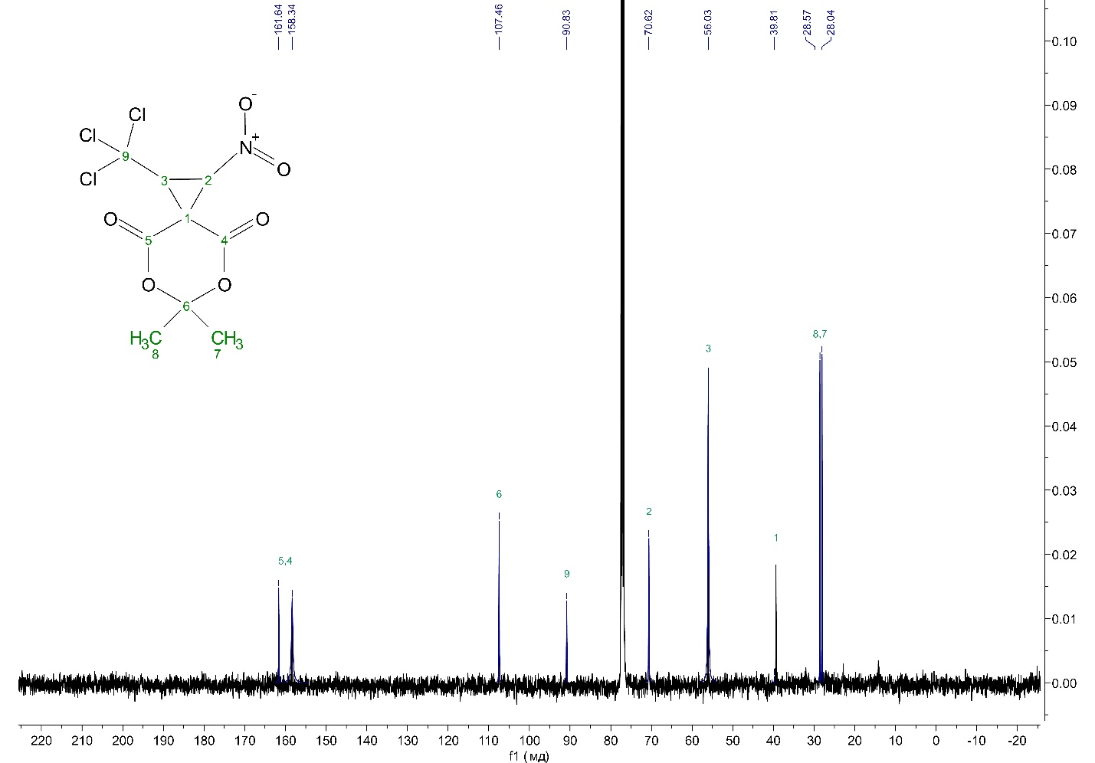
Figure S22. ¹³С{¹H} NMR spectrum of 6,6-dimethyl-1-nitro-2-(trichloromethyl)-5,7-dioxaspiro[2.5]octane-4,8-dione 6 in CDCl₃.
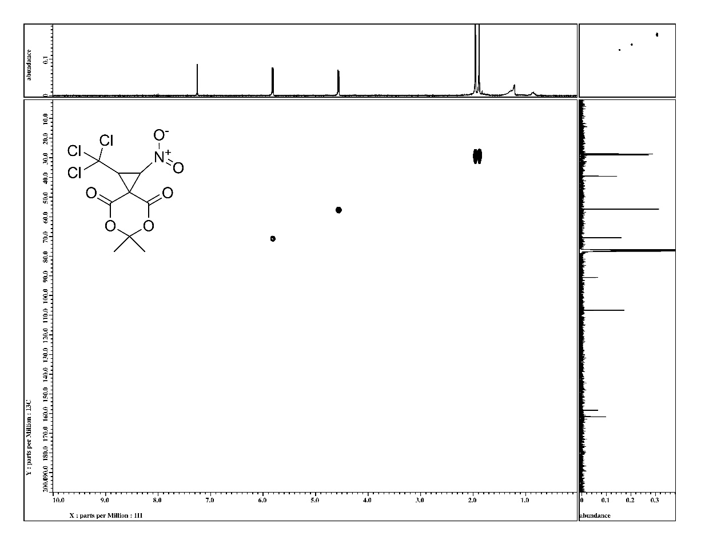
Figure S23. ¹H-¹³C HMQC NMR spectrum of 6,6-dimethyl-1-nitro-2-(trichloromethyl)-5,7-dioxaspiro[2.5]octane-4,8-dione 6 in CDCl₃.
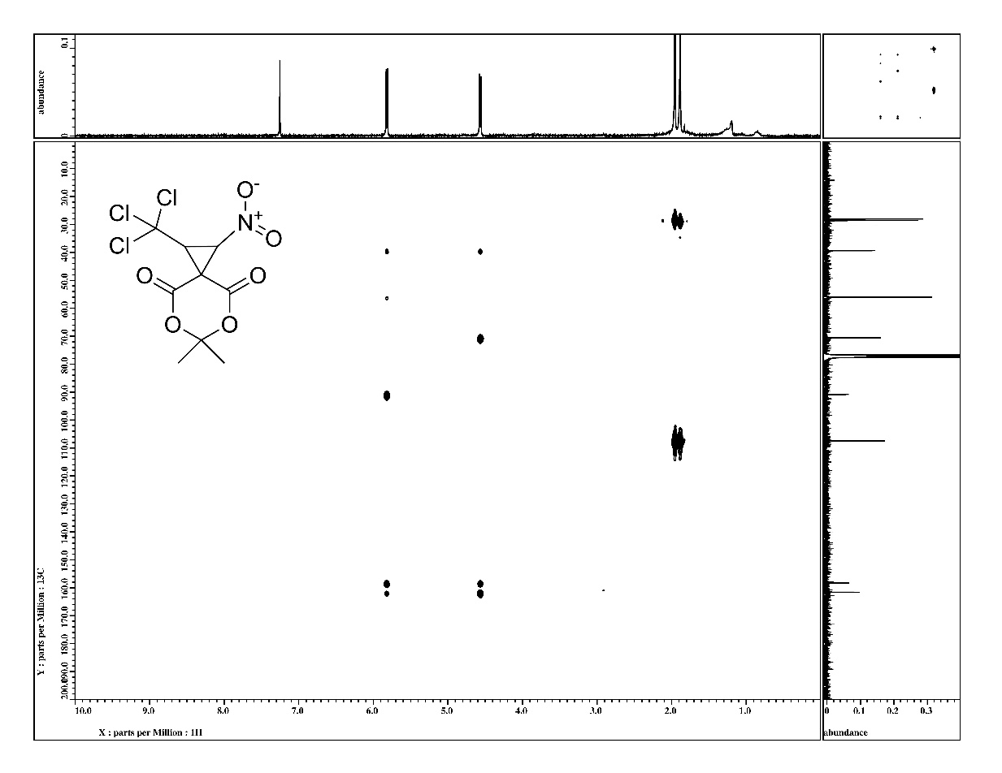
Figure S24. ¹H-¹³C HMBC NMR spectrum of 6,6-dimethyl-1-nitro-2-(trichloromethyl)-5,7-dioxaspiro[2.5]octane-4,8-dione 6 in CDCl₃.
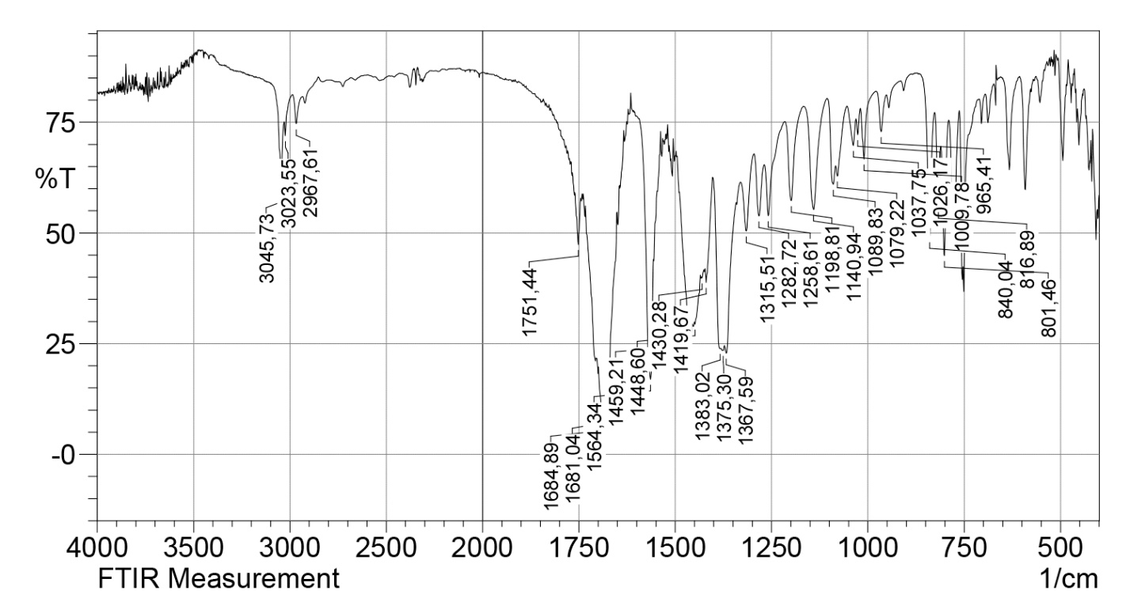
Figure S25. IR spectrum of 5,7-dimethyl-1-nitro-2-(trichloromethyl)-5,7-diazaspiro[2.5]octane-4,6,8-trione 7 in KBr.
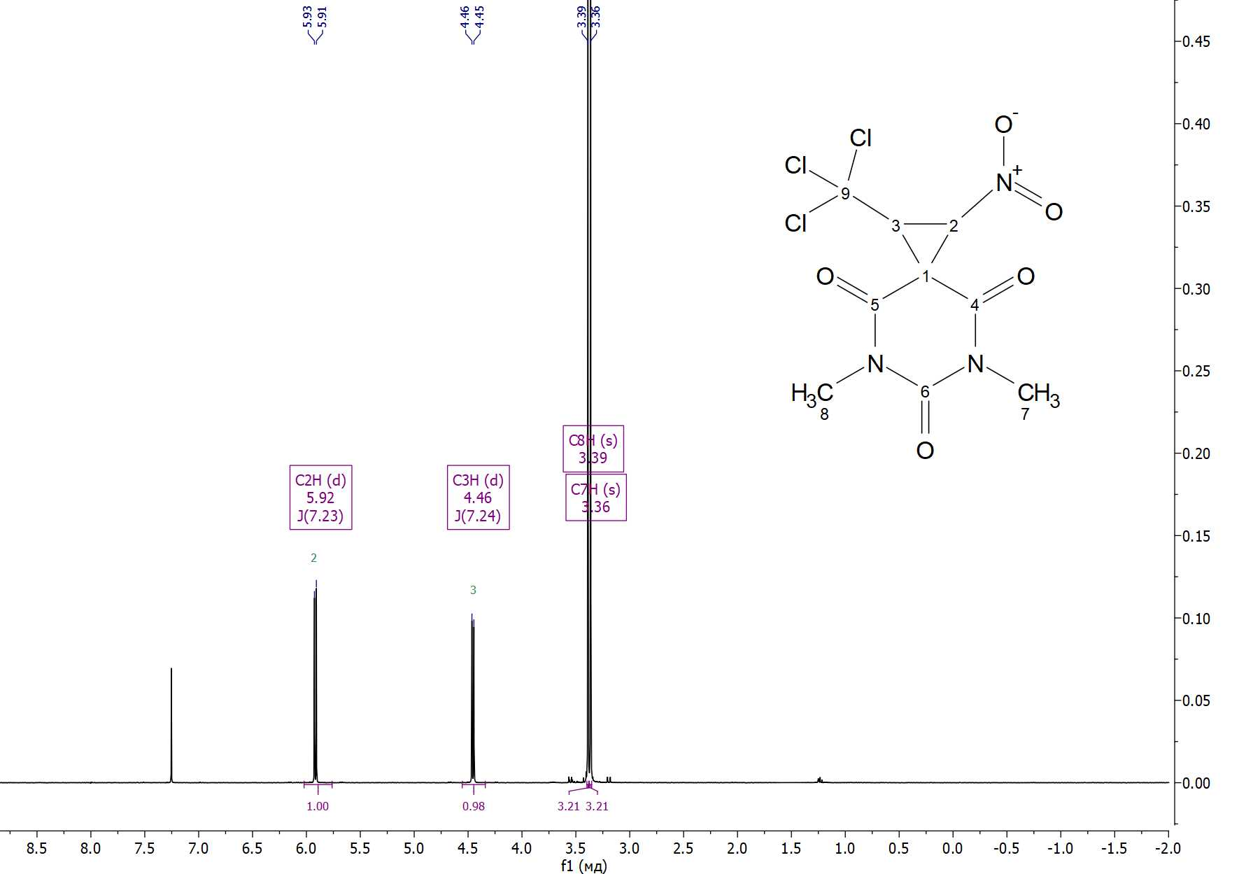
Figure S26. ¹Н NMR spectrum of 5,7-dimethyl-1-nitro-2-(trichloromethyl)-5,7-diazaspiro[2.5]octane-4,6,8-trione 7 in CDCl₃.
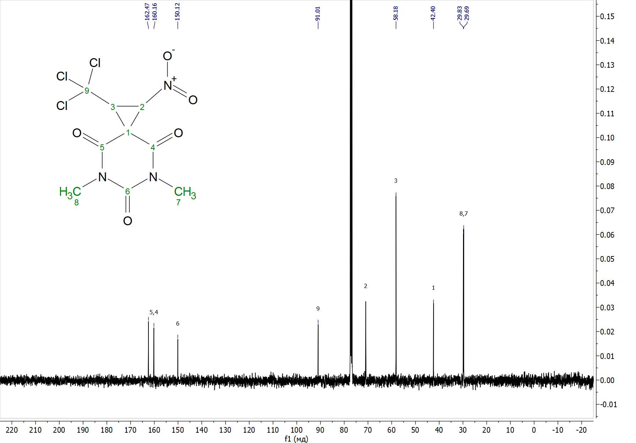
Figure S27. ¹³С{¹H} NMR spectrum of 5,7-dimethyl-1-nitro-2-(trichloromethyl)-5,7-diazaspiro[2.5]octane-4,6,8-trione 7 in CDCl₃.
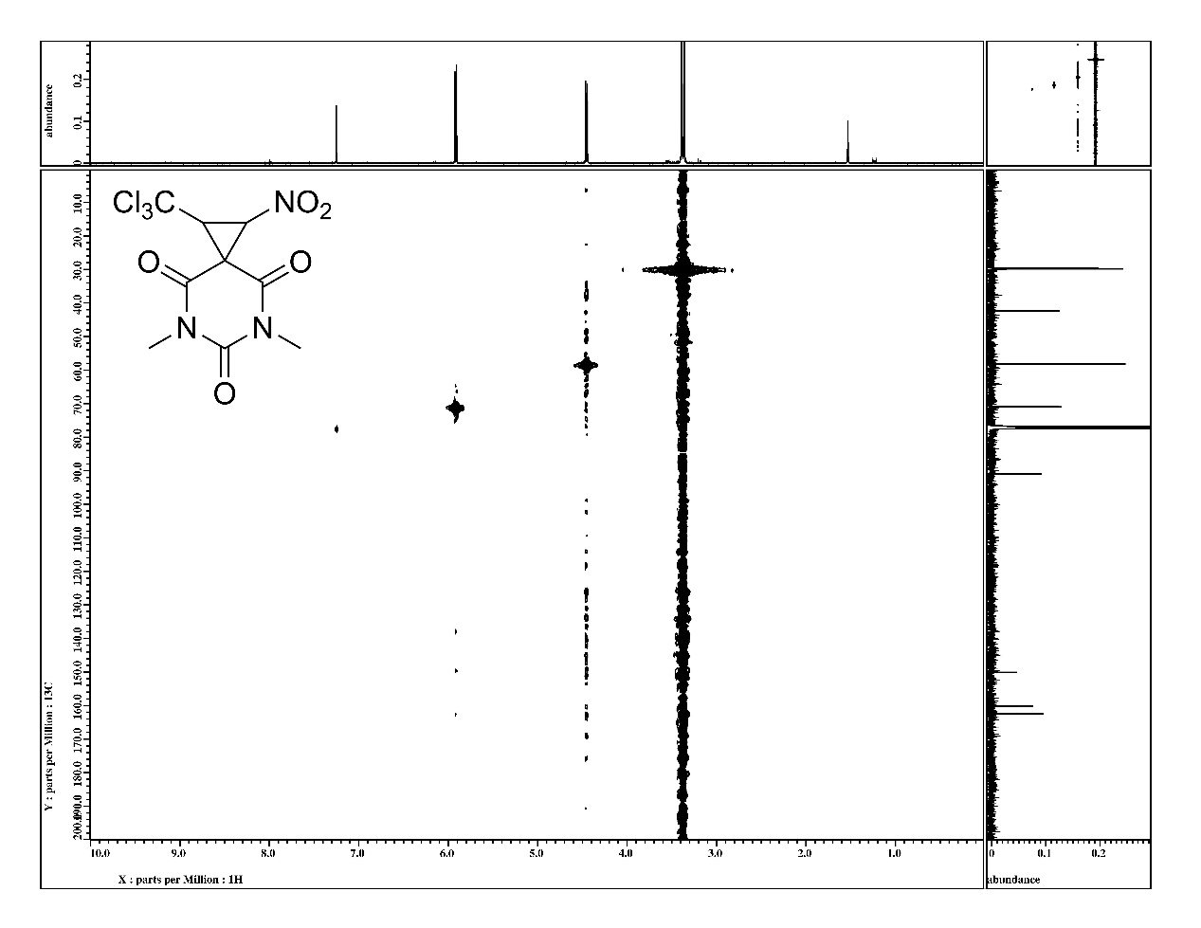
Figure S28. ¹H-¹³C HMQC NMR spectrum of 5,7-dimethyl-1-nitro-2-(trichloromethyl)-5,7-diazaspiro[2.5]octane-4,6,8-trione 7 in CDCl₃.
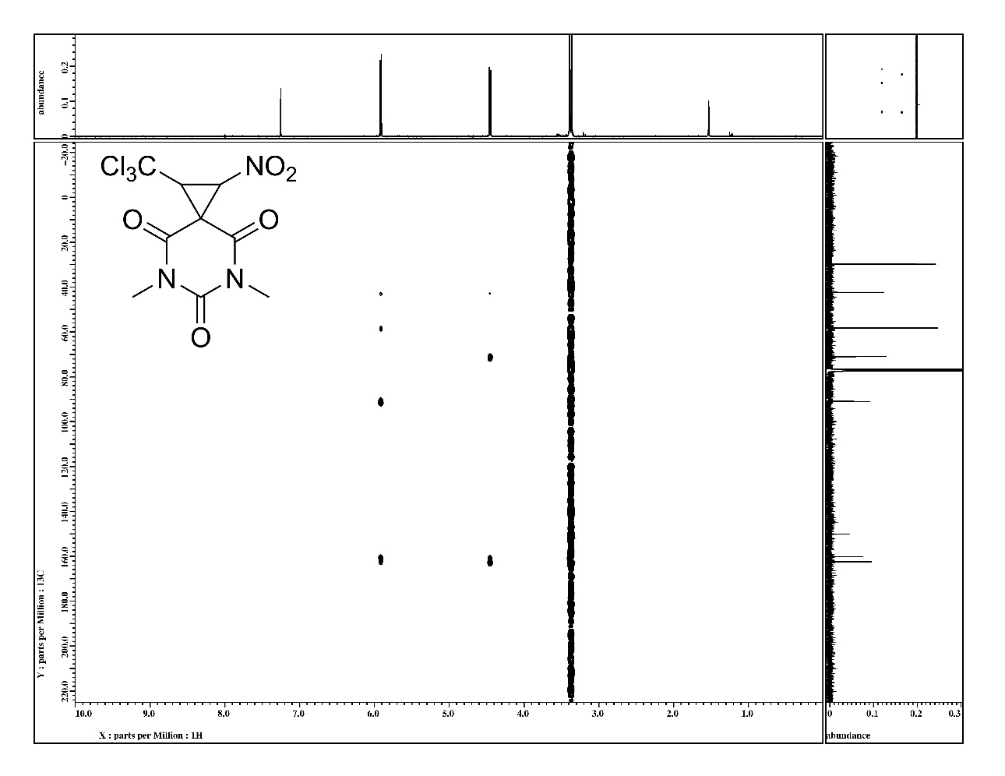
Figure S29. ¹H-¹³C HMBC NMR spectrum of 5,7-dimethyl-1-nitro-2-(trichloromethyl)-5,7-diazaspiro[2.5]octane-4,6,8-trione 7 in CDCl₃.
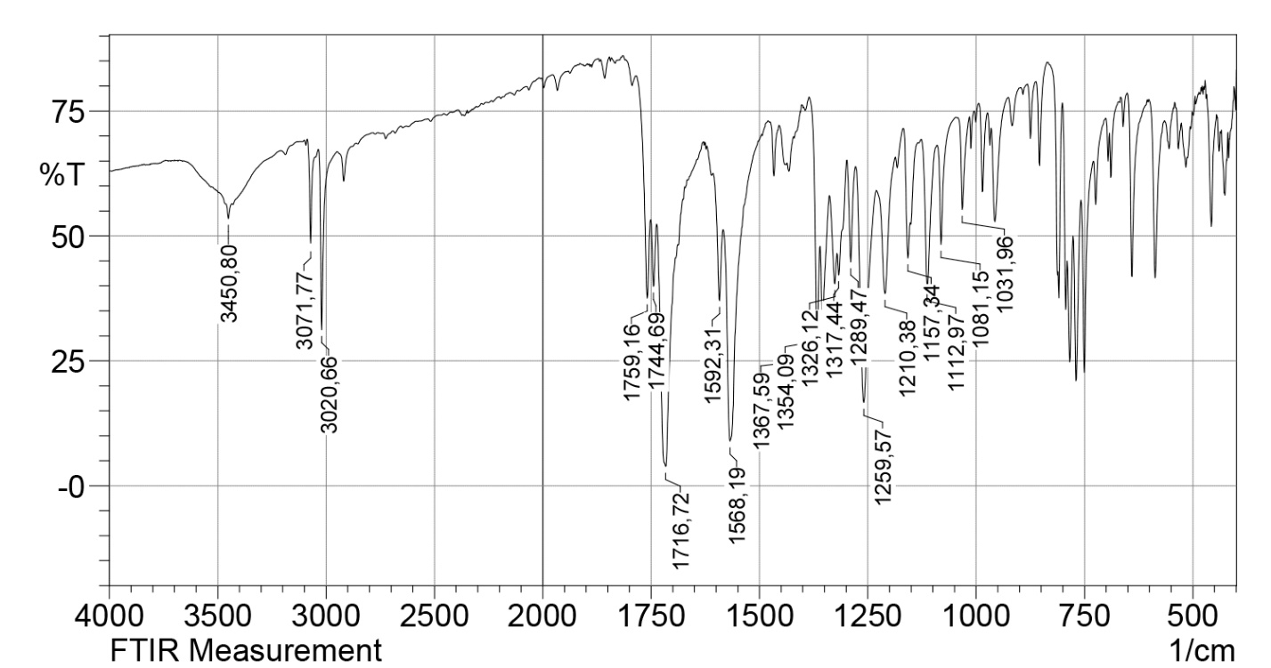
Figure S30. IR spectrum of 1',3'-dimethylidene-2-nitro-3-(trichloromethyl)-1',3'-dihydrospiro[cyclopropane-1,2'-indene] 8 in KBr.
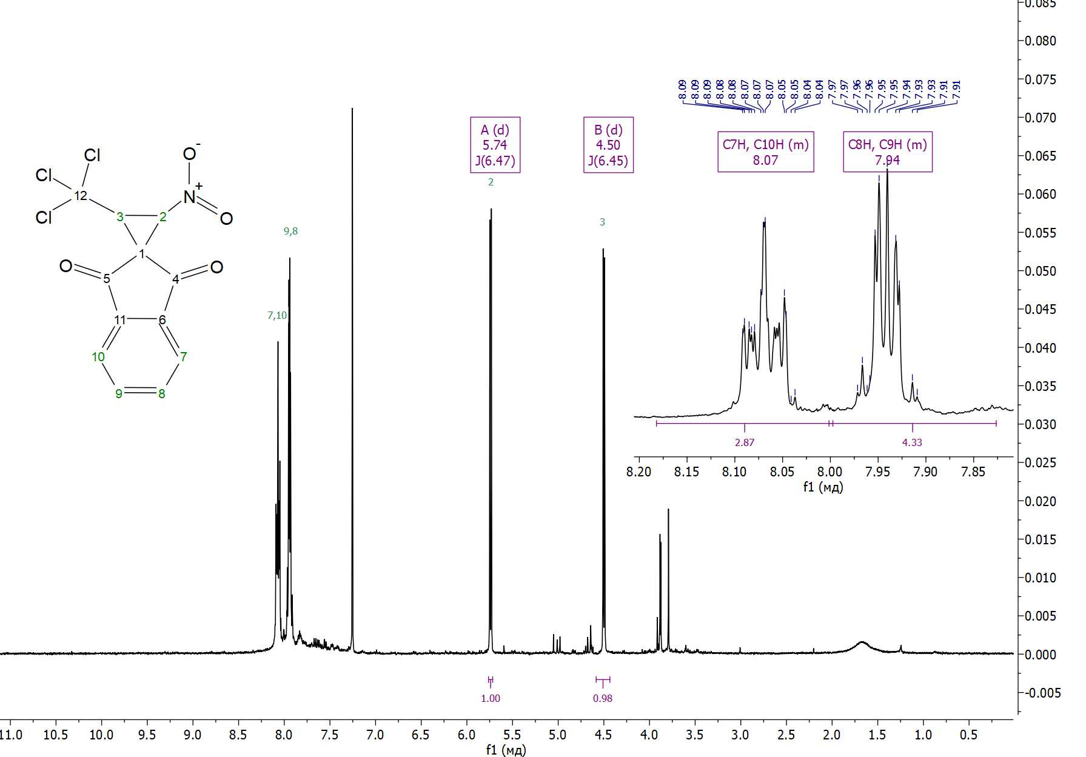
Figure S31. ¹H NMR spectrum of 1',3'-dimethylidene-2-nitro-3-(trichloromethyl)-1',3'-dihydrospiro[cyclopropane-1,2'-indene] 8 in CDCl₃.
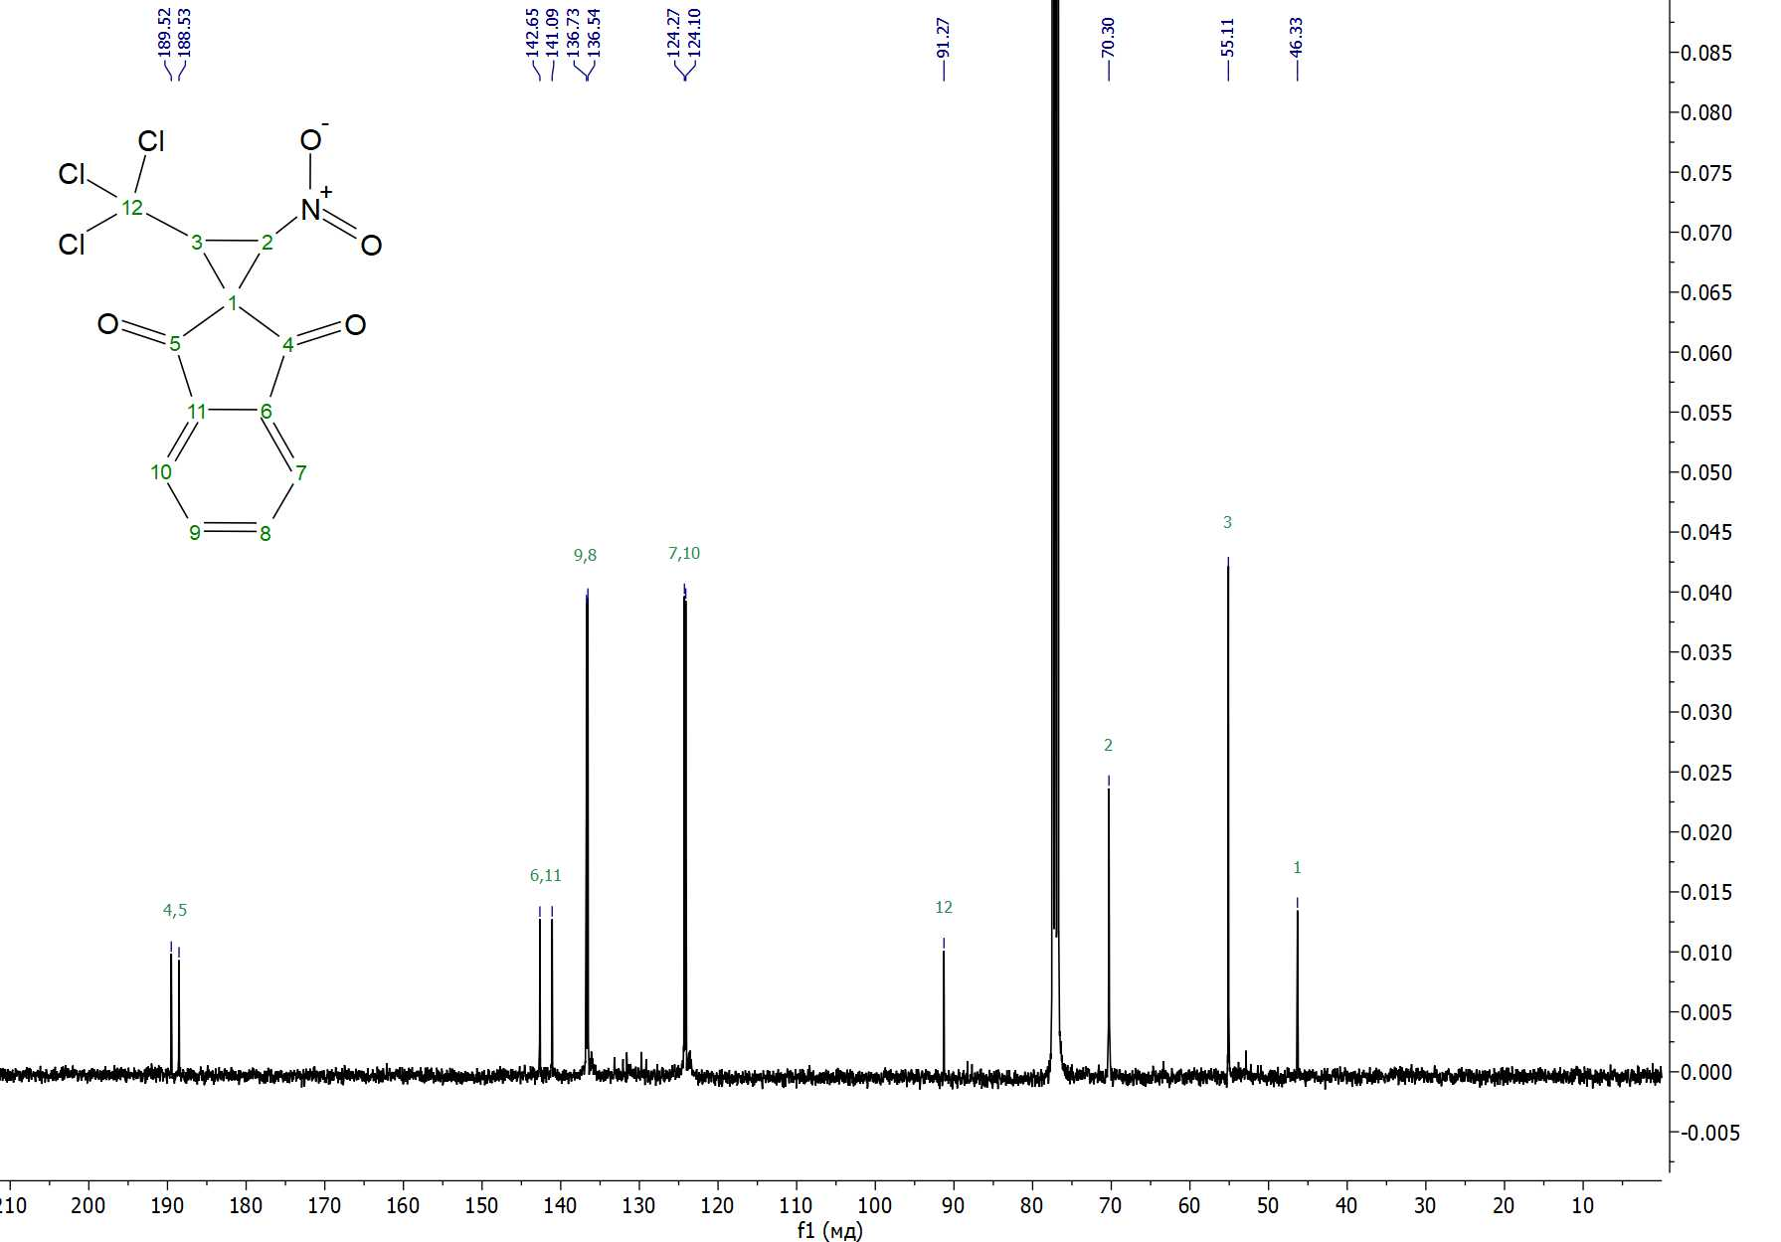
Figure S32. ¹H-¹³C NMR spectrum of 1',3'-dimethylidene-2-nitro-3-(trichloromethyl)-1',3'-dihydrospiro[cyclopropane-1,2'-indene] 8 in CDCl₃.
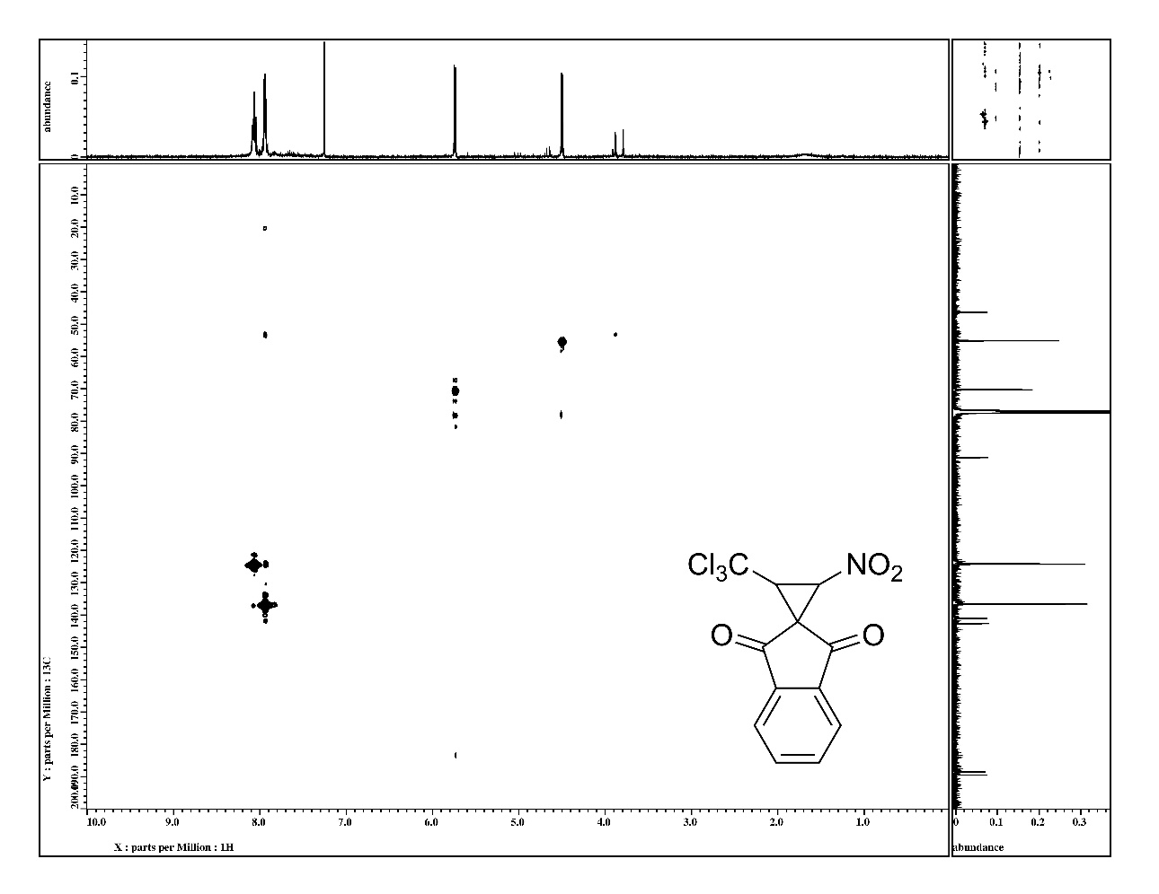
Figure S33. ¹H-¹³C HMQC NMR spectrum of 1',3'-dimethylidene-2-nitro-3-(trichloromethyl)-1',3'-dihydrospiro[cyclopropane-1,2'-indene] 8 in CDCl₃.
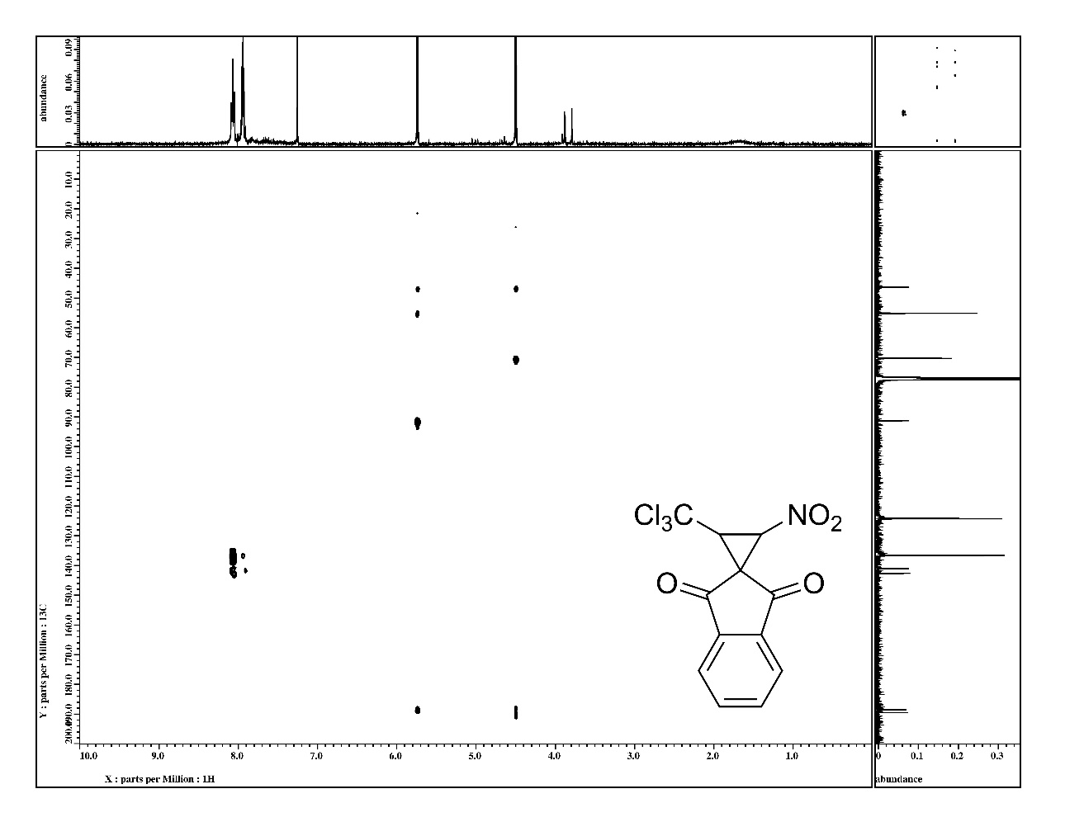
Figure S34. ¹H-¹³C HMBC NMR spectrum of 1',3'-dimethylidene-2-nitro-3-(trichloromethyl)-1',3'-dihydrospiro[cyclopropane-1,2'-indene] 8 in CDCl₃.
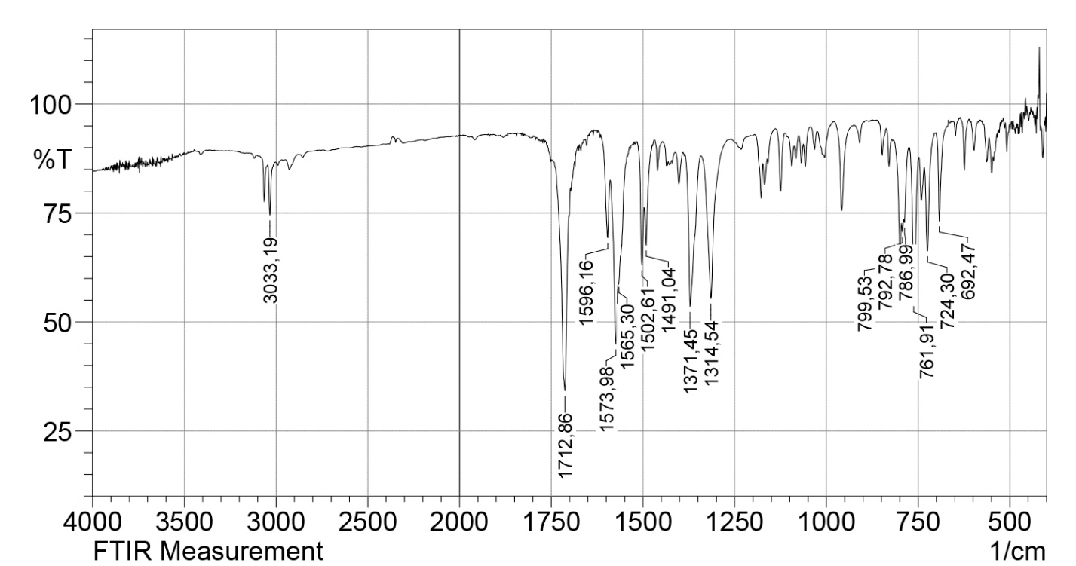
Figure S35. IR spectrum of 7-methyl-1-nitro-5-phenyl-2-(trichloromethyl)-5,6-diazaspiro[2.4]hept-6-en-4-one 9a in KBr.
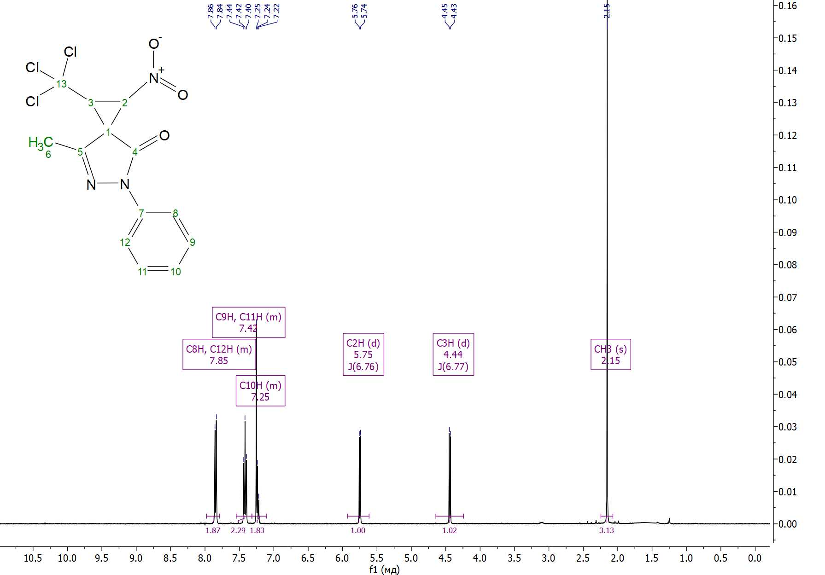
Figure S36. ¹H NMR spectrum of 7-methyl-1-nitro-5-phenyl-2-(trichloromethyl)-5,6-diazaspiro[2.4]hept-6-en-4-one 9a in CDCl₃.
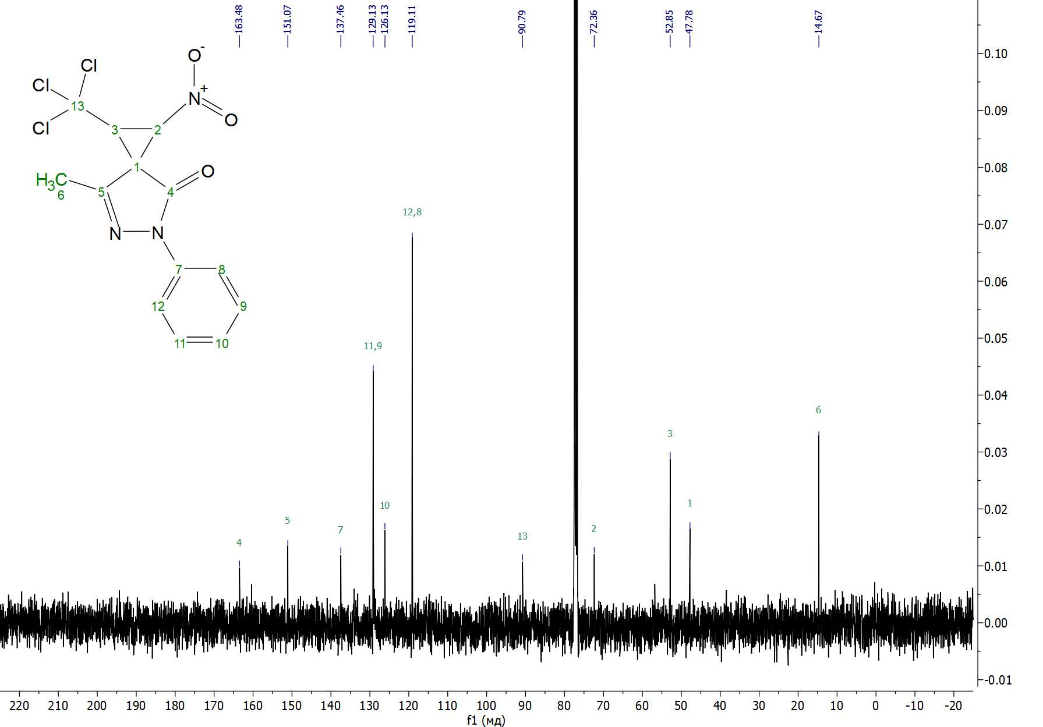
Figure S37. ¹³С{¹H} NMR spectrum of 7-methyl-1-nitro-5-phenyl-2-(trichloromethyl)-5,6-diazaspiro[2.4]hept-6-en-4-one 9a in CDCl₃.
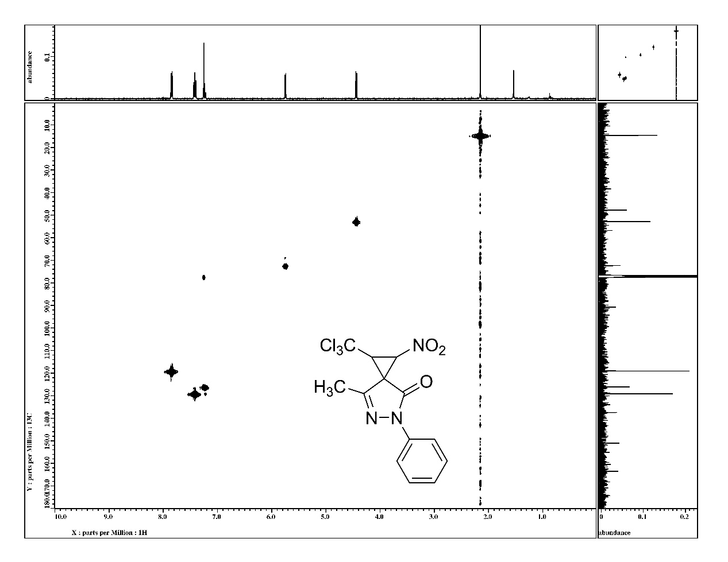
Figure S38. ¹H-¹³C HMQC NMR spectrum of 7-methyl-1-nitro-5-phenyl-2-(trichloromethyl)-5,6-diazaspiro[2.4]hept-6-en-4-one 9a in CDCl₃.
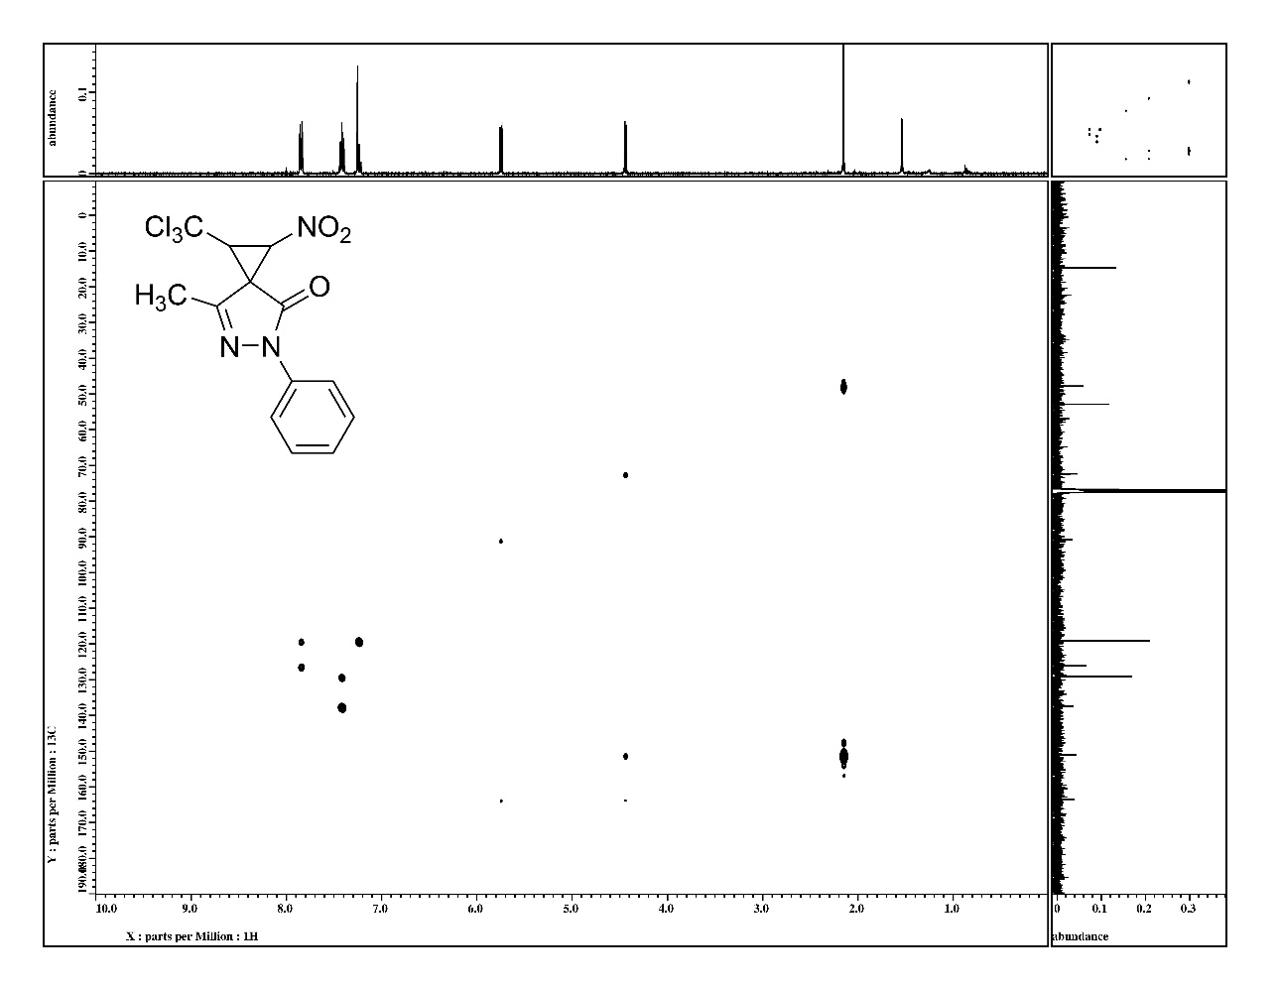
Figure S39. ¹H-¹³C HMBC NMR spectrum of 7-methyl-1-nitro-5-phenyl-2-(trichloromethyl)-5,6-diazaspiro[2.4]hept-6-en-4-one 9a in CDCl₃.
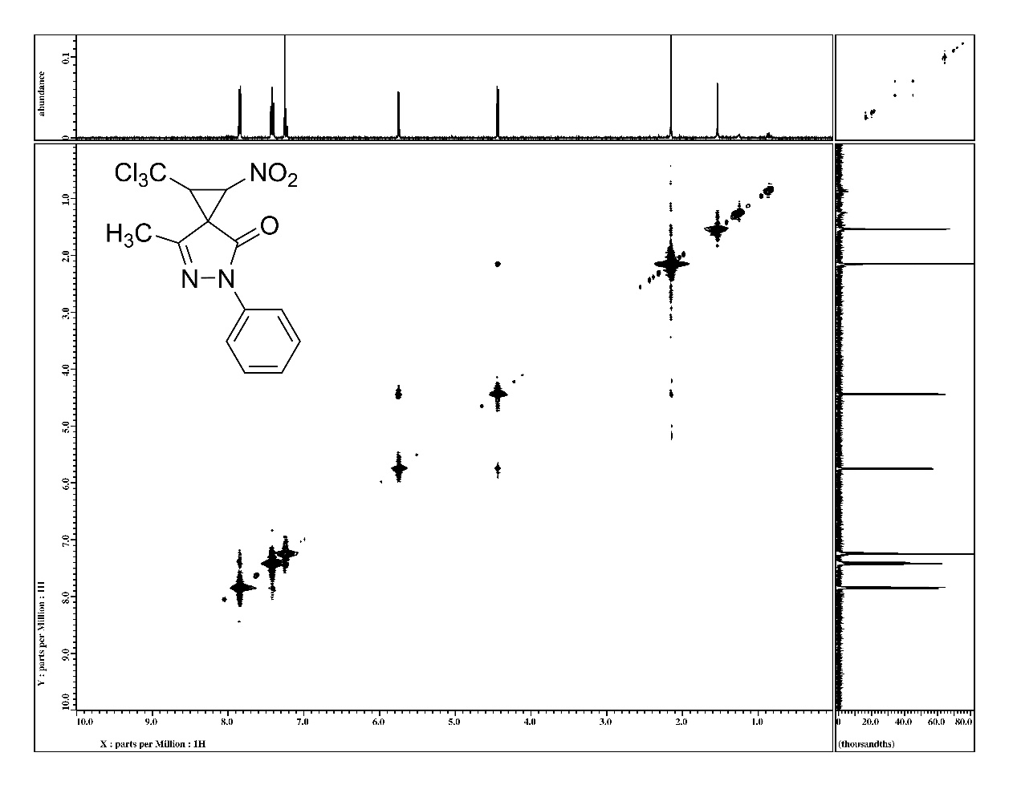
Figure S40. ¹H-¹H NOESY NMR spectrum of 7-methyl-1-nitro-5-phenyl-2-(trichloromethyl)-5,6-diazaspiro[2.4]hept-6-en-4-one 9a in CDCl₃.
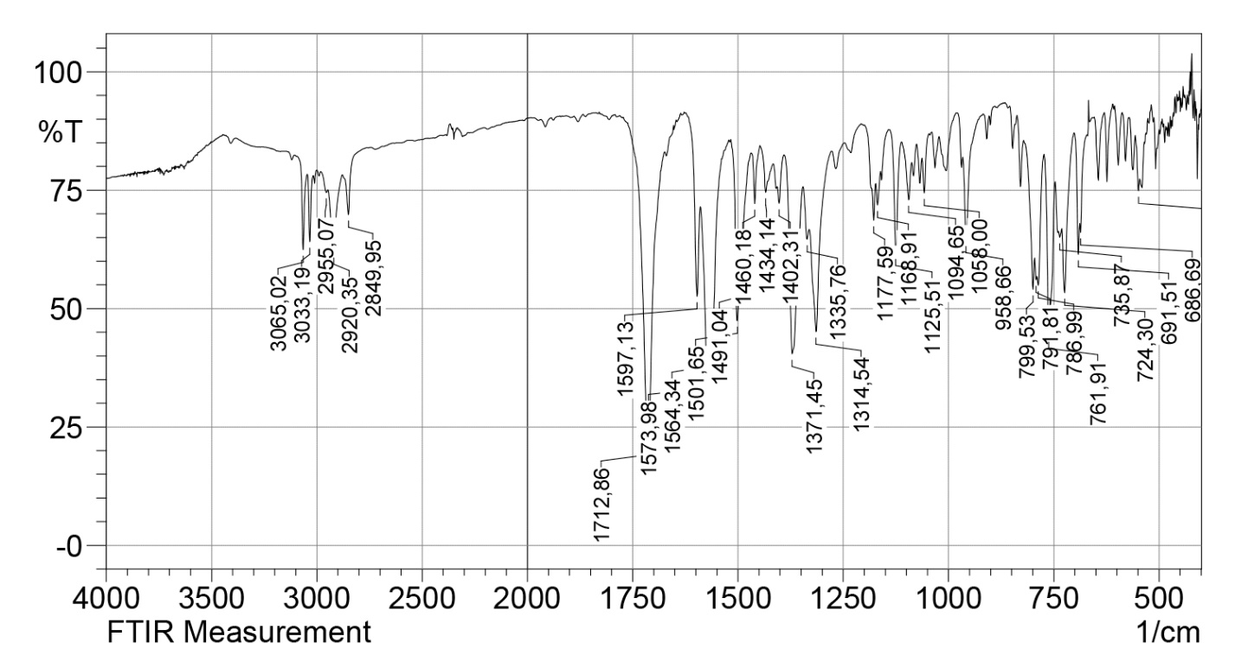
Figure S41. IR spectrum of 7-methyl-1-nitro-5-phenyl-2-(trichloromethyl)-5,6-diazaspiro[2.4]hept-6-en-4-one 9b in KBr.
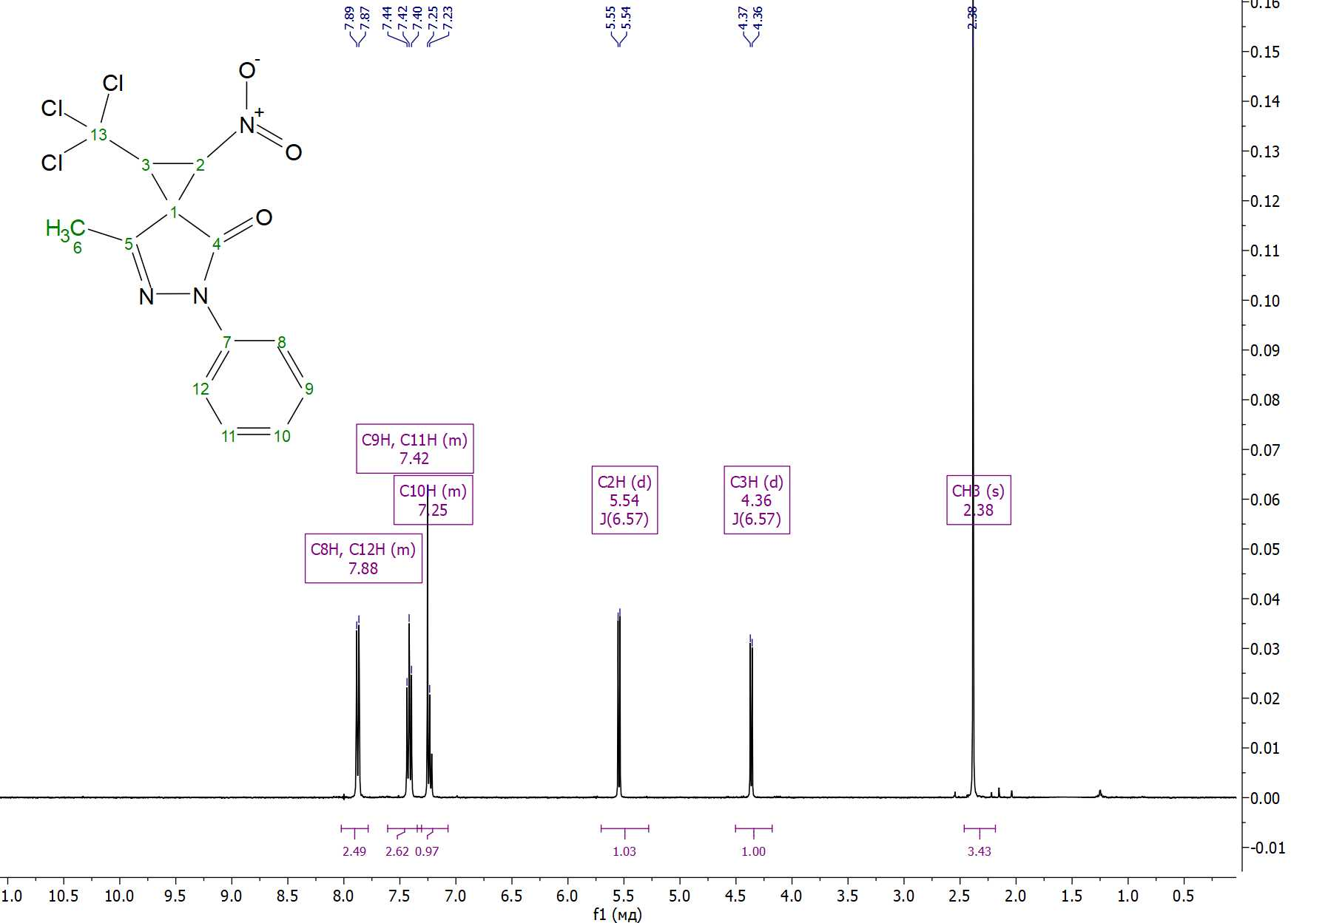
Figure S42. ¹H NMR spectrum of 7-methyl-1-nitro-5-phenyl-2-(trichloromethyl)-5,6-diazaspiro[2.4]hept-6-en-4-one 9b in CDCl₃.
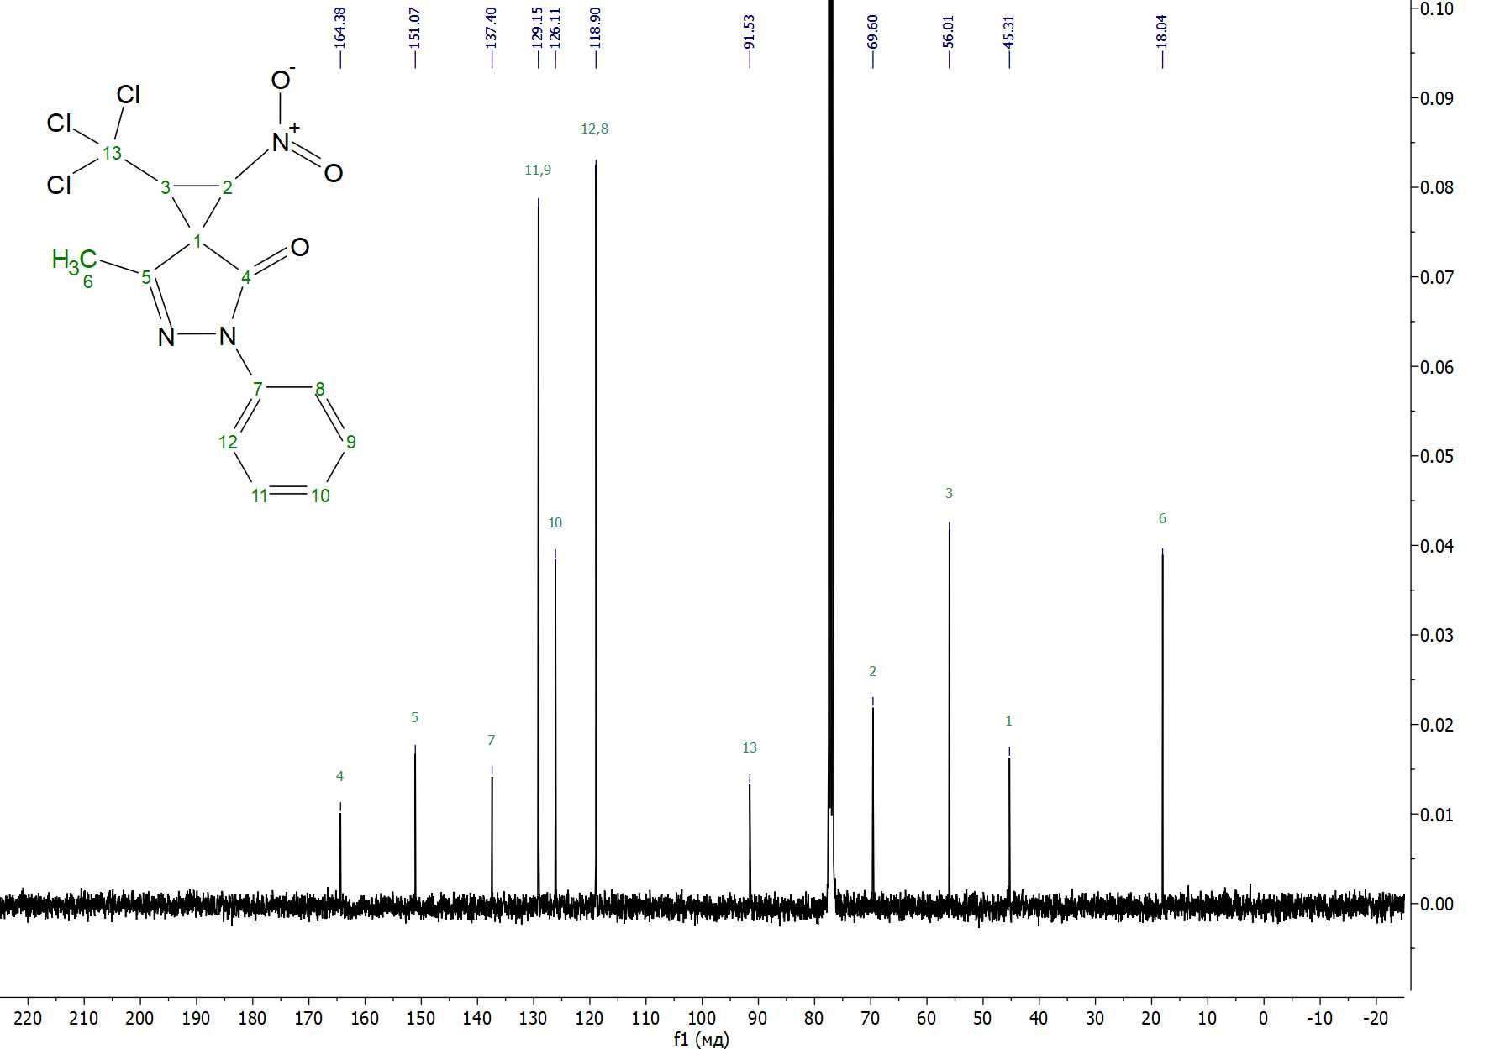
Figure S43. ¹³С{¹H} NMR spectrum of 7-methyl-1-nitro-5-phenyl-2-(trichloromethyl)-5,6-diazaspiro[2.4]hept-6-en-4-one 9b in CDCl₃.
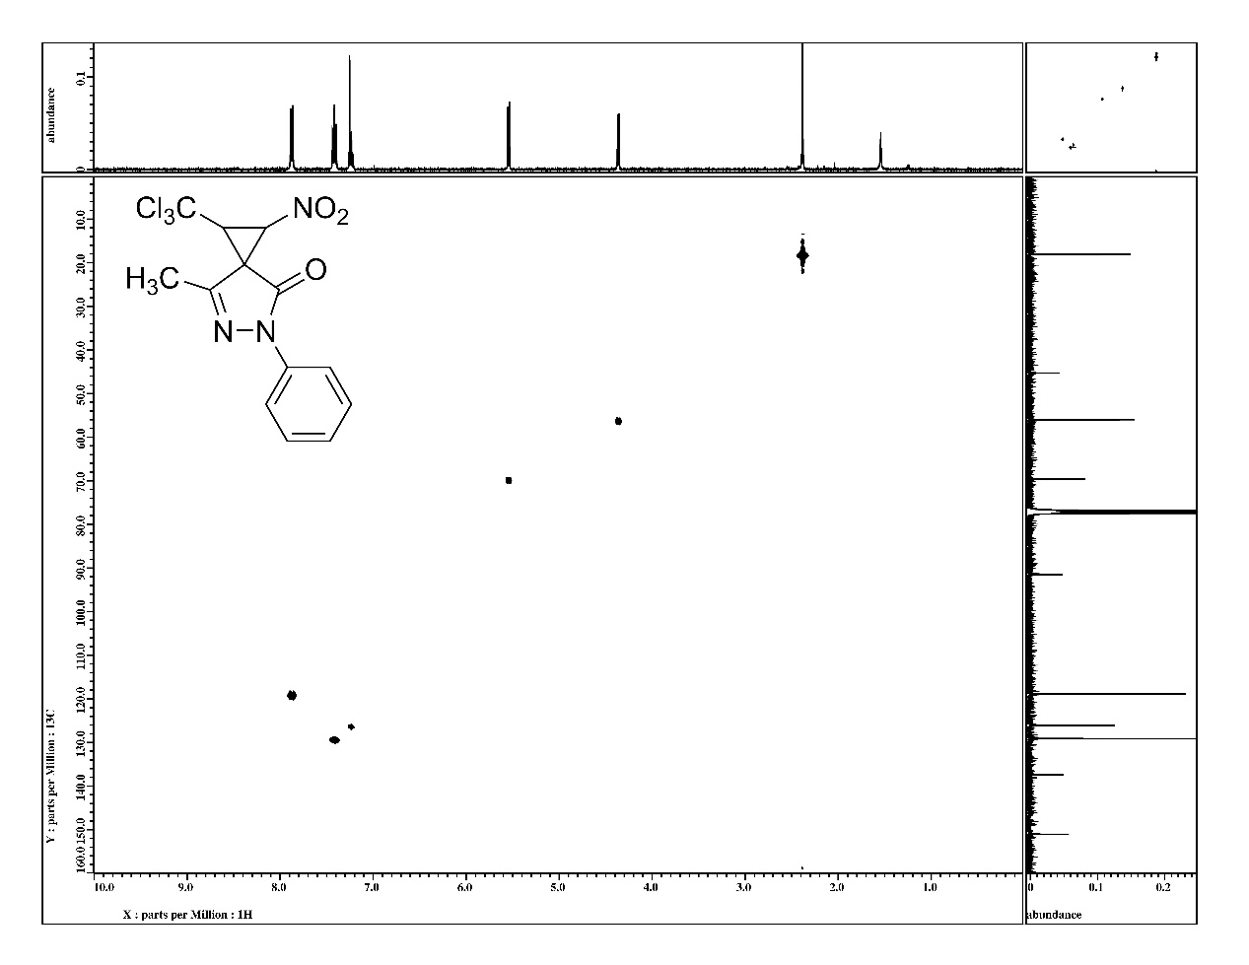
Figure S44. ¹H-¹³C HMQC NMR spectrum of 7-methyl-1-nitro-5-phenyl-2-(trichloromethyl)-5,6-diazaspiro[2.4]hept-6-en-4-one 9b in CDCl₃.
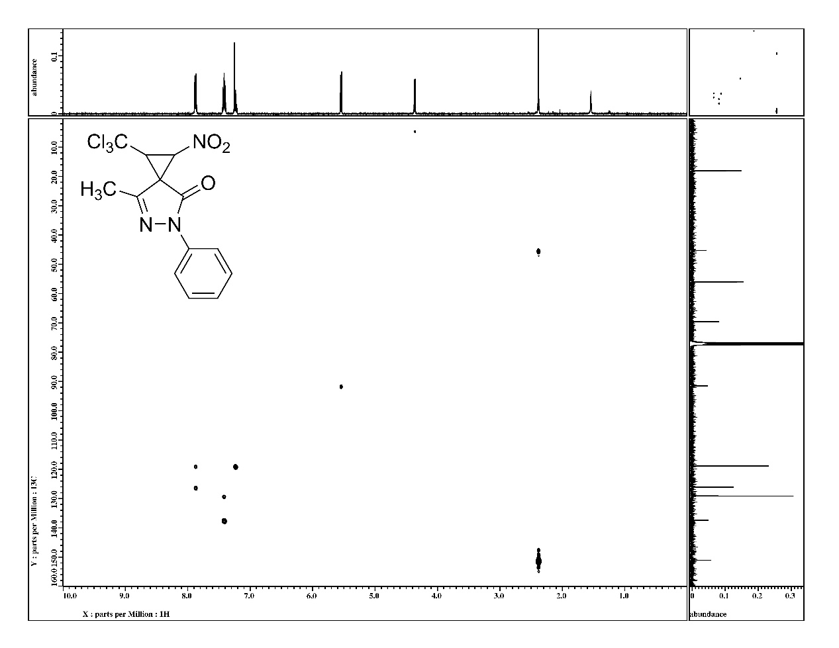
Figure S45. ¹H-¹³C HMBC NMR spectrum of 7-methyl-1-nitro-5-phenyl-2-(trichloromethyl)-5,6-diazaspiro[2.4]hept-6-en-4-one 9b in CDCl₃.
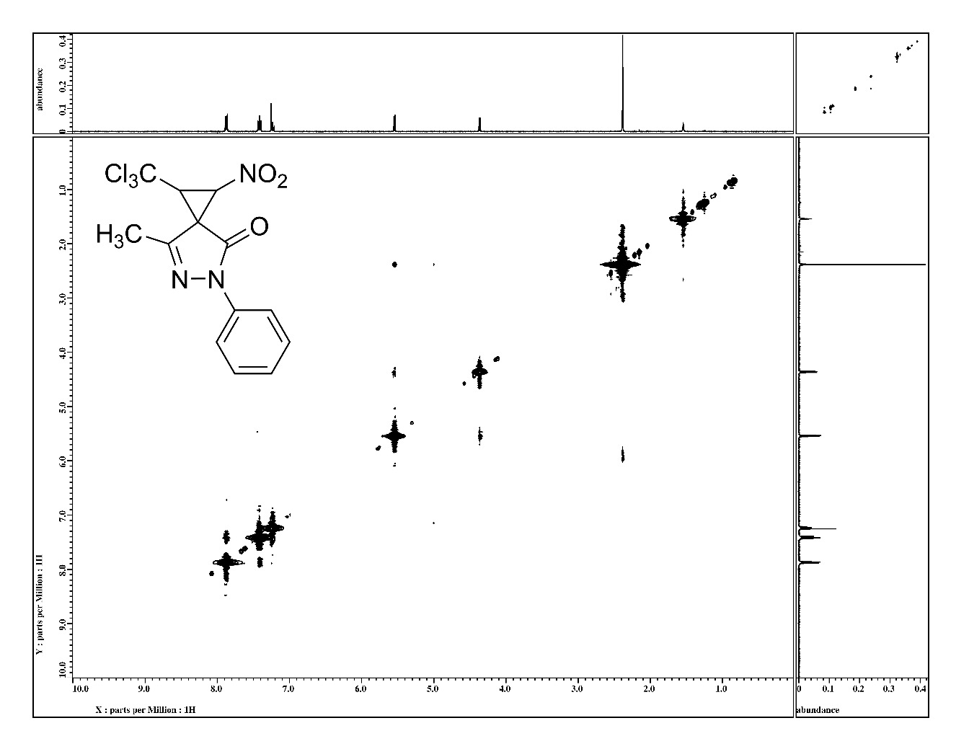
Figure S46. ¹H-¹H NOESY NMR spectrum of 7-methyl-1-nitro-5-phenyl-2-(trichloromethyl)-5,6-diazaspiro[2.4]hept-6-en-4-one 9b in CDCl₃.
Table S1. Principal crystallographic parameters of compound 2, 3, 7a, 7b based on X-ray diffraction data
Parameter | 2 | 3 | 9a | 9b
Molecular formula | C₆H₂Cl₃N₃O₂ | C₇H₅Cl₃N₂O₄ | C₁₃H₁₀Cl₃N₃O₃ | C₁₃H₁₀Cl₃N₃O₃
Molecular weight | 254.46 | 287.48 | 362.59 | 362.59
Crystal system | monoclinic | monoclinic | monoclinic | monoclinic
Space group | P2₁ | P2₁/n | P2₁/n | P2₁/n
Z | 4 | 4 | 8 | 8
a/Å | 11.6233(2) | 8.3468(3) | 11.4834(6) | 16.6097(2)
b/Å | 6.39530(10) | 6.1819(2) | 11.0564(5) | 9.76570(10)
c/Å | 13.1586(2) | 21.2056(6) | 23.7834(10) | 19.4325(2)
α/deg | 90 | 90 | 90 | 90
β/deg | 96.5730(10) | 93.234(3) | 91.057(4) | 102.7570(10)
γ/deg | 90 | 90 | 90 | 90
V/Å³ | 971.71(3) | 1092.45(6) | 3019.1(2) | 3074.25(6)
d_{calc}/g cm^{–3} | 1.739 | 1.748 | 1.595 | 1.567
μ(CuKα)/mm^{–1} | 8.393 | 7.658 | 5.651 | 5.550
F(000) | 504 | 576.0 | 1472 | 1472
Reflections measured | 9591 | 3763 | 21046 | 26692
Independent reflections | 3718 | 2056 | 6151 | 6279
R_{int} | 0.0391 | 0.0223 | 0.0984 | 0.0567
R_{sigma} | 0.0425 | 0.0260 | 0.0556 | 0.0359
GOOF | 1.0374 | 1.087 | 1.085 | 1.055
R₁(I≥2σ(I)) | 0.0262 | 0.0321 | 0.0732 | 0.0395
wR₂(I≥2σ(I)) | 0.0656 | 0.0832 | 0.2101 | 0.1022
R₁(all data) | 0.0267 | 0.0340 | 0.0811 | 0.0414
wR₂ | 0.0661 | 0.0844 | 0.2192 | 0.0979
* refined as racemic twin, BASF 0.29936, flack parameter 0.299(14)

Table S2. Bond Lengths for 2.
Atom | Atom | Length/Å |  | Atom | Atom | Length/Å |  | Atom | Atom | Length/Å
C1A | C2A | 1.490(4) |  | C3A | C4A | 1.457(4) |  | C11A | Cl2A | 1.773(3)
C1A | C3A | 1.542(4) |  | C3A | C6A | 1.452(5) |  | C11A | Cl3A | 1.763(3)
C1A | N8A | 1.475(4) |  | C3B | C4B | 1.449(5) |  | C11B | Cl1B | 1.769(3)
C1B | C2B | 1.486(4) |  | C3B | C6B | 1.452(4) |  | C11B | Cl2B | 1.769(3)
C1B | C3B | 1.537(4) |  | C4A | N5A | 1.140(5) |  | C11B | Cl3B | 1.774(3)
C1B | N8B | 1.474(4) |  | C4B | N5B | 1.152(5) |  | N8A | O9A | 1.220(4)
C2A | C3A | 1.534(4) |  | C6A | N7A | 1.143(5) |  | N8A | O10A | 1.225(4)
C2A | C11A | 1.517(4) |  | C6B | N7B | 1.145(4) |  | N8B | O9B | 1.223(4)
C2B | C3B | 1.535(4) |  | C11A | Cl1A | 1.779(3) |  | N8B | O10B | 1.223(4)
C2B | C11B | 1.527(4)

Table S3. Bond Angles for 2.
Atom | Atom | Atom | Angle/˚ |  | Atom | Atom | Atom | Angle/˚ |  | Atom | Atom | Atom | Angle/˚
C2A | C1A | C3A | 60.75(19) |  | C6B | C3B | C2B | 115.4(3) |  | Cl2A | C11A | Cl1A | 109.89(17)
N8A | C1A | C2A | 118.6(3) |  | N5A | C4A | C3A | 177.3(3) |  | Cl3A | C11A | Cl1A | 109.44(17)
N8A | C1A | C3A | 117.4(3) |  | N5B | C4B | C3B | 179.2(4) |  | Cl3A | C11A | Cl2A | 108.59(16)
C2B | C1B | C3B | 61.0(2) |  | N7A | C6A | C3A | 177.2(3) |  | C2B | C11B | Cl1B | 107.8(2)
N8B | C1B | C2B | 118.7(3) |  | N7B | C6B | C3B | 178.2(3) |  | C2B | C11B | Cl2B | 109.0(2)
N8B | C1B | C3B | 118.2(2) |  | C2A | C11A | Cl1A | 107.9(2) |  | C2B | C11B | Cl3B | 112.4(2)
C1A | C2A | C3A | 61.29(19) |  | C2A | C11A | Cl2A | 107.7(2) |  | Cl1B | C11B | Cl3B | 109.69(18)
C1A | C2A | C11A | 122.6(3) |  | C2A | C11A | Cl3A | 113.3(2) |  | Cl2B | C11B | Cl1B | 109.07(16)
C11A | C2A | C3A | 122.1(3) |  | C6A | C3A | C2A | 122.7(3) |  | Cl2B | C11B | Cl3B | 108.82(18)
C1B | C2B | C3B | 61.15(19) |  | C6A | C3A | C4A | 113.1(3) |  | O9A | N8A | C1A | 116.1(3)
C1B | C2B | C11B | 123.2(3) |  | C2B | C3B | C1B | 57.86(18) |  | O9A | N8A | O10A | 126.0(3)
C11B | C2B | C3B | 121.8(3) |  | C4B | C3B | C1B | 115.5(3) |  | O10A | N8A | C1A | 118.0(3)
C2A | C3A | C1A | 57.96(19) |  | C4B | C3B | C2B | 121.0(3) |  | O9B | N8B | C1B | 116.6(3)
C4A | C3A | C1A | 120.1(3) |  | C4B | C3B | C6B | 115.3(3) |  | O10B | N8B | C1B | 118.2(2)
C4A | C3A | C2A | 115.4(3) |  | C6B | C3B | C1B | 120.0(3) |  | O10B | N8B | O9B | 125.2(3)
C6A | C3A | C1A | 117.1(3)

Table S4. Torsion Angles for 2.
A | B | C | D | Angle/˚ |  | A | B | C | D | Angle/˚
C1A | C2A | C3A | C4A | -111.0(3) |  | C3A | C2A | C11A | Cl3A | 54.0(3)
C1A | C2A | C3A | C6A | 103.6(3) |  | C3B | C1B | C2B | C11B | 111.0(3)
C1A | C2A | C11A | Cl1A | -141.6(2) |  | C3B | C1B | N8B | O9B | -130.9(3)
C1A | C2A | C11A | Cl2A | 99.9(3) |  | C3B | C1B | N8B | O10B | 49.4(4)
C1A | C2A | C11A | Cl3A | -20.3(4) |  | C3B | C2B | C11B | Cl1B | -59.3(3)
C1B | C2B | C3B | C4B | 102.4(3) |  | C3B | C2B | C11B | Cl2B | -177.5(2)
C1B | C2B | C3B | C6B | -110.8(3) |  | C3B | C2B | C11B | Cl3B | 61.8(3)
C1B | C2B | C11B | Cl1B | -133.4(3) |  | C11A | C2A | C3A | C1A | -112.5(3)
C1B | C2B | C11B | Cl2B | 108.3(3) |  | C11A | C2A | C3A | C4A | 136.5(3)
C1B | C2B | C11B | Cl3B | -12.4(4) |  | C11A | C2A | C3A | C6A | -8.8(4)
C2A | C1A | C3A | C4A | 102.9(3) |  | C11B | C2B | C3B | C1B | -113.2(3)
C2A | C1A | C3A | C6A | -113.4(3) |  | C11B | C2B | C3B | C4B | -10.8(4)
C2A | C1A | N8A | O9A | 148.3(3) |  | C11B | C2B | C3B | C6B | 136.0(3)
C2A | C1A | N8A | O10A | -32.6(4) |  | N8A | C1A | C2A | C3A | 107.2(3)
C2B | C1B | C3B | C4B | -112.0(3) |  | N8A | C1A | C2A | C11A | -141.2(3)
C2B | C1B | C3B | C6B | 102.8(3) |  | N8A | C1A | C3A | C2A | -109.2(3)
C2B | C1B | N8B | O9B | 158.6(3) |  | N8A | C1A | C3A | C4A | -6.3(4)
C2B | C1B | N8B | O10B | -21.1(4) |  | N8A | C1A | C3A | C6A | 137.5(3)
C3A | C1A | C2A | C11A | 111.6(3) |  | N8B | C1B | C2B | C3B | 108.3(3)
C3A | C1A | N8A | O9A | -141.8(3) |  | N8B | C1B | C2B | C11B | -140.7(3)
C3A | C1A | N8A | O10A | 37.3(4) |  | N8B | C1B | C3B | C2B | -108.9(3)
C3A | C2A | C11A | Cl1A | -67.4(3) |  | N8B | C1B | C3B | C4B | 139.1(3)
C3A | C2A | C11A | Cl2A | 174.1(2) |  | N8B | C1B | C3B | C6B | -6.1(4)

Table S5. Bond Lengths for 3.
Atom | Atom | Length/Å |  | Atom | Atom | Length/Å |  | Atom | Atom | Length/Å
C1 | C2 | 1.479(3) |  | C6 | O6 | 1.202(3) |  | C11 | Cl1 | 1.766(2)
C1 | C3 | 1.526(3) |  | C6 | O7 | 1.314(2) |  | C11 | Cl2 | 1.7780(19)
C1 | N8 | 1.486(2) |  | C7 | O7 | 1.454(2) |  | C11 | Cl3 | 1.775(2)
C2 | C3 | 1.533(3) |  | C3 | C6 | 1.519(3) |  | N8 | O9 | 1.217(2)
C2 | C11 | 1.512(3) |  | C4 | N5 | 1.146(3) |  | N8 | O10 | 1.218(2)
C3 | C4 | 1.448(3)
Table S6. Bond Angles for 3.
Atom | Atom | Atom | Angle/˚ |  | Atom | Atom | Atom | Angle/˚ |  | Atom | Atom | Atom | Angle/˚
C2 | C1 | C3 | 61.34(12) |  | O6 | C6 | C3 | 122.07(17) |  | C2 | C11 | Cl3 | 109.18(14)
C2 | C1 | N8 | 119.27(16) |  | O6 | C6 | O7 | 126.69(18) |  | Cl1 | C11 | Cl2 | 109.90(11)
N8 | C1 | C3 | 117.22(16) |  | O7 | C6 | C3 | 111.14(16) |  | Cl1 | C11 | Cl3 | 108.71(11)
C1 | C2 | C3 | 60.84(12) |  | C2 | C11 | Cl1 | 113.04(14) |  | Cl3 | C11 | Cl2 | 108.53(10)
C1 | C2 | C11 | 121.63(17) |  | C2 | C11 | Cl2 | 107.39(13) |  | O9 | N8 | C1 | 116.42(16)
C11 | C2 | C3 | 125.05(16) |  | C6 | C3 | C1 | 115.79(16) |  | O9 | N8 | O10 | 125.95(18)
C1 | C3 | C2 | 57.82(12) |  | C6 | C3 | C2 | 113.13(16) |  | O10 | N8 | C1 | 117.56(17)
C4 | C3 | C1 | 117.71(16) |  | N5 | C4 | C3 | 177.1(2) |  | C6 | O7 | C7 | 114.56(15)
C4 | C3 | C2 | 123.80(17) |  | C4 | C3 | C6 | 115.99(16)

Table S7. Torsion Angles for 3.
A | B | C | D | Angle/˚ |  | A | B | C | D | Angle/˚ |  | A | B | C | D | Angle/˚
C1 | C2 | C3 | C4 | -103.9(2) |  | C3 | C2 | C11 | Cl1 | -47.3(2) |  | C4 | C3 | C6 | O7 | 23.5(2)
C1 | C2 | C3 | C6 | 106.87(17) |  | C3 | C2 | C11 | Cl2 | -168.73(15) |  | C11 | C2 | C3 | C1 | 110.0(2)
C1 | C2 | C11 | Cl1 | 27.2(2) |  | C3 | C2 | C11 | Cl3 | 73.8(2) |  | C11 | C2 | C3 | C4 | 6.1(3)
C1 | C2 | C11 | Cl2 | -94.22(18) |  | C3 | C6 | O7 | C7 | 177.32(15) |  | C11 | C2 | C3 | C6 | -143.12(18)
C1 | C2 | C11 | Cl3 | 148.30(15) |  | C4 | C3 | C6 | O6 | -159.86(18) |  | N8 | C1 | C2 | C3 | -106.93(19)
C1 | C3 | C6 | O6 | 56.0(2) |  | C2 | C3 | C6 | O6 | -8.1(3) |  | N8 | C1 | C2 | C11 | 137.68(18)
C1 | C3 | C6 | O7 | -120.65(18) |  | C2 | C3 | C6 | O7 | 175.25(16) |  | N8 | C1 | C3 | C2 | 110.21(19)
C2 | C1 | C3 | C4 | 114.32(19) |  | C3 | C1 | C2 | C11 | -115.4(2) |  | N8 | C1 | C3 | C4 | -135.46(18)
C2 | C1 | C3 | C6 | -102.20(18) |  | C3 | C1 | N8 | O9 | 62.9(2) |  | N8 | C1 | C3 | C6 | 8.0(2)
C2 | C1 | N8 | O9 | 133.6(2) |  | C3 | C1 | N8 | O10 | -119.9(2) |  | O6 | C6 | O7 | C7 | 0.8(3)
C2 | C1 | N8 | O10 | -49.1(2)

Table S8. Bond Lengths for 9a.
Atom | Atom | Length/Å |  | Atom | Atom | Length/Å |  | Atom | Atom | Length/Å
C1A | C2A | 1.485(4) |  | C8A | N5A | 1.416(4) |  | C11A | C12A | 1.390(6)
C1A | C3A | 1.524(4) |  | C8B | C9B | 1.381(4) |  | C11B | C12B | 1.396(5)
C1A | N16A | 1.475(4) |  | C8B | C13B | 1.396(5) |  | C12A | C13A | 1.384(5)
C1B | C2B | 1.487(4) |  | C8B | N5B | 1.416(4) |  | C12B | C13B | 1.380(5)
C1B | C3B | 1.514(4) |  | C9A | C10A | 1.391(5) |  | C19A | Cl1A | 1.775(4)
C1B | N16B | 1.471(4) |  | C9B | C10B | 1.386(5) |  | C19A | Cl2A | 1.785(4)
C2A | C3A | 1.541(4) |  | C10A | C11A | 1.381(5) |  | C19A | Cl3A | 1.770(3)
C2A | C19A | 1.520(5) |  | C10B | C11B | 1.376(5) |  | C19B | Cl1B | 1.770(3)
C2B | C3B | 1.539(4) |  | C4B | N5B | 1.373(4) |  | C19B | Cl2B | 1.795(3)
C2B | C19B | 1.518(5) |  | C4B | O15B | 1.217(4) |  | C19B | Cl3B | 1.778(3)
C3A | C4A | 1.503(4) |  | C7A | C14A | 1.493(5) |  | N5A | N6A | 1.414(4)
C3A | C7A | 1.491(5) |  | C7A | N6A | 1.290(4) |  | N5B | N6B | 1.413(4)
C3B | C4B | 1.508(4) |  | C7B | C14B | 1.488(5) |  | N16A | O17A | 1.220(4)
C3B | C7B | 1.501(4) |  | C7B | N6B | 1.294(4) |  | N16A | O18A | 1.228(4)
C4A | N5A | 1.374(4) |  | C8A | C9A | 1.394(5) |  | N16B | O17B | 1.233(4)
C4A | O15A | 1.216(4) |  | C8A | C13A | 1.398(5) |  | N16B | O18B | 1.223(4)

Table S9. Bond Angles for 9a.
Atom | Atom | Atom | Angle/˚ |  | Atom | Atom | Atom | Angle/˚ |  | Atom | Atom | Atom | Angle/˚
C2A | C1A | C3A | 61.6(2) |  | C9B | C8B | C13B | 119.9(3) |  | C2A | C19A | Cl1A | 109.3(2)
N16A | C1A | C2A | 119.0(3) |  | C9B | C8B | N5B | 119.3(3) |  | C2A | C19A | Cl2A | 107.6(2)
N16A | C1A | C3A | 121.7(3) |  | C13B | C8B | N5B | 120.7(3) |  | C2A | C19A | Cl3A | 114.4(2)
C2B | C1B | C3B | 61.7(2) |  | C10A | C9A | C8A | 119.8(3) |  | Cl1A | C19A | Cl2A | 108.84(19)
N16B | C1B | C2B | 120.2(3) |  | C8B | C9B | C10B | 119.6(3) |  | Cl3A | C19A | Cl1A | 109.67(19)
N16B | C1B | C3B | 121.1(3) |  | C11A | C10A | C9A | 120.6(3) |  | Cl3A | C19A | Cl2A | 106.82(18)
C1A | C2A | C3A | 60.4(2) |  | C11B | C10B | C9B | 121.4(3) |  | C2B | C19B | Cl1B | 115.3(2)
C1A | C2A | C19A | 123.4(3) |  | C10A | C11A | C12A | 119.2(3) |  | C2B | C19B | Cl2B | 108.7(2)
C19A | C2A | C3A | 125.0(3) |  | C10B | C11B | C12B | 118.4(3) |  | C2B | C19B | Cl3B | 109.2(2)
C1B | C2B | C3B | 60.0(2) |  | C13A | C12A | C11A | 121.4(3) |  | Cl1B | C19B | Cl2B | 106.33(17)
C1B | C2B | C19B | 124.2(3) |  | C13B | C12B | C11B | 121.1(3) |  | Cl1B | C19B | Cl3B | 109.73(18)
C19B | C2B | C3B | 123.0(3) |  | C12A | C13A | C8A | 118.9(3) |  | Cl3B | C19B | Cl2B | 107.18(17)
C1A | C3A | C2A | 58.0(2) |  | C12B | C13B | C8B | 119.4(3) |  | C4A | N5A | C8A | 129.3(3)
C4A | C3A | C1A | 116.4(3) |  | O15A | C4A | N5A | 127.6(3) |  | C4A | N5A | N6A | 112.2(3)
C4A | C3A | C2A | 121.2(3) |  | N5B | C4B | C3B | 104.5(3) |  | N6A | N5A | C8A | 118.4(3)
C7A | C3A | C1A | 131.9(3) |  | O15B | C4B | C3B | 127.6(3) |  | C4B | N5B | C8B | 128.6(3)
C7A | C3A | C2A | 120.9(3) |  | O15B | C4B | N5B | 127.9(3) |  | C4B | N5B | N6B | 112.2(3)
C7A | C3A | C4A | 103.9(3) |  | C3A | C7A | C14A | 129.3(3) |  | N6B | N5B | C8B | 118.8(3)
C1B | C3B | C2B | 58.3(2) |  | N6A | C7A | C3A | 110.2(3) |  | C7A | N6A | N5A | 109.2(3)
C4B | C3B | C1B | 115.9(3) |  | N6A | C7A | C14A | 120.4(3) |  | C7B | N6B | N5B | 109.4(3)
C4B | C3B | C2B | 120.5(3) |  | C14B | C7B | C3B | 129.3(3) |  | O17A | N16A | C1A | 120.1(3)
C7B | C3B | C1B | 134.3(3) |  | N6B | C7B | C3B | 110.0(3) |  | O17A | N16A | O18A | 124.3(3)
C7B | C3B | C2B | 119.6(3) |  | N6B | C7B | C14B | 120.6(3) |  | O18A | N16A | C1A | 115.5(3)
C7B | C3B | C4B | 103.5(2) |  | C9A | C8A | C13A | 120.1(3) |  | O17B | N16B | C1B | 115.8(3)
N5A | C4A | C3A | 104.2(3) |  | C9A | C8A | N5A | 119.4(3) |  | O18B | N16B | C1B | 119.8(3)
O15A | C4A | C3A | 128.2(3) |  | C13A | C8A | N5A | 120.6(3) |  | O18B | N16B | O17B | 124.4(3)

Table S10. Torsion Angles for 9a.
A | B | C | D | Angle/˚ |  | A | B | C | D | Angle/˚
C1A | C2A | C3A | C4A | 103.5(3) |  | C4B | C3B | C7B | C14B | -178.4(3)
C1A | C2A | C3A | C7A | -123.0(3) |  | C4B | C3B | C7B | N6B | 6.5(3)
C1A | C2A | C19A | Cl1A | -123.9(3) |  | C4B | N5B | N6B | C7B | -0.7(4)
C1A | C2A | C19A | Cl2A | 118.1(3) |  | C7A | C3A | C4A | N5A | -5.5(3)
C1A | C2A | C19A | Cl3A | -0.5(4) |  | C7A | C3A | C4A | O15A | 173.3(3)
C1A | C3A | C4A | N5A | -158.4(3) |  | C7B | C3B | C4B | N5B | -6.5(3)
C1A | C3A | C4A | O15A | 20.3(5) |  | C7B | C3B | C4B | O15B | 173.0(3)
C1A | C3A | C7A | C14A | -31.2(6) |  | C8A | C9A | C10A | C11A | -2.1(5)
C1A | C3A | C7A | N6A | 152.0(3) |  | C8A | N5A | N6A | C7A | 175.2(3)
C1B | C2B | C3B | C4B | 103.4(3) |  | C8B | C9B | C10B | C11B | -2.1(6)
C1B | C2B | C3B | C7B | -126.4(3) |  | C8B | N5B | N6B | C7B | 173.1(3)
C1B | C2B | C19B | Cl1B | 1.6(4) |  | C9A | C8A | C13A | C12A | -1.6(5)
C1B | C2B | C19B | Cl2B | 120.9(3) |  | C9A | C8A | N5A | C4A | -178.3(3)
C1B | C2B | C19B | Cl3B | -122.4(3) |  | C9A | C8A | N5A | N6A | 6.1(4)
C1B | C3B | C4B | N5B | -162.8(3) |  | C9A | C10A | C11A | C12A | 0.0(6)
C1B | C3B | C4B | O15B | 16.7(5) |  | C9B | C8B | C13B | C12B | -2.8(5)
C1B | C3B | C7B | C14B | -28.8(6) |  | C9B | C8B | N5B | C4B | 174.6(3)
C1B | C3B | C7B | N6B | 156.1(3) |  | C9B | C8B | N5B | N6B | 2.0(4)
C2A | C1A | C3A | C4A | -111.8(3) |  | C9B | C10B | C11B | C12B | -0.7(6)
C2A | C1A | C3A | C7A | 104.6(4) |  | C10A | C11A | C12A | C13A | 1.4(6)
C2A | C1A | N16A | O17A | -17.7(5) |  | C10B | C11B | C12B | C13B | 1.8(6)
C2A | C1A | N16A | O18A | 161.0(3) |  | C11A | C12A | C13A | C8A | -0.6(6)
C2A | C3A | C4A | N5A | 134.6(3) |  | C11B | C12B | C13B | C8B | -0.1(6)
C2A | C3A | C4A | O15A | -46.6(5) |  | C13A | C8A | C9A | C10A | 2.9(5)
C2A | C3A | C7A | C14A | 41.7(5) |  | C13A | C8A | N5A | C4A | 2.0(5)
C2A | C3A | C7A | N6A | -135.1(3) |  | C13A | C8A | N5A | N6A | -173.6(3)
C2B | C1B | C3B | C4B | -111.2(3) |  | C13B | C8B | C9B | C10B | 3.9(5)
C2B | C1B | C3B | C7B | 101.9(4) |  | C13B | C8B | N5B | C4B | -4.2(5)
C2B | C1B | N16B | O17B | 154.1(3) |  | C13B | C8B | N5B | N6B | -176.8(3)
C2B | C1B | N16B | O18B | -25.9(5) |  | C14A | C7A | N6A | N5A | -179.8(3)
C2B | C3B | C4B | N5B | 130.3(3) |  | C14B | C7B | N6B | N5B | -179.5(3)
C2B | C3B | C4B | O15B | -50.2(5) |  | C19A | C2A | C3A | C1A | -112.1(4)
C2B | C3B | C7B | C14B | 44.3(5) |  | C19A | C2A | C3A | C4A | -8.5(5)
C2B | C3B | C7B | N6B | -130.8(3) |  | C19A | C2A | C3A | C7A | 124.9(3)
C3A | C1A | C2A | C19A | 114.6(3) |  | C19B | C2B | C3B | C1B | -113.6(3)
C3A | C1A | N16A | O17A | 55.0(4) |  | C19B | C2B | C3B | C4B | -10.1(4)
C3A | C1A | N16A | O18A | -126.3(3) |  | C19B | C2B | C3B | C7B | 120.0(3)
C3A | C2A | C19A | Cl1A | -48.9(4) |  | N5A | C8A | C9A | C10A | -176.8(3)
C3A | C2A | C19A | Cl2A | -166.9(2) |  | N5A | C8A | C13A | C12A | 178.1(3)
C3A | C2A | C19A | Cl3A | 74.5(4) |  | N5B | C8B | C9B | C10B | -174.9(3)
C3A | C4A | N5A | C8A | -171.6(3) |  | N5B | C8B | C13B | C12B | 176.0(3)
C3A | C4A | N5A | N6A | 4.3(3) |  | N16A | C1A | C2A | C3A | 112.5(3)
C3A | C7A | N6A | N5A | -2.6(4) |  | N16A | C1A | C2A | C19A | -132.9(3)
C3B | C1B | C2B | C19B | 111.6(3) |  | N16A | C1A | C3A | C2A | -108.3(3)
C3B | C1B | N16B | O17B | -132.7(3) |  | N16A | C1A | C3A | C4A | 139.9(3)
C3B | C1B | N16B | O18B | 47.3(4) |  | N16A | C1A | C3A | C7A | -3.8(5)
C3B | C2B | C19B | Cl1B | 75.5(3) |  | N16B | C1B | C2B | C3B | 111.4(3)
C3B | C2B | C19B | Cl2B | -165.3(2) |  | N16B | C1B | C2B | C19B | -136.9(3)
C3B | C2B | C19B | Cl3B | -48.6(4) |  | N16B | C1B | C3B | C2B | -110.1(3)
C3B | C4B | N5B | C8B | -168.2(3) |  | N16B | C1B | C3B | C4B | 138.7(3)
C3B | C4B | N5B | N6B | 4.8(3) |  | N16B | C1B | C3B | C7B | -8.1(5)
C3B | C7B | N6B | N5B | -3.9(4) |  | O15A | C4A | N5A | C8A | 9.7(6)
C4A | C3A | C7A | C14A | -178.1(3) |  | O15A | C4A | N5A | N6A | -174.4(3)
C4A | C3A | C7A | N6A | 5.1(4) |  | O15B | C4B | N5B | C8B | 12.3(5)
C4A | N5A | N6A | C7A | -1.2(4) |  | O15B | C4B | N5B | N6B | -174.7(3)

Table S11. Bond Lengths for 9b.
Atom | Atom | Length/Å |  | Atom | Atom | Length/Å |  | Atom | Atom | Length/Å
C1A | C2A | 1.468(2) |  | C8A | N5A | 1.419(2) |  | C11A | C12A | 1.390(3)
C1A | C3A | 1.517(2) |  | C8B | C9B | 1.391(3) |  | C11B | C12B | 1.388(3)
C1A | N16A | 1.491(2) |  | C8B | C13B | 1.399(2) |  | C12A | C13A | 1.389(3)
C1B | C2B | 1.470(2) |  | C8B | N5B | 1.421(2) |  | C12B | C13B | 1.388(3)
C1B | C3B | 1.525(2) |  | C9A | C10A | 1.387(3) |  | C19 | Cl1B | 1.7718(18)
C1B | N16B | 1.485(2) |  | C9B | C10B | 1.389(3) |  | C19 | Cl2B | 1.7615(18)
C2A | C3A | 1.538(2) |  | C10A | C11A | 1.386(3) |  | C19 | Cl3B | 1.7850(18)
C2A | C19A | 1.517(2) |  | C10B | C11B | 1.390(3) |  | C19A | Cl1A | 1.7841(19)
C2B | C3B | 1.540(2) |  | C4B | N5B | 1.368(2) |  | C19A | Cl2A | 1.7653(19)
C2B | C19 | 1.512(2) |  | C4B | O15B | 1.216(2) |  | C19A | Cl3A | 1.7681(18)
C3A | C4A | 1.503(2) |  | C7A | C14A | 1.488(2) |  | N5A | N6A | 1.407(2)
C3A | C7A | 1.487(2) |  | C7A | N6A | 1.287(2) |  | N5B | N6B | 1.4085(19)
C3B | C4B | 1.506(2) |  | C7B | C14B | 1.487(2) |  | N16A | O17A | 1.219(2)
C3B | C7B | 1.487(2) |  | C7B | N6B | 1.286(2) |  | N16A | O18A | 1.222(2)
C4A | N5A | 1.367(2) |  | C8A | C9A | 1.394(3) |  | N16B | O17B | 1.220(2)
C4A | O15A | 1.215(2) |  | C8A | C13A | 1.392(3) |  | N16B | O18B | 1.219(2)

Table S12. Bond Angles for 9b.
Atom | Atom | Atom | Angle/˚ |  | Atom | Atom | Atom | Angle/˚ |  | Atom | Atom | Atom | Angle/˚
C2A | C1A | C3A | 62.00(11) |  | C9B | C8B | C13B | 120.46(16) |  | C2B | C19 | Cl1B | 113.93(13)
C2A | C1A | N16A | 118.15(15) |  | C9B | C8B | N5B | 120.67(15) |  | C2B | C19 | Cl2B | 110.64(12)
N16A | C1A | C3A | 119.60(14) |  | C13B | C8B | N5B | 118.88(15) |  | C2B | C19 | Cl3B | 106.23(12)
C2B | C1B | C3B | 61.88(11) |  | C10A | C9A | C8A | 118.84(19) |  | Cl1B | C19 | Cl3B | 107.19(9)
C2B | C1B | N16B | 117.98(15) |  | C10B | C9B | C8B | 119.25(17) |  | Cl2B | C19 | Cl1B | 108.55(10)
N16B | C1B | C3B | 118.89(14) |  | C11A | C10A | C9A | 120.92(19) |  | Cl2B | C19 | Cl3B | 110.21(10)
C1A | C2A | C3A | 60.55(11) |  | C9B | C10B | C11B | 120.88(18) |  | C2A | C19A | Cl1A | 106.72(12)
C1A | C2A | C19A | 123.31(15) |  | C10A | C11A | C12A | 119.54(18) |  | C2A | C19A | Cl2A | 110.20(12)
C19A | C2A | C3A | 127.45(15) |  | C12B | C11B | C10B | 119.33(17) |  | C2A | C19A | Cl3A | 113.97(13)
C1B | C2B | C3B | 60.82(11) |  | C13A | C12A | C11A | 120.6(2) |  | Cl2A | C19A | Cl1A | 109.31(10)
C1B | C2B | C19 | 122.65(15) |  | C13B | C12B | C11B | 120.74(17) |  | Cl2A | C19A | Cl3A | 108.55(10)
C19 | C2B | C3B | 128.67(15) |  | C12A | C13A | C8A | 119.02(18) |  | Cl3A | C19A | Cl1A | 108.00(9)
C1A | C3A | C2A | 57.44(11) |  | C12B | C13B | C8B | 119.31(17) |  | C4A | N5A | C8A | 127.74(15)
C4A | C3A | C1A | 120.47(14) |  | O15A | C4A | N5A | 128.54(16) |  | C4A | N5A | N6A | 112.55(14)
C4A | C3A | C2A | 113.47(14) |  | N5B | C4B | C3B | 104.49(14) |  | N6A | N5A | C8A | 119.54(14)
C7A | C3A | C1A | 126.51(15) |  | O15B | C4B | C3B | 126.79(16) |  | C4B | N5B | C8B | 128.49(14)
C7A | C3A | C2A | 131.16(15) |  | O15B | C4B | N5B | 128.71(16) |  | C4B | N5B | N6B | 112.30(13)
C7A | C3A | C4A | 103.30(14) |  | C3A | C7A | C14A | 128.18(16) |  | N6B | N5B | C8B | 119.14(13)
C1B | C3B | C2B | 57.29(11) |  | N6A | C7A | C3A | 110.94(15) |  | C7A | N6A | N5A | 108.70(14)
C4B | C3B | C1B | 118.30(14) |  | N6A | C7A | C14A | 120.82(16) |  | C7B | N6B | N5B | 109.05(14)
C4B | C3B | C2B | 114.14(14) |  | C14B | C7B | C3B | 128.46(16) |  | O17A | N16A | C1A | 116.01(15)
C7B | C3B | C1B | 126.21(15) |  | N6B | C7B | C3B | 110.78(15) |  | O17A | N16A | O18A | 125.21(16)
C7B | C3B | C2B | 132.83(15) |  | N6B | C7B | C14B | 120.73(16) |  | O18A | N16A | C1A | 118.75(15)
C7B | C3B | C4B | 103.36(14) |  | C9A | C8A | N5A | 118.71(16) |  | O17B | N16B | C1B | 115.87(16)
N5A | C4A | C3A | 104.49(14) |  | C13A | C8A | C9A | 121.04(17) |  | O18B | N16B | C1B | 119.07(15)
O15A | C4A | C3A | 126.95(15) |  | C13A | C8A | N5A | 120.23(16) |  | O18B | N16B | O17B | 125.03(17)

Table S13. Torsion Angles for 9b.
A | B | C | D | Angle/˚ |  | A | B | C | D | Angle/˚
C1A | C2A | C3A | C4A | 112.25(16) |  | C4B | C3B | C7B | C14B | 178.34(18)
C1A | C2A | C3A | C7A | -112.3(2) |  | C4B | C3B | C7B | N6B | -0.03(19)
C1A | C2A | C19A | Cl1A | -111.33(16) |  | C4B | N5B | N6B | C7B | -0.9(2)
C1A | C2A | C19A | Cl2A | 130.09(15) |  | C7A | C3A | C4A | N5A | -1.30(18)
C1A | C2A | C19A | Cl3A | 7.8(2) |  | C7A | C3A | C4A | O15A | -179.71(18)
C1A | C3A | C4A | N5A | -149.33(16) |  | C7B | C3B | C4B | N5B | -0.51(18)
C1A | C3A | C4A | O15A | 32.3(3) |  | C7B | C3B | C4B | O15B | 179.01(18)
C1A | C3A | C7A | C14A | -30.3(3) |  | C8A | C9A | C10A | C11A | -0.4(3)
C1A | C3A | C7A | N6A | 147.02(17) |  | C8A | N5A | N6A | C7A | 175.92(16)
C1B | C2B | C3B | C4B | -109.25(16) |  | C8B | C9B | C10B | C11B | -0.8(3)
C1B | C2B | C3B | C7B | 111.2(2) |  | C8B | N5B | N6B | C7B | -178.32(15)
C1B | C2B | C19 | Cl1B | -13.2(2) |  | C9A | C8A | C13A | C12A | -1.3(3)
C1B | C2B | C19 | Cl2B | -135.86(14) |  | C9A | C8A | N5A | C4A | 155.42(18)
C1B | C2B | C19 | Cl3B | 104.53(16) |  | C9A | C8A | N5A | N6A | -19.4(2)
C1B | C3B | C4B | N5B | 144.33(15) |  | C9A | C10A | C11A | C12A | -0.4(3)
C1B | C3B | C4B | O15B | -36.2(3) |  | C9B | C8B | C13B | C12B | -1.4(3)
C1B | C3B | C7B | C14B | 37.3(3) |  | C9B | C8B | N5B | C4B | 8.6(3)
C1B | C3B | C7B | N6B | -141.10(17) |  | C9B | C8B | N5B | N6B | -174.52(16)
C2A | C1A | C3A | C4A | -99.94(17) |  | C9B | C10B | C11B | C12B | -0.4(3)
C2A | C1A | C3A | C7A | 119.9(2) |  | C10A | C11A | C12A | C13A | 0.4(3)
C2A | C1A | N16A | O17A | 163.16(15) |  | C10B | C11B | C12B | C13B | 0.6(3)
C2A | C1A | N16A | O18A | -18.8(2) |  | C11A | C12A | C13A | C8A | 0.5(3)
C2A | C3A | C4A | N5A | 145.84(15) |  | C11B | C12B | C13B | C8B | 0.2(3)
C2A | C3A | C4A | O15A | -32.6(3) |  | C13A | C8A | C9A | C10A | 1.2(3)
C2A | C3A | C7A | C14A | 45.7(3) |  | C13A | C8A | N5A | C4A | -23.4(3)
C2A | C3A | C7A | N6A | -137.00(19) |  | C13A | C8A | N5A | N6A | 161.79(16)
C2B | C1B | C3B | C4B | 101.90(17) |  | C13B | C8B | C9B | C10B | 1.7(3)
C2B | C1B | C3B | C7B | -122.1(2) |  | C13B | C8B | N5B | C4B | -171.10(17)
C2B | C1B | N16B | O17B | -161.00(16) |  | C13B | C8B | N5B | N6B | 5.8(2)
C2B | C1B | N16B | O18B | 20.8(2) |  | C14A | C7A | N6A | N5A | 176.32(17)
C2B | C3B | C4B | N5B | -151.21(14) |  | C14B | C7B | N6B | N5B | -177.96(16)
C2B | C3B | C4B | O15B | 28.3(3) |  | C19 | C2B | C3B | C1B | -110.2(2)
C2B | C3B | C7B | C14B | -39.2(3) |  | C19 | C2B | C3B | C4B | 140.59(18)
C2B | C3B | C7B | N6B | 142.46(19) |  | C19 | C2B | C3B | C7B | 1.1(3)
C3A | C1A | C2A | C19A | -117.68(18) |  | C19A | C2A | C3A | C1A | 111.2(2)
C3A | C1A | N16A | O17A | 91.1(2) |  | C19A | C2A | C3A | C4A | -136.53(17)
C3A | C1A | N16A | O18A | -90.89(19) |  | C19A | C2A | C3A | C7A | -1.1(3)
C3A | C2A | C19A | Cl1A | 172.42(14) |  | N5A | C8A | C9A | C10A | -177.56(17)
C3A | C2A | C19A | Cl2A | 53.8(2) |  | N5A | C8A | C13A | C12A | 177.49(17)
C3A | C2A | C19A | Cl3A | -68.5(2) |  | N5B | C8B | C9B | C10B | -177.96(17)
C3A | C4A | N5A | C8A | -174.45(16) |  | N5B | C8B | C13B | C12B | 178.24(16)
C3A | C4A | N5A | N6A | 0.68(19) |  | N16A | C1A | C2A | C3A | -110.49(16)
C3A | C7A | N6A | N5A | -1.3(2) |  | N16A | C1A | C2A | C19A | 131.83(17)
C3B | C1B | C2B | C19 | 119.48(18) |  | N16A | C1A | C3A | C2A | 108.21(18)
C3B | C1B | N16B | O17B | -89.4(2) |  | N16A | C1A | C3A | C4A | 8.3(2)
C3B | C1B | N16B | O18B | 92.38(19) |  | N16A | C1A | C3A | C7A | -131.86(18)
C3B | C2B | C19 | Cl1B | 63.5(2) |  | N16B | C1B | C2B | C3B | 109.65(17)
C3B | C2B | C19 | Cl2B | -59.1(2) |  | N16B | C1B | C2B | C19 | -130.86(17)
C3B | C2B | C19 | Cl3B | -178.70(15) |  | N16B | C1B | C3B | C2B | -108.23(18)
C3B | C4B | N5B | C8B | 177.95(16) |  | N16B | C1B | C3B | C4B | -6.3(2)
C3B | C4B | N5B | N6B | 0.87(19) |  | N16B | C1B | C3B | C7B | 129.69(19)
C3B | C7B | N6B | N5B | 0.6(2) |  | O15A | C4A | N5A | C8A | 3.9(3)
C4A | C3A | C7A | C14A | -175.74(19) |  | O15A | C4A | N5A | N6A | 179.05(18)
C4A | C3A | C7A | N6A | 1.6(2) |  | O15B | C4B | N5B | C8B | -1.6(3)
C4A | N5A | N6A | C7A | 0.3(2) |  | O15B | C4B | N5B | N6B | -178.63(18)
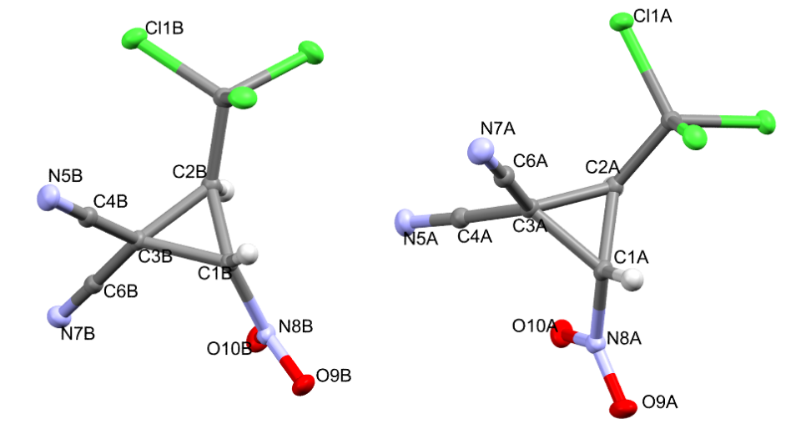
Figure S47. Geometry of 2 independent molecules (A and B) 2 in crystal. Ellipsoids of anisotropic displacements are shown with 50% probability.
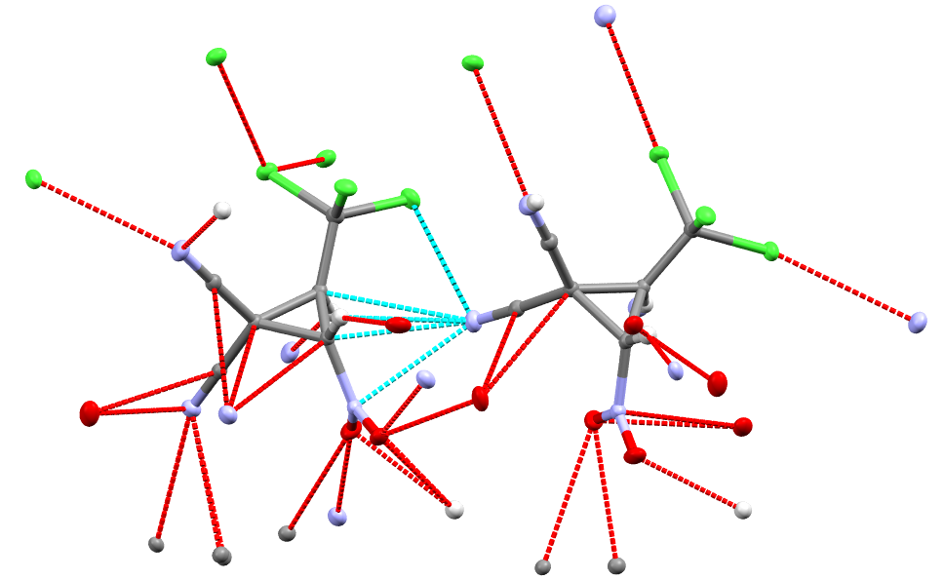
Figure S48. System of short contacts in crystal 2. Contacts are shown with dotted lines.

Figure S49. Crystal packaging of 2. Short contacts are shown with dotted lines.

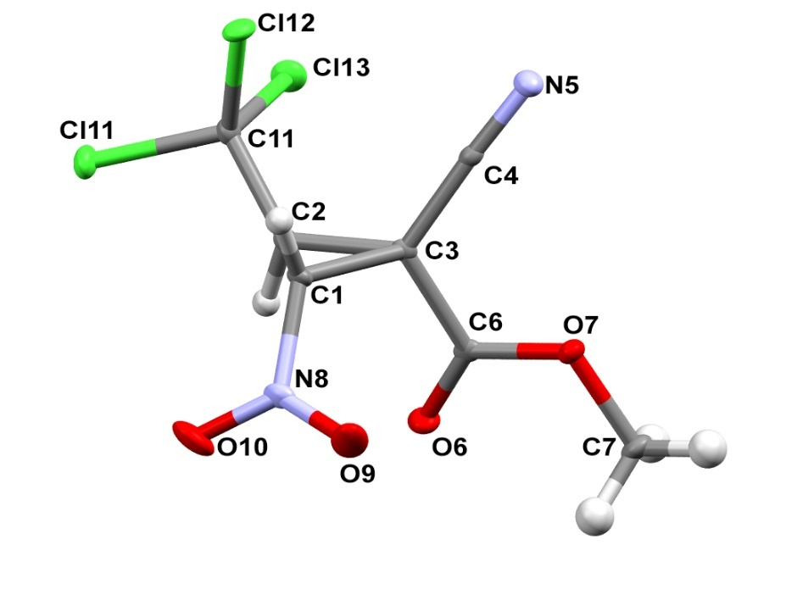
Figure S50. Geometry of 2 independent molecules (A and B) 3 in crystal.

Figure S51. Crystal packaging of 3. Short contacts are shown with dotted lines.
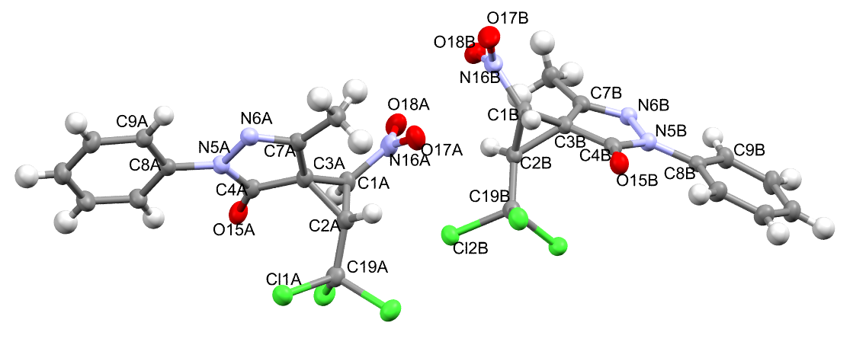
Figure S52. Geometry of 2 independent molecules 9a in crystal. Ellipsoids of anisotropic displacements are shown with 50% probability.
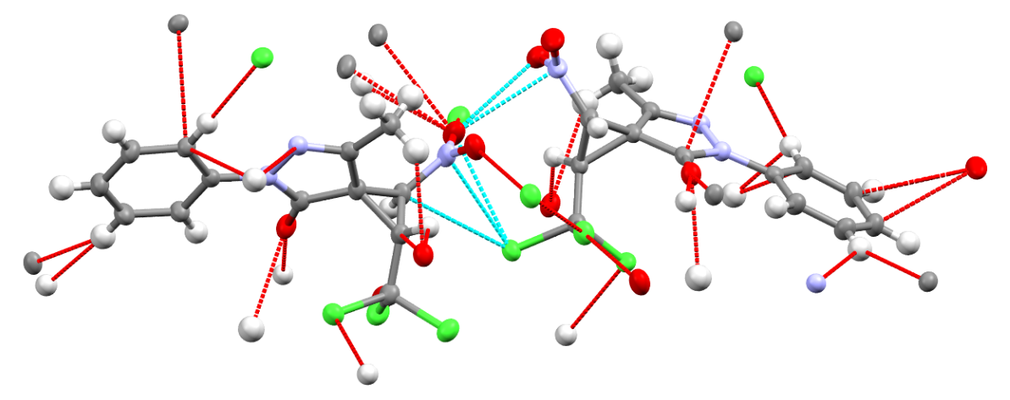
Figure S53. System of short contacts in crystal 9a. Short contacts are shown with dotted lines.

Figure S54. Fragment of 9а crystal packaging. Short contacts are shown with dotted lines.
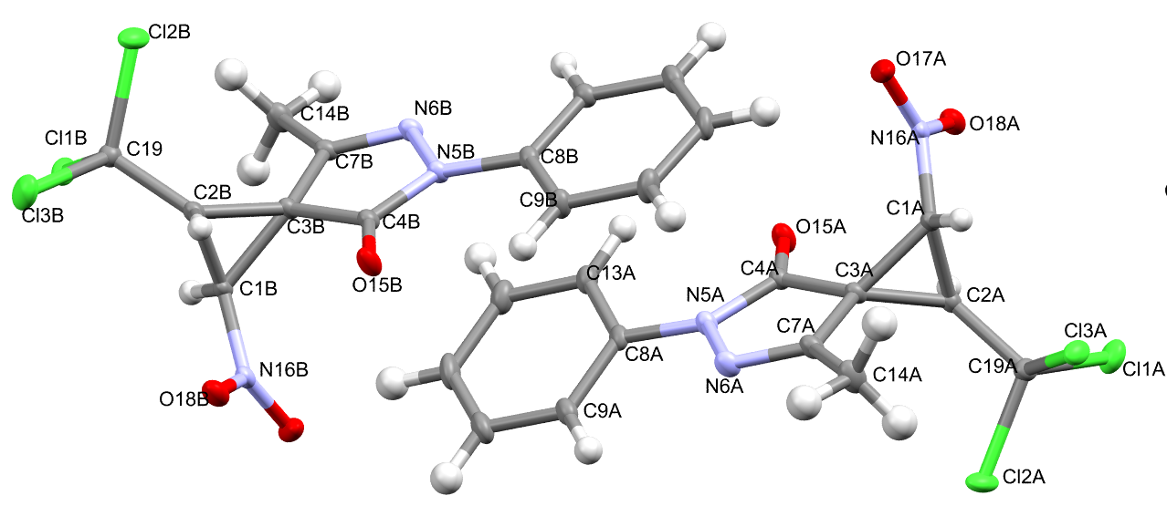
Figure S55. Geometry of 2 independent molecules 9b in crystal. Ellipsoids of anisotropic displacements are shown with 50% probability.

Figure S56. System of short contacts in crystal 9b. Short contacts are shown with dotted lines.

Figure S57. Fragment of 9b crystal packaging. Short contacts are shown with dotted lines.

References
1. Sheldrick, G.M. Acta Crystallogr. Sect. A Found. Adv., 2015, 71, 3-8.
2. Sheldrick, G.M. Acta Crystallogr. Sect. С, 2015, 71, 3-8.
3. Farrugia, L.J. J. Appl. Crystallogr., 2012, 45, 849-854.
4. Spek, A.L. Acta Crystallogr. Sect. D Biol. Crystallogr., 2009, 65, 148-155.
5. Durden, Jr, J. A., Heywood, D. L., Sousa, A. A., Spurr, H. W. J. Agric. Food. Chem. 1970, 18 (1), 50-56. DOI: 10.1021/jf60167a011.

