Supporting Information

Supramolecular hydration structure of graphene-based hydrogels: density functional theory, green chemistry and interface application
Hon Nhien Le*^{1,4}, Duy Khanh Nguyen^{5,6}, Minh Triet Dang⁷, Huyen Trinh Nguyen^{3,4}, Thi Bang Tam Dao^{1,4}, Trung Do Nguyen^{1,4}, Chi Nhan Ha Thuc*^{1,4} and Van Hieu Le*^{1,2,4}

Address: ¹Faculty of Materials Science and Technology, University of Science, Ho Chi Minh City, 700000, Vietnam, ²Faculty of Chemistry, VNUHCM University of Science, 227 Nguyen Van Cu Street, Ward 4, District 5, Ho Chi Minh City, 700000, Vietnam, ³Multifunctional Materials Laboratory, VNUHCM University of Science, 227 Nguyen Van Cu Street, Ward 4, District 5, Ho Chi Minh City, 700000, Vietnam, ⁴Vietnam National University, Linh Trung Ward, Thu Duc City, Ho Chi Minh City, 700000, Vietnam, ⁵Laboratory for Computational Physics, Institute for Computational Science and Artificial Intelligence, Van Lang University, Ho Chi Minh City, 700000, Vietnam, ⁶Faculty of Mechanical – Electrical and Computer Engineering, School of Technology, Van Lang University, Ho Chi Minh City, 700000, Vietnam and ⁷Faculty of Physics, School of Education, Can Tho University, Can Tho City, Viet Nam
Email: Hon Nhien Le - lhnhien@hcmus.edu.vn
Chi Nhan Ha Thuc - htcnhan@hcmus.edu.vn
Van Hieu Le - lvhieu@hcmus.edu.vn
* Corresponding author

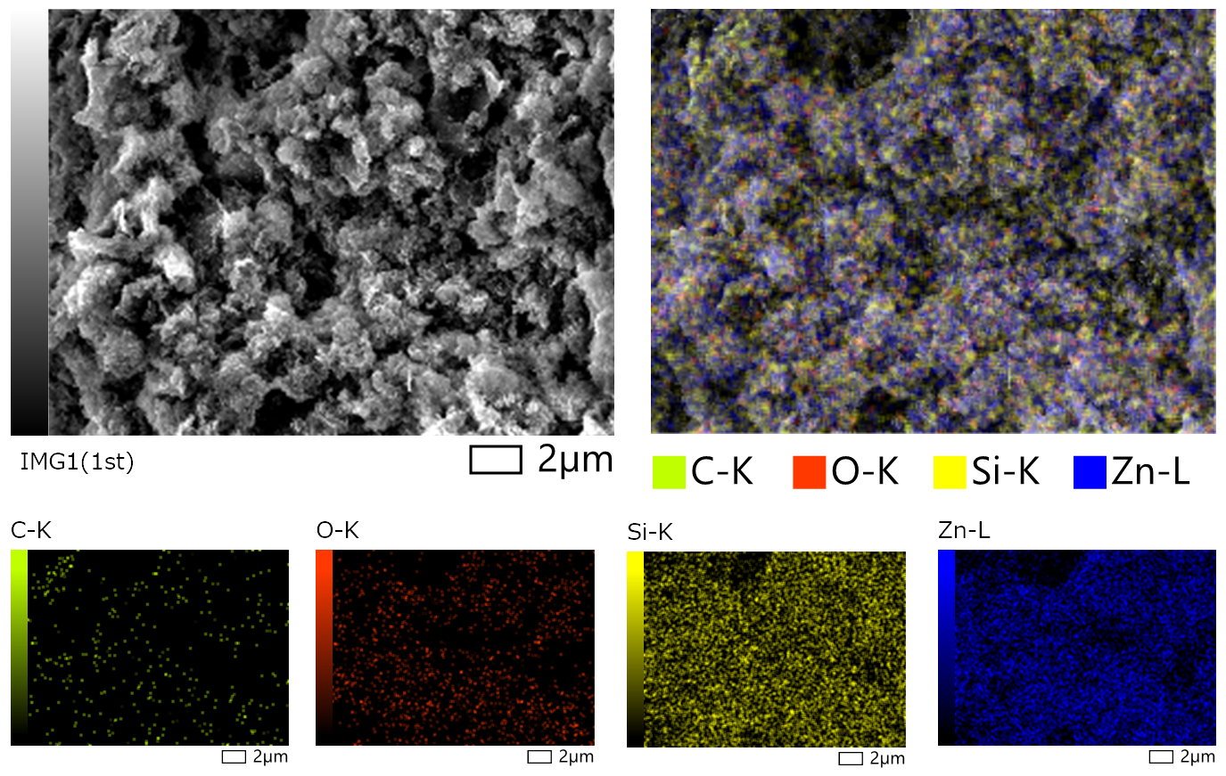
Figure S1: SEM-EDS elemental mapping of carbon atoms (green dots), oxygen atoms (red dots), silicon atoms (yellow dots) and zinc atoms (blue atoms) on the graphene-based nanostructures of GO-SG-ZH hydrogel after dehydration.
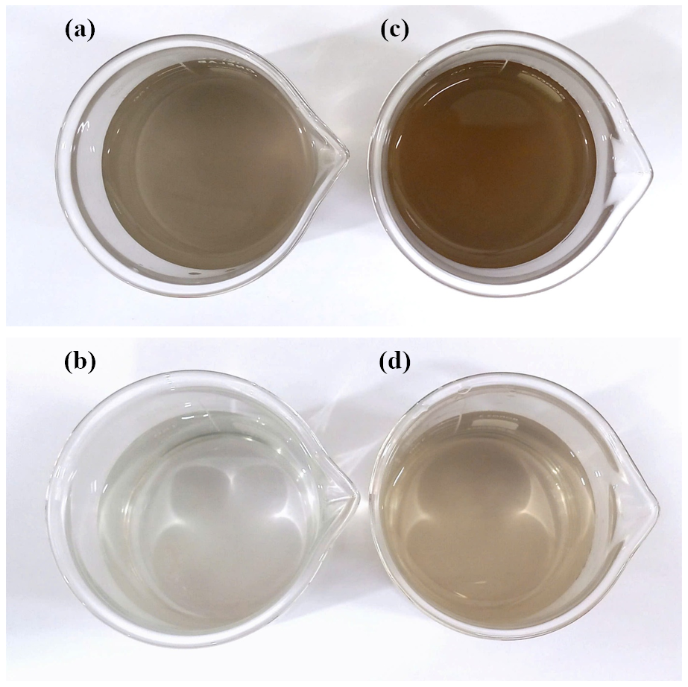
Figure S2: Aqueous dispersions of GO-SG-ZH powder in water at the concentrations of 200 ppm (a) and 50 ppm (b). Aqueous dispersions of GO-SG-ZH hydrogel in water at the concentrations of 200 ppm (c) and 50 ppm (d).

Table S1: Value results of tensile measurement of SG/PLA films.
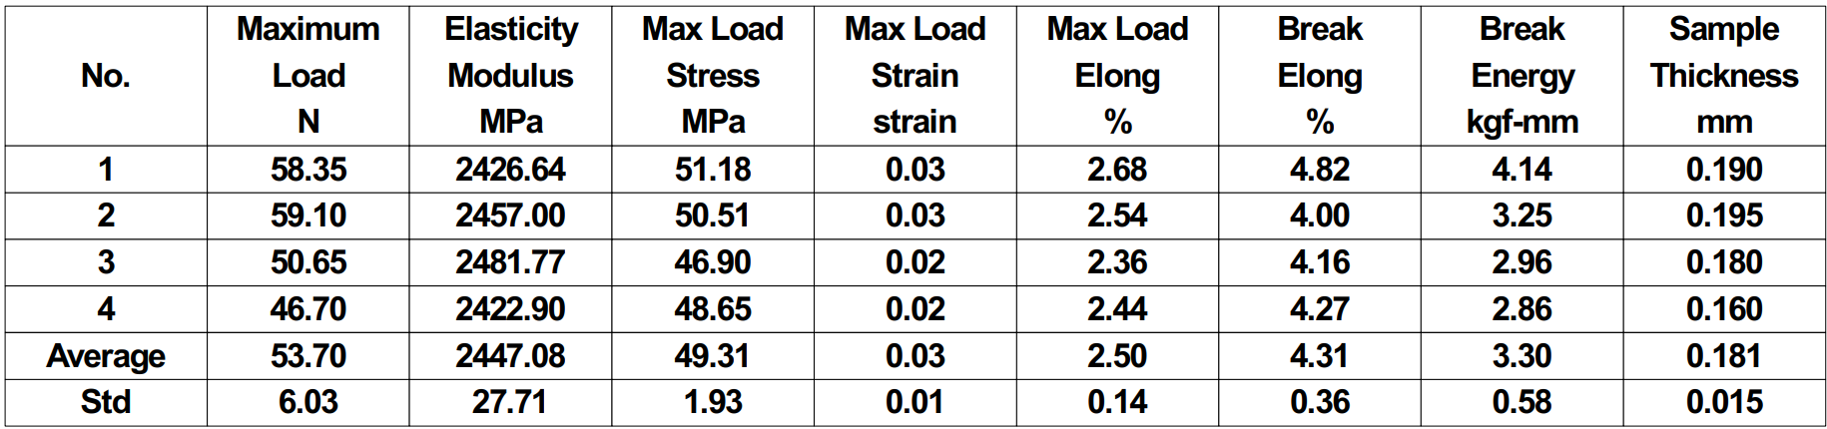
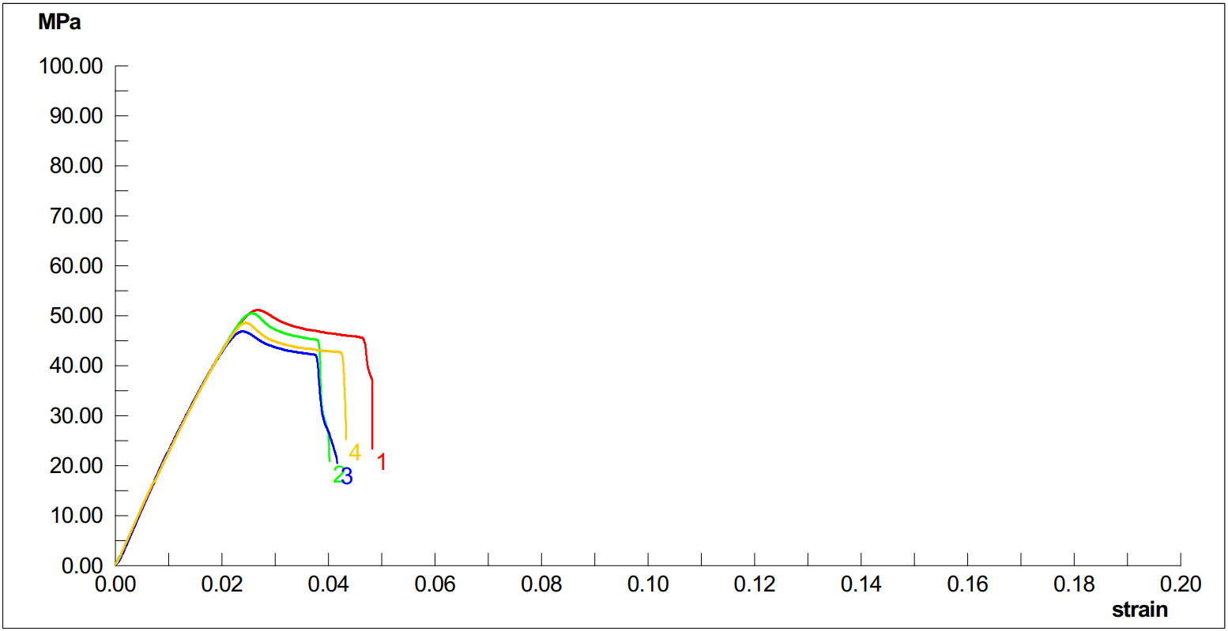
Figure S3: Stress – strain curves of tensile testing of SG/PLA films.

Table S2: Value results of tensile measurement of GO-SG-ZH/PLA films.
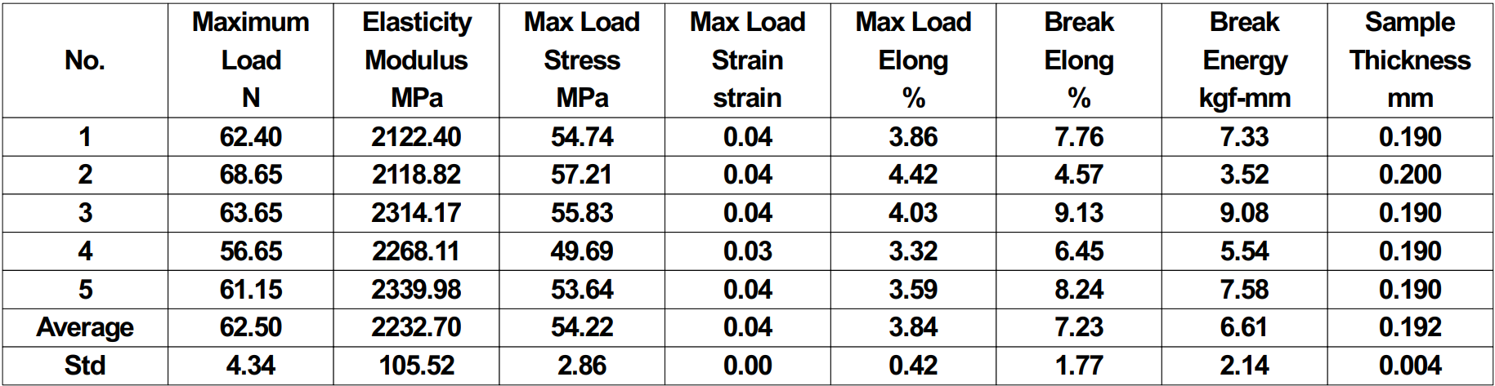
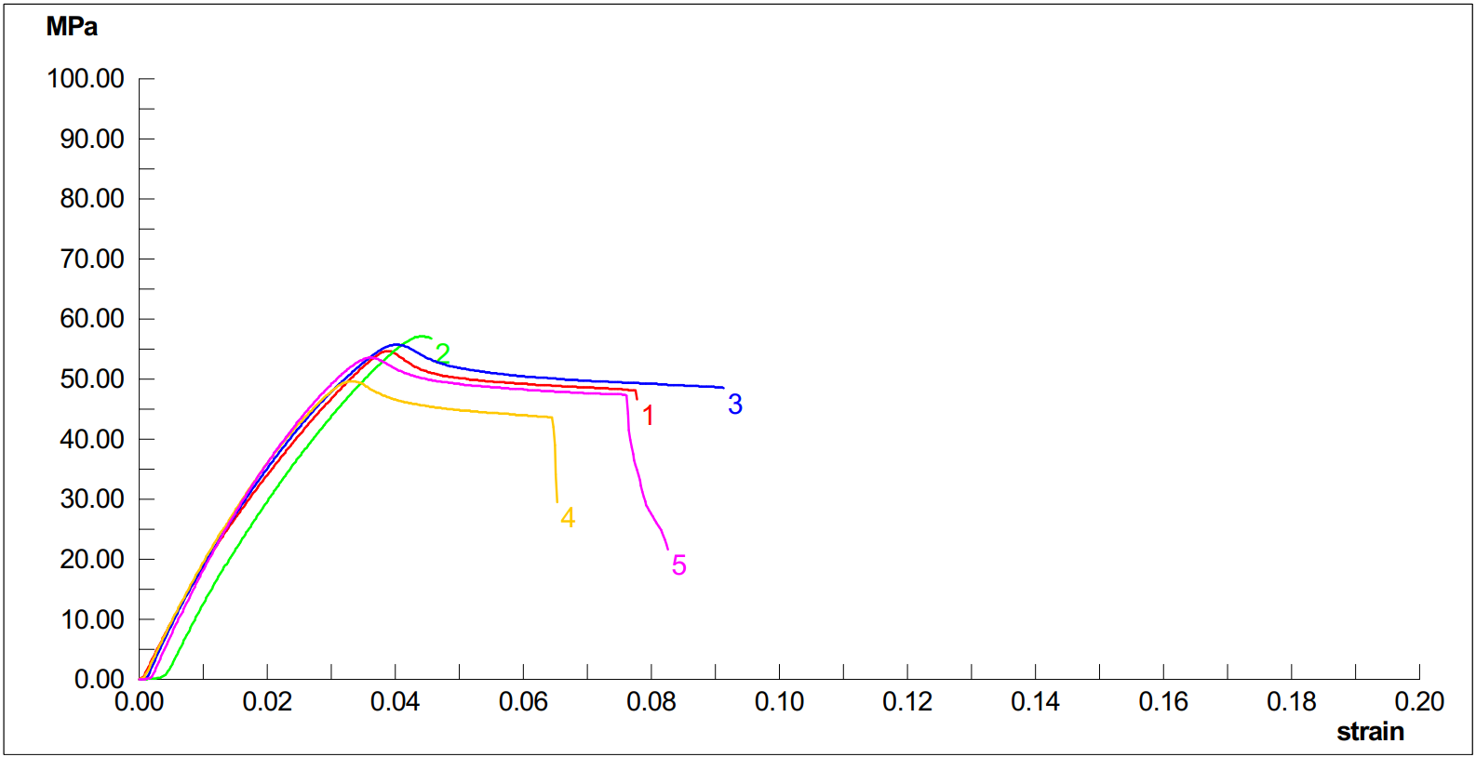
Figure S4: Stress – strain curves of tensile testing of GO-SG-ZH/PLA films.
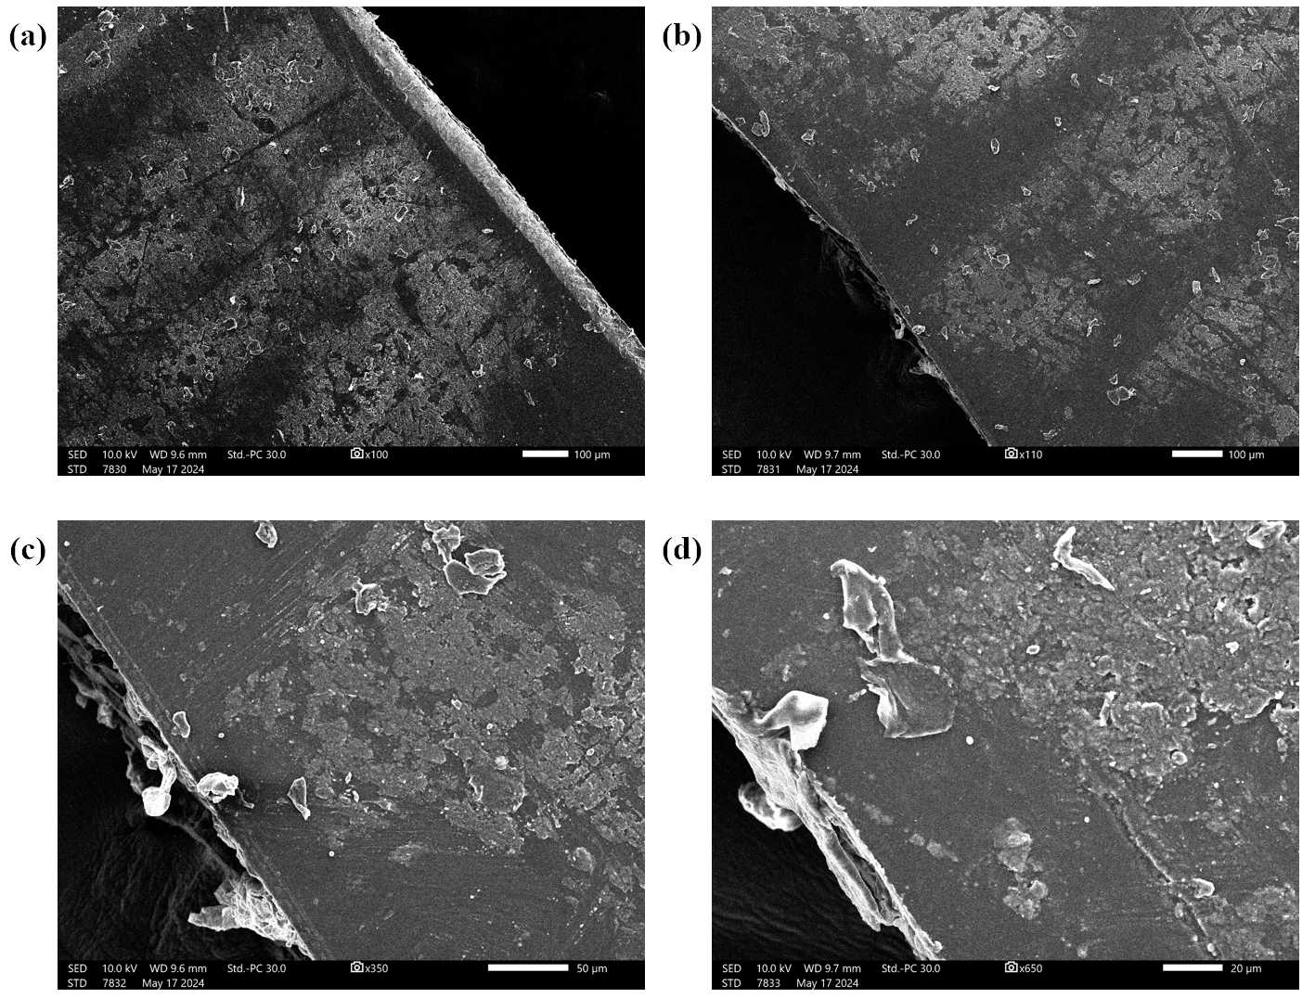
Figure S5: SEM images of surfaces and fractures of GO-SG-ZH/PLA films after tensile testing. The fractures were generated by the tensile measurement.

