Supporting information
for

Preparation of furfural derived enantioenriched vinyl oxazoline building block and exploring its reactivity
Madara Darzina, Anna Lielpetere, Aigars Jirgensons

Table of contents
Table of contents 2
General considerations 3
Synthesis of Alloc-protected amino alcohol 2d 5
Electrosynthesis of unsaturated ester 3d 7
Synthesis of unsaturated amide 5 9
Synthesis of vinyl oxazoline 6 11
Synthesis of oxazolo[3,2-c]pyrimidine 7 12
Chiral HPLC analysis of rac-6 13
Chiral HPLC analysis of S-6 14
Chiral HPLC analysis of R-6 15
Copies of NMR spectra 16
Figure 1. ¹H‒NMR of compound S-S1 (CDCl₃, 300 MHz) 17
Figure 2. ¹H‒NMR of compound S-2d (DMSO-d₆, 400 MHz) 18
Figure 3. ¹³C{¹H}–NMR of compound S-2d (DMSO-d₆, 101 MHz) 19
Figure 4. ¹H‒NMR of compound S-3d (CD₃CN, 400 MHz) 20
Figure 5. ¹³C{¹H}–NMR of compound S-3d (CD₃CN, 101 MHz). 21
Figure 6. ¹H‒NMR of compound trans-S-5 (CDCl₃, 400 MHz) 22
Figure 7. ¹³C{¹H}–NMR of compound trans-S-5 (CDCl₃, 101 MHz). 23
Figure 8. ¹H‒NMR of compound cis-S-5 (CDCl₃, 400 MHz). 24
Figure 9. ¹³C{¹H}–NMR of compound cis-S-5 (CDCl₃, 101 MHz). 25
Figure 10. ¹H‒NMR of compound S-6 (CDCl₃, 400 MHz) 26
Figure 11. ¹³C{¹H}–NMR of compound S-6 (CDCl₃, 101 MHz). 27
Figure 12. ¹H‒NMR of compound 7 (CD₃CN, 400 MHz). 28
Figure 13. ¹³C{¹H}–NMR of compound 7 (CD₃CN, 101 MHz). 29

General considerations
Reagents and starting materials for synthesis were obtained from commercial sources and used as received. All solvents were used as received. For electrolysis, MeOH (>= 99.8%, HPLC grade) from Fisher Chemical and HFIP (>99.5%) from Fluorochem were used.
¹H–NMR, ¹³C–NMR and 2D spectra were recorded on 400 MHz Brucker Avance Neo and 300 MHz Brucker UltraShield spectrometers. Chemical shift values (δ) are given in parts per million (ppm), using residual solvent as an internal standard. Coupling constants are reported as J values in hertz (Hz). Structural assignments were made with additional information from COSY, NOESY, HSQC, and HMBC experiments.
High resolution mass spectra (HR-MS) were recorded on a Waters Synapt G2-Si TOF MS instrument in ESI technique.
Specific optical rotations were measured at 20°C on a Rudolph Research Analytical Autopol VI polarimeter, cell length 100 mm at 589 nm. CHCl₃ was used as solvent. Concentration specified for each sample.
Flash column chromatography was carried out using silica gel (230−400 mesh). Thin layer chromatography (TLC) was performed on silica gel and was visualized by UV lamp or staining with potassium permanganate stain. Reverse phase flash chromatography was carried out on Biotage Isolera One flash chromatograph, using commercially available C18 silica gel columns.
Batch electrolysis was performed using potentiostat ElectraSyn 2.0 in constant current conditions, using undivided 20 mL ElectraSyn cells. Graphite (SK-50; dimensions (W x H x D): 8 x 52.5 x 2 mm) electrodes from IKA were used. Distance between electrodes is 0.8 cm; during electrolysis 2.4 cm of the electrode was submerged in solution. Graphite electrodes were polished with emery paper before each experiment. During electrolysis, reaction mixture was stirred at 750 rpm. Electrolysis was performed at room temperature (~20°C) and under atmospheric conditions.

Photo of batch electrolysis set-up:

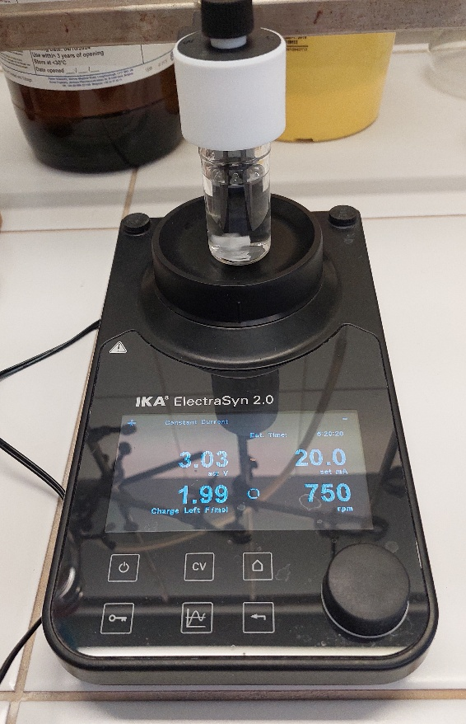

Synthesis of Alloc-protected amino alcohol 2d
Synthesis was performed according to a known literature procedure¹. Furfural 1 (2.00 mL; 1.0 equiv.; 24.1 mmol) and L-valinol ((S)-valinol) (2.49 g; 1.0 equiv.; 24.1 mmol) were dissolved in abs. EtOH (20 mL) under argon atmosphere and left to stir at room temperature overnight. After 16 h, reaction mixture was cooled in an ice bath and NaBH₄ (1.10 g; 1.2 equiv.; 29.0 mmol;) was added in small portions. Then reaction mixture was left to stir for another 20 h at room temperature. Afterwards, reaction mixture was cooled in an ice bath and aqueous 5% KHSO₄ solution was added slowly until gas evolution ceased. Ethanol was evaporated and reaction mixture was partitioned between Et₂O and aqueous 5% KHSO₄ solution. The organic layer was washed with KHSO₄ solution four more times. Aqueous layers were combined and carefully neutralized by addition of solid NaHCO₃ until pH was >7. The water phase was washed with CHCl₃:iPrOH (3:1) mixture four times, the organic layers were combined, dried with Na₂SO₄, filtered and the solvent was evaporated. Product S-S1 (3.73 g; 84%) was obtained as an orange oil. Product was used in the next step without further purification. The ¹H‒NMR spectrum was in agreement with that reported in the literature¹.
¹H–NMR (300 MHz, CDCl₃, ppm) δ 7.37 (dd, J = 1.9, 0.8 Hz, 1H), 6.32 (dd, J = 3.2, 1.9 Hz, 1H), 6.22 (dd, J = 3.2, 0.7 Hz, 1H), 3.95 – 3.78 (m, 2H), 3.65 (dd, J = 11.0, 4.1 Hz, 1H), 3.43 (dd, J = 11.0, 6.8 Hz, 1H), 2.79 (s, 3H), 2.48 (td, J = 6.6, 4.1 Hz, 1H), 1.83 (dq, J = 13.5, 6.8 Hz, 1H), 0.98 – 0.88 (m, 6H).
Synthesis of R-S1 was performed using the same procedure as for S-S1. Furfural 1 (2.04 mL; 1.0 equiv.; 24.6 mmol), D-valinol ((R)-valinol) (2.54 g; 1.0 equiv.; 24.6 mmol) and NaBH₄ (1.11 g; 1.2 equiv.; 29.5 mmol) were used. Product R-S1 (3.96 g; 88%) was obtained as an orange oil. The ¹H‒NMR spectrum was in agreement with that reported in the literature¹.
¹H‒NMR spectrum for R-S1 matches that of S-S1.

¹: Dārziņa, M.; Lielpētere, A.; Jirgensons, A. Torii-type electrosynthesis of α,β-unsaturated esters from furfurylated ethylene glycols and amino alcohols. Eur. J. Org. Chem. 2021, 4224–4228. https://doi.org/10.1002/ejoc.202100605

Substrate S-S1 (1.43 g; 1.0 equiv.; 7.80 mmol) was dissolved in dry THF (10 mL) under argon atmosphere. The flask was cooled in an ice bath and DIPEA (2.70 mL; 2.0 equiv.; 15.6 mmol) was added to the reaction mixture. Then allyl chloroformate (0.87 mL; 1.05 equiv.; 8.19 mmol) was added dropwise. The flask was left to stir at 0°C for 2 hours, then allowed to warm to room temperature and stirred overnight. Solvent was evaporated and reaction mixture was dissolved in EtOAc (20 mL) and transferred into a separatory funnel. The organic layer was washed with sat. NH₄Cl solution (1x), sat. NaHCO₃ solution (1x) and sat. NaCl solution (1x). Then organic layer was dried with Na₂SO₄, filtered and solvent was evaporated. Crude product was then purified using flash chromatography system on reverse phase using C18 silica gel column. Eluent system H₂O/MeCN, gradient 10% to 100% MeCN. Product S-2d (1.55 g; 74%) was obtained as a colorless oil.
Note: Compound observed as rotamers.
¹H–NMR (400 MHz, DMSO-d₆, ppm) δ 7.50 (dd, J = 1.9, 0.9 Hz, 1H), 6.36 (dd, J = 3.2, 1.8 Hz, 1H), 6.29 (dd, J = 3.1, 0.6 Hz, 1H), 5.91 (ddt, J = 17.3, 10.5, 5.2 Hz, 1H), 5.28 (dq, J = 17.3, 1.7 Hz, 1H), 5.17 (dq, J = 10.6, 1.5 Hz, 1H), 4.54 (dq, J = 5.3, 1.5 Hz, 2H), 4.50 – 4.31 (m, 3H), 3.63 (t, J = 5.5 Hz, 2H), 3.49 (dt, J = 9.9, 6.1 Hz, 1H), 1.90 (s, 1H), 0.89 (d, J = 6.6 Hz, 3H), 0.66 (d, J = 6.7 Hz, 3H). Note: spectra taken at 75°C.
¹³C{¹H}–NMR (101 MHz, DMSO-d₆, ppm) δ 155.4 (broad signal), 152.2, 141.4, 133.3, 116.3, 110.2, 107.5, 65.0, 64.8, 60.4, 41.5, 27.4 (broad signal), 19.9, 19.5. Note: spectra taken at 60°C.
HRMS (ESI) m/z: [M+Na]⁺ Calcd for C₁₄H₂₁NO₄Na 290.1368; Found 290.1372.
S-2d: $α_{D}^{20}+8.6 (c 1.16;C{HCl}_{3})$.

Synthesis of R-2d was performed using the same procedure as for S-2d. Substrate R-S1 (2.01 g; 1.0 equiv.; 11.0 mmol), DIPEA (3.82 mL; 2.0 equiv.; 21.9 mmol) and allyl chloroformate (1.22 mL; 1.05 equiv.; 11.5 mmol) were used. Product R-2d (2.08 g; 71%) was obtained as a colorless oil.
¹H‒NMR and ¹³C‒NMR spectra for R-2d matches that of S-2d.
R-2d: $α_{D}^{20}-8.6 (c 1.02;C{HCl}_{3})$.

Electrosynthesis of unsaturated ester 3d
Substrate S-2d batch electrolysis at 2 mmol/500 mg scale:
Substrate S-2d (534 mg; 1.0 equiv.; 2.00 mmol) and LiClO₄ (212 mg; 1.0 equiv.; 2.00 mmol) were transferred into 20 mL electrolytic cell and dissolved in 10 mL MeOH and 4 mL HFIP mixture. The electrolytic cell was fitted with graphite anode and cathode. Constant current electrolysis was performed at 20 mA (j = 10.4 mA/cm², distance between electrodes 0.8 cm), ambient conditions, until 2 F of charge was passed through the solution. Then AcOH (0.46 mL; 4.0 equiv.; 8.00 mmol) was added to the reaction mixture and electrolysis was continued at 20 mA until additional 3.5 F of charge was passed through the solution. Total electrolysis time: approx. 15 hours.
After electrolysis, TEA (1.11 mL; 4.0 equiv.; 8.00 mmol) was added to the electrolytic cell and then reaction mixture was diluted with approx. 20 mL EtOAc. The solution was filtered through a pad of silica gel and solvent was evaporated. Product was purified using column chromatography, eluent system Hex:MTBE: Acetone ((6:1:1), product Rf~0.4). Product S-3d (514 mg; 72%) was obtained as a colorless oil.

Substrate S-2d batch electrolysis at 4 mmol/1 g scale:
Substrate S-2d (1.07 g; 1.0 equiv.; 4.00 mmol) and LiClO₄ (212 mg; 0.5 equiv.; 2.00 mmol) were transferred into 20 mL electrolytic cell and dissolved in 10 mL MeOH and 4 mL HFIP mixture. The electrolytic cell was fitted with graphite anode and cathode. Constant current electrolysis was performed at 20 mA (j = 10.4 mA/cm², distance between electrodes 0.8 cm), ambient conditions, until 2 F of charge was passed through the solution. Then AcOH (0.92 mL; 4.0 equiv.; 16.0 mmol) was added to the reaction mixture and electrolysis was continued at 20 mA until additional 3.5 F of charge was passed through the solution. Total electrolysis time: approx. 30 hours.
After electrolysis, TEA (2.23 mL; 4.0 equiv.; 16.0 mmol) was added to the electrolytic cell and then reaction mixture was diluted with approx. 20 mL EtOAc. The solution was filtered through a pad of silica gel and solvent was evaporated. Crude product was then purified using flash chromatography system on reverse phase, using C18 silica gel column. Eluent system H₂O/MeCN, gradient 20% to 65% MeCN. Product S-3d (925 mg; 64%) was obtained as a colorless oil.
Note: Compound observed as rotamers.
¹H–NMR (400 MHz, CD₃CN, ppm) δ 6.08 (dd, J = 11.8, 7.5 Hz, 1H), 6.02 – 5.88 (m, 2H), 5.68 (dd, J = 7.5, 1.0 Hz, 1H), 5.31 (dq, J = 17.3, 1.7 Hz, 1H), 5.20 (dq, J = 10.6, 1.5 Hz, 1H), 4.74 – 4.69 (m, 1H), 4.68 – 4.55 (m, 3H), 4.39 (dd, J = 11.7, 4.2 Hz, 1H), 4.34 – 4.29 (m, 1H), 3.77 (td, J = 9.7, 3.9 Hz, 1H), 3.33 (d, J = 1.1 Hz, 6H), 3.25 (s, 3H), 2.05 – 2.00 (m, 1H), 1.01 (d, J = 6.6 Hz, 3H), 0.89 (d, J = 6.7 Hz, 3H). Note: spectra taken at 40°C.
¹³C{¹H}–NMR (101 MHz, CD₃CN, ppm) δ 165.9, 164.7, 157.8, 156.8, 144.1, 143.8, 134.2, 122.9, 122.8, 117.7, 117.4, 99.4, 78.2, 66.8, 66.6, 65.1 64.7, 62.9, 56.5, 56.1, 54.2, 29.4, 29.0, 20.4, 20.3.
HRMS (ESI) m/z: [M+Na]⁺ Calcd for C₁₇H₂₉NO₇Na 382.1842; Found 382.1840.
S-3d: $α_{D}^{20}+15.9 (c 0.97;C{HCl}_{3})$.
Synthesis of R-3d was performed using the same procedure as for S-3d (2 mmol/500 mg scale). Substrate R-2d (535 mg; 1.0 equiv.; 2.00 mmol), LiClO₄ (213 mg; 1.0 equiv.; 2.00 mmol), AcOH (0.46 mL; 4.00 equiv.; 8.01 mmol) and TEA (1.12 mL; 4.0 equiv.; 8.01 mmol) were used. Product R-3d (468 mg; 65%) was obtained as a colorless oil.
¹H‒NMR and ¹³C‒NMR spectra for R-3d matches that of S-3d.
R-3d: $α_{D}^{20}-15.6 (c 1.00;C{HCl}_{3})$.

Synthesis of unsaturated amide 5
Substrate S-3d (502 mg; 1.0 equiv.; 1.40 mmol) was dissolved in dry DCM (15 mL). Argon gas was slowly bubbled through the solution for 10 minutes, then catalyst PdCl₂(S-BINAP) (78.4 mg; 0.07 equiv.; 0.10 mmol) was added to the solution and argon gas was bubbled through the solution for 5 more minutes. Then the flask was sealed with a septum and pyrrolidine (0.34 mL; 3.0 equiv.; 4.19 mmol) was added to the reaction mixture. The reaction was left to stir overnight at room temperature. After about 16 hours, reaction mixture was transferred into separatory funnel and partitioned between DCM and sat. aqueous NH₄Cl solution. The aqueous layer was washed with CHCl₃:iPrOH (3:1) mixture two more times, the organic layers were combined, dried with Na₂SO₄, filtered and solvent was evaporated. Product was purified using column chromatography, eluent system MTBE:Acetone ((3:1), product Rf~0.45). Product trans-S-5 (242 mg; 75%) was obtained as a while solid.
¹H–NMR (400 MHz, CDCl₃, ppm) δ 6.67 (dd, J = 15.5, 3.7 Hz, 1H), 6.18 (dd, J = 15.5, 1.4 Hz, 1H), 6.11 (d, J = 8.6 Hz, 1H), 4.94 (dd, J = 3.8, 1.4 Hz, 1H), 3.83 – 3.75 (m, 1H), 3.73 – 3.63 (m, 2H), 3.32 (s, 6H), 3.09 (s, 1H), 1.98 – 1.84 (m, J = 6.8 Hz, 1H), 1.02 – 0.85 (m, 6H).
¹³C{¹H}–NMR (101 MHz, CDCl₃, ppm) δ 165.9 139.1, 127.0, 100.7, 63.6, 57.3, 52.9, 29.2, 19.9, 19.0.
HRMS (ESI) m/z: [M+H]⁺ Calcd for C₁₁H₂₂NO₄ 232.1549; Found 232.1558.
trans-S-5: $α_{D}^{20}-41.0 (c 1.07;C{HCl}_{3})$.

Synthesis of trans-R-5 was performed using the same procedure as for trans-S-5. Substrate R-3d (363 mg; 1.0 equiv.; 1.01 mmol), PdCl₂(S-BINAP) (56.7 mg; 0.07 equiv.; 0.07 mmol) and pyrrolidine (0.25 mL; 3.00 equiv.; 3.03 mmol) were used. Product trans-R-5 (169 mg; 72%) was obtained as a as a while solid.
¹H‒NMR and ¹³C‒NMR spectra for trans-R-5 matches that of trans-S-5.
trans-R-5: $α_{D}^{20}+39.1 (c 1.00;C{HCl}_{3})$.

Substrate S-3d (158 mg; 1.0 equiv.; 0.44 mmol) and pyrrolidine (0.11 mL; 3.0 equiv.; 1.32 mmol) were dissolved in dry DCM (5 mL). Argon gas was slowly bubbled through the solution for 10 minutes, then catalyst Pd(PPh₃)₄ (25.4 mg; 0.02 equiv.; 0.05 mmol) was added to the solution and argon gas was bubbled through the solution for 2 more minutes. Then the flask was sealed with a septum and reaction was left to stir at room temperature. Reaction progress was monitored via TLC. When all starting material was consumed (about 30 min), reaction mixture was transferred into separatory funnel and partitioned between DCM and sat. aqueous NH₄Cl solution. The aqueous layer was washed with DCM two more times, the organic layers were combined, dried with Na₂SO₄, filtered and solvent was evaporated. At this stage, double bond isomer ratio was determined to be 1:0.5 (cis:trans; determined by ¹H-NMR).

Products were purified using column chromatography, eluent system MTBE:Acetone ((3:1), cis-S-5 Rf~0.54, trans-S-5 Rf~0.45), followed by flash chromatography on reverse phase, using C18 silica gel column. Eluent system H₂O/MeCN, gradient 2% to 30% MeCN. Products S-5 (58 mg; 57%) were obtained as a cis:trans mixture (1:0.5; determined by ¹H-NMR).

Isomer cis-S-5 was then separated for characterization, using reverse phase flash chromatography in the same conditions as described above.

¹H–NMR (400 MHz, CDCl₃, ppm) δ 6.71 (d, J = 9.1 Hz, 1H), 5.98 (dd, J = 12.1, 0.6 Hz, 1H), 5.92 (dd, J = 12.1, 5.9 Hz, 1H), 5.54 (dd, J = 5.9, 0.6 Hz, 1H), 3.79 (dtd, J = 8.3, 6.4, 3.5 Hz, 1H), 3.74 – 3.62 (m, 2H), 3.37 (d, J = 1.3 Hz, 6H), 1.98 – 1.85 (m, J = 6.8 Hz, 1H), 0.99 – 0.92 (m, 6H).
¹³C{¹H}–NMR (101 MHz, CDCl₃, ppm) δ 166.4, 137.1, 127.7, 99.0, 64.0, 57.5, 53.4, 53.2, 29.1, 19.6, 18.7.
HRMS (ESI) m/z: [M+Na]⁺ Calcd for C₁₁H₂₁NO₄Na 254.1368; Found 254.1366.

Synthesis of vinyl oxazoline 6
In a heat-dried flask, under Ar atmosphere, substrate trans-S-5 (374 mg; 1.0 equiv.; 1.62 mmol) was dissolved in dry DCM (7 mL). The flask was cooled in an ice bath and TEA was added (0.90 mL; 4.0 equiv; 6.47 mmol). Mesyl chloride (0.25 mL; 2.0 equiv; 3.23 mmol) was added dropwise and reaction was left to warm up to room temperature overnight. Then sat. NaHCO₃ solution (15 mL) was added and reaction mixture was transferred into separatory funnel. Organic layer was separated and aqueous layer was washed with DCM two more times, organic layers were combined and dried using Na₂SO₄. Then the salt was filtered off, and the solvent was evaporated. Product was purified using column chromatography, eluent system Petroleum ether: MTBE:Acetone ((4:1:1), product Rf~0.4). The product S-6 (260 mg; 75%) was obtained as a clear oil.
¹H–NMR (400 MHz, CDCl₃, ppm) δ 6.41 (dd, J = 16.1, 4.1 Hz, 1H), 6.32 (dd, J = 16.1, 1.0 Hz, 1H), 4.90 (dd, J = 4.1, 1.0 Hz, 1H), 4.32 – 4.23 (m, 1H), 4.02 – 3.92 (m, 2H), 3.33 (d, J = 0.6 Hz, 6H), 1.82 – 1.71 (m, 1H), 0.97 (d, J = 6.7 Hz, 3H), 0.88 (d, J = 6.8 Hz, 3H).
¹³C{¹H}–NMR (101 MHz, CDCl₃, ppm) δ 162.2, 137.7, 121.4, 101.4, 72.8, 70.1, 53.0, 53.0, 32.9, 19.0, 18.4.
HRMS (ESI) m/z: [M+H]⁺ Calcd for C₁₁H₂₀NO₃ 214.1443; Found 214.1454.
S-6: $α_{D}^{20}-99.4 (c 1.01;C{HCl}_{3})$.

Synthesis of R-6 was performed using analogous procedure as for S-6. Substrate trans-R-5 (207 mg; 1.0 equiv.; 0.90 mmol), TEA (0.75 mL; 6.0 equiv.; 5.37 mmol) and mesyl chloride (0.21 mL; 3.0 equiv.; 2.68 mmol) were used. Product R-6 (133 mg; 70%) was obtained as a colorless oil.
¹H‒NMR and ¹³C‒NMR spectra for R-6 matches that of S-6.
R-6: $α_{D}^{20}+96.9 (c 1.00;C{HCl}_{3})$.

Synthesis of oxazolo[3,2-c]pyrimidine 7
Substrate S-6 (114 mg; 1.0 equiv.; 0.53 mmol) was dissolved in dry toluene (5 mL). Tosyl isocyanate (0.18 mL; 2.2 equiv; 1.18 mmol) was added dropwise and reaction mixture was left to stir at room temperature. Reaction progress was monitored with UPLC-MS. After 3 days all starting material was consumed. Solvent was evaporated and the crude product was purified, using column chromatography, eluent system Petroleum ether:MTBE:Acetone ((2:1:1), product Rf~0.3), followed by flash chromatography on reverse phase, using C18 silica gel column. Eluent system H₂O/MeCN, gradient 20% to 80% MeCN. Product 7 (280 mg; 86%) was obtained as an amorphous white solid. Product was obtained as a single diastereomer.
¹H–NMR (400 MHz, CD₃CN, ppm) δ 8.93 (s, 1H), 7.95 – 7.88 (m, 2H), 7.88 – 7.79 (m, 2H), 7.45 – 7.37 (m, 2H), 7.38 – 7.29 (m, 2H), 5.35 (d, J = 2.4 Hz, 1H), 4.66 – 4.52 (m, 2H), 4.32 – 4.25 (m, 1H), 4.02 (d, J = 2.4 Hz, 1H), 3.26 (s, 3H), 3.23 (s, 3H), 2.44 (s, 3H), 2.40 (s, 3H), 2.35 (ddt, J = 10.4, 7.0, 3.4 Hz, 1H), 0.80 (d, J = 7.2 Hz, 3H), 0.45 (d, J = 6.9 Hz, 3H).
¹³C{¹H}–NMR (101 MHz, CD₃CN, ppm) δ 161.5, 157.4, 148.4, 146.3, 145.9, 137.7, 137.1, 130.5, 130.1, 129.9, 129.0, 118.3, 107.0, 78.1, 72.2, 61.3, 58.0, 56.0, 55.2, 27.1, 21.7, 21.6, 18.3, 13.9.
HRMS (ESI) m/z: [M+H]⁺ Calcd for C₂₇H₃₄N₃O₉S₂ 608.1736; Found 608.1755.
7: $α_{D}^{20}+158.5 (c 1.01;C{HCl}_{3})$.

Chiral HPLC analysis of rac-6
Rac-6 was synthesized using the same methodology as for S-6 and R-6. DL-Valinol (CAS: 16369-05-4) was used as starting material.
HPLC (Chiralpak IG, isopropanol/n-hexane = 10/90, flow rate = 1.0 mL/min, l = 210 nm) t_{R} =8.43 min (isomer A), 9.90 min (isomer B)
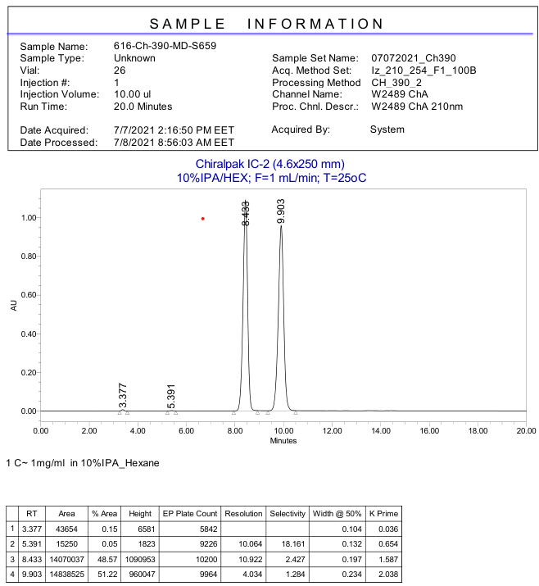

Chiral HPLC analysis of S-6
HPLC (Chiralpak IG, isopropanol/n-hexane = 10/90, flow rate = 1.0 mL/min, l = 210 nm) t_{R} =8.34 min (isomer A), 9.88 min (isomer B)
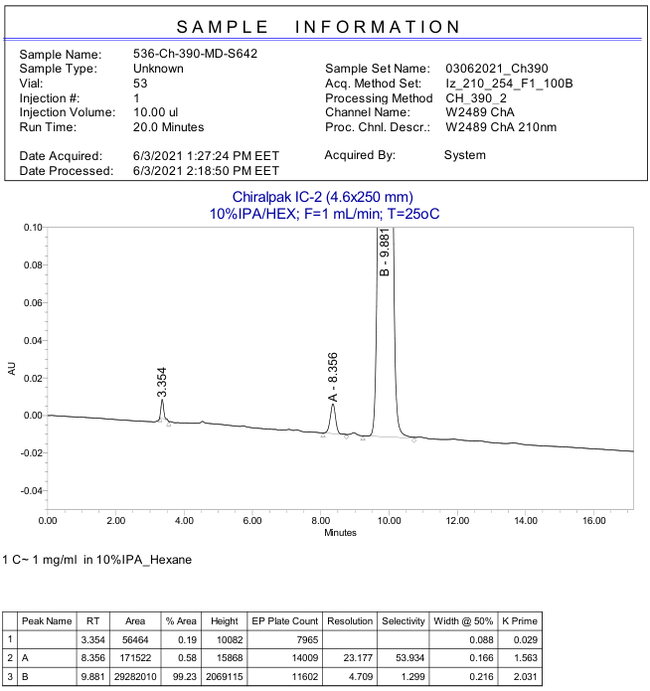

Chiral HPLC analysis of R-6
HPLC (Chiralpak IG, isopropanol/n-hexane = 10/90, flow rate = 1.0 mL/min, l = 210 nm) t_{R} =8.23 min (isomer A), 9.73 min (isomer B)
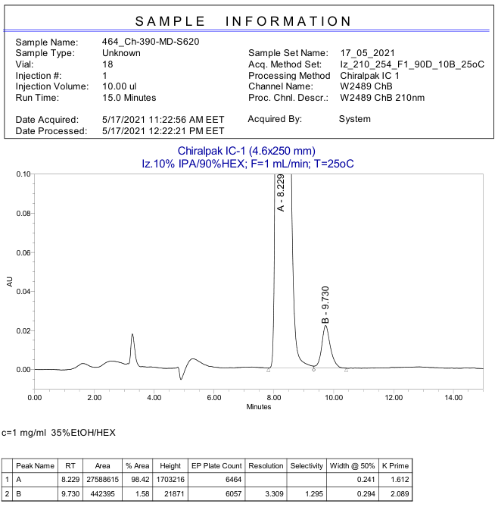

Copies of NMR spectra

Figure 1. ¹H‒NMR of compound S-S1 (CDCl₃, 300 MHz)

Figure 2. ¹H‒NMR of compound S-2d (DMSO-d₆, 400 MHz)

Figure 3. ¹³C{¹H}–NMR of compound S-2d (DMSO-d₆, 101 MHz)

Figure 4. ¹H‒NMR of compound S-3d (CD₃CN, 400 MHz)

Figure 5. ¹³C{¹H}–NMR of compound S-3d (CD₃CN, 101 MHz).

Figure 6. ¹H‒NMR of compound trans-S-5 (CDCl₃, 400 MHz)

Figure 7. ¹³C{¹H}–NMR of compound trans-S-5 (CDCl₃, 101 MHz).

Figure 8. ¹H‒NMR of compound cis-S-5 (CDCl₃, 400 MHz).

Figure 9. ¹³C{¹H}–NMR of compound cis-S-5 (CDCl₃, 101 MHz).

Figure 10. ¹H‒NMR of compound S-6 (CDCl₃, 400 MHz)

Figure 11. ¹³C{¹H}–NMR of compound S-6 (CDCl₃, 101 MHz).

Figure 12. ¹H‒NMR of compound 7 (CD₃CN, 400 MHz).

Figure 13. ¹³C{¹H}–NMR of compound 7 (CD₃CN, 101 MHz).

