**Photochemical synthesis of Silver Nanoprisms via green LEDs irradiation and evaluation of SERS activity**

Tuan Anh Mai-Ngoc1*, Nhi Kieu Vo1, Cong Danh Nguyen1, Thi Kim Xuan Nguyen1 and Thanh Sinh Do1

1Nanotechnology Lab, Research Laboratories of Saigon Hi-Tech Park, Lot I3, N2 Street, Tan Phu Ward, Ho Chi Minh City 70000, Vietnam

Email: [anhmnt.shtplabs@gmail.com](mailto:anhmnt.shtplabs@gmail.com)

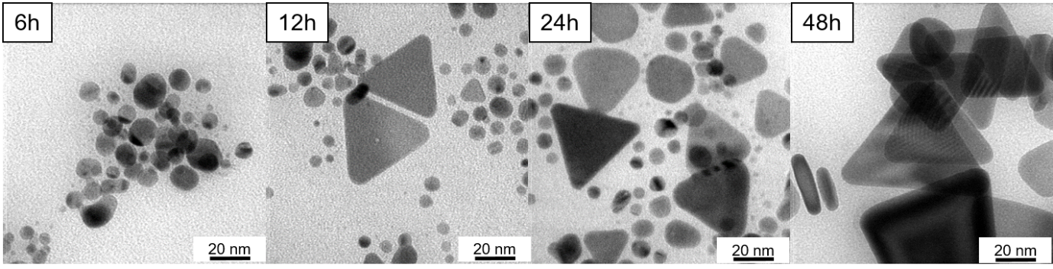

**Figure S1:** TEM images of the samples at a magnification of 200,000 after 6, 12, 24 and 48 hours of LED irradiation.

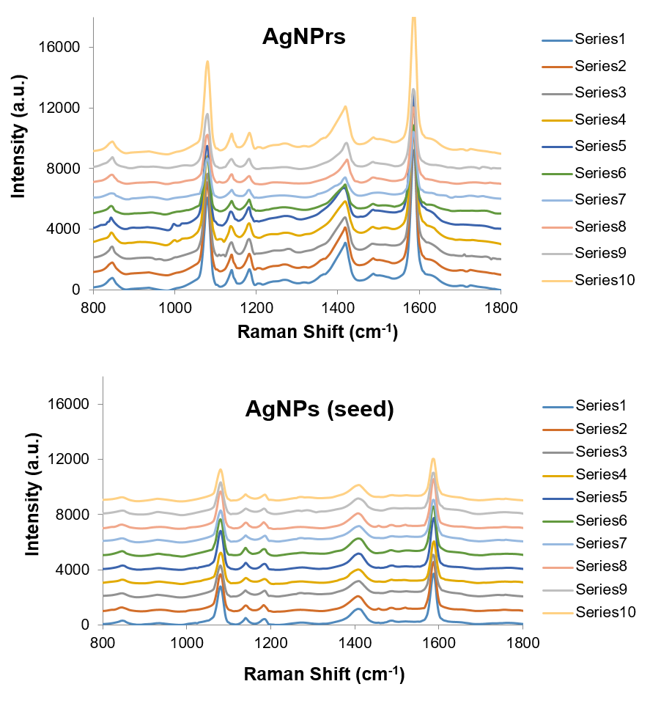

**Figure S2:** SERS spectra of 4-MBA at 10⁻⁵ M, enhanced by (a) AgNPrs and (b) AgNPs, recorded 10 different measurements.

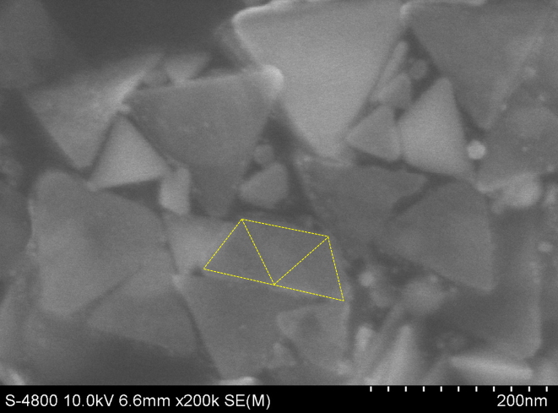

**Figure S3:** FE-SEM image of AgNPrs at 72h LED irradiation: a trapezoid-shaped silver nanoparticles was seen. An additional small AgNPrs is required to assemble an AgNPrs with twice the original size (via mechamism 2 in Figure 6).