SUPPLEMENTARY INFORMATION

Ultrathin water layers on mannosylated gold nanoparticles
Maiara A. Iriarte Alonso, Jorge H. Melillo, Silvina Cerveny, Yujin Tong, and Alexander M. Bittner

S1. Hydrophobic and hydrophilic surfaces by silanization of oxidized silicon wafers

The silanes shown in Figure S1 were employed (procedure see main text) to produce hydrophilic and hydrophobic flat surfaces, respectively.

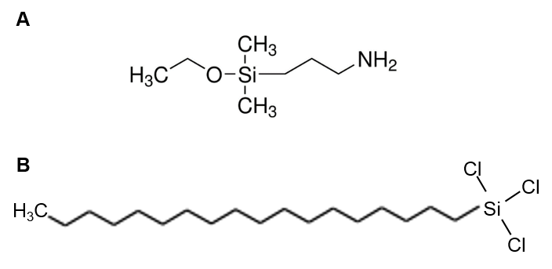

Figure S1: Molecular structures of silanes. (A) 3 (Ethoxydimethylsilyl)propylamine (APDMES). (B) n-Octadecyltrichlorosilane (OTS).

S2. FTIR spectroscopy

We recorded FTIR spectra in dry nitrogen, hence the samples were at humidities well below 5%. Figure S2 shows that the PEG AuNPs show the characteristic absorption bands of PEG, whereas the dimanno-AuNPs show a very different spectrum. In either case, however, it is obvious that an organic shell is present on the AuNPs.
To assign the IR bands, we used experimental spectra of water, mono-, di-, triethylene glycol, methoxy-diethylene glycol, arabinose, glucose [1], and of poly(ethlyene oxide), triethylene glycol dimethyl ether, didecylsulfide, diethylsulfide, decane, ethoxyacetic acid, acetic acid, Ag-, Na-, K-acetate, diethylthiourea, L-mannose [2]. We furthermore employed simple simulations (based on semiempirical quantum mechanics) of gas phase IR spectra of water and parts of our ligands (dimannose, triethylene glycol, HO(CH₂CH₂O)₃CH₂COOH, HS(CH₂)₁₀(OCH₂CH₂)₂OH, HO(CH₂CH₂O)₂CH₂CH₂NHCSNHCH₂CH₂OH) to clear up doubtful assignments [3]. We cross-checked the simulations with gas phase spectra of water and triethylene glycol [4]. We also employed [5-7].
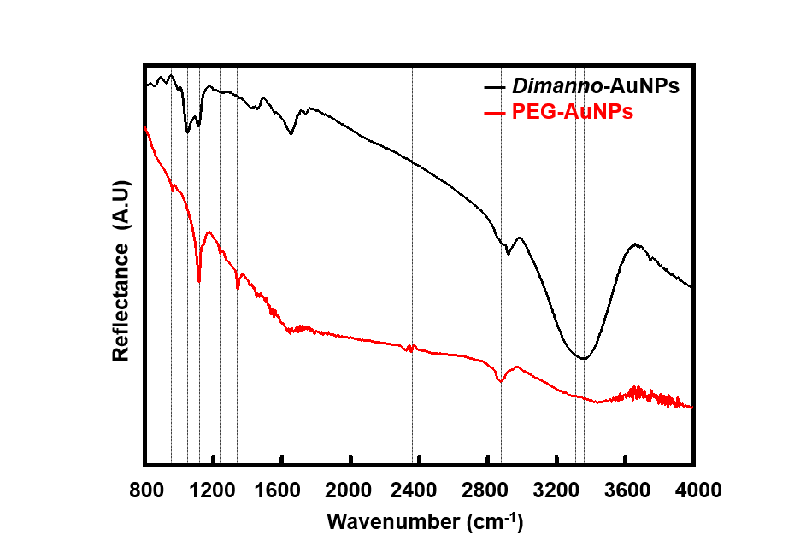
Figure S2: Infrared spectra of dimanno-AuNPs and PEG AuNPs achieved by FTIR in grazing incidence on gold surface, normalized to pure gold, without background correction. Black line represents the infrared spectra of dimanno-AuNPs; red line represents the infrared spectra of PEG AuNPs. The vertical lines indicate the characteristic peaks.

PEG-Au-NPs: The band at 950 cm⁻¹ is well resolved. Its origin is hard to elucidate, and we propose a disordered EG chain (smaller cyclic EGs show this complex band). The strongest band at 1110 cm⁻¹, based on asymmetric C-O-C stretching, appears only as a shoulder. The signal at 1260 cm⁻¹ can be assigned to the very strong C-O stretching in COOH (protonated carboxylate), although there are rather few COOH groups. The remainder of the fingerprint region is masked by H₂O (apparent as "noise" from 1350 to 2150 cm⁻¹) and CO₂ (2350 cm⁻¹) traces in the gas phase. The second strongest band at 2880 cm⁻¹ is based on C-H stretching in the CH₂ groups. This band has a substructure, based on symmetric and asymmetric stretching, which is usually not resolved in EGs. There is no trace of OH groups, which are sometimes present due to unwanted hydrolysis (O-H stretching at ~3500 cm⁻¹), or from adsorbed water (H-O-H bending at 1640 cm⁻¹). These very broad bands are found in liquid water, but also in impure or not completely dried compounds. A good example is triethylene glycol dimethyl ether (1,2-bis (2-methoxyethoxy) ethane).

Dimanno-Au-NPs: Although the same alkyl-PEG derivate chains must contribute, the alkyl-PEG-thiourea-dimannose shell totally dominates. This already follows from the main feature of the spectrum, a very broad and extremely intense feature of two overlapping bands at 3250 cm⁻¹ and 3400 cm⁻¹, which stems from O-H stretching vibrations (the contribution from N-H can only be from the thiourea group and must be much smaller than that from O-H). While adsorbed or absorbed water can also contribute here, this feature is assigned to the dimannoside OH groups. The band at 3700 cm⁻¹ is from free (not hydrogen-bonded) OH groups. The band at 1050 cm⁻¹ cannot easily be assigned (it contains C-O stretchings), but regularly occurs in sugars, while 1120 cm⁻¹ is again from C-O-C stretching. This low-energy fingerprint region is thus based on PEG and alkyl chains, present everywhere on the NP surface. It is furthermore noteworthy that the thiourea group does not result in any strong bands (expected at 1500 cm⁻¹ and 1550 cm⁻¹, as deduced from dialkyl thiourea spectra and simulations. Water is responsible for 1650 cm⁻¹, assigned to H-O-H bending from adsorbed or absorbed molecules. Because we can exclude this on the pure alkyl PEG shell (see above), we assign these water molecules to the dimannose residues. Indeed, sugars are very difficult to dry completely, such that this band is easily found in many carbohydrates. The spectrum shows again a band from CO₂ in the gas phase (2350 cm⁻¹). The C-H stretching region is rather different from that of the PEG-Au-NPs, though, with two bands at 2850 cm⁻¹ (symmetric C-H) and 2920 cm⁻¹ (asymmetric C-H). These positions are typical for alkyl chains but are also found in carbohydrates.

The main differences are thus found in the O-H stretching region (3000-3500 cm⁻¹), from which we can deduce a larger concentration of OH groups in dimanno-AuNPs.

S3. AFM amplitude-distance curves

We verified that the AC (“noncontact”) AFM amplitude decreases linearly from large distances (tens of nm, quasi zero force) to zero when the surface is hit (Figure S3). A monotonous (here even linear) decrease is important to allow for scanning the surface of liquids.

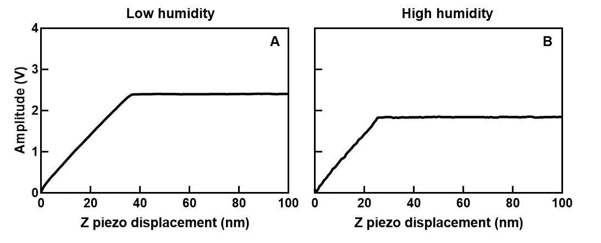
Figure S3: AFM amplitude versus z piezo displacement under hydrophilic conditions, (A) obtained at low humidity (~15 % RH) (setpoint 2.2 V, drive amplitude 1.2 %), (B) obtained at high humidity (~95 % RH) (setpoint 1.9 V, drive amplitude 6 %). In both cases, the free amplitude (A0) was 4 V.
S4. AFM scan profiles for selected particles

Figure S4 shows additional data, which follow Figure 7 (main text).

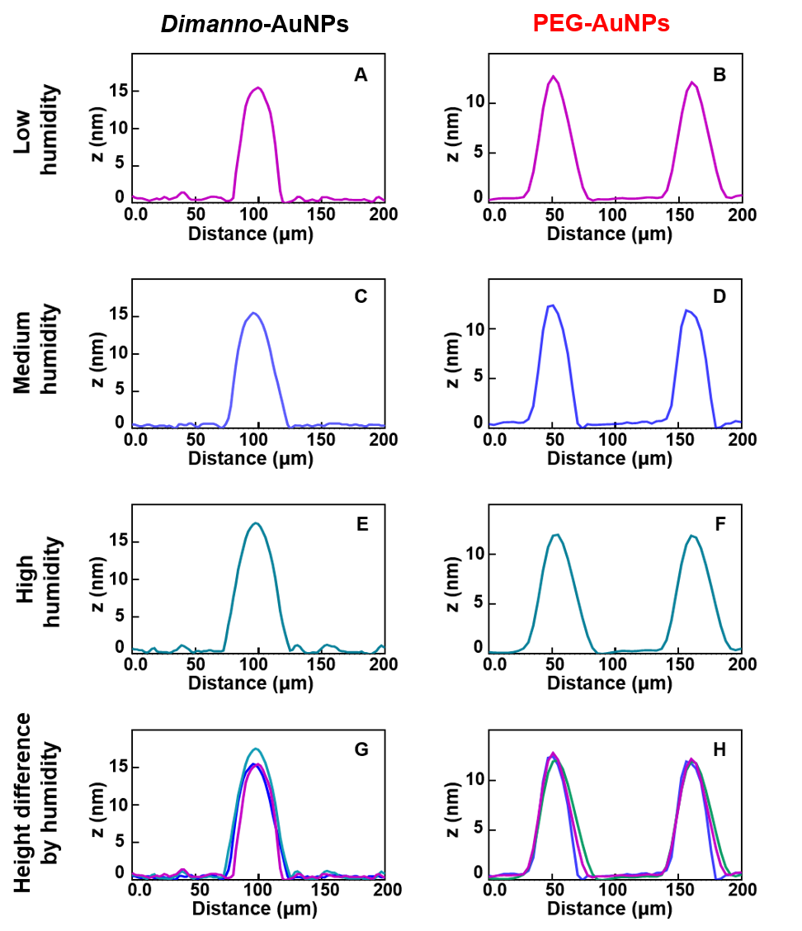
Figure S4. Representative AFM topography height profiles for Figure 7. (A and B) Height profiles of the samples at low humidity (~15 % RH), extracted from the horizontal lines of (A and B) in Figure 7, respectively. (C and D) Height profiles of the samples at medium humidity (~50 % RH) extracted from the horizontal lines of (C and D) in Figure 7, respectively. (E and F) Height profiles of the samples at high humidity ((~95 % RH) extracted from the horizontal lines of (E and F) in Figure 7, respectively. (G and H) Comparison of the scanned particles at low humidity (magenta) medium humidity (blue) and high humidity (dark cyan).

S5. AFM experiments in air humidified with D₂O

Figure S5 shows data obtained in D₂O atmosphere to verify that the system is geometrically identical the the one investigated in H₂O vapour.

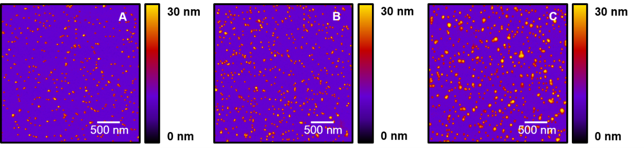
Figure S5. Representative AFM topography images of dimanno-AuNPs on gold obtained at variable humidity. (A) Particles scanned at low humidity. (B) Particles scanned at medium humidity. (C) Particles scanned at high humidity. Note that the humidity set up at medium and high humidity was achieved by using a stream of air/D₂O.

S6. Mann-Whitney test of z max.

We tested the reliability of our results with a nonparametric Mann-Whitney test, presented in Figure S6, which compares the AFM height distribution in terms of z max., for low and high humidity, independently for the dimanno-AuNPs and for the PEG-AuNPs. The statistical analysis for the dimanno-AuNPs on hydrophilic and hydrophobic conditions and experiments with deuterated water show no significant differences in sample distribution at both low (p = 0.46) and high humidity (p = 0.06). In contrast, the z max. achieved on PEG-AuNPs depend on the scanning conditions. Non-significant differences in height distribution are found at low humidity (p = 0.51), but significant differences are found when comparing the hydrophilic and hydrophobic conditions at high humidity (p < 0.0001).
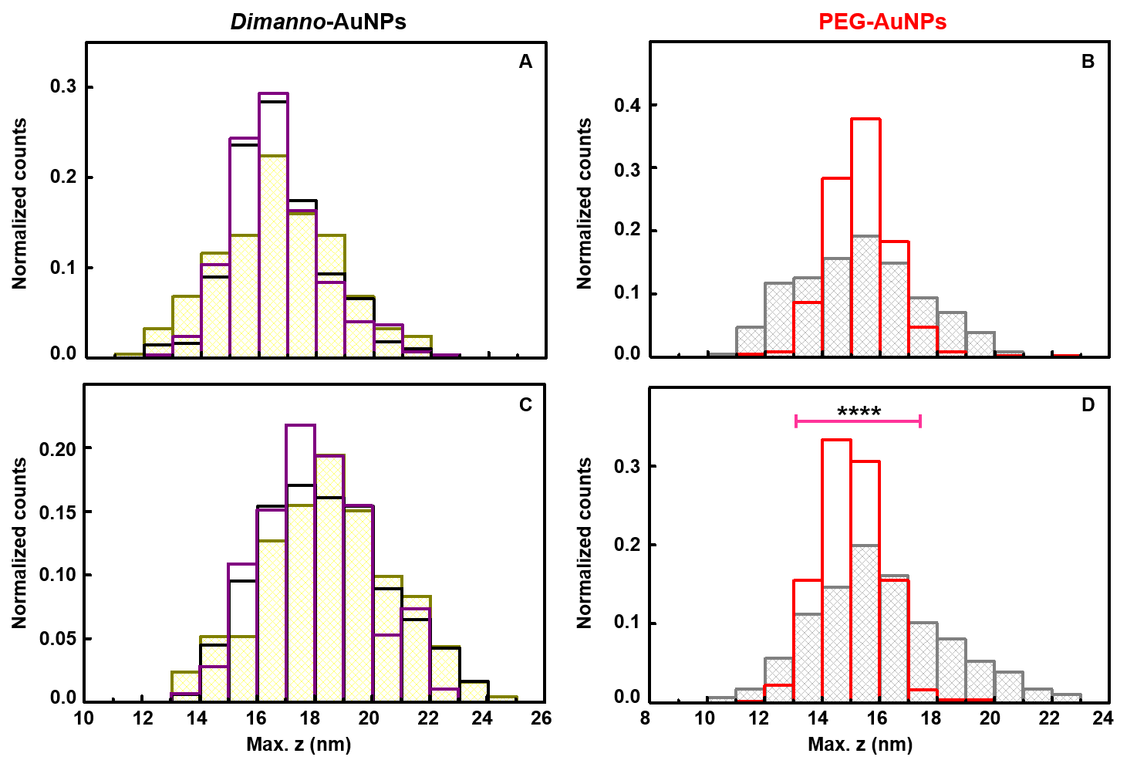
Figure S6. AFM height histograms (z max.) of individual dimanno-AuNPs and PEG-AuNPs achieved at low and high humidity. (A) Dimanno-AuNPs at low humidity. (B) PEG-AuNPs at low humidity. (C) Dimanno-AuNPs at high humidity. (D) PEG-AuNPs at high humidity. Yellow bars; measurements performed on gold. Purple and grey bars; measurements performed on hydrophobic conditions. Black and red bars; measurements performed on hydrophilic conditions. The pink horizontal line in (D) refers to a meaningful increase in z max. of the particles scanned on hydrophobic conditions with respect to the hydrophilic conditions (****p <0.0001). Note that the counts are normalized.

References

[1] B. Schrader, Raman/infrared atlas of organic compounds, 2nd ed., VCH, Weinheim 1989
[2] Database National Institute of Advanced Industrial Science and Technology, AIST, https://sdbs.db.aist.go.jp, last access 16.3.2025
[3] https://www.cheminfo.org/flavor/biooriented/IR/IR_spectra_prediction/index.html, last access 16.3.2025
[4] Database National Institute of Science, chemistry webbook, https://doi.org/10.18434/T4D303, last access 16.3.2025
[5] W. Reusch, S. Farmer, Spectroscopy of Carboxylic Acids, Libretexts Chemistry (2020) 21.3. https://chem.libretexts.org/@go/page/45921
(accessed 15 April 2023)
[6] H.A. Wells, R.H. Atalla, An investigation of the vibrational spectra of glucose, galactose and mannose, J. Mol. Struct. 224 (1990) 385–424, https://doi.org/10.1016/0022-2860(90)87031-R
[7] J.G.G. Daimay Lin-Vien, Norman B. Colthup, William G. Fateley, The Handbook of Infrared and Raman Characteristic Frequencies of Organic Molecules, Elsevier, 1991

