Supporting Information

# Improving magnetic properties of Mn and Zn doped core-shell iron oxide nanoparticles by tuning their size

Dounia Louaguef 1, Ghouti Medjahdi1, Sébastien Diliberto1, Klaus M. Seemann1, Thomas Gries1, Joelle Bizeau2, Damien Mertz2, Eric Gaffet1 and Halima Alem*1

1 Université de Lorraine. CNRS. IJL, F54011 Nancy. France

2 Institut de physique et de chimie des matériaux. UMR 7504 CNRS – Université de Strasbourg. France

* corresponding author: halima.alem@univ-lorraine.fr

1. **X- ray diffraction analysis**

XRD investigations reveals the structural characterization of the NPs.X-ray patterns of Zn0.4Fe2,6O4 NPs before and after annealing at 300°C and 700°C are shown in **Figure SI 1**. The annealing of the nanoparticles at these temperatures was an essential step to eliminate the excess of oleic acid to distinguish the Bragg peaks.



**Figure SI 1 .** XRD patterns of the as-prepared Zn0.4Fe2,6O4 NPs at 300°C (Cu kalpha wavelength).

The X-ray diffractograms of the NPs annealed at 300°C (b) show the iron oxide phases of the NPs. They can represent either magnetite (Fe2O3) or maghemite (γ-Fe2O3), because of the similarity of their XRD patterns, it is impossible to make the difference between the Fe3-δO4 magnetite phase from the maghemite phase with the X-Ray analysis36,38. To precise the right phase, the NPs were analyzed by Mössbauer spectroscopy in the next step, we have also compared to the as prepared nanoparticles (**Figure 2)**.

**b- M**ö**ssbauer spectroscopy:**

Mössbauer spectroscopy analysis were performed to determine the NPs phase. The obtained MS spectra of the as-prepared NPs and those annealed at 300 and 700°C are shown in (**Figure 2)**. Their hyperfine parameters are listed in **Table 2**.

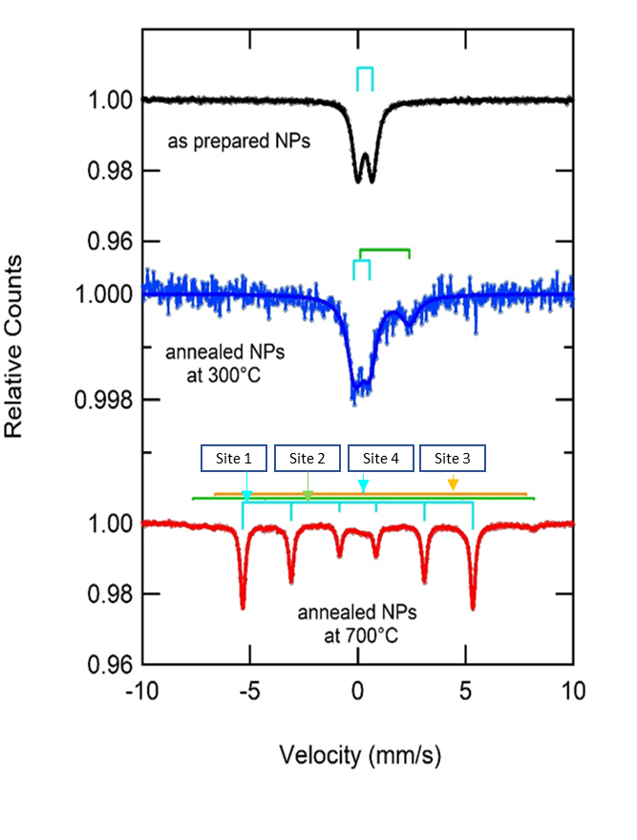

**Figure 2 .**  Mössbauer spectra of the as-prepared Zn0.4Fe2,6O4 NPs (a), annealed NPs at 300°C (b), and at 700°C (c).

The as-prepared NPs Mössbauer (**spectrum (a), figure 2**) represents one pure doublet which corresponds to the superparamagnetic Fe3O4 NPs (Iron in oxidation state III). The presence of Fe3+ is also shown in spectrum (**spectrum(b),figure** **2**) which corresponds to NPs annealed at 300°C with a percentage of 65% and the remaining 35% represent Fe2+. On the other hand, the well-defined sextet obtained from the annealed NPs at 700°C (**spectrum (c), figure 2**) (line width 0.50mm/s) is attributed to Fe metal. The site 1 of this spectrum corresponds to Fe0 and the percentage of this phase is 85%, the sites 2 and 3 correspond to magnetite with a percentage of 8%, finally the site 4 is attributed to 7% of superparamagnetic NPs (**see Table 1**).

**Table 1.** The hyperfine parameters of the as-prepared NPs and those annealed at 300 and 700°C obtained from Mössbauer analysis.

|  |  |  |  |  |  |  |
| --- | --- | --- | --- | --- | --- | --- |
| T (°C) | Component (sites) | IS (mm/s) | EQ (mm/s) | B(T) | Phase | Mass(%) |
| As Prepared NPs | 1 | 0.33 | 0.69 | - | Fe III | - |
| 300°C | 1 | 0.19 | 0.74 | - | Fe III | 65 |
|  | 2 | 1.24 | 2.28 | - | Fe II | 35 |
| 700°C | 1 | 0 | 0 | 33.1 | Fe0 | 85 |
|  | 2 | 0.29 | 0 | 49 | Fe3- δO4 | 8 |
|  | 3 | 0.62 | 0 | 46 |  |  |
|  | 4 | 0.25 | 0 | _ | Fe III | 7 |