# Supporting Information

# Heat-induced transformation of nickel-coated polycrystalline diamond film studied in situ by XPS and NEXAFS

O. V. Sedelnikova*‡1, Y. V. Fedoseeva‡1, D. V. Gorodetskiy1, Y. N. Palyanov,2 E.V. Shlyakhova,1 E. A. Maksimovskiy,1 A. A. Makarova§3, L. G. Bulusheva,1 and A. V. Okotrub1

Address: 1Nikolaev Institute of Inorganic Chemistry, SB RAS, 630090 Novosibirsk, Russia; 2Sobolev Institute of Geology and Mineralogy SB RAS, 630090 Novosibirsk, Russia, and 3Physical Chemistry, Institute of Chemistry and Biochemistry, Free University of Berlin, 14195 Berlin, Germany

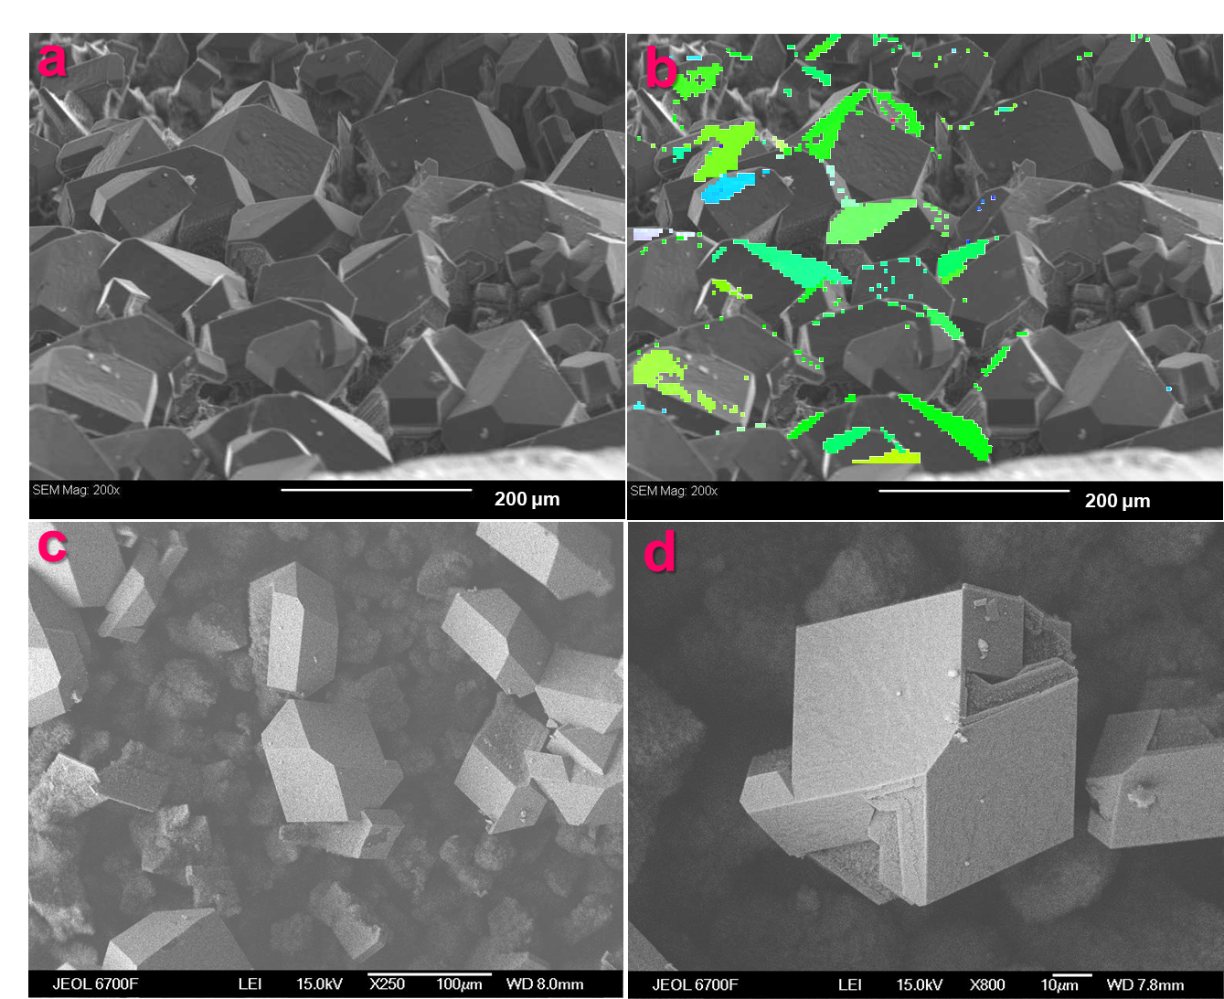

**Figure S1:** Scanning electron microscopy (SEM) images of the surface of initial polycrystalline diamond (PCD) film (a-c). Image a with an overlay of the grain orientation map in the colours of the reverse pole figure obtained by electron backscattered diffraction (EBSD) (b). In panel (b) grains with (110) and (111) orientations are shown in green and blue. SEM image of micro-sized crystallites covered with Ni (d)



**Figure S2:** Raman spectrum of as-grown PCD film.

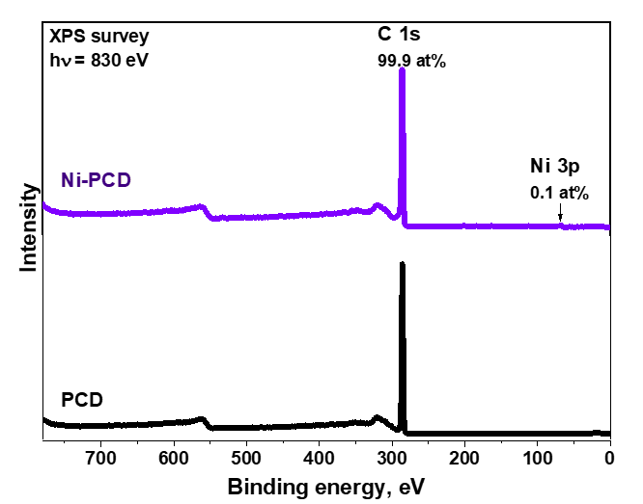

**Figure S3:** XPS survey spectra of PCD and N-PCD films after annealing in high vacuum at 1100 °C for 15 min. The spectra were measured at an excitation photon energy of 830 eV.

D:\Оля\Оля\результаты\Проекты\РНФ-22-diamond\3\статьи\diamond with Ni\BJNANO\optic-ramam-sm.tif

**Figure S4:** Optical images of PCD (a) and Ni-PCD (b, c) films after annealing in high vacuum at 1100 °C for 15 min. Raman spectra of annealed Ni-PCD (d) films recorded from the areas shown in panels (b, c) by red ovals.



**Figure S5:** Raman spectrum of the Ni-PCD film after annealing in high vacuum at 1100 °C for 15 min. The spectra were measured at out-of-focus sample region.

**Table S1:** Summary on the absorption coefficients (α) of graphite measured at different methods at 532 nm [1]. The probing depth of Raman measurements (d) of graphite-like materials can be estimated as follows: d=1/2α.

|  |  |  |  |
| --- | --- | --- | --- |
| 532 nm | Photoacoustic | Ablation | Ellipsometry |
| Absorption coefficient (α, 1/μm) | 7.7 | 4.7 | 5.5 |
| Probing depth (d, nm) | 64 | 110 | 91 |

1. T. Smausz, et al., Determination of UV–visible–NIR absorption coefficient of graphite bulk using direct and indirect methods, Appl. Phys. A (2017) 123:633, DOI 10.1007/s00339-017-1249-y.



**Figure S6:** Raman spectra of bare and Ni-coated (110) face of single-crystal diamond after annealing in high vacuum at 1150 °C for 15 min.