# *Supporting Information*

# A calix[4]arene-based supramolecular nanoassembly targeting cancer cells and triggering the release of nitric oxide with green light

Cristina Parisi,‡1 Loredana Ferreri,‡2 Tassia J. Martins,‡1 Francesca Laneri,1 Samantha Sollima,1 Antonina Azzolina,3 Antonella Cusimano,3 Nicola D’Antona,2 Grazia M. L. Consoli*2 and Salvatore Sortino*1

1Department of Drug and Health Sciences, University of Catania, I-95125 Catania, Italy;

2Istituto di Chimica Biomolecolare, C.N.R., I-95126 Catania, Italy.

3Institute for Biomedical Research and Innovation, National Research Council (CNR), I-90146 Palermo, Italy.

Email: [grazia.consoli@icb.cnr.it](mailto:grazia.consoli@icb.cnr.it); [ssortino@unict.it](mailto:ssortino@unict.it)

*Corresponding authors

‡Equal contributors

**Synthesis of 5,11,17,23-tetra-amino-25,26,27-tripropoxy-28-propoxy-ABF-calix[4]arene (1a)** was performed by a multistep procedure reported in the literature [S1], with the variation that the upper rim Boc amino protection was removed using TFA rather than HCl gas.

**Synthesis of 5,11,17,23-tetra-amidochloromethyl-25,26,27-tripropoxy-28-propoxy-ABF-calix[4]arene (1b)**

Compound **1b** was prepared by adapting a procedure reported in literature [S2]. To a solution of compound **1a** (165 mg, 0.20 mmol) in CH2Cl2 (2.5 mL), triethylamine (110 µL, 0.76 mmol) and chloroacetic acid (44 µL, 0.76 mmol) were added dropwise. The reaction mixture was stirred at room temperature for 1 hour. The organic phase was washed with 0.5 N HCl and water. The organic solvent was removed under vacuum and the crude product was purified by column chromatography on neutral alumina by using ethyl acetate as eluent, and pure compound **1b** was obtained as an orange powder (50 mg, 0.044 mmol, 22 % yield). 1H NMR (400.13 MHz, CDCl3): δ 0.93 (t, OCH2CH2*CH3*, 3H, *J* = 7.2 Hz), 0.96 (t, 2 × OCH2CH2*CH3*, 6H, *J* = 7.2 Hz), 1.86 (m, 2 × OCH2C*H2*CH3, 6H, *J* = 7.2 Hz), 2.41 (m, OCH2C*H2*CH2N, 2H), 3.17 (d, ArC*H2*Ar, 2H, *J* = 12.8 Hz), 3.19 (d, ArC*H2*Ar, 2H, *J* = 12.8 Hz), 3.64 (m, OCH2CH2C*H2*N, 2H, *J* = 6.1 Hz), 3.76, 3.80, 3.86 (t, OC*H2*CH2CH3,2H each), 4.09 and 4.13 (s, CH2Cl, 4H each), 4.11 (t, O*CH2*CH2CH2N, 2H), 4.36 (d, ArC*H2*Ar, 2H, *J* = 13.2 Hz), 4.41 (d, ArC*H2*Ar,2H, *J* = 13.2 Hz), 6.14 (d, ArH-NBD, 1H, d, *J* = 8.4 Hz), 6.29 (m, NH-NBD, 1H), 6.70 and 6.94 (d, ArH, 4H each), 7.99, 8.10, 8.16 (s, ArNH, 2H, 1H, 1H, respectively), 8.49 (d, ArH-NBD,1H, *J* = 8.4 Hz). 13C NMR (100.61 MHz, CDCl3): δ 10.4, 23.1, 23.3, 29.2, 31.1, 31.2, 41.3, 42.9, 60.4, 71.5, 98.6, 121.3, 121.7, 124.6, 130.7, 131.2, 134.3, 134.8, 135.3,135.5, 136.2, 143.5, 143.8, 144.3, 153.6, 154.2, 163.9, 164.0.

**Synthesis of 5,11,17,23-Tetra-amidomethyl-dimethyl-ethanolamine-25,26,27-tripropoxy-28-propoxyABF-calix[4]arene (1)**

To a solution of compound **1b** (22.6 mg, 0.0198 mmol) in THF (371 µL), *N,N*-dimethylethanolamine (9.2 µL, 0.092 mmol) dissolved in THF (92 µL) was added. The reaction mixture was refluxed under stirring for 24 hours. After cooling, the precipitate formed was recovered by centrifugation and washed more time with THF (two times) and CH3CN (4 times). The orange powder was dried under vacuum to give pure compound **1** as an orange powder (29 mg, 0.02 mmol, 98% yield).

1H NMR (400.13 MHz, MeOD): δ 0.97 (t, OCH2CH2*CH3*, 3H, *J* = 7.2 Hz), 1.00 (t, 2 × OCH2CH2*CH3*,6H, *J* = 7.2 Hz), 1.92 (m, 2 × OCH2C*H2*CH3, 4H, *J* = 7.2 Hz), 1.94 (m, OCH2C*H2*CH3, 2H, *J* = 7.2 Hz), 2.42 (m, OCH2C*H2*CH2N, 2H), 3.13 (d, ArC*H2*Ar, 2H, *J* = 13.3 Hz), 3.15 (d, ArC*H2*Ar, 2H, *J* = 13.3 Hz,), 3.41 (s, 2 × N(CH3)2, 12H), 3.43 (s, N(CH3)2, 6H), 3.45 (s, N(CH3)2, 6H), 3.71-3.77 (m, overlapped, N*CH2*CH2OH, OCH2CH2C*H2*N, 8H and 2H, respectively), 3.81(t, 2 × O*CH2*CH2CH3, 6H, *J* = 7.24), 3.91 (t, O*CH2*CH2CH3, 2H, *J* = 6.4), 3.98-4.10 (m, NCH2*CH2*OH, 8H), 4.23 (t, O*CH2*CH2CH2N, 2H), 4.32 and 4.36 (s, NHCO*CH2*N, 8H), 4.33 (d, ArC*H2*Ar, 2H, *J* = 13.2 Hz), 4.46 (d, ArC*H2*Ar, 2H, *J* = 13.2 Hz), 6.21 (d, ArH-NBD, 1H, *J* = 7.2 Hz), 6.79 (d, ArH, 2H), 6.82 (d, ArH, 2H), 6.96 (s, ArH, 2H), 7.05 (s, ArH, 2H), 8.48 (d, ArH-ND,1H, *J* = 7.2 Hz). 13C NMR (100.61 MHz, MeOD): δ 11.5, 11.7, 25.2, 25.3, 32.9, 33.1, 53.8, 54.7, 57.9, 65.6, 67.2, 68.7, 74.1, 78.9, 79.3, 101.0, 122.9, 124.1, 133.4, 133.7, 133.8, 136.6, 136.8, 137.5, 137.6, 139.2, 146.7, 155.8, 163.8.

**Synthesis of N-butyl-4-nitro-3-(trifluoromethyl)aniline (2b).**

To a solution of butylamine (350 mg, 4.8 mmol) and potassium carbonate K2CO3 (663 mg, 4.8 mmol) in acetonitrile (CH3CN, 10 mL), 5-fluoro-2nitrobenzotrifluoride **2a** (500 mg, 2.4 mmol) was added. The reaction mixture was stirred at room temperature for 24 hours. Then, the solvent was evaporated under reduced pressure and the crude product was purified by flash chromatography eluting with Cyclohexane/Ethyl Acetate (Cy/ EtOAc, 9/1 v/v) to give compound **2b** as a yellow solid (428 mg, 68%). 1H NMR (500 MHz, CDCl3): δ 0.98 (t, J = 7.4 Hz, 4H),1.45 (m, J = 14.7, 7.4 Hz, 3H), 1.59 – 1.72 (m, 3H), 3.22 (t, J = 7.2 Hz, 3H), 6.66 (d, J = 9.1, 2.6 Hz, 1H), 6.89 (s, J = 2.7 Hz, 1H), 8.01 (d, J = 9.1 Hz, 1H).

**Synthesis of N-butyl-N-(4-nitro-3-(trifluoromethyl)phenyl)nitrous amide (2).**

To a solution of compound **2b** (0.58 mmol, 150 mg) in THF/CH3COOH (2/1 v/v; 3 mL) cooled at 0 °C with an ice bath, sodium nitrite (NaNO₂, 2.32 mmol, 160 mg) was added; the reaction mixture was stirred at 0 °C for 1 h and then at room temperature overnight. The crude mixture was diluted with dichloromethane (DCM, 10 mL) and washed with water (3 × 10 mL), dried over Na2SO4 and concentrated to dryness. Purification of the residue by flash chromatography, using Cy/EtOAc (95/5 v/v) as the eluent, gave compound **2** as a pale yellow oil (100 mg, 60 %). 1H NMR (500 MHz, CDCl3): δ 0.96 (t, J = 7.3, 1.5 Hz, 2H) , 1.35 (m, J = 7.4, 1.5 Hz, 1H), 1.53 (m, J = 7.4, 1.4 Hz, 1H), 4.06 (t, J = 7.6, 1.5 Hz, 1H), 7.88 (d, J = 9.1, 1.9 Hz, 1H), 8.13 – 8.08 (m, 1H).

S1. R. Lalor, H. Baillie-Johnson, C. Redshaw, S. E. Matthews, A. Mueller. J. Am. Chem. Soc. 2008, *130*, 2892.

S2. D. M. Rudkevich, W. Verboom, D. N. Reinhoudt. J. Org. Chem. 1994, 59, 3683.

**Figure S1**. 1H-NMR spectrum of compound **1b** (400.13 MHz, 25 °C, CDCl3).

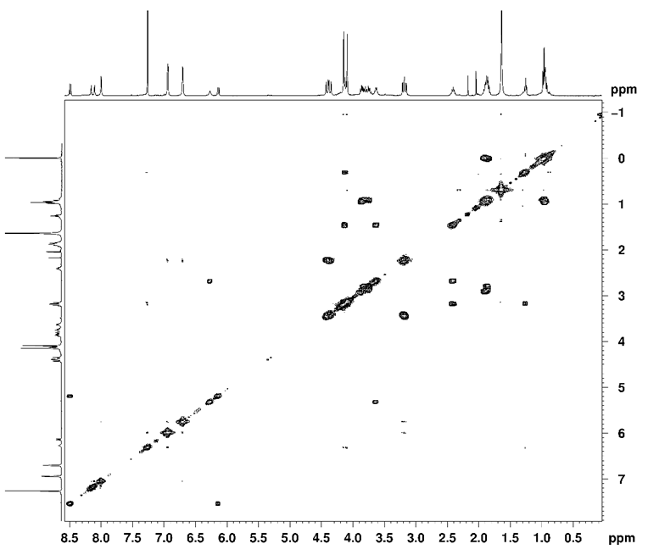

**Figure S2**. 2D-COSY NMR spectrum of compound **1b** (400.13 MHz, 25 °C, CDCl3).

**Figure S3.** 13C-NMR spectrum of compound **1b** (100.61 MHz, 25 °C, CDCl3).

**Figure S4.** 1H-NMR spectrum of compound **1** (400.13 MHz, 25 °C, MeOD).

**Figure S5.** 13C-NMR spectrum of compound **1** (100.61 MHz, 25 °C, MeOD)

**Figure S6**. 2D-HSQC NMR spectrum of compound **1** (400.13 MHz, 25 °C, MeOD).

**Figure S7**. 2D-HSQC NMR spectrum of compound **1** (400.13 MHz, 25 °C, MeOD).

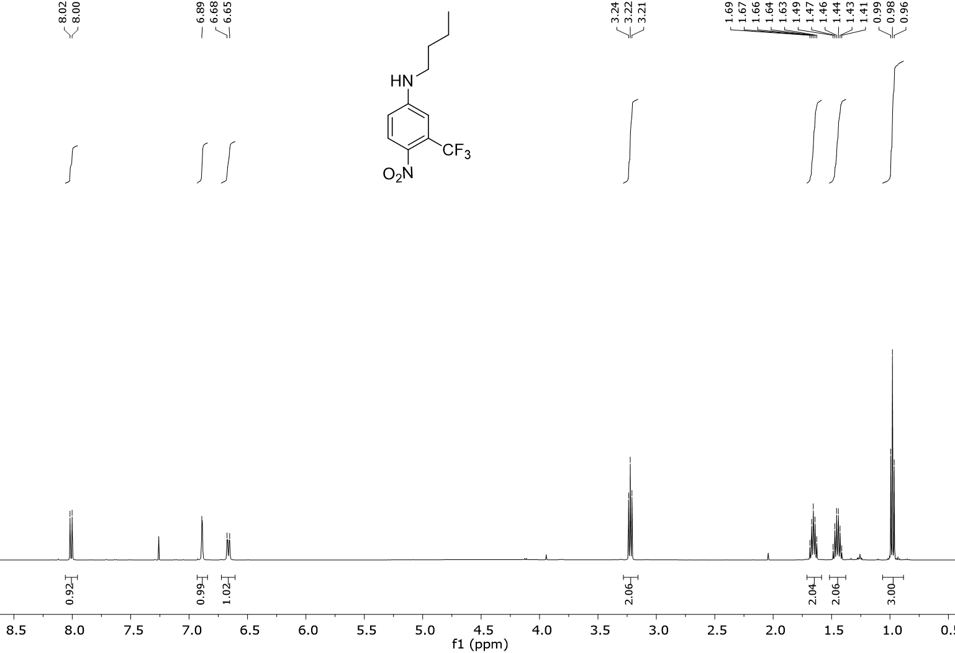

**Figure S8**. 1H NMR spectrum of compound **2b** (500 MHz, 25 °C, CDCl3)

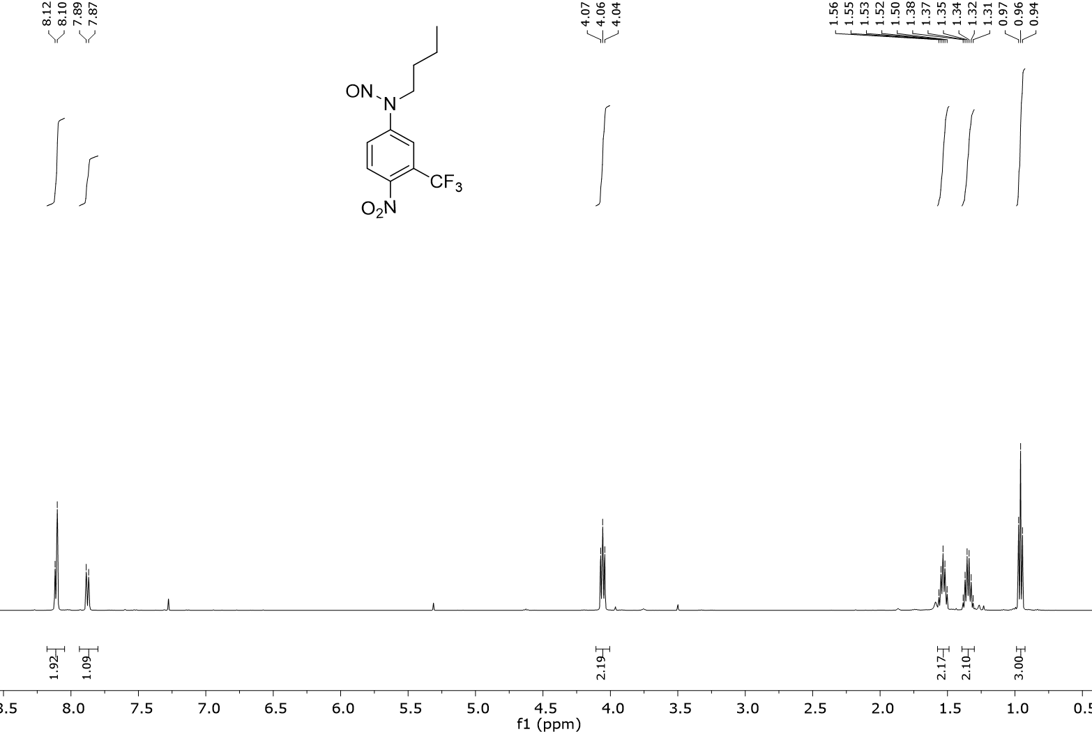

**Figure S9**. 1H NMR spectrum of compound **2** (500 MHz, 25 °C, CDCl3)