Supporting Information
For
Synthesis of deoxypropionates using a combination of enzymatic desymmetrisation and substrate controlled conjugate addition

Guillaume Le Calvez, Martin D. Witte,* and Adriaan J. Minnaard*

Address: Stratingh Institute for Chemistry, University of Groningen, Nijenborgh 7, 9747 AG, Groningen, The Netherlands

Email: Adriaan J. Minnaard – a.j.minnaard@rug.nl, Martin D. Witte – m.d.witte@rug.nl
* Corresponding authors

Detailed experimental procedures and spectral data of all new compounds

Table of contents
General remarks S3
Procedures and spectral data of all new compounds S5
References S32
NMR Spectra of all new compounds S33

General remarks
All moisture sensitive reactions were performed using flame-dried glassware under N₂-atmosphere using standard Schlenk techniques and anhydrous solvents. Reaction temperatures below 0 °C refer to internal temperatures, while reaction temperatures higher than rt refer to heating bath temperatures. Anhydrous solvents (CH₂Cl₂ and THF) were taken from an MBraun solvent purification system (SPS-800). All other reagents were purchased from Sigma-Aldrich, Acros, TCI Europe, Strem chemicals or Fluorochem and used without further purification unless noted otherwise. AK Amano lipase from Pseudomonas fluorescens was supplied by Sigma-Aldrich, CAS: 9001-62-1, cat nr: 534730.

TLC analysis was performed with Merck silica gel 60/Kieselguhr F245, 0.25 mm. Compounds were visualized using either an anisaldehyde stain [EtOH absolute (135 ml), H₂SO₄ (5 ml), AcOH glacial (1.5 ml), p-anisaldehyde (3.7 ml)], dinitrophenylhydrazine (DNP) stain [2,4-dinitrophenylhydrazine (12 g), H₂SO₄ (60 ml), H₂O (80 mL) and EtOH 95% (200 mL)], potassium permanganate stain [K₂CO₃ (40 g), KMnO₄ (6 g), H₂O (600 ml) and 10% NaOH (5 ml)], PMA stain [phosphomolybdic acid (10 g) in ethanol (100 ml)], Seebach stain [phosphomolybdic acid (10 g), cerium (IV) sulfate (4 g), H₂O (376 mL), H₂SO₄ (24 ml)] or elemental iodine.

Flash chromatography was performed using SiliCycle silica gel type SiliaFlash P60 (230-400 mesh) as obtained from Screening Devices.

¹H- and ¹³C-NMR spectra were recorded on an Agilent MR400 (400 and 100.6 MHz, respectively) or a Bruker Avance NEO 600 (600 and 150.9 MHz, respectively). CDCl₃ was used as solvent unless stated otherwise. Chemical shift values are reported in ppm with the solvent resonance as the internal standard (CDCl₃: δ 7.26 for ¹H, δ 77.16 for ¹³C). Data are reported as follows: chemical shifts, multiplicity (s = singlet, d = doublet, dd = double doublet, ddd = double double doublet, dddd = double double double doublet, dqd = double quadruple doublet, brs = broad singlet, m = multiplet), coupling constants J (Hz), and integration.

Enantiomeric excesses were determined by Chiral HPLC analysis using a Shimadzu LC-10ADVP HPLC instrument equipped with a Shimadzu SPD-M10AVP diode-array detector. Integration at three different wavelengths (254, 225, 190 nm) was performed and the reported enantiomeric excess is an average of the three integrations. Retention times (t_{R}) are given in min.

High resolution mass spectra (HRMS) were recorded on a Thermo Scientific LTQ Orbitrap XL mass spectrometer with electron spray ionization (ESI) in positive or negative mode.

Optical rotations were measured on a Schmidt+Haensch polarimeter (Polartronic MH8) with a 10 cm long cell (c given in g/100 mL) at ambient temperature (±20 °C).

GC-FID measurements were made using a Shimadzu GCFID HP 6890 gas chromatograph system bearing an Agilent DB-5ht column (length: 30 m; diameter: 0.25 mm; film thickness: 0.10 μm) and flame ionization detector (FID) detection.

GCMS measurements were made using a Shimadzu GCMS QP2010 gas chromatograph system bearing an Agilent HP-5 column (length: 30 m; diameter: 0.25 mm; film thickness: 0.25 μm) and MS detection.

Procedures and spectral data of all new compounds
(3R,5S)-3,5-dimethyldihydro-2H-pyran-2,6(3H)-dione (6):
cis-2,4-dimethylglutaric anhydride 6 was synthesized using the procedure reported by R. N. Saicic, with a cis : trans ratio = 96:4.[1]
The analytical data are in agreement with previous reports.[2]

(2R,4S)-2,4-dimethylpentane-1,5-diol (7):
To a cooled (0 °C) solution of 6 (28 g, 197 mmol) in anhydrous THF (420 mL), was added portion-wise lithium aluminium hydride (15.7 g, 414 mmol, 2.1 eq) over 45 min. After addition, the reaction mixture was kept at 0 °C for an additional 30 min and subsequently allowed to warm to rt with overnight stirring. TLC indicated complete consumption of the starting material. The reaction was cooled to 0 °C, carefully quenched using a saturated aqueous Rochelle salt solution (400 mL) and diluted with Et₂O (350 mL). The resulting mixture was stirred at rt overnight. The phases were separated and the aqueous layer was extracted with Et₂O (4 x 300 mL). The combined organic phases were washed with brine (600 mL), dried with MgSO₄, filtered, and concentrated under reduced pressure. The crude residue was purified by flash column chromatography (pentane/EtOAc: 3/7) to give the product 7 (25 g, 190 mmol, 96%) as colourless oil.
¹H NMR (400 MHz, CDCl₃) δ 3.47 (dd, J = 10.6, 5.5 Hz, 2H), 3.40 (dd, J = 10.6, 5.8 Hz, 2H), 2.99 (brs, 2H), 1.76 – 1.63 (m, 2H), 1.61 – 1.51 (m, 1H), 0.91 (d, J = 6.8 Hz, 6H), 0.89 – 0.81 (m, 1H).
¹³C NMR (101 MHz, CDCl₃) δ 67.65, 36.99, 33.13, 17.78.
HRMS (ESI+): calculated for C₇H₁₆NaO₂⁺ [M+Na⁺] = 155.104; found: 155.104.
The analytical data are in agreement with previous reports.[3]

(2S,4R)-5-hydroxy-2,4-dimethylpentyl acetate (8):
To a solution of meso-diol 7 (10 g, 76.4 mmol) and vinyl acetate (7.2 mL, 78 mmol, 1.02 eq) in anhydrous THF (215 mL) at rt, was added AK Amano lipase from Pseudomonas fluorescens (505 mg, 5 weight%). The resulting mixture was stirred at rt for 24 h and filtered over a celite pad. The filtrate was dried on MgSO₄, and concentrated under reduced pressure. The crude residue was purified by flash column chromatography (pentane/EtOAc: 7/3) to give 8 (10.7 g, 61.4 mmol, 80% yield, 98% ee) as a colourless oil.

Note: The conversion to the monoacetate was carefully monitored by GC-FID analysis using a Shimadzu GC-FID HP 6890 gas chromatograph system bearing an Agilent DB-5ht column (length: 30 m; diameter: 0.25 mm; film thickness: 0.10 μm) and flame ionization detector (FID). Helium was used as carrier gas with a linear gas flow velocity of 30 cm.s⁻¹. The oven temperature programme was isothermal at 100 °C. Inlet (injection temperature) and interface temperatures were set to 250 °C.

Figure S1: Line chart showing the progress of the enzymatic desymmetrization.

Before HPLC analysis, all monoacetate compounds were benzoylated.
The enantiomeric excess (%ee) was determined by chiral HPLC analysis on a Chiralpak OD-H column, Heptane/i-PrOH: 98/2, 40°C, flow rate: 0.5 mL/min UV detection at 190 nm, 225 nm and 254 nm. Retention times: 12.85 min (minor) and 16.15 min (major)

The scheme below is required to explain the HPLC chromatograms of the syn/anti monoacetate mixture.

Scheme S1: Synthesis of the syn/anti monoacetate mixture using acetic anhydride and pyridine
Monoacetate 3 and 4 are identical, monoacetate 5 and 6 are identical.
Monoacetate 3 and 6 are enantiomers, monoacetate 5 and 4 are enantiomers.

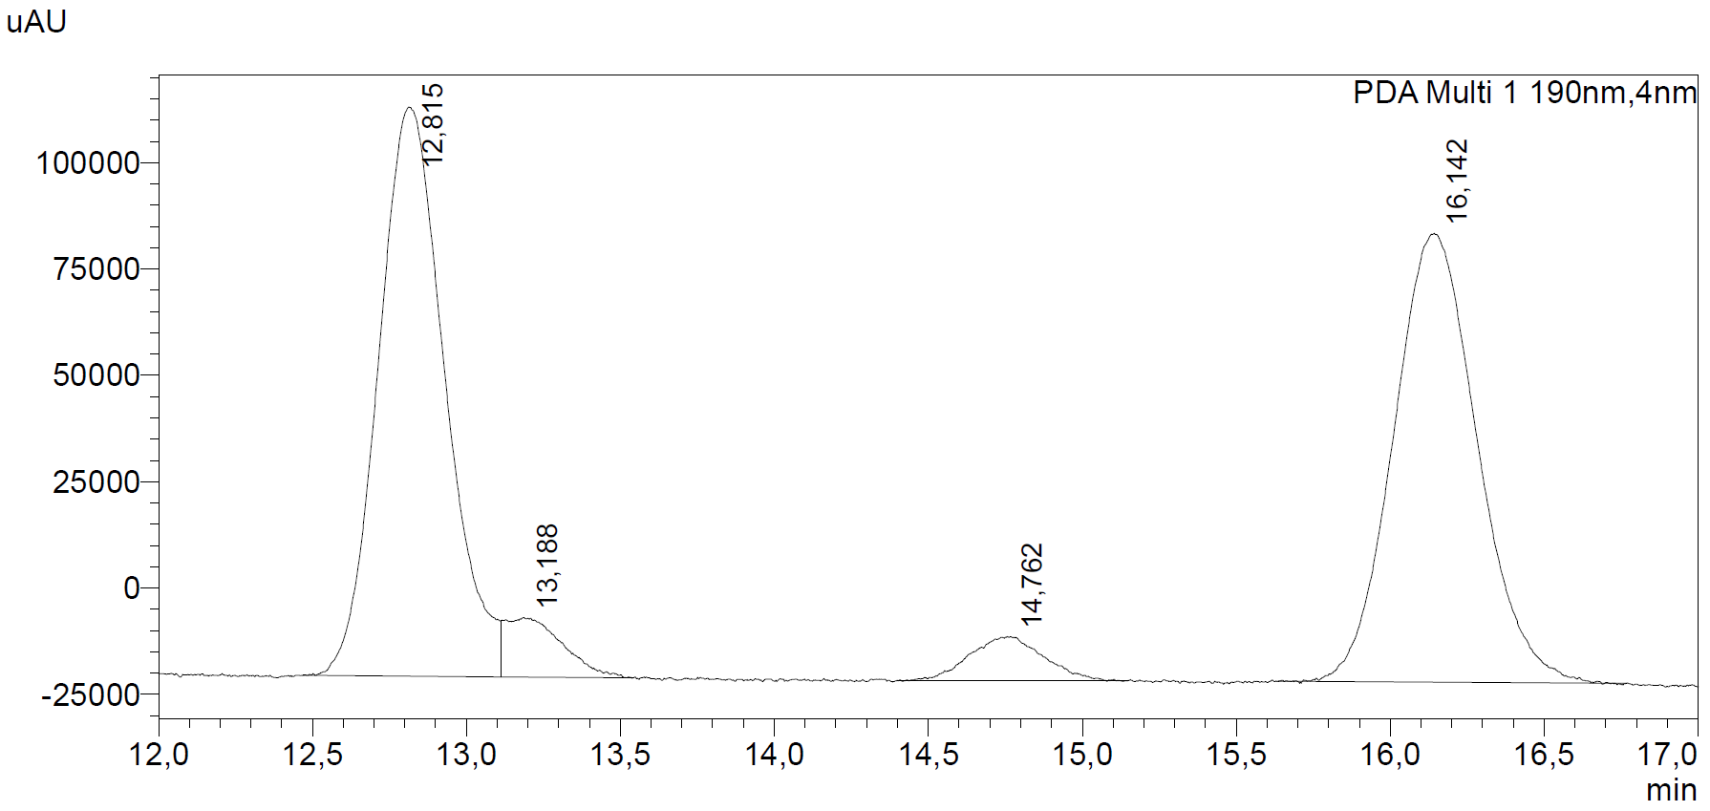
1
6
3
2

Compound 1 and 2 are the syn-monoacetate.
Compound 3 and 6 are the anti-monoacetate.
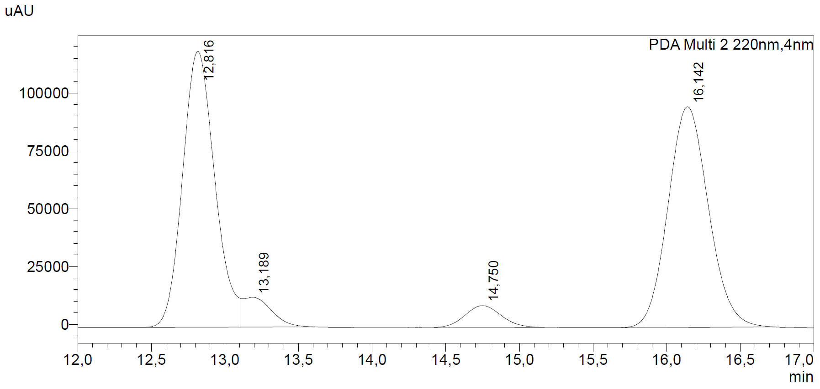
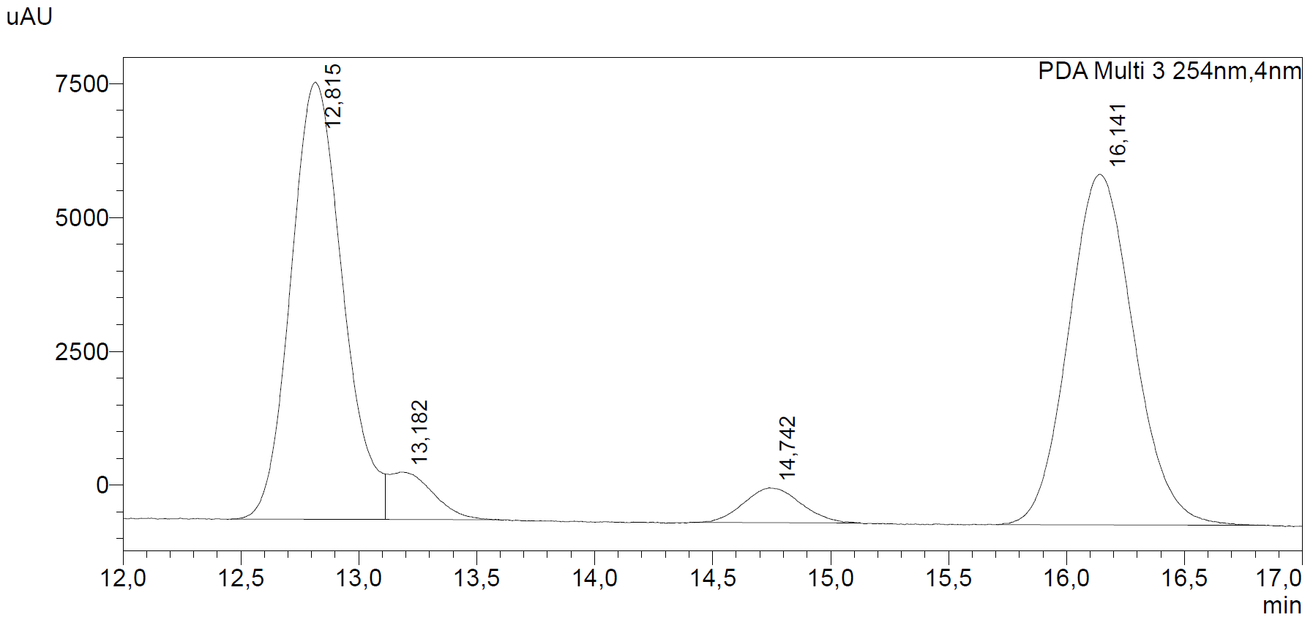
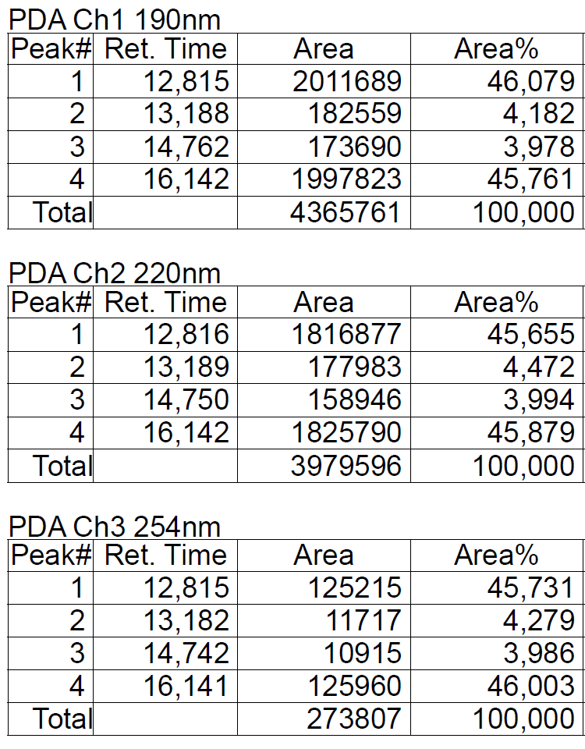
Figure S2: Chromatograms of syn/anti monoacetate mixture at 190, 220 and 254 nm with the table showing retention times, peak area and area%.

Scheme S2: Synthesis of the desired enantiopure monoacetate using AK Amano lipase (from Pseudomonas fluorescens) and vinyl acetate.

AK Amano lipase is pro-S selective. S,S-monoacetate 3 and 4 are identical. The R,R-diol is not acetylated by the enzyme. During the enzymatic desymmetrization, the minor products S,S-monoacetates 3 and 4 are converted into their diacetates, therefore these are not visible in the chromatograms.

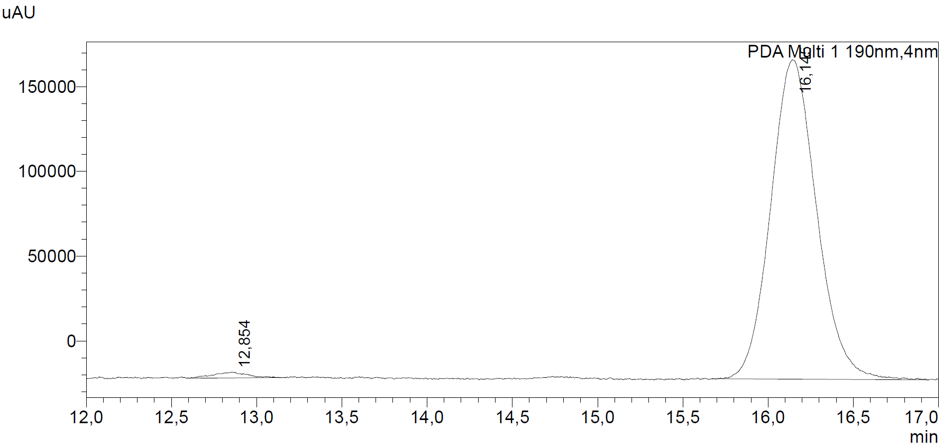
1
2

After enzymatic desymmetrisation, only compound 1 and 2 from the syn-monoacetate are present.
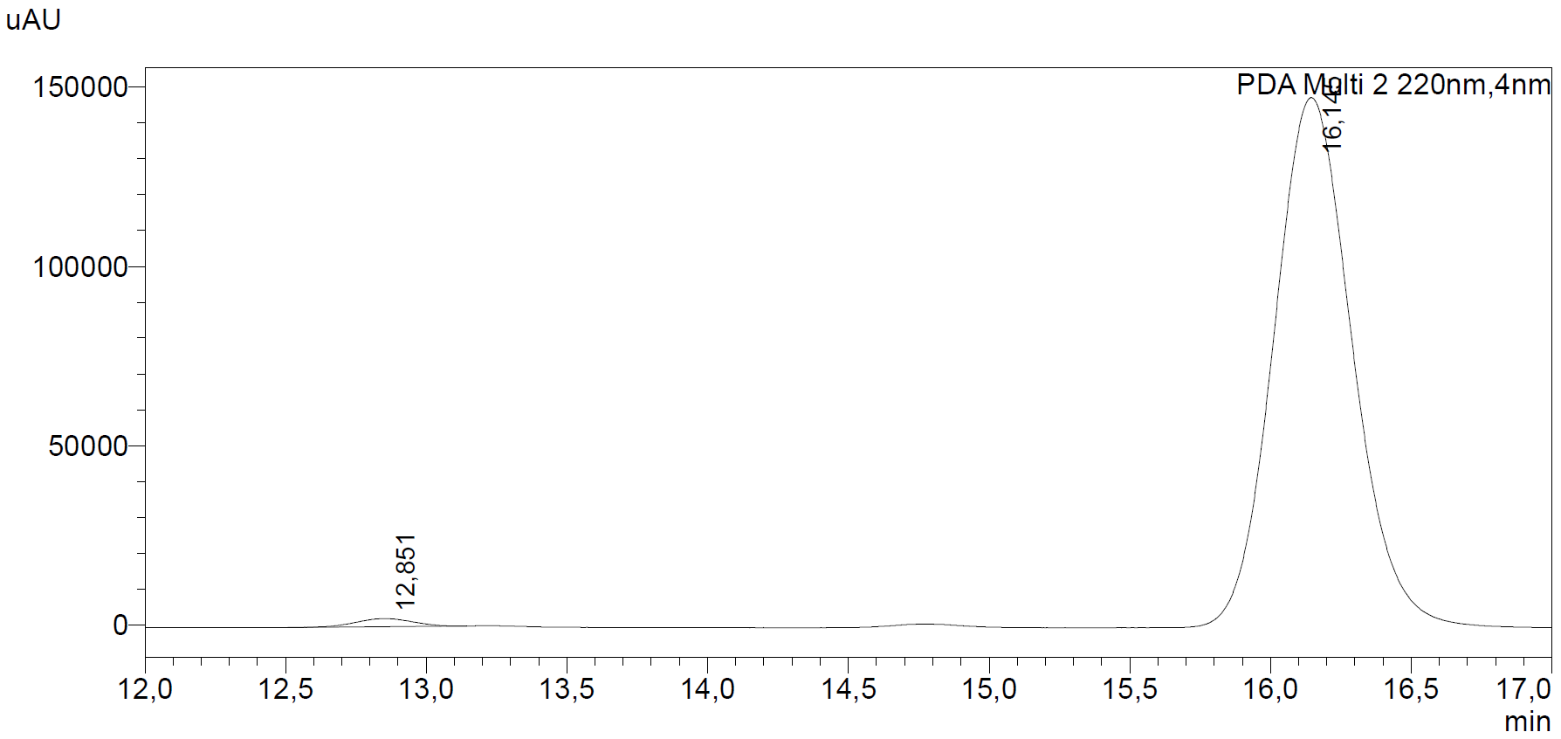
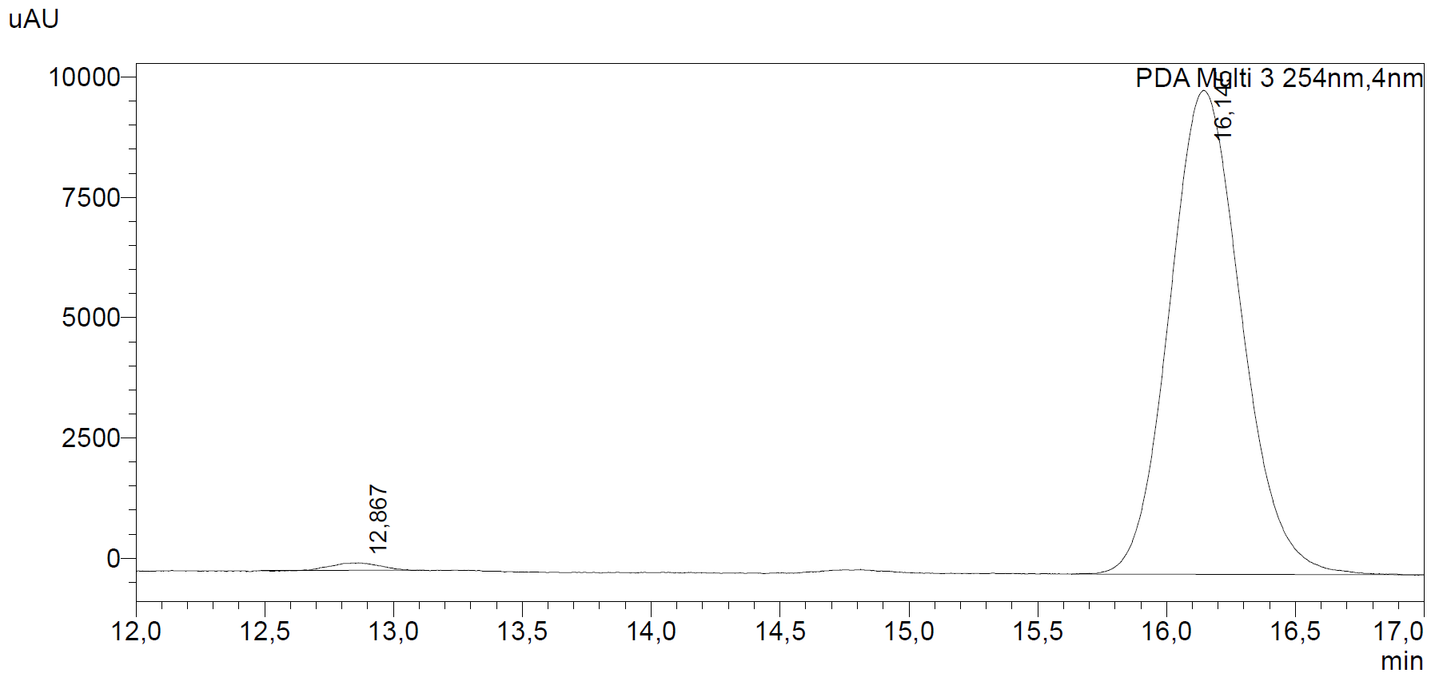
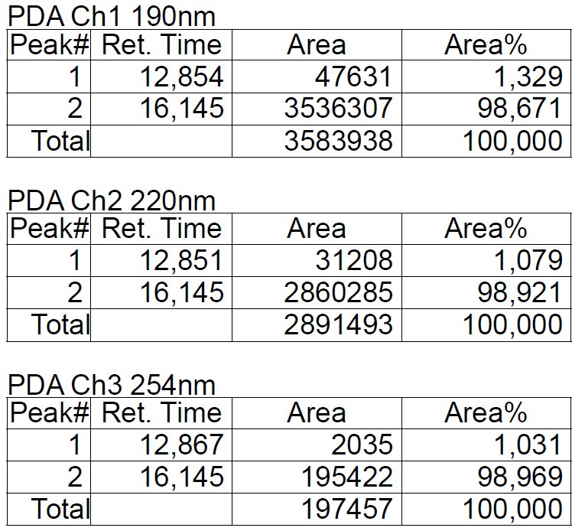
Figure S3: Chromatograms of the enantiomerically enriched syn-monoacetate (at 190, 220 and 254 nm) with the table showing retention times, peak area and area%. The enantiomeric excess is 98%.

¹H NMR (400 MHz, CDCl₃) δ 3.95 (dd, J = 10.8, 5.4 Hz, 1H), 3.83 (dd, J = 10.8, 6.8 Hz, 1H), 3.48 (dd, J = 10.5, 5.4 Hz, 1H), 3.39 (dd, J = 10.5, 6.4 Hz, 1H), 2.04 (s, 3H), 1.94 – 1.84 (m, 1H), 1.77 – 1.67 (m, 1H), 1.60 (brs, 1H), 1.47 – 1.38 (m, 1H), 1.02 – 0.96 (m, 1H), 0.95 (d, J = 3.5 Hz, 3H), 0.93 (d, J = 3.5 Hz, 3H
¹³C NMR (101 MHz, CDCl₃) δ 171.47, 69.30, 68.13, 37.39, 33.17, 30.14, 21.07, 17.97, 17.37.
Optical rotation: [α]_{D}²⁰ = +12.9 (CHCl₃, c = 1.50)
HRMS (ESI+): calculated for C₉H₁₈NaO₃⁺ [M+Na⁺] = 197.115; found: 197.115.
The analytical data are in agreement with previous reports. [4]

(2S,4R)-5-((tert-butyldiphenylsilyl)oxy)-2,4-dimethylpentyl acetate (9):
To a solution of alcohol 8 (10.2 g, 58.5 mmol) and imidazole (5.58 g, 82 mmol, 1.4 eq) in anhydrous THF (230 mL) was added tert-butyldiphenylchlorosilane (19.3 g, 70.3 mmol, 1.2 eq) at rt. The milky reaction mixture was stirred at rt overnight, whereafter water (150 mL) was added to the reaction mixture. The phases were separated and the aqueous layer was extracted with Et₂O (3 x 150 mL). The combined organic phases were washed with brine (150 mL), dried on MgSO₄, filtered, and concentrated under reduced pressure. The crude residue was purified by flash column chromatography (pentane/Et₂O: 96/4) to give 9 (23.4 g, 56.7 mmol, 97%) as a colourless oil.

¹H NMR (400 MHz, CDCl₃) δ 7.69 – 7.63 (m, 4H), 7.45 – 7.35 (m, 6H), 3.93 (dd, J = 10.7, 5.5 Hz, 1H), 3.80 (dd, J = 10.7, 6.8 Hz, 1H), 3.49 (dd, J = 9.8, 5.4 Hz, 1H), 3.43 (dd, J = 9.8, 6.1 Hz, 1H), 2.03 (s, 3H), 1.90 – 1.79 (m, 1H), 1.79 – 1.68 (m, 1H), 1.56 – 1.47 (m, 1H), 1.05 (s, 9H), 0.99 – 0.92 (m, 1H), 0.95 (d, J = 6.7 Hz, 3H), 0.89 (d, J = 6.7 Hz, 3H).
¹³C NMR (101 MHz, CDCl₃) δ 171.42, 135.76, 134.10, 129.68, 127.74, 69.51, 68.72, 37.50, 33.16, 30.12, 27.02, 21.09, 19.45, 17.81, 17.78.
HRMS (ESI+): calculated for C₂₅H₃₇O₃Si⁺ [M+H⁺] = 413.251; found: 413.250.
The analytical data are in agreement with previous reports.[5]

(2S,4R)-5-((tert-butyldiphenylsilyl)oxy)-2,4-dimethylpentan-1-ol (10):
To a solution of monoacetate 9 (23.4 g, 56.7 mmol) was added NaOEt (0.87 M, 130 mL, 113 mmol, 2 eq), and the reaction was stirred at rt for 4 h. TLC indicated complete consumption of the starting material. The reaction was quenched by addition of 1 M HCl (140 mL) to reach a pH between 1 and 2, and then water (200 mL) and Et₂O (200 mL) were added. The phases were separated and the aqueous layer was extracted with Et₂O (3 x 200 mL). The combined organic phases were washed with brine (300 mL), dried over MgSO₄, filtered, and concentrated under reduced pressure. The crude residue was purified by flash column chromatography (using a gradient from 10 to 20% Et₂O in pentane) to give the product 10 (20.1 g, 54.3 mmol, 96%) as a colourless oil.

¹H NMR (400 MHz, CDCl₃) δ 7.70 – 7.63 (m, 4H), 7.46 – 7.34 (m, 6H), 3.52 (dd, J = 9.8, 5.4 Hz, 1H), 3.48 (dd, J = 10.5, 5.1 Hz, 1H), 3.43 (dd, J = 9.8, 6.3 Hz, 1H), 3.35 (dd, J = 10.6, 6.7 Hz, 1H), 1.81 – 1.69 (m, 1H), 1.69 – 1.57 (m, 1H), 1.52 – 1.41 (m, 1H), 1.36 – 1.24 (m, 1H), 1.06 (s, 9H), 0.96 (d, J = 6.7 Hz, 3H), 0.94 – 0.86 (m, 1H), 0.89 (d, J = 6.7 Hz, 3H).
¹³C NMR (101 MHz, CDCl₃) δ 135.79, 134.14, 129.68, 127.74, 68.87, 68.46, 37.30, 33.33, 33.31, 27.04, 19.45, 18.05, 17.56.
HRMS (ESI+): calculated for C₂₃H₃₄NaO₂Si⁺ [M+H⁺] = 393.222; found: 393.222.
The analytical data are in agreement with previous reports.[6]

(3S,5R)-6-((tert-butyldiphenylsilyl)oxy)-3,5-dimethylhexanenitrile (11):
To a solution of alcohol 10 (33.4 g, 90.2 mmol) and anhydrous pyridine (8.7 mL, 108 mmol, 1.2 eq) in anhydrous CH₂Cl₂ (450 mL) was added DMAP (550 mg, 4.51 mmol, 0.05 eq) and para-toluenesulfonyl chloride (18 g, 95 mmol, 1.05 eq) at 0 °C. The reaction mixture was allowed to reach rt and stirred overnight. TLC indicated complete conversion. The reaction was cooled to 0 °C, and carefully quenched with sodium bicarbonate (5% aqueous solution, 300 mL) and stirred for 2 h at rt. The phases were separated and the aqueous layer was extracted with CH₂Cl₂ (3 x 200 mL). The combined organic phases were washed with brine (300 mL), dried on MgSO₄, filtered, and concentrated under reduced pressure to provide the crude tosylate which was used without further purification for the next step.
To a solution of the tosylate in DMSO (500 mL) was added KI (307 mg, 1.85 mmol, 0.02 eq) and KCN (6.62 g, 101 mmol, 1.1 eq) at room temperature. After addition, the reaction mixture turned yellow and was heated to 85 °C for 3 h. The reaction mixture was allowed to reach rt again, cooled to 0 °C, quenched with water (200 mL) and stirred at rt for 1 h. The phases were separated and the aqueous layer was extracted with Et₂O (3 x 200 mL). The combined organic phases were washed with brine (2 x 200 mL), dried over MgSO₄, filtered, and concentrated under reduced pressure. The crude residue was purified by flash column chromatography (using a gradient from 2 to 5% Et₂O in pentane) to give the product 11 (31.6 g, 83.2 mmol, 92% over 2 steps) as a colourless oil.

¹H NMR (400 MHz, CDCl₃) δ 7.69 – 7.63 (m, 4H), 7.47 – 7.35 (m, 6H), 3.50 (dd, J = 9.9, 5.5 Hz, 1H), 3.45 (dd, J = 10.0, 5.9 Hz, 1H), 2.27 (dd, J = 16.7, 5.0 Hz, 1H), 2.12 (dd, J = 16.7, 7.3 Hz, 1H), 1.95 – 1.82 (m, 1H), 1.73 – 1.63 (m, 1H), 1.55 – 1.43 (m, 1H), 1.14 – 1.08 (m, 1H), 1.06 (s, 9H), 1.04 (d, J = 6.7 Hz, 3H), 0.93 (d, J = 6.7 Hz, 3H).
¹³C NMR (101 MHz, CDCl₃) δ 135.77, 133.93, 129.78, 127.79, 118.92, 68.63, 40.08, 33.22, 28.11, 27.04, 24.53, 20.19, 19.42, 17.47.
Optical rotation: [α]_{D}²⁰ = +18.7 (CHCl₃, c = 1.50)
HRMS (ESI+): calculated for C₂₄H₃₃NNaOSi⁺ [M+Na⁺] = 402.222; found: 402.222.
The analytical data are in agreement with previous reports.[7]

tert-butyl (5R,7R,E)-8-((tert-butyldiphenylsilyl)oxy)-5,7-dimethyloct-2-enoate (12):
To a solution of nitrile 11 (31.6 g, 83.2 mmol) in anhydrous CH₂Cl₂ (415 mL) was added dropwise DIBAL-H (1.0 M in CH₂Cl₂, 91.6 mL, 91.6 mmol, 1.1 eq) over 30 min at -78 °C. The reaction mixture was stirred at -78 °C for an additional 2 h 30 min after which TLC (pentane/Et₂O: 95/5) indicated complete conversion. At -60 °C, the reaction was carefully quenched with 1 M HCl (400 mL) and subsequently stirred at rt for 1 h. The phases were separated and the aqueous layer was extracted with Et₂O (3 x 400 mL). The combined organic phases were washed with brine (2 x 200 mL), dried on MgSO₄, filtered, and concentrated under reduced pressure to provide the aldehyde, which was used without further purification for the next step.
To a stirred solution of the aldehyde (1 eq) in CH₂Cl₂ (420 mL) was added tert-butyl 2-(triphenylphosphoranylidene)acetate (41.2 g, 109 mmol, 1.3 eq) at rt. The reaction mixture was stirred at rt overnight. The solvent was removed by evaporation in vacuo and the residue triturated with pentane/Et₂O: 3/1 (300 mL). The organic layers were filtered over a short silica pad to remove triphenylphosphine oxide. The filtrate was concentrated under reduced pressure. The residue was purified by flash column chromatography (using a gradient from 1 to 2% Et₂O in pentane) to give 12 (34.1 g, 70.9 mmol, 85% over 2 steps) as a colourless oil.

¹H NMR (400 MHz, CDCl₃) δ 7.69 – 7.63 (m, 4H), 7.46 – 7.34 (m, 6H), 6.81 (ddd, J = 15.2, 8.0, 7.0 Hz, 1H), 5.72 (dt, J = 15.6, 1.5 Hz, 1H), 3.50 (dd, J = 9.8, 5.3 Hz, 1H), 3.41 (dd, J = 9.8, 6.4 Hz, 1H), 2.17 (dddd, J = 13.7, 6.7, 4.7, 1.6 Hz, 1H), 1.94 – 1.84 (m, 1H), 1.77 – 1.68 (m, 1H), 1.68 – 1.58 (m, 1H), 1.48 (s, 9H), 1.43 – 1.34 (m, 1H), 1.05 (s, 9H), 1.00 – 0.94 (m, 1H), 0.93 (d, J = 6.7 Hz, 3H), 0.84 (d, J = 6.6 Hz, 3H).
¹³C NMR (101 MHz, CDCl₃) δ 166.16, 146.92, 135.77, 134.16, 129.67, 127.74, 124.29, 80.11, 68.85, 40.97, 39.53, 33.27, 30.07, 28.33, 27.04, 20.26, 19.45, 17.76.
Optical rotation: [α]_{D}²⁰ = +6.5 (CHCl₃, c = 1.35)
HRMS (ESI+): calculated for C₃₀H₄₄NaO₃Si⁺ [M+Na⁺] = 503.295; found: 503.295.

tert-butyl (3S,5R,7R)-8-((tert-butyldiphenylsilyl)oxy)-3,5,7-trimethyloctanoate (13) and tert-butyl (3R,5R,7R)-8-((tert-butyldiphenylsilyl)oxy)-3,5,7-trimethyloctanoate (13’):
To a solution of CuI (17.60 g, 92.40 mmol, 6 eq) in THF (264 mL) was added MeLi (1.6 M in Et₂O, 110.7 mL, 177.1 mmol, 11.5 eq) at -20 °C over 45 min. The mixture was allowed to warm up to 0 °C for 1 h and then cooled to -78 °C. To the resulting mixture was added TMSCl (23.5 mL, 185 mmol, 12 eq) followed by a solution of 12 (7.40 g, 15.4 mmol) in THF (40.5 mL) dropwise addition over 2 h. The reaction mixture was stirred at -78 °C overnight, quenched with a NH₄OH/NH₄Cl buffer solution (pH 8, 200 mL) and stirred at room temperature for 2 h. The phases were separated. The organic layer was filtrated over a celite pad. The aqueous layer was extracted with Et₂O (3 x 150 mL). The combined organic phases were washed with NH₄OH/NH₄Cl (1:1) solution (150 mL), saturated NH₄Cl (150 mL), brine (150 mL), dried over MgSO₄, filtered, and concentrated under reduced pressure. The crude was used for the next step without further purification. Ratio: syn/anti = 83/17, quantitative yield.

Note: MeLi is used for the reaction, MeLi•LiBr complex gave the same syn/anti ratio. The syn/anti mixture is not separable at this stage.

¹H NMR (400 MHz, CDCl₃) δ 7.70 – 7.63 (m, 4H), 7.45 – 7.34 (m, 6H), 3.54 – 3.47 (m, 1H), 3.44 – 3.37 (m, 1H), 2.20 (dd, J = 14.1, 5.0 Hz, 1H), 2.14 – 1.94 (m, 1H), 1.88 (dd, J = 14.1, 8.6 Hz, 1H), 1.79 – 1.66 (m, 1H), 1.55 – 1.46 (m, 1H), 1.44 (s, 9H), 1.40 – 1.15 (m, 2H), 1.06 (s, 9H), 0.98 – 0.79 (m, 11H).
¹³C NMR (101 MHz, CDCl₃) δ 172.94, 172.76, 135.80, 135.77, 134.24, 134.21, 129.63, 129.62, 127.70, 80.05, 69.15, 68.94, 44.91, 44.40, 44.10, 42.93, 42.15, 41.42, 33.26, 33.17, 28.28, 28.10, 28.08, 27.74, 27.50, 27.04, 20.81, 20.76, 20.07, 19.46, 19.21, 18.12, 17.69.
HRMS (ESI+): calculated for C₃₁H₄₈NaO₃Si⁺ [M+H⁺] = 519.326; found: 519.326.

(3S,5R,7R)-8-((tert-butyldiphenylsilyl)oxy)-3,5,7-trimethyloctan-1-ol (14):
To a solution of crude ester 13 and 13’ (26.7 g, 53.7 mmol) in anhydrous THF (265 mL) was added portion-wise LiAlH₄ powder (4.07 g, 107 mmol, 2 eq) over 40 min at -30 °C. The reaction mixture was allowed to reach 0 °C and stirred at 0 °C overnight, after which TLC (pentane/Et₂O: 7/3) indicated complete conversion. The reaction was diluted with Et₂O (200 mL) and carefully quenched with aqueous saturated Rochelle salt solution (400 mL) at -30 °C followed by stirring at rt for 4 h. The phases were separated and the aqueous layer was extracted with Et₂O (3 x 200 mL). The combined organic phases were washed with brine (250 mL), dried on MgSO₄, filtered, and concentrated under reduced pressure. The crude residue was purified by flash column chromatography (pentane/Et₂O: 8/2) to give the product 14 (12.64 g, 29.62 mmol, 55% as the pure syn alcohol) as a colourless oil.

¹H NMR (400 MHz, cdcl₃) δ 7.70 – 7.64 (m, 4H), 7.45 – 7.34 (m, 6H), 3.73 – 3.59 (m, 2H), 3.51 (dd, J = 9.8, 5.1 Hz, 1H), 3.41 (dd, J = 9.8, 6.5 Hz, 1H), 1.77 – 1.68 (m, 1H), 1.68 – 1.48 (m, 3H), 1.40 – 1.31 (m, 1H), 1.31 – 1.15 (m, 3H), 1.05 (s, 9H), 0.96 – 0.79 (m, 11H).
¹³C NMR (101 MHz, CDCl₃) δ 135.80, 134.23, 129.63, 127.70, 68.92, 61.41, 45.62, 41.45, 39.68, 33.32, 27.71, 27.04, 20.93, 20.64, 19.47, 18.18.
Optical rotation: [α]_{D}²⁰ = +6.3 (CHCl₃, c = 1.60)
HRMS (ESI+): calculated for C₂₇H₄₂NaO₂Si⁺ [M+Na⁺] = 449.285; found: 449.284.

tert-butyl (5S,7R,9R,E)-10-((tert-butyldiphenylsilyl)oxy)-5,7,9-trimethyldec-2-enoate (15):
To a solution of (COCl)₂ (4.9 mL, 57.5 mmol, 2.45 eq) in anhydrous CH₂Cl₂ (230 mL) was added anhydrous DMSO (8.2 mL, 115 mmol, 4.9 eq) at -78 °C. The reaction mixture was stirred at -78 °C for 60 min and alcohol 14 (10.0 g, 23.5 mmol) in anhydrous CH₂Cl₂ (94 mL) was added dropwise. The solution was stirred at -78 °C for 90 min. NEt₃ (16.7 mL, 119 mmol, 5.1 eq) was added and the reaction mixture was stirred for another 90 min at -70 °C, then quenched with saturated NH₄Cl solution (120 mL). The phases were separated and the aqueous layer was extracted with Et₂O (3 x 250 mL). The combined organic phases were washed with 1 M HCl (120 mL), brine (120 mL), dried over MgSO₄, filtered, and concentrated under reduced pressure to provide the corresponding aldehyde, which was used without further purification for the next step.
To a stirred solution of aldehyde (1 eq) in CH₂Cl₂ (240 mL) was added tert-butyl 2-(triphenylphosphoranylidene)acetate (14 g, 37 mmol, 1.5 eq) at rt. The reaction mixture was stirred at rt overnight. Removal of the solvent under reduced pressure was followed by trituration of the residue with pentane/Et₂O: 3/1 (100 mL) and filtration of the organic phases over a short silica pad to remove triphenylphosphine oxide. The filtrate was concentrated under reduced pressure. The crude residue was purified by flash column chromatography (using a gradient from 1 to 2% Et₂O in pentane) to give 15 (9.52 g, 18.2 mmol, 78% over 2 steps) as a colourless oil.

¹H NMR (400 MHz, CDCl₃) δ 7.69 – 7.63 (m, 4H), 7.45 – 7.34 (m, 6H), 6.82 (ddd, J = 15.2, 8.0, 6.9 Hz, 1H), 5.72 (dt, J = 15.5, 1.4 Hz, 1H), 3.50 (dd, J = 9.8, 5.1 Hz, 1H), 3.41 (dd, J = 9.8, 6.4 Hz, 1H), 2.18 (dddd, J = 13.5, 6.6, 4.6, 1.6 Hz, 1H), 1.93 – 1.82 (m, 1H), 1.76 – 1.63 (m, 2H), 1.58 – 1.44 (m, 10H), 1.39 – 1.15 (m, 2H), 1.05 (s, 9H), 0.96 – 0.78 (m, 11H).
¹³C NMR (101 MHz, CDCl₃) δ 166.19, 147.08, 135.79, 134.20, 129.64, 127.71, 124.24, 80.10, 68.91, 44.89, 41.37, 39.13, 33.26, 29.95, 28.32, 27.70, 27.03, 20.86, 20.55, 19.45, 18.09.
Optical rotation: [α]_{D}²⁰ = +7.4 (CHCl₃, c = 1.45)
HRMS (ESI+): calculated for C₃₃H₅₀NaO₃Si⁺ [M+Na⁺] = 545.342; found: 545.346.

tert-butyl (3S,5S,7R,9R)-10-((tert-butyldiphenylsilyl)oxy)-3,5,7,9-tetramethyldecanoate (16) and tert-butyl (3R,5S,7R,9R)-10-((tert-butyldiphenylsilyl)oxy)-3,5,7,9-tetramethyldecanoate (16’):
To a solution of CuI (20.80 g, 109.3 mmol, 6 eq) in THF (312 mL) was added MeLi (1.6 M in Et₂O, 131 mL, 209 mmol, 11.5 eq) at -20 °C over 45 min. The mixture was allowed to warm up to 0 °C for 1h and then cooled to -78 °C. To the resulting mixture was added TMSCl (27.7 mL, 218 mmol, 12 eq) followed by a solution of 15 (9.52 g, 18.2 mmol) in THF (48 mL) via dropwise addition over 2 h 30 min. The reaction mixture was stirred at -78 °C overnight, quenched with a NH₄OH/NH₄Cl buffer solution (pH 8, 200 mL) and stirred at room temperature for 2 h. The phases were separated. The organic layer was filtered over a celite pad. The aqueous layer was extracted with Et₂O (3 x 200 mL). The combined organic phases were washed with NH₄OH/NH₄Cl (1:1) solution (150 mL), saturated NH₄Cl (150 mL), brine (150 mL), dried on MgSO₄, filtered, and concentrated under reduced pressure. The crude was used for the next step without further purification. Ratio: syn/anti = 83/17. Quantitative yield.

Note: MeLi is used for the reaction, MeLi•LiBr complex did not change the syn/anti ratio. The syn/anti mixture is not separable at this stage.

¹H NMR (400 MHz, CDCl₃) δ 7.69 – 7.64 (m, 4H), 7.45 – 7.34 (m, 6H), 3.54 – 3.48 (m, 1H), 3.41 (dd, J = 9.8, 6.4 Hz, 1H), 2.23 (dd, J = 14.1, 4.9 Hz, 1H), 2.15 – 1.94 (m, 1H), 1.89 (dd, J = 14.1, 8.7 Hz, 1H), 1.77 – 1.68 (m, 1H), 1.58 – 1.48 (m, 2H), 1.44 (s, 9H), 1.41 – 1.10 (m, 3H), 1.05 (s, 9H), 0.97 – 0.77 (m, 15H).
¹³C NMR (101 MHz, CDCl₃) δ 172.99, 172.79, 135.80, 135.78, 134.27, 134.24, 129.63, 129.61, 127.70, 80.05, 68.99, 68.86, 46.19, 45.72, 44.69, 44.43, 43.84, 42.87, 41.57, 41.28, 33.32, 33.26, 28.30, 28.28, 28.22, 28.15, 28.13, 28.10, 27.81, 27.71, 27.55, 27.39, 27.04, 21.09, 20.95, 20.87, 20.77, 20.41, 19.47, 19.26, 18.35, 18.14.
HRMS (ESI+): calculated for C₃₄H₅₄NaO₃Si⁺ [M+Na⁺] = 561.373; found: 561.372.

(3S,5S,7R,9R)-10-((tert-butyldiphenylsilyl)oxy)-3,5,7,9-tetramethyldecan-1-ol (17):
To a solution of crude ester 16 and 16’ (10.3 g, 19.2 mmol) in anhydrous THF (96 mL) was added portion-wise LiAlH₄ powder (1.45 g, 38.4 mmol, 2 eq) over 25 min at -30 °C. The reaction mixture was allowed to reach 0 °C and stirred at 0 °C overnight, after which TLC (pentane/Et₂O: 7/3) indicated complete conversion. The reaction was diluted Et₂O (70 mL). and carefully quenched with aqueous saturated Rochelle salt solution (140 mL) at -30 °C and stirred at rt for 2 h. The phases were separated and the aqueous layer was extracted with Et₂O (3 x 80 mL). The combined organic phases were washed with brine (150 mL), dried on MgSO₄, filtered, and concentrated under reduced pressure. The crude residue was purified by flash column chromatography (pentane/Et₂O: 8/2) to give 17 (4.86 g, 10.4 mmol, 57% over 2 steps as the pure syn alcohol) as a colourless oil.

¹H NMR (400 MHz, CDCl₃) δ 7.70 – 7.64 (m, 4H), 7.45 – 7.34 (m, 6H), 3.74 – 3.60 (m, 2H), 3.52 (dd, J = 9.8, 5.0 Hz, 1H), 3.42 (dd, J = 9.8, 6.4 Hz, 1H), 1.78 – 1.47 (m, 5H), 1.42 – 1.33 (m, 1H), 1.32 – 1.12 (m, 4H), 1.06 (s, 9H), 0.97 – 0.78 (m, 15H).
¹³C NMR (101 MHz, CDCl₃) δ 135.78, 134.29, 129.62, 129.61, 127.70, 68.87, 61.43, 45.80, 45.34, 41.35, 39.60, 33.34, 27.76, 27.53, 27.07, 27.05, 21.14, 21.10, 20.72, 19.47, 18.35.
Optical rotation: [α]_{D}²⁰ = +6.4 (CHCl₃, c = 1.06)
HRMS (ESI+): calculated for C₃₀H₄₈NaO₂Si⁺ [M+Na⁺] = 491.332; found: 491.336
The analytical data are in agreement with previous reports.[8]

(3S,5S,7R,9R)-10-((tert-butyldiphenylsilyl)oxy)-3,5,7,9-tetramethyldecyl 4-methylbenzenesulfonate (18):
To a solution of alcohol 17 (1.32 g, 2.82 mmol) and anhydrous pyridine (0.32 mL, 3.94 mmol, 1.4 eq) in anhydrous CH₂Cl₂ (14 mL) was added DMAP (19 mg, 0.16 mmol, 0.05 eq) and para-toluenesulfonyl chloride (644 mg, 3.38 mmol, 1.2 eq) at 0 °C. The reaction mixture was allowed to reach rt and stirred overnight. TLC indicated complete conversion. The reaction was cooled to 0 °C, carefully quenched with sodium bicarbonate 5% aqueous solution (50 mL) and stirred for 2 h at rt. The phases were separated and the aqueous layer was extracted with CH₂Cl₂ (3 x 30 mL). The combined organic phases were washed with brine (50 mL), dried on MgSO₄, filtered, and concentrated under reduced pressure. The crude residue was purified by flash column chromatography (using a gradient from 2 to 5% Et₂O in pentane) to give 18 (1.64 g, 2.63 mmol, 94%) as a yellow-green oil.

¹H NMR (600 MHz, CDCl₃) δ 7.79 (d, J = 8.1 Hz, 2H), 7.66 (d, J = 6.4 Hz, 4H), 7.44 – 7.32 (m, 8H), 4.10 – 4.01 (m, 2H), 3.50 (dd, J = 9.9, 5.0 Hz, 1H), 3.41 (dd, J = 9.8, 6.4 Hz, 1H), 2.44 (s, 3H), 1.76 – 1.67 (m, 2H), 1.63 – 1.56 (m, 1H), 1.52 – 1.43 (m, 2H), 1.38 – 1.25 (m, 2H), 1.14 – 1.07 (m, 2H), 1.05 (s, 9H), 0.93 (d, J = 6.6 Hz, 3H), 0.88 – 0.73 (m, 12H).
¹³C NMR (151 MHz, CDCl₃) δ 144.74, 135.76, 134.22, 133.40, 129.94, 129.62, 128.03, 127.70, 69.25, 68.79, 45.54, 44.81, 41.23, 35.30, 33.28, 27.64, 27.31, 27.02, 26.74, 21.79, 21.08, 20.94, 20.16, 19.45, 18.35.
Optical rotation: [α]_{D}²⁰ = +5.5 (CHCl₃, c = 1.00)
HRMS (ESI+): calculated for C₃₇H₅₄NaO₄SSi⁺ [M+Na⁺] = 645.340; found: 645.340.
The analytical data are in agreement with previous reports.[8]

tert-butyldiphenyl(((2R,4R,6R,8R)-2,4,6,8-tetramethylundecyl)oxy)silane (19):
To a solution of 18 (306 mg, 0.491 mmol) and CuBr•SMe₂ (101 mg, 0.491 mmol, 1 eq) in anhydrous THF (2.5 mL) was added MeMgBr (3.0 M in Et₂O, 0.49 mL, 1.47 mmol, 3 eq) at 0 °C. The reaction mixture was stirred at 0 °C for 3 h, quenched with a NH₄OH/NH₄Cl buffer solution (pH 8, 5 mL) and stirred at room temperature for 15 min. The phases were separated and the aqueous layer was extracted with Et₂O (3 x 15 mL). The combined organic phases were washed with brine (20 mL), dried on MgSO₄, filtered, and concentrated under reduced pressure. The crude residue was purified by flash column chromatography (100% pentane) to give the product 19 (195 mg, 0.418 mmol, 85%) as a colourless oil.

¹H NMR (600 MHz, CDCl₃) δ 7.70 – 7.65 (m, 4H), 7.45 – 7.35 (m, 6H), 3.52 (dd, J = 9.8, 4.9 Hz, 1H), 3.42 (dd, J = 9.8, 6.4 Hz, 1H), 1.78 – 1.69 (m, 1H), 1.61 – 1.45 (m, 3H), 1.42 – 1.13 (m, 6H), 1.06 (s, 9H), 1.03 – 0.96 (m, 1H), 0.94 (d, J = 6.7 Hz, 3H), 0.91 – 0.77 (m, 15H).
¹³C NMR (151 MHz, CDCl₃) δ 135.81, 134.29, 134.26, 129.61, 127.70, 68.88, 45.94, 45.24, 41.40, 38.89, 33.34, 29.89, 27.78, 27.57, 27.04, 21.22, 21.14, 20.72, 20.11, 19.47, 18.33, 14.60.
Optical rotation: [α]_{D}²⁰ = +7.8 (CHCl₃, c = 1.00)
HRMS (ESI+): calculated for C₃₁H₅₀NaOSi⁺ [M+Na⁺] = 489.352; found: 489.353.
(2R,4R,6R,8R)-2,4,6,8-tetramethylundecan-1-ol (2):
To a cooled (0 °C) solution of TBDPS ether 19 (195 mg, 0.418 mmol) in anhydrous THF (2.1 mL) was added dropwise HF•pyridine (~70% HF, 0.59 mL, 4.60 mmol, 11 eq). The mixture was stirred at 0 °C overnight, and poured carefully into a saturated aqueous NaHCO₃ solution (15 mL). The mixture was extracted with pentane/Et₂O: 1/1 (3 x 10 mL). The combined organic phases were washed with brine (15 mL), dried over MgSO₄, filtered, and concentrated under reduced pressure. The crude residue was purified by flash column chromatography (pentane/Et₂O: 8/2) to give the product 2 (87 mg, 0.38 mmol, 91%) as a colourless oil.

Note: the reaction was performed in a plastic conical Eppendorf tube as a flask. The reaction mixture should be poured into a large beaker in order to prevent spilling during the NaHCO₃ quench.

¹H NMR (600 MHz, CDCl₃) δ 3.54 (dd, J = 10.5, 4.9 Hz, 1H), 3.37 (dd, J = 10.4, 6.9 Hz, 1H), 1.77 – 1.68 (m, 1H), 1.62 – 1.54 (m, 2H), 1.53 – 1.45 (m, 1H), 1.40 – 1.16 (m, 7H), 1.03 – 0.96 (m, 1H), 0.93 (d, J = 6.7 Hz, 3H), 0.91 – 0.80 (m, 15H).
¹³C NMR (151 MHz, CDCl₃) δ 68.34, 45.66, 45.21, 41.20, 38.90, 33.24, 29.88, 27.69, 27.56, 21.20, 21.16, 20.69, 20.09, 17.80, 14.58.
Optical rotation: [α]_{D}²⁰ = +13.3 (CHCl₃, c = 1.04)
HRMS (ESI+ and APCI) analysis was not successful.
Instead, GC analysis was carried out using a Shimadzu GCMS QP2010 gas chromatograph system bearing an Agilent HP-5 column (length: 30 m; diameter: 0.25 mm; film thickness: 0.25 μm) and MS detection. Helium was used as carrier gas with a linear gas flow velocity of 36.1 cm.s⁻¹. The oven temperature programme began at 40 °C, ramping at 4 °C.min⁻¹ to 250 °C and holding for 5 min. Inlet (injection temperature) and interface temperatures were set to 250 °C. Electron impact mass spectral data were acquired at 70 eV, scanning from m/z 25 to 250 at 0.3 s/scan.

GC-MS analysis of (2R,4R,6R,8R)-2,4,6,8-tetramethylundecan-1-ol (sex pheromone)
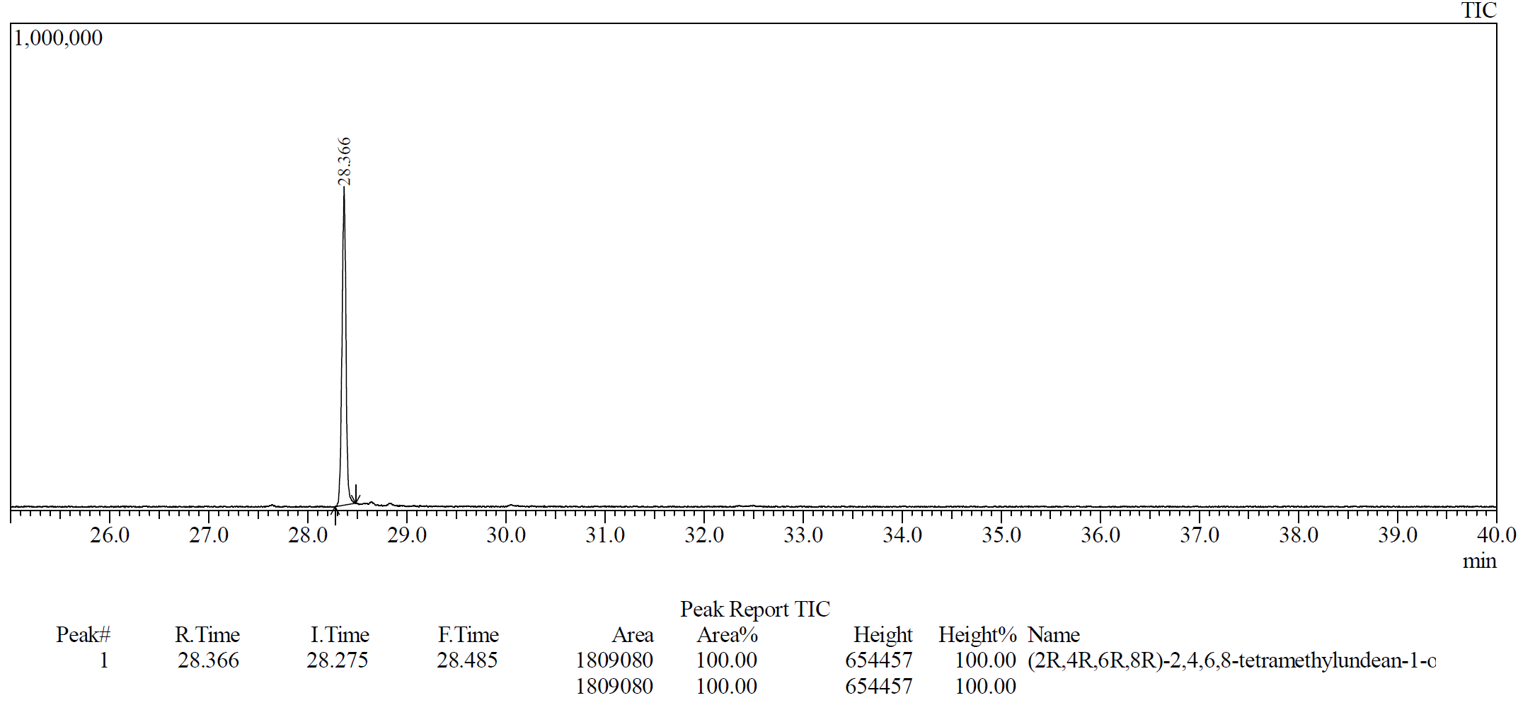
Figure S4: Total ion chromatogram (TIC) of (2R,4R,6R,8R)-2,4,6,8-tetramethylundecan-1-ol

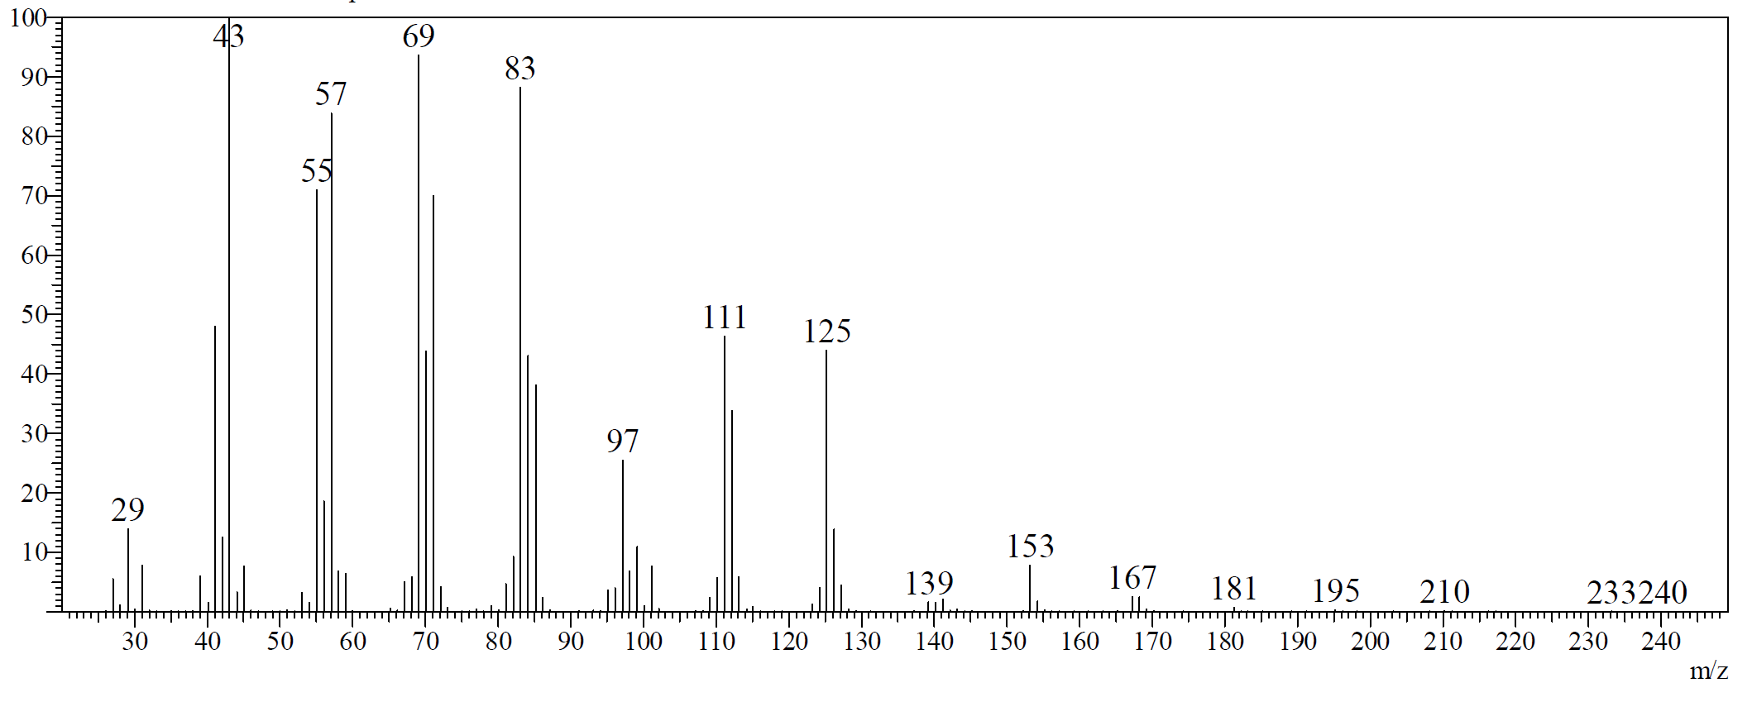
Figure S5: Mass spectrum of (2R,4R,6R,8R)-2,4,6,8-tetramethylundecan-1-ol eluting at 28.37 min in a GC-MS analysis.
The analytical data are in agreement with previous reports.[9,10]

(((2R,4R,6S,8S)-10-bromo-2,4,6,8-tetramethyldecyl)oxy)(tert-butyl)diphenylsilane (20):
To a solution of alcohol 17 (4.86 g, 10.4 mmol) and PPh₃ (3.81 g, 14.5 mmol, 1.4 eq) in anhydrous CH₂Cl₂ (90 mL) was added N-bromosuccinimide (2.21 g, 12.4 mmol, 1.2 eq) at 0 °C. The reaction mixture was stirred at 0 °C for 2 h. Removal of the solvent under reduced pressure was followed by trituration with pentane (100 mL), and filtration of the organic phases over a short silica pad to remove triphenylphosphine oxide. The filtrate was concentrated under reduced pressure. The crude residue was purified by flash column chromatography (using a gradient from 1 to 10% Et₂O in pentane) to give the product 20 (4.97 g, 9.35 mmol, 90%) as a colourless oil.

¹H NMR (600 MHz, CDCl₃) δ 7.69 (d, J = 7.5 Hz, 4H), 7.46 – 7.36 (m, 6H), 3.56 – 3.36 (m, 4H), 1.97 – 1.89 (m, 1H), 1.80 – 1.70 (m, 2H), 1.63 – 1.50 (m, 3H), 1.43 – 1.36 (m, 1H), 1.27 – 1.15 (m, 2H), 1.08 (d, J = 1.8 Hz, 9H), 0.99 – 0.80 (m, 15H).
¹³C NMR (151 MHz, CDCl₃) δ 135.80, 134.25, 129.61, 127.71, 68.84, 45.75, 44.70, 41.35, 39.67, 33.32, 32.30, 29.18, 27.77, 27.46, 27.05, 21.11, 21.07, 20.00, 19.47, 18.36.
Optical rotation: [α]_{D}²⁰ = +6.9 (CHCl₃, c = 1.00)
HRMS (ESI+): calculated for C₃₀H₄₇BrNaOSi⁺ [M+Na⁺] = 553.247; found: 553.246.

tert-butyldiphenyl(((2R,4R,6R,8R)-2,4,6,8-tetramethyloctacosyl)oxy)silane (21):
To a solution of 1-octadecene (2.55 g, 10.1 mmol, 2 eq) in anhydrous THF (15.3 mL) was added 9-BBN dimer (1.36 g, 5.55 mmol, 1.1 eq) and the resulting solution was stirred overnight at rt. ¹H NMR indicated complete conversion of 1-octadecene (no detectable olefin signals).

Cross-coupling:
To the prepared alkylborane solution (1.5 eq) was added K₃PO₄•H₂O (1.74 g, 7.57 mmol, 1.5 eq) followed by Pd(PCy₃)₂ (337 mg, 0.505 mmol, 10 mol%). The reaction mixture was stirred at rt for 30 min, which resulted in a clear yellow solution. Then, bromide 20 (2.68 g, 5.05 mmol) dissolved in anhydrous THF (12 mL) was added dropwise and the reaction was stirred at rt overnight. The reaction mixture was filtered through a short celite pad to remove solids. After evaporation of the filtrate, the residue was purified by flash column chromatography (using a gradient from 0.5 to 2% Et₂O in pentane) to give the product 21 (3.21 g, 4.55 mmol, 90%) as a colourless oil.

¹H NMR (600 MHz, CDCl₃) δ 7.70 – 7.65 (m, 4H), 7.45 – 7.35 (m, 6H), 3.52 (dd, J = 9.8, 4.9 Hz, 1H), 3.42 (dd, J = 9.8, 6.4 Hz, 1H), 1.78 – 1.68 (m, 1H), 1.61 – 1.43 (m, 3H), 1.41 – 1.34 (m, 1H), 1.34 – 1.13 (m, 39H), 1.06 (s, 9H), 1.03 – 0.97 (m, 1H), 0.94 (d, J = 6.7 Hz, 3H), 0.89 (t, J = 7.0 Hz, 3H), 0.87 – 0.78 (m, 12H).
¹³C NMR (151 MHz, CDCl₃) δ 135.81, 135.79, 134.29, 134.26, 129.61, 129.60, 127.70, 68.88, 45.92, 45.22, 41.40, 36.57, 33.34, 32.09, 30.23, 30.13, 29.93, 29.87, 29.82, 29.53, 27.77, 27.58, 27.05, 22.86, 21.24, 21.15, 20.77, 19.47, 18.33, 14.29.
Optical rotation: [α]_{D}²⁰ = +7.3 (CHCl₃, c = 1.01)
HRMS (ESI+): calculated for C₄₈H₈₅OSi⁺ [M+H⁺] = 705.636; found: 705.636.
The analytical data are in agreement with previous reports.[8]

(2R,4R,6R,8R)-2,4,6,8-tetramethyloctacosan-1-ol (22):
To a cooled (0 °C) solution of TBDPS ether 21 (2.03 g, 2.88 mmol) in anhydrous THF (14.4 mL) was added dropwise HF•pyridine (~70% HF, 4.1 mL, 31 mmol, 11 eq). After addition, the mixture was allowed to reach rt and stirred overnight. Then, the reaction mixture was poured carefully into a saturated aqueous NaHCO₃ solution (100 mL). The mixture was extracted with pentane/Et₂O: 1/1 (3 x 100 mL). The combined organic phases were washed with brine (100 mL), dried over MgSO₄, filtered, and concentrated under reduced pressure. The crude residue was purified by flash column chromatography (pentane/Et₂O: 8/2) to give 22 (1.28 g, 2.74 mmol, 95%) as a colourless oil.

Note: the reaction was performed into a plastic conical Eppendorf tube as a flask. The reaction mixture should be poured into a large beaker in order to prevent spilling during the NaHCO₃ quench.

¹H NMR (600 MHz, CDCl₃) δ 3.55 (dd, J = 10.5, 4.9 Hz, 1H), 3.38 (dd, J = 10.5, 6.9 Hz, 1H), 1.77 – 1.69 (m, 1H), 1.62 – 1.53 (m, 2H), 1.52 – 1.43 (m, 1H), 1.39 – 1.12 (m, 41H), 1.05 – 0.80 (m, 19H).
¹³C NMR (151 MHz, CDCl₃) δ 68.36, 45.67, 45.20, 41.22, 36.58, 33.25, 32.09, 30.22, 30.14, 29.91, 29.86, 29.82, 29.52, 27.70, 27.60, 27.02, 22.85, 21.21, 21.19, 20.75, 17.81, 14.27.
Optical rotation: [α]_{D}²⁰ = +7.8 (CHCl₃, c = 1.01)
HRMS (ESI+): calculated for C₃₂H₆₆NaO⁺ [M+Na⁺] = 489.501; found: 489.500.
The analytical data are in agreement with previous reports.[8]

(2R,4R,6R,8R)-2,4,6,8-tetramethyloctacosanoic acid (5):
To a stirred mixture of alcohol 22 (249 mg, 0.533 mmol) in 3.9 mL CCl₄, 3.9 mL of CH₃CN and 5.8 mL of H₂O was added RuCl₃•(H₂O)_{x} (3.6 mg, 0.016 mmol, 0.03 eq) and NaIO₄ (568 mg, 2.19 mmol, 4.1 eq) at rt under N₂ atmosphere. The reaction was stirred at rt overnight and poured into pentane (10 mL) and water (10 mL). The phases were separated and the aqueous layer was extracted with pentane/Et₂O: 1/1 (2 x 5 mL). The combined organic phases were washed with ammonium pyrrolidinedithiocarbamate solution (120 mg in 4 mL of water), dried over MgSO₄, filtered, and concentrated under reduced pressure.
The crude residue was redissolved in pentane (5 mL), placed into an Eppendorf tube and submitted to centrifugation (14000 rpm) for 5 min. The supernatant was collected and the pentane was removed under reduced pressure. The crude residue was purified by flash column chromatography (using a gradient from 1 to 10% Et₂O in pentane) to give the product 5 (234 mg, 0.486 mmol, 91%) as a white wax.

Note: This reaction was repeated several time at this scale (~250 mg of starting material). All the steps are important to have a ruthenium-free product.

¹H NMR (600 MHz, CDCl₃) δ 2.59 (dqd, J = 9.6, 6.9, 5.1 Hz, 1H), 1.77 (ddd, J = 13.9, 9.6, 4.6 Hz, 1H), 1.64 – 1.52 (m, 2H), 1.52 – 1.42 (m, 1H), 1.40 – 1.13 (m, 43H), 1.09 – 0.97 (m, 2H), 0.95 – 0.78 (m, 14H).
¹³C NMR (151 MHz, CDCl₃) δ 183.41, 45.49 (2C), 41.01, 37.41, 36.81, 32.09, 30.22, 30.09, 29.93, 29.87, 29.83, 29.53, 28.28, 27.37, 27.09, 22.86, 20.76, 20.62, 20.57, 18.23, 14.28.
Optical rotation: [α]_{D}²⁰ = -7.6 (CHCl₃, c = 1.00)
HRMS (ESI+): calculated for C₃₂H₆₄NaO₂⁺ [M+Na⁺] = 503.480; found: 503.479.
The analytical data are in agreement with previous reports.[8]

References
(1) Saicic, R. N. Synth. Commun. 2006, 36, 2559–2562. doi:10.1080/00397910600781497
(2) Lautens, M.; Colucci, J. T.; Hiebert, S.; Smith, N. D.; Bouchain, G. Org. Lett. 2002, 4, 1879–1882. doi:10.1021/ol025872f
(3) Kumar Mishra, V. Studies on C-H-Activation, Organocatalysis, and Synthesis of Amphidinolide Q. Doctoral dissertation, University of Tübingen, 2016
(4) Fujita, K.; Mori, K. Eur. J. Org. Chem. 2001, 493–502. doi:10.1002/1099-0690(200102)2001:3<493::AID-EJOC493>3.0.CO;2-B
(5) Yadav, J. S.; Rao, T. S.; Yadav, N. N.; Rao, K. V. R.; Reddy, B. V. S.; al Khazim Al Ghamdi, A. Synthesis (Stuttg) 2012, 44, 788–792. doi:10.1055/s-0031-1289699
(6) Chen, J.; Forsyth, C. J. Angew. Chem. Int. Ed. 2004, 43, 2148–2152. doi:10.1002/anie.200453663
(7) Hoye, T. R.; Tennakoon, M. A. Org. Lett. 2000, 2, 1481–1483. doi:10.1021/ol0058386
(8) Ter Horst, B.; Feringa, B. L.; Minnaard, A. J. Chem. Commun. 2007, 489–491. doi:10.1039/b612593j
(9) Morr, M.; Proppe, C.; Wray, V. Liebigs Ann. Chem. 1995, 2001–2004. doi:10.1002/jlac.1995199511280
(10) Burger, B. V.; de Klerk, C. A.; Morr, M.; Burger, W. J. G. J. Chem. Ecol. 2017, 43, 94–105. doi:10.1007/s10886-016-0801-0

NMR Spectra of all new compounds

