Clays enhanced with niobium: potential in wastewater treatment and reuse as pigment with antibacterial activity
Silvia Jaerger*^{1,2}, Patricia Appelt ^{‡2}, Mario Antônio Alves da Cunha ^{‡3}, Fabián Ccahuana Ayma ^{‡2}, Ricardo Schneider ^{‡1}, Carla Bittencourt ^{‡4}, Fauze Jacó Anaissi ^{*‡2}

¹Federal University of Technology - Paraná - UTFPR, Campus Toledo, Rua Cristo Rei, 19. 85902-490, Toledo, Brazil.
²Chemistry Department, Universidade Estadual do Centro-Oeste, Guarapuava 85040-167, PR, Brazil.
³ Department of Chemistry, Universidade Tecnológica Federal do Paraná, Pato Branco 85503-390, Brazil;
⁴ Chimie des Interactions Plasma-Surface (ChIPS), Research Institute for Materials Science and Engineering, University of Mons, 7000 Mons, Belgium

Email: Silvia Jaerger sjaerger@gmail.com and Fauze J. Anaissi anaissi@unicentro.br
* Corresponding author
‡ Equal contributors

Supplementary Materials
Figure S1: Absorbance spectrum in the visible region for the smectite samples modified with Niobium Oxide (A) and Niobium Phosphate (B) dispersed in colorless paint.
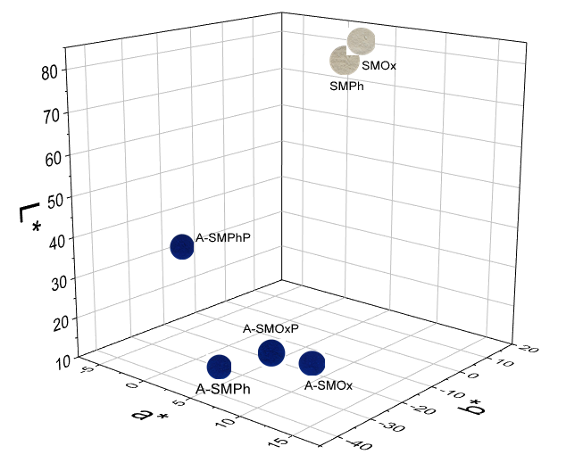
Figure S2: A graph of the CieL*a*b* system highlighting the colorimetric changes of the SMPh and SMOx samples, obtained before and after the adsorption/photocatalysis process of MB in powder form.

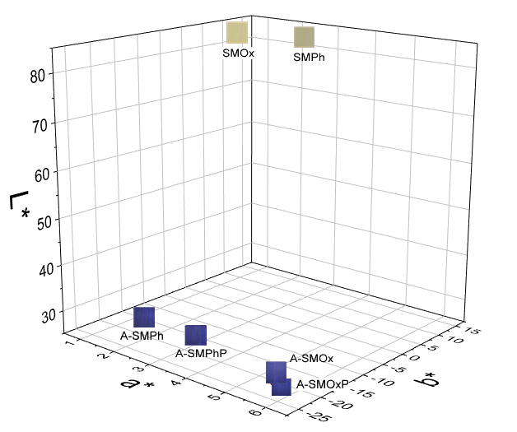
Figure S3: A graph of the CieL*a*b* system highlighting the colorimetric changes of the SMPh and SMOx samples, obtained before and after the adsorption/photocatalysis process of MB as a pigment dispersed in clear paint.

