Supporting Information
for
Green synthesis of pyrrole-fused dibenzoxazepine/dibenzothiazepine/triazolobenzodiazepine derivatives via isocyanide-based multicomponent reactions
Marzieh Norouzi,ª Mohammad Taghi Nazeri,^{∗, a} Ahmad Shaabani^{∗, a} and Behrouz Notash^{b}
ª Department of Organic Chemistry, Shahid Beheshti University, Daneshjou Boulevard, Tehran, 1983969411, Iran
^{b}Department of Inorganic Chemistry, Shahid Beheshti University, Daneshjou Boulevard, Tehran, 1983969411, Iran

General synthetic procedures and characterisation

Table of Contents
X-Ray crystallographic information 1
Preparation Method of a Single Crystal of Compound 4h 1
Preparation Method of a Single Crystal of Compound 6a 4
Photophysical study 5
Fluorescence quantum yield in solution 8
¹H NMR, ¹³C NMR and mass spectra of the compounds 10

Experimental
General information
All commercially available reagents and chemicals were bought from Merck & Co. and utilized without extra purification. The melting points of all the synthesized were measured utilizing an Electrothermal 9200 apparatus. ¹H and ¹³C NMR and spectra in CDCl₃ and DMSO-d₆ solvents were recorded on a BRUKER AVANCE spectrometer at 300.13 MHz and 75.47 MHz, respectively. IR spectra were created on a Thermo Nicolet NEXUS 470 FT-IR spectrometer in cm⁻¹. Mass spectra with an HP (Agile Technologies) 5975C Mass Selective Detector were used to confirm the mass of the synthesized products. The PL spectra prepared for the products were obtained by a spectrofluorometric (LS45, PerkinElmer). Elemental analyses were conducted using the GmbH VarioEL CHN mode elementaranalyse system. The ultrasound used for the reactions was carried out in a Specord S 600 ultrasound cleaner device with a frequency of 45 kHz and an output power of 350 W.
Preventive Education for Synthesizing Triazolobenzodiazepine 6a-h.
Azides are highly reactive, toxic, explosive, and shock-sensitive chemicals that can be used under certain conditions. Special safety procedures must be followed during preparation, storage, handling, and disposal. TMSN₃ is an organic azide that is very sensitive to external factors such as light, heat, friction, and pressure. Which should be stored in amber plastic containers without light and at a temperature below zero degrees Celsius. Exposure to azide occurs through skin absorption, inhalation, or ingestion through the respiratory tract. Which leads to skin and eye irritation, blurred vision, dizziness, weakness/fatigue, hypotension, seizures, and respiratory failure. The following instructions are required to work with TMSN₃. It is necessary to have a silver shield apron, breathing mask, safety glasses, lab coat, and gloves with high chemical resistance. The reaction should be carried out in a hood with a strong suction and with a protective explosion shield, which in this test should be as low as possible. Since exposure to water and strong acids leads to the formation of hydrazoic acid, which is very toxic, volatile, and explosive, therefore, the reaction containers must be completely dry and clean. When consuming TMSN₃, it should be done cold (below zero degrees Celsius) in a container insulated from light. The reaction must be completely closed under the hood and the lid of the reaction container, and the product purification process must be carried out under the mentioned personal protective equipment. The reaction on a larger scale is carried out under special safety conditions.[46-48]
3-(Cyclohexylamino)-2-phenyldibenzo[b,f]pyrrolo[1,2-d][1,4]oxazepine-1-carbonitrile (4a); Ethyl 2-(4-chlorophenyl)-3-(cyclohexylamino)dibenzo[b,f]pyrrolo[1,2-d][1,4]thiazepine-1-carboxylate (4e) and 11-(Cyclohexylamino)-12-phenyl-9H-benzo[f]pyrrolo[1,2-d][1,2,3]triazolo[1,5-a][1,4]diazepine-13-carbonitrile (6a); Typical Procedure
Cyclic imines of dibenzo[b,f][1,4]oxazepine 3a-c, dibenzo[b,f][1,4]thiazepine 3d and 4H-benzo[f][1,2,3]triazolo[1,5-a][1,4]diazepine 5 were prepared according to the procedure in the previous report and 0.50 mmol ( 3a, 98 mg; 3d, 105 mg; 5, 92 mg) of each was added separately along with 2-benzylidenemalononitrile 1a (0.55 mmol, 85 mg), cyclohexyl isocyanide 2a (0.55 mmol, 60 mg). The reaction mixture was stirred at temperatures of 100 or 80 °C for 2 h using a magnetic stirrer. After making sure that the reactions were completed (monitored by TLC), the reaction mixture was cooled to ambient temperature. Then, the crudes mixture was purified using a silica gel chromatography column and washed with n-hexane and ethyl acetate solvents (1:3 in 3a and 3d; 2:1 in the compounds 5).

Dibenzo[b,f][1,4]oxazepine (3a)
Yellow crystals; yield: 683 mg (70%); mp 69-71 °C. ¹H NMR (300 MHz, CDCl₃) δ 8.55 (s, 1H, H_{imine}), 7.48 (td, J = 7.0, 2.0 Hz, 1H, H_{Ar}), 7.38 (td, J = 7.0, 2.0 Hz, 2H, H_{Ar}), 7.29 – 7.25 (m, 1H, H_{Ar}), 7.24 – 7.19 (m, 2H, H_{Ar}), 7.19 – 7.12 (m, 2H, H_{Ar}). ¹³C NMR (75 MHz, CDCl₃) δ 160.7 (C=N), 160.4, 152.7, 140.4, 133.4, 130.2, 129.2, 128.9, 127.3, 125.7, 125.1, 121.4, 120.8 (C_{Ar}).
8-Methyldibenzo[b,f][1,4]oxazepine (3b)
Orange crystals; yield: 753 mg (72%); mp 42-46 °C. ¹H NMR (300 MHz, CDCl₃) δ 8.53 (s, 1H, H_{imine}), 7.45 (t, J = 7.9 Hz, 1H, H_{Ar}), 7.34 (d, J = 7.7 Hz, 1H, H_{Ar}), 7.24 – 7.11 (m, 3H, H_{Ar}), 7.03 (s, 2H, H_{Ar}), 2.33 (s, 3H, CH₃). ¹³C NMR (75 MHz, CDCl₃) δ 160.6 (C=N), 160.5, 150.5, 140.0, 135.4, 133.3, 130.1, 129.5, 129.4, 127.3, 125.0, 121.0, 120.6 (C_{Ar}), 20.7 (CH₃).
8-Chlorodibenzo[b,f][1,4]oxazepine (3c)
Orange crystals; yield: 858 mg (75%); mp 70-74 °C. ¹H NMR (300 MHz, DMSO-d₆) δ 8.62 (s, 1H, H_{imine}), 7.64 – 7.48 (m, 2H, H_{Ar}), 7.41 – 7.26 (m, 3H, H_{Ar}), 7.27 – 7.17 (m, 2H, H_{Ar}). ¹³C NMR (75 MHz, DMSO-d₆) δ 162.5 (C=N), 159.4, 151.0, 141.4, 134.2, 130.8, 129.6, 128.5, 127.9, 126.7, 125.8, 123.0, 120.5 (C_{Ar}).
Dibenzo[b,f][1,4]thiazepine (3d)
Yellow solid; yield: 739 mg (70%); mp 106-107 °C. ¹H NMR (300 MHz, CDCl₃) δ 8.92 (s, 1H, H_{imine}), 7.48 – 7.43 (m, 3H, H_{Ar}), 7.42 – 7.36 (m, 3H, H_{Ar}), 7.36 – 7.33 (m, 2H, H_{Ar}). ¹³C NMR (75 MHz, CDCl₃) δ 163.0 (C=N), 159.1, 138.2, 136.5, 134.9, 133.9, 133.6, 130.5, 130.1, 129.8, 126.8, 126.1, 125.0 (C_{Ar}).
4H-benzo[f][1,2,3]triazolo[1,5-a][1,4]diazepine (5)
Brownish solid; yield: 1.12 g (61%). mp 147-149 °C. ¹H NMR (300 MHz, DMSO-d₆) δ 8.53 (s, 1H, H_{imine}), 8.12 (d, J = 8.0 Hz, 1H, H_{Ar}), 7.86 (s, 1H, H_{Ar}), 7.84 – 7.74 (m, 2H, H_{Ar}), 7.67 (t, J = 7.5 Hz, 1H, H_{Ar}), 4.73 (s, 2H, CH₂). ¹³C NMR (75 MHz, DMSO-d₆) δ 162.9 (C=N), 136.8, 134.0, 132.5, 131.6, 131.5, 128.6, 124.8, 121.8 (C_{Ar}), 42.7 (CH₂).
3-(Cyclohexylamino)-2-phenyldibenzo[b,f]pyrrolo[1,2-d][1,4]oxazepine-1-carbonitrile (4a)
Yellowish orange powder; yield: 161 mg (75%); mp 87-89 °C; R_{f} (n-hexane/EtOAc 2:1) 0.70. Found: C, 80.70; H, 5.81; N, 9.70. C₂₉H₂₅N₃O requires C, 80.72; H, 5.84; N, 9.74. (ATR) ν (cm⁻¹) 3357 (NH), 2932 (CH), 2854 (CH), 2217 (C≡N), 1497 (C=C) cm⁻¹. ¹H NMR (300 MHz, CDCl₃) δ 7.99 (t, J = 7.9 Hz, 2H, H_{Ar}), 7.69 – 7.46 (m,3H, H_{Ar}), 7.46 – 7.32 (m, 4H, H_{Ar}), 7.31 – 7.10 (m,3H, H_{Ar}), 3.59 (s, 1H, NH), 2.61 – 2.28 (m, 1H, H_{cyclohexyl}), 1.74 – 1.35 (m, 5H, H_{cyclohexyl}), 1.12 – 0.74 (m, 5H, H_{cyclohexyl}).¹³C NMR (75 MHz, CDCl₃) δ 157.6, 153.7, 136.3, 132.8, 132.4, 130.4, 130.1, 129.0, 128.9, 128.8, 128.7, 127.3, 126.2, 126.0, 125.4, 124.8, 122.5, 122.1, 120.7, 117.2, 115.9 (C_{Ar}), 91.548 (CN), 56.2, 33.5, 33.3, 25.5, 24.8, 24.4 (C_{Aliphatic}). MS m/z (EI, 70 eV) 431(M⁺, 58.40), 348 (31.71), 321 (10.03), 221 (9.54), 180 (9.56), 139 (8.09), 105 (19.94), 83 (32.24), 55 (100).
3-(Cyclohexylamino)-2-(4-nitrophenyl)dibenzo[b,f]pyrrolo[1,2-d][1,4]oxazepine-1-carbonitrile (4b)
Orange solid; yield: 207 mg (87%); mp 242-245 °C; R_{f} (n-hexane/EtOAc 2:1) 0.56. Found: C, 73.04; H, 5.08; N, 11.73. C₂₉H₂₄N₄O₃ requires C, 73.09; H, 5.08; N, 11.76. (ATR) ν (cm⁻¹) 3387 (NH), 2919 (CH), 2852 (CH), 2216 (C≡N), 1462 (C=C) cm⁻¹. ¹H NMR (300 MHz, CDCl₃) δ 8.38 (d, J = 8.4 Hz, 1H, H_{Ar}), 7.96 (d, J = 7.7 Hz, 1H, H_{Ar}), 7.88 (d, J = 8.0 Hz, 1H, H_{Ar}), 7.78 (d, J = 8.4 Hz, 1H, H_{Ar}), 7.55 – 7.16 (m, 6H, H_{Ar}), 5.15 (s, 1H,NH) 2.51 (bs, 1H, H_{cyclohexyl}), 1.66 (bs, 2H, H_{cyclohexyl}), 1.34 – 1.29 (m, 4H, H_{cyclohexyl}), 0.93 – 0.85 (m, 4H, H_{cyclohexyl}). ¹³C NMR (75 MHz, CDCl₃) δ 157.8, 154.1, 146.4, 139.6, 137.0, 134.0, 130.7, 129.7, 129.2, 129.1, 128.9, 126.2, 125.8, 125.6, 124.3, 122.4, 122.0, 120.8, 116.6, 113.1 (C_{Ar}), 91.0 (CN), 56.4, 33.7, 33.3, 25.3, 24.7, 24.4 (C_{Aliphatic}). MS m/z (EI, 70 eV) 476 (M⁺, 58.02), 394 (35.65), 377 (13.60), 346 (29.69), 221 (13.95), 180 (16.05), 83 (34.85), 55 (100).
3-(Cyclohexylamino)-6-methyl-2-phenyldibenzo[b,f]pyrrolo[1,2-d][1,4]oxazepine-1-carbonitrile (4c)
Reddish brown oil; yield: 158 mg (71%); mp 82-83 °C; R_{f} (n-hexane/EtOAc 2:1) 0.76. Found: C, 80.81; H, 6.07; N, 9.40. C₃₀H₂₇N₃O requires C, 80.87; H, 6.11; N, 9.43. (ATR) ν (cm⁻¹) 3355 (NH), 2928 (CH), 2854 (CH), 2216 (C≡N), 1453 (C=C) cm⁻¹. ¹H NMR (300 MHz, CDCl₃) δ 7.95 (d, J = 7.3 Hz, 1H, H_{Ar}), 7.82 (s, 1H, H_{Ar}), 7.52 (s, 4H, H_{Ar}), 7.42 – 7.19 (m, 5H, H_{Ar}), 7.12 (d, J = 8.5 Hz, 1H, H_{Ar}), 3.61 (s, 1H, NH), 2.47 (bs, 1H. H_{cyclohexyl}), 2.36 (s, 3H, CH₃), 1.62 (bs, 4H, H_{cyclohexyl}), 1.41 (bs, 2H, H_{cyclohexyl}), 0.95 (bs, 4H, H_{cyclohexyl}). ¹³C NMR (75 MHz, CDCl₃) δ 157.8, 151.6, 136.2, 135.2, 132.8, 132.4, 130.0, 129.9, 129.1, 129.0, 128.9, 127.2, 126.3, 125.9, 122.5, 121.6, 120.6, 117.2, 115.6 (C_{Ar}), 91.8 (CN), 53.8, 33.5, 33.3, 25.5, 24.8, 24.4, 20.9 (C_{Aliphatic}). MS m/z (EI, 70 eV) 445 (M⁺, 79.78), 362 (35.22), 335 (8.93), 235 (7.19), 221 (8.52), 194 (8.43), 149 (8.03), 98 (12.74), 83 (34.03), 55 (100).
2-(4-Chlorophenyl)-3-(cyclohexylamino)-6-methyldibenzo[b,f]pyrrolo[1,2-d][1,4]oxazepine-1-carbonitrile (4d)
Light lime green powder; yield: 189 mg (79%); mp 190-192 °C; R_{f} (n-hexane/EtOAc 2:1) 0.70. Found: C, 75.01; H, 5.45; N, 8.72. C₃₀H₂₆ClN₃O requires C, 75.07; H, 5.46; N, 8.75. (ATR) ν (cm⁻¹) 3378 (NH), 2925 (CH), 2852 (CH), 2219 (C≡N), 1456 (C=C) cm⁻¹. ¹H NMR (300 MHz, CDCl₃) δ 7.94 (d, J = 7.7 Hz, 1H, H_{Ar}), 7.77 (s, 1H, H_{Ar}), 7.55 – 7.39 (m, 3H, H_{Ar}), 7.38 – 7.21 (m, 3H, H_{Ar}), 7.14 (d, J = 8.4 Hz, 1H, H_{Ar}), 3.53 (s, 1H, NH), 2.53 – 2.43 (m, 1H, H_{cyclohexyl}), 2.37 (s, 3H, CH₃), 1.53 – 1.36 (m, 3H, H_{cyclohexyl}), 1.34 – 1.20 (m, 2H, H_{cyclohexyl}), 1.10 – 0.88 (m, 5H, H_{cyclohexyl}). ¹³C NMR (75 MHz, CDCl₃) δ 157.9, 151.7, 136.8, 135.3, 133.1, 133.1, 131.0, 130.2, 130.2, 129.65, 129.3, 129.2, 128.8, 126.2, 125.9, 122.4, 121.7, 120.6, 117.1, 114.3 (C_{Ar}), 91.2 (CN), 56.2, 33.7, 33.4, 25.5, 24.8, 24.4, 20.9(C_{Aliphatic}). MS m/z (EI, 70 eV) 479 (M⁺, 30.54), 481 (M⁺+1, 12.44), 397 (14.56), 361 (8.85), 235 (5.88), 221 (7.25), 194 (8.07), 98 (12.42), 83 (34.82), 55 (100).
2-(4-Bromophenyl)-3-(tert-butylamino)dibenzo[b,f]pyrrolo[1,2-d][1,4]oxazepine-1-carbonitrile (4e)
Yellowish orange powder; yield: 205 mg (85%); mp 200-202 °C; R_{f} (n-hexane/EtOAc 2:1) 0.69. Found: C, 66.94; H, 4.56; N, 8.65. C₂₇H₂₂BrN₃O requires C, 66.95; H, 4.58; N, 8.67. (ATR) ν (cm⁻¹) 3408 (NH), 2960 (CH), 2925 (CH), 2854 (CH), 2222 (C≡N), 1462 (C=C) cm⁻¹. ¹H NMR (300 MHz, CDCl₃) δ 7.94 (d, J = 7.7 Hz, 1H, H_{Ar}), 7.84 (d, J = 7.9 Hz, 1H, H_{Ar}), 7.64 (s, 1H, H_{Ar}), 7.61 (s, 1H, H_{Ar}), 7.43 (d, J = 8.3 Hz, 2H, H_{Ar}), 7.40 – 7.31 (m, 3H, H_{Ar}), 7.30 – 7.21 (m, 2H, H_{Ar}), 3.29 (s, 1H, NH), 0.66 (s, 9H, H_{tert-butyl}). ¹³C NMR (75 MHz, CDCl₃) δ 158.1, 154.6, 134.1, 134.1, 132.2, 132.1, 131.0, 130.8, 130.7, 129.0, 128.7, 128.0, 126.0, 125.0, 122.3, 121.7, 121.6, 120.7, 116.8 (C_{Ar}), 90.9 (CN), 56.9, 29.4 (C_{Aliphatic}). MS m/z (EI, 70 eV) 483 (M⁺, 18.68), 485 (M⁺+1, 15,65), 359 (31.30), 231 (14.64), 97 (17.17), 84 (52.52), 69 (32.82), 55 (100).
3-(Tert-butylamino)-2-(4-methoxyphenyl)dibenzo[b,f]pyrrolo[1,2-d][1,4]oxazepine-1-carbonitrile (4f)
Light green solid; yield: 158 mg (73%); mp 183-185 °C; R_{f} (n-hexane/EtOAc 2:1) 0.60. Found: C, 77.19; H, 5.77; N, 9.64. C₂₈H₂₅N₃O₂ requires C, 77.22; H, 5.79; N, 9.65. (ATR) ν (cm⁻¹) 3390 (NH), 2966 (CH), 2928 (CH), 2857 (CH), 2219 (C≡N), 1462 (C=C) cm⁻¹. ¹H NMR (300 MHz, CDCl₃) δ 8.03 – 7.93 (dd, J = 9, 3 Hz, 1H, H_{Ar}), 7.93 – 7.83 (dd, J = 9, 3 Hz 1H, H_{Ar}), 7.50 – 7.41 (m, 2H, H_{Ar}), 7.41 – 7.34 (m, 2H, H_{Ar}), 7.33 – 7.23 (m, 3H, H_{Ar}), 7.06 (s, 1H, H_{Ar}), 7.03 (s, 1H, H_{Ar}), 3.88 (s, 3H, CH₃), 3.36 (s, 1H, NH), 0.66 (s, 9H, H_{tert-butyl}). ¹³C NMR (75 MHz, CDCl₃) δ 158.9, 158.0, 154.5, 134.0, 133.6, 131.3, 130.4, 130.3, 129.0, 128.4, 128.1, 125.9, 125.4, 124.9, 122.6, 122.5, 121.6, 120.7, 117.2, 114.4 (C_{Ar}), 91.3 (CN), 56.7, 55.3, 29.4 (C_{Aliphatic}). MS m/z (EI, 70 eV) 435 (M⁺, 31.48), 379 (67.62), 221 (11.39), 180 (9.68), 139 (8.50), 77 (7.95), 57 (100).
3-(Tert-butylamino)-2-(2-methoxyphenyl)-6-methyldibenzo[b,f]pyrrolo[1,2-d][1,4] oxazepine-1-carbonitrile (4g)
Yellow oil; yield: 159 mg (71%); mp 193-196 °C, R_{f} (n-hexane/EtOAc 2:1) 0.61. Found: C, 77.45; H, 6.01; N, 9.34. C₂₉H₂₇N₃O₂ requires C, 77.48; H, 6.05; N, 9.35. (ATR) ν (cm⁻¹) 3346 (NH), 2966 (CH), 2919 (CH), 2857 (CH), 2222 (C≡N), 1468 (C=C) cm⁻¹. ¹H NMR (300 MHz, CDCl₃) δ 7.97 (d, J = 7.7 Hz, 1H, H_{Ar}), 7.86 (s, 1H, H_{Ar}), 7.54 (d, J = 7.6 Hz, 1H, H_{Ar}), 7.42 – 7.30 (m, 3H, H_{Ar}), 7.29 – 7.22 (m, 2H, H_{Ar}), 7.17 – 7.04 (m, 3H, H_{Ar}), 4.01 (s, 3H, OCH₃), 3.46 (s, 1H, NH), 2.40 (s, 3H, CH₃), 0.66 (s, 9H, H_{tert-butyl}). ¹³C NMR (75 MHz, CDCl₃) δ 158.1, 152.4, 135.8, 134.5, 134.2, 133.3, 131.9, 130.8, 130.2, 130.1, 129.1, 129.0, 128.8, 125.8, 125.0, 122.9, 122.1, 121.6, 120.9, 120.5, 117.3, 111.6 (C_{Ar}), 91.5 (CN), 56.2, 56.0, 29.5, 20.9 (C_{Aliphatic}). MS m/z (EI, 70 eV) 449 (M⁺, 80.24), 393 (58.06), 235 (10.69), 221 (16.44), 194 (7.40), 180 (6.52), 77 (7.10), 57 (100).
3-(Tert-butylamino)-6-methyl-2-phenyldibenzo[b,f]pyrrolo[1,2-d][1,4]oxazepine-1-carbonitrile (4h)
Orange oil (151 mg, 72%); mp 227-229 °C; R_{f} (n-hexane/EtOAc 2:1) 0.74. Found: C, 80.10; H, 5.98; N, 10.01. C₂₈H₂₅N₃O requires C, 80.16; H, 6.01; N, 10.02. (ATR) ν (cm⁻¹) 3349 (NH), 2960 (CH), 2925 (CH), 2857 (CH), 2213 (C≡N), 1462 (C=C) cm⁻¹. ¹H NMR (300 MHz, CDCl₃) δ 7.97 (dd, J = 9, 3 Hz, 1H, H_{Ar}), 7.78 (s, 1H, H_{Ar}), 7.60 – 7.48 (m, 3H, H_{Ar}), 7.44 – 7.33 (m, 2H, H_{Ar}), 7.33 – 7.23 (m, 2H, H_{Ar}), 7.12 (dd, J = 9, 3 Hz,1H), 3.42 (s, 1H, NH), 2.39 (s, 3H, CH₃), 0.67 (s, 9H, H_{tert-butyl}). ¹³C NMR (75 MHz, CDCl₃) δ 158.3, 152.5, 134.7, 134.2, 133.9, 133.2, 130.8, 130.4, 129.2, 129.1, 129.0 128.9, 128.4, 127.4, 125.8, 122.6, 121.1, 120.6, 117.1 (C_{Ar}), 91.1 (CN), 56.8, 29.4, 20.9 (C_{Aliphatic}). MS m/z (EI, 70 eV) 419 (M⁺, 48.38), 363 (66.04), 335 (7.13), 235 (11.39), 221 (11.46), 194 (8.44), 165 (5.16), 105 (4.47), 77 (11.85), 57 (100).
3-(Isopropylamino)-2-(p-tolyl)dibenzo[b,f]pyrrolo[1,2-d][1,4]oxazepine-1-carbonitrile (4i)
Yellowish white powder; yield: 141 mg (70%); mp 185-186 °C; R_{f} (n-hexane/EtOAc 2:1) 0.67. Found: C, 79.95; H, 5.71; N, 10.32. C₂₇H₂₃N₃O requires C, 79.97; H, 5.72; N, 10.36. (ATR) ν (cm⁻¹) 3361 (NH), 2922 (CH), 2216 (C≡N), 1459 (C=C) cm⁻¹. ¹H NMR (300 MHz, CDCl₃) δ 8.09 – 7.93 (m, 2H, H_{Ar}), 7.48 – 7.38 (m, 2H, H_{Ar}), 7.38 – 7.21 (m, 7H, H_{Ar}), 3.48 – 3.33 (m, 1H, H_{isopropyl}), 2.82 (s, 1H, NH), 2.44 (s, 3H, CH₃), 0.88 (dd, J = 6.4, 2.0 Hz, 3H, H_{isopropyl}), 0.83 (dd, J = 6.4, 2.0 Hz, 3H, H_{isopropyl}). ¹³C NMR (75 MHz, CDCl₃) δ 157.6, 153.7, 137.2, 136.3, 132.7, 130.5, 130.1, 129.8, 129.3, 128.8, 128.8, 128.6, 126.1, 126.0, 125.4, 122.5, 122.0, 120.7, 117.2, 116.1 (C_{Ar}), 91.6 (CN), 49.1, 22.9, 21.3 (C_{Aliphatic}). MS m/z (EI, 70 eV) 405 (M⁺, 100), 362 (52.52), 346 (8.91), 221 (9.24), 180 (8.82), 140 (11.18), 115 (5.56), 91 (6.29), 77 (10.97), 51 (6.27).
3-(Isopropylamino)-6-methyl-2-(o-tolyl)dibenzo[b,f]pyrrolo[1,2-d][1,4]oxazepine-1-carbonitrile (4j)
Reddish brown oil; yield: 142 mg (68%); mp 135-138 °C; R_{f} (n-hexane/EtOAc 2:1) 0.69. Found: C, 80.14; H, 5.99; N, 9.97. C₂₈H₂₅N₃O requires C, 80.16; H, 6.01; N, 10.02. (ATR) ν (cm⁻¹) 3346 (NH), 2928 (CH), 2216 (C≡N), 1456 (C=C) cm⁻¹. ¹H NMR (300 MHz, CDCl₃) δ 7.95 (d, J = 7.8 Hz, 1H, H_{Ar}), 7.90 (s, 1H, NH), 7.80 (s, 1H, H_{Ar}), 7.51 – 7.22 (m, 8H, H_{Ar}), 7.13 (d, J = 8.6 Hz, 1H, H_{Ar}), 2.88 – 2.73 (m, 1H, H_{isopropyl}), 2.42 (s, 3H, CH₃), 2.38 (s, 3H, CH₃), 0.88 (d, J = 15.0 Hz, 6H, H_{isopropyl}). ¹³C NMR (75 MHz, CDCl₃) δ 157.6, 151.5, 138.5, 137.6, 136.2, 135.3, 133.2, 132.5, 131.3, 130.7, 130.3, 130.0, 129.1, 128.7, 128.2, 125.9, 125.9, 122.7, 121.7, 120.6, 117.1, 114.1 (C_{Ar}), 92.4 (CN), 48.7, 20.9, 20.1, 14.2 (C_{Aliphatic}). MS m/z (EI, 70 eV) 419 (M⁺, 100), 376 (30.40), 360 (7.23), 235 (11.43), 220 (16.64), 195 (15.71), 125 (10.44), 111 (16.80), 85 (30.39), 71 (44.34), 57 (82.88).
Ethyl6-chloro-3-(isopropylamino)-2-(3-nitrophenyl)dibenzo[b,f]pyrrolo[1,2-d][1,4]oxazepine-1-carboxylate (4k)
Orange oil ; yield: 212 mg (82%); mp 92-96 °C; R_{f} (n-hexane/EtOAc 2:1) 0.10. Found: C, 64.90; H, 4.66; N, 8.07. C₂₈H₂₄ClN₃O₅ requires C, 64.93; H, 4.67; N, 8.11. (ATR) ν (cm⁻¹) 3373 (NH), 2925 (CH), 1712 (C=O), 1447 (C=C) cm⁻¹. ¹H NMR (300 MHz, CDCl₃) δ 8.33 – 8.27 (m, 2H, H_{Ar}), 8.22 (s, 1H, H_{Ar}), 8.15 (s, 1H, H_{Ar}), 7.83 (s, 1H, NH), 7.71 (d, J = 5.8 Hz, 3H, H_{Ar}), 7.63 (d, J = 4.9 Hz, 3H, H_{Ar}), 7.28 (s, 1H, H_{Ar}), 4.12 (q, J = 7.2 Hz, 2H, CH₂), 3.80 – 3.69 (m, 1H, H_{isopropyl}), 1.33 (d, J = 6.0 Hz, 6H, H_{isopropyl}), 1.02 (t, J = 7.2 Hz, 3H, CH₃). ¹³C NMR (75 MHz, CDCl₃) δ 164.3 (CO), 158.1, 158.1, 156.4, 156.0, 153.4, 148.5, 148.5, 137.4, 135.7, 134.8, 130.5, 130.1, 125.3, 124.7, 124.3, 123.5, 117.4, 116.8 (C_{Ar}), 58.3, 46.4, 23.1, 13.5 (C_{Aliphatic}). MS m/z (EI, 70 eV) 517 (M⁺, 17.88), 519 (M⁺+1, 5.67), 472 (11.41), 416 (22.99), 374 (9.54), 154 (13.79), 127 (12.77), 101 (12.60), 84 (100), 59 (24.70).
Ethyl 2-(4-chlorophenyl)-3-(cyclohexylamino)dibenzo[b,f]pyrrolo[1,2-d][1,4]thiazepine-1-carboxylate (4l)
Green powder; yield: 193 mg (73%); mp 158-162 °C; R_{f} (n-hexane/EtOAc 2:1) 0.67. Found: C, 70.35; H, 5.50; N, 5.26; S, 6.01. C₃₁H₂₉ClN₂O₂S requires C, 70.37; H, 5.52; N, 5.29; S, 6.06. (ATR) ν (cm⁻¹) 3364 (NH), 2925 (CH), 2854 (CH), 1709 (C=O), 1442 (C=C) cm⁻¹. ¹H NMR (300 MHz, CDCl3) δ 7.85 – 7.65 (m, 2H, H_{Ar}), 7.65 – 7.55 (m, 1H, H_{Ar}), 7.50 – 7.31 (m, 5H, H_{Ar}), 7.29 – 7.13 (m, 3H, H_{Ar}), 4.11 – 3.98 (m, 2H, OCH₂CH₃), 3.31 (bs, 1H, NH), 2.03 (bs, 1H, H_{cyclohexyl}), 1.52 (s, 1H, H_{cyclohexyl}), 1.43 – 1.29 (m, 4H, H_{cyclohexyl}), 0.97 (t, J = 7.1 Hz, 3H, OCH₂CH₃), 0.92 – 0.80 (m, 3H, H_{cyclohexyl}), 0.70 (d, J = 9.3 Hz, 1H, H_{cyclohexyl}), 0.58 (d, J = 10.8 Hz, 1H, H_{cyclohexyl}). ¹³C NMR (75 MHz, CDCl₃) δ 165.7(CO), 138.3, 137.7, 136.7, 135.4, 133.5, 133.3, 133.2, 132.5, 132.3, 132.2, 132.2, 131.2, 128.8, 128.4, 128.3, 127.9, 127.7, 121.2, 112.9, 112.6 (C_{Ar}), 60.0, 55.9, 33.5, 33.2, 25.5, 24.8, 24.4, 13.7 (C_{Aliphatic}). MS m/z (EI, 70 eV) 528 (M⁺, 13.96), 530 (M⁺+1, 6.30), 372 (4.75), 210 (7.82), 149 (7.88), 83 (35.85), 55 (100).

11-(Cyclohexylamino)-12-phenyl-9H-benzo[f]pyrrolo[1,2-d][1,2,3]triazolo[1,5-a][1,4]diazepine-13-carbonitrile (6a)
White powder; yield: 166 mg (79%); mp 126-129 °C; R_{f} (n-hexane/EtOAc 2:1) 0.2. Found: C, 74.22; H, 5.73; N, 19.97. C₂₆H₂₄N₆ requires C, 74.26; H, 5.75; N, 19.99. (ATR) ν (cm⁻¹) 3337 (NH), 29348 (CH), 2857 (CH), 2213 (C≡N), 1447 (C=C) cm⁻¹. ¹H NMR (300 MHz, CDCl₃) δ 8.22 – 8.06 (m, 2H, H_{Ar}), 7.76 (s, 1H, H_{Ar}), 7.71 – 7.61 (m, 2H, H_{Ar}), 7.50 – 7.42 (m, 3H, H_{Ar}), 7.36 (s, 1H, H_{Ar}), 7.29 (s, 1H, H_{Ar}), 5.92 (bs, 1H, CH₂), 4.63 (bs, 1H, CH₂), 3.49 (s, 1H, NH), 2.56 (bs, 1H, H_{cyclohexyl}), 1.76 – 1.58 (m, 4H, H_{cyclohexyl}), 1.08 (bs, 4H, H_{cyclohexyl}), 0.89 (bs, 2H, H_{cyclohexyl}). ¹³C NMR (75 MHz, CDCl₃) δ 137.1, 134.4, 134.1, 132.6, 132.2, 131.4, 130.2, 130.2, 129.7, 128.9, 128.5, 124.4, 121.5, 120.6, 116.6, 115.3 (C_{Ar}), 91.8 (CN), 60.4, 53.8, 35.3, 31.8, 29.3, 21.1, 14.2 (C_{Aliphatic}). MS m/z (EI, 70 eV) 420 (M⁺, 35.00), 309 (47.76), 295 (12.83), 232 (10.26), 155 (6.97), 128 (6.72), 102 (8.19), 84 (100), 55 (43.28).
12-(4-Bromophenyl)-11-(cyclohexylamino)-9H-benzo[f]pyrrolo[1,2-d][1,2,3]triazolo[1,5-a][1,4]diazepine-13-carbonitrile (6b)
Yellowish white powder; yield: 217 mg (87%); mp 235-239 °C; R_{f} (n-hexane/EtOAc 2:1) 0.10. Found: C, 62.51; H, 4.62; N, 16.81. C₂₆H₂₃BrN₆ requires C, 62.53; H, 4.64; N, 16.83. (ATR) ν (cm⁻¹) 3346 (NH), 2923 (CH), 2851 (CH), 2217 (C≡N), 1478 (C=C) cm⁻¹. ¹H NMR (300 MHz, DMSO-d₆, CDCl₃) δ 8.07 – 7.94 (m, 2H, H_{Ar}), 7.77 (d, J = 10.2 Hz, 2H, H_{Ar}), 7.68 – 7.56 (m, 3H, H_{Ar}), 7.50 – 7.45 (m, 2H, H_{Ar}), 7.44 (s, 1H, NH), 5.95 (bs, 1H, CH₂), 4.63 (bs, 1H, CH₂), 2.11 (bs, 1H, H_{cyclohexyl}), 1.70 – 1.47 (m, 5H, H_{cyclohexyl}), 1.01 (bs, 5H, H_{cyclohexyl}). ¹³C NMR (75 MHz, DMSO-d₆, CDCl₃) δ 135.2, 134.5, 132.7, 131.7, 131.7, 130.2, 129.6, 124.3, 121.5, 121.0, 118.4, 116.8, 111.3, 109.6 (C_{Ar}), 91.1 (CN), 57.7, 50.9, 35.2, 33.8, 29.6, 25.6, 24.8 (C_{Aliphatic}). MS m/z (EI, 70 eV) 498 (M⁺, 2.33), 500 (M⁺+1, 2.22), 420 (60.05), 309 (100), 295 (27.54), 282 (21.32), 231 (24.80), 214 (9.30), 155 (6.59), 128 (10.75), 102 (16.04), 83 (18.52), 55 (81.26).
11-(Cyclohexylamino)-12-(naphthalen-2-yl)-9H-benzo[f]pyrrolo[1,2-d][1,2,3]triazolo[1,5-a][1,4]diazepine-13-carbonitrile (6c)
Reddish brown powder; yield: 190 mg (81%); mp 133-137 °C; R_{f} (n-hexane/EtOAc 2:1) 0.10. Found: C, 76.55; H, 5.56; N, 17.82. C₃₀H₂₆N₆ requires C, 76.57; H, 5.57; N, 17.86. (ATR) ν (cm⁻¹) 3343 (NH), 2922 (CH), 2852 (CH), 2213 (C≡N), 1450 (C=C) cm⁻¹. ¹H NMR (300 MHz, CDCl₃) δ 8.22 – 8.09 (m, 2H, H_{Ar}), 7.96 – 7.87 (m, 3H, H_{Ar}), 7.77 (s, 1H, H_{Ar}), 7.70 – 7.61 (m, 2H, H_{Ar}), 7.61 – 7.50 (m, 3H, H_{Ar}), 7.28 (s, 1H, H_{Ar}), 5.95 (bs, 1H, CH₂), 4.64 (bs, 1H, CH₂), 3.39 (bs, 1H, NH), 2.63 – 2.49 (m, 1H, H_{cyclohexyl}), 1.63 (bs, 4H, H_{cyclohexyl}), 1.26 – 1.18 (m, 2H, H_{cyclohexyl}), 1.05 – 0.90 (m, 4H, H_{cyclohexyl}). ¹³C NMR (75 MHz, CDCl₃) δ 134.6, 134.1, 133.5, 132.7, 132.5, 131.5, 131.5, 130.3, 129.8, 129.7, 128.7, 128.0, 127.8, 127.4, 126.5, 126.4, 126.2, 124.4, 121.5, 120.7, 116.6 (C_{Ar}), 92.0 (CN), 58.7, 53.7, 33.8, 29.7, 29.3, 25.4, 24.8 (C_{Aliphatic}). MS m/z (EI, 70 eV) 470 (M⁺, 15.92), 359 (46.50), 345 (11.26), 231 (16.52), 155 (11.64), 97 (13.14), 83 (41.32), 69 (24.64), 55 (100).
11-(Tert-butylamino)-12-(4-chlorophenyl)-9H-benzo[f]pyrrolo[1,2-d][1,2,3]triazolo[1,5-a][1,4]diazepine-13-carbonitrile (6d)
Reddish brown powder; yield: 195 mg (91%); mp 89-92 °C; R_{f} (n-hexane/EtOAc 2:1) 0.09. Found: C, 67.20; H, 4.92; N, 19.57. C₂₄H₂₁ClN₆ requires C, 67.21; H, 4.94; N, 19.59. (ATR) ν (cm⁻¹) 3343 (NH), 2969 (CH), 2922 (CH), 2854 (CH), 2216 (C≡N), 1463 (C=C) cm⁻¹. ¹H NMR (300 MHz, CDCl₃) δ 8.15 (d, J = 2.1 Hz, 2H, H_{Ar}), 7.77 (s, 1H, H_{Ar}), 7.68 (s, 2H, H_{Ar}), 7.50 – 7.29 (m, 4H, H_{Ar}), 6.11 (s, 1H, CH₂), 4.58 (s, 1H, CH₂), 3.23 (s, 1H, NH), 0.96 (s, 9H, H_{tert-butyl}). ¹³C NMR (75 MHz, CDCl₃) δ 133.9, 133.6, 132.8, 132.6, 132.2, 131.7, 130.6, 130.5, 130.3, 129.7, 129.2, 124.2, 123.0, 121.3, 116.4 (C_{Ar}), 92.2 (CN), 55.9, 35.7, 30.1 (C_{Aliphatic}). MS m/z (EI, 70 eV) 428 (M⁺, 12.11), 430 (M⁺+1, 5.68), 372 (15.35), 344 (13.76), 329 (13.91), 308 (18.63), 231 (6.16), 155 (6.22), 111 (7.55), 84 (100), 57 (91.31).
11-(Tert-butylamino)-12-(4-methoxyphenyl)-9H-benzo[f]pyrrolo[1,2-d][1,2,3]triazolo[1,5-a][1,4]diazepine-13-carbonitrile (6e)
Reddish brown powder; yield: 163 mg (77%); mp 133-137 °C; R_{f} (n-hexane/EtOAc 2:1) 0.09. Found: C, 70.71; H, 5.66; N, 19.75. C₂₅H₂₄N₆O requires C, 70.73; H, 5.70; N, 19.80. (ATR) ν (cm⁻¹) 3343 (NH), 2963 (CH), 2925 (CH), 2854 (CH), 2216 (C≡N), 1474 (C=C) cm⁻¹. ¹H NMR (300 MHz, CDCl₃) δ 8.20 – 8.08 (m, 2H, H_{Ar}), 7.76 (s, 1H, H_{Ar}), 7.69 – 7.61 (m, 2H, H_{Ar}), 7.33 (s, 1H, H_{Ar}), 7.28 (s, 1H, H_{Ar}), 6.99 (d, J = 8.4 Hz, 2H, H_{Ar}), 6.10 (d, J = 14.8 Hz, 1H, CH₂), 4.55 (s, 1H, CH₂), 3.85 (s, 3H, CH₃), 3.24 (s, 1H, NH), 0.93 (s, 9H, H_{tert-butyl}). ¹³C NMR (75 MHz, CDCl₃) δ 159.0, 134.1, 132.8, 132.4, 131.9, 130.5, 130.3, 130.1, 129.6, 125.5, 124.2, 124.0, 121.5, 116.7, 114.4 (C_{Ar}), 92.4 (CN), 55.8, 55.3, 53.7, 30.1 (C_{Aliphatic}). MS m/z (EI, 70 eV) 424 (M⁺, 30.27), 368 (31.47), 339 (30.85), 325 (38.03), 308 (11.08), 295 (16.51), 231 (29.17), 155 (15.99), 102 (14.23), 77 (13.25), 57 (100).
11-(Butylamino)-12-phenyl-9H-benzo[f]pyrrolo[1,2-d][1,2,3]triazolo[1,5-a][1,4]diazepine-13-carbonitrile (6f)
Yellowish white oil; yield: 153 mg (78%); mp 163-165 °C; R_{f} (n-hexane/EtOAc 2:1) 0.12. Found: C, 73.05; H, 5.58; N, 21.29. C₂₄H₂₂N₆ requires C, 73.07; H, 5.62; N, 21.30. (ATR) ν (cm⁻¹) 3352 (NH), 2963 (CH), 2934 (CH), 2857 (CH), 2213 (C≡N), 1483 (C=C) cm⁻¹. ¹H NMR (300 MHz, CDCl₃) δ 8.22 – 8.04 (m, 2H, H_{Ar}), 7.76 (s, 1H, H_{Ar}), 7.65 (dt, J = 6.0, 3.7 Hz, 2H, H_{Ar}), 7.57 – 7.43 (m, 4H, H_{Ar}), 7.40 – 7.33 (m, 1H, H_{Ar}), 7.28 (s, 1H, NH), 5.84 (s, 1H, CH₂), 4.65 (s, 1H, CH₂), 2.87 (t, , J = 6 Hz, 2H, H_{n-butyl}), 1.56 – 1.40 (m, 2H, H_{n-butyl}), 1.39 – 1.29 (m, 2H, H_{n-butyl}), 0.87 (t, J = 7.3 Hz, 3H, H_{n-butyl}). ¹³C NMR (75 MHz, CDCl₃) δ 135.7, 134.1, 132.6, 131.9, 131.4, 130.2, 129.7, 129.0, 128.5, 127.6, 125.2, 124.4, 121.4, 119.6, 116.6 (C_{Ar}), 91.7 (CN), 50.9, 35.26, 32.3, 20.1, 13.8 (C_{Aliphatic}). MS m/z (EI, 70 eV) 394 (M⁺, 56.99), 323 (27.31), 309 (100), 295 (15.30), 282 (27.45), 255 (12.45), 231 (47.67), 214 (15.66), 167 (16.39), 155 (25.29), 140 (14.96), 128 (26.46), 102 (42.42), 77 (64.40), 57 (85.39).
11-(Butylamino)-12-(o-tolyl)-9H-benzo[f]pyrrolo[1,2-d][1,2,3]triazolo[1,5-a][1,4]diazepine-13-carbonitrile (6g)
White powder; yield: 146 mg (72%); mp 144-149 °C; R_{f} (n-hexane/EtOAc 2:1) 0.12. Found: C, 73.46; H, 5.87; N, 20.55. C₂₅H₂₄N₆ requires C, 73.51; H, 5.92; N, 20.57. (ATR) ν (cm⁻¹) 3367 (NH), 2963 (CH), 2925 (CH), 2857 (CH), 2219 (C≡N), 1480 (C=C) cm⁻¹. ¹H NMR (300 MHz, CDCl₃) δ 8.21 – 8.07 (m, 2H, H_{Ar}), 7.78 (s, 1H, H_{Ar}), 7.69 – 7.61 (m, 2H, H_{Ar}), 7.37 – 7.22 (m, 4H, H_{Ar}), 5.84 (bs, 1H, CH₂), 4.67 (bs, 1H, CH₂), 2.95 (s, 1H, NH), 2.74 (bs, 2H, H_{n-butyl}), 1.41 – 1.32 (m, 2H, H_{n-butyl}), 1.27 (s, 3H, CH₃), 1.24 – 1.16 (m, 2H, H_{n-butyl}), 0.82 (t, J = 7.4 Hz, 3H, H_{n-butyl}). ¹³C NMR (75 MHz, CDCl₃) δ 135.6, 134.2, 132.6, 131.4, 131.4, 131.0, 130.5, 130.1, 129.7, 128.4, 126.0, 124.4, 121.5, 119.4, 116.5 (C_{Ar}), 92.9 (CN), 53.8, 50.5, 35.3, 32.1, 19.9, 13.8 (C_{Aliphatic}). MS m/z (EI, 70 eV) 408 (M⁺, 80.87), 365 (15.48), 337 (24.26), 323 (100), 308 (35.84), 294 (16.29), 281 (16.40), 231 (62.65), 155 (37.11), 140 (27.27), 129 (25.10), 115 (29.27), 102 (34.37), 77 (27.30), 57 (35.42).
11-(Butylamino)-12-(2-methoxyphenyl)-9H-benzo[f]pyrrolo[1,2-d][1,2,3]triazolo[1,5-a][1,4]diazepine-13-carbonitrile (6h)
Brown powder; yield: 159 mg (75%); mp 202-206 °C; R_{f} (n-hexane/EtOAc 2:1) 0.09. Found: C, 70.70; H, 5.67; N, 19.76. C₂₅H₂₄N₆O requires C, 70.73; H, 5.70; N, 19.80. (ATR) ν (cm⁻¹) 3321 (NH), 2965 (CH), 2926 (CH), 2859 (CH), 2212 (C≡N), 1447 (C=C) cm⁻¹. ¹H NMR (300 MHz, CDCl₃) δ 8.19 – 8.07 (m, 2H, H_{Ar}), 7.77 (s, 1H, H_{Ar}), 7.66 – 7.62 (m, 1H, H_{Ar}), 7.44 – 7.34 (m, 2H, H_{Ar}), 7.28 (s, 1H, H_{Ar}), 7.14 – 7.01 (m, 2H, H_{Ar}), 5.86 (bs, 1H, CH₂), 4.64 (bs, 1H, CH₂), 3.91 (s, 3H, CH₃), 3.49 (s, 1H, NH), 2.72 (bs, 2H, H_{n-butyl}), 1.26 – 1.14 (m, 4H, H_{n-butyl}), 0.76 (t, J = 7.1 Hz, 3H, H_{n-butyl}). ¹³C NMR (75 MHz, CDCl₃) δ 155.9, 136.8, 134.2, 132.5, 131.4, 129.7, 129.2, 127.6, 127.0, 124.4, 121.5, 121.5, 120.7, 120.2, 116.7, 115.7, 111.4 (C_{Ar}), 92.2 (CN), 55.9, 50.4, 35.2, 32.2, 20.0, 13.7 (C_{Aliphatic}). MS m/z (EI, 70 eV) 424 (M⁺, 14.36), 372 (11.48), 329 (10.05), 307 (13.83), 231 (10.88), 155 (13.40), 135 (21.48), 101 (27.70), 84 (51.92), 57 (100).

X-Ray crystallographic information

Preparation Method of a Single Crystal of Compound 4h
For the formation of compound 4h, 50 mg of the compound was dissolved in 0.2 mL of hot ethyl acetate solvent in a 10 mL vial. Subsequently, 0.8 mL of n-hexane was added to the vial. The container was sealed with a lid, and single crystal particles were first observed after three days. Five days later, the single crystal particles had substantially grown and were ready for study to determine the structure using crystallography.
ORTEP diagram for 4h; summary of data: The Cambridge Crystallographic Data Centre (CCDC) 2365305; unit cell parameters: a = 12.830 (3) A alpha = 90 deg, b = 12.634 (3) A beta = 98.10 (3) deg, c = 14.283 (3) A gamma = 90 deg.
 | Calculated | Reported
Volume | 2292.1 (9) | 2292.1 (9)
Space group | p 21/n | p 21/n
Hall group | -p 2yn | -p 2yn
Moiety formula | C₂₈ H₂₅ N₃O | C₂₈ H₂₅ N₃O
Sum formula | C₂₈ H₂₅ N₃O [+ solvent] | C₂₈ H₂₅ N₃O [+ solvent]
Mr | 419.51 | 419.51
Dx,g cm⁻³ | 1.216 | 1.216
Z | 4 | 4
Mu (mm-1) | 0.075 | 0.075
F000 | 888.0 | 888.0
F000’ | 888.32
h,k,lmax | 15,15,16 | 15,15,16
Nref | 4027 | 4024
Tmin,Tmax | 0.982, 0.989
Tmin’ | 0.963
Correction method = Not given, Data completeness = 0.999, Theta(max) = 25.000, R(reflections) = 0.0723 (2024), wR2(reflections) = 0.1490 (2024), S = 0.943, Npar = 297

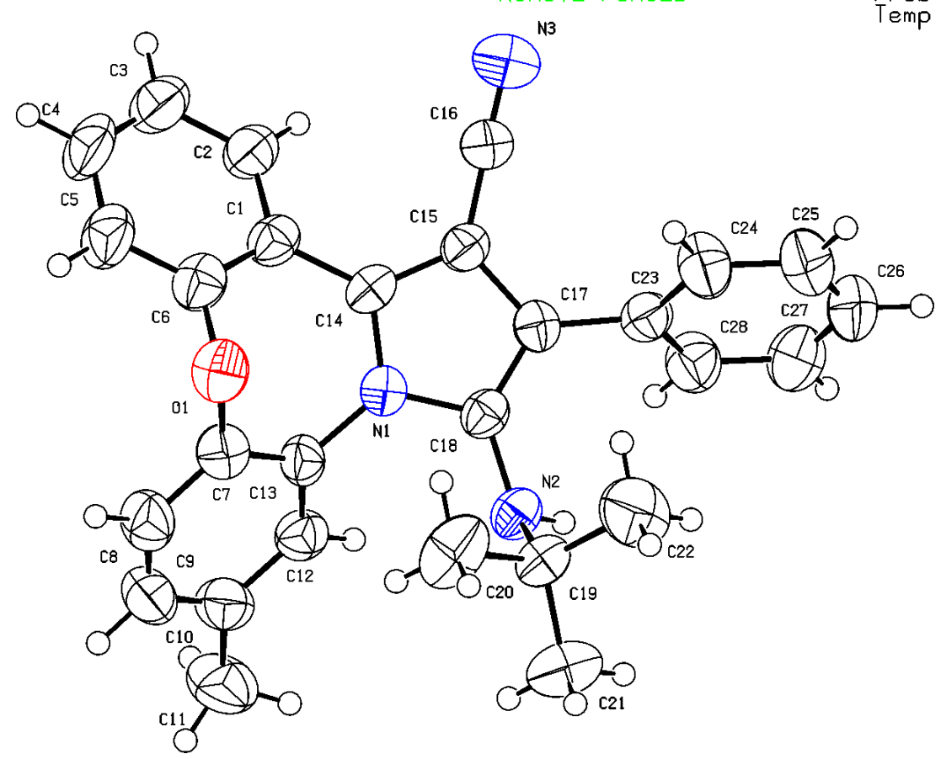
Figure S1. X-ray crystal structure of compound 4h.

Preparation Method of a Single Crystal of Compound 6a
For the formation of compound 6a, 60 mg of the compound was dissolved in 0.4 mL of hot chloroform solvent in a 10 mL vial. Subsequently, 1 mL of n-hexane was added to the vial. The container was sealed with a lid, and single crystal particles were first observed after ten days. Fifteen days later, the single crystal particles had substantially grown and were ready for study to determine the structure using crystallography.
ORTEP diagram for 6a; summary of data: The Cambridge Crystallographic Data Centre (CCDC) 2365306; unit cell parameters: a = 32.586(6) A alpha = 90 deg, b = 11.376(2) A beta = 123.10(3) deg, c = 18.366(4) A gamma = 90 deg.
 | Calculated | Reported
Volume | 5703 (3) | 5703 (3)
Space group | C 2/c | C 2/c
Hall group | -C 2yc | -C 2yc
Moiety formula | C₂₆ H₂₄ N₆ | C₂₆ H₂₄ N₆
Sum formula | C₂₇ H₂₅ C₁₃N₆ [+ solvent] | C₂₇ H₂₅ C₁₃N₆ [+ solvent]
Mr | 539.88 | 539.88
Dx,g cm⁻³ | 1.258 | 1.257
Z | 8 | 8
Mu (mm-1) | 0.348 | 0.348
F000 | 2240.00 | 2240.00
F000’ | 2244.14
h,k,lmax | 38,13,21 | 38,13,21
Nref | 5021 | 5013
Tmin,Tmax | 0.882, 0.933
Tmin’ | 0.840
Correction method = Not given, Data completeness = 0.998, Theta(max) = 25.000, R(reflections) = 0.0876 (2257), wR2(reflections) = 0.2617 ( 5013), S = 0.887, Npar = 298

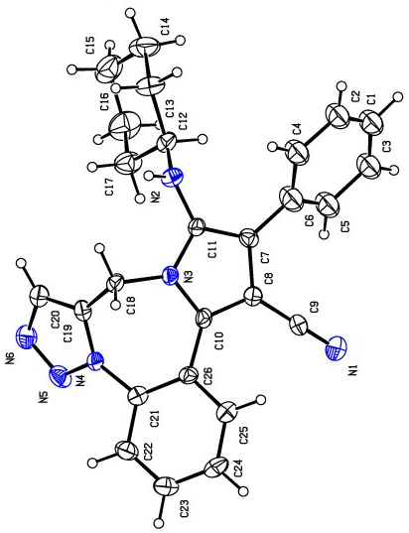
Figure S2. X-ray crystal structure of compound 6a.

Photophysical study

Figure S3. UV-Vis absorption pyrrole-fused derivatives 4a-l and 6a-h; c = 75 ppm in EtOH and T = 298 K

Figure S4. Emission pyrrole-fused derivatives 4a-l and 6a-h; c = 75 ppm in EtOH and T = 298 K;

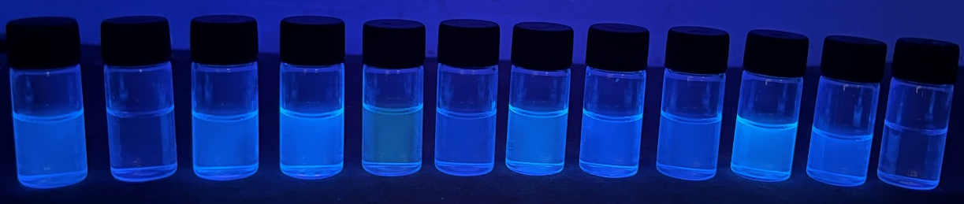
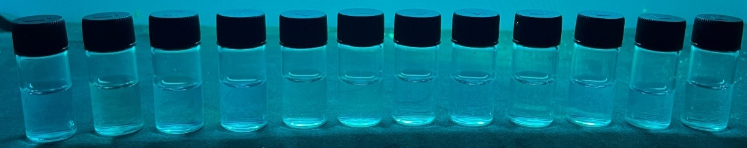

Figure S5.; The digital photograph under sunlight and UV light 265 nm for pyrrole-fused dibenzoxazepine/thoazepine derivatives 4a-l.
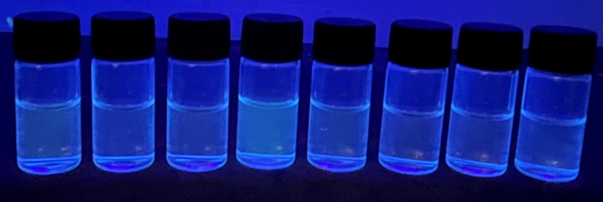

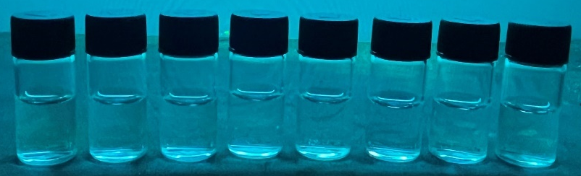

Figure S6.; The digital photograph under sunlight and UV light 265 nm for pyrrole-fused triazolobenzodiazepine derivatives 6a-h.

Fluorescence quantum yield in solution
Fluorescence quantum yield was determined using the optical method for products 4a-l and 6a-h in ethanol solution with a concentration of 75 ppm. quinine sulfate solutions (Φ_{f} = 0.546 in 1N H₂SO₄) were used as standards at an excitation wavelength of 320-345 nm. The quantum yield is calculated using equation 1.
Φ_{f} = Φ_{r} (A_{r}F_{s}/A_{s}F_{r}) (ηs² /ηr²).........(1)
Where, A_{s} and A_{r} are in the absorbance of the sample and reference solutions, respectively, at the
same excitation wavelength, F_{s} and F_{r} are the corresponding relative integrated fluorescence
intensities and η is the refractive index of the solvents.¹ The quantum yield of products 4a-l and 6a-h was calculated according to equation 1, which can be seen in Table S1.
Table S1. Quantum Yield of products 4a-l and 6a-h
Substrate | Absorption λ_{max} (nm) | Emission λ_{max} (nm) | Φ_{f}ª (%)
4a | 320 | 446 | 48.35
4b | 317 | 413 | 14.10
4c | 314 | 447 | 42.10
4d | 315 | 442 | 34.58
4e | 305 | 434 | 20.54
4f | 325 | 445 | 42.14
4g | 311 | 434 | 39.39
4h | 315 | 442 | 44.03
4i | 331 | 446 | 29.48
4j | 340 | 443 | 47.79
4k | 266 | 403 | 3.32
4l | 322 | 465 | 8.74
6a | 325 | 457 | 0.90
6b | 306 | 408 | 0.83
6c | 319 | 461 | 1.04
6d | 317 | 454 | 0.74
6e | 322 | 424 | 0.98
6f | 324 | 449 | 0.64
6g | 320 | 407 | 0.85
6h | 308 | 428 | 0.91
ªFluorescence quantum yield relative to quinine sulfate as a standard

¹H NMR, ¹³C NMR and mass spectra of the compounds
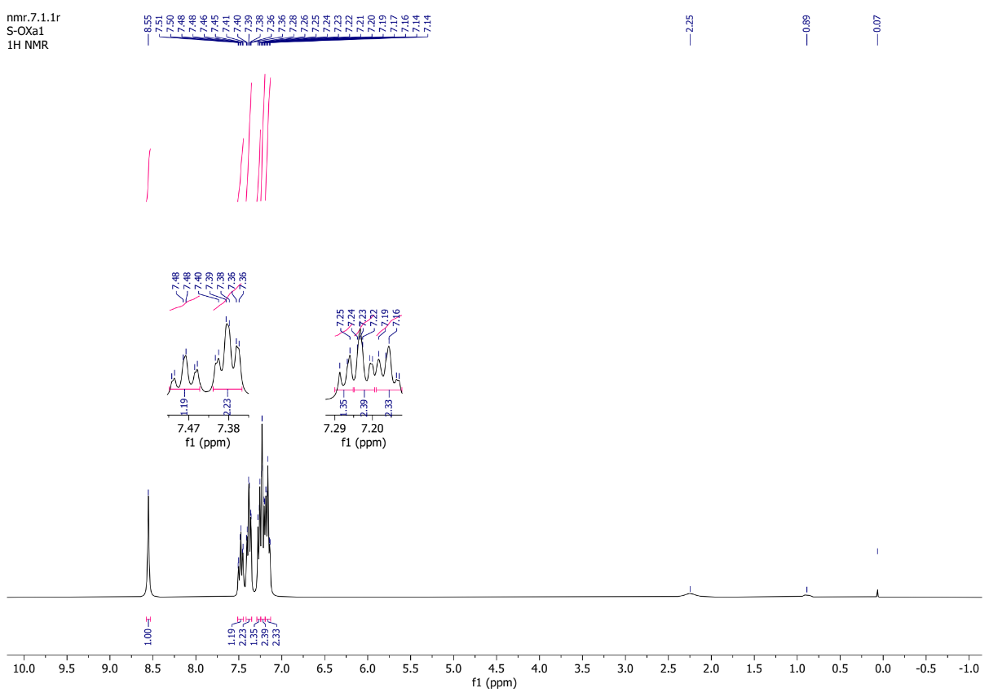

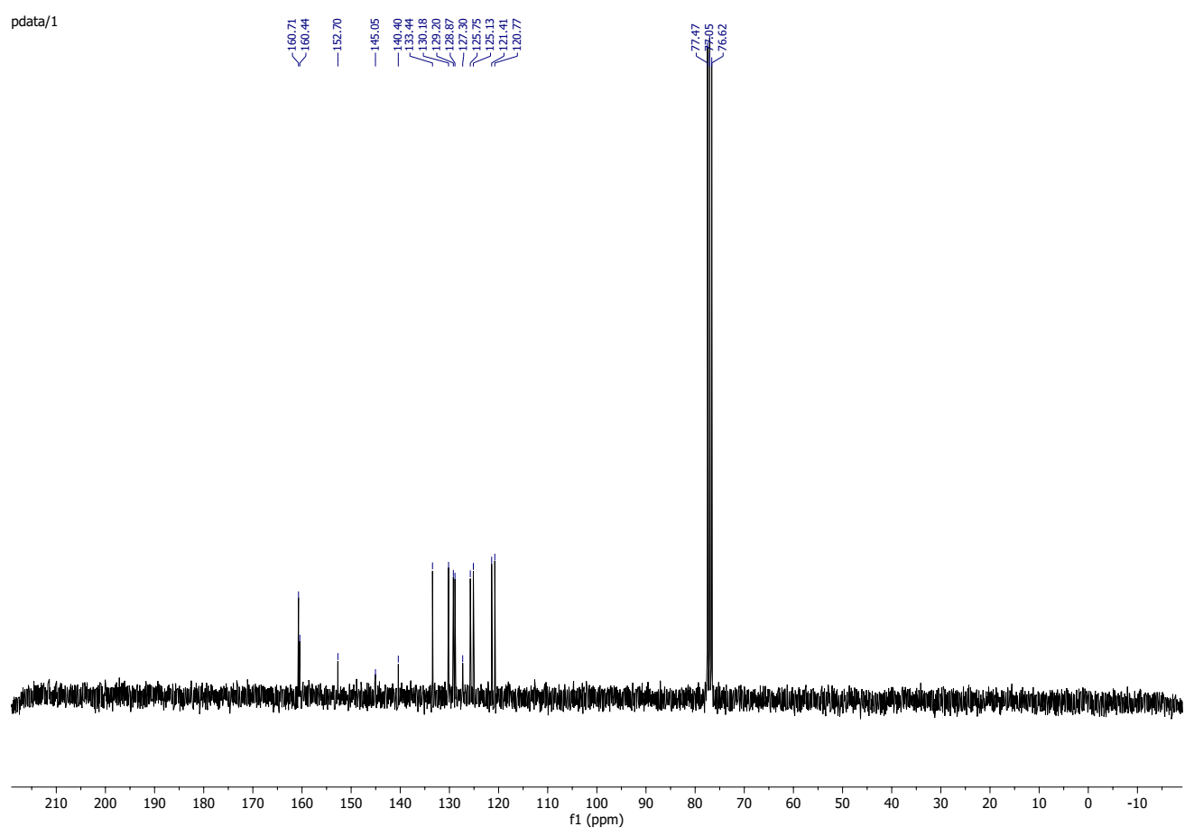

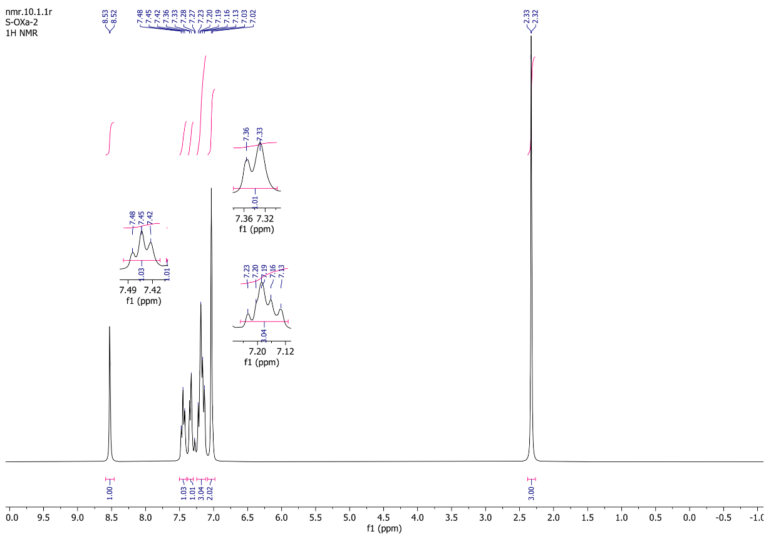

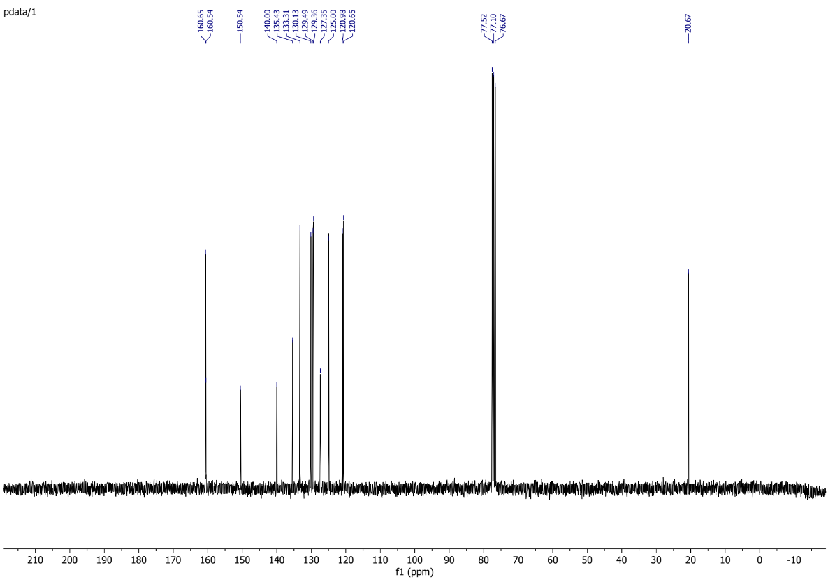

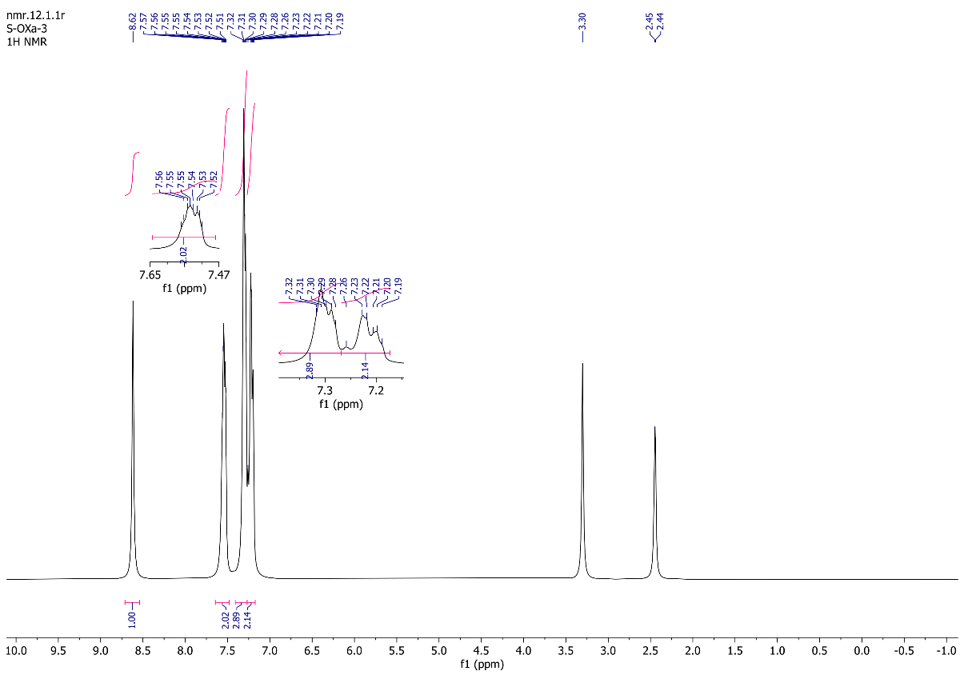

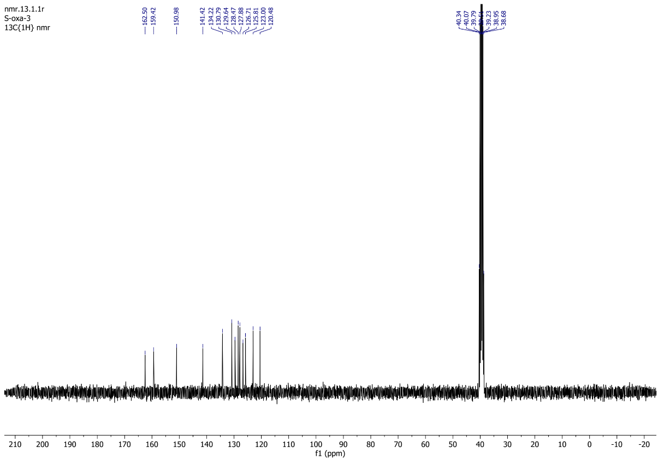

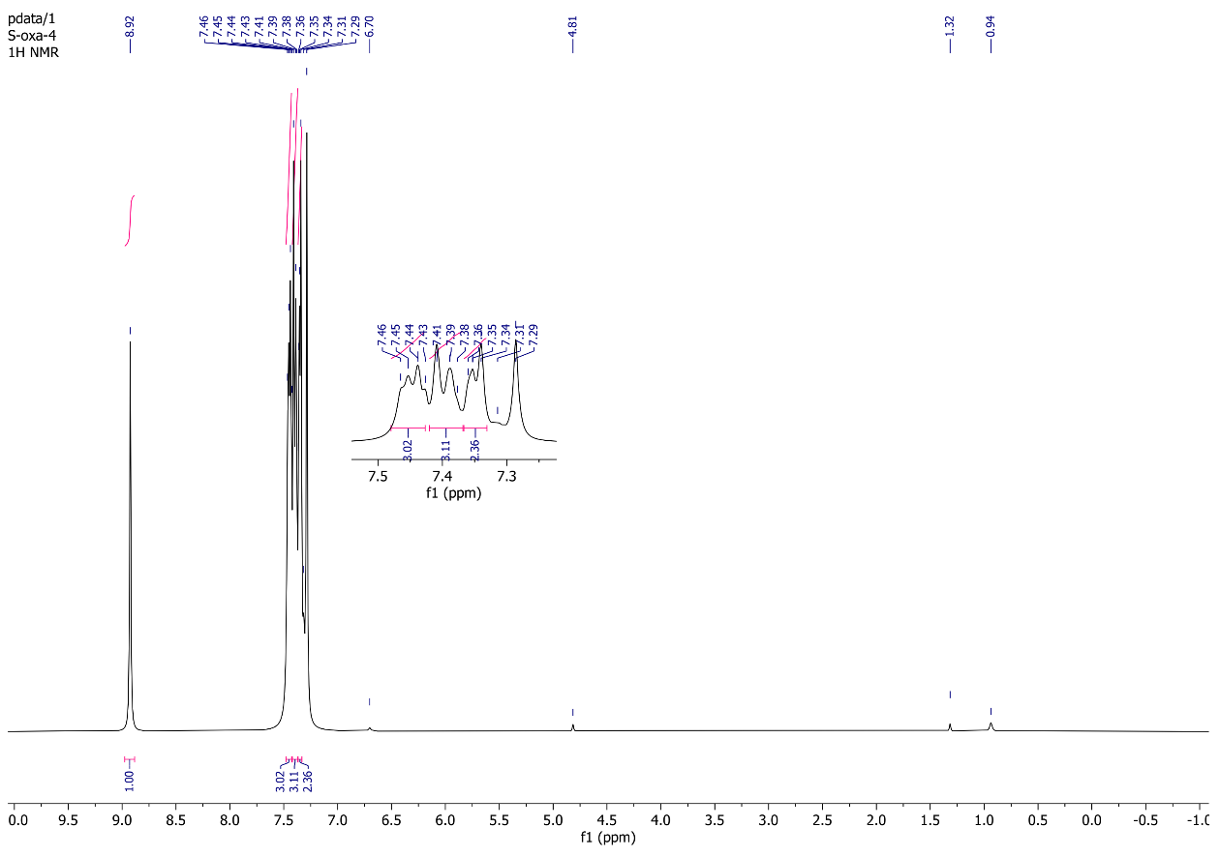

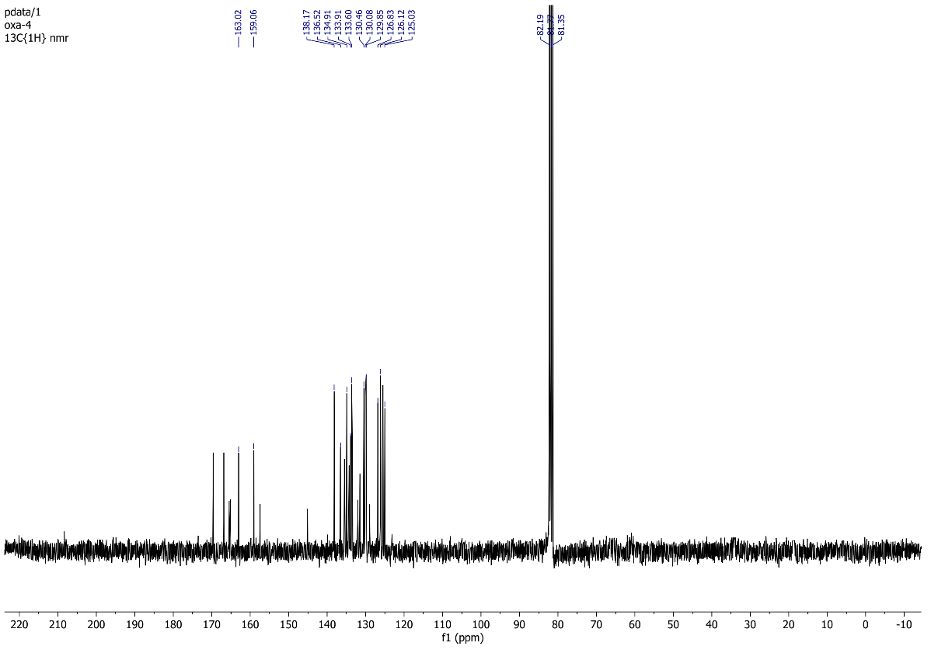

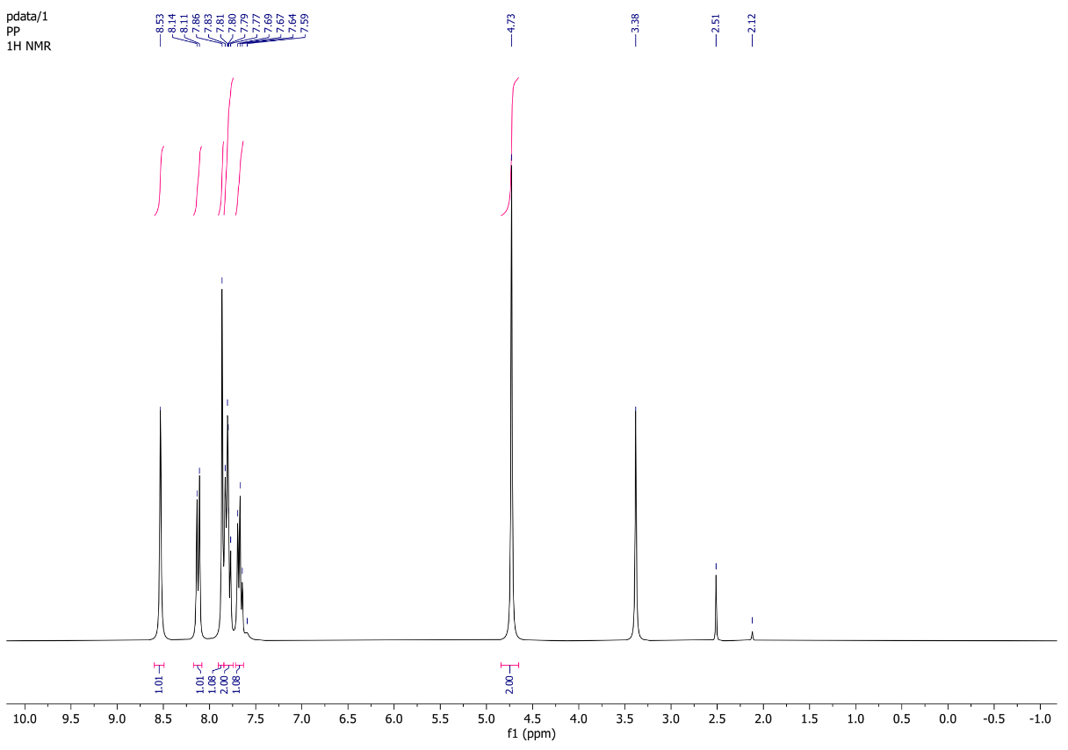

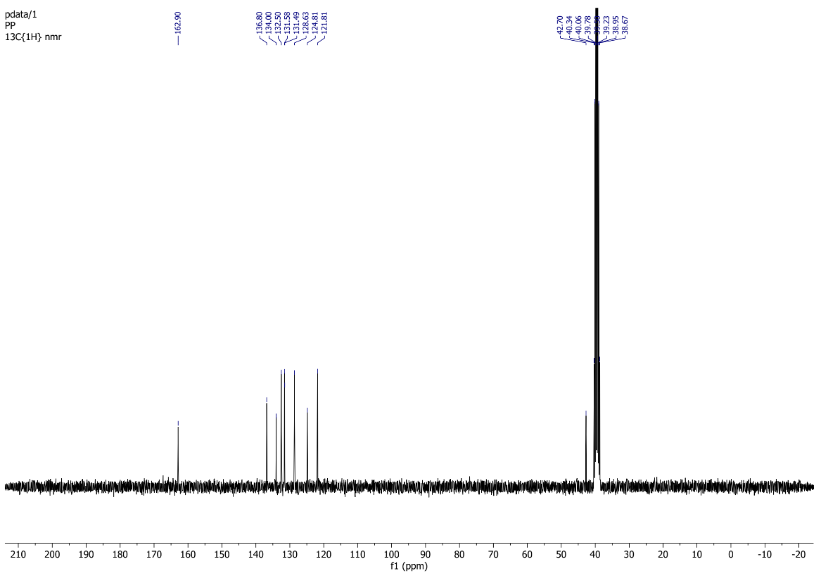

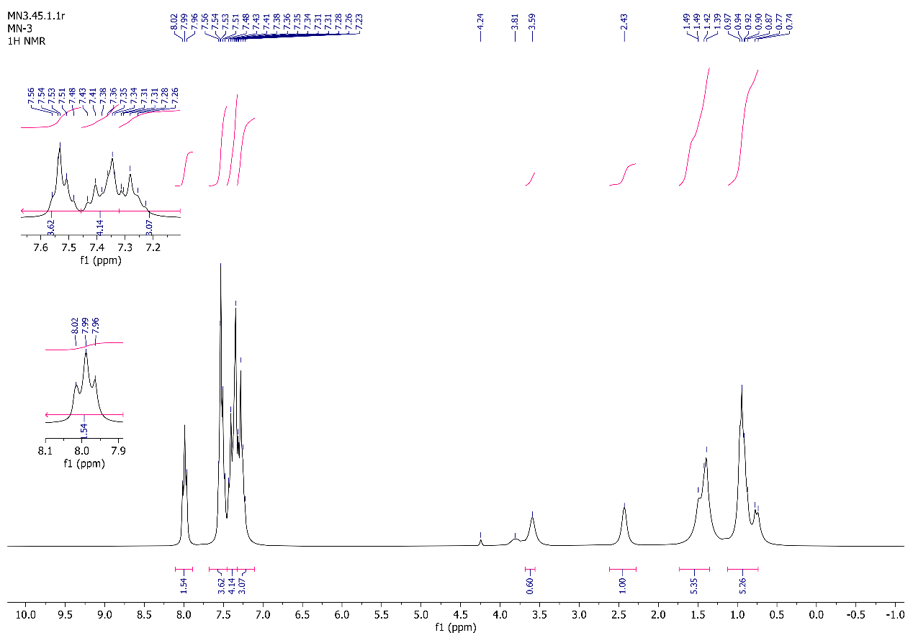

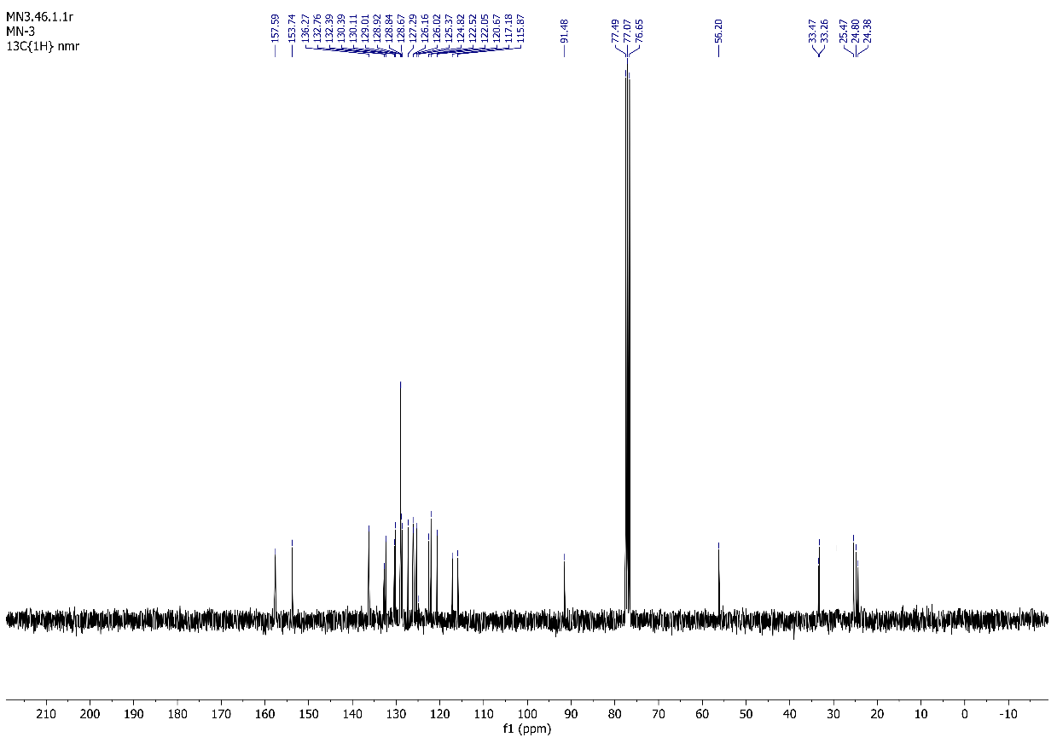

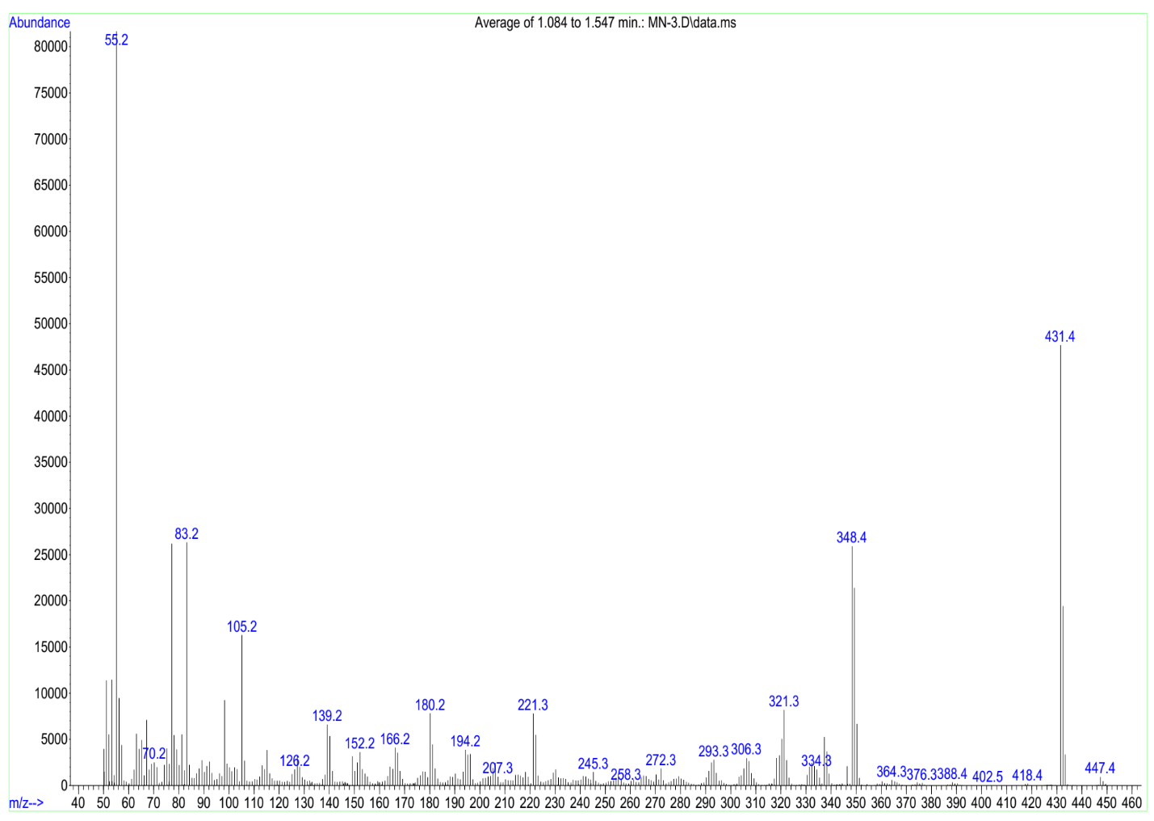

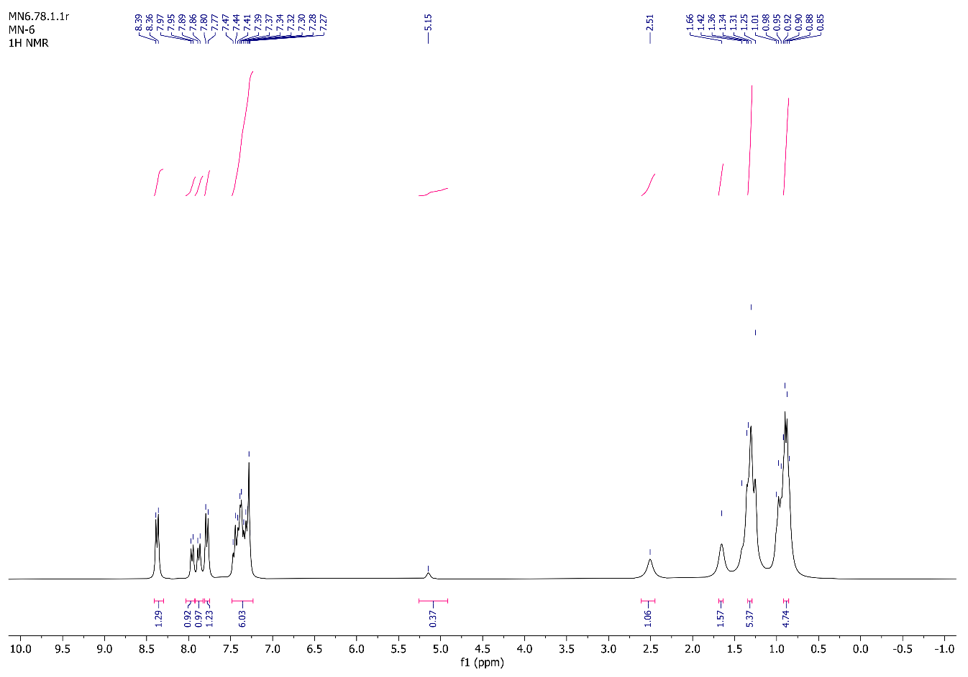

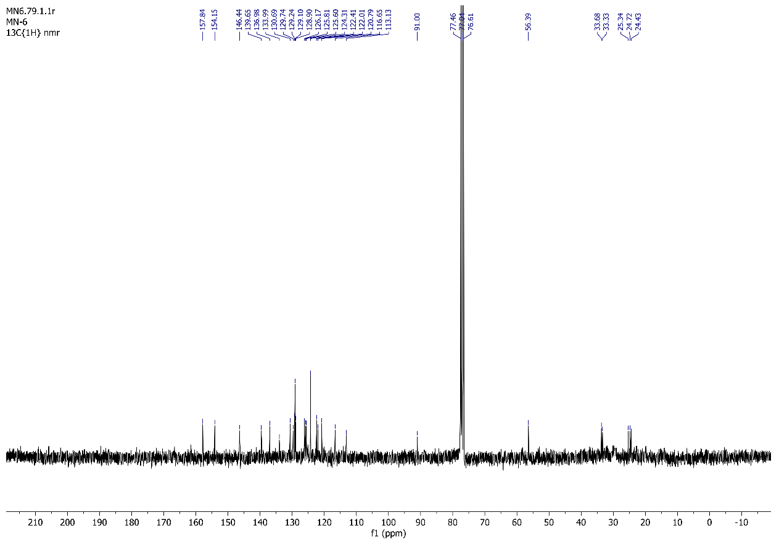

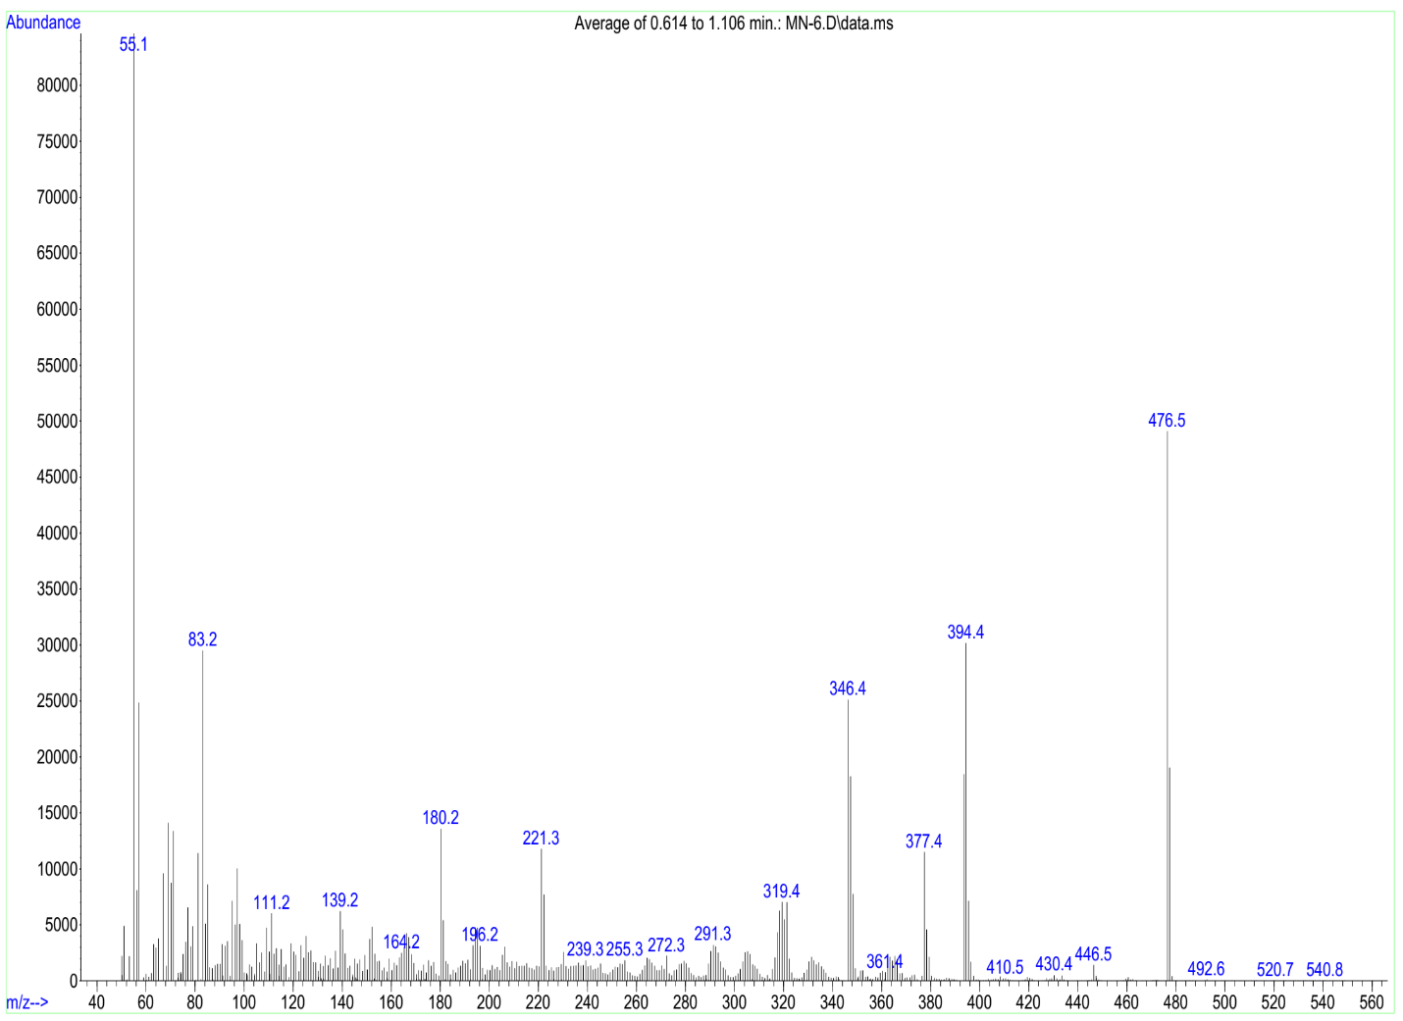

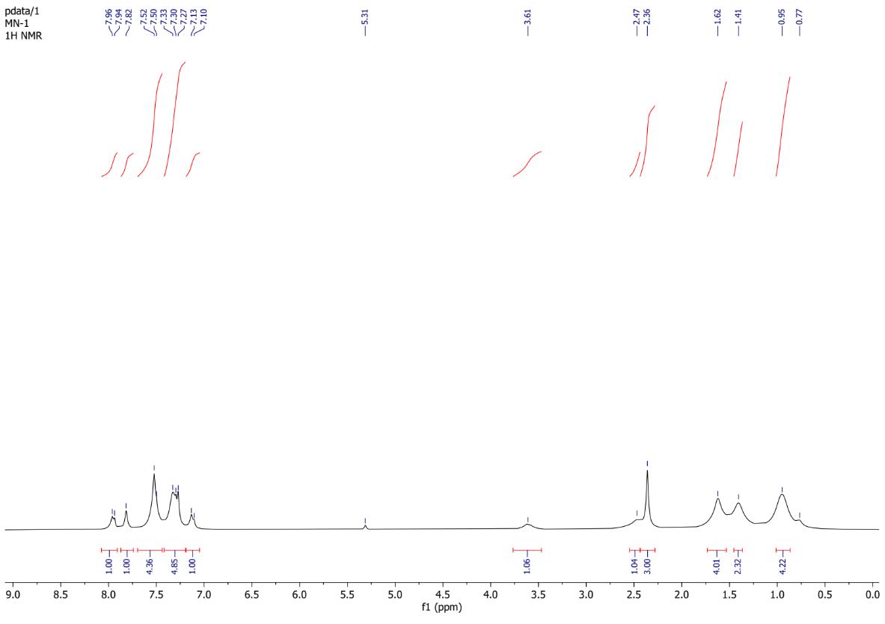

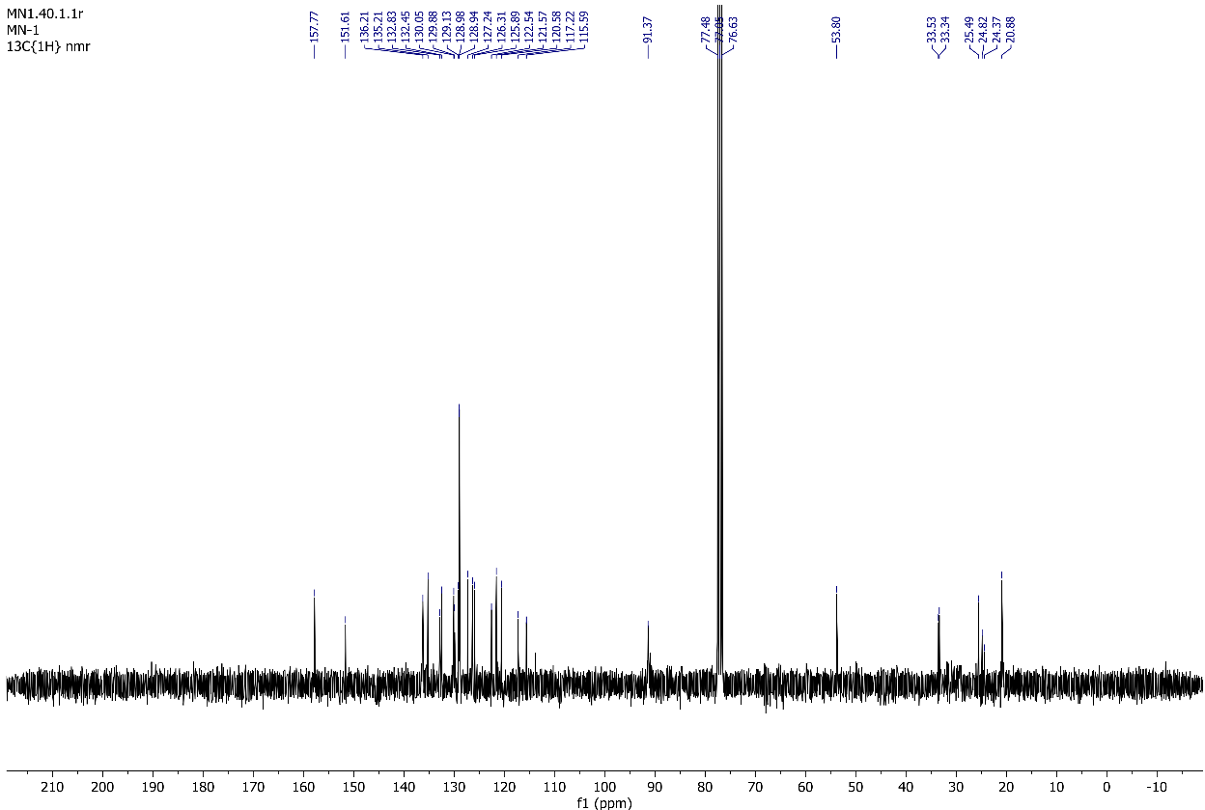

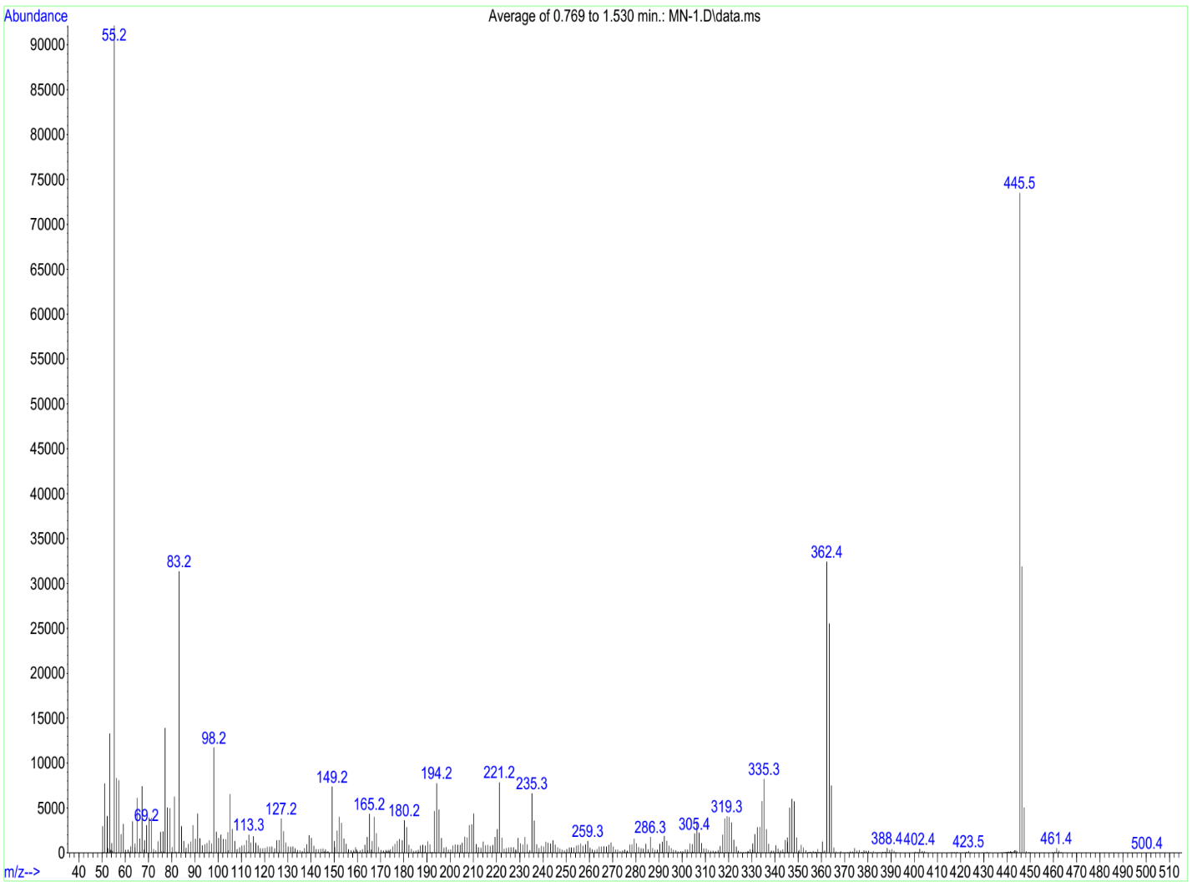

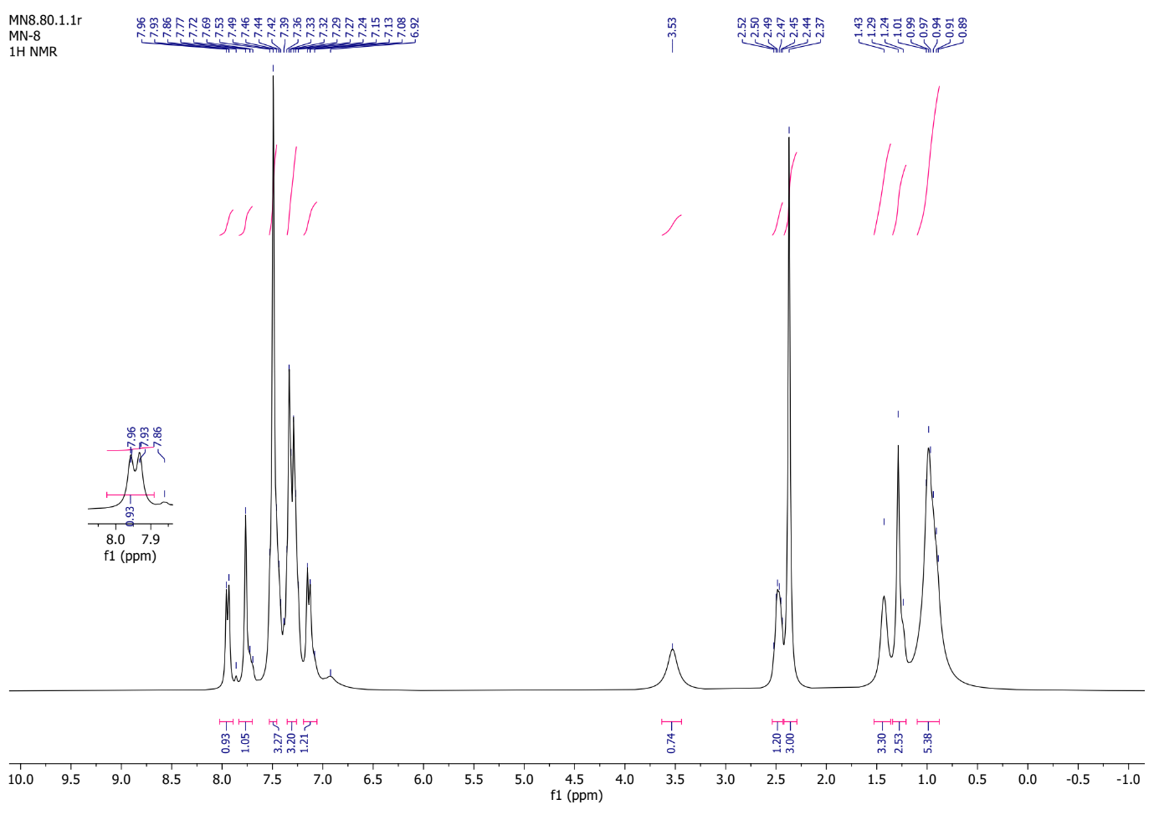
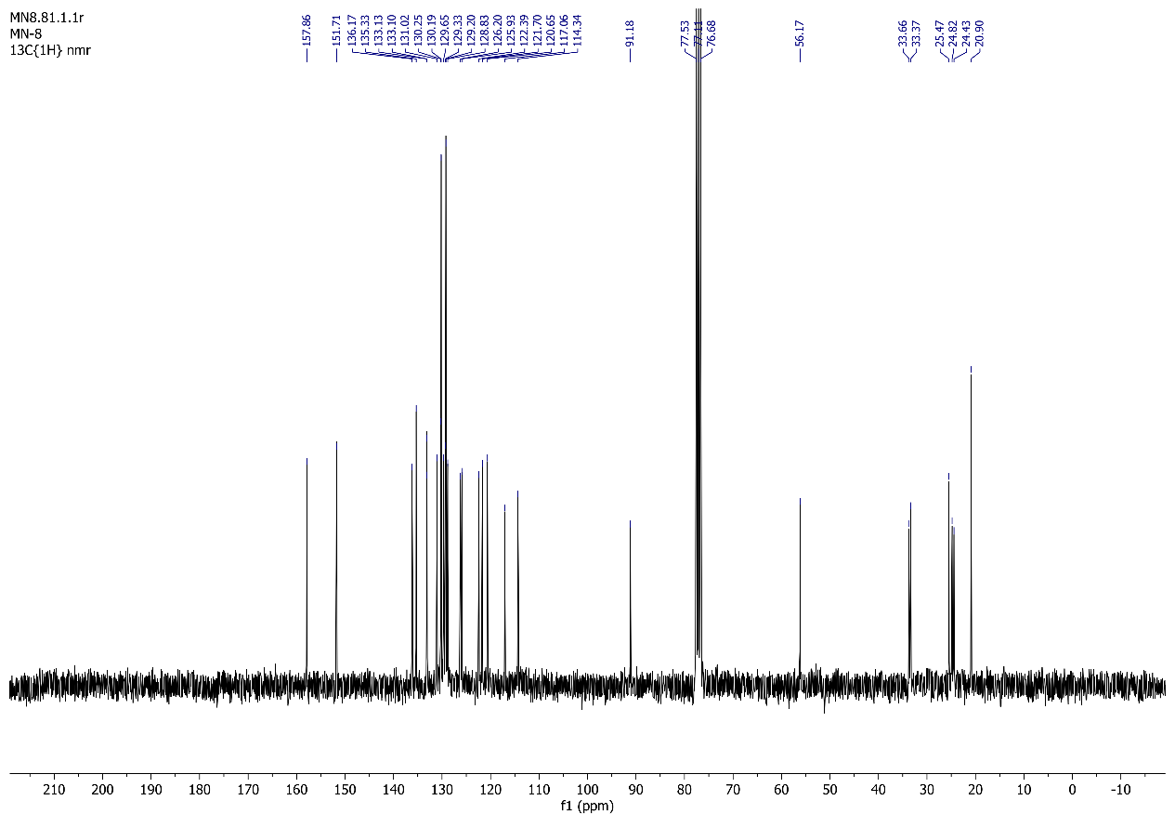

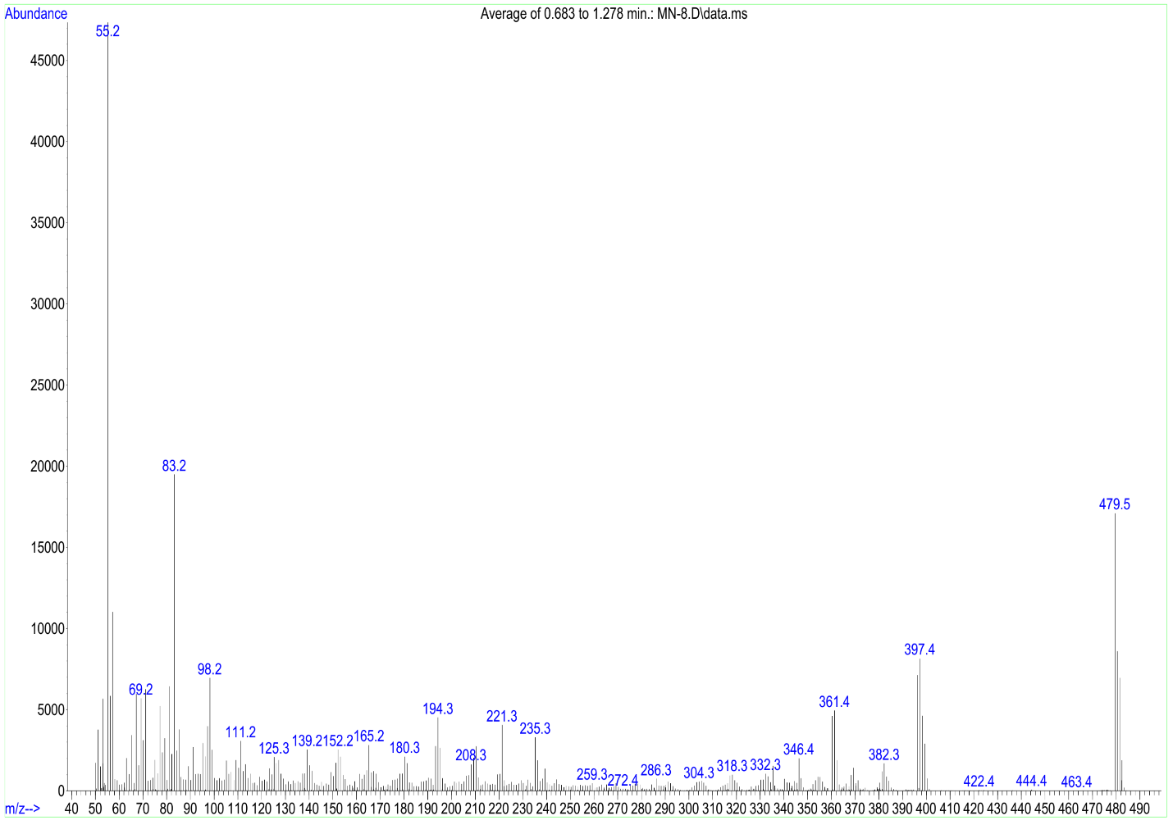

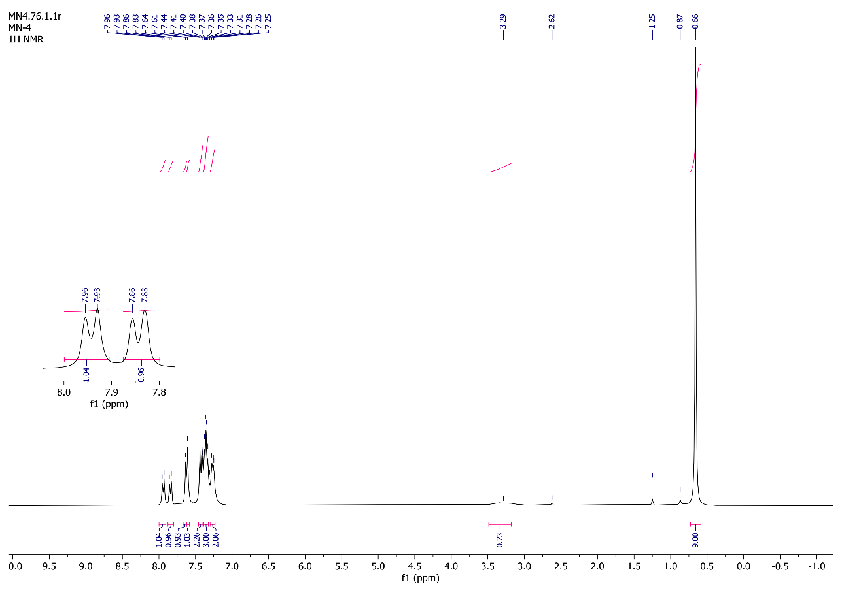

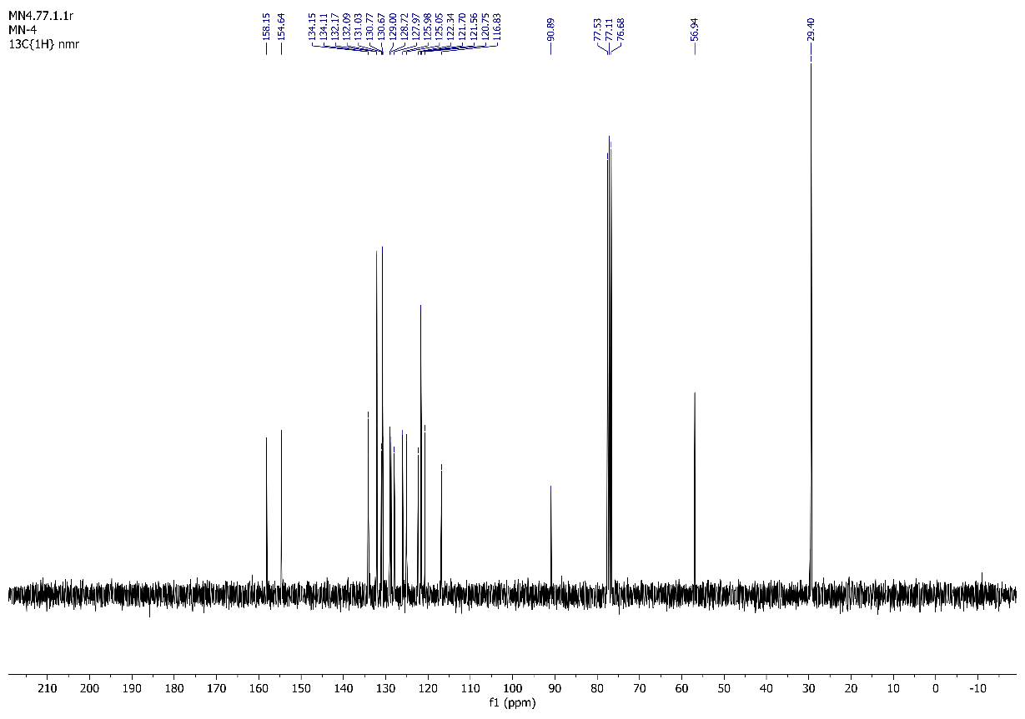

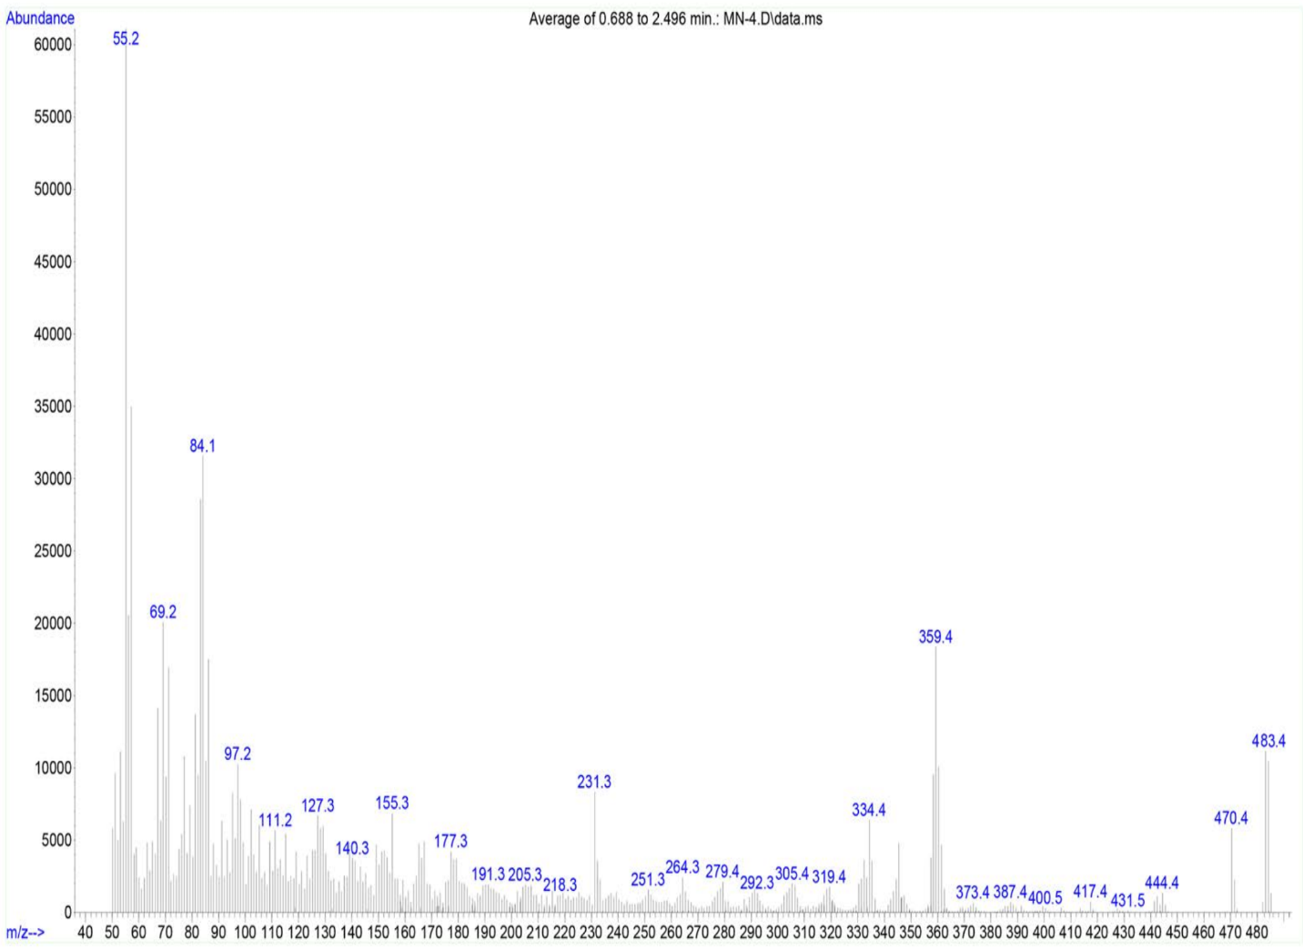

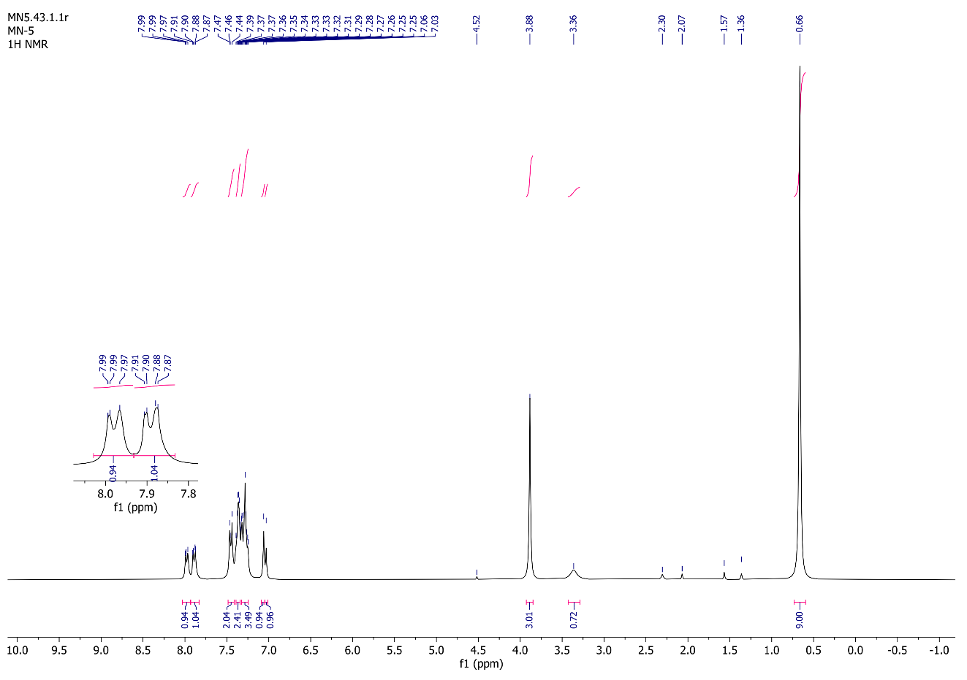
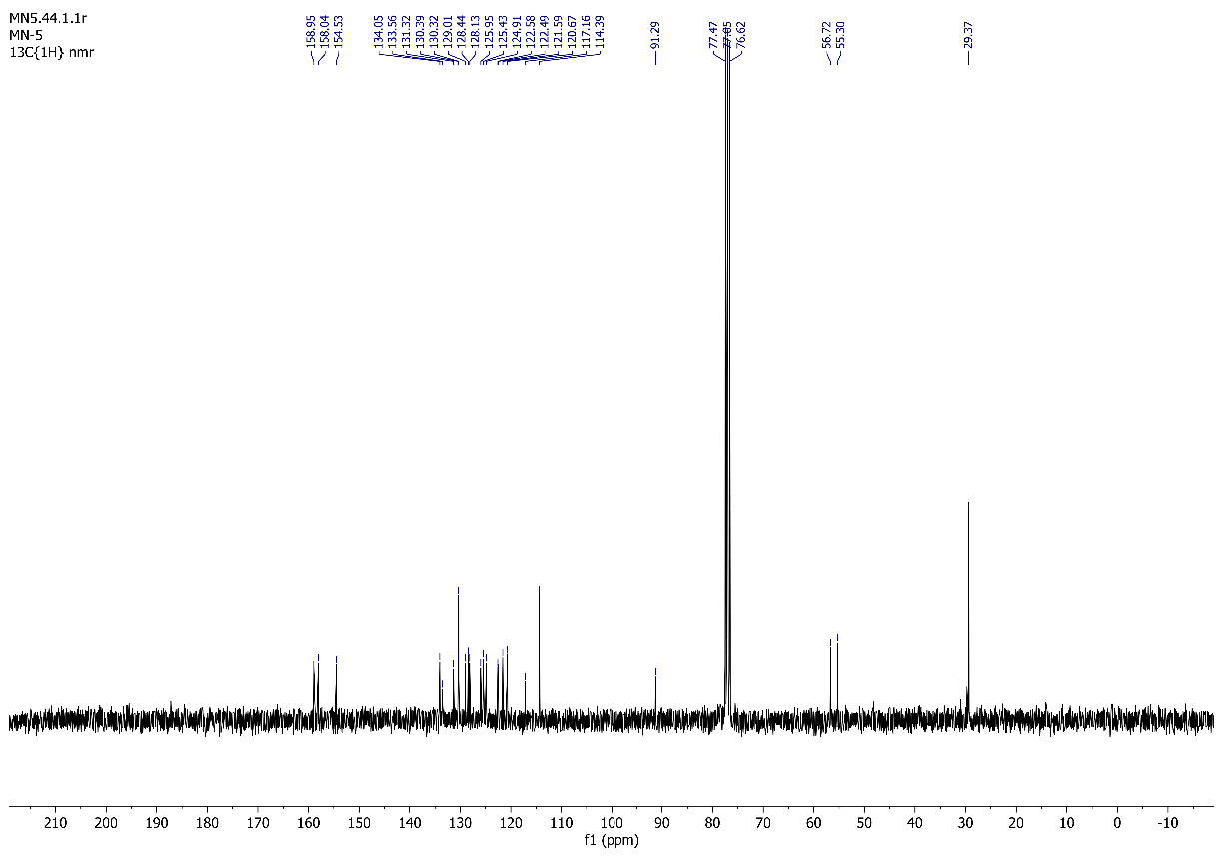

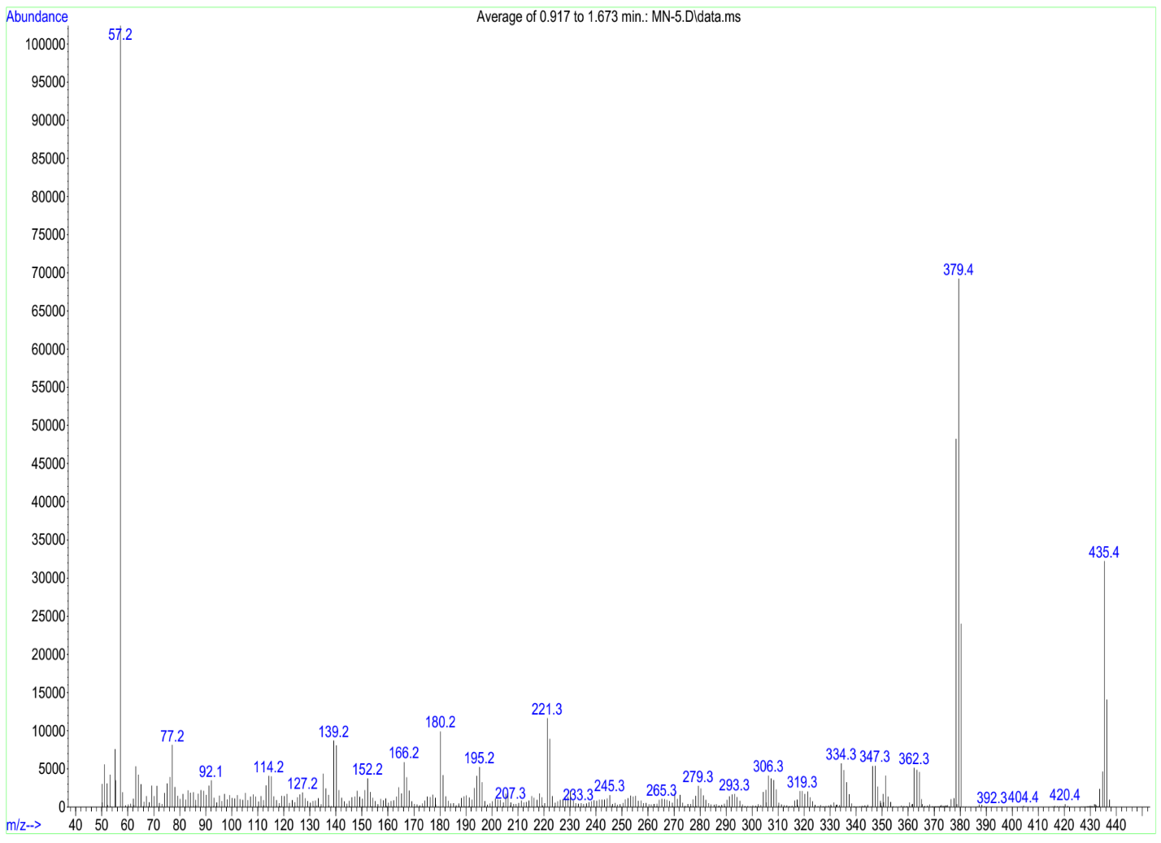

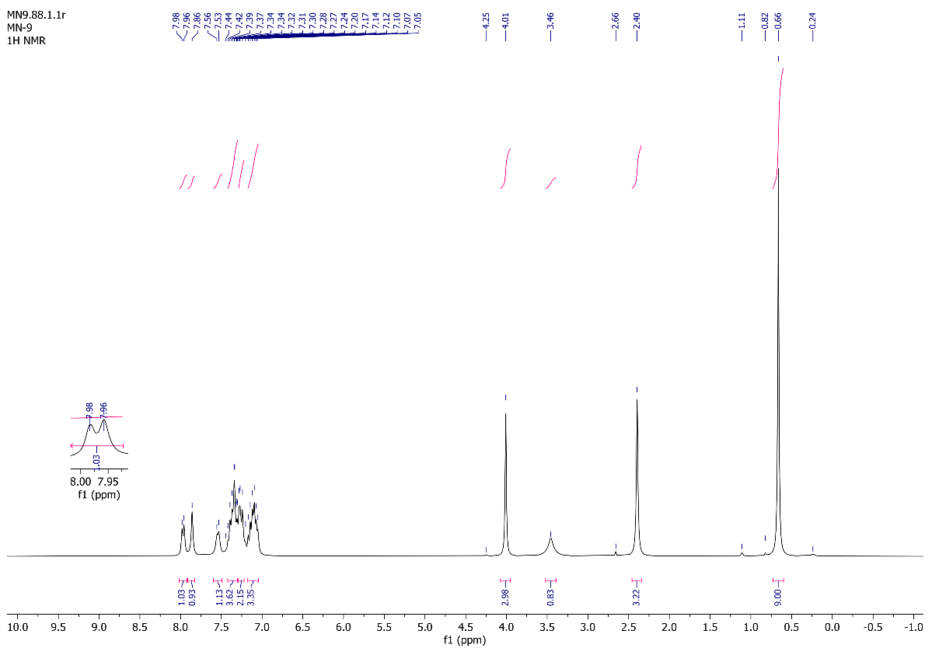

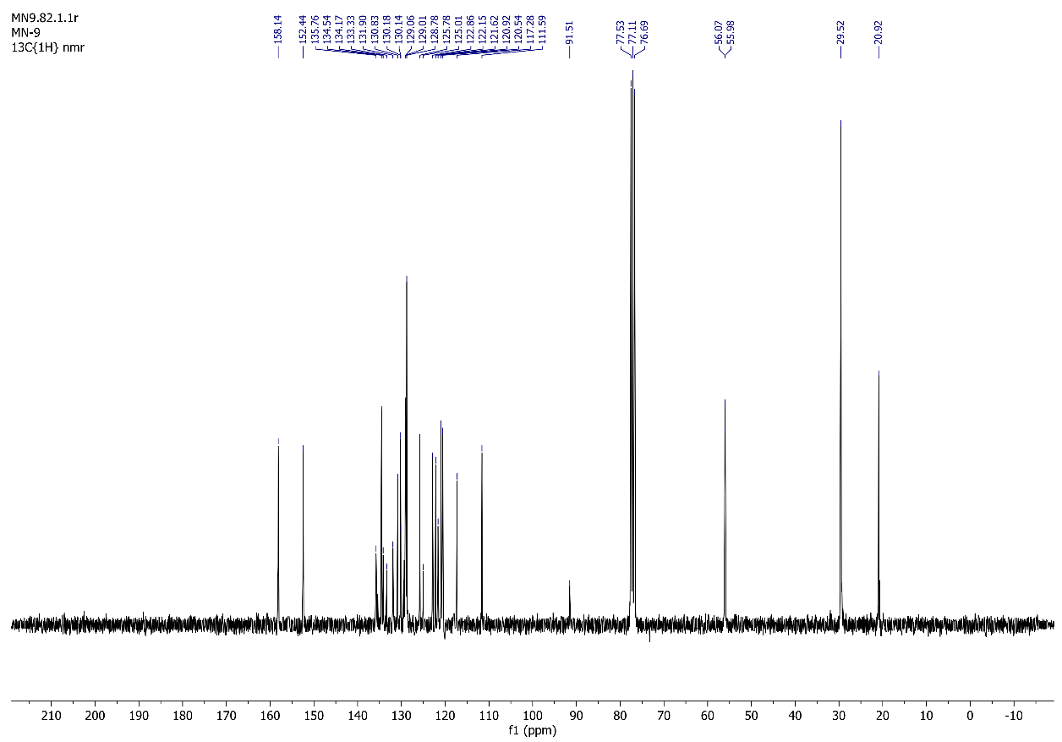

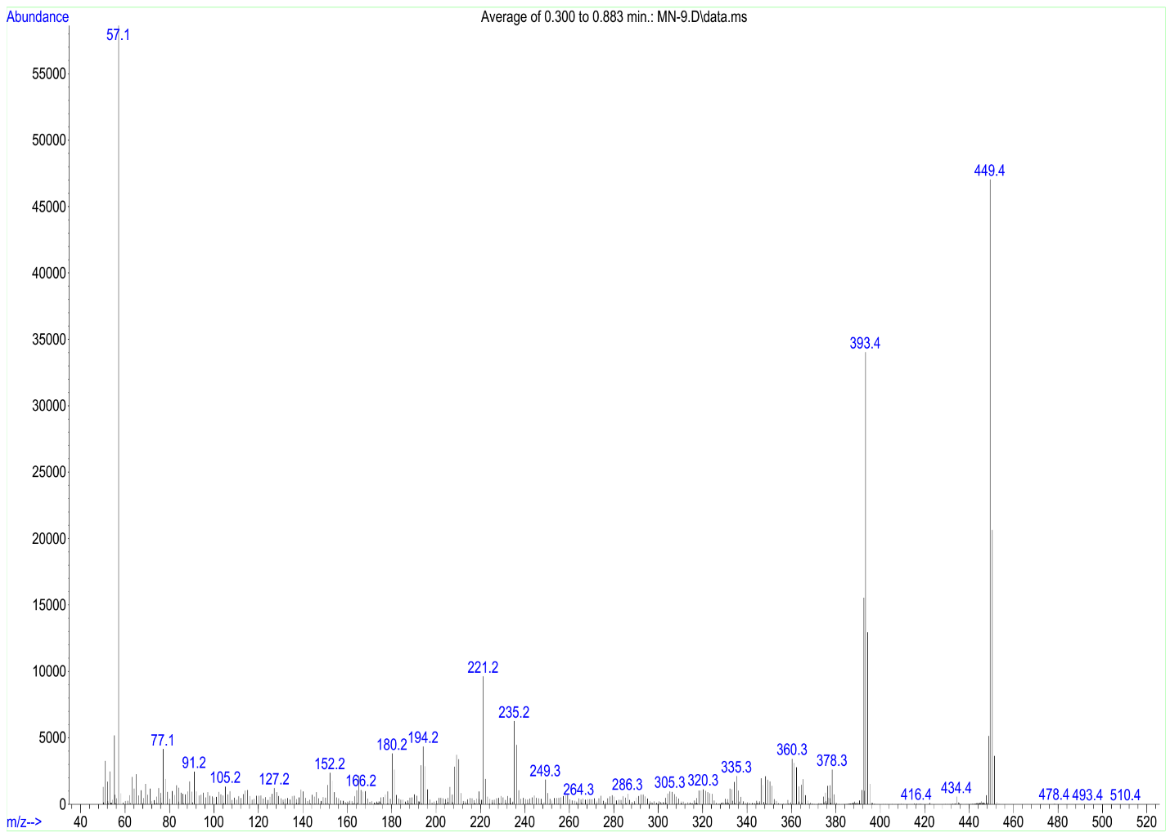

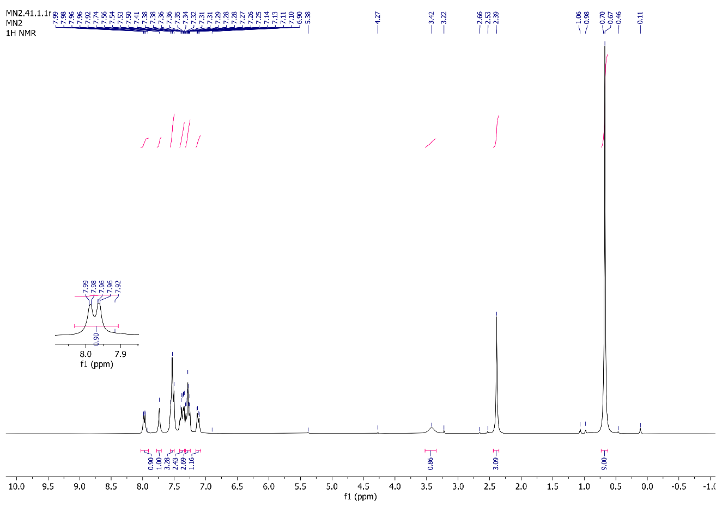
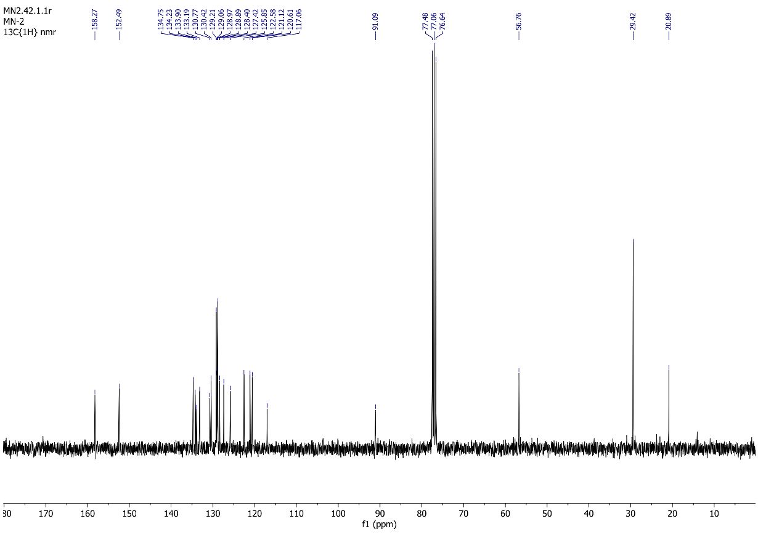

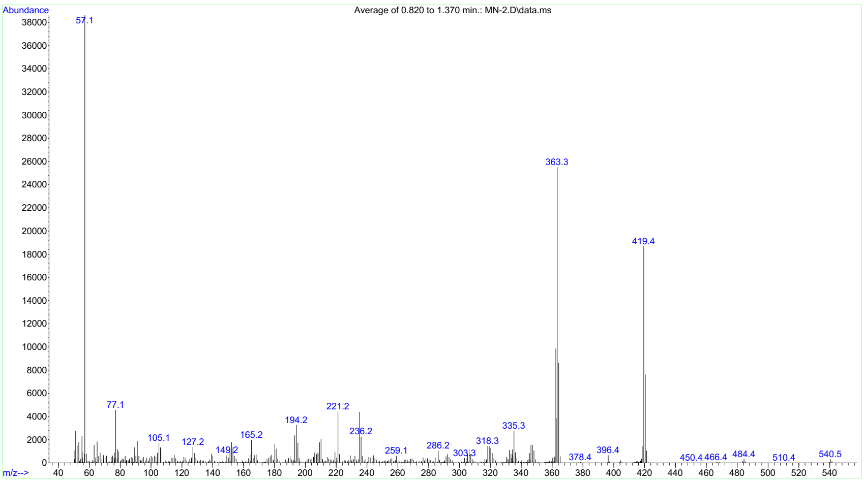

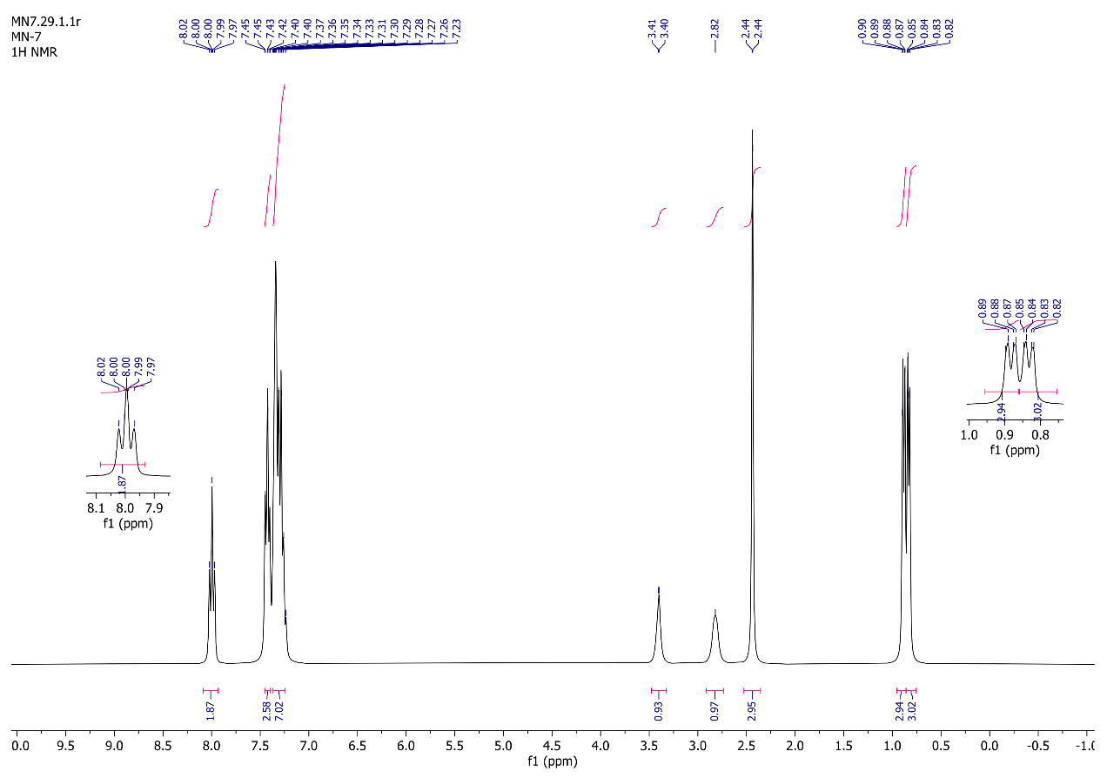

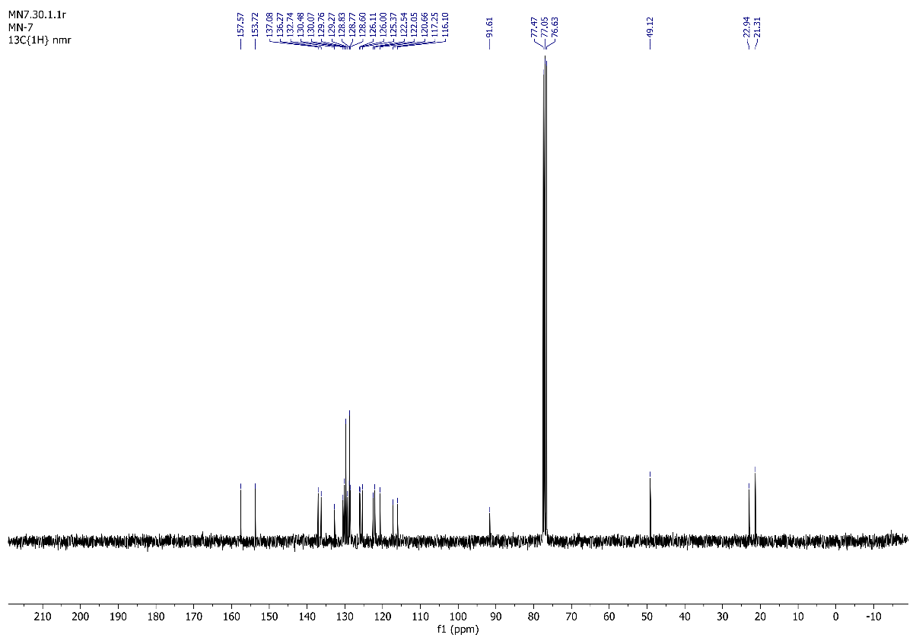

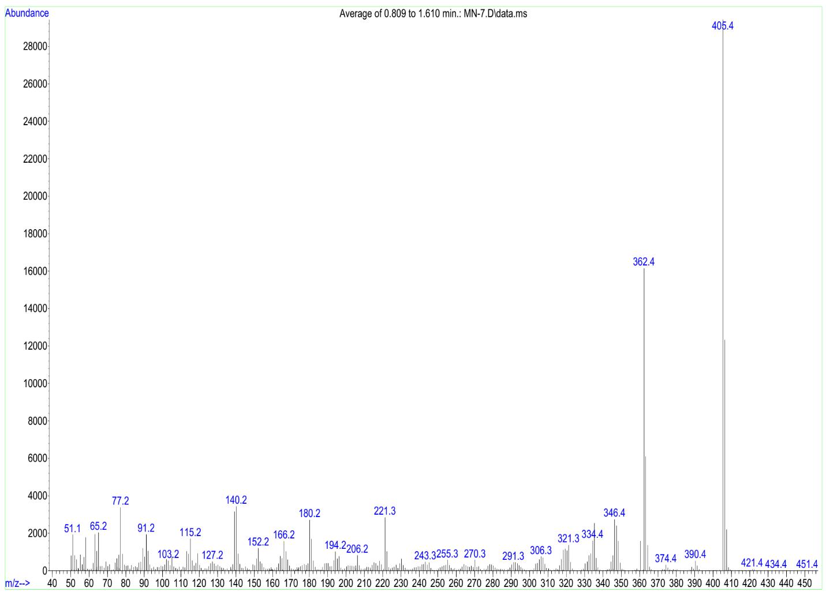

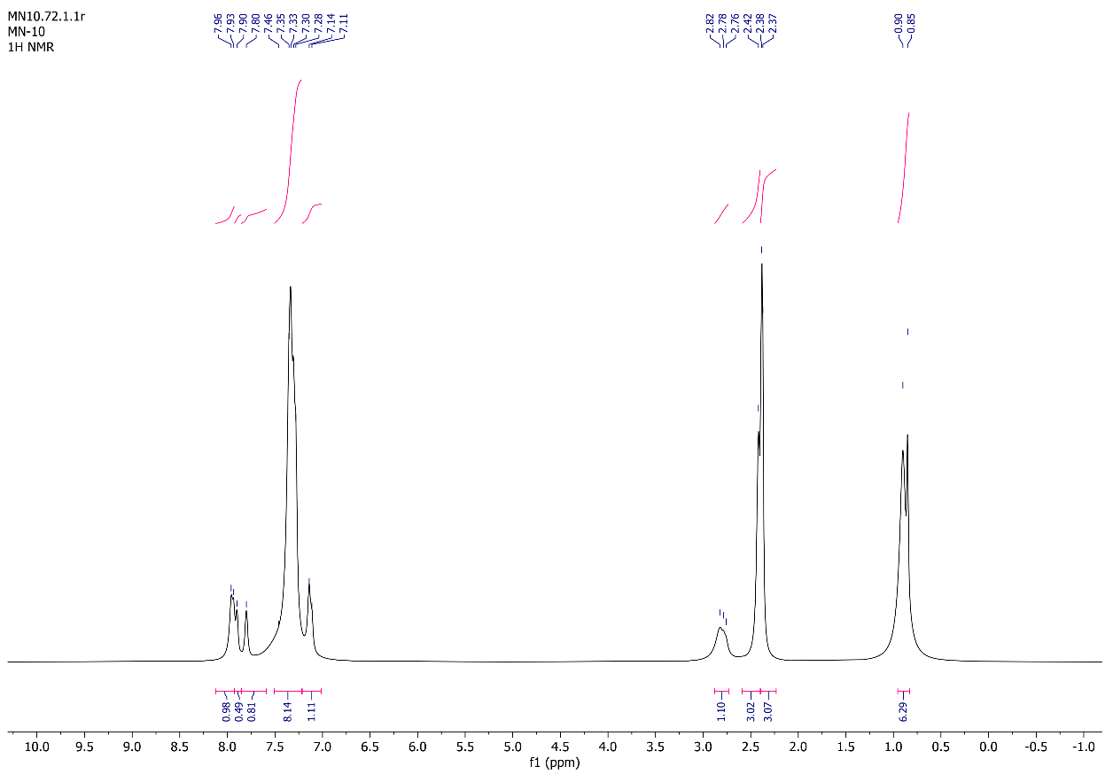

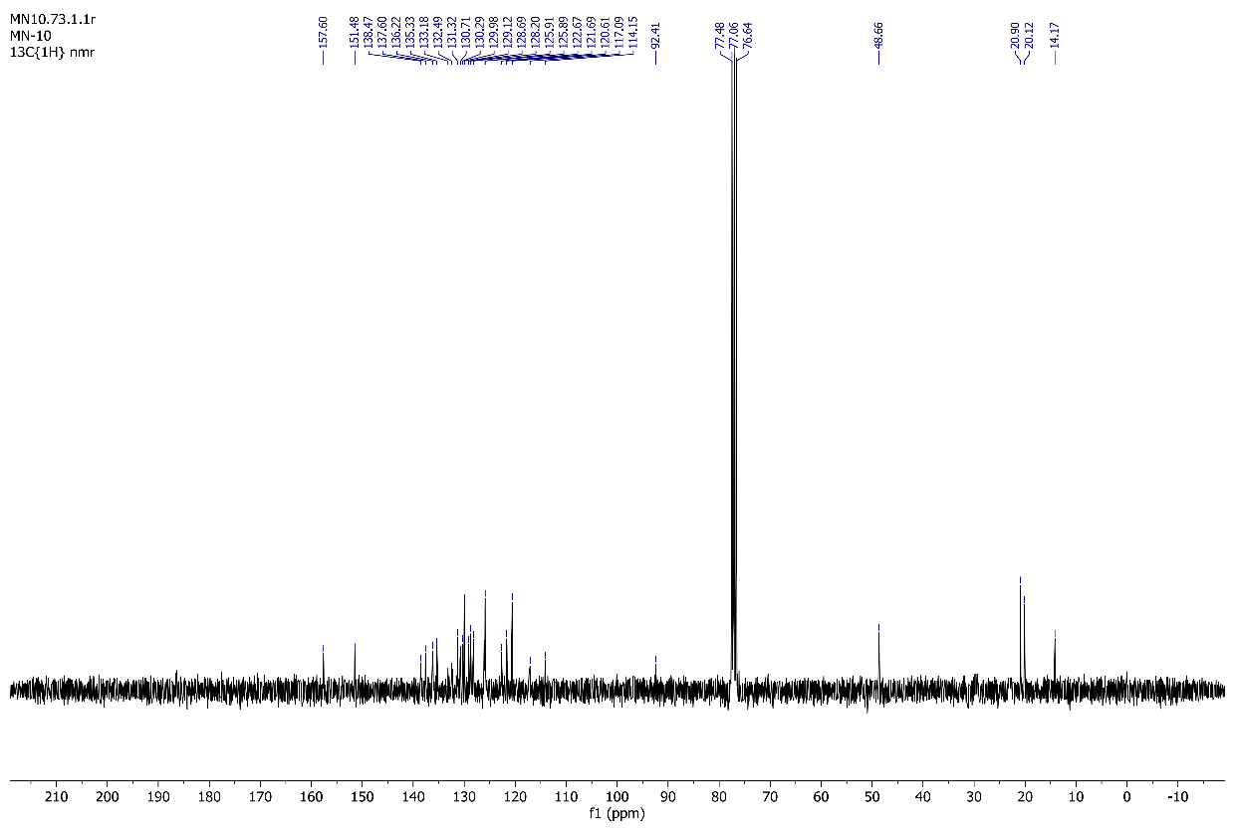

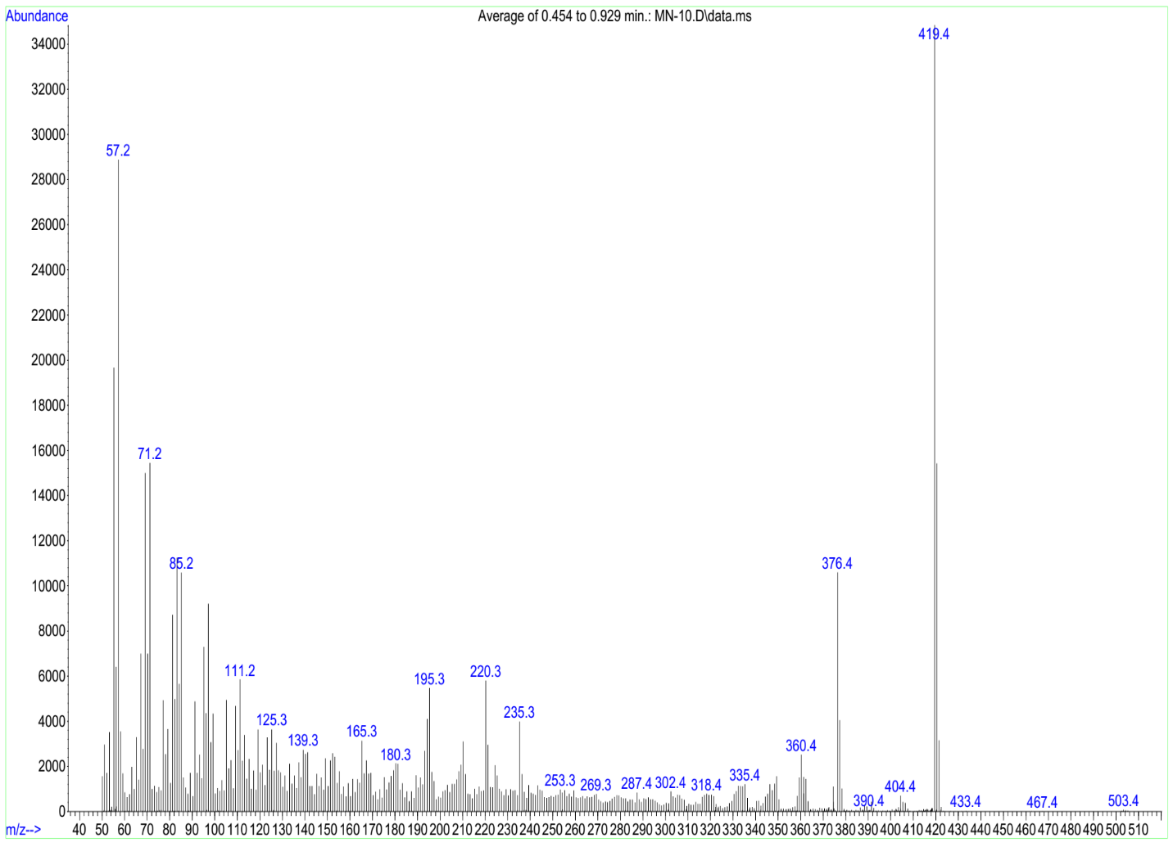

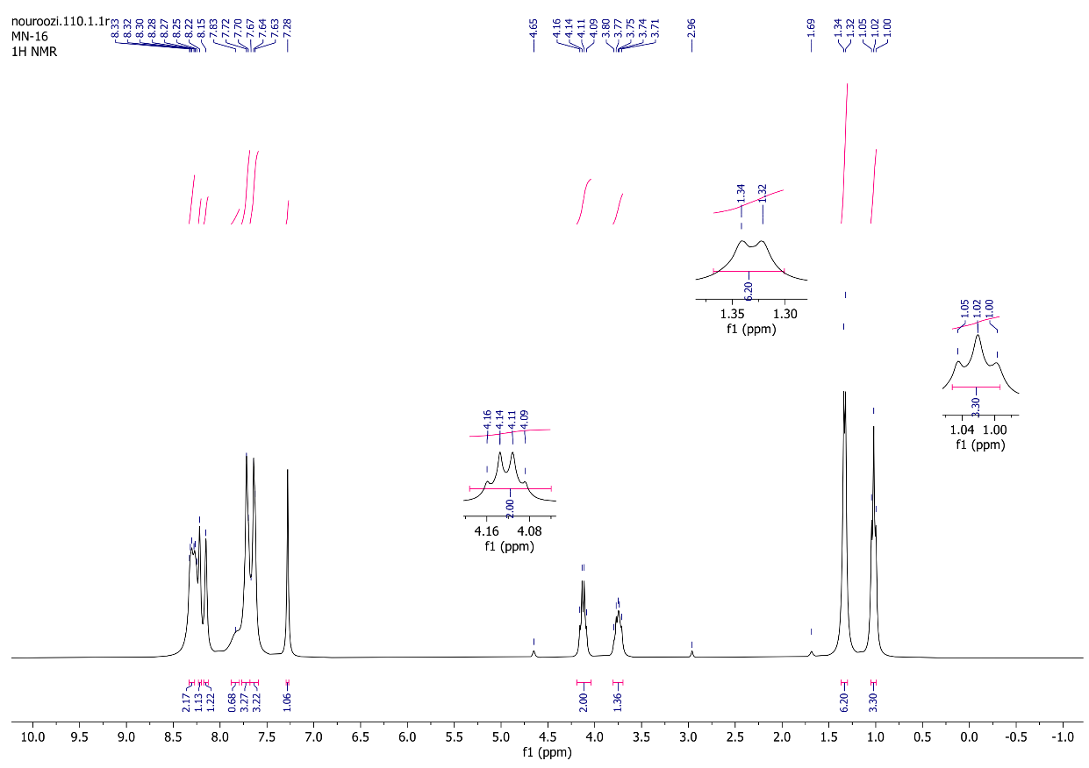

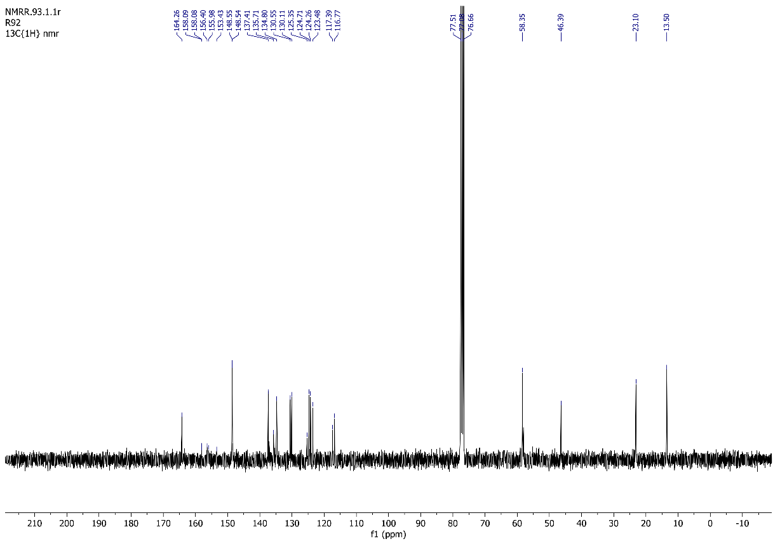

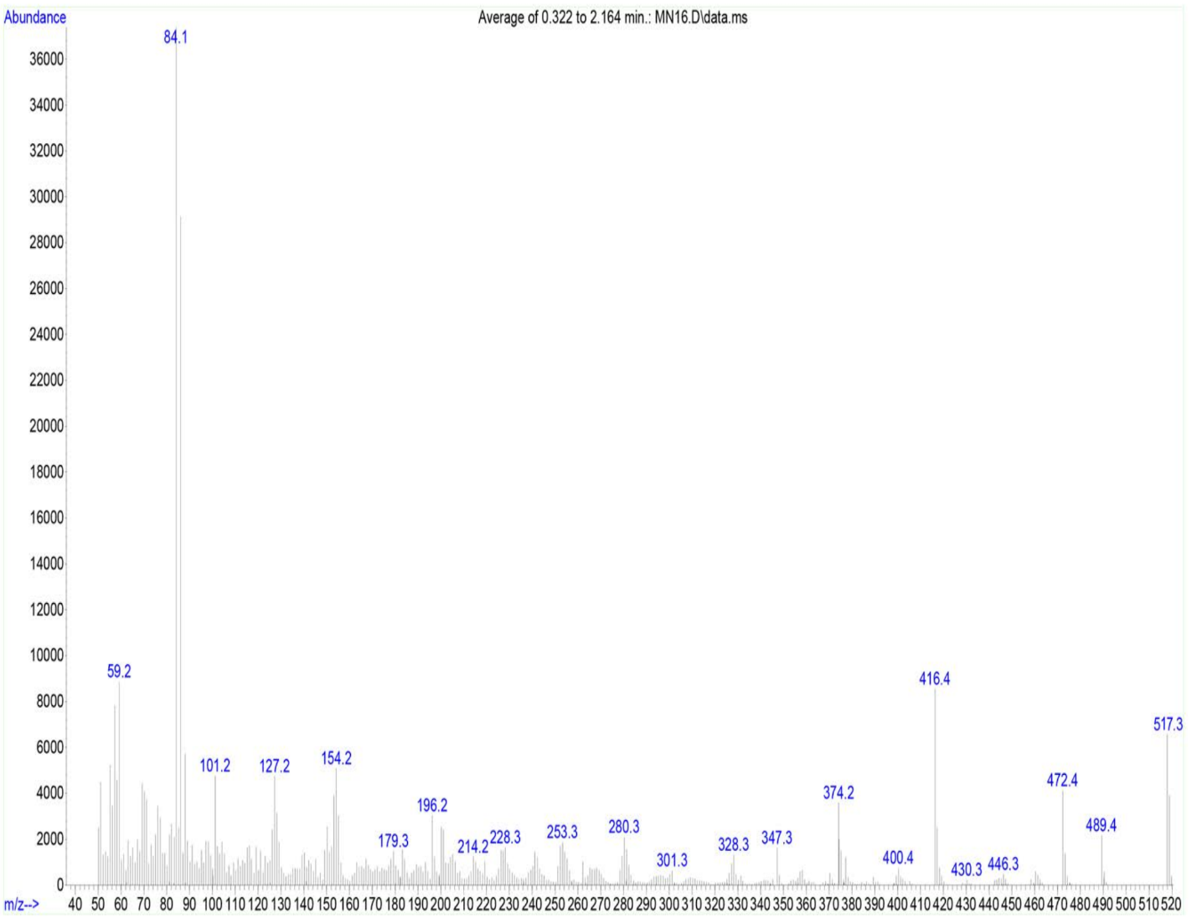

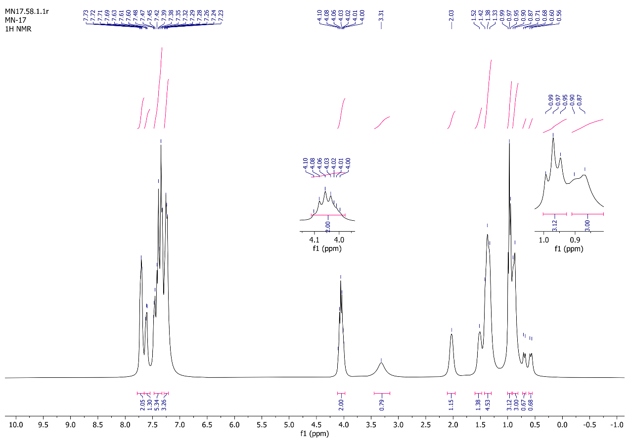

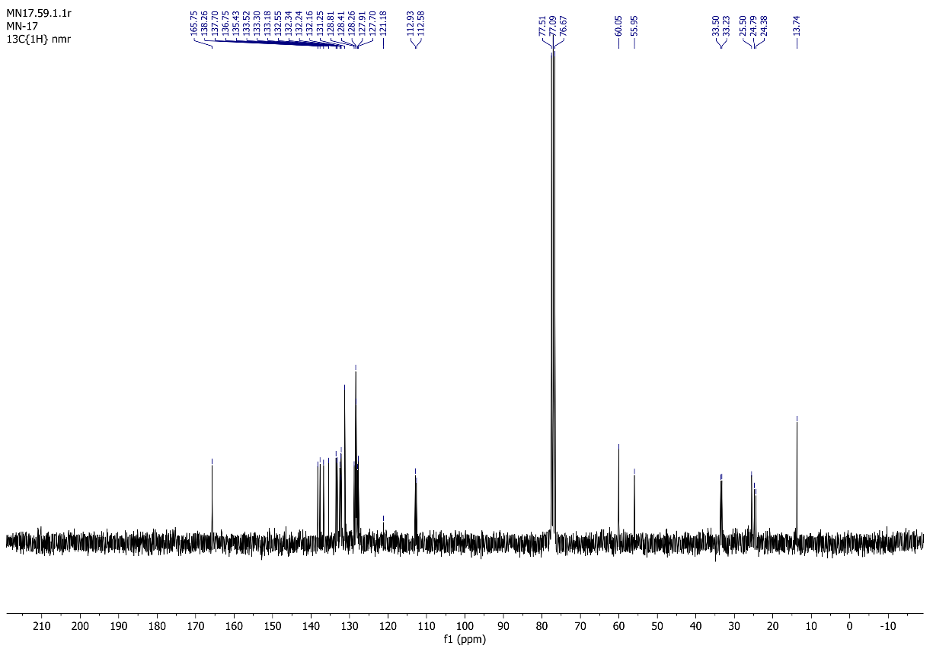

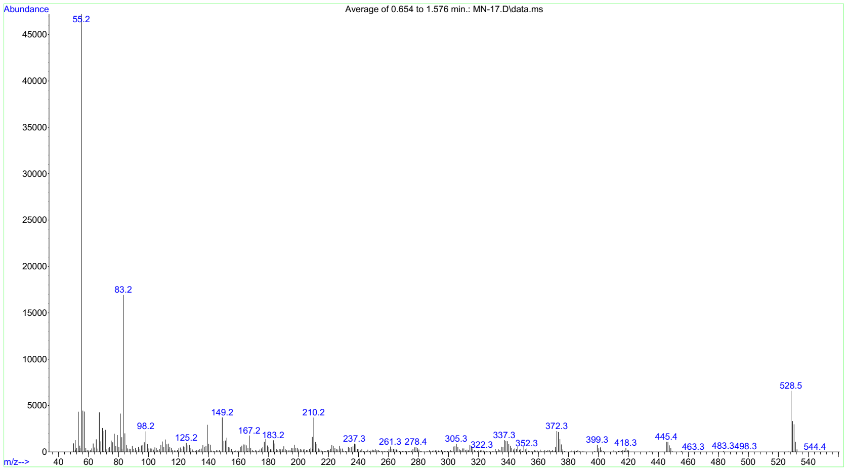

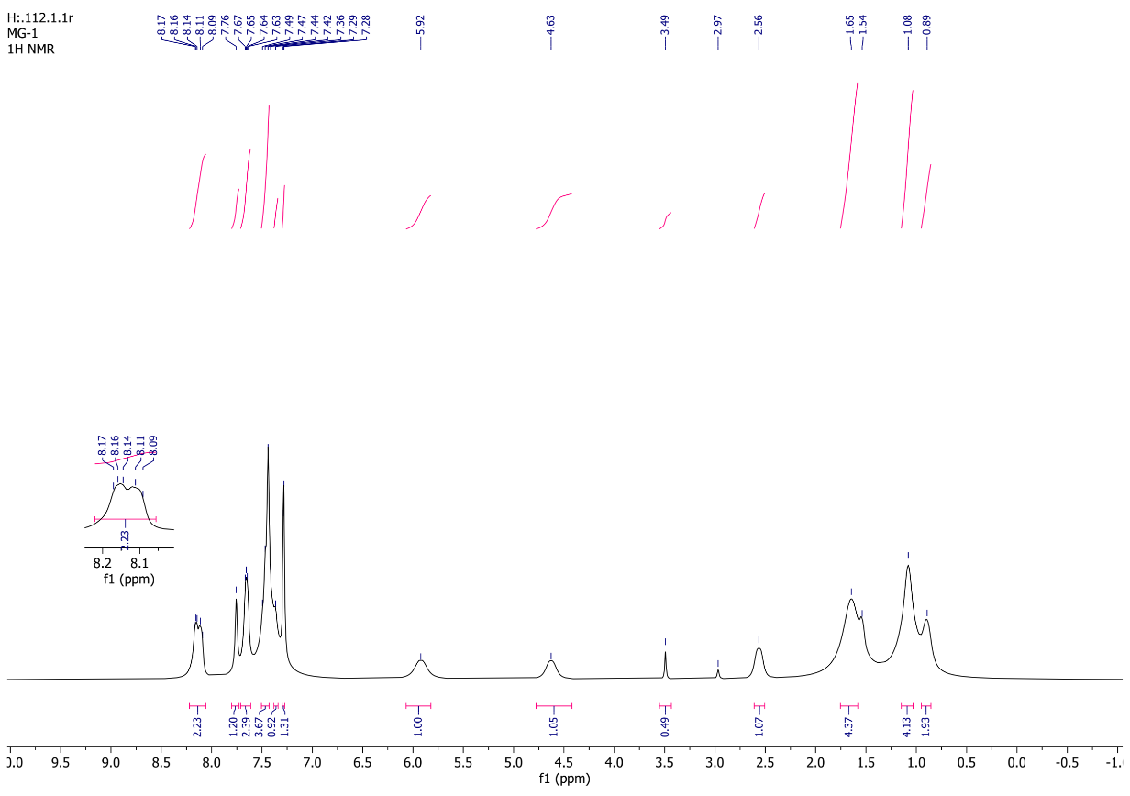

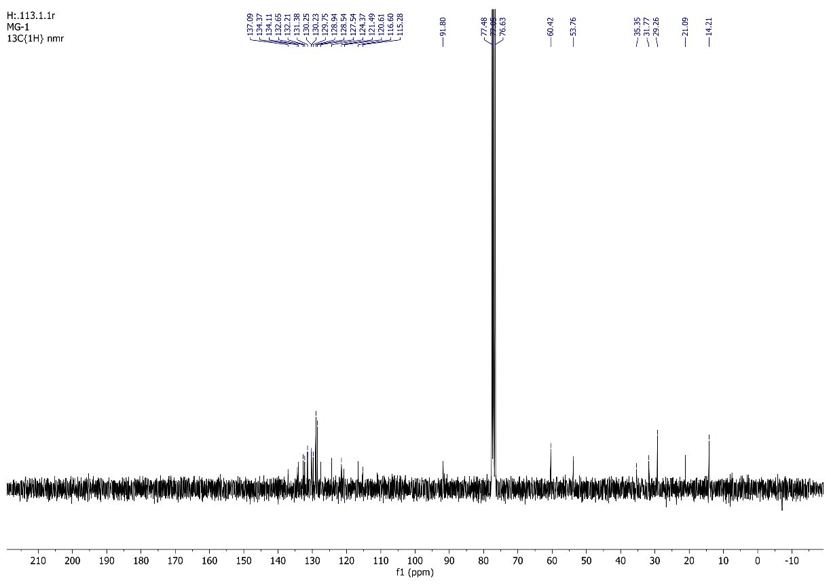

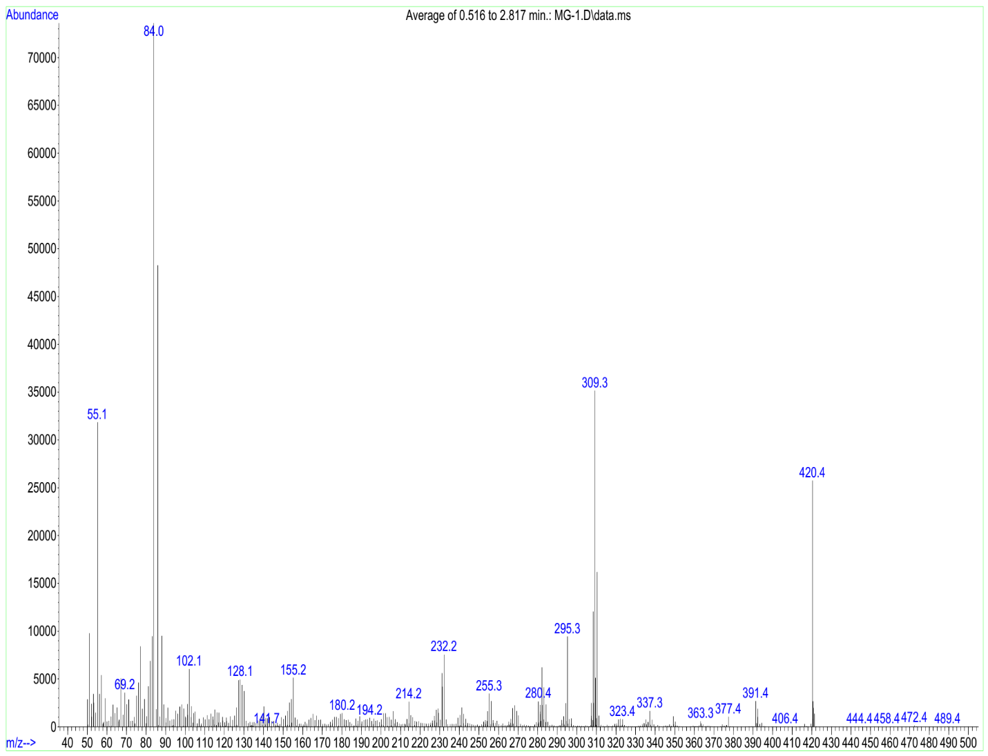

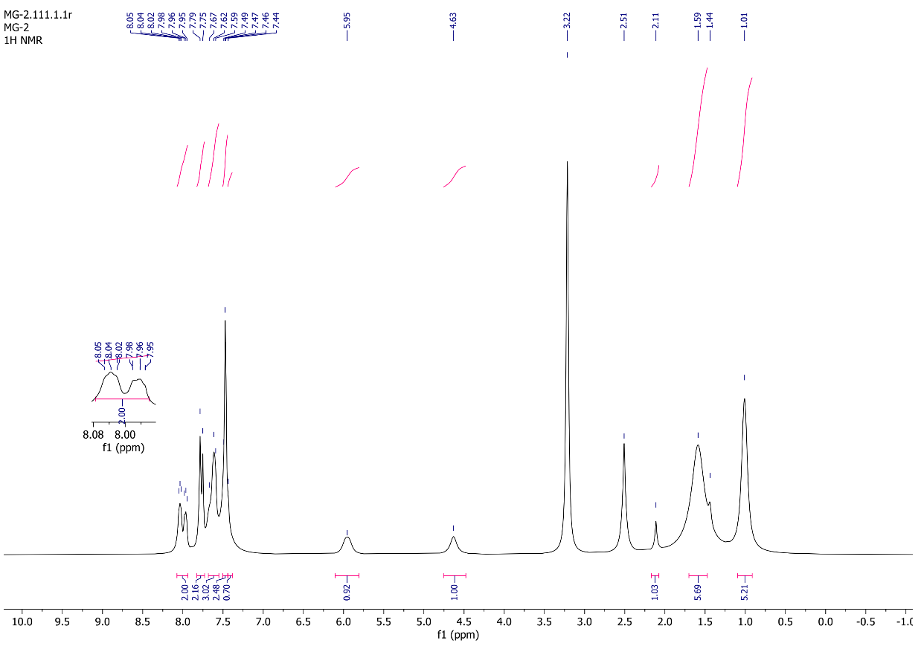

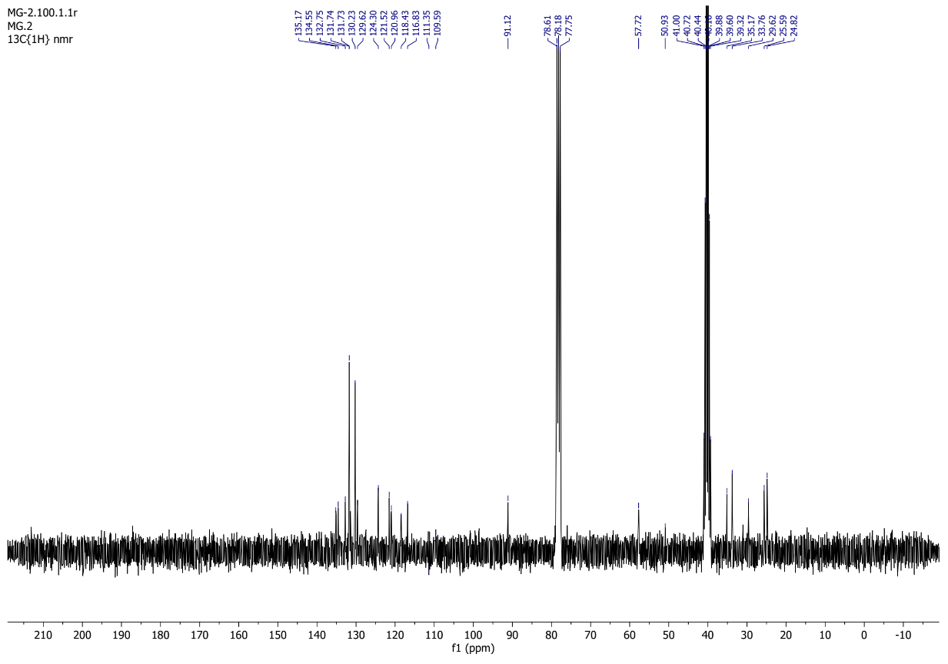

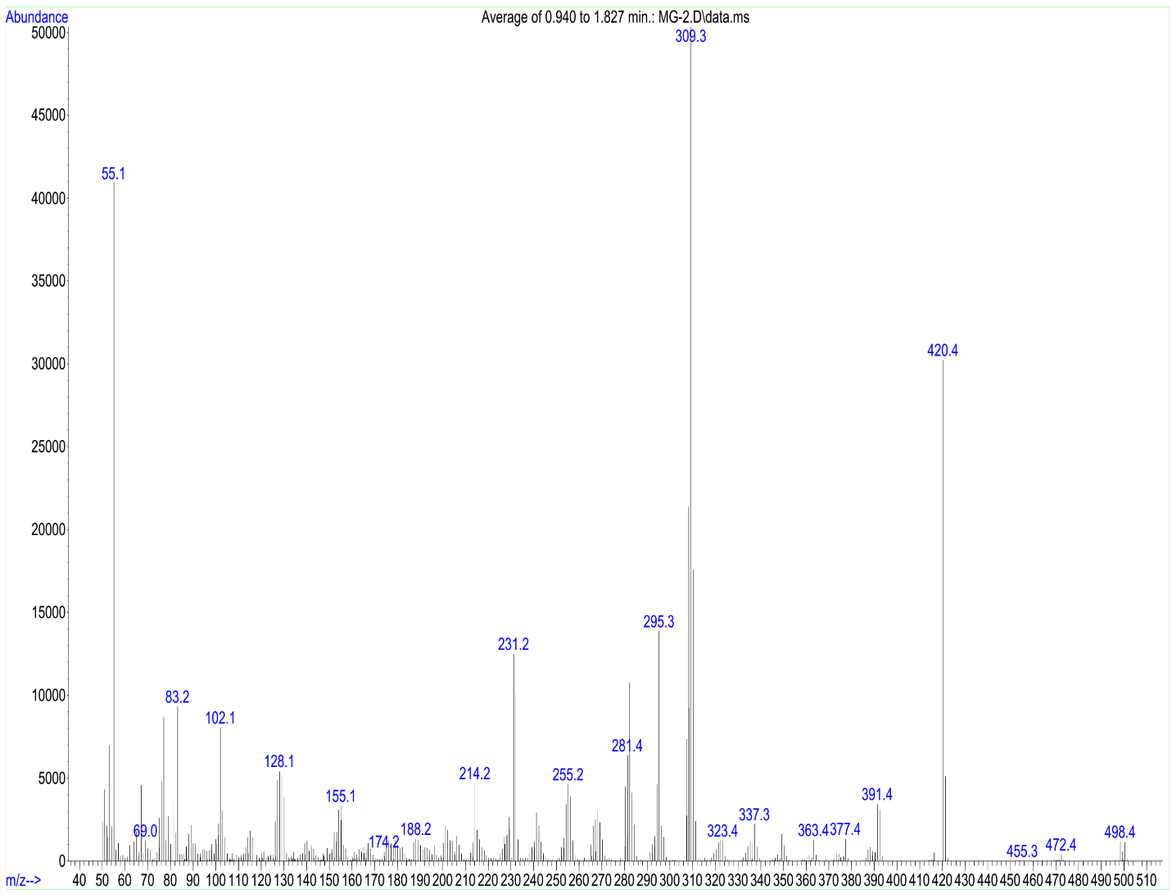

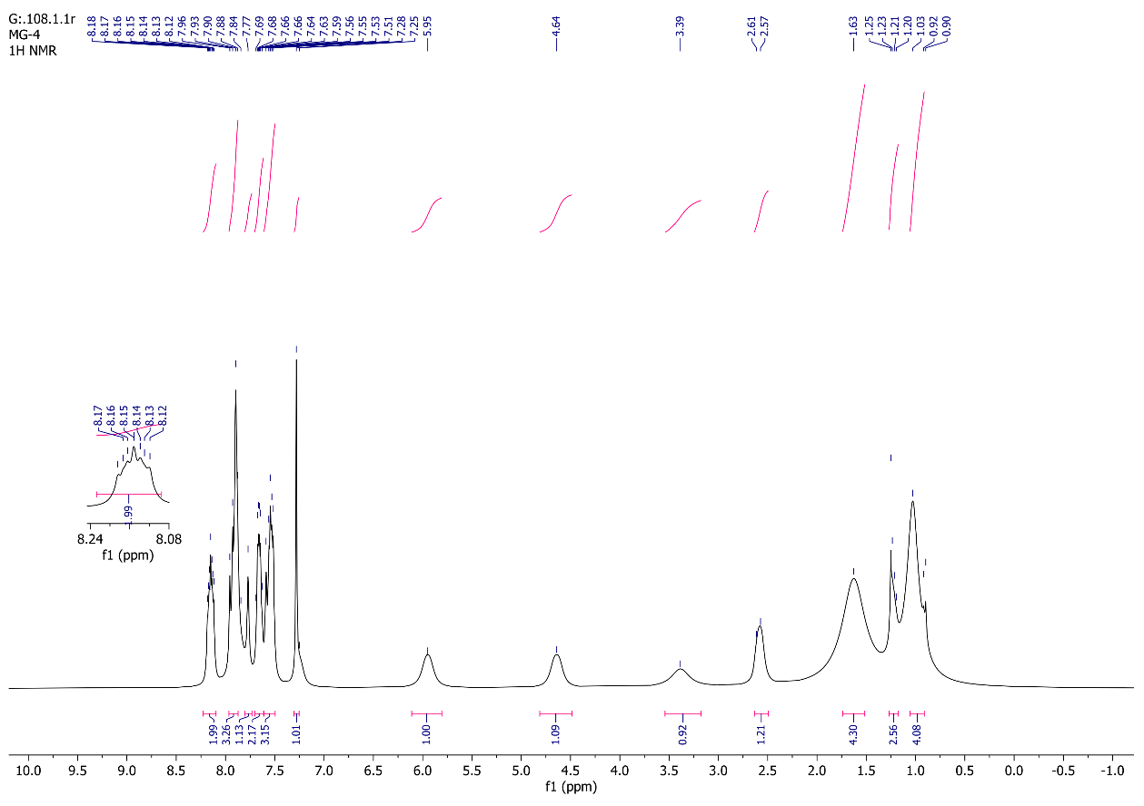

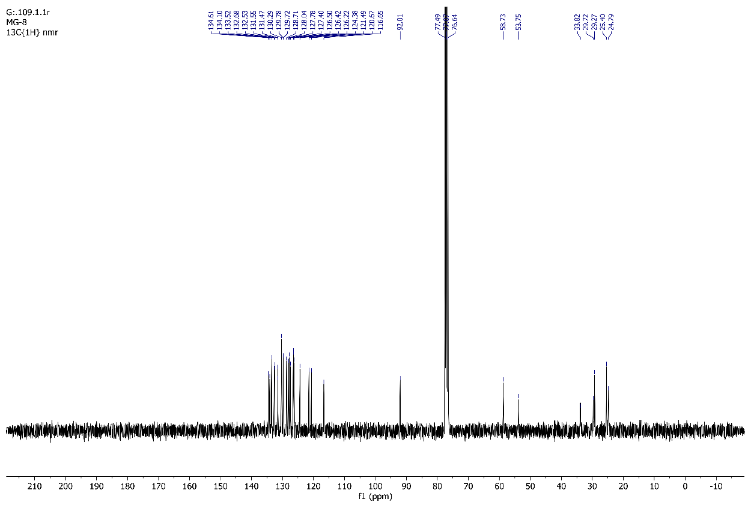

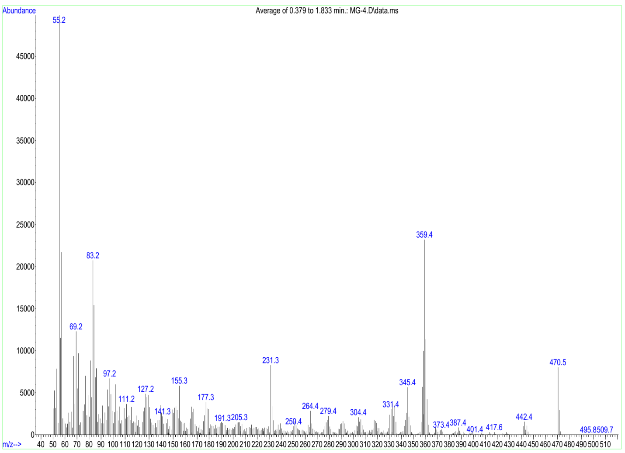

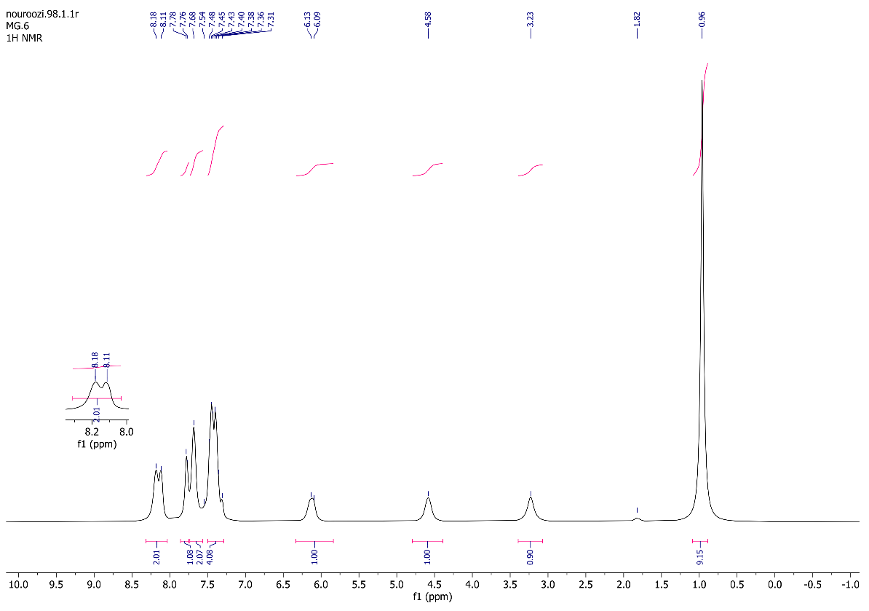

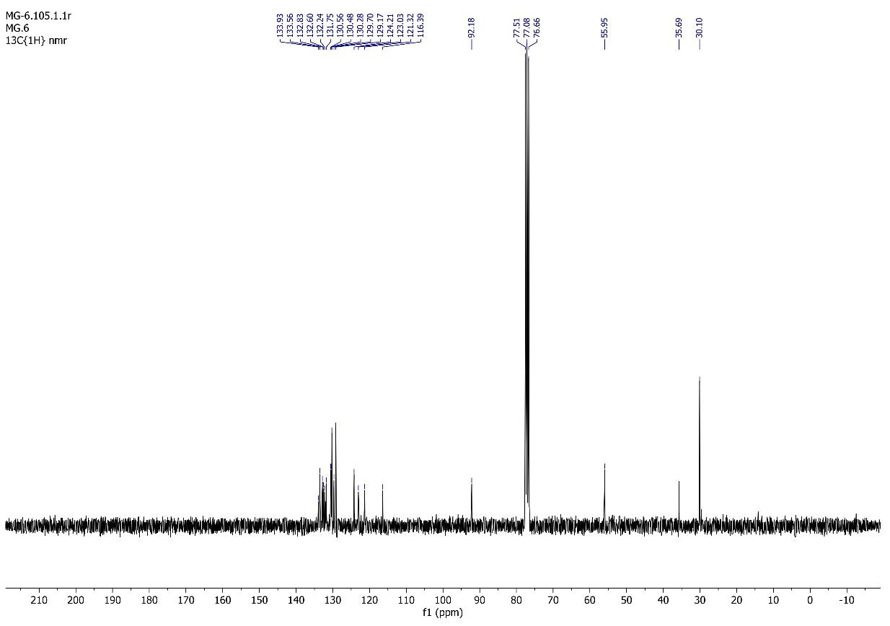

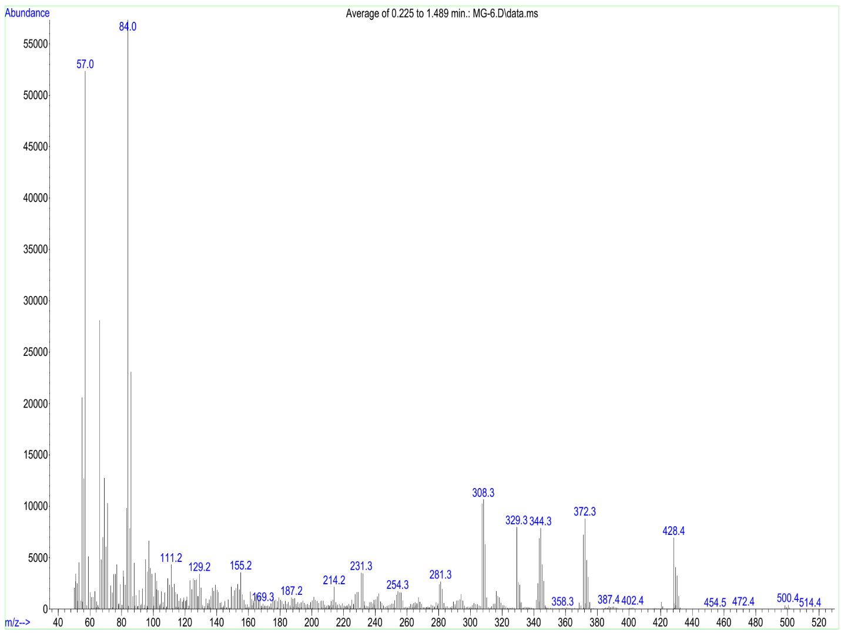

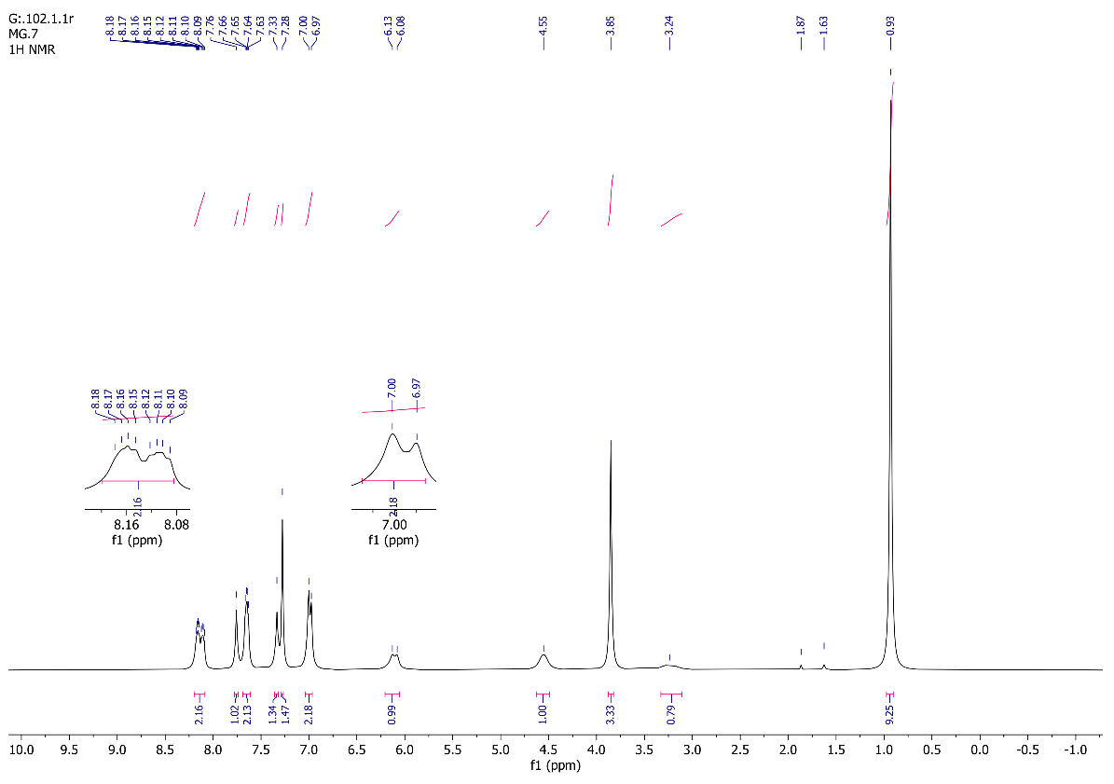

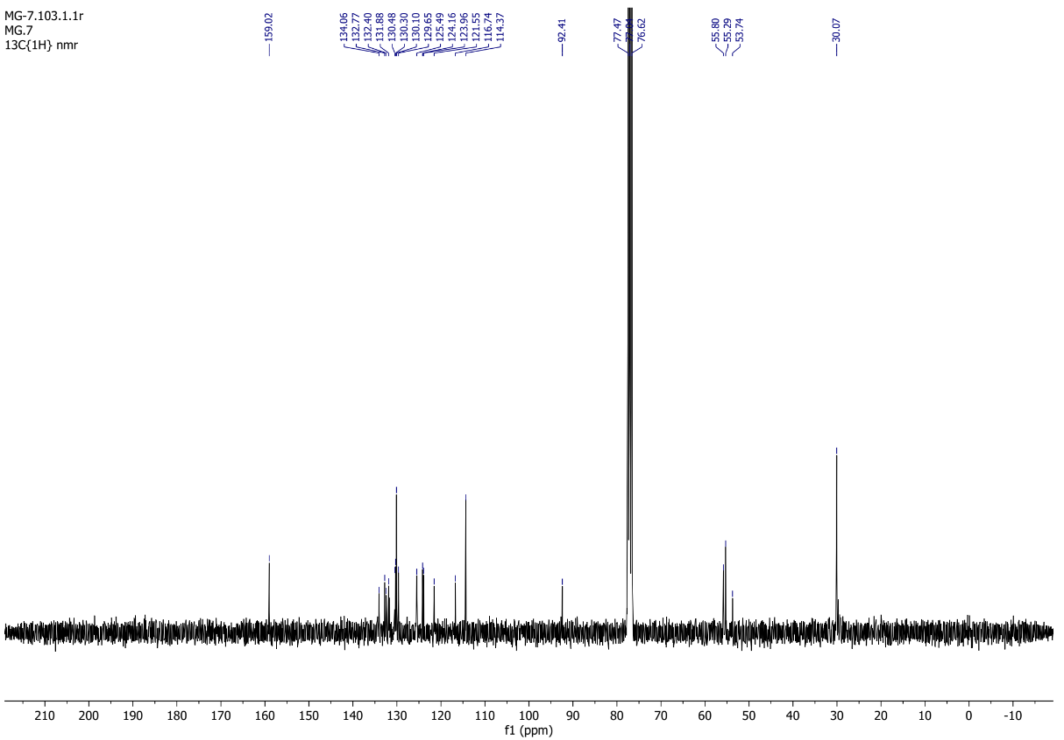

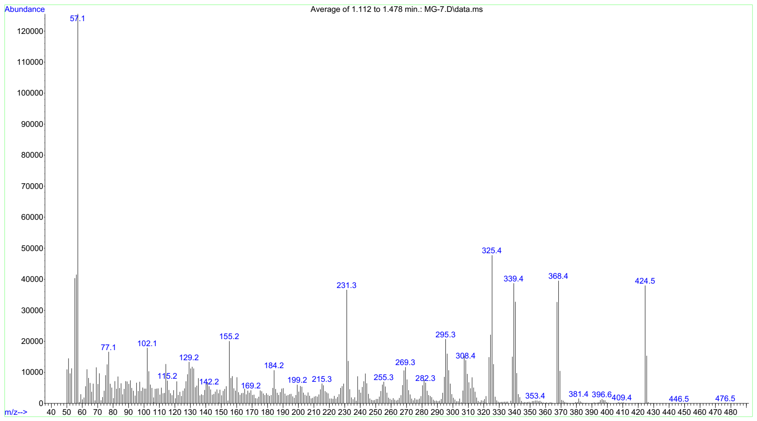

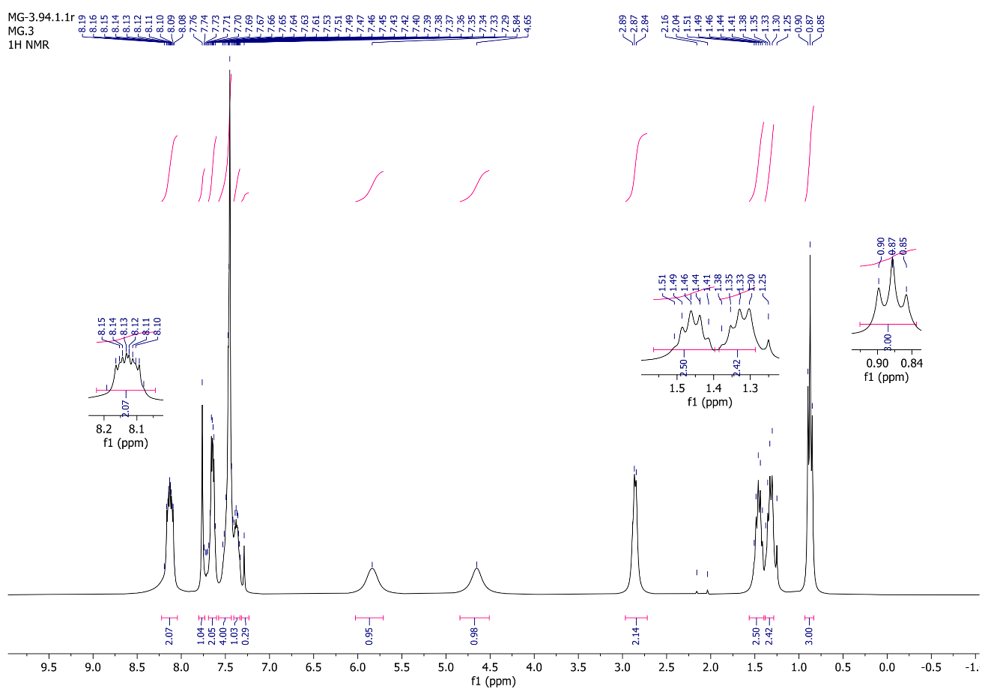
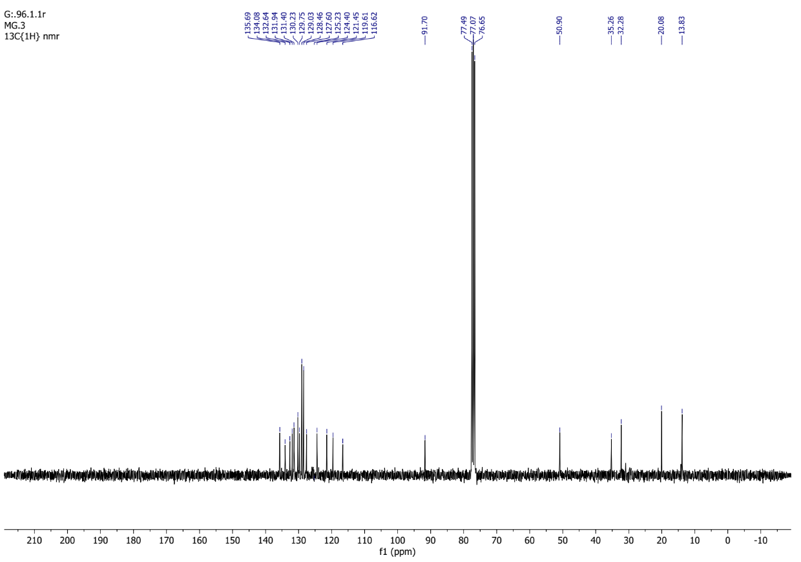

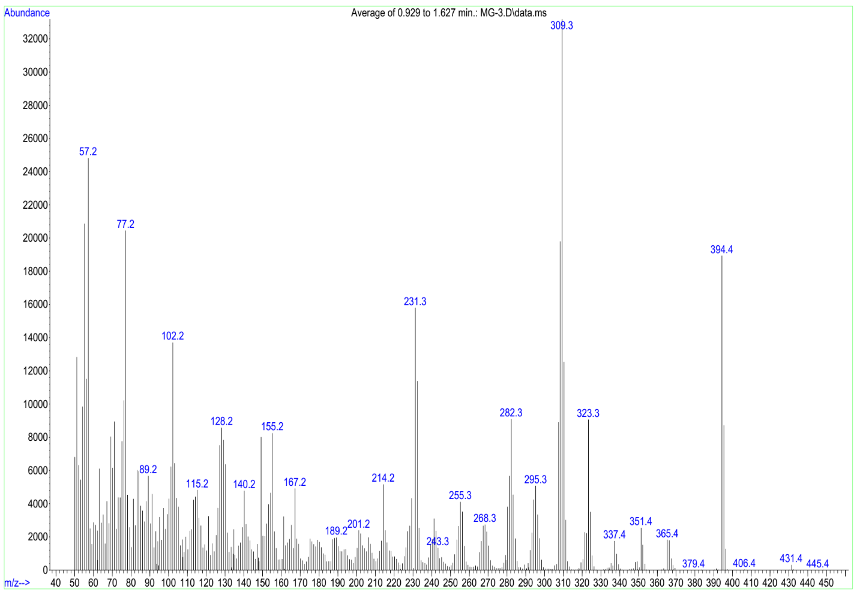

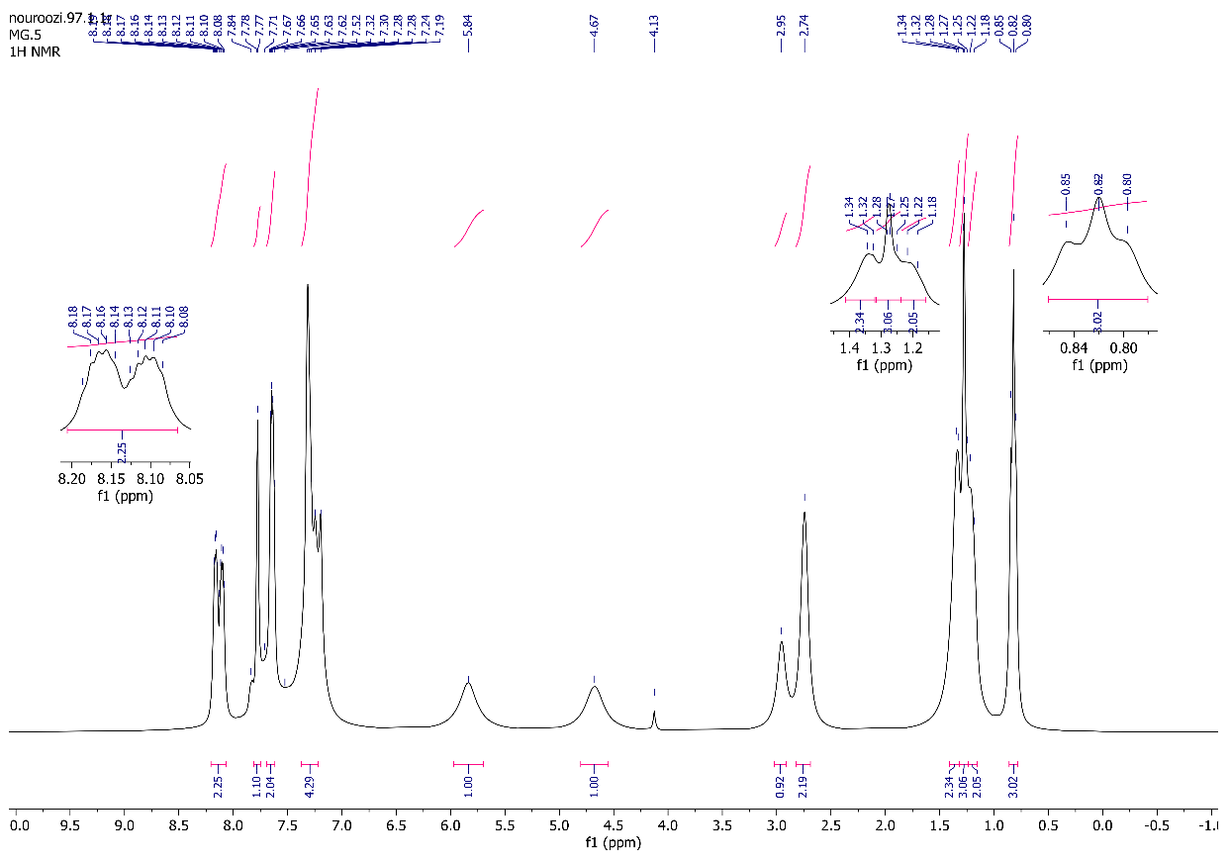

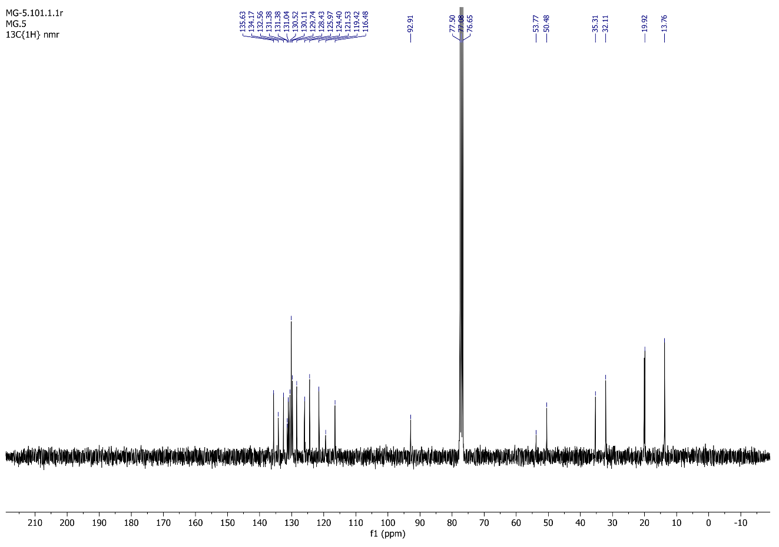
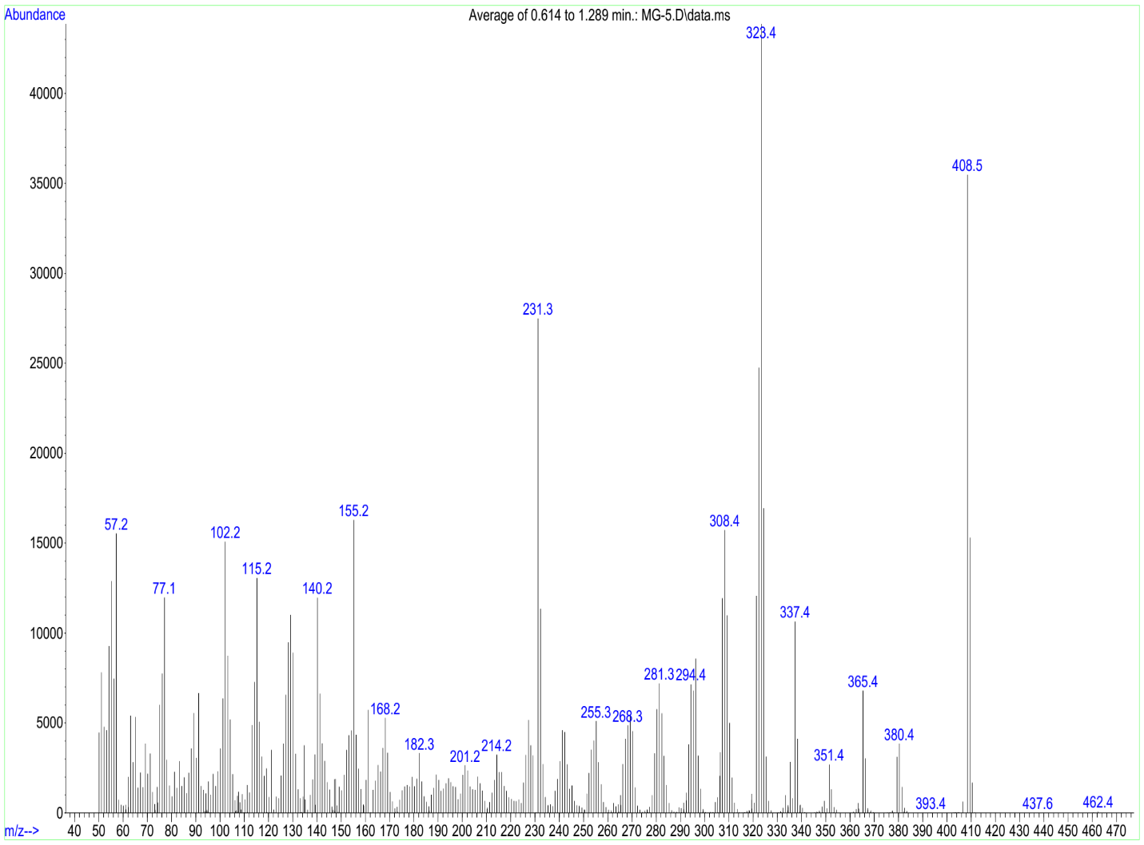

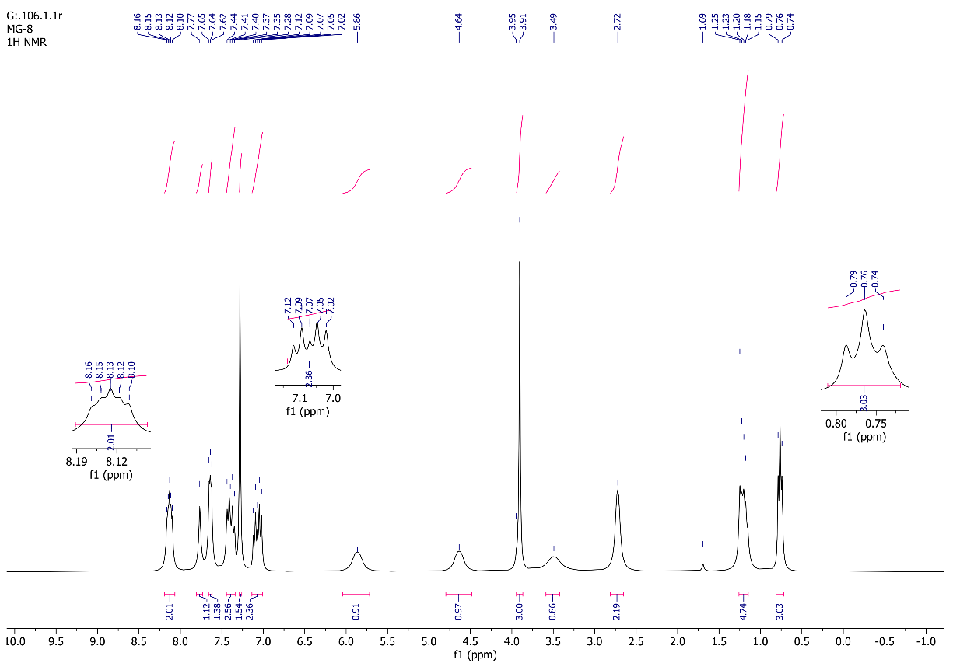

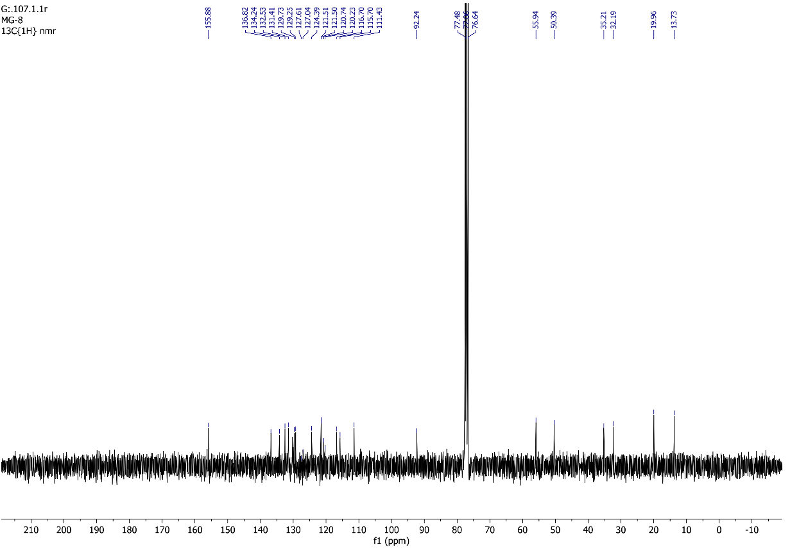

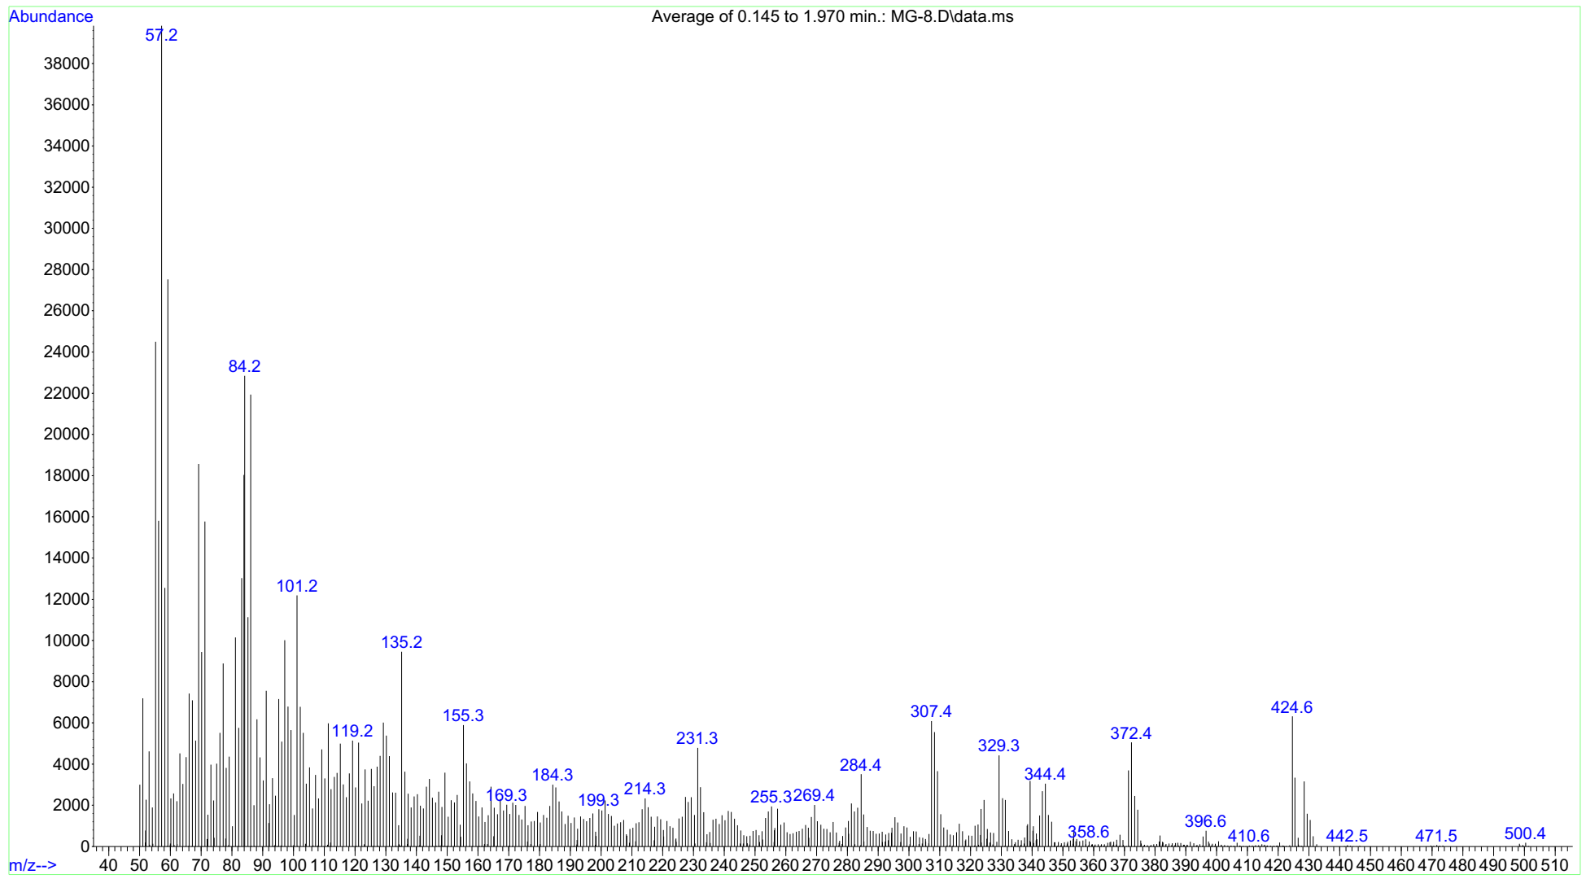

Reference
1. S. Sreejith, K. P. Divya and A. Ajayaghosh, Chem. Commun., 2008, 25, 2903-2905.

∗Corresponding author. Tel.: +982129904331; E-mail: mt_nazeri@sbu.ac.ir
∗Corresponding author. Tel.: +982129902800; E-mail: a-shaabani@sbu.ac.ir

