*Supporting Information*

**Dual-Functionalized Architecture Enables Stable and Tumor Cell-Specific SiO2NPs in Complex Biological Fluids**

Iris Renata Sousa Ribeiro1,2*, Raquel Frenedoso da Silva2, Romênia Ramos Domingues3, Adriana Franco Paes Leme3, and Mateus Borba Cardoso1,2*

1 Institute of Chemistry (IQ), University of Campinas (UNICAMP), Postal Code 13083- 970, Post Office Box 6154, Campinas, SP, Brazil.

2 Brazilian Synchrotron Light Laboratory (LNLS), Brazilian Center for Research in Energy and Materials (CNPEM), Postal Code 13083-970, Campinas, Brazil.

3 Brazilian Biosciences National Laboratory (LNBio), Brazilian Center for Research in Energy and Materials (CNPEM), Postal Code 13083-970, Campinas, Brazil and Department of Biochemistry and Tissue Biology, Institute of Biology, University of Campinas (UNICAMP), P.O.Box: 6109, Postal Code 13083-970, Campinas, SP, Brazil.

*Authors for correspondence: iris.ribeiro@lnls.br, cardosomb@lnls.br

**Figure S1:** 1H NMR spectrum for ZW compound. Band assignments are included in the spectrum.

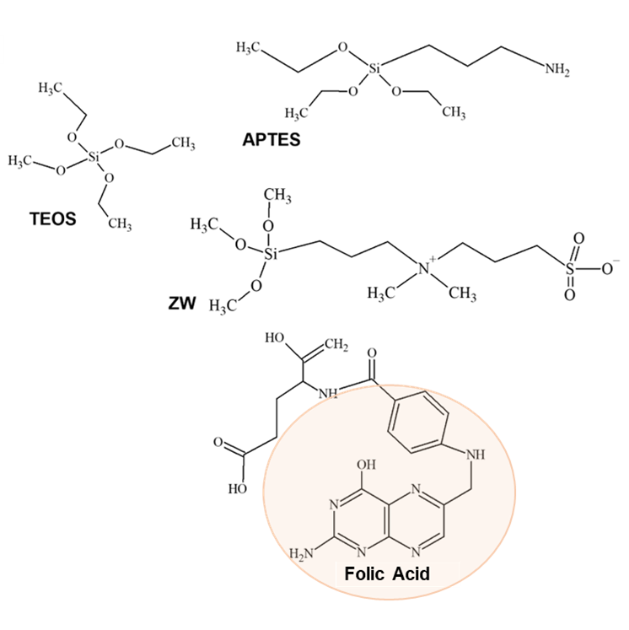

**Figure S2:** Chemical structures of the main compounds used for the synthesis and functionalization of SiO2NPs. In the structure of folic acid, the region that will be recognized by the folate receptor is highlighted.

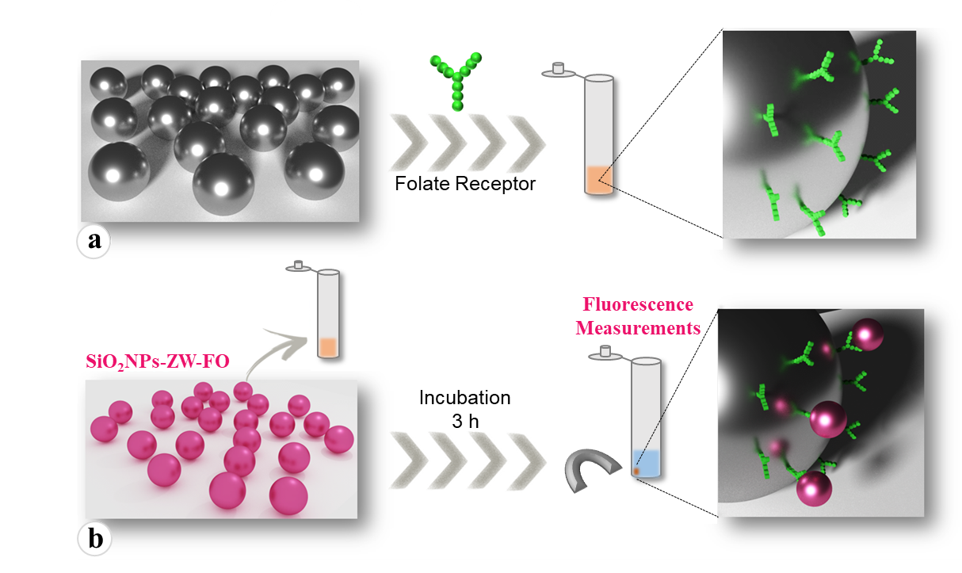

**Figure S3:** Schematic representation of the magnetic beads preparation for immunoprecipitation assay. Briefly, the beads are modified with a) the folate receptor and subsequently exposed to b) SiO2NPs and SiO2NPs-ZW-FO. After incubation, measurements are performed using the fluorescence technique.

**Figure S4:** High resolution XPS spectrum (N1s) for a) SiO2NPs, b) SiO2NPs-ZW, c) SiO2NPs-ZW-NH2, d) SiO2NPs-ZW-FO. High resolution XPS spectrum (C1s) for e) SiO2NPs-ZW-NH2. The main peaks for each sample are marked on the spectrum itself.

**Figure S5:** Analytical curve showing fluorescence responses as a function of SiO2NPs concentration (0.1, 0.2, 0.5, 0.7 and 1.0 mg mL–1).

**Figure S6:** Polyacrylamide gel electrophoresis of non-functionalized and functionalized SiO2NPs samples after incubation in a) DMEM medium (10% FBS) and b) human plasma. In DMEM, the concentrations of SiO2NPs (functionalized and non-functionalized) used were 2 mg mL–1 (samples delimited by the blue square, duplicates for each sample) and 5 mg mL–1 (samples delimited by the orange square). DMEM medium (10% FBS) was also used for control without NPs at 0.3 dilution. In human plasma, the concentration of SiO2NPs (functionalized and non-functionalized) used was 3 mg mL–1 (triplicates for each sample). Lane M is a protein marker.

**Table S1:** 20 Most abundant proteins identified in DMEM and hard corona of SiO2NPs, SiO2NPs-ZW, and SiO2NPs-ZW-FO in descending order.

|  |  |  |  |
| --- | --- | --- | --- |
| DMEM | SiO2NPs | SiO2NPs-ZW | SiO2NPs-ZW-FO |
| Albumin | Complement C3 | Albumin | Albumin |
| Alpha-1-antiproteinase | Hemoglobin fetal subunit beta | Trypsin | Similar to complement C4-A precursor |
| Alpha-2-HS-glycoprotein | Apolipoprotein A-I | Gelsolin | Apolipoprotein A-I |
| Serotransferrin | Albumin | Similar to complement C4-A precursor | Trypsin |
| Alpha-2-macroglobulin | Hemoglobin subunit alpha | Hemoglobin fetal subunit beta | Alpha-2-HS-glycoprotein |
| Hemoglobin fetal subunit beta | Alpha-1-antiproteinase | Alpha-2-HS-glycoprotein | Gelsolin |
| Fetuin-B | Gelsolin | Apolipoprotein A-I | Hemoglobin fetal subunit beta |
| Alpha-fetoprotein | Alpha-2-HS-glycoprotein | Complement C3 | Complement C3 |
| Vitamin D-binding protein | Similar to complement C4-A precursor | Methanethiol oxidase | Hemoglobin subunit alpha |
| Complement C3 | Trypsin | Alpha-1-antiproteinase | Alpha-1-antiproteinase |
| Hemoglobin subunit alpha | Complement factor B | Hemoglobin subunit alpha | Tetranectin |
| Apolipoprotein A-I | Alpha-2-macroglobulin | Complement factor H | Complement factor H |
| Trypsin | Inter-alpha-trypsin inhibitor heavy chain H2 | Tetranectin | Kininogen-1 |
| Inter-alpha-trypsin inhibitor heavy chain H2 | Alpha-fetoprotein | Complement factor B | Alpha-2-macroglobulin |
| Hemopexin | Plasminogen | Alpha-2-macroglobulin | Complement factor B |
| Methanethiol oxidase | Inter-alpha-trypsin inhibitor heavy chain H4 | Thrombospondin-1 | Inter-alpha-trypsin inhibitor heavy chain H2 |
| Serpin A3-1 | Fetuin-B | Plasminogen | Inter-alpha-trypsin inhibitor heavy chain H4 |
| Antithrombin-III | Actin | Pigment epithelium-derived factor | Thrombospondin-1 |
| Similar to complement C4-A precursor | Complement factor H | Plasminogen | Apolipoprotein E |
| Elongation factor 1-alpha | Apolipoprotein B-48 | Apolipoprotein E | Pigment epithelium-derived factor |

**Table S2:** 20 Most abundant proteins identified in human plasma and hard corona of SiO2NPs, SiO2NPs-ZW, and SiO2NPs-ZW-FO in descending order.

|  |  |  |  |
| --- | --- | --- | --- |
| PLASMA | SiO2NPs | SiO2NPs-ZW | SiO2NPs-ZW-FO |
| Albumin | Apolipoprotein A-I | Apolipoprotein B-100 | Apolipoprotein B-100 |
| Apolipoprotein A-I | Fibrinogen alpha chain | Apolipoprotein A-I | Apolipoprotein A-I |
| Serotransferrin | Fibrinogen gamma chain | Histidine-rich glycoprotein | Fibrinogen alpha chain |
| Alpha-1-antitrypsin | Fibrinogen beta chain | Fibrinogen alpha chain | Fibrinogen gamma chain |
| Immunoglobulin kappa | Apolipoprotein B-100 | Complement C1q subcomponent subunit C | Fibrinogen beta chain |
| Fibrinogen alpha chain | Albumin | Complement C1q subcomponent subunit B | Apolipoprotein E |
| Haptoglobin | Immunoglobulin heavy constant gamma 1 | Apolipoprotein E | Immunoglobulin heavy constant gamma 1 |
| Apolipoprotein B-100 | Histidine-rich glycoprotein | Trypsin | Histidine-rich glycoprotein |
| Fibrinogen gamma chain | Apolipoprotein E | Immunoglobulin heavy constant gamma 1 | Immunoglobulin kappa |
| Immunoglobulin lambda constant 3 | Apolipoprotein A-II | Immunoglobulin kappa | Trypsin |
| Immunoglobulin heavy constant alpha 1 | Immunoglobulin kappa | Fibrinogen gamma chain | Albumin |
| Fibrinogen beta chain | Sialic acid-binding Ig-like lectin | Complement C1q subcomponent subunit A | Complement C1q subcomponent subunit C |
| Immunoglobulin heavy constant gamma 1 | Serum amyloid A-4 | Albumin | Immunoglobulin lambda constant 3 |
| Apolipoprotein A-IV | Trypsin | Fibrinogen beta chain | Complement C1q subcomponent subunit B |
| Vitamin D-binding protein | Gelsolin | Immunoglobulin lambda constant 3 | Serum amyloid A-4 |
| Transthyretin | Immunoglobulin lambda constant 3 | Plasma kallikrein | Complement C1q subcomponent subunit A |
| Alpha-1-antichymotrypsin | Complement C1q subcomponent subunit C | Immunoglobulin heavy constant mu | Complement C3 |
| Trypsin | Complement C1q subcomponent subunit B | Complement C3 | Apolipoprotein A-II |
| Alpha-2-macroglobulin | Complement C3 | Kininogen-1 | Sialic acid-binding Ig-like lectin |
| Plasma protease C1 inhibitor | Apolipoprotein A-IV | Immunoglobulin heavy constant gamma 3 | Immunoglobulin heavy constant mu |

**Figure S7:** Hemolytic activity of SiO2NPs, SiO2NPs-ZW, SiO2NPs-ZW-NH2, and SiO2NPs-ZW-FO diluted in PBS 1x. The concentrations of NPs used were 0.5 and 1.0 mg mL–1. Results are presented as mean ± standard deviation (n=3). The common symbols on the tops of the bars indicate that there is no statistical difference between them. For samples marked with an asterisk, no significant hemolysis was observed.

**Figure S8:** Western Blot of HaCat and KB cell lysates (20 μg protein), showing identification of the folate receptor (37 kDa) by the anti-folate receptor alpha antibody. FRα: Folate alpha receptor. As expected, the band referring to FRα in the KB cell was more intense than the one in the HaCat cell, indicating a higher expression of the receptor. β-actin protein (42 kDa) was used as a loading control.

**Figure S9:** Cell targeting assay using non-functionalized SiO2NPs and SiO2NPs-ZW-FO, after a) 6 h, b) 12 h, and c) 24 h of incubation, obtained by Operetta microscope. Cells were stained with DAPI (cell nucleus, blue) and phalloidin 488 (actin filaments, green) and SiO2NPs can be visualized in red. Scale bar: 50 μm.

**Figure S10:** Percentage of positive cells for SiO2NPs, SiO2NPs-ZW, and SiO2NPs-ZW-FO, where a) HaCat and b) KB cells.