Supporting Information

For

An efficient one-step synthesis of a new series of multifunctional olefins

Olfa Mhasni*^{1,2}, Julien Legros³ and Farhat Rezgui²

¹Laboratory of Materials, Treatement and Analysis LMTA, LR 15 INRAP 03, National Institute of Research and Physico-Chemical Analysis (INRAP), Biotechpôle Sidi Thabet 2020, Tunisia.
²University of Tunis El Manar, Laboratory of Stuctural (Bio) Organic Chemistry and Polymers, LR99ES14, Faculty of Sciences, Campus, 2092 Tunis, Tunisia.
³Laboratory COBRA University of Rouen Normandy 1, rue Lucien Tesni`ere, Mont-Saint-Aignan F-76821 France

* Corresponding author. Email: olfa.mha@gmail.com

¹H and ¹³C NMR and HRMS Spectra of all products

Table of contents

¹H NMR, ¹³C NMR and dept 135 NMR spectra ……………………………...................... S2-S27
ESI-HRMS spectra ……………………………………….………....………………..….. S29-S41

¹H/¹³C NMR Spectra for compounds 5, 6, 7a-c, 8a-c, 9a-d, 10

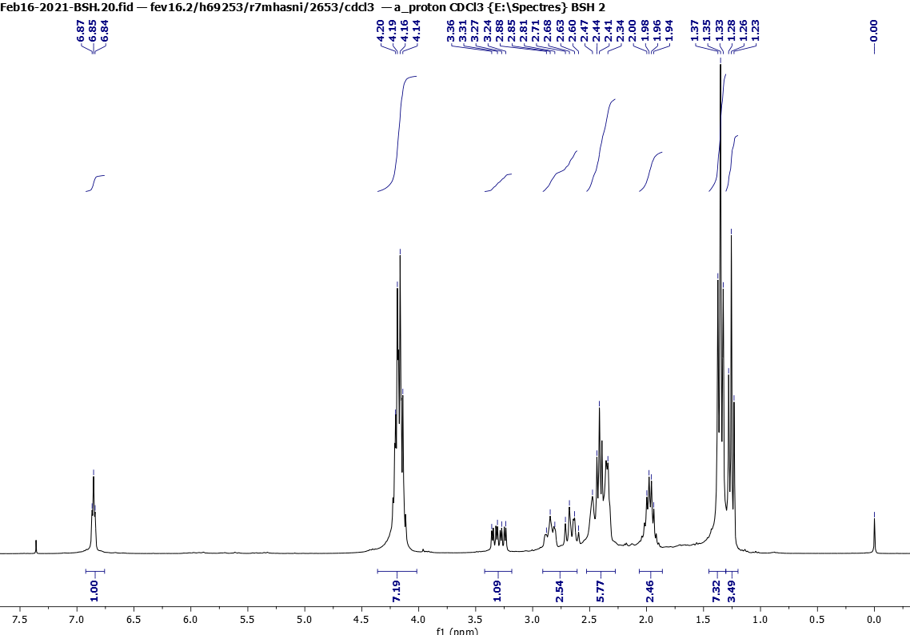Figure 1. ¹H NMR (300 MHz, CDCl₃) spectra of 5

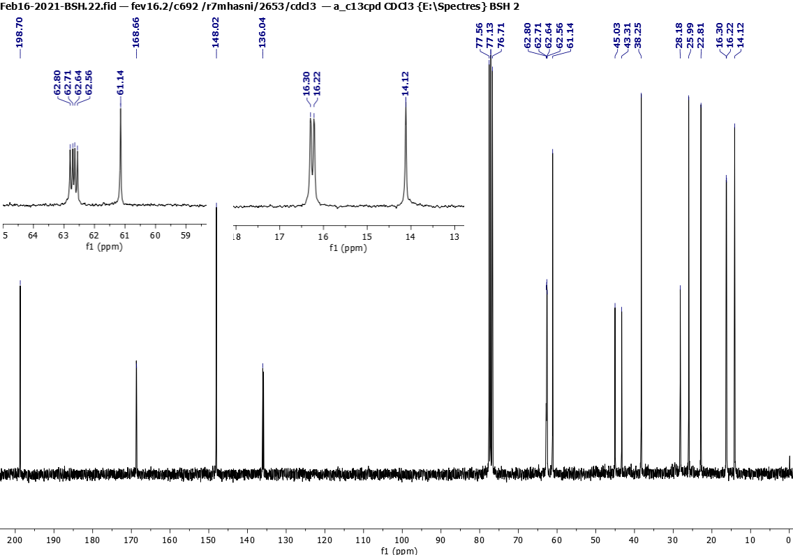

Figure 2. ¹³C NMR (75 MHz, CDCl₃) spectra of 5
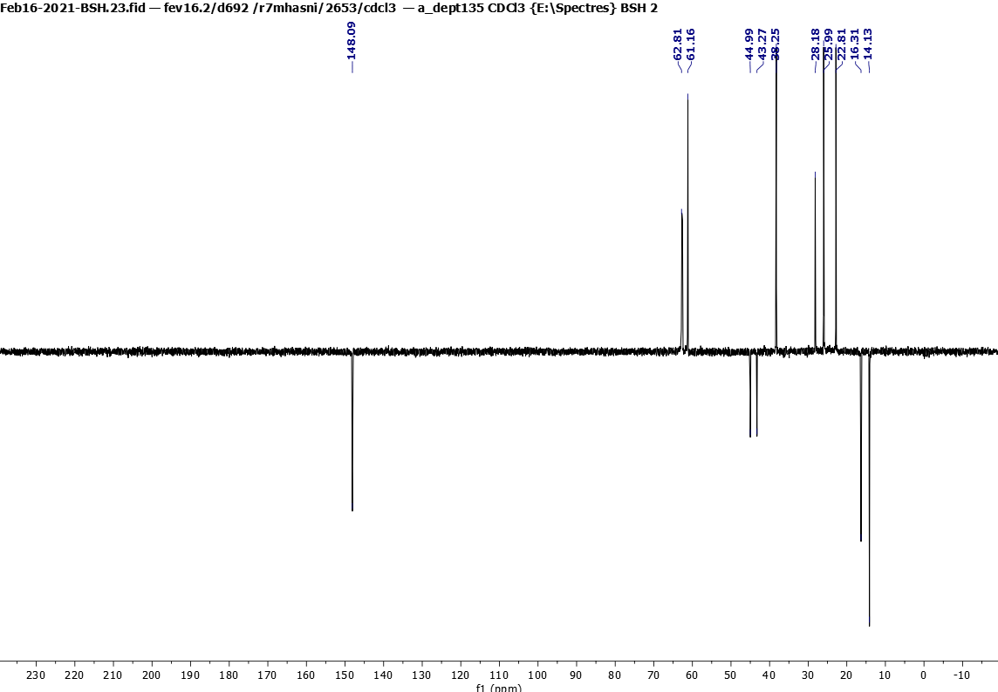

Figure 3. dept 135 NMR (75 MHz, CDCl₃) spectra of 5

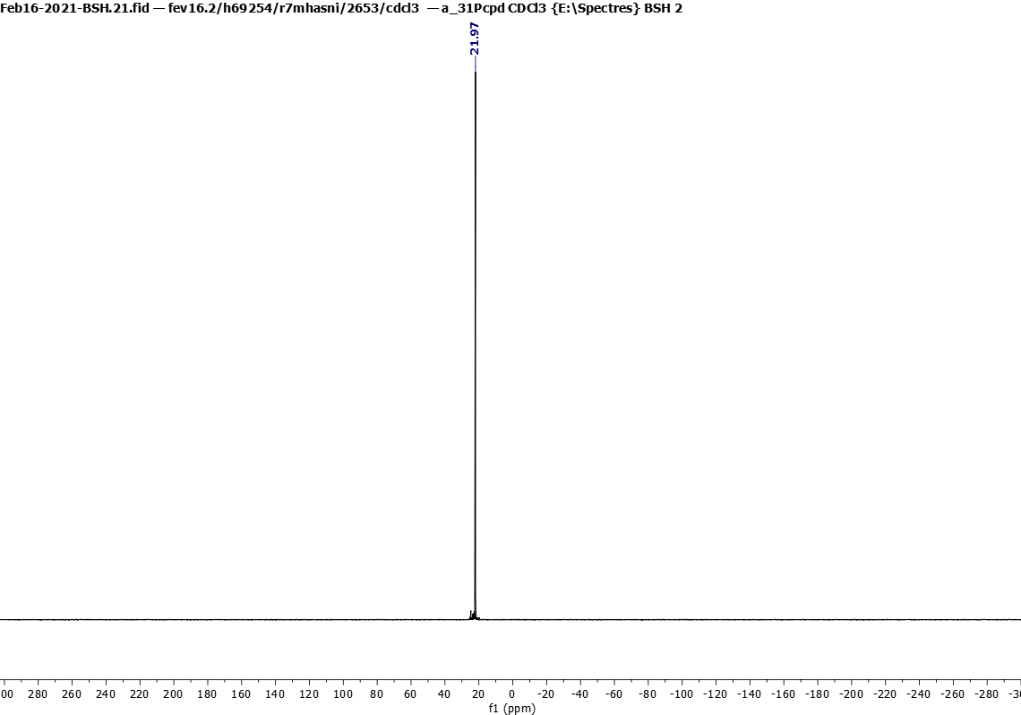

Figure 4. ³¹P NMR (121 MHz, CDCl₃) spectra of 5

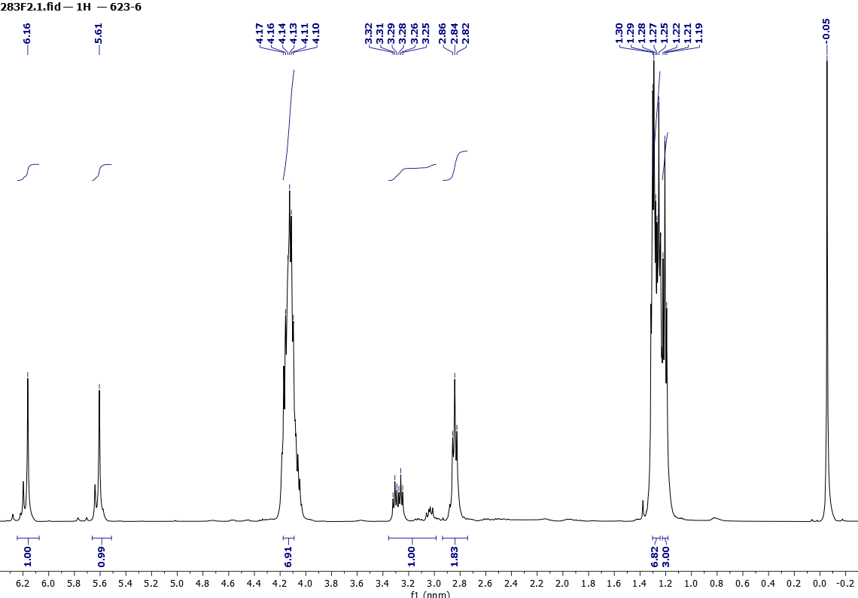

Figure 5. ¹H NMR (500 MHz, CDCl₃) spectra of 6

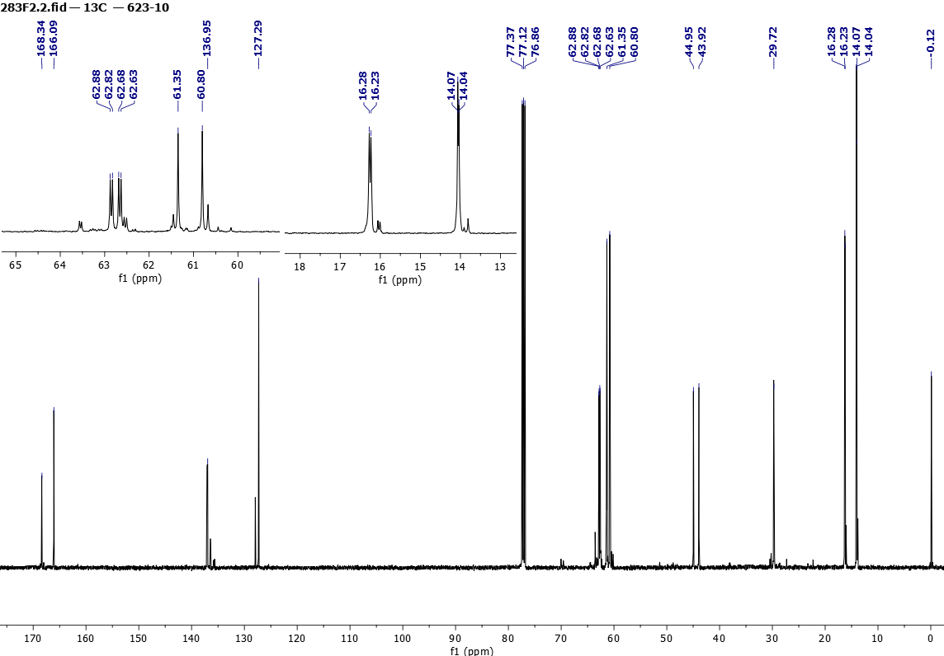

Figure 6. ¹³C NMR (125 MHz, CDCl₃) spectra of 6

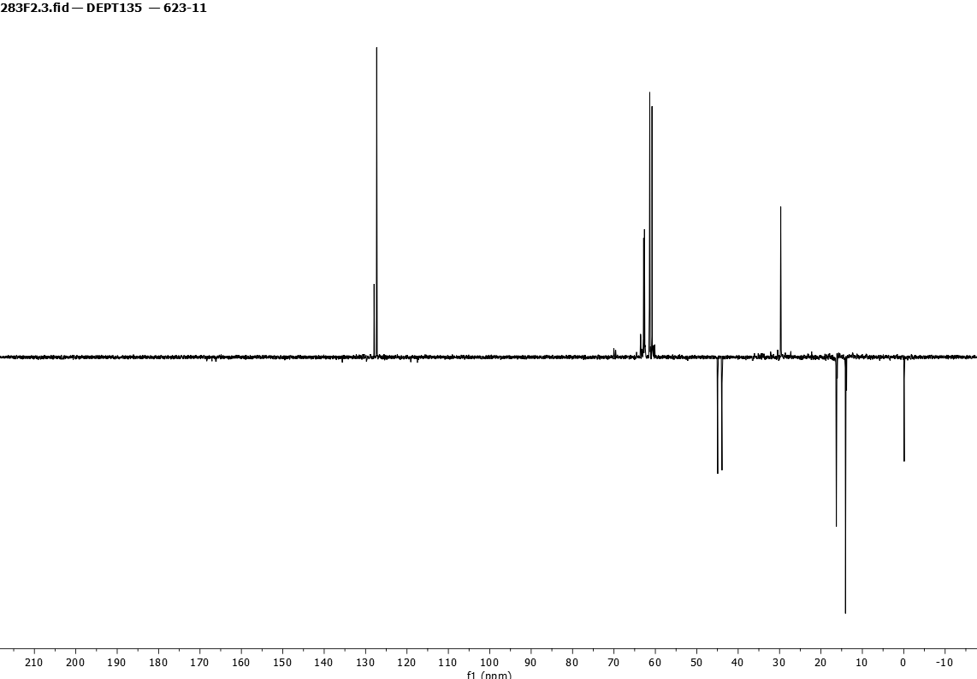

Figure 7. dept 135 NMR (125 MHz, CDCl₃) spectra of 6

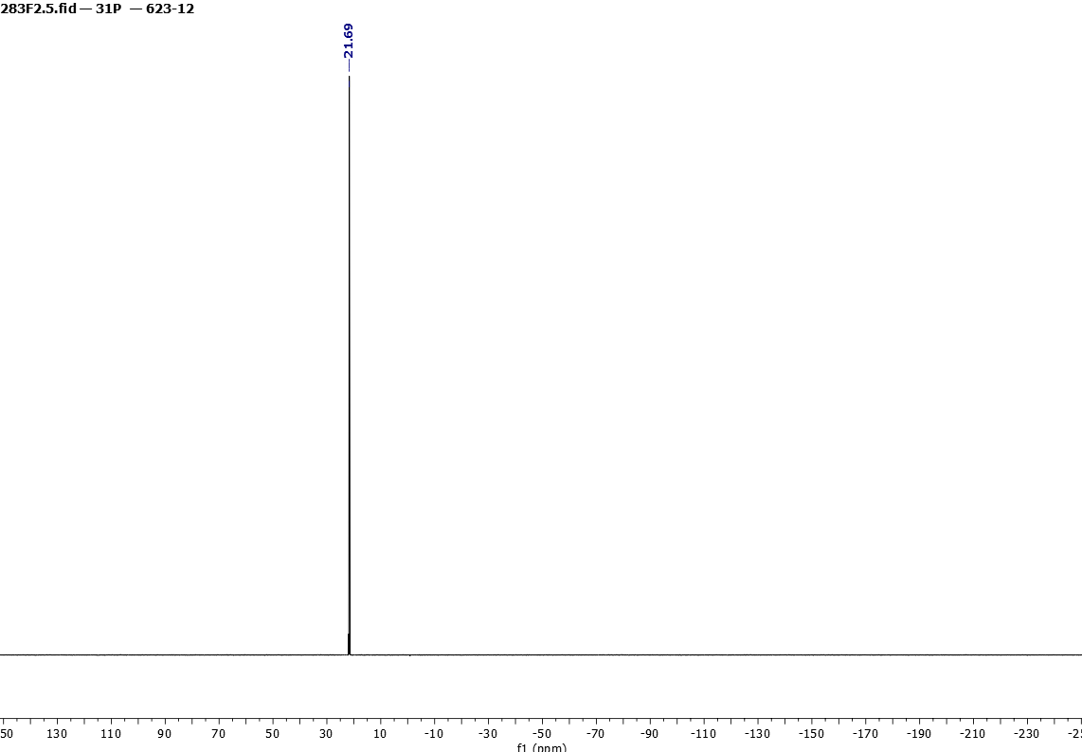

Figure 8. ³¹P NMR (202 MHz, CDCl₃) spectra of 6

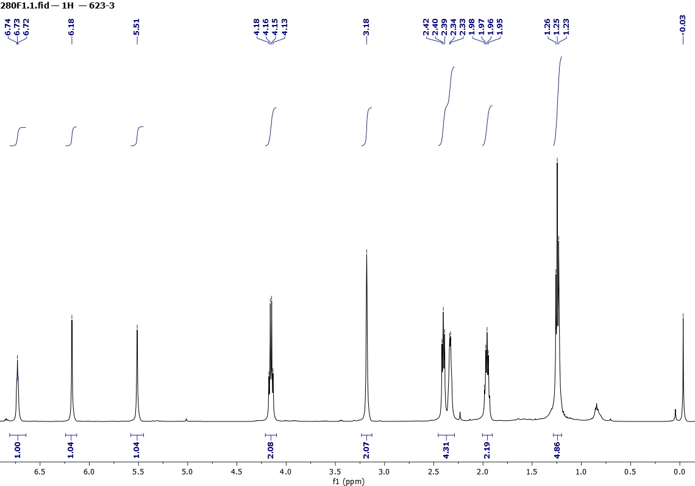

Figure 9. ¹H NMR (500 MHz, CDCl₃) spectra of 7a

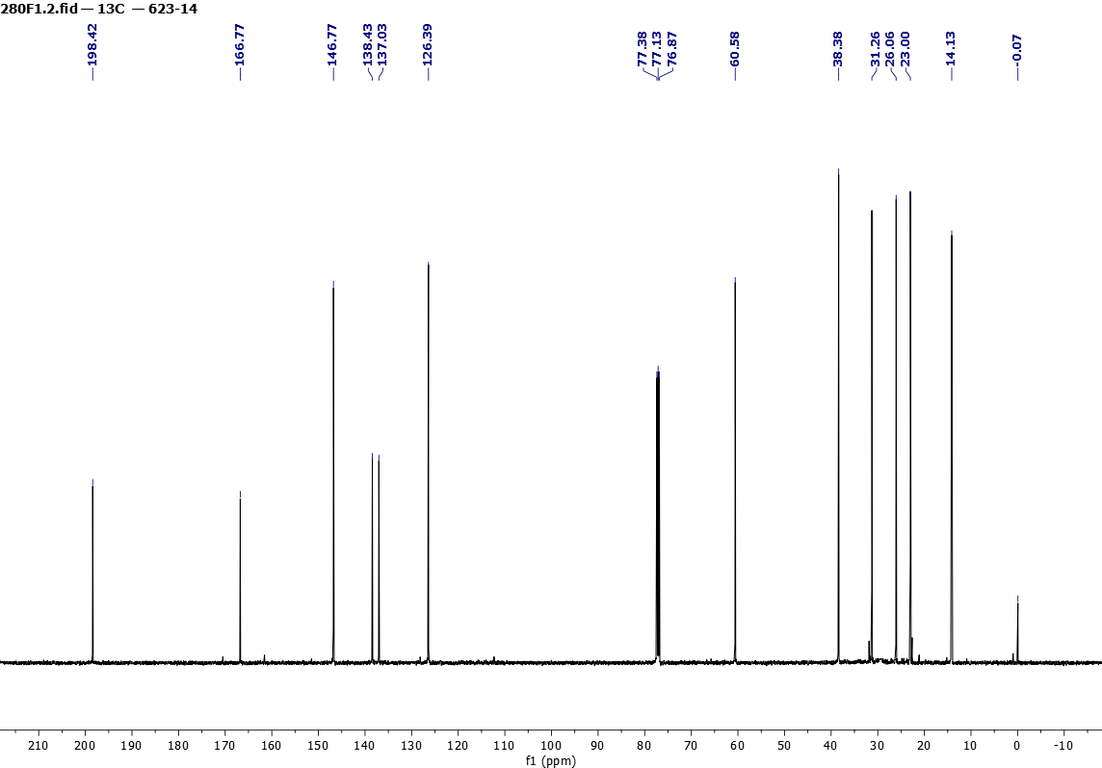

Figure 10. ¹³C NMR (125 MHz, CDCl₃) spectra of 7a
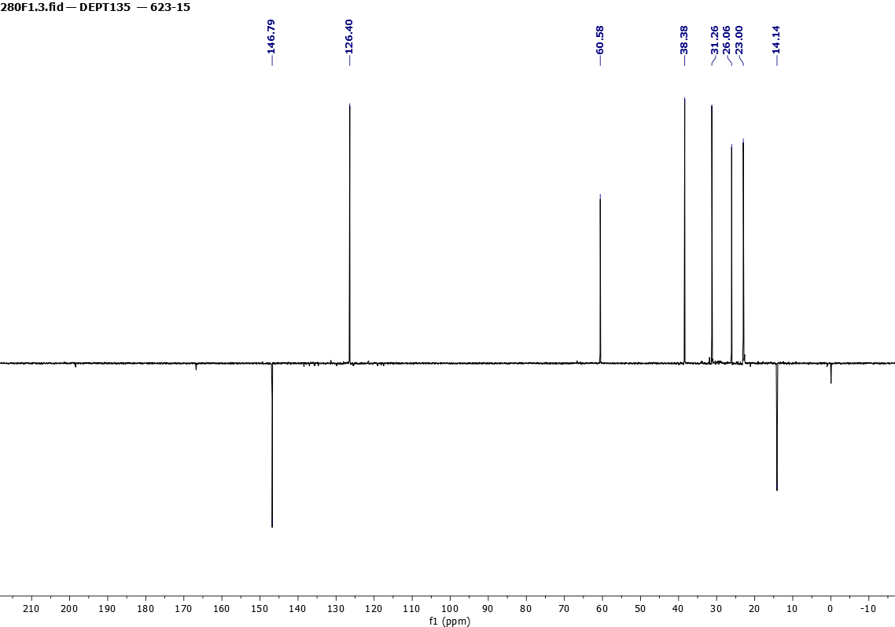

Figure 11. dept 135 NMR (125 MHz, CDCl₃) spectra of 7a

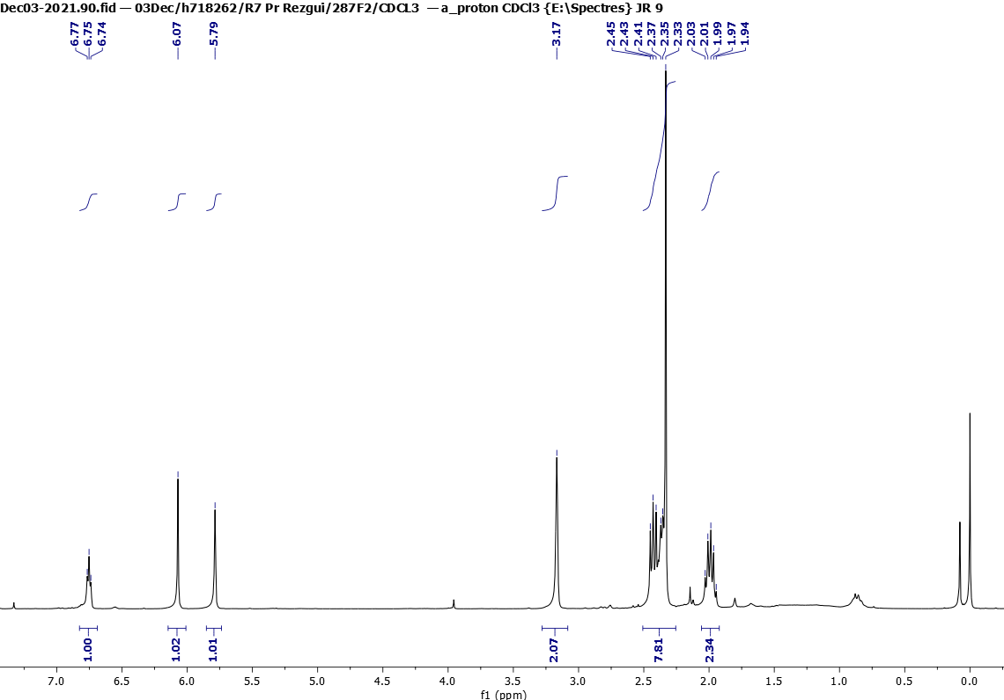

Figure 12. ¹H NMR (300 MHz, CDCl₃) spectra of 7b

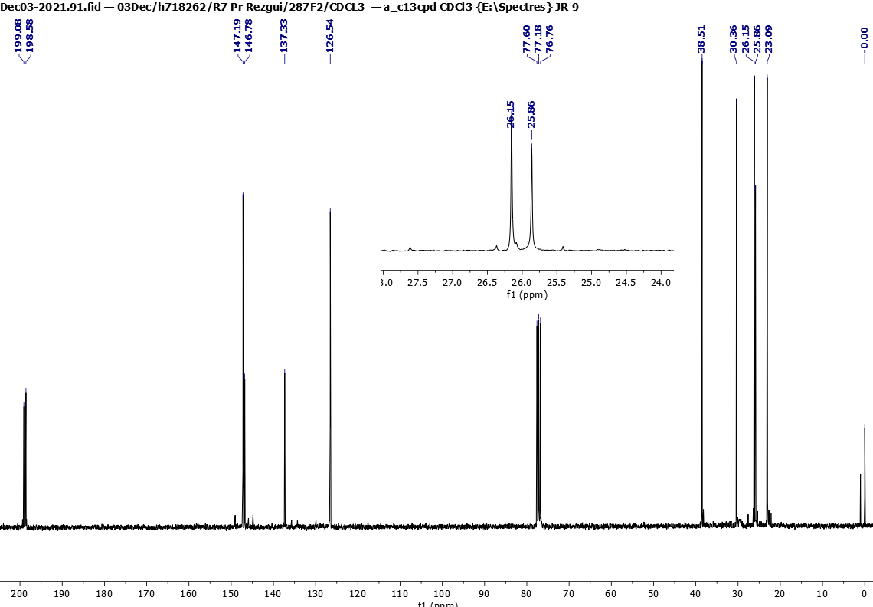

Figure 13. ¹³C NMR (75 MHz, CDCl₃) spectra of 7b
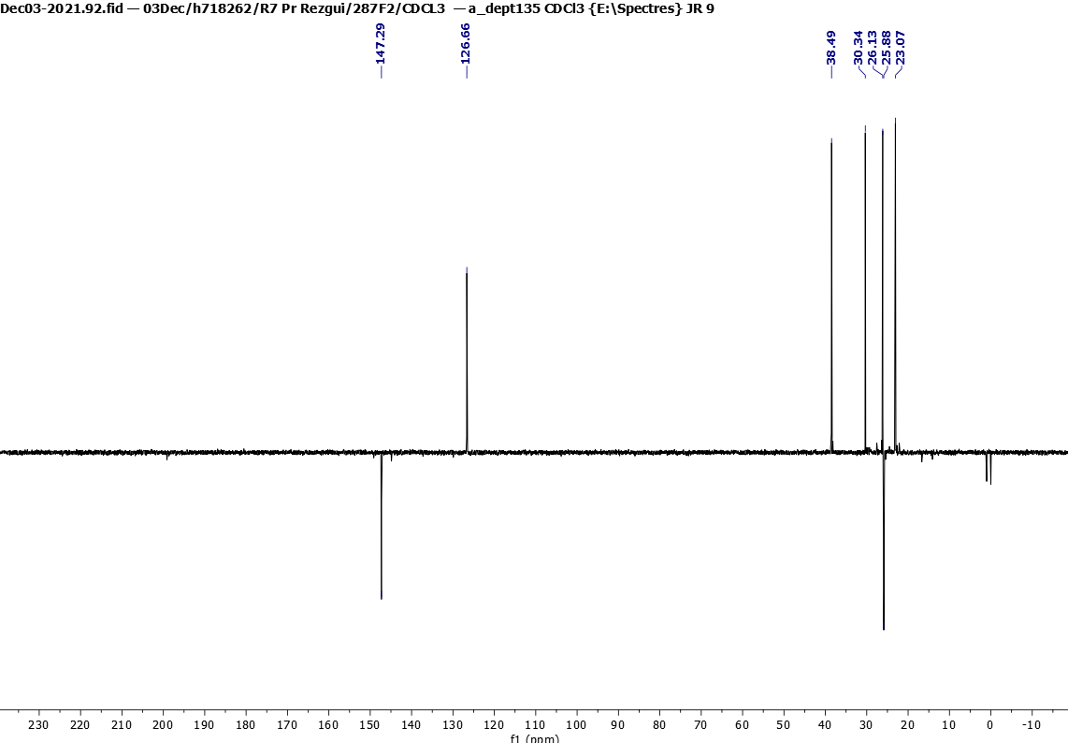

Figure 14. dept 135 NMR (75 MHz, CDCl₃) spectra of 7b

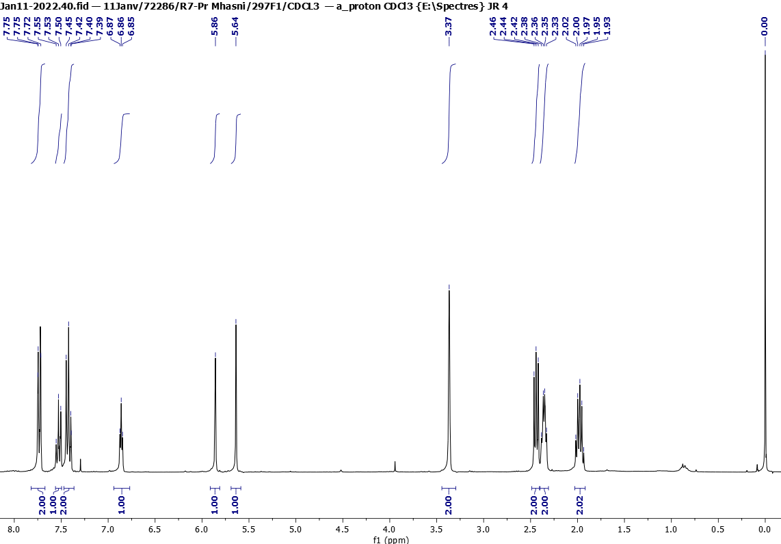

Figure 15. ¹H NMR (300 MHz, CDCl₃) spectra of 7c

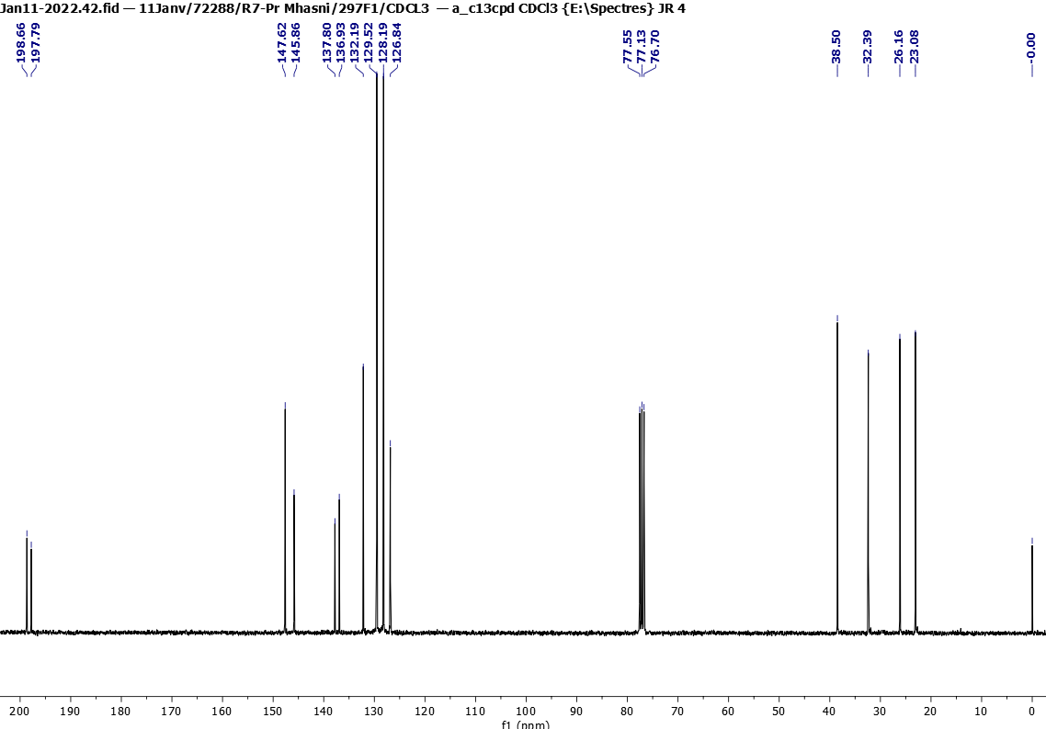

Figure 16. ¹³C NMR (75 MHz, CDCl₃) spectra of 7c

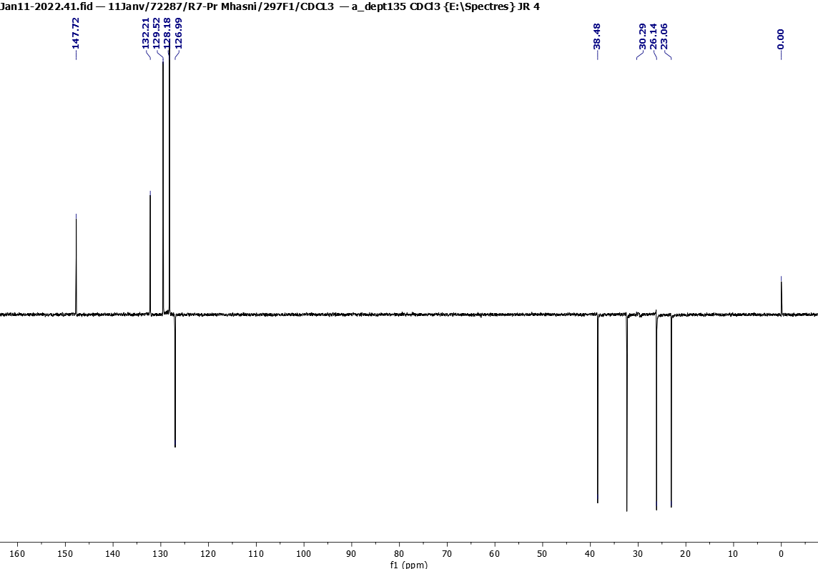

Figure 17. dept 135 NMR (75 MHz, CDCl₃) spectra of 7c

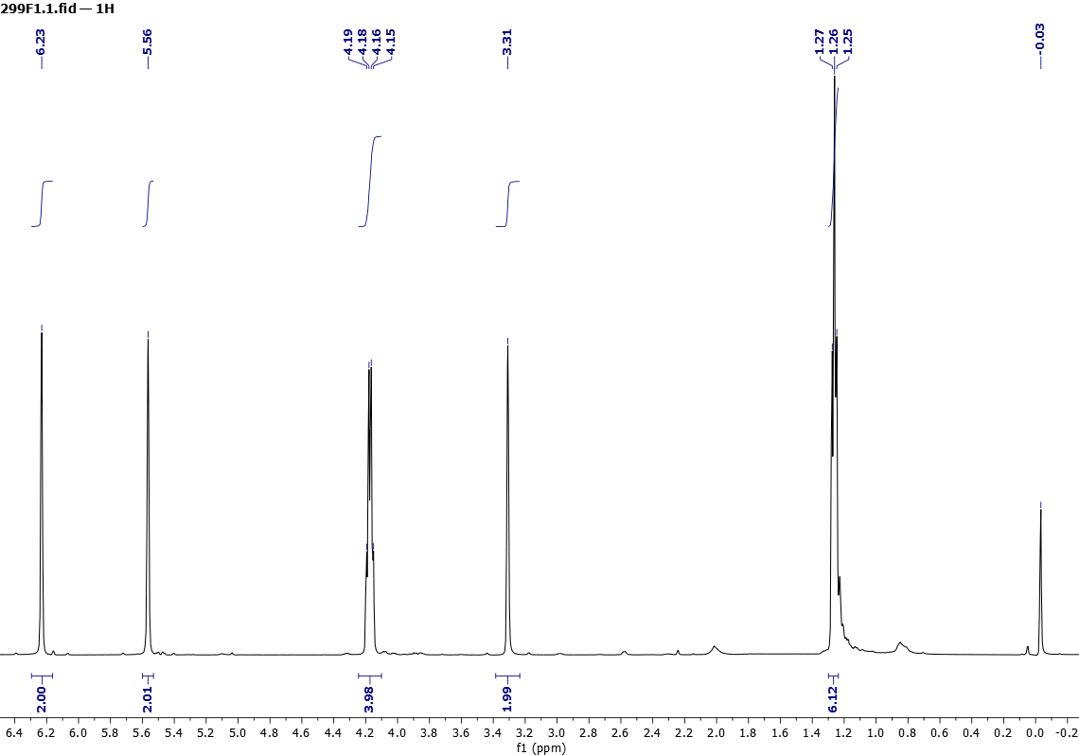

Figure 18. ¹H NMR (500 MHz, CDCl₃) spectra of 8a

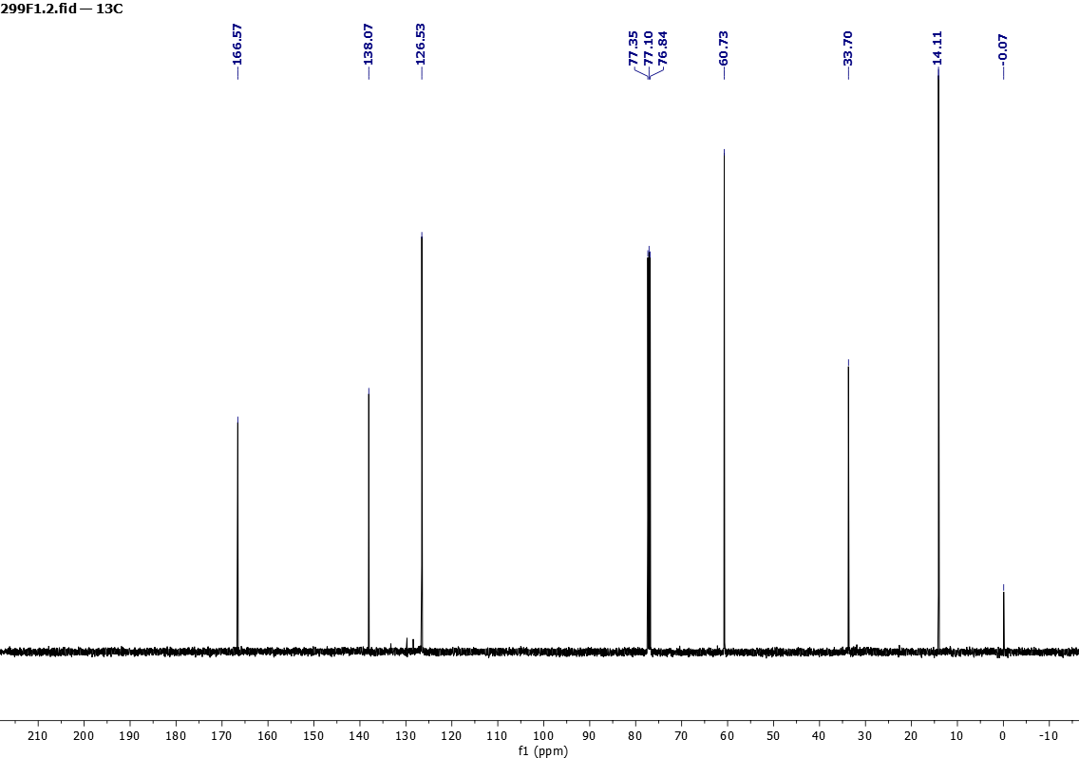
Figure 19. ¹³C NMR (125 MHz, CDCl₃) spectra of 8a
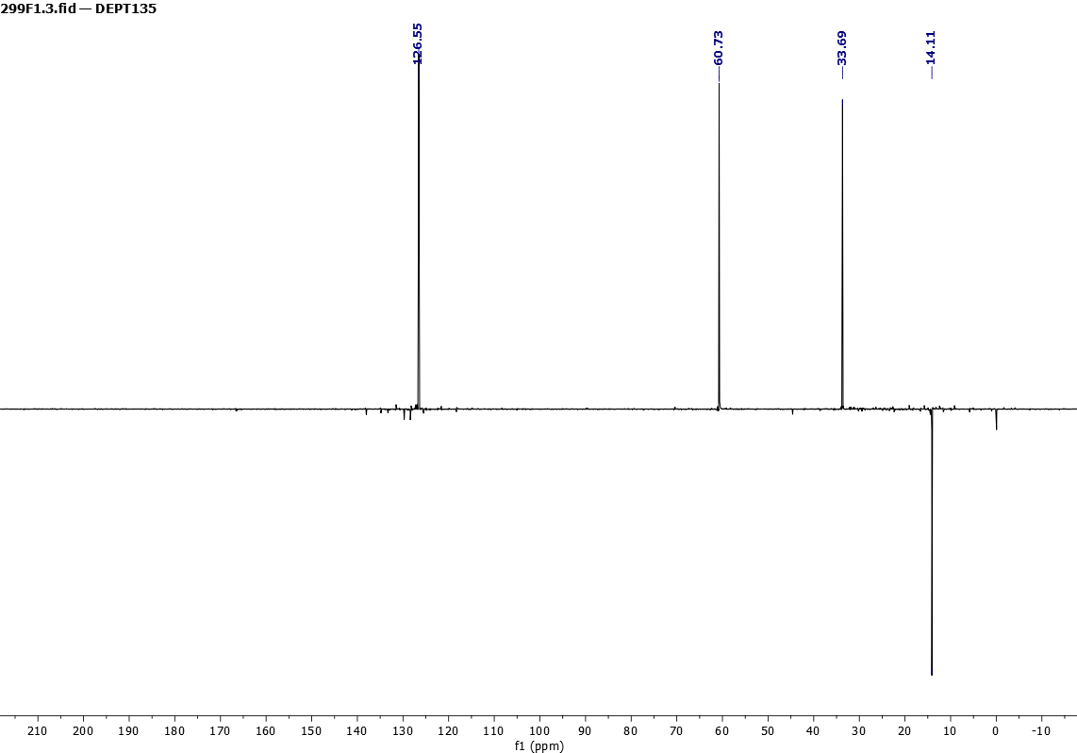

Figure 20. dept 135 NMR (75 MHz, CDCl₃) spectra of 8a

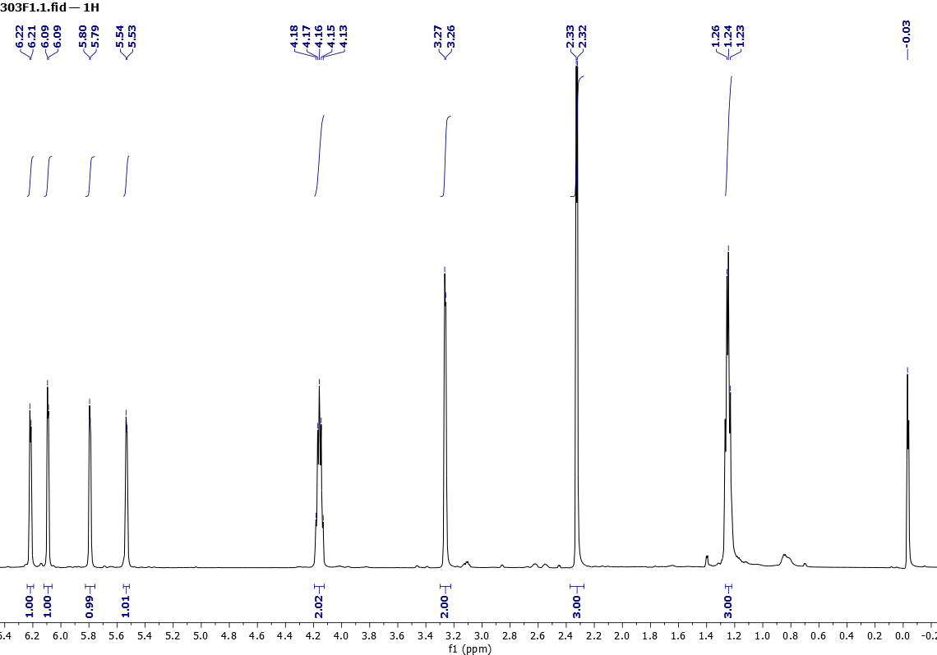

Figure 21. ¹H NMR (500 MHz, CDCl₃) spectra of 8b

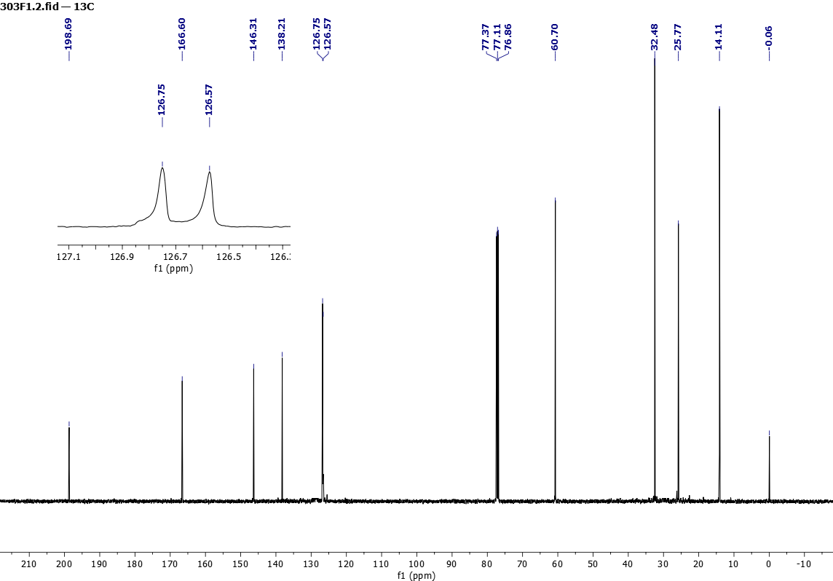

Figure 22. ¹³C NMR (125 MHz, CDCl₃) spectra of 8b
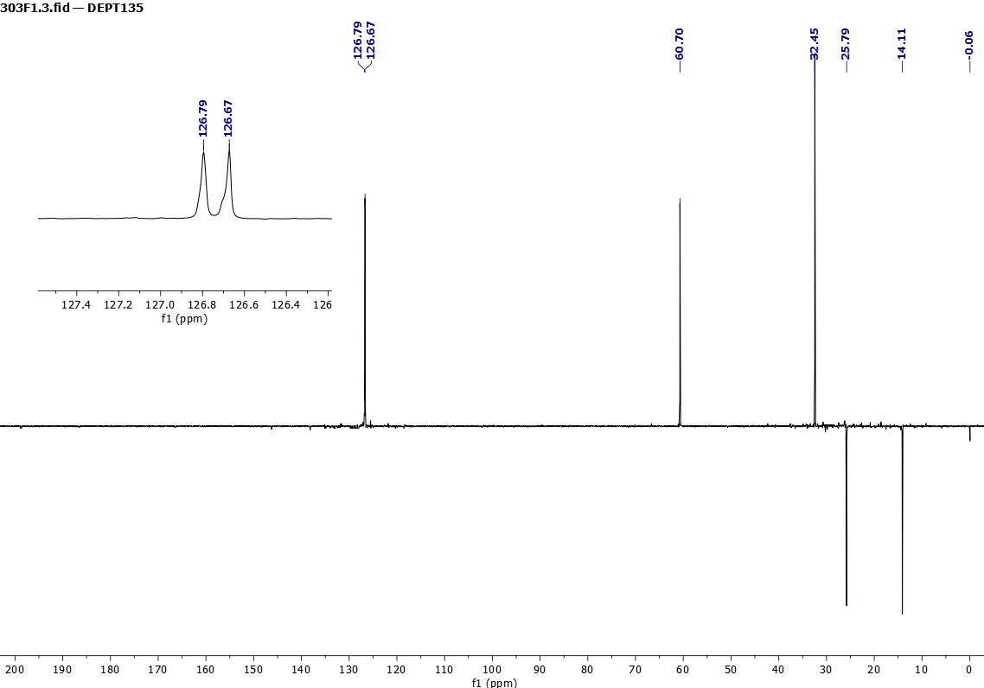

Figure 23. dept 135 NMR (75 MHz, CDCl₃) spectra of 8b

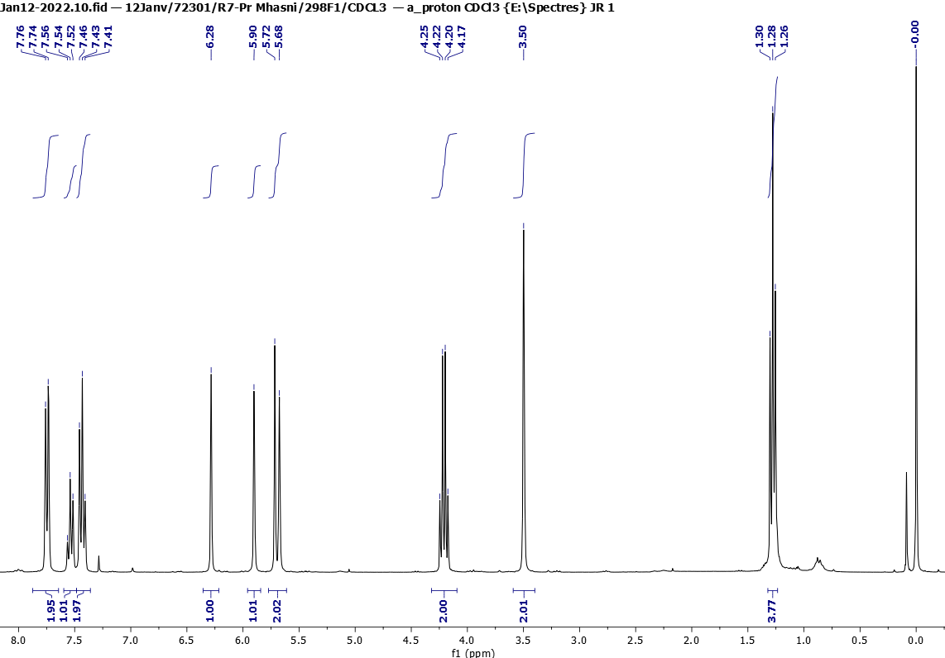

Figure 24. ¹H NMR (300 MHz, CDCl₃) spectra of 8c

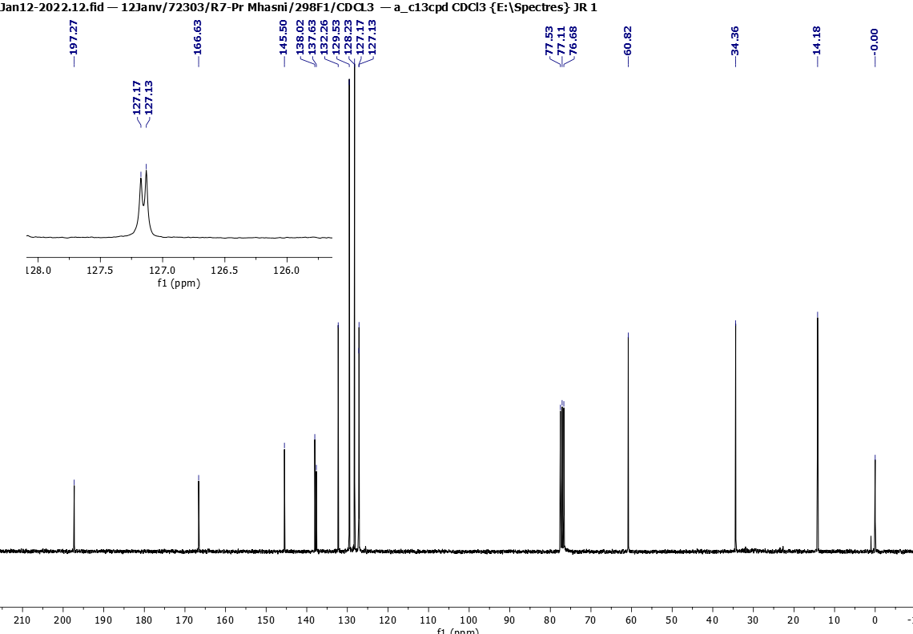
Figure 25. ¹³C NMR (75 MHz, CDCl₃) spectra of 8c
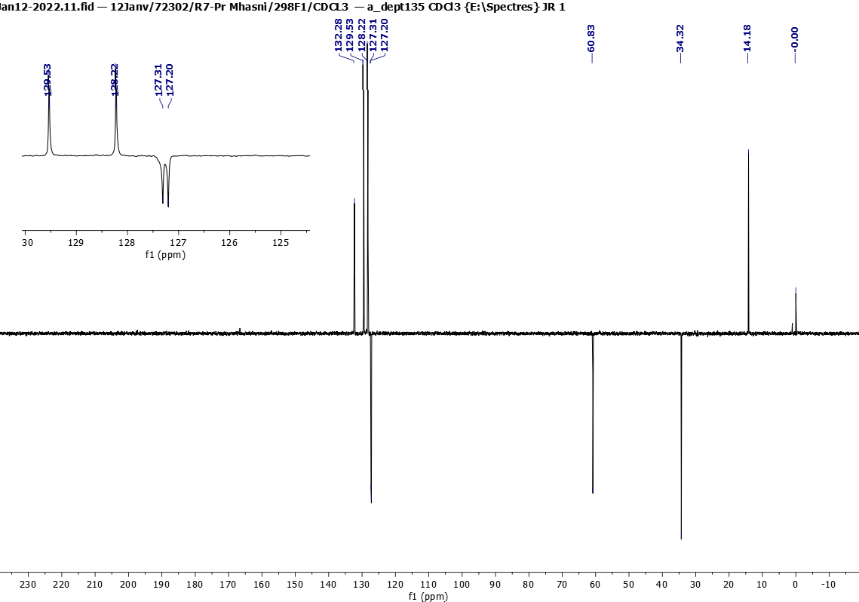
Figure 26. dept 135 NMR (75 MHz, CDCl₃) spectra of 8c

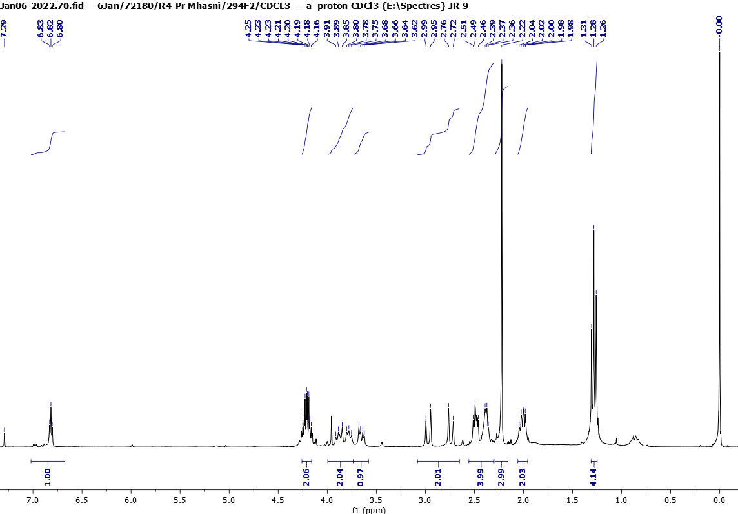

Figure 17. ¹H NMR (300 MHz, CDCl₃) spectra of 9a

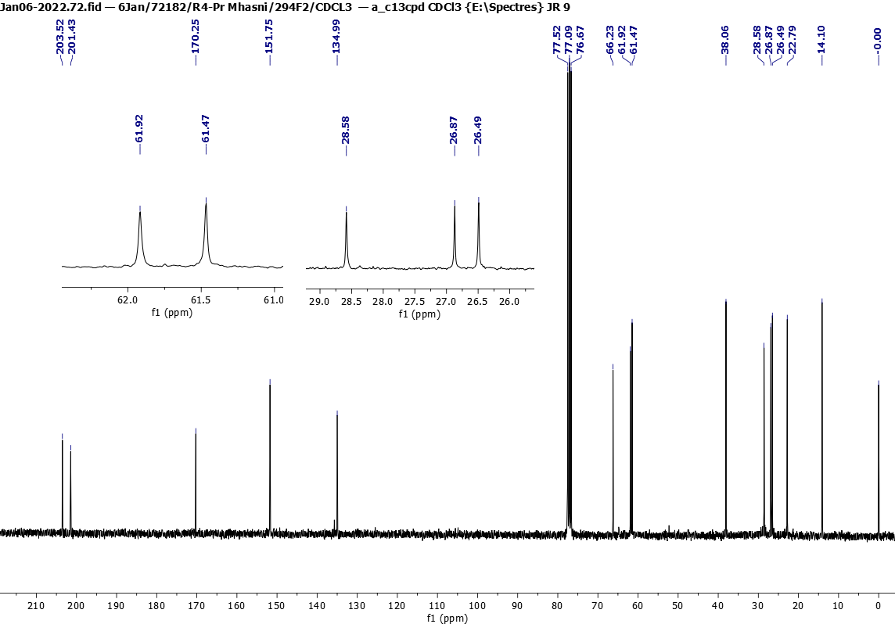

Figure 18. ¹³C NMR (75 MHz, CDCl₃) spectra of 9a
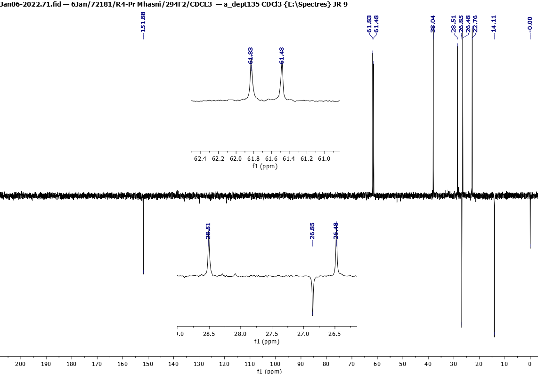
Figure 19. dept 135 NMR (75 MHz, CDCl₃) spectra of 9a

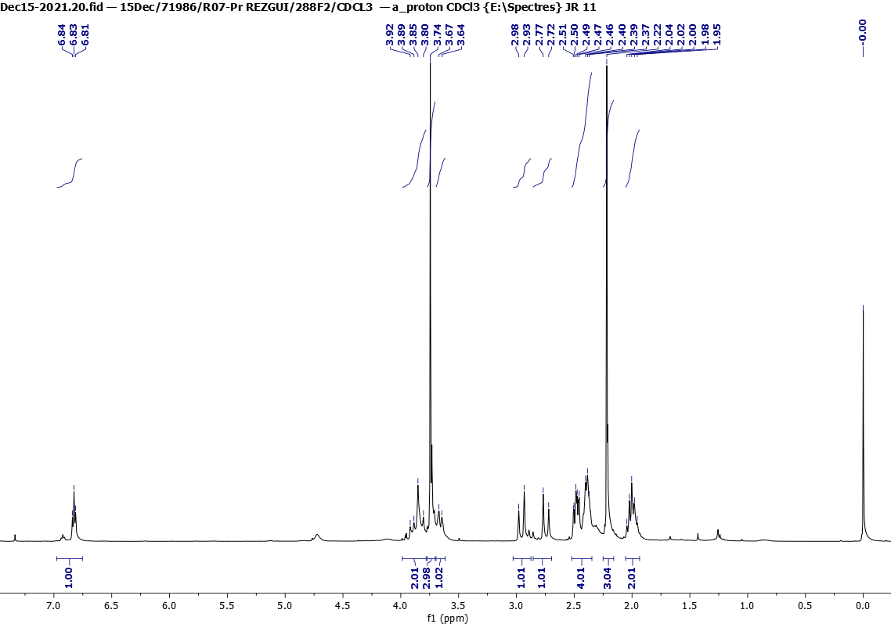
Figure 20. ¹H NMR (300 MHz, CDCl₃) spectra of 9b

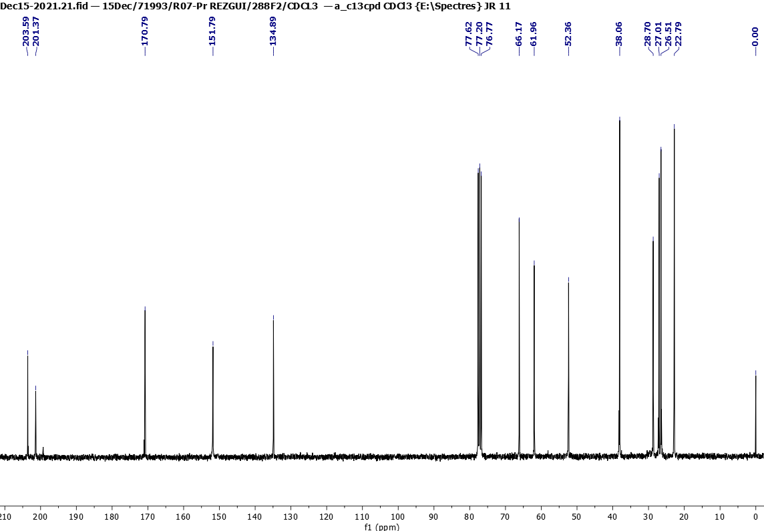

Figure 21. ¹³C NMR (75 MHz, CDCl₃) spectra of 9b
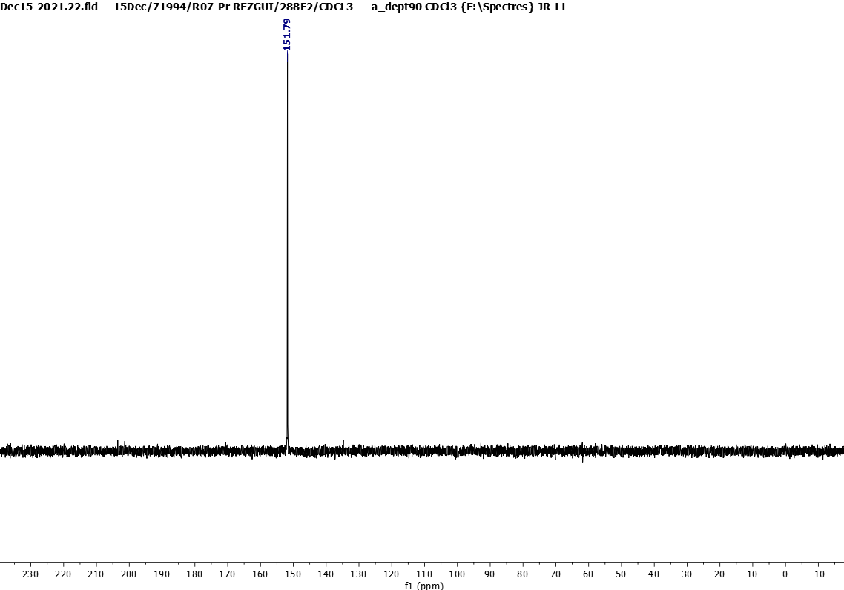

Figure 22. dept 90 NMR (75 MHz, CDCl₃) spectra of 9b

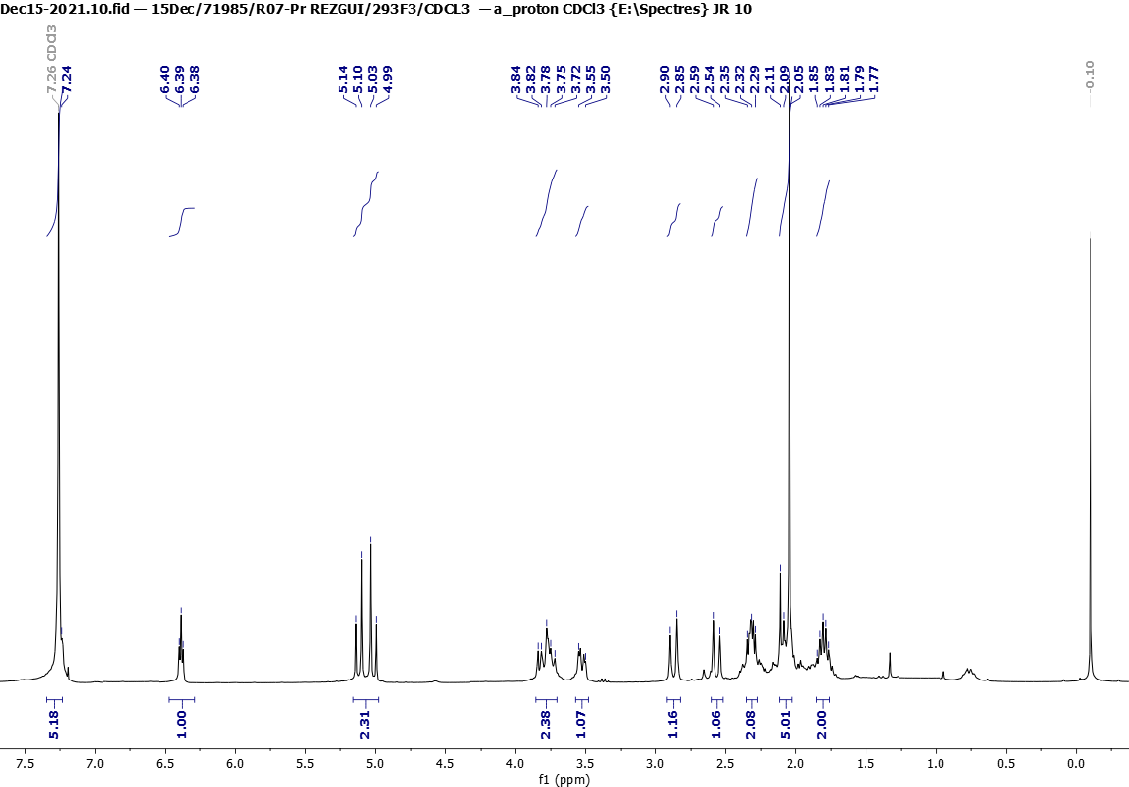

Figure 23. ¹H NMR (300 MHz, CDCl₃) spectra of 9c

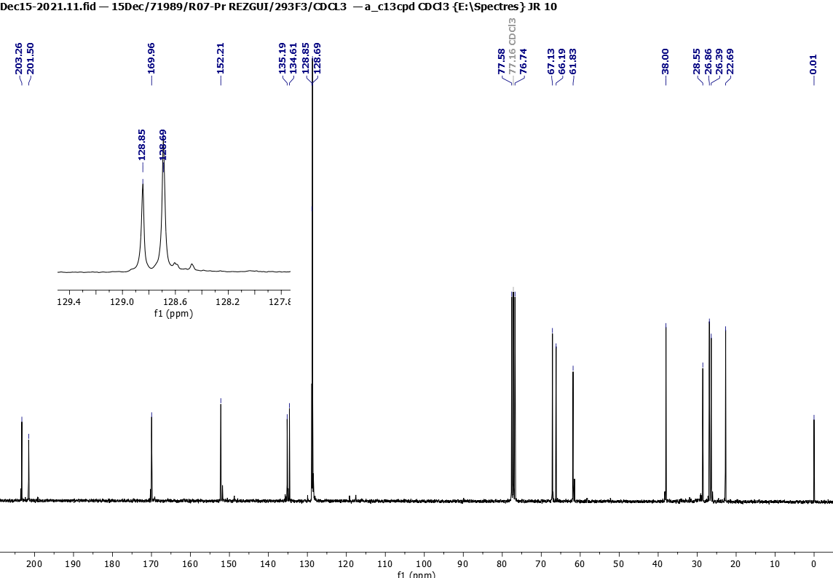

Figure 24. ¹³C NMR (75 MHz, CDCl₃) spectra of 9c
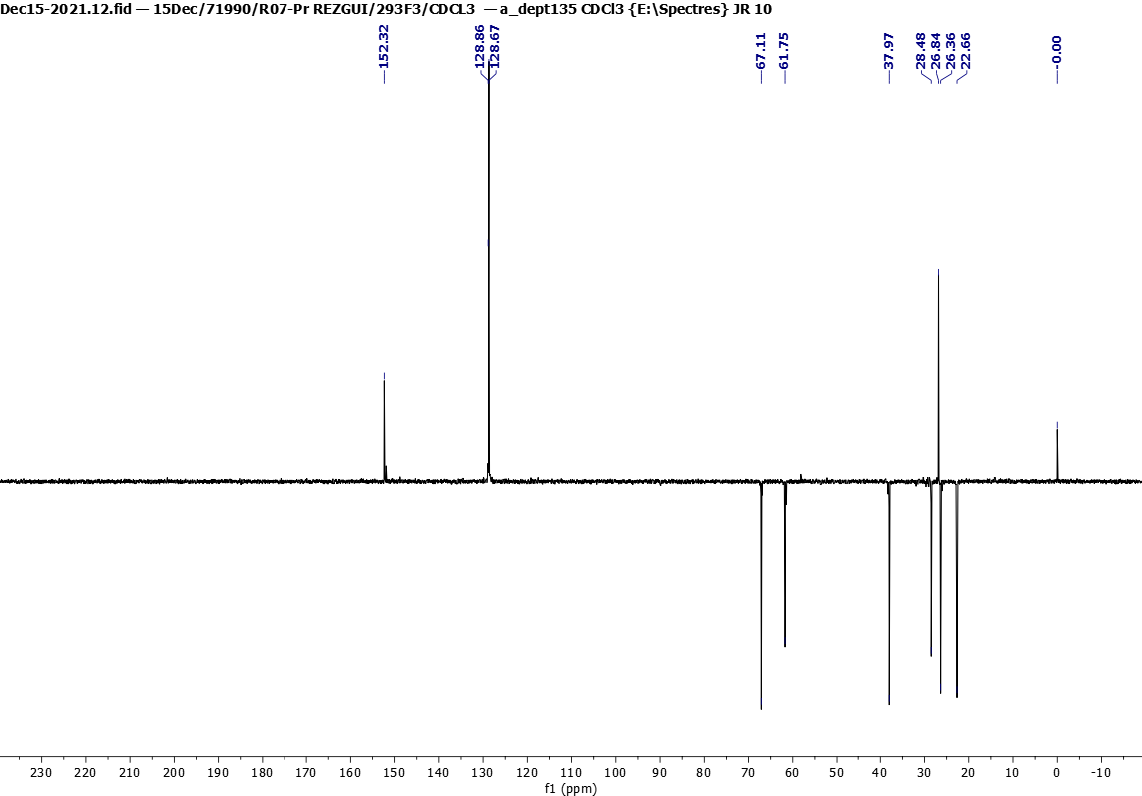

Figure 25. dept 135 NMR (75 MHz, CDCl₃) spectra of 9c

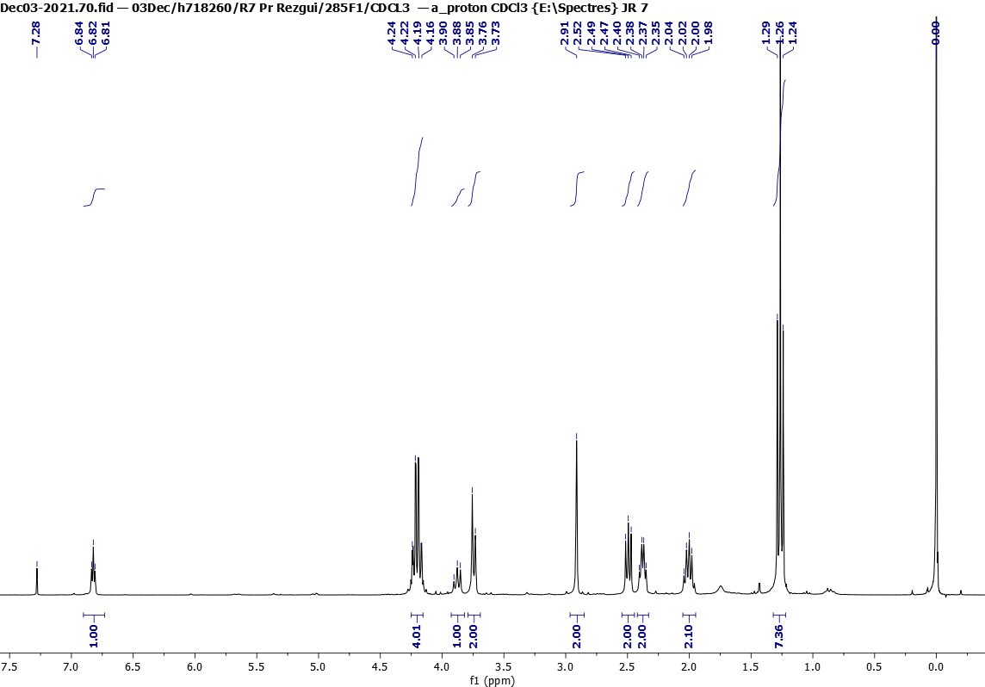

Figure 26. ¹H NMR (300 MHz, CDCl₃) spectra of 9d
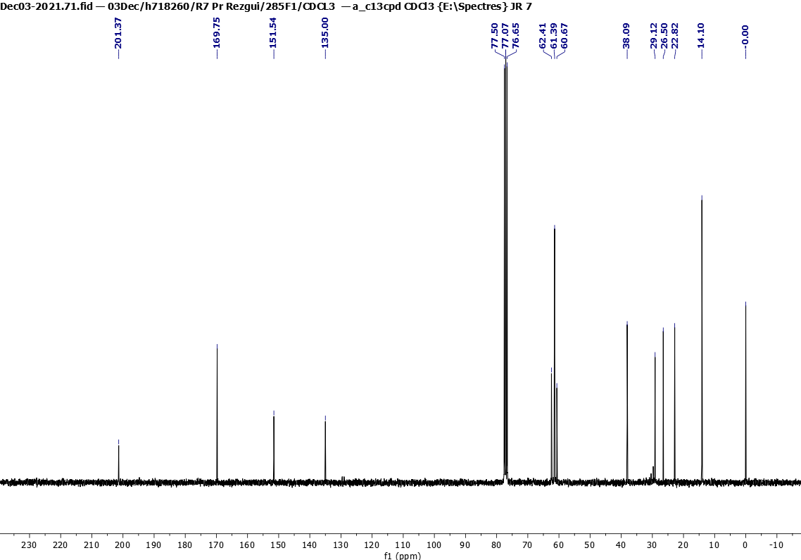

Figure 27. ¹³C NMR (75 MHz, CDCl₃) spectra of 9d
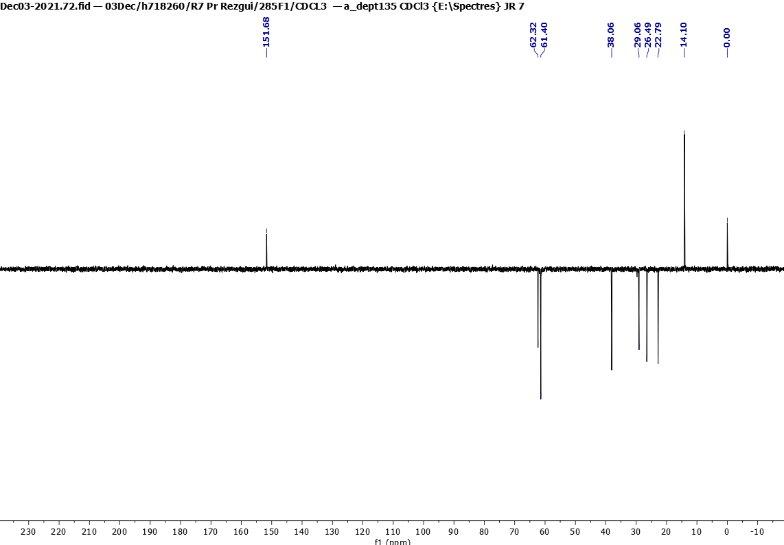

Figure 28. dept 135 NMR (75 MHz, CDCl₃) spectra of 9d

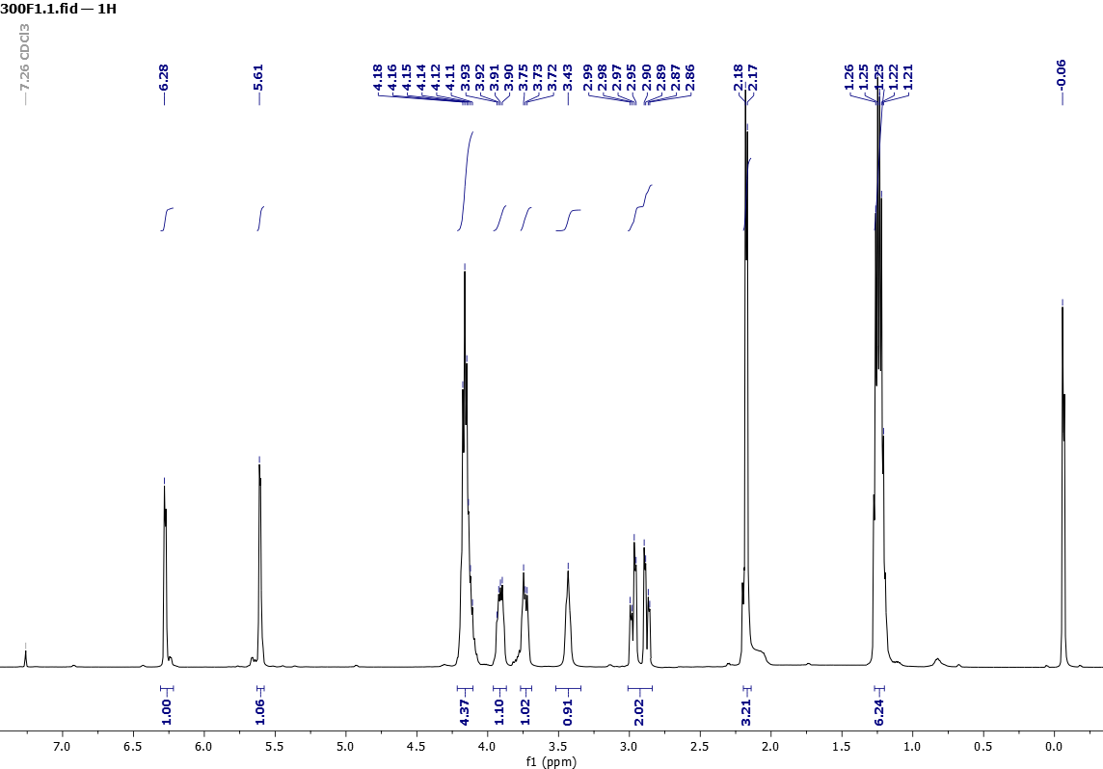
Figure 29. ¹H NMR (500 MHz, CDCl₃) spectra of 10

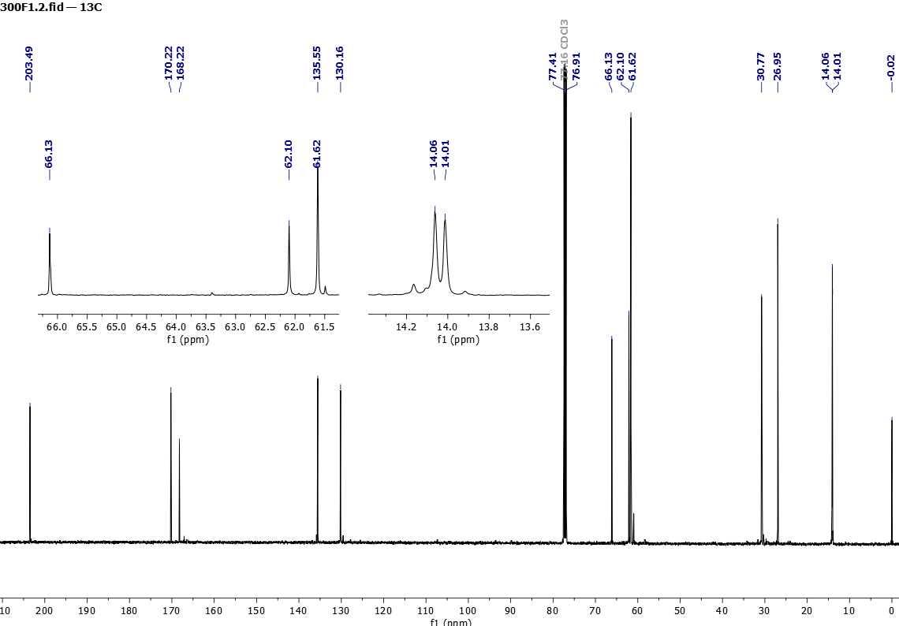

Figure 30. ¹³C NMR (125 MHz, CDCl₃) spectra of 10
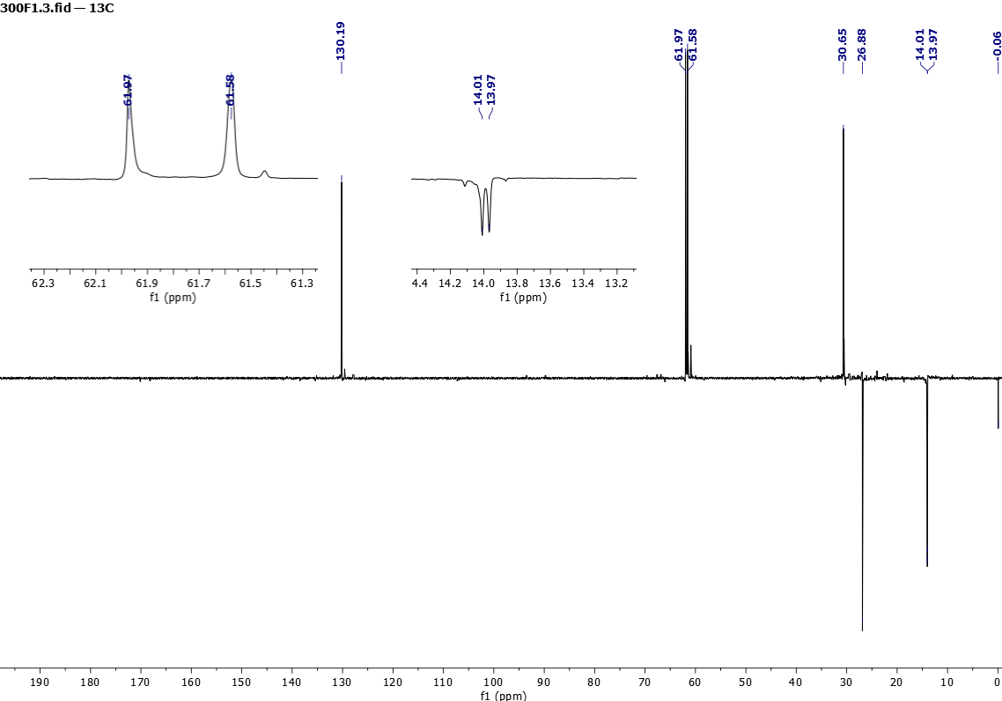
Figure 31. dept 135 NMR (125 MHz, CDCl₃) spectra of 10

ESI-HRMS spectra for compounds 5, 6, 7a-c, 8a-c, 9a-d, 10

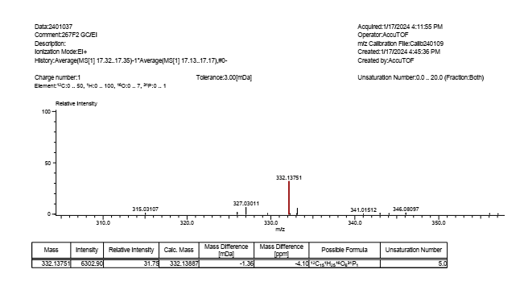
Figure 35. ESI-HRMS spectra of 5

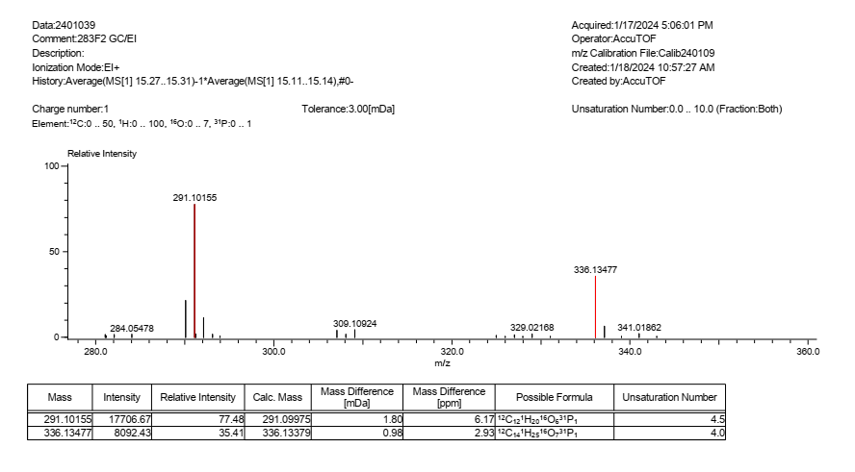
Figure 36. ESI-HRMS spectra of 6

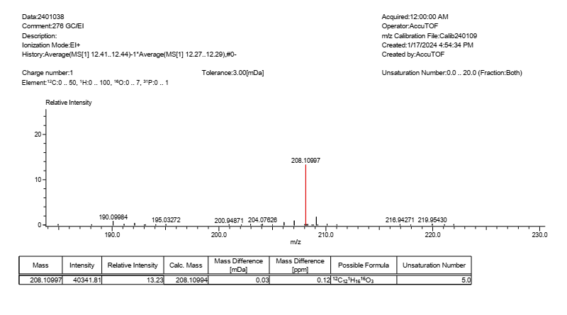

Figure 37. ESI-HRMS spectra of 7a

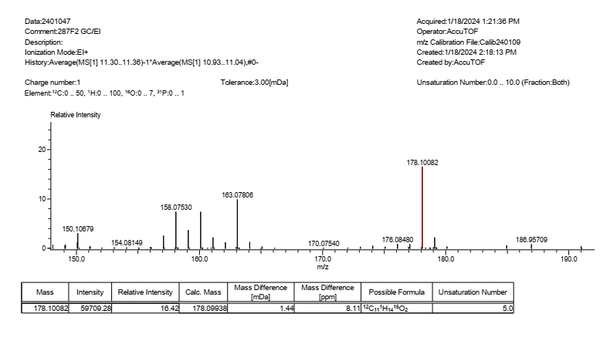

Figure 38. ESI-HRMS spectra of 7b

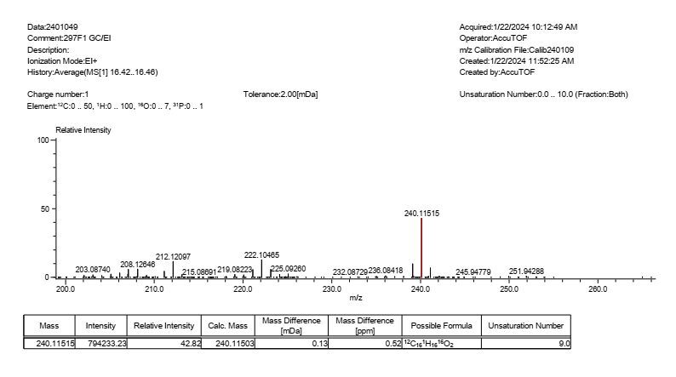
Figure 39. ESI-HRMS spectra of 7c

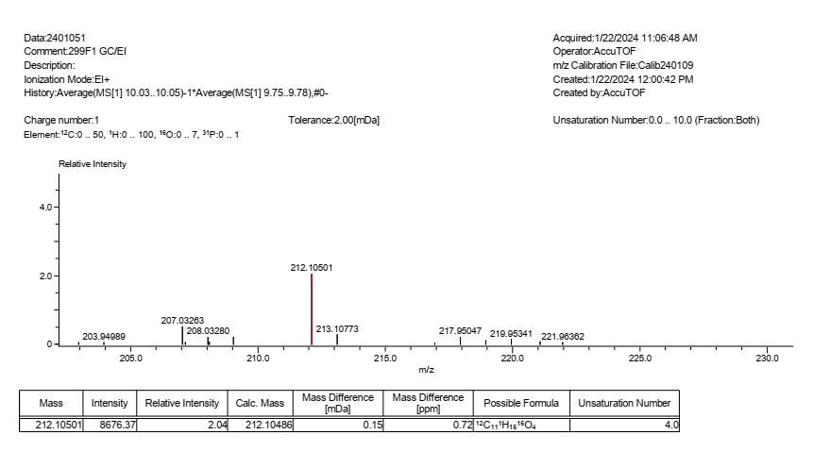
Figure 40. ESI-HRMS spectra of 8a

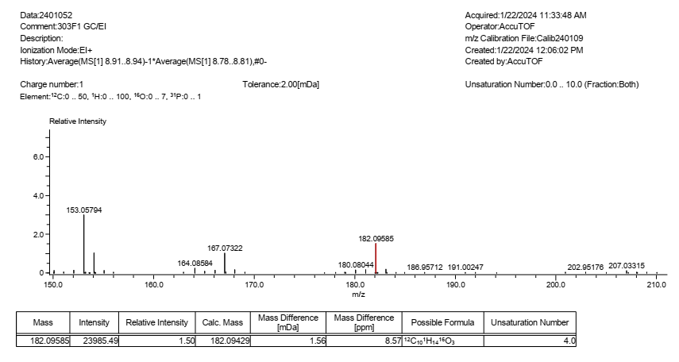
Figure 41. ESI-HRMS spectra of 8b

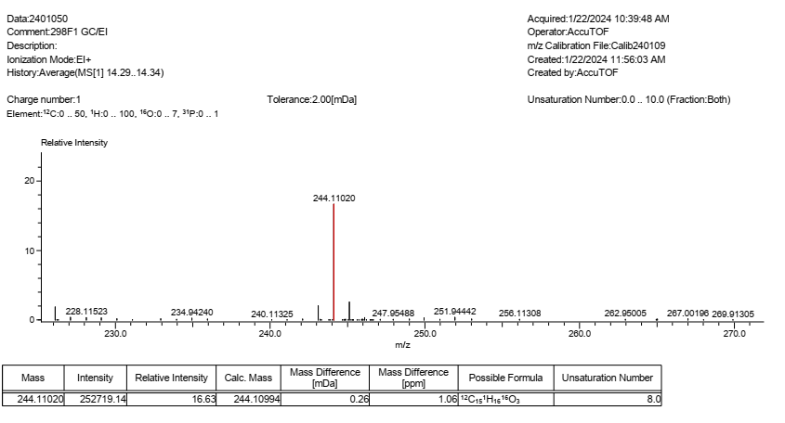

Figure 42. ESI-HRMS spectra of 8c

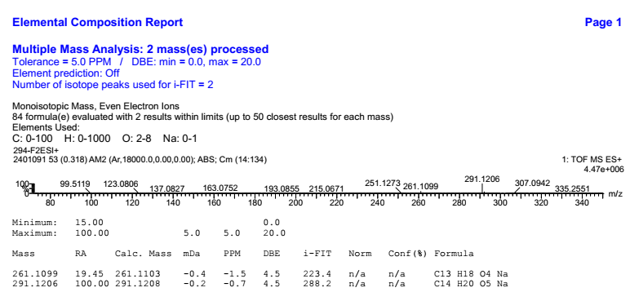
Figure 43. ESI-HRMS spectra of 9a

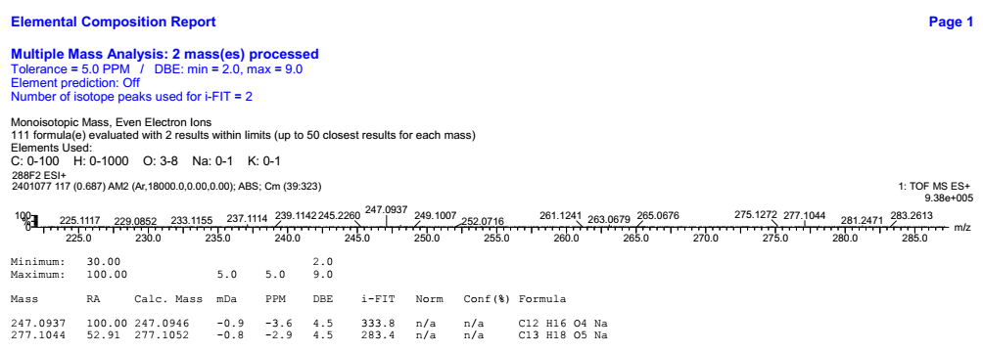

Figure 44. ESI-HRMS spectra of 9b

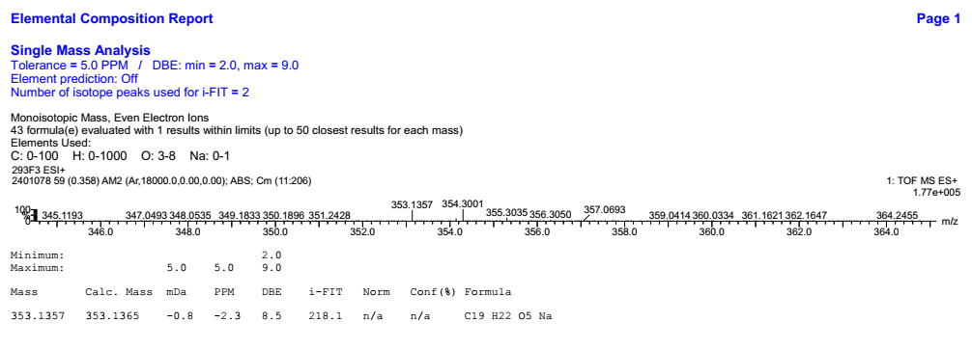

Figure 45. ESI-HRMS spectra of 9c

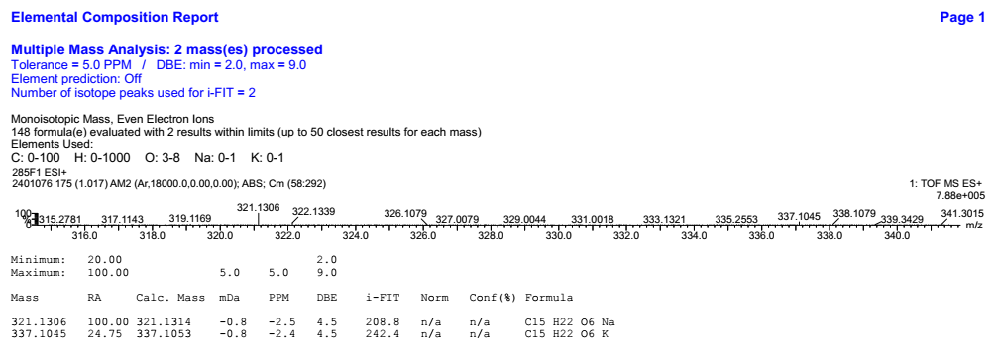

Figure 46. ESI-HRMS spectra of 9d

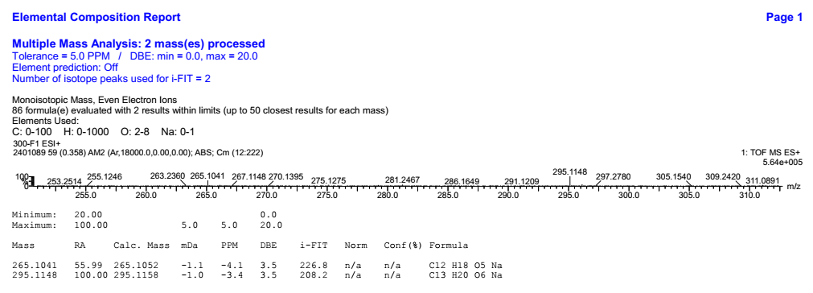

Figure 47. ESI-HRMS spectra of 10

