***Supporting information for***

**Access to 2-Oxoazetidine-3-carboxylic Acids Derivatives via Thermal Microwave-Assisted Wolff Rearrangement of 3-Diazotetramic Acids**

**in the Presence of Nucleophiles**

Ivan Lyutin,1 Vasilisa Krivovicheva,1 Grigory Kantin,1 Dmitry Dar’in*1,2

1 Saint Petersburg State University, Saint Petersburg, 199034 Russian Federation

2Saint Petersburg Research Institute of Phthisiopulmonology, Saint Petersburg, 191036 Russian Federation

* Correspondence: Corresponding author at: Department of Medicinal Chemistry, Institute of Chemistry, Saint Petersburg State University, 26 Universitetskiy pr., Peterhof 198504 Russian Federation, E-mail address: d.dariin@spbu.ru

**Table of Contents**

**1.** **General Information** S3

**2.** **Experimental Procedures** S4

***2.1.*** Diazo tetramic Acids **1a-m**. S4

***2.2.*** List of source nucleophiles. S5

***2.3.*** Preparation of β-lactams **3a-r**. S6

***2.4.*** Preparation of β-lactamic acids **4a** and **4b**. S13

***2.5.*** Preparation of β-lactams **3s-t** from **4a**. S14

**3.** **NMR Data** S15

***3.1.*** NMR Spectra of β-lactams **3a-t**. S15

***3.1.*** NMR Spectra of β-lactamic acids **4a** and **4b**. S39

**4.** **Crystal Structure Data for Compounds 3r** S41

**5.** **References** S43

# General Information

**Solvents:** Solvents were obtained from commercial suppliers. Chlorobenzene (PhCl) was dried by distillation according to the standard protocol and stored over molecular sieves (4Å).

**Reagents:** All reagents were used as purchased from commercial suppliers.

**Nuclear Magnetic Resonance Spectroscopy:** NMR spectroscopic data were recorded with a Bruker Avance III 400 MHz spectrometer (400.13 MHz for 1H and NOESY 100.61 MHz for 13C{1H} and 376.50 MHz for 19F{1H}) in CDCl3 and DMSO-*d*6 and were referenced to residual solvent proton signals (δH = 7.26 and 2.50, respectively) and solvent carbon signals (δC = 77.16 and 39.52, respectively).

**Melting Points:** Melting points were determined with a melting point apparatus REACH Devices RD-MP in the open capillary tubes.

**Mass Spectrometry:** HRMS were recorded using a microOTOF-Q spectrometer (Brucker); ionization by electrospray, positive detection.

**X-ray Crystallography:** Single crystal X-ray data were obtained using an Agilent Technologies SuperNova Atlas and an Agilent Technologies Xcalibur Eos diffractometers at a temperature of 100 K.

**Thin Layer Chromatography:** Thin layer chromatography (TLC) was performed on aluminum-backed pre-coated plates with silica gel 60 F254 with suitable solvent system and was visualized using UV fluorescence.

**Column Chromatography:** Column chromatography was carried out with silica gel grade 60 (0.040−0.063 mm) 230−400 mesh using Biotage Isolera Prime instrument.

**Microwave Reactor:** Microwave-assisted reactions were performed using Microwave Synthesizer CEM Discover® 2.0 (Standard mode – irradiating the sample with the highest available power for the shortest period of time).

# Experimental Procedures

## ***2.1.*** Diazo tetramic Acids **1a-m**



The diazo tetramic acids **1a-m** were obtained as described previously1.

## ***2.2.*** List of source nucleophiles.



## ***2.3.*** Preparation of β-lactams **3a-r**

**General Procedure 1: Preparation of β-lactams 3a-r.**

A solution of the corresponding diazo tetramic acid **1** (0.25 mmol, 1 equiv.) and corresponding nucleophile (0.275 mmol, 1.1 equiv. for **3a-k,m-r** or 7.5 mmol, 30 equiv. for **3l**) in dry PhCl (1 mL) was placed in sealed vial (10 mL) equipped with stirring bar. The sample was placed in the microwave reactor and irradiated using “standard” mode at 200 °C for 1 hour. The solvent was evaporated under reduced pressure and the residue was purified by column chromatography (absorption at λ = 214 nm).

*N-(4-Methoxyphenyl)-1-methyl-2-oxo-1-azaspiro[3.5]nonane-3-carboxamide (****3a****).* Obtained according to GP1 from diazo tetramic acid **1a** (52 mg, 0.25 mmol, 1 equiv.) and *p*-anisidine (34 mg, 0.275 mmol, 1.1 equiv.). Column chromatography was carried out on silica gel, eluent: *n*-hexane/acetone, from 3 to 45% of acetone. Yield: 63 mg (83%). White solid; mp 157.1–158.3 °C. 1H NMR (400 MHz, Chloroform-*d*) δ 8.30 (s, 1H), 7.62 – 7.36 (m, 2H), 6.97 – 6.61 (m, 2H), 3.79 (s, 3H), 3.65 (s, 1H), 2.84 (s, 3H), 2.12 – 1.97 (m, 1H), 1.98 – 1.84 (m, 1H), 1.84 – 1.61 (m, 4H), 1.37 – 1.17 (m, 2H). 13C NMR (101 MHz, Chloroform-*d*) δ 165.5, 163.4, 156.7, 130.7, 122.0, 114.2, 63.8, 63.6, 55.6, 35.9, 30.6, 24.8, 24.6, 23.9, 23.0. HRMS (ESI) *m/z*: [M+Na]+ Calc. for C17H22N2NaO3 325.1523; Found 325.1534.

*1-Cyclopropyl-2-oxo-N-(p-tolyl)-1-azaspiro[3.5]nonane-3-carboxamide (****3b****). Obtained* according to GP1 from diazo tetramic acid **1d** (58 mg, 0.25 mmol, 1 equiv.) and *p*-toluidine (29 mg, 0.275 mmol, 1.1 equiv.). Column chromatography was carried out on silica gel, eluent: *n*-hexane/acetone, from 5 to 25% of acetone. Yield: 58 mg (74%). Redish amorphous solid. 1H NMR (400 MHz, Chloroform-*d*) δ 8.35 (s, 1H), 7.45 – 7.37 (m, 2H), 7.16 – 7.09 (m, 2H), 3.60 (s, 1H), 2.37 (tt, *J* = 7.3, 3.9 Hz, 1H), 2.31 (s, 3H), 2.09 – 1.80 (m, 5H), 1.80 – 1.60 (m, 4H), 1.36 – 1.22 (m, 1H), 1.07 – 0.97 (m, 1H), 0.97 – 0.88 (m, 1H), 0.86 – 0.70 (m, 2H). 13C NMR (126 MHz, Chloroform-*d*) δ 166.1, 163.4, 135.0, 134.4, 129.6, 120.3, 65.3, 64.0, 36.9, 31.5, 24.9, 23.9, 23.0, 21.4, 21.0, 5.7, 5.5. HRMS (ESI) *m/z*: [M+Na]+ Calc. for C19H24N2NaO2 335.1730; Found 335.1729.

*1-Benzyl-N-cyclopropyl-2-oxo-1-azaspiro[3.5]nonane-3-carboxamide (****3c****).* Obtained according to GP1 from diazo tetramic acid **1b** (71 mg, 0.25 mmol, 1 equiv.) and cyclopropylamine (16 mg, 0.275 mmol, 1.1 equiv.). Column chromatography was carried out on silica gel, eluent: *n*-pentane/acetone, from 5 to 40% of acetone. Yield: 62 mg (79%). Redish oil. 1H NMR (400 MHz, Chloroform-*d*) δ 7.38 – 7.16 (m, 5H), 6.71 (s, 1H), 4.39 (d, *J* = 15.7 Hz, 1H), 4.28 (d, *J* = 15.7 Hz, 1H), 3.52 (s, 1H), 2.71 (tq, *J* = 6.9, 3.5 Hz, 1H), 1.86 – 1.70 (m, 2H), 1.67 – 1.35 (m, 7H), 1.16 – 0.99 (m, 1H), 0.81 – 0.71 (m, 2H), 0.57 – 0.47 (m, 2H). 13C NMR (101 MHz, Chloroform-*d*) δ 166.9, 165.5, 136.9, 128.8, 127.9, 127.7, 64.7, 63.7, 43.0, 37.1, 31.2, 24.7, 23.8, 22.9, 22.6, 6.7, 6.5. HRMS (ESI) *m/z*: [M+H]+ Calc. for C19H25N2O2 313.1911; Found 313.1912.

*N-(3,4-Dimethoxyphenyl)-1-methyl-2-oxo-7-oxa-1-azaspiro[3.5]nonane-3-carboxamide* *(****3d****).* Obtained according to GP1 from diazo tetramic acid **1f** (52 mg, 0.25 mmol, 1 equiv.) and 3,4-dimethoxyaniline (42 mg, 0.275 mmol, 1.1 equiv.). Column chromatography was carried out on silica gel, eluent: *n*-hexane/acetone, from 3 to 25% of acetone. Yield: 81 mg (97%). Light brown solid; mp 217.5–219.3 °C. 1H NMR (400 MHz, Chloroform-*d*) δ 8.48 (s, 1H), 7.21 – 7.16 (m, 1H), 7.00 – 6.93 (m, 1H), 6.80 – 6.71 (m, 1H), 4.12 – 4.04 (m, 1H), 4.03 – 3.96 (m, 1H), 3.92 – 3.85 (m, 1H), 3.83 (s, 3H), 3.82 (s, 3H), 3.77 (s, 1H), 3.72 – 3.64 (m, 1H), 2.79 (s, 3H), 2.15 – 2.02 (m, 1H), 2.00 – 1.90 (m, 1H), 1.90 – 1.82 (m, 1H), 1.66 – 1.60 (m, 1H). 13C NMR (101 MHz, Chloroform-*d*) δ 165.0, 162.9, 149.1, 146.2, 130.9, 112.3, 111.3, 104.9, 65.3, 65.0, 63.7, 60.9, 56.1, 56.0, 35.3, 30.4, 24.1. HRMS (ESI) *m/z*: [M+Na]+ Calc. for C18H24N2NaO4 357.1421; Found 357.1418.

*1-Ethyl-N-(4-methoxybenzyl)-2-oxo-7-thia-1-azaspiro[3.5]nonane-3-carboxamide (****3e****).* Obtained according to GP1 from diazo tetramic acid **1e** (60 mg, 0.25 mmol, 1 equiv.) and *p*-methoxybenzyl amine (38 mg, 0.275 mmol, 1.1 equiv.). Column chromatography was carried out on silica gel, eluent: *n*-pentane/acetone, from 5 to 50% of acetone. Yield: 63 mg (68%). Orange solid; mp 153.0–154.0 °C. 1H NMR (400 MHz, Chloroform-*d*) δ 7.22 – 7.17 (m, 2H), 6.91 (s, 1H), 6.87 – 6.82 (m, 2H), 4.42 – 4.33 (m, 2H), 3.79 (s, 3H), 3.54 (s, 1H), 3.51 – 3.40 (m, 1H), 3.30 – 3.09 (m, 2H), 2.96 – 2.84 (m, 1H), 2.72 – 2.63 (m, 1H), 2.54 – 2.44 (m, 1H), 2.19 – 2.06 (m, 2H), 2.06 – 1.93 (m, 2H), 1.23 (t, *J* = 7.3 Hz, 3H). 13C NMR (101 MHz, Chloroform-*d*) δ 167.0, 161.4, 135.1, 128.9, 128.8, 128.8, 67.5, 62.4, 62.0, 38.7, 34.2, 32.4, 27.0, 26.0, 15.0. HRMS (ESI) *m/z*: [M+Na]+ Calc. for C18H24N2NaO3S371.1400; Found 371.1397.

*N-(3,4-Dimethoxyphenethyl)-2-oxo-1-phenyl-1-azaspiro[3.5]nonane-3-carboxamide (****3f****).* Obtained according to GP1 from diazo tetramic acid **1c** (67 mg, 0.25 mmol, 1 equiv.) and 3,4-dimethoxyphenethylamine (50 mg, 0.275 mmol, 1.1 equiv.). Column chromatography was carried out on silica gel, eluent: *n*-hexane/acetone, from 5 to 35% of acetone. Yield: 67 mg (54%). Yellowish oil. 1H NMR (400 MHz, Chloroform-*d*) δ 7.52 – 7.47 (m, 2H), 7.37 – 7.29 (m, 2H), 7.18 – 7.10 (m, 1H), 6.79 – 6.72 (m, 3H), 6.65 – 6.57 (br.m, 1H), 3.84 (s, 3H), 3.82 (s, 3H), 3.64 (s, 1H), 3.61 – 3.45 (m, 2H), 2.88 – 2.72 (m, 2H), 2.22 – 2.15 (m, 1H), 2.07 – 2.01 (m, 1H), 1.96 – 1.50 (m, 7H), 1.23 – 1.13 (m, 1H). 13C NMR (101 MHz, Chloroform-*d*) δ 165.0, 163.8, 149.2, 147.9, 136.5, 131.3, 129.3, 125.2, 120.8, 119.9, 112.0, 111.5, 67.0, 64.6, 56.0, 56.0, 41.0, 36.9, 35.4, 30.7, 24.9, 23.9, 23.0. HRMS (ESI) *m/z*: [M+Na]+ Calc. for C25H30N2NaO4 445.2100; Found 445.2104.

*N-(4-Chlorophenyl)-1-(4-methoxyphenyl)-2-oxo-1-azaspiro[3.3]heptane-3-carboxamide (****3g****).* Obtained according to GP1 from diazo tetramic acid **1h** (68 mg, 0.25 mmol, 1 equiv.) and *p*-chloroaniline (35 mg, 0.275 mmol, 1.1 equiv.). Column chromatography was carried out on silica gel, eluent: *n*-hexane/acetone, from 3 to 35% of acetone. Yield: 63 mg (68%). Brown solid; mp 167.0–167.9 °C. 1H NMR (400 MHz, Chloroform-*d*) δ 8.49 (s, 1H), 7.60 – 7.46 (m, 4H), 7.37 – 7.21 (m, 2H), 6.98 – 6.87 (m, 2H), 4.09 (s, 1H), 3.82 (s, 3H), 2.98 – 2.88 (m, 1H), 2.78 – 2.59 (m, 2H), 2.51 – 2.40 (m, 1H), 2.24 – 2.10 (m, 1H), 2.02 – 1.87 (m, 1H). 13C NMR (101 MHz, Chloroform-*d*) δ 163.4, 162.8, 157.4, 135.9, 129.9, 129.4, 129.2, 121.5, 120.8, 114.8, 65.8, 63.3, 55.6, 32.2, 28.1, 13.5. HRMS (ESI) *m/z*: [M+Na]+ Calc. for C20H19ClN2NaO3 393.0976; Found 393.0981.

*N-(4-Fluorobenzyl)-1-methyl-2-oxo-1-azaspiro[3.6]decane-3-carboxamide (****3h****).* Obtained according to GP1 from diazo tetramic acid **1g** (55 mg, 0.25 mmol, 1 equiv.) and *p*-fluorobenzyl amine (34 mg, 0.275 mmol, 1.1 equiv.). Column chromatography was carried out on silica gel, eluent: *n*-hexane/acetone, from 5 to 30% of acetone. Yield: 68 mg (85%). Yellow oil. 1H NMR (400 MHz, Chloroform-*d*) δ 7.24 – 7.18 (m, 2H), 7.00 (s, 1H), 6.98 – 6.93 (m, 2H), 4.42 – 4.32 (m, 2H), 3.57 (s, 1H), 2.73 (s, 3H), 2.05 – 1.92 (m, 2H), 1.92 – 1.82 (m, 1H), 1.79 – 1.44 (m, 9H). 13C NMR (101 MHz, Chloroform-*d*) δ 165.2, 164.9, 161.9 (d, 1*J*C‒F = 245.4 Hz), 133.7 (d, 4*J*C‒F = 2.9 Hz), 129.2 (d, 3*J*C‒F = 8.1 Hz), 115.2 (d, 2*J*C‒F = 21.4 Hz), 66.0, 64.0, 42.2, 37.4, 33.6, 33.6, 29.7, 24.0, 22.8, 22.8. 19F NMR (376 MHz, Chloroform-*d*) δ -115.11. HRMS (ESI) *m/z*: [M+Na]+ Calc. for C18H23FN2NaO2 341.1636; Found 341.1632.

*1-(4-Chlorophenyl)-N-(4-fluorophenyl)-2-oxoazetidine-3-carboxamide (****3i****).* Obtainedaccording to GP1 from diazo tetramic acid **1k** (59 mg, 0.25 mmol, 1 equiv.) and *p*-fluoroaniline (38 mg, 0.275 mmol, 1.1 equiv.). Column chromatography was carried out on silica gel, eluent: *n*-pentane/ethyl acetate, from 5 to 35% of ethyl acetate. Yield: 32 mg (40%). Beige solid; mp 223.0–224.7 °C. 1H NMR (400 MHz, DMSO-*d*6) δ 10.34 (s, 1H), 7.66 – 7.58 (m, 2H), 7.37 – 7.31 (m, 4H), 7.07 – 7.00 (m, 2H), 4.37 (dd, *J* = 5.4, 2.6 Hz, 1H), 3.91 (dd, *J* = 5.6, 2.6 Hz, 1H), 3.81 (t, *J* = 5.6 Hz, 1H). 13C NMR (101 MHz, DMSO-*d*6) δ 163.8, 160.8, 158.2 (d, 1*J*C‒F = 241.3 Hz), 136.4, 134.7 (d, 4*J*C‒F = 2.5 Hz), 128.8, 127.7, 120.9 (d, 3*J*C‒F = 7.7 Hz), 117.4, 115.0 (d, 2*J*C‒F = 22.2 Hz), 54.6, 41.2. 19F NMR (376 MHz, DMSO-*d*6) δ -118.40. HRMS (ESI) *m/z*: [M+Na]+ Calc. for C16H12ClFN2NaO2341.0464; Found 341.0471.

*2-Oxo-1-(p-tolyl)-N-(3-(trifluoromethyl)phenyl)azetidine-3-carboxamide (****3j****). Obtained* according to GP1 from diazo tetramic acid **1l** (54 mg, 0.25 mmol, 1 equiv.) and nucleophile **2h** (44 mg, 0.275 mmol, 1.1 equiv.). The sample obtained after chromatographic isolation was triturated with *n*-hexane/diethyl ether (1:1, 2×2 mL). Yield: 23 mg (26%). White solid; mp 217.1–218.0 °C. 1H NMR (400 MHz, DMSO-*d*6) δ 10.45 (s, 1H), 8.05 – 8.00 (m, 1H), 7.80 – 7.74 (m, 1H), 7.45 – 7.37 (m, 1H), 7.32 – 7.24 (m, 1H), 7.24 – 7.16 (m, 2H), 7.13 – 7.04 (m, 2H), 4.34 (dd, *J* = 5.4, 2.6 Hz, 2H), 3.93 (dd, *J* = 5.5, 2.6 Hz, 2H), 3.73 (t, *J* = 5.6 Hz, 1H), 2.25 (s, 3H). 13C NMR (101 MHz, DMSO-*d*6) δ 164.6, 160.0, 139.1, 134.1 (q, 1*J*C‒F = 233.0 Hz), 129.9 (q, 2*J*C‒F = 31.0 Hz), 129.2, 122.4, 119.64 (q, 3*J*C‒F = 2.9 Hz), 115.8, 115.6 (q, 3*J*C‒F = 3.4 Hz), 54.4, 40.7, 20.4. 19F NMR (376 MHz, DMSO-*d*6) δ -62.06. HRMS (ESI) *m/z*: [M+Na]+ Calc. for C18H15F3N2NaO2 371.0978; Found 371.0982.

*Benzyl 1-methyl-2-oxo-1-azaspiro[3.5]nonane-3-carboxylate (****3k****).* Obtained according to GP1 from diazo tetramic acid **1a** (52 mg, 0.25 mmol, 1 equiv.) and benzyl alcohol (30 mg, 0.275 mmol, 1.1 equiv.). Column chromatography was carried out on silica gel, eluent: *n*-hexane/acetone, from 3 to 25% of acetone. Yield: 70 mg (96%). Yellow oil. 1H NMR (400 MHz, Chloroform-*d*) δ 7.38 – 7.29 (m, 5H), 5.22 (d, *J* = 12.2 Hz, 1H), 5.11 (d, *J* = 12.2 Hz, 1H), 3.64 (s, 1H), 2.71 (s, 3H), 1.99 – 1.91 (m, 1H), 1.84 – 1.76 (m, 1H), 1.73 – 1.67 (m, 1H), 1.63 – 1.47 (m, 4H), 1.45 – 1.34 (m, 1H), 1.17 – 0.99 (m, 2H). 13C NMR (101 MHz, Chloroform-*d*) δ 167.4, 162.2, 135.3, 128.7, 128.64, 128.5, 67.1, 62.8, 62.3, 35.7, 29.4, 24.8, 24.0, 23.9, 23.2. HRMS (ESI) *m/z*: [M+Na]+ Calc. for C17H21NNaO3 310.1414; Found 310.1426.

The synthesis of **3k** was additionally performed on a 6-fold scale (1.5 mmol) and yielded 336 mg (78%).

*Methyl 1-methyl-2-oxo-1-azaspiro[3.5]nonane-3-carboxylate (****3l****).* Obtainedaccording to GP1 from diazo tetramic acid **1a** (52 mg, 0.25 mmol, 1 equiv.) and methanol (240 mg, 7.5 mmol, 30 equiv.). Column chromatography was carried out on silica gel, eluent: *n*-pentane/acetone, from 5 to 40% of acetone. Yield: 69 mg (64%). Light brown oil. 1H NMR (400 MHz, Chloroform-*d*) δ 3.71 (s, 3H), 3.59 (s, 1H), 2.71 (s, 3H), 2.04 – 1.91 (m, 1H), 1.87 – 1.51 (m, 6H), 1.48 – 1.34 (m, 1H), 1.27 – 1.08 (m, 2H). 13C NMR (101 MHz, Chloroform-*d*) δ 167.9, 162.3, 62.7, 62.1, 52.2, 35.7, 29.5, 24.8, 23.9, 23.3. HRMS (ESI) *m/z*: [M+Na]+ Calc. for C11H17NNaO3 234.1101; Found 234.1109.

*Benzyl 1-ethyl-2-oxo-7-thia-1-azaspiro[3.5]nonane-3-carboxylate (****3m****).* Obtained according to GP1 from diazo tetramic acid **1e** (60 mg, 0.25 mmol, 1 equiv.) and benzyl alcohol (30 mg, 0.275 mmol, 1.1 equiv.). Column chromatography was carried out on silica gel, eluent: *n*-hexane/acetone, from 3 to 25% of acetone. Yield: 65 mg (81%). Red oil. 1H NMR (400 MHz, Chloroform-*d*) δ 7.48 – 7.32 (m, 5H), 5.24 (d, *J* = 12.1 Hz, 1H), 5.12 (d, *J* = 12.1 Hz, 1H), 3.65 (s, 1H), 3.21 (q, *J* = 7.3 Hz, 2H), 2.82 – 2.63 (m, 2H), 2.42 – 2.32 (m, 3H), 2.19 – 2.08 (m, 1H), 2.02 – 1.87 (m, 2H), 1.23 (t, *J* = 7.3 Hz, 3H). 13C NMR (101 MHz, Chloroform-*d*) δ 167.0, 161.4, 135.1, 128.9, 128.8, 128.8, 67.5, 62.4, 62.0, 38.7, 34.2, 32.4, 27.0, 26.0, 15.0. HRMS (ESI) *m/z*: [M+Na]+ Calc. for C17H21NNaO3S342.1134; Found 342.1148.

*S-(4-Methoxybenzyl) 1-methyl-2-oxo-1-azaspiro[3.5]nonane-3-carbothioate (****3n****).* Obtained according to GP1 from diazo tetramic acid **1a** (52 mg, 0.25 mmol, 1 equiv.) and *p*-methoxybenzyl mercaptan (42 mg, 0.275 mmol, 1.1 equiv.). Column chromatography was carried out on silica gel, eluent: *n*-hexane/acetone, from 3 to 20% of acetone. Yield: 40 mg (48%). Yellow oil. 1H NMR (400 MHz, Chloroform-*d*) δ 7.23 – 7.12 (m, 2H), 6.88 – 6.70 (m, 2H), 4.15 (d, *J* = 13.7 Hz, 1H), 4.09 (d, *J* = 13.7 Hz, 1H), 3.81 (s, 1H), 3.76 (s, 3H), 2.71 (s, 3H), 2.11 – 1.97 (m, 1H), 1.88 – 1.74 (m, 1H), 1.76 – 1.67 (m, 1H), 1.68 – 1.36 (m, 5H), 1.28 – 1.05 (m, 2H). 13C NMR (101 MHz, Chloroform-*d*) δ 192.1, 162.2, 159.0, 130.2, 128.8, 114.1 69.8, 63.3, 55.3, 35.9, 33.4, 29.2, 24.8, 24.0, 23.9, 23.3. HRMS (ESI) *m/z*: [M+Na]+ Calc. for C18H23NNaO3S356.1291; Found 356.1294.

*benzyl 1-(4-chlorophenyl)-2-oxoazetidine-3-carboxylate (****3o****).* Obtained according to GP1 from diazo tetramic acid **1k** (59 mg, 0.25 mmol, 1 equiv.) and benzyl alcohol (30 mg, 0.275 mmol, 1.1 equiv.). Column chromatography was carried out on silica gel, eluent: *n*-pentane/acetone, from 3 to 20% of acetone. Yield: 42 mg (41%). Yellowish solid; mp 122.1–123.8 °C. 1H NMR (400 MHz, Chloroform-*d*) δ 7.45 – 7.22 (m, 9H), 5.27 (d, *J* = 12.3 Hz, 1H), 5.23 (d, *J* = 12.3 Hz, 1H), 4.25 (dd, *J* = 5.7, 2.9 Hz, 1H), 3.95 (dd, *J* = 5.9, 2.9 Hz, 1H), 3.75 (t, *J* = 5.8 Hz, 1H). 13C NMR (101 MHz, Chloroform-*d*) δ 166.6, 158.7, 136.4, 135.2, 129.6, 129.4, 128.8, 128.6, 128.4, 117.8, 67.7, 53.5, 41.6. HRMS (ESI) *m/z*: [M+Na]+ Calc. for C17H14ClNNaO3 338.0554; Found 338.0561.

*Benzyl (3S/R,4R/S)-1-(4-methoxybenzyl)-2-oxo-4-phenylazetidine-3-carboxylate (****3p****).* Obtained according to GP1 from diazo tetramic acid **1i** (80 mg, 0.25 mmol, 1 equiv.) and benzyl alcohol (30 mg, 0.275 mmol, 1.1 equiv.). Column chromatography was carried out on silica gel, eluent: *n*-pentane/acetone, from 3 to 20% of acetone. Yield: 46 mg (46%). Yellowish oil. 1H NMR (400 MHz, Chloroform-*d*) δ 7.41 – 7.32 (m, 8H), 7.26 – 7.21 (m, 2H), 7.07 – 7.02 (m, 2H), 6.79 – 6.74 (m, 2H), 5.26 (d, *J* = 12.4 Hz, 1H), 5.18 (d, *J* = 12.4 Hz, 1H), 4.68 (d, *J* = 2.2 Hz, 1H), 4.29 (dd, *J* = 420.3, 14.8 Hz, 2H), 3.95 (d, *J* = 1.7 Hz, 1H), 3.78 (s, 3H). 13C NMR (101 MHz, Chloroform-*d*) δ 166.7, 162.1, 159.3, 136.1, 135.3, 129.7, 129.2, 129.1, 128.7, 128.5, 128.3, 126.9, 126.7, 114.2, 67.5, 63.4, 56.9, 55.3, 44.4. HRMS (ESI) *m/z*: [M+H]+ Calc. for C25H24NO4 402.1699; Found 402.1687.

*(3R/S,4R/S)-1-(4-Methoxybenzyl)-3-(morpholine-4-carbonyl)-4-phenylazetidin-2-one (****3q****).* Obtained according to GP1 from diazo tetramic acid **1i** (80 mg, 0.25 mmol, 1 equiv.) and morpholine (22 mg, 0.275 mmol, 1.1 equiv.). Column chromatography was carried out on silica gel, eluent: *n*-hexane/acetone, from 5 to 20% of acetone. Yield: 42 mg (44%). Red oil. 1H NMR (400 MHz, Chloroform-*d*) δ 7.40 – 7.31 (m, 4H), 7.30 – 7.25 (m, 1H), 7.08 – 6.99 (m, 2H), 6.83 – 6.73 (m, 2H), 5.11 (d, *J* = 1.9 Hz, 1H), 4.68 (d, *J* = 15.0 Hz, 1H), 4.05 (d, *J* = 1.8 Hz, 1H), 3.94 – 3.81 (m, 3H), 3.77 (s, 3H), 3.77 – 3.68 (m, 4H), 3.66 – 3.58 (m, 1H), 3.46 – 3.36 (m, 1H), 3.35 – 3.27 (m, 1H). 13C NMR (101 MHz, Chloroform-*d*) δ 163.7, 163.6, 136.9, 129.8, 129.1, 128.8, 126.8, 126.8, 114.3, 67.1, 66.7, 63.2, 56.8, 55.3, 46.1, 44.6, 42.5. HRMS (ESI) *m/z*: [M+H]+ Calc. for C22H25N2O4 381.1809; Found 381.1818.

*(2R/S,3R/S)-**2-(Adamantan-1-yl)-N-(4-chlorobenzyl)-1-(4-fluorobenzyl)-4-oxoazetidine-3-* *carboxamide (****3r****).* Obtainedaccording to GP1 from diazo tetramic acid **1j** (92 mg, 0.25 mmol, 1 equiv.) and *p*-chlorobenzyl amine (39 mg, 0.275 mmol, 1.1 equiv.). Column chromatography was carried out on silica gel, eluent: *n*-pentane/acetone, from 5 to 30% of acetone. Yield: 60 mg (50%). Redish solid; mp 124.8–126.0 °C. 1H NMR (400 MHz, Chloroform-*d*) δ 7.32 – 7.23 (m, 3H), 7.22 – 7.14 (m, 3H), 7.05 – 6.95 (m, 2H), 6.88 (s, 1H), 4.73 (d, *J* = 15.3 Hz, 1H), 4.44 – 4.36 (m, 2H), 4.12 (d, *J* = 15.3 Hz, 1H), 3.76 (d, *J* = 1.7, 0.2 Hz, 1H), 3.48 (d, *J* = 1.6 Hz, 1H), 1.97 (s, 3H), 1.71 – 1.66 (m, 3H), 1.58 – 1.52 (m, 6H), 1.46 – 1.40 (m, 3H). 13C NMR (101 MHz, Chloroform-*d*) δ 166.5, 166.1, 162.4 (d, 1*J*C‒F = 246.6 Hz), 136.6, 133.4, 131.3 (d, 4*J*C‒F = 3.2 Hz), 129.9 (d, 3*J*C‒F = 8.2 Hz), 129.1, 128.9, 115.9 (d, 2*J*C‒F = 21.6 Hz), 65.0, 53.4, 46.6, 42.9, 38.7, 36.8, 34.3, 27.9. 19F NMR (376 MHz, Chloroform-*d*) δ -114.09. HRMS (ESI) *m/z*: [M+Na]+ Calc. for C28H30ClFN2NaO2 503.1872; Found 503.1871.

***2.4.*** Preparation of β-lactamic acids **4a** and **4b**

**General Procedure 2: Preparation of β-lactamic acids 4a and 4b.**

5% Pd/C (10 mol %) was added to the solution of corresponding benzyl ester in THF (for **3k**) or ethyl acetate (for **3o**). The reaction was stirring overnight in an atmosphere of hydrogen. The reaction mixture was filtered through a syringe filter, the solvent was evaporated under reduced pressure.

*1-Methyl-2-oxo-1-azaspiro[3.5]nonane-3-carboxylic acid* *(****4a****).*  Obtained according to GP2 from β-lactam **3k** (0.91 mmol, 261 mg). Yield: 179 mg (100%). White solid. 1H NMR (400 MHz, Chloroform-*d*) δ 3.68 (s, 1H), 2.76 (s, 3H), 2.14 – 2.05 (m, 1H), 1.89 – 1.58 (m, 6H), 1.54 – 1.34 (m, 2H), 1.27 – 1.12 (m, 1H). 13C NMR (101 MHz, Chloroform-*d*) δ 170.9, 163.7, 62.9, 62.6, 35.7, 29.5, 24.9, 24.2, 23.9, 23.3. HRMS (ESI) *m/z*: [M+Na]+ Calc. for C10H15NNaO3 220.0944; Found 220.0946. The substance decomposes slowly at room temperature and should be stored at reduced temperatures.

*1-(4-Chlorophenyl)-2-oxoazetidine-3-carboxylic acid (****4b****).* Obtained according to GP2 from β-lactam **3o** (0.3 mmol, 100 mg). Yield: 68 mg (100%). 1H NMR (400 MHz, Chloroform-*d*) δ 10.53 (br.s, 1H), 7.36 – 7.27 (m, 4H), 4.27 (dd, *J* = 5.3, 2.7 Hz, 1H), 3.97 (dd, *J* = 5.5, 2.3 Hz, 1H), 3.81 (t, *J* = 5.6 Hz, 1H). 13C NMR (101 MHz, Chloroform-*d*) δ 171.2, 158.6, 136.2, 130.01, 129.5, 117.9, 53.3, 41.7. HRMS (ESI) *m/z*: [M+H]+ Calc. for C10H9ClNO3 226.0265; Found 226.0263. The substance decomposes slowly at room temperature and should be stored at reduced temperatures.

## ***2.5.*** Preparation of β-lactams **3s,t** from acid **4a**

**General Procedure 3: Preparation of β-lactams 3s,t from 4a.**

A solution of the β-lactamic acid **4a** (0.3 mmol, 30 mg, 1 equiv.) and corresponding nucleophile (0.32 mmol, 1.05 equiv.) in dry DMF (5 mL) was added to the solution of the HATU (0.33, 1.1 equiv., 127 mg) and DIPEA (0.33 mmol, 1.1 equiv., 43 mg) in dry DMF (5 mL). The reaction mixture was stirring overnight at room temperature. The solution was diluted with sat. aq. NaHCO3 (15 mL), extracted ethyl acetate and dried over Na2SO4. The solvent was evaporated under reduced pressure and the residue was purified by column chromatography (absorption at λ = 214 nm).

*3-(Indoline-1-carbonyl)-1-methyl-1-azaspiro[3.5]nonan-2-one (****3s****).* Obtainedaccording to GP3 from acid **4a** and indoline (38 mg, 0.32 mmol, 1.05 equiv.). Column chromatography was carried out on silica gel, eluent: *n*-hexane/acetone, from 3 to 50% of acetone. Yield: 78 mg (86%). Beige solid, mp 156.3–157.8 °C. 1H NMR (400 MHz, Chloroform-*d*) δ 8.36 – 8.20 (m, 1H), 7.22 – 7.13 (m, 2H), 7.09 – 6.94 (m, 1H), 4.35 – 4.22 (m, 1H), 4.18 – 4.02 (m, 1H), 3.85 (s, 1H), 3.33 – 3.12 (m, 2H), 2.80 (s, 3H), 2.49 – 2.33 (m, 1H), 2.03 – 1.77 (m, 2H), 1.80 – 1.55 (m, 4H), 1.49 – 1.36 (m, 1H), 1.36 – 1.09 (m, 2H). 13C NMR (101 MHz, Chloroform-*d*) δ 164.6, 163.4, 142.8, 131.4, 127.8, 124.6, 124.3, 117.9, 62.9, 62.76, 49.0, 36.0, 29.1, 28.2, 24.9, 24.2, 24.1. HRMS (ESI) *m/z*: [M+Na]+ Calc. for C18H22N2NaO2 321.1573; Found 321.1574.

*tert-Butyl 4-(1-methyl-2-oxo-1-azaspiro[3.5]nonane-3-carbonyl)piperazine-1-carboxylate (****3t****).* Obtainedaccording to GP3 from acid **4a** and *N*-Boc-piperazine (59 mg, 0.32 mmol, 1.05 equiv.). Column chromatography was carried out on silica gel, eluent: *n*-hexane/acetone, from 3 to 50% of acetone. Yield: 105 mg (95%). White solid, mp 123.4–124.2 °C. 1H NMR (400 MHz, DMSO-*d*6) δ 4.22 (s, 1H), 3.77 – 3.56 (m, 2H), 3.51 – 3.17 (m, 5H), 2.63 (s, 3H), 2.02 – 1.91 (m, 1H), 1.82 – 1.45 (m, 6H), 1.41 (s, 9H), 1.36 – 1.21 (m, 3H), 1.10 – 0.92 (m, 1H). 13C NMR (101 MHz, DMSO-*d*6) δ 165.1, 163.1, 153.7, 130.3, 128.4, 127.0, 79.2, 61.4, 58.4, 45.5, 41.0, 34.3, 28.5, 28.0, 24.1, 23.9, 23.6, 23.2. HRMS (ESI) *m/z*: [M+Na]+ Calc. for C19H31N3NaO4 388.2207; Found 388.2212.

# NMR Data

## ***3.1.*** NMR Spectra of β-lactams **3a-t**.

Copies of 1H (400.13 MHz, CDCl3) and 13C{1H} (100.61 MHz, CDCl3) spectra of **3a**

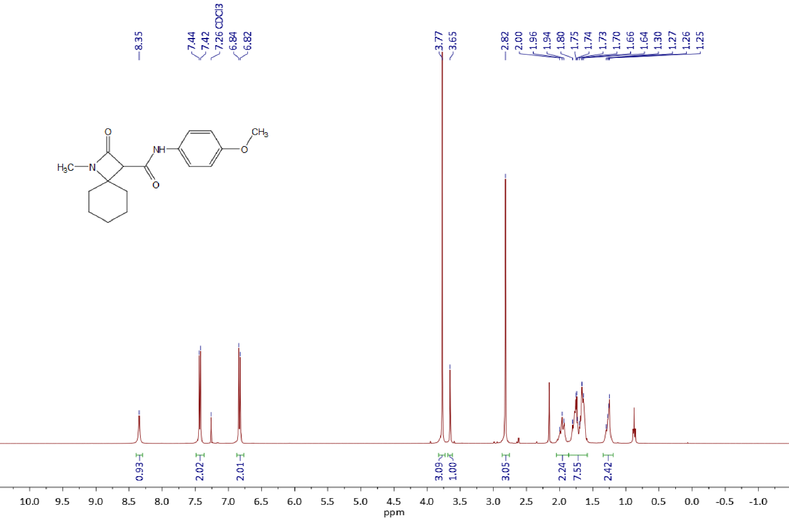

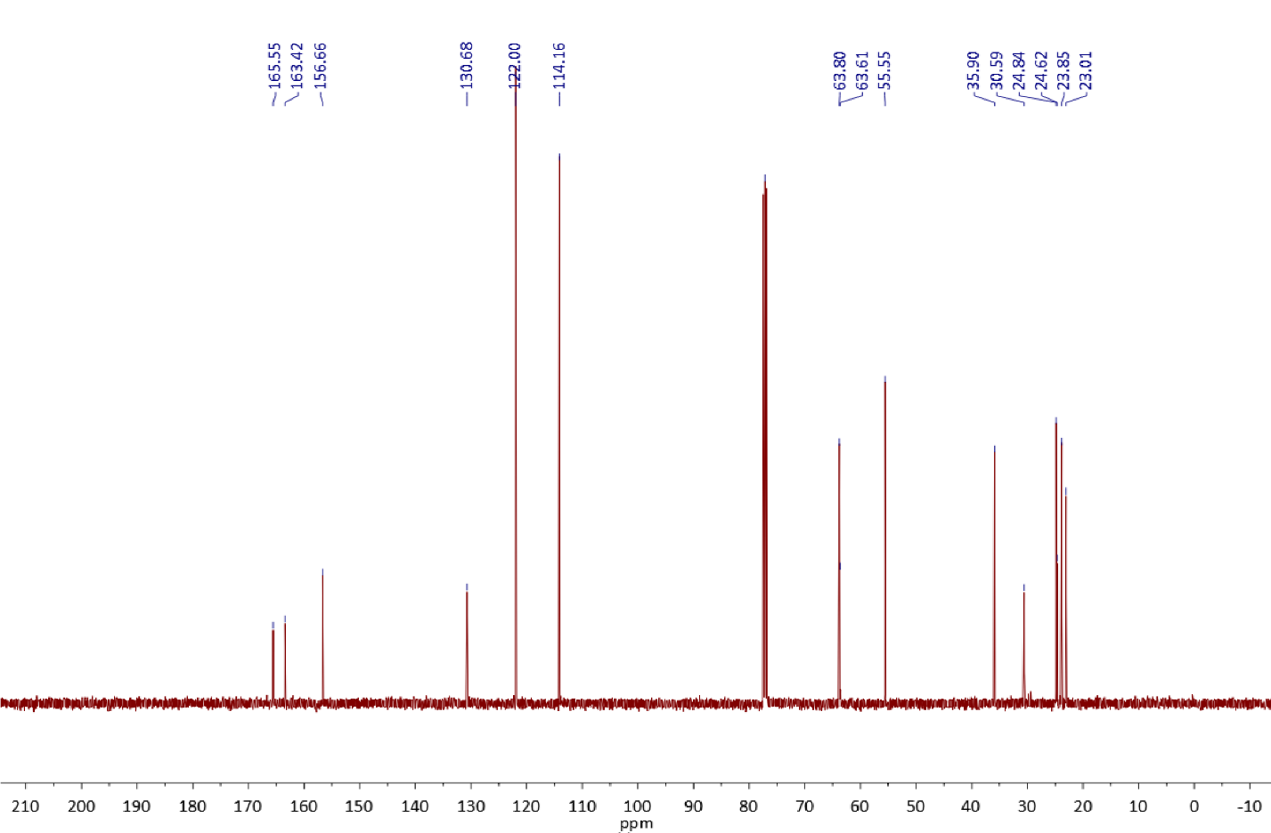

Copies of 1H (400.13 MHz, CDCl3) and 13C{1H} (100.61 MHz, CDCl3) spectra of **3b**

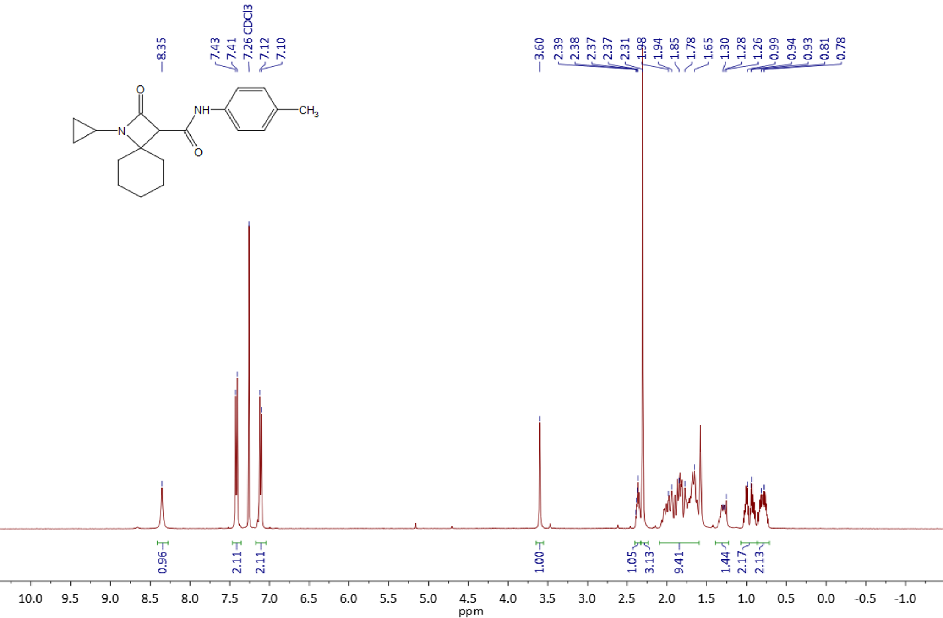

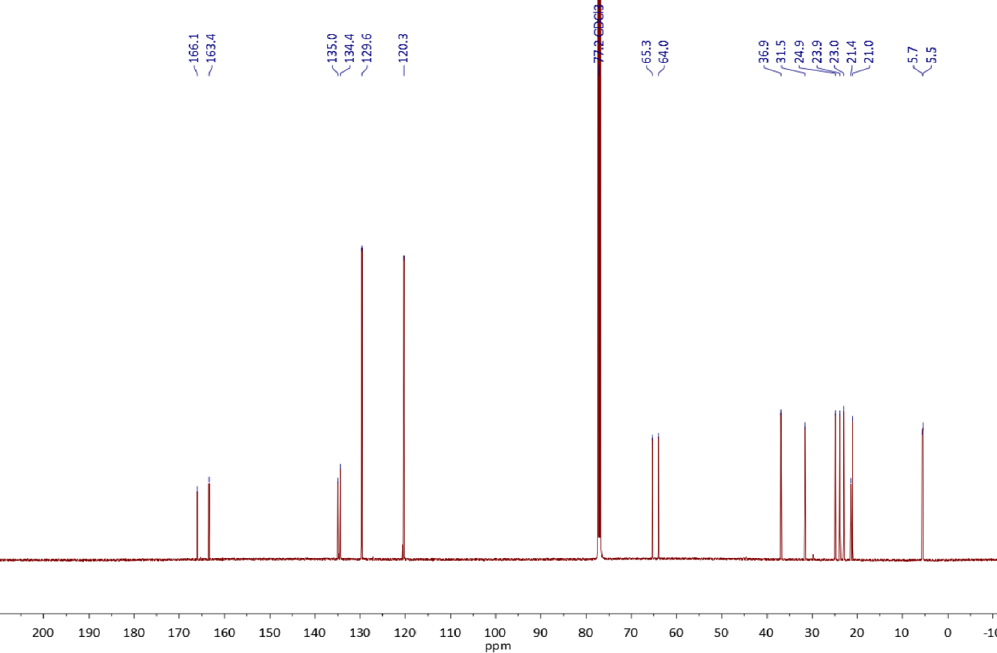

Copies of 1H (400.13 MHz, CDCl3) and 13C{1H} (100.61 MHz, CDCl3) spectra of **3c**

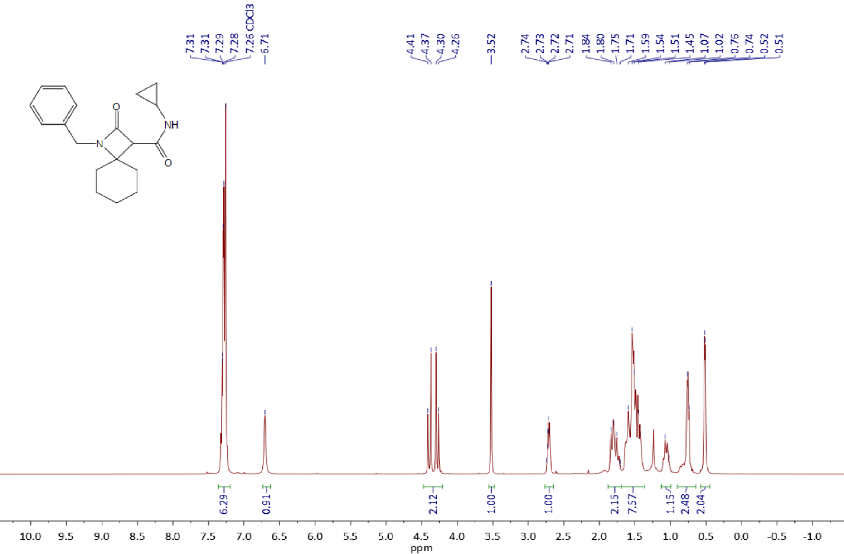



Copies of 1H (400.13 MHz, CDCl3) and 13C{1H} (100.61 MHz, CDCl3) spectra of **3d**

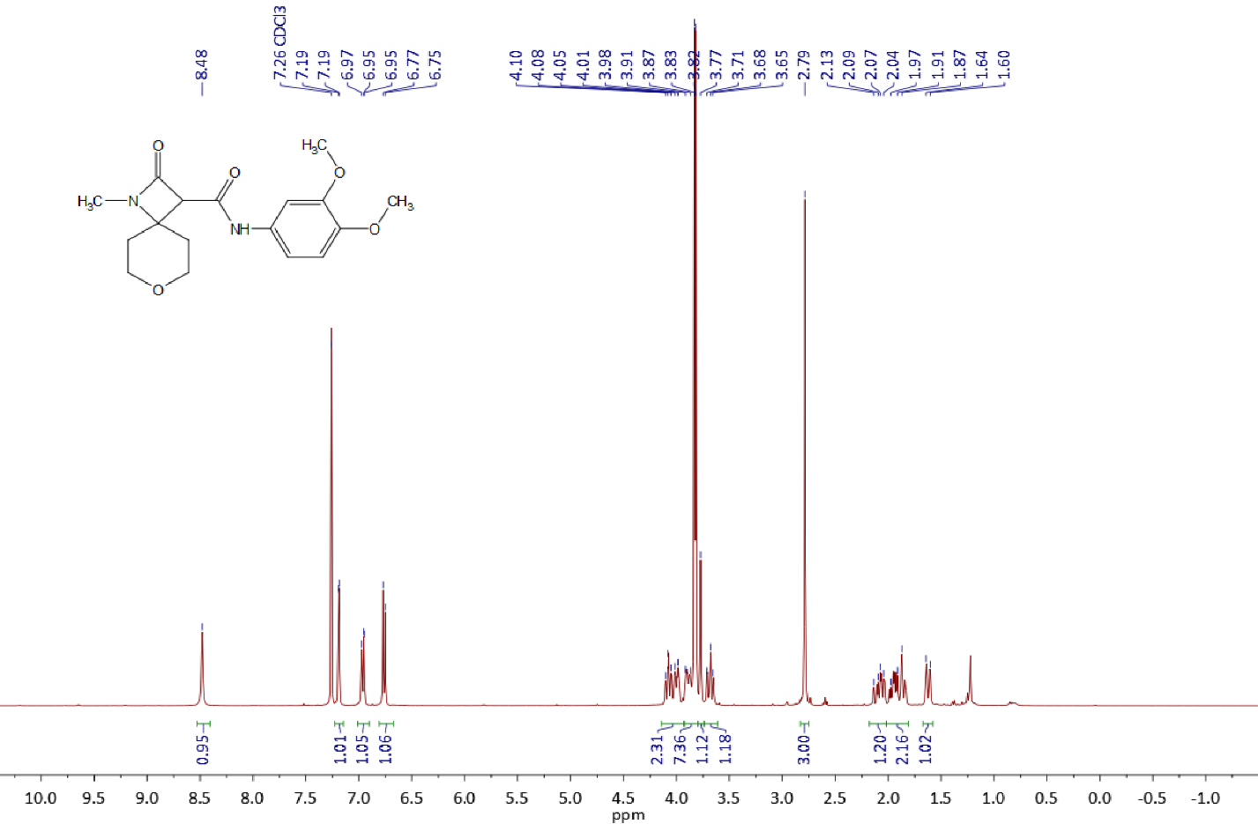

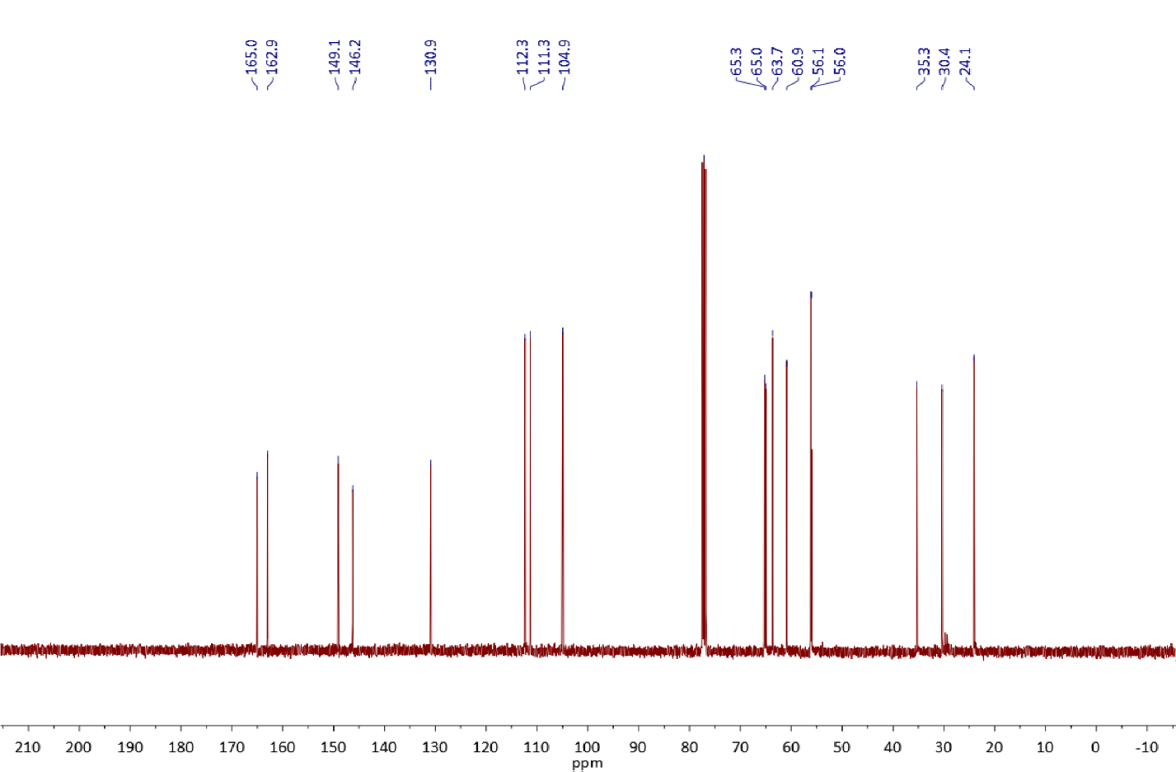

Copies of 1H (400.13 MHz, CDCl3) and 13C{1H} (100.61 MHz, CDCl3) spectra of **3e**

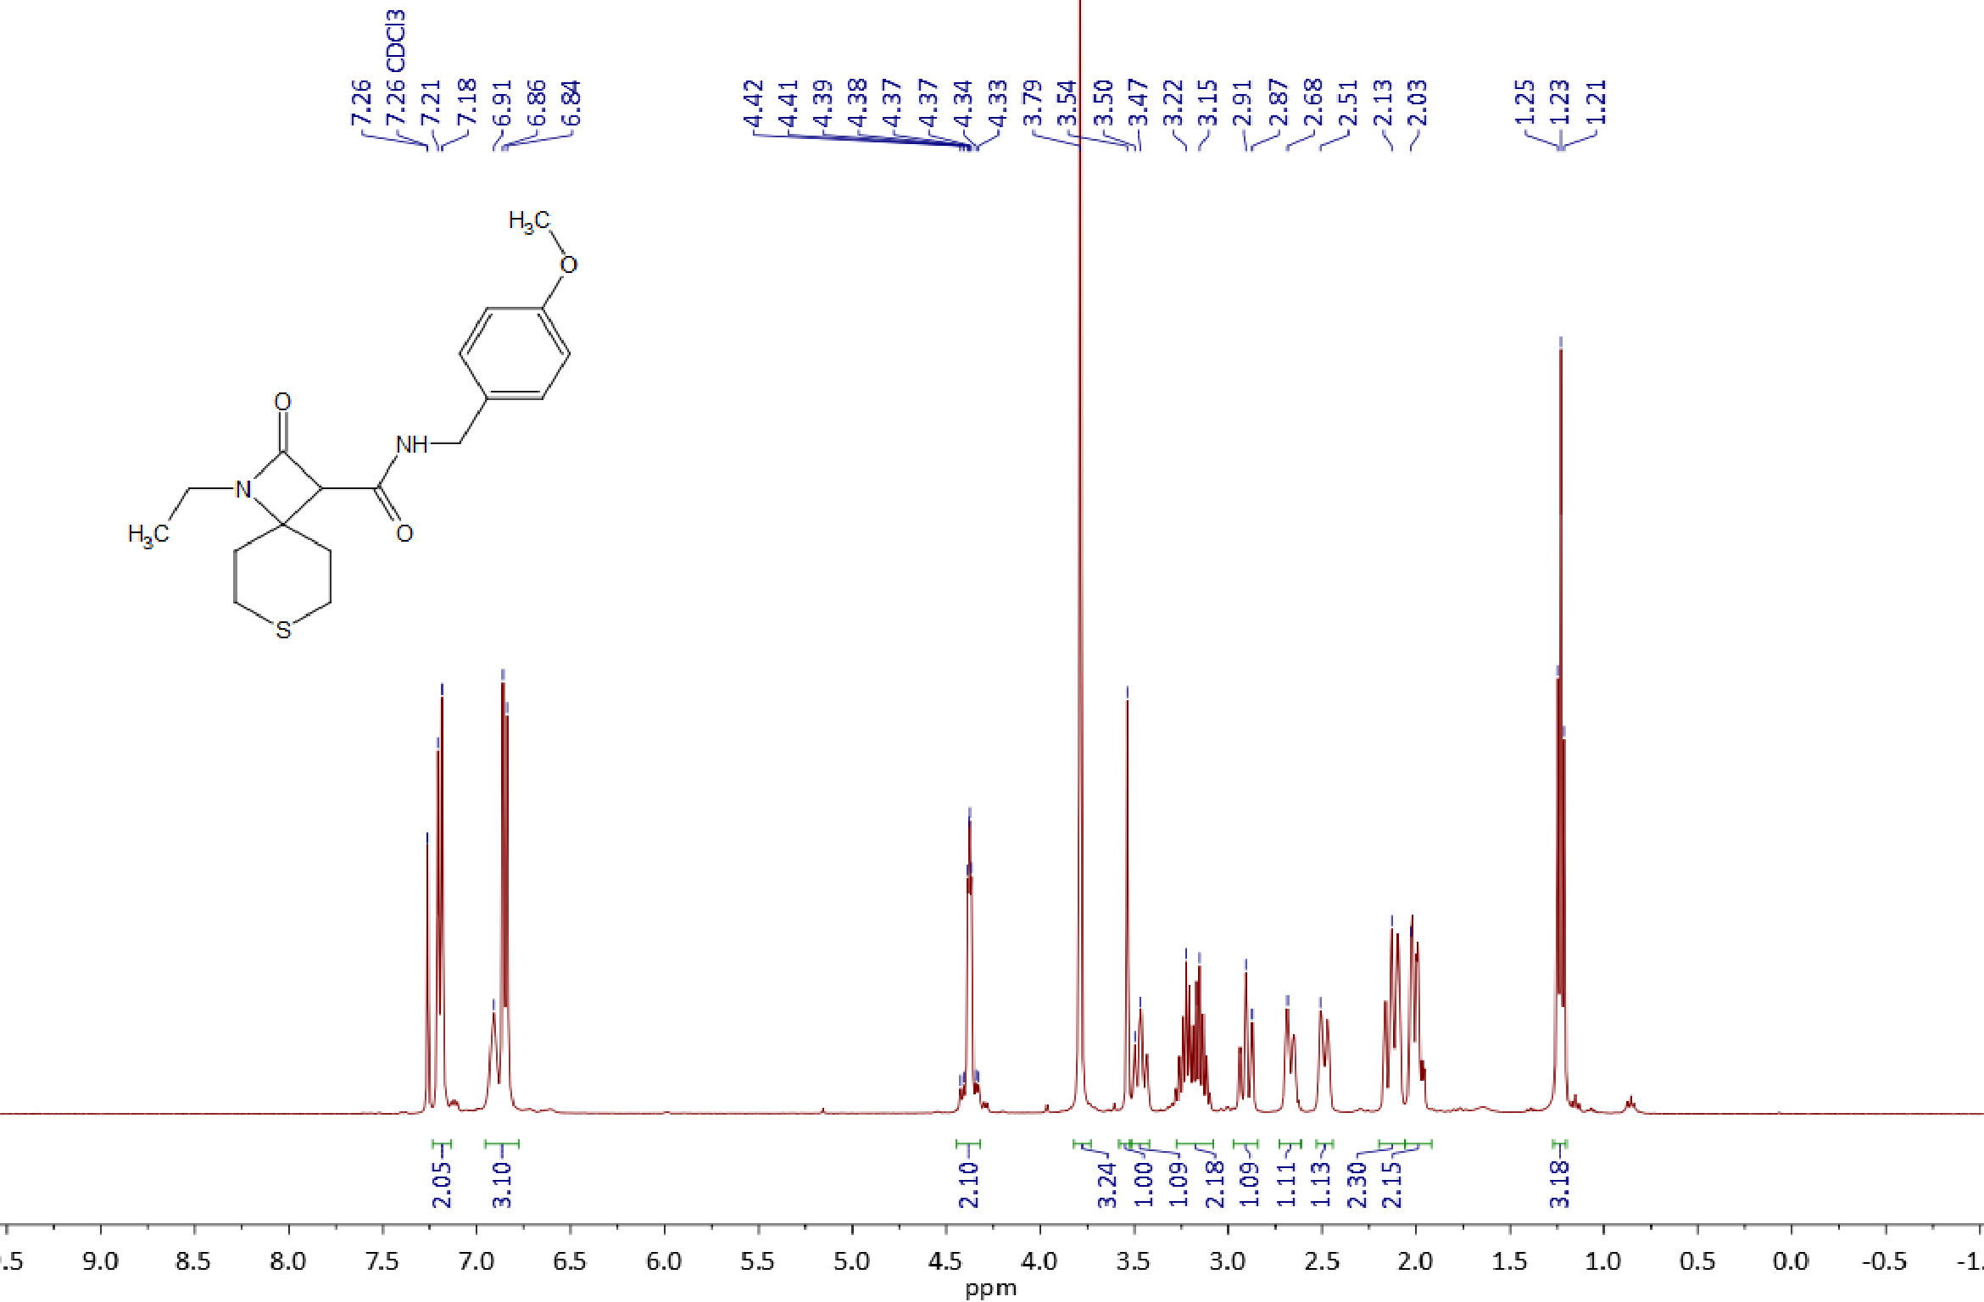

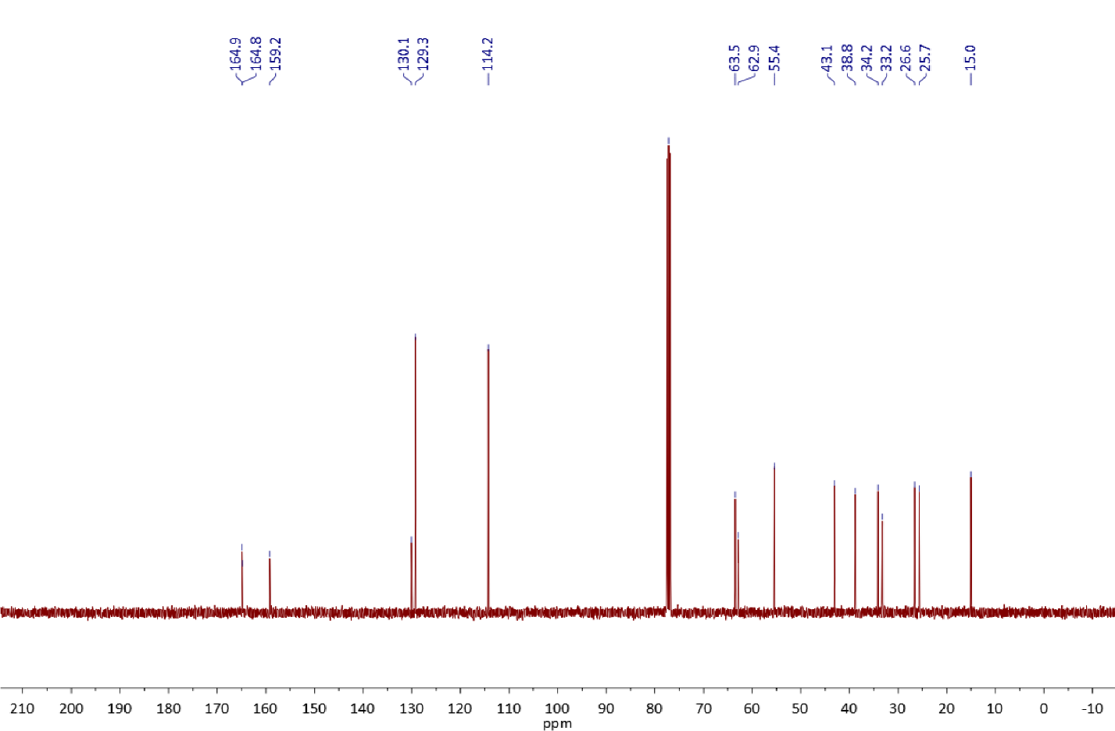

Copies of 1H (400.13 MHz, CDCl3) and 13C{1H} (100.61 MHz, CDCl3) spectra of **3f**

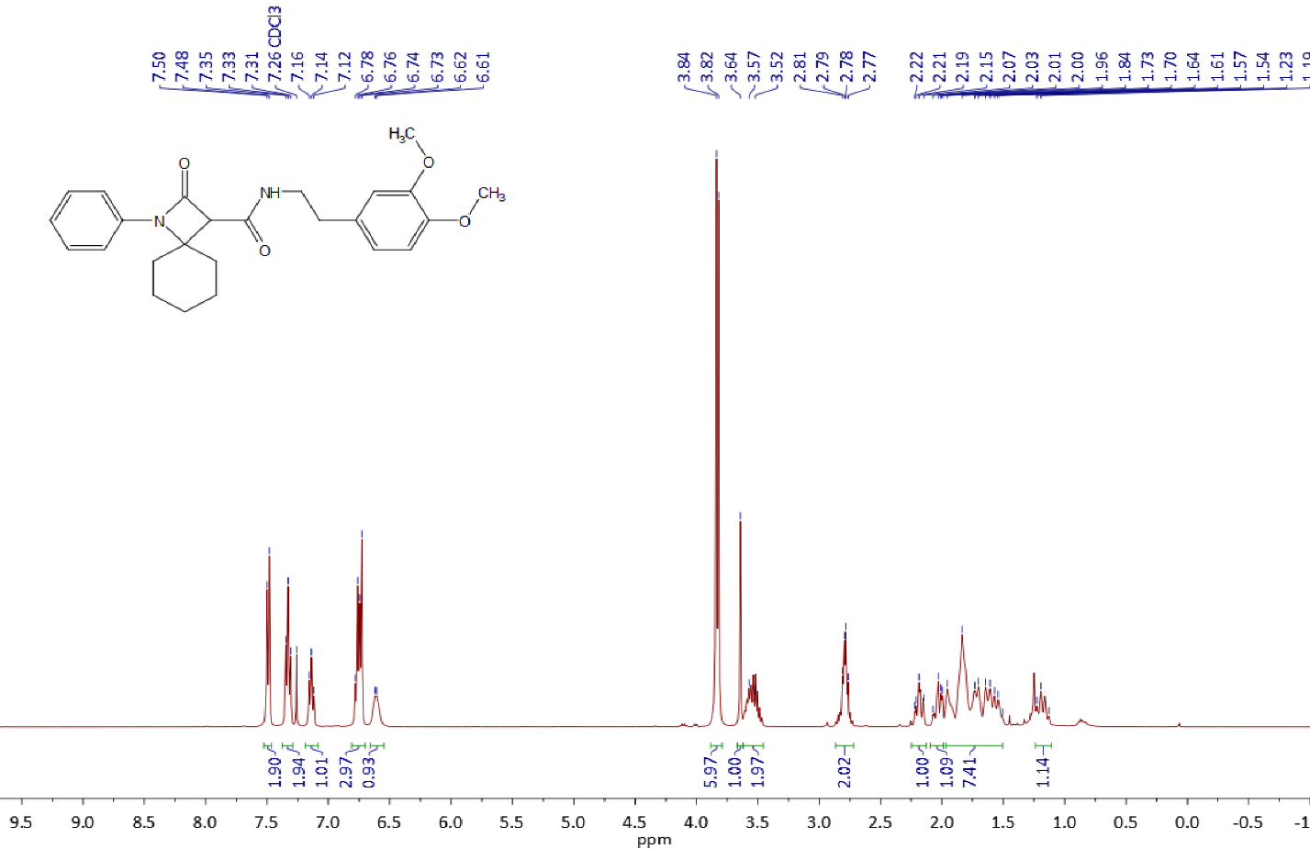

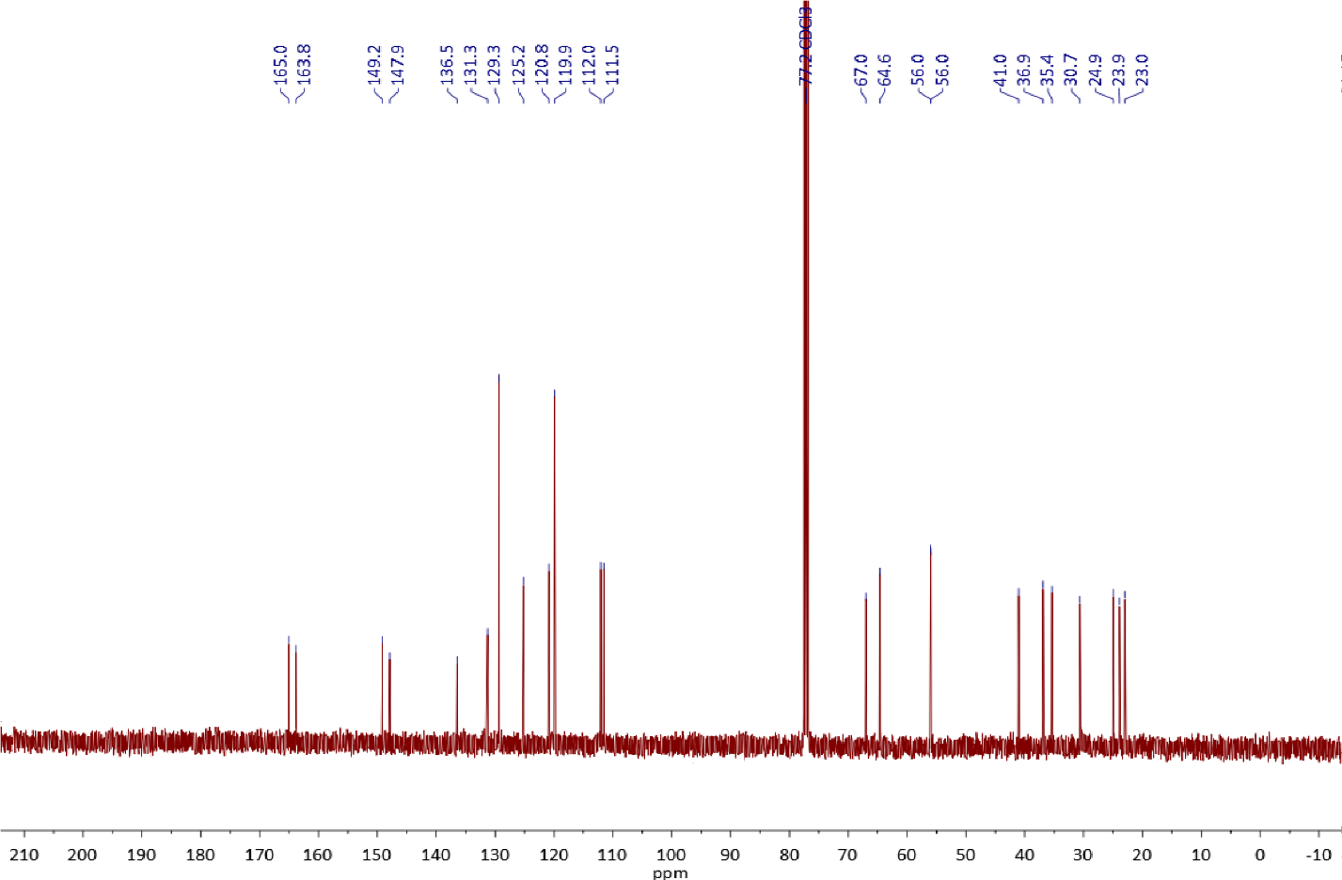

Copies of 1H (400.13 MHz, CDCl3) and 13C{1H} (100.61 MHz, CDCl3) spectra of **3g**

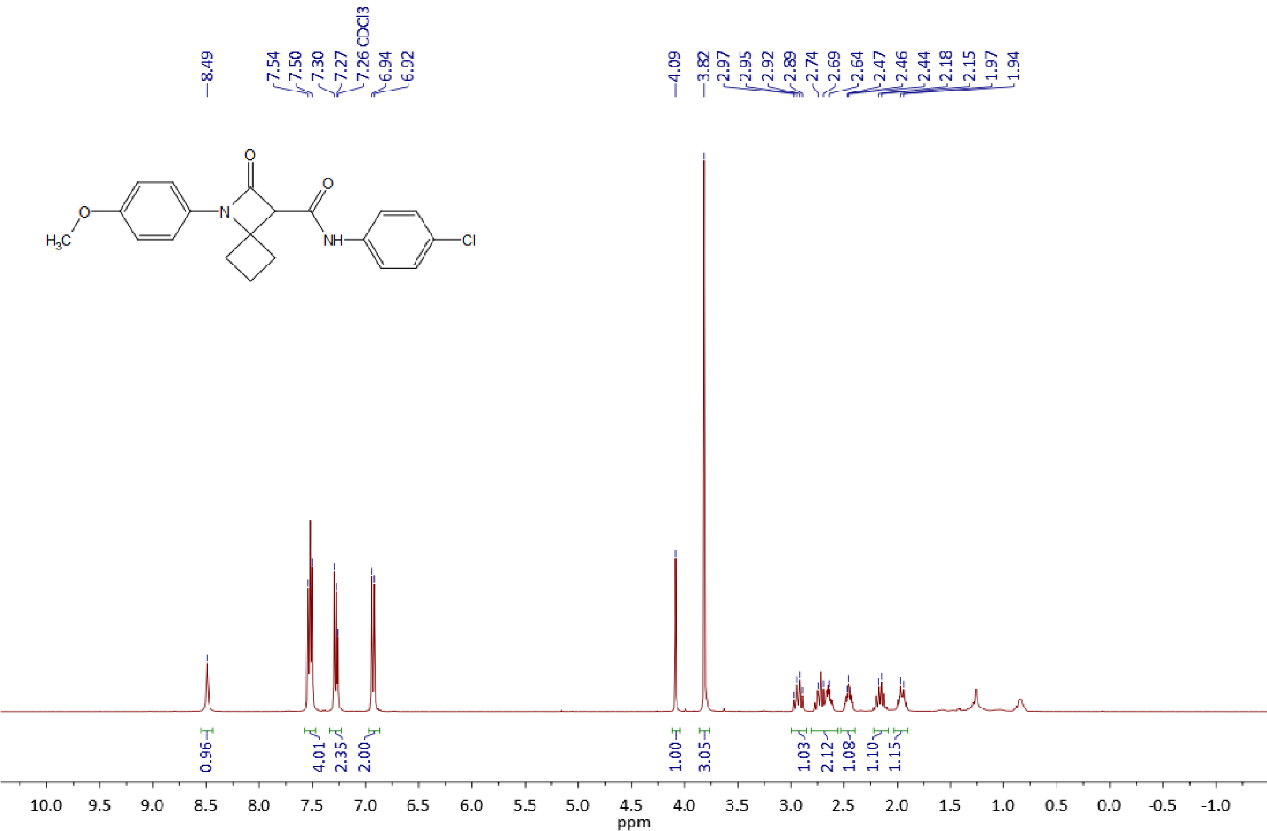

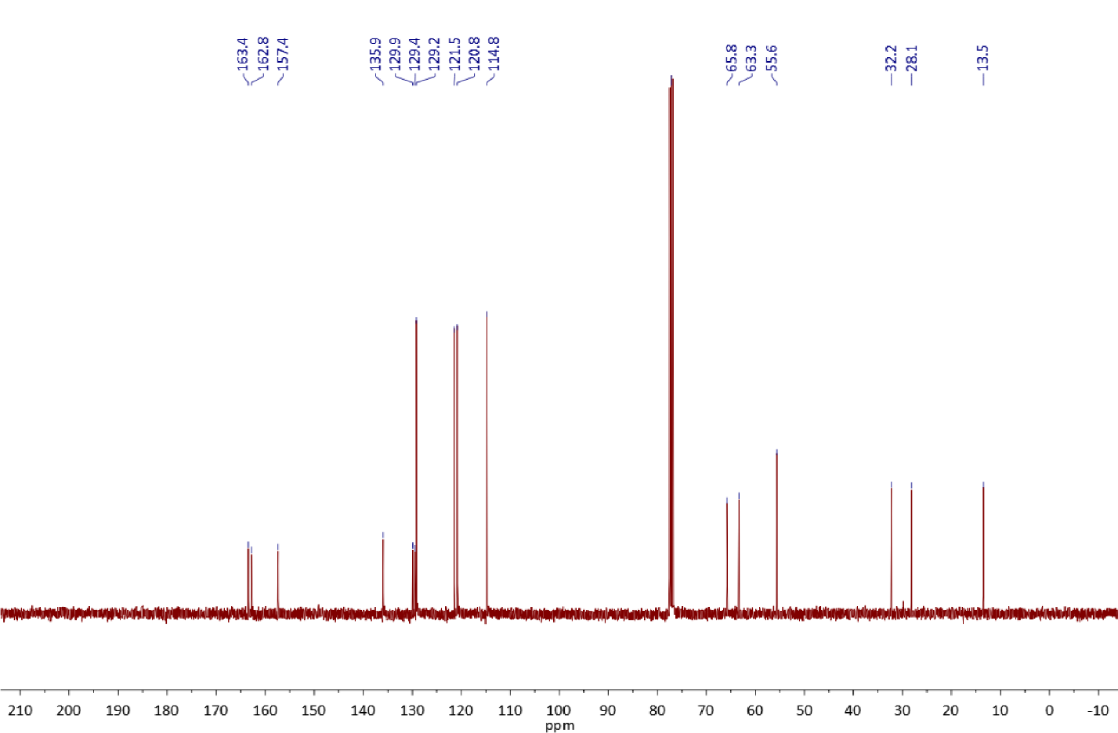

Copies of 1H (400.13 MHz, CDCl3), 13C{1H} (100.61 MHz, CDCl3) and 19F{1H} (376.50 MHz, CDCl3) spectra of **3h**

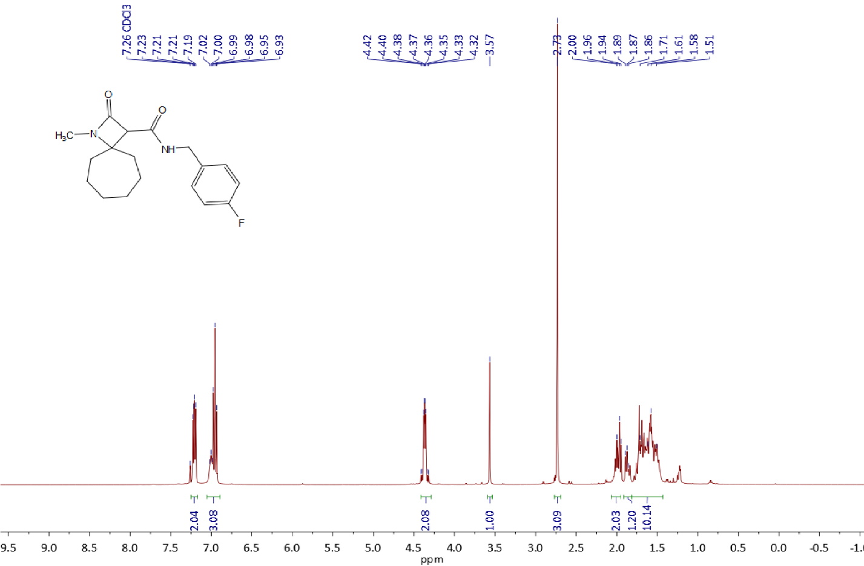

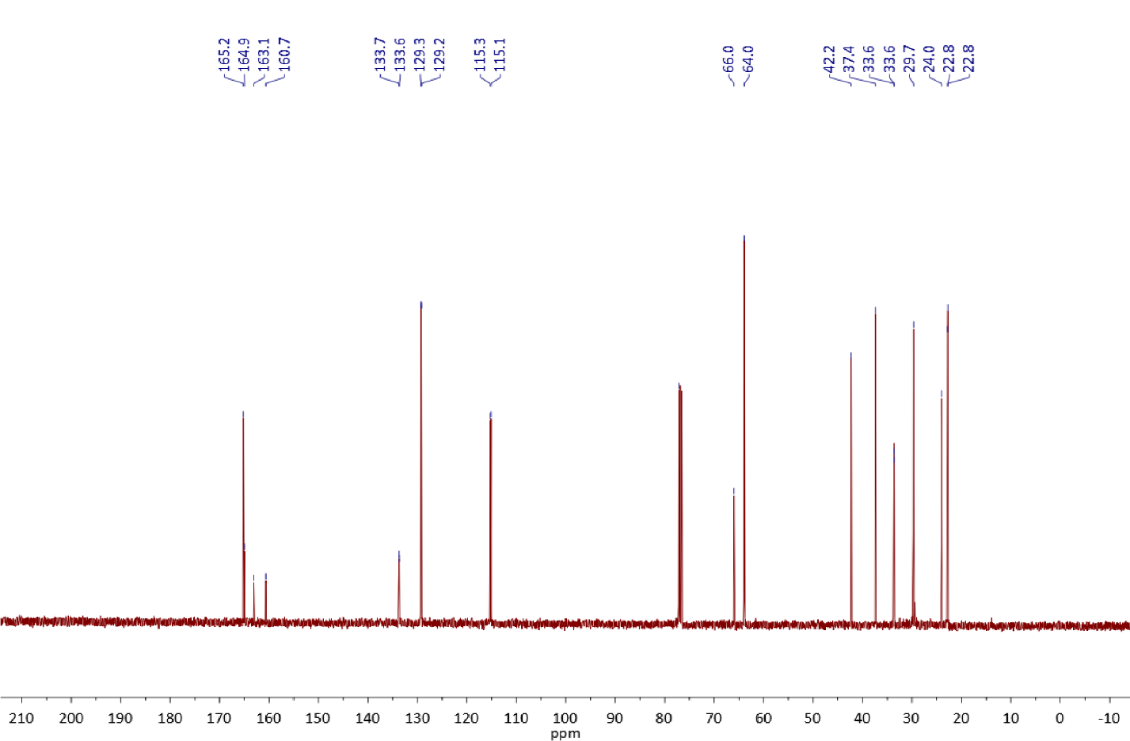

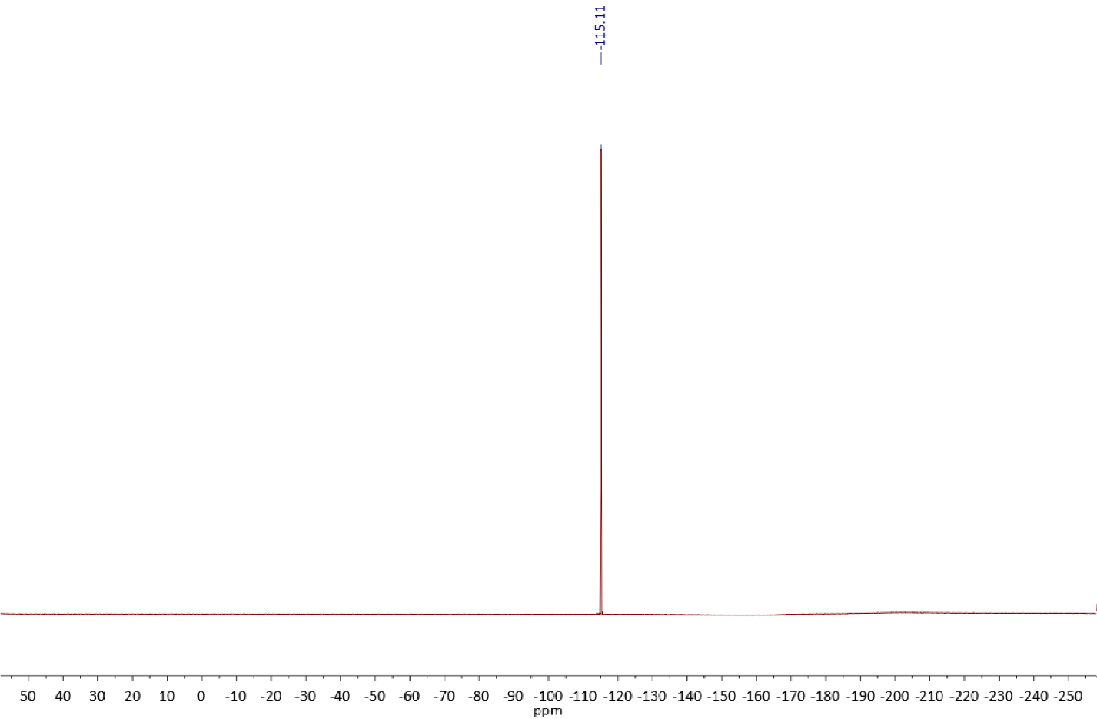

Copies of 1H (400.13 MHz, DMSO-*d6*), 13C{1H} (100.61 MHz, DMSO-*d6*) and 19F{1H} (376.50 MHz, DMSO-*d6*) spectra of **3i**

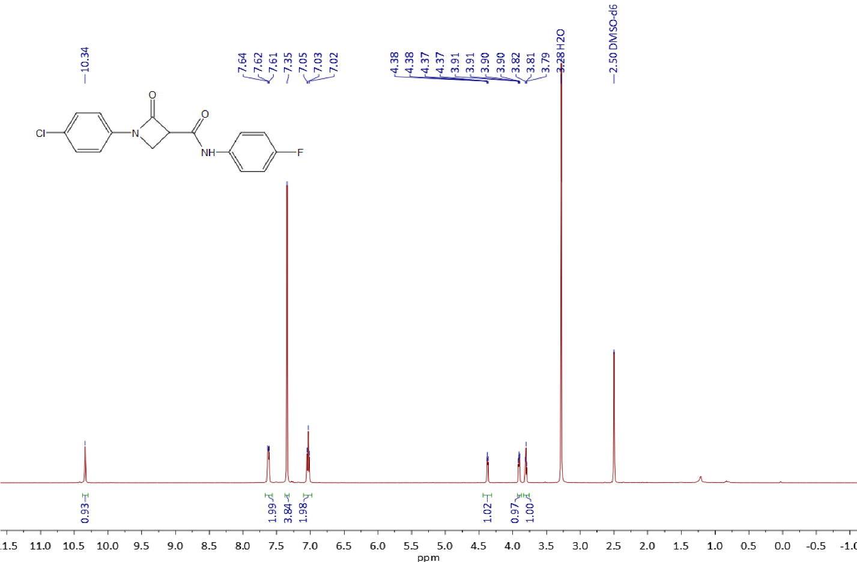

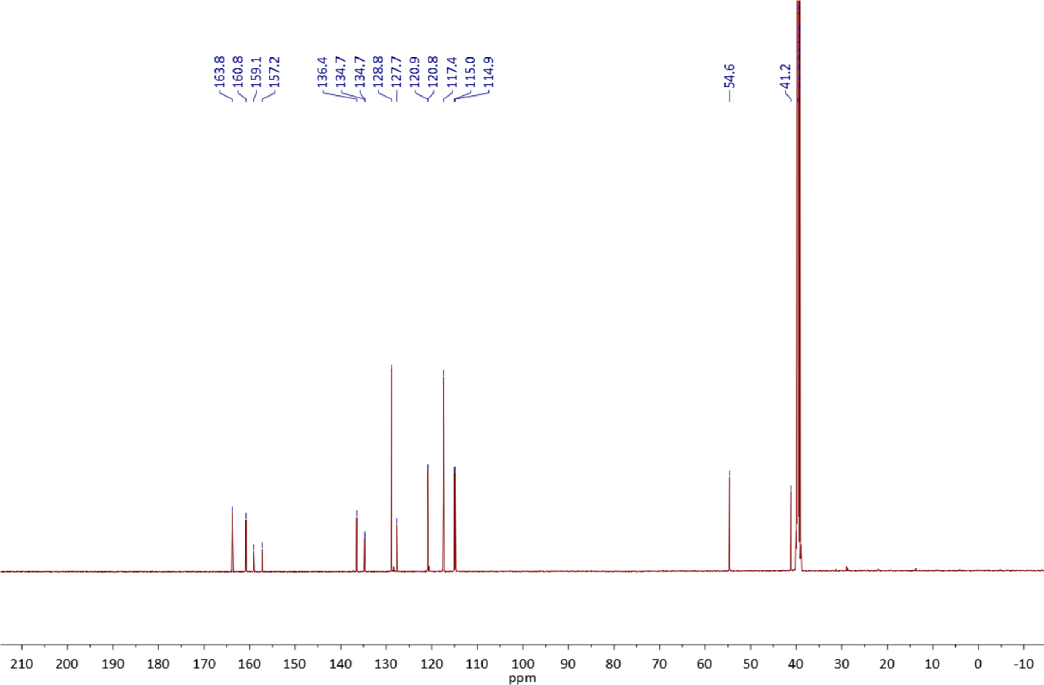

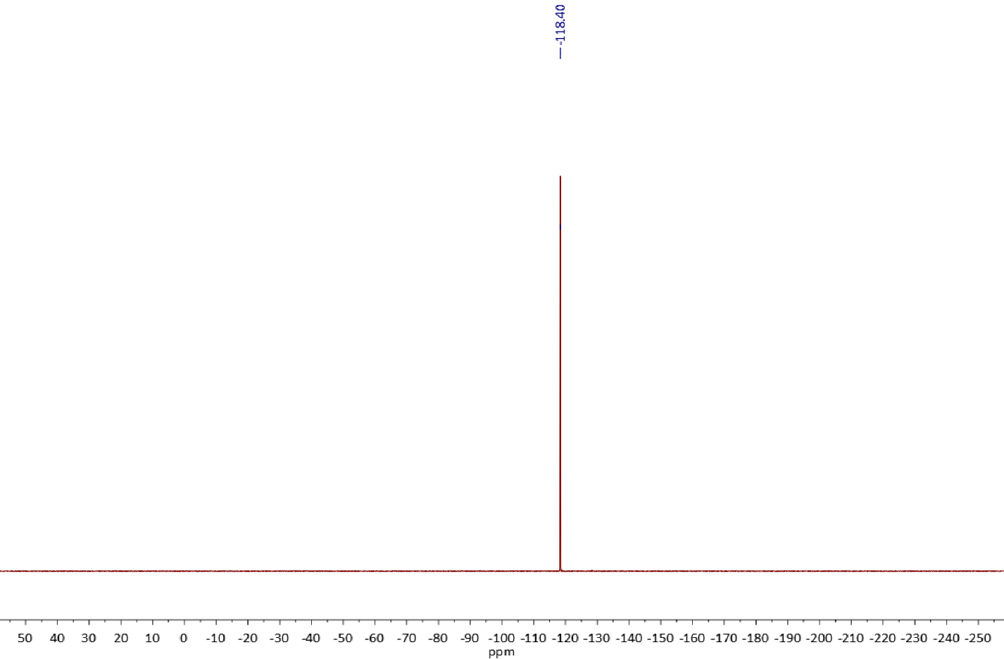

Copies of 1H (400.13 MHz, DMSO-*d6*), 13C{1H} (100.61 MHz, DMSO-*d6*) and 19F{1H} (376.50 MHz, DMSO-*d6*) spectra of **3j**

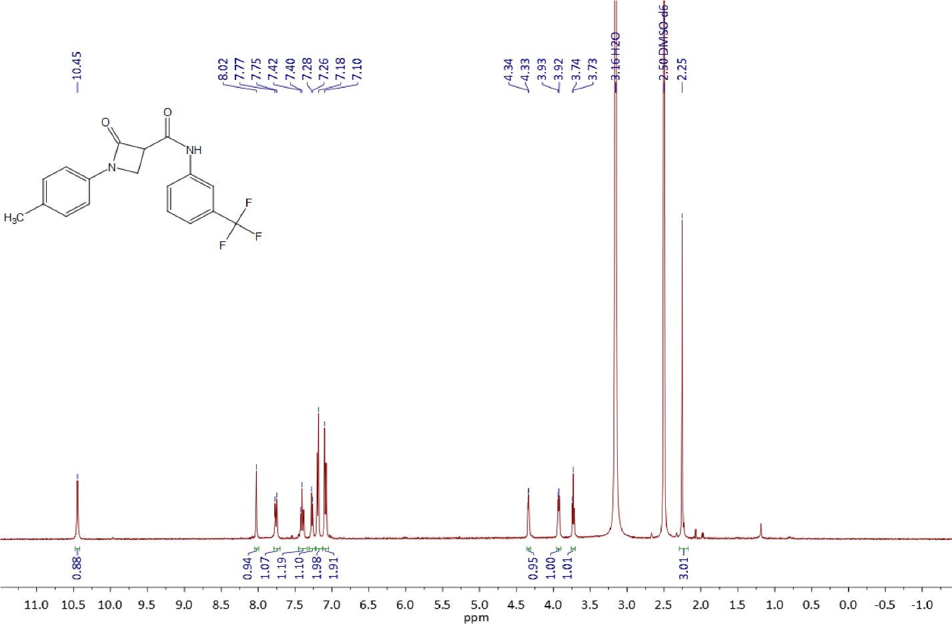

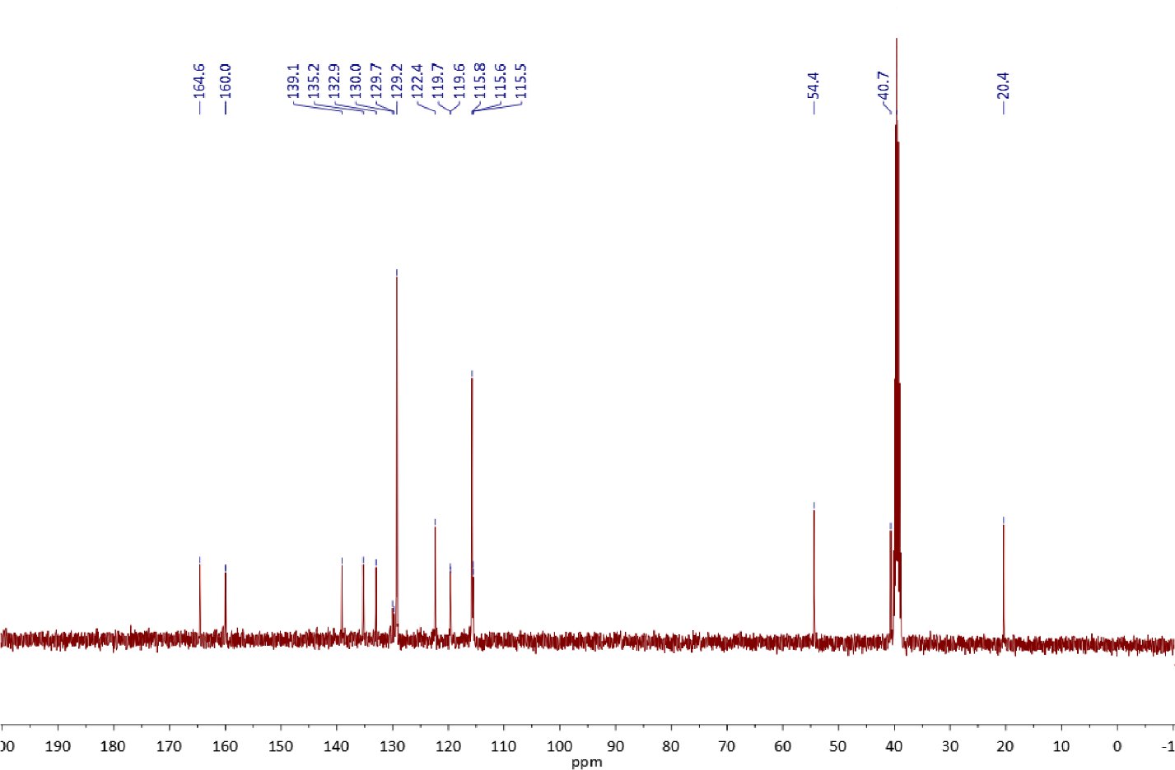

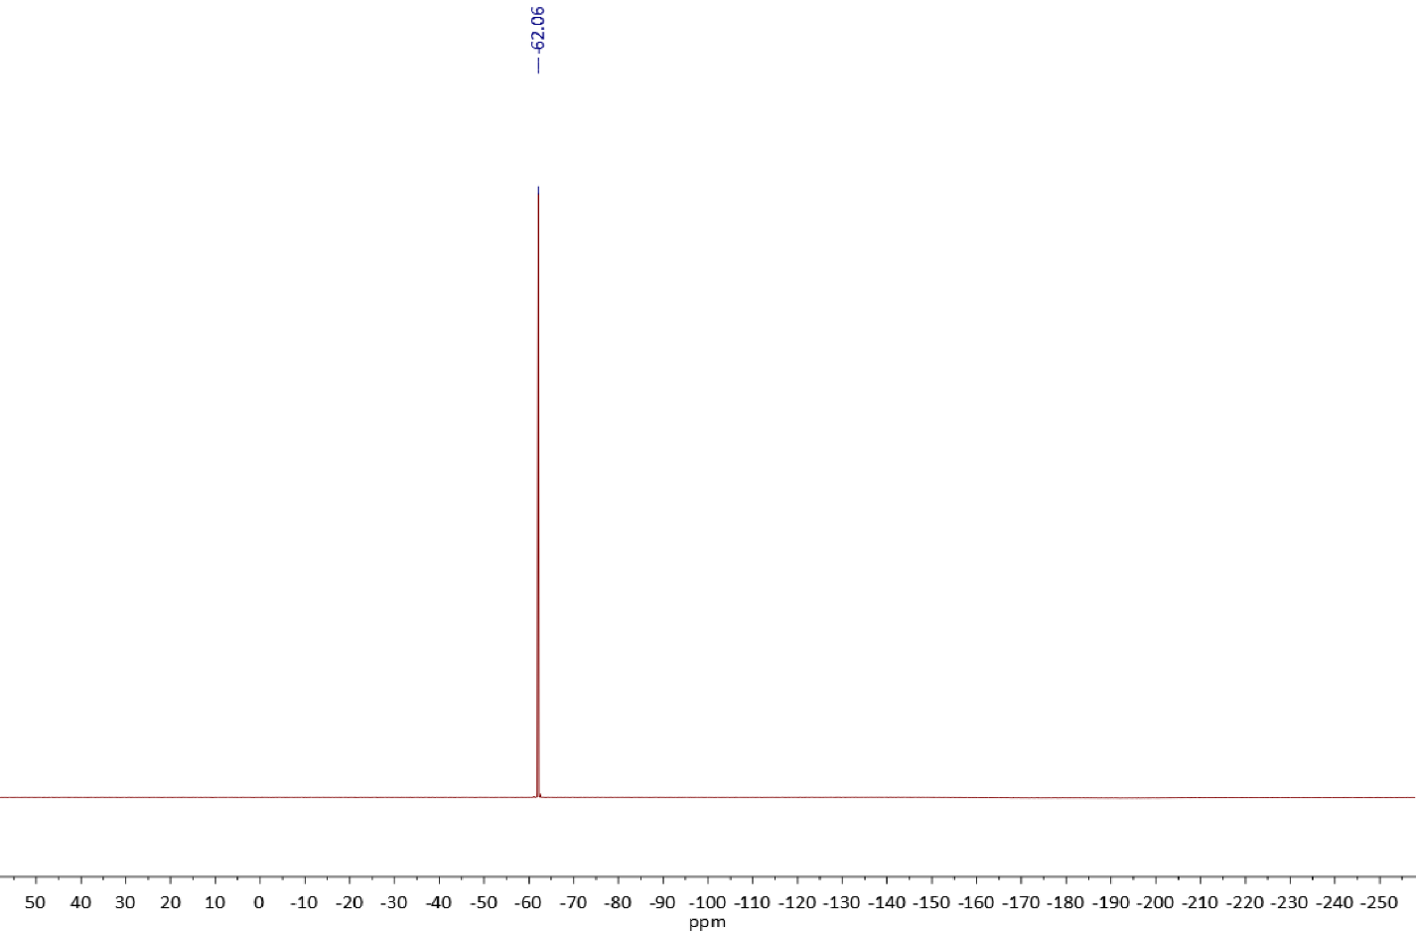

Copies of 1H (400.13 MHz, CDCl3) and 13C{1H} (100.61 MHz, CDCl3) spectra of **3k**

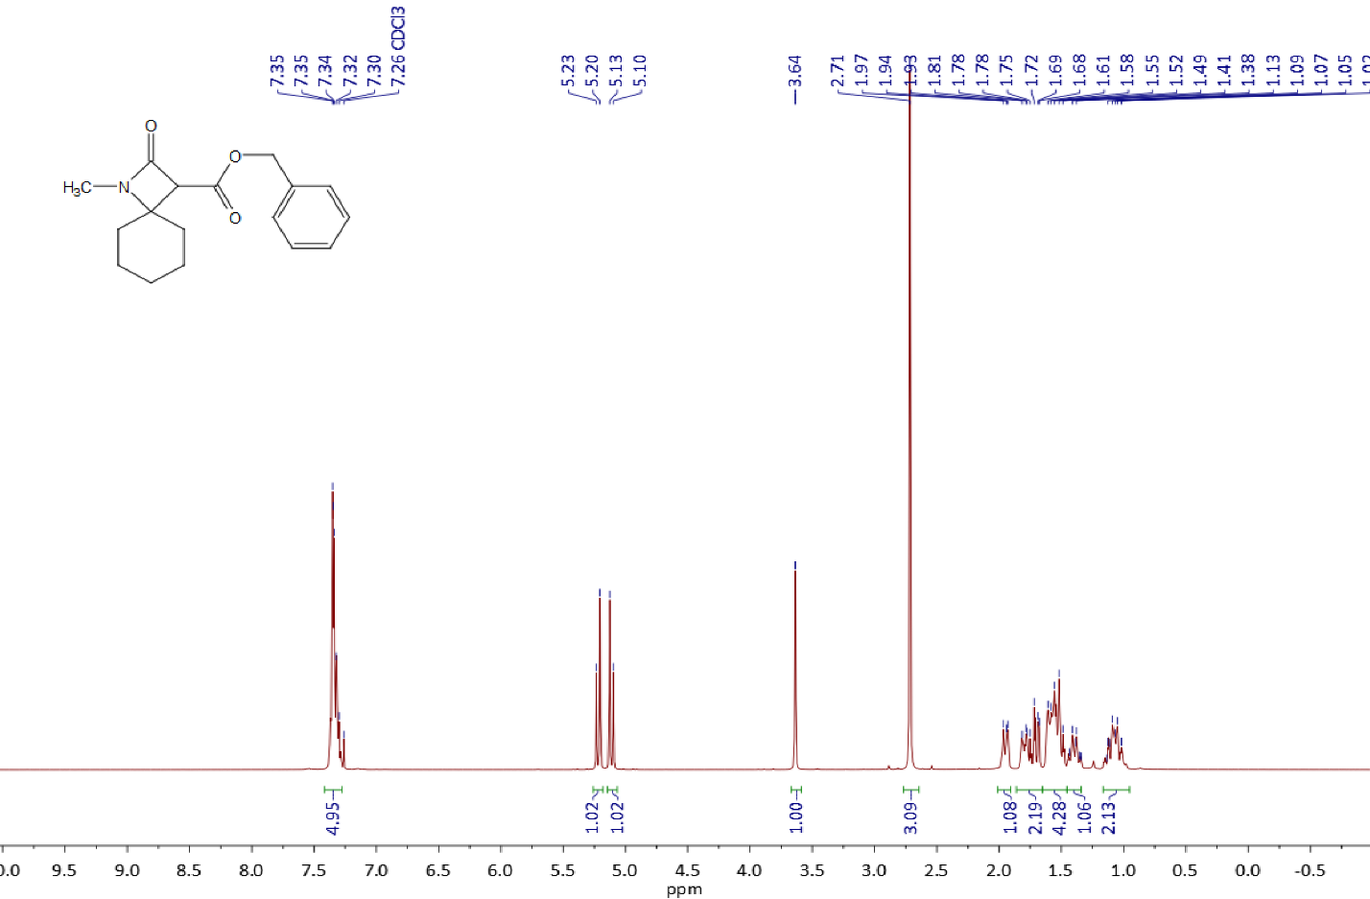

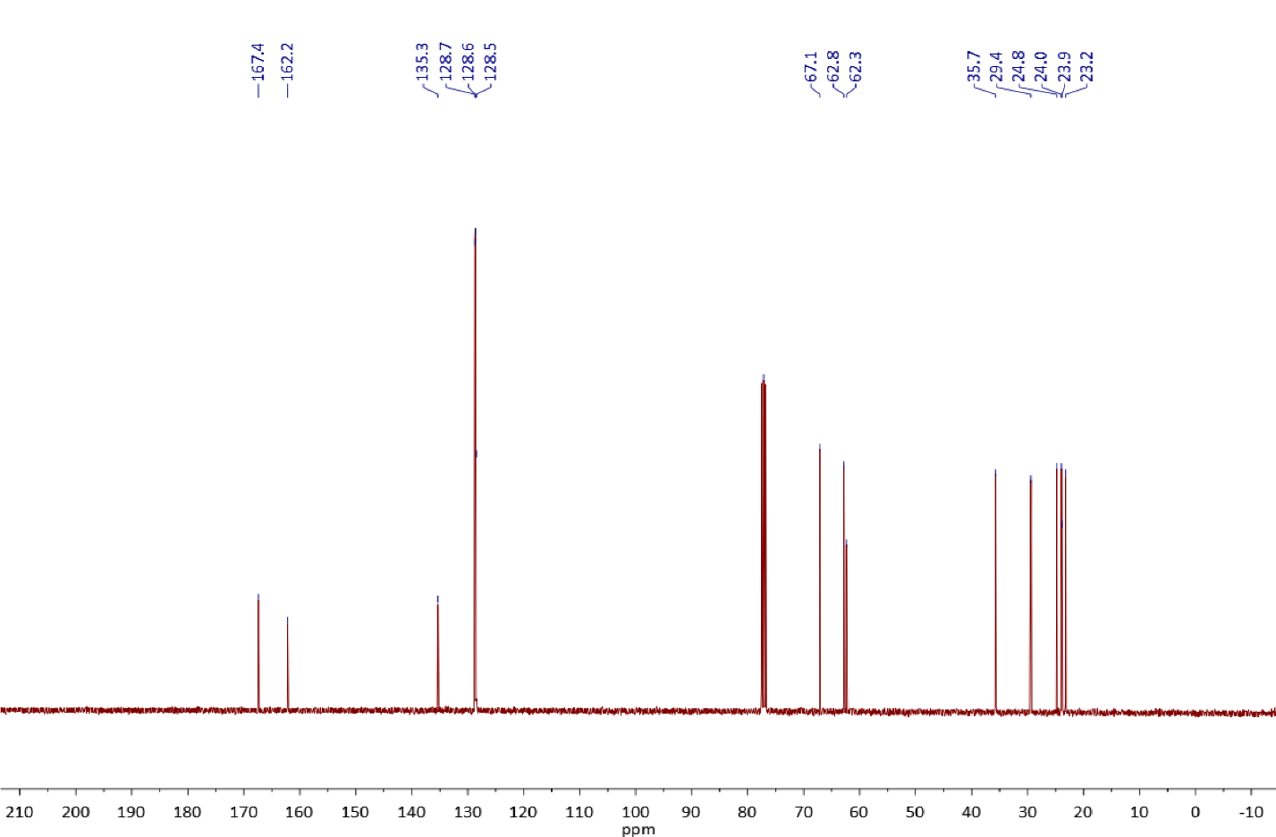

Copies of 1H (400.13 MHz, CDCl3) and 13C{1H} (100.61 MHz, CDCl3) spectra of **3l**

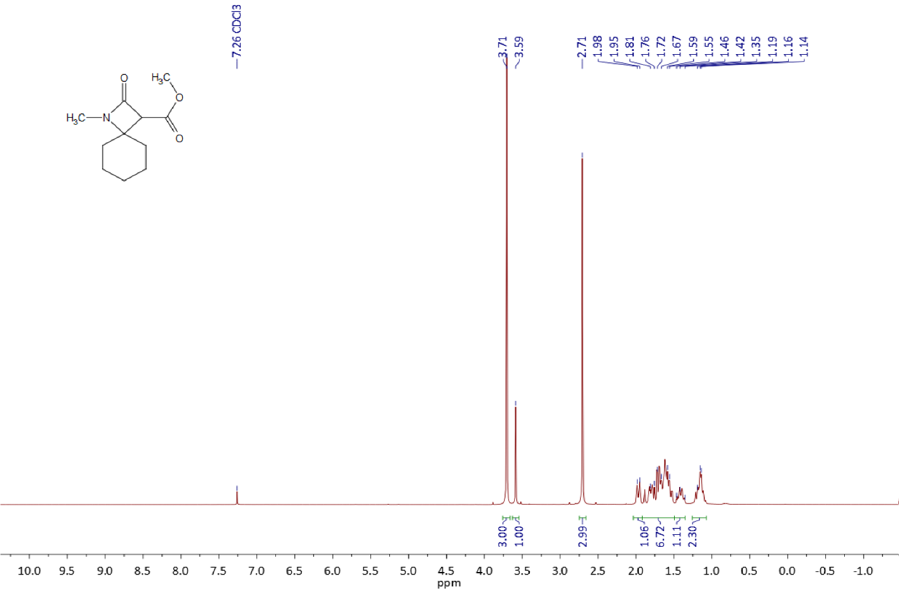

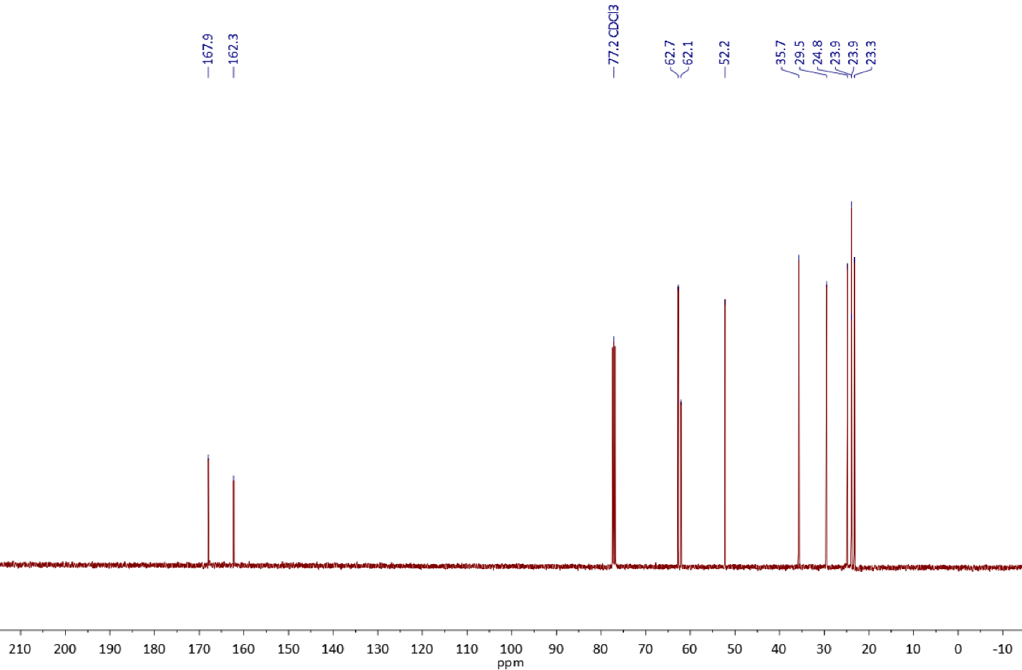

Copies of 1H (400.13 MHz, CDCl3) and 13C{1H} (100.61 MHz, CDCl3) spectra of **3m**

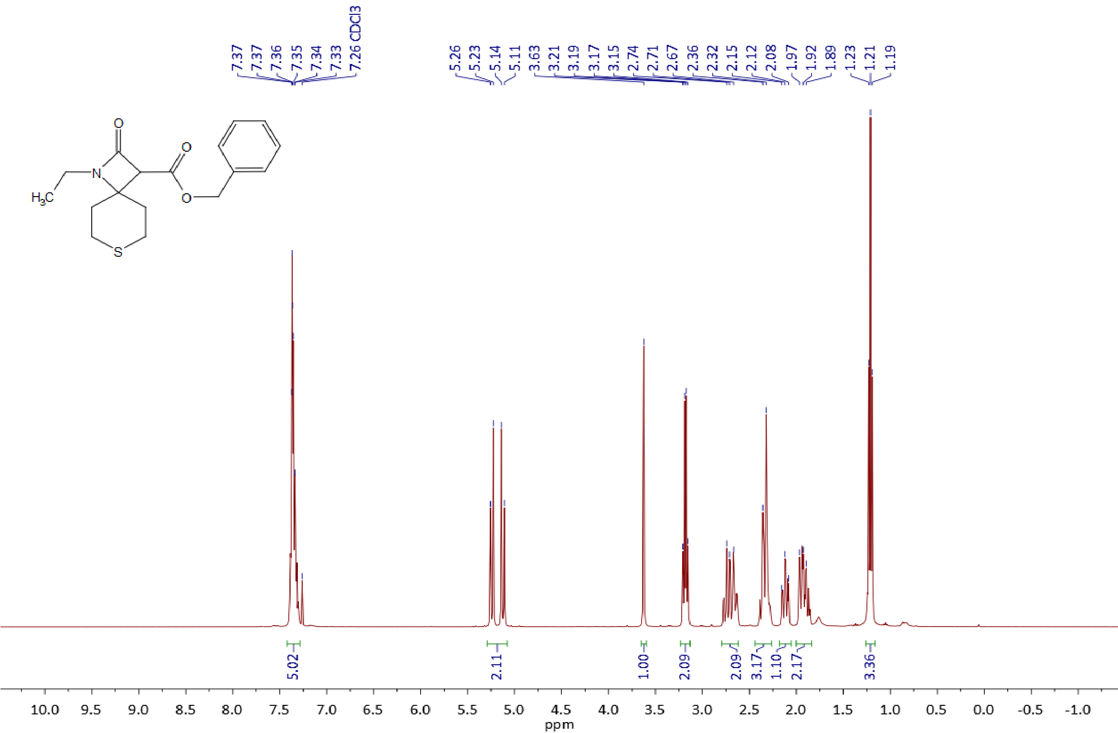

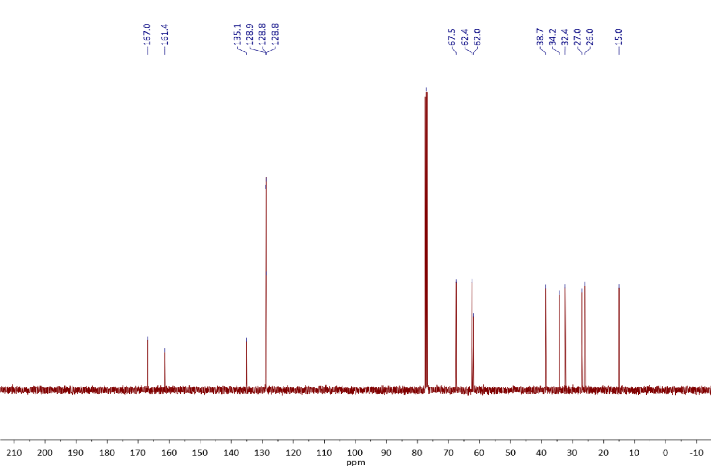

Copies of 1H (400.13 MHz, CDCl3) and 13C{1H} (100.61 MHz, CDCl3) spectra of **3n**

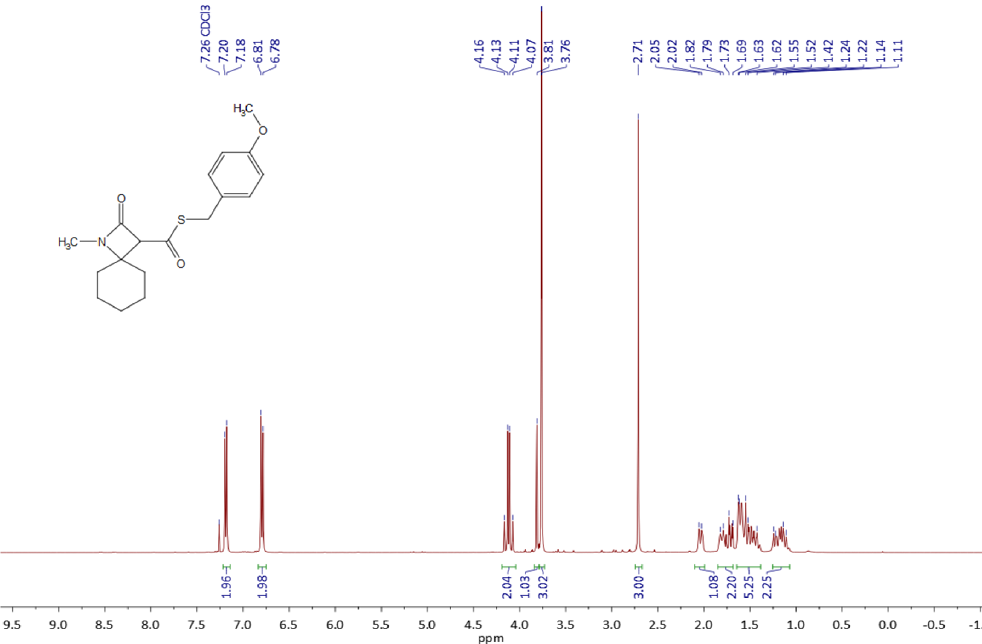

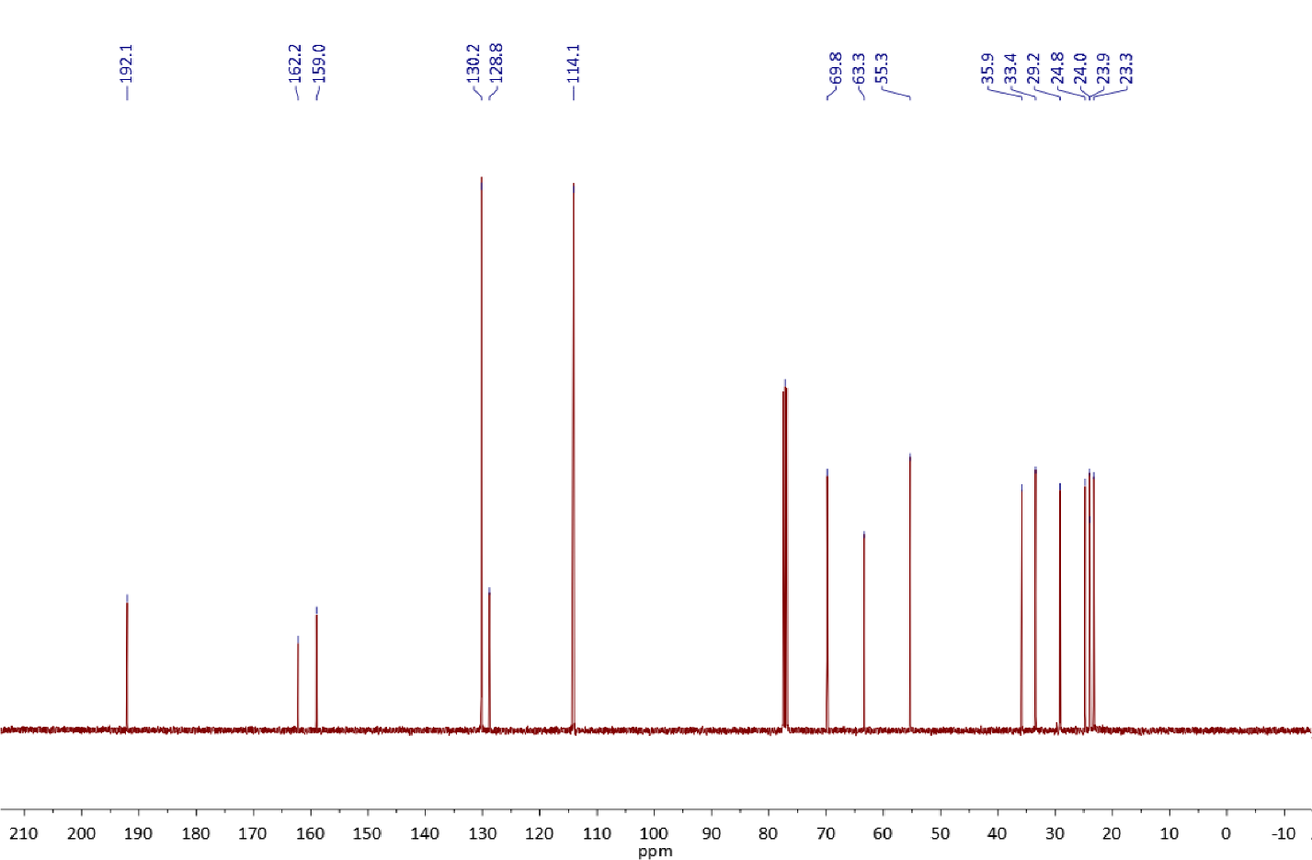

Copies of 1H (400.13 MHz, CDCl3) and 13C{1H} (100.61 MHz, CDCl3) spectra of **3o**

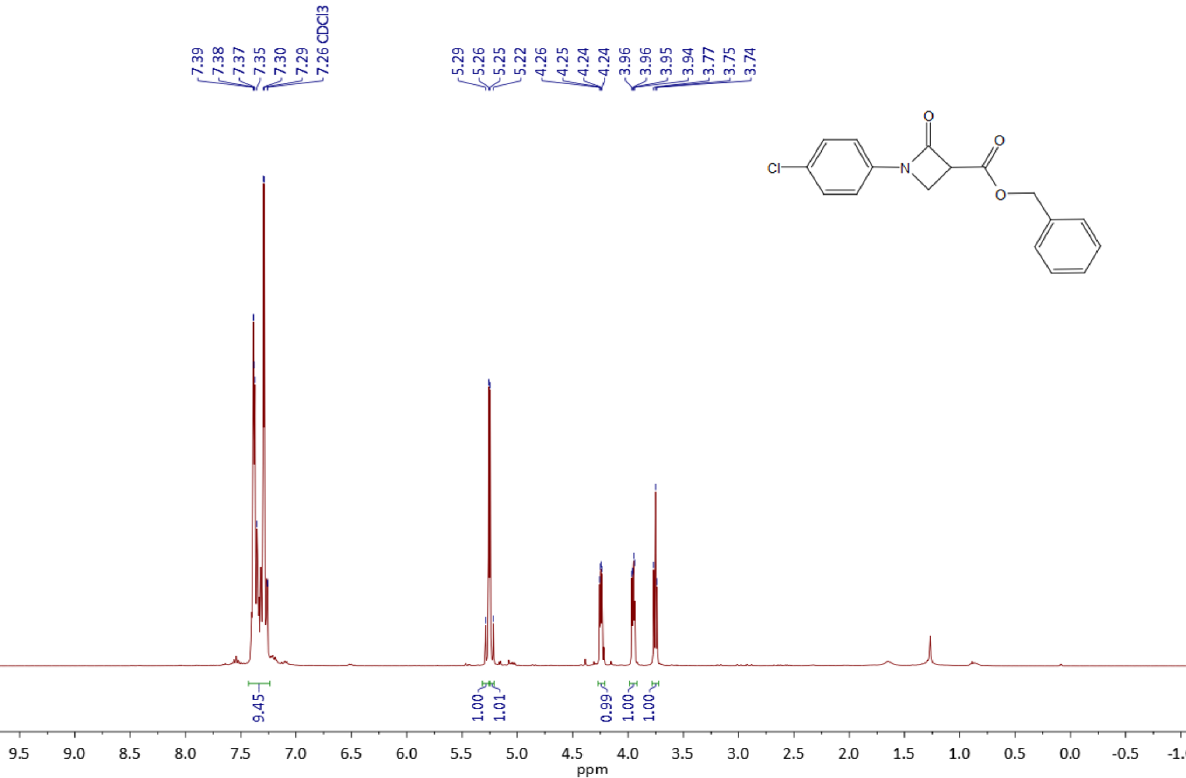



Copies of 1H (400.13 MHz, CDCl3) and 13C{1H} (100.61 MHz, CDCl3) spectra of **3p**

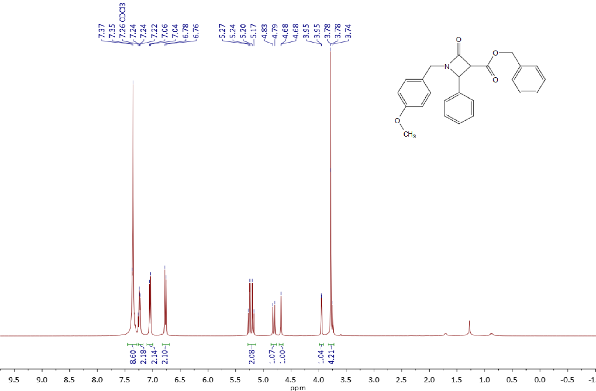

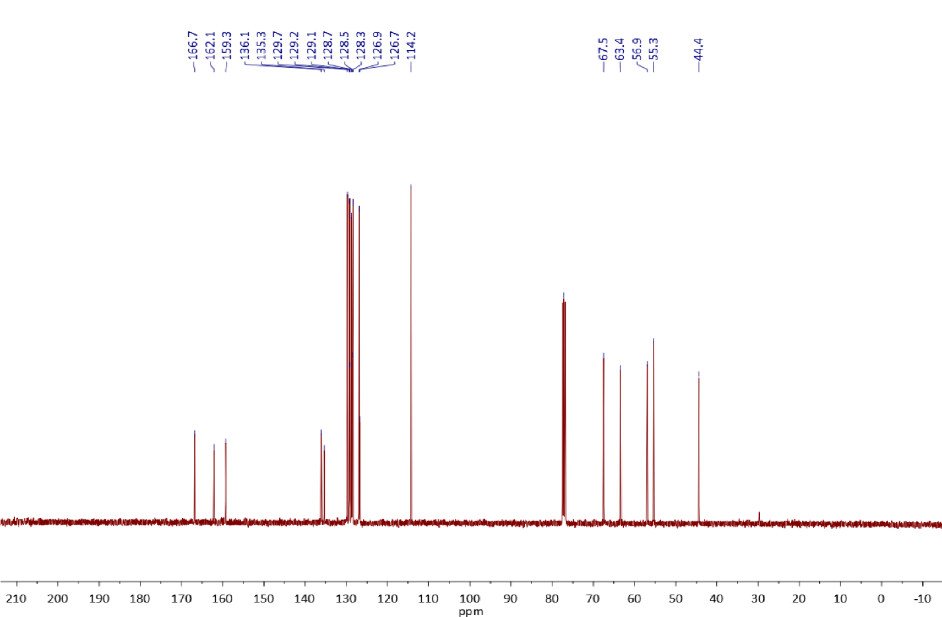

Copies of 1H (400.13 MHz, CDCl3) and 13C{1H} (100.61 MHz, CDCl3) spectra of **3q**

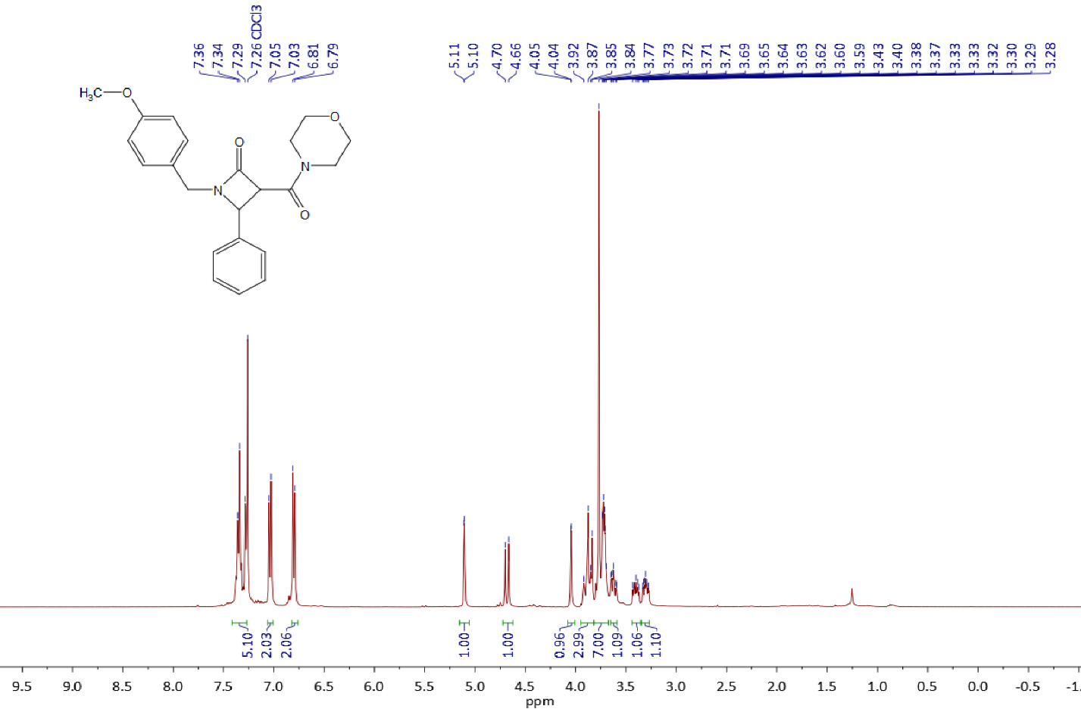

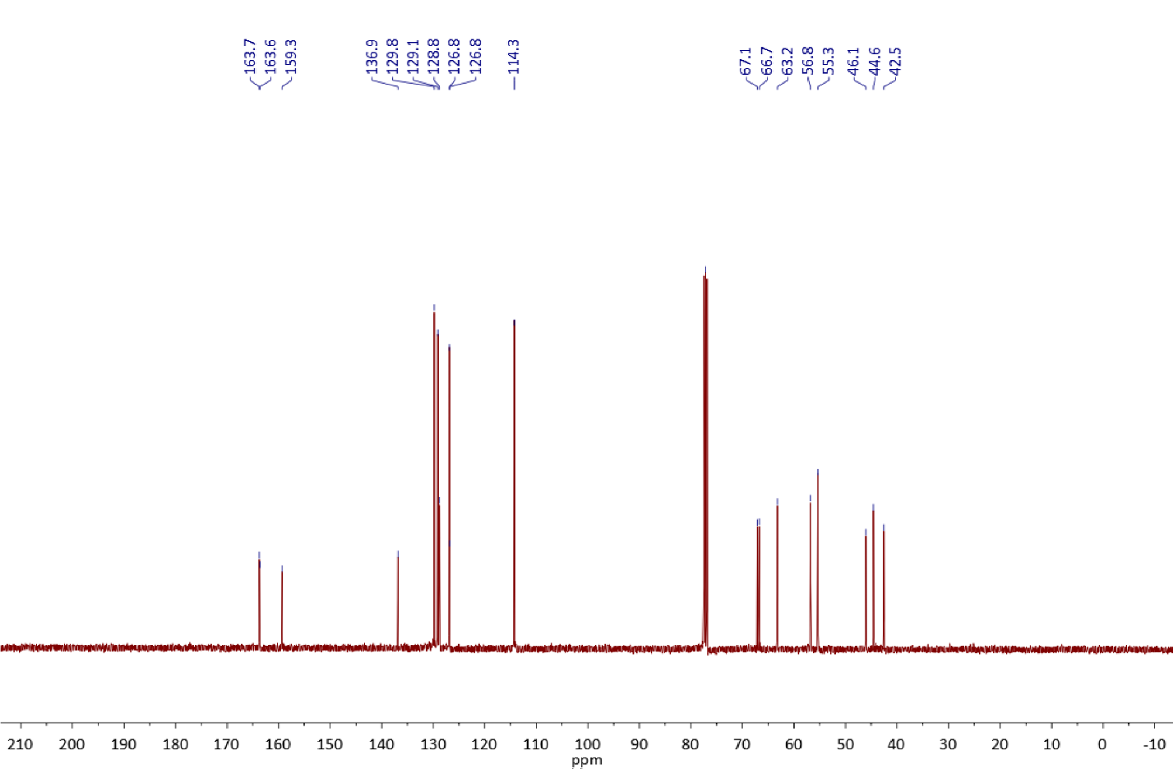

Copies of 1H (400.13 MHz, CDCl3), 13C{1H} (100.61 MHz, CDCl3) and 19F{1H} (376.50 MHz, CDCl3) spectra of **3r**

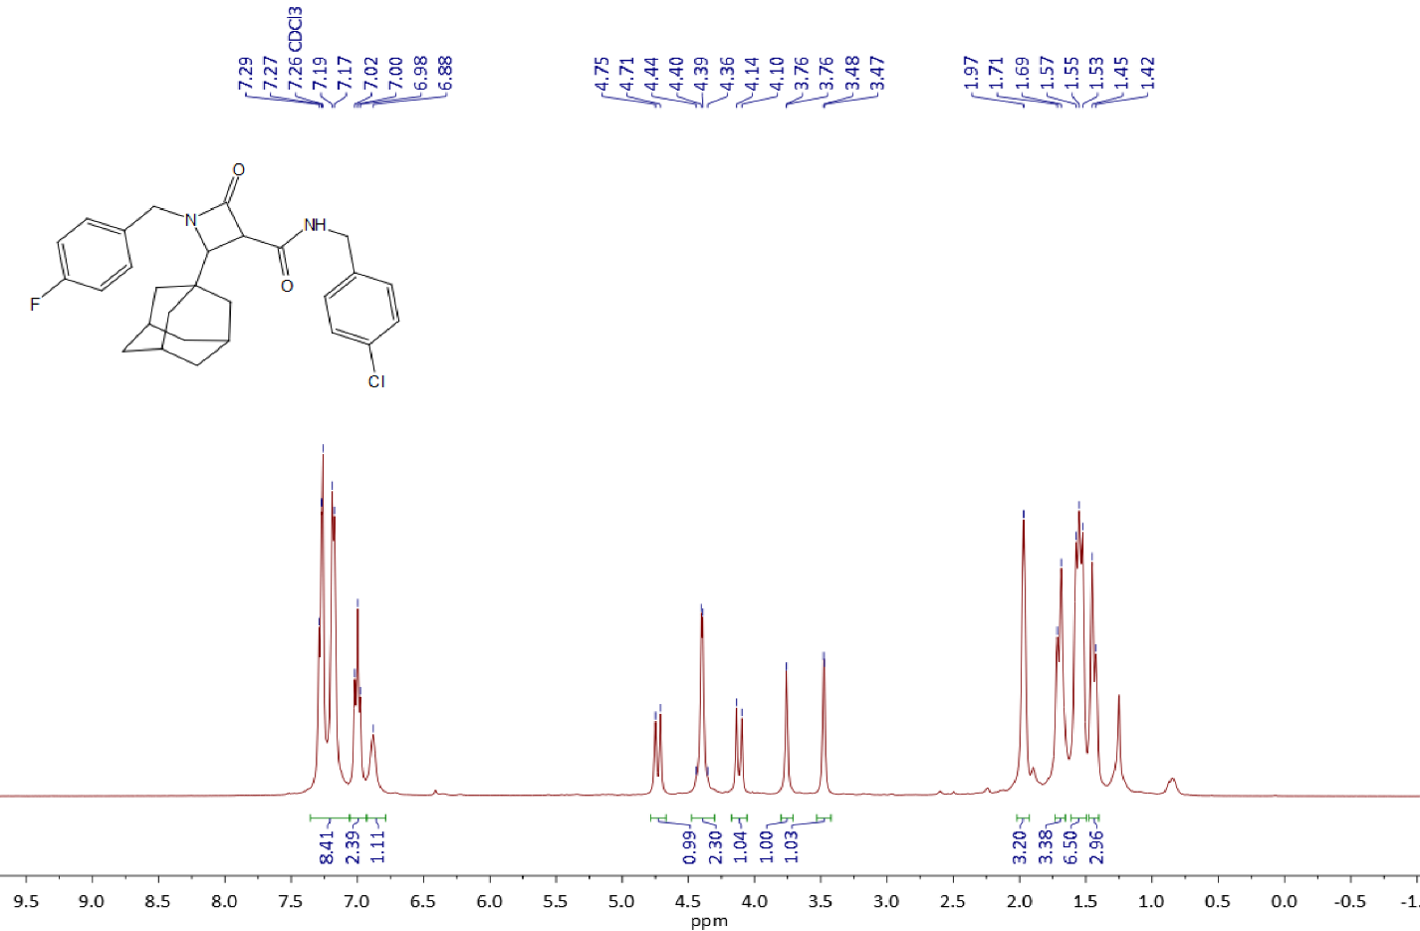

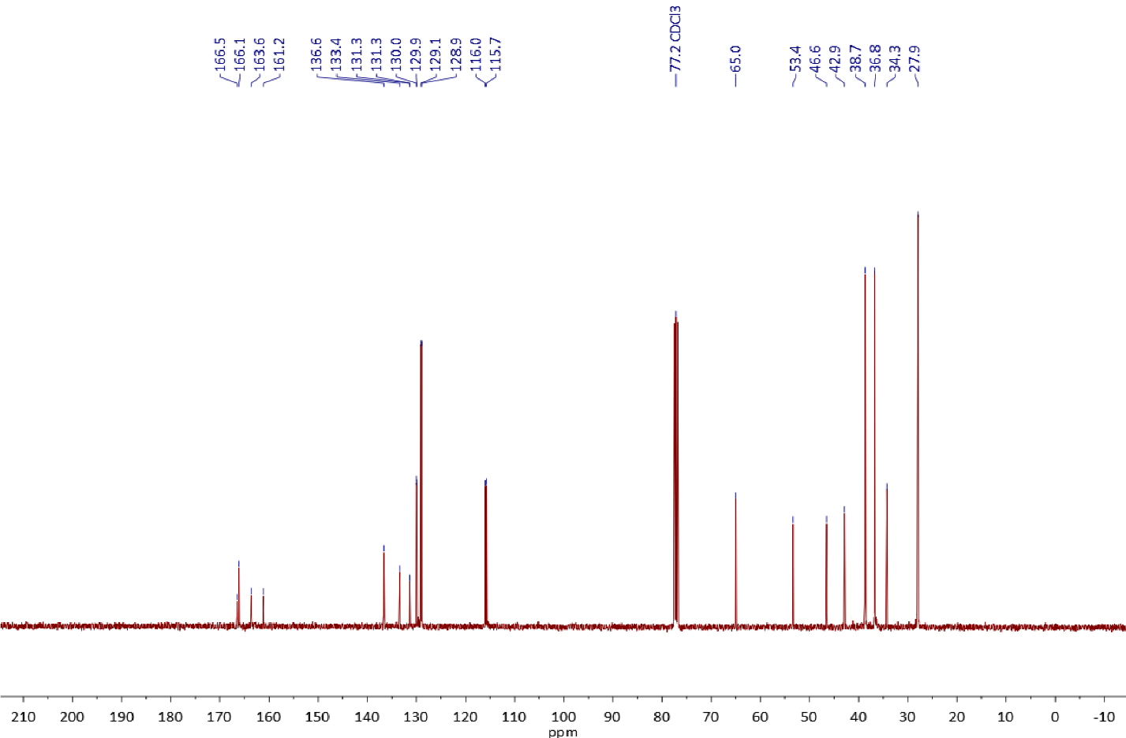

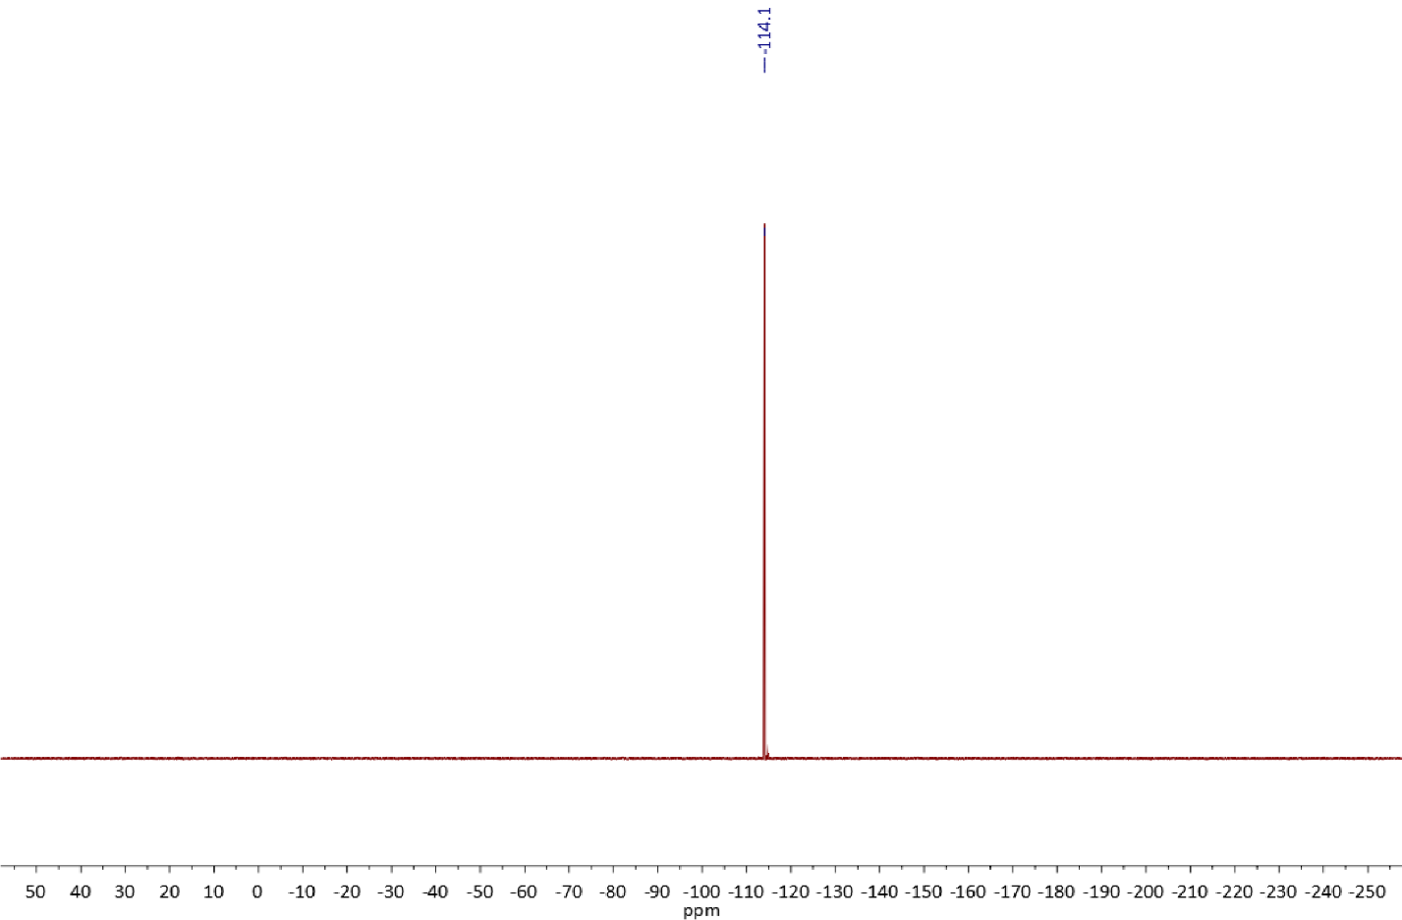

Copies of 1H (400.13 MHz, CDCl3) and 13C{1H} (100.61 MHz, CDCl3) spectra of **3s**

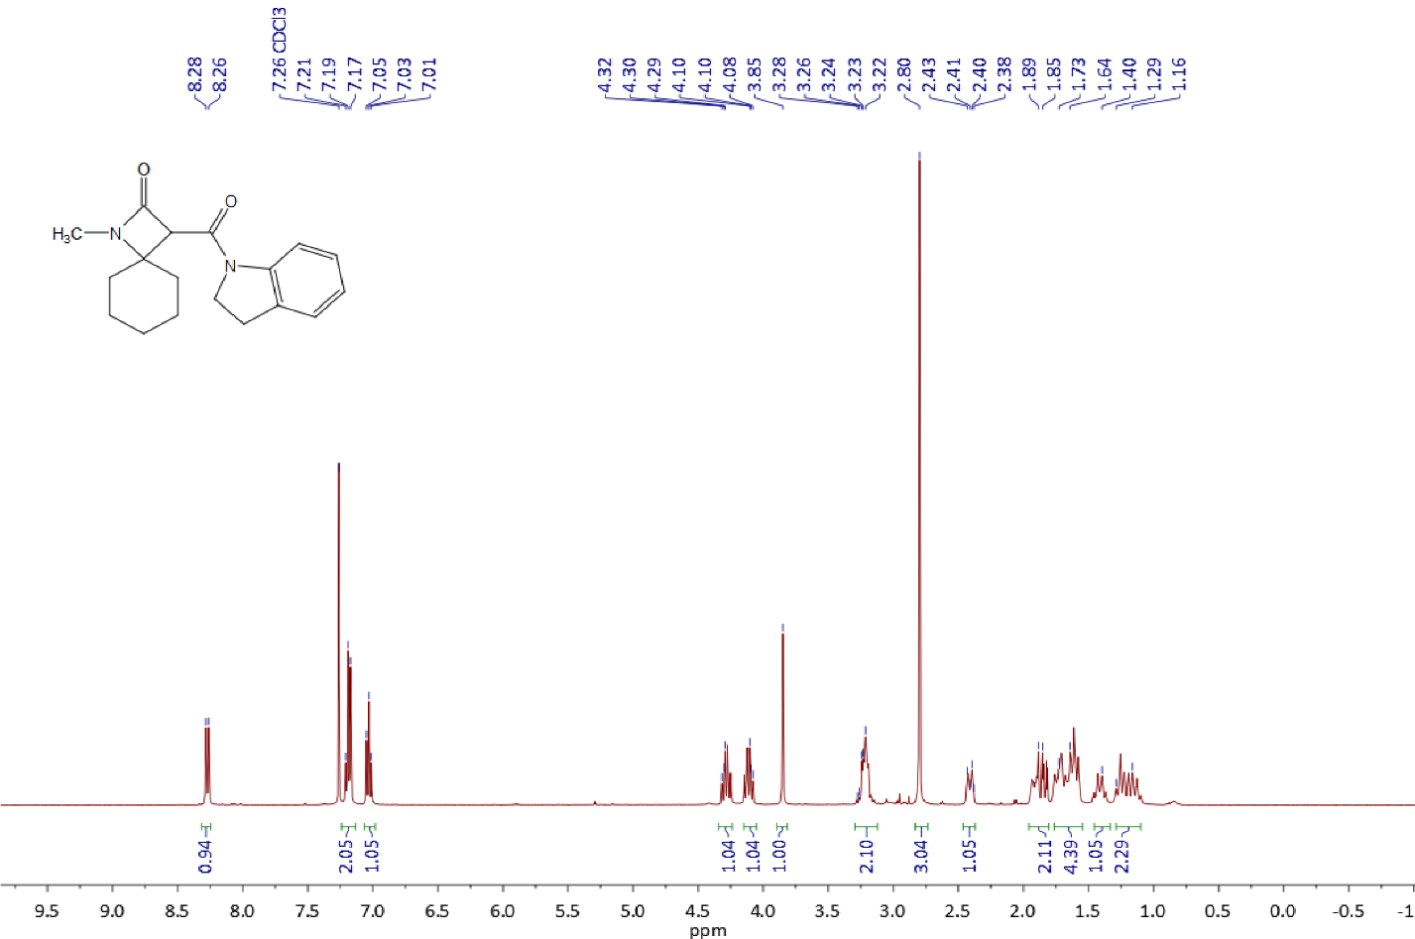

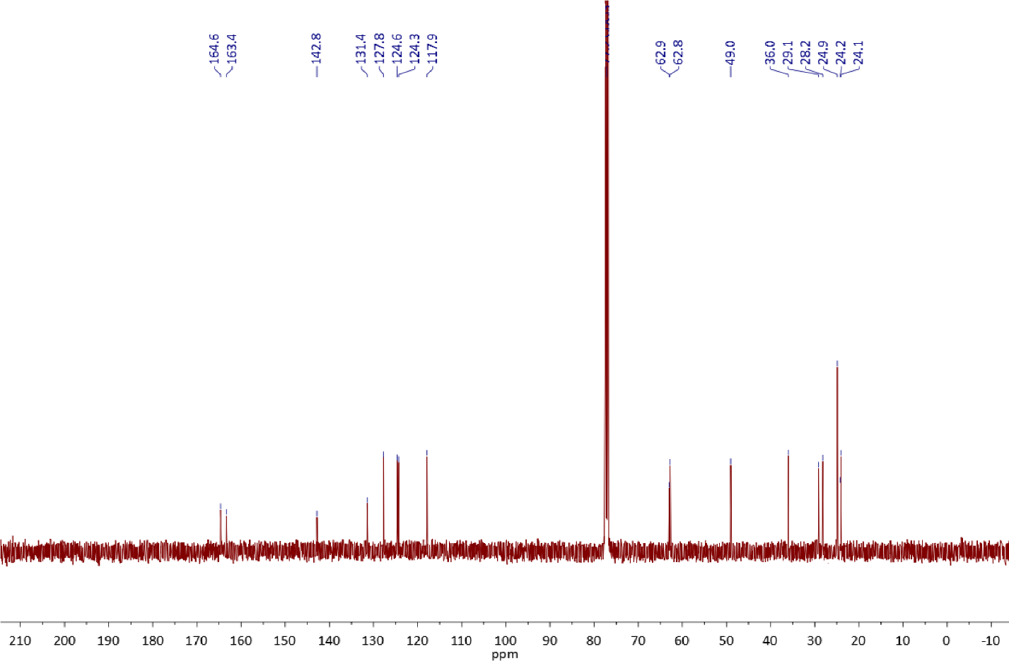

Copies of 1H (400.13 MHz, DMSO-*d6*) and 13C{1H} (100.61 MHz, DMSO-*d6*) spectra of **3t**.

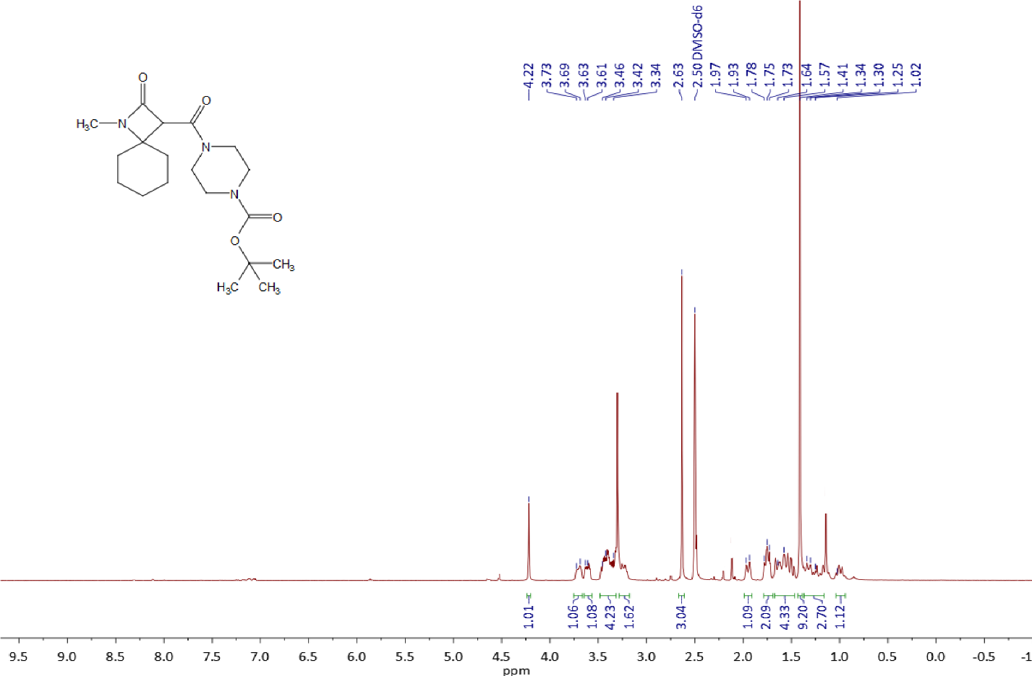

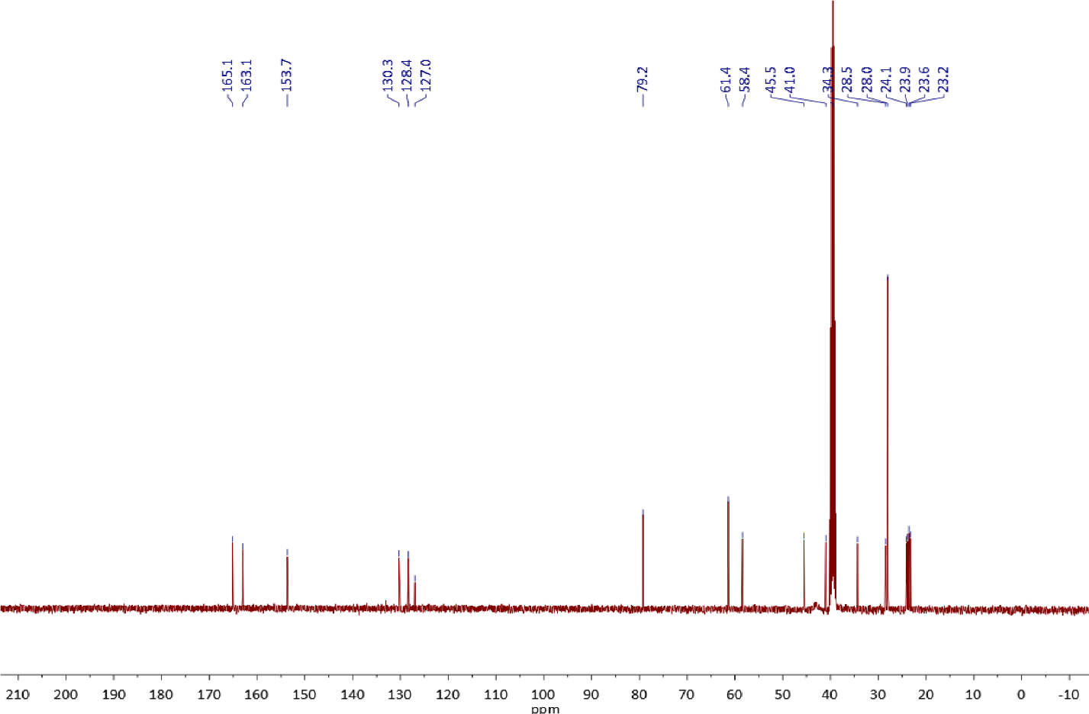

## ***3.1.*** NMR Spectra of β-lactamic acids **4a** and **4b**

Copies of 1H (400.13 MHz, CDCl3) and 13C{1H} (100.61 MHz, CDCl3) spectra of **4a**

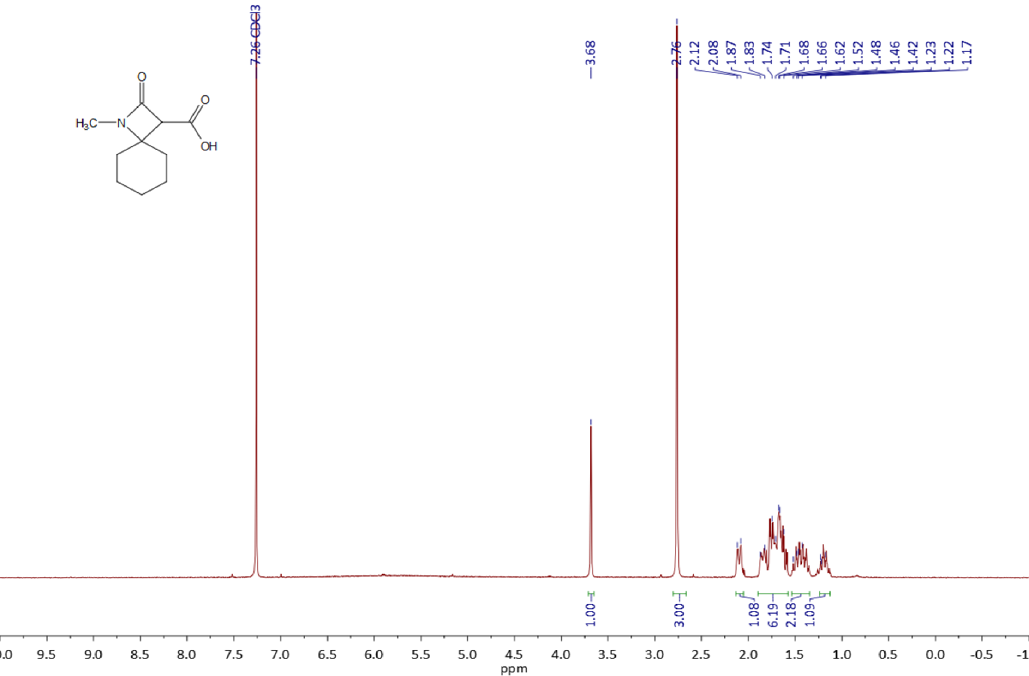

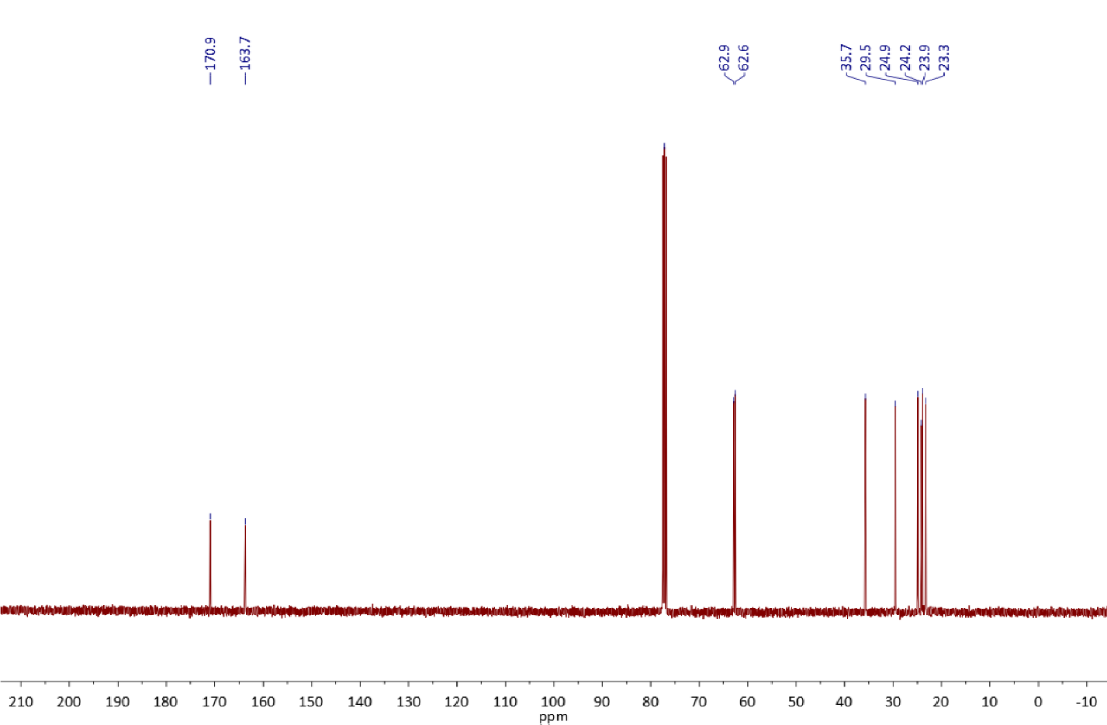

Copies of 1H (400.13 MHz, CDCl3) and 13C{1H} (100.61 MHz, CDCl3) spectra of **4b**

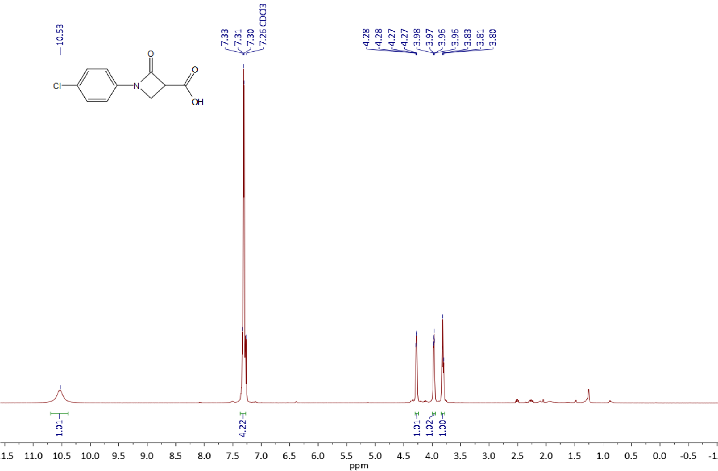

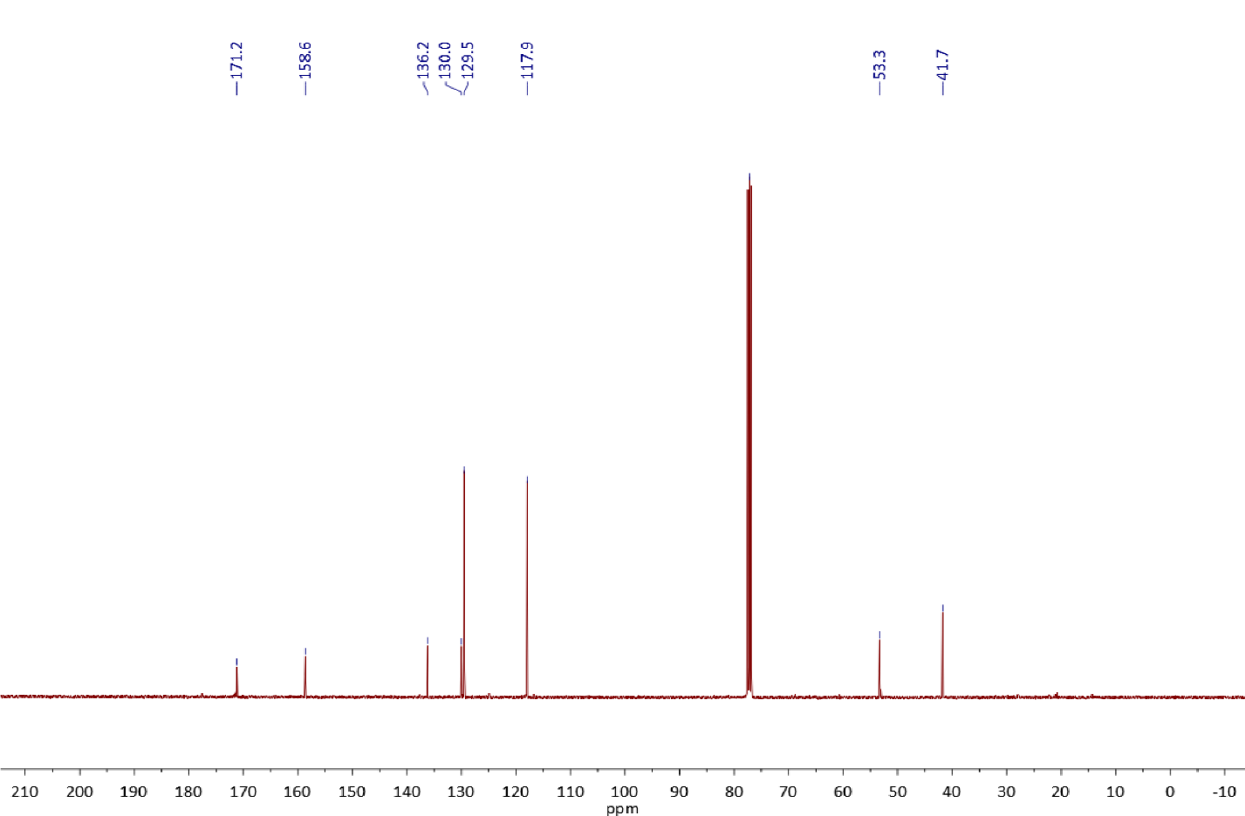

# Crystal Structure Data for Compounds 3r

X-Ray Single Crystall Analysis was performed on a SuperNova diffractometer. Crystals were kept at 100(2) K during data collection. Using Olex22, the structures were solved with the SHELXT3 structure solution program using Intrinsic Phasing and refined with the SHELXL4 refinement package using Least Squares minimisation.

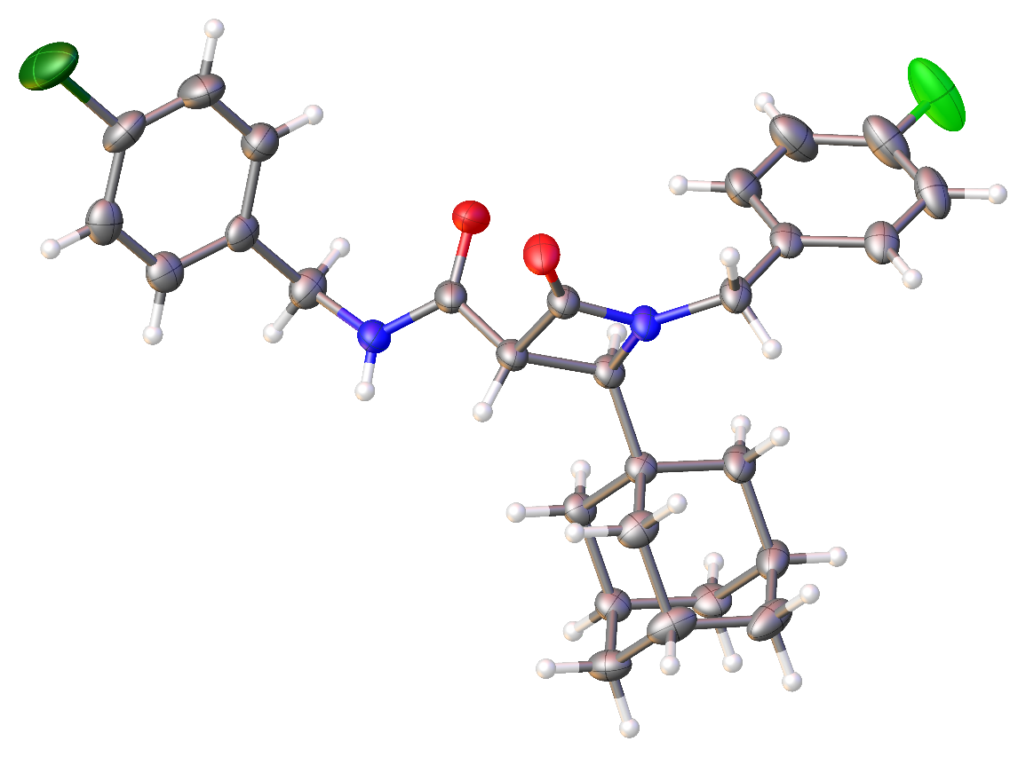

**Figure 1.** ORTEP representation of compound **3o** (thermal ellipsoids are shown at 50% probability).

|  |  |
| --- | --- |
| **Table S1.** Crystal data and structure refinement for **3r** | |
| **CCDC** | **2323689** |
| Empirical formula | C28H30ClFN2O2 |
| Formula weight | 480.99 |
| Temperature/K | 100(2) |
| Crystal system | monoclinic |
| Space group | P21/c |
| a/Å | 9.7326(3) |
| b/Å | 32.1486(5) |
| c/Å | 9.6486(2) |
| α/° | 90 |
| β/° | 118.040(4) |
| γ/° | 90 |
| Volume/Å3 | 2664.58(14) |
| Z | 4 |
| ρcalcg/cm3 | 1.199 |
| μ/mm‑1 | 1.536 |
| F(000) | 1016.0 |
| Crystal size/mm3 | 0.16 × 0.1 × 0.08 |
| Radiation | Cu Kα (λ = 1.54184) |
| 2Θ range for data collection/° | 5.498 to 134.966 |
| Index ranges | -7 ≤ h ≤ 11, -38 ≤ k ≤ 38, -11 ≤ l ≤ 11 |
| Reflections collected | 21040 |
| Independent reflections | 4646 [Rint = 0.0718, Rsigma = 0.0430] |
| Data/restraints/parameters | 4646/0/311 |
| Goodness-of-fit on F2 | 1.055 |
| Final R indexes [I>=2σ (I)] | R1 = 0.0690, wR2 = 0.1838 |
| Final R indexes [all data] | R1 = 0.0746, wR2 = 0.1882 |
| Largest diff. peak/hole / e Å-3 | 0.49/-0.75 |

# References

(1) Dar’in, D.; Kantin, G.; Glushakova, D.; Sharoyko, V.; Krasavin, M. Diazo Tetramic Acids Provide Access to Natural-Like Spirocyclic Δ α,β -Butenolides through Rh(II)-Catalyzed O–H Insertion/Base-Promoted Cyclization. *J Org Chem* **2023**. https://doi.org/10.1021/acs.joc.2c02600.

(2) Dolomanov, O. V.; Bourhis, L. J.; Gildea, R. J.; Howard, J. A. K.; Puschmann, H. *OLEX2* : A Complete Structure Solution, Refinement and Analysis Program. *J Appl Crystallogr* **2009**, *42* (2), 339–341. https://doi.org/10.1107/S0021889808042726.

(3) Sheldrick, G. M. *SHELXT* – Integrated Space-Group and Crystal-Structure Determination. *Acta Crystallogr A Found Adv* **2015**, *71* (1), 3–8. https://doi.org/10.1107/S2053273314026370.

(4) Sheldrick, G. M. Crystal Structure Refinement with *SHELXL*. *Acta Crystallogr C Struct Chem* **2015**, *71* (1), 3–8. https://doi.org/10.1107/S2053229614024218.