AFMDAQ Visualizer: Software and guide to reconstruct and analyze images with raw external data acquisition from the atomic force microscopies
D. Fernandez-Brito, E. Murillo-Bracamontes, C. I. Enriquez-Flores, J. J. Gervacio-Arciniega

Supporting information:
The program AFMDAQ Visualizer contain the Topography, Piezoresponse force microscopy, and force-time curves options. For every option there are some images and curves that can be obtained as is shown in the figure S1.
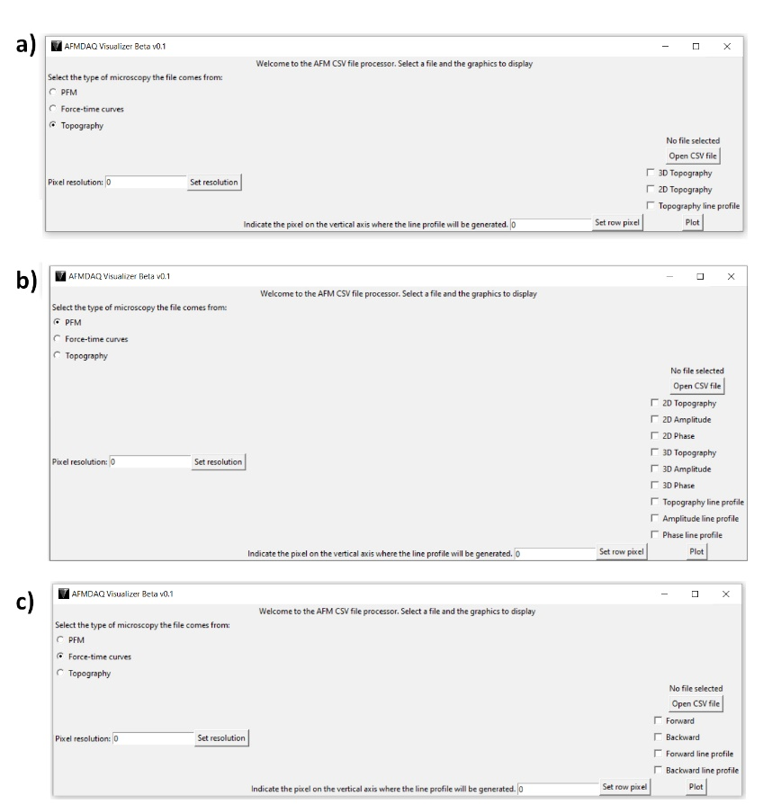
Figure S1. AFMDAQ Visualizer GUI, a) options for topography, b) options for Piezoresponse force microscopy PFM, and c) options for Force-time curves.

Additionally, the AFMDAQ Acquisition and AFMDAQ Visualizer programs was used in the Bruker/Veeco/Digital Instruments Nanoscope IV Dimension 3100 AFM. This AFM was upgraded with a closed-loop x–y nanopositioning stage, nPoint, Inc. NPXY100. A signal access module (SAM) accessory was used for signal input/output to the AFM. Raw data of topography was obtained by using the NI USB-6356 DAQ. From this measurement a CSV file with 3 columns and 9606801 rows was obtained, first rows of this CVS file are shown in Figure S2.
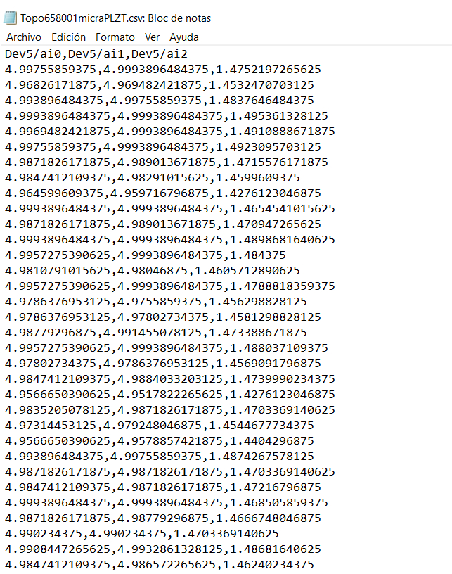
Figure S2. Data obtained by using the AFMDAQ Acquisition software in the Bruker/Veeco/Digital Instruments Nanoscope IV Dimension 3100 AFM.

The 2D topography of 256 pixels x 256 pixels generated from the data observed in Figure S2 is showed in figure S3. The sample used is a PLZT thin film.
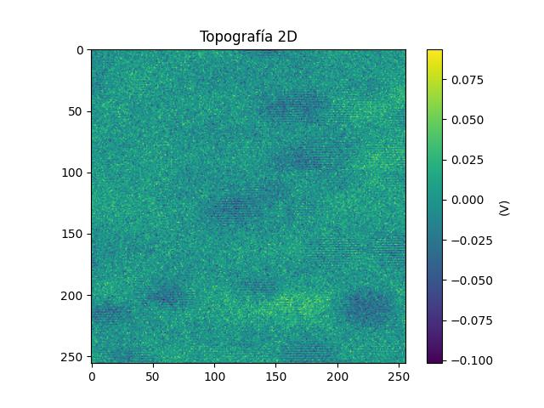
Figure S3. Topography of PLZT thin film, image reconstructed from the raw data obtained by using the AFMDAQ Acquisition software and process with the AFMDAQ Visualizer.

