Hypervalent iodine mediated cyclization of bishomoallylamides to prolinols

Smaher E. Butt,ª Konrad Kepski,ª Jean-Marc Sotiropoulos*^{b} and Wesley J. Moran*^{c}
ª Department of Physical and Life Sciences, University of Huddersfield, Queensgate, Huddersfield HD1 3DH, UK
^{b} Université de Pau et des Pays de l’Adour, IPREM (CNRS-UMR 5254), Technopole Hélioparc, 2 Avenue du Président Pierre Angot, 64053 Pau Cedex 09, France
^{c} School of Pharmacy and Bioengineering, Keele University, Keele, Staffordshire ST5 5JX, UK
Email: jean-marc.sotiro@univ-pau.fr; w.j.moran@keele.ac.uk

Contents

General information S3
Experimental procedures and compound characterization data S4
Cartesian coordinates and energies of calculated structures S25
Copies of NMR spectra S50
References S113

General information

Chemicals were purchased from Sigma Aldrich, Fisher Scientific, or Fluorochem and were used as received without purification or drying. Solvents were used as received without drying. Thin layer chromatography (TLC) was performed on precoated aluminum sheets of Merck silica gel 60 F254 (0.20 mm) and visualized by UV radiation (254 nm). Automated column chromatography was performed on a Biotage® Isolera Four using Biotage® SNAP Ultra cartridges. Melting points were obtained by DSC analysis. ¹H NMR and ¹³C NMR spectra were measured on Bruker AV III 400 or Bruker Neo 600 apparatus and were referenced to the solvent peak. Chemical shifts δ are given in ppm and the multiplicity of the signals are reported as: s = singlet, s_{br} = broad singlet, d = doublet, t = triplet, q = quartet, sept = septet, dd = doublet of doublets, dt = doublet of triplets, dq = doublet of quartets, qd = quartet of doublets, m = multiplet. The coupling constants (J) are given in Hertz. Mass spectrometric measurements were performed at Innovative Physical Organic Solutions (IPOS), University of Huddersfield on Agilent 1290 HPLC + 6530 QTOF instrument. Ions were generated by electrospray ionisation (ESI) and only the mass ions are reported. Spectral data for previously reported compounds are in good agreement with the literature values.

Preparation of cyclization substrates 3
Substrates were prepared in three steps using the strategy below:
General procedure for STEP 1. Synthesis of 2-(pent-4-en-1-yl)-1H-isoindole-1,3(2H)-dione (S2a).
Prepared using a modified version of the procedure reported by White et al. PPh₃ (17.5 g, 67 mmol, 1.0 equiv) was added to an oven dried flask and purged with N₂. THF (180 mL) was added and the mixture cooled to 0 °C. DIAD (14.5 mL, 74 mmol, 1.1 equiv) was added dropwise followed by the addition of 4-penten-1-ol (6.9 mL, 67 mmol, 1.0 equiv). After 5 minutes, phthalimide (9.83 g, 67 mmol, 1.0 equiv) was added. The reaction vessel was raised out of the cooling bath and left stirring at rt overnight. All volatiles were removed under vacuum and a mixture of petroleum ether/EtOAc (10:1, 125 mL) was added. The suspension was filtered, and the filtrate was concentrated under vacuum. The crude was purified using flash chromatography (silica gel, 95:5 petrol/EtOAc) to afford the product S2a as a pale-yellow oil (12.12 g, 84% yield). Data matched the literature values.¹
IR: 716 (s), 884 (m), 1047 (w), 1071 (w), 1335 (m), 1367 (m), 1393 (s), 1437 (m), 1467 (w), 1640 (w), 1703 (s), 2937 (w) cm⁻¹.
¹H NMR (CDCl₃, 600 MHz): δ 1.77 (2H, quint, J = 7.4 Hz, CH₂), 2.10 (2H, q, J = 7.3 Hz, CH₂), 3.68 (2H, t, J = 7.3 Hz, CH₂), 4.96 (1H, dq, J = 10.3, 1.5 Hz, H^{b}), 5.04 (1H, dq, J = 17.1, 1.7 Hz, Hª), 5.80 (1H, ddt, J = 17.2, 10.4, 6.6 Hz, CH), 7.69 (2H, dd, J = 5.5, 3.0 Hz, Ar), 7.82 (2H, dd, J = 5.5, 3.0 Hz, Ar).
¹³C NMR (CDCl₃, 150 MHz): δ 27.7, 31.1, 37.7, 115.4, 123.3, 132.3, 134.0, 137.4, 168.5.
HRMS (ESI-TOF) m/z: [M+H]⁺ Cald for C₁₃H₁₄NO₂⁺ 216.1019; Found 216.1024.

Synthesis of 2-((4Z)-hex-4-en-1-yl)-1H-isoindole-1,3(2H)-dione (S2o).
Prepared according to the general procedure for step 1, at half the scale, using cis-4-hexen-1-ol (3.9 mL, 33 mmol, 1.0 equiv). The crude was purified using flash chromatography (silica gel, 95:5 petrol/EtOAc) to afford the product S2o as a pale-yellow oil (6.26 g, 82% yield).
IR: 712 (s), 883 (w), 1017 (m), 1072 (m), 1334 (m), 1365 (m), 1392 (s), 1436 (m), 1466 (w), 1614 (w), 1703 (s), 2937 (w) cm⁻¹.
¹H NMR (CDCl₃, 400 MHz): δ 1.59 (3H, d, J = 6.5 Hz, Me), 1.75 (2H, quint, J = 7.5 Hz, CH₂), 2.11 (2H, q, J = 7.4 Hz, CH₂), 3.69 (2H, t, J = 7.5 Hz, CH₂), 5.34-5.52 (2H, m, Hª+H^{b}), 7.70 (2H, dd, J = 5.6, 3.1 Hz, Ar), 7.84 (2H, dd, J = 5.5, 3.1 Hz, Ar).
¹³C NMR (CDCl₃, 100 MHz): δ 12.9, 24.4, 28.5, 37.9, 123.3, 125.0, 129.2, 132.3, 134.0, 168.6.
HRMS (ESI-TOF) m/z: [M+H]⁺ Cald for C₁₄H₁₆NO₂⁺ 230.1176; Found 230.1181.

Synthesis of 2-(6-methylhept-5-en-2-yl)-1H-isoindole-1,3(2H)-dione (S2p).
Prepared according to the general procedure for step 1, at half the scale, using 6-methyl-5-hepten-2-ol (5.1 mL, 33 mmol, 1.0 equiv). The crude was purified using flash chromatography (silica gel, 98:2 petrol/EtOAc) to afford the product S2p as a colorless oil (6.48 g, 75% yield).
IR: 717 (s), 879 (m), 1039 (m), 1085 (w), 1332 (m), 1355 (s), 1392 (m), 1451 (w), 1466 (w), 1613 (w), 1702 (s), 2929 (w) cm⁻¹.
¹H NMR (CDCl₃, 400 MHz): δ 1.46 (3H, d, J = 6.9 Hz, Me), 1.49 (3H, s, Meª), 1.54 (3H, d, J = 1.0 Hz, Me^{b}), 1.75 (1H, ddt, J = 13.8, 7.5, 6.0 Hz, CH₂), 1.97 (2H, q, J = 7.3 Hz, CH₂), 2.16 (1H, ddt, J = 14.7, 9.6, 7.3 Hz, CH₂), 4.36 (1H, ddt, J = 14.6, 9.6, 6.9 Hz, Hª), 5.04 (1H, tt, J = 7.1, 1.4 Hz, CH), 7.69 (2H, dd, J = 5.6, 3.0 Hz, Ar), 7.81 (2H, dd, J = 5.6, 3.0 Hz, Ar).
¹³C NMR (CDCl₃, 100 MHz): δ 17.8, 19.0, 25.6, 25.7, 33.6, 47.4, 123.1, 123.5, 132.2, 132.3, 133.9, 168.7.
HRMS (ESI-TOF) m/z: [M+H]⁺ Cald for C₁₆H₂₀NO₂⁺ 258.1489; Found 258.1494.

General procedure for STEP 2. Synthesis of pent-4-en-1-amine (S3a).
Prepared using a modified version of the procedure reported by Xu et al. Phthalimide S2a (3.0 g, 14 mmol, 1.0 equiv), hydrazine monohydrate (1.0 mL, 21 mmol, 1.5 equiv) and styrene (3.2 mL, 28 mmol, 2.0 equiv) were all dissolved in ethanol (70 mL) and stirred at reflux for 4 hours. The suspension was cooled down to rt and filtered. The filtrate was acidified using HCl (1 M, 20 mL), filtered and transferred to a separating funnel. The organic layer was extracted with Et₂O (50 mL) and then discarded. The aqueous layer was basified using NaOH (4 M, 20 mL) and extracted three times with DCM (3 x 50 mL). The organic extracts were combined, dried using Na₂SO₄ and filtered. The filtrate was reduced under vacuum (20 °C, 500 mbar) to ~30 mL and immediately used in the next step.

Synthesis of (Z)-hex-4-en-1-amine (S3o).
Prepared according to the general procedure for step 2 using phthalimide S2o (3.19 g, 14 mmol, 1.0 equiv). The crude amine was used directly in the next step.

Synthesis of 6-methylhept-5-en-2-amine (S3p).

Prepared according to the general procedure for step 2 using phthalimide S29 (2.99 g, 12 mmol, 1.0 equiv). The crude amine was used directly in the next step.

General procedure for STEP 3. Synthesis of N-(pent-4-en-1-yl)benzamide (3a)
Prepared using the procedure reported by Gilmour et al.³ Pent-4-en-1-amine (S3a) (2.6 g, 14 mmol, 1.0 equiv) was dissolved in DCM (30 mL), purged with N₂, and cooled to 0 °C. Et₃N (3.9 mL, 28 mmol, 2.0 equiv) was added followed by dropwise addition of benzoyl chloride (1.6 mL, 14 mmol, 1.0 equiv). The reaction vessel was raised out of the cooling bath and left stirring at rt overnight. All volatiles were removed under vacuum and Et₂O (50 mL) was added. The suspension was filtered and the filtrate was basified using NaOH (2 M, 10 mL). The resulting mixture was transferred to a separating funnel and extracted three times with Et₂O (3 x 50 mL). The organic extracts were combined, dried using Na₂SO₄, filtered and reduced under vacuum. The crude was purified by flash chromatography (silica gel, 85:15 petrol/EtOAc) to afford the product 3a as a colorless oil (1.74 g, 66% yield). Data matched literature values.³
IR: 692 (s, b), 910 (m), 1204 (w), 1366 (w), 1435 (m), 1489 (m), 1603 (m), 1634 (s), 2931 (w), 3074 (w), 3307 (w, b) cm⁻¹.
¹H NMR (CDCl₃, 400 MHz): δ 1.72 (2H, quint, J = 7.4 Hz, CH₂), 2.16 (2H, q, J = 7.2 Hz, CH₂), 3.47 (2H, q, J = 6.7 Hz, CH₂), 5.00 (1H, dd, J = 10.2, 1.0 Hz, H^{b}), 5.06 (1H, dd, J = 17.2, 1.5 Hz, Hª), 5.83 (1H, ddt, J = 17.2, 10.4, 6.6 Hz, CH), 6.28 (1H, br s, NH), 7.41 (2H, t, J = 7.4 Hz, Ar), 7.48 (1H, t, J = 7.2 Hz, Ar), 7.75 (2H, d, J = 8.0 Hz, Ar).
¹³C NMR (CDCl₃, 100 MHz): δ 28.9, 31.4, 39.8, 115.4, 126.9, 128.7, 131.5, 134.9, 138.0, 167.6.
HRMS (ESI-TOF) m/z: [M+H]⁺ Cald for C₁₂H₁₆NO⁺ 190.1226; Found 190.1238.

Synthesis of 4-chloro-N-(pent-4-en-1-yl)benzamide (3b)
Prepared according to the general procedure for step 3 using pent-4-en-1-amine (S3a) (12 mmol, 1.0 equiv) in DCM (30 mL). Et₃N (3.4 mL, 24 mmol, 2.0 equiv). 4-Chlorobenzoyl chloride (1.6 mL, 12 mmol, 1.0 equiv). The crude was purified using flash chromatography (silica gel, 90:10 petrol/EtOAc) to afford the product 3b as a white powder (1.28 g, 47% yield).
M.p.: 48-51 °C.
IR: 664 (s, b), 758 (m), 917 (s), 1210 (m), 1374 (m), 1435 (m), 1460 (m), 1483 (m), 1595 (m), 1630 (s), 2979 (m), 3074 (w), 3301 (m, br) cm⁻¹.
¹H NMR (CDCl₃, 400 MHz): δ 1.72 (2H, quint, J = 7.4 Hz, CH₂), 2.15 (2H, q, J = 7.2 Hz, CH₂), 3.46 (2H, q, J = 6.7 Hz, CH₂), 5.01 (1H, dd, J = 10.2, 1.0 Hz, H^{b}), 5.06 (1H, dd, J = 17.2, 1.5 Hz, Hª), 5.83 (1H, ddt, J = 17.2, 10.3, 6.6 Hz, CH), 6.23 (1H, br s, NH), 7.39 (2H, d, J = 8.5 Hz, Ar), 7.69 (2H, d, J = 8.5 Hz, Ar).
¹³C NMR (CDCl₃, 100 MHz): δ 28.8, 31.4, 39.9, 115.5, 128.4, 128.9, 133.2, 137.7, 137.9, 166.6.
HRMS (ESI-TOF) m/z: [M+H]⁺ Cald for C₁₂H₁₅ClNO⁺ 224.0837; Found 224.0846.
Synthesis of 4-bromo-N-(pent-4-en-1-yl)benzamide (3c)
Prepared according to the general procedure for step 3 using pent-4-en-1-amine (S3a) (14 mmol, 1.0 equiv) in DCM (30 mL). Et₃N (3.9 mL, 28 mmol, 2.0 equiv) and 4-bromobenzoyl chloride (3.05 g, 14 mmol, 1.0 equiv). The crude was purified using flash chromatography (silica gel, 89:11 petrol/EtOAc) to afford the product as a white solid (0.45 g, 12% yield).
M.p.: 67-70 °C.
IR: 641 (m, b), 756 (m), 919 (s), 1263 (m), 1333 (m), 1436 (m), 1479 (m), 1589 (m), 1630 (s), 2979 (s), 3077 (w), 3301 (m, b) cm⁻¹.
¹H NMR (CDCl₃, 400 MHz): δ 1.73 (2H, quint, J = 7.3 Hz, CH₂), 2.16 (2H, q, J = 7.1 Hz, CH₂), 3.46 (2H, q, J = 6.7 Hz, CH₂), 5.01 (1H, dd, J = 10.2, 1.5 Hz, H^{b}), 5.07 (1H, dq, J = 17.2, 1.7 Hz, Hª), 5.84 (1H, ddt, J = 17.2, 10.3, 6.7 Hz, CH), 6.16 (1H, br s, NH), 7.56 (2H, d, J = 8.7 Hz, Ar), 7.62 (2H, d, J = 8.7 Hz, Ar).
¹³C NMR (CDCl₃, 100 MHz): δ 28.8, 31.4, 39.9, 115.5, 126.1, 128.6, 131.9, 133.7, 137.9, 166.6.
HRMS (ESI-TOF) m/z: [M+H]⁺ Cald for C₁₂H₁₅BrNO⁺ 268.0346; Found 268.0336.

Synthesis of N-(pent-4-en-1-yl)[1,1'-biphenyl]-4-carboxamide (3d)
Prepared according to the general procedure for step 3 using pent-4-en-1-amine (S3a) (14 mmol, 1.0 equiv) in DCM (30 mL). Et₃N (3.9 mL, 28 mmol, 2.0 equiv). Biphenyl-4-carbonyl chloride (3.01 g, 13.9 mmol, 1.0 equiv). The crude was purified using flash chromatography (silica gel, 85:15 petrol/EtOAc) to afford the product as a white powder (0.46 g, 12% yield).
M.p.: 141-144 °C.
IR: 654 (m, b), 742 (s), 912 (m), 1448 (m), 1483 (m), 1608 (w), 1630 (s), 2979 (w), 3325 (w, b) cm⁻¹.
¹H NMR (CDCl₃, 400 MHz): δ 1.76 (2H, quint, J = 7.3 Hz, CH₂), 2.19 (2H, q, J = 7.2 Hz, CH₂), 3.51 (2H, q, J = 6.7 Hz, CH₂), 5.02 (1H, dd, J = 10.2, 1.5 Hz, H^{b}), 5.09 (1H, dq, J = 17.2, 1.7 Hz, Hª), 5.86 (1H, ddt, J = 17.2, 10.3, 6.6 Hz, CH), 6.21 (1H, br s, NH), 7.38 (1H, t, J = 7.3 Hz, Ar), 7.46 (2H, t, J = 7.5 Hz, Ar), 7.61 (2H, d, J = 7.8 Hz, Ar), 7.65 (2H, d, J = 8.3 Hz, Ar), 7.83 (2H, d, J = 8.3 Hz, Ar).
¹³C NMR (CDCl₃, 100 MHz): δ 29.0, 31.4, 39.8, 115.5, 127.3, 127.4, 127.5, 128.1, 129.1, 133.6, 138.0, 140.2, 144.3, 167.3.
HRMS (ESI-TOF) m/z: [M+H]⁺ Cald for C₁₈H₂₀NO⁺ 266.1539; Found 266.1551.

Synthesis of 4-methoxy-N-(pent-4-en-1-yl)benzamide (3e)
Prepared according to the general procedure for step 3 using pent-4-en-1-amine (S3a) (14 mmol, 1.0 equiv) in DCM (30 mL). Et₃N (3.9 mL, 28 mmol, 2.0 equiv) and 4-methoxybenzoyl chloride (1.9 mL, 14 mmol, 1.0 equiv). The crude was purified using flash chromatography (silica gel, 80:20 petrol/EtOAc) to afford the product as a white solid (0.92 g, 30% yield). Data matches the literature values.
M.p.: 48-51 °C.
IR: 652 (m, b), 762 (s), 911 (m), 1250 (m), 1366 (w), 1440 (m), 1452 (m), 1462 (m), 1603 (s), 1628 (s), 2924 (w), 3079 (w), 3323 (m, b) cm⁻¹.
¹H NMR (CDCl₃, 400 MHz): δ 1.64 (2H, quint, J = 7.3 Hz, CH₂), 2.06 (2H, q, J = 7.3 Hz, CH₂), 3.36 (2H, q, J = 6.6 Hz, CH₂), 3.76 (3H, s, OMe), 4.92 (1H, dd, J = 10.2, 1.5 Hz, H^{b}), 4.98 (1H, dq, J = 17.2, 1.7 Hz, Hª), 5.75 (1H, ddt, J = 17.2, 10.3, 6.6 Hz, CH), 6.82 (2H, d, J = 8.9 Hz, Ar), 6.85 (1H, br s, NH), 7.73 (2H, d, J = 8.9 Hz, Ar).
¹³C NMR (CDCl₃, 100 MHz): δ 28.8, 31.2, 39.6, 55.3, 113.5, 115.0, 127.0, 128.0, 137.9, 161.9, 167.2.
HRMS (ESI-TOF) m/z: [M+H]⁺ Cald for C₁₃H₁₈O₂⁺ 220.1332; Found 220.1341.

Synthesis of 2-methyl-N-(pent-4-en-1-yl)benzamide (3f)
Prepared according to the general procedure for step 3 using pent-4-en-1-amine (S3a) (12 mmol, 1.0 equiv) in DCM (30 mL). Et₃N (3.4 mL, 24 mmol, 2.0 equiv) and o-toluoyl chloride (1.6 mL, 12 mmol, 1.0 equiv). The crude was purified using flash chromatography (silica gel, 90:10 petrol/EtOAc to afford the product as a colorless oil (0.84 g, 34% yield).
IR: 693 (m, b), 727 (m), 909 (m), 1205 (w), 1378 (w), 1435 (m), 1486 (m), 1600 (m), 1634 (s), 2927 (w), 3073 (w), 3271 (w, b) cm⁻¹.
¹H NMR (CDCl₃, 400 MHz): δ 1.71 (2H, quint, J = 7.3 Hz, CH₂), 2.16 (2H, q, J = 7.3 Hz, CH₂), 2.43 (3H, s, Me), 3.44 (2H, q, J = 6.7 Hz, CH₂), 5.00 (1H, dd, J = 10.2, 1.5 Hz, H^{b}), 5.06 (1H, dq, J = 17.2, 1.7 Hz, Hª), 5.77-5.89 (2H, m, CH+NH), 7.15-7.22 (2H, m, Ar), 7.25-7.35 (2H, m, Ar).
¹³C NMR (CDCl₃, 100 MHz): δ 19.8, 29.0, 31.3, 39.4, 115.5, 125.8, 126.7, 129.8, 131.1, 136.0, 136.8, 137.8, 170.2.
HRMS (ESI-TOF) m/z: [M+H]⁺ Cald for C₁₃H₁₈NO⁺ 204.1383; Found 204.1374.

Synthesis of 2-fluoro-N-(pent-4-en-1-yl)benzamide (3g)
Prepared according to the general procedure for step 3 using pent-4-en-1-amine (S3a) (14 mmol, 1.0 equiv) in DCM (30 mL). Et₃N (3.9 mL, 28 mmol, 2.0 equivand 2-fluorobenzoyl chloride (1.7 mL, 14mmol, 1.0 equiv. The crude was purified using flash chromatography (silica gel, 90:10 petrol/EtOAc) to afford the product as a yellow oil (1.76 g, 61% yield).
IR: 912 (m), 1223 (m), 1366 (w), 1451 (m), 1480 (m), 1614 (m), 1639 (s), 2932 (w), 3078 (w), 3297 (w, b) cm⁻¹.
¹H NMR (CDCl₃, 400 MHz): δ 1.72 (2H, quint, J = 7.3 Hz, CH₂), 2.15 (2H, q, J = 7.3 Hz, CH₂), 3.48 (2H, q, J = 6.7 Hz, CH₂), 4.99 (1H, dq, J = 10.2, 1.5 Hz, H^{b}), 5.05 (1H, dq, J = 17.2, 1.7 Hz, Hª), 5.82 (1H, ddt, J = 17.2, 10.3, 6.7 Hz, CH), 6.78 (1H, br s, NH), 7.08 (1H, ddd, J = 12.3, 8.3, 1.0 Hz, Ar), 7.23 (1H, td, J = 7.6, 1.1 Hz, Ar), 7.39-7.47 (1H, m, Ar), 8.06 (1H, td, J = 7.9, 1.9 Hz, Ar).
¹³C NMR (CDCl₃, 100 MHz): δ 28.7, 31.3, 39.6, 115.5, 116.1 (d, J = 24.9 Hz), 121.3 (d, J = 11.8 Hz), 124.9 (d, J = 3.4 Hz), 132.2 (d, J = 2.2 Hz), 133.3 (d, J = 9.2 Hz), 137.8, 160.7 (d, J = 247 Hz), 163.4 (d, J = 3.2 Hz).
¹⁹F (CDCl₃, 376 MHz): -114.0.
HRMS (ESI-TOF) m/z: [M+H]⁺ Cald for C₁₂H₁₅FNO⁺ 208.1132; Found 208.1132.

Synthesis of 2-methoxy-N-(pent-4-en-1-yl)benzamide (3h)
Prepared according to the general procedure for step 3 using pent-4-en-1-amine (S3a) (14 mmol, 1.0 equiv) in DCM (30 mL). Et₃N (3.9 mL, 28 mmol, 2.0 equiv) and o-methoxybenzoyl chloride (2.0 mL, 14 mmol, 1.0 equiv). The crude was purified using flash chromatography (silica gel, 80:20 petrol/EtOAc) to afford the product as a yellow oil (1.07 g, 35% yield).
IR: 655 (m, b), 753 (s), 909 (m), 1236 (s), 1435 (m), 1464 (m), 1482 (m), 1598 (m), 1642 (s), 2931 (w), 3075 (w), 3404 (w, b) cm⁻¹.
¹H NMR (CDCl₃, 400 MHz): δ 1.72 (2H, quint, J = 7.2 Hz, CH₂), 2.16 (2H, q, J = 7.2 Hz, CH₂), 3.48 (2H, q, J = 6.6 Hz, CH₂), 3.96 (3H, s, OMe), 4.99 (1H, dq, J = 10.3, 1.5 Hz, H^{b}), 5.06 (1H, dq, J = 17.1, 1.7 Hz, Hª), 5.84 (1H, ddt, J = 17.2, 10.3, 6.7 Hz, CH), 6.96 (1H, d, J = 8.5 Hz, Ar), 7.07 (1H, td, J = 7.6, 0.8 Hz, Ar), 7.40-7.45 (1H, m, Ar), 7.87 (1H, br s, NH), 8.21 (1H, dd, J = 7.8, 1.8 Hz, Ar).
¹³C NMR (CDCl₃, 100 MHz): δ 28.9, 31.4, 39.3, 56.0, 111.4, 115.2, 121.4, 121.8, 132.4, 132.7, 138.0, 157.5, 165.3.
HRMS (ESI-TOF) m/z: [M+Na]⁺ Cald for C₁₃H₁₈NO₂⁺ 242.1151; Found 242.1157.

Synthesis of N-(pent-4-en-1-yl)acetamide (3i)
Prepared according to the general procedure for step 3 using pent-4-en-1-amine (S3a) (14 mmol, 1.0 equiv) in DCM (30 mL). Et₃N (3.9 mL, 28 mmol, 2.0 equiv) and acetyl chloride (1.0 mL, 14 mmol, 1.0 equiv). The crude was purified using flash chromatography (silica gel, 80:20 petrol/EtOAc) to afford the product as a yellow oil (0.60 g, 34% yield). Data matched the literature values.⁴
IR: 604 (m, b), 724 (w), 910 (m), 1289 (m), 1366 (m), 1640 (m), 2929 (w), 3079 (w), 3287 (w, b) cm⁻¹.
¹H NMR (CDCl₃, 400 MHz): δ 1.58 (2H, quint, J = 7.3 Hz, CH₂), 1.94 (3H, s, Me), 2.06 (2H, q, J = 7.3 Hz, CH₂), 3.22 (2H, q, J = 6.6 Hz, CH₂), 4.95 (1H, dq, J = 10.3, 1.4 Hz, H^{b}), 5.00 (1H, dq, J = 17.2, 1.7 Hz, Hª), 5.77 (1H, ddt, J = 17.0, 10.2, 6.7 Hz, CH), 5.86 (1H, br s, NH).
¹³C NMR (CDCl₃, 100 MHz): δ 23.4, 28.8, 31.2, 39.3, 115.3, 137.9, 170.2.
HRMS (ESI-TOF) m/z: [M+H]⁺ Cald for C₇H₁₄NO⁺ 128.1070; Found 128.1076.

Synthesis of 2,2-dimethyl-I-(pent-4-en-1-yl)propanamide (3j)
Prepared according to the general procedure for step 3 using pent-4-en-1-amine (S3a) (12 mmol, 1.0 equiv) in DCM (30 mL). Et₃N (3.4 mL, 24 mmol, 2.0 equiv) and trimethylacetyl chloride (1.5 mL, 12 mmol, 1.0 equiv). The crude was purified using flash chromatography (silica gel, 85:15 petrol/EtOAc) to afford the product as a pale-brown oil (0.64 g, 31% yield).
IR: 640 (w, b), 908 (m), 1210 (m), 1366 (w), 1480 (w), 1635 (s), 2963 (w), 3077 (w), 3342 (w, b) cm⁻¹.
¹H NMR (CDCl₃, 400 MHz): δ 1.18 (9H, s, Me), 1.60 (2H, quint, J = 7.2 Hz, CH₂), 2.08 (2H, q, J = 7.2 Hz, CH₂), 3.25 (2H, q, J = 6.7 Hz, CH₂), 4.98 (1H, dd, J = 10.3, 1.0 Hz, H^{b}), 5.03 (1H, dq, J = 17.2, 1.7 Hz, Hª), 5.67 (1H, br s, NH), 5.80 (1H, ddt, J = 17.1, 10.3, 6.7 Hz, CH).
¹³C NMR (CDCl₃, 100 MHz): δ 27.7, 28.8, 31.3, 38.8, 39.2, 115.3, 138.1, 178.5.
HRMS (ESI-TOF) m/z: [M+H]⁺ Cald for C₁₀H₂₀NO⁺ 170.1539; Found 170.1547.

Synthesis of N-(pent-4-en-1-yl)(phenyl)acetamide (3k)
Prepared according to the general procedure for step 3 using pent-4-en-1-amine (S3a) (14 mmol, 1.0 equiv) in DCM (30 mL). Et₃N (3.9 mL, 28 mmol, 2.0 equiv) and phenylacetyl chloride (1.8 mL, 14 mmol, 1.0 equiv). The crude was purified using flash chromatography (silica gel, 83:17 petrol/EtOAc) to afford the product as a yellow solid (1.07 g, 38% yield).
M.p.: 39-42 °C.
IR: 692 (s), 754 (m), 909 (m), 1270 (m), 1346 (m), 1453 (m), 1472 (m), 1491 (m), 1626 (m), 1655 (m), 2932 (m), 3063 (m), 3242 (m, b) cm⁻¹.
¹H NMR (CDCl₃, 400 MHz): δ 1.52 (2H, quint, J = 7.2 Hz, CH₂), 1.99 (2H, q, J = 7.2 Hz, CH₂), 3.21 (2H, q, J = 6.5 Hz, CH₂), 3.56 (2H, s, ArCH₂), 4.88-4.97 (2H, m, Hª+H^{b}), 5.45 (1H, br s, NH), 5.72 (1H, ddt, J = 17.1, 10.2, 6.7 Hz, CH), 7.23-7.39 (5H, m, Ar).
¹³C NMR (CDCl₃, 100 MHz): δ 28.6, 31.2, 39.2, 44.0, 115.3, 127.5, 129.1, 129.6, 135.1, 137.8, 171.0.
HRMS (ESI-TOF) m/z: [M+H]⁺ Cald for C₁₃H₁₈NO⁺ 204.1383; Found 204.1388.

Synthesis of N-(pent-4-en-1-yl)prop-2-enamide (3l)
Prepared according to the general procedure for step 3 using pent-4-en-1-amine (S3a) (14mmol, 1.0 equiv) in DCM (30 mL). Et₃N (3.9 mL, 28 mmol, 2.0 equiv) and acryloyl chloride (1.1 mL, 14 mmol, 1.0 equiv). The crude was purified using flash chromatography (silica gel, 75:25 petrol/EtOAc) to afford the product as a pale-yellow oil (0.47 g, 24% yield). Data matched the literature values.
IR: 648 (w, b), 710 (w), 911 (m), 1242 (m), 1655 (m), 2931 (w), 3078 (w), 3284 (w, b) cm⁻¹.
¹H NMR (CDCl₃, 400 MHz): δ 1.64 (2H, quint, J = 7.3 Hz, CH₂), 2.10 (2H, q, J = 7.3 Hz, CH₂), 3.34 (2H, q, J = 6.7 Hz, CH₂), 4.98 (1H, dd, J = 10.3, 1.1 Hz, H^{e}), 5.03 (1H, dq, J = 17.2, 1.7 Hz, H^{d}), 5.61 (1H, dd, J = 10.3, 1.4 Hz, H^{b}), 5.74-5.85 (2H, m, CH+NH), 6.08 (1H, dd, J = 16.9, 10.3 Hz, H^{c}), 6.26 (1H, dd, J = 17.1, 1.5 Hz, Hª).
¹³C NMR (CDCl₃, 100 MHz): δ 28.8, 31.2, 39.3, 115.4, 126.3, 131.1, 137.8, 165.7.
HRMS (ESI-TOF) m/z: [M+H]⁺ Cald for C₈H₁₄NO⁺ 140.1070; Found 140.1073.

Synthesis of N-(pent-4-en-1-yl)cyclopropanecarboxamide (3m)
Prepared according to the general procedure for step 3 using pent-4-en-1-amine (S3a) (14 mmol, 1.0 equiv) in DCM (30 mL). Et₃N (3.9 mL, 28 mmol, 2.0 equiv) and cyclopropanecarbonyl chloride (1.3 mL, 14 mmol, 1.0 equiv). The crude was purified using flash chromatography (silica gel, 85:15 petrol/EtOAc) to afford the product as a pale-yellow oil (0.93 g, 44% yield).
¹H NMR (CDCl₃, 400 MHz): δ 0.65-0.73 (2H, m, cycloprop), 0.88-0.95 (2H, m, cycloprop), 1.28-1.37 (1H, m, cyclopropCH), 1.59 (2H, quint, J = 7.2 Hz, CH₂), 2.07 (2H, q, J = 7.3 Hz, CH₂), 3.25 (2H, q, J = 6.8 Hz, CH₂), 4.96 (1H, dd, J = 10.3, 1.1 Hz, H^{b}), 5.01 (1H, dd, J = 17.0, 1.6, Hz Hª), 5.79 (1H, ddt, J = 17.2, 10.4, 6.5 Hz, CH), 5.94 (1H, br s, NH).
¹³C NMR (CDCl₃, 100 MHz): δ 7.0, 14.8, 29.0, 31.2, 39.3, 115.2, 137.9, 173.6.
IR: 640 (w, b), 910 (m), 1242 (m), 1364 (w), 1640 (s), 2932 (w), 3080 (w), 3290 (w, b) cm⁻¹.
HRMS (ESI-TOF) m/z: [M+H]⁺ Cald for C₉H₂₀NO⁺ 154.1226; Found 154.1229.

Synthesis of N-(pent-4-en-1-yl)cyclohexanecarboxamide (3n)
Prepared according to the general procedure for step 3 using pent-4-en-1-amine (S3a) (14 mmol, 1.0 equiv) in DCM (30 mL). Et₃N (3.9 mL, 28 mmol, 2.0 equiv) and cyclohexanecarbonyl chloride (1.9 mL, 14 mmol, 1.0 equiv). The crude was purified using flash chromatography (silica gel, 86:14 petrol/EtOAc) to afford the product as a white solid (0.77 g, 28% yield).
M.p.: 39-42 °C.
IR: 697 (m, b), 747 (w), 911 (m), 1256 (m), 1392 (m), 1636 (s), 2928 (s), 3093 (w), 3286 (m, b) cm⁻¹.
¹H NMR (CDCl₃, 400 MHz): δ 1.19-1.31 (3H, m, cyclohex), 1.34-1.47 (2H, m, cyclohex), 1.53-1.68 (3H, m, cyclohexCH+CH₂), 1.72-1.87 (4H, m, cyclohex), 2.03-2.10 (3H, m, CH₂), 3.23 (2H, q, J = 6.7 Hz, CH₂), 4.95 (1H, dd, J = 10.2, 1.5, Hz, H^{b}), 5.01 (1H, dq, J = 17.2, 1.7 Hz, Hª), 5.63 (1H, br s, NH), 5.78 (1H, ddt, J = 17.1, 10.2, 6.7 Hz, CH).
¹³C NMR (CDCl₃, 100 MHz): δ 25.9, 28.9, 29.8, 31.2, 38.9, 45.7, 115.2, 138.0, 176.2.
HRMS (ESI-TOF) m/z: [M+H]⁺ Cald for C₁₂H₂₂NO⁺ 196.1696; Found 196.1702.

Synthesis of N-(pent-4-en-1-yl)furan-2-carboxamide (3o)
Prepared according to the general procedure for step 3 using pent-4-en-1-amine (S3a) (12 mmol, 1.0 equiv) in DCM (30 mL). Et₃N (3.4 mL, 24 mmol, 2.0 equiv). 2-Furoyl chloride (1.2 mL, 12 mmol, 1.0 equiv). The crude was purified using flash chromatography (silica gel, 85:15 petrol/EtOAc) to afford the product as a yellow oil (0.80 g, 36% yield).
IR: 678 (w, b), 749 (s), 911 (m), 1242 (w), 1376 (w), 1475 (m), 1639 (s), 2932 (m), 3076 (w), 3297 (m, b) cm⁻¹.
¹H NMR (CDCl₃, 400 MHz): δ 1.70 (2H, quint, J = 7.3 Hz, CH₂), 2.14 (2H, q, J = 7.2 Hz, CH₂), 3.43 (2H, q, J = 6.7 Hz, CH₂), 5.00 (1H, dd, J = 10.2, 1.5 Hz, H^{b}), 5.06 (1H, dq, J = 17.2, 1.7 Hz, Hª), 5.82 (1H, ddt, J = 17.2, 10.3, 6.6 Hz, CH), 6.40 (1H, br s, NH), 6.48 (1H, dd, J = 3.5, 1.7 Hz, furan), 7.09 (1H, d, J = 3.5 Hz, furan), 7.41 (1H, d, J = 1.0 Hz, furan).
¹³C NMR (CDCl₃, 100 MHz): δ 28.9, 31.2, 38.8, 112.2, 114.1, 115.4, 137.8, 143.8, 148.3, 158.5.
HRMS (ESI-TOF) m/z: [M+H]⁺ Cald for C₁₀H₁₄NO₂⁺ 180.1019; Found 180.1024.

Synthesis of N-(2,2-dimethylpent-4-en-1-yl)benzamide (3p)
Prepared according to the general procedure for step 3 using 2,2-dimethylpent-4-en-1-amine (20 mmol, 1.0 equiv) in DCM (50 mL). Et₃N (5.6 mL, 40 mmol, 2.0 equiv) and benzoyl chloride (2.3 mL, 20 mmol, 1.0 equiv). The crude was purified using flash chromatography (silica gel, 90:10 petrol/EtOAc) to afford the product as a yellow oil (0.14 g, 3% yield). Data matched the literature values.
IR: 913 (m), 1204 (w), 1367 (m), 1431 (w), 1489 (w), 1579 (w), 1639 (m), 2913 (w), 3328 (m, b) cm⁻¹.
¹H NMR (CDCl₃, 400 MHz): δ 0.97 (6H, s, Me), 2.06 (2H, d, J = 7.5 Hz, CH₂), 3.31 (2H, d, J = 6.4 Hz, CH₂), 5.05-5.12 (2H, m, Hª+H^{b}), 5.89 (1H, ddt, J = 16.7, 7.5, 7.4, Hz, CH), 6.23 (1H, br s, NH), 7.43 (2H, t, J = 7.3 Hz, Ar), 7.49 (1H, t, J = 7.3 Hz, Ar), 7.75 (2H, d, J = 7.8 Hz, Ar).
¹³C NMR (CDCl₃, 100 MHz): δ 25.2, 35.2, 45.0, 49.5, 117.7, 126.9, 128.7, 131.5, 135.1, 135.2, 167.7.
HRMS (ESI-TOF) m/z: [M+H]⁺ Cald for C₁₄H₁₉NO 218.1539; Found 218.1547.

Synthesis of N-((4Z)-hex-4-en-1-yl)benzamide (3q)
Prepared according to the general procedure for step 3 using (Z)-hex-4-en-1-amine (S3o) (14 mmol, 1.0 equiv) in DCM (30 mL). Et₃N (3.9 mL, 28 mmol, 2.0 equiv) and benzoyl chloride (1.6 mL, 14 mmol, 1.0 equiv). The crude was purified using flash chromatography (silica gel, 90:10 petrol/EtOAc) to afford the product as a pale-yellow oil (1.46 g, 52% yield).
IR: 691 (s, b), 1369 (w), 1435 (w), 1489 (m), 1602 (m), 1634 (m), 2932 (w), 3310 (w, b) cm⁻¹.
¹H NMR (CDCl₃, 400 MHz): δ 1.61 (3H, d, J = 6.7 Hz, Me), 1.68 (2H, quint, J = 7.3 Hz, CH₂), 2.14 (2H, q, J = 7.2 Hz, CH₂), 3.45 (2H, q, J = 6.7 Hz, CH₂), 5.36-5.55 (2H, m, Hª+H^{b}), 6.35 (1H, br s, NH), 7.40 (2H, t, J = 7.4 Hz, Ar), 7.47 (1H, t, J = 7.3 Hz, Ar), 7.75 (2H, d, J = 8.0 Hz, Ar).
¹³C NMR (CDCl₃, 100 MHz): δ 12.9, 24.5, 29.5, 39.9, 125.0, 126.9, 128.6, 129.6, 131.4, 134.9, 167.6.
HRMS (ESI-TOF) m/z: [M+H]⁺ Cald for C₁₃H₁₈NO⁺ 204.1383; Found 204.1384.

Synthesis of N-(6-methylhept-5-en-2-yl)benzamide (3r)
Prepared according to the general procedure for step 3 using 6-methylhept-5-en-2-amine (S3p) (12 mmol, 1.0 equiv) in DCM (30 mL). Et₃N (3.2 mL, 23 mmol, 2.0 equiv) and benzoyl chloride (1.3 mL, 11.6 mmol, 1.0 equiv). The crude was purified using flash chromatography (silica gel, 90:10 petrol/EtOAc) to afford the product as an orange powder (0.18 g, 7% yield).
M.p.: 84-87 °C.
IR: 664 (m, b), 746 (w), 893 (w), 1278 (w), 1352 (m), 1450 (m), 1492 (m), 1602 (m), 1629 (m), 2922 (m), 3302 (w, b) cm⁻¹.
¹H NMR (CDCl₃, 400 MHz): δ 1.24 (3H, d, J = 6.6 Hz, Me), 1.56-1.66 (6H, m, Meª+CH₂), 1.68 (3H, d, J = 0.9 Hz, Me^{b}), 2.05-2.13 (2H, m, CH₂), 4.21 (1H, ddt, J = 13.3, 12.7, 6.7 Hz, Hª), 5.14 (1H, tt, J = 7.2, 1.4 Hz, CH), 5.96 (1H, br d, J = 7.2 Hz, NH), 7.42 (2H, t, J = 7.4 Hz, Ar), 7.48 (1H, t, 7.3 Hz, Ar), 7.74 (1H, d, J = 7.8 Hz, Ar).
¹³C NMR (CDCl₃, 100 MHz): δ 17.8, 21.1, 24.8, 25.9, 37.0, 45.8, 123.9, 126.9, 128.7, 131.4, 132.4, 135.2, 166.9.
HRMS (ESI-TOF) m/z: [M+H]⁺ Cald for C₁₅H₂₂NO⁺ 232.1696; Found 232.1703.

General procedure for the cyclization reaction: synthesis of (2-(hydroxymethyl)pyrrolidin-1-yl)(phenyl)methanone (7a)
N-(Pent-4-en-1-yl)benzamide (3a) (69.4 mg, 0.37 mmol, 1.0 equiv) was dissolved in MeCN (3.0 mL) at room temperature. TFA (42 µL, 0.55 mmol, 1.5 equiv) was added followed by Selectfluor (260 mg, 0.73 mmol, 2.0 equiv). After 5 minutes, 1-iodo-2,4-dimethoxybenzene (145 mg, 0.55 mmol, 1.5 equiv) was added and the mixture was left stirring for 48 hours. The resulting mixture was basified with aqueous NaOH solution (2 M, 2.0 mL), stirred for 10 minutes, then transferred to a separating funnel containing a saturated aqueous solution of sodium thiosulfate pentahydrate (5.0 mL). After vigorous shaking, the organic layer was extracted three times with EtOAc (3 x 10 mL). The organic extracts were combined, dried using Na₂SO₄, filtered and concentrated under vacuum. The crude was purified by flash chromatography (silica gel, 35:65 petrol/EtOAc) to afford the product as a brown oil (51.3 mg, 68% yield). Data matched the literature values.
IR: 700 (s), 1027 (m), 1421 (s), 1598 (s), 2970 (m), 3378 (w, b) cm⁻¹.
¹H NMR (CDCl₃, 400 MHz): δ 1.58-1.78 (2H, m, CH₂), 1.80-1.90 (1H, m, CH₂), 2.08-2.18 (1H, m, CH₂), 3.40-3.52 (2H, m, CH₂), 3.67-3.81 (2H, m, CH₂OH), 4.32-4.41 (1H, m, CH), 4.94 (1H, br s, OH), 7.35-7.42 (3H, m, Ar), 7.48 (2H, d, J = 6.5 Hz, Ar).
¹³C NMR (CDCl₃, 100 MHz): δ 25.0, 28.5, 51.2, 61.4, 67.0, 127.1, 128.4, 130.2, 136.7, 172.2.
HRMS (ESI-TOF) m/z: [M+H]⁺ Cald for C₁₂H₁₆NO₂⁺ 206.1176; Found 206.1175.

Synthesis of (4-chlorophenyl)(2-(hydroxymethyl)pyrrolidin-1-yl)methanone (7b)
Prepared according to the general procedure for the cyclization reaction using 4-chloro-N-(pent-4-en-1-yl)benzamide (3b) (83 mg, 0.37 mmol, 1.0 equiv). The crude was purified using flash chromatography (silica gel, 40:60 petrol/EtOAc) to afford the product as a brown oil (49 mg, 55% yield). Data matched the literature values.
IR: 756 (m), 1014 (m), 1422 (s), 1595 (s), 2969 (w), 3398 (w, b) cm⁻¹.
¹H NMR (CDCl₃, 400 MHz): δ 1.60-1.80 (2H, m, CH₂), 1.83-1.92 (1H, m, CH₂), 2.08-2.19 (1H, m, CH₂), 3.38-3.52 (2H, m, CH₂), 3.64-3.84 (2H, m, CH₂OH), 4.29-4.39 (1H, m, CH), 4.73 (1H, br s, OH), 7.36 (2H, d, J = 8.4 Hz, Ar), 7.44 (2H, d, J = 8.4 Hz, Ar).
¹³C NMR (CDCl₃, 150 MHz): δ 25.1, 28.4, 51.2, 61.5, 66.8, 128.7, 135.0, 136.3, 171.0.
HRMS (ESI-TOF) m/z: [M+H]⁺ Cald for C₁₂H₁₅ClNO₂⁺ 240.0786; Found 240.0783.

Synthesis of (4-bromophenyl)(2-(hydroxymethyl)pyrrolidin-1-yl)methanone (7c)
Prepared according to the general procedure for the cyclization reaction using 4-bromo-N-(pent-4-en-1-yl)benzamide (3c) (81 mg, 0.30 mmol, 1.0 equiv). The crude was purified using flash chromatography (silica gel, 40:60 petrol/EtOAc) to afford the product as a brown oil (47 mg, 55% yield). Data matched the literature values.⁷
IR: 754 (m), 1047 (m), 1422 (s), 1589 (s), 2970 (w), 3362 (w, b) cm⁻¹.
¹H NMR (CDCl₃, 400 MHz): δ 1.60-1.79 (2H, m, CH₂), 1.82-1.91 (1H, m, CH₂), 2.08-2.17 (1H, m, CH₂), 3.40-3.47 (1H, m, CH₂), 3.65-3.73 (1H, m, CH₂OH), 3.73-3.80 (1H, m, CH₂OH), 4.29-4.38 (1H, m, CH), 4.73 (1H, br s, OH), 7.36 (2H, d, J = 8.2 Hz, Ar), 7.52 (2H, d, J = 8.2 Hz, Ar).
¹³C NMR (CDCl₃, 100 MHz): δ 25.0, 28.4, 51.2, 61.4, 66.6, 124.6, 128.8, 131.6, 135.5, 171.0.
HRMS (ESI-TOF) m/z: [M+H]⁺ Cald for C₁₂H₁₅NO₂⁺ 284.0281; Found 284.0290.

Synthesis of [1,1'-biphenyl]-4-yl(2-(hydroxymethyl)pyrrolidin-1-yl)methanone (7d)
Prepared according to the general procedure for the cyclization reaction using N-(pent-4-en-1-yl)[1,1'-biphenyl]-4-carboxamide (3d) (71 mg, 0.27 mmol, 1.0 equiv). The crude was purified using flash chromatography (silica gel, 40:60 petrol/EtOAc) to afford the product as a brown oil (43 mg, 57% yield). Data matched the literature values.⁷
IR: 747 (s), 1031 (m), 1426 (s), 1599 (s), 2970 (w), 3346 (w, b) cm⁻¹.
¹H NMR (CDCl₃, 400 MHz): δ 1.61-1.82 (2H, m, CH₂), 1.84-1.95 (1H, m, CH₂), 2.10-2.25 (1H, m, CH₂), 3.48-3.63 (2H, m, CH₂), 3.70-3.89 (2H, m, CH₂OH), 4.35-4.50 (1H, m, CH), 4.95 (1H, br d, J = 5.0 Hz, OH), 7.37 (1H, t, J = 7.3 Hz, Ar), 7.45 (2H, t, J = 7.5 Hz, Ar), 7.54-7.66 (6H, m, Ar).
¹³C NMR (CDCl₃, 100 MHz): δ 25.2, 28.6, 51.3, 61.7 67.3, 127.1, 127.2, 127.7, 128.0, 129.0, 135.4, 140.2, 143.2, 172.1.
HRMS (ESI-TOF) m/z: [M+H]⁺ Cald for C₁₈H₂₀NO₂⁺ 282.1489; Found 282.1498.

Synthesis of (2-(hydroxymethyl)pyrrolidin-1-yl)(4-methoxyphenyl)methanone (7e)
Prepared according to the general procedure for the cyclization reaction using 4-methoxy-N-(pent-4-en-1-yl)benzamide (3e) (75 mg, 0.34 mmol, 1.0 equiv). The crude was purified using flash chromatography (silica gel, 35:65 petrol/EtOAc) to afford the product as a brown oil (36 mg, 45% yield). Data matched the literature values.⁷
IR: 727 (m), 1026 (s), 1422 (s), 1600 (s), 2970 (w), 3394 (w, b) cm⁻¹.
¹H NMR (CDCl₃, 400 MHz): δ 1.55-1.78 (2H, m, CH₂), 1.80-1.90 (1H, m, CH₂), 2.06-2.18 (1H, m, CH₂), 3.45-3.60 (2H, m, CH₂), 3.65-3.83 (5H, m, CH₂OH+OMe), 4.32-4.41 (1H, m, CH), 4.98 (1H, br s, OH), 6.88 (2H, d, J = 8.5 Hz, Ar), 7.47 (2H, d, J = 8.5 Hz, Ar).
¹³C NMR (CDCl₃, 100 MHz): δ 25.2, 28.5, 51.4, 55.4, 61.5, 67.2, 113.6, 128.7, 129.2, 161.1, 172.0.
HRMS (ESI-TOF) m/z: [M+H]⁺ Cald for C₁₃H₁₈NO₃⁺ 236.1281; Found 236.1290.

Synthesis of (2-(hydroxymethyl)pyrrolidin-1-yl)(2-methylphenyl)methanone (7f)
Prepared according to the general procedure for the cyclization reaction using N-(pent-4-en-1-yl)[1,1'-biphenyl]-4-carboxamide (3f) (72 mg, 0.35 mmol, 1.0 equiv). The crude was purified using flash chromatography (silica gel, 35:65 petrol/EtOAc) to afford the product as a brown oil (24 mg, 32% yield). Data matched the literature values.
IR: 728 (s), 1030 (m), 1421 (s), 1595 (s), 2980 (m), 3367 (w, b) cm⁻¹.
¹H NMR (CDCl₃, 400 MHz): δ 1.58-1.90 (3H, m, CH₂), 2.11-2.21 (1H, m, CH₂), 2.32 (3H, s, Me), 3.13-3.26 (2H, m, CH₂), 3.70-3.81 (2H, m, CH₂OH), 4.34-4.42 (1H, m, CH), 5.11 (1H, br s, OH), 7.16-7.30 (4H, m, Ar).
¹³C NMR (CDCl₃, 100 MHz): δ 18.9, 24.7, 28.7, 50.0, 61.2, 67.4, 125.4, 126.1, 129.2, 130.6, 133.6, 137.3, 172.5.
HRMS (ESI-TOF) m/z: [M+H]⁺ Cald for C₁₃H₁₈NO₂⁺ 220.1332; Found 220.1331.

Synthesis of (2-fluorophenyl)(2-(hydroxymethyl)pyrrolidin-1-yl)methanone (7g)
Prepared according to the general procedure for the cyclization reaction using 2-fluoro-N-(pent-4-en-1-yl)benzamide (3g) (83 mg, 0.40 mmol, 1.0 equiv). The crude was purified using flash chromatography (silica gel, 40:60 petrol/EtOAc) to afford the product as a brown oil (37 mg, 42% yield).
IR: 754 (m), 1050 (m), 1425 (s), 1608 (s), 2958 (w), 3382 (w, b) cm⁻¹.
¹H NMR (CDCl₃, 400 MHz): δ 1.62-1.81 (2H, m, CH₂), 1.82-1.91 (1H, m, CH₂), 2.11-2.20 (1H, m, CH₂), 3.31-3.42 (2H, m, CH₂), 3.70-3.81 (2H, m, CH₂OH), 4.30-4.39 (1H, m, CH), 4.76 (1H, br s, OH), 7.09 (1H, t, J = 9.2 Hz, Ar), 7.19 (1H, t, J = 7.4 Hz, Ar), 7.35-7.43 (2H, m, Ar).
¹³C NMR (CDCl₃, 100 MHz): δ 24.6, 28.6, 49.5 (d, J = 3.7 Hz), 61.6, 66.7, 116.1 (d, J = 21.4 Hz), 124.7 (d, J = 3.4 Hz), 125.2 (d, J = 17.4 Hz), 128.8 (d, J = 3.6 Hz), 131.7 (d, J = 8.1 Hz), 158.2 (d, J = 248 Hz), 167.6.
¹⁹F (CDCl₃, 376 MHz): -114.9.
HRMS (ESI-TOF) m/z: [M+H]⁺ Cald for C₁₂H₁₅FNO₂⁺ 224.1081; Found 224.1090.

Synthesis of (2-(hydroxymethyl)pyrrolidin-1-yl)(2-methoxyphenyl)methanone (7h)
Prepared according to the general procedure for the cyclization reaction using 2-methoxy-N-(pent-4-en-1-yl)benzamide (3h) (68 mg, 0.31 mmol, 1.0 equiv). The crude was purified using flash chromatography (silica gel, 35:65 petrol/EtOAc) to afford the product as a brown oil (39 mg, 53% yield).
IR: 726 (s), 1021 (m), 1437 (s), 1597 (s), 2979 (m), 3398 (w, b) cm⁻¹.
¹H NMR (CDCl₃, 400 MHz): δ 1.59-1.87 (3H, m, CH₂), 2.09-2.19 (1H, m, CH₂), 3.19-3.31 (2H, m, CH₂), 3.65-3.73 (1H, m, CH₂OH), 3.77-3.85 (4H, m, CH₂OH+OMe), 4.28-4.37 (1H, m, CH), 4.97 (1H, br s, OH), 6.91 (1H, d, J = 8.4 Hz, Ar), 6.97 (1H, t, J = 7.4 Hz, Ar), 7.25 (1H, t, J = 7.7 Hz, Ar), 7.34 (1H, t, J = 7.9 Hz, Ar).
¹³C NMR (CDCl₃, 100 MHz): δ 24.5, 28.7, 49.4, 55.8, 61.2, 66.8, 111.2, 121.0, 126.8, 127.7, 130.8, 155.1.
HRMS (ESI-TOF) m/z: [M+H]⁺ Cald for C₁₃H₁₈NO₃⁺ 236.1281; Found 236.1292.

Synthesis of 1-(2-(hydroxymethyl)pyrrolidin-1-yl)-2-phenylethan-1-one (7k)
Prepared according to the general procedure for the cyclization reaction using N-(pent-4-en-1-yl)(phenyl)acetamide (3k) (83 mg, 0.41 mmol, 1.0 equiv). The crude was purified using flash chromatography (silica gel, 35:65 petrol/EtOAc) to afford the product as a brown oil (19 mg, 22% yield).
IR: 720 (m), 1029 (m), 1427 (m), 1614 (m), 2979 (w), 3362 (w, b) cm⁻¹.
¹H NMR (CDCl₃, 400 MHz): δ 1.52-1.62 (1H, m, CH₂), 1.76-1.96 (3H, m, CH₂), 1.97-2.08 (1H, m, CH₂), 3.39-3.47 (1H, m, CH₂), 3.52-3.68 (3H, m, CH₂+CH₂OH), 3.69 (2H, s, ArCH₂), 4.19-4.27 (1H, m, CH), 5.03 (1H, br s, OH), 7.23-7.28 (3H, m, Ar), 7.30-7.36 (2H, m, Ar).
¹³C NMR (CDCl₃, 100 MHz): δ 24.5, 28.4, 42.5, 48.5, 61.6, 67.4, 127.1, 128.8, 129.0, 134.4, 172.5.
HRMS (ESI-TOF) m/z: [M+H]⁺ Cald for C₁₃H₁₈NO₂⁺ 220.1332; Found 220.1341.

Synthesis of cyclopropyl(2-(hydroxymethyl)pyrrolidin-1-yl)methanone (7m)
Prepared according to the general procedure for the cyclization reaction using N-(pent-4-en-1-yl)cyclopropanecarboxamide (3m) (71 mg, 0.47 mmol, 1.0 equiv). The crude was purified using flash chromatography (silica gel, 40:60 petrol/EtOAc) to afford the product as a brown oil (40 mg, 50% yield).
IR: 739 (m), 1030 (m), 1438 (s), 1602 (s), 2950 (w), 3374 (w, b) cm⁻¹.
¹H NMR (CDCl₃, 400 MHz): δ 0.78-0.85 (2H, m, cycloprop), 0.98-1.08 (2H, m, cycloprop), 1.58-1.68 (2H, m, CH₂), 1.86-2.08 (3H, m, CH₂+Hª), 3.52-3.79 (4H, m, CH₂+CH₂OH), 4.18-4.27 (1H, m, CH), 5.21 (1H, dd, J = 7.4, 1.6 Hz, OH).
¹³C NMR (CDCl₃, 100 MHz): δ 8.0, 8.5, 12.9, 24.5, 28.5, 48.3, 61.6, 68.0, 175.2.
HRMS (ESI-TOF) m/z: [M+H]⁺ Cald for C₉H₁₆NO₂⁺ 170.1176; Found 170.1183.

Synthesis of cyclohexyl(2-(hydroxymethyl)pyrrolidin-1-yl)methanone (7n)
Prepared according to the general procedure for the cyclization reaction using N-(pent-4-en-1-yl)cyclohexanecarboxamide (3n) (76 mg, 0.39 mmol, 1.0 equiv). The crude was purified using flash chromatography (silica gel, 50:50 petrol/EtOAc) to afford the product as a yellow oil (22 mg, 26% yield).
IR: 1050 (m), 1435 (m), 1606 (m), 2924 (m), 3363 (w, b) cm⁻¹.
¹H NMR (CDCl₃, 400 MHz): δ 1.17-1.31 (4H, m, cyclohex), 1.43-1.60 (3H, m, cyclohex+CH₂), 1.63-1.70 (1H, m, CH₂), 1.73-1.82 (2H, m, cyclohex+CH₂), 1.82-2.07 (4H, m, cyclohex), 2.34 (1H, tt, J = 3.1, 11.7 Hz, cyclohexCH), 3.43-3.64 (4H, m, CH₂+CH₂OH), 4.15-4.23 (1H, m, CH), 5.24 (1H, br s, OH).
¹³C NMR (CDCl₃, 100 MHz): δ 24.6, 25.81, 25.83, 25.9, 28.3, 28.6, 29.4, 43.2, 47.8, 61.2, 67.8, 177.8.
HRMS (ESI-TOF) m/z: [M+H]⁺ Cald for C₁₂H₂₂NO₂⁺ 212.1645; Found 212.1653.

Synthesis of furan-2-yl(2-(hydroxymethyl)pyrrolidin-1-yl)methanone (7o)
Prepared according to the general procedure for the cyclization reaction using N-(pent-4-en-1-yl)furan-2-carboxamide (3o) (73 mg, 0.41 mmol, 1.0 equiv). The crude was purified using flash chromatography (silica gel, 35:65 petrol/EtOAc) to afford the product as a brown oil (50 mg, 63% yield).
IR: 750 (s), 1027 (s), 1422 (s), 1594 (s), 2947 (w), 3351 (w, b) cm⁻¹.
¹H NMR (CDCl₃, 400 MHz): δ 1.61-1.72 (1H, m, CH₂), 1.81-1.92 (1H, m, CH₂), 1.92-2.09 (2H, m, CH₂), 3.64-3.73 (2H, m, CH₂), 3.77-3.85 (1H, m, CH₂OH), 3.91-4.00 (1H, m, CH₂OH), 4.36-4.44 (1H, m, CH), 4.78 (1H, br s, OH), 6.47 (1H, d, J = 1.6 Hz, furan), 7.07 (1H, d, J = 3.0 Hz, furan), 7.50 (1H, s, furan).
¹³C NMR (CDCl₃, 100 MHz): δ 25.0, 27.8, 49.2, 62.3, 66.9, 111.6, 117.0, 144.7, 148.2, 160.4.
HRMS (ESI-TOF) m/z: [M+H]⁺ Cald for C₁₀H₁₄NO₃⁺ 196.0968; Found 196.0966.

Synthesis of (2-(hydroxymethyl)-4,4-dimethylpyrrolidin-1-yl)(phenyl)methanone (7p)
Prepared according to the general procedure for the cyclization reaction using N-(2,2-dimethylpent-4-en-1-yl)benzamide (3p) (198 mg, 0.91 mmol, 1.0 equiv). The crude was purified using flash chromatography (silica gel, 40:60 petrol/EtOAc) to afford the product as a brown oil (20 mg, 10% yield).
IR: 698 (m), 1028 (m), 1426 (m), 1600 (m), 2959 (w), 3347 (w, b) cm⁻¹.
¹H NMR (CDCl₃, 400 MHz): δ 0.96 (3H, s, Me), 1.05 (3H, s, Me), 1.43 (1H, t, J = 11.6 Hz, CH₂), 1.89 (1H, ddd, J = 12.6, 7.4, 1.8Hz, CH₂), 3.18 (1H, dd, J = 10.7, 1.5 Hz, CH₂), 3.27 (1H, d, J = 10.7 Hz, CH₂), 3.69-3.81 (2H, m, CH₂OH), 4.45-4.54 (1H, m, CH), 4.98 (1H, br s, OH), 7.38-7.44 (3H, m, Ar), 7.46-7.50 (2H, m, Ar).
¹³C NMR (CDCl₃, 100 MHz): δ 25.4, 25.6, 37.7, 42.2, 61.3, 63.4, 67.5, 127.2, 128.5, 130.3, 136.6, 172.7.
HRMS (ESI-TOF) m/z: [M+H]⁺ Cald for C₁₄H₂₀NO₂⁺ 234.1489; Found 234.1499.

Synthesis of (2-(1-hydroxyethyl)pyrrolidin-1-yl)(phenyl)methanone (7q)
Prepared according to the general procedure for the cyclization reaction using N-((4Z)-hex-4-en-1-yl)benzamide (3q) (72 mg, 0.35 mmol, 1.0 equiv). The crude was purified using flash chromatography (silica gel, 40:60 petrol/EtOAc) to afford the product as a brown oil (26 mg, 34% yield). Only one diastereomer observed.
IR: 699 (m), 1026 (m), 1420 (s), 1599 (s), 2970 (w), 3381 (w, b) cm⁻¹.
¹H NMR (CDCl₃, 400 MHz): δ 1.17 (3H, d, J = 6.3 Hz, Me), 1.61-1.77 (2H, m, CH₂), 1.81-1.90 (1H, m, CH₂), 2.09-2.20 (1H, m, CH₂), 3.38-3.47 (1H, m, CH₂), 3.49-3.57 (1H, m, CH₂), 4.06 (1H, d, J = 5.7 Hz, CH), 4.39 (1H, t, J = 7.8 Hz, CHOH), 4.79 (1H, br s, OH), 7.37-7.43 (3H, H, Ar), 7.50 (2H, J = 6.6 Hz, Ar).
¹³C NMR (CDCl₃, 100 MHz): δ 17.5, 25.2, 28.0, 52.1, 64.8, 69.3, 127.2, 128.4, 130.3, 136.8, 171.9.
HRMS (ESI-TOF) m/z: [M+H]⁺ Cald for C₁₃H₁₈NO₂⁺ 220.1332; Found 220.1340.

Synthesis of N-(6-(acetylamino)-5-fluoro-6-methylheptan-2-yl)benzamide (15)
Prepared according to the general procedure for the cyclization reaction using N-(6-methylhept-5-en-2-yl)benzamide (3r) (75 mg, 0.32 mmol, 1.0 equiv). The crude was purified using flash chromatography (silica gel, 35:65 petrol/EtOAc) to afford the product as a brown oil (56 mg, 56% yield). The product is a 1:1 mixture of diastereomers.
IR: 1028 (m), 1451 (m), 1634 (m), 2972 (w), 3305 (w, b) cm⁻¹.
¹H NMR (CDCl₃, 400 MHz): δ 1.22 (3H, d, J = 5.6 Hz, Me), 1.22 (3H, d, J = 5.6 Hz, Me), 4.27 (2x3H, d, J = 5.6 Hz, Me), 1.29 (3H, s, Me), 1.32 (3H, s, Me), 1.50-1.73 (2x4H, m, CH₂), 1.83 (3H, s, Me), 1.86 (3H, s, Me), 4.10-4.30 (2x1H, m, CHN), 4.68-4.77 (1H, m, CHF), 4.80-4.89 (1H, m, CHF), 5.76 (1H, s, NH), 5.91 (1H, s, NH), 6.33-6.41 (2x1H, m, NH), 7.34-7.41 (2x2H, m, Ar), 7.41-7.50 (2x1H, m, Ar), 7.70-7.77 (2x2H, m, Ar).
¹³C NMR (CDCl₃, 100 MHz): δ 21.4, 21.6, 22.0 (d, J = 3.3 Hz), 22.5 (d, J = 3.0 Hz), 22.6 (d, J = 3.5 Hz), 22.8 (d, J = 4.1 Hz), 24.37, 24.44, 26.1 (d, J = 21 Hz), 26.5 (d, J = 21 Hz), 33.6 (d, J = 1.7 Hz), 34.0 (d, J = 2.2 Hz), 45.1, 45.9, 56.2 (d, J = 21 Hz), 56.3 (d, J = 20 Hz), 96.0 (d, J = 175 Hz), 96.7 (d, J = 175 Hz), 126.9 (2x2C), 128.6, 128.7, 131.5, 131.6, 134.7, 134.9, 167.2, 167.4, 170.07, 170.12.
¹⁹F (CDCl₃, 376 MHz): -193.8, -193.2.
HRMS (ESI-TOF) m/z: [M+H]⁺ Cald for C₁₇H₂₆FN₂O₂⁺ 309.1973; Found 309.1968.

Cartesian coordinates and energies of calculated structures
8
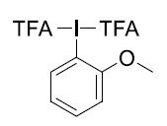
C -0.000004 1.568477 -0.539663
C -0.000022 2.465623 0.543921
C 0.000005 2.000779 -1.862347
C -0.000031 3.838184 0.254964
C -0.000003 3.370447 -2.132954
H 0.000020 1.281853 -2.674148
C -0.000021 4.275885 -1.071080
H -0.000043 4.562876 1.059898
H 0.000003 3.718646 -3.160003
H -0.000027 5.343182 -1.270565
O 2.201147 -0.222484 -0.184127
C 2.803245 -1.359379 0.020475
C 4.352072 -1.199825 0.007068
O 2.277486 -2.443260 0.203918
F 4.747053 -0.324951 0.958231
F 4.769709 -0.731585 -1.189615
F 4.963552 -2.368315 0.235023
I 0.000007 -0.498674 -0.137704
O -2.201133 -0.222507 -0.184159
C -4.352055 -1.199853 0.007054
F -4.963531 -2.368358 0.234943
F -4.769695 -0.731546 -1.189600
F -4.747037 -0.325035 0.958269
C -2.803227 -1.359400 0.020462
O -2.277464 -2.443276 0.203927
O -0.000032 1.938191 1.788154
C -0.000063 2.812646 2.919788
H -0.898601 3.439108 2.929620
H -0.000078 2.158193 3.790738
H 0.898465 3.439122 2.929658
Zero-point correction = 0.178345 (Hartree/Particle)
Thermal correction to Energy = 0.202063
Thermal correction to Enthalpy = 0.203007
Thermal correction to Gibbs Free Energy = 0.117439
SCF Done: E(RB3LYP) = -1409.97140056 Hartree

3a
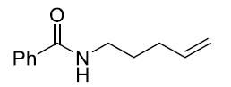
C 0.49522 -0.92112 0.09276
C -1.6235 -1.40535 -1.1189
C -5.31559 -0.12613 -1.2968
C -2.81342 -0.43586 -1.04999
C -4.15804 -1.07594 -1.44093
H -5.48708 0.26706 -0.29266
H -1.6813 -2.14181 -0.31356
H -2.60338 0.40868 -1.71902
H -1.64432 -1.94808 -2.07194
H -2.88348 -0.01498 -0.03643
H -4.32787 -1.9537 -0.80223
H -4.10375 -1.44659 -2.47157
N -0.32717 -0.74602 -0.98744
H 0.03694 -0.25644 -1.79108
O 0.62702 -2.01025 0.65197
C -6.12421 0.26498 -2.28661
H -6.94444 0.95584 -2.11369
H -5.99542 -0.09876 -3.30391
C 1.24665 0.29615 0.56691
C 2.41155 0.08095 1.31766
C 0.82919 1.61283 0.31784
C 3.15845 1.16022 1.78893
H 2.71029 -0.94142 1.52316
C 1.57274 2.69365 0.79757
H -0.09441 1.81034 -0.21918
C 2.74222 2.46972 1.52849
H 4.06308 0.98079 2.3626
H 1.2333 3.70781 0.60814
H 3.32091 3.31055 1.89987
Zero-point correction = 0.245807 (Hartree/Particle)
Thermal correction to Energy = 0.259812
Thermal correction to Enthalpy = 0.260756
Thermal correction to Gibbs Free Energy = 0.202185
SCF(Done): E(RB3LYP): -596.331553629 Hartree

TS[8-9]
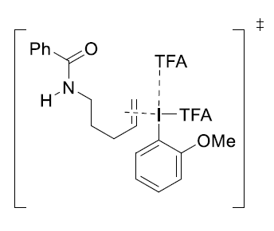
C -1.71301 2.06039 1.60314
H -2.61314 1.4932 1.367
C -1.49709 3.33669 0.83413
H -2.29361 4.05089 1.09662
H -0.55125 3.77893 1.15807
C -0.88434 1.58866 2.54814
H 0.02313 2.12049 2.82129
H -1.11105 0.67268 3.087
C -0.19931 -1.50337 0.82227
C 0.05606 -2.31956 1.94932
C -2.30384 -2.6202 0.43144
C -0.88322 -3.30379 2.28959
C -2.04775 -3.4442 1.53133
H -3.21571 -2.73127 -0.14483
H -0.71406 -3.95132 3.14141
H -2.76657 -4.20831 1.81295
O 2.07699 -1.48591 -1.15492
C 3.13476 -2.17159 -0.75138
C 3.60463 -3.11411 -1.9073
O 3.68289 -2.16477 0.32215
F 2.71489 -4.12325 -2.05275
F 4.79778 -3.64796 -1.61967
F 3.70019 -2.46352 -3.0781
C -1.37495 -1.643 0.07585
H -1.01199 2.19946 -0.96419
H -0.81815 3.93109 -1.13161
C -1.46802 3.15824 -0.7037
N -3.86618 2.35933 -0.97986
H -4.72522 2.75806 -0.63197
C -3.87408 1.04191 -1.32781
O -2.93813 0.52078 -1.94316
C -5.08536 0.24474 -0.92387
C -5.86984 0.55446 0.19783
C -5.42083 -0.86922 -1.70794
C -6.97748 -0.23226 0.52327
H -5.60556 1.38766 0.84324
C -6.53379 -1.64698 -1.38866
H -4.79994 -1.10592 -2.56587
C -7.31502 -1.33021 -0.27224
H -7.57091 0.00899 1.4002
H -6.79354 -2.49869 -2.01062
H -8.17965 -1.93788 -0.02175
H -2.65722 3.13697 -2.49957
H -3.21841 4.2932 -1.28183
C -2.81651 3.28483 -1.42522
I 1.24508 -0.08035 0.22003
O 1.67682 2.44417 0.86679
C 2.66576 2.53947 0.08416
C 3.3534 3.93774 0.05727
F 4.44187 3.96411 -0.72838
F 2.48834 4.87673 -0.40749
F 3.73126 4.31716 1.3002
O 3.11874 1.64381 -0.65937
H -1.57678 -0.9919 -0.77043
O 1.19822 -2.08625 2.62904
C 1.58117 -2.95769 3.69345
H 2.55568 -2.59929 4.02283
H 1.66956 -3.99056 3.33968
H 0.8669 -2.90297 4.52284
Zero-point correction = 0.424395 (Hartree/Particle)
Thermal correction to Energy = 0.463471
Thermal correction to Enthalpy = 0.464416
Thermal correction to Gibbs Free Energy = 0.338895
SCF Done: E(RB3LYP) = -2006.27254238 Hartree
Imaginary frequency= -51.06 cm⁻¹

9
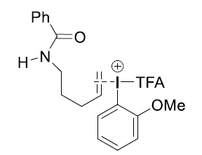
C 1.29369 -1.33116 0.10995
H 1.59497 -0.65708 -0.68765
C 1.51879 -2.79165 -0.11672
H 1.20066 -3.36601 0.76147
C 0.7389 -0.78786 1.24173
H 0.52486 -1.40642 2.11015
H 0.74647 0.28635 1.39205
C -1.44919 1.2283 -0.42502
C -1.59216 2.18695 0.6014
C -1.15046 2.91892 -2.1015
C -1.5211 3.5385 0.22811
C -1.30552 3.8889 -1.10467
H -0.98295 3.20606 -3.1335
H -1.63036 4.31173 0.9788
H -1.2544 4.941 -1.36683
O -3.72194 -0.75241 -0.72123
C -4.6835 -0.57585 0.17177
C -6.07597 -0.60382 -0.54039
O -4.56953 -0.42603 1.36452
F -6.15725 0.41159 -1.42291
F -7.0578 -0.47497 0.35252
F -6.23857 -1.76326 -1.20227
C -1.22334 1.57084 -1.76055
I -1.69964 -0.7988 0.07391
H -1.11791 0.80276 -2.51833
O -1.76478 1.73333 1.85495
C -2.09436 2.65777 2.90927
H -2.27144 2.0377 3.78628
H -3.00226 3.21396 2.65957
H -1.2612 3.34173 3.09711
C 2.98844 -3.12614 -0.47829
H 3.01867 -4.16735 -0.81384
H 3.29917 -2.51641 -1.33203
C 3.98889 -2.91385 0.6913
H 3.47193 -2.46865 1.54874
H 4.4013 -3.8697 1.0208
N 5.11742 -2.05711 0.3419
H 6.05013 -2.42901 0.4351
C 4.94632 -0.71494 0.18607
O 3.80659 -0.22304 0.24371
C 6.15503 0.12735 -0.07123
C 7.39359 -0.40268 -0.46977
C 6.0261 1.51535 0.09402
C 8.48359 0.44037 -0.68654
H 7.51934 -1.46631 -0.65245
C 7.11804 2.35555 -0.11691
H 5.06407 1.91561 0.39403
C 8.34975 1.82 -0.50528
H 9.43347 0.02084 -1.00238
H 7.00996 3.42682 0.02194
H 9.20028 2.47391 -0.6713
H 0.89094 -3.11547 -0.96057
Zero-point correction = 0.398225 (Hartree/Particle)
Thermal correction to Energy = 0.429813
Thermal correction to Enthalpy = 0.430758
Thermal correction to Gibbs Free Energy = 0.325847
SCF Done: E(RB3LYP) = -1479.83351702 Hartree

TS[9-10]
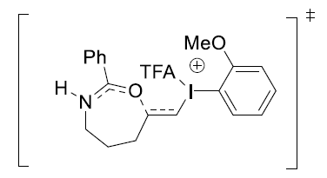

C 4.85643 0.08058 -0.5201
C 3.86485 1.58585 -2.25404
C 1.6285 0.18542 -0.63183
C 2.93605 2.32447 -1.2681
C 1.57919 1.63735 -0.98225
H 1.92727 -0.50581 -1.41387
H 3.29662 0.89371 -2.89038
H 2.7078 3.3151 -1.6734
H 4.33072 2.3086 -2.92731
H 3.46231 2.48555 -0.32407
H 0.96436 1.71552 -1.89279
H 1.0598 2.19399 -0.19683
N 4.97214 0.87516 -1.60546
H 5.872 0.90961 -2.06267
O 3.74958 -0.14682 0.0245
C 1.00725 -0.35611 0.50093
H 1.23471 -1.38972 0.74891
H 0.79963 0.29092 1.34915
I -1.32184 -0.76923 -0.31962
C -1.90739 1.21908 0.0879
C -2.30322 2.03506 -0.9718
C -1.99404 1.61647 1.43573
C -2.81115 3.30238 -0.68691
C -2.51443 2.89382 1.69639
C -2.91567 3.71754 0.64427
H -3.13639 3.94676 -1.49618
H -2.60934 3.23863 2.71905
H -3.31982 4.69892 0.87186
C 6.10203 -0.52516 0.03396
C 5.98912 -1.71713 0.76664
C 7.36647 0.06357 -0.13976
C 7.12674 -2.32519 1.29443
H 5.00868 -2.15725 0.91042
C 8.50099 -0.54373 0.39816
H 7.47429 1.01406 -0.65483
C 8.3837 -1.74135 1.10953
H 7.03411 -3.25269 1.85055
H 9.47289 -0.07781 0.27066
H 9.26862 -2.21348 1.52486
O -3.42417 -1.19891 -0.97407
C -4.3029 -1.23182 -0.00278
O -4.11492 -1.03411 1.18076
C -5.72916 -1.54716 -0.55862
F -6.61576 -1.65298 0.43528
F -6.12799 -0.55339 -1.38219
F -5.7254 -2.69945 -1.25471
H -2.25009 1.68052 -1.99538
O -1.54971 0.75419 2.37115
C -1.92673 0.95367 3.74692
H -3.01376 1.03154 3.83333
H -1.57731 0.06584 4.27165
H -1.43863 1.84236 4.15878
Zero-point correction = 0.398904 (Hartree/Particle)
Thermal correction to Energy = 0.429287
Thermal correction to Enthalpy = 0.430231
Thermal correction to Gibbs Free Energy = 0.329718
SCF Done: E(RB3LYP) = -1479.82962603 Hartree
Imaginary frequency= -64.42 cm⁻¹

TS[9-11]
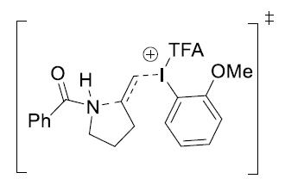
C -1.74335 -1.43442 -0.57096
H -1.99244 -1.64832 0.46795
C -1.39823 -2.63693 -1.3983
H -1.08385 -2.33162 -2.40323
H -0.54063 -3.13737 -0.92402
C -1.20576 -0.1412 -0.83862
H -1.03895 0.12522 -1.88078
H -1.54849 0.6758 -0.20839
I 1.14792 -0.29757 -0.06924
C 1.20577 1.81398 0.02362
C 1.42985 2.53012 -1.16732
C 1.19662 3.82749 1.33494
C 1.53616 3.92586 -1.07392
C 1.42076 4.55784 0.16549
H 1.11957 4.32642 2.29462
H 1.71341 4.51724 -1.96394
H 1.51185 5.63845 0.21309
O 3.33659 -0.13121 0.57107
C 4.04054 -0.21322 -0.51505
C 5.57115 -0.08709 -0.24215
O 3.61036 -0.36484 -1.65132
F 6.27515 -0.2182 -1.37001
F 5.97217 -1.03737 0.62596
F 5.84391 1.1203 0.29507
C 1.09082 2.43807 1.26477
H 0.94387 1.85356 2.16638
H -2.76151 -4.05207 -0.4684
H -2.40812 -4.41617 -2.16151
C -2.58839 -3.60489 -1.45133
N -3.7922 -1.50341 -1.0992
H -3.93148 -0.68306 -1.68051
C -4.53467 -1.46431 0.1349
O -4.70633 -2.51072 0.73196
C -4.98434 -0.1386 0.62896
C -4.85003 1.06305 -0.09258
C -5.60008 -0.11411 1.8948
C -5.31859 2.2616 0.44412
H -4.39678 1.09318 -1.07959
C -6.06513 1.08499 2.42699
H -5.7076 -1.04509 2.44044
C -5.92541 2.27434 1.70355
H -5.21921 3.18162 -0.12279
H -6.54051 1.09322 3.40249
H -6.29401 3.20815 2.11666
H -4.74334 -3.31136 -1.66072
H -3.76887 -2.51971 -2.92378
C -3.81113 -2.77934 -1.86254
O 1.51577 1.82256 -2.31738
C 1.9362 2.48923 -3.51908
H 2.91083 2.96496 -3.37476
H 2.01761 1.70534 -4.27087
H 1.19416 3.22937 -3.83553
Zero-point correction = 0.399081 (Hartree/Particle)
Thermal correction to Energy = 0.429286
Thermal correction to Enthalpy = 0.430230
Thermal correction to Gibbs Free Energy = 0.329111
SCF Done: E(RB3LYP) = -1479.82658287 Hartree
Imaginary frequency= -170.91 cm⁻¹

10
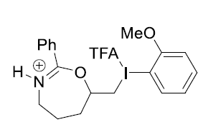
C 5.02142 0.16231 -0.49328
C 4.03556 1.6686 -2.23236
C 1.81006 0.26428 -0.60402
C 3.10888 2.40807 -1.24582
C 1.75659 1.71746 -0.94958
H 2.10695 -0.42351 -1.38991
H 3.46517 0.98294 -2.87379
H 2.8756 3.39572 -1.65551
H 4.50759 2.39206 -2.90065
H 3.63956 2.57642 -0.30542
H 1.13317 1.79598 -1.85441
H 1.24213 2.27094 -0.1587
N 5.13743 0.94852 -1.58411
H 6.03683 0.97501 -2.04298
O 3.91555 -0.05724 0.05825
C 1.17994 -0.28214 0.5233
H 1.40784 -1.31643 0.76826
H 0.9749 0.36166 1.37468
I -1.14666 -0.69019 -0.29346
C -1.73246 1.29836 0.11384
C -2.12902 2.11389 -0.94588
C -1.81967 1.69582 1.46153
C -2.63785 3.38094 -0.6612
C -2.34098 2.97282 1.72207
C -2.74272 3.79622 0.66989
H -2.96368 4.02489 -1.47057
H -2.43632 3.31758 2.74472
H -3.14767 4.77729 0.89737
C 6.26656 -0.44469 0.06037
C 6.15389 -1.63604 0.79412
C 7.53116 0.14346 -0.11515
C 7.29197 -2.24427 1.32081
H 5.17353 -2.0758 0.93961
C 8.66601 -0.46396 0.4219
H 7.63854 1.09369 -0.63079
C 8.54899 -1.66112 1.1341
H 7.19958 -3.17139 1.8776
H 9.63795 0.00156 0.29314
H 9.43415 -2.13341 1.54874
O -3.25185 -1.1172 -0.94927
C -4.13004 -1.15076 0.02197
O -3.94202 -0.95354 1.20579
C -5.55651 -1.46656 -0.53303
F -6.44294 -1.57247 0.46115
F -5.95624 -0.47322 -1.3568
F -5.55293 -2.61911 -1.22889
H -2.07606 1.75907 -1.96938
O -1.37501 0.83385 2.3972
C -1.75405 1.03241 3.7725
H -2.84128 1.1092 3.85748
H -1.40452 0.14471 4.29738
H -1.26736 1.9214 4.18543
Zero-point correction = 0.402266 (Hartree/Particle)
Thermal correction to Energy = 0.432218
Thermal correction to Enthalpy = 0.433162
Thermal correction to Gibbs Free Energy = 0.333758
SCF Done: E(RB3LYP) = -1479.84721816 Hartree

11
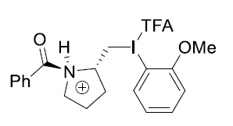
C 2.08785 -1.76064 0.00492
H 2.03411 -1.21267 -0.93854
C 1.90146 -3.26004 -0.21203
H 1.706 -3.75745 0.74613
H 1.03645 -3.43538 -0.8576
C 1.26336 -1.11347 1.07524
H 1.2659 -1.66387 2.0198
H 1.46575 -0.05458 1.23391
I -1.06553 -1.05659 0.56201
C -0.74639 0.50729 -0.83302
C -0.44803 1.78326 -0.32635
C -0.83733 1.32538 -3.08821
C -0.35836 2.83999 -1.24468
C -0.55211 2.60535 -2.60692
H -0.99947 1.15411 -4.14675
H -0.14688 3.84309 -0.89337
H -0.4853 3.43921 -3.29872
O -3.30334 -0.92456 -0.01655
C -3.90466 0.14412 0.40552
C -5.41217 0.13801 0.0078
O -3.42789 1.08863 1.01764
F -6.05745 1.20503 0.49719
F -6.02768 -0.97266 0.46448
F -5.53111 0.15806 -1.34091
C -0.94427 0.26152 -2.18956
H -1.21471 -0.72861 -2.53977
H 3.29188 -3.44019 -1.87604
H 3.28662 -4.85691 -0.81343
C 3.20237 -3.76777 -0.83618
N 3.767 -1.70282 0.2986
H 3.88747 -1.46932 1.28429
C 4.45429 -0.66504 -0.57712
O 4.68423 -1.00276 -1.71177
C 4.73229 0.65474 0.00667
C 4.61294 0.9669 1.37563
C 5.14999 1.65436 -0.89867
C 4.89605 2.25505 1.82472
H 4.31593 0.22617 2.11296
C 5.42058 2.93975 -0.44427
H 5.248 1.40376 -1.94905
C 5.29226 3.24242 0.91655
H 4.81186 2.48777 2.88105
H 5.73418 3.70521 -1.14641
H 5.50848 4.24533 1.27149
H 5.25648 -3.03986 -0.47647
H 4.3978 -3.60869 0.98104
C 4.28667 -3.11195 0.01417
O -0.23773 1.8967 1.00517
C -0.40918 3.18257 1.62607
H -1.38047 3.60549 1.35627
H -0.37767 2.99275 2.69833
H 0.40219 3.86351 1.34814
Zero-point correction = 0.401673 (Hartree/Particle)
Thermal correction to Energy = 0.431988
Thermal correction to Enthalpy = 0.432932
Thermal correction to Gibbs Free Energy = 0.330865
SCF Done: E(RB3LYP) = -1479.83676517 Hartree

12
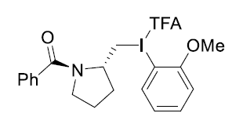
C -1.51763 -1.40908 0.44972
H -1.41329 -0.68666 1.26171
C -1.0716 -2.79757 0.9141
H -0.99126 -3.48418 0.06134
H -0.09173 -2.75074 1.39467
C -0.9324 -0.8748 -0.8352
H -1.00033 -1.59119 -1.66009
H -1.34784 0.08882 -1.13479
I 1.31732 -0.48546 -0.63028
C 0.94985 1.55649 -0.16531
C 1.16002 2.51112 -1.15588
C 0.42048 3.26386 1.44074
C 0.98738 3.86229 -0.8464
C 0.62086 4.22697 0.4494
H 0.14282 3.5732 2.44109
H 1.15774 4.61522 -1.6081
H 0.49481 5.27506 0.70215
O 3.55552 0.2749 -0.36008
C 4.29346 -0.76739 -0.51662
C 5.81388 -0.4681 -0.35428
O 3.91446 -1.91168 -0.76623
F 6.21474 0.45545 -1.25676
F 6.56119 -1.56694 -0.52503
F 6.06815 0.02224 0.88153
C 0.58777 1.90335 1.14627
H -2.06597 -2.73488 2.84459
H -2.17951 -4.31623 2.06374
C -2.17683 -3.23944 1.88019
N -3.07135 -1.60036 0.30611
C -3.86724 -0.33228 0.65313
O -3.52601 0.23761 1.65642
C -4.96159 0.03177 -0.25114
C -5.37026 -0.74295 -1.35698
C -5.64037 1.23472 0.04199
C -6.43121 -0.31905 -2.15238
H -4.89719 -1.68774 -1.61055
C -6.69539 1.65297 -0.75997
H -5.32447 1.82256 0.89669
C -7.09135 0.87848 -1.85714
H -6.74509 -0.92097 -2.99849
H -7.21155 2.57973 -0.53242
H -7.91692 1.20598 -2.48125
H -4.25292 -2.46784 1.88801
H -3.88617 -3.55908 0.53377
C -3.47578 -2.79544 1.19723
H 1.48064 2.21405 -2.14826
O 0.4083 0.89462 2.04277
C 0.33323 1.22328 3.43898
H 0.34481 0.26891 3.96489
H 1.20029 1.81777 3.74192
H -0.59413 1.75859 3.66763
Zero-point correction = 0.388844 (Hartree/Particle)
Thermal correction to Energy = 0.418807
Thermal correction to Enthalpy = 0.419751
Thermal correction to Gibbs Free Energy = 0.319675
SCF Done: E(RB3LYP) = -1479.49475645 Hartree

TS[12-13]
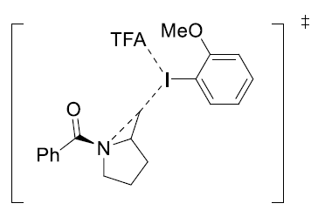

C 0.96983 -0.75281 -1.83137
H 0.97099 0.27727 -2.19043
C 0.9439 -1.87153 -2.88845
H 0.09767 -2.54331 -2.70963
H 0.83142 -1.46089 -3.89429
I -2.49507 -0.69937 -1.14688
C -3.05617 -1.21904 0.85261
C -3.82769 -2.36188 1.06882
C -3.04192 -0.71273 3.19286
C -4.20689 -2.67208 2.37885
C -3.81518 -1.84977 3.43892
H -2.73654 -0.06852 4.01198
H -4.81045 -3.55606 2.56319
H -4.11537 -2.09397 4.45356
O -0.42511 1.63143 0.75073
C -0.51481 2.38133 -0.26373
C -0.8976 3.85852 0.08623
O -0.37117 2.10508 -1.46748
F -0.89839 4.68458 -0.98068
F -0.0522 4.39661 1.00259
F -2.15073 3.9132 0.62642
C -2.65354 -0.37782 1.88988
H -2.04479 0.50362 1.69722
H 3.06244 -2.14909 -3.32578
H 2.23072 -3.6712 -2.97576
C 2.28739 -2.61271 -2.70653
N 2.13164 -1.03285 -0.94277
C 3.01582 0.04278 -0.58978
O 2.92682 1.11881 -1.14339
C 4.01237 -0.24116 0.48329
C 3.78397 -1.17939 1.502
C 5.18864 0.52537 0.49669
C 4.72683 -1.35442 2.51558
H 2.8589 -1.74618 1.52312
C 6.13507 0.33669 1.50181
H 5.33873 1.26761 -0.28027
C 5.90582 -0.60337 2.51215
H 4.53722 -2.06771 3.31192
H 7.0457 0.92783 1.504
H 6.63959 -0.74303 3.30057
H 3.6938 -2.46529 -1.00071
H 2.11091 -3.13474 -0.58584
C 2.62799 -2.40828 -1.22301
C 0.17319 -0.90353 -0.59432
H 0.04819 -0.01482 0.05128
H 0.01668 -1.90501 -0.2033
O -4.22749 -3.17368 0.09162
C -4.97656 -4.29598 0.42634
H -5.22806 -4.87523 -0.43744
H -5.87327 -3.97085 0.91122
H -4.40244 -4.89453 1.10237
Zero-point correction = 0.386878 (Hartree/Particle)
Thermal correction to Energy = 0.416760
Thermal correction to Enthalpy = 0.417704
Thermal correction to Gibbs Free Energy = 0.318013
SCF Done: E(RB3LYP) = -1479.46950749 Hartree
Imaginary frequency= -254.56 cm⁻¹

13
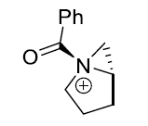
C 2.38567 0.15507 -1.06911
H 2.26113 1.04283 -1.70149
C 3.65486 -0.10833 -0.27013
H 4.09952 -1.06684 -0.55991
H 4.39602 0.67151 -0.45635
H 3.22446 0.89415 1.61387
H 3.8228 -0.75642 1.84435
C 3.19905 -0.12178 1.20868
N 1.20912 -0.10535 -0.14729
C 0.06022 0.89351 -0.03776
O 0.37453 2.04542 0.09112
C -1.29718 0.32219 -0.00944
C -1.53903 -1.05935 0.0656
C -2.378 1.22121 -0.03022
C -2.84815 -1.53585 0.12789
H -0.71807 -1.7674 0.07205
C -3.68137 0.73894 0.02249
H -2.17725 2.2838 -0.10955
C -3.91862 -0.63825 0.10227
H -3.03271 -2.60392 0.18299
H -4.51442 1.434 -0.01083
H -4.93763 -1.01187 0.13803
H 1.1242 -0.21088 1.97194
H 1.66294 -1.70282 1.17394
C 1.74561 -0.6125 1.17014
C 1.43871 -0.946 -1.37228
H 0.71321 -0.70303 -2.14942
H 1.68514 -1.98212 -1.15627
Zero-point correction = 0.238493 (Hartree/Particle)
Thermal correction to Energy = 0.250232
Thermal correction to Enthalpy = 0.251177
Thermal correction to Gibbs Free Energy = 0.199739
SCF Done: E(RB3LYP) = -595.452695757 Hartree

TS[13-14]
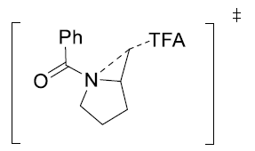
C 0.21166 1.93727 0.50731
H 0.24422 2.01994 1.59437
C 0.0869 3.24009 -0.30183
H -0.78257 3.19271 -0.9658
H -0.04768 4.10089 0.35685
O -2.72712 0.54701 0.41535
C -3.10817 -0.56942 -0.03832
C -4.65438 -0.7914 0.07018
O -2.43806 -1.50133 -0.51788
F -5.07944 -1.93112 -0.51468
F -5.35458 0.22641 -0.49359
F -5.0377 -0.85555 1.37947
H 2.1716 3.83796 -0.52991
H 1.28405 3.85295 -2.06112
C 1.40006 3.32267 -1.11166
N 1.27537 1.16138 -0.03811
C 2.23014 0.58905 0.8722
O 2.31091 0.99354 2.0129
C 3.07909 -0.51285 0.33376
C 2.65323 -1.36116 -0.70032
C 4.32194 -0.73656 0.94753
C 3.46652 -2.41397 -1.12087
H 1.67665 -1.22142 -1.152
C 5.13819 -1.77952 0.51427
H 4.62597 -0.0908 1.76462
C 4.712 -2.61929 -0.52025
H 3.12468 -3.07893 -1.9082
H 6.10106 -1.94429 0.98801
H 5.34473 -3.43783 -0.85066
H 2.87523 1.7081 -1.46737
H 1.27586 1.40123 -2.15649
C 1.80623 1.85554 -1.31198
C -0.31866 0.53468 -0.05712
H -0.3819 -0.31175 0.65094
H -0.50827 0.39942 -1.11762
Zero-point correction = 0.264695 (Hartree/Particle)
Thermal correction to Energy = 0.283716
Thermal correction to Enthalpy = 0.284660
Thermal correction to Gibbs Free Energy = 0.212184
SCF Done: E(RB3LYP) = -1121.88063434 Hartree
Imaginary frequency= -54.28 cm⁻¹

14
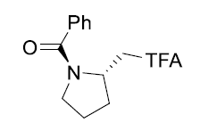
C 0.21993 0.83048 -0.43067
H 0.31488 0.57367 -1.4921
C 0.55422 2.31378 -0.17637
H 0.95439 2.43977 0.83744
H 1.3035 2.68679 -0.87776
O 2.44023 0.00696 -0.07866
C 3.35885 -0.71191 0.55436
C 4.75653 -0.44933 -0.06867
O 3.1872 -1.4715 1.47584
F 5.6926 -1.17674 0.5502
F 5.0935 0.8552 0.04429
F 4.76638 -0.77033 -1.37975
H -1.0687 3.17147 -1.34942
H -0.82265 3.9983 0.19828
C -0.80279 3.0229 -0.29653
N -1.206 0.70902 -0.04023
C -1.9205 -0.36442 -0.52299
O -1.37714 -1.22774 -1.21633
C -3.37284 -0.48197 -0.15671
C -3.85993 -0.18509 1.12398
C -4.24933 -1.00281 -1.12141
C -5.20767 -0.39052 1.4305
H -3.18661 0.18235 1.89207
C -5.59809 -1.18656 -0.82095
H -3.85424 -1.26592 -2.09723
C -6.08047 -0.88119 0.45652
H -5.5719 -0.17262 2.4302
H -6.27215 -1.57735 -1.57751
H -7.12923 -1.0355 0.69324
H -2.79446 2.12134 -0.00016
H -1.76517 2.13347 1.44295
C -1.76626 2.02224 0.35079
C 1.06502 -0.15521 0.37328
H 0.75906 -1.18538 0.1846
H 1.02052 0.04906 1.44671
Zero-point correction = 0.268103 (Hartree/Particle)
Thermal correction to Energy = 0.287045
Thermal correction to Enthalpy = 0.287989
Thermal correction to Gibbs Free Energy = 0.216407
SCF Done: E(RB3LYP) = -1121.95686024 Hartree

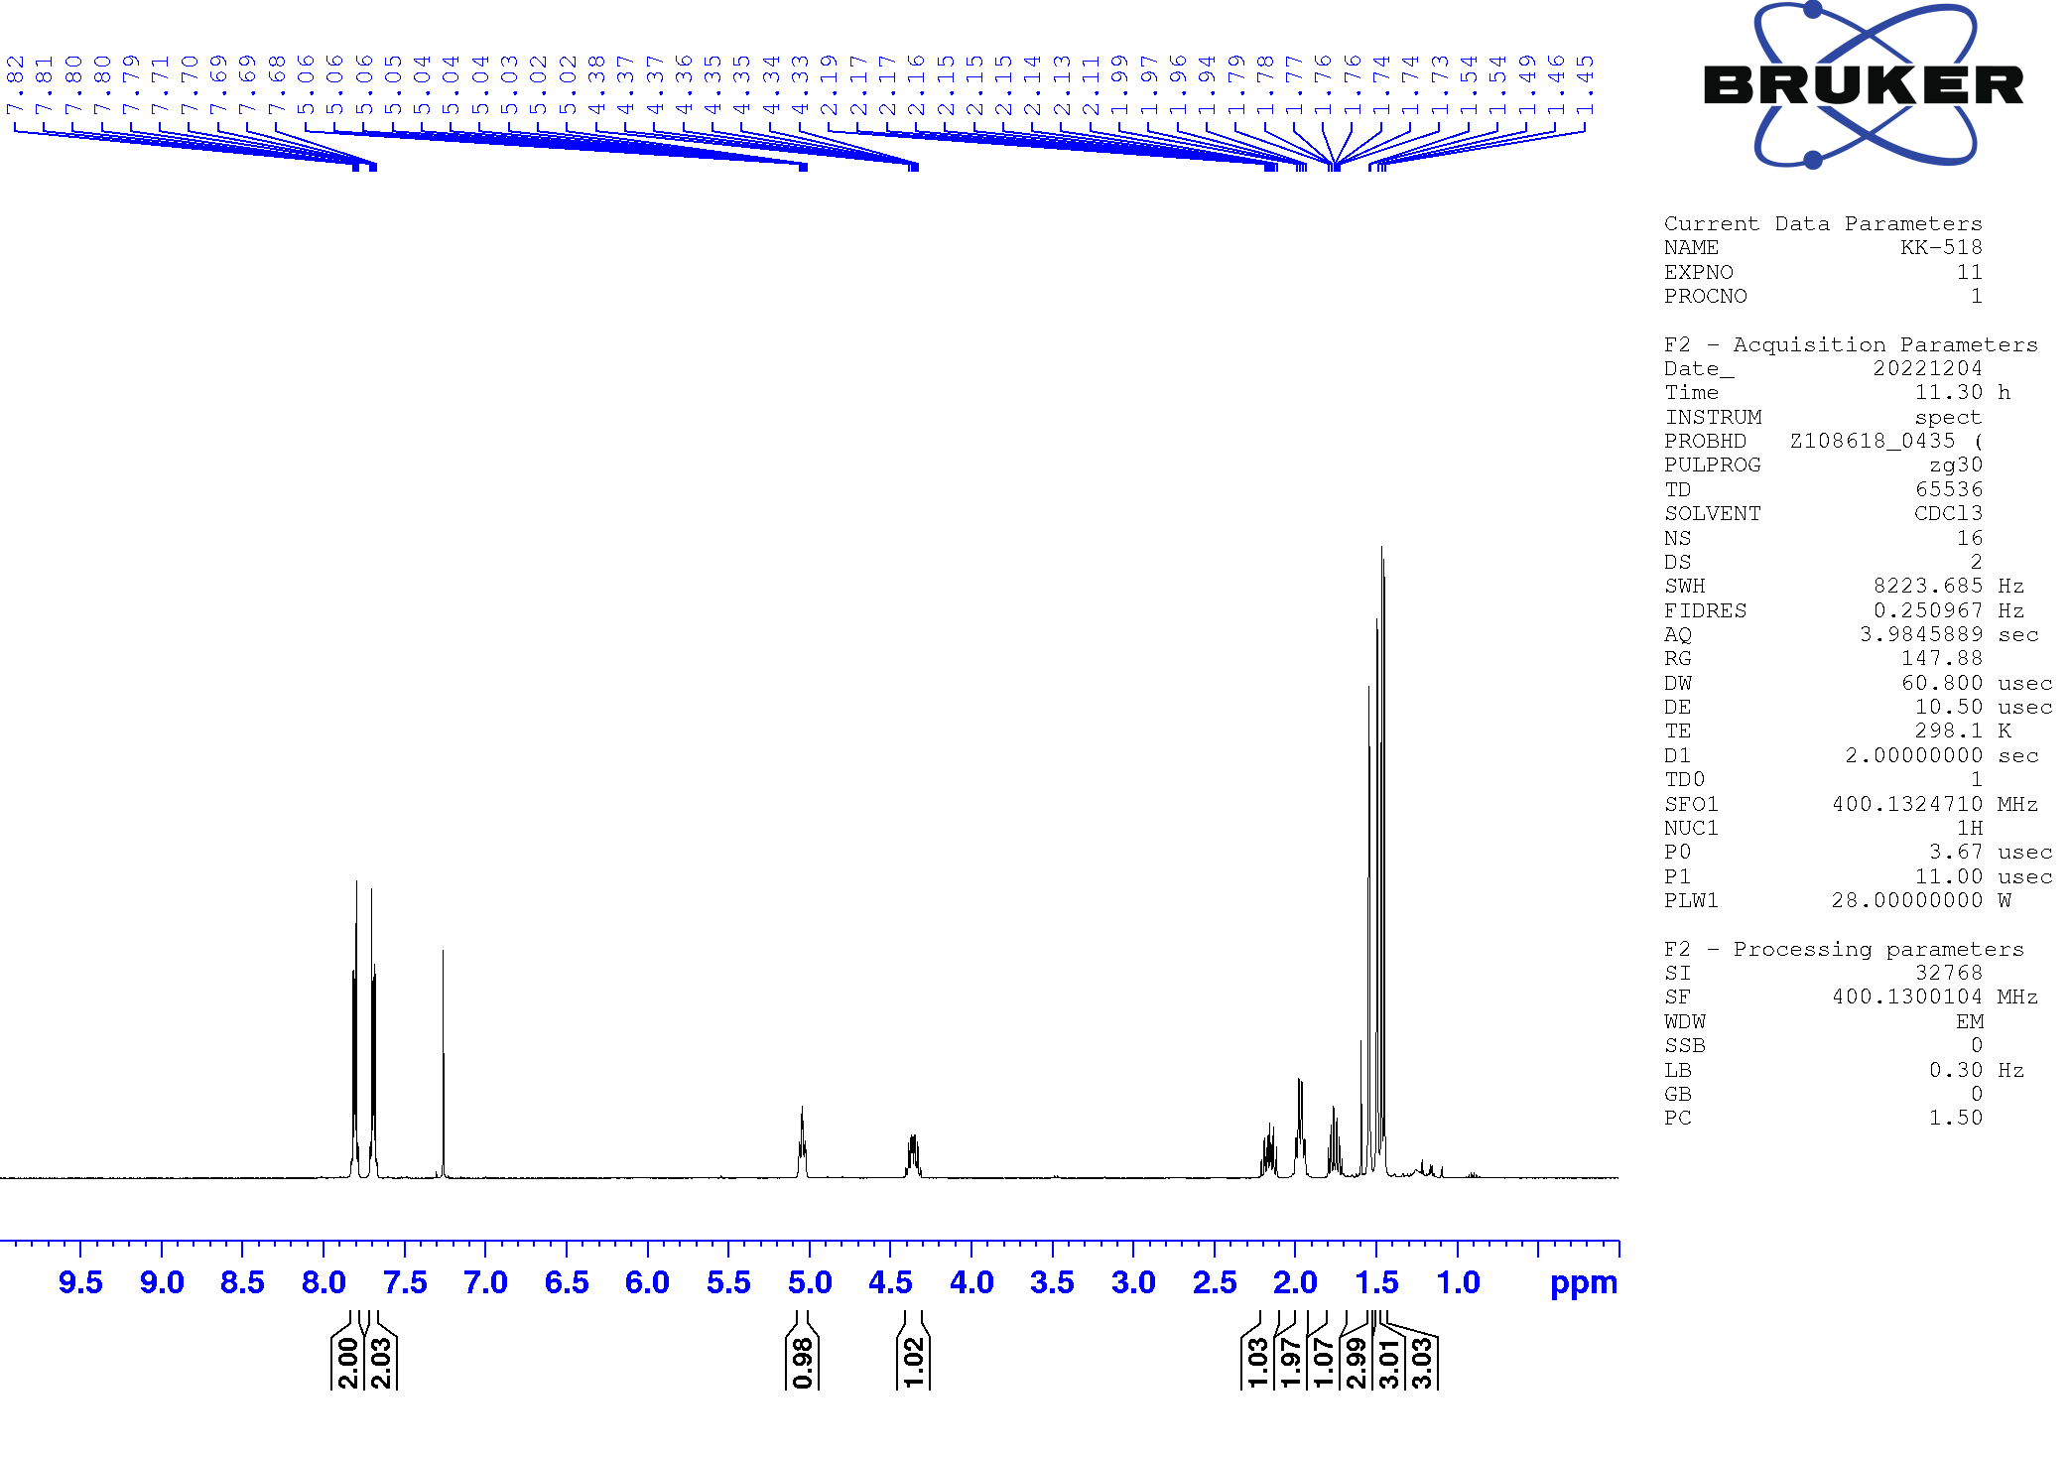
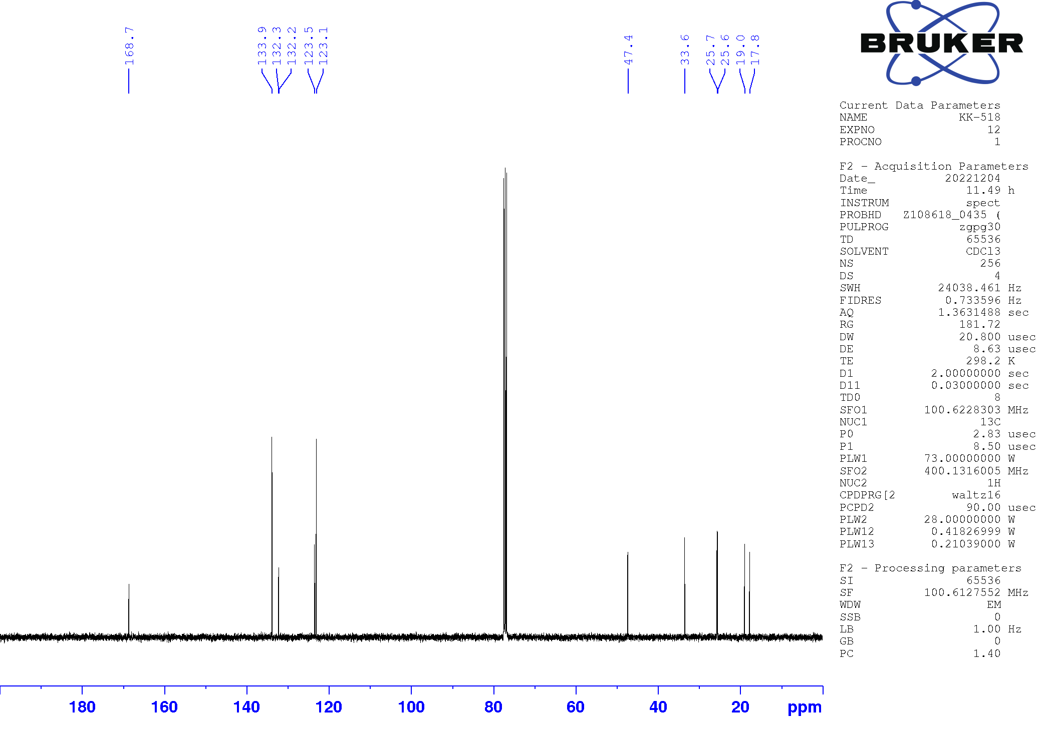
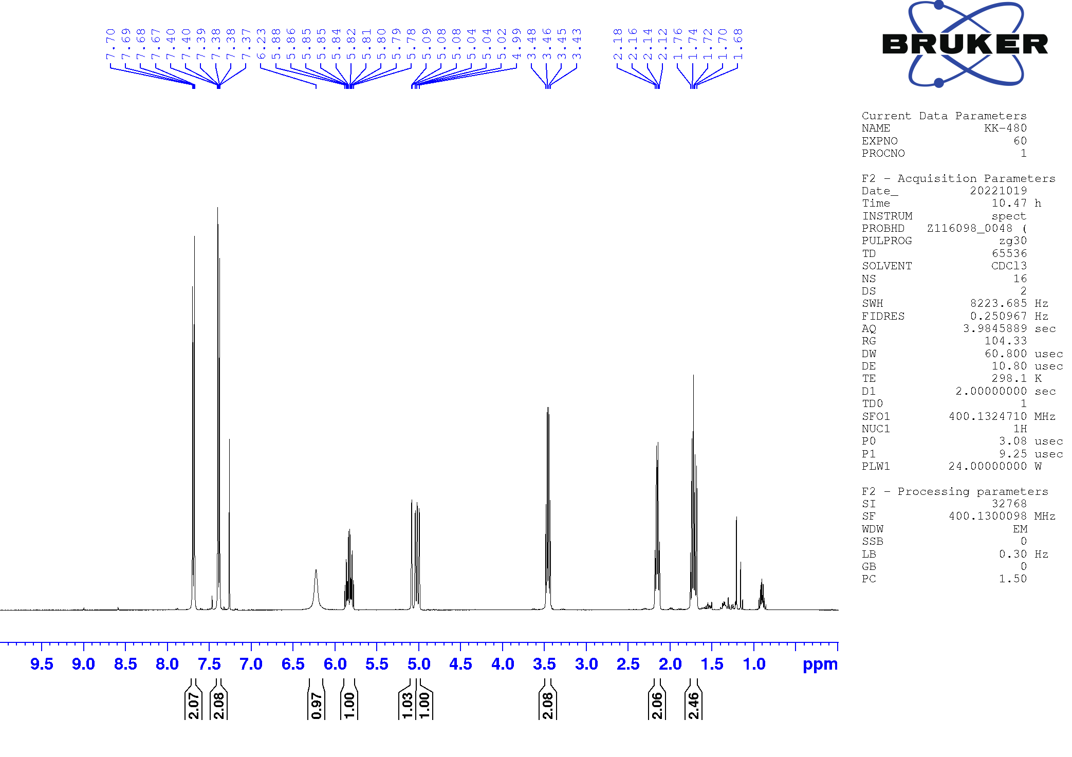
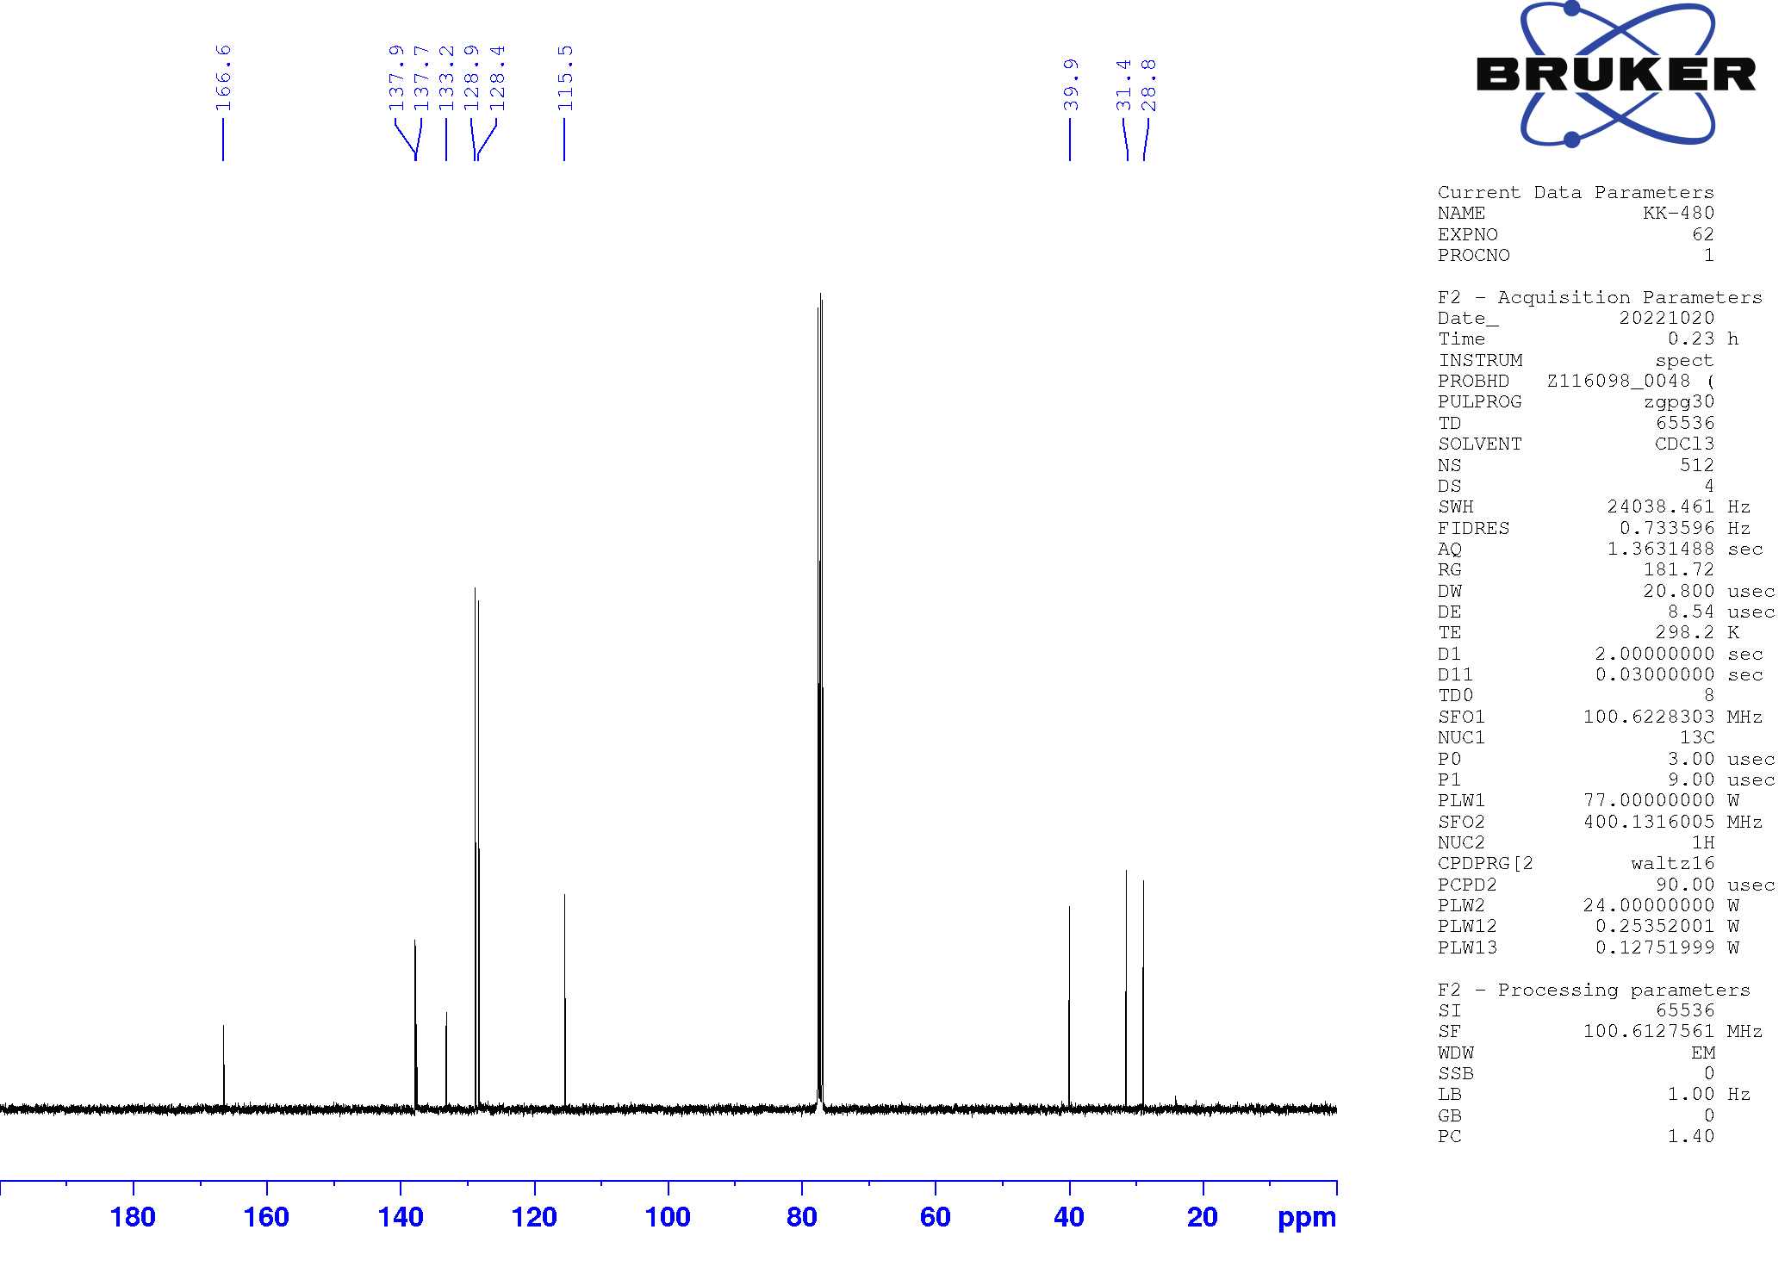
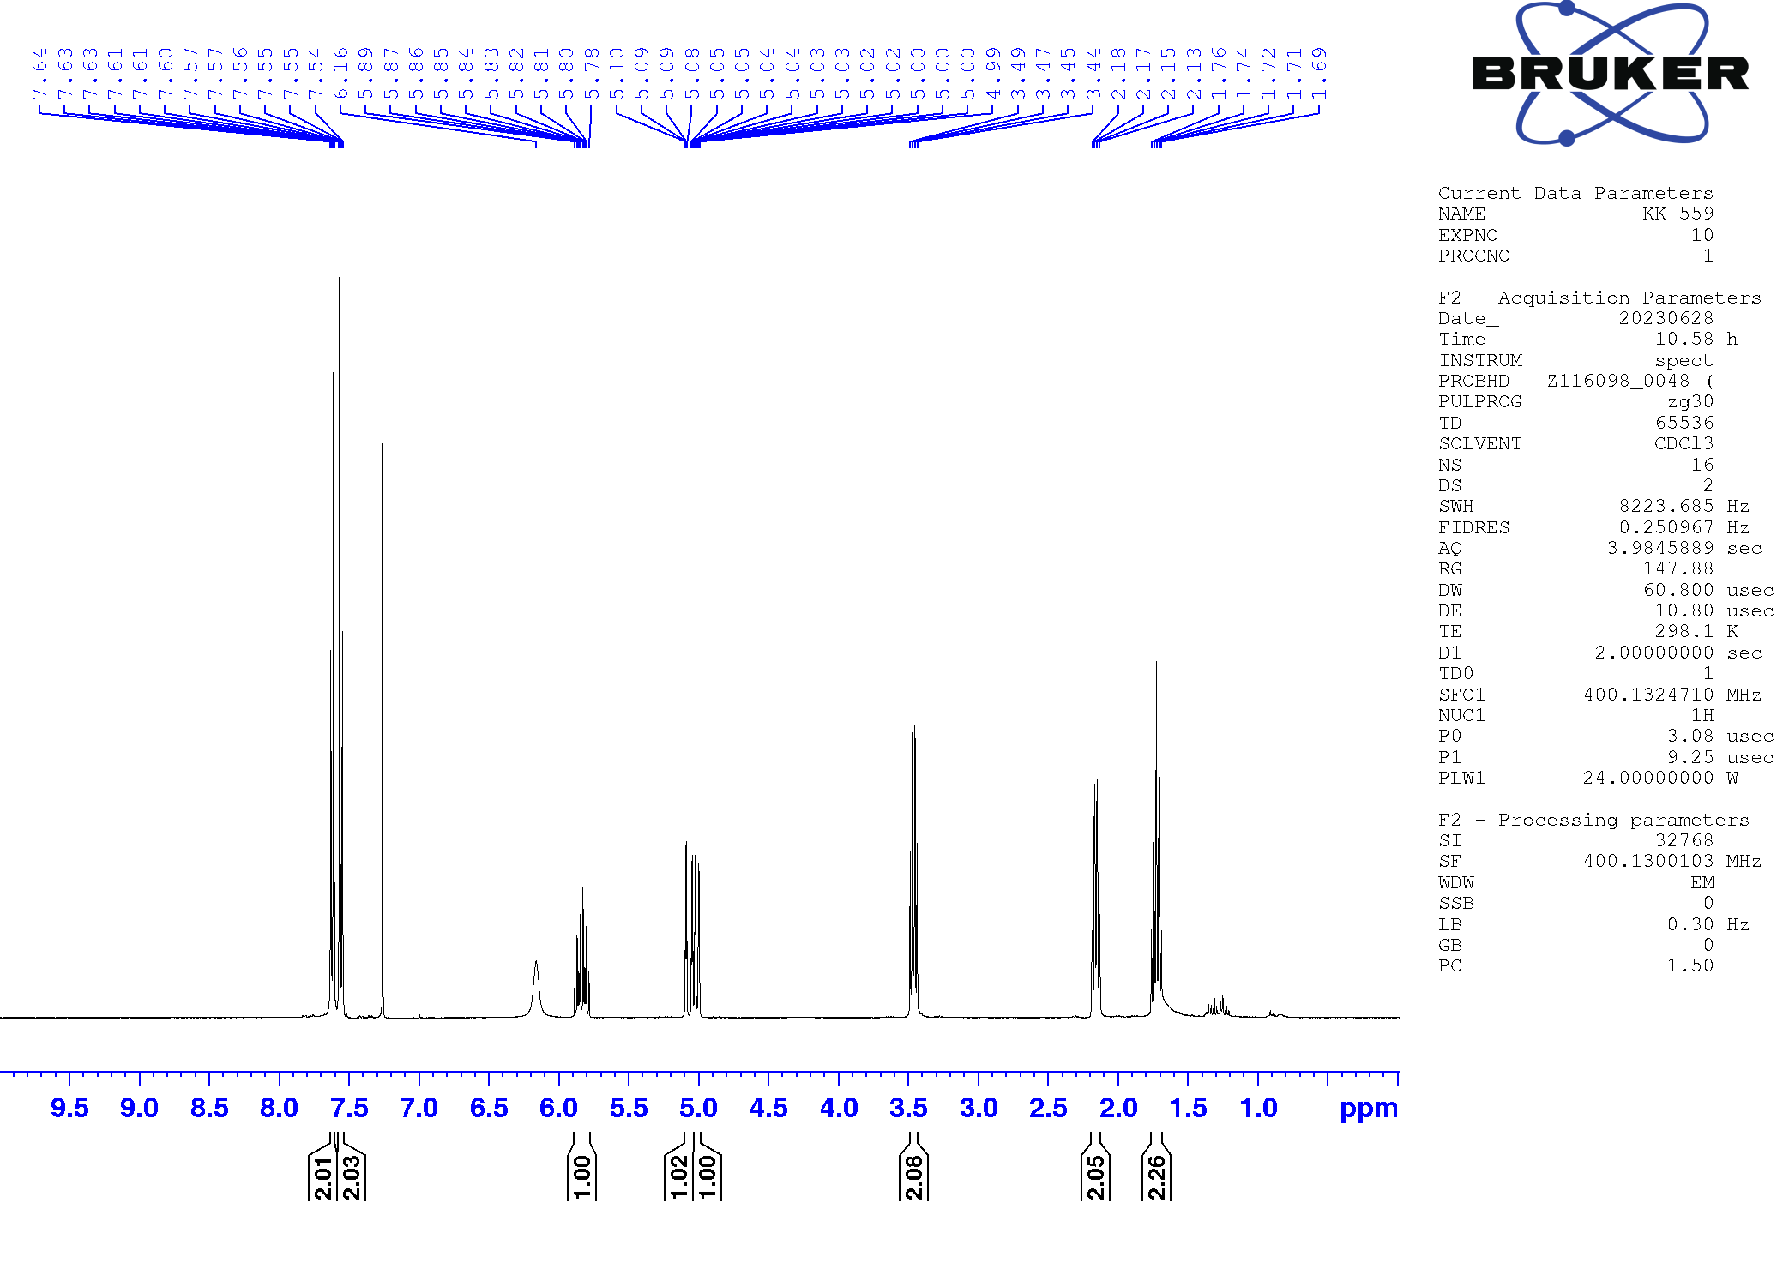
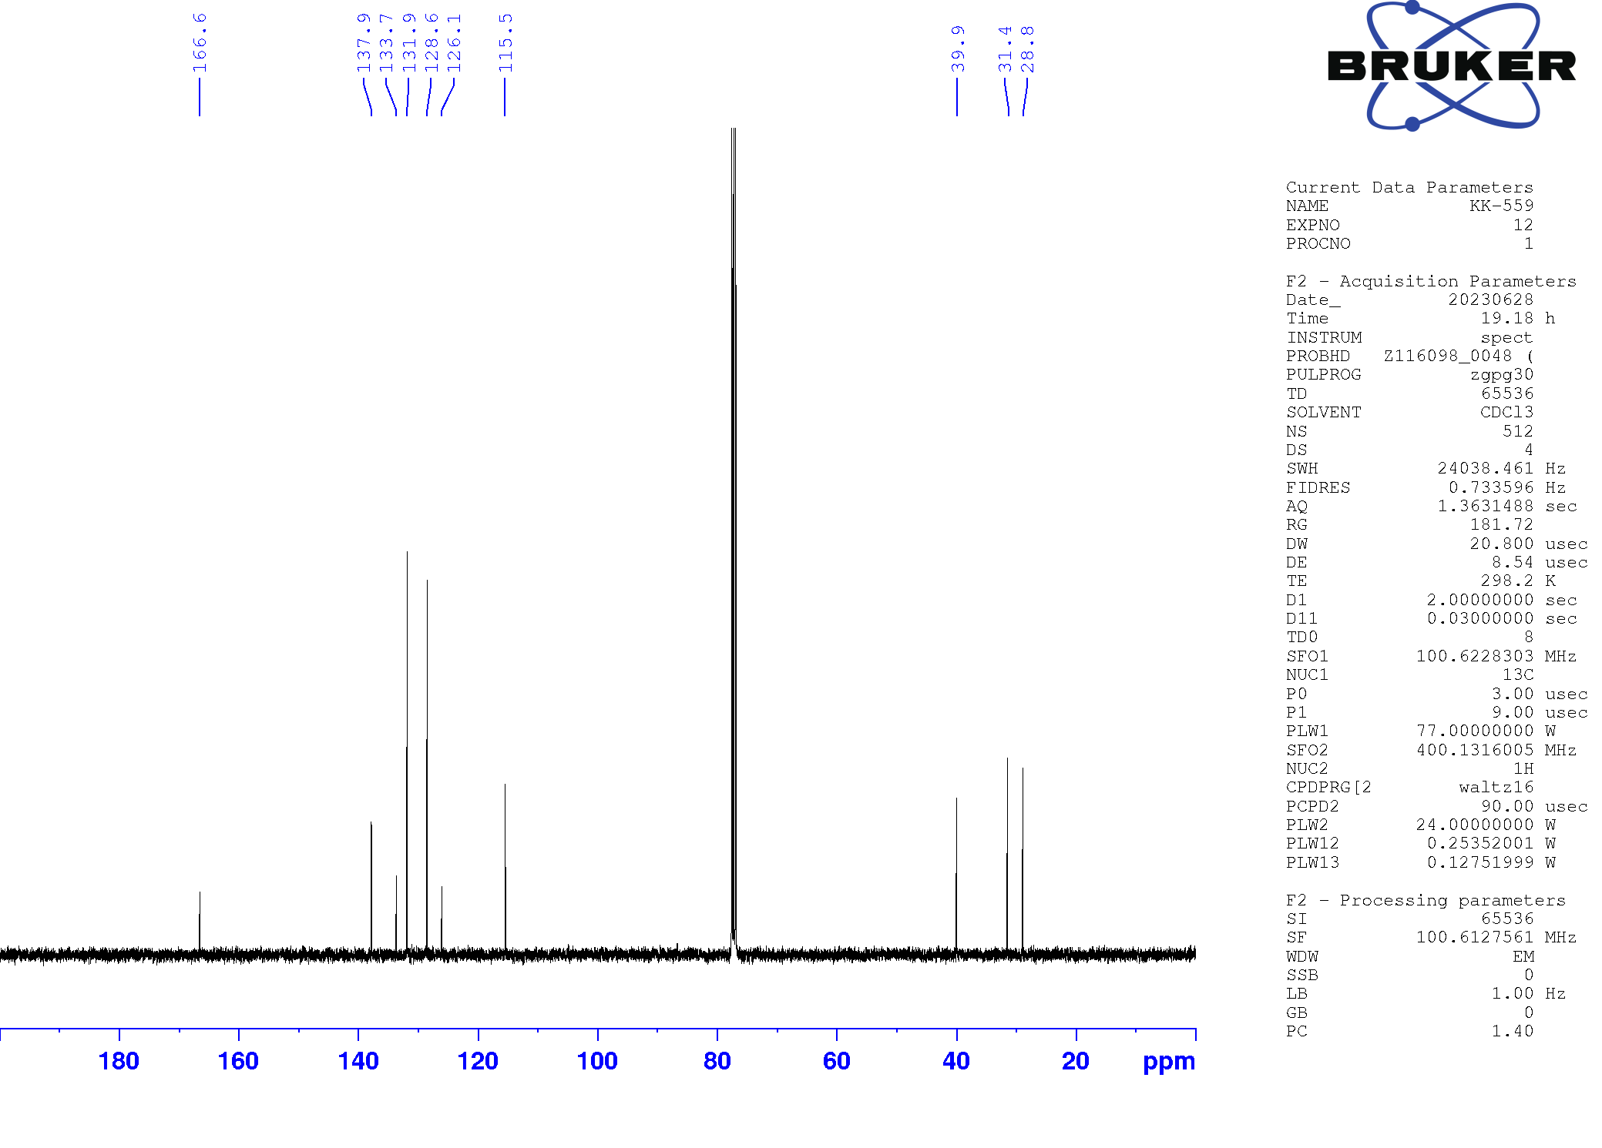
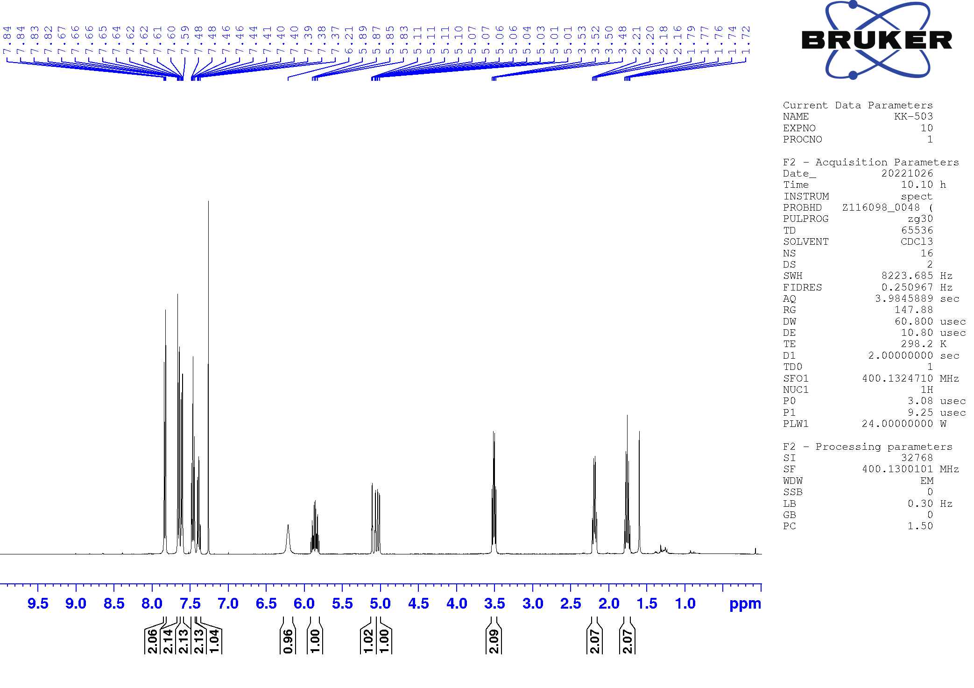
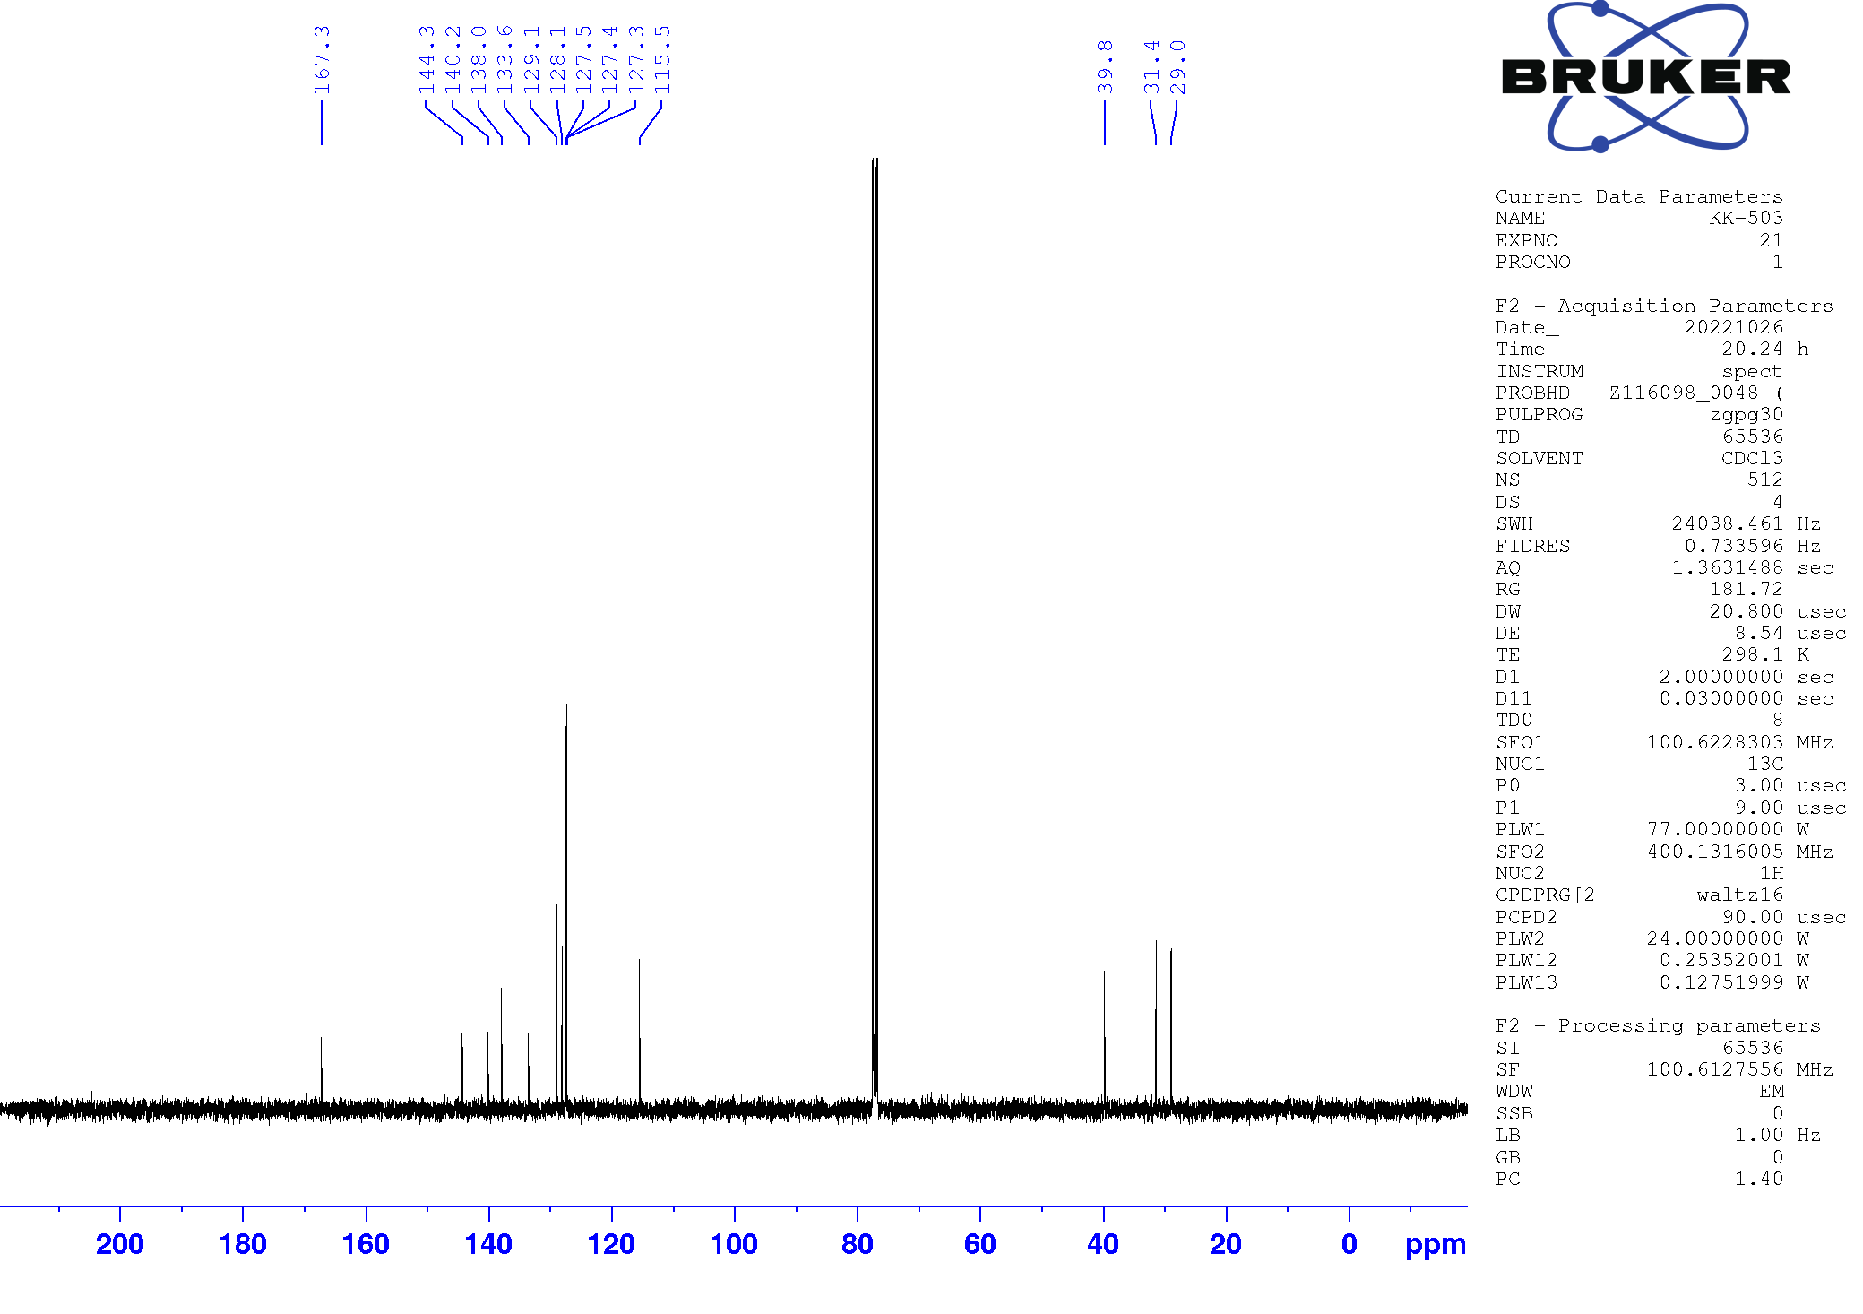
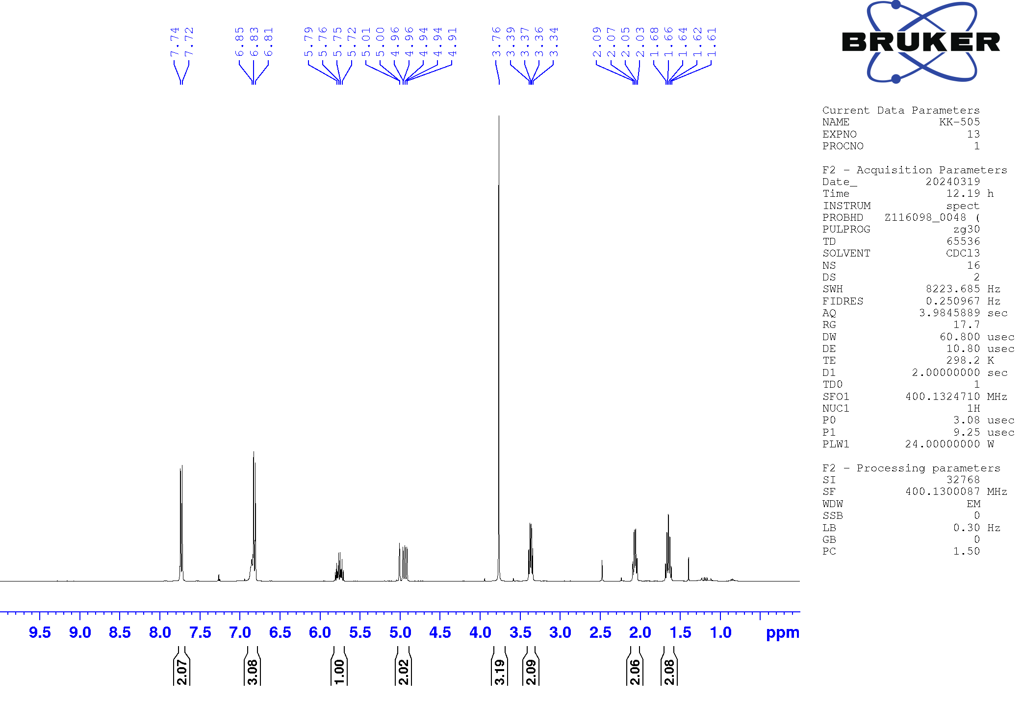
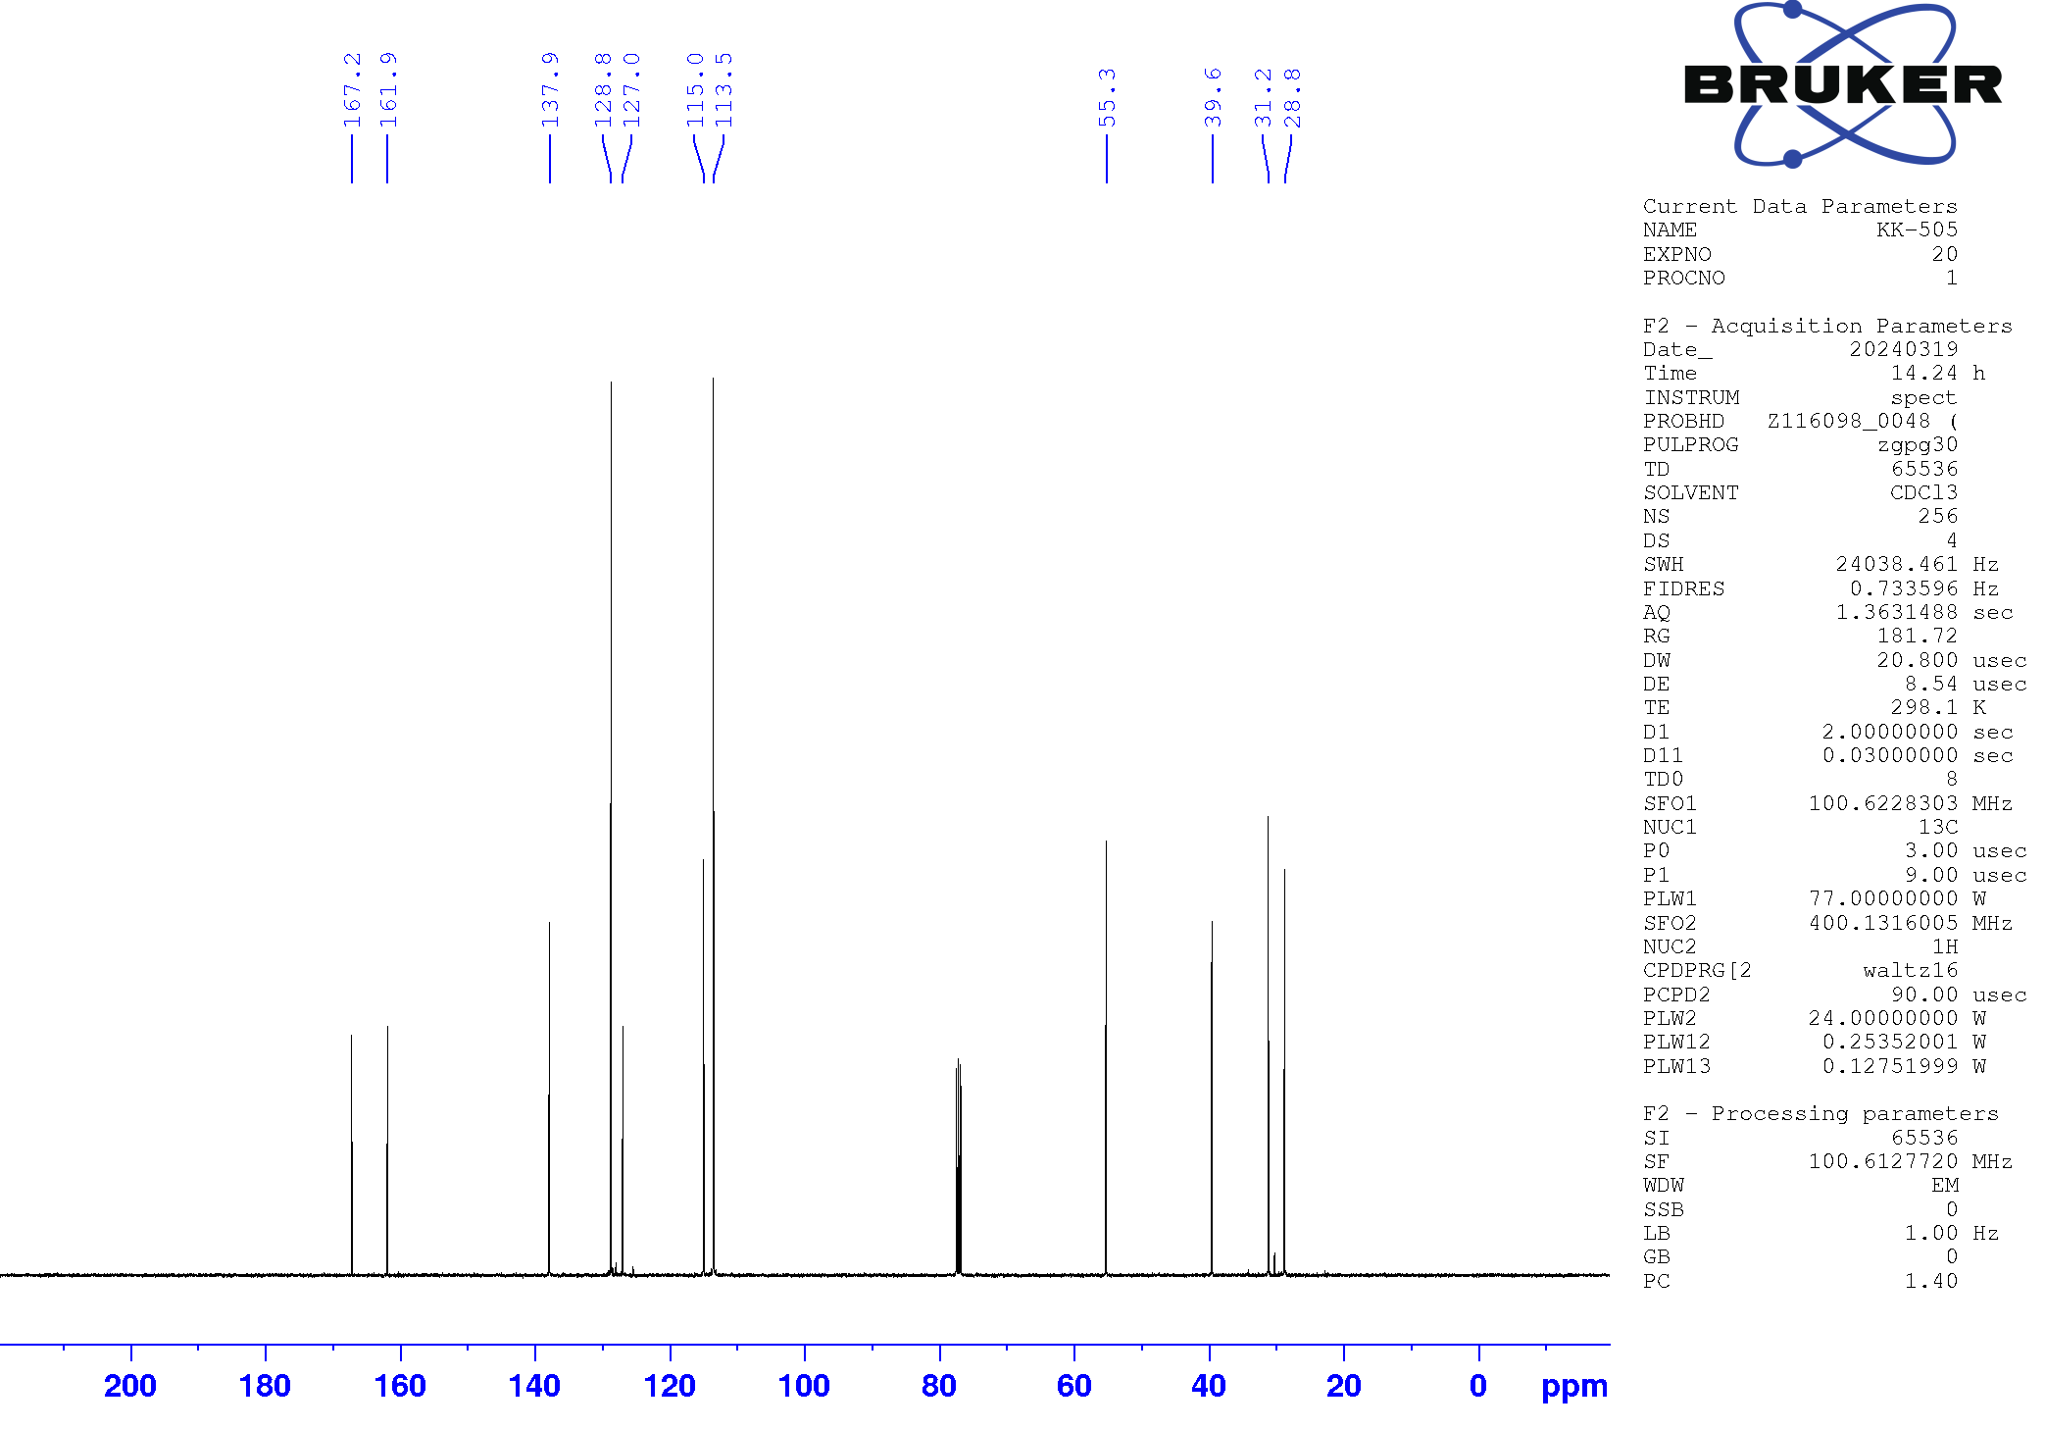
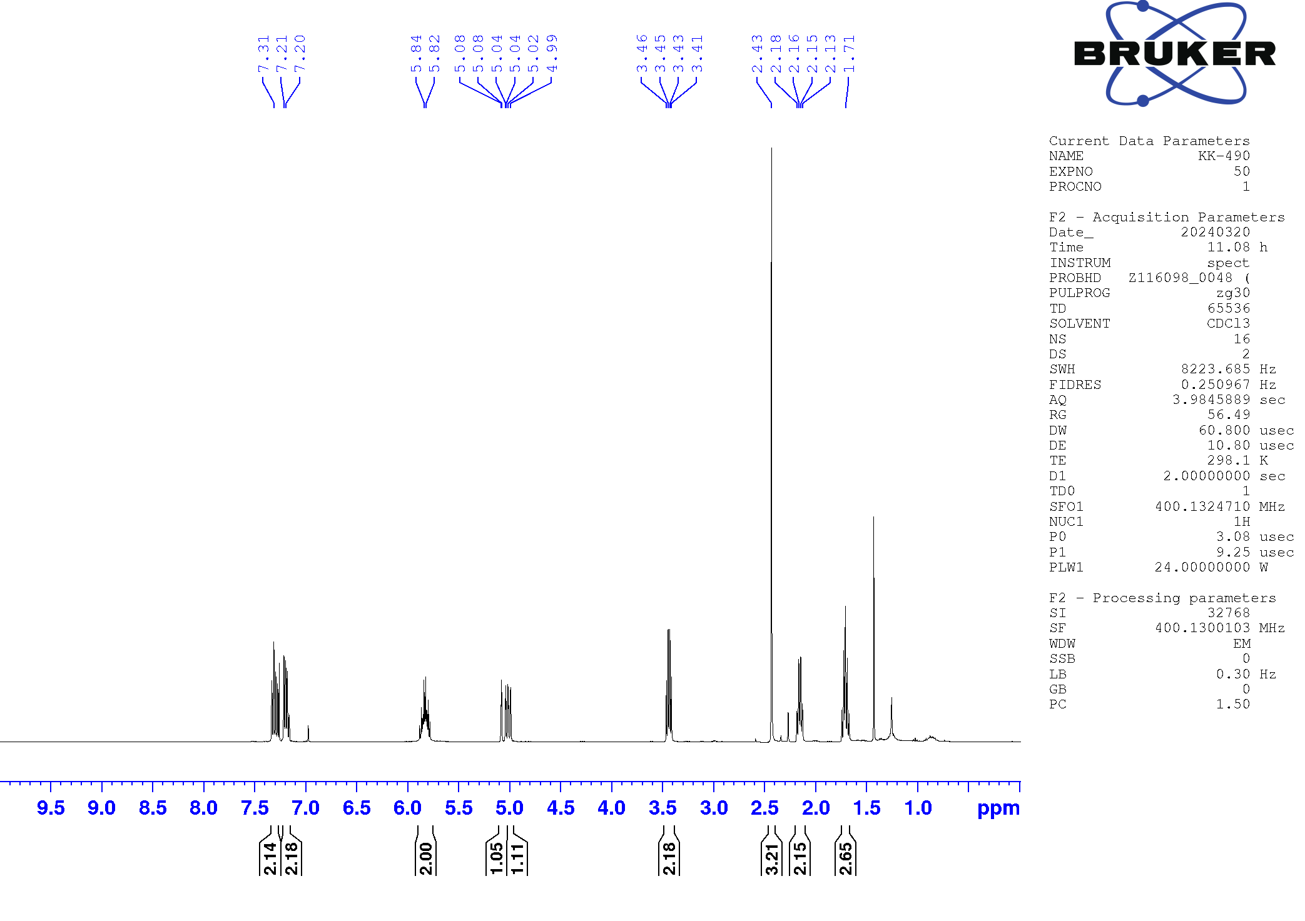
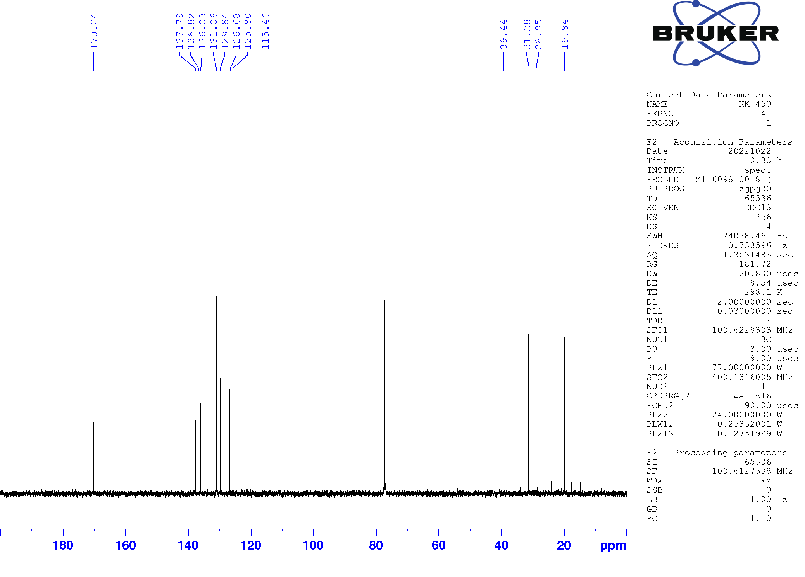
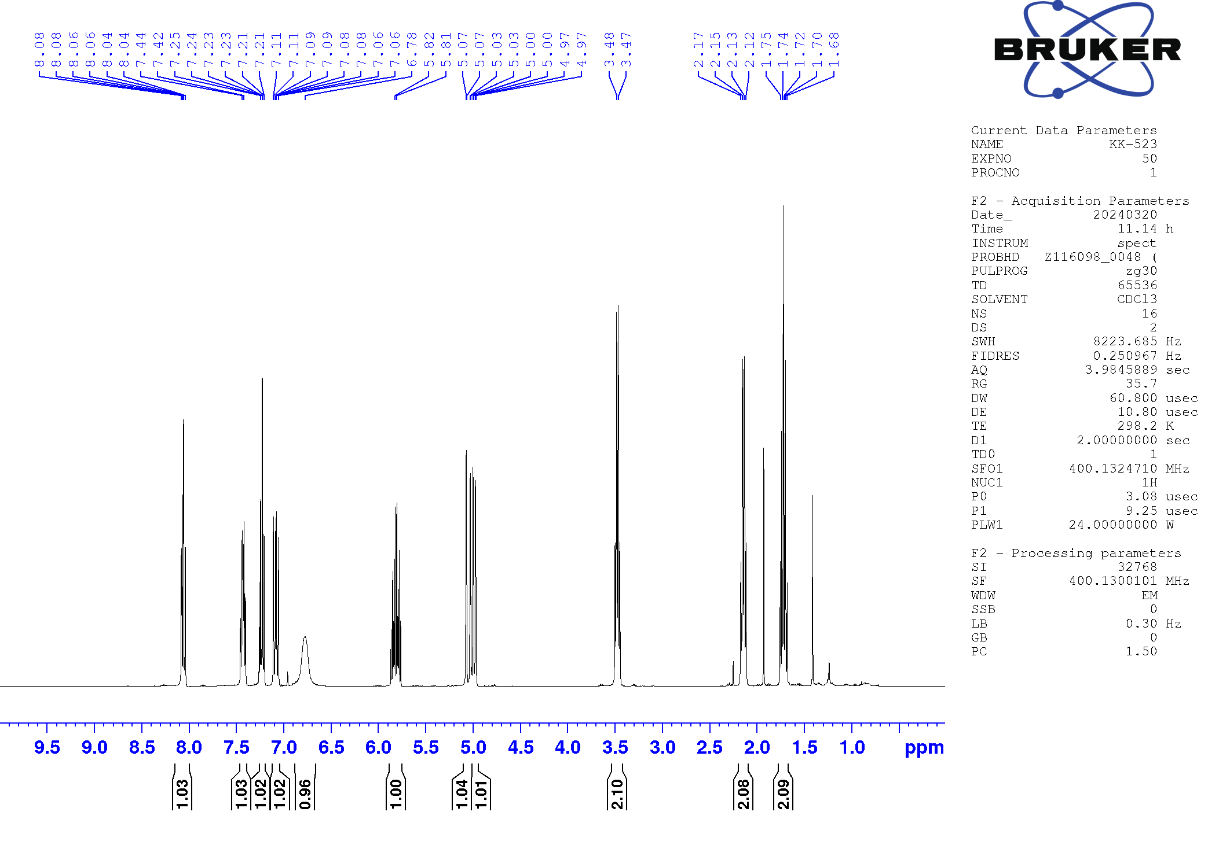
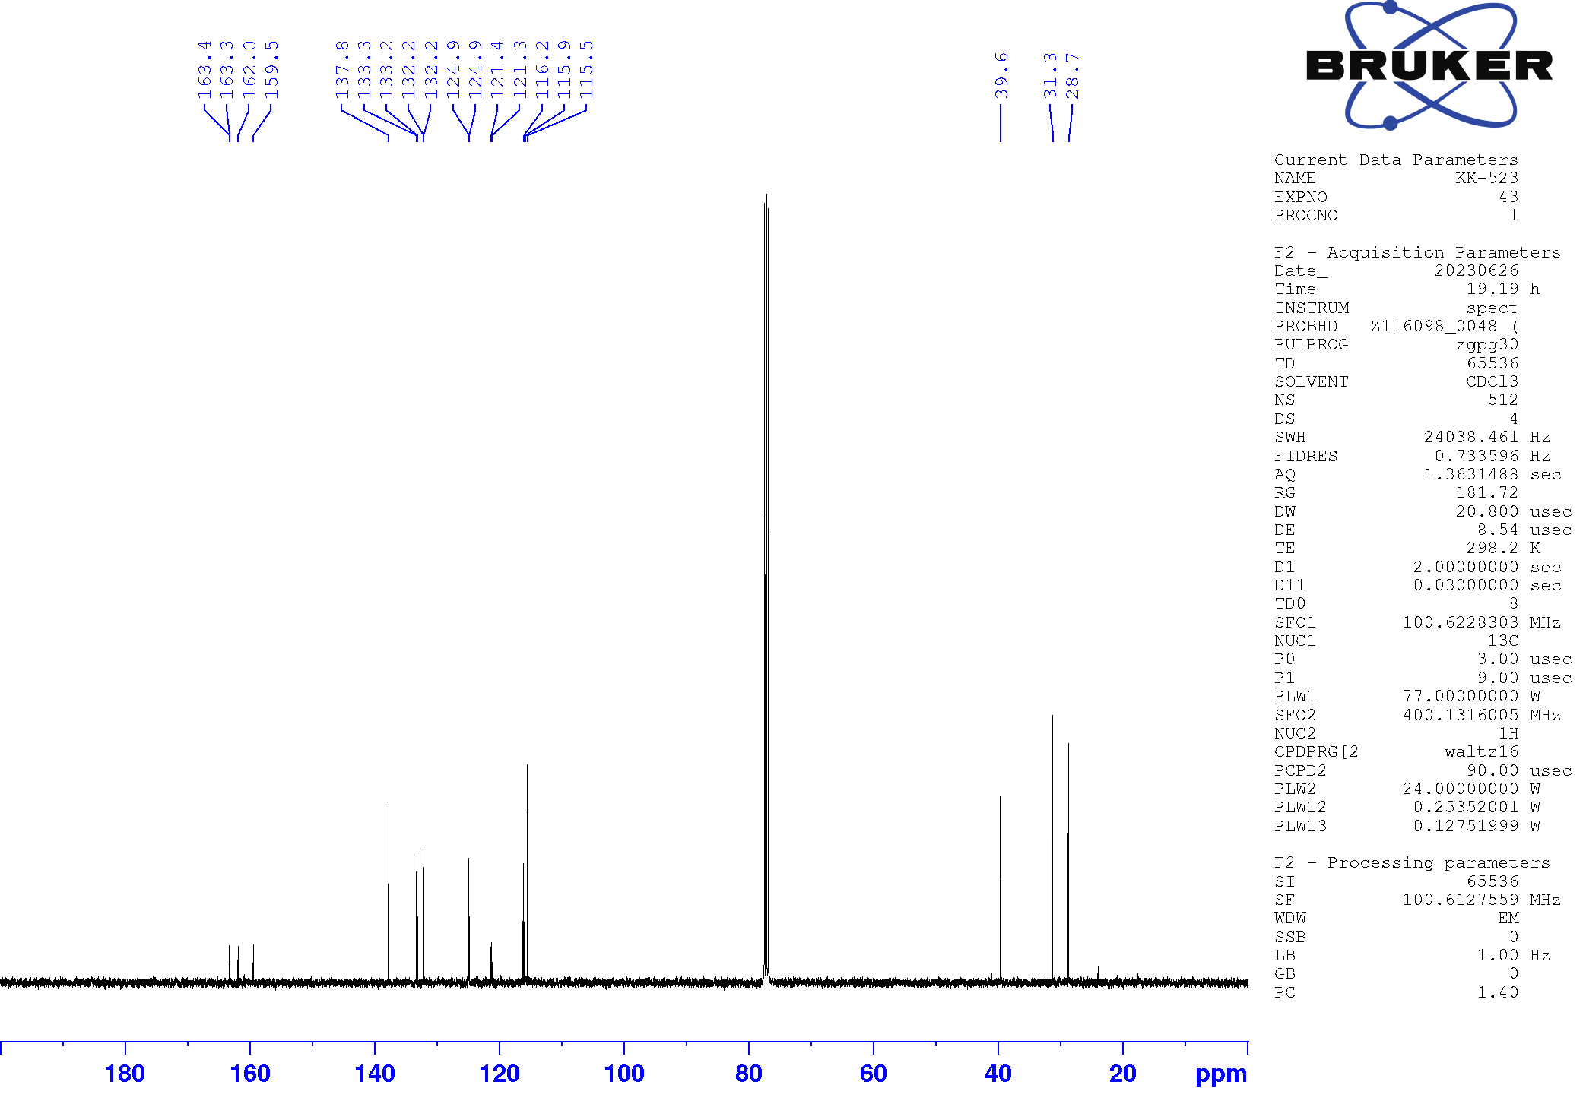
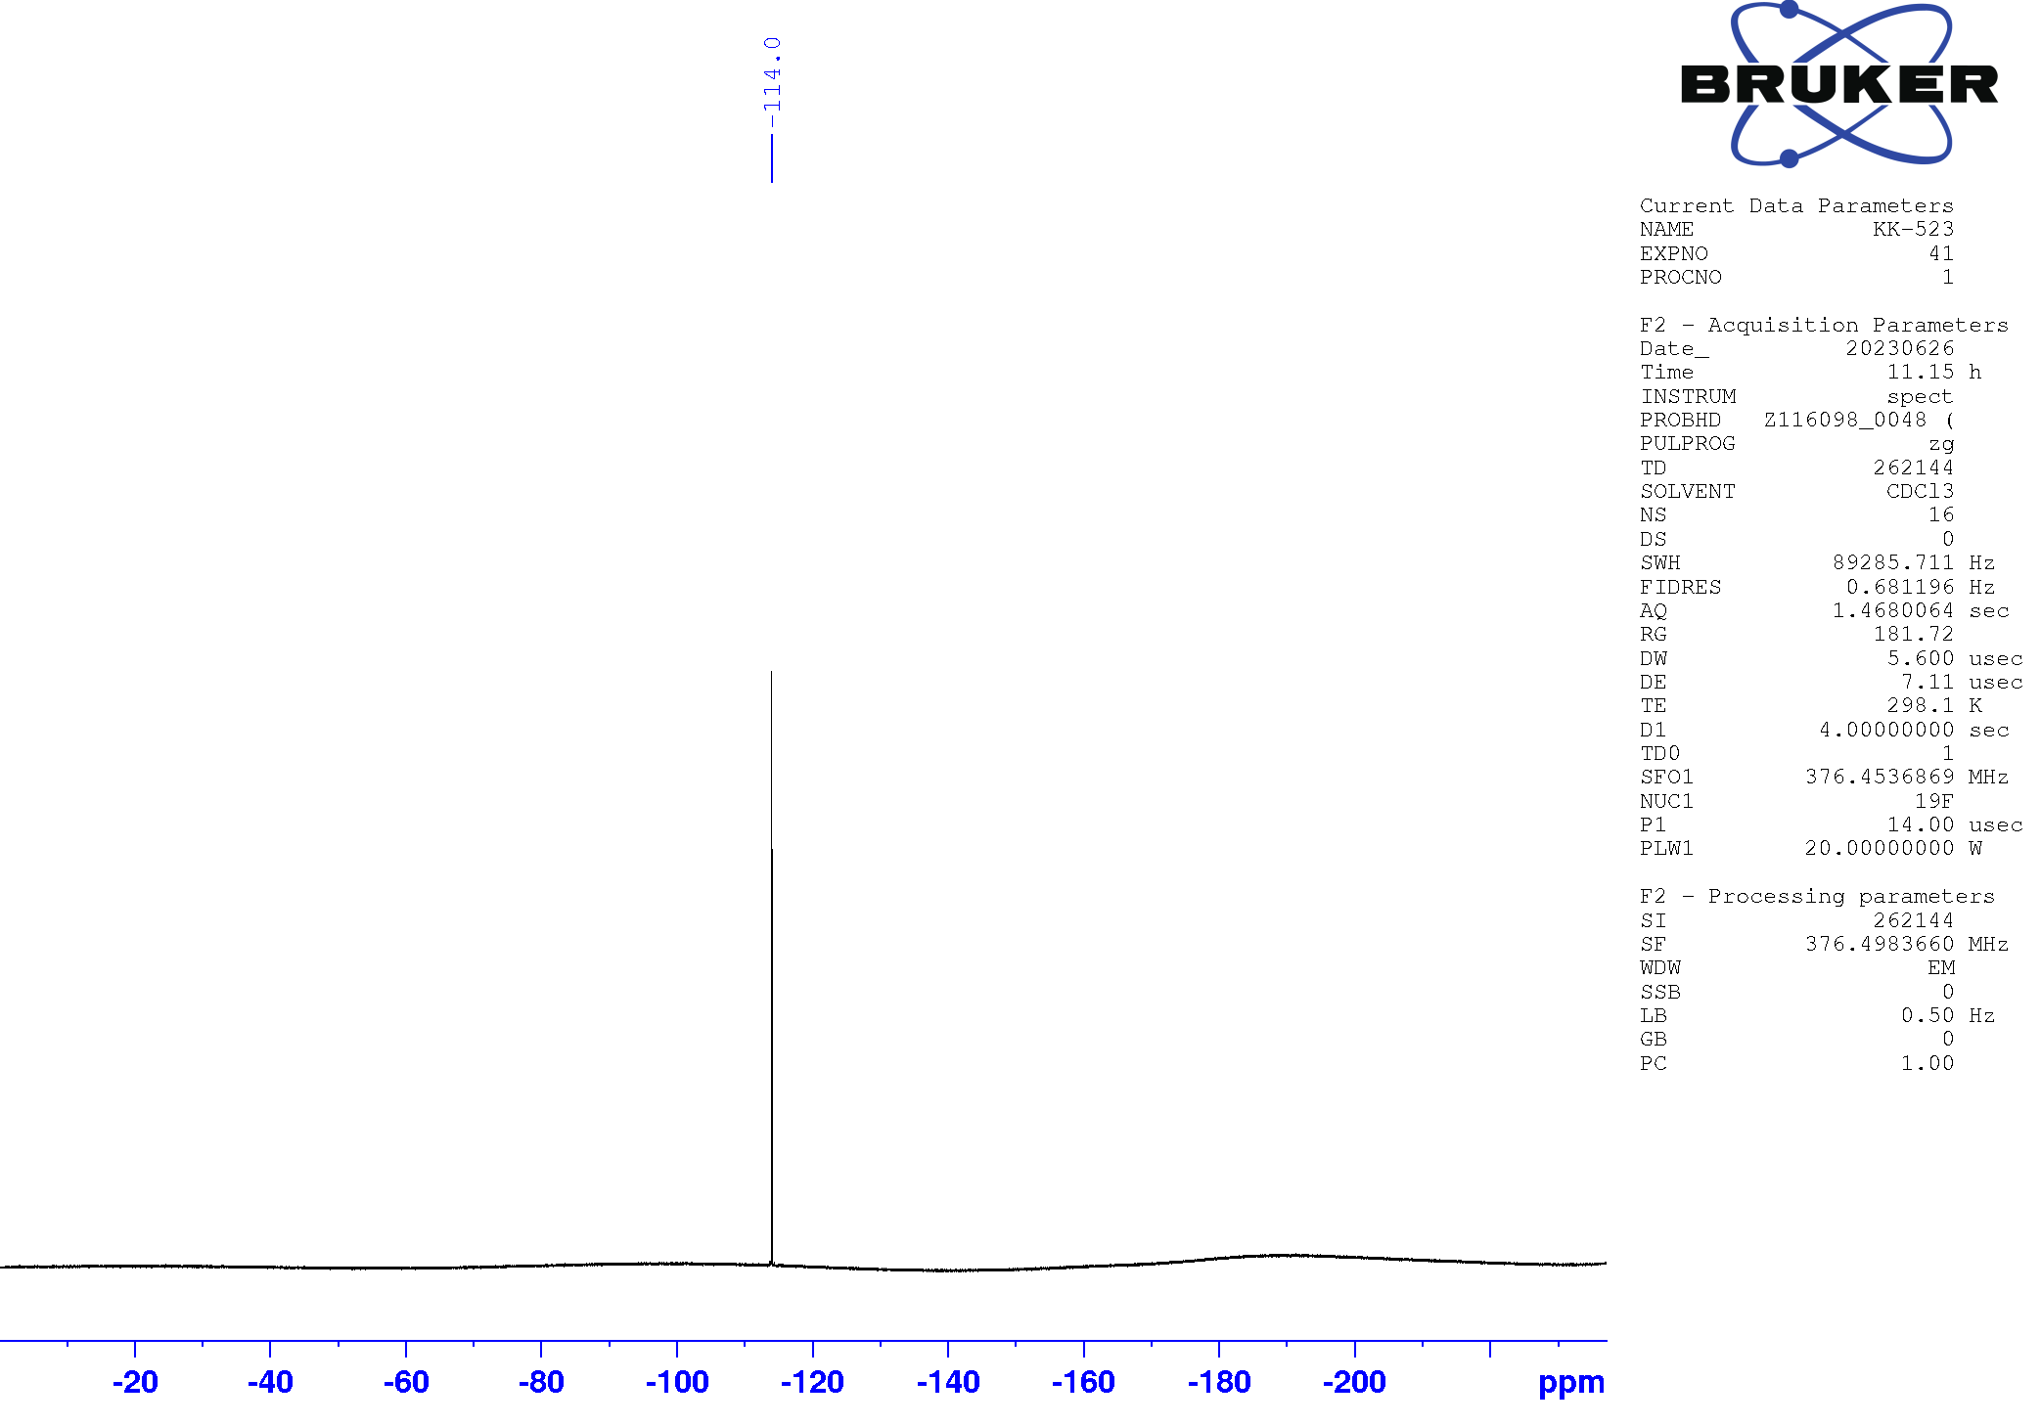
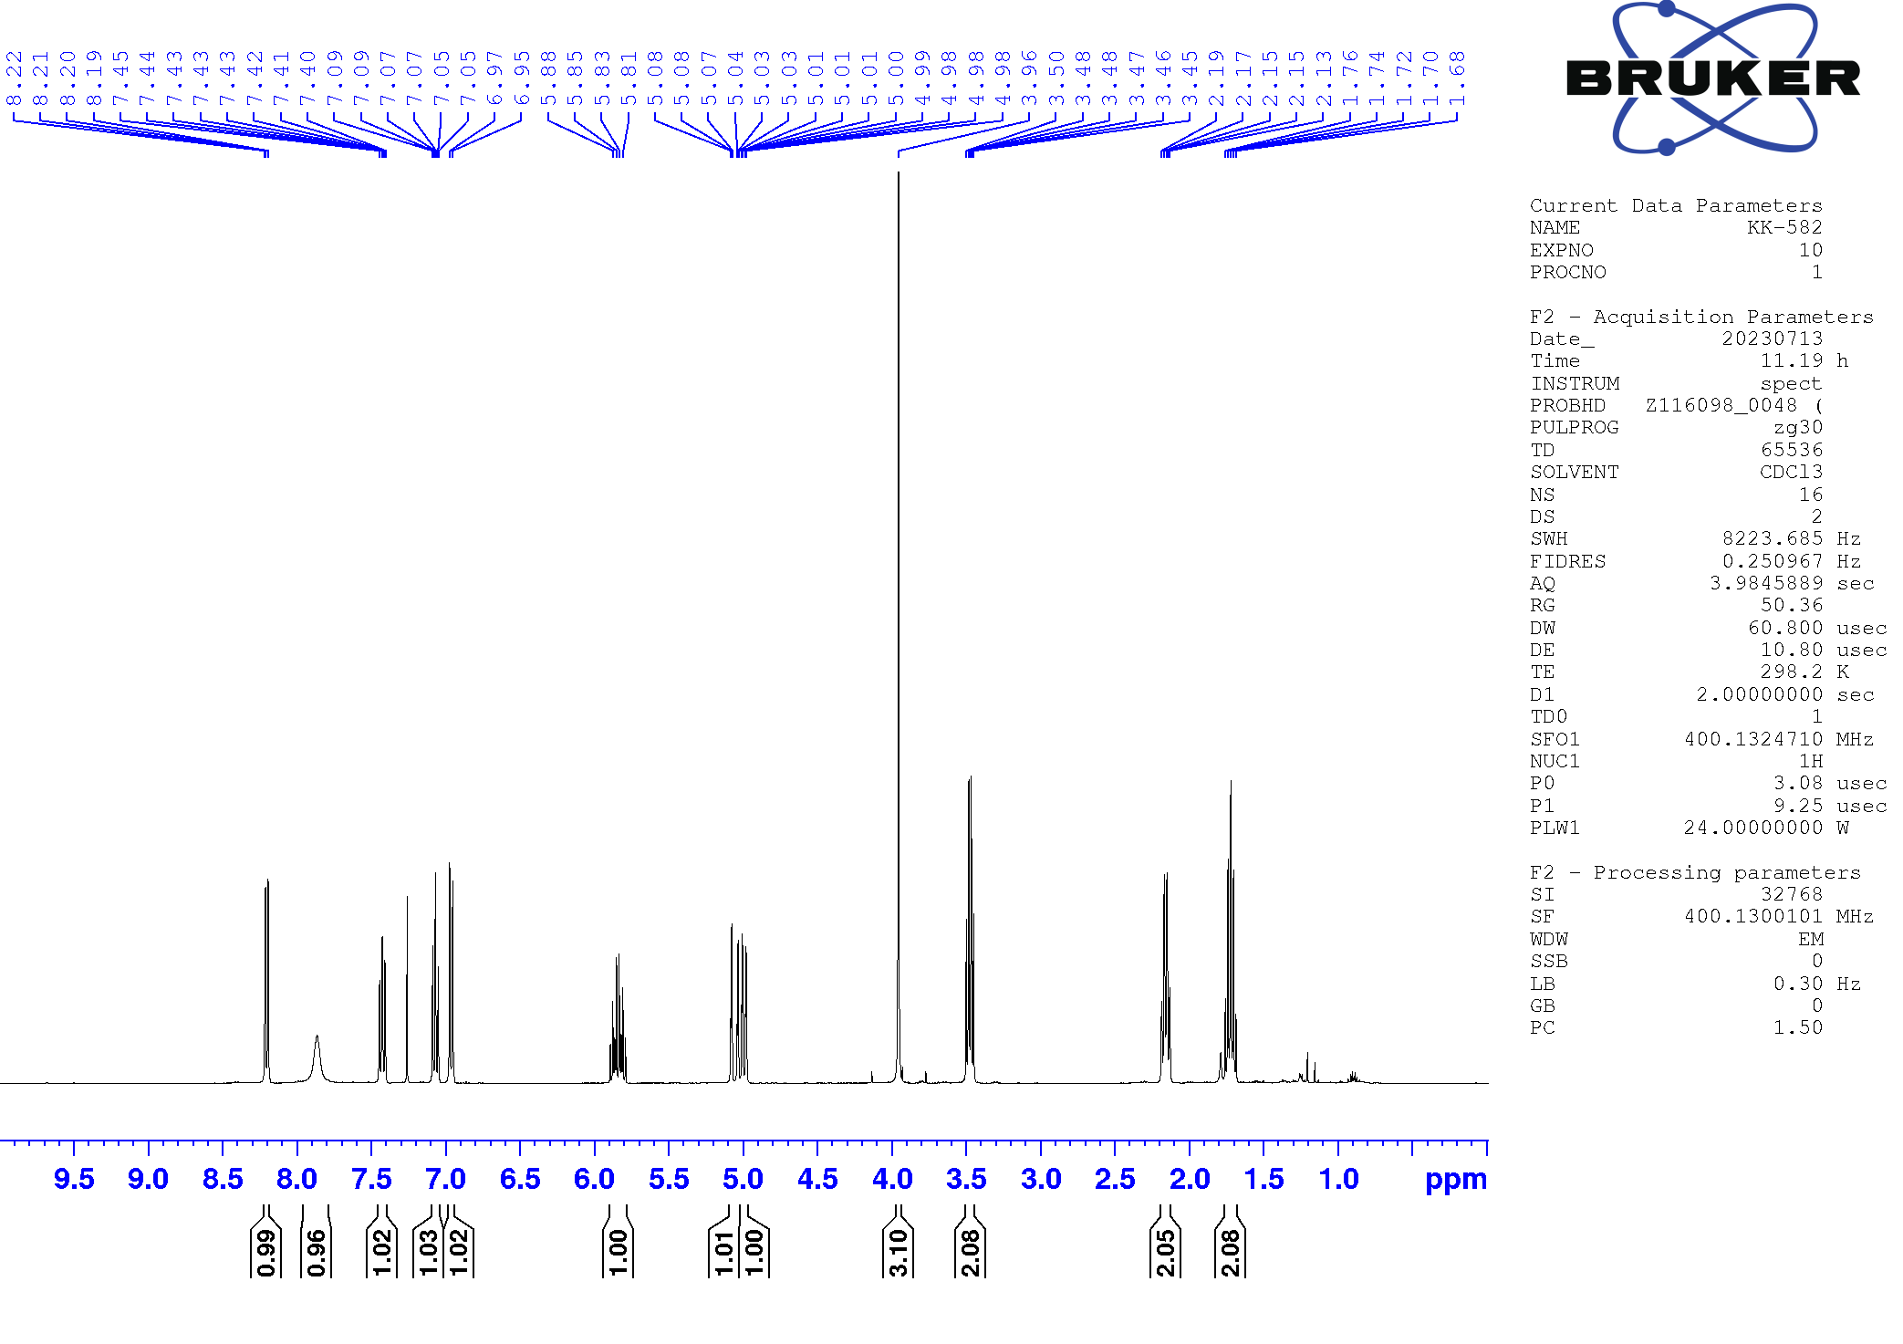
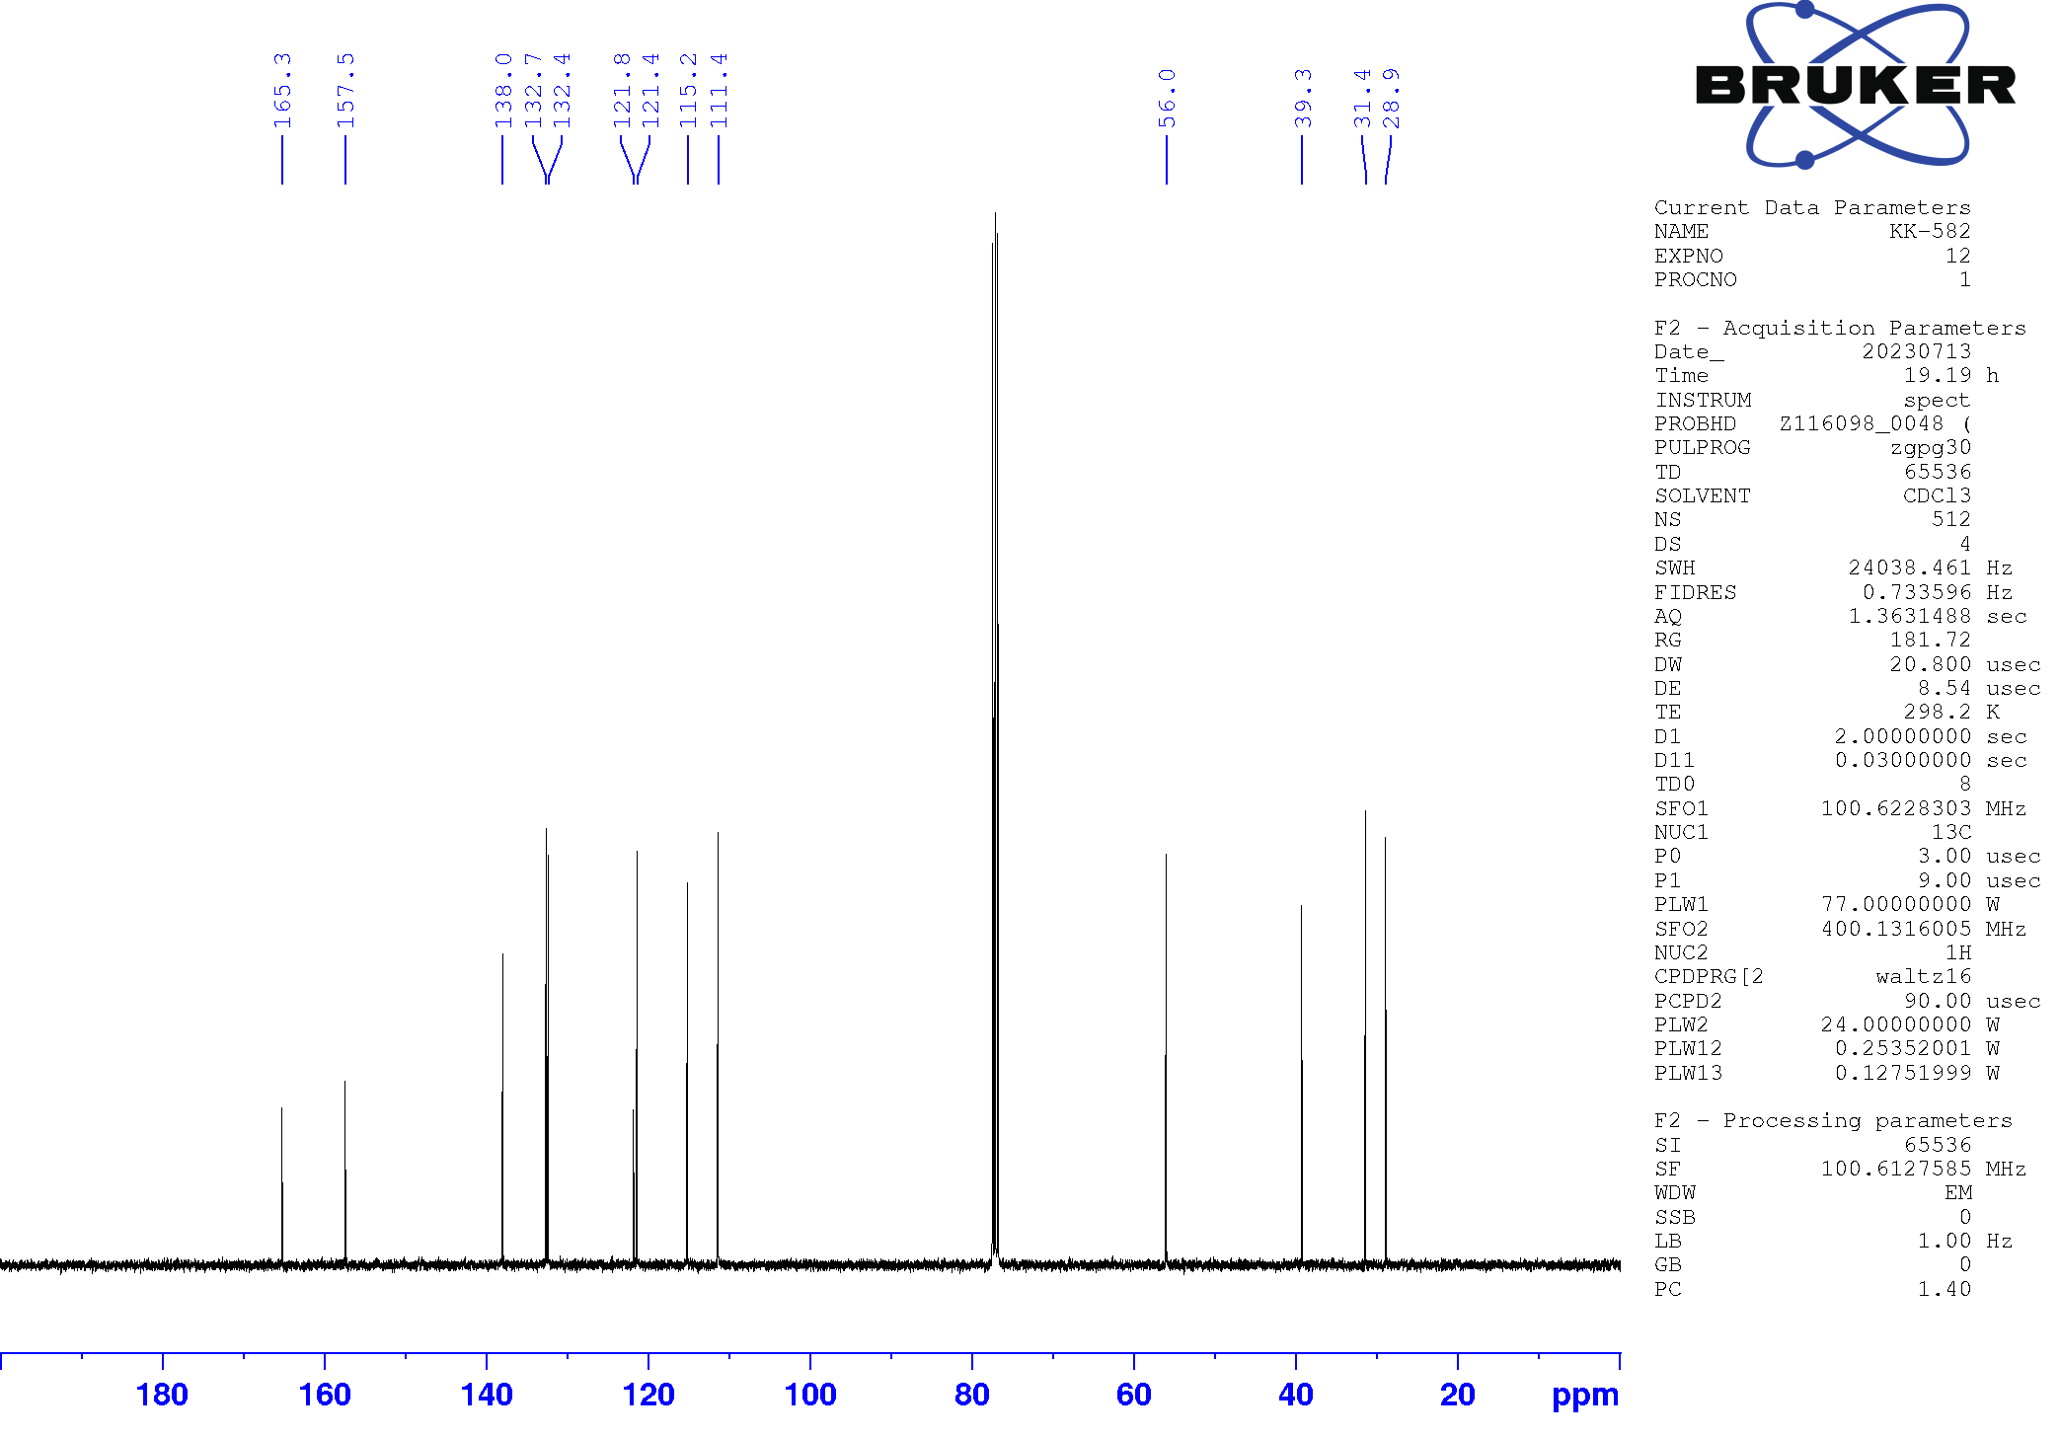
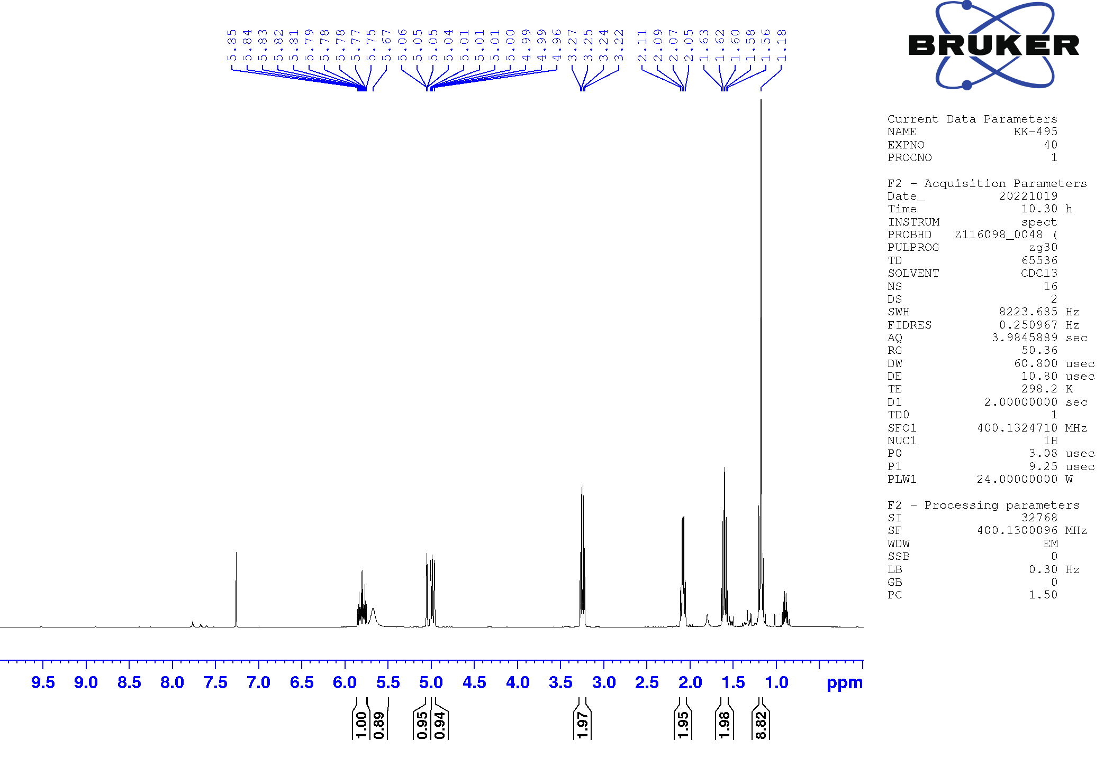
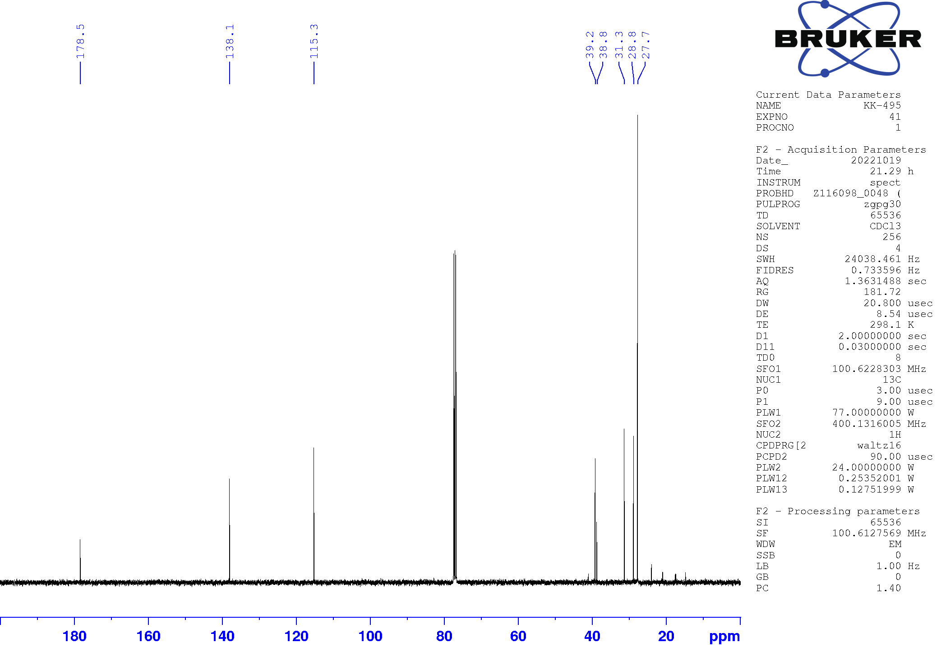
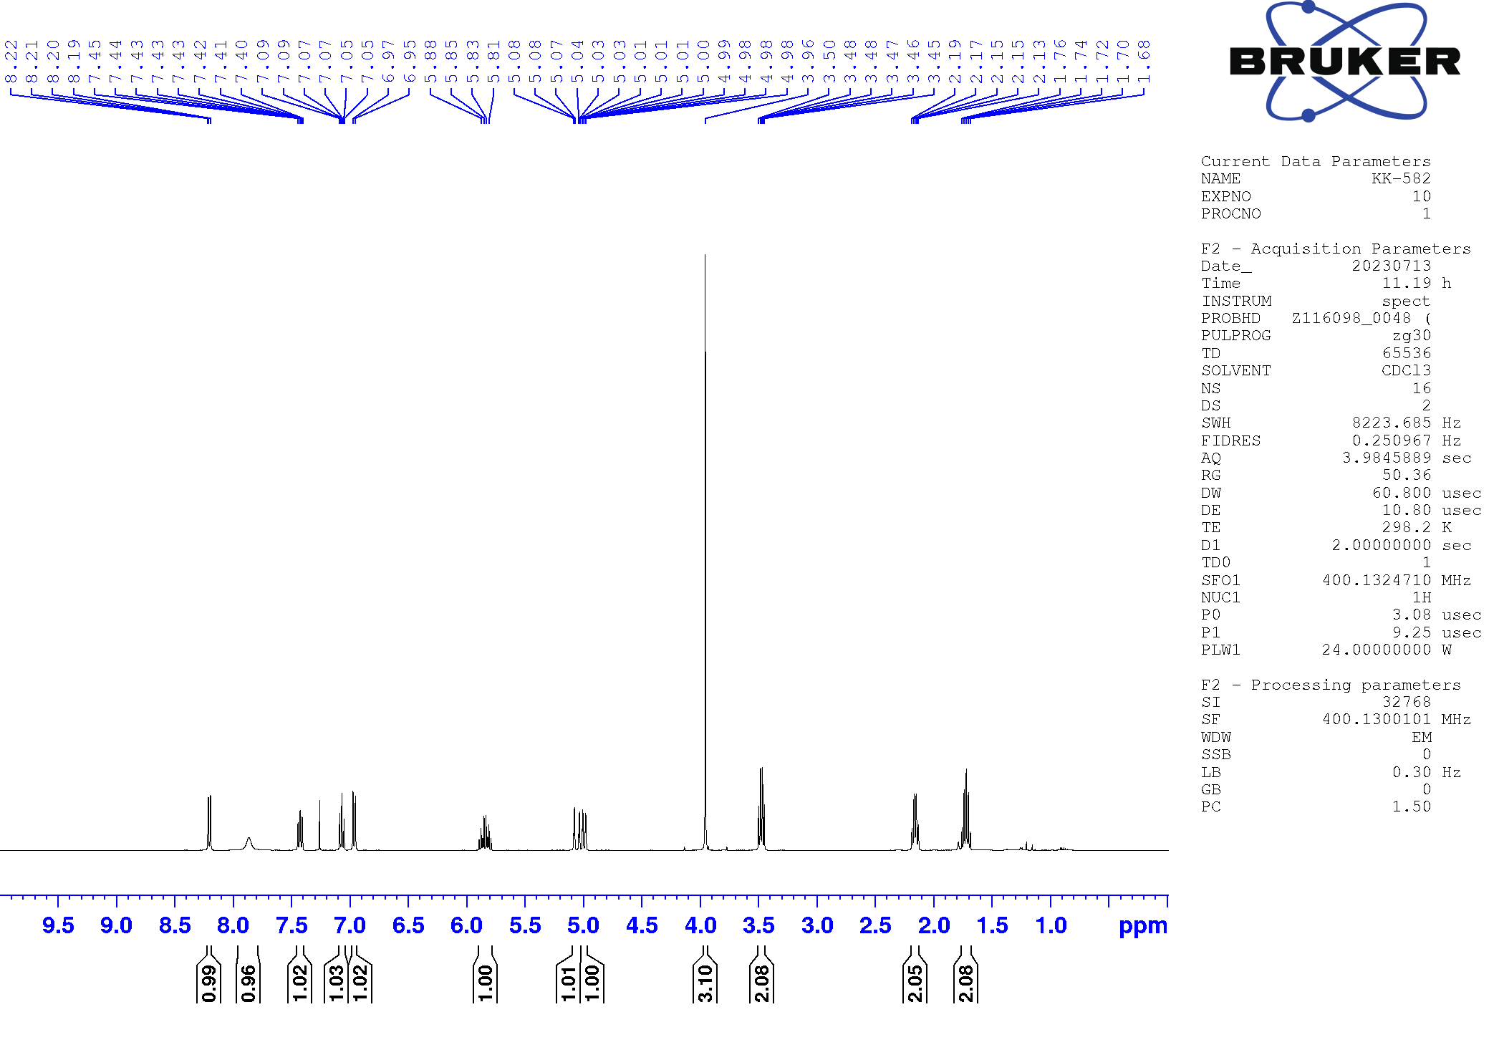
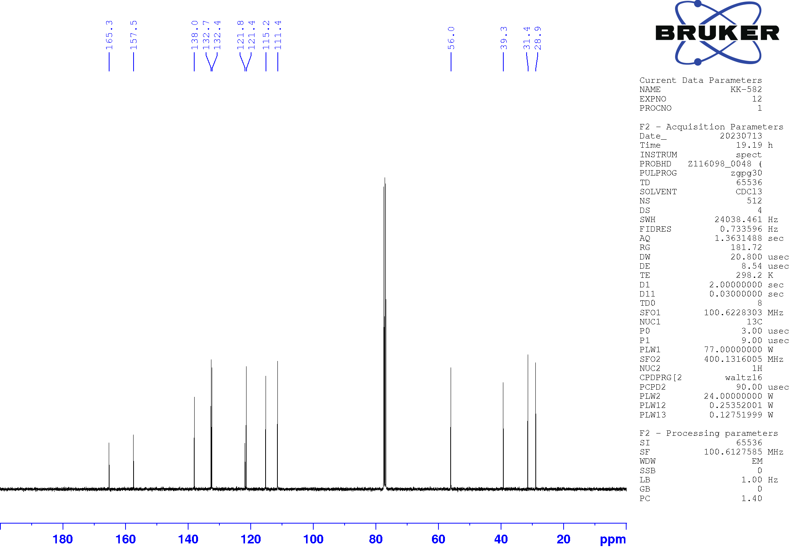
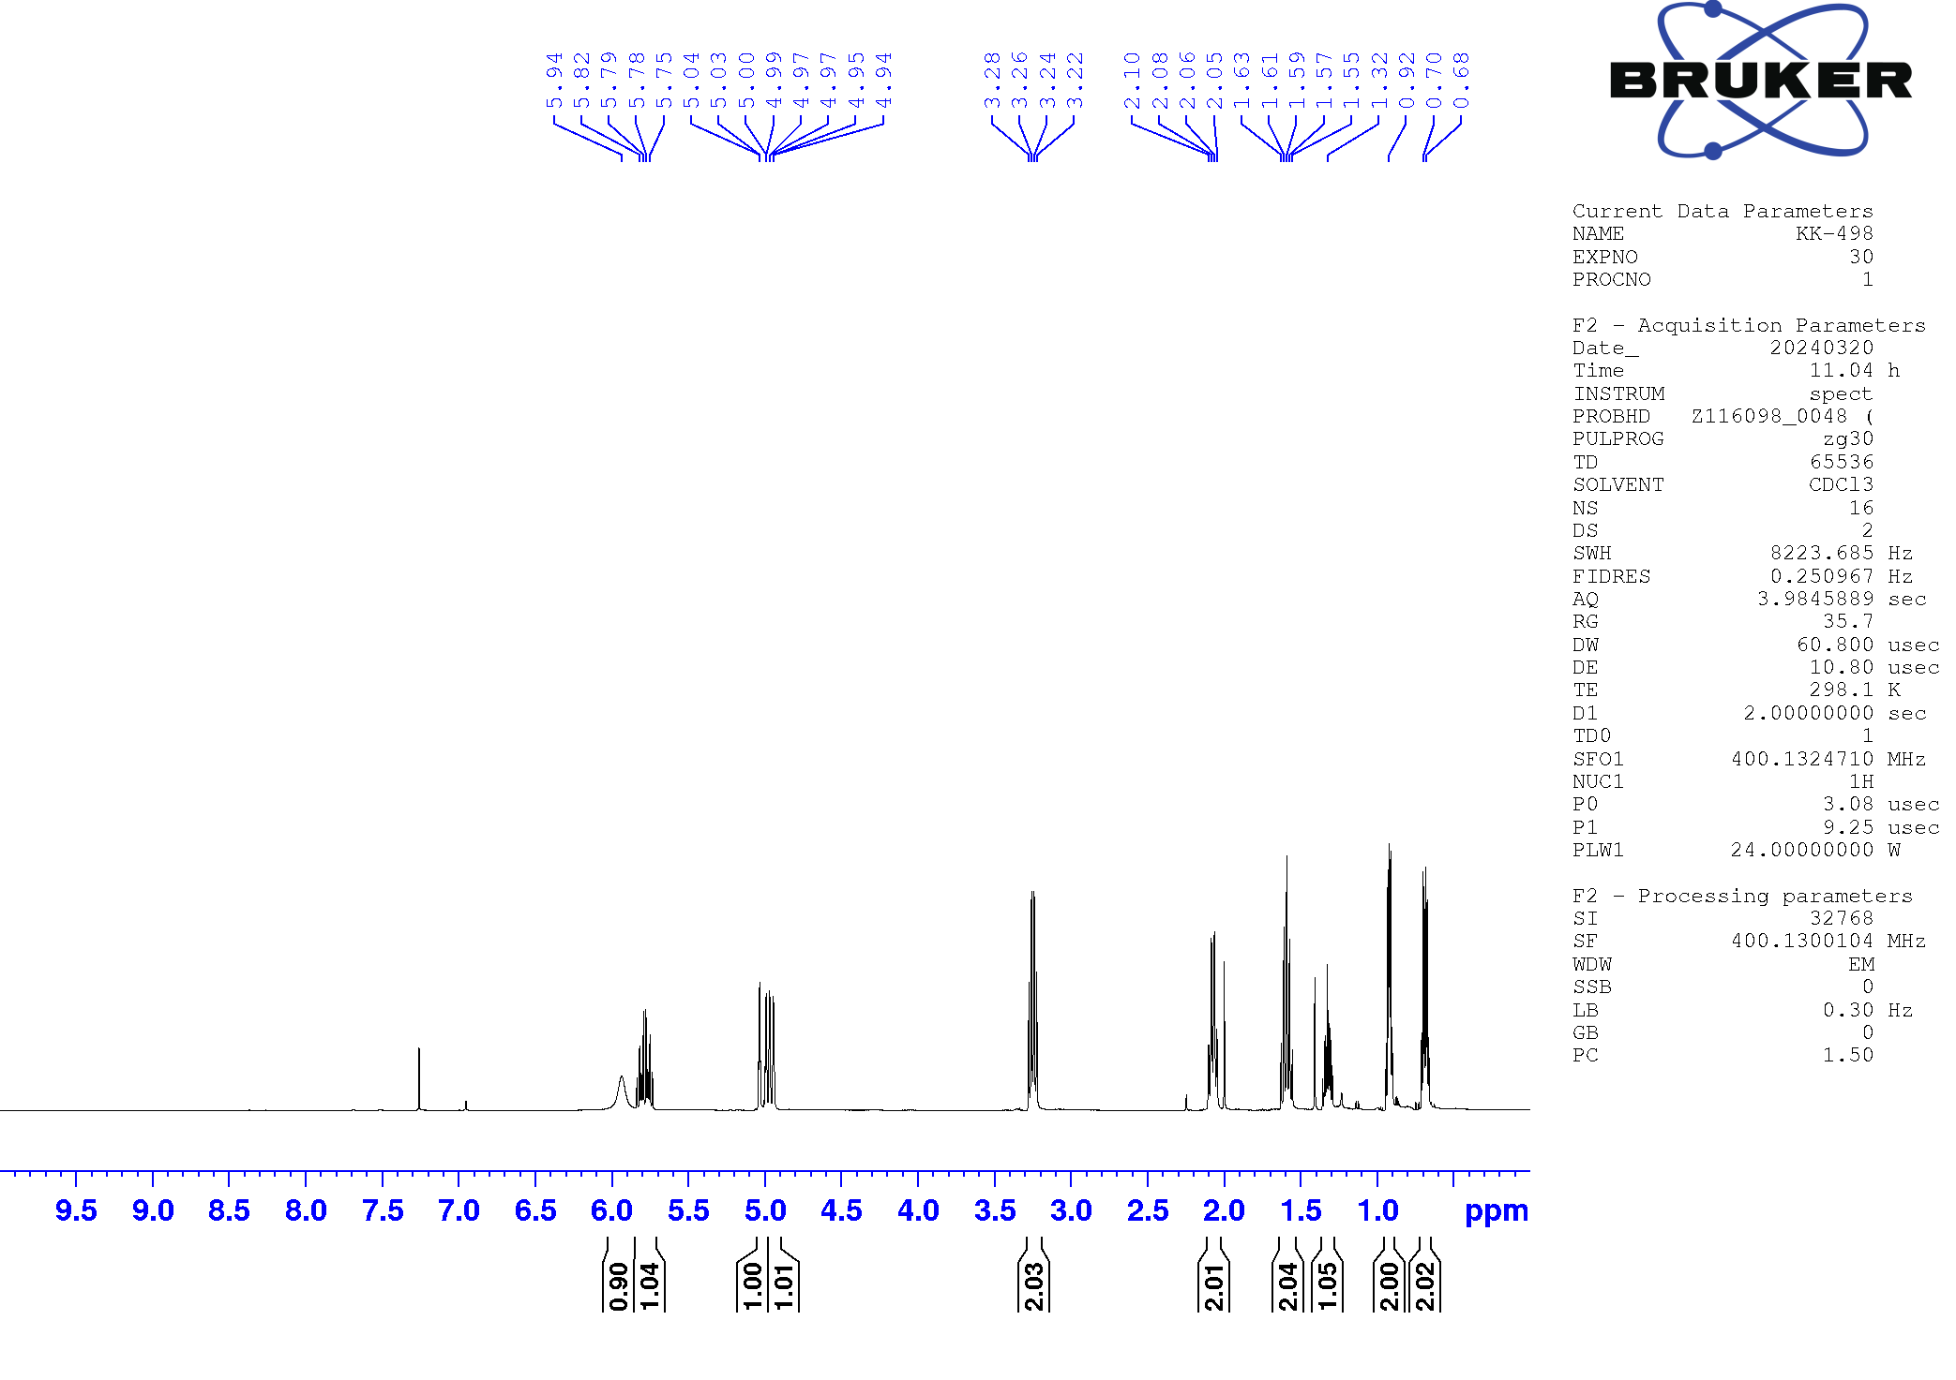
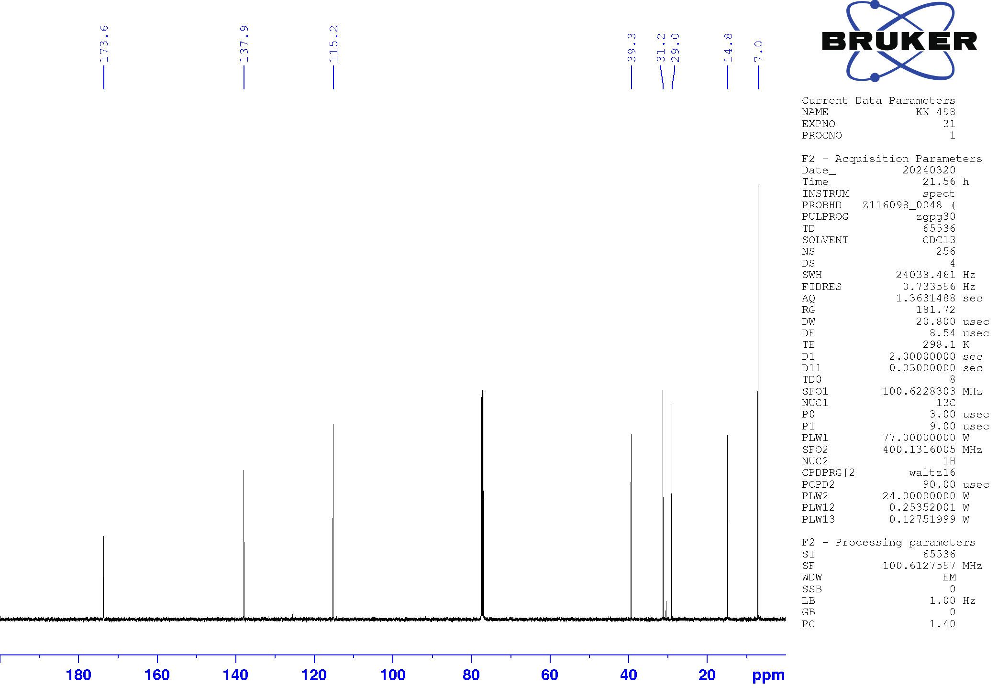
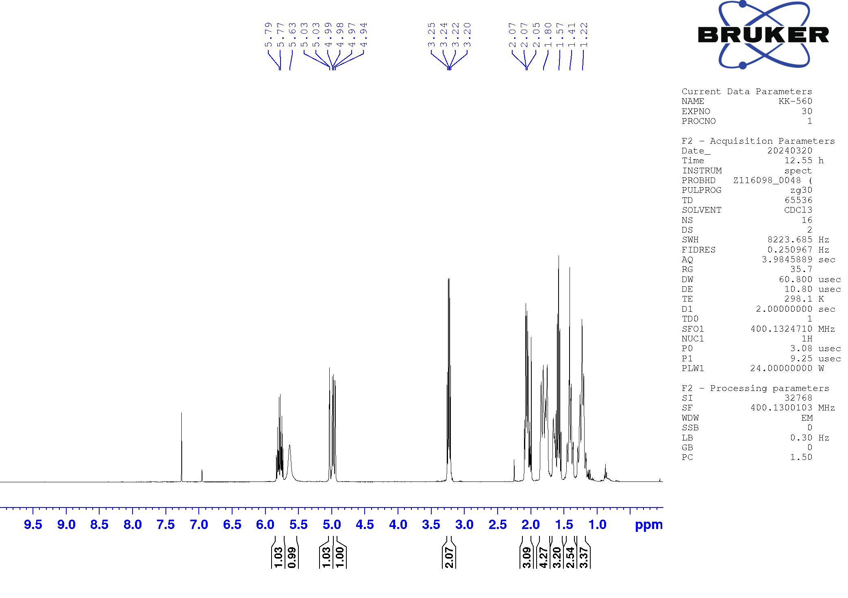
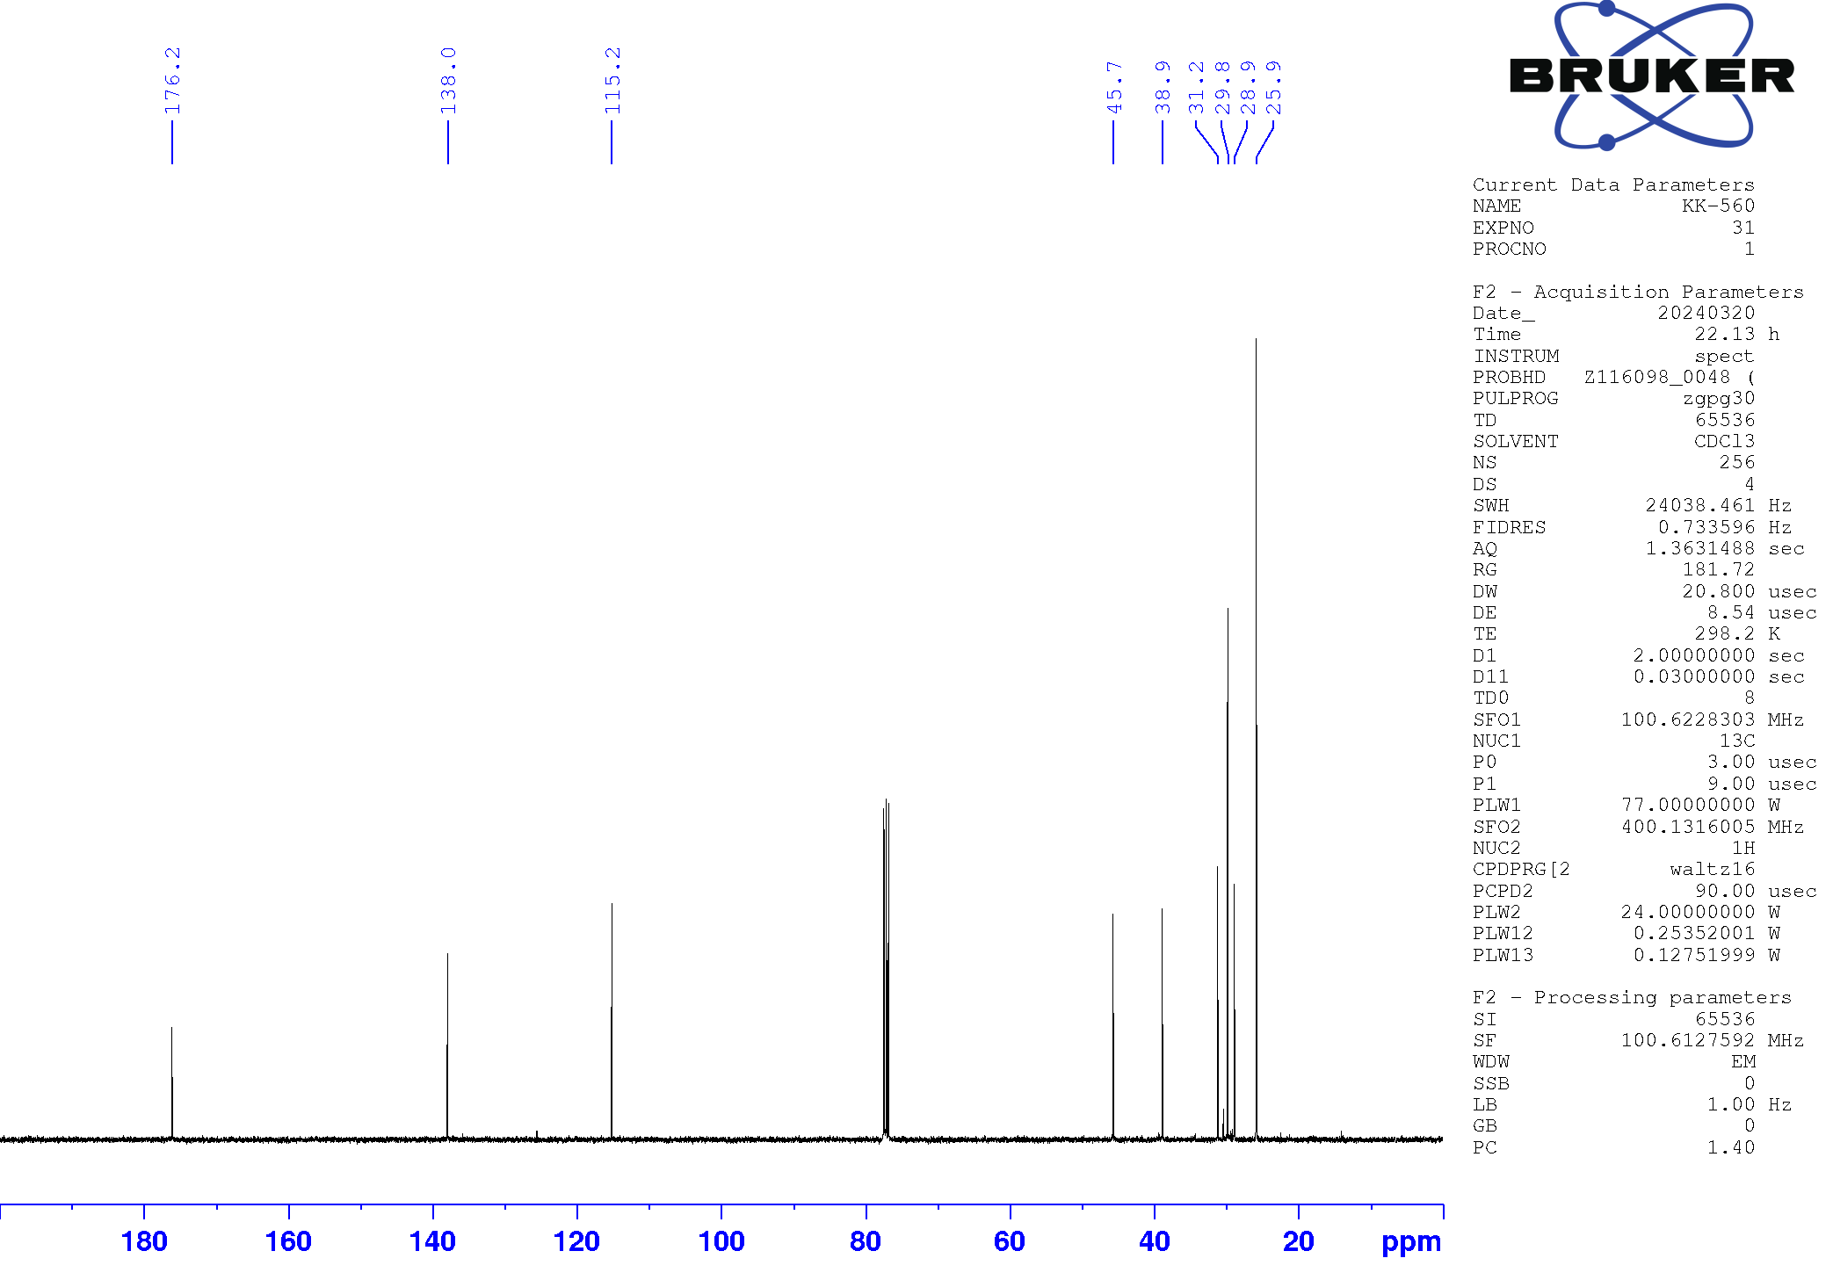
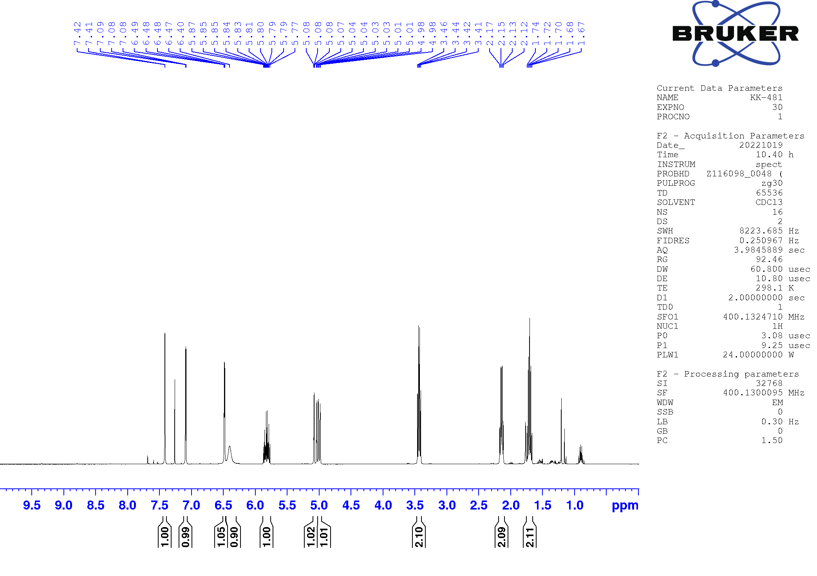
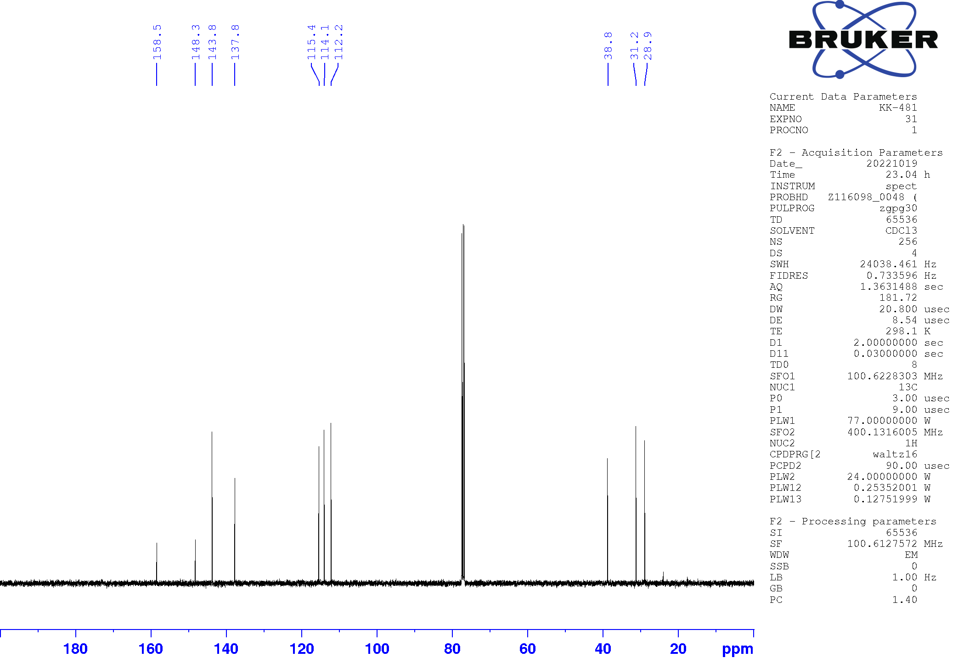
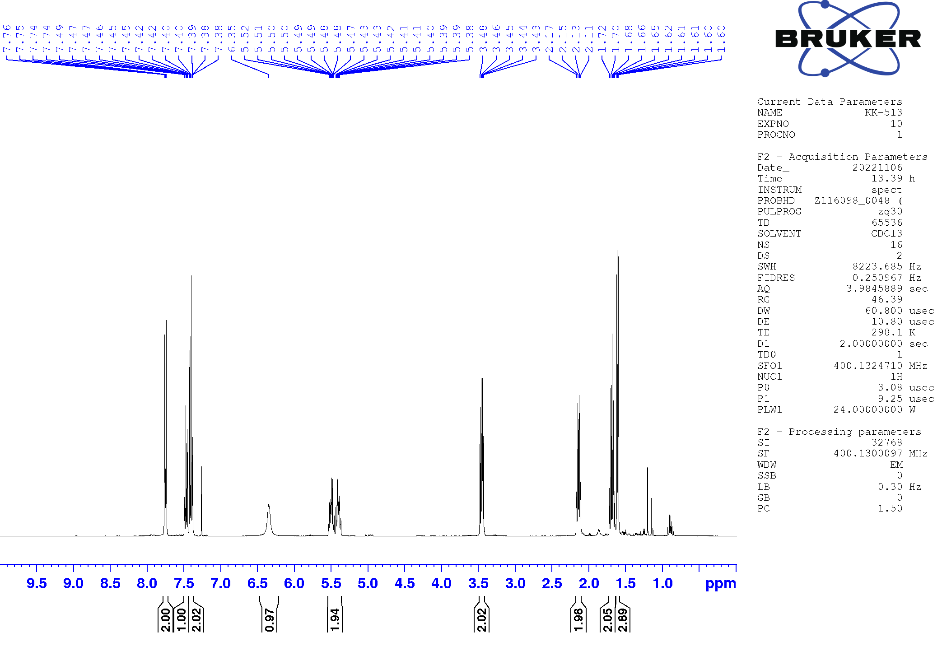
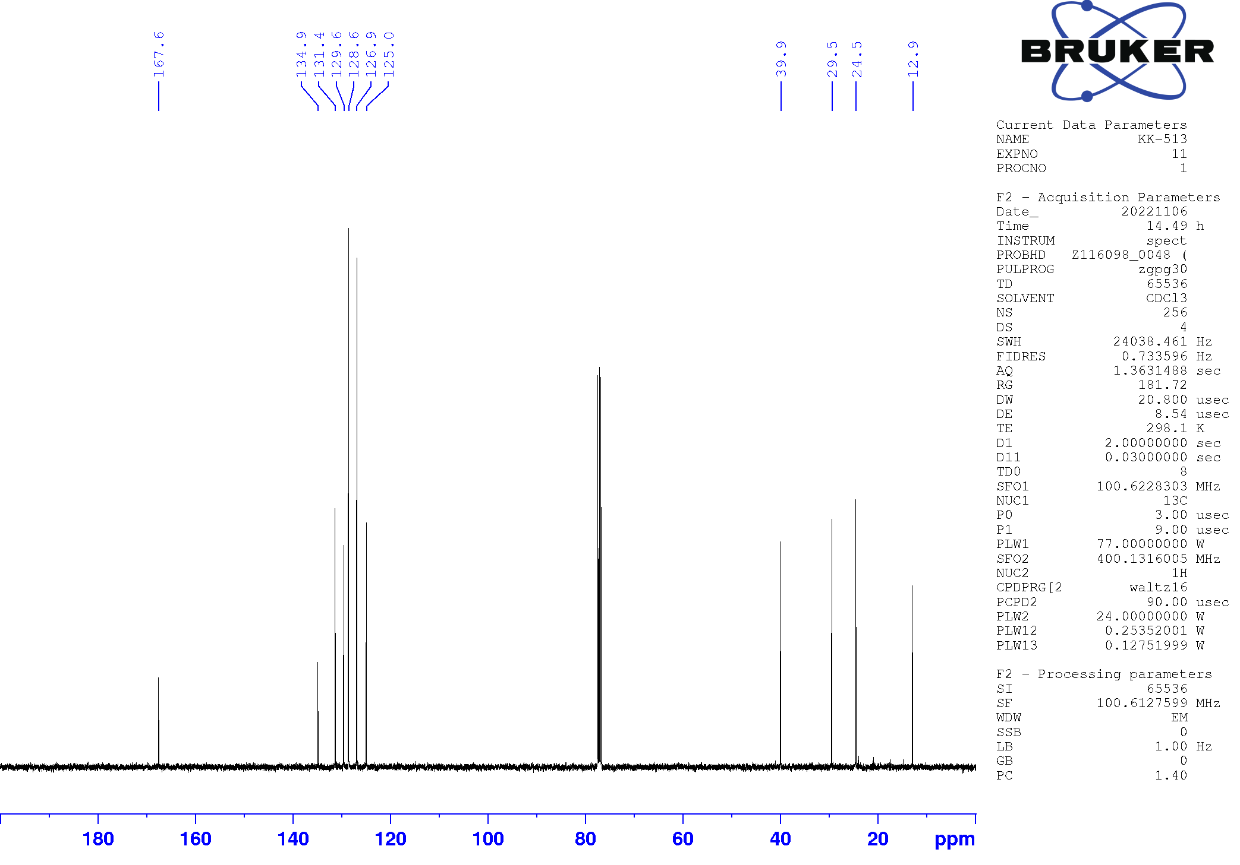
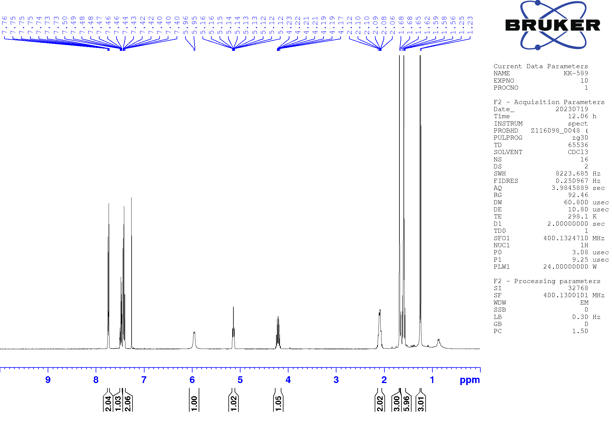
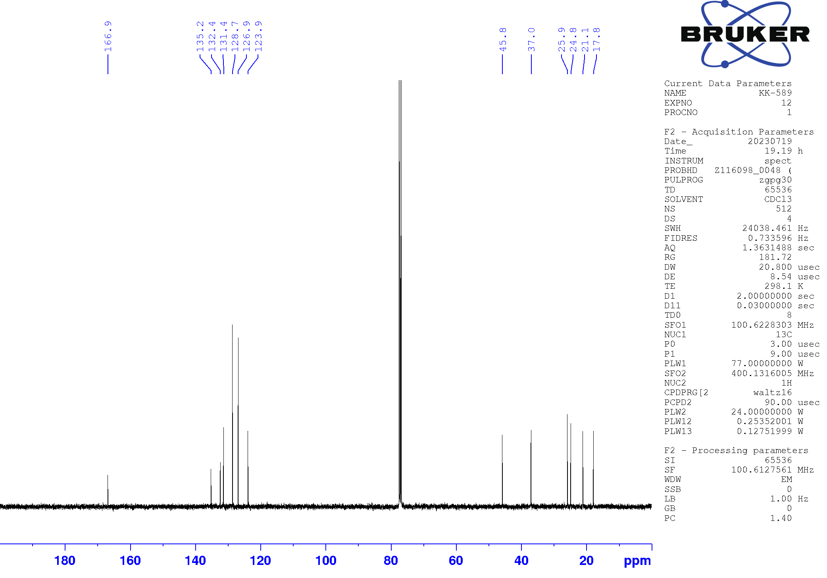
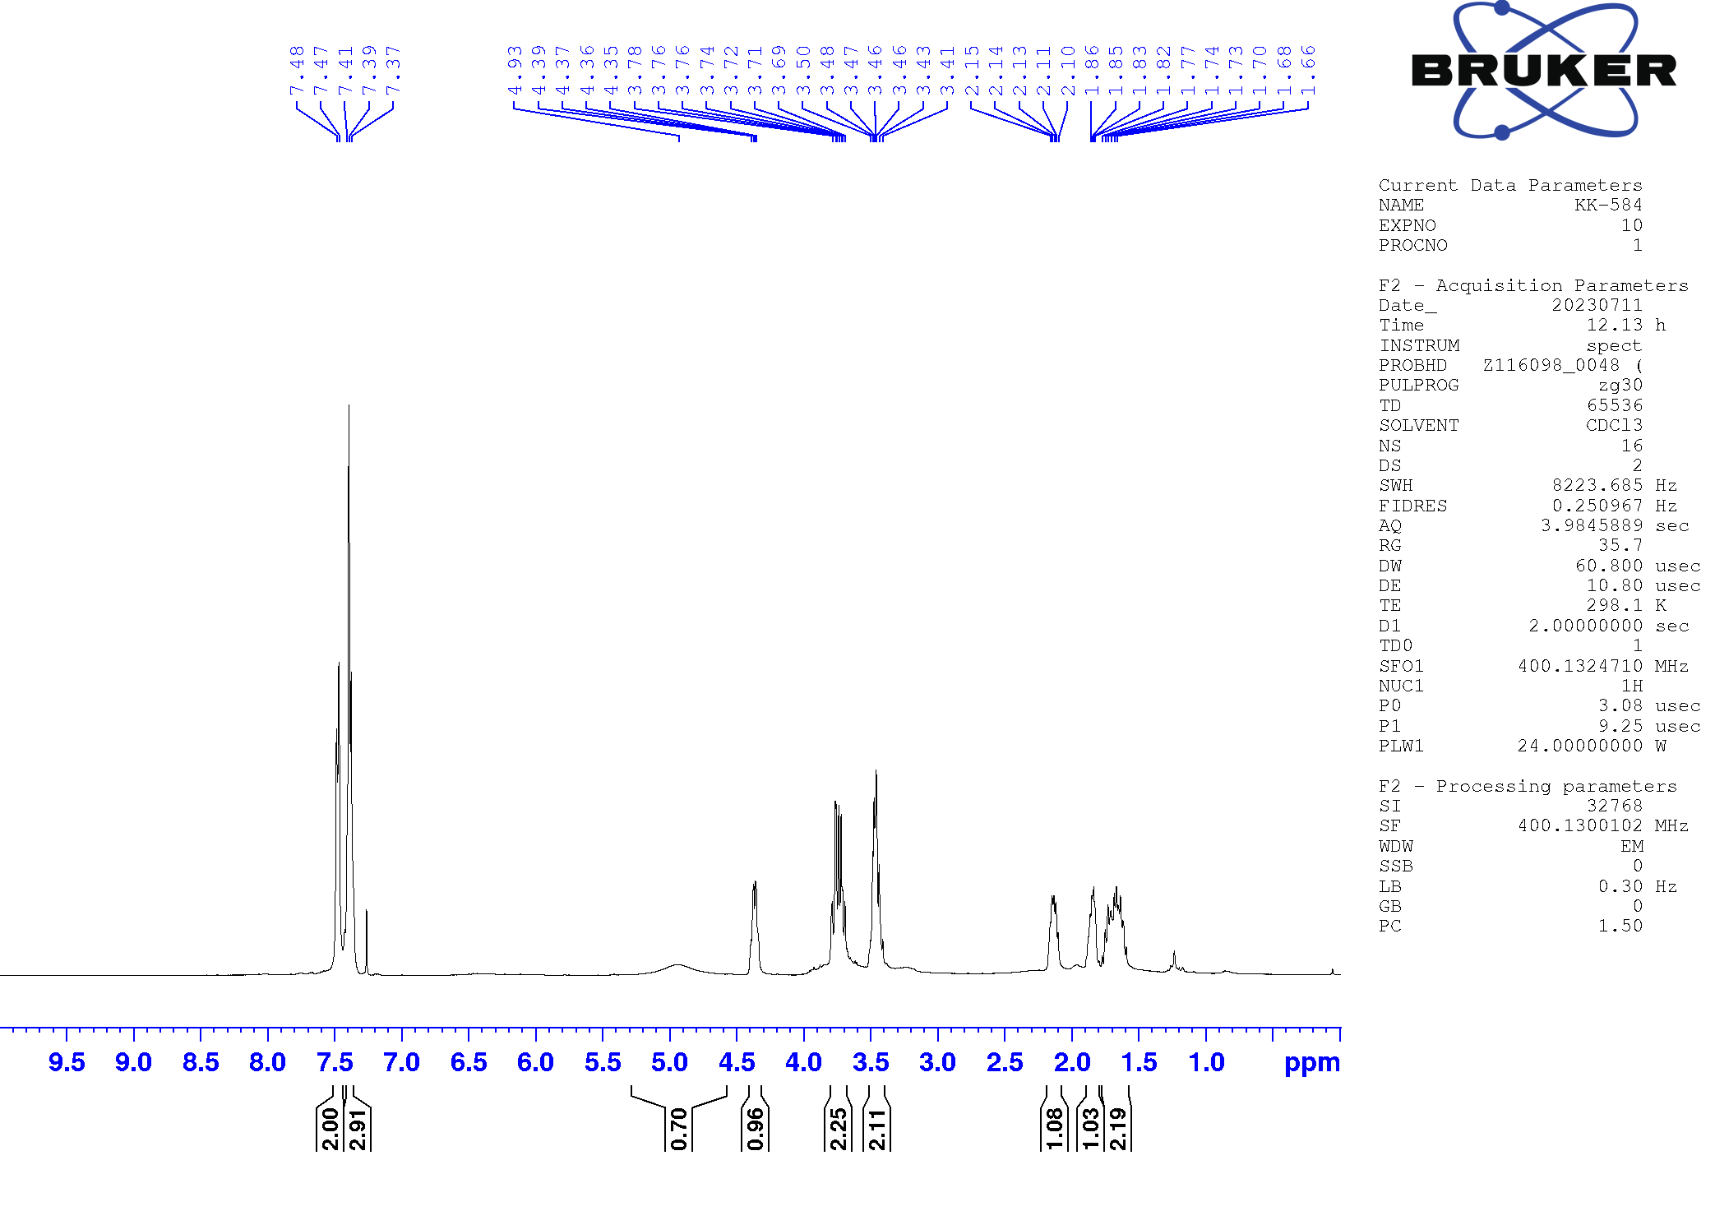
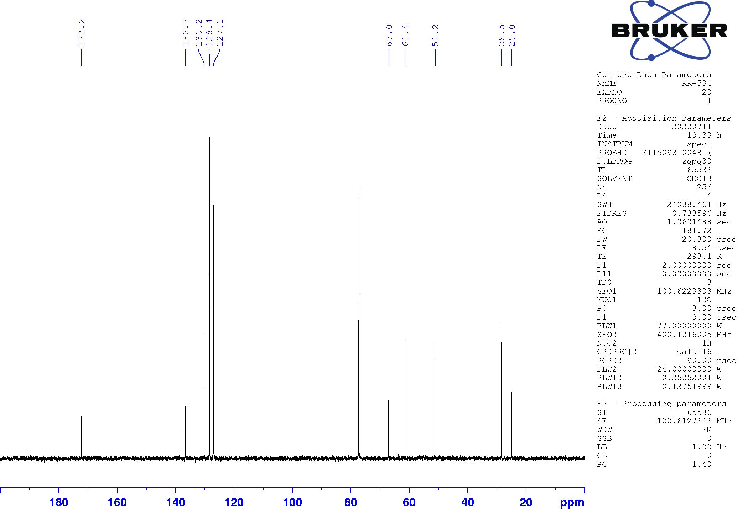
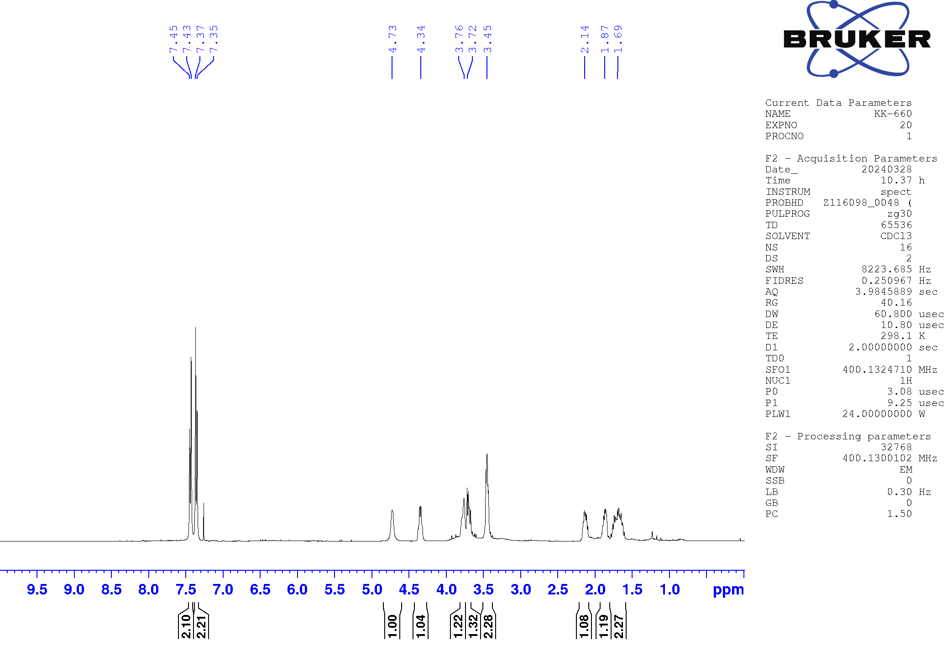
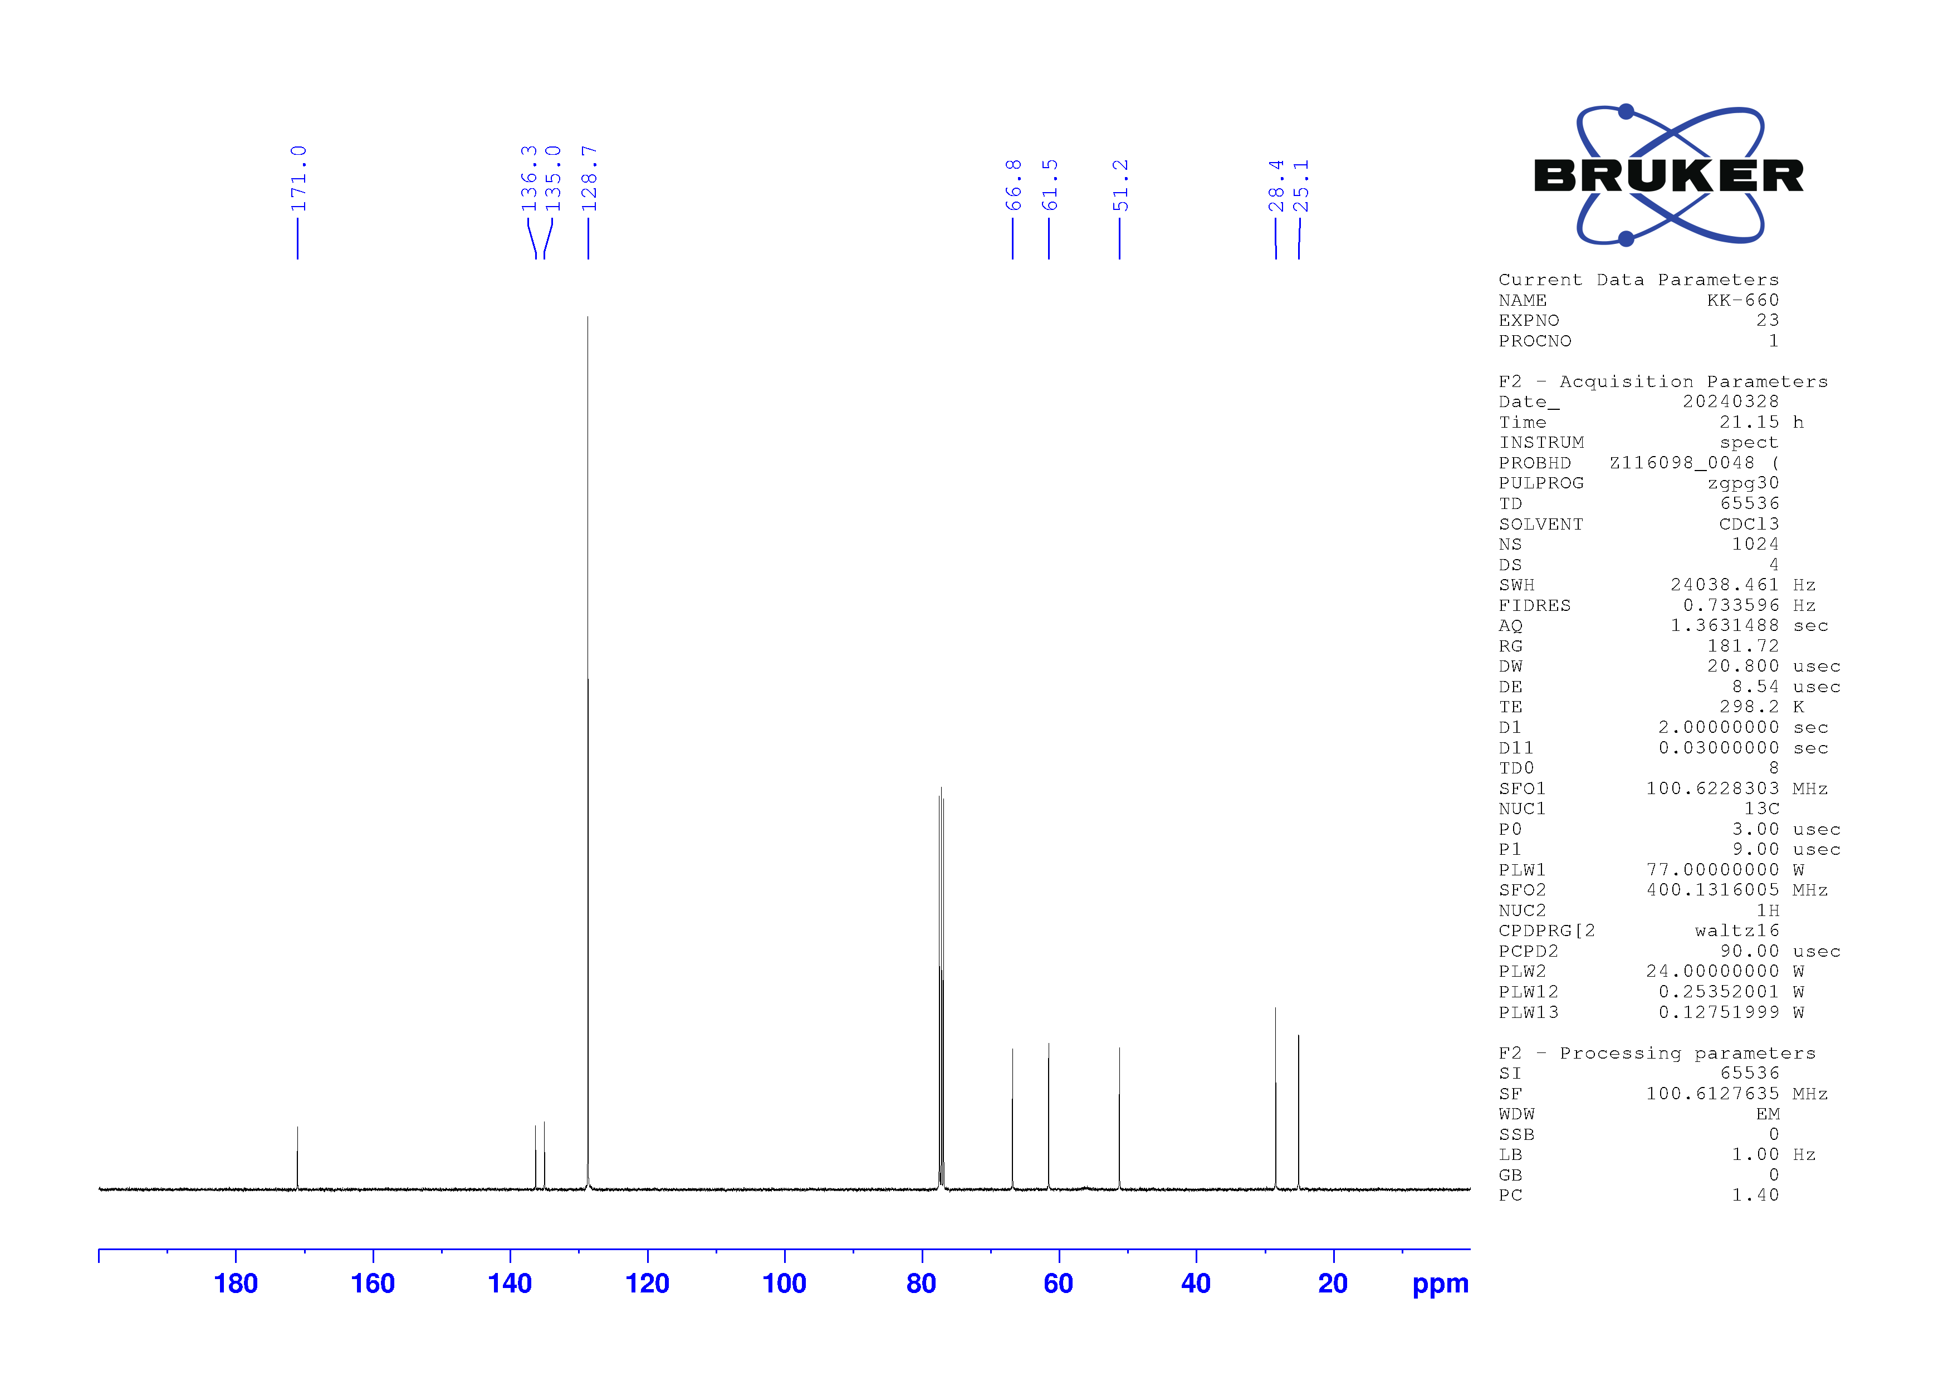
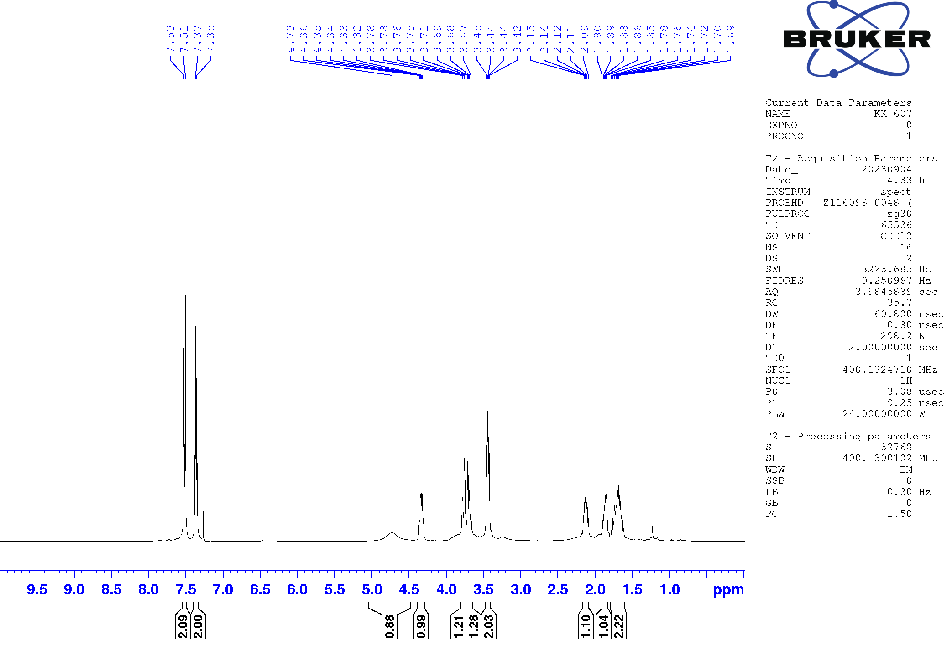
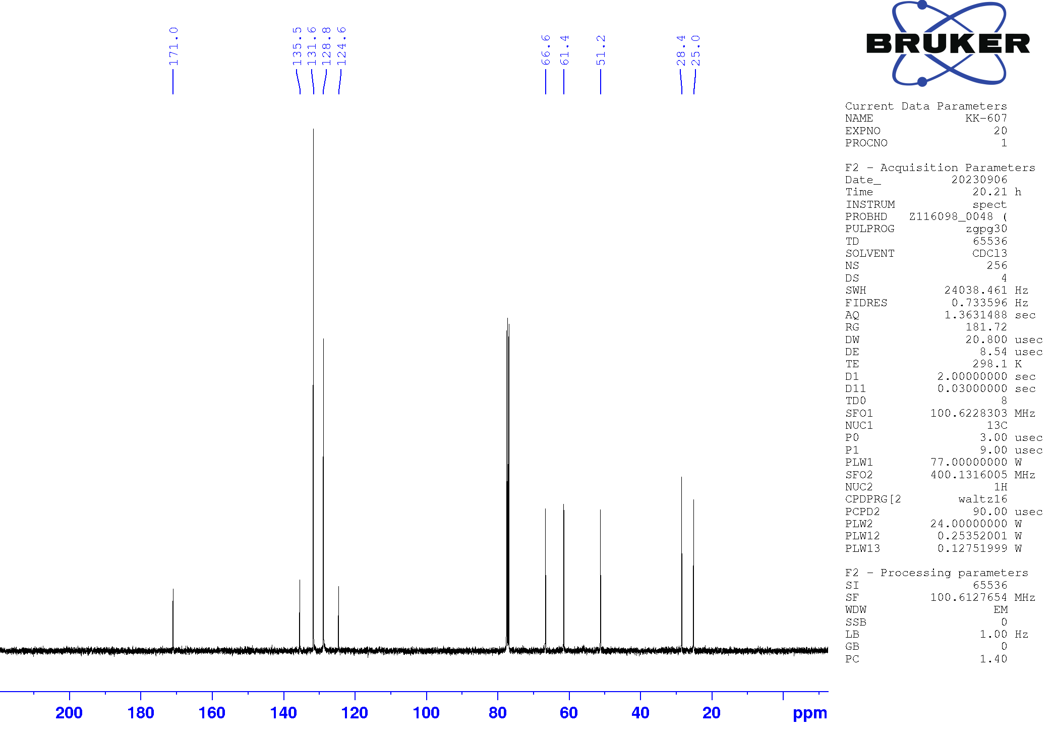
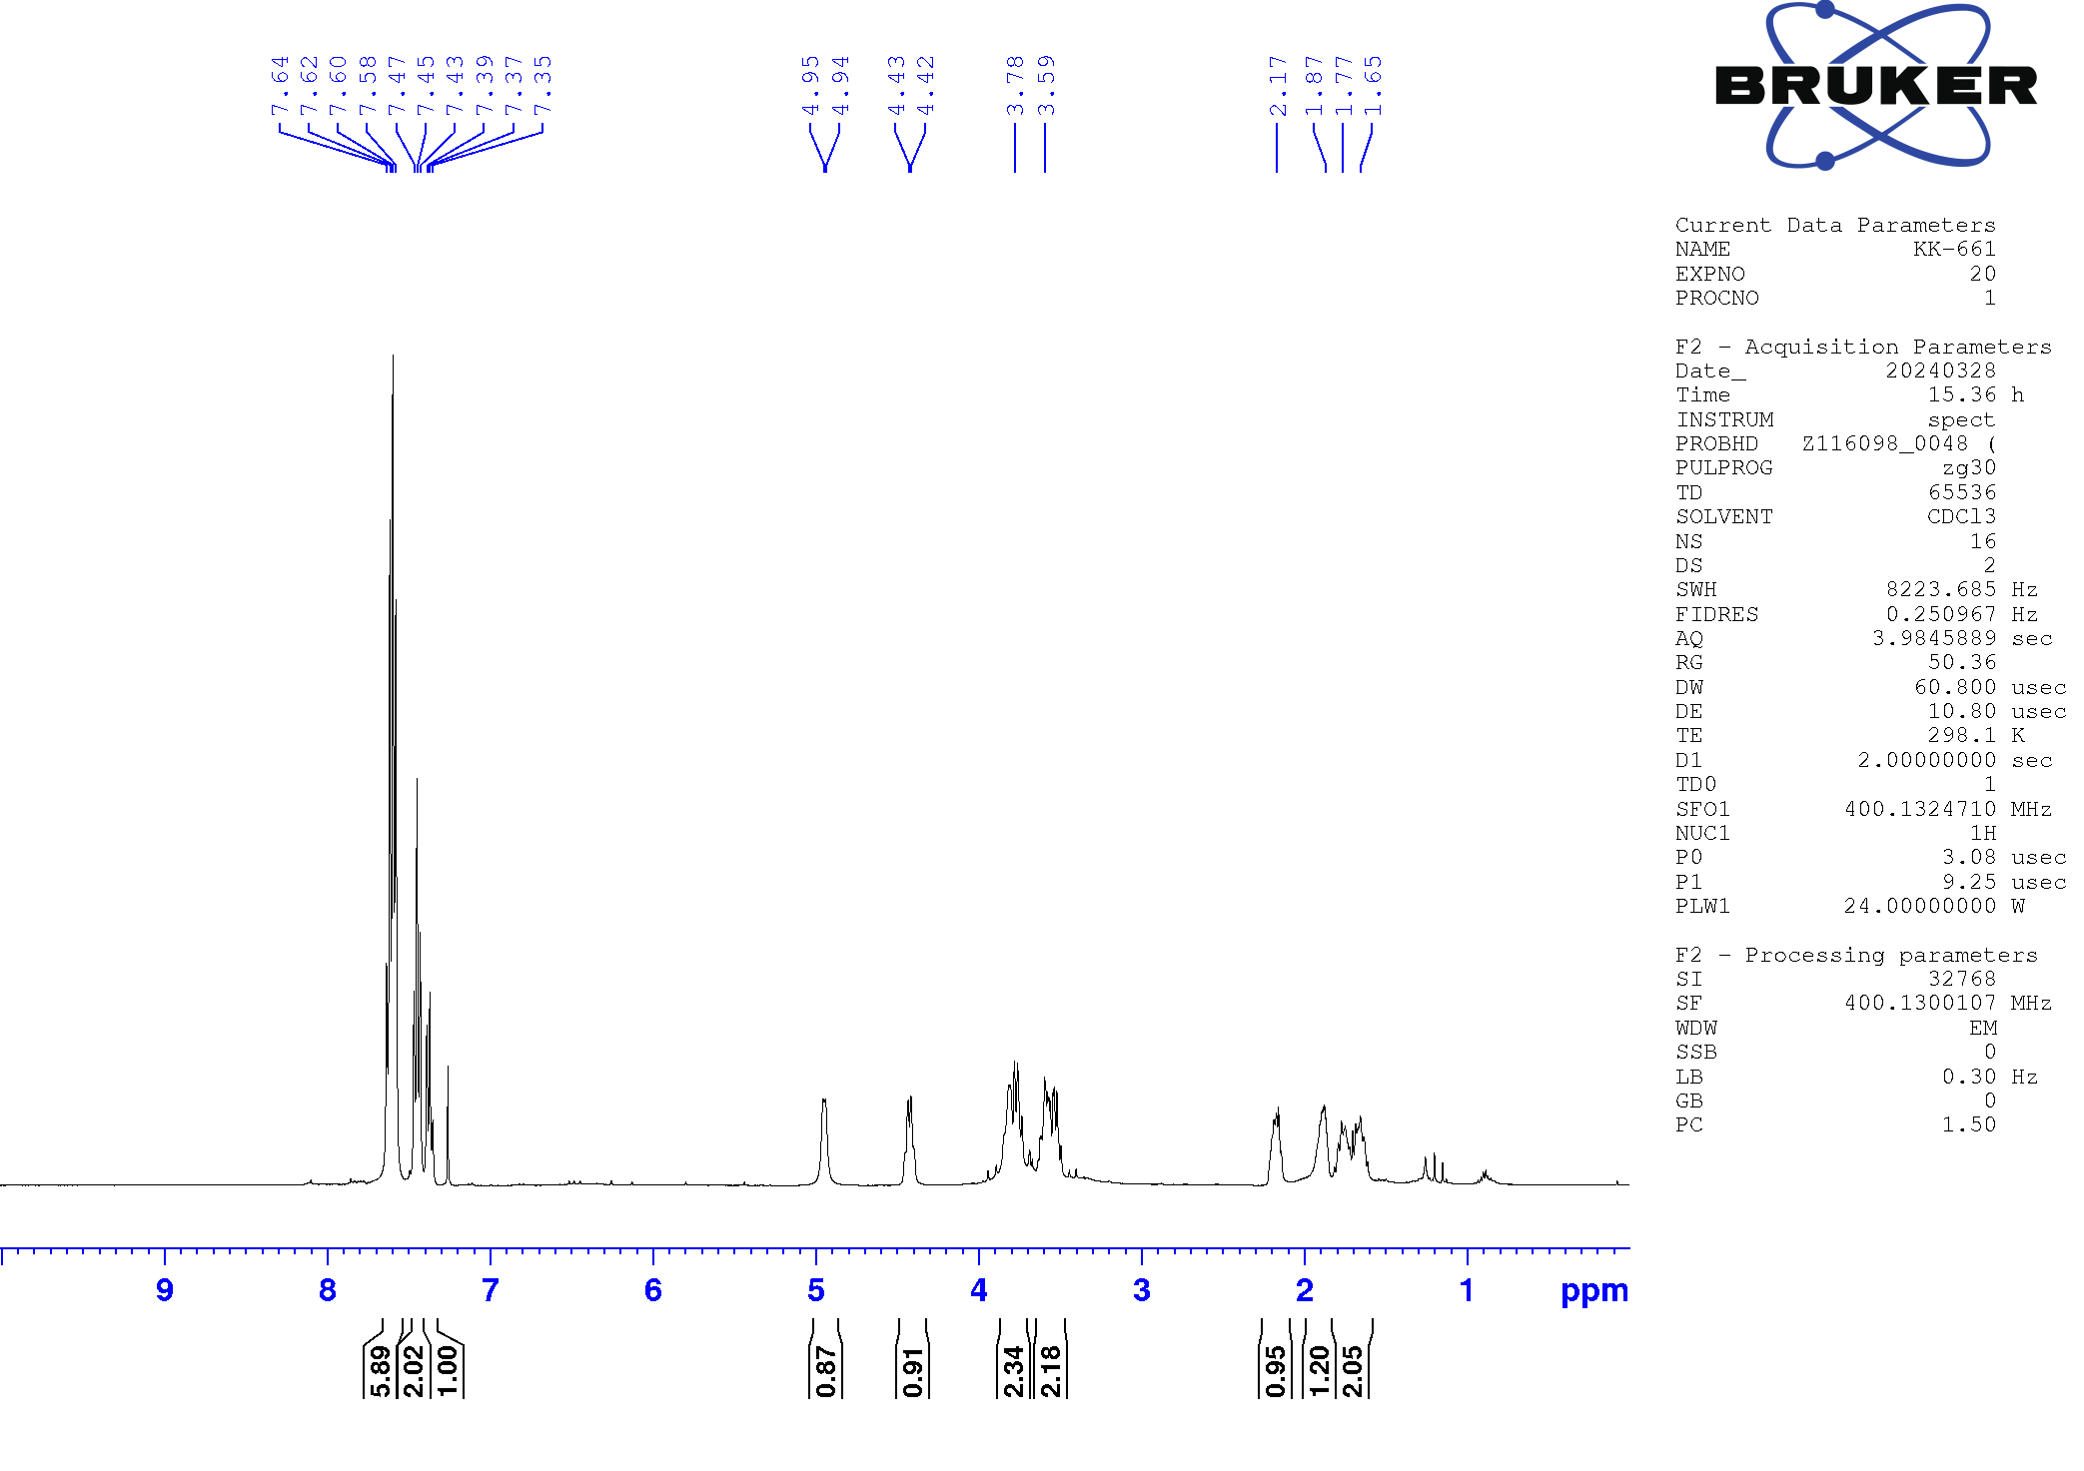
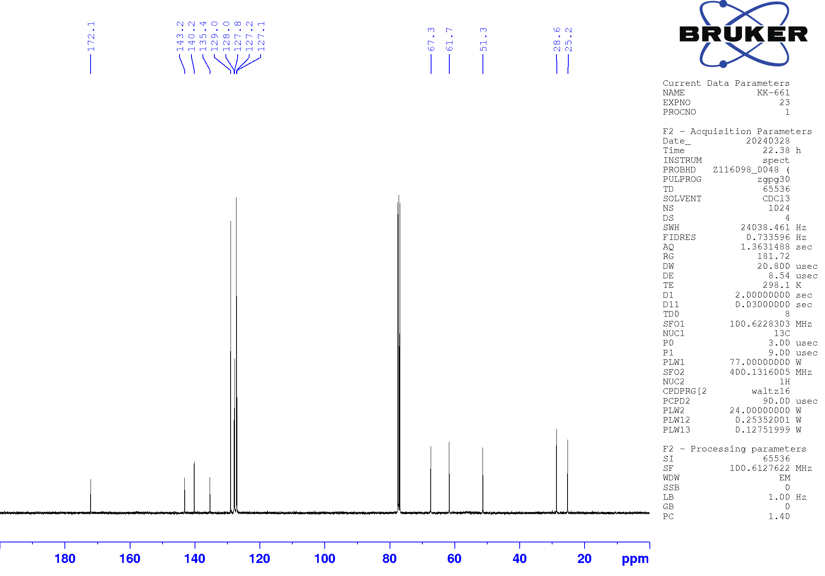
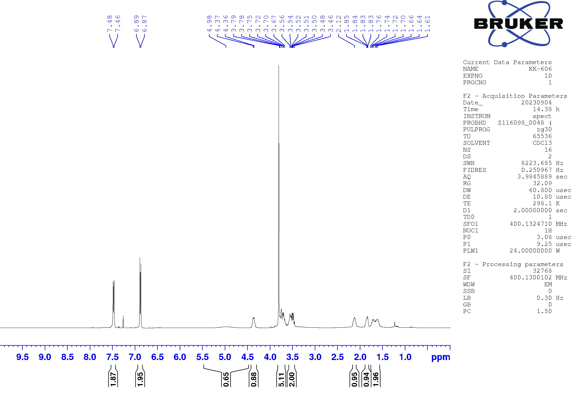
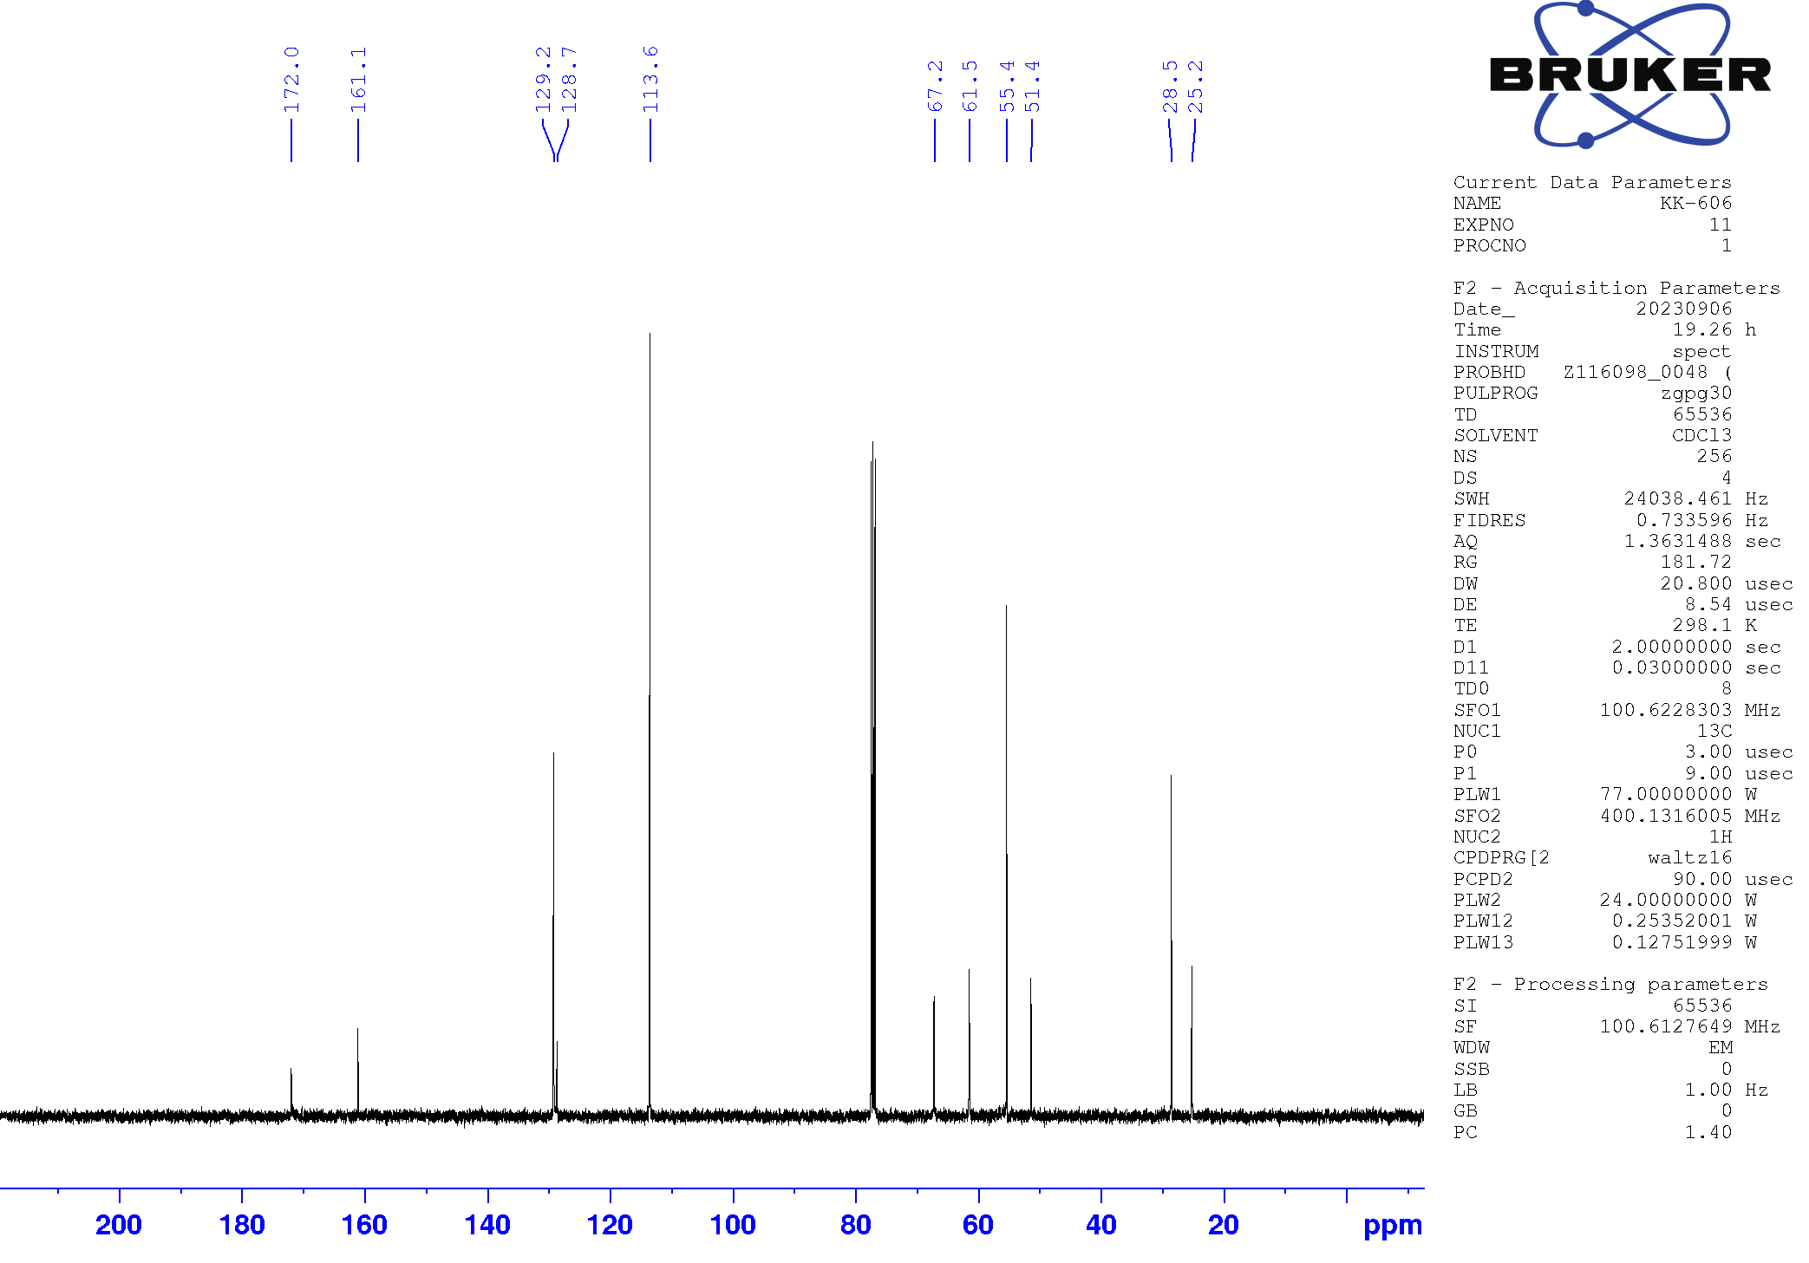
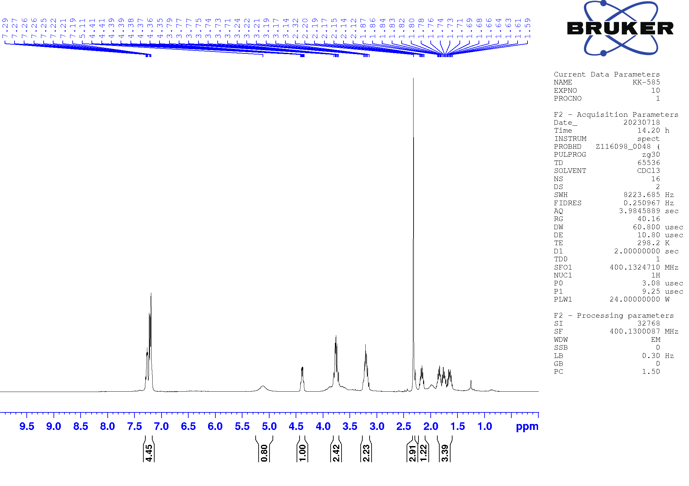
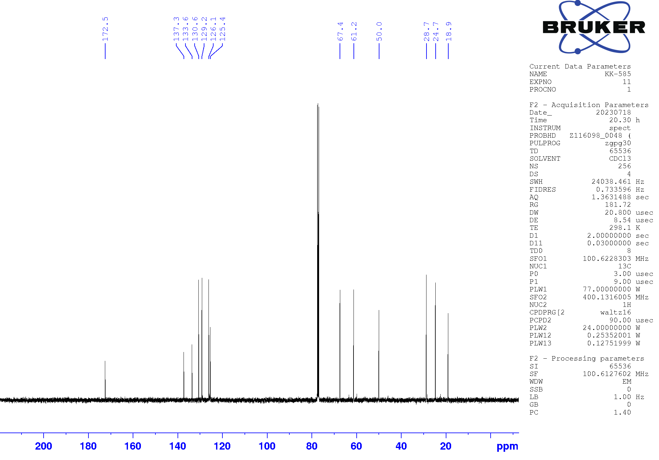
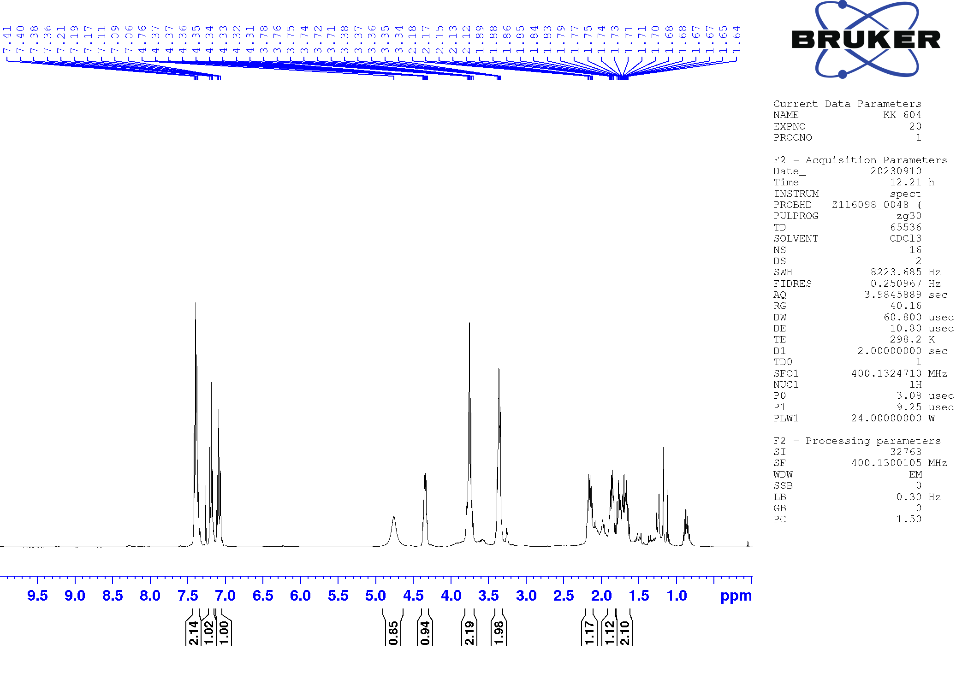
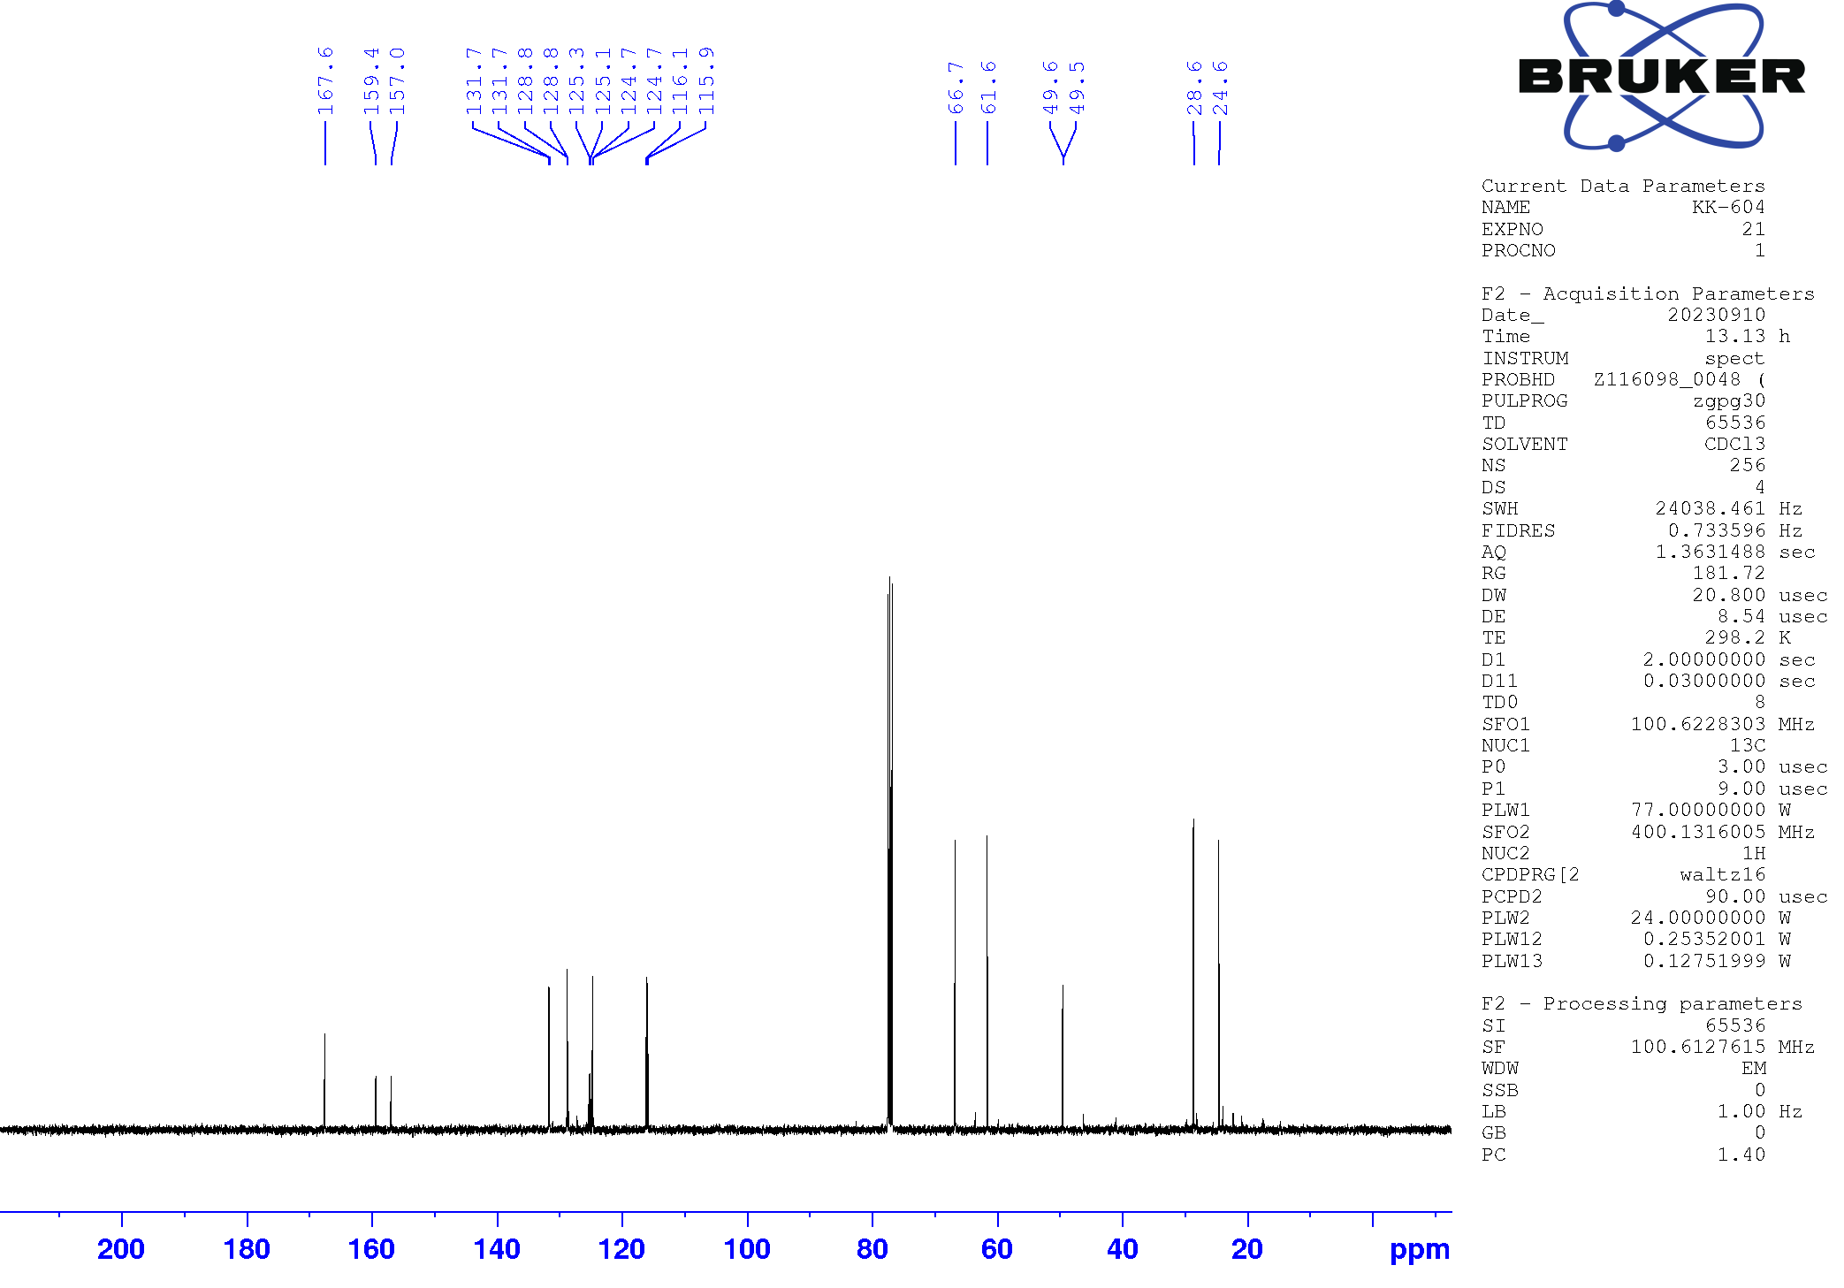
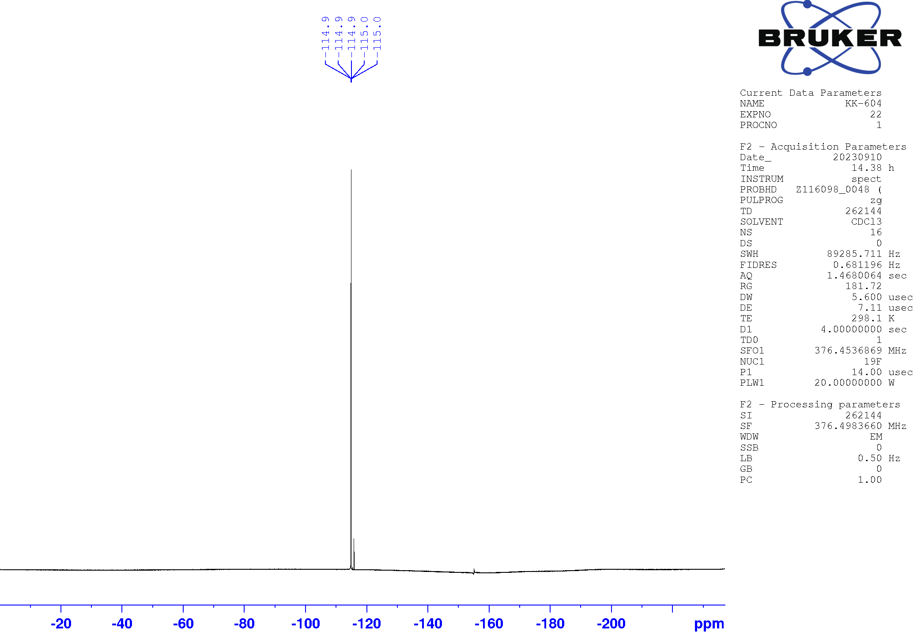
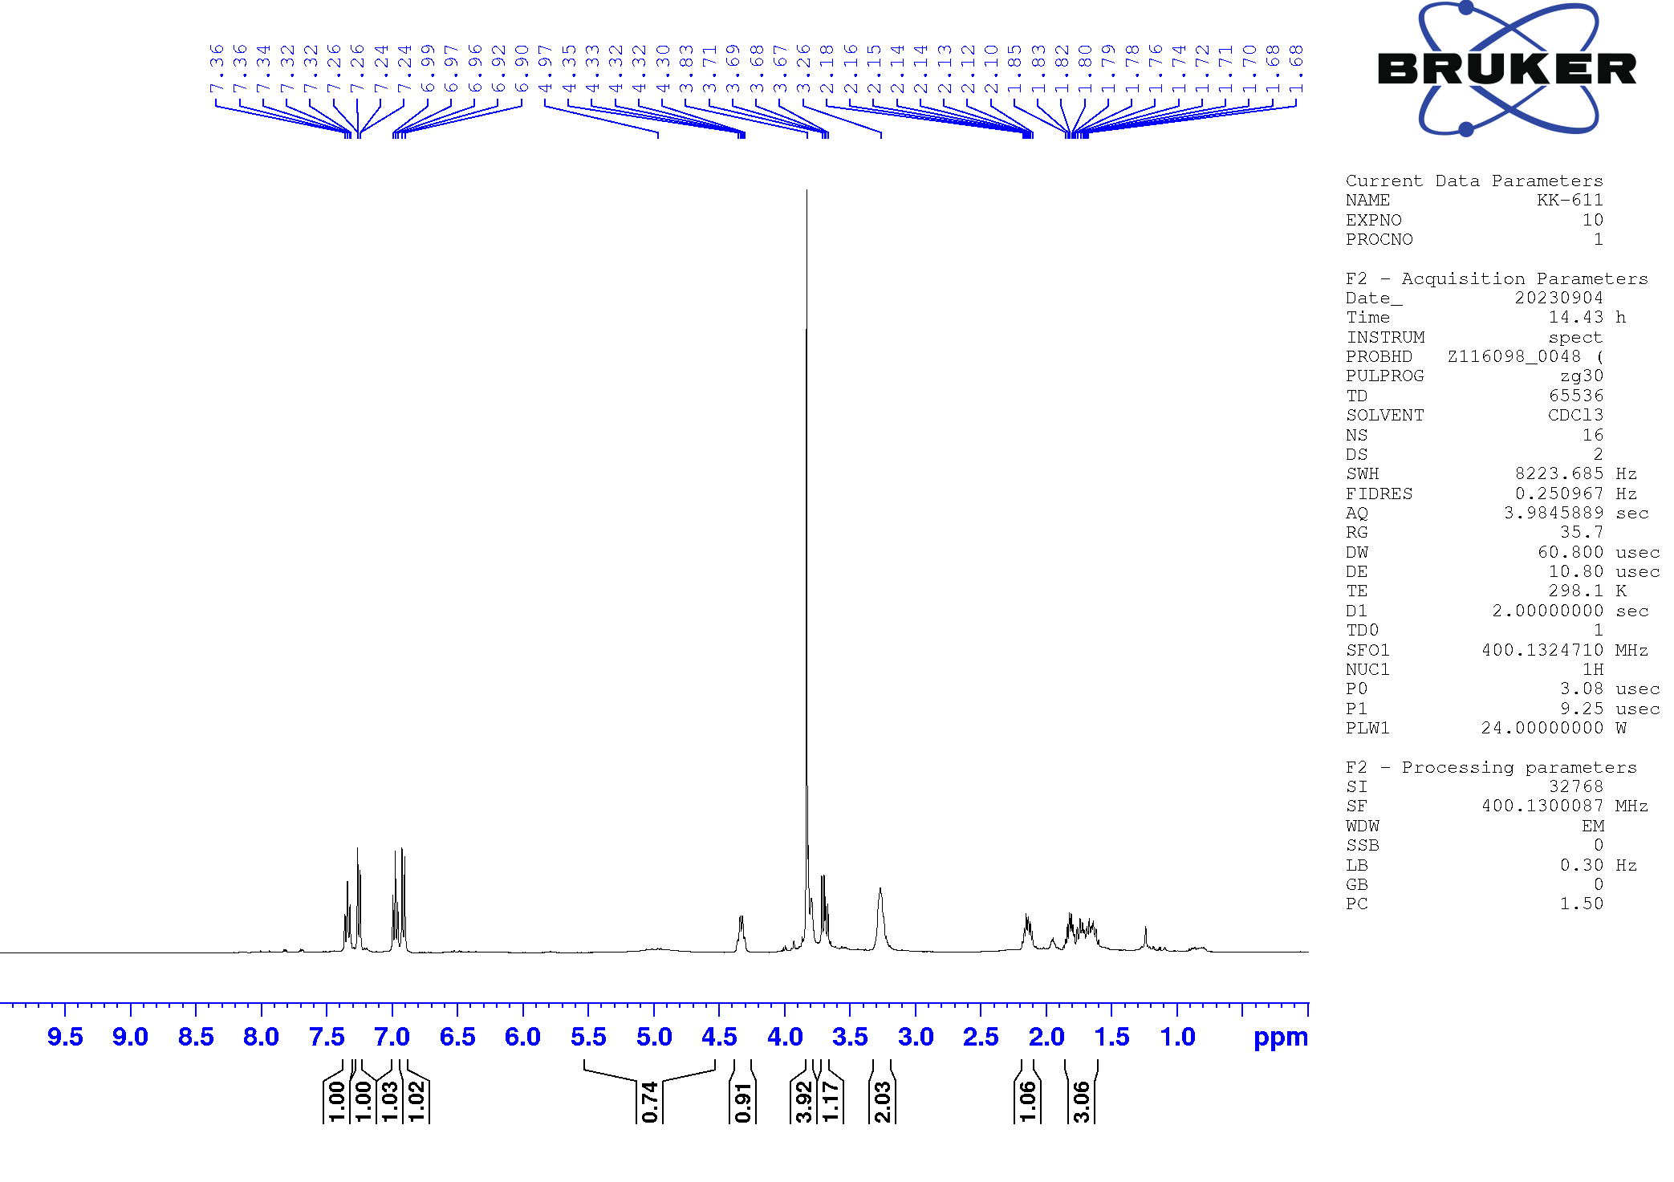
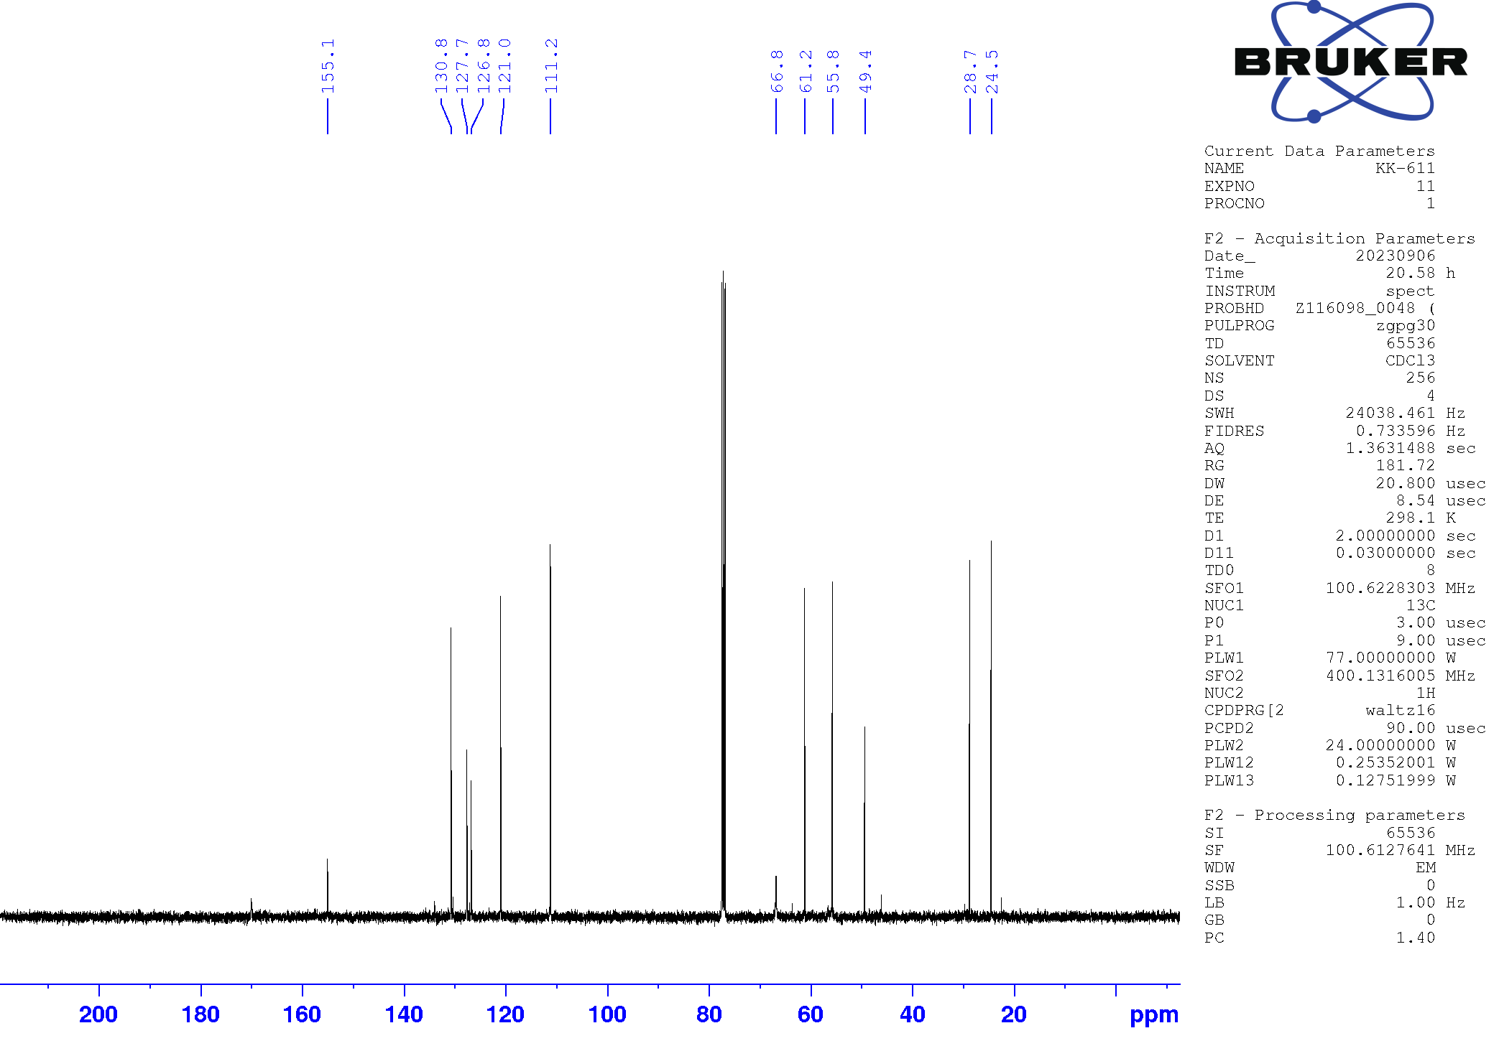
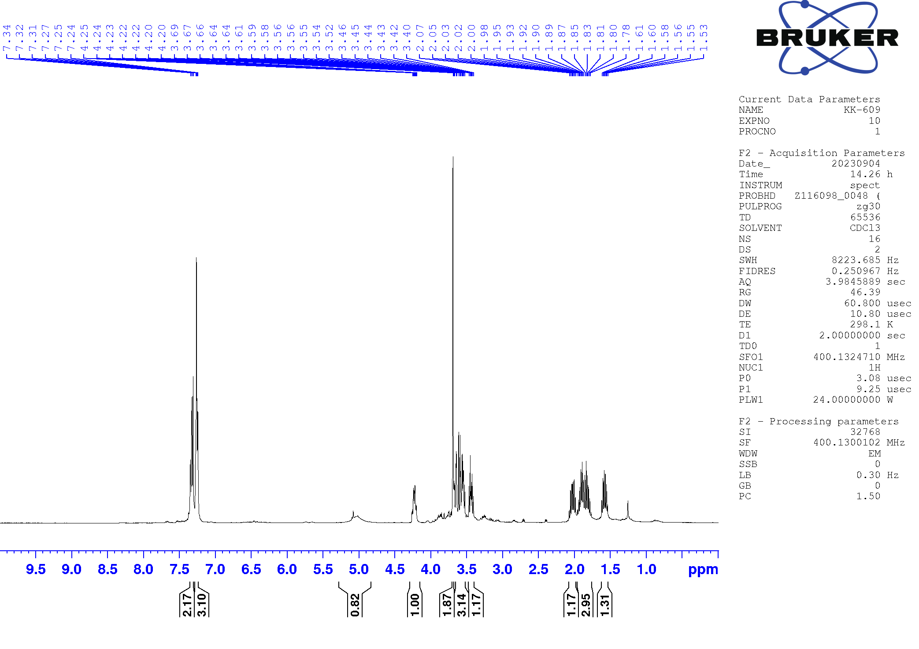
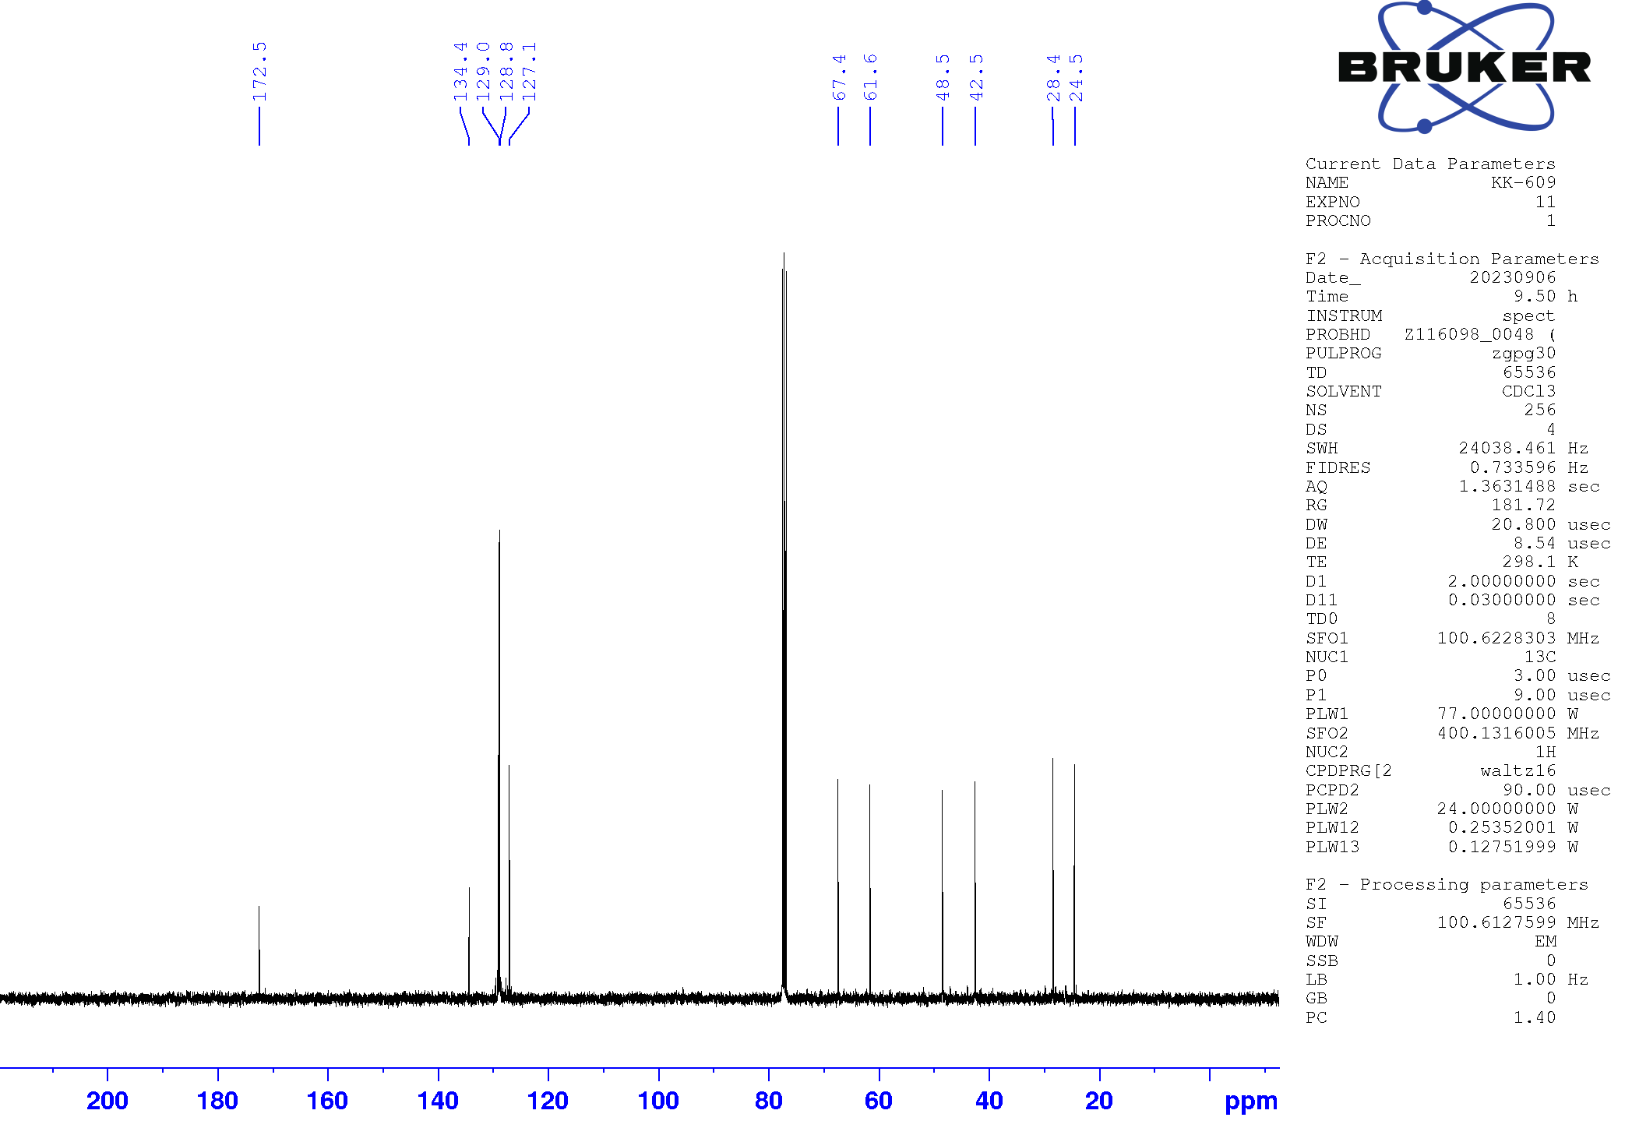
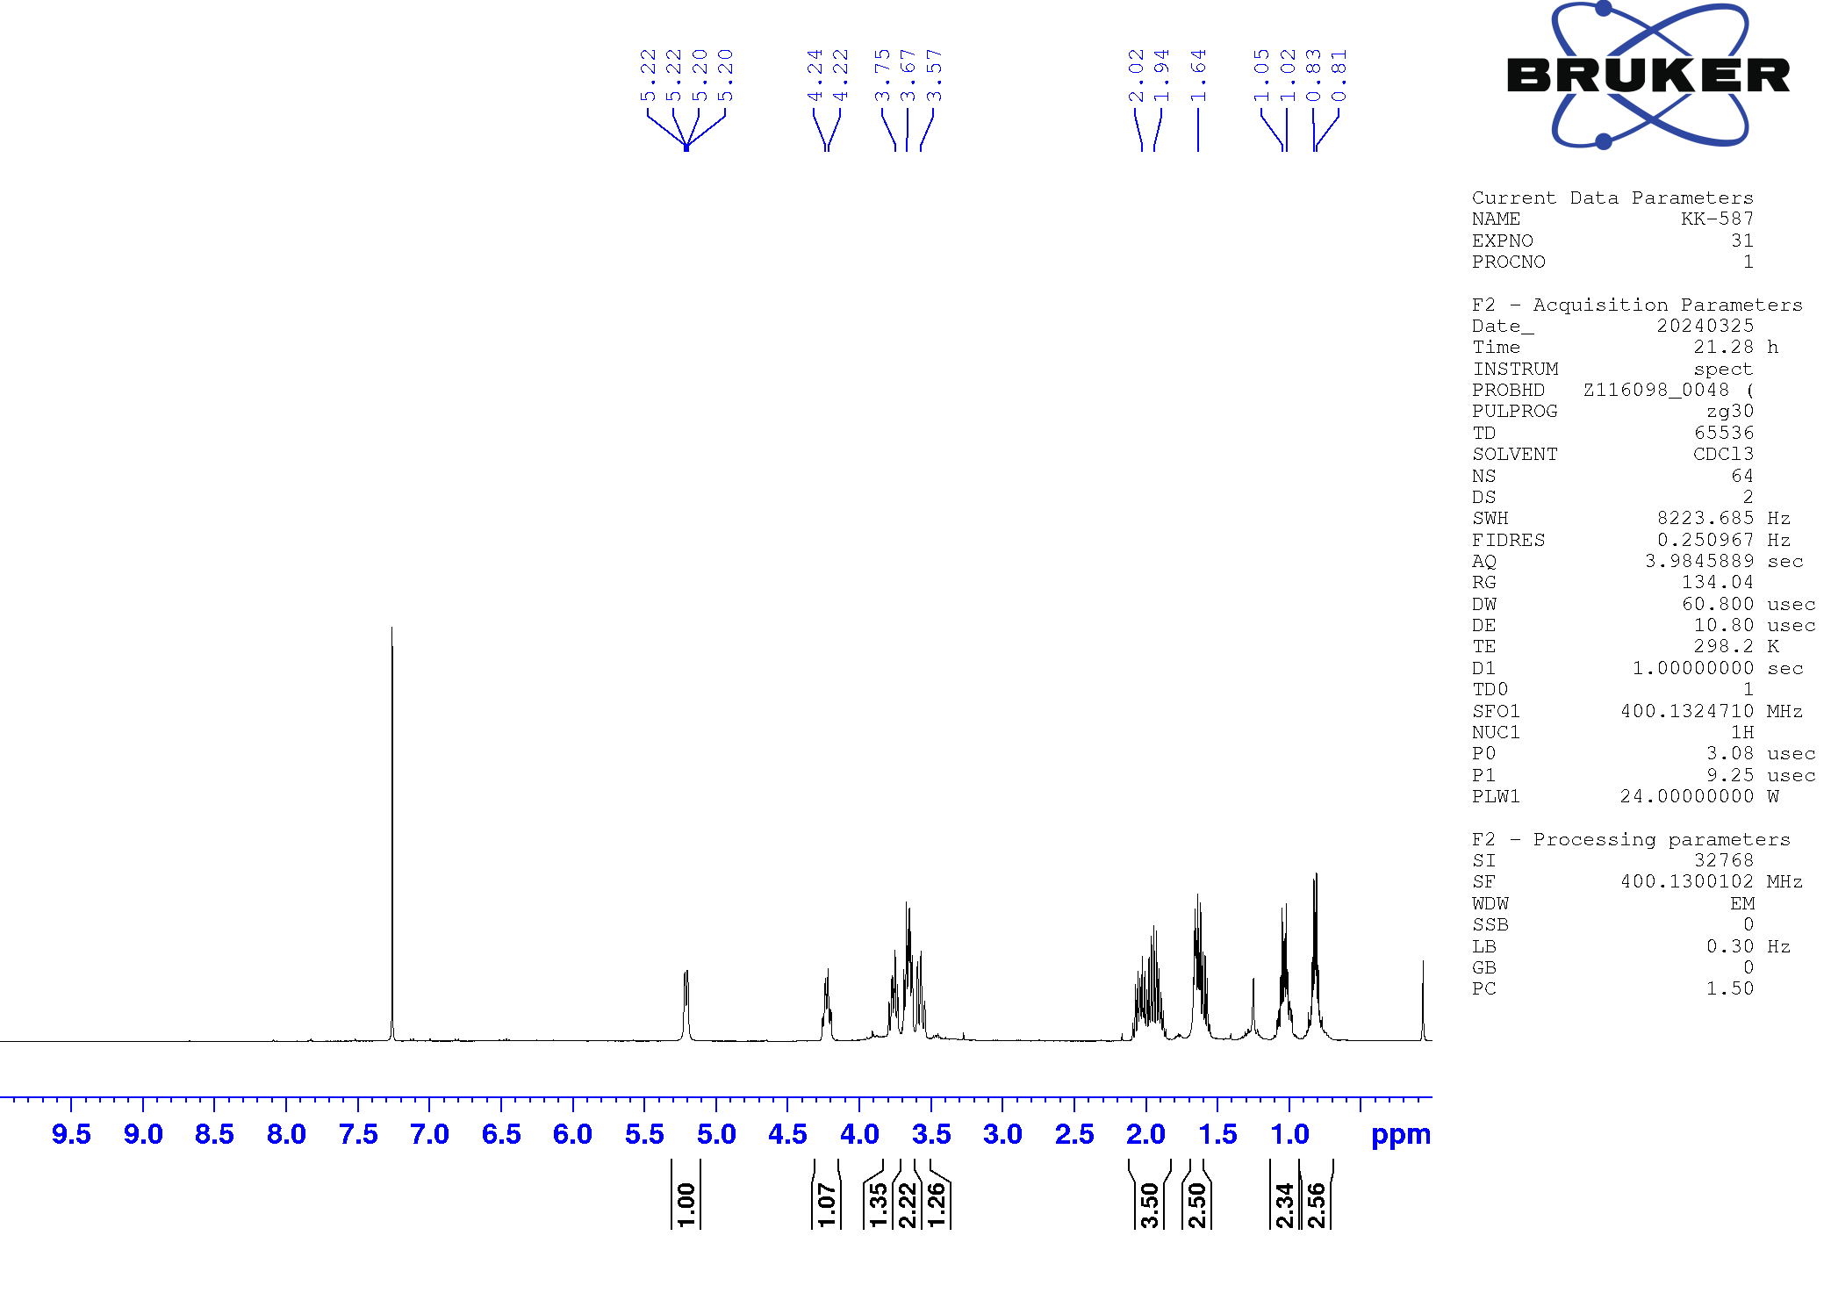
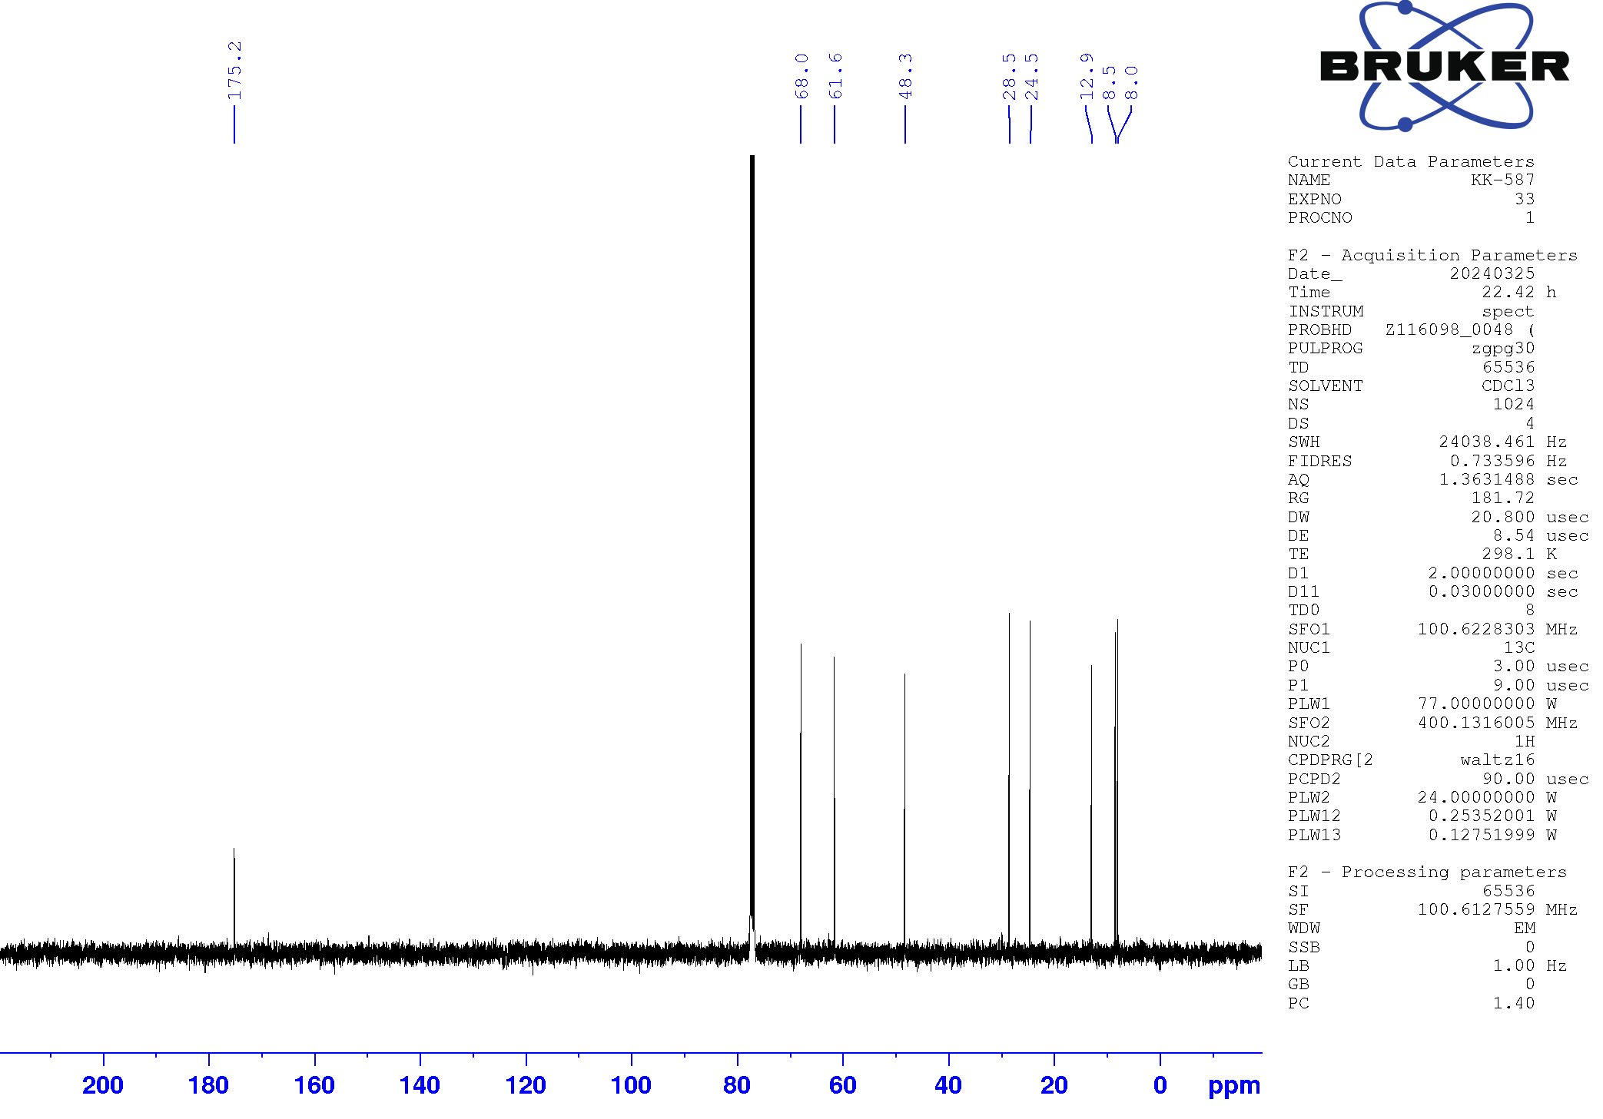
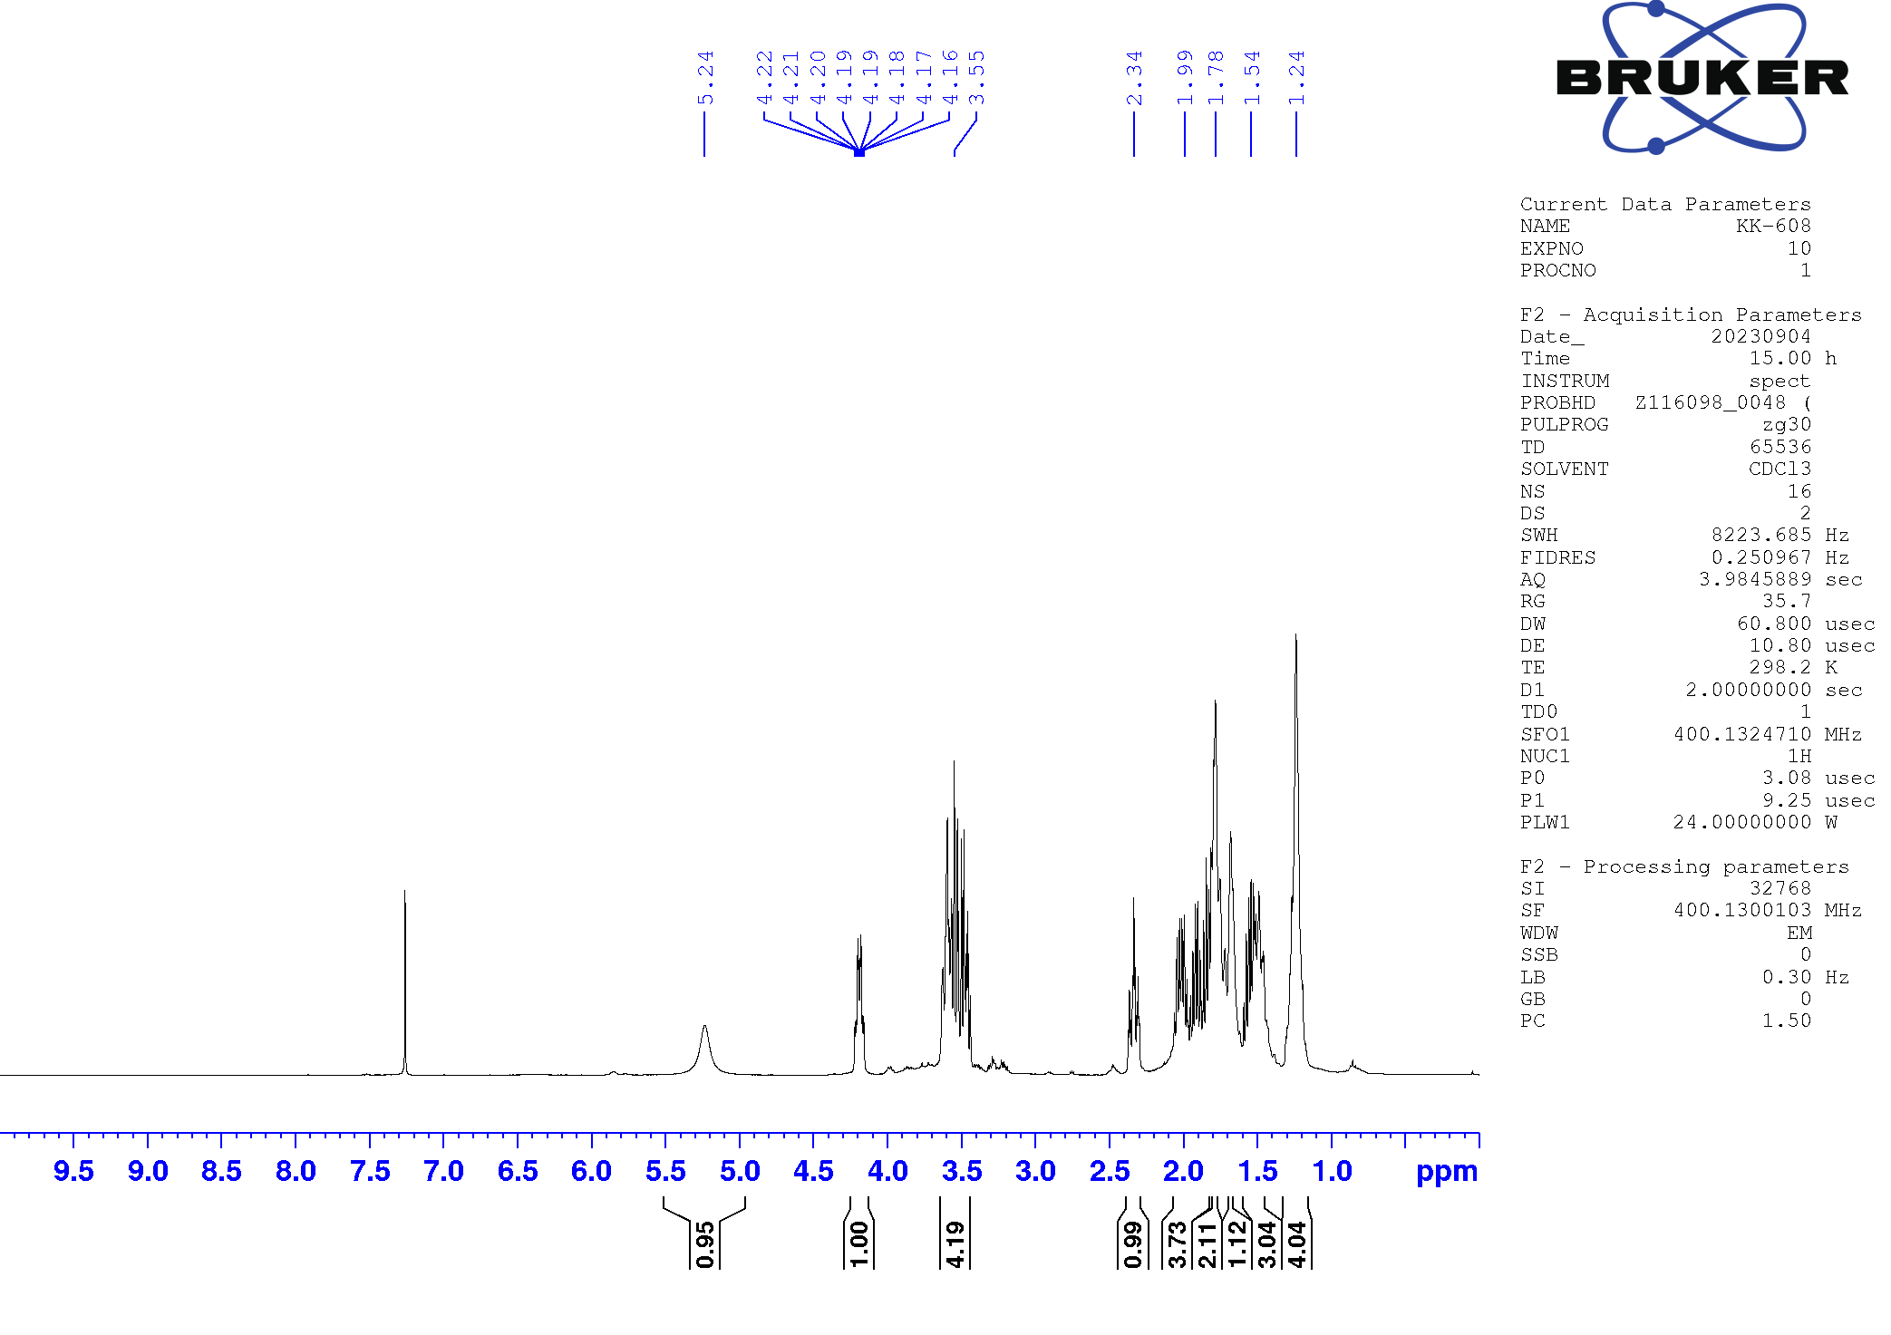
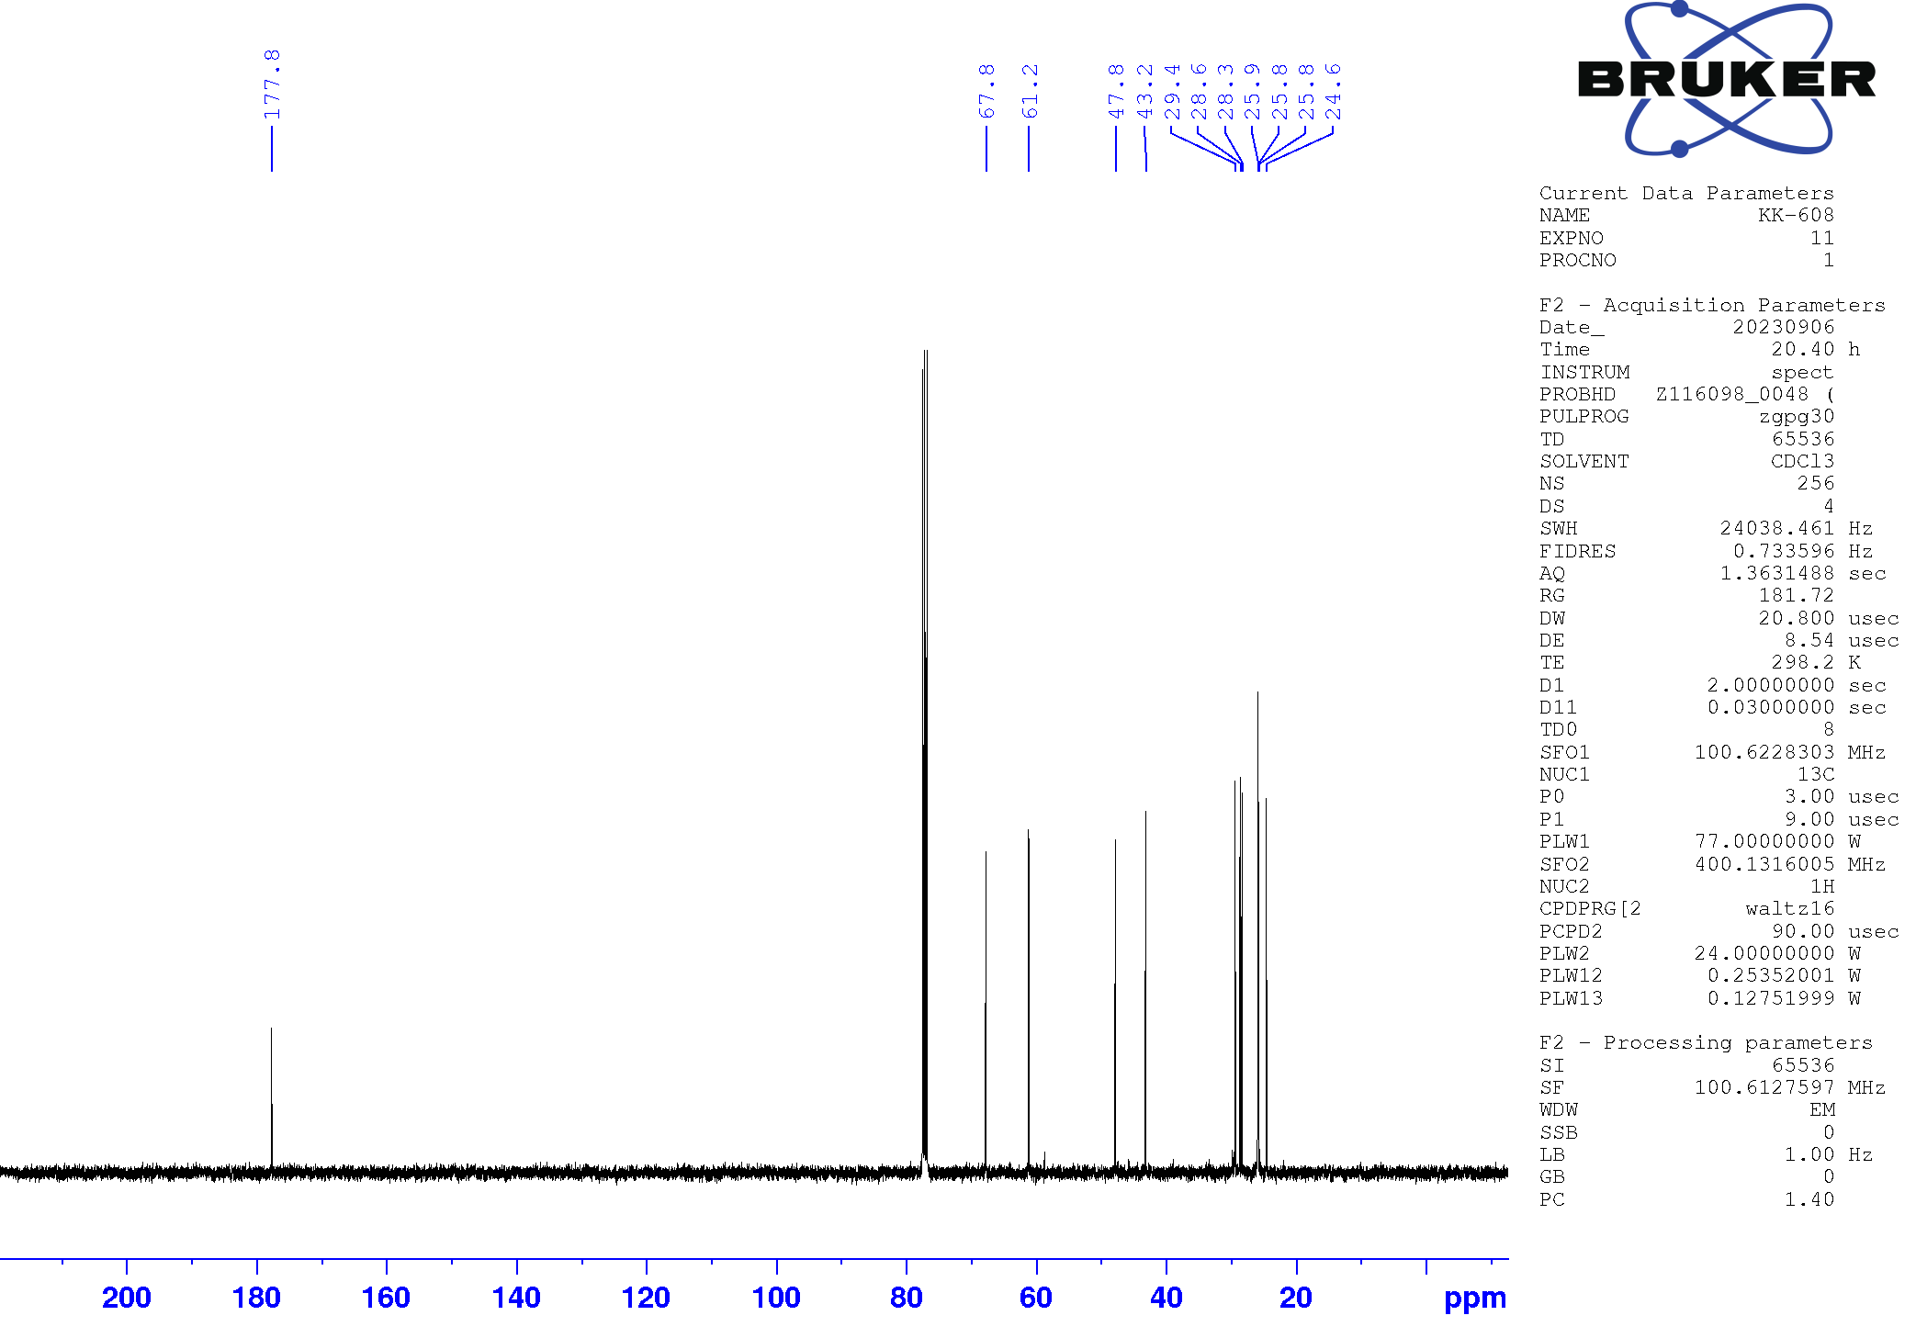
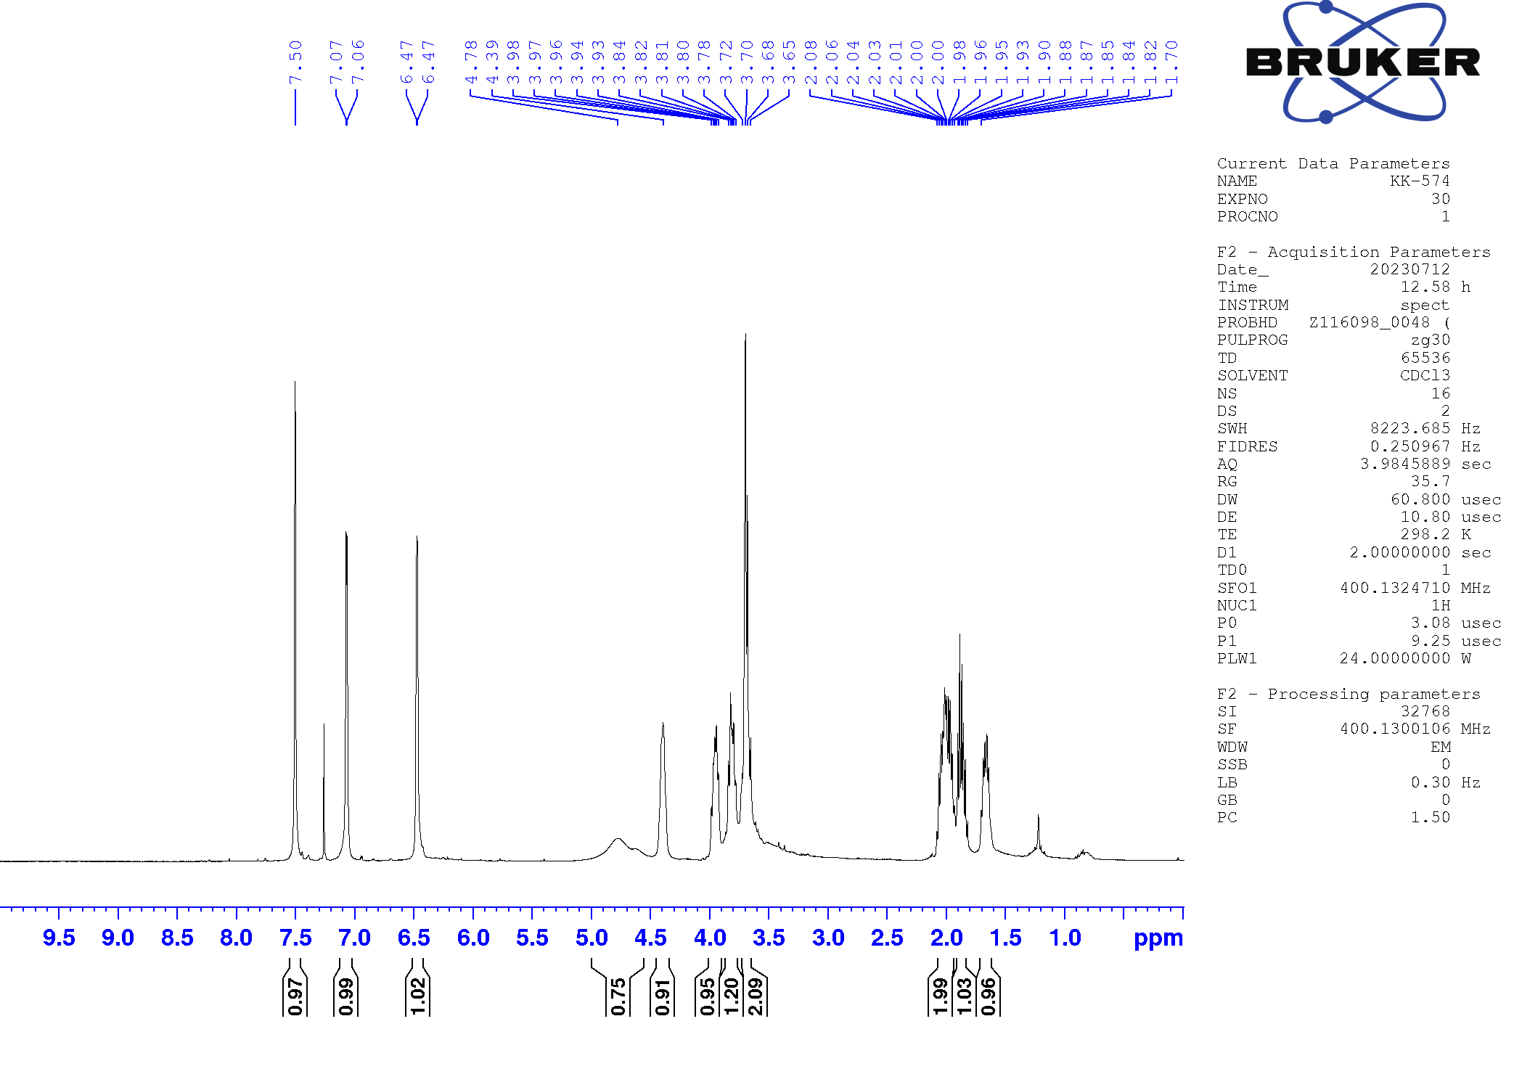
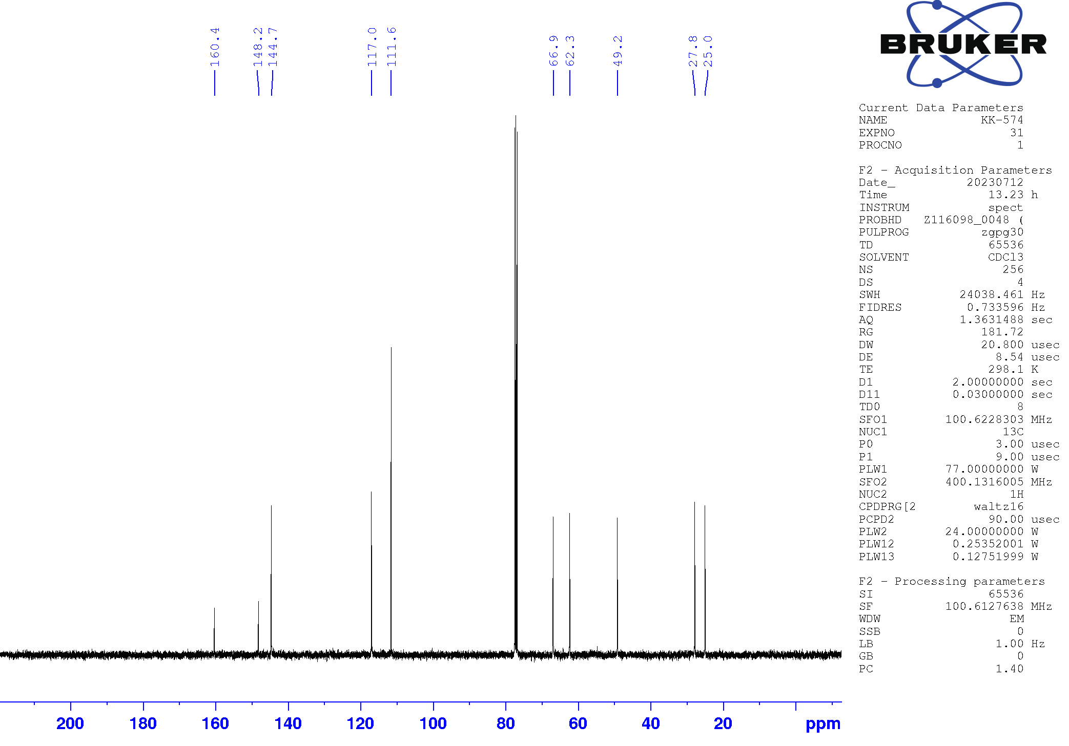
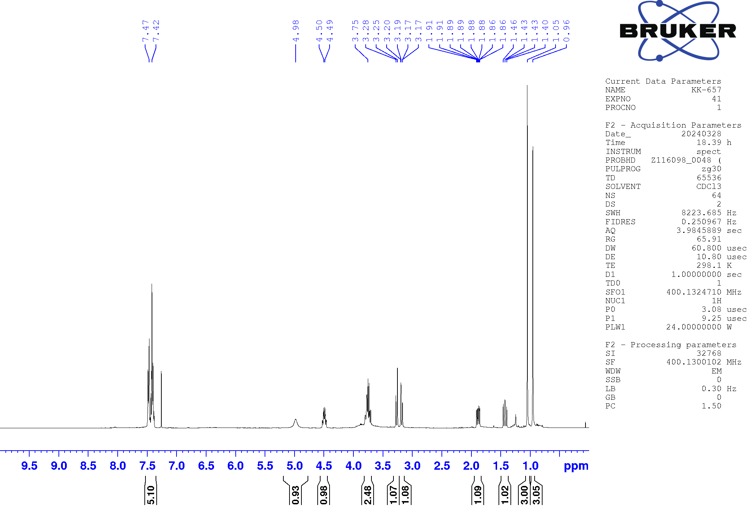
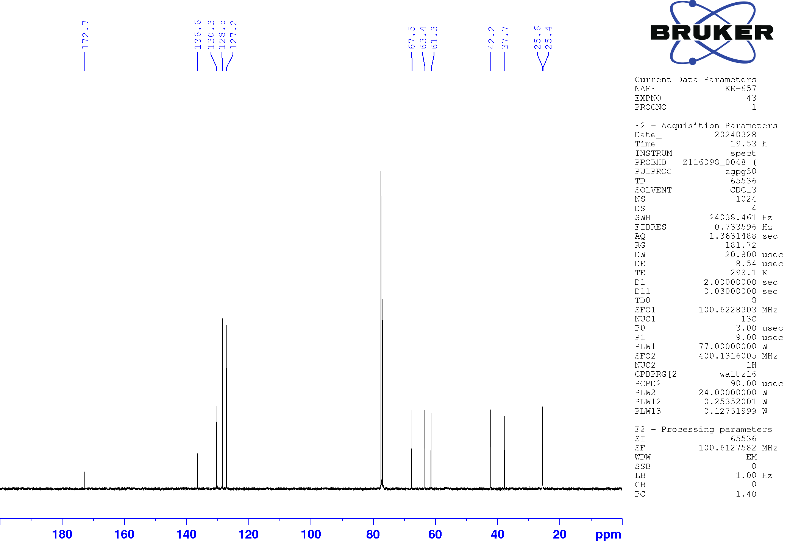
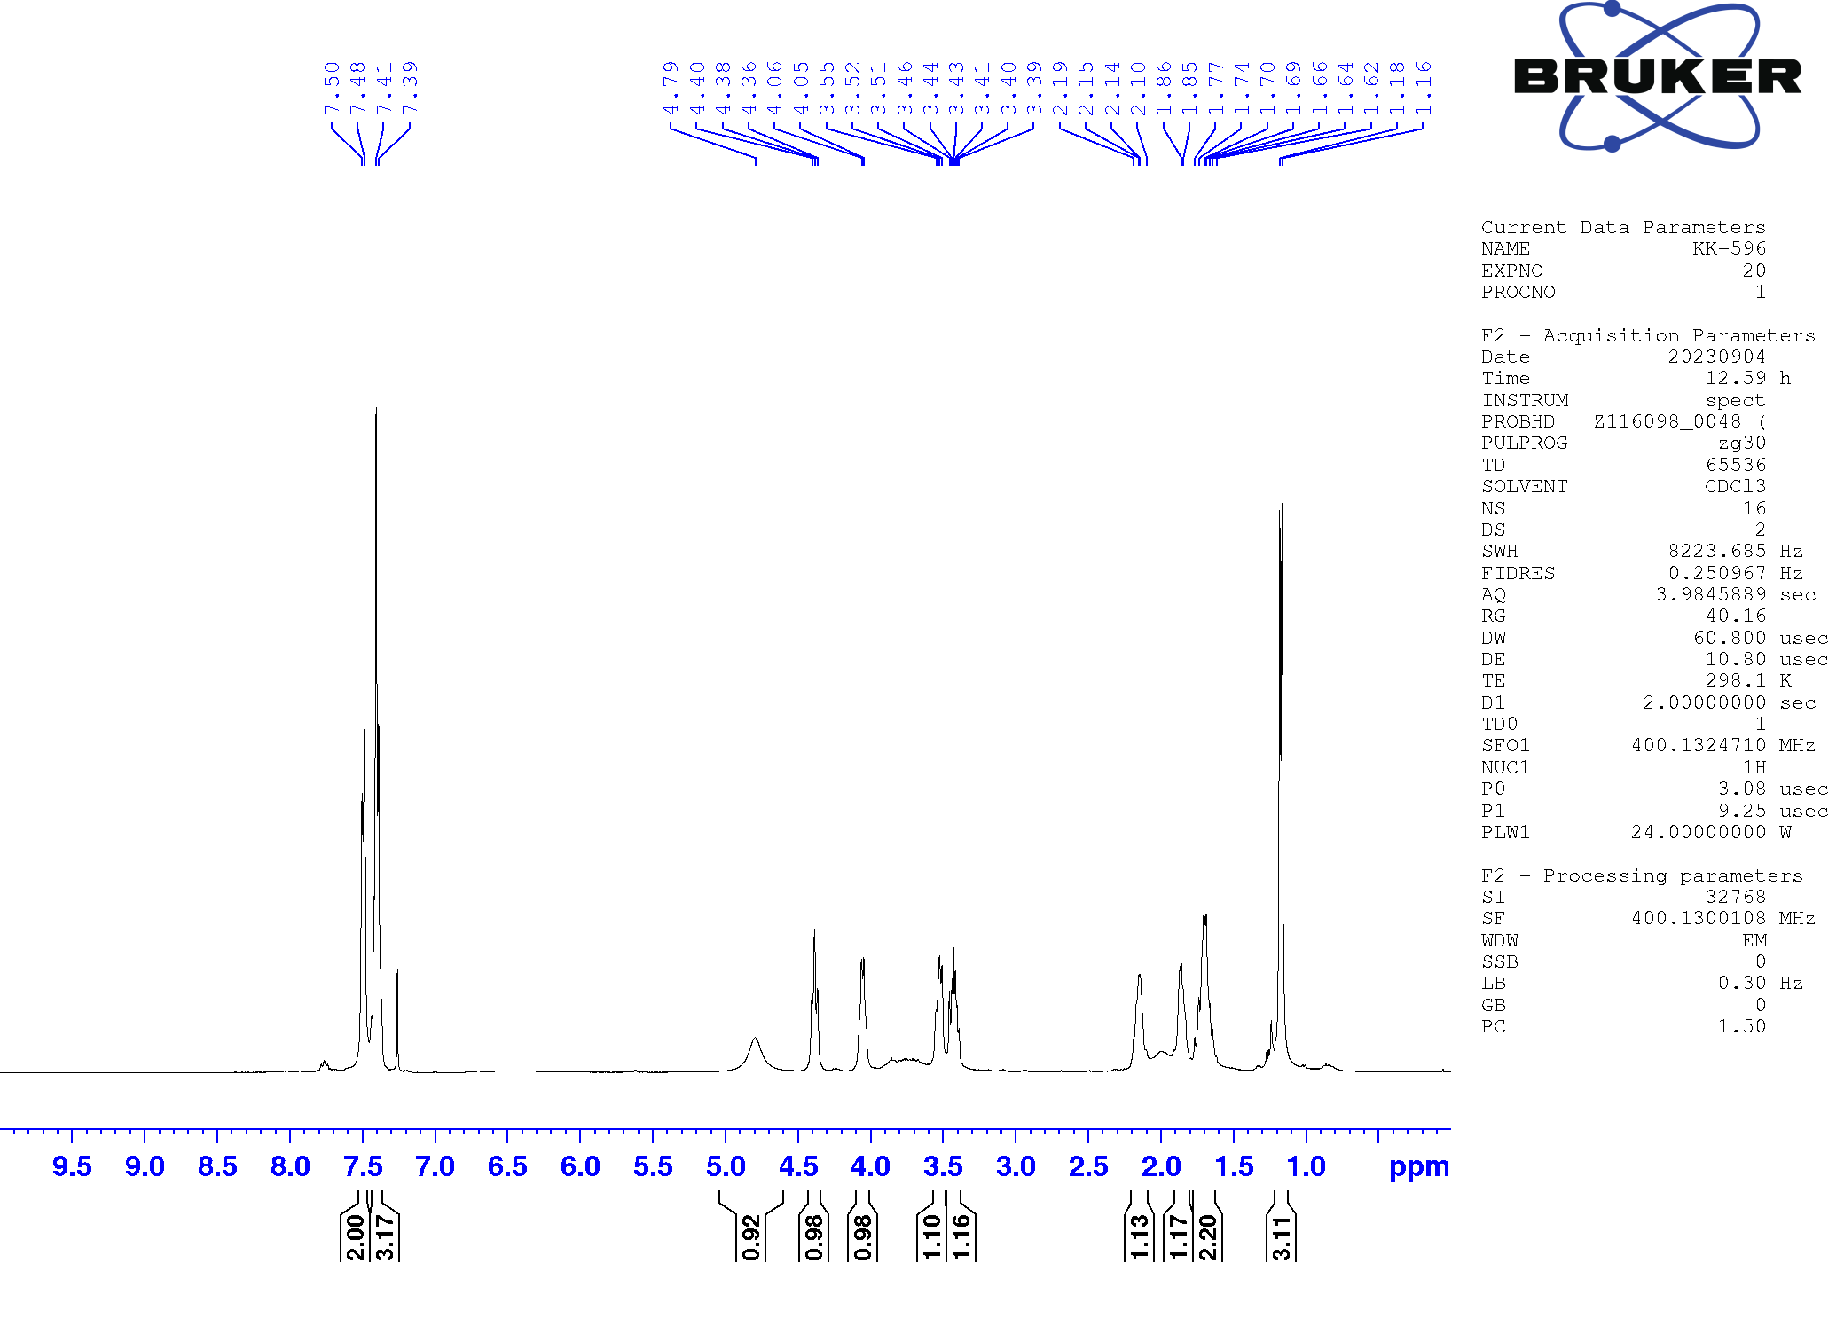
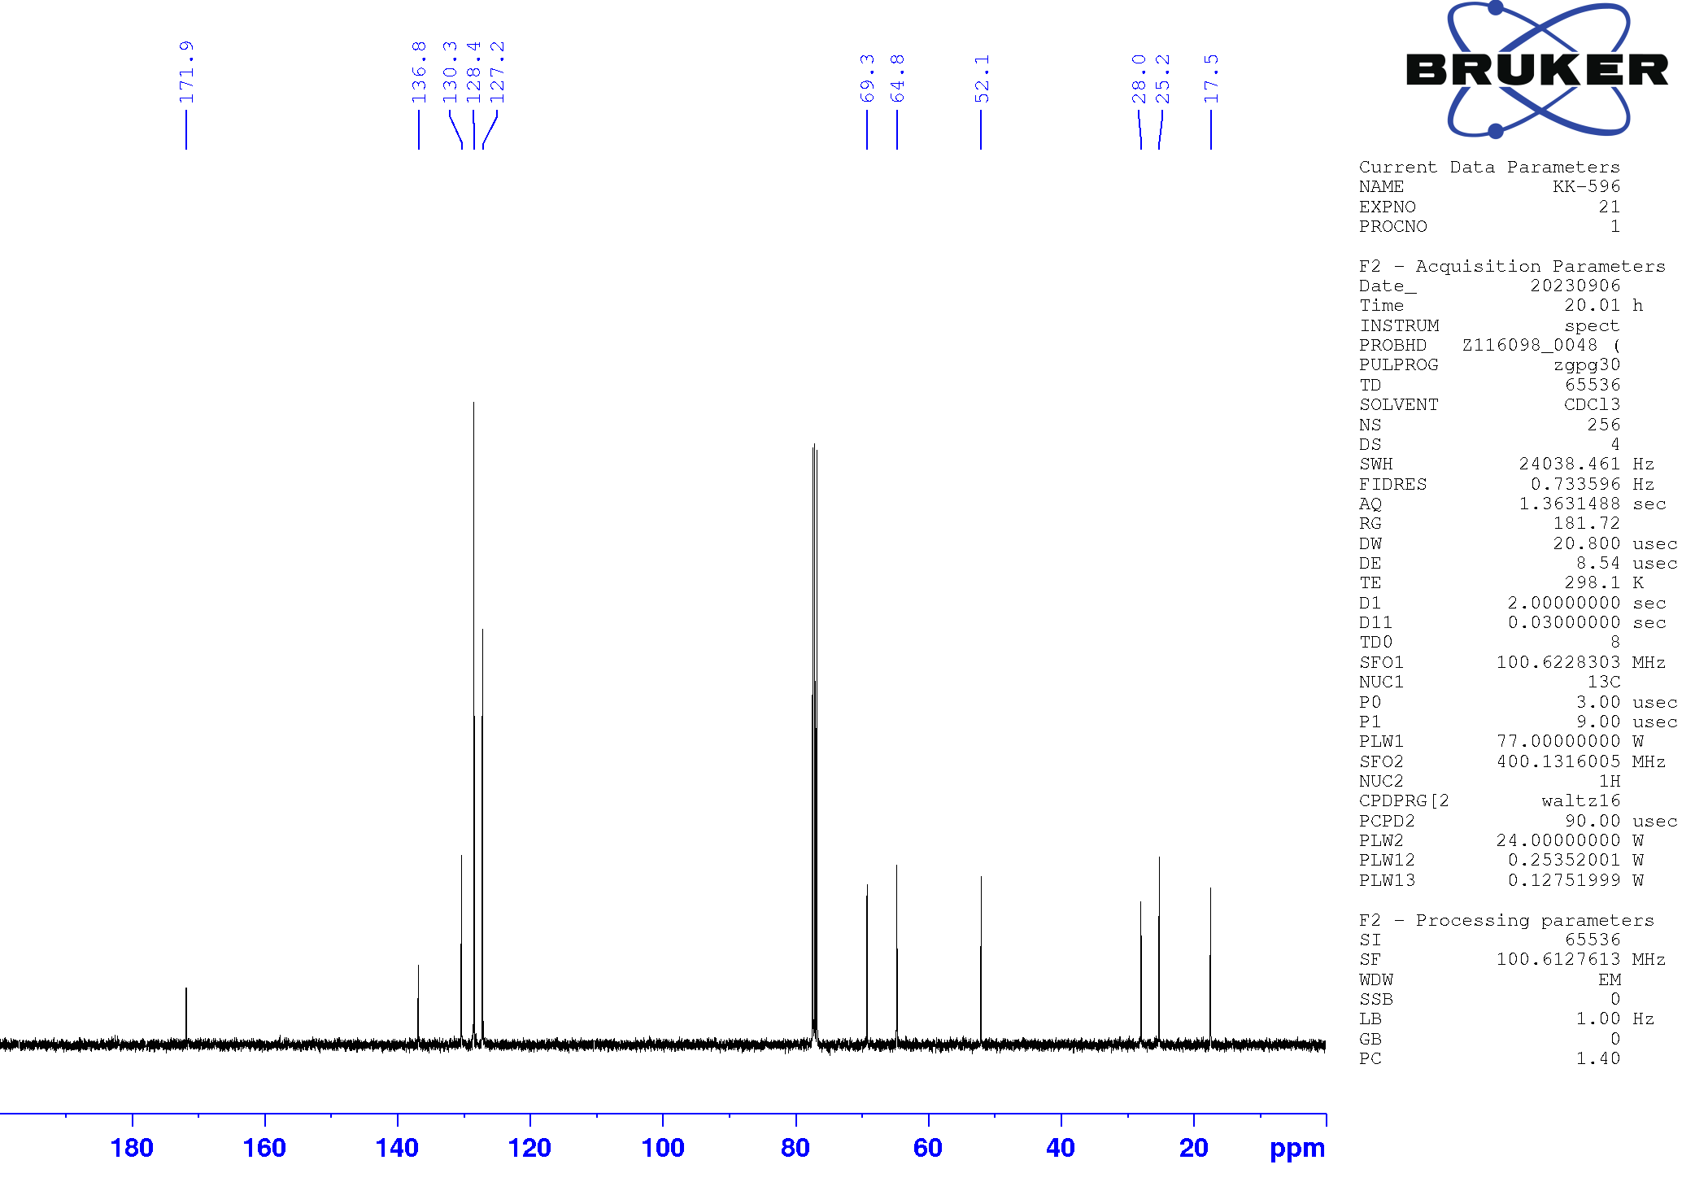
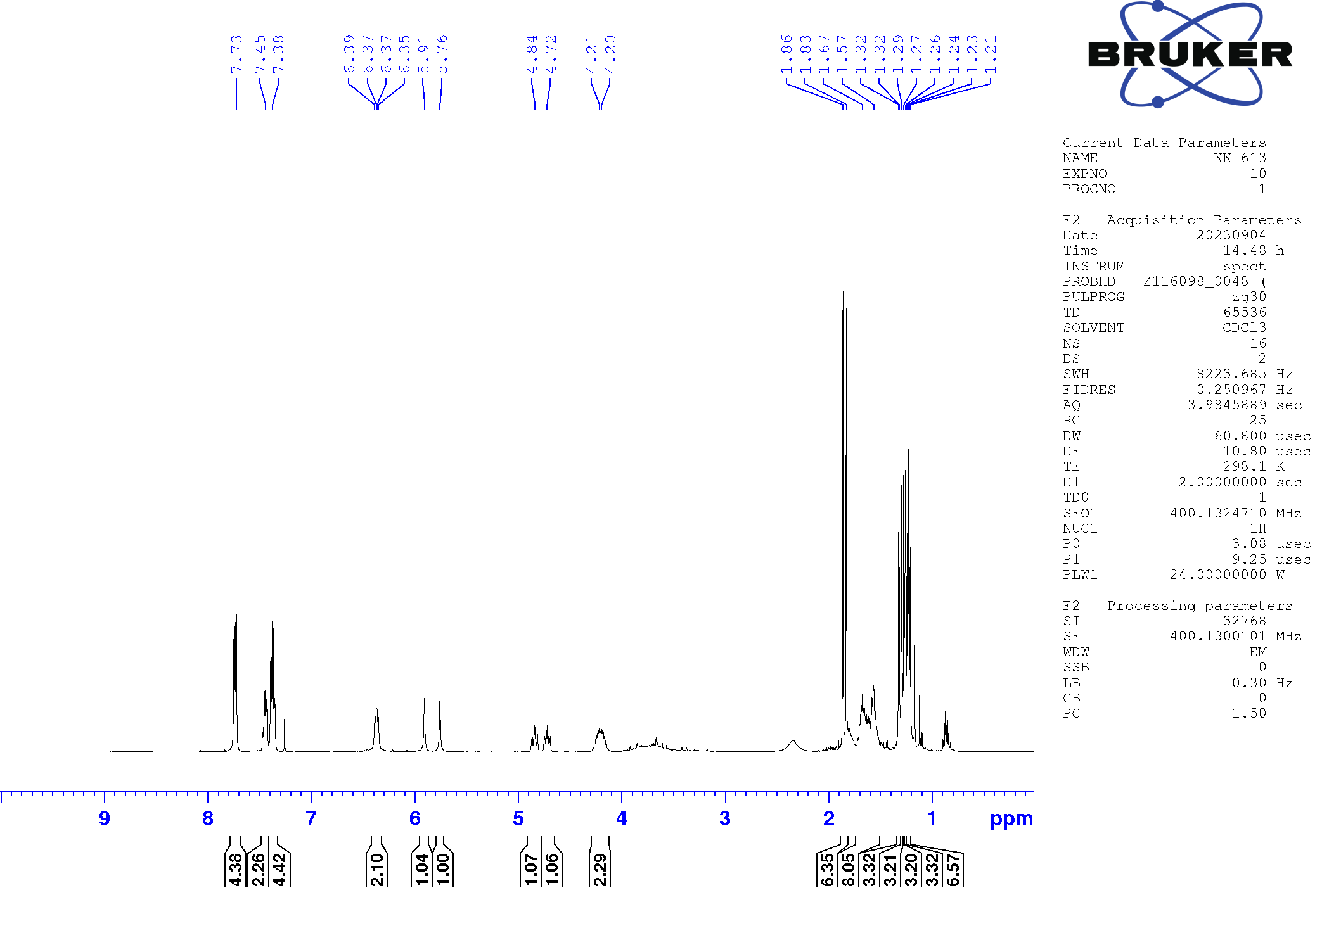
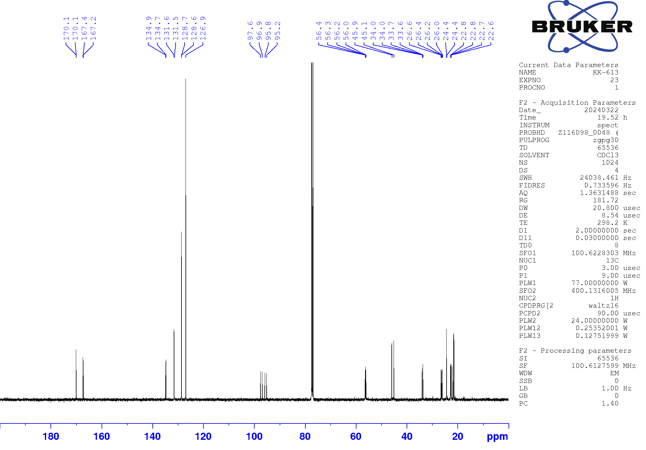
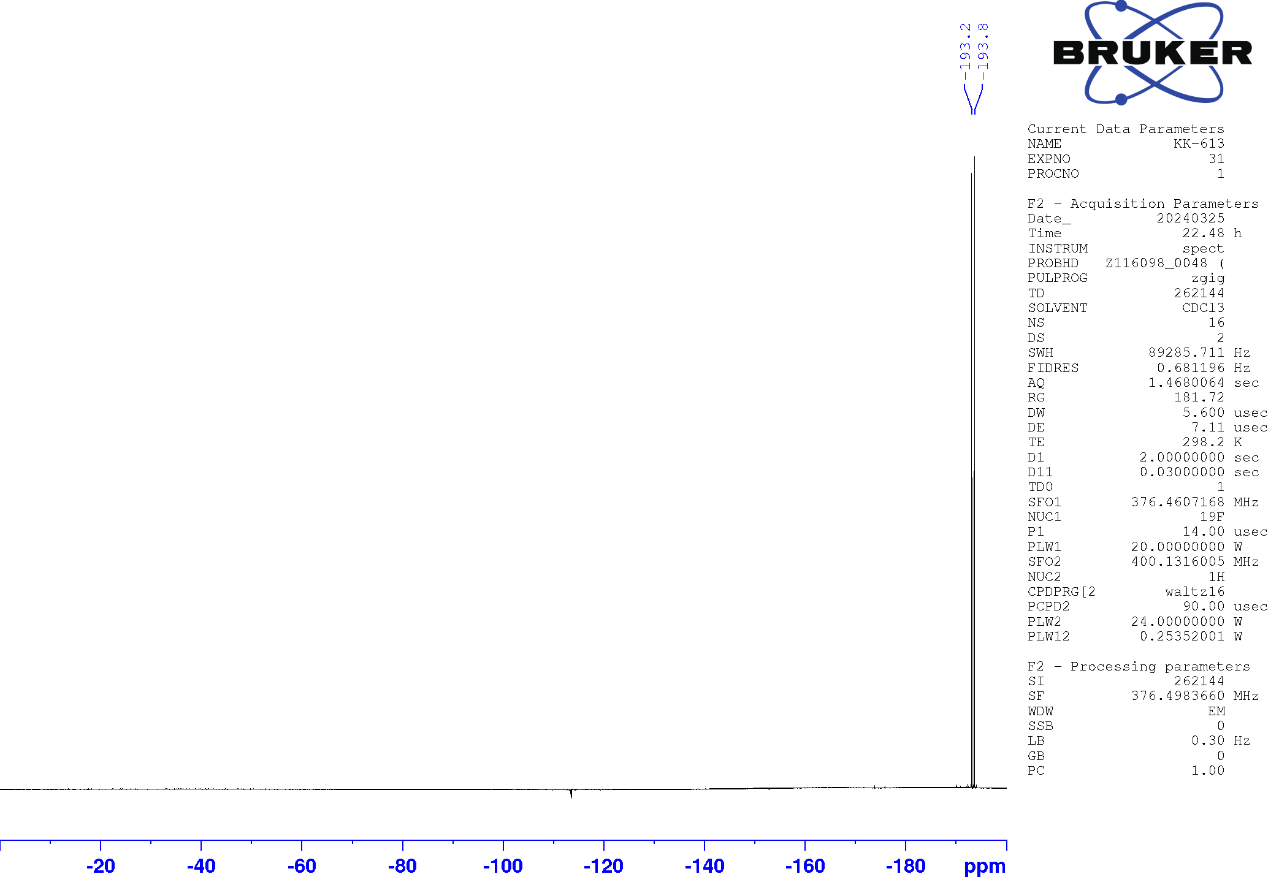

E. M. Stang and M. C. White J. Am. Chem. Soc. 2011, 133, 14892–14895.
D.-W. Gao, E. V. Vinogradova, S. K. Nimmagadda, J. M. Medina, Y. Xiao, R. M. Suciu, B. F. Cravatt, and K. M. Engle J. Am. Chem. Soc. 2018, 140, 8069–8073.
Q. Hu, W-L. Yu, Y-C. Luo, X-Q. Hu, P-F. Xu J. Org. Chem., 2022, 87, 1493-1501.
M. B. Bertrand and J. P. Wolfe Tetrahedron 2005, 61, 6447–6459.
Du, W.; Gu, Q.; Li, Y.; Lin, Z.; Yang, D. Org. Lett. 2017, 19, 316-319.
G. Zhang, L. Cui, Y. Wang, L. Zhang, J. Am. Chem. Soc. 2010, 132, 1474-1475.
P. A. Sibbald and F. E. Michael Org. Lett. 2009, 11, 1147-1149.
Y. Nishii, T. Hirai, S. Fernandez, P. Knochel, K. Mashima Eur. J. Org. Chem. 2017, 34, 5010-5014.
Mao, K.; Lv, L.; Li, Z. J. Org. Chem. 2023, 88, 10137–10146.
M. Besson, P. Gallezot, S. Neto and C. Pinel Tetrahedron: Asymm. 2000, 11, 1809-1818.

