The Ullmann coupling reaction catalyzed by a highly reactive rhodium-aryl complex derived from Grignard reagent and its application.

Kazuyuki Sato,¹* Satoki Teranishi,¹ Atsushi Sakaue,² Yukiko Karuo,¹ Atsushi Tarui,¹ Kentaro Kawai,¹ Hiroyuki Takeda,³ Tatsuo Kinashi,⁴ Masaaki Omote¹*

1) Faculty of Pharmaceutical Sciences, Setsunan University, 45-1 Nagaotoge-cho, Hirakata, Osaka, 573-0101, Japan
2) Kyowa Marina Hospital, 4-15-1 Nishinomiyahama, Nishinomiya, Hyogo 662-0934, Japan
3) Division of Proteo-Drug-Discovery Sciences, Ehime University Proteo-Science Center, 3 Bunkyo-cho, Matsuyama, Ehime, 790-8577, Japan.
4) Department of Molecular Genetics, Institute of Biomedical Science, Kansai Medical University, 2-5-1 Shin-machi, Hirakata, Osaka, 573-1010, Japan

Supplementary Materials

General Information ………………………………………………. S2
Materials ………………………………………….………………. S2
Experimental Section
Typical procedure for the synthesis of 3a
by using Grignard reagent ……………….. S2
General procedure for Rh-catalyzed
one-pot Ullmann coupling reaction ……………….. S3
Synthetic procedure for
[1,1'-biphenyl]-3,3',4,4'-tetracarboxylic acid ………S3
Inhibitory activity evaluation
against integrin complex formation ………S4
References ………………………………………….……………... S5
Spectroscopic Data …………………………….……………... S6–S9
NMR charts ………………………………………………. S10–S19

General Information:
¹H NMR, ¹³C NMR and ¹⁹F NMR spectra were recorded on JNM-GX400 spectrometers. Chemical shifts of ¹H NMR are reported in ppm from tetramethylsilane (TMS: 0 ppm) as an internal standard. Chemical shifts of ¹³C NMR are reported in ppm from the solvent (DMSO-d6: 39.520 ppm) as an internal standard. Chemical shifts of ¹⁹F NMR are reported in ppm from trichlorofluoromethane (CFCl₃: 0 ppm) as an internal standard. All data are reported as follows: chemical shifts, relative integration value, multiplicity (s = singlet, d = doublet, t = triplet, q = quartet, br = broad, m = multiplet), coupling constants (Hz). Mass spectra were obtained on JEOL JMS-700T (EI or FAB) spectrometers.

Materials:
Tetrahydrofuran (THF) was distilled over benzophenone ketyl sodium just before use. All commercially available reagents were used without further purification. All experiments were carried out under argon atmosphere in flame-dried glassware using standard inert techniques for introducing reagents and solvents unless otherwise noted.

Experimental Section:
Typical procedure for the synthesis of 3a by using Grignard reagent.
To a solution of RhCl(PPh₃)₃ (2 mol %) and 1,2-dibromoethane (1.0 mmol) in THF (10 mL) was added 1.0 M 3-methoxyphenylmagnesium bromide in THF (2 mL, 2.0 mmol) at ambient temperature, and the mixture was stirred for 2h at the same temperature. The resulting mixture was quenched with 10 % HCl, and extracted with AcOEt. The AcOEt layer was washed with sat NaCl and dried over MgSO₄. The solvent was removed in vacuo and the residue was purified by column chromatography (SiO₂) to give 3,3'-dimethoxy-1,1'-biphenyl (3a) in 73%.

General procedure for Rh-catalyzed one-pot Ullmann coupling reaction.
To a suspension of RhCl(PPh₃)₃ (2 mol%) and Mg (Turnings, Grade for Grignard Reaction; 3 mmol) in THF (10 mL) was added a aryl halide (5; 2.0 mmol) and 1,2-dibromoethane (1.0 mmol), then it was refluxed for 24h. The resulting mixture was quenched with 10% HCl, and extracted with AcOEt. The AcOEt layer was washed with sat. NaCl and dried over MgSO₄. The solvent was removed in vacuo and the residue was purified by column chromatography (SiO₂) to give the product (3).

Synthetic procedure for [1,1'-biphenyl]-3,3',4,4'-tetracarboxylic acid.¹
According to the above procedure, 3n was synthesized from 4-bromo-o-xylene (5n; 2.0 mmol). The reaction mixture was purified by column chromatography (SiO₂, hexane) to give 3n (171 mg, 81%) as a colorless solid.
A solution of 3n (1 mmol) in tert-butanol (1.25 mL) and water (1.25 mL) was heated at 70°C, then KMnO₄ (10 mmol) was added directly to the mixture in small portions (over 15 min). After 3h, the cooled reaction mixture at ambient temperature was added sat. Na₂S₂O₃ and stirred overnight. The resulting mixture was filtered through Celite and removed in vacuo, then the addition of conc. HCl to the mixture was adjusted to pH = 1.0 and it stirred for 18h. On cooling, the precipitates were collected and rinsed with water and AcOEt to give 10n (155 mg, 47%).

Inhibitory activity evaluation against integrin complex formation.
To evaluate the integrin complex formation, we established the evaluation system using AlphaScreen technology.²

1. Construction of tagged recombinant cDNA plasmids.
Genes encoding human integrin b2 cytoplasmic tail and talin FERM domain were amplified by PCR using human cDNA from Mammalian Gene Collection as templates.³ Overlapping sequences were added at the 5′ and 3′ ends for seamless cloning. Amplified integrin β2 cytoplasmic tail and talin-1 FERM domain were subcloned into the pEU-E01-GW-FLAG-GST and pEU-E01-GW-His-bls vectors, respectively, using Gibson Assembly seamless cloning. Template DNA fragments for in vitro transcription were PCR-amplified using the SPu-2 primer (5′-CAGTAAGCCAGATGCTACAC-3′), AODA2306 primer (5′-AGCGTCAGACCCCGTAGAAA-3′), and with the pEU plasmids diluted by TE buffer.

2. Preparation of recombinant proteins using a wheat germ cell-free synthesis system.
The recombinant FLAG-GST tagged human integrin β2 cytoplasmic tail and His-biotin tagged talin-1 FERM domains were synthesized using a wheat germ cell-free synthesis system.⁴ Transcription and translation reactions were conducted using a WEPRO7240 Expression Kit (CellFree Sciences, Matsuyama, Japan). The transcription reaction mixture was prepared by mixing 2.6 µL of transcription buffer LM, 1.3 µL of NTP mixture (25 mM each), 0.26 µL of RNase inhibitor, 0.52 µL of SP6 polymerase, and 2.6 µL of PCR product. The transcription reaction was incubated at 37 ℃ for 18 h. Twenty-five microliters of the translation mixture containing 12.5 µL of mRNA, 8 µL of WEPRO 7240 wheat germ extract, 1 µL of creatine kinase (2 mg/mL) (Roche Diagnostics, Basel, Switzerland), and 0.55 µL of RNase inhibitor was prepared and overlaid with 125 µL of translation buffer (SUB-AMIX SGC) in a 96-well plate. The biotin ligation site (bls) was biotinylated enzymatically by adding BirA biotin ligase and biotin (Sigma-Aldrich, St. Louis, MO, USA) to the translation mixture.⁵ The plate containing the translation reaction was incubated at 15 ℃ for 24 h. After incubation, the reaction mixtures were mixed well, divided into small portions, and frozen in liquid nitrogen. The recombinant protein samples were stored at –80 ℃ until use.

3. Amplified luminescence proximity homogeneous assay.
All ALPHA reactions were conducted in an 1/2 area OptiPlate-96 microplate (PerkinElmer, Waltham, MA, USA). All proteins and reagents were diluted in reaction buffer [100 mM Tris-HCl (pH 8.0), 0.01% Tween 20, and 1 mg/mL bovine serum albumin]. The reaction total volume is Forty microliters, and first, 10 μL of solution containing 20 nL of a biotin-tagged domain in reaction buffer was dispensed into the reaction plate. Next, 10 μL of objective concentration of compounds was added into the well. Then, 20 nL of FLAG-tagged protein was transferred to the reaction plate. After gently mixture, 10 μL of detection mixture containing 20 nL of an anti-DYKDDDDK tag monoclonal antibody, 50 nL of streptavidin-conjugated AlphaScreen donor beads, and 50 nL of protein A-conjugated AlphaScreen acceptor beads in reaction buffer was added to each well of the reaction plate. After incubation at 26°C for 1 h, the ALPHA chemiluminescence signal was detected by an EnSpire Plate Reader (Revvity). The signal data were analysed using GraphPad Prism 8.

References:
- Hayashi, T. JP2009079008A, 2009-04-16.
- Zhou, W.; Kaneko, N.; Nakagita, T.; Takeda, H.; Masumoto, J. Cell Death Differ. 2021, 28, 2991–3008.
- Mammalian Gene Collection Program Team Proc. Natl. Acad. Sci. 2002, 99, 16899–16903.
- Takai, K.; Sawasaki, T.; Endo, Y. Nat. Protoc. 2010, 5, 227–238.
- Sawasaki, T.; Kamura, N.; Matsunaga, S.; Saeki, M.; Tsuchimochi, M.; Morishita, R.; Endo, Y. FEBS Lett. 2008, 582, 221–228.

Spectroscopic Data:
3,3'-dimethoxy-1,1'-biphenyl (3a)
¹H NMR (400 MHz, CDCl₃) δ: 3.86 (6H, s), 6.89–6.91 (2H, m), 7.11–7.12 (2H, m), 7.16–7.19 (2H, m), 7.33–7.37 (2H, m); MS m/z: 214 (M⁺); HRMS Calcd for C₁₄H₁₄O₂: 214.0994 (M⁺), Found: 214.0998.

1,1'-biphenyl (3b)
¹H NMR (400 MHz, CDCl₃) δ: 7.32–7.37 (2H, m), 7.42–7.46 (4H, m), 7.58–7.61 (4H, m); MS m/z: 154 (M⁺); HRMS Calcd for C₁₂H₁₀: 154.0783 (M⁺), Found: 154.0786.

4,4'-dimethoxy-1,1'-biphenyl (3c)
¹H NMR (400 MHz, CDCl₃) δ: 3.84 (6H, s), 6.94–6.97 (4H, m), 7.46–7.49 (4H, m); MS m/z: 214 (M⁺); HRMS Calcd for C₁₄H₁₄O₂: 214.0994 (M⁺), Found: 214.0995.

3,3'-dimethyl-1,1'-biphenyl (3d)
¹H NMR (400 MHz, CDCl₃) δ: 2.42 (6H, s), 7.14–7.16 (2H, m), 7.30–7.34 (2H, m), 7.37–7.40 (4H, m); MS m/z: 182 (M⁺); HRMS Calcd for C₁₄H₁₄: 182.1096 (M⁺), Found: 182.1098.

4,4'-dimethyl-1,1'-biphenyl (3e)
¹H NMR (400 MHz, CDCl₃) δ: 2.38 (6H, s), 7.22–7.25 (4H, m), 7.46–7.49 (4H, m); MS m/z: 182 (M⁺); HRMS Calcd for C₁₄H₁₄: 182.1096 (M⁺), Found: 182.1097.

2,2'-bithiophene (3f)
¹H NMR (400 MHz, CDCl₃) δ: 6.99–7.01 (2H, m), 7.16–7.20 (4H, m); MS m/z: 166 (M⁺); HRMS Calcd for C₈H₆S₂: 165.9911 (M⁺), Found: 165.9902.

3,3'-difluoro-1,1'-biphenyl (3h)
¹H NMR (400 MHz, CDCl₃) δ: 7.01–7.06 (2H, m), 7.21–7.25 (2H, m), 7.30–7.39 (4H, m); ¹⁹F NMR (376 MHz, CDCl₃) δ: -112.5 (2F, m); MS m/z: 190 (M⁺); HRMS Calcd for C₁₂H₈F₂: 190.0594 (M⁺), Found: 190.0599.

4,4'-dichloro-1,1'-biphenyl (3i)
¹H NMR (400 MHz, CDCl₃) δ: 7.40–7.42 (4H, m), 7.46–7.49 (4H, m); MS m/z: 222 (M⁺); HRMS Calcd for C₁₂H₈Cl₂: 222.0003 (M⁺), Found: 221.9999.

[1,1'-biphenyl]-3,3'-dicarbonitrile (3j)
¹H NMR (400 MHz, CDCl₃) δ: 7.60–7.63 (2H, m), 7.71–7.73 (2H, m), 7.79–7.81 (2H, m), 7.85 (2H, m); MS m/z: 204 (M⁺); HRMS Calcd for C₁₄H₈N₂: 204.0687 (M⁺), Found: 204.0690.

1,1'-bi(cyclohexane) (3l)
¹H NMR (400 MHz, CDCl₃) δ: 0.90–1.26 (12H, m), 1.62–1.73 (10H, m); MS m/z: 166 (M⁺); HRMS Calcd for C₁₂H₂₂: 166.1722 (M⁺), Found: 166.1720.

2,2',4,4'-tetramethyl-1,1'-biphenyl (3m)
¹H NMR (400 MHz, CDCl₃) δ: 2.03 (6H, s), 2.36 (6H, s), 6.97–7.04 (4H, m), 7.08 (2H, m); MS m/z: 210 (M⁺); HRMS Calcd for C₁₆H₁₈: 210.1409 (M⁺), Found: 210.1407.

3,3',4,4'-tetramethyl-1,1'-biphenyl (3n)
¹H NMR (400 MHz, CDCl₃) δ: 2.29 (6H, s), 2.32 (6H, s), 7.17–7.19 (2H, m), 7.30–7.32 (2H, m), 7.35–7.36 (2H, m); ¹³C NMR (100 MHz, CDCl₃) δ: 19.41, 19.93, 124.3, 128.3, 130.0, 135.3, 136.8, 138.9; MS m/z: 210 (M⁺); HRMS Calcd for C₁₆H₁₈: 210.1409 (M⁺), Found: 210.1409.

3,3',5,5'-tetramethyl-1,1'-biphenyl (3o)
¹H NMR (400 MHz, CDCl₃) δ: 2.37 (12H, s), 6.97–6.98 (2H, m), 7.19 (4H, m); ¹³C NMR (100 MHz, CDCl₃) δ: 21.40, 125.1, 128.7, 138.1, 141.5; MS m/z: 210 (M⁺); HRMS Calcd for C₁₆H₁₈: 210.1409 (M⁺), Found: 210.1409.

3,3''-difluoro-1,1':3',1''-terphenyl (6h)
¹H NMR (400 MHz, CDCl₃) δ: 7.04–7.09 (2H, m), 7.31–7.35 (2H, m), 7.38–7.45 (4H, m), 7.50–7.58 (3H, m), 7.75 (1H, m); ¹³C NMR (100 MHz, CDCl₃) δ: 114.1 (d, J = 19.3 Hz), 114.4 (d, J = 18.5 Hz), 122.9 (d, J = 2.6 Hz), 126.0, 126.6, 129.4, 130.3 (d, J = 8.4 Hz) 140.7 (d, J = 1.9 Hz), 143.2 (d, J = 7.6 Hz), 163.2 (d, J = 245.9 Hz); ¹⁹F NMR (376 MHz, CDCl₃) δ: -112.8 (2F, m); MS m/z: 266 (M⁺).

[1,1'-biphenyl]-3,3',4,4'-tetracarboxylic acid (10n)
¹H NMR (400 MHz, DMSO-d6) δ: 7.81–7.83 (2H, m), 7.96–8.00 (4H, m); ¹³C NMR (100 MHz, DMSO-d6) δ: 126.7, 129.1, 129.6, 132.1, 134.2, 140.7, 168.3, 168.6; MS m/z: 294 (M⁺ − 2H₂O); HRMS Calcd for C₁₆H₆O₆: 294.0164 (M⁺ − 2H₂O), Found: 294.0163; MS (FAB⁺) m/z: 331 (M⁺ + H); HRMS Calcd for C₁₆H₁₁O₈: 331.0454 (M⁺ + H), Found: 331.0457.

NMR charts:
¹H NMR of 3,3'-dimethoxy-1,1'-biphenyl (3a)
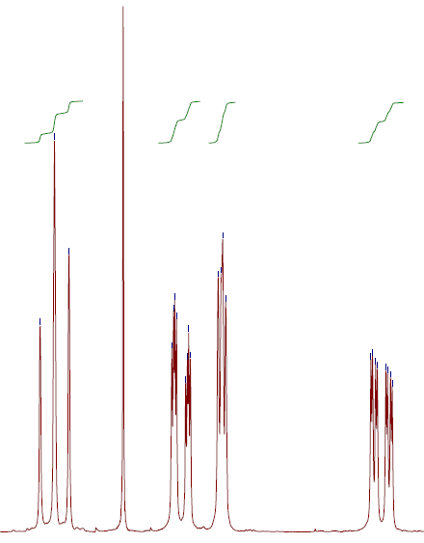
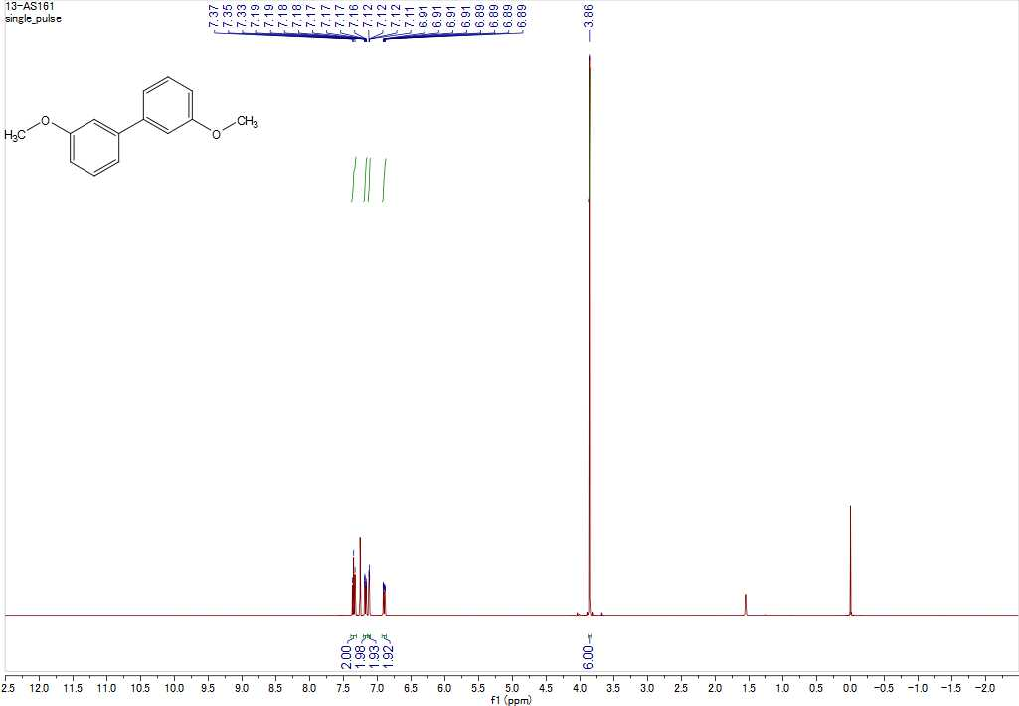

¹H NMR of 1,1'-biphenyl (3b)
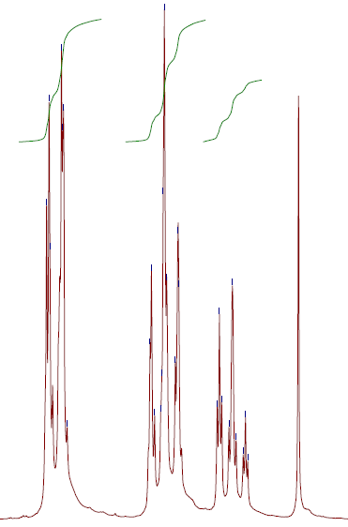
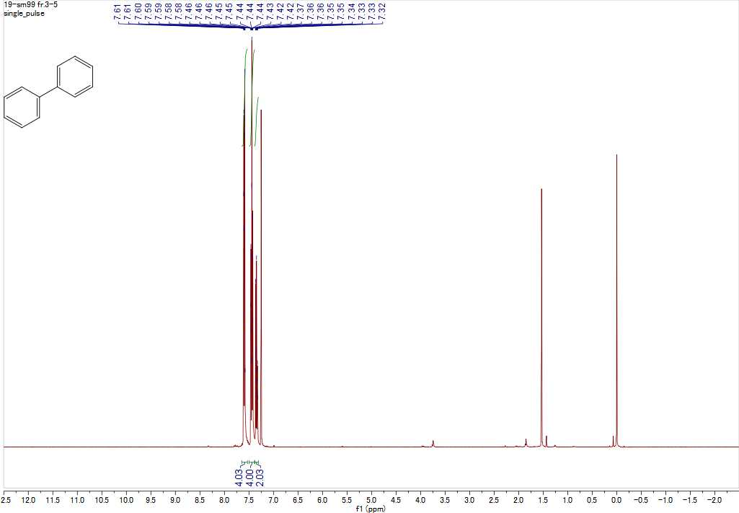

¹H NMR of 4,4'-dimethoxy-1,1'-biphenyl (3c)
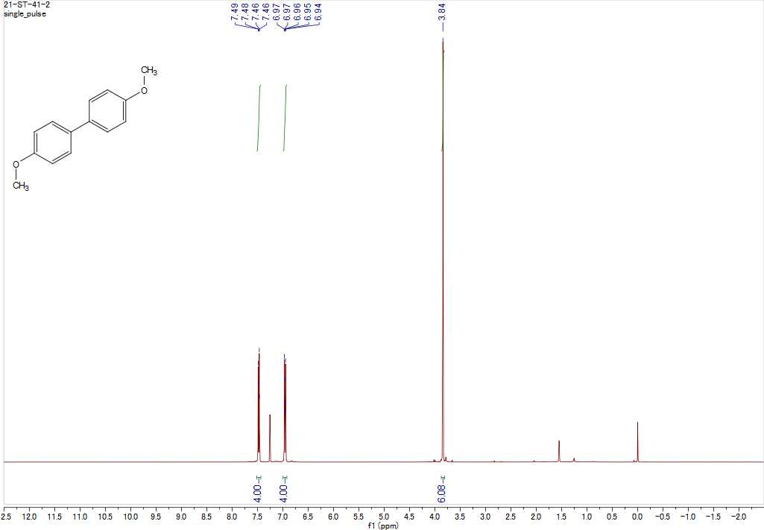

¹H NMR of 3,3'-dimethyl-1,1'-biphenyl (3d)
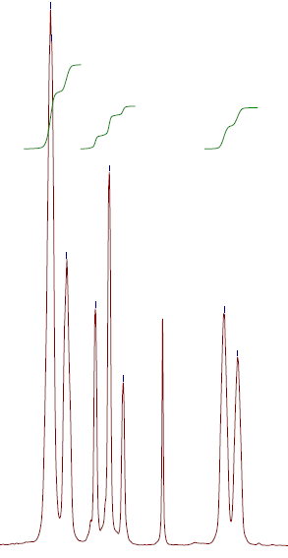
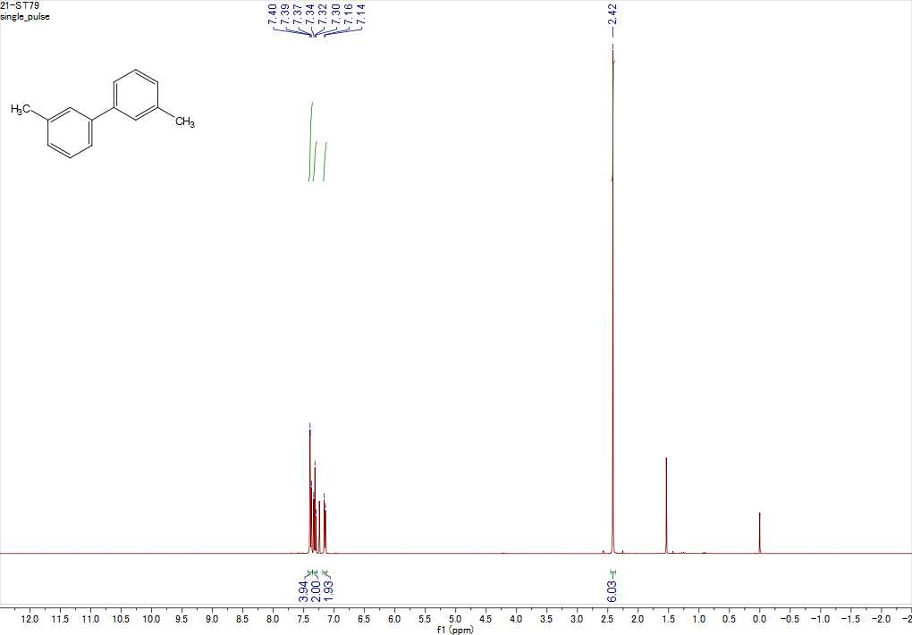
¹H NMR of 4,4'-dimethyl-1,1'-biphenyl (3e)
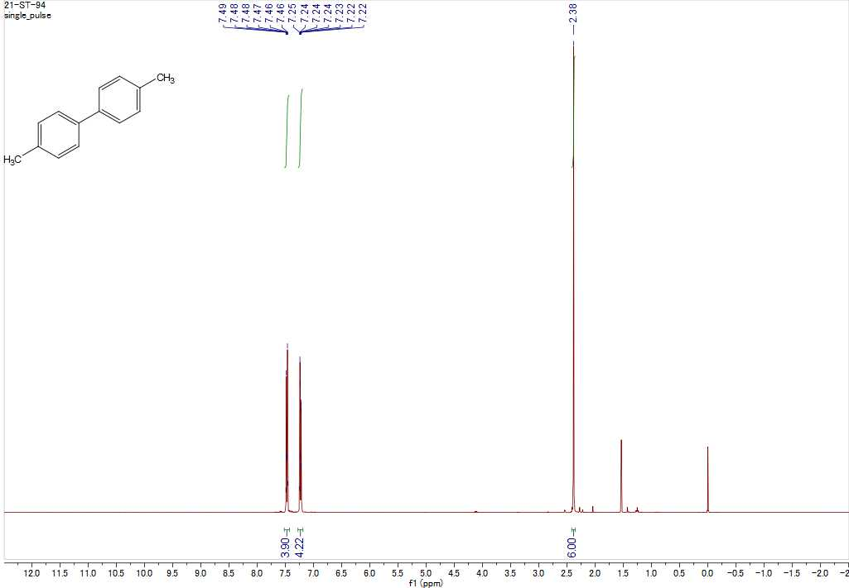

¹H NMR of 2,2'-bithiophene (3f)
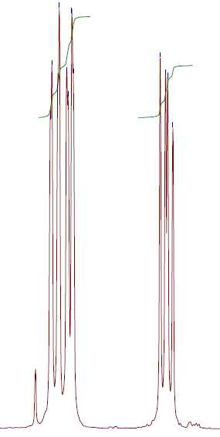
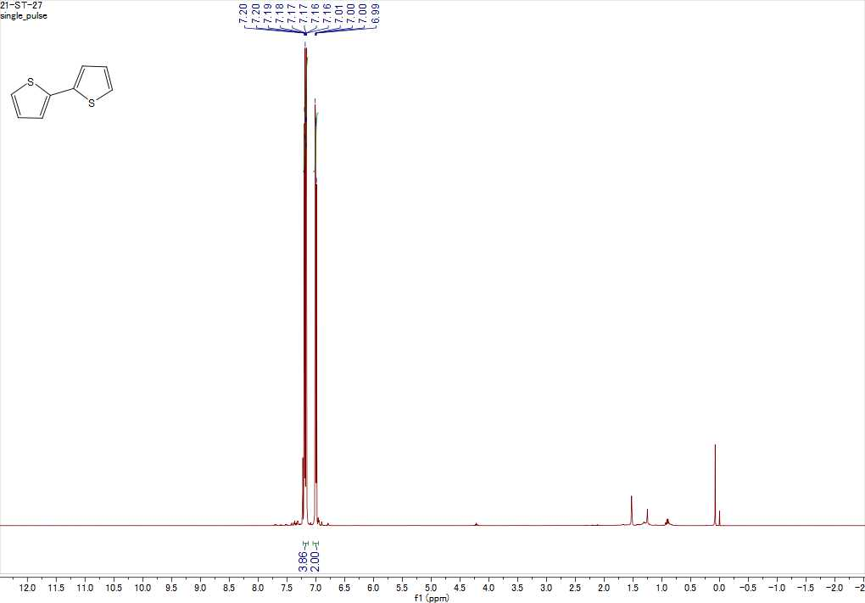

¹H NMR of 3,3'-difluoro-1,1'-biphenyl (3h)
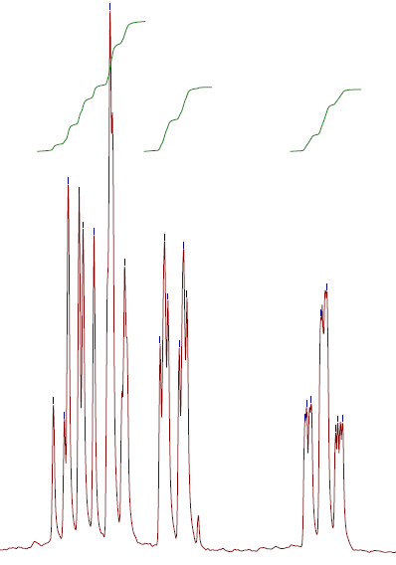
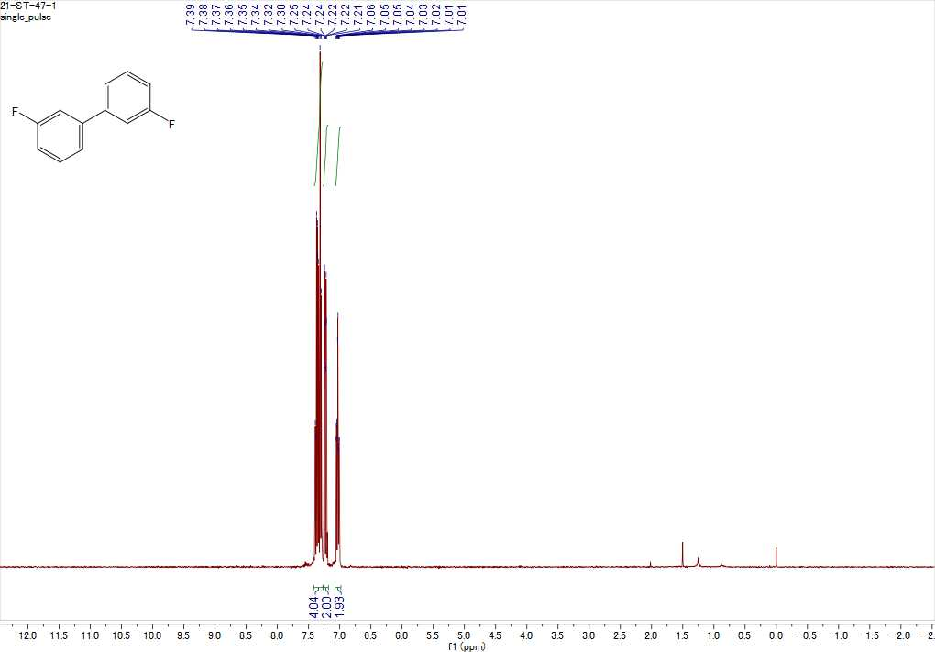

¹⁹F NMR of 3,3'-difluoro-1,1'-biphenyl (3h)
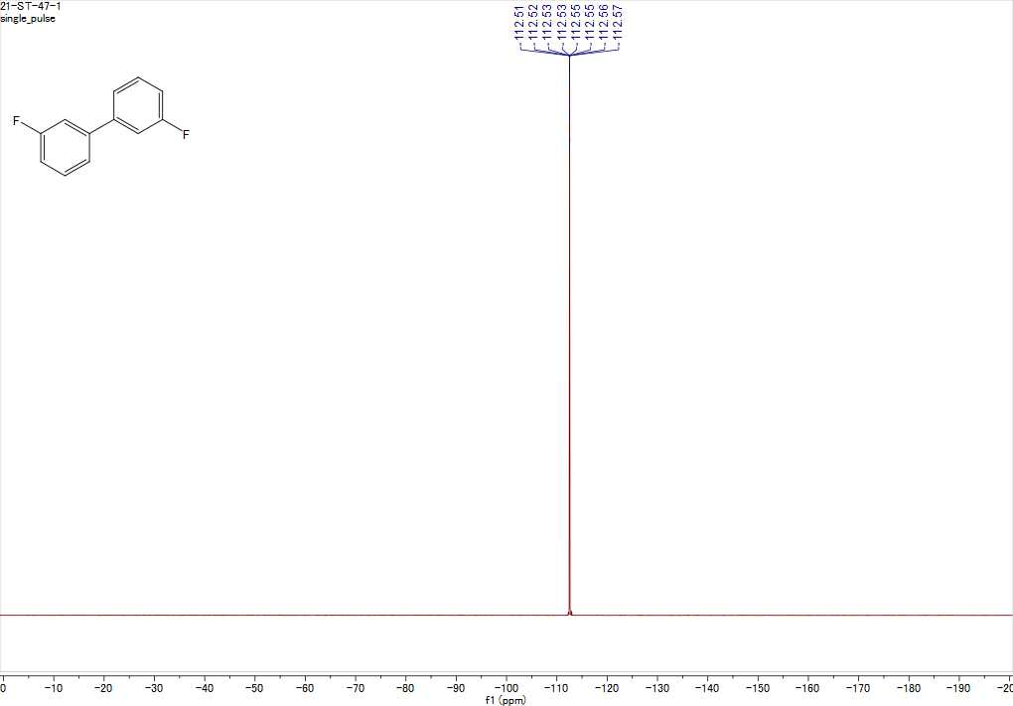

¹H NMR of 4,4'-dichloro-1,1'-biphenyl (3i)
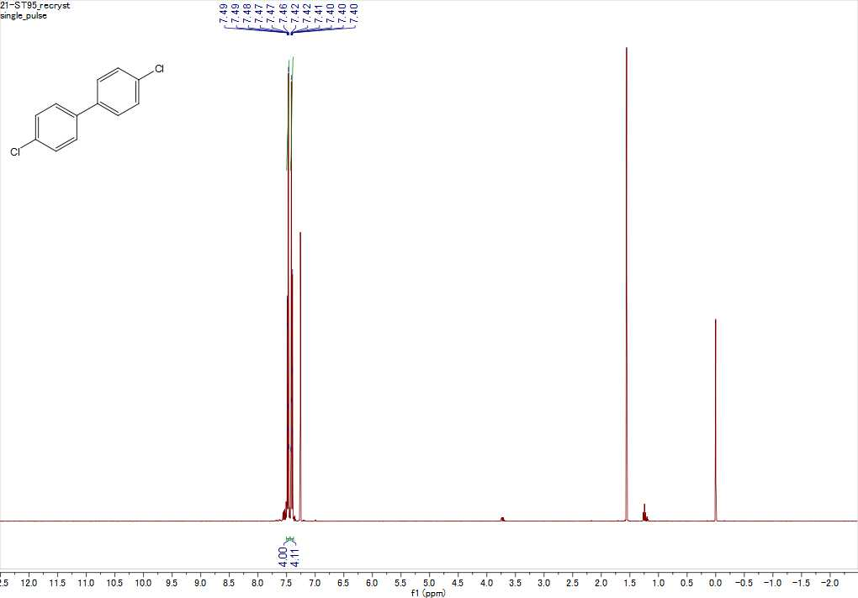

¹H NMR of [1,1'-biphenyl]-3,3'-dicarbonitrile (3j)
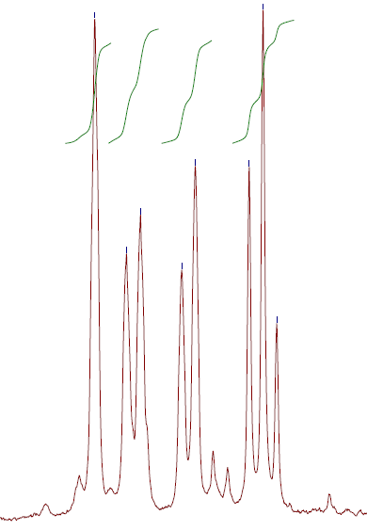
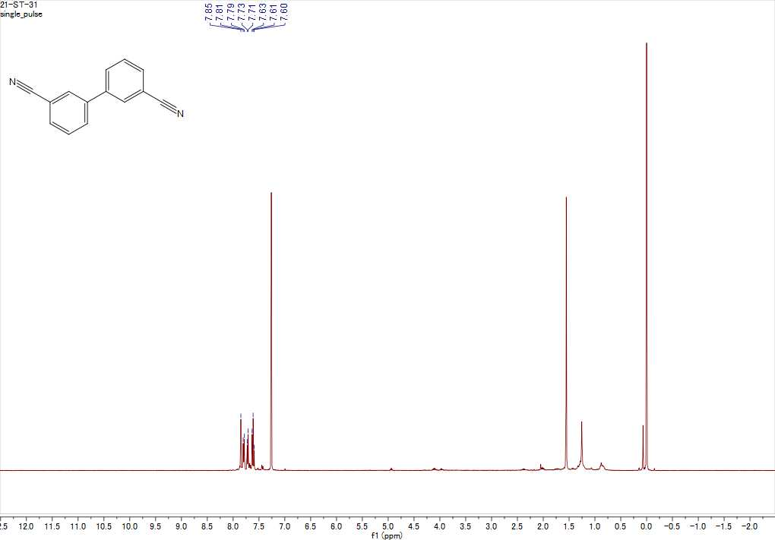

¹H NMR of 1,1'-bi(cyclohexane) (3l)
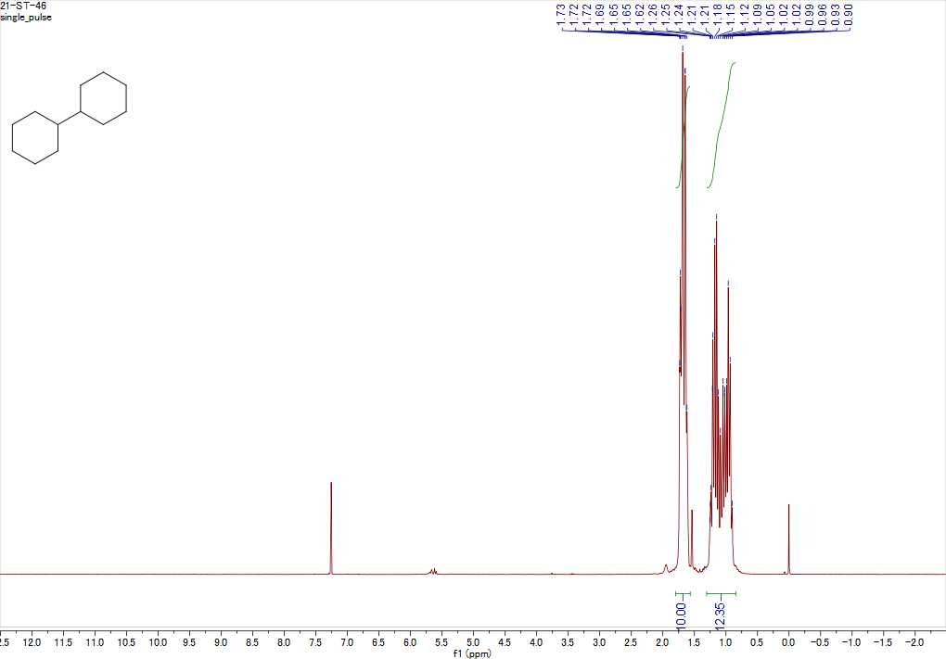

¹H NMR of 2,2',4,4'-tetramethyl-1,1'-biphenyl (3m)
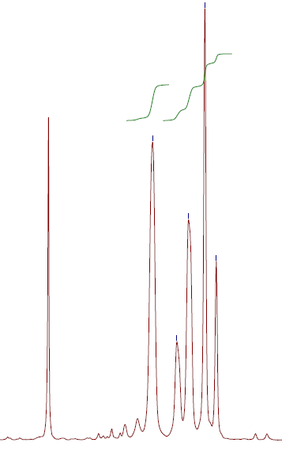
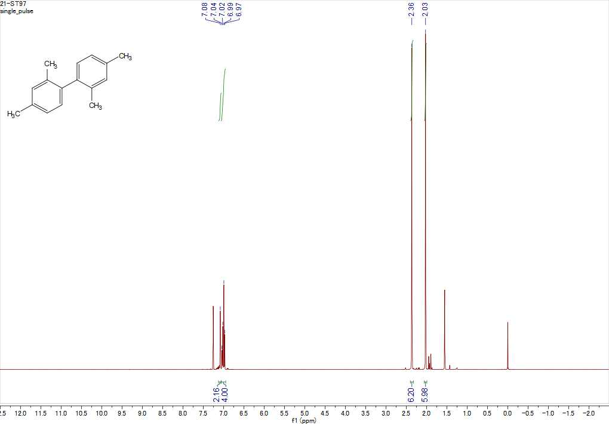

¹H NMR of 3,3',4,4'-tetramethyl-1,1'-biphenyl (3n)
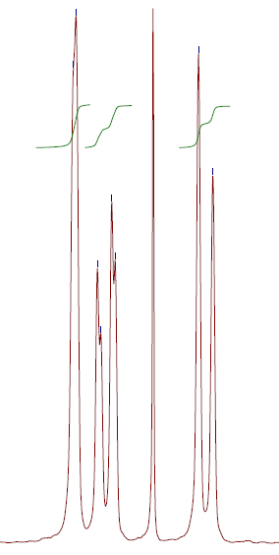
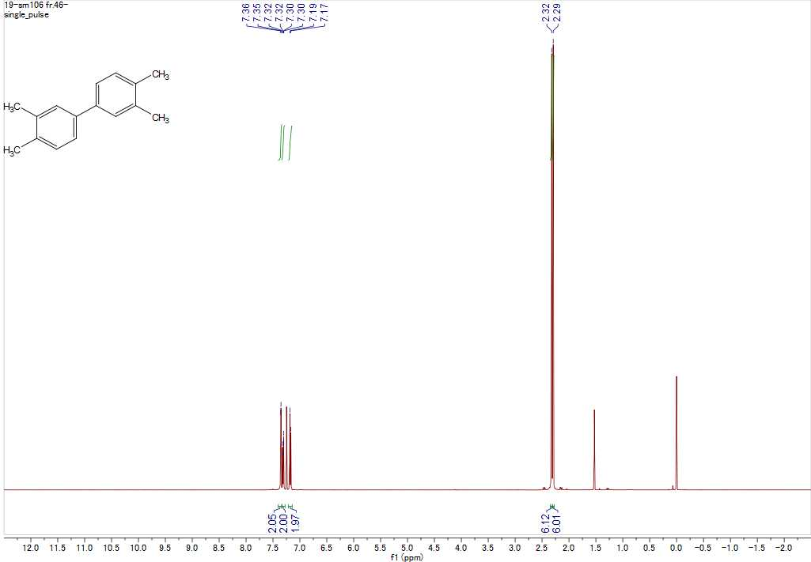

¹H NMR of 3,3',5,5'-tetramethyl-1,1'-biphenyl (3o)
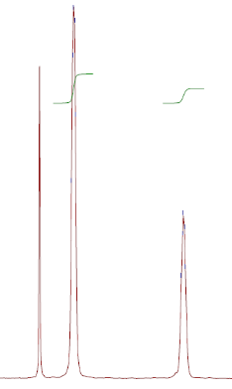
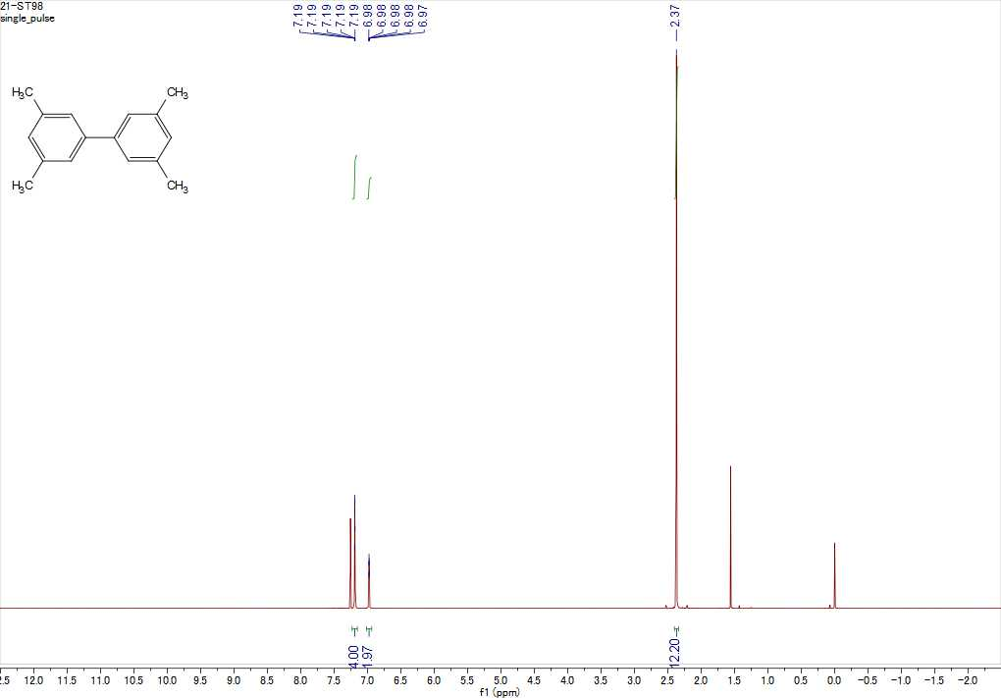

¹H NMR of 3,3''-difluoro-1,1':3',1''-terphenyl (6h)
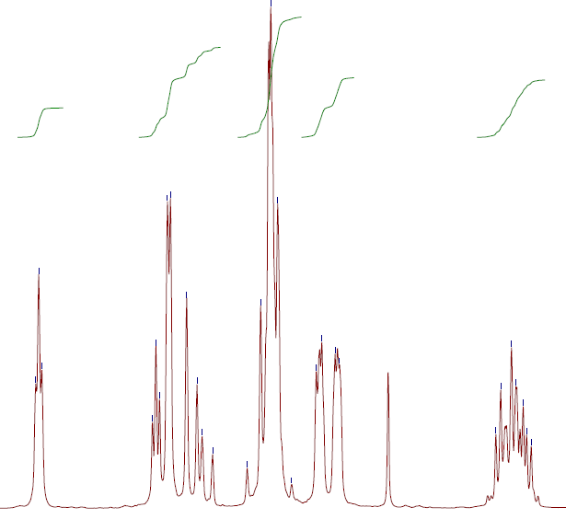
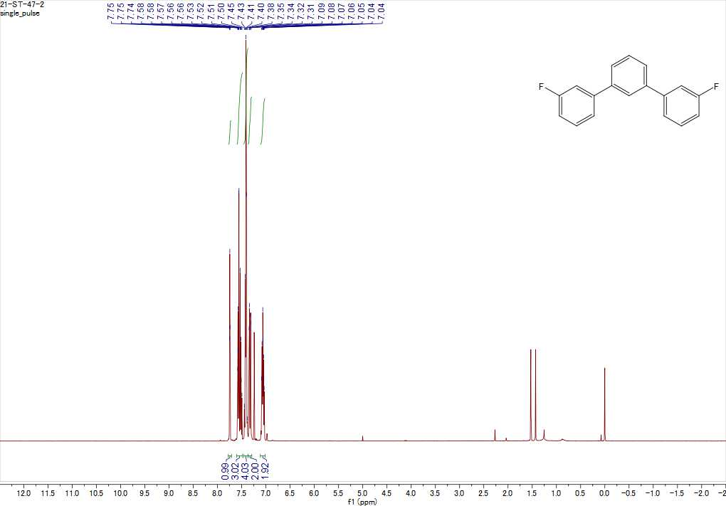

¹³C NMR of 3,3''-difluoro-1,1':3',1''-terphenyl (6h)
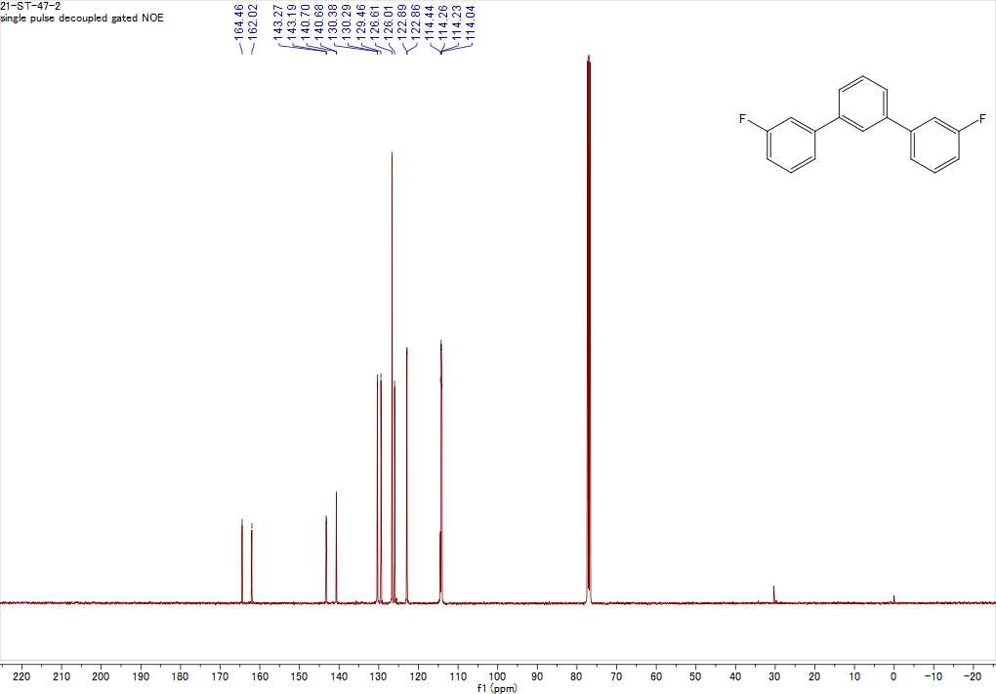

¹⁹F NMR of 3,3''-difluoro-1,1':3',1''-terphenyl (6h)
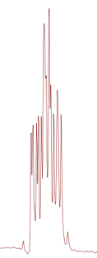
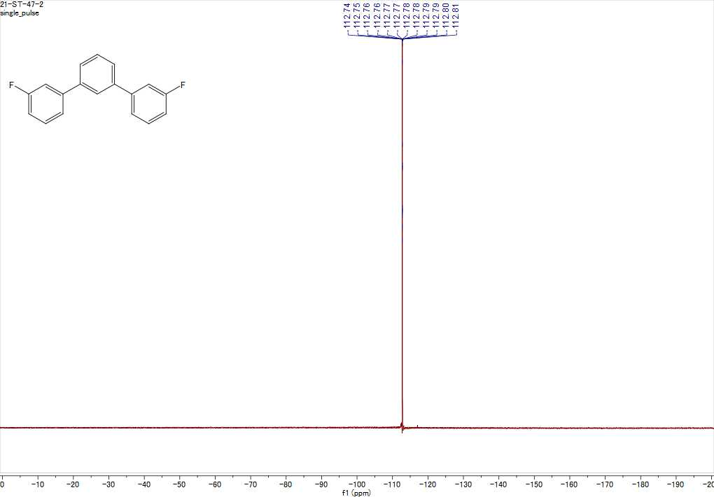

¹H NMR of [1,1'-biphenyl]-3,3',4,4'-tetracarboxylic acid (10n)
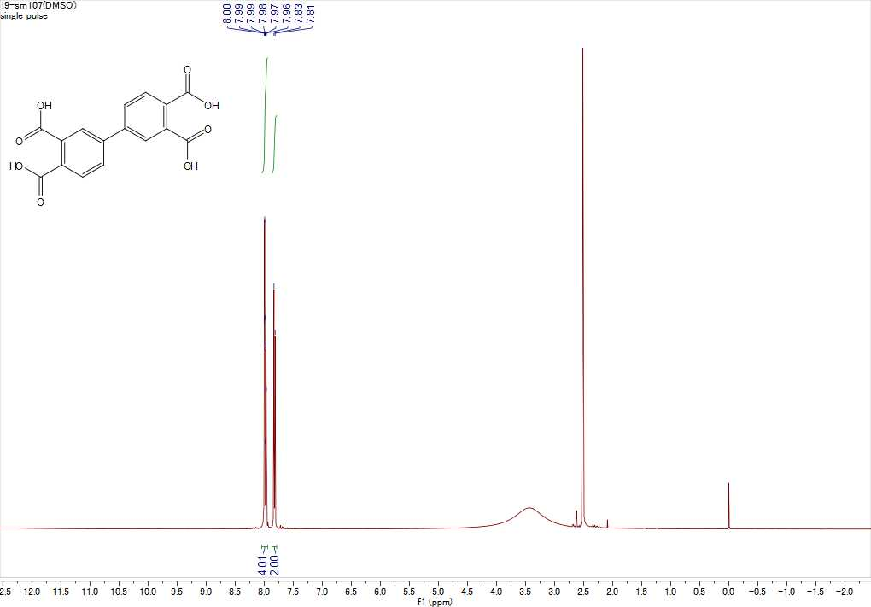

¹³C NMR of [1,1'-biphenyl]-3,3',4,4'-tetracarboxylic acid (10n)
