Supporting Information
for
Atomistic Insights into the Morphological Dynamics of Gold and Platinum Nanoparticles: MD simulations in Vacuum and Aqueous Media
Evangelos Voyiatzis, Eugenia Valsami-Jones and Antreas Afantitis

Additional figures

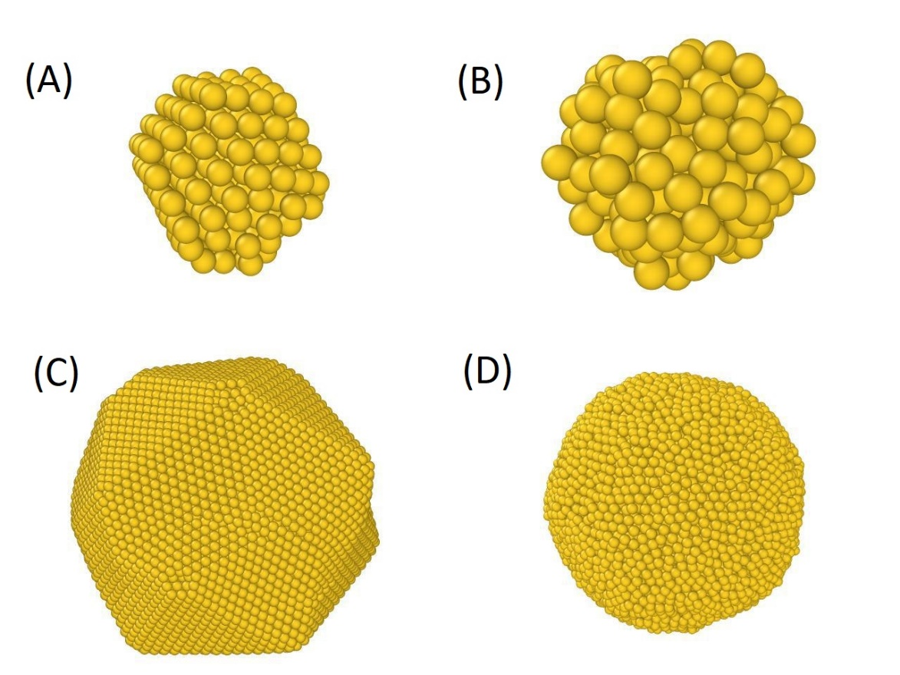
Figure S1: Visualization of Au NPs with diameters of 2 nm (panels A and B) and 8 nm (panels C and D) at 100 K (panels A and C) and 1100 K (panels B and D).

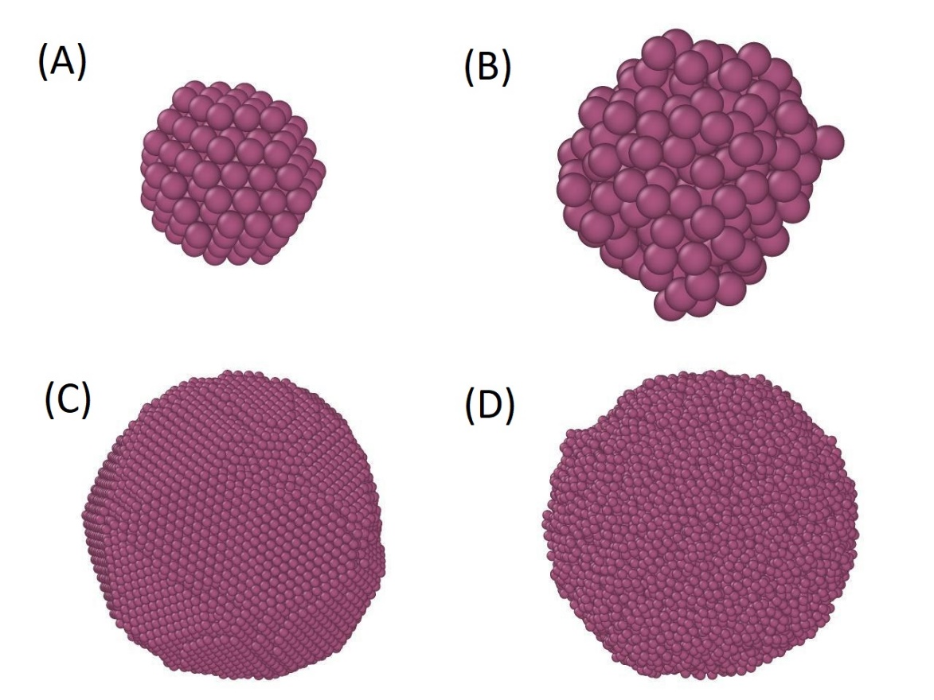
Figure S2: Visualization of Pt NPs with diameters of 2 nm (panels A and B) and 8 nm (panels C and D) at 100 K (panels A and C) and 2000 K (panels B and D).

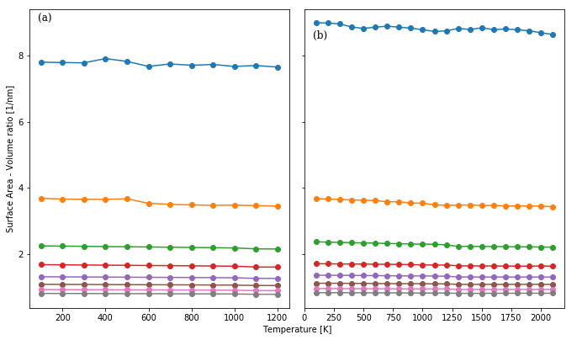
Figure S3: Temperature dependence of surface area to volume ratio for Au (panel a) and Pt (panel b) NPs. The NP diameters range from 1 nm to 8 nm.

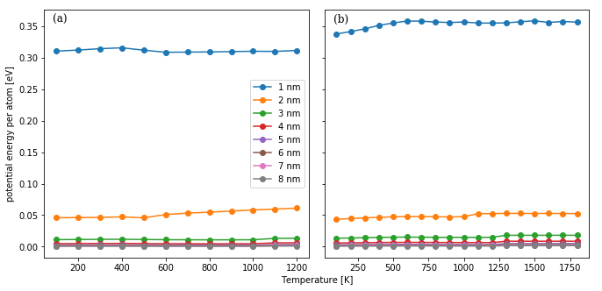
Figure S4: Temperature dependence of the average surface potential energy per atom for Au (panel a) and Pt (panel b) NPs. The NP diameters range from 1 up to 8 nm. The symbols for the NP diameters are explained in Fig. S3.

