Supporting Information
for
Evaluation of the enantioselectivity of new chiral ligands based on imidazolidine-4-one derivatives
Jan Bartáček, Karel Chlumský, Jan Mrkvička, Lucie Paloušová, Miloš Sedlák and Pavel Drabina*
Institute of Organic Chemistry and Technology, Faculty of Chemical Technology, University of Pardubice, Studentská 573, 532 10 Pardubice, Czech Republic
* The corresponding author: e-mail: pavel.drabina@upce.cz; tel. +420 466 037 010; fax. +420 466 037 068; postal address: Institute of Organic Chemistry and Technology, Faculty of Chemical Technology, University of Pardubice, Studentská 573, 532 10 Pardubice, Czech Republic
ORCID: 0000-0003-1861-8979

General information and experimental data of prepared compounds, copies of ¹H and ¹³C NMR spectra and DFT calculations

Table of content

- Experimental procedures 3
  - General procedures 3
  - Synthesis 4
- NMR spectra .11
- DFT calculations 32
- Summarisation of the results of catalytic experiments…………………………………….37
- References and notes 38

- Experimental procedures
1.1. General procedures
The starting chemicals and solvents were obtained from TCI Chemicals or Fluorochem and used without further purification. (S)-2-amino-2,3-dimethylbutanamide was prepared according to the method described previously [1]. Column chromatography was performed using 60 Å (60–200 μm) silica gel. TLC was performed on aluminium-backed silica gel plates (Merck DC, Alufolien Kieselgel 60 F₂₅₄) with spots visualised by UV light. The melting point temperatures are uncorrected. The IR spectra were measured at room temperature using Thermo Scientific Nicolet iS50 FT-IR Spectrometer with ATR technique, the resolution was 4 cm^{–1}, FT-IR data are presented in cm^{–1}. ¹H NMR spectra were recorded on a Bruker Avance 400 instrument (400.13 MHz for 1H) or Bruker Ascend 500 instrument (500.13 MHz for ¹H). Chemical shifts δ were referenced to the residual peak of CDCl₃ at 7.26 ppm or MeOD-d₄ at 3.31 ppm. The ¹³C NMR spectra were calibrated with respect to the middle signal in the triplet of CDCl₃ (δ = 77.23 ppm). High-resolution mass spectra were measured on the Thermo Fisher Scientific MALDI LTQ Orbitrap instrument. The used matrix was a 0.2M solution of 2,5-dihydroxybenzoic acid (DHB) in MeCN/H₂O (95/5). Spectra were calibrated with respect to the used matrix. The optical rotation was measured on a Perkin–Elmer 341 instrument; the concentration c was given in g/100 mL. HPLC analyses were performed on the Watrex HPLC instrument with UV-Vis DAD (200–800 nm) SYKAM 3240 and with chiral Daicel columns Chilacel OD-H, Chiralpak AD-H, Chiralpak IA and Chiralpak AS-H (250 mm × 4.6 mm). Hydrogenations were performed in pressure vessel Berghof BR-100. To evaluate the effectiveness of the catalysts, the values of Turnover Number (TON) and Turnover Frequency (TOF) related to the production of the major stereoisomer were calculated using the following equations:
$TON=\frac{\frac{yield \left(\%\right)∙(\frac{ee \left(\%\right)}{2}+50)}{100}}{mol \% cat.}$ ; $TOF=\frac{TON}{time (h)}$

1.2. Synthesis
2,6-Bis(5-isopropyl-5-methylimidazolidine-4-on-2-yl)pyridines Ia-c

A solution of pyridine-2,6-dicarbaldehyde (271.2 mg, 2 mmol), (S)-2-amino-2,3-dimethylbutanamide (780 mg, 6 mmol) and TsOH (30 mg) in nBuOH (6 mL) was heated at 80 °C under argon for 5 d. TEA (50 µl) was added to the cooled reaction mixture, and the solvent was evaporated under reduced pressure. The residue was at least twice chromatographed (SiO₂; acetone/AcOEt /MeOH (13/7/1; v/v/v)) to afford individual diastereomers of ligand I.

(2R,2´R,5S,5´S)-2,6-Bis(5-isopropyl-5-methylimidazolidine-4-on-2-yl)pyridine (Ia)
Yield: 150 mg (20%), white crystalline solid; R_{f} 0.51; mp 235–⁠⁠⁠237 °C; ${[α]}_{D}^{20}$ +32.6 (c 0.212; DCM/MeOH (9/1; v/v); ¹H NMR (500 MHz, CD₃OD): δ 7.91 (t, 1H, J = 7.8 Hz), 7.52 (d, 2H, J = 7.8 Hz), 5.54 (s, 2H), 1.93 (sp, 2H, J = 6.5 Hz), 1.33 (s, 6H), 1.03 (m, 12H); ¹³C NMR (125 MHz, CD₃OD): δ 182.3, 160.6, 139.8, 123.1, 72.6, 66.4, 36.2, 24.1, 18.1, 16.7; FT-IR (ATR, cm^{–1}): 3171, 2962, 2922, 2871, 1709, 1681, 1453, 1333, 1080, 1058, 804, 627; HR-MALDI-MS (DHB): Calcd for C₁₉H₂₉N₅O₂ m/z 360.23940 [M+H]⁺; found 360.23984.

(2R,2´S,5S,5´S)-2,6-Bis(5-isopropyl-5-methylimidazolidine-4-on-2-yl)pyridine (Ib)

Yield: 311 mg (41%), white crystalline solid; R_{f} 0.43; mp 208–210 °C; ${[α]}_{D}^{20}$ –13.0 (c 0.432; DCM/MeOH (9/1; v/v); ¹H NMR (500 MHz, CD₃OD): δ 7.92 (t, 1H, J = 7.8 Hz), 7.61 (d, 1H, J = 7.8 Hz), 7.53 (d, 1H, J = 7.8 Hz), 5.64 (s, 1H), 5.55 (s, 1H), 1.94 (m, 2H), 1.36 (s, 3H), 1.34 (s, 3H), 1.03 (m, 6H); 1.00 (d, 3H, J = 6.8 Hz), 0.96 (d, 3H, J = 6.8 Hz); ¹³C NMR (125 MHz, CD₃OD): δ 182.2, 182.0, 160.1, 160.0, 139.7, 123.2, 123.1, 72.6, 70.8, 66.5, 66.4, 36.2, 34.7, 24.0, 21.9, 18.5, 18.1, 16.7; FT-IR (ATR, cm^{–1}): 3220, 2965, 2873, 1690, 1447, 1320, 1108, 758, 666. HR-MALDI-MS (DHB): Calcd for C₁₉H₂₉N₅O₂ m/z 360.23940 [M+H]⁺; found 360.23992.

(2S,2´S,5S,5´S)-2,6-Bis(5-isopropyl-5-methylimidazolidine-4-on-2-yl)pyridine (1c)

Yield: 115 mg (15%), white crystalline solid; R_{f} 0.36; mp 172–174 °C; ${[α]}_{D}^{20}$ –70.0 (c 0.216; DCM/MeOH (9/1; v/v); ¹H NMR (500 MHz, CD₃OD): δ 7.95 (t, 1H, J = 7.8 Hz), 7.62 (d, 2H, J = 7.8 Hz), 5.68 (s, 2H), 1.96 (sp, 2H, J = 6.8 Hz), 1.38 (s, 6H), 1.01 (d, 6H, J = 6.8 Hz), 0.95 (d, 6H, J = 6.8 Hz); ¹³C NMR (125 MHz, CD₃OD): δ 181.5, 159.6, 139.7, 123.2, 70.7, 66.7, 34.6, 21.5, 18.4, 16.7; FT-IR (ATR, cm^{–1}): 3209, 2962, 2872, 2854, 1688, 1446, 1320, 1077, 756; HR-MALDI-MS (DHB): Calcd for C₁₉H₂₉N₅O₂ m/z 360.23940 [M+H]⁺; found 360.23976.

2,6-Bis(5-isopropyl-2,5-dimethylimidazolidine-4-on-2-yl)pyridines IIa-c

A solution of 2,6-diacetyl pyridine (332.8 mg, 2 mmol), (S)-2-amino-2,3-dimethylbutanamide (780 mg, 6 mmol) and TsOH (30 mg) in ortho-dichlorobenzene (6 mL) was heated at 140 °C under argon for 4 d. TEA (50 µl) was added to the cooled reaction mixture, and the solvent was evaporated under reduced pressure. The residue was at least twice chromatographed (SiO₂; AcOEt/MeOH (20/1; v/v)) to afford individual diastereomers of ligand II.

(2R,2´R,5S,5´S)-2,6-Bis(5-isopropyl-2,5-dimethylimidazolidine-4-on-2-yl)pyridine (IIa)
Yield: 186 mg (23%), white crystalline solid; R_{f} 0.39; mp 188–190 °C; ${[α]}_{D}^{20}$ +80.5 (c 0.41; DCM); ¹H NMR (500 MHz, CDCl₃): δ 8.73 (bs, 2H), 7.63 (t, 1H, J = 8.0 Hz), 7.54 (d, 2H, J = 8.0 Hz), 2.30 (bs, 2H), 2.05 (sp, 2H, J = 6.8 Hz), 1.53 (s, 6H), 1.00 (d, 12H, J = 6.8 Hz), 0.97 (s, 6H); ¹³C NMR (125 MHz, CDCl₃): δ 180.3, 164.2, 137.5, 117.7, 75.1, 66.2, 33.7, 31.4, 23.7, 18.2, 16.6; FT-IR (ATR, cm^{–1}): 3199, 2964, 2874, 1693, 1574, 1343, 1236, 1101, 949, 820, 680; HR-MALDI-MS (DHB): Calcd for C₂₁H₃₃N₅O₂ m/z 388.27070 [M+H]⁺; found 388.27151.

(2R,2´S,5S,5´S)-2,6-Bis(5-isopropyl-2,5-dimethylimidazolidine-4-on-2-yl)pyridine (IIb)
Yield: 288 mg (35%), white crystalline solid; R_{f} 0.34; mp 172–174 °C; ${[α]}_{D}^{20}$ –30.6 (c 0.252; DCM); ¹H NMR (500 MHz, CDCl₃): δ 8.41 (bs, 1H), 8.22 (bs, 1H), 7.68 (t, 1H, J = 7.8 Hz), 7.59 (m, 2H), 2.32 (bs, 2H), 2.03 (sp, 1H, J = 6.8 Hz), 1.77 (sp, 1H, J = 6.8 Hz), 1.69 (s, 3H), 1.63 (s, 3H), 1.43 (s, 3H), 1.06 (s, 3H), 1.01 (m, 6H), 0.92 (d, 3H, J = 6.8 Hz), 0.64 (d, 3H, J = 6.8 Hz); ¹³C NMR (125 MHz, CDCl₃): δ 180.0, 178.8, 164.1, 163.8, 137.7, 117.6, 117.5, 75.0, 74.8, 66.0, 65.7, 34.5, 34.0, 33.5, 31.5, 24.7, 24.0, 18.3, 18.2, 16.6; FT-IR (ATR, cm^{–1}): 3196, 2965, 2873, 1697, 1574, 1445, 1364, 1237, 1111, 758, 674; HR-MALDI-MS (DHB): Calcd for C₂₁H₃₃N₅O₂ m/z 388.27070 [M+H]⁺; found 388.27113.

(2S,2´S,5S,5´S)-2,6-Bis(5-isopropyl-2,5-dimethylimidazolidine-4-on-2-yl)pyridine (IIc)
Yield: 96 mg (12%), white crystalline solid; R_{f} 0.30; mp 141–143 °C; ${[α]}_{D}^{20}$ –133.5 (c 0.212; DCM); ¹H NMR (500 MHz, CDCl₃): δ 9.45 (bs, 2H), 7.65 (t, 1H, J = 7.8 Hz), 7.45 (d, 2H, J = 7.8 Hz), 2.14 (bs, 2H), 1.75 (sp, 2H, J = 6.8 Hz), 1.54 (s, 6H), 1.44 (s, 6H), 0.84 (d, 6H, J = 6.8 Hz), 0.44 (d, 6H, J = 6.8 Hz); ¹³C NMR (125 MHz, CDCl₃): δ 179.3, 163.8, 137.3, 117.2, 75.5, 66.2, 34.1, 33.9, 24.5, 18.2, 16.5; FT-IR (ATR, cm^{–1}): 3214, 2964, 2872, 1673, 1575, 1370, 1260, 1097, 793; HR-MALDI-MS (DHB): Calcd for C₂₁H₃₃N₅O₂ m/z 388.27070 [M+H]⁺; found 388.27104.

5-Isopropyl-5-methyl-2-(1H-imidazole-2-yl)imidazolidine-4-one III

A solution of 1H-imidazole-2-carbaldehyde (380 mg, 4 mmol), (S)-2-amino-2,3-dimethylbutanamide (390 mg, 3 mmol) and AcOH (3 drops) in nBuOH (4 mL) was heated to reflux under argon for 17h. The reaction mixture was diluted with DCM (10 mL) and washed with a saturated solution of Na₂CO₃ (10 mL). The organic layer was dried over Na₂SO₄ and evaporated under reduced pressure. The residue was chromatographed (SiO₂; acetone) to afford individual diastereomers of ligand III.

(2R,5S)-5-Isopropyl-5-methyl-2-(1H-imidazole-2-yl)imidazolidine-4-one IIIa
Yield: 175 mg (28%), yellow crystalline solid; R_{f} 0.25; mp 82–84 °C; ${[α]}_{D}^{20}$ –8.5 (c 0.52; DCM); ¹H NMR (500 MHz, CDCl₃): δ 8.53 (bs, 1H), 6.98 (s 2H), 5.60 (s, 1H), 1.89 (sp, 1H, J = 6.8 Hz), 1.20 (s, 3H), 0.95 (d, 6H, J = 6.8 Hz); ¹³C NMR (125 MHz, CDCl₃): δ 180.6, 148.0, 122.7, 65.3, 64.8, 34.9, 23.7, 17.9, 16.5; HR-MALDI-MS (DHB): Calcd for C₁₀H₁₆N₄O m/z 209.13969 [M+H]⁺; found 209.13972.

(2S,5S)-5-Isopropyl-5-methyl-2-(1H-imidazole-2-yl)imidazolidine-4-one IIIb
Yield: 237 mg (38%), yellow oil; R_{f} 0.17; ${[α]}_{D}^{20}$ –34.1 (c 0.50; DCM); ¹H NMR (500 MHz, CDCl₃): δ 7.47 (bs, 1H), 7.03 (s 2H), 5.72 (s, 1H), 1.93 (sp, 1H, J = 6.8 Hz), 1.33 (s, 3H), 0.95 (d, 3H, J = 6.8 Hz), 0.90 (d, 3H, J = 6.8 Hz); ¹³C NMR (125 MHz, CDCl₃): δ 178.9, 147.5, 122.9, 64.6, 63.4, 33.7, 22.3, 18.3, 16.5; HR-MALDI-MS (DHB): Calcd for C₁₀H₁₆N₄O m/z 209.13969 [M+H]⁺; found 209.13968.

(S)-1-Cbz-Pyrrolidine-2-carbaldehyde

(S)-1-Cbz-Pyrrolidine-2-carbaldehyde was prepared according to the method described in Ref. [2]. To a solution of DMSO (3.32 mL, 50 mmol, 3 equiv.) in dry DCM (35 mL) was added dropwise a solution of oxalyl chloride (3.3 mL, 37.5 mmol, 2.25 equiv.) in dry DCM (15 mL) at –78 °C. The reaction mixture was stirred for 45 min and then, a solution of (S)-(1-Cbz-pyrrolidine-2-yl) methanol (3.05 mL, 16.7 mmol) in dry DCM (20 mL) was over 20 min. After being stirred for an additional 20 min, TEA (9.4 mL; 67 mmol, 4 equiv.) was added, the reaction mixture was gradually heated at 0 °C and stirred for 2 h. After the addition of DCM (75 mL), the mixture was washed with a saturated solution of NaHCO₃ (75 mL) and brine (75 mL). The organic layer was dried over Na₂SO₄ and evaporated under reduced pressure to give 2.92 g (75 %) of aldehyde as a yellow oil, which was introduced into the next step without further purification. ¹H NMR (500 MHz, CDCl₃): δ 9.54 (d, 1H, J = 8.0 Hz), 7.38–7.31 (m, 5H), 5.29–5.13 (m, 2H), 4.30–4.19 (m, 1H), 3.60–3.51 (m, 2H), 2.17–2.00 (m, 2H), 1.94–1.85 (m, 2H).

(S)-2-(1-CBz-pyrrolidine-2-yl)-1H-imidazole

(S)-2-(1-CBz-pyrrolidine-2-yl)-1H-imidazole was prepared according to the method described in Ref. [3]. To a solution of (S)-1-Cbz-pyrrolidine-2-carbaldehyde (2.62 g, 12.2 mmol) in MeOH (20 mL) was added 40% aqueous solution of glyoxal (4.8 mL, 42 mmol, 3.5 equiv.) and 26% aqueous solution of ammonia (5.6 mL, 70 mmol, 5.75 equiv.) at 0 °C. The reaction mixture was stirred at room temperature for 24 hours. The solvents were evaporated under reduced pressure, and the residue was mixed with AcOEt (50 mL). The precipitate was removed by filtration, and the organic phase was washed with a saturated solution of NaHCO₃ (2× 25 mL). The organic layer was dried over Na₂SO₄ and evaporated under reduced pressure. The crude product was purified by column chromatography (R_{f} 0.41; SiO₂; acetone) to give the imidazole derivative as a white crystalline solid (1.36 g; 48%); mp 118–119 °C; = –58.7 (c 1.006; MeOH); ¹H NMR (500 MHz, CDCl₃): δ 10.37 (bs, 1H), 7.38–7.31 (m, 5H), 6.96 (s, 2H), 5.18 (d, 1H, J = 10.0 Hz), 5.13 (d, 1H, J = 10.0 Hz), 4.99 (m, 1H), 3.48 (m, 2H), 2.94 (m, 1H), 2.19–2.13 (m, 2H), 1.98 (m, 1H); ¹³C NMR (125 MHz, CDCl₃): δ 156.9, 148.4, 148.1, 136.6, 128.8, 128.4, 128.0, 67.5, 54.7, 47.3, 28.3, 25.1; FT-IR (ATR, cm^{–1}): 1697, 1456, 1408, 1348, 1099, 955, 773, 741, 731, 696; HR-MALDI-MS (DHB): Calcd for C₁₅H₁₇N₃O₂ m/z 272.13936 [M+H]⁺; found 272.13971.

(S)-2-(Pyrrolidine-2-yl)-1H-imidazole (IV)

To a solution of (S)-2-(1-CBz-pyrrolidine-2-yl)-1H-imidazole (813 mg, 3.21 mmol) in EtOH (20 mL) was carefully added 10% Pd/C (318 mg, 0.3 mmol). The mixture was stirred under an atmosphere of hydrogen (40 bar) at room temperature for 5 d. After this period, the stream of argon was introduced to the mixture (ca. 5 min), the catalyst was removed by filtration and washed with MeOH (50 mL). The solvents were evaporated under reduced pressure to give compound 4 (0.42 g; 97%) as a yellow oil; = –41.2 (c 1.00; MeOH); ¹H NMR (500 MHz, CDCl₃): δ 7.15 (bs, 2H), 6.94 (s, 2H), 4.30 (d, 1H, J = 7.0 Hz), 3.03–2.96 (m, 1H), 2.94–2.91 (m, 1H), 2.21–2.14 (m, 1H), 2.11–2.04 (m, 1H), 1.88–1.83 (m, 2H); ¹³C NMR (125 MHz, CDCl₃): δ 149.8, 122.1, 56.2, 46.5, 31.9, 25.6; FT-IR (ATR, cm^{–1}): 2972, 1697, 1406, 1254, 1099, 741, 696; HR-MALDI-MS (DHB): Calcd for C₇H₁₁₇N₃ m/z 138.10257 [M+H]⁺; found 138.10253.

General procedure for asymmetric Henry reaction
A mixture of ligand I–IV (27.5 μmol), Cu(OAc)₂ (4.5 mg, 25 μmol) and nitromethane (0.5 mL, 9 mmol) in absolute ethanol (1 mL) was stirred for 1 h at room temperature. Then the mixture was cooled at 10 °C, aldehyde (0.5 mmol) was added, and a formed solution was stirred for the 2 d. The solvents were removed under reduced pressure, and the crude product was analysed by ¹H NMR for determination of conversion. The nitroalcohol was purified by column or flash chromatography (AcOEt/hexane; 1/3 (v/v). The enantiomeric excess was determined by HPLC. The characterisation data for corresponding nitroalcohols were in accordance with data published previously [4,5].

General procedure for asymmetric aldol reaction
To a solution of catalyst IV (13.6, 0.1 mmol) and TFA (0.1 mmol or 0.2 mmol) in an appropriate solvent (2 mL) was added cyclohexanone or acetone (5 mmol). The reaction mixture was cooled to the corresponding temperature, and the aldehyde (0.5 mmol) was added. The mixture was kept at the used temperature for the chosen reaction time. The catalyst was removed by flash chromatography (SiO₂; PE/AcOEt 1/1 (v/v)) and the solvent and excess ketone were evaporated under reduced pressure. The crude product was analysed by ¹H NMR for determination of diastereomeric ratio. The aldol was purified by column or flash chromatography (AcOEt/hexane; 1/1 (v/v). The enantiomeric excess in the major diastereomer was determined by HPLC. The characterisation data for corresponding aldols were in accordance with data published previously [6,7].
- NMR spectra
- DFT calculations
Detailed DFT calculations were employed to analyse the structural and electronic characteristics of three nitrogen-rich molecules. The calculation was performed using Orca 5.0.2 [8,9]. The geometry of individual structures was optimised at the B3LYP/def2-TZVP level of theory with Grimme’s dispersion correction D3. The optimised geometries, which do not contain imaginary frequencies, are listed below. We modelled the following compounds: Substance A (5,5-dimethyl-2-(pyridine-2-yl)imidazolidine-4-one), Substance B (2-(1H-imidazole-2-yl)-5,5-dimethylimidazolidine-4-one), and Substance C (2-(pyrrolidine-2-yl)-1H-imidazole). The primary objective of this modelling was to investigate the impact of substituting the pyridine unit with an imidazole group on the coordination potential of these molecules. A critical aspect of our study focused on comparing the Mulliken atomic charges of the coordinating nitrogen atoms.

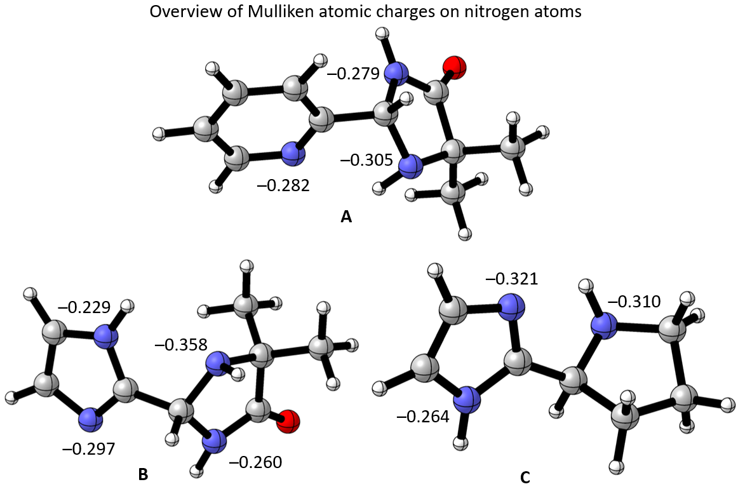

In Substance A, the pyridine nitrogen exhibited a Mulliken charge of –0.282. Intriguingly, in Substance B, where the pyridine is replaced by an imidazole ring, the corresponding nitrogen showed a higher charge of –0.297. This trend was further accentuated in Substance C, with the imidazole nitrogen displaying a charge of –0.321. These findings compellingly suggest that the replacement of pyridine with imidazole leads to an increased negative charge on the coordinating nitrogen, likely due to electron donation from the adjacent imidazole nitrogen. Consequently, our DFT analysis strongly supports the hypothesis that such a substitution would result in compounds exhibiting coordination properties closely analogous to their pyridine-based counterparts.
Optimised geometries of model compounds (in cartesian coordinates)
A – 5,5-dimethyl-2-(pyridine-2-yl)imidazolidine-4-one

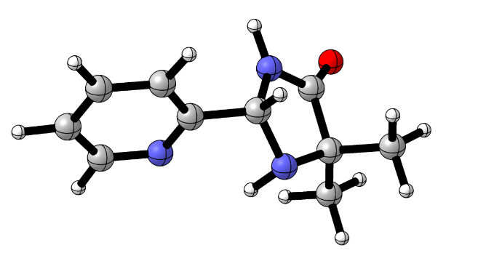

C 2.20699 –1.71209 –0.32207
C 2.58477 –2.90607 –0.92625
C 3.09198 –1.11438 0.56393
C 4.31421 –1.72839 0.80201
C 4.61087 –2.91357 0.13716
N 3.75823 –3.49387 –0.70701
H 1.91622 –3.41173 –1.61469
H 1.24235 –1.27260 –0.53721
H 2.83391 –0.19004 1.06475
H 5.02793 –1.30113 1.49494
C 5.95772 –3.58394 0.31828
N 5.86761 –5.03606 0.26144
N 6.87857 –3.24292 –0.76819
H 6.38098 –3.26083 1.27726
C 7.58688 –4.31255 –1.22177
C 7.08035 –5.52937 –0.42529
O 8.46081 –4.29954 –2.06318
H 5.05420 –5.24951 –0.30858
C 6.75795 –6.69263 –1.35030
H 5.99193 –6.41223 –2.07611
H 6.39866 –7.54593 –0.77221
H 7.65182 –6.98806 –1.89864
C 8.15502 –5.91397 0.59707
H 8.35734 –5.08846 1.28240
H 9.08560 –6.17514 0.09223
H 7.81070 –6.76569 1.18475
H 7.11623 –2.30082 –1.03321

B – 2-(1H-imidazole-2-yl)-5,5-dimethylimidazolidine-4-one

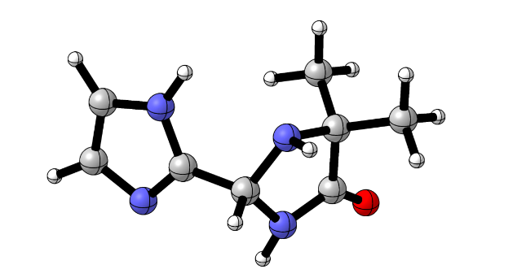

C –0.48440 –1.37693 –0.15184
C –1.38549 –2.55964 –0.37351
N –1.99093 –3.02477 0.87892
C –1.24581 –4.23081 1.32062
C –0.45005 –4.66375 0.07507
N –0.65282 –3.71135 –0.87942
O 0.23952 –5.65511 –0.02061
C –0.24630 –3.88263 2.42811
N –0.53560 –0.61742 0.97143
C 0.39586 0.38707 0.83449
C 0.96908 0.17947 –0.39172
N 0.41008 –0.92230 –0.99897
H –2.17146 –2.27401 –1.07813
C –2.19483 –5.33261 1.77005
H –2.95340 –3.27773 0.70005
H –0.01510 –3.61834 –1.65586
H 0.43161 –3.08874 2.11253
H 0.35132 –4.75812 2.68128
H –0.78497 –3.54622 3.31568
H –1.13523 –0.81904 1.75474
H 0.56159 1.12711 1.59702
H 1.74589 0.75367 –0.86853
H –2.90295 –5.58863 0.97862
H –2.75293 –5.01839 2.65450
H –1.62651 –6.22903 2.01487

C – 2-(pyrrolidine-2-yl)-1H-imidazole

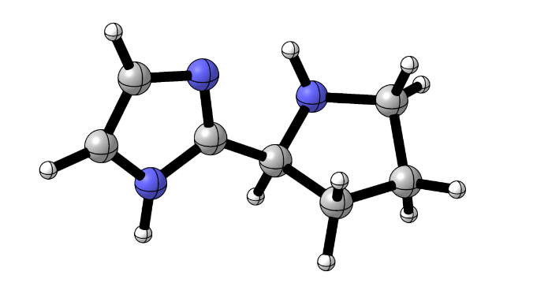

C 2.074538 –2.370055 0.844080
C 2.269428 –3.787409 1.276012
N 0.984226 –4.486498 1.414732
C 1.043107 –5.772298 0.698673
C 2.537602 –6.038418 0.502699
C 3.095959 –4.633234 0.280229
N 2.960013 –1.370482 1.119865
C 2.486871 –0.213283 0.535040
C 1.317893 –0.574643 –0.071843
N 1.072350 –1.915148 0.126633
H 2.790871 –3.778196 2.244020
H 0.244571 –3.896392 1.057367
H 3.797163 –1.458166 1.669910
H 3.007378 0.724793 0.612477
H 0.639351 0.047015 –0.631797
H 0.558097 –6.561799 1.277297
H 0.542146 –5.716853 –0.275669
H 2.965018 –6.477765 1.407848
H 2.737387 –6.717314 –0.326580
H 4.170453 –4.552477 0.450765
H 2.884199 –4.298710 –0.737956

- Summarisation of the results of catalytic experiments
Ligand* |  | Time  (h) | Conversion (%)ª | ee  (%)^{b} | TON  (–) | TOF  (h^{–1})
ref. [4] | (2R,5S) | 36 | 97 | 92 (R) | 18.62 | 0.52
 | (2S,5S) | 48 | 85 | 25 (S) | 10.63 | 0.22
ref. [4] | (2R, 5S) | 36 | 97 | 89 (R) | 18.33 | 0.51
 | (2S,5S) | 48 | 80 | 23 (S) | 9.84 | 0.21
 | Ia  (2R,2'R,5S,5'S) | 48 | 99 | 60 (R) | 15.84 | 0.33
 | Ib  (2S,2'R,5S,5'S) | 48 | 99 | 38 (R) | 13.66 | 0.28
 | Ic  (2S,2'S,5S,5'S) | 48 | 99 | 94 (S) | 19.21 | 0.40
 | IIa  (2R,2'R,5S,5'S) | 48 | 99 | 80 (R) | 17.82 | 0.37
 | IIb  (2S,2'R,5S,5'S) | 48 | 99 | 70 (R) | 16.83 | 0.35
 | IIc  (2S,2'S,5S,5'S) | 48 | 99 | 90 (S) | 18.81 | 0.39
 | IIIa  (2R,5S) | 48 | 63 | 89 (R) | 11.91 | 0.25
 | IIIb  (2S,5S) | 48 | 57 | 86 (S) | 10.60 | 0.22
 | IV  (2S) | 48 | 97 | 50 (S) | 14.55 | 0.30
ª The conversion was determined by ¹H NMR analysis of the crude product.
^{b} The enantiomeric excess was determined by chiral HPLC.

- References
[1] Wepplo, P. J. Pestic. Sci. 1990, 29, 293–315.
[2] Wommack, A. J.; Kingsbury, J. S. J. Org. Chem. 2013, 78, 10573–10587.
[3] Moore, T. O.; Paradowski, M.; Ward, S. E. Org. Biomol. Chem. 2016, 14, 3307–3313.
[4] Panov, I.; Drabina, P.; Padělková, Z.; Šimůnek, P.; Sedlák, M. J. Org. Chem. 2011, 76, 4787–4793.
[5] Nováková, G.; Drabina, P.; Frumarová, B.; Sedlák, M. Adv. Synth. Catal. 2016, 358, 2541–2552.
[6] Moorthy, J. N.; Saha, S. Eur. J. Org. Chem. 2009, 739–748.
[7] Mase, N.; Nakai, Y.; Ohara, N.; Yoda, H.; Takabe, K.; Tanaka, F.; Barbas C. F. III J. Am. Chem. Soc. 2006, 128, 734–735.
[8] Neese, F. The ORCA program system, Wiley Interdiscip. Rev.: Comput. Mol. Sci., 2, 73-78, 2012.
[9] Neese, F. Software update: the ORCA program system, version 4.0, Wiley Interdiscip. Rev.: Comput. Mol. Sci., 8, e1327, 2017.

