Supporting information
A Reaction of N-substituted Succinimides with Hydroxylamine as a Novel Approach to the Synthesis of Hydroxamic Acids
Bogdan A. Tretyakov¹, Svyatoslav Y. Gadomsky¹*, Alexei A. Terentiev¹
¹ Federal Research Center of Problems of Chemical Physics and Medicinal Chemistry RAS, Chernogolovka 142432 Russia, e-mail: gadomsky@icp.ac.ru

1-phenylpyrrolidine-2,5-dione (1a) s3
1-(4-methoxyphenyl)pyrrolidine-2,5-dione (1b) s6
1-(4-bromophenyl)pyrrolidine-2,5-dione (1c) s9
1-(4-nitrophenyl)pyrrolidine-2,5-dione (1d) s12
1-(4-fluorophenyl)pyrrolidine-2,5-dione (1e) s15
1-[3-(trifluoromethyl)phenyl]pyrrolidine-2,5-dione (1f) s18
N-(2,5-dioxopyrrolidin-1-yl)benzamide (1g) s21
N-(2,5-dioxopyrrolidin-1-yl)[1,1’-biphenyl]-4-carboxamide (1h) s24
2-(2,4-dichlorophenoxy)-N-(2,5-dioxopyrrolidin-1-yl)acetamide (1i) s27
N-(2,5-dioxopyrrolidin-1-yl)-2-(2,4,5-trichlorophenoxy)acetamide (1j) s30
N-(2,5-dioxopyrrolidin-1-yl)-2-(3-methylphenoxy)acetamide (1k) s33
N-(2,5-dioxopyrrolidin-1-yl)-3-phenylpropanamide (1l) s36
N-(2,5-dioxopyrrolidin-1-yl)-2-phenoxyacetamide (1m) s39
3-(1H-benzotriazol-1-yl)-N-(2,5-dioxopyrrolidin-1-yl)propenamide (1n) s42
4-(dimethylamino)-N-(2,5-dioxopyrrolidin-1-yl)benzamide (1o) s45
2-(3,5-dimethylphenoxy)-N-(2,5-dioxopyrrolidin-1-yl)acetamide (1p) s48
N1-hydroxy-N4-phenylbutanediamide (2a) s51
N1-hydroxy-N4-(4-methoxyphenyl)butanediamide (2b) s55
N1-(4-bromophenyl)-N4-hydroxybutanediamide (2c) s59
N1-hydroxy-N4-(4-nitrophenyl)butanediamide (2d) s62
N1-(4-fluorophenyl)-N4-hydroxybutanediamide (2e) s65
N1-hydroxy-N4-[3-(trifluoromethyl)phenyl]butanediamide (2f) s69
4-(2-benzoylhydrazinyl)-N-hydroxy-4-oxobutanamide (2g) s73
4-[2-([1,1’-biphenyl]-4-carbonyl)hydrazinyl]-N-hydroxy-4-oxobutanamide (2h) s76
4-{2-[(2,4-dichlorophenoxy)acetyl]hydrazinyl}-N-hydroxy-4-oxobutanamide (2i) s80
N-hydroxy-4-oxo-4-{2-[(2,4,5-trichlorophenoxy)acetyl]hydrazinyl}butanamide (2j) s84
N-hydroxy-4-{2-[(3-methylphenoxy)acetyl]hydrazinyl}-4-oxobutanamide (2k) s88
N-hydroxy-4-oxo-4-[2-(3-phenylpropanoyl)hydrazinyl]butanamide (2l) s92
N-hydroxy-4-oxo-4-[2-(phenoxyacetyl)hydrazinyl]butanamide (2m) s96
4-{2-[3-(1H-benzotriazol-1-yl)propanoyl]hydrazinyl}-N-hydroxy-4-oxobutanamide (2n) s100
4-{2-[4-(dimethylamino)benzoyl]hydrazinyl}-N-hydroxy-4-oxobutanamide (2o) s104
4-{2-[(3,5-dimethylphenoxy)acetyl]hydrazinyl}-N-hydroxy-4-oxobutanamide (2p) s109

1-phenylpyrrolidine-2,5-dione (1a)
Yield 1.19 g (68%), colorless crystals. Found, %: C 68.13; H 5.67; N 7.89; O 18.46. C₁₀H₉NO₂. Calculated, %: C 68.56; H 5.18; N 8.00; O 18.27. IR spectrum, ν, cm^{–1}: 2985, 2936, 1775, 1697, 1591, 1497, 1456, 1423, 1383, 1287, 1179, 1171, 1145, 1070, 1027, 977, 942, 924, 813, 762, 695, 666, 624, 583, 496, 459. ¹H NMR spectrum (CDCl₃), ppm (J, Hz): 2.90 (4H, s, -CH₂-), 7.25-7.30 (2H, m, H Ar), 7.40 (1H, t, J = 7.4, H Ar), 7.48 (2H, t, J = 7.7, H Ar).

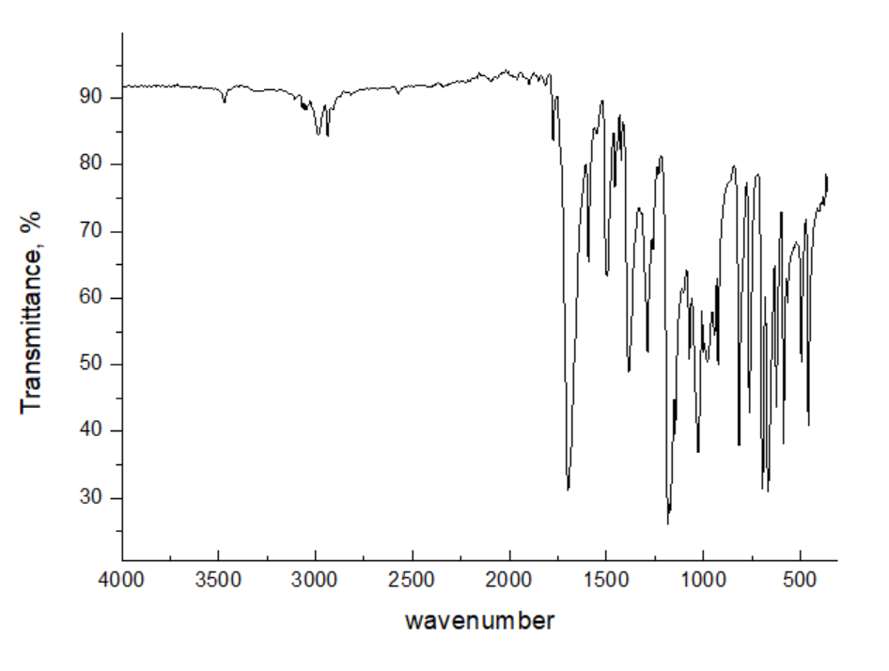
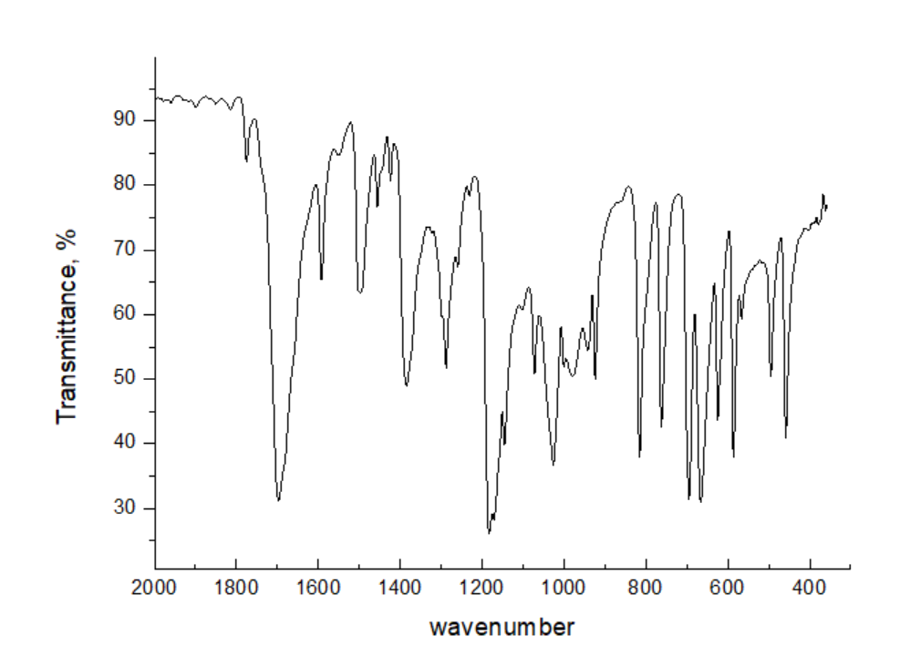

Figure S1: IR spectrum view of 1-phenylpyrrolidine-2,5-dione (1a)

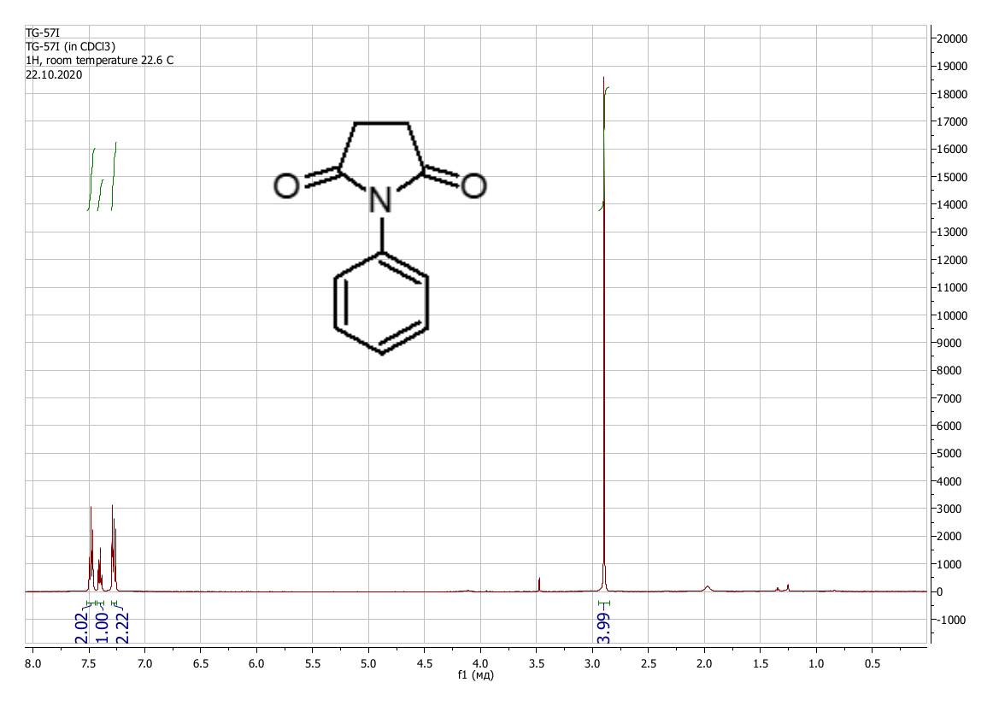
Figure S2: ¹H NMR spectrum view of 1-phenylpyrrolidine-2,5-dione (CDCl₃) (1a)

1-(4-methoxyphenyl)pyrrolidine-2,5-dione (1b)
Yield 1.11 g (54%), colorless crystals. Found, %: C 64.03; H 5.78; N 6.41; O 23.64. C₁₁H₁₁NO₃. Calculated, %: C 64.38; H 5.40; N 6.83; O 23.39. IR spectrum, ν, cm^{–1}: 3680, 2967, 1699, 1606, 1509, 1386, 1346, 1307, 1247, 1161, 1055, 1033, 1017, 925, 838, 808, 720, 668, 587, 532, 495, 430, 374. ¹H NMR spectrum (CDCl₃), ppm (J, Hz): 2.87 (4H, s, -CH₂-), 3.82 (3H, s, -CH₃), 6.96 – 7.00 (2H, m, H Ar), 7.16 – 7.20 (2H, m, H Ar).

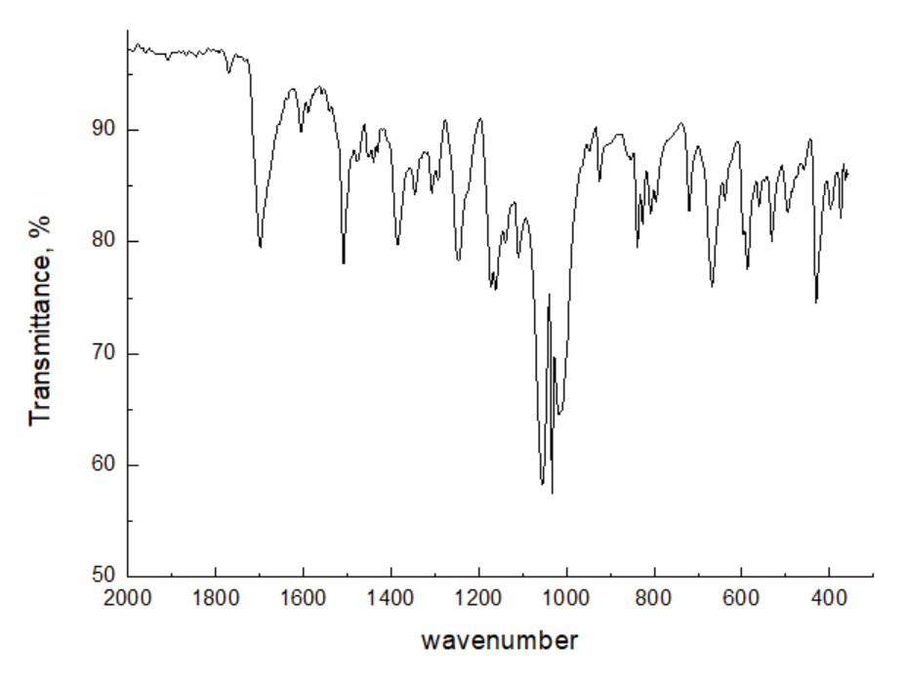
Figure S3: IR spectrum view of 1-(4-methoxyphenyl)pyrrolidine-2,5-dione (1b)

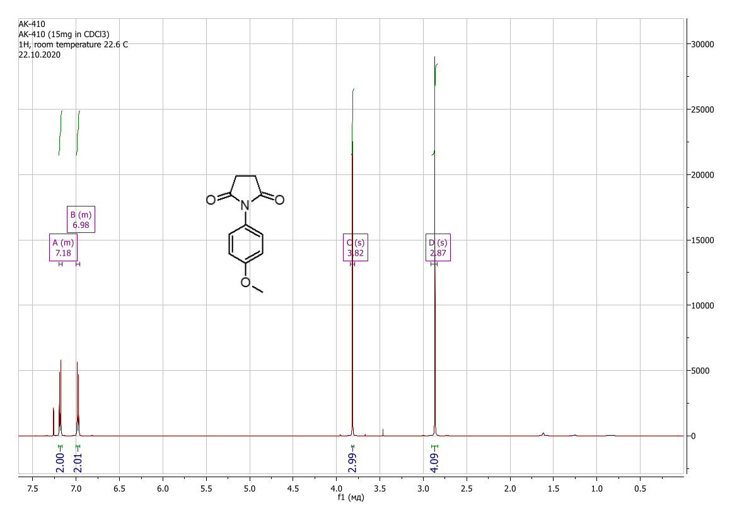
Figure S4: ¹H NMR spectrum view of 1-(4-methoxyphenyl)pyrrolidine-2,5-dione (CDCl₃) (1b)

1-(4-bromophenyl)pyrrolidine-2,5-dione (1c)
Yield 1.65 g (65%), colorless crystals. Found, %: C 47.02; H 3.25; N 5.30; O 12.81. C₁₀H₈BrNO₂. Calculated, %: C 47.27; H 3.17; Br 31.45; N 5.51; O 12.59. IR spectrum, ν, cm^{–1}: 2979, 2928, 1765, 1698, 1587, 1487, 1393, 1294, 1184, 1162, 1146, 1067, 1012, 968, 922, 846, 824, 727, 712, 669, 633, 586, 563, 502, 371. ¹H NMR spectrum (CDCl₃), ppm (J, Hz): 2.89 (4H, s, -CH₂-), 7.18 – 7.21 (2H, m, H Ar), 7.58 – 7.61 (2H, m, H Ar).

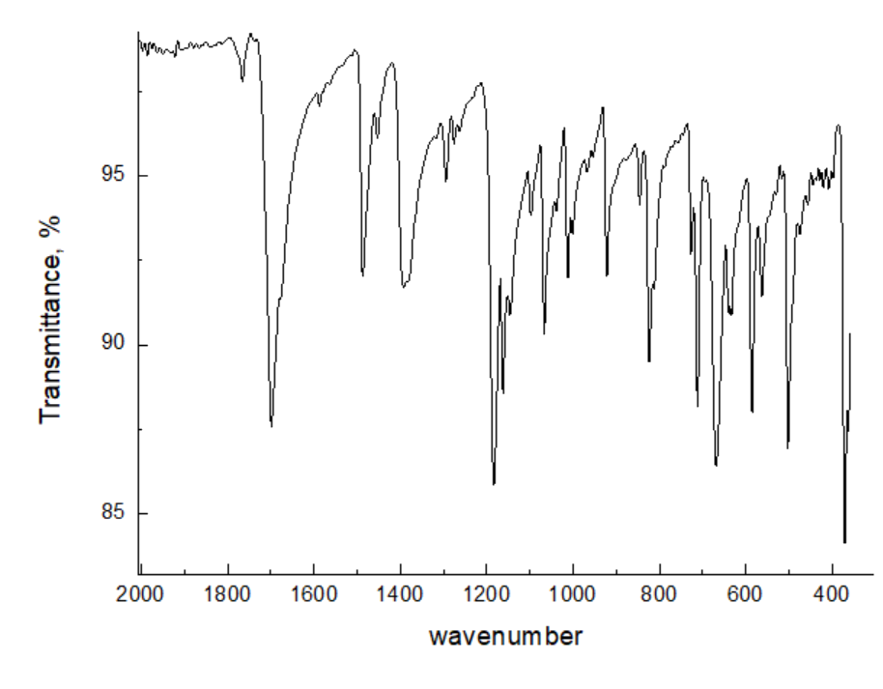
Figure S5: IR spectrum view of 1-(4-bromophenyl)pyrrolidine-2,5-dione (1c)

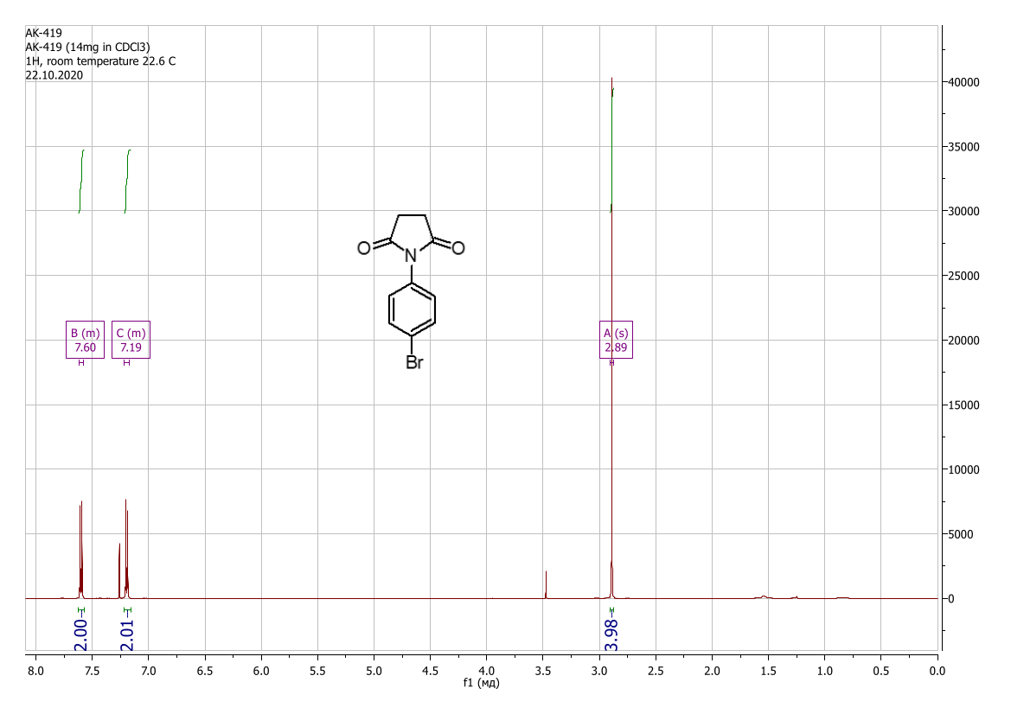
Figure S6: ¹H NMR spectrum view of 1-(4-bromophenyl)pyrrolidine-2,5-dione (CDCl₃) (1c)

1-(4-nitrophenyl)pyrrolidine-2,5-dione (1d)
Yield 0.98 g (44%), colorless crystals. Found, %: C 54.42; H 3.72; N 12.53; O 29.32. C₁₀H₈N₂O₄. Calculated, %: C 54.55; H 3.66; N 12.72; O 29.07. IR spectrum, ν, cm^{–1}: 3680, 2973, 2922, 2867, 1699, 1598, 1519, 1492, 1345, 1322, 1288, 1266, 1055, 1033, 1008, 954, 925, 850, 823, 753, 723, 674, 628, 586, 484, 405. ¹H NMR spectrum (CDCl₃), ppm (J, Hz): 2.96 (4H, s, -CH₂-), 7.58 – 7.62 (2H, m, H Ar), 8.32 – 8.36 (2H, m, H Ar).
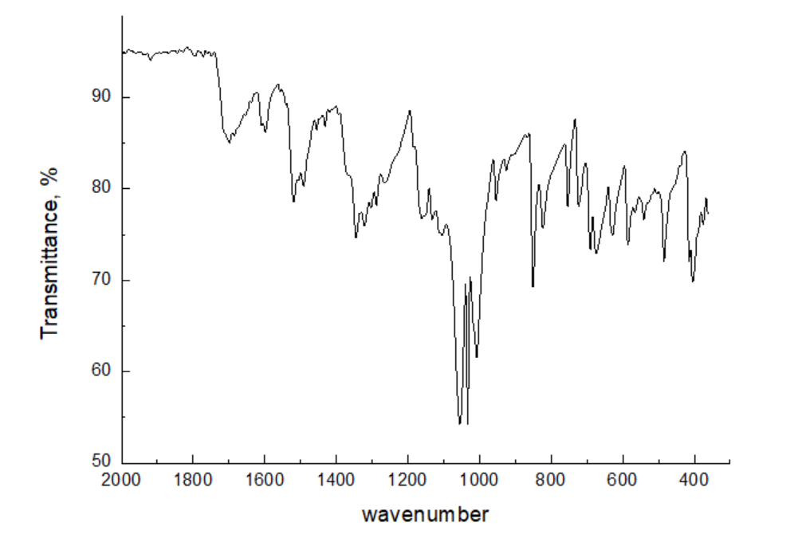
Figure S7: IR spectrum view of 1-(4-nitrophenyl)pyrrolidine-2,5-dione (1d)

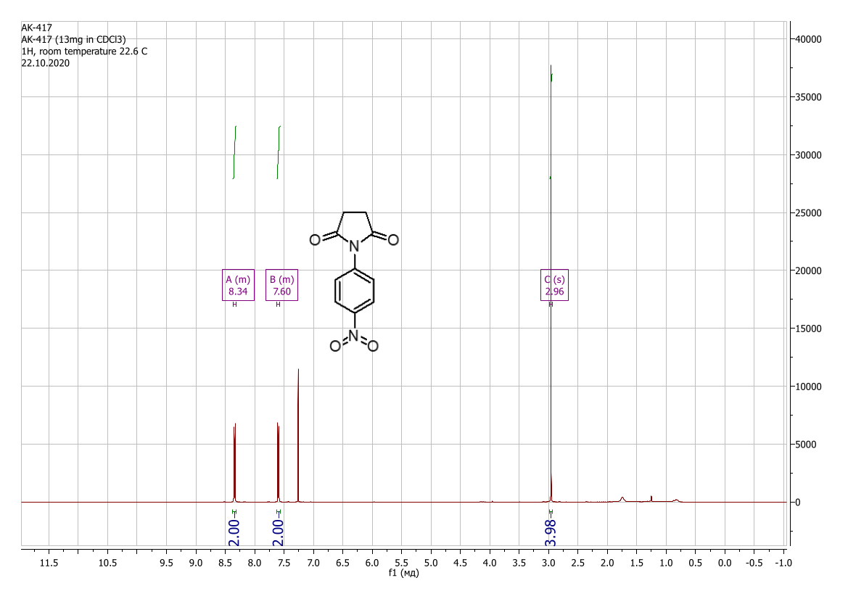
Figure S8: NMR ¹H spectrum view of 1-(4-nitrophenyl)pyrrolidine-2,5-dione (CDCl₃) (1d)

1-(4-fluorophenyl)pyrrolidine-2,5-dione (1e)
Yield 1.23 g (64%), colorless crystals. Found, %: C 62.31; H 4.22; N 7.18; O 16.68. C₁₀H₈FNO₂. Calculated, %: C 62.18; H 4.17; F 9.83; N 7.25; O 16.56. IR spectrum, ν, cm^{–1}: 1701, 1509, 1425, 1387, 1290, 1216, 1180, 1158, 1009, 941, 924, 839, 812, 714, 655, 581, 517, 447, 389, 377. ¹H NMR spectrum (CDCl₃), ppm (J, Hz): 2.90 (4H, s, -CH₂-), 7.17 (2H, t, J = 8.6, H-Ar); 7.26-7.30 (2H, m, H-Ar).
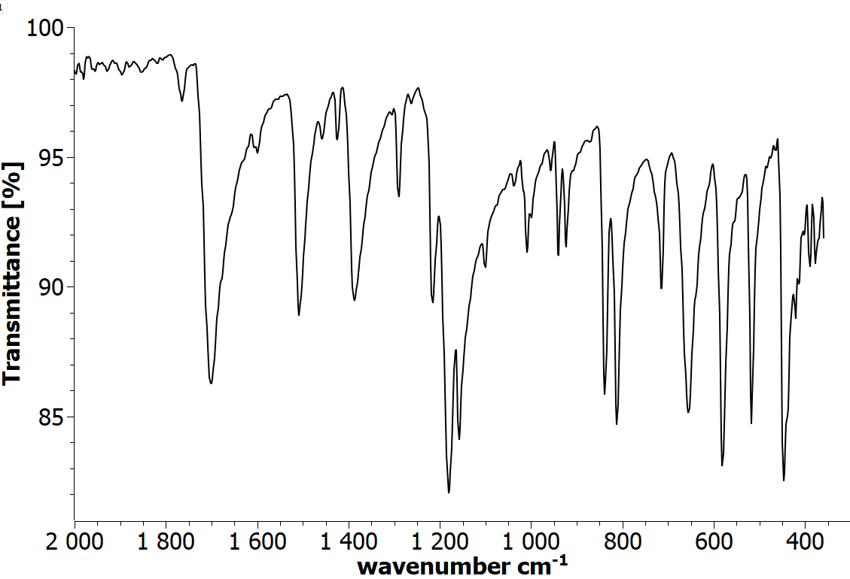

Figure S9: IR spectrum view of 1-(4-fluorophenyl)pyrrolidine-2,5-dione (1e)

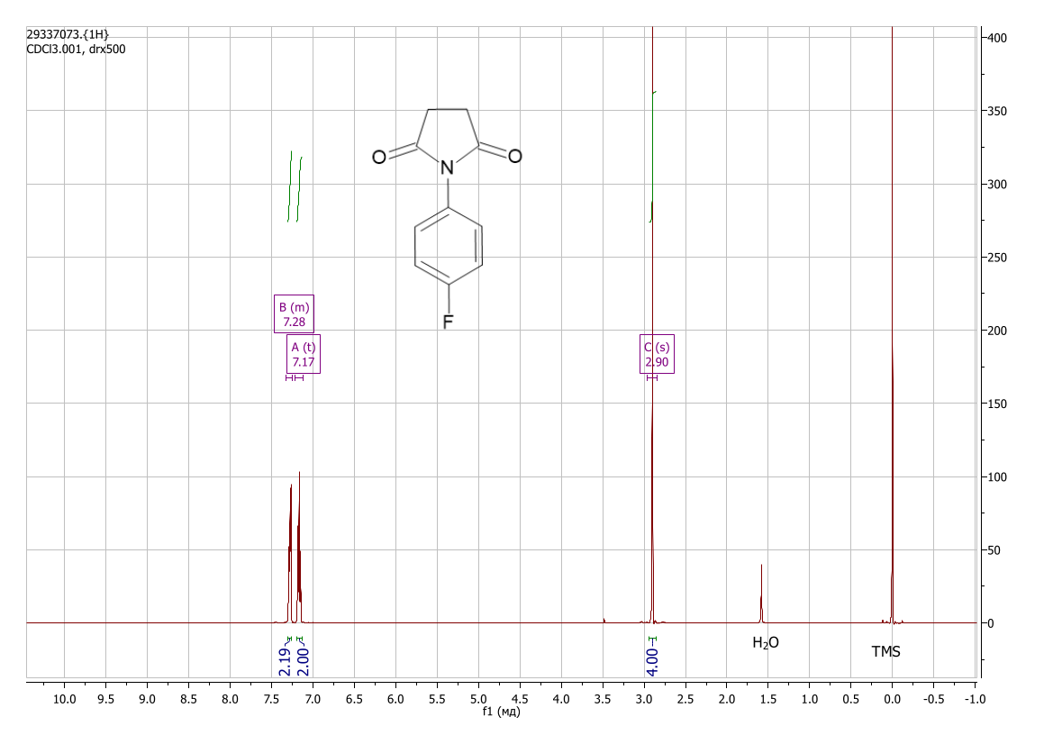
Figure S10: ¹H NMR spectrum view of 1-(4-fluorophenyl)pyrrolidine-2,5-dione (CDCl₃) (1e)

1-[3-(trifluoromethyl)phenyl]pyrrolidine-2,5-dione (1f)
Yield 1.17 g (48%), colorless crystals. Found, %: C 54.22; H 3.41; N 5.91; O 13.35. C₁₁H₈F₃NO₂. Calculated, %: C 54.33; H 3.32; F 23.44; N 5.76; O 13.16. IR spectrum, ν, cm^{–1}: 1707, 1492, 1455, 1391, 1324, 1183, 1164, 1109, 1064, 1004, 954, 894, 815, 697, 670, 654, 624, 575, 464, 442, 375. ¹H NMR spectrum (DMSO, d₆), ppm (J, Hz): 2.80 (4H, s, -CH₂-), 7.61 (1H, d, J = 7.8, H-Ar), 7.69 (1H, s, H-Ar), 7.75 (1H, t, J = 7.8, H-Ar), 7.80 (1H, d, J = 7.9, H-Ar).
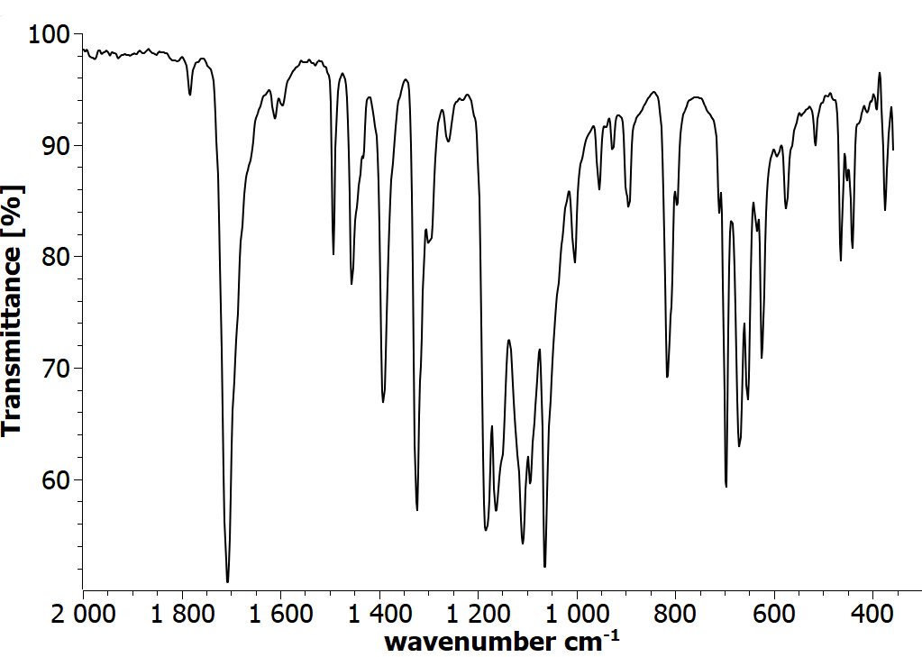
Figure S11: IR spectrum view of 1-[3-(trifluoromethyl)phenyl]pyrrolidine-2,5-dione (1f)

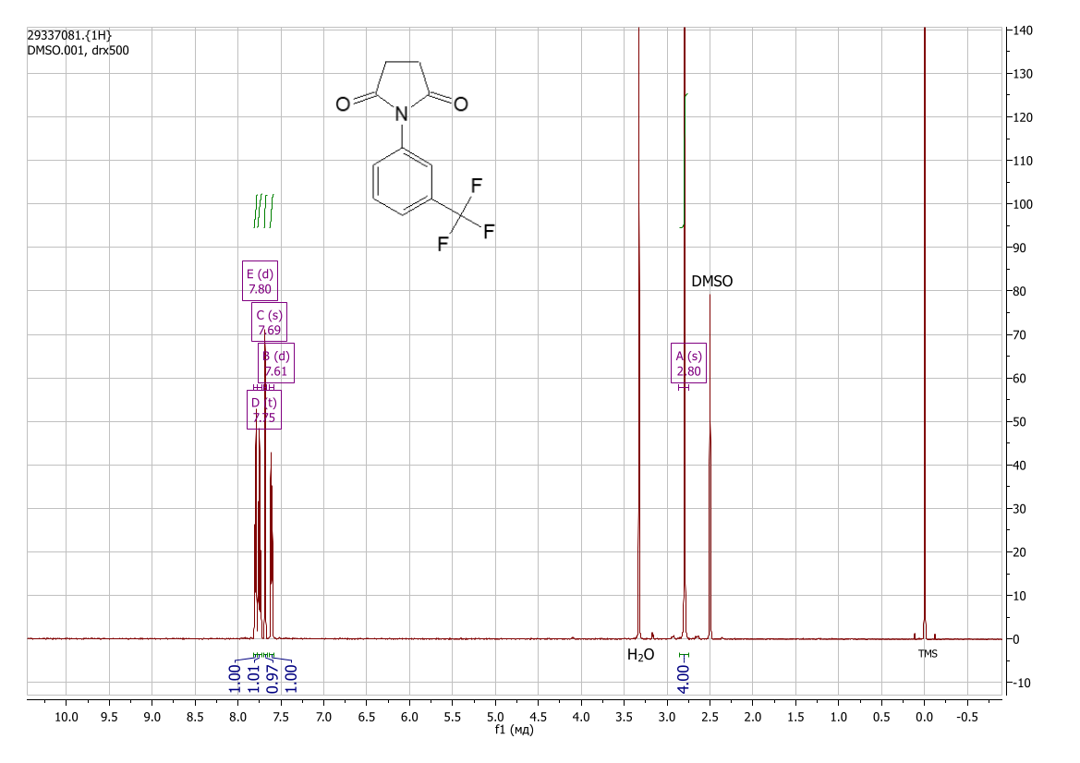
Figure S12: ¹H NMR spectrum view of 1-[3-(trifluoromethyl)phenyl]pyrrolidine-2,5-dione (DMSO-d₆) (1f)

N-(2,5-dioxopyrrolidin-1-yl)benzamide (1g)
Yield 1.00 g (45%), colorless crystals. Found, %: C 60.32; H 4.78; N 12.67; O 22.12. C₁₁H₁₀N₂O₃. Calculated, %: C 60.55; H 4.62; N 12.84; O 22.00. IR spectrum, ν, cm^{–1}: 3128, 2988, 1791, 1723, 1655, 1601, 1578, 1521, 1484, 1416, 1307, 1291, 1189, 1158, 1086, 1046, 1001, 920, 820, 718, 688, 654, 607, 492, 421, 404. ¹H NMR spectrum (DMSO-d₆), ppm (J, Hz): 2.86 (4H, s, -CH₂-), 7.52 – 7.58 (2H, m, H Ar), 7.62 – 7.67 (1H, m, H Ar), 7.90 – 7.94 (2H, m, H Ar), 11.06 (1H, s, N-H).
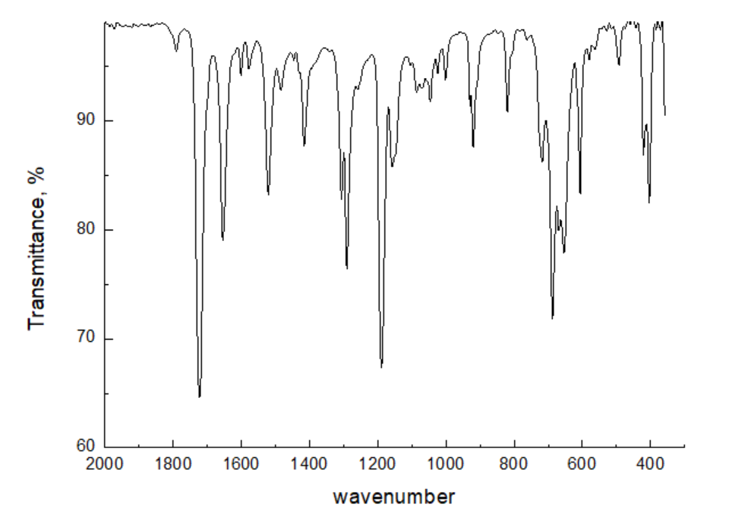

Figure S13: IR spectrum view of N-(2,5-dioxopyrrolidin-1-yl)benzamide (1g)

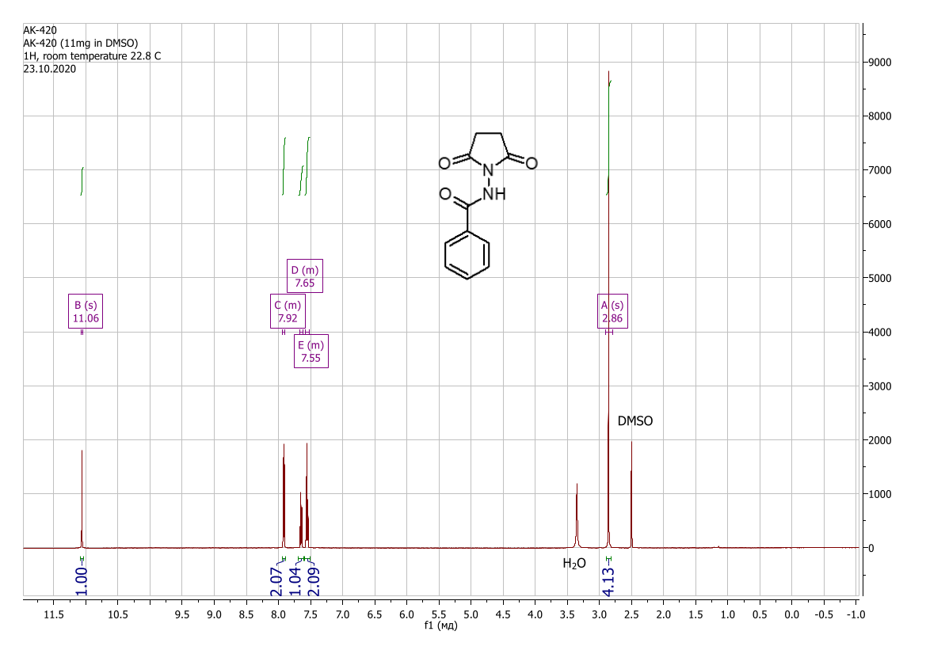
Figure S14: ¹H NMR spectrum view of N-(2,5-dioxopyrrolidin-1-yl)benzamide (DMSO-d₆) (1g)

N-(2,5-dioxopyrrolidin-1-yl)[1,1’-biphenyl]-4-carboxamide (1h)
Yield 1.27 g (43%), colorless crystals. Found, %: C 69.24; H 4.88; N 9.70; O 16.38. C₁₇H₁₄N₂O₃. Calculated, %: C 69.38; H 4.79; N 9.52; O 16.31. IR spectrum, ν, cm^{–1}: 1712, 1685, 1607, 1536, 1486, 1417, 1277, 1196, 996, 910, 858, 816, 740, 695, 651, 612, 482, 438, 392, 378. ¹H NMR spectrum (DMSO-d₆), ppm (J, Hz): 2.87 (4H, s, -CH₂-), 7.44 (1H, t, J = 7.3, H-Ar), 7.52 (2H, t, J = 7.5, H-Ar), 7.77 (2H, d, J = 7.7, H-Ar), 7.87 (2H, d, J = 8.1, H-Ar), 8.02 (2H, d, J = 8.1, H-Ar), 11.11 (1H, s, N-H).
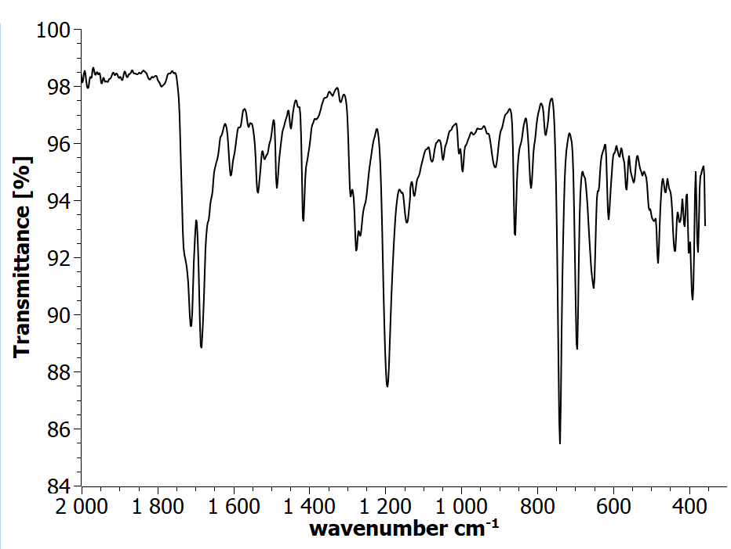
Figure S15: IR spectrum view of N-(2,5-dioxopyrrolidin-1-yl)[1,1'-biphenyl]-4-carboxamide (1h)
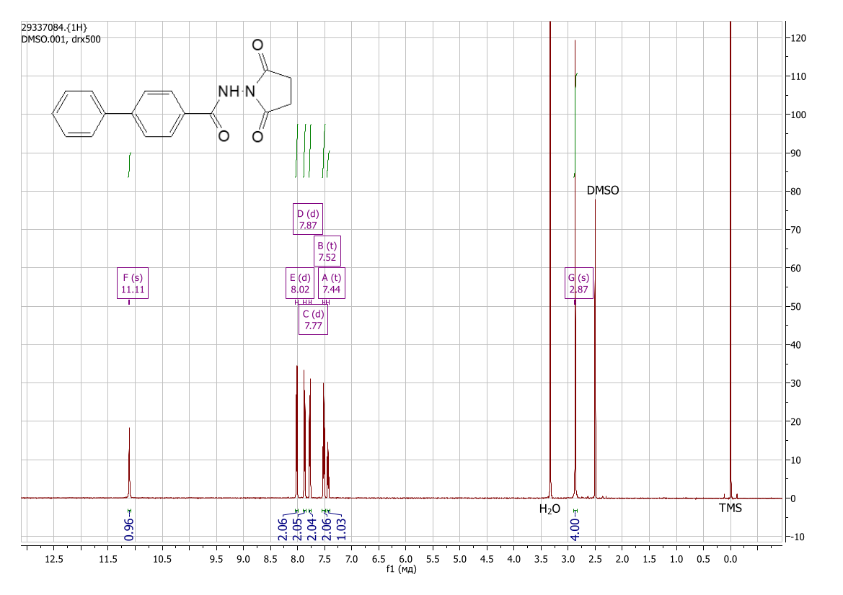
Figure S16: ¹H NMR spectrum view of N-(2,5-dioxopyrrolidin-1-yl)[1,1'-biphenyl]-4-carboxamide (DMSO-d₆) (1h)

2-(2,4-dichlorophenoxy)-N-(2,5-dioxopyrrolidin-1-yl)acetamide (1i)
Yield 2.41 g (76%), colorless crystals. Found, %: C 69.24; H 4.88; N 9.70; O 16.38. C₁₂H₁₀Cl₂N₂O₄. Calculated, %: C 45.45; H 3.18; Cl 22.36; N 8.83; O 20.18. IR spectrum, ν, cm^{–1}: 1793, 1722, 1678, 1542, 1483, 1437, 1412, 1291, 1243, 1222, 1186, 1106, 1076, 1045, 975, 893, 822, 806, 762, 688, 648, 603, 562, 435, 414, 395. ¹H NMR spectrum (DMSO-d₆), ppm (J, Hz): 2.79 (4H, s, -CH₂-), 4.91 (2H, s, -CH₂-), 7.13 (1H, d, J = 8.9, H-Ar), 7.39 (1H, dd, J₁ = 8.9, J₂ = 2.5, H-Ar), 7.61 (1H, d, J = 2.5, H-Ar), 10.76 (1H, s, N-H).
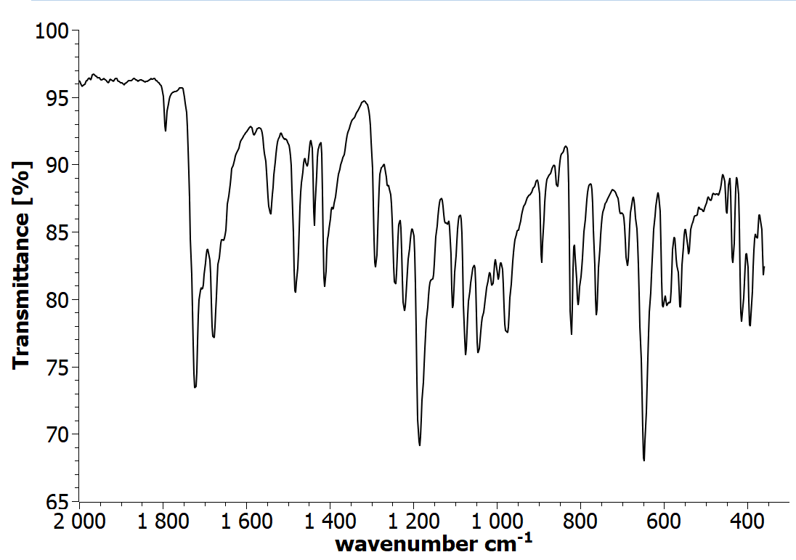
Figure S17: IR spectrum view of 2-(2,4-dichlorophenoxy)-N-(2,5-dioxopyrrolidin-1-yl)acetamide (1i)

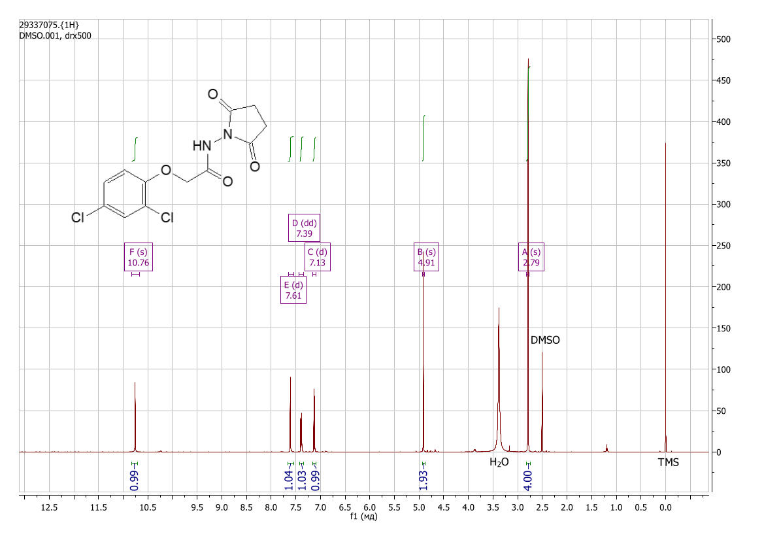
Figure S18: ¹H NMR spectrum view of 2-(2,4-dichlorophenoxy)-N-(2,5-dioxopyrrolidin-1-yl)acetamide (DMSO-d₆) (1i)

N-(2,5-dioxopyrrolidin-1-yl)-2-(2,4,5-trichlorophenoxy)acetamide (1j)
Yield 1.54 g (44%), colorless crystals. Found, %: C 40.89; H 3.65; N 8.02; O 18.31. C₁₂H₉Cl₃N₂O₄. Calculated, %: C 41.00; H 2.58; Cl 30.25; N 7.97; O 18.20. IR spectrum, ν, cm^{–1}: 3375, 2982, 1801, 1706, 1584, 1479, 1461, 1430, 1355, 1289, 1233, 1186, 1125, 1078, 1047, 1007, 925, 869, 848, 819, 757, 676, 616, 598, 576, 554, 534, 499, 426. ¹H NMR spectrum (DMSO-d₆), ppm (J, Hz): 2.79 (4H, s, -CH₂-), 5.00 (2H, s, -CH₂-), 7.40 (1H, s, H-Ar), 7.85 (1H, s, H-Ar), 10.79 (1H, s, N-H).
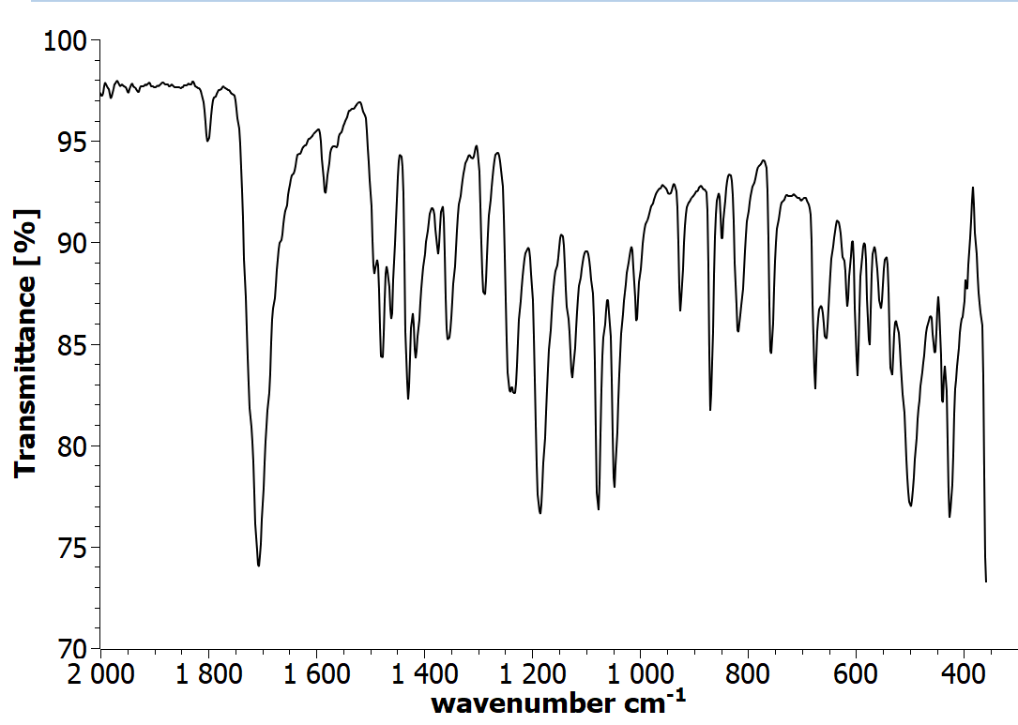

Figure S19: IR spectrum view of N-(2,5-dioxopyrrolidin-1-yl)-2-(2,4,5-trichlorophenoxy)acetamide (1j)

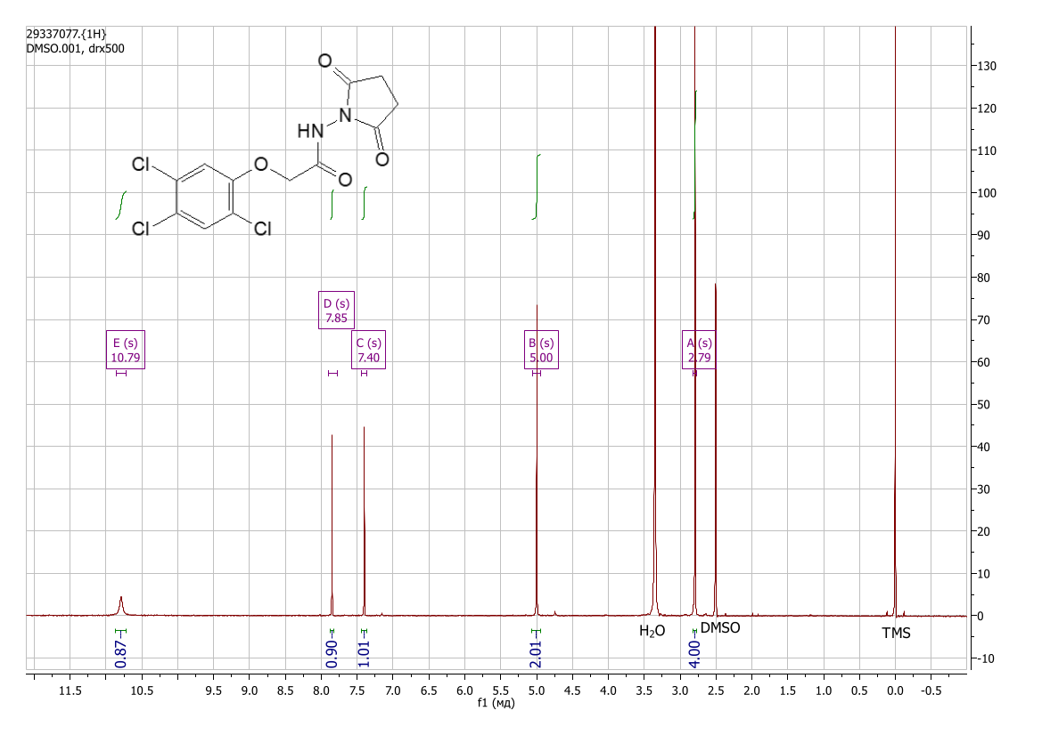
Figure S20: ¹H NMR spectrum view of N-(2,5-dioxopyrrolidin-1-yl)-2-(2,4,5-trichlorophenoxy)acetamide (DMSO-d₆) (1j)

N-(2,5-dioxopyrrolidin-1-yl)-2-(3-methylphenoxy)acetamide (1k)
Yield 1.80 g (69%), colorless crystals. Found, %: C 59.48; H 5.41; N 10.75; O 24.51. C₁₃H₁₄N₂O₄. Calculated, %: C 59.54; H 5.38; N 10.68; O 24.40. IR spectrum, ν, cm^{–1}: 3237, 2975, 1727, 1688, 1591, 1491, 1410, 1248, 1170, 1121, 1084, 1046, 1000, 967, 930, 880, 820, 780, 692, 651, 583, 438, 401. 1H NMR spectrum (DMSO-d₆), ppm (J, Hz): 2.29 (3H, s, -CH₃), 2.80 (4H, s, -CH₂-), 4.71 (2H, s, -CH₂-), 6.80 (2H, t, J = 7.3, H-Ar), 6.84 (1H, s, H-Ar), 7.19 (1H, t, J = 7.8, H-Ar), 10.75 (1H, s, N-H).
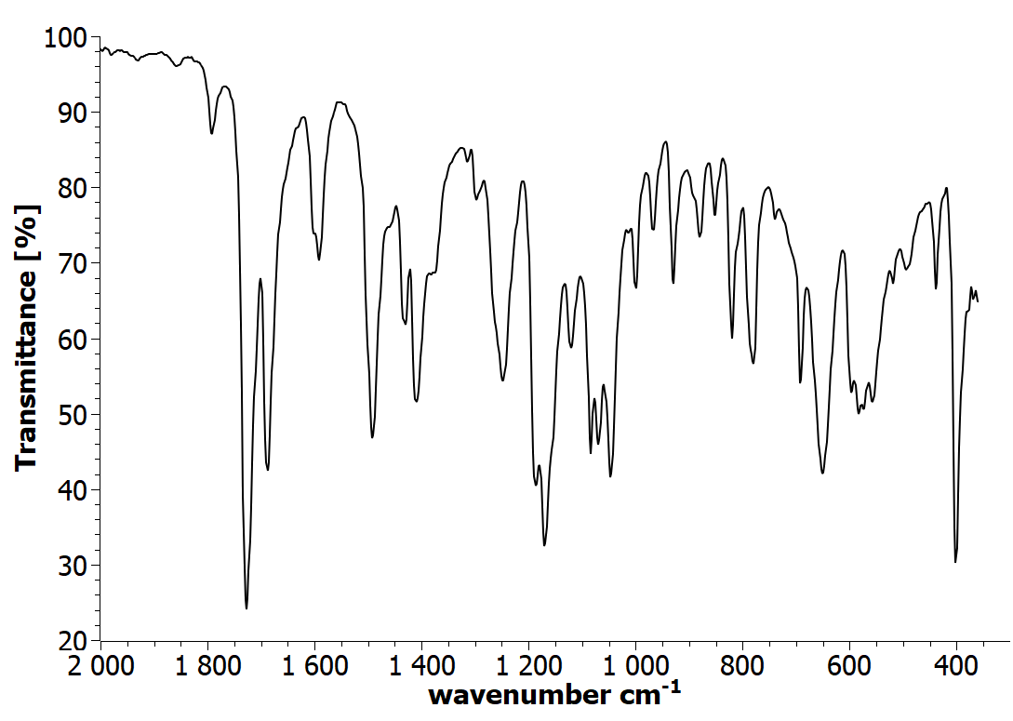
Figure S21: IR spectrum view of N-(2,5-dioxopyrrolidin-1-yl)-2-(3-methylphenoxy)acetamide (1k)

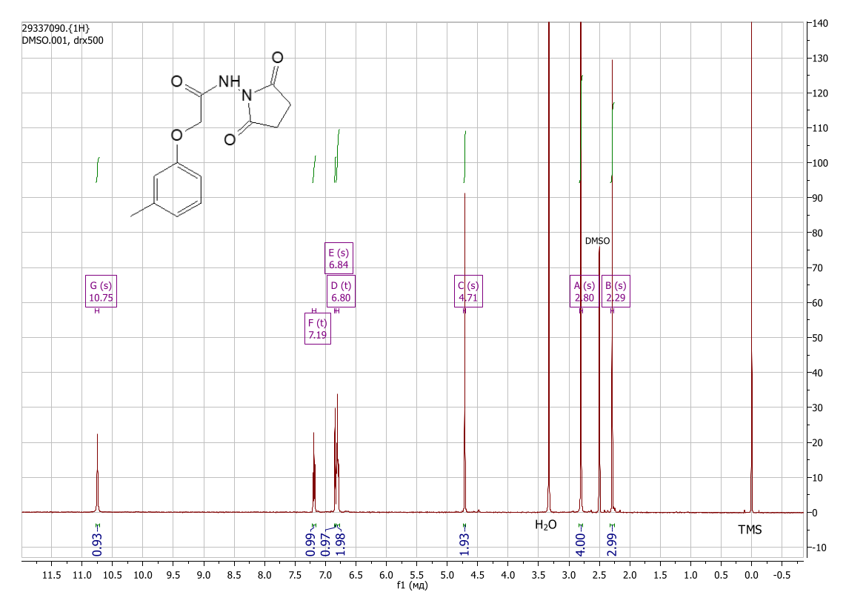
Figure S22: ¹H NMR spectrum view of N-(2,5-dioxopyrrolidin-1-yl)-2-(3-methylphenoxy)acetamide (DMSO-d₆) (1k)

N-(2,5-dioxopyrrolidin-1-yl)-3-phenylpropanamide (1l)
Yield 1.10 g (45%), colorless crystals. Found, %: C 63.51; H 5.68; N 11.35; O 19.59. C₁₃H₁₄N₂O₃. Calculated, %: C 63.40; H 5.73; N 11.38; O 19.49. IR spectrum, ν, cm^{–1}: 3347, 2938, 1729, 1699, 1489, 1452, 1409, 1375, 1296, 1184, 1079, 976, 809, 781, 755, 708, 646, 611, 554, 508, 426, 376. ¹H NMR spectrum (DMSO-d₆), ppm (J, Hz): 2.56 (2H, t, J = 7.8, -CH₂-), 2.76 (4H, s, -CH₂-), 2.86 (2H, t, J = 7.8, -CH₂-), 7.19 (1H, t, J = 6.9, H-Ar), 7.23-7.31 (4H, m, H-Ar), 10.44 (1H, s, N-H).
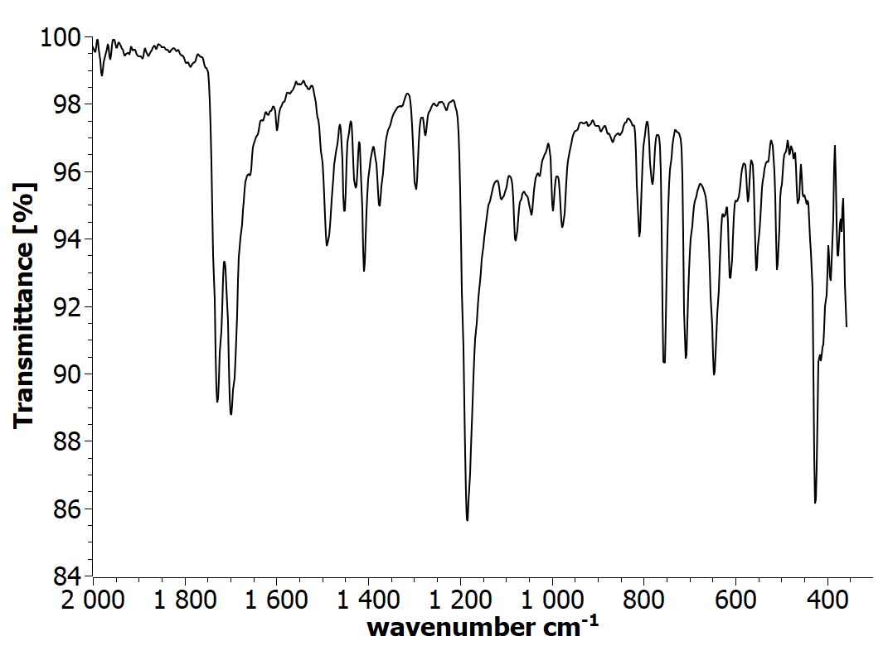
Figure S23: IR spectrum view of N-(2,5-dioxopyrrolidin-1-yl)-3-phenylpropanamide (1l)

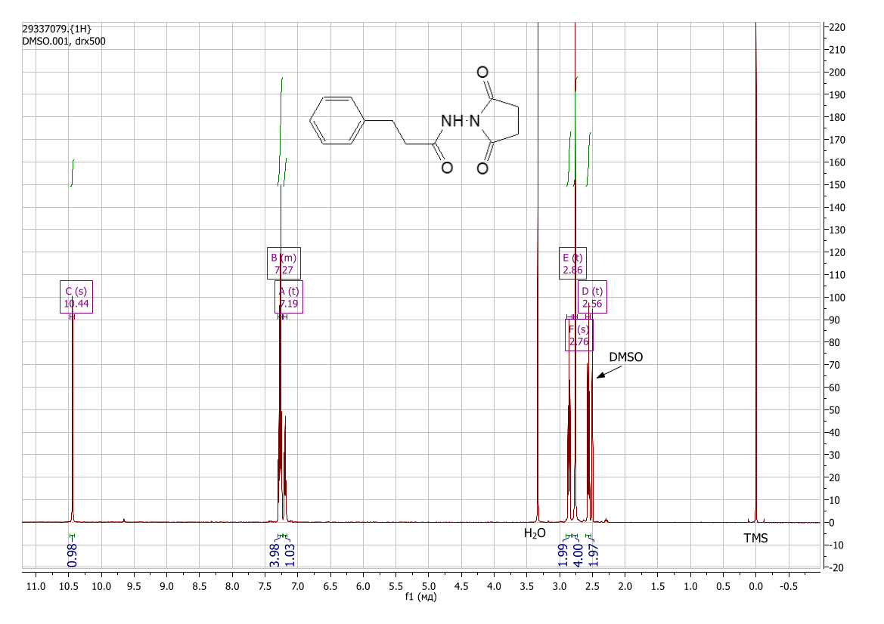
Figure S.24: ¹H NMR spectrum view of N-(2,5-dioxopyrrolidin-1-yl)-3-phenylpropanamide (DMSO-d₆) (1l)

N-(2,5-dioxopyrrolidin-1-yl)-2-phenoxyacetamide (1m)
Yield 1.99 g (80%), colorless crystals. Found, %: C 57.99; H 4.96; N 11.24; O 25.84. C₁₂H₁₂N₂O₄. Calculated, %: C 58.06; H 4.87; N 11.29; O 25.78. IR spectrum, ν, cm^{–1}: 3311, 2988, 1704, 1589, 1491, 1433, 1411, 1371, 1298, 1229, 1193, 1121, 1080, 1065, 889, 845, 812, 753, 691, 665, 601, 584, 505, 475, 385. ¹H NMR spectrum (DMSO-d₆), ppm (J, Hz): 2.81 (4H, s, -CH₂-), 4.74 (2H, s, -CH₂-), 6.97-7.04 (3H, m, H-Ar), 7.32 (2H, t, J = 7.8, H-Ar), 10.76 (1H, s, N-H).
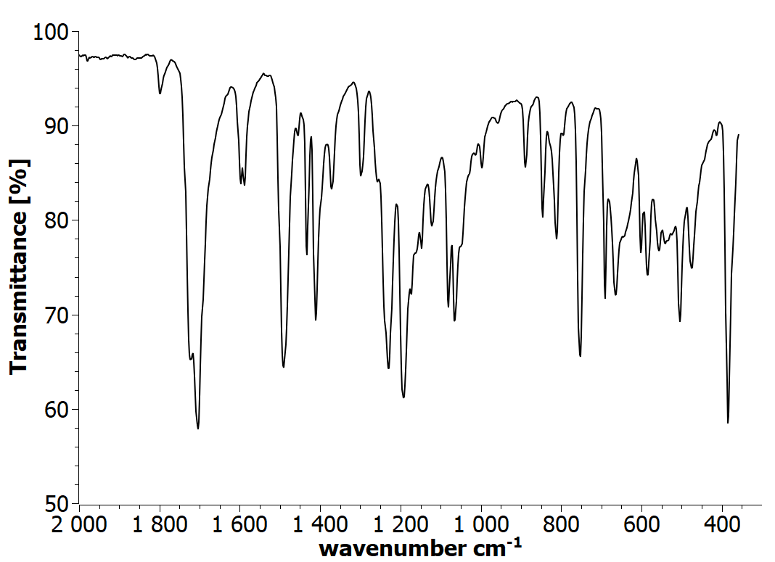
Figure S25: IR spectrum view of N-(2,5-dioxopyrrolidin-1-yl)-2-phenoxyacetamide (1m)

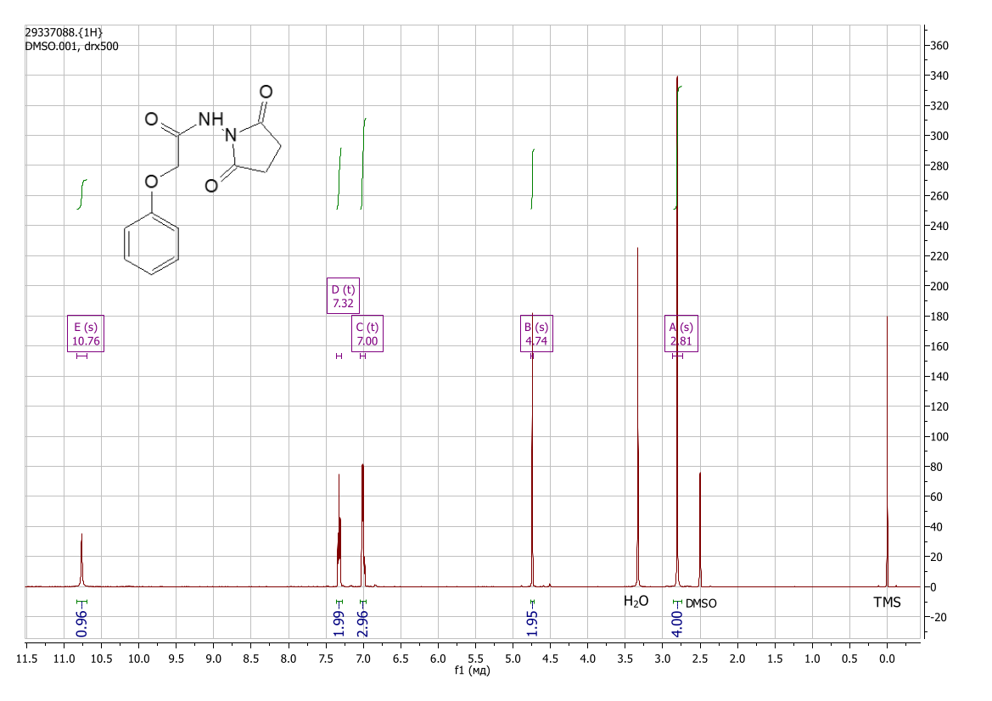
Figure S26: ¹H NMR spectrum view of N-(2,5-dioxopyrrolidin-1-yl)-2-phenoxyacetamide (DMSO-d₆) (1m)

3-(1H-benzotriazol-1-yl)-N-(2,5-dioxopyrrolidin-1-yl)propenamide (1n)
Yield 1.73 g (60%), colorless crystals. Found, %: C 54.41; H 4.62; N 24.31; O 16.77. C₁₃H₁₃N₅O₃. Calculated, %: C 54.35; H 4.56; N 24.38; O 16.71. IR spectrum, ν, cm^{–1}: 2943, 1729, 1693, 1544, 1457, 1409, 1381, 1317, 1266, 1187, 1162, 1114, 1017, 999, 967, 826, 749, 654, 617, 586, 561, 440, 429, 386. ¹H NMR spectrum (DMSO-d₆), ppm (J, Hz): 2.73 (4H, s, -CH₂-), 3.10 (2H, t, J = 6.7, -CH₂-), 4.92 (2H, t, J = 6.7, -CH₂-), 7.40 (1H, t, J = 7.6, H-Ar), 7.54 (1H, t, J = 7.6, H-Ar), 7.88 (1H, d, J = 8.3, H-Ar), 8.03 (1H, d, J = 8.3, H-Ar), 10.60 (1H, s, N-H).
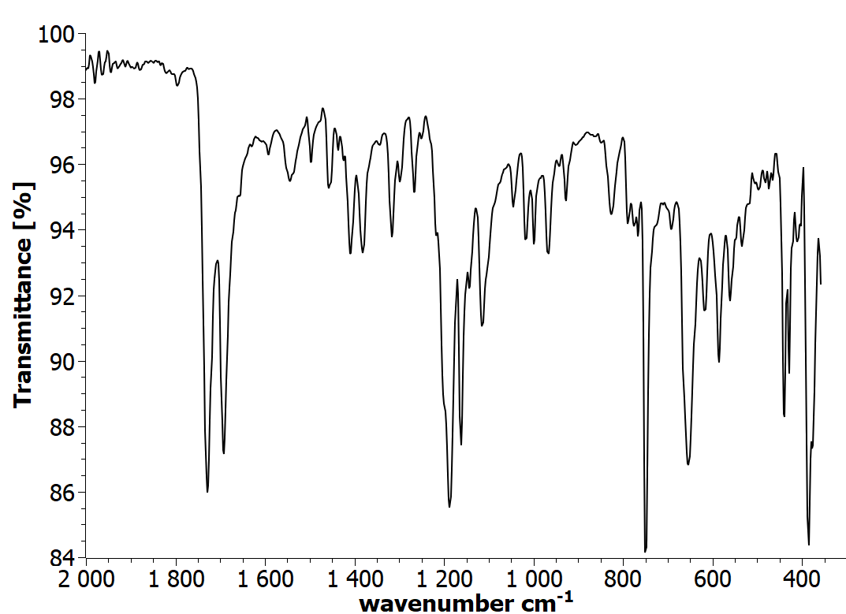
Figure S27: IR spectrum view of 3-(1H-benzotriazol-1-yl)-N-(2,5-dioxopyrrolidin-1-yl)propenamide (1n)
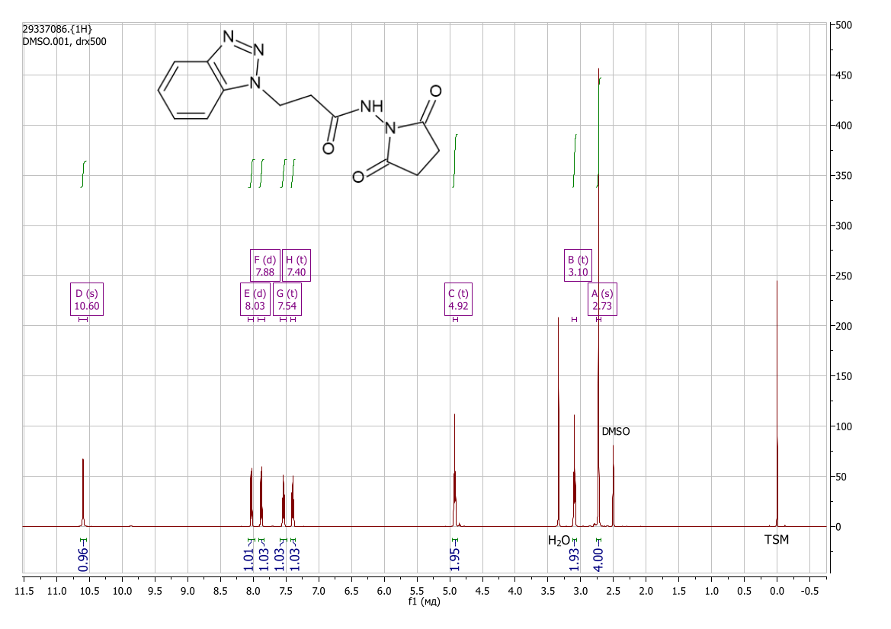
Figure S28: ¹H NMR spectrum view of 3-(1H-benzotriazol-1-yl)-N-(2,5-dioxopyrrolidin-1-yl)propenamide (DMSO-d₆) (1n)

4-(dimethylamino)-N-(2,5-dioxopyrrolidin-1-yl)benzamide (1o)
Yield 1.83 g (70%), colorless crystals. Found, %: C 59.67; H 5.94; N 15.96; O 18.49. C₁₃H₁₅N₃O₃. Calculated, %: C 59.76; H 5.79; N 16.08; O 18.37. IR spectrum, ν, cm^{–1}: 3676, 3225, 2988, 2901, 1730, 1637, 1604, 1543, 1510, 1448, 1412, 1377, 1336, 1290, 1189, 1137, 1066, 944, 907, 824, 764, 698, 652, 622, 584, 500, 491, 443, 381. ¹H NMR spectrum (DMSO-d₆), ppm (J, Hz): 2.82 (4H, s, -CH₂-), 3.00 (6H, s, -CH₃), 6.75 (2H, d, J = 8.5, Ar-H), 7.78 (2H, d, J = 8.4, Ar-H), 10.58 (1H, s, N-H).
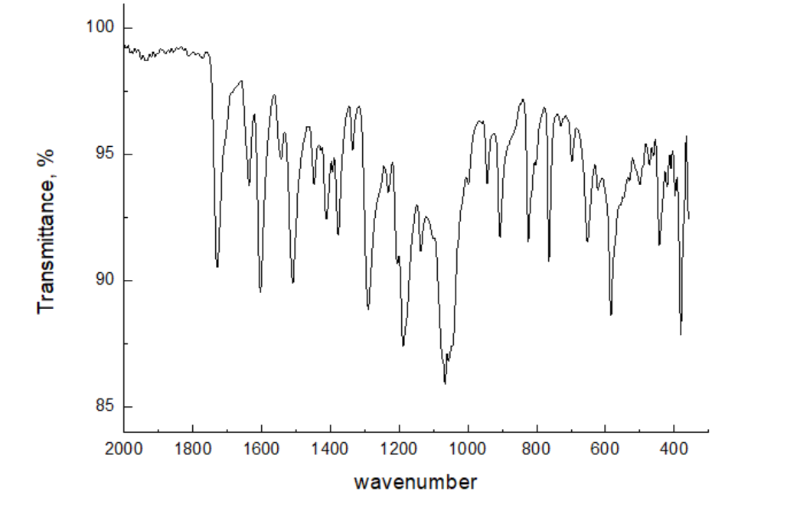
Figure S29: IR spectrum view of 4-(dimethylamino)-N-(2,5-dioxopyrrolidin-1-yl)benzamide (1o)

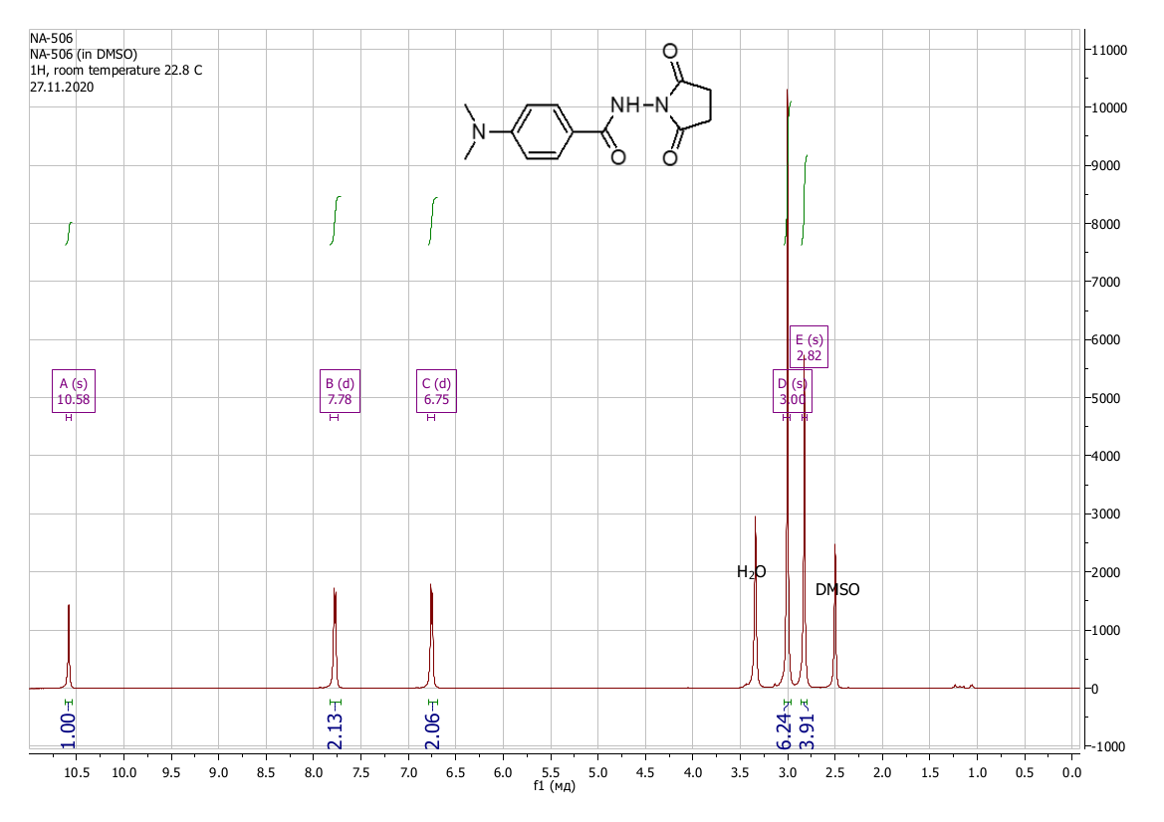
Figure S30: NMR ¹H spectrum view of 4-(dimethylamino)-N-(2,5-dioxopyrrolidin-1-yl)benzamide (DMSO-d₆) (1o)

2-(3,5-dimethylphenoxy)-N-(2,5-dioxopyrrolidin-1-yl)acetamide (1p)
Yield 2.43 g (88%), colorless crystals. Found, %: C 60.70; H 5.98; N 10.03; O 23.19. C₁₄H₁₆N₂O₄. Calculated, %: C 60.86; H 5.84; N 10.14; O 23.16. IR spectrum, ν, cm^{–1}: 2985, 2912, 1719, 1645, 1595, 1476, 1421, 1396, 1321, 1297, 1192, 1157, 1028, 975, 838, 822, 748, 682, 505, 475, 439, 398, 373. ¹H NMR spectrum (DMSO-d₆), ppm (J, Hz): 2.24 (6H, s, CH₃), 2.80 (4H, s, -CH₂-), 4.68 (2H, s, O-CH₂-), 6.63 (3H, s, Ar-H), 10.74 (1H, s, N-H).
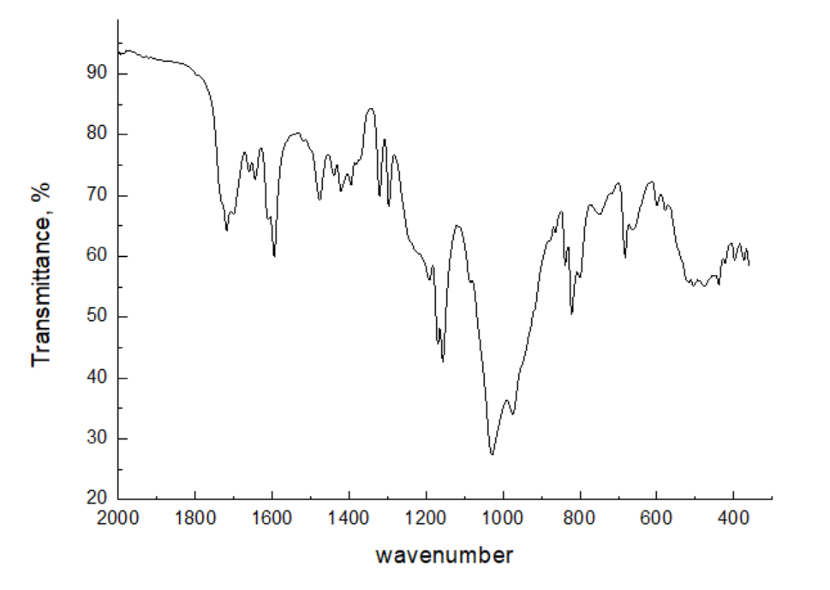

Figure S31: IR spectrum view of 2-(3,5-dimethylphenoxy)-N-(2,5-dioxopyrrolidin-1-yl)acetamide (1p)

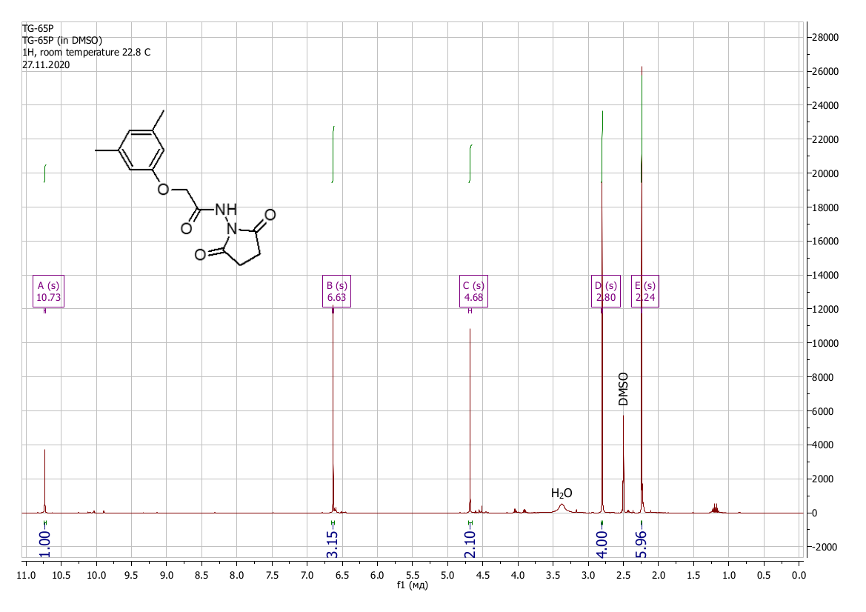
Figure S32: ¹H NMR spectrum view of 2-(3,5-dimethylphenoxy)-N-(2,5-dioxopyrrolidin-1-yl)acetamide (DMSO-d₆) (1p)

N1-hydroxy-N4-phenylbutanediamide (2a)
Yield 0.61 g (73%), colorless crystals. The compound also described in [14]. Found, %: C 57.57; H 5.92; N 13.36; O 23.29. C₁₀H₁₂N₂O₃. Calculated, %: C 57.68; H 5.81; N 13.45; O 23.05. IR spectrum, ν, cm^{–1}: 3270, 2927, 2728, 1662, 1599, 1571, 1535, 1498, 1421, 1352, 1313, 1265, 1242, 1191, 1165, 1083, 1047, 1007, 966, 903, 844, 782, 747, 693, 656, 588, 541, 505, 465, 445, 422, 387, 372. Mass spectrum, m/z (Irel, %): 194 (7.6), 193 (61.5), 120 (7.5), 119 (6.6), 101 (18.5), 94 (18.5), 93 (98.5), 92 (38.5), 91 (15.4), 77 (23.7), 73 (21.5), 66 (21.5), 65 (53.8), 55 (38.5), 51 (16.9), 45 (100.0), 39 (40.0), 27 (73.1). ¹H NMR spectrum (DMSO-d₆), ppm (J, Hz): 2.28 (2H, t, J = 7.2, -CH₂-), 2.52 – 2.60 (2H, m, -CH₂-), 7.01 (1H, t, J = 7.4, H Ar), 7.27 (2H, t, J = 7.9, Ar-H), 7.58 (2H, d, J = 7.8, Ar-H), 8.74 (1H, s, N-OH), 9.95 (1H, s, N-H), 10.43 (1H, s, N-H). ¹³C NMR spectrum (DMSO-d₆), δ, ppm: 27.4; 31.5; 118.9; 122.9; 128.7; 139.3; 168.4; 170.2.
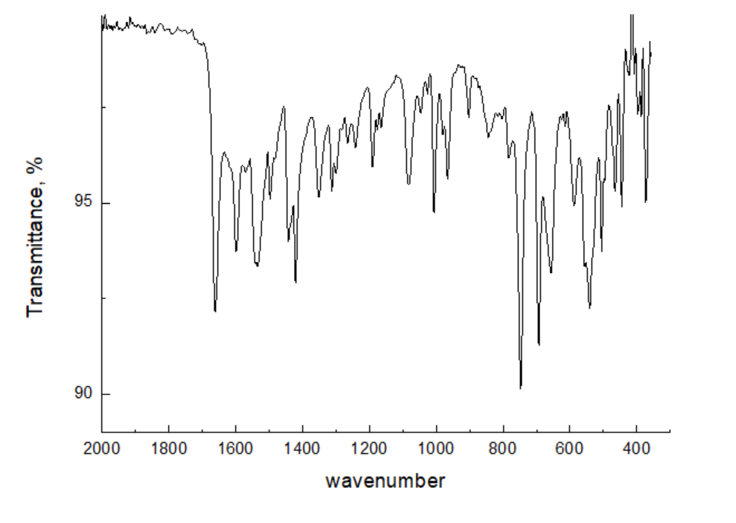
Figure S33: IR spectrum view of N¹-hydroxy-N⁴-phenylbutanediamide (2a)
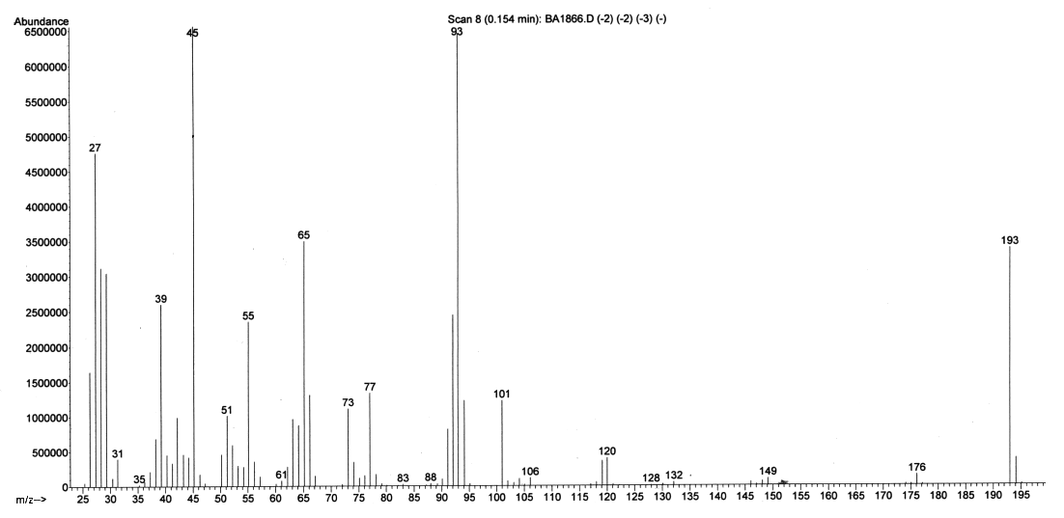
Figure S34: Mass spectrum view of N¹-hydroxy-N⁴-phenylbutanediamide (2a)

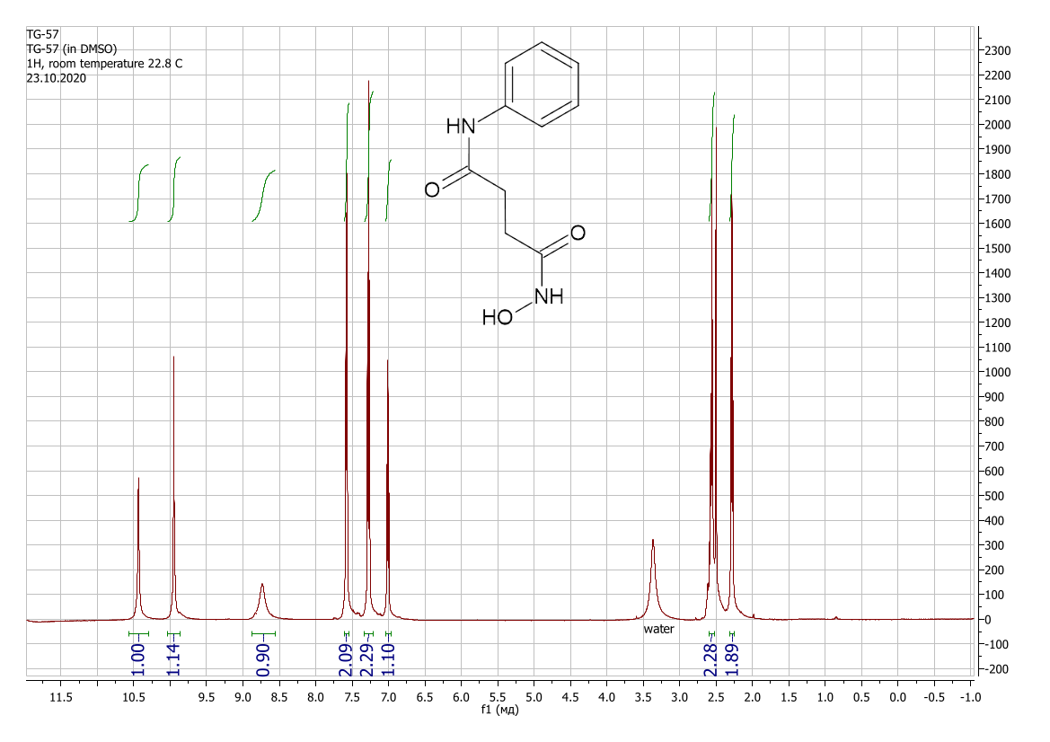
Figure S35: ¹H NMR spectrum view of N¹-hydroxy-N⁴-phenylbutanediamide (DMSO-d₆) (2a)
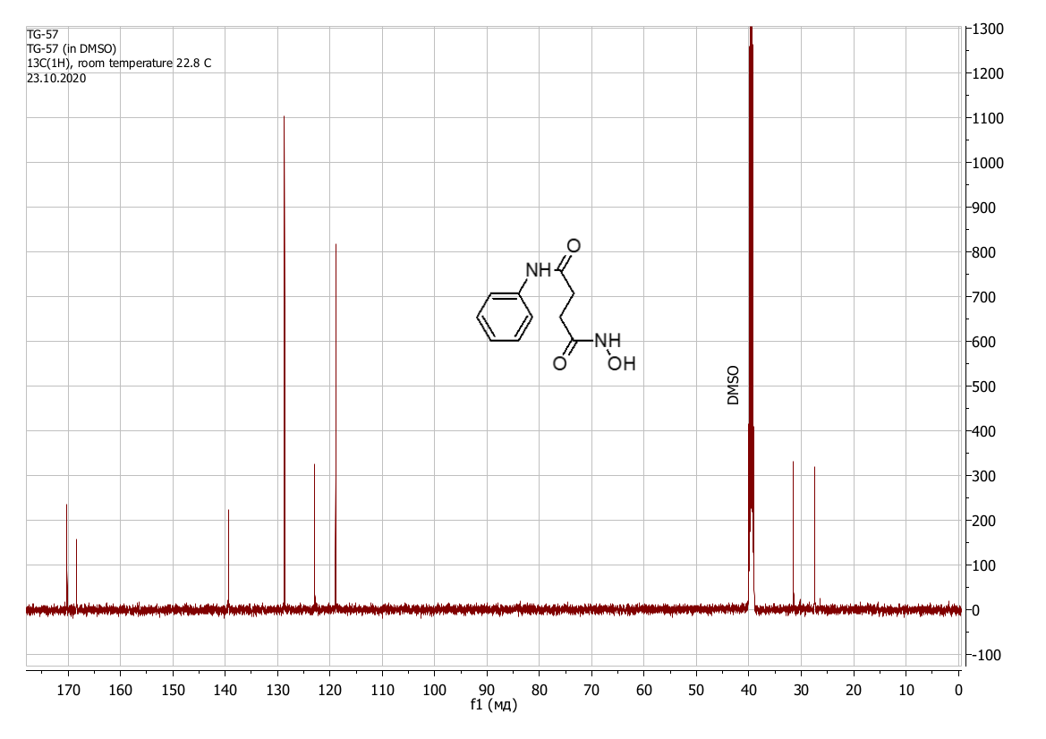
Figure S36: ¹³C NMR spectrum view of N¹-hydroxy-N⁴-phenylbutanediamide (DMSO-d₆) (2a)

N1-hydroxy-N4-(4-methoxyphenyl)butanediamide (2b)
Yield 0.63 g (66%), colorless crystals. Found, %: C 55.51; H 5.98; N 11.89; O 26.95. C₁₁H₁₄N₂O₄. Calculated, %: C 55.46; H 5.92; N 11.76; O 26.86. IR spectrum, ν, cm^{–1}: 3260, 1656, 1604, 1539, 1512, 1423, 1409, 1354, 1248, 1086, 1029, 1007, 967, 827, 752, 683, 647, 541, 465, 448, 427, 401, 393, 376, 369. Mass spectrum, m/z (Irel, %): 238 [M]+ (23.8), 206 (18.2), 205 (4.9), 124 (9.9), 123 (100), 122 (42.8), 116 (6.2), 109 (5.1), 108 (67.3), 95 (14.0), 80 (16.8), 79 (7.2), 78 (6.4), 77 (5.5), 65 (9.4), 64 (7.9), 63 (10.0), 60 (9.4), 56 (30.4), 55 (37.8), 54 (7.3), 53 (19.3), 52 (25.0), 51 (9.1), 44 (25.4), 43 (9.9), 42 (21.6), 41 (13.3), 39 (40.0), 33 (11.1), 31 (8.7), 30 (10.2), 29 (36.2), 28 (32.5), 27 (49.5), 26 (16.7), 15 (44.7). ¹H NMR spectrum (DMSO-d₆), ppm (J, Hz): 2.27 (2H, t, J = 7.3, -CH₂-), 2.50 – 2.55 (2H, m, -CH₂-), 3.70 (3H, s, -CH₃), 6.85 (2H, d, J = 9.0, Ar-H), 7.49 (2H, d, J = 8.9, Ar-H), 8.71 (1H, s, N-OH), 9.82 (1H, s, N-H), 10.49 (1H, s, N-H). ¹³C NMR spectrum (DMSO-d₆), δ, ppm: 27.97; 29.04; 66.37; 115.16; 121.68; 129.92; 158.18; 167.05; 168.55; 170.67.
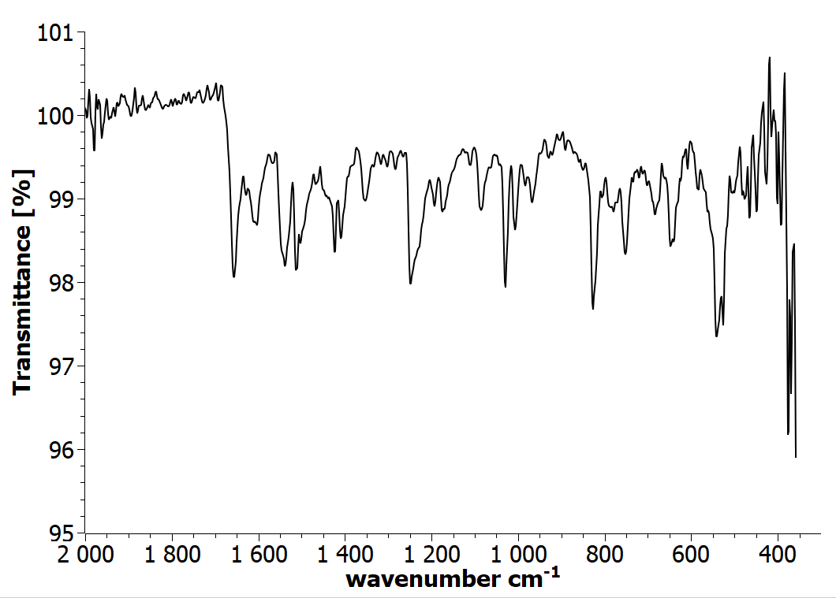
Figure S37: IR spectrum view of N¹-hydroxy-N⁴-(4-methoxyphenyl)butanediamide (2b)
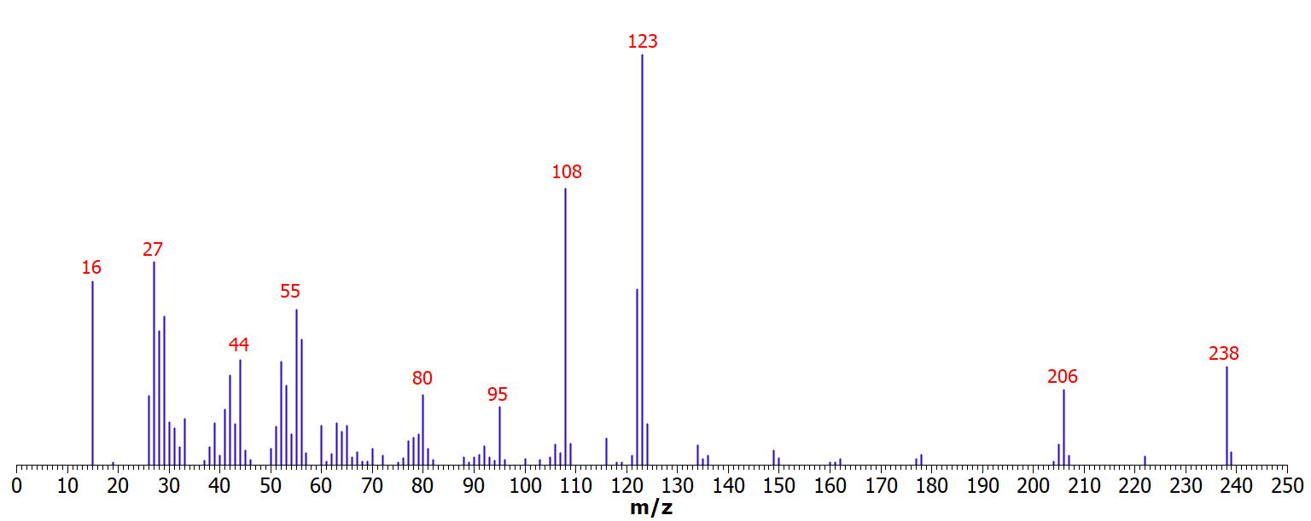
Figure S38: Mass spectrum view of N¹-hydroxy-N⁴-(4-methoxyphenyl)butanediamide (2b)

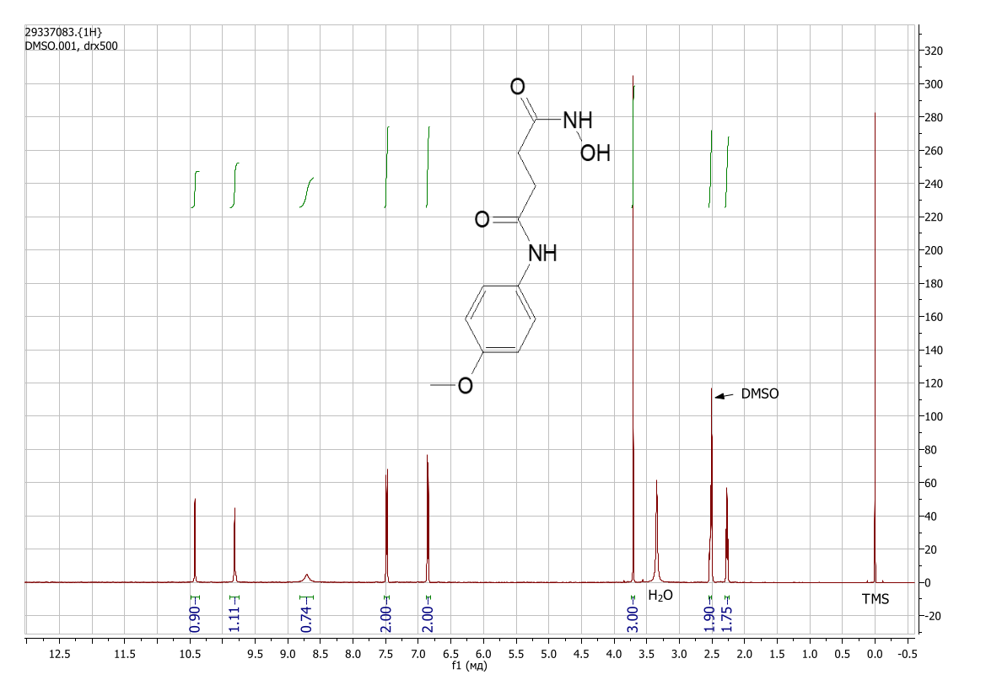
Figure S39: ¹H NMR spectrum view of of N¹-hydroxy-N⁴-(4-methoxyphenyl)butanediamide (DMSO-d₆) (2b)

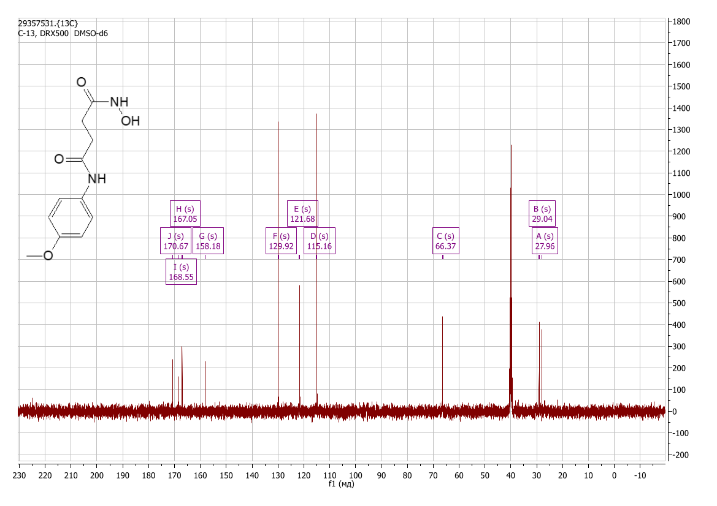
Figure S40: ¹³C NMR spectrum view of of N¹-hydroxy-N⁴-(4-methoxyphenyl)butanediamide (DMSO-d₆) (2b)

N1-(4-bromophenyl)-N4-hydroxybutanediamide (2c)
Yield 0.61 g (53%), colorless crystals. Found, %: C 41.78; H 4.01; N 9.52; O 16.89. C₁₀H₁₁BrN₂O₃. Calculated, %: C 41.83; H 3.86; Br 27.83; N 9.76; O 16.72. IR spectrum, ν, cm⁻¹: 3257, 2685, 1654, 1588, 1532, 1486, 1418, 1394, 1350, 1299, 1241, 1189, 1073, 1007, 969, 708, 665, 611, 548, 504, 470, 453, 392, 378. ¹H NMR spectrum (DMSO-d₆), δ, ppm (J, Hz): 2.28 (2H, t, J = 7.2, -CH₂-), 2.56 (2H, t, J = 7.2, -CH₂-), 7.43 (2H, d, J = 8.8, Ar-H), 7.58 (2H, d, J = 8.8, Ar-H), 8.5 – 10.0 (broad peak, -OH), 10.26 (1H, s, N-H), 10.51 (1H, s, N-H). ¹³C NMR spectrum (DMSO-d₆), δ, ppm: 27.43; 31.59; 114.49; 120.93; 131.51; 138.79; 168.50; 170.56.
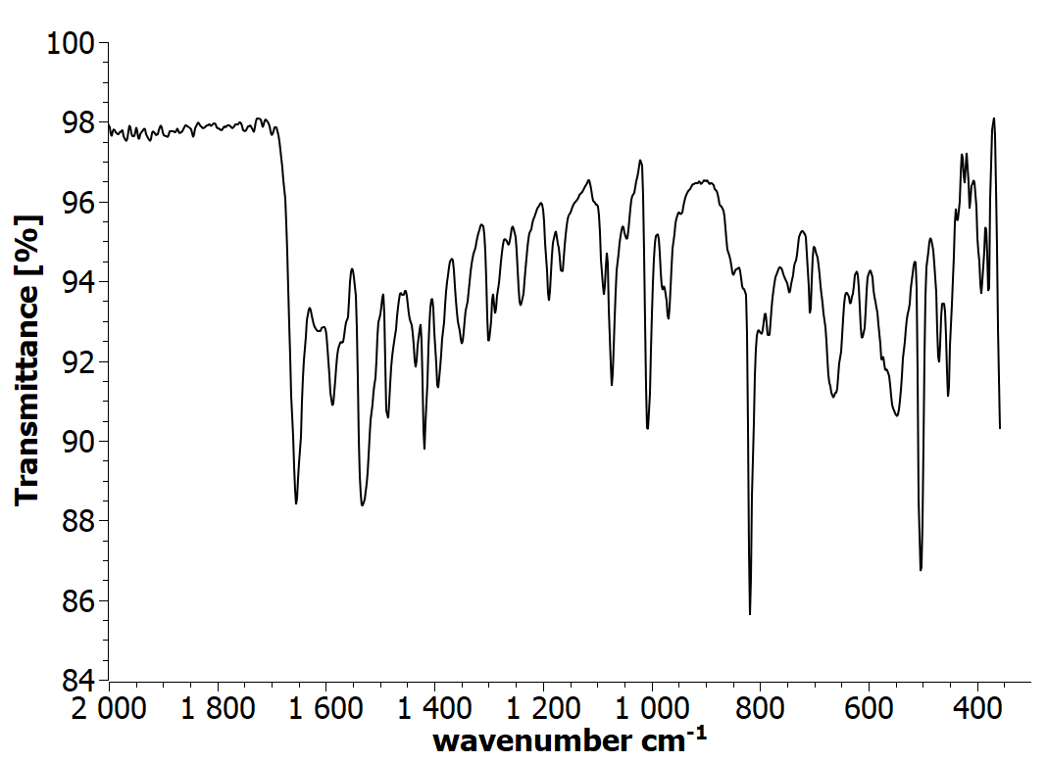
Figure S41: IR spectrum view of N¹-(4-bromophenyl)-N⁴-hydroxybutanediamide (2c)
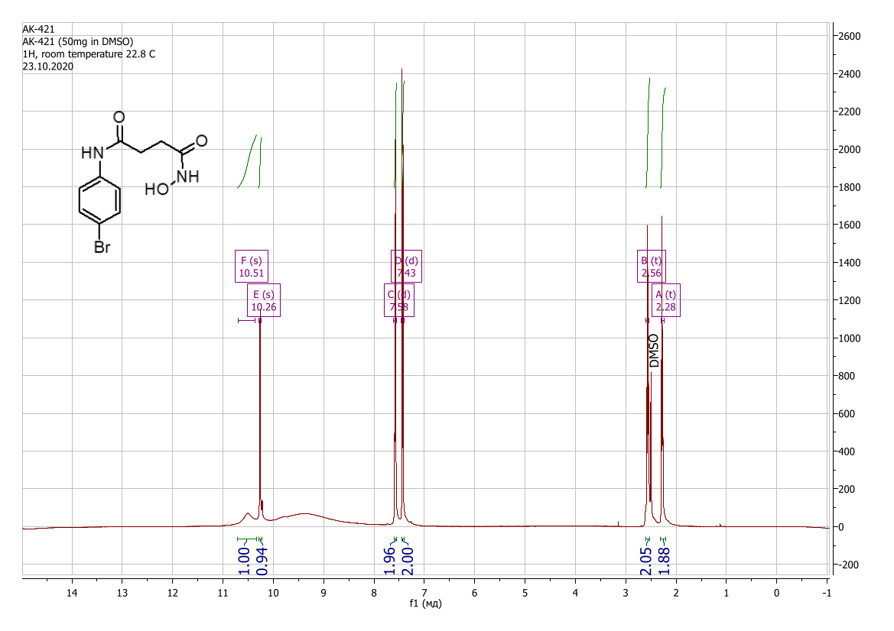
Figure S42: ¹H NMR spectrum view of N¹-(4-bromophenyl)-N⁴-hydroxybutanediamide ( DMSO-d₆) (2c)
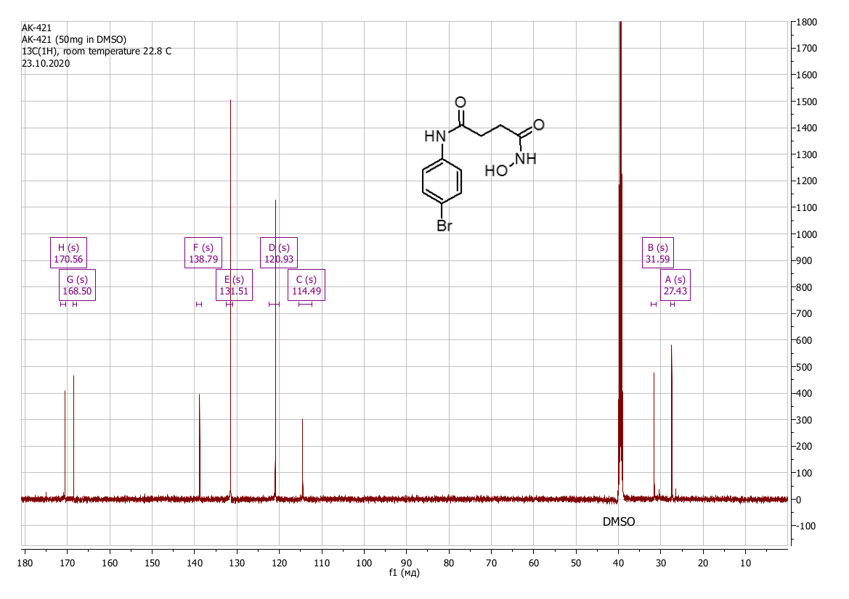
Figure S43: ¹³C NMR spectrum view of N¹-(4-bromophenyl)-N⁴-hydroxybutanediamide (DMSO-d₆) (2c)

N1-hydroxy-N4-(4-nitrophenyl)butanediamide (2d)
Yield 0.65 g (64%), colorless crystals. Found, %: C 47.41; H 4.25; N 16.37; O 31.36. C₁₀H₁₁N₃O₅. Calculated, %: C 47.43; H 4.38; N 16.59; O 31.59. IR spectrum, ν, cm⁻¹: 3680, 2972, 1664, 1614, 1597, 1558, 1521, 1495, 1455, 1412, 1340, 1259, 1179, 1113, 1055, 1033, 1013, 853, 774, 751, 690, 642, 531, 494, 408, 375. 1H NMR spectrum (DMSO-d₆), δ, ppm (J, Hz): 2.31 (2H, t, J = 7.0, -CH₂-), 2.64 (2H, t, J = 7.0, -CH₂-), 7.82 (2H, d, J = 9.1, Ar-H), 8.20 (2H, d, J = 9.2, Ar-H), 8.74 (1H, s, -OH), 10.46 (1H, s, N-H), 10.59 (1H, s, N-H). ¹³C NMR spectrum (DMSO-d₆), δ, ppm: 27.06; 31.60; 118.54; 125.02; 141.97; 145.45; 168.22; 171.38.
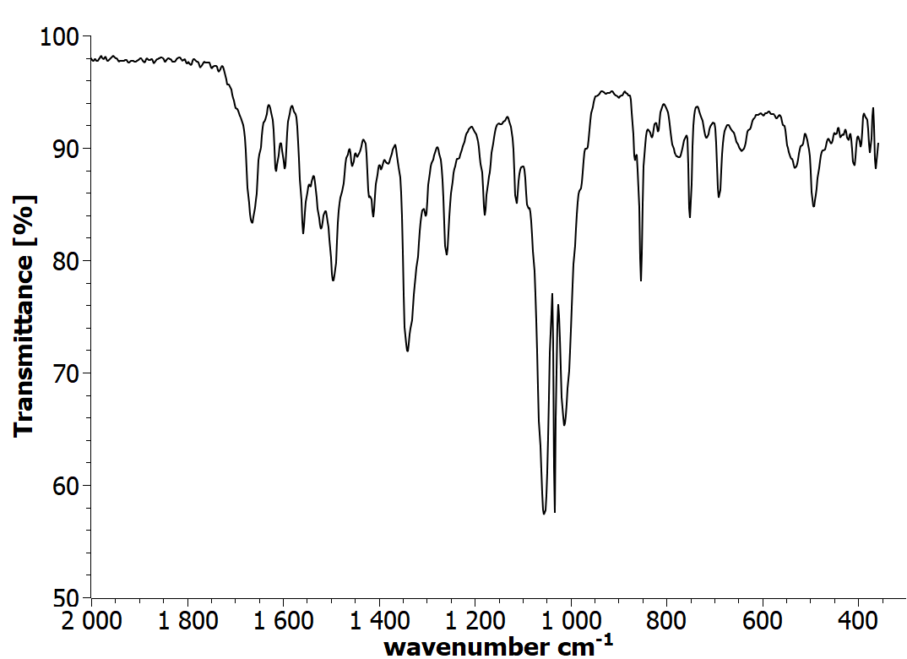
Figure S44: IR spectrum view of N¹-hydroxy-N⁴-(4-nitrophenyl)butanediamide (2d)
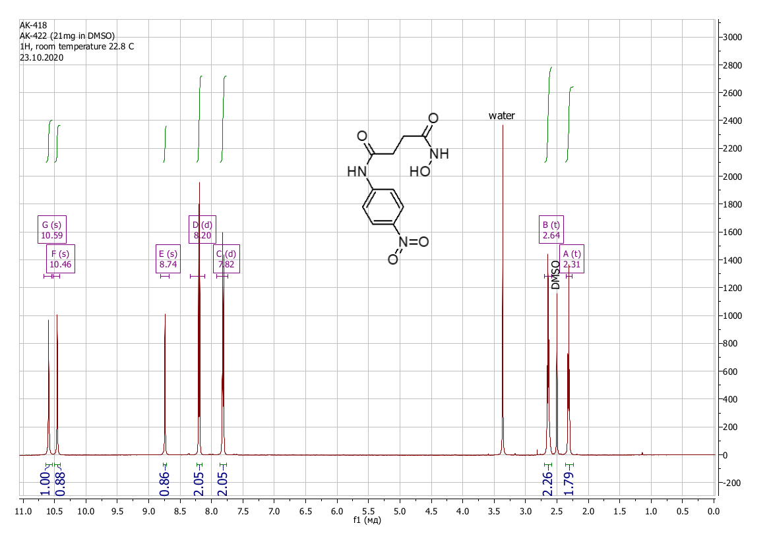
Figure S45: ¹H NMR spectrum view of N¹-hydroxy-N⁴-(4-nitrophenyl)butanediamide (DMSO-d₆) (2d)
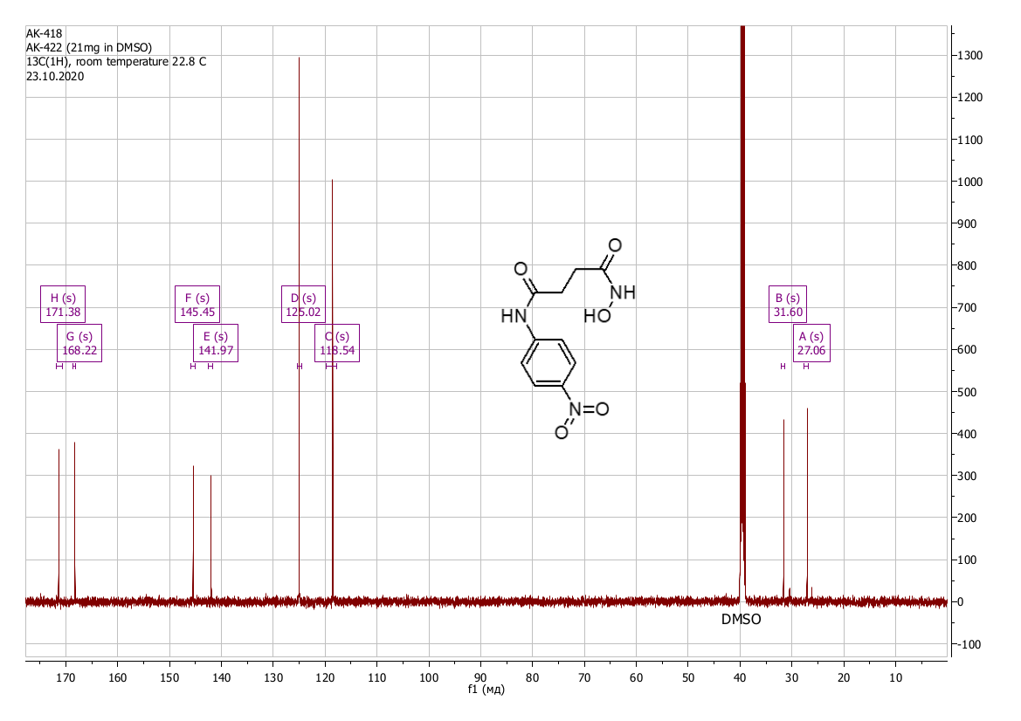
Figure S46: ¹³C NMR spectrum view of N¹-hydroxy-N⁴-(4-nitrophenyl)butanediamide (DMSO-d₆) (2d)

N1-(4-fluorophenyl)-N4-hydroxybutanediamide (2e)
Yield 0.35 g (38%), colorless crystals. Found, %: C 53.16; H 4.99; N 12.52; O 21.31. C₁₀H₁₁FN₂O₃. Calculated, %: C 53.10; H 4.90; F 8.40; N 12.38; O 21.22. IR spectrum, ν, cm⁻¹: 3272, 2988, 1658, 1613, 1539, 1510, 1423, 1407, 1342, 1307, 1217, 1084, 1008, 983, 965, 832, 782, 706, 647, 514, 454. Mass spectrum, m/z (Irel, %): 226 [M]+ (10.9), 195 (4.3), 194 (36.8), 193 (5.2), 138 (9.5), 116 (8.7), 112 (8.9), 111 (100), 110 (22.0), 109 (5.9), 95 (6.7), 84 (5.9), 83 (21.6), 82 (5.2), 57 (11.2), 56 (10.3), 55 (21.9), 44 (10.5), 42 (6.6), 29 (6.2), 28 (11.5), 27 (17.3), 26 (5.8). ¹H NMR spectrum (DMSO-d₆), δ, ppm (J, Hz): 2.28 (2H, t, J = 7.2, -CH₂-), 2.55 (2H, t, J = 7.2, -CH₂-), 5.80 – 8.10 (2H, broad peak, -OH, N-H), 7.12 (2H, t, J = 8.8, Ar-H), 7.59 (2H, dd, J₁ = 8.7, J₂ = 5.1, Ar-H), 10.03 (1H, s, N-H). ¹³C NMR spectrum (DMSO-d₆), δ, ppm (J, Hz): 27.88; 31.87; 115.63 (d, J = 22.1); 121.08 (d, J = 7.7); 136.15; 157.28; 159.19; 169.80; 170.57.
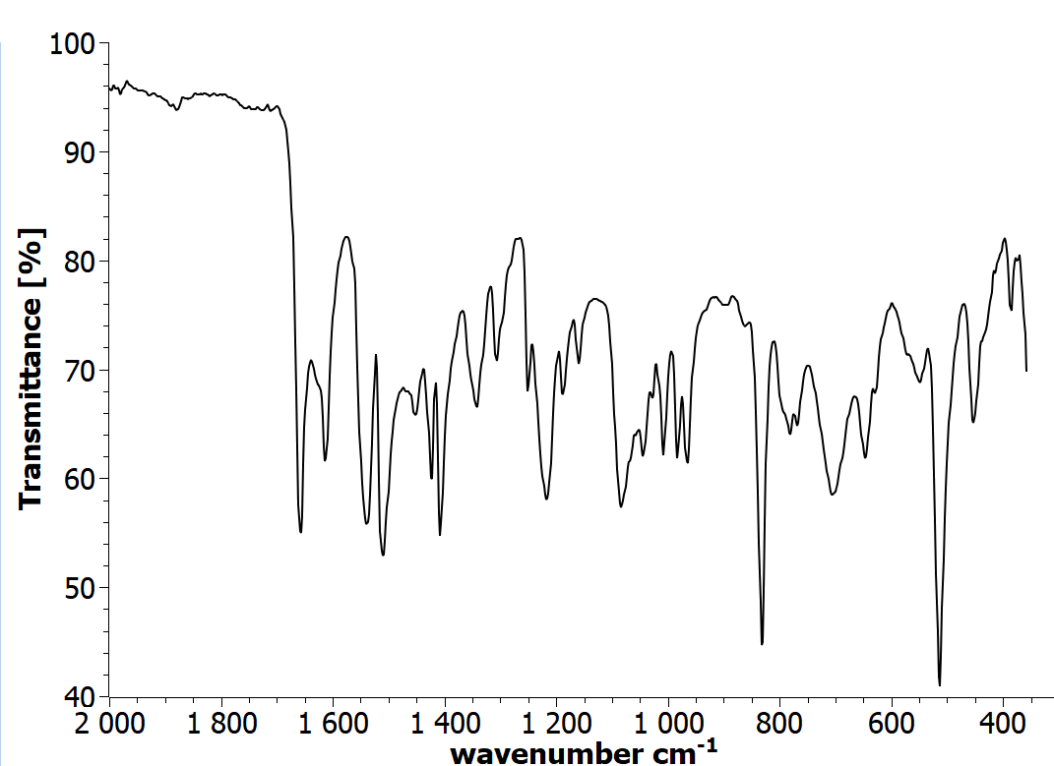
Figure S47: IR spectrum view of N¹-(4-fluorophenyl)-N⁴-hydroxybutanediamide (2e)

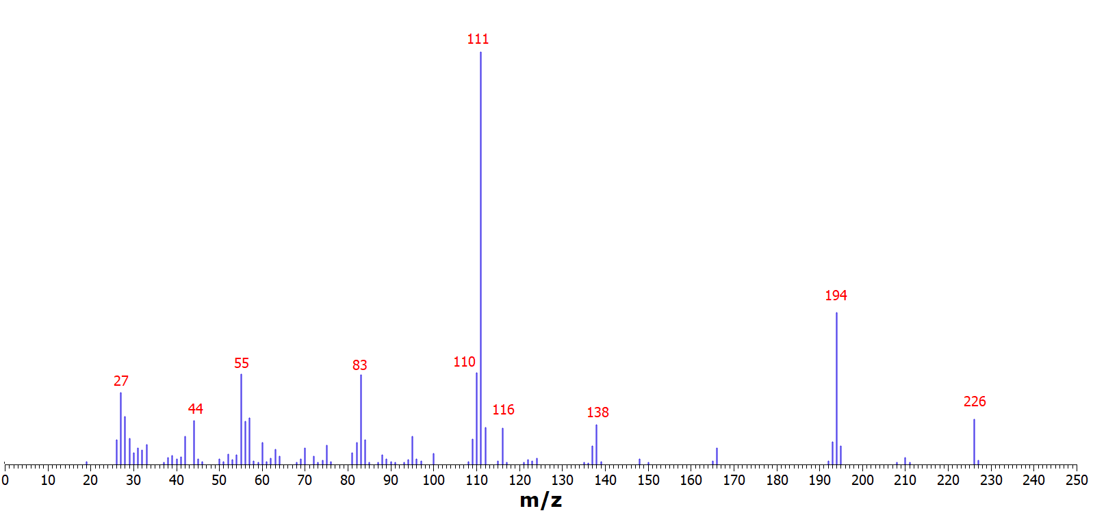
Figure S48: Mass spectrum view of N¹-(4-fluorophenyl)-N⁴-hydroxybutanediamide (2e)

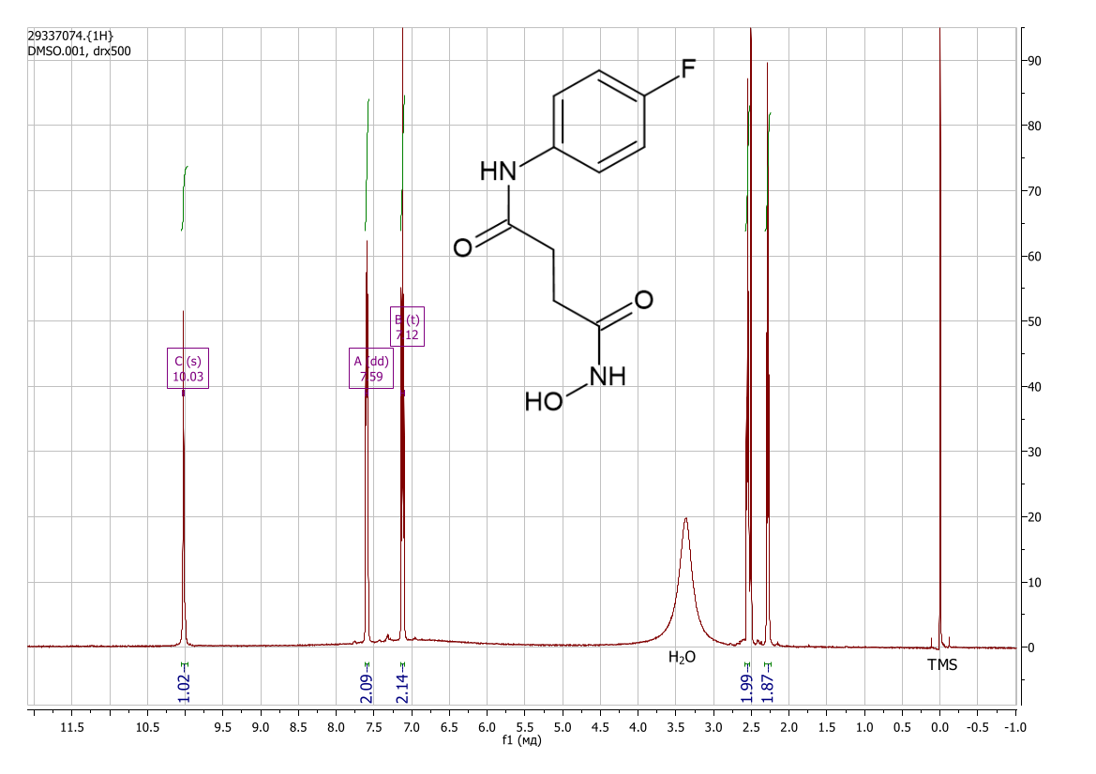
Figure S49: ¹H NMR spectrum view of N¹-(4-fluorophenyl)-N⁴-hydroxybutanediamide (DMSO-d₆) (2e)

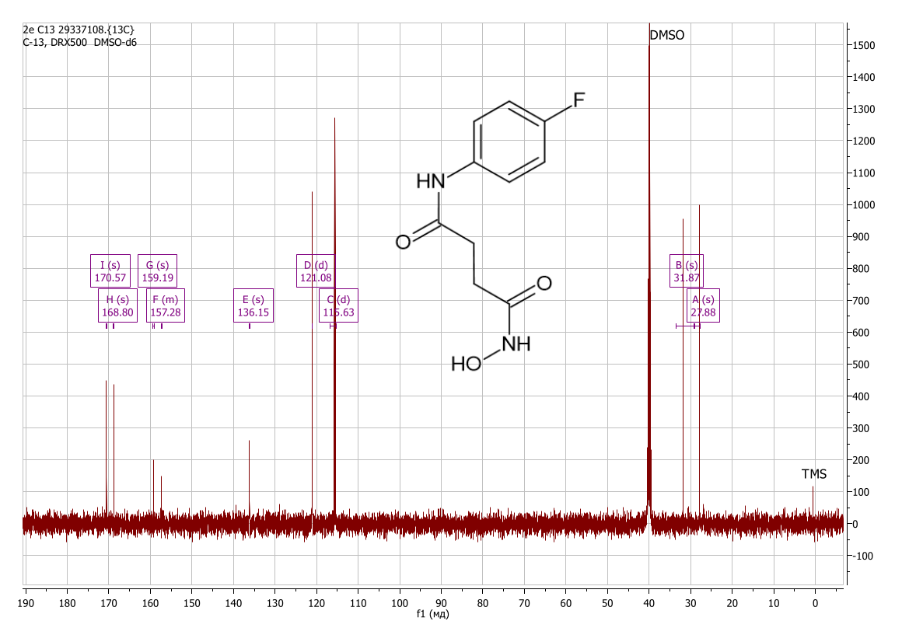
Figure S50: ¹³C NMR spectrum view of N¹-(4-fluorophenyl)-N⁴-hydroxybutanediamide (DMSO-d₆) (2e)

N1-hydroxy-N4-[3-(trifluoromethyl)phenyl]butanediamide (2f)
Yield 0.38 g (34%), colorless crystals. Found, %: C 47.91; H 4.12; N 10.31; O 17.52. C₁₁H₁₁F₃N₂O₃. Calculated, %: C 47.83; H 4.01; F 20.63; N 10.14; O 17.38. IR spectrum, ν, cm⁻¹: 3262, 2970, 1675, 1624, 1570, 1523, 1486, 1451, 1333, 1284, 1261, 1179, 1138, 1102, 1071, 1026, 966, 898, 800, 698, 664, 545, 451. Mass spectrum, m/z (Irel, %): 276 [M]⁺ (6.5), 255 (37.0), 224 (7.4), 188 (13.3), 161 (100), 160 (15.6), 145 (17.6), 142 (6.4), 140 (8.8), 116 (18.3), 114 (11.5), 113 (8.8), 100 (9.6), 91 (5.6), 88 (9.1), 83 (5.8), 75 (8.0), 69 (23.8), 63 (15.3), 60 (14.2), 57 (7.9), 56 (25.6), 55 (77.2), 54 (8.4), 52 (5.8), 45 (6.3), 44 (39.2), 43 (15.5), 42 (33.2), 33 (22.9), 32 (25.0), 31 (11.0), 30 (14.8), 29 (39.5), 28 (82.3), 27 (73.1), 26 (22.9). ¹H NMR spectrum (DMSO-d₆), δ, ppm (J, Hz): 2.30 (2H, t, J = 7.1, -CH₂-), 2.60 (2H, t, J = 7.1, -CH₂-), 7.37 (1H, d, J = 7.6, Ar-H), 7.53 (1H, t, J = 7.9, Ar-H), 7.74 (1H, d, J = 8.2, Ar-H), 8.11 (1H, s, Ar-H), 8.72 (1H, s, -OH), 10.31 (1H, s, N-H), 10.44 (1H, s, N-H). ¹³C NMR spectrum (DMSO-d₆), δ, ppm (J, Hz): 27.17; 31.43; 114.89 (d, J = 3.7); 119.18 (d, J = 3.4); 122.33; 123.00; 125.16; 129.37 (q, J = 31.5), 129.83; 139.95; 168.22; 170.82.
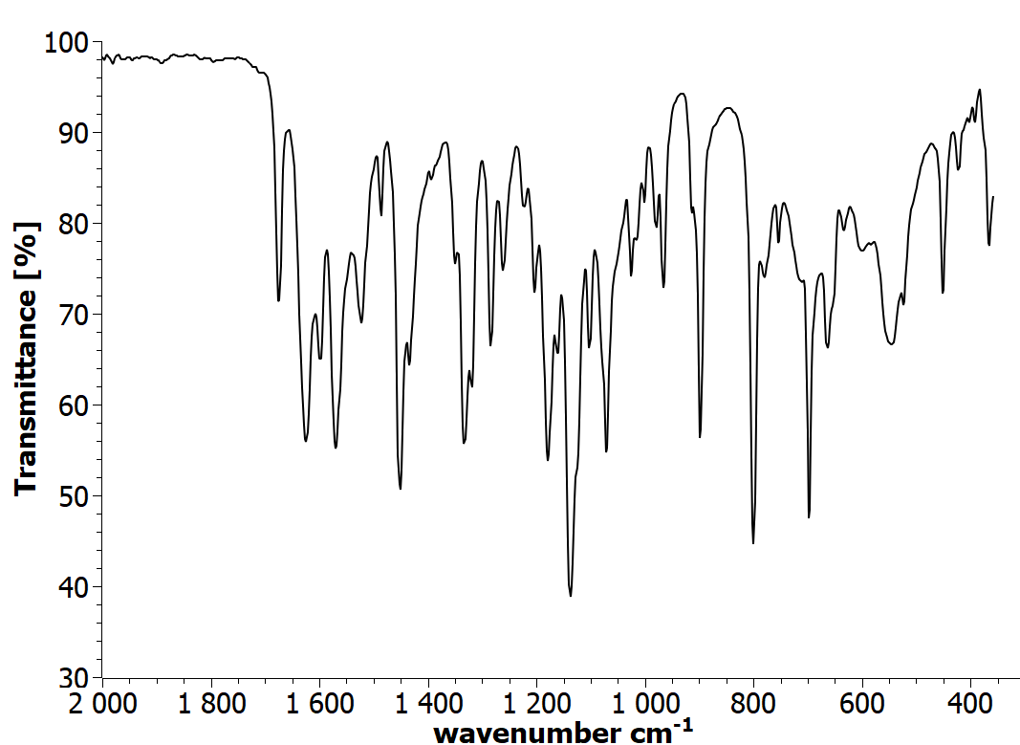
Figure S51: IR spectrum view of N¹-hydroxy-N⁴-[3-(trifluoromethyl)phenyl]butanediamide (2f)

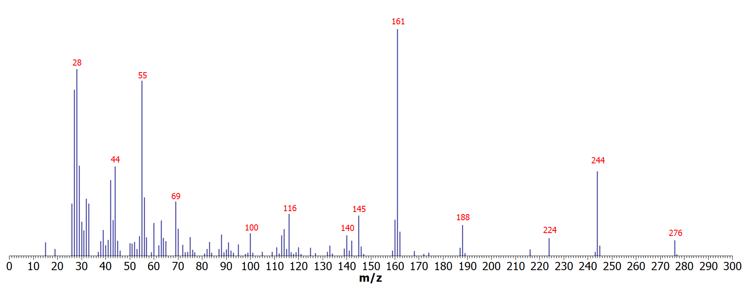
Figure S52: Mass spectrum view of N¹-hydroxy-N⁴-[3-(trifluoromethyl)phenyl]butanediamide (2f)
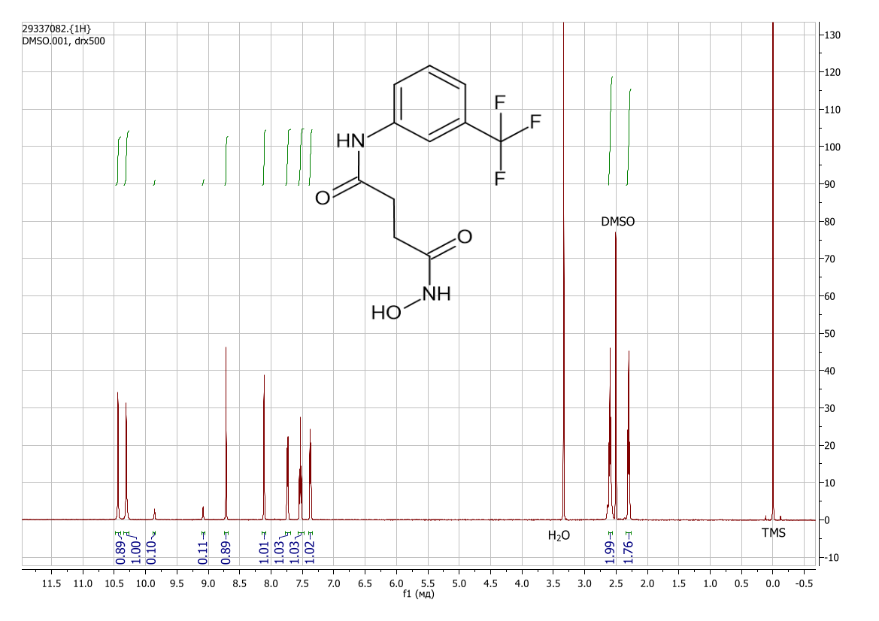
Figure S53: ¹H NMR spectrum view of N¹-hydroxy-N⁴-[3-(trifluoromethyl)phenyl]butanediamide (DMSO-d₆) (2f) (the additional signals are related to cis-trans isomerisation [DOI: 10.1002/mrc.1260261107])

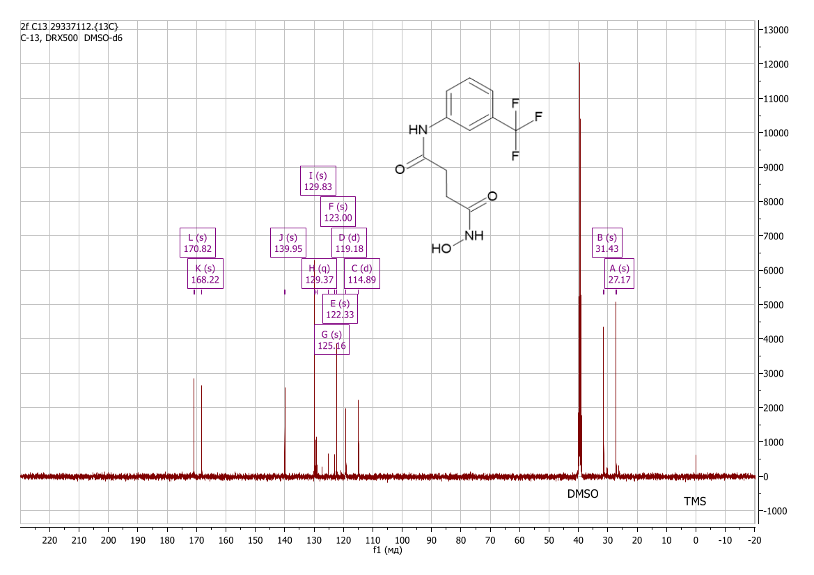
Figure S54: ¹³C NMR spectrum view of N¹-hydroxy-N⁴-[3-(trifluoromethyl)phenyl]butanediamide (DMSO-d₆) (2f)

4-(2-benzoylhydrazinyl)-N-hydroxy-4-oxobutanamide (2g)
Yield 0.76 g (75%), colorless crystals. Found, %: C 52.48; H 5.34; N 16.58; O 25.59. C₁₁H₁₃N₃O₄. Calculated, %: C 52.59; H 5.22; N 16.73; O 25.47. IR spectrum, ν, cm⁻¹: 3677, 3233, 2988, 2901, 1685, 1629, 1564, 1524, 1487, 1417, 1330, 1271, 1231, 1162, 1066, 997, 898, 809, 718, 694, 605, 556, 547, 527, 422, 395, 370. ¹H NMR spectrum (DMSO-d₆), δ, ppm (J, Hz): 2.15 – 2.30 (2H, m, -CH₂-), 2.40 – 2.48 (2H, m, -CH₂-), 7.44 – 7.52 (2H, m, Ar-H), 7.53 – 7.61 (1H, m, Ar-H) 7.84 – 7.90 (2H, m, Ar-H), 8.76 (1H, s, O-H), 9.80 – 10.02 (1H, m, N-H), 10.33 (1H, s, N-H), 10.50 (1H, s, N-H). ¹³C NMR spectrum (DMSO-d₆), δ, ppm: 27.66; 28.81; 127.51; 128.52; 131.87; 132.57; 165.57; 168.26; 170.78.

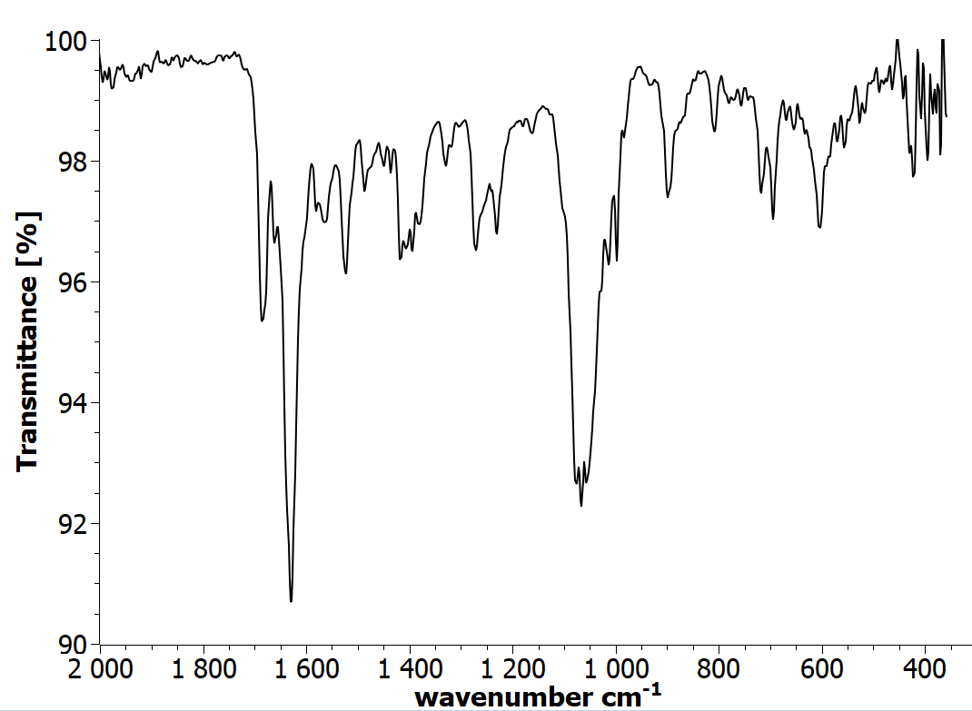
Figure S55: IR spectrum view of 4-(2-benzoylhydrazinyl)-N-hydroxy-4-oxobutanamide (2g)

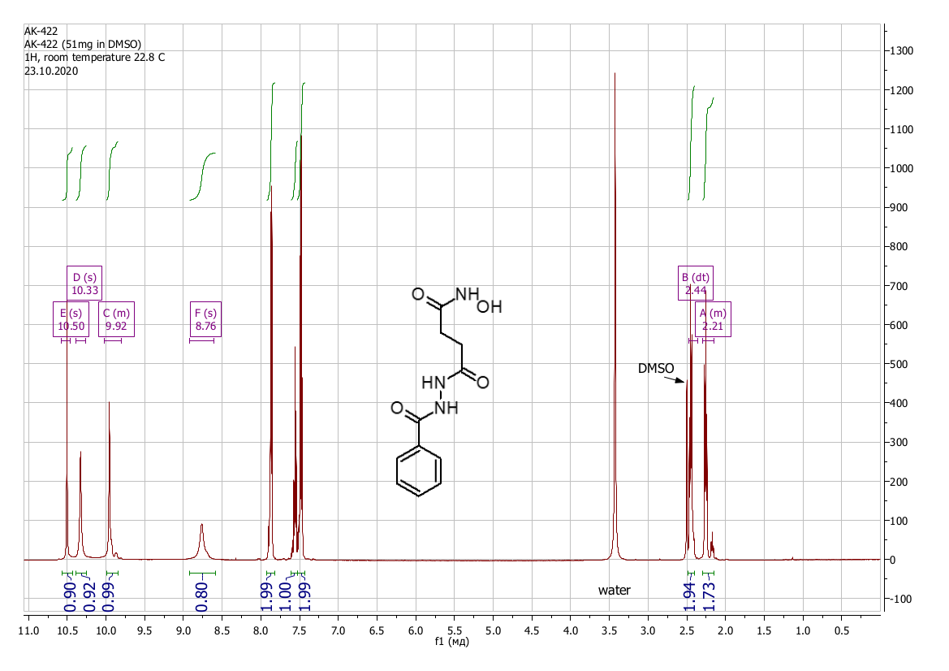
Figure S56: ¹H NMR spectrum view of 4-(2-benzoylhydrazinyl)-N-hydroxy-4-oxobutanamide (DMSO-d₆) (2g) (the additional signals are related to cis-trans isomerisation [DOI: 10.1002/mrc.1260261107])
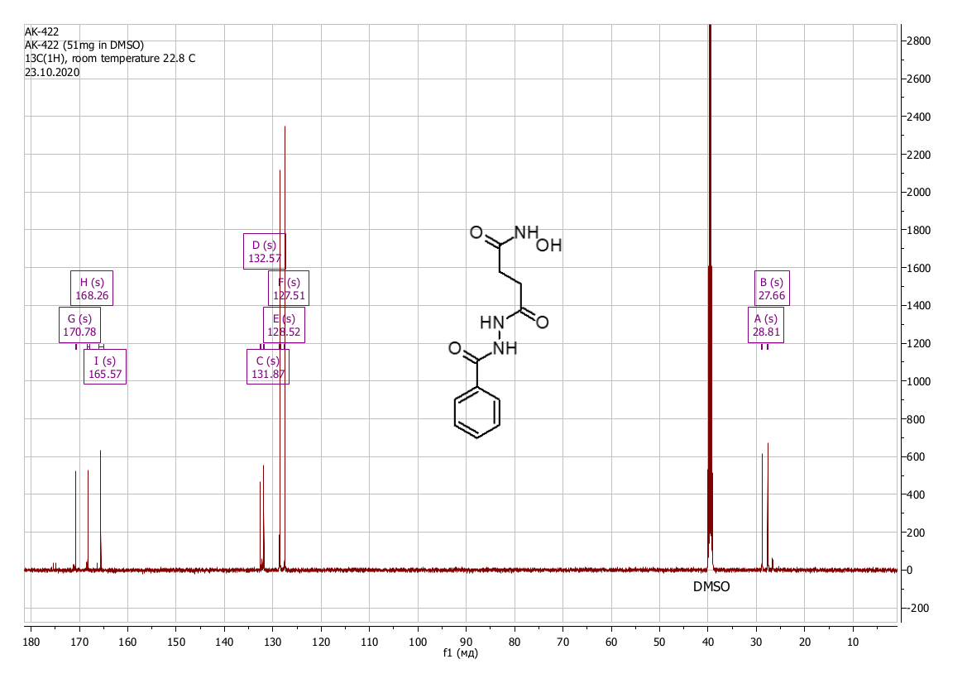
Figure S57: ¹³C NMR spectrum view of 4-(2-benzoylhydrazinyl)-N-hydroxy-4-oxobutanamide (DMSO-d₆) (2g)

4-[2-([1,1’-biphenyl]-4-carbonyl)hydrazinyl]-N-hydroxy-4-oxobutanamide (2h)
Yield 0.91 g (69%), colorless crystals. Found, %: C 62.42; H 5.29; N 12.97; O 19.62. C₁₇H₁₇N₃O₄. Calculated, %: C 62.38; H 5.23; N 12.84; O 19.55. IR spectrum, ν, cm⁻¹: 3270, 2988, 1642, 1484, 1447, 1325, 1307, 1256, 1065, 969, 897, 858, 736, 695, 618, 523, 462, 369. Mass spectrum, m/z (Irel, %): 294 (4.9), 212 (4.4), 182 (14.9), 181 (100), 153 (15.2), 152 (31.3), 151 (7.8), 127 (3.7), 126 (3.2), 76 (3.0), 55 (4.6), 31 (4.1), 27 (4.9). ¹H NMR spectrum (DMSO-d₆), δ, ppm (J, Hz): 2.14 – 2.30 (2H, m, -CH₂-), 2.41 – 2.49 (2H, m, -CH₂-), 7.42 (1H, t, J = 7.2, Ar-H), 7.50 (2H, t, J = 7.5, Ar-H), 7.75 (2H, d, J = 7.6, Ar-H), 7.80 (2H, d, J = 8.1, Ar-H), 7.97 (2H, d, J = 8.0, Ar-H), 8.65 – 8.77 (1H, m, O-H), 9.84 – 9.99 (1H, m, N-H), 10.30 – 10.70 (2H, m, N-H). ¹³C NMR spectrum (DMSO-d₆), δ, ppm: 27.93; 32.00; 119.39; 123.38; 129.10; 139.76; 168.83; 170.67.
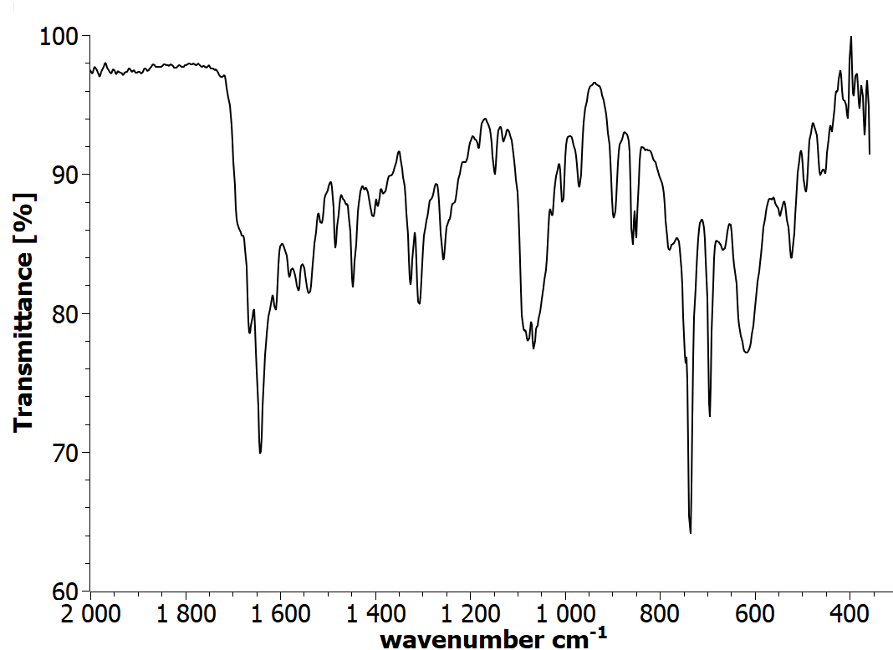
Figure S58: IR spectrum view of 4-[2-([1,1'-biphenyl]-4-carbonyl)hydrazinyl]-N-hydroxy-4-oxobutanamide (2h)
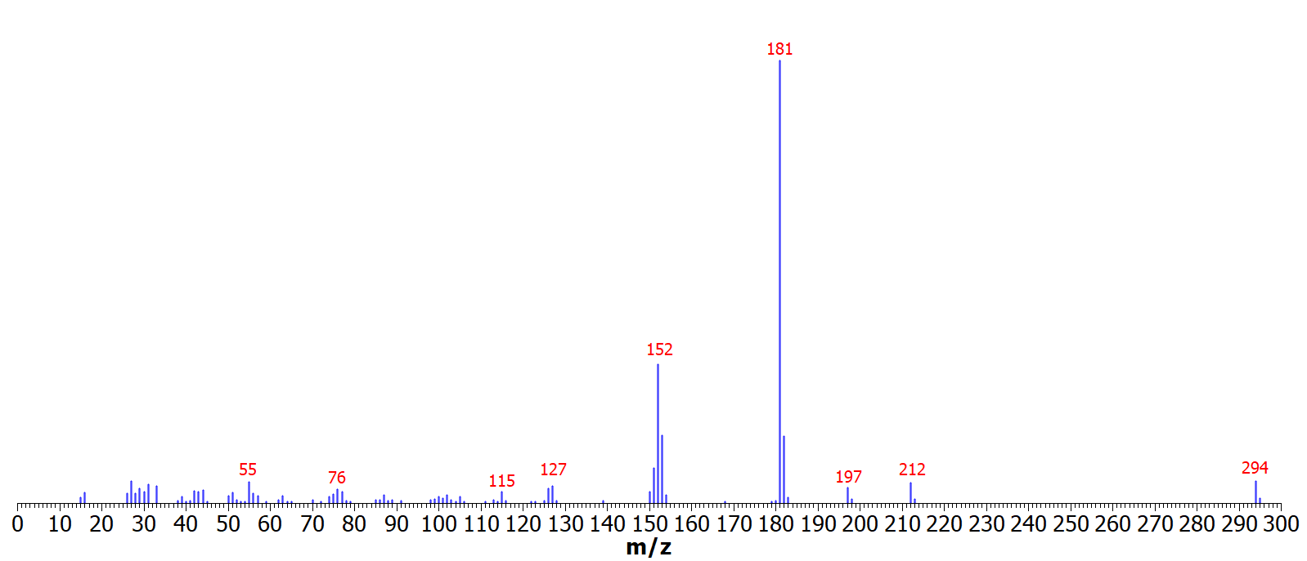Figure S59: Mass spectrum view of 4-[2-([1,1'-biphenyl]-4-carbonyl)hydrazinyl]-N-hydroxy-4-oxobutanamide (2h)
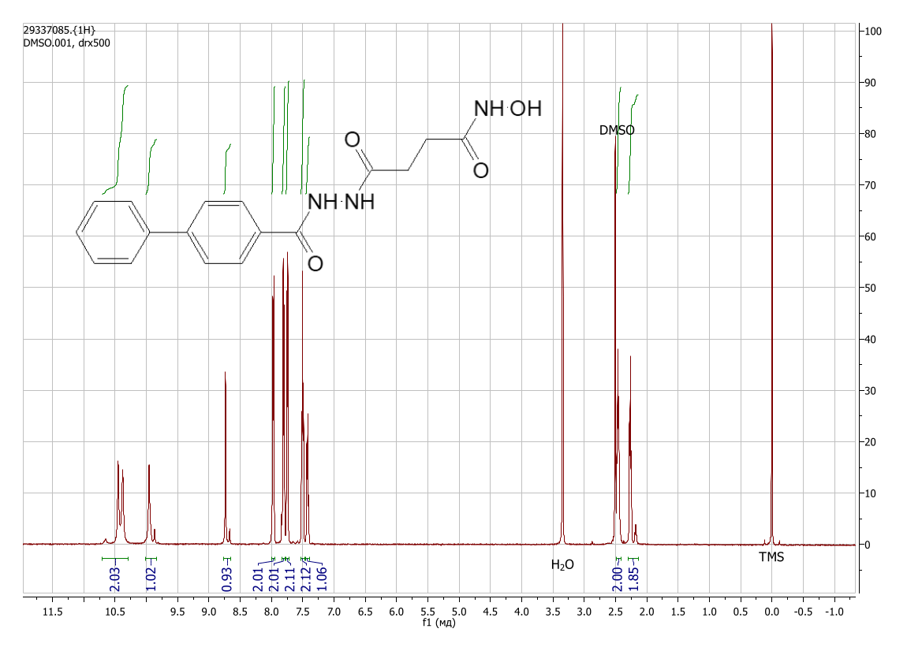
Figure S60: ¹H NMR spectrum view of 4-[2-([1,1'-biphenyl]-4-carbonyl)hydrazinyl]-N-hydroxy-4-oxobutanamide (DMSO-d₆) (2h) (the additional signals are related to cis-trans isomerisation [DOI: 10.1002/mrc.1260261107])

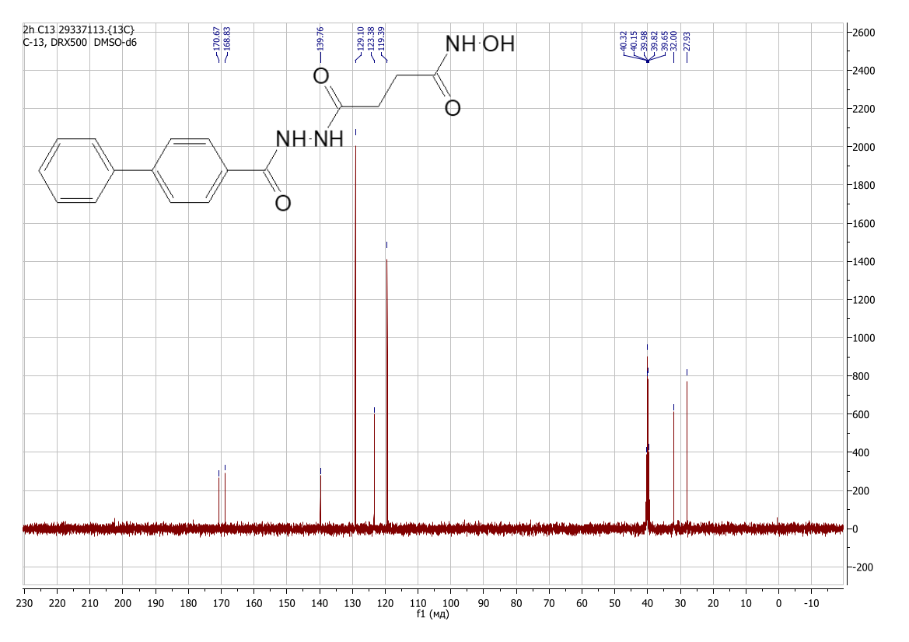
Figure S61: ¹³C NMR spectrum view of 4-[2-([1,1'-biphenyl]-4-carbonyl)hydrazinyl]-N-hydroxy-4-oxobutanamide (DMSO-d₆) (2h)

4-{2-[(2,4-dichlorophenoxy)acetyl]hydrazinyl}-N-hydroxy-4-oxobutanamide (2i)
Yield 1.01 g (72.1%), colorless crystals. Found, %: C 41.21; H 3.80; N 12.06; O 22.91. C₁₂H₁₃C_{l2}N₃O₅. Calculated, %: C 41.16; H 3.74; Cl 20.25; N 12.00; O 22.85. IR spectrum, ν, cm⁻¹: 3190, 2988, 1690, 1650, 1626, 1569, 1476, 1420, 1353, 1255, 1223, 1101, 1066, 1040, 997, 904, 867, 811, 742, 714, 651, 608, 586, 548, 461, 424, 377. Mass spectrum, m/z (Irel, %): 318 (2.0), 316 (6.2), 281 (2.9), 177 (8.6), 176 (1.6), 175 (17.1), 164 (29.4), 163 (4.9), 162 (46.8), 155 (26.5), 149 (6.1), 147 (21.8), 145 (22.5), 135 (5.8), 133 (11.2), 128 (9.9), 127 (73.5), 115 (6.0), 113 (7.6), 112 (5.2), 111 (30.1), 110 (5.8), 109 (23.6), 105 (5.2), 100 (15.2), 99 (21.0), 98 (9.0), 97 (5.0), 87 (5.2), 85 (11.1), 75 (29.7), 74 (24.5), 73 (40.4), 72 (13.2), 71 (9.2), 63 (48.6), 62 (22.6), 61 (12.8), 57 (21.6), 56 (23.9), 55 (73.2), 53 (9.3), 51 (9.2), 50 (13.9), 49 (7.0), 45 (40.6), 44 (57.9), 43 (44.3), 42 (82.5), 38 (19.0), 37 (16.4), 36 (20.0), 33 (26.5), 31 (77.7), 30 (56.8), 29 (100.0), 27 (75.5), 26 (40.8), 15 (23.6). ¹H NMR spectrum (DMSO-d₆), δ, ppm (J, Hz): 2.13 – 2.32 (2H, m, -CH₂-), 2.35 – 2.41 (2H, m, -CH₂-), 4.72 – 4.81 (2H, m, -CH₂-), 7.05 – 7.14 (1H, m, Ar-H), 7.32 – 7.40 (1H, m, Ar-H), 7.56 – 7.62 (1H, m, Ar-H), 8.73 (1H, s, O-H), 9.90 – 10.15 (2H, m, N-H), 10.43 (1H, m, N-H). ¹³C NMR spectrum (DMSO-d₆), δ, ppm: 26.77; 27.91; 28.98; 67.10; 115,88; 123.03; 125.63; 128.40; 129.82; 153.99; 166.21; 168.54; 170.59.
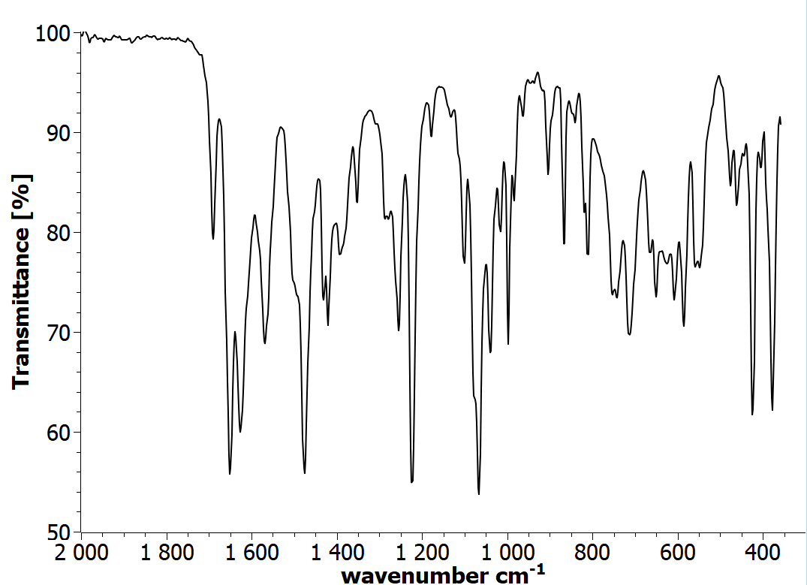
Figure S62: IR spectrum view of 4-{2-[(2,4-dichlorophenoxy)acetyl]hydrazinyl}-N-hydroxy-4-oxobutanamide (2i)
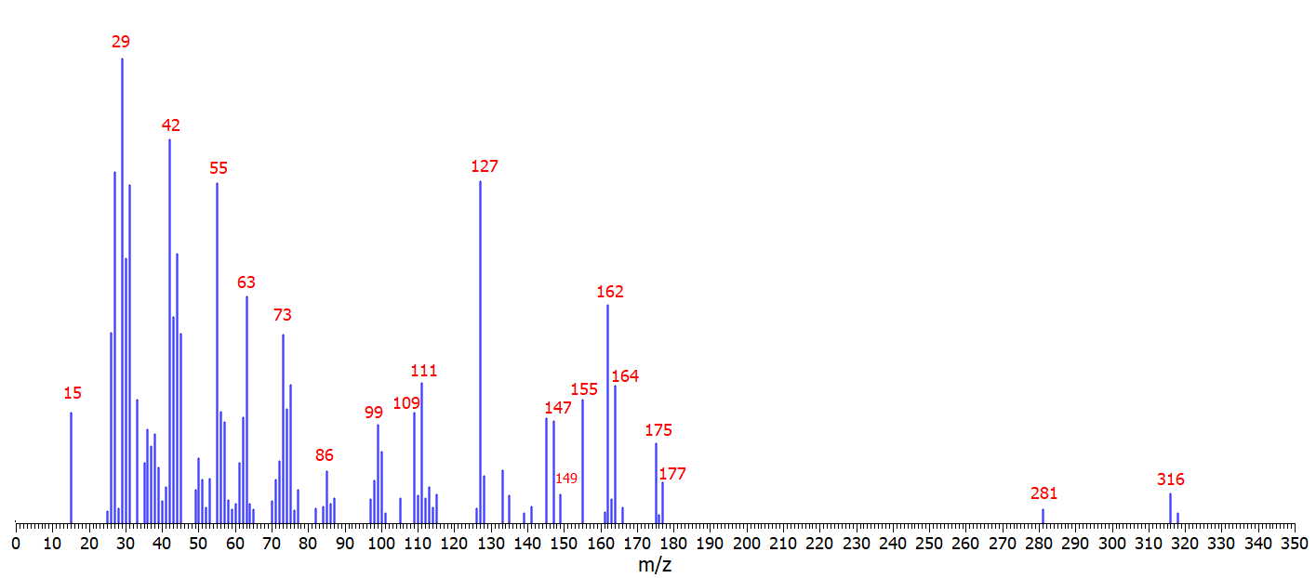
Figure S63: Mass spectrum view of 4-{2-[(2,4-dichlorophenoxy)acetyl]hydrazinyl}-N-hydroxy-4-oxobutanamide (2i)
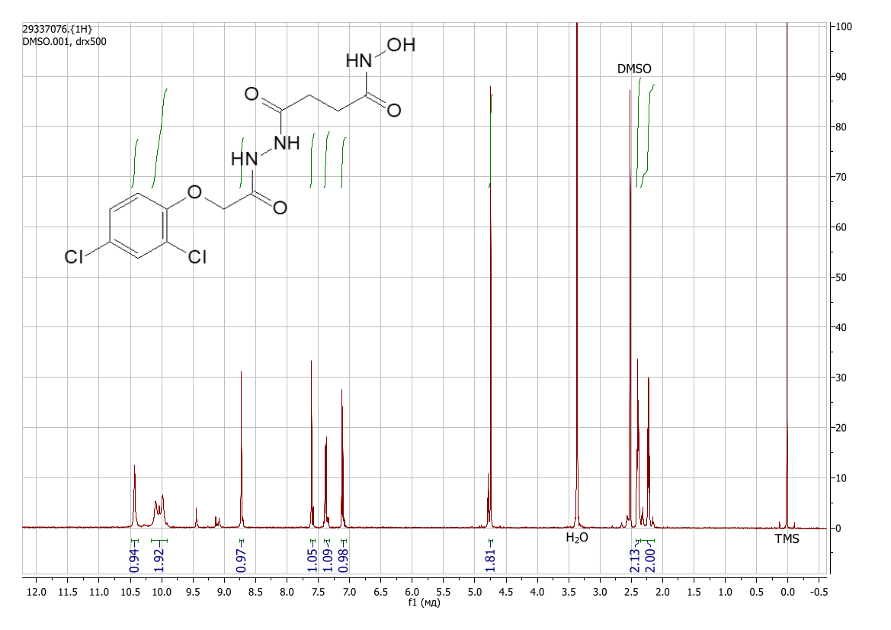
Figure S64: ¹H NMR spectrum view of 4-{2-[(2,4-dichlorophenoxy)acetyl]hydrazinyl}-N-hydroxy-4-oxobutanamide (DMSO-d₆) (2i) (the additional signals are related to cis-trans isomerisation [DOI: 10.1002/mrc.1260261107])

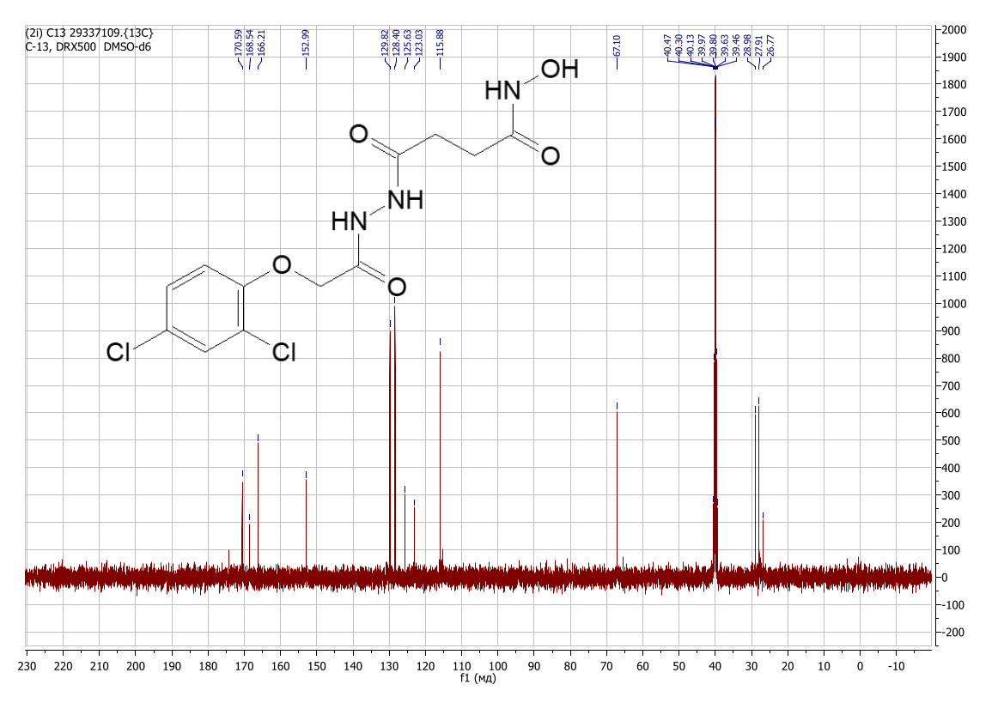
Figure S65: ¹³C NMR spectrum view of 4-{2-[(2,4-dichlorophenoxy)acetyl]hydrazinyl}-N-hydroxy-4-oxobutanamide (DMSO-d₆) (2i)

N-hydroxy-4-oxo-4-{2-[(2,4,5-trichlorophenoxy)acetyl]hydrazinyl}butanamide (2j)
Yield 0.97 g (63%), colorless crystals. Found, %: C 37.52; H 3.28; N 11.08; O 21.10. C₁₂H₁₂Cl₃N₃O₅. Calculated, %: C 37.47; H 3.14; Cl 27.65; N 10.93; O 20.80. IR spectrum, ν, cm⁻¹: 3225, 2988, 1728, 1700, 1657, 1630, 1571, 1477, 1456, 1422, 1381, 1356, 1296, 1241, 1205, 1140, 1088, 1062, 1015, 999, 967, 908, 869, 842, 733, 678, 644, 599, 549, 528, 510, 438, 393. Mass spectrum, m/z (Irel, %): 355 (1.8), 354 (11.4), 353 (6.6), 352 (36.7), 351 (7.2), 350 (37.9), 318 (5.6), 317 (23.9), 316 (17.1), 315 (35.5), 314 (15.0), 270 (5.9), 268 (5.1), 235 (5.1), 233 (7.2), 218 (5.8), 213 (10.1), 211 (31.2), 209 (33.3), 200 (17.0), 198 (56.8), 197 (8.2), 196 (56.4), 183 (27.2), 181 (64.5), 179 (57.0), 171 (7.4), 169 (23.3), 167 (26.6), 155 (41.9), 148 (10.8), 147 (13.2), 146 (22.9), 145 (29.2), 143 (18.2), 128 (6.1), 116 (7.8), 111 (6.8), 109 (14.9), 100 (12.3), 99 (19.0), 97 (19.0), 85 (7.9), 74 (11.9), 73 (22.03), 71 (7.9), 62 (9.8), 61 (7.5), 57 (10.8), 56 (11.0), 55 (33.0), 45 (15.2), 44 (14.9), 43 (13.4), 41 (27.0), 36 (6.7), 33 (15.4), 32 (7.6), 30 (14.7), 29 (23.2), 28 (41.5), 27 (18.8), 16 (12.6). ¹H NMR spectrum (DMSO-d₆), δ, ppm (J, Hz): 2.15 – 2.33 (2H, m, -CH₂-), 2.38 (2H, t, J = 7.4, -CH₂-), 4.79 – 4.86 (2H, m, -CH₂-), 7.38 (1H, s, Ar-H), 7.80 – 7.85 (1H, m, Ar-H), 8.66 – 8.75 (1H, m, O-H), 9.90 – 10.15 (2H, m, N-H), 10.41 (1H, s, N-H). ¹³C NMR spectrum (DMSO-d₆), δ, ppm: 27.93; 29.00; 67.30; 116.37; 121.85; 123.88; 130.78; 131.08; 153.43; 165.97; 168.54; 170.61.
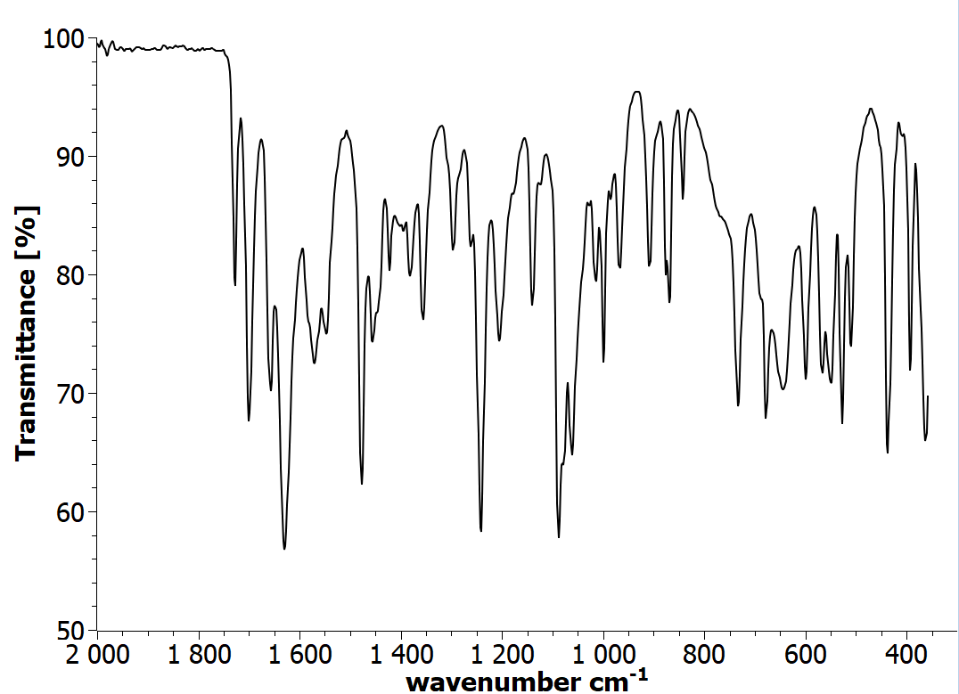
Figure S66: IR spectrum view of N-hydroxy-4-oxo-4-{2-[(2,4,5-trichlorophenoxy)acetyl]hydrazinyl}butanamide (2j)

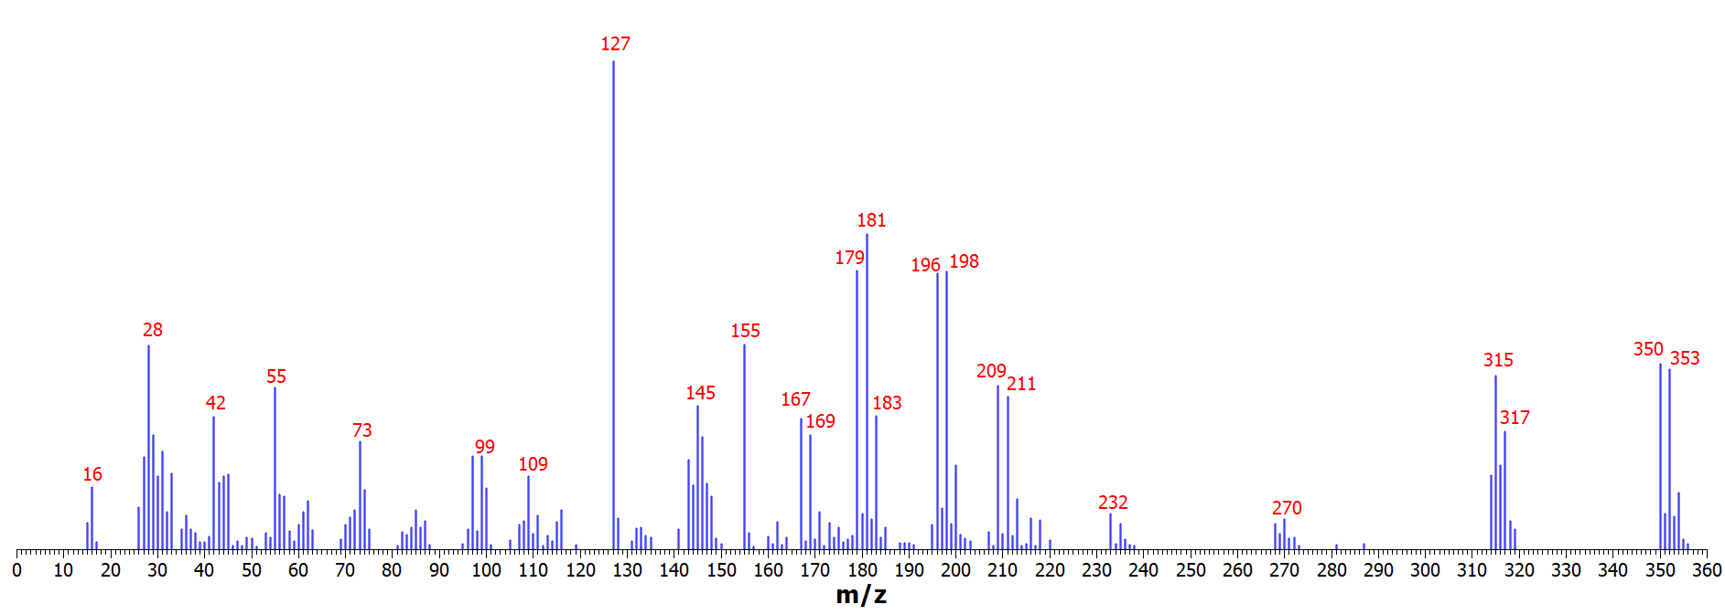
Figure S67: Mass spectrum view of N-hydroxy-4-oxo-4-{2-[(2,4,5-trichlorophenoxy)acetyl]hydrazinyl}butanamide (2j)
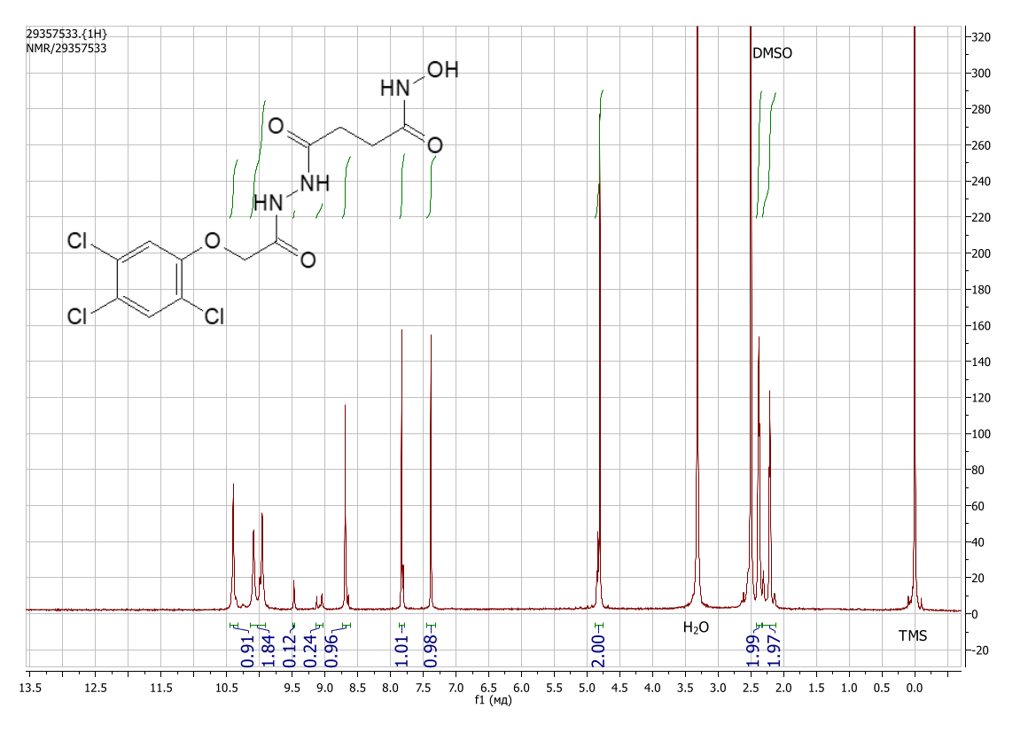
Figure S68: ¹H NMR spectrum view of N-hydroxy-4-oxo-4-{2-[(2,4,5-trichlorophenoxy)acetyl]hydrazinyl}butanamide (DMSO-d₆) (2j) (acquired on a Bruker DRX-600, the additional signals are related to cis-trans isomerisation [DOI: 10.1002/mrc.1260261107])

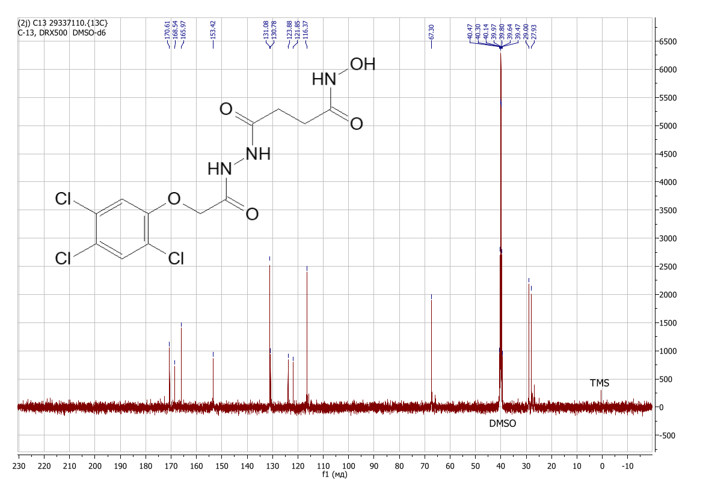
Figure S69: ¹³C NMR spectrum view of N-hydroxy-4-oxo-4-{2-[(2,4,5-trichlorophenoxy)acetyl]hydrazinyl}butanamide (DMSO-d₆) (2j)

N-hydroxy-4-{2-[(3-methylphenoxy)acetyl]hydrazinyl}-4-oxobutanamide (2k)
Yield 0.41 g (35%), colorless crystals. Found, %: C 52.99; H 5.88; N 14.14; O 27.15. C₁₃H₁₇N₃O₅. Calculated, %: C 52.88; H 5.80; N 14.23; O 27.09. IR spectrum, ν, cm⁻¹: 3209, 2988, 1705, 1656, 1517, 1494, 1433, 1347, 1264, 1170, 1067, 967, 934, 775, 688, 571, 460, 440, 378. Mass spectrum, m/z (Irel, %): 263 (6.1), 262 (40.0), 127 (17.2), 121 (23.2), 109 (9.6), 108 (100), 107 (13.8), 100 (5.9), 93 (11.2), 92 (7.3), 91 (85.5), 90 (7.8), 89 (12,7), 79 (11.2), 78 (9.3), 77 (26.3), 65 (47.8), 64 (5.4), 63 (17.6), 62 (5.1), 57 (12.0), 56 (13.6), 55 (44.0), 53 (9.9), 52 (9.4), 51 (18.9), 50 (9.9), 45 (13.6), 44 (25.6), 43 (20.6), 42 (41.5), 41 (11.7), 39 (38.2), 38 (8.7), 33 (42.5), 32 (15.3), 31 (44.7), 30 (35.8), 29 (50.5), 28 (98.4), 27 (68.2), 26 (28.7), 17 (20.2), 16 (49.5), 15 (22.5). ¹H NMR spectrum (DMSO-d₆), δ, ppm (J, Hz): 2.19 – 2.34 (5H, m, -CH₂-, -CH₃), 2.41 (2H, t, J = 7.4, -CH₂-), 4.54 – 4.63 (2H, m, -CH₂-), 6.75 – 6.85 (3H, m, Ar-H), 7.18 (1H, t, J = 7.8), 8.68 – 8.76 (1H, m, O-H), 9.85 – 10.10 (2H, m, N-H), 10.36 – 10.47 (1H, m, N-H). ¹³C NMR spectrum (DMSO-d₆), δ, ppm: 21.56; 27.98; 29.06; 66.35; 112.20; 115.81; 122.41; 129.64; 139.43; 158.21; 167.10; 168.55; 170.67.
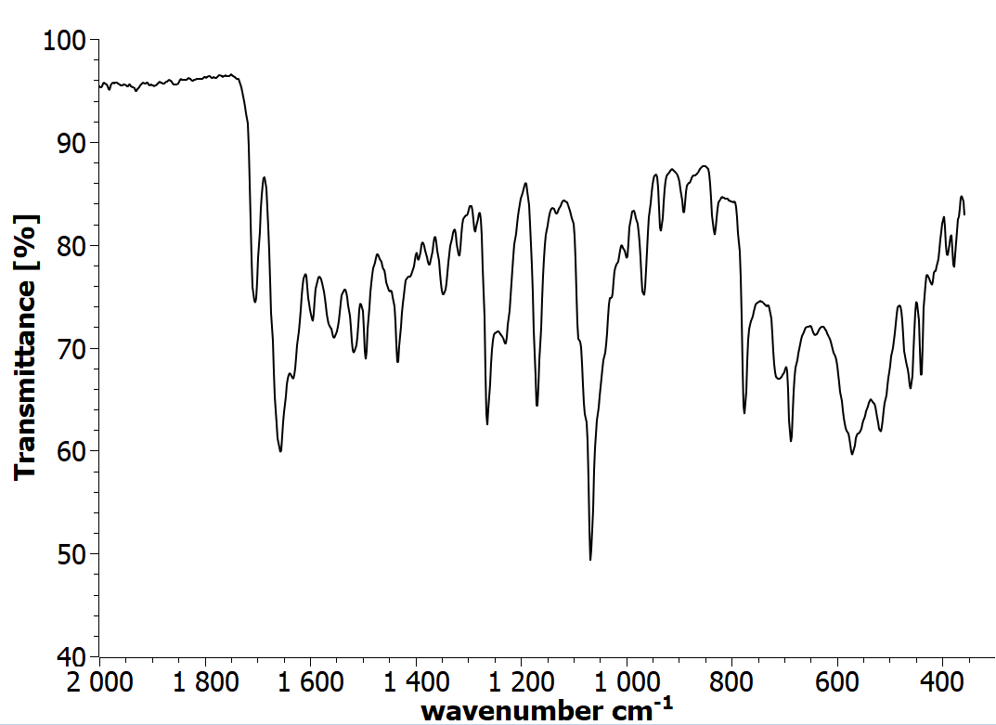

Figure S70: IR spectrum view of N-hydroxy-4-{2-[(3-methylphenoxy)acetyl]hydrazinyl}-4-oxobutanamide (2k)

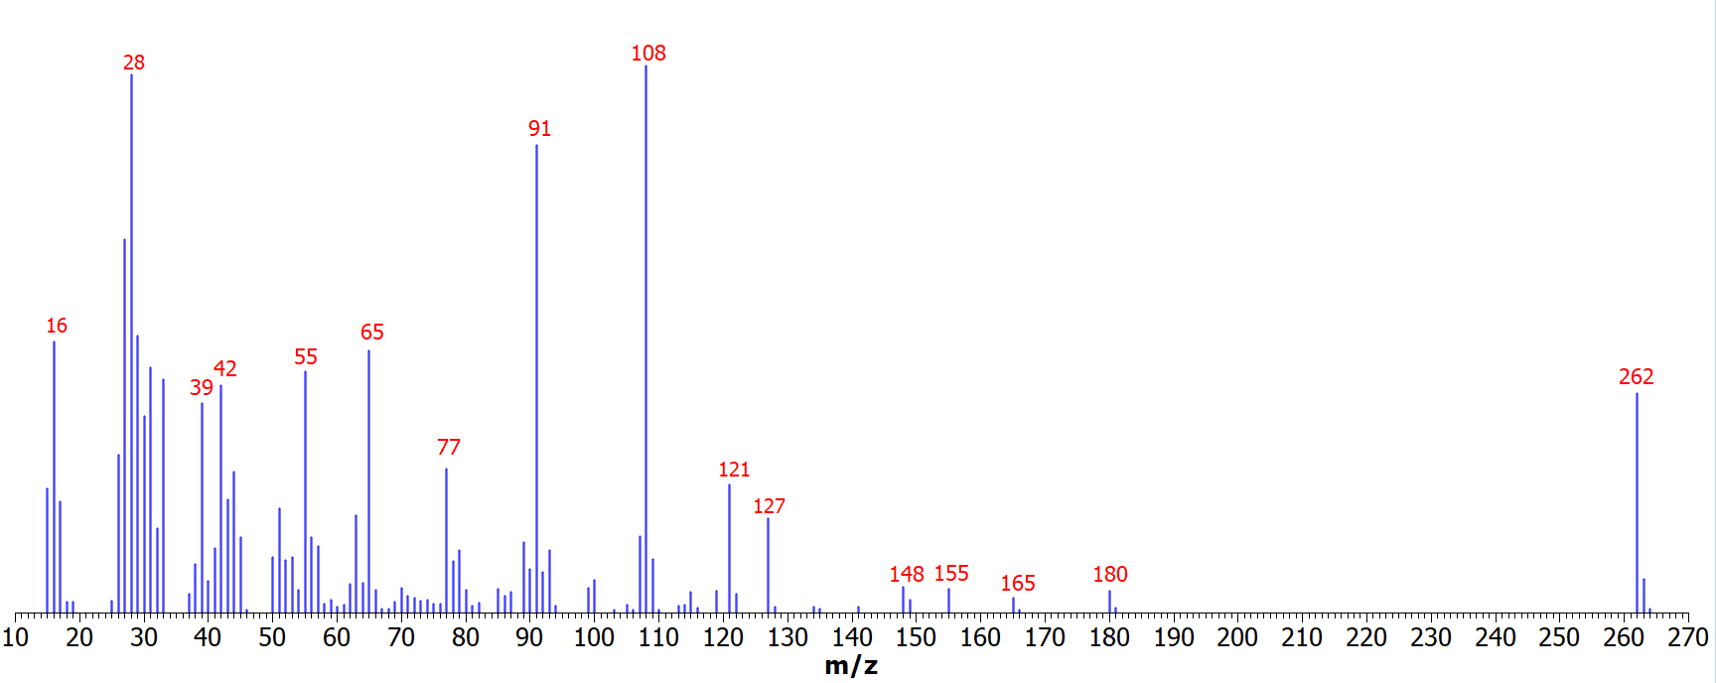
Figure S71: Mass spectrum view of N-hydroxy-4-{2-[(3-methylphenoxy)acetyl]hydrazinyl}-4-oxobutanamide (2k)

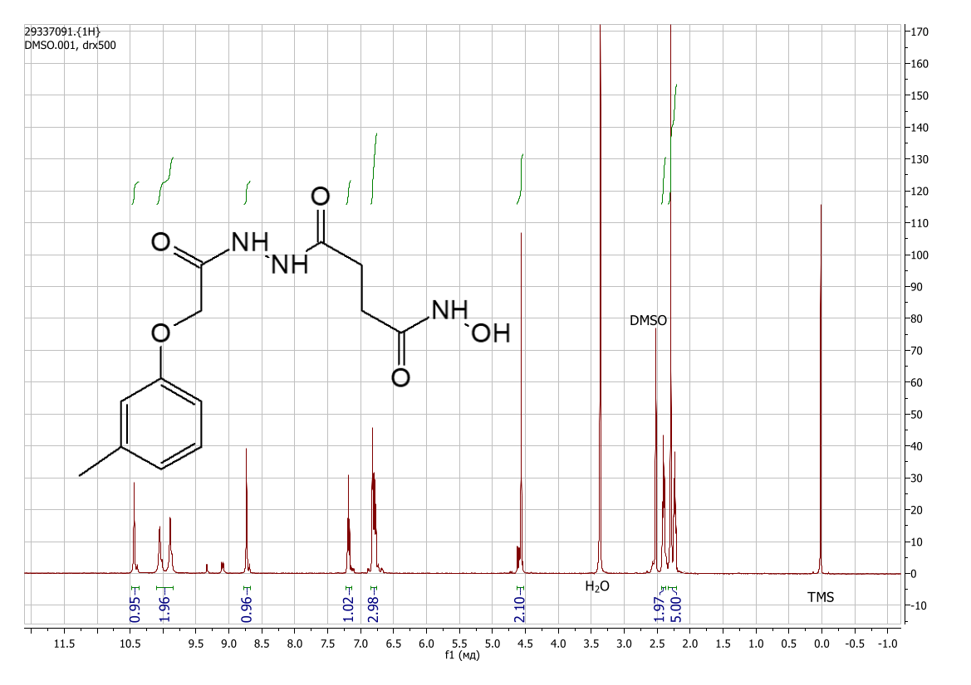
Figure S72: ¹H NMR spectrum view of N-hydroxy-4-{2-[(3-methylphenoxy)acetyl]hydrazinyl}-4-oxobutanamide (DMSO-d₆) (2k) (the additional signals are related to cis-trans isomerisation [DOI: 10.1002/mrc.1260261107])
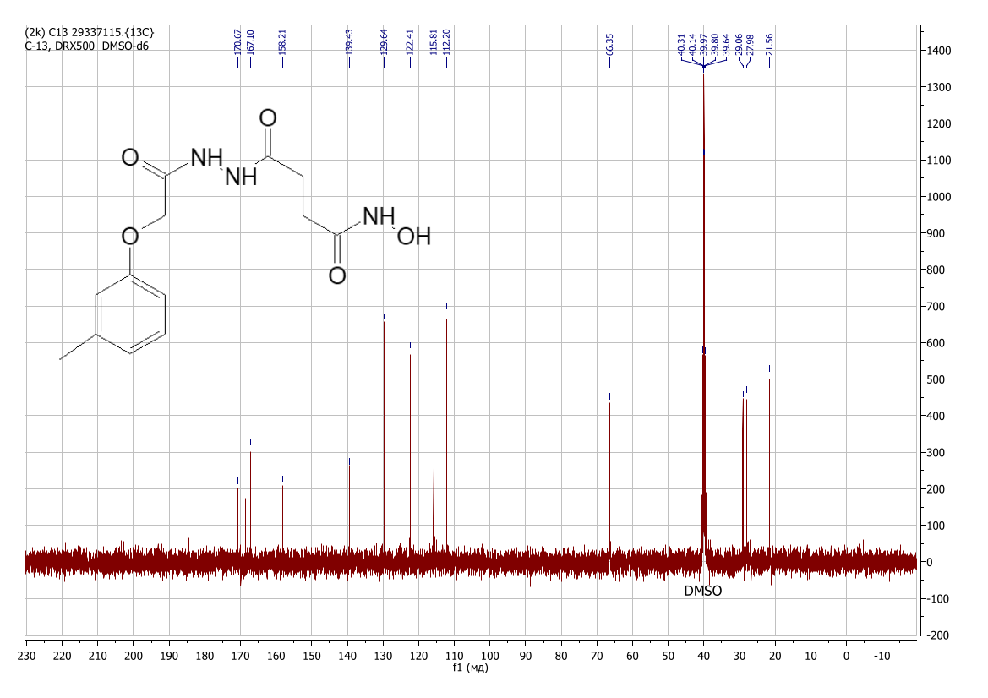

Figure S73: ¹³C NMR spectrum view of N-hydroxy-4-{2-[(3-methylphenoxy)acetyl]hydrazinyl}-4-oxobutanamide (DMSO-d₆) (2k)

N-hydroxy-4-oxo-4-[2-(3-phenylpropanoyl)hydrazinyl]butanamide (2l)
Yield 0.48 g (43%), colorless crystals. Found, %: C 56.02; H 5.98; N 15.09; O 23.02. C₁₃H₁₇N₃O₄. Calculated, %: C 55.91; H 6.14; N 15.05; O 22.91. IR spectrum, ν, cm⁻¹: 3212, 1598, 1558, 1485, 1447, 1330, 1283, 1163, 1121, 1069, 1001, 979, 896, 796, 696, 653, 517. Mass spectrum, m/z (Irel, %): 247 (8.5), 246 (22.3), 165 (7.43), 164 (21.0), 133 (11.2), 132 (6.3), 131 (7.8), 116 (10.1), 115 (11.2), 106 (7.2), 105 (84.9), 104 (49.1), 103 (15.6), 100 (16.2), 92 (7.3), 91 (100), 79 (12.2), 78 (13.9), 77 (23.4), 65 (11.9), 56 (6.0), 55 (19.7), 51 (12.2), 44 (17.4), 43 (6.5), 42 (11.8), 39 (8.6), 31 (9.9), 30 (6.2), 29 (8.5), 27 (19.4), 26 (5.7). ). ¹H NMR spectrum (DMSO-d₆), δ, ppm (J, Hz): 2.04 – 2.24 (2H, m, -CH₂-), 2.30 – 2.47 (4H, m, -CH₂-), 2.73 – 2.87 (2H, m, -CH₂-), 7.15 – 7.30 (5H, m, Ar-H), 8.64 – 8.73 (1H, m, O-H), 9.71 – 9.93 (2H, m, N-H), 10.32 – 10.45 (1H, m, N-H). ¹³C NMR spectrum (DMSO-d₆), δ, ppm: 28.04; 29.04; 31.18; 35.17; 126.41; 128.68; 128.76; 141.48; 168.60; 170.51; 170.66.
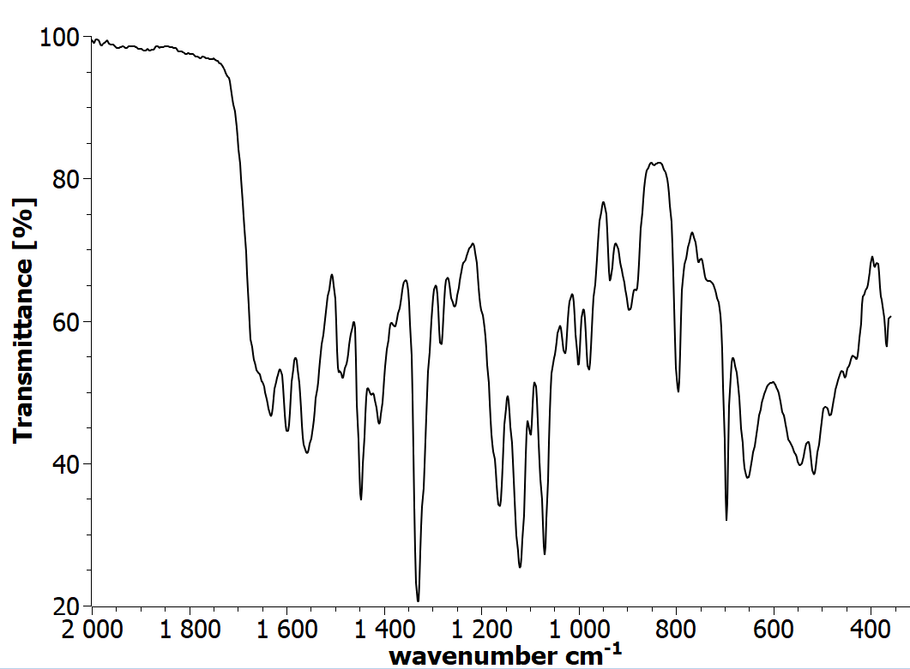

Figure S74: IR spectrum view of N-hydroxy-4-oxo-4-[2-(3-phenylpropanoyl)hydrazinyl]butanamide (2l)
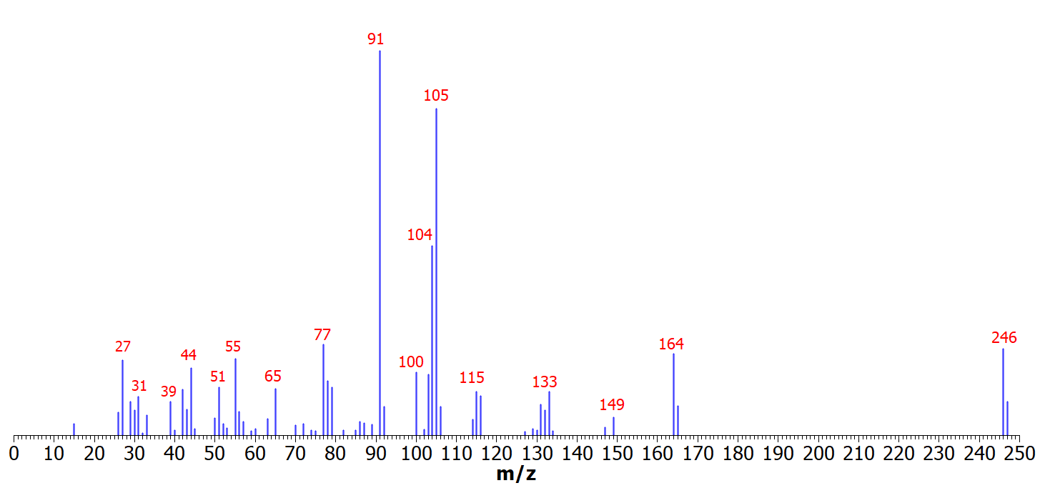
Figure S75: Mass spectrum view of N-hydroxy-4-oxo-4-[2-(3-phenylpropanoyl)hydrazinyl]butanamide (2l)

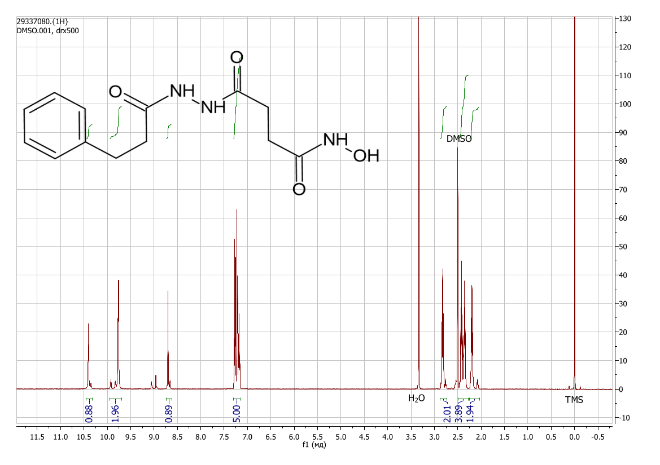
Figure S76: ¹H NMR spectrum view of N-hydroxy-4-oxo-4-[2-(3-phenylpropanoyl)hydrazinyl]butanamide (DMSO-d₆) (2l) (the additional signals are related to cis-trans isomerisation [DOI: 10.1002/mrc.1260261107])

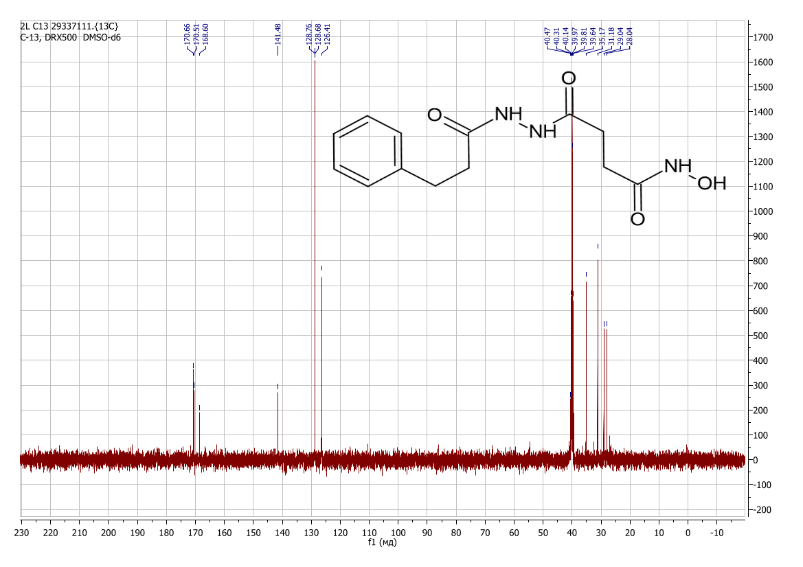
Figure S77: ¹³C NMR spectrum view of N-hydroxy-4-oxo-4-[2-(3-phenylpropanoyl)hydrazinyl]butanamide (DMSO-d₆) (2l)

N-hydroxy-4-oxo-4-[2-(phenoxyacetyl)hydrazinyl]butanamide (2m)
Yield 0.51 g (46%), colorless crystals. Found, %: C 51.16; H 5.45; N 15.01; O 28.33. C₁₂H₁₅N₃O₅. Calculated, %: C 51.24; H 5.38; N 14.94; O 28.44. IR spectrum, ν, cm⁻¹: 3225, 2988, 1699, 1664, 1560, 1502, 1434, 1293, 1224, 1069, 971, 890, 748, 690, 585, 509, 466, 368. Mass spectrum, m/z (Irel, %): 249 (4.0), 248 (27.0), 127 (47.3), 107 (26.8), 100 (9.8), 99 (6.9), 95 (5.6), 94 (66.4), 79 (22.2), 78 (11.4), 77 (100), 66 (11.2), 65 (23.4), 63 (11.0), 57 (11.4), 56 (12.3), 55 (41.7), 52 (5.5), 51 (45.5), 50 (16.3), 45 (11.5), 44 (31.9), 43 (20.0), 42 (38.9), 41 (5.4), 40 (7.3), 39 (43.6), 38 (13.2), 37 (5.5), 33 (22.2), 32 (10.0), 31 (24.7), 30 (27.1), 29 (43.8), 28 (71.7), 27 (46.5), 26 (25.4), 16 (19.0), 15 (12.5). ¹H NMR spectrum (DMSO-d₆), δ, ppm (J, Hz): 2.10 – 2.30 (2H, m, -CH₂-), 2.39 (2H, t, J = 7.5, -CH₂-), 4.54 – 4.64 (2H, m, -CH₂-), 6.85 – 7.00 (3H, m, Ar-H), 7.23 – 7. 34 (2H, m, Ar-H), 8.65 – 8.76 (1H, m, -OH), 9.75 -10.15 (2H, m, N-H), 10.35 – 10.45 (1H, m, N-H). ¹³C NMR spectrum (DMSO-d₆), δ, ppm: 28.03; 31.86; 55.58; 114.23; 120.89; 132.97; 155.42; 168.85; 170.10.
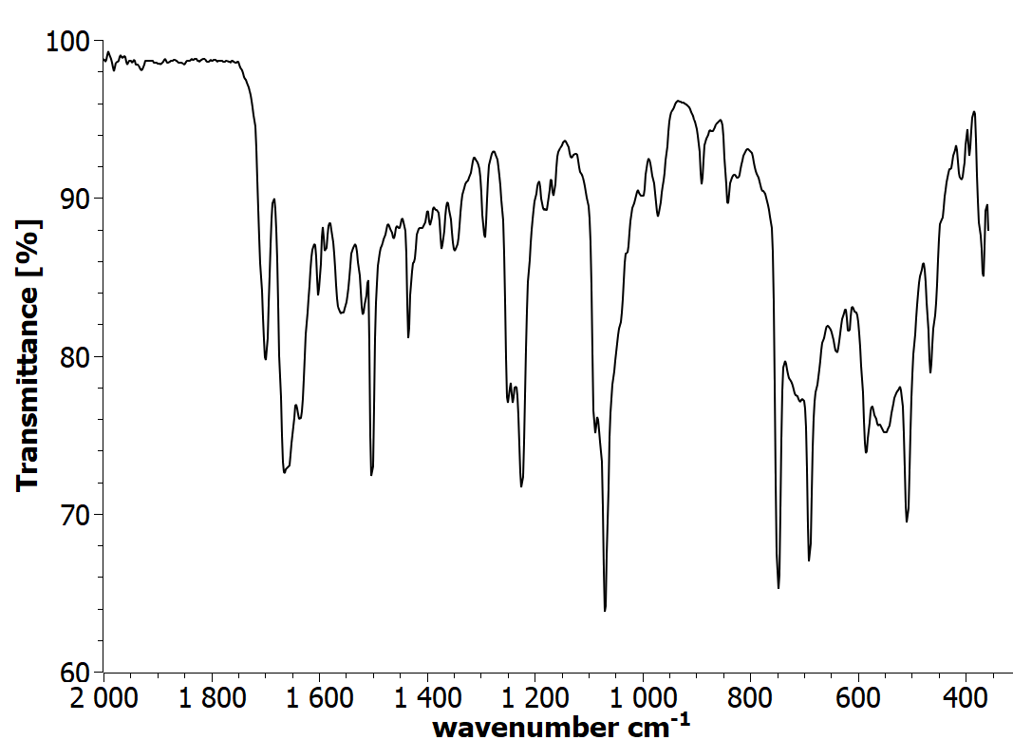
Figure S78: IR spectrum view of N-hydroxy-4-oxo-4-[2-(phenoxyacetyl)hydrazinyl]butanamide (2m)

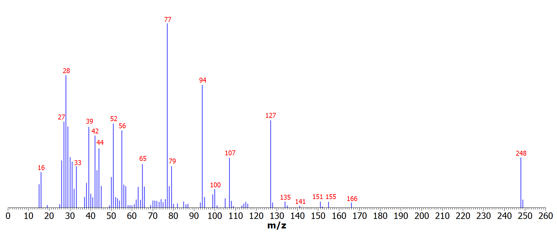
Figure S79: Mass spectrum view of N-hydroxy-4-oxo-4-[2-(phenoxyacetyl)hydrazinyl]butanamide (2m)

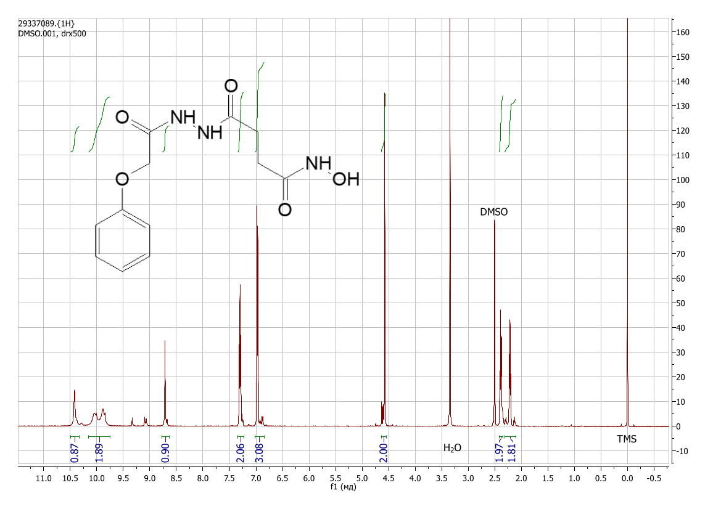
Figure S80: ¹H NMR spectrum view of N-hydroxy-4-oxo-4-[2-(phenoxyacetyl)hydrazinyl]butanamide (DMSO-d₆) (2m) (the additional signals are related to cis-trans isomerisation [DOI: 10.1002/mrc.1260261107])

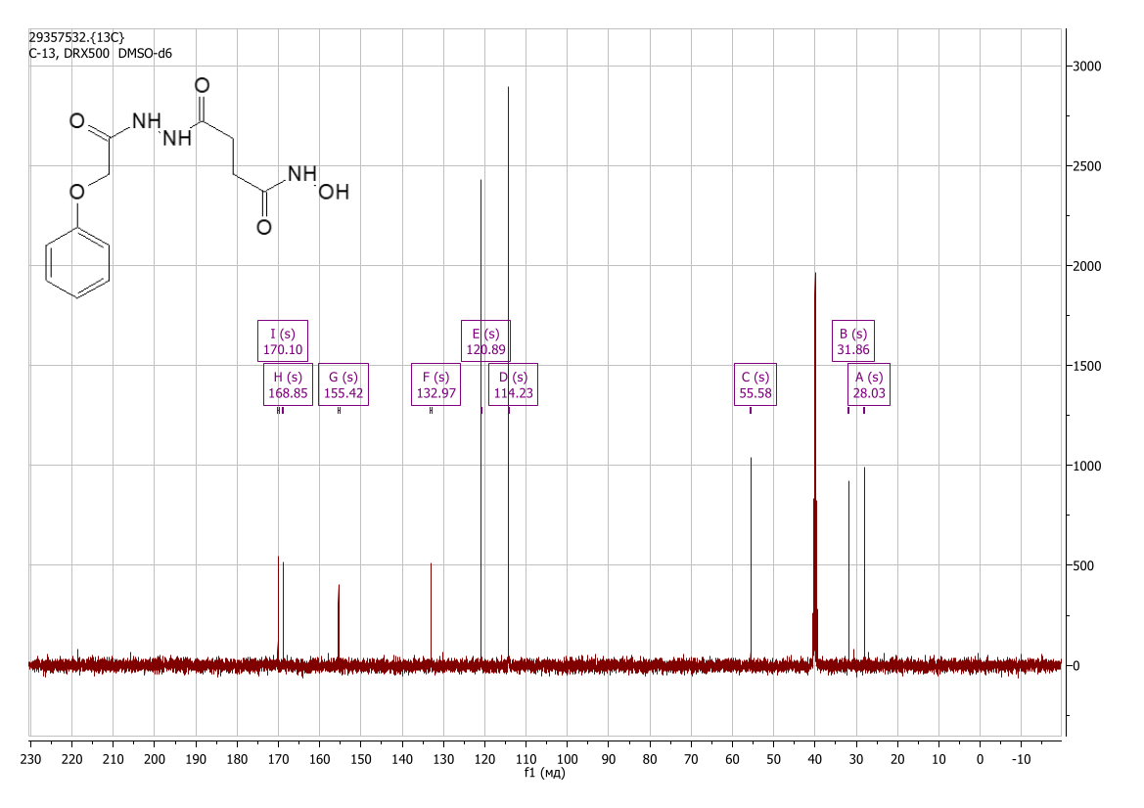
Figure S81: ¹³C NMR spectrum view of N-hydroxy-4-oxo-4-[2-(phenoxyacetyl)hydrazinyl]butanamide (DMSO-d₆) (2m)

4-{2-[3-(1H-benzotriazol-1-yl)propanoyl]hydrazinyl}-N-hydroxy-4-oxobutanamide (2n)
Yield 1.09 g (85%), colorless crystals. Found, %: C 48.88; H 5.09; N 26.35; O 20.13. C₁₃H₁₆N₆O₄. Calculated, %: C 48.75; H 5.03; N 26.24; O 19.98. IR spectrum, ν, cm⁻¹: 3192, 2987, 1649, 1594, 1492, 1455, 1413, 1277, 1223, 1196, 1161, 1080, 979, 939, 775, 755, 742, 664, 545, 522, 428. Mass spectrum, m/z (Irel, %): 287 (2.7), 205 (1.5), 174 (28.0), 146 (24.0), 141 (5.2), 120 (7.5), 119 (11.1), 118 (11.4), 117 (9.5), 114 (7.5), 104 (13.5), 93 (4.5), 91 (21.3), 90 (24.9), 89 (4.6), 86 (10.9), 85 (6.6), 78 (6.8), 77 (52.6), 76 (9.8), 70 (6.3), 69 (5.3), 65 (12.0), 64 (22.5), 63 (24.1), 62 (6.4), 59 (5.2), 57 (12.7), 56 (19.0), 55 (97.0), 54 (6.0), 52 (9.4), 51 (30.0), 50 (15.3), 44 (15.7), 43 (16.5), 42 (48.4), 41 (8.3), 39 (31.5), 38 (12.1), 33 (8.1), 31 (34.9), 30 (17.8), 29 (48.4), 28 (35.5), 27 (100), 26 (37.7), 15 (14.6). ). ¹H NMR spectrum (DMSO-d₆), δ, ppm (J, Hz): 1.97 – 2.27 (2H, m, -CH₂-), 2.30 – 2.40 (2H, m, -CH₂-), 2.87 – 2.99 (2H, m, -CH₂-), 4.84 – 4.98 (2H, m, -CH₂-), 7.41 (1H, t, J = 7.6, Ar-H), 7.57 (1H, t, J = 7.6, Ar-H), 7.87 – 7.93 (1H, m, Ar-H), 8.04 (1H, d, J = 8.3, Ar-H), 8.64 – 8.74 (1H, m, -OH), 9.75 – 10.10 (2H, m, -NH), 10.30 – 10.45 (1H, m, -NH). ¹³C NMR spectrum (DMSO-d₆), δ, ppm: 27.97; 28.95; 32.52; 43.90; 111.36; 119.43; 124.36; 127.59; 133.37; 145.54; 168.39; 170.33.
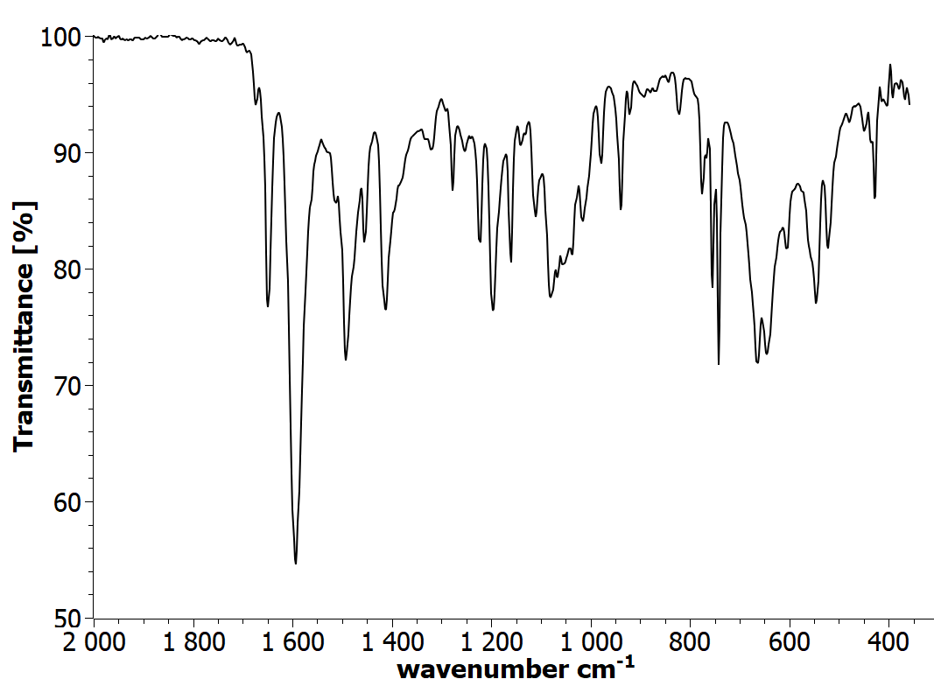
Figure S82: IR spectrum view of 2-[3-(1H-benzotriazol-1-yl)propanoyl]hydrazinyl}-N-hydroxy-4-oxobutanamide (2n)

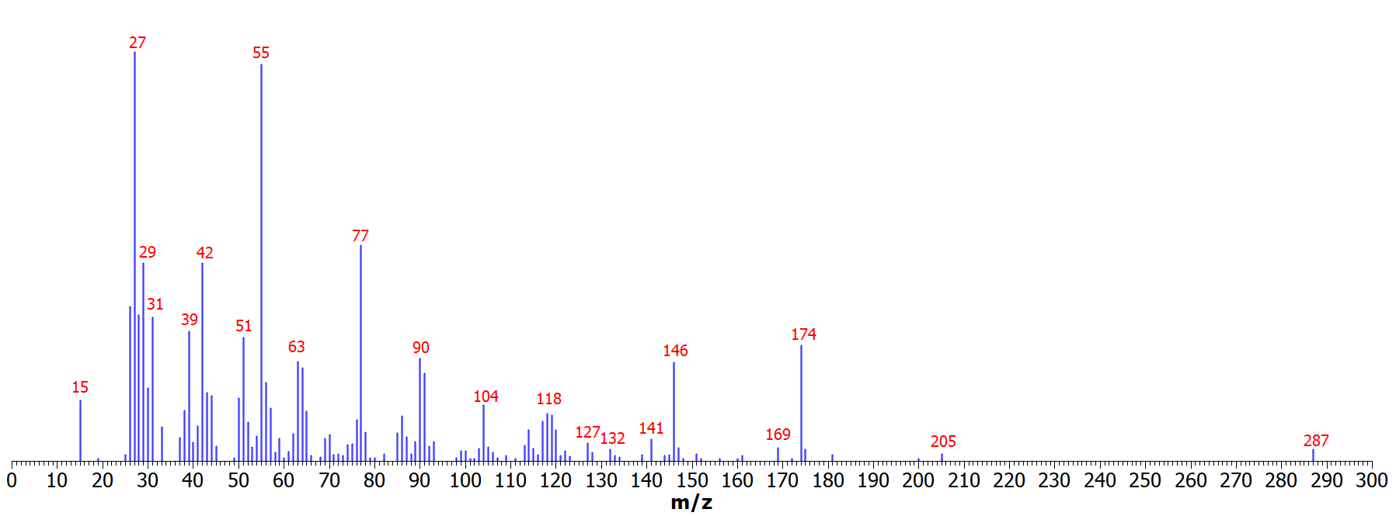
Figure S83: Mass spectrum view of 2-[3-(1H-benzotriazol-1-yl)propanoyl]hydrazinyl}-N-hydroxy-4-oxobutanamide (2n)
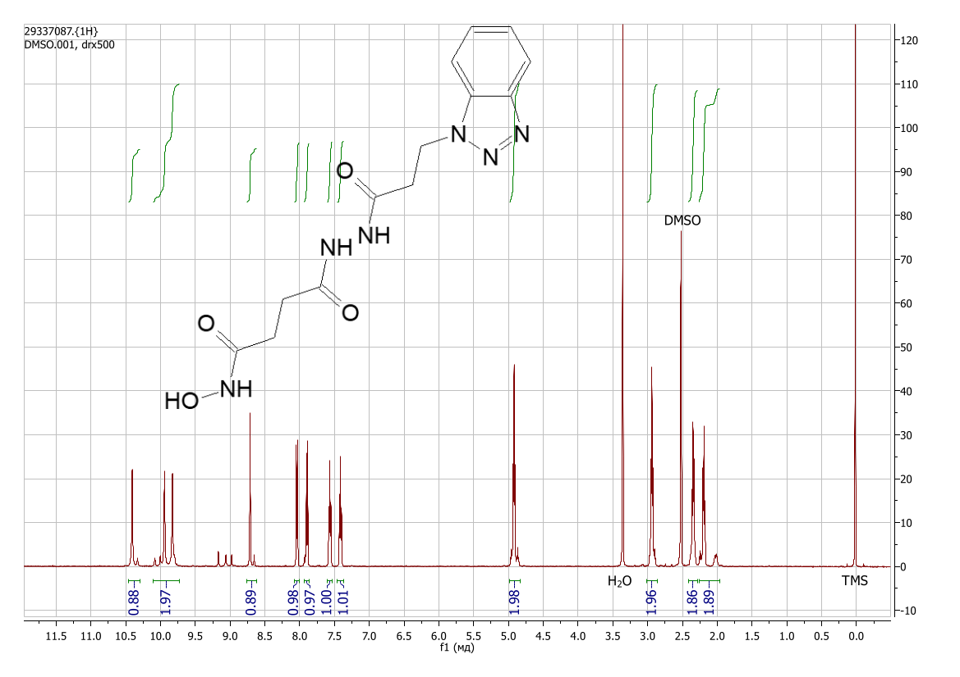
Figure S84: ¹H NMR spectrum view of 2-[3-(1H-benzotriazol-1-yl)propanoyl]hydrazinyl}-N-hydroxy-4-oxobutanamide (DMSO-d₆) (2n) (the additional signals are related to cis-trans isomerisation [DOI: 10.1002/mrc.1260261107])

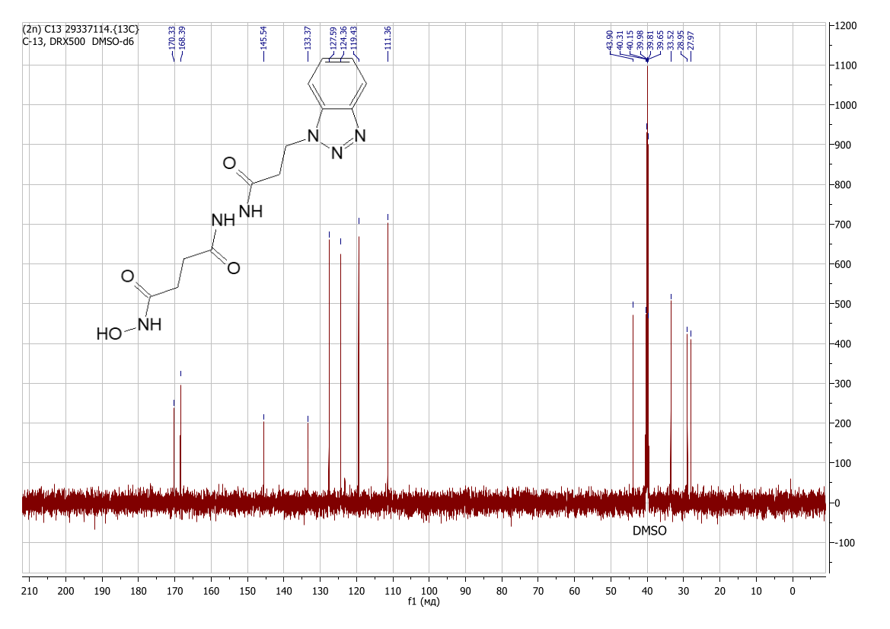
Figure S85: ¹³C NMR spectrum view of 2-[3-(1H-benzotriazol-1-yl)propanoyl]hydrazinyl}-N-hydroxy-4-oxobutanamide (DMSO-d₆) (2n)

4-{2-[4-(dimethylamino)benzoyl]hydrazinyl}-N-hydroxy-4-oxobutanamide (2o)
Yield 1.01 g (86%), colorless crystals. Found, %: C 52.99; H 6.27; N 19.01; O 21.84. C₁₃H₁₈N₄O₄. Calculated, %: C 53.05; H 6.16; N 19.04; O 21.75. IR spectrum, ν, cm⁻¹: 3676, 3250, 2988, 2972, 2901, 1678, 1620, 1573, 1558, 1541, 1522, 1406, 1382, 1320, 1276, 1235, 1207, 1066, 897, 826, 756, 669, 614, 570, 527, 505, 443, 420, 398, 378. ¹H NMR spectrum (DMSO-d₆), δ, ppm (J, Hz): 2.10 – 2.48 (4H, m, -CH₂-), 2.92 – 3.04 (6H, m, -CH₃), 6.65 – 6.77 (2H, m, Ar-H), 7.66 – 7.81 (2H, s, Ar-H), 8.59 – 8.81 (1H, m, O-H), 9.60 – 10.05 (2H, m, N-H), 10.15 – 10.55 (1H, m, N-H). ¹³C NMR spectrum (DMSO-d₆), δ, ppm: 27.57; 28.68; 110.66; 118.75; 128.74; 152.29; 165.32; 168.09; 170.66.
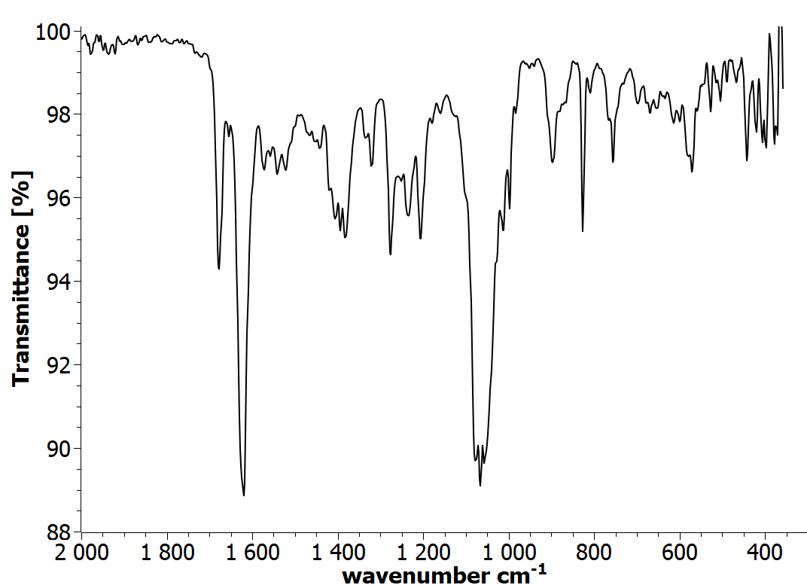
Figure S86: IR spectrum view of 4-{2-[4-(dimethylamino)benzoyl]hydrazinyl}-N-hydroxy-4-oxobutanamide (2o)

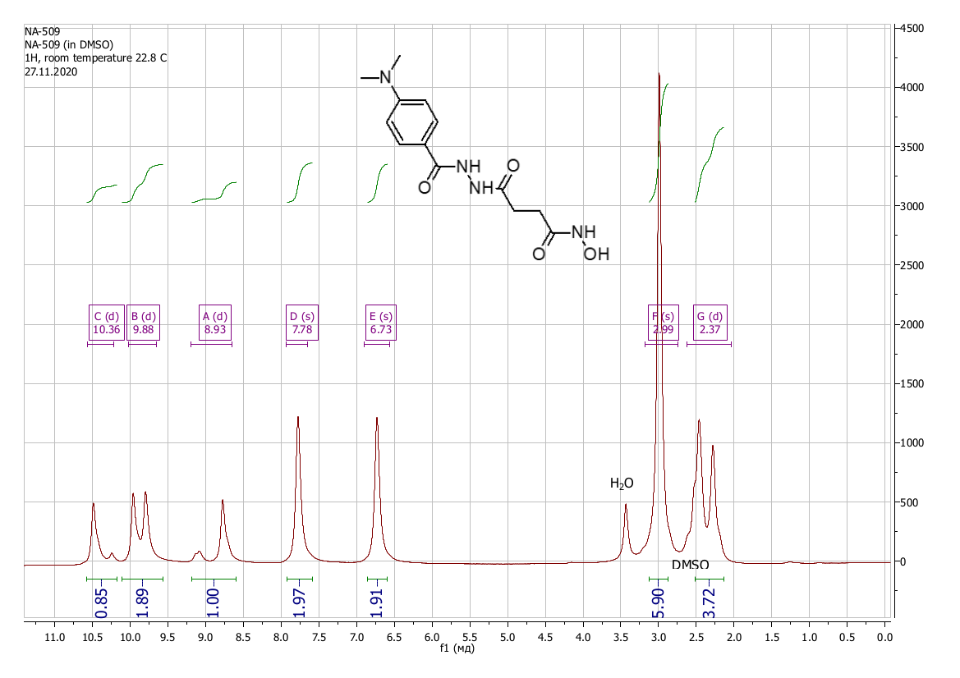
Figure S87: ¹H NMR spectrum view of 4-{2-[4-(dimethylamino)benzoyl]hydrazinyl}-N-hydroxy-4-oxobutanamide (DMSO-d₆) (2o) (acquired on a Bruker DRX-500)

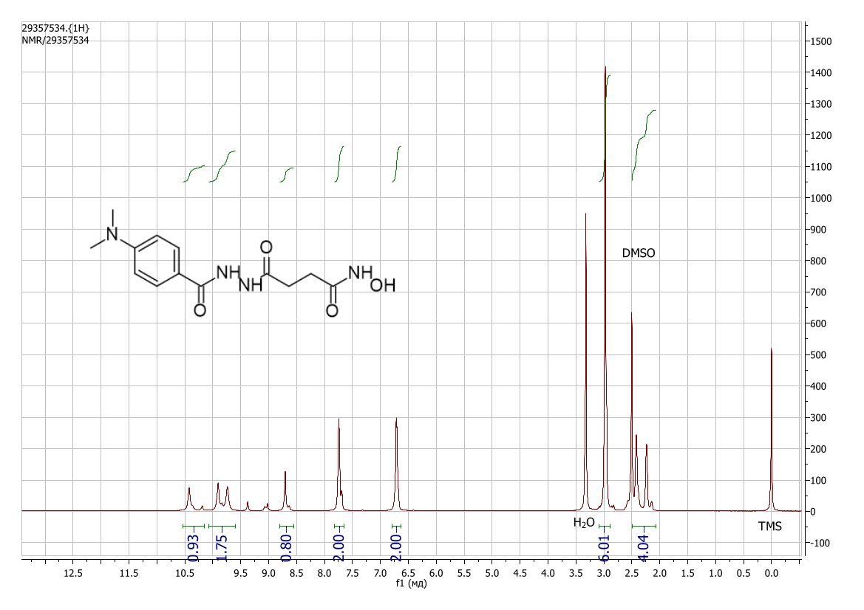
Figure S88: ¹H NMR spectrum view of 4-{2-[4-(dimethylamino)benzoyl]hydrazinyl}-N-hydroxy-4-oxobutanamide (DMSO-d₆) (2o) (acquired on a Bruker DRX-600) (the additional signals are related to cis-trans isomerisation [DOI: 10.1002/mrc.1260261107])

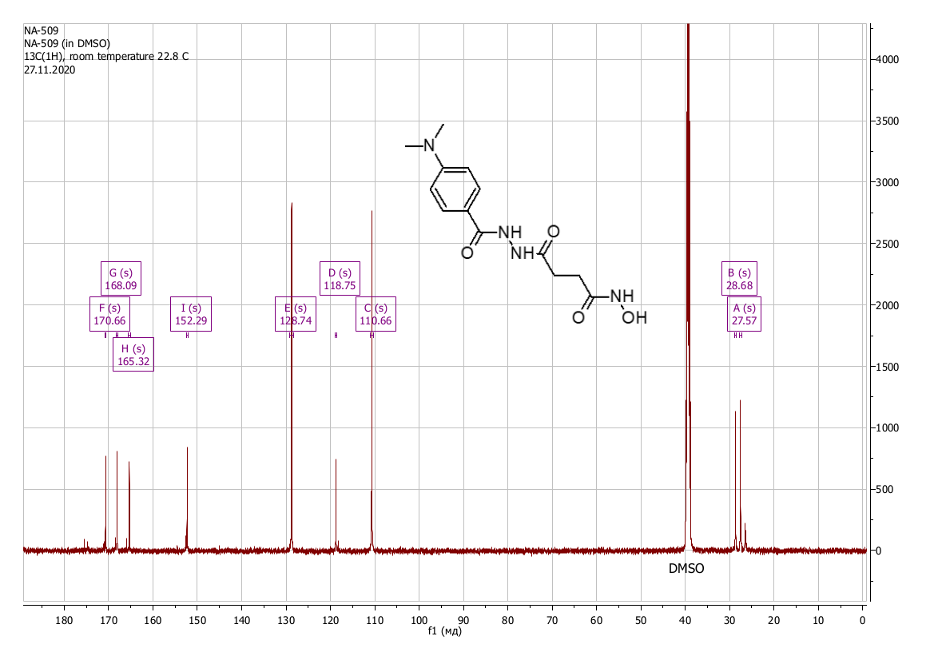
Figure S86: ¹³C NMR spectrum view of 4-{2-[4-(dimethylamino)benzoyl]hydrazinyl}-N-hydroxy-4-oxobutanamide (DMSO-d₆) (2o)

4-{2-[(3,5-dimethylphenoxy)acetyl]hydrazinyl}-N-hydroxy-4-oxobutanamide (2p)
Yield 0.99 g (80%), colorless crystals Found, %: C 54.39; H 6.25; N 13.61; O 25.92. C₁₄H₁₉N₃O₅. Calculated, %: C 54.36; H 6.19; N 13.58; O 25.86. IR spectrum, ν, cm⁻¹: 3676, 3238, 2988, 2914, 1689, 1656, 1613, 1561, 1516, 1471, 1422, 1394, 1350, 1297, 1264, 1221, 1162, 1149, 1071, 1019, 997, 899, 848, 789, 755, 702, 678, 625, 598, 552, 480, 434, 407, 375. ¹H NMR spectrum (DMSO-d₆), δ, ppm (J, Hz): 2.20 – 2.25 (8H, m, -CH₃, -CH₂- ), 2.40 (2H, t, J = 7.6, -CH₂-), 4.51 – 4.58 (2H, m, O-CH₂-C=O), 6.59 (3H, s, Ar-H), 8.73 (1H, s, O-H), 9.88 (1H, s, N-H), 10.02 (1H, s, N-H), 10.44 (1H, s, N-H). ¹³C NMR spectrum (DMSO-d₆), δ, ppm: 21.11; 27.10; 28.67; 65.97; 112.35; 122.93; 138.65; 157.76; 166.30; 168.20; 170.30.

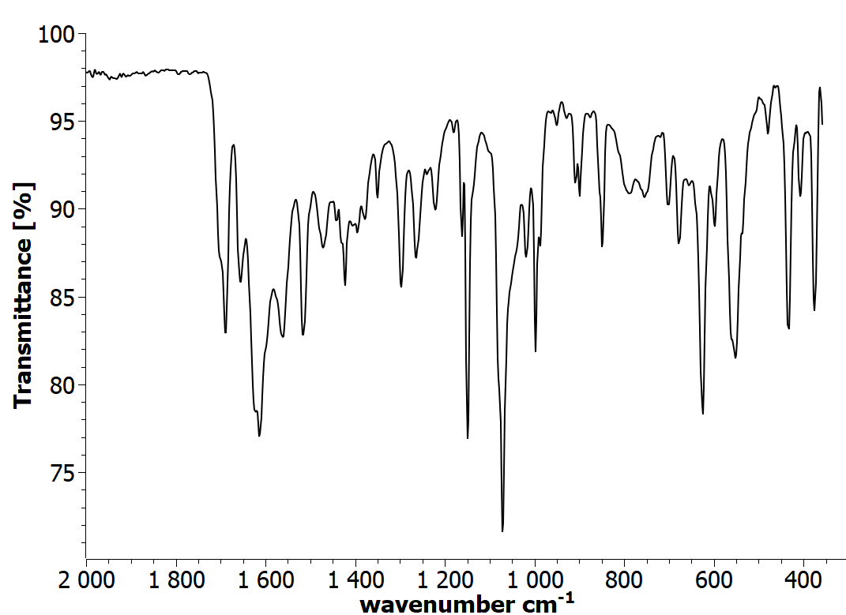

Figure S87: IR spectrum view of 4-{2-[(3,5-dimethylphenoxy)acetyl]hydrazinyl}-N-hydroxy-4-oxobutanamide (2p)

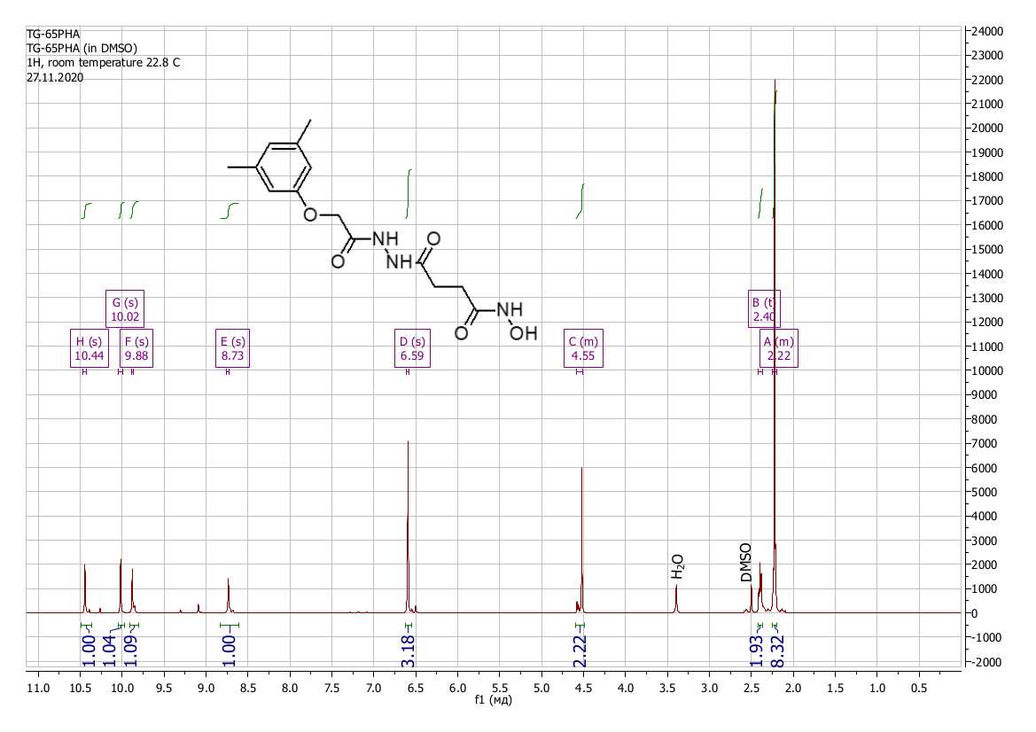
Figure S88: ¹H NMR spectrum view of 4-{2-[(3,5-dimethylphenoxy)acetyl]hydrazinyl}-N-hydroxy-4-oxobutanamide (DMSO-d₆) (2p) (the additional signals are related to cis-trans isomerisation [DOI: 10.1002/mrc.1260261107])
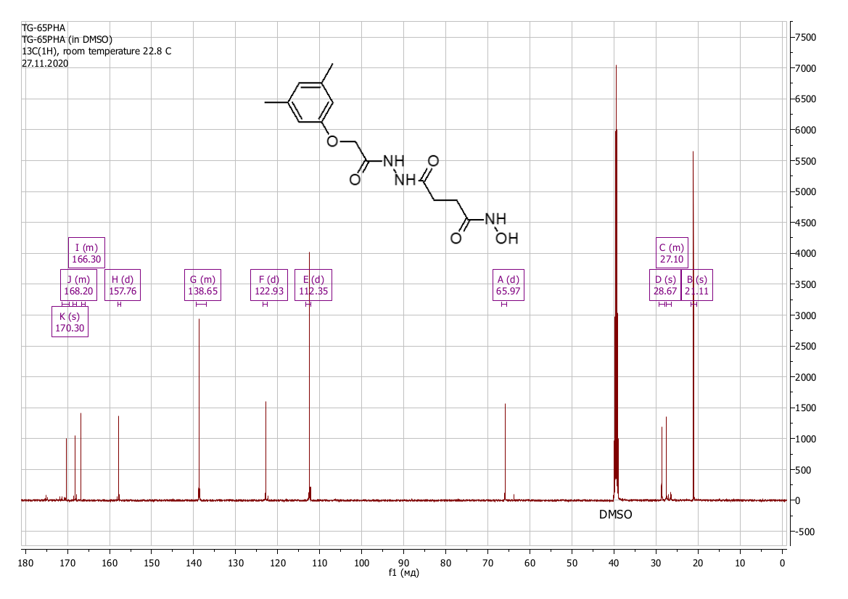
Figure S89: ¹³C NMR spectrum view of 4-{2-[(3,5-dimethylphenoxy)acetyl]hydrazinyl}-N-hydroxy-4-oxobutanamide (DMSO-d₆) (2p)

