Nucleophilic Functionlization of Thianthrenium Salts under Base Conditions
Xinting Fan,¹ Duo Zhang,² Xiangchuan Xiu,¹ Bin Xu,¹ Yu Yuan,^{1,}* Feng Chen,^{1,}* Pan Gao^{1,}*
¹School of Chemistry and Chemical Engineering, Yangzhou University, Yangzhou 225002, China
²Medicine Center, Guangxi University of Science and Technology, Liushi Road 257, Liuzhou, Guangxi 545006, China

Table of Contents
1. General Information. S2
2. General Procedure for Synthesis of Starting Materials S2
3. Experimental Procedures S5
4. The Mechanism Study S18
5. References S19
6. Spectra of ¹H NMR, ¹³C NMR, ¹⁹F NMR S21

1. General Information.
All new compounds were fully characterized. All reactions and manipulations involving air-sensitive compounds were performed using standard Schlenk techniques. Anhydrous MeCN was purchased from Annaiji Chemical and was used as received. ¹H and ¹³C NMR spectra were recorded on an Agilent DD2 400 MHz spectrometer. The chemical shifts in ¹H NMR spectra were recorded relative to CDCl₃ (δ 7.26). The chemical shifts in ¹³C NMR spectra were recorded relative to CDCl₃ (δ 77.0). The High-resolution mass spectral (HRMS) data were obtained on quadrupole-type Bruker Dalton MAXIS (APCI). Gas analyses were conducted with a Shimadzu GC-2014 equipped with ULBON HR-1 glass capillary column (Shinwa Chemical Industries) and an FID detector. Unless otherwise noted, materials obtained from commercial suppliers were used without further purification.

2. General Procedure for Synthesis of Starting Materials
General Procedure A
A flame-dried 100 mL flask was placed under an atmosphere of nitrogen and charged with a stir bar and alcohol (5.0 mmol, 1.0 equiv). The alcohol was dissolved in CH₂Cl₂ (20.0 mL) and cooled to -30 °C before adding pyridine (483 µL, 6.0 mmol, 1.2 equiv). While stirring, triflic anhydride (1.0 mL, 29.3 mmol, 1.20 equiv) was added dropwise, and then the reaction mixture stirred for 3 h while remaining at -5 °C. While the flask was still in a -5 °C bath, 0.5 M H₂SO₄ (30 mL) was added. The flask was removed from the cold bath, and the mixture was transferred to a separatory funnel and extracted with 3×20 mL of CH₂Cl₂. The organic layers were combined and washed 1× 50mL of distilled water. The collected organic layers were then dried over MgSO₄, then filtered and concentrated to a 10 mL liquid under vacuum (without heating), which was used directly in the next step.
Flame-dried 25 mL Schlenk tube was added thianthrene (1.08g, 5.0 mmol), then the above liquid was added. The mixture was stired at 55 °C for 24 h. The mixture was carefully condensed under reduced pressure at 25 ºC and purified by precipitation with Et₂O/DCM. Most of the unreacted dibenzothiophene was removed by repeating the precipitation procedure 2 or 3 times. If the salt still did not precipitate, it was subjected to silica gel chromatography with acetone/DCM.¹

Method B:
A solution of alcohol (20 mmol) in ethyl formate (60 ml) was treated with 0.4 mmol of Bi(OTf)₃. The reaction mixture was stirred under reflux conditions for 5 h. Evaporation of the solvent followed by silica-gel chromatography gave the pure formate.
To a stirred mixture of Thianthrene (1.08 g, 5.0 mmol) and formate (10.0 mmol), cooled in an ice-bath, was added 2.5 ml of trifluoromethanesulfonic acid. The mixture was removed from the ice-bath and stirred for 10 h at room temperature, after which it was poured into 100 ml of water. The resulting suspension was extracted with DCM. The collected organic layers were then dried over MgSO₄, then filtered and concentrated under reduced pressure at 25 ºC and purified by precipitation with Et₂O/DCM. Most of the unreacted dibenzothiophene was removed by repeating the precipitation procedure 2 or 3 times.¹
Alkyl thianthrenium salts exhibit greater stability and are more amenable to long-term preservation when compared to alkyl trifluoromethanesulfonate compounds. For instance, when phenethyl trifluoromethanesulfonate is exposed to air at room temperature for 24 hours, its initially colorless and transparent appearance transforms into a deep yellow hue (Scheme S1). Our comparison of the NMR data reveals that compound has undergone decomposition, resulting in the formation of unidentified by-products. By comparison, alkyl thianthrenium salt 1a do not exhibit significant changes after being placed in the air for 24 hours (Scheme S3).
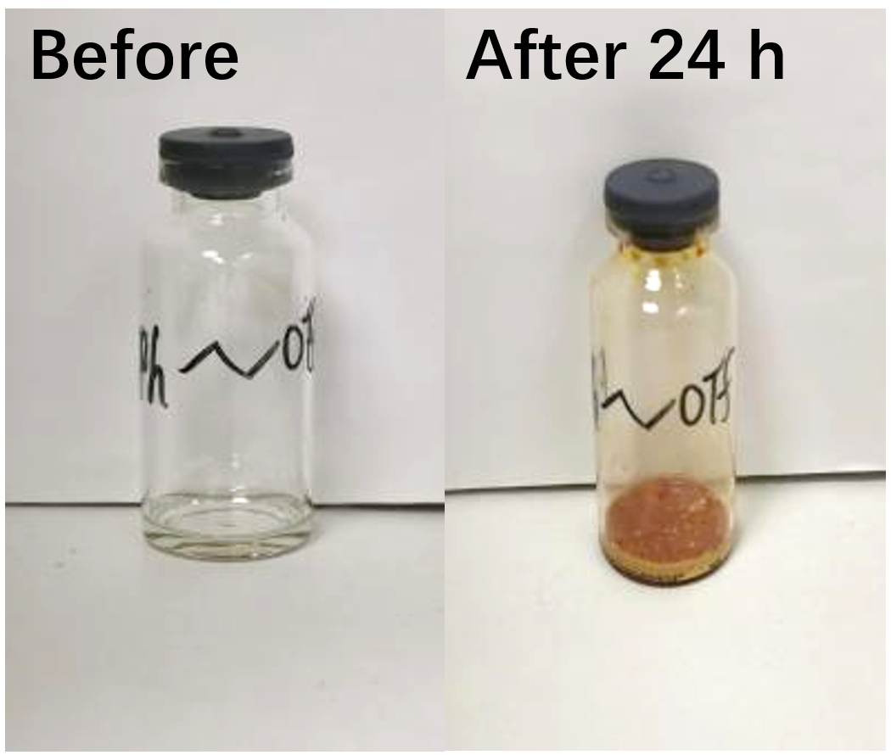
Scheme S1
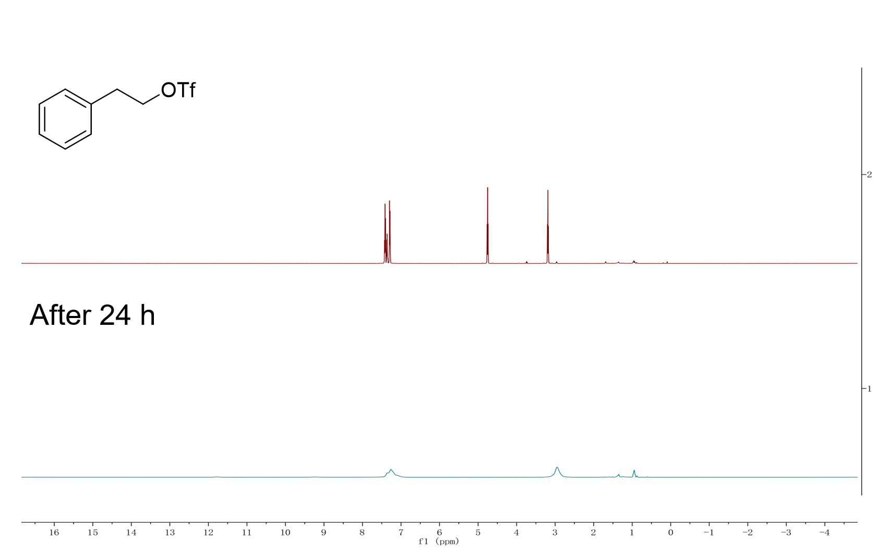
Scheme S2
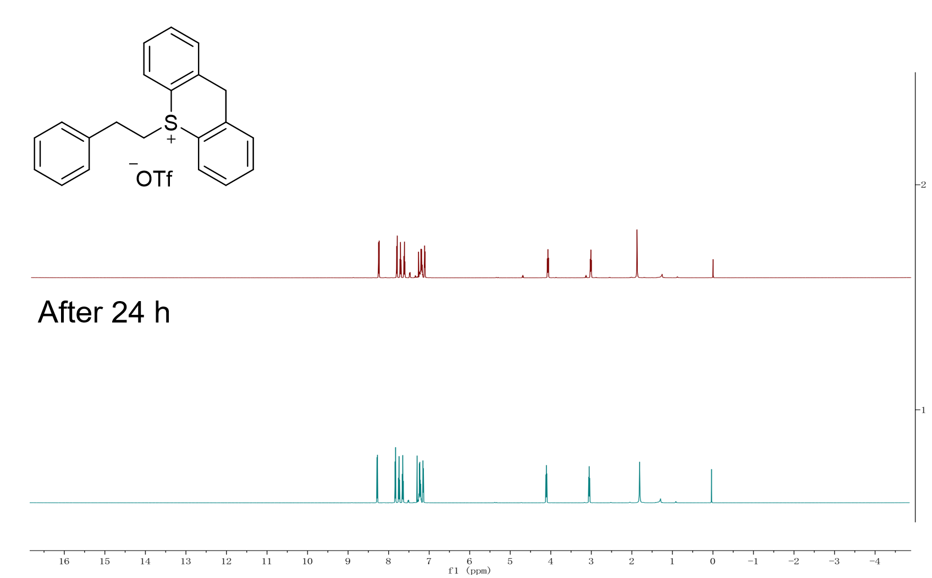
Scheme S3

3. Experimental Procedures
General procedure for the synthesis of thioetherification product:

To a 10 mL Schlenk tube was added alkyl sulfonate 1 (0.3 mmol,1.5 equiv), thiophenol 2 (0.2 mmol, 1.0 equiv), DIPEA (0.4 mmol, 2.0 equiv) and anhydrous acetonitrile (2 mL). The resulting mixture was stirred at room temperature for 16 h. The reaction mixture was quenched with dichloromethane. The organic layer was concentrated and purified by silica gel chromatography (petroleum ether and ethyl acetate) to afford the desired product 3.
Gram-scale reaction:

To a 50 mL Schlenk tube was added alkyl sulfonate 1a (6 mmol, 2.82 g, 1.5 equiv), thiophenol 2a (5 mmol, 0.96 g, 1.0 equiv), DIPEA (10 mmol, 1.77 mL, 2.0 equiv) and anhydrous acetonitrile (10 mL). The resulting mixture was stirred at room temperature for 16 h. After the reaction was completed, it was quenched with water. The residue was then extracted with CH₂Cl₂ (3 × 20 mL) and the combined organic layers were dried over anhydrous Na₂SO₄. The organic layer was concentrated in vacuo, resulting in a Colorless oil. It was then concentrated and purified by silica gel chromatography to afford 3aa (1.01 g, yield: 69%).

(4-bromophenyl)(phenethyl)sulfane (3aa)²

Following the general procedure, the reaction of 1a (141.3 mg, 0.3 mmol, 1.5 equiv.), 2a (38.3 mg, 0.2 mmol, 1.0 equiv), DIPEA (71 µL, 0.4 mmol, 2.0 equiv) and anhydrous acetonitrile (2 mL) at room temperature for 16 h. After column chromatography on silica (eluent: petroleum ether), afford 3aa (55.4 mg, 88%) as a colorless oil. ¹H NMR (400 MHz, Chloroform-d) δ 7.42 (d, J = 7.0 Hz, 2H), 7.32 (t, J = 7.3 Hz, 2H), 7.27 – 7.16 (m, 5H), 3.16 (t, J = 7.8 Hz, 2H), 2.98 – 2.89 (m, 2H) ppm. ¹³C NMR (101 MHz, Chloroform-d) δ 139.9, 135.7, 132.0, 130.7, 128.6, 128.5, 126.7, 119.8, 35.5, 35.2 ppm. HRMS m/z (ESI): calcd for C₁₄H₁₃BrS (M + H)⁺ 292.9994, found 292.9996.

(5-bromophenyl)(4-fluorophenethyl)sulfane (3ba)

Following the general procedure, the reaction of 1b (146.7 mg, 0.3 mmol, 1.5 equiv.), 2a (38.3 mg, 0.2 mmol, 1.0 equiv), DIPEA (71 µL, 0.4 mmol, 2.0 equiv) and anhydrous acetonitrile (2 mL) at room temperature for 16 h. After column chromatography on silica (eluent: petroleum ether), afford 3ba (47.9 mg, 77%) as a colorless oil. ¹H NMR (400 MHz, Chloroform-d) δ 7.42 (d, J = 8.4 Hz, 2H), 7.20 (d, J = 8.4 Hz, 2H), 7.17 – 7.10 (m, 2H), 6.99 (t, J = 8.6 Hz, 2H), 3.17 – 3.09 (m, 2H), 2.94 – 2.85 (m, 2H) ppm. ¹³C NMR (101 MHz, Chloroform-d) δ 161.6 (d, J = 244.6 Hz), 135.5 (d, J = 3.2 Hz), 135.4, 132.0, 130.8, 129.9 (d, J = 7.9 Hz), 119.9, 115.3 (d, J = 21.2 Hz), 35.3, 34.6 ppm. ¹⁹F NMR (376 MHz, Chloroform-d) δ -116.42 ppm. EI-MS (m/z, relative intensity): 311.21 (M+, 55), 309.94 (55), 202.94 (64), 200.93 (72), 123.07 (86), 122.03 (100), 109.02 (50), 103.01 (42).

(4-bromophenyl)(4-chlorophenethyl)sulfane (3ca)²

Following the general procedure, the reaction of 1c (151.5 mg, 0.3 mmol, 1.5 equiv.), 2a (38.3 mg, 0.2 mmol, 1.0 equiv), DIPEA (71 µL, 0.4 mmol, 2.0 equiv) and anhydrous acetonitrile (2 mL) at room temperature for 16 h. After column chromatography on silica (eluent: petroleum ether), afford 3ca (57.8 mg, 88%) as a colorless oil. ¹H NMR (400 MHz, Chloroform-d )δ 7.41 (d, J = 8.4 Hz, 2H), 7.26 (d, J = 8.3 Hz, 2H), 7.19 (d, J = 8.4 Hz, 2H), 7.10 (d, J = 8.3 Hz, 2H), 3.16 – 3.08 (m, 2H), 2.92 – 2.83 (m, 2H) ppm. ¹³C NMR (101 MHz, Chloroform-d) δ 138.2, 135.3, 132.4, 132.0, 130.9, 129.9, 128.7, 120.0, 35.1, 34.8 ppm. HRMS m/z (ESI): calcd for C₁₄H₁₂BrClS (M + Na)⁺ 348.9424, found 348.9428.

(4-bromophenethyl)(4-bromophenyl)sulfane (3da)³

Following the general procedure, the reaction of 1d (164.7 mg, 0.3 mmol, 1.5 equiv.), 2a (38.3 mg, 0.2 mmol, 1.0 equiv), DIPEA (71 µL, 0.4 mmol, 2.0 equiv) and anhydrous acetonitrile (2 mL) at room temperature for 16 h. After column chromatography on silica (eluent: petroleum ether), afford 3da (56.3 mg, 76%) as a colorless oil. ¹H NMR (400 MHz, Chloroform-d) δ 7.42 (dd, J = 8.5, 2.1 Hz, 4H), 7.20 (d, J = 8.5 Hz, 2H), 7.05 (d, J = 8.3 Hz, 2H), 3.16 – 3.08 (m, 2H), 2.90 – 2.83 (m, 2H) ppm. ¹³C NMR (101 MHz, Chloroform-d) δ 138.8, 135.3, 132.0, 131.6, 130.9, 130.3, 120.4, 120.0, 35.0, 34.8 ppm. HRMS m/z (APCI): calcd for C₁₄H₁₂Br₂S (M)⁺ 369.9026, found 369.9024.

(5-bromophenyl)(4-iodophenethyl)sulfane (3ea)
Following the general procedure, the reaction of 1e (178.9 mg, 0.3 mmol, 1.5 equiv.), 2a (38.3 mg, 0.2 mmol, 1.0 equiv), DIPEA (71 µL, 0.4 mmol, 2.0 equiv) and anhydrous acetonitrile (2 mL) at room temperature for 16 h. After column chromatography on silica (eluent: petroleum ether), afford 3ea (74.5 mg, 89%) as a colorless oil. ¹H NMR (400 MHz, Chloroform-d) δ 7.62 (d, J = 8.2 Hz, 2H), 7.41 (d, J = 8.4 Hz, 2H), 7.19 (d, J = 8.5 Hz, 2H), 6.93 (d, J = 8.1 Hz, 2H), 3.16 – 3.08 (m, 2H), 2.90 – 2.81 (m, 2H) ppm. ¹³C NMR (101 MHz, Chloroform-d) δ 139.4, 137.6, 135.3, 132.0, 130.9, 130.6, 120.0, 91.8, 35.0, 34.9 ppm. HRMS m/z (ESI): calcd for C₁₄H₁₂BrIS (M + Na)⁺ 440.8780, found 440.8718.

(6-bromophenyl)(4-isocyanophenethyl)sulfane (3fa)

Following the general procedure, the reaction of 1f (148.8 mg, 0.3 mmol, 1.5 equiv.), 2a (38.3 mg, 0.2 mmol, 1.0 equiv), DIPEA (71 µL, 0.4 mmol, 2.0 equiv) and anhydrous acetonitrile (2 mL) at room temperature for 16 h. After column chromatography on silica (eluent: petroleum ether), afford 3fa (40.4 mg, 64%) as a colorless oil. ¹H NMR (400 MHz, Chloroform-d) δ 7.58 (d, J = 8.2 Hz, 2H), 7.41 (d, J = 8.5 Hz, 2H), 7.27 (d, J = 8.1 Hz, 2H), 7.19 (d, J = 8.5 Hz, 2H), 3.14 (t, J = 7.5 Hz, 2H), 2.95 (t, J = 7.5 Hz, 2H) ppm. ¹³C NMR (101 MHz, Chloroform-d) δ 145.2, 134.8, 132.3, 132.1, 131.1, 129.4, 120.3, 118.8, 110.5, 35.4, 34.7 ppm. HRMS m/z (ESI): calcd for C₁₅H₁₂BrNS (M + Na)⁺ 339.9766, found 339.9756.

(7-bromopentyl)(4-bromophenyl)sulfane (3ga)

Following the general procedure, the reaction of 1g (158.7 mg, 0.3 mmol, 1.5 equiv.), 2a (38.3 mg, 0.2 mmol, 1.0 equiv), DIPEA (71 µL, 0.4 mmol, 2.0 equiv) and anhydrous acetonitrile (2 mL) at room temperature for 16 h. After column chromatography on silica (eluent: petroleum ether), afford 3ga (49.5 mg, 73%) as a colorless oil. ¹H NMR (400 MHz, Chloroform-d) δ 7.39 (d, J = 8.6 Hz, 2H), 7.18 (d, J = 8.6 Hz, 2H), 3.39 (t, J = 6.7 Hz, 2H), 2.90 (t, J = 7.1 Hz, 2H), 1.86 (p, J = 6.8 Hz, 2H), 1.71 – 1.51 (m, 4H) ppm. ¹³C NMR (101 MHz, Chloroform-d) δ 135.8, 131.9, 130.6, 119.6, 33.49, 33.46, 32.2, 28.1, 27.3 ppm. HRMS m/z (APCI): calcd for C₁₁H₁₄Br₂S (M + H)⁺ 336.9256, found 339.9245.

1,6-bis((4-bromophenyl)thio)hexane (3ha)

Following the general procedure, the reaction of 1h (179.6 mg, 0.3 mmol, 1.5 equiv.), 2a (76.6 mg, 0.4 mmol, 2.0 equiv), DIPEA (71 µL, 0.4 mmol, 2.0 equiv) and anhydrous acetonitrile (2 mL) at room temperature for 16 h. After column chromatography on silica (eluent: petroleum ether), afford 3ha (124.9 mg, 89%) as a white solid. ¹H NMR (400 MHz, Chloroform-d) δ 7.38 (d, J = 8.5 Hz, 4H), 7.16 (d, J = 8.5 Hz, 4H), 2.87 (t, J = 7.3 Hz, 4H), 1.68 – 1.59 (m, 4H), 1.42 (p, J = 3.7 Hz, 4H) ppm. ¹³C NMR (101 MHz, Chloroform-d) δ 136.0, 131.9, 130.4, 119.5, 33.5, 28.8, 28.2 ppm. m.p.: 73.6-78.8 ℃. HRMS m/z (ESI): calcd for C₁₈H₂₀Br₂S₂ (M + H)⁺ 458.9446, found 458.9445.

(4-bromophenyl)(cyclododecyl)sulfane (3ia)

Following the general procedure, the reaction of 1i (160.4 mg, 0.3 mmol, 1.5 equiv.), 2a (38.3 mg, 0.2 mmol, 1.0 equiv), DIPEA (71 µL, 0.4 mmol, 2.0 equiv) and anhydrous acetonitrile (2 mL) at room temperature for 16 h. After column chromatography on silica (eluent: petroleum ether), afford 3ia (41.3 mg, 58%) as a white solid. ¹H NMR (400 MHz, Chloroform-d) δ 7.40 (dd, J = 11.7, 8.5 Hz, 3H), 7.33 (d, J = 8.4 Hz, 1H), 7.22 (d, J = 8.4 Hz, 2H), 3.22 (ddd, J = 12.1, 7.2, 4.7 Hz, 1H), 1.69 (dq, J = 15.4, 8.3, 7.5 Hz, 2H), 1.54 – 1.23 (m, 18H) ppm. ¹³C NMR (101 MHz, Chloroform-d) δ 132.76, 132.23, 131.82, 129.41, 45.04, 29.81, 24.18, 23.84, 23.37, 23.35, 22.09 ppm. m.p.: 43.1-47.3 ℃. HRMS m/z (ESI): calcd for C₁₈H₂₇BrS (M + H)⁺ 355.1090, found 355.1008.

Diphenethylsulfane (3ab)⁴

Following the general procedure, the reaction of 1a (141.3 mg, 0.3 mmol, 1.5 equiv.), 2b (27 µL, 0.2 mmol, 1.0 equiv), DIPEA (71 µL, 0.4 mmol, 2.0 equiv) and anhydrous acetonitrile (2 mL) at room temperature for 16 h. After column chromatography on silica (eluent: petroleum ether), afford 3ab (46.3 mg, 95%) as a colorless oil. ¹H NMR (400 MHz, Chloroform-d) δ 7.38 – 7.29 (m, 4H), 7.29 – 7.18 (m, 6H), 2.96 – 2.87 (m, 4H), 2.87 – 2.77 (m, 4H) ppm. ¹³C NMR (101 MHz, Chloroform-d) δ 140.6, 128.5, 126.4, 36.4, 33.8 ppm. HRMS m/z (ESI): calcd for C₁₆H₁₈S (M + Na)⁺ 265.1021, found 265.1003.

phenethyl(p-tolyl)sulfane (3ac)⁵

Following the general procedure, the reaction of 1a (141.3 mg, 0.3 mmol, 1.5 equiv.), 2c (25 µL, 0.2 mmol, 1.0 equiv), DIPEA (71 µL, 0.4 mmol, 2.0 equiv) and anhydrous acetonitrile (2 mL) at room temperature for 16 h. After column chromatography on silica (eluent: petroleum ether), afford 3ea (28.0 mg, 61%) as a colorless oil. ¹H NMR (400 MHz, Chloroform-d) δ 7.35 – 7.26 (m, 4H), 7.25 – 7.17 (m, 3H), 7.13 (d, J = 7.9 Hz, 2H), 3.18 – 3.10 (m, 2H), 2.96 – 2.87 (m, 2H), 2.34 (s, 3H) ppm. ¹³C NMR (101 MHz, Chloroform-d) δ 140.3, 136.2, 132.5, 130.1, 129.7, 128.5, 126.4, 35.84, 35.77, 21.0 ppm. HRMS m/z (ESI): calcd for C₁₅H₁₆ S (M + Na)⁺ 251.0865, found 251.0857.

(4-(tert-butyl)phenyl)(phenethyl)sulfane (3ad)

Following the general procedure, the reaction of 1a (141.3 mg, 0.3 mmol, 1.5 equiv.), 2d (38.3 mg, 0.2 mmol, 1.0 equiv), DIPEA (71 µL, 0.4 mmol, 2.0 equiv) and anhydrous acetonitrile (2 mL) at room temperature for 16 h. After column chromatography on silica (eluent: petroleum ether), afford 3ad (51.4 mg, 95%) as a colorless oil. ¹H NMR (400 MHz, Chloroform-d) δ 7.40 – 7.31 (m, 6H), 7.26 (t, J = 8.7 Hz, 3H), 3.23 – 3.16 (m, 2H), 3.02 – 2.93 (m, 2H), 1.36 (s, 9H) ppm. ¹³C NMR (101 MHz, Chloroform-d)δ 149.3, 140.4, 132.7, 129.5, 128.5, 126.4, 126.0, 35.9, 35.5, 34.5, 31.3 ppm. HRMS m/z (ESI): calcd for C₁₈H₂₂S (M + Na)⁺ 293.1334, found 293.1331.

(4-methoxyphenyl)(phenethyl)sulfane (3ae)⁶

Following the general procedure, the reaction of 1a (141.3 mg, 0.3 mmol, 1.5 equiv.), 2e (25 µL, 0.2 mmol, 1.0 equiv), DIPEA (71 µL, 0.4 mmol, 2.0 equiv) and anhydrous acetonitrile (2 mL) at room temperature for 16 h. After column chromatography on silica (eluent: petroleum ether/ethyl acetate 100:1), afford 3ae (39.2 mg, 80%) as a colorless oil. ¹H NMR (400 MHz, Chloroform-d) δ 7.39 (d, J = 7.9 Hz, 2H), 7.31 (t, J = 7.6 Hz, 2H), 7.23 (d, J = 6.9 Hz, 1H), 7.19 (d, J = 7.6 Hz, 2H), 6.88 (d, J = 8.8 Hz, 2H), 3.82 (s, 3H), 3.13 – 3.05 (m, 2H), 2.93 – 2.84 (m, 2H) ppm. ¹³C NMR (101 MHz, Chloroform-d) δ 158.9, 140.4, 133.3, 128.5, 128.4, 126.4, 114.6, 55.4, 37.3, 35.9 ppm. HRMS m/z (ESI): calcd for C₁₅H₁₆OS (M + Na)⁺ 267.0814, found 267.0794.

(4-chlorophenyl)(phenethyl)sulfane(3af)⁵

Following the general procedure, the reaction of 1a (141.3 mg, 0.3 mmol, 1.5 equiv.), 2f (28.9 mg, 0.2 mmol, 1.0 equiv), DIPEA (71 µL, 0.4 mmol, 2.0 equiv) and anhydrous acetonitrile (2 mL) at room temperature for 16 h. After column chromatography on silica (eluent: petroleum ether), afford 3af (36.6mg, 74%) as a colorless oil. ¹H NMR (400 MHz, Chloroform-d) δ 7.35 – 7.22 (m, 7H), 7.20 (d, J = 6.9 Hz, 2H), 3.20 – 3.12 (m, 2H), 2.97 – 2.87 (m, 2H) ppm. ¹³C NMR (101 MHz, Chloroform-d) δ 139.9, 134.9, 132.0, 130.6, 129.1, 128.6, 128.5, 126.6, 35.5, 35.4 ppm. HRMS m/z (ESI): calcd for C₁₄H₁₃ClS (M + Na)⁺ 271.0319, found 271.0297.

phenethyl(4-(trifluoromethyl)phenyl)sulfane(3ag)

Following the general procedure, the reaction of 1a (141.3 mg, 0.3 mmol, 1.5 equiv.), 2g (28 µL, 0.2 mmol, 1.0 equiv), DIPEA (71 µL, 0.4 mmol, 2.0 equiv) and anhydrous acetonitrile (2 mL) at room temperature for 16 h. After column chromatography on silica (eluent: petroleum ether), afford 3ag (36.0 mg, 64%) as a colorless oil. ¹H NMR (400 MHz, Chloroform-d) δ 7.53 (d, J = 8.2 Hz, 2H), 7.41 – 7.29 (m, 4H), 7.24 (dd, J = 15.8, 6.9 Hz, 3H), 3.28 – 3.19 (m, 2H), 3.02 – 2.93 (m, 2H) ppm. ¹³C NMR (101 MHz, Chloroform-d) δ 142.1, 139.7, 128.6 (d, J = 13.1 Hz), 127.4, 126.7, 125.7 (q, J = 3.7 Hz), 124.2 (q, J = 271.6 Hz), 35.2, 33.9 ppm. ¹⁹F NMR (471 MHz, Chloroform-d) δ -62.4 ppm. HRMS m/z (ESI): calcd for C₁₅H₁₃F₃S (M + H)⁺ 283.0763, found 283.0755.

- bromophenyl)(phenethyl)sulfane (3ah)

Following the general procedure, the reaction of 1a (141.3 mg, 0.3 mmol, 1.5 equiv.), 2h (21 µL, 0.2 mmol, 1.0 equiv), DIPEA (71 µL, 0.4 mmol, 2.0 equiv) and anhydrous acetonitrile (2 mL) at room temperature for 16 h. After column chromatography on silica (eluent: petroleum ether), afford 3ah (47.4 mg, 81%) as a colorless oil. ¹H NMR (400 MHz, Chloroform-d) δ 7.47 (s, 1H), 7.33 (t, J = 7.3 Hz, 3H), 7.24 (dd, J = 16.7, 7.5 Hz, 4H), 7.15 (t, J = 7.9 Hz, 1H), 3.22 – 3.15 (m, 2H), 2.99 – 2.91 (m, 2H) ppm. ¹³C NMR (101 MHz, Chloroform-d) δ 139.8, 139.0, 131.1, 130.2, 128.8, 128.6, 128.5, 127.2, 126.6, 122.9, 35.4, 34.8 ppm. HRMS m/z (ESI): calcd for C₁₄H₁₃BrS (M + Na)⁺ 314.9814, found 314.9803.

- chlorophenyl)(phenethyl)sulfane (3ai)

Following the general procedure, the reaction of 1a (141.3 mg, 0.3 mmol, 1.5 equiv.), 2i (23 µL, 0.2 mmol, 1.0 equiv), DIPEA (71 µL, 0.4 mmol, 2.0 equiv) and anhydrous acetonitrile (2 mL) at room temperature for 16 h. After column chromatography on silica (eluent: petroleum ether), afford 3ai (40.8 mg, 82%) as a colorless oil. ¹H NMR (400 MHz, Chloroform-d) δ 7.38 (d, J = 7.1 Hz, 1H), 7.36 – 7.19 (m, 7H), 7.12 (t, J = 7.1 Hz, 1H), 3.26 – 3.14 (m, 2H), 3.03 – 2.93 (m, 2H) ppm. ¹³C NMR (101 MHz, Chloroform-d) δ 140.0, 135.8, 133.6, 129.7, 128.6, 128.5, 128.4, 127.1, 126.6, 126.5, 35.2, 33.9 ppm. HRMS m/z (ESI): calcd for C₁₄H₁₃ClS (M + Na)⁺ 271.0319, found 271.0297.

- fluorophenyl)(phenethyl)sulfane (3aj)

Following the general procedure, the reaction of 1a (141.3 mg, 0.3 mmol, 1.5 equiv.), 2j (22 µL, 0.2 mmol, 1.0 equiv), DIPEA (71 µL, 0.4 mmol, 2.0 equiv) and anhydrous acetonitrile (2 mL) at room temperature for 16 h. After column chromatography on silica (eluent: petroleum ether), afford 3aj (40.5 mg, 87%) as a colorless oil. ¹H NMR (400 MHz, Chloroform-d) δ 7.44 – 7.37 (m, 1H), 7.31 (t, J = 7.2 Hz, 2H), 7.27 – 7.17 (m, 4H), 7.14 – 7.04 (m, 2H), 3.22 – 3.12 (m, 2H), 2.98 – 2.87 (m, 2H) ppm. ¹³C NMR (101 MHz, Chloroform-d) δ 161.5 (d, J = 245.4 Hz), 140.0, 132.2 (d, J = 15.1 Hz), 128.6, 128.5, 126.5, 124.4, 123.0 (d, J = 17.8 Hz), 115.7 (d, J = 22.0 Hz), 35.8, 34.8 ppm. ¹⁹F NMR (376 MHz, Chloroform-d) δ -109.3 ppm. HRMS m/z (ESI): calcd for C₁₄H₁₃FS (M + Na)⁺ 255.0614, found 255.0610.

(2,6-dimethylphenyl)(phenethyl)sulfane (3ak)

Following the general procedure, the reaction of 1a (141.3 mg, 0.3 mmol, 1.5 equiv.), 2k (27 µL, 0.2 mmol, 1.0 equiv), DIPEA (71 µL, 0.4 mmol, 2.0 equiv) and anhydrous acetonitrile (2 mL) at room temperature for 16 h. After column chromatography on silica (eluent: petroleum ether), afford 3ak (31.8 mg, 54%) as a colorless oil. ¹H NMR (400 MHz, Chloroform-d) δ 7.29 (d, J = 7.0 Hz, 2H), 7.24 – 7.06 (m, 6H), 2.98 – 2.88 (m, 2H), 2.88 – 2.79 (m, 2H), 2.54 (s, 6H) ppm. ¹³C NMR (101 MHz, Chloroform-d) δ 143.1, 140.5, 133.4, 128.4, 128.4, 128.2, 128.1, 126.3, 36.5, 36.4, 22.1 ppm. HRMS m/z (ESI): calcd for C₁₆H₁₈S (M + Na)⁺ 265.1021, found 265.1008.

2-(Phenethylthio)pyridine(3al)⁷

Following the general procedure, the reaction of 1a (141.3 mg, 0.3 mmol, 1.5 equiv.), 2l (23 µL, 0.2 mmol, 1.0 equiv), DIPEA (71 µL, 0.4 mmol, 2.0 equiv) and anhydrous acetonitrile (2 mL) at room temperature for 16 h. After column chromatography on silica (eluent: petroleum ether), afford 3al (37.8 mg, 90%) as a colorless oil. ¹H NMR (400 MHz, Chloroform-d) δ 8.50 – 8.42 (m, 1H), 7.51 – 7.43 (m, 1H), 7.35 – 7.20 (m, 5H), 7.17 (d, J = 8.1 Hz, 1H), 6.98 (dd, J = 7.3, 4.9 Hz, 1H), 3.48 – 3.40 (m, 2H), 3.07 – 2.99 (m, 2H) ppm. ¹³C NMR (101 MHz, Chloroform-d) δ 158.9, 149.4, 140.5, 135.9, 128.6, 128.4, 126.4, 122.4, 119.3, 35.8, 31.5 ppm. HRMS m/z (ESI): calcd for C₁₃H₁₃NS (M + Na)⁺ 238.0661, found 238.0644.

3-(phenethylthio)thiophene (3am)

Following the general procedure, the reaction of 1a (141.3 mg, 0.3 mmol, 1.5 equiv.), 2m (19 µL, 0.2 mmol, 1.0 equiv), DIPEA (71 µL, 0.4 mmol, 2.0 equiv) and anhydrous acetonitrile (2 mL) at room temperature for 16 h. After column chromatography on silica (eluent: petroleum ether), afford 3am (31.5 mg, 71%) as a colorless oil. ¹H NMR (400 MHz, Chloroform-d) δ 7.37 (d, J = 4.6 Hz, 1H), 7.30 (t, J = 7.3 Hz, 2H), 7.26 – 7.12 (m, 4H), 7.00 (dd, J = 5.3, 3.5 Hz, 1H), 3.09 – 3.01 (m, 2H), 2.96 – 2.88 (m, 2H) ppm. ¹³C NMR (101 MHz, Chloroform-d) δ 140.0, 134.4, 133.6, 129.2, 128.6, 128.5, 127.6, 126.4, 40.1, 36.0 ppm. HRMS m/z (ESI): calcd for C₁₂H₁₂S₂ (M + Na)⁺ 243.0273, found 243.0258.

2-(phenethylthio)benzo[d]oxazole (3an)

Following the general procedure, the reaction of 1a (141.3 mg, 0.3 mmol, 1.5 equiv.), 2n (30.2 mg, 0.2 mmol, 1.0 equiv), DIPEA (71 µL, 0.4 mmol, 2.0 equiv) and anhydrous acetonitrile (2 mL) at room temperature for 16 h. After column chromatography on silica (eluent: petroleum ether), afford 3an (44.6 mg, 87%) as a colorless oil. ¹H NMR (400 MHz, Chloroform-d) δ 7.63 (d, J = 7.0 Hz, 1H), 7.44 (d, J = 7.6 Hz, 1H), 7.37 – 7.21 (m, 7H), 3.61 – 3.51 (m, 2H), 3.21 – 3.11 (m, 2H) ppm. ¹³C NMR (101 MHz, Chloroform-d) δ 164.8, 151.8, 142.0, 139.4, 128.7, 128.6, 126.8, 124.3, 123.8, 118.5, 109.9, 35.6, 33.5 ppm. HRMS m/z (ESI): calcd for C₁₅H₁₃NSO (M + Na)⁺ 278.0610, found 278.0640.

2-(phenethylthio)-1H-benzo[d]imidazole (3ao)

Following the general procedure, the reaction of 1a (141.3 mg, 0.3 mmol, 1.5 equiv.), 2o (30.0 mg, 0.2 mmol, 1.0 equiv), DIPEA (71 µL, 0.4 mmol, 2.0 equiv) and anhydrous acetonitrile (2 mL) at room temperature for 16 h. After column chromatography on silica (eluent: petroleum ether), afford 3ao (36.0 mg, 71%) as a white solid. ¹H NMR (400 MHz, Chloroform-d) δ 7.52 (s, 2H), 7.30 – 7.14 (m, 7H), 3.55 (t, J = 7.4 Hz, 2H), 3.05 (t, J = 7.4 Hz, 2H) ppm. ¹³C NMR (101 MHz, Chloroform-d) δ 150.11, 139.60, 128.74, 128.52, 126.61, 122.33, 35.84, 34.09 ppm. m.p.:145.0-151.7 ℃. HRMS m/z (ESI): calcd for C₁₅H₁₄N₂S (M + Na)⁺ 277.0770, found 277.0750.

General procedure for the synthesis of amination products:

To a 10 mL Schlenk tube was added alkyl sulfonate 1a (0.3 mmol,1.5 equiv), amines 2 (0.2 mmol, 1.0 equiv), DIPEA (0.4 mmol, 2.0 equiv) and anhydrous acetonitrile (2 mL). The resulting mixture was stirred at 80 ℃ for 16 h. The reaction mixture was quenched with dichloromethane. The organic layer was concentrated and purified by silica gel chromatography (petroleum ether and ethyl acetate) to afford the desired product 3.

N-phenethylaniline (3ap)

Following the general procedure, the reaction of 1a (141.3 mg, 0.3 mmol, 1.5 equiv.), 2p (18 µL, 0.2 mmol, 1.0 equiv), DIPEA (71 µL, 0.4 mmol, 2.0 equiv) and anhydrous acetonitrile (2 mL) at 80 ℃ for 16 h. After column chromatography on silica (eluent: petroleum ether), afford 3ap (20.7 mg, 53%) as a Pale yellow. ¹H NMR (400 MHz, Chloroform-d) δ 7.39 – 7.04 (m, 7H), 6.79 – 6.48 (m, 3H), 3.68 (s, 1H), 3.40 (t, J = 6.7 Hz, 2H), 2.92 (t, J = 6.6 Hz, 2H) ppm. ¹³C NMR (101 MHz, Chloroform-d) δ 148.0, 139.3, 129.3, 128.8, 128.6, 126.4, 117.5, 113.0, 45.0, 35.5 ppm. HRMS m/z (ESI): calcd for C₁₄H₁₅N (M + Na)⁺ 220.1097, found 220.1099.

N-methyl-N-phenethylaniline(3aq)⁸

Following the general procedure, the reaction of 1a (141.3 mg, 0.3 mmol, 1.5 equiv.), 2q (22 µL, 0.2 mmol, 1.0 equiv), DIPEA (71 µL, 0.4 mmol, 2.0 equiv) and anhydrous acetonitrile (2 mL) at 80 ℃ for 16 h. After column chromatography on silica (eluent: petroleum ether), afford 3aq (30.0 mg, 71%) as a colorless liquid. ¹H NMR (400 MHz, Chloroform-d) δ 7.38 – 7.14 (m, 7H), 6.80 – 6.67 (m, 3H), 3.65 – 3.51 (m, 2H), 2.95 – 2.83 (m, 5H) ppm. ¹³C NMR (101 MHz, Chloroform-d) δ 148.8, 139.8, 129.3, 128.8, 128.5, 126.2, 116.2, 112.2, 54.8, 38.5, 32.9 ppm. HRMS m/z (ESI): calcd for C₁₅H₁₇N (M + Na)⁺ 234.1253, found 234.1261.

N-methyl-N-(naphthalen-1-ylmethyl)-2-phenylethan-1-amine (3ar)

Following the general procedure, the reaction of 1a (141.3 mg, 0.3 mmol, 1.5 equiv.), 2r (33 µL, 0.2 mmol, 1.0 equiv), DIPEA (71 µL, 0.4 mmol, 2.0 equiv) and anhydrous acetonitrile (2 mL) at 80 ℃ for 16 h. After column chromatography on silica (eluent: petroleum ether), afford 3ar (48.6 mg, 88%) as a colorless oil. ¹H NMR (400 MHz, Chloroform-d) δ 8.22 (s, 1H), 7.82 (d, J = 25.4 Hz, 2H), 7.45 (dd, J = 22.7, 4.8 Hz, 4H), 7.35 – 7.15 (m, 5H), 3.97 (s, 2H), 2.86 (dt, J = 40.6, 6.9 Hz, 4H), 2.32 (s, 3H) ppm. ¹³C NMR (101 MHz, Chloroform-d) δ 140.6, 134.7, 133.9, 132.5, 128.8, 128.4, 128.3, 128.0, 127.4, 125.9, 125.8, 125.6, 125.1, 124.7, 60.6, 59.8, 42.1, 33.7 ppm. HRMS m/z (ESI): calcd for C₂₀H₂₁N (M + Na)⁺ 298.1566, found 298.1555.

4. Mechanistic Studies

Radical trapping experiment with TEMPO

To a 10 mL Schlenk tube was added alkyl sulfonate 1a (0.3 mmol, 141 mg, 1.5 equiv), thiophenol 2a (0.2 mmol, 38.32 g, 1.0 equiv), DIPEA (0.4 mmol, 71 µL, 2.0 equiv), TEMPO(0.4 mmol, 62.5 mg, 2 equiv) and anhydrous acetonitrile (2 mL). The resulting mixture was stirred at room temperature for 16 h. After the reaction was completed, it was quenched with water. The residue was then extracted with CH₂Cl₂ (3 × 20 mL) and the combined organic layers were dried over anhydrous Na₂SO₄. The organic layer was concentrated in vacuo, resulting in a Colorless oil. It was then concentrated and purified by silica gel chromatography to afford 3aa (yield : 46%).

Radical trapping experiment with BHT

To a 10 mL Schlenk tube was added alkyl sulfonate 1a (0.3 mmol, 141 mg, 1.5 equiv), thiophenol 2a (0.2 mmol, 38.32 g, 1.0 equiv), DIPEA (0.4 mmol, 71 µL, 2.0 equiv), BHT(0.4 mmol, 62.5 mg, 2 equiv) and anhydrous acetonitrile (2 mL). The resulting mixture was stirred at room temperature for 16 h. After the reaction was completed, it was quenched with water. The residue was then extracted with CH₂Cl₂ (3 × 20 mL) and the combined organic layers were dried over anhydrous Na₂SO₄. The organic layer was concentrated in vacuo, resulting in a Colorless oil. It was then concentrated and purified by silica gel chromatography to afford 3aa (yield : 83%).

5. References
1. C. Chen, M. Wang, H. Lu, B. Zhao, Z. Shi, Angew. Chem. Int. Ed. 2021, 60, 21756−21760.
2. D. V. Jawale, J.-A. Tchuiteng-Kouatchou, F. Fossard, F. Miserque, V. Geertsen, E. Gravel and E. Doris, Green Chem., 2022, 24 , 1231.
3. Y. Cai, F. Nie, Q. Song, J. Org. Chem. 2021, 86, 12419– 12426.
4. Shinkar, E. V.; Shvetsova, A. V.; Okhlobystin, A. O.; Berberova, N. T. Russ J Electrochem. 2020. 56, 285–292.
5. Guo, Z.; Liu, X.; Bai, R.; Che, Y.; Chi, Y.; Guo, C.; Xing, H. Inorg. Chem. 2021, 60, 8672– 8681.
6. F. Zhang, Y. Wang, Y. Wang, Y. Pan, Org. Lett. 2021, 23, 7524−7528.
7. Z. Qiao, J. Wei, X. Jiang, Org. Lett. 2014, 16, 1212−1215.
8. Y. Wei, Q. Xuan, Y. Zhou, Q. Song, Org. Chem. Front. 2018, 5, 3510.

6. Spectra of ¹H NMR, ¹³C NMR
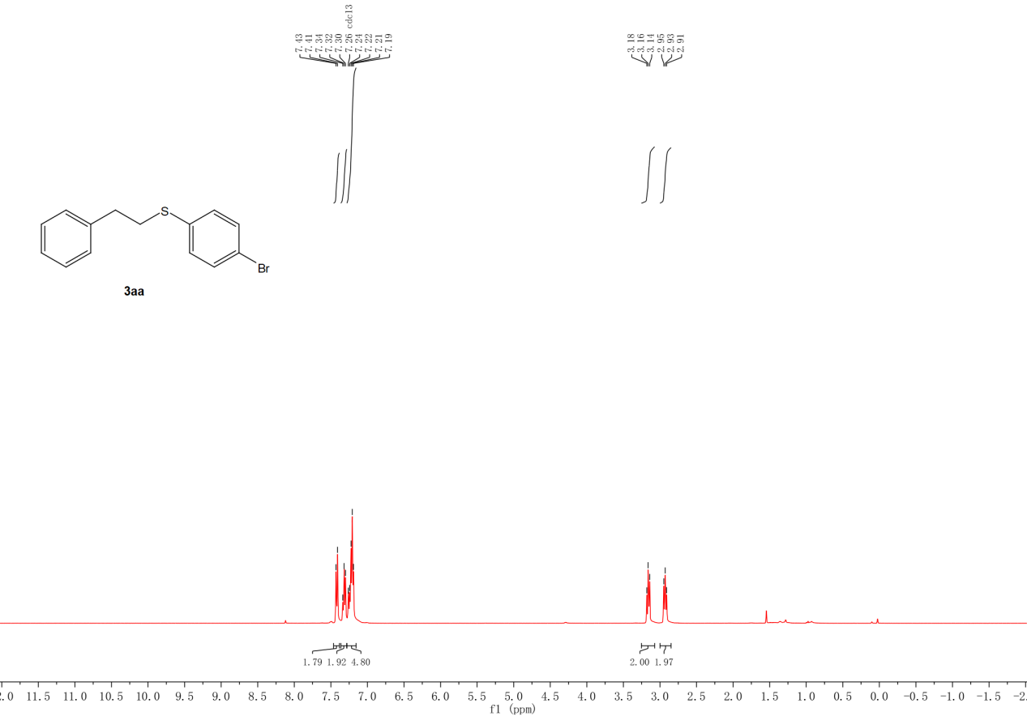
Figure S1. ¹H NMR spectra (400 MHz) of 3aa in CDCl₃.
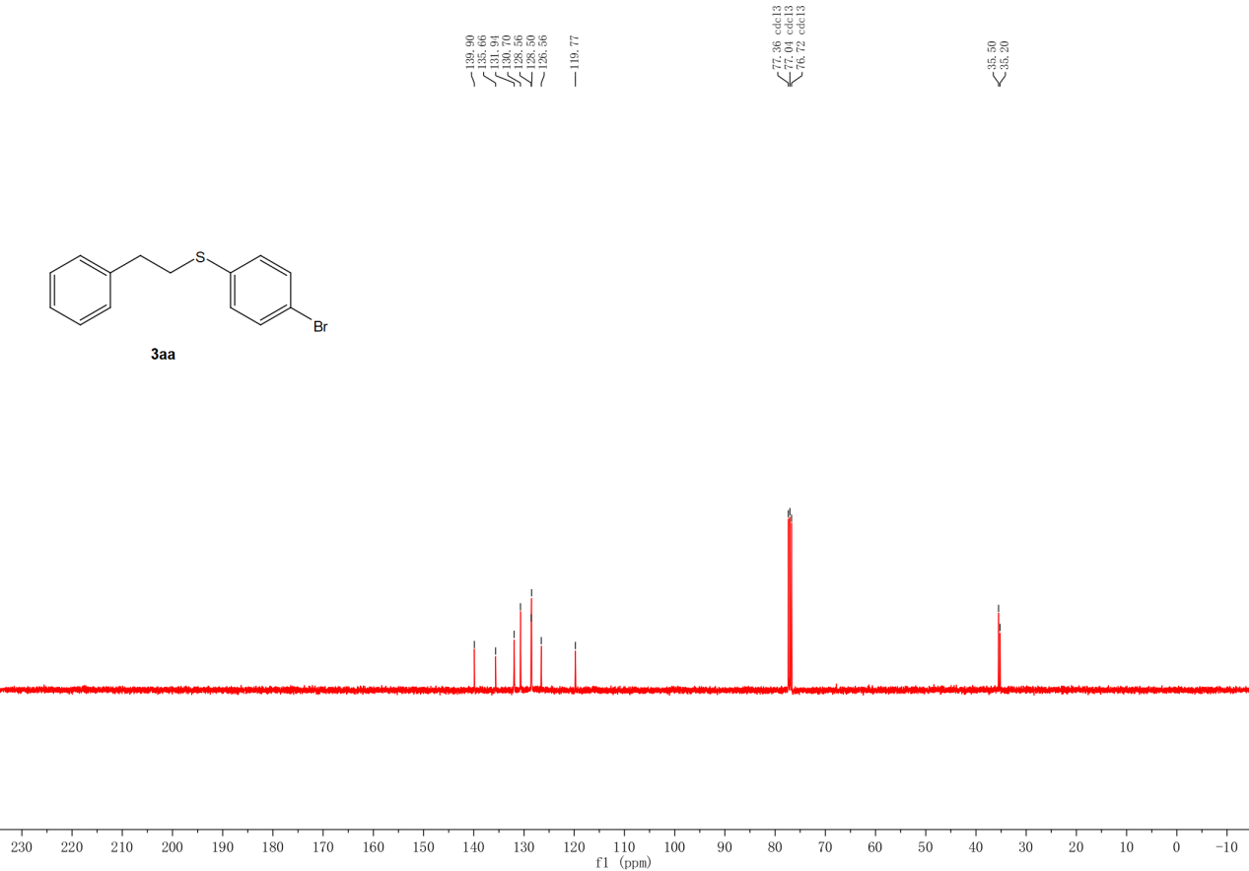
Figure S2. ¹³C NMR spectra (400 MHz) of 3aa in CDCl₃.
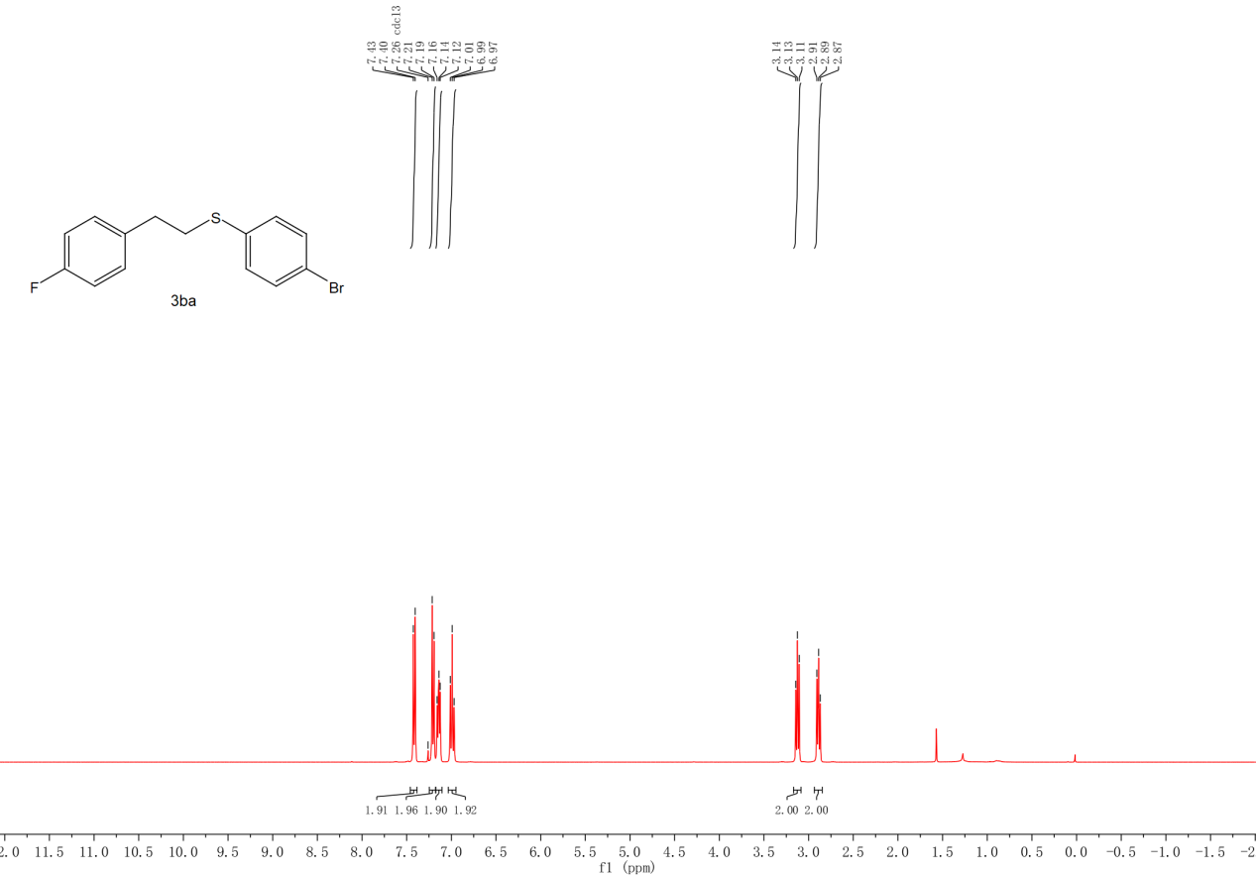
Figure S3. ¹H NMR spectra (400 MHz) of 3ba in CDCl₃.

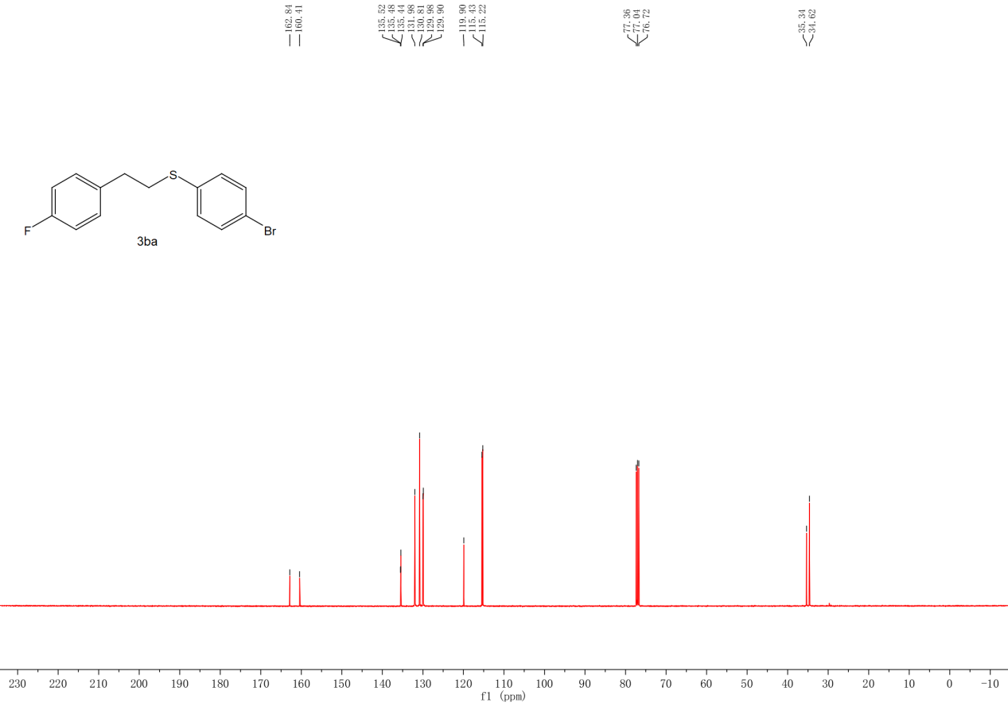
Figure S4. ¹³C NMR spectra (400 MHz) of 3ba in CDCl₃.
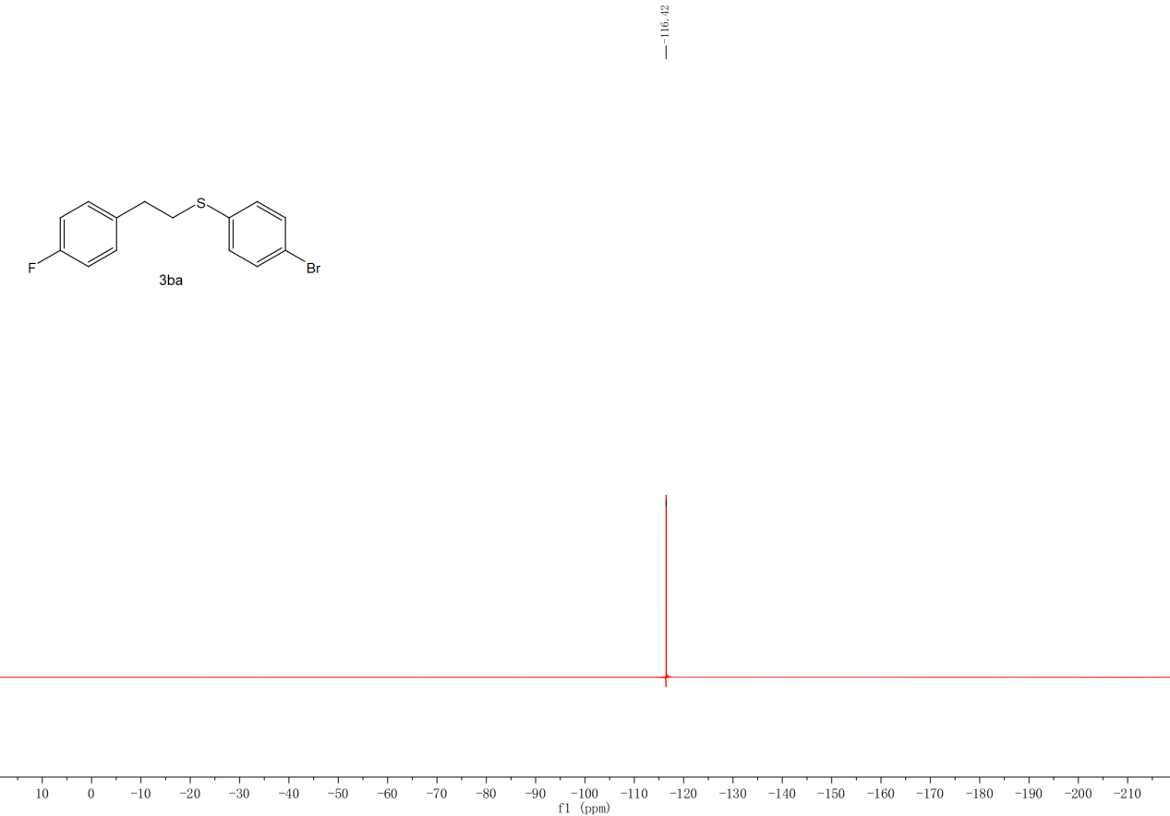
Figure S5. ¹⁹F NMR spectra (400 MHz) of 3ba in CDCl₃.

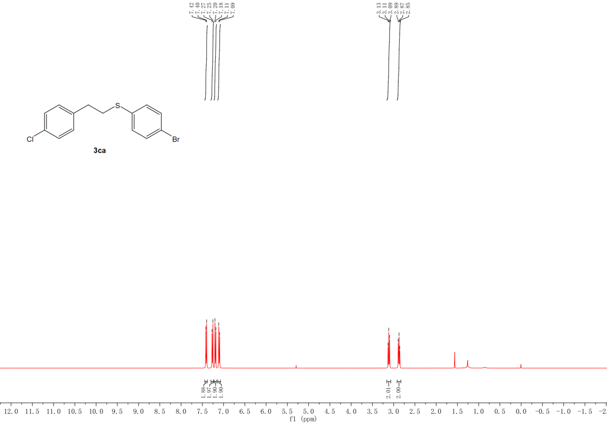
Figure S6. ¹H NMR spectra (400 MHz) of 3ca in CDCl₃.

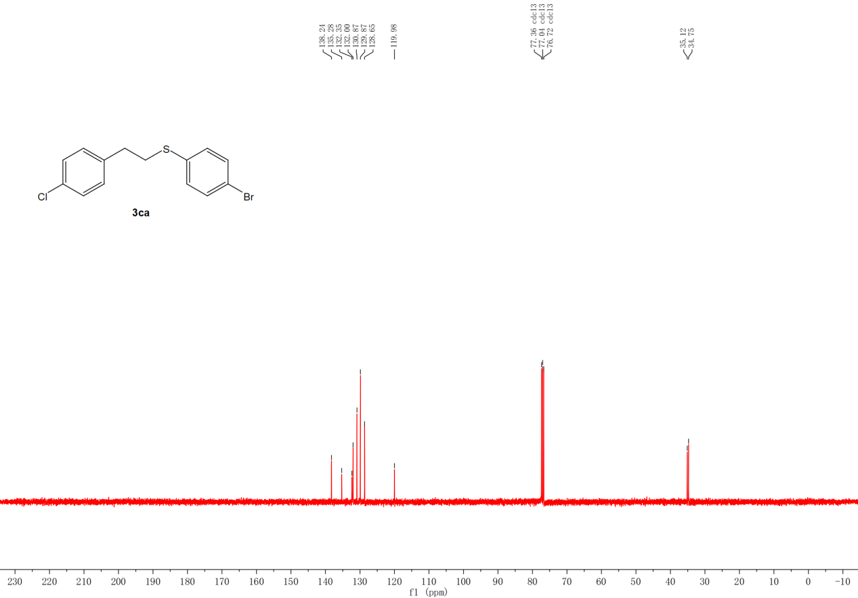
Figure S7. ¹³C NMR spectra (400 MHz) of 3ca in CDCl₃.
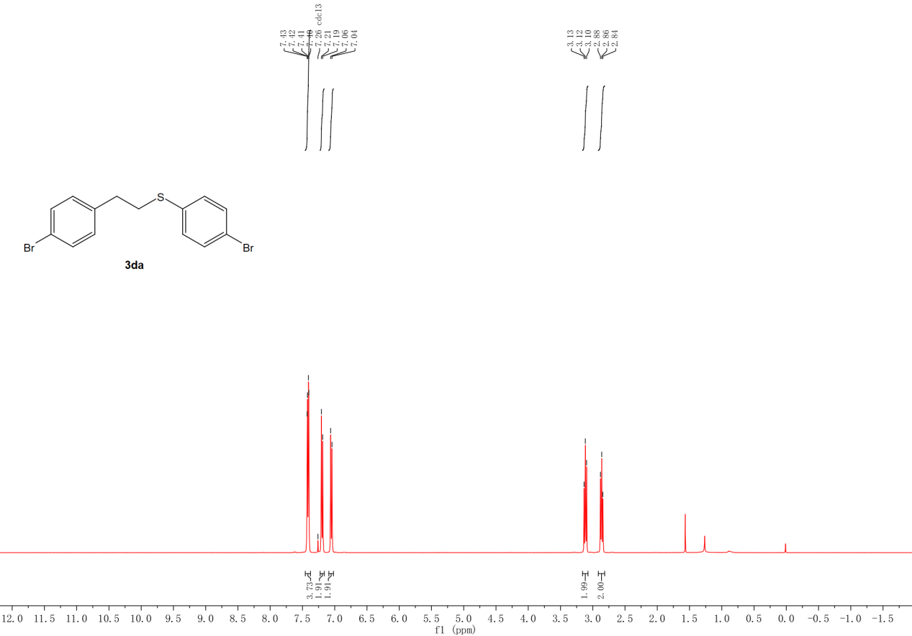
Figure S8. ¹H NMR spectra (400 MHz) of 3da in CDCl₃.
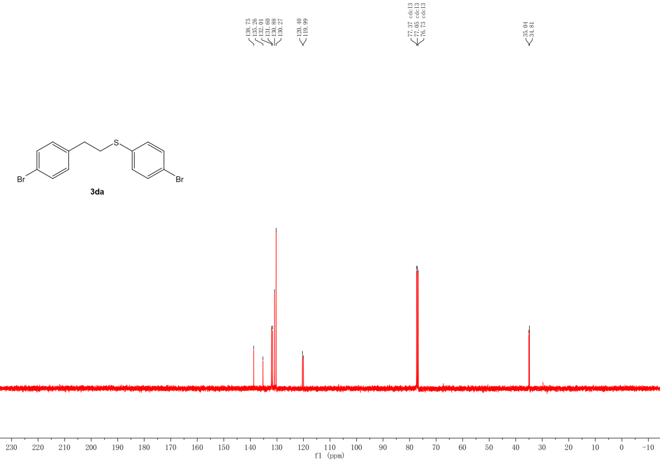
Figure S9. ¹³C NMR spectra (400 MHz) of 3da in CDCl₃.

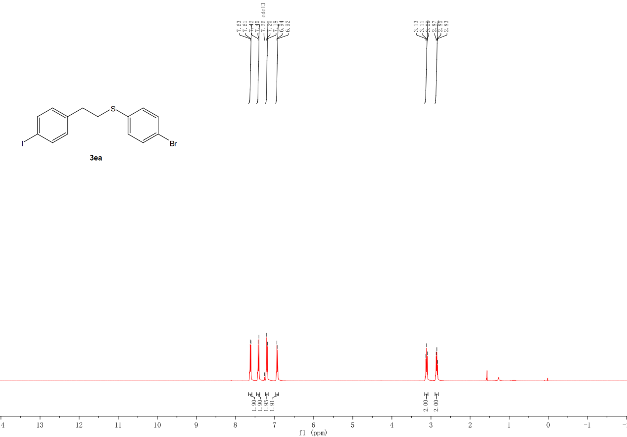
Figure S10. ¹H NMR spectra (400 MHz) of 3ea in CDCl₃.
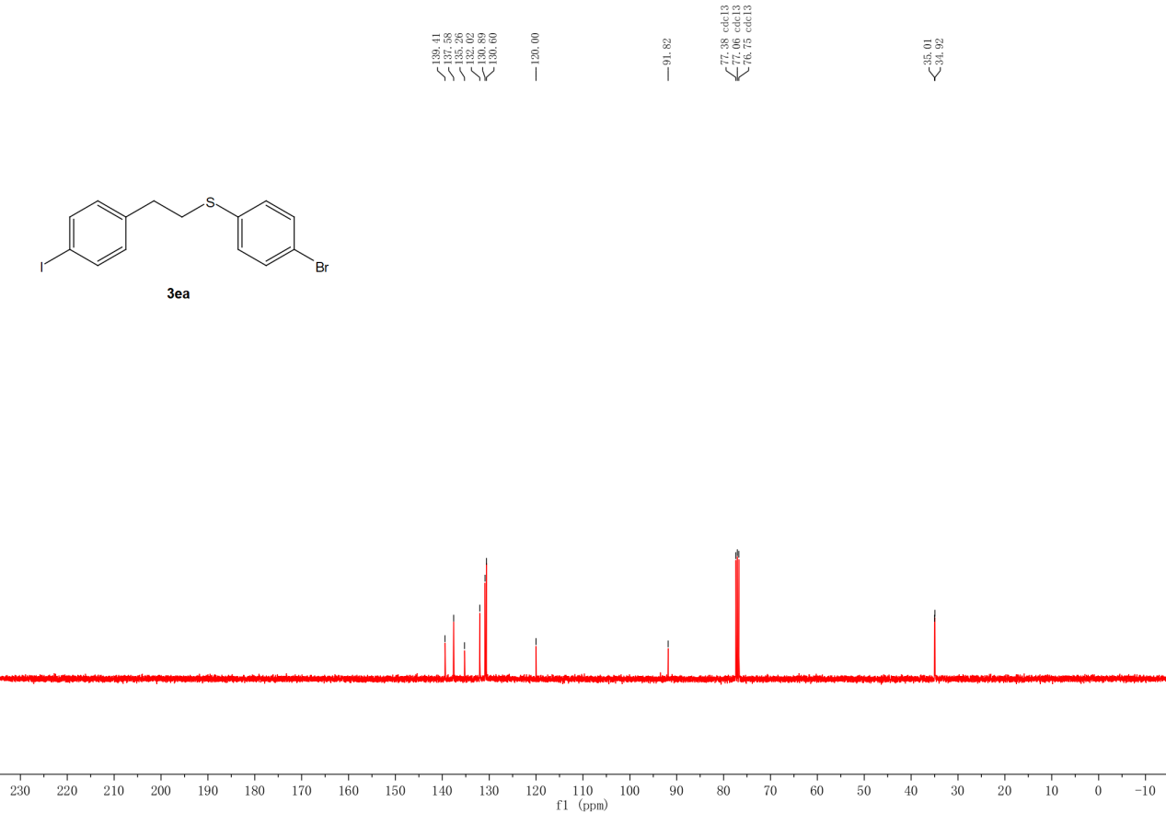
Figure S11. ¹³C NMR spectra (400 MHz) of 3ea in CDCl₃.

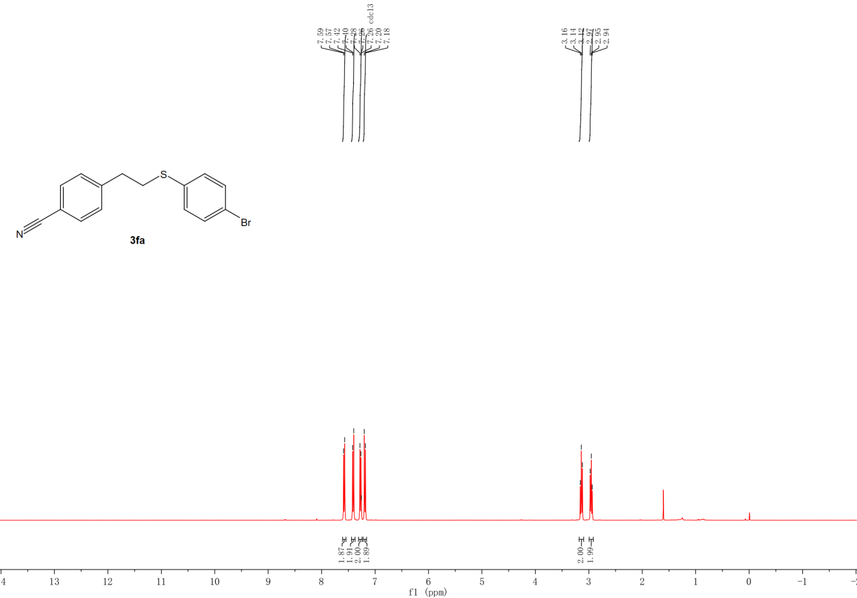
Figure S12. ¹H NMR spectra (400 MHz) of 3fa in CDCl₃.
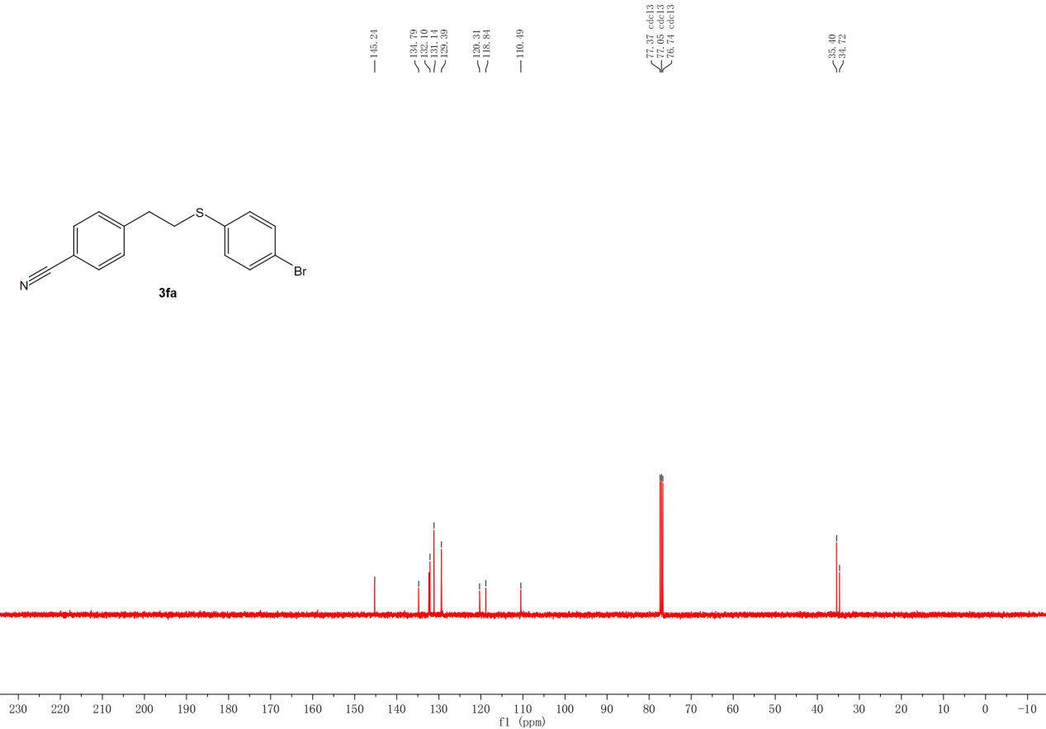
Figure S13. ¹³C NMR spectra (400 MHz) of 3fa in CDCl₃.

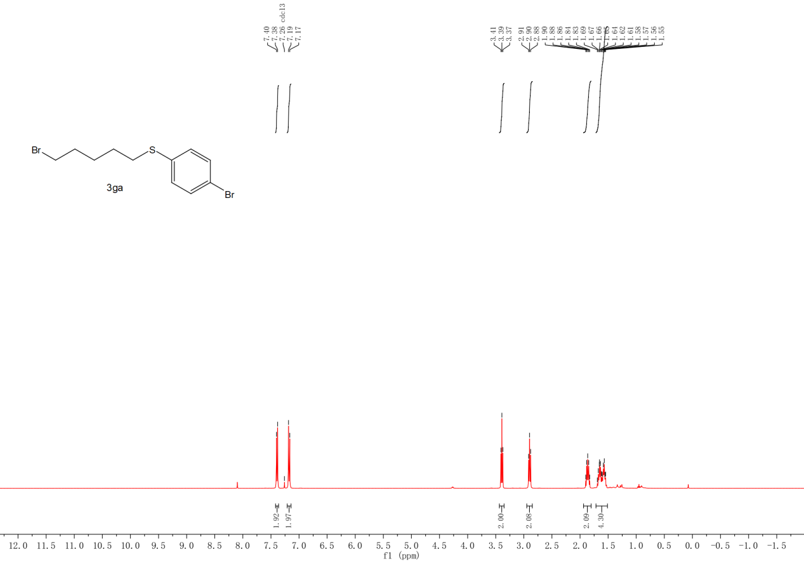
Figure S14. ¹H NMR spectra (400 MHz) of 3ga in CDCl₃.
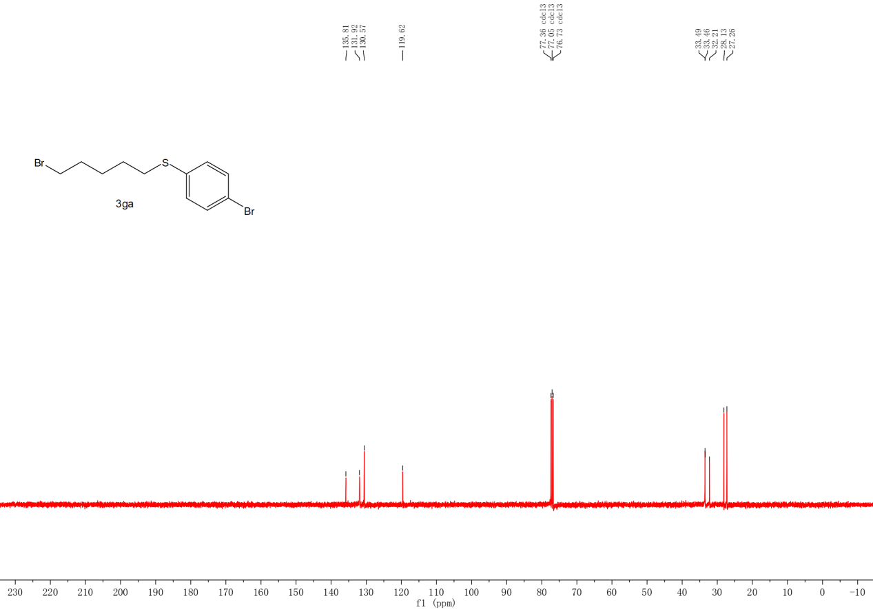
Figure S15. ¹³C NMR spectra (400 MHz) of 3ga in CDCl₃.

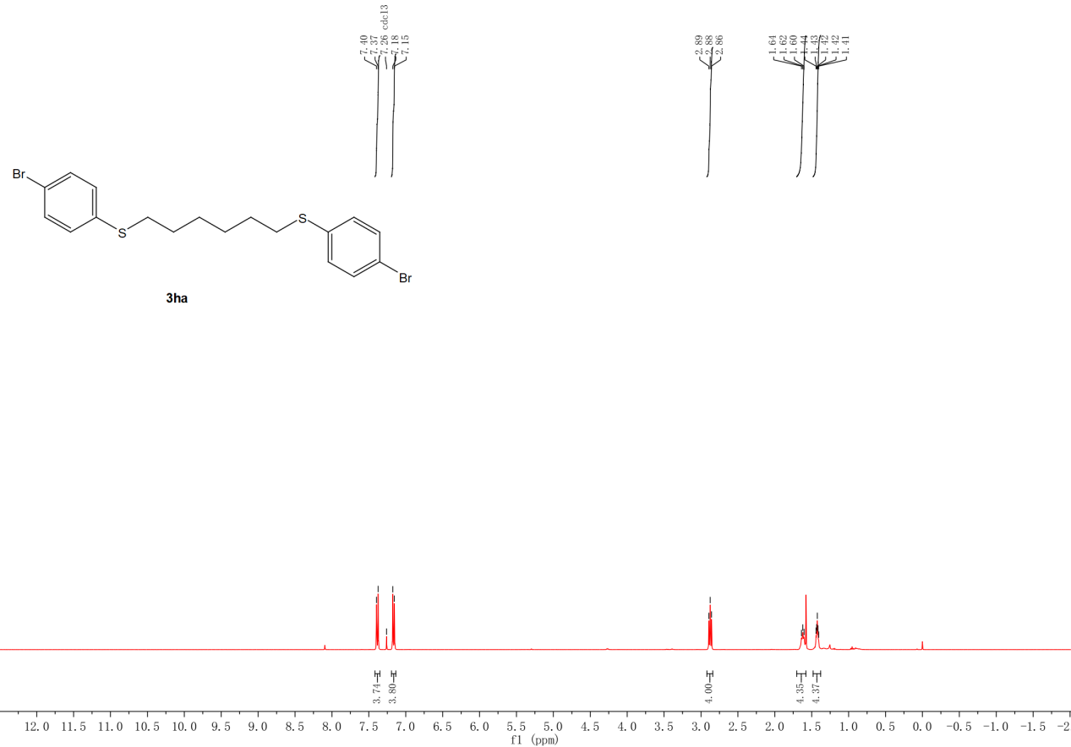
Figure S16. ¹H NMR spectra (400 MHz) of 3ha in CDCl₃.
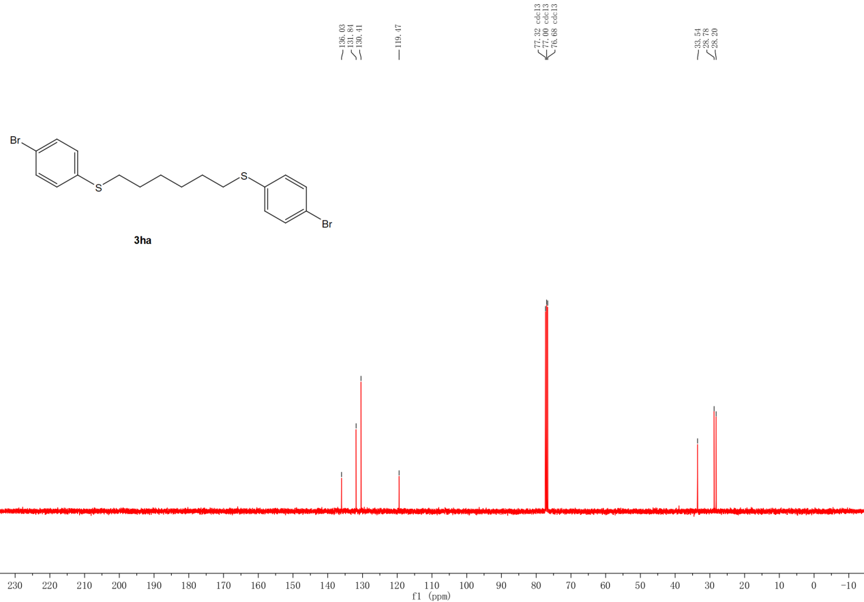
Figure S17. ¹³C NMR spectra (400 MHz) of 3ha in CDCl₃.

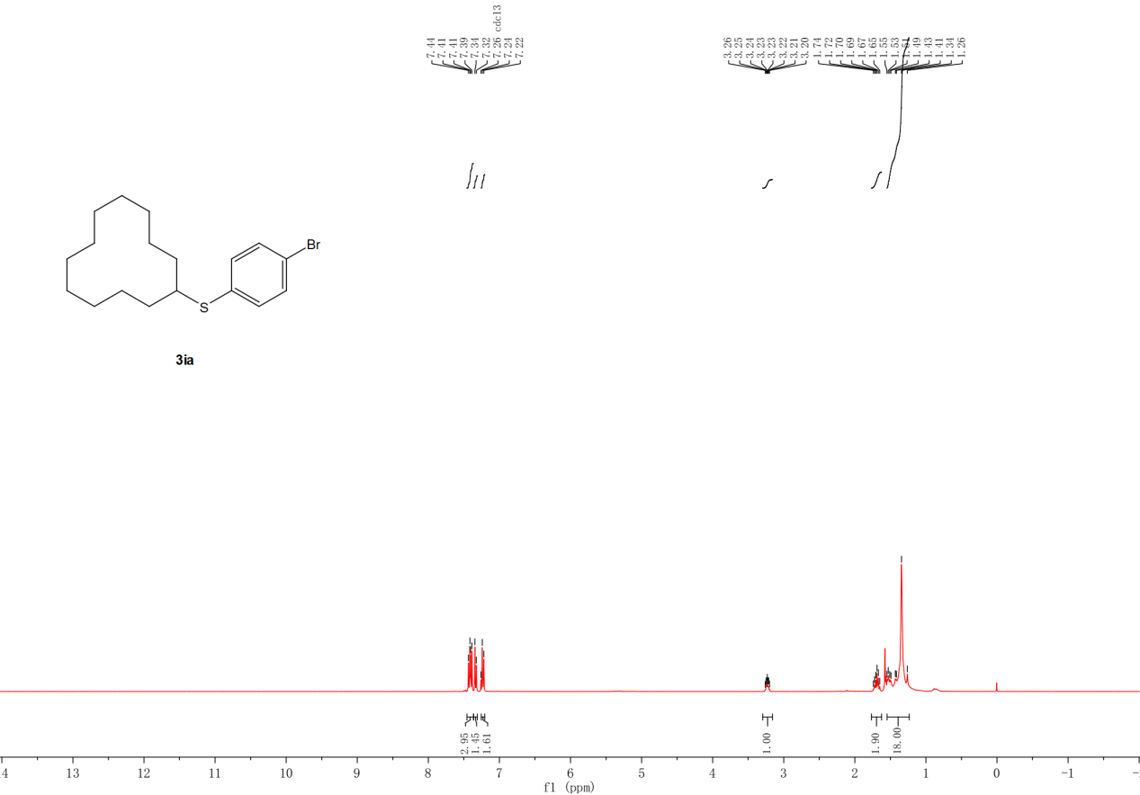
Figure S18. ¹H NMR spectra (400 MHz) of 3ia in CDCl₃.

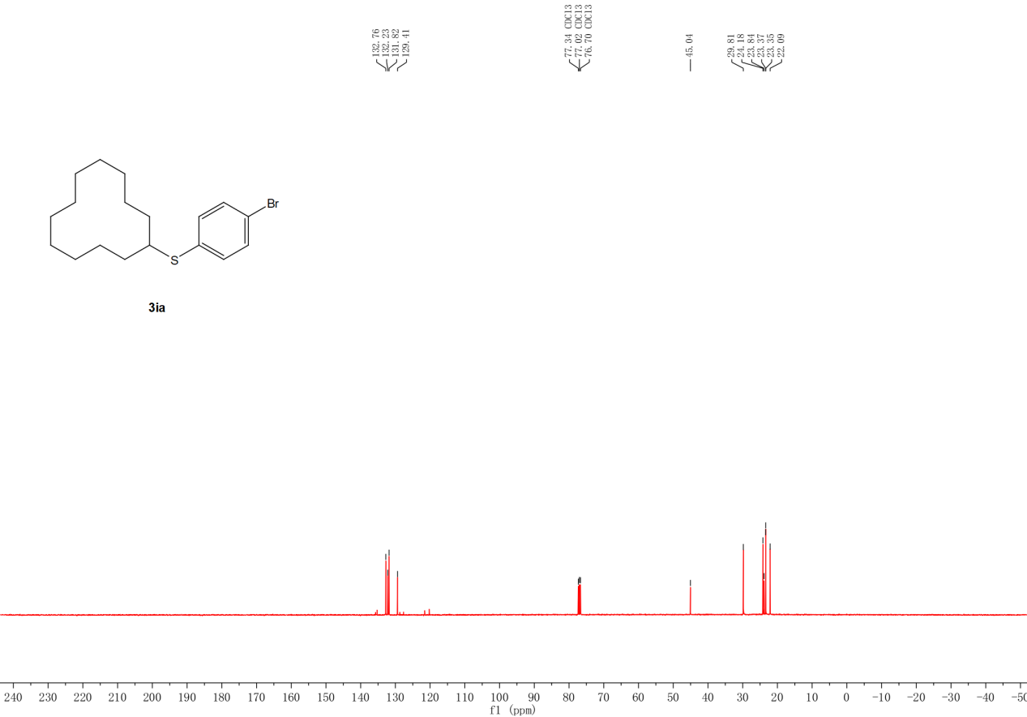
Figure S19. ¹³C NMR spectra (400 MHz) of 3ia in CDCl₃.

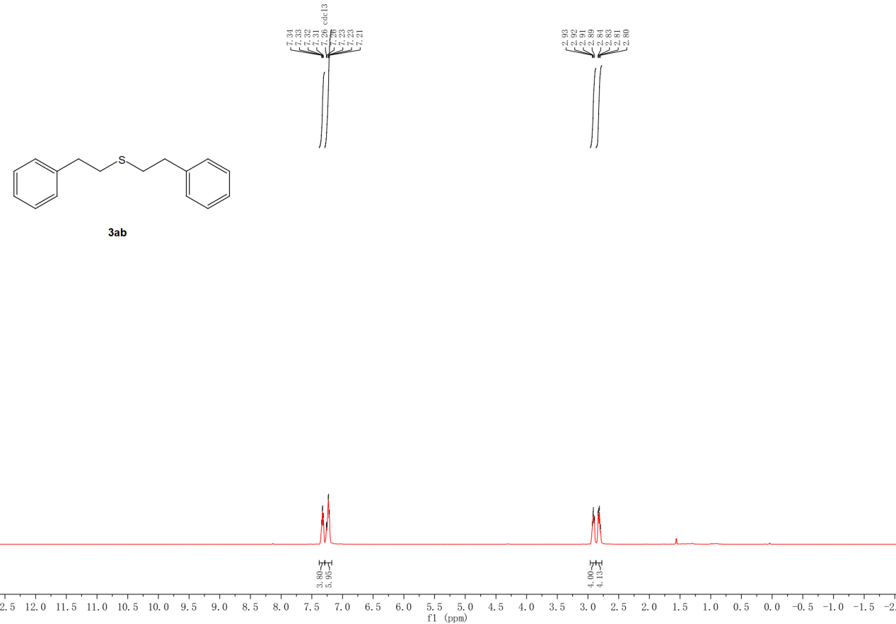
Figure S20. ¹H NMR spectra (400 MHz) of 3ab in CDCl₃.

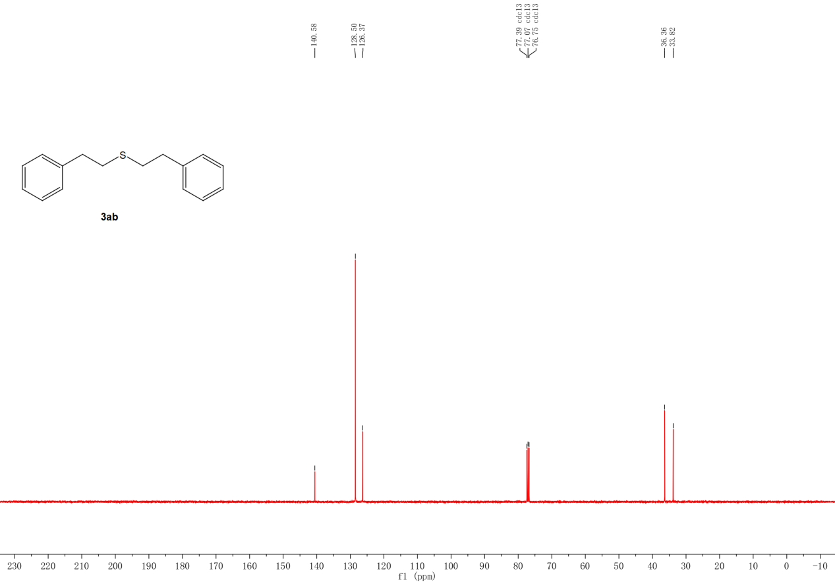
Figure S21. ¹³C NMR spectra (400 MHz) of 3ab in CDCl₃.

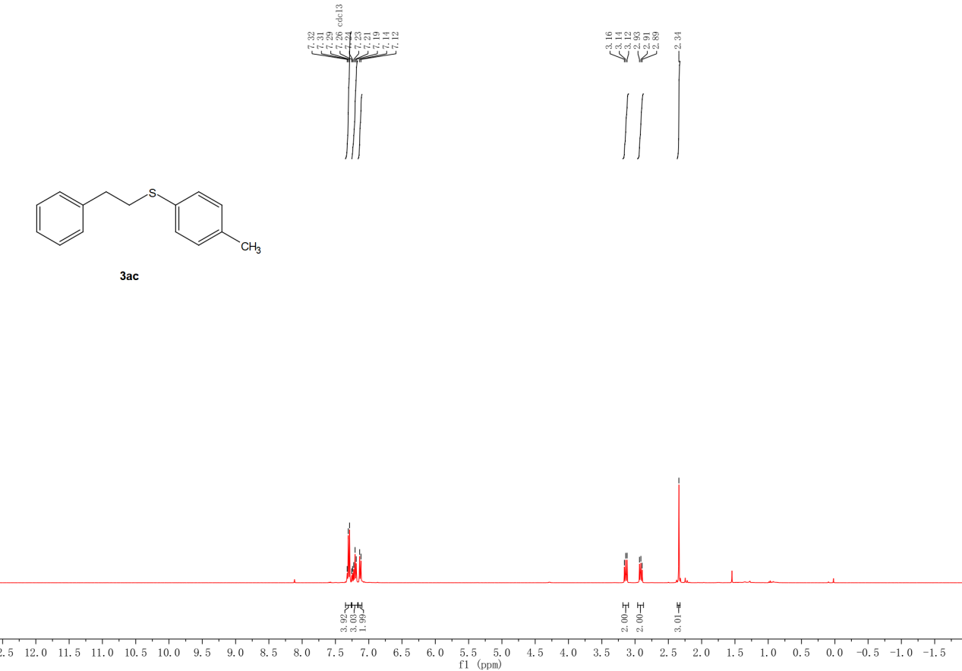
Figure S22. ¹H NMR spectra (400 MHz) of 3ac in CDCl₃.
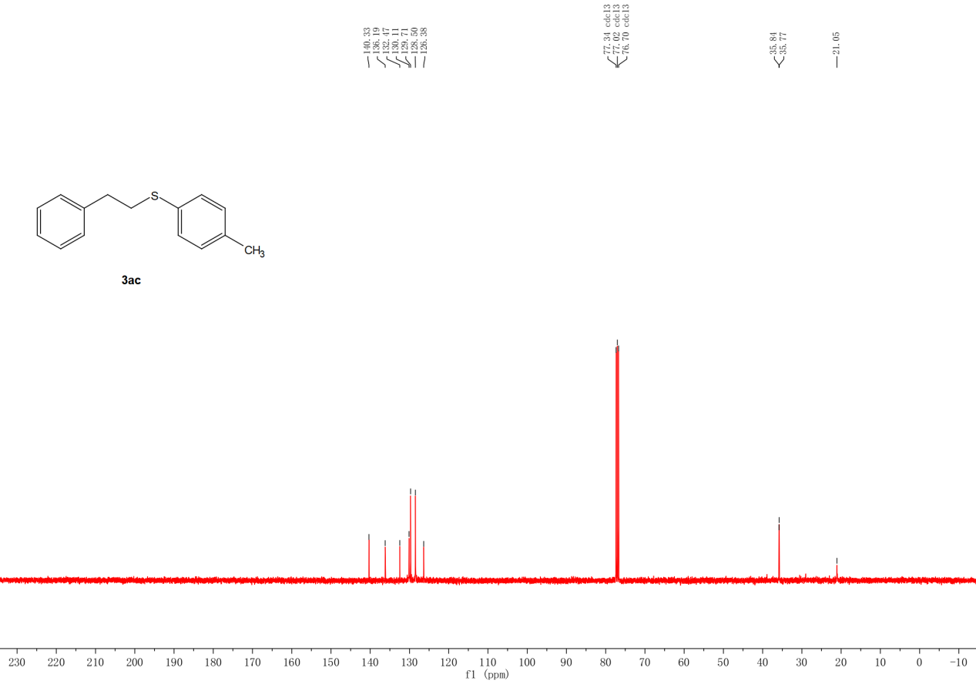
Figure S23. ¹³C NMR spectra (400 MHz) of 3ac in CDCl₃.

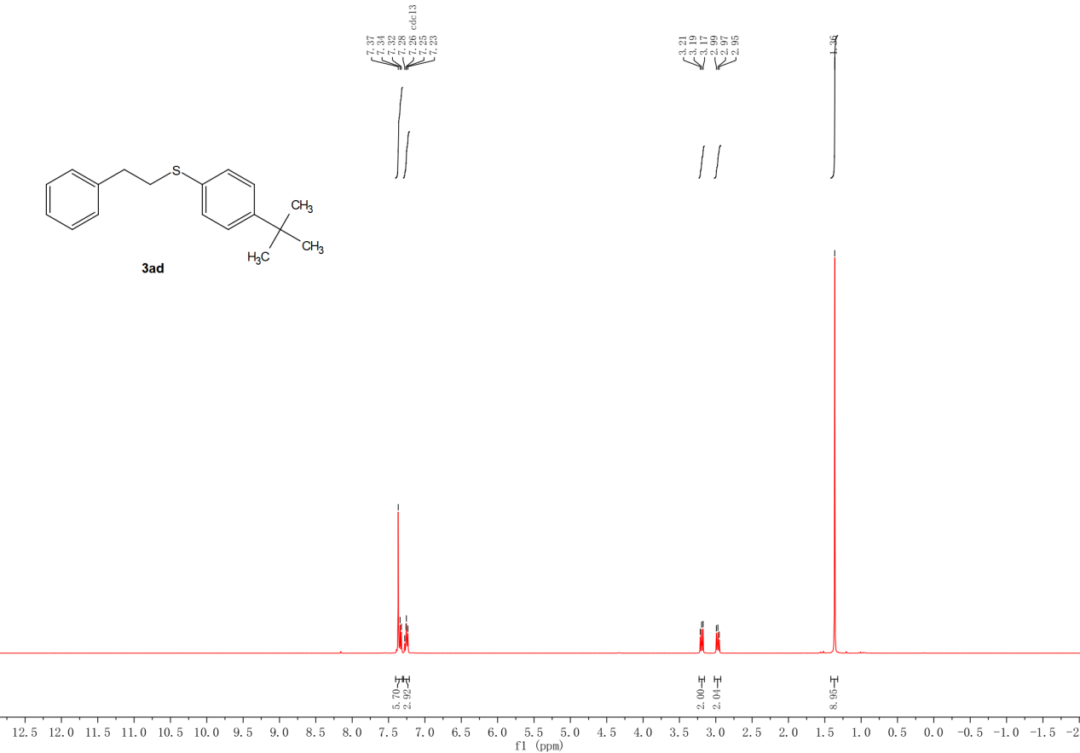
Figure S24. ¹H NMR spectra (400 MHz) of 3ad in CDCl₃.
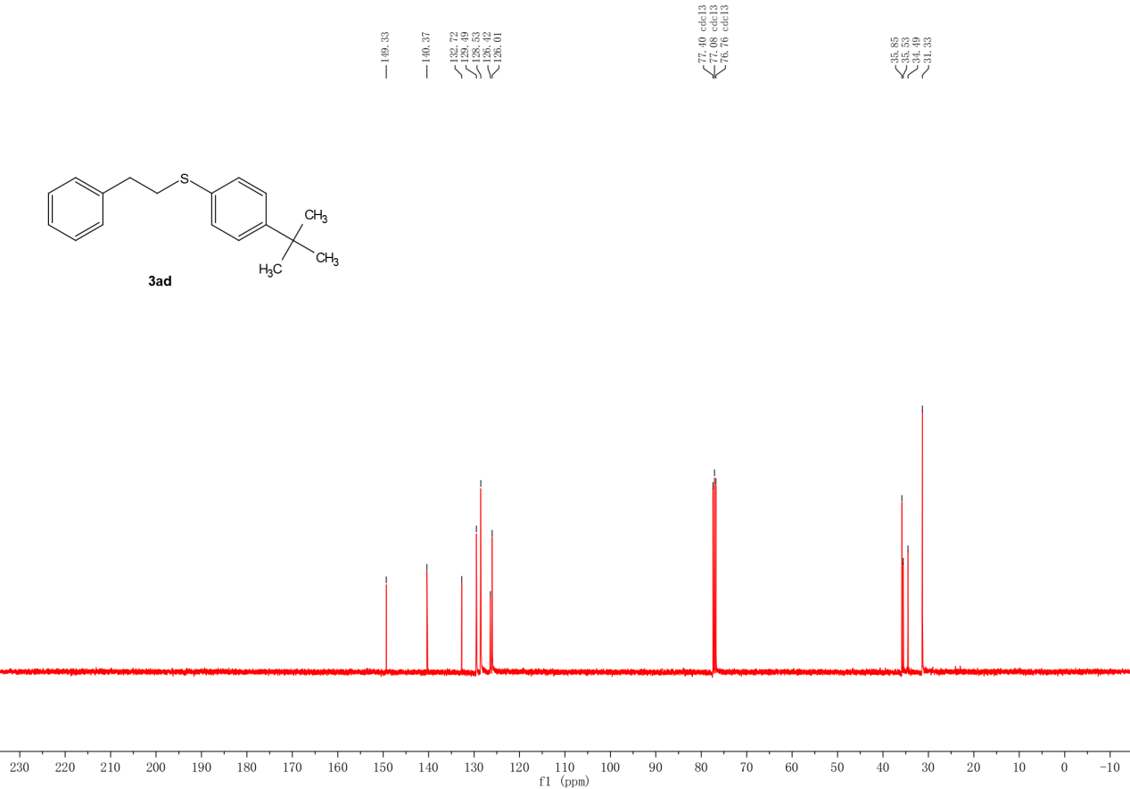
Figure S25. ¹³C NMR spectra (400 MHz) of 3ad in CDCl₃.

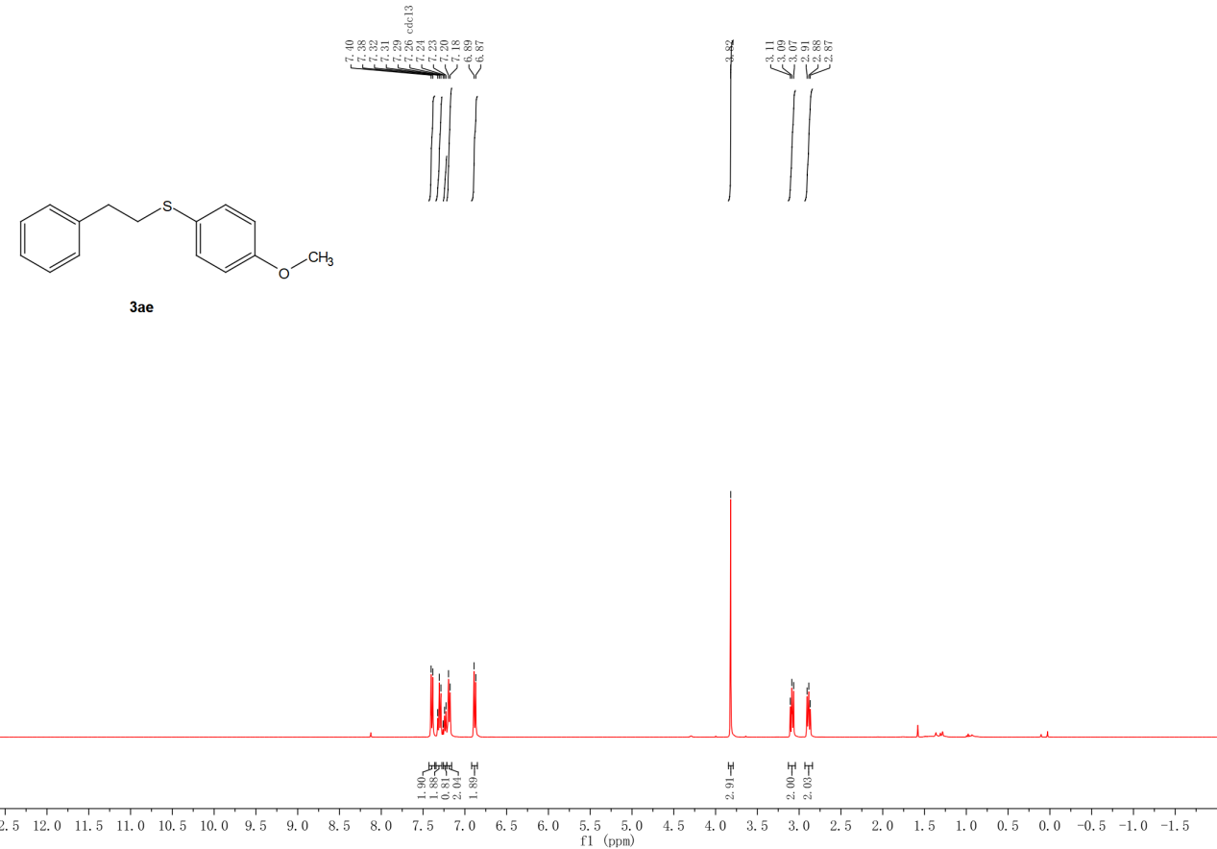
Figure S26. ¹H NMR spectra (400 MHz) of 3ae in CDCl₃.
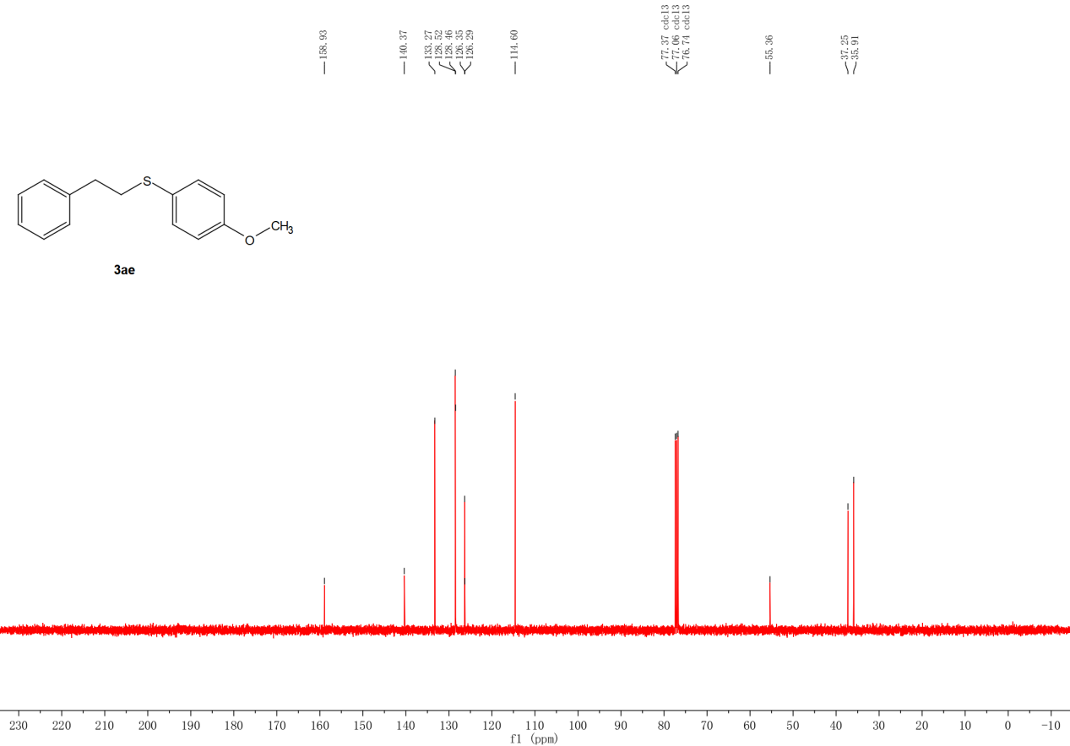
Figure S27. ¹³C NMR spectra (400 MHz) of 3ae in CDCl₃.

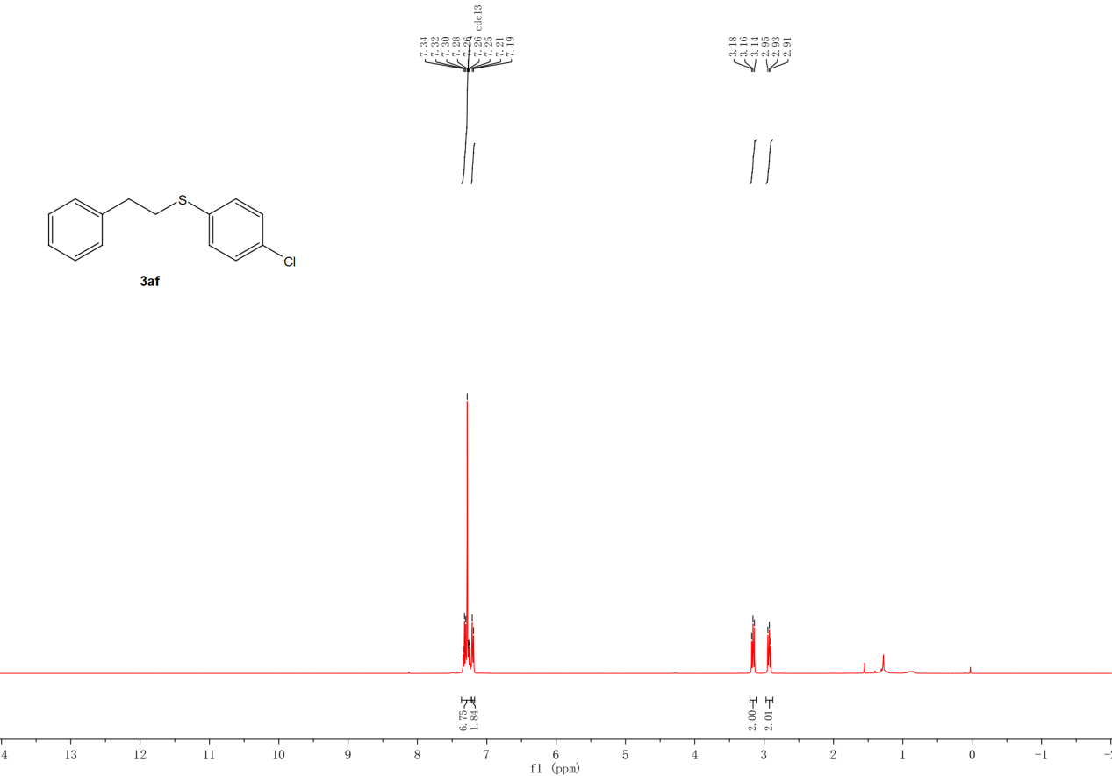
Figure S28. ¹H NMR spectra (400 MHz) of 3af in CDCl₃.
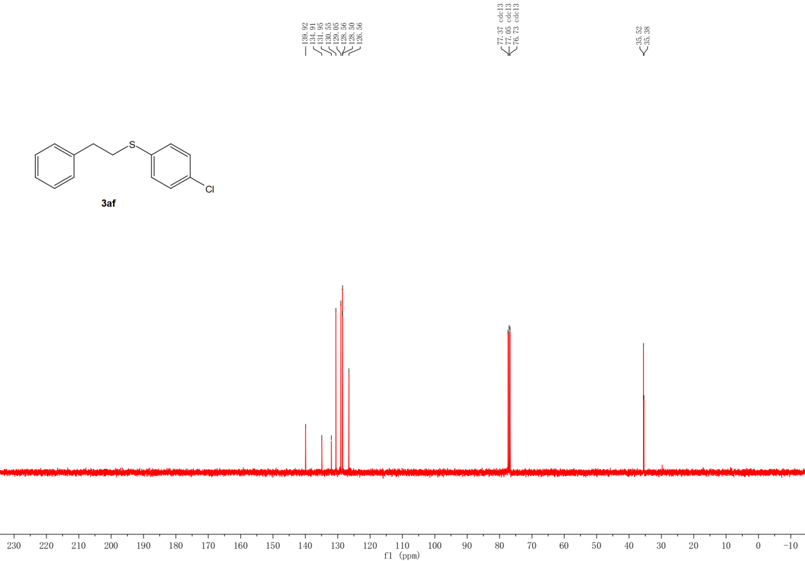
Figure S29. ¹³C NMR spectra (400 MHz) of 3af in CDCl₃.

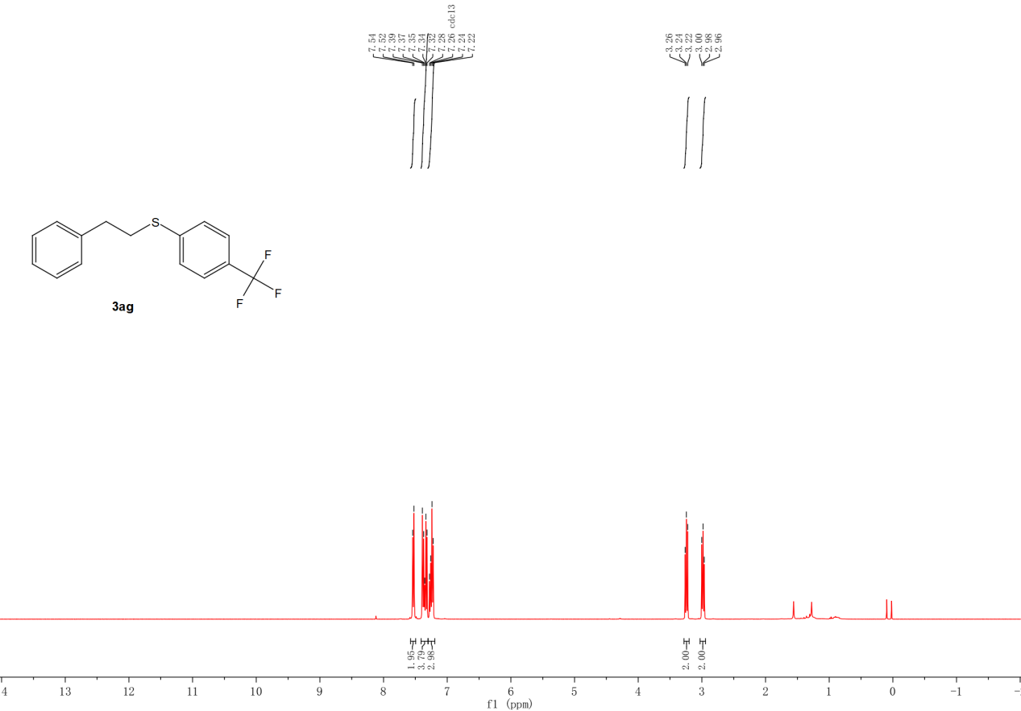
Figure S30. ¹H NMR spectra (400 MHz) of 3ag in CDCl₃.

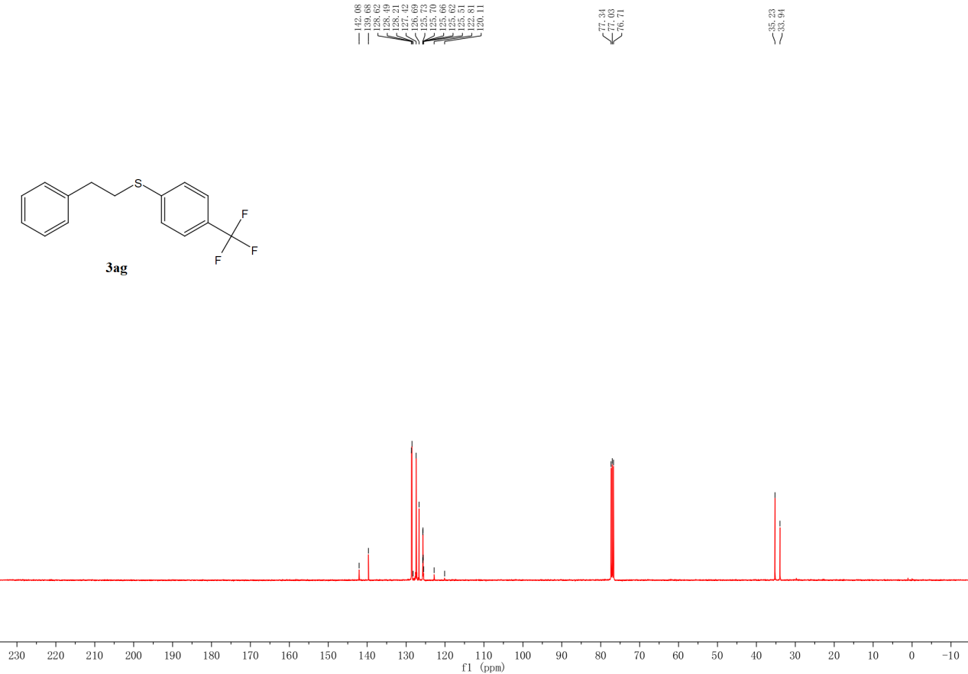
Figure S31. ¹³C NMR spectra (400 MHz) of 3ag in CDCl₃.

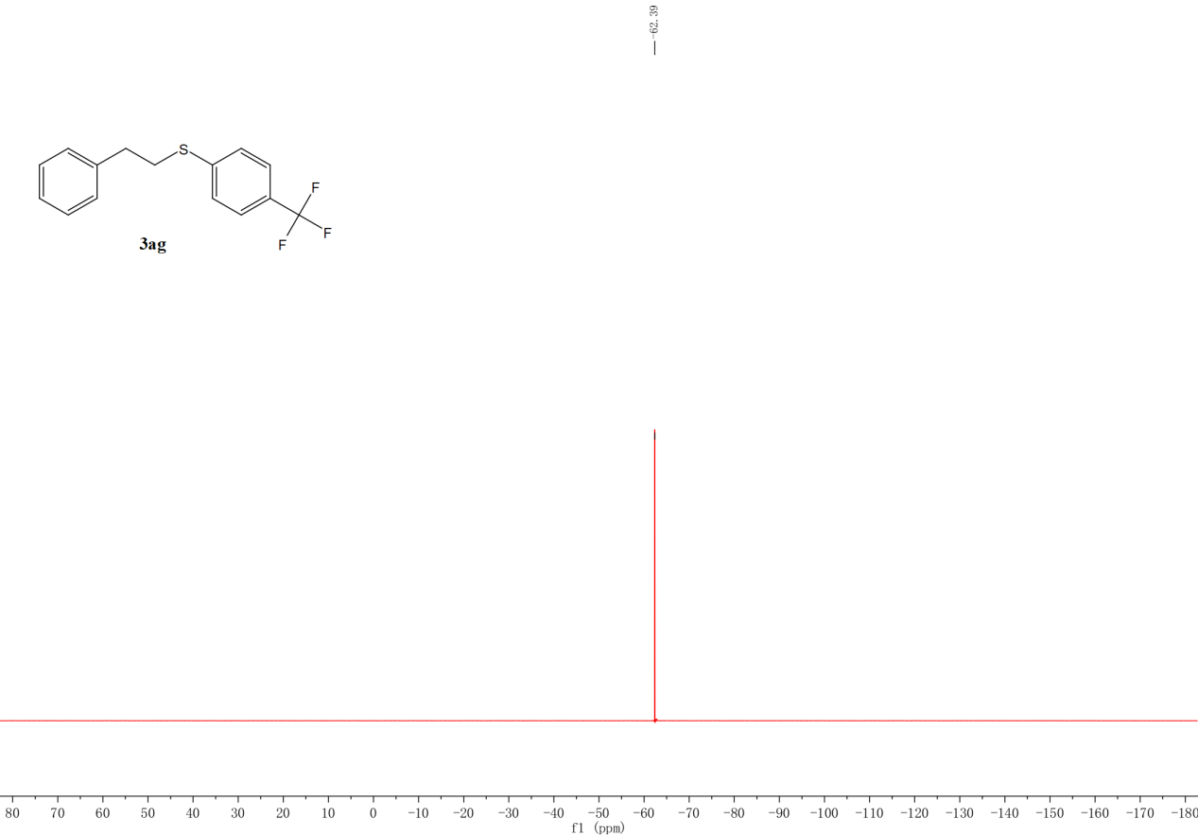
Figure S32. ¹⁹F NMR spectra (400 MHz) of 3ag in CDCl₃.
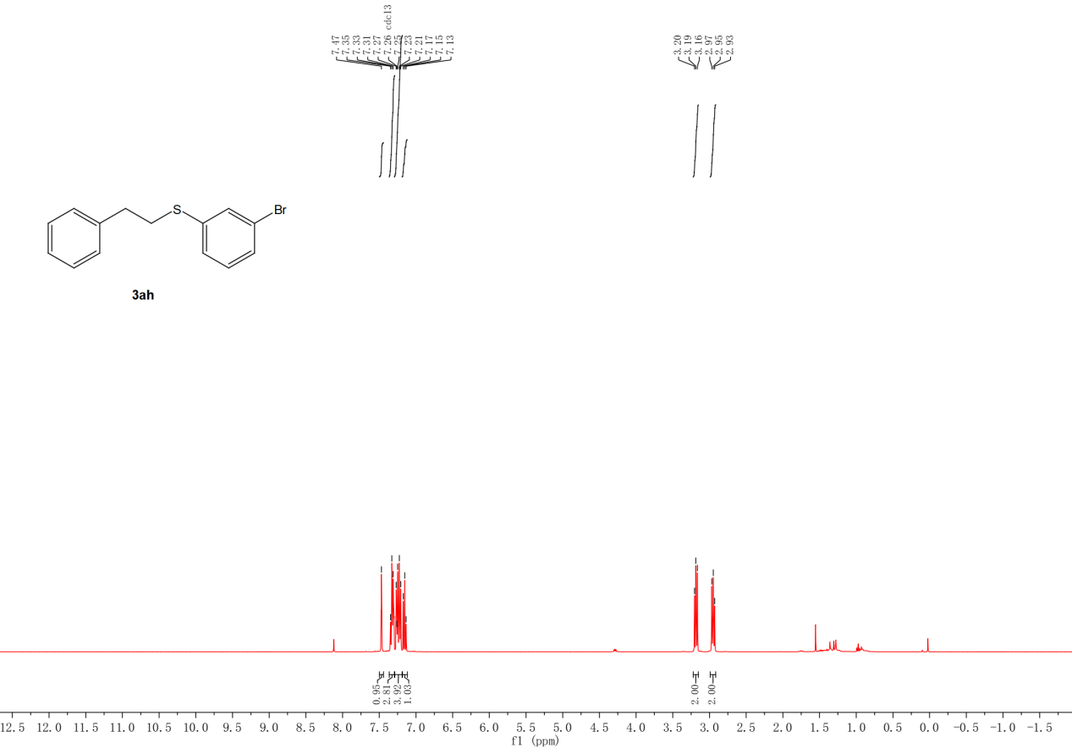
Figure S33. ¹H NMR spectra (400 MHz) of 3ah in CDCl₃.

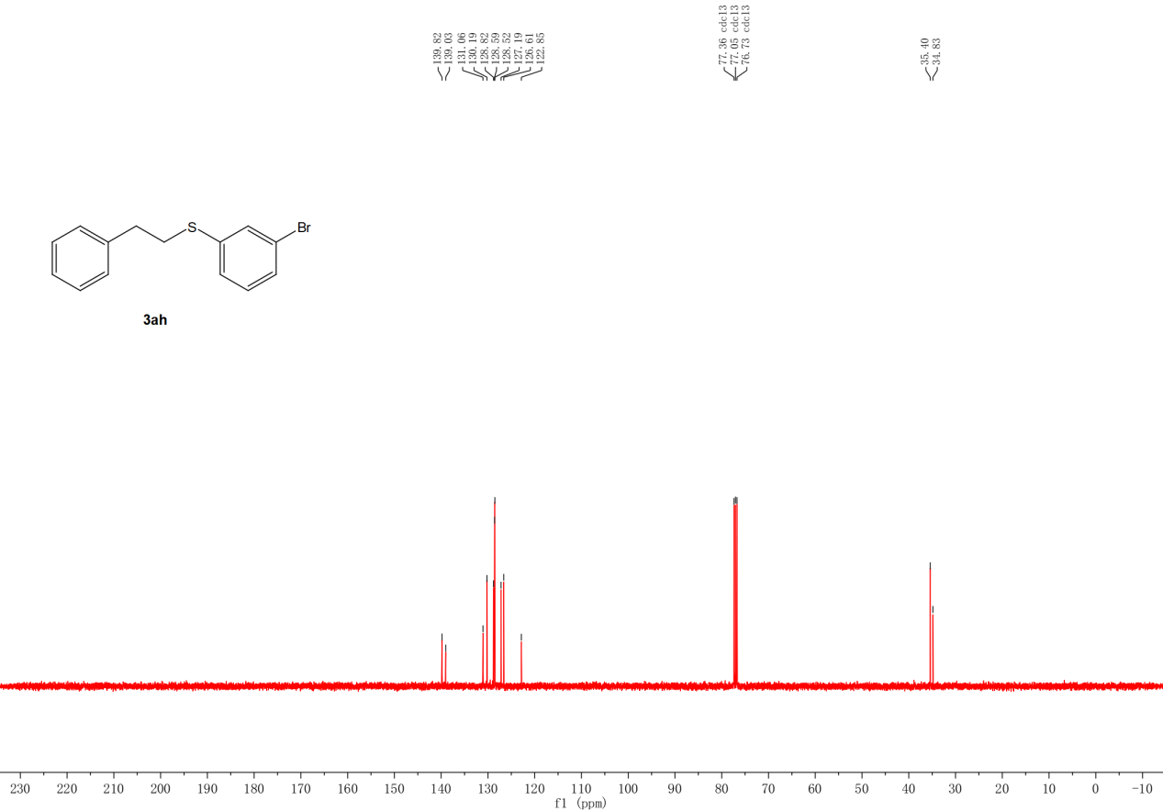
Figure S34. ¹³C NMR spectra (400 MHz) of 3ah in CDCl₃.

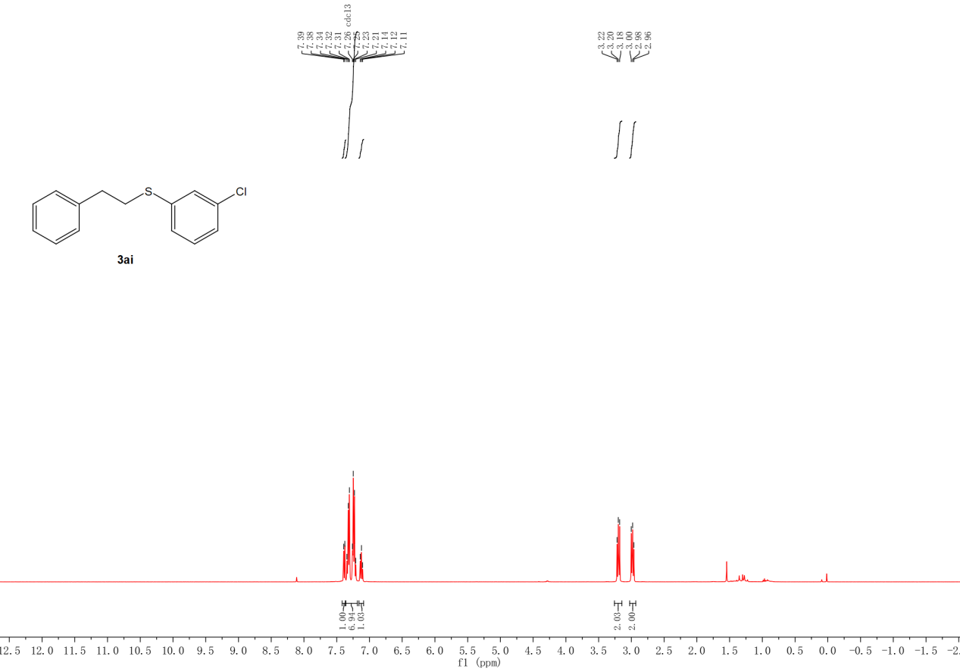
Figure S35. ¹H NMR spectra (400 MHz) of 3ai in CDCl₃.

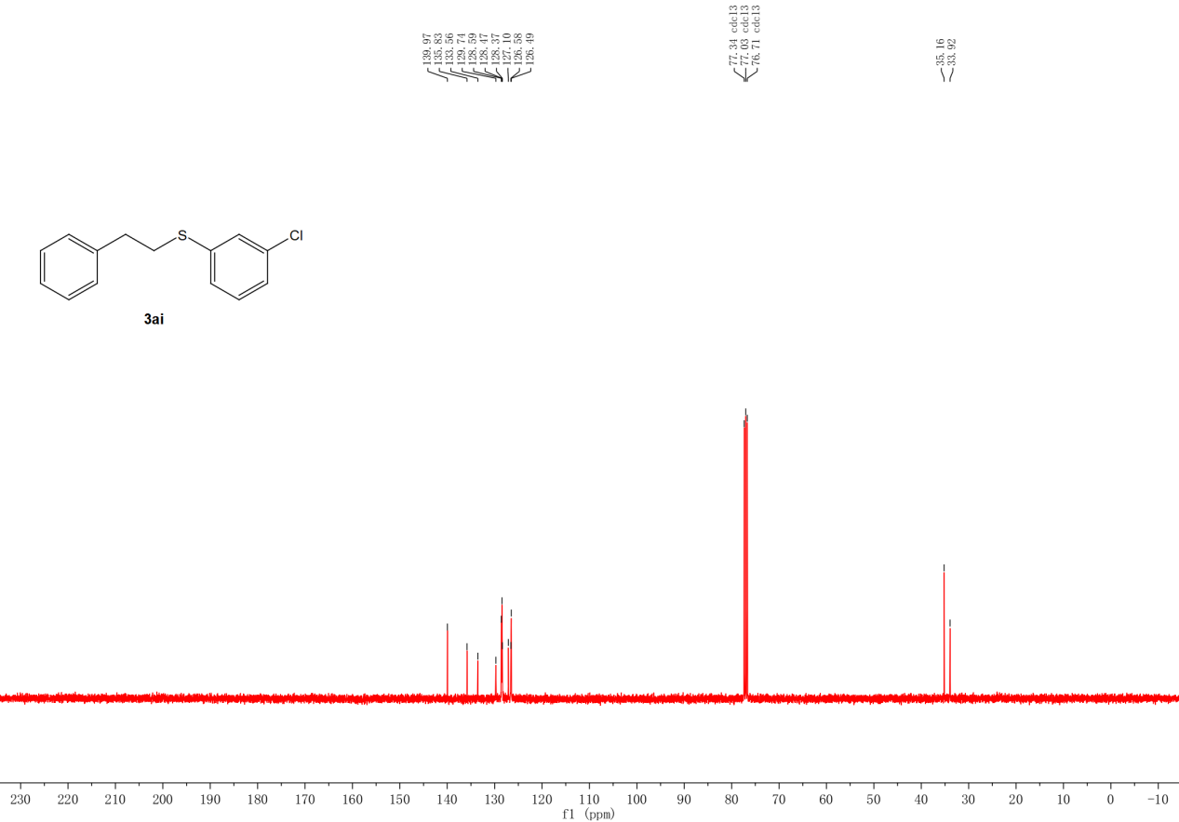
Figure S36. ¹³C NMR spectra (400 MHz) of 3ai in CDCl₃.

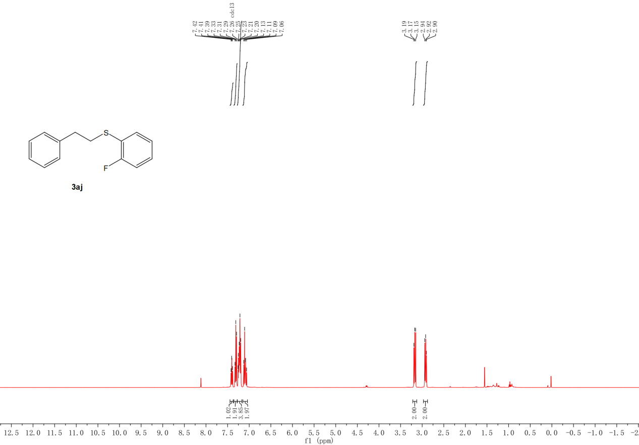
Figure S37. ¹H NMR spectra (400 MHz) of 3aj in CDCl₃.

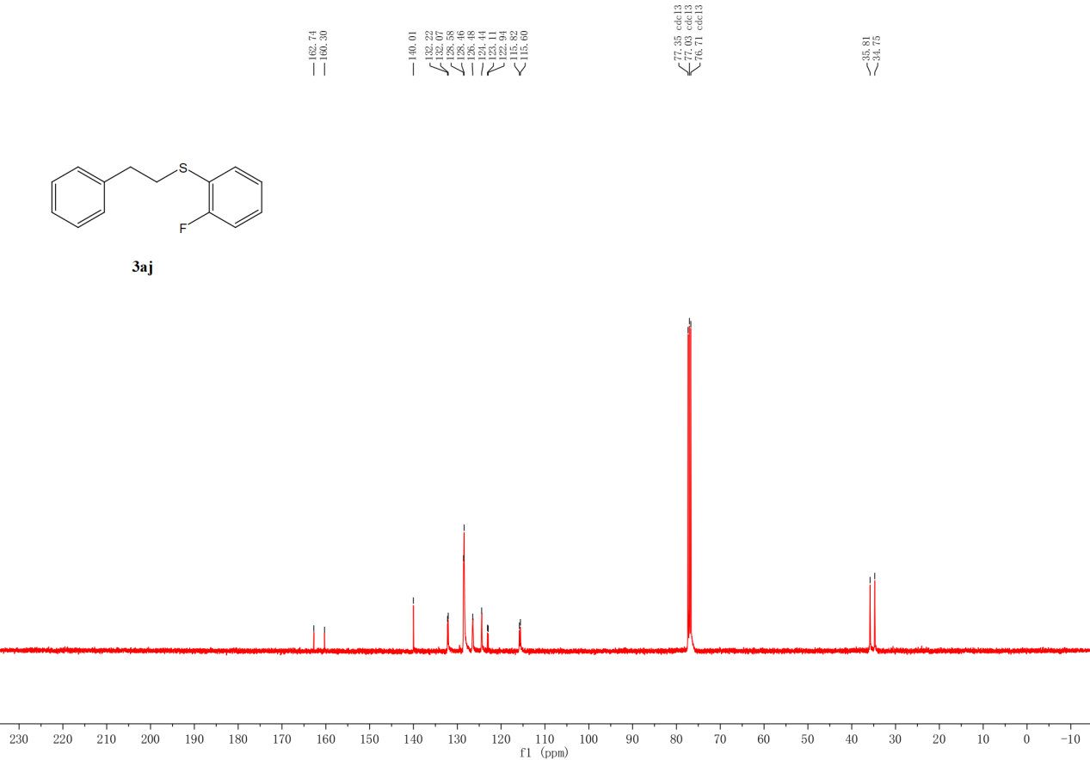
Figure S38. ¹³C NMR spectra (400 MHz) of 3aj in CDCl₃.
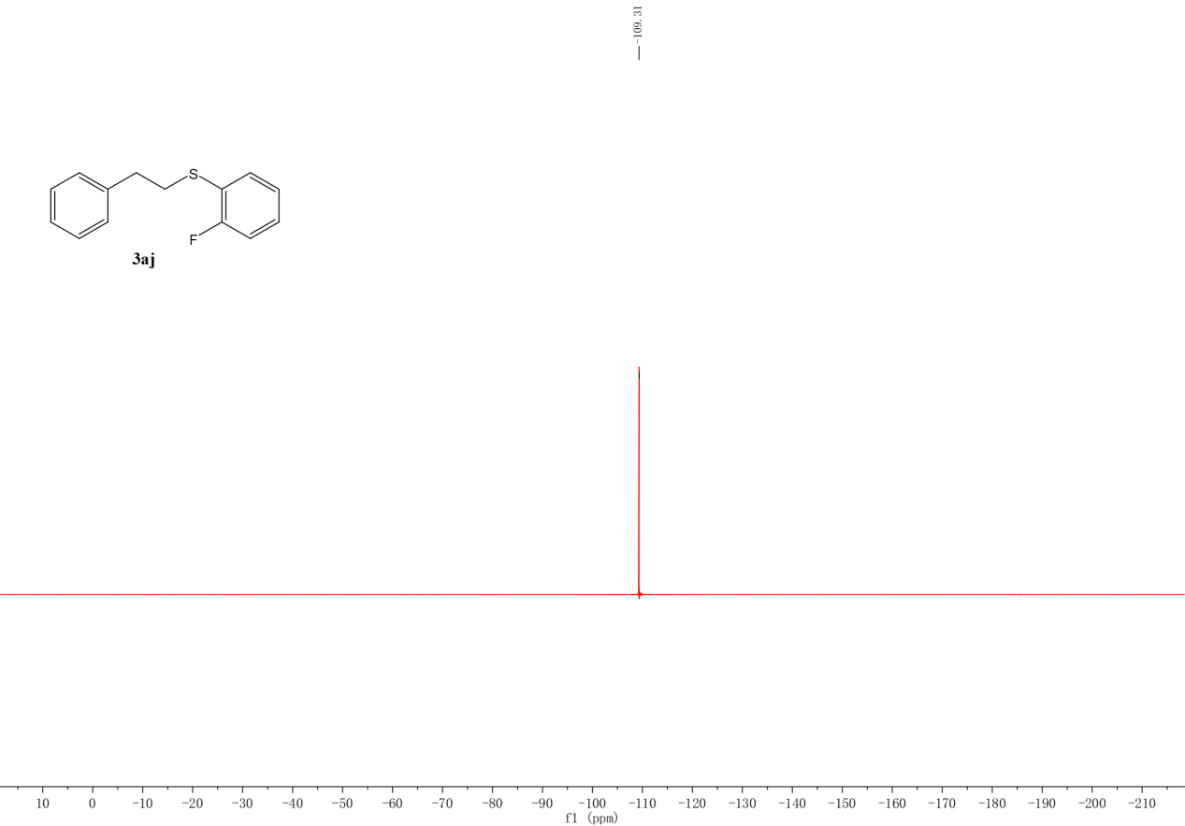
Figure S39. ¹⁹F NMR spectra (400 MHz) of 3aj in CDCl₃.

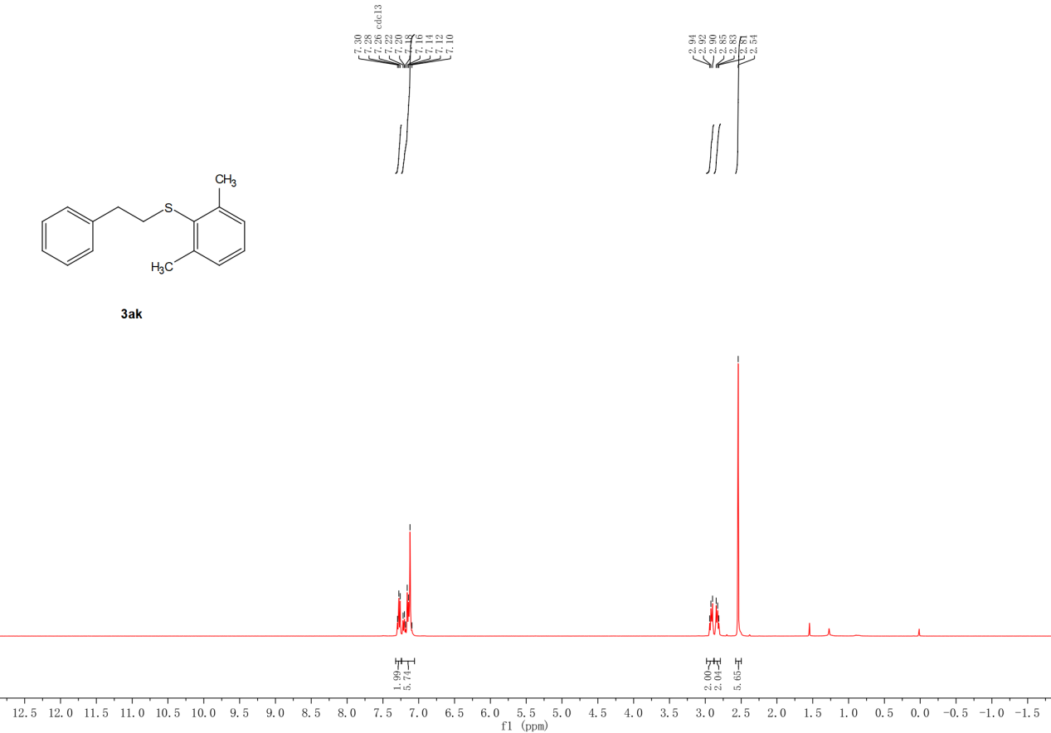
Figure S40. ¹H NMR spectra (400 MHz) of 3ak in CDCl₃.

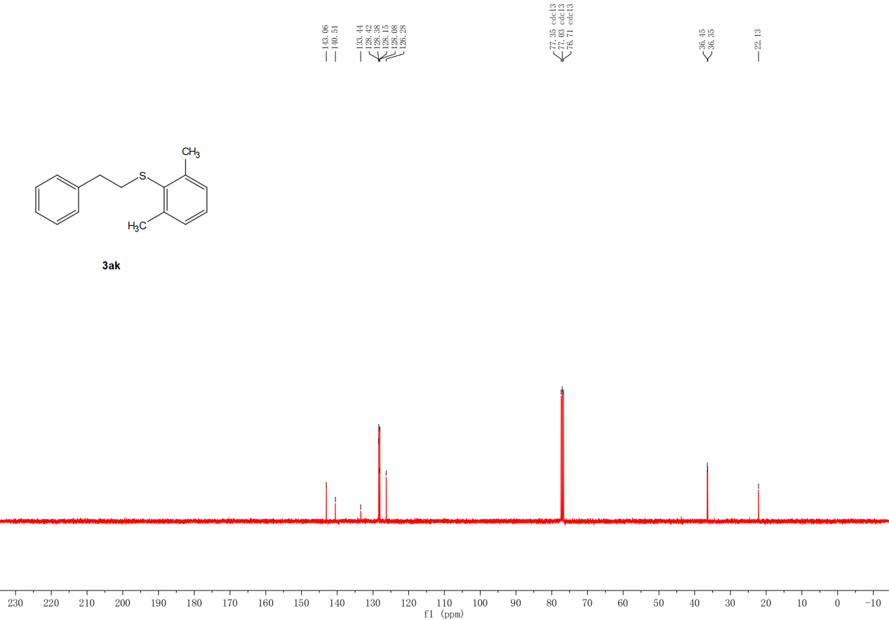
Figure S41. ¹³C NMR spectra (400 MHz) of 3ak in CDCl₃.

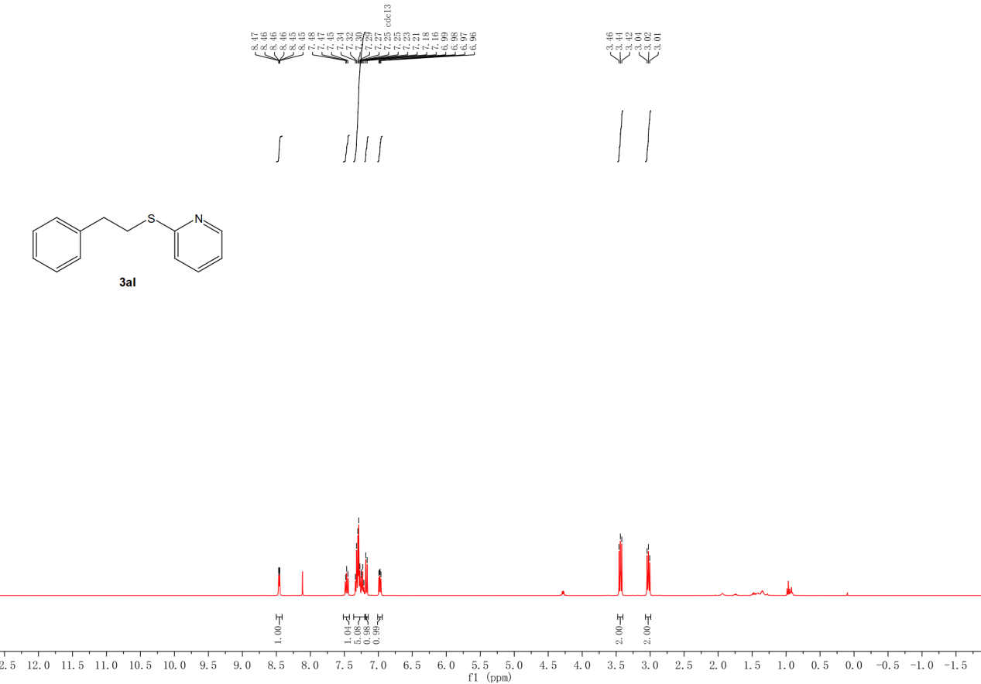
Figure S42. ¹H NMR spectra (400 MHz) of 3al in CDCl₃.

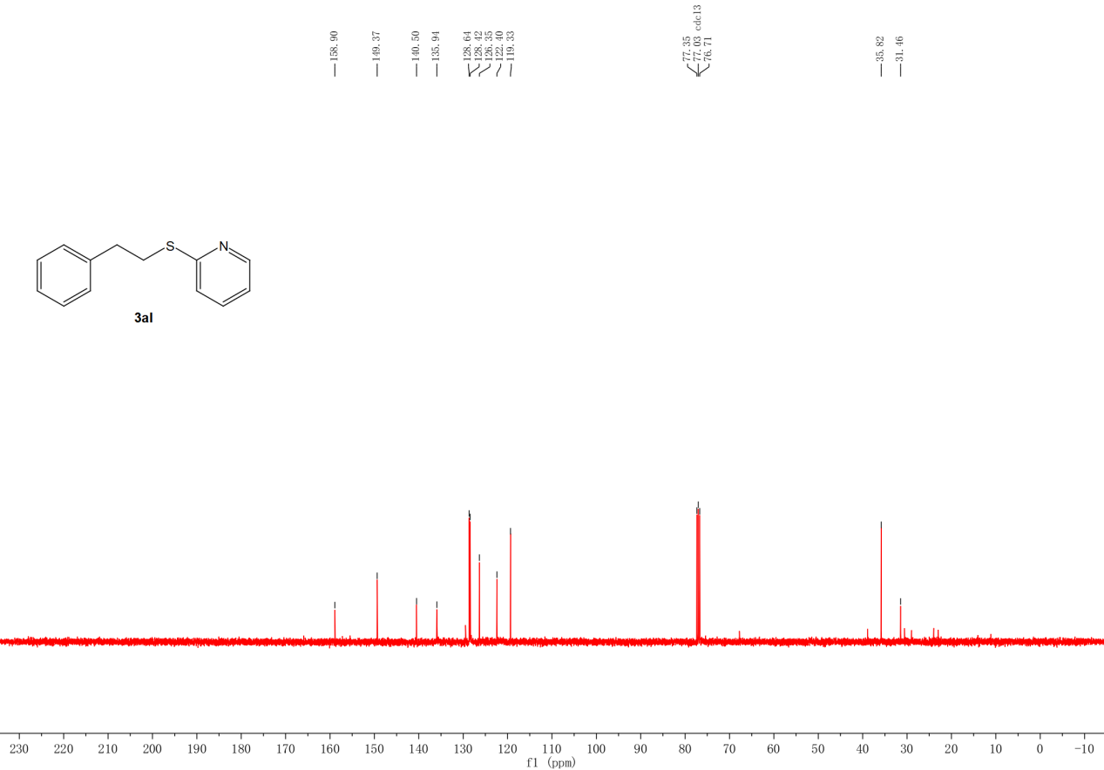
Figure S43. ¹³C NMR spectra (400 MHz) of 3al in CDCl₃.

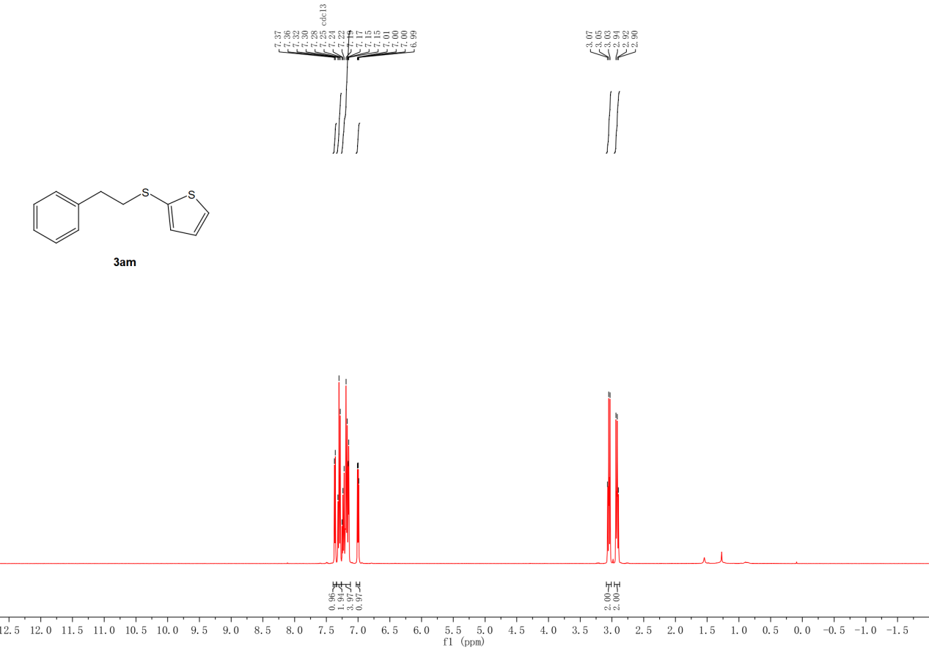
Figure S44. ¹H NMR spectra (400 MHz) of 3am in CDCl₃.

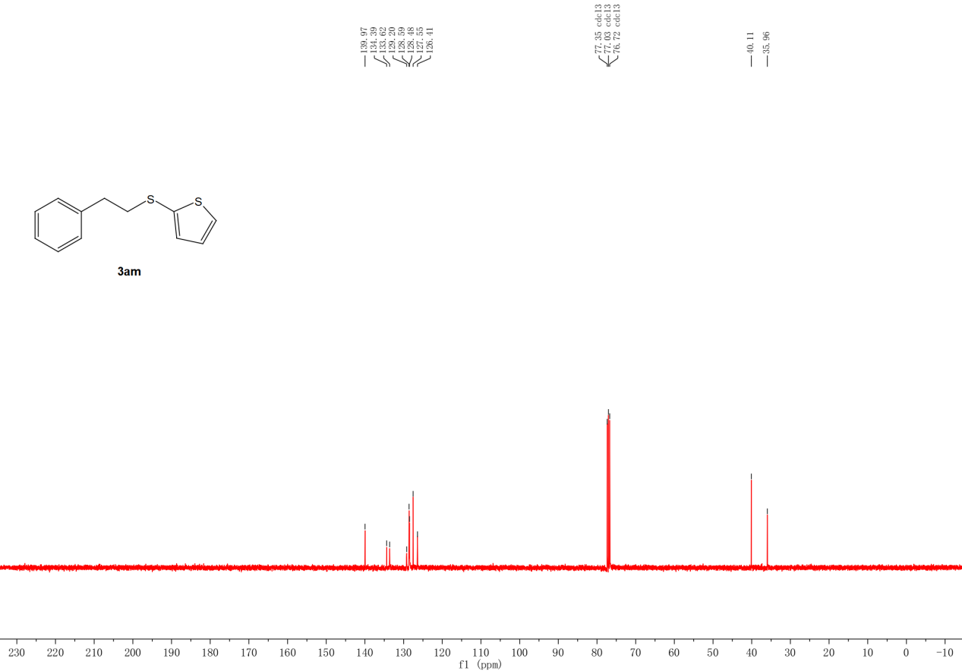
Figure S45. ¹³C NMR spectra (400 MHz) of 3am in CDCl₃.

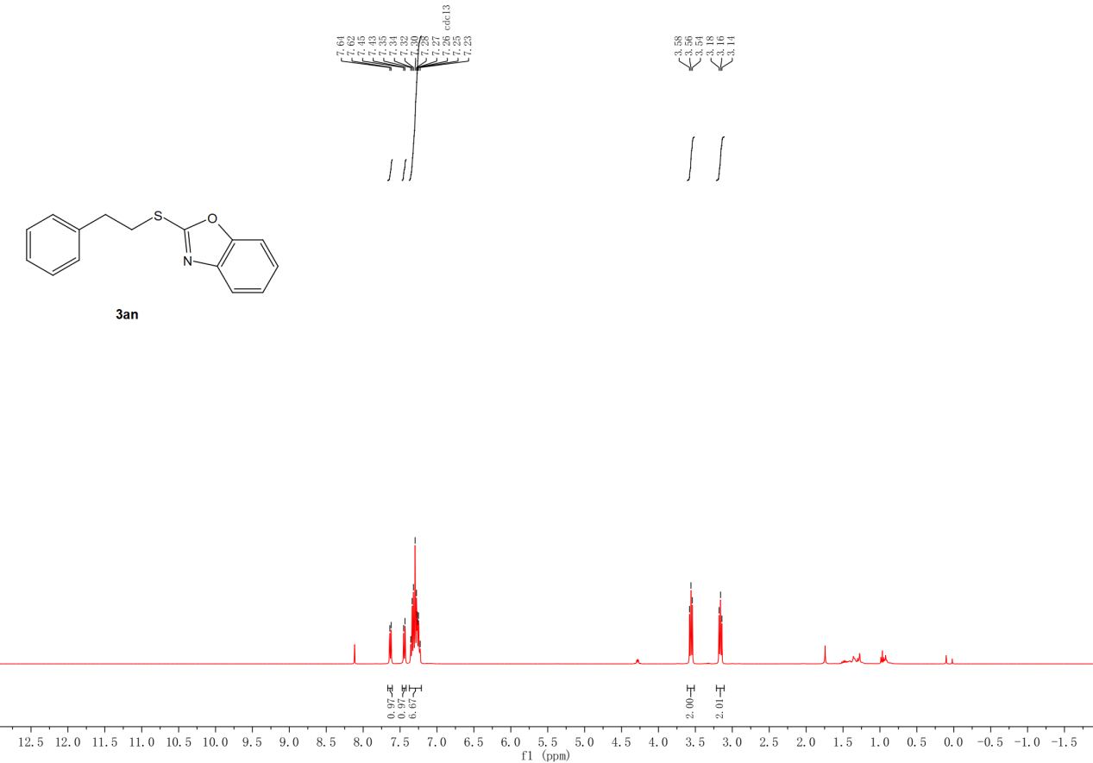
Figure S46. ¹H NMR spectra (400 MHz) of 3an in CDCl₃.

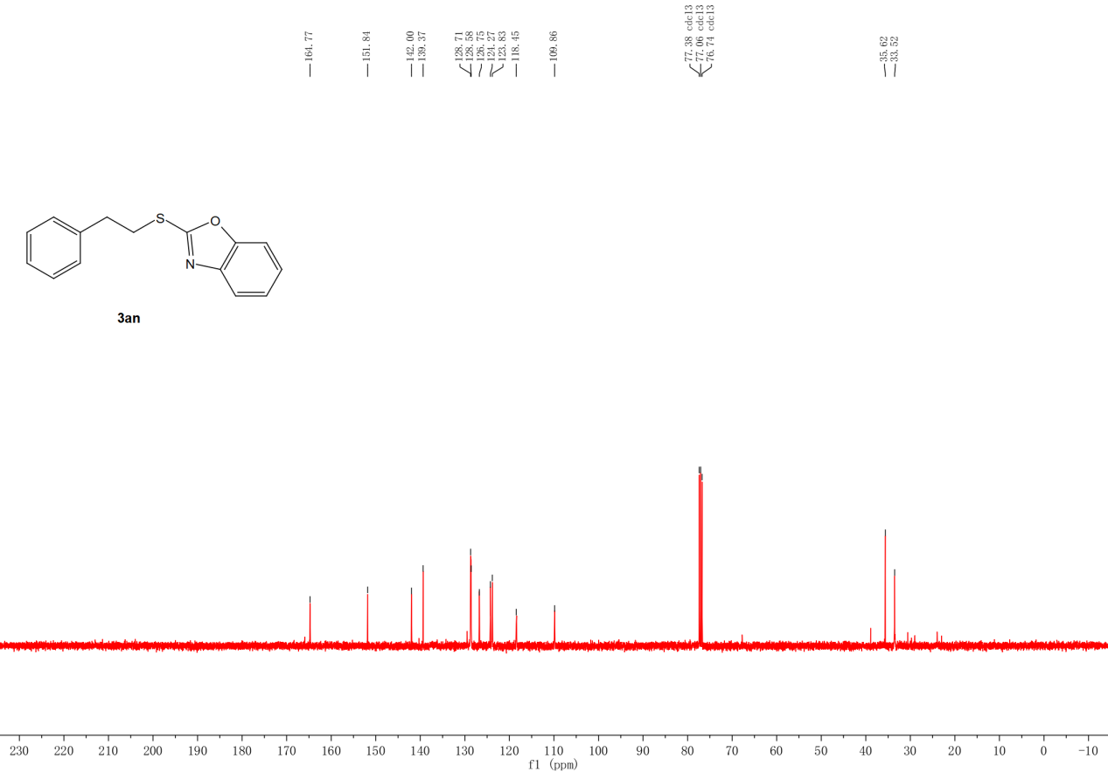
Figure S47. ¹³C NMR spectra (400 MHz) of 3an in CDCl₃.

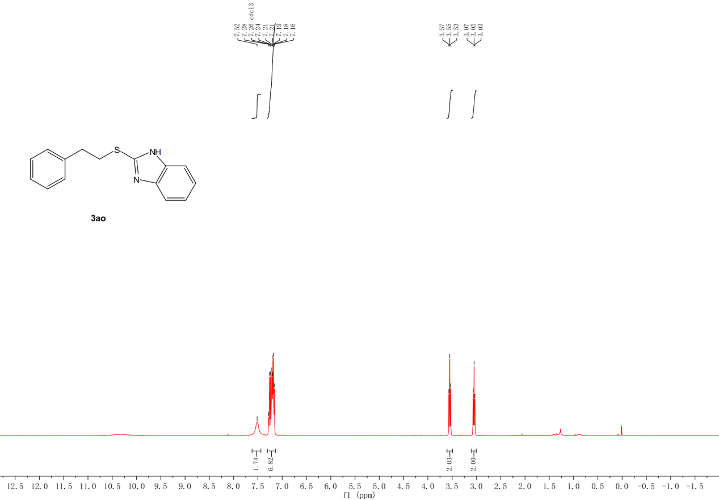
Figure S48. ¹H NMR spectra (400 MHz) of 3ao in CDCl₃.
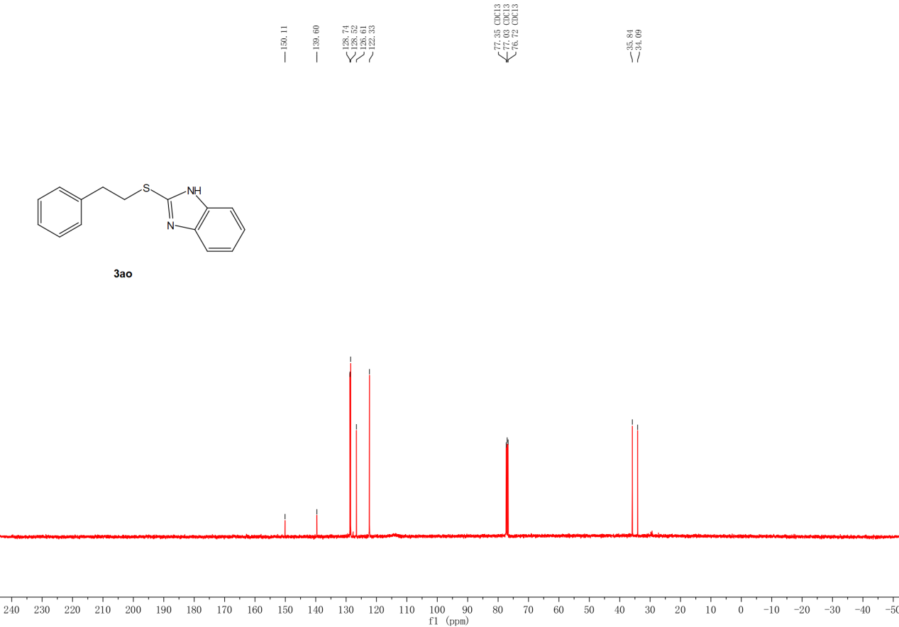
Figure S49. ¹³C NMR spectra (400 MHz) of 3ao in CDCl₃.

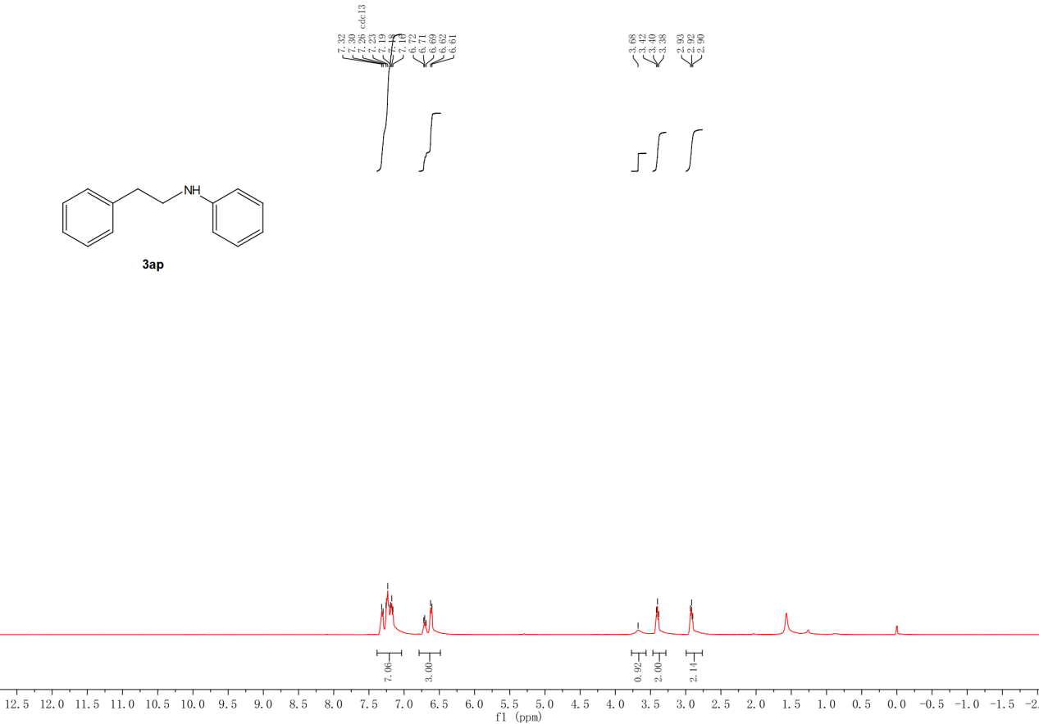
Figure S50. ¹H NMR spectra (400 MHz) of 3ap in CDCl₃.
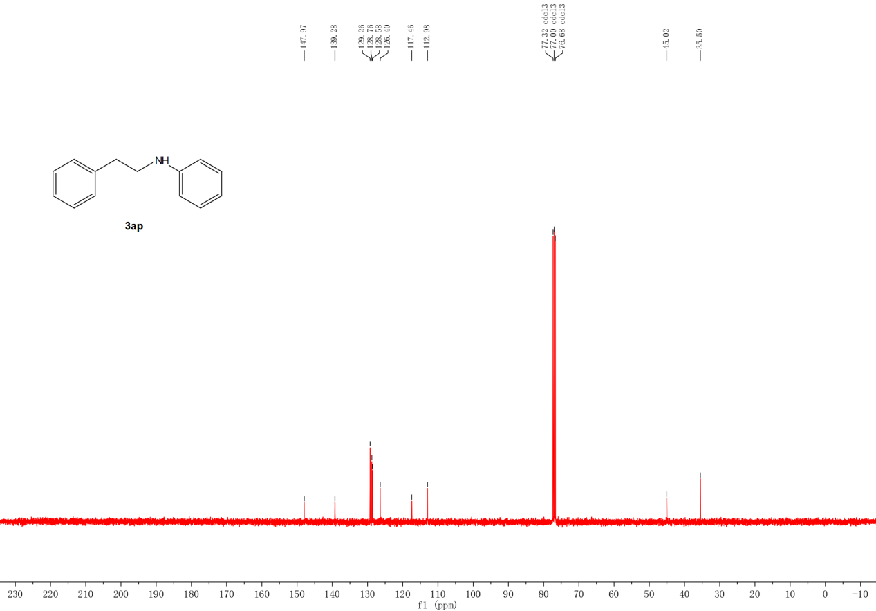
Figure S51. ¹³C NMR spectra (400 MHz) of 3ap in CDCl₃.

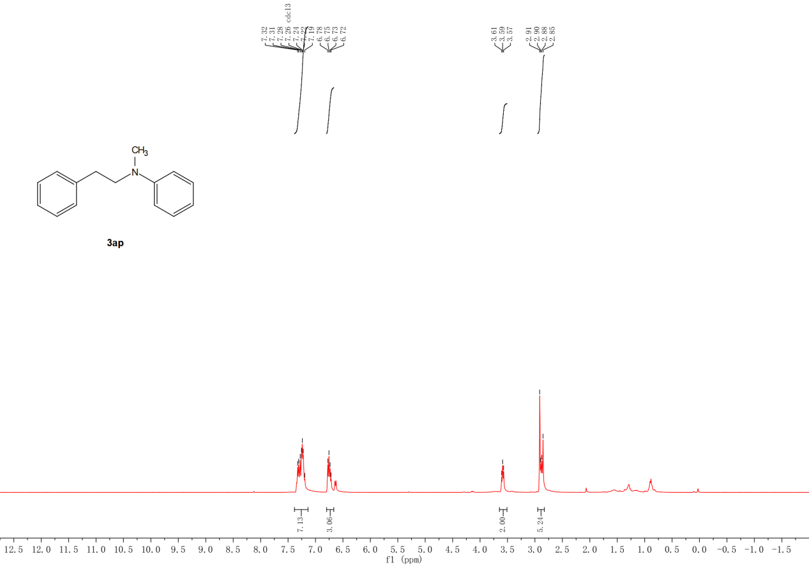
Figure S52. ¹H NMR spectra (400 MHz) of 3aq in CDCl₃.

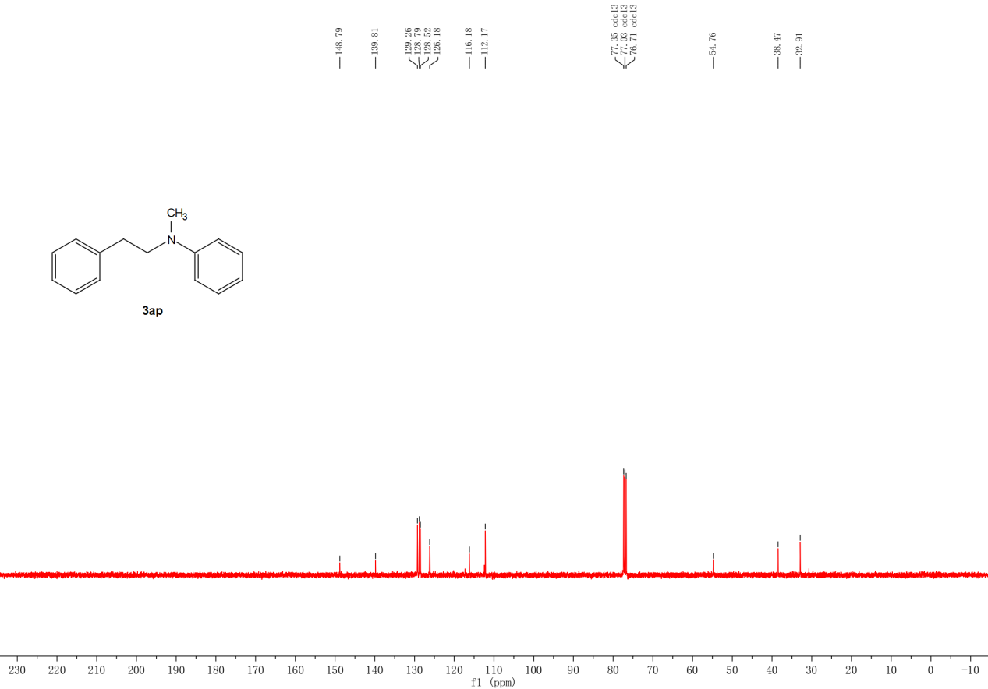
Figure S53. ¹³C NMR spectra (400 MHz) of 3aq in CDCl₃.

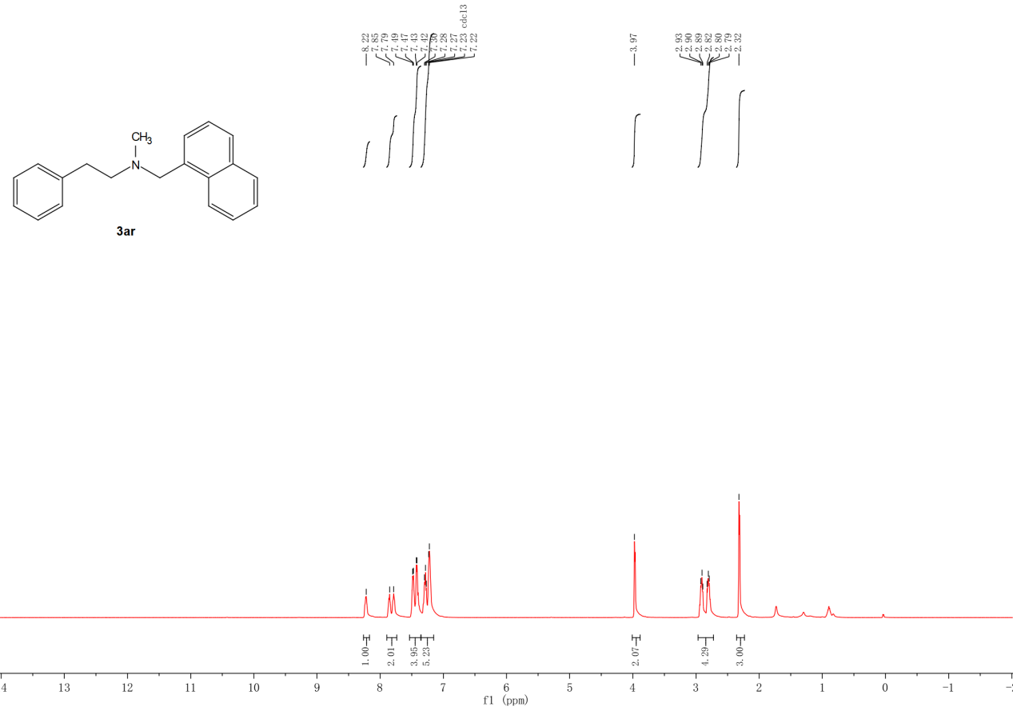
Figure S54. ¹H NMR spectra (400 MHz) of 3ar in CDCl₃.

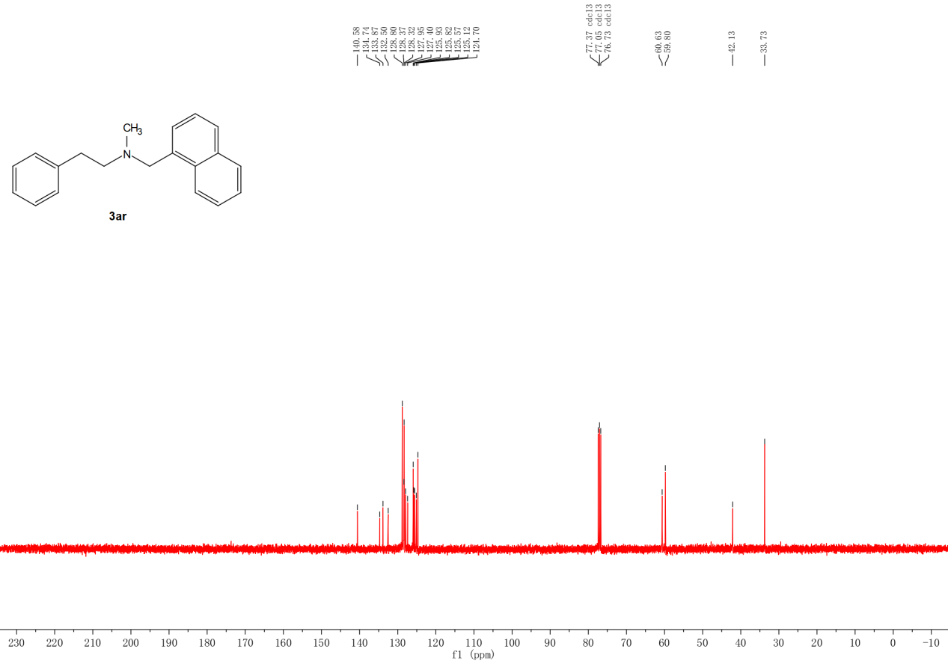
Figure S55. ¹³C NMR spectra (400 MHz) of 3ar in CDCl₃.

