Supporting Information
Ortho-Ester-Substituted Diaryliodonium Salts Enabled Regioselective Cyclization of Naphthol toward 3,4-Benzocoumarins

Ke Jiang¹, Cheng Pan¹, Limin Wang¹, Hao-Yang Wang,*² and Jianwei Han*¹

Address: ¹Key Laboratory for Advanced Materials and Feringa Nobel Prize Scientist Joint Research Center, Department of Fine Chemistry and Institute of Fine Chemicals, School of Chemistry and Molecular Engineering, East China University of Science and Technology, 130 Meilong Road, Shanghai 200237, P. R. China
Email: Jianwei Han* – jianweihan@ecust.edu.cn;
²National Center for Organic Mass Spectrometry in Shanghai, Shanghai Institute of Organic Chemistry, The Chinese Academy of Sciences, 345 Lingling Road, Shanghai 200032, China.
Email: Hao-Yang Wang* – haoyangwang@sioc.ac.cn

Table of Contents
Part 1. General Information 2
Part 2. Synthesis and Characterization of Ortho-Ester -Substituted Diaryliodonium Salts 3
Part 3. Table of Reaction Condition Optimization 8
Part 4. Synthesis and Characterization of 3,4-Benzocoumarins 9
Part 5. References 25
Part 6. ¹H, ¹³C, and ¹⁹F NMR spectra of Products 26
Part 7. LC-MS of Template reaction………………………………………………………………82

Part 1. General Information
- Methods:
NMR spectrum: ¹H, ¹³C, and ¹⁹F NMR spectra were recorded in CDCl₃ or DMSO-d₆ (with tetramethylsilane as an internal standard) on a Bruker AVANCE 400 spectrometer at ambient temperature, operating at 400 MHz, 101 MHz, and 376 MHz respectively. Data were reported as follows: Chemical shifts (δ) are reported in ppm, and coupling constants (J) are in Hertz (Hz). The following abbreviations were used to explain the multiplicities: s = singlet, d = doublet, t = triplet, q = quartet, m = multiplet, br = broad.
Mass spectroscopy: Mass spectra were in general recorded on a Waters LCT Premier XE spectrometer or EI Mass spectra were measured on HP HP5989A, Aglient HP5873 or Waters Micromass GCT mass spectrometer. ESI-MS analyses were performed in positive ionization mode on an Agilent 1100-MSD or Bruker Daltonics FTMS-7 mass spectrometer.
Chromatography: Column chromatography was performed with silica gel (200-300 mesh ASTM).

- Materials:
All solvents were purchased from Adamas-beta and dried and/or distilled by standard methods. All reagents were purchased from commercial sources (Adamas-beta; Sinopharma reagents; TCI; Acros) and used without further purification. Reactions were monitored by TLC (detection with UV light).The preparation of all other materials is described in detail below.

Part 2. Synthesis and Characterization of Ortho-Ester-Substituted Diaryliodonium Salts

General procedure 1: To a solution of methyl 2-iodobenzoate (10 mmol) in CH₂Cl₂ (40 mL) was slowly added mCPBA (2.5g,11mmol) at room temperature. After stirring for 5 minutes, Mesitylene(2.0ml,12mmol) was added. Then trifluoromethanesulfonic acid(1.2ml,15mmol) was added dropwise over 2 minute at 0°C and the solution was stirred at 40°C for 2-3 hours until TLC indicated that the methyl 2-iodobenzoate was completely consumed. The solvent was removed in vacuo and Et₂O(50ml) was added in the mixture. The mixture was stirred vigorously until the solid precipitated. The solids were washed with Et₂O(2*10ml) and filtrated under reduced pressure to give the ortho-Ester-Substituted Diaryliodonium Salts(2a-2j) in a pure form.

methyl 2-(mesityl(((trifluoromethyl)sulfonyl)oxy)-λ³-iodaneyl)benzoate (2a)

Prepared according to the General procedure 1 on 10 mmol scale. The desired product of ortho-Ester-Substituted Diaryliodonium Salts (2a) was obtained as white solid (4.24g, 81%).
¹H NMR (400 MHz, DMSO-d₆) δ 8.34 (d, J = 7.3 Hz, 1H), 7.83 – 7.73 (m, 2H), 7.42 (s, 2H), 6.90 (d, J = 7.7 Hz, 1H), 4.07 (s, 3H), 2.53 (s, 6H), 2.43 (s, 3H).
Analytical data are consistent with the reported ones.^{[1]}

ethyl 2-(mesityl(((trifluoromethyl)sulfonyl)oxy)- λ³-iodaneyl)benzoate (2b)

Prepared according to the General procedure 1 on 1 mmol scale. The desired product of ortho-Ester-Substituted Diaryliodonium Salts (2b) was obtained as white solid (462mg, 85%).
M.P.: 186-189 ℃.
¹H NMR (400 MHz, DMSO-d₆) δ 8.33 (dd, J = 7.5, 1.8 Hz, 1H), 7.80 (d, J = 1.0 Hz, 2H), 7.41 (s, 2H), 6.87 (dd, J = 8.0, 0.9 Hz, 1H), 4.52 (d, J = 7.1 Hz, 2H), 2.51 (s, 6H), 2.42 (s, 3H), 1.42 (t, J = 7.1 Hz, 3H).
¹³C NMR (101 MHz, DMSO-d₆) δ 167.44 (s), 144.59 (s), 143.30 (s), 137.37 (s), 132.97 (s), 131.43 (s), 130.17 (s), 128.57 (s), 127.65 (s), 120.72(q, J_{C-F} = 323.2Hz), 117.87 (s), 113.65 (s), 63.82 (s), 26.13 (s), 20.83 (s), 13.95 (s).
¹⁹F NMR (376 MHz, DMSO-d₆) δ -77.77.
HRMS m/z (ESI-TOF): calculated for C₁₈H₂₀O₂I⁺ [M-OTf]⁺ 395.0508, found 395.0486.

methyl 2-(mesityl(((trifluoromethyl)sulfonyl)oxy)- λ³-iodaneyl)-6-methylbenzoate (2c)
Prepared according to the General procedure 1 on 1 mmol scale. The desired product of ortho-Ester-Substituted Diaryliodonium Salts (2c) was obtained as white solid (450mg, 80%).
M.P.: 175-178 ℃.
¹H NMR (400 MHz, DMSO-d₆) δ 7.65 (d, J = 7.5 Hz, 1H), 7.56 (t, J = 7.9 Hz, 1H), 7.37 (s, 2H), 6.92 (d, J = 8.0 Hz, 1H), 4.04 (s, 3H), 2.64 (s, 3H), 2.51 (s, 6H), 2.40 (s, 3H).
¹³C NMR (101 MHz, DMSO-d₆) δ 169.41, 144.37, 144.35, 143.05, 135.65, 135.03, 130.07, 127.70, 127.63, 120.69(q, J_{C-F} = 323.2Hz), 119.38, 115.59, 54.32, 39.52, 26.04, 22.90, 20.75.
¹⁹F NMR (376 MHz, DMSO-d₆) δ -77.77.
HRMS m/z (ESI-TOF): calculated for C₁₈H₂₀O₂I⁺ [M-OTf]⁺ 395.0508, found 395.0489.

methyl 4-chloro-2-(mesityl(((trifluoromethyl)sulfonyl)oxy)- λ³-iodaneyl)benzoate (2d)

Prepared according to the General procedure 1 on 1 mmol scale. The desired product of ortho-Ester-Substituted Diaryliodonium Salts (2d) was obtained as white solid (423mg, 75%).
M.P.: 157-160 ℃.
¹H NMR (400 MHz, DMSO-d₆) δ 8.29 (d, J = 8.4 Hz, 1H), 7.90 (dd, J = 8.3, 1.4 Hz, 1H), 7.43 (s, 2H), 6.64 (d, J = 1.5 Hz, 1H), 4.06 (s, 3H), 2.54 (s, 6H), 2.44 (s, 3H).
¹³C NMR (101 MHz, DMSO-d₆) δ 167.34, 144.96, 143.32, 141.45, 133.88, 131.58, 130.28, 127.91, 126.88, 120.69(q, J_{C-F} = 323.2Hz), 118.34, 115.40, 54.63, 39.52, 26.09, 20.82.
¹⁹F NMR (376 MHz, DMSO-d₆) δ -77.76.
HRMS m/z (ESI-TOF): calculated for C₁₇H₁₇ClO₂I⁺ [M-OTf]⁺ 414.9962, found 414.9986.

methyl 2-(mesityl(((trifluoromethyl)sulfonyl)oxy)- λ³-iodaneyl)-3-methylbenzoate (2e)

Prepared according to the General procedure 1 on 1 mmol scale. The desired product of ortho-Ester-Substituted Diaryliodonium Salts (2e) was obtained as white solid (425mg, 78%).
M.P.: 159-162 ℃.
¹H NMR (400 MHz, DMSO-d₆) δ 7.82 (dd, J = 7.5, 1.4 Hz, 1H), 7.77 (d, J = 6.3 Hz, 1H), 7.69 (t, J = 7.6 Hz, 1H), 7.18 (s, 2H), 3.77 (s, 3H), 2.53 (s, 3H), 2.39 (s, 6H), 2.29 (s, 3H).
¹³C NMR (101 MHz, DMSO-d₆) δ 166.19, 143.54, 143.00, 142.11, 135.95, 133.21, 132.44, 130.20, 129.85, 120.69(q, J_{C-F} = 324.2Hz), 120.62, 119.09, 117.44, 53.38, 39.52, 25.37, 25.23, 20.38.
¹⁹F NMR (376 MHz, DMSO-d₆) δ -77.77.
HRMS m/z (ESI-TOF): calculated for C₁₈H₂₀O₂I⁺ [M-OTf]⁺ 395.0508, found 395.0488.

methyl 2-(mesityl(((trifluoromethyl)sulfonyl)oxy)-λ³-iodaneyl)-4-(trifluoromethyl)benzoate (2f)

Prepared according to the General procedure 1 on 1 mmol scale. The desired product of ortho-Ester-Substituted Diaryliodonium Salts (2f) was obtained as white solid (425mg, 71%).
M.P.: 175-178 ℃.
¹H NMR (400 MHz, DMSO-d₆) δ 8.48 (d, J = 8.0 Hz, 1H), 8.20 (d, J = 8.1 Hz, 1H), 7.45 (s, 2H), 6.89 (s, 1H), 4.10 (s, 3H), 2.53 (s, 6H), 2.44 (s, 3H).
¹³C NMR (101 MHz, DMSO-d₆) δ 167.03, 145.05, 143.30, 135.41, 135.08, 133.59, 131.87, 130.20, 126.71(dd, J_{C-F} = 394.9, 4.0Hz), 122.29(q, J_{C-F} = 274.7Hz), 120.68(q, J_{C-F} = 323.2Hz), 118.44, 115.14, 54.86, 39.52, 26.00, 20.76.
¹⁹F NMR (376 MHz, DMSO-d₆) δ -62.28, -77.80.
HRMS m/z (ESI-TOF): calculated for C₁₈H₁₇F₃O₂I⁺ [M-OTf]⁺ 449.0225, found 449.0206.

methyl 4-bromo-2-(mesityl(((trifluoromethyl)sulfonyl)oxy)- λ³-iodaneyl)benzoate (2g)

Prepared according to the General procedure 1 on 1 mmol scale. The desired product of ortho-Ester-Substituted Diaryliodonium Salts (2g) was obtained as white solid (487mg, 80%).
M.P.: 187-190 ℃.
¹H NMR (400 MHz, DMSO-d₆) δ 8.20 (d, J = 8.3 Hz, 1H), 8.03 (d, J = 1.7 Hz, 1H), 7.44 (s, 2H), 6.77 (d, J = 1.7 Hz, 1H), 4.05 (s, 3H), 2.53 (s, 6H), 2.44 (s, 3H).
¹³C NMR (101 MHz, DMSO-d₆) δ 167.49, 144.94, 143.30, 134.50, 134.00, 130.63, 130.49, 130.26, 127.16, 120.69(q, J_{C-F} = 324.2Hz), 118.32, 115.47, 54.62, 39.52, 26.08, 20.82.
¹⁹F NMR (376 MHz, DMSO-d₆) δ -77.76.
HRMS m/z (ESI-TOF): calculated for C₁₇H₁₇BrO₂I⁺ [M-OTf]⁺ 458.9457, found 458.9435.

methyl 2-(mesityl(((trifluoromethyl)sulfonyl)oxy)- λ³-iodaneyl)-4,5-dimethoxybenzoate (2h)

Prepared according to the General procedure 1 on 1 mmol scale. The desired product of ortho-Ester-Substituted Diaryliodonium Salts (2h) was obtained as white solid (442mg, 75%).
M.P.: 190-193 ℃.
¹H NMR (400 MHz, DMSO-d₆) δ 7.73 (s, 1H), 7.41 (s, 2H), 6.11 (s, 1H), 4.04 (s, 3H), 3.88 (s, 3H), 2.52 (d, J = 7.5 Hz, 6H), 2.41 (s, 3H).
¹³C NMR (101 MHz, DMSO-d₆) δ 167.77, 155.12, 150.35, 144.65, 143.22, 129.97, 120.69(q, J_{C-F} = 324.2Hz), 119.74, 118.50, 114.04, 110.35, 104.53, 56.30, 55.56, 54.30, 39.52, 26.12, 20.75.
¹⁹F NMR (376 MHz, DMSO-d₆) δ -77.77.
HRMS m/z (ESI-TOF): calculated for C₁₉H₂₂O₄I⁺ [M-OTf]⁺ 441.0563, found 441.0541.

methyl 5-fluoro-2-(mesityl(((trifluoromethyl)sulfonyl)oxy)- λ³-iodaneyl)benzoate (2i)
Prepared according to the General procedure 1 on 1 mmol scale. The desired product of ortho-Ester-Substituted Diaryliodonium Salts (2i) was obtained as white solid (438mg, 80%).
M.P.: 186-189 ℃.
¹H NMR (400 MHz, CDCl₃) δ 8.03 (dd, J = 8.1, 2.9 Hz, 1H), 7.30 (ddd, J = 10.0, 7.3, 2.9 Hz, 1H), 7.20 (s, 2H), 6.79 (dd, J = 9.0, 4.6 Hz, 1H), 4.13 (s, 3H), 2.55 (s, 6H), 2.42 (s, 3H).
¹³C NMR (101 MHz, CDCl₃) δ 166.81, 162.99, 145.57, 143.91, 130.61(d, J_{C-F} = 8.1Hz), 129.56(d, J_{C-F} = 8.1Hz), 124.40(d, J_{C-F} = 23.2Hz), 120.79(d, J_{C-F} = 23.2Hz), 120.42(q, J_{C-F} = 321.2Hz), 117.53(d, J_{C-F} = 263.6Hz), 117.40, 116.22, 105.91(d, J_{C-F} = 3.0Hz), 77.16, 55.21, 26.94, 26.84, 21.43.
¹⁹F NMR (376 MHz, CDCl₃) δ -77.23, -109.22.
HRMS m/z (ESI-TOF): calculated for C₁₇H₁₇FO₂I⁺ [M-OTF]⁺ 399.0257, found 399.0240.

methyl 2-(mesityl(((trifluoromethyl)sulfonyl)oxy)-λ³-iodaneyl)-5-methylbenzoate (2j)
Prepared according to the General procedure 1 on 1 mmol scale. The desired product of ortho-Ester-Substituted Diaryliodonium Salts (2j) was obtained as white solid (478mg, 88%).
M.P.: 176-179 ℃.
¹H NMR (400 MHz, DMSO-d₆) δ 8.76 (d, J = 1.6 Hz, 1H), 8.04 (dd, J = 8.5, 1.6 Hz, 1H), 7.90 (s, 2H), 7.34 (d, J = 8.5 Hz, 1H), 4.65 (s, 3H), 3.06 (s, 6H), 3.00 (s, 6H).
¹³C NMR (101 MHz, DMSO-d₆) δ 167.93, 144.51, 143.18, 141.86, 137.91, 133.36, 130.12, 128.43, 127.33, 120.68(q, J_{C-F} = 324.2Hz), 117.83, 109.87, 54.38, 39.52, 26.09, 20.78, 20.09.
¹⁹F NMR (377 MHz, DMSO-d₆) δ -77.76.
HRMS m/z (ESI-TOF): calculated for C₁₈H₂₀O₂I⁺ [M-OTF]⁺ 395.0508, found 395.0496.

methyl 5-chloro-2-(mesityl(((trifluoromethyl)sulfonyl)oxy)- λ³-iodaneyl)benzoate (2k)
Prepared according to the General procedure 1 on 1 mmol scale. The desired product of ortho-Ester-Substituted Diaryliodonium Salts (2k) was obtained as white solid (456mg, 81%).
M.P.: 179-182℃.
¹H NMR (400 MHz, CDCl₃) δ 8.29 (d, J = 2.4 Hz, 1H), 7.51 (dd, J = 8.7, 2.4 Hz, 1H), 7.20 (s, 2H), 6.74 (d, J = 8.7 Hz, 1H), 4.14 (s, 3H), 2.55 (s, 6H), 2.43 (s, 3H).
¹³C NMR (101 MHz, DMSO-d₆) δ 166.87, 144.73, 143.27, 136.66, 136.42, 132.15, 130.40, 130.23, 129.58, 120.68(q, J_{C-F} = 324.2Hz), 118.06, 111.93, 54.66, 39.52, 26.11, 20.78.
¹⁹F NMR (377 MHz, DMSO-d₆) δ -77.76.
HRMS m/z (ESI-TOF): calculated for C₁₇H₁₇ClO₂I⁺ [M-OTF]⁺ 414.9962, found 414.9946.

methyl 5-bromo-2-(mesityl(((trifluoromethyl)sulfonyl)oxy)- λ³-iodaneyl)benzoate (2l)
Prepared according to the General procedure 1 on 1 mmol scale. The desired product of ortho-Ester-Substituted Diaryliodonium Salts (2l) was obtained as white solid (510mg, 84%).
M.P.: 170-173℃.
¹H NMR (400 MHz, CDCl₃) δ 8.43 (d, J = 2.3 Hz, 1H), 7.65 (dd, J = 8.7, 2.3 Hz, 1H), 7.20 (s, 2H), 6.66 (d, J = 8.7 Hz, 1H), 4.14 (s, 3H), 2.55 (s, 6H), 2.43 (s, 3H).
¹³C NMR (101 MHz, DMSO-d₆) δ 166.84, 144.76, 143.31, 139.62, 135.00, 130.53, 130.26, 129.68, 124.79, 120.70(q, J_{C-F} = 324.2Hz), 118.01, 112.75, 54.69, 39.52, 26.14, 20.82.
¹⁹F NMR (377 MHz, DMSO-d₆) δ -77.76.
HRMS m/z (ESI-TOF): calculated for C₁₇H₁₇BrO₂I⁺ [M-OTF]⁺ 458.9457, found 458.9445.

methyl 2-fluoro-6-(mesityl(((trifluoromethyl)sulfonyl)oxy)- λ³-iodaneyl)benzoate (2m)
Prepared according to the General procedure 1 on 1 mmol scale. The desired product of ortho-Ester-Substituted Diaryliodonium Salts (2m) was obtained as white solid (427mg, 78%).
M.P.: 140-143℃.
¹H NMR (400 MHz, DMSO-d₆) δ 7.78 – 7.67 (m, 2H), 7.39 (s, 2H), 6.79 (d, J = 7.3 Hz, 1H), 4.06 (s, 3H), 2.52 (s, 6H), 2.41 (s, 3H).
¹³C NMR (101 MHz, DMSO-d₆) δ 166.78, 164.33, 161.69, 144.68, 143.23, 138.30, 138.20, 130.19, 125.39(d, J_{C-F} = 3.0Hz), 120.71(q, J_{C-F} = 322.2Hz), 120.36(d, J_{C-F} = 24.2Hz), 116.88(d, J_{C-F} = 7.1Hz), 116.04, 54.79, 39.52, 26.08, 20.80.
¹⁹F NMR (376 MHz, DMSO-d₆) δ -77.77, -100.41.
HRMS m/z (ESI-TOF): calculated for C₁₇H₁₇FO₂I⁺ [M-OTF]⁺ 399.0257, found 399.0240.

Part 3. Table of Recation Condition Optimization

Table S1: Base optimization
Entry | Base | Yield
1 | K₂CO₃ | 27%
2 | Na₂CO₃ | 25%
3 | Cs₂CO₃ | 16%
4 | KOH | 24%
5 | KH₂PO₄ | 10%
6 | / | 50%
7 | DMAP | 26%
8 | NaO^{t}Bu | 35%
9 | LiHMDS | 30%
10 | NaHMDS | 20%
11 | HNa | 0%
Reaction conditions unless specifically noted: 1a (43.2mg, 0.3 mmol, 1.0 equiv.), 2a (174.9mg, 0.33 mmol, 1.1 equiv.), base (0.3mmol, 1.0 equiv.), and catalyst Cu(OTf)₂ (10.8mg, 0.03 mmol, 10 mol%) in solvent DCE (2mL) at 80 ℃ for 3 h. Isolated yields were obtained after purification with column chromatography.

Table S2: Solvent optimization
Entry | Solvent | Yield
1 | DCE | 50%
2 | DMSO | 45%
3 | DMF | 23%
4 | NMP | 0%
5 | Toluene | 10%
6 | AcOH | 0%
7 | MeCN | 36%
8 | DMA | 35%
9 | EA | 17%
10 | H₂O | 0%
11 | Ethanol | 28%
12 | DCE/H₂O (1/1) | 0%
13 | Cyclohexane | 30%
14 | Cyclohexane/ Ethyl ether (1/1) | 0%
15 | DMSO (110 ℃) | 40%
16 | DMSO (130 ℃) | 37%
17 | DCE (12 h) | 48%
Reaction conditions unless specifically noted: 1a (43.2mg, 0.3 mmol, 1.0 equiv.), 2a (174.9mg, 0.33 mmol, 1.1 equiv.), and catalyst Cu(OTf)₂ (10.8mg, 0.03 mmol, 10 mol%) in solvent (2mL) at 80 ℃ for 3 h. Isolated yields were obtained after purification with column chromatography.

Table S3: Catalyst optimization
Entry | Catalyst | Yield
1 | Cu(OAc)₂ | 61%
2 | Cu(OTf)₂ | 50%
3 | Pd(OAc)₂ | 22%
4 | Cu(CF₃SO₃)₂ | 32%
5 | Pd(PPh₃)₄ | 20%
6 | / | 0%
7 | PdCl₂ | 40%
8 | Pd(acac)₂ | 24%
9 | FeCl₃ | 21%
10 | AgOAc | 20%
Reaction conditions unless specifically noted: 1a (43.2mg, 0.3 mmol, 1.0 equiv.), 2a (174.9mg, 0.33 mmol, 1.1 equiv.), and catalyst ( 0.03 mmol, 10 mol%) in solvent DCE (2mL) at 80 ℃ for 3 h. Isolated yields were obtained after purification with column chromatography.

Part 4. Synthesis and Characterization of 3,4-Benzocoumarins
General procedure 2: To an oven-dried Schlenk tube was added 2-Naphthol 1 (0.3 mmol, 1.0 equiv.) ortho-Ester-Substituted Diaryliodonium Salt 2 (0.33 mmol, 1.1 equiv.) Cu(OAc)₂ (0.03mmol, 10%equiv.) and DCE (2 mL). The mixture was stirred at 80 ℃ in an oil bath until TLC indicated that the 2-Naphthol was completely consumed. The solvent was evaporated under vacuum. The crude products were purified using flash column chromatography (eluent: Petroleum ether: EtOAc) on silica gel to afford the desired product 3.

5H-dibenzo[c,f]chromen-5-one (3aa,3ba)

The preparation was according to the general procedure 2 on 0.3 mmol scale, and obtained an isolated yield of 61% (45 mg) as yellow solid after column chromatography (petroleum ether: EtOAc = 8:1) on silica gel.
¹H NMR (400 MHz, CDCl₃) δ 8.78 (d, J = 8.6 Hz, 1H), 8.66 (d, J = 8.3 Hz, 1H), 8.51 (dd, J = 7.9, 1.3 Hz, 1H), 7.99 – 7.86 (m, 3H), 7.72 – 7.61 (m, 2H), 7.56 (ddd, J = 8.0, 6.9, 1.0 Hz, 1H), 7.49 (d, J = 8.9 Hz, 1H).
Analytical data are consistent with the reported ones.^{[2]}

11-bromo-5H-dibenzo[c,f]chromen-5-one (3ab)

The preparation was according to the general procedure 2 on 0.3 mmol scale, and obtained an isolated yield of 63% (61 mg) as yellow solid after column chromatography (petroleum ether: EtOAc = 8:1) on silica gel.
M.P.: 131-134℃.
¹H NMR (400 MHz, CDCl₃) δ 8.85 (s, 1H), 8.54 – 8.45 (m, 2H), 7.95 – 7.89 (m, 1H), 7.85 (d, J = 8.9 Hz, 1H), 7.77 (d, J = 8.7 Hz, 1H), 7.65 (s, 1H), 7.60 (dd, J = 8.6, 1.8 Hz, 1H), 7.46 (d, J = 8.9 Hz, 1H).
¹³C NMR (101 MHz, CDCl₃) δ 161.08, 150.82, 134.87, 134.83, 131.40, 130.96, 130.87, 130.71, 130.13, 128.89, 128.66, 127.46, 126.10, 122.73, 122.37, 118.18, 111.98, 77.16.
HRMS m/z (EI-TOF): calculated for C₁₇H₉BrO₂ [M]⁺ 323.9786, found 323.9787.

11-methyl-5H-dibenzo[c,f]chromen-5-one (3ac)

The preparation was according to the general procedure 2 on 0.3 mmol scale, and obtained an isolated yield of 80% (62 mg) as yellow solid after column chromatography (petroleum ether: EtOAc = 8:1) on silica gel.
M.P.: 133-136℃.
¹H NMR (400 MHz, CDCl₃) δ 8.66 (d, J = 8.3 Hz, 1H), 8.54 (s, 1H), 8.50 (dd, J = 7.9, 1.2 Hz, 1H), 7.88 (ddd, J = 20.2, 9.4, 4.9 Hz, 3H), 7.66 – 7.59 (m, 1H), 7.40 (dd, J = 13.0, 5.0 Hz, 2H), 2.62 (s, 3H).
¹³C NMR (101 MHz, CDCl₃) δ 161.57, 150.56, 137.97, 135.70, 134.43, 131.42, 130.80, 129.94, 129.92, 129.29, 128.15, 127.56, 126.47, 124.47, 122.40, 116.73, 112.15, 77.16, 22.51.
HRMS m/z (EI-TOF): calculated for C₁₈H₁₂O₂ [M]⁺ 260.0837, found 260.0840.

11-methoxy-5H-dibenzo[c,f]chromen-5-one (3ad)

The preparation was according to the general procedure 2 on 0.3 mmol scale, and obtained an isolated yield of 77% (64 mg) as yellow solid after column chromatography (petroleum ether: EtOAc = 8:1) on silica gel.
M.P.: 129-132℃.
¹H NMR (400 MHz, CDCl₃) δ 8.69 (d, J = 8.3 Hz, 1H), 8.51 (dd, J = 7.9, 1.2 Hz, 1H), 8.15 (d, J = 2.2 Hz, 1H), 7.92 – 7.83 (m, 3H), 7.65 – 7.59 (m, 1H), 7.35 (d, J = 8.8 Hz, 1H), 7.23 (dd, J = 8.9, 2.4 Hz, 1H), 4.00 (s, 3H).
¹³C NMR (101 MHz, CDCl₃) δ 161.56, 159.63, 151.14, 135.89, 134.47, 131.46, 131.14, 131.01, 130.96, 128.10, 127.00, 125.71, 122.39, 116.59, 115.29, 111.86, 105.95, 77.16, 55.69.
HRMS m/z (EI-TOF): calculated for C₁₈H₁₂O₃ [M]⁺ 276.0786, found 276.0791.

11-phenyl-5H-dibenzo[c,f]chromen-5-one (3ae)

The preparation was according to the general procedure 2 on 0.3 mmol scale, and obtained an isolated yield of 26% (26 mg) as yellow solid after column chromatography (petroleum ether: EtOAc = 8:1) on silica gel.
M.P.: 139-142℃.
¹H NMR (400 MHz, CDCl₃) δ 8.96 – 8.94 (m, 1H), 8.86 (d, J = 0.6 Hz, 1H), 8.62 (d, J = 8.3 Hz, 1H), 8.49 (dd, J = 7.9, 1.3 Hz, 1H), 7.97 (d, J = 8.4 Hz, 1H), 7.91 – 7.83 (m, 2H), 7.76 (dd, J = 8.4, 1.6 Hz, 1H), 7.71 (dd, J = 5.2, 3.4 Hz, 2H), 7.64 – 7.58 (m, 1H), 7.53 (dd, J = 10.3, 4.8 Hz, 2H), 7.44 (dt, J = 7.3, 2.9 Hz, 2H).
¹³C NMR (101 MHz, CDCl₃) δ 161.35, 150.67, 141.06, 140.69, 135.45, 134.54, 131.29, 130.85, 130.77, 129.94, 129.87, 129.19, 128.29, 127.93, 127.67, 126.37, 125.16, 123.31, 122.43, 117.63, 112.83, 77.16.
HRMS m/z (EI-TOF): calculated for C₂₃H₁₄O₂ [M]⁺ 322.0994, found 322.0990.

10-methyl-5H-dibenzo[c,f]chromen-5-one (3af)

The preparation was according to the general procedure 2 on 0.3 mmol scale, and obtained an isolated yield of 31% (25 mg) as yellow solid after column chromatography (petroleum ether: EtOAc = 8:1) on silica gel.
M.P.:141-144℃.
¹H NMR (400 MHz, CDCl₃) δ 8.67 – 8.59 (m, 2H), 8.49 (dd, J = 7.9, 1.2 Hz, 1H), 7.90 – 7.85 (m, 1H), 7.82 (d, J = 8.9 Hz, 1H), 7.70 (s, 1H), 7.64 – 7.59 (m, 1H), 7.48 (dd, J = 8.8, 1.7 Hz, 1H), 7.44 (d, J = 8.9 Hz, 1H), 2.55 (s, 3H).
¹³C NMR (101 MHz, CDCl₃) δ 161.56, 149.91, 135.65, 135.23, 134.43, 132.04, 131.11, 130.81, 130.01, 128.62, 128.21, 127.69, 126.47, 124.97, 122.44, 117.67, 112.60, 77.16, 21.35.
HRMS m/z (EI-TOF): calculated for C₁₈H₁₂O₂ [M]⁺ 260.0837, found 260.0841.

5-oxo-5H-dibenzo[c,f]chromene-10-carbaldehyde (3ag)

The preparation was according to the general procedure 2 on 0.3 mmol scale, and obtained an isolated yield of 28% (23 mg) as yellow solid after column chromatography (petroleum ether: EtOAc = 8:1) on silica gel.
M.P.:145-148℃.
¹H NMR (400 MHz, CDCl₃) δ 10.22 (s, 1H), 8.88 (d, J = 8.9 Hz, 1H), 8.61 (d, J = 8.3 Hz, 1H), 8.53 (dd, J = 7.9, 1.2 Hz, 1H), 8.45 (d, J = 1.6 Hz, 1H), 8.15 (dd, J = 8.9, 1.7 Hz, 1H), 8.10 (d, J = 8.9 Hz, 1H), 7.98 – 7.92 (m, 1H), 7.72 – 7.67 (m, 1H), 7.61 (d, J = 8.9 Hz, 1H).
¹³C NMR (101 MHz, CDCl₃) δ 191.66, 160.91, 152.23, 134.86, 134.83, 134.79, 133.50, 132.81, 131.16, 131.06, 129.01, 126.61, 126.26, 125.14, 122.60, 119.16, 113.43, 111.88, 77.16.
HRMS m/z (EI-TOF): calculated for C₁₈H₁₀O₃ [M]⁺ 274.0630, found 274.0633.

10-bromo-5H-dibenzo[c,f]chromen-5-one (3ah)

The preparation was according to the general procedure 2 on 0.3 mmol scale, and obtained an isolated yield of 54% (52 mg) as yellow solid after column chromatography (petroleum ether: EtOAc = 8:1) on silica gel.
M.P.:201-204℃.
¹H NMR (400 MHz, CDCl₃) δ 8.61 (d, J = 9.2 Hz, 1H), 8.56 – 8.47 (m, 2H), 8.08 (d, J = 2.1 Hz, 1H), 7.93 – 7.87 (m, 1H), 7.81 (d, J = 8.9 Hz, 1H), 7.71 (dd, J = 9.2, 2.1 Hz, 1H), 7.68 – 7.63 (m, 1H), 7.50 (d, J = 8.9 Hz, 1H).
¹³C NMR (101 MHz, CDCl₃) δ 161.13, 150.39, 134.99, 134.65, 133.02, 131.37, 131.02, 130.98, 130.55, 128.72, 128.20, 126.84, 126.35, 122.56, 119.36, 118.95, 113.01, 77.16.
HRMS m/z (EI-TOF): calculated for C₁₇H₉BrO₂ [M]⁺ 323.9786, found 323.9790.

10-phenyl-5H-dibenzo[c,f]chromen-5-one (3ai)

The preparation was according to the general procedure 2 on 0.3 mmol scale, and obtained an isolated yield of 25% (24 mg) as yellow solid after column chromatography (petroleum ether: EtOAc = 8:1) on silica gel.
M.P.:149-152℃.
¹H NMR (400 MHz, CDCl₃) δ 8.82 (d, J = 8.9 Hz, 1H), 8.67 (d, J = 8.3 Hz, 1H), 8.51 (dd, J = 7.9, 1.1 Hz, 1H), 8.13 (d, J = 1.8 Hz, 1H), 7.92 (ddd, J = 12.4, 9.7, 5.1 Hz, 3H), 7.78 – 7.73 (m, 2H), 7.64 (t, J = 7.6 Hz, 1H), 7.55 – 7.49 (m, 3H), 7.43 (d, J = 7.4 Hz, 1H).
¹³C NMR (101 MHz, CDCl₃) δ 161.42, 150.42, 140.16, 138.15, 135.49, 134.55, 132.15, 131.91, 130.89, 129.17, 128.77, 128.41, 127.88, 127.38, 127.32, 127.10, 126.49, 125.72, 122.51, 118.17, 112.71, 77.16.
HRMS m/z (EI-TOF): calculated for C₂₃H₁₄O₂ [M]⁺ 322.0994, found 322.0998.

7-bromo-5H-dibenzo[c,f]chromen-5-one (3aj)

The preparation was according to the general procedure 2 on 0.3 mmol scale, and obtained an isolated yield of 22% (20 mg) as yellow solid after column chromatography (petroleum ether: EtOAc = 8:1) on silica gel.
M.P.:154-157℃.
¹H NMR (400 MHz, CDCl₃) δ 8.71 (d, J = 8.6 Hz, 1H), 8.62 (d, J = 8.3 Hz, 1H), 8.52 (dd, J = 7.9, 1.2 Hz, 1H), 8.22 (s, 1H), 7.94 – 7.89 (m, 1H), 7.87 (d, J = 8.1 Hz, 1H), 7.67 (dd, J = 11.3, 4.1 Hz, 2H), 7.61 – 7.55 (m, 1H).
¹³C NMR (101 MHz, CDCl₃) δ 160.46, 146.54, 135.02, 134.63, 134.19, 131.97, 130.92, 129.01, 128.72, 128.52, 128.08, 126.97, 126.35, 125.35, 122.54, 114.48, 111.04, 77.16.
HRMS m/z (EI-TOF): calculated for C₁₇H₉BrO₂ [M]⁺ 323.9786, found 323.9790.

7-methyl-5H-dibenzo[c,f]chromen-5-one (3ak)
The preparation was according to the general procedure 2 on 0.3 mmol scale, and obtained an isolated yield of 49% (38 mg) as yellow solid after column chromatography (petroleum ether: EtOAc = 8:1) on silica gel.
M.P.:127-130℃.
¹H NMR (400 MHz, CDCl₃) δ 8.67 (d, J = 8.5 Hz, 1H), 8.60 (d, J = 8.3 Hz, 1H), 8.49 (dd, J = 7.9, 1.2 Hz, 1H), 7.86 (ddd, J = 8.9, 5.3, 1.6 Hz, 2H), 7.73 (s, 1H), 7.59 (ddd, J = 10.0, 8.2, 1.2 Hz, 2H), 7.53 – 7.47 (m, 1H), 2.60 (d, J = 0.8 Hz, 3H).
¹³C NMR (101 MHz, CDCl₃) δ 161.44, 149.61, 135.71, 134.32, 131.43, 131.36, 130.63, 128.58, 128.42, 128.16, 126.85, 126.72, 126.60, 125.44, 124.99, 122.25, 112.47, 77.16, 16.92.
HRMS m/z (EI-TOF): calculated for C₁₈H₁₂O₂ [M]⁺ 260.0837, found 260.0845.

methyl 5-oxo-5H-dibenzo[c,f]chromene-10-carboxylate (3al)

The preparation was according to the general procedure 2 on 0.3 mmol scale, and obtained an isolated yield of 48% (44 mg) as yellow solid after column chromatography (petroleum ether: EtOAc = 8:1) on silica gel.
M.P.:150-153℃.
¹H NMR (400 MHz, CDCl₃) δ 8.81 (d, J = 9.0 Hz, 1H), 8.68 (d, J = 1.6 Hz, 1H), 8.62 (d, J = 8.3 Hz, 1H), 8.52 (dd, J = 7.9, 1.1 Hz, 1H), 8.24 (dd, J = 9.0, 1.8 Hz, 1H), 8.03 (d, J = 8.9 Hz, 1H), 7.96 – 7.90 (m, 1H), 7.67 (t, J = 7.6 Hz, 1H), 7.56 (d, J = 8.9 Hz, 1H), 4.02 (s, 3H).
¹³C NMR (101 MHz, CDCl₃) δ 166.80, 161.07, 151.76, 135.06, 134.73, 132.74, 132.19, 132.07, 131.01, 130.98, 128.77, 127.36, 127.09, 126.51, 125.40, 122.51, 118.73, 112.98, 77.16, 52.56.
HRMS m/z (EI-TOF): calculated for C₁₉H₁₂O₄ [M]⁺ 304.0736, found 304.0741.

methyl 6-(2-(methoxycarbonyl)phenoxy)-2-naphthoate (3al’)

The preparation was according to the general procedure 2 on 0.3 mmol scale, and obtained an isolated yield of 20% (20 mg) as yellow solid after column chromatography (petroleum ether: EtOAc = 8:1) on silica gel.
M.P.:125-128℃.
¹H NMR (400 MHz, CDCl₃) δ 8.56 (s, 1H), 8.00 (dd, J = 8.3, 1.5 Hz, 2H), 7.93 (d, J = 8.9 Hz, 1H), 7.66 (d, J = 8.7 Hz, 1H), 7.58 – 7.51 (m, 1H), 7.34 – 7.26 (m, 2H), 7.12 (dd, J = 6.0, 1.8 Hz, 2H), 3.96 (s, 3H), 3.75 (s, 3H).
¹³C NMR (101 MHz, CDCl₃) δ 129.66, 128.21, 120.53, 117.54, 99.15, 96.37, 94.62, 93.87, 93.32, 91.25, 89.65, 88.52, 88.44, 87.05, 86.19, 84.69, 82.34, 74.16, 39.52, 14.67, 14.62.
HRMS m/z (EI-TOF): calculated for C₂₀H₁₆O₅ [M]⁺ 336.0998, found 336.1002.

8-bromo-5H-dibenzo[c,f]chromen-5-one (3am)

The preparation was according to the general procedure 2 on 0.3 mmol scale, and obtained an isolated yield of 83% (81 mg) as yellow solid after column chromatography (petroleum ether: EtOAc = 8:1) on silica gel.
M.P.:151-154℃.
¹H NMR (400 MHz, CDCl₃) δ 8.73 (d, J = 8.5 Hz, 1H), 8.56 (d, J = 8.3 Hz, 1H), 8.48 (dd, J = 7.9, 1.1 Hz, 1H), 8.38 (dd, J = 8.3, 1.0 Hz, 1H), 7.93 – 7.86 (m, 1H), 7.81 (s, 1H), 7.71 (ddd, J = 8.5, 6.9, 1.4 Hz, 1H), 7.65 (t, J = 7.5 Hz, 2H).
¹³C NMR (101 MHz, CDCl₃) δ 160.92, 149.32, 134.92, 134.67, 131.00, 130.26, 130.16, 128.67, 128.58, 128.50, 127.88, 126.75, 126.66, 125.67, 125.53, 124.69, 122.47, 122.20, 121.72, 112.72, 77.16.
HRMS m/z (EI-TOF): calculated for C₁₇H₉BrO₂ [M]⁺ 323.9786, found 323.9795.

6H-dibenzo[c,h]chromen-6-one (3an)

The preparation was according to the general procedure 2 on 0.3 mmol scale, and obtained an isolated yield of 49% (36 mg) as yellow solid after column chromatography (petroleum ether: EtOAc = 8:1) on silica gel.
M.P.:171-174℃.
¹H NMR (400 MHz, CDCl₃) δ 8.57 (d, J = 7.9 Hz, 1H), 8.46 (d, J = 7.9 Hz, 1H), 8.18 (d, J = 8.1 Hz, 1H), 8.04 (d, J = 8.7 Hz, 1H), 7.86 (t, J = 7.2 Hz, 2H), 7.75 (d, J = 8.7 Hz, 1H), 7.65 – 7.58 (m, 3H).
¹³C NMR (101 MHz, CDCl₃) δ 161.38, 147.35, 135.50, 135.10, 134.36, 130.76, 128.74, 128.01, 127.77, 127.24, 124.62, 123.98, 122.44, 122.15, 121.27, 119.27, 113.14, 77.16.
HRMS m/z (EI-TOF): calculated for C₁₇H₁₀O₂ [M]⁺ 246.0681, found 246.0685.

2-methoxy-6H-dibenzo[c,h]chromen-6-one (3ao)

The preparation was according to the general procedure 2 on 0.3 mmol scale, and obtained an isolated yield of 40% (33 mg) as yellow solid after column chromatography (petroleum ether: EtOAc = 8:1) on silica gel.
M.P.:155-158℃.
¹H NMR (400 MHz, CDCl₃) δ 8.49 – 8.40 (m, 2H), 8.13 (d, J = 8.0 Hz, 1H), 8.00 (d, J = 8.8 Hz, 1H), 7.87 – 7.80 (m, 1H), 7.63 (d, J = 8.7 Hz, 1H), 7.58 – 7.52 (m, 1H), 7.27 – 7.23 (m, 2H), 7.15 (d, J = 2.5 Hz, 1H), 3.95 (s, 3H).
¹³C NMR (101 MHz, CDCl₃) δ 161.52, 159.41, 147.62, 136.08, 135.77, 135.04, 130.70, 128.23, 124.15, 123.51, 121.81, 120.78, 120.02, 119.43, 118.93, 111.36, 106.36, 77.16, 55.49.
HRMS m/z (EI-TOF): calculated for C₁₈H₁₂O₃ [M]⁺ 276.0786, found 276.0790.

12-bromo-5H-dibenzo[c,f]chromen-5-one (3ap)

The preparation was according to the general procedure 2 on 0.3 mmol scale, and obtained an isolated yield of 25% (24 mg) as yellow solid after column chromatography (petroleum ether: EtOAc = 8:1) on silica gel.
M.P.:152-155℃.
¹H NMR (400 MHz, DMSO-d₆) δ 8.35 (d, J = 9.1 Hz, 1H), 8.15 (td, J = 8.3, 1.1 Hz, 2H), 8.06 (dd, J = 7.6, 1.1 Hz, 1H), 7.87 (ddd, J = 8.7, 7.2, 1.7 Hz, 1H), 7.74 (t, J = 9.1 Hz, 2H), 7.56 (ddd, J = 11.5, 9.5, 4.4 Hz, 2H).
¹³C NMR (101 MHz, DMSO-d₆) δ 174.24, 158.03, 153.68, 136.38, 135.30, 134.33, 132.66, 128.84, 128.23, 127.15, 125.76, 125.12, 124.30, 120.31, 118.92, 117.55, 115.89, 39.52.
HRMS m/z (EI-TOF): calculated for C₁₇H₉BrO₂ [M]⁺ 323.9786, found 323.9788.

methyl 5-oxo-5H-dibenzo[c,f]chromene-7-carboxylate (3aq)

The preparation was according to the general procedure 2 on 0.3 mmol scale, and obtained an isolated yield of 43% (39 mg) as yellow solid after column chromatography (petroleum ether: EtOAc = 8:1) on silica gel.
M.P.:145-148℃.
¹H NMR (400 MHz, CDCl₃) δ 8.53 (s, 1H), 8.01 (dd, J = 7.8, 1.7 Hz, 1H), 7.93 (d, J = 8.1 Hz, 1H), 7.69 (d, J = 8.2 Hz, 1H), 7.58 – 7.53 (m, 1H), 7.52 – 7.44 (m, 2H), 7.26 – 7.21 (m, 1H), 6.99 (d, J = 8.2 Hz, 1H), 3.90 (s, 3H).
¹³C NMR (101 MHz, CDCl₃) δ 166.21, 156.77, 156.51, 153.13, 135.88, 133.73, 133.62, 132.14, 129.30, 128.91, 128.68, 126.97, 125.74, 123.47, 122.86, 122.70, 120.11, 115.99, 77.16, 52.43.
HRMS m/z (EI-TOF): calculated for C₁₉H₁₂O₄ [M]⁺ 304.0736, found 304.0741.

9,10,11,12-tetrahydro-5H-dibenzo[c,f]chromen-5-one (3ar)

The preparation was according to the general procedure 2 on 0.3 mmol scale, and obtained an isolated yield of 45% (34 mg) as yellow solid after column chromatography (petroleum ether: EtOAc = 8:1) on silica gel.
M.P.:144-147℃.
¹H NMR (400 MHz, CDCl₃) δ 8.26 (dd, J = 8.0, 1.6 Hz, 1H), 7.68 – 7.62 (m, 1H), 7.39 (dd, J = 12.3, 8.5 Hz, 2H), 7.32 (dd, J = 11.5, 4.4 Hz, 1H), 7.23 (d, J = 8.6 Hz, 1H), 3.53 (t, J = 6.0 Hz, 2H), 2.83 (t, J = 6.0 Hz, 2H), 1.89 – 1.75 (m, 4H).
¹³C NMR (101 MHz, CDCl₃) δ 179.28, 156.28, 155.24, 140.73, 135.94, 134.16, 133.23, 126.92, 123.61, 123.26, 119.87, 117.41, 115.41, 77.16, 30.35, 29.40, 23.30, 22.26.
HRMS m/z (EI-TOF): calculated for C₁₇H₁₄O₂ [M]⁺ 250.0994, found 250.0998.

8,9,10,11-tetrahydro-5H-dibenzo[c,g]chromen-5-one (3as)

The preparation was according to the general procedure 2 on 0.3 mmol scale, and obtained an isolated yield of 15% (11 mg) as yellow solid after column chromatography (petroleum ether: EtOAc = 8:1) on silica gel.
M.P.:142-145℃.
¹H NMR (400 MHz, CDCl₃) δ 8.33 (dd, J = 8.0, 1.6 Hz, 1H), 8.02 (s, 1H), 7.69 (ddd, J = 8.7, 7.1, 1.7 Hz, 1H), 7.48 – 7.43 (m, 1H), 7.37 – 7.31 (m, 1H), 7.19 (s, 1H), 2.91 (dd, J = 6.0, 3.3 Hz, 4H), 1.88 – 1.82 (m, 4H).
¹³C NMR (101 MHz, CDCl₃) δ 177.36, 156.38, 154.32, 146.13, 134.58, 133.80, 126.85, 126.29, 123.63, 121.96, 119.85, 118.02, 117.30, 77.16, 30.27, 28.95, 23.13, 22.78.
HRMS m/z (EI-TOF): calculated for C₁₇H₁₄O₂ [M]⁺ 250.0994, found 250.0998.

methyl 2-((4-nitronaphthalen-1-yl)oxy)benzoate (3at)

The preparation was according to the general procedure 2 on 0.3 mmol scale, and obtained an isolated yield of 51% (49 mg) as yellow solid after column chromatography (petroleum ether: EtOAc = 8:1) on silica gel.
M.P.:133-136℃.
¹H NMR (400 MHz, CDCl₃) δ 8.79 (d, J = 8.8 Hz, 1H), 8.58 (d, J = 8.1 Hz, 1H), 8.24 (d, J = 8.7 Hz, 1H), 8.09 (dd, J = 7.8, 1.7 Hz, 1H), 7.81 (ddd, J = 8.6, 6.9, 1.3 Hz, 1H), 7.67 (ddd, J = 17.3, 8.1, 1.3 Hz, 2H), 7.41 (td, J = 7.8, 1.0 Hz, 1H), 7.22 (d, J = 8.1 Hz, 1H), 6.51 (d, J = 8.7 Hz, 1H), 3.61 (s, 3H).
¹³C NMR (101 MHz, CDCl₃) δ 165.26, 160.01, 153.99, 134.52, 132.83, 130.56, 130.51, 127.29, 127.24, 126.48, 126.09, 125.88, 124.13, 123.67, 123.39, 123.05, 106.49, 77.16, 52.40.
HRMS m/z (EI-TOF): calculated for C₁₈H₁₃NO₅ [M]⁺ 323.0794, found 323.0799.

2-methoxy-6H-benzo[c]chromen-6-one (3au)

The preparation was according to the general procedure 2 on 0.3 mmol scale, and obtained an isolated yield of 34% (23 mg) as yellow solid after column chromatography (petroleum ether: EtOAc = 8:1) on silica gel.
M.P.:140-143℃.
¹H NMR (400 MHz, CDCl₃) δ 8.35 (d, J = 8.0 Hz, 1H), 7.71 (s, 1H), 7.49 (d, J = 8.5 Hz, 1H), 7.44 (d, J = 9.1 Hz, 1H), 7.40 – 7.33 (m, 2H), 6.87 (d, J = 9.0 Hz, 1H), 3.92 (s, 3H).
¹³C NMR (101 MHz, CDCl₃) δ 177.13, 156.00, 151.02, 134.60, 126.69, 124.94, 123.73, 121.25, 120.30, 119.43, 117.98, 114.86, 105.83, 55.95.
HRMS m/z (EI-TOF): calculated for C₁₄H₁₀O₃ [M]⁺ 226.0630, found 226.0638.

2-(tert-butyl)-6H-benzo[c]chromen-6-one (3av)

The preparation was according to the general procedure 2 on 0.3 mmol scale, and obtained an isolated yield of 39% (29 mg) as yellow solid after column chromatography (petroleum ether: EtOAc = 8:1) on silica gel.
M.P.:135-138℃.
¹H NMR (400 MHz, CDCl₃) δ 8.35 (dd, J = 8.0, 1.6 Hz, 1H), 8.33 (d, J = 2.5 Hz, 1H), 7.79 (dd, J = 8.8, 2.5 Hz, 1H), 7.70 (ddd, J = 8.6, 7.1, 1.7 Hz, 1H), 7.47 (d, J = 8.4 Hz, 1H), 7.43 (d, J = 8.8 Hz, 1H), 7.39 – 7.34 (m, 1H), 1.40 (s, 9H).
¹³C NMR (101 MHz, CDCl₃) δ 177.44, 156.16, 154.33, 147.07, 134.59, 132.76, 126.75, 126.53, 123.69, 122.41, 117.96, 117.91, 117.59, 31.48, 31.36.
HRMS m/z (EI-TOF): calculated for C₁₇H₁₆O₂ [M]⁺ 252.1150, found 252.1145.

4-methyl-5H-dibenzo[c,f]chromen-5-one (3ca)

The preparation was according to the general procedure 2 on 0.3 mmol scale, and obtained an isolated yield of 32% (25 mg) as yellow solid after column chromatography (petroleum ether: EtOAc = 8:1) on silica gel.
M.P.:122-125℃.
¹H NMR (400 MHz, CDCl₃) δ 8.70 (d, J = 8.6 Hz, 1H), 8.44 (d, J = 8.2 Hz, 1H), 7.91 (dd, J = 15.5, 8.4 Hz, 2H), 7.72 (t, J = 7.9 Hz, 1H), 7.64 (ddd, J = 8.5, 6.9, 1.4 Hz, 1H), 7.56 – 7.51 (m, 1H), 7.44 (t, J = 7.5 Hz, 2H), 2.92 (s, 3H).
¹³C NMR (101 MHz, CDCl₃) δ 160.68, 149.98, 143.92, 136.80, 133.44, 131.68, 131.45, 131.44, 129.66, 129.36, 127.65, 125.30, 125.21, 124.89, 121.13, 117.26, 113.17, 77.16, 23.81.
HRMS m/z (EI-TOF): calculated for C₁₈H₁₂O₂ [M]⁺ 260.0837, found 260.0838.

2-chloro-5H-dibenzo[c,f]chromen-5-one (3da)

The preparation was according to the general procedure 2 on 0.3 mmol scale, and obtained an isolated yield of 50% (42 mg) as yellow solid after column chromatography (petroleum ether: EtOAc = 8:1) on silica gel.
M.P.:132-135℃.
¹H NMR (400 MHz, CDCl₃) δ 8.68 (d, J = 8.7 Hz, 1H), 8.61 (d, J = 1.7 Hz, 1H), 8.42 (d, J = 8.5 Hz, 1H), 7.97 – 7.93 (m, 2H), 7.71 (ddd, J = 8.4, 6.9, 1.3 Hz, 1H), 7.61 – 7.55 (m, 2H), 7.47 (d, J = 8.9 Hz, 1H).
¹³C NMR (101 MHz, CDCl₃) δ 160.71, 150.97, 141.46, 136.90, 132.52, 132.40, 131.70, 129.63, 129.41, 128.68, 128.43, 126.28, 125.78, 124.62, 120.71, 117.65, 111.60, 77.16.
HRMS m/z (EI-TOF): calculated for C₁₇H₉ClO₂ [M]⁺ 280.0291, found 280.0298.

1-methyl-5H-dibenzo[c,f]chromen-5-one (3ea)

The preparation was according to the general procedure 2 on 0.3 mmol scale, and obtained an isolated yield of 46% (36 mg) as yellow solid after column chromatography (petroleum ether: EtOAc = 8:1) on silica gel.
M.P.:135-138℃.
¹H NMR (400 MHz, CDCl₃) δ 8.31 (d, J = 7.7 Hz, 1H), 7.94 (dd, J = 13.5, 8.3 Hz, 2H), 7.76 (dd, J = 15.4, 8.1 Hz, 2H), 7.60 – 7.47 (m, 4H), 2.35 (s, 3H).
¹³C NMR (101 MHz, CDCl₃) δ 162.26, 149.87, 137.84, 135.67, 134.31, 131.16, 131.03, 129.39, 128.44, 128.11, 127.99, 127.04, 126.38, 125.29, 124.57, 117.16, 113.57, 77.16, 23.84.
HRMS m/z (EI-TOF): calculated for C₁₈H₁₂O₂ [M]⁺ 260.0837, found 260.0838.

2-(trifluoromethyl)-5H-dibenzo[c,f]chromen-5-one (3fa)

The preparation was according to the general procedure 2 on 0.3 mmol scale, and obtained an isolated yield of 46% (36 mg) as yellow solid after column chromatography (petroleum ether: EtOAc = 8:1) on silica gel.
M.P.:140-143℃.
¹H NMR (400 MHz, CDCl₃) δ 8.90 (s, 1H), 8.64 (dd, J = 18.8, 8.4 Hz, 2H), 7.98 (d, J = 9.1 Hz, 2H), 7.85 (d, J = 7.9 Hz, 1H), 7.74 (ddd, J = 8.5, 7.0, 1.3 Hz, 1H), 7.61 (dd, J = 11.1, 3.9 Hz, 1H), 7.50 (d, J = 8.9 Hz, 1H).
¹³C NMR (101 MHz, CDCl₃) δ 160.31, 150.90, 136.01, 135.94 (q, J_{C-F} = 33.3Hz), 132.80, 131.79, 131.72, 129.73, 129.35, 128.70, 125.95, 124.57(q, J_{C-F} = 4Hz), 124.41, 123.62 (q, J_{C-F} = 274.7Hz), 123.56 (q, J_{C-F} = 4 Hz), 117.56, 114.34, 111.76, 77.16.
¹⁹F NMR (376 MHz, CDCl₃) δ -63.16.
HRMS m/z (EI-TOF): calculated for C₁₈H₉F₃O₂ [M]⁺ 314.0555, found 314.0558.

2-bromo-5H-dibenzo[c,f]chromen-5-one (3ga)

The preparation was according to the general procedure 2 on 0.3 mmol scale, and obtained an isolated yield of 55% (53 mg) as yellow solid after column chromatography (petroleum ether: EtOAc = 8:1) on silica gel.
M.P.:136-139℃.
¹H NMR (400 MHz, CDCl₃) δ 8.78 (d, J = 9.8 Hz, 1H), 8.65 (d, J = 8.6 Hz, 1H), 8.32 (d, J = 8.4 Hz, 1H), 7.94 (dd, J = 8.4, 3.1 Hz, 2H), 7.72 (ddd, J = 12.8, 8.4, 1.4 Hz, 2H), 7.57 (t, J = 7.5 Hz, 1H), 7.46 (d, J = 8.9 Hz, 1H).
¹³C NMR (101 MHz, CDCl₃) δ 160.82, 150.94, 136.95, 132.51, 132.33, 131.69, 131.55, 130.21, 129.62, 129.37, 129.27, 128.46, 125.78, 124.58, 121.07, 117.63, 111.47, 77.16.
HRMS m/z (EI-TOF): calculated for C₁₇H₉BrO₂ [M]⁺ 323.9786, found 323.9791.

2,3-dimethoxy-5H-dibenzo[c,f]chromen-5-one (3ha)

The preparation was according to the general procedure 2 on 0.3 mmol scale, and obtained an isolated yield of 43% (39 mg) as yellow solid after column chromatography (petroleum ether: EtOAc = 8:1) on silica gel.
M.P.:129-132℃.
¹H NMR (400 MHz, CDCl₃) δ 8.06 (s, 1H), 7.86 (s, 1H), 7.68 (d, J = 1.9 Hz, 1H), 7.66 (d, J = 1.9 Hz, 1H), 7.53 (d, J = 2.0 Hz, 2H), 6.88 (d, J = 8.4 Hz, 2H), 4.10 (s, 3H), 4.04 (s, 3H).
¹³C NMR (101 MHz, CDCl₃) δ 167.00, 153.04, 148.69, 131.78, 130.77, 129.64, 127.66, 125.34, 124.56, 123.68, 122.77, 117.82, 115.85, 112.03, 110.89, 110.34, 108.09, 77.16, 56.11, 52.12.
HRMS m/z (EI-TOF): calculated for C₁₉H₁₄O₄ [M]⁺ 306.0892, found 306.0895.

3-fluoro-5H-dibenzo[c,f]chromen-5-one (3ia)

The preparation was according to the general procedure 2 on 0.3 mmol scale, and obtained an isolated yield of 21% (17 mg) as yellow solid after column chromatography (petroleum ether: EtOAc = 8:1) on silica gel.
M.P.:130-133℃.
¹H NMR (400 MHz, CDCl₃) δ 8.71 – 8.62 (m, 2H), 8.15 (dd, J = 8.4, 2.9 Hz, 1H), 7.93 (dd, J = 13.6, 8.2 Hz, 2H), 7.68 (ddd, J = 8.5, 6.9, 1.4 Hz, 1H), 7.63 – 7.53 (m, 2H), 7.48 (d, J = 8.9 Hz, 1H).
¹³C NMR (101 MHz, CDCl₃) δ 160.56, 149.93, 132.08(d, J_{C-F} = 3.0Hz), 131.95, 131.81, 131.63, 129.57, 129.37, 128.93(d, J_{C-F} = 8.1Hz),127.89, 126.88(d, J_{C-F} = 243.4Hz), 124.85, 124.46(d, J_{C-F} = 8.1Hz), 122.53(d, J_{C-F} = 22.2Hz), 117.63, 116.50(d, J_{C-F} = 23.2Hz), 112.13, 77.16.
¹⁹F NMR (376 MHz, CDCl₃) δ -110.76.
HRMS m/z (EI-TOF): calculated for C₁₇H₉FO₂ [M]⁺ 264.0587, found 264.0580.

3-methyl-5H-dibenzo[c,f]chromen-5-one (3ja)

The preparation was according to the general procedure 2 on 0.3 mmol scale, and obtained an isolated yield of 59% (46 mg) as yellow solid after column chromatography (petroleum ether: EtOAc = 8:1) on silica gel.
M.P.:154-157℃.
¹H NMR (400 MHz, CDCl₃) δ 8.74 (d, J = 8.6 Hz, 1H), 8.53 (d, J = 8.4 Hz, 1H), 8.29 (d, J = 0.8 Hz, 1H), 7.93 (d, J = 7.9 Hz, 1H), 7.88 (d, J = 8.9 Hz, 1H), 7.71 – 7.62 (m, 2H), 7.57 – 7.51 (m, 1H), 7.46 (d, J = 8.9 Hz, 1H), 2.54 (s, 3H).
¹³C NMR (101 MHz, CDCl₃) δ 161.62, 149.98, 138.66, 135.64, 132.96, 131.72, 131.10, 130.65, 129.61, 129.41, 127.73, 126.45, 125.40, 125.16, 122.30, 117.69, 112.78, 77.16, 21.29.
HRMS m/z (EI-TOF): calculated for C₁₈H₁₂O₂ [M]⁺ 260.0837, found 260.0831.

8-methyl-6H-dibenzo[c,h]chromen-6-one (3jb)

The preparation was according to the general procedure 2 on 0.3 mmol scale, and obtained an isolated yield of 28% (22 mg) as yellow solid after column chromatography (petroleum ether: EtOAc = 8:1) on silica gel.
M.P.:150-153℃.
¹H NMR (400 MHz, CDCl₃) δ 8.57 (d, J = 8.0 Hz, 1H), 8.26 (s, 1H), 8.05 (dd, J = 16.5, 8.5 Hz, 2H), 7.86 (d, J = 7.4 Hz, 1H), 7.75 (d, J = 8.8 Hz, 1H), 7.66 (dd, J = 8.2, 1.4 Hz, 1H), 7.61 (ddd, J = 9.1, 7.7, 1.1 Hz, 2H), 2.51 (s, 3H).
¹³C NMR (101 MHz, CDCl₃) δ 161.57, 146.86, 139.09, 136.31, 134.10, 132.94, 130.51, 130.48, 127.75, 127.15, 124.52, 123.97, 122.32, 122.12, 121.08, 119.26, 113.29, 77.16, 21.40.
HRMS m/z (EI-TOF): calculated for C₁₈H₁₂O₂ [M]⁺ 260.0837, found 260.0840.

3-chloro-5H-dibenzo[c,f]chromen-5-one (3ka)

The preparation was according to the general procedure 2 on 0.3 mmol scale, and obtained an isolated yield of 37% (31 mg) as yellow solid after column chromatography (petroleum ether: EtOAc = 8:1) on silica gel.
M.P.:140-143℃.
¹H NMR (400 MHz, CDCl₃) δ 8.64 (d, J = 8.6 Hz, 1H), 8.56 (d, J = 8.8 Hz, 1H), 8.43 (d, J = 2.4 Hz, 1H), 7.93 (t, J = 9.0 Hz, 2H), 7.80 (dd, J = 8.8, 2.4 Hz, 1H), 7.67 (ddd, J = 8.5, 7.0, 1.4 Hz, 1H), 7.59 – 7.53 (m, 1H), 7.45 (d, J = 8.9 Hz, 1H).
¹³C NMR (101 MHz, CDCl₃) δ 160.30, 150.35, 134.66, 134.31, 133.93, 132.05, 131.77, 130.25, 129.60, 129.40, 128.19, 128.01, 125.74, 124.82, 123.77, 117.62, 112.00, 77.16.
HRMS m/z (EI-TOF): calculated for C₁₇H₉ClO₂ [M]⁺ 280.0291, found 280.0290.

8-chloro-6H-dibenzo[c,h]chromen-6-one (3kb)

The preparation was according to the general procedure 2 on 0.3 mmol scale, and obtained an isolated yield of 45% (37 mg) as yellow solid after column chromatography (petroleum ether: EtOAc = 8:1) on silica gel.
M.P.:142-145℃.
¹H NMR (400 MHz, CDCl₃) δ 8.58 – 8.53 (m, 1H), 8.42 (d, J = 2.3 Hz, 1H), 8.12 (d, J = 8.6 Hz, 1H), 8.00 (d, J = 8.8 Hz, 1H), 7.88 (dd, J = 6.7, 2.4 Hz, 1H), 7.82 – 7.76 (m, 2H), 7.66 – 7.60 (m, 2H).
¹³C NMR (101 MHz, CDCl₃) δ 160.27, 147.31, 135.41, 134.82, 134.48, 133.98, 130.24, 130.20, 128.28, 127.85, 127.48, 124.96, 123.88, 122.52, 122.42, 119.04, 112.44, 77.16.
HRMS m/z (EI-TOF): calculated for C₁₇H₉ClO₂ [M]⁺ 280.0291, found 280.0295.

3-bromo-5H-dibenzo[c,f]chromen-5-one (3la)

The preparation was according to the general procedure 2 on 0.3 mmol scale, and obtained an isolated yield of 35% (34 mg) as yellow solid after column chromatography (petroleum ether: EtOAc = 8:1) on silica gel.
M.P.:140-143℃.
¹H NMR (400 MHz, CDCl₃) δ 8.64 (d, J = 8.6 Hz, 1H), 8.59 (d, J = 2.2 Hz, 1H), 8.49 (d, J = 8.8 Hz, 1H), 7.94 (dt, J = 15.6, 5.6 Hz, 3H), 7.67 (ddd, J = 8.5, 6.9, 1.3 Hz, 1H), 7.59 – 7.53 (m, 1H), 7.45 (d, J = 8.9 Hz, 1H).
¹³C NMR (101 MHz, CDCl₃) δ 160.15, 150.40, 137.48, 134.30, 133.31, 132.13, 131.78, 129.61, 129.37, 128.21, 128.08, 125.75, 124.81, 123.90, 122.08, 117.63, 112.04, 77.16.
HRMS m/z (EI-TOF): calculated for C₁₇H₉BrO₂ [M]⁺ 323.9786, found 323.9791.

4-fluoro-5H-dibenzo[c,f]chromen-5-one (3ma)

The preparation was according to the general procedure 2 on 0.3 mmol scale, and obtained an isolated yield of 50% (40 mg) as yellow solid after column chromatography (petroleum ether: EtOAc = 8:1) on silica gel.
M.P.:147-150℃.
¹H NMR (400 MHz, CDCl₃) δ 8.68 (d, J = 8.6 Hz, 1H), 8.40 (d, J = 8.3 Hz, 1H), 7.94 (dd, J = 8.5, 4.9 Hz, 2H), 7.84 (td, J = 8.3, 5.4 Hz, 1H), 7.70 – 7.63 (m, 1H), 7.56 (t, J = 7.5 Hz, 1H), 7.44 (d, J = 8.9 Hz, 1H), 7.31 (dd, J = 10.0, 8.6 Hz, 1H).
¹³C NMR (101 MHz, CDCl₃) δ 164.79, 162.13, 156.96, 156.91, 150.66, 137.98, 135.79(d, J_{C-F} = 10.1Hz), 132.46, 130.63(d, J_{C-F} = 226.1Hz), 129.55, 128.14, 125.69, 124.95, 122.50(d, J_{C-F} = 4.1Hz), 117.41, 115.79(d, J_{C-F} = 21.2Hz), 111.91(d, J_{C-F} = 22.1Hz), 111.40(d, J_{C-F} = 10.0Hz), 77.16.
¹⁹F NMR (377 MHz, CDCl₃) δ -106.47.
HRMS m/z (EI-TOF): calculated for C₁₇H₉FO₂ [M]⁺ 264.0587, found 264.0590.

Part 5. References
[1] Saravanan, P.; Anbarasan, P.; Adv. Synth. Catal. 2015, 357, 3521-3528.
[2] Beugelmans, R.; Bois-Choussy, M.; Chastanet, J.; Heterocycl. 1993, 36, 2723-2732.

Part 6. 1H, 13C, and 19F NMR spectra of Products
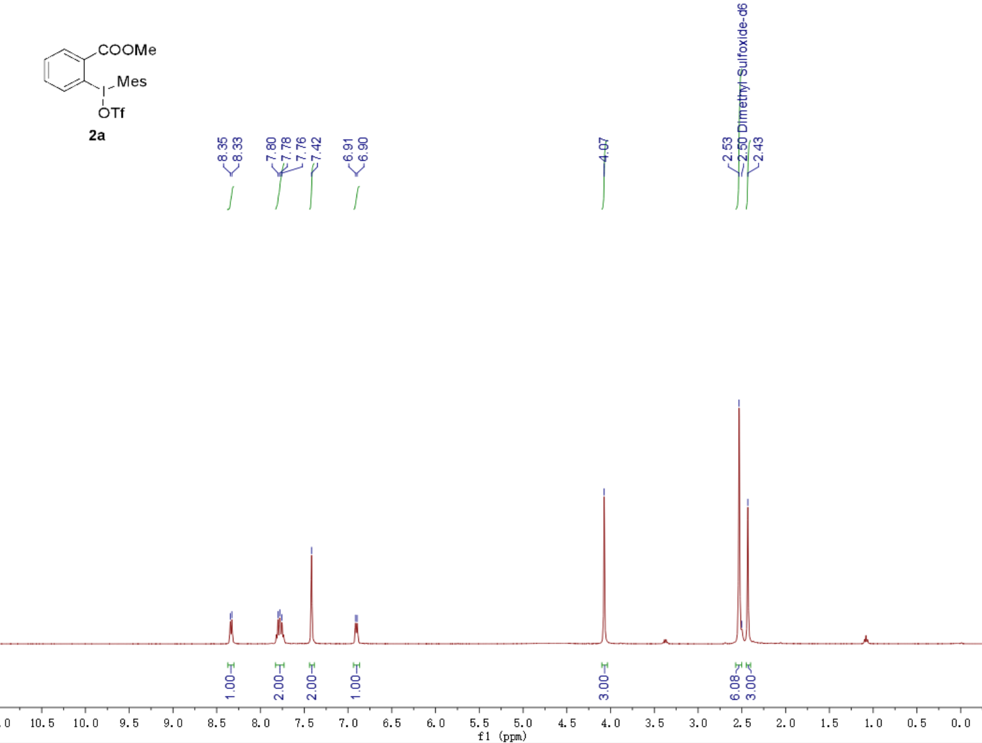

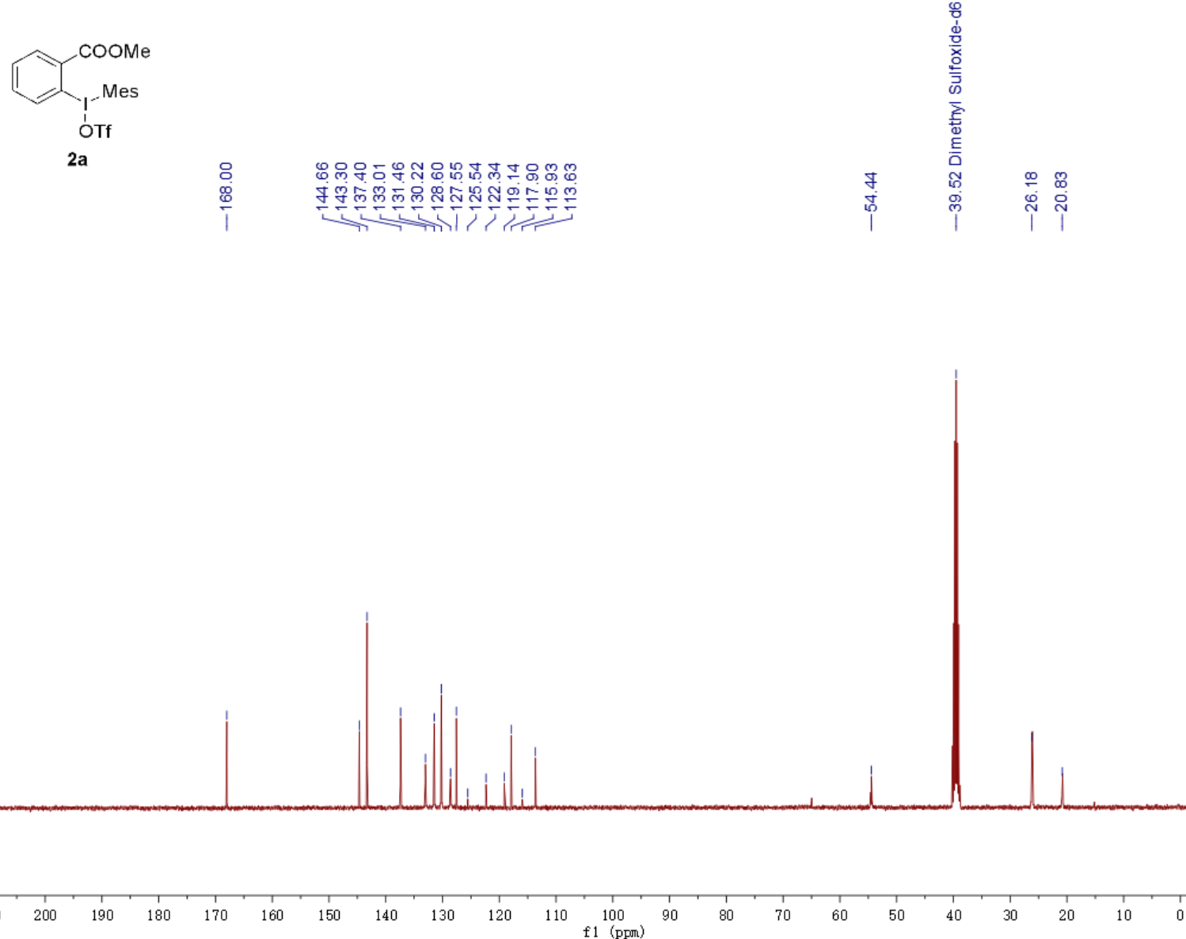
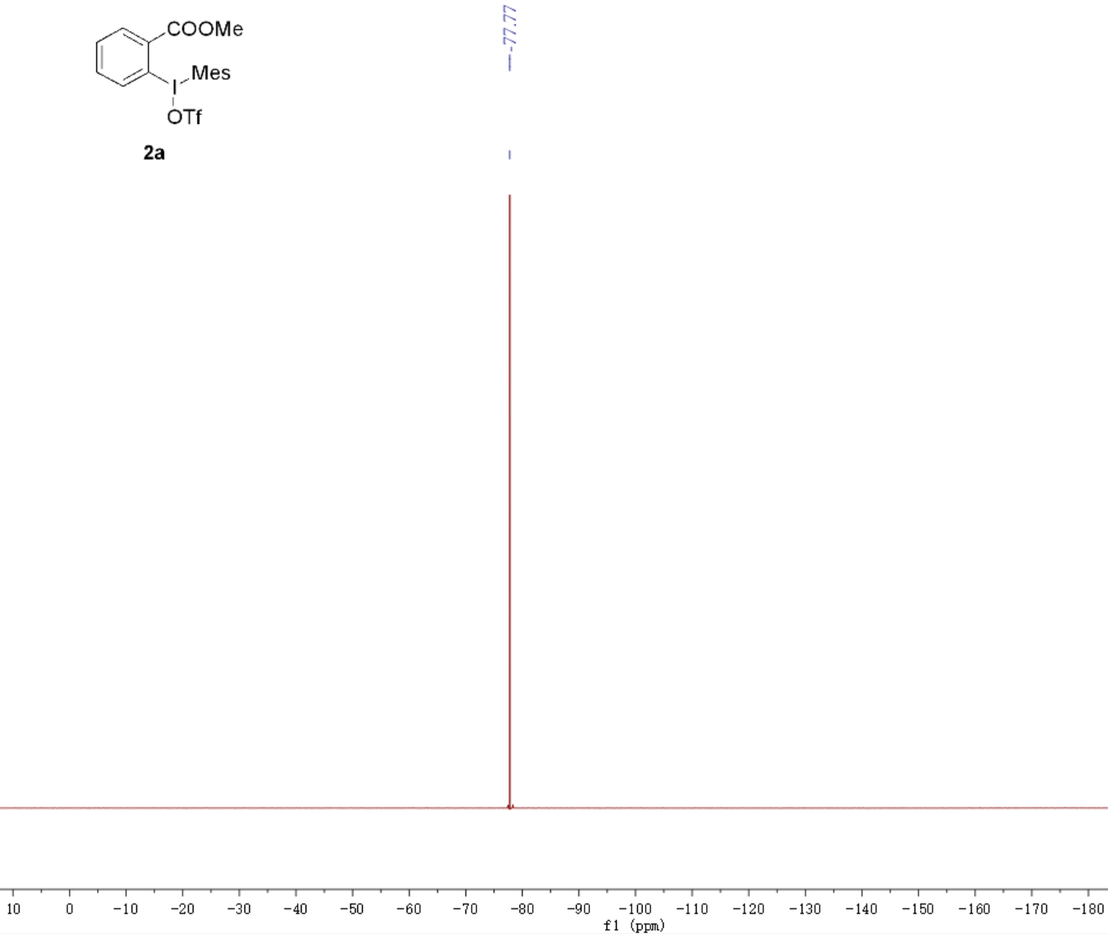
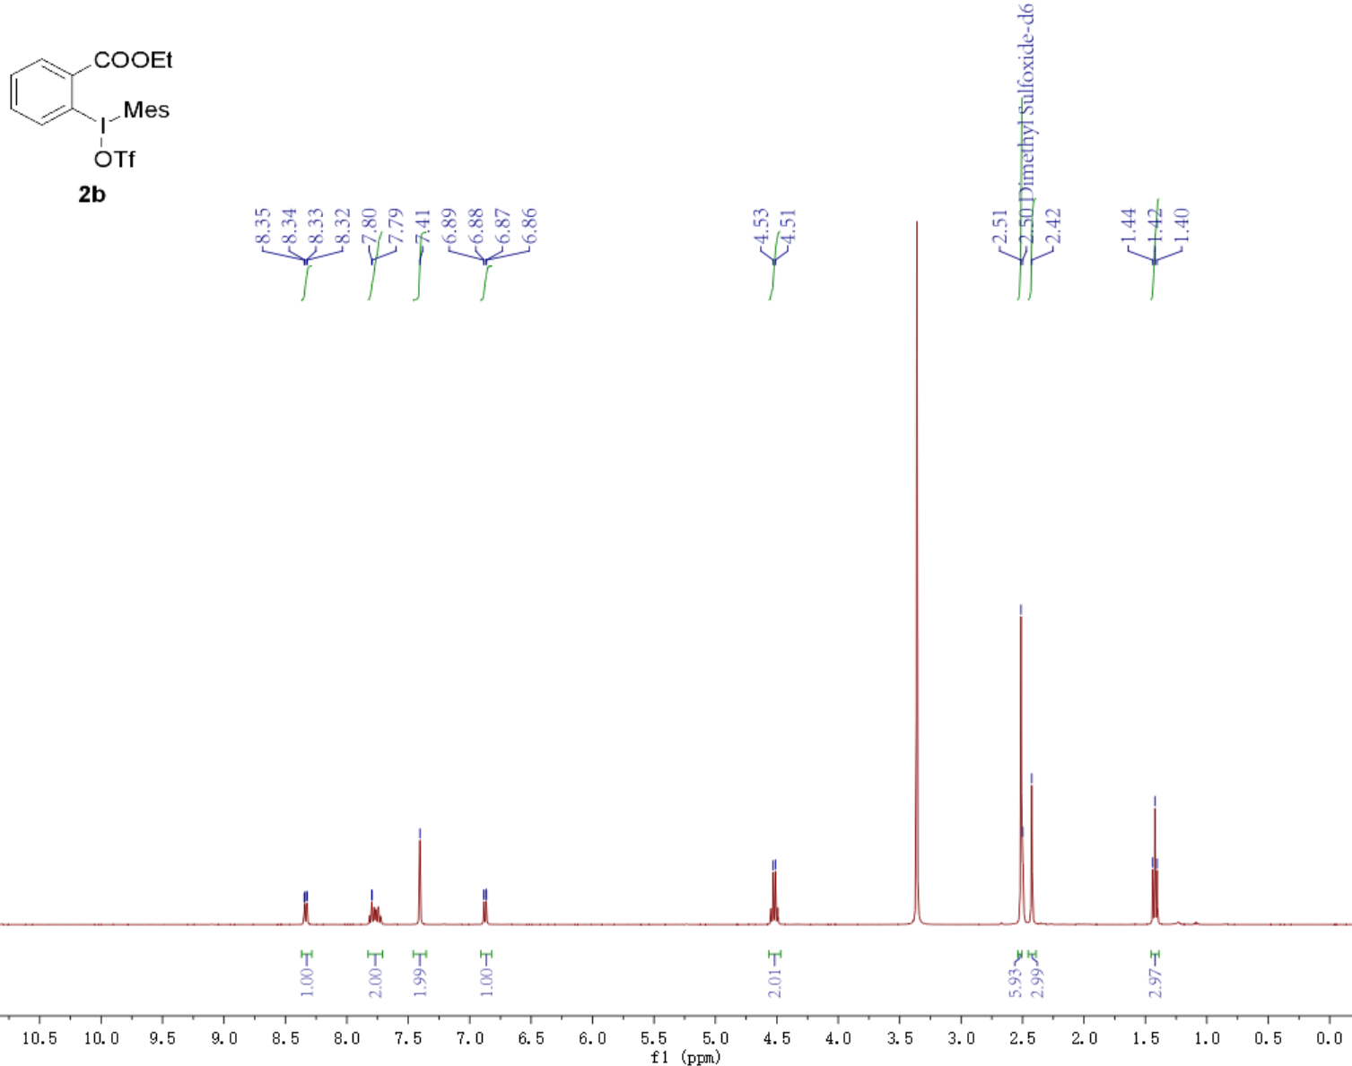

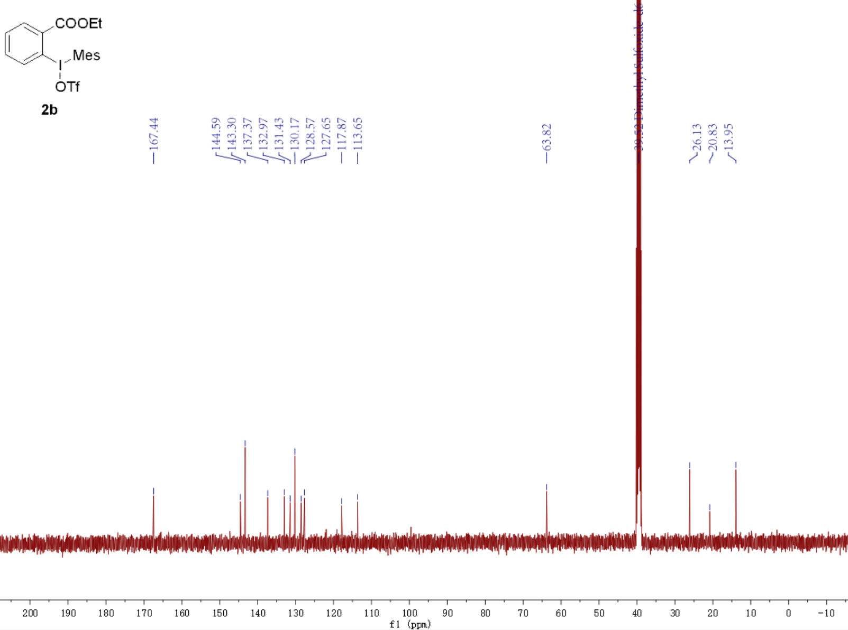

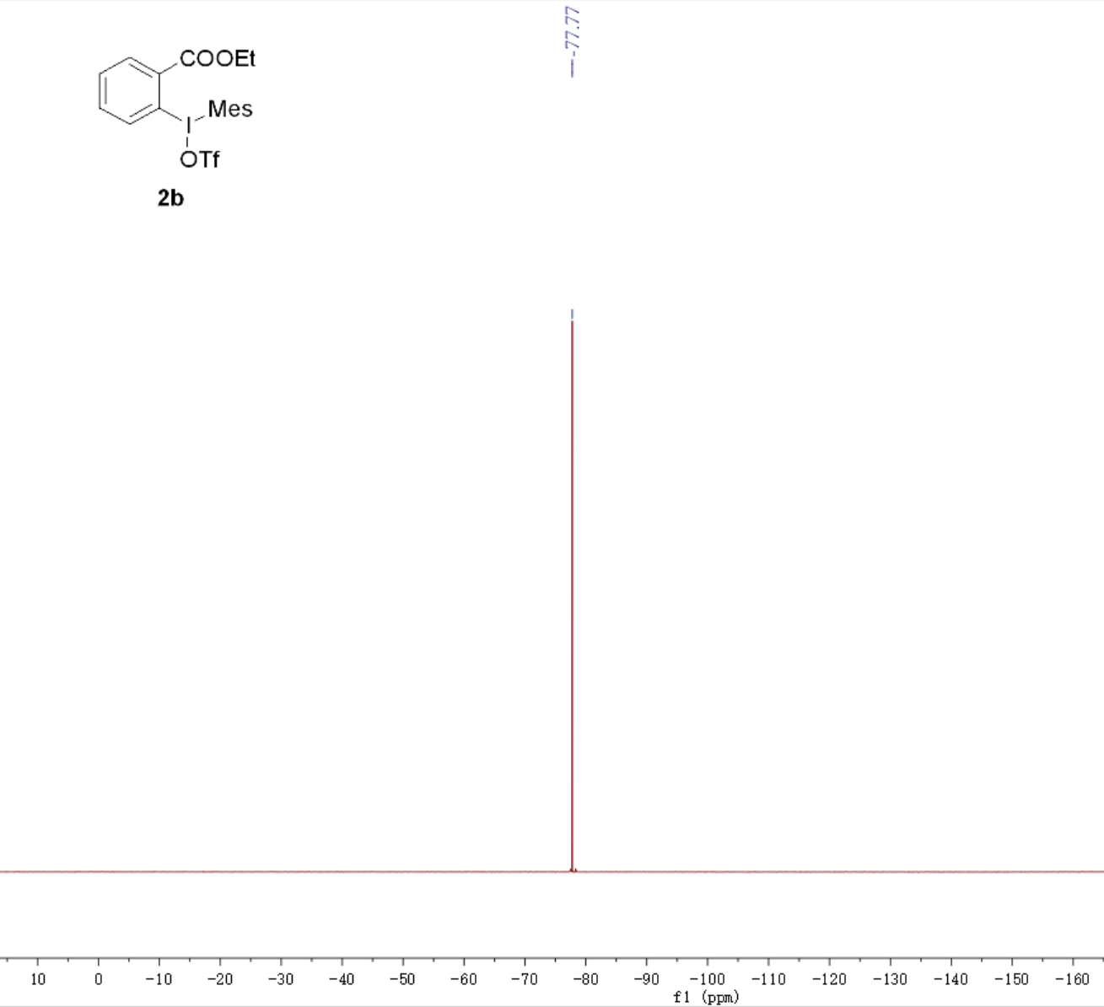

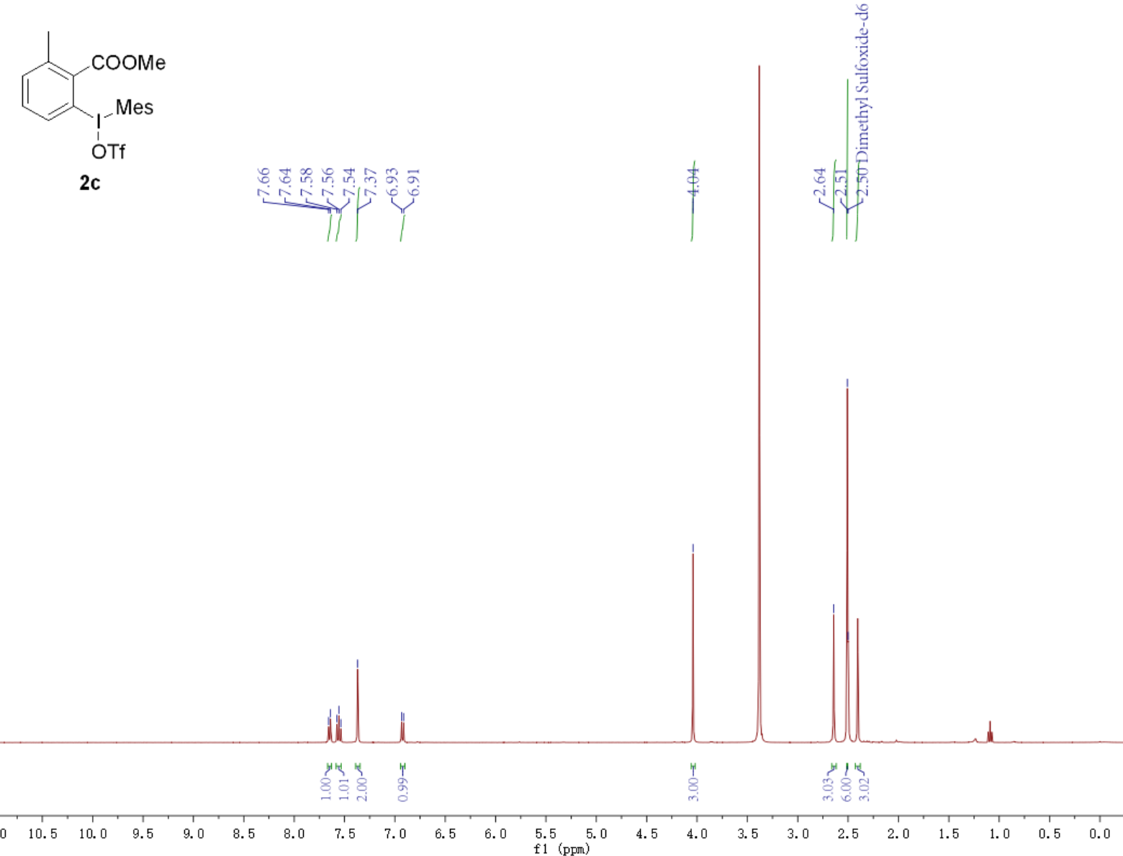
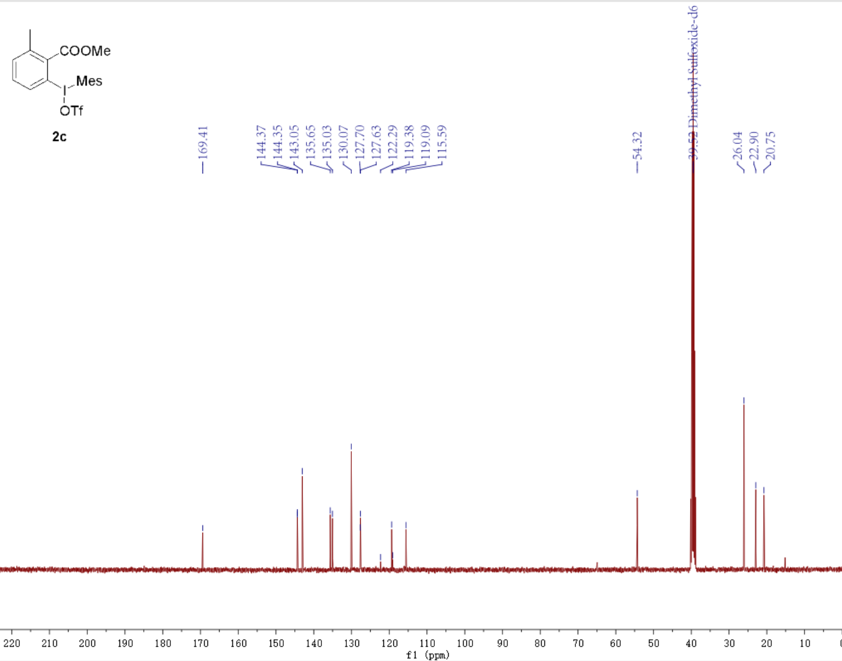
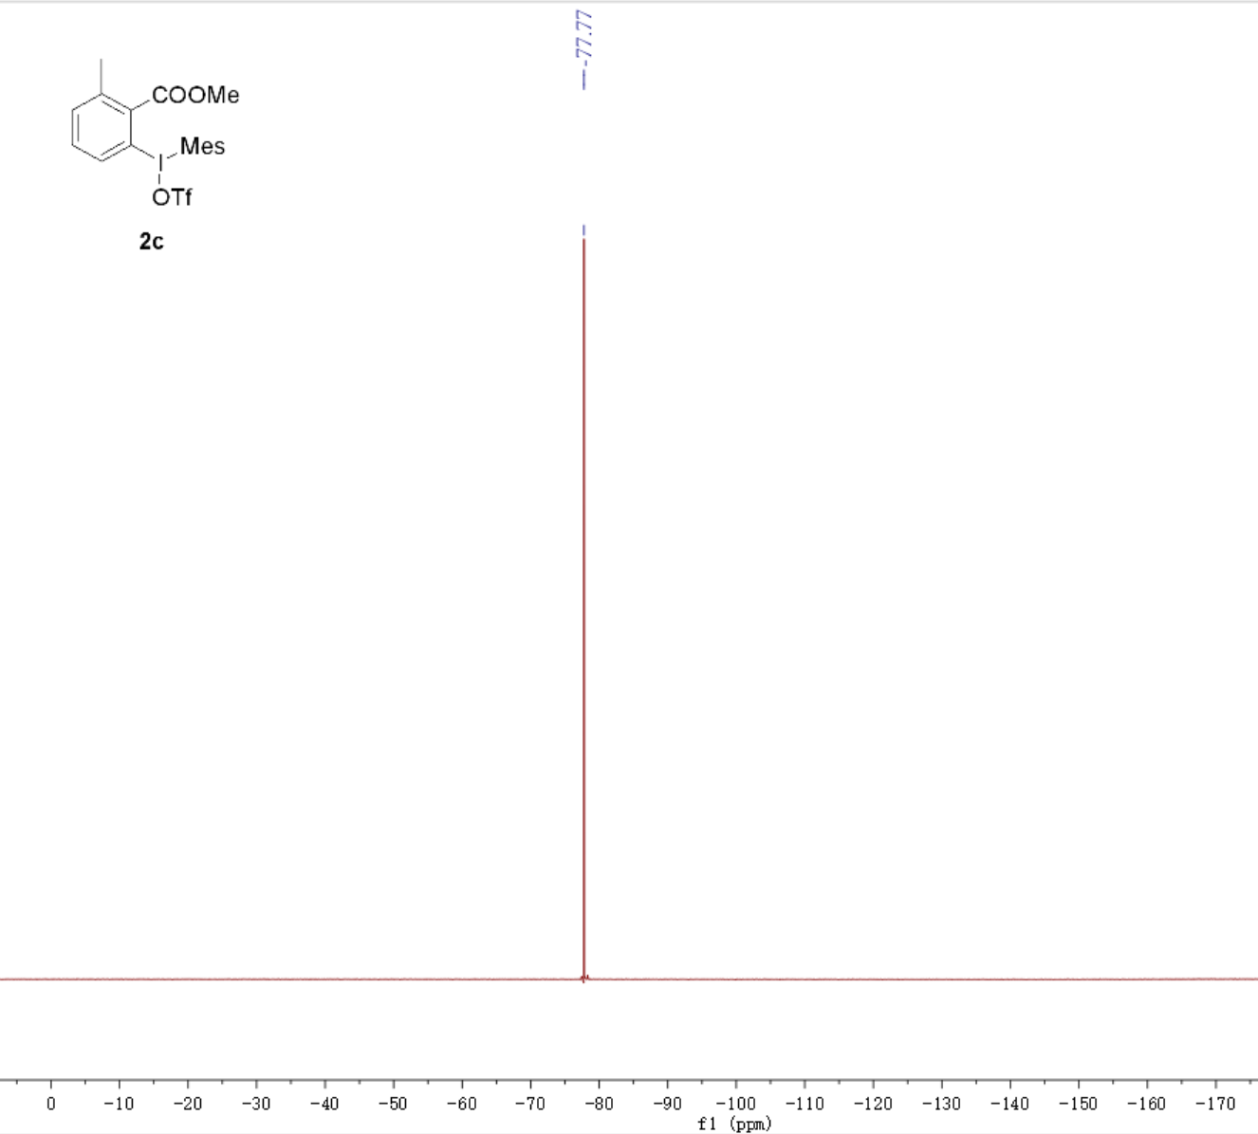

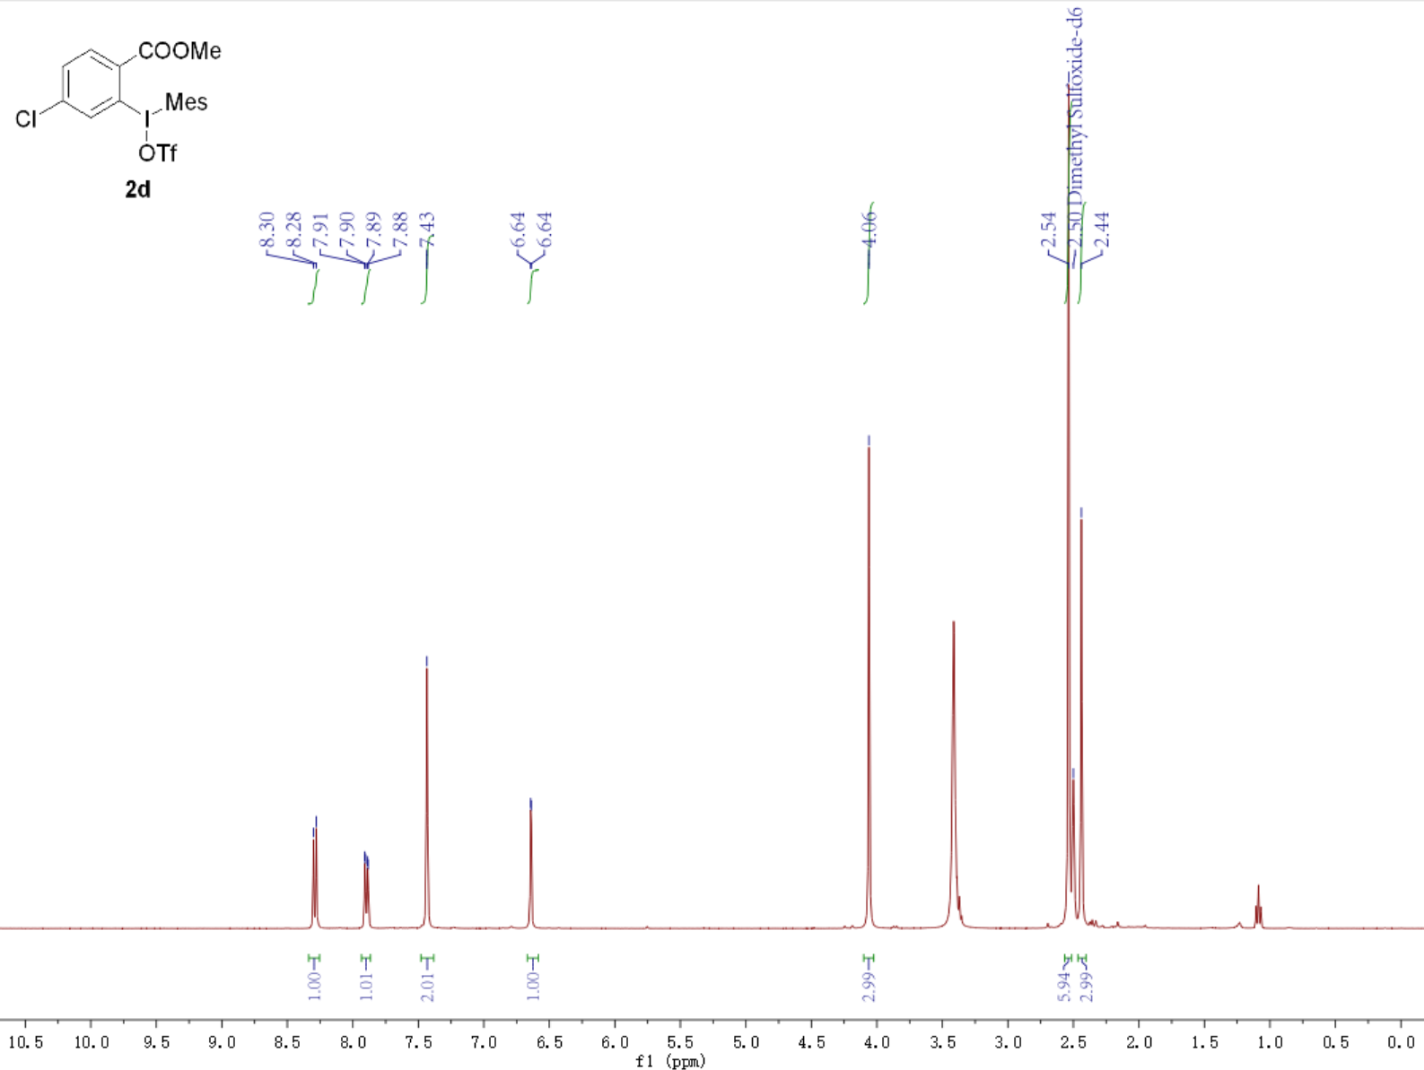
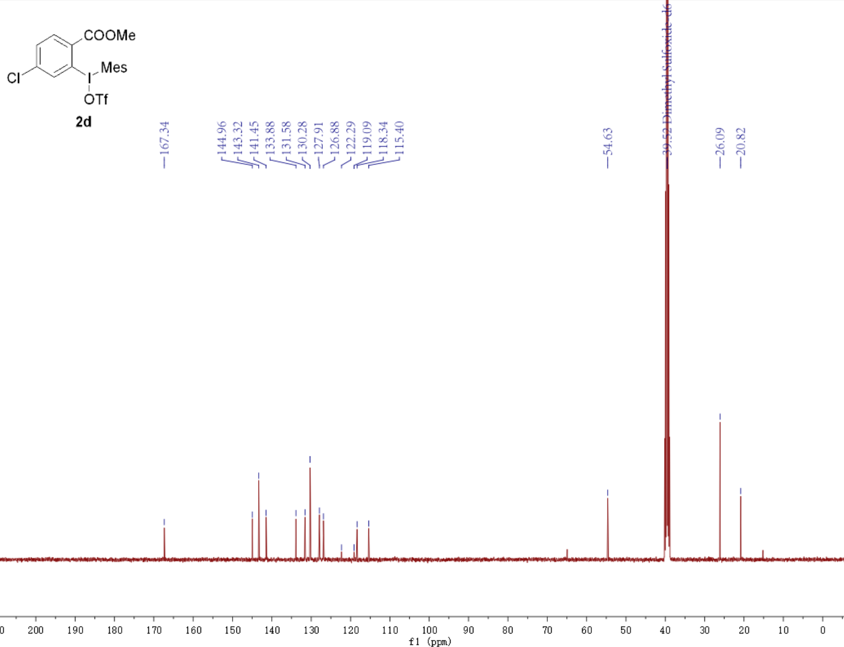
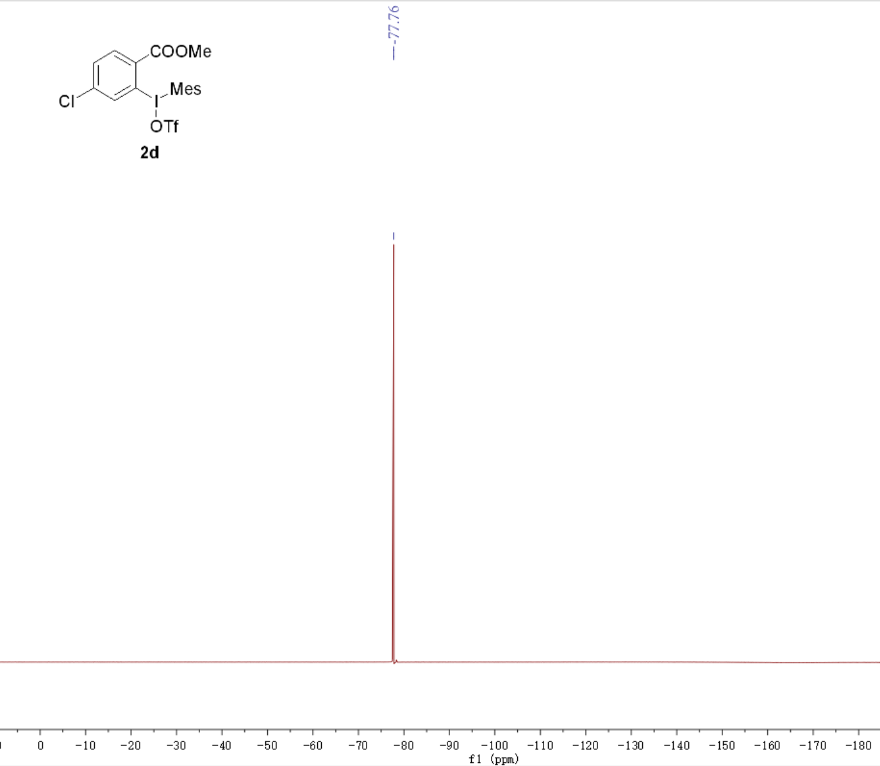

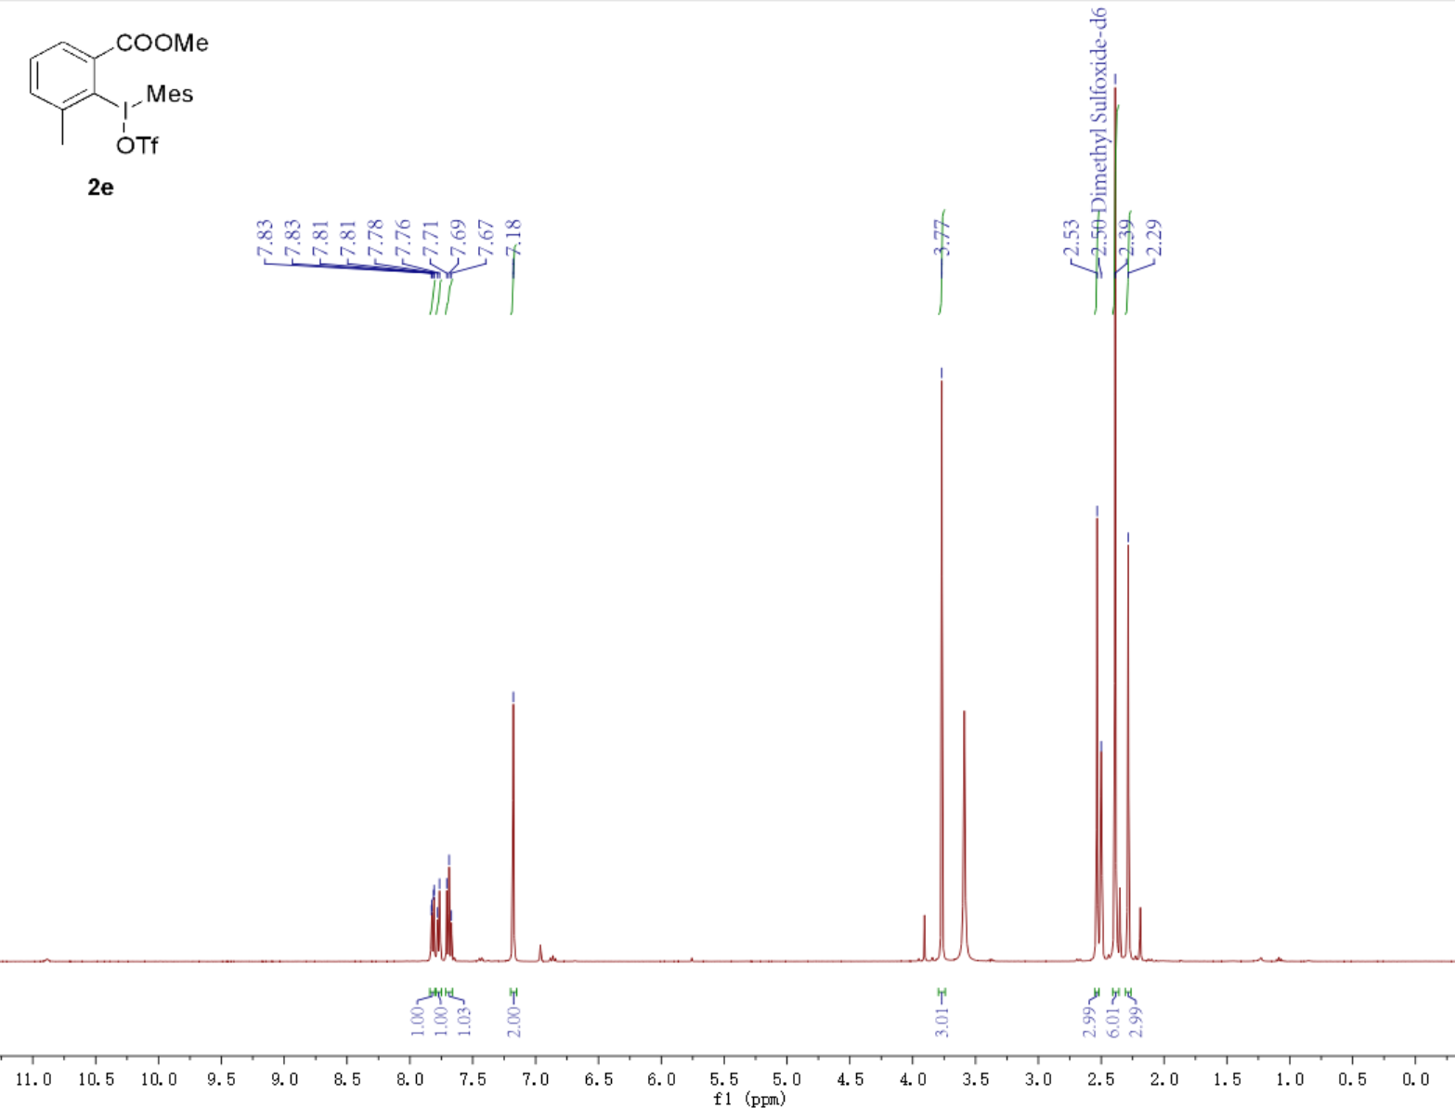
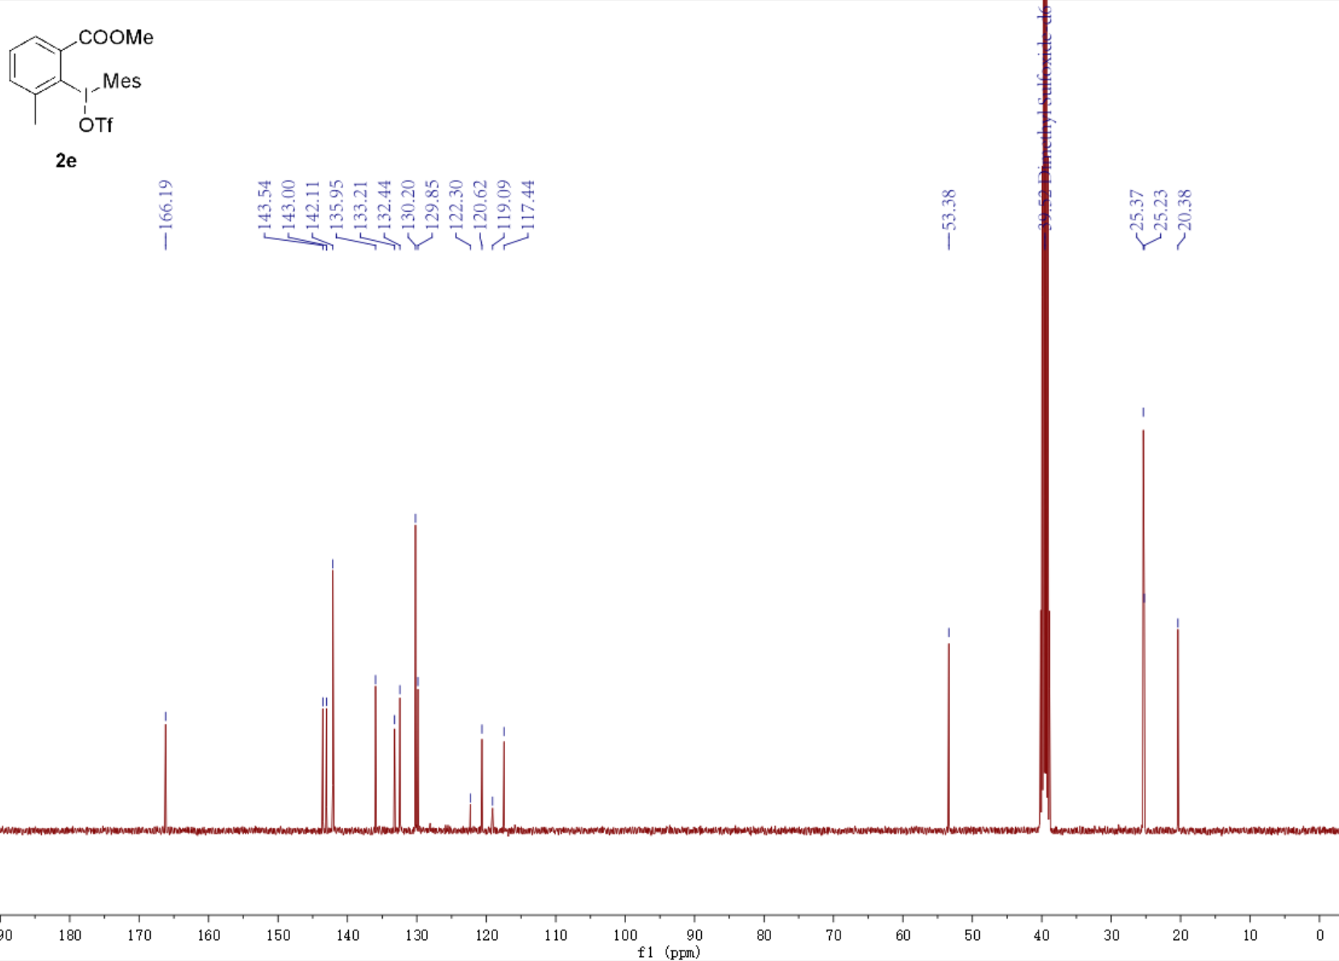
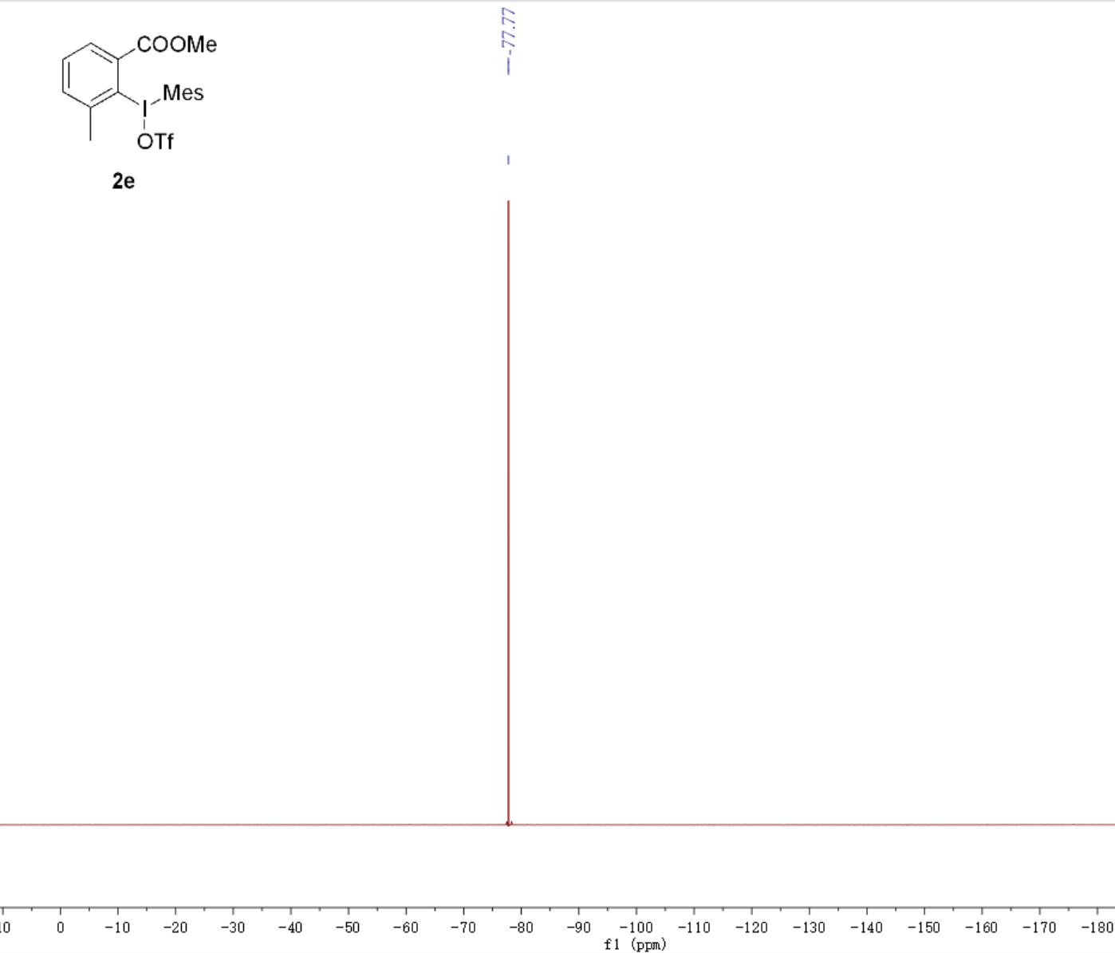
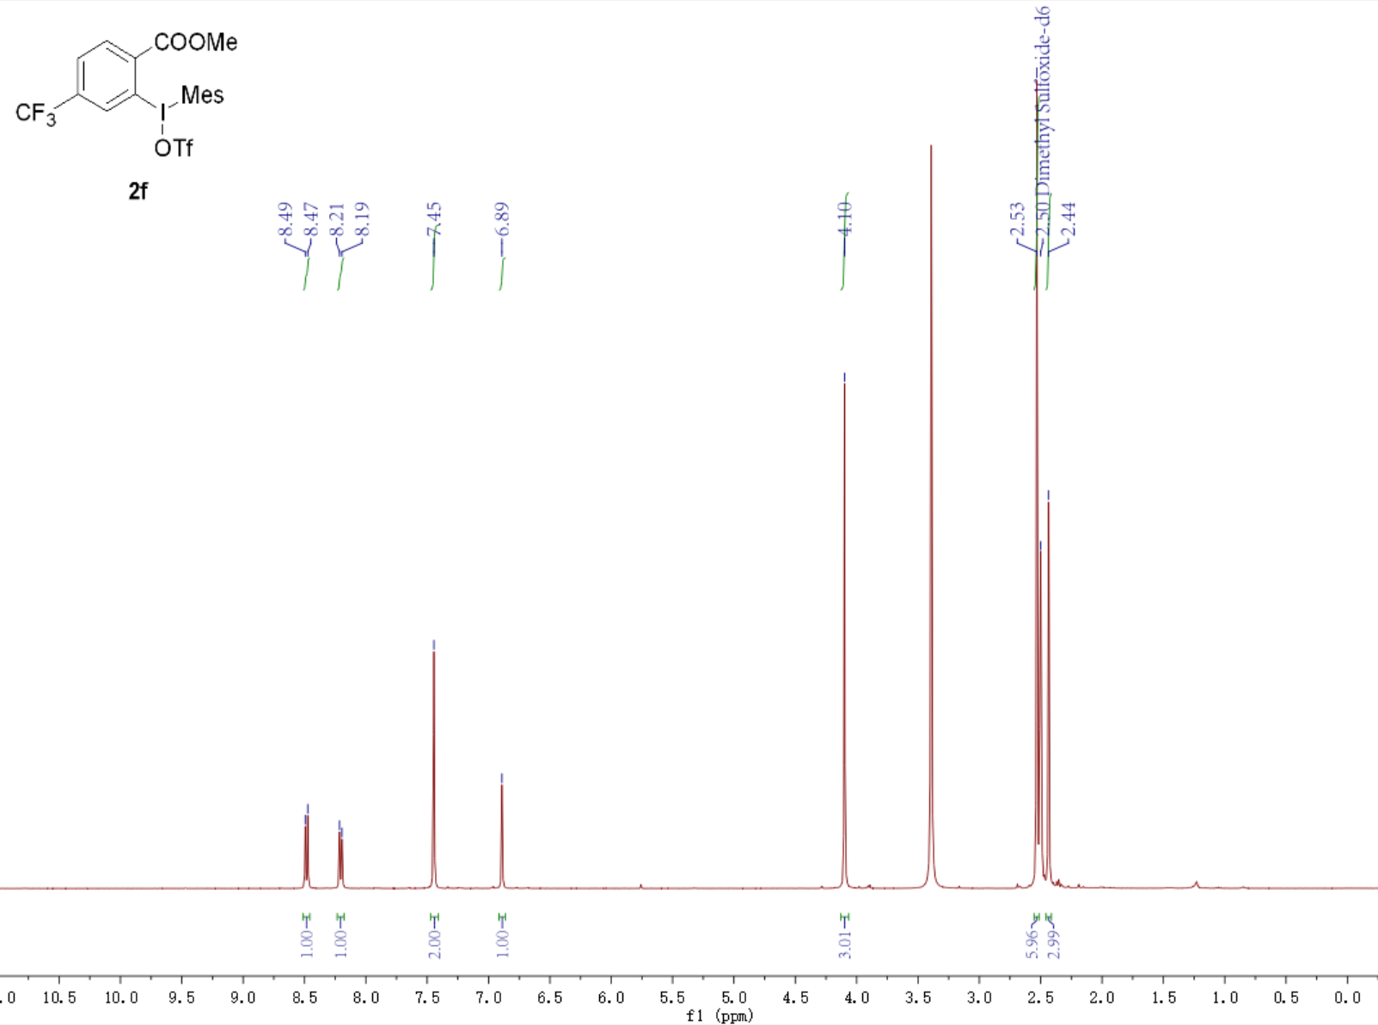
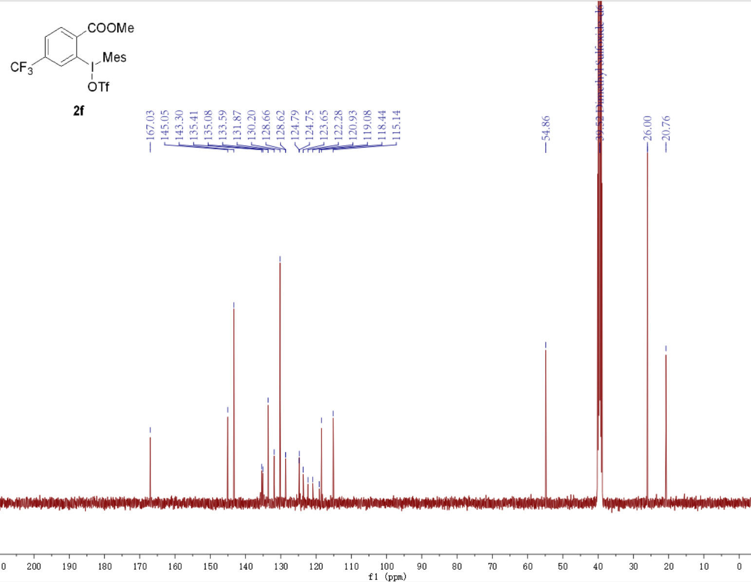
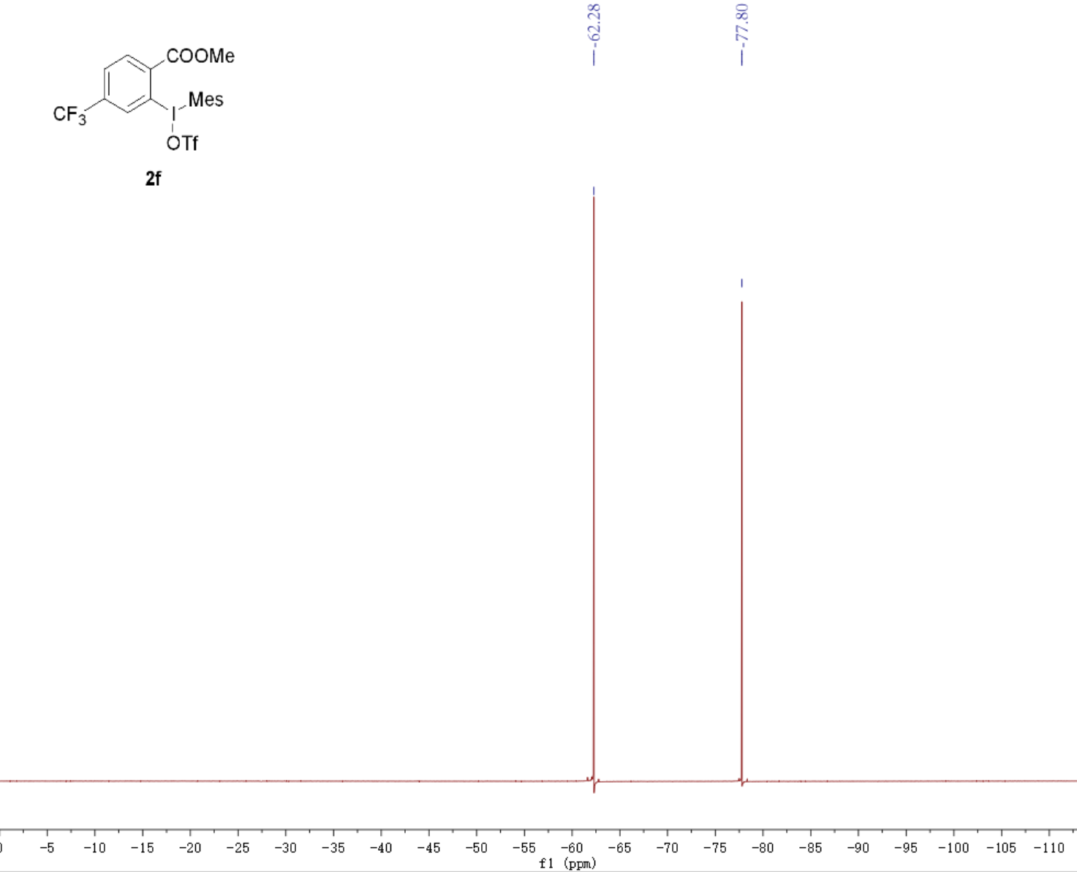
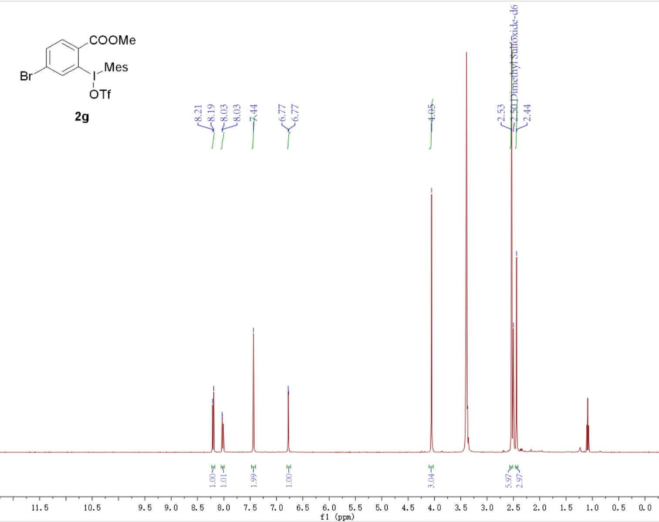
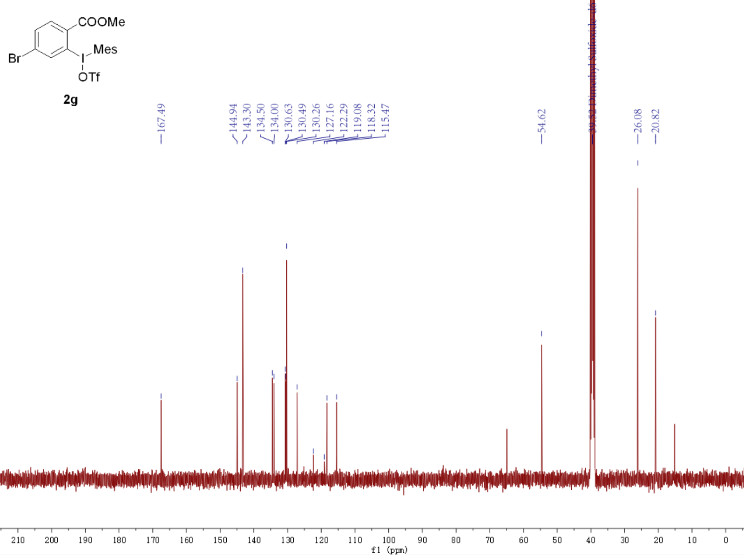
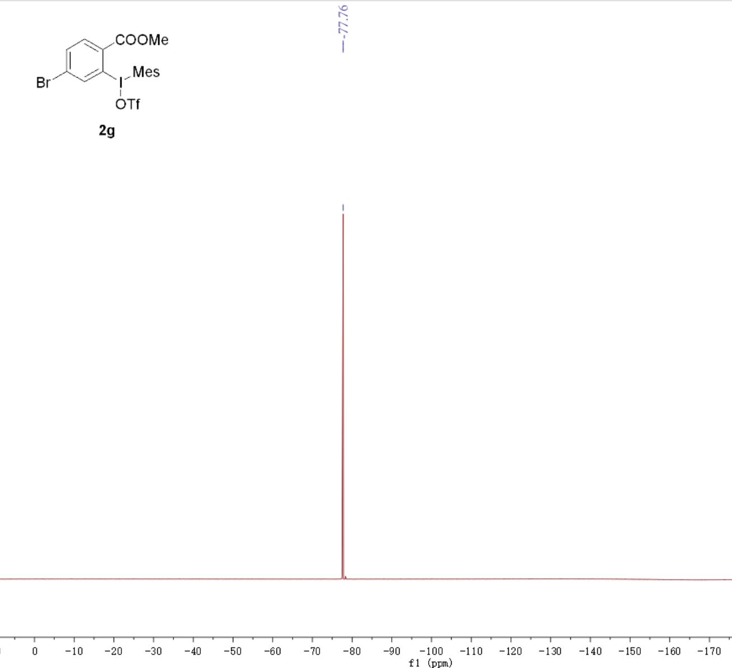

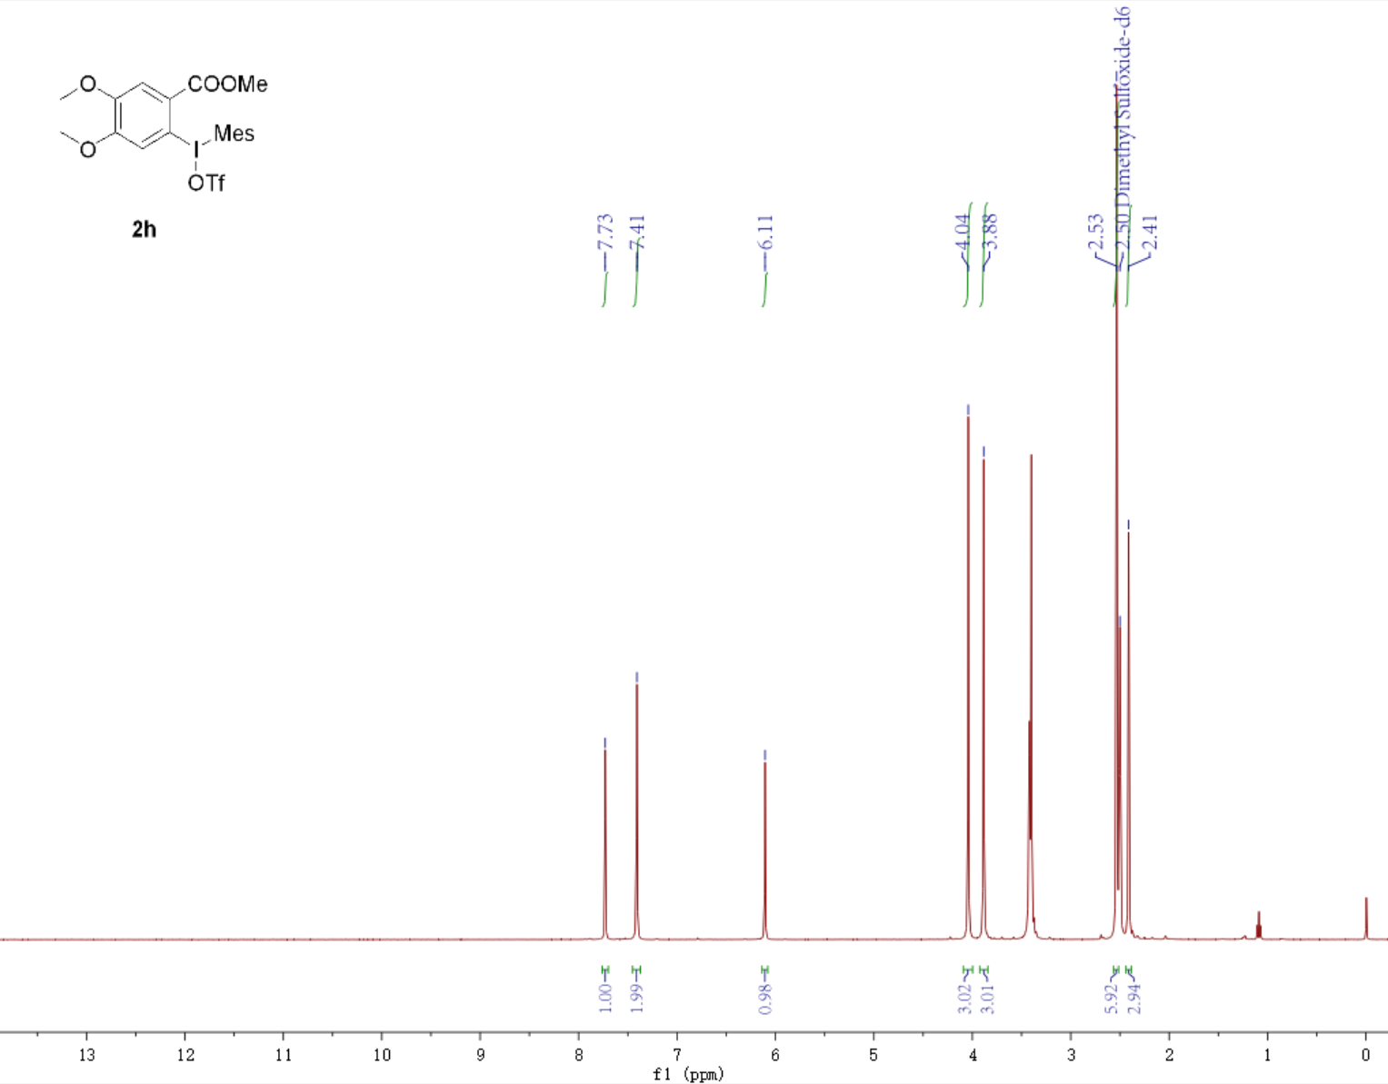
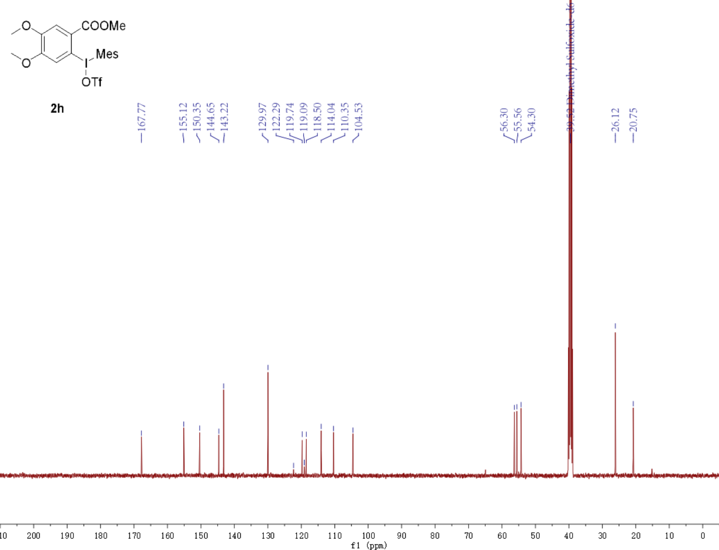
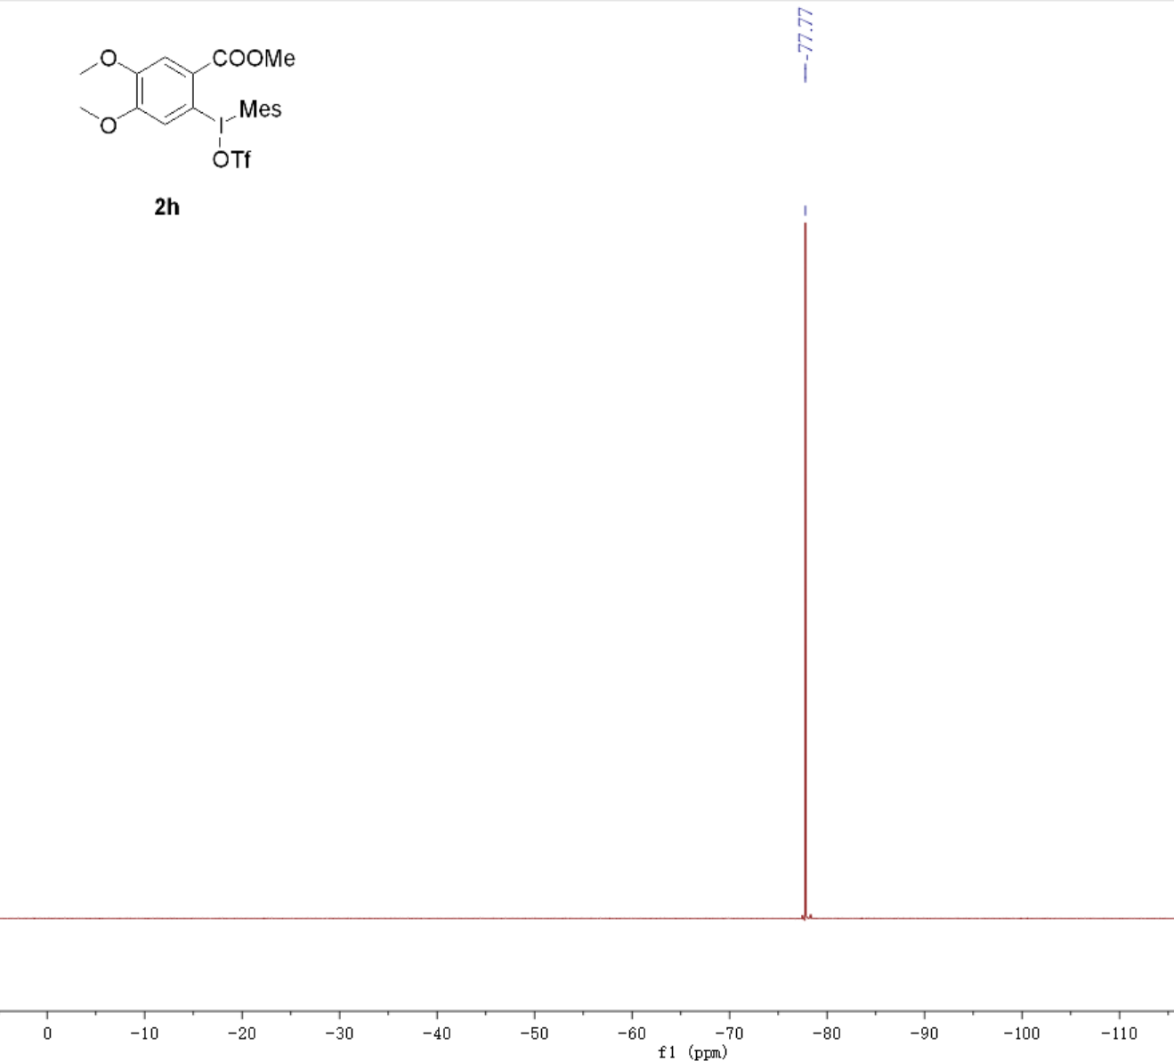
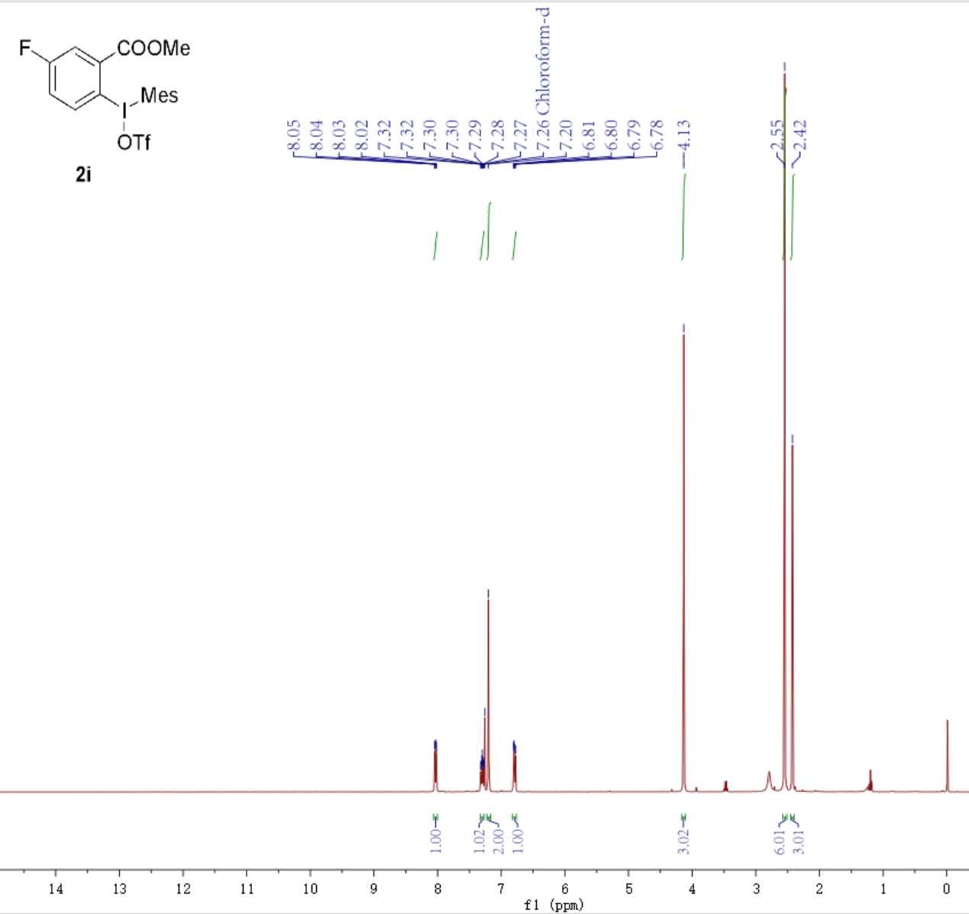

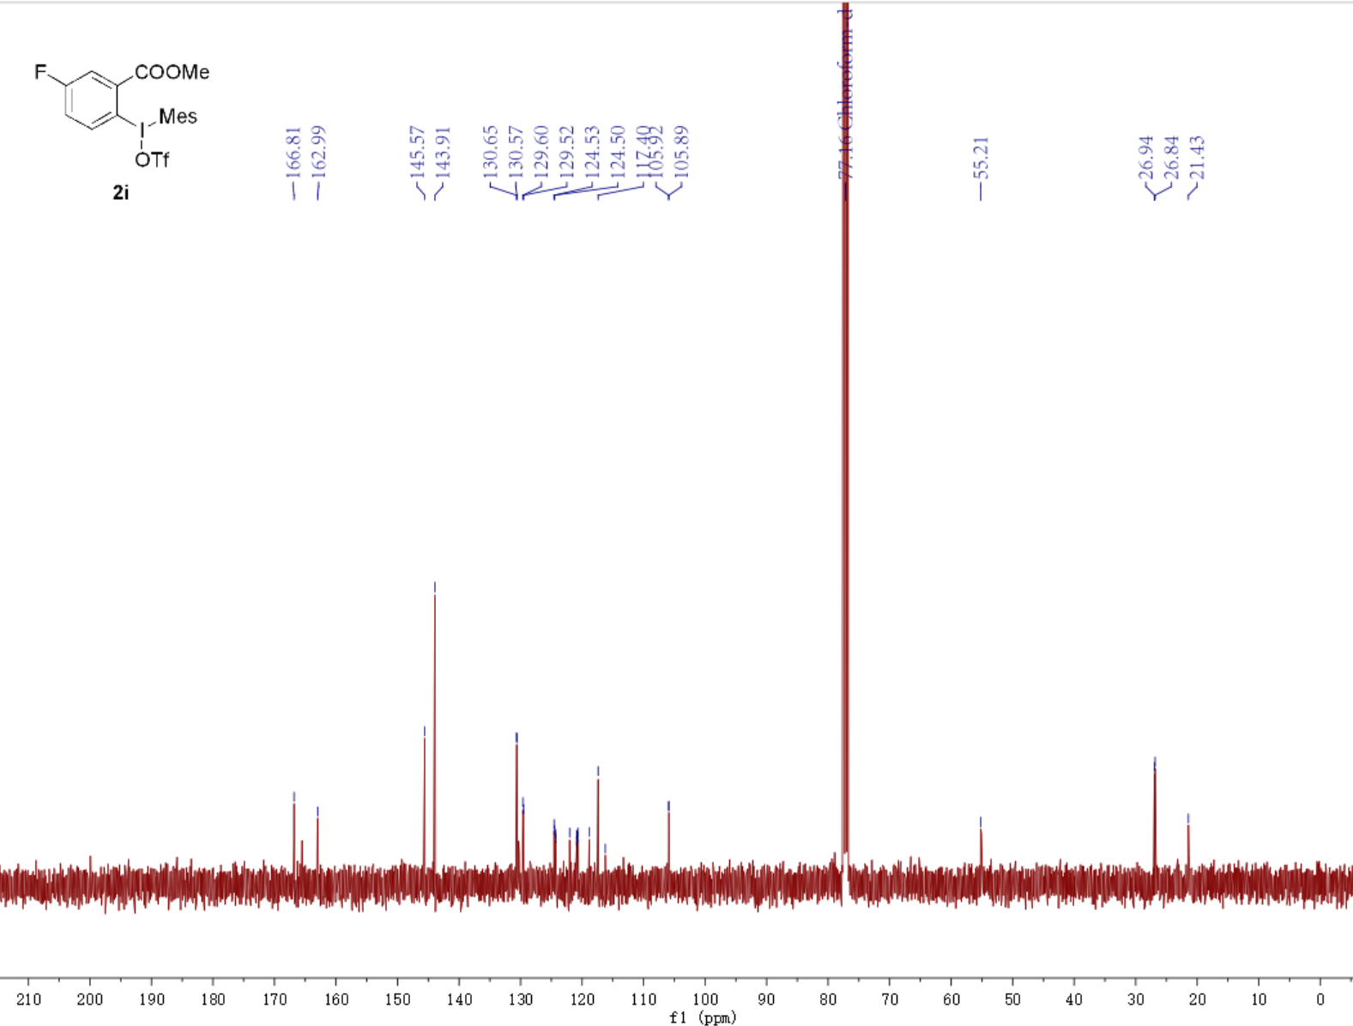
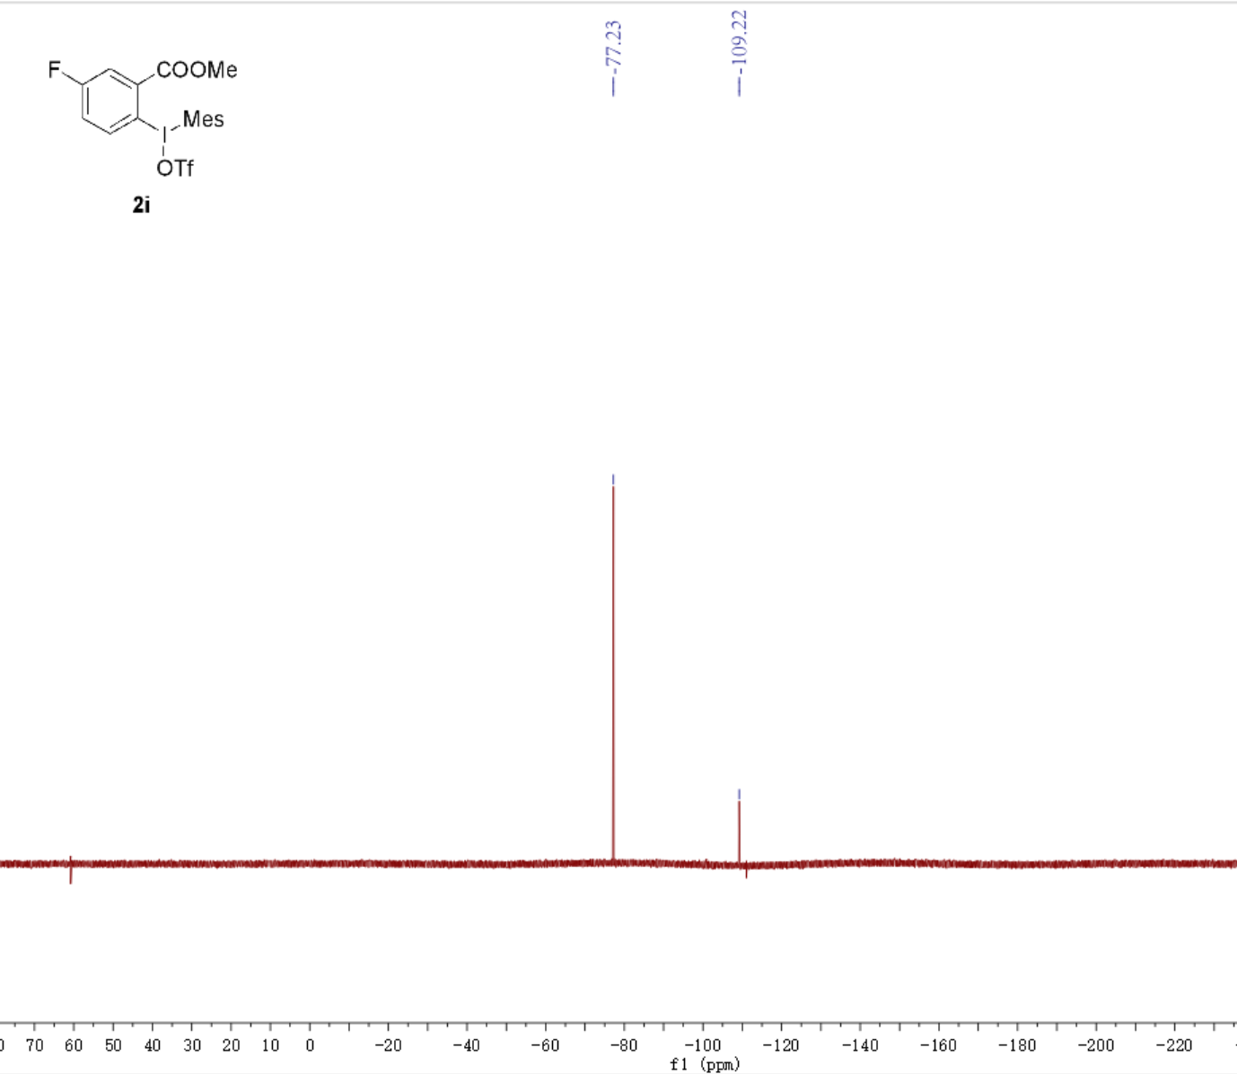

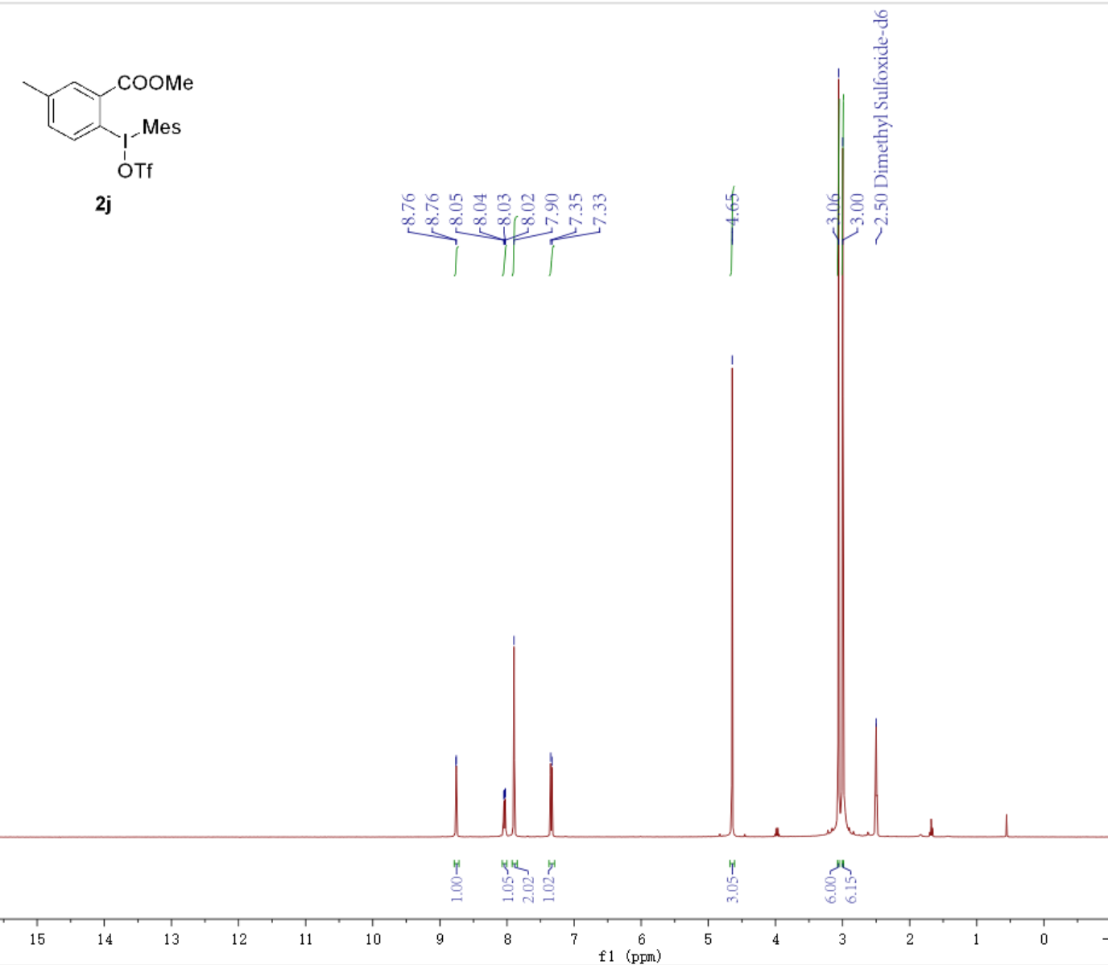

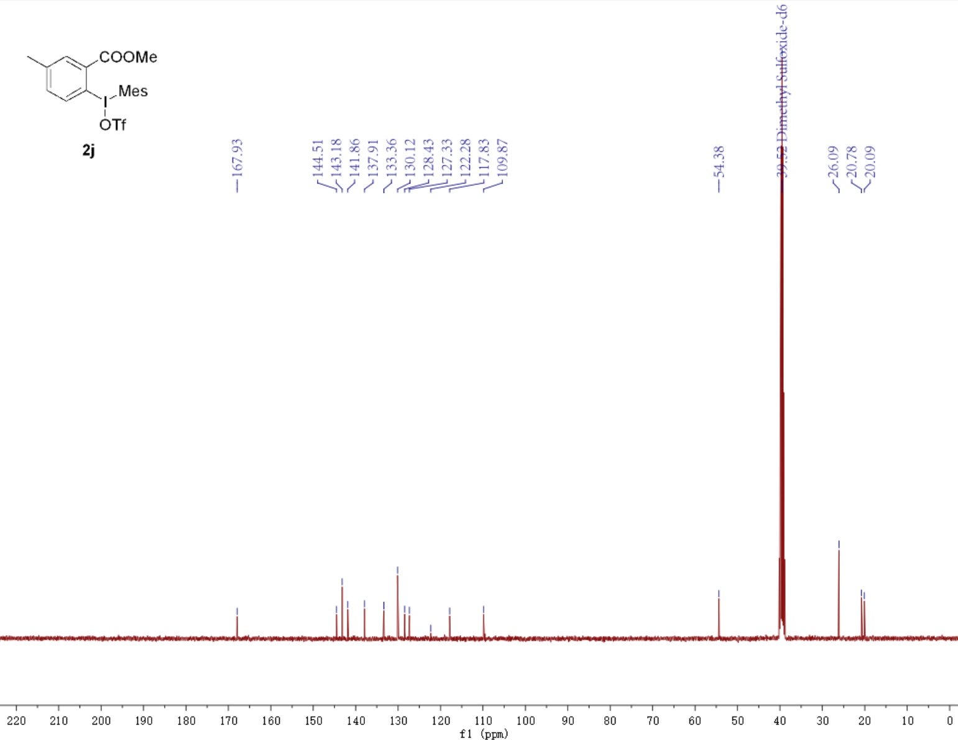

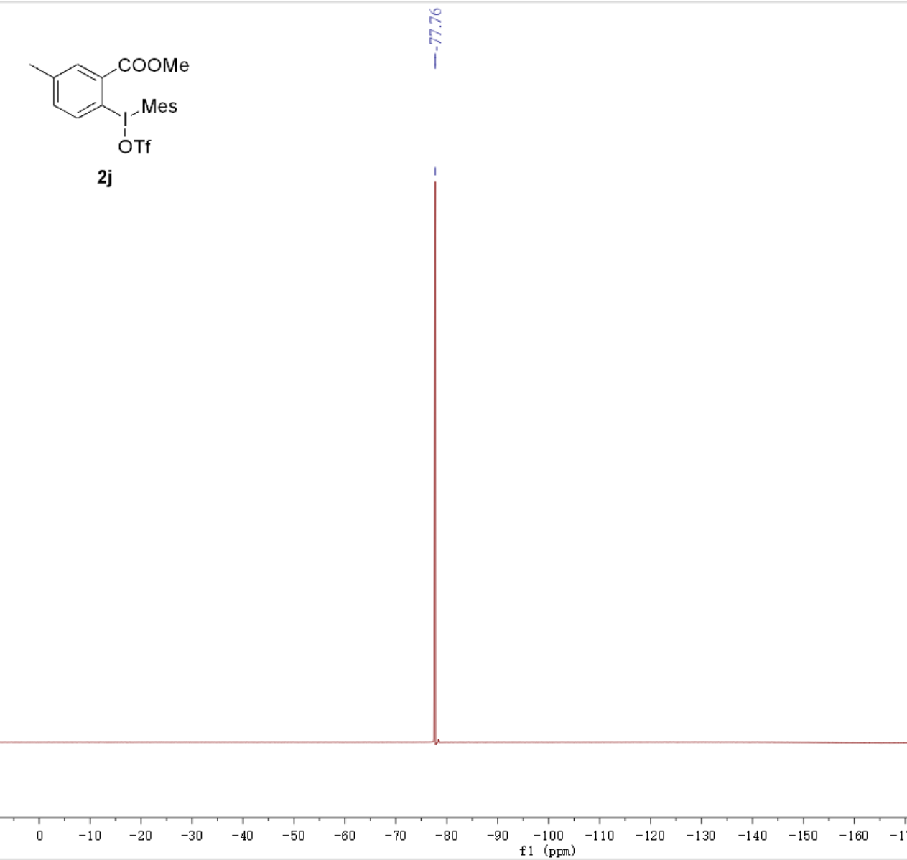

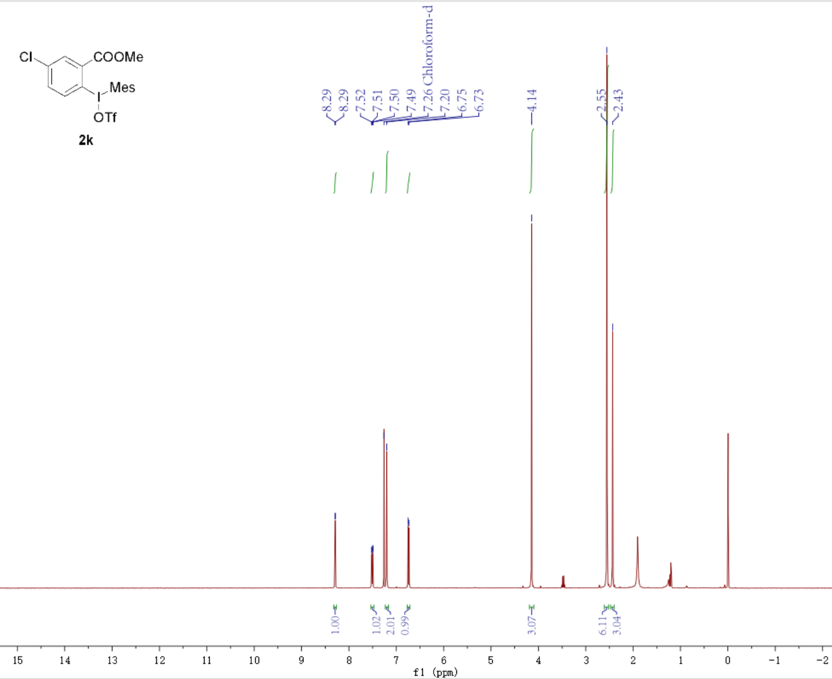

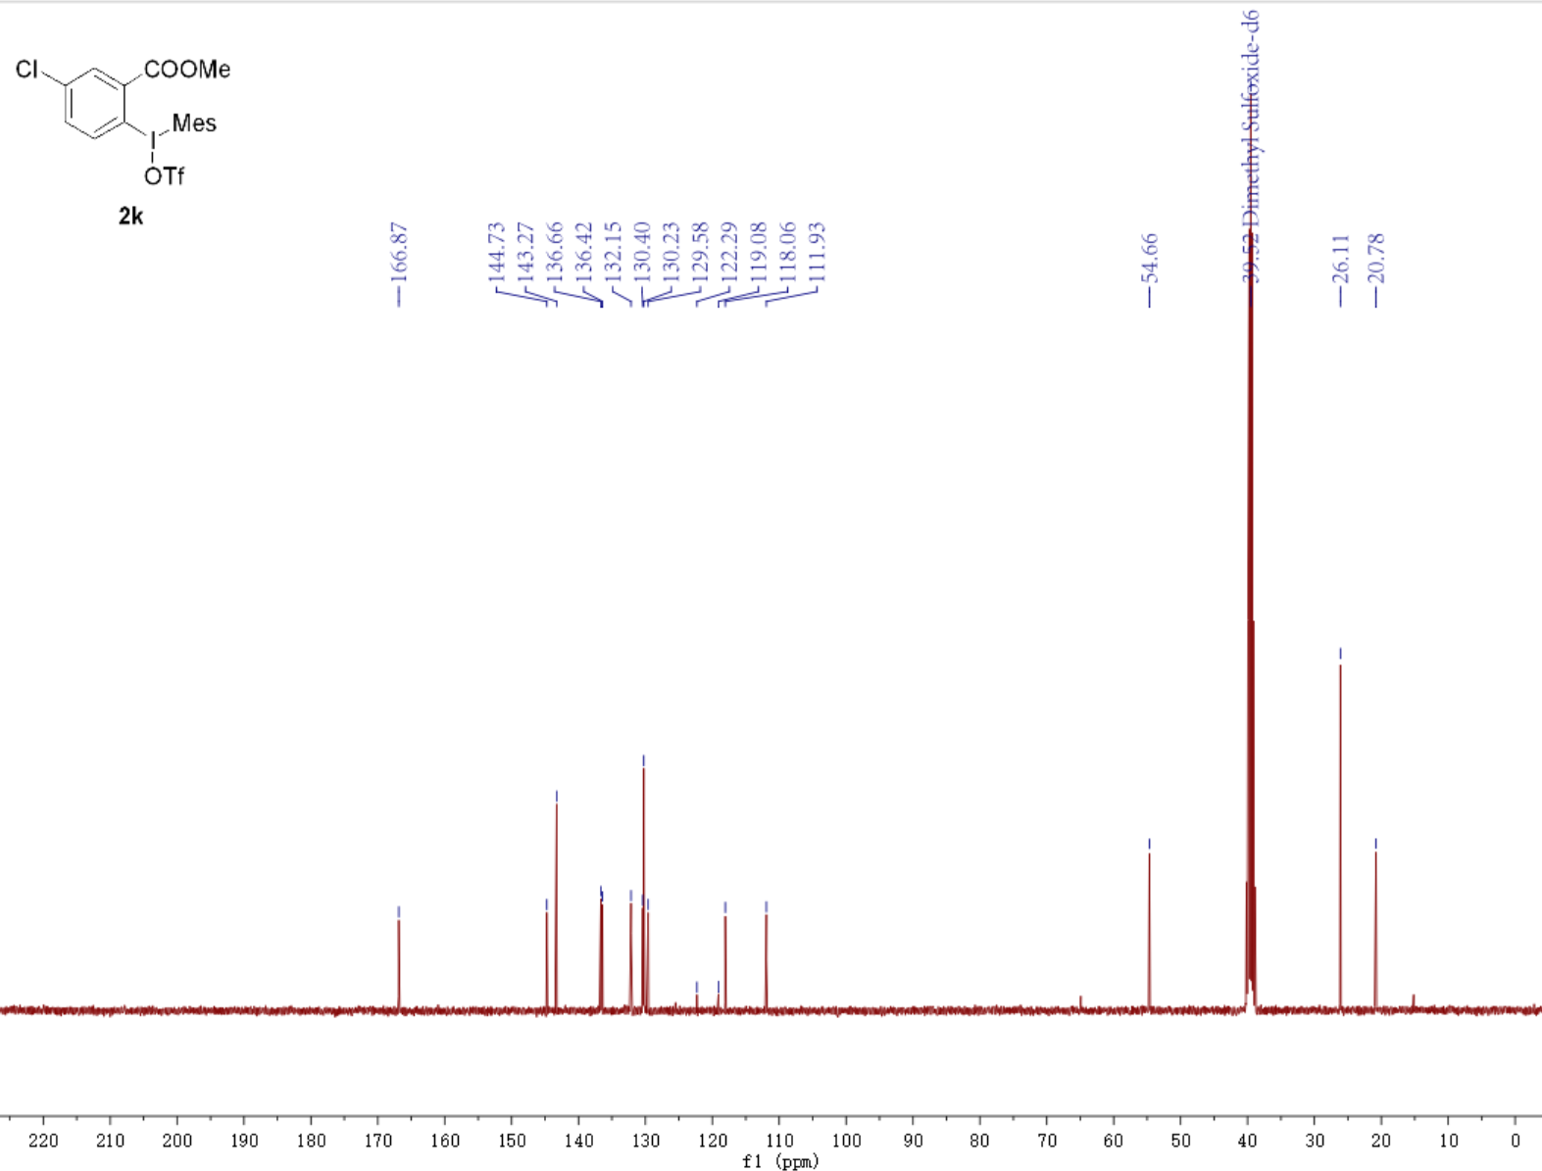
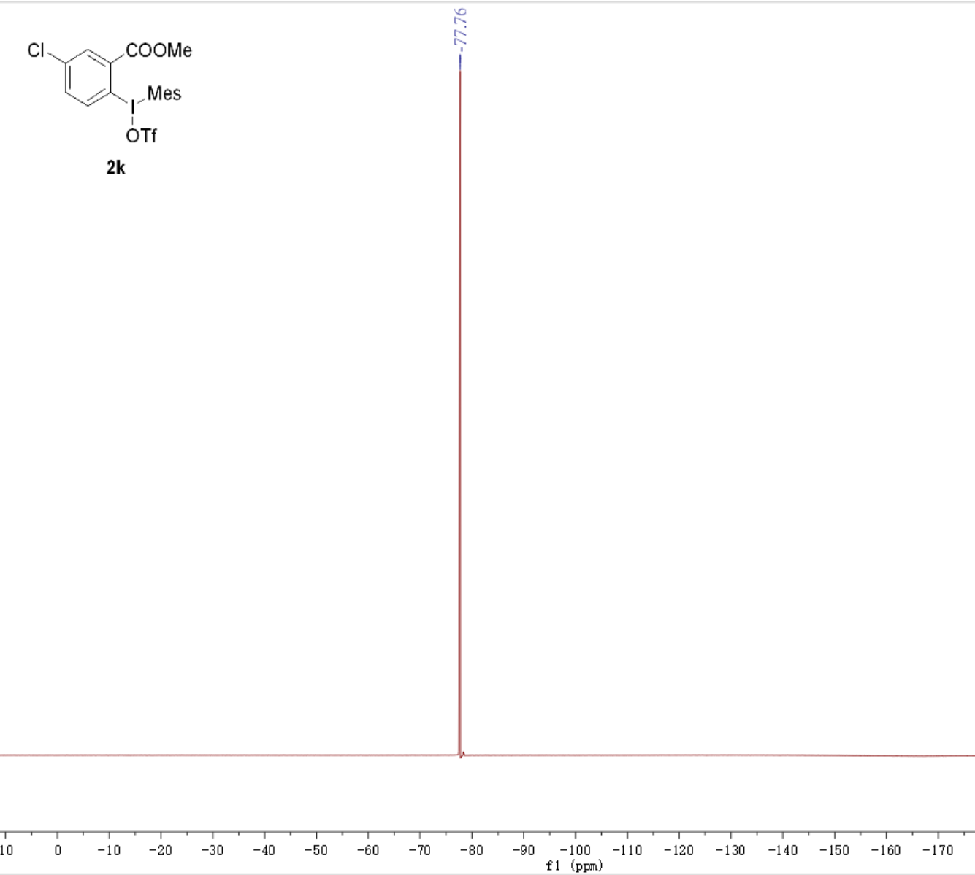

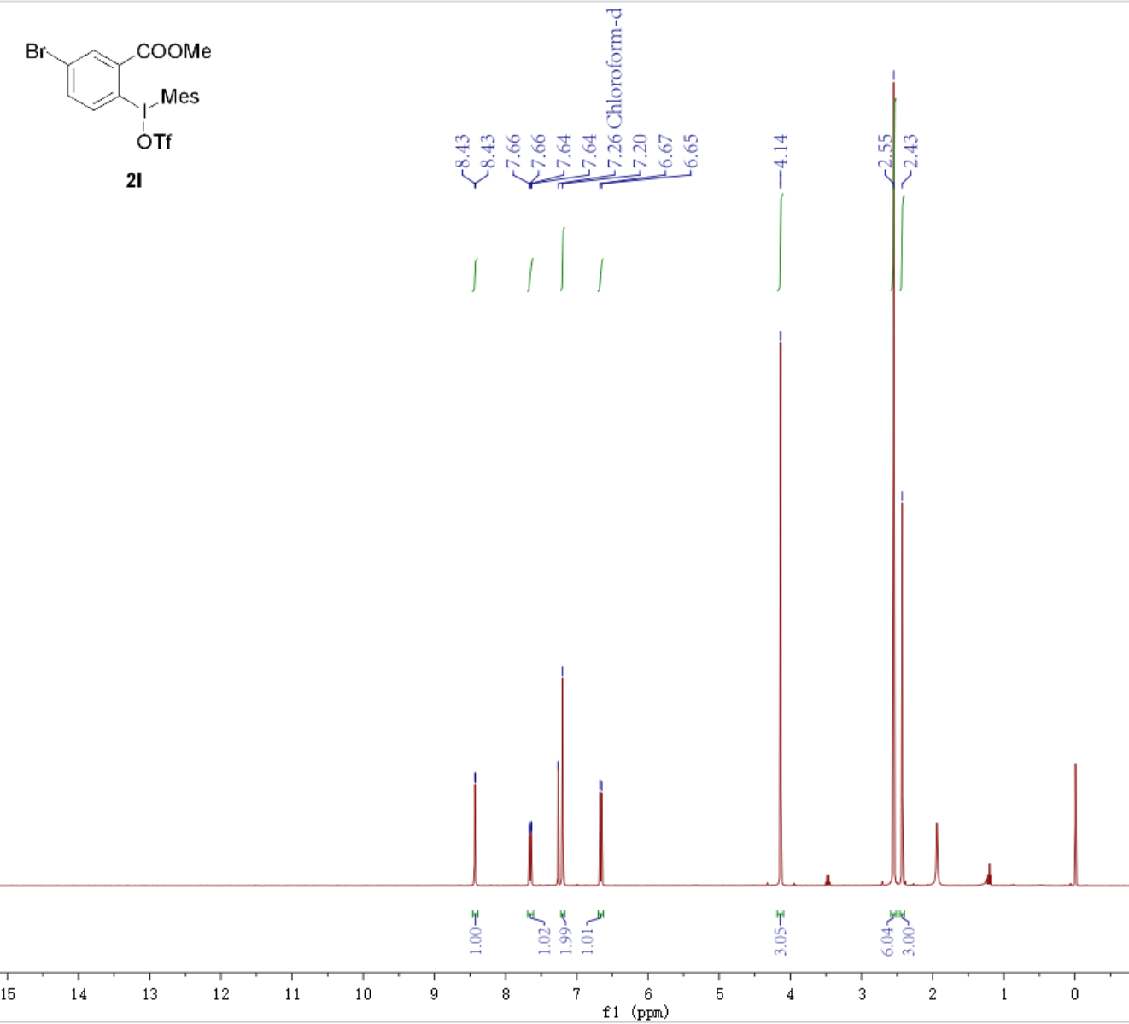
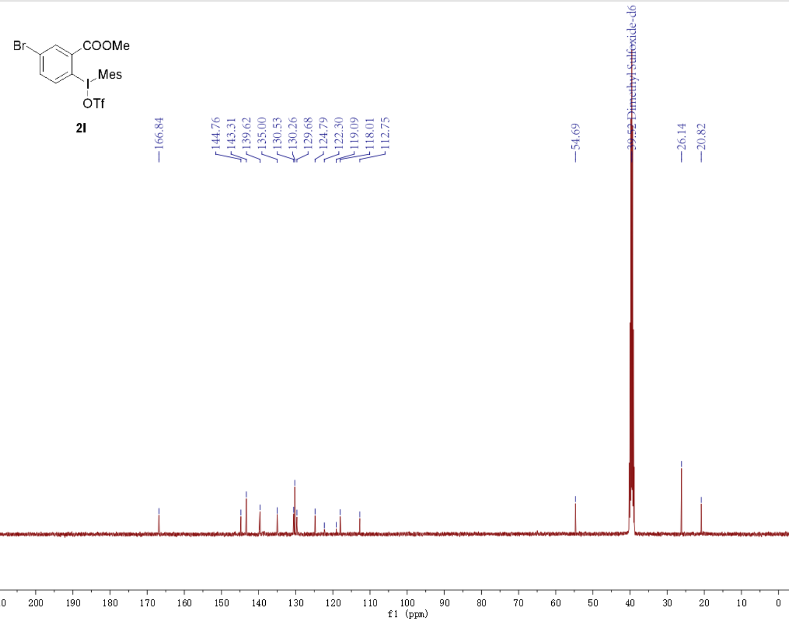
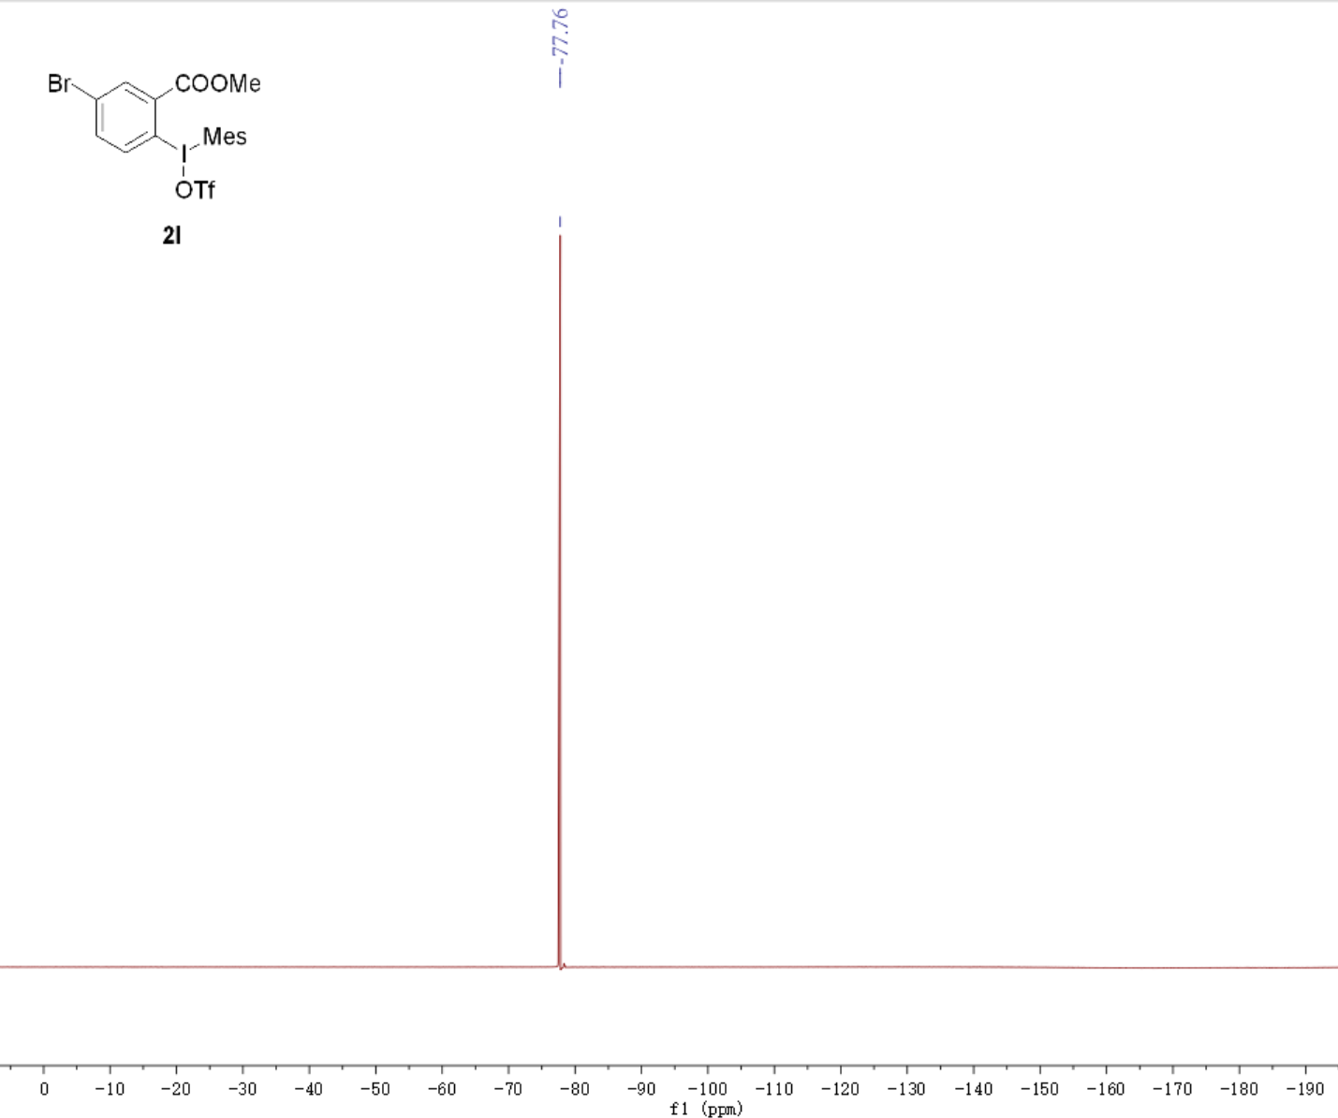

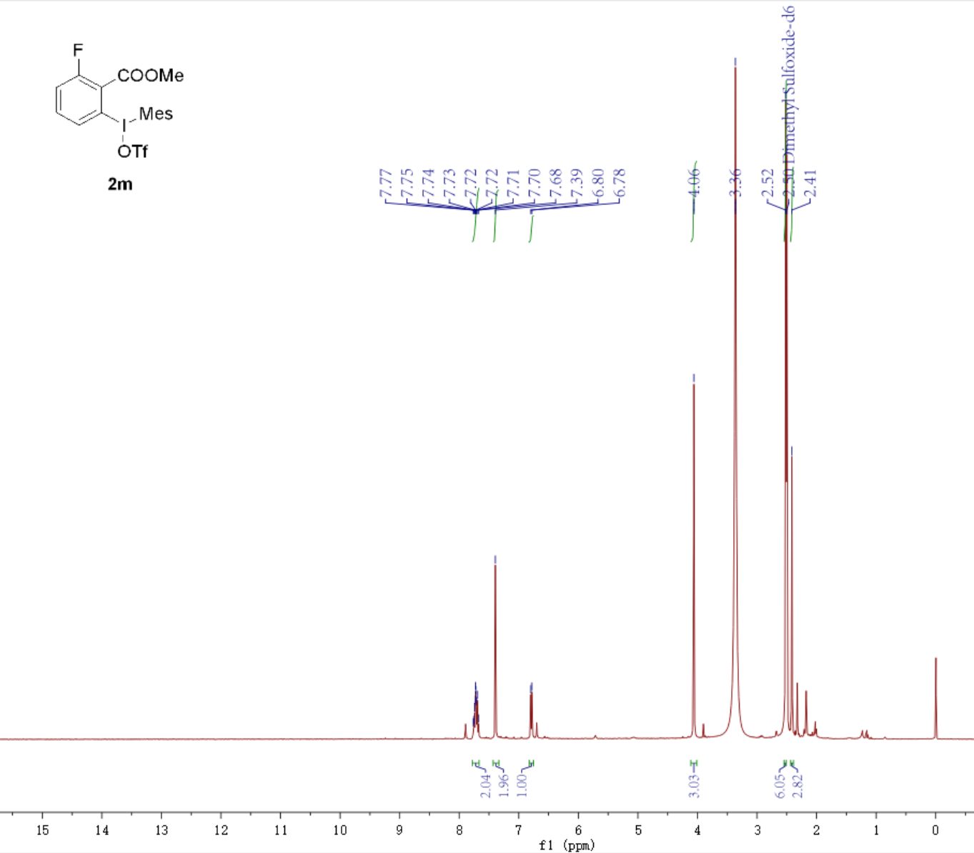

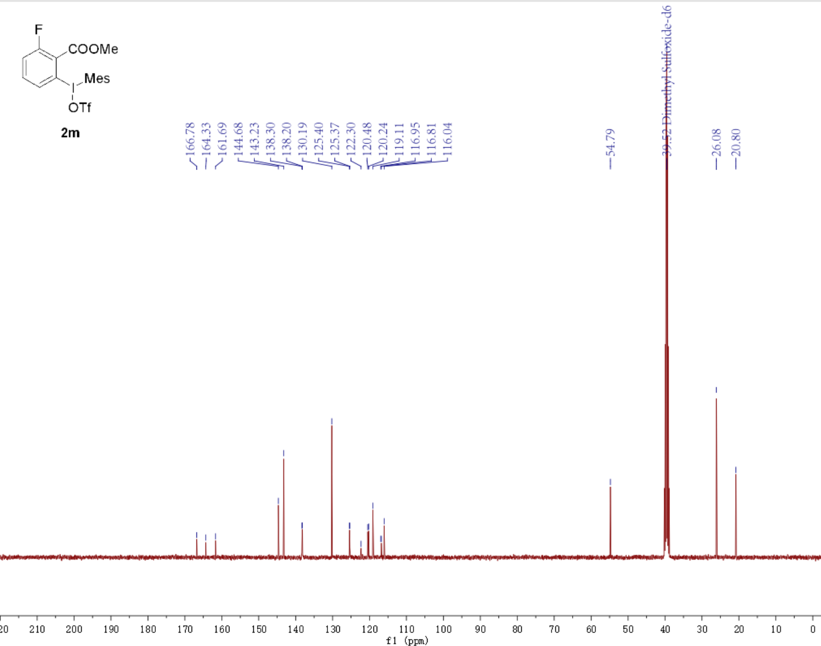

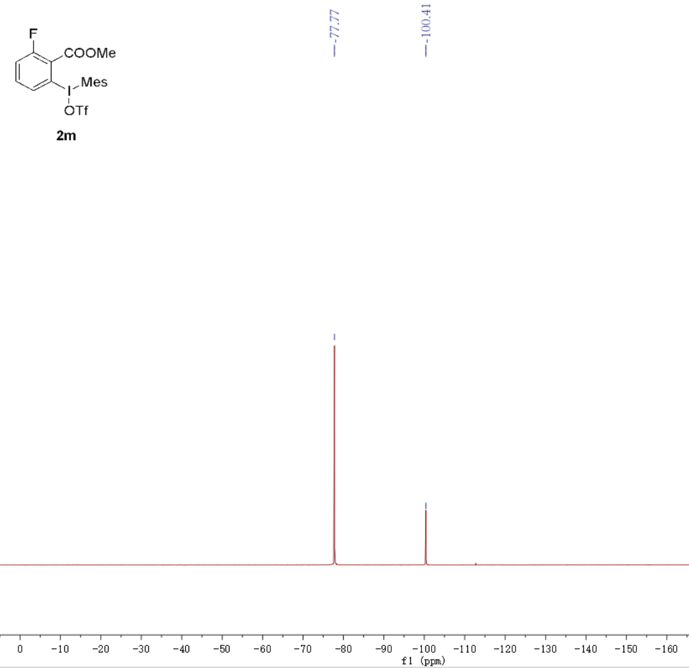
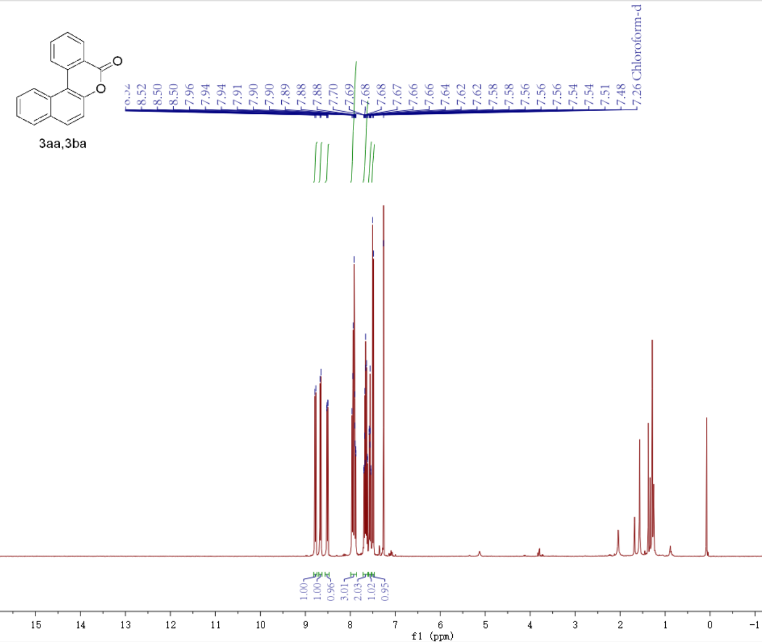
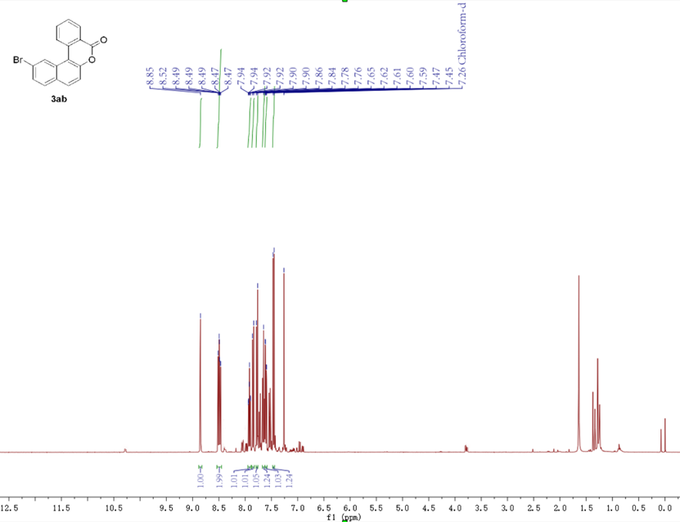
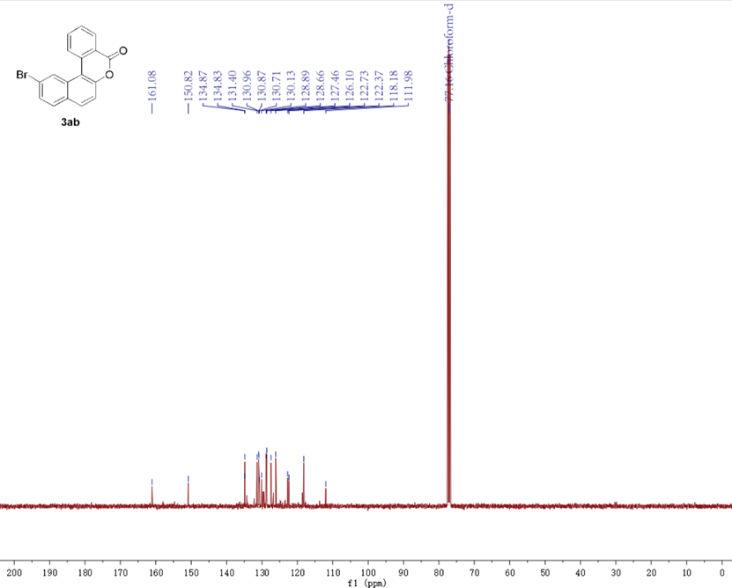
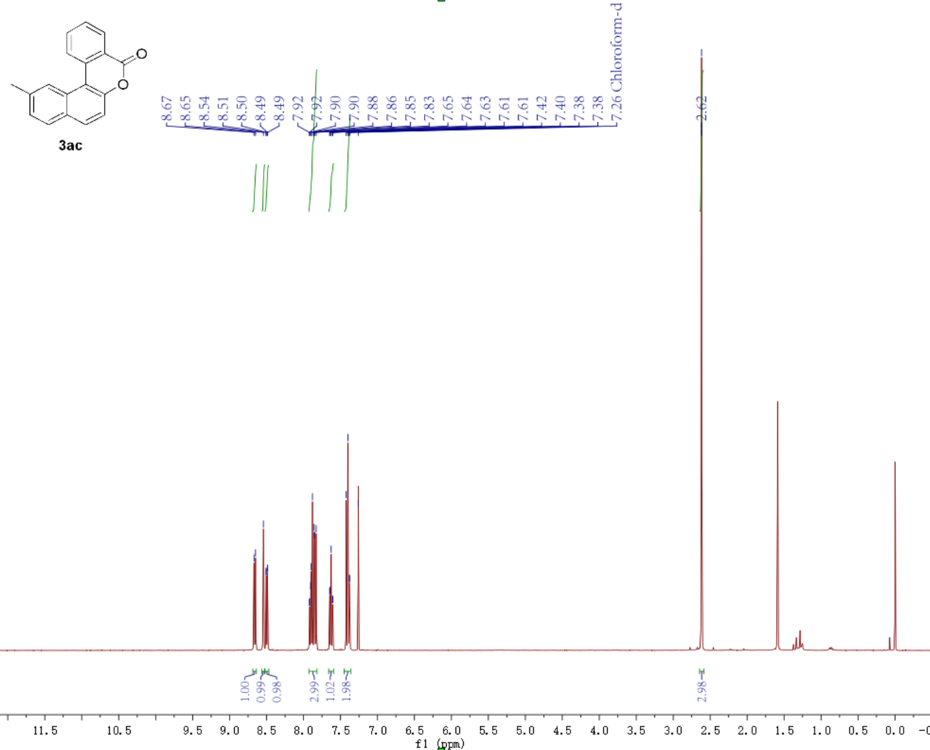
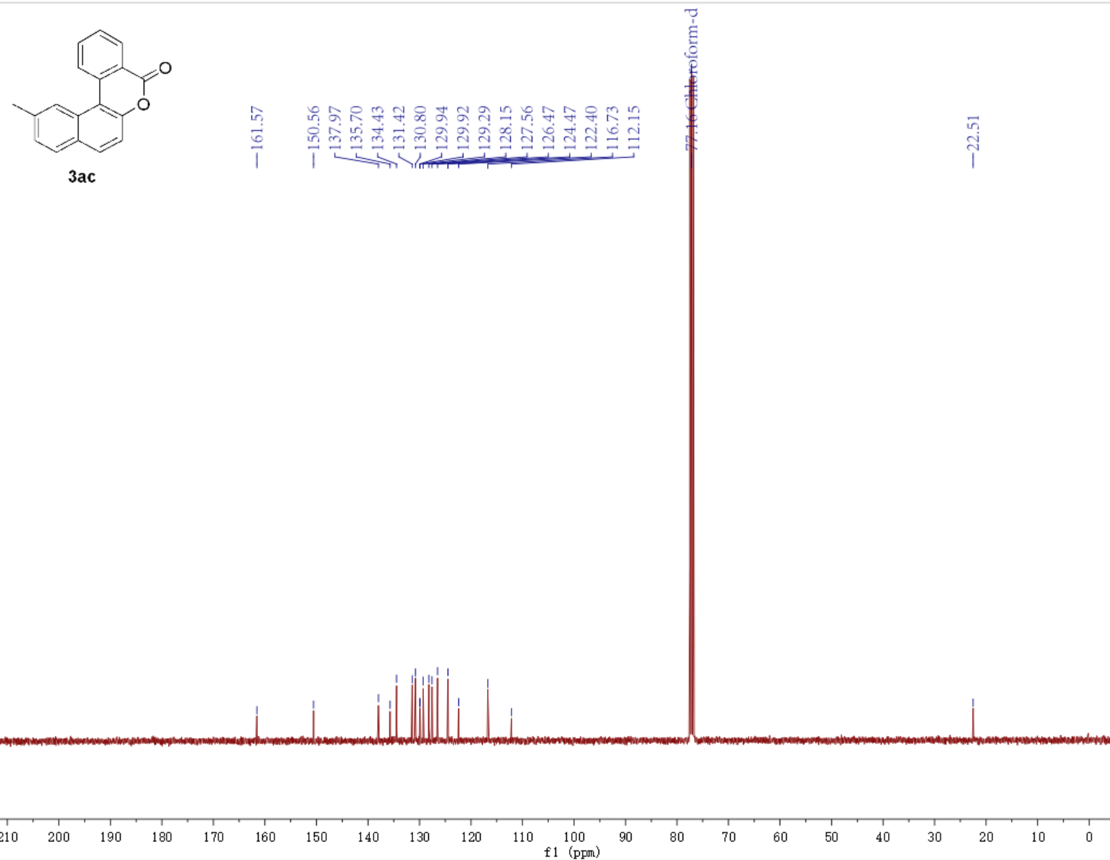

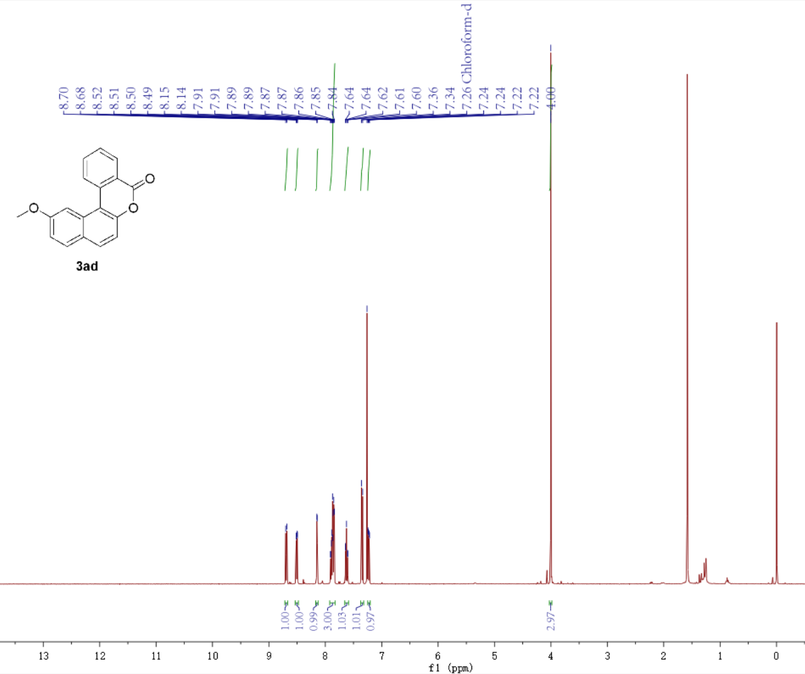
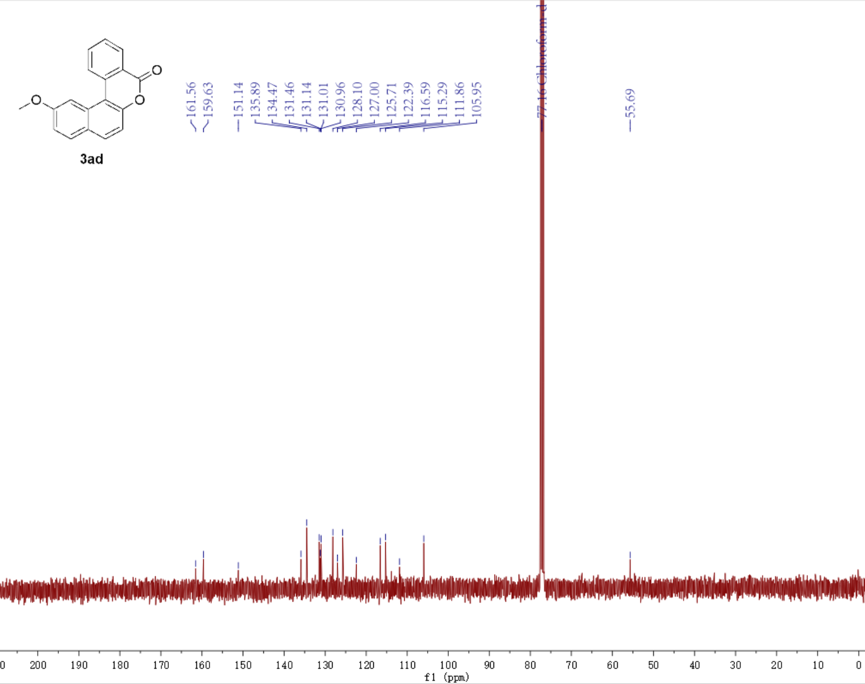
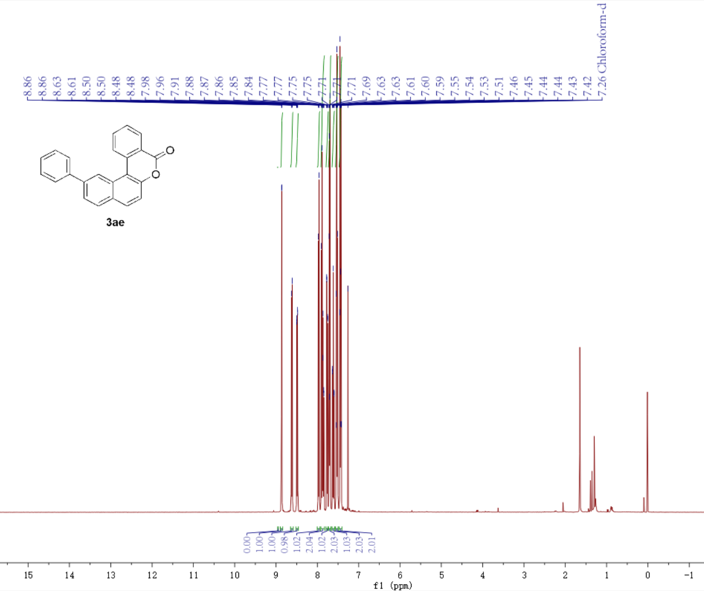
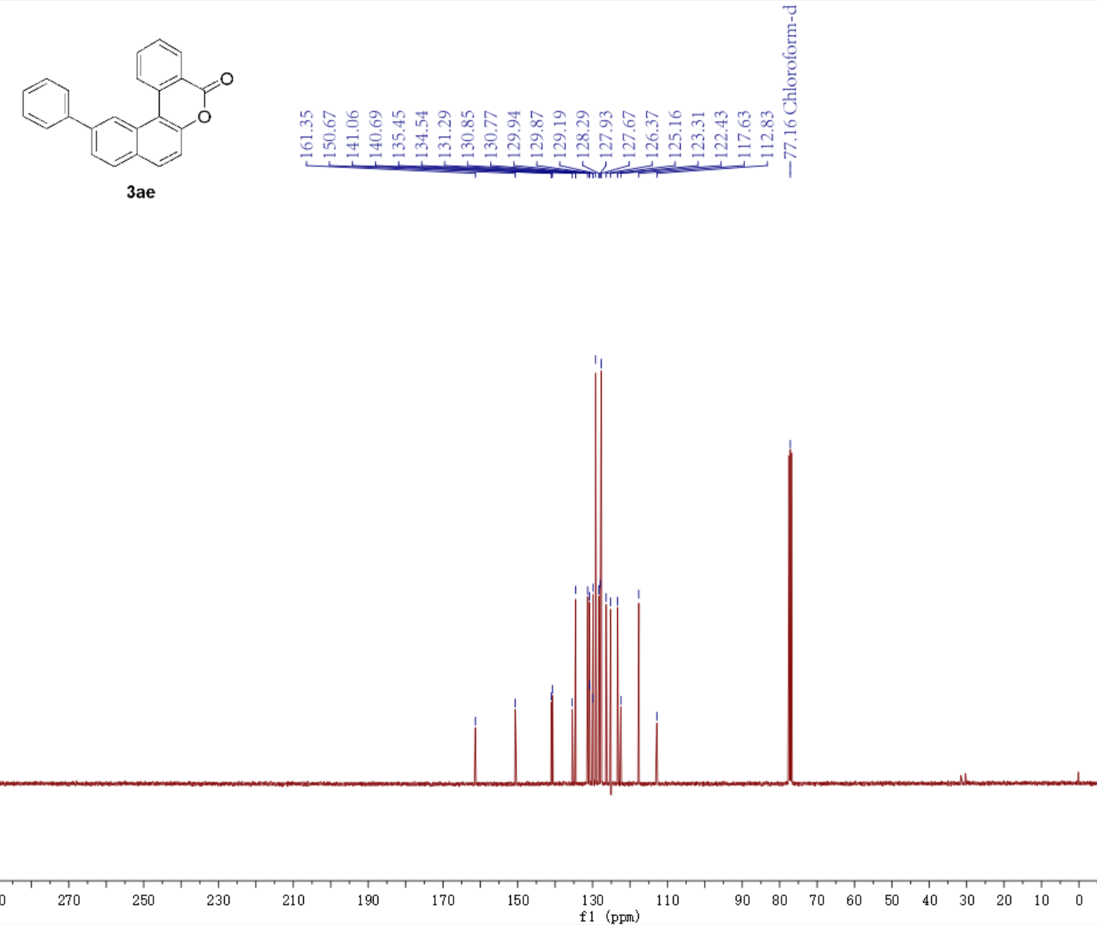
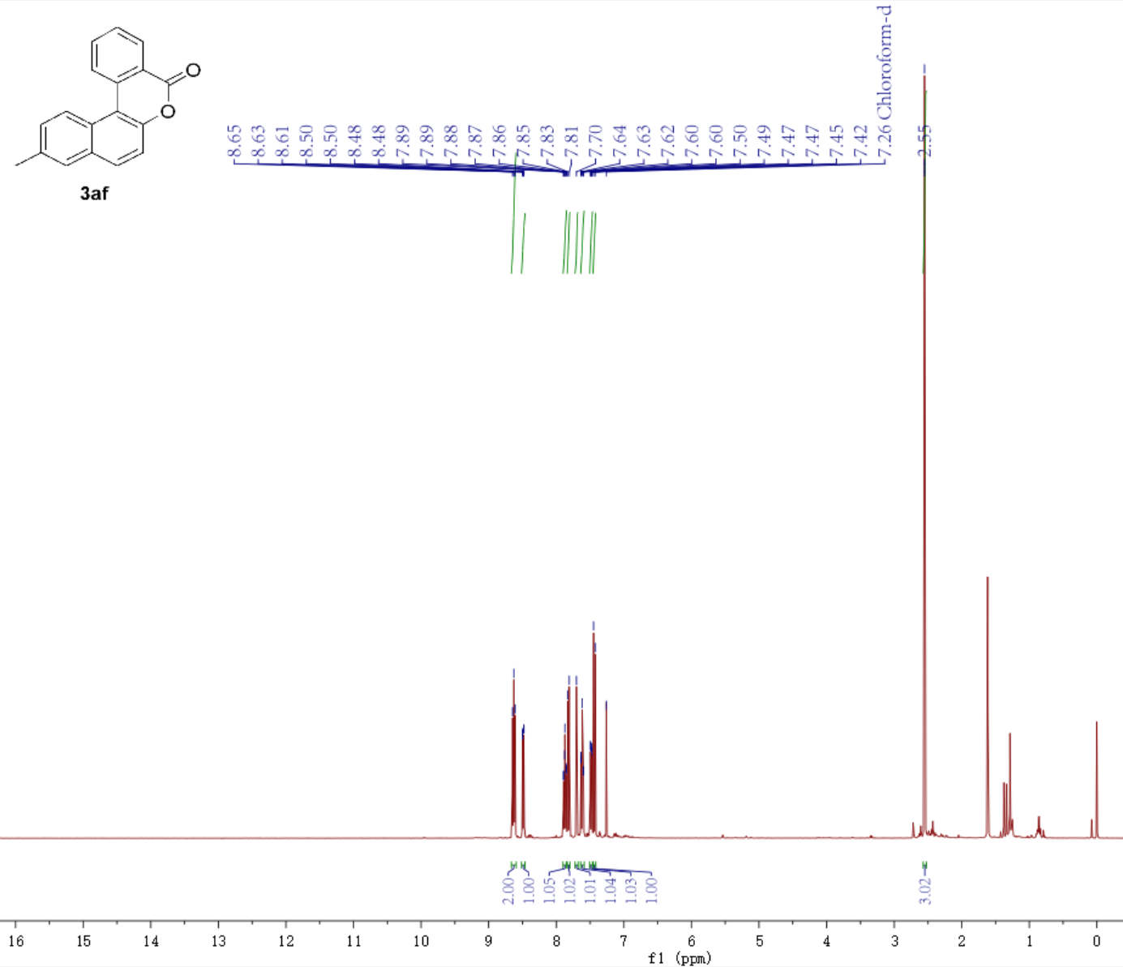
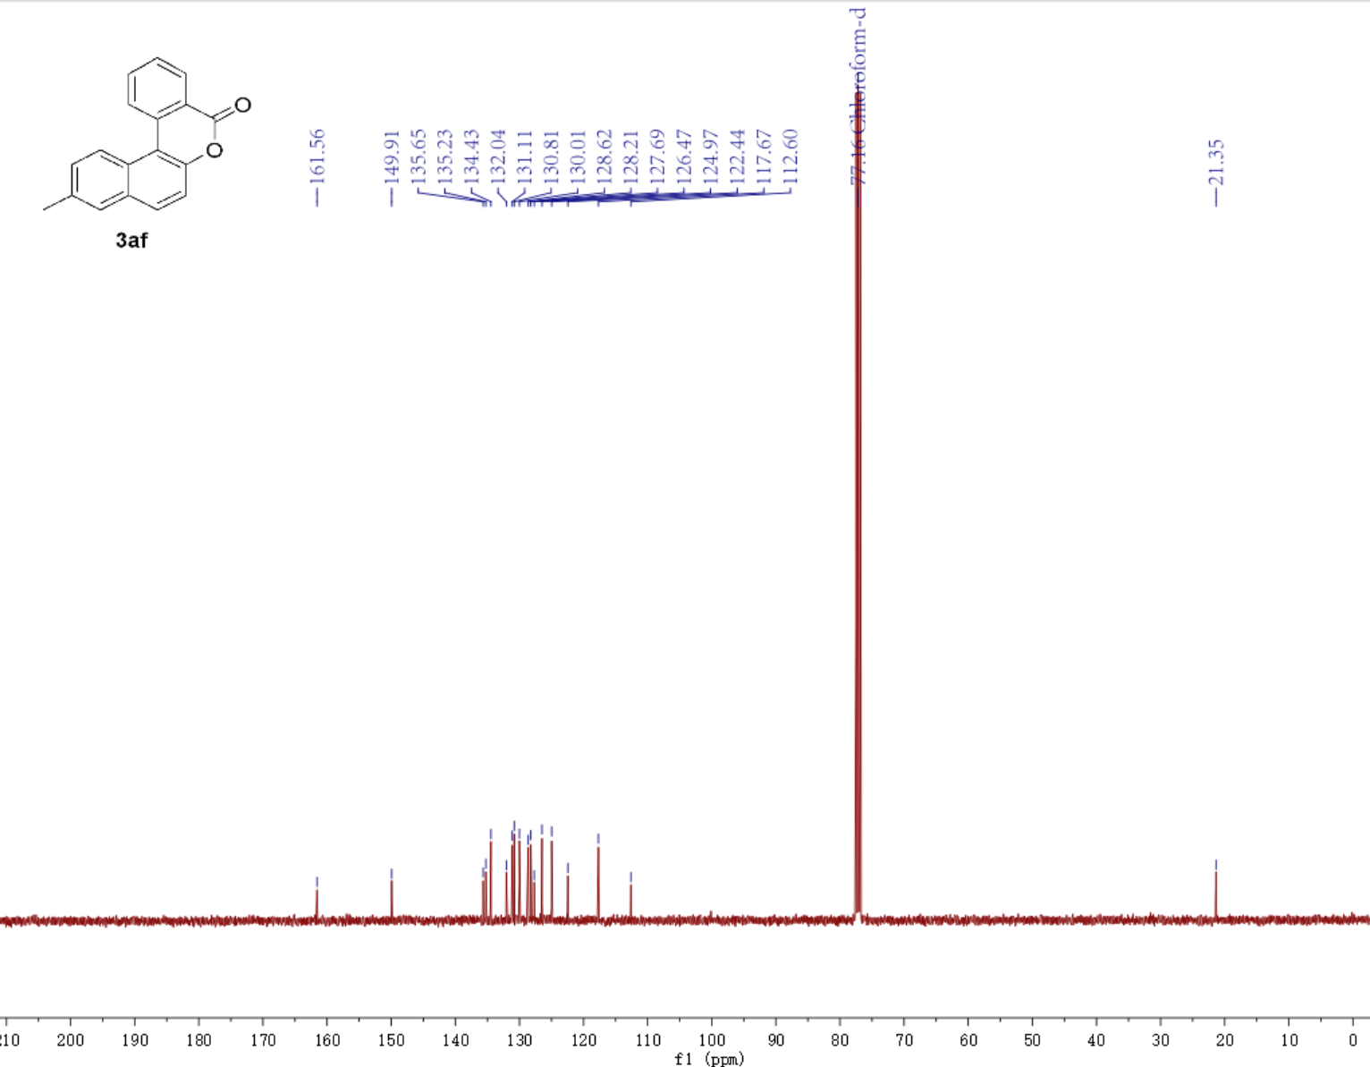
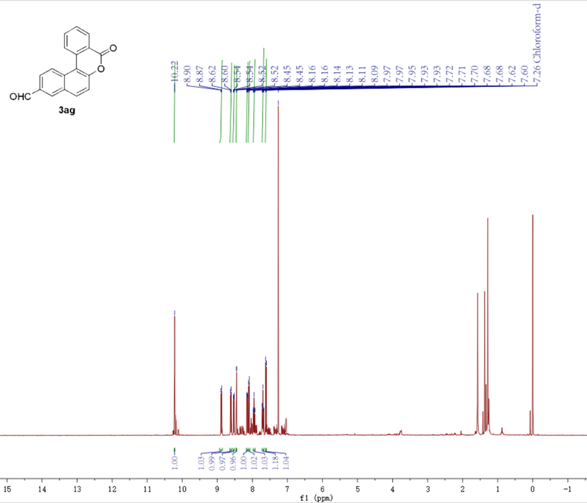
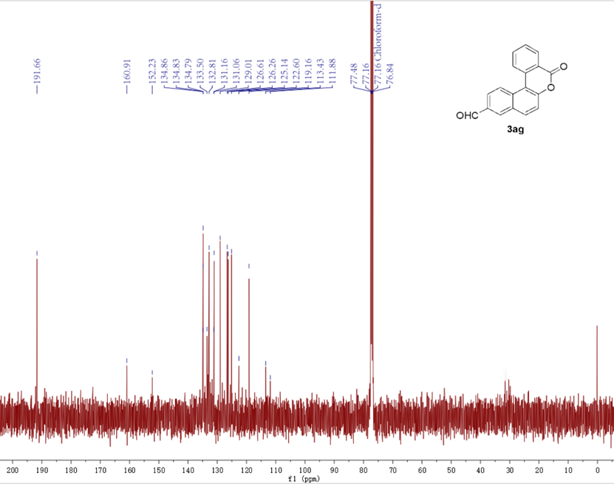
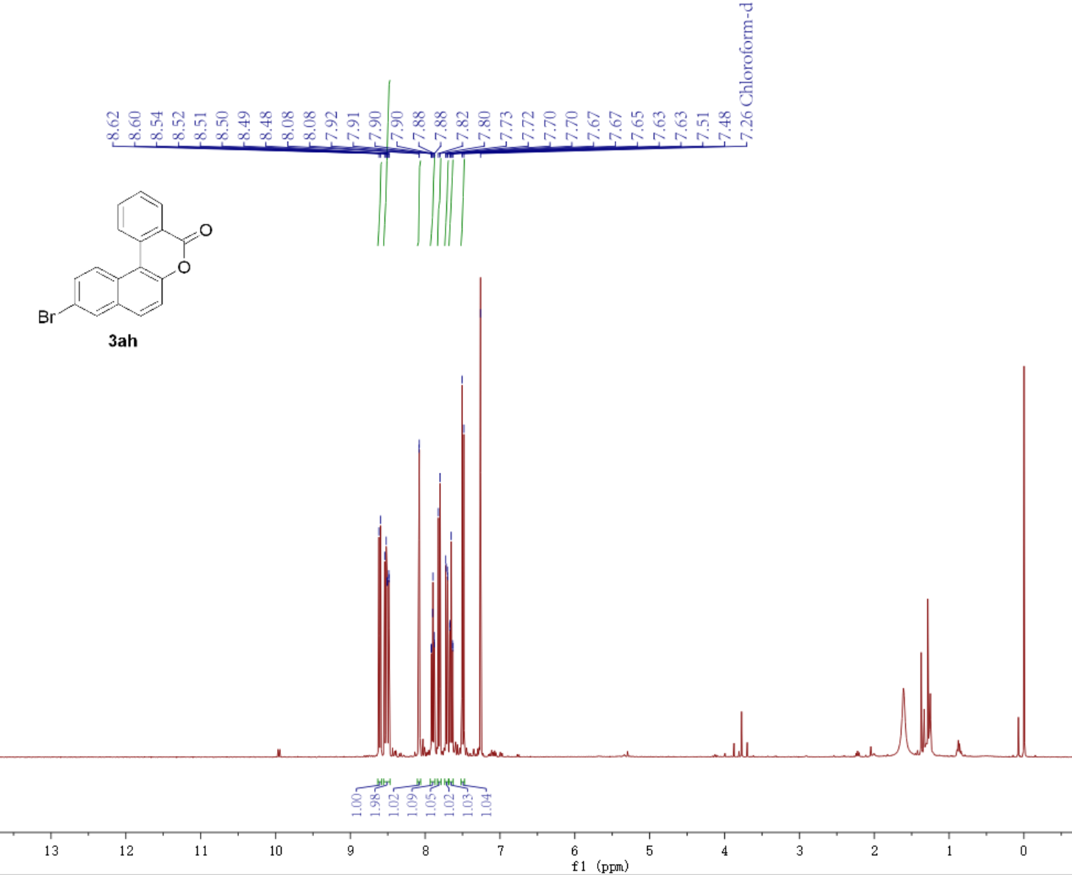
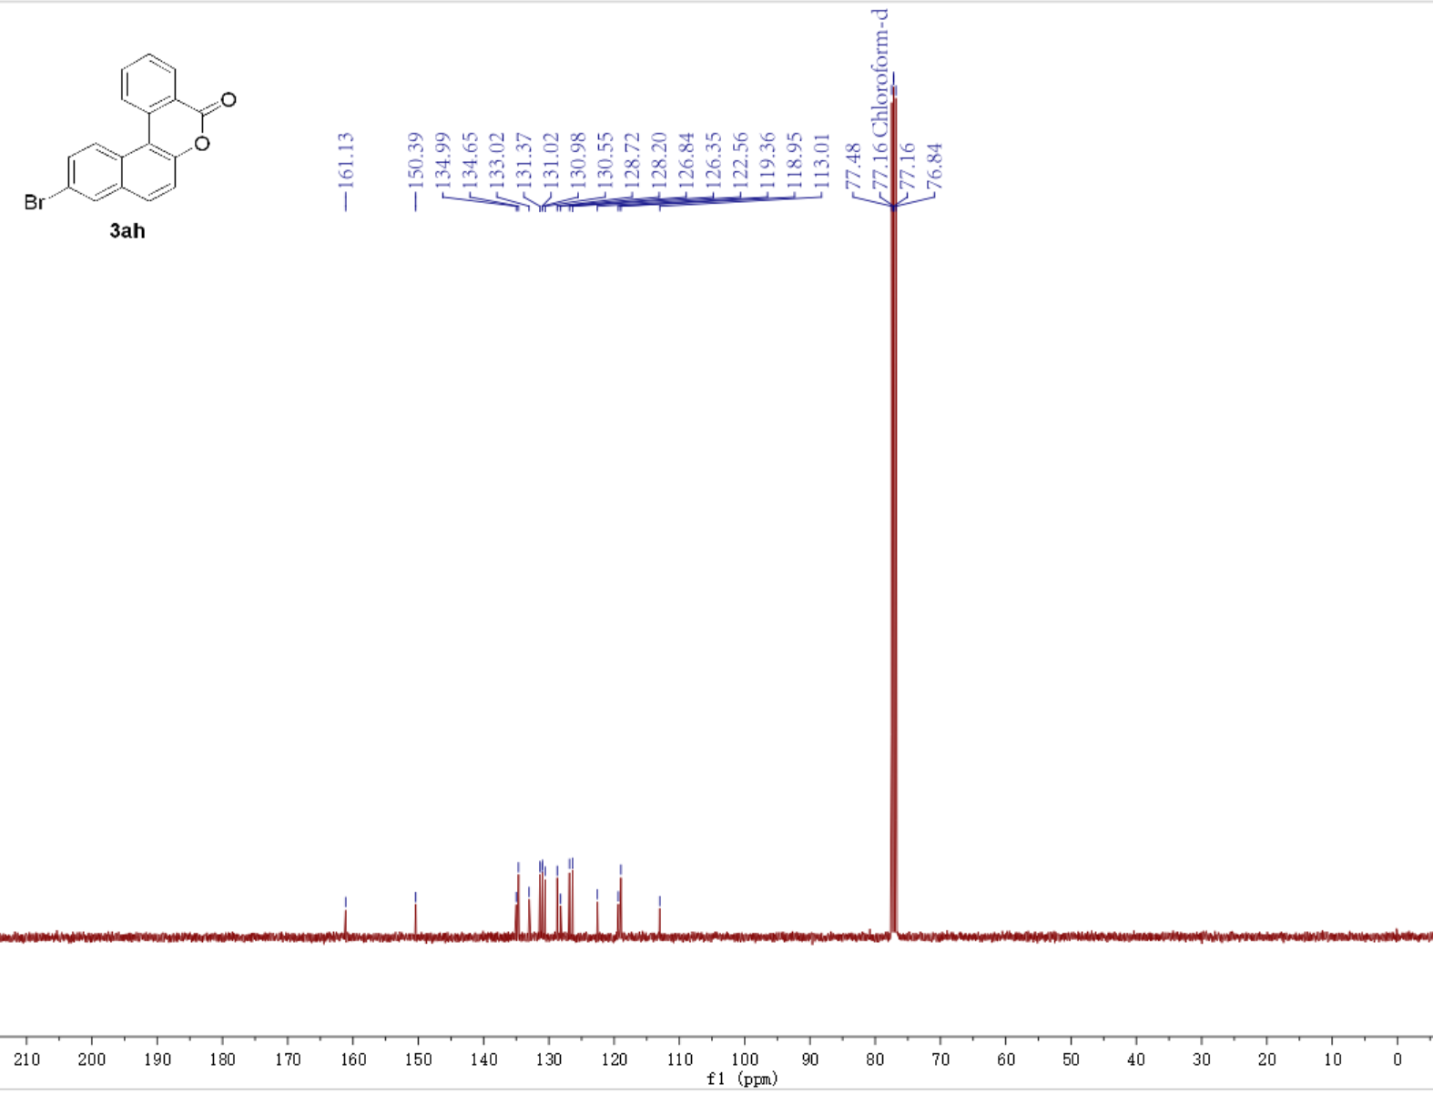
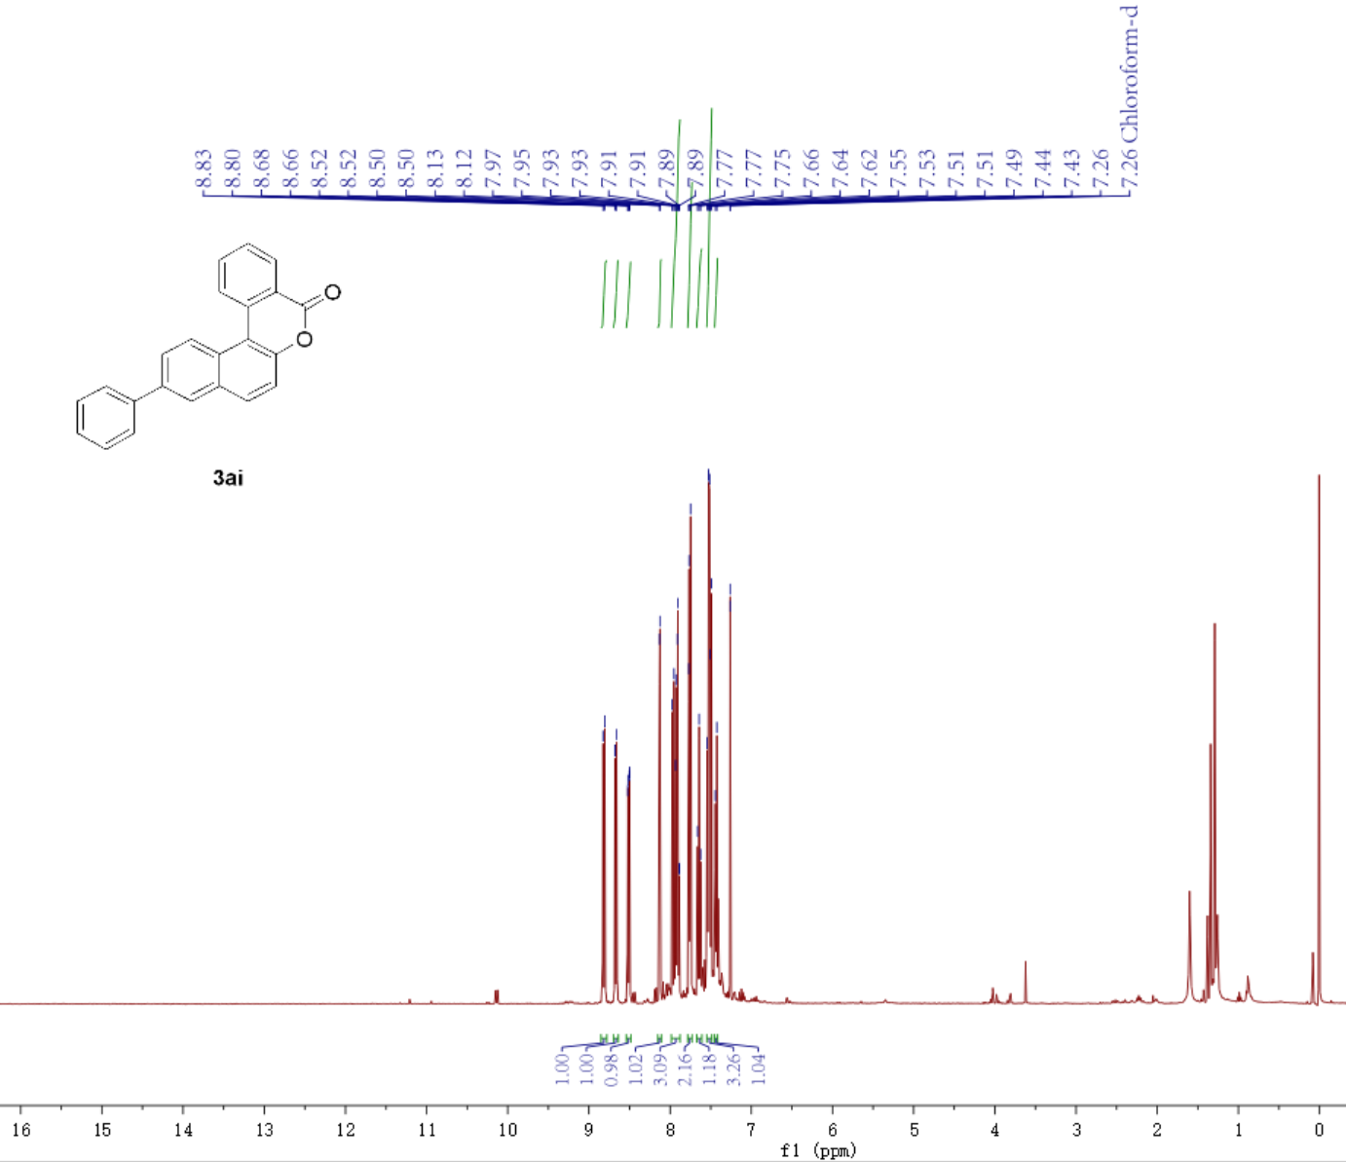
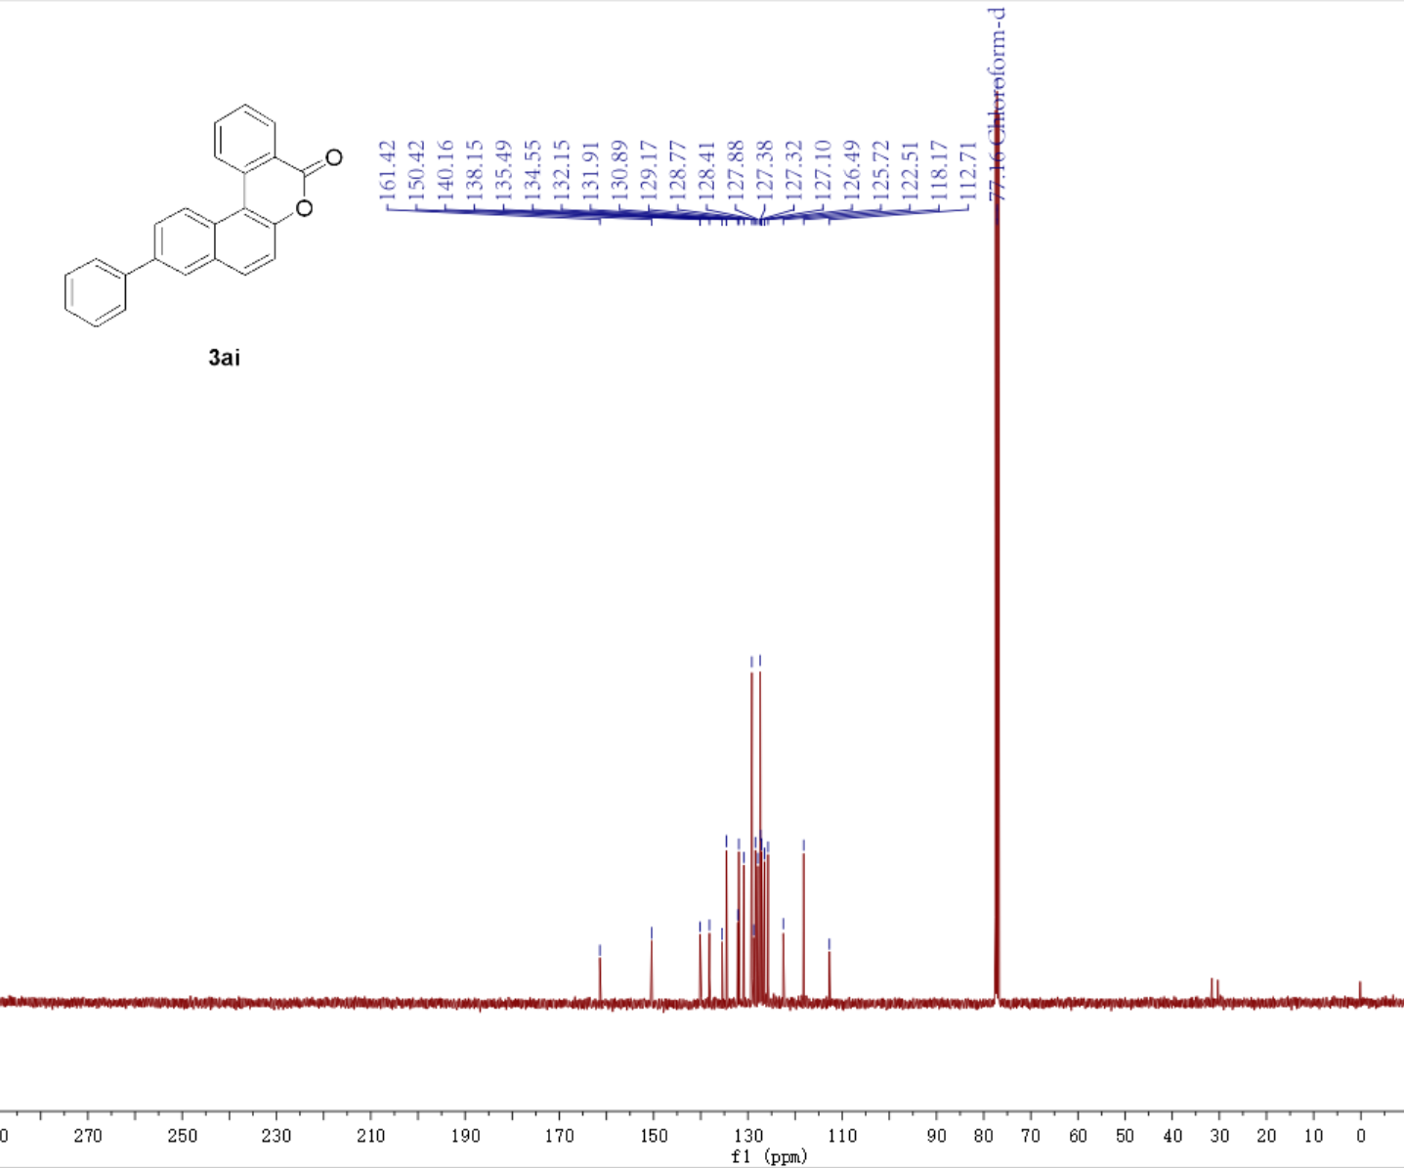

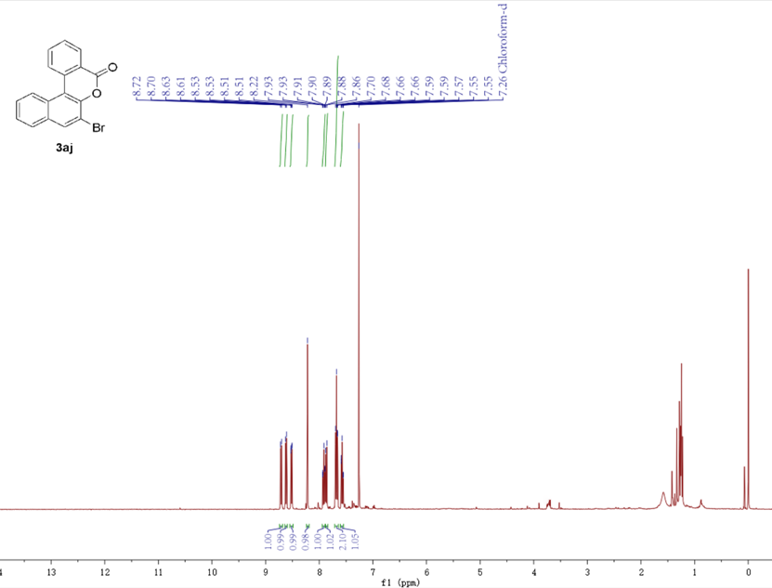
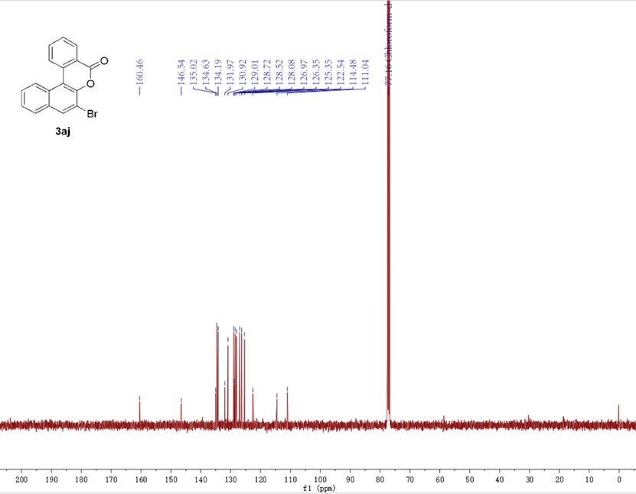

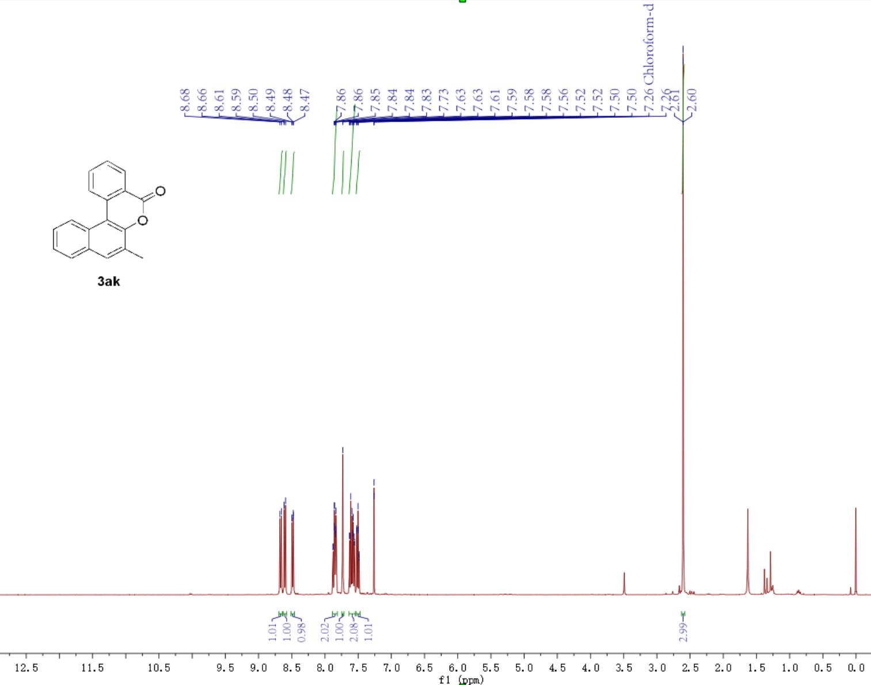
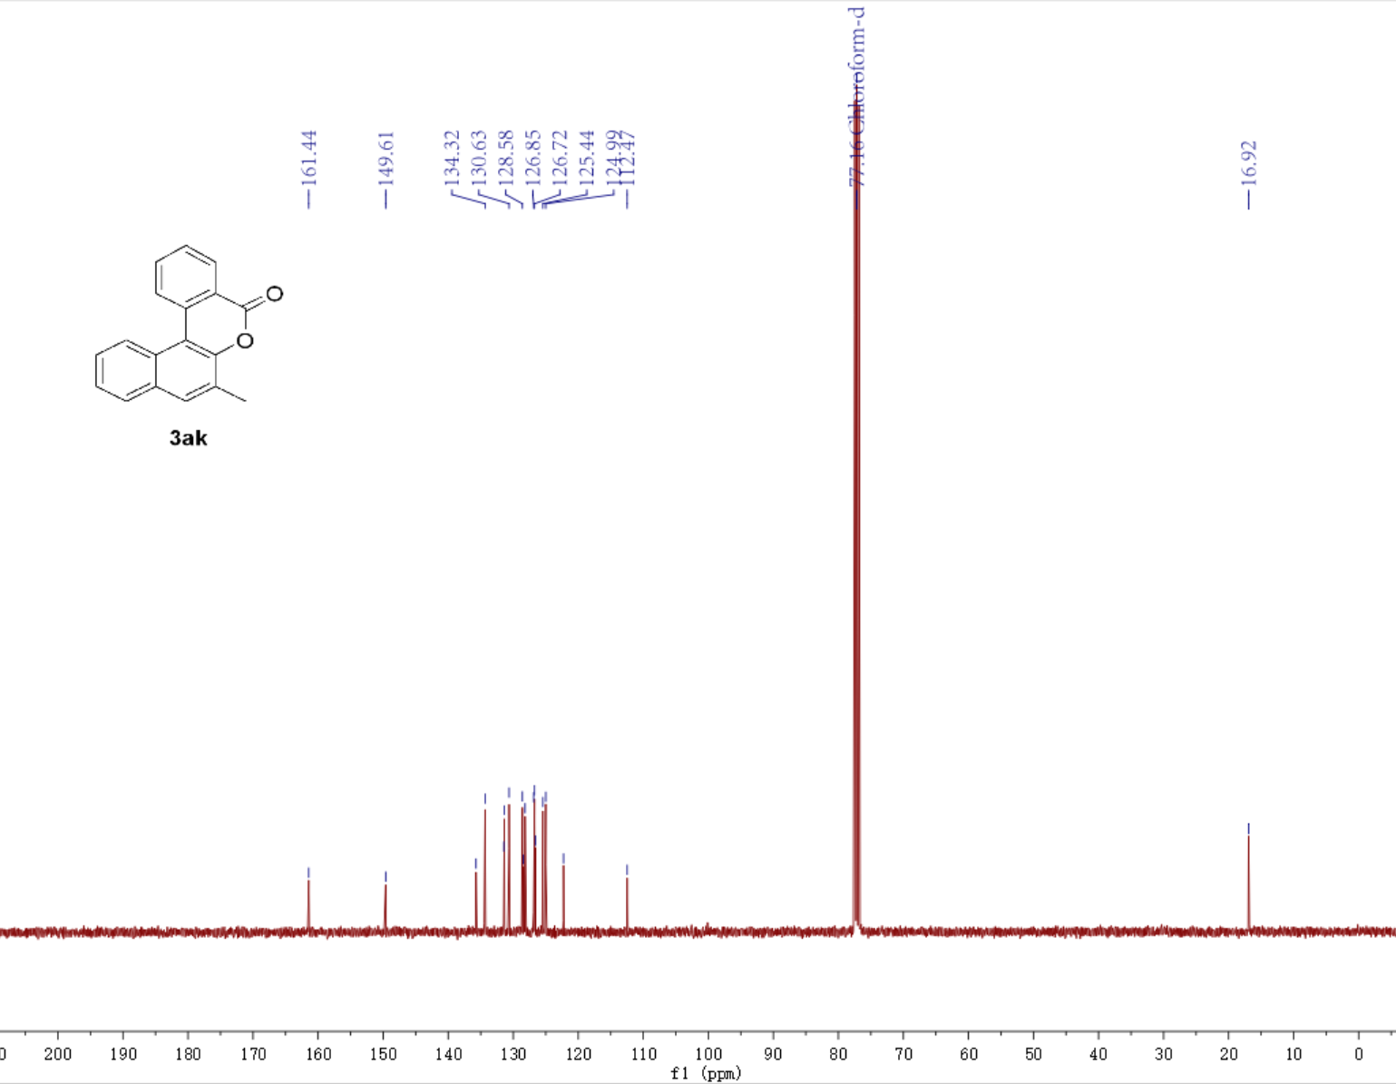

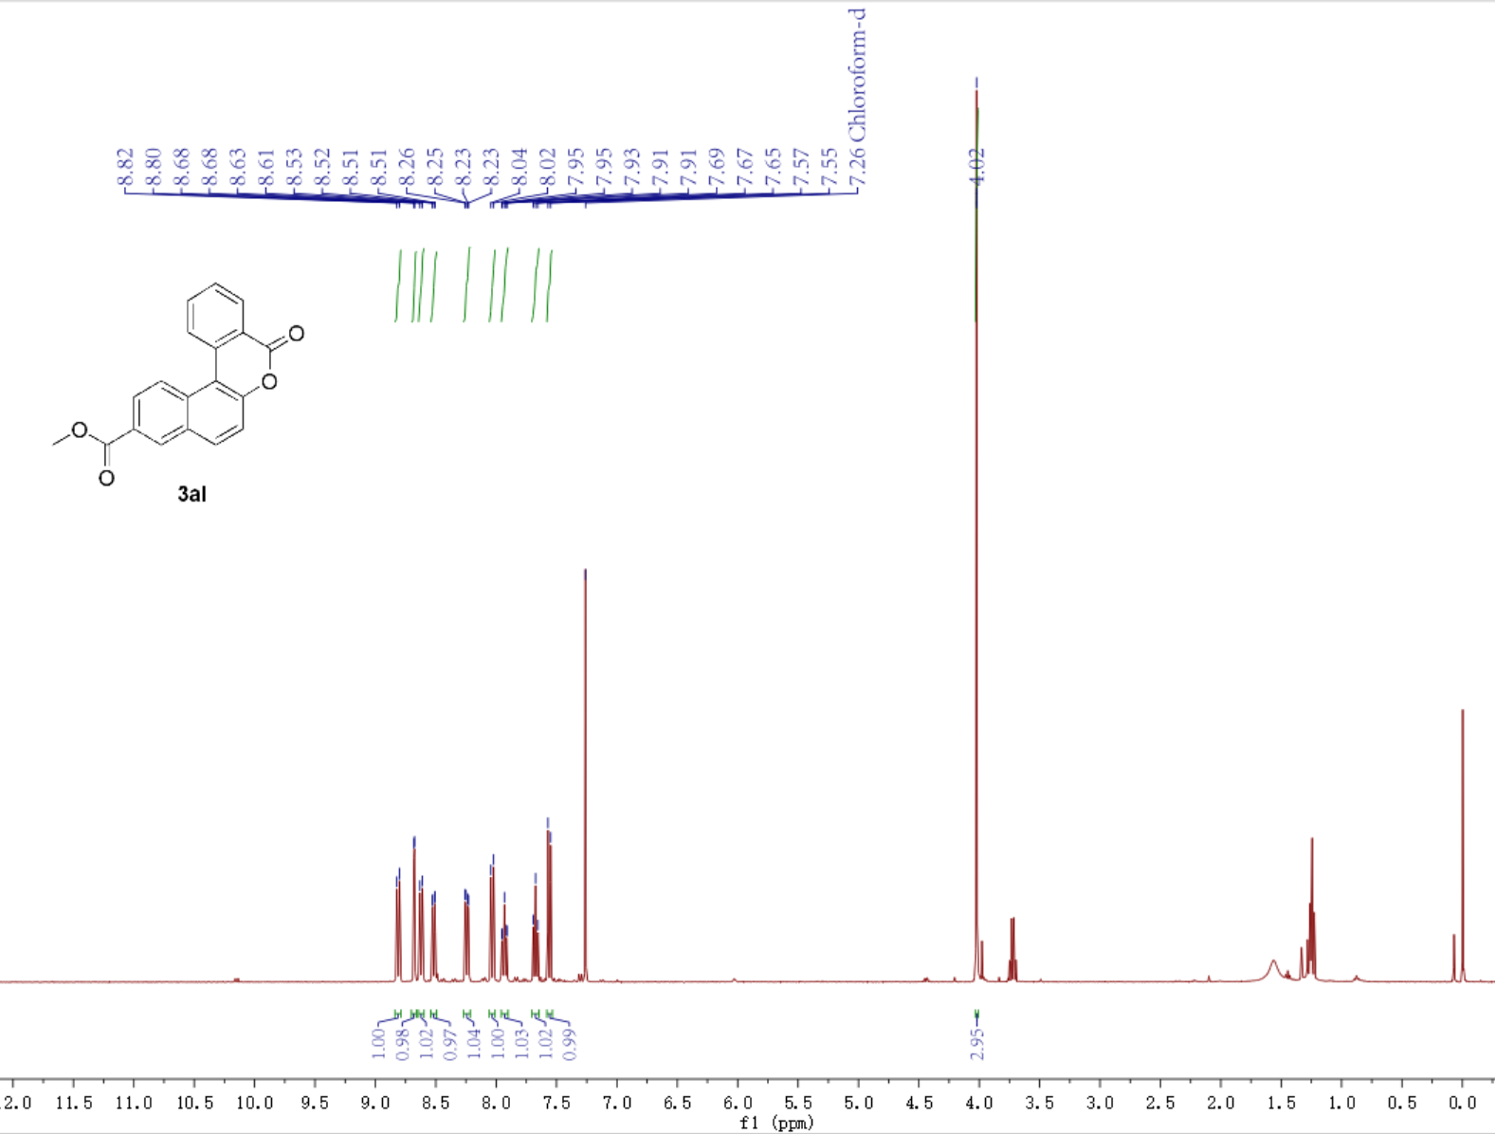
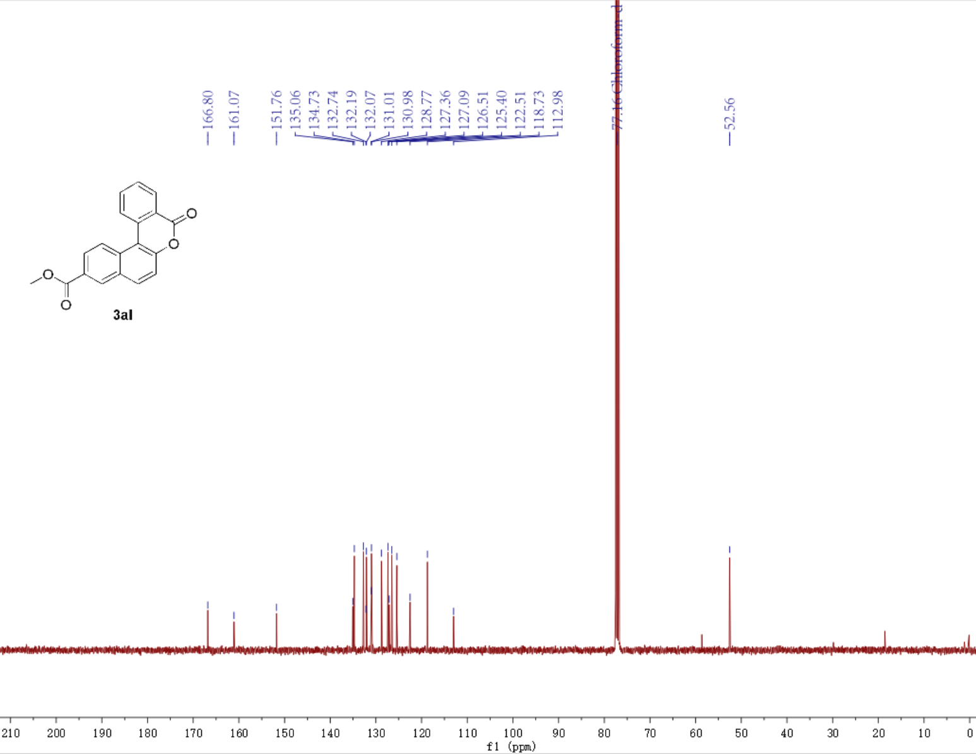

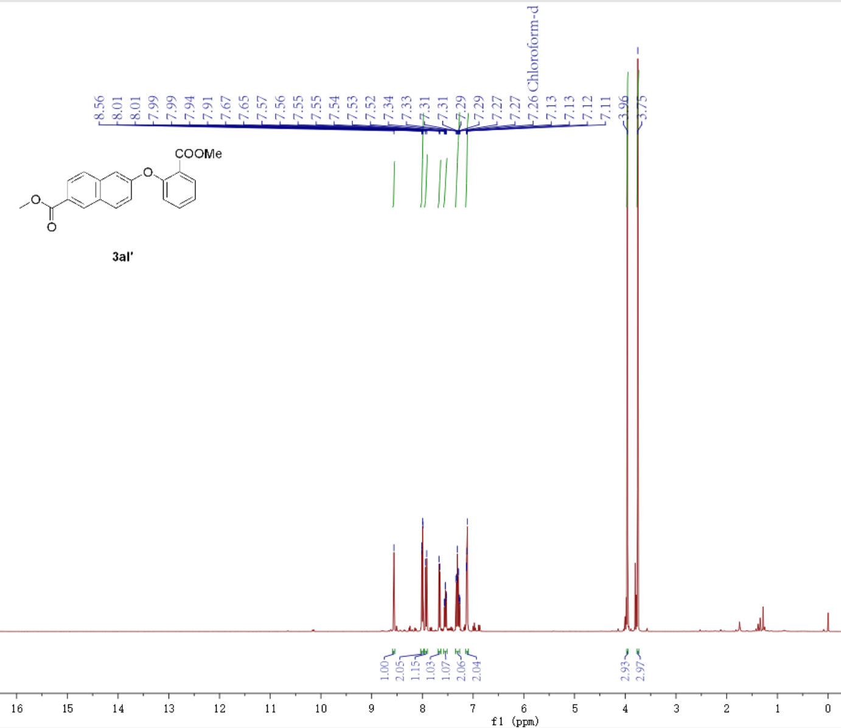
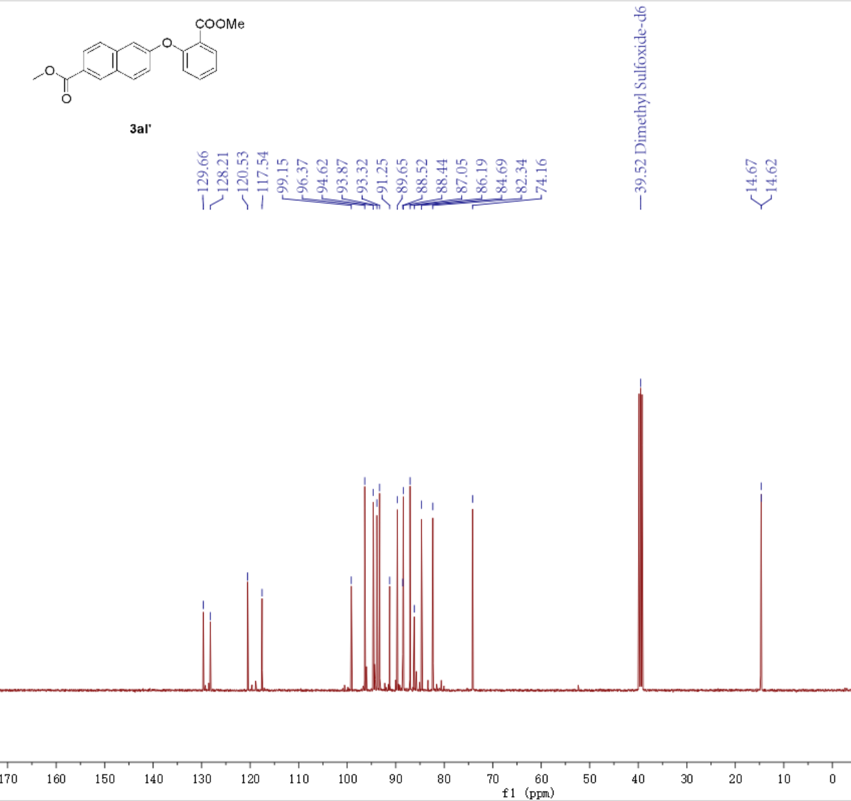

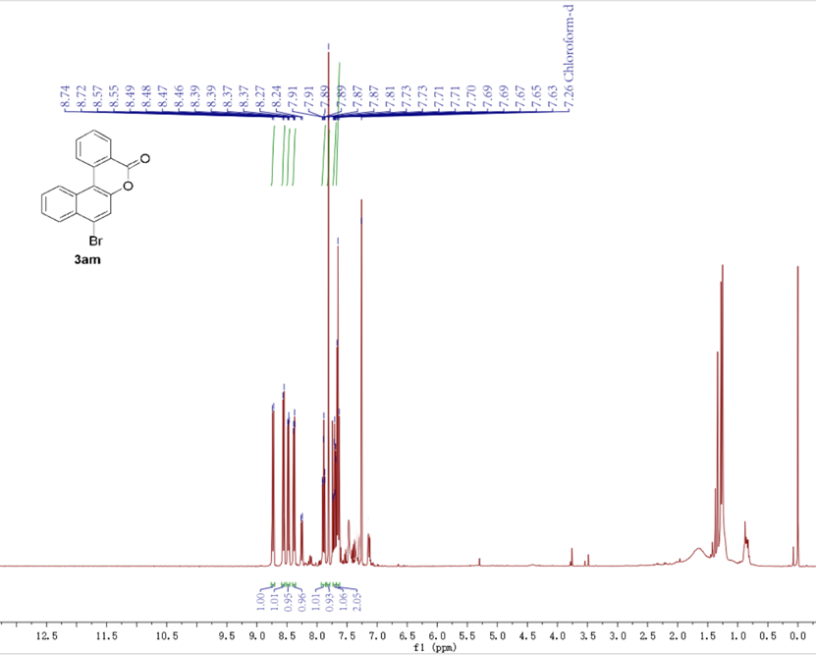
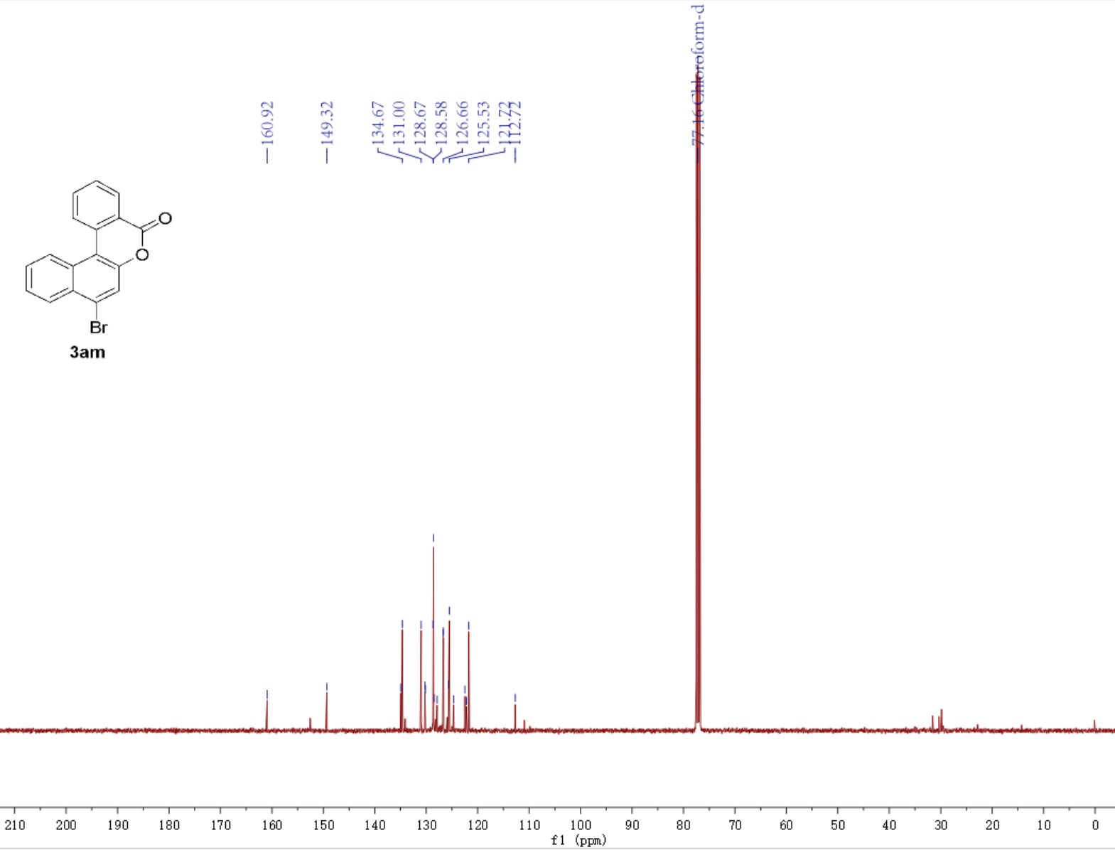

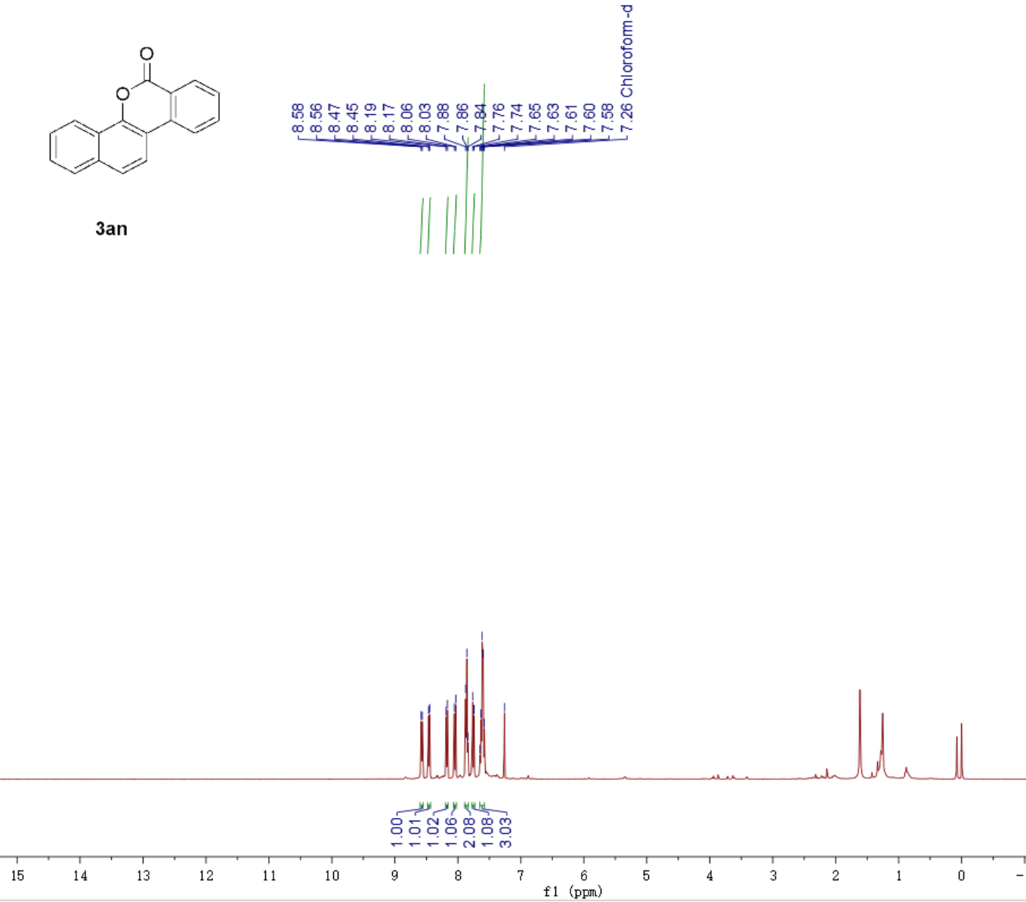
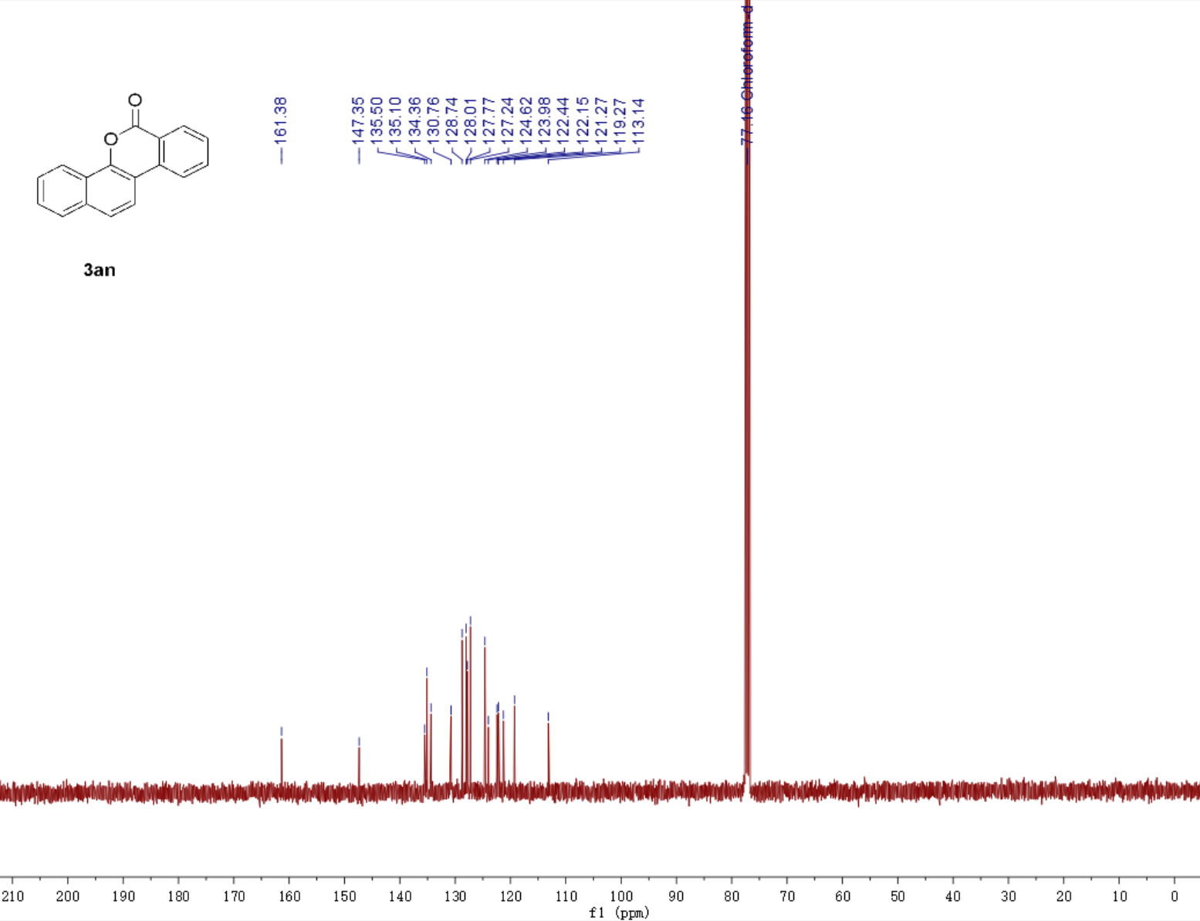
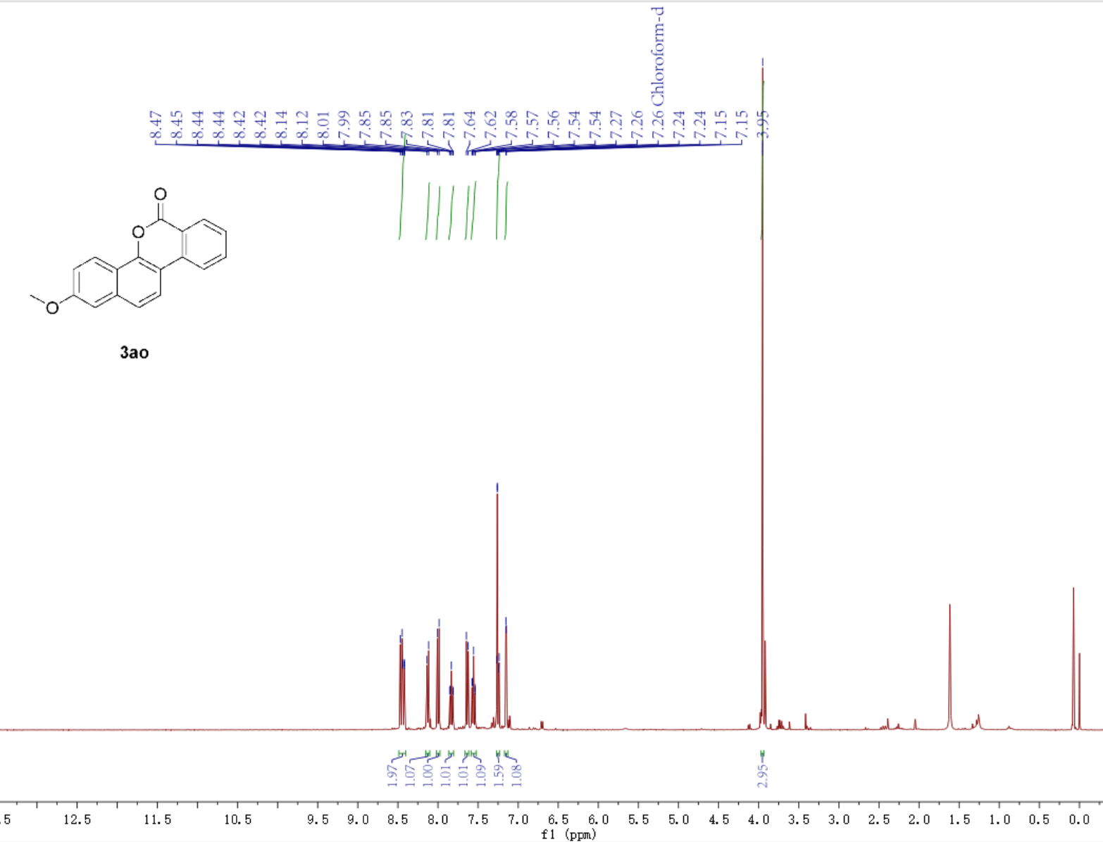
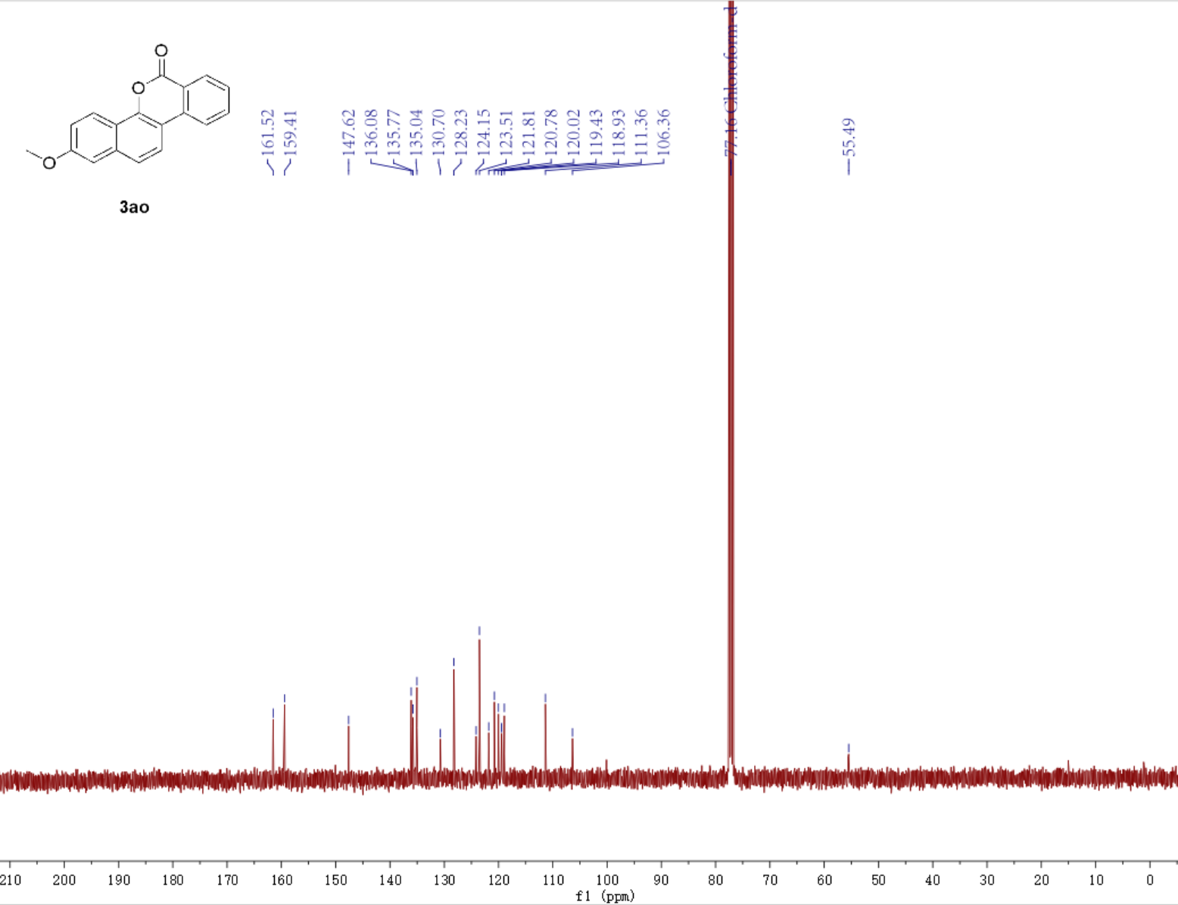

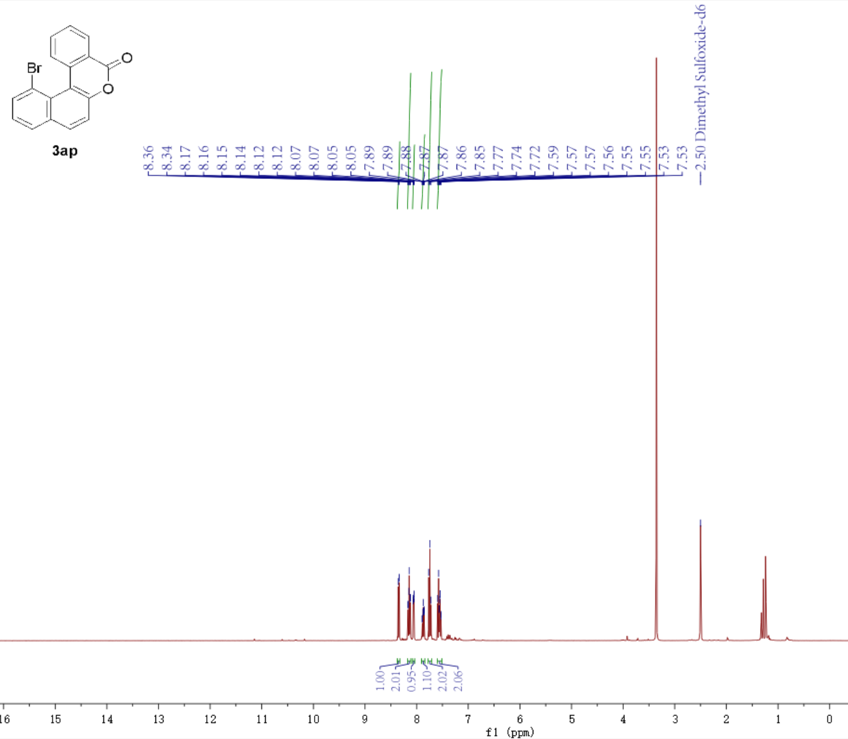
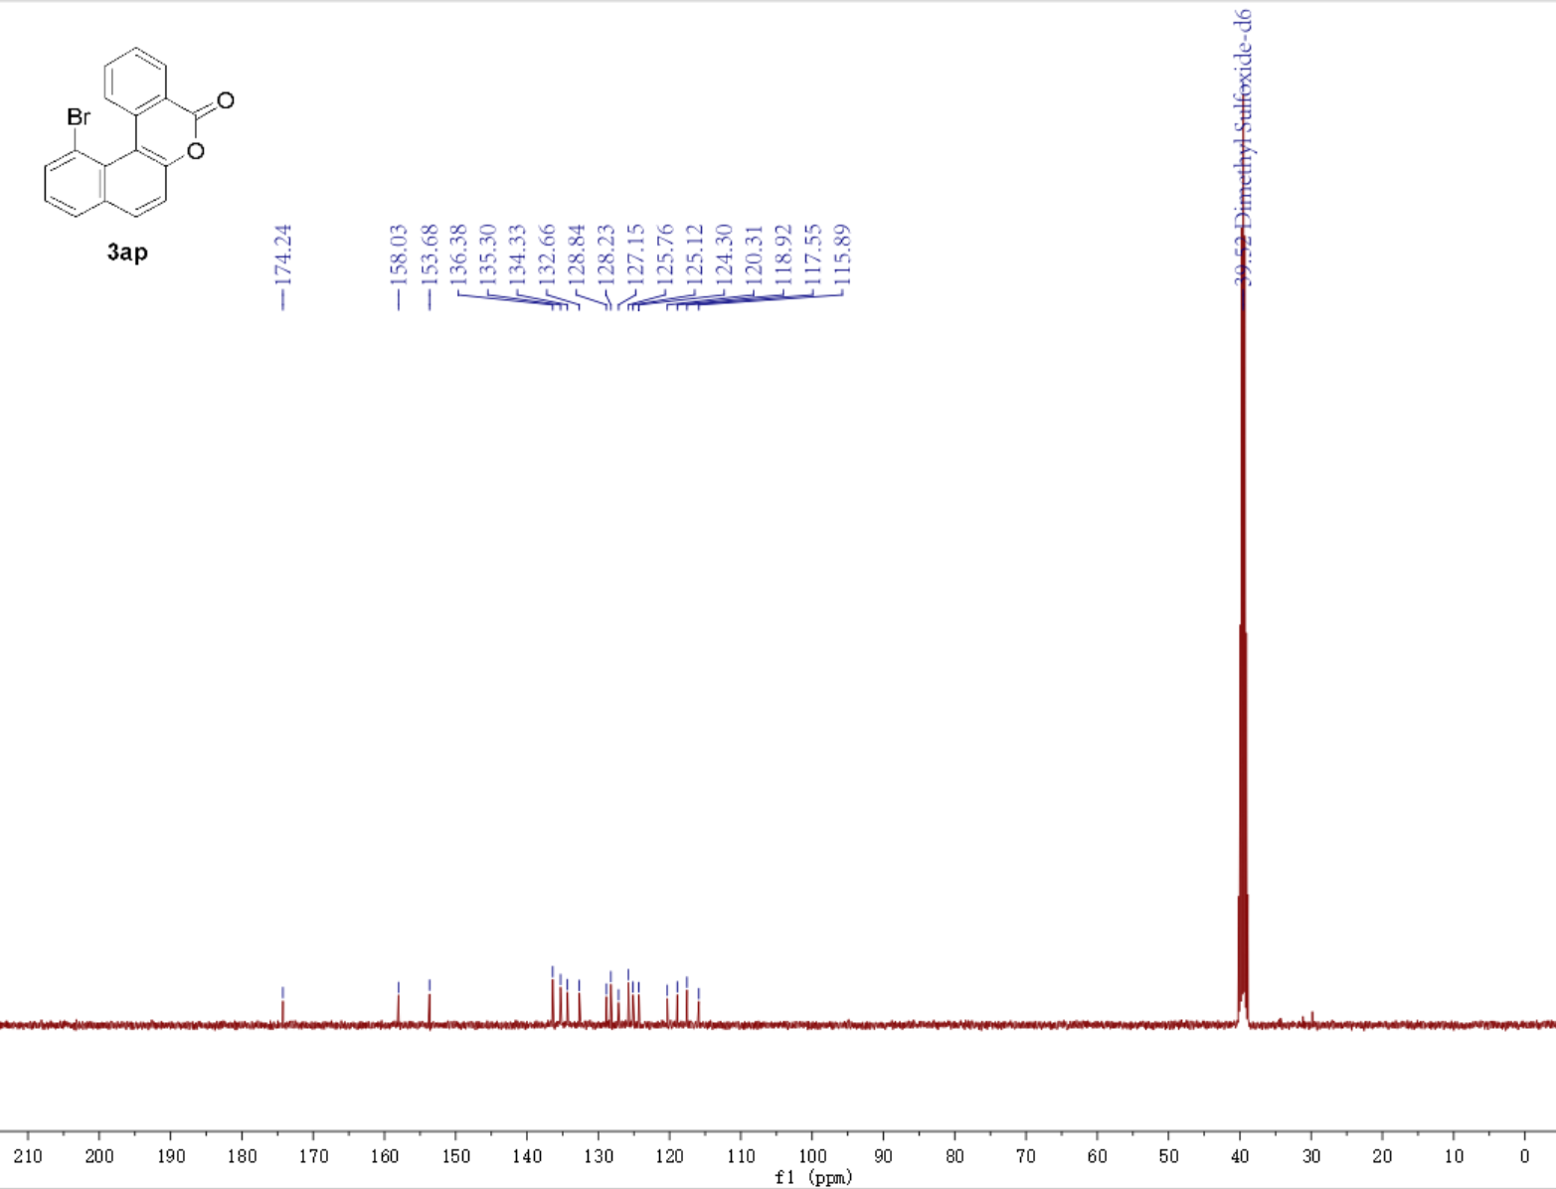

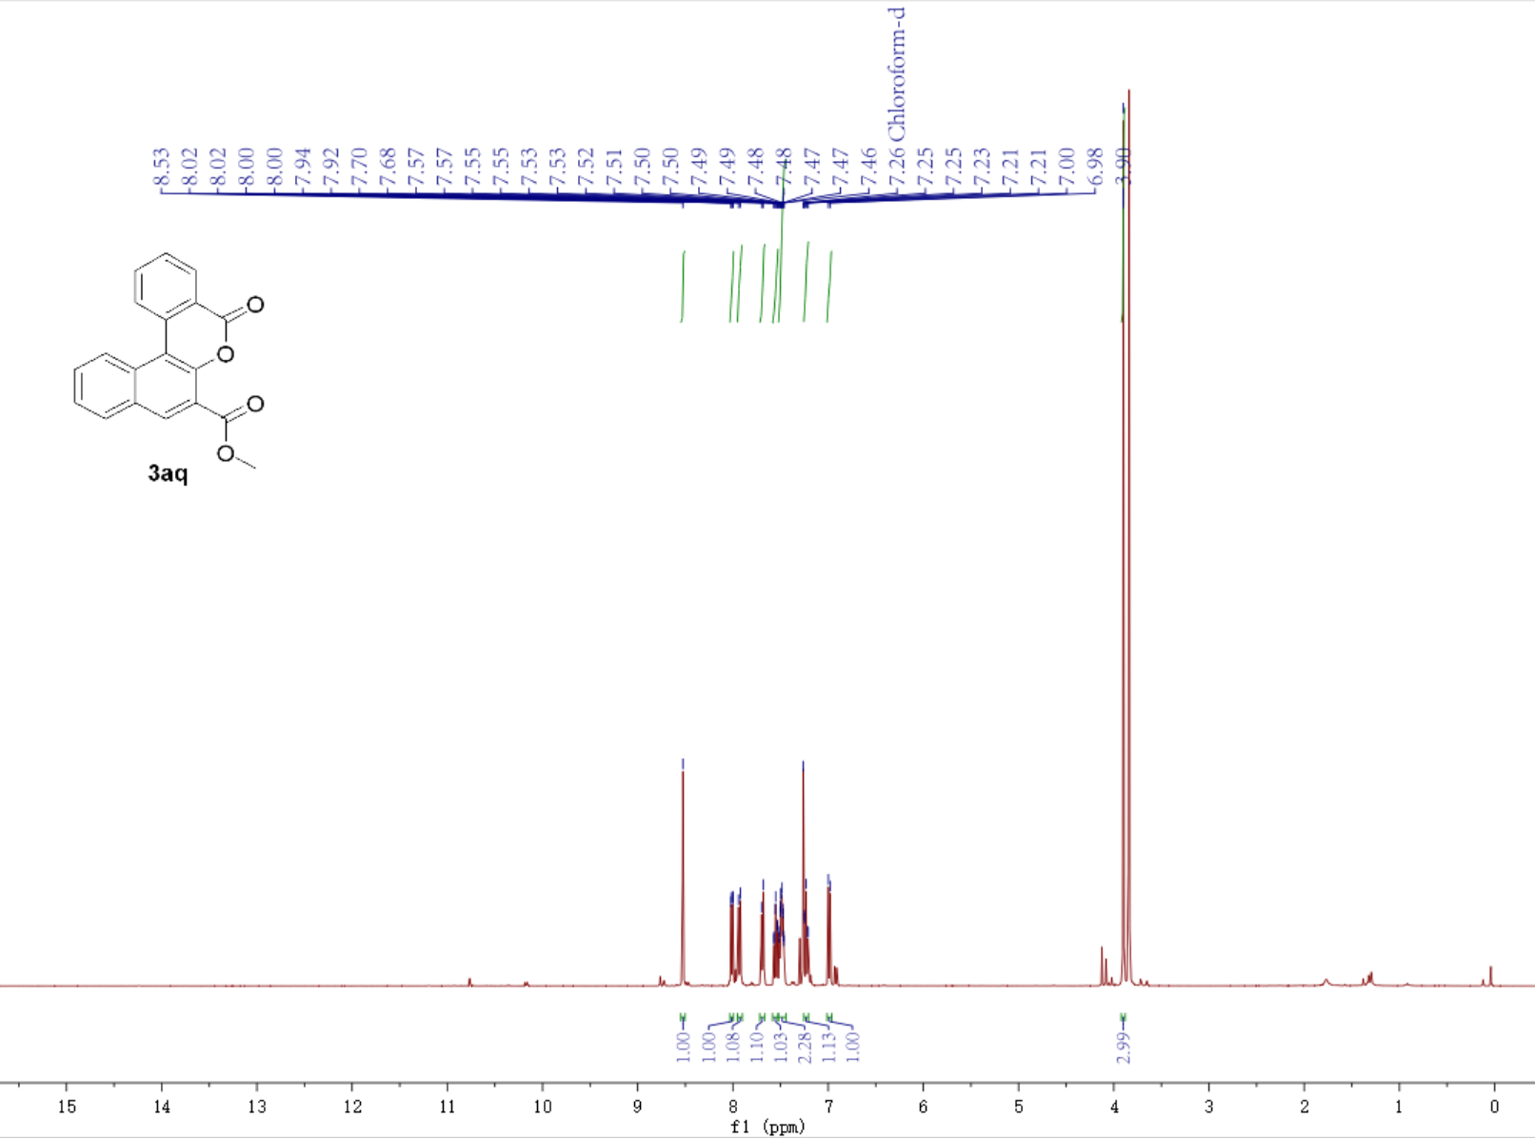

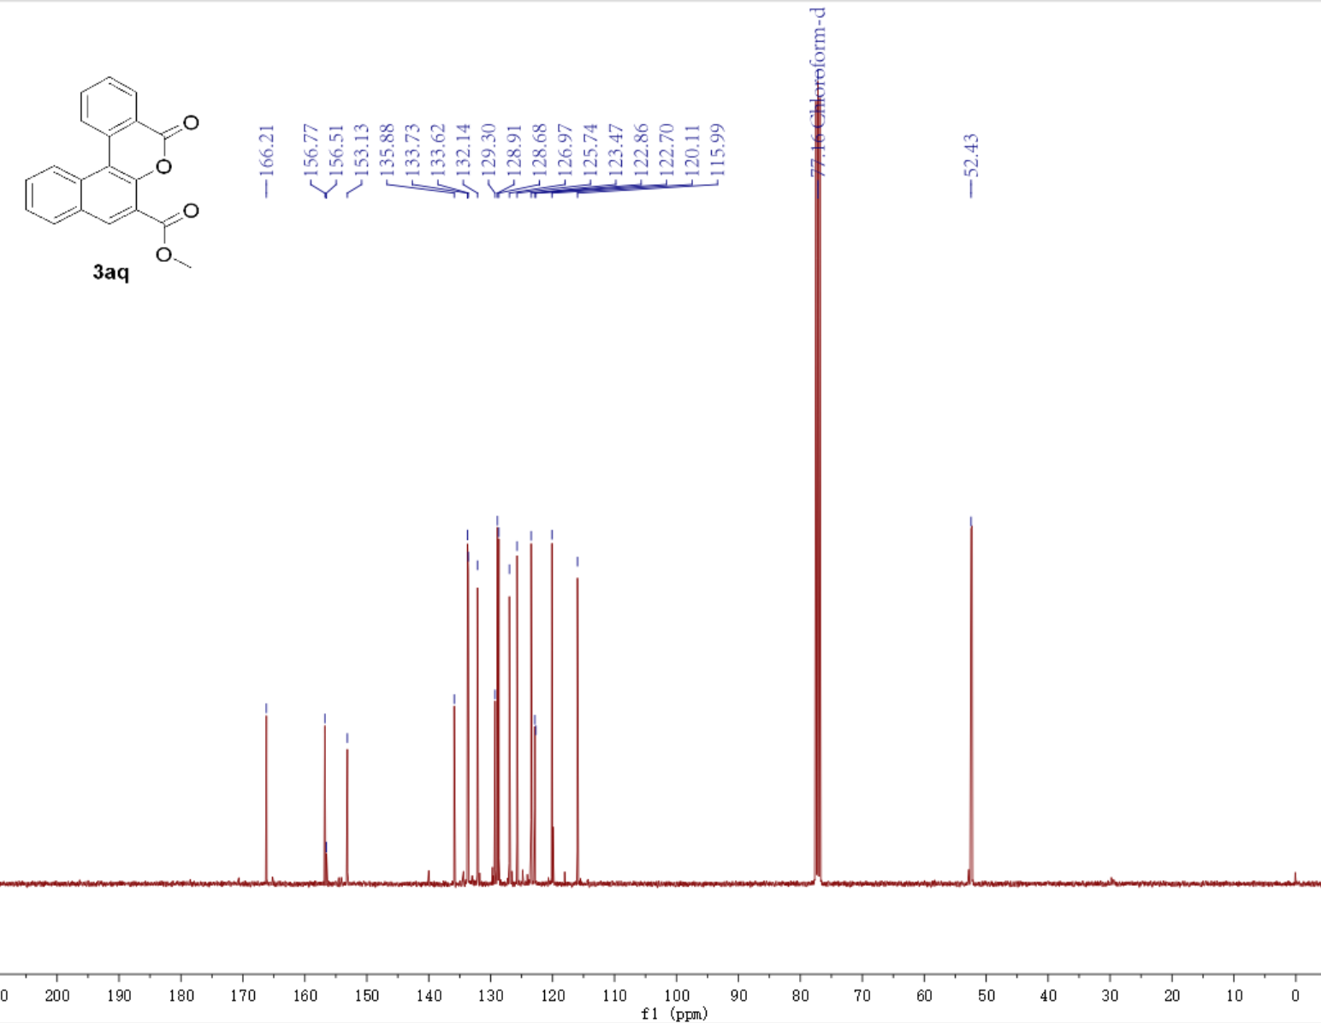

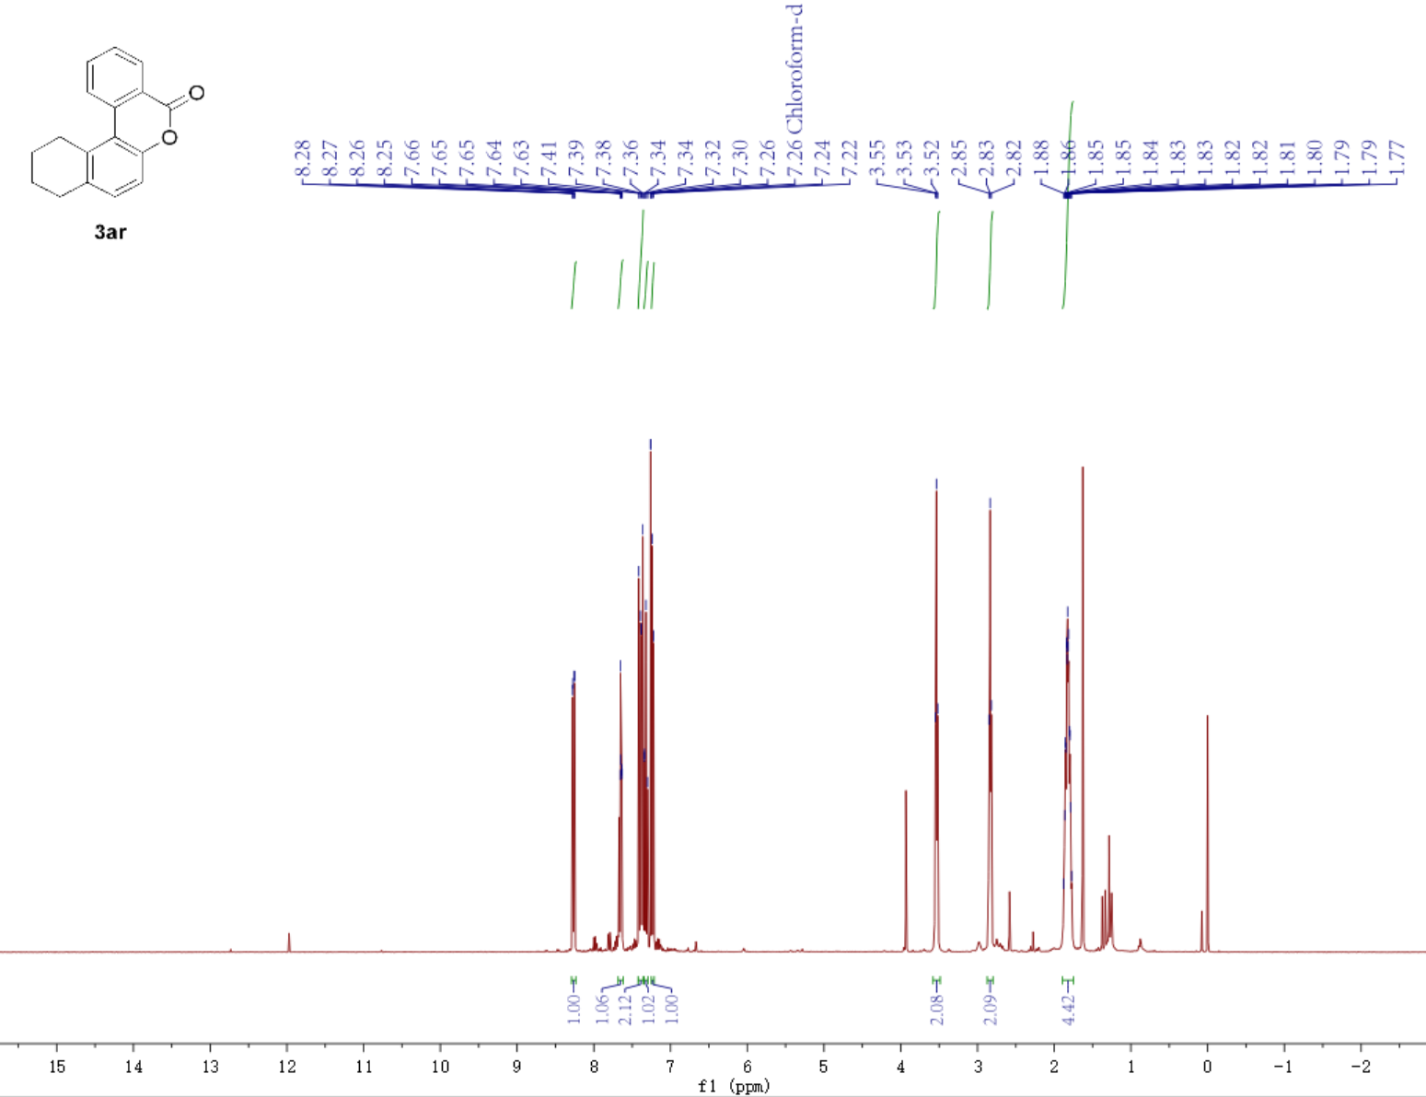
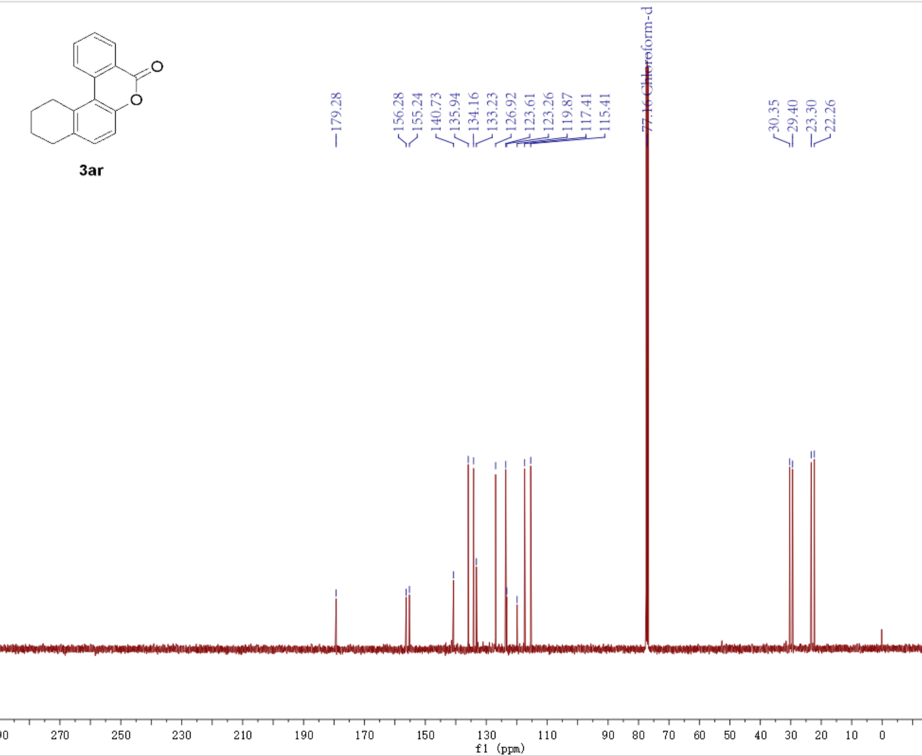
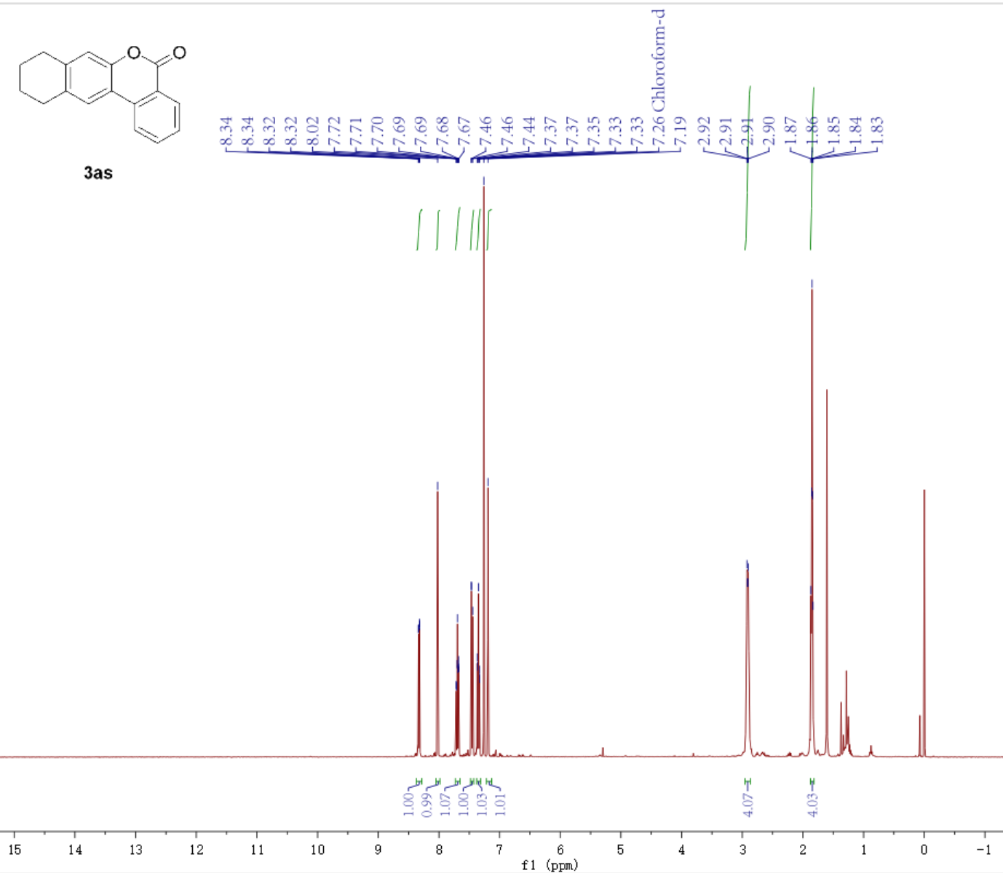

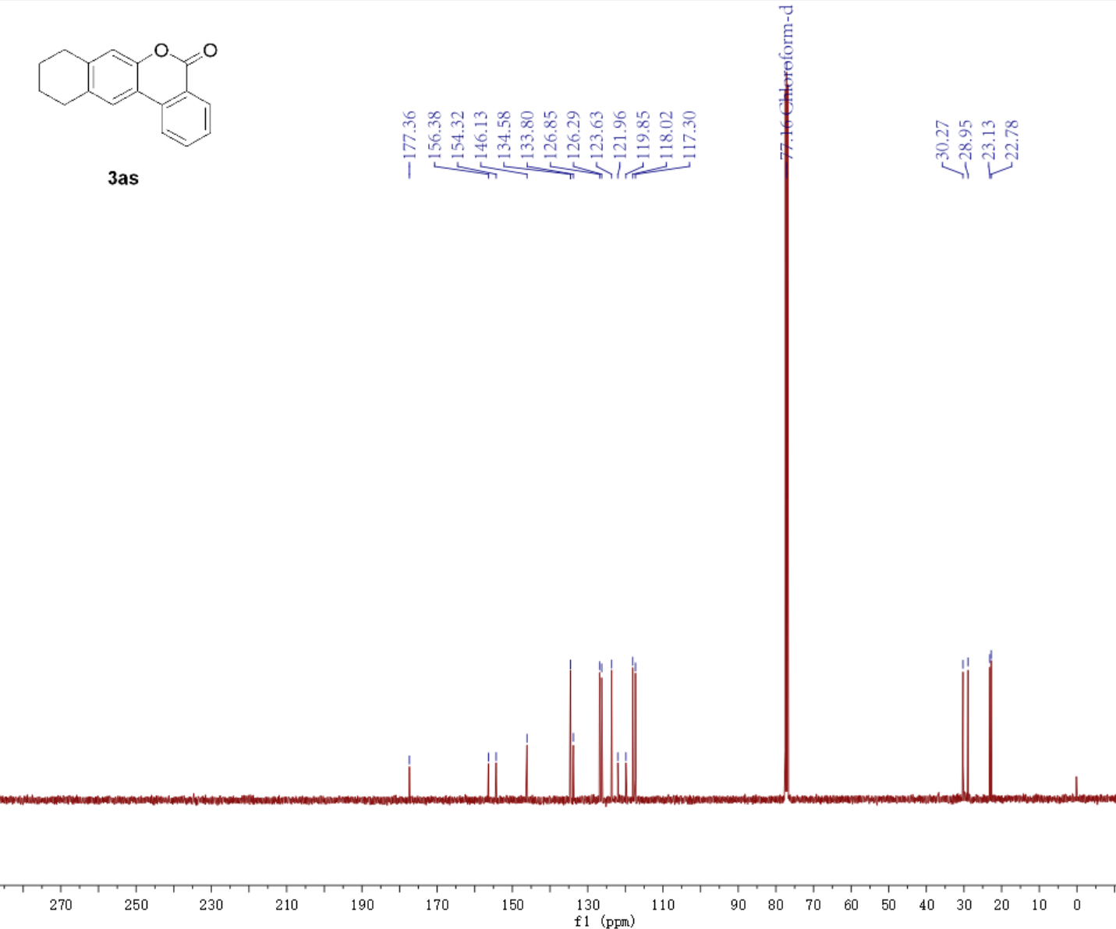
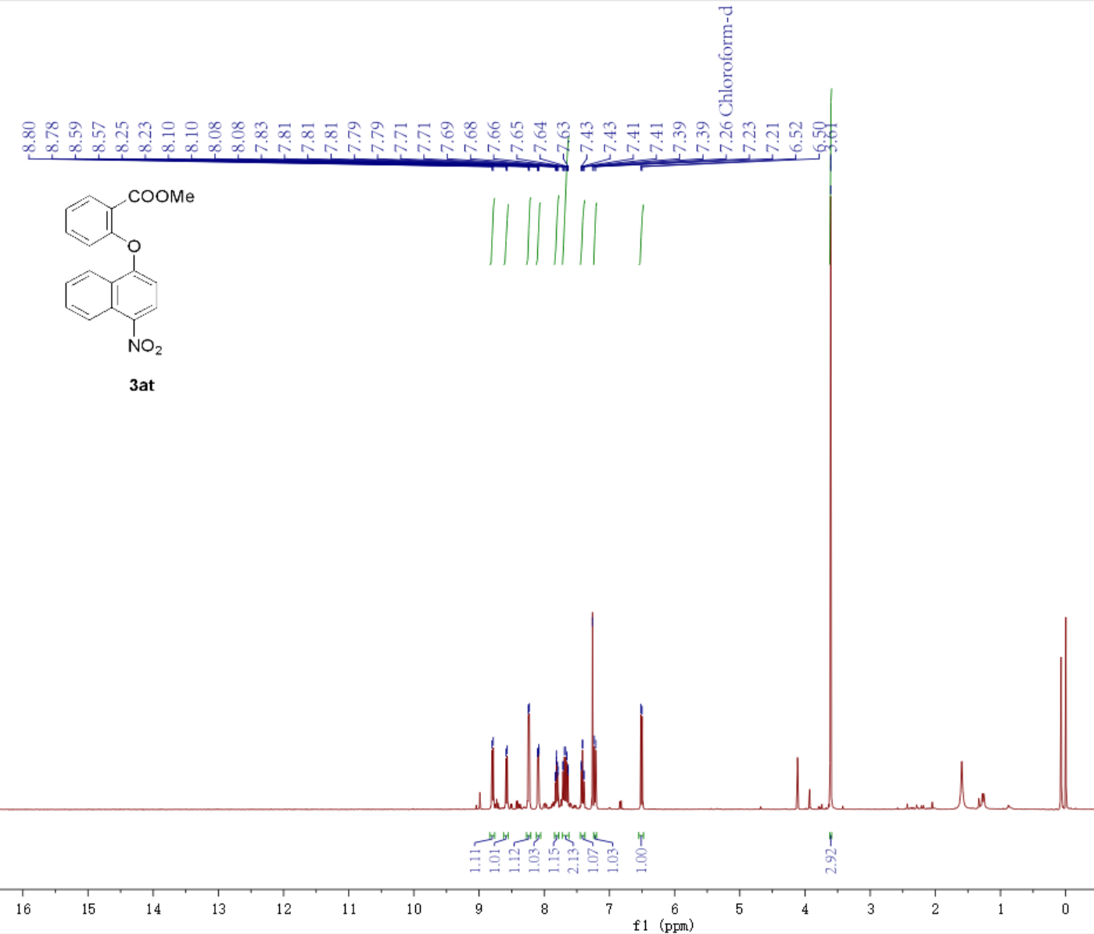

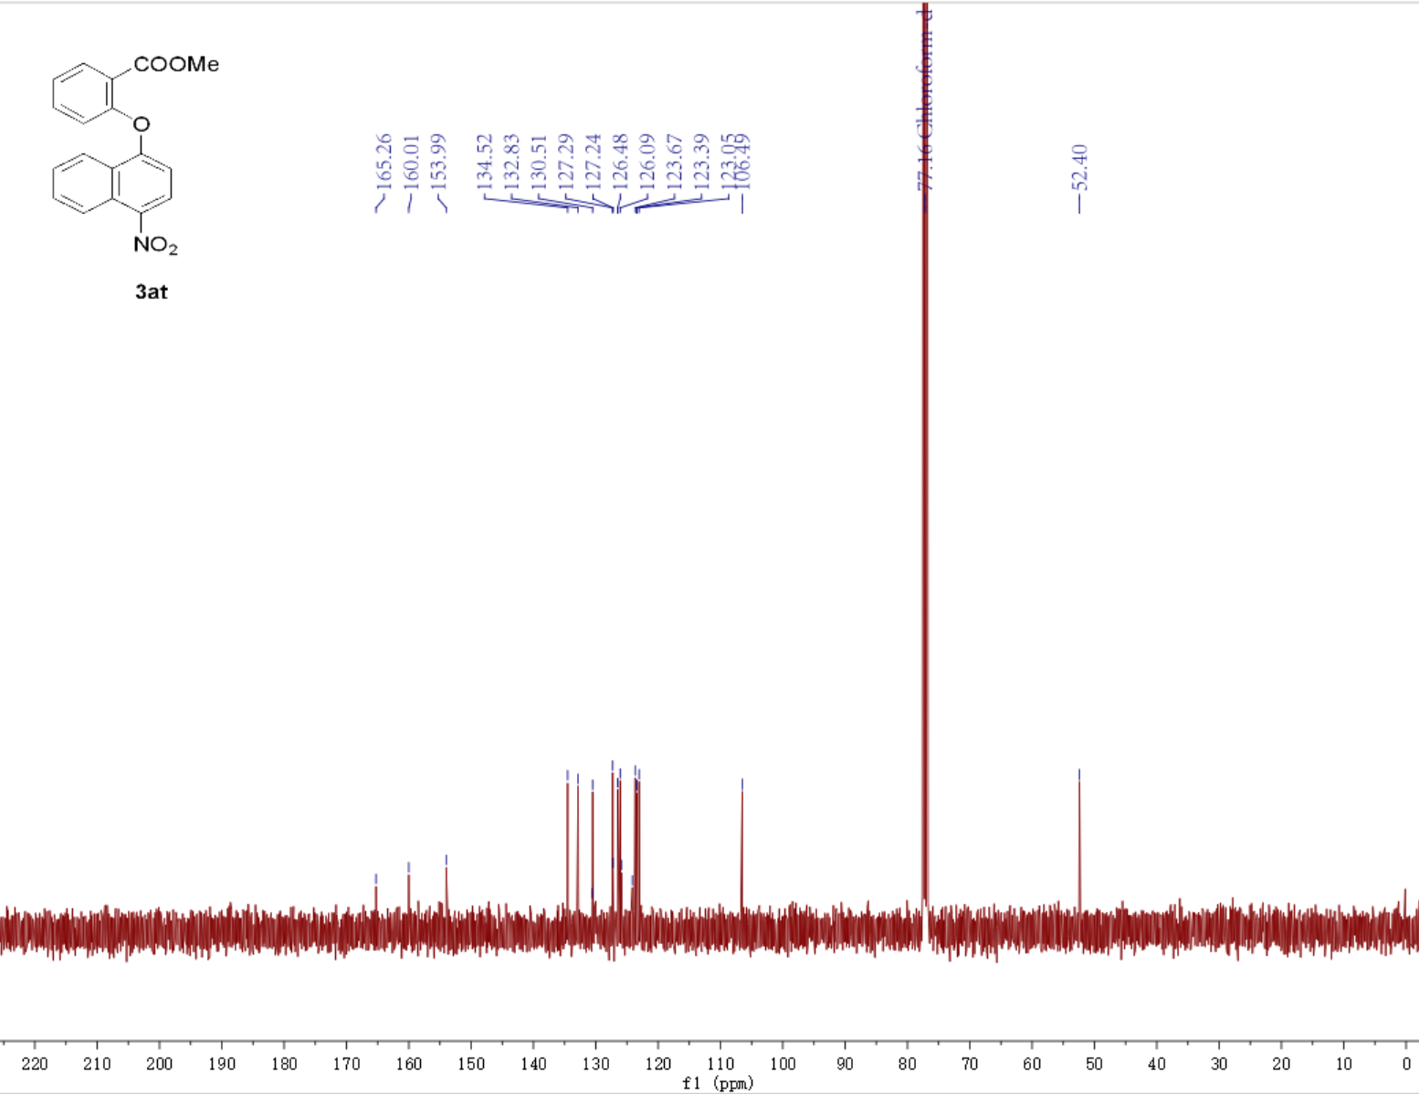
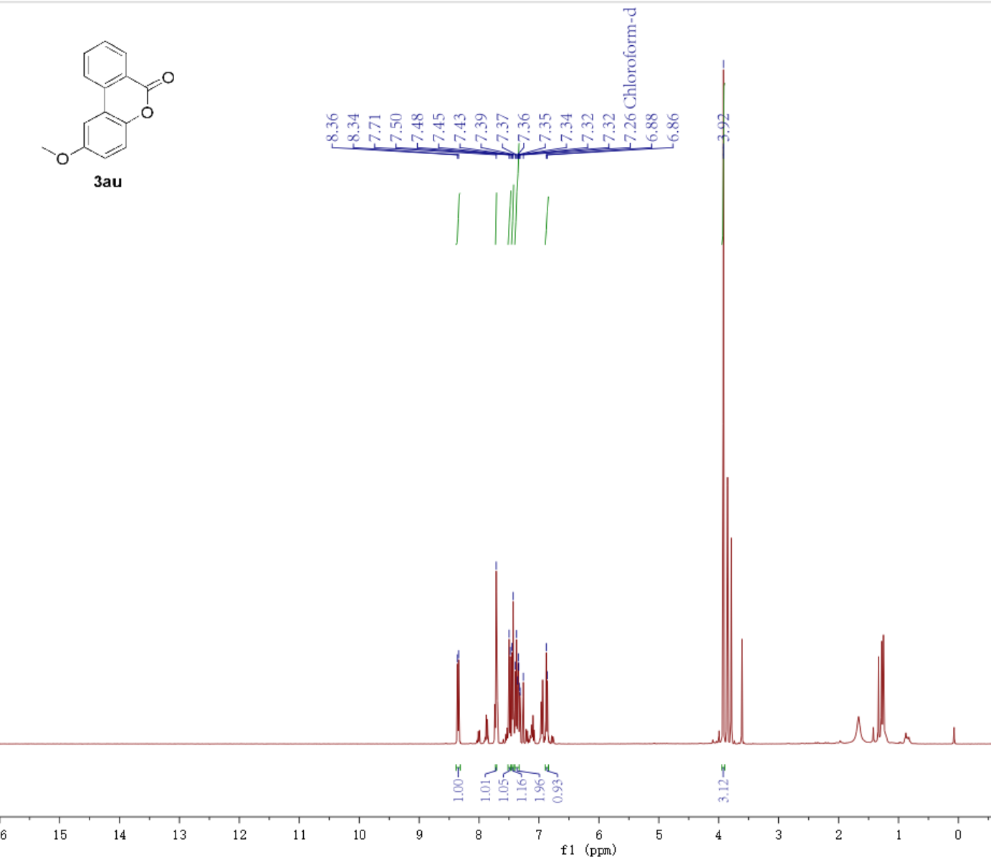
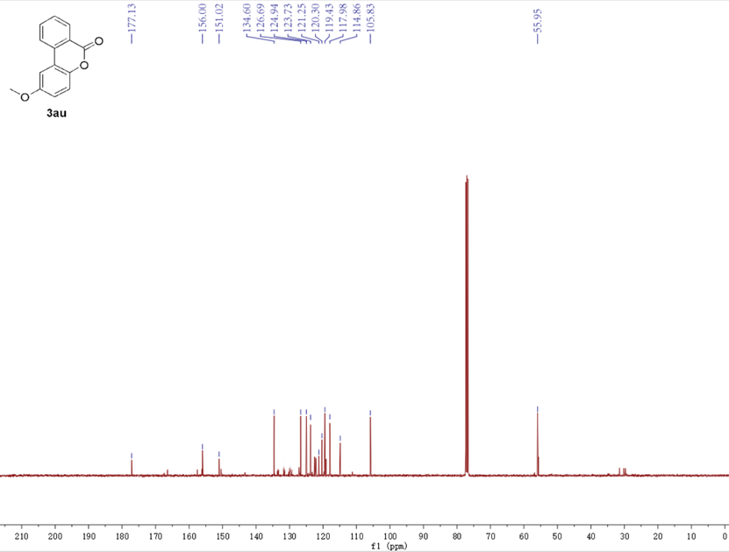
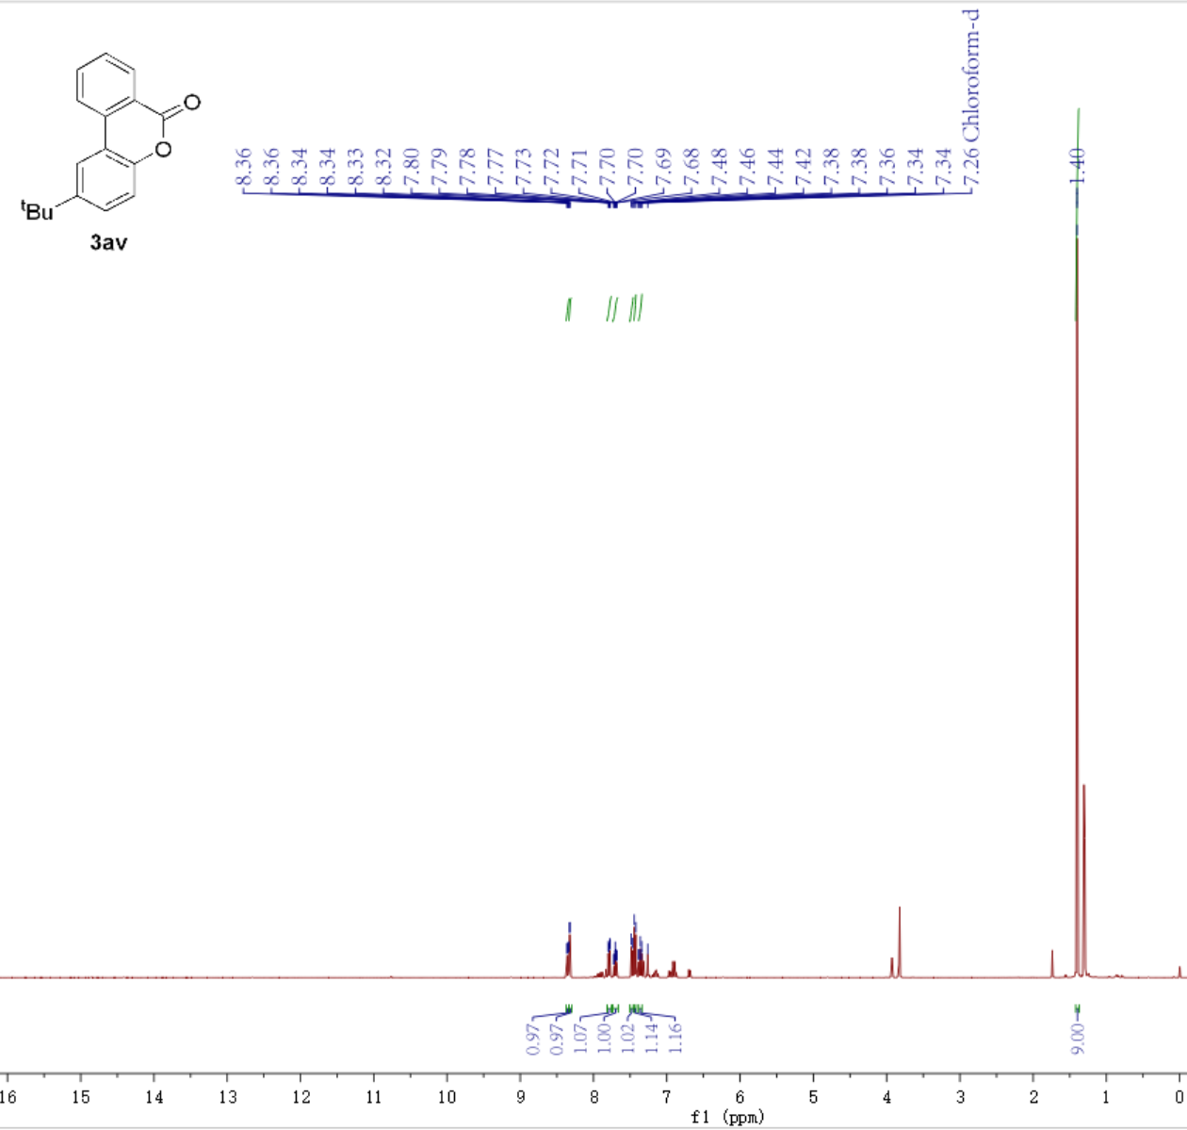
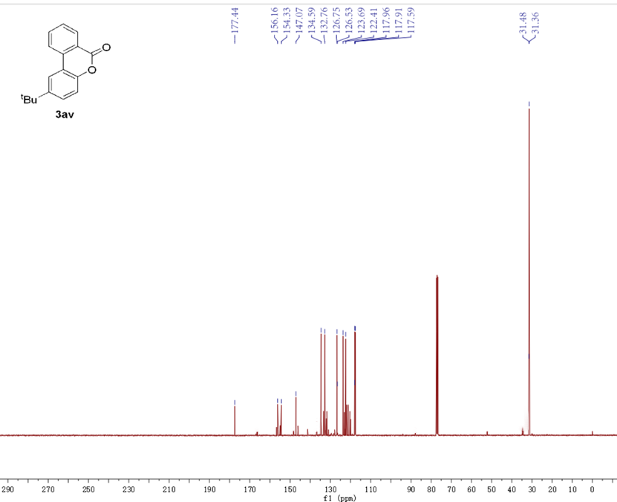
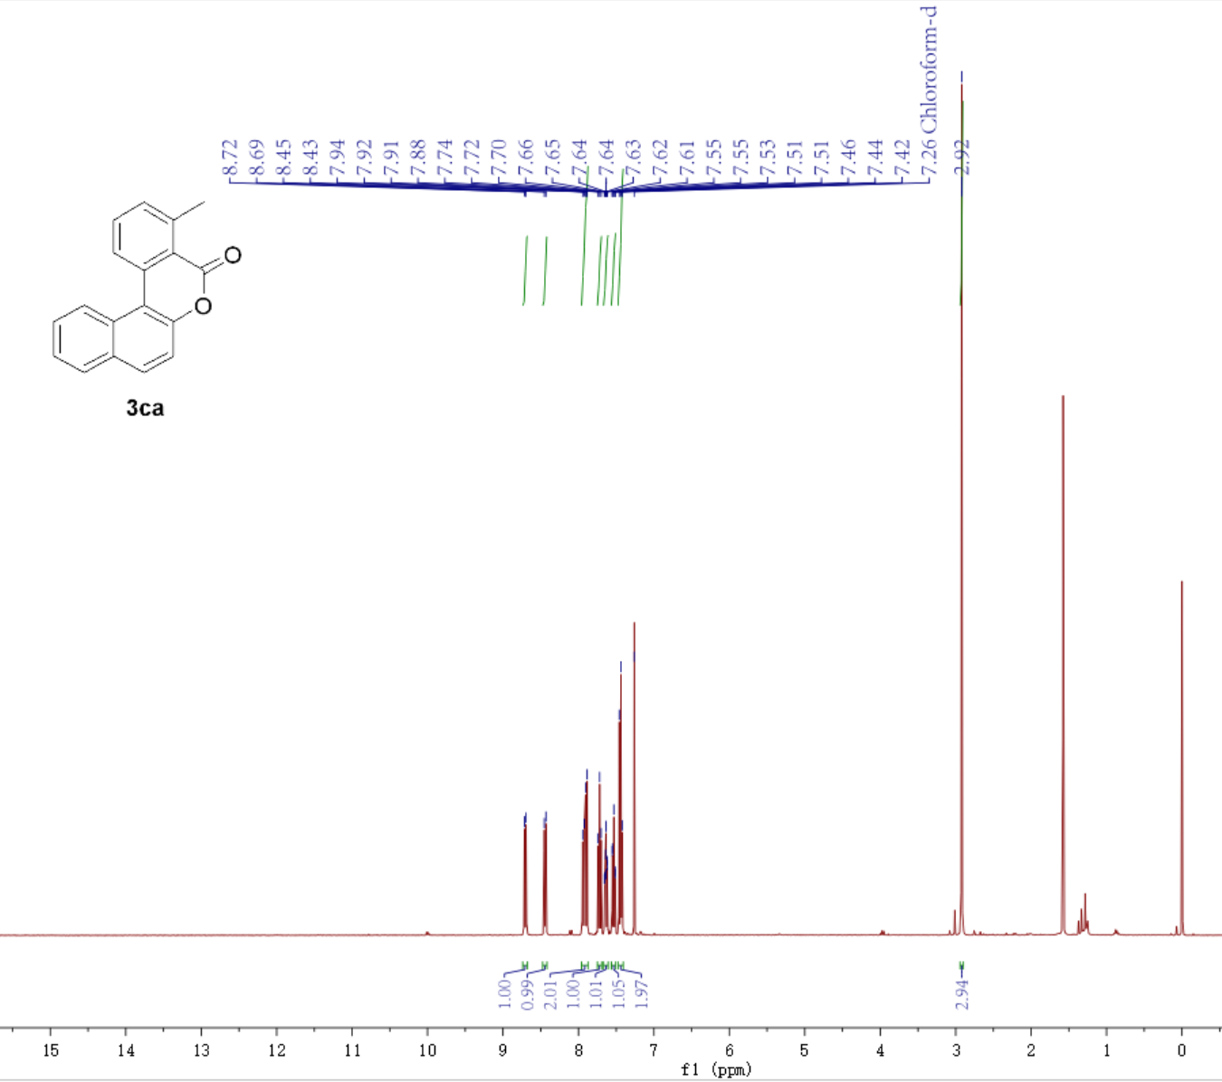
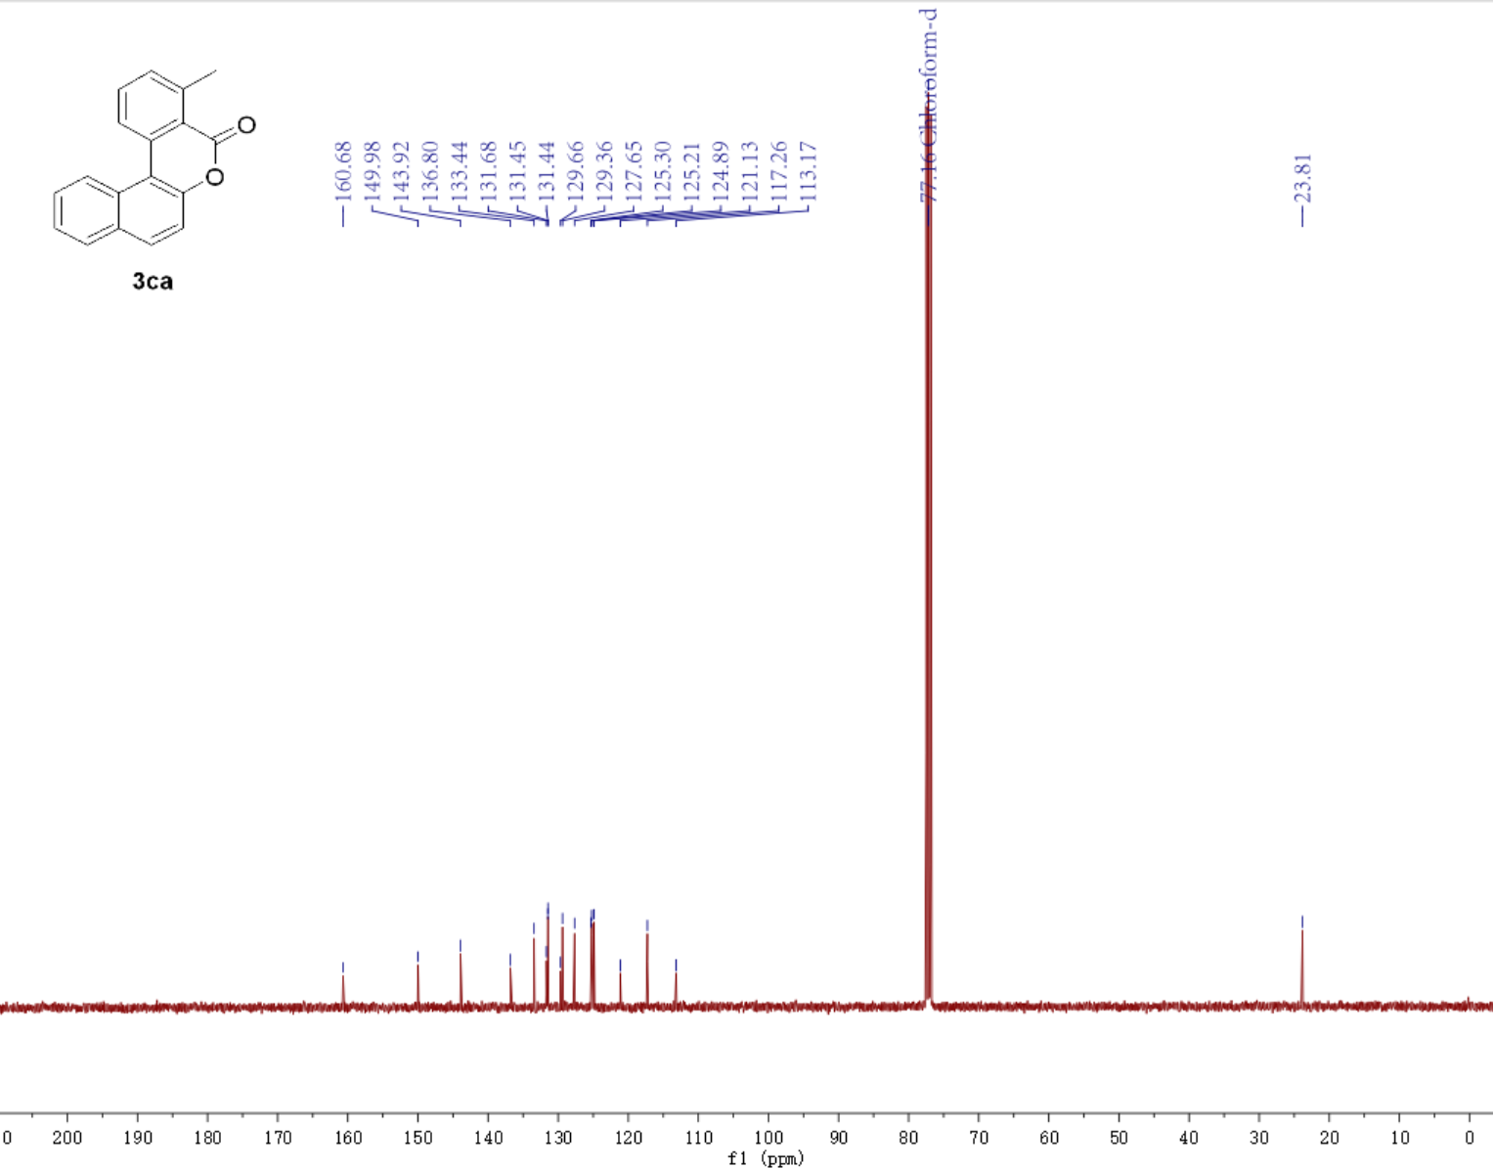
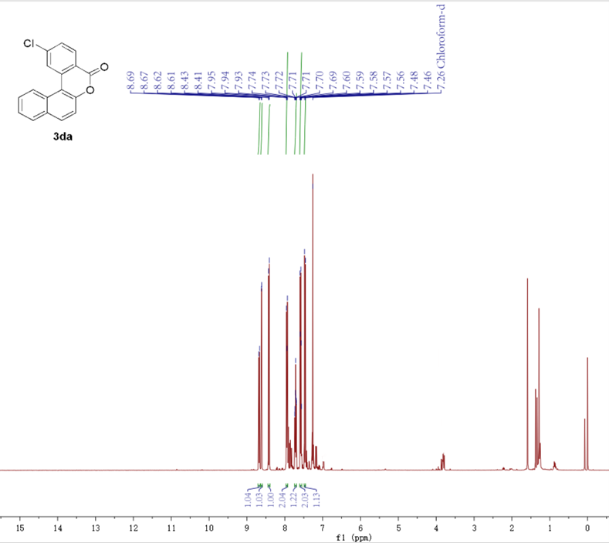
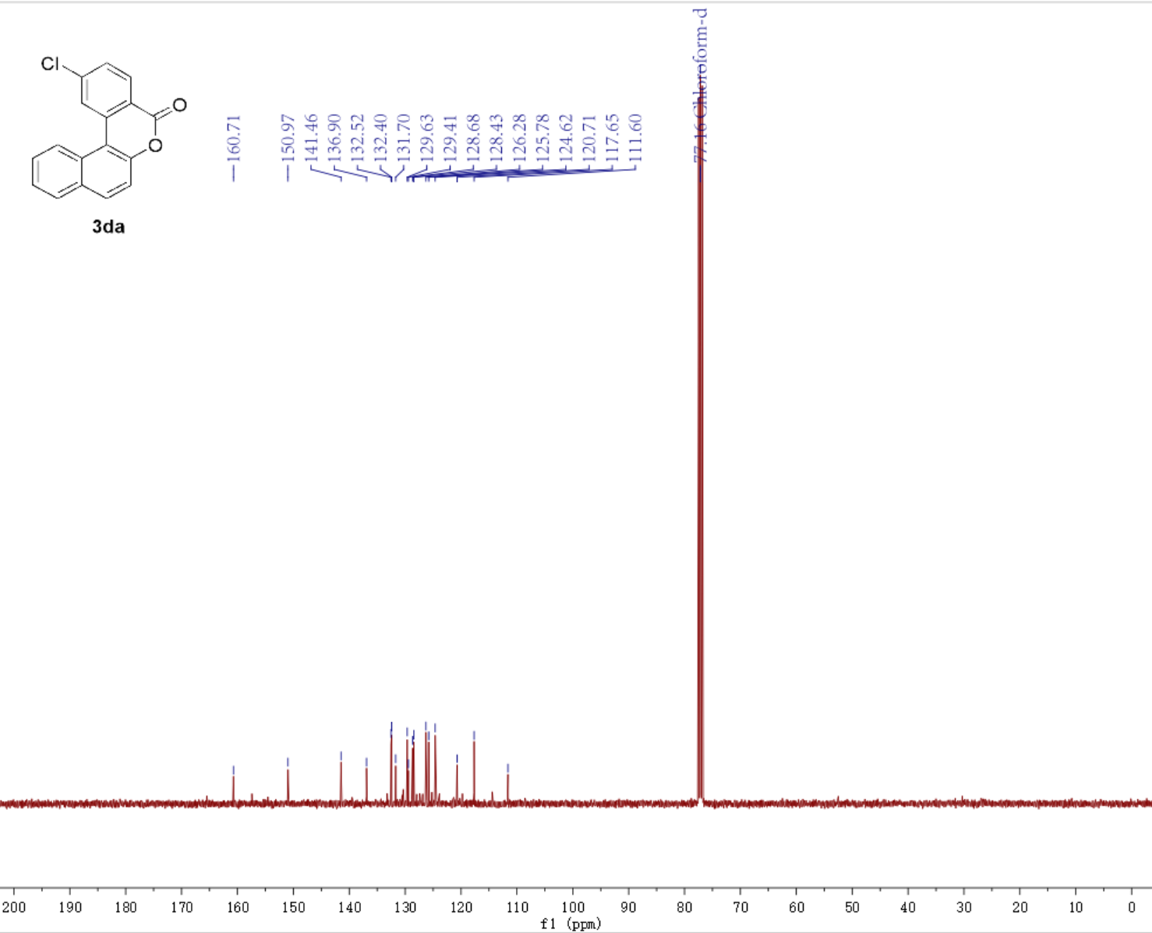
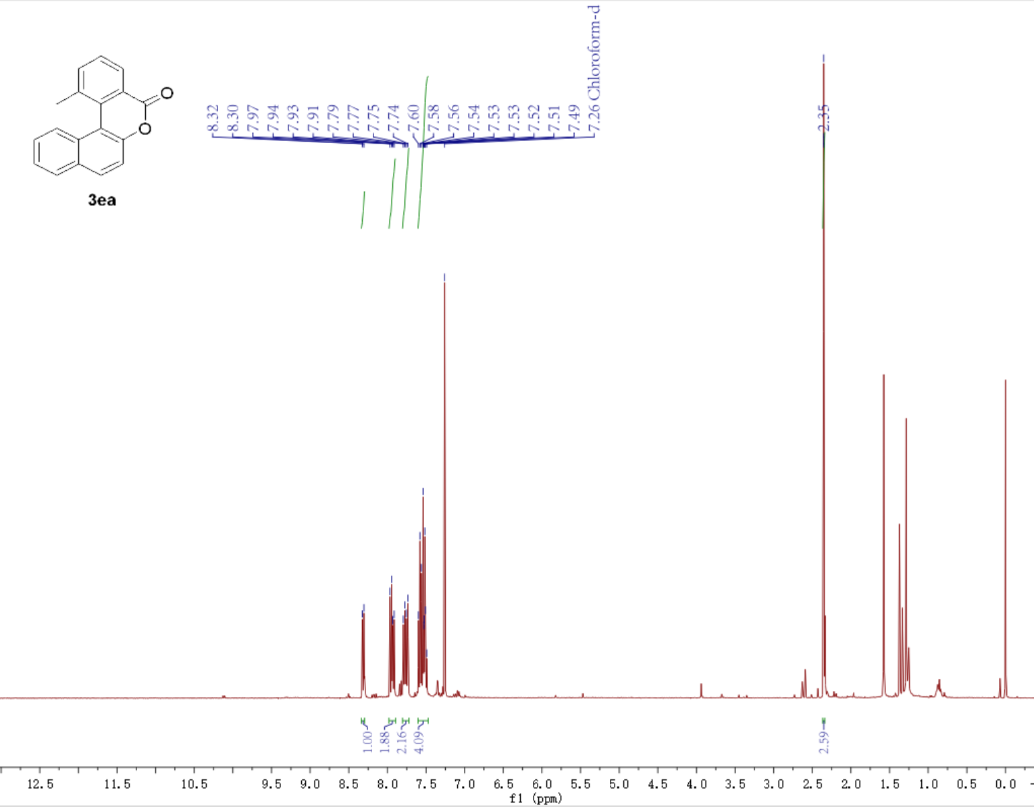
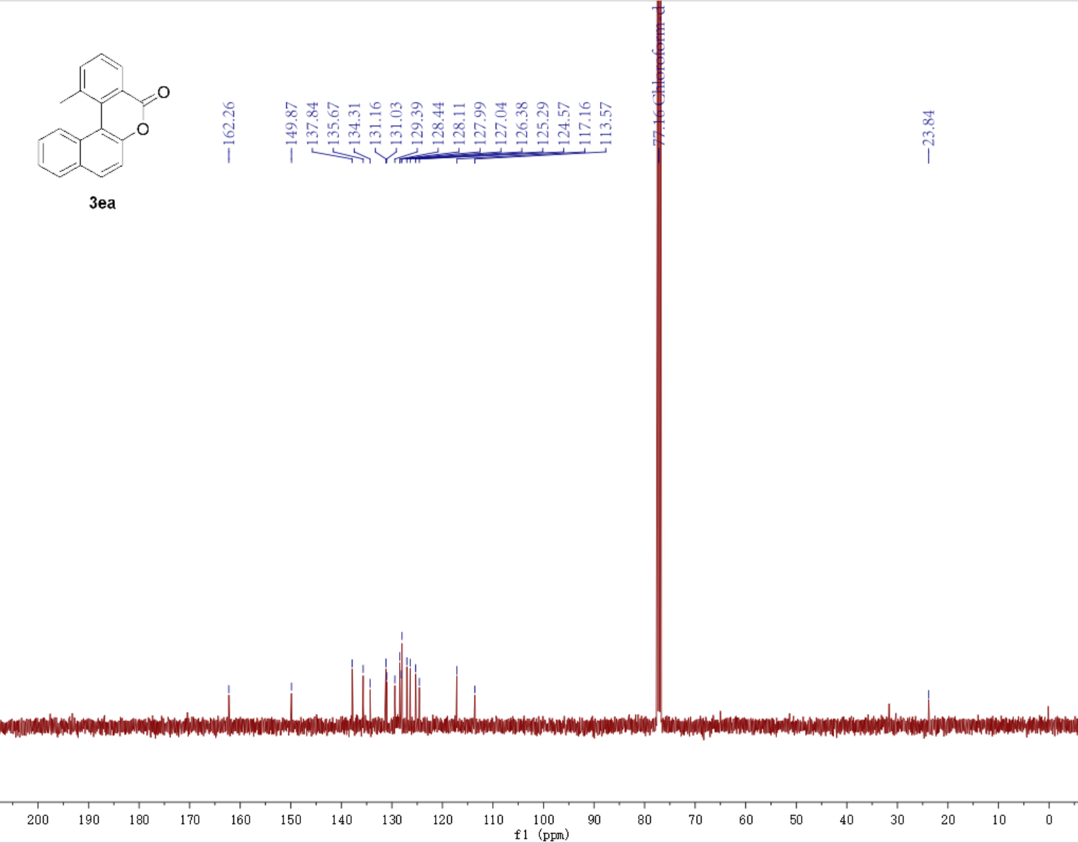

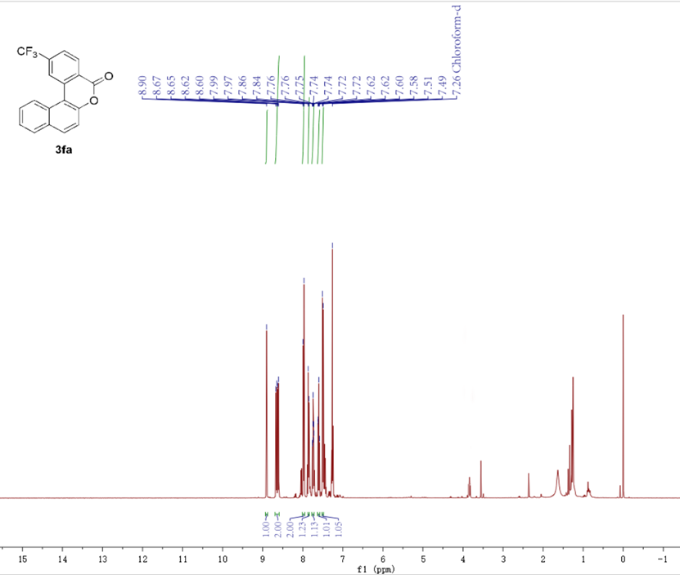
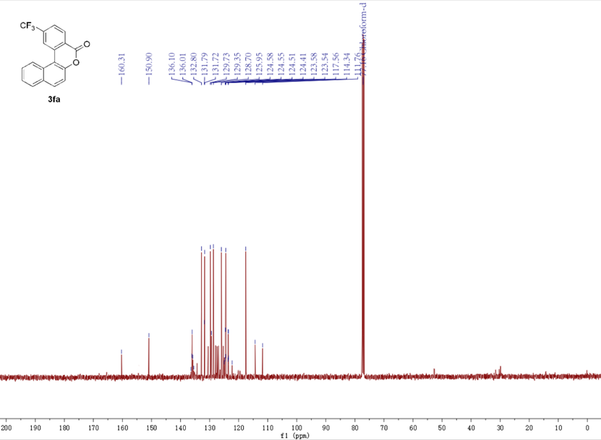
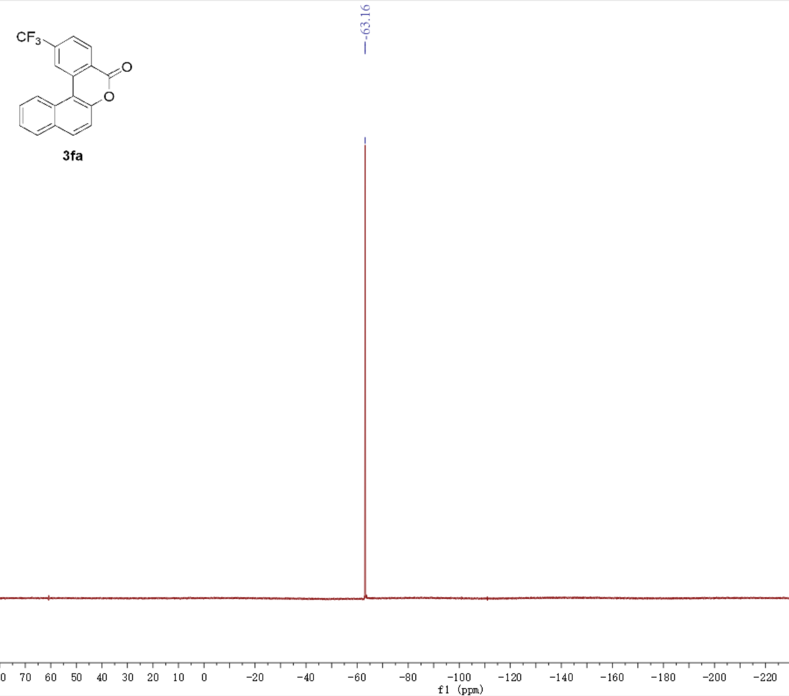

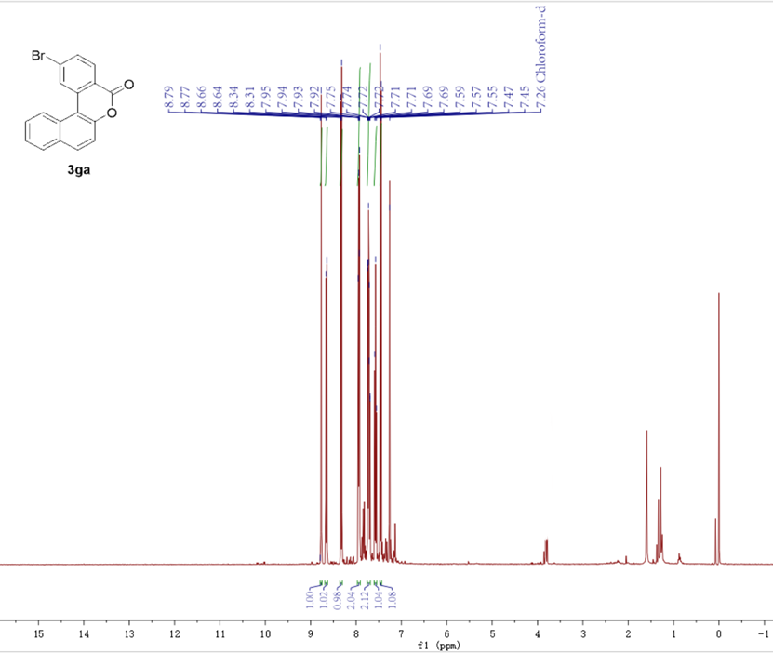

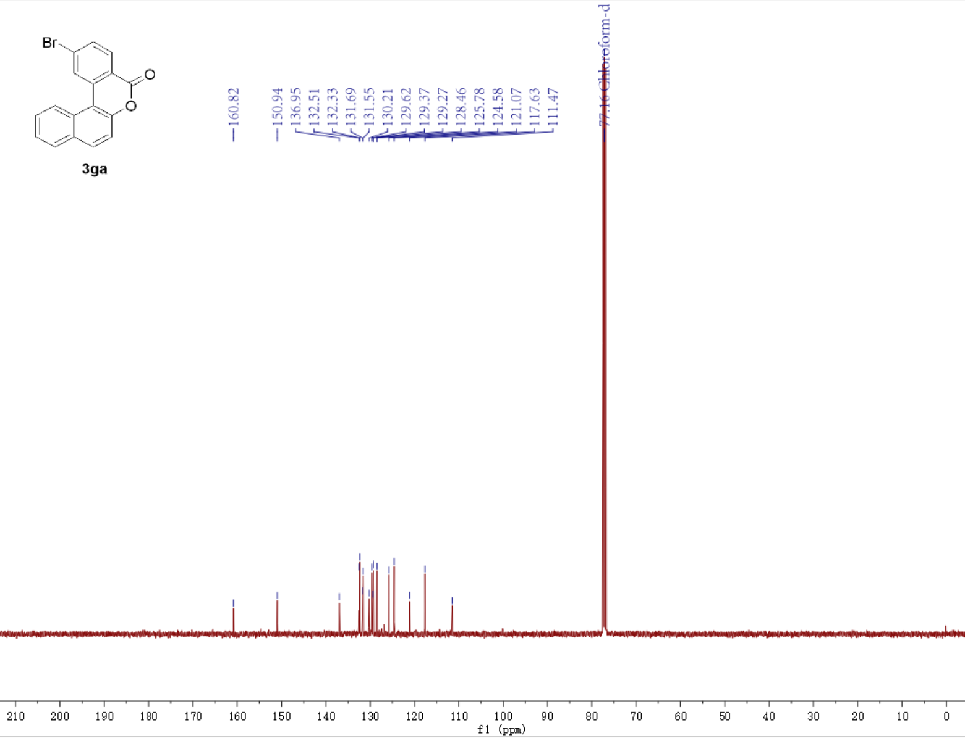
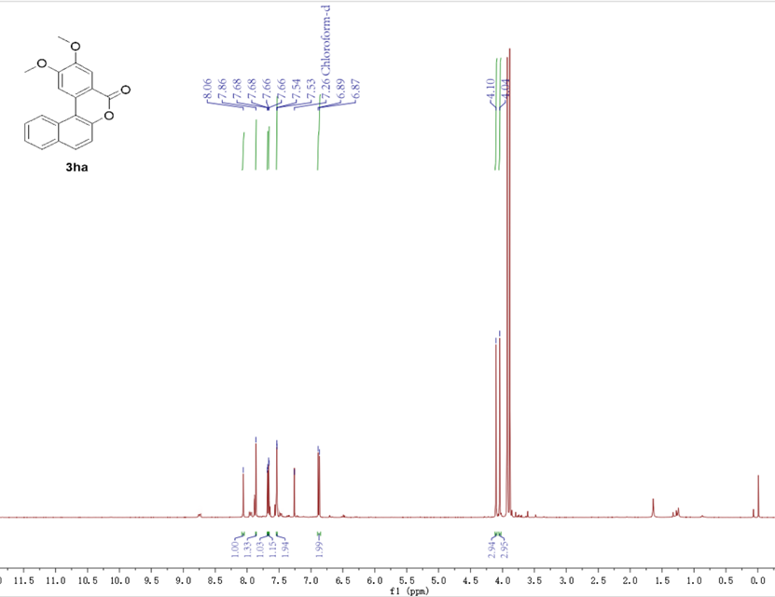
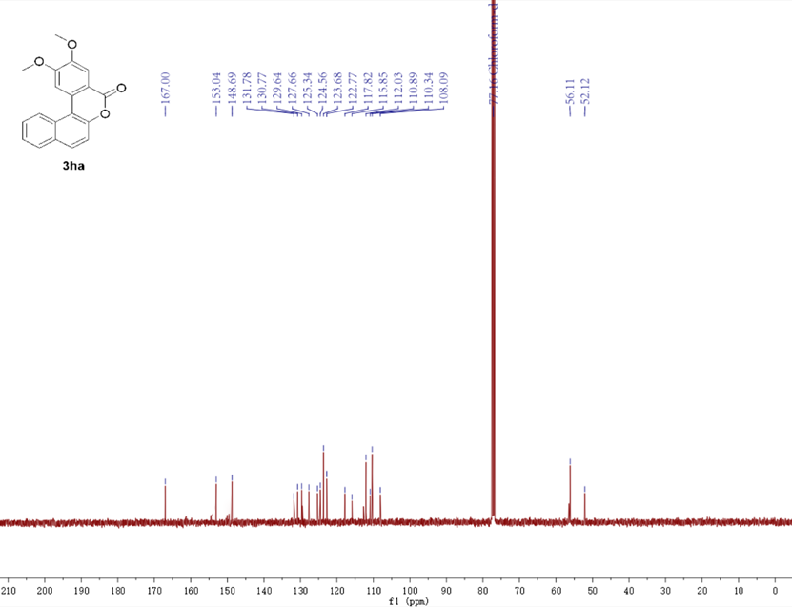
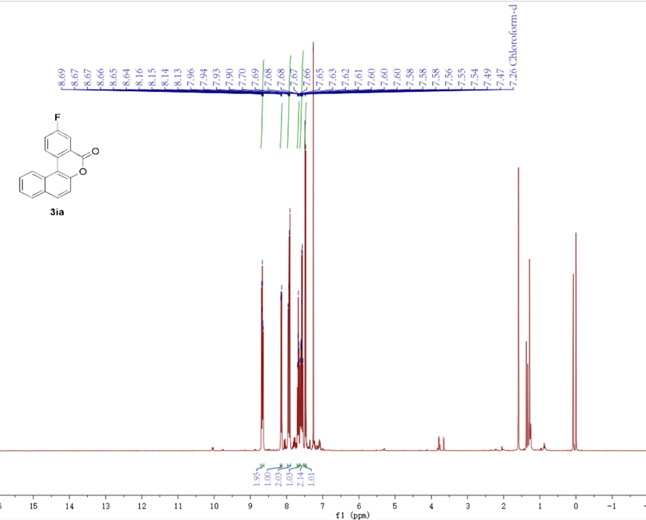
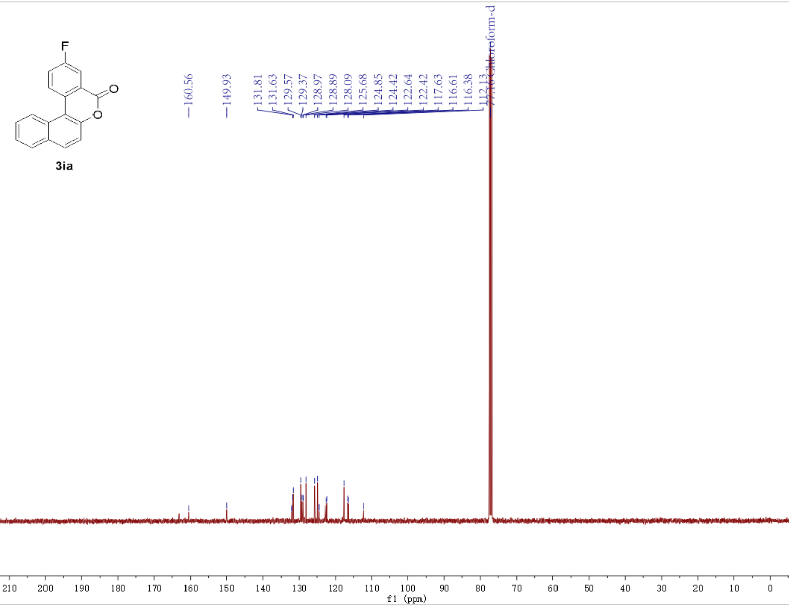

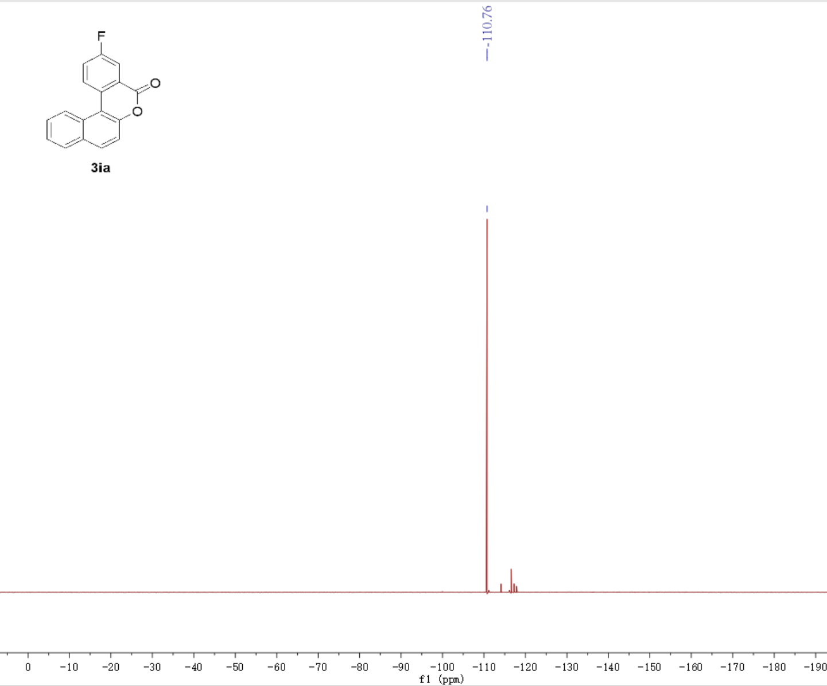
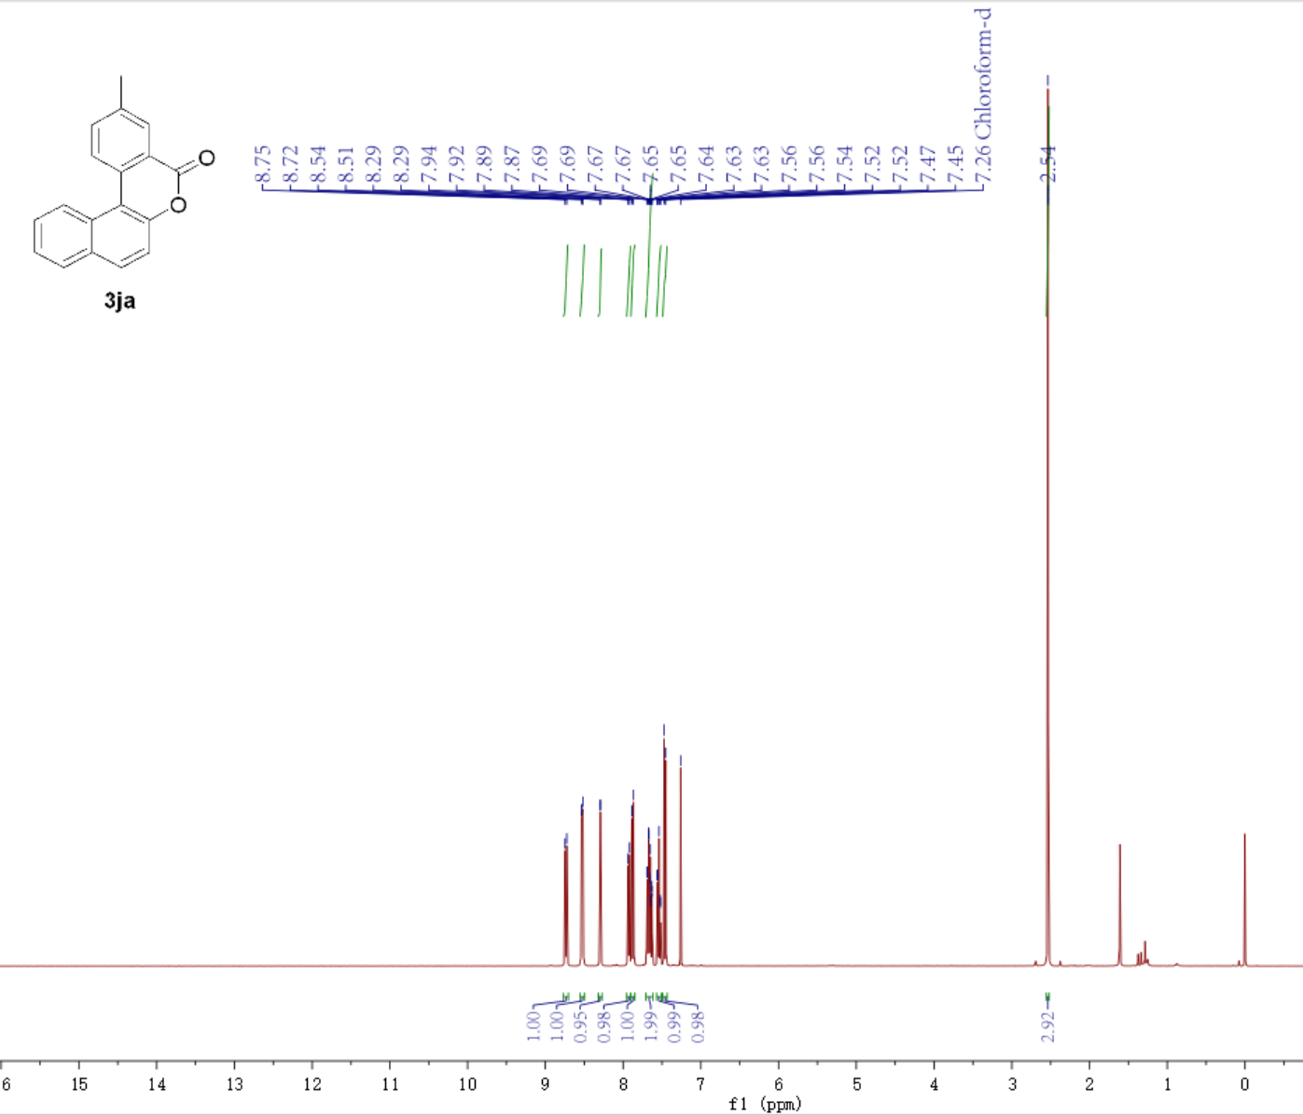

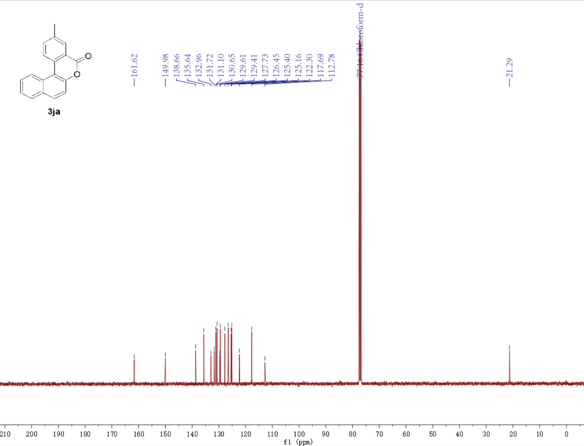
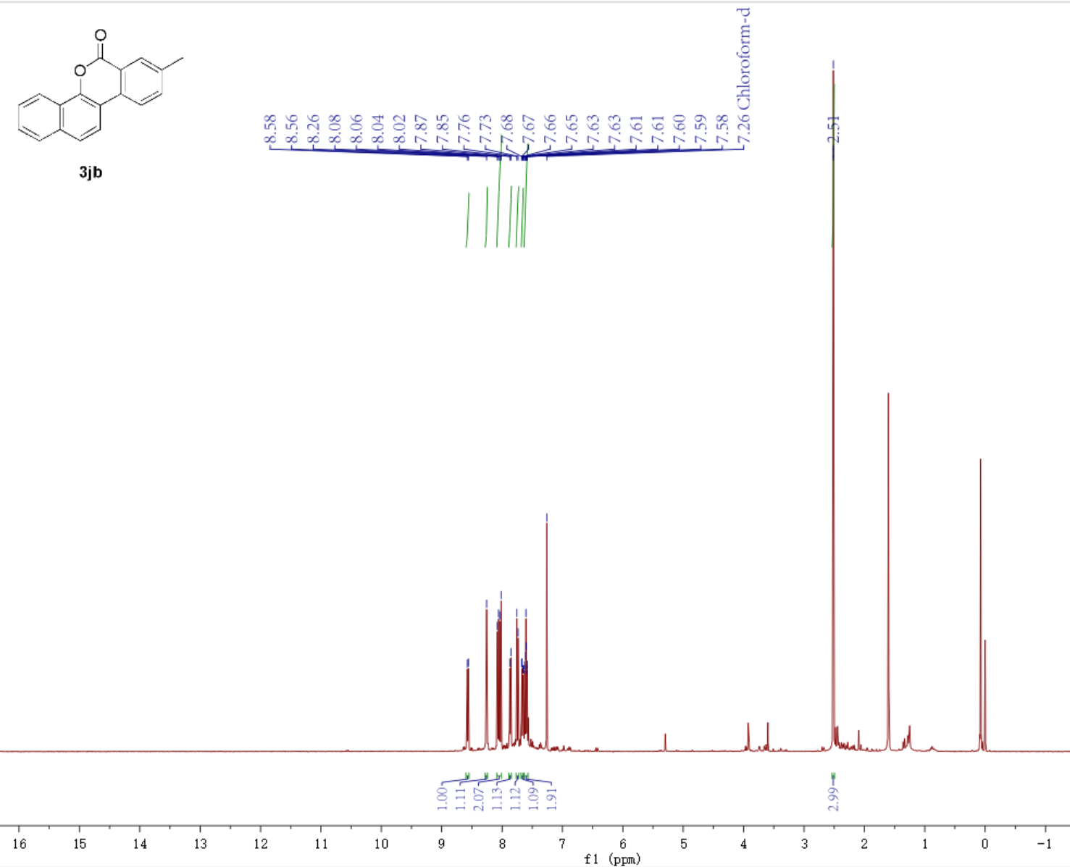
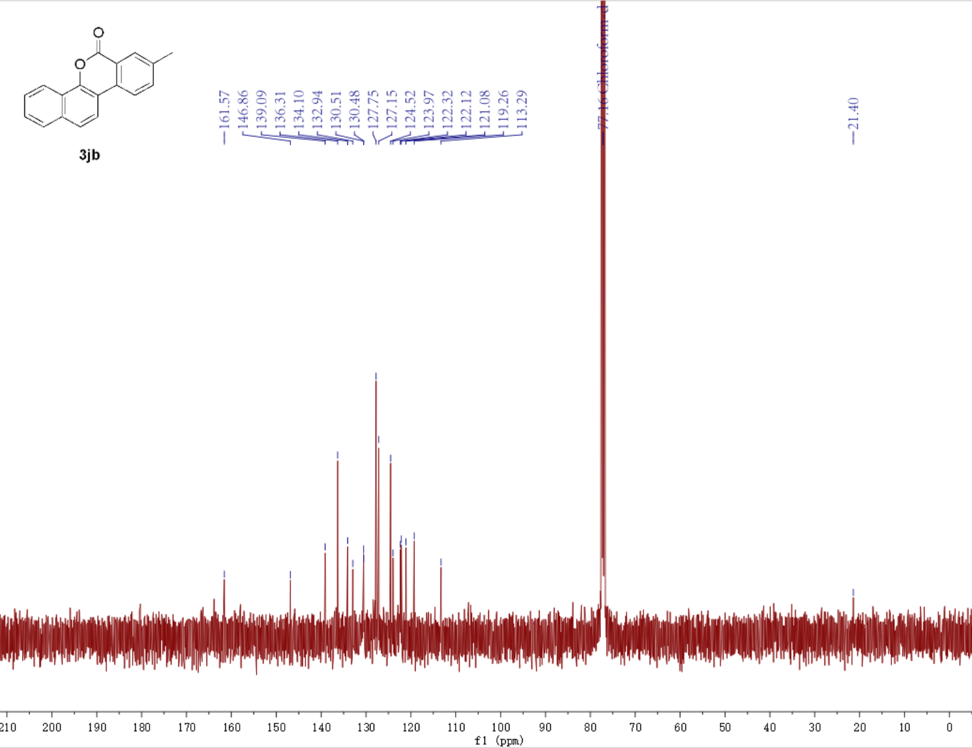

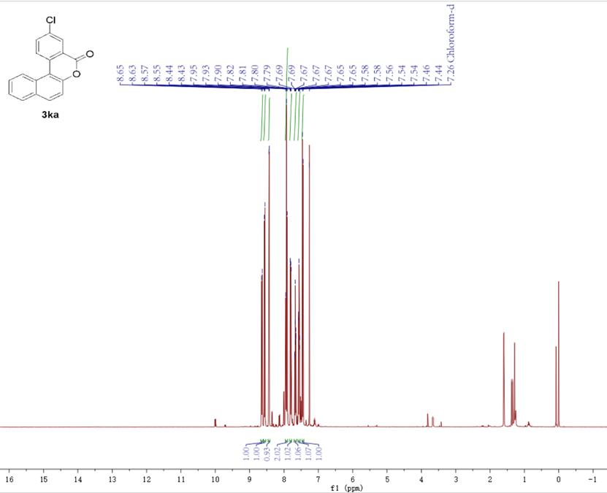
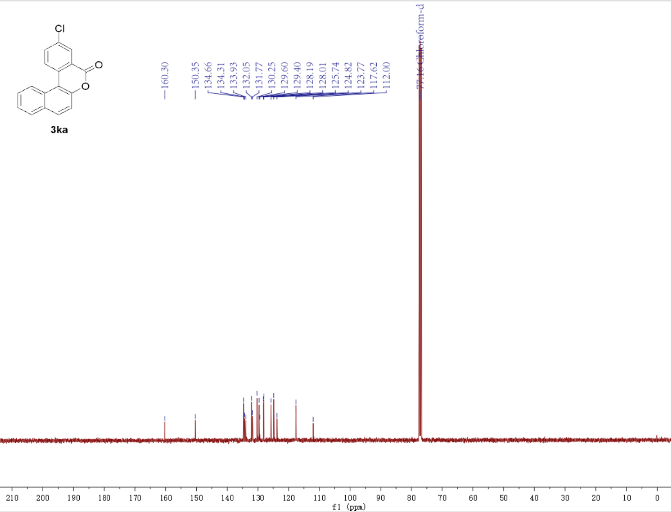

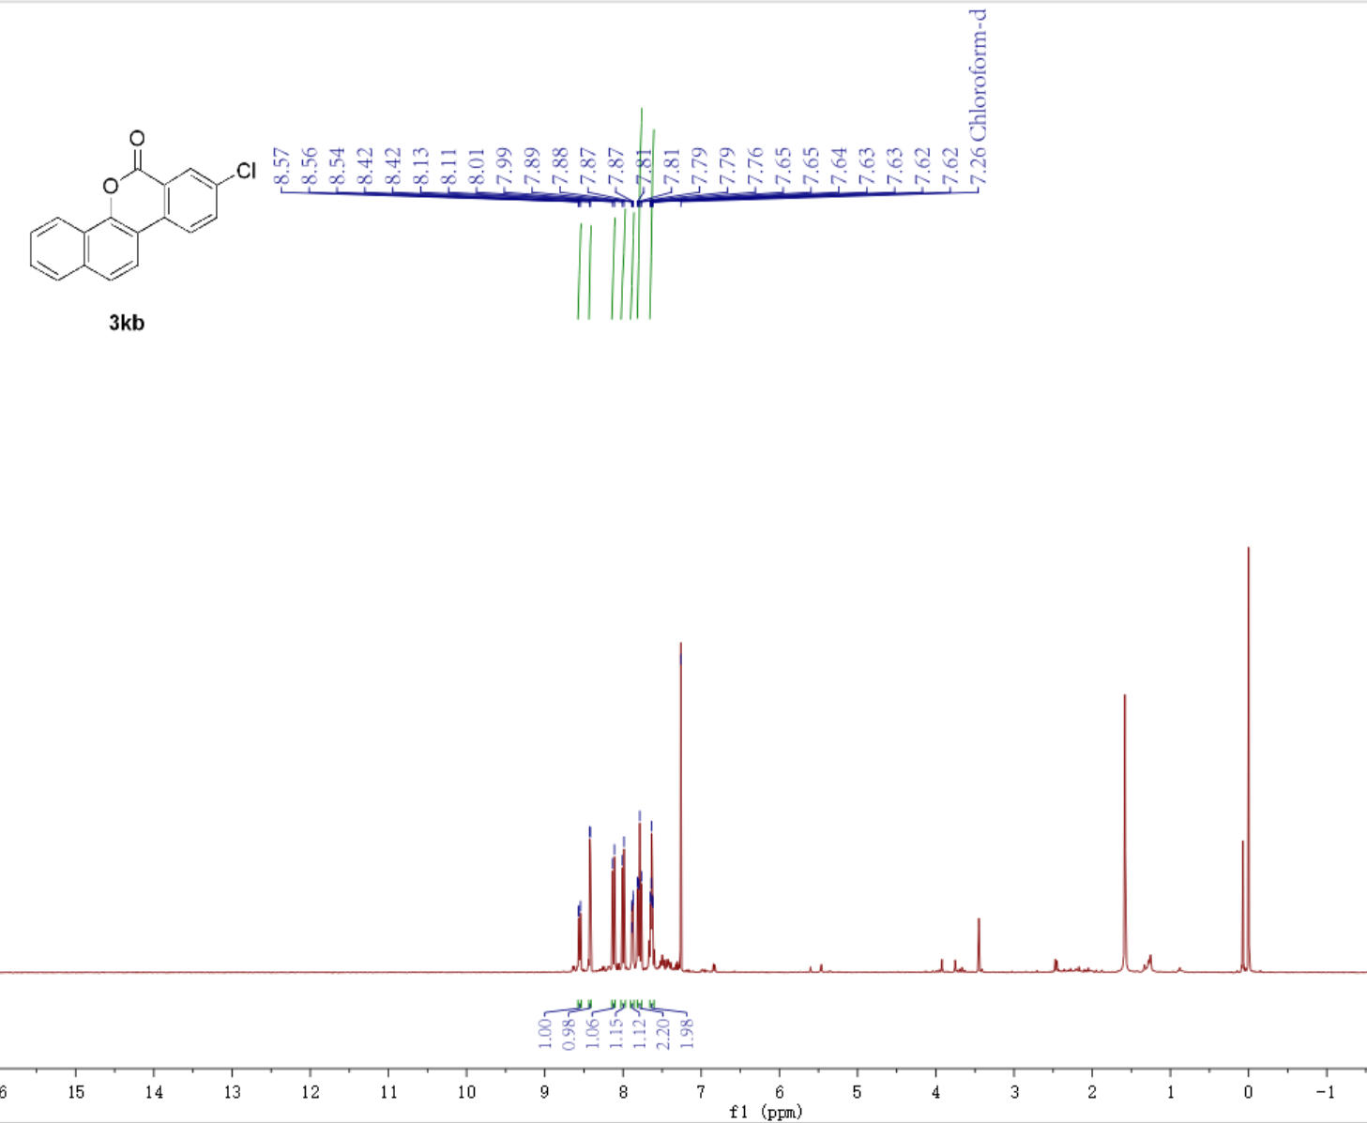
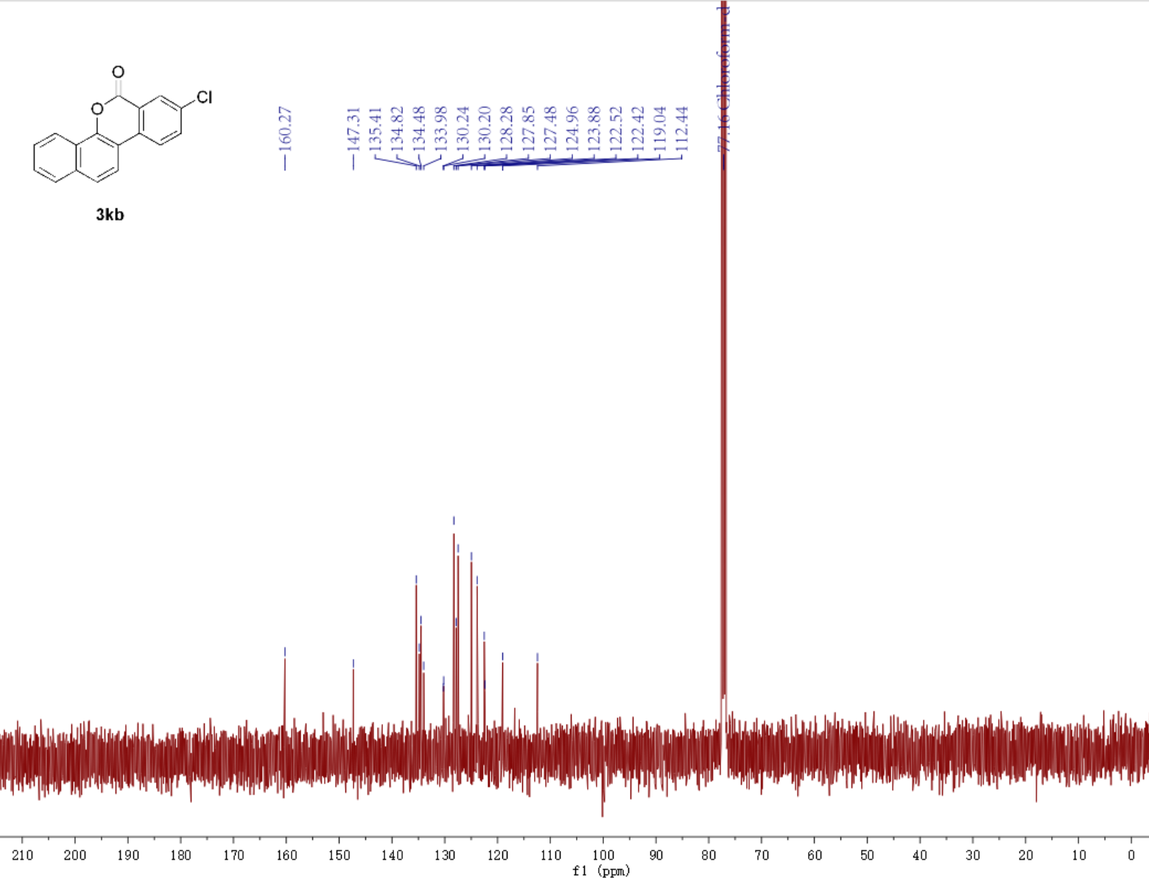

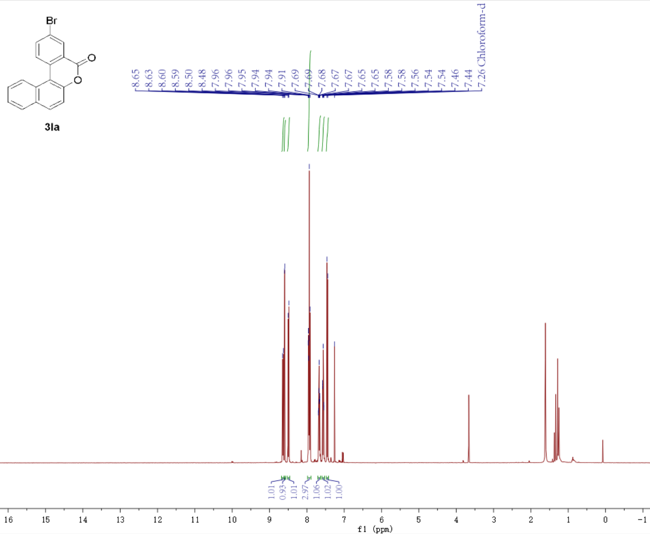

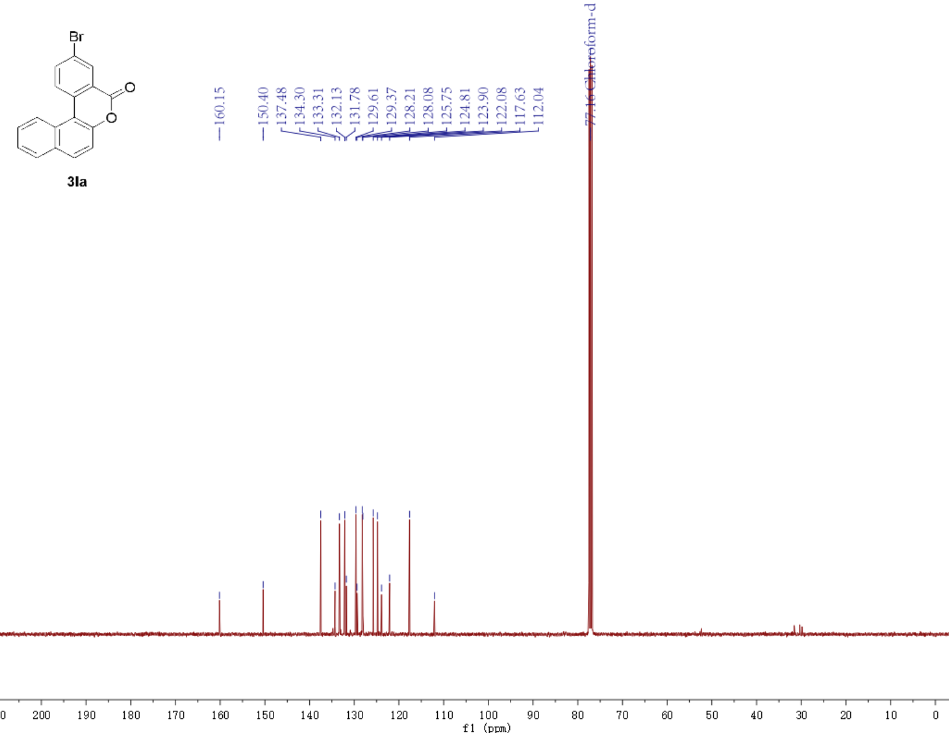

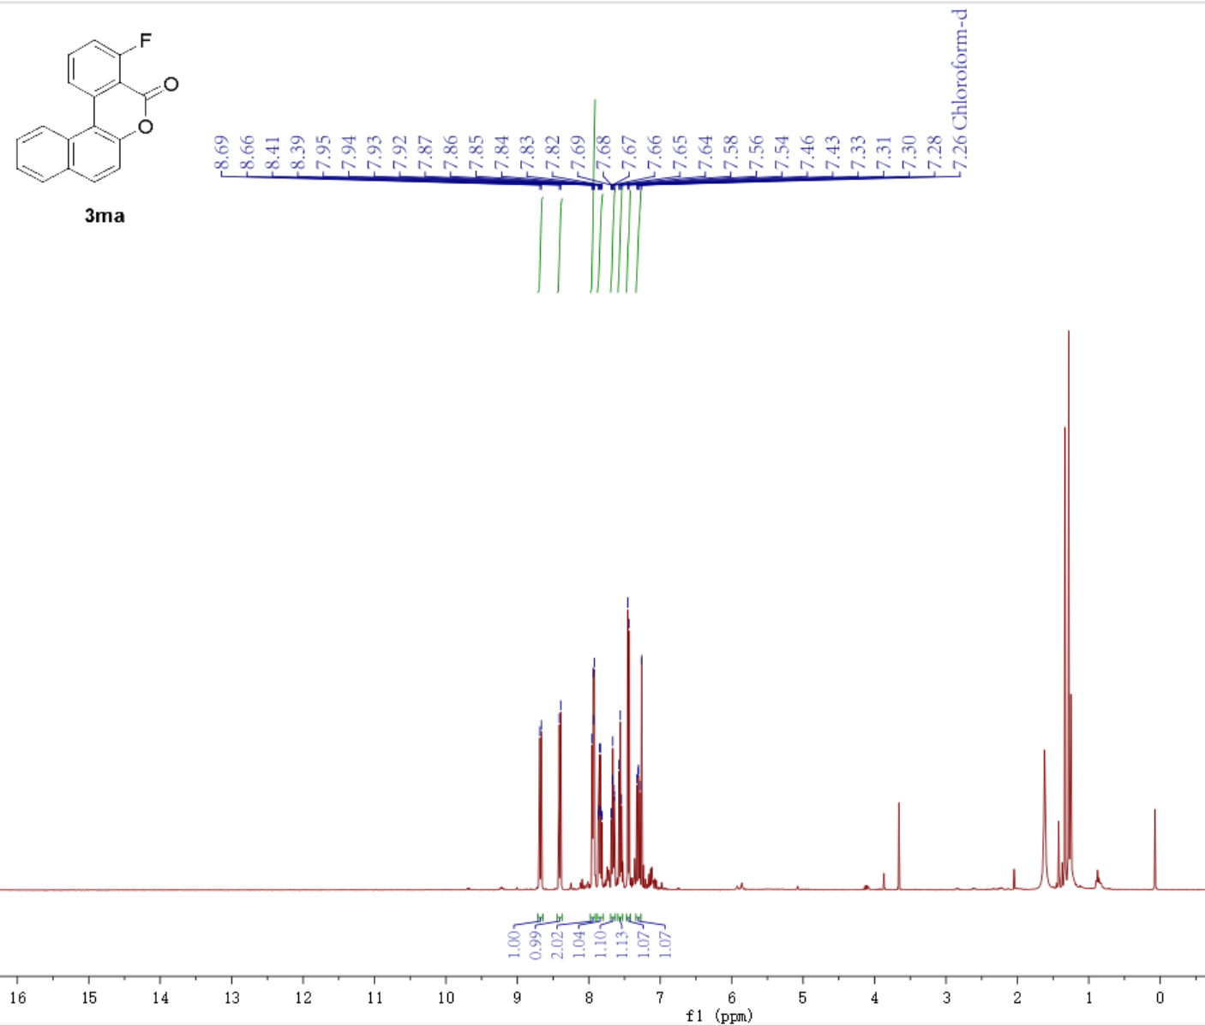
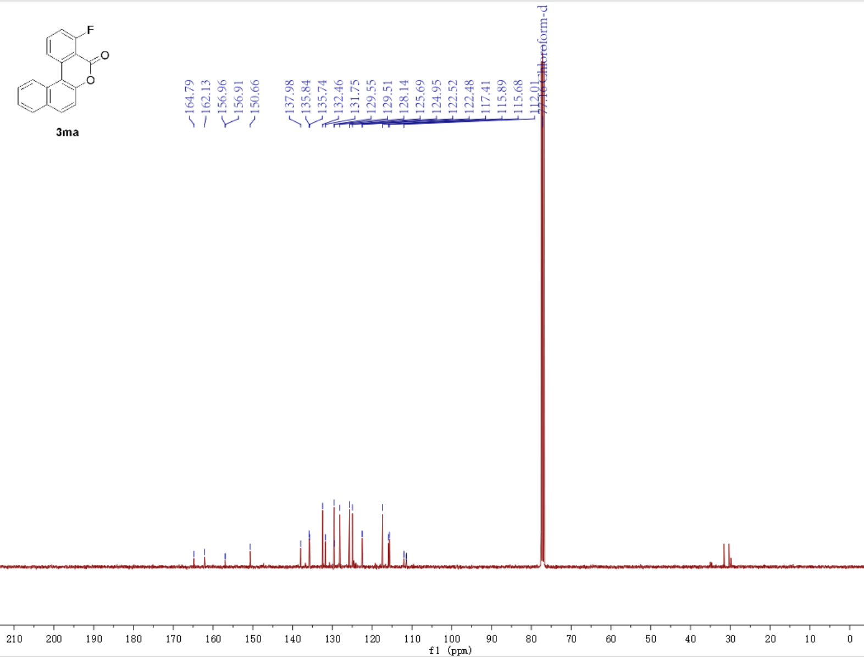
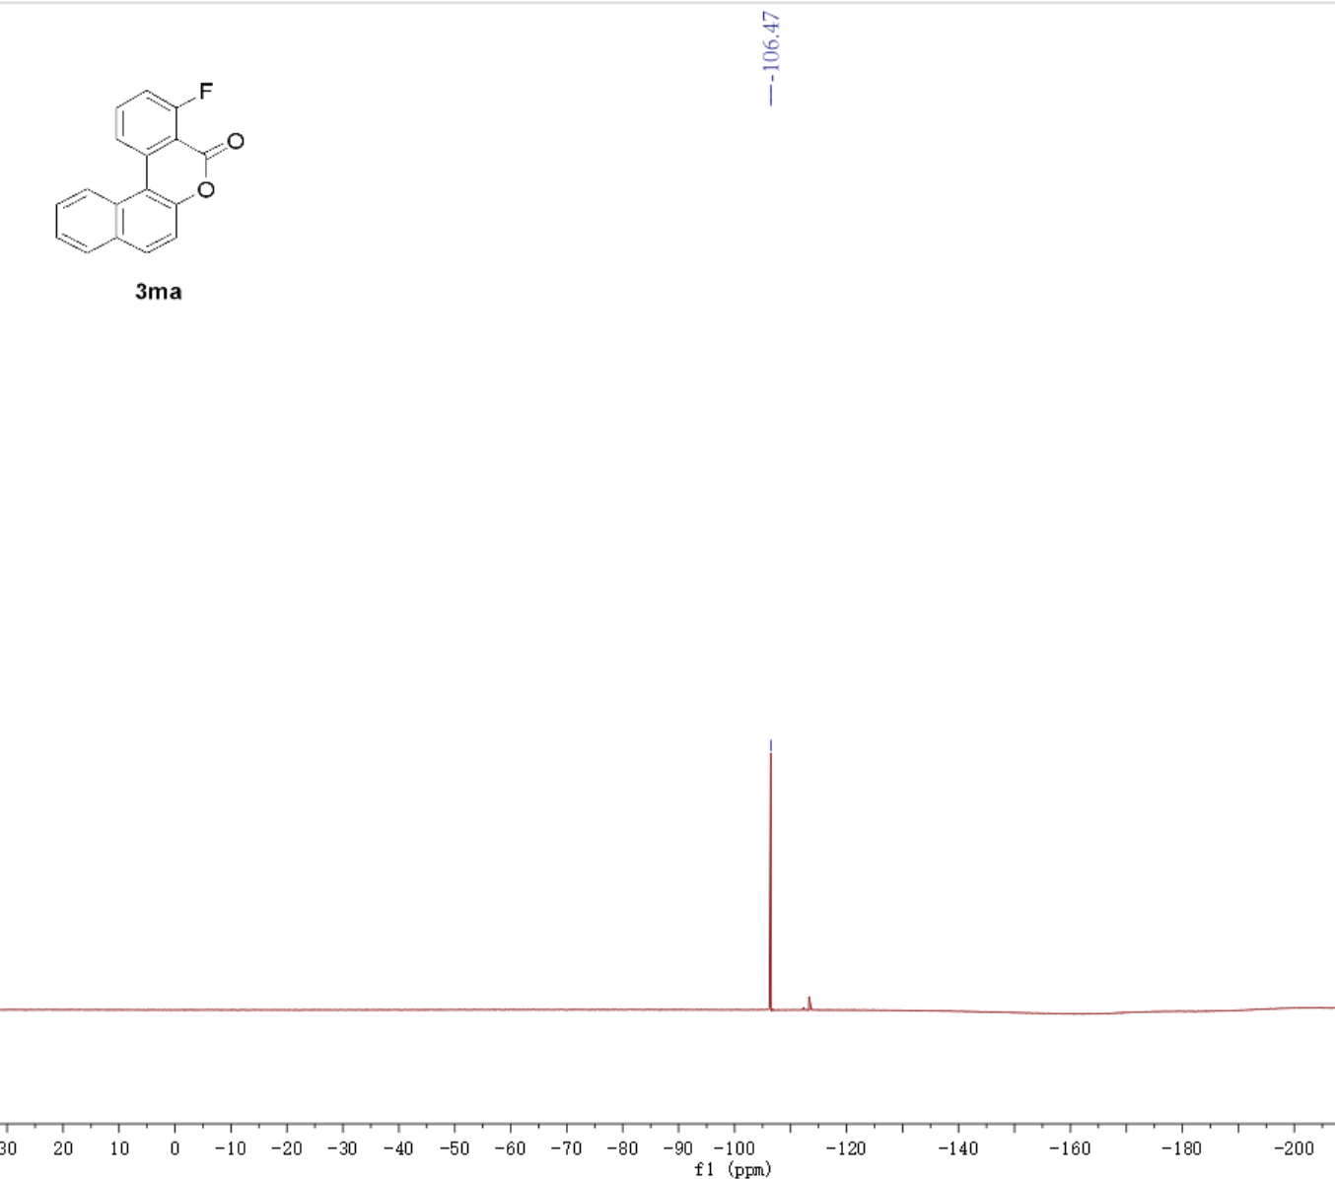

Part 7. LC-MS of Template reaction
