SUPPLEMENTARY MATERIAL
Cytotoxicity and molecular docking analysis of new sesquiterpenoids from the leaves of Datura stramonium L.
Juan Pan, Yan Liu, Ao-Fei Wang, Jia-Tong Wu, Rui Yang, Wei Guan, Adnan Mohammed Algradi, Hai-Xue Kuang* and Bing-You Yang*

Key Laboratory of Basic and Application Research of Beiyao (Heilongjiang University of Chinese Medicine), Ministry of Education; Harbin 150040, P.R. China

* Corresponding authors
Hai-xue Kuang, Email: hxkuang@yahoo.com, Tel.: +86-451-87267188;
Bing-you Yang, Email: ybywater@163.com, Tel.: +86-451-82193007.

Table of Contents
Figure S1. HR-ESI-MS spectrum of 1. | Figure S30. NOESY spectrum of 3.
Figure S2. ¹H NMR spectrum of 1. | Figure S31. UV spectrum of 3.
Figure S3. ¹³C NMR spectrum of 1. | Figure S32. CD spectrum of 3
Figure S4. DEPT 135 spectrum of 1. | Figure S33. IR spectrum of 3
Figure S5. HSQC spectrum of 1. | Figure S34. HR-ESI-MS spectrum of 4.
Figure S6. ¹H-¹H COSY spectrum of 1. | Figure S35. ¹H NMR data of compounds 4
Figure S7. HMBC spectrum of 1. | Figure S36. ¹³C NMR spectrum of 4.
Figure S8. NOESY spectrum of 1. | Figure S37. DEPT 135 spectrum of 4.
Figure S9. UV spectrum of 1. | Figure S38. HSQC spectrum of 4.
Figure S10. CD spectrum of 1. | Figure S39. ¹H-¹H COSY spectrum of 4.
Figure S11. IR spectrum of 1. | Figure S40. HMBC spectrum of 4.
Figure S12. HR-ESI-MS spectrum of 2. | Figure S41. NOESY spectrum of 4.
Figure S13. ¹H NMR spectrum of 2. | Figure S42. UV spectrum of 4.
Figure S14. ¹³C NMR spectrum of 2. | Figure S43. CD spectrum of 4
Figure S15. DEPT 135 spectrum of 2. | Figure S44. IR spectrum of 4
Figure S16. HSQC spectrum of 2. | Figure S45. HR-ESI-MS spectrum of 5.
Figure S17. ¹H-¹H COSY spectrum of 2. | Figure S46. ¹H NMR spectrum of 5.
Figure S18. HMBC spectrum of 2. | Figure S47 ¹³C NMR spectrum of 5.
Figure S19. NOESY spectrum of 2. | Figure S48. DEPT 135 spectrum of 5.
Figure S20. UV spectrum of 2. | Figure S49. HSQC spectrum of 5.
Figure S21. CD spectrum of 2 | Figure S50. ¹H-¹H COSY spectrum of 5.
Figure S22. IR spectrum of 2 | Figure S51. HMBC spectrum of 5.
Figure S23. HR-ESI-MS spectrum of 3. | Figure S52. NOESY spectrum of 5.
Figure S24. ¹H NMR spectrum of 3. | Figure S53 UV spectrum of 5.
Figure S25. ¹³C NMR spectrum of 3. | Figure S54. CD spectrum of 5
Figure S26. DEPT 135 spectrum of 3. | Figure S55. IR spectrum of 5
Figure S27. HSQC spectrum of 3. | Figure S56. GC chromatogram of the sugars of 1-3.
Figure S28 ¹H-¹H COSY spectrum of 3. | Table S57. ¹³C NMR data of compounds 6-8
Figure S29. HMBC spectrum of 3.

Figure S1. HR-ESI-MS spectrum of 1.
Figure S2. ¹H NMR spectrum of 1.
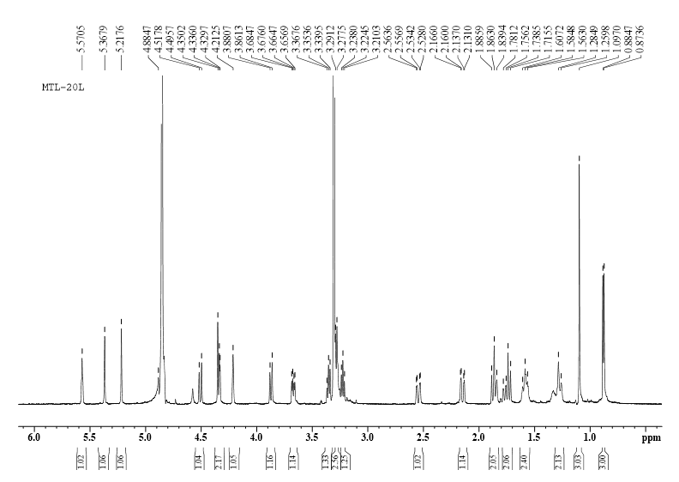

Figure S3. ¹³C NMR spectrum of 1.
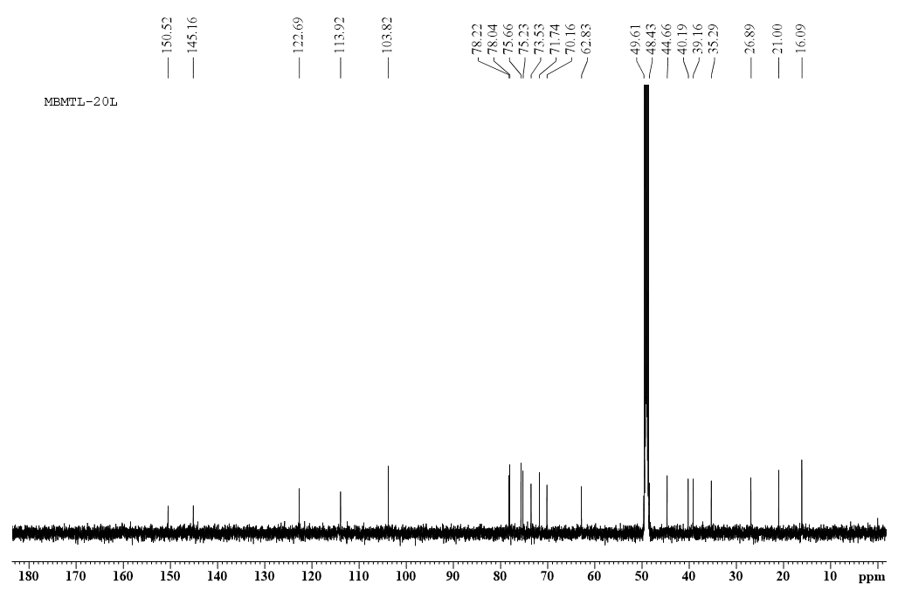
Figure S4. DEPT 135 spectrum of 1.
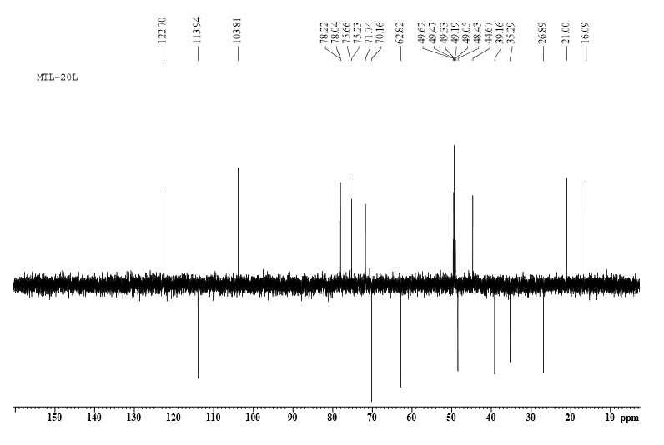

Figure S5. HSQC spectrum of 1.
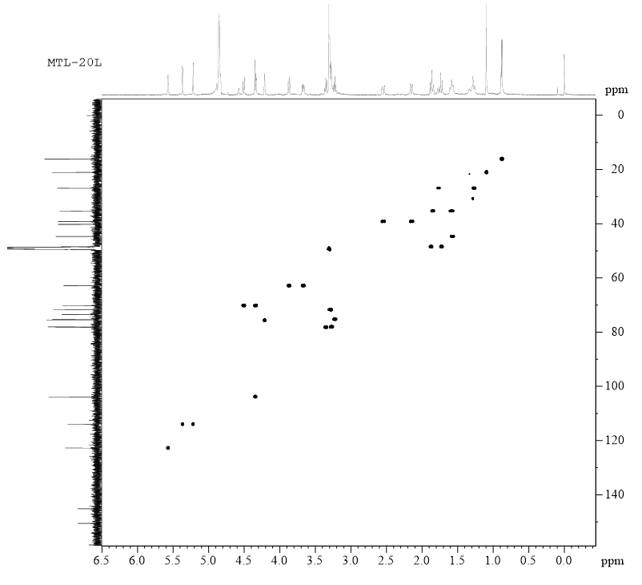
Figure S6. ¹H-¹H COSY spectrum of 1.
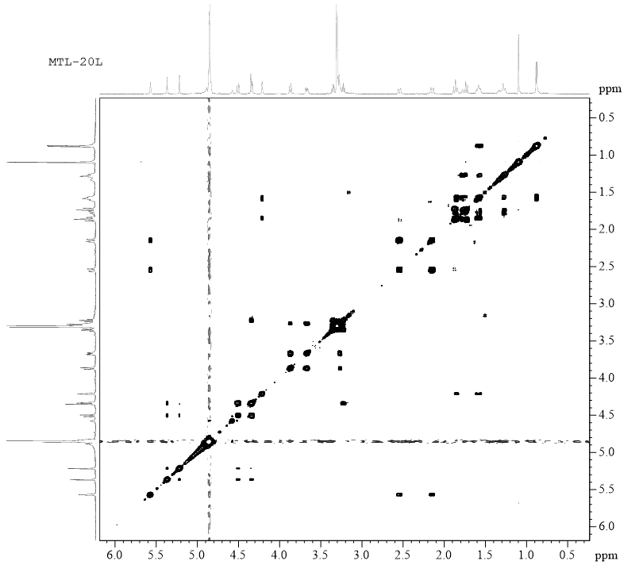
Figure S7. HMBC spectrum of 1.
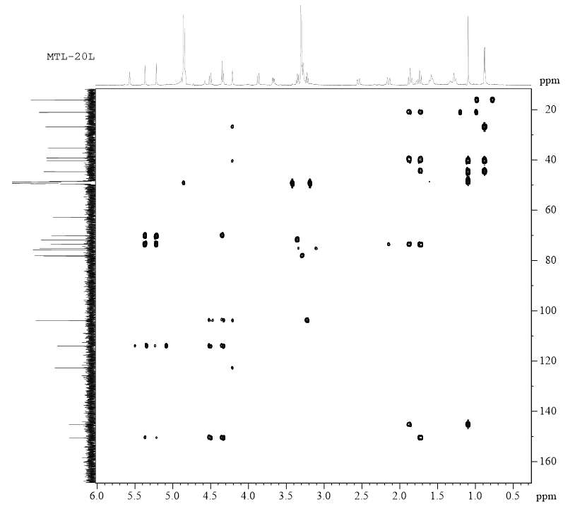
Figure S8. NOESY spectrum of 1.
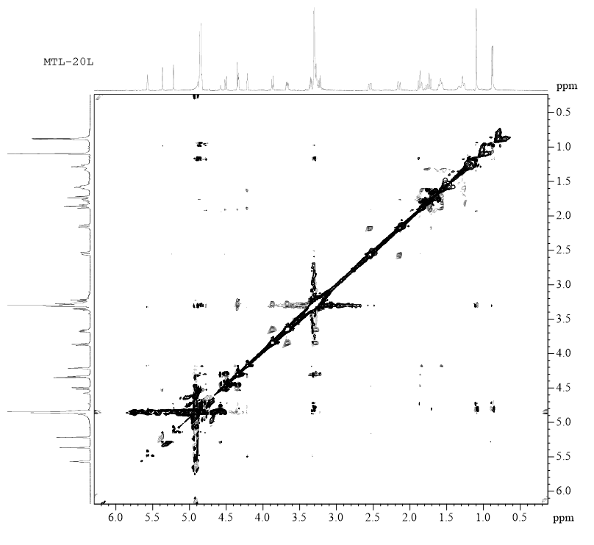
Figure S9. UV spectrum of 1.
Figure S10.CD spectrum of 1.
Figure S11. IR spectrum of 1.
Figure S12. HR-ESI-MS spectrum of 2.
Figure S13. ¹H NMR spectrum of 2.
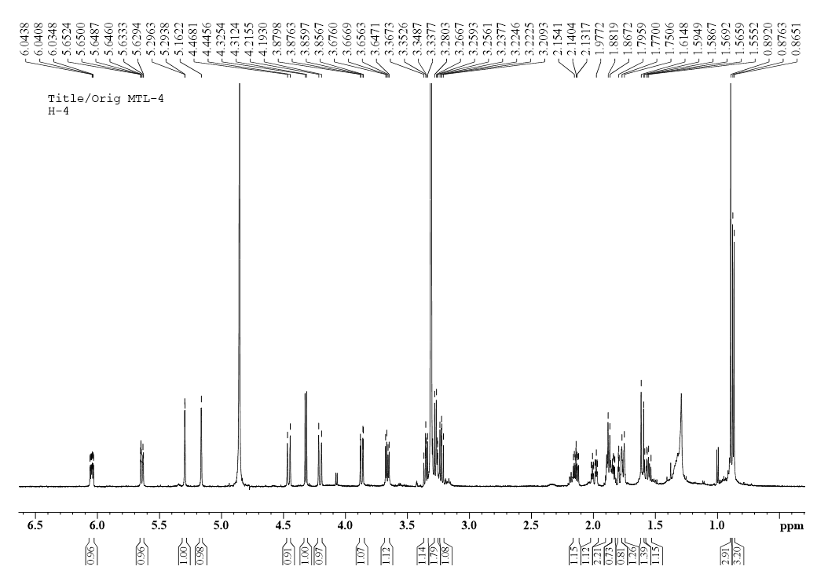

Figure S14. ¹³C NMR spectrum of 2.
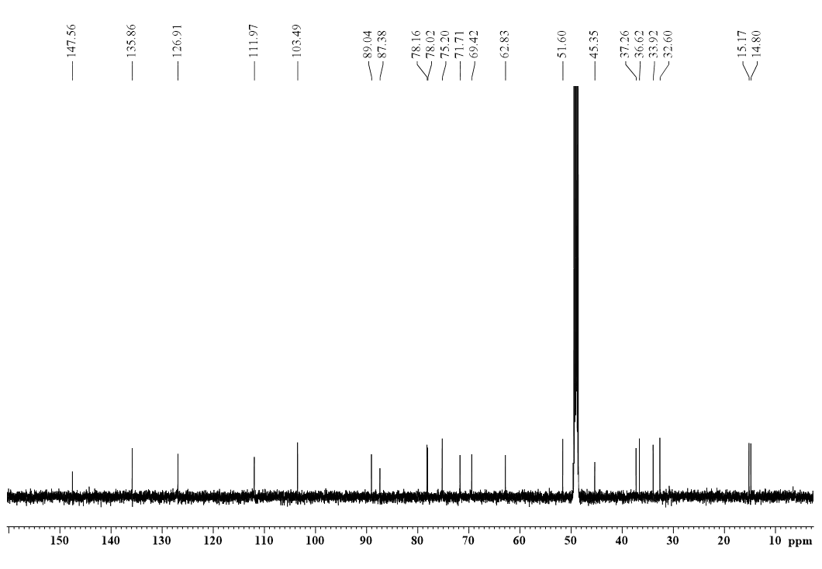
Figure S15. DEPT 135 spectrum of 2.
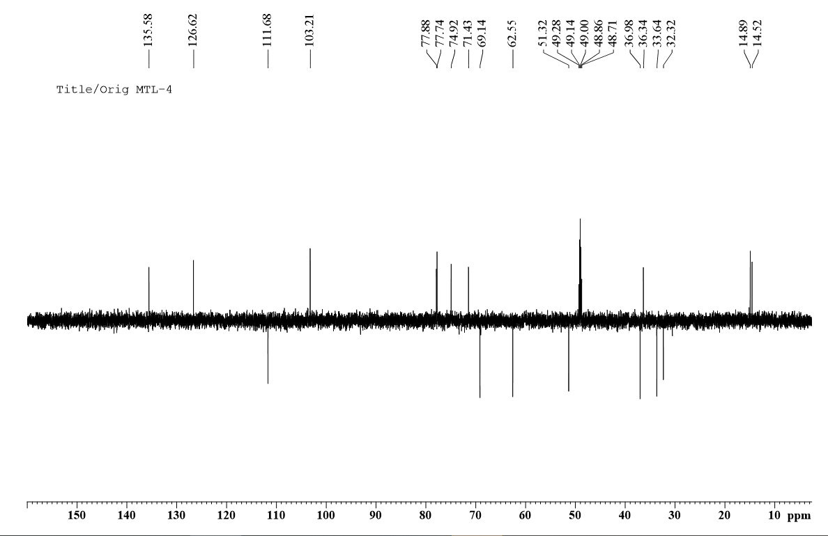
Figure S16. HSQC spectrum of 2.
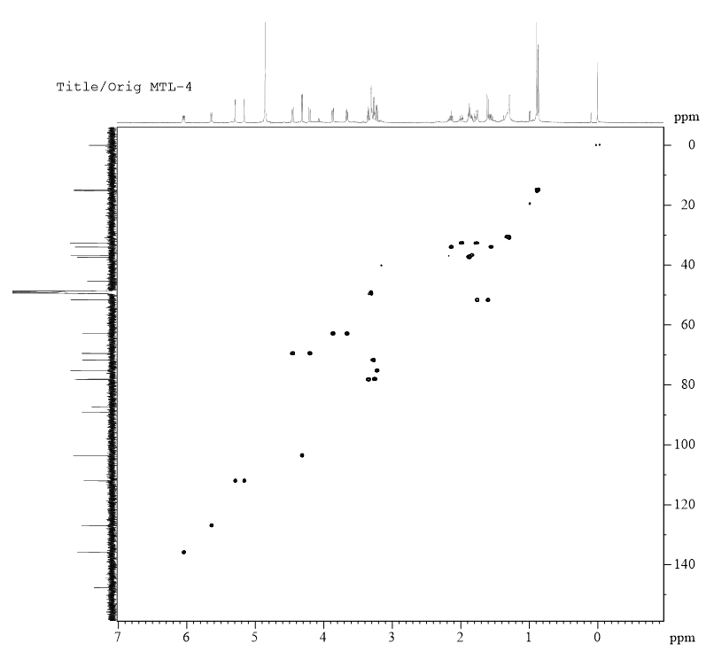
Figure S17. ¹H-¹H COSY spectrum of 2.
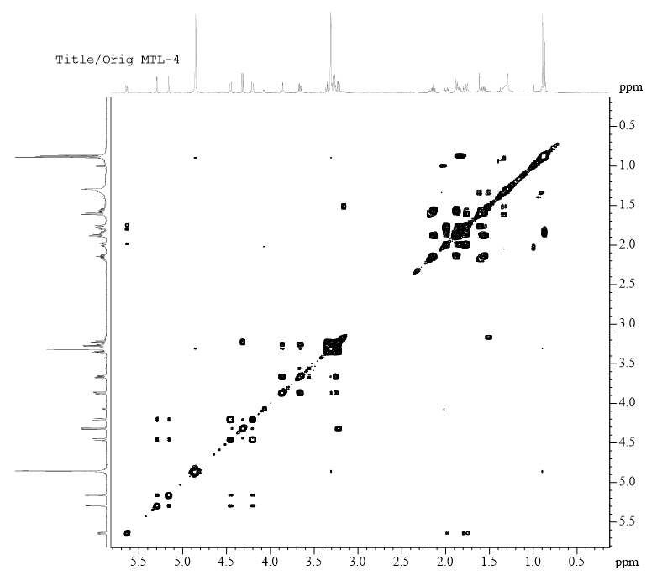
Figure S18. HMBC spectrum of 2.
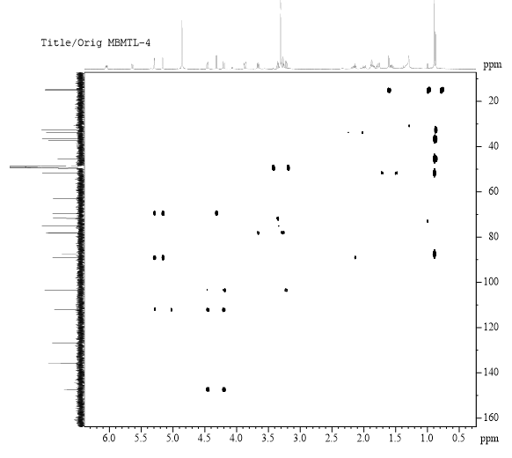
Figure S19. NOESY spectrum of 2.
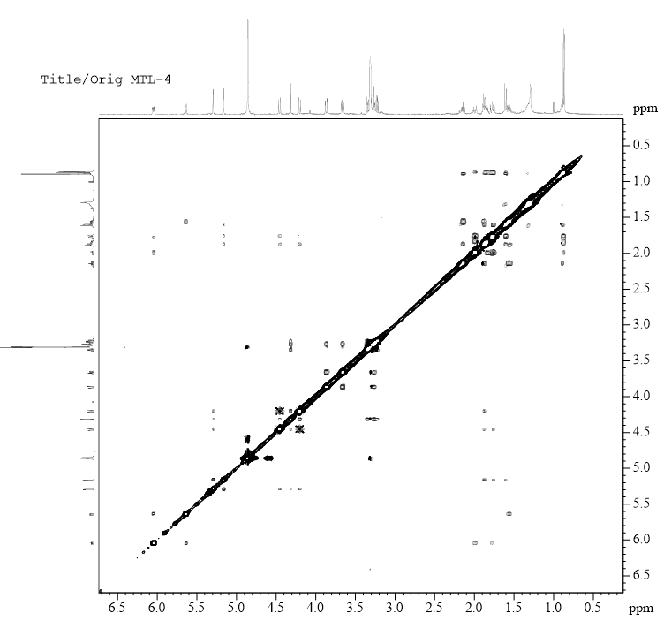
Figure S20. UV spectrum of 2.
Figure S21. CD spectrum of 2.
Figure S22. IR spectrum of 2
Figure S23. HR-ESI-MS spectrum of 3.
Figure S24. ¹H NMR spectrum of 3.
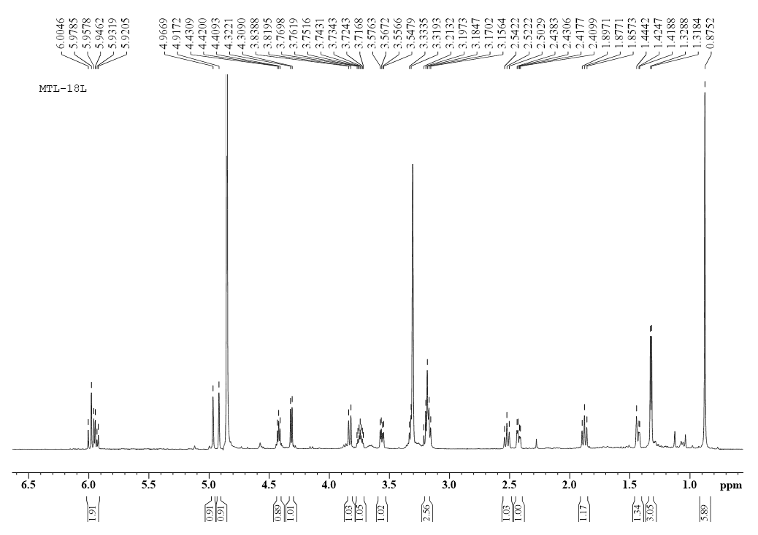
Figure S25. ¹³C NMR spectrum of 3
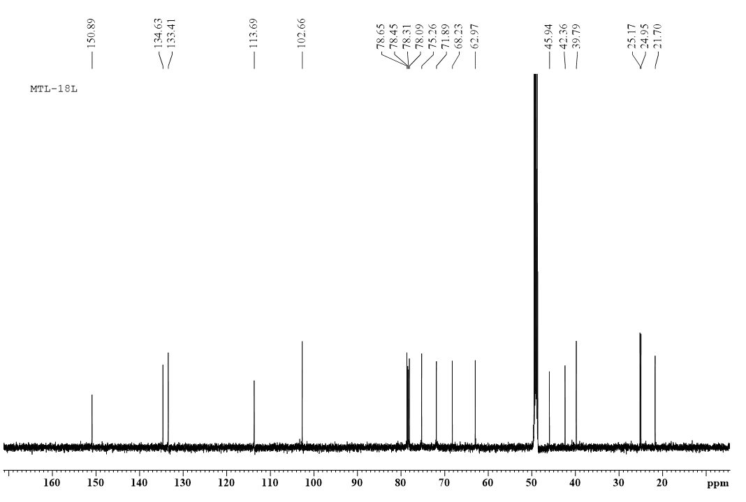 Figure S26. DEPT 135 spectrum of 3.

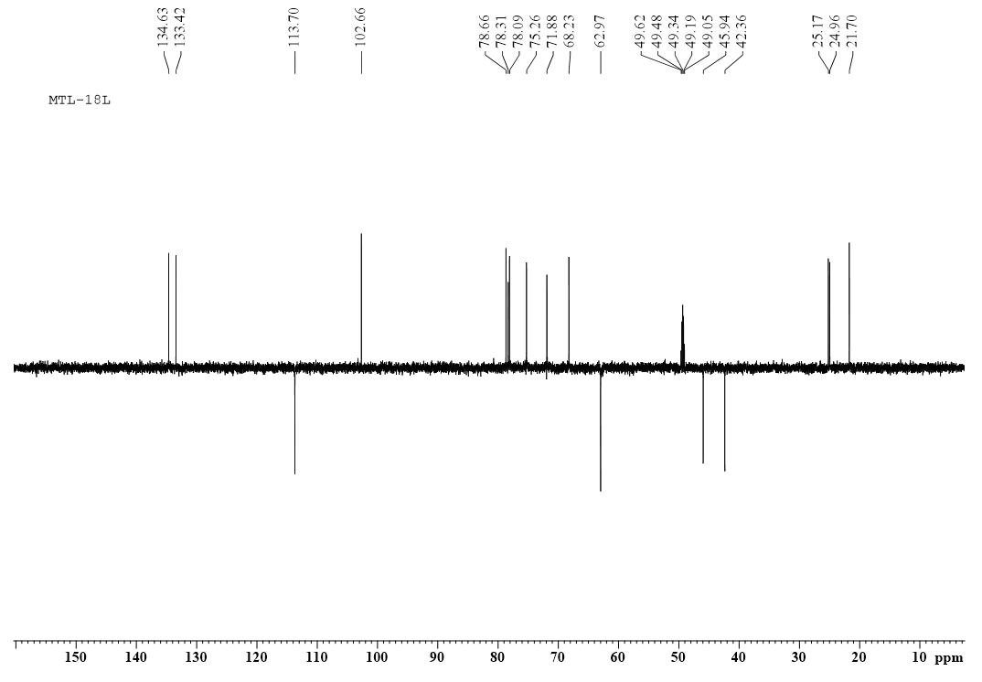
Figure S27. HSQC spectrum of 3.
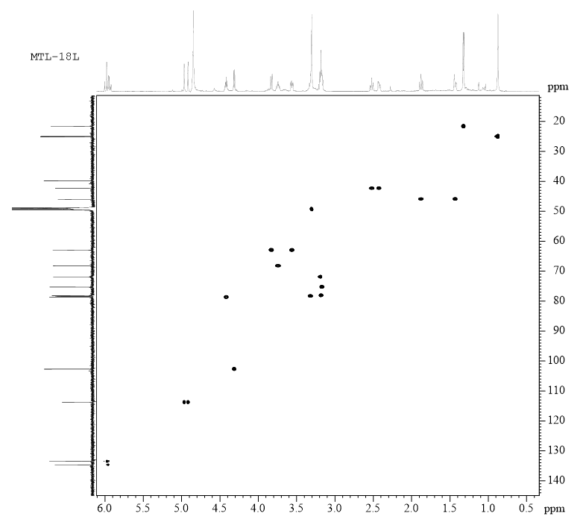
Figure S28. ¹H-¹H COSY spectrum of 3.
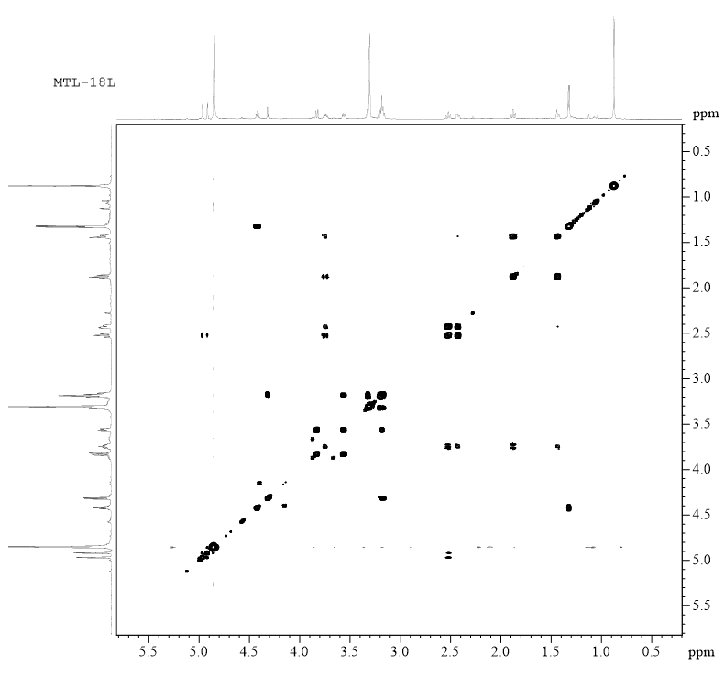
Figure S29. HMBC spectrum of 3.
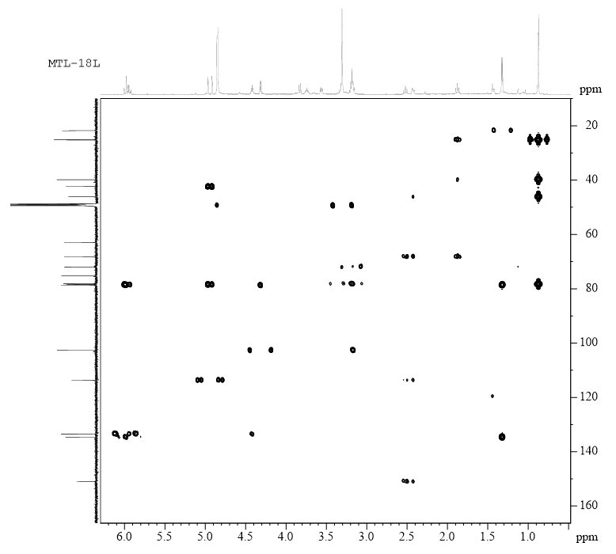
Figure S30. NOESY spectrum of 3.
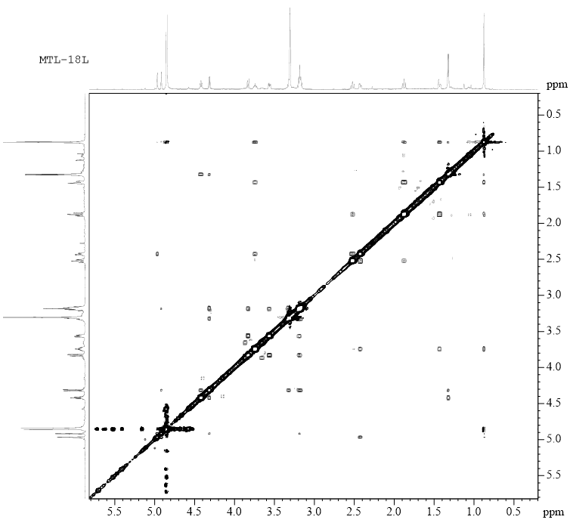
Figure S31. UV spectrum of 3.
Figure S32. CD spectrum of 3.
Figure S33. IR spectrum of 3.
Figure S34. HR-ESI-MS spectrum of 4.
Figure S35. ¹H NMR spectrum of 4.
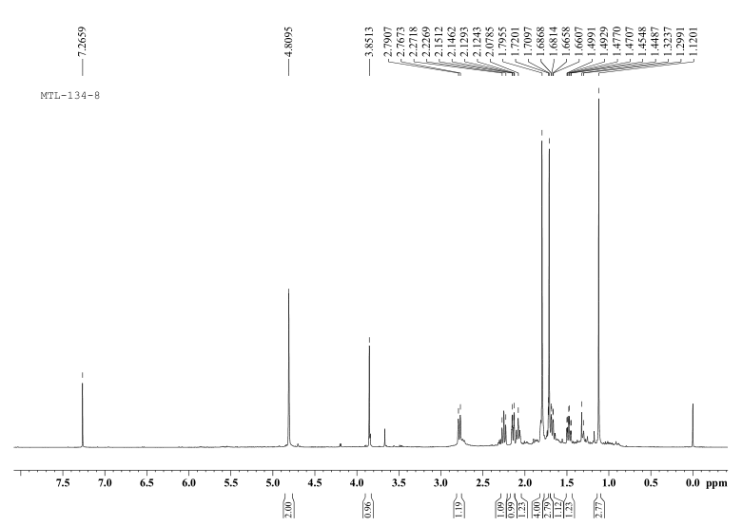
Figure S36. ¹³C NMR spectrum of 4.
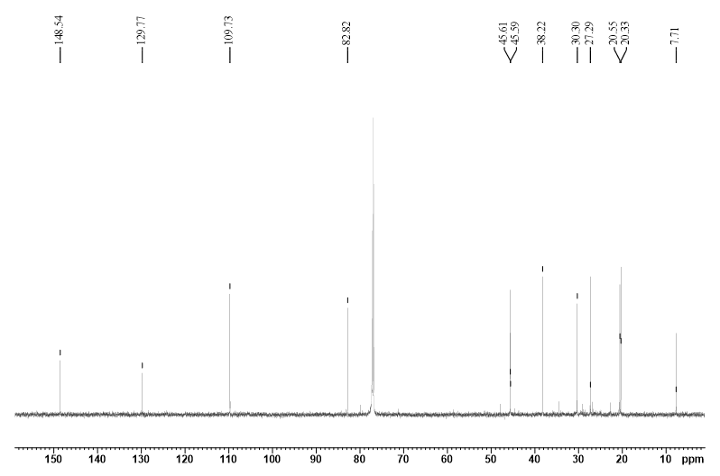 Figure S37. DEPT 135 spectrum of 4.
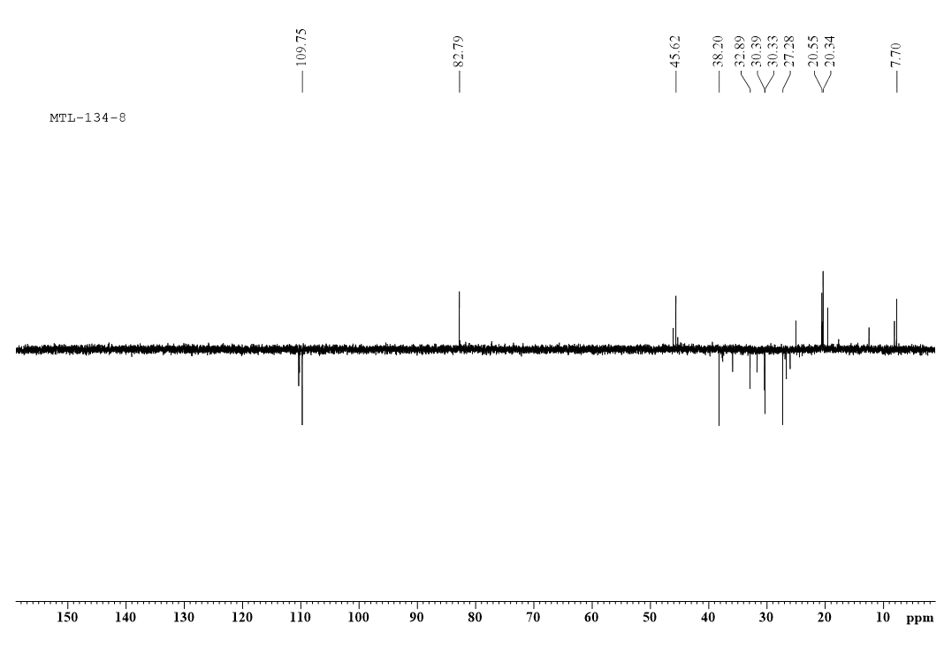
Figure S38. HSQC spectrum of 4.
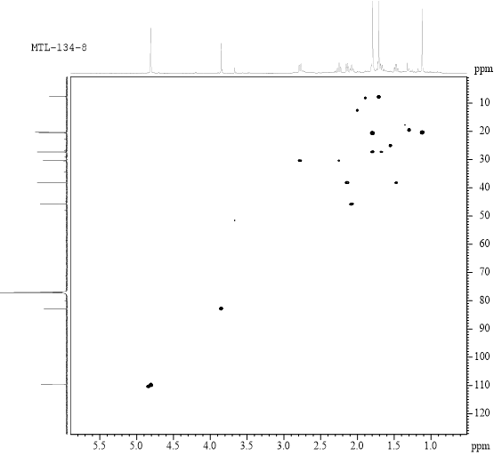
Figure S39. ¹H-¹H COSY spectrum of 4.
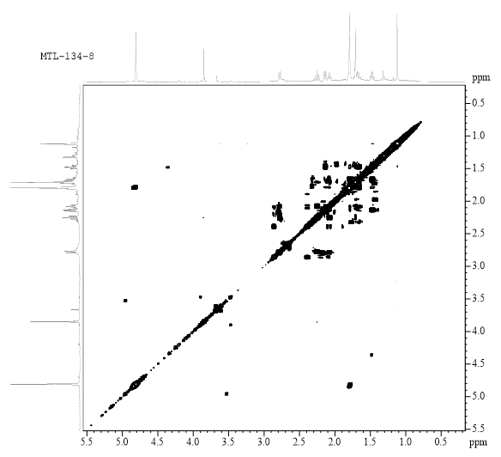
Figure S40. HMBC spectrum of 4.
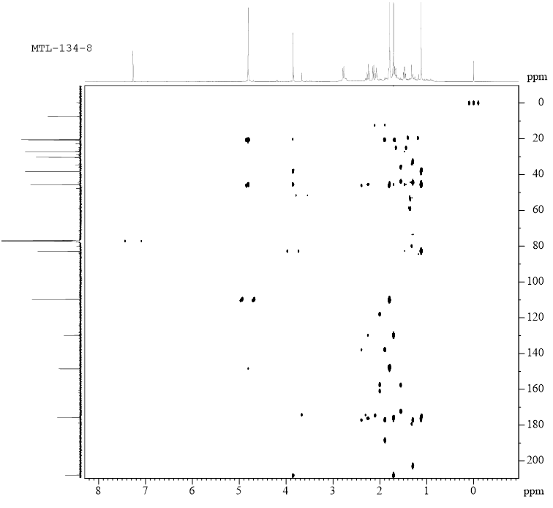
Figure S41. NOESY spectrum of 4.
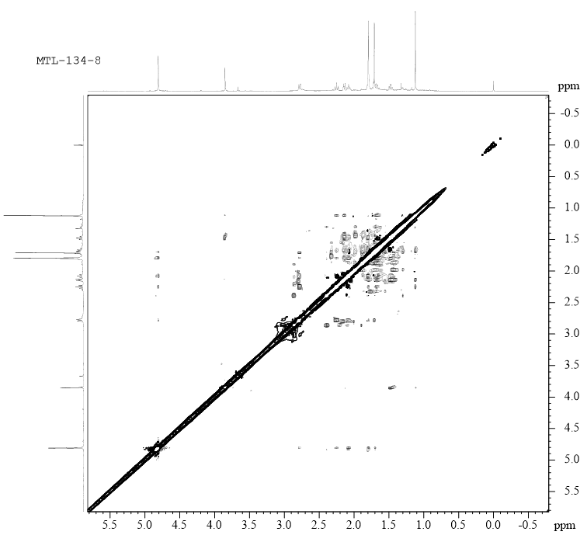
Figure S42. UV spectrum of 4.
Figure S43. CD spectrum of 4.
Figure S44. IR spectrum of 4.
Figure S45. HR-ESI-MS spectrum of 5.
Figure S46. ¹H NMR spectrum of 5.
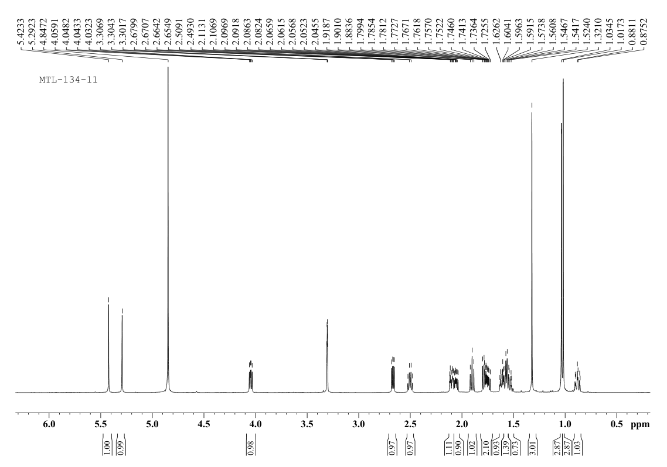
Figure S47. ¹³C NMR spectrum of 5.
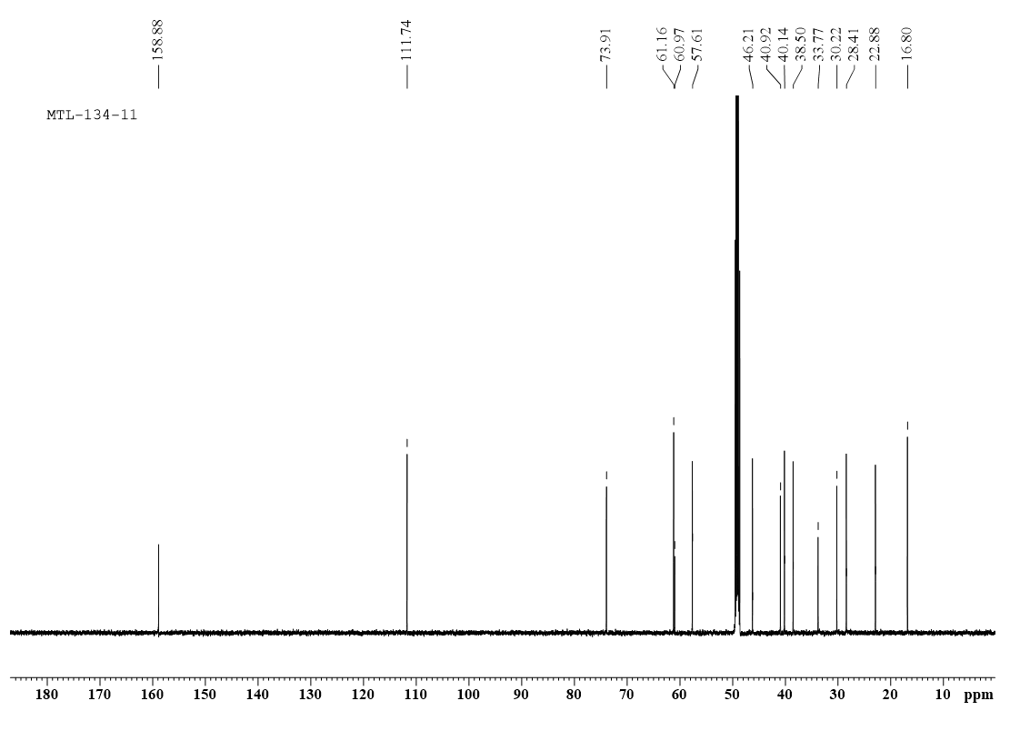
Figure S48. DEPT 135 spectrum of 5.
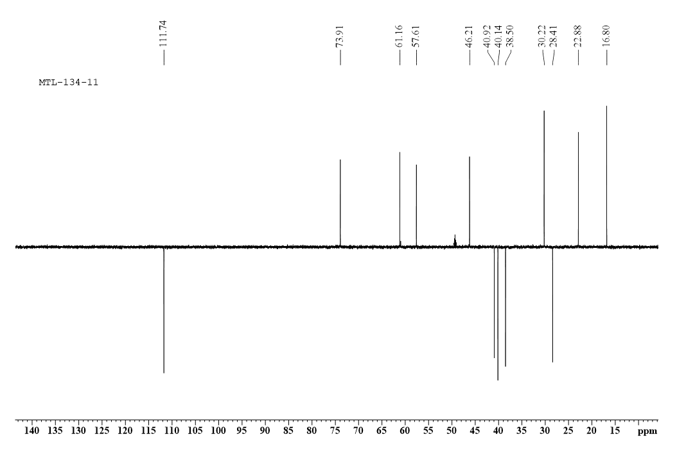

Figure S49. HSQC spectrum of 5.
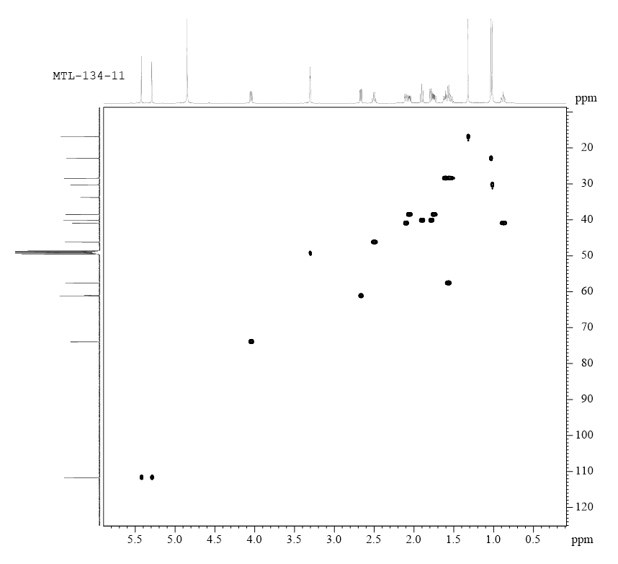
Figure S50. ¹H-¹H COSY spectrum of 5.
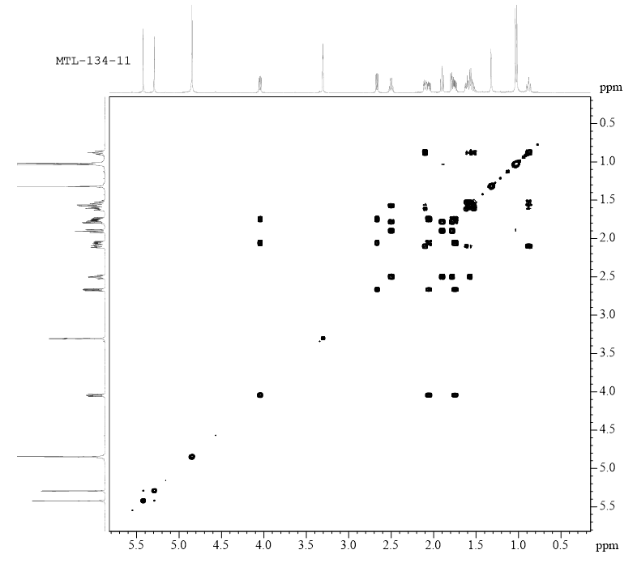
Figure S51. HMBC spectrum of 5.
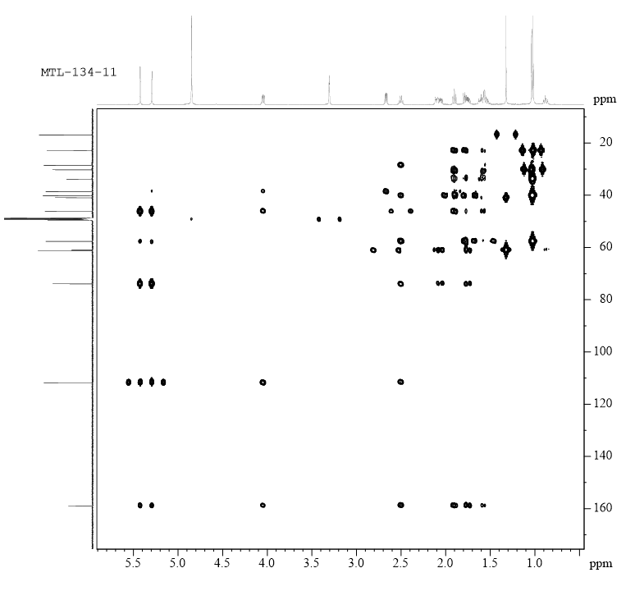
Figure S52. NOESY spectrum of 5.
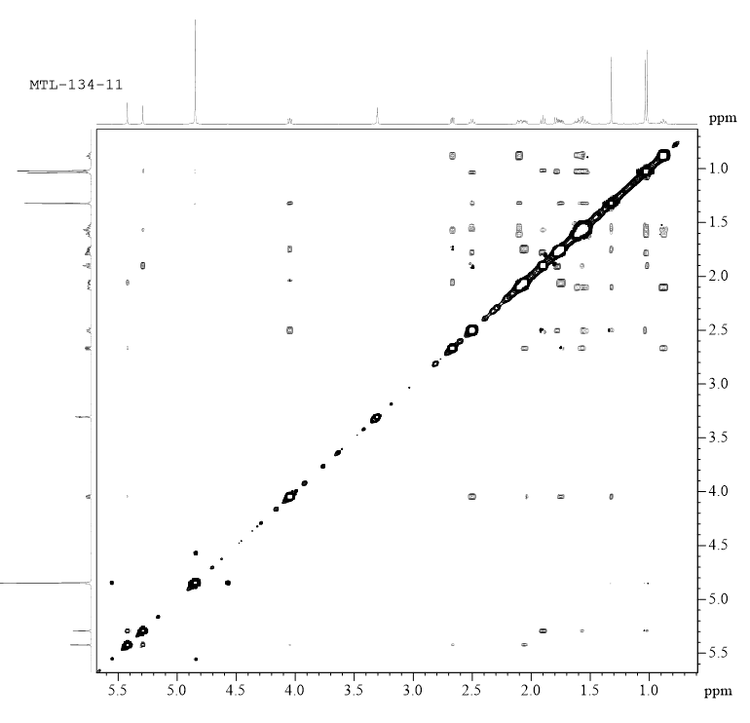
Figure S53. UV spectrum of 5.
Figure S54. CD spectrum of 5.
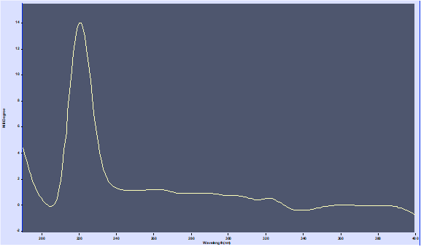
Figure S55. IR spectrum of 5.

Figure S56. GC-MS chromatogram of the sugars of compounds 1-3.
Fig.S56-1 the GC chromatogram of hydrolyzed D-glucose
Fig.S56-2 the GC chromatogram of compound 1 after hydrolysis
Fig.S56-3 the GC chromatogram of compound 2 after hydrolysis
Fig.S56-4 the GC chromatogram of compound 3 after hydrolysis
Table S57 ¹³C-NMR data of compounds 6-8 (MeOD, δ in ppm)
NO. | 6 | 7 | 8
1 | 49.0 | 204.6 | 50.7
2 | 26.5 | 125.6 | 27.5
3 | 28.7 | 153.5 | 39.8
4 | 62.8 | 70.7 | 59.1
5 | 65.0 | 52.2 | 57.5
6 | 30.2 | 26.4 | 34.6
7 | 33.5 | 45.0 | 69.3
8 | 151.4 | 26.3 | 61.1
9 | 49.9 | 34.8 | 42.9
10 | 39.9 | 44.7 | 33.8
11 | 34.5 | 149.7 | 32.9
12 | 21.4 | 108.8 | 16.3
13 | 29.9 | 21.1 | 45.0
14 | 62.1 | 22.3 | 30.0
15 | 113.3 | 18.1 | 22.8

