Supporting Information

ALD-Grown Ultrathin Coatings on Bismuth Oxyhalide Photocatalysts: Effect of UV-ozone Pretreatment on Coating Quality
Nitai Arbell^{1,2}, Shakked Regev^{1,2}, Yaron Paz*^{1,2}

Address: ¹The Russell Berrie Nanotechnology Institute, Technion-Israel Institute of Technology, Haifa 3200003, Israel ²The Wolfson Department of Chemical Engineering, Technion-Israel Institute of Technology

Email: Yaron Paz* - Paz@technion.ac.il
*Corresponding author

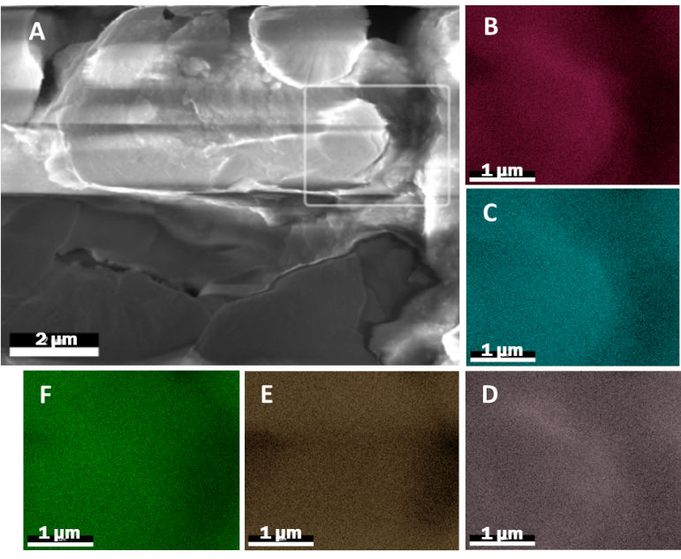
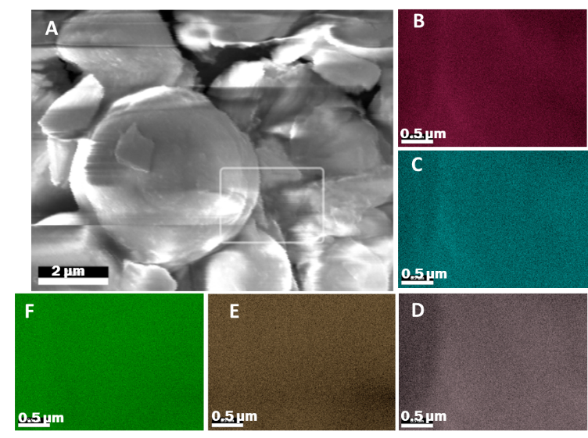
Figure S1. SEM micrograph (A) and EDS elemental maps (B-F) of the highlighted area for BiOCl in an SiO₂ binder coated with 10 cycles of Al₂O₃ ALD at 40⁰C following UV-ozone treatment. EDS legend: O (B), Al (C), Si (D), Bi (E) and Cl (F) atoms.
Figure S2. SEM micrograph (A) and EDS elemental maps (B-F) of the highlighted area for BiOCl in an SiO₂ binder coated with 10 cycles of Al₂O₃ ALD at 40⁰C without UV-ozone treatment. EDS legend: O (B), Al (C), Si (D), Bi (E) and Cl (F) atoms

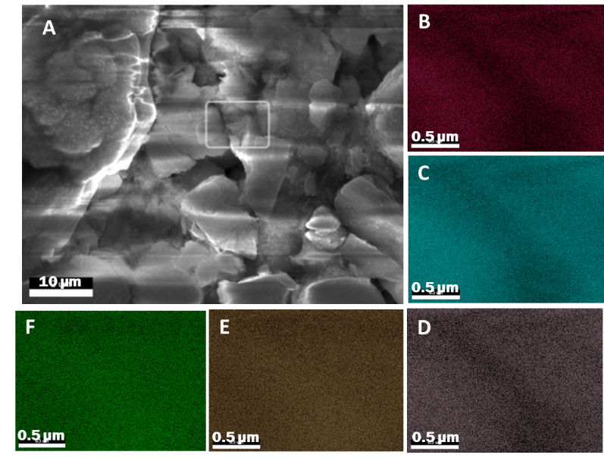
Figure S3. SEM micrograph (A) and EDS elemental maps (B-F) of the highlighted area for BiOBr in an SiO2 binder coated with 10 cycles of Al2O3 ALD at 80⁰C following UV-ozone treatment. EDS legend: O (B), Al (C), Si (D), Bi (E) and Br (F) atoms.
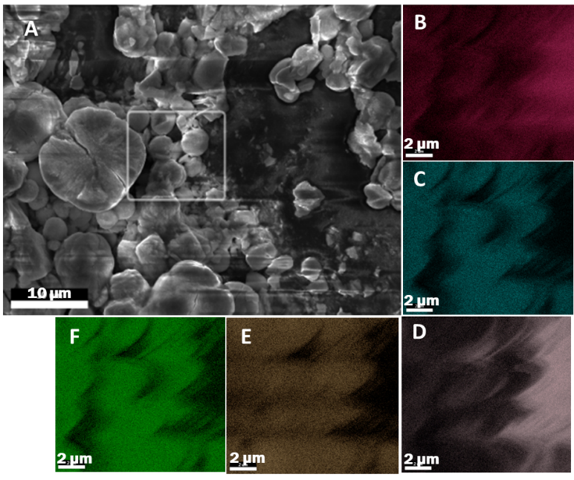
Figure S4. SEM micrograph (A) and EDS elemental maps (B-F) of the highlighted area for BiOBr in an SiO₂ binder coated with 10 cycles of Al₂O₃ ALD at 80⁰C without UV-ozone treatment. EDS legend: O (B), Al (C), Si (D), Bi (E) and Br (F) atoms.

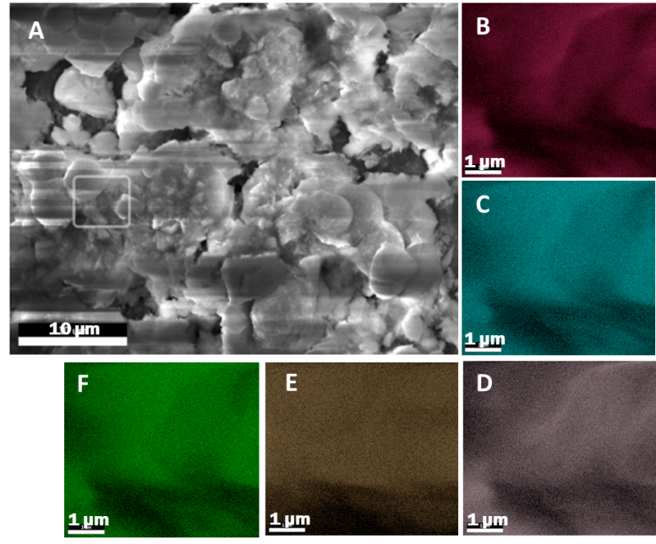
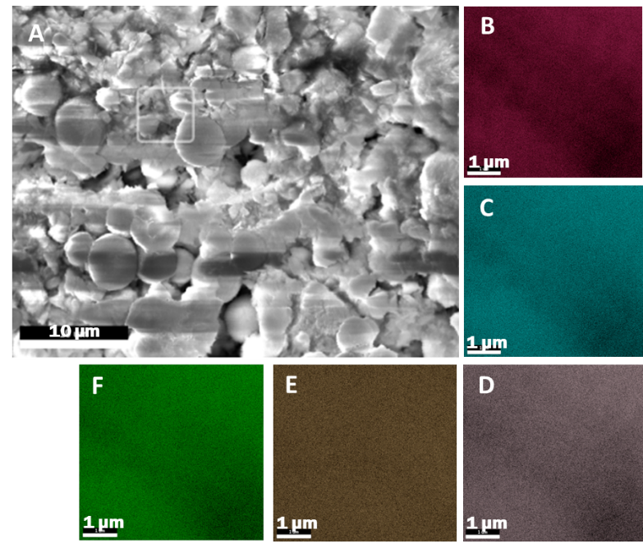
Figure S5. SEM micrograph (A) and EDS elemental maps (B-F) of the highlighted area for BiOBr in an SiO₂ binder coated with 10 cycles of Al₂O₃ ALD at 40⁰C following UV-ozone treatment. EDS legend: O (B), Al (C), Si (D), Bi (E) and Br (F) atoms.
Figure S6. SEM micrograph (A) and EDS elemental maps (B-F) of the highlighted area for BiOBr in an SiO₂ binder coated with 10 cycles of Al₂O₃ ALD at 40⁰C without UV-ozone treatment. EDS legend: O (B), Al (C), Si (D), Bi (E) and Br (F) atoms.

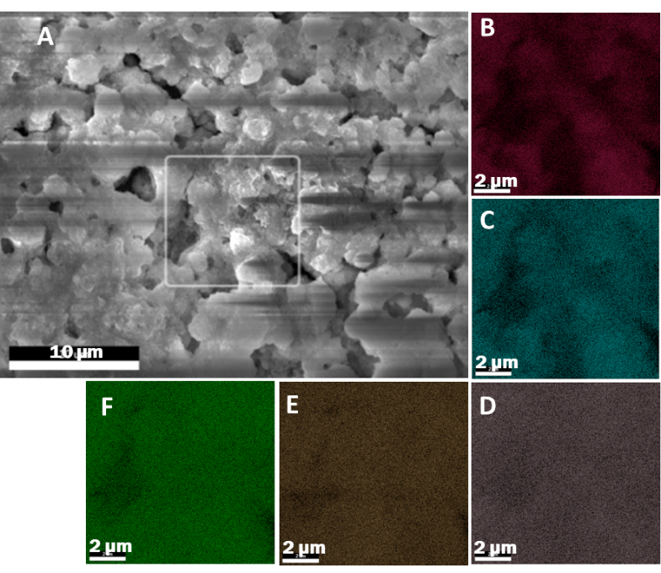
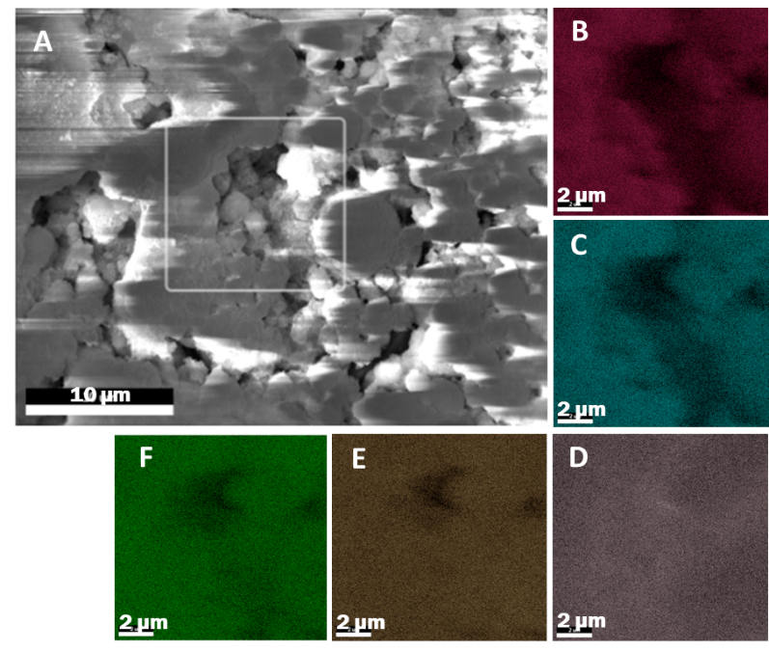
Figure S7. SEM micrograph (A) and EDS elemental maps (B-F) of the highlighted area for BiOI in an SiO₂ binder coated with 10 cycles of Al₂O₃ ALD at 80⁰C following UV-ozone treatment. EDS legend: O (B), Al (C), Si (D), Bi (E) and I (F) atoms.
Figure S8. SEM micrograph (A) and EDS elemental maps (B-F) of the highlighted area for BiOI in an SiO₂ binder coated with 10 cycles of Al₂O₃ ALD at 80⁰C without UV-ozone treatment. EDS legend: O (B), Al (C), Si (D), Bi (E) and I (F) atoms.

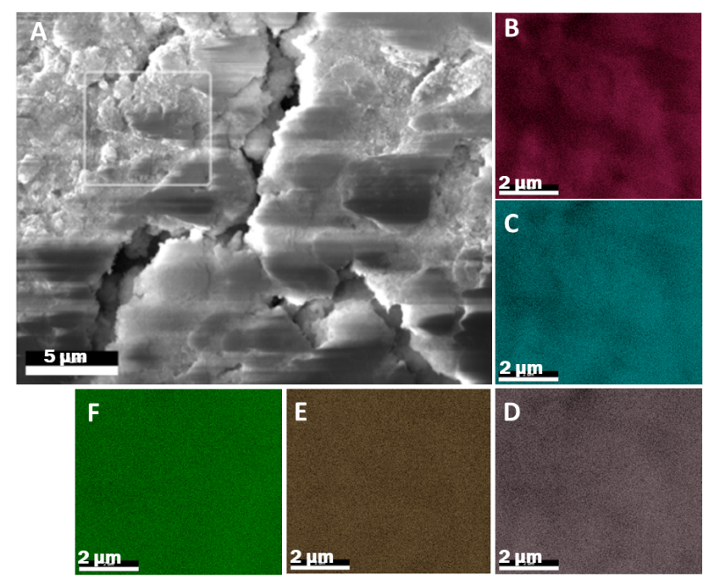
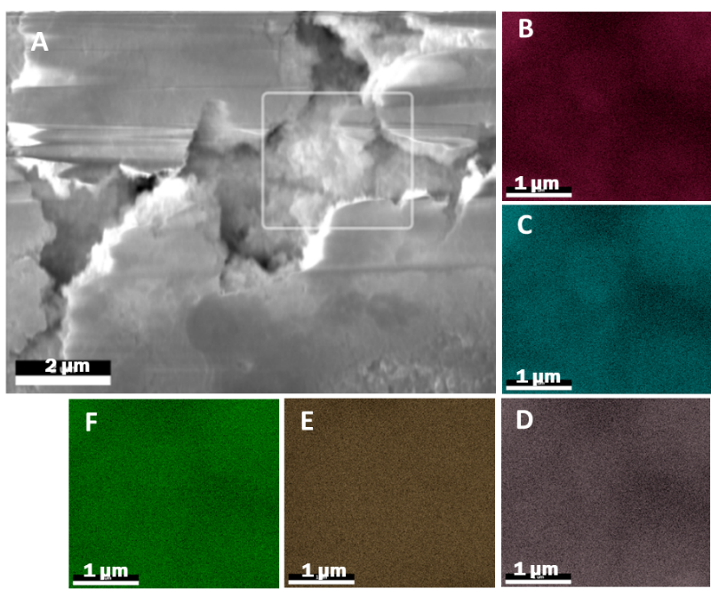
Figure S9. SEM micrograph (A) and EDS elemental maps (B-F) of the highlighted area for BiOI in an SiO₂ binder coated with 10 cycles of Al₂O₃ ALD at 40⁰C following UV-ozone treatment. EDS legend: O (B), Al (C), Si (D), Bi (E) and I (F) atoms.
Figure S10. SEM micrograph (A) and EDS elemental maps (B-F) of the highlighted area for BiOI in an SiO₂ binder coated with 10 cycles of Al₂O₃ ALD at 40⁰C without UV-ozone treatment. EDS legend: O (B), Al (C), Si (D), Bi (E) and I (F) atoms.

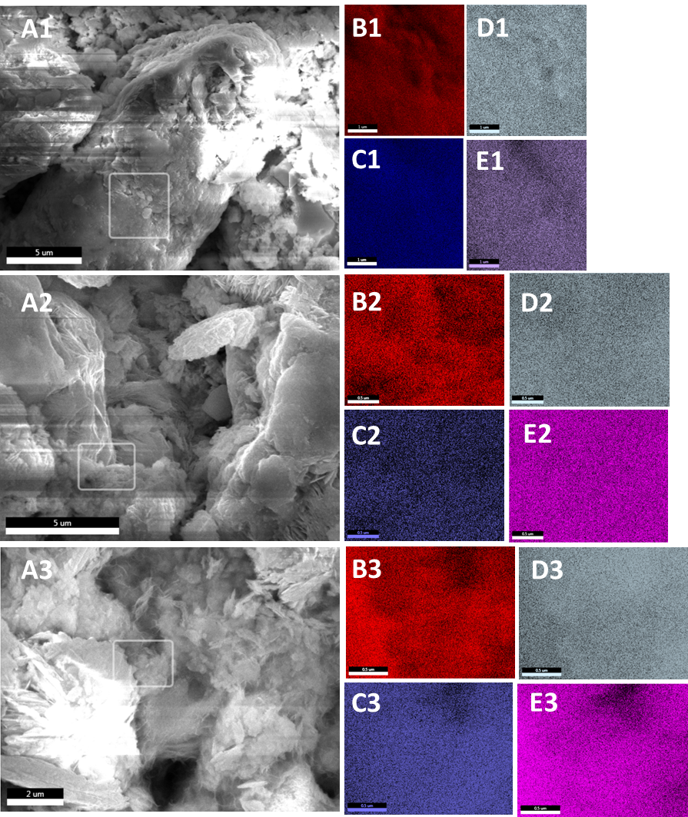
Figure S11. SEM micrograph (A) and EDS elemental maps (B-F) of the highlighted area for pure BiOCl-particle films with 10 cycles of Al₂O₃ ALD at (A1-E1) 40⁰C, (A2-E2) 60⁰C, (A3-E3) 80⁰C, following UV-ozone treatment. EDS legend: O (B), Al (C), Si (D), Bi (E) and Cl (F) atoms.

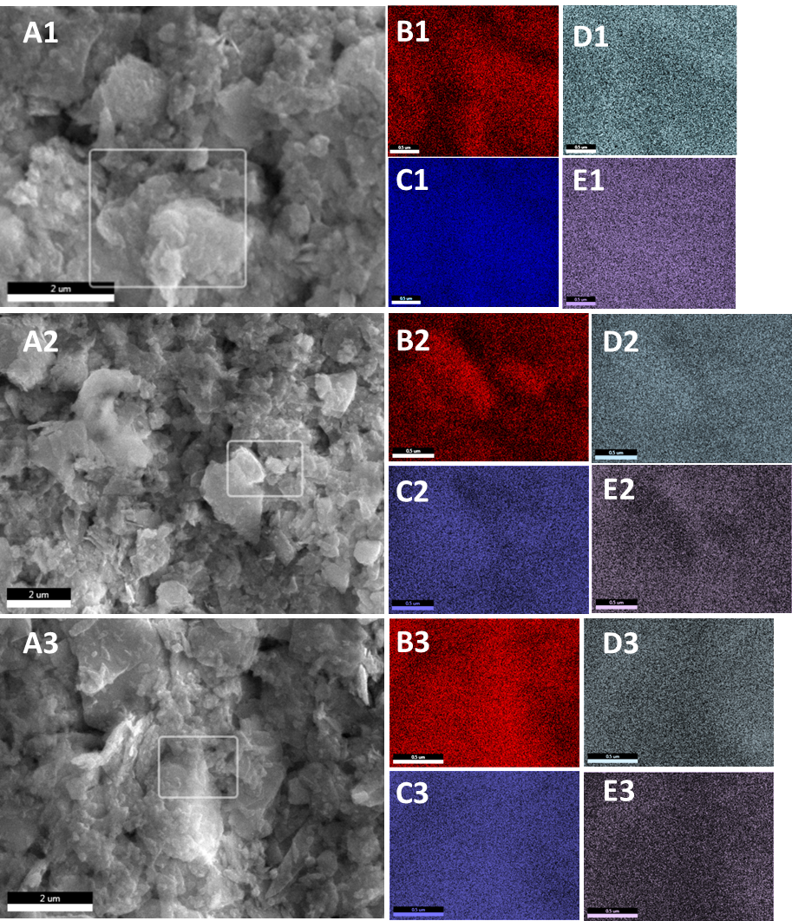
Figure S12. SEM micrograph (A) and EDS elemental maps (B-F) of the highlighted area for pure BiOBr-particle films with 10 cycles of Al₂O₃ ALD at (A1-E1) 40⁰C, (A2-E2) 60⁰C, (A3-E3) 80⁰C, following UV-ozone treatment. EDS legend: O (B), Al (C), Si (D), Bi (E) and Br (F) atoms.

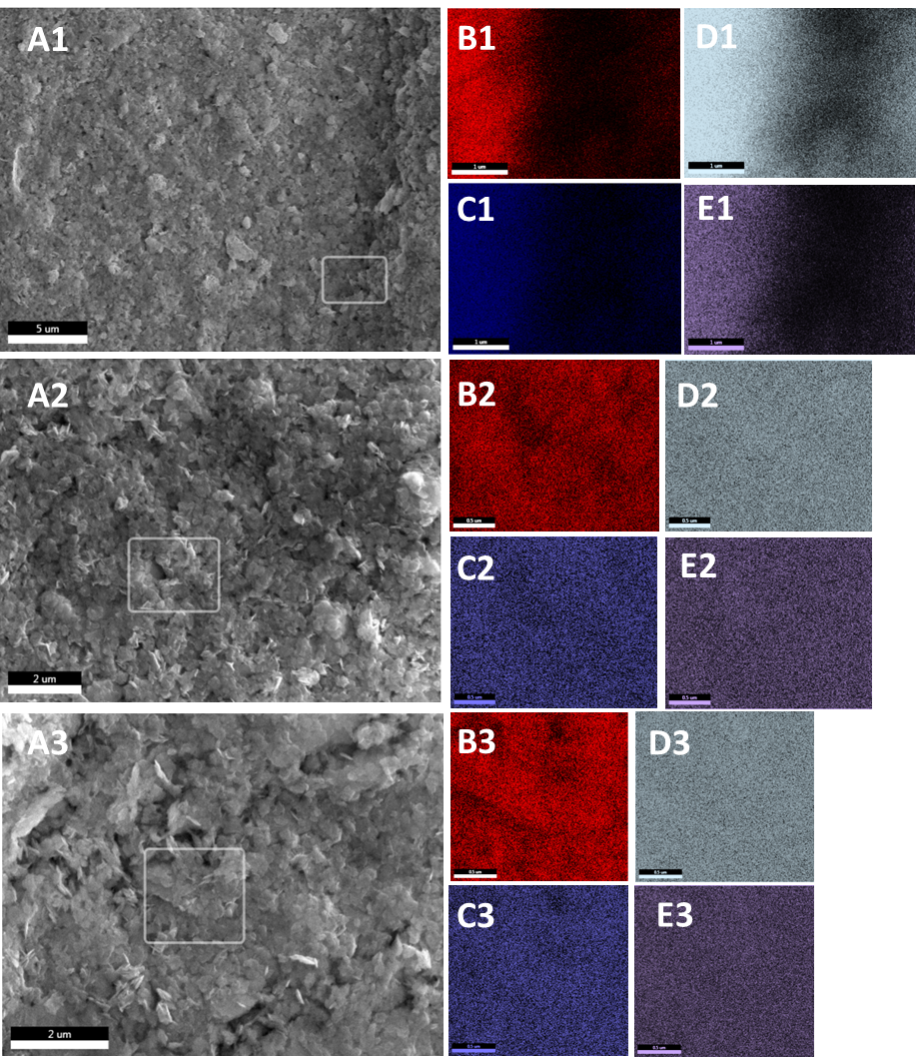
Figure S13. SEM micrograph (A) and EDS elemental maps (B-F) of the highlighted area for pure BiOI-particle films with 10 cycles of Al₂O₃ ALD at (A1-E1) 40⁰C, (A2-E2) 60⁰C, (A3-E3) 80⁰C, following UV-ozone treatment. EDS legend: O (B), Al (C), Si (D), Bi (E) and I (F) atoms.

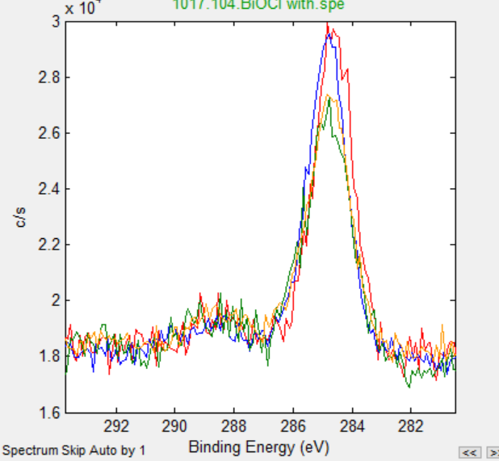
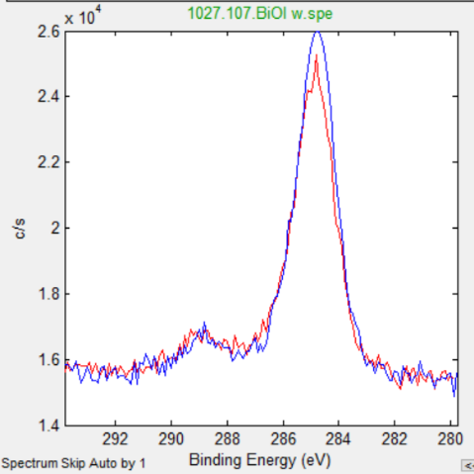
A
B
Figure S14. High resolution XPS peaks for C1s lines in (A) BiOCl samples with (red, blue) and without (green, orange) UV-ozone pre-treatment, (B) BiOI samples with (red) and without (blue) UV-ozone pre-treatment. All samples were coated with 10 cycles of Al₂O₃ ALD at 60°C.
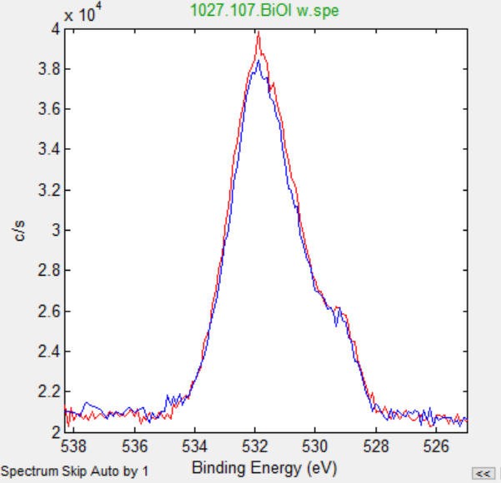
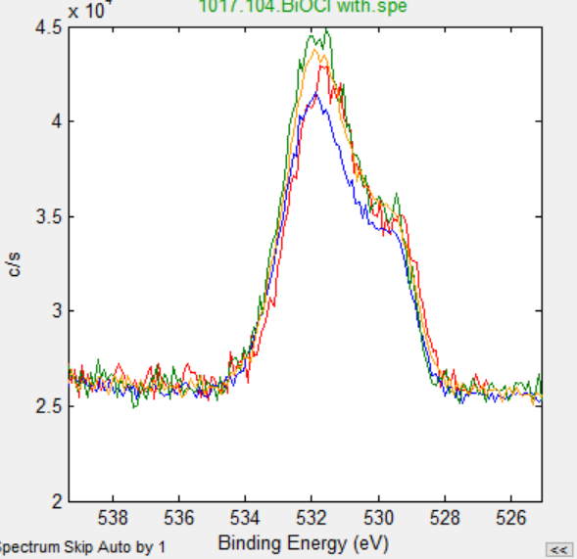
A
B

Figure S15. High resolution XPS peaks for O1s lines in (A) BiOCl samples with (red, blue) and without (green, orange) UV-ozone pre-treatment, (B) BiOI samples with (red) and without (blue) UV-ozone pre-treatment. All samples were coated with 10 cycles of Al₂O₃ ALD at 60°C.

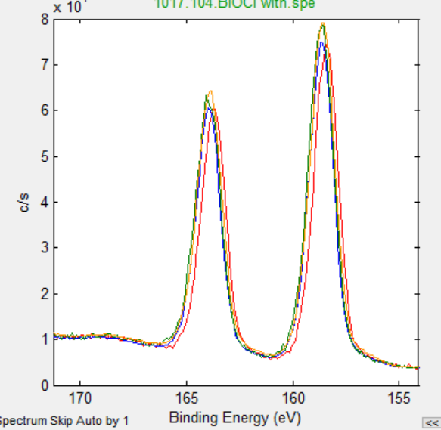
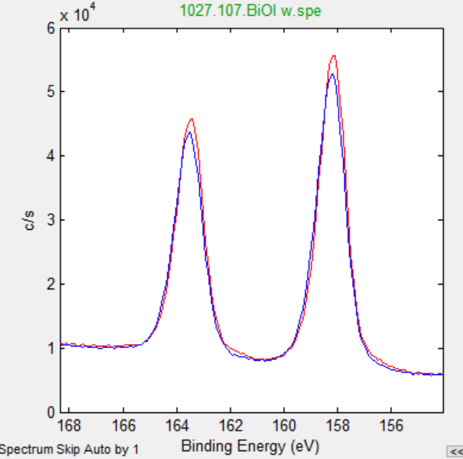
A
B

Figure S16. High resolution XPS peaks for Bi4f lines in (A) BiOCl samples with (red, blue) and without (green, orange) UV-ozone pre-treatment, (B) BiOI samples with (red) and without (blue) UV-ozone pre-treatment. All samples were coated with 10 cycles of Al₂O₃ ALD at 60°C.
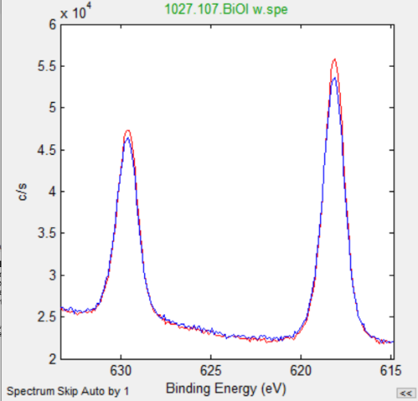
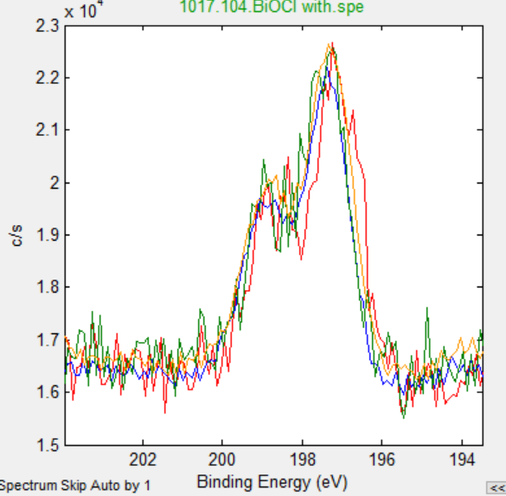
A
B

Figure S17. High resolution XPS peaks for (A) Cl2p, and (B) I3d lines in (A) BiOCl samples with (red, blue) and without (green, orange) UV-ozone pre-treatment, (B) BiOI samples with (red) and without (blue) UV-ozone pre-treatment. All samples were coated with 10 cycles of Al₂O₃ ALD at 60°C.

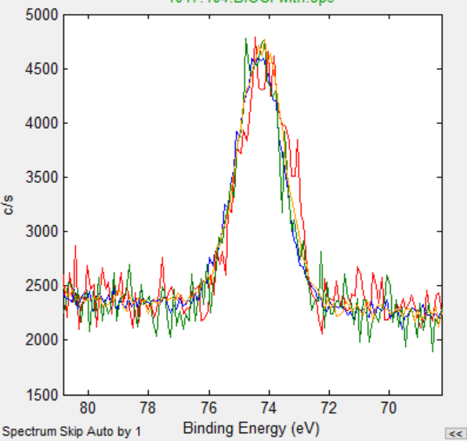
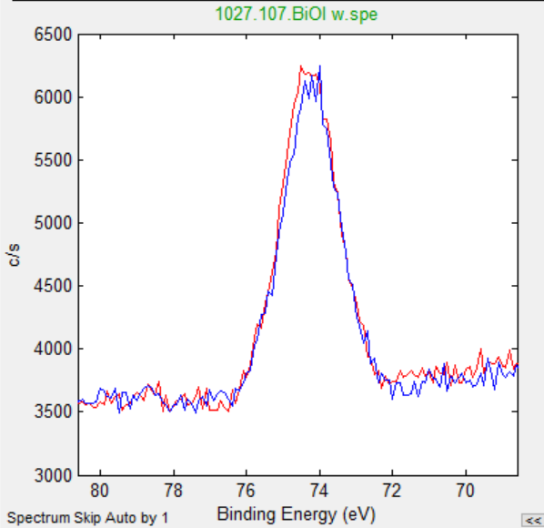
A
B
Figure S18. High resolution XPS peaks for Al2p lines in (A) BiOCl samples with (red, blue) and without (green, orange) UV-ozone pre-treatment, (B) BiOI samples with (red) and without (blue) UV-ozone pre-treatment. All samples were coated with 10 cycles of Al₂O₃ ALD at 60°C.

