**Supplementary Information**

**Metal catalyst-free *N*-Allylation/alkylation of Imidazole and Benzimidazole with Morita-Baylis-Hillman (MBH) alcohols and acetates**

**Olfa Mhasnia*, Jalloul BOUAJILAb Farhat Rezguic**

*a Laboratory of Materials, Treatement and Analysis LMTA, LR 15 INRAP 03, Institute National for Research and Physico-Chemical Analysis (INRAP), Biotechpole Sidi Thabet 2020, Tunisia*

*E-mail :* [*olfa.mha@gmail.com*](mailto:olfa.mha@gmail.com)

*b Paul Sabatier University, Toulouse 3, Laboratoire de Génie Chimique UMR 5503 Toulouse France. E-mail :* [*jalloul.bouajila@univ-tlse3.fr*](mailto:jalloul.bouajila@univ-tlse3.fr)

*c University of Tunis El Manar, Laboratory of Organic Chemistry, Faculty of Sciences, Campus, 2092 Tunis, Tunisia. E-mail : farhat.rezgui@fst.utm.tn*

**\*** Corresponding author. Email: [olfa.mha@gmail.com](mailto:olfa.mha@gmail.com)

**Contents**

**1.** 1H NMR, 13C NMR and dept 135 NMR spectra ……………………………........ S3-S20

**2.** ESI-HRMS spectra ……………………………………….………....………….. S21-S35

**1H/13C NMR Spectra**

**for compounds 6a-d, 7a-d, 8a-f**



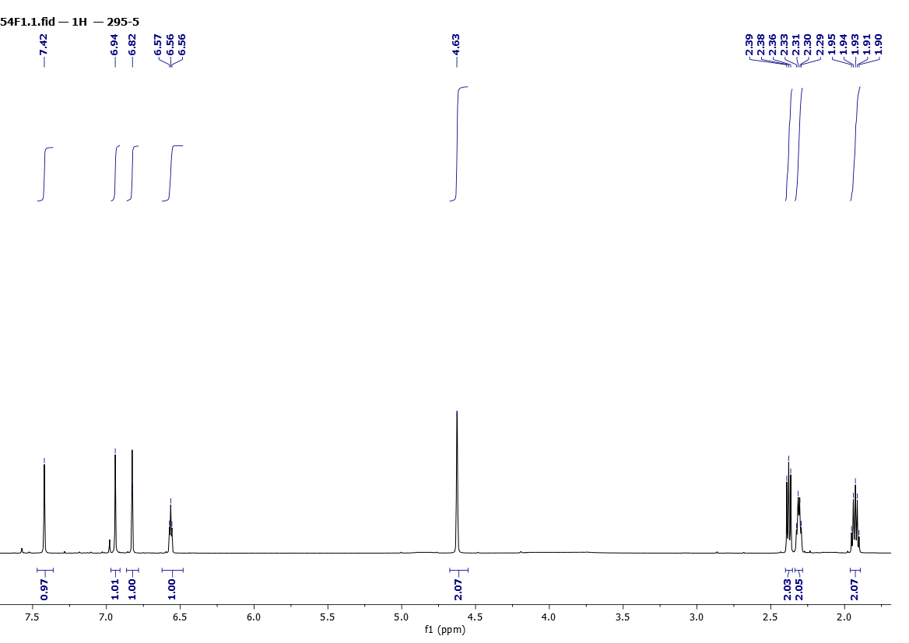

Figure 1. 1H NMR (500 MHz, CDCl3) spectra of **6a**

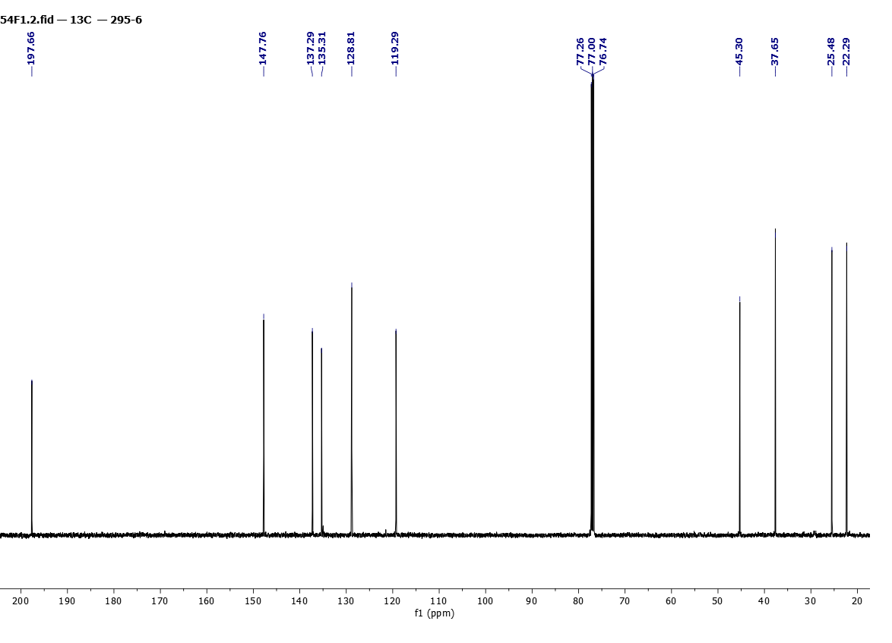

Figure 2. 13C NMR (125 MHz, CDCl3) spectra of **6a**



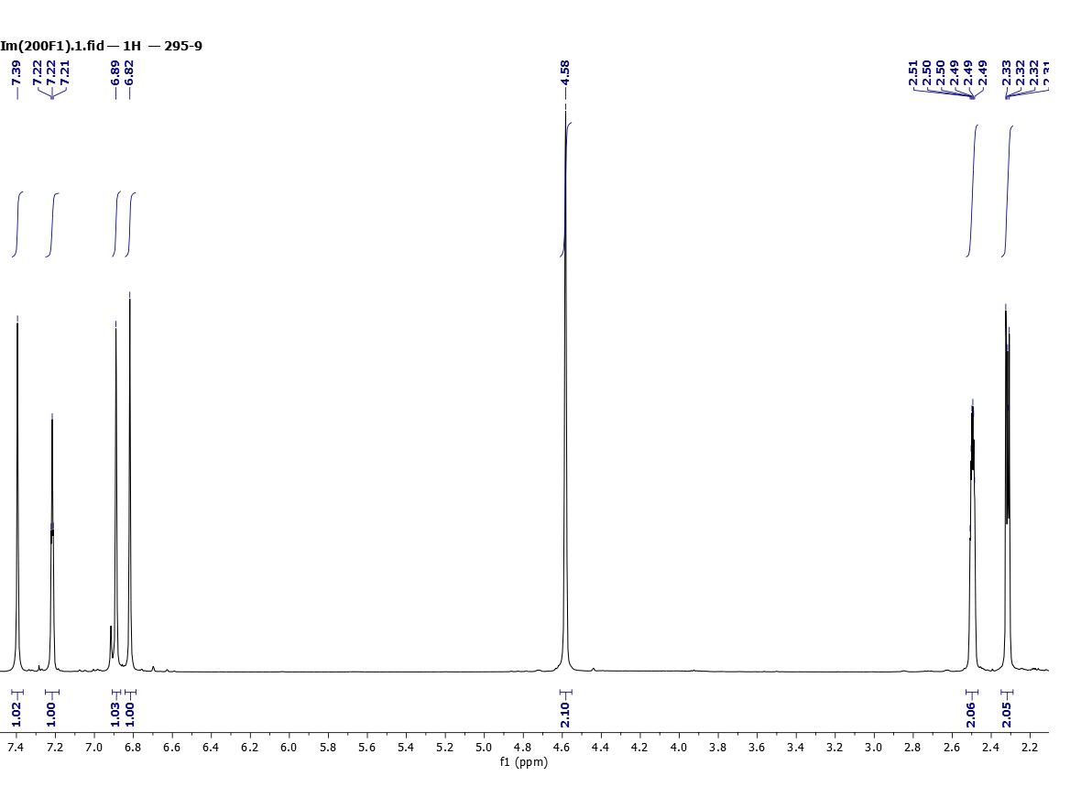

Figure 3. 1H NMR (500 MHz, CDCl3) spectra of **6b**



Figure 4. 13C NMR (125 MHz, CDCl3) spectra of **6b**



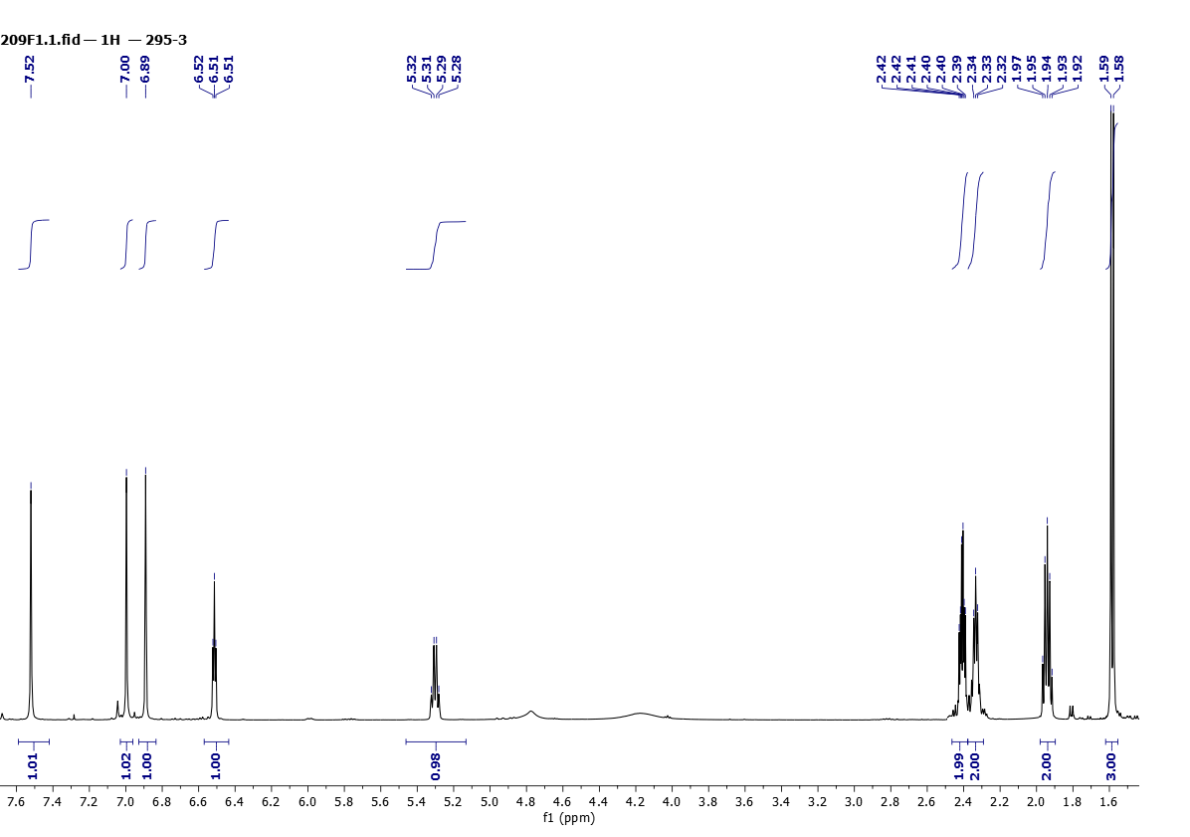

Figure 5. 1H NMR (500 MHz, CDCl3) spectra of **6c**

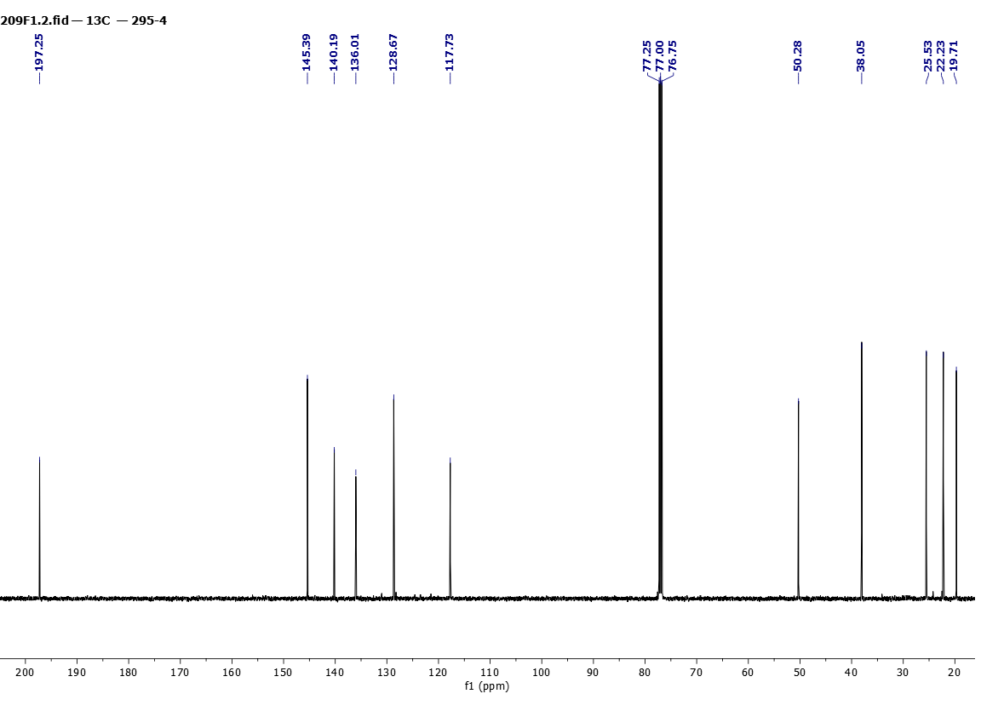

Figure 6. 13C NMR (125 MHz, CDCl3) spectra of **6c**



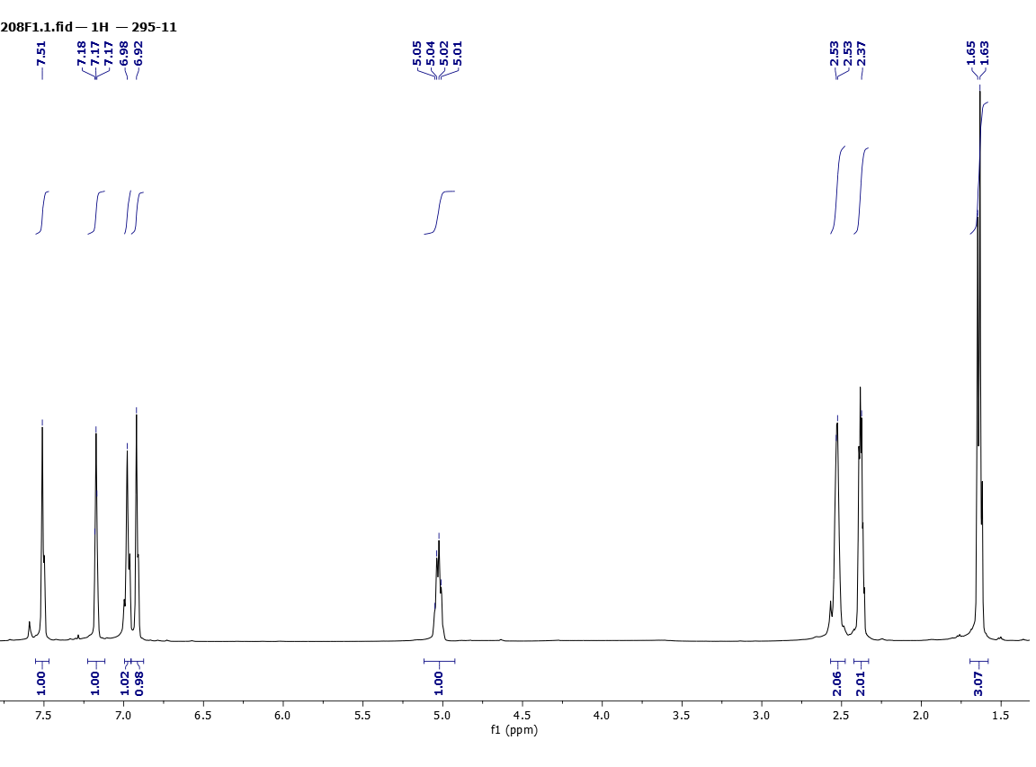

Figure 7. 1H NMR (500 MHz, CDCl3) spectra of **6d**

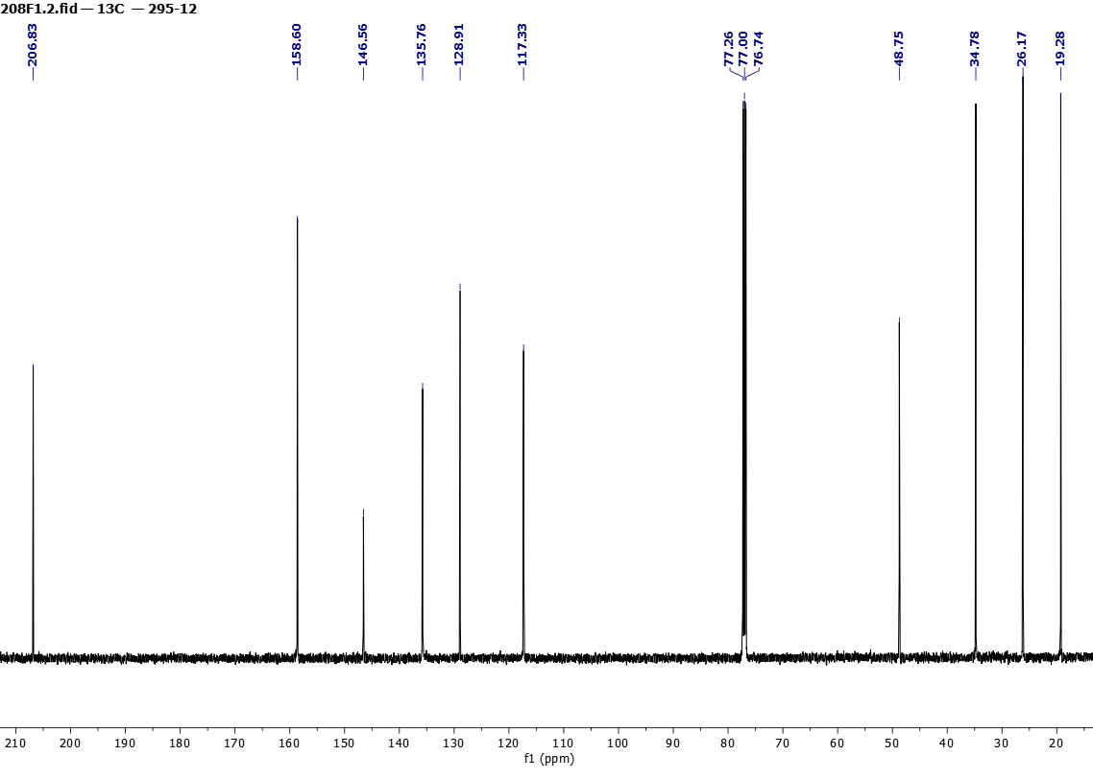

Figure 8. 13C NMR (125 MHz, CDCl3) spectra of **6d**



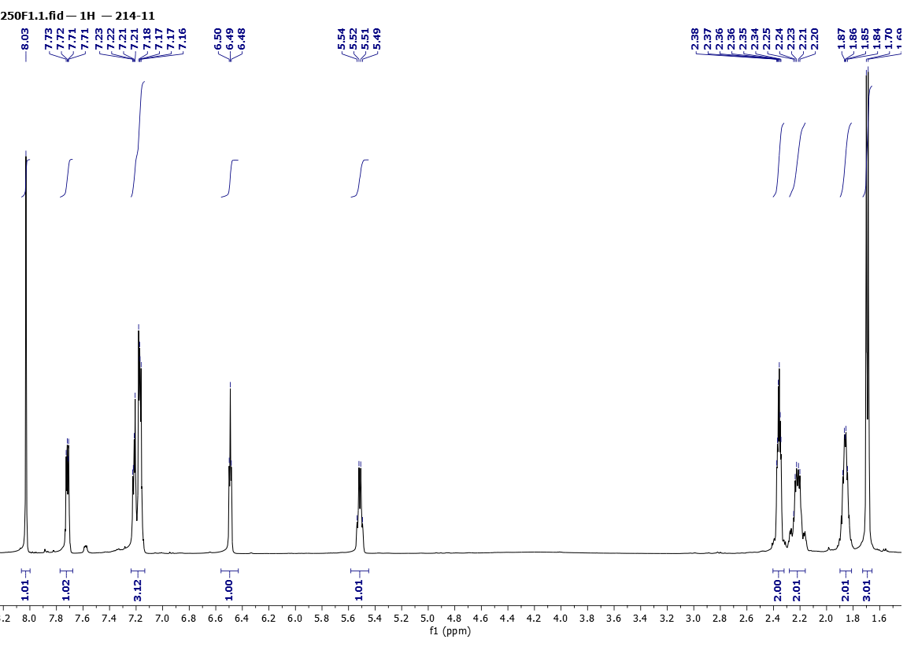

Figure 9. 1H NMR (500 MHz, CDCl3) spectra of **7a**

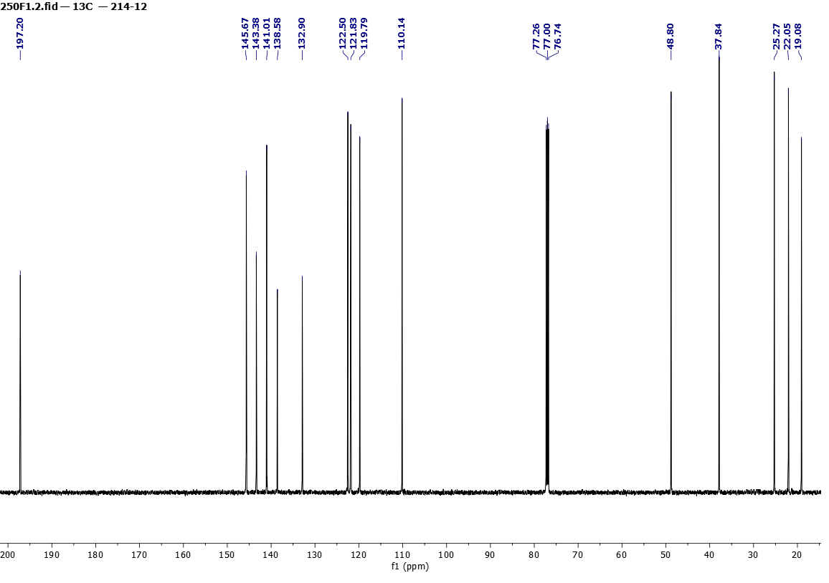

Figure 10. 13C NMR (125 MHz, CDCl3) spectra of **7a**



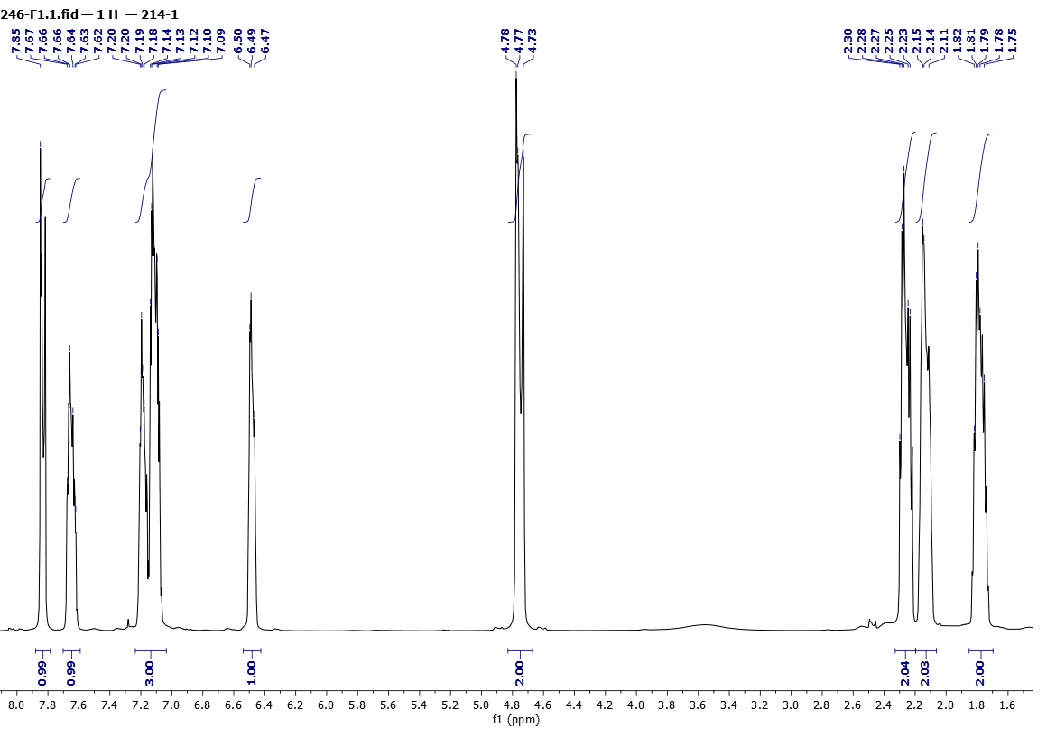

Figure 11. 1H NMR (500 MHz, CDCl3) spectra of **7b**



Figure 12. 13C NMR (125 MHz, CDCl3) spectra of **7b**





Figure 13. 1H NMR (500 MHz, CDCl3) spectra of **7c**



Figure 14. 13C NMR (125 MHz, CDCl3) spectra of **7c**



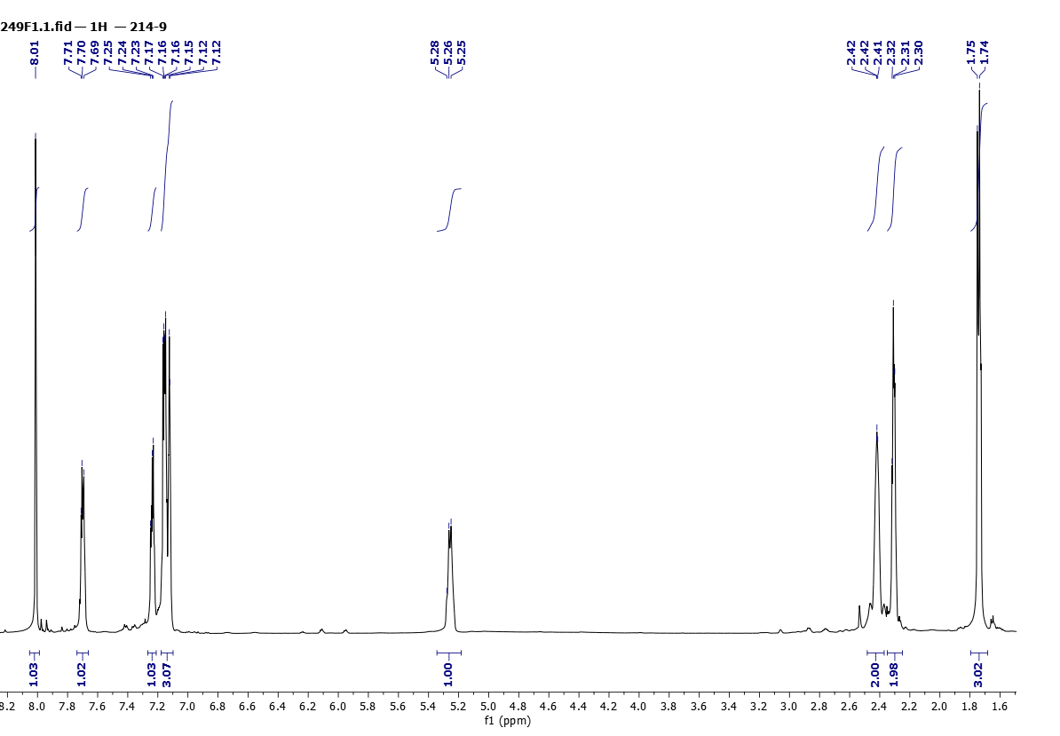

Figure 15. 1H NMR (500 MHz, CDCl3) spectra of **7d**

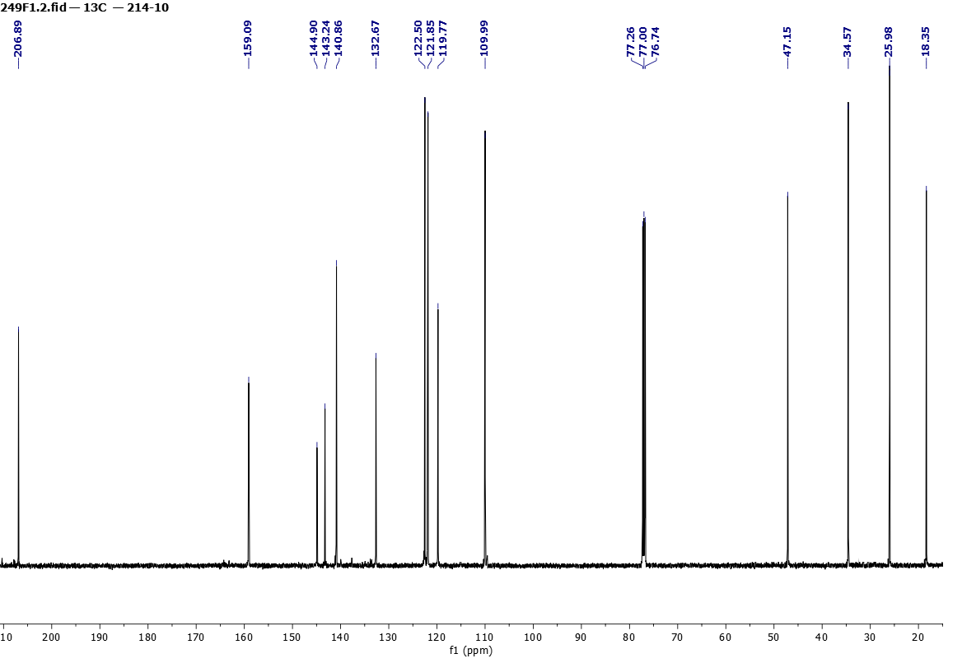

Figure 16. 13C NMR (125 MHz, CDCl3) spectra of **7d**



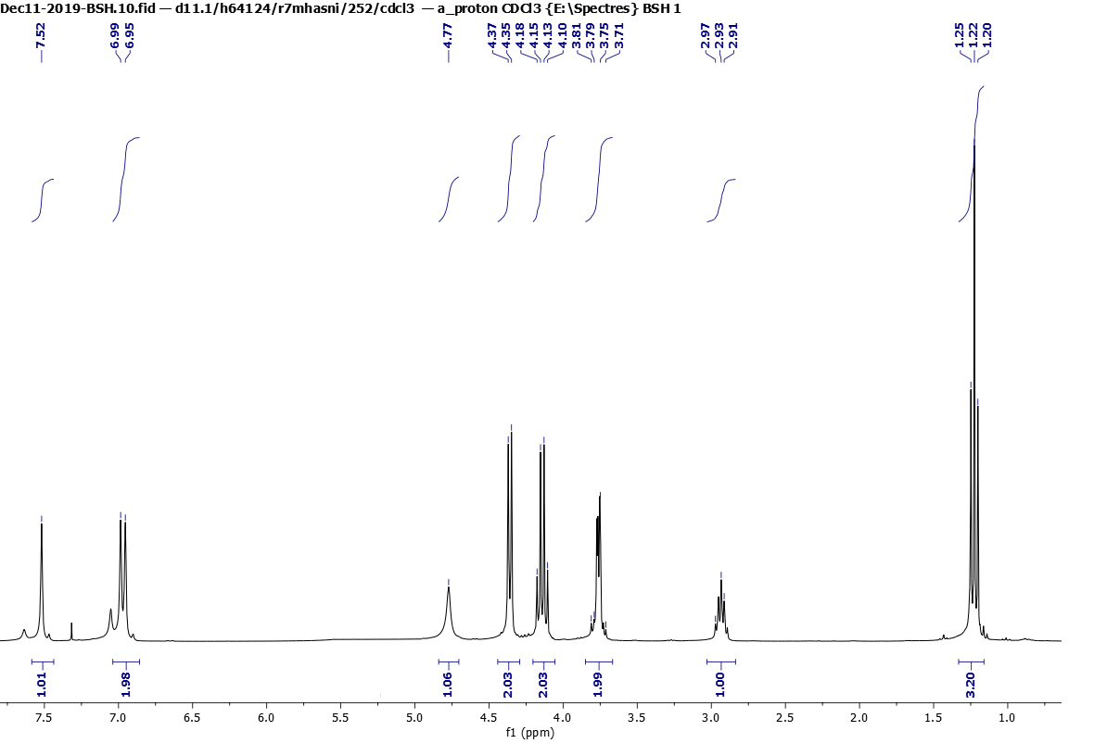

Figure 17. 1H NMR (300 MHz, CDCl3) spectra of **8a**



Figure 18. 13C NMR (75 MHz, CDCl3) spectra of **8a**



Figure 19. dept 135 NMR (75 MHz, CDCl3) spectra of **8a**



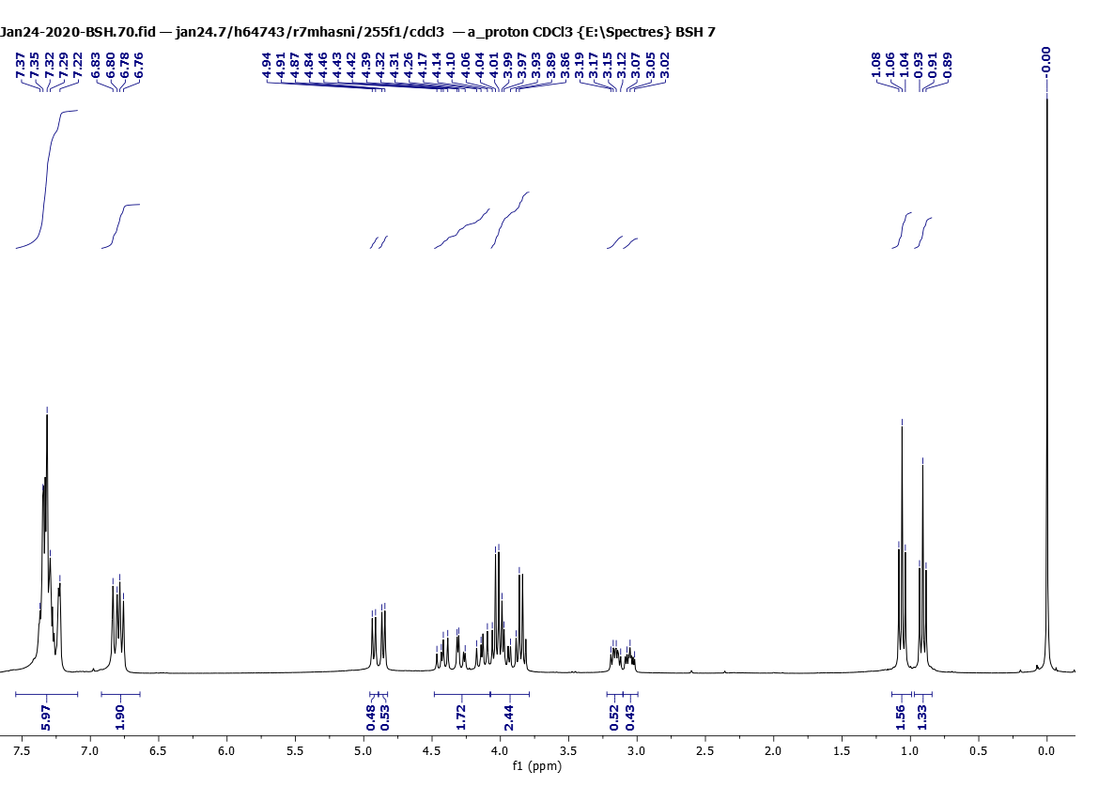

Figure 20. 1H NMR (300 MHz, CDCl3) spectra of **8b**



Figure 21. 13C NMR (75 MHz, CDCl3) spectra of **8b**



Figure 22. dept 135 NMR (75 MHz, CDCl3) spectra of **8b**





Figure 23. 1H NMR (300 MHz, CDCl3) spectra of **8c**



Figure 24. 13C NMR (75 MHz, CDCl3) spectra of **8c**



Figure 25. dept 135 NMR (75 MHz, CDCl3) spectra of **8c**



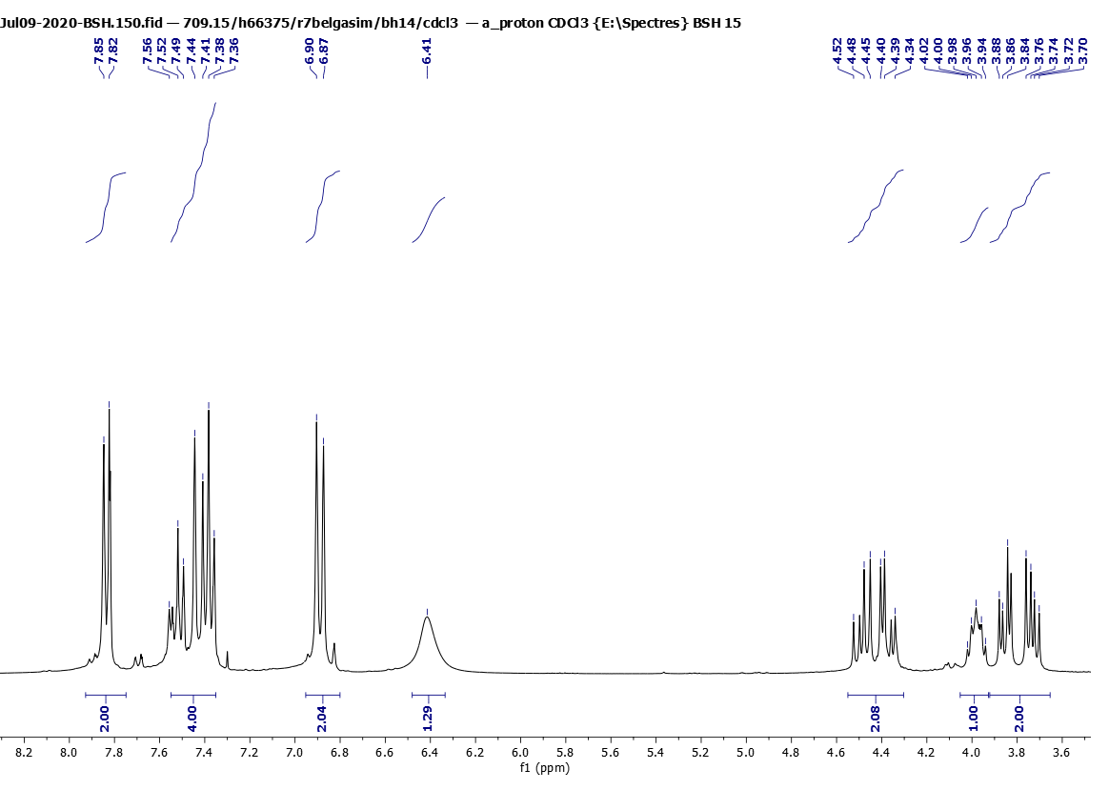

Figure 26. 1H NMR (300 MHz, CDCl3) spectra of **8d**



Figure 27. 13C NMR (75 MHz, CDCl3) spectra of **8d**



Figure 28. dept 135 NMR (75 MHz, CDCl3) spectra of **8d**



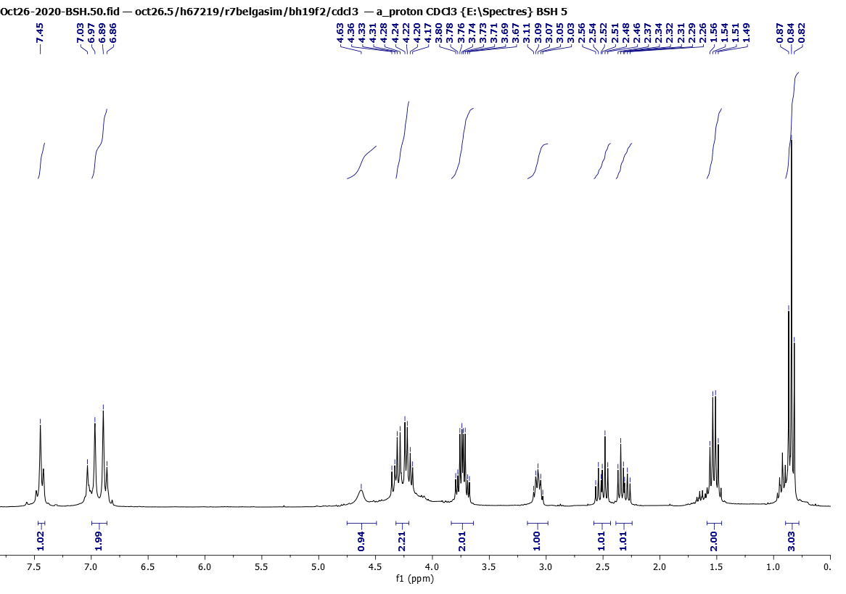

Figure 29. 1H NMR (300 MHz, CDCl3) spectra of **8e**

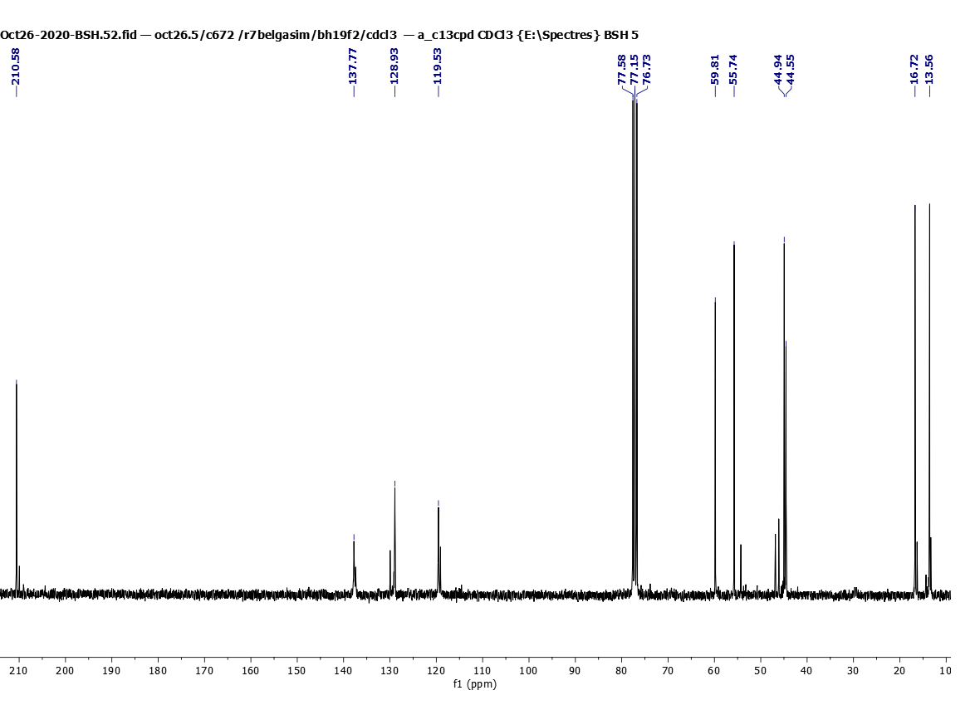

Figure 30. 13C NMR (75 MHz, CDCl3) spectra of **8e**

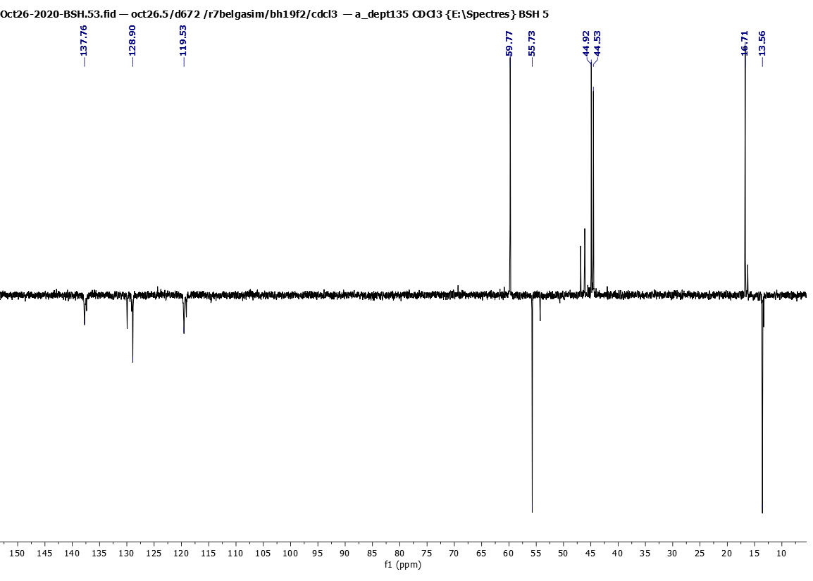

Figure 31. dept 135 NMR (75 MHz, CDCl3) spectra of **8e**



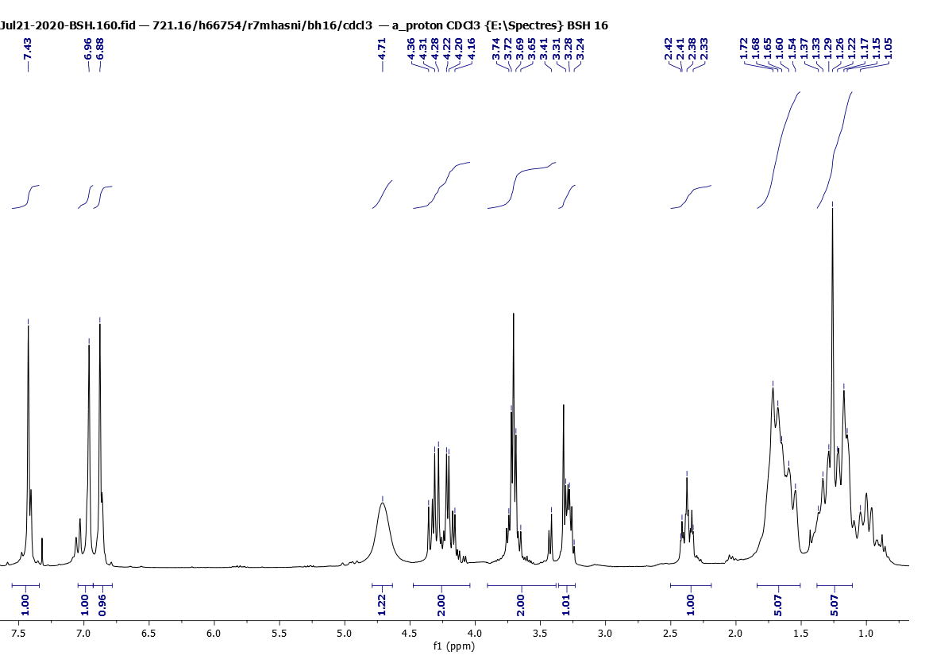

Figure 32. 1H NMR (300 MHz, CDCl3) spectra of **8f**

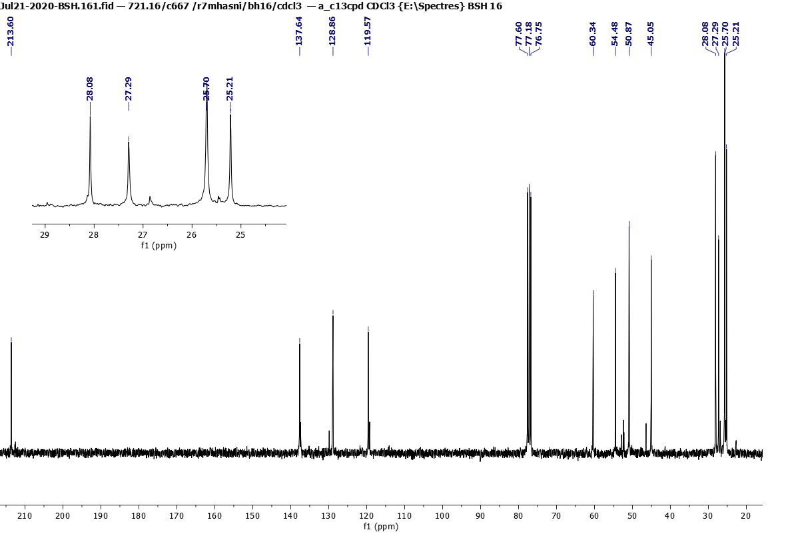

Figure 33. 13C NMR (75 MHz, CDCl3) spectra of **8f**

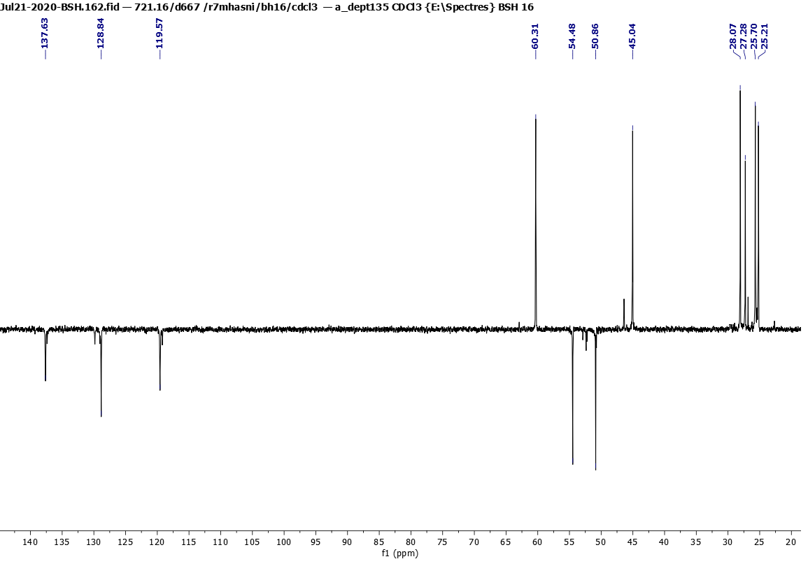

Figure 34. dept 135 NMR (75 MHz, CDCl3) spectra of **8f**

**ESI-HRMS spectra for compounds 6a-d, 7a-d, 8a-f**



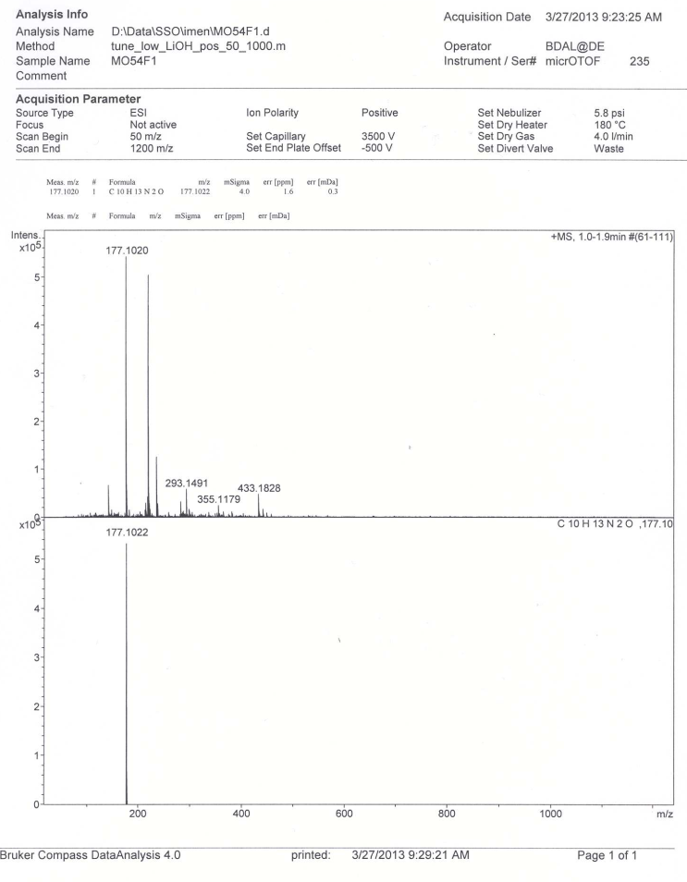

Figure 35. ESI-HRMS spectra of **6a**



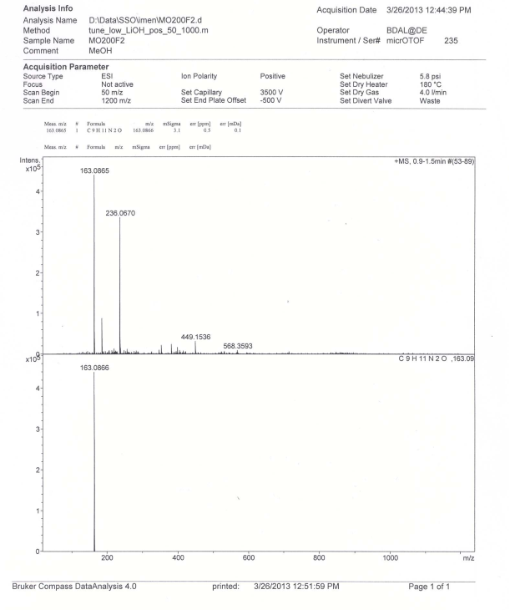

Figure 36. ESI-HRMS spectra of **6b**



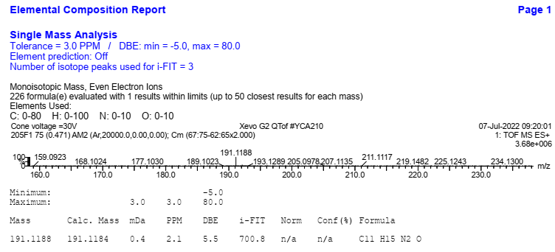

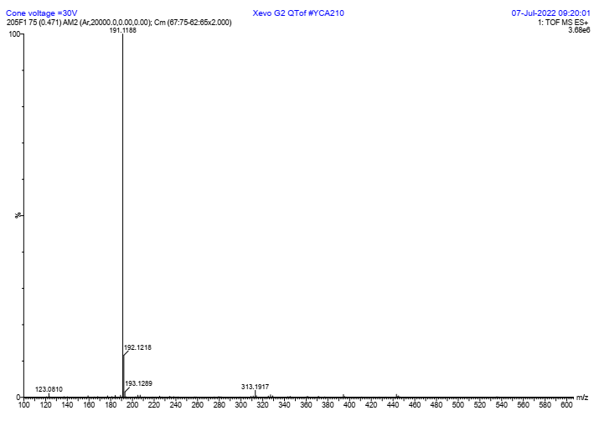

Figure 37. ESI-HRMS spectra of **6c**



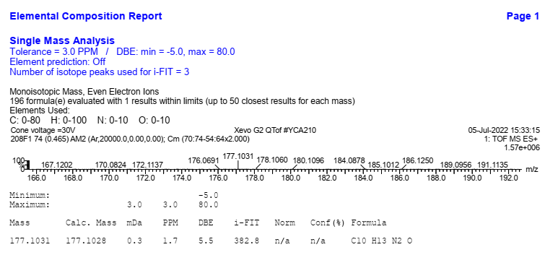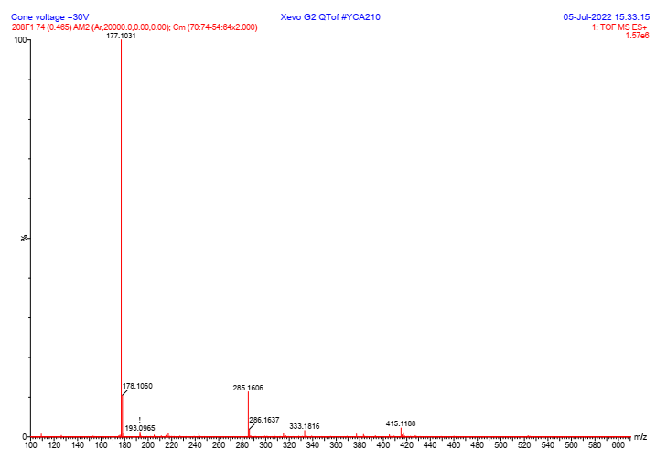

Figure 38. ESI-HRMS spectra of **6d**



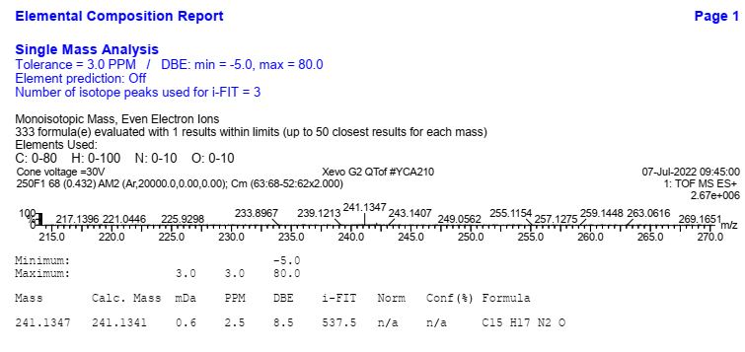

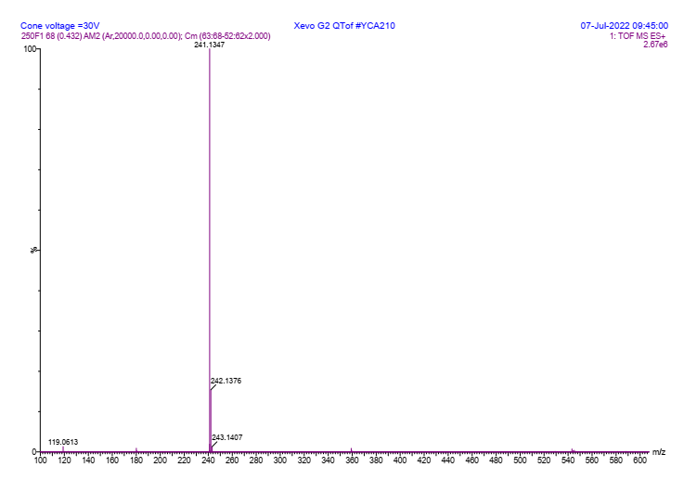

Figure 39. ESI-HRMS spectra of **7a**



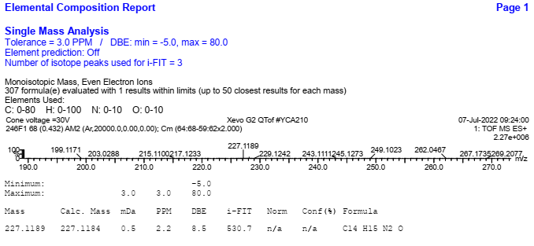

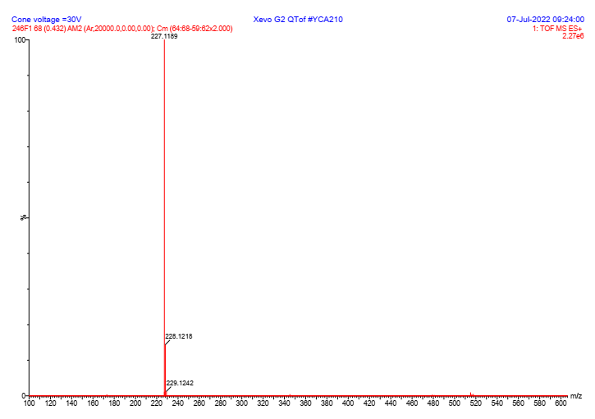

Figure 40. ESI-HRMS spectra of **7b**



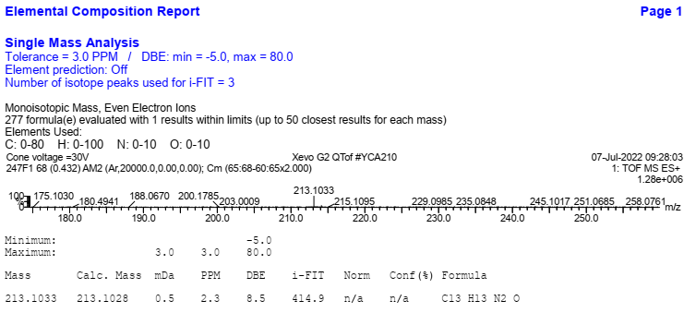

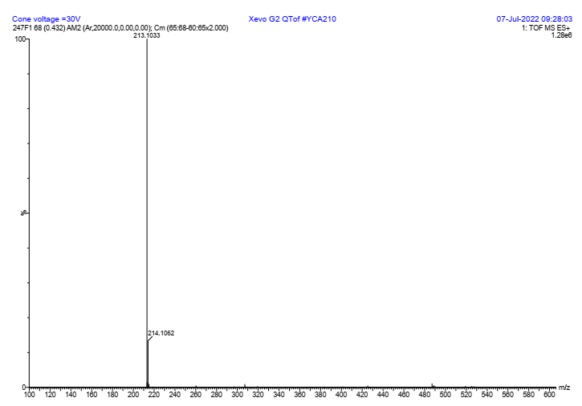

Figure 41. ESI-HRMS spectra of **7c**



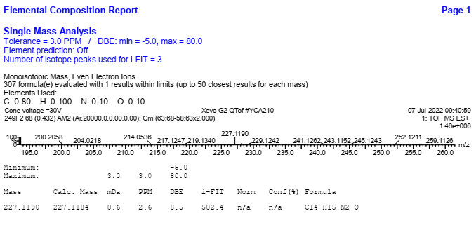

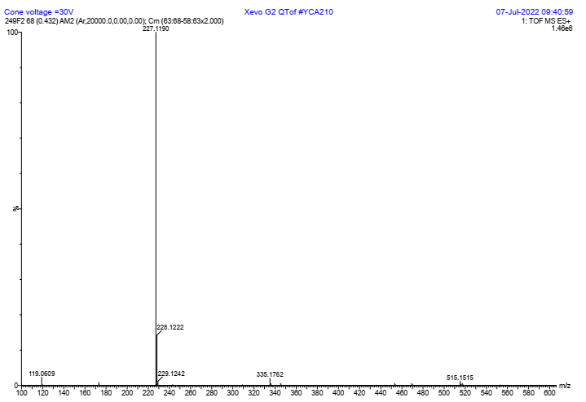

Figure 42. ESI-HRMS spectra of **7d**



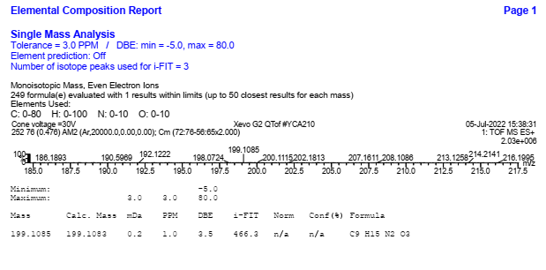

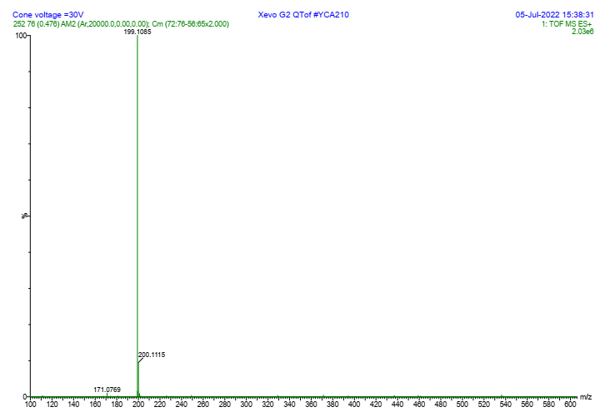

Figure 43. ESI-HRMS spectra of **8a**



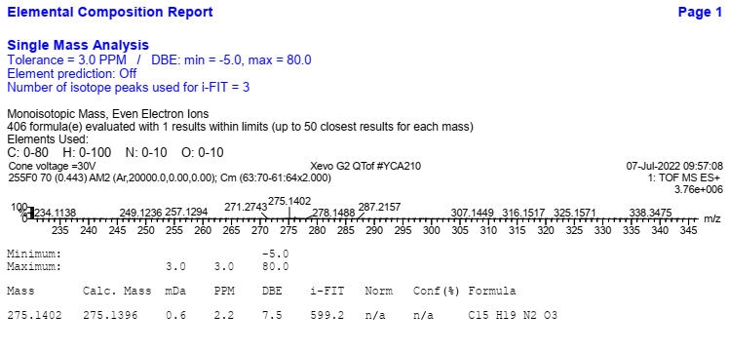

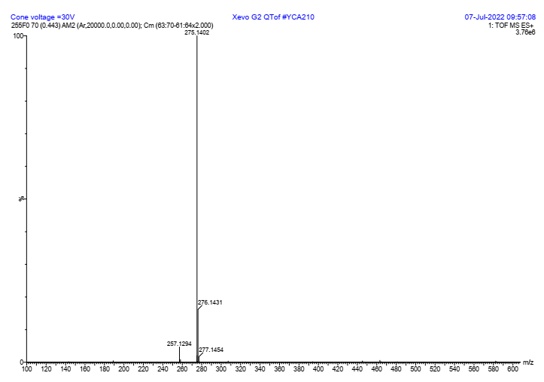

Figure 44. ESI-HRMS spectra of **8b**



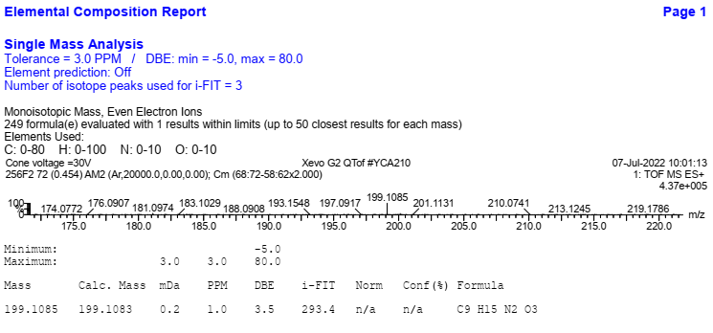

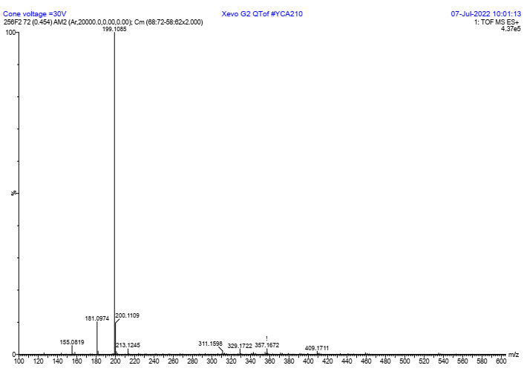

Figure 45. ESI-HRMS spectra of **8c**



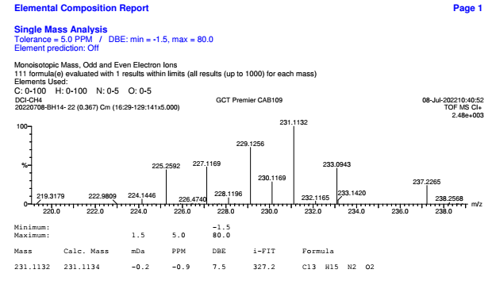

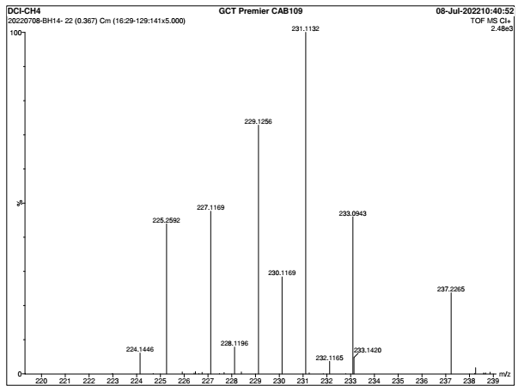

Figure 46. ESI-HRMS spectra of **8d**



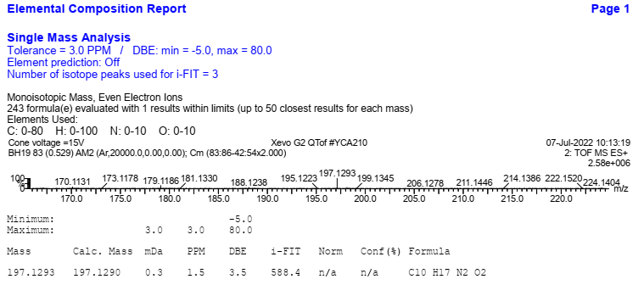

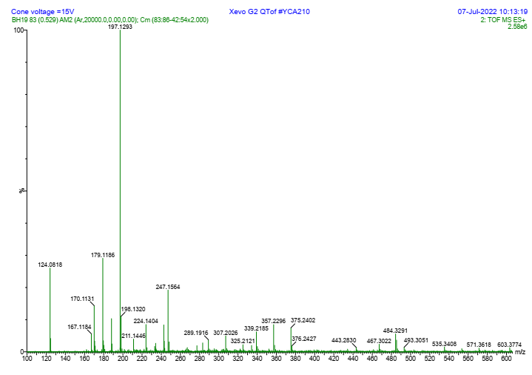

Figure 47. ESI-HRMS spectra of **8e**



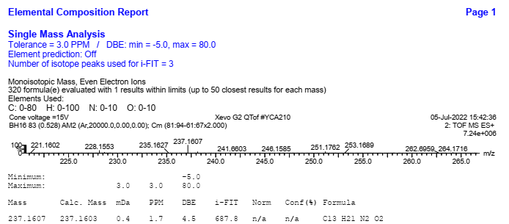

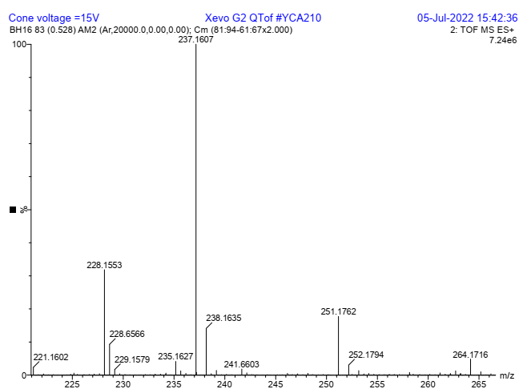

Figure 48. ESI-HRMS spectra of **8f**