Supporting Information for:

Tuning the photophysical property of naphthalimide-phenothiazine dyads by variation of the electron donating and accepting capability: synthesis and study of the intersystem crossing and thermally-activated delayed fluorescence

Liyuan Cao^{‡1}, Xi Liu^{‡2}, Xue Zhang^{‡1}, Jianzhang Zhao*¹, Fabiao Yu*³ and Yan Wan*²
¹State Key Laboratory of Fine Chemicals, Frontier Science Center for Smart Materials, School of Chemical Engineering, Dalian University of Technology, 2 Ling Gong Road, Dalian, 116024, P. R. China. E-mail: zhaojzh@dlut.edu.cn
²College of Chemistry, Beijing Normal University, Beijing 100875, P. R. China. E-mail: wanyan@bnu.edu.cn
³Key Laboratory of Hainan Trauma and Disaster Rescue, The First Affiliated Hospital of Hainan Medical University, Hainan Medical University, Haikou 571199, P. R. China. E-mail: yufabiao@hainmc.edu.cn

Experimental procedures, characterization data, ¹H and ¹³C NMR spectra of compounds, mass spectra and Spectral data

Table of Contents
1. General information……………………………………………………………………S2
2. Synthesis of the compounds……………………………………………………………S2
3. Molecular structure characterization data……………………………………………S5
4. Steady state UV−vis absorption and luminescence spectra………………………S19
5. Fluorescence lifetimes…………………………………………………………………S21
6. Femtosecond transient absorption spectroscopy……………………………………S22
7. Nanosecond transient absorption spectroscopy……………………………………S22
8. Theoretical computation……………………………………………………………S24
9. Coordinates of the optimized geometries of the compounds……………………S27

1. General information
All the chemicals used in synthesis are analytically pure and were used as received. Solvents were dried and distilled prior to use. ¹H and ¹³C NMR spectra were recorded on the Bruker Avance spectrometers (400 / 500 MHz). ¹H and ¹³C chemical shifts are reported in parts per million (ppm) relative to TMS, with the residual solvent peak used as an internal reference. The mass spectra were measured by HRMS (MALDI-TOF, recorded on the Bruker Ultraflextreme mass spectrometer) and HRMS (ESI-TOF, recorded on the Agilent G6224A mass spectrometer). UV−vis absorption spectra were measured on a UV-2550 UV−vis spectrophotometer (Shimadzu Ltd., Japan). Fluorescence spectra were recorded with an FS5 spectrofluorometer (Edinburgh instruments, UK). Luminescence lifetimes of compounds were recorded with an OB920 luminescence lifetime spectrometer (Edinburgh Instruments, U.K.). All these calculations were performed with Gaussian 09W [1]. Natural transition orbital analysis was performed by the Multiwfn program [2].

2. Synthesis of the compounds
2.1. Synthesis of NI-PTZ-C₅. NI-PTZ-C₅ was synthesized with a method similar to that of NI-PTZ-F. The crude product was purified by column chromatography (silica gel, DCM:PE = 1:2, v:v). The product was obtained as orange solid. Yield: 20 mg (46%). M.p.: 110.5−111.6 °C. ¹H NMR (CDCl₃, 400 MHz) δ: 8.82 (d, J = 7.76 Hz, 1H), 8.65 (d, J = 6.38 Hz, 1H), 8.52 (d, J = 9.26 Hz, 1H), 7.94 (d, J = 7.63 Hz, 1H), 7.71−7.75 (m, 1H), 7.09 (d, J = 7.50 Hz, 2H), 6.74−6.86 (m, 4H), 6.04 (d, J = 7.50 Hz, 2H), 4.22 (t, J = 15.26 Hz, 2H), 1.74−1.81 (m, 2H), 1.47 (t, J = 28.02 Hz, 4H), 0.94 (t, J = 14.01 Hz, 3H). HRMS (ESI, m/z) calcd for C₂₉H₂₄N₂O₂S [M+H]⁺, 465.1558, found 465.1623.
2.2. Synthesis of NI-PTZ-Ph-O. NI-PTZ-Ph-O was synthesized with a method similar to that of NI-PTZ-F-O. The crude product was purified by column chromatography (silica gel, DCM:MeOH = 50:1, v:v). NI-PTZ-Ph-O was obtained as yellow solid. Yield: 40 mg (82%). M.p.: 176.2−177.2 °C. ¹H NMR (CDCl₃, 400 MHz) δ: 8.86 (d, J = 7.62 Hz, 1H), 8.70 (d, J = 7.62 Hz, 1H), 8.57 (d, J = 7.63 Hz, 1H), 7.99 (d, J = 7.63 Hz, 1H), 7.77−7.80 (m, 1H), 7.57−7.60 (m, 2H), 7.51−7.54 (m, J = 8.26 Hz, 1H), 7.35 (d, J = 7.25 Hz, 2H), 7.11 (d, J = 7.49 Hz, 2H), 6.77−6.87 (m, 4H), 6.49 (d, J = 7.73 Hz, 2H). ¹³C NMR (CDCl₃, 125 MHz) δ: 163.61, 163.24, 140.63, 133.41, 132.66, 131.86, 130.61, 129.86, 129.50, 129.24, 123.73, 123.58, 122.99, 116.66. HRMS (ESI, m/z) calcd for C₃₀H₁₈N₂O₃S [M+H]⁺, 487.1038, found 487.1054.
2.3. Synthesis of NI-PTZ-C₅-O. NI-PTZ-C₅-O was synthesized with a method similar to that of NI-PTZ-Ph-O. The crude product was purified by column chromatography (silica gel, DCM:MeOH = 50:1, v:v). NI-PTZ-C₅-O was obtained as yellow solid. Yield: 34 mg (69%). M.p.: 120.1−121.3 °C. ¹H NMR (CDCl₃, 400 MHz) δ: 8.81 (d, J = 7.76 Hz, 1H), 8.60 (d, J = 7.76 Hz, 1H), 8.52 (d, J = 7.75 Hz, 1H), 7.94 (d, J = 7.63 Hz, 1H), 7.71−7.75 (m, 1H), 7.07 (d, J = 7.50 Hz, 2H), 6.74−6.84 (m, 4H), 6.49 (d, J = 7.52 Hz, 2H), 4.22 (t, J = 15.26 Hz, 2H), 1.74−1.81 (m, 2H), 1.43 (s, 4H), 0.94 (t, J = 14.02 Hz, 3H). ¹³C NMR (CDCl₃, 125 MHz) δ: 163.55, 163.18, 140.33, 133.21, 132.49, 131.52, 130.38, 129.66, 129.15, 128.97, 123.71, 123.50, 122.93, 116.86, 40.74, 29.24, 27.82, 22.45, 14.01. HRMS (ESI, m/z) calcd for C₂₉H₂₄N₂O₃S [M+H]⁺, 481.1508, found 481.1512.
2.4. Synthesis of F-NI-Br. Compound F-NI-Br was synthesized in a manner similar to the reported literature [3]. A mixture of 4-bromo-1, 8-naphthalene anhydride (500 mg, 1.8 mmol) and 4-fluoroaniline (1.7 mL, 18.1 mmol) was dissolved in acetic acid (21 mL). The solution was refluxed under nitrogen overnight. After cooling to room temperature, the mixture was poured into water (30 mL). The precipitate was filtered and recrystallized to afford compound F-NI-Br as a yellow crystal. Yield: 480 mg (72%). M.p.: 98.8−99.6 °C. ¹H NMR (CDCl₃, 400 MHz) δ: 8.64−8.72 (m, 2H), 8.46 (d, J = 7.75 Hz, 1H), 8.09 (m, J = 7.88 Hz, 1H), 7.88−7.92 (m, 1H), 7.56 (d, J = 7.75 Hz, 2H), 7.29−7.31 (m, 1H), 7.23 (d, J = 8.63 Hz, 1H).
2.5. Synthesis of Ph-NI-Br. Compound Ph-NI-Br was synthesized with a method similar to that of F-NI-Br. The precipitate was filtered and recrystallized to afford compound Ph-NI-Br as a yellow crystal. Yield: 565 mg (89%). M.p.: 96.5−97.3 °C. ¹H NMR (CDCl₃, 400 MHz) δ: 8.71 (d, J = 7.12 Hz, 1H), 8.65 (d, J = 8.51 Hz, 1H), 8.47 (d, J = 7.88 Hz, 1H), 8.09 (d, J = 7.75 Hz, 1H), 7.88−7.92 (m, 1H), 7.55−7.59 (m, 2H), 7.48−7.52 (m, 1H), 7.32 (d, J = 7.38 Hz, 2H).
2.6. Synthesis of CH₃-NI-Br. Compound CH₃-NI-Br was synthesized with a method similar to that of F-NI-Br The precipitate was filtered and recrystallized to afford compound CH₃-NI-Br as a yellow crystal. Yield: 520 mg (83%). M.p.: 100.3−100.9 °C. ¹H NMR (CDCl₃, 400 MHz) δ: 8.71 (d, J = 7.00 Hz, 1H), 8.64 (d, J = 8.51 Hz, 1H), 8.47 (d, J = 7.75 Hz, 1H), 8.08 (d, J = 7.75 Hz, 1H), 7.87−7.91 (m, 1H), 7.36 (d, J = 8.00 Hz, 2H), 7.20 (d, J = 8.13 Hz, 2H), 2.45 (s, 3H).
2.7. Synthesis of OCH₃-NI-Br. Compound OCH₃-NI-Br was synthesized with a method similar to that of F-NI-Br. The precipitate was filtered and recrystallized to afford compound OCH₃-NI-Br as a white crystal. Yield: 550 mg (75%). M.p.: 98.9−99.9 °C. ¹H NMR (CDCl₃, 400 MHz) δ: 8.54 (s, 2H), 8.29 (s, 1H), 7.76 (s, 1H), 7.52 (d, J = 4.63 Hz, 2H), 7.30 (s, 1H), 7.19−7.22 (m, 2H), 4.02 (t, J = 15.38 Hz, 3H).

3. Molecular structure characterization data
Figure S1. ¹H NMR spectrum of compound F-NI-Br in CDCl₃ (400 MHz), 25 °C.

Figure S2. ¹H NMR spectrum of compound Ph-NI-Br in CDCl₃ (400 MHz), 25 °C.
Figure S3. ¹H NMR spectrum of compound CH₃-NI-Br in CDCl₃ (400 MHz), 25 °C.

Figure S4. ¹H NMR spectrum of compound OCH₃-NI-Br in CDCl₃ (400 MHz), 25 °C.

Figure S5. ¹H NMR spectrum of compound NI-PTZ-F in CDCl₃ (400 MHz), 25 °C.

Figure S6. ESI-HRMS spectrum of NI-PTZ-F, 25 °C.

Figure S7. ¹³C NMR spectrum of NI-PTZ-F in CDCl₃ (125 MHz), 25 °C.

Figure S8. ¹H NMR spectrum of NI-PTZ-Ph in CDCl₃ (400 MHz), 25 °C.

Figure S9. ESI-HRMS spectrum of NI-PTZ-Ph, 25 °C.

Figure S10. ¹H NMR spectrum of NI-PTZ-CH₃ in CDCl₃ (400 MHz), 25 °C.

Figure S11. ESI-HRMS spectrum of NI-PTZ-CH₃, 25 °C.

Figure S12. ¹³C NMR spectrum of NI-PTZ-CH₃ in CDCl₃ (125 MHz), 25 °C.

Figure S13. ¹H NMR spectrum of NI-PTZ-OCH₃ in CDCl₃ (400 MHz), 25 °C.

Figure S14. ESI-HRMS spectrum of NI-PTZ-OCH₃, 25 °C.

Figure S15. ¹³C NMR spectrum of NI-PTZ-OCH₃ in CDCl₃ (125 MHz), 25 °C.

Figure S16. ¹H NMR spectrum of NI-PTZ-C₅ in CDCl₃ (400 MHz), 25 °C.

Figure S17. ESI-HRMS spectrum of NI-PTZ-C₅, 25 °C.

Figure S18. ¹H NMR spectrum of NI-PTZ-F-O in CDCl₃ (400 MHz), 25 °C.

Figure S19. MALDI-HRMS spectrum of NI-PTZ-F-O, 25 °C.

Figure S20. ¹³C NMR spectrum of NI-PTZ-F-O in CDCl₃ (125 MHz), 25 °C.

Figure S21. ¹H NMR spectrum of NI-PTZ-Ph-O in CDCl₃ (400 MHz), 25 °C.

Figure S22. MALDI-HRMS spectrum of NI-PTZ-Ph-O, 25 °C.

Figure S23. ¹³C NMR spectrum of NI-PTZ-Ph-O in CDCl₃ (125 MHz), 25 °C.

Figure S24. ¹H NMR spectrum of NI-PTZ-C₅-O in CDCl₃ (400 MHz), 25 °C.

Figure S25. MALDI-HRMS spectrum of NI-PTZ-C₅-O, 25 °C.

Figure S26. ¹³C NMR spectrum of NI-PTZ-C₅-O in CDCl₃ (125 MHz), 25 °C.

4. Steady state UV−vis absorption and luminescence spectra

Figure S27. UV−vis absorption spectra of NI-PTZ-F; NI-PTZ-Ph; NI-PTZ-CH₃; NI-PTZ-OCH₃ and NI-PTZ-C₅ in (a) cyclohexane (CHX); (b) toluene (TOL); (c) acetonitrile (ACN). NI-PTZ-F-O; NI-PTZ-Ph-O and NI-PTZ-C₅-O in (d) CHX; (e) TOL; (f) ACN. c = 1.0 × 10⁻⁵ M, 20 °C.

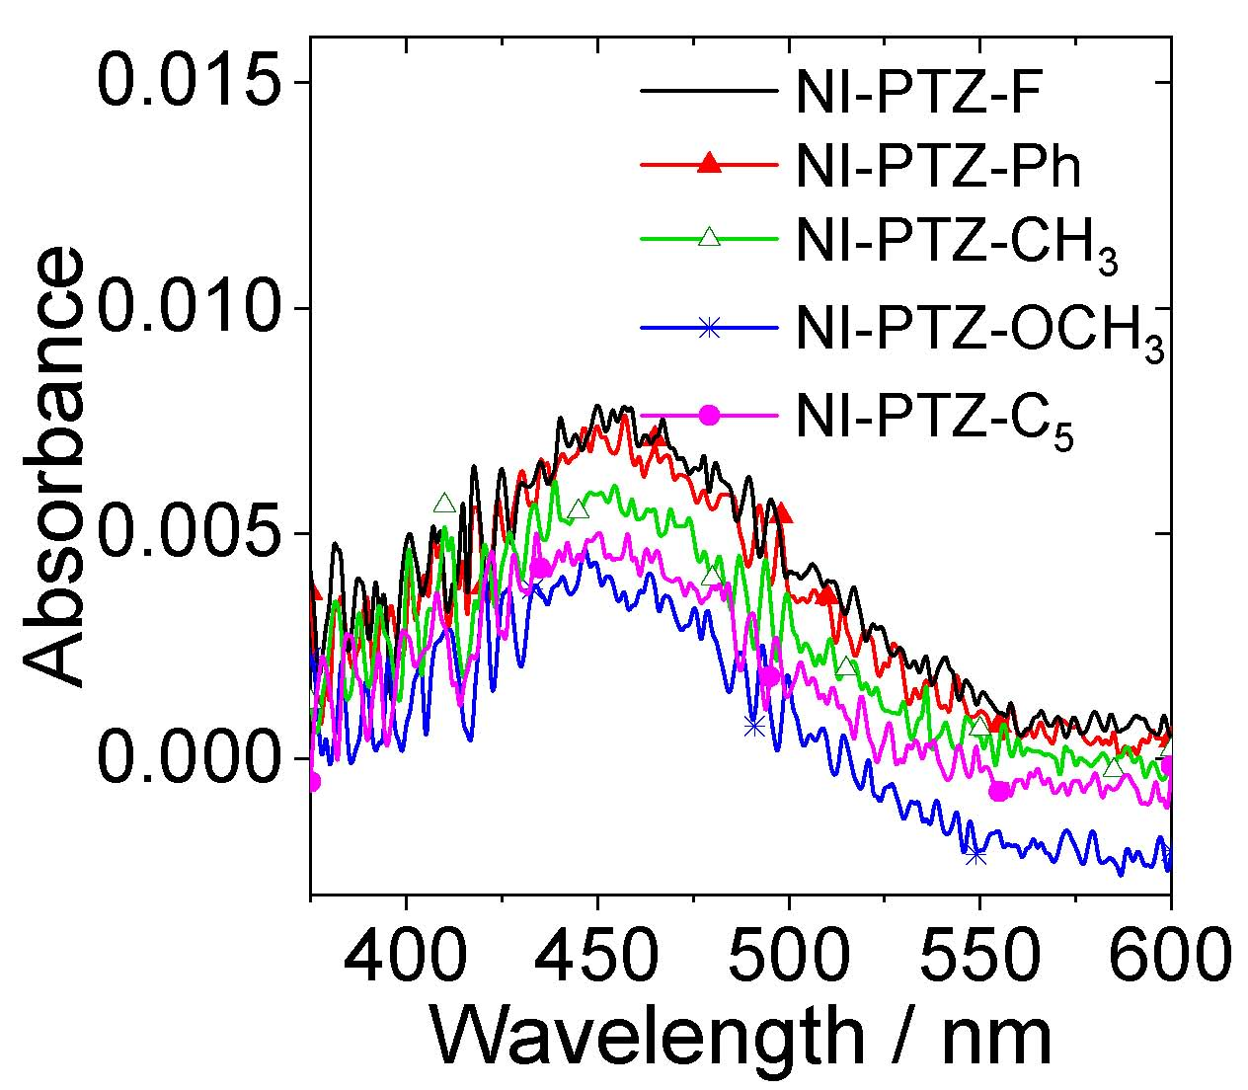
Figure S28. The CT absorption bands locally amplified spectra of NI-PTZ-F; NI-PTZ-Ph; NI-PTZ-CH₃; NI-PTZ-OCH₃ and NI-PTZ-C₅ in n-hexane (HEX). c = 1.0 × 10⁻⁵ M, 20 °C.

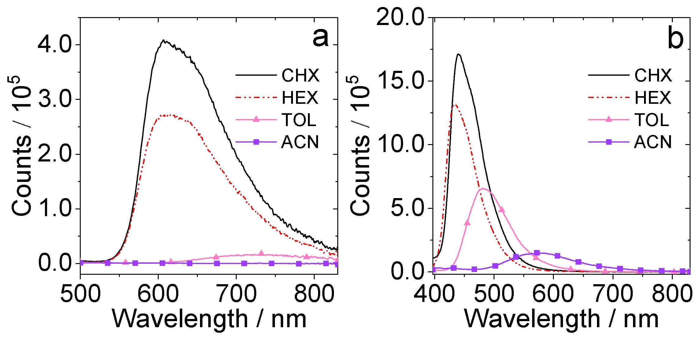
Figure S29. Fluorescence emission spectra of (a) NI-PTZ-C₅ and (b) NI-PTZ-C₅-O in different solvents. Optically-matched solutions were used, A = 0.107, λ_{ex} = 310 nm, 20 °C.

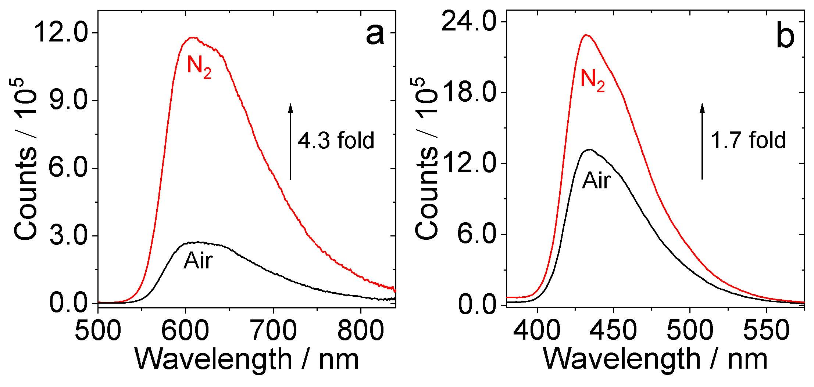
Figure S30. Fluorescence emission spectra of (a) NI-PTZ-C₅; (b) NI-PTZ-C₅-O in HEX. Under different atmospheres (N₂, air). Optically-matched solutions were used, A = 0.107, λ_{ex} = 310 nm, 20 °C.

5. Fluorescence lifetimes
Figure S31. Decay traces of the luminescence of (a) NI-PTZ-C₅ (λ_{em} = 610 nm, c = 1.0 × 10⁻⁵ M) and (b) NI-PTZ-C₅-O (λ_{em} = 440 nm, c = 2.0 × 10⁻⁵ M) in different atmosphere (N₂, Air) in HEX and (c) NI-PTZ-F-O (λ_{em} = 440 nm, c = 2.0 × 10⁻⁵ M) in ACN. Excited with picoseconds pulsed laser for fluorescence band (λ_{ex} = 340 nm), 20 °C.

6. Femtosecond transient absorption spectroscopy
Figure S32. Femtosecond transient absorption spectra of NI-PTZ-F. (a) Transient absorption spectra; (b) relative EADS obtained with global analysis in ACN. Femtosecond transient absorption spectra of NI-PTZ-F-O (c) Transient absorption spectra; (d) relative EADS obtained with global analysis in HEX. λ_{ex} = 340 nm.

7. Nanosecond transient absorption spectroscopy
Figure S33. Nanosecond transient absorption spectra of (a)NI-PTZ-Ph; (b) NI-PTZ-CH₃; (c) NI-PTZ-OCH₃; (d) NI-PTZ-C₅ and decay trace of (e)NI-PTZ-Ph; (f) NI-PTZ-CH₃; (g) NI-PTZ-OCH₃; (h) NI-PTZ-C₅ in deaerated HEX at 430 nm. c = 2.0 × 10⁻⁵ M, λ_{ex} = 355 nm.

Figure S34. Nanosecond transient absorption (ns-TA) spectra of (a) NI-PTZ-Ph; (b) NI-PTZ-CH₃; (c) NI-PTZ-OCH₃; (d)NI-PTZ-C₅ and Decay trace of (e) NI-PTZ-Ph; (f) NI-PTZ-CH₃; (g) NI-PTZ-OCH₃; (h)NI-PTZ-C₅ in deaerated ACN at 430 nm. c = 1.0 × 10⁻⁴ M, λ_{ex} = 355 nm.

Figure S35. Nanosecond transient absorption spectra of (a) NI-PTZ-F-O (c = 4.0 × 10⁻⁵ M); (b) NI-PTZ-Ph-O (c = 4.0 × 10⁻⁵ M); (c) NI-PTZ-C₅-O (c = 4.0 × 10⁻⁵ M) and (d) F-NI-Br (c = 2.0 × 10⁻⁵ M). The corresponding decay traces are (e) NI-PTZ-F-O (c = 4.0 × 10⁻⁵ M); (f) NI-PTZ-Ph-O (c = 4.0 × 10⁻⁵ M); (g) NI-PTZ-C₅-O (c = 4.0 × 10⁻⁵ M) and (h) F-NI-Br (c = 2.0 × 10⁻⁵ M) in deaerated HEX at 460 nm. λ_{ex} = 355 nm, 20 °C.

8. Theoretical computation
Table S1. Optimized S₁ state geometry of NI-PTZ-F; NI-PTZ-Ph; NI-PTZ-CH₃; NI-PTZ-OCH₃; NI-PTZ-F-O; NI-PTZ-Ph-O and NI-PTZ-C₅-O. Calculated at the B3LYP/6-31G(d) level with Gaussian 09W.
Compounds | S₁
 | vacuum | HEX | ACN
NI-PTZ-F
NI-PTZ-Ph
NI-PTZ-CH₃
NI-PTZ-OCH₃
NI-PTZ-F-O
NI-PTZ-Ph-O
NI-PTZ-C₅-O

Table S2. Optimized T₁ state geometry of NI-PTZ-F; NI-PTZ-Ph; NI-PTZ-CH₃; NI-PTZ-OCH₃; NI-PTZ-F-O; NI-PTZ-Ph-O and NI-PTZ-C₅-O. Calculated at the B3LYP/6-31G(d) level with Gaussian 09W.
Compounds | T₁
 | vacuum | HEX | ACN
NI-PTZ-F
NI-PTZ-Ph
NI-PTZ-CH₃
NI-PTZ-OCH₃
NI-PTZ-F-O
NI-PTZ-Ph-O
NI-PTZ-C₅-O

Table S3. Spin density surfaces of the dyads at T₁ state in different solvents of (a) NI-PTZ-F; (b) NI-PTZ-Ph; (c) NI-PTZ-CH₃; (d) NI-PTZ-OCH₃; (e) NI-PTZ-F-O; (f) NI-PTZ- Ph-O; (g) NI-PTZ-C₅-O. Calculated at the B3LYP/6-31G(d) level with Gaussian 09W. Isovalues = 0.02.
Compounds | Solvents
 | CHX | TOL | DCM | ACN
NI-PTZ-F
NI-PTZ-Ph
NI-PTZ-CH₃
NI-PTZ-OCH₃
NI-PTZ-F-O | 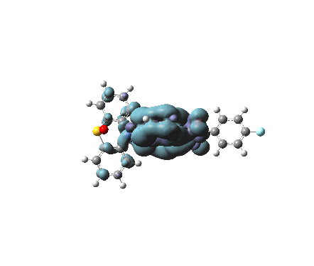 | 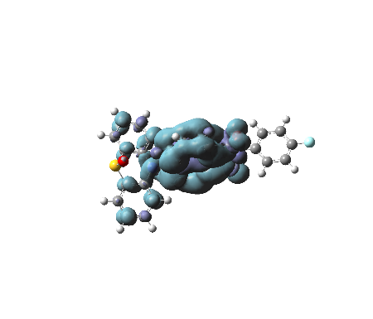 | 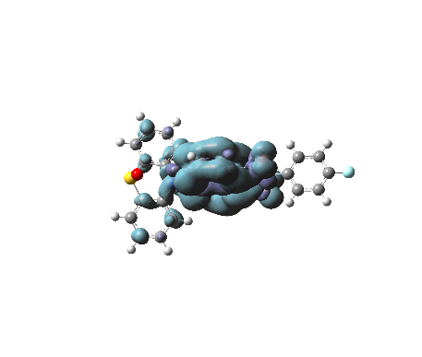 | 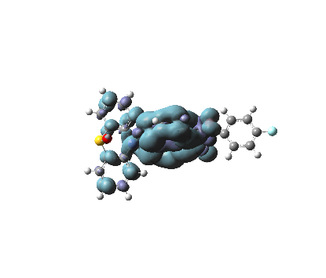
NI-PTZ-Ph-O | 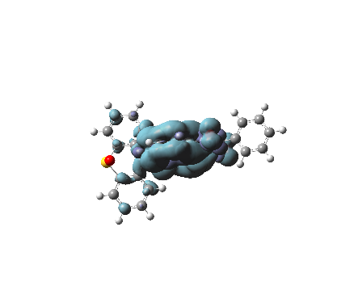 | 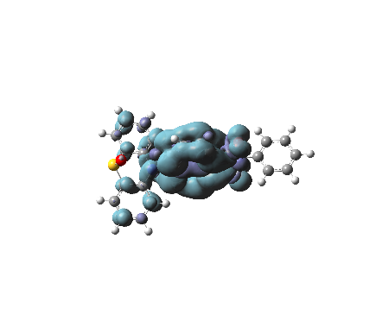 | 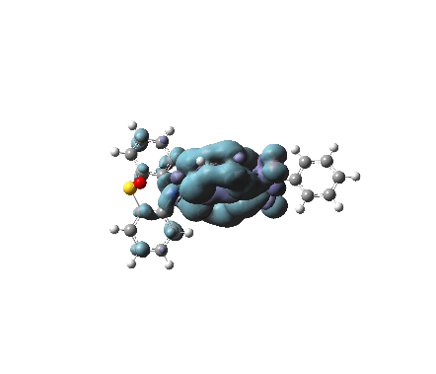 | 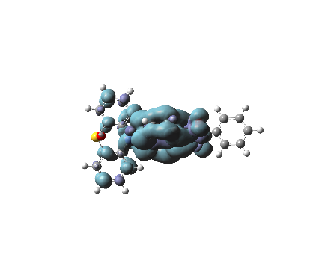
NI-PTZ-C₅-O | 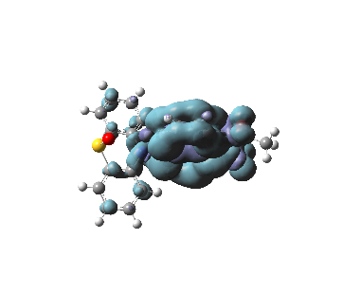 | 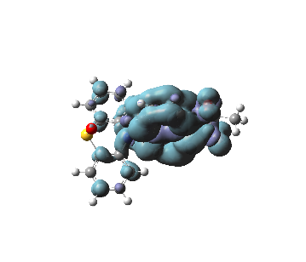 | 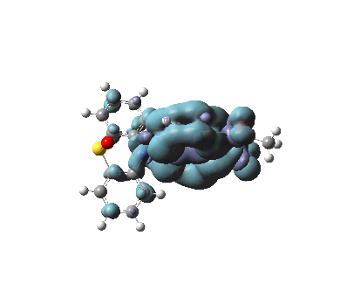 | 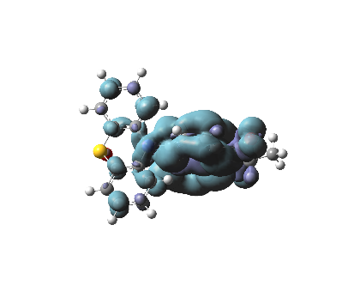

Figure S36. Selected frontier molecular orbitals of NI-PTZ-CH₃ and NI-PTZ-OCH₃ calculated by DFT at the B3LYP/6-31G(d) level with Gaussian 09W, based on the optimized ground state geometries, respectively. Isovalues = 0.02.

9. Coordinates of the optimized geometries of the compounds
Optimized ground state geometries, based on the DFT-B3LYP/6-31(G) level.

NI-PTZ-F
0 1
C 3.25043 -0.44951 -1.15381
C 3.58498 -0.67388 1.30216
C 1.78878 -0.31154 -0.92403
O 3.74425 -0.39252 -2.27263
C 2.12039 -0.53128 1.50107
O 4.36344 -0.81531 2.23561
C 0.94692 -0.13691 -2.00653
C 1.25745 -0.35596 0.38925
C 1.60309 -0.57028 2.78325
C -0.44215 -0.00589 -1.81212
H 1.3766 -0.10399 -3.00215
C -0.14988 -0.22189 0.59978
C 0.21506 -0.43918 2.99391
H 2.28722 -0.70412 3.61467
C -0.99163 -0.04644 -0.5418
H -1.09837 0.12948 -2.66656
C -0.64623 -0.2689 1.92929
C -2.5782 1.23999 2.69677
C -2.92282 -1.20715 2.53378
C -2.0283 2.34886 2.0368
C -3.66839 1.45311 3.5619
C -4.04599 -1.22188 3.38285
C -2.68698 -2.32976 1.72654
C -2.54898 3.628 2.2359
H -1.18252 2.21643 1.37314
C -4.21125 2.72864 3.72239
C -4.92262 -2.30767 3.38538
H -1.82432 -2.35146 1.07187
C -3.54401 -3.43021 1.76662
C -3.6469 3.82516 3.0705
H -2.09387 4.46913 1.72061
H -5.06653 2.85792 4.37964
C -4.67005 -3.42319 2.58688
H -5.7929 -2.2801 4.03501
H -3.32822 -4.29013 1.13881
H -4.06193 4.81788 3.21649
H -5.34549 -4.27308 2.60951
N -2.05935 -0.07478 2.5235
S -4.28821 0.10453 4.54776
H -2.04928 0.05386 -0.41449
H -0.17456 -0.47207 3.9899
C 5.00853 -1.06278 -0.37638
C 5.1944 -2.44391 -0.4354
C 6.03576 -0.20327 -0.76684
C 6.40799 -2.96589 -0.88478
H 4.38469 -3.1217 -0.12839
C 7.249 -0.72505 -1.21554
H 5.88893 0.8855 -0.72041
C 7.43515 -2.10649 -1.27416
H 6.55442 -4.05477 -0.93155
H 8.05879 -0.04767 -1.523
N 4.0522 -0.65109 -0.02225
F 8.60921 -2.61113 -1.70939

NI-PTZ-Ph
0 1
C 3.25043 -0.44951 -1.15381
C 3.58498 -0.67388 1.30216
C 1.78878 -0.31154 -0.92403
O 3.74425 -0.39252 -2.27263
C 2.12039 -0.53128 1.50107
O 4.36344 -0.81531 2.23561
C 0.94692 -0.13691 -2.00653
C 1.25745 -0.35596 0.38925
C 1.60309 -0.57028 2.78325
C -0.44215 -0.00589 -1.81212
H 1.3766 -0.10399 -3.00215
C -0.14988 -0.22189 0.59978
C 0.21506 -0.43918 2.99391
H 2.28722 -0.70412 3.61467
C -0.99163 -0.04644 -0.5418
H -1.09837 0.12948 -2.66656
C -0.64623 -0.2689 1.92929
C -2.5782 1.23999 2.69677
C -2.92282 -1.20715 2.53378
C -2.0283 2.34886 2.0368
C -3.66839 1.45311 3.5619
C -4.04599 -1.22188 3.38285
C -2.68698 -2.32976 1.72654
C -2.54898 3.628 2.2359
H -1.18252 2.21643 1.37314
C -4.21125 2.72864 3.72239
C -4.92262 -2.30767 3.38538
H -1.82432 -2.35146 1.07187
C -3.54401 -3.43021 1.76662
C -3.6469 3.82516 3.0705
H -2.09387 4.46913 1.72061
H -5.06653 2.85792 4.37964
C -4.67005 -3.42319 2.58688
H -5.7929 -2.2801 4.03501
H -3.32822 -4.29013 1.13881
H -4.06193 4.81788 3.21649
H -5.34549 -4.27308 2.60951
N -2.05935 -0.07478 2.5235
S -4.28821 0.10453 4.54776
H -2.04928 0.05386 -0.41449
H -0.17456 -0.47207 3.9899
C 5.00853 -1.06278 -0.37638
C 5.1944 -2.44391 -0.4354
C 6.03576 -0.20327 -0.76684
C 6.40799 -2.96589 -0.88478
H 4.38469 -3.1217 -0.12839
C 7.249 -0.72505 -1.21554
H 5.88893 0.8855 -0.72041
C 7.43515 -2.10649 -1.27416
H 6.55442 -4.05477 -0.93155
H 8.05879 -0.04767 -1.523
H 8.39149 -2.51755 -1.62868
N 4.0522 -0.65109 -0.02225

NI-PTZ-CH₃
0 1
C 3.25043 -0.44951 -1.15381
C 3.58498 -0.67388 1.30216
C 1.78878 -0.31154 -0.92403
O 3.74425 -0.39252 -2.27263
C 2.12039 -0.53128 1.50107
O 4.36344 -0.81531 2.23561
C 0.94692 -0.13691 -2.00653
C 1.25745 -0.35596 0.38925
C 1.60309 -0.57028 2.78325
C -0.44215 -0.00589 -1.81212
H 1.3766 -0.10399 -3.00215
C -0.14988 -0.22189 0.59978
C 0.21506 -0.43918 2.99391
H 2.28722 -0.70412 3.61467
C -0.99163 -0.04644 -0.5418
H -1.09837 0.12948 -2.66656
C -0.64623 -0.2689 1.92929
C -2.5782 1.23999 2.69677
C -2.92282 -1.20715 2.53378
C -2.0283 2.34886 2.0368
C -3.66839 1.45311 3.5619
C -4.04599 -1.22188 3.38285
C -2.68698 -2.32976 1.72654
C -2.54898 3.628 2.2359
H -1.18252 2.21643 1.37314
C -4.21125 2.72864 3.72239
C -4.92262 -2.30767 3.38538
H -1.82432 -2.35146 1.07187
C -3.54401 -3.43021 1.76662
C -3.6469 3.82516 3.0705
H -2.09387 4.46913 1.72061
H -5.06653 2.85792 4.37964
C -4.67005 -3.42319 2.58688
H -5.7929 -2.2801 4.03501
H -3.32822 -4.29013 1.13881
H -4.06193 4.81788 3.21649
H -5.34549 -4.27308 2.60951
N -2.05935 -0.07478 2.5235
S -4.28821 0.10453 4.54776
H -2.04928 0.05386 -0.41449
H -0.17456 -0.47207 3.9899
C 5.00853 -1.06278 -0.37638
C 5.1944 -2.44391 -0.4354
C 6.03576 -0.20327 -0.76684
C 6.40799 -2.96589 -0.88478
H 4.38469 -3.1217 -0.12839
C 7.249 -0.72505 -1.21554
H 5.88893 0.8855 -0.72041
H 6.55296 -4.0548 -0.93548
H 8.06025 -0.04764 -1.51907
N 4.0522 -0.65109 -0.02225
C 8.44458 -2.46072 -1.29574
H 8.95908 -2.12533 -0.41955
H 8.4467 -3.53037 -1.32311
H 8.9374 -2.08069 -2.16615
C 7.43515 -2.10649 -1.27416

NI-PTZ-OCH₃
0 1
C 3.25043 -0.44951 -1.15381
C 3.58498 -0.67388 1.30216
C 1.78878 -0.31154 -0.92403
O 3.74425 -0.39252 -2.27263
C 2.12039 -0.53128 1.50107
O 4.36344 -0.81531 2.23561
C 0.94692 -0.13691 -2.00653
C 1.25745 -0.35596 0.38925
C 1.60309 -0.57028 2.78325
C -0.44215 -0.00589 -1.81212
H 1.3766 -0.10399 -3.00215
C -0.14988 -0.22189 0.59978
C 0.21506 -0.43918 2.99391
H 2.28722 -0.70412 3.61467
C -0.99163 -0.04644 -0.5418
H -1.09837 0.12948 -2.66656
C -0.64623 -0.2689 1.92929
C -2.5782 1.23999 2.69677
C -2.92282 -1.20715 2.53378
C -2.0283 2.34886 2.0368
C -3.66839 1.45311 3.5619
C -4.04599 -1.22188 3.38285
C -2.68698 -2.32976 1.72654
C -2.54898 3.628 2.2359
H -1.18252 2.21643 1.37314
C -4.21125 2.72864 3.72239
C -4.92262 -2.30767 3.38538
H -1.82432 -2.35146 1.07187
C -3.54401 -3.43021 1.76662
C -3.6469 3.82516 3.0705
H -2.09387 4.46913 1.72061
H -5.06653 2.85792 4.37964
C -4.67005 -3.42319 2.58688
H -5.7929 -2.2801 4.03501
H -3.32822 -4.29013 1.13881
H -4.06193 4.81788 3.21649
H -5.34549 -4.27308 2.60951
N -2.05935 -0.07478 2.5235
S -4.28821 0.10453 4.54776
H -2.04928 0.05386 -0.41449
H -0.17456 -0.47207 3.9899
C 5.00853 -1.06278 -0.37638
C 5.1944 -2.44391 -0.4354
C 6.03576 -0.20327 -0.76684
C 6.40799 -2.96589 -0.88478
H 4.38469 -3.1217 -0.12839
C 7.249 -0.72505 -1.21554
H 5.88893 0.8855 -0.72041
H 6.55296 -4.0548 -0.93548
H 8.06025 -0.04764 -1.51907
N 4.0522 -0.65109 -0.02225
C 7.43515 -2.10649 -1.27416
C 9.29695 -2.90693 -1.96161
H 9.92818 -3.11289 -1.12254
H 9.1177 -3.81185 -2.50371
H 9.77589 -2.19626 -2.60229
O 8.36605 -2.50671 -1.61788

NI-PTZ-C₅
0 1
N 4.0522 -0.65109 -0.02225
C 3.25043 -0.44951 -1.15381
C 3.58498 -0.67388 1.30216
C 1.78878 -0.31154 -0.92403
O 3.74358 -0.39689 -2.27304
C 2.12039 -0.53128 1.50107
O 4.36409 -0.81093 2.23583
C 0.94692 -0.13691 -2.00653
C 1.25745 -0.35596 0.38925
C 1.60309 -0.57028 2.78325
C -0.44215 -0.00589 -1.81212
H 1.3766 -0.10399 -3.00215
C -0.14988 -0.22189 0.59978
C 0.21506 -0.43918 2.99391
H 2.28722 -0.70412 3.61467
C -0.99163 -0.04644 -0.5418
H -1.09837 0.12948 -2.66656
C -0.64623 -0.2689 1.92929
C -2.5782 1.23999 2.69677
C -2.92282 -1.20715 2.53378
C -2.0283 2.34886 2.0368
C -3.66839 1.45311 3.5619
C -4.04599 -1.22188 3.38285
C -2.68698 -2.32976 1.72654
C -2.54898 3.628 2.2359
H -1.18252 2.21643 1.37314
C -4.21125 2.72864 3.72239
C -4.92262 -2.30767 3.38538
H -1.82432 -2.35146 1.07187
C -3.54401 -3.43021 1.76662
C -3.6469 3.82516 3.0705
H -2.09387 4.46913 1.72061
H -5.06653 2.85792 4.37964
C -4.67005 -3.42319 2.58688
H -5.7929 -2.2801 4.03501
H -3.32822 -4.29013 1.13881
H -4.06193 4.81788 3.21649
H -5.34549 -4.27308 2.60951
N -2.05935 -0.07478 2.5235
S -4.28821 0.10453 4.54776
C 5.50426 -0.8052 -0.23469
H 5.9145 -1.42067 0.53848
H 5.67894 -1.26341 -1.18571
H 5.97228 0.15672 -0.2109
H -2.04928 0.05386 -0.41449
H -0.17456 -0.47207 3.9899

NI-PTZ-F-O
0 1
C -10.32216 -0.56994 -2.05175
C -10.28176 0.81095 -1.86886
C -9.50737 1.35936 -0.84513
C -8.76467 0.53265 0.01219
C -8.80444 -0.86737 -0.17719
C -9.57768 -1.41431 -1.21758
C -7.98713 1.05893 1.05558
C -7.26603 0.21497 1.9018
C -7.30927 -1.16539 1.71531
C -8.0668 -1.71287 0.67157
C -8.15077 -3.20843 0.48324
N -8.42906 -3.57991 -0.90616
C -9.64335 -2.91346 -1.38302
O -8.005 -4.00805 1.3769
O -10.58977 -3.4972 -1.85503
C -7.67487 -4.41626 -1.64151
C -6.53504 -4.99787 -1.08652
C -5.75284 -5.86513 -1.84921
C -6.11058 -6.1508 -3.16675
C -7.25044 -5.56928 -3.72171
C -8.03261 -4.70193 -2.95905
N -7.93939 2.31182 1.23093
C -9.14759 2.95002 1.56353
C -9.20629 4.30892 1.91593
C -6.46769 4.28082 1.37133
C -6.68349 2.92472 1.07343
C -5.18149 4.82682 1.23803
C -4.10989 4.03412 0.82683
C -4.31369 2.68662 0.55143
C -5.58989 2.13542 0.68113
C -10.32359 2.18392 1.62263
C -11.54119 2.76072 1.98873
C -11.59739 4.11092 2.31593
C -10.43459 4.88072 2.28273
F -5.37035 -6.97153 -3.88845
H -10.94081 -0.9986 -2.85395
H -10.86108 1.46989 -2.53233
H -9.47889 2.45052 -0.70889
H -6.66258 0.64018 2.7173
H -6.74666 -1.82747 2.38994
H -6.25299 -4.77264 -0.04743
H -4.85387 -6.32376 -1.4116
H -7.53257 -5.79463 -4.76075
H -8.93154 -4.24324 -3.39669
H -5.01676 5.89147 1.46026
H -3.10707 4.47358 0.72082
H -3.47097 2.05594 0.23194
H -5.74131 1.066 0.47277
H -10.28451 1.11251 1.37655
H -12.45434 2.14812 2.01826
H -12.55556 4.5705 2.60001
H -10.48072 5.94753 2.54689
S -7.77189 5.37142 1.91563
O -6.62728 6.04414 1.21307

NI-PTZ-Ph-O
0 1
C -10.32216 -0.57252 -2.05402
C -10.28176 0.80837 -1.87113
C -9.50737 1.35678 -0.8474
C -8.76467 0.53007 0.00992
C -8.80444 -0.86995 -0.17946
C -9.57768 -1.41689 -1.21985
C -7.98713 1.05635 1.05331
C -7.26603 0.21238 1.89953
C -7.30927 -1.16797 1.71304
C -8.0668 -1.71545 0.66931
C -8.15077 -3.21101 0.48097
N -8.42906 -3.58249 -0.90843
C -9.64335 -2.91604 -1.38529
O -8.005 -4.01063 1.37463
O -10.58977 -3.49978 -1.8573
C -7.67487 -4.41884 -1.64378
C -6.53504 -5.00045 -1.08879
C -5.75284 -5.86771 -1.85148
C -6.11058 -6.15338 -3.16902
C -7.25044 -5.57186 -3.72398
C -8.03261 -4.70451 -2.96132
N -7.93939 2.30924 1.22866
C -9.14759 2.94744 1.56126
C -9.20629 4.30634 1.91366
C -6.46769 4.27824 1.36906
C -6.68349 2.92214 1.07116
C -5.18149 4.82424 1.23576
C -4.10989 4.03154 0.82456
C -4.31369 2.68404 0.54916
C -5.58989 2.13284 0.67886
C -10.32359 2.18134 1.62036
C -11.54119 2.75814 1.98646
C -11.59739 4.10834 2.31366
C -10.43459 4.87814 2.28046
H -10.94081 -1.00118 -2.85622
H -10.86108 1.46731 -2.5346
H -9.47889 2.44793 -0.71116
H -6.66258 0.6376 2.71503
H -6.74666 -1.83005 2.38767
H -6.25299 -4.77522 -0.0497
H -4.85387 -6.32634 -1.41387
H -5.49373 -6.83732 -3.77044
H -7.53257 -5.79721 -4.76302
H -8.93154 -4.24582 -3.39896
H -5.01676 5.88889 1.45799
H -3.10707 4.471 0.71855
H -3.47097 2.05336 0.22967
H -5.74131 1.06342 0.4705
H -10.28451 1.10993 1.37428
H -12.45434 2.14554 2.01599
H -12.55556 4.56792 2.59774
H -10.48072 5.94495 2.54462
S -7.77189 5.36884 1.91336
O -6.62728 6.04156 1.21081

NI-PTZ-C₅-O
0 1
C -10.32216 -0.17624 -1.82567
C -10.28176 1.20465 -1.64278
C -9.50737 1.75305 -0.61904
C -8.76467 0.92635 0.23827
C -8.80444 -0.47367 0.04889
C -9.57768 -1.02061 -0.9915
C -7.98713 1.45263 1.28166
C -7.26603 0.60866 2.12788
C -7.30927 -0.77169 1.94139
C -8.0668 -1.31917 0.89766
C -8.15077 -2.81473 0.70932
C -9.64335 -2.51976 -1.15694
O -8.00821 -3.61728 1.60302
O -10.58853 -3.10018 -1.63146
N -7.93939 2.70552 1.45701
C -9.14759 3.34372 1.78961
C -9.20629 4.70262 2.14201
C -6.46769 4.67452 1.59741
C -6.68349 3.31842 1.29951
C -5.18149 5.22052 1.46411
C -4.10989 4.42782 1.05291
C -4.31369 3.08032 0.77751
C -5.58989 2.52912 0.90721
C -10.32359 2.57762 1.84871
C -11.54119 3.15442 2.21481
C -11.59739 4.50462 2.54201
C -10.43459 5.27442 2.50881
H -10.94081 -0.60491 -2.62787
H -10.86108 1.86359 -2.30624
H -9.47889 2.84421 -0.4828
H -6.66258 1.03388 2.94338
H -6.74666 -1.43377 2.61602
H -5.01676 6.28517 1.68634
H -3.10707 4.86727 0.9469
H -3.47097 2.44964 0.45802
H -5.74131 1.4597 0.69885
H -10.28451 1.50621 1.60263
H -12.45434 2.54182 2.24434
H -12.55556 4.9642 2.82609
H -10.48072 6.34123 2.77297
S -7.77189 5.76512 2.14171
O -6.62728 6.43783 1.43916
C -8.42906 -3.18621 -0.68008
C -7.26333 -2.82377 -1.55212
H -8.61568 -4.28732 -0.70697
H -7.45554 -3.11895 -2.61217
H -7.07697 -1.72258 -1.52492
H -6.33603 -3.34317 -1.20802

References
[1] Frisch, M. J.; Trucks, G. W.; Schlegel, H. B.; Scuseria, G. E.; Robb, M. A.; Cheeseman, J. R.; Scalmani, G.; Barone, V.; Mennucci, B.; Petersson, G. A. Gaussian 09, Revision A.01; Gaussian, Inc.: Wallingford CT, 2009.
[2] Boonnab, S.; Chaiwai, C.; Nalaoh, P.; Manyum, T.; Namuangruk, S.; Chitpakdee, C.; Sudyoadsuk, T.; Promarak, V. Eur. J. Org. Chem. 2021, 2021, 2402. doi: org/10.1002/ejoc.202100134.
[3] Wang, B.; Zheng, Y.; Wang, T.; Ma, D.; Wang, Q. Org. Electron. 2021, 88, 106012. doi: org/10.1016/j.orgel.2020.106012

