# Supplementary Information

**Secondary metabolites of *Diaporthe* sp., isolated from the Cameroonian medicinal plant *Trema guineensis* (Schumach. & Thonn.)** **Ficalho**

Bel Youssouf G. Mountessou1, Élodie Gisèle M. Anoumedem1, Blondelle M. Kemkuignou2,3, Yasmina Marin-Felix2,3, Frank Surup2,3, Marc Stadler2,3, Simeon F. Kouam1,*

1*Department of Chemistry, Higher Teacher Training College, University of Yaoundé I, P.O. Box 47, Yaoundé, Cameroon*

2*Department of Microbial Drugs, Helmholtz Centre for Infection Research (HZI) and German Centre for Infection Research (DZIF), Partner Site Hannover/Braunschweig, Inhoffenstrasse 7, 38124 Braunschweig, Germany*

3*Institute of Microbiology, Technische Universität Braunschweig, Spielmannstraße 7, 38106 Braunschweig, Germany*

*Corresponding author email

Simeon F. Kouam (kfogue@yahoo.com)

D:\Diaporthe sp. MS\New TIFF images for Diaporthe sp MS\Diapositive1.TIF

Fig. S1. HPLC chromatogram (a) and positive ion mode HR-ESI-MS spectrum (b) of compound 1.



Fig. S2. 1H NMR spectrum of compound 1 (500 MHz, DMSO-*d*6).



Fig. S3. 13C NMR spectrum of compound 1 (125 MHz, DMSO-*d*6).

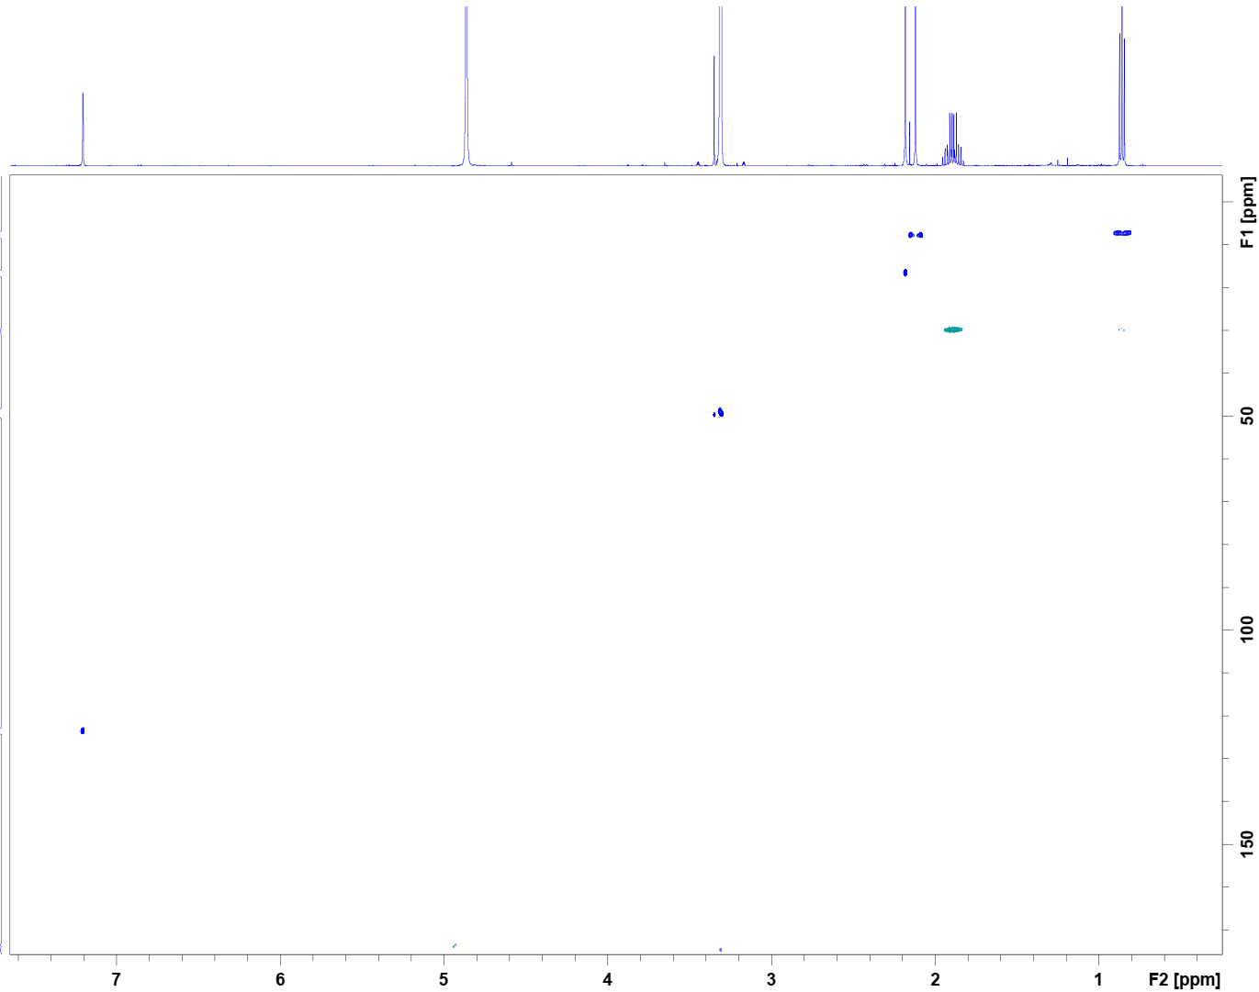

Fig. S4. HSQC-DEPT spectrum of compound 1.

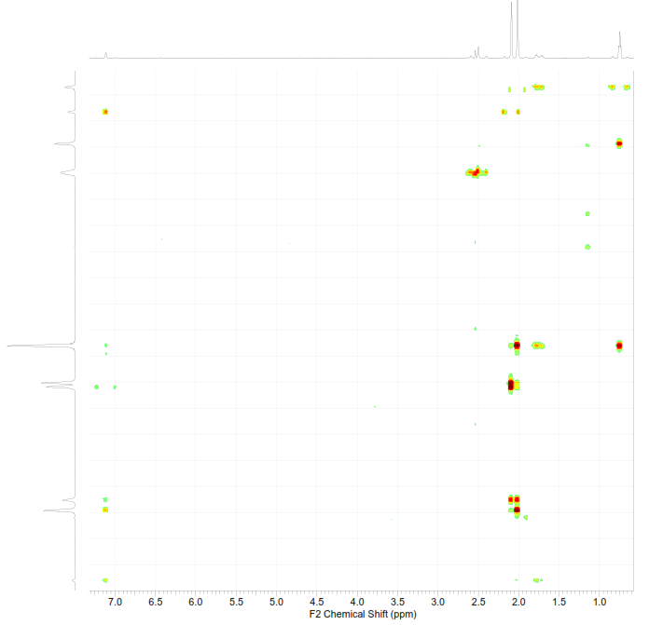

Fig. S5. HMBC spectrum of compound 1.

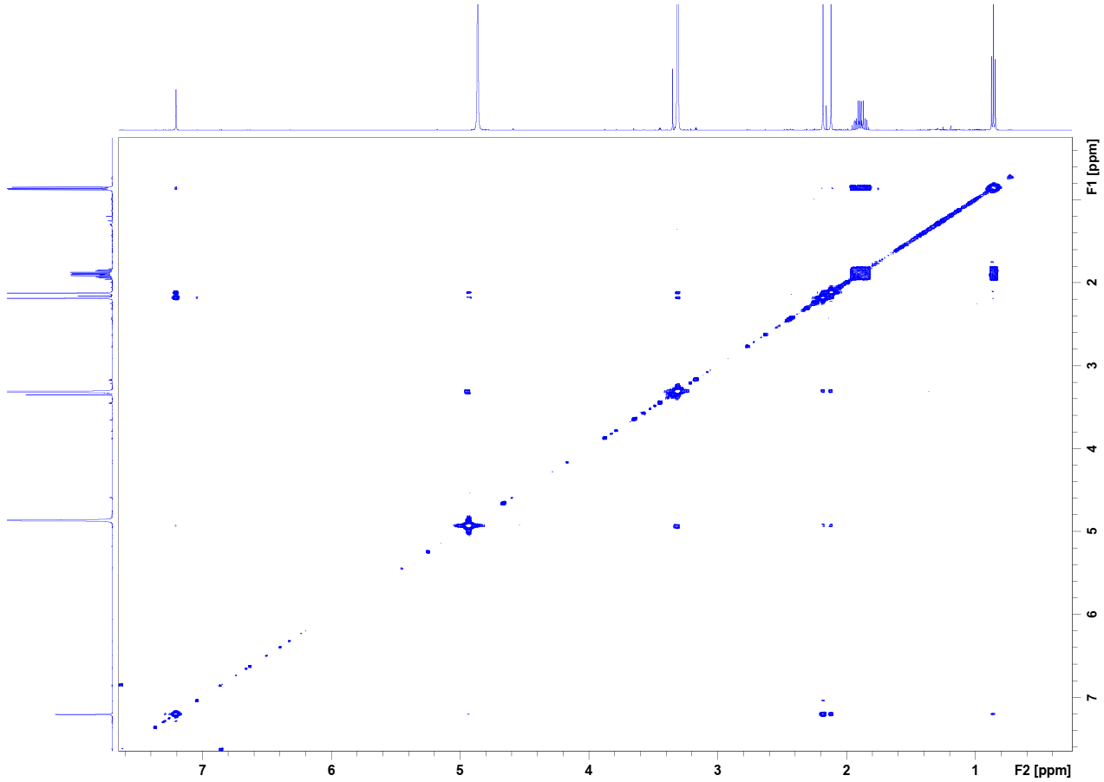

Fig. S6. COSY spectrum of compound 1.

D:\Diaporthe sp. MS\New TIFF images for Diaporthe sp MS\Diapositive2.TIF

Fig. S7. HPLC chromatogram (a) and positive ion mode HR-ESI-MS spectrum (b) of compound 2.

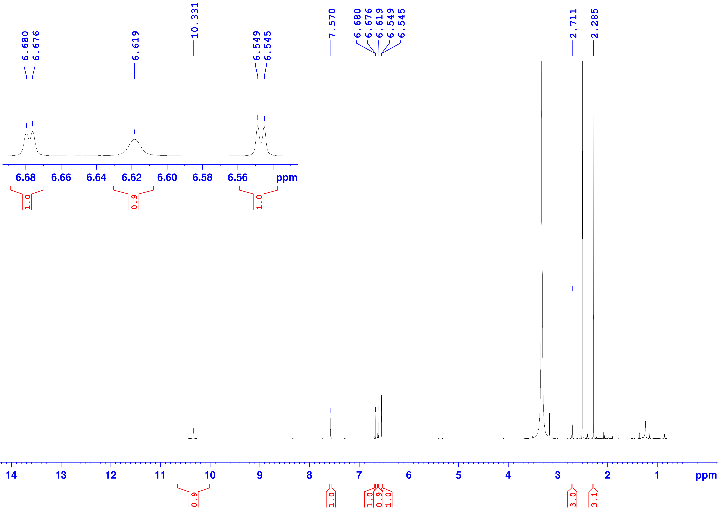

Fig. S8. 1H NMR spectrum of compound 2 (500 MHz, DMSO-*d*6).

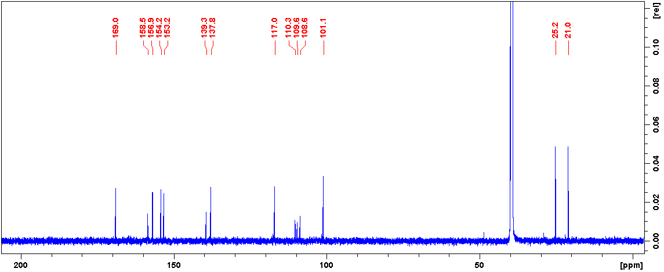

Fig. S9. 13C NMR spectrum of compound 2 (125 MHz, DMSO-*d*6).

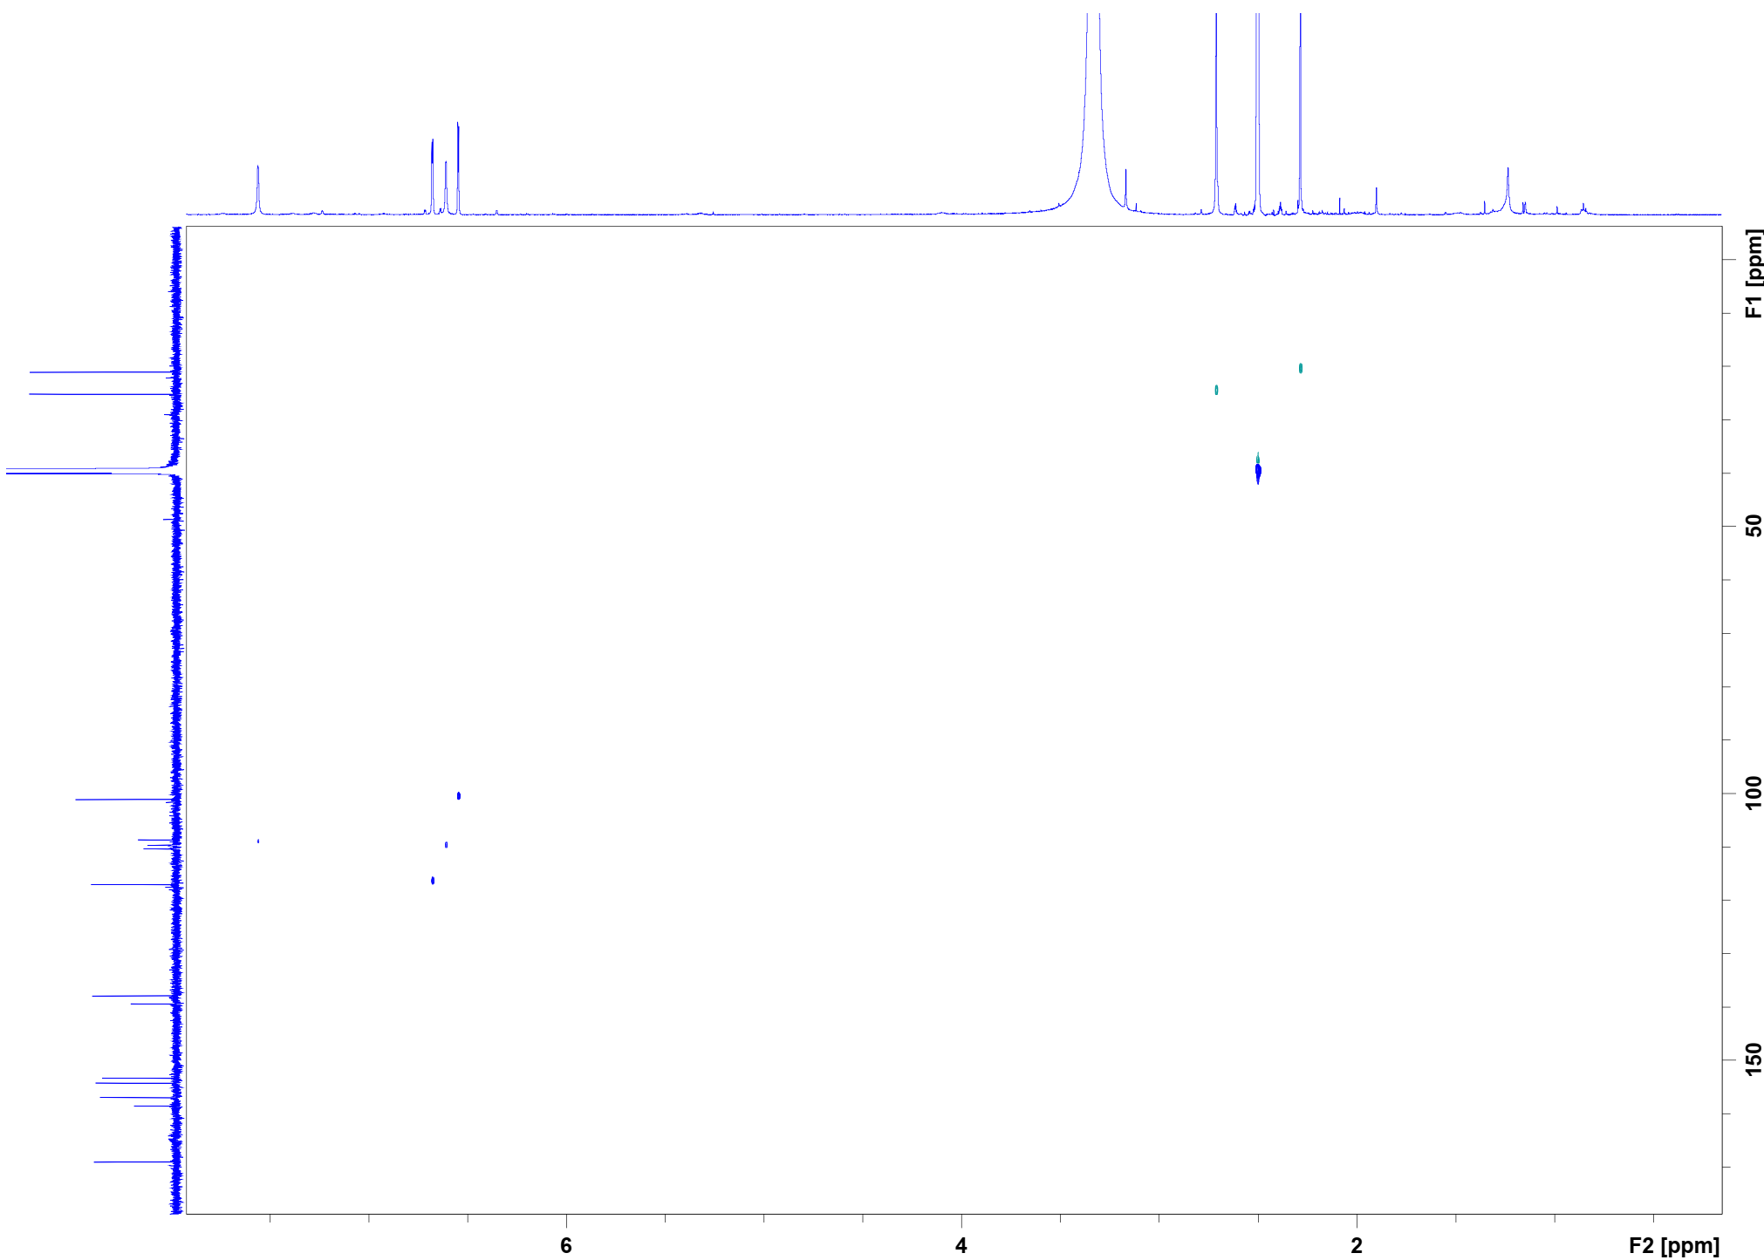

Fig. S10. HSQC-DEPT spectrum of compound 2.

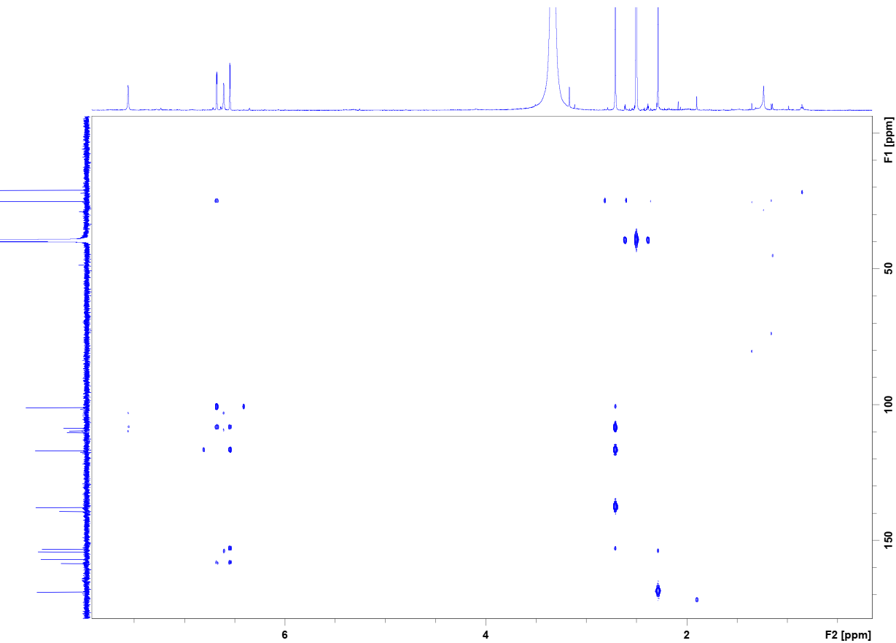

Fig. S11. HMBC spectrum of compound 2.

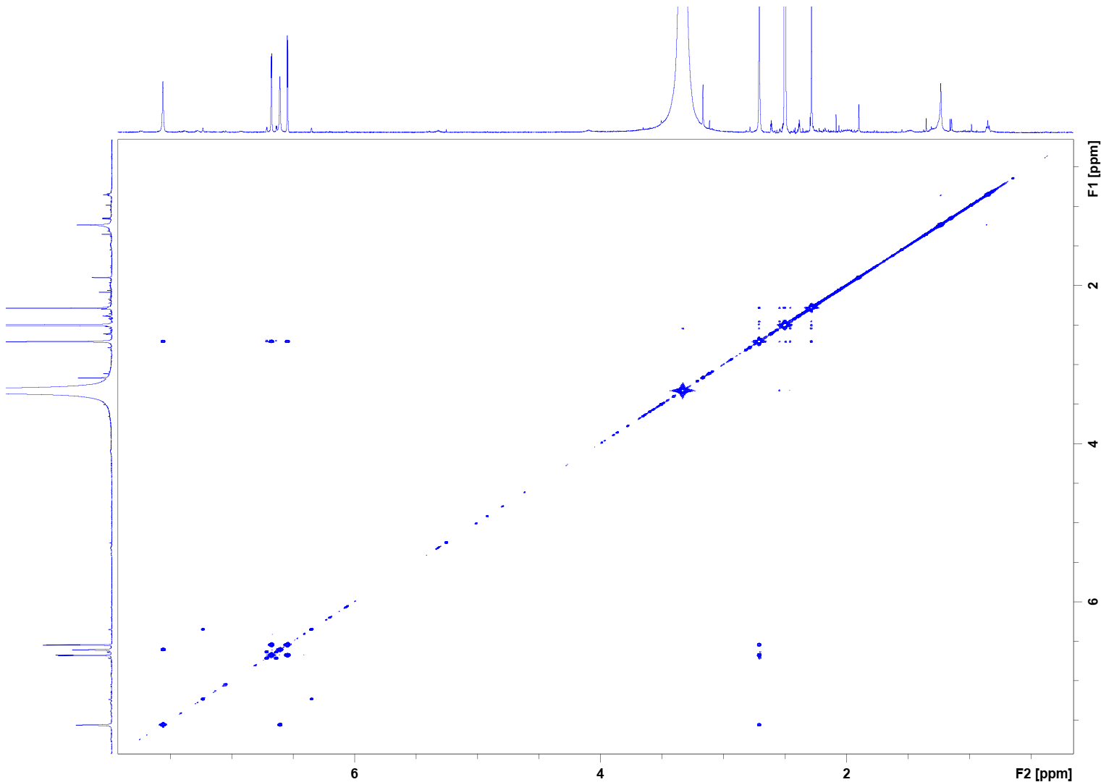

Fig. S12. COSY spectrum of compound 2.