Phenanthridine-pyrene conjugates as fluorescent probes for DNA/RNA and an inactive mutant of dipeptidyl peptidase enzyme

Josipa Matićª, Tana Tandarić^{b}, Marijana Radić Stojkovićª, Filip Šupljika^{c}, Robert Vianello^{b}*, Lidija-Marija Tumir ª*

ªLaboratory for Biomolecular Interactions and Spectroscopy, Division of Organic Chemistry and Biochemistry, Ruđer Bošković Institute, Bijenička cesta 54, 10000 Zagreb, Croatia, E-mail: tumir@irb.hr
^{b}Laboratory for the Computational Design and Synthesis of Functional Materials, Division of Organic Chemistry and Biochemistry, Ruđer Bošković Institute, Bijenička cesta 54, 10000 Zagreb, Croatia, E-mail: robert.vianello@irb.hr
^{c}Laboratory for Physical Chemistry and Corrosion, Department of Chemistry and Biochemistry, Faculty of Food Technology and Biotechnology, University of Zagreb, Croatia

Supporting Information

Content
1. Spectroscopic properties of Phen-Py-1-2 compounds
2. Interactions of Phen-Py-1-2 compounds with DNA/RNA and protein
3. NMR spectra of Phen-Py-1-2 compounds
4. Computational analysis
Phen-Py-1 | Phen-Py-2
Scheme 1. Structures of examined Phen-Py-1-2 compounds
Phen-AA | 1-Pyrenebutyric acid (PBA)
Scheme 2. Structures of referent compounds

1. Spectroscopic properties of Phen-Py-1-2 compounds

Studied compounds were moderately soluble in DMSO (up to c = 1 × 10⁻³ mol dm⁻³). DMSO stock solutions of compounds were stable during few months. All measurements were recorded in Na-cacodylate buffer (I_{c} = 0.05mol dm⁻³) both at pH = 5.0 and pH = 7.0. Volume ratio of DMSO was less than 1% in all measurements.
UV/Vis spectra of examined compounds were recorded in Na-cacodylate buffer (I_{c} = 0.05mol dm⁻³) both at pH = 5 and pH = 7. Further, spectra were recorded using immersion probe with 5 cm light path length, which allowed measurements at concentration range 5 × 10⁻⁷ - 3 × 10⁻⁶ mol dm⁻³ to avoid self-aggregation. Absorbancies of aqueous solutions of compounds Phen-Py-1 and 2 were proportional to their concentrations up to concentrations c = 3 × 10⁻⁶ mol dm⁻³. Thermal dependent UV/Vis spectra were recorded using quartz cuvettes (1 cm path). UV/Vis spectra of aqueous solutions of examined compounds 1-2 showed minor irreversible changes upon heating that were attributed to precipitation.
Absorption maxima and corresponding molar extinction coefficients (ε) were given in Table S1 and Figure S1.

Table S1. Electronic absorption data of Phen-Py-1 and 2 (sodium cacodylate/HCl buffer, I_{c} = 0.05 mol dm⁻³, pH = 5 or pH = 7) and referent compounds Phen-AA and Pyr.
 | pH = 5 |  |  | pH = 7
 | λ_{max} / nm | ε / mmol⁻¹ cm² | Hª (%) | λ_{max} / nm | ε / mmol⁻¹ cm² | H^{b}(%)
1 | 276  329  343 | 19387  10994  11140 | 55% | 277  331  346 | 35310  18451  19756 | 35%
2 | 276  348 | 20059  9741 | 53% | 278  277  333  350 | 27895  28154  13018  13697 | 48%

ªH (hypochromic effect, %)_{276 nm} = 100 × {[ε_{276 nm} (Phen-AA) + ε_{276 nm} (PBA)]-ε_{276 nm} (Phen-Py-1 or 2)_{276 nm} }/ [ε_{276 nm} (Phen-AA) + ε_{276 nm} (PBA)]; ε_{276 nm} (Phen-AA) = 11.35 mol⁻¹ cm²; ε_{276 nm} (PBA) = 31.65 mol⁻¹ cm²; ε_{276 nm} (1) = 19.39 mol⁻¹ cm²; ε_{276 nm} (2) = 20.06 mol⁻¹ cm²; (pH = 5.0)
^{b}H (hypochromic effect, %)_{277 nm} = 100 × {[ε_{277 nm} (Phen-AA) + ε_{277 nm} (PBA)]-ε_{277 nm} (Phen-Py-1 or 2)_{277 nm} }/ [ε_{277 nm} (Phen-AA) + ε_{277 nm} (PBA)]; ε_{277 nm} (Phen-AA) = 9.20 mol⁻¹ cm²; ε_{277 nm} (PBA) = 44.91 mol⁻¹ cm²; ε_{277 nm} (1) = 35.31 mol⁻¹ cm²; ε_{277 nm} (2) = 28.15 mol⁻¹ cm² (pH = 7.0)

Figure S1. UV/Vis spectra of Phen-Py-1 and 2 and referent compounds Phen-AA and PBA at pH = 5 and pH = 7

Fluorescence emission of Phen-Py-1-2 measured at pH = 5 and pH = 7 (cacodylate buffer, I_{c} =0.05 mol dm⁻³) was linearly dependent on the concentration up to 3 × 10⁻⁶ mol dm⁻³ (Figure S2).
Fluorescence intensity was decreased upon time and also upon temperature increase without reproducibility after cooling back. That was attributed to the temperature-induced unstacking of phenanthridine and pyrene but also aggregation/precipitation of the compounds.
Figure S2. Normalized fluorescence emission spectra of Phen-Py-1 (λ_{exc} = 350 nm), Phen-Py-2 (λ_{exc} = 350 nm), referent Phen-AA (λ_{exc} = 250 nm) and referent PBA (λ_{exc} = 342 nm) compounds (sodium cacodylate buffer, I_{c} = 0.05 mol dm⁻³, left: pH = 5 right: pH = 7)

Figure S3. Fluorescence emission spectra of Phen-Py-1 (c = 2 × 10⁻⁶ mol dm⁻³) measured during 60 cycles every 2 minutes at 25 °C, λ_{exc} = 352 nm in methanol A: MeOH
2. Study of interactions of Phen-Py-1-2 with ds-DNA and ds-RNA in aqueous media
2.1. Thermal melting experiments
Non-covalent binding of small molecules to ds-polynucleotides usually has a certain effect on the thermal stability of helices thus giving different T_{m} values (temperature of dissociation of double stranded helix into two single stranded polynucleotides). Difference between T_{m} value of free polynucleotide and complex with a small molecule (ΔT_{m} value) is an important factor in the characterisation of small molecule / ds-polynucleotide interactions. All thermal melting experiments were performed sodium cacodylate buffer, pH = 7.0, I_{c} = 0.05 mol dm⁻³.
At pH = 7 Phen-Py-1 and Phen-Py-2 didn’t thermally stabilize any ds-DNA/RNA (Table 2,Figure S4-S6).
Figure S4. Melting curves of ct-DNA upon addition of Phen-Py-1 and Phen-Py-2 (c(DNA)= 2 ×10⁻⁵ mol dm⁻³; ratio r[compound] / [polynucleotide] = 0.3) at pH = 7.0 (sodium cacodylate buffer, I_{c} = 0.05 mol dm⁻³).

Figure S5. Melting curves of poly rA-poly rU upon addition of Phen-Py-1 and Phen-Py-2 (c(RNA)= 2 ×10⁻⁵ mol dm⁻³; ratio r[compound] / [polynucleotide] = 0.3) at pH = 7.0 (sodium cacodylate buffer, I_{c} = 0.05 mol dm⁻³).
Figure S6. Melting curves of poly dAdT – poly dAdT upon addition of Phen-Py-1 and Phen-Py-2 (c (DNA) = 2 ×10⁻⁵ mol dm⁻³; ratio r[compound] / [polynucleotide] = 0.3) at pH = 7.0 (sodium cacodylate buffer, I_{c} = 0.05 mol dm⁻³).

Table S2. The ªΔT_{m} values (°C ) of studied ds-polynucleotides upon addition of Phen-Py-1 and Phen-Py-2 (ratio r^{b} = 0.3) at pH = 7.0 (buffer sodium cacodylate, I_{c} = 0.05 mol dm⁻³ ), c(DNA / RNA) = 1-2 ×10⁻⁵ mol dm⁻³.
 | ΔT_{m} / °C
Compound | ct-DNA | poly dAdT – poly dAdT | poly rA – poly rU
Phen-Py-1 | 0 | 0 | 0
Phen-Py-2 | precipitation | 0 | precipitation
ª Error in ΔT_{m} : ± 0.5°C;
^{b} r = [compound] / [polynucleotide];
^{d} not determined due to precipitation

2.1. Spectrophotometric titrations
Table S3. Stability constants (log K_{s})ª of complexes of Phen-Py-1-2 with ds-polynucleotides and protein calculated according to fluorimetric titrations (Na-cacodylate buffer, I_{c} = 0.05 mol dm⁻³, pH = 7.0; λ_{exc} = 352 nm; λ_{em}= 370-600, c(Phen-Py-1-2) = 1-2 × 10⁻⁶ mol dm⁻³)
 | log K_{s}ª
polynucleotide | Phen-Py-1 | Phen-Py-2
ct-DNA | 6.97 | <4^{c}
poly dAdT–poly dAdT | 5.97 | ^{d}
poly dGdC–poly dGdC | 6.87 | ^{d}
poly rA–poly rU | 7.07 | ^{c}
protein | Phen-Py-1 | Phen-Py-2
E451A | 7.54 (n = 1)^{b} | ^{d}
ª Processing of titration data by means of Scatchard equation and Global Fit procedure gave stability constants and values of ratio n = [bound compounds] / [polynucleotide or protein]; for easier comparison values of log Ks for polynucleotide complexes were recalculated for fixed n=0.2; correlation coefficients were >0.9 for all calculated Ks
^{b} n = [bound compound] / [protein];
^{c} small /linear fluorescence change / no fluorescence change disabled calculation of stability constant
^{d} not determined

Figure S7. Left: Fluorimetric titration of Phen-Py-1 with ct-DNA, λ_{exc} = 352 nm, c = 2 × 10⁻⁶ mol dm⁻³, Right: Experimental (●) fluorescence intensities of Phen-Py-1 at λ_{em} = 400 nm upon addition of ct-DNA (pH = 5.0, Na cacodylate buffer, I_{c} = 0.05 mol dm⁻³).
Figure S8. Left: Fluorimetric titration of Phen-Py-1, λ_{exc} = 352 nm, c = 2 × 10⁻⁶ mol dm⁻³ with poly rA-poly rU, Right: Experimental (●) fluorescence intensities of Phen-Py-1 at λ_{em} = 400 nm upon addition of poly rA-poly rU (pH = 5.0, Na cacodylate buffer, I_{c} = 0.05 mol dm⁻³).

Figure S9. Left: Fluorimetric titration of Phen-Py-2, λ_{exc} = 352 nm, c = 2 × 10⁻⁶ mol dm⁻³ with ct-DNA, Right: Experimental (●) fluorescence intensities of Phen-Py-2 at λ_{em} = 400 nm upon addition of ct-DNA (pH = 5.0, Na cacodylate buffer, I_{c} = 0.05 mol dm⁻³).
Figure S10. Left: Fluorimetric titration of Phen-Py-2, λ_{exc} = 352 nm, c = 2 × 10⁻⁶ mol dm⁻³ with poly rA-poly rU, Right: Experimental (●) fluorescence intensities of Phen-Py-2 at λ_{em} = 400 nm upon addition of poly rA-poly rU (pH = 5.0, Na cacodylate buffer, I_{c} = 0.05 mol dm⁻³).

Figure S11. Left: Fluorimetric titration of Phen-Py-2, λ_{exc} = 352 nm, c = 2 × 10⁻⁶ mol dm⁻³ with ct-DNA, Right: Experimental (●) fluorescence intensities of Phen-Py-2 at λ_{em} = 403 nm upon addition of ct-DNA (pH = 7.0, Na cacodylate buffer, I_{c} = 0.05 mol dm⁻³).

Figure S12. Left: Fluorimetric titration of Phen-Py-2, λ_{exc} = 352 nm, c = 2 × 10⁻⁶ mol dm⁻³ with poly rA-poly rU, Right: Experimental (●) fluorescence intensities of Phen-Py-2 at λ_{em} = 400 nm upon addition of poly rA-poly rU (pH = 7.0, Na cacodylate buffer, I_{c} = 0.05 mol dm⁻³

Figure S13. Left: Fluorimetric titration of Phen-Py-1, λ_{exc} = 352 nm, c = 2 × 10⁻⁶ mol dm⁻³ with ct-DNA, Right: Experimental (●) fluorescence intensities of Phen-Py-1 at λ_{em} = 471 nm upon addition of ct-DNA (pH = 7.0, Na cacodylate buffer, I_{c} = 0.05 mol dm⁻³).
Figure S14. Left: Fluorimetric titration of Phen-Py-1, λ_{exc} = 352 nm, c = 2 × 10⁻⁶ mol dm⁻³ with poly rA-poly rU, Right: Experimental (●) fluorescence intensities of Phen-Py-1 at λ_{em} = 467 nm upon addition of poly rA-poly rU (pH = 7.0, Na cacodylate buffer, I_{c} = 0.05 mol dm⁻³).
Figure S15. Left: Fluorimetric titration of Phen-Py-1, λ_{exc} = 352 nm, c = 2 × 10⁻⁶ mol dm⁻³ with poly dAdT - poly dAdT, Right: Experimental (●) fluorescence intensities of Phen-Py-1 at λ_{em} = 471 nm upon addition of poly dAdT - poly dAdT (pH = 7.0, Na cacodylate buffer, I_{c} = 0.05 mol dm⁻³).
Figure S16. Left: Fluorimetric titration of Phen-Py-1, λ_{exc} = 352 nm, c = 2 × 10⁻⁶ mol dm⁻³ with poly dGdC - poly dGdC, Right: Experimental (●) fluorescence intensities of Phen-Py-1 at λ_{em} = 471 nm upon addition of poly dGdC - poly dGdC (pH = 7.0, Na cacodylate buffer, I_{c} = 0.05 mol dm⁻³).

2.3. Circular dichroism (CD) experiments
CD spectroscopy was chosen to monitor conformational changes of polynucleotide secondary structure induced by small molecule binding. Compounds Phen-Py-1 and Phen-Py-2 were built using chiral amino acid building blocks and consequently have intrinsic CD spectrum.
Figure S17. Changes in the CD spectrum of ct-DNA (c(DNA) = 2 × 10⁻⁵ mol dm⁻³) upon addition of Phen-Py-1 (left) and Phen-Py-2 (right) at different molar ratios r = [compound] / [polynucleotide], pH = 7.0, sodium cacodylate buffer, I_{c} = 0.05 mol dm⁻³
Figure S18. Changes in the CD spectrum of poly rA-poly rU upon addition of Phen-Py-1 (c(RNA) =1 × 10⁻⁵ mol dm⁻³) (left) and Phen-Py-2; (c(RNA) = 1 × 10⁻⁵ mol dm⁻³) (right) at different molar ratios r = [compound] / [polynucleotide], pH = 7.0, sodium cacodylate buffer, I_{c} = 0.05 mol dm⁻³
Figure S19. Comparation of spectra of RNA-dye complex (r= 0.5, ―) and sum of poly rA-poly rU and dye spectra (―) of appropriate concentrations
3. NMR spectra of

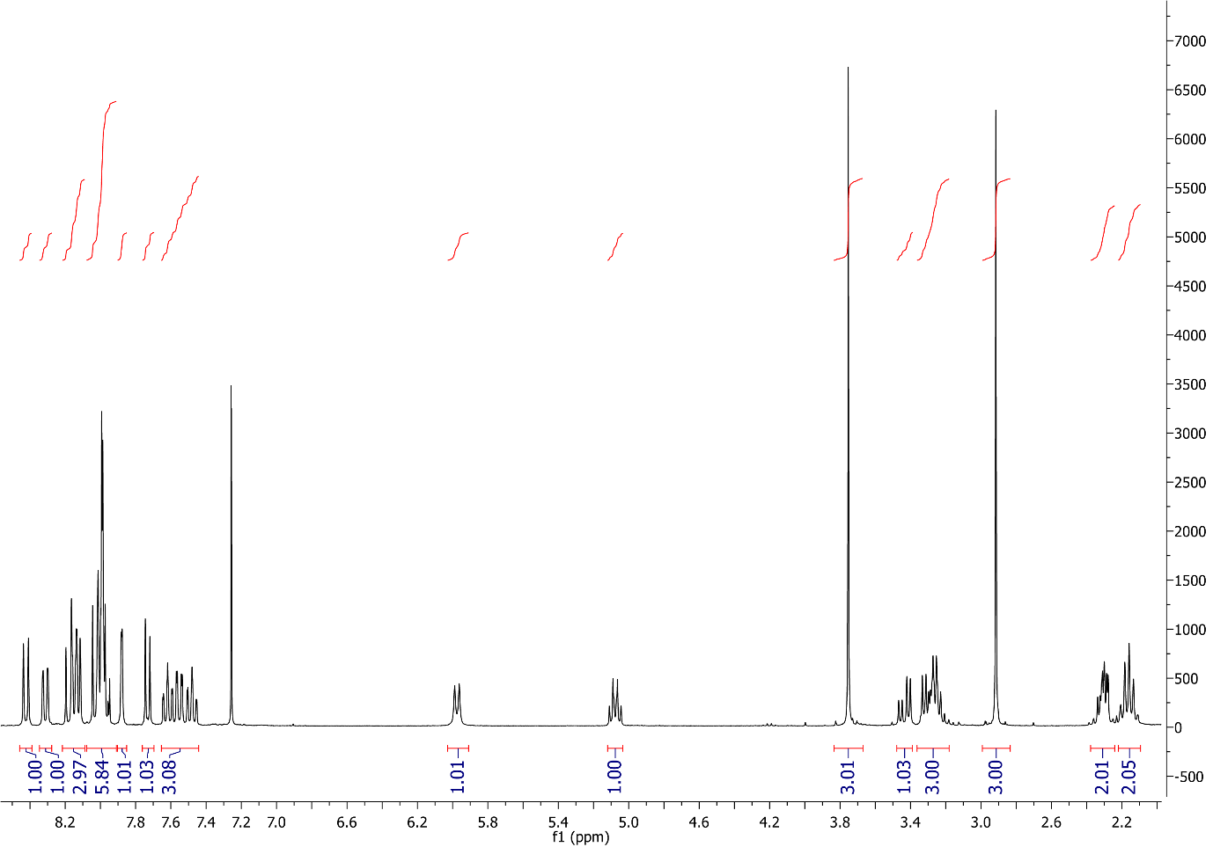
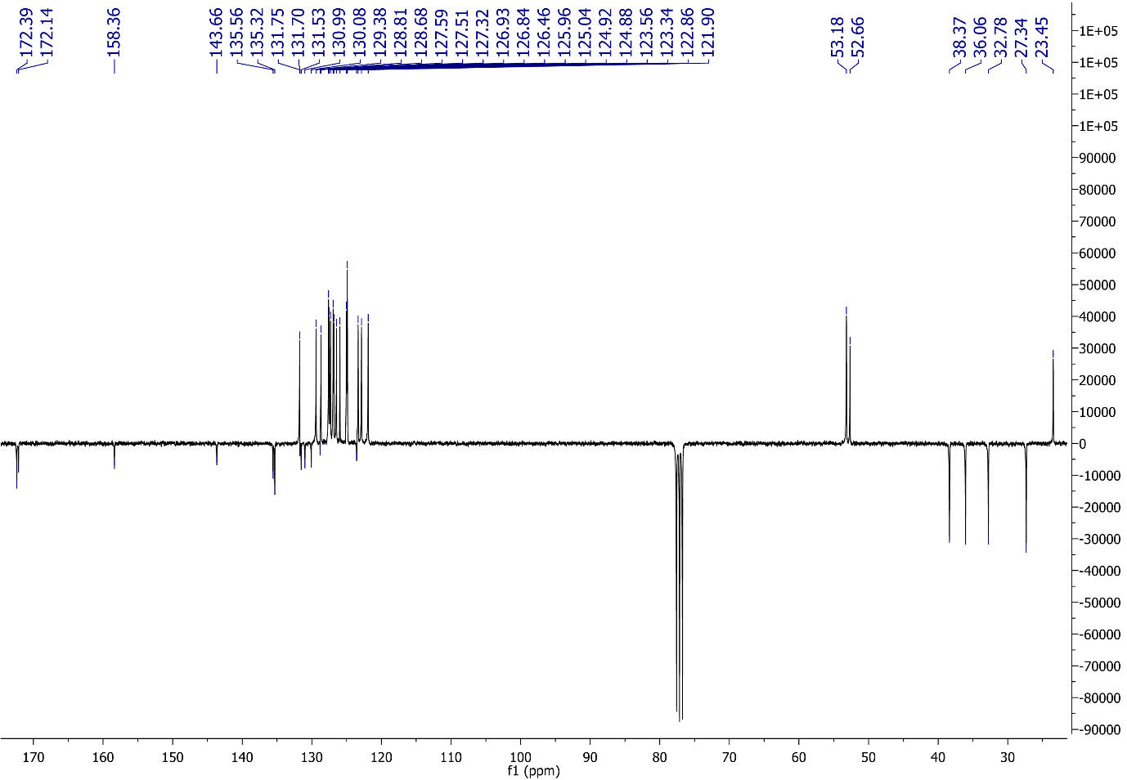
Figure S20. ¹H and ¹³C NMR spectra of Phen-Py-1.
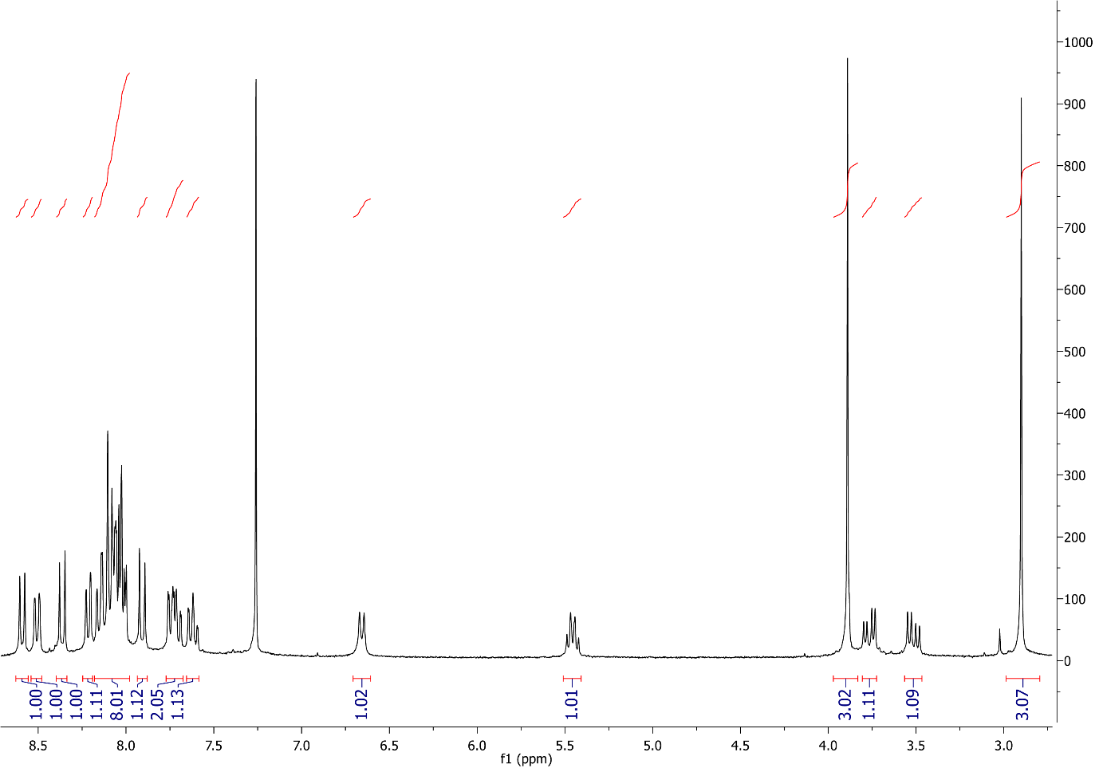
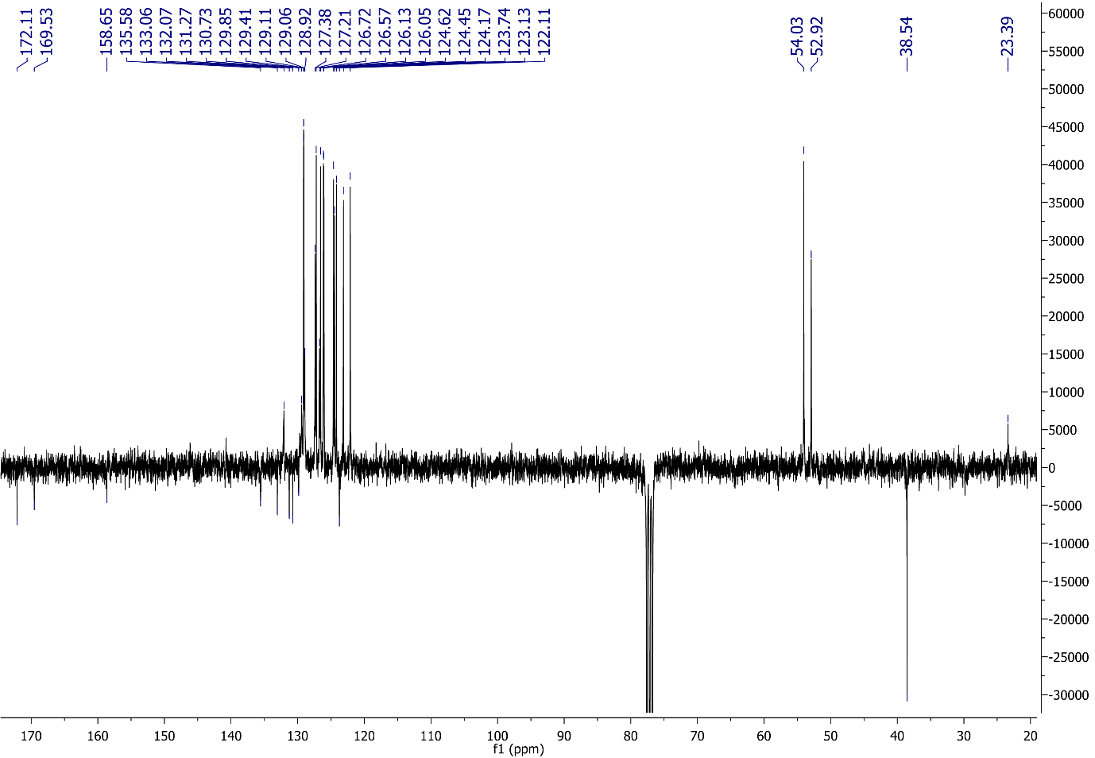

Figure S21. H and ¹³C NMR spectra of Phen-Py-2.

4. Computational analysis

Phen-Py-1 at pH = 7 | Phen-Py-2 at pH = 7
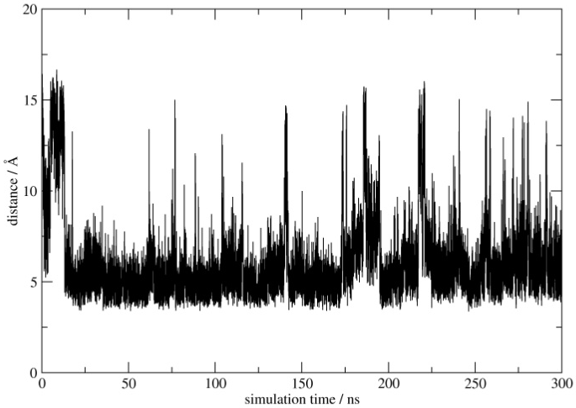 | 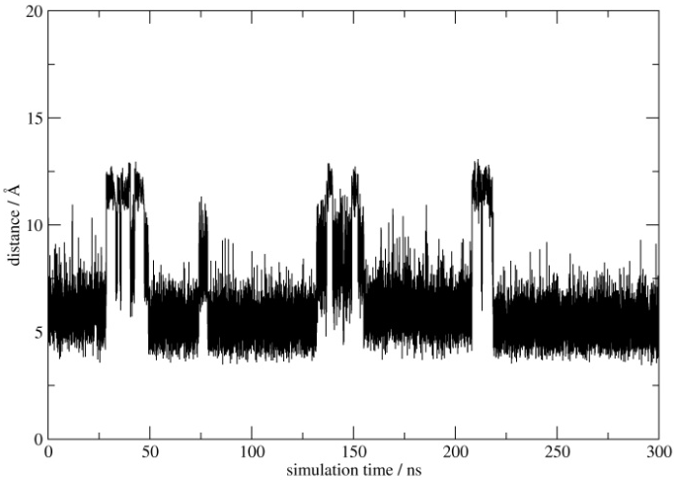
Average value = 8.3 Å | Average value = 6.4 Å
Phen-Py-1⁺ at pH = 5 | Phen-Py-2⁺ at pH = 5
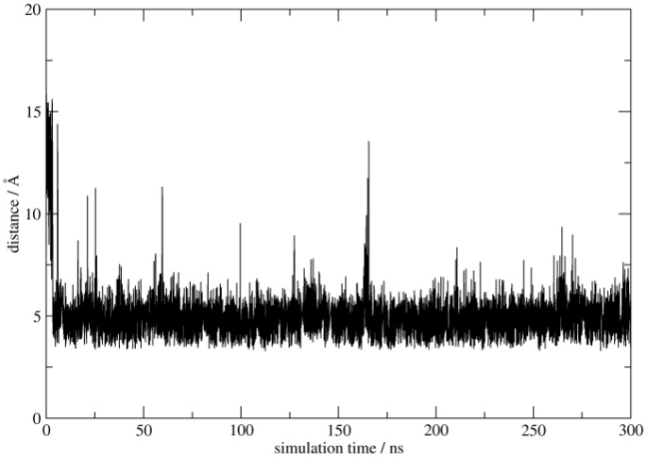 | 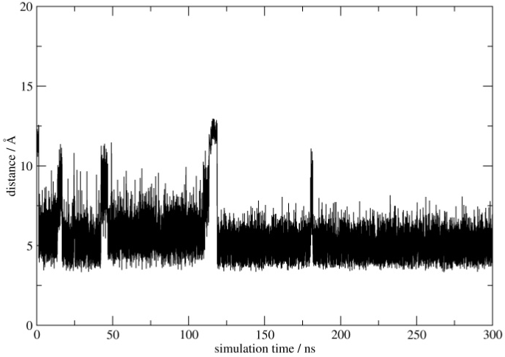
Average value = 5.5 Å | Average value = 5.4 Å

Figure S22. Evolution of distances between the centers of mass among pyrene and phenanthridine aromatic units during 300 ns of MD simulations in Phen-Py-1-2 conjugates under neutral (pH = 7) and acidic (pH = 5) conditions.

Phen-Py-1 at pH = 7 | Phen-Py-2 at pH = 7
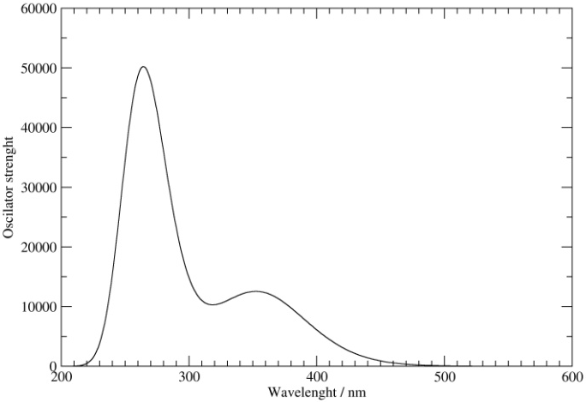 | 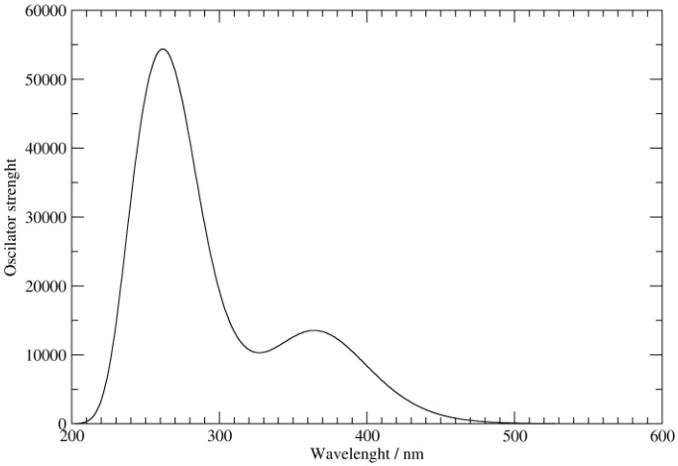
λ_{max} = 264 nm, 355 nm | λ_{max} = 264 nm, 370 nm
Phen-Py-1⁺ at pH = 5 | Phen-Py-2⁺ at pH = 5
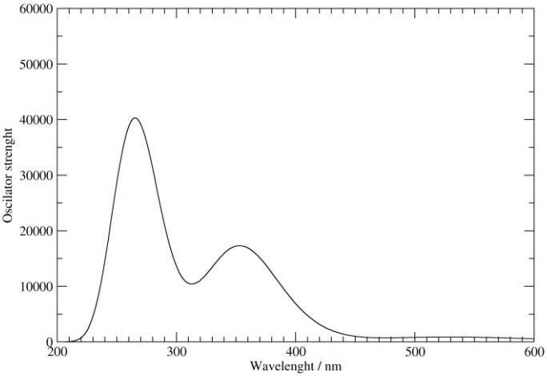 | 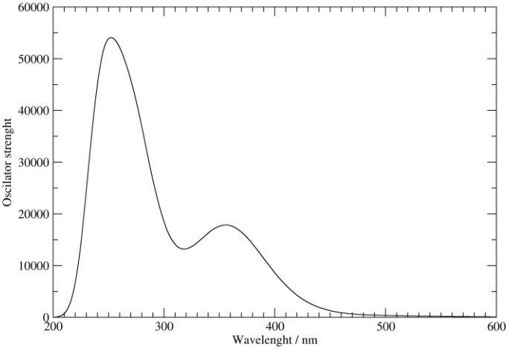
λ_{max} = 264 nm, 356 nm | λ_{max} = 254 nm, 352 nm

Figure S23. Calculated UV-Vis absorption spectra for Phen-Py-1-2 conjugates under neutral (pH = 7) and acidic (pH = 5) conditions using the TD–DFT approach and the (IEF-PCM)/M06–2X/6–31+G(d) level of theory.

Supporting Information References

Mergny, J. L. and L. Lacroix (2003). "Analysis of thermal melting curves." Oligonucleotides 13(6): 515-537.
(a) J. D. McGhee and P. H. von Hippel, J. Mol. Biol., 1974, 86, 469-489. b) G. Scatchard, Ann. N. Y. Acad. Sci., 1949, 51, 660-672.
I. Crnolatac, I. Rogan, B. Majić, S. Tomić, T. Deligeorgiev, G. Horvat, D. Makuc, J. Plavec, G. Pescitelli, I. Piantanida, Anal. Chim. Acta, 2016, 940, 128-135.
Rodger A., Norden B., In Circular Dichroism and Linear Dichroism; Oxford University Press: New York, 1997, Chapter 2.

