An Efficient Metal-free and Catalyst-free C-S/C-O Bond Formation Strategy: Synthesis of Pyrazole Conjugated Thioamides and Amides
Shubham Sharma¹, Dharmender Singh^{1,2}, Sunit Kumar¹, Vaishali¹, Rahul Jamra^{1,4}, Naveen Banyal^{1,4}, Deepika¹, Chandi C. Malakar³ and Virender Singh*^{1,4}
¹Department of Chemistry, Dr B R Ambedkar National Institute of Technology (NIT) Jalandhar, 144027, Punjab, India.
²Central Revenues Control Laboratory, New Delhi-110012.
³Department of Chemistry, National Institute of Technology (NIT) Manipur, Imphal, 795004, India.
⁴Department of Chemistry, Central University of Punjab, Bathinda, 151401, Punjab, India.
Email:- virender.singh@cup.edu.in
Supporting information
Table of Contents
1 Experimental data 2-9
2. ¹H and ¹³C-NMR spectra of the new products (Figure S1-55) 10-37

(5-(4-Fluorophenyl)-1-phenyl-1H-pyrazol-3-yl)(pyrrolidin-1-yl)methanethione (1A). Yield: 82% (0.215 g from 0.20 g) as a light pink solid; m.p. 134–136 ºC; R_{f} = 0.68 (hexane/EtOAc, 70:30, v/v); IR (neat): ν_{max} (cm⁻¹) = 1232 (C=S) ; ¹H NMR (500 MHz, CDCl₃): δ = 2.05–2.07 (m, 4 H, (CH₂)₂), 4.03–4.06 (m, 2 H, CH₂), 4.14–4.17 (m, 2 H, CH₂), 6.97–7.02 (m, 2 H, ArH), 7.11 (s, 1 H, ArH), 7.19–7.23 (m, 2 H, ArH), 7.24–7.25 (m, 1 H, ArH), 7.27–7.28 (m, 1 H, ArH), 7.33–7.38 (m, 3 H, ArH) ppm; ¹³C NMR (100 MHz, CDCl₃): δ = 24.3, 26.9, 54.6, 54.9, 112.2, 115.8 (d, J = 22 Hz), 125.3, 126.0 (d, J = 4 Hz), 128.1, 129.2, 130.8 (d, J = 8 Hz), 139.6, 142.3, 153.4, 162.8 (d, J = 248 Hz), 185.9 ppm; HRMS (ESI) m/z: calcd. for C₂₀H₁₈FN₃S [M + H⁺]: 352.1283, found: 352.1275.
(5-(4-Fluorophenyl)-1-phenyl-1H-pyrazol-3-yl)(piperidin-1-yl)methanethione (1B). Yield: 88% (0.241 g from 0.20 g) as a yellow solid; m.p. 148–150 ºC; R_{f} = 0.60 (hexane/EtOAc, 90:10, v/v); IR (neat): ν_{max} (cm⁻¹) = 1238 (C=S) ; ¹H NMR (500 MHz, CDCl₃): δ = 1.74–1.84 (m, 6 H, (CH₂)₃), 4.02 (t, J = 5.2 Hz, 2 H, CH₂), 4.38 (t, J = 5.5 Hz, 2 H, CH₂), 6.85 (s, 1 H, ArH), 7.00 (t, J = 8.6 Hz, 2 H, ArH), 7.20–7.23 (m, 2 H, ArH), 7.24–7.25 (m, 1 H, ArH), 7.27–7.28 (m, 1 H, ArH), 7.32–7.36 (m, 3 H, ArH) ppm; ¹³C NMR (100 MHz, CDCl₃): δ = 24.5, 25.7, 27.2, 51.6, 54.0, 110.8, 115.8 (d, J = 21 Hz), 125.3, 126.0 (d, J = 3 Hz), 128.0, 129.2, 130.7 (d, J = 8 Hz), 139.5, 142.6, 152.9, 162.8 (d, J = 248 Hz), 189.5 ppm; HRMS (ESI) m/z: calcd. for C₂₁H₂₀FN₃S [M + H⁺]: 366.144, found: 366.1428.
(5-(4-Fluorophenyl)-1-phenyl-1H-pyrazol-3-yl)(morpholino)methanethione (1C). Yield: 90% (0.247 g from 0.20 g) as a yellow solid; m.p. 174–176 ºC; R_{f} = 0.19 (hexane/EtOAc, 90:10, v/v); IR (neat): ν_{max} (cm⁻¹) = 1236 (C=S) ; ¹H NMR (500 MHz, CDCl₃): δ = 3.80 (t, J = 4.8 Hz, 2 H, CH₂), 3.91 (t, J = 4.9 Hz, 2 H, CH₂), 4.20 (t, J = 4.8 Hz, 2 H, CH₂), 4.48 (t, J = 4.8 Hz, 2 H, CH₂), 6.94 (s, 1 H, ArH), 7.00 (t, J = 8.6 Hz, 2 H, ArH), 7.19–7.22 (m, 2 H, ArH), 7.24–7.26 (m, 2 H, ArH), 7.34–7.37 (m, 3 H, ArH) ppm; ¹³C NMR (100 MHz, CDCl₃): δ = 50.6, 53.3, 66.7, 67.2, 112.0, 115.9 (d, J = 22 Hz), 125.3, 125.8 (d, J = 3 Hz), 128.2, 129.2, 130.7 (d, J = 8 Hz), 139.4, 142.9, 152.2, 162.9 (d, J = 248 Hz), 190.0 ppm; HRMS (ESI) m/z: calcd. for C₂₀H₁₈FN₃OS [M + H⁺]: 368.1233, found: 368.1211.
(5-(4-Fluorophenyl)-1-phenyl-1H-pyrazol-3-yl)(thiomorpholino)methanethione (1D). Yield: 89% (0.255 g from 0.20 g) as a yellow solid; m.p. 190–192 ºC; R_{f} = 0.73 (hexane/EtOAc, 90:10, v/v); IR (neat): ν_{max} (cm⁻¹) = 1225 (C=S) ; ¹H NMR (500 MHz, CDCl₃): δ = 2.85 (t, J = 5.0 Hz, 2 H, CH₂), 2.92 (t, J = 5.1 Hz, 2 H, CH₂), 4.39 (t, J = 5.0 Hz, 2 H, CH₂), 4.72 (t, J = 5.0 Hz, 2 H, CH₂), 6.90 (s, 1 H, ArH), 7.01 (t, J = 8.7 Hz, 2 H, ArH), 7.19–7.23 (m, 2 H, ArH), 7.23–7.25 (m, 2 H, ArH), 7.34–7.37 (m, 3 H, ArH) ppm; ¹³C NMR (100 MHz, CDCl₃): δ = 27.5, 29.0, 53.2, 55.5, 111.6, 115.9 (d, J = 22 Hz), 125.2, 125.8 (d, J = 3 Hz), 128.1, 129.2, 130.8 (d, J = 8 Hz), 139.4, 142.8, 152.6, 162.9 (d, J = 248 Hz), 190.8 ppm; HRMS (ESI) m/z: calcd. for C₂₀H₁₈FN₃S₂ [M + H⁺]: 384.1004, found: 384.1023.
(5-(4-Fluorophenyl)-1-phenyl-1H-pyrazol-3-yl)(4-methylpiperazin-1-yl)methanethione (1E). Yield: 53% (0.152 g from 0.20 g) as a red solid; m.p. 118–120 ºC; R_{f} = 0.24 (hexane/EtOAc, 50:50, v/v); IR (neat): ν_{max} (cm⁻¹) = 1230 (C=S) ; ¹H NMR (500 MHz, CDCl₃): δ = 2.36 (s, 3 H, NCH₃), 2.55 (t, J = 5.0 Hz, 2 H, CH₂), 2.65 (t, J = 5.1 Hz, 2 H, CH₂), 4.17 (t, J = 4.9 Hz, 2 H, CH₂), 4.48 (t, J = 4.5 Hz, 2 H, CH₂), 6.89 (s, 1 H, ArH), 7.00 (t, J = 8.6 Hz, 2 H, ArH), 7.19–7.23 (m, 2 H, ArH), 7.24–7.25 (m, 1 H, ArH), 7.27 (s, 1 H, ArH), 7.33–7.38 (m, 3 H, ArH) ppm; ¹³C NMR (125 MHz, CDCl₃): δ = 45.7, 50.0, 52.5, 54.5, 55.5, 111.5, 115.8 (d, J = 22.5 Hz), 125.3, 125.9 (d, J = 3.8 Hz), 128.1, 129.2, 130.8 (d, J = 7.5 Hz), 139.5, 142.8, 152.6, 162.9 (d, J = 247.5 Hz), 190.3 ppm; HRMS (ESI) m/z: calcd. for C₂₁H₂₁FN₄S [M + H⁺]: 381.1549, found: 381.1522.
(5-(4-Chlorophenyl)-1-methyl-1H-pyrazol-3-yl)(morpholino)methanethione (2C). Yield: 88% (0.255 g from 0.20 g) as a pale yellow solid; m.p. 144–146 ºC; R_{f} = 0.12 (hexane/EtOAc, 90:10, v/v); IR (neat): ν_{max} (cm⁻¹) = 1225 (C=S) ; ¹H NMR (500 MHz, CDCl₃): δ = 3.77 (t, J = 4.8 Hz, 2 H, CH₂), 3.85 (s, 3 H, NCH₃), 3.89 (t, J = 4.8 Hz, 2 H, CH₂), 4.12 (t, J = 4.8 Hz, 2 H, CH₂), 4.45 (t, J = 4.9 Hz, 2 H, CH₂), 6.70 (s, 1 H, ArH), 7.35–7.38 (m, 2 H, ArH), 7.44–7.46 (m, 2 H, ArH) ppm; ¹³C NMR (125 MHz, CDCl₃): δ = 40.0, 50.4, 53.1, 66.6, 67.1, 109.9, 128.1, 129.2, 130.1, 135.2, 143.3, 150.8, 190.9 ppm; HRMS (ESI) m/z: calcd. for C₁₅H₁₆ClN₃OS [M + H⁺]: 322.0781, found: 322.0792.
(5-(4-Chlorophenyl)-1-phenyl-1H-pyrazol-3-yl)(morpholino)methanethione (3C). Yield: 87% (0.235 g from 0.20 g) as a white solid; m.p. 158–160 ºC; R_{f} = 0.52 (hexane/EtOAc, 90:10, v/v); IR (neat): ν_{max} (cm⁻¹) = 1245 (C=S) ; ¹H NMR (500 MHz, CDCl₃): δ = 3.80 (t, J = 4.8 Hz, 2 H, CH₂), 3.90 (t, J = 4.8 Hz, 2 H, CH₂), 4.22 (t, J = 4.8 Hz, 2 H, CH₂), 4.48 (t, J = 4.8 Hz, 2 H, CH₂), 6.96 (s, 1 H, ArH), 7.15–7.17 (m, 2 H, ArH), 7.24–7.25 (m, 1 H, ArH), 7.27–7.29 (m, 3 H, ArH), 7.36–7.37 (m, 3 H, ArH) ppm; ¹³C NMR (125 MHz, CDCl₃): δ = 50.5, 53.2, 66.6, 67.1, 112.0, 125.3, 128.1, 128.3, 128.9, 129.2, 130.0, 134.8, 139.3, 142.6, 152.3, 190.3 ppm; HRMS (ESI) m/z: calcd. for C₂₀H₁₈ClN₃OS [M + H⁺]: 384.0937, found: 384.0955.
(1,5-Diphenyl-1H-pyrazol-3-yl)(morpholino)methanethione (4C). Yield: 86% (0.121 g from 0.10 g) as a yellow solid; m.p. 160–162 ºC; R_{f} = 0.21 (hexane/EtOAc, 90:10, v/v); IR (neat): ν_{max} (cm⁻¹) = 1237 (C=S) ; ¹H NMR (500 MHz, CDCl₃): δ = 3.80 (t, J = 4.8 Hz, 2 H, CH₂), 3.91 (t, J = 4.8 Hz, 2 H, CH₂), 4.23 (t, J = 4.8 Hz, 2 H, CH₂), 4.49 (t, J = 4.8 Hz, 2 H, CH₂), 6.96 (s, 1 H, ArH), 7.22–7.24 (m, 2 H, ArH), 7.27–7.28 (m, 1 H, ArH), 7.30–7.32 (m, 3 H, ArH), 7.33–7.35 (m, 4 H, ArH) ppm; ¹³C NMR (125 MHz, CDCl₃): δ = 50.5, 53.2, 66.6, 67.2, 111.8, 125.3, 128.1, 128.6, 128.7, 128.8, 129.1, 129.6, 139.6, 143.9, 152.2, 190.6 ppm; HRMS (ESI) m/z: calcd. for C₂₀H₁₉N₃OS [M + H⁺]: 350.1327, found: 350.1338.
Ethyl 1-phenyl-4-(pyrrolidine-1-carbonothioyl)-1H-pyrazole-3-carboxylate (5A). Yield: 70% (0.186 g from 0.20 g) as a light brown solid; m.p. 175–177 ºC; R_{f} = 0.47 (hexane/EtOAc, 90:10, v/v); IR (neat): ν_{max} (cm⁻¹) = 1695 (CO₂Et), 1232 (C=S); ¹H NMR (500 MHz, CDCl₃): δ = 1.39 (t, J = 7.1 Hz, 3 H, CO₂CH₂CH₃), 2.01 (t, J = 6.8 Hz, 2 H, CH₂), 2.11 (t, J = 7.0 Hz, 2 H, CH₂), 3.50 (t, J = 6.8 Hz, 2 H, CH₂), 3.99 (t, J = 7.1 Hz, 2 H, CH₂), 4.41 (q, J = 7.1 Hz, 2 H, CO₂CH₂CH₃), 7.38 (t, J = 7.4 Hz, 1 H, ArH), 7.48 (t, J = 7.9 Hz, 2 H, ArH), 7.72 (d, J = 7.8 Hz, 2 H, ArH), 8.04 (s, 1 H, ArH) ppm; ¹³C NMR (125 MHz, CDCl₃): δ = 14.4, 24.8, 26.3, 53.1, 53.3, 61.5, 120.1, 127.4, 128.2, 129.6, 129.7, 138.8, 139.1, 161.5, 186.5 ppm; HRMS (ESI) m/z: calcd. for C₁₇H₁₉N₃O₂S [M + H⁺]: 330.1276, found: 330.1292.
Ethyl 1-phenyl-4-(piperidine-1-carbonothioyl)-1H-pyrazole-3-carboxylate (5B). Yield: 49% (0.135 g from 0.20 g) as a off white solid; m.p. 155–157 ºC; R_{f} = 0.61 (hexane/EtOAc, 90:10, v/v); IR (neat): ν_{max} (cm⁻¹) = 1698 (CO₂Et), 1241 (C=S) ; ¹H NMR (500 MHz, CDCl₃): δ = 1.39 (t, J = 7.1 Hz, 3 H, CO₂CH₂CH₃), 1.58 (s, 2 H, CH₂), 1.71–1.86 (m, 5 H, (CH₂)₂ and CH), 3.59 (t, J = 5.5 Hz, 2 H, CH₂), 4.41 (q, J = 7.1 Hz, 3 H, CO₂CH₂CH₃ and CH), 7.37 (t, J = 7.4 Hz, 1 H, ArH), 7.48 (t, J = 7.9 Hz, 2 H, ArH), 7.73 (d, J = 7.8 Hz, 2 H, ArH), 8.02 (s, 1 H, ArH) ppm; ¹³C NMR (125 MHz, CDCl₃): δ = 14.5, 24.1, 25.3, 26.3, 50.2, 53.1, 61.5, 120.1, 127.5, 128.1, 128.7, 129.6, 138.8, 139.1, 161.3, 188.2 ppm; HRMS (ESI) m/z: calcd. for C₁₈H₂₁N₃O₂S [M + H⁺]: 344.1432, found: 344.145.

Ethyl 4-(morpholine-4-carbonothioyl)-1-phenyl-1H-pyrazole-3-carboxylate (5C). Yield: 76% (0.211 g from 0.20 g) as a white solid; m.p. 170–172 ºC; R_{f} = 0.25 (hexane/EtOAc, 90:10, v/v); IR (neat): ν_{max} (cm⁻¹) = 1230 (C=S), 1707 (CO₂Et) ; ¹H NMR (500 MHz, CDCl₃): δ = 1.41 (t, J = 7.1 Hz, 3 H, CO₂CH₂CH₃), 3.62–3.68 (m, 4 H, (CH₂)₂), 3.91 (t, J = 4.9 Hz, 2 H), 4.40–4.49 (m, 4 H, CO₂CH₂CH₃ and CH₂), 7.39 (t, J = 7.4 Hz, 1 H, ArH), 7.49 (t, J = 7.9 Hz, 2 H, ArH), 7.71–7.73 (m, 2 H, ArH), 8.05 (s, 1 H, ArH) ppm; ¹³C NMR (125 MHz, CDCl₃): δ = 14.5, 49.2, 52.2, 61.7, 66.2, 66.3, 120.2, 128.0, 128.2, 128.3, 129.7, 138.8, 139.0, 161.3, 189.7 ppm; HRMS (ESI) m/z: calcd. for C₁₇H₁₉N₃O₃S [M + H⁺]: 346.1225, found: 346.1216.
Ethyl 1-phenyl-4-(thiomorpholine-4-carbonothioyl)-1H-pyrazole-3-carboxylate (5D). Yield: 34% (0.101 g from 0.20 g) as a light brown solid; m.p. 170–172 ºC; R_{f} = 0.35 (hexane/EtOAc, 80:20, v/v); IR (neat): ν_{max} (cm⁻¹) = 1711 (CO₂Et), 1234 (C=S) ; ¹H NMR (500 MHz, CDCl₃): δ = 1.41 (t, J = 7.1 Hz, 3 H, CO₂CH₂CH₃), 2.64 (t, J = 5.0 Hz, 2 H, CH₂), 2.92 (t, J = 5.1 Hz, 2 H, CH₂), 3.93 (t, J = 5.1 Hz, 2 H, CH₂), 4.42 (q, J = 7.1 Hz, 2 H, CO₂CH₂CH₃), 4.73 (s, 2 H, CH₂), 7.39 (t, J = 7.4 Hz, 1 H, ArH), 7.49 (t, J = 7.9 Hz, 2 H, ArH), 7.71–7.74 (m, 2 H, ArH), 8.02 (s, 1 H, ArH) ppm; ¹³C NMR (125 MHz, CDCl₃): δ = 14.5, 27.2, 27.9, 51.6, 54.6, 61.7, 120.1, 127.6, 128.2, 128.3, 129.7, 138.7, 139.0, 161.2, 190.0 ppm; HRMS (ESI) m/z: calcd. for C₁₇H₁₉N₃O₂S₂ [M + H⁺]: 362.0997, found: 362.0981.
Ethyl 4-(4-methylpiperazine-1-carbonothioyl)-1-phenyl-1H-pyrazole-3-carboxylate (5E). Yield: 56% (0.164 g from 0.20 g) as a yellow solid; m.p. 124–126 ºC; R_{f} = 0.13 (hexane/EtOAc, 80:20, v/v); IR (neat): ν_{max} (cm⁻¹) = 1705 (CO₂Et), 1233 (C=S); ¹H NMR (500 MHz, CDCl₃): δ = 1.40 (t, J = 7.1 Hz, 3 H, CO₂CH₂CH₃), 2.35 (s, 3 H, NCH₃), 2.41 (s, 2 H, CH₂), 2.64 (s, 2 H, CH₂), 3.65 (t, J = 5.1 Hz, 2 H, CH₂), 4.40–4.50 (m, 4 H, CO₂CH₂CH₃ and CH₂), 7.36– 7.40 (m, 1 H, ArH), 7.46–7.50 (m, 2 H, ArH), 7.72–7.74 (m, 2 H, ArH), 8.04 (s, 1 H, ArH) ppm; ¹³C NMR (125 MHz, CDCl₃): δ = 14.5, 45.7, 48.7, 51.7, 54.1, 54.5, 61.6, 120.1, 127.9, 128.2, 129.7, 138.9, 139.0, 161.2, 189.4 ppm; HRMS (ESI) m/z: calcd. for C₁₈H₂₂N₄O₂S [M + H⁺]: 359.1541, found: 359.152.
Ethyl 4-(morpholine-4-carbonothioyl)-1-(p-tolyl)-1H-pyrazole-3-carboxylate (6C). Yield: 66% (0.184 g from 0.20 g) as a off white solid; m.p. 158–160 ºC; R_{f} = 0.44 (hexane/EtOAc, 70:30, v/v); IR (neat): ν_{max} (cm⁻¹) = 1710 (CO₂Et), 1234 (C=S); ¹H NMR (500 MHz, CDCl₃): δ = 1.40 (t, J = 7.1 Hz, 3 H, CO₂CH₂CH₃), 2.40 (s, 3 H, ArCH₃), 3.62–3.68 (m, 4 H, (CH₂)₂), 3.91 (t, J = 4.9 Hz, 2 H, CH₂), 4.40–4.47 (m, 4 H, CO₂CH₂CH₃ and CH₂), 7.27–7.28 (m, 2 H, ArH), 7.58–7.60 (m, 2 H, ArH), 8.01–8.02 (m, 1 H, ArH) ppm; ¹³C NMR (125 MHz, CDCl₃): δ = 14.5, 21.1, 49.2, 52.2, 61.6, 66.2, 66.3, 120.0, 127.8, 128.1, 130.2, 136.7, 138.4, 138.5, 161.3, 189.8 ppm; HRMS (ESI) m/z: calcd. for C₁₈H₂₁N₃O₃S [M + H⁺]: 360.1382, found: 360.1362.
Ethyl 1-(3,4-dimethylphenyl)-4-(morpholine-4-carbonothioyl)-1H-pyrazole-3-carboxylate (7C). Yield: 60% (0.164 g from 0.20 g) as a light yellow solid; m.p. 160–162 ºC; R_{f} = 0.35 (hexane/EtOAc, 70:30, v/v); IR (neat): ν_{max} (cm⁻¹) = 1717 (CO₂Et), 1220 (C=S); ¹H NMR (500 MHz, CDCl₃): δ = 1.40 (t, J = 7.1 Hz, 3 H, CO₂CH₂CH₃), 2.29 (s, 3 H, ArCH₃), 2.32 (s, 3 H, ArCH₃), 3.62–3.68 (m, 4 H, (CH₂)₂), 3.90 (t, J = 4.9 Hz, 2 H, CH₂), 4.39–4.49 (m, 4 H, CO₂CH₂CH₃ and CH₂), 7.21 (d, J = 8.2 Hz, 1 H, ArH), 7.39 (dd, J₁ = 8.1, J₂ = 2.4 Hz, 1 H, ArH), 7.52 (d, J = 2.2 Hz, 1 H, ArH), 8.01 (s, 1 H, ArH) ppm; ¹³C NMR (125 MHz, CDCl₃): δ = 14.5, 19.5, 20.0, 49.2, 52.2, 61.6, 66.2, 66.3, 117.3, 121.3, 127.7, 128.2, 130.6, 136.9, 137.1, 138.3, 138.4, 161.4, 189.9 ppm; HRMS (ESI) m/z: calcd. for C₁₉H₂₃N₃O₃S [M + H⁺]: 374.1538, found: 374.1554.
Ethyl 1-(4-chlorophenyl)-4-(morpholine-4-carbonothioyl)-1H-pyrazole-3-carboxylate (8C). Yield: 68% (0.184 g from 0.20 g) as a light pink solid; m.p. 188–190 ºC; R_{f} = 0.28 (hexane/EtOAc, 70:30, v/v); IR (neat): ν_{max} (cm⁻¹) = 1696 (CO₂Et), 1236 (C=S) ; ¹H NMR (500 MHz, CDCl₃): δ = 1.41 (t, J = 7.1 Hz, 3 H, CO₂CH₂CH₃), 3.61–3.68 (m, 4 H, (CH₂)₂), 3.91 (t, J = 4.9 Hz, 2 H, CH₂), 4.40–4.46 (m, 4 H, CO₂CH₂CH₃ and CH₂), 7.45–7.47 (m, 2 H, ArH), 7.67–7.69 (m, 2 H, ArH), 8.02 (s, 1 H, ArH) ppm; ¹³C NMR (100 MHz, CDCl₃): δ = 14.5, 49.1, 52.2, 61.8, 66.1, 66.3, 121.2, 128.0, 128.2, 129.8, 134.0, 137.5, 139.0, 161.1, 189.3 ppm; HRMS (ESI) m/z: calcd. for C₁₇H₁₈ClN₃O₃S [M + H⁺]: 380.0835, found: 380.0851.
(3-(4-Chlorophenyl)-1-methyl-1H-pyrazol-5-yl)(morpholino)methanethione (9C). Yield: 67% (0.097 g from 0.10 g) as a light yellow solid; m.p. 196–198 ºC; R_{f} = 0.20 (hexane/EtOAc, 70:30, v/v); IR (neat): ν_{max} (cm⁻¹) = 1226 (C=S) ; ¹H NMR (500 MHz, CDCl₃): δ = 3.69 (s, 4 H, (CH₂)₂), 3.88–3.91 (m, 5 H, NCH₃ and CH₂), 4.41–4.43 (m, 2 H, CH₂), 6.43 (s, 1 H, ArH), 7.34–7.37 (m, 2 H, ArH), 7.67–7.69 (m, 2 H, ArH) ppm; ¹³C NMR (125 MHz, CDCl₃): δ = 37.6, 48.9, 52.5, 66.5, 66.8, 101.4, 126.9, 128.9, 131.2, 133.8, 142.4, 149.5, 187.9 ppm; HRMS (ESI) m/z: calcd. for C₁₅H₁₆ClN₃OS [M + H⁺]: 322.0781, found: 322.0789.
(3-(4-Chlorophenyl)-1-phenyl-1H-pyrazol-5-yl)(pyrrolidin-1-yl)methanethione (10A). Yield: 71% (0.092 g from 0.10 g) as a brown solid; m.p. 168–170 ºC; R_{f} = 0.43 (hexane/EtOAc, 90:10, v/v); IR (neat): ν_{max} (cm⁻¹) = 1217 (C=S); ¹H NMR (500 MHz, CDCl₃): δ = 2.05–2.12 (m, 4 H, (CH₂)₂), 3.75 (t, J = 6.6 Hz, 2 H, CH₂), 4.01 (t, J = 6.8 Hz, 2 H, CH₂), 7.07 (t, J = 8.6 Hz, 2 H, CH₂), 7.17–7.19 (m, 2 H, ArH), 7.26–7.31 (m, 6 H, ArH) ppm; ¹³C NMR (125 MHz, CDCl₃): δ = 24.3, 26.0, 52.9, 53.2, 105.7, 122.6, 127.2, 127.8, 129.0, 129.4, 131.0, 134.1, 139.8, 144.2, 151.1, 185.0 ppm; HRMS (ESI) m/z: calcd. for C₂₀H₁₈ClN₃S [M + H⁺]: 368.0988, found: 368.0994.
(5-(4-Fluorophenyl)-4-iodo-1-phenyl-1H-pyrazol-3-yl)(pyrrolidin-1-yl)methanethione (11A). Yield: 90% (0.11 g from 0.10 g) as a brown solid; m.p. 162–164 ºC; R_{f} = 0.28 (hexane/EtOAc, 90:10, v/v); IR (neat): ν_{max} (cm⁻¹) = 1227 (C=S); ¹H NMR (500 MHz, CDCl₃): δ = 2.05 (t, J = 3.3 Hz, 4 H, (CH₂)₂), 4.05 (t, J = 7.0 Hz, 2 H, CH₂), 4.16 (t, J = 6.7 Hz, 2 H, CH₂), 7.00 (t, J = 8.7 Hz, 2 H, ArH), 7.12 (s, 1 H, ArH), 7.20–7.28 (m, 2 H, ArH), 7.27–7.28 (m, 1 H, ArH), 7.33–7.37 (m, 3 H, ArH) ppm; ¹³C NMR (125 MHz, CDCl₃): δ = 24.2, 26.8, 54.5, 54.8, 112.2, 115.8 (d, J = 22.5 Hz), 125.2, 126.0, (d, J = 2.5 Hz), 128.0, 129.1, 130.7 (d, J = 7.5 Hz), 139.6, 142.3, 153.3, 162.8 (d, J = 248.8 Hz), 185.8 ppm; HRMS (ESI) m/z: calcd. for C₂₀H₁₇FIN₃S [M + H⁺]: 478.025, found: 478.0268.
(5-(4-Fluorophenyl)-4-iodo-1-phenyl-1H-pyrazol-3-yl)(piperidin-1-yl)methanethione (11B). Yield: 92% (0.115 g from 0.10 g) as a light pink solid; m.p. 190–192 ºC; R_{f} = 0.47 (hexane/EtOAc, 90:10, v/v); IR (neat): ν_{max} (cm⁻¹) = 1238 (C=S); ¹H NMR (500 MHz, CDCl₃): δ = 1.74-1.78 (m, 4 H, (CH₂)₂), 1.83–1.88 (m, 2 H, CH₂), 3.66–3.68 (m, 2 H, CH₂), 4.38 (t, J = 5.6 Hz, 2 H, CH₂), 7.07 (t, J = 8.7 Hz, 2 H, ArH), 7.18–7.20 (m, 2 H, ArH), 7.27–7.30 (m, 5 H, ArH) ppm; ¹³C NMR (125 MHz, CDCl₃): δ = 24.3, 25.5, 27.2, 50.0, 53.5, 63.1, 115.9 (d, J = 22.5 Hz), 124.8, 125.4, 128.0, 129.0, 132.4 (d, J = 8.8 Hz), 139.3, 143.8, 154.8, 163.1 (d, J = 248.8 Hz), 189.1 ppm; HRMS (ESI) m/z: calcd. for C₂₁H₁₉FIN₃S [M + H⁺]: 492.0406, found: 492.0416.
(5-(4-Fluorophenyl)-4-iodo-1-phenyl-1H-pyrazol-3-yl)(4-methylpiperazin-1-yl)methanethione (11E). Yield: 62% (0.079 g from 0.10 g) as a light brown solid; m.p. 196–198 ºC; R_{f} = 0.32 (hexane/EtOAc, 90:10, v/v); IR (neat): ν_{max} (cm⁻¹) = 1226 (C=S); ¹H NMR (500 MHz, CDCl₃): δ = 2.37 (s, 3 H, NCH₃), 2.56 (t, J = 5.1 Hz, 2 H, CH₂), 2.66 (t, J = 5.2 Hz, 2 H, CH₂), 3.75 (t, J = 5.1 Hz, 2 H, CH₂), 4.47 (t, J = 4.8 Hz, 2 H, CH₂), 7.07 (t, J = 8.6 Hz, 2 H, ArH), 7.18–7.19 (m, 2 H, ArH), 7.28–7.30 (m, 5 H, ArH) ppm; ¹³C NMR (125 MHz, CDCl₃): δ = 45.8, 48.5, 52.0, 54.3, 55.4, 63.4, 116.0 (d, J = 22.5 Hz), 124.8, 125.3, 128.1, 129.1, 132.4 (d, J = 8.8 Hz), 139.3, 143.9, 154.4, 163.1 (d, J = 248.8 Hz), 190.0 ppm; HRMS (ESI) m/z: calcd. for C₂₁H₂₀FIN₄S [M + H⁺]: 507.0515, found: 507.0502.
(4-Iodo-1,5-diphenyl-1H-pyrazol-3-yl)(morpholino)methanethione (12C). Yield: 58% (0.089 g from 0.132 g) as a off white solid; m.p. 200–202 ºC; R_{f} = 0.45 (hexane/EtOAc, 90:10, v/v); IR (neat): ν_{max} (cm⁻¹) = 1238 (C=S); ¹H NMR (500 MHz, CDCl₃): δ = 3.76–3.82 (m, 4 H, (CH₂)₂), 3.92 (t, J = 4.8 Hz, 2 H, CH₂), 4.47 (t, J = 4.8 Hz, 2 H, CH₂), 7.19–7.20 (m, 2 H, ArH), 7.26–7.30 (m, 5 H, ArH), 7.36–7.40 (m, 3 H, ArH) ppm; ¹³C NMR (125 MHz, CDCl₃): δ = 48.9, 52.6, 63.2, 66.5, 67.1, 124.8, 128.0, 128.7, 129.0, 129.2, 129.5, 130.4, 139.4, 145.0, 154.0, 190.5 ppm; HRMS (ESI) m/z: calcd. for C₂₀H₁₈IN₃OS [M + H⁺]: 476.0293, found: 476.0273.
5-(4-Fluorophenyl)-1-phenyl-N-(pyridin-2-yl)-1H-pyrazole-3-carboxamide (1F). Yield: 61 % (0.082 g from 0.10 g) as a white solid; m.p. 176–178 ºC; R_{f} = 0.63 (hexane/EtOAc, 90:10, v/v); IR (neat): ν_{max} (cm⁻¹) = 3367 (NH); ¹H NMR (400 MHz, CDCl₃): δ = 7.01–7.08 (m, 3 H, ArH), 7.11 (s, 1 H, ArH), 7.21–7.24 (m, 2 H, ArH), 7.31–7.33 (m, 2 H, ArH), 7.39–7.41 (m, 3 H, ArH), 7.76 (t, J = 7.3 Hz, 1 H, ArH), 8.33 (d, J = 3.8 Hz, 1 H, ArH), 8.40 (d, J = 8.3 Hz, 1 H, ArH), 9.47 (s, 1 H, NH) ppm; ¹³C NMR (125 MHz, CDCl₃): δ = 108.5, 114.2, 115.9 (d, J = 22.5 Hz), 119.8, 125.3, 125.8 (d, J = 3.8 Hz), 128.5, 129.2, 130.8 (d, J = 8.8 Hz), 138.5, 139.3, 144.4, 146.7, 148.1, 151.3, 161.0 (d, J = 238.8 Hz), 164.0 ppm; HRMS (ESI) m/z: calcd. for C₂₁H₁₅FN₄O [M + H⁺]: 359.1308, found: 359.1319.
5-(4-Fluorophenyl)-N-(5-nitropyridin-2-yl)-1-phenyl-1H-pyrazole-3-carboxamide (1G). Yield: 34 % (0.051 g from 0.10 g) as a light yellow solid; m.p. 170–172 ºC; R_{f} = 0.76 (hexane/EtOAc, 90:10, v/v); IR (neat): ν_{max} (cm⁻¹) = 3250 (NH) ; ¹H NMR (500 MHz, CDCl₃): δ = 7.04 (t, J = 8.6 Hz, 2 H, ArH), 7.14 (s, 1 H, ArH), 7.21–7.24 (m, 2 H, ArH), 7.32–7.34 (m, 2 H, ArH), 7.42–7.43 (m, 3 H, ArH), 8.54–8.61 (m, 2 H, ArH), 9.20 (d, J = 2.4 Hz, 1 H, ArH), 9.81 (s, 1 H, NH) ppm; ¹³C NMR (150 MHz, CDCl₃): δ = 108.7, 113.0, 116.1 (d, J = 22.5 Hz), 125.4, 125.5 (d, J = 3 Hz), 128.9, 129.4, 130.8 (d, J = 7.5 Hz), 134.1, 139.2, 140.6, 145.0, 145.1, 145.9, 155.4, 160.2, 163.1 (d, J = 247.5 Hz) ppm; HRMS (ESI) m/z: calcd. for C₂₁H₁₄FN₅O₃ [M + H⁺]: 404.1159, found: 404.1123.
1,5-Diphenyl-N-(pyridin-2-yl)-1H-pyrazole-3-carboxamide (4F). Yield: 70 % (0.144 g from 0.15 g) as a off white solid; m.p. 188–190 ºC; R_{f} = 0.50 (hexane/EtOAc, 90:10, v/v); IR (neat): ν_{max} (cm⁻¹) = 3398 (NH); ¹H NMR (500 MHz, CDCl₃): δ = 7.05–7.07 (m, 1 H, ArH), 7.13 (s, 1 H, ArH), 7.24 (d, J = 1.9 Hz, 1 H, ArH), 7.31–7.36 (m, 6 H, ArH), 7.37–7.39 (m, 3 H, ArH), 7.74–7.77 (m, 1 H, ArH), 8.33 (d, J = 3.8 Hz, 1 H, ArH), 8.41 (d, J = 8.4 Hz, 1 H, ArH), 9.51 (s, 1 H, NH) ppm; ¹³C NMR (125 MHz, CDCl₃): δ = 108.5, 114.2, 119.8, 125.3, 128.4, 128.8, 128.9, 129.0, 129.1, 129.7, 138.5, 139.5, 145.4, 146.7, 148.1, 151.4, 160.2 ppm; HRMS (ESI) m/z: calcd. for C₂₁H₁₆N₄O [M + H⁺]: 341.1402, found: 341.1424.
3-(4-Chlorophenyl)-1-methyl-N-(pyridin-2-yl)-1H-pyrazole-5-carboxamide (9F). Yield: 36 % (0.051 g from 0.10 g) as a light yellow solid; m.p. 213–215 ºC; R_{f} = 0.66 (hexane/EtOAc, 90:10, v/v); IR (neat): ν_{max} (cm⁻¹) = 3082 (NH); ¹H NMR (500 MHz, CDCl₃): δ = 4.28 (s, 3 H, NCH₃), 7.15–7.20 (m, 1 H, ArH), 7.29 (s, 1 H, ArH), 7.39 (d, J = 6.9 Hz, 2 H, ArH), 7.75 (d, J = 7.6 Hz, 2 H, ArH), 7.85 (t, J = 7.2 Hz, 1 H, ArH), 8.27 (s, 1 H, ArH), 8.41 (d, J = 7.7 Hz, 1 H, ArH), 9.77 (s, 1 H, NH) ppm; ¹³C NMR (125 MHz, d⁶-DMSO): δ = 39.6, 106.0, 114.7, 120.2, 126.6, 129.0, 131.4, 132.4, 136.4, 138.3, 147.1, 148.1, 151.6, 158.3 ppm; HRMS (ESI) m/z: calcd. for C₁₆H₁₃ClN₄O [M + H⁺]: 313.0856, found: 313.084.
3-(4-Chlorophenyl)-1-phenyl-N-(pyridin-2-yl)-1H-pyrazole-5-carboxamide (10F). Yield: 62 % (0.082 g from 0.10 g) as a light yellow solid; m.p. 192–194 ºC; R_{f} = 0.22 (hexane/EtOAc, 90:10, v/v); IR (neat): ν_{max} (cm⁻¹) = 3063 (NH); ¹H NMR (500 MHz, CDCl₃): δ = 7.12–7.15 (m, 1 H, ArH), 7.29–7.31 (m, 1 H, ArH), 7.38 (s, 1 H, ArH), 7.41 (d, J = 8.5 Hz, 2 H, ArH), 7.48 (s, 2 H, ArH), 7.50–7.52 (m, 2 H, ArH), 7.75–7.77 (m, 2 H, ArH), 7.81 (d, J = 8.4 Hz, 1 H, ArH), 8.21–8.22 (m, 1 H, ArH), 8.30 (d, J = 8.5 Hz, 1 H, ArH), 9.91 (s, 1 H, NH) ppm; ¹³C NMR (125 MHz, CDCl₃): δ = 107.2, 110.3, 115.9, 120.4, 125.6, 127.3, 128.6, 129.1, 130.9, 134.3, 137.2, 140.3, 145.8, 150.6, 158.1, 163.8 ppm; HRMS (ESI) m/z: calcd. for C₂₁H₁₅ClN₄O [M + H⁺]: 375.1012, found: 375.1025.
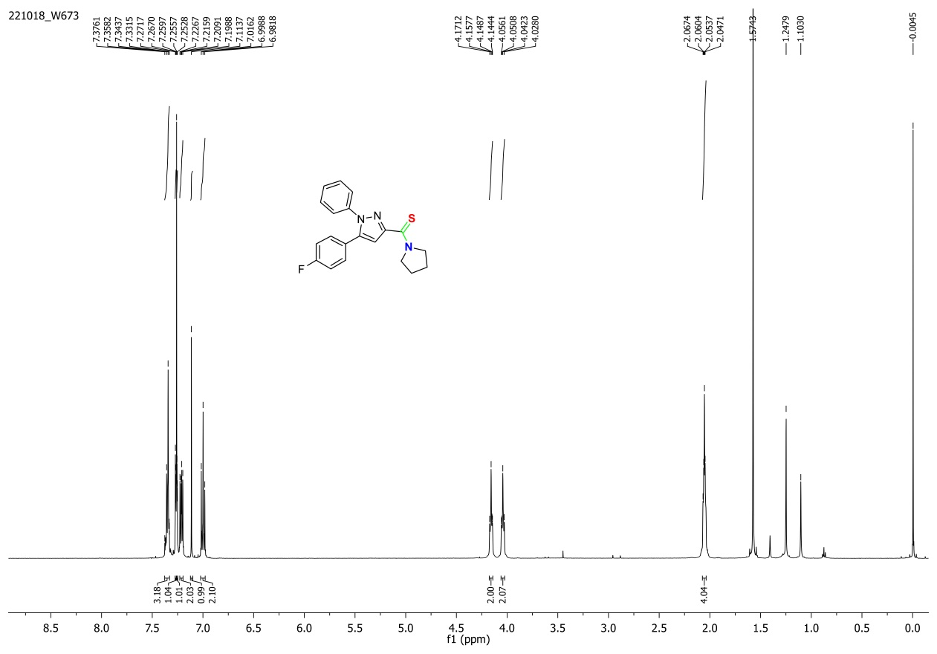
Figure S1. ¹H NMR spectrum of 1A
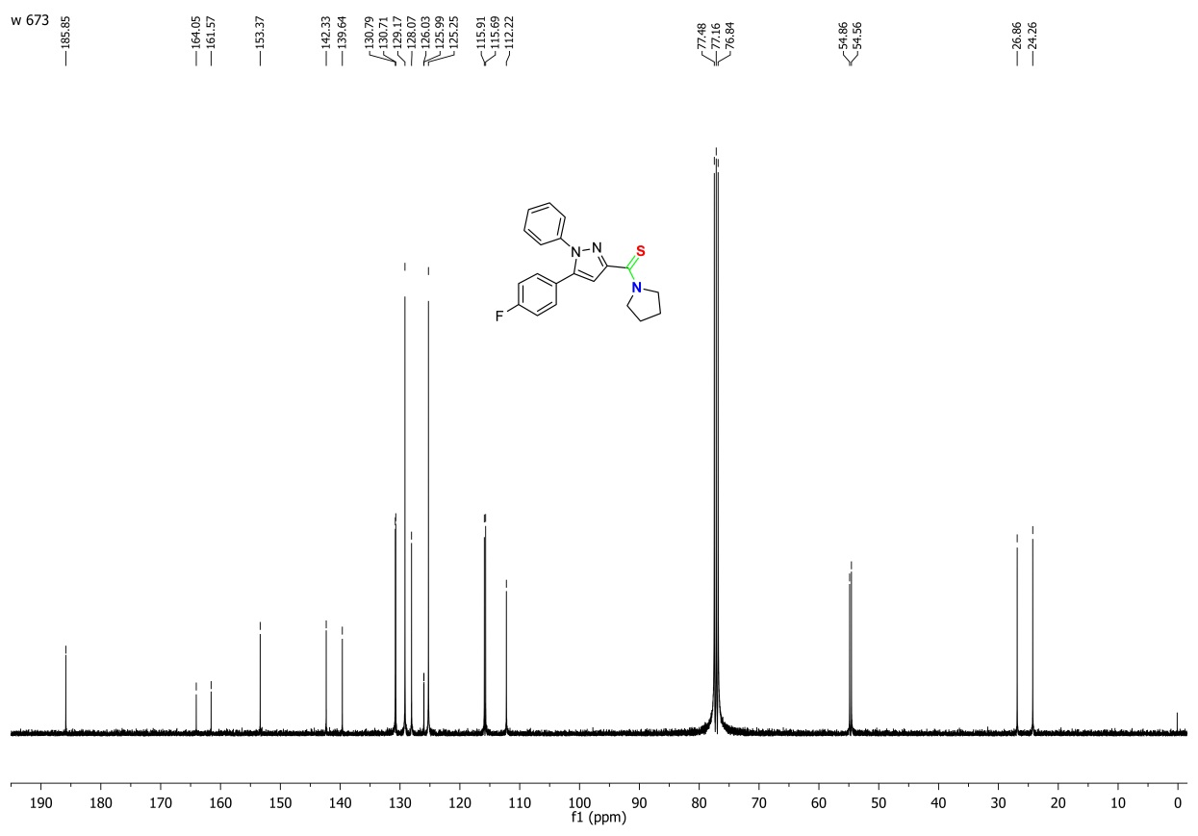
Figure S2. ¹³C NMR spectrum of 1A
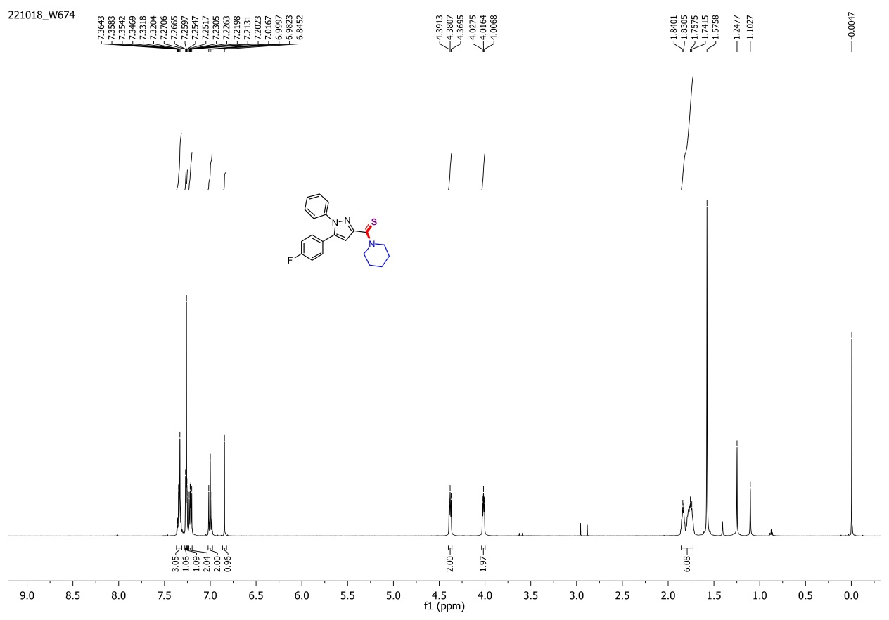
Figure S3. ¹H NMR spectrum of 1B
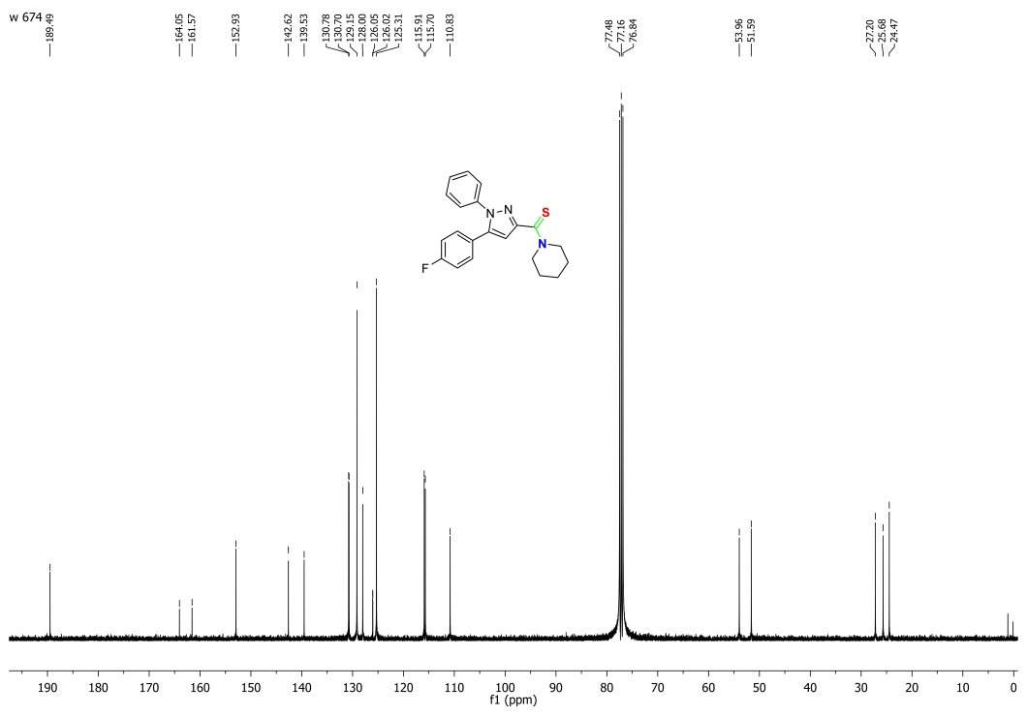
Figure S4. ¹³C NMR spectrum of 1B
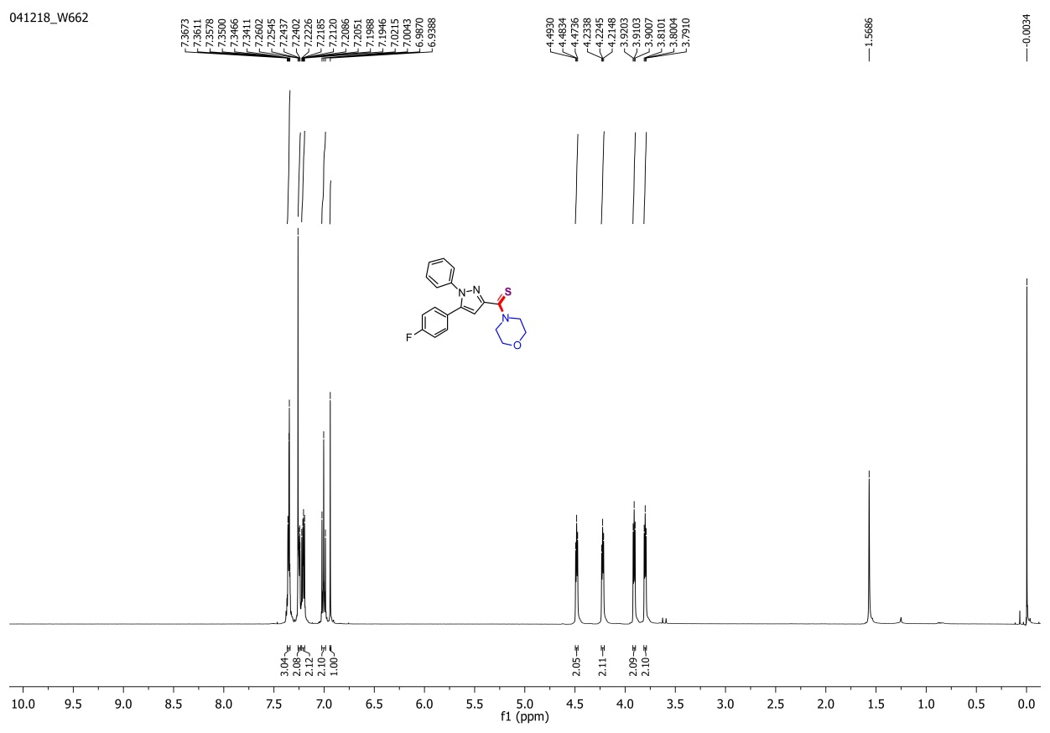
Figure S5. ¹H NMR spectrum of 1C
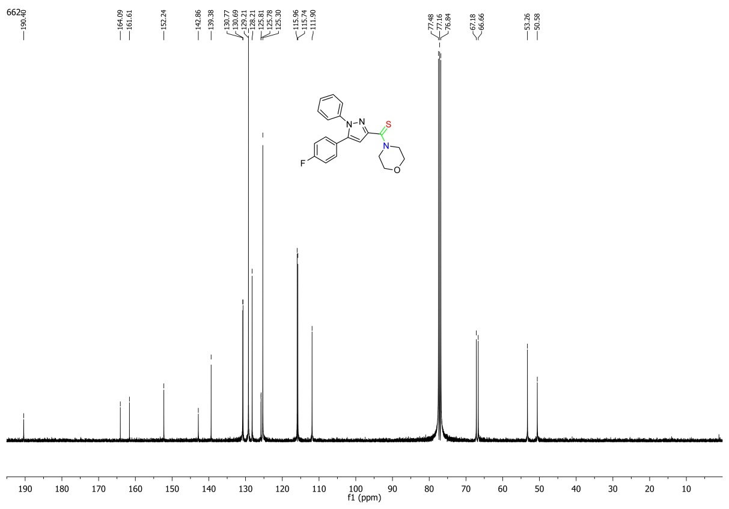
Figure S6. ¹³C NMR spectrum of 1C
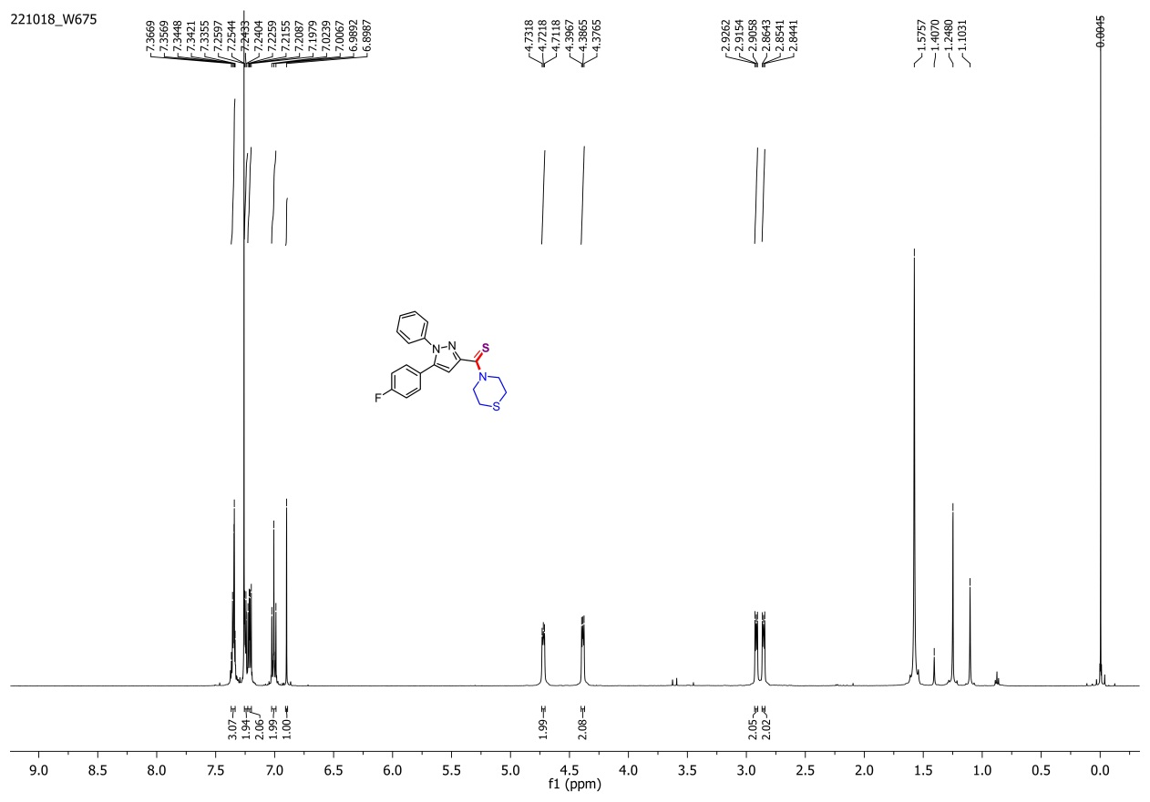
Figure S7. ¹H NMR spectrum of 1D.
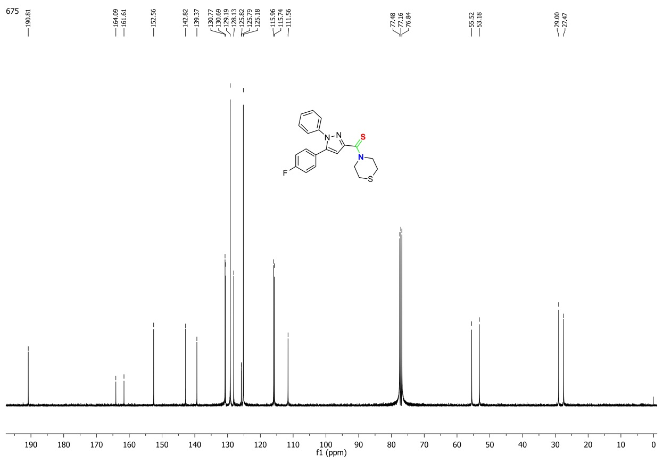
Figure S8. ¹³C NMR spectrum of 1D.
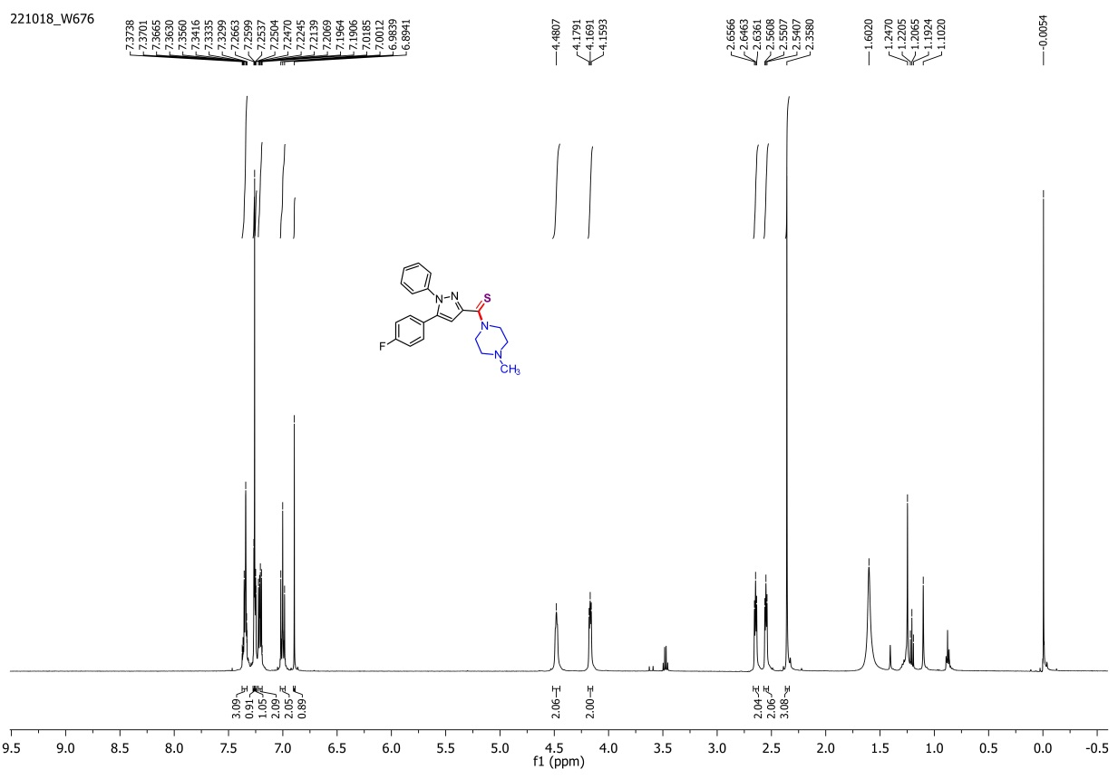
Figure S9. ¹H NMR spectrum of 1E
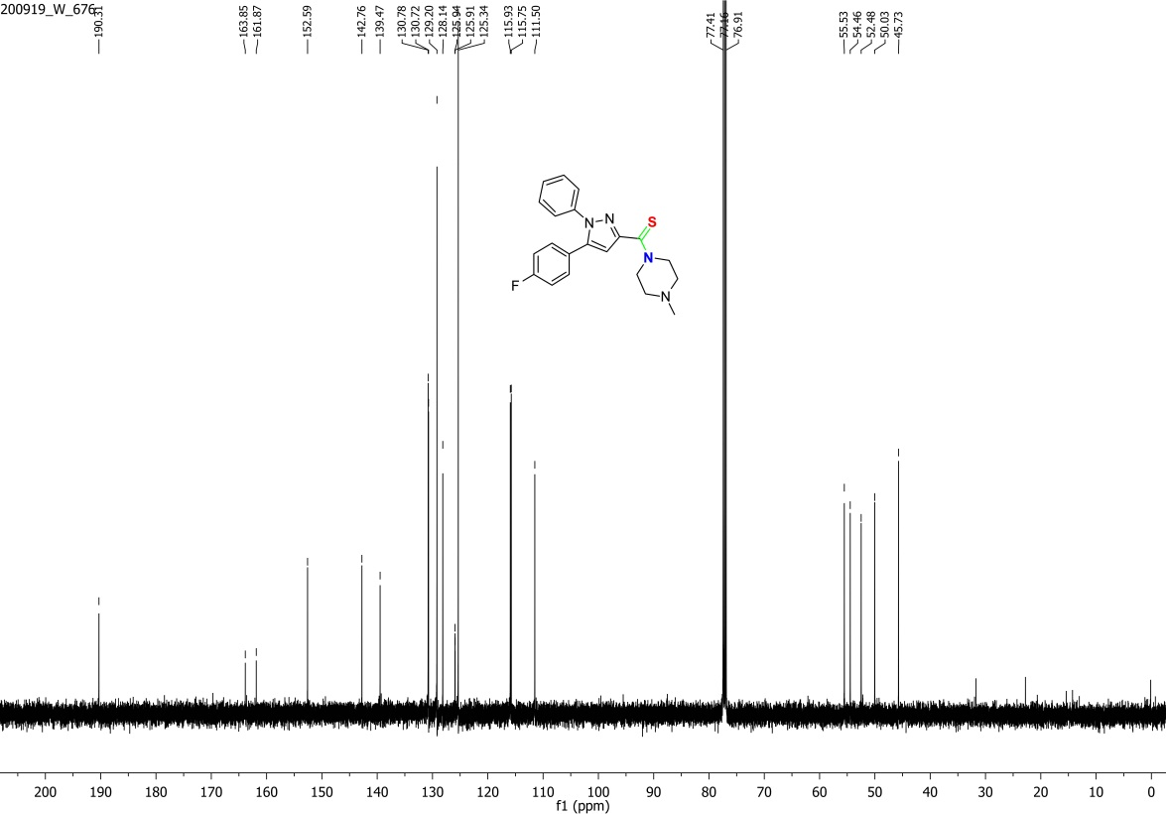
Figure S10. ¹³C NMR spectrum of 1E.
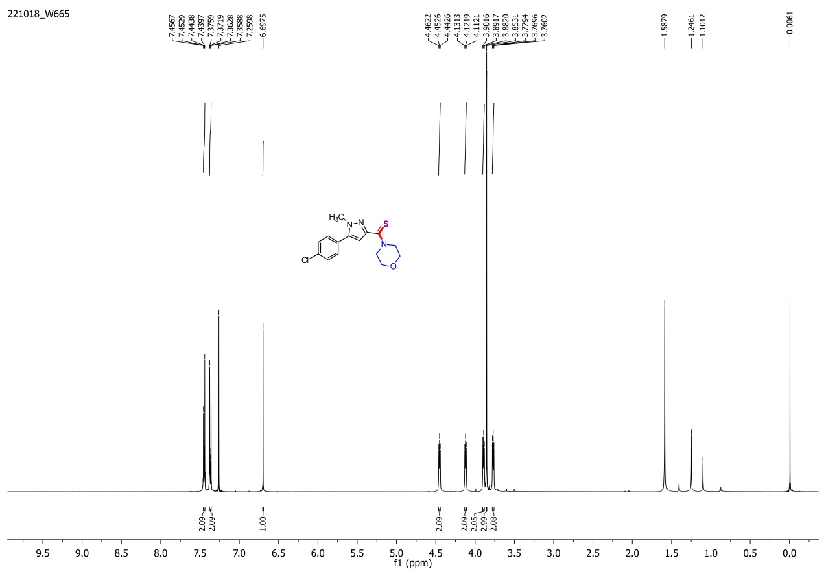
Figure S11. ¹H NMR spectrum of 2C.
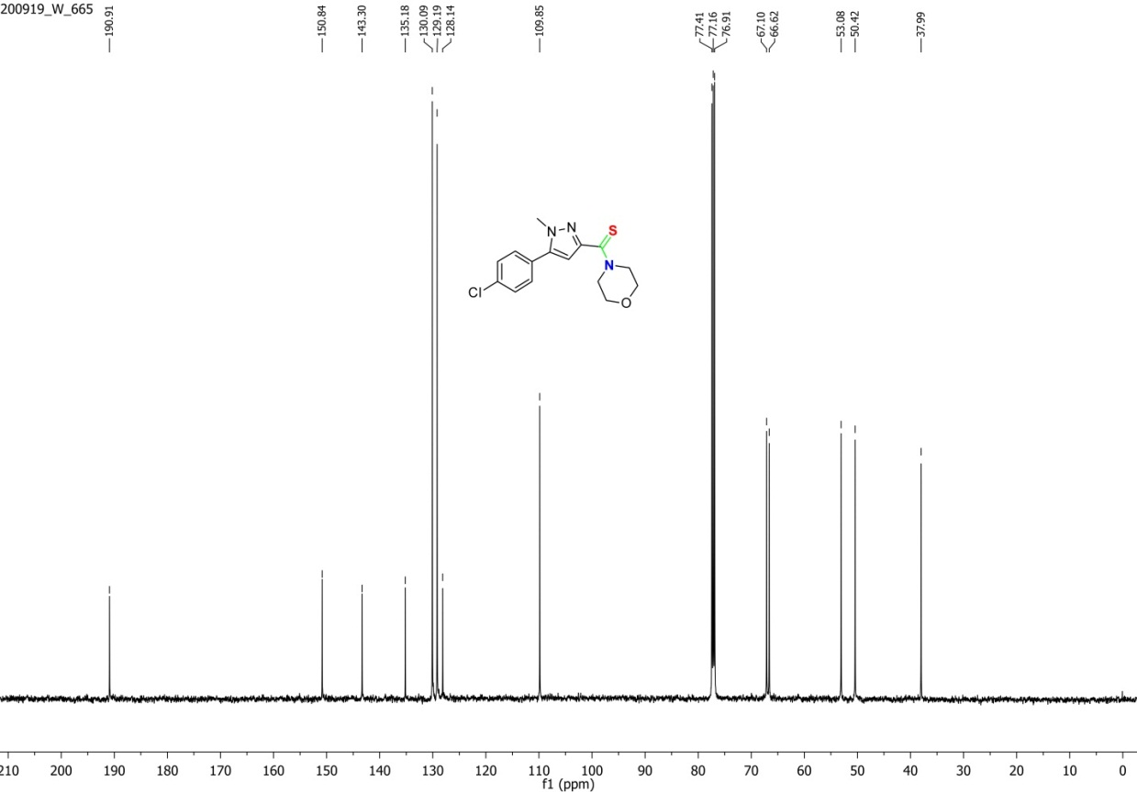
Figure S12. ¹³C NMR spectrum of 2C.
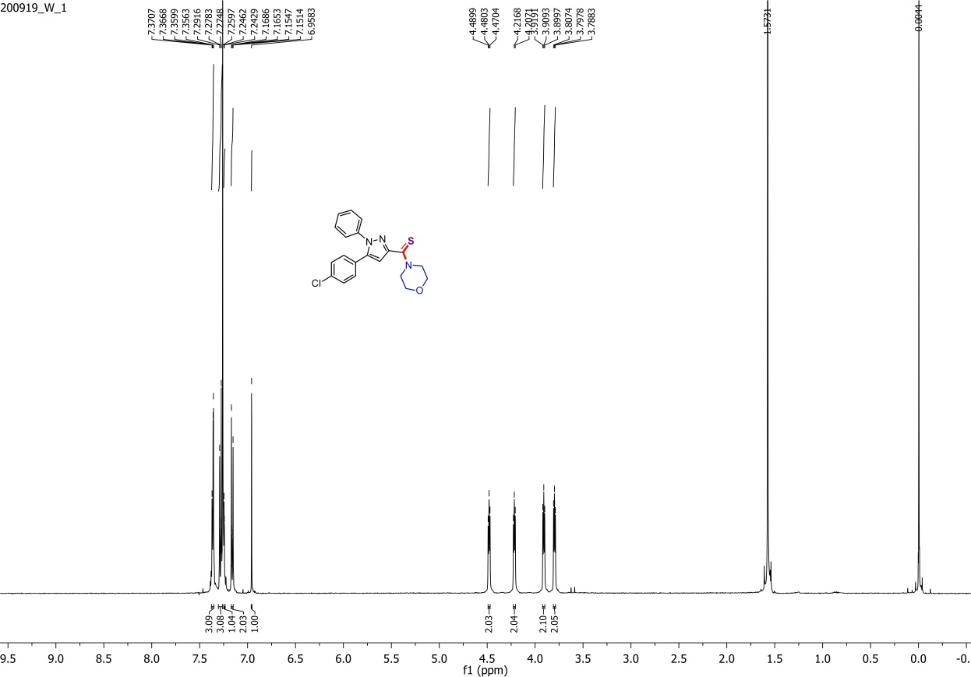
Figure S13. ¹H NMR spectrum of 3C.
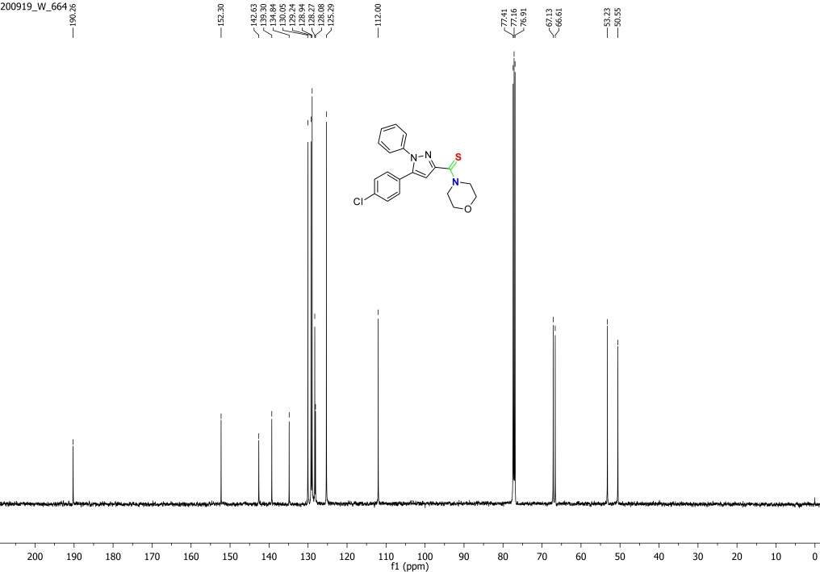
Figure S14. ¹³C NMR spectrum of 3C.
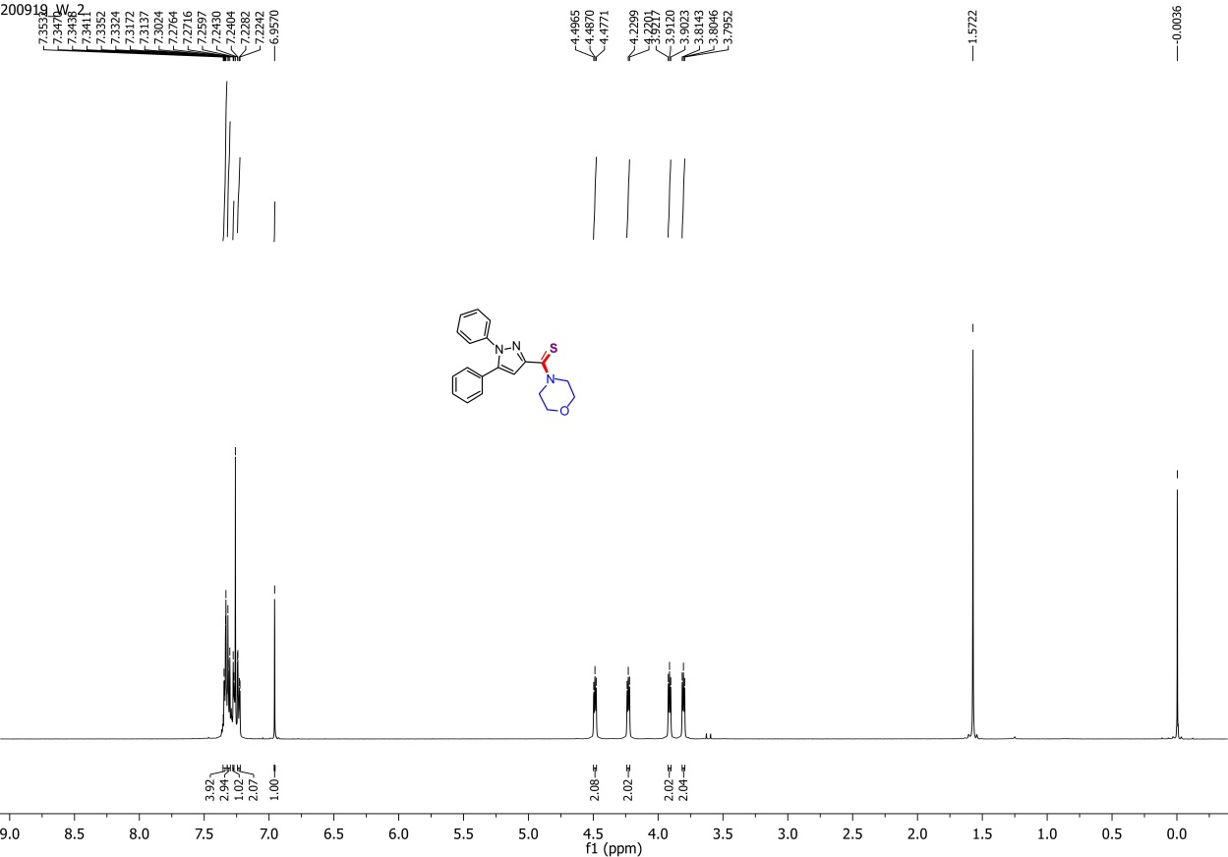
Figure S15. ¹H NMR spectrum of 4C.
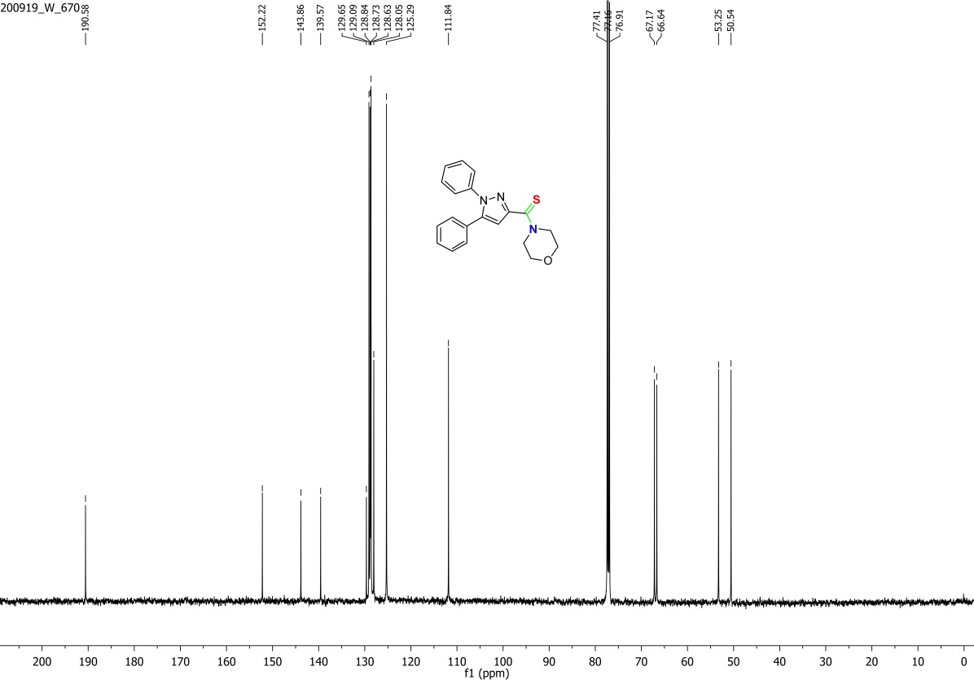
Figure S16. ¹³C NMR spectrum of 4C.
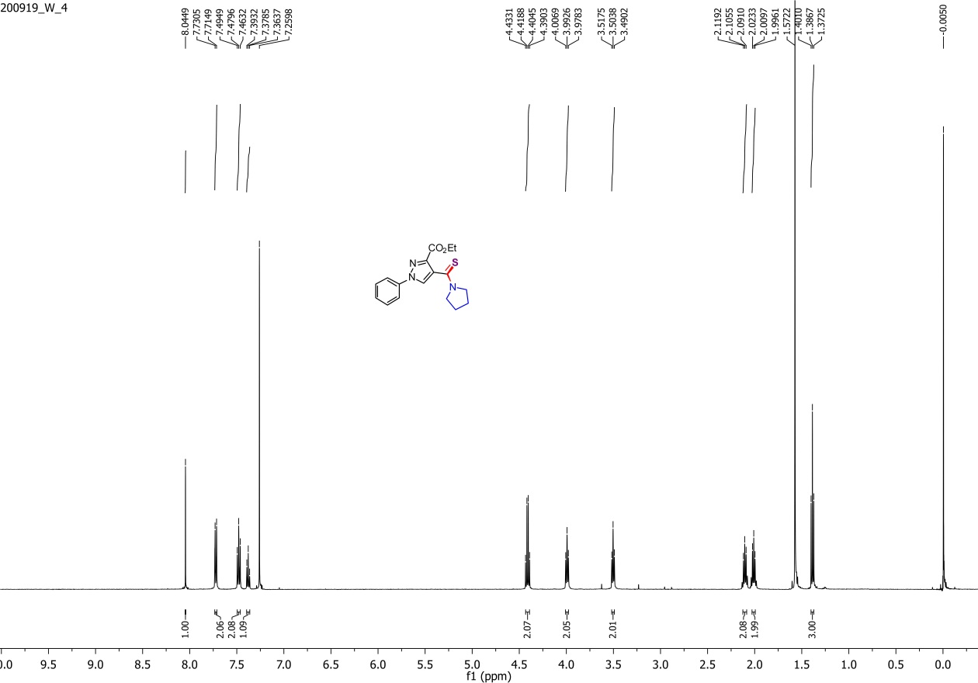
Figure S17. ¹H NMR spectrum of 5A.
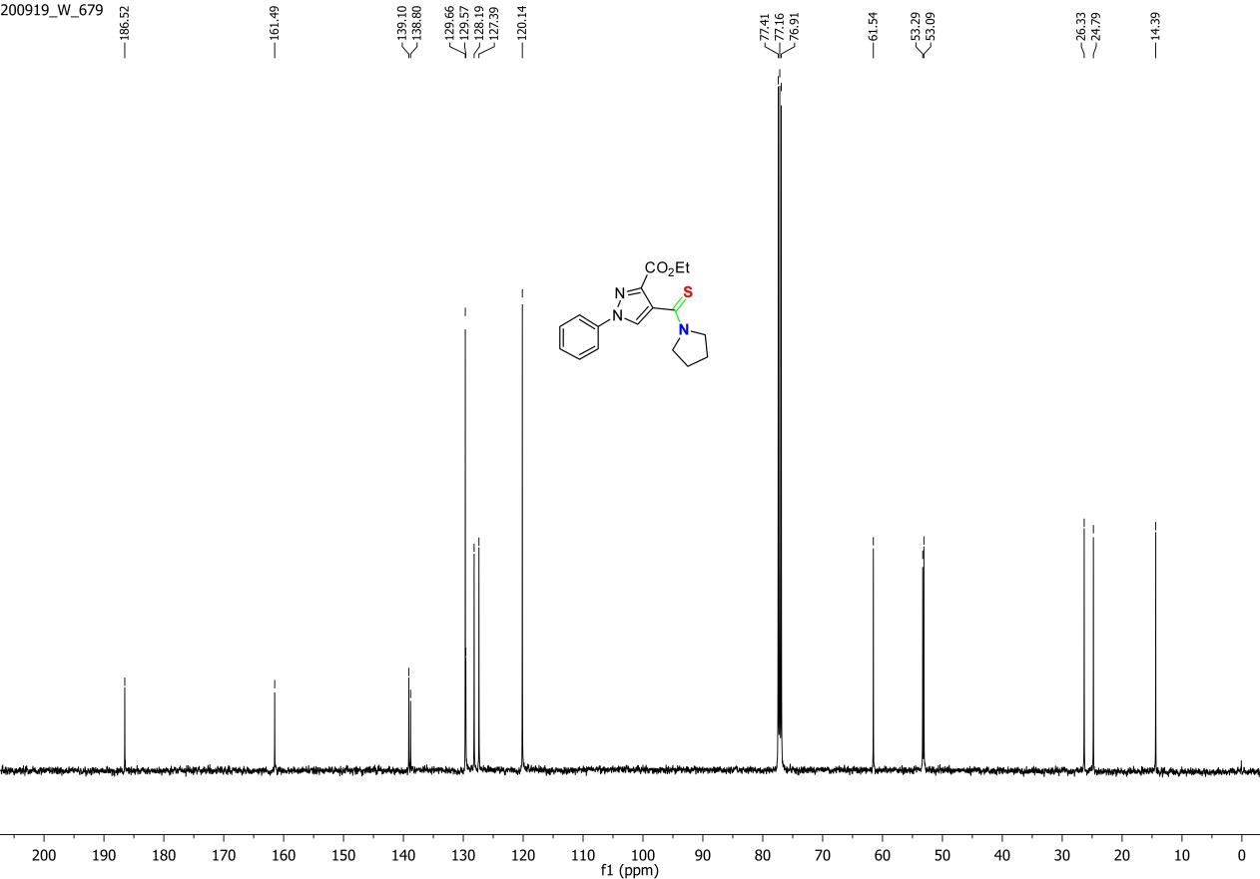
Figure S18. ¹³C NMR spectrum of 5A.
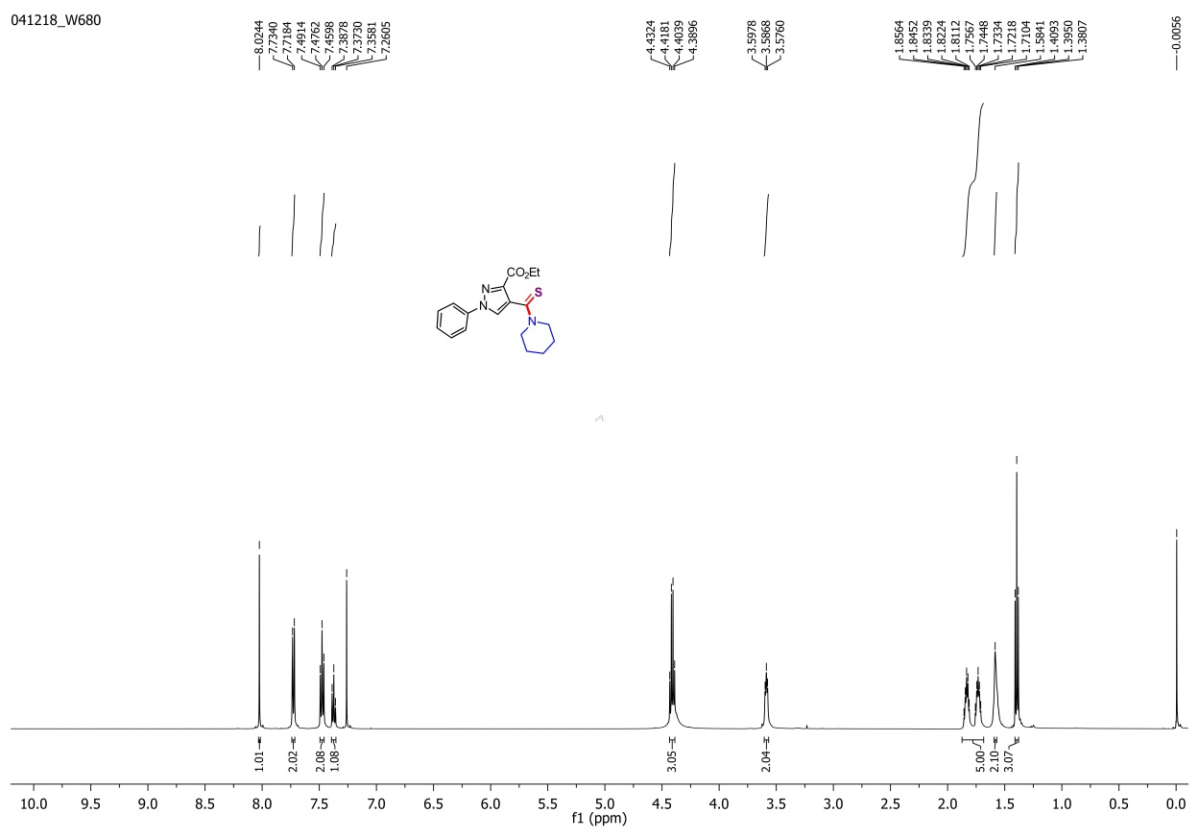
Figure S19. ¹H NMR spectrum of 5B.
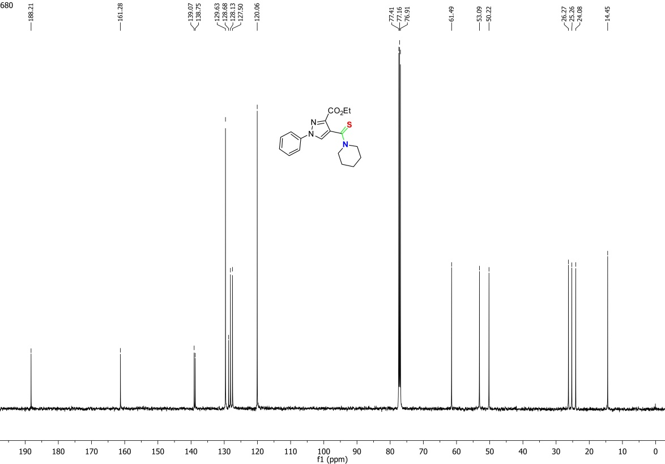
Figure S20. ¹³C NMR spectrum of 5B.
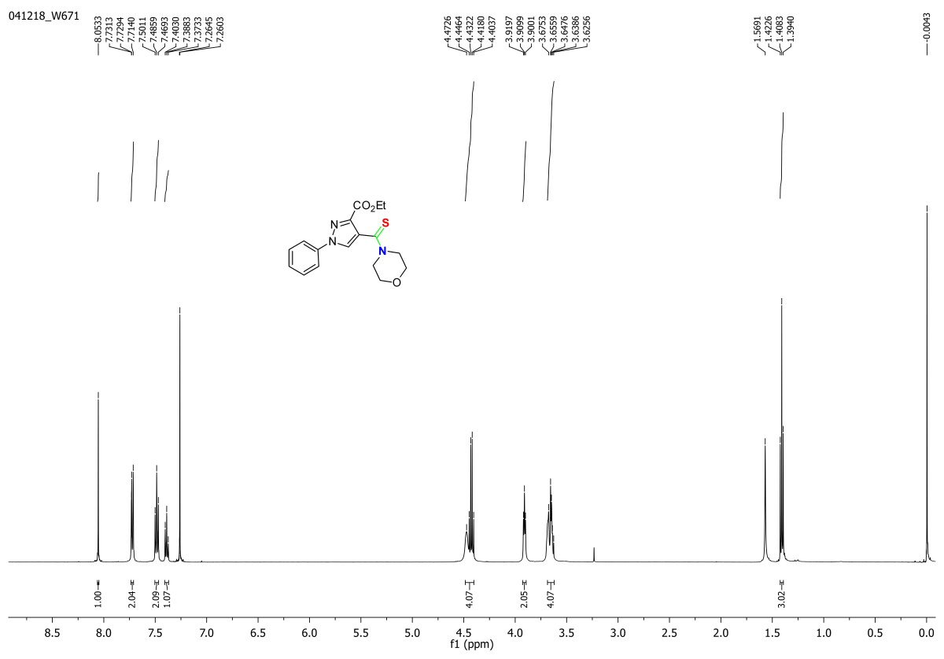
Figure S21. ¹H NMR spectrum of 5C.
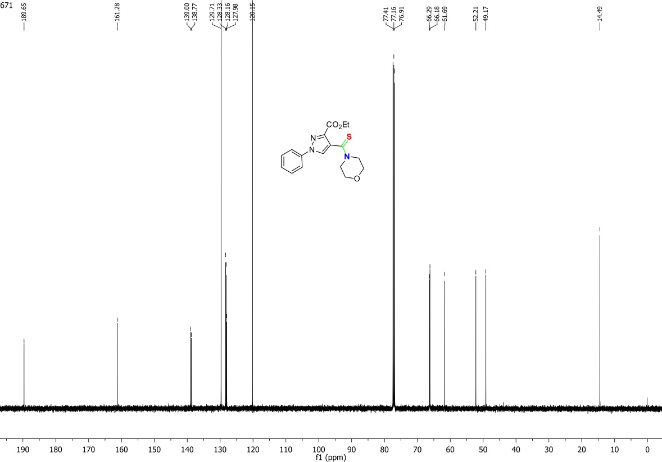
Figure S22. ¹³C NMR spectrum of 5C.
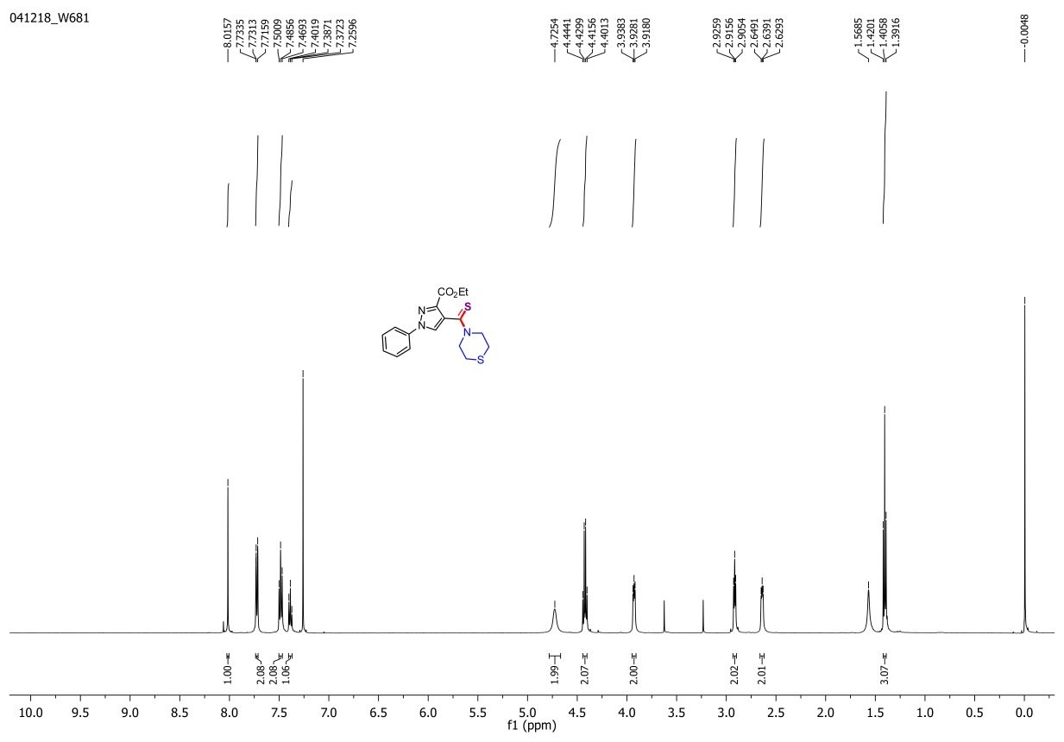
Figure S23. ¹H NMR spectrum of 5D.
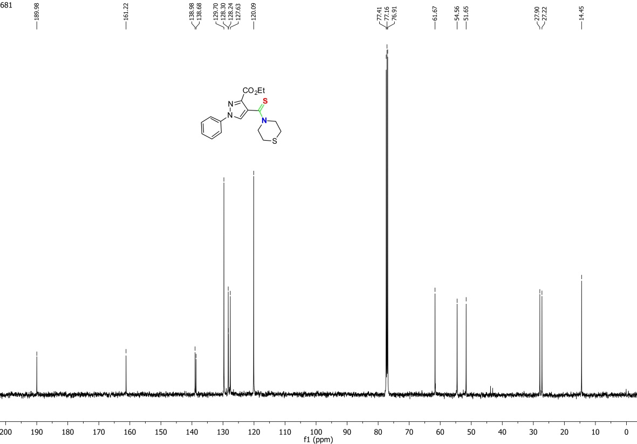
Figure S24. ¹³C NMR spectrum of 5D.
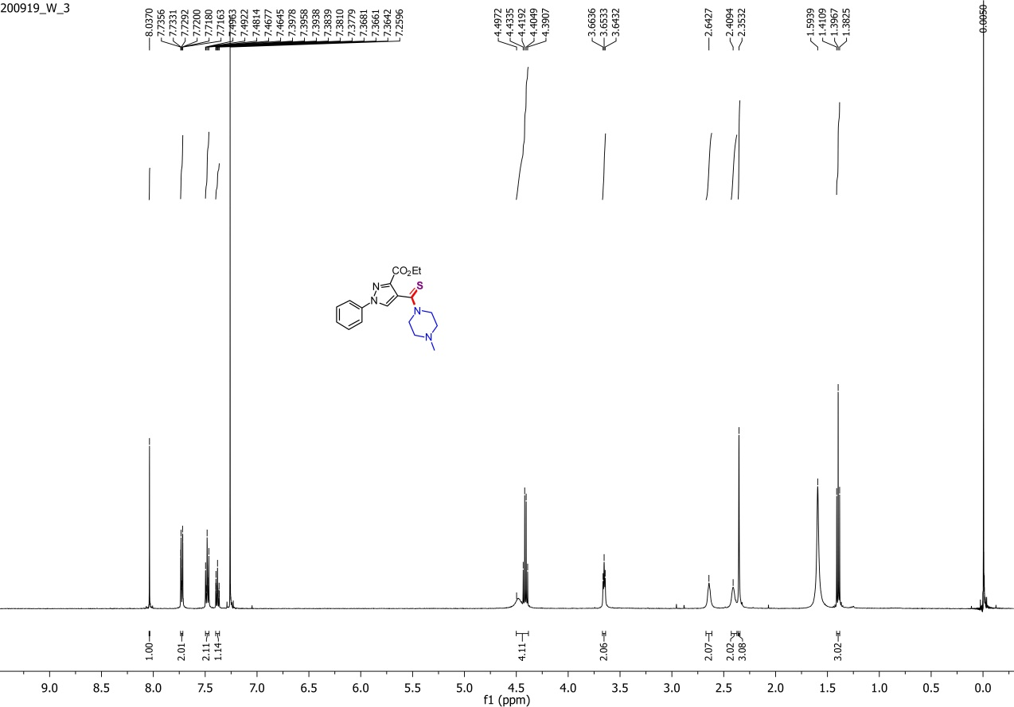
Figure S25. ¹H NMR spectrum of 5E.
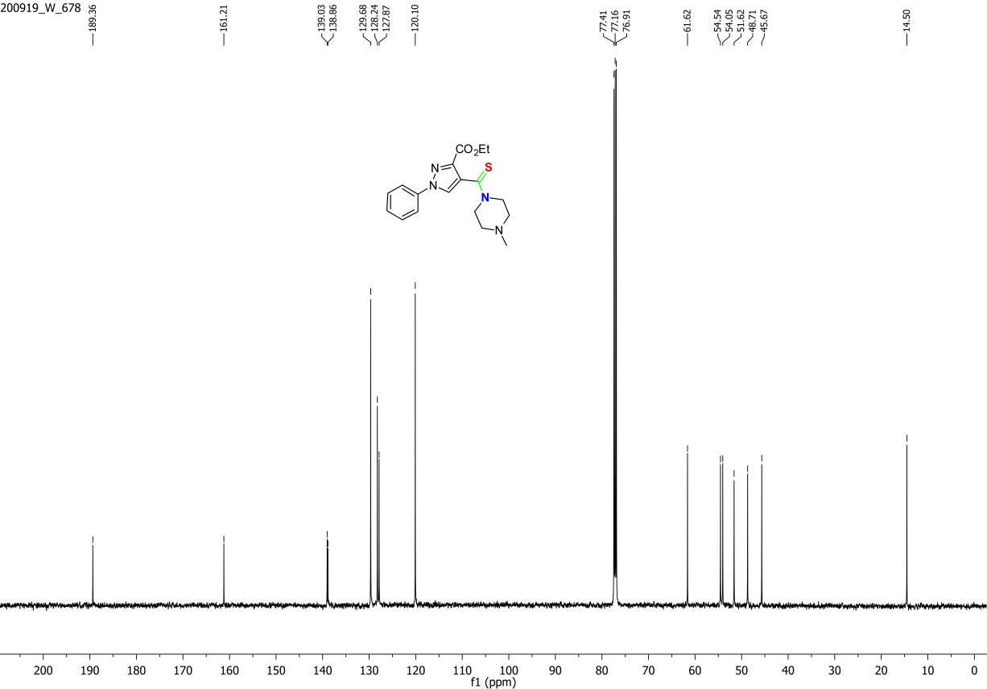
Figure S26. ¹³C NMR spectrum of 5E
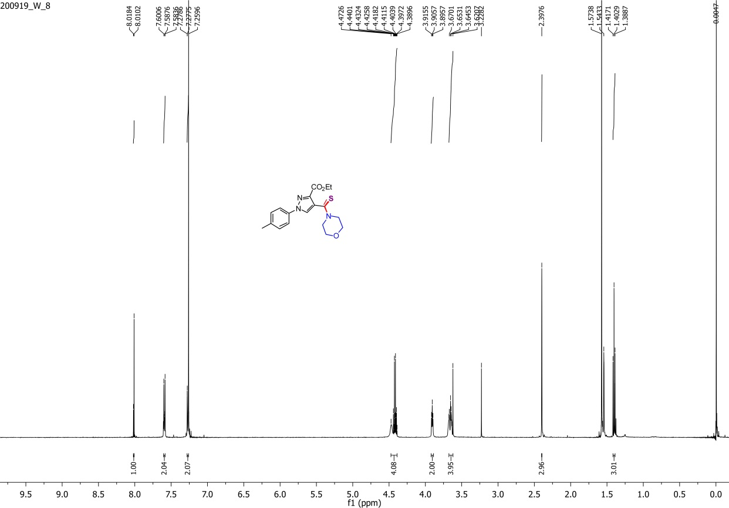
Figure S27. ¹H NMR spectrum of 6C
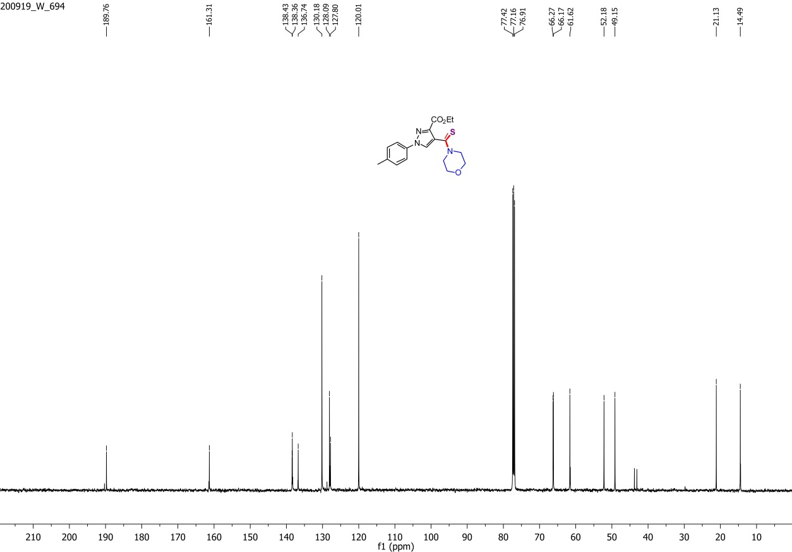
Figure S28. ¹³C NMR spectrum of 6C
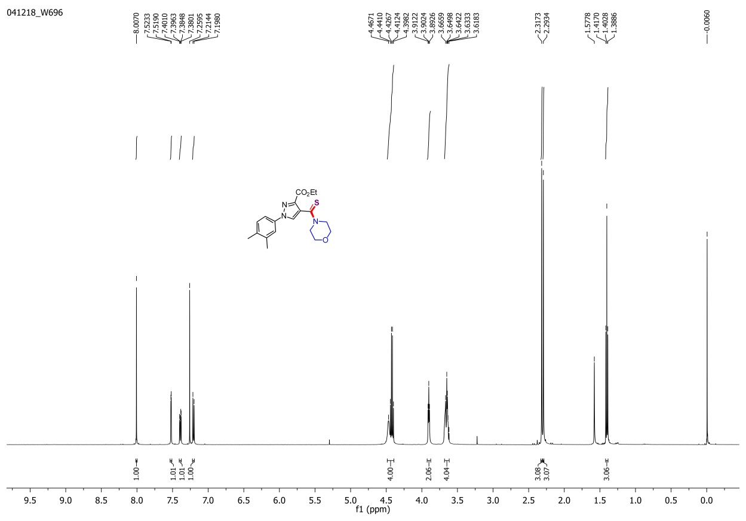
Figure S29. ¹H NMR spectrum of 7C
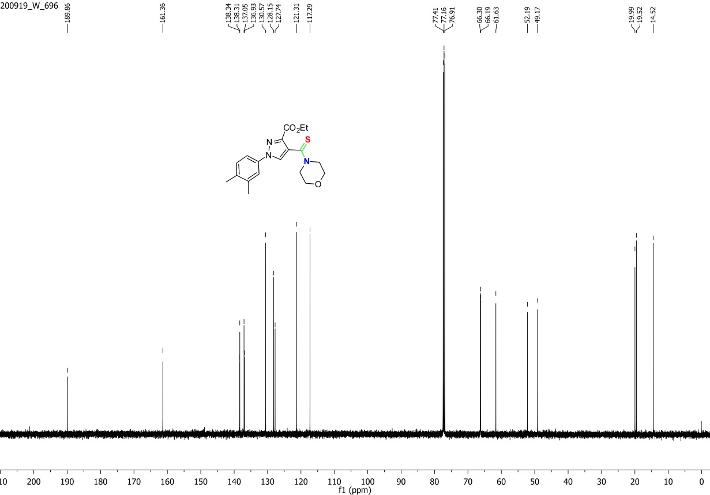
Figure S30. ¹³C NMR spectrum of 7C
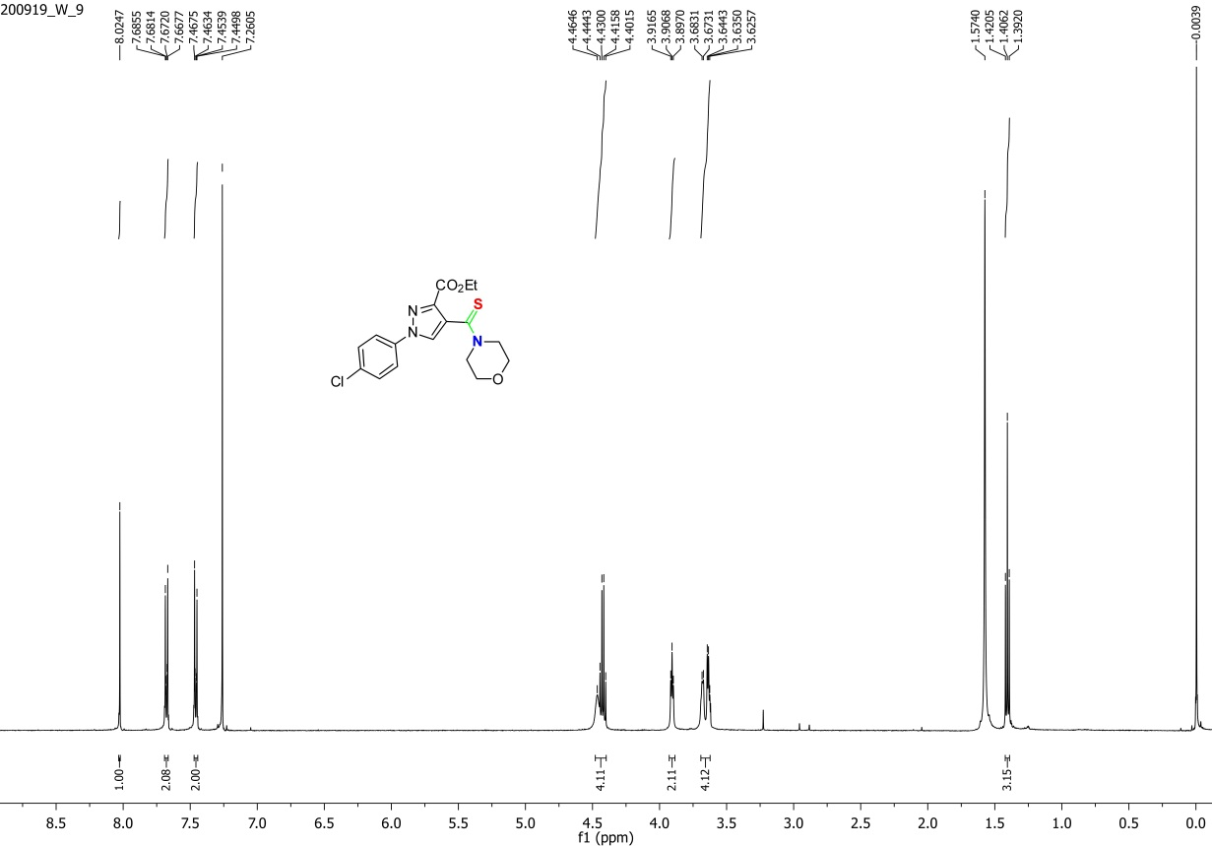
Figure S31. ¹H NMR spectrum of 8C
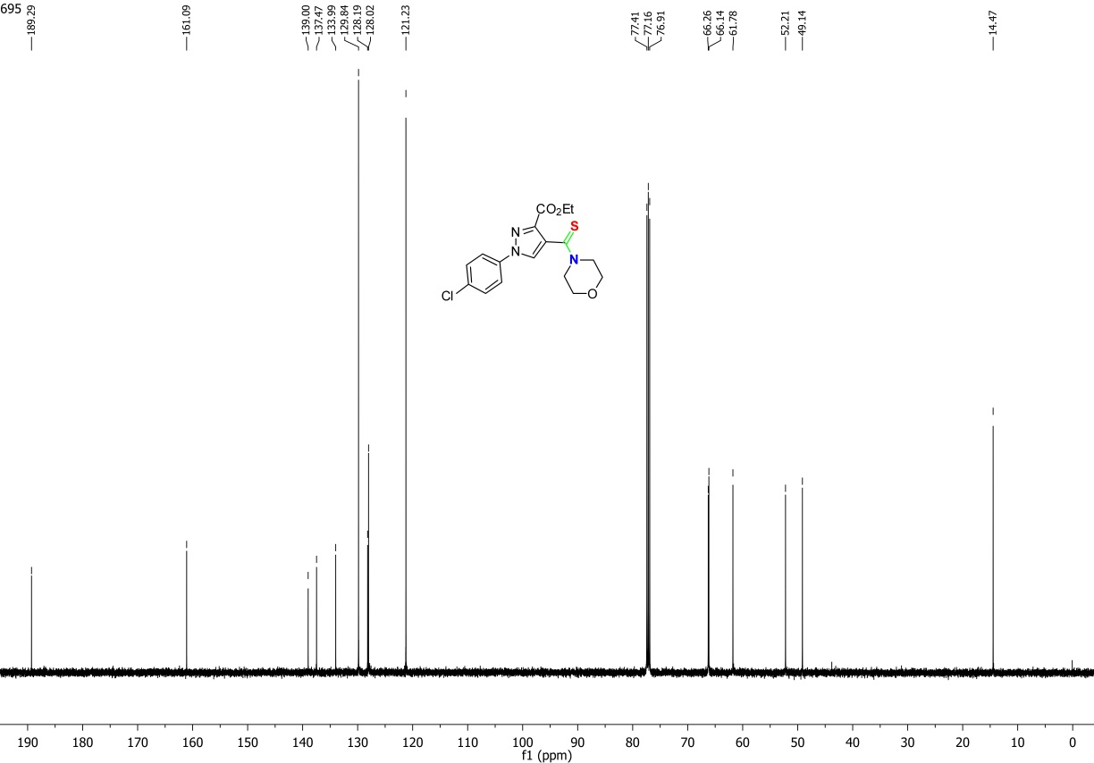
Figure S32. ¹³C NMR spectrum of 8C
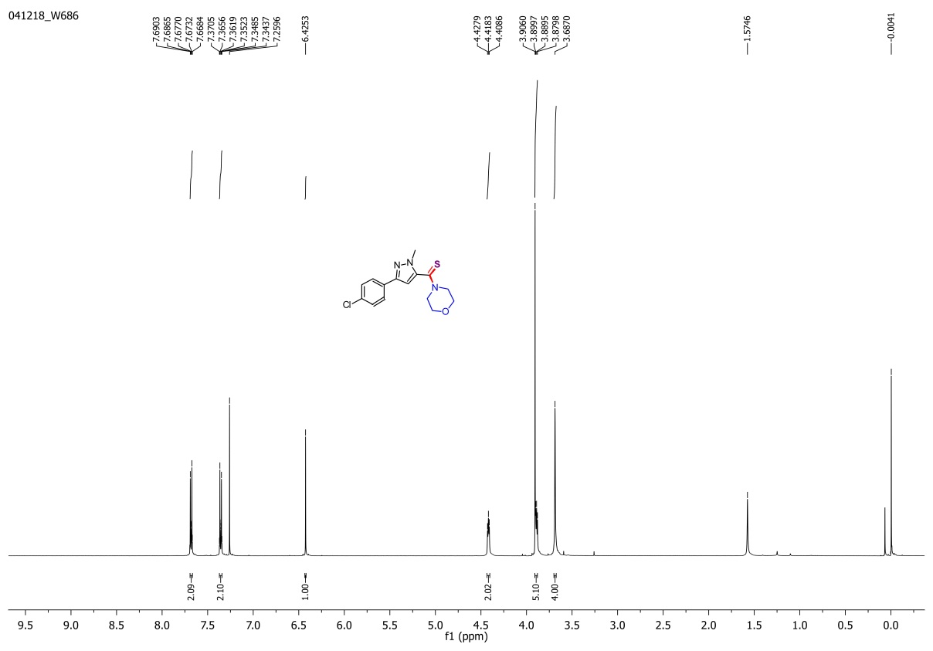
Figure S33. ¹H NMR spectrum of 9C
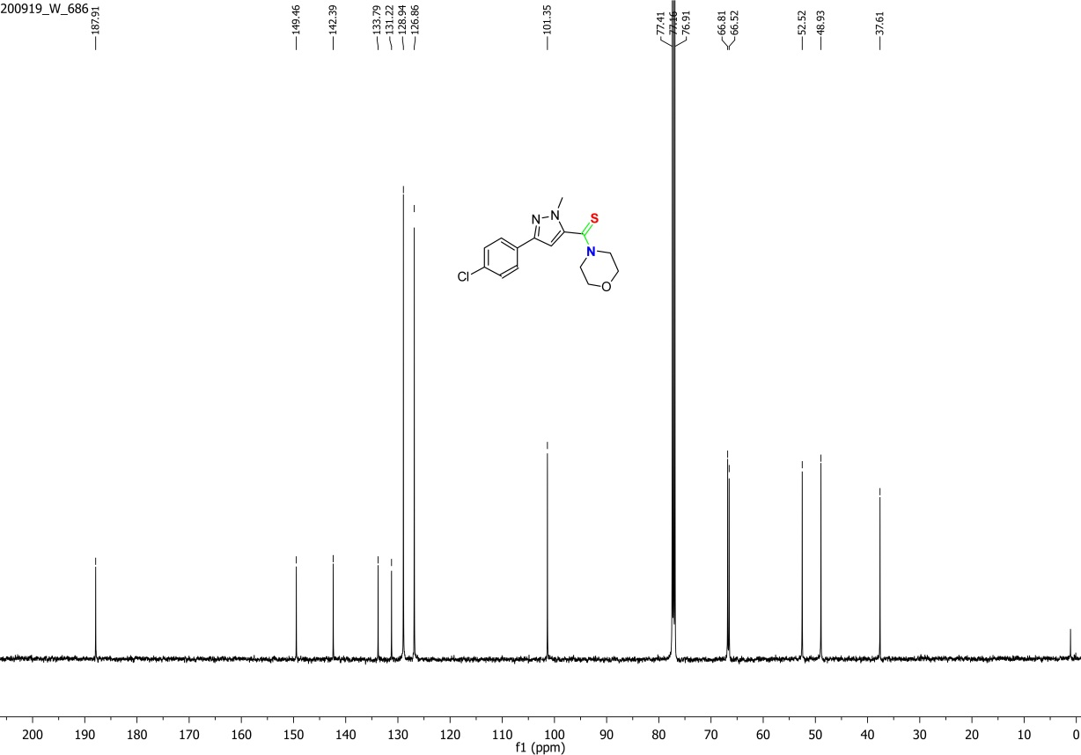
Figure S34. ¹³C NMR spectrum of 9C
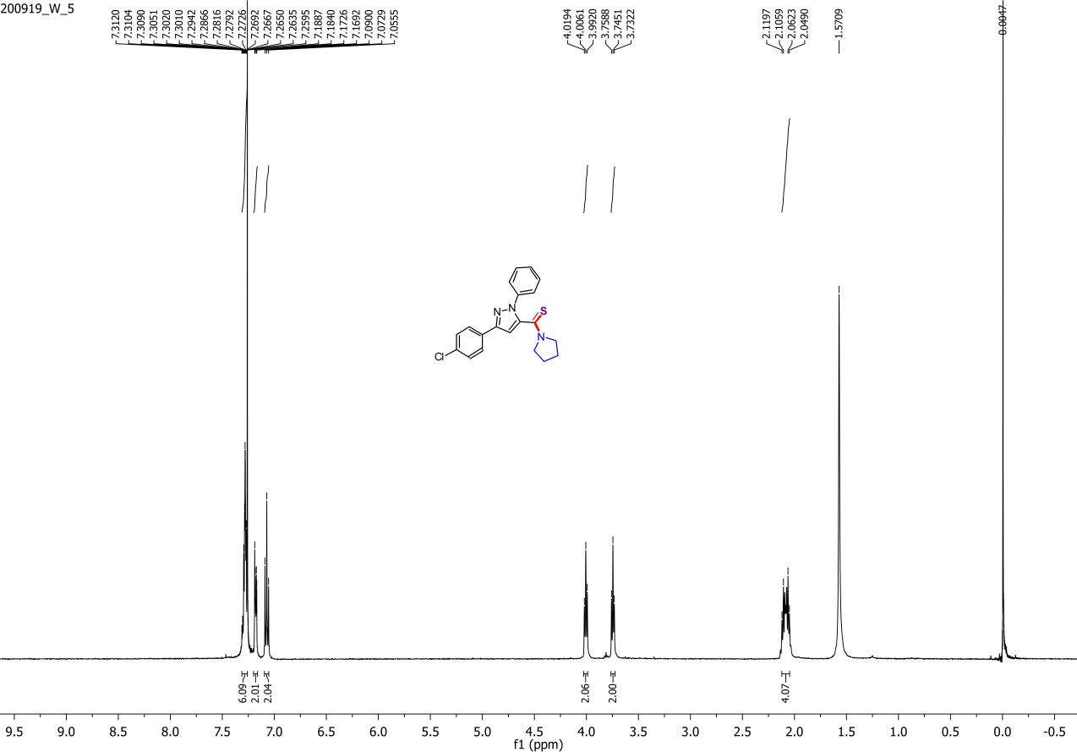
Figure S35. ¹H NMR spectrum of 10A
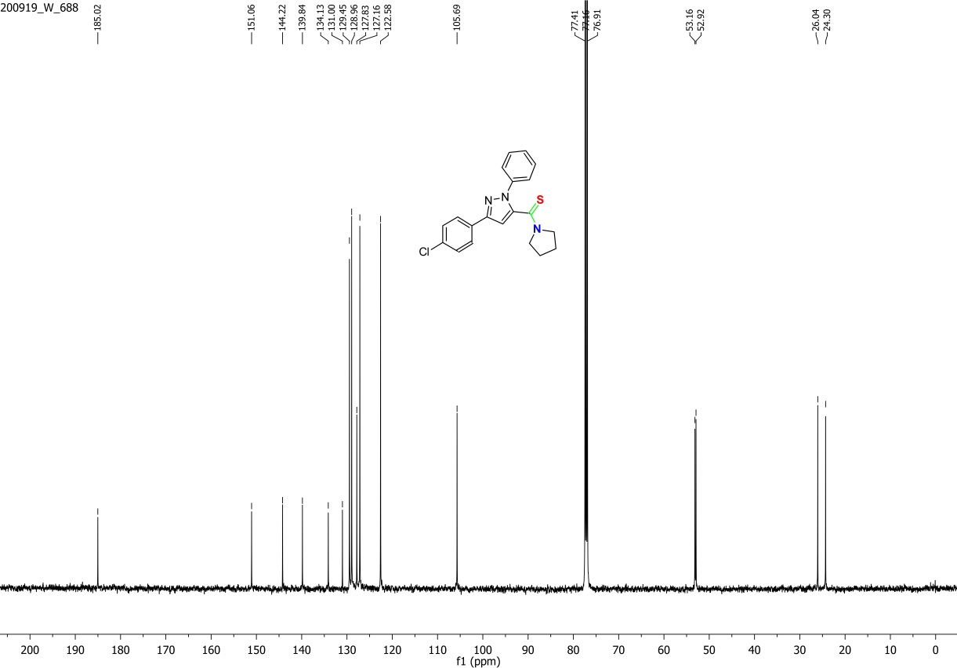
Figure S36. ¹³C NMR spectrum of 10A
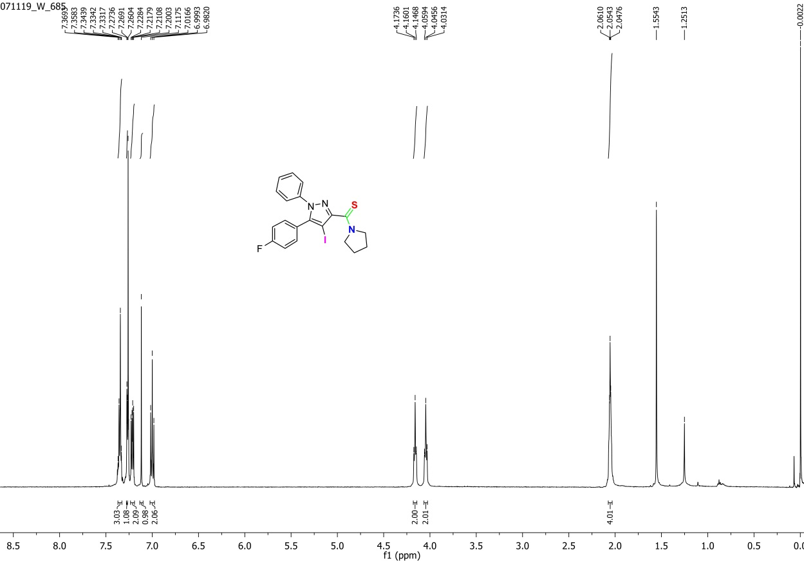
Figure S37. ¹H NMR spectrum of 11A
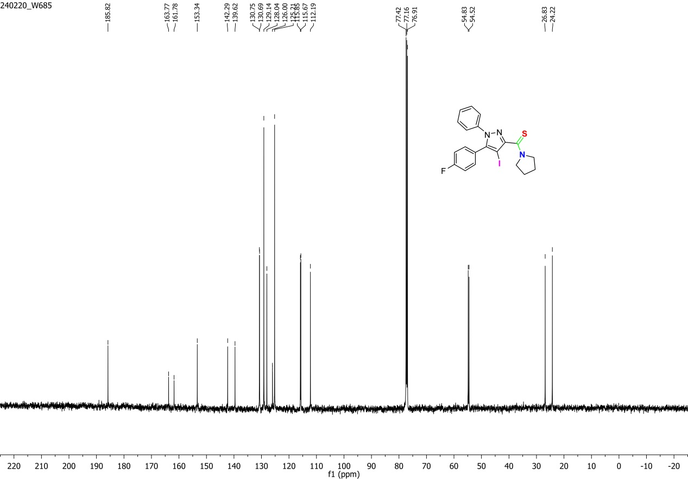
Figure S38. ¹³C NMR spectrum of 11A
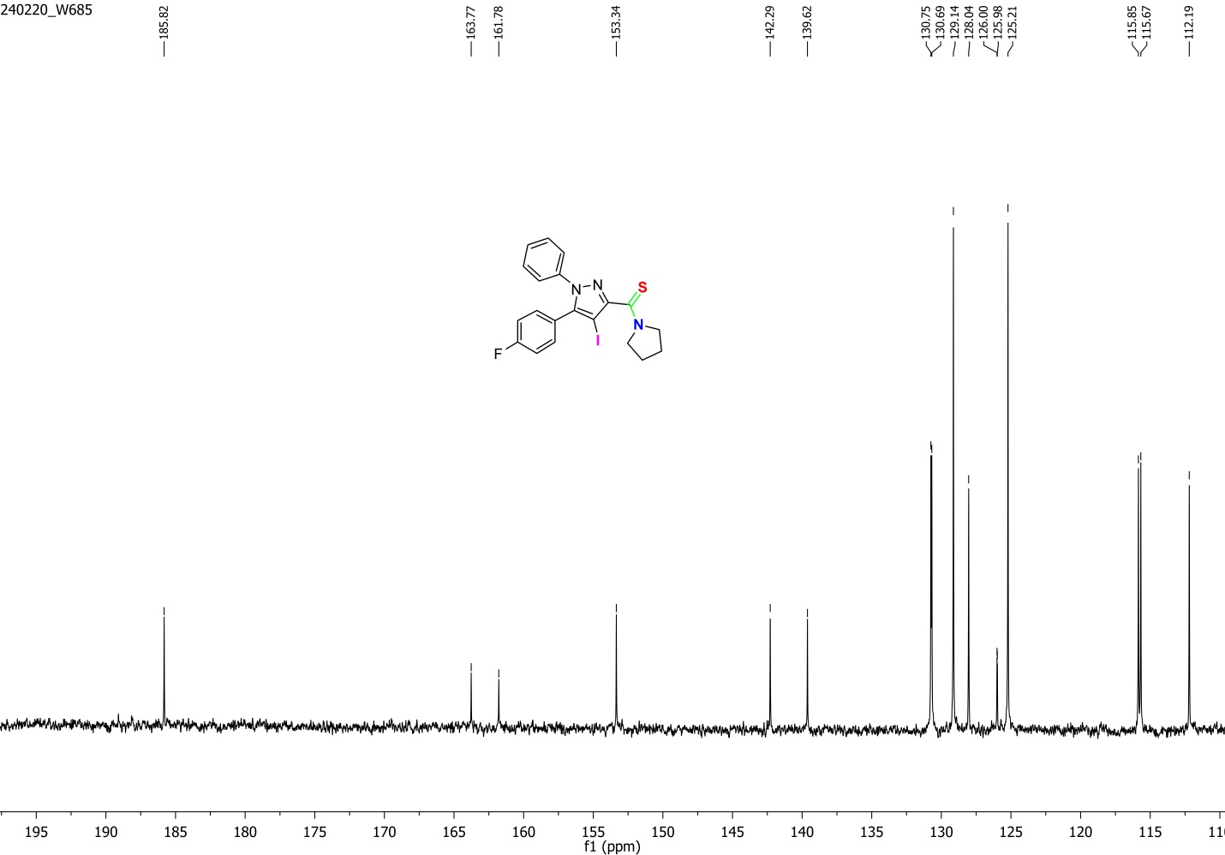
Figure S39. Expansion of ¹³C NMR spectrum of 11A
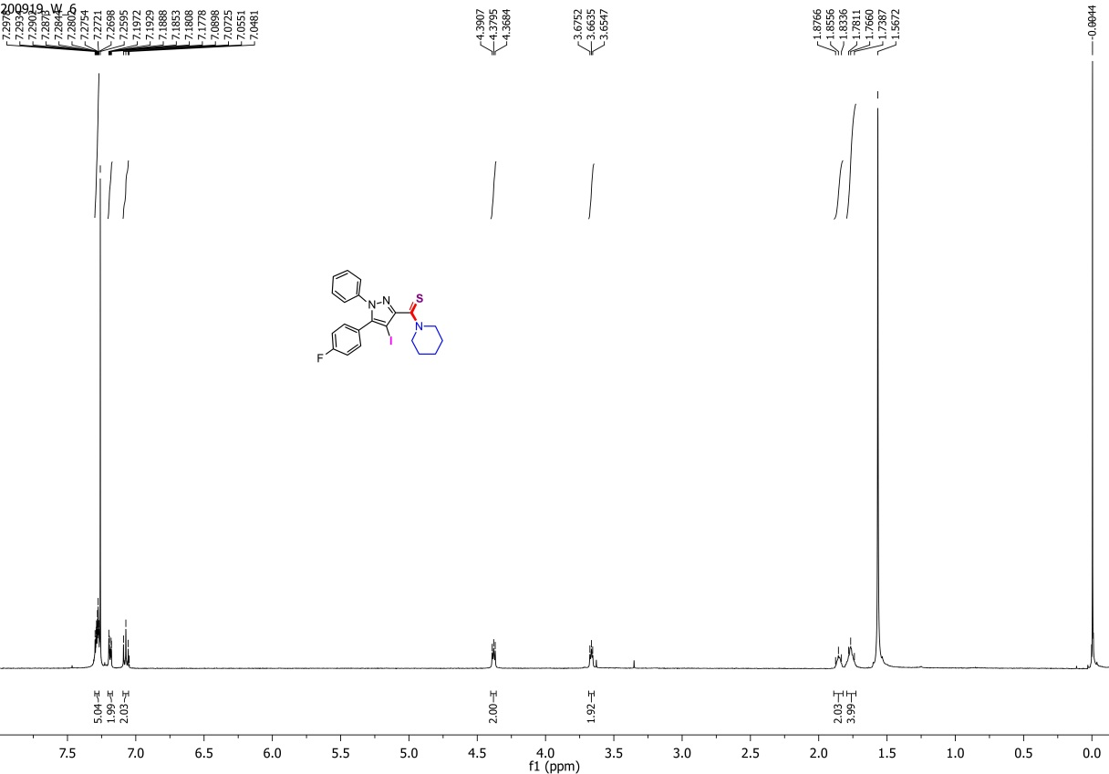
Figure S40. ¹H NMR spectrum of 11B
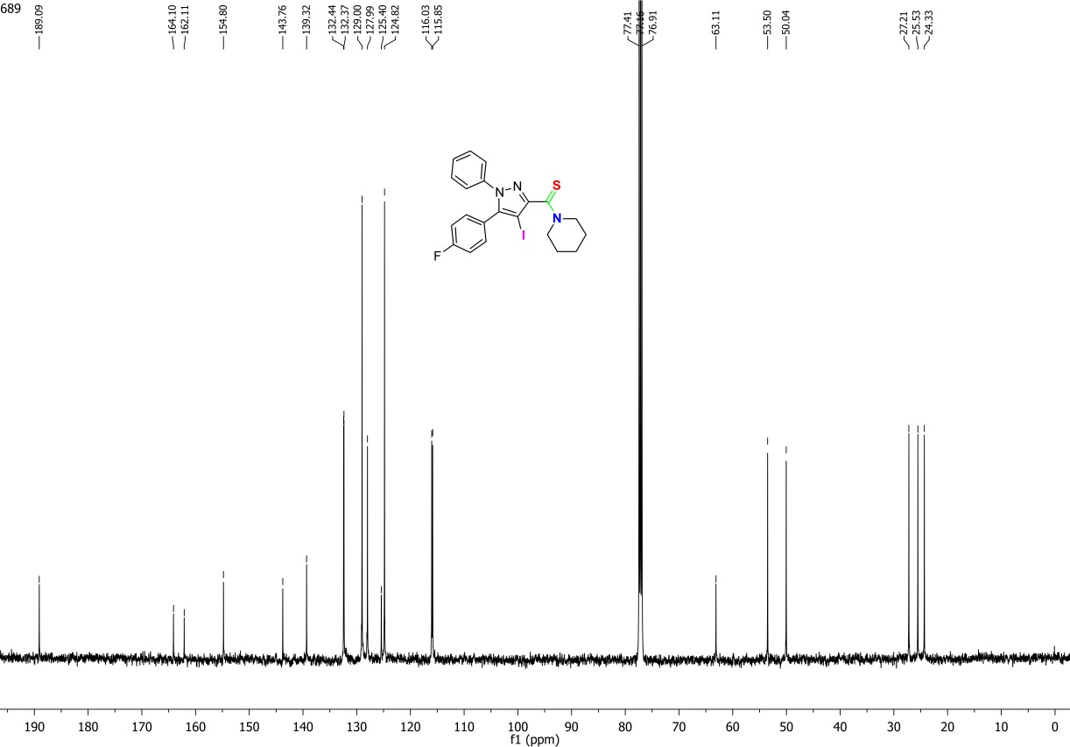
Figure S41. ¹³C NMR spectrum of 11B
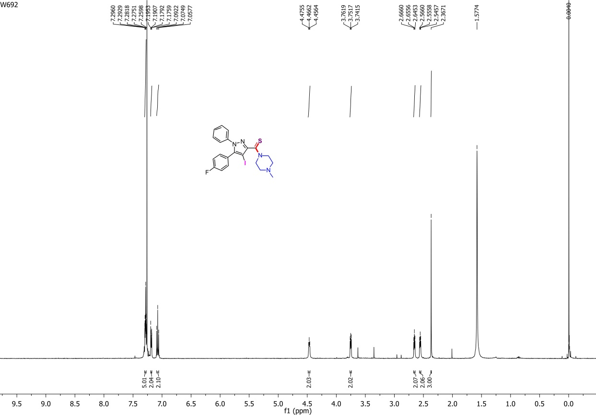
Figure S42. ¹H NMR spectrum of 11E
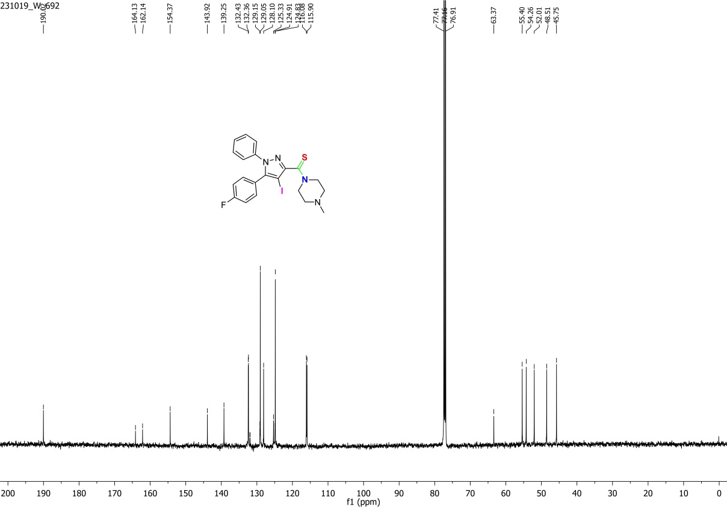
Figure S43. ¹³C NMR spectrum of 11E
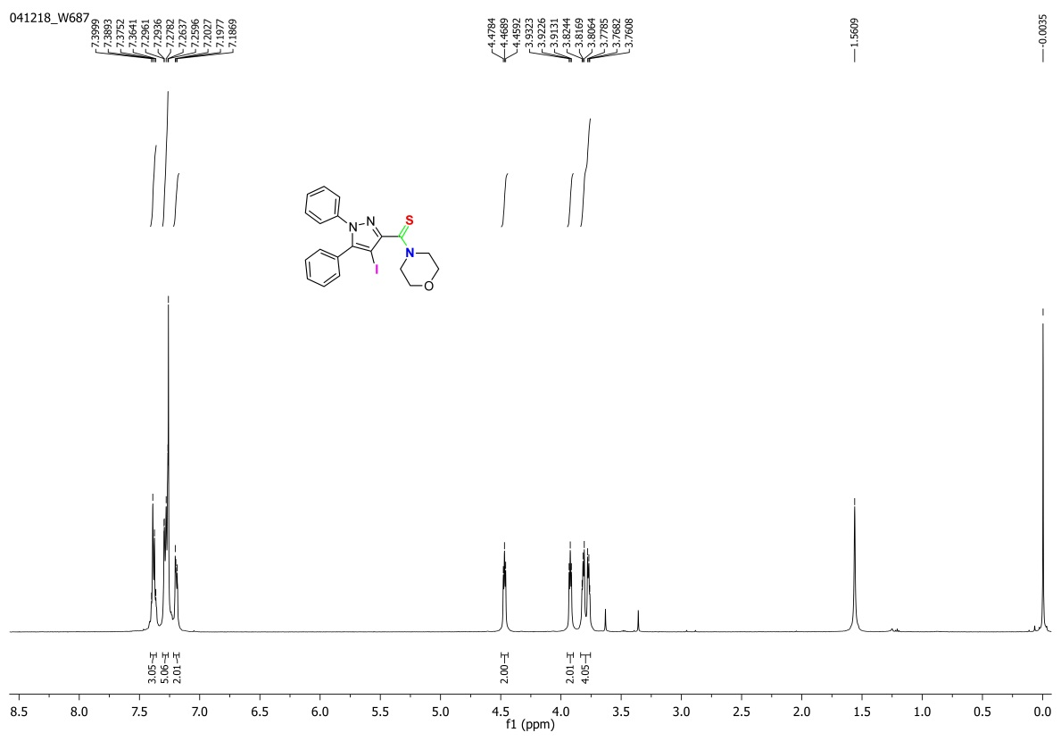
Figure S44. ¹H NMR spectrum of 12C
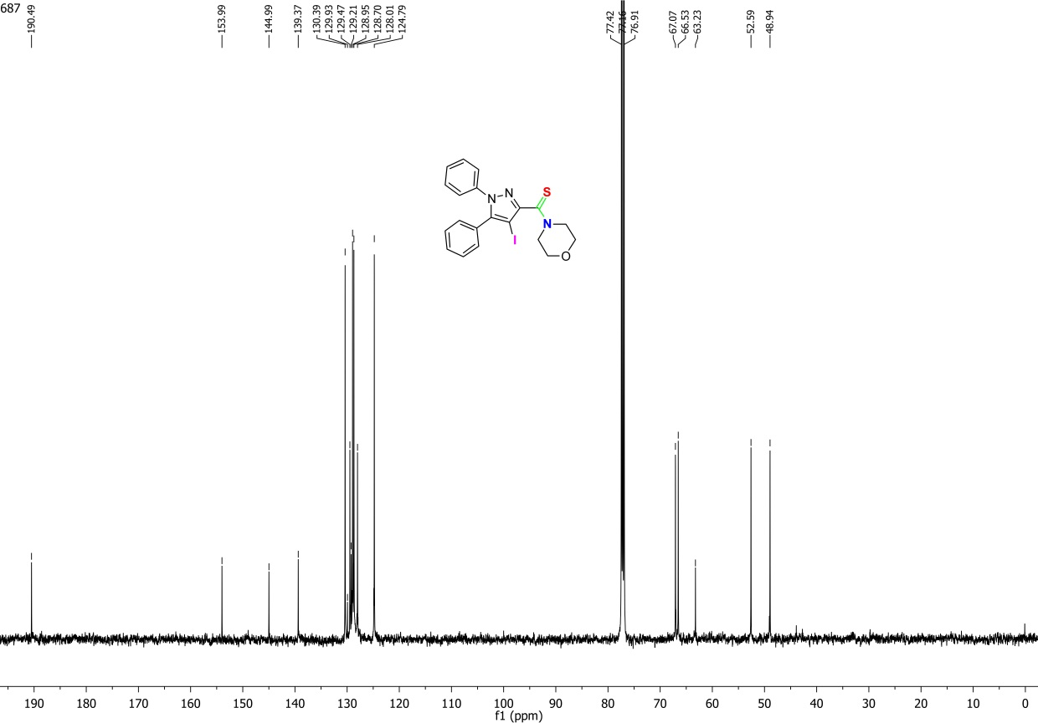
Figure S45. ¹³C NMR spectrum of 12C
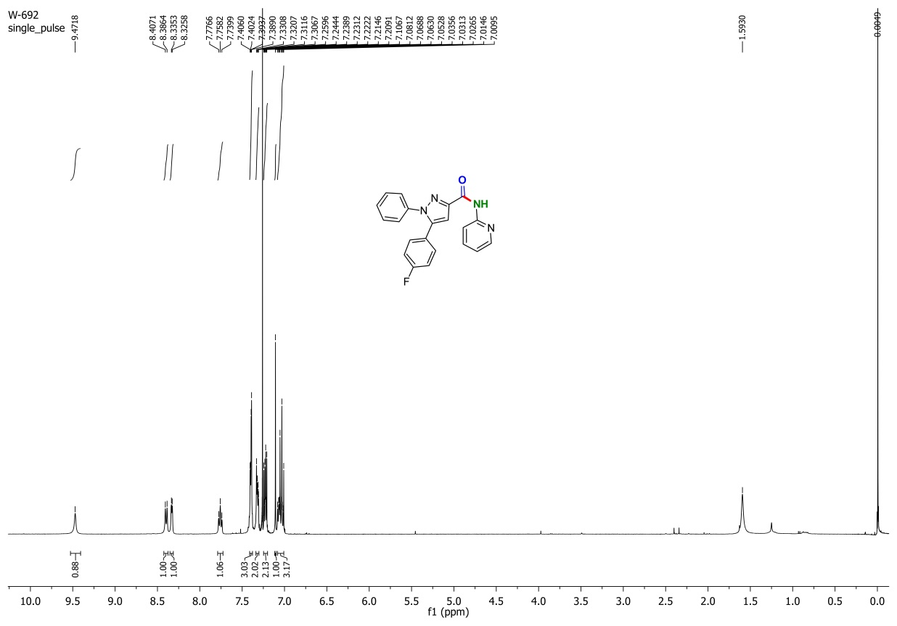
Figure S46. ¹H NMR spectrum of 1F
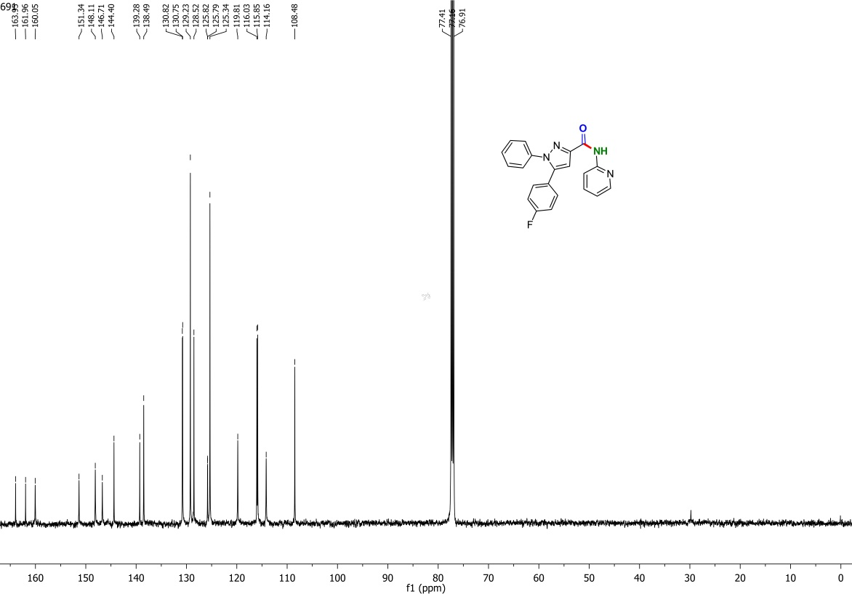
Figure S47. ¹³C NMR spectrum of 1F
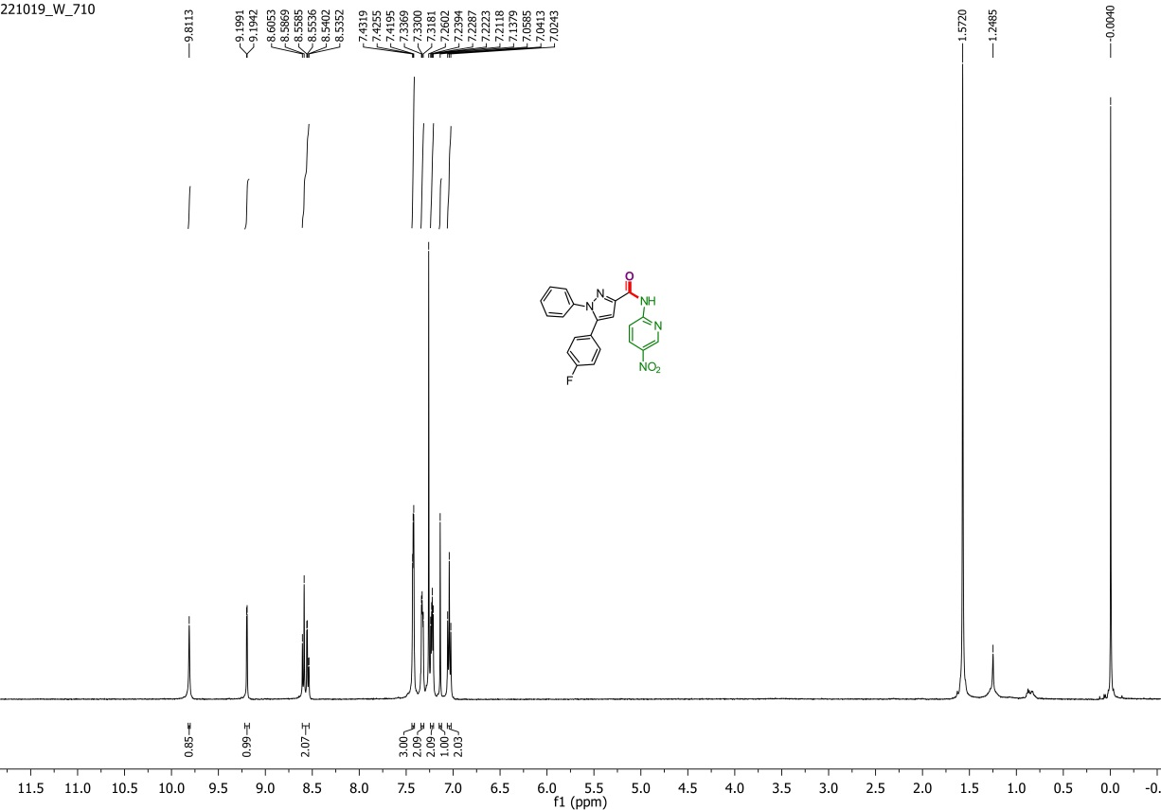
Figure S48. ¹H NMR spectrum of 1G
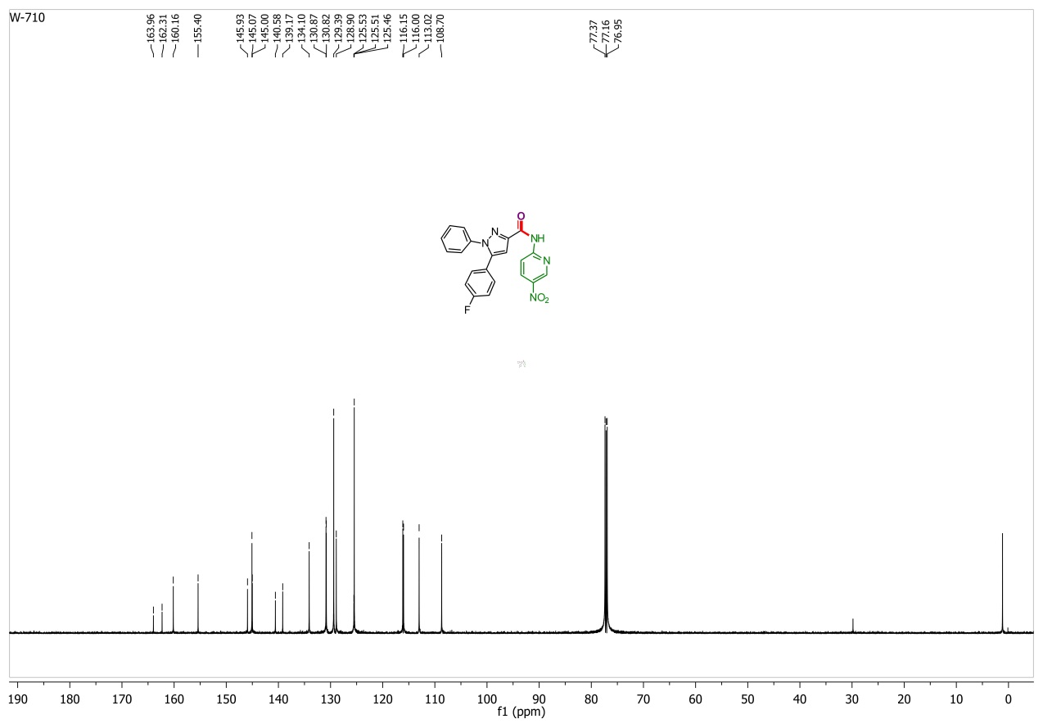
Figure S49. ¹³C NMR spectrum of 1G
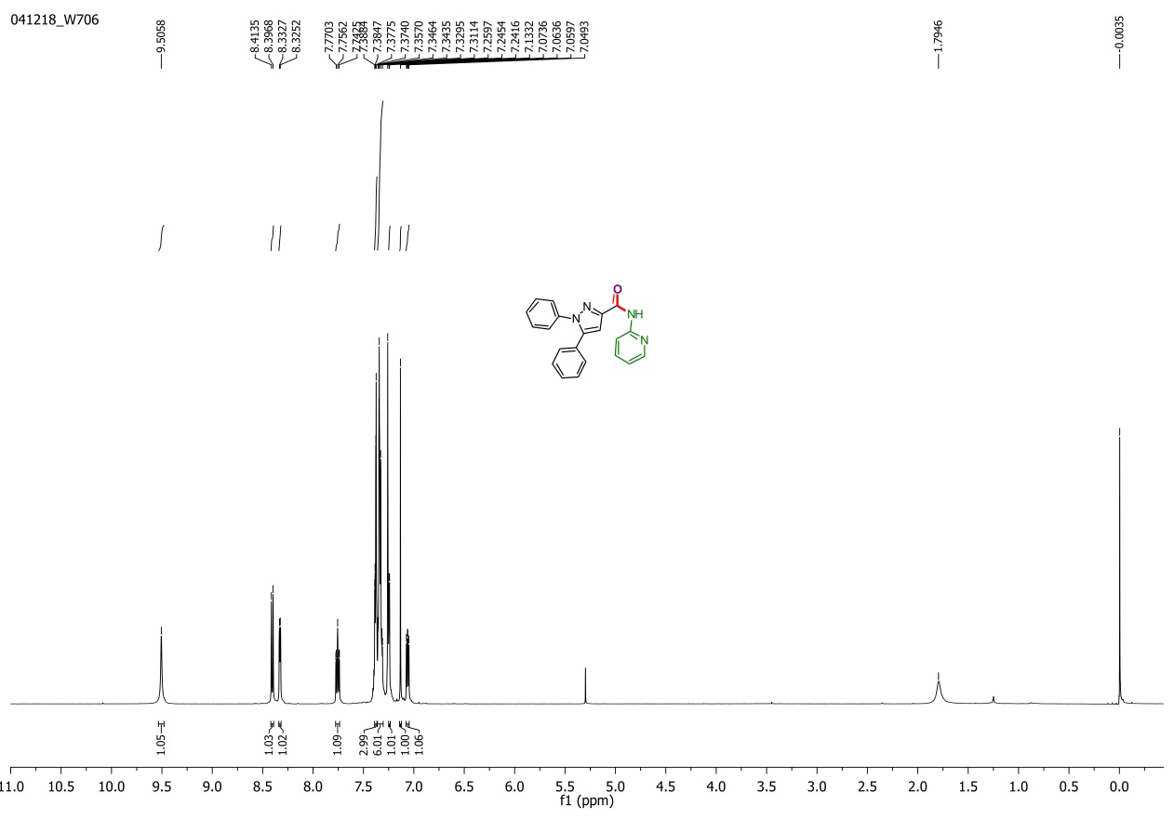
Figure S50. ¹H NMR spectrum of 4F
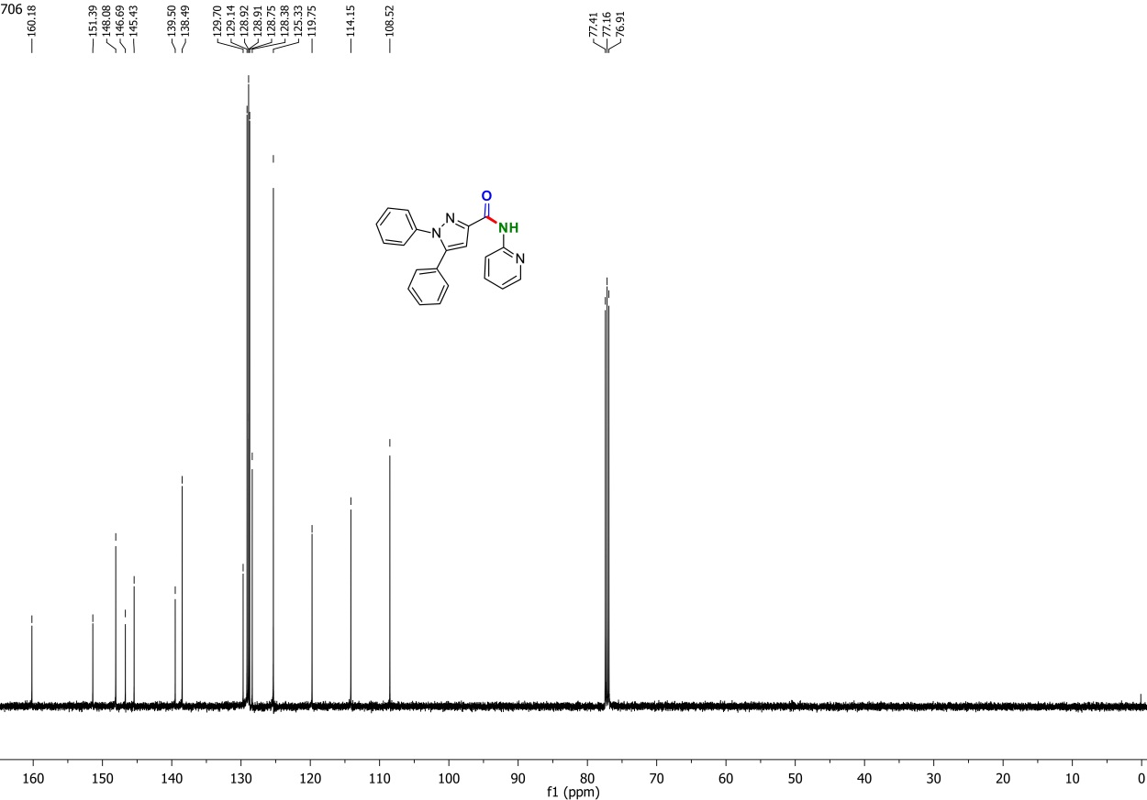
Figure S51. ¹³C NMR spectrum of 4F
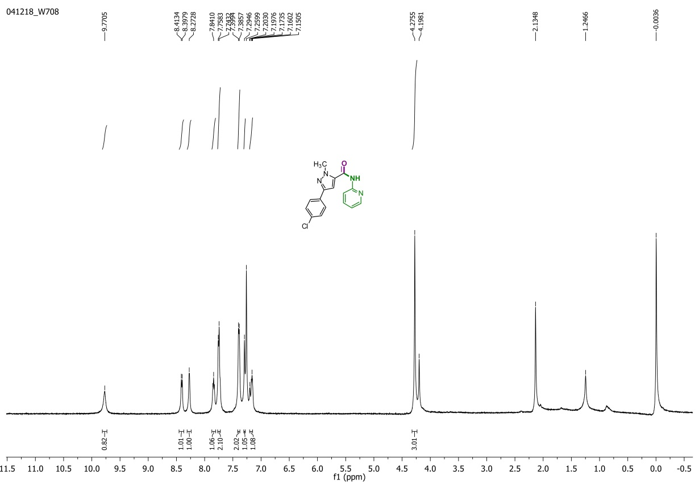
Figure S52. ¹H NMR spectrum of 9F
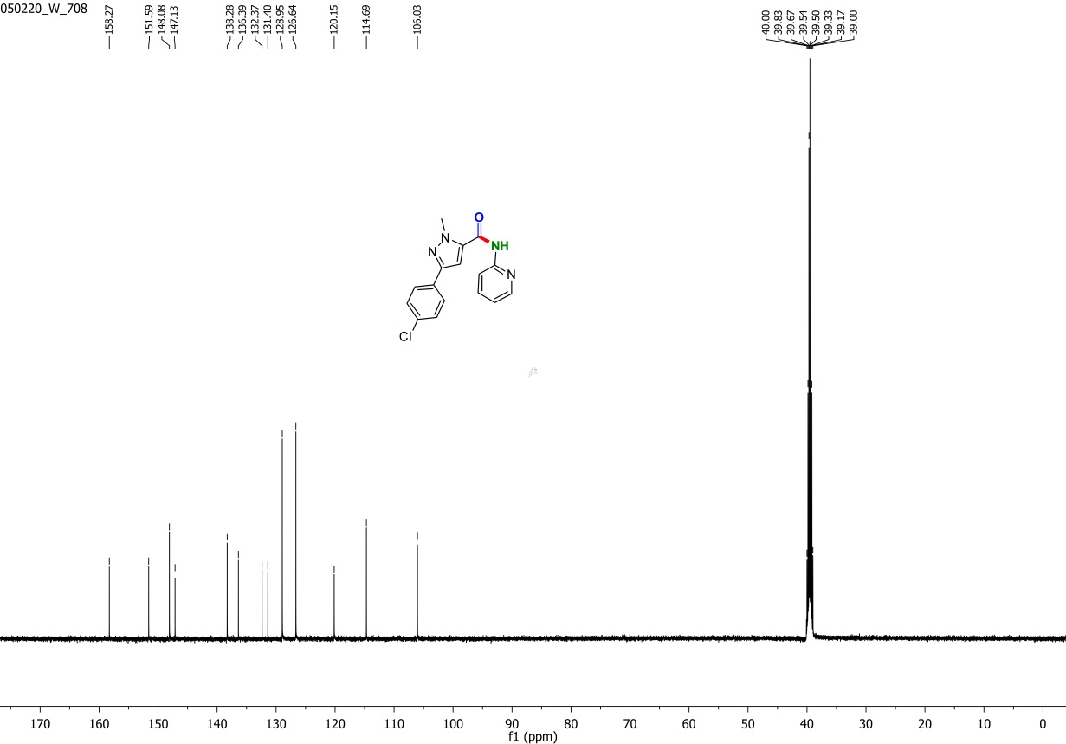
Figure S53. ¹³C NMR spectrum of 9F
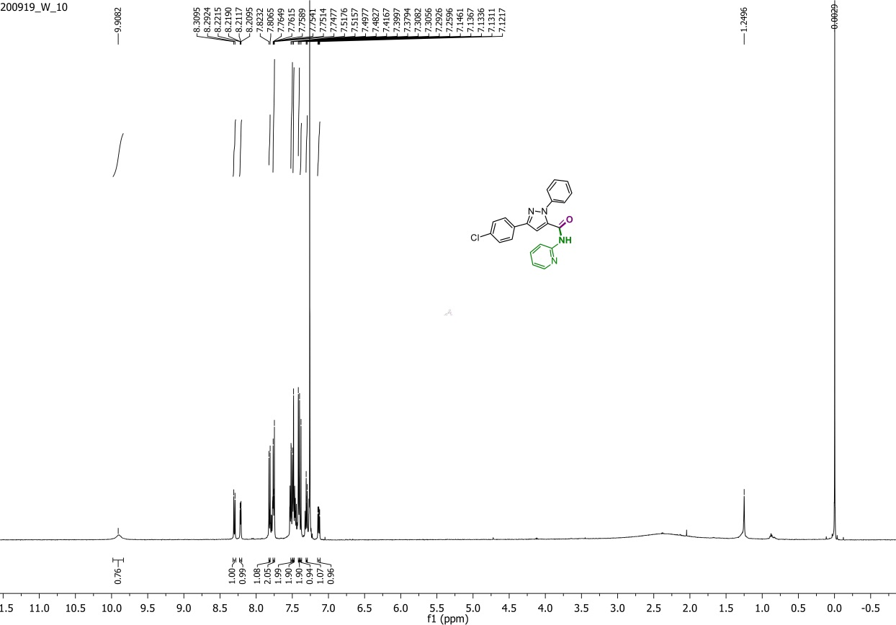
Figure S54. ¹H NMR spectrum of 10F
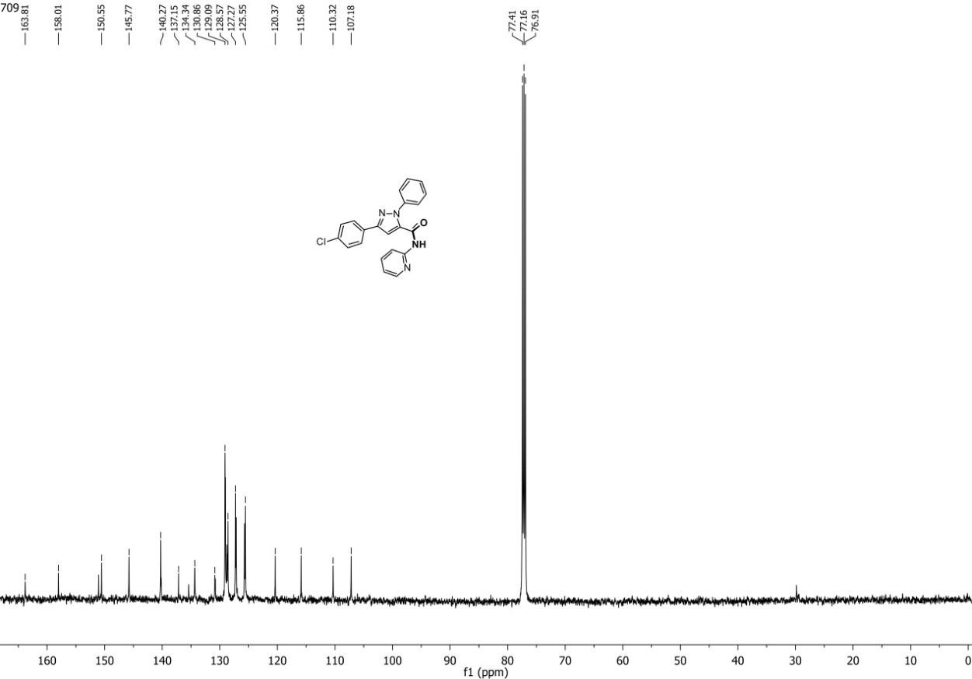
Figure S55. ¹³C NMR spectrum of 10F.

