Supporting Information
for

Revisiting the bromination of 3β-hydroxycholest-5-ene with CBr₄/PPh₃ and the subsequent azidolysis of the resulting bromide, disparity in stereochemical behavior

Christian Schumacher¹, Jas S. Ward², Kari Rissanen², Carsten Bolm¹, and Mohamed Ramadan El Sayed Aly³*
¹Institute of Organic Chemistry, RWTH Aachen University, Landoltweg 1, 52074 Aachen, Germany; ²University of Jyvaskyla, Department of Chemistry, P.O. Box 35, 40014 Jyväskylä, Finland; ³Chemistry Department, Faculty of Science, Port Said University, 42522-Port Said, Egypt.

Email:
Carsten.Bolm@oc.rwth-aachen.de; kari.t.rissanen@jyu.fi; mrea34@hotmail.com (mohamed_ramadan@ sci.psu.edu.eg)

* Corresponding author
Table of Contents

I. X-ray crystallography S3
II. NMR spectra S5
III. References S28

- X-ray crystallography
Due to the known stereochemistry of the cholesterol skeleton no need for ab initio absolute structure determination (viz. based on Flack parameter) is not needed. Single-crystal X-ray data for diene 2 was measured using a Bruker-Nonius Kappa CCD diffractometer with an APEX-II detector with graphite-monochromatized Mo-Kα (λ = 0.71073 Å) radiation at 170 K. Data collection and reduction were performed using the program COLLECT [1] and HKL DENZO AND SCALEPACK [2], respectively, and the intensities were corrected for absorption using SADABS [3]. Single-crystal X-ray data for bromide 3 was measured using a Rigaku SuperNova dual-source Oxford diffractometer equipped with an Eos detector using mirror-monochromated Mo-Kα (λ = 0.71073 Å) radiation at 120 K. The data collection and reduction were performed using the program CrysAlisPro and Gaussian face index absorption correction method was applied [4]. The structures were solved with intrinsic phasing (SHELXT) [5] and refined by full-matrix least squares on F² using the OLEX2 software [6], which utilizes the SHELXL module [7]. For the azide 4 only a partial data collection was performed (see below) verifying the structure to be the known azide, 3a-azidocholest-5-ene [8].

Crystal data for the diene 2
C₂₇H₄₄, M = 368.62, colourless block, 0.24 x 0.30 x 0.40 mm, orthorhombic, space group P2₁2₁2₁, a = 7.5850(2) Å, b = 15.9238(4) Å, c = 19.4795(4) Å, V = 2352.77(10) Å³, Z = 4, D_{calc} = 1.041 gcm⁻³, F000 = 824, µ = 0.06 mm⁻¹, T = 170(1) K, θ_{max} = 28.7°, 5169 total reflections, 3861 with I_{o} > 2σ(I_{o}), R_{int} = 0.052, 5169 data, 249 parameters, no restraints, GooF = 1.03, 0.28 < d∆ρ < -0.17 eÅ⁻³, R[F² > 2σ(F²)] = 0.053, wR(F²) = 0.131. CCDC-2204245.
Crystal data for the bromide 3
C₂₇H₄₅Br, M = 449.54, colourless plate, 0.06 x 0.17 x 0.25 mm³, monoclinic, space group P2₁, a = 11.4127(12) Å, b = 7.5896(9) Å, c = 28.603(5) Å, β = 90.077(13)°, V = 2477.5(6) Å³, Z = 4, D_{calc} = 1.205 gcm⁻³, F000 = 968, µ = 1.67 mm⁻¹, T = 120.0(1) K, θ_{max} = 25.8°, 11562 total reflections, 5812 with I_{o} > 2σ(I_{o}), R_{int} = 0.109, 11562 data, 467 parameters, 130 restraints, GooF = 1.06, 1.51 < d∆ρ < -1.68 eÅ⁻³, R[F² > 2σ(F²)] = 0.098, wR(F²) = 0.309. CCDC-2204246.
Verification of the structure of the azide 4
The physical habit (colorless plates), the unit cell (a = 13.2746(14) Å, b = 6.1854(6) Å, c = 14.9159(15) Å, β = 93.285(9)°, V = 1222.7(2) Å³) and the space group (P2₁) matched that previously reported for 3a-azidocholest-5-ene [8]. A partial (30%) data set was collected and a figure base on it is shown in (Figure S1) confirming the studied sample to be the 3a-azidocholest-5-ene.
Fig. S1. The ORTEP plot of the 3a-azidocholest-5-ene from a partial data set with thermal displacement parameter at 50% probability level.

- NMR spectra
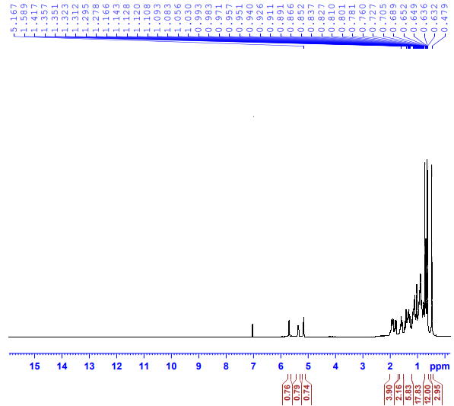
Fig. S2. ¹H NMR spectrum (400 MHz, CDCl₃) of compound 2. A spectrum for this compound was previously published in [9], but incorrectly assigned to 3α-bromocholest-5-ene.
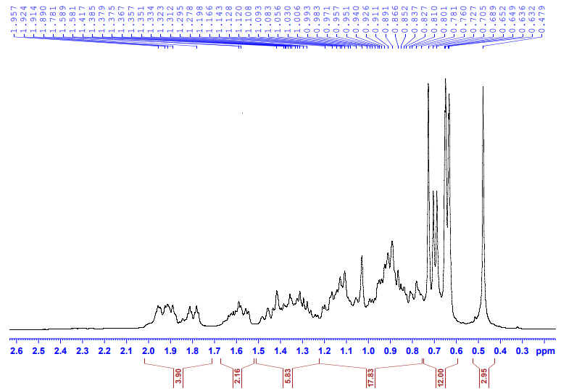
Fig. S3. Cross-section in the ¹H NMR spectrum (400 MHz, CDCl₃) of compound 2.

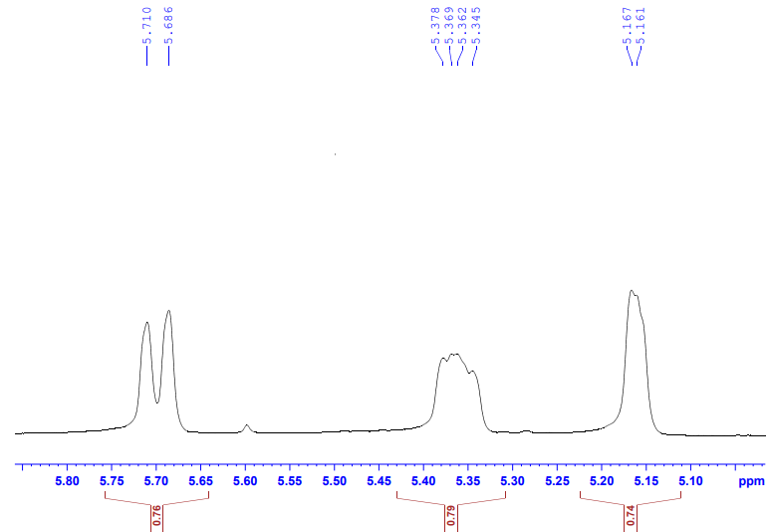
Fig. S4. Cross-section in the ¹H NMR spectrum (400 MHz, CDCl₃) of compound 2.
Fig. S5. Cross-section in the ¹H NMR spectrum (400 MHz, CDCl₃) of compound 2.

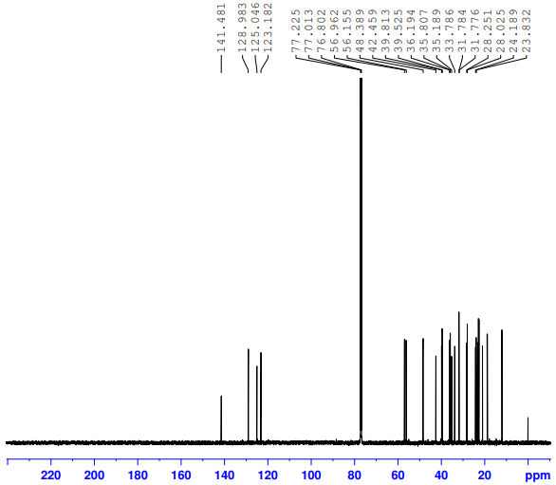
Fig. S6. ¹³C {¹H} NMR spectrum (150 MHz, CDCl₃) of compound 2. This spectrum was slightly adapted from [9] (“Synthesis, antimicrobial and cytotoxicity evaluation of new cholesterol congeners”, © 2015 M. R. E. S. Aly et al., published by the Beilstein-Institut, distributed under the terms of the Creative Commons Attribution 2.0 Generic License, https://creativecommons.org/licenses/by/2.0). This spectrum was incorrectly assigned to 3α-bromocholest-5-ene in [9].

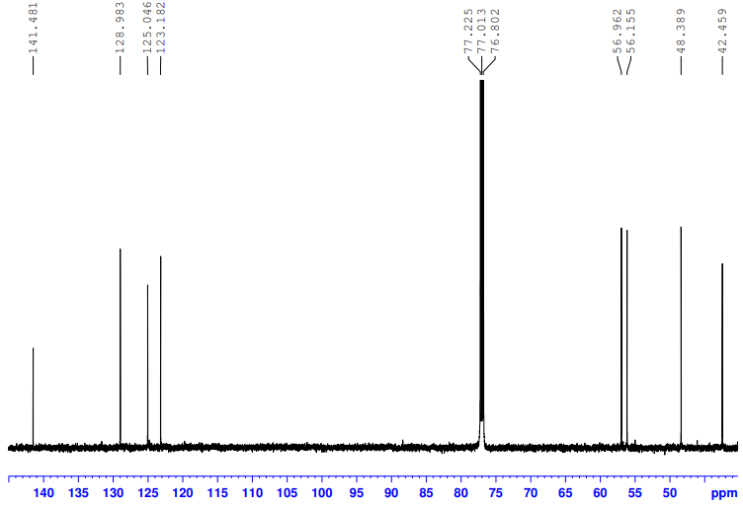

Fig. S7. Cross-section in the ¹³C {¹H} NMR spectrum of compound 2.

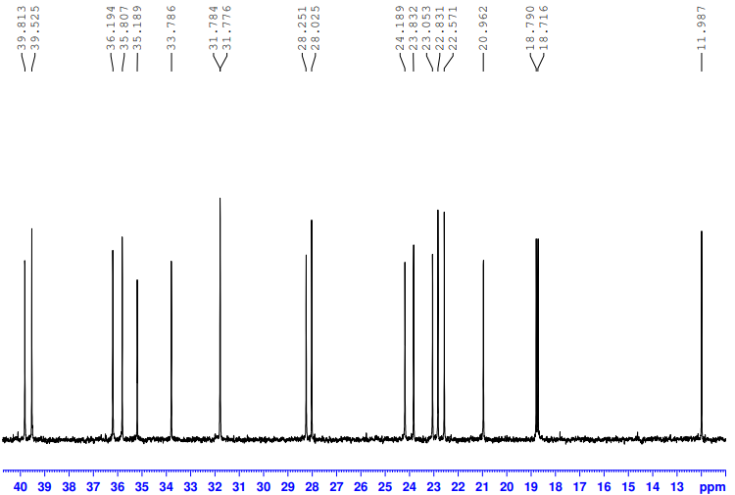

Fig. S8. Cross-section in the ¹³C {¹H} NMR spectrum of compound 2.

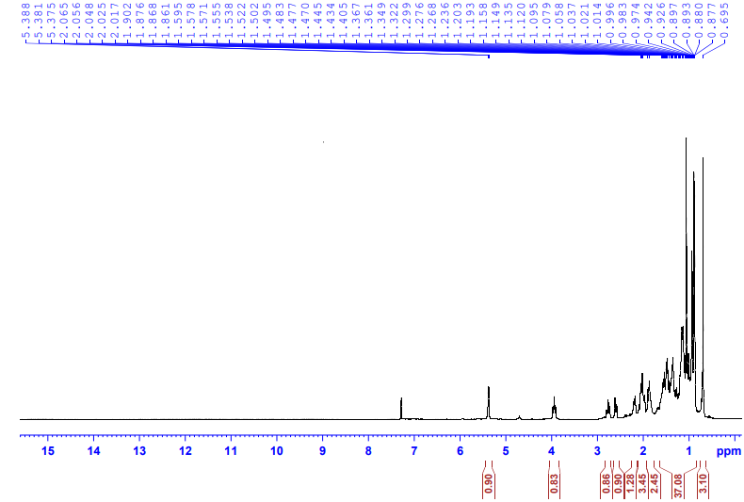
Fig. S9. ¹H NMR spectrum (400 MHz, CDCl₃) of compound 3.

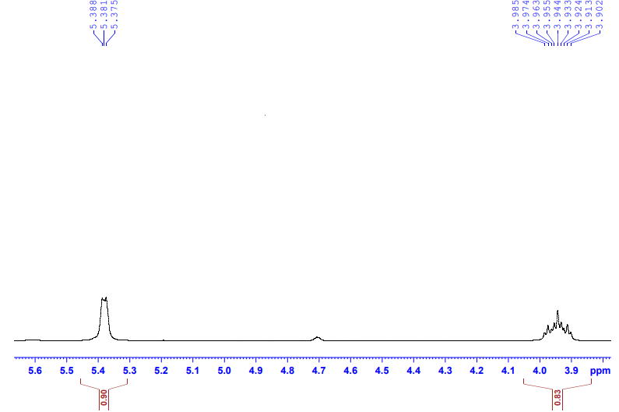
Fig. S10. Cross-section in the ¹H NMR spectrum of compound 3.
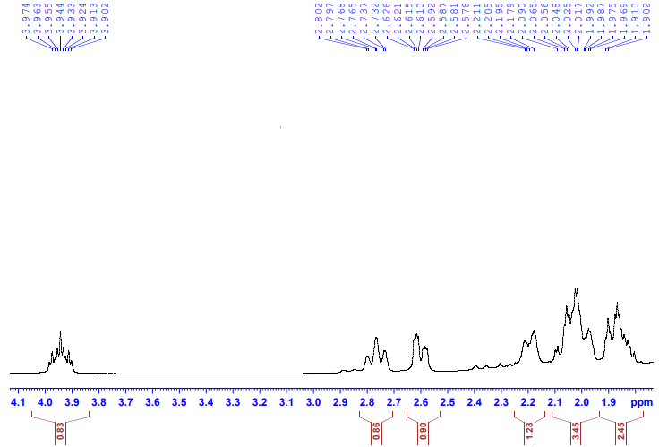
Fig. S11. Cross-sections in the ¹H NMR spectrum of compound 3.

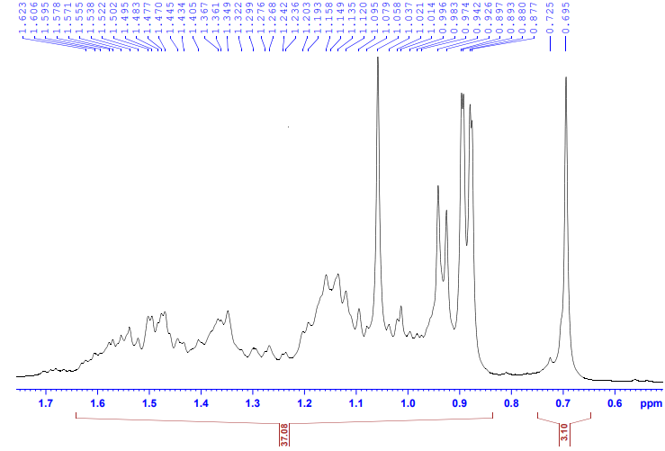
Fig. S12. Cross-sections in the ¹H NMR spectrum of compound 3.

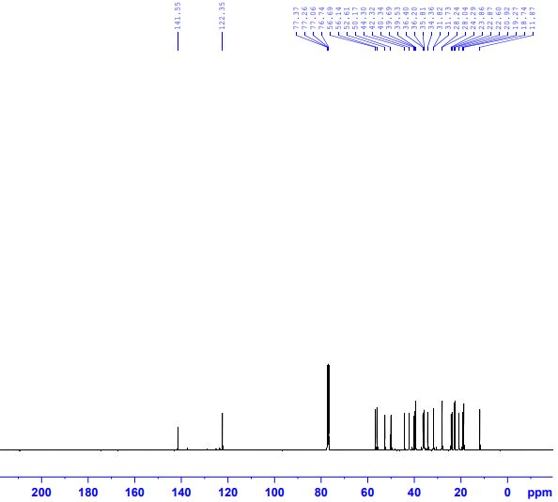

Fig. S13. ¹³C {¹H} NMR spectrum (100 MHz, CDCl₃) of compound 3.
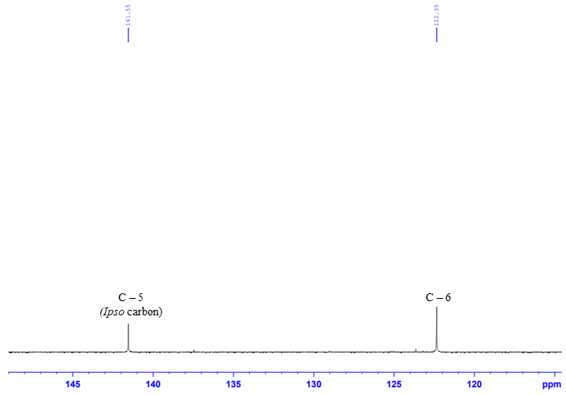
Fig. S14. Cross-section in the ¹³C {¹H} NMR spectrum (100 MHz, CDCl₃) of compound 3.
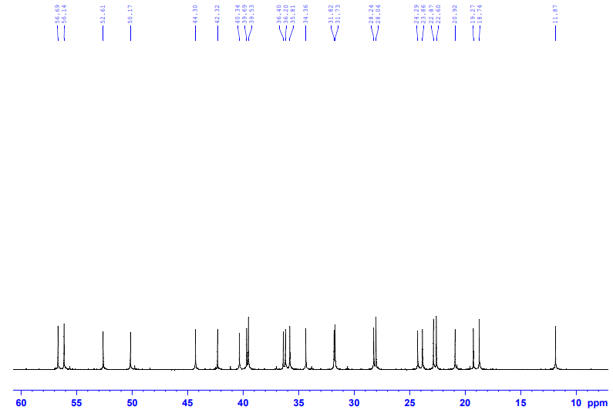
Fig. S15. Cross-section in the ¹³C {¹H} NMR spectrum (100 MHz, CDCl₃) of compound 3.
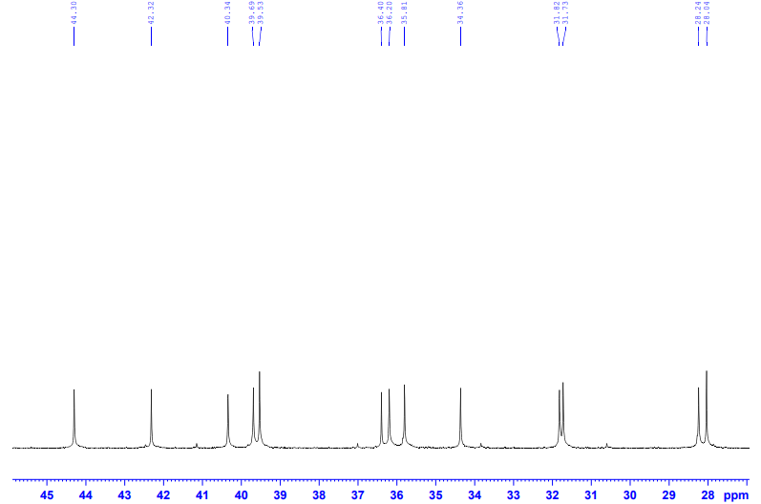
Fig. S16. Cross-section in the ¹³C {¹H} NMR spectrum (100 MHz, CDCl₃) of compound 3.

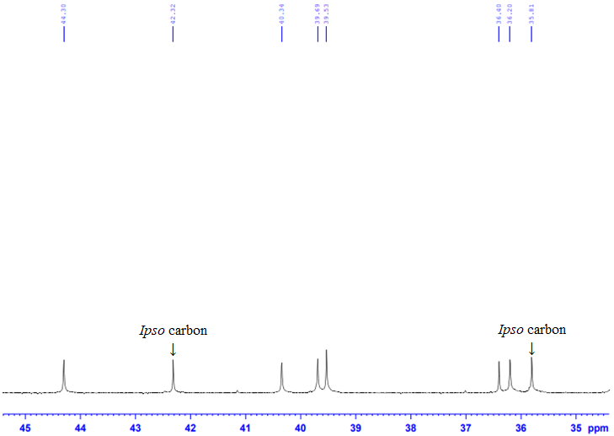
Fig. S17. Cross-section in the ¹³C {¹H} NMR spectrum (100 MHz, CDCl₃) of compound 3.

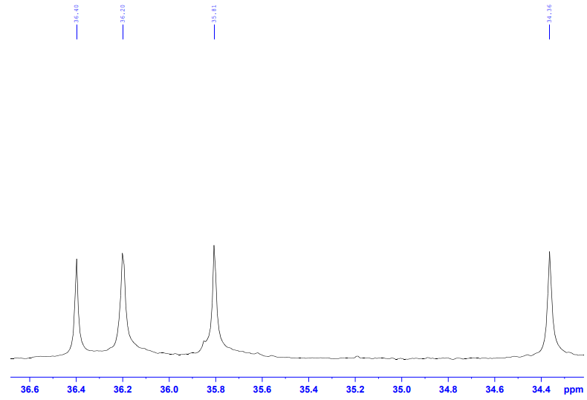
Fig. S18. Cross-section in the ¹³C {¹H} NMR spectrum (100 MHz, CDCl₃) of compound 3.

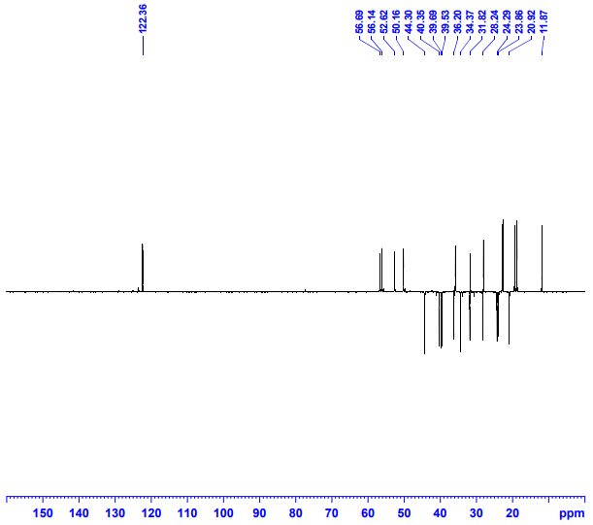
Fig. S19. DEPT-135º spectrum (100 MHz, CDCl₃) of compound 3.

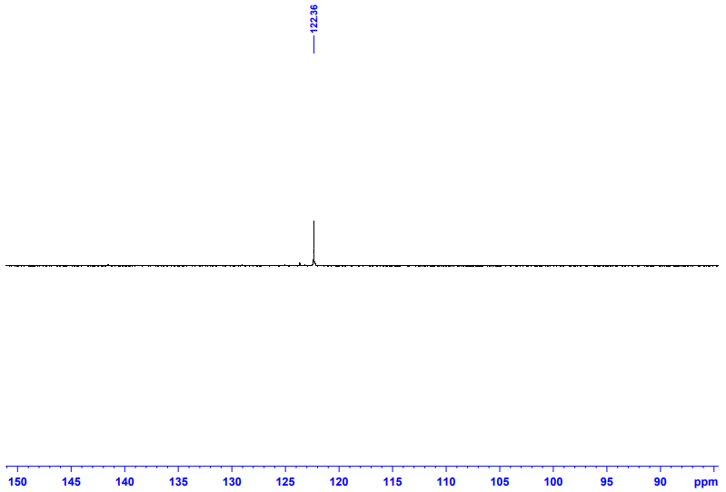
Fig. S20. Cross-section in the DEPT-135º spectrum (100 MHz, CDCl₃) of compound 3.

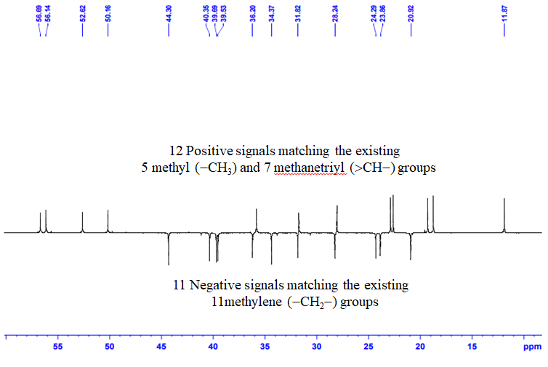
Fig. S21. Cross-section in the DEPT-135º spectrum (100 MHz, CDCl₃) of compound 3.

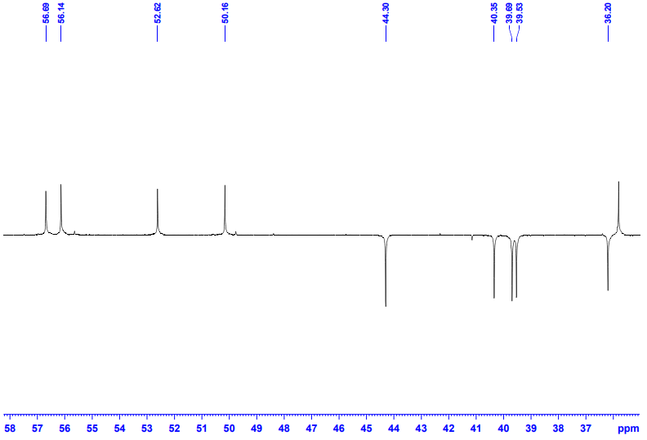
Fig. S22. Cross-section in the DEPT-135º spectrum (100 MHz, CDCl₃) of compound 3.

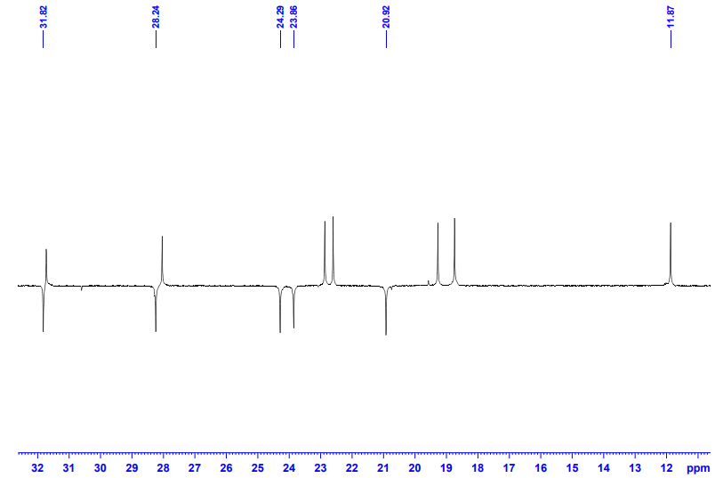
Fig. S23. Cross-section in the DEPT-135º spectrum (100 MHz, CDCl₃) of compound 3.

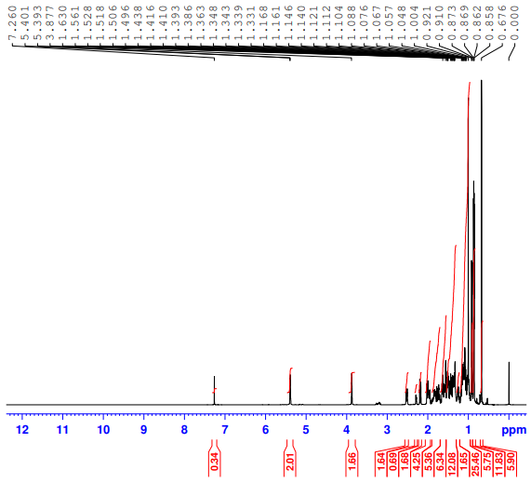

Fig. S24. ¹H NMR spectrum (600 MHz, CDCl₃) of compound 4. This spectrum was slightly adapted from [9] (“Synthesis, antimicrobial and cytotoxicity evaluation of new cholesterol congeners”, © 2015 M. R. E. S. Aly et al., published by the Beilstein-Institut, distributed under the terms of the Creative Commons Attribution 2.0 Generic License, https://creativecommons.org/licenses/by/2.0). This spectrum was incorrectly assigned to 3β-azidocholest-5-ene in [9]. The weak signal at δ = 3.20 (H−3_{β}) belongs to the β‒epimer (ca. 15%) [10].
.

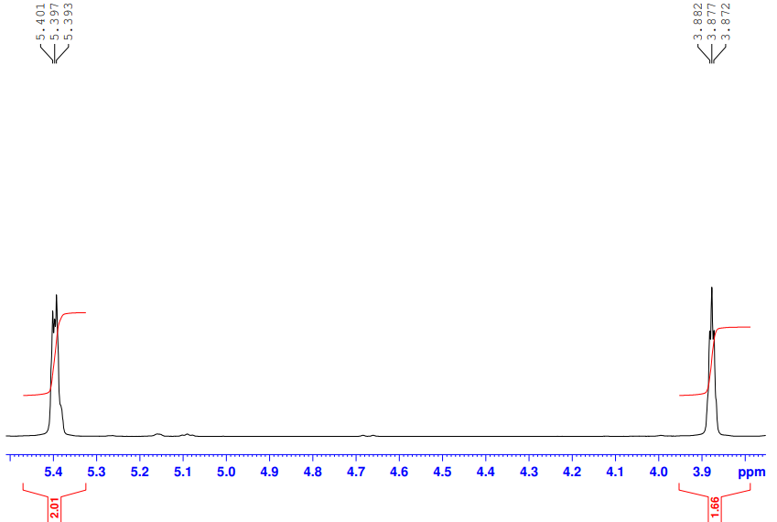

Fig. S25. Cross-section in the ¹H NMR spectrum of compound 4.

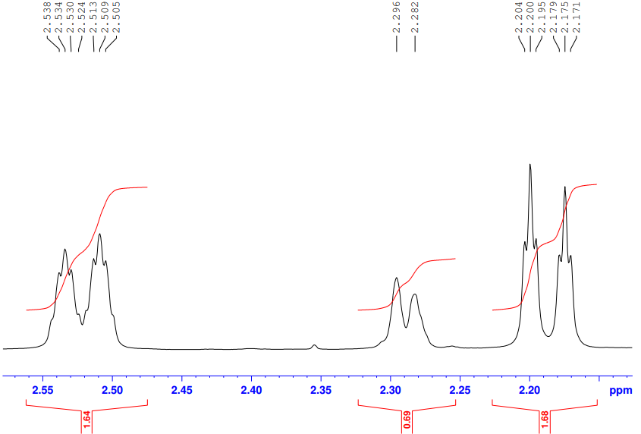

Fig. S26. Cross-section in the ¹H NMR spectrum of compound 4. The signal at δ = 2.28 ppm arise from two protons of the β‒epimer (ca. 15%) [10].

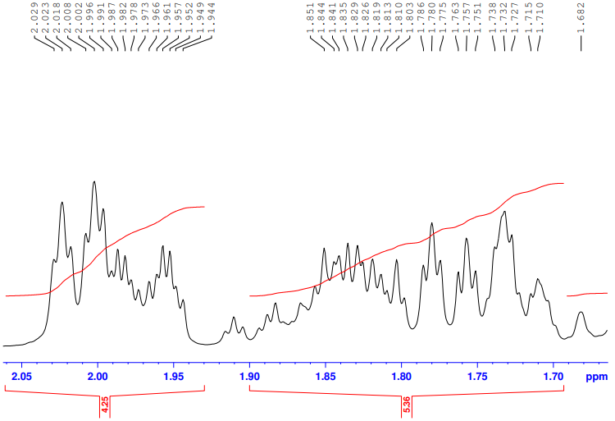

Fig. S27. Cross-section in the ¹H NMR spectrum of compound 4.

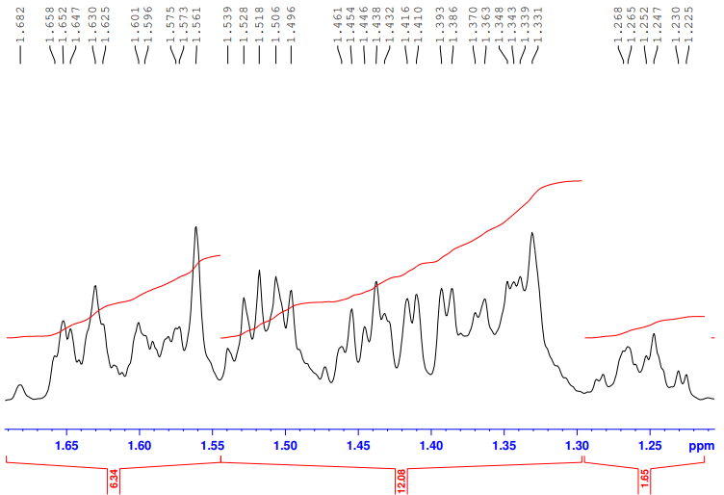

Fig. S28. Cross-section in the ¹H NMR spectrum of compound 4.

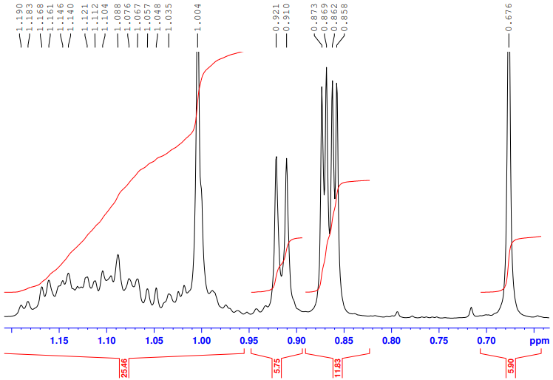

Fig. S29. Cross-section in the ¹H NMR spectrum of compound 4.

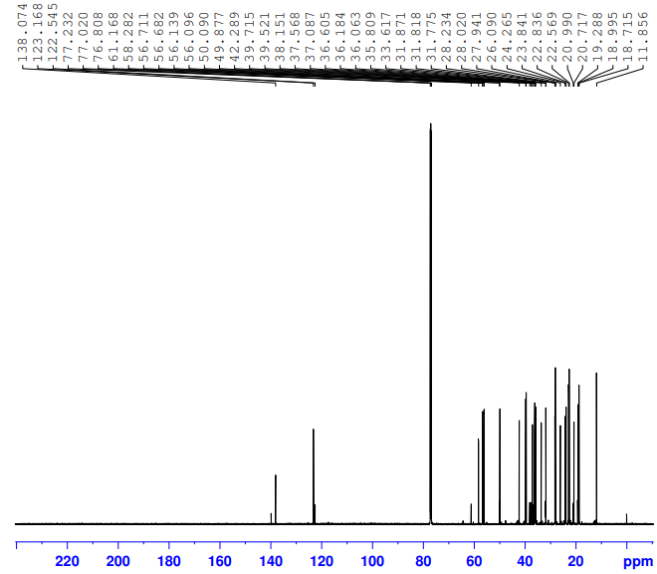

Fig. S30. ¹³C {¹H} NMR spectrum (150 MHz, CDCl₃) of compound 4. This spectrum was slightly adapted from [9] (“Synthesis, antimicrobial and cytotoxicity evaluation of new cholesterol congeners”, © 2015 M. R. E. S. Aly et al., published by the Beilstein-Institut, distributed under the terms of the Creative Commons Attribution 2.0 Generic License, https://creativecommons.org/licenses/by/2.0). This spectrum was incorrectly assigned to 3β-azidocholest-5-ene in [9].
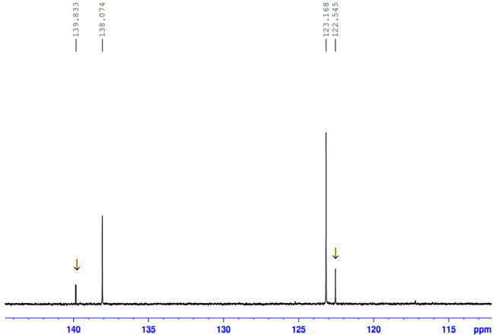

Fig. S31. Cross-section in the ¹³C {¹H} NMR spectrum (150 MHz, CDCl₃) of compound 4. The arrows here and in the next cross-sections denote to the signals arising from the presence of trace of 3β-azidocholest-5-ene [10].

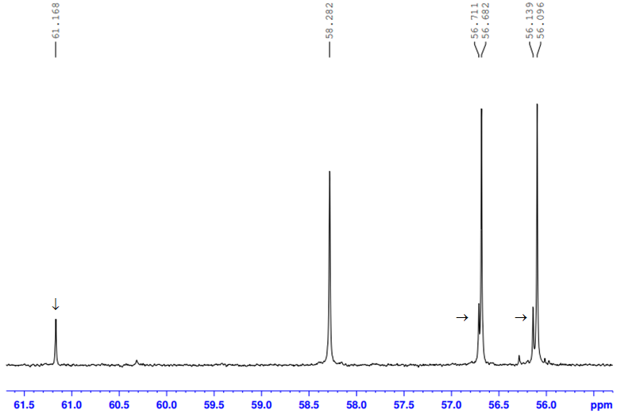

Fig. S32. Cross-section in the ¹³C {¹H} NMR spectrum (150 MHz, CDCl₃) of compound 4.

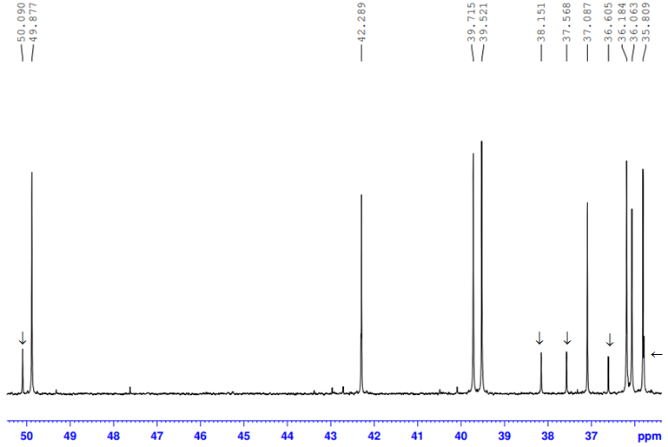

Fig. S33. Cross-section in the ¹³C {¹H} NMR spectrum (150 MHz, CDCl₃) of compound 4.

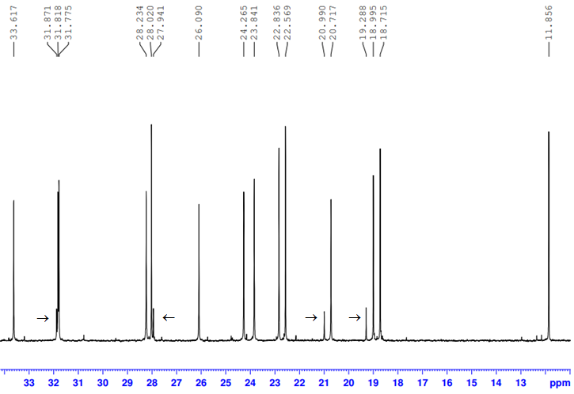
Fig. S34 . Cross-section in the ¹³C {¹H} NMR spectrum (150 MHz, CDCl₃) of compound 4.
- References
1. Hooft, R.W.W. COLLECT 1998, Nonius BV, Delft, The Netherlands.
2. Otwinowski, Z.; Minor, W. Methods in Enzymology, Macromolecular Crystallography, Part A 1997, 276, 307‒326. Edited by Carter Jr C. W.; Sweet, R. M. New York: Academic Press.
3. Sheldrick, G. M. SADABS Version 2008/2 1996, University of Göttingen, Germany.
4. Rigaku Oxford Diffraction, 2018, CrysAlisPro Software system, Rigaku Corporation, Oxford, UK.
5. Sheldrick, G. M. Acta Crystallogr. Sect. A 2015, 71, 3‒8.
6. Dolomanov, O. V; Bourhis, L. J.; Gildea, R. J.; Howard, J. A. K.; Puschmann, H. J. Appl. Crystallogr. 2009, 42, 339‒341.
7. Sheldrick, G. M. Acta Crystallogr. Sect. C 2015, 71, 3‒8.
8. Houston, T. A.; Quader, S.; Boyd, S. E.; Jenkins, I. D.; Healy, P. C. Acta Cryst. 2008, E64, o1738.
9. Aly, M. R. E.; Saad, H. A.; Abdel Hafez, S. H. Beilstein J. Org. Chem. 2015, 11, 1922−1932. doi.org/10.3762/bjoc.11.208
10. Sun, Q.; Cai, S.; Peterson, B. R. Org. Lett. 2009, 11, 567−570. doi.org/10.1021/ol802343z

