Rhodium-catalyzed intramolecular reductive aldol-type cyclization: Application for the synthesis of a chiral necic acid lactone.

Motoyuki Isoda,¹ Kazuyuki Sato,^{2*} Kenta Kameda,² Kana Wakabayashi,² Ryota Sato,² Hideki Minami,³ Yukiko Karuo,² Atsushi Tarui,² Kentaro Kawai,² Masaaki Omote^{2*}

1) School of Pharmacy at Fukuoka, International University of Health and Welfare, 137-1 Enokizu, Okawa, Fukuoka 831-8501, Japan
2) Faculty of Pharmaceutical Sciences, Setsunan University, 45-1, Nagaotoge-cho, Hirakata, Osaka 573-0101, Japan
3) Faculty of Pharmaceutical Sciences, Hiroshima International University, 5-1-1 Hirokoshingai, Kure, Hiroshima 737-0112, Japan

Supporting Information

General Information ………………………………………………. S2
Materials ………………………………………….………………. S2
Experimental Section
General procedure for the cyclization precursor (1). ..……….. S2
General procedure for intramolecular
reductive aldol-type cyclization. ………..…S3
Spectroscopic Data …………………………….……………... S4–S6
Thermal ellipsoid plot of the crystallographic structure. …….. S7–S14
References ……….…………………………..…….…………….. S15
NMR charts …………….……………………………...…. S16–S24

General Information:
¹H NMR and ¹³C NMR spectra were recorded on JEOL JNM-ECZS-400 spectrometers. Chemical shifts of ¹H NMR are reported in ppm from signal of tetramethylsilane (TMS: 0 ppm) as an internal standard. Chemical shifts of ¹³C NMR are reported in ppm from signal of CDCl₃ (77.20 ppm) as an internal standard. All data are reported as follows: chemical shifts, relative integration value, multiplicity (s = singlet, d = doublet, t = triplet, q = quartet, br s= broad singlet, m = multiplet), coupling constants (Hz). Mass spectra were obtained on JEOL JMS-700T spectrometers. Melting points were measured on Yanagimoto micro melting point apparatus MP-S3.

Materials:
Dichloromethane (DCM) was distilled over phosphorus pentoxide just before use. Tetrahydrofuran (THF) was purchased from Kanto Chemical Co. Inc. as “Dehydrated”. All other solvents were distilled under inert argon atmosphere or under reduced pressure before use. All commercially available reagents were used without further purification. All experiments were carried out under argon atmosphere in flame-dried glassware using standard inert techniques for introducing reagents unless otherwise noted.

Experimental Section:
General procedure for the cyclization precursor (1).
To a solution of hydroxyketone (5 mmol) in DCM (50 mL) was added Et₃N (8 mmol) and stirred for 30 min. Then, α,β-unsaturated acid chloride (6 mmol) was added to the mixture and stirred until TLC analysis showed the reaction to be complete. The mixture was quenched with 10% HCl and extracted with DCM. The organic layer was washed with sat. NaCl and dried over MgSO₄. The solvent was removed in vacuo to give the crude mixture. The mixture was purified by recrystallization by hexane and was obtained the product 1.

General procedure for intramolecular reductive aldol-type cyclization.
To a solution of [RhCl(cod)]₂ (2 mol %) in DCM (2.5 mL) was added cyclization precursors (1; 1 mmol) at 0 °C, and then 1.0 M Et₂Zn in hexane (1.2 mL) was gradually added to the mixture. After consumption of starting material 1 was monitored by TLC, the mixture was quenched with 10% HCl and extracted with AcOEt. The organic layer was washed with sat. NaCl and dried over MgSO₄. The solvent was removed in vacuo, and the residue was purified by column chromatography (SiO₂; AcOEt : hexane = 4 : 1) to give the product.

Synthesis for a chiral necic acid lactone.
Benzyl (S)-2-hydroxy-2-methyl-3-oxobutanoate (5):
Under an Ar atomosphere, to a solution of CH₃SO₂NH₂ (4.5 mmol) and AD-mix-β (15 g) in tBuOH - H₂O (1 : 1, 18 mL) was stirred for 15 min, then the mixture cooled to 0 °C. Benzyl tiglate (3, 9 mmol) was added to the mixture and it was stirred for 16h at same temperature. After consumption of starting material 3 was monitored by TLC, the mixture was quenched with sat. NH₄Cl and extracted with DCM. The organic layer was washed with sat. NaCl and dried over MgSO₄. The solvent was removed in vacuo, and the residue was passed through a short column chromatography (SiO₂; AcOEt : hexane = 3 : 7) to correct 4.
Under an Ar atomosphere, to a solution of corrected 4 in DCM (30 mL) was added DMSO (5.5 mL) and Et₃N (45 mmol) and then a solution of SO₃Py (28 mmol) in DMSO (14 mL) was added to the mixture. The resulting mixture was stirred for 24h at ambient temperature, then it was quenched with sat. NH₄Cl and extracted with DCM. The organic layer was washed with sat. NaCl and dried over MgSO₄. The solvent was removed in vacuo, and the residue was purified by column chromatography (SiO₂; AcOEt : hexane = 1 : 4) to give the product 5 in 68% (1.25g, 5.6 mmol, 96% ee) from 3.

Benzyl (S)-2-(acryloyloxy)-2-methyl-3-oxobutanoate ((S)-1j):
Under an Ar atomosphere, to a solution of DMAP (0.23 mmol) in DCM (2 mL) was added 5 (2.23 mmol) and Et₃N (6.5 mmol) at 0 °C and it was stirred for 30 min at same temperature. To the mixture was added acryloyl chloride (4.9 mmol) and hydroquinone (0.5 mmol) and was stirred overnight at same temperature. The mixture was quenched with sat. NH₄Cl and extracted with DCM. The organic layer was washed with sat. NaCl and dried over MgSO₄. The solvent was removed in vacuo, and the residue was passed through a short column chromatography (SiO₂; AcOEt : hexane = 1 : 4) to give the product (S)-1j in 61% (378 mg, 1.37 mmol) from 3.

Benzyl (2S,3S,4R)-3-hydroxy-2,3,4-trimethyl-5-oxotetrahydrofuran-2-carboxylate (2j):
To a solution of [RhCl(cod)]₂ (2 mol %) in THF (3.25 mL) was added cyclization precursors ((S)-1j; 1.3 mmol) at ambient temperature, and then 1.0 M Et₂Zn in hexane (1.56 mL) was gradually added to the mixture and the mixture was stirred for 48h. The mixture was quenched with 10% HCl and extracted with AcOEt. The organic layer was washed with sat. NaCl and dried over MgSO₄. The solvent was removed in vacuo, and the residue including the diastereomeric mixture was purified by column chromatography (AcOEt : toluene = 4 : 1) to give the product (2S,3S,4R)-2j in 32% (116 mg, 0.41 mmol).

Spectroscopic Data:
benzyl (S)-2-(acryloyloxy)-2-methyl-3-oxobutanoate ((S)-1j)
Pale yellow oil; ¹H NMR (400 MHz, CDCl₃) δ: 1.77 (s, 3H), 2.33 (s, 3H), 5.20 (s, 2H), 5.95 (dd, J = 10.5, 1.2 Hz, 1H), 6.21 (dd, J = 17.3, 10.5 Hz, 1H), 6.49 (dd, J = 17.3, 1.1 Hz, 1H), 7.30–7.38 (5H, m); MS m/z: 276 (M⁺). HR-MS Calcd for C₁₅H₁₆O₅: 276.0998 (M⁺), Found: 276.0992; IR (neat) cm⁻¹: 1193, 1267, 1634, 1724, 3462.

(3R,4R/3S,4S)-4-hydroxy-3,5,5-trimethyl-4-phenyldihydrofuran-2(3H)-one (syn-2a)¹
A colorless solid; mp 142–146°C; ¹H NMR (400 MHz, CDCl₃) δ: 1.03 (s, 3H), 1.23 (d, J = 7.2 Hz, 3H), 1.56 (s, 3H), 2.04 (s, 1H), 3.60 (q, J = 7.2 Hz, 1H), 7.35–7.49 (m, 5H); ¹³C NMR (100 MHz, CDCl₃) δ: 7.59, 20.17, 25.40, 42.30, 83.33, 88.44, 126.4, 128.9, 129.0, 138.4, 176.7; HR-MS Calcd for C₁₃H₁₆O₃: 220.1099 (M⁺), Found: 220.1096; IR (KBr) cm⁻¹: 3439, 1749.

(3R,4S/3S,4R)-4-hydroxy-3,5,5-trimethyl-4-phenyldihydrofuran-2(3H)-one (anti-2a)¹
A colorless solid; mp 185–187°C; ¹H NMR (400 MHz, CDCl₃) δ: 0.99 (d, J = 7.2 Hz, 3H), 1.01 (s, 3H), 1.60 (s, 3H), 2.41 (s, 1H), 3.28 (q, J = 7.2 Hz, 1H), 7.28–7.40 (m, 5H); ¹³C NMR (100 MHz, CDCl₃) δ: 8.92, 23.82, 24.22, 46.03, 83.58, 87.93, 126.1, 128.1, 128.7, 138.9, 176.7; HR-MS Calcd for C₁₃H₁₆O₃: 220.1099 (M⁺), Found: 220.1105; IR (KBr) cm⁻¹: 3439, 1749.

(3S,4S,5R/3R,4R,5S)-4-hydroxy-3-methyl-4,5-diphenyldihydrofuran-2(3H)-one (Major form) (2b)
A colorless solid; mp: 150.5–152.5 °C; ¹H NMR (400 MHz, CDCl₃) δ: 1.19 (d, J = 6.86 Hz, 3H), 1.68 (d, J = 1.37 Hz, 1H), 3.19 (qd, J = 5.49, 1.37 Hz, 1H), 5.80 (s, 1H), 7.06–7.09 (m, 2H), 7.27–7.46 (m, 8H); ¹³C NMR (CDCl₃) δ: 7.0, 49.0, 81.6, 86.9, 125.6, 126.7, 128.4, 128.8, 129.0, 129.3, 132.0, 139.1, 176.7; HR-MS Calcd for C₁₇H₁₆O₃: 268.1099 (M⁺), Found: 268.1098; IR (KBr) cm⁻¹: 698, 942, 1449, 1772, 3468.

4-hydroxy-3-methyl-4-phenyldihydrofuran-2(3H)-one (syn-form) (2c)
A colorless oil; ¹H NMR (CDCl₃) δ: 1.18 (d, J = 7.32 Hz, 3H), 3.00 (q, J = 7.32 Hz, 1H), 3.15 (br s, 1H), 4.35 (d, J = 10.1 Hz, 1H), 4.39 (d, J = 10.1 Hz, 1H), 7.33–7.50 (m, 5H); ¹³C NMR (CDCl₃) δ: 6.9, 45.7, 78.3, 79.9, 125.3, 128.5, 129.0, 139.5, 178.2; HR-MS Calcd for C₁₁H₁₂O₃⁺: 192.0786 (M⁺), Found: 192.0790 (M⁺); IR (neat) cm⁻¹: 701, 1187, 1772, 2983, 3448.

4-hydroxy-3,4-dimethyltetrahydro-2H-pyran-2-one (Diastereomeric mixture) (2d)
A colorless oil; ¹H NMR (CDCl₃) δ: 1.26 (d, J = 7.32 Hz, 0.16H),1.27 (s, 0.16H), 1.31 (d, J = 7.32 Hz, 2.84H), 1.38 (s, 2.84H), 1.93–2.14 (m, 3H), 2.46 (q, J = 7.32 Hz, 0.95H), 2.67 (q, J = 7.32 Hz, 0.05H), 4.25–4.31 (m, 1H), 4.47–4.57 (m, 1H); ¹³C NMR (CDCl₃) δ: 9.2, 11.7, 25.4, 28.3, 36.3, 37.4, 46.2, 47.7, 65.0, 65.3, 70.2, 70.8, 174.0, 174.7; HR-MS (FAB⁺) Calcd for C₇H₁₃O₃⁺: 145.0865 [M+H]⁺, Found: 145.0874 [M+H]⁺; IR (neat) cm⁻¹: 740, 930, 1242, 1433, 1587, 2916, 3017.

4-hydroxy-3,4-dimethylchroman-2-one (Diastereomeric mixture) (2e)
A yellow oil; ¹H NMR (CDCl₃) δ: 1.32 (d, J = 7.32 Hz, 1.2H), 1.34 (d, J = 6.86 Hz, 1.8H), 1.43 (s, 1.8H), 1.64 (s, 1.2H), 2.65 (q, J = 7.32 Hz, 0.4H), 2.93 (q, J = 6.86Hz, 0.6H,), 7.05–7.09 (m, 1H), 7.18–7.22 (m, 1H), 7.30–7.37 (m, 1H), 7.50–7.56 (m, 1H); ¹³C NMR (CDCl₃) δ: 9.30, 10.0, 23.8, 26.6, 46.4, 46.9, 70.9, 71.8, 117.0, 124.4, 124.7, 125.1, 128.7, 129.8, 130.1, 131.2, 149.2, 149.9, 170.6; HR-MS Calcd for C₁₁H₁₂O₃⁺: 192.0786 (M⁺), Found: 192.0791 (M⁺); IR (neat) cm⁻¹: 761, 1207, 1454, 1766, 3420.

3-ethyl-4-hydroxy-5,5-dimethyl-4-phenyldihydrofuran-2(3H)-one (syn-form) (2g)
A colorless solid; Mp: 108.9–109.1 °C; ¹H NMR (CDCl₃) δ: 1.04 (s, 3H), 1.11 (t, J = 7.55 Hz, 3H), 1.45–1.55 (m, 1H), 1.50 (s, 3H), 1.84–1.95 (m, 1H), 2.07 (s, 1H), 3.35 (dd, J = 5.49, 8.23, 1H), 7.35–7.44 (m, 3H), 7.47–7.50 (m, 2H); ¹³C NMR (CDCl₃) δ: 13.0, 17.8, 20.0, 25.6, 48.7, 83.7, 88.0, 126.4, 128.7, 128.8, 138.7, 176.5; HR-MS (FAB⁺) for C₁₄H₁₉O₃⁺: 235.1334 [M+H]⁺, Found: 235.1339 [M+H]⁺; IR (KBr) cm⁻¹: 703, 756, 1758, 3003, 3459.

3-benzyl-4-hydroxy-5,5-dimethyl-4-phenyldihydrofuran-2(3H)-one (syn-form) (2h)
A colorless solid; Mp: 184.0–184.3 °C; ¹H NMR (CDCl₃) δ: 1.02 (s, 3H), 1.51 (s, 3H), 2.23 (s, 1H), 2.78 (dd, J = 14.4, 4.8 Hz, 1H), 3.21 (q, J = 7.0 Hz, 1H), 3.72 (dd, J = 7.1, 4.8 Hz, 1H), 7.27–7.13 (m, 5H), 7.36–7.30 (m, 5H); ¹³C NMR (CDCl₃) δ: 20.1, 25.5, 30.5, 49.7, 84.2, 88.3, 126.4, 126.7, 128.6, 128.7 (2C), 129.4, 138.0, 139.2, 176.0; HR-MS for C₁₉H₂₀O₃⁺: 296.1412 (M⁺), Found: 296.1407 (M⁺); IR (KBr) cm⁻¹: 697, 1056, 1560, 1752, 3482.

benzyl (2S,3S,4R)-3-hydroxy-2,3,4-trimethyl-5-oxotetrahydrofuran-2-carboxylate ((2S,3S,4R)-2j)
A colorless solid; ¹H NMR (400 MHz, CDCl₃) δ: 1.16 (s, 3H), 1.17 (d, J = 7.2 Hz, 3H), 1.63 (s, 3H), 1.74 (s, 1H), 2.72 (q, J = 7.2 Hz, 1H), 5.16 (d, J = 11.9 Hz, 1H), 5.25 (d, J = 11.9 Hz, 1H), 7.33–7.40 (5H, m); ¹³C NMR (100 MHz, CDCl₃) δ: 7.37, 16.5, 21.5, 44.2, 68.1, 79.0, 89.2, 128.8, 128.9, 129.0, 134.7, 170.9, 177.4; MS m/z: 278 (M⁺). HR-MS Calcd for C₁₅H₁₈O₅: 278.1154 (M⁺), Found: 278.1156; IR (KBr) cm⁻¹: 1458, 1734, 3431.

Thermal ellipsoid plot of the crystallographic structure:
X-ray crystallographic analysis of syn-2a:
The product was recrystallized from ethyl acetate-hexane. The single crystal was mounted on a glass fiber. All measurements were made on a Rigaku R-AXIS RAPID diffractometer using graphite monochromated CuΚα (λ = 1.54187 Å) radiation. The 2θ (max) value cut of 68.01°. The crystal structure was solved by SHELXT² and refined by SHELXL³. The crystallographic data were summarized in the following table.
emprical formula | C₂₆H₃₂O₆
formula weight | 440.54
crystal system | Triclinic
space group | P$\overline{1}$(2)
a, Å | 8.5541(5)
b, Å | 11.5651(7)
c, Å | 12.9776(7)
α, ° | 97.656(7)
β, ° | 100.498(7)
γ, ° | 104.252(7)
V, Å³ | 1201.96(13)
Z | 2
D_{calc}, g/cm³ | 1.217
T, °C | 23
μ (CuKα), cm⁻¹ | 0.698
No. of reflens measured | 13308
No. of reflens observed | 2169
No. of reflens variable | 319
R (All reflections) | 0.0583
R_{w} (All reflections) | 0.0797
Good of Fit | 1.085
Max Shift/Error | 0.000
The crystal structure has been deposited at the Cambridge Crystallographic Data Centre (CCDC 2109686). The data can be obtained free of charge via the Internet at www.ccdc.cam.ac.uk/conts/retrieving.html.

X-ray crystallographic analysis of anti-2a:
The product was recrystallized from ethyl acetate-hexane. The single crystal was mounted on a glass fiber. All measurements were made on a Rigaku R-AXIS RAPID diffractometer using graphite monochromated CuΚα (λ = 1.54187 Å) radiation. The 2θ (max) value cut of 68.14°. The crystal structure was solved by SHELXT²and refined bySHELXL³. The crystallographic data were summarized in the following table.
emprical formula | C₁₃H₁₆O₃
formula weight | 220.27
crystal system | orthorhombic
space group | Iba2(45)
a, Å | 13.6211(6)
b, Å | 25.5188(12)
c, Å | 6.8860(3)
β, ° | 90.0000
V, Å³ | 2393.53(19)
Z | 8
D_{calc}, g/cm³ | 1.222
T, °C | 23
μ (CuKα), cm⁻¹ | 0.701
No. of reflens measured | 12470
No. of reflens observed | 1204
No. of reflens variable | 168
R (All reflections) | 0.0447
R_{w} (All reflections) | 0.0372
Good of Fit | 1.068
Max Shift/Error | 0.072
The crystal structure has been deposited at the Cambridge Crystallographic Data Centre (CCDC 2109703). The data can be obtained free of charge via the Internet at www.ccdc.cam.ac.uk/conts/retrieving.html.

X-ray crystallographic analysis of 2b (major form):
The product was recrystallized from ethyl acetate-hexane. The single crystal was mounted on a glass fiber. All measurements were made on a Rigaku R-AXIS RAPID diffractometer using graphite monochromated CuΚα (λ = 1.54187 Å) radiation. The 2θ (max) value cut of 68.09°. The crystal structure was solved by SHELXT² and refined by SHELXL³. The crystallographic data were summarized in the following table.
emprical formula | C₁₇H₁₆O₃
formula weight | 268.31
crystal system | monoclinic
space group | C 2/c(15)
a, Å | 27.7420(10)
b, Å | 6.3547(2)
c, Å | 18.7633(7)
β, ° | 119.894(8)
V, Å³ | 2867.7(3)
Z | 8
D_{calc}, g/cm³ | 1.243
T, °C | 23
μ (CuKα), cm⁻¹ | 0.685
No. of reflens measured | 15128
No. of reflens observed | 2376
No. of reflens variable | 200
R (All reflections) | 0.0459
R_{w} (All reflections) | 0.0708
Good of Fit | 1.614
Max Shift/Error | 0.020
The crystal structure has been deposited at the Cambridge Crystallographic Data Centre (CCDC 2109704). The data can be obtained free of charge via the Internet at www.ccdc.cam.ac.uk/conts/retrieving.html.

X-ray crystallographic analysis of (2S,3S,4R)-2j:
The product was recrystallized from ethyl acetate-hexane. The single crystal was mounted on a glass fiber. All measurements were made on a Rigaku R-AXIS RAPID diffractometer using graphite monochromated CuΚα (λ = 1.54187 Å) radiation. The 2θ (max) value cut of 136.4°. The crystal structure was solved by SHELXT²and refined by SHELXL³. The crystallographic data were summarized in the following table.
emprical formula | C₁₅H₁₈O₅
formula weight | 278.30
crystal system | monoclinic
space group | P 2₁(4)
a, Å | 7.7895(5)
b, Å | 10.8470(6)
c, Å | 8.8801(5)
β, ° | 91.079(6)
V, Å³ | 750.17(8)
Z | 2
D_{calc}, g/cm³ | 1.232
T, °C | 23
μ (CuKα), cm⁻¹ | 0.770
No. of reflens measured | 8338
No. of reflens observed | 2521
No. of reflens variable | 189
R (All reflections) | 0.0369
R_{w} (All reflections) | 0.1142
Good of Fit | 0.839
Max Shift/Error | 0.004
The crystal structure has been deposited at the Cambridge Crystallographic Data Centre (CCDC 2111153). The data can be obtained free of charge via the Internet at www.ccdc.cam.ac.uk/conts/retrieving.html.

References:
[1] Isoda, M.; Sato, K.; Tokura, Y.; Tarui, A.; Omote, M.; Ando, A. Chem. Pharm. Bull. 2014, 62, 956–961.
[2] Sheldrick, G. M. (2014) SHELXT Version 2014/5, Acta Cryst. A70, C1437.
[3] Sheldrick, G.M. (2008) SHELXL Version 2018/1, Acta Cryst. A64, 112-122.

NMR charts:
¹H NMR (400 MHz) and ¹³C NMR (100 MHz) spectra of syn-2a (CDCl₃)
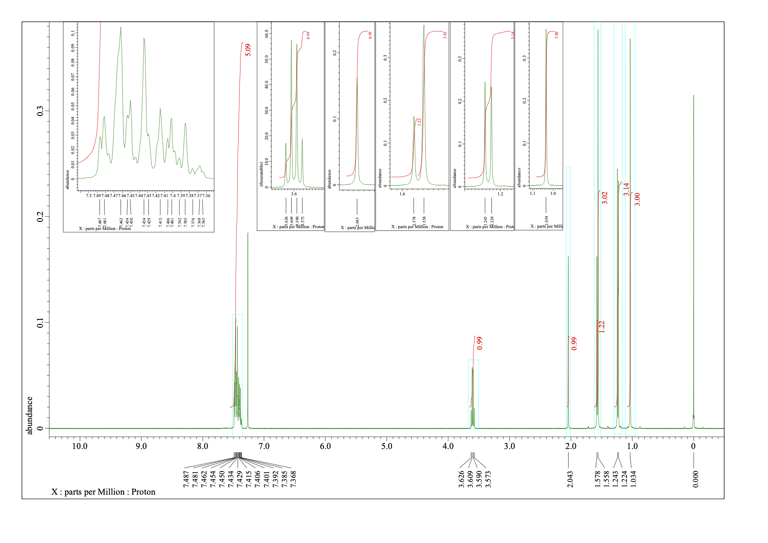
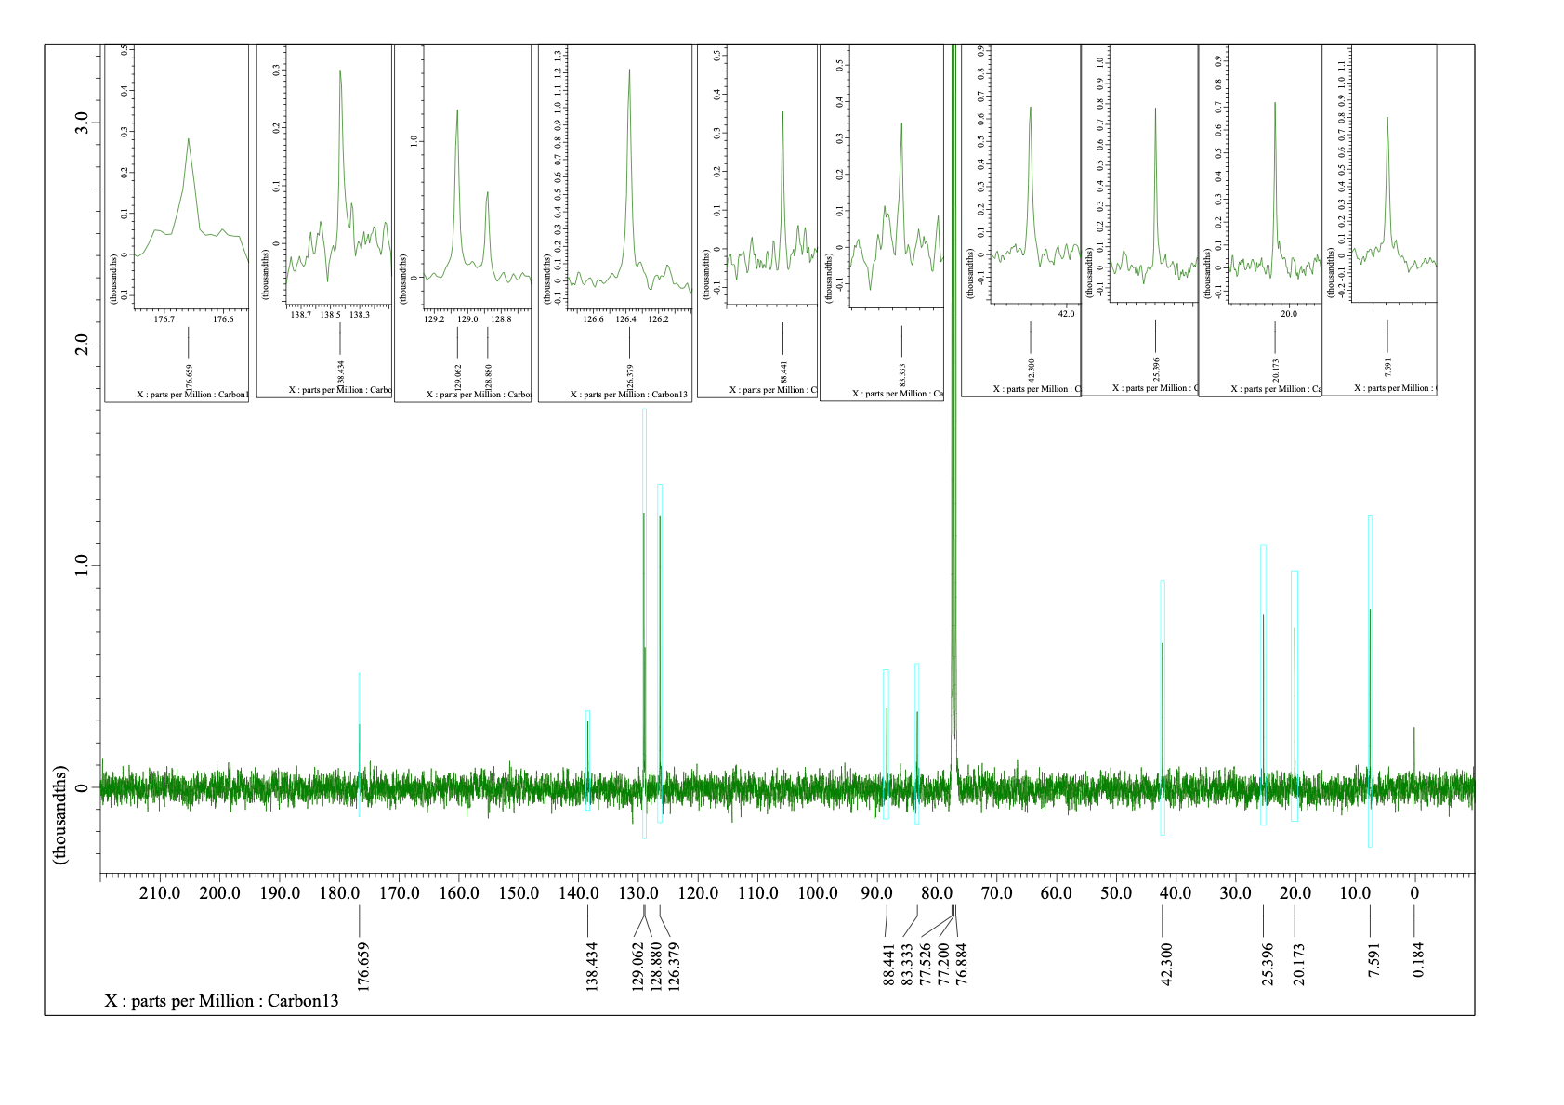
¹H NMR (400 MHz) and ¹³C NMR (100 MHz) spectra of anti-2a (CDCl₃)
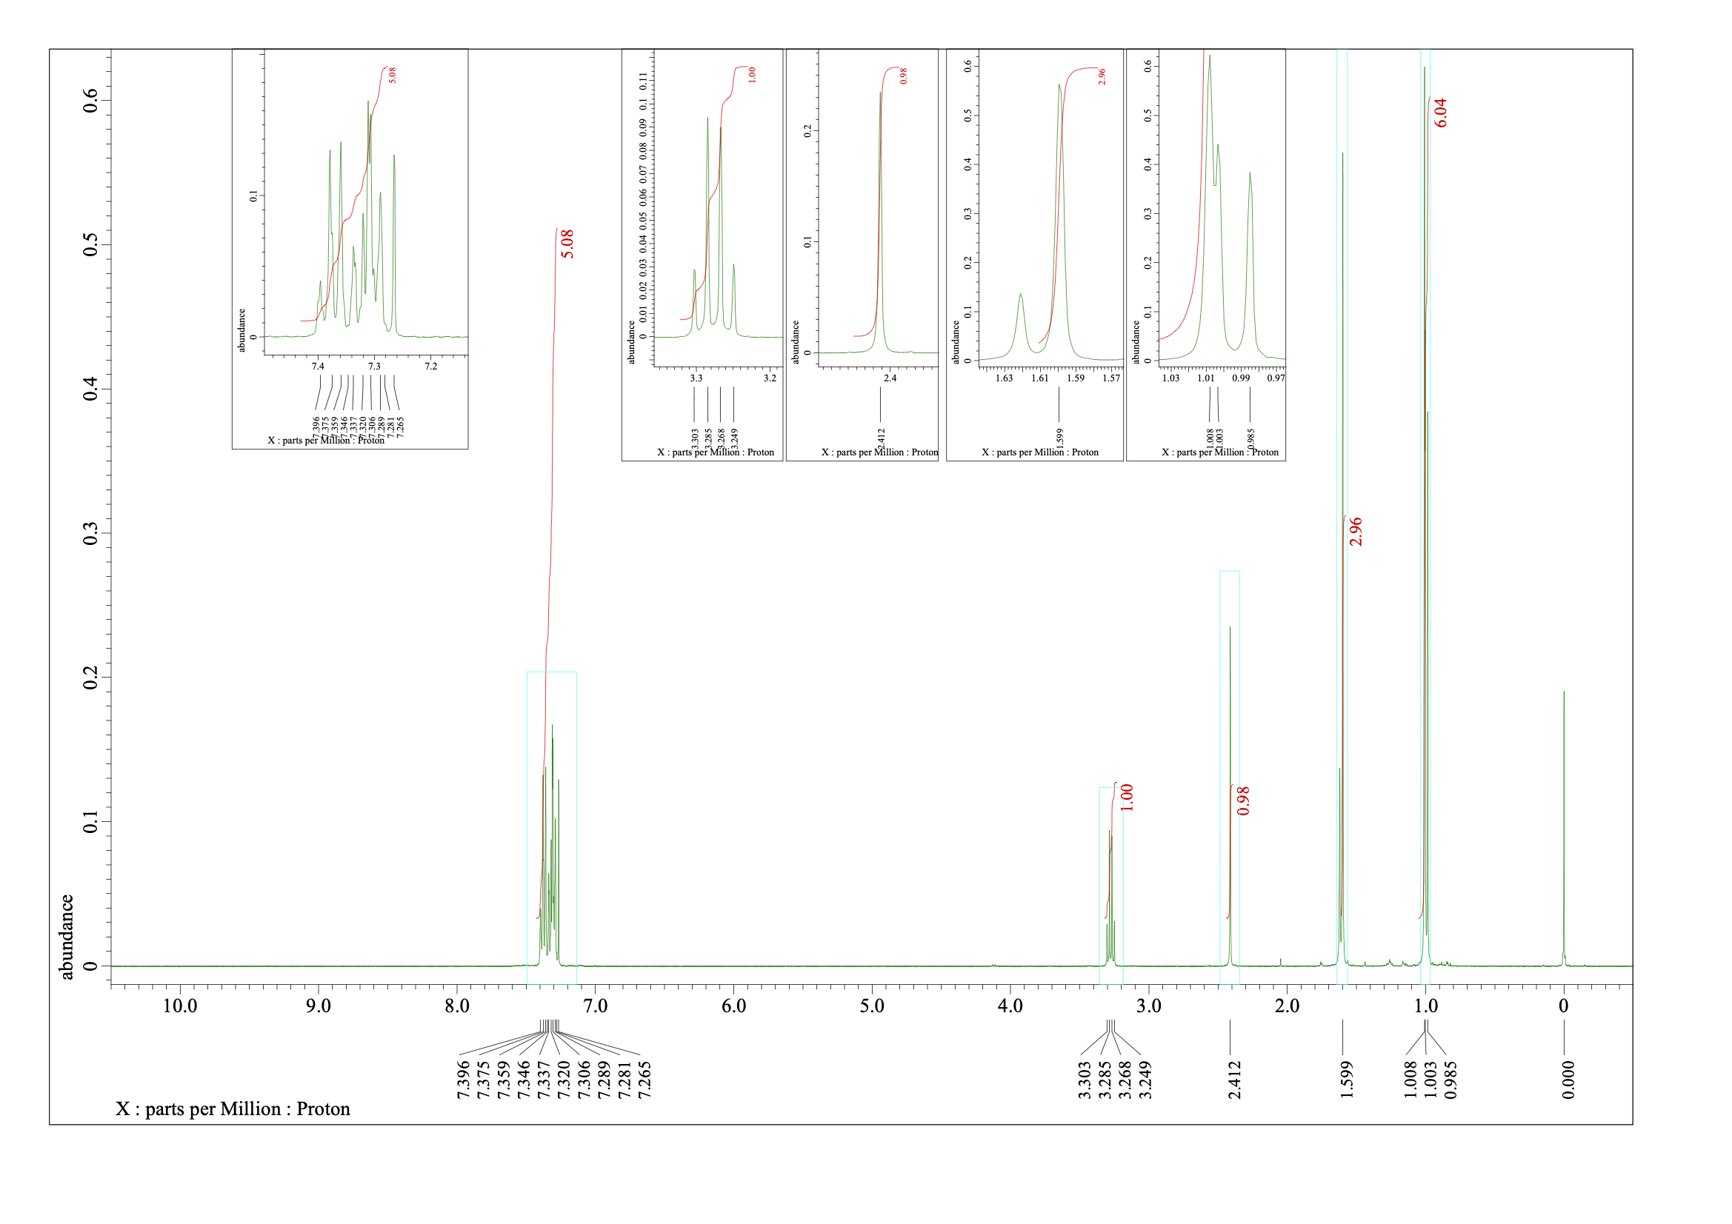
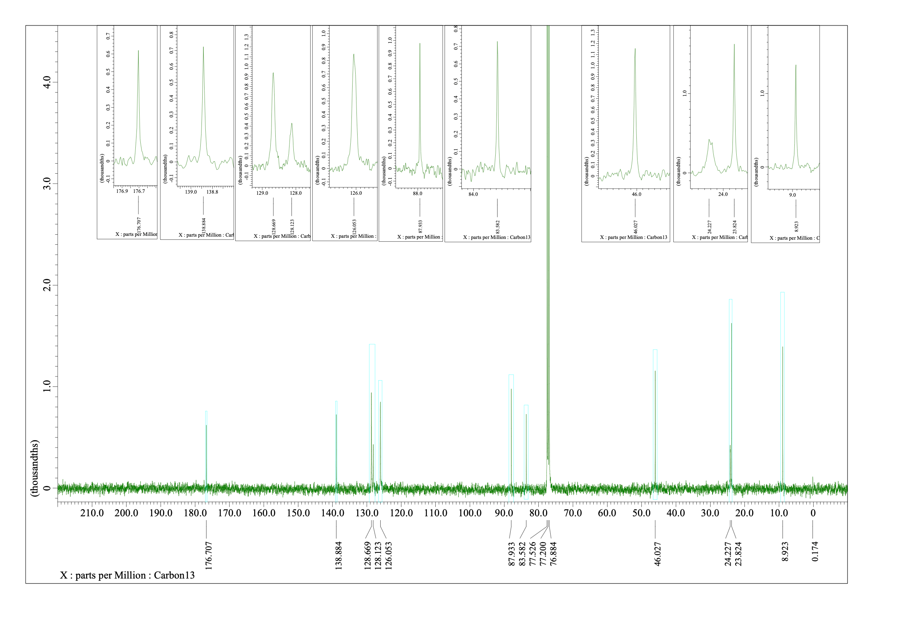

¹H NMR (400 MHz) and ¹³C NMR (100 MHz) spectra of 2b (CDCl₃)
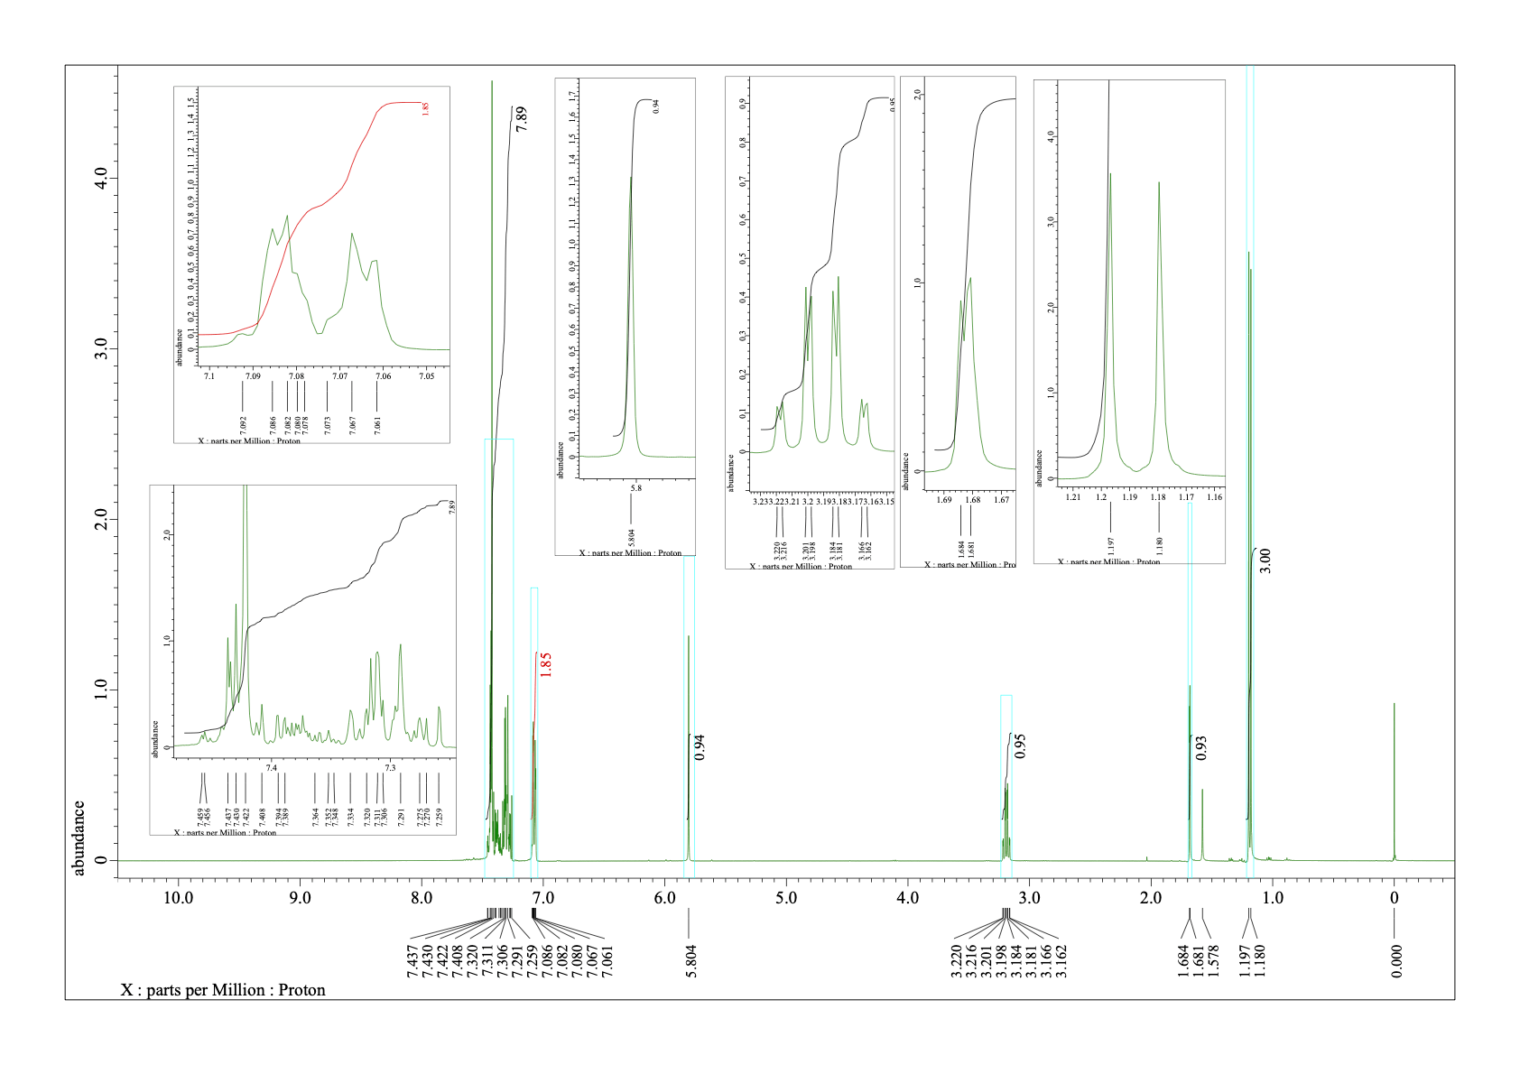
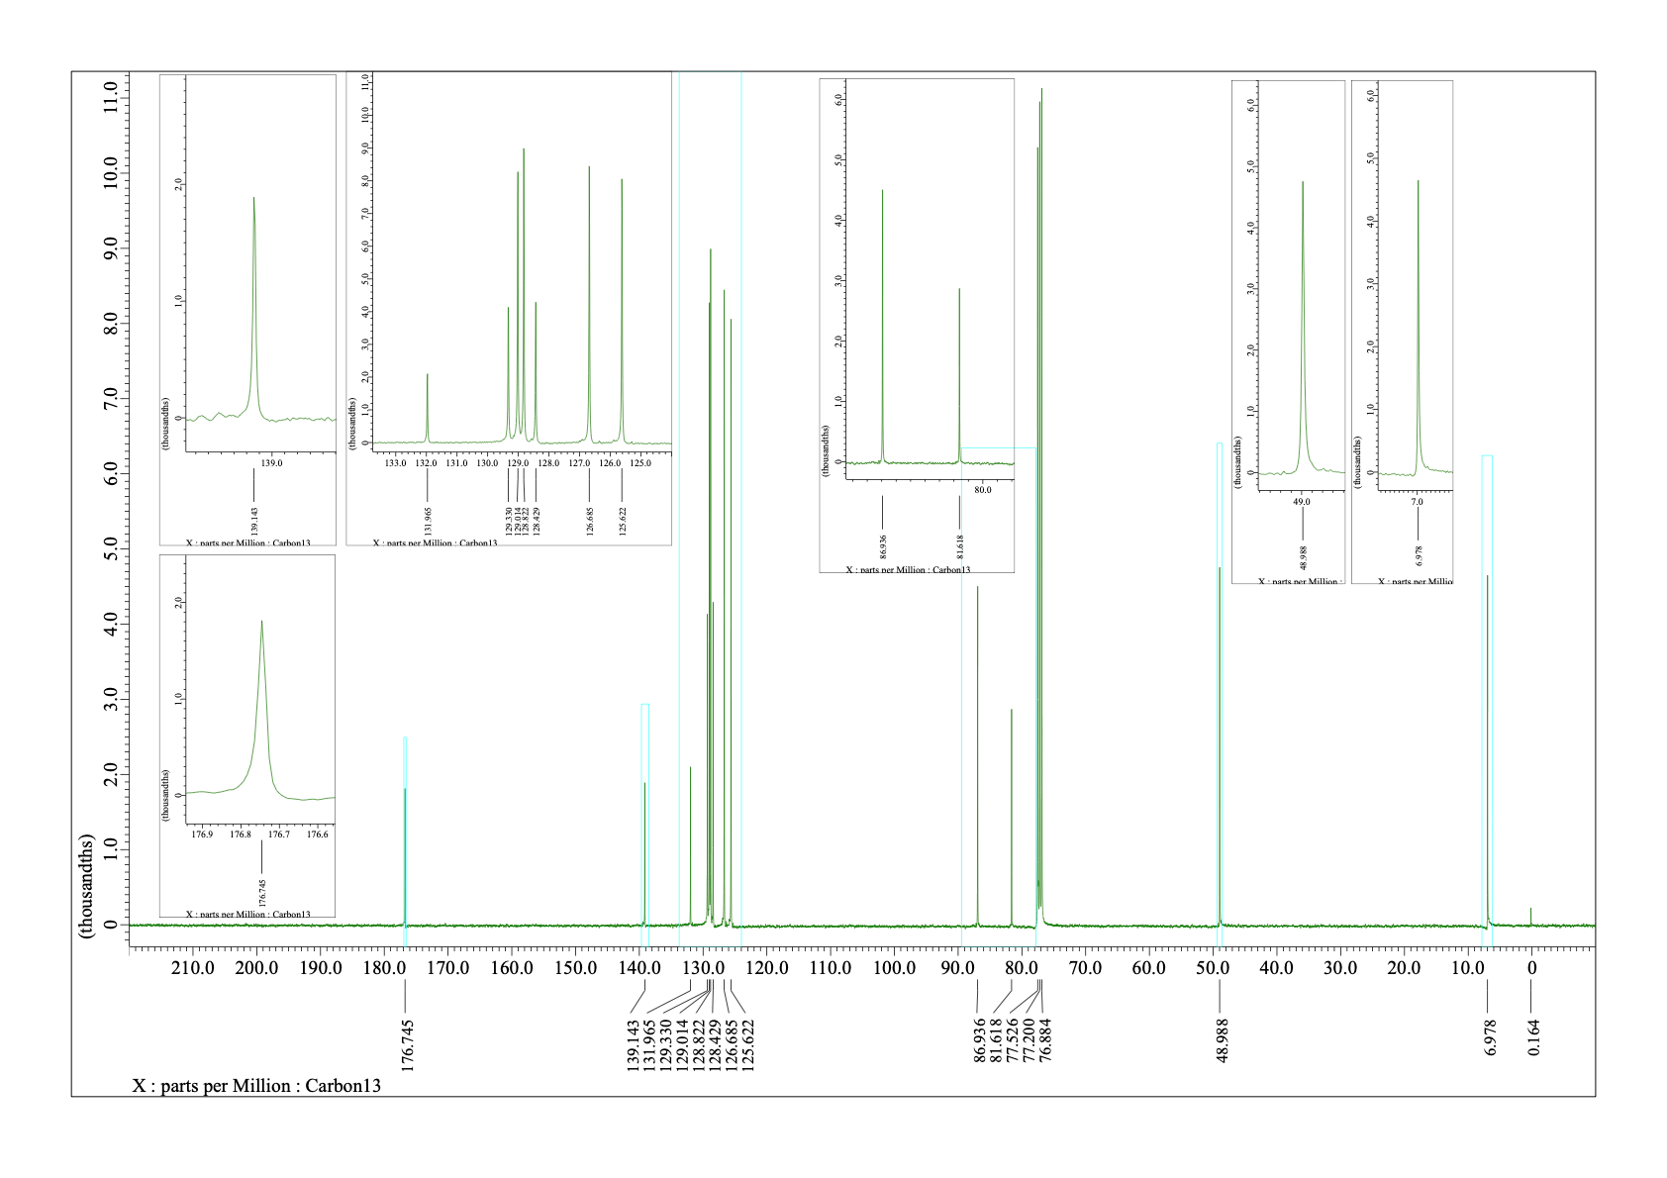
¹H NMR (400 MHz) and ¹³C NMR (100 MHz) spectra of 2c (CDCl₃)
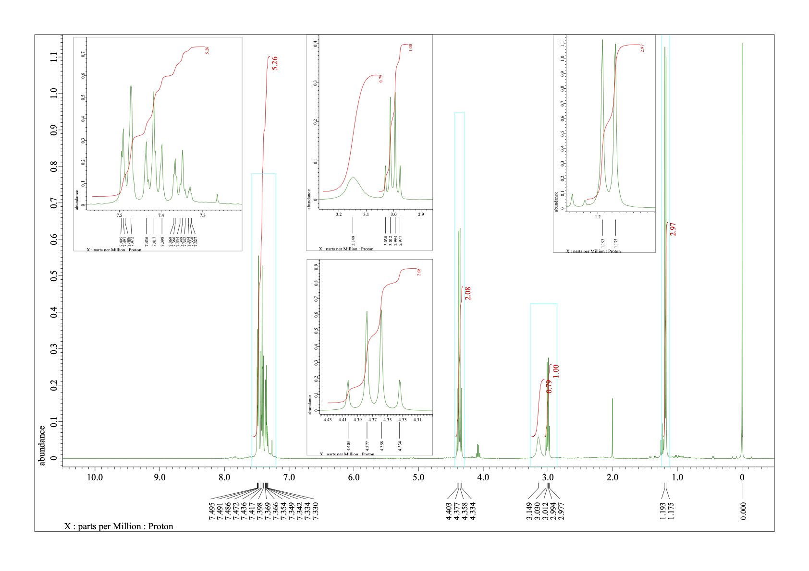
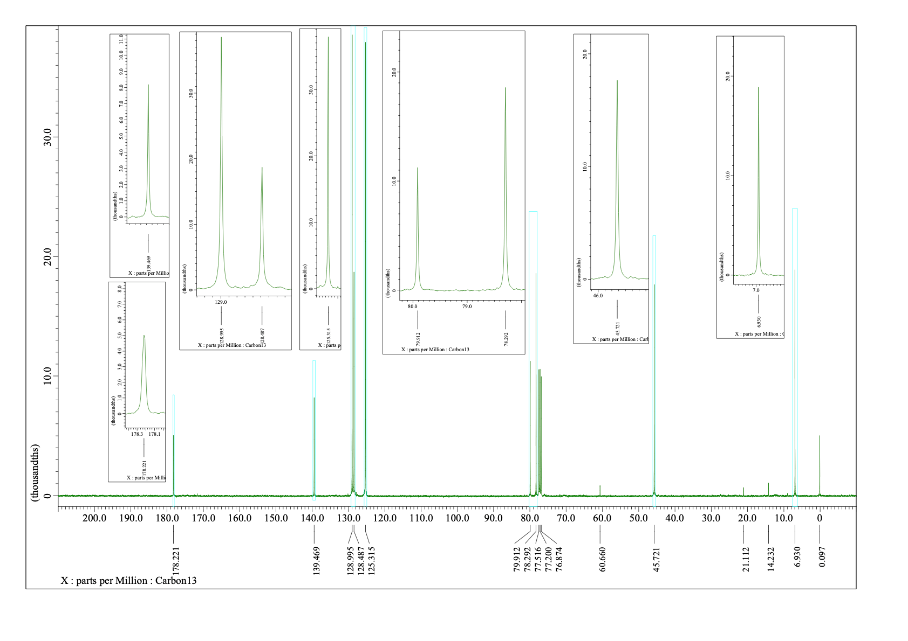

¹H NMR (400 MHz) and ¹³C NMR (100 MHz) spectra of 2d (CDCl₃)
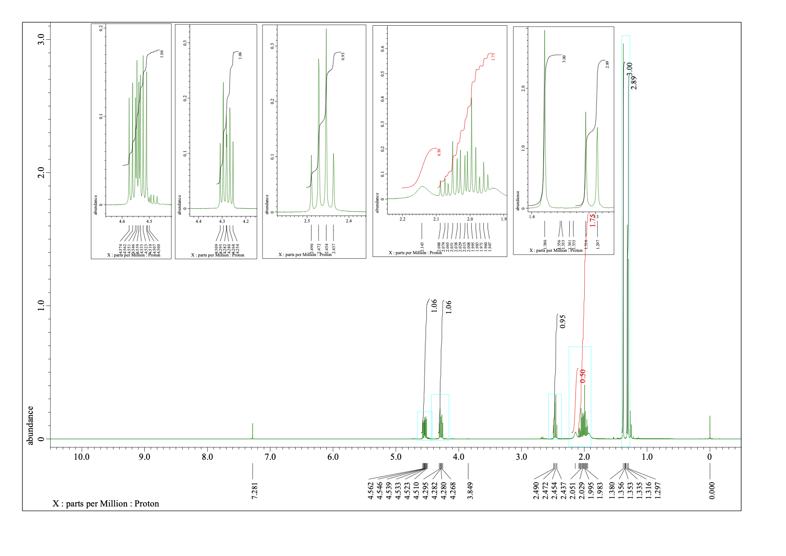
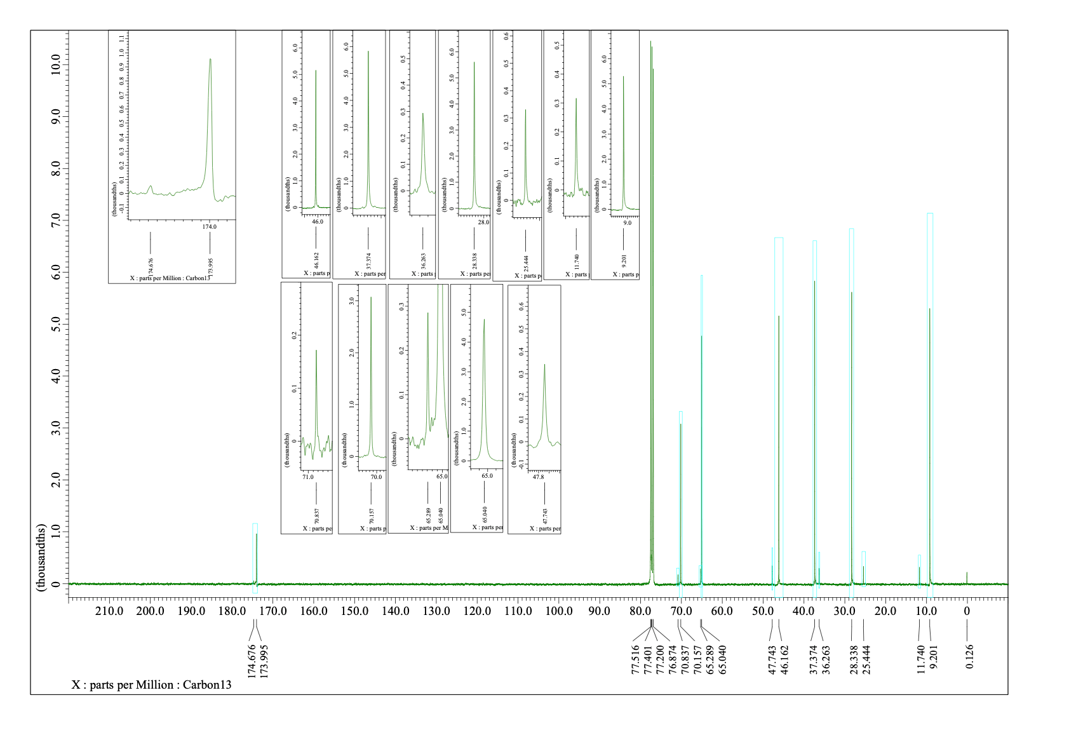
¹H NMR (400 MHz) and ¹³C NMR (100 MHz) spectra of 2e (CDCl₃)
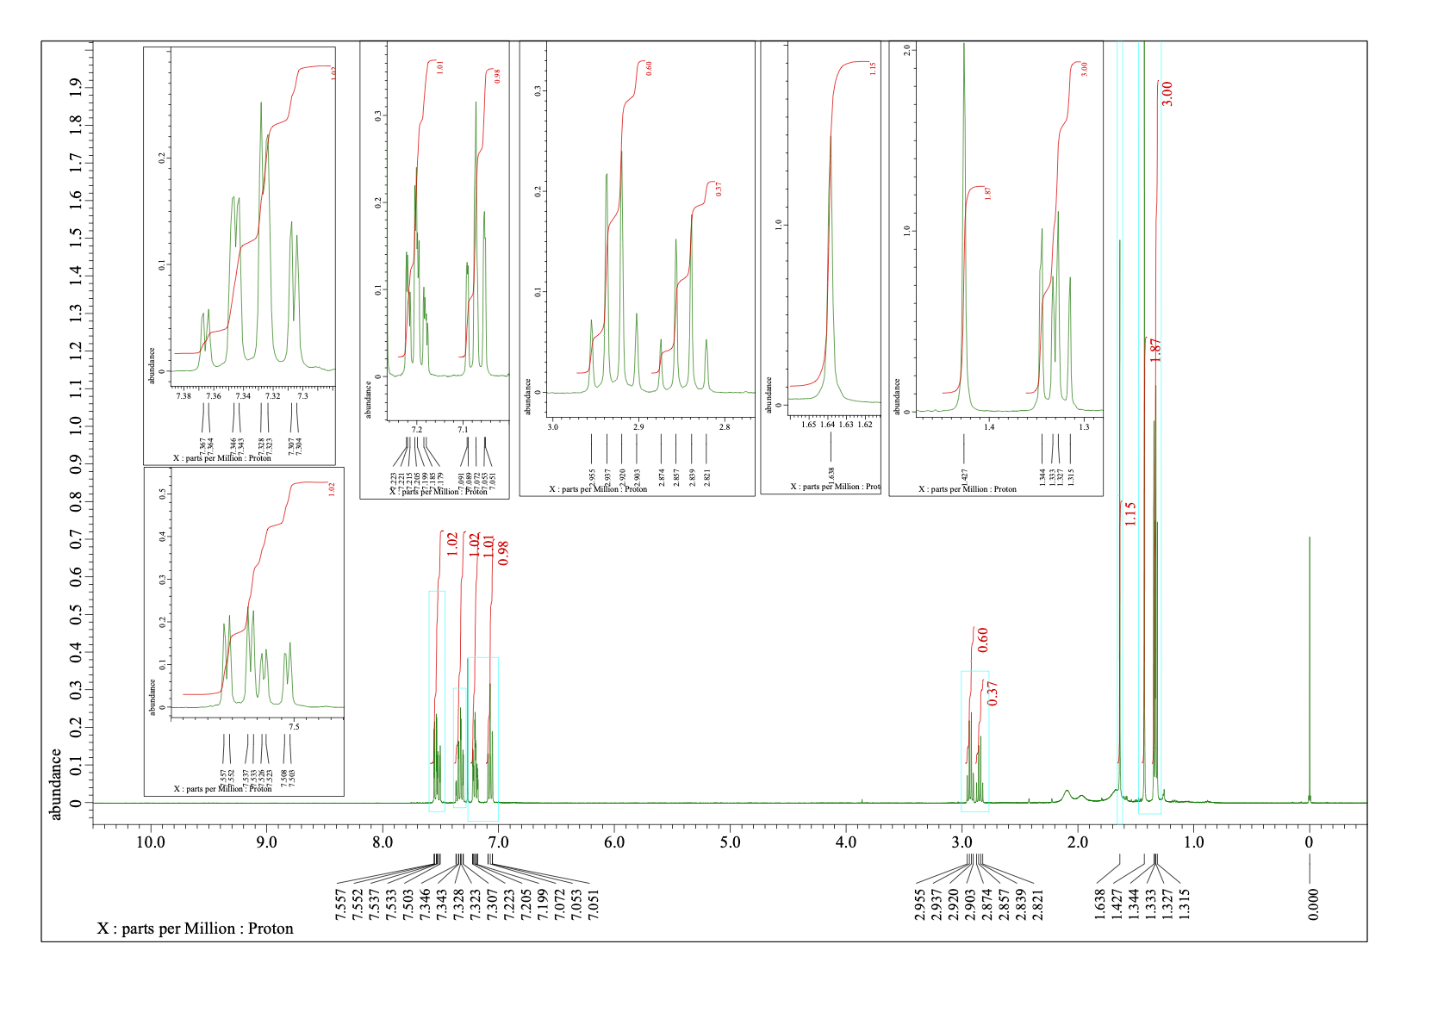
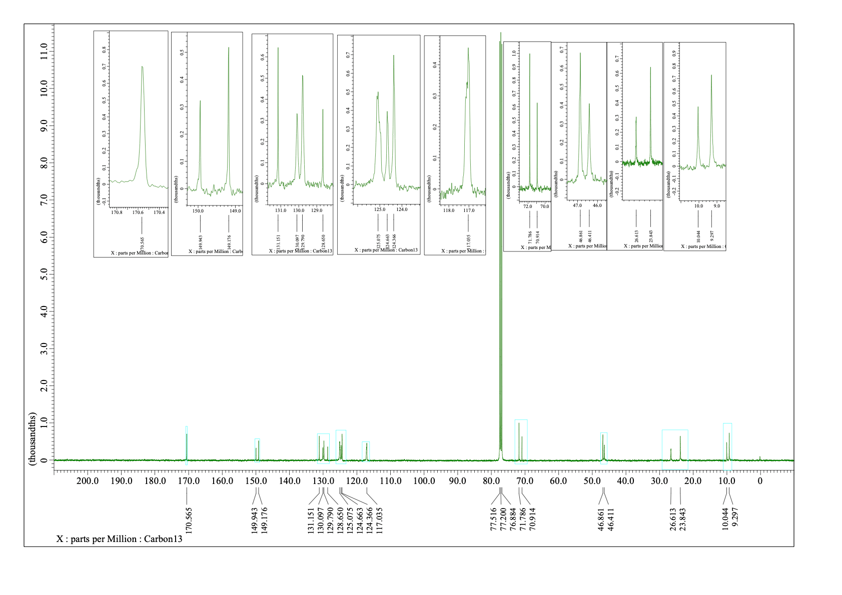
¹H NMR (400 MHz) and ¹³C NMR (100 MHz) spectra of 2g (CDCl₃)
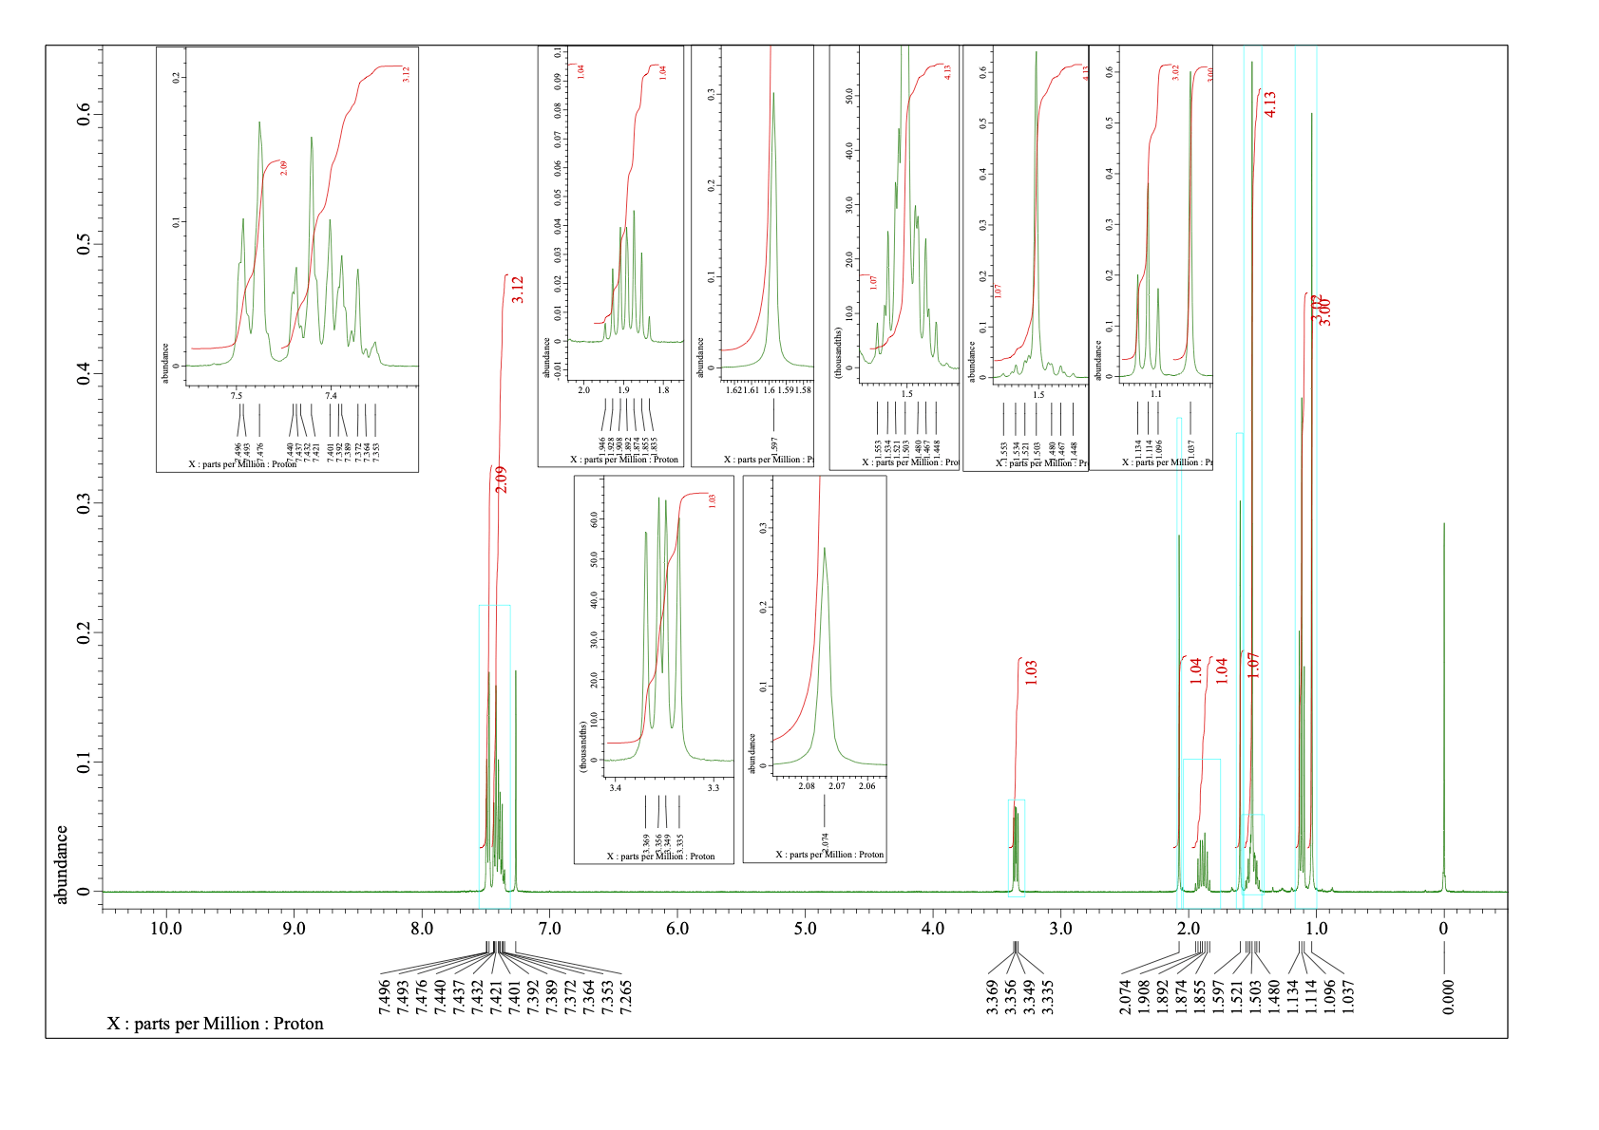
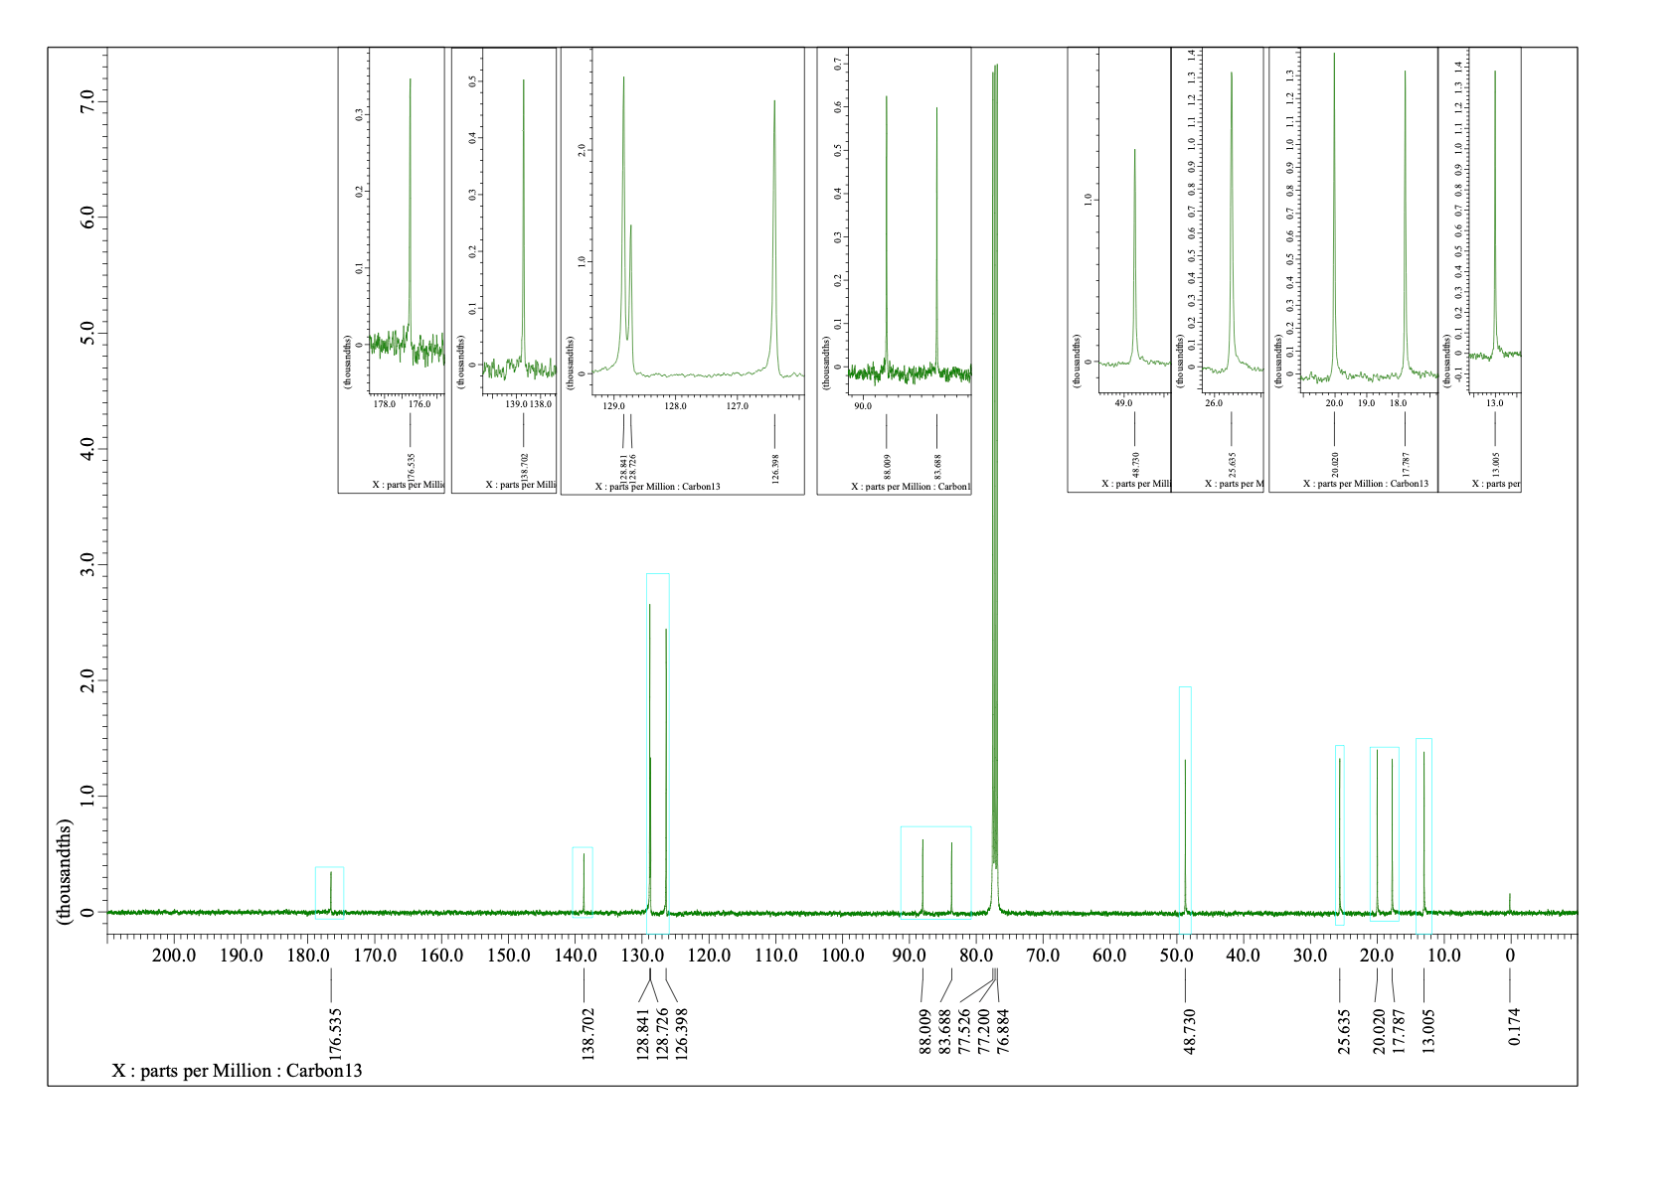
¹H NMR (400 MHz) and ¹³C NMR (100 MHz) spectra of 2h (CDCl₃)
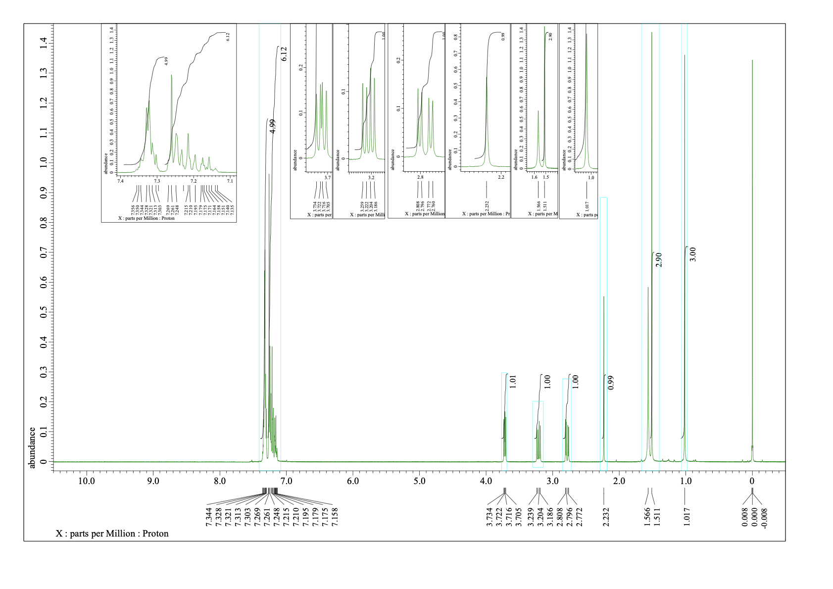
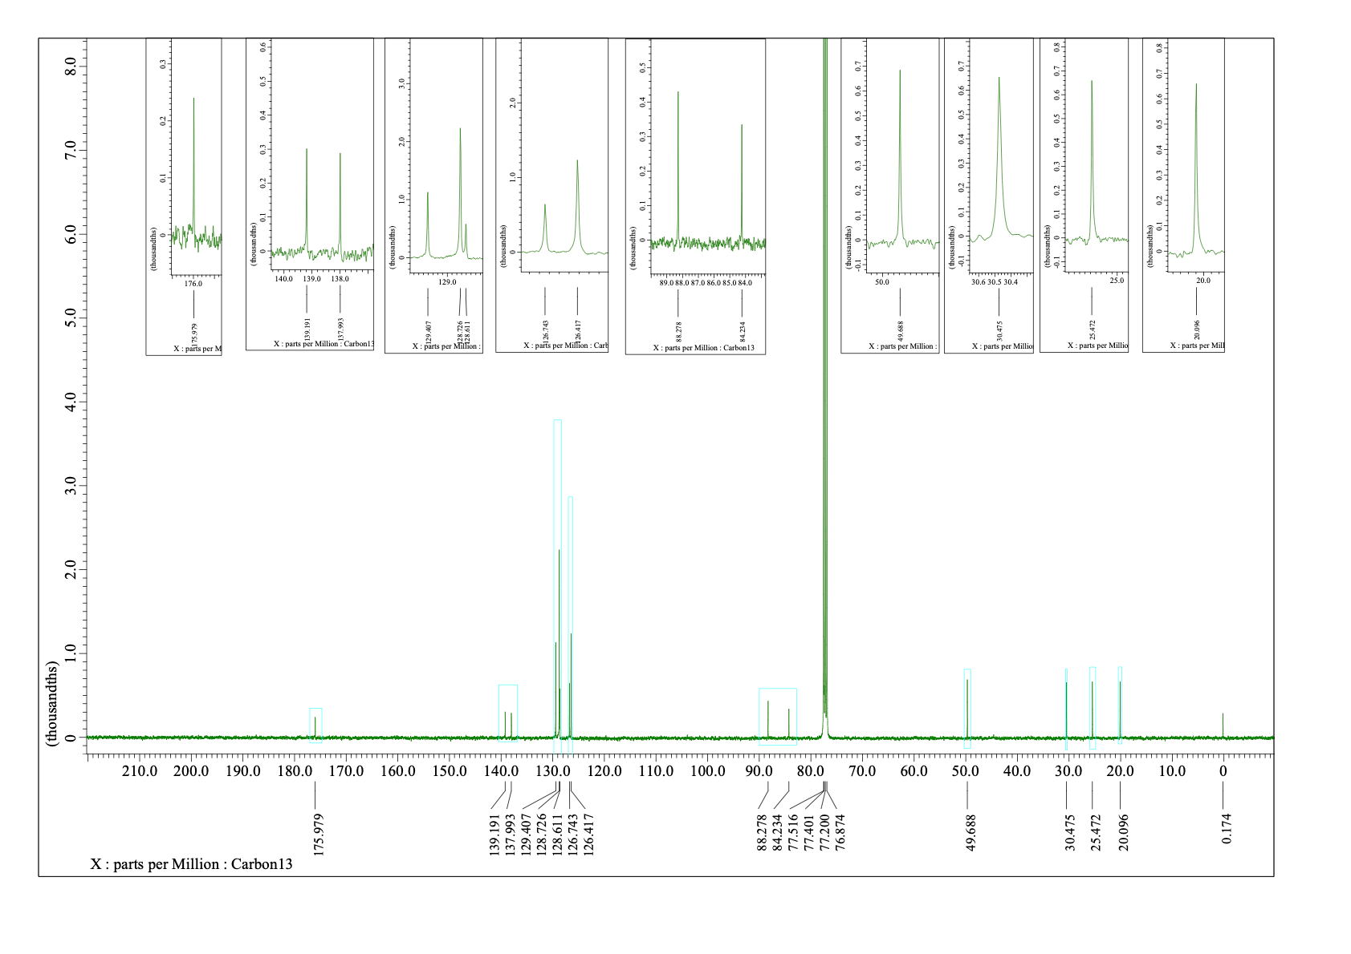
¹H NMR (400 MHz) and ¹³C NMR (100 MHz) spectra of 2j (CDCl₃)
