Supporting Information

Size and Frequency Dependent Heating Rates of Gold Nanoparticles Exposed to Radiofrequency Electric Field

Justin Case,^{1,2} Kelly McNear,² Mazen Alrahili,³ Viktoria Savchuk,^{1,2} Andrii M. Lopatynskyi,⁴ Volodymyr Chegel,⁴ and Anatoliy O. Pinchuk^{1,2}
¹ Department of Physics and Energy Science, University of Colorado Colorado Springs, 1420 Austin Bluffs Parkway, Colorado Springs, Colorado 80918, USA
² UCCS BioFrontiers Center, University of Colorado Colorado Springs, 1420 Austin Bluffs Parkway, Colorado Springs, Colorado 80918, USA
³ Physics Department, School of Science, Taibah University, Janadah Bin Umayyah Road, Medina 42353, Saudi Arabia
⁴ V.E. Lashkaryov Institute of Semiconductor Physics, National Academy of Sciences of Ukraine, 41, prospect Nauky, 03028 Kyiv, Ukraine

Power dependence measurements carried out also show that as less power is delivered to the system, less heating occurs. This was expected as previous results in the literature have indicated that a high electric field and high power are needed in order to successfully heat gold nanoparticles. The heating of the particles was measured at 90%, 70%, 50%, and 30% and, as no heating was observed at 50% or 30%, the authors did not conduct experiments at lower powers. As shown in Fig. S1, the power significantly affects the heating and a severe drop in heating capabilities was observed at even 70%. It should be noted that the authors were unable to perform the heating test above 90% as this amount of power saturates the tuning antenna and risks damage to the equipment.
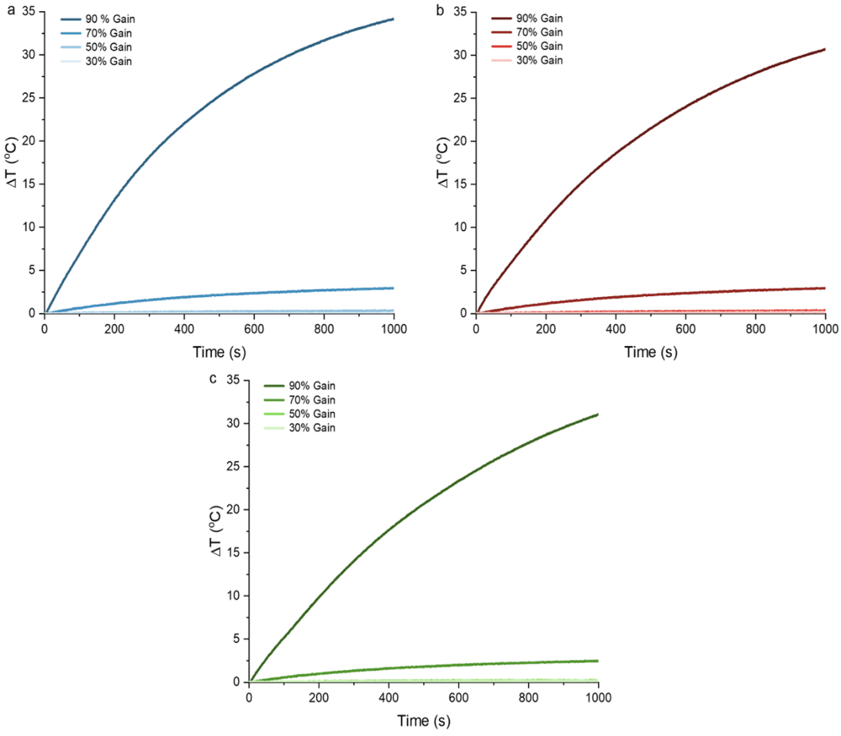

Figure S1 Temperature change as a function of power for a) 5 nm AuNPs, b) 20 nm AuNPs, and c) 30 nm AuNPs. The gain was adjusted on the power amplifier to deliver 90%, 70%, 50%, and 30% of the incoming power from the signal generator.

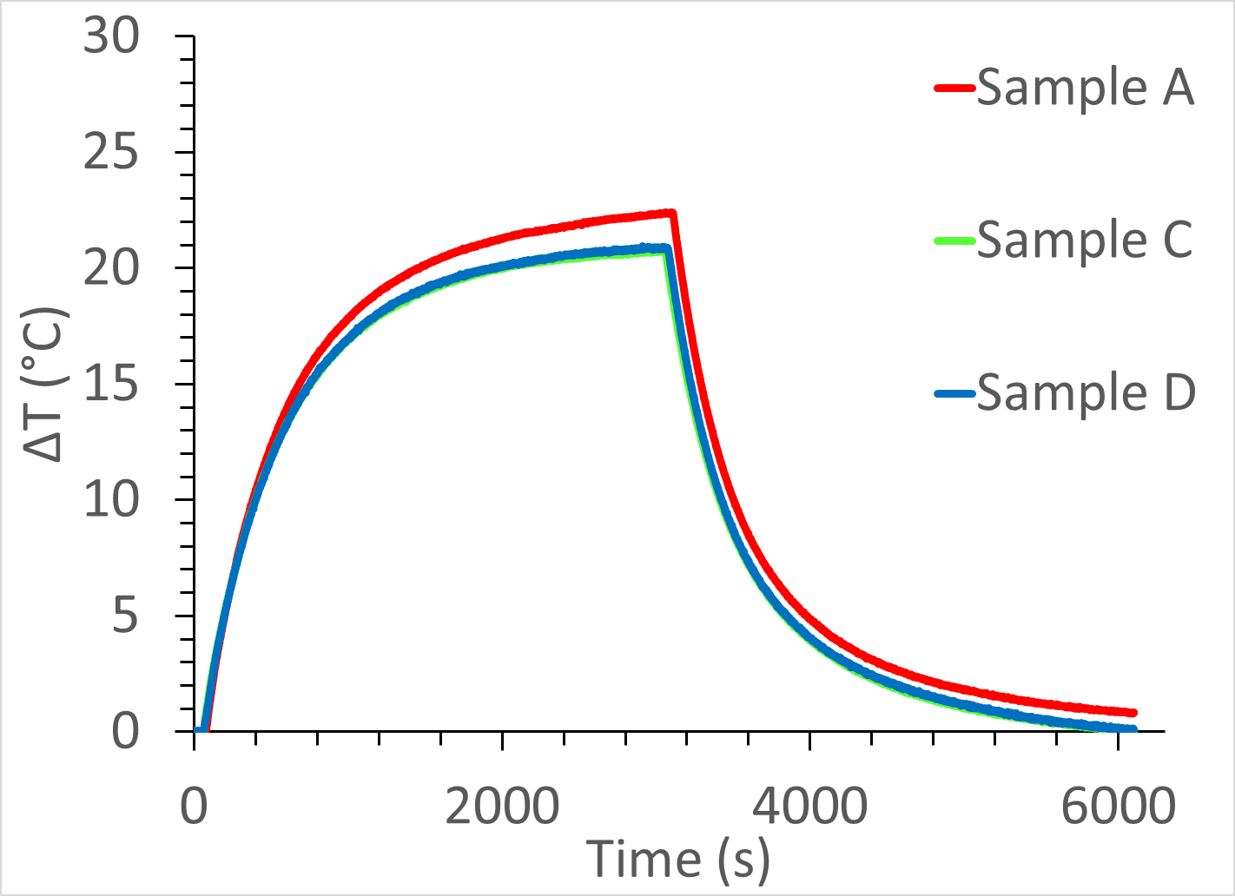
Figure S2. Heating profiles of three samples of 20 nm (Nanopartz) dissolved in DI water at the frequency 13.56 MHz.

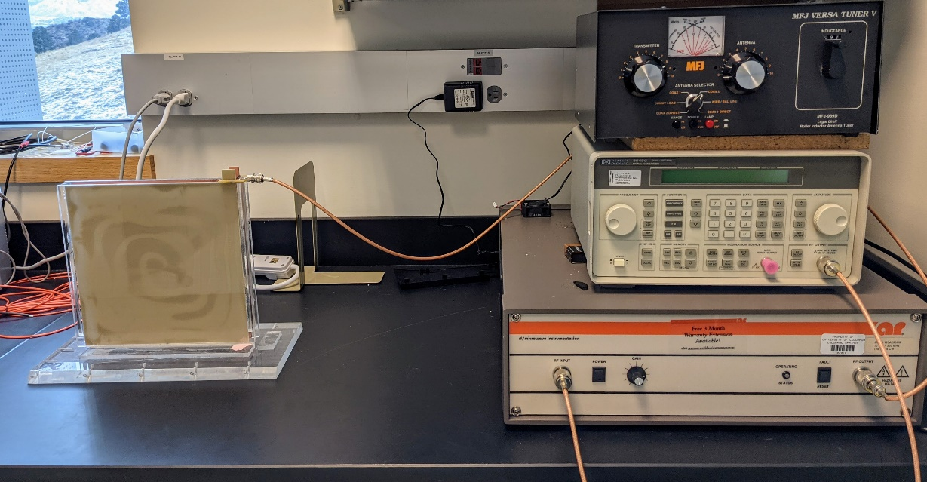
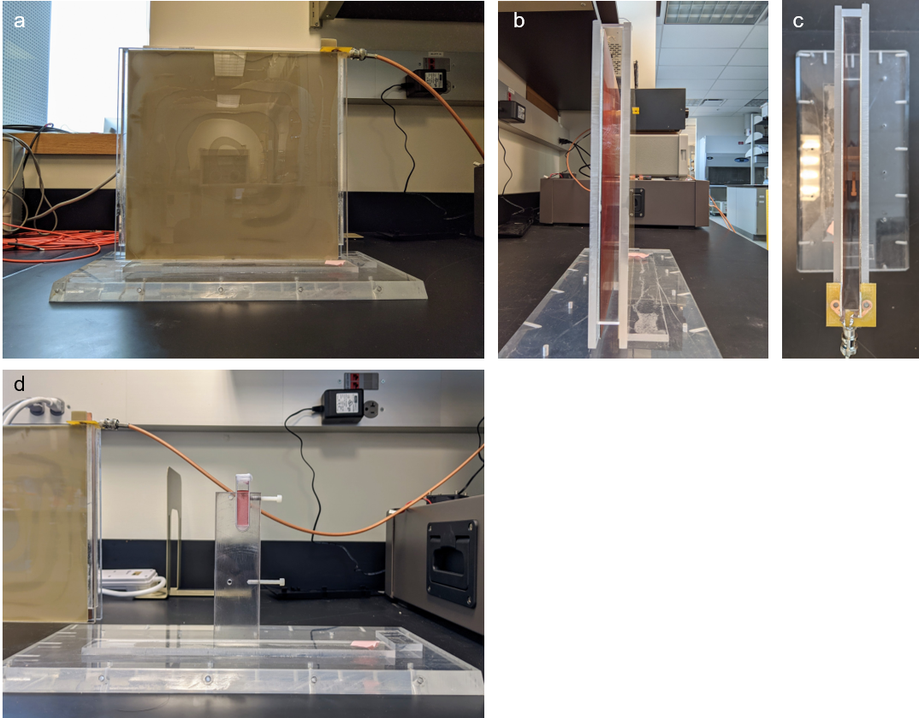
Fig. S4 The capacitor plates and sample holder is pictured on the left. On the right, from top to bottom, is the tunable antenna, the signal generator, and the power amplifier.
Fig. S3 a) Side view 1, b) side view 2, c) top view, and d) inside view of the capacitor setup. The capacitor is connected to the rest of the components via a BNC female connection soldered to a printed circuit board. The gold nanoparticles are placed inside the holder and the capacitor plates slide over the holder to avoid moving of the sample.
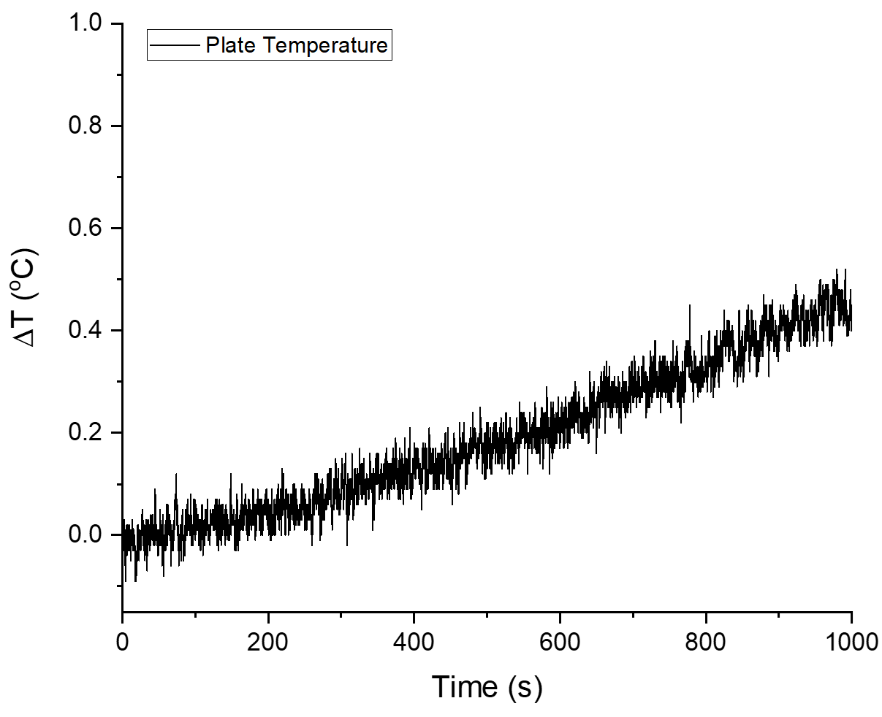
Fig. S5 The temperature of the plates with the setup running as usual at 13.56 MHz. The voltage across the plates measured 970 V_{pp} which corresponds to an electric field of 80.8 kV/m.

