Electronic Supplementary Information for

Facile and Diastereoselective Arylation of the Privileged 1,4-Dihydroisoquinolin-3(2H)-one Scaffold
Dmitry Dar’in,* Grigory Kantin, Alexander Bunev, and Mikhail Krasavin*

Table of Contents

- Experimental procedures and characterization data S2
- Crystallographic data for compounds 9a, 10с and 16 …………S27
- Biological data S30
- References S32
- Copies of ¹H, ¹³C NMR, ¹⁹F and NOESY NMR spectra S33

- Experimental procedures and characterization data
General considerations. All reagents were used as purchased from commercial suppliers without further purification. Dichloromethane (DCM) and 1,2-dichloroethane (DCE) were freshly distilled over P₂O₅. NMR spectrum were recorded using Bruker Avance III spectrometer in CDCl₃ (¹H: 400.13 MHz; ¹³С: 100.61 MHz; ¹⁹F 376.50 MHz); chemical shifts are reported as parts per million (δ, ppm); the residual solvent peak (CHCl₃) was used as internal standard: 7.26 for ¹H and 77.16 ppm for ¹³C; multiplicities are abbreviated as follows: s = singlet, d = doublet, t = triplet, q = quartet, m = multiplet, dd = doublet of doublets, dt = doublet of triplets, ddd = doublet/doublets of doublets; coupling constants, J, are reported in Hz. Mass spectra were recorded using Bruker microTOF spectrometer (ionization by electrospray, positive ions detection). Melting points were determined in open capillary tubes on Stuart SMP50 Automatic Melting Point Apparatus. Analytical thin-layer chromatography was carried out on UV-254 silica gel plates using appropriate eluents. Compounds were visualized with short-wavelength UV light. Column chromatography was performed using silica gel Merk grade 60 (0.040−0.063 mm) 230−400 mesh. Starting compounds 11 were synthesized according to slightly modified literature procedures.^{1,2}
Preparation of 1,4-Dihydroisoquinolin-3(2H)-ones 11 and compound 14
Method A:
To a solution of the corresponding imine (5.0 mmol) in DCM (50 mL) was added arylacetyl chloride (5.0 mmol). After stirring at ambient temperature for 2.5 h, triflic acid (20 mL) was added and stirring was continued for 4 h. The resulting mixture was poured onto crushed ice, extracted with DCM (3×20 mL), washed with water and brine, dried over MgSO₄. After removal of solvent under reduced pressure, the crude product was purified flash chromatography on silica gel (DCM‒acetone, 0-30% of acetone).
Method B:
To a solution of the corresponding imine (4.0 mmol) in DCE (20 mL) was added arylacetyl chloride (4.0 mmol). After stirring for 20 min, AlCl₃ (5.0 mmol) was added and stirring was continued at 80 °C for 1.5 h. Upon cooling to ambient temperature, 10% HCl (30 mL) was added and the mixture was extracted with DCM (3×15 mL), washed with brine and evaporated. The crude material was subjected to flash chromatography on silica gel (DCM‒acetone, 0-30% of acetone).
1,2-Diphenyl-1,4-dihydroisoquinolin-3(2H)-one² (11a): prepared from 2-phenylacetyl chloride and N-benzylidene aniline according to both Method A and Method B (scale ‒ 5 mmol). Yield: 1.14 g (76%) for Method A and 1.23 g (82%) for Method B. White solid; m.p. 145.0–146.1 °C. ¹H NMR (400 MHz, CDCl₃) δ 7.60 – 7.10 (m, 14H), 5.94 (s, 1H), 3.94 (d, J = 19.3 Hz, 1H), 3.83 (d, J = 19.2 Hz, 1H).
2-Methyl-1-phenyl-1,4-dihydroisoquinolin-3(2H)-one² (11b): prepared from 2-phenylacetyl chloride and N-benzylidene methylamine according to both Method A and Method B (scale ‒ 5 mmol). Yield: 819 mg (69%) for Method A and 771 mg (65%) for Method B. White solid; m.p. 96.2–97.7 °C. ¹H NMR (400 MHz, CDCl₃) δ 7.44 – 7.03 (m, 9H), 5.49 (s, 1H), 3.84 (d, J = 20.0 Hz, 1H), 3.73 (d, J = 20.0 Hz, 1H), 3.07 (s, 3H).
7-Chloro-1,2-diphenyl-1,4-dihydroisoquinolin-3(2H)-one (11c): prepared from 2-(4-chlorophenyl)acetyl chloride and N-benzylidene aniline according to Method A (scale ‒ 5 mmol). Yield: 1.1 g (66%). White solid; m.p. 146.2–148.0 °C. ¹H NMR (400 MHz, CDCl₃) δ 7.41 – 7.27 (m, 8H), 7.27 – 7.15 (m, 5H), 5.88 (s, 1H), 3.90 (d, J = 19.3 Hz, 1H), 3.80 (d, J = 19.3 Hz, 1H). ¹³C{¹H} NMR (101 MHz, CDCl₃) δ 168.8, 141.7, 139.6, 137.5, 132.8, 130.1, 129.23, 129.19, 129.0, 128.1, 127.2, 126.62, 126.56, 126.2, 68.7, 37.8. HRMS (ESI), m/z calcd for C₂₁H₁₇ClNO [M+H]⁺ 334.0993/336.0971 found 334.0999/336.0972.
5-Chloro-1,2-diphenyl-1,4-dihydroisoquinolin-3(2H)-one (11d): prepared from 2-(2-chlorophenyl)acetyl chloride and N-benzylidene aniline according to Method B (scale ‒ 5 mmol). Yield: 1.32 g (79%). White solid; m.p. 182.6–184.0 °C. ¹H NMR (400 MHz, CDCl₃) δ 7.41 – 7.27 (m, 7H), 7.27 – 7.15 (m, 6H), 5.93 (s, 1H), 4.21 (d, J = 20.3 Hz, 1H), 3.81 (d, J = 20.3 Hz, 1H). ¹³C{¹H} NMR (101 MHz, CDCl₃) δ 168.2, 141.5, 140.3, 137.5, 133.2, 129.6, 129.2, 129.0, 128.4, 128.1, 128.0, 127.2, 126.7, 126.6, 124.7, 69.1, 35.4. HRMS (ESI), m/z calcd for C₂₁H₁₆ClNNaO [M+Na]⁺ 356.0813/358.0791 found 356.0818/358.0794.
7-Methoxy-1,2-diphenyl-1,4-dihydroisoquinolin-3(2H)-one (11e): prepared from 2-(4-methoxyphenyl)acetyl chloride and N-benzylidene aniline according to Method A (scale ‒ 5 mmol). Yield: 1.3 g (79%). White solid; m.p. 129.2–130.8 °C. ¹H NMR (400 MHz, CDCl₃) δ 7.41 – 7.19 (m, 10H), 7.17 (d, J = 8.2 Hz, 1H), 6.91 – 6.82 (m, 2H), 5.86 (s, 1H), 3.87 (d, J = 19.3 Hz, 1H), 3.82 (s, 3H), 3.77 (d, J = 19.3 Hz, 1H). ¹³C{¹H} NMR (101 MHz, CDCl₃) δ 169.6, 158.6, 142.0, 140.3, 136.9, 129.1, 128.9, 128.8, 127.8, 127.0, 126.7, 126.6, 123.6, 113.4, 111.8, 69.2, 55.4, 37.5. HRMS (ESI), m/z calcd for C₂₂H₂₀NO₂ [M+H]⁺ 330.1489 found 330.1489.
5-Methoxy-1,2-diphenyl-1,4-dihydroisoquinolin-3(2H)-one (11f): prepared from 2-(2-methoxyphenyl)acetyl chloride and N-benzylidene aniline according to Method B (scale ‒ 4 mmol). Yield: 742 mg (56%). White solid; m.p. 186.9–188.8 °C. ¹H NMR (400 MHz, CDCl₃) δ 7.38 – 7.19 (m, 9H), 7.19 – 7.11 (m, 2H), 6.88 (d, J = 7.7 Hz, 1H), 6.83 (d, J = 8.2 Hz, 1H), 5.89 (s, 1H), 4.13 (d, J = 20.6 Hz, 1H), 3.89 (s, 3H), 3.65 (d, J = 20.6 Hz, 1H). ¹³C{¹H} NMR (101 MHz, CDCl₃) δ 169.2, 156.3, 141.9, 141.0, 136.7, 129.1, 128.8, 127.8, 127.7, 127.0, 126.9, 126.7, 120.0, 118.2, 108.8, 69.2, 55.5, 31.8. HRMS (ESI), m/z calcd for C₂₂H₂₀NO₂ [M+H]⁺ 330.1489 found 330.1490.
6,7-Dimethoxy-1,2-diphenyl-1,4-dihydroisoquinolin-3(2H)-one² (11g): prepared from 2-(3,4-dimethoxyphenyl)acetyl chloride and N-benzylidene aniline according to Method B (scale ‒ 4 mmol). Yield: 1.24 g (86%). Pale beige amorphous solid. ¹H NMR (400 MHz, CDCl₃) δ 7.40 – 7.23 (m, 6H), 7.21 – 7.13 (m, 4H), 6.74 (s, 1H), 6.73 (s, 1H), 5.82 (s, 1H), 3.93 (d, J = 19.6 Hz, 1H), 3.92 (s, 3H), 3.86 (s, 3H), 3.76 (d, J = 19.6 Hz, 1H).
6-Chloro-2-methyl-1-phenyl-1,4-dihydroisoquinolin-3(2H)-one (11h): prepared from 2-(3-chlorophenyl)acetyl chloride and N-benzylidene methylamine according to Method B (scale ‒ 6 mmol) as mixture with 8-chloro regioisomer (ratio 10:1). Yield: 933 mg (58%); pure compound 11h was obtained after crystallization from n-Hexane‒Ether mixture. White solid; m.p. 132.5–133.6 °C. ¹H NMR (400 MHz, CDCl₃) δ 7.43 – 7.29 (m, 3H), 7.26 – 7.10 (m, 5H), 5.46 (s, 1H), 3.81 (d, J = 20.2 Hz, 1H), 3.70 (d, J = 20.2 Hz, 1H), 3.05 (s, 3H). ¹³C{¹H} NMR (101 MHz, CDCl₃) δ 168.0, 140.3, 133.4, 133.2, 132.8, 129.2, 128.2, 127.8, 127.5, 127.1, 126.4, 67.3, 36.1, 33.5. HRMS (ESI), m/z calcd for C₁₆H₁₅ClNO [M+H]⁺ 272.0837/274.0812 found 272.0843/274.0816.
2-(4-Methoxyphenyl)-7-methyl-1-(4-(trifluoromethyl)phenyl)-1,4-dihydroisoquinolin-3(2H)-one (11i): prepared from 2-(4-methylphenyl)acetyl chloride and N-(4-(trifluoromethyl)benzylidene) 4-methoxyaniline according to Method A (scale ‒ 5 mmol). Yield: 1.11 g (54%). Pale beige amorphous solid. ¹H NMR (400 MHz, CDCl₃) δ 7.58 (d, J = 8.1 Hz, 1H), 7.35 (d, J = 8.1 Hz, 1H), 7.16 (s, 2H), 7.11 – 7.04 (m, 3H), 6.89 (d, J = 9.0 Hz, 2H), 5.87 (s, 1H), 3.91 (d, J = 19.6 Hz, 1H), 3.82 (d, J = 19.6 Hz, 1H), 3.81 (s, 3H), 2.37 (s, 3H). ¹³C{¹H} NMR (101 MHz, CDCl₃) δ 169.3, 158.5, 144.8, 136.9, 134.6, 134.4, 130.1 (q, ²J_{C‒F} = 32.5 Hz), 129.1, 128.4, 128.0, 127.9, 127.1, 126.6, 125.9 (q, ³J_{C‒F} = 3.7 Hz), 123.9 (q, ¹J_{C‒F} = 272.1 Hz), 114.6, 69.2, 55.4, 37.5, 21.1. ¹⁹F{¹H} NMR (377 MHz, CDCl₃) δ ‒62.58. HRMS (ESI), m/z calcd for C₂₄H₂₁F₃NO₂ [M+H]⁺ 412.1519 found 412.1521.
7-Methoxy-2-methyl-1-(3-nitrophenyl)-1,4-dihydroisoquinolin-3(2H)-one (11j): prepared from 2-(4-methoxyphenyl)acetyl chloride and N-(3-nitrobenzylidene) methylamine according to Method B (scale ‒ 4 mmol). Yield: 1.01 g (81%). White solid; m.p. 154.8–156.2 °C. ¹H NMR (400 MHz, CDCl₃) δ 8.20 – 8.12 (m, 2H), 7.60 – 7.52 (m, 2H), 7.12 (d, J = 8.4 Hz, 1H), 6.85 (dd, J = 8.5, 2.6 Hz, 1H), 6.72 (d, J = 2.6 Hz, 1H), 5.54 (s, 1H), 3.78 (s, 3H), 3.78 (d, J = 20.2 Hz, 1H), 3.71 (d, J = 20.2 Hz, 1H), 3.07 (s, 3H). ¹³C{¹H} NMR (101 MHz, CDCl₃) δ 168.9, 158.6, 148.7, 143.1, 134.3, 132.3, 130.3, 129.2, 123.2, 122.8, 121.7, 114.0, 111.7, 67.2, 55.4, 35.6, 33.6. HRMS (ESI), m/z calcd for C₁₇H₁₆N₂NaO₄ [M+Na]⁺ 335.1002 found 335.1008.
7-Chloro-2-(4-chlorobenzyl)-1-(4-fluorophenyl)-1,4-dihydroisoquinolin-3(2H)-one (11k): prepared from 2-(4-chlorophenyl)acetyl chloride and N-(4-fluorobenzylidene) 4-chlorobenzylamine according to Method A (scale ‒ 5 mmol). Yield: 1.84 g (92%). White solid; m.p. 115.4–117.3 °C. ¹H NMR (400 MHz, CDCl₃) δ 7.30 (d, J = 8.6 Hz, 2H), 7.23 (dd, J = 8.2, 2.1 Hz, 1H), 7.21 – 7.11 (m, 5H), 7.10 – 7.01 (m, 3H), 5.62 (d, J = 15.1 Hz, 1H), 5.33 (s, 1H), 3.88 (d, J = 20.1 Hz, 1H), 3.80 (d, J = 20.1 Hz, 1H), 3.69 (d, J = 15.1 Hz, 1H). ¹³C{¹H} NMR (101 MHz, CDCl₃) δ 168.4, 162.5 (d, ¹J_{C‒F} = 248.1 Hz), 136.1, 135.6 (d, ⁴J_{C‒F} = 3.4 Hz), 134.7, 133.6, 132.8, 129.4, 129.2, 129.0, 128.3 (d, ³J_{C‒F} = 8.4 Hz), 128.1, 126.3, 116.3 (d, ²J_{C‒F} = 21.7 Hz), 63.0, 47.0, 36.1. ¹⁹F{¹H} NMR (377 MHz, CDCl₃) δ ‒113.15. HRMS (ESI), m/z calcd for C₂₂H₁₇Cl₂FNO [M+H]⁺ 400.0666/402.0641 found 400.0667/402.0641.
7-Chloro-1-(2-chlorophenyl)-2-methyl-1,4-dihydroisoquinolin-3(2H)-one (11l): prepared from 2-(4-chlorophenyl)acetyl chloride and N-(2-chlorobenzylidene) methylamine according to Method A (scale ‒ 2.5 mmol). Yield: 655 mg (85%). White solid; m.p. 167.8–169.2 °C. ¹H NMR (400 MHz, CDCl₃) δ 7.50 – 7.40 (m, 1H), 7.31 – 7.19 (m, 4H), 7.15 – 7.07 (m, 2H), 6.16 (s, 1H), 3.94 (d, J = 21.1 Hz, 1H), 3.79 (d, J = 21.1 Hz, 1H), 2.94 (s, 3H). ¹³C{¹H} NMR (101 MHz, CDCl₃) δ 167.6, 138.7, 135.1, 132.71, 132.69, 130.4, 129.6, 129.2, 128.8, 128.7, 128.12, 128.09, 126.2, 62.9, 35.1, 32.8. HRMS (ESI), m/z calcd for C₁₆H₁₄Cl₂NO [M+H]⁺ 306.0447/308.0420 found 306.0447/308.0418.
7-Chloro-2-(4-fluorophenyl)-1-(p-tolyl)-1,4-dihydroisoquinolin-3(2H)-one (11m): prepared from 2-(4-chlorophenyl)acetyl chloride and N-(4-methylbenzylidene) 4-fluoroaniline according to Method B (scale ‒ 4 mmol). Yield: 875 mg (60%). Pale tan amorphous solid. ¹H NMR (400 MHz, CDCl₃) δ 7.31 – 7.26 (m, 2H), 7.19 (d, J = 8.0 Hz, 1H), 7.17 – 7.10 (m, 4H), 7.10 – 7.01 (m, 4H), 5.77 (s, 1H), 3.93 (d, J = 19.6 Hz, 1H), 3.80 (d, J = 19.6 Hz, 1H), 2.34 (s, 3H). ¹³C{¹H} NMR (101 MHz, CDCl₃) δ 168.8, 161.3 (d, ¹J_{C‒F} = 246.9 Hz), 138.2, 137.5 (d, ⁴J_{C‒F} = 3.1 Hz), 137.3, 136.7, 132.8, 129.8, 129.7, 129.2, 128.6 (d, ³J_{C‒F} = 8.5 Hz), 128.1, 126.5, 126.2, 116.1 (d, ²J_{C‒F} = 22.7 Hz), 68.8, 37.4, 21.0. ¹⁹F{¹H} NMR (377 MHz, CDCl₃) δ ‒114.34. HRMS (ESI), m/z calcd for C₂₂H₁₈ClFNO [M+H]⁺ 366.1056/368.1034 found 366.1055/368.1031.
7-Chloro-1-(4-nitrophenyl)-2-propyl-1,4-dihydroisoquinolin-3(2H)-one (11n): prepared from 2-(4-chlorophenyl)acetyl chloride and N-(4-nitrobenzylidene) n-propylamine according to Method B (scale ‒ 4 mmol). Yield: 1.04 g (75%). Light yellow amorphous solid. ¹H NMR (400 MHz, CDCl₃) δ 8.23 (d, J = 8.8 Hz, 2H), 7.44 (d, J = 8.7 Hz, 2H), 7.34 – 7.21 (m, 2H), 7.13 (d, J = 8.1 Hz, 1H), 5.61 (s, 1H), 4.08 (ddd, J = 13.6, 9.2, 6.4 Hz, 1H), 3.72 (d, J = 19.8 Hz, 1H), 3.65 (d, J = 19.8 Hz, 1H), 2.84 (ddd, J = 14.0, 9.1, 5.5 Hz, 1H), 1.72 – 1.50 (m, 2H), 0.90 (t, J = 7.4 Hz, 3H). ¹³C{¹H} NMR (101 MHz, CDCl₃) δ 168.4, 147.7, 147.1, 135.5, 132.9, 130.0, 129.4, 128.5, 127.2, 126.1, 124.5, 64.5, 48.0, 36.6, 20.8, 11.3. HRMS (ESI), m/z calcd for C₁₈H₁₈ClN₂O₃ [M+H]⁺ 345.1001/347.0978 found 345.1005/347.0979.
1-(2-Nitrophenyl)-2-(p-tolyl)-1,4-dihydroisoquinolin-3(2H)-one (11o): prepared from 2-phenylacetyl chloride and N-benzylidene aniline according to both Method A (scale ‒ 2.5 mmol) and Method B (scale ‒ 6 mmol). Yield: 308 mg (34%) for Method A and 1.56 g (72%) for Method B. Pale beige amorphous solid. ¹H NMR (400 MHz, CDCl₃) δ 7.70 (dd, J = 8.2, 1.4 Hz, 1H), 7.57 (td, J = 7.6, 1.4 Hz, 1H), 7.46 (dd, J = 7.9, 1.4 Hz, 1H), 7.42 – 7.23 (m, 6H), 7.11 (d, J = 8.1 Hz, 2H), 6.92 (s, 1H), 6.85 (d, J = 8.3 Hz, 2H), 4.16 (d, J = 20.8 Hz, 1H), 3.97 (d, J = 20.8 Hz, 1H), 2.33 (s, 3H). ¹³C{¹H} NMR (101 MHz, CDCl₃) δ 168.2, 149.2, 137.8, 137.7, 136.3, 133.32, 133.28, 130.9, 130.1, 129.6, 128.8, 128.3, 128.0, 127.4, 127.0, 126.6, 124.4, 62.4, 36.8, 21.1. HRMS (ESI), m/z calcd for C₂₂H₁₉N₂O₃ [M+H]⁺ 359.1390 found 359.1391.
1,2-Bis(3,4-dimethoxyphenyl)-1,4-dihydroisoquinolin-3(2H)-one (11p): prepared from 2-phenylacetyl chloride and N-(3,4-dimethoxybenzylidene) 3,4-dimethoxyaniline according to Method B (scale ‒ 4 mmol). Yield: 772 mg (46%). Yellowish amorphous solid. ¹H NMR (400 MHz, CDCl₃) δ 7.34 – 7.24 (m, 4H), 6.84 (d, J = 8.4 Hz, 1H), 6.78 (d, J = 8.3 Hz, 1H), 6.75 – 6.67 (m, 3H), 6.66 (d, J = 2.1 Hz, 1H), 5.79 (s, 1H), 3.99 (d, J = 19.6 Hz, 1H), 3.88 (s, 3H), 3.85 (s, 3H), 3.85 (d, J = 19.5 Hz, 1H), 3.77 (s, 3H), 3.76 (s, 3H). ¹³C{¹H} NMR (101 MHz, CDCl₃) δ 169.2, 149.2, 149.1, 148.7, 148.1, 135.6, 134.8, 133.3, 131.32, 127.9, 127.8, 127.0, 126.1, 119.2, 119.1, 111.2, 111.1, 111.0, 110.3, 69.4, 56.0, 55.91, 55.90, 37.9. HRMS (ESI), m/z calcd for C₂₅H₂₆NO₅ [M+H]⁺ 420.1806 found 420.1811.
1-(2-Methoxyphenyl)-2-(4-methoxyphenyl)-1,4-dihydroisoquinolin-3(2H)-one (11q): prepared from 2-phenylacetyl chloride and N-(2-methoxybenzylidene) 4-methoxyaniline according to Method B (scale ‒ 2.5 mmol). Yield: 705 mg (78%). White amorphous solid. ¹H NMR (400 MHz, CDCl₃) δ 7.40 – 7.34 (m, 1H), 7.31 – 7.17 (m, 5H), 7.02 (d, J = 8.9 Hz, 2H), 6.92 (td, J = 7.5, 1.1 Hz, 1H), 6.88 – 6.80 (m, 3H), 6.24 (s, 1H), 4.13 (d, J = 20.0 Hz, 1H), 3.89 (d, J = 20.0 Hz, 1H), 3.78 (s, 3H), 3.74 (s, 3H). ¹³C{¹H} NMR (101 MHz, CDCl₃) δ 169.7, 158.3, 156.6, 134.9, 134.6, 131.4, 129.4, 129.2, 128.3, 128.0, 127.4, 126.5, 126.4, 120.8, 114.3, 111.4, 64.7, 55.37, 55.35, 37.5. HRMS (ESI), m/z calcd for C₂₃H₂₂NO₃ [M+H]⁺ 360.1594 found 360.1597.
1-(Naphthalen-1-yl)-2-phenyl-1,4-dihydroisoquinolin-3(2H)-one (11r): prepared from 2-phenylacetyl chloride and N-naphthalen-1-ylidene aniline according to Method B (scale ‒ 4 mmol). Yield: 1.05 g (71%); purity 90%. Pale beige amorphous solid. This substance was used in diazo transfer step without additional purification. ¹H NMR (400 MHz, CDCl₃) δ 7.92 (d, J = 8.5 Hz, 1H), 7.84 (dd, J = 8.1, 1.5 Hz, 1H), 7.77 (dd, J = 7.9, 1.7 Hz, 1H), 7.48 – 7.37 (m, 4H), 7.35 – 7.27 (m, 3H), 7.21 – 7.11 (m, 4H), 7.04 – 6.96 (m, 2H), 6.78 (s, 1H), 4.33 (d, J = 20.5 Hz, 1H), 4.07 (d, J = 20.4 Hz, 1H).
5,8,9,13b-Tetrahydro-6H-isoquinolino[1,2-a]isoquinolin-6-one (11s): prepared from 2-phenylacetyl chloride and 3,4-dihydroisoquinoline according to Method B (scale ‒ 5 mmol). Yield: 806 mg (65%). Beige amorphous solid. ¹H NMR (400 MHz, CDCl₃) δ 7.38 – 7.20 (m, 6H), 7.14 – 7.06 (m, 1H), 6.95 (d, J = 7.5 Hz, 1H), 5.72 (s, 1H), 4.71 (ddd, J = 12.8, 5.7, 3.8 Hz, 1H), 3.70 (d, J = 18.3 Hz, 1H), 3.63 (d, J = 18.4 Hz, 1H), 3.21 (ddd, J = 12.6, 10.1, 4.9 Hz, 1H), 2.96 (ddd, J = 15.9, 10.2, 5.7 Hz, 1H), 2.87 (dt, J = 15.9, 4.4 Hz, 1H). ¹³C{¹H} NMR (101 MHz, CDCl₃) δ 169.9, 136.3, 135.0, 134.1, 133.6, 129.0, 127.9, 127.7, 127.4, 127.0, 126.4, 126.2, 125.6, 59.2, 40.7, 38.6, 28.5. HRMS (ESI), m/z calcd for C₁₇H₁₆NO [M+H]⁺ 250.1226 found 250.1231.
N-(3-Oxo-1,3-dihydroisobenzofuran-1-yl)-N,2-diphenylacetamide (14): prepared from 2-phenylacetyl chloride and methyl 2-((phenylimino)methyl)benzoate according to Method B (scale ‒ 4 mmol). Yield: 1.13 g (82%). White solid; m.p. 162.0–162.7 °C. ¹H NMR (400 MHz, CDCl₃) δ 8.04 (s, 1H), 7.67 (dd, J = 7.7, 1.0 Hz, 1H), 7.63 (td, J = 7.5, 1.1 Hz, 1H), 7.53 (d, J = 7.7 Hz, 1H), 7.44 (t, J = 7.5 Hz, 1H), 7.32 – 7.10 (m, 7H), 7.10 – 7.04 (m, 2H), 6.72 (br.s, 1H), 3.53 (s, 2H). ¹³C{¹H} NMR (101 MHz, CDCl₃) δ 172.6, 168.6, 144.8, 135.7, 134.1, 134.0, 130.4, 130.1, 129.6, 129.1, 129.0, 128.5, 127.5, 127.0, 125.4, 123.4, 83.4, 41.7. HRMS (ESI), m/z calcd for C₂₂H₁₇NNaO₃ [M+Na]⁺ 366.1101 found 366.1107.
Preparation of Diazo Isoquinolin-3-ones 10. General procedure (GP1):
To a stirring mixture of compound 11 (2.0 mmol) and 4-acetamidobenzenesulfonyl azide (2.2 mmol) in DCM (8 mL) was added DBU (2.1 mmol) and the resulting solution was stirred at room temperature for 2‒5 days (controlled by TLC). The reaction mixture was subjected to flash chromatography on silica gel (10 g) eluting with DCM to afford pure diazo compound 10.
4-Diazo-1,2-Diphenyl-1,4-dihydroisoquinolin-3(2H)-one (10a): prepared according to the general procedure GP1 from compound 11a (scale ‒ 2 mmol). Yield: 612 mg (94%). Light orange solid; m.p. 142.6–144.3 °C. ¹H NMR (400 MHz, CDCl₃) δ 7.39 – 7.20 (m, 9H), 7.18 – 7.07 (m, 4H), 7.02 (d, J = 7.8 Hz, 1H), 5.91 (s, 1H). ¹³C{¹H} NMR (101 MHz, CDCl₃) δ 162.5, 142.0, 141.2, 130.2, 129.1, 128.9, 128.5, 128.1, 127.5, 127.22, 127.18, 126.7, 125.3, 122.5, 119.4, 69.0, 65.2 (C=N₂). HRMS (ESI), m/z calcd for C₂₁H₁₆N₃O [M+H]⁺ 326.1288 found 326.1289.
4-Diazo-2-methyl-1-phenyl-1,4-dihydroisoquinolin-3(2H)-one (10b): prepared according to the general procedure GP1 from compound 11b (scale ‒ 2.5 mmol). Yield: 434 mg (66%). Light orange solid; m.p. 96.6–97.9 °C. ¹H NMR (400 MHz, CDCl₃) δ 7.39 – 7.22 (m, 6H), 7.10 – 6.99 (m, 2H), 6.92 (d, J = 7.6 Hz, 1H), 5.53 (s, 1H), 2.99 (s, 3H). ¹³C{¹H} NMR (101 MHz, CDCl₃) δ 162.1, 141.6, 129.5, 129.2, 128.3, 127.4, 126.7, 125.1, 122.1, 119.3, 67.7, 64.2 (C=N₂), 33.4. HRMS (ESI), m/z calcd for C₁₆H₁₃N₃NaO [M+Na]⁺ 286.0951 found 286.0950.
7-Chloro-4-diazo-1,2-diphenyl-1,4-dihydroisoquinolin-3(2H)-one (10c): prepared according to the general procedure GP1 from compound 11c (scale ‒ 1.5 mmol). Yield: 504 mg (93%). Orange solid; m.p. 160.4–162.1 °C. ¹H NMR (400 MHz, CDCl₃) δ 7.38 – 7.24 (m, 7H), 7.27 – 7.19 (m, 2H), 7.13 (d, J = 2.1 Hz, 1H), 7.09 (d, J = 7.6 Hz, 2H), 6.94 (d, J = 8.4 Hz, 1H), 5.85 (s, 1H). ¹³C{¹H} NMR (101 MHz, CDCl₃) δ 162.0, 141.3, 140.9, 131.6, 130.7, 129.2, 129.1, 128.7, 128.4, 127.5, 127.4, 127.3, 126.7, 121.3, 120.6, 68.6, 65.1 (C=N₂). HRMS (ESI), m/z calcd for C₂₁H₁₄ClN₃NaO [M+Na]⁺ 382.0718/384.0696 found 382.0719/384.0694.
5-Chloro-4-diazo-1,2-diphenyl-1,4-dihydroisoquinolin-3(2H)-one (10d): prepared according to the general procedure GP1 from compound 11d (scale ‒ 2.0 mmol). Yield: 690 mg (96%). Orange solid; m.p. 158.1–159.7 °C. ¹H NMR (400 MHz, CDCl₃) δ 7.40 – 7.22 (m, 9H), 7.20 – 7.11 (m, 3H), 7.07 (t, J = 7.8 Hz, 1H), 5.85 (s, 1H). ¹³C{¹H} NMR (101 MHz, CDCl₃) δ 163.7, 141.4, 141.0, 132.9, 130.0, 129.1, 129.0, 128.2, 126.8, 126.4, 126.3, 126.1, 125.6, 121.0, 68.1, 64.7 (C=N₂). HRMS (ESI), m/z calcd for C₂₁H₁₄ClN₃NaO [M+Na]⁺ 382.0718/384.0696 found 382.0724/384.0701.
4-Diazo-7-methoxy-1,2-diphenyl-1,4-dihydroisoquinolin-3(2H)-one (10e): prepared according to the general procedure GP1 from compound 11e (scale ‒ 1.5 mmol). Yield: 432 mg (81%). Orange solid; m.p. 148.3–149.7 °C. ¹H NMR (400 MHz, CDCl₃) δ 7.37 – 7.19 (m, 8H), 7.15 – 7.06 (m, 2H), 6.98 – 6.89 (m, 2H), 6.71 (s, 1H), 5.85 (s, 1H), 3.77 (s, 3H). ¹³C{¹H} NMR (101 MHz, CDCl₃) δ 163.0, 157.6, 141.8, 141.2, 131.5, 129.0, 128.9, 128.1, 127.6, 127.1, 126.7, 120.7, 114.5, 114.0, 113.2, 69.1, 64.5 (C=N₂), 55.5. HRMS (ESI), m/z calcd for C₂₂H₁₈N₃O₂ [M+H]⁺ 356.1394 found 356.1399.
4-Diazo-5-methoxy-1,2-diphenyl-1,4-dihydroisoquinolin-3(2H)-one (10f): prepared according to the general procedure GP1 from compound 11f (scale ‒ 1.2 mmol). Yield: 312 mg (73%). Orange solid; m.p. 170.3–171.9 °C. ¹H NMR (400 MHz, CDCl₃) δ 7.36 – 7.19 (m, 8H), 7.17 – 7.10 (m, 2H), 7.07 (t, J = 8.0 Hz, 1H), 6.82 (d, J = 7.5 Hz, 1H), 6.79 (d, J = 8.3 Hz, 1H), 5.85 (s, 1H), 3.88 (s, 3H). ¹³C{¹H} NMR (101 MHz, CDCl₃) δ 164.2, 152.8, 141.9, 141.7, 131.1, 129.0, 128.9, 128.0, 127.0, 126.8, 126.5, 125.9, 119.6, 111.6, 109.6, 68.5, 62.7 (C=N₂), 55.7. HRMS (ESI), m/z calcd for C₂₂H₂₀N₃O₂ [M+H]⁺ 356.1394 found 356.1396.
4-Diazo-6,7-dimethoxy-1,2-diphenyl-1,4-dihydroisoquinolin-3(2H)-one (10g): prepared according to the general procedure GP1 from compound 11g (scale ‒ 1.5 mmol). Yield: 393 mg (68%). Red-orange solid; m.p. 159.3–160.6 °C. ¹H NMR (400 MHz, CDCl₃) δ 7.35 – 7.20 (m, 6H), 7.23 – 7.15 (m, 2H), 7.11 – 7.02 (m, 2H), 6.60 (s, 1H), 6.45 (s, 1H), 5.82 (s, 1H), 3.92 (s, 3H), 3.79 (s, 3H). ¹³C{¹H} NMR (101 MHz, CDCl₃) δ 162.6, 149.7, 147.4, 142.0, 141.1, 129.0, 128.9, 128.1, 127.8, 127.2, 126.8, 122.4, 113.9, 110.8, 102.4, 69.0, 64.8 (C=N₂), 56.2, 56.1. HRMS (ESI), m/z calcd for C₂₃H₁₉N₃NaO₃ [M+Na]⁺ 408.1319 found 408.1327.
6-Chloro-4-diazo-2-methyl-1-phenyl-1,4-dihydroisoquinolin-3(2H)-one (10h): prepared according to the general procedure GP1 from compound 11h (scale ‒ 1.8 mmol). Yield: 520 mg (97%). Orange solid; m.p. 130.8–132.3 °C. ¹H NMR (400 MHz, CDCl₃) δ 7.41 – 7.23 (m, 5H), 7.03 – 6.92 (m, 2H), 6.89 (d, J = 1.9 Hz, 1H), 5.49 (s, 1H), 2.97 (s, 3H). ¹³C{¹H} NMR (101 MHz, CDCl₃) δ 161.3, 141.2, 134.2, 129.3, 128.7, 128.5, 127.8, 126.6, 125.2, 124.4, 118.9, 67.2, 64.2 (C=N₂), 33.3 HRMS (ESI), m/z calcd for C₁₆H₁₃ClN₃O [M+H]⁺ 298.0742/300.0717 found 298.0741/300.0719.
4-Diazo-2-(4-methoxyphenyl)-7-methyl-1-(4-(trifluoromethyl)phenyl)-1,4-dihydroisoquinolin-3(2H)-one (10i): prepared according to the general procedure GP1 from compound 11i (scale ‒ 1.5 mmol). Yield: 623 mg (95%). Orange solid; m.p. 165.4–166.5 °C. ¹H NMR (400 MHz, CDCl₃) δ 7.55 (d, J = 8.1 Hz, 2H), 7.34 (d, J = 8.1 Hz, 2H), 7.18 (dd, J = 8.0, 1.9 Hz, 1H), 6.97 (d, J = 8.9 Hz, 2H), 6.92 (d, J = 8.0 Hz, 1H), 6.90 (d, J = 1.7 Hz, 1H), 6.84 (d, J = 8.9 Hz, 2H), 5.87 (s, 1H), 3.80 (s, 3H), 2.30 (s, 3H). ¹³C{¹H} NMR (101 MHz, CDCl₃) δ 162.5, 158.6, 146.0, 135.3, 133.6, 130.3 (q, ²J_{C‒F} = 32.6 Hz), 129.7, 129.1, 128.9, 127.8, 127.3, 126.0 (q, ³J_{C‒F} = 3.8 Hz), 123.9 (q, ¹J_{C‒F} = 272.3 Hz), 119.5, 119.4, 114.5, 69.0, 64.7 (C=N₂), 55.4, 21.0. ¹⁹F{¹H} NMR (377 MHz, CDCl₃) δ ‒62.57. HRMS (ESI), m/z calcd for C₂₄H₁₉F₃N₃O₂ [M+H]⁺ 438.1424 found 438.1427.
4-Diazo-7-methoxy-2-methyl-1-(3-nitrophenyl)-1,4-dihydroisoquinolin-3(2H)-one (10j): prepared according to the general procedure GP1 from compound 11j (scale ‒ 2.6 mmol). Yield: 484 mg (55%). Orange solid; m.p. 153.8–155.5 °C. ¹H NMR (400 MHz, CDCl₃) δ 8.30 – 8.08 (m, 2H), 7.64 (dt, J = 7.8, 1.5 Hz, 1H), 7.56 (dd, J = 8.7, 7.7 Hz, 1H), 6.96 – 6.78 (m, 2H), 6.61 (d, J = 2.1 Hz, 1H), 5.60 (s, 1H), 3.74 (s, 3H), 3.00 (s, 3H). ¹³C{¹H} NMR (101 MHz, CDCl₃) δ 162.4, 157.6, 148.6, 143.7, 132.6, 130.5, 129.2, 123.4, 121.7, 120.9, 114.9, 113.9, 113.3, 67.0, 63.6 (C=N₂), 55.5, 33.5. HRMS (ESI), m/z calcd for C₁₇H₁₅N₄O₄ [M+H]⁺ 339.1088 found 339.1084.
7-Chloro-2-(4-chlorobenzyl)-4-diazo-1-(4-fluorophenyl)-1,4-dihydroisoquinolin-3(2H)-one (10k): prepared according to the general procedure GP1 from compound 11k (scale ‒ 1.5 mmol). Yield: 588 mg (92%). Orange solid; m.p. 64.8–66.0 °C. ¹H NMR (400 MHz, CDCl₃) δ 7.32 (d, J = 8.4 Hz, 2H), 7.28 – 7.21 (m, 3H), 7.18 (d, J = 8.3 Hz, 2H), 7.07 (t, J = 8.5 Hz, 2H), 6.91 (d, J = 2.1 Hz, 1H), 6.87 (d, J = 8.4 Hz, 1H), 5.59 (d, J = 15.2 Hz, 1H), 5.35 (s, 1H), 3.57 (d, J = 15.2 Hz, 1H). ¹³C{¹H} NMR (101 MHz, CDCl₃) δ 162.7 (d, ¹J_{C‒F} = 248.4 Hz), 161.9, 136.7 (d, ⁴J_{C‒F} = 3.3 Hz), 134.6, 133.7, 130.7, 130.4, 129.6, 129.1, 128.8, 128.5 (d, ³J_{C‒F} = 8.2 Hz), 127.6, 120.6, 120.5, 116.4 (d, ²J_{C‒F} = 21.9 Hz), 64.3 (C=N₂), 62.8, 46.6. ¹⁹F{¹H} NMR (377 MHz, CDCl₃) δ ‒112.56. HRMS (ESI), m/z calcd for C₂₂H₁₅Cl₂FN₃O [M+H]⁺ 426.0571/428.0546 found 426.0574/428.0546.
7-Chloro-1-(2-chlorophenyl)-4-diazo-2-methyl-1,4-dihydroisoquinolin-3(2H)-one (10l): prepared according to the general procedure GP1 from compound 11l (scale ‒ 1.8 mmol). Yield: 508 mg (85%). Orange solid; m.p. 157.3–153.8 °C. ¹H NMR (400 MHz, CDCl₃) δ 7.48 – 7.42 (m, 1H), 7.34 – 7.29 (m, 1H), 7.28 – 7.23 (m, 3H), 7.15 (d, J = 2.1 Hz, 1H), 6.85 (d, J = 8.4 Hz, 1H), 6.24 (s, 1H), 2.93 (s, 3H). ¹³C{¹H} NMR (101 MHz, CDCl₃) δ 161.4, 138.8, 132.0, 130.7, 130.3, 130.1, 129.8, 128.81, 128.80, 128.3, 126.9, 120.9, 120.5, 64.1 (C=N₂), 62.3, 33.0. HRMS (ESI), m/z calcd for C₁₆H₁₂Cl₂N₃O [M+H]⁺ 332.0352/334.0325 found 332.0354/334.0330.
7-Chloro-4-diazo-2-(4-fluorophenyl)-1-(p-tolyl)-1,4-dihydroisoquinolin-3(2H)-one (10m): prepared according to the general procedure GP1 from compound 11m (scale ‒ 1.5 mmol). Yield: 470 mg (80%). Light orange solid; m.p. 150.1–151.6 °C. ¹H NMR (400 MHz, CDCl₃) δ 7.30 (dd, J = 8.5, 2.2 Hz, 1H), 7.14 – 7.04 (m, 5H), 7.08 – 6.97 (m, 5H), 6.93 (d, J = 8.4 Hz, 1H), 5.75 (s, 1H), 2.33 (s, 3H). ¹³C{¹H} NMR (101 MHz, CDCl₃) δ 162.0, 161.5 (d, ¹J_{C‒F} = 247.3 Hz), 138.5, 138.2, 136.7 (d, ⁴J_{C‒F} = 3.3 Hz), 131.6, 130.8, 129.8, 129.6 (d, ³J_{C‒F} = 8.6 Hz), 128.7, 127.4, 126.7, 121.0, 120.6, 116.1 (d, ²J_{C‒F} = 22.7 Hz), 68.7, 65.0 (C=N₂), 21.1. ¹⁹F{¹H} NMR (377 MHz, CDCl₃) δ ‒114.00. HRMS (ESI), m/z calcd for C₂₂H₁₅ClFN₃NaO [M+Na]⁺ 414.0780/416.0759 found 414.0785/416.0760.
7-Chloro-4-diazo-1-(4-nitrophenyl)-2-propyl-1,4-dihydroisoquinolin-3(2H)-one (10n): prepared according to the general procedure GP1 from compound 11n (scale ‒ 2.5 mmol). Yield: 482 mg (52%). Orange amorphous solid. ¹H NMR (400 MHz, CDCl₃) δ 8.30 – 8.11 (m, 2H), 7.61 – 7.45 (m, 2H), 7.28 (dd, J = 8.5, 2.0 Hz, 1H), 7.10 (d, J = 2.1 Hz, 1H), 6.88 (d, J = 8.4 Hz, 1H), 5.66 (s, 1H), 4.02 (ddd, J = 13.9, 9.0, 6.7 Hz, 1H), 2.74 (ddd, J = 14.0, 8.9, 5.3 Hz, 1H), 1.77 – 1.43 (m, 2H), 0.91 (t, J = 7.4 Hz, 3H). ¹³C{¹H} NMR (101 MHz, CDCl₃) δ 161.6, 148.4, 147.9, 130.8, 129.4, 129.1, 127.3, 127.2, 124.6, 121.3, 120.8, 64.2 (C=N₂), 47.5, 20.7, 11.24. HRMS (ESI), m/z calcd for C₁₈H₁₆ClN₄O₃ [M+H]⁺ 371.0905/373.0883 found 371.0907/373.0885.
4-Diazo-1-(2-nitrophenyl)-2-(p-tolyl)-1,4-dihydroisoquinolin-3(2H)-one (10o): prepared according to the general procedure GP1 from compound 11o (scale ‒ 1.5 mmol). Yield: 525 mg (91%). Light orange solid; m.p. 159.4–161.3 °C. ¹H NMR (400 MHz, CDCl₃) δ 7.73 – 7.63 (m, 2H), 7.59 (td, J = 7.6, 1.4 Hz, 1H), 7.40 – 7.37 (m, 2H), 7.31 (d, J = 7.8 Hz, 1H), 7.12 (td, J = 7.6, 1.2 Hz, 1H), 7.08 (d, J = 8.0 Hz, 2H), 7.03 (d, J = 7.9 Hz, 1H), 6.98 (s, 1H), 6.87 – 6.78 (m, 2H), 2.32 (s, 3H). ¹³C{¹H} NMR (101 MHz, CDCl₃) δ 161.7, 148.4, 137.7, 137.2, 136.9, 133.7, 130.1, 130.0, 129.0, 128.9, 128.6, 127.5, 127.3, 125.6, 124.0, 122.7, 119.4, 64.9 (C=N₂), 61.7, 21.1. HRMS (ESI), m/z calcd for C₂₂H₁₆N₄NaO₃ [M+Na]⁺ 407.1115 found 407.1116.
4-Diaz0-1,2-bis(3,4-dimethoxyphenyl)-1,4-dihydroisoquinolin-3(2H)-one (10p): prepared according to the general procedure GP1 from compound 11p (scale ‒ 1.5 mmol). Yield: 541 mg (81%). Orange amorphous solid. ¹H NMR (400 MHz, CDCl₃) δ 7.34 – 7.24 (m, 4H), 6.84 (d, J = 8.4 Hz, 1H), 6.78 (d, J = 8.3 Hz, 1H), 6.75 – 6.67 (m, 3H), 6.66 (d, J = 2.1 Hz, 1H), 5.79 (s, 1H), 3.99 (d, J = 19.6 Hz, 1H), 3.88 (s, 3H), 3.85 (s, 3H), 3.85 (d, J = 19.5 Hz, 1H), 3.77 (s, 3H), 3.76 (s, 3H). ¹³C{¹H} NMR (101 MHz, CDCl₃) δ 162.3, 149.2, 149.0, 148.9, 148.2, 134.7, 133.9, 130.2, 128.4, 127.3, 125.3, 122.3, 120.1, 119.7, 119.3, 111.7, 111.1, 111.0, 110.2, 69.3, 64.9 (C=N₂), 55.98, 55.97, 55.9, 55.8. HRMS (ESI), m/z calcd for C₂₅H₂₄N₃O₅ [M+H]⁺ 446.1711 found 446.1719.
4-Diazo-1-(2-methoxyphenyl)-2-(4-methoxyphenyl)-1,4-dihydroisoquinolin-3(2H)-one (10q): prepared according to the general procedure GP1 from compound 11q (scale ‒ 1.7 mmol). Yield: 490 mg (75%). Light orange solid; m.p. 128.8–129.4 °C. ¹H NMR (400 MHz, CDCl₃) δ 7.34 (dd, J = 7.6, 1.7 Hz, 1H), 7.30 (td, J = 7.6, 1.3 Hz, 1H), 7.25 – 7.17 (m, 2H), 7.05 (td, J = 7.5, 1.0 Hz, 1H), 7.01 (d, J = 8.9 Hz, 2H), 6.97 (dd, J = 7.8, 1.2 Hz, 1H), 6.91 (td, J = 7.5, 1.1 Hz, 1H), 6.85 – 6.76 (m, 3H), 6.43 (s, 1H), 3.77 (s, 3H), 3.69 (s, 3H). ¹³C{¹H} NMR (101 MHz, CDCl₃) δ 162.9, 158.3, 156.0, 134.0, 130.7, 130.5, 129.2, 128.8, 128.1, 128.0, 126.9, 125.0, 122.6, 121.2, 119.1, 114.1, 111.3, 65.0 (C=N₂), 62.7, 55.6, 55.4. HRMS (ESI), m/z calcd for C₂₃H₂₀N₃O₃ [M+H]⁺ 386.1499 found 386.1500.
4-Diazo-1-(naphthalen-1-yl)-2-phenyl-1,4-dihydroisoquinolin-3(2H)-one (10r): prepared according to the general procedure GP1 from compound 11r (scale ‒ 2.0 mmol). Yield: 623 mg (83%). Orange amorphous solid. ¹H NMR (400 MHz, CDCl₃) δ 8.07 – 8.00 (m, 1H), 7.87 – 7.80 (m, 1H), 7.76 (dd, J = 8.2, 1.2 Hz, 1H), 7.51 – 7.47 (m, 1H), 7.46 – 7.41 (m, 2H), 7.37 (dd, J = 8.2, 7.2 Hz, 1H), 7.31 (ddd, J = 8.4, 7.3, 1.7 Hz, 1H), 7.18 – 7.09 (m, 3H), 7.05 (dd, J = 7.7, 1.1 Hz, 1H), 7.01 – 6.91 (m, 4H), 6.78 (s, 1H). ¹³C{¹H} NMR (101 MHz, CDCl₃) δ 162.2, 140.7, 137.3, 134.1, 130.4, 130.1, 129.11, 129.07, 127.0, 128.5, 127.9, 127.4, 127.3, 126.9, 126.6, 125.7, 125.4, 125.2, 123.1, 122.1, 119.3, 66.1, 65.2 (C=N₂). HRMS (ESI), m/z calcd for C₂₅H₁₈N₃O [M+H]⁺ 376.1444 found 376.1448.
5-Diazo-5,8,9,13b-tetrahydro-6H-isoquinolino[1,2-a]isoquinolin-6-one (10s): prepared according to the general procedure GP1 from compound 11s (scale ‒ 3.0 mmol). Yield: 545 mg (66%). Beige solid; m.p. 131.4–133.6 °C. ¹H NMR (400 MHz, CDCl₃) δ 7.43 (td, J = 7.5, 1.4 Hz, 1H), 7.34 – 7.29 (m, 1H), 7.27 – 7.18 (m, 3H), 7.11 (ddd, J = 8.6, 6.9, 2.1 Hz, 1H), 6.98 (dd, J = 7.9, 1.1 Hz, 1H), 6.83 (dd, J = 7.8, 1.4 Hz, 1H), 5.77 (s, 1H), 4.69 (ddd, J = 12.4, 6.8, 4.4 Hz, 1H), 3.42 (ddd, J = 12.5, 9.0, 5.9 Hz, 1H), 3.38 – 3.27 (m, 1H), 2.99 – 2.88 (m, 1H). ¹³C{¹H} NMR (101 MHz, CDCl₃) δ 163.3, 137.5, 135.3, 129.2, 128.8, 128.7, 127.7, 126.11, 126.08, 124.8, 124.4, 124.1, 119.8, 64.7 (C=N₂), 60.2, 42.5, 27.3. HRMS (ESI), m/z calcd for C₁₇H₁₃N₃NaO [M+Na]⁺ 298.0951 found 298.0949.

General Procedure for Hydroarylation of Diazo Compounds 10 (GP2)
To a stirred mixture of arene (18 mmol, 60 equiv. or 1.5 mmol, 5 equiv.) and TfOH (0.45 mmol, 1.5 equiv.) the solution of diazo compound 10 (0.3 mmol) in DCM (0.5 mL) was added dropwise during 1 min (vigorous gas evolution). Upon stirring for 15 min at room temperature, the mixture was diluted with DCM (5 mL), washed with sat. aq. NaHCO₃, dried over CaCl₂ and evaporated. The crude material was subjected to column chromatography on silica gel. Elution with n-hexane‒acetone (5 to 35% of acetone) gave compound 9, subsequent elution with acetone gave isoquinolone 15.
(1R/S,4R/S)-1,2,4-Triphenyl-1,4-dihydroisoquinolin-3(2H)-one (9a) and 1,2-diphenylisoquinolin-3(2H)-one (15a): prepared according to the general procedure GP2 from diazo compound 10a and benzene (60 equiv.). Eluent – n-hexane–acetone (5% to 35%, then 100% of acetone).
Compound 9a: Yield: 94 mg (83%). White solid; m.p. 176.1–177.9 °C. ¹H NMR (400 MHz, CDCl₃) δ 7.46 – 7.37 (m, 2H), 7.38 – 7.18 (m, 16H), 6.85 (d, J = 7.6 Hz, 1H), 6.12 (s, 1H), 4.96 (s, 1H). ¹³C{¹H} NMR (101 MHz, CDCl₃) δ 170.4, 142.0, 139.9, 138.2, 135.85, 135.84, 130.4, 128.9, 128.8, 128.5, 128.1, 127.9, 127.8, 127.3, 127.2, 127.0, 126.8, 126.7, 126.3, 68.0, 53.0. HRMS (ESI), m/z calcd for C₂₇H₂₂NO [M+H]⁺ 376.1696 found 376.1703.
Compound 15a: Yield: 12 mg (13%). Yellow solid; m.p. 232.8–234.7 °C (decomp.). ¹H NMR (400 MHz, CDCl₃) δ 7.35 (d, J = 8.8 Hz, 1H), 7.31 – 7.18 (m, 7H), 7.18 – 7.11 (m, 2H), 7.12 – 7.05 (m, 2H), 7.00 (d, J = 8.9 Hz, 1H), 6.91 (s, 1H), 6.78 (ddd, J = 9.0, 6.4, 1.2 Hz, 1H). ¹³C{¹H} NMR (101 MHz, CDCl₃) δ 161.2, 151.5, 143.5, 139.3, 132.8, 131.5, 130.2, 128.9, 128.8, 128.7, 128.3, 128.2, 128.0, 125.2, 122.1, 116.7, 110.4. HRMS (ESI), m/z calcd for C₂₁H₁₆NO [M+H]⁺ 298.1226 found 298.1228.
(1R/S,4R/S)-2-Methyl-1,4-diphenyl-1,4-dihydroisoquinolin-3(2H)-one (9b): prepared according to the general procedure GP2 from diazo compound 10b and benzene (60 equiv.). Eluent – n-hexane–acetone (5% to 35% of acetone). Yield: 75 mg (80%). White amorphous solid. ¹H NMR (400 MHz, CDCl₃) δ 7.43 – 7.29 (m, 8H), 7.26 – 7.22 (m, 2H), 7.21 – 7.18 (m, 1H), 7.18 – 7.12 (m, 2H), 6.87 – 6.81 (m, 1H), 5.67 (d, J = 1.4 Hz, 1H), 4.90 (s, 1H), 3.02 (s, 3H). ¹³C{¹H} NMR (101 MHz, CDCl₃) δ 170.1, 140.8, 140.3, 135.0, 134.6, 129.7, 129.1, 128.62, 128.60, 128.1, 127.6, 127.1, 126.9, 126.5, 67.2, 51.5, 34.1. HRMS (ESI), m/z calcd for C₂₂H₂₀NNaO [M+Na]⁺ 336.1359 found 336.1361.
(1R/S,4R/S)-7-Chloro-1,2,4-triphenyl-1,4-dihydroisoquinolin-3(2H)-one (9c) and 7-chloro-1,2-diphenylisoquinolin-3(2H)-one (15c): prepared according to the general procedure GP2 from diazo compound 10c and benzene (60 equiv.). Eluent – n-hexane–acetone (5% to 35%, then 100% of acetone).
Compound 9c: Yield: 85 mg (69%). White solid; m.p. 131.5–133.3 °C. ¹H NMR (400 MHz, CDCl₃) δ 7.43 – 7.19 (m, 17H), 6.79 (d, J = 8.3 Hz, 1H), 6.05 (s, 1H), 4.92 (s, 1H). ¹³C{¹H} NMR (101 MHz, CDCl₃) δ 169.9, 141.7, 139.3, 137.9, 137.4, 134.4, 132.9, 130.2, 129.7, 129.0, 128.9, 128.7, 128.2, 128.1, 127.5, 127.2, 126.9, 126.8, 126.2, 67.6, 52.5. HRMS (ESI), m/z calcd for C₂₇H₂₁ClNO [M+H]⁺ 410.1306/412.1288 found 410.1307/412.1287.
Compound 15c: Yield: 28 mg (27%). Yellow amorphous solid. ¹H NMR (400 MHz, CDCl₃) δ 7.35 – 7.24 (m, 6H), 7.24 – 7.19 (m, 1H), 7.18 – 7.10 (m, 3H), 7.10 – 7.05 (m, 2H), 6.96 (dt, J = 1.9, 0.9 Hz, 1H), 6.90 (d, J = 1.0 Hz, 1H). ¹³C{¹H} NMR (101 MHz, CDCl₃) δ 161.0, 150.8, 141.5, 139.0, 132.8, 132.2, 130.1, 129.2, 128.9, 128.5, 128.3, 128.2, 127.4, 127.2, 125.9, 116.7, 111.3. HRMS (ESI), m/z calcd for C₂₁H₁₅ClNO [M+H]⁺ 332.0837/334.807 found 332.0844/334.809.
(1R/S,4R/S)-5-Chloro-1,2,4-triphenyl-1,4-dihydroisoquinolin-3(2H)-one (9d): prepared according to the general procedure GP2 from diazo compound 10d and benzene (60 equiv.). Eluent – n-hexane–acetone (5% to 35% of acetone). Yield: 106 mg (86%). White solid; m.p. 210.6–212.0 °C. ¹H NMR (400 MHz, CDCl₃) δ 7.41 (dt, J = 8.0, 1.0 Hz, 1H), 7.38 – 7.29 (m, 5H), 7.23 – 7.11 (m, 6H), 7.10 – 7.03 (m, 3H), 6.91 – 6.85 (m, 2H), 6.68 (dd, J = 7.9, 1.1 Hz, 1H), 6.08 (d, J = 1.0 Hz, 1H), 5.56 (s, 1H). ¹³C{¹H} NMR (101 MHz, CDCl₃) δ 169.4, 140.2, 140.0, 138.03, 138.00, 133.7, 132.9, 129.7, 129.2, 128.7, 128.50, 128.49, 128.4, 128.2, 128.1, 128.0, 127.4, 126.9, 126.6, 67.1, 50.5. HRMS (ESI), m/z calcd for C₂₇H₂₁ClNO [M+H]⁺ 410.1306/412.1288 found 410.1311/412.1289.
(1R/S,4R/S)-6-Chloro-2-methyl-1,4-diphenyl-1,4-dihydroisoquinolin-3(2H)-one (9e): prepared according to the general procedure GP2 from diazo compound 10h and benzene (60 equiv.). Eluent – n-hexane–acetone (5% to 35% of acetone). Yield: 84 mg (81%). White solid; m.p. 153.6–155.0 °C. ¹H NMR (400 MHz, CDCl₃) δ 7.44 – 7.31 (m, 6H), 7.30 – 7.26 (m, 2H), 7.24 – 7.20 (m, 2H), 7.17 (ddd, J = 8.4, 2.2, 0.8 Hz, 1H), 7.06 (d, J = 8.3 Hz, 1H), 6.85 (dd, J = 2.2, 1.0 Hz, 1H), 5.70 – 5.59 (m, 1H), 4.86 (s, 1H), 3.00 (s, 3H). ¹³C{¹H} NMR (101 MHz, CDCl₃) δ 169.4, 140.4, 139.6, 136.9, 133.6, 133.1, 129.5, 129.2, 128.8, 128.4, 128.3, 128.1, 127.5, 127.3, 127.1, 66.7, 51.3, 34.1. HRMS (ESI), m/z calcd for C₂₂H₁₈ClNO [M+H]⁺ 348.1150/350.1128 found 348.1151/350.1126.
7-Methoxy-1,2-diphenylisoquinolin-3(2H)-one (15f): prepared according to the general procedure GP2 from diazo compound 10e and benzene (60 equiv.). Eluent – n-hexane–acetone (5% to 35%, then 100% of acetone). Yield: 83 mg (85%). Orange solid; m.p. 97.2–99.8 °C. ¹H NMR (400 MHz, CDCl₃) δ 7.31 (d, J = 9.4 Hz, 1H), 7.29 – 7.24 (m, 5H), 7.22 – 7.17 (m, 1H), 7.16 – 7.12 (m, 2H), 7.11 – 7.06 (m, 2H), 7.00 (dd, J = 9.4, 2.4 Hz, 1H), 6.92 (s, 1H), 6.13 (d, J = 2.4 Hz, 1H), 3.56 (s, 3H). ¹³C{¹H} NMR (101 MHz, CDCl₃) δ 161.0, 154.3, 147.8, 140.7, 139.5, 133.3, 130.3, 128.79, 128.76, 128.7, 128.1, 128.0, 127.5, 127.1, 116.8, 111.7, 101.9, 54.9. HRMS (ESI), m/z calcd for C₂₂H₁₈NO₂ [M+H]⁺ 328.1332 found 328.1327.
(1R/S,4R/S)-5-Methoxy-1,2,4-triphenyl-1,4-dihydroisoquinolin-3(2H)-one (9g) and 5-methoxy-1,2-diphenylisoquinolin-3(2H)-one (15g): prepared according to the general procedure GP2 from diazo compound 10f and benzene (60 equiv.). Eluent – n-hexane–acetone (5% to 35%, then 100% of acetone).
Compound 9g: Yield: 37 mg (30%). White solid; m.p. 233.3–235.0 °C. ¹H NMR (400 MHz, CDCl₃) δ 7.38 – 7.30 (m, 4H), 7.28 – 7.24 (m, 1H), 7.23 – 7.11 (m, 6H), 7.11 – 7.03 (m, 3H), 6.96 – 6.88 (m, 2H), 6.83 (d, J = 8.2 Hz, 1H), 6.36 (d, J = 7.9 Hz, 1H), 6.10 (s, 1H), 5.47 (s, 1H), 3.75 (s, 3H). ¹³C{¹H} NMR (101 MHz, CDCl₃) δ 170.2, 156.3, 140.8, 140.7, 140.1, 136.7, 129.6, 128.51, 128.46, 128.4, 128.3, 127.9, 127.8, 126.9, 126.7, 123.9, 119.8, 109.50, 67.3, 55.7, 47.2. HRMS (ESI), m/z calcd for C₂₈H₂₄NO₂ [M+H]⁺ 406.1802 found 406.1808.
Compound 15g: Yield: 17 mg (17%). Yellow amorphous solid. ¹H NMR (400 MHz, CDCl₃) δ 7.35 (d, J = 1.0 Hz, 1H), 7.30 – 7.24 (m, 5H), 7.23 – 7.17 (m, 1H), 7.16 – 7.11 (m, 2H), 7.10 – 7.07 (m, 2H), 6.57 (dt, J = 8.9, 1.0 Hz, 1H), 6.49 (d, J = 7.2 Hz, 1H), 3.97 (s, 3H). ¹³C{¹H} NMR (101 MHz, CDCl₃) δ 161.3, 152.5, 150.3, 139.3, 137.7, 133.2, 130.3, 128.8, 128.73, 128.71, 128.1, 127.9, 121.7, 119.8, 117.3, 106.7, 105.6, 55.6. HRMS (ESI), m/z calcd for C₂₂H₁₈NO₂ [M+H]⁺ 328.1332 found 328.1337.
(1R/S,4R/S)-2-(4-Methoxyphenyl)-7-methyl-4-phenyl-1-(4-(trifluoromethyl)phenyl)-1,4-dihydro-isoquinolin-3(2H)-one (9h) and 2-(4-methoxyphenyl)-7-methyl-1-(4-(trifluoromethyl)phenyl)-isoquinolin-3(2H)-one (15h): prepared according to the general procedure GP2 from diazo compound 10i and benzene (60 equiv.). Eluent – n-hexane–acetone (5% to 35%, then 100% of acetone).
Compound 9h: Yield: 60 mg (41%). White solid; m.p. 96.9–98.0 °C. ¹H NMR (400 MHz, CDCl₃) δ 7.61 (d, J = 8.0 Hz, 2H), 7.46 – 7.31 (m, 4H), 7.36 – 7.32 (m, 1H), 7.31 – 7.23 (m, 2H), 7.17 – 7.01 (m, 4H), 6.88 – 6.79 (m, 2H), 6.77 (d, J = 7.9 Hz, 1H), 6.07 (s, 1H), 4.94 (s, 1H), 3.79 (s, 3H), 2.36 (s, 3H). ¹³C{¹H} NMR (101 MHz, CDCl₃) δ 170.4, 158.2, 144.6, 138.7, 137.0, 134.54, 134.47, 132.8, 130.2, 130.1 (q, ²J_{C‒F} = 32.7 Hz), 129.1, 128.6, 128.4, 128.2, 127.7, 127.3, 126.8, 125.8 (q, ³J_{C‒F} = 3.8 Hz), 123.9 (q, ¹J_{C‒F} = 272.1 Hz), 114.3, 68.1, 55.4, 52.4, 21.1. ¹⁹F{¹H} NMR (377 MHz, CDCl₃) δ ‒62.52. HRMS (ESI), m/z calcd for C₃₀H₂₅F₃NO₂ [M+H]⁺ 488.1832 found 488.1836.
Compound 15h: Yield: 47 mg (38%). Yellow solid; m.p. 142.6–144.7 °C. ¹H NMR (400 MHz, CDCl₃) δ 7.58 (d, J = 7.9 Hz, 2H), 7.33 – 7.23 (m, 3H), 7.10 (dd, J = 8.9, 1.6 Hz, 1H), 6.97 (d, J = 8.9 Hz, 2H), 6.91 (d, J = 0.9 Hz, 1H), 6.78 (d, J = 8.9 Hz, 2H), 6.59 (t, J = 1.3 Hz, 1H), 3.75 (s, 3H), 2.19 (d, J = 1.2 Hz, 3H). ¹³C{¹H} NMR (101 MHz, CDCl₃) δ 161.3, 159.1, 148.1, 142.2, 136.9, 134.6, 132.0, 131.6, 130.8, 130.7 (q, ²J_{C‒F} = 32.8 Hz), 129.6, 125.3, 125.1 (q, ³J_{C‒F} = 3.8 Hz), 124.5, 123.6 (q, ¹J_{C‒F} = 272.5 Hz), 116.7, 114.3, 111.4, 55.4, 21.5. ¹⁹F{¹H} NMR (377 MHz, CDCl₃) δ ‒62.83. HRMS (ESI), m/z calcd for C₂₄H₁₉F₃NO₂ [M+H]⁺ 410.1362 found 410,1370.
(1R/S,4R/S)-7-Сhloro-2-(4-chlorobenzyl)-1-(4-fluorophenyl)-4-phenyl-1,4-dihydroisoquinolin-3(2H)-one (9i) and 7-сhloro-2-(4-chlorobenzyl)-1-(4-fluorophenyl)isoquinolin-3(2H)-one (15i): prepared according to the general procedure GP2 from diazo compound 10k and benzene (60 equiv.). Eluent – n-hexane–acetone (5% to 35%, then 100% of acetone).
Compound 9i: Yield: 103 mg (72%). White solid; m.p. 135.8–137.5 °C. ¹H NMR (400 MHz, CDCl₃) δ 7.46 – 7.32 (m, 3H), 7.27 – 7.17 (m, 6H), 7.16 – 7.06 (m, 3H), 6.99 (d, J = 8.3 Hz, 2H), 6.95 (d, J = 2.1 Hz, 1H), 6.81 (d, J = 8.4 Hz, 1H), 5.59 (d, J = 15.1 Hz, 1H), 5.46 (s, 1H), 4.95 (s, 1H), 3.63 (d, J = 15.0 Hz, 1H). ¹³C{¹H} NMR (101 MHz, CDCl₃) δ 169.8, 162.6 (d, ¹J_{C‒F} = 248.3 Hz), 139.7, 135.9, 135.6 (d, ⁴J_{C‒F} = 3.4 Hz), 134.9, 133.5, 133.04, 133.01, 130.3, 129.5, 129.4, 129.1 (d, ³J_{C‒F} = 8.3 Hz), 128.90, 128.88, 128.2, 127.6, 126.5, 116.4 (d, ²J_{C‒F} = 21.7 Hz), 62.6, 51.2, 47.2. ¹⁹F{¹H} NMR (377 MHz, CDCl₃) δ ‒112.73. HRMS (ESI), m/z calcd for C₂₈H₂₁Cl₂FNO [M+H]⁺ 476.0979/478.0956 found 476.0987/478.0966.
Compound 15i: Yield: 16 mg (13%). Yellow amorphous solid. ¹H NMR (400 MHz, CDCl₃) δ 7.31 (d, J = 9.3 Hz, 1H), 7.24 – 7.11 (m, 5H), 7.06 (dd, J = 8.0, 5.1 Hz, 2H), 6.92 (s, 1H), 6.80 (d, J = 8.4 Hz, 2H), 6.77 – 6.70 (m, 1H), 5.33 (br.s, 2H). ¹³C{¹H} NMR (101 MHz, CDCl₃) δ 163.5 (d, ¹J_{C‒F} = 252.0 Hz), 160.6, 149.6, 140.9, 134.9, 133.46, 132.9, 131.4 (d, ³J_{C‒F} = 8.5 Hz), 128.7, 128.4, 127.9, 127.7 (d, ⁴J_{C‒F} = 3.8 Hz), 127.0, 125.2, 117.7, 116.3 (d, ²J_{C‒F} = 22.0 Hz), 111.1, 49.7. ¹⁹F{¹H} NMR (377 MHz, CDCl₃) δ ‒108.90. HRMS (ESI), m/z calcd for C₂₂H₁₅Cl₂FNO [M+H]⁺ 398.0509/400.0484 found 398.0513/400.0486.
(1R/S,4R/S)-7-Chloro-1-(2-chlorophenyl)-2-methyl-4-phenyl-1,4-dihydroisoquinolin-3(2H)-one (9j) and 7-chloro-1-(2-chlorophenyl)-2-methylisoquinolin-3(2H)-one (15j): prepared according to the general procedure GP2 from diazo compound 10i and benzene (60 equiv.). Eluent – n-hexane–acetone (5% to 35%, then 100% of acetone).
Compound 9j: Yield: 84 mg (73%). White solid; m.p. 153.8–154.9 °C. ¹H NMR (400 MHz, CDCl₃) δ 7.53 – 7.46 (m, 1H), 7.40 – 7.34 (m, 2H), 7.34 – 7.29 (m, 3H), 7.26 – 7.20 (m, 2H), 7.20 – 7.12 (m, 2H), 7.09 (d, J = 2.2 Hz, 1H), 6.89 (dd, J = 8.4, 0.9 Hz, 1H), 6.34 (d, J = 1.9 Hz, 1H), 4.97 (s, 1H), 2.88 (s, 3H). ¹³C{¹H} NMR (101 MHz, CDCl₃) δ 169.1, 141.1, 138.5, 134.9, 133.13, 133.10, 132.9, 130.6, 130.4, 129.8, 129.4, 129.1, 128.8, 128.3, 128.1, 127.4, 126.1, 62.7, 50.5, 33.4. HRMS (ESI), m/z calcd for C₂₂H₁₈Cl₂NO [M+H]⁺ 382.0760/384.0735 found 382.0767/384.0740.
Compound 15j: Yield: 22 mg (21%). Yellow amorphous solid. ¹H NMR (400 MHz, CDCl₃) δ 7.67 (dd, J = 8.1, 1.2 Hz, 1H), 7.60 (td, J = 7.7, 1.7 Hz, 1H), 7.54 (td, J = 7.5, 1.4 Hz, 1H), 7.35 – 7.29 (m, 2H), 7.14 (dd, J = 9.2, 2.0 Hz, 1H), 6.85 (s, 1H), 6.74 (dt, J = 1.9, 0.8 Hz, 1H), 3.53 (s, 3H). ¹³C{¹H} NMR (101 MHz, CDCl₃) δ 160.8, 147.5, 140.5, 133.7, 132.5, 131.8, 131.6, 130.7, 130.6, 127.8, 127.7, 127.1, 124.7, 116.8, 110.6, 34.8. HRMS (ESI), m/z calcd for C₁₆H₁₂Cl₂NO [M+H]⁺ 304.0291/306.0263 found 304.0296/306.0267.
(1R/S,4R/S)-1-(2-Nitrophenyl)-4-phenyl-2-(p-tolyl)-1,4-dihydroisoquinolin-3(2H)-one (9k) and 1-(2-nitrophenyl)-2-(p-tolyl)isoquinolin-3(2H)-one (15k): prepared according to the general procedure GP2 from diazo compound 10o and benzene (60 equiv.). Eluent – n-hexane–acetone (5% to 35%, then 100% of acetone).
Compound 9k: Yield: 87 mg (67%). White solid; m.p. 105.6–107.3 °C. ¹H NMR (400 MHz, CDCl₃) δ 7.70 (dd, J = 8.1, 1.3 Hz, 1H), 7.55 (td, J = 7.6, 1.4 Hz, 1H), 7.44 (dd, J = 8.0, 1.4 Hz, 1H), 7.41 – 7.34 (m, 3H), 7.33 – 7.22 (m, 5H), 7.14 (dd, J = 7.6, 1.6 Hz, 1H), 7.11 – 7.07 (m, 1H), 7.06 (d, J = 1.5 Hz, 1H), 7.01 (d, J = 8.1 Hz, 2H), 6.83 (d, J = 8.3 Hz, 2H), 5.19 (s, 1H), 2.26 (s, 3H). ¹³C{¹H} NMR (101 MHz, CDCl₃) δ 169.5, 149.8, 140.2, 137.6, 137.2, 136.2, 134.9, 133.4, 133.2, 130.8, 129.7, 129.1, 129.0, 128.8, 128.7, 128.4, 127.4, 127.3, 127.2, 126.9, 124.1, 61.5, 52.1, 21.0. HRMS (ESI), m/z calcd for C₂₈H₂₃N₂O₃ [M+H]⁺ 435.1703 found 435.1709.
Compound 15k: Yield: 26 mg (24%). Yellow solid; m.p. 247.5–249.3 °C (decomp.). ¹H NMR (400 MHz, CDCl₃) δ 8.11 (dd, J = 8.2, 1.3 Hz, 1H), 7.65 (td, J = 7.6, 1.3 Hz, 1H), 7.55 (td, J = 7.9, 1.5 Hz, 1H), 7.42 – 7.33 (m, 2H), 7.22 (ddd, J = 8.8, 6.3, 1.3 Hz, 1H), 7.13 – 6.99 (m, 3H), 6.94 (s, 1H), 6.88 (dd, J = 8.0, 2.1 Hz, 1H), 6.75 (ddd, J = 9.1, 6.2, 1.0 Hz, 1H), 6.69 (dd, J = 8.9, 1.2 Hz, 1H), 2.25 (s, 3H). ¹³C{¹H} NMR (101 MHz, CDCl₃) δ 161.4, 147.5, 147.2, 143.3, 138.8, 136.2, 133.5, 133.0, 131.4, 130.7, 130.2, 129.6, 128.4, 128.1, 126.9, 126.3, 125.6, 125.0, 122.7, 115.8, 111.2, 21.1. HRMS (ESI), m/z calcd for C₂₂H₁₇N₂O₃ [M+H]⁺ 357.1234 found 357.1238.
(1R/S,4R/S)-1,2-Bis(3,4-dimethoxyphenyl)-4-phenyl-1,4-dihydroisoquinolin-3(2H)-one (9l) and 1,2-bis(3,4-dimethoxyphenyl)isoquinolin-3(2H)-one (15l): prepared according to the general procedure GP2 from diazo compound 10p and benzene (60 equiv.). Eluent – n-hexane–acetone (5% to 35%, then 100% of acetone).
Compound 9l: Yield: 86 mg (58%). Pale beige amorphous solid. ¹H NMR (400 MHz, CDCl₃) δ 7.47 – 7.35 (m, 2H), 7.36 – 7.23 (m, 4H), 7.20 (dd, J = 7.2, 1.9 Hz, 1H), 6.91 (d, J = 7.3 Hz, 1H), 6.85 – 6.62 (m, 6H), 5.99 (s, 1H), 5.01 (s, 1H), 3.87 (s, 3H), 3.85 (s, 3H), 3.77 (s, 3H), 3.75 (s, 3H). ¹³C{¹H} NMR (101 MHz, CDCl₃) δ 170.4, 148.8, 148.7, 147.8, 138.5, 135.7, 134.9, 132.6, 130.1, 128.6, 128.3, 127.9, 127.3, 127.0, 126.4, 120.1, 119.2, 111.4, 111.0, 110.9, 110.8, 68.1, 56.0, 55.93, 55.89, 52.9. HRMS (ESI), m/z calcd for C₃₁H₃₀NO₅ [M+H]⁺ 496.2119 found 496.2127.
Compound 15l: Yield: 30 mg (25%). Yellow amorphous solid. ¹H NMR (400 MHz, CDCl₃, 2 rotamers (55:45)) δ 7.35 – 7.28 (m, 1H), 7.27 – 7.18 (m, 1H), 7.14 – 7.02 (m, 1H), 6.86 (d, J = 2.3 Hz, 1H), 6.82 – 6.71 (m, 4.55H), 6.68 (d, J = 2.3 Hz, 0.45H), 6.64 (d, J = 1.9 Hz, 0.45H), 6.62 – 6.57 (m, 1H), 6.52 (d, J = 2.1 Hz, 0.55H), 3.88 (s, 1.35H), 3.87 (s, 1.65H), 3.84 (s, 1.65H), 3.83 (s, 1.35H), 3.76 (s, 1.35H), 3.73 (s, 1.65H), 3.72 (s, 1.35H), 3.71 (s, 1.65H). ¹³C{¹H} NMR (101 MHz, CDCl₃, 2 rotamers (55:45)) δ 161.40, 149.3, 149.0, 148.9, 148.6, 148.4, 148.3, 143.4, 132.2, 131.5, 128.5, 128.4, 125.22, 125.20, 125.1, 123.6, 123.2, 122.03, 122.02, 121.0, 120.9, 117.0, 113.6, 113.2, 112.1, 111.9, 110.9, 110.6, 110.4, 110.22, 110.20, 110.1, 55.95, 55.92, 55.89, 55.87, 55.82, 55.78. HRMS (ESI), m/z calcd for C₂₅H₂₄NO₅ [M+H]⁺ 418.1649 found 418.1657.
(1R/S,4R/S)-1-(Naphthalen-1-yl)-2,4-diphenyl-1,4-dihydroisoquinolin-3(2H)-one (9m) and 1-(naphthalen-1-yl)-2-phenylisoquinolin-3(2H)-one (15m): prepared according to the general procedure GP2 from diazo compound 10r and benzene (60 equiv.). Eluent – n-hexane–acetone (5% to 35%, then 100% of acetone).
Compound 9m: Yield: 89 mg (70%). White solid; m.p. 206.9–208.6 °C. ¹H NMR (400 MHz, CDCl₃) δ 7.85 (d, J = 8.9 Hz, 1H), 7.80 (dd, J = 8.2, 1.4 Hz, 1H), 7.73 (dd, J = 8.3, 1.5 Hz, 1H), 7.49 – 7.22 (m, 11H), 7.10 (td, J = 7.5, 1.6 Hz, 1H), 7.04 – 6.93 (m, 3H), 6.91 – 6.85 (m, 2H), 6.82 (d, J = 7.9 Hz, 1H), 6.69 (s, 1H), 5.36 (s, 1H). ¹³C{¹H} NMR (101 MHz, CDCl₃) δ 170.1, 140.7, 139.7, 135.3, 135.2, 134.3, 134.2, 130.9, 129.32, 129.29, 128.9, 128.84, 126.83, 128.8, 128.6, 128.2, 128.1, 127.8, 127.3, 127.2, 126.8, 126.1, 125.6, 124.9, 124.5, 66.2, 53.0. HRMS (ESI), m/z calcd for C₃₁H₂₃NNaO [M+Na]⁺ 448.1672 found 448.1673.
Compound 15m: Yield: 25 mg (26%). Yellow solid; m.p. 116.4–118.5 °C. ¹H NMR (400 MHz, CDCl₃) δ 7.85 – 7.75 (m, 2H), 7.52 – 7.43 (m, 2H), 7.42 – 7.33 (m, 3H), 7.31 – 7.17 (m, 4H), 7.06 – 7.02 (m, 1H), 7.01 (s, 1H), 6.92 – 6.83 (m, 2H), 6.75 (dd, J = 8.9, 1.2 Hz, 1H), 6.67 (ddd, J = 9.0, 6.3, 1.1 Hz, 1H). ¹³C{¹H} NMR (101 MHz, CDCl₃) δ 161.5, 150.1, 143.3, 139.1, 132.9, 131.8, 131.6, 130.2, 129.7, 129.1, 128.6, 128.47, 128.45, 128.4, 128.2, 128.1, 127.1, 126.8, 126.4, 125.4, 125.2, 124.5, 122.3, 117.4, 110.9. HRMS (ESI), m/z calcd for C₂₅H₁₈NO [M+H]⁺ 348.1383 found 348.1388.
(5R/S,13bR/S)-5-Phenyl-5,8,9,13b-tetrahydro-6H-isoquinolino[1,2-a]isoquinolin-6-one (9n) and 8,9-dihydro-6H-isoquinolino[1,2-a]isoquinolin-6-one (15n): prepared according to the general procedure GP2 from diazo compound 10s and benzene (60 equiv.). Eluent – n-hexane–acetone (5% to 35%, then 100% of acetone).
Compound 9n: Yield: 49 mg (50%) as mixture of diastereomers 90:10. Pure compound 9n was obtained after additional chromatographic purification, eluent – n-hexane–acetone (5% to 25% of acetone). White amorphous solid. ¹H NMR (400 MHz, CDCl₃) δ 7.45 – 7.30 (m, 2H), 7.30 – 7.19 (m, 4H), 7.18 – 7.07 (m, 5H), 7.05 – 6.96 (m, 2H), 5.85 (s, 1H), 4.87 (s, 1H), 4.66 (ddd, J = 12.9, 6.5, 4.7 Hz, 1H), 3.38 (ddd, J = 12.9, 9.1, 5.8 Hz, 1H), 3.04 (ddd, J = 15.8, 9.0, 6.4 Hz, 1H), 2.93 (dt, J = 16.1, 5.3 Hz, 1H). ¹³C{¹H} NMR (101 MHz, CDCl₃) δ 169.6, 139.1, 136.6, 136.5, 135.6, 132.5, 129.2, 129.0, 128.6, 128.3, 128.2, 127.7, 127.1, 126.9, 126.5, 126.2, 125.7, 59.5, 52.6, 41.8, 28.0. HRMS (ESI), m/z calcd for C₂₃H₁₉NNaO [M+Na]⁺ 348.1359 found 348.1361.
Compound 15n: Yield: 25 mg (32%). Dark yellow amorphous solid. ¹H NMR (400 MHz, CDCl₃) δ 7.95 (d, J = 9.0 Hz, 1H), 7.85 (d, J = 7.5 Hz, 1H), 7.50 (td, J = 7.0, 6.5, 1.3 Hz, 1H), 7.46 – 7.39 (m, 2H), 7.35 (d, J = 8.7 Hz, 1H), 7.31 – 7.21 (m, 1H), 6.95 (ddd, J = 9.1, 6.4, 1.2 Hz, 1H), 6.79 (s, 1H), 4.44 (br.s, 1H), 2.98 (t, J = 6.1 Hz, 1H). ¹³C{¹H} NMR (101 MHz, CDCl₃) δ 159.7, 145.9, 142.9, 138.8, 131.2, 130.9, 130.8, 128.9, 127.7, 127.6, 126.7, 125.8, 122.5, 115.3, 109.1, 41.4, 28.4. HRMS (ESI), m/z calcd for C₁₇H₁₄NO [M+H]⁺ 248.1070 found 248.1074.
(1R/S,4R/S)-1,2-Diphenyl-4-(p-tolyl)-1,4-dihydroisoquinolin-3(2H)-one (9o): prepared according to the general procedure GP2 from diazo compound 10a and toluene (60 equiv.). Eluent – n-hexane–acetone (5% to 35% of acetone). Yield: 112 mg (96%) as mixture of regioisomers 10:1. White solid; m.p. 112.3–115.0 °C. ¹H NMR (400 MHz, CDCl₃) δ 7.40 – 7.15 (m, 17H), 6.90 (dd, J = 7.5, 1.1 Hz, 1H), 6.13 (s, 1H), 4.94 (s, 1H), 2.41 (s, 3H). ¹³C{¹H} NMR (101 MHz, CDCl₃) δ 170.6, 142.1, 140.0, 136.9, 136.0, 135.9, 135.1, 130.2, 129.3, 128.82, 128.79, 128.2, 127.8, 127.2, 126.9, 126.8, 126.6, 126.2, 67.9, 52.7, 21.2. HRMS (ESI), m/z calcd for C₂₈H₂₄NO [M+H]⁺ 390.1852 found 390.1853.
(1R/S,4R/S)-4-(4-Fluorophenyl)-1,2-diphenyl-1,4-dihydroisoquinolin-3(2H)-one (9p): prepared according to the general procedure GP2 from diazo compound 10a and fluorobenzene (60 equiv.). Eluent – n-hexane–acetone (5% to 35% of acetone). Yield: 76 mg (64%) as mixture diastereomers 95:5. White solid; m.p. 161.9–162.3 °C. ¹H NMR (400 MHz, CDCl₃) δ 7.38 – 7.20 (m, 15H), 7.11 (t, J = 8.7 Hz, 2H), 6.82 (d, J = 7.6 Hz, 1H), 6.12 (s, 1H), 4.94 (s, 1H). ¹³C{¹H} NMR (101 MHz, CDCl₃) δ 170.2, 162.2 (d, ¹J_{C-F} = 245.7 Hz), 142.0, 139.7, 135.9, 135.7, 133.7 (d, ⁴J_{C-F} = 3.3 Hz), 132.1 (d, ³J_{C-F} = 8.0 Hz), 128.9, 128.8, 128.0, 127.9, 127.1, 127.0, 126.8, 126.6, 126.3, 115.4 (d, ²J_{C-F} = 21.5 Hz), 68.0, 52.3. ¹⁹F{¹H} NMR (377 MHz, CDCl₃) δ ‒115.43. HRMS (ESI), m/z calcd for C₂₇H₂₁FNO [M+H]⁺ 394.1602 found 394.1607.
Additionally, elution with acetone afforded isoquinolinone 15a. Yield: 17 mg (19%).
(1R/S,4R/S)-4-(4-Methoxyphenyl)-1,2-diphenyl-1,4-dihydroisoquinolin-3(2H)-one (9q): prepared according to the general procedure GP2 from diazo compound 10a and anisole (60 equiv.). Eluent – n-hexane–acetone (5% to 35% of acetone). Yield: 118 mg (97%) as mixture two diastereomers and regioisomer 68:9:23. Crystallization from n-hexane–acetone afforded mixture of regioisomers 94:6. White solid; m.p. 162.8–163.6 °C. ¹H NMR (400 MHz, CDCl₃) δ 7.47 – 7.16 (m, 15H), 6.97 (d, J = 8.4 Hz, 2H), 6.89 (d, J = 7.6 Hz, 2H), 6.13 (s, 2H), 4.92 (s, 2H), 3.86 (s, 3H). ¹³C{¹H} NMR (101 MHz, CDCl₃) δ 170.7, 158.8, 142.2, 139.9, 136.2, 135.9, 131.4, 130.1, 128.9, 128.8, 128.1, 127.9, 127.8, 127.2, 126.9, 126.7, 126.6, 126.2, 114.0, 67.9, 55.3, 52.3. HRMS (ESI), m/z calcd for C₂₈H₂₄NO₂ [M+H]⁺ 406.1802 found 406.1809.
(1R/S,4R/S)-4-(2,5-Dimethylphenyl)-1,2-Diphenyl-1,4-dihydroisoquinolin-3(2H)-one (9r): prepared according to the general procedure GP2 from diazo compound 10a and p-xylene (60 equiv.). Eluent – n-hexane–acetone (5% to 35% of acetone). Yield: 109 mg (90%) as mixture diastereomers 96:4. Pure compound 9r was obtained by recrystallization from n-hexane–acetone. White solid; m.p. 186.5–187.9 °C. ¹H NMR (400 MHz, CDCl₃) δ 7.41 – 7.18 (m, 13H), 7.14 (d, J = 7.7 Hz, 1H), 7.09 (dd, J = 7.6, 1.9 Hz, 1H), 7.06 (d, J = 1.8 Hz, 1H), 6.74 (d, J = 7.8 Hz, 1H), 6.12 (s, 1H), 5.04 (s, 1H), 2.35 (s, 3H), 2.07 (s, 3H). ¹³C{¹H} NMR (101 MHz, CDCl₃) δ 170.2, 142.3, 140.4, 136.4, 135.4, 135.3, 135.2, 134.1, 132.8, 131.0, 129.0, 128.9, 128.3, 127.9, 127.8, 127.4, 126.8, 126.7, 126.6, 126.5, 125.9, 68.3, 51.4, 21.0, 19.6. HRMS (ESI), m/z calcd for C₂₉H₂₆NO [M+H]⁺ 404.2009 found 404.2016.
(1R/S,4R/S)-4-(2,4-Dimethylphenyl)-1,2-Diphenyl-1,4-dihydroisoquinolin-3(2H)-one (9s): prepared according to the general procedure GP2 from diazo compound 10a and m-xylene (60 equiv.). Eluent – n-hexane–acetone (5% to 35% of acetone). Yield: 115 mg (95%) as mixture two diastereomers and regioisomer 90:5:5. Pure compound 9s was obtained by recrystallization from n-hexane–acetone. White solid; m.p. 173.9–175.1 °C. ¹H NMR (400 MHz, CDCl₃) δ 7.41 – 7.25 (m, 11H), 7.25 – 7.16 (m, 2H), 7.12 (d, J = 7.5 Hz, 1H), 7.10 – 7.03 (m, 2H), 6.76 (d, J = 7.8 Hz, 1H), 6.11 (s, 1H), 5.05 (s, 1H), 2.37 (s, 3H), 2.10 (s, 3H). ¹³C{¹H} NMR (101 MHz, CDCl₃) δ 170.3, 140.4, 137.02, 137.01, 135.5, 135.2, 133.7, 131.9, 131.8, 128.90, 128.88, 127.9, 127.8, 127.4, 126.8, 126.76, 126.74, 126.6, 126.4, 125.9, 68.2, 50.9, 21.1, 20.0. HRMS (ESI), m/z calcd for C₂₉H₂₆NO [M+H]⁺ 404.2009 found 404.2014.
(1R/S,4R/S)-4-(5-Fluoro-2-methylphenyl)-1,2-diphenyl-1,4-dihydroisoquinolin-3(2H)-one (9t): prepared according to the general procedure GP2 from diazo compound 10a and 4-fluorotoluene (60 equiv.). Eluent – n-hexane–acetone (5% to 35% of acetone). Yield: 60 mg (49%) as mixture diastereomers 96:4. White solid; m.p. 119.7–122.6 °C. ¹H NMR (400 MHz, CDCl₃) δ 7.45 – 7.19 (m, 13H), 7.20 – 7.10 (m, 2H), 7.03 (dd, J = 10.0, 8.3 Hz, 1H), 6.83 (d, J = 7.7 Hz, 1H), 6.13 (s, 1H), 5.09 (s, 1H), 2.37 (s, 3H). ¹³C{¹H} NMR (101 MHz, CDCl₃) δ 169.4, 159.5 (d, ¹J_{C-F} = 244.6 Hz), 142.2, 140.1, 135.4, 134.7, 133.5 (d, ⁴J_{C-F} = 3.6 Hz), 133.1, 133.0, 129.8 (d, ³J_{C-F} = 8.1 Hz), 129.0, 128.9, 127.90, 127.88, 127.1 (d, ³J_{C-F} = 10.3 Hz), 126.8, 126.7, 126.5, 126.1, 125.0 (d, ²J_{C-F} = 14.4 Hz), 115.4 (d, ²J_{C-F} = 21.7 Hz), 68.2, 47.8 (d, ⁴J_{C-F} = 1.7 Hz), 20.7. ¹⁹F{¹H} NMR (377 MHz, CDCl₃) δ ‒120.20. HRMS (ESI), m/z calcd for C₂₈H₂₃FNO [M+H]⁺ 408.1758 found 408.1759.
Additionally, elution with acetone afforded isoquinolinone 15a. Yield: 26 mg (29%).
(1R/S,4R/S)-4-(2,4,6-Trimethylphenyl)-1,2-Diphenyl-1,4-dihydroisoquinolin-3(2H)-one (9u): prepared according to the general procedure GP2 from diazo compound 10a and mesitylene (60 equiv.). Eluent – n-hexane–acetone (5% to 35% of acetone). Yield: 122 mg (98%) as mixture diastereomers 95:5. Pure compound 9u was obtained by recrystallization from n-hexane–acetone. White solid; m.p. 228.3–229.4 °C. ¹H NMR (400 MHz, CDCl₃) δ 7.43 – 7.22 (m, 12H), 7.18 (td, J = 7.6, 1.3 Hz, 1H), 6.97 (s, 1H), 6.91 (s, 1H), 6.71 (d, J = 7.8 Hz, 1H), 6.09 (s, 1H), 5.35 (s, 1H), 2.34 (s, 3H), 2.33 (s, 3H), 1.92 (s, 3H). ¹³C{¹H} NMR (101 MHz, CDCl₃) δ 170.2, 142.4, 140.7, 137.5, 137.3, 136.6, 135.0, 134.9, 132.5, 130.5, 128.93, 128.91, 128.7, 128.0, 127.8, 126.7, 126.6, 126.5, 126.3, 125.9, 68.3, 47.0, 21.0, 20.8. HRMS (ESI), m/z calcd for C₃₀H₂₈NO [M+H]⁺ 418.2165 found 418.2168.
(1R/S,4R/S)-4-(2,5-Dimethoxyphenyl)-1,2-Diphenyl-1,4-dihydroisoquinolin-3(2H)-one (9v): prepared according to the general procedure GP2 from diazo compound 10a and 1,4-dimethoxybenzene (5 equiv.). Eluent – n-hexane–acetone (5% to 35% of acetone). Yield: 120 mg (91%) as mixture diastereomers 90:10. Pure compound 9v was obtained by recrystallization from n-hexane–acetone. White solid; m.p. 154.8–156.2 °C. ¹H NMR (400 MHz, CDCl₃) δ 7.38 – 7.15 (m, 13H), 6.96 – 6.84 (m, 3H), 6.80 (d, J = 7.8 Hz, 1H), 6.08 (s, 1H), 5.14 (s, 1H), 3.80 (s, 3H), 3.67 (s, 3H). ¹³C{¹H} NMR (101 MHz, CDCl₃) δ 170.1, 153.7, 152.0, 142.4, 140.8, 135.5, 135.0, 128.9, 128.81, 128.78, 127.7, 127.6, 127.2, 126.9, 126.7, 126.6, 126.5, 125.9, 118.1, 113.4, 112.9, 68.3, 56.5, 55.8, 48.3. HRMS (ESI), m/z calcd for C₂₉H₂₆NO₃ [M+H]⁺ 436.1907 found 436.1915.
(1R/S,4R/S)-4-(2,4-Dimethoxyphenyl)-1,2-diphenyl-1,4-dihydroisoquinolin-3(2H)-one (9w): prepared according to the general procedure GP2 from diazo compound 10a and 1,3-dimethoxybenzene (5 equiv.). Eluent – n-hexane–acetone (5% to 35% of acetone). Yield: 112 mg (85%) as mixture two diastereomers and regioisomer 74:9:17. Crystallization from n-hexane–acetone afforded mixture of regioisomers 94:6. White solid; m.p. 161.5–163.8 °C. ¹H NMR (400 MHz, CDCl₃) δ 7.37 – 7.15 (m, 14H), 6.80 (d, J = 7.8 Hz, 1H), 6.61 – 6.52 (m, 2H), 6.08 (s, 1H), 5.12 (s, 1H), 3.86 (s, 3H), 3.70 (s, 3H). ¹³C{¹H} NMR (101 MHz, CDCl₃) δ 170.6, 160.4, 158.6, 142.6, 140.7, 136.0, 135.2, 132.5, 128.83, 128.80, 127.7, 127.5, 127.2, 126.8, 126.50, 126.45, 126.4, 125.8, 119.9, 104.6, 99.4, 68.2, 55.7, 55.4, 47.6. HRMS (ESI), m/z calcd for C₂₉H₂₆NO₃ [M+H]⁺ 436.1907 found 436.1914.
(1R/S,4R/S)-4-(5-Fluoro-2-methoxyphenyl)-1,2-diphenyl-1,4-dihydroisoquinolin-3(2H)-one (9x): prepared according to the general procedure GP2 from diazo compound 10a and 4-fluoroanisole (60 equiv.). Eluent – n-hexane–acetone (5% to 35% of acetone). Yield: 108 mg (85%) as mixture diastereomers 94:6. Pure compound 9x was obtained by recrystallization from n-hexane–acetone. White solid; m.p. 203.3–205.1 °C. ¹H NMR (400 MHz, CDCl₃) δ 7.47 – 7.13 (m, 13H), 7.09 – 6.99 (m, 2H), 6.95 – 6.85 (m, 1H), 6.78 (d, J = 7.7 Hz, 1H), 6.09 (s, 1H), 5.20 (s, 1H), 3.71 (s, 3H). ¹³C{¹H} NMR (101 MHz, CDCl₃) δ 169.8, 157.0 (d, ¹J_{C-F} = 238.6 Hz), 153.9 (d, ⁴J_{C-F} = 2.2 Hz), 142.3, 140.6, 135.1, 135.0, 129.1 (d, ³J_{C-F} = 7.4 Hz), 128.93, 128.87, 127.8, 127.7, 127.0, 126.8, 126.8, 126.7, 126.6, 126.0, 118.9 (d, ²J_{C-F} = 23.6 Hz), 114.7 (d, ²J_{C-F} = 22.7 Hz), 112.5 (d, ³J_{C-F} = 8.3 Hz), 68.3, 56.4, 47.8. ¹⁹F{¹H} NMR (377 MHz, CDCl₃) δ ‒123.71. HRMS (ESI), m/z calcd for C₂₈H₂₃FNO₂ [M+H]⁺ 424.1707 found 424.1713.
(1R/S,4R/S)-4-(5-Bromo-2-methoxyphenyl)-1,2-diphenyl-1,4-dihydroisoquinolin-3(2H)-one (9y): prepared according to the general procedure GP2 from diazo compound 10a and 4-bromoanisole (5 equiv.). Eluent – n-hexane–acetone (5% to 35% of acetone). Yield: 90 mg (62%) as mixture diastereomers 93:7. Pure compound 9y was obtained by recrystallization from n-hexane–acetone. White solid; m.p. 204.9–206.3 °C. ¹H NMR (400 MHz, CDCl₃) δ 7.45 (dd, J = 8.7, 2.5 Hz, 1H), 7.40 (d, J = 2.5 Hz, 1H), 7.37 – 7.14 (m, 13H), 6.85 (d, J = 8.7 Hz, 1H), 6.76 (dt, J = 8.0, 1.4 Hz, 1H), 6.08 (s, 1H), 5.14 (s, 1H), 3.71 (s, 3H). ¹³C{¹H} NMR (101 MHz, CDCl₃) δ 169.7, 156.9, 142.3, 140.5, 135.0, 134.9, 134.8, 131.5, 129.6, 128.9, 128.8, 127.8, 127.7, 127.0, 126.80, 126.78, 126.7, 126.6, 126.0, 113.2, 112.9, 68.3, 56.0, 47.9. HRMS (ESI), m/z calcd for C₂₈H₂₃BrNO₂ [M+H]⁺ 484.0907/486.0890 found 484.0914/486.0897.
Additionally, elution with acetone afforded isoquinolinone 15a. Yield: 5 mg (6%).
(1R/S,4R/S)-4-(4-(Methylthio)phenyl)-1,2-diphenyl-1,4-dihydroisoquinolin-3(2H)-one (9z): prepared according to the general procedure GP2 from diazo compound 10a and thioanisole (60 equiv.). Eluent – n-hexane–acetone (5% to 35% of acetone). Yield: 41 mg (32%) as mixture two diastereomers and regioisomer 88:4:8. Crystallization from n-hexane–acetone afforded pure compound 9z. White solid; m.p. 180.4–181.8 °C. ¹H NMR (400 MHz, CDCl₃) δ 7.54 – 7.10 (m, 17H), 6.86 (dd, J = 7.6, 1.1 Hz, 1H), 6.11 (s, 1H), 4.91 (s, 1H), 2.52 (s, 3H). ¹³C{¹H} NMR (101 MHz, CDCl₃) δ 170.3, 142.0, 139.8, 137.4, 135.9, 135.7, 134.9, 130.8, 128.9, 128.8, 128.0, 127.91, 127.87, 127.1, 127.0, 126.9, 126.7, 126.3, 67.9, 52.5, 16.0. HRMS (ESI), m/z calcd for C₂₈H₂₄NOS [M+H]⁺ 422.1573 found 422.1579.
(1R/S,4R/S)-3-Oxo-1,2-diphenyl-1,2,3,4-tetrahydroisoquinolin-4-yl formate (16): prepared according to the general procedure GP2 from diazo compound 10a and N-methyl formanilide (5 equiv.). Eluent – n-hexane–acetone (5% to 25% of acetone). Yield: 75 mg (73%) as mixture two diastereomers and regioisomer 85:15. Crystallization from n-hexane–acetone afforded pure compound 16. White solid; m.p. 187.7–188.5 °C. ¹H NMR (400 MHz, CDCl₃) δ 8.50 (d, J = 1.0 Hz, 1H), 7.51 – 7.48 (m, 1H), 7.47 – 7.42 (m, 3H), 7.42 – 7.34 (m, 4H), 7.34 – 7.26 (m, 6H), 6.57 (s, 1H), 6.05 (s, 1H). ¹³C{¹H} NMR (101 MHz, CDCl₃) δ 165.7, 159.9, 141.5, 138.6, 134.8, 130.9, 129.2, 129.1, 128.33, 128.32, 128.1, 127.2, 126.3, 126.02, 125.99, 124.3, 68.4, 68.1. HRMS (ESI), m/z calcd for C₂₂H₁₇NNaO₃ [M+Na]⁺ 366.1095 found 366.1095.

Crystallographic data for compounds 9a, 10с and 16
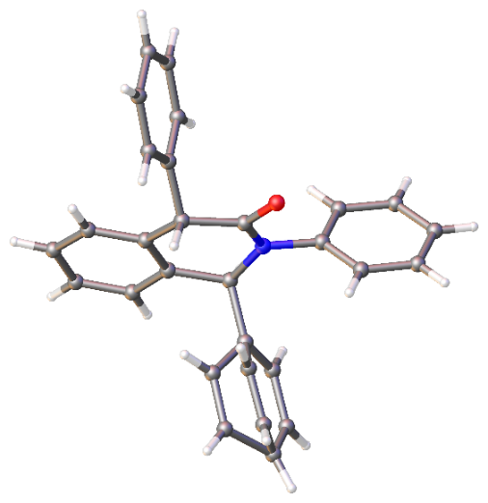
X-ray Single Crystal analysis was performed on Rigaku XtaLAB Synergy-S diffractometer with monochromated CuKα radiation. Crystal growth was performed by slow evaporation of solution in n-hexane/acetone mixture (2:1) at 5 °C. The crystal was kept at 100 K during data collection. Using Olex2³, the structure was solved with the SHELXT⁴ structure solution program using Intrinsic Phasing and refined with the SHELXL⁵ refinement package using Least Squares minimization. CCDC 2158046 (9a), CCDC 2170881 (10c) and CCDC 2170877 (16) contain the supplementary crystallographic data for this paper. These data can be obtained free of charge from The Cambridge Crystallographic Data Centre via https://www.ccdc.cam.ac.uk/.
Figure S1. ORTEP representation of compound 9a (thermal ellipsoids are shown at 50% probability)
Table S1. Crystal data and ORTEP representation for 9a (2158046)
Empirical Formula | C₂₇H₂₁NO
Formula weight | 375.45
Temperature, K | 100.15
Crystal system | monoclinic
Space group | P2₁/n
a/Å | 5.67820(10)
b/Å | 18.7912(3)
c/Å | 18.4603(3)
α/Å | 90
β/Å | 94.686(2)
γ/Å | 90
Volume/Å³ | 1963.13(6)
Z | 4
ρ_{calc}g/cm³ | 1.270
μ/mm⁻¹ | 0.595
F(000) | 792.0
Crystal size/mm³ | 0.12 × 0.12 × 0.1
Radiation | CuKα (λ = 1.54184)
2Θ range for data collection/° | 9.412 to 152.518
Index ranges | -6 ≤ h ≤ 7, -22 ≤ k ≤ 23, -22 ≤ l ≤ 22
Reflections collected | 9001
Independent reflections | 4005 [R_{int} = 0.0289, R_{sigma} = 0.0314]
Data/restraints/parameters | 4005/0/281
Goodness-of-fit on F² | 1.041
Final R indexes [I>=2σ (I)] | R₁ = 0.0485, wR₂ = 0.1176
Final R indexes [all data] | R₁ = 0.0558, wR₂ = 0.1231
Largest diff. peak/hole / e Å⁻³ | 0.38/-0.41

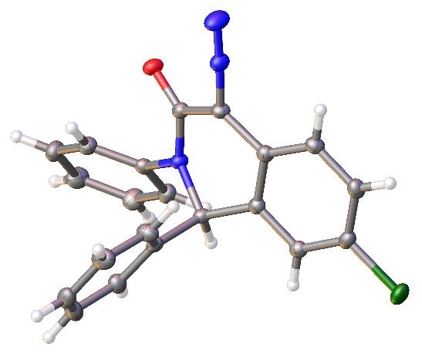
Figure S2. ORTEP representation of compound 10c (thermal ellipsoids are shown at 50% probability)
Table S2. Crystal data and ORTEP representation for 10c (2170881)
Empirical Formula | C₂₁H₁₄ClN₃O
Formula weight | 359.80
Temperature, K | 100.15
Crystal system | monoclinic
Space group | P2₁/c
a/Å | 13.2187(2)
b/Å | 9.93980(10)
c/Å | 12.9617(2)
α/Å | 90
β/Å | 91.9380(10)
γ/Å | 90
Volume/Å³ | 1702.08(4)
Z | 4
ρ_{calc}g/cm³ | 1.404
μ/mm⁻¹ | 2.106
F(000) | 744.0
Crystal size/mm³ | 0.1 × 0.05 × 0.04
Radiation | CuKα (λ = 1.54184)
2Θ range for data collection/° | 6.69 to 160.914
Index ranges | -16 ≤ h ≤ 16, -12 ≤ k ≤ 7, -16 ≤ l ≤ 13
Reflections collected | 14200
Independent reflections | 3578 [R_{int} = 0.0345, R_{sigma} = 0.0285]
Data/restraints/parameters | 3578/0/235
Goodness-of-fit on F² | 1.081
Final R indexes [I>=2σ (I)] | R₁ = 0.0372, wR₂ = 0.0908
Final R indexes [all data] | R₁ = 0.0397, wR₂ = 0.0925
Largest diff. peak/hole / e Å⁻³ | 0.27/-0.32

Table S3. Crystal data and ORTEP representation for 16 (2170877)
Empirical Formula | C₂₂H₁₇NO₃
Formula weight | 343.36
Temperature, K | 100.15
Crystal system | orthorhombic
Space group | P2₁2₁2₁
a/Å | 11.4269(6)
b/Å | 11.6108(7)
c/Å | 12.5127(8)
α/Å | 90
β/Å | 90
γ/Å | 90
Volume/Å³ | 1660.13(17)
Z | 4
ρ_{calc}g/cm³ | 1.374
μ/mm⁻¹ | 0.741
F(000) | 720.0
Crystal size/mm³ | 0.06 × 0.01 × 0.01
Radiation | CuKα (λ = 1.54184)
2Θ range for data collection/° | 10.394 to 160.51
Index ranges | -14 ≤ h ≤ 13, -13 ≤ k ≤ 14, -15 ≤ l ≤ 15
Reflections collected | 6733
Independent reflections | 3218 [R_{int} = 0.0820, R_{sigma} = 0.0808]
Data/restraints/parameters | 3218/0/235
Goodness-of-fit on F² | 1.051
Final R indexes [I>=2σ (I)] | R₁ = 0.0623, wR₂ = 0.1658
Final R indexes [all data] | R₁ = 0.0665, wR₂ = 0.1704
Largest diff. peak/hole / e Å⁻³ | 0.43/-0.36
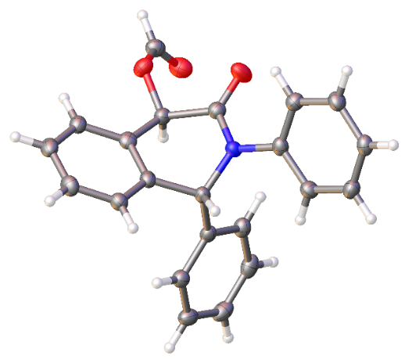
Figure S3. ORTEP representation of compound 16 (thermal ellipsoids are shown at 50% probability)

- Biological data
Сell culture
NCI-H460 and A549 lung carcinoma cells were purchased from the ATCC. NCI-H460 and A549 cells were maintained in Advanced RPMI-1640 (Gibco, UK) supplemented with 5% fetal bovine serum (FBS, Gibco, UK), penicillin (100 UI mL-1), streptomycin (100 µg mL-1) and GlutaMax (2 mM, Gibco, UK). All cells line cultivation under a humidified atmosphere of 95% air/5% CO2 at 37 °C. Subconfluent monolayers, in the log growth phase, were harvested by a brief treatment with TrypLE Express solution (Gibco, UK) in phosphate buffered saline (PBS, Capricorn Scientific, Germany) and washed three times in serum-free PBS. The number of viable cells was determined by trypan blue exclusion.
Antiproliferative assay
The effects of the synthesized compounds on cell viability were determined using the MTT colorimetric test. All examined cells were diluted with the growth medium to 3.5×104 cells per mL and the aliquots (7×103 cells per 200 μL) were placed in individual wells in 96-multiplates (Eppendorf, Germany) and incubated for 24 h. The next day the cells were then treated with synthesized compounds separately at the final concentration 30 μМ (or 300.0 μM concentration and diluted at various concentrations for determination of IC50) and incubated for 24 h at 37 °C in 5% CO2 atmosphere. After incubation, the cells were then treated with 40 μL MTT solution (3-(4,5-dimethylthiazol-2-yl)-2,5-diphenyltetrazolium bromide, 5 mg mL-1 in PBS) and incubated 4 h. After an additional 4h incubation, the medium with MTT was removed and DMSO (150 μL) was added to dissolve the crystals formazan. The plates were shaken for 10 min. The optical density of each well was determined at 560 nm using a microplate reader GloMax Multi+ (Promega, USA). Each of the tested compounds was evaluated for cytotoxicity in three separate experiments.

NCI-H460 cell viability in the presence of 30 μM concentration of compound 9a-z
IC₅₀ value of the most cytotoxic compound (9j) determined against A549 and NCI-H460 cell lines
IC₅₀ (A549) = 31.4 ± 0.48 μM
IC₅₀ (NCI-H460) = 13.6 ± 3.34 μM
- References

- Zhang, Y.; Kindelin, P. J.; DeSchepper, D. J.; Zheng, C.; Klumpp, D. A. Synthesis 2006, 1775-1780.
- Venkov, A. P.; Mollov, N. M. Synthesis 1982, 216-217.
- Dolomanov, O. V; Bourhis, L. J.; Gildea, R. J.; Howard, J. A. K.; Puschmann, H. J. Appl. Crystallogr. 2009, 42, 339–341.
- Sheldrick, G. M. A Acta Crystallogr. Sec. A 2015, 71, 3–8.
- Sheldrick, G. M. Acta Crystallogr. Sec. C 2015, 71, 3–8.

Copies of ¹H, ¹³C NMR, ¹⁹F and NOESY NMR spectra
Copies of ¹H (400.13 MHz, CDCl₃) and ¹³C{¹H} (100.61 MHz, CDCl₃) spectra of 11c
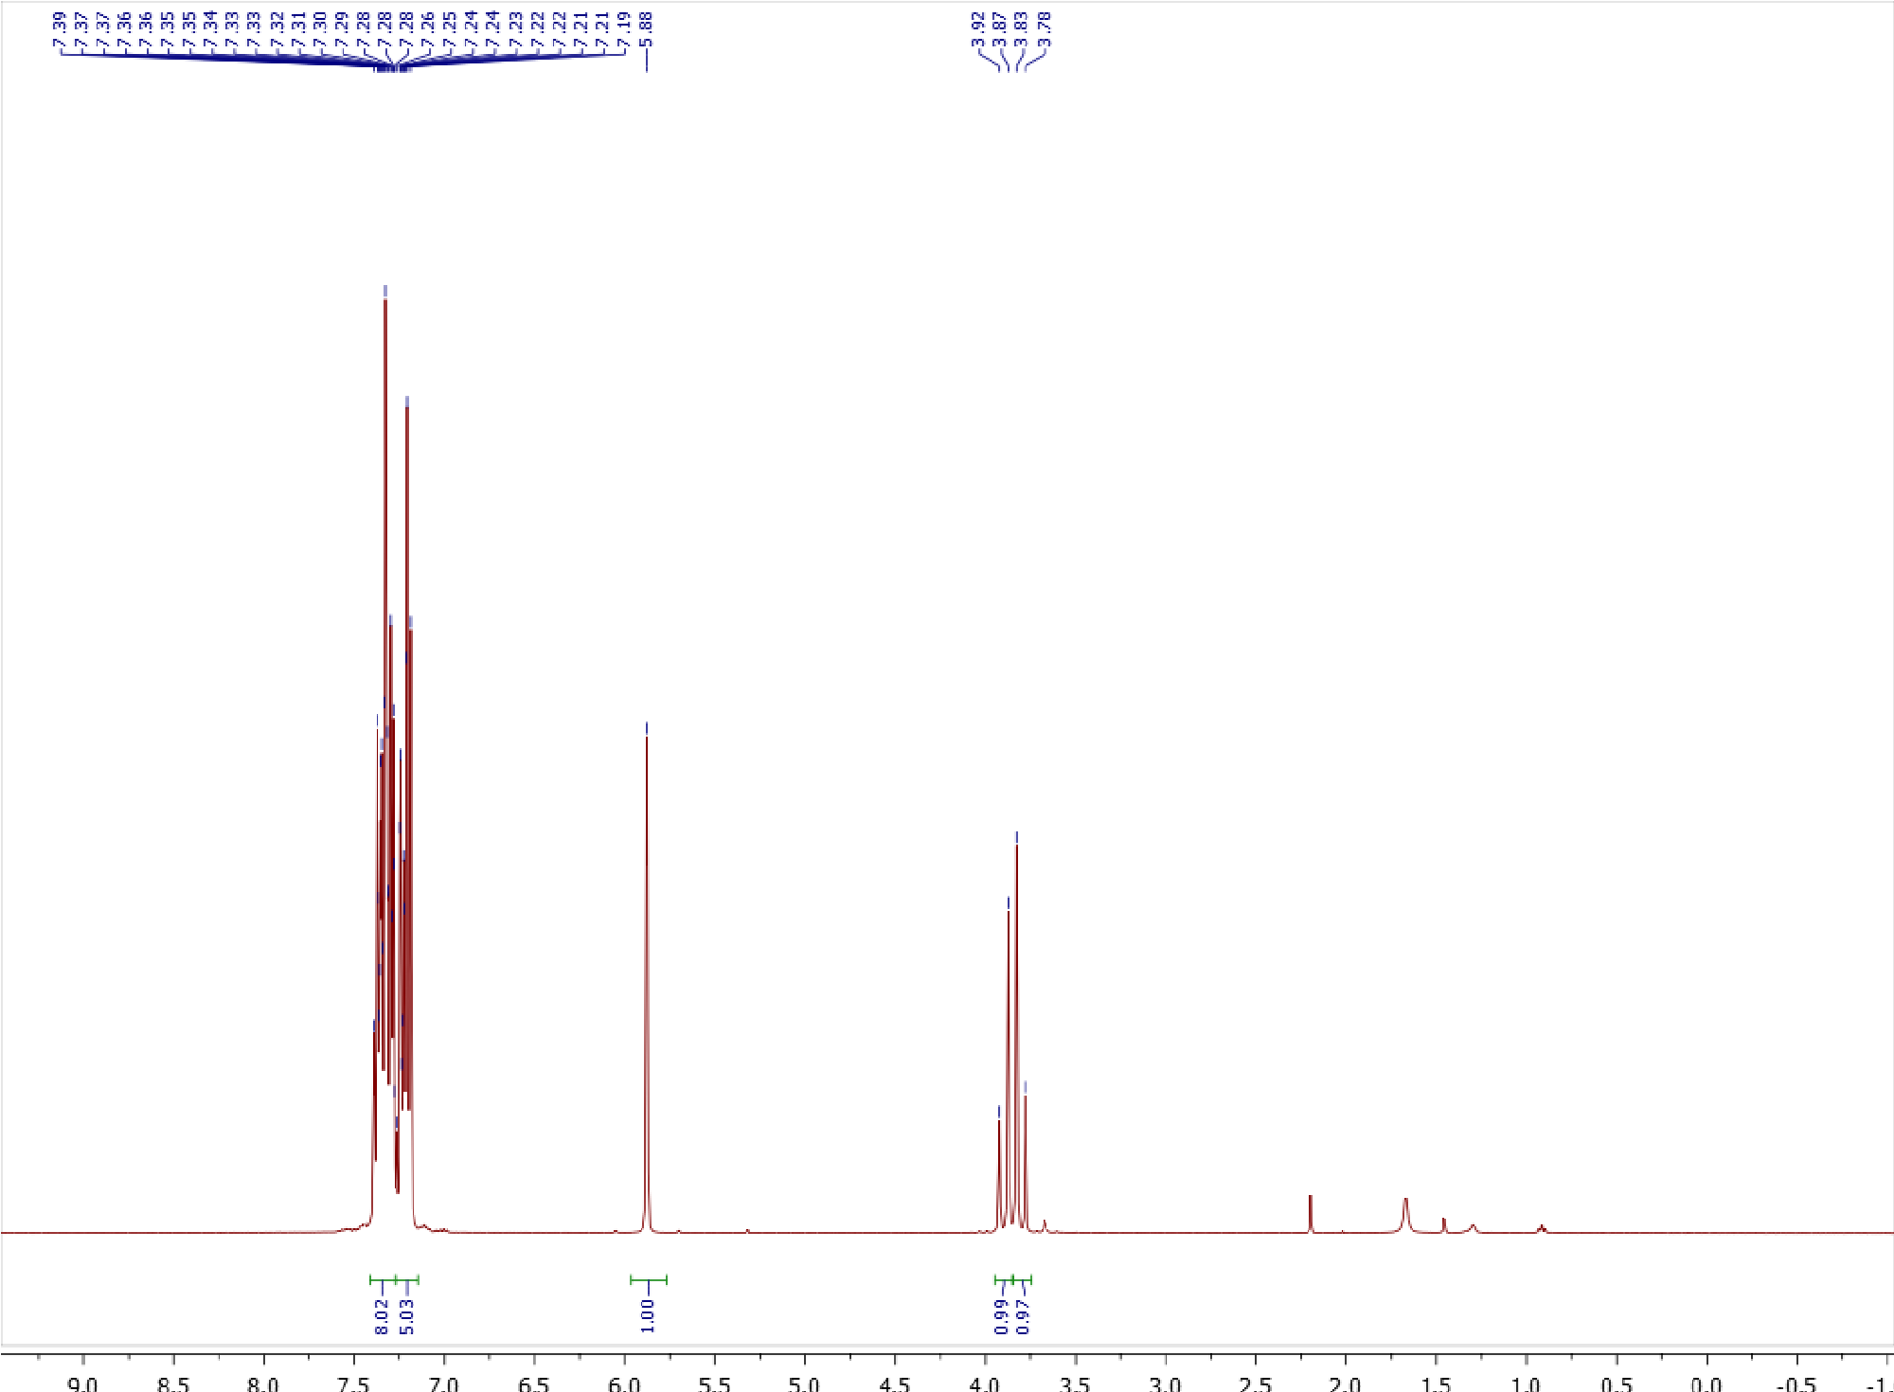
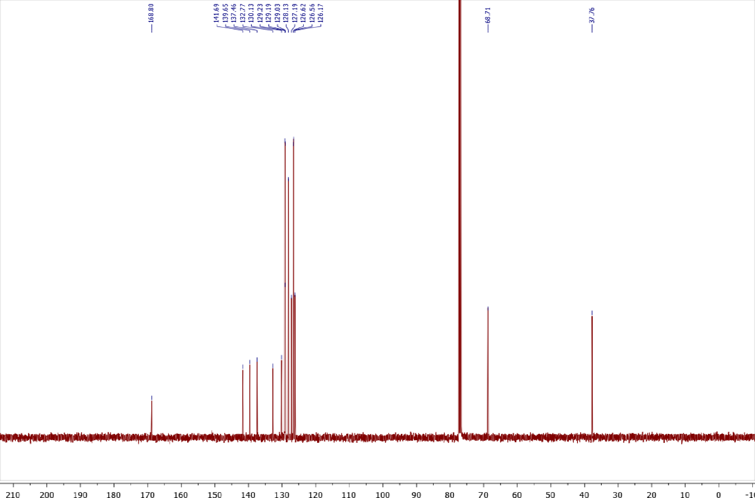
Copies of ¹H (400.13 MHz, CDCl₃) and ¹³C{¹H} (100.61 MHz, CDCl₃) spectra of 11d
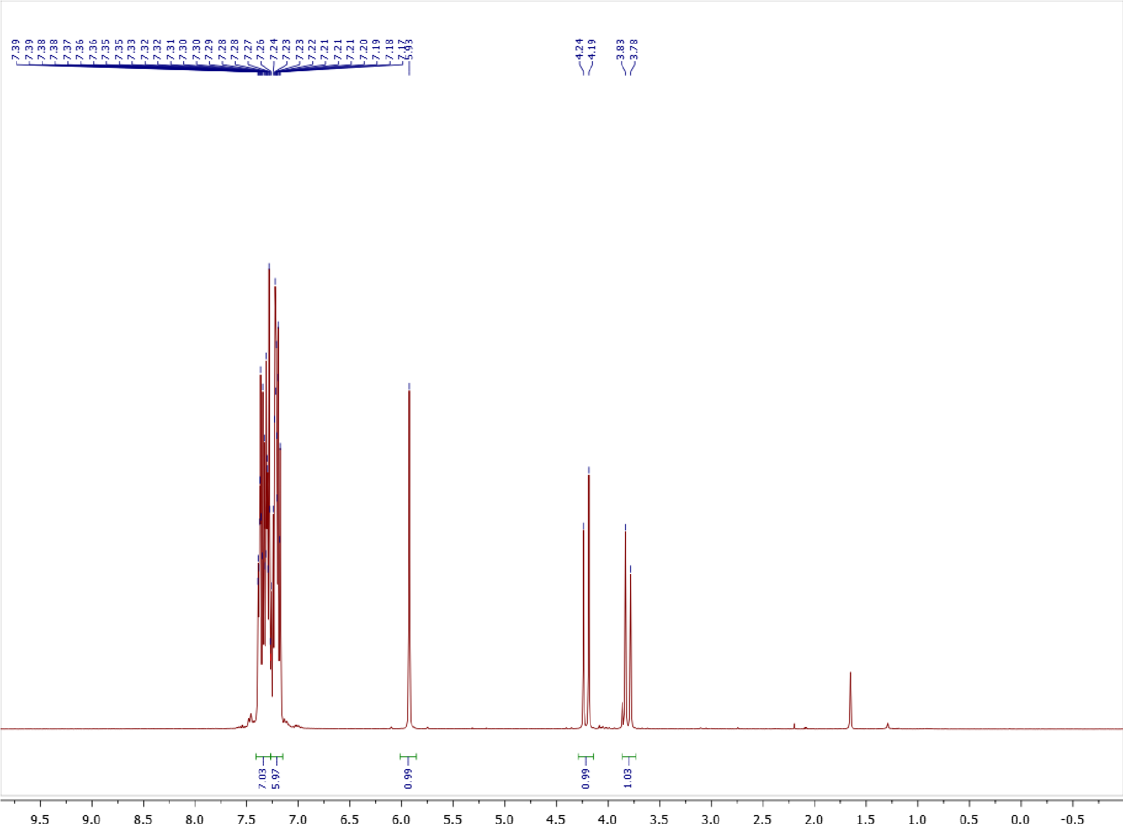
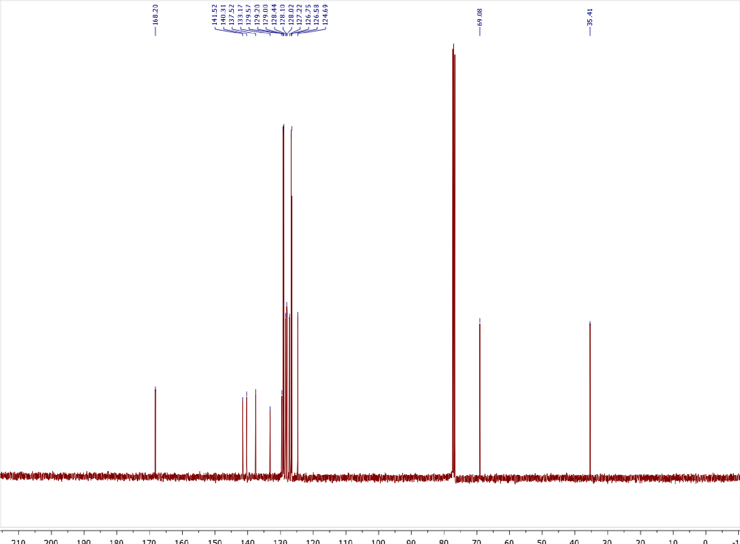
Copies of ¹H (400.13 MHz, CDCl₃) and ¹³C{¹H} (100.61 MHz, CDCl₃) spectra of 11e
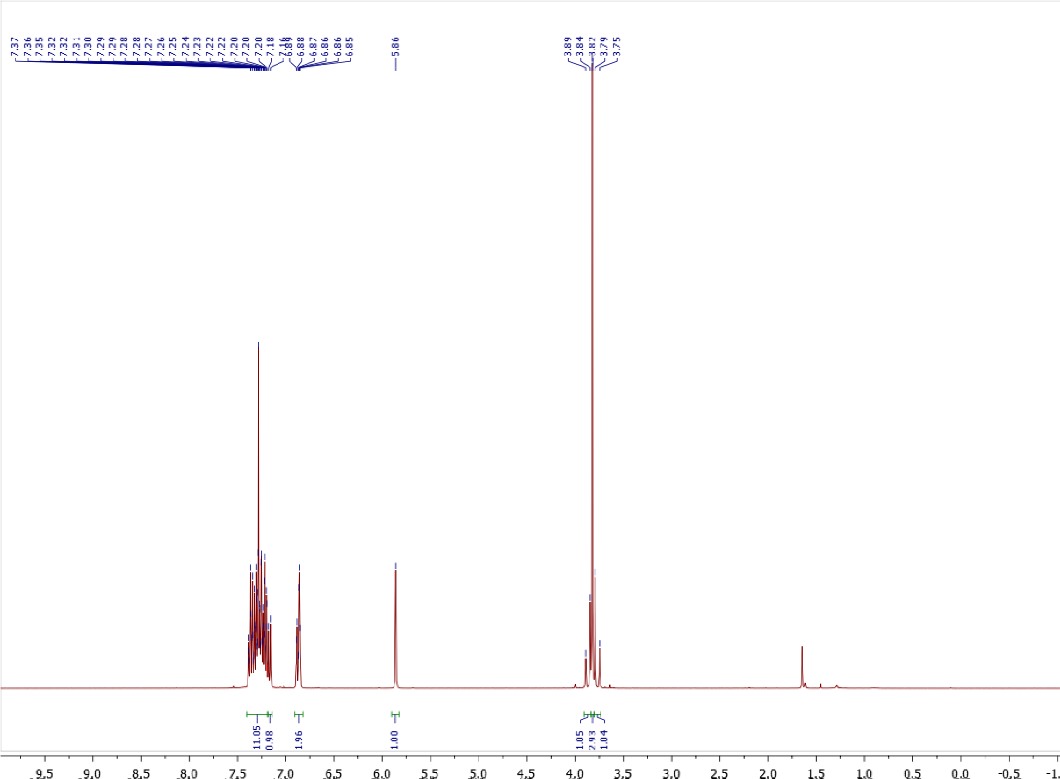
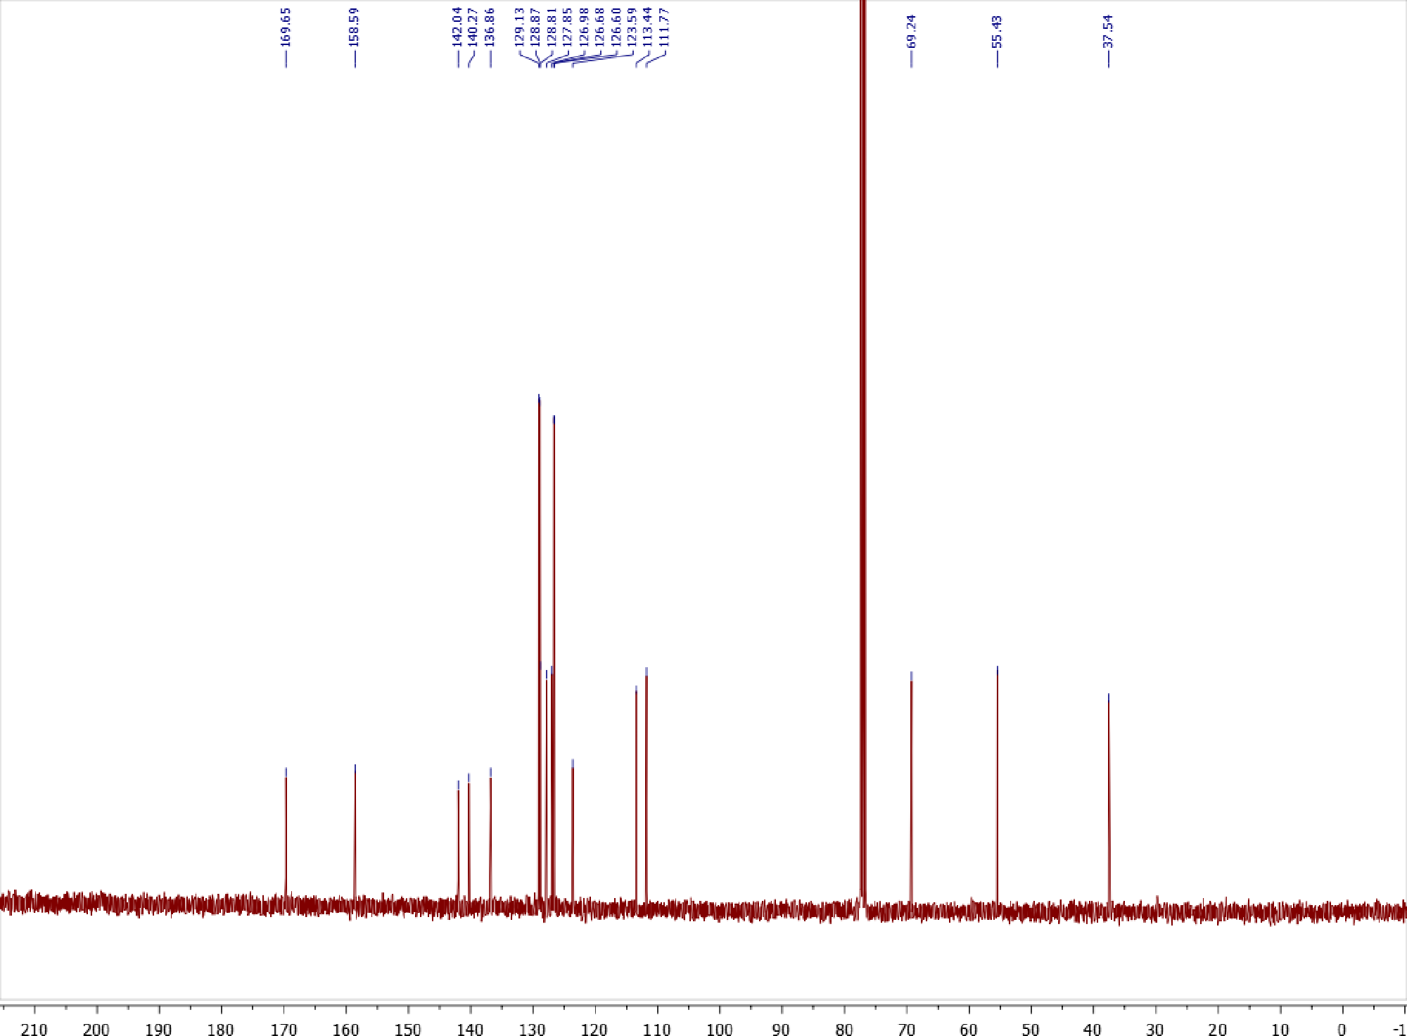
Copies of ¹H (400.13 MHz, CDCl₃) and ¹³C{¹H} (100.61 MHz, CDCl₃) spectra of 11f
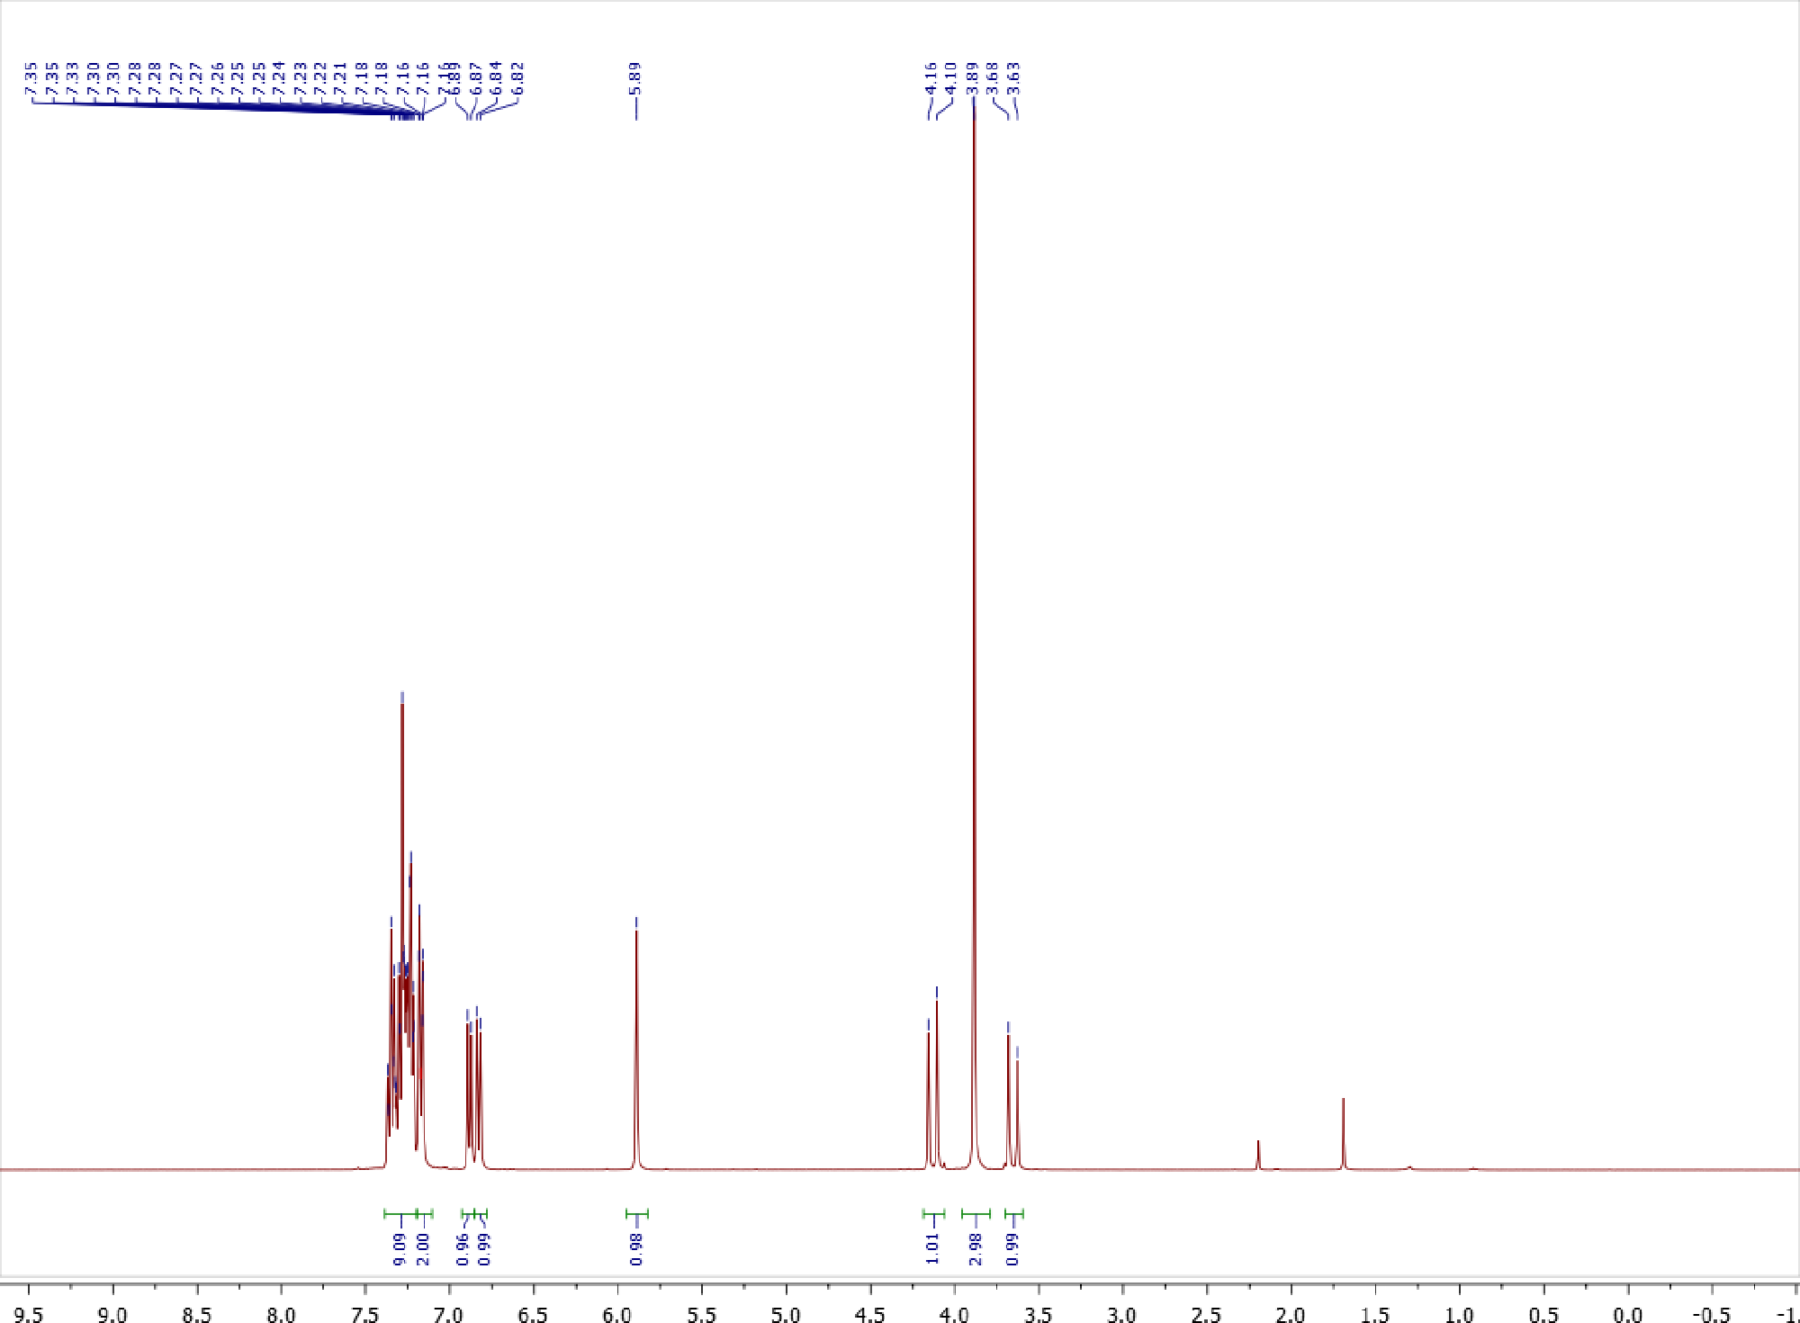
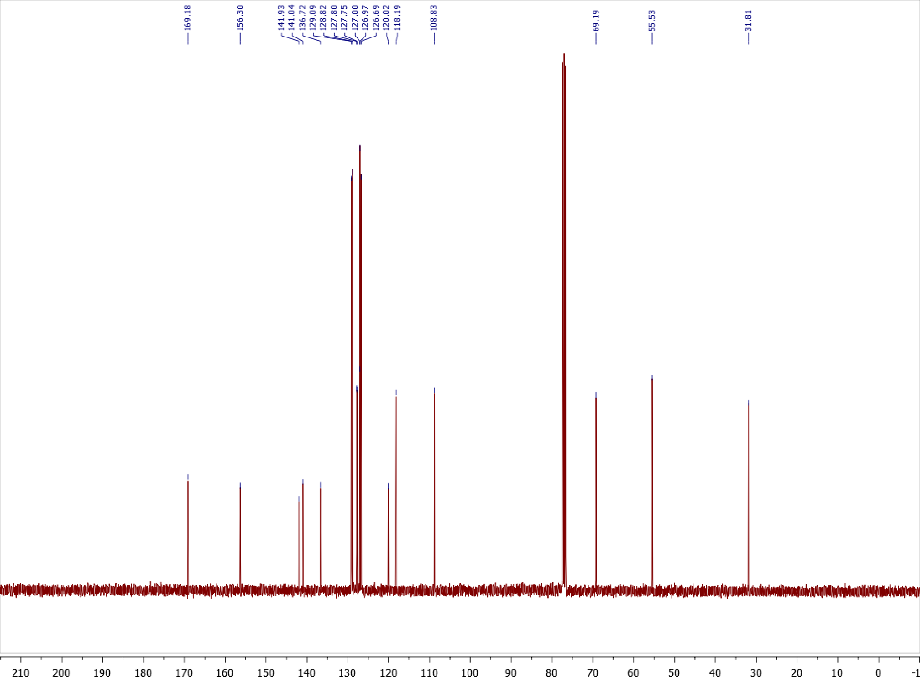
Copies of ¹H (400.13 MHz, CDCl₃) and ¹³C{¹H} (100.61 MHz, CDCl₃) spectra of 11h
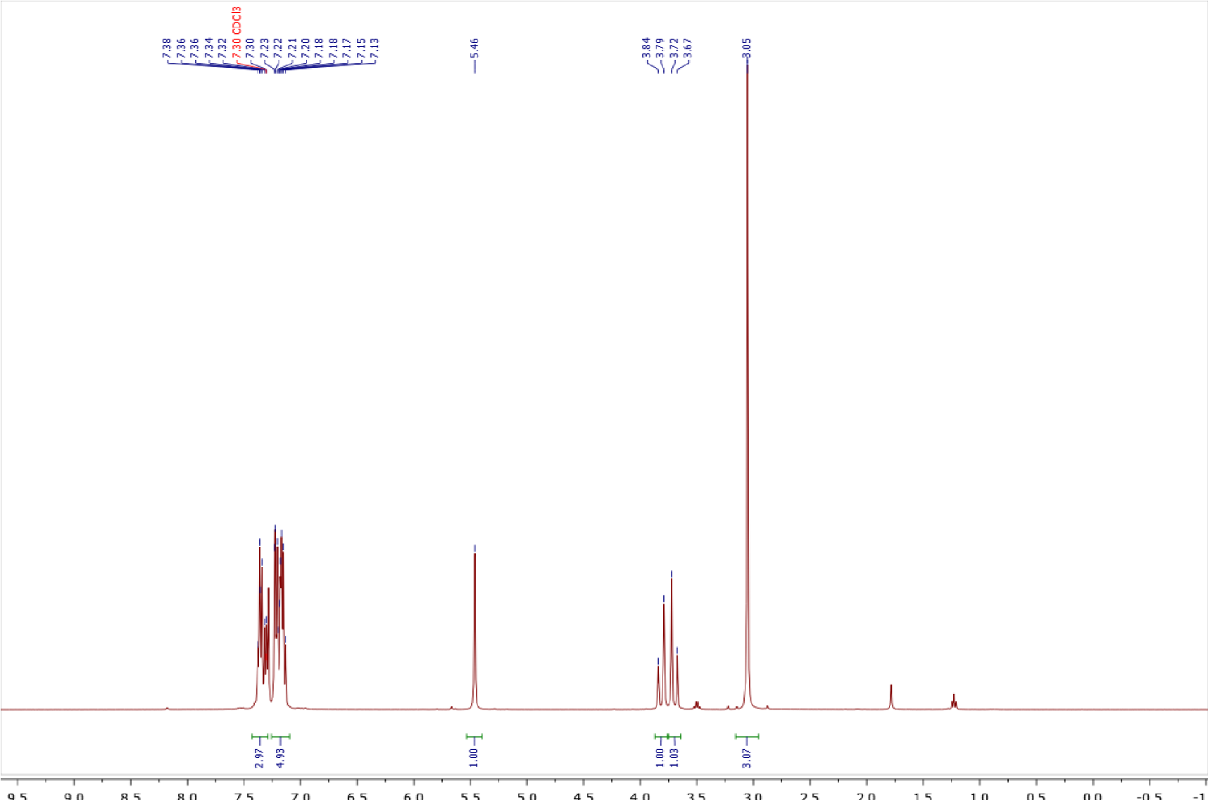
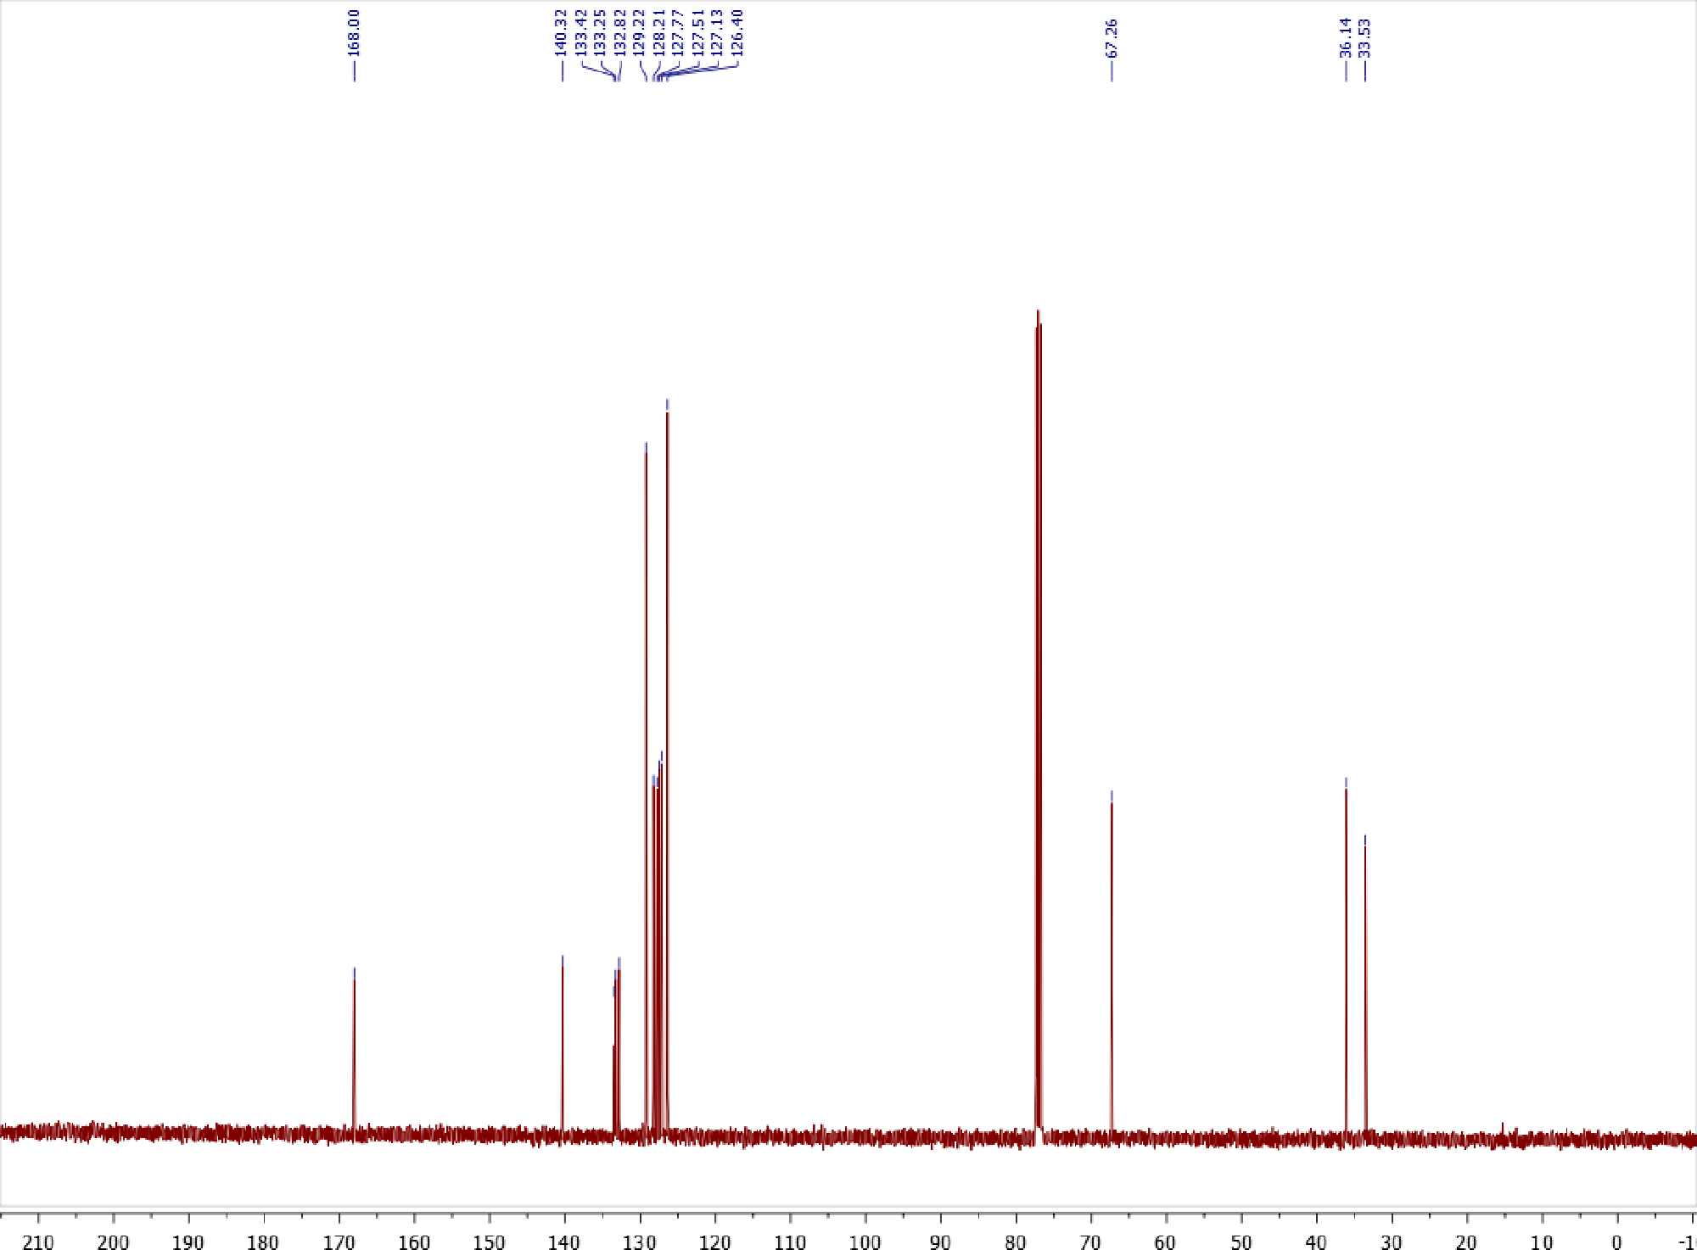
Copies of ¹H (400.13 MHz, CDCl₃) and ¹³C{¹H} (100.61 MHz, CDCl₃) spectra of 11i
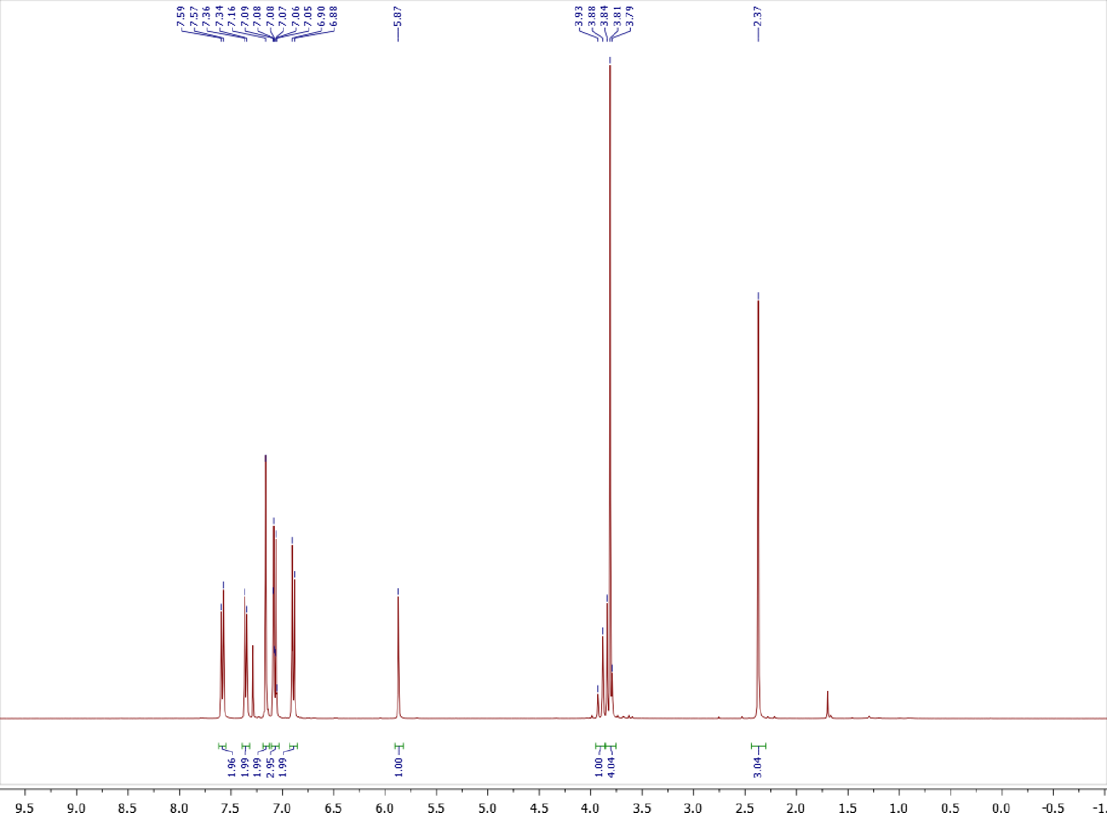
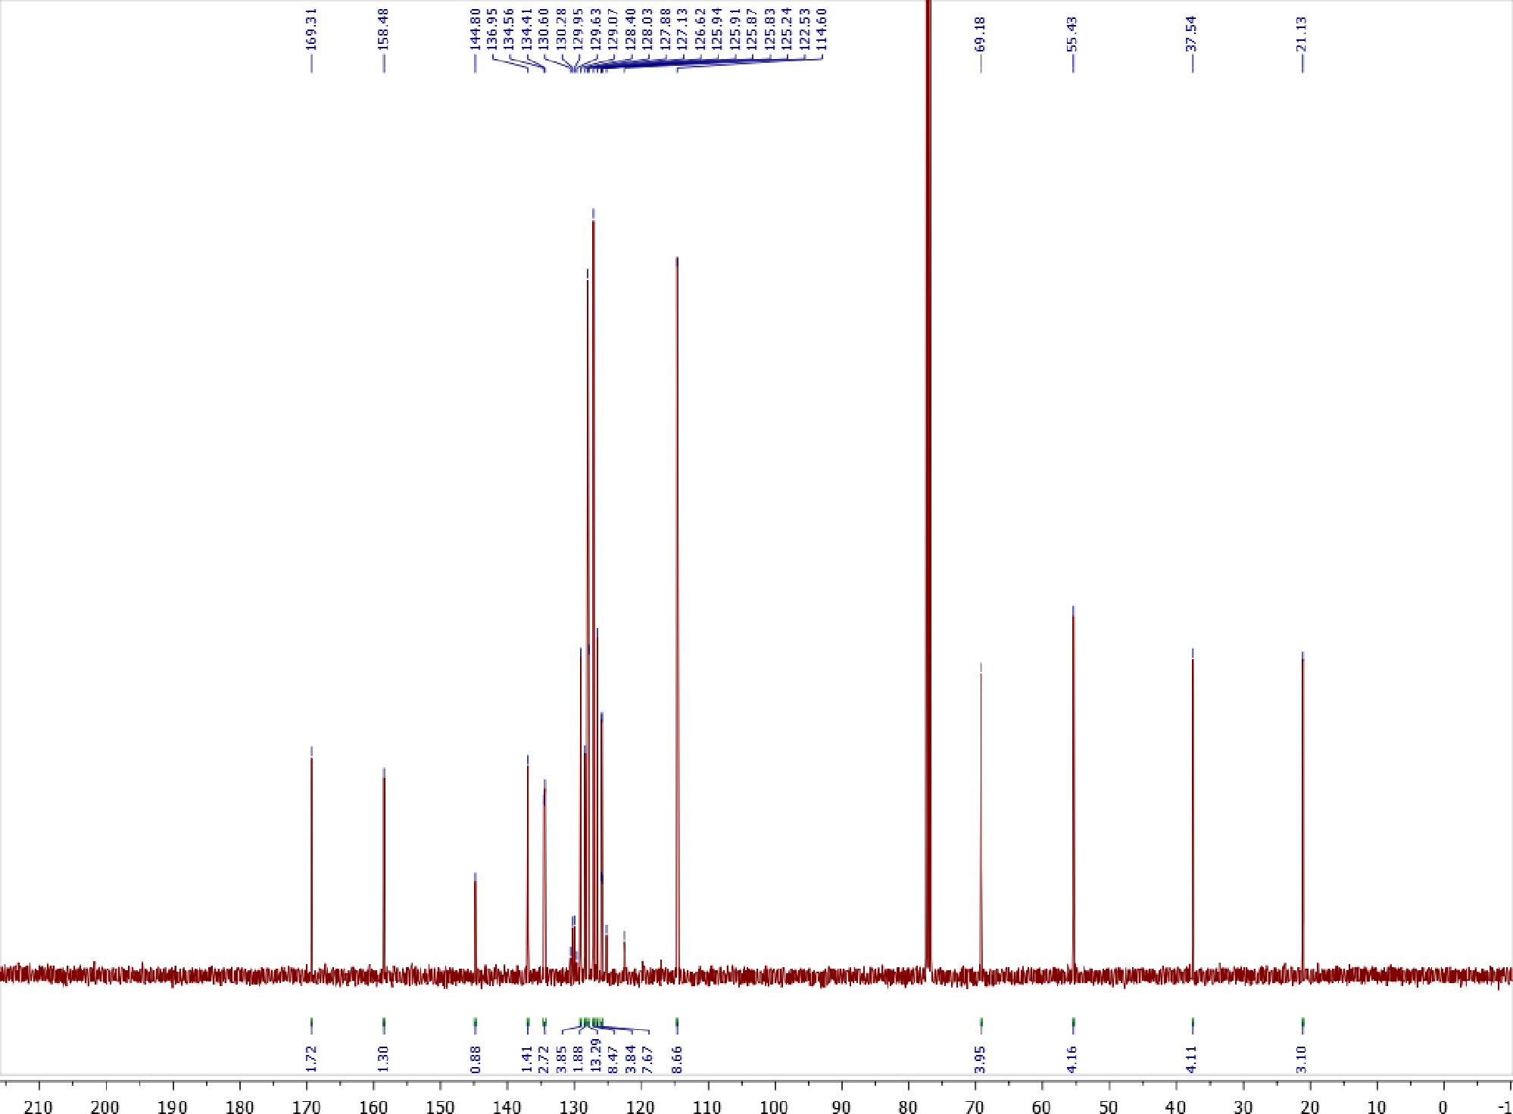
Copy of ¹⁹F{¹H} (376.50 MHz, CDCl₃) spectrum of 11i
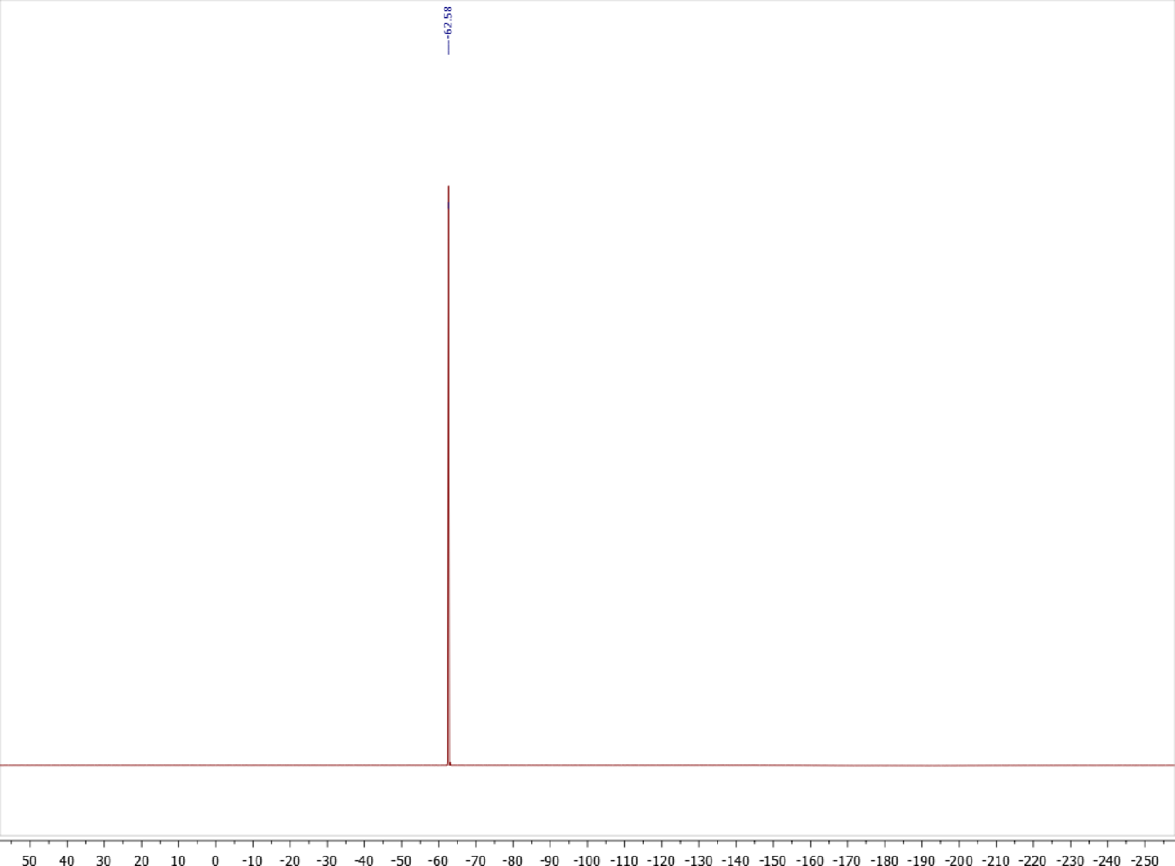

Copies of ¹H (400.13 MHz, CDCl₃) and ¹³C{¹H} (100.61 MHz, CDCl₃) spectra of 11j
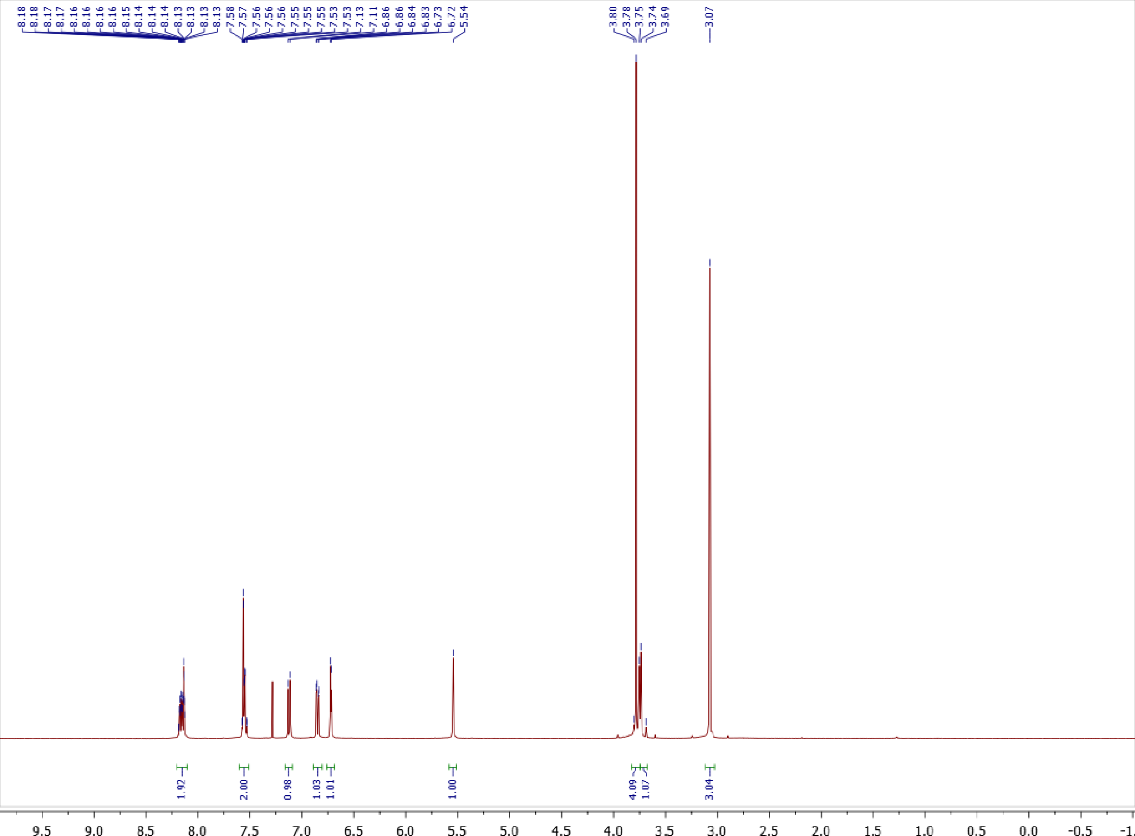
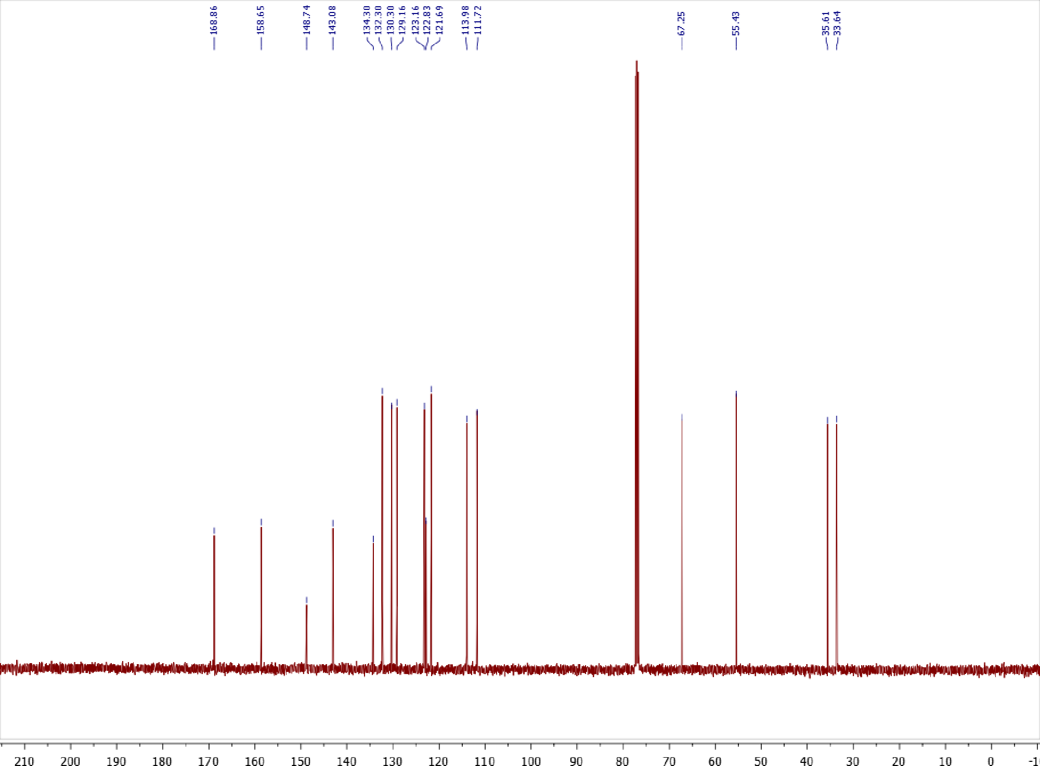
Copies of ¹H (400.13 MHz, CDCl₃) and ¹³C{¹H} (100.61 MHz, CDCl₃) spectra of 11k
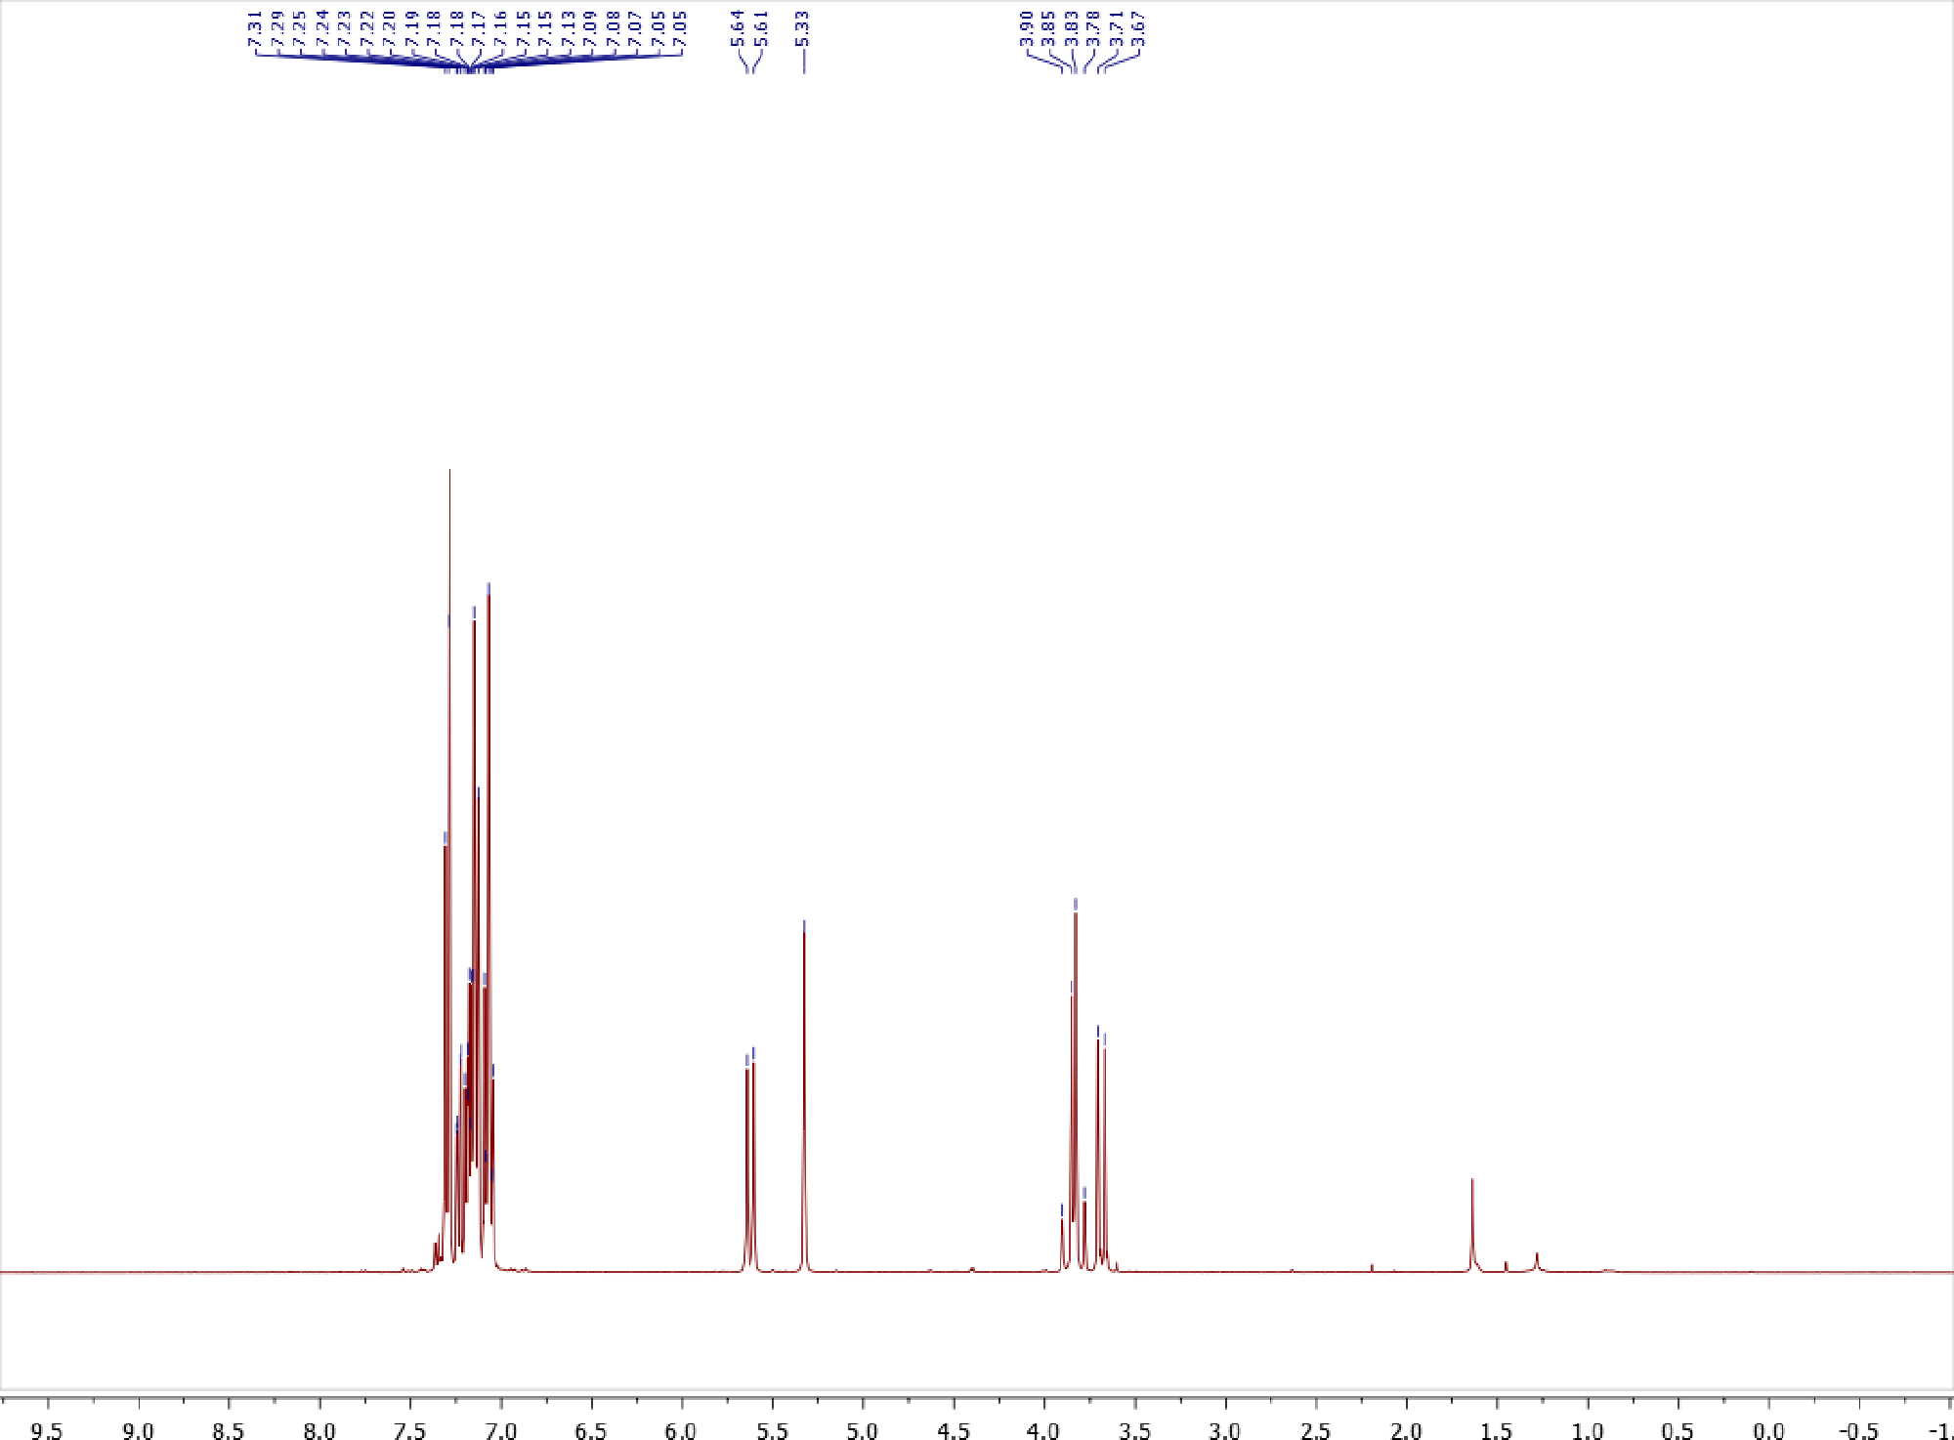
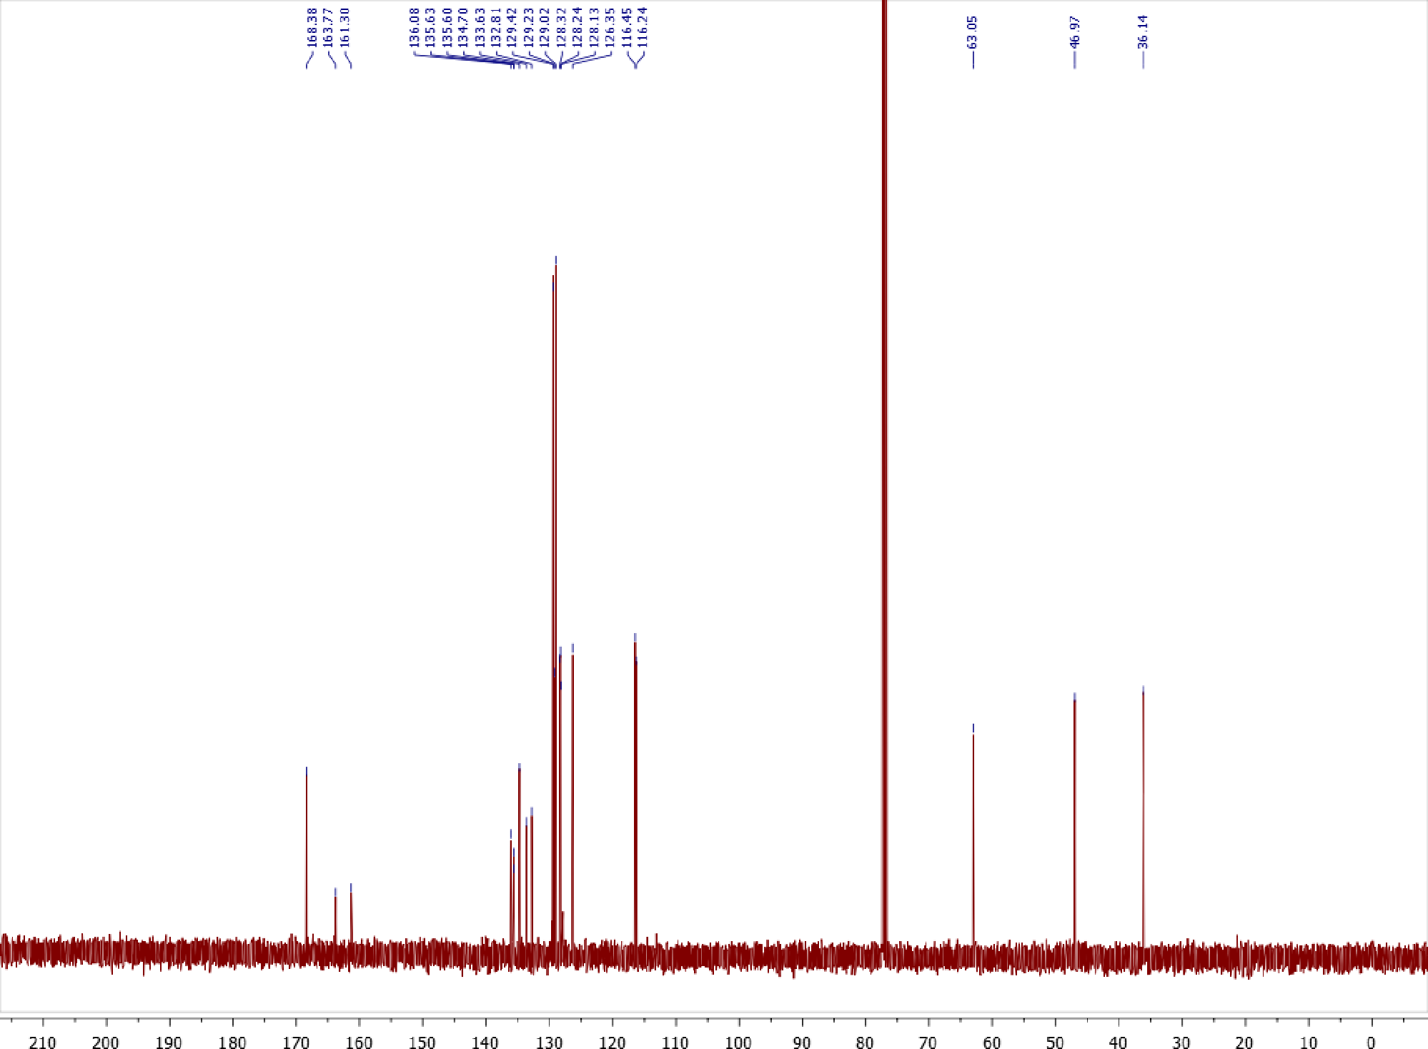
Copy of ¹⁹F{¹H} (376.50 MHz, CDCl₃) spectrum of 11k
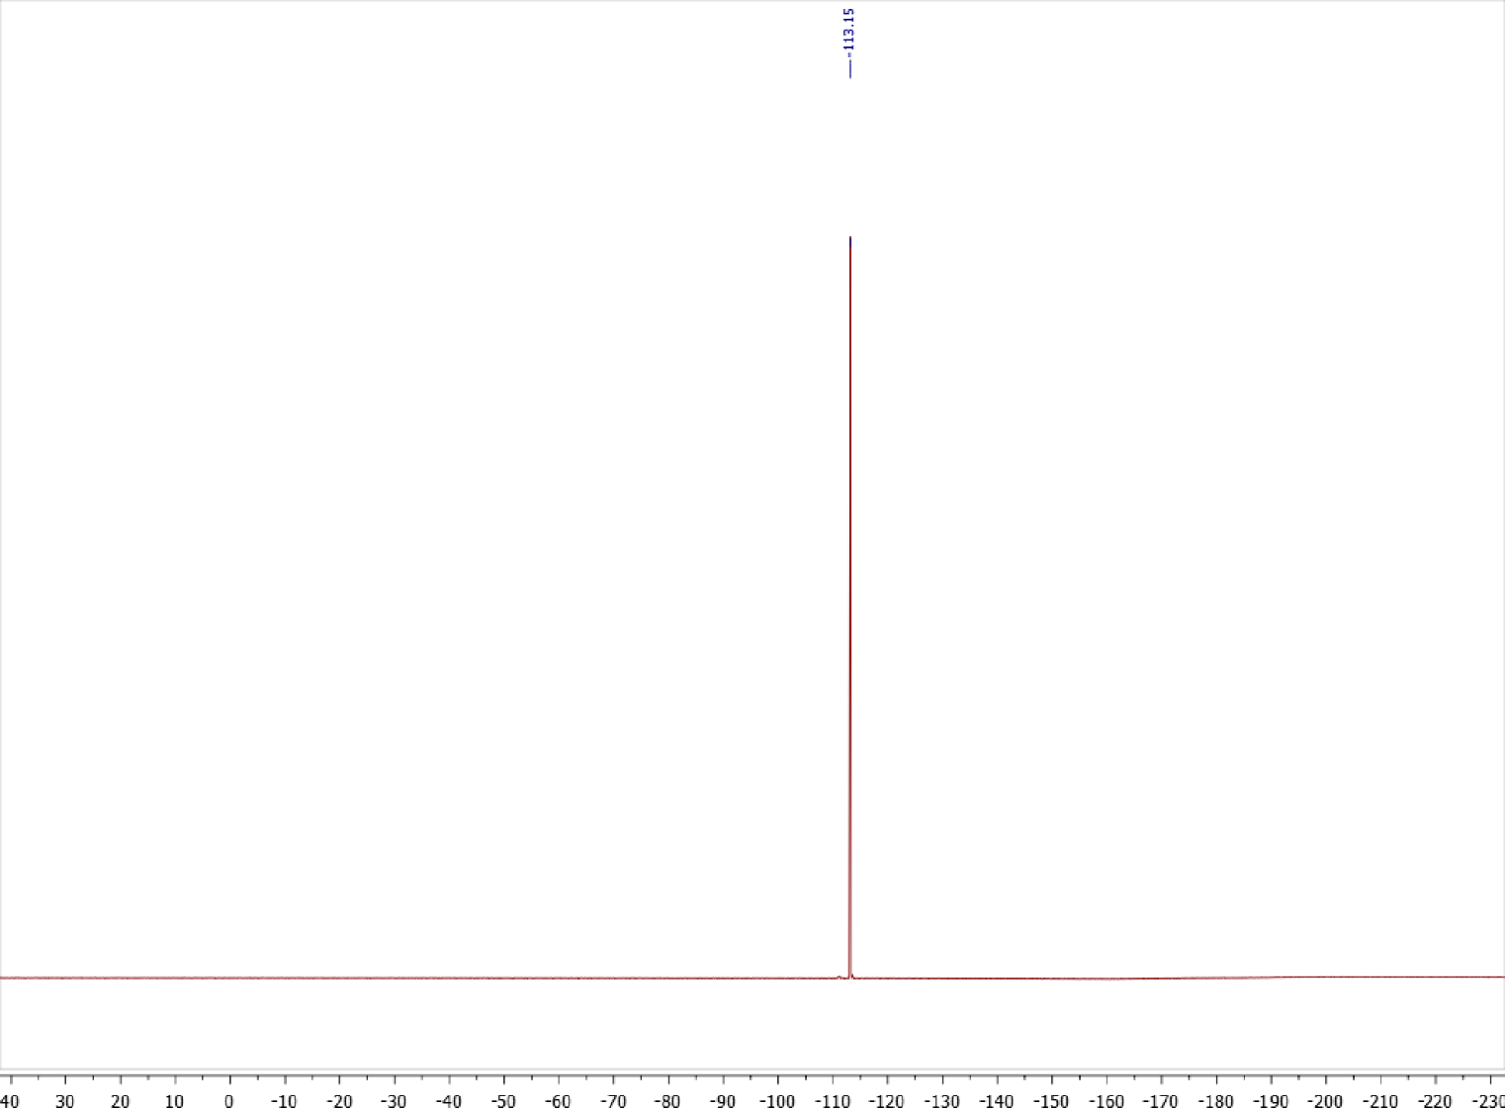
Copies of ¹H (400.13 MHz, CDCl₃) and ¹³C{¹H} (100.61 MHz, CDCl₃) spectra of 11l
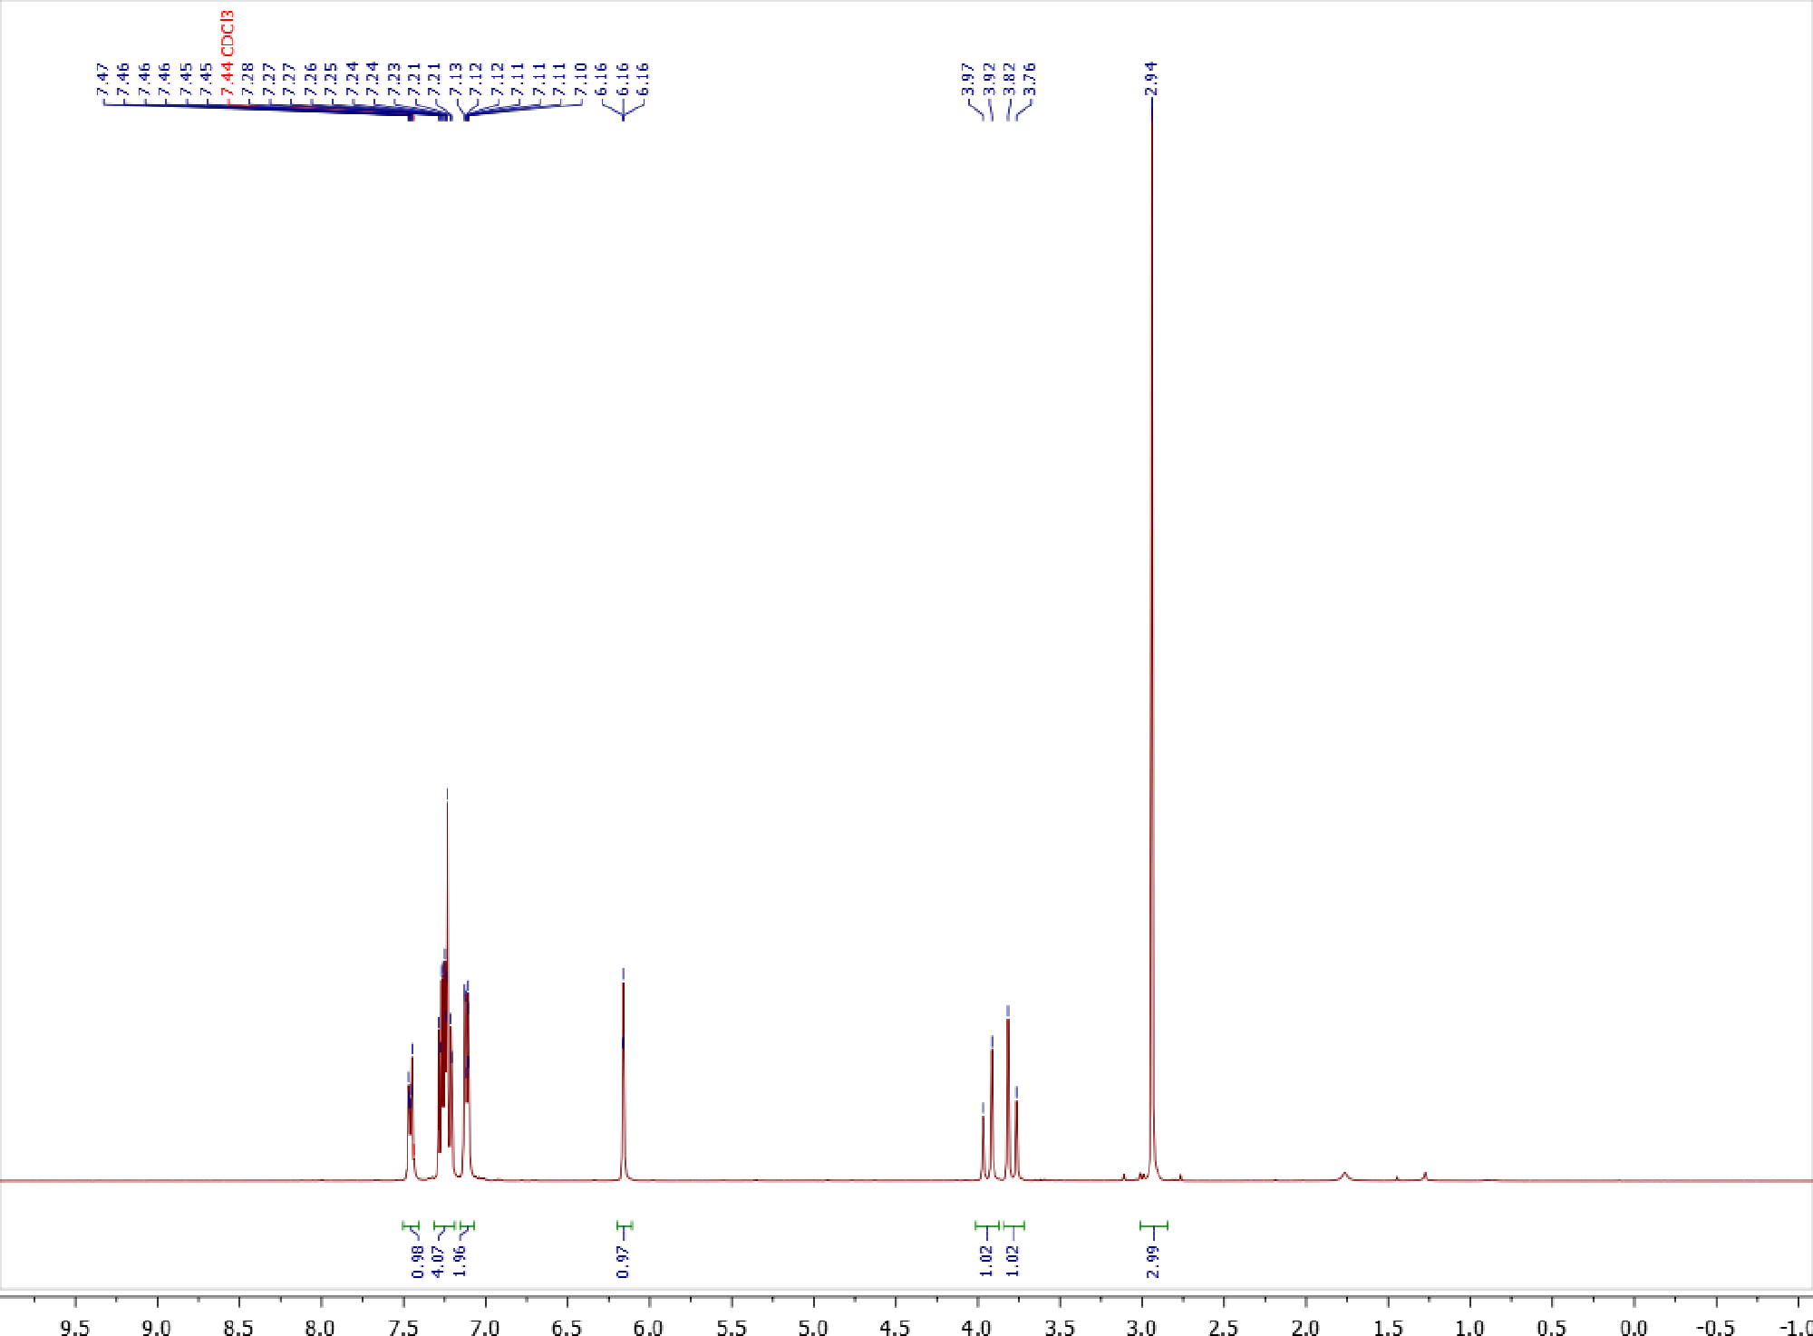
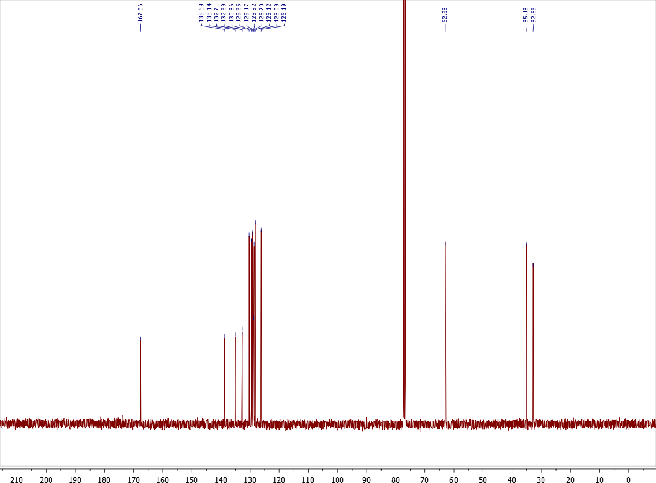
Copies of ¹H (400.13 MHz, CDCl₃) and ¹³C{¹H} (100.61 MHz, CDCl₃) spectra of 11m
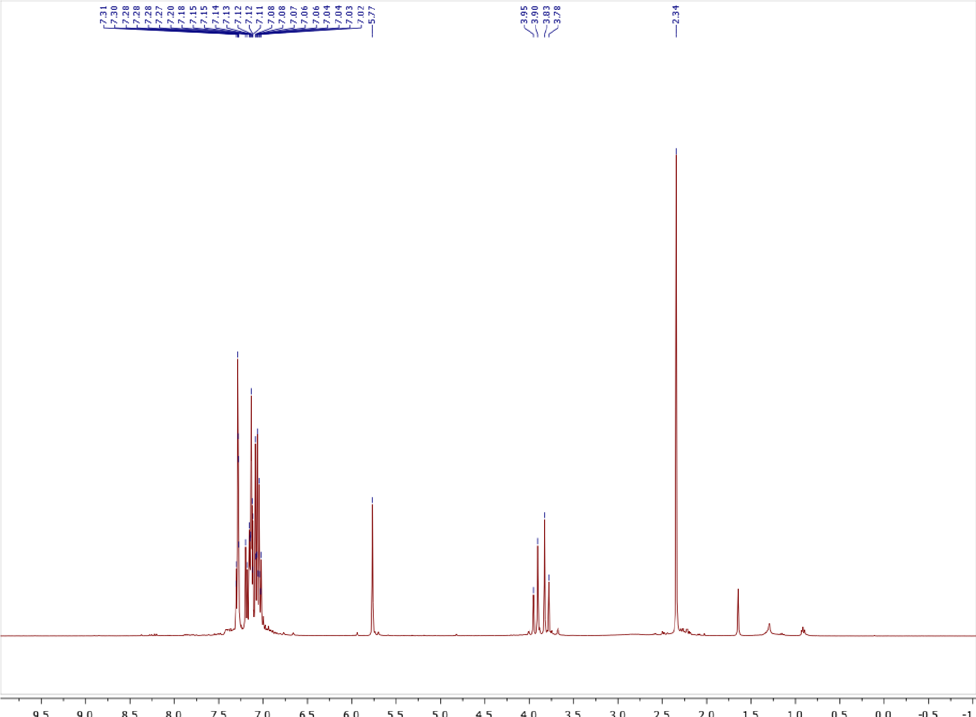
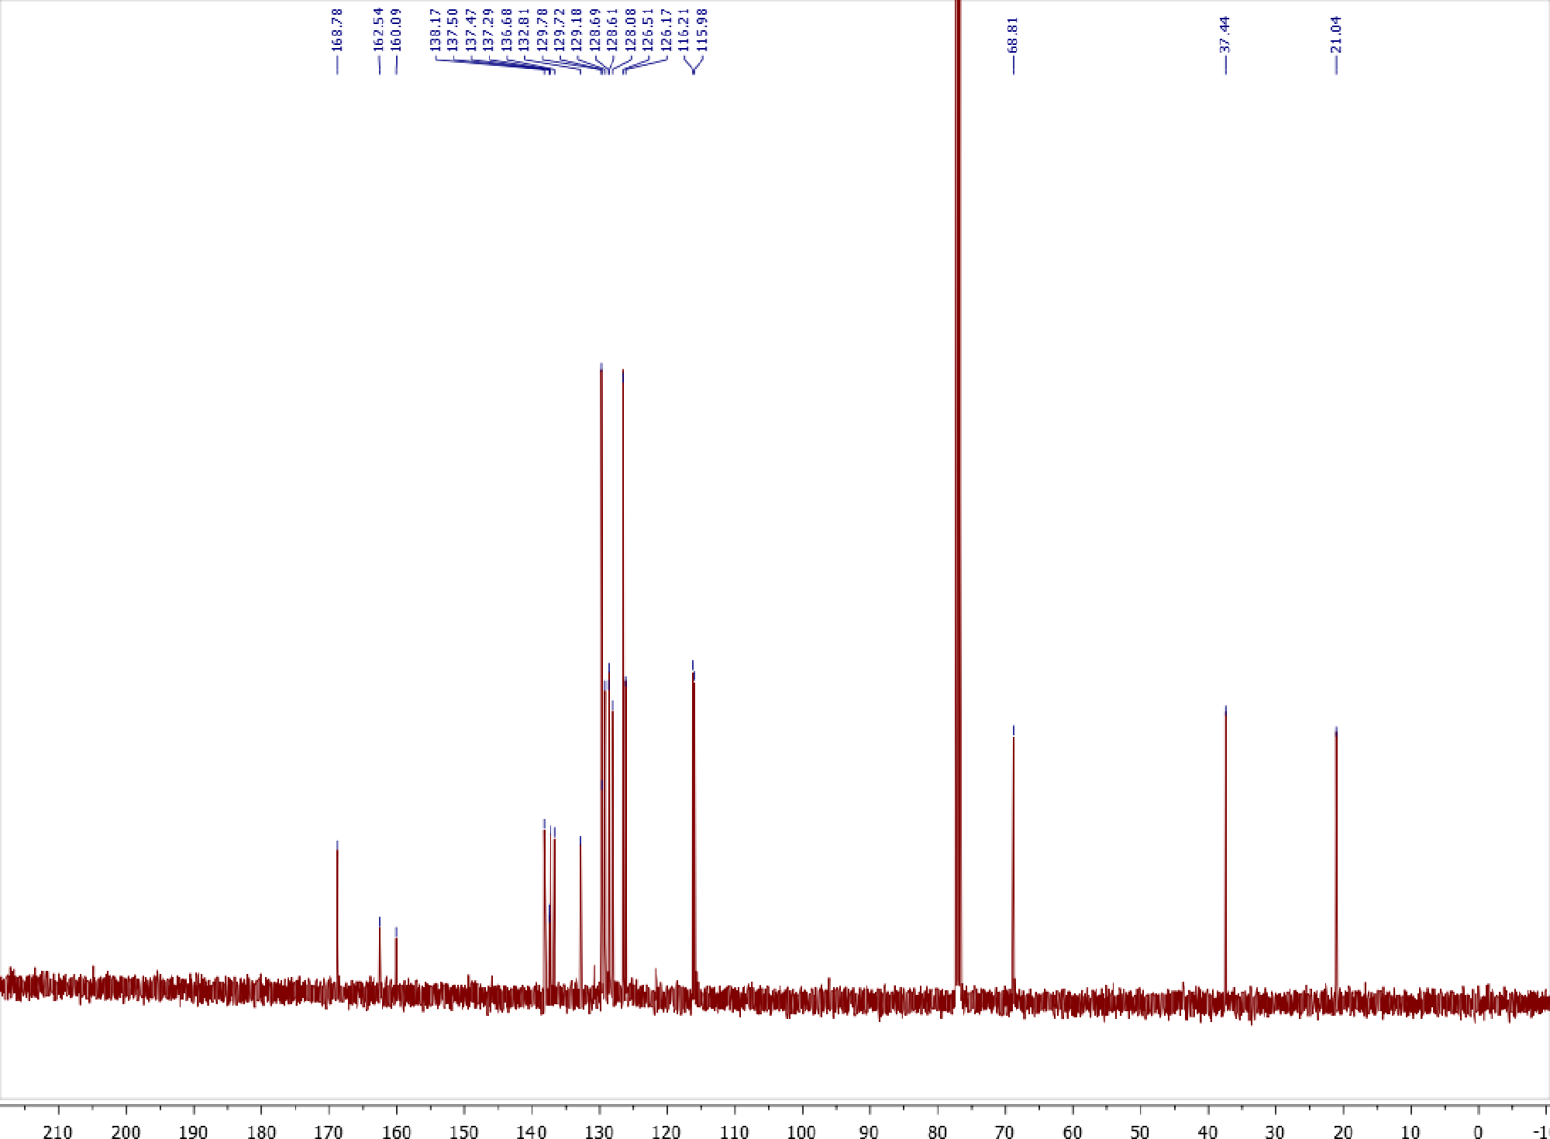
Copy of ¹⁹F{¹H} (376.50 MHz, CDCl₃) spectrum of 11m
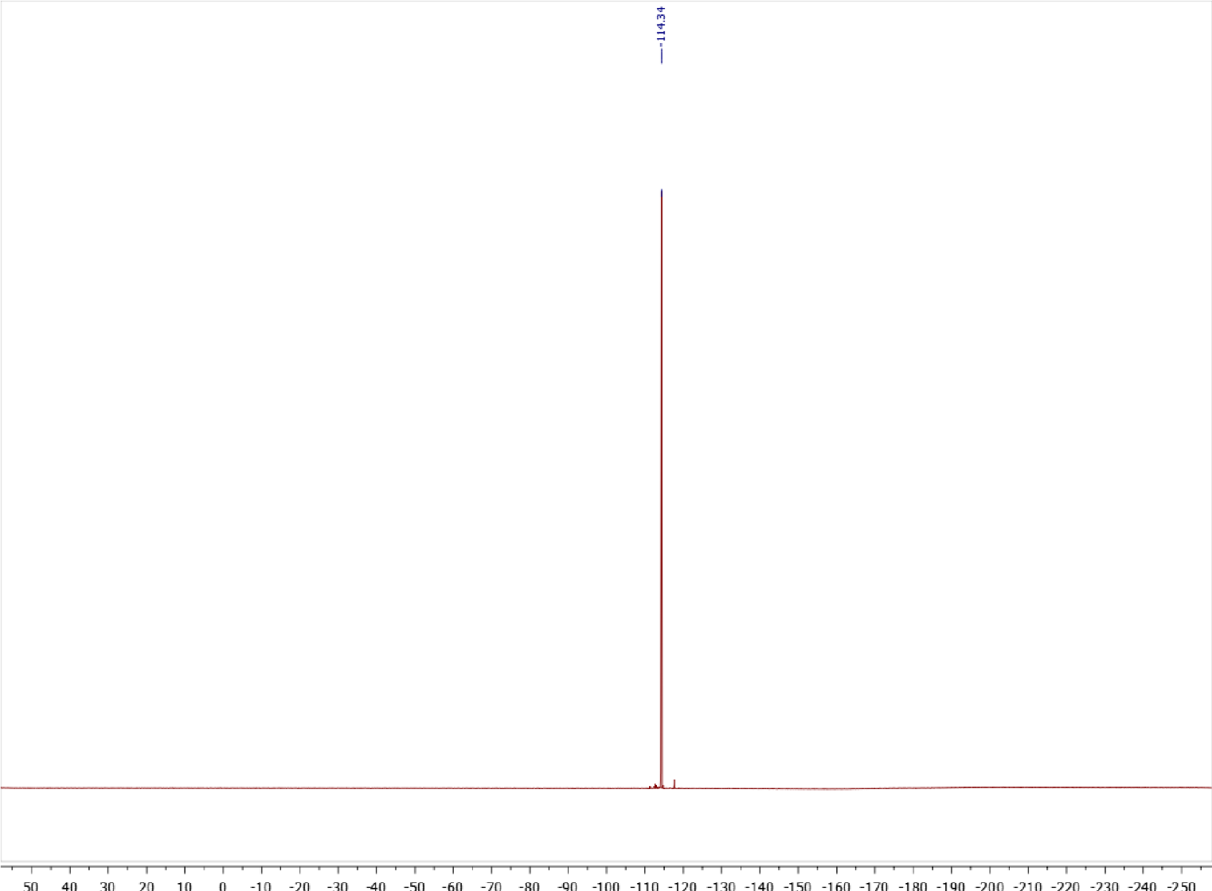
Copies of ¹H (400.13 MHz, CDCl₃) and ¹³C{¹H} (100.61 MHz, CDCl₃) spectra of 11n
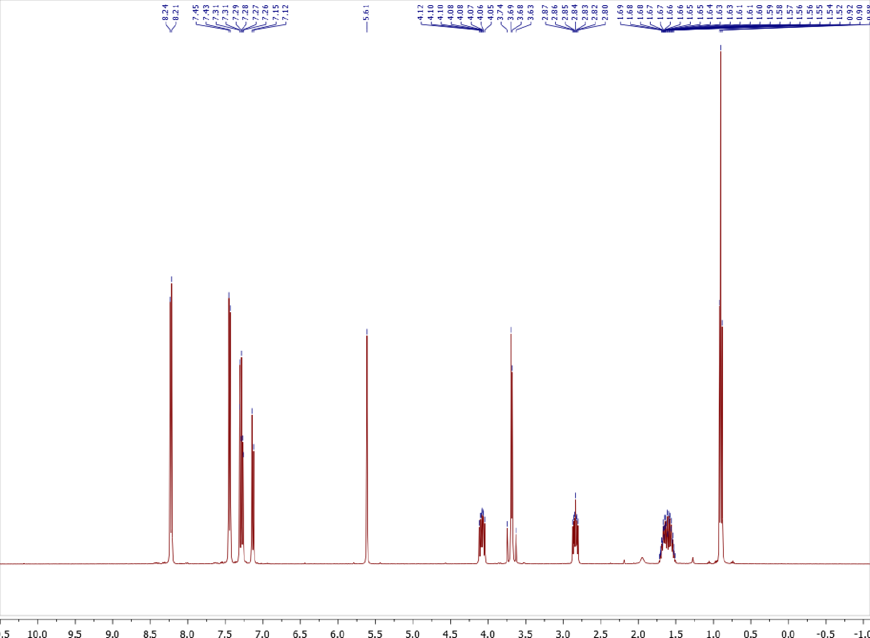
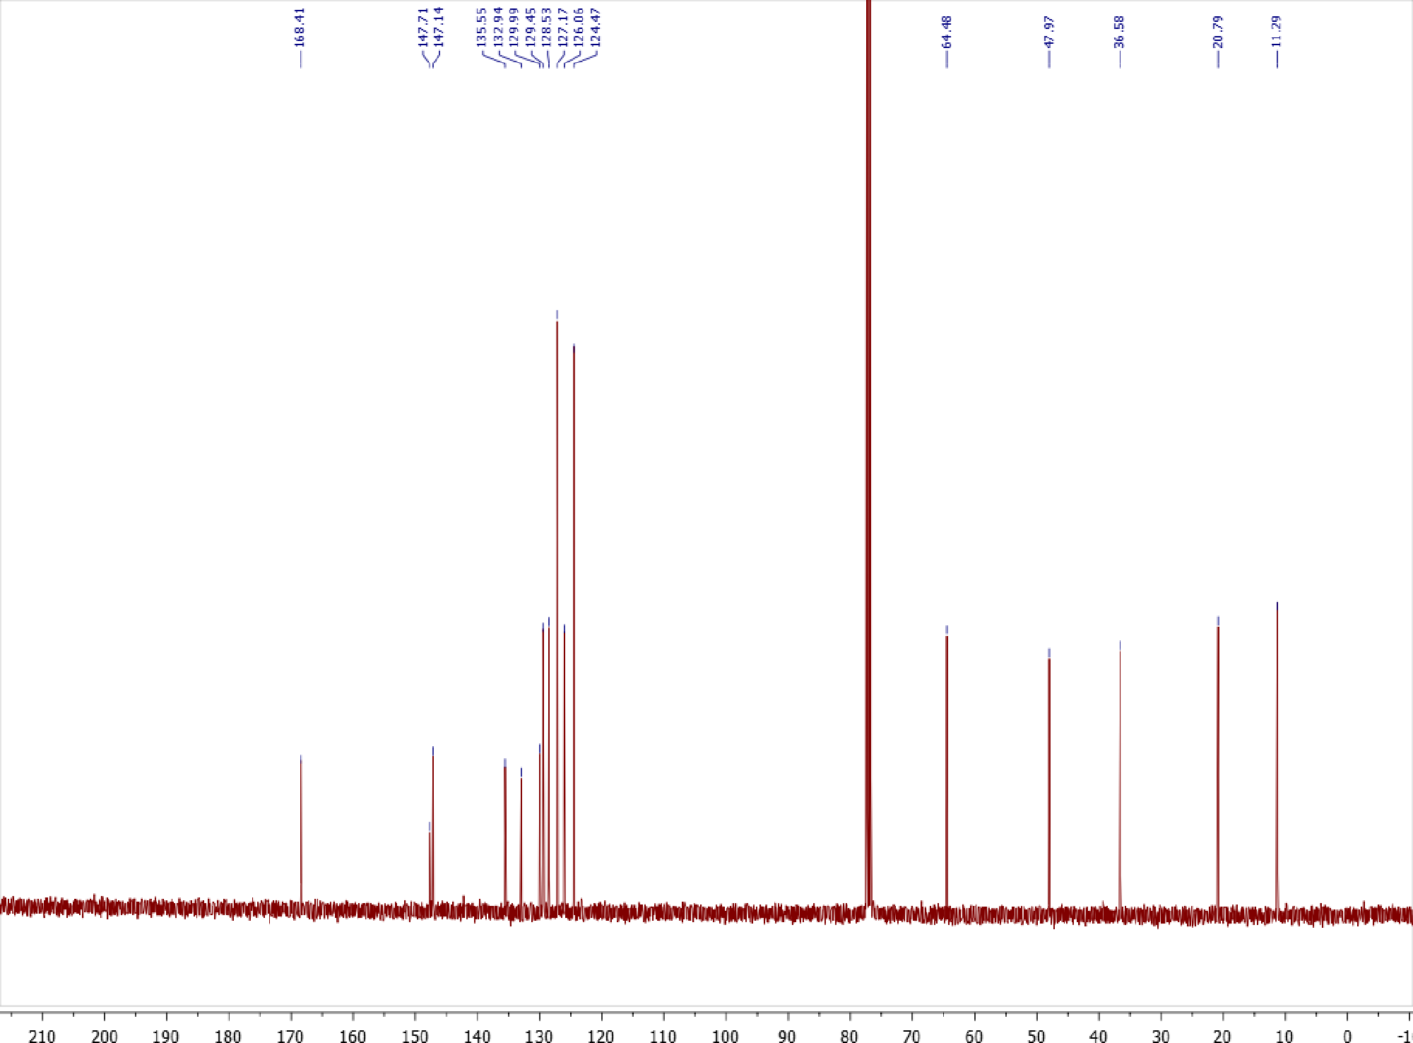
Copies of ¹H (400.13 MHz, CDCl₃) and ¹³C{¹H} (100.61 MHz, CDCl₃) spectra of 11o
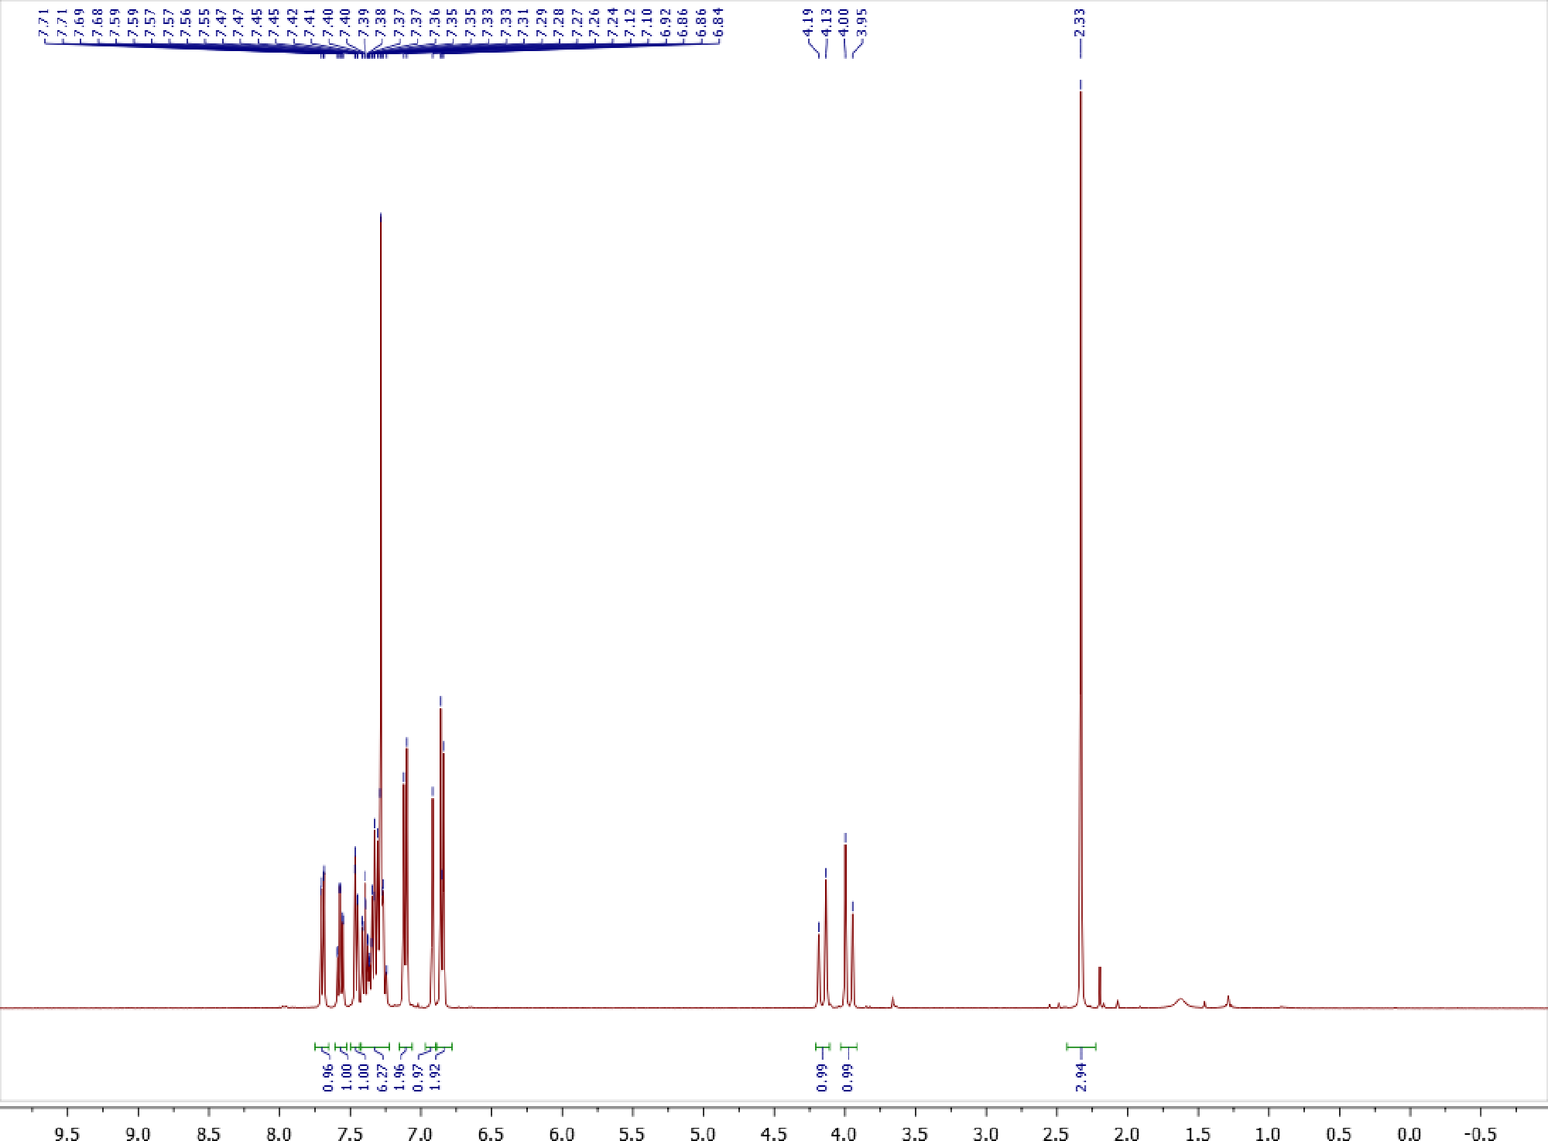
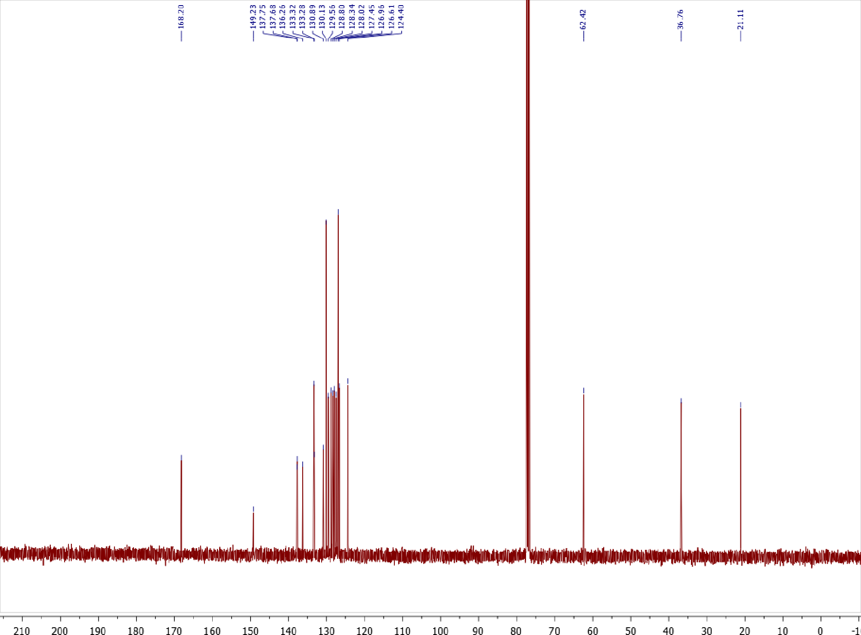
Copies of ¹H (400.13 MHz, CDCl₃) and ¹³C{¹H} (100.61 MHz, CDCl₃) spectra of 11p
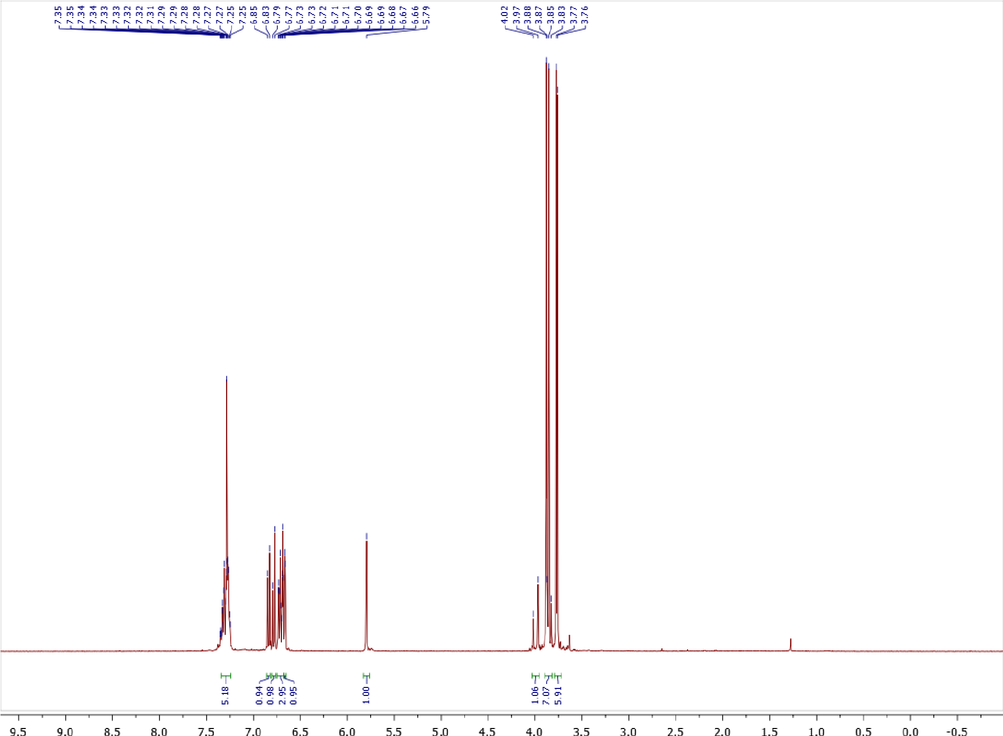
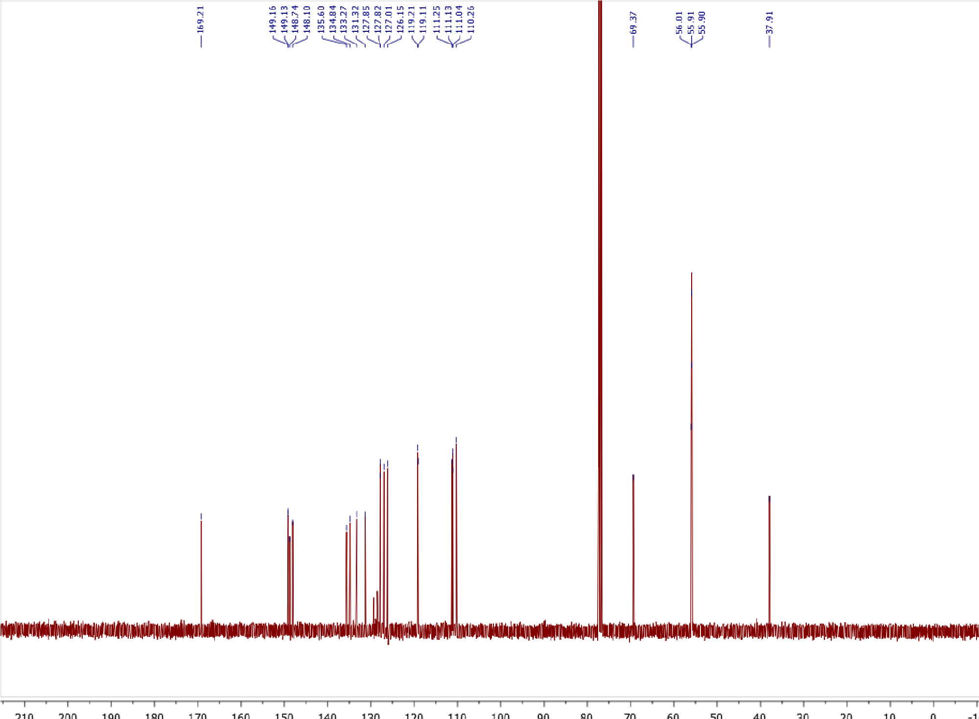
Copies of ¹H (400.13 MHz, CDCl₃) and ¹³C{¹H} (100.61 MHz, CDCl₃) spectra of 11q
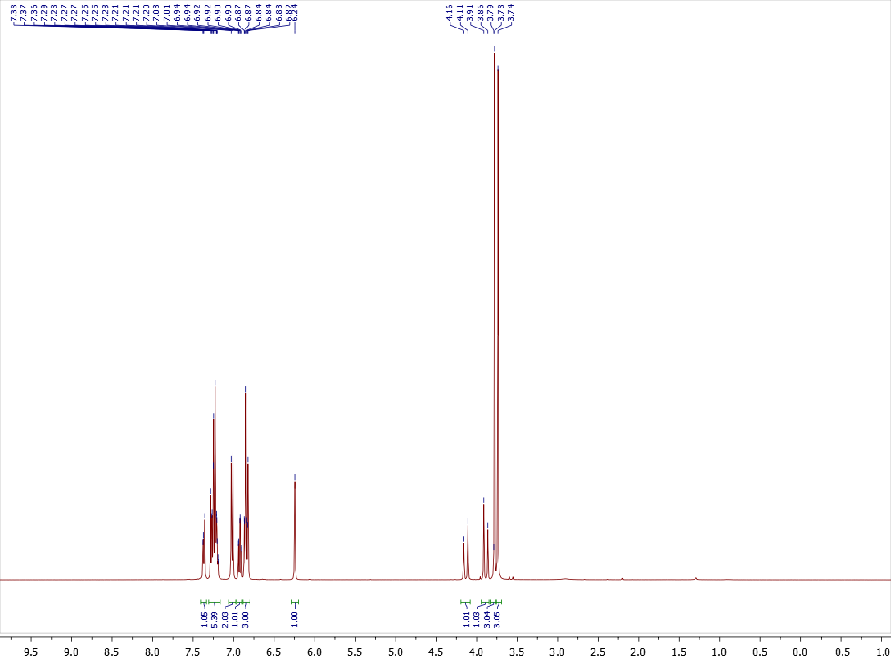
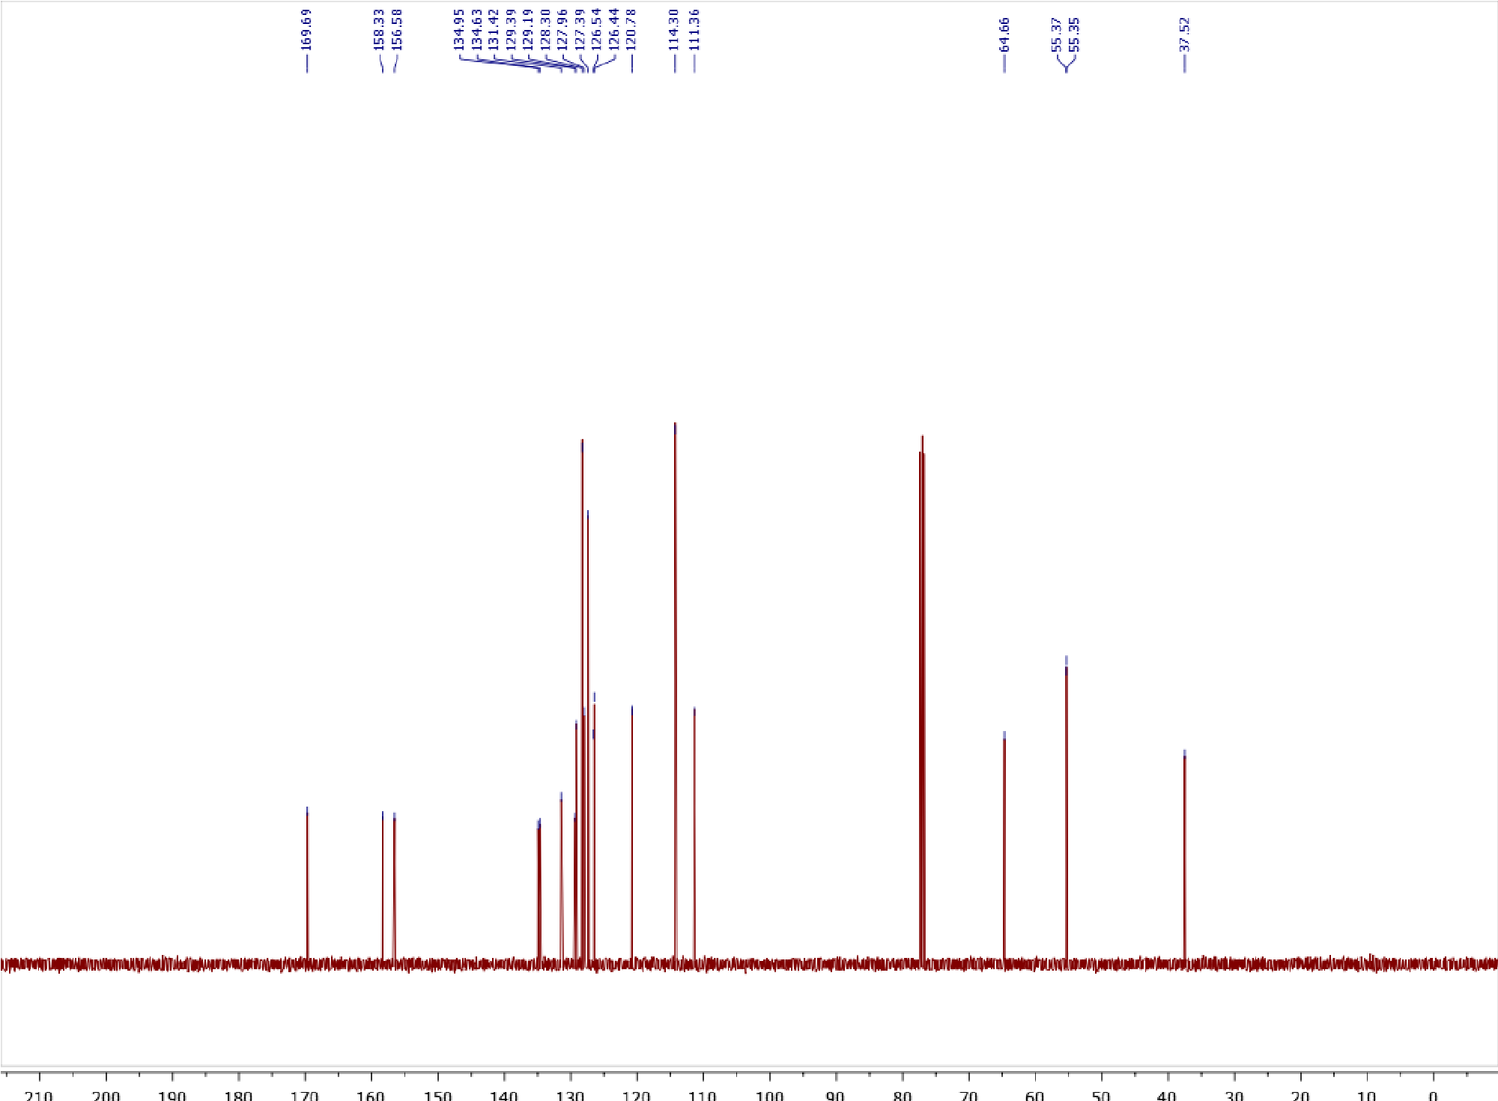
Copies of ¹H (400.13 MHz, CDCl₃) and ¹³C{¹H} (100.61 MHz, CDCl₃) spectra of 11s
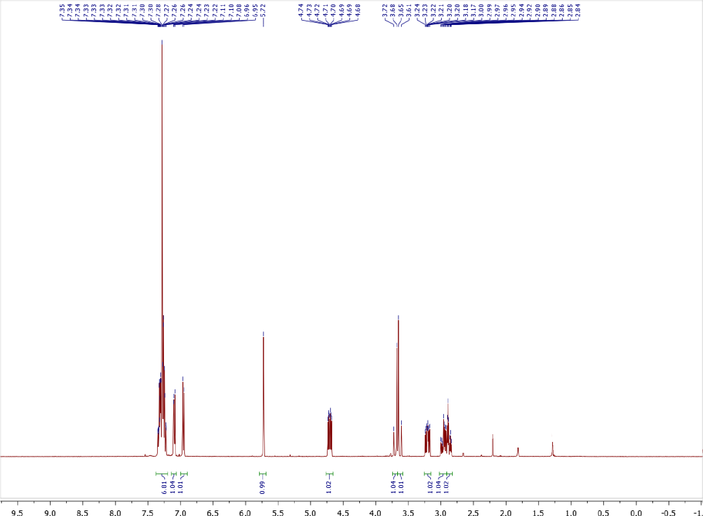
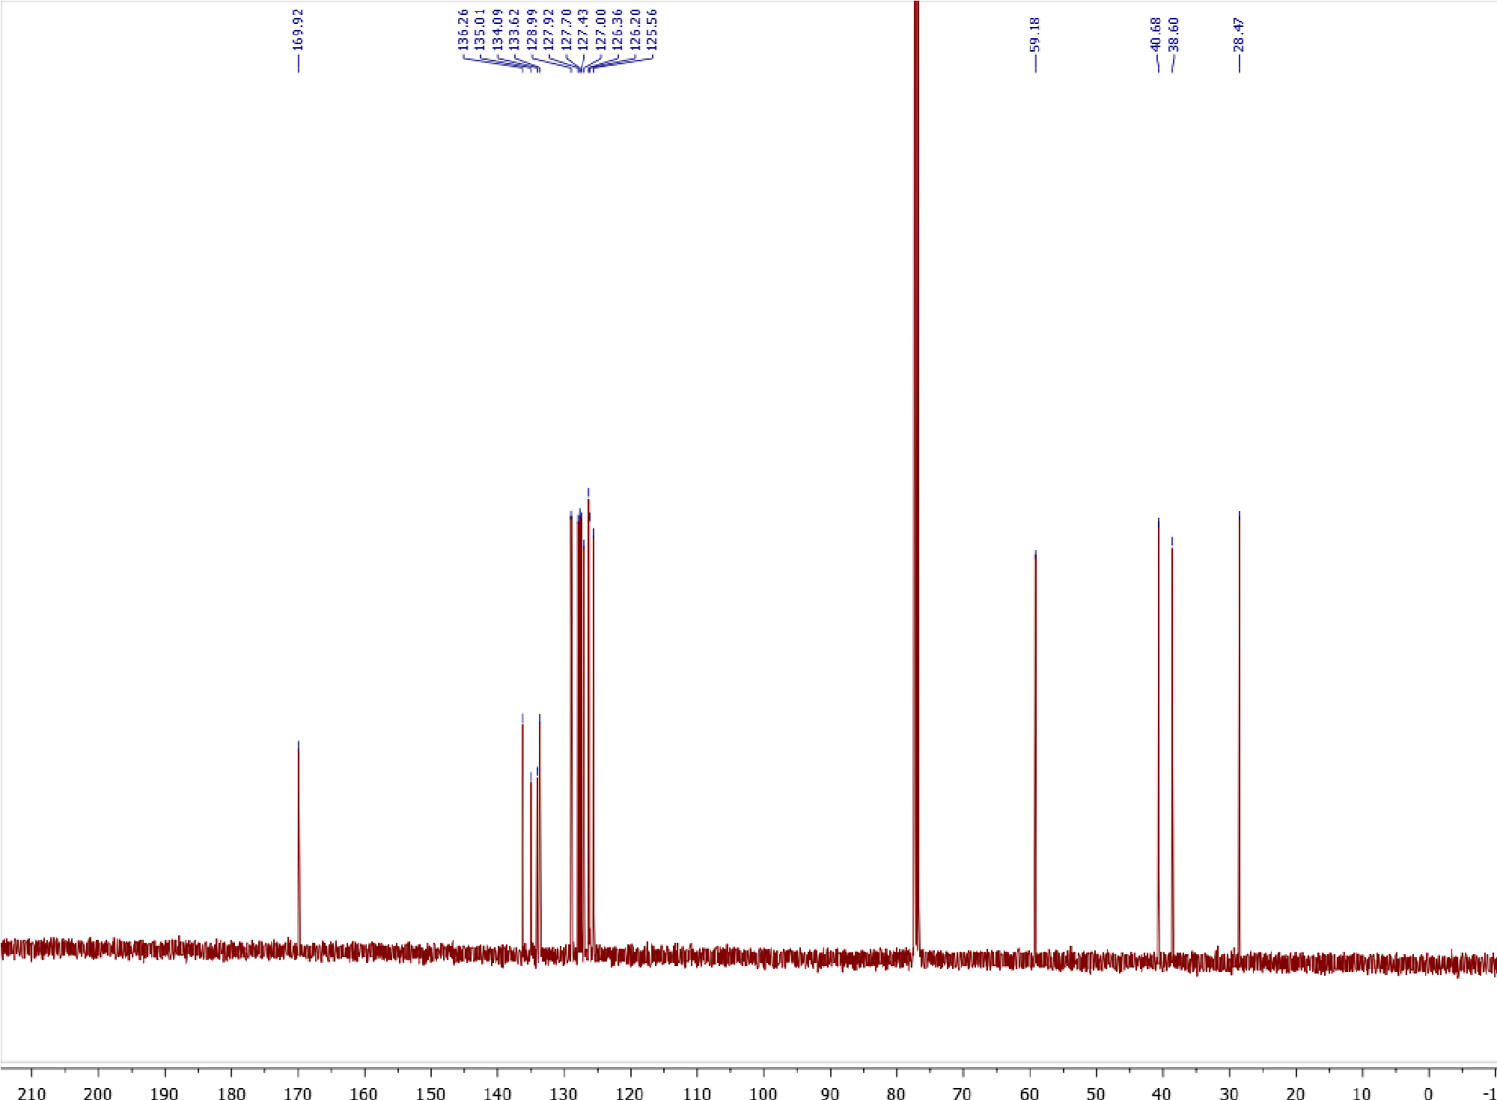
Copies of ¹H (400.13 MHz, CDCl₃) and ¹³C{¹H} (100.61 MHz, CDCl₃) spectra of 14
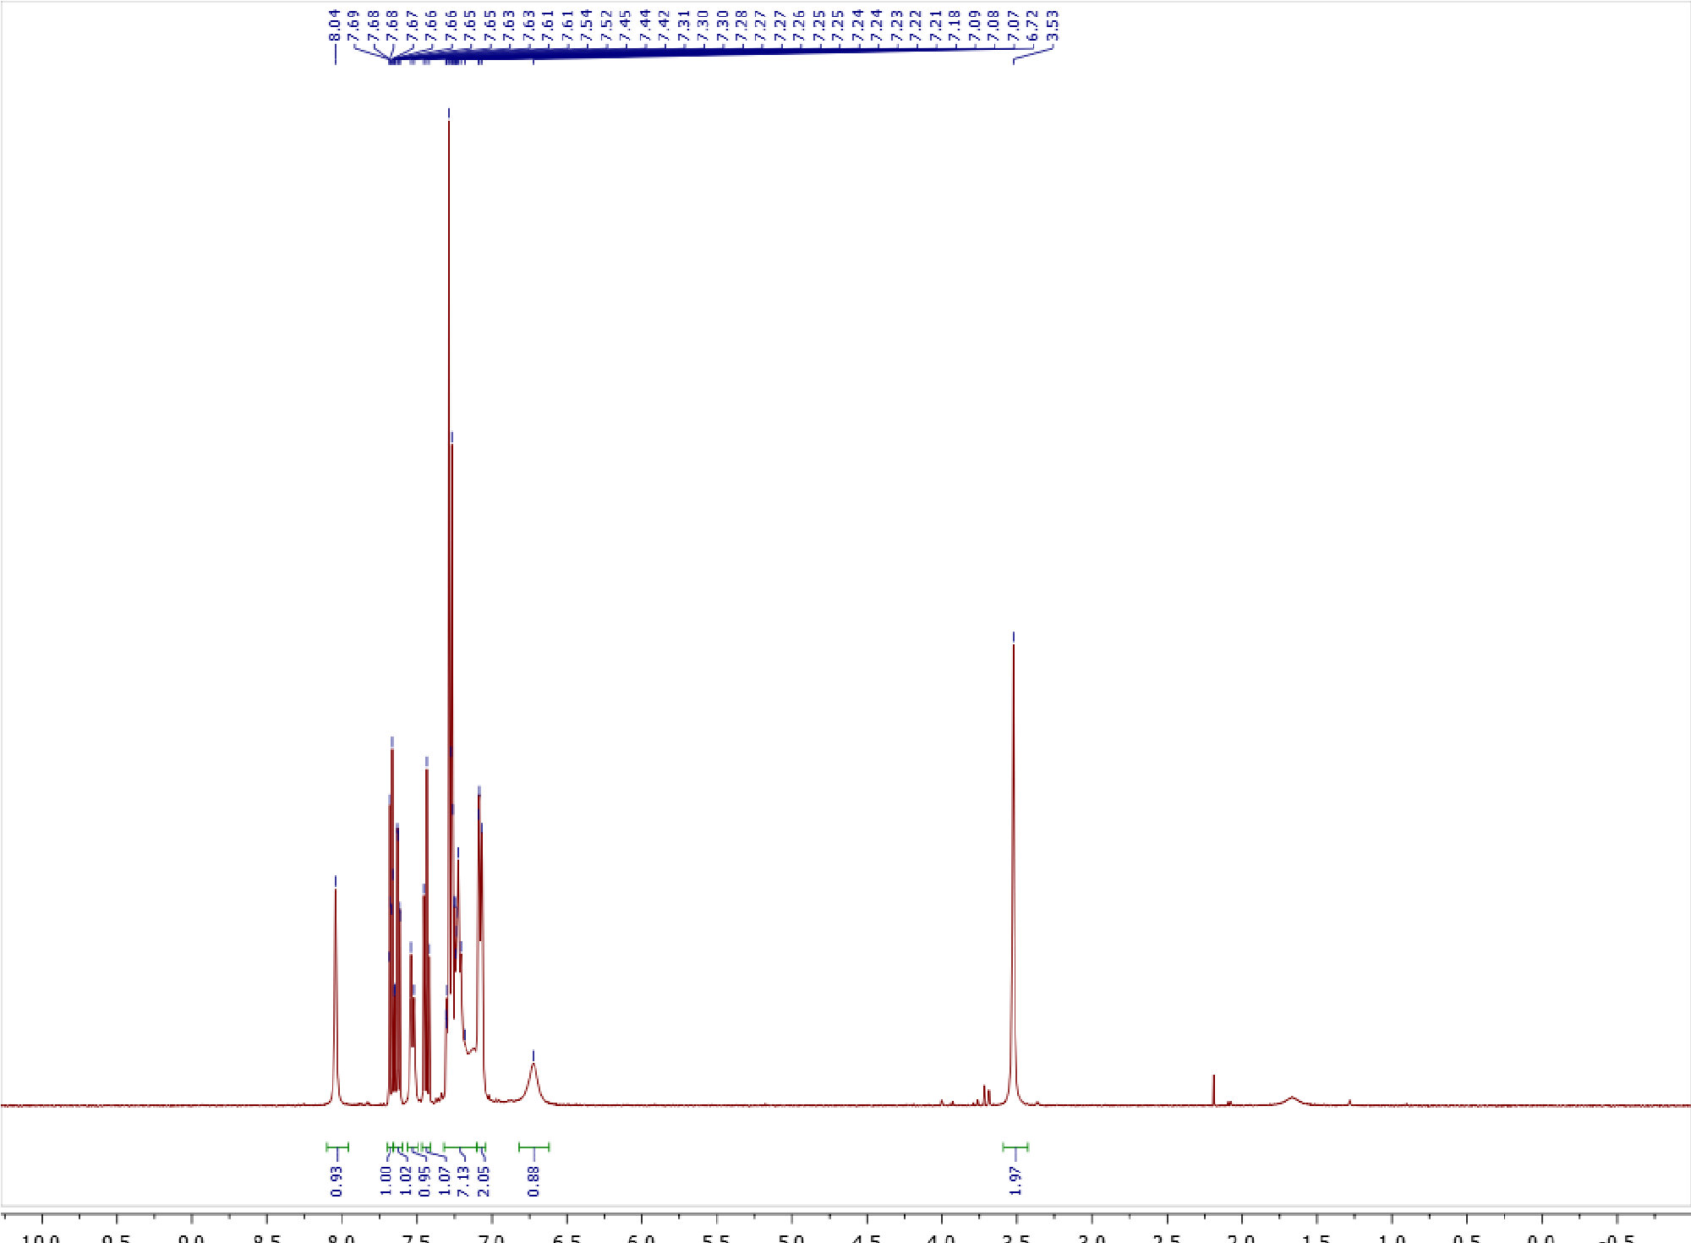
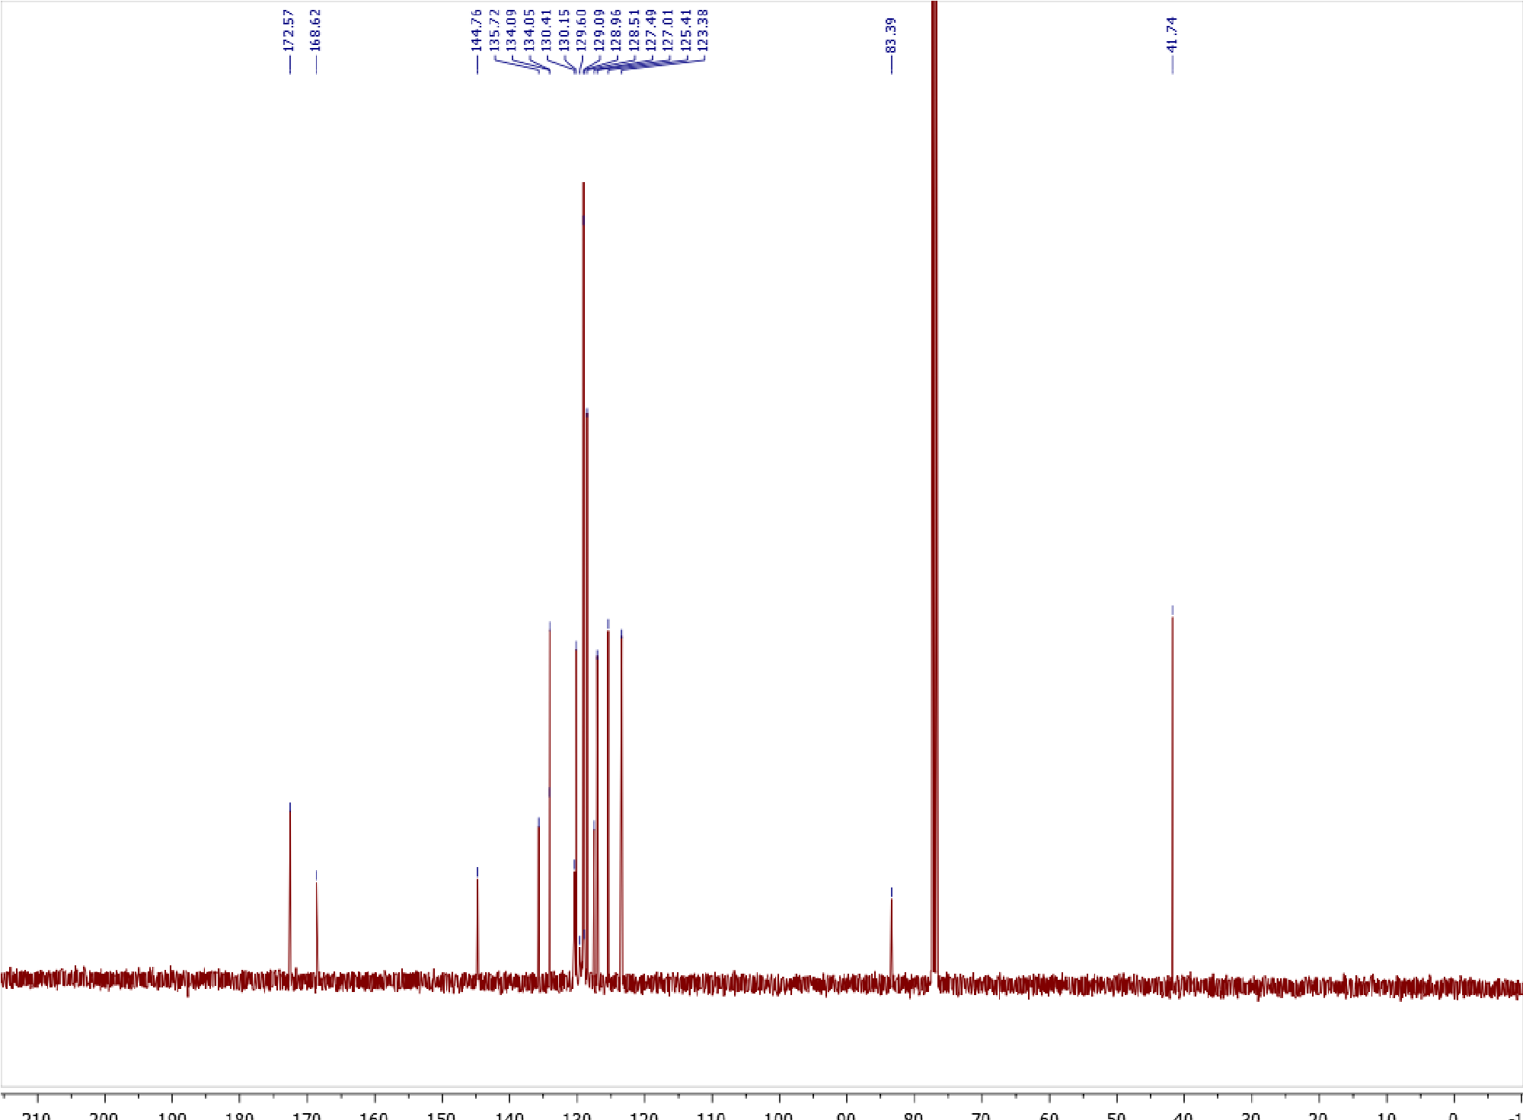
Copies of ¹H (400.13 MHz, CDCl₃) and ¹³C{¹H} (100.61 MHz, CDCl₃) spectra of 10a
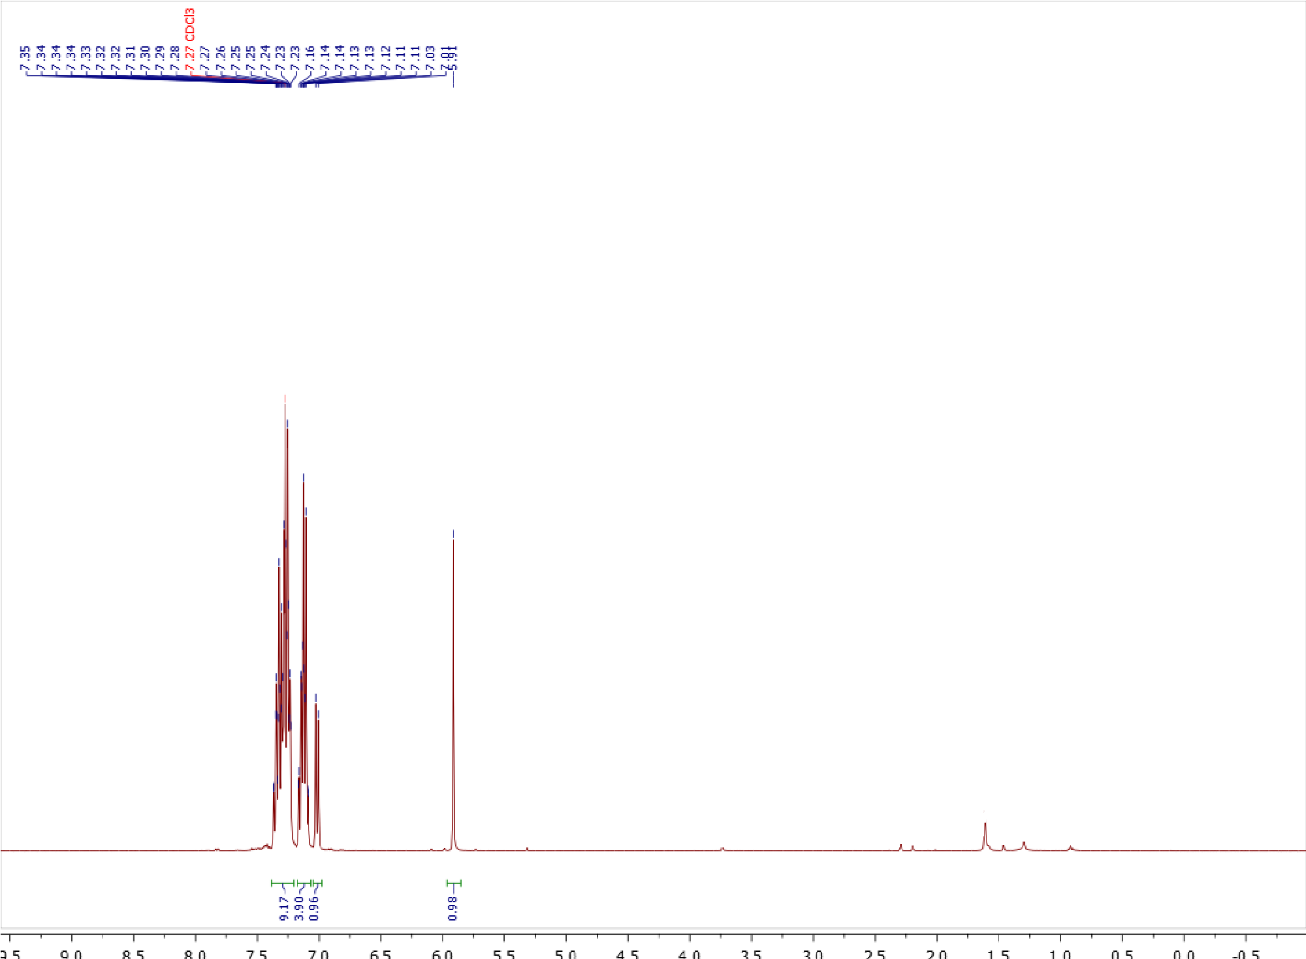
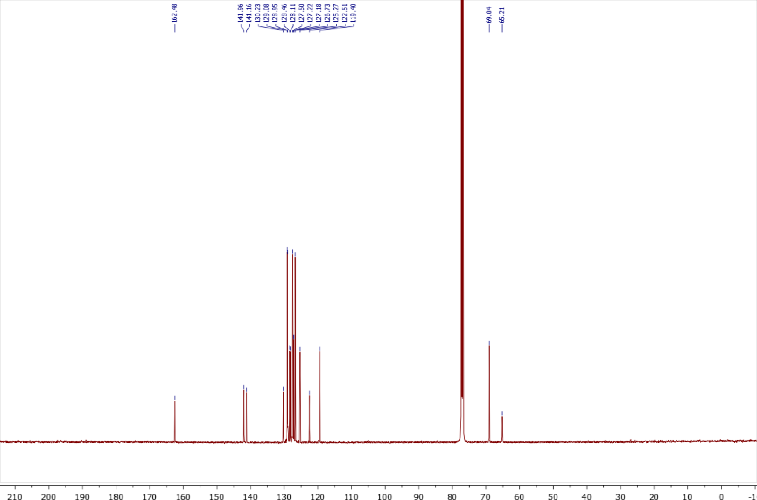
Copies of ¹H (400.13 MHz, CDCl₃) and ¹³C{¹H} (100.61 MHz, CDCl₃) spectra of 10b
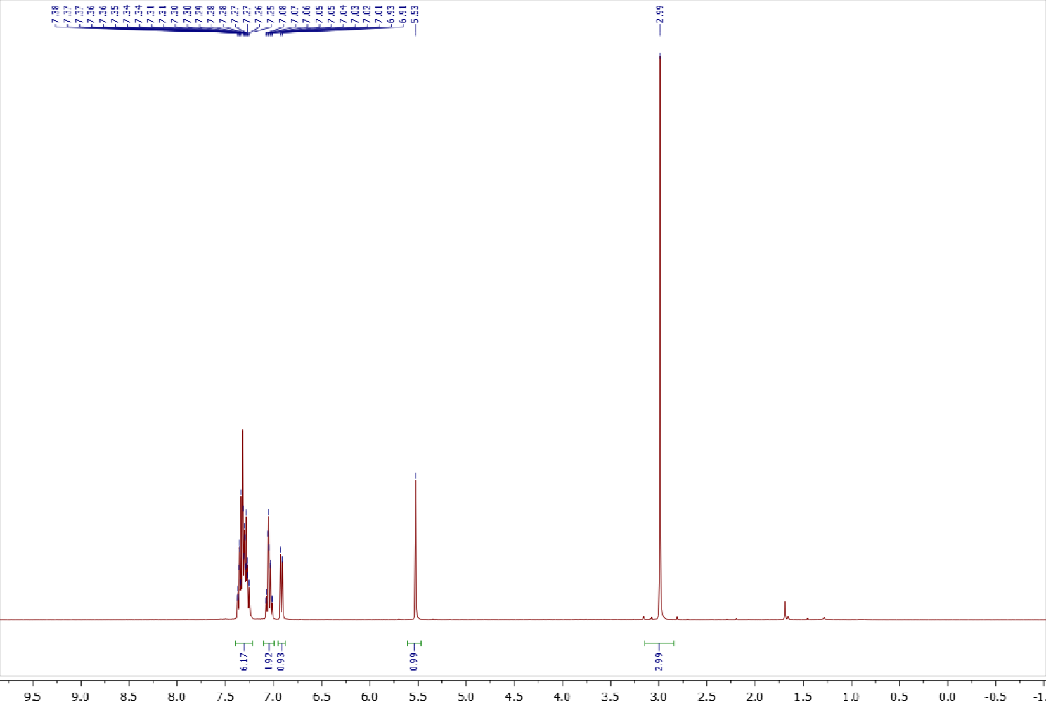
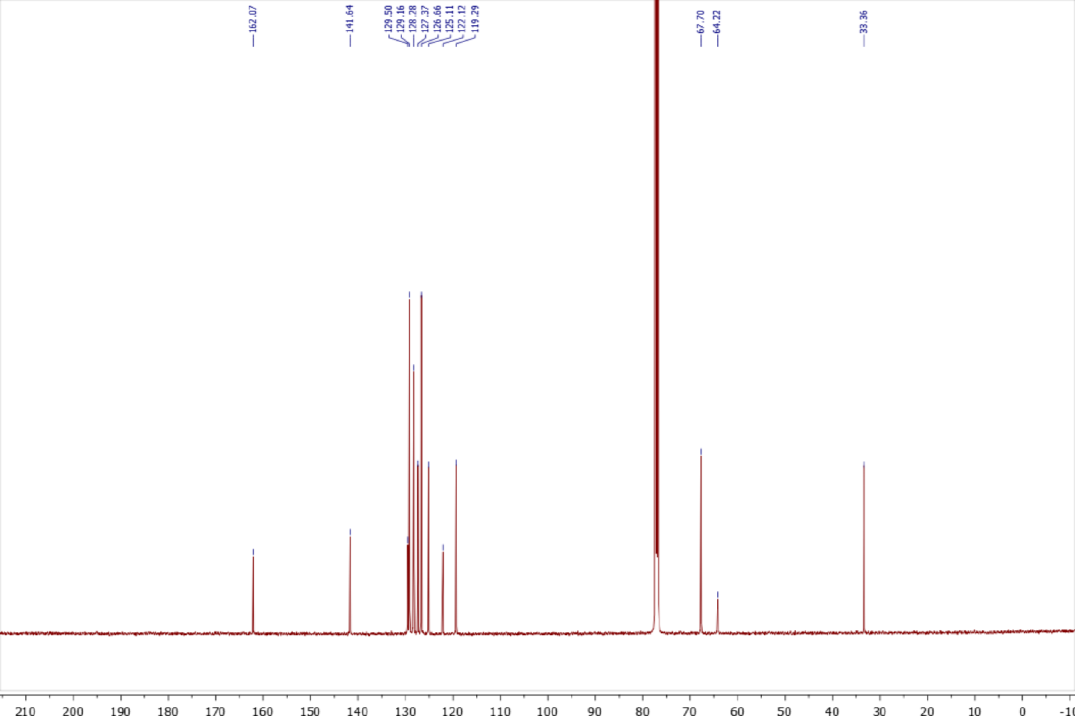
Copies of ¹H (400.13 MHz, CDCl₃) and ¹³C{¹H} (100.61 MHz, CDCl₃) spectra of 10c
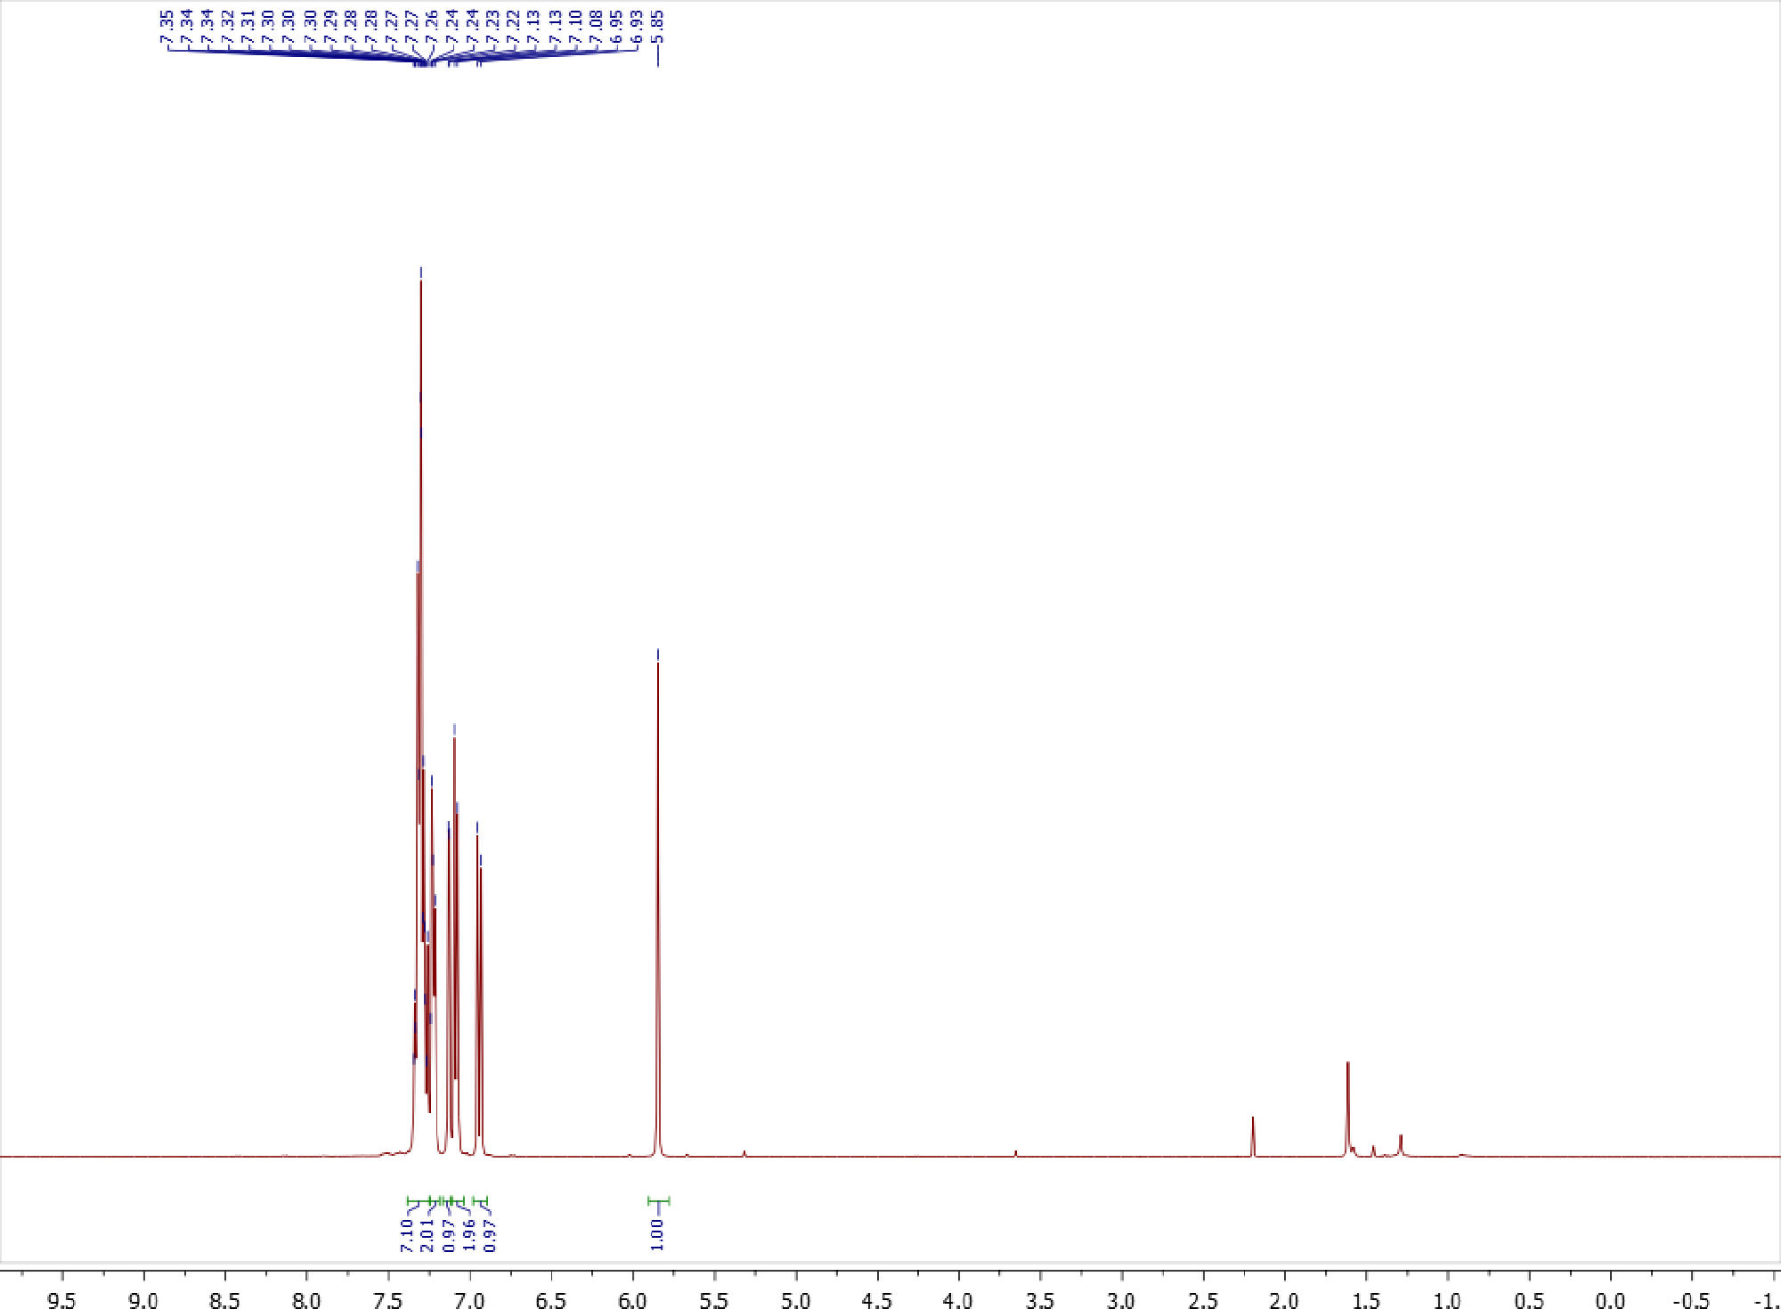
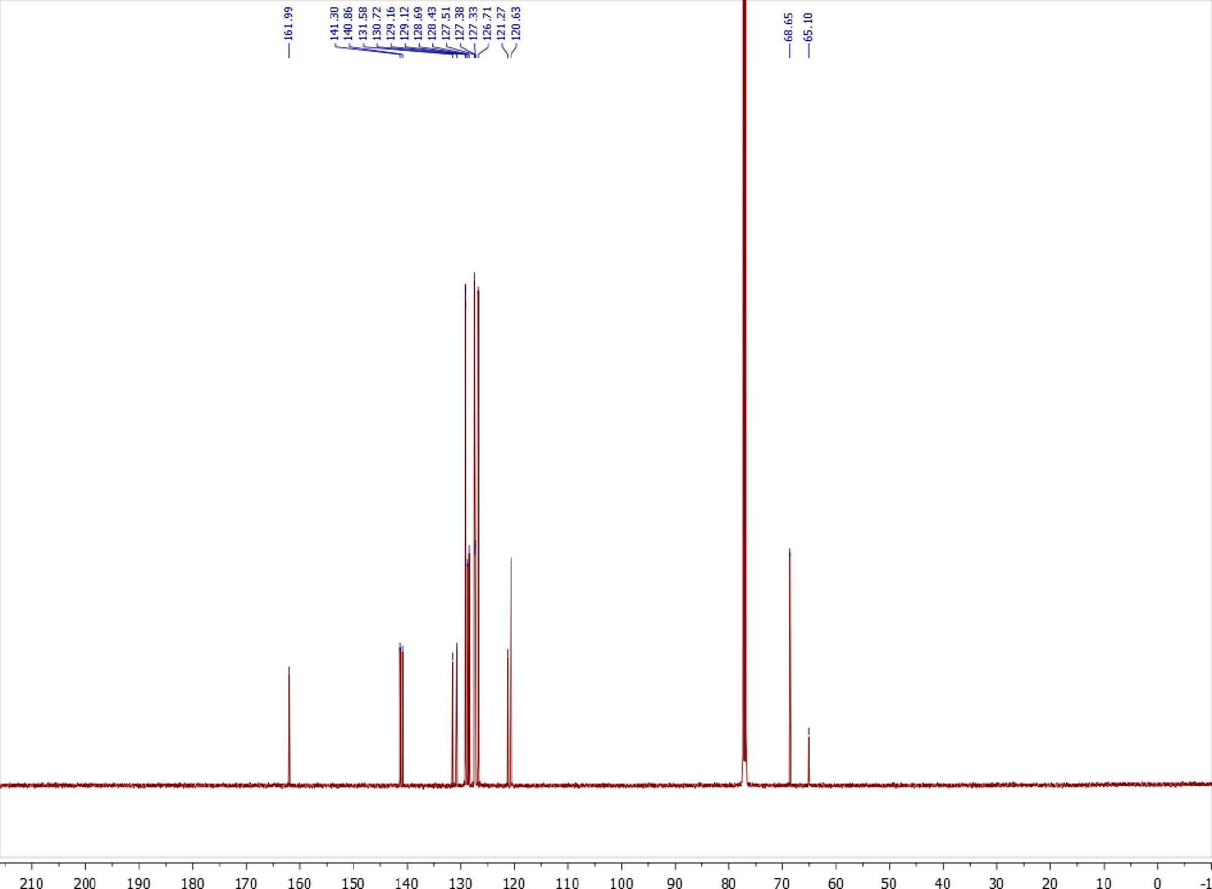
Copies of ¹H (400.13 MHz, CDCl₃) and ¹³C{¹H} (100.61 MHz, CDCl₃) spectra of 10d
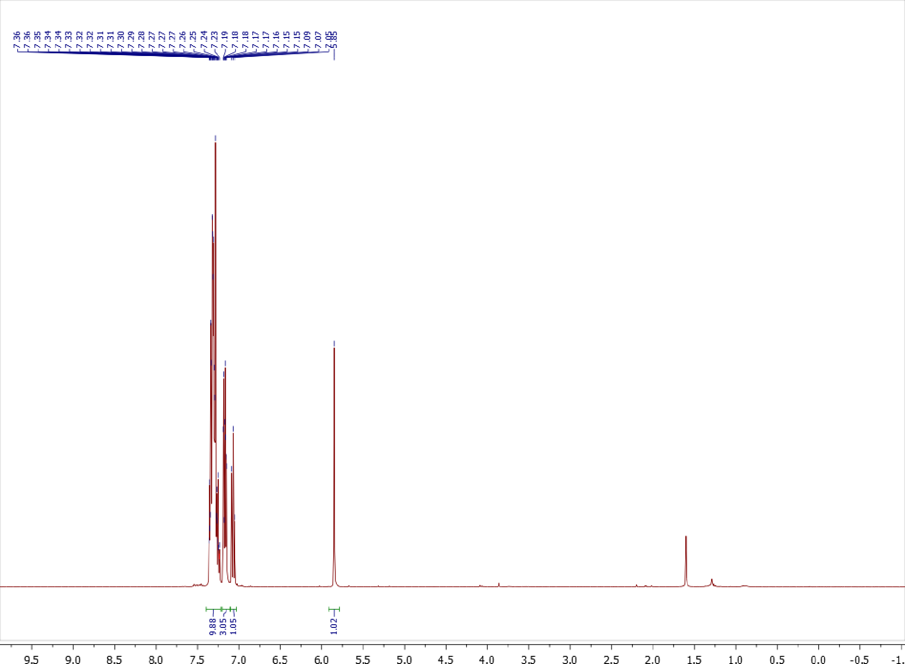
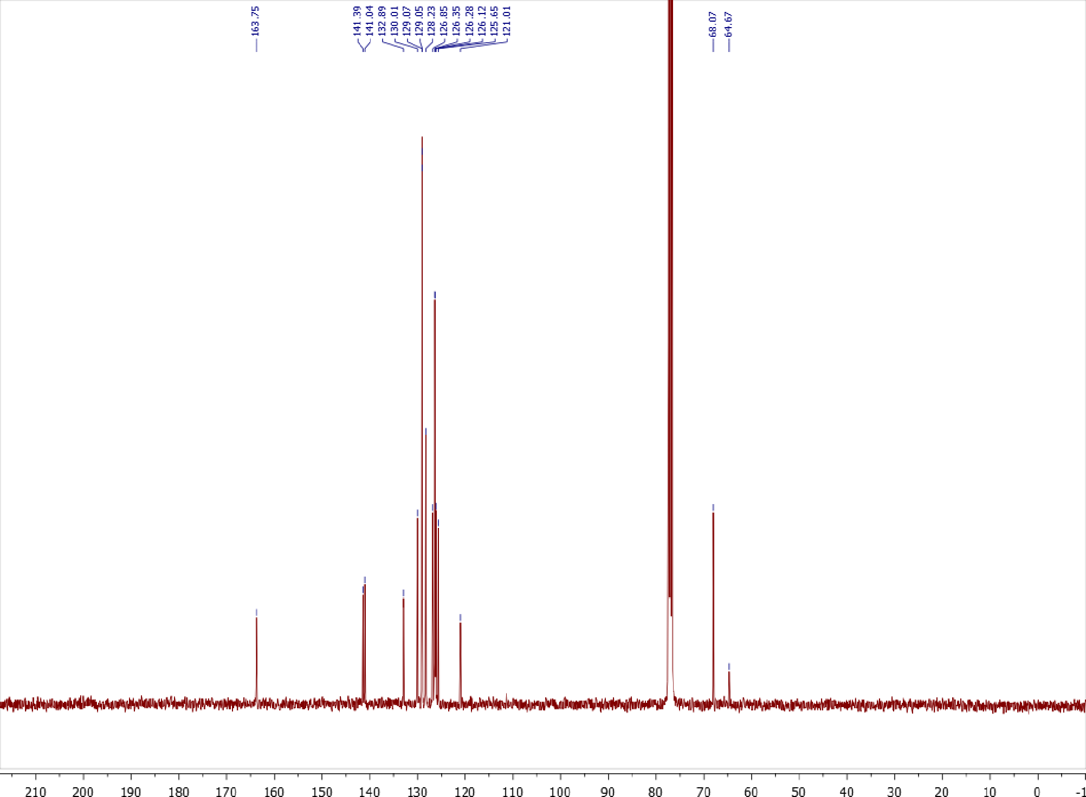
Copies of ¹H (400.13 MHz, CDCl₃) and ¹³C{¹H} (100.61 MHz, CDCl₃) spectra of 10e
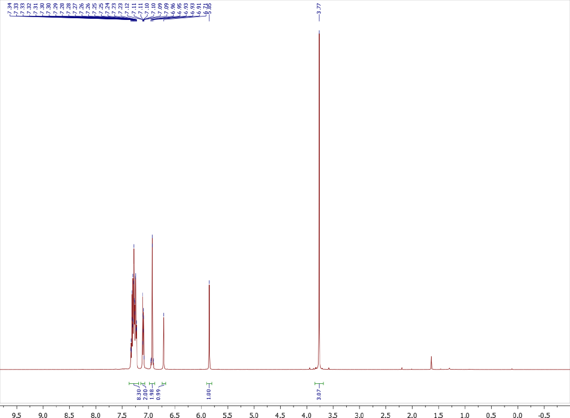
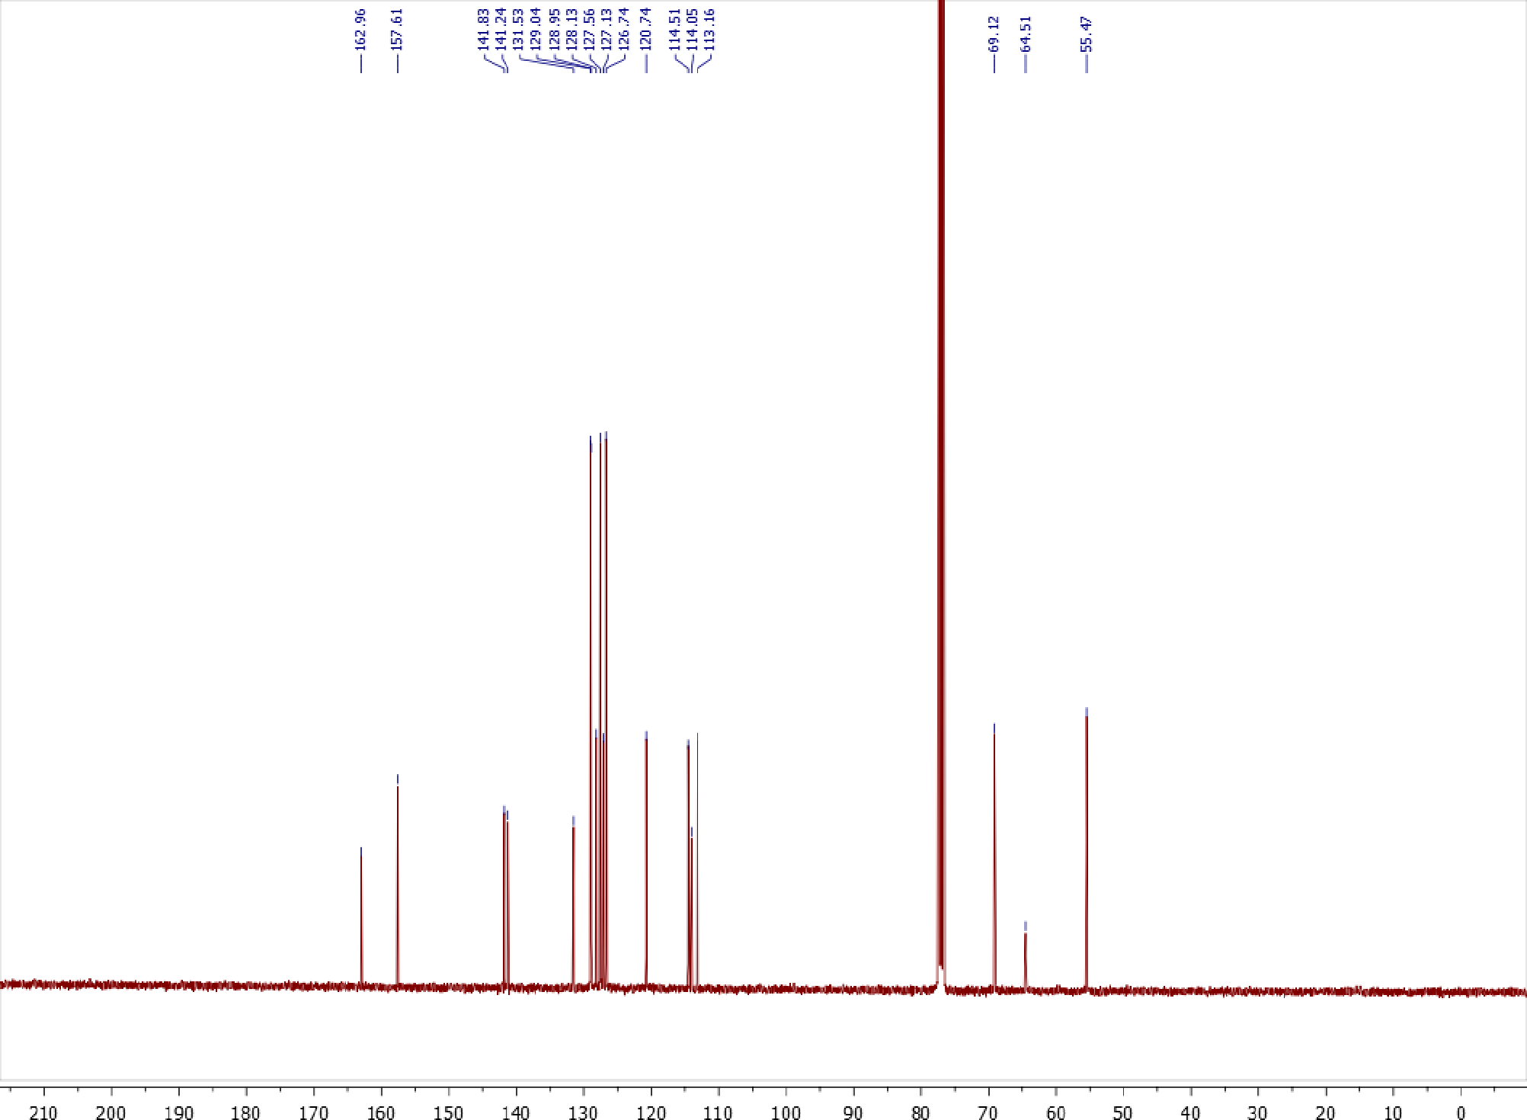
Copies of ¹H (400.13 MHz, CDCl₃) and ¹³C{¹H} (100.61 MHz, CDCl₃) spectra of 10f
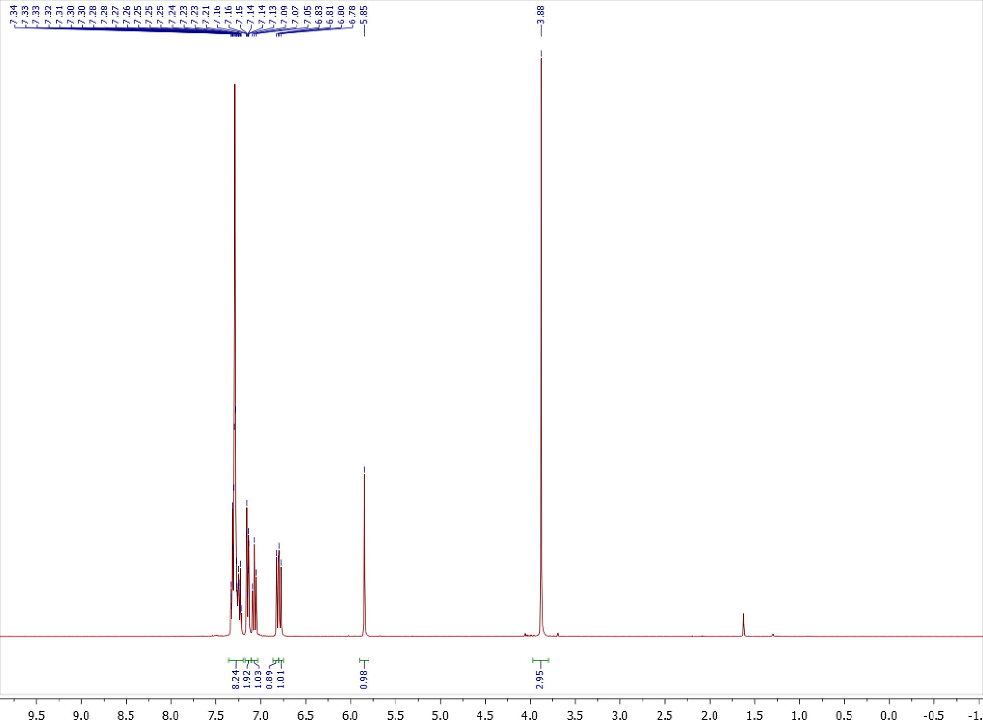
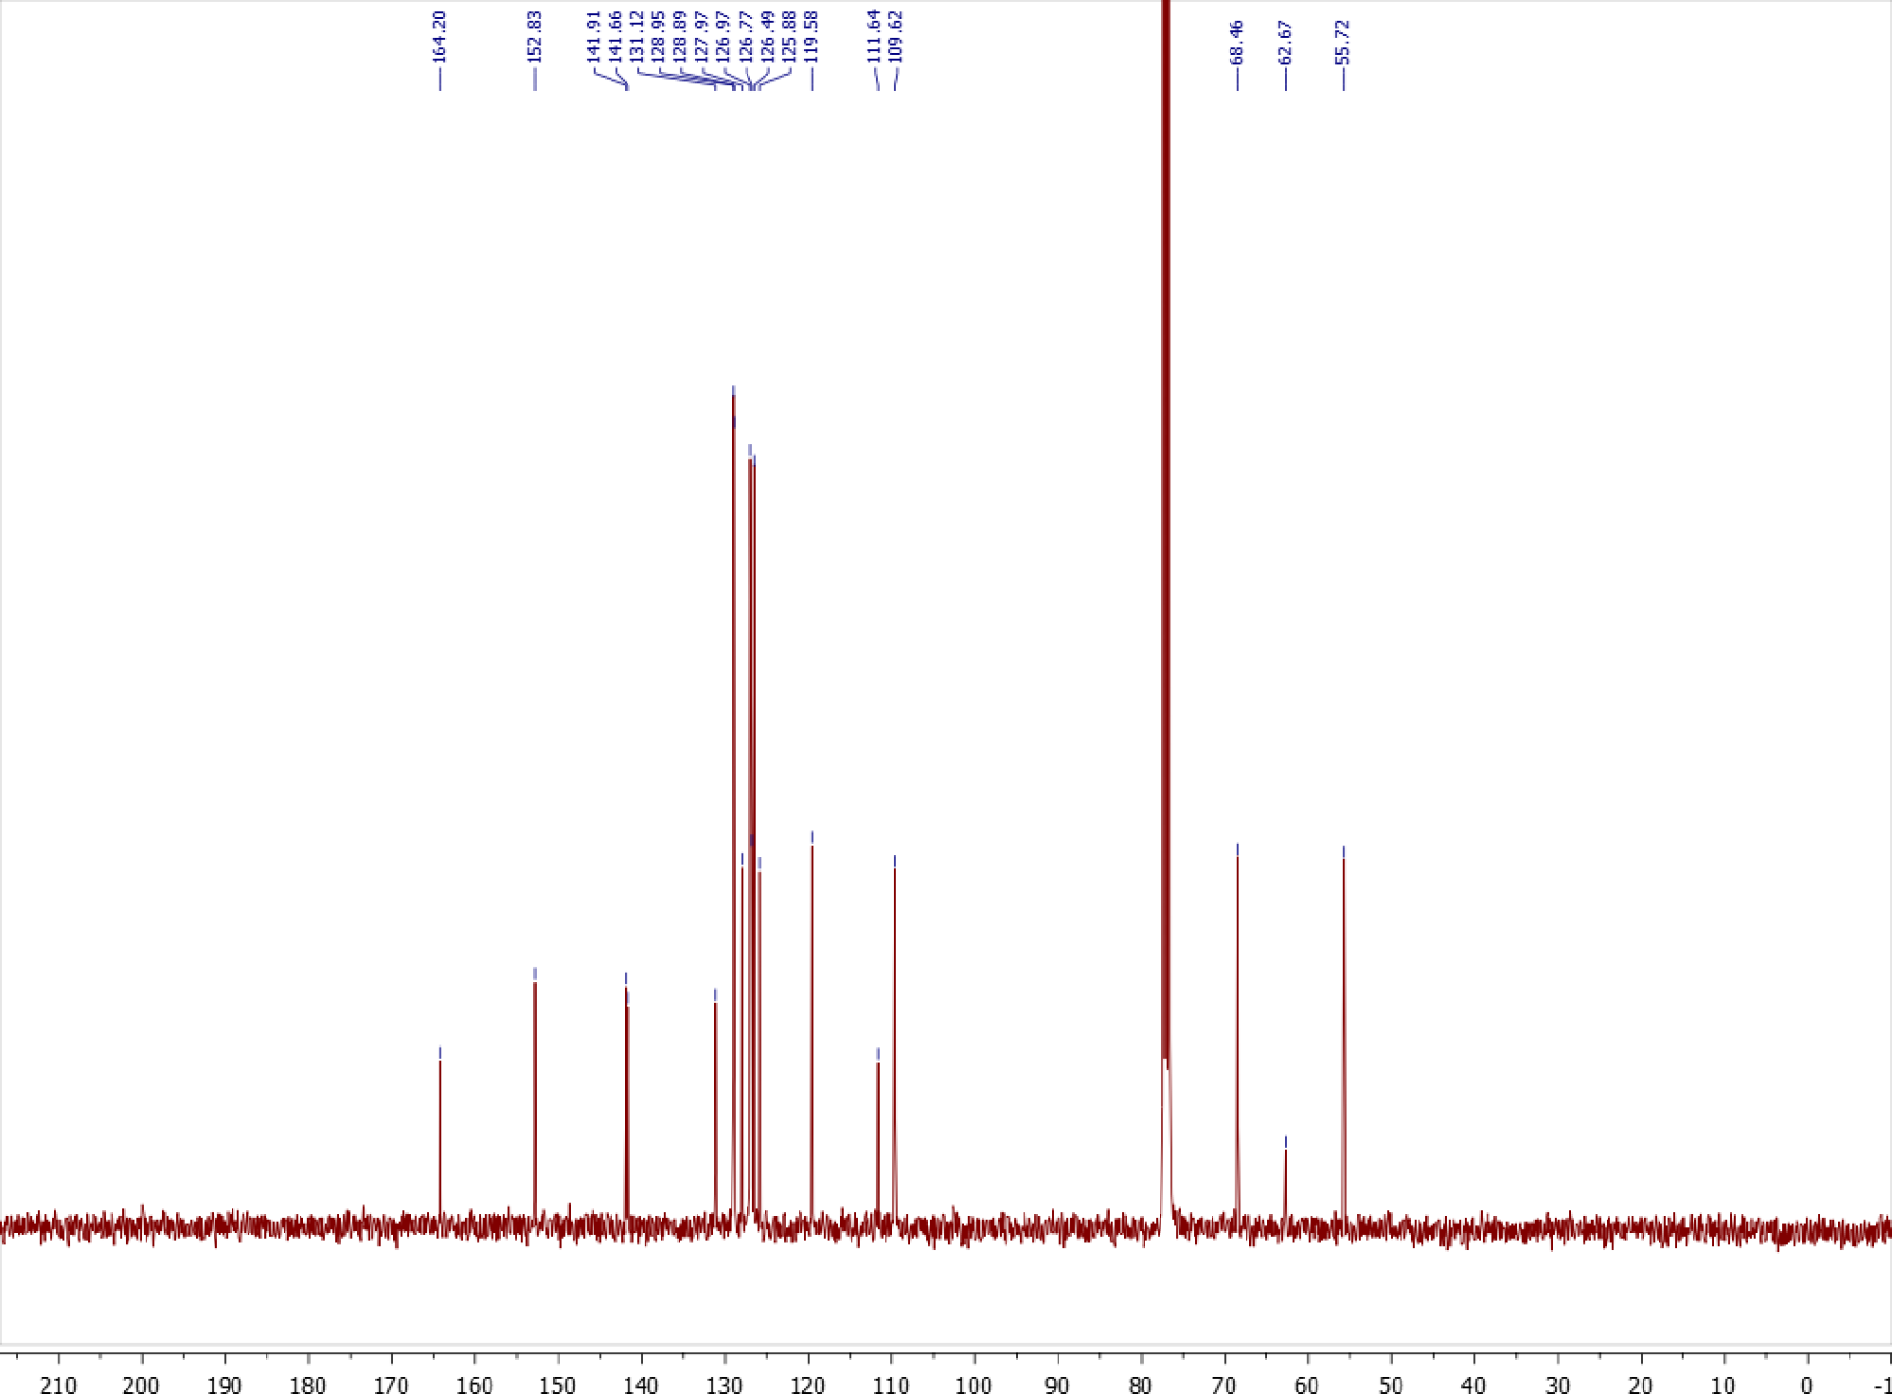
Copies of ¹H (400.13 MHz, CDCl₃) and ¹³C{¹H} (100.61 MHz, CDCl₃) spectra of 10g
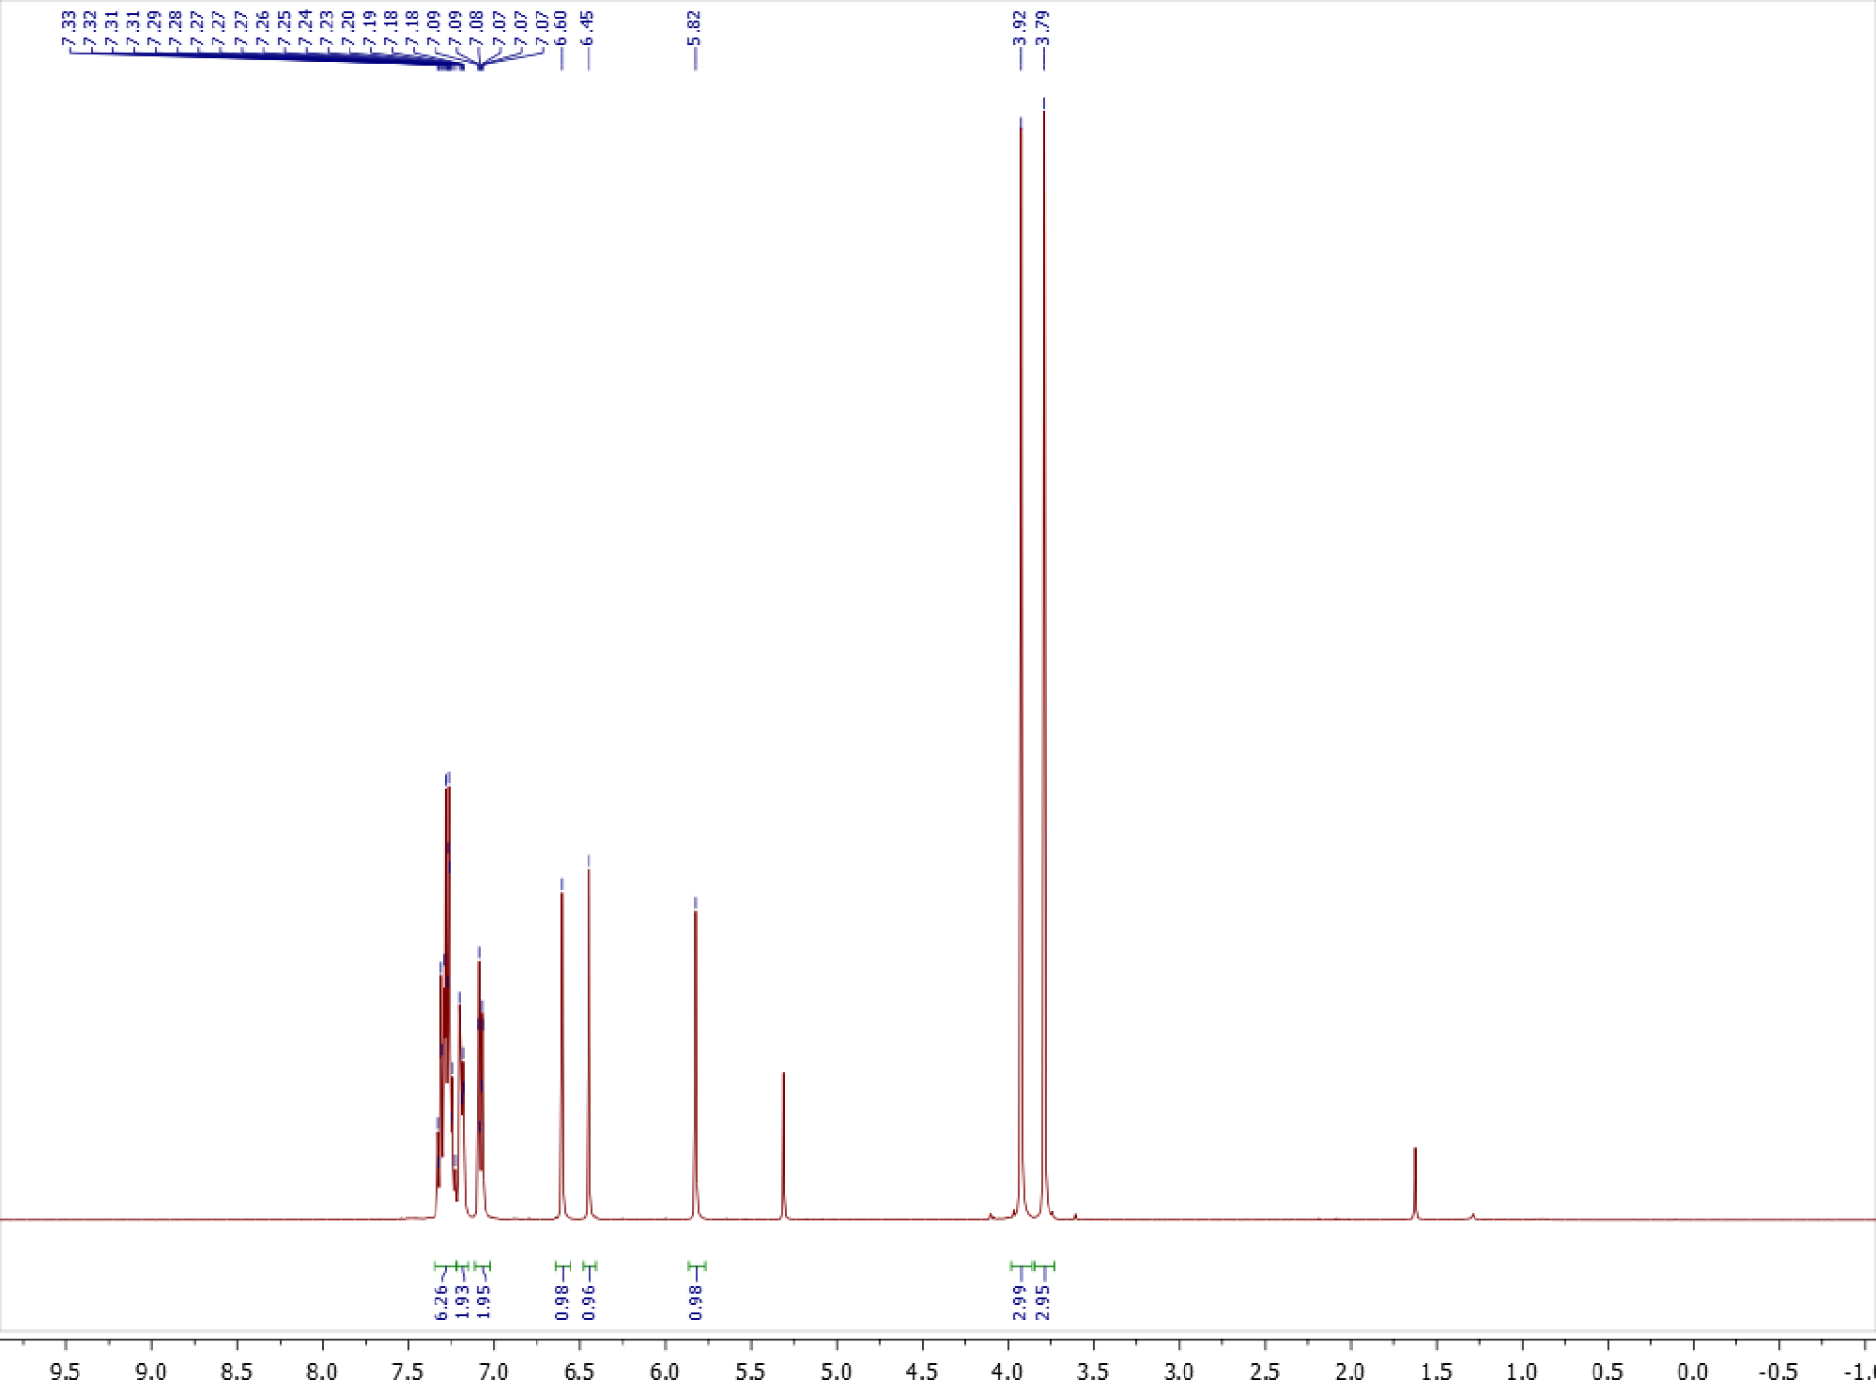
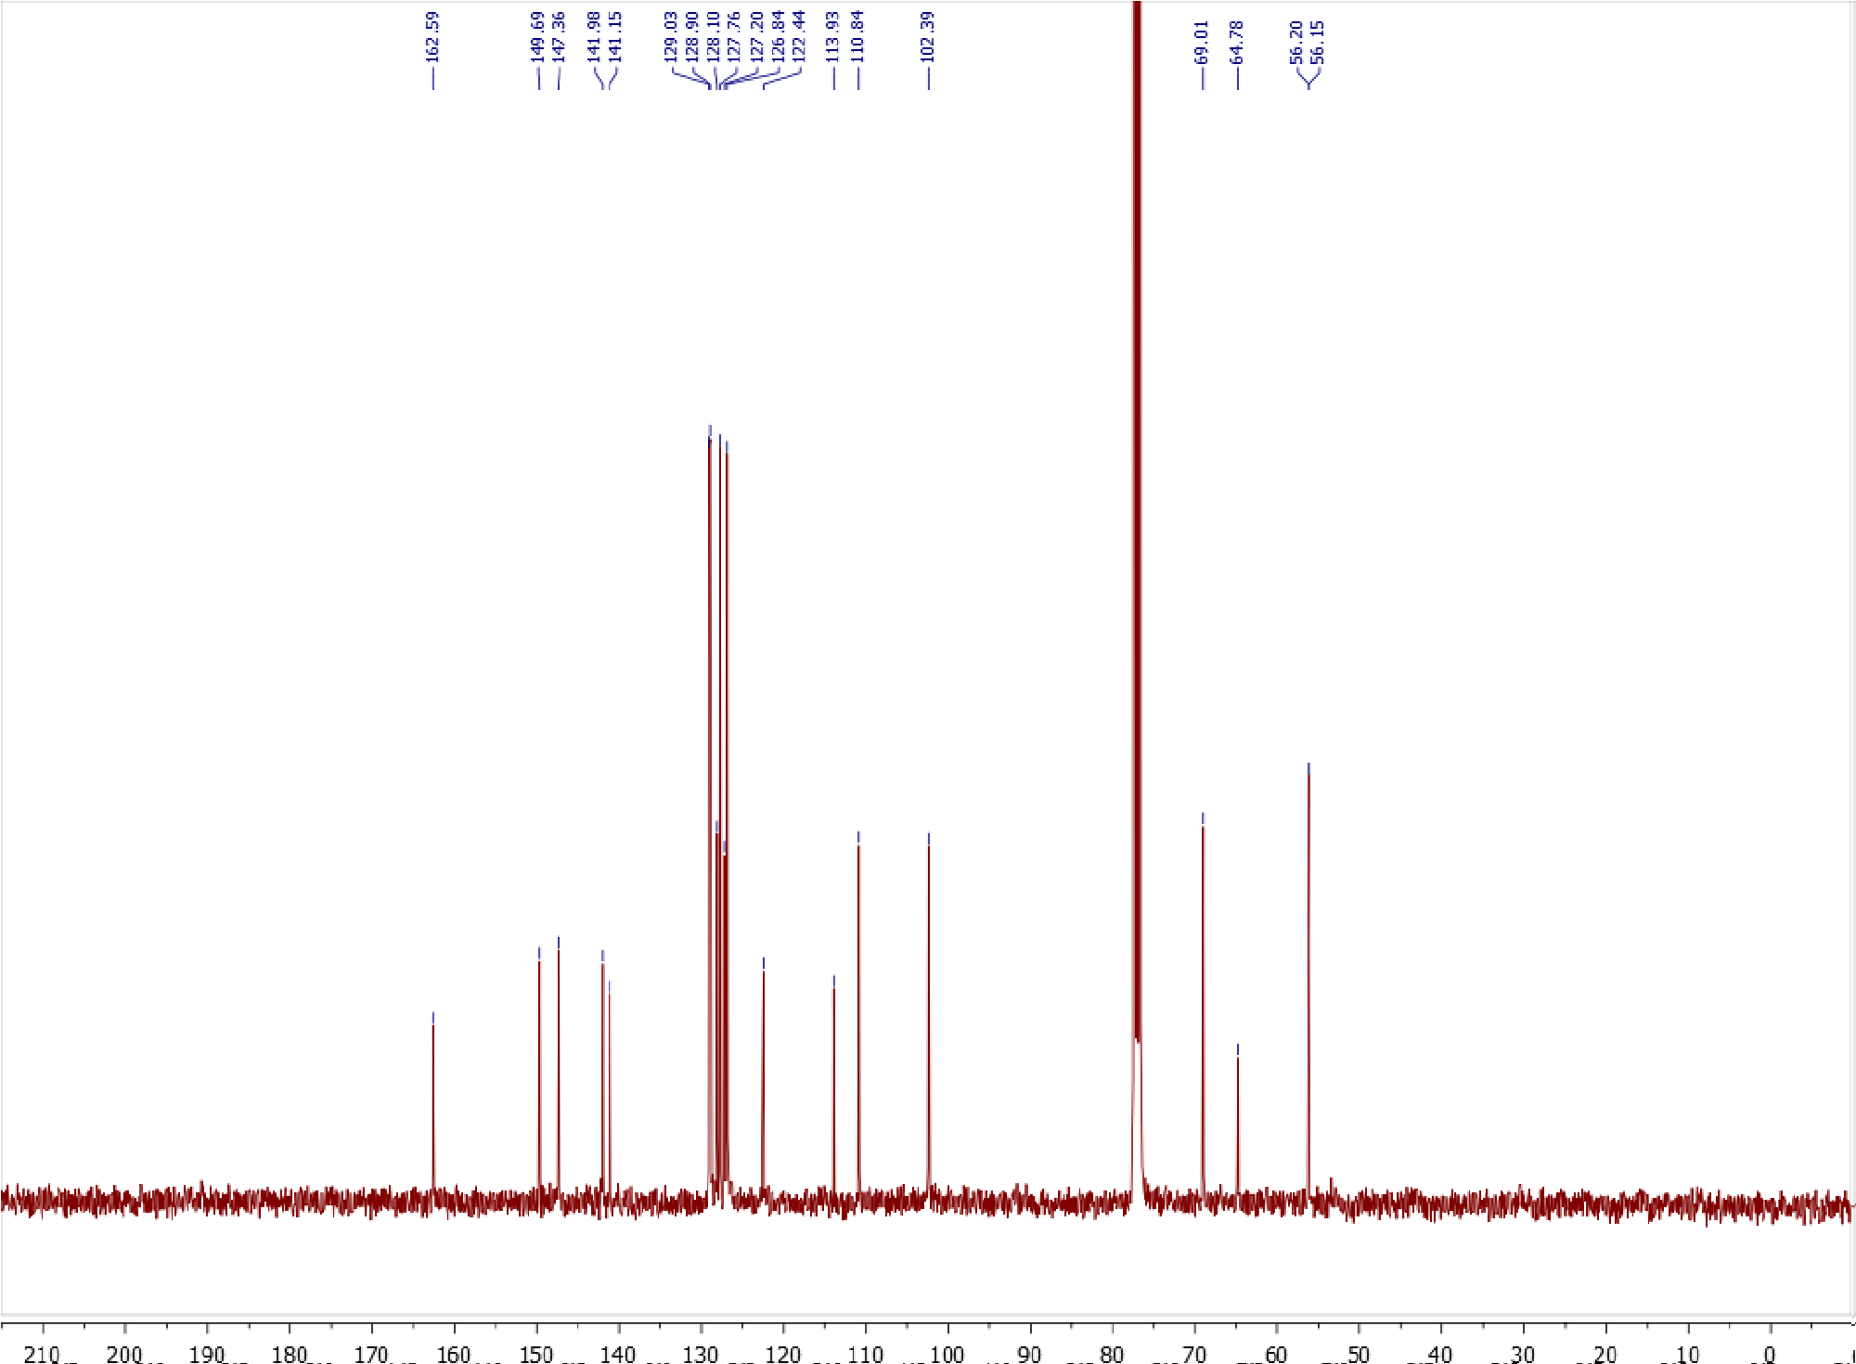
Copies of ¹H (400.13 MHz, CDCl₃) and ¹³C{¹H} (100.61 MHz, CDCl₃) spectra of 10h
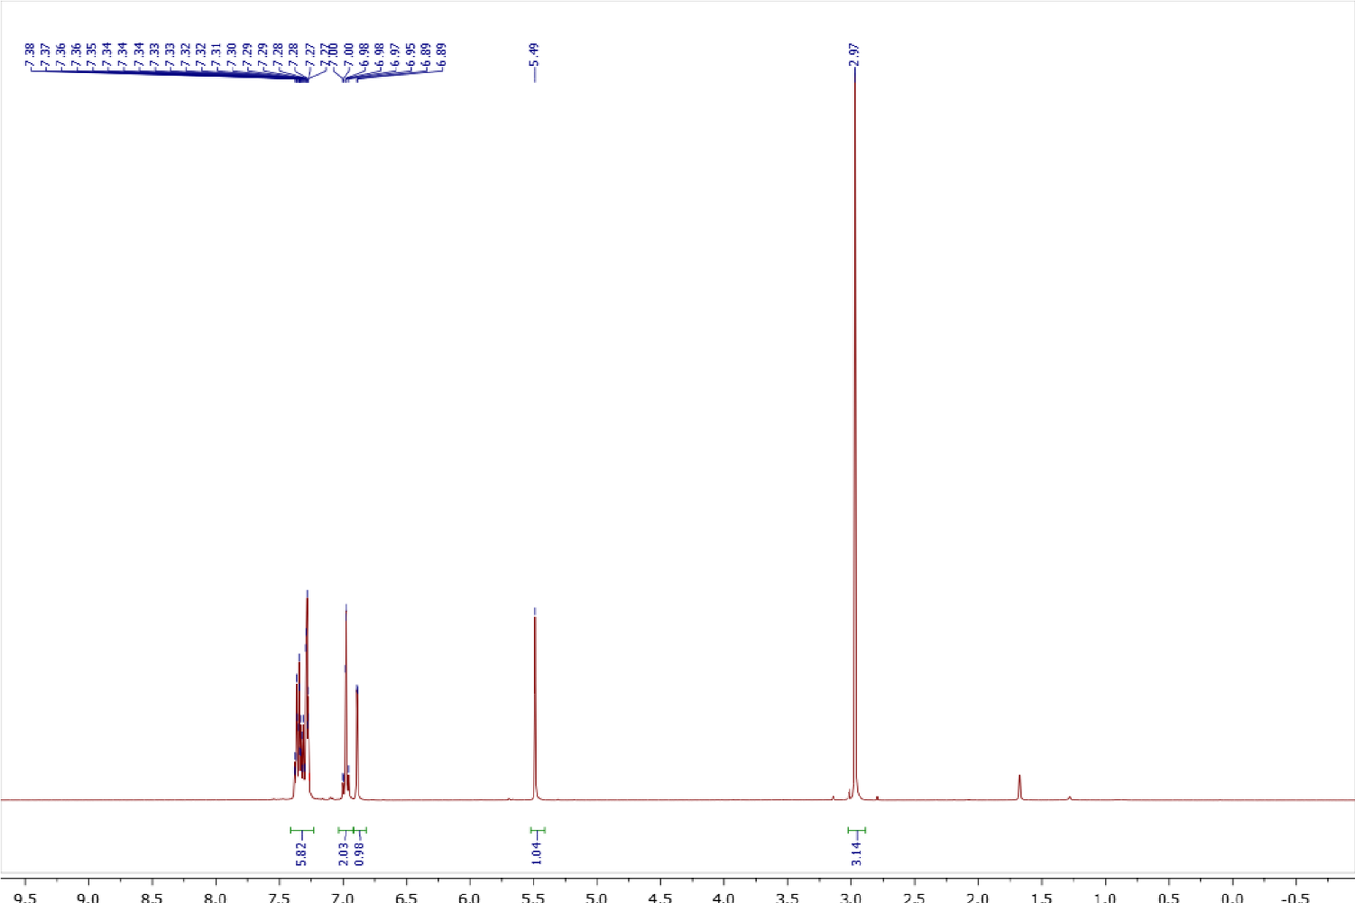
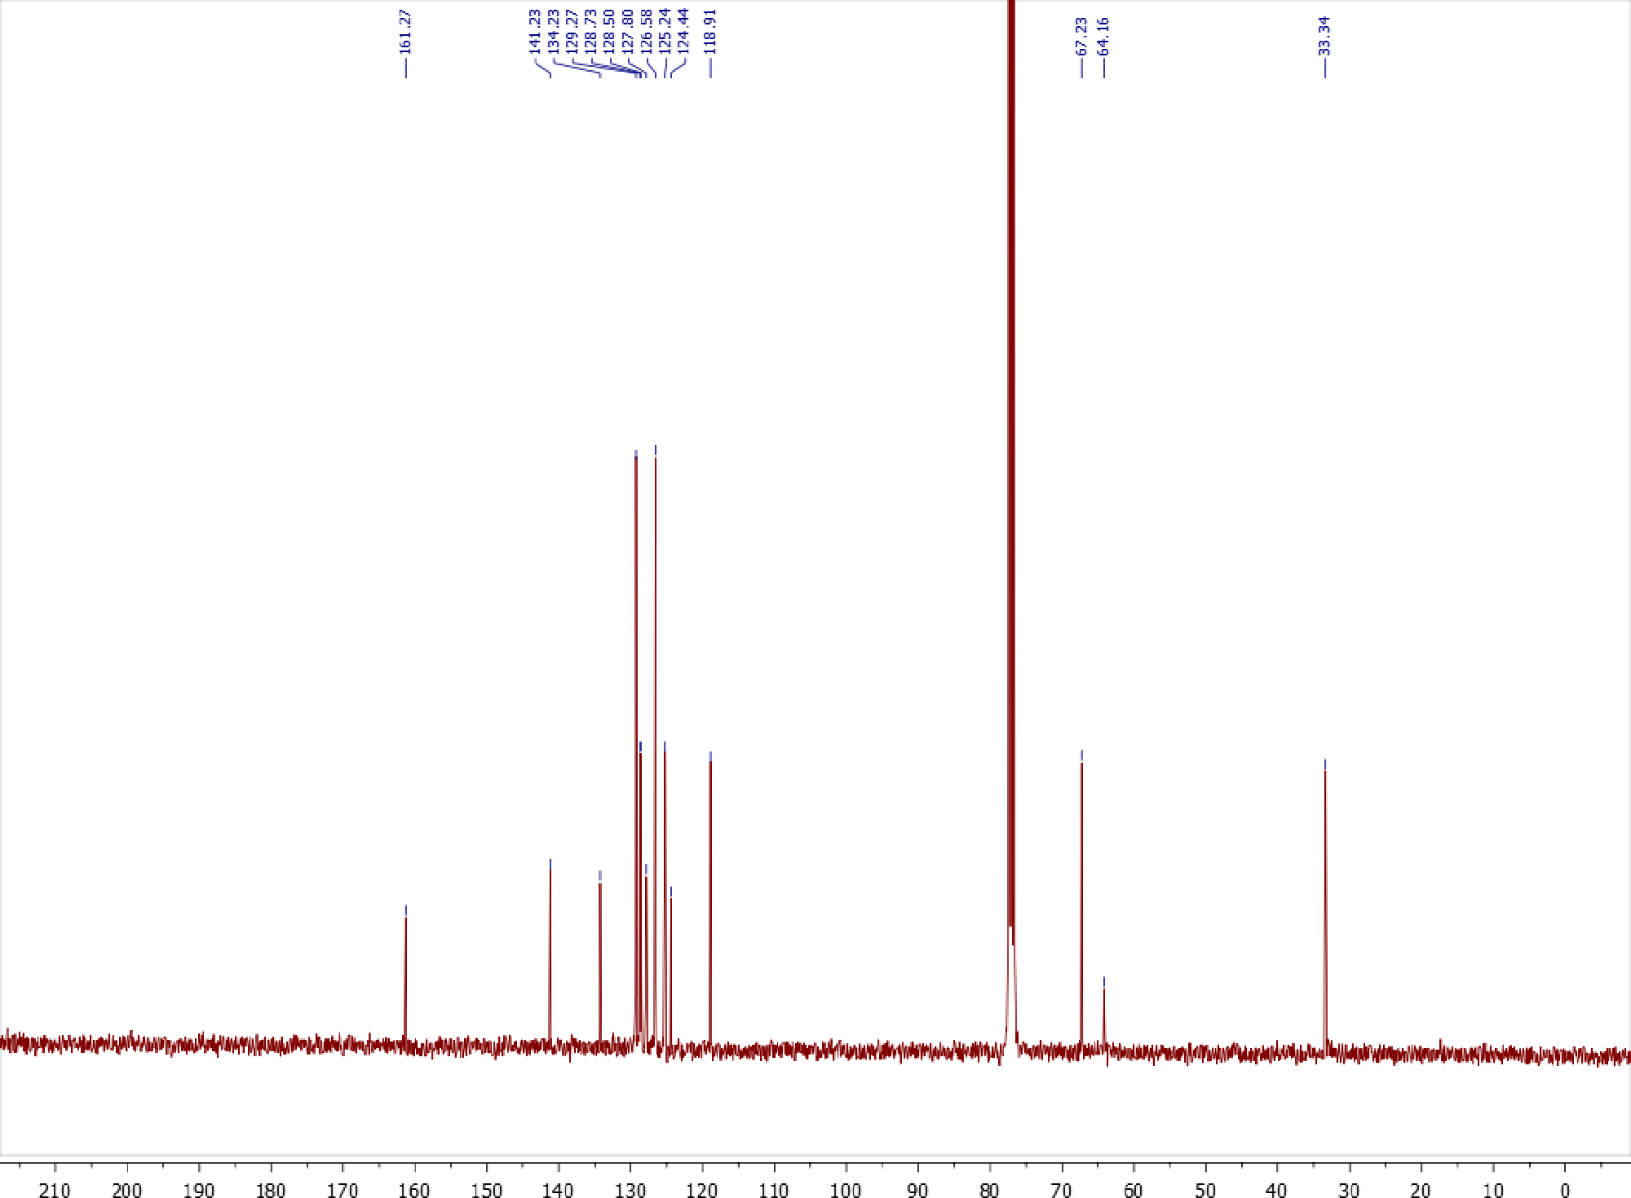
Copies of ¹H (400.13 MHz, CDCl₃) and ¹³C{¹H} (100.61 MHz, CDCl₃) spectra of 10i
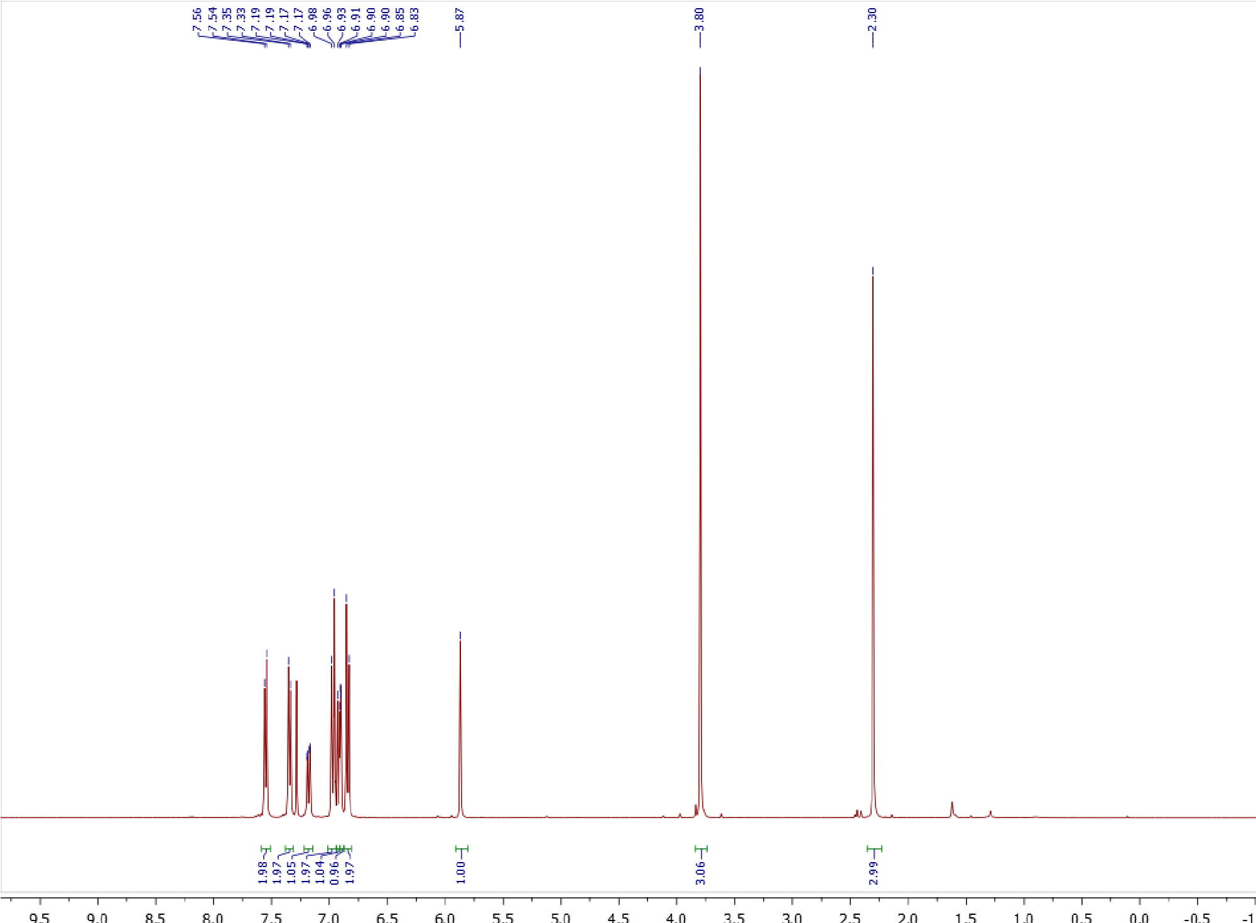
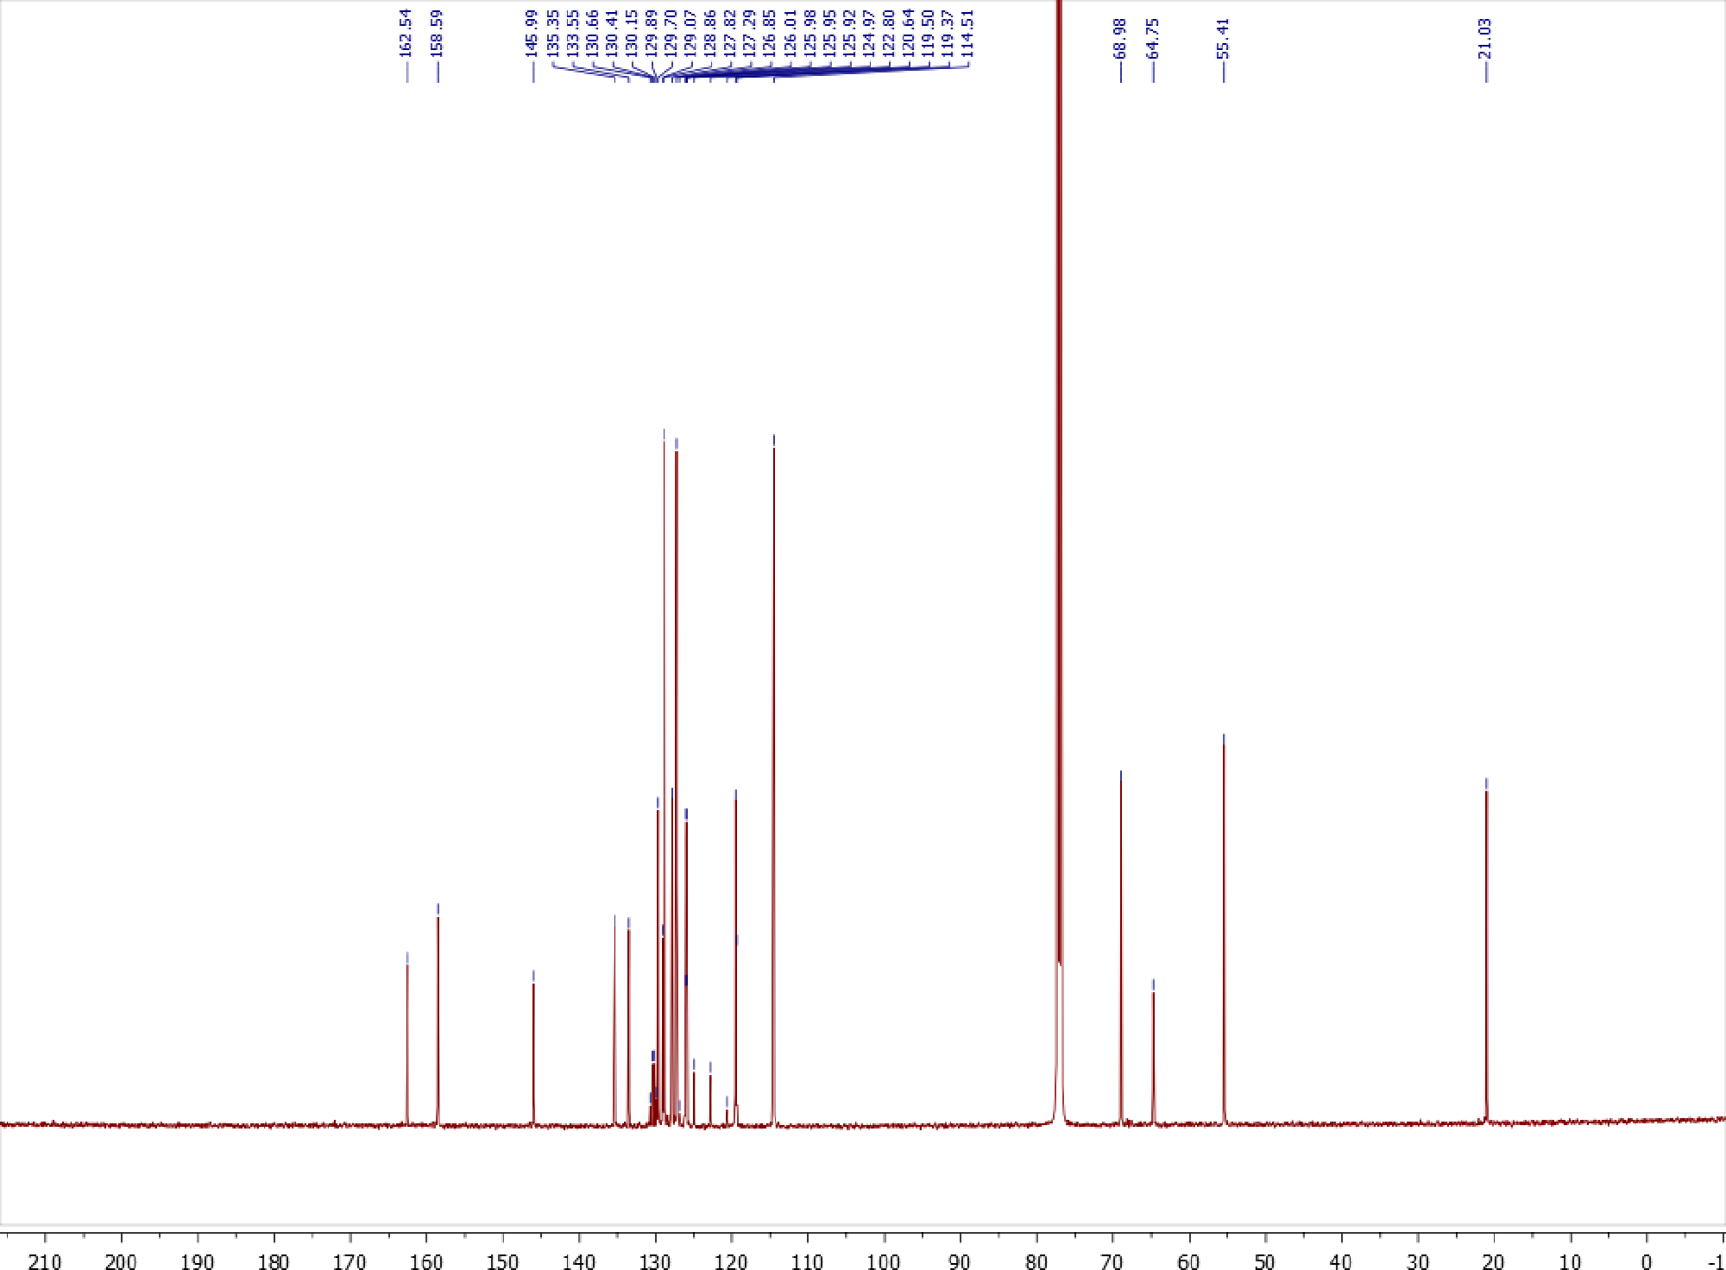
Copy of ¹⁹F{¹H} (376.50 MHz, CDCl₃) spectrum of 10i
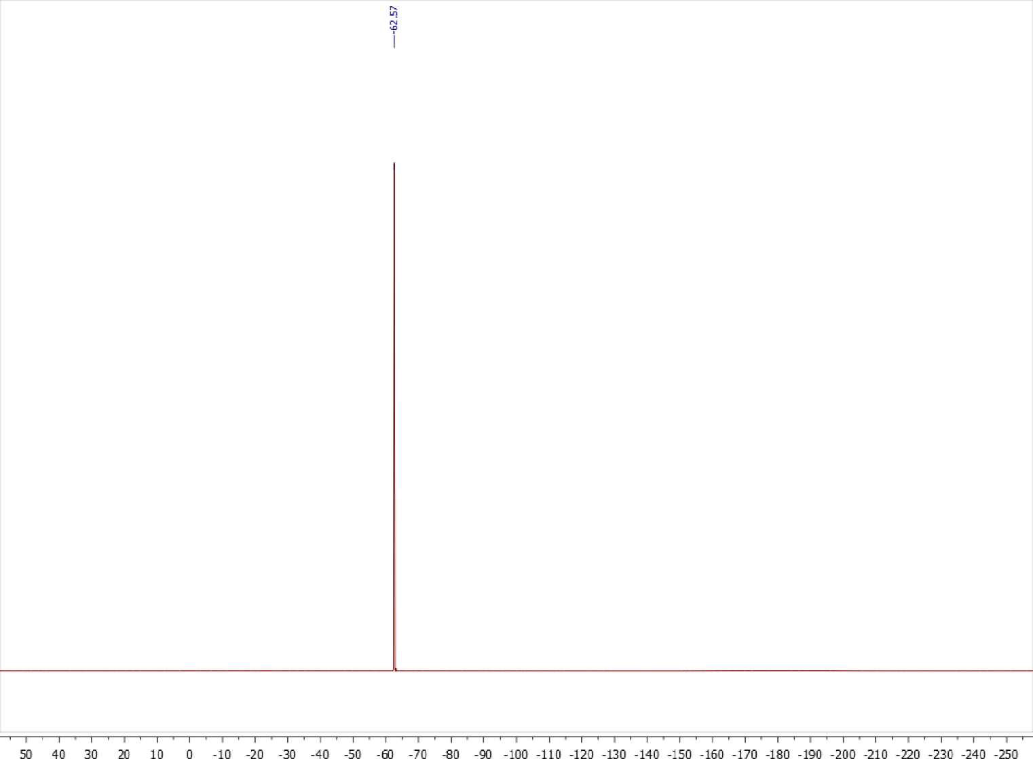
Copies of ¹H (400.13 MHz, CDCl₃) and ¹³C{¹H} (100.61 MHz, CDCl₃) spectra of 10j
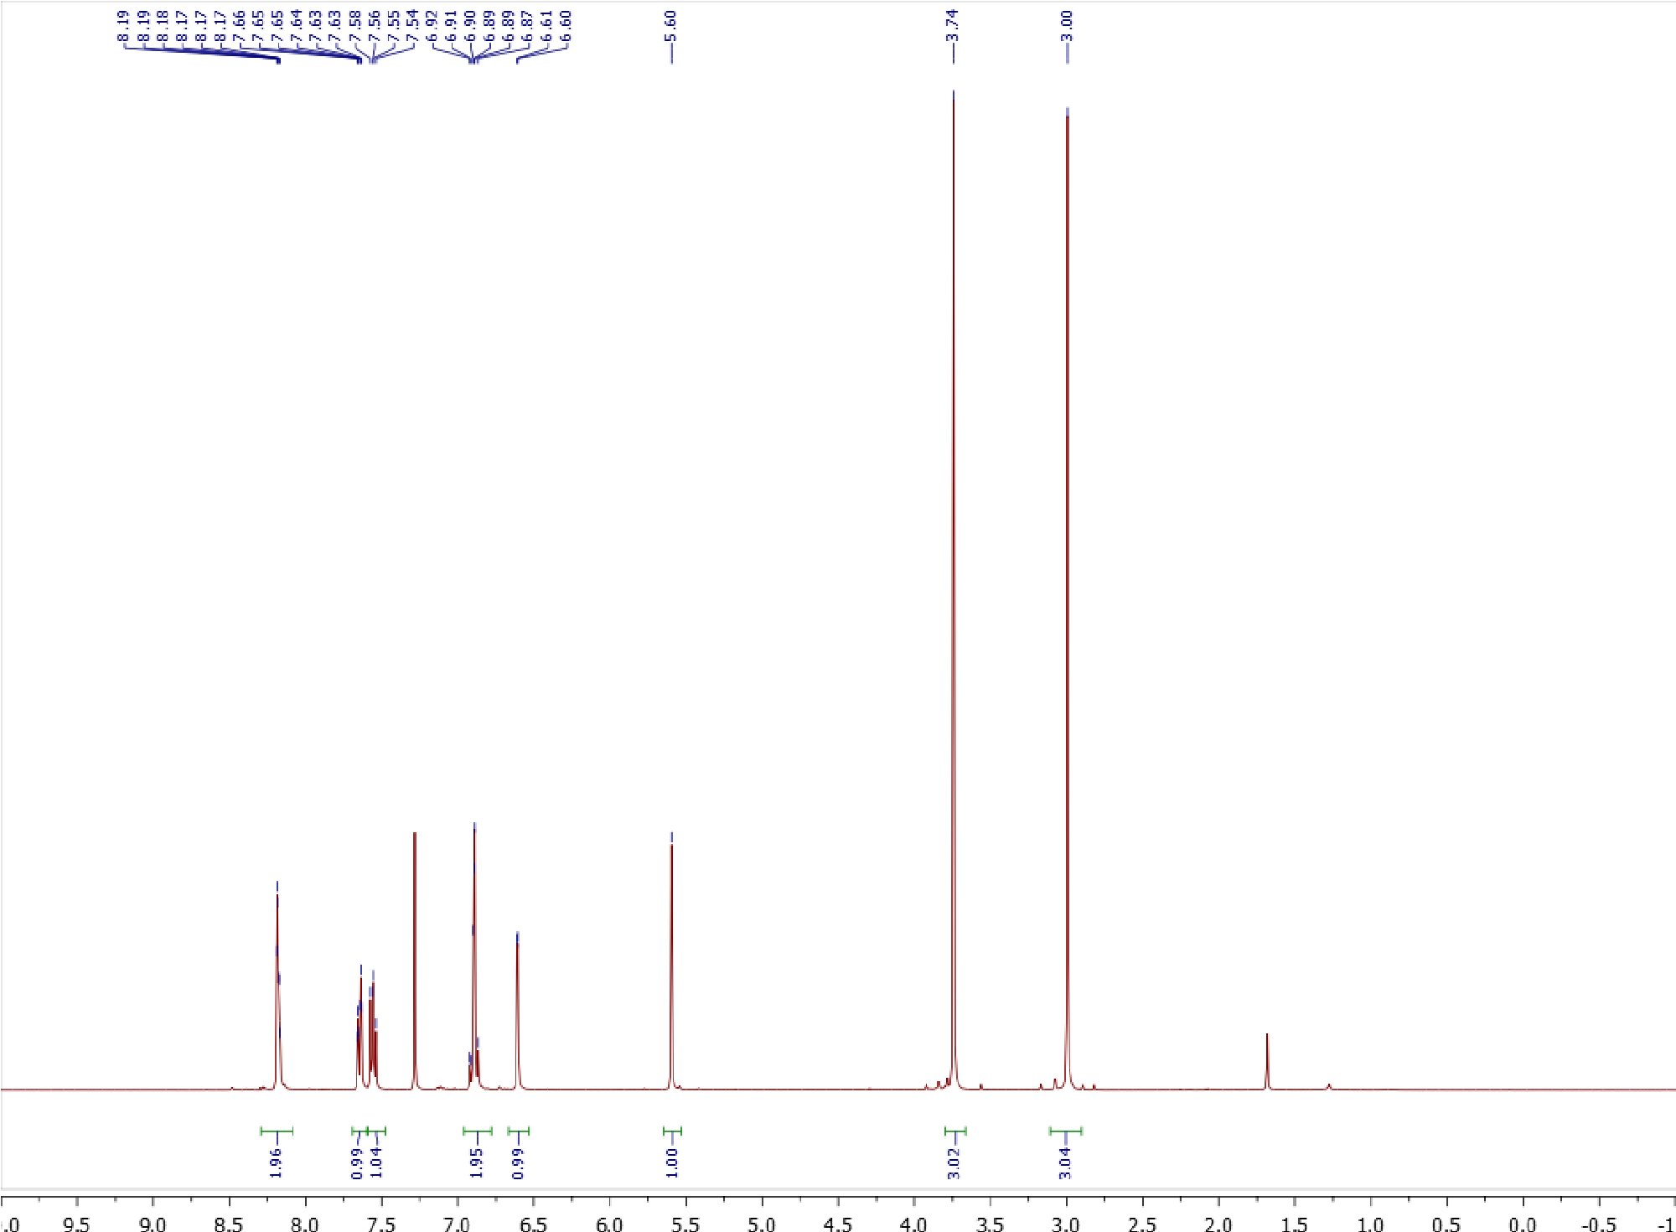
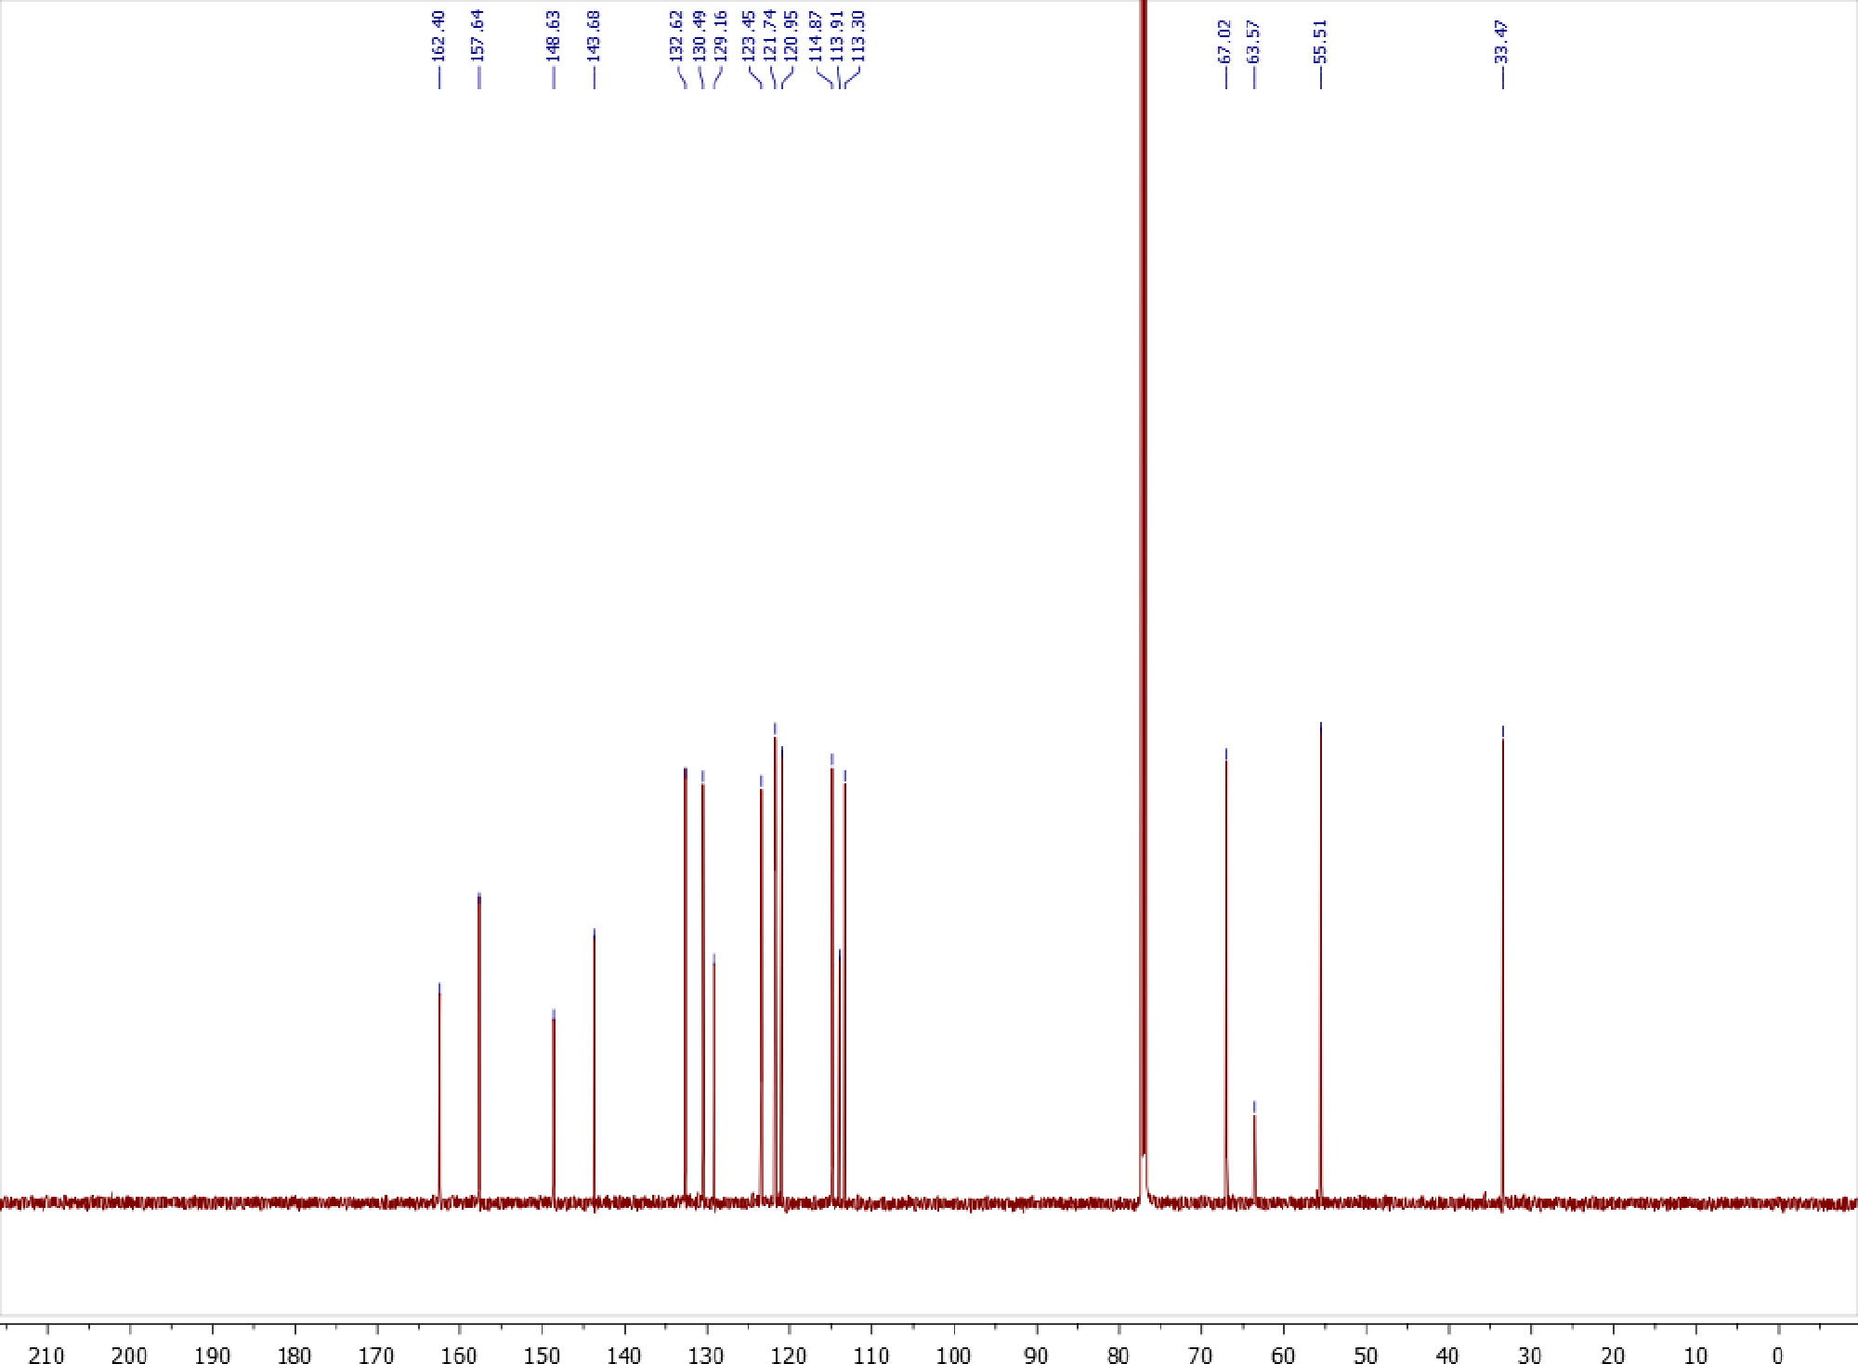
Copies of ¹H (400.13 MHz, CDCl₃) and ¹³C{¹H} (100.61 MHz, CDCl₃) spectra of 10k
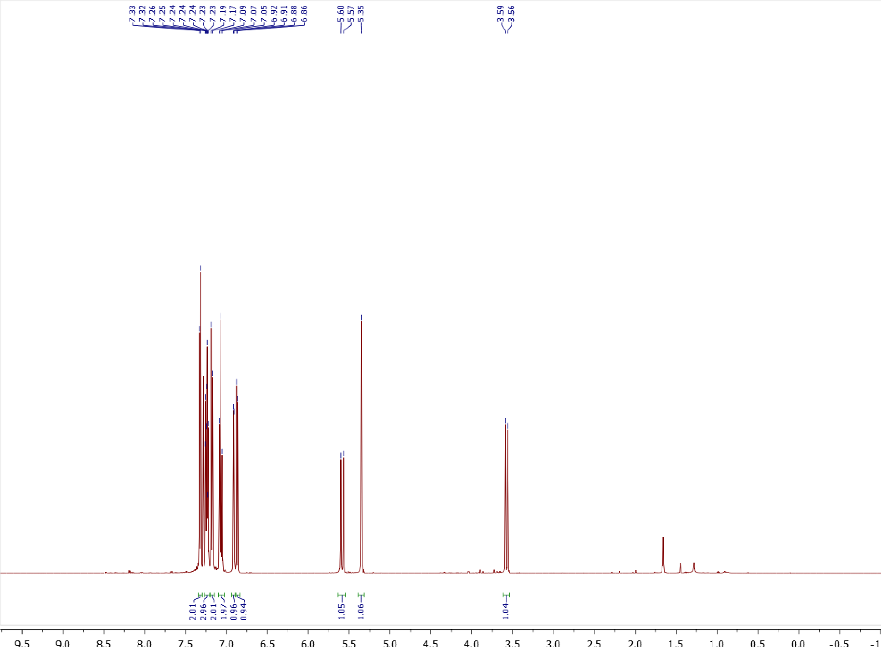
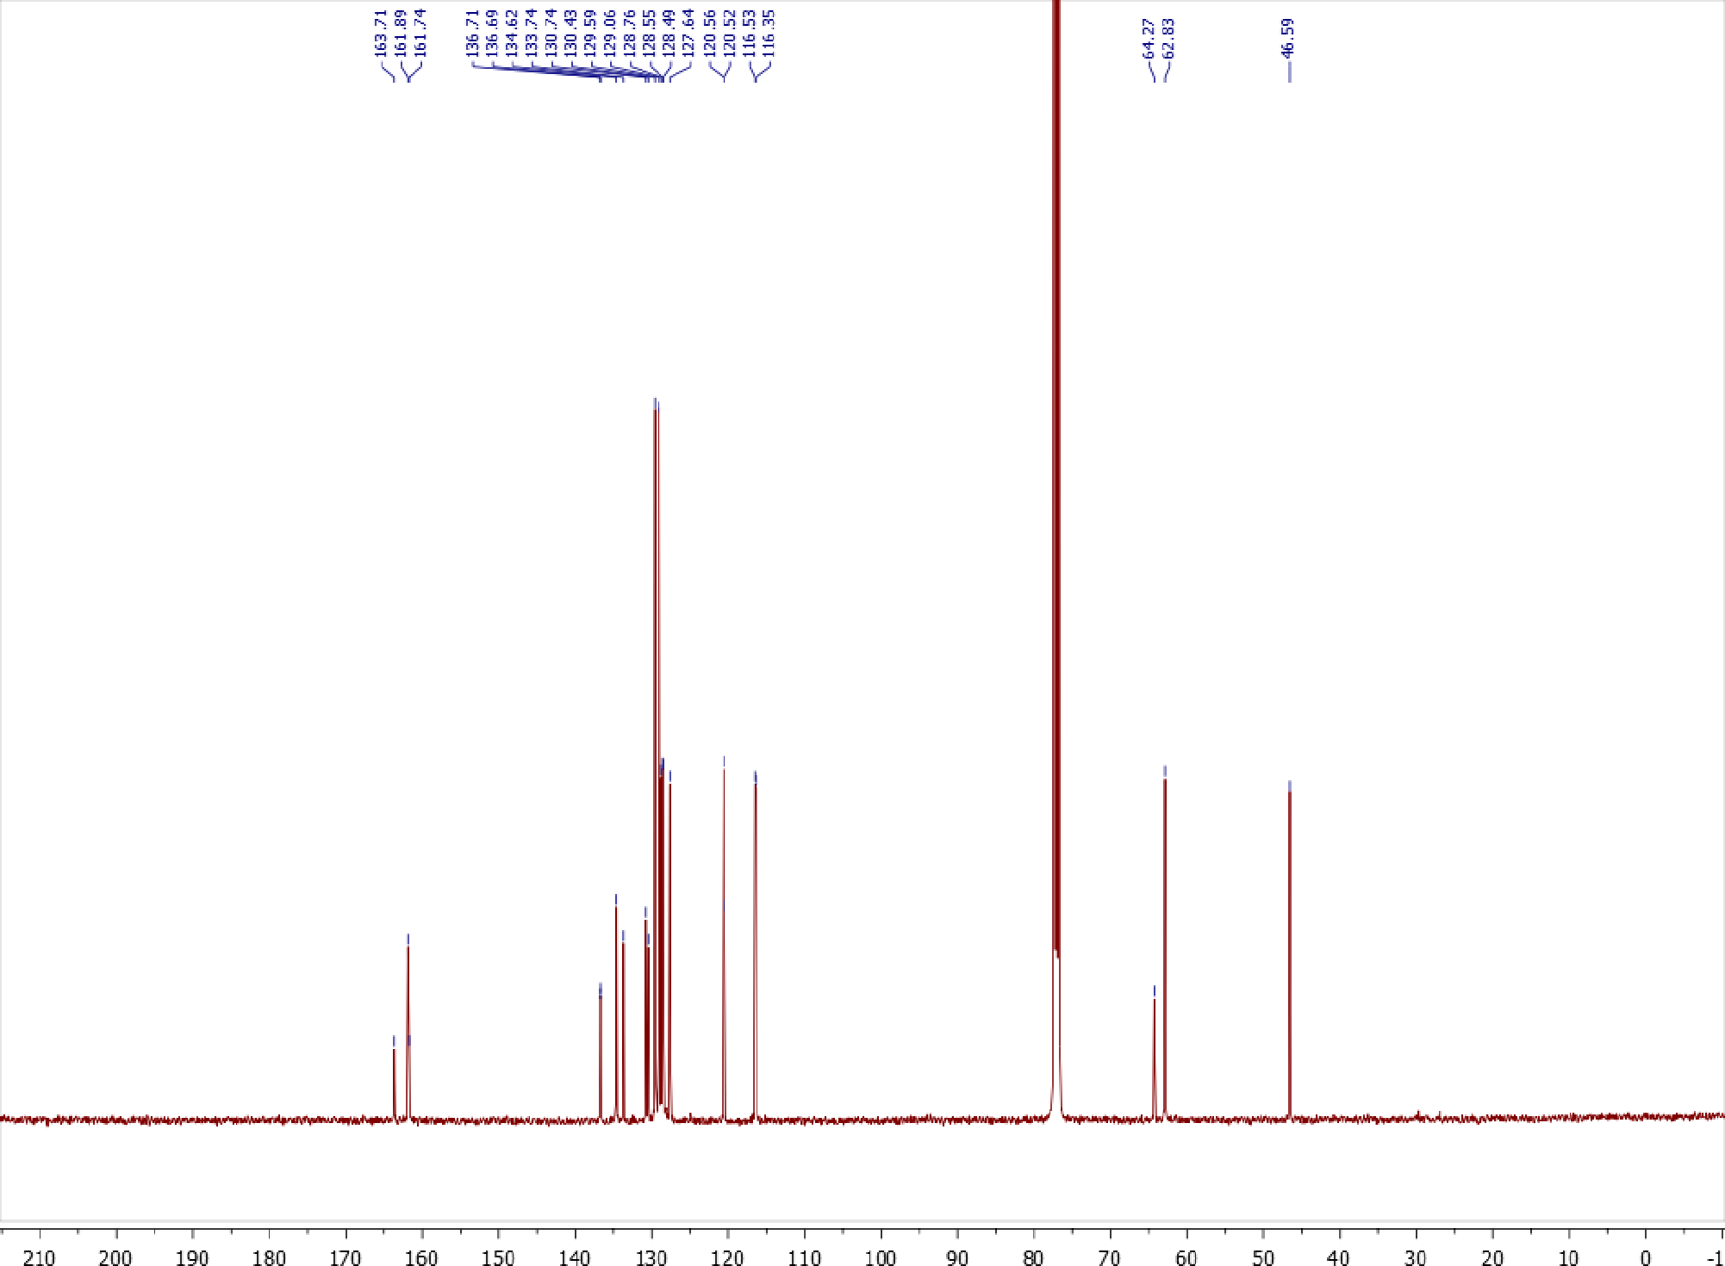
Copy of ¹⁹F{¹H} (376.50 MHz, CDCl₃) spectrum of 10k
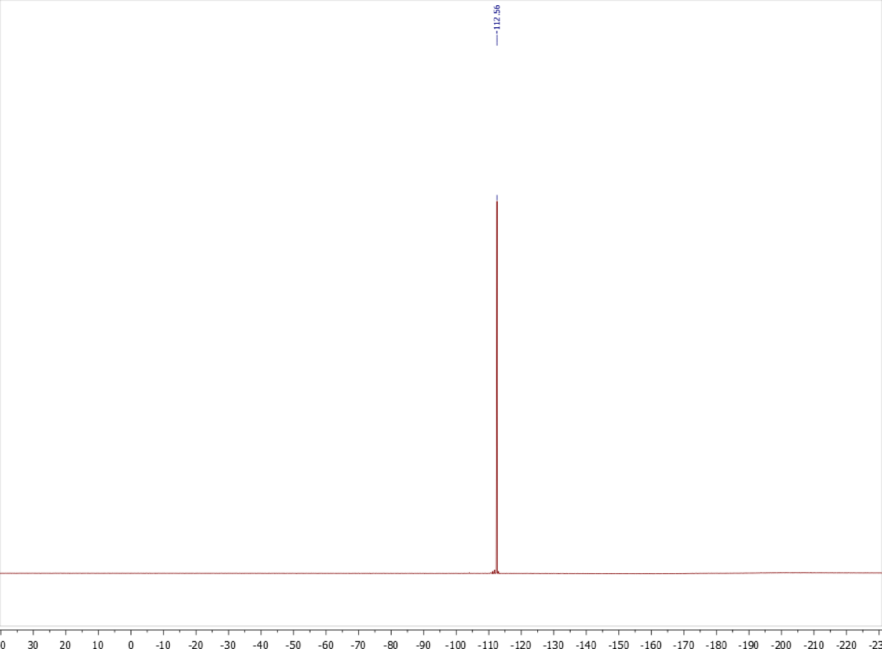
Copies of ¹H (400.13 MHz, CDCl₃) and ¹³C{¹H} (100.61 MHz, CDCl₃) spectra of 10l
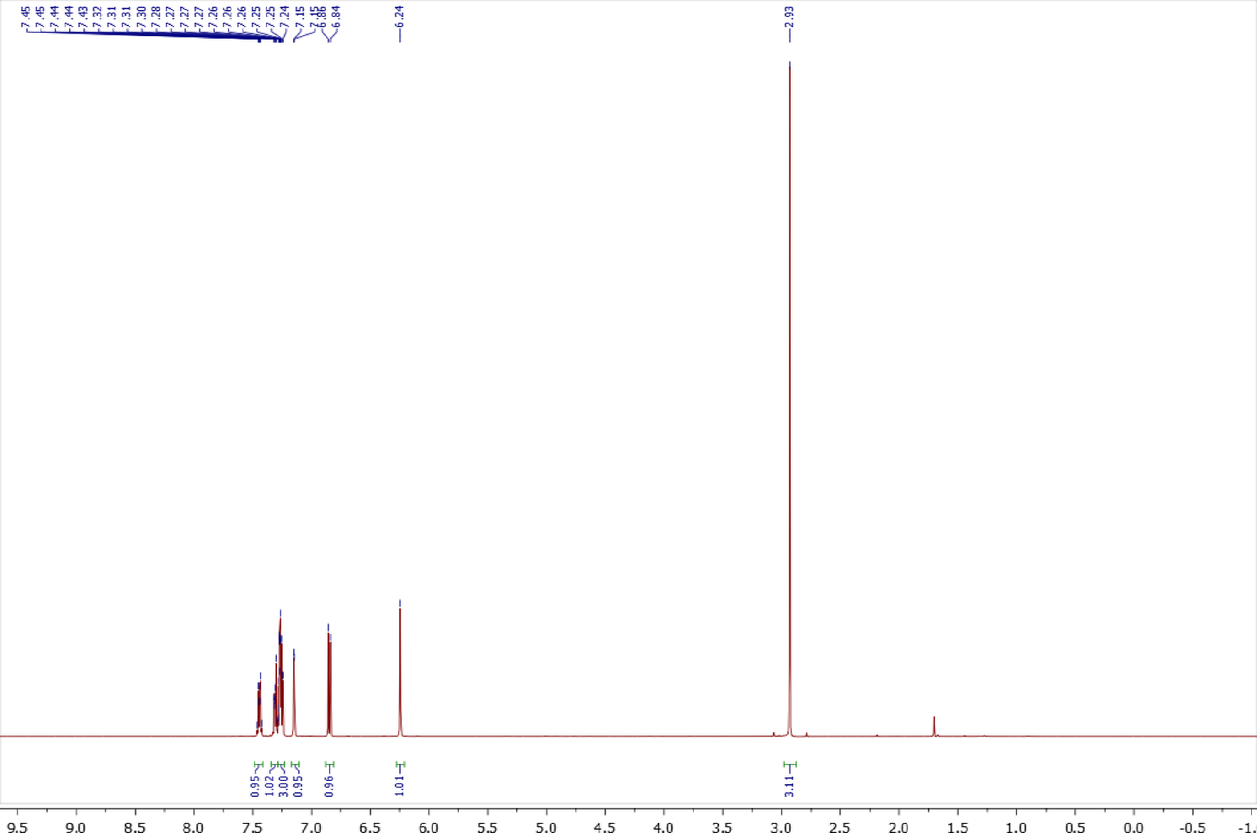
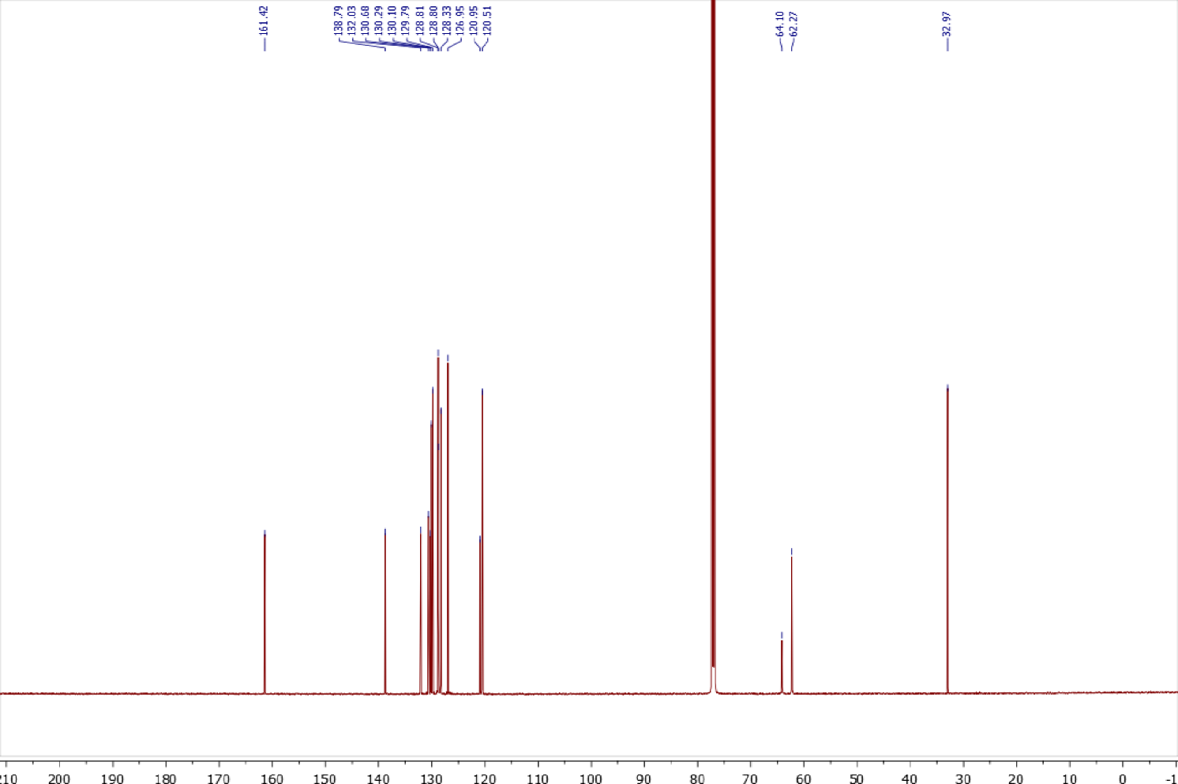
Copies of ¹H (400.13 MHz, CDCl₃) and ¹³C{¹H} (100.61 MHz, CDCl₃) spectra of 10m
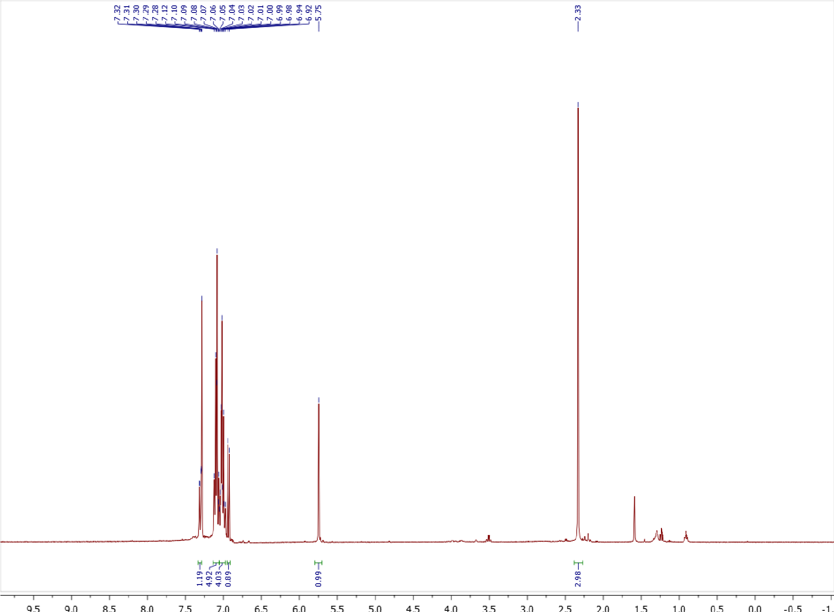
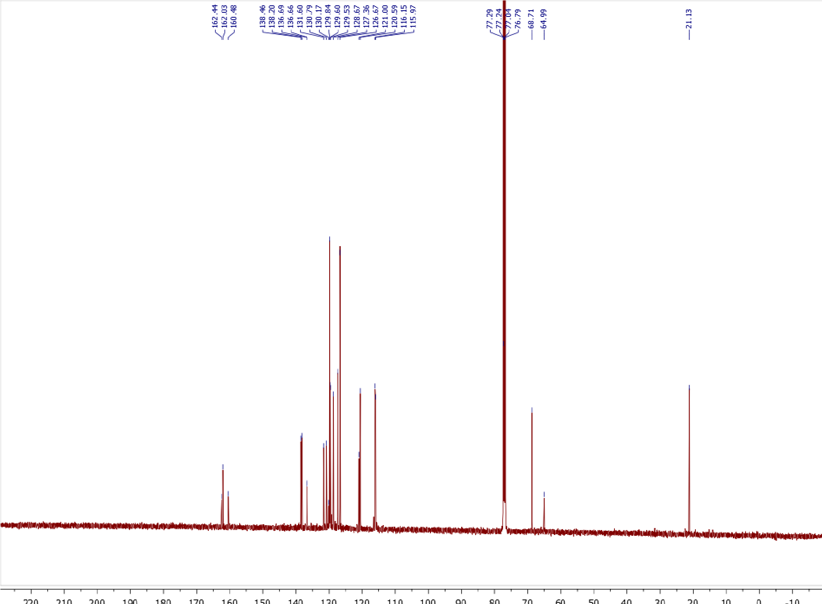
Copy of ¹⁹F{¹H} (376.50 MHz, CDCl₃) spectrum of 10m
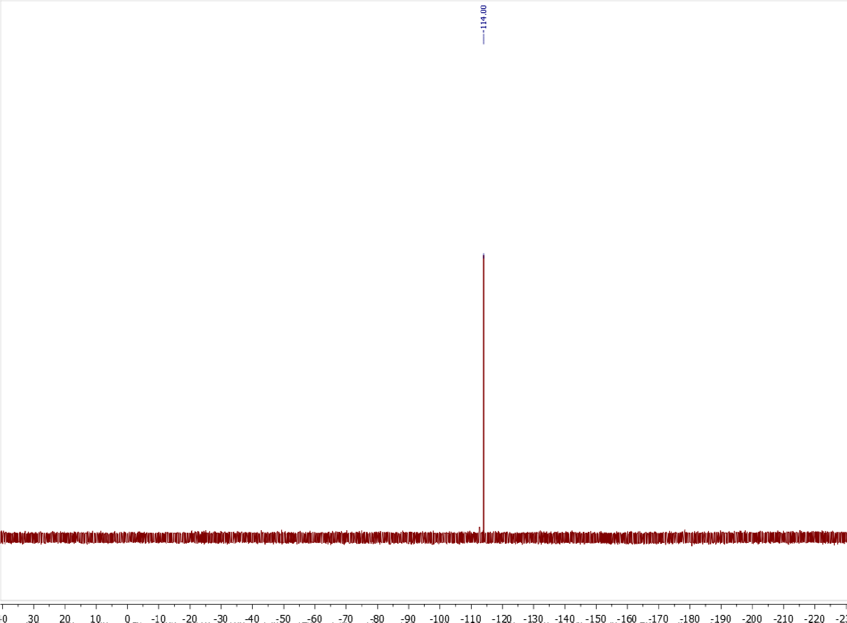
Copies of ¹H (400.13 MHz, CDCl₃) and ¹³C{¹H} (100.61 MHz, CDCl₃) spectra of 10n
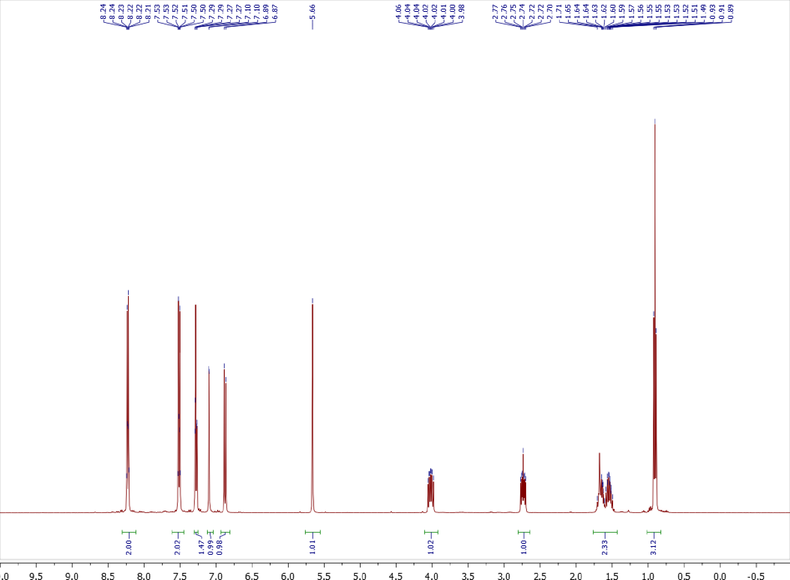
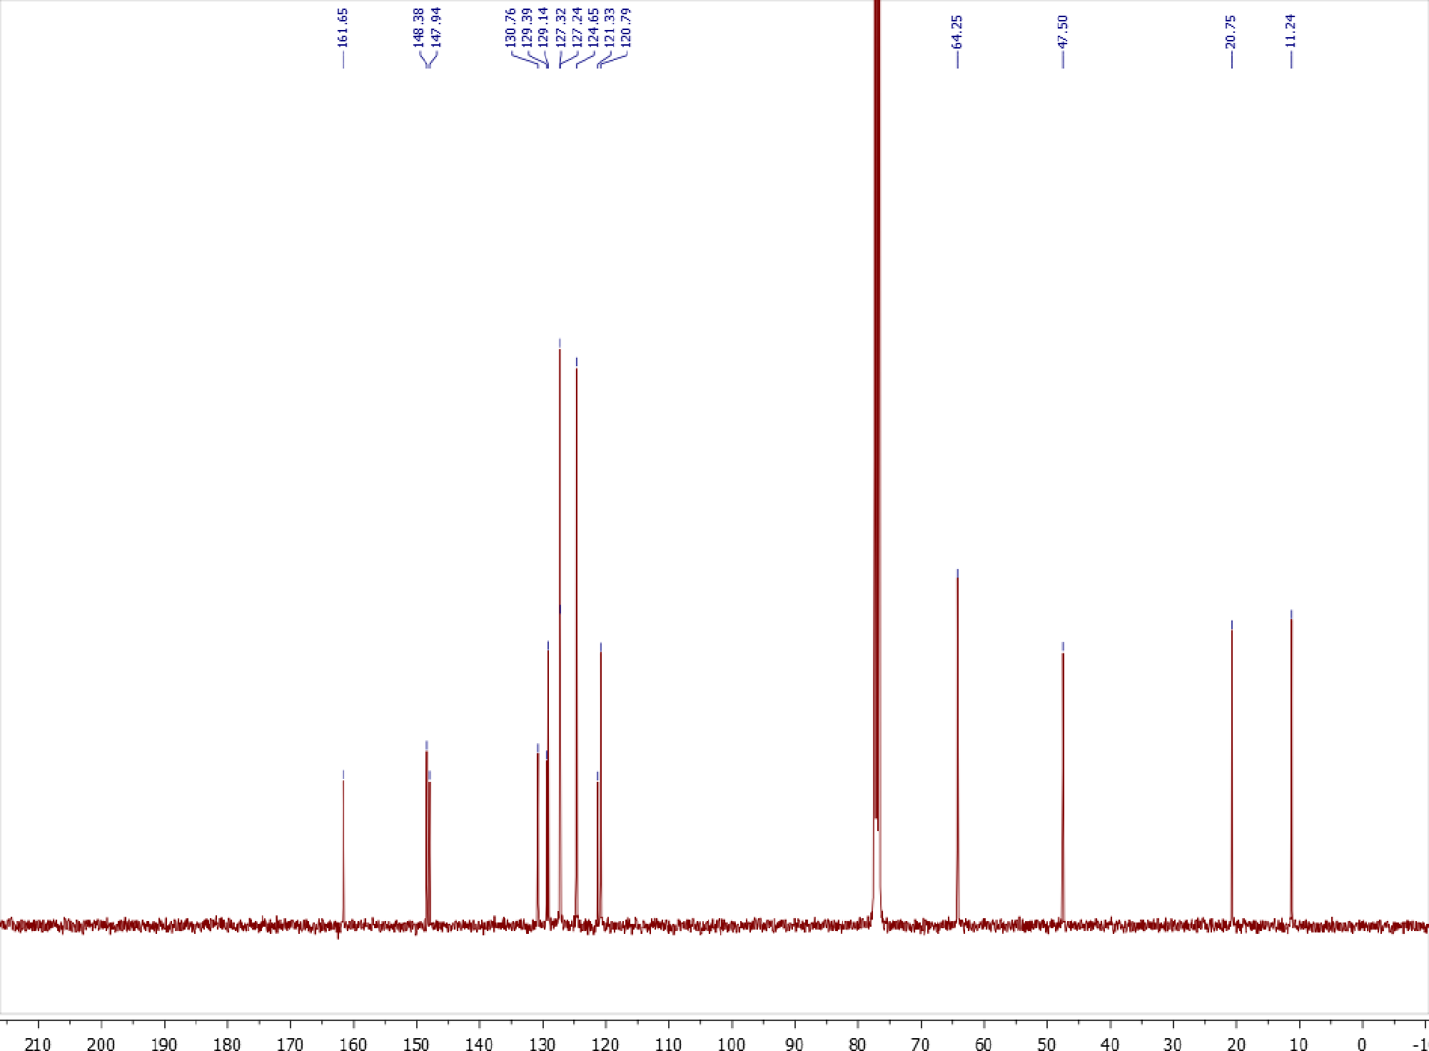
Copies of ¹H (400.13 MHz, CDCl₃) and ¹³C{¹H} (100.61 MHz, CDCl₃) spectra of 10o
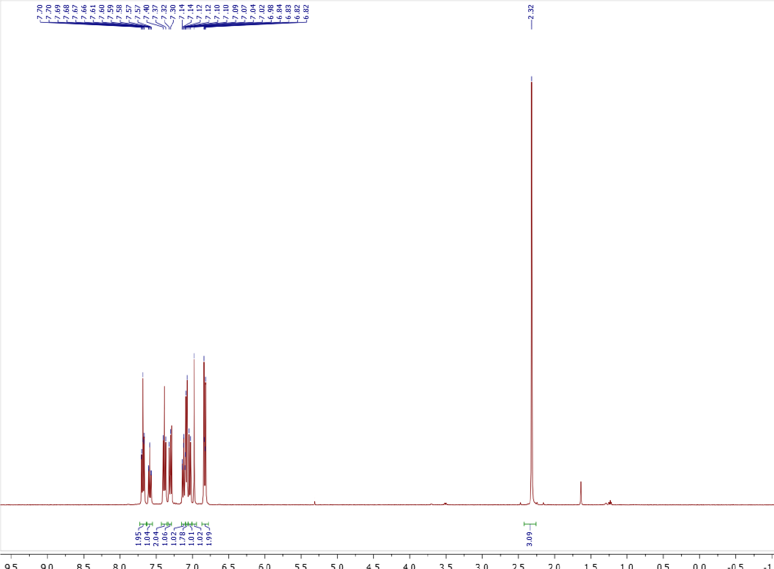
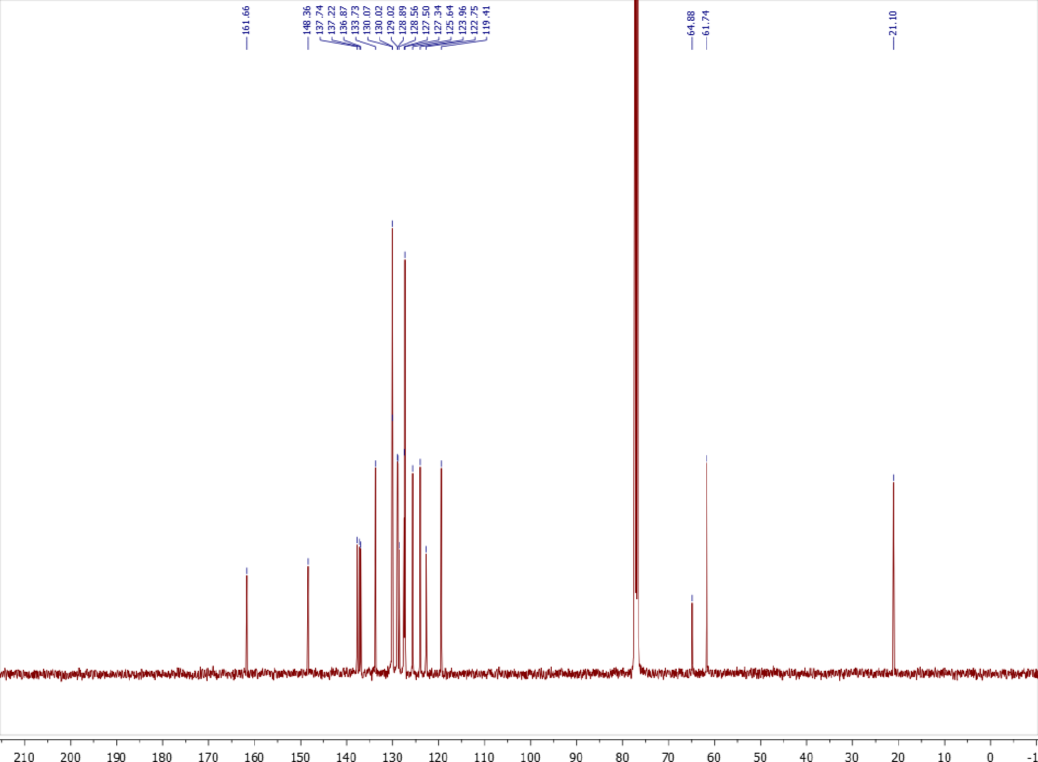
Copies of ¹H (400.13 MHz, CDCl₃) and ¹³C{¹H} (100.61 MHz, CDCl₃) spectra of 10p
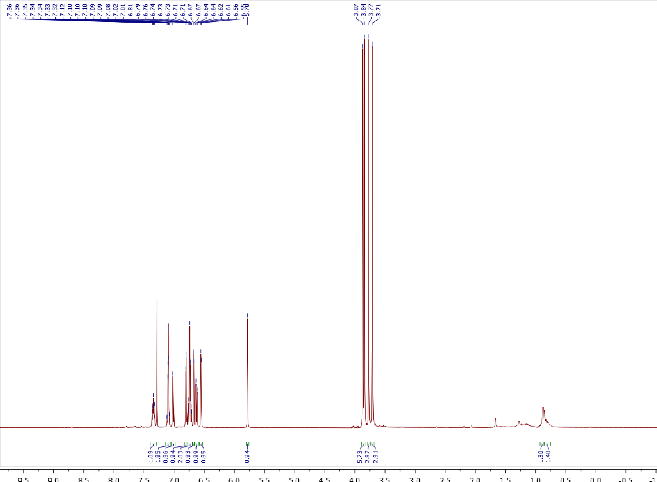
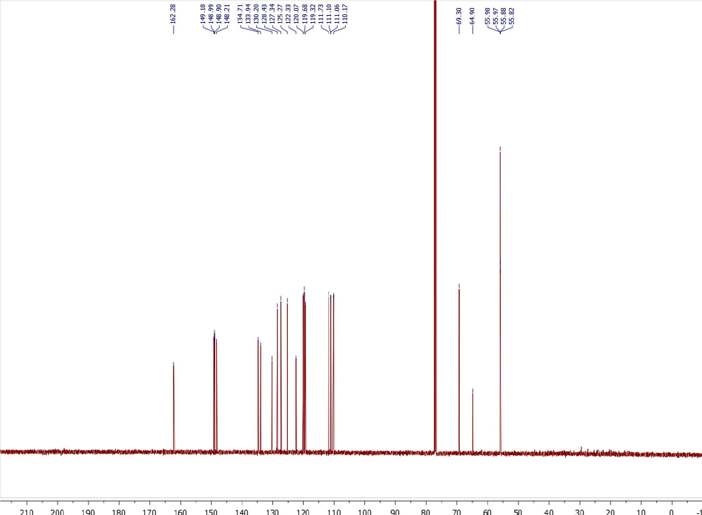
Copies of ¹H (400.13 MHz, CDCl₃) and ¹³C{¹H} (100.61 MHz, CDCl₃) spectra of 10q
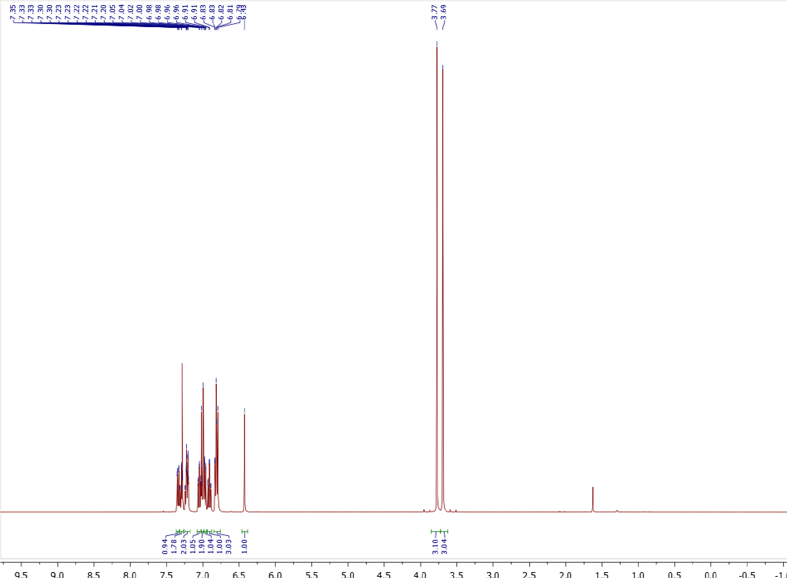
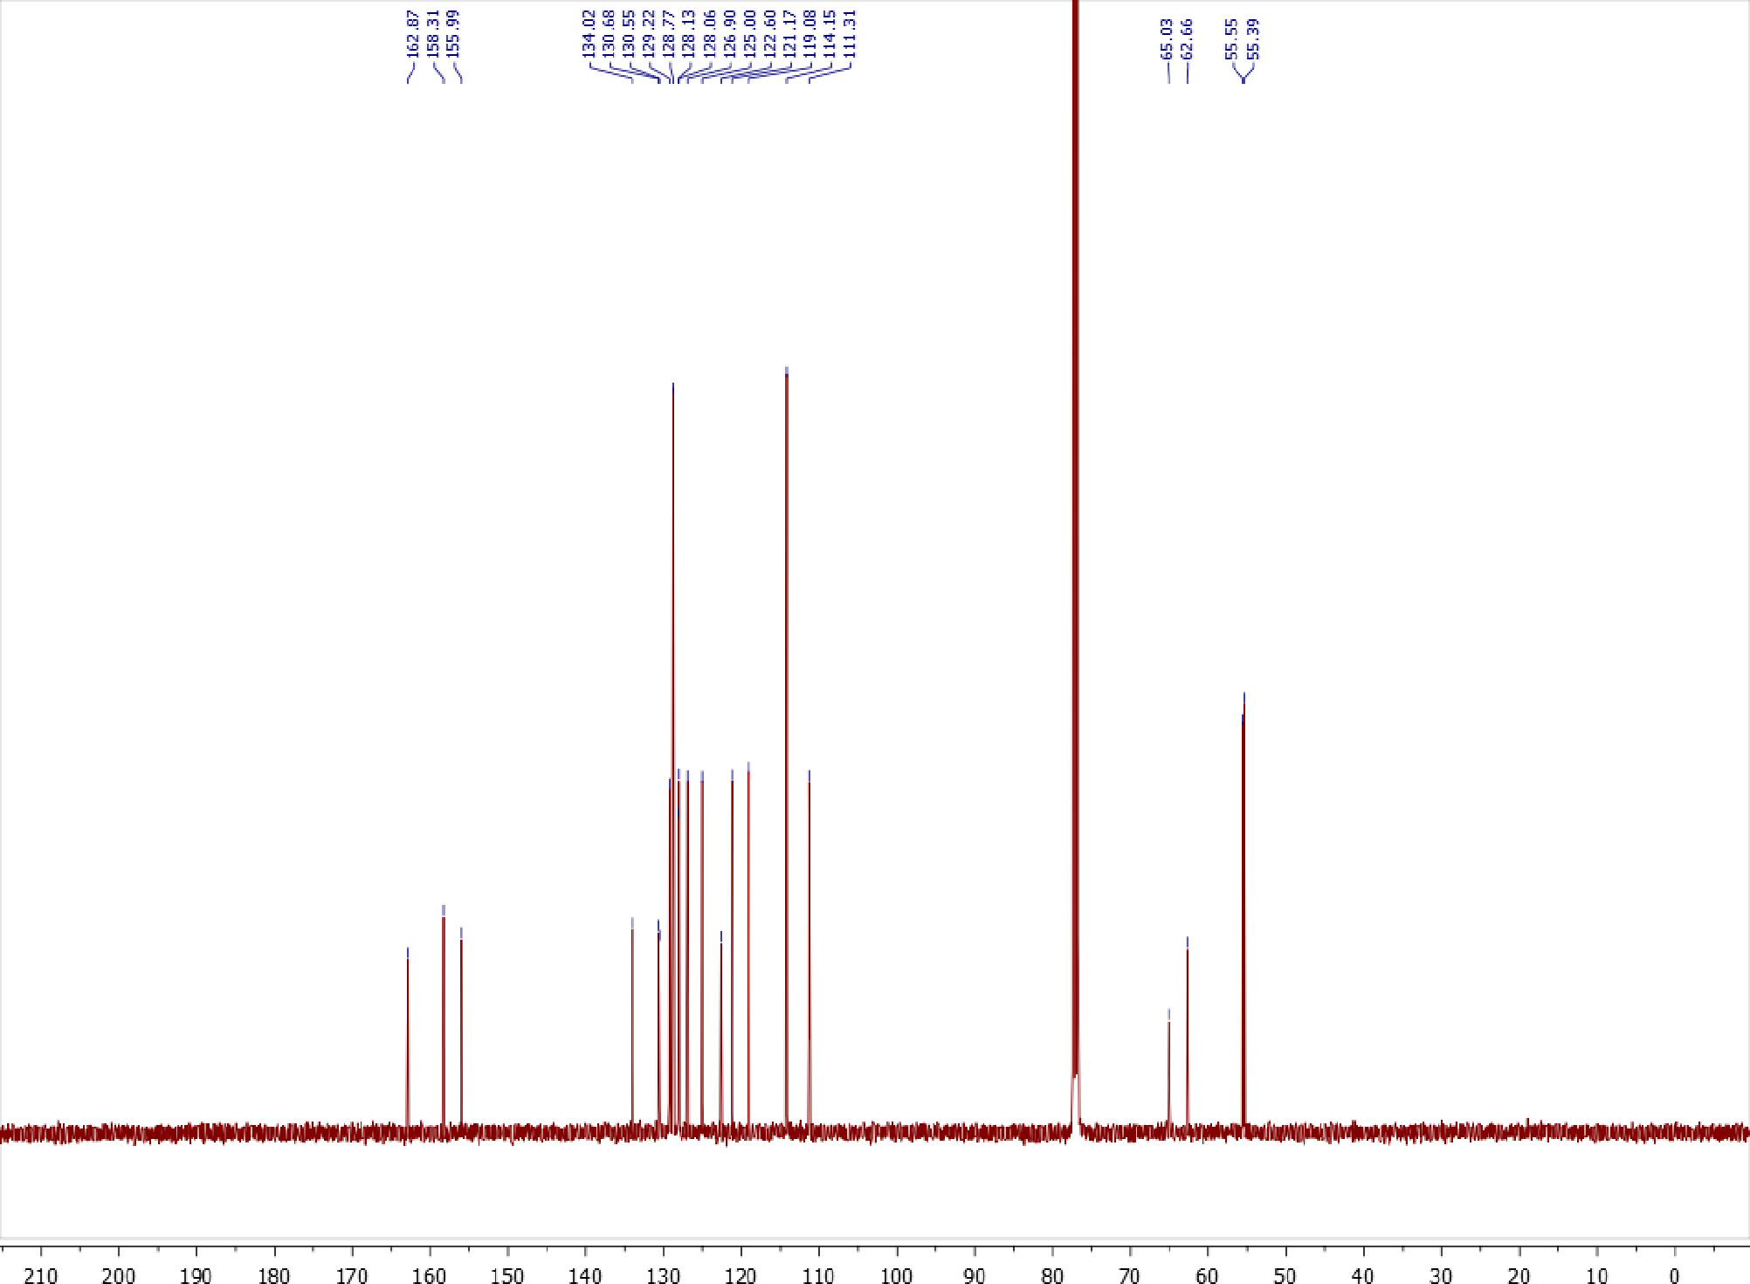
Copies of ¹H (400.13 MHz, CDCl₃) and ¹³C{¹H} (100.61 MHz, CDCl₃) spectra of 10r
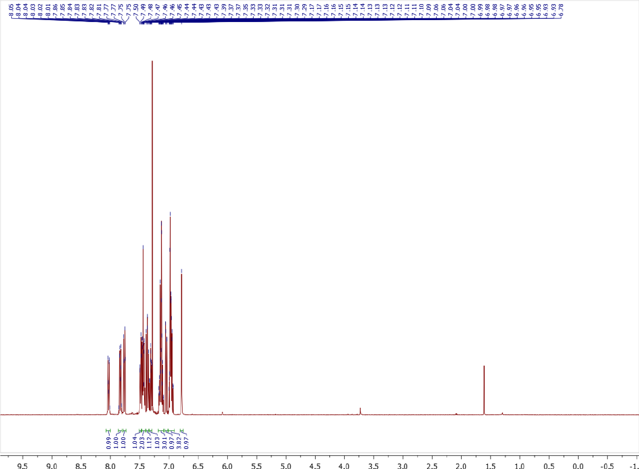
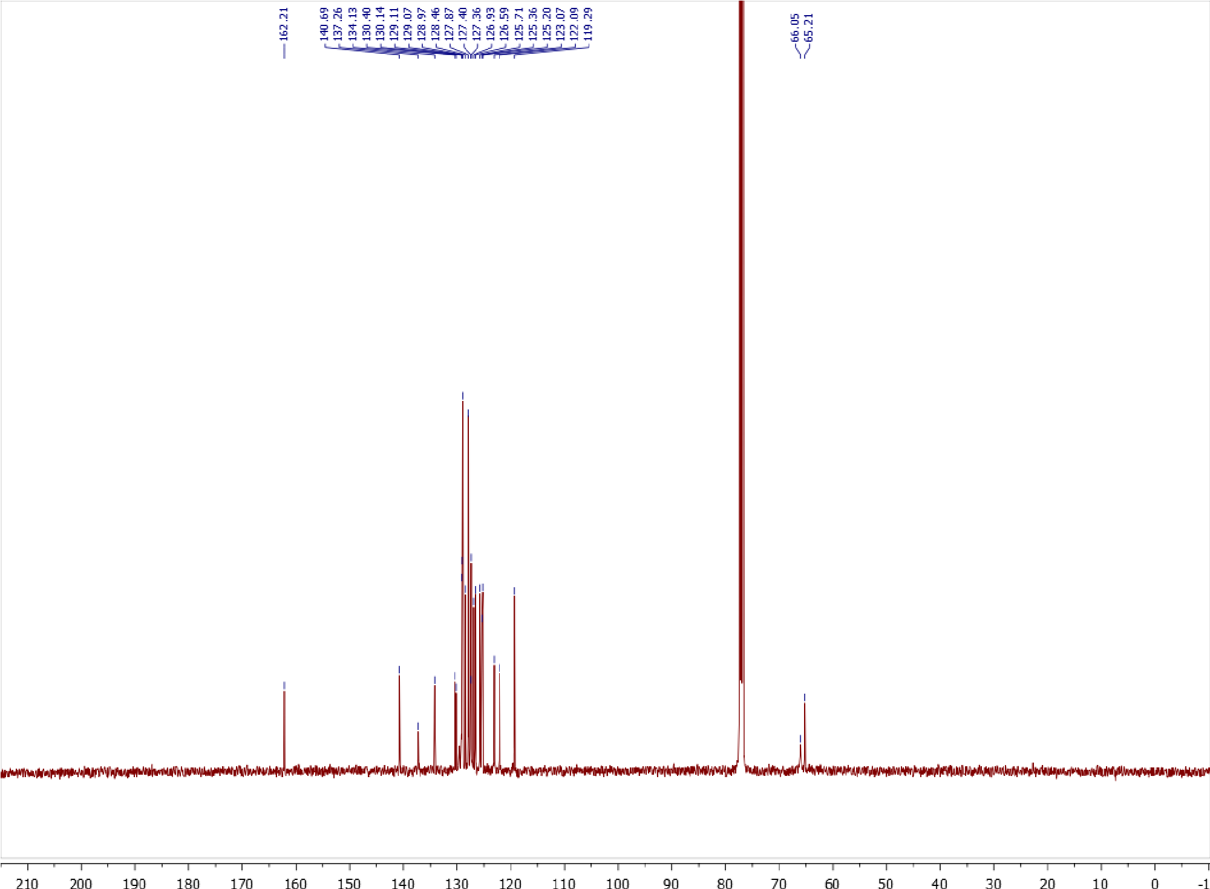
Copies of ¹H (400.13 MHz, CDCl₃) and ¹³C{¹H} (100.61 MHz, CDCl₃) spectra of 10s
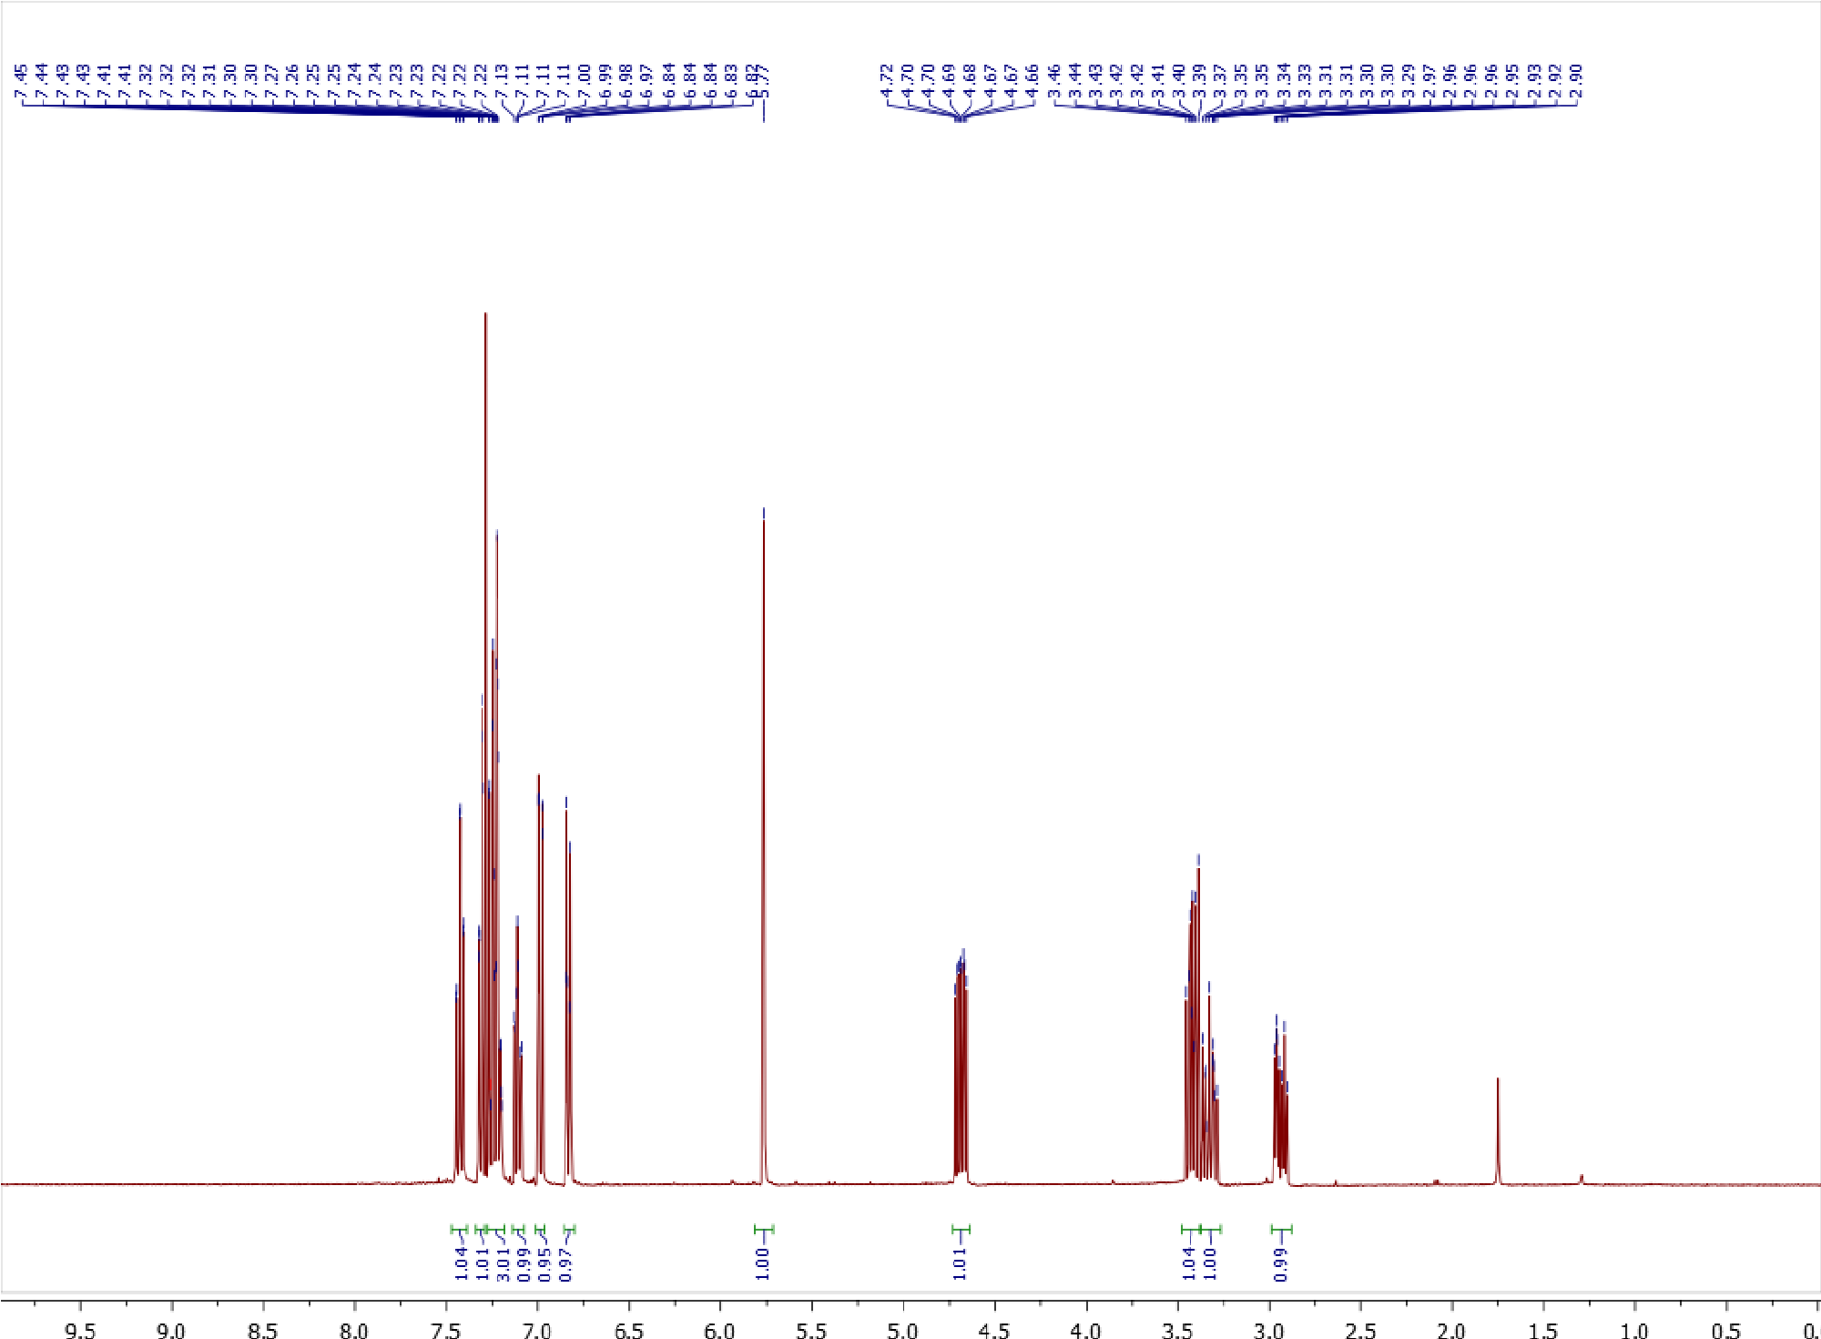
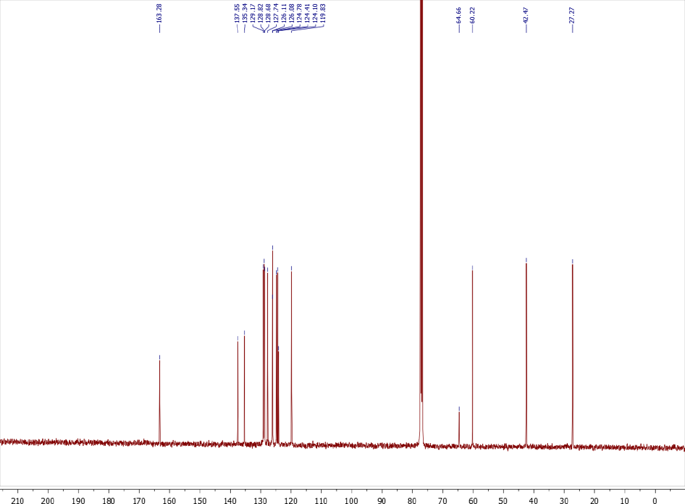
Copies of ¹H (400.13 MHz, CDCl₃) and ¹³C{¹H} (100.61 MHz, CDCl₃) spectra of 9a
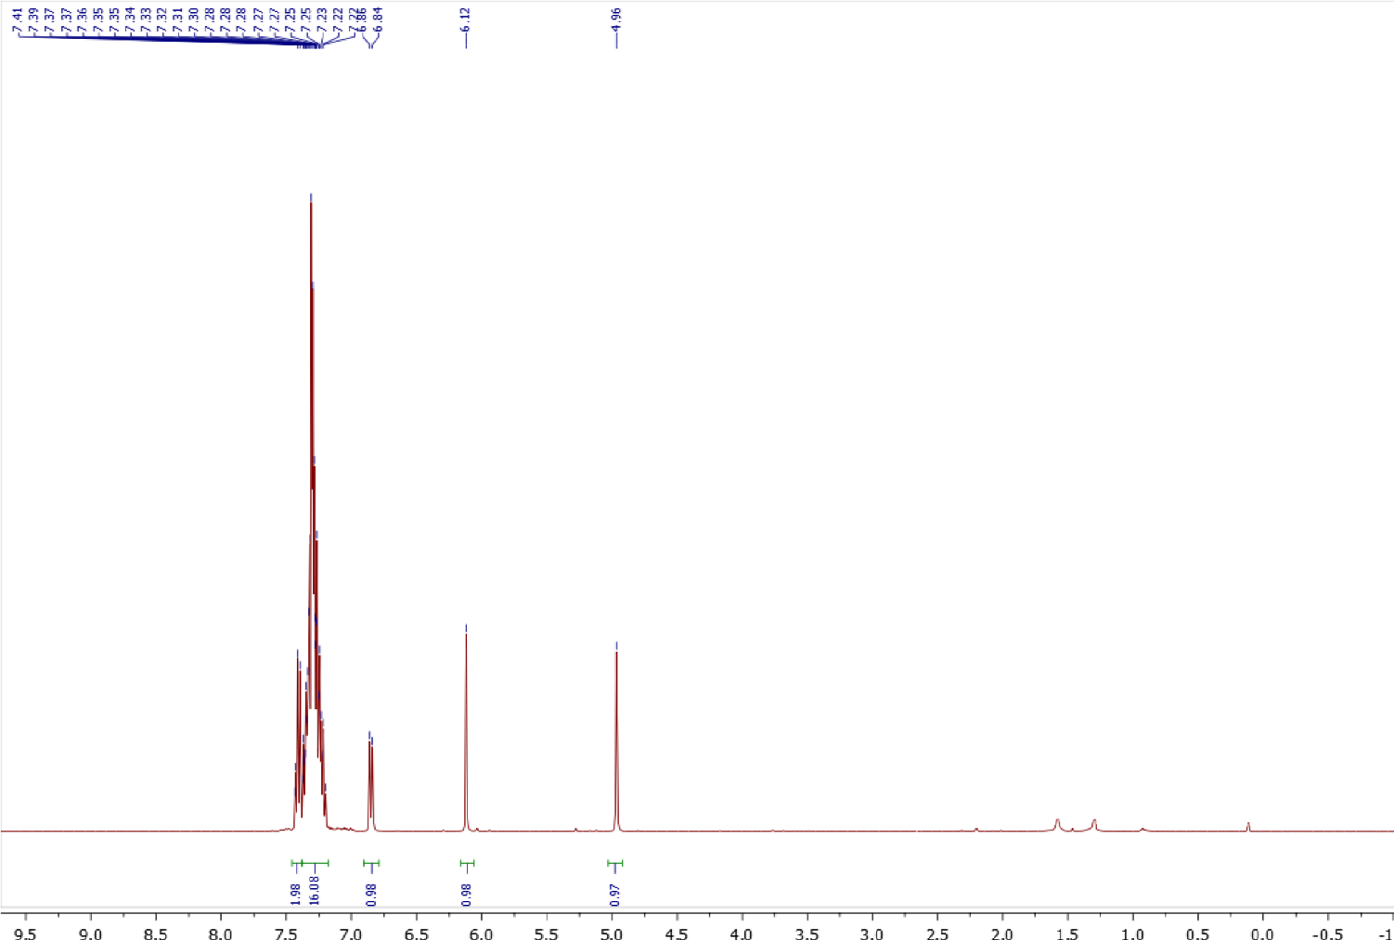
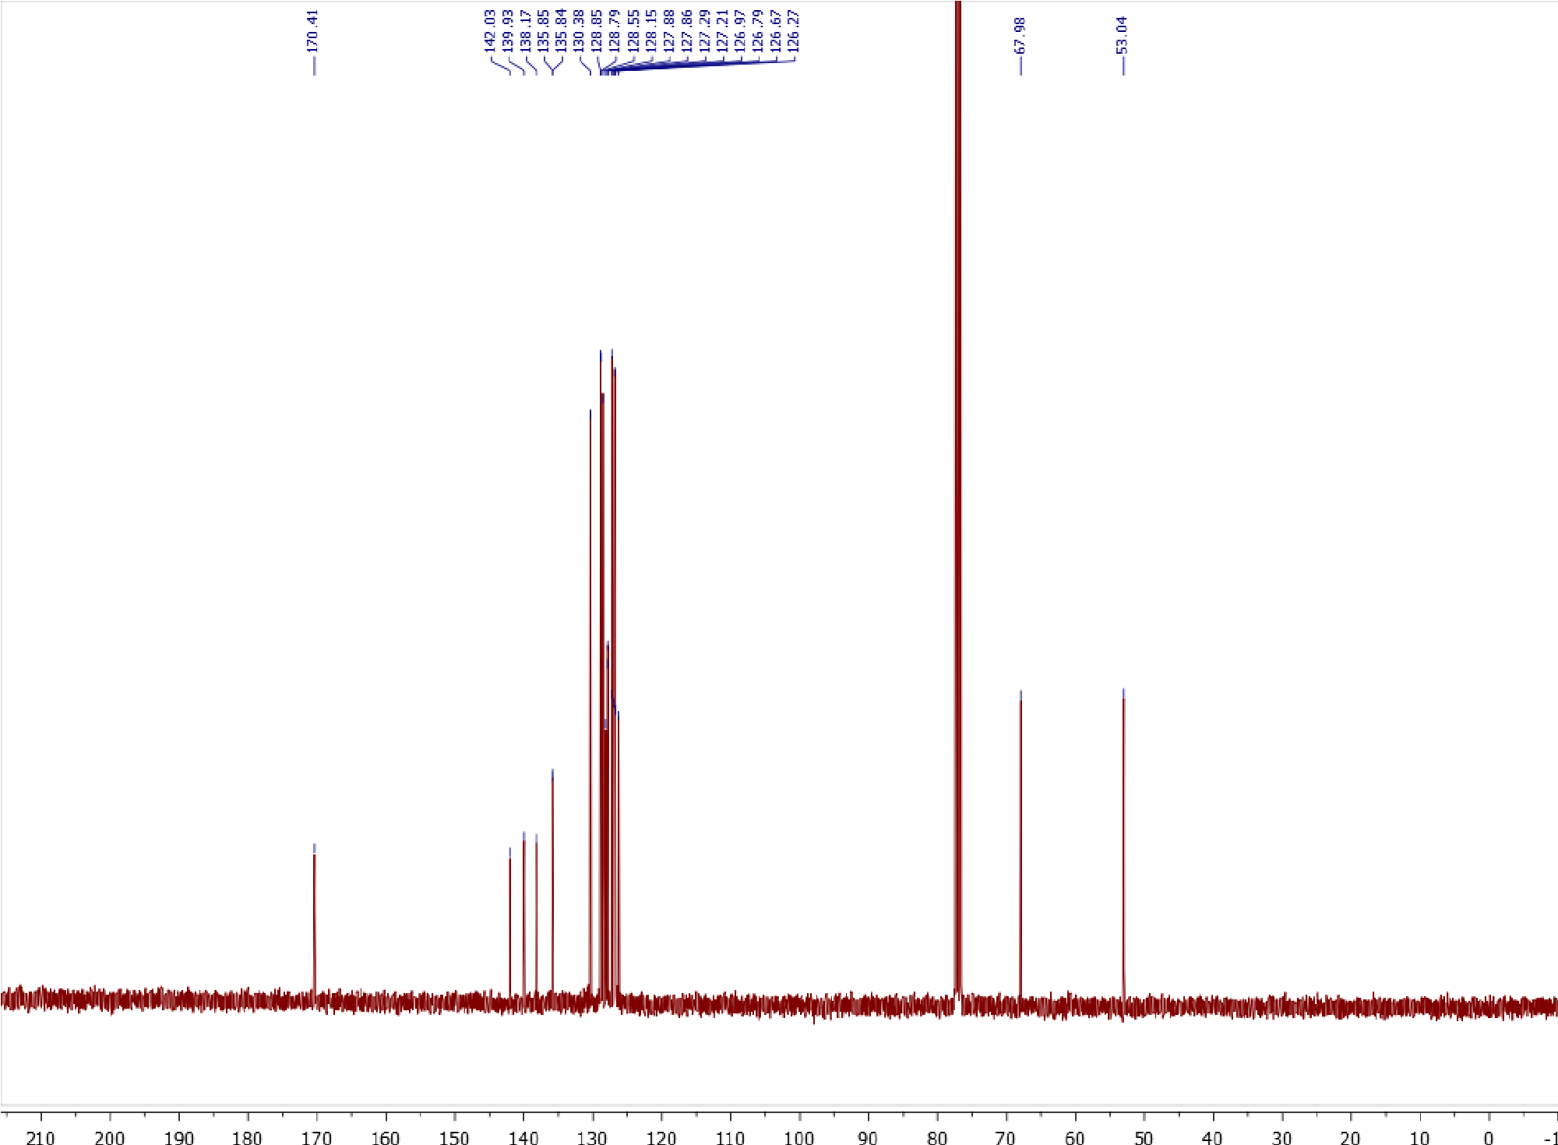
Copies of ¹H (400.13 MHz, CDCl₃) and ¹³C{¹H} (100.61 MHz, CDCl₃) spectra of 15a
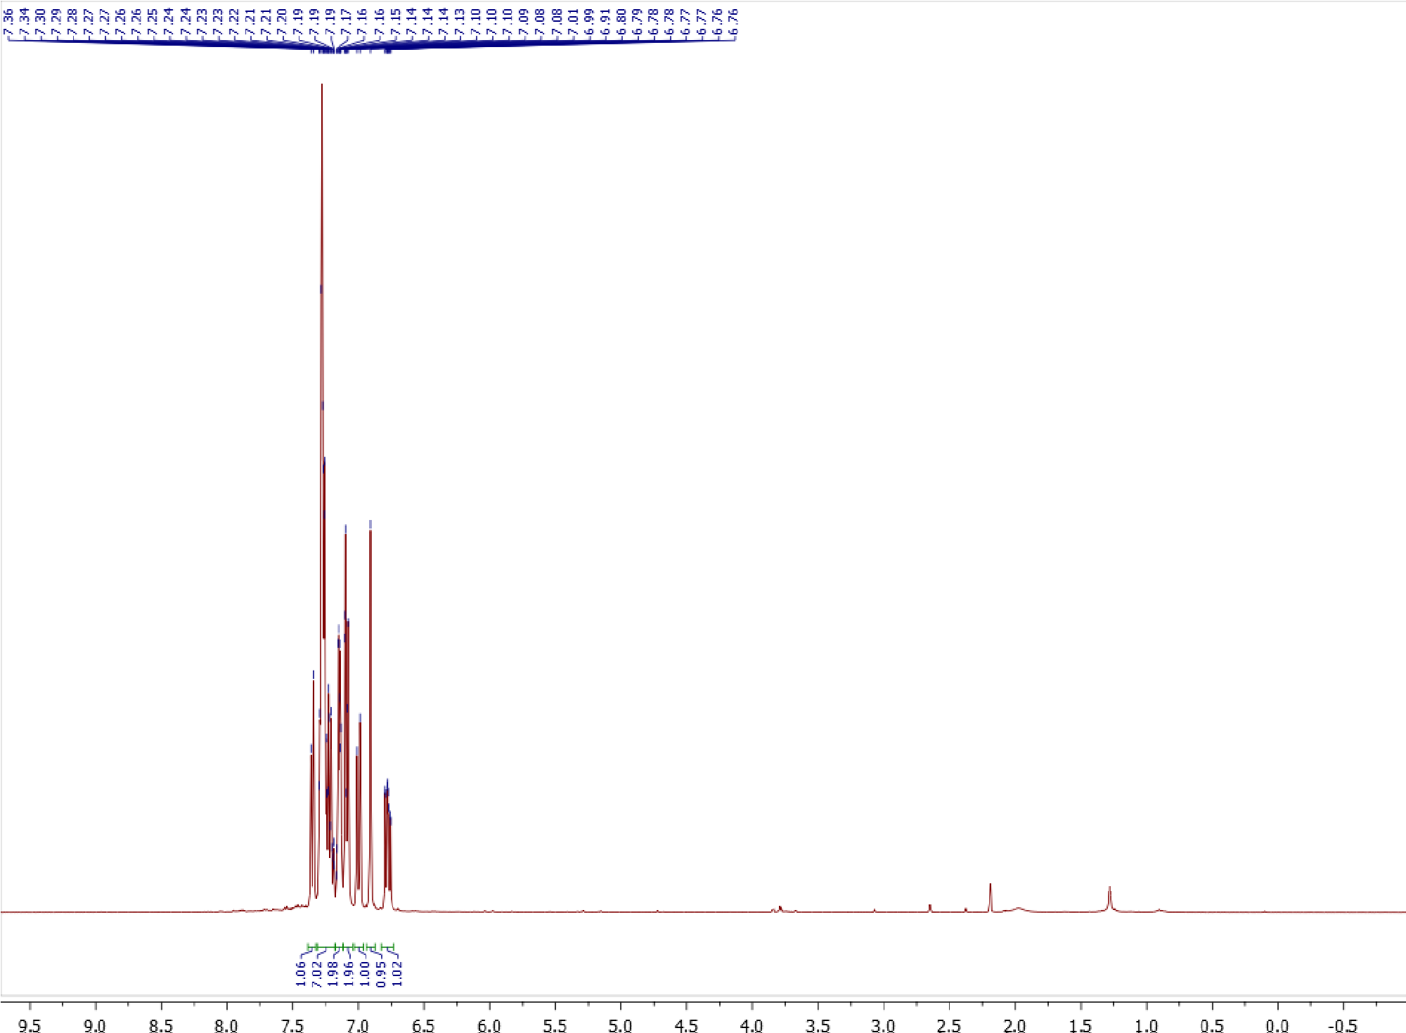
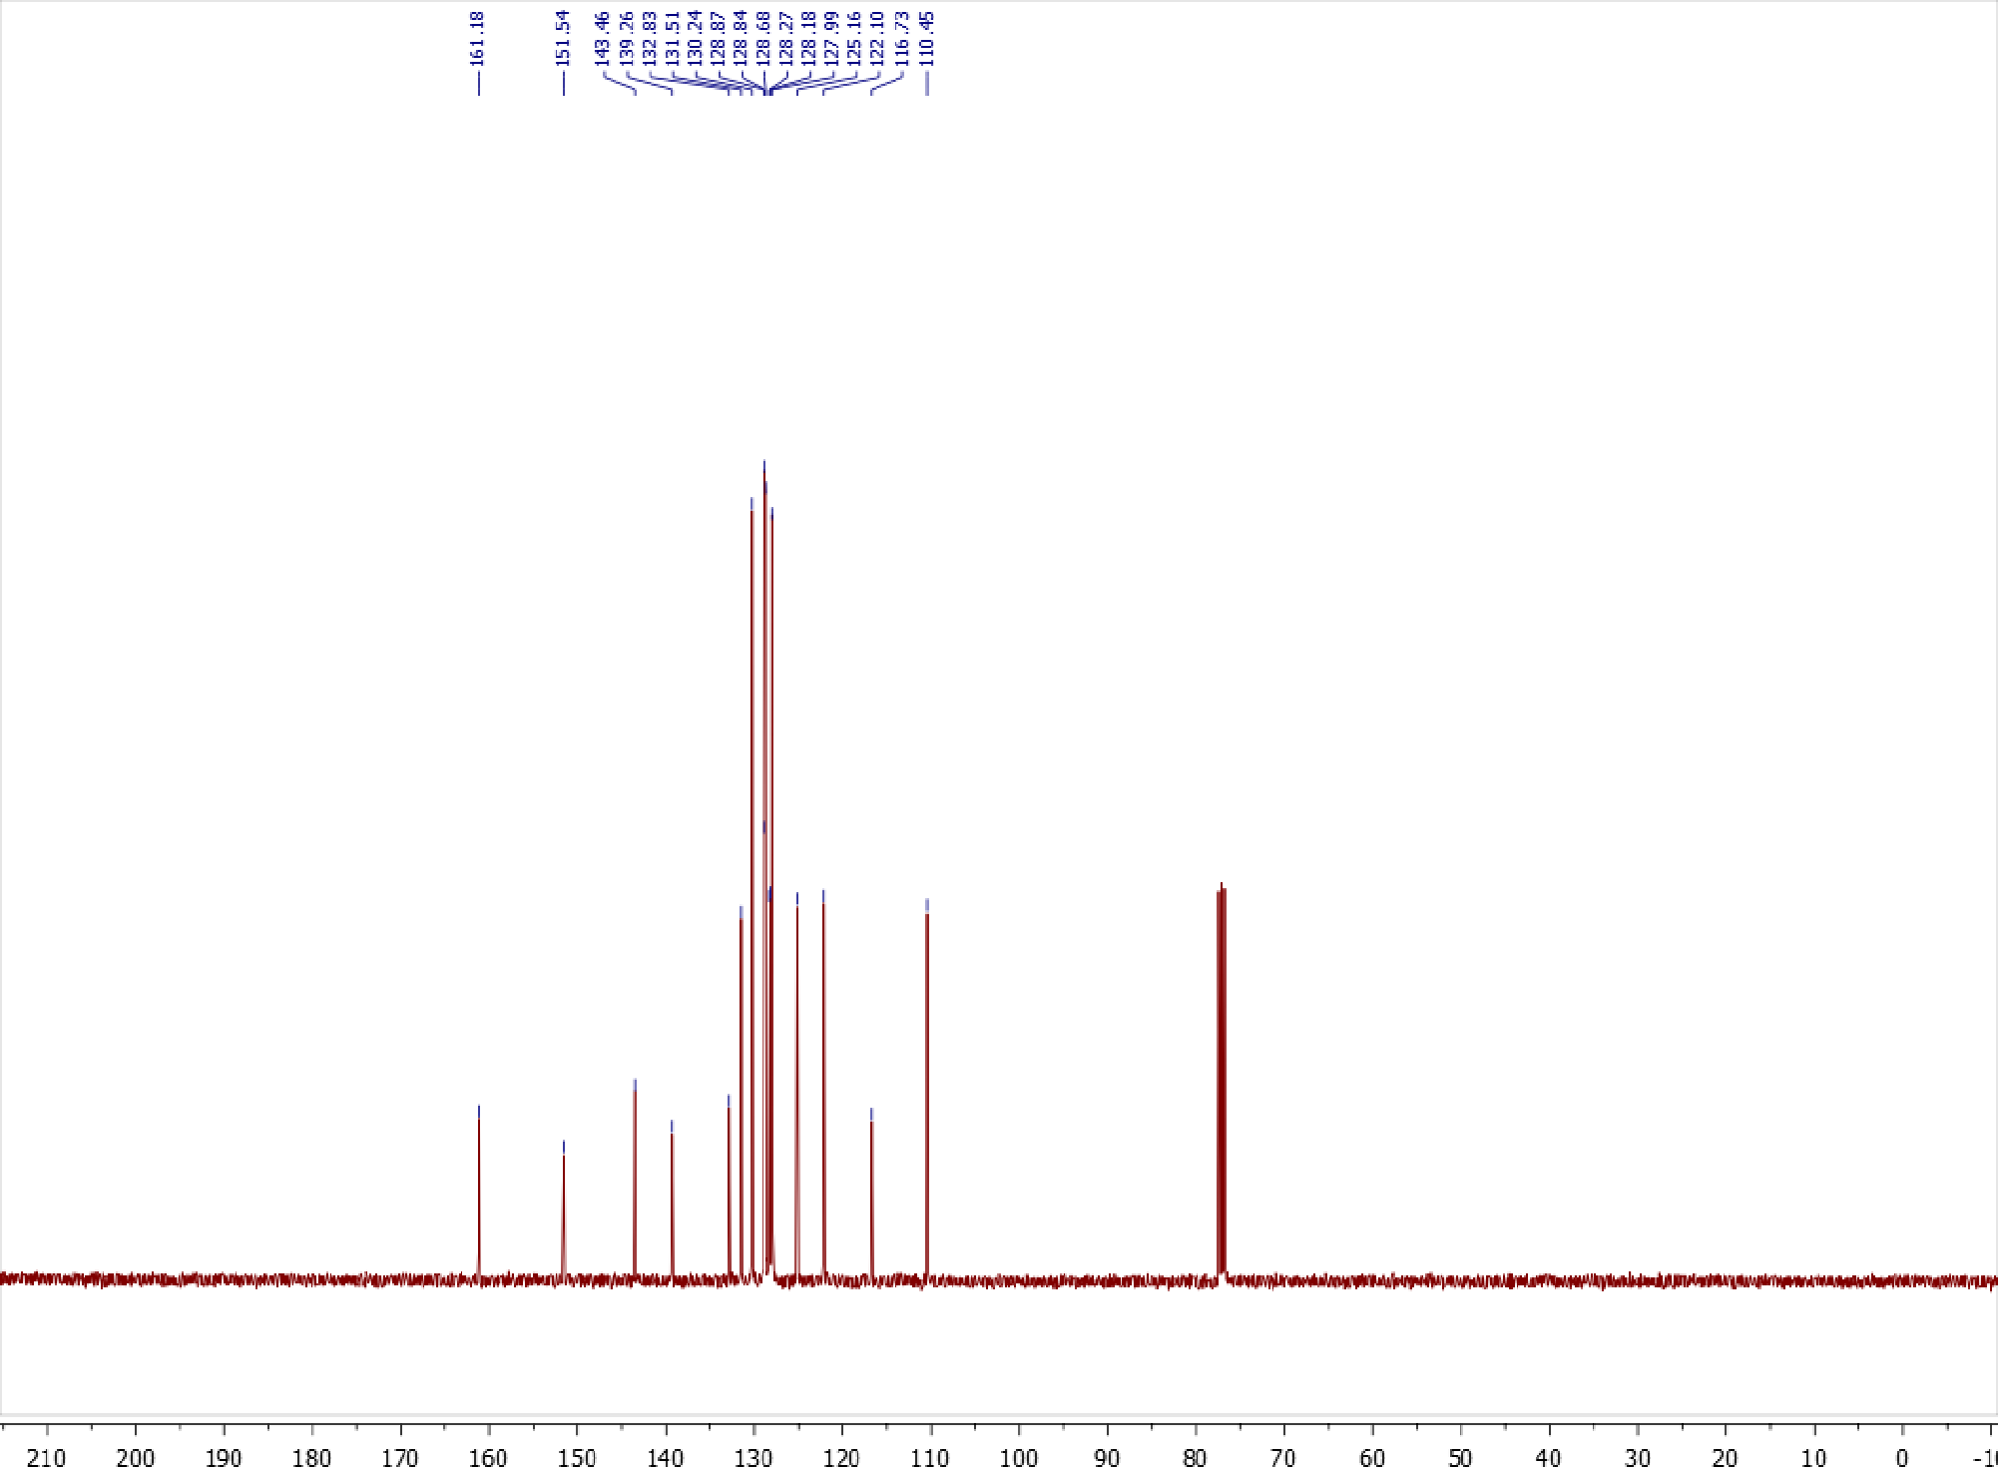
Copies of ¹H (400.13 MHz, CDCl₃) and ¹³C{¹H} (100.61 MHz, CDCl₃) spectra of 9b
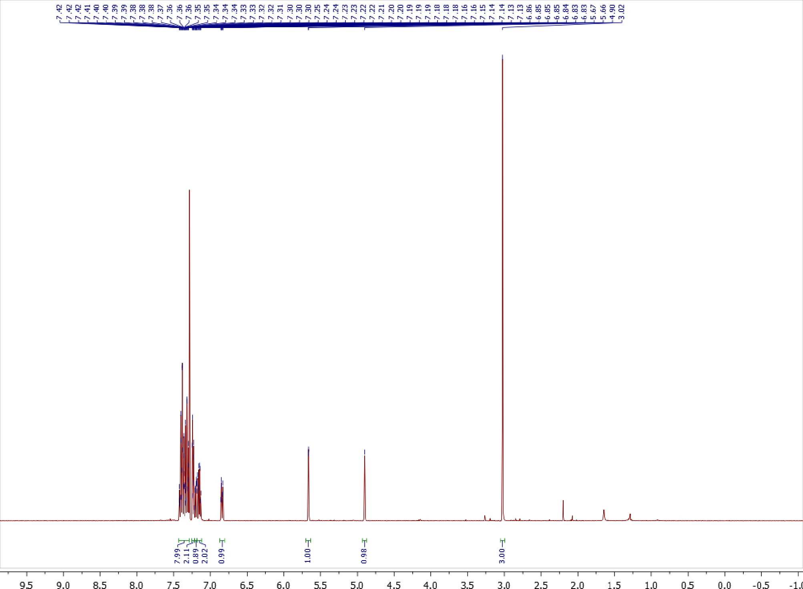
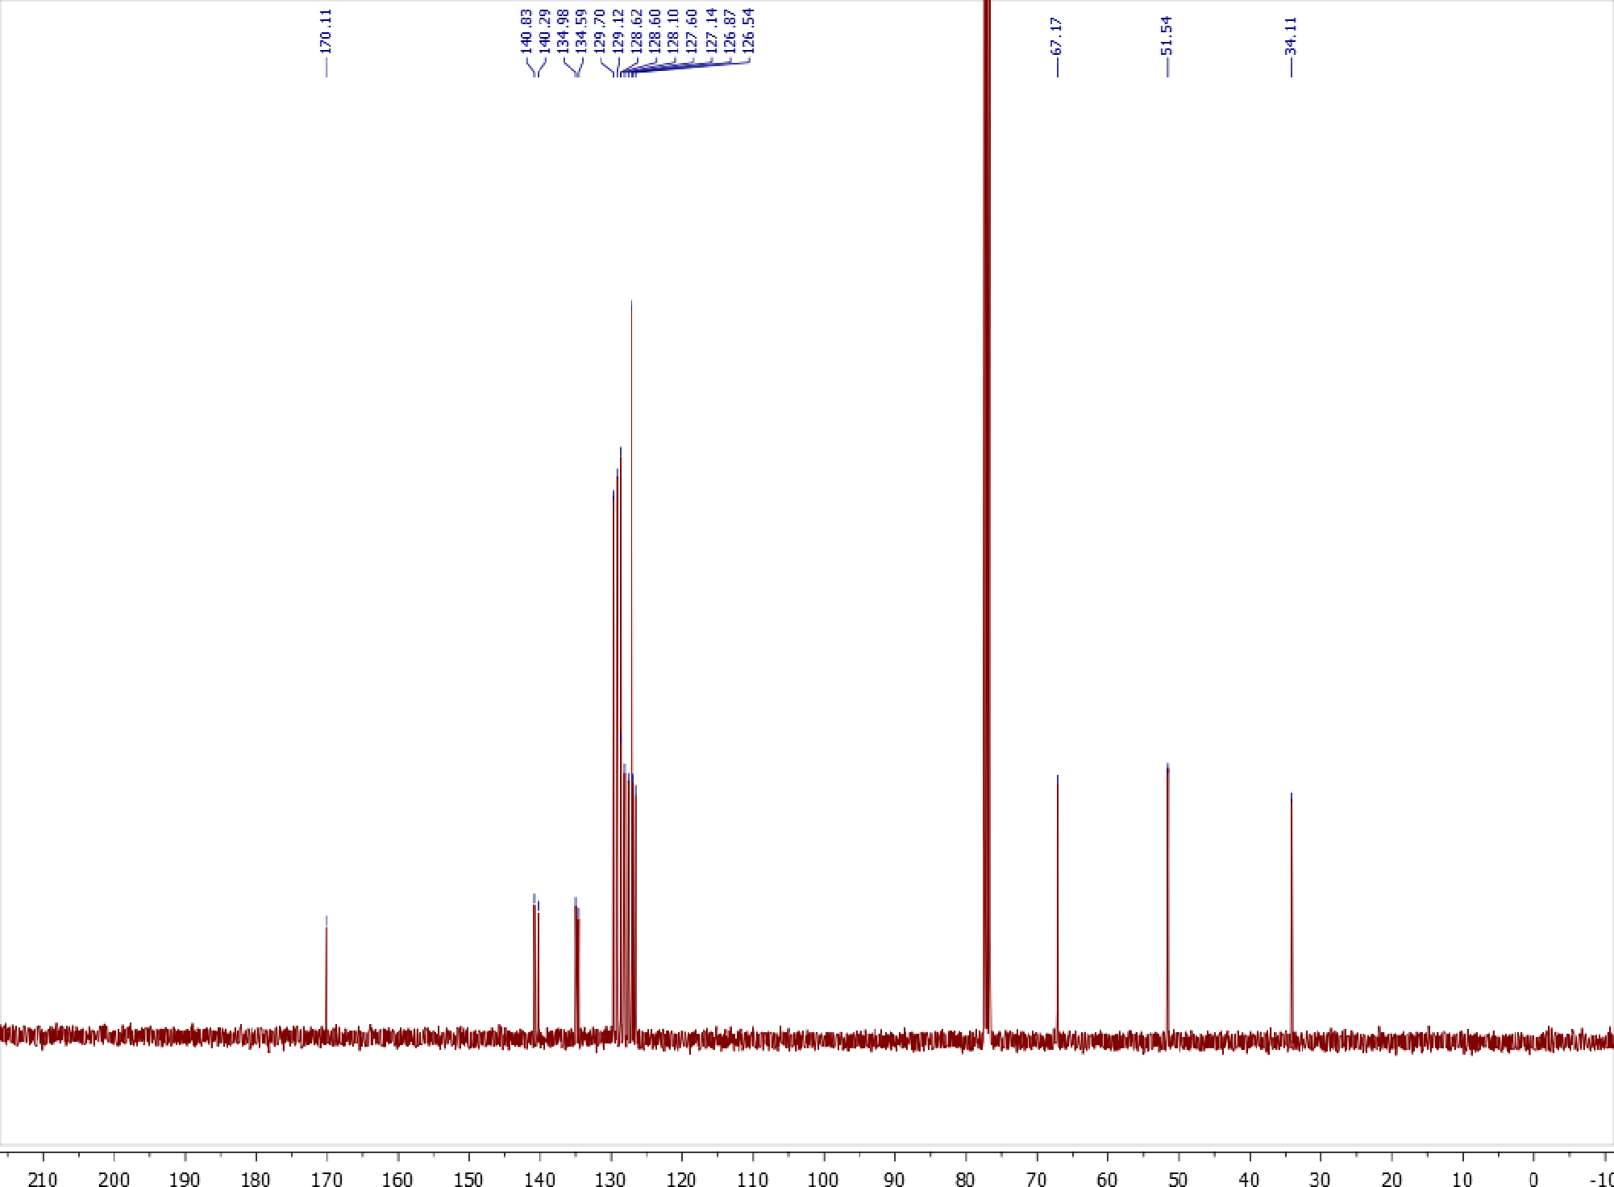
Copies of ¹H (400.13 MHz, CDCl₃) and ¹³C{¹H} (100.61 MHz, CDCl₃) spectra of 9c
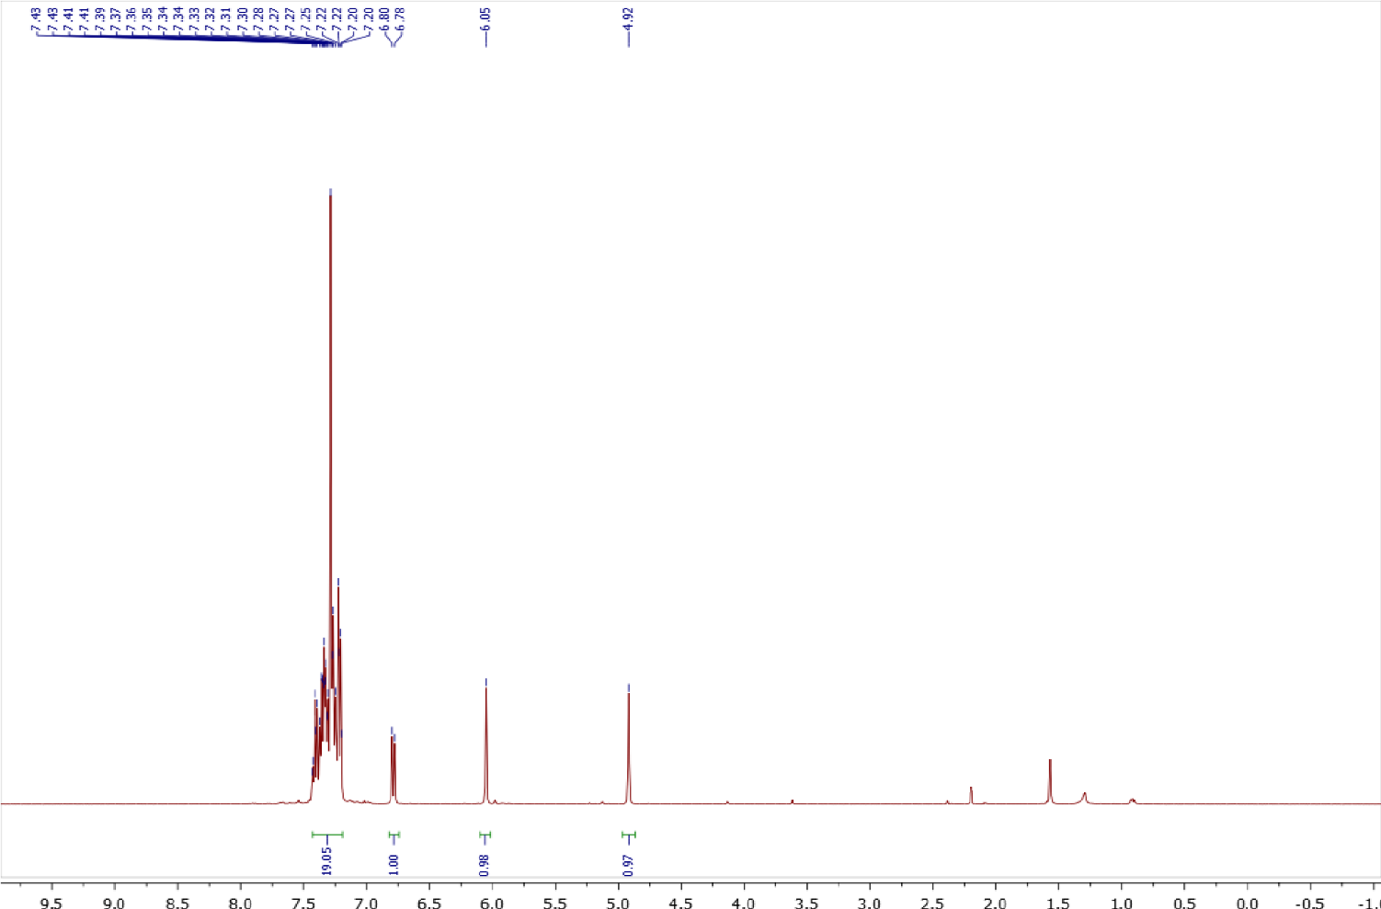
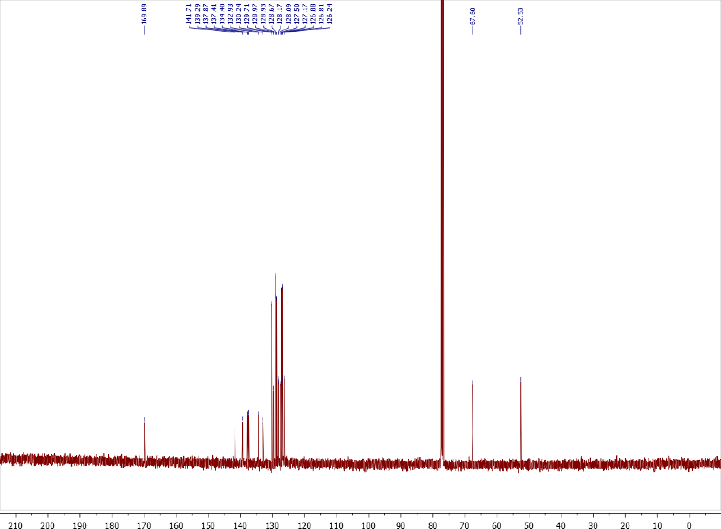
Copies of ¹H (400.13 MHz, CDCl₃) and ¹³C{¹H} (100.61 MHz, CDCl₃) spectra of 15c
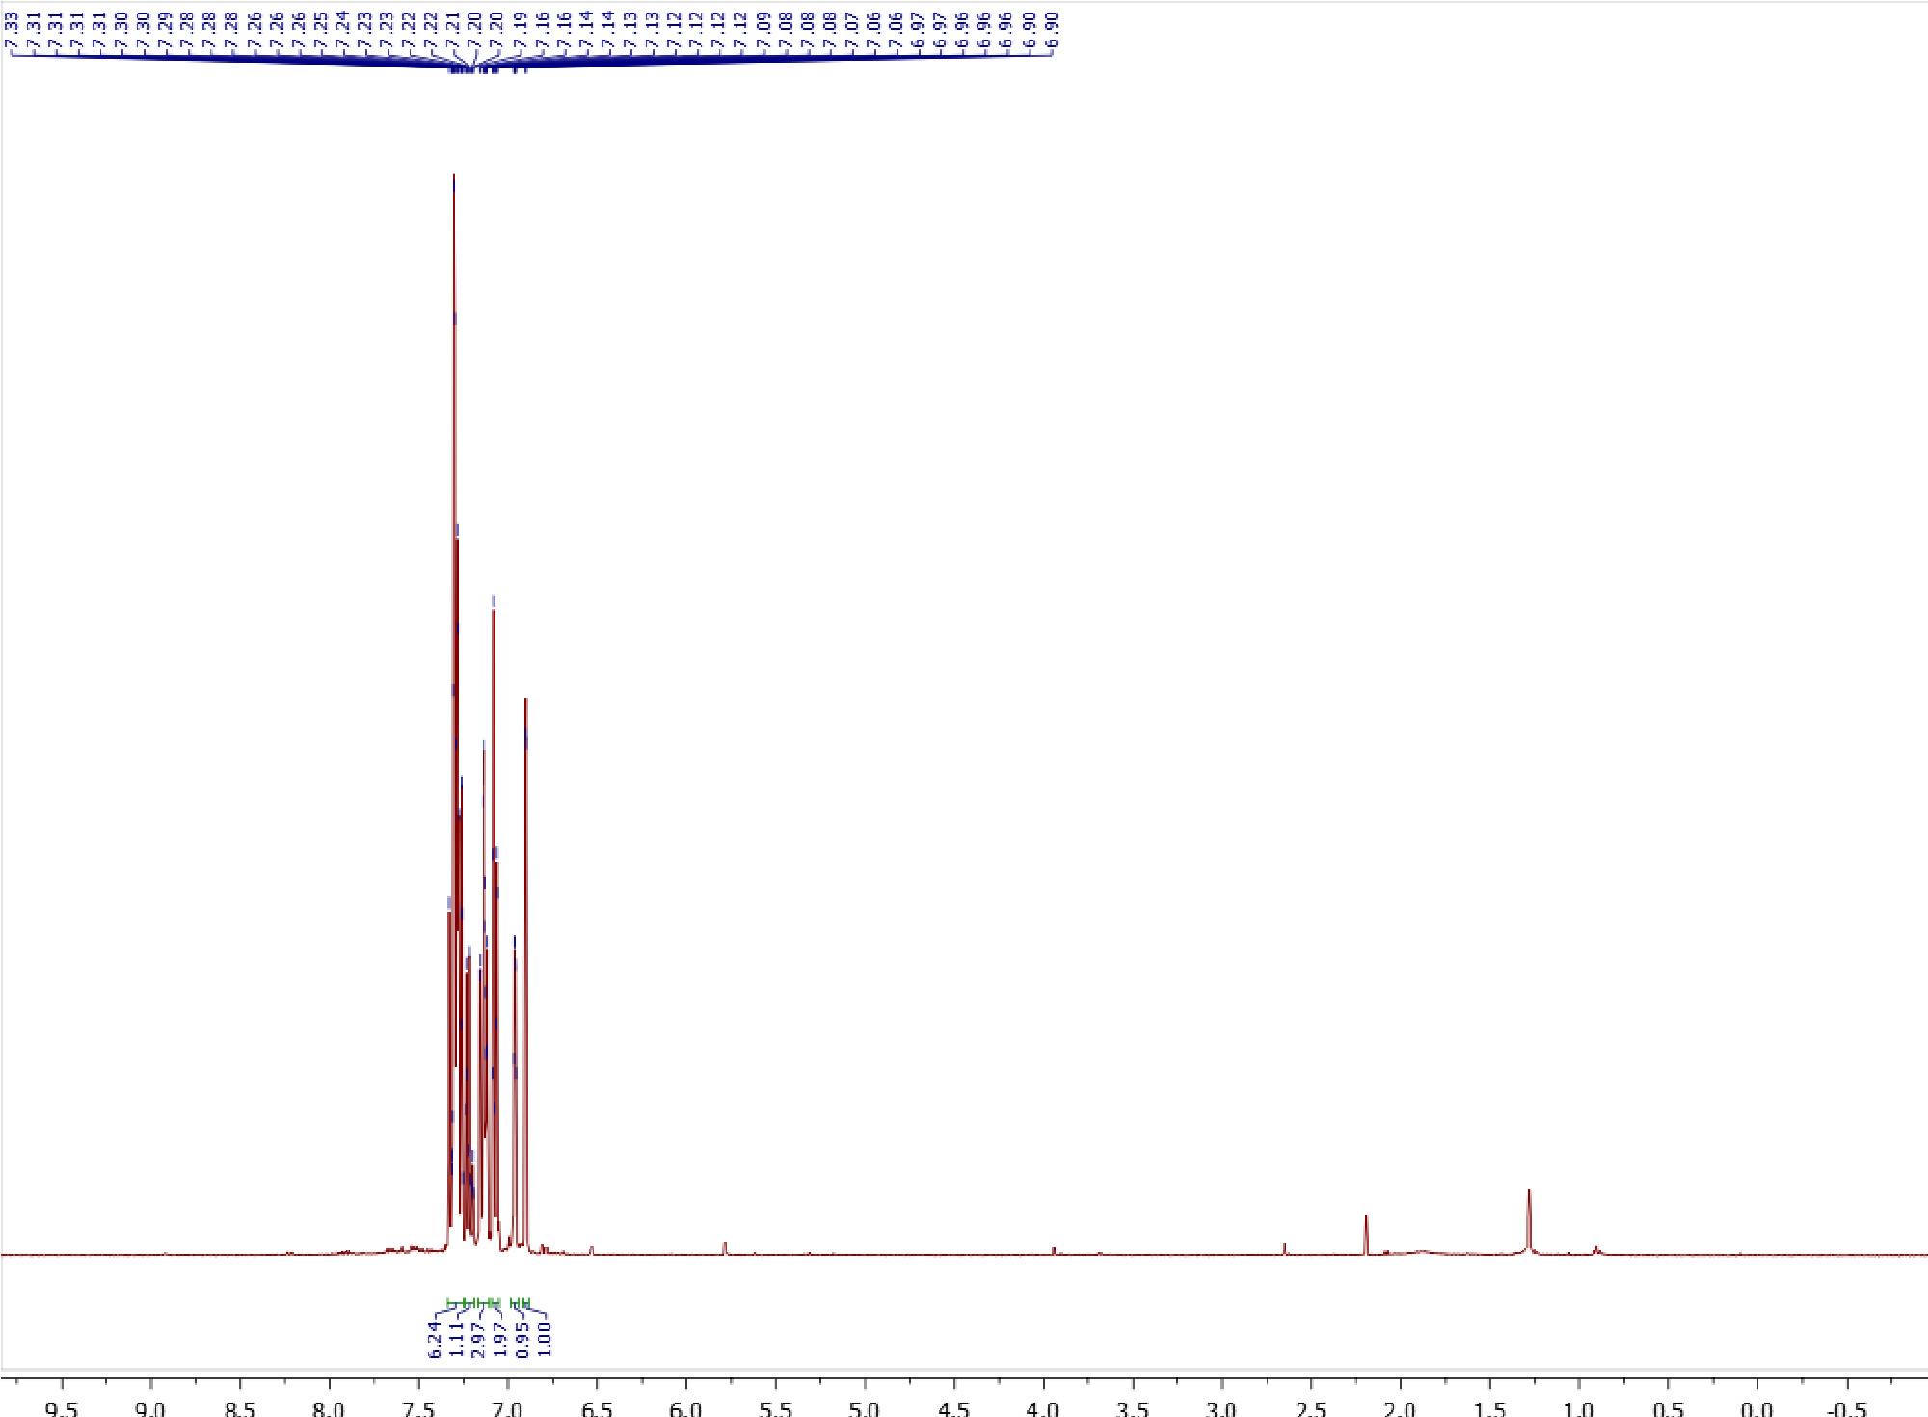
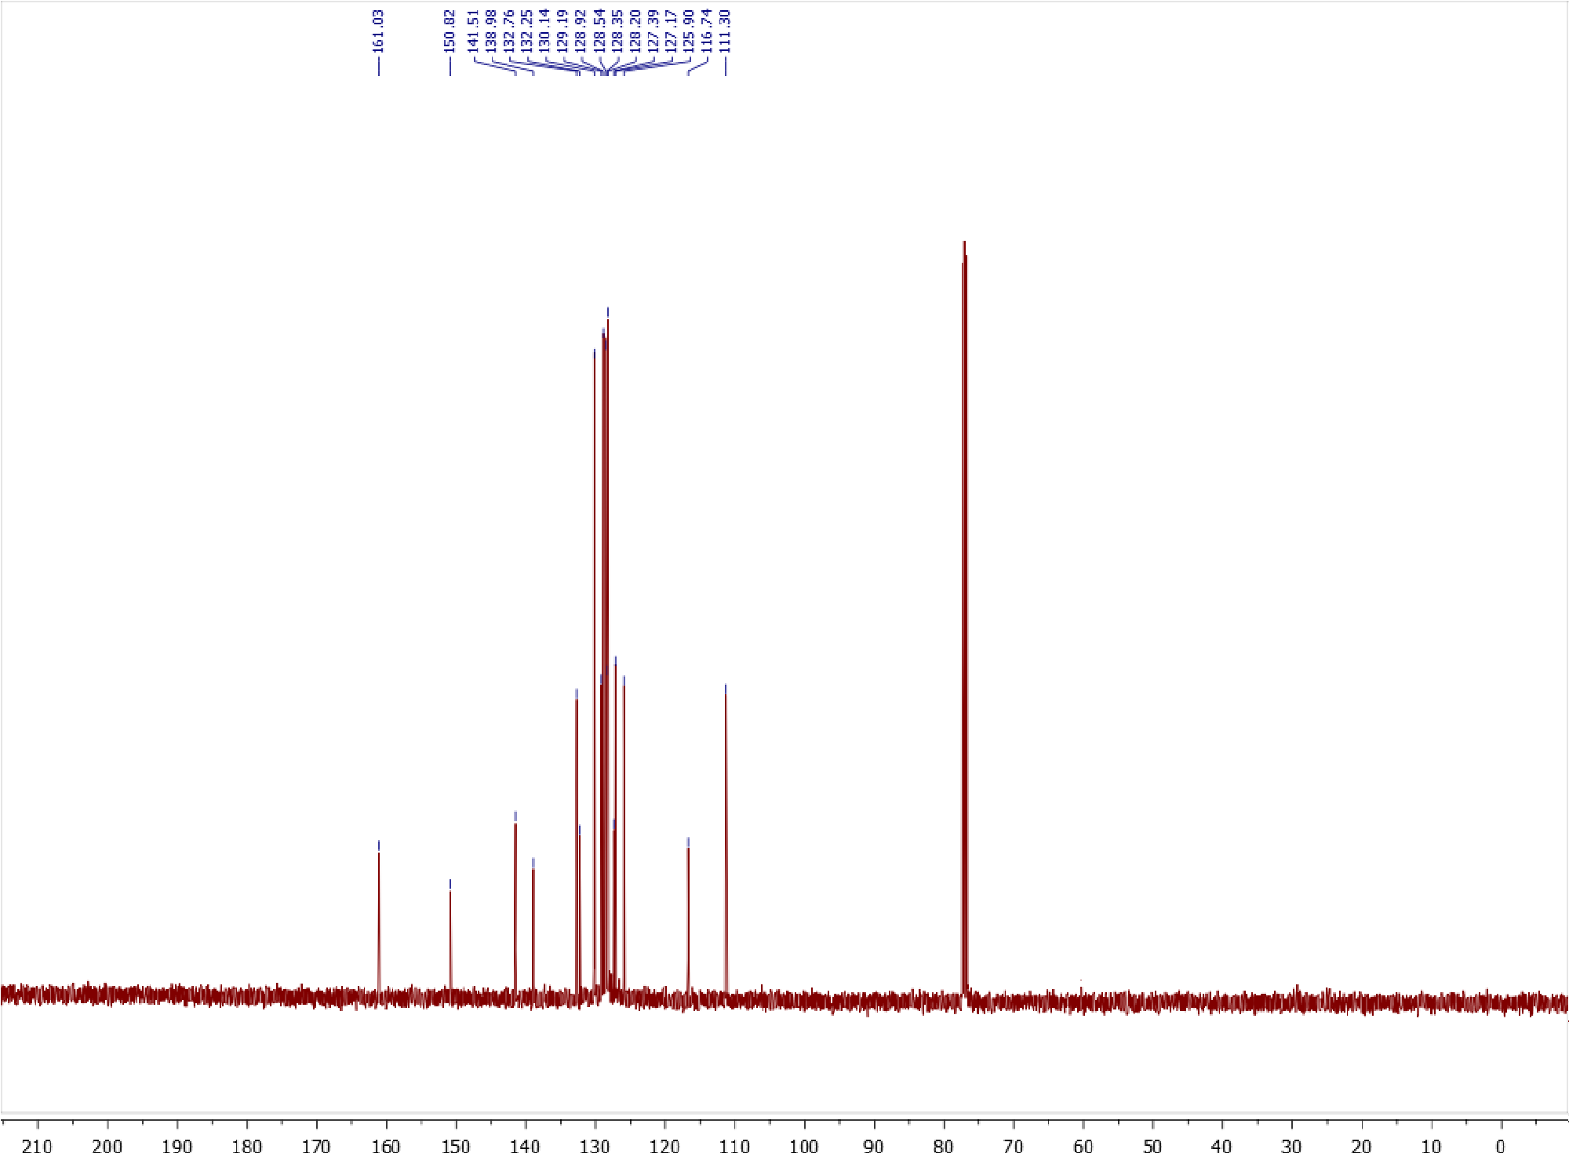
Copies of ¹H (400.13 MHz, CDCl₃) and ¹³C{¹H} (100.61 MHz, CDCl₃) spectra of 9d
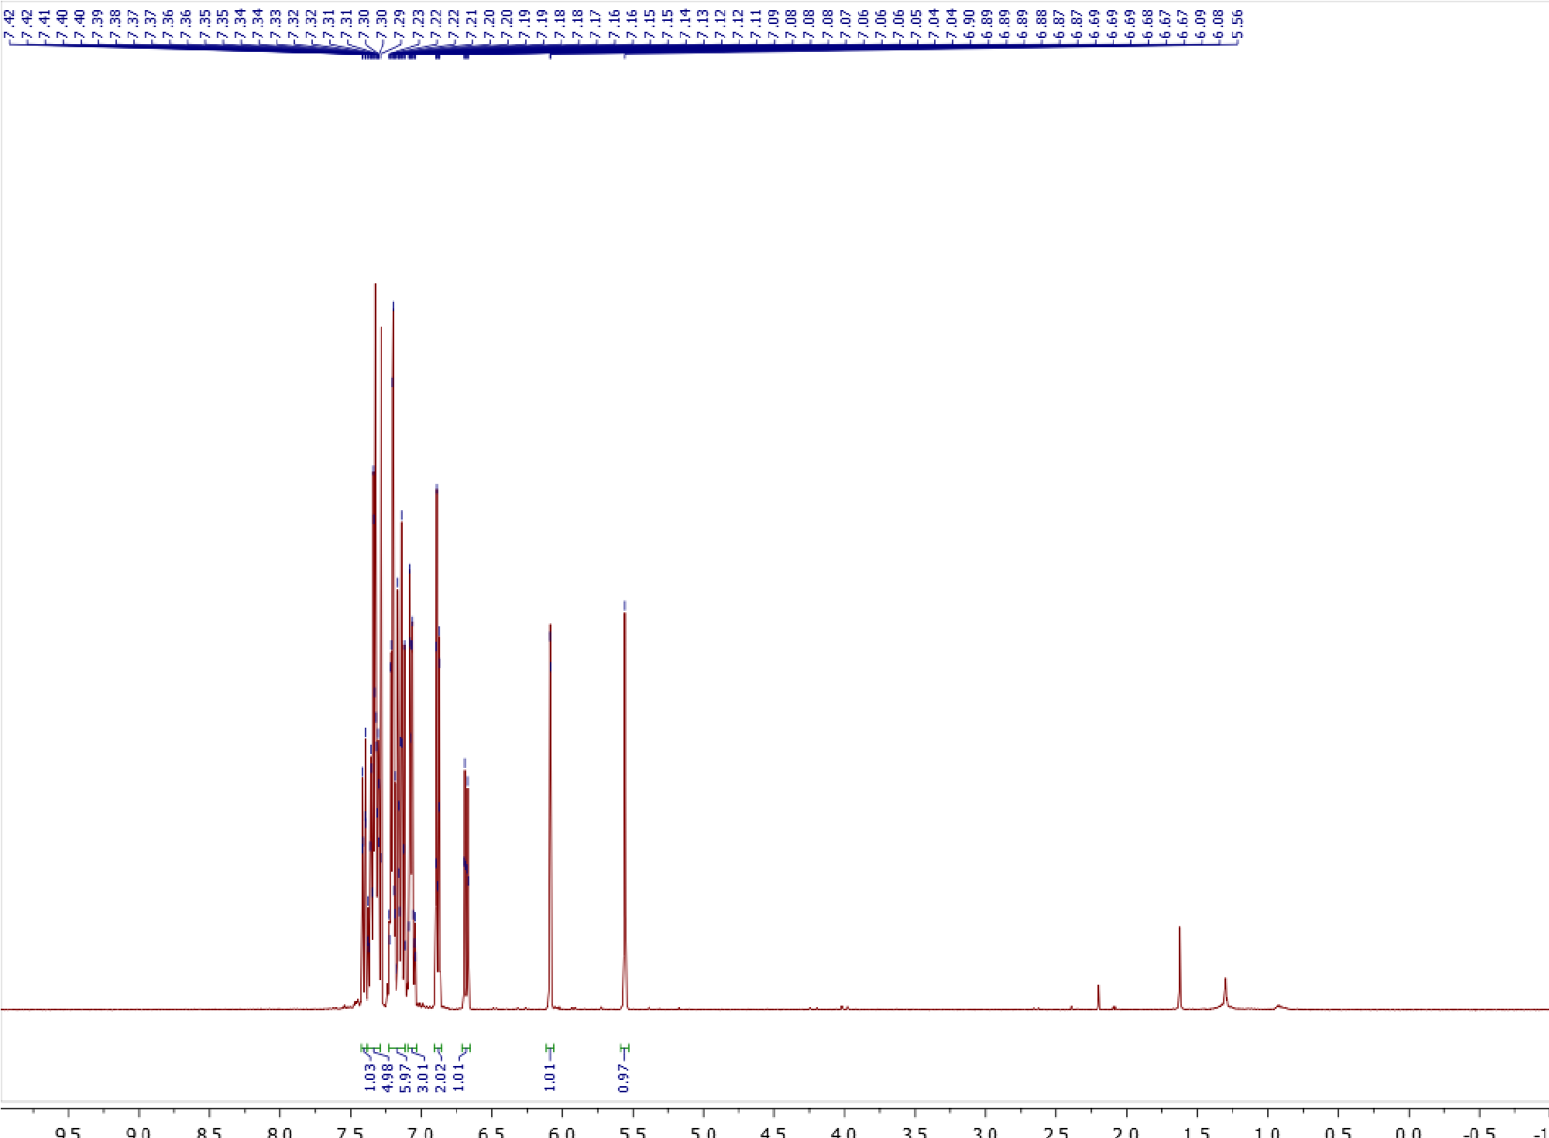
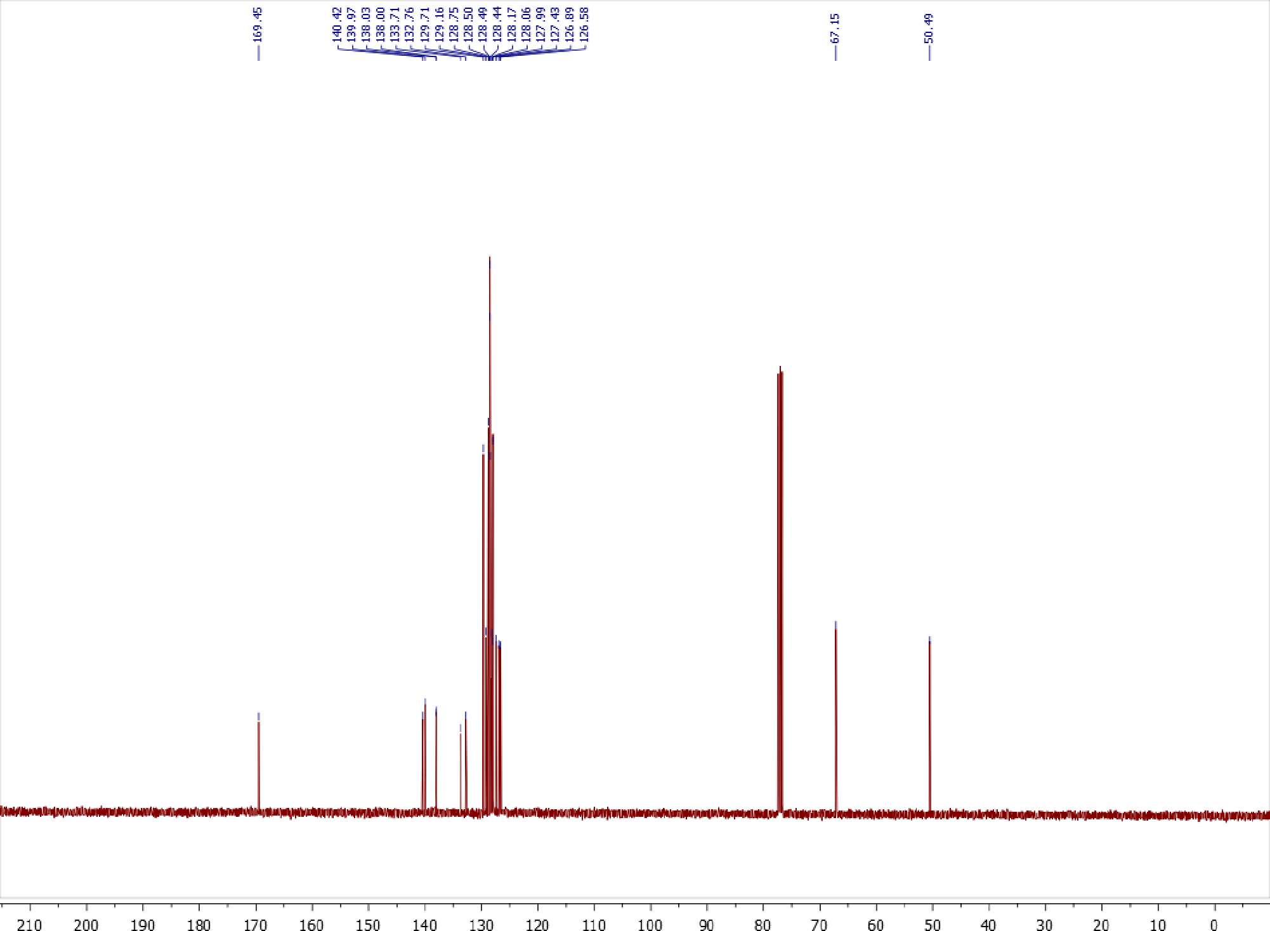
Copies of ¹H (400.13 MHz, CDCl₃) and ¹³C{¹H} (100.61 MHz, CDCl₃) spectra of 9e
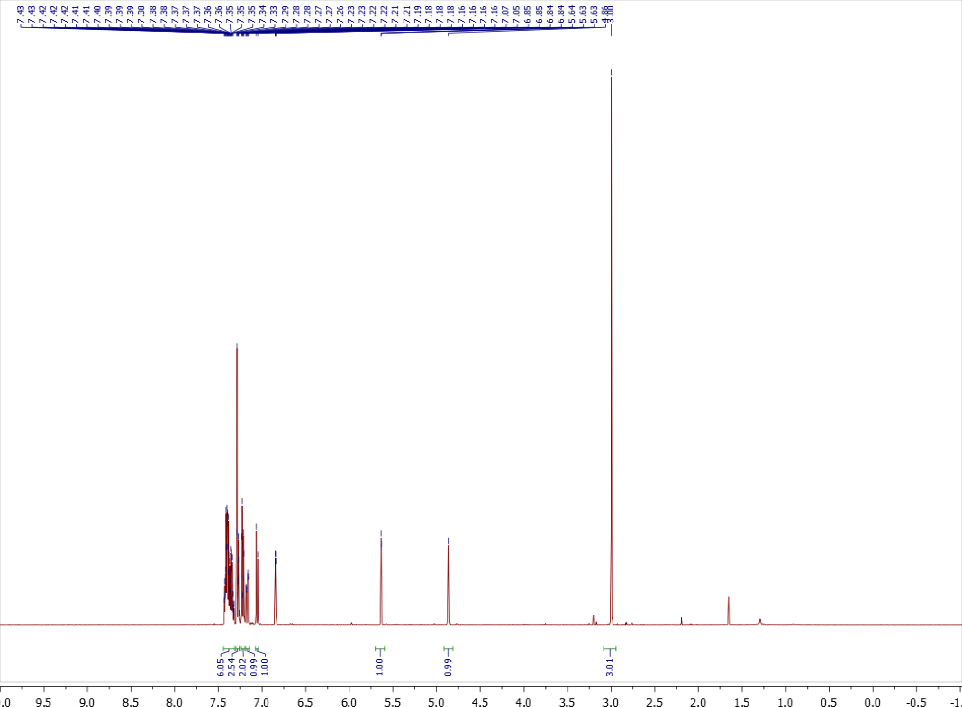
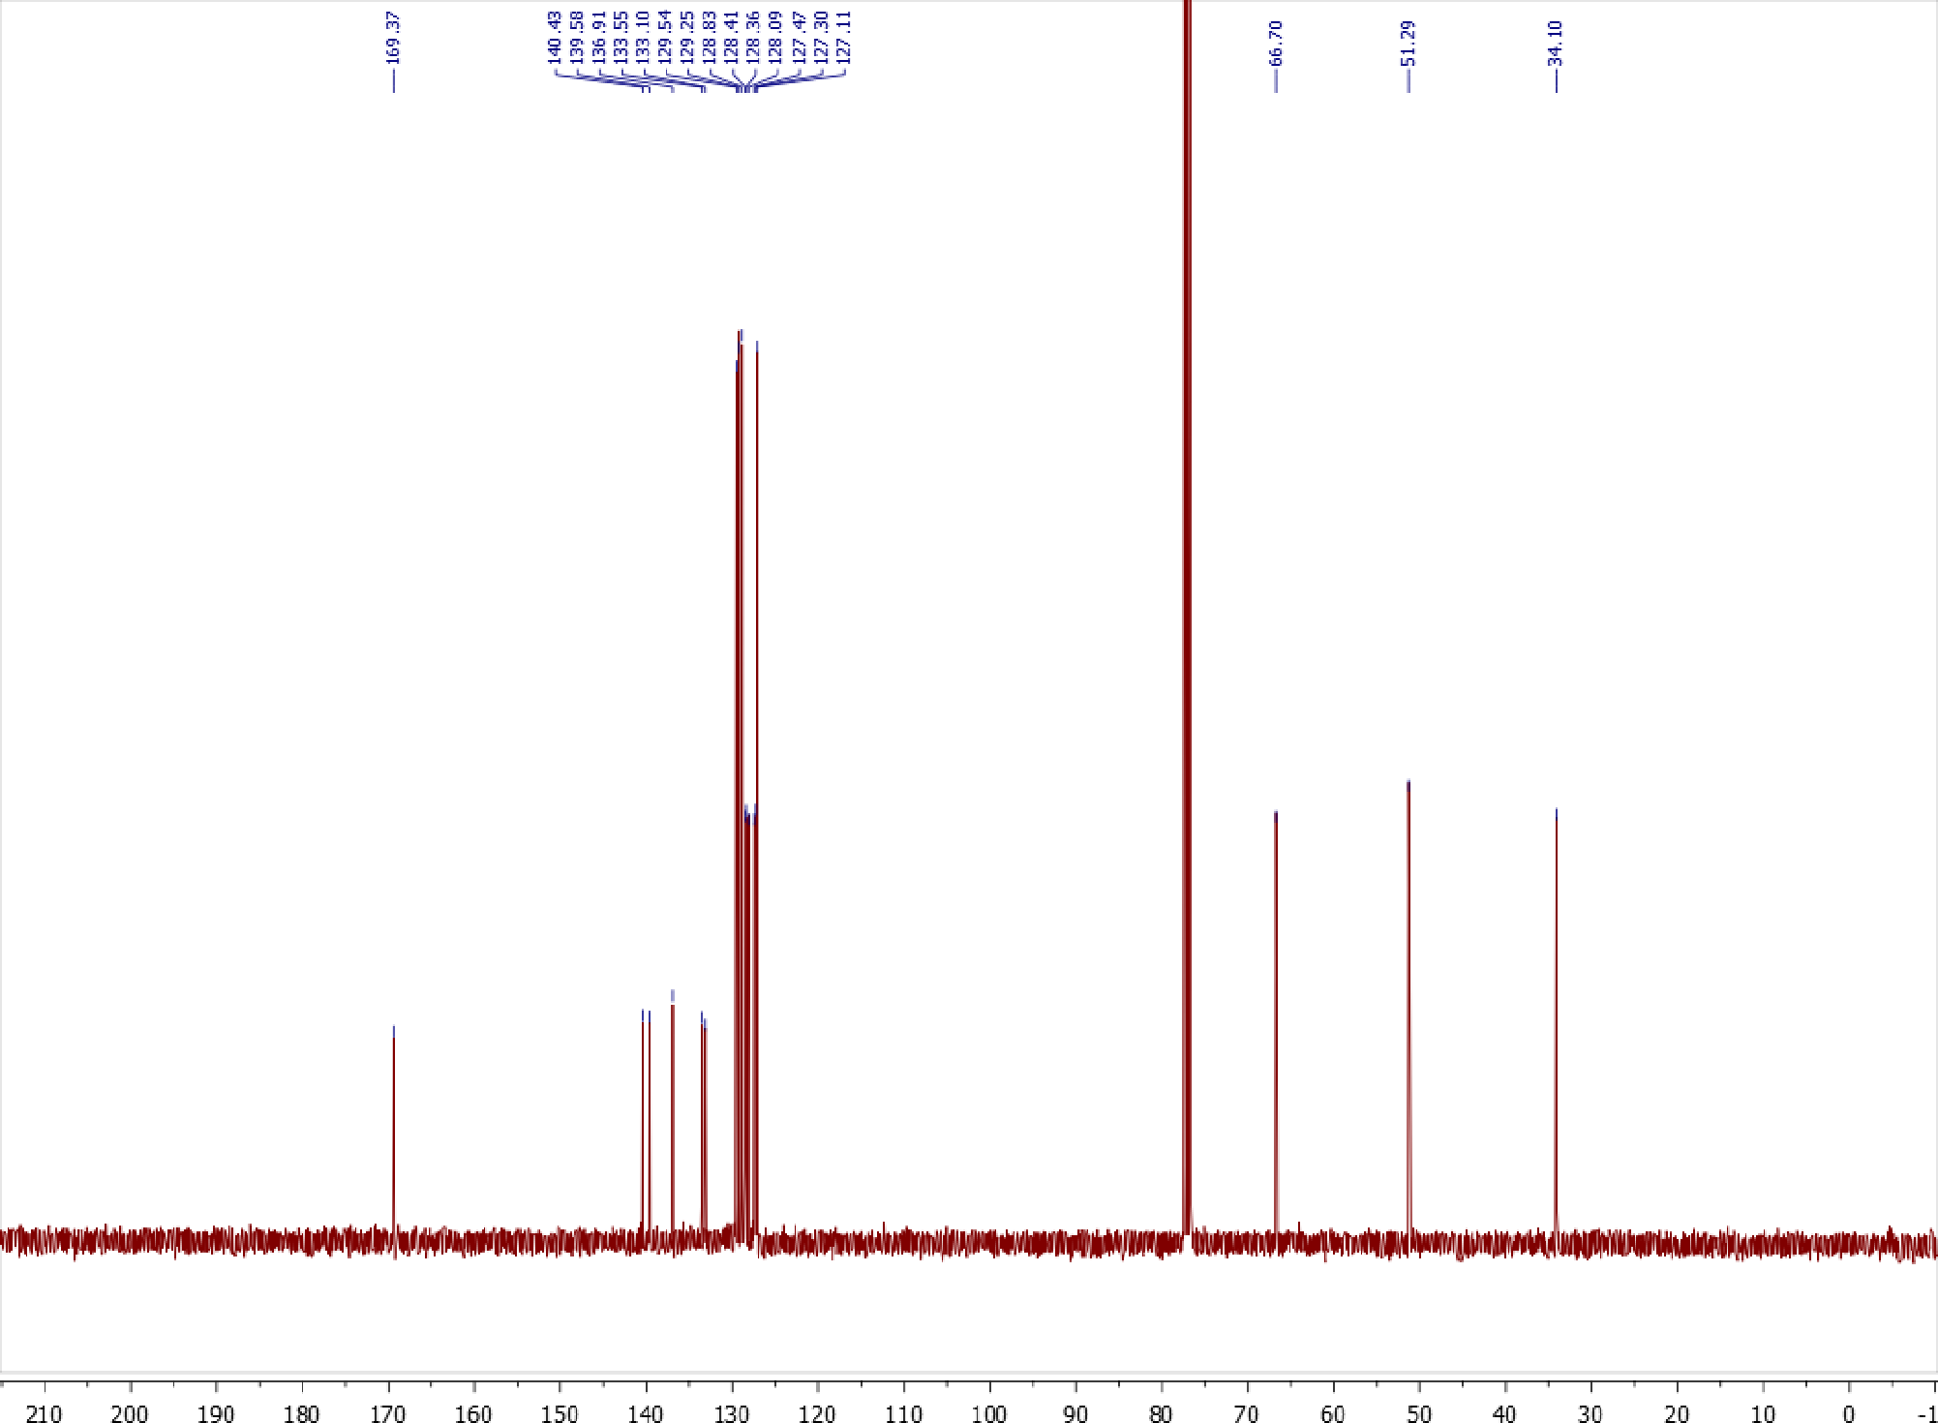
Copies of ¹H (400.13 MHz, CDCl₃) and ¹³C{¹H} (100.61 MHz, CDCl₃) spectra of 15f
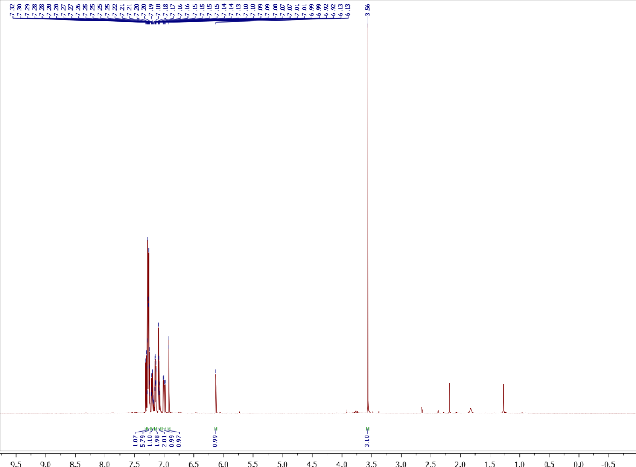
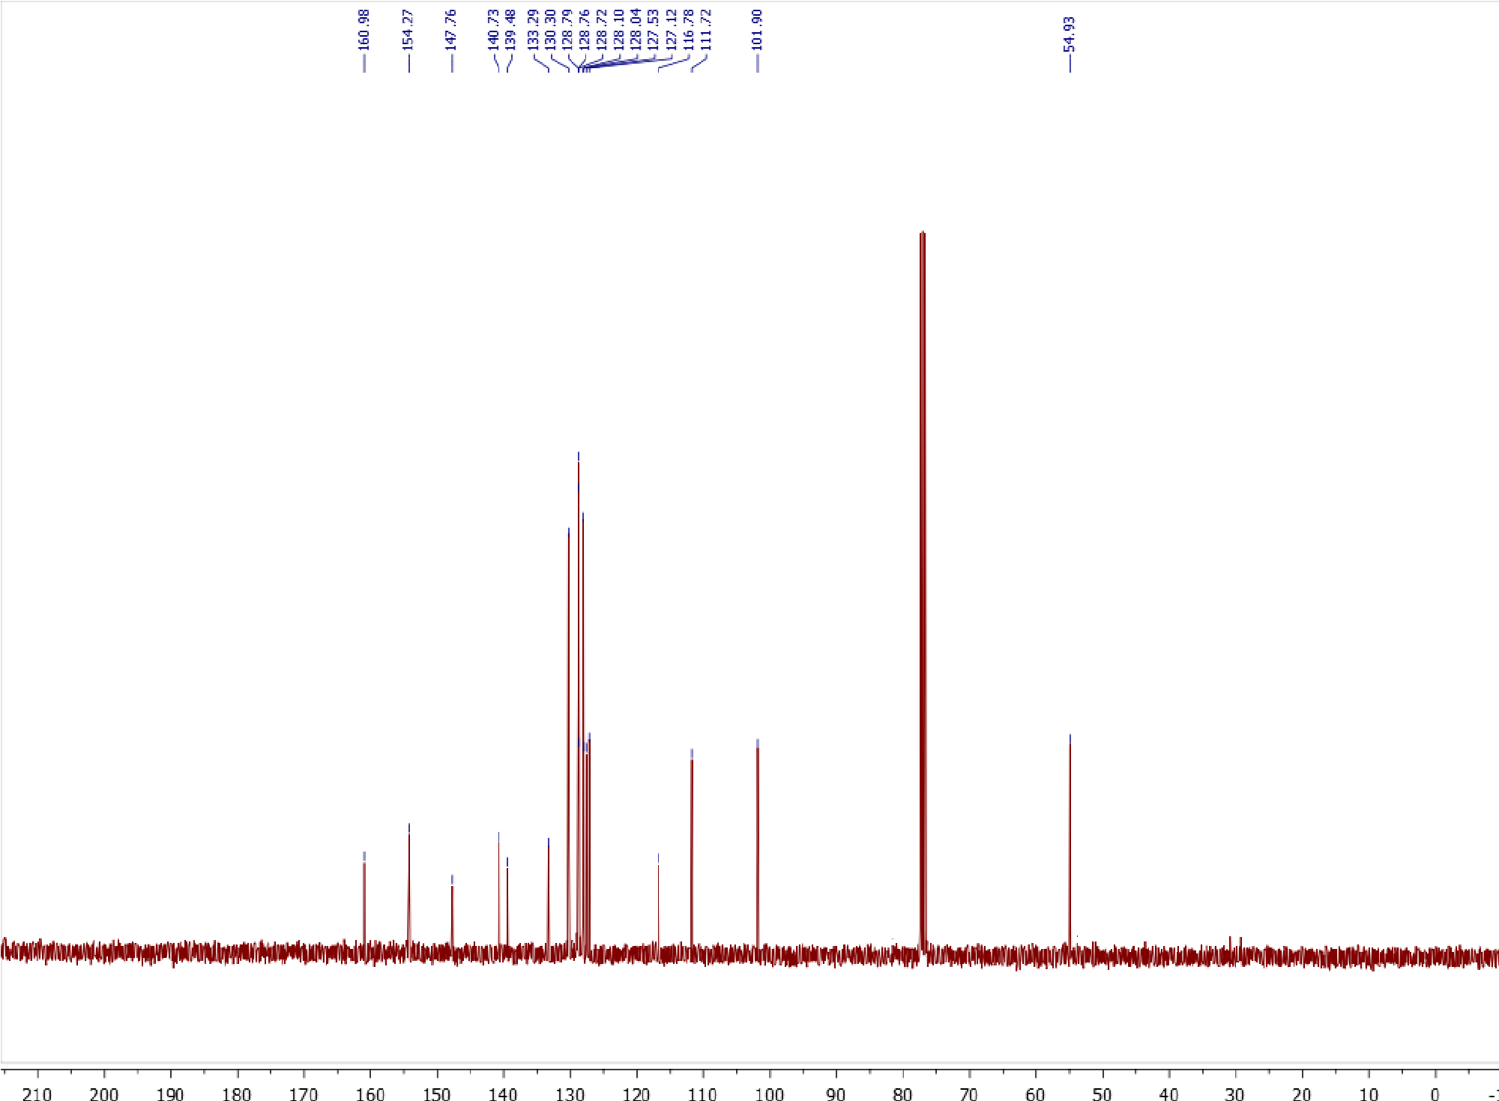
Copies of ¹H (400.13 MHz, CDCl₃) and ¹³C{¹H} (100.61 MHz, CDCl₃) spectra of 9g
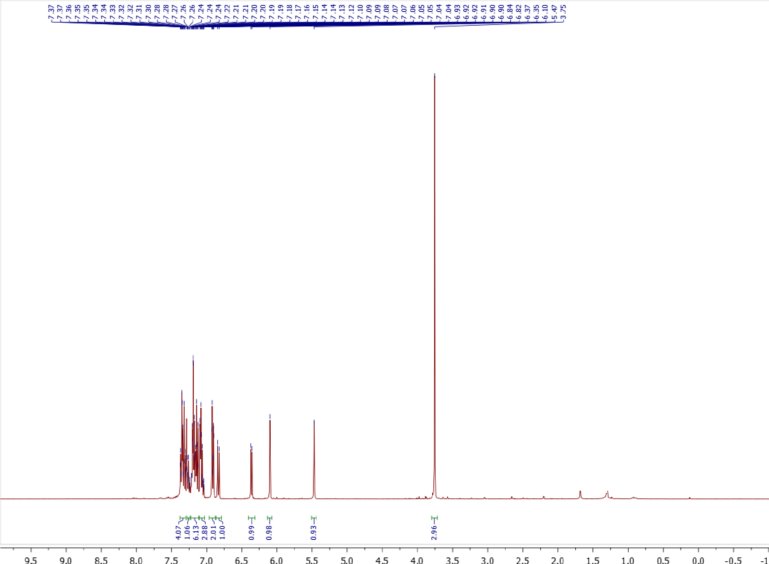
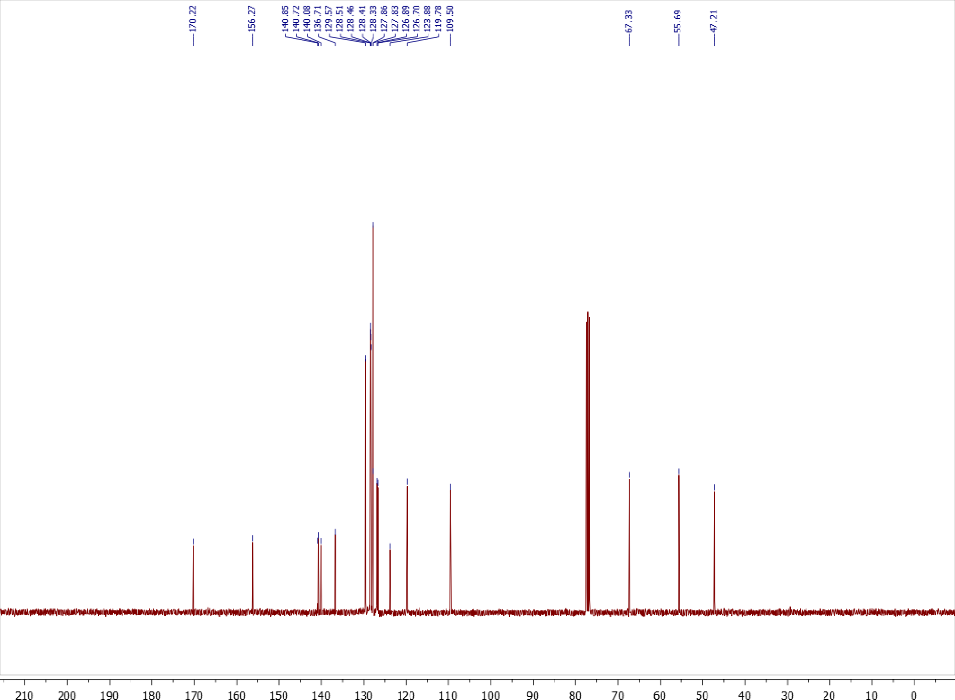
Copies of ¹H (400.13 MHz, CDCl₃) and ¹³C{¹H} (100.61 MHz, CDCl₃) spectra of 15g
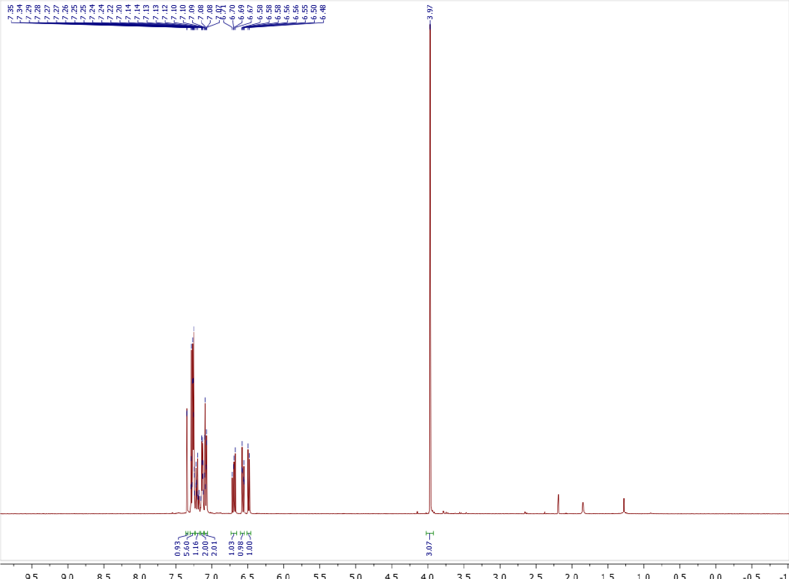
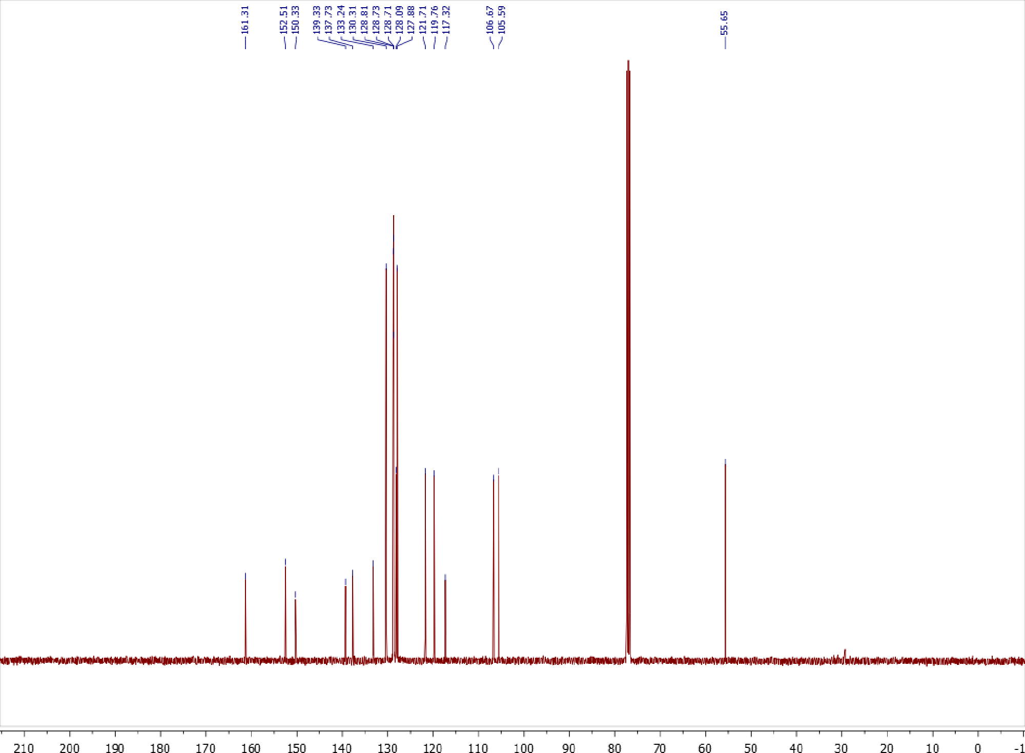
Copies of ¹H (400.13 MHz, CDCl₃) and ¹³C{¹H} (100.61 MHz, CDCl₃) spectra of 9h
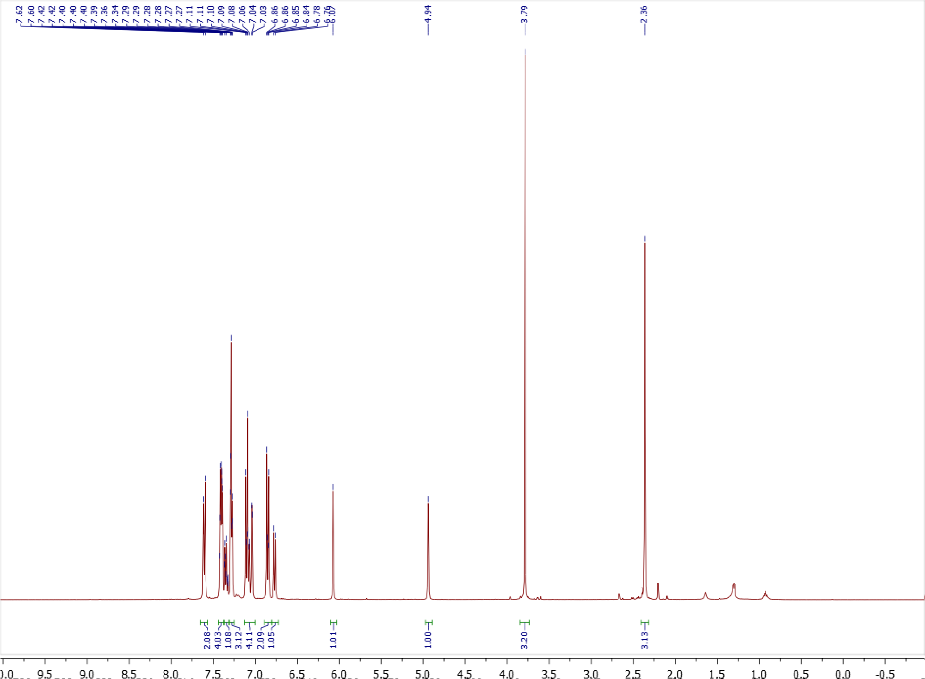
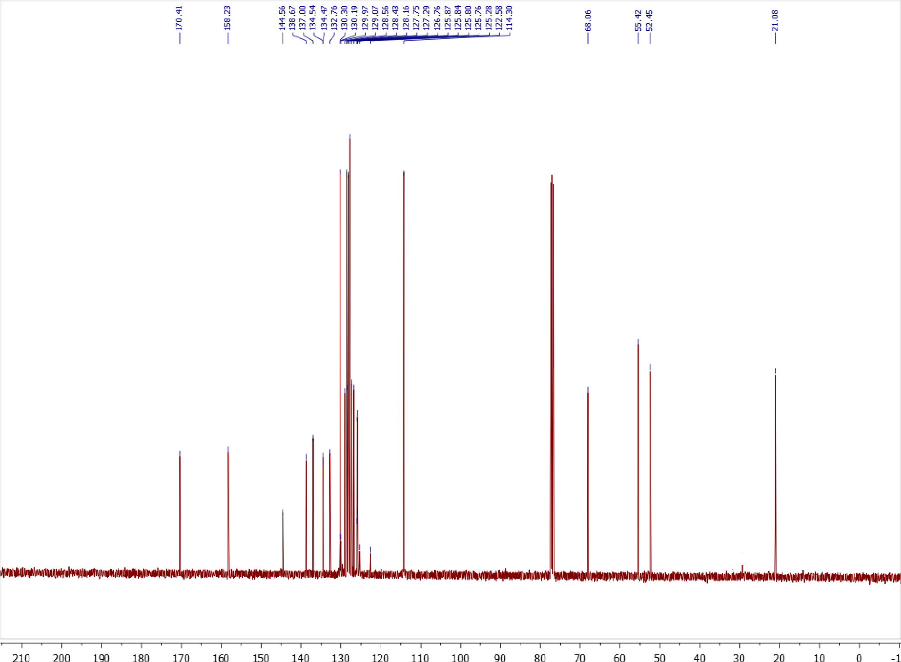
Copy of ¹⁹F{¹H} (376.50 MHz, CDCl₃) spectrum of 9h
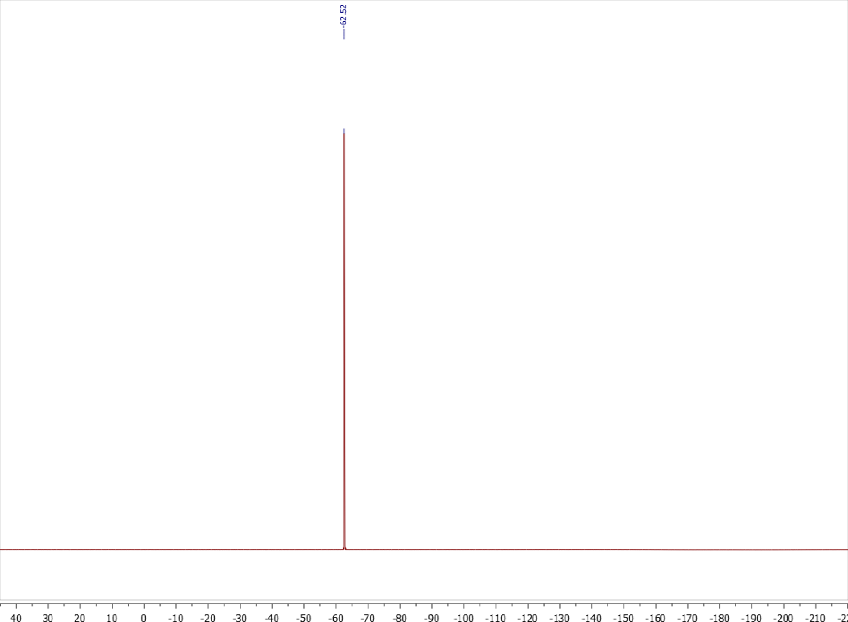
Copies of ¹H (400.13 MHz, CDCl₃) and ¹³C{¹H} (100.61 MHz, CDCl₃) spectra of 15h
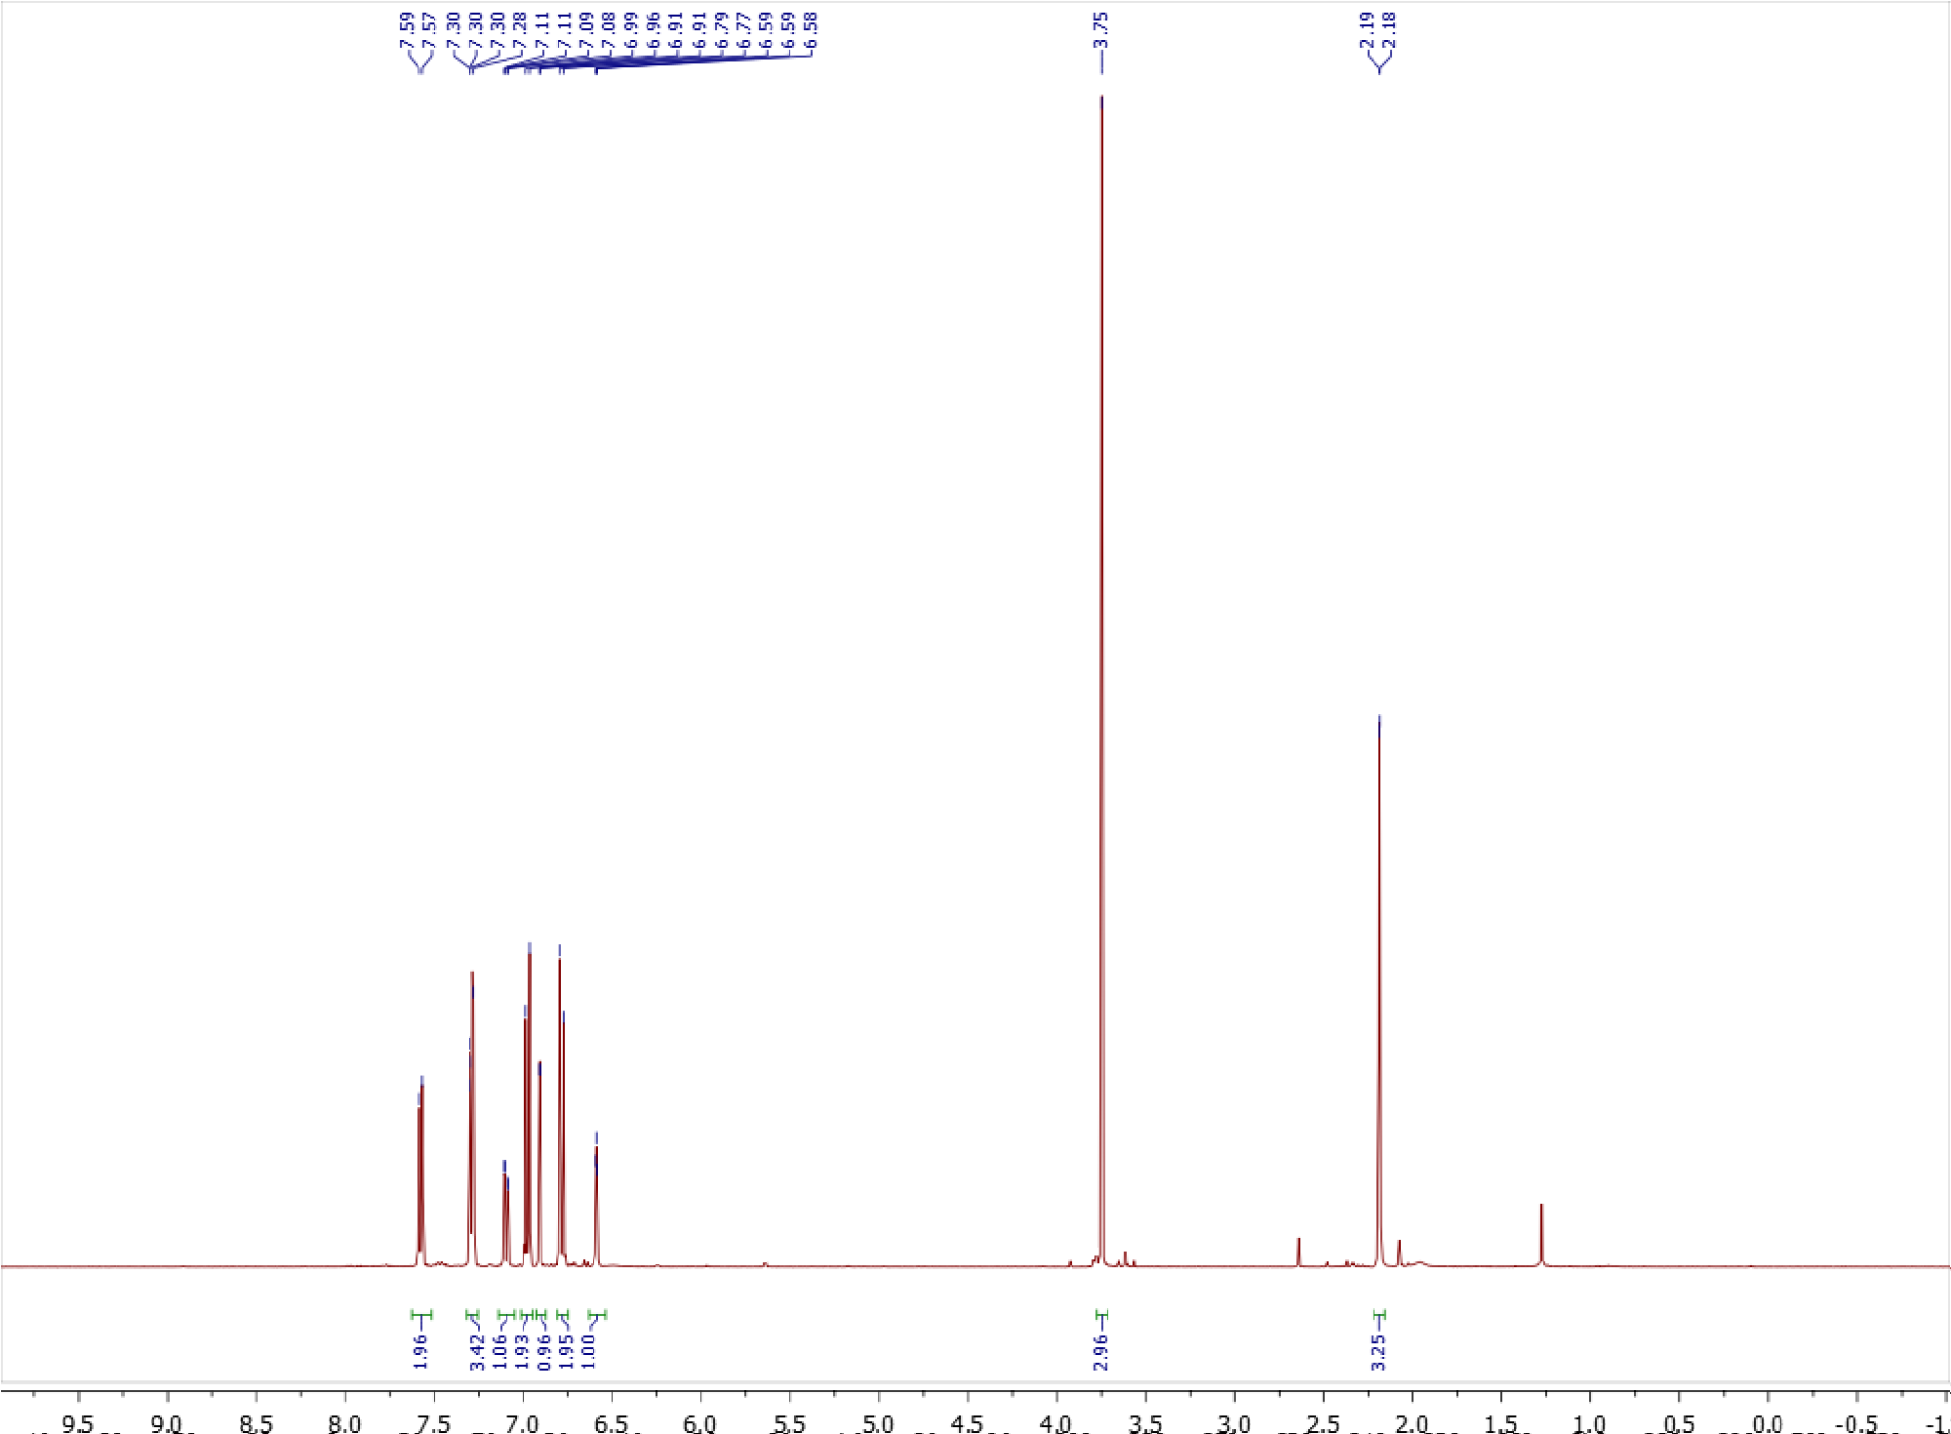
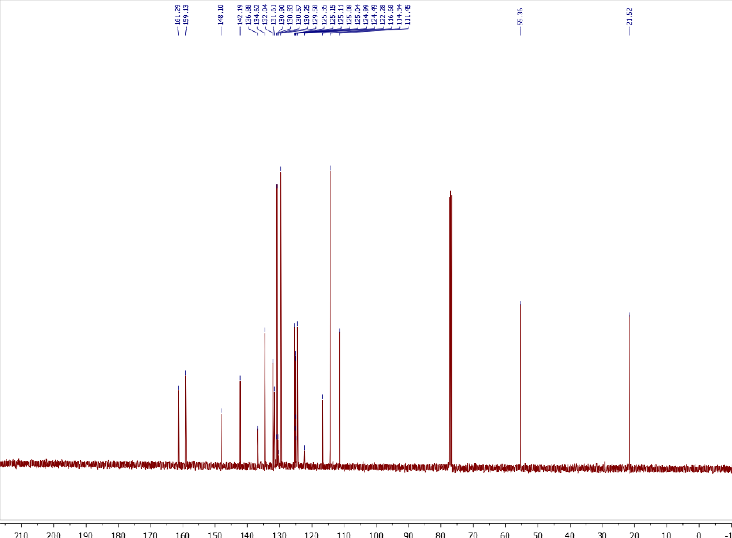
Copy of ¹⁹F{¹H} (376.50 MHz, CDCl₃) spectrum of 15h
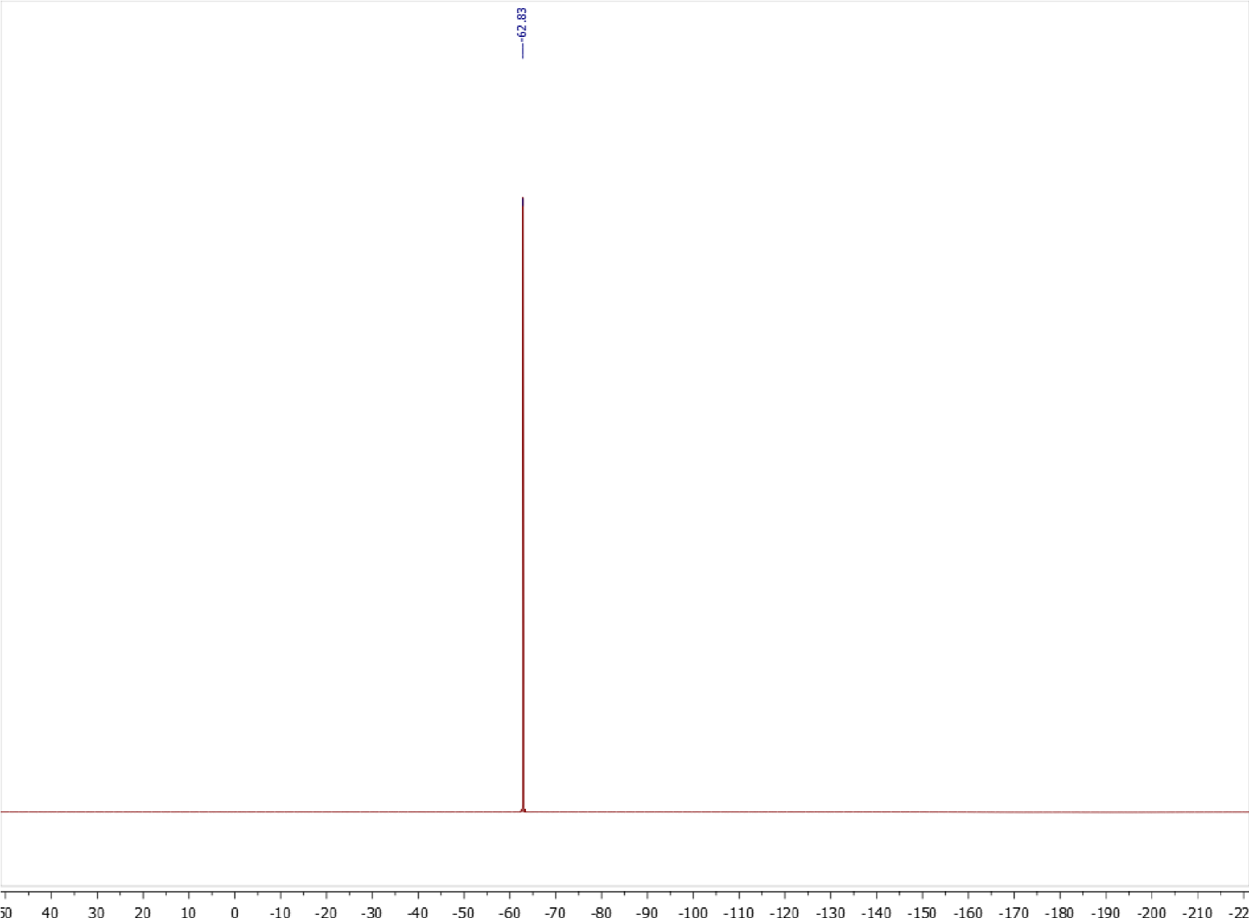
Copies of ¹H (400.13 MHz, CDCl₃) and ¹³C{¹H} (100.61 MHz, CDCl₃) spectra of 9i
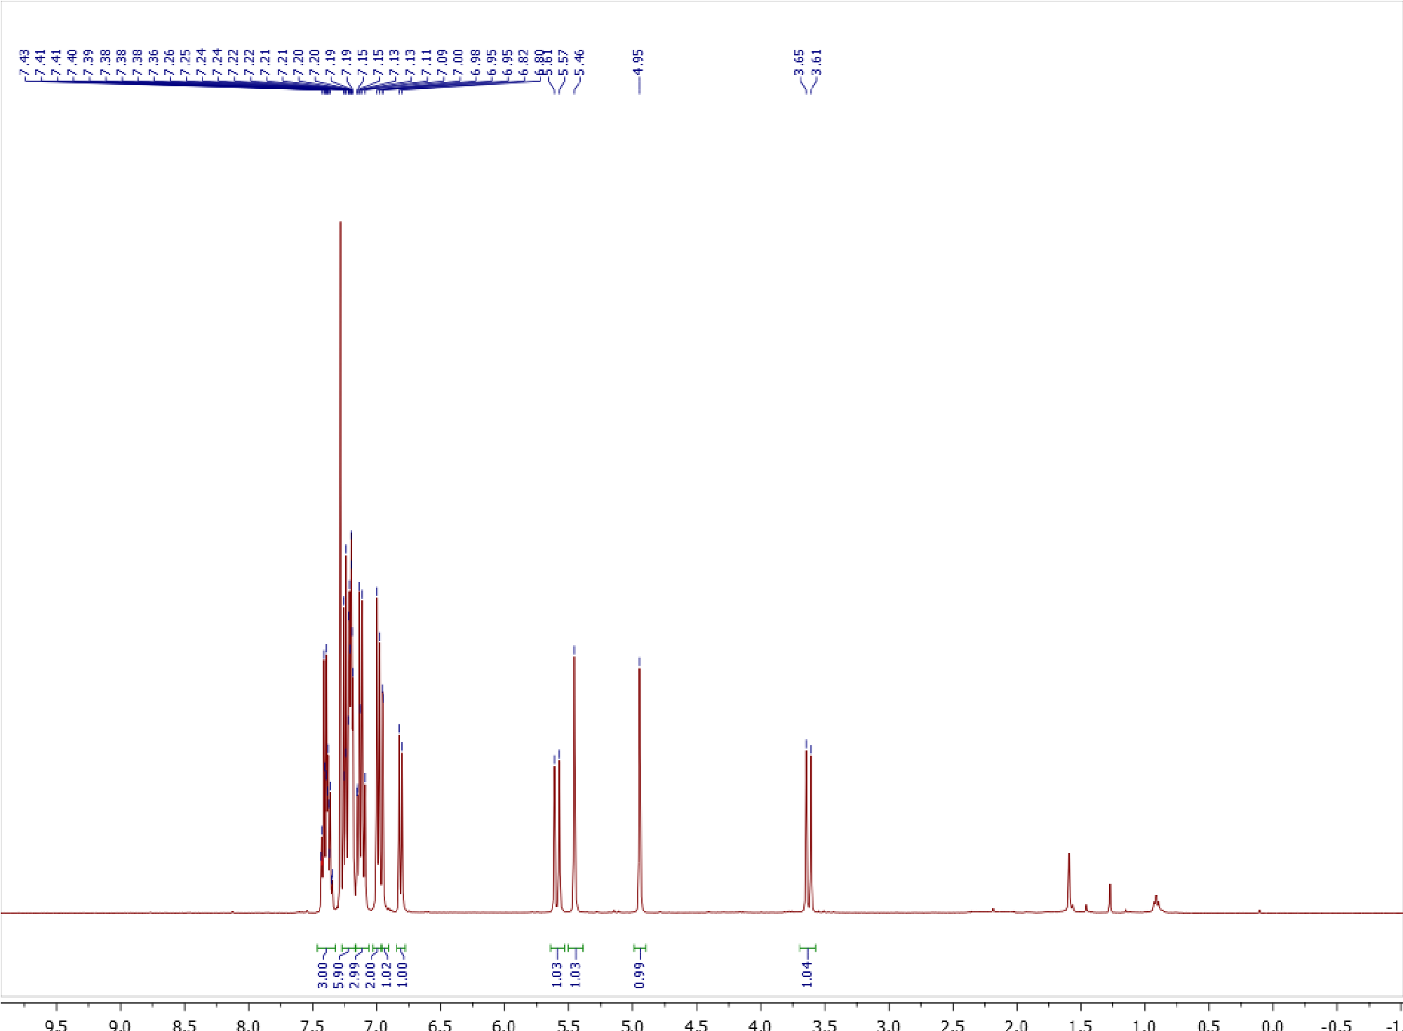
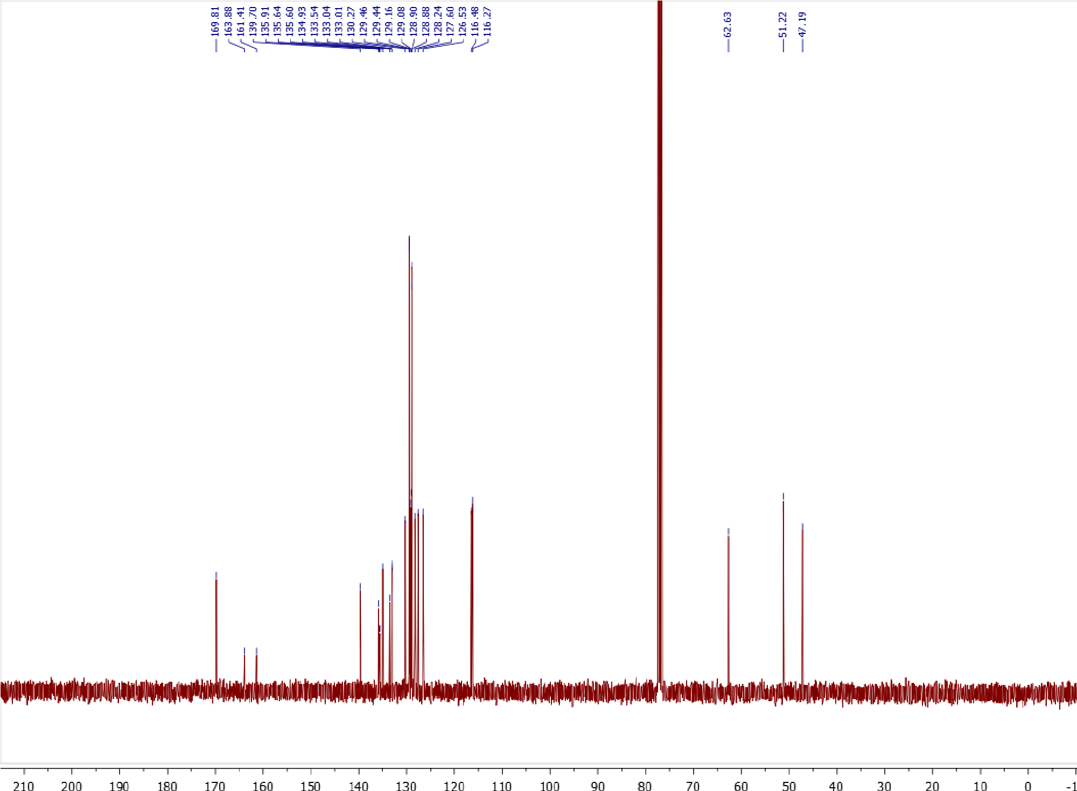
Copy of ¹⁹F{¹H} (376.50 MHz, CDCl₃) spectrum of 9i
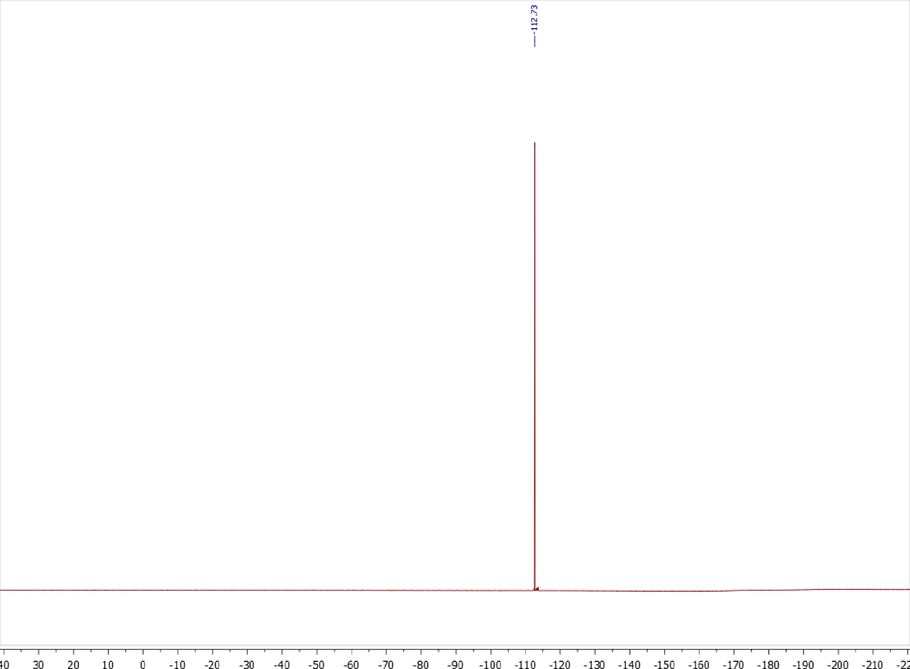
Copies of ¹H (400.13 MHz, CDCl₃) and ¹³C{¹H} (100.61 MHz, CDCl₃) spectra of 15i
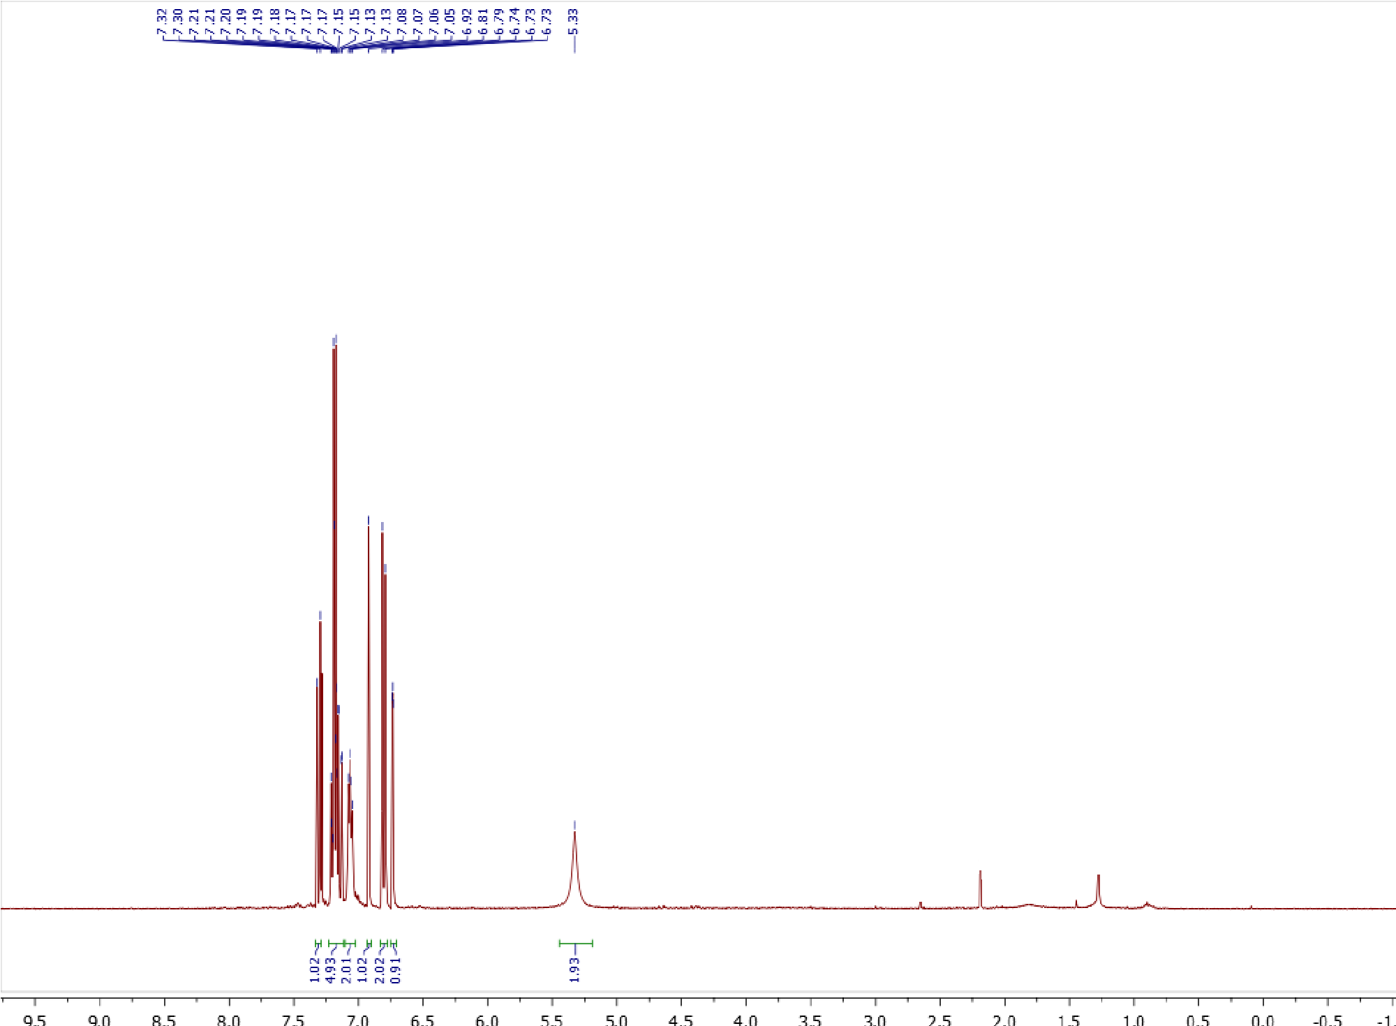
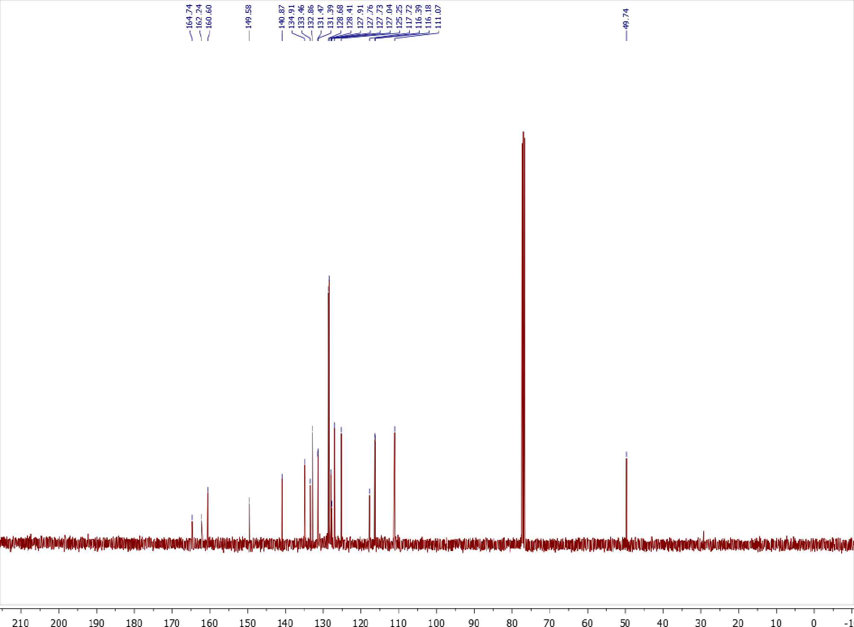
Copy of ¹⁹F{¹H} (376.50 MHz, CDCl₃) spectrum of 15i
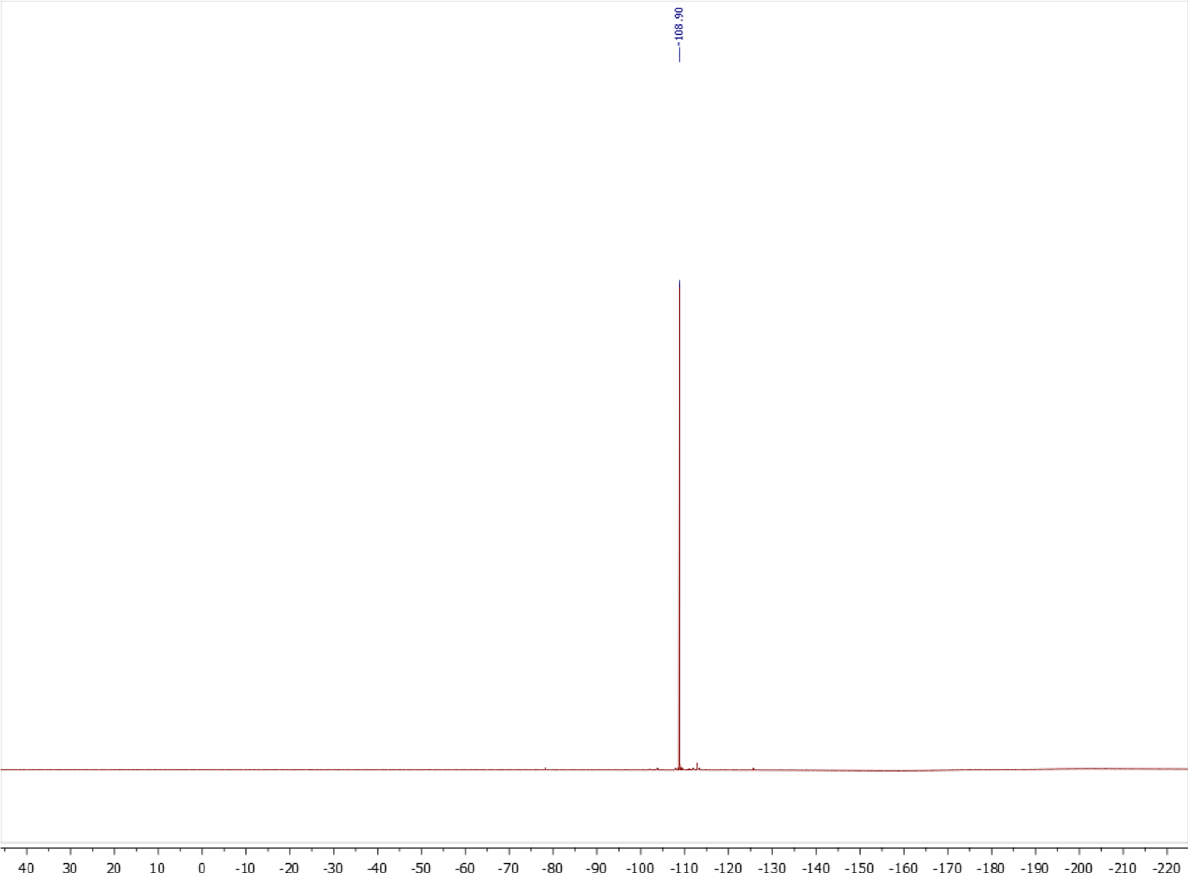
Copies of ¹H (400.13 MHz, CDCl₃) and ¹³C{¹H} (100.61 MHz, CDCl₃) spectra of 9j
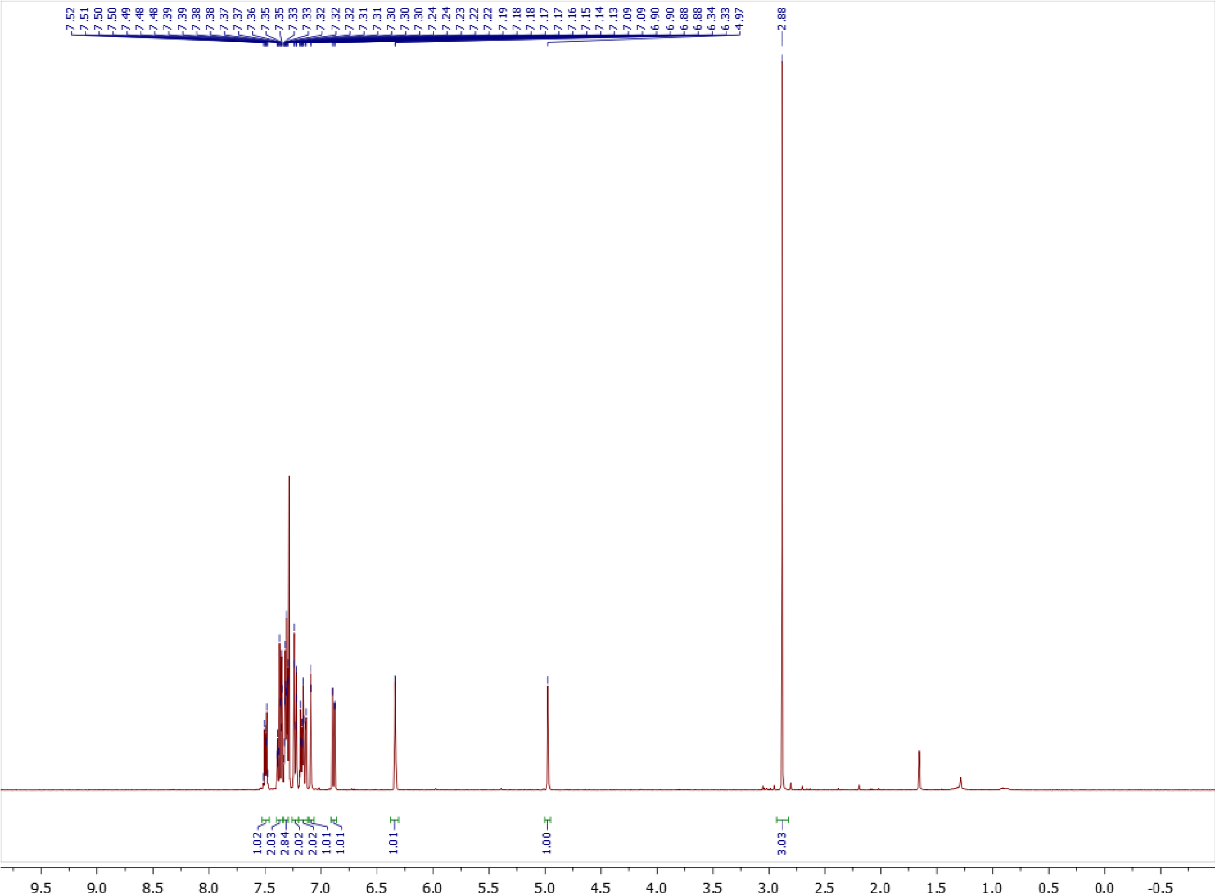
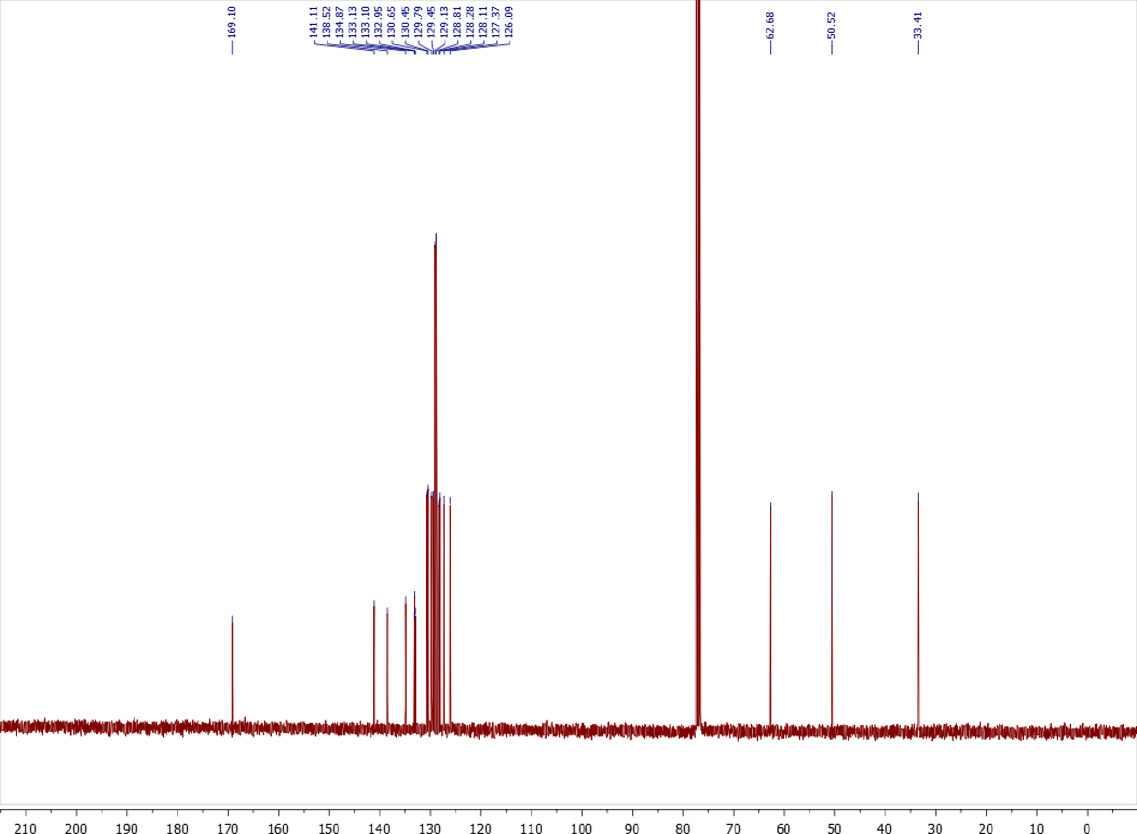
Copies of ¹H (400.13 MHz, CDCl₃) and ¹³C{¹H} (100.61 MHz, CDCl₃) spectra of 15j
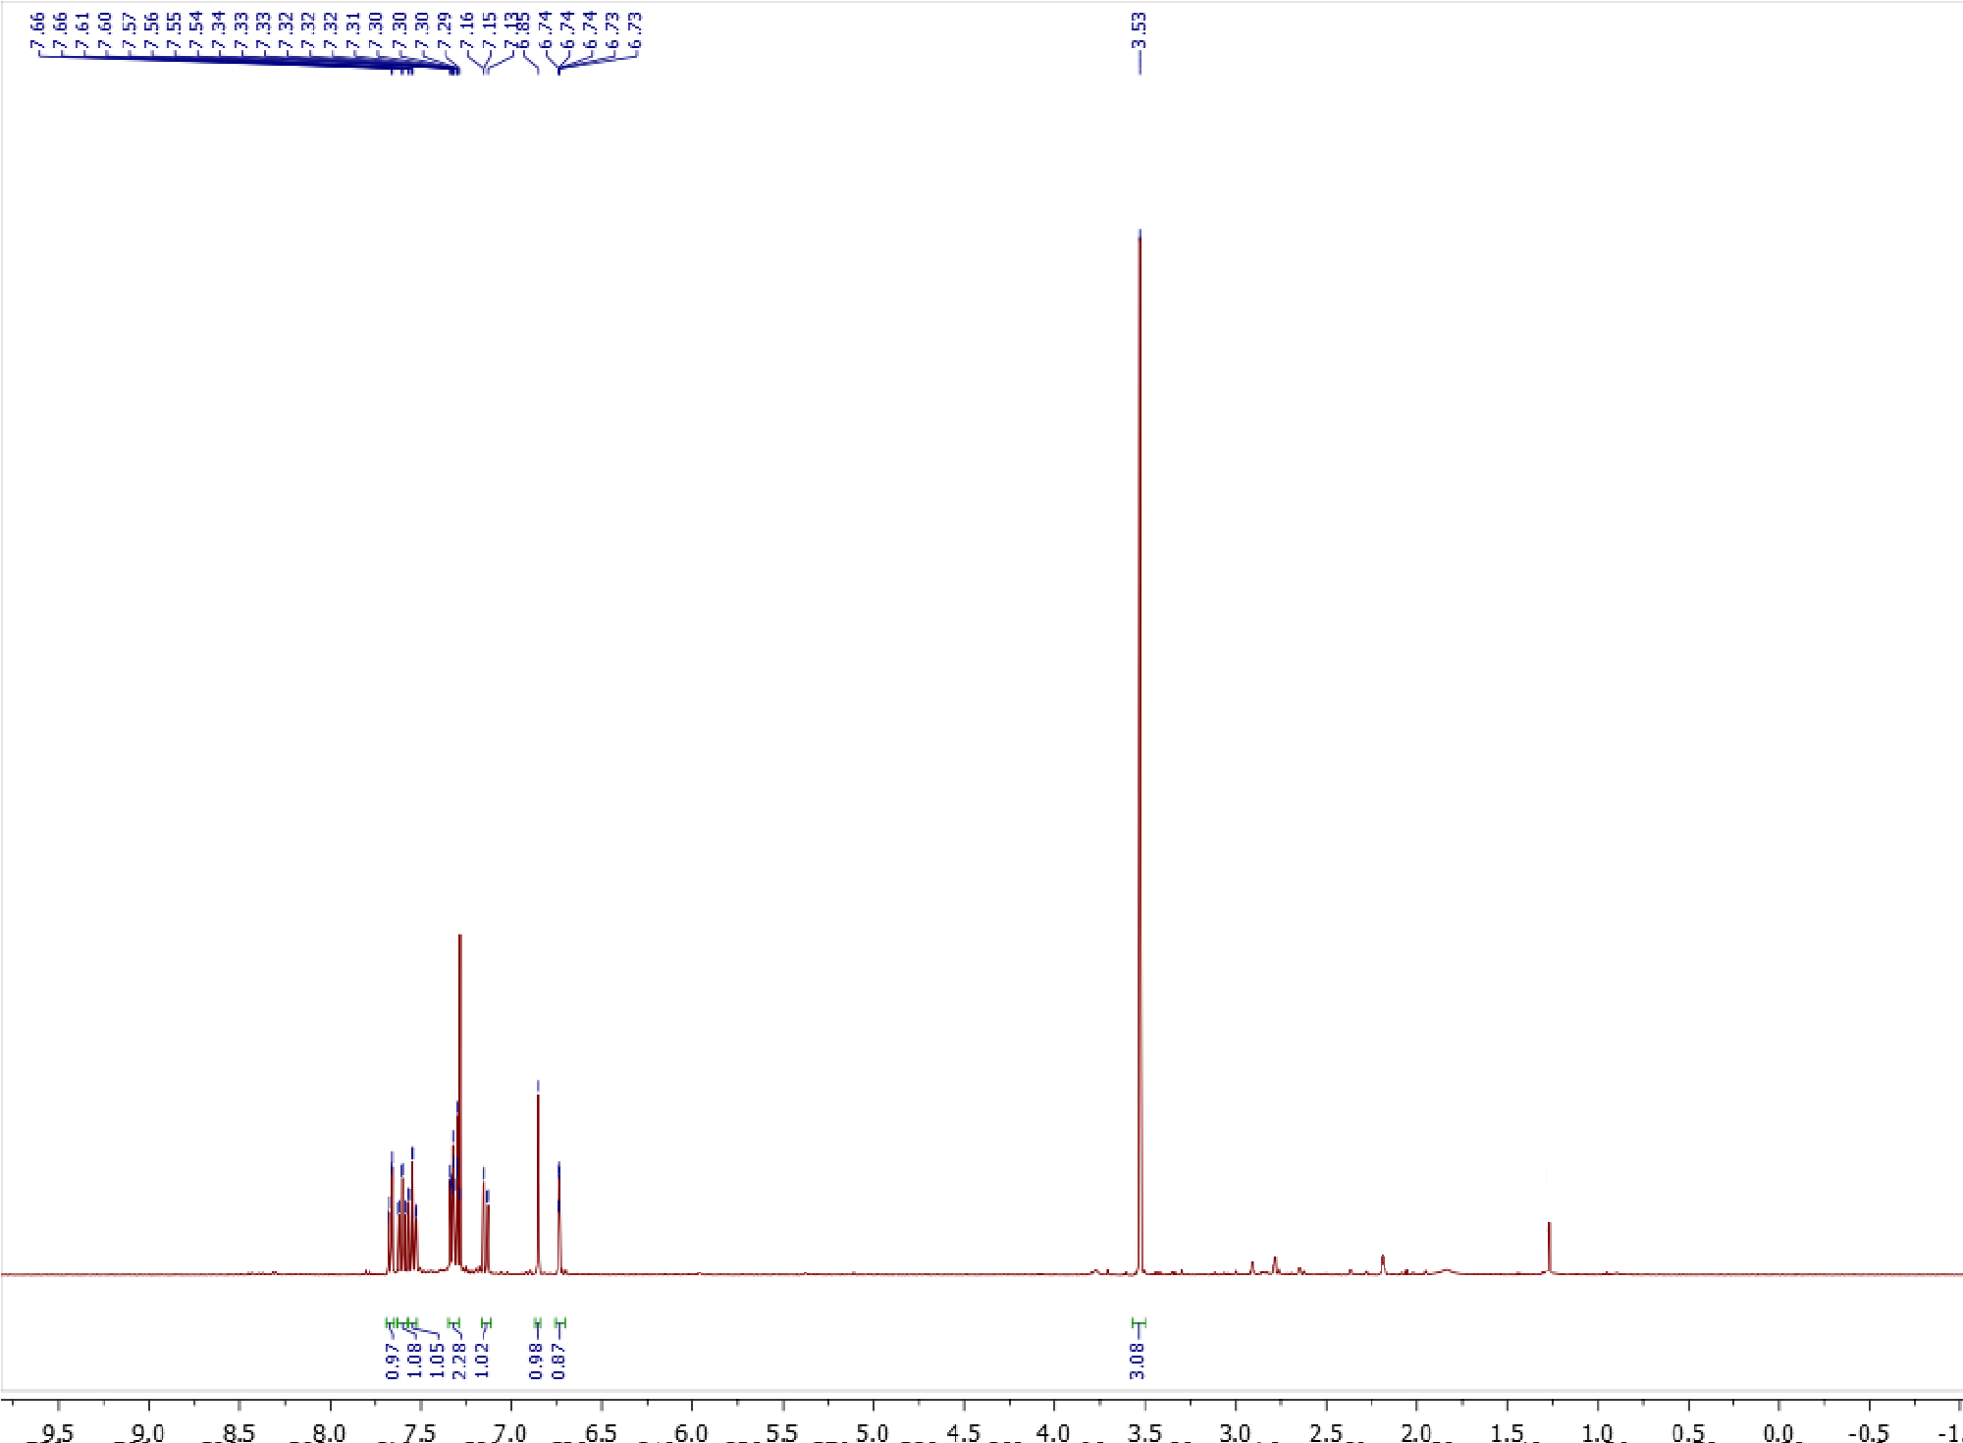
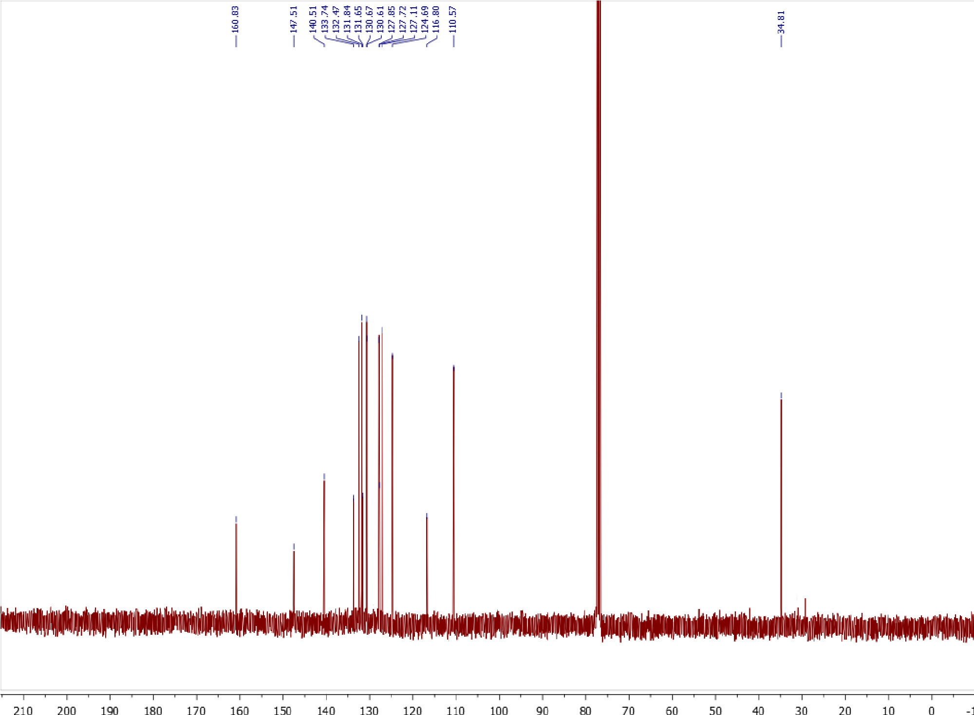
Copies of ¹H (400.13 MHz, CDCl₃) and ¹³C{¹H} (100.61 MHz, CDCl₃) spectra of 9k
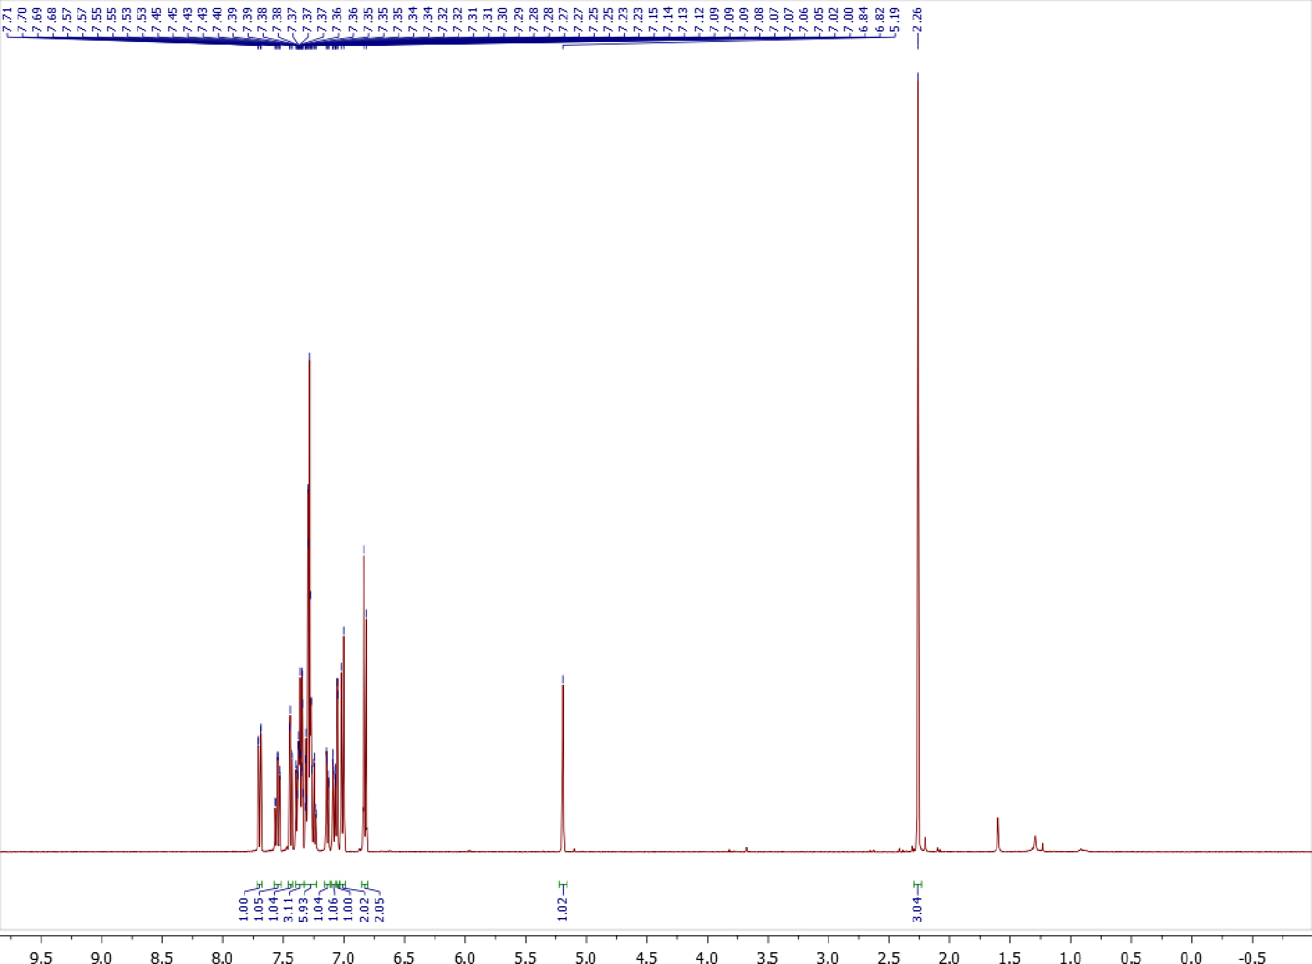
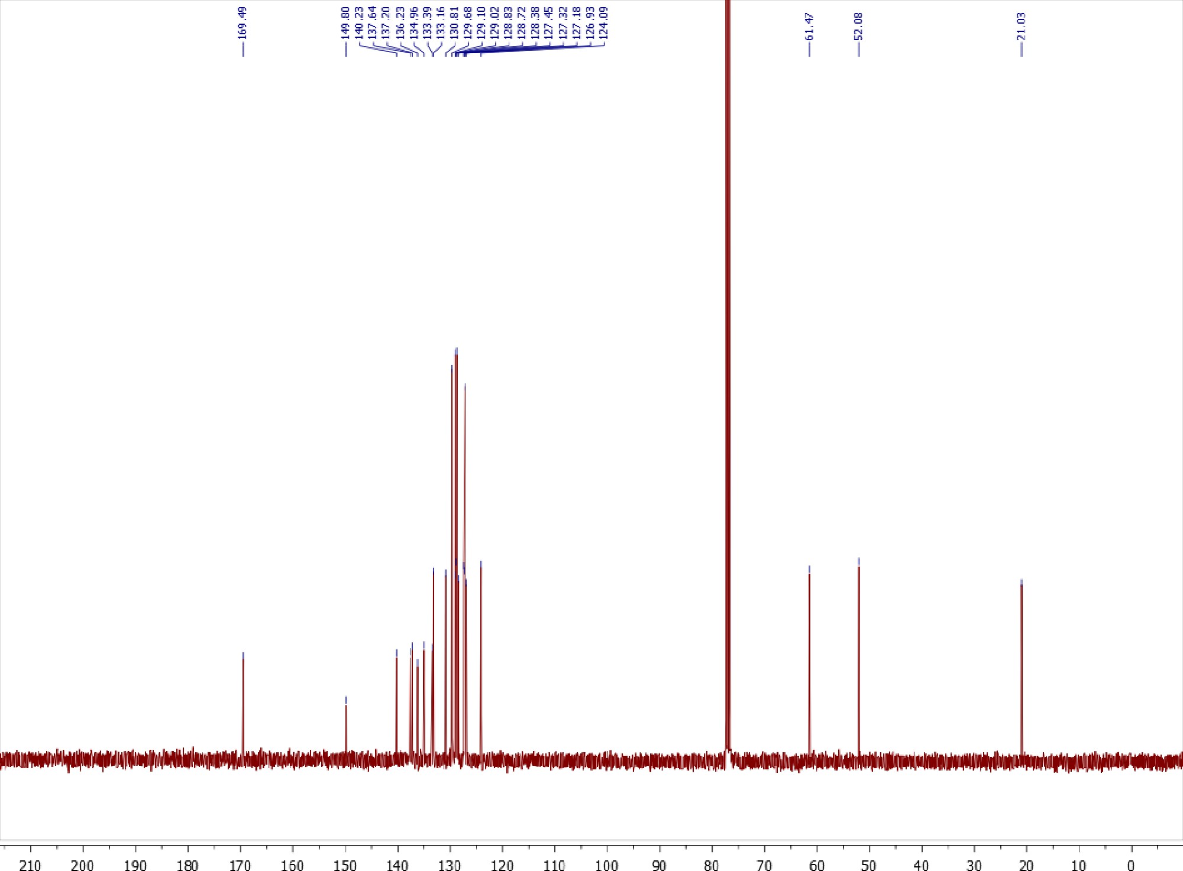
Copies of ¹H (400.13 MHz, CDCl₃) and ¹³C{¹H} (100.61 MHz, CDCl₃) spectra of 15k
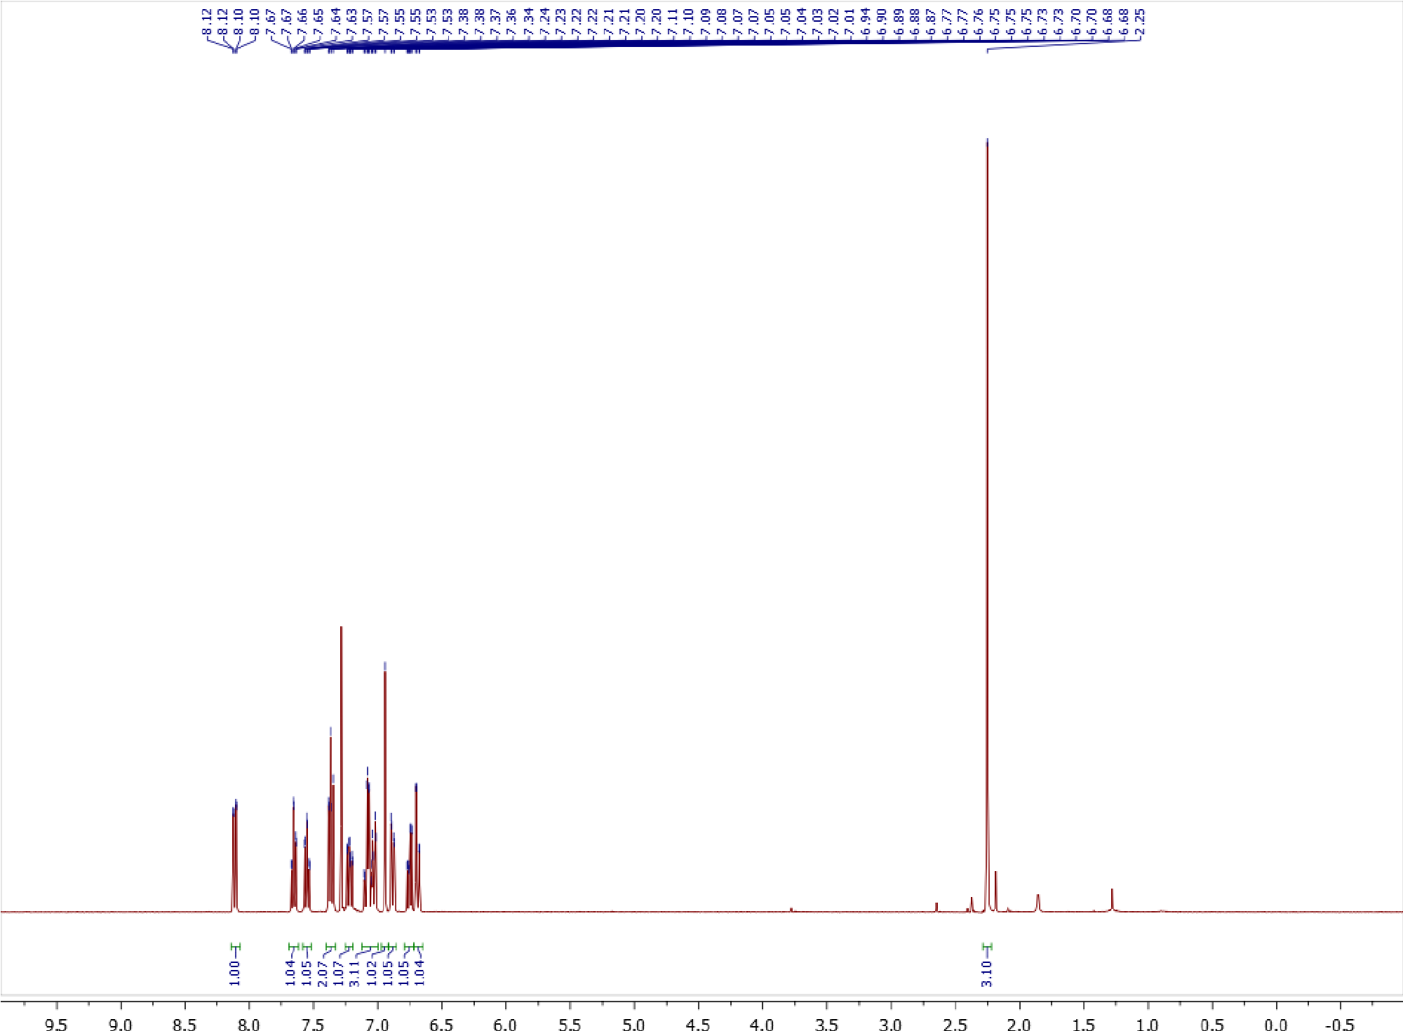
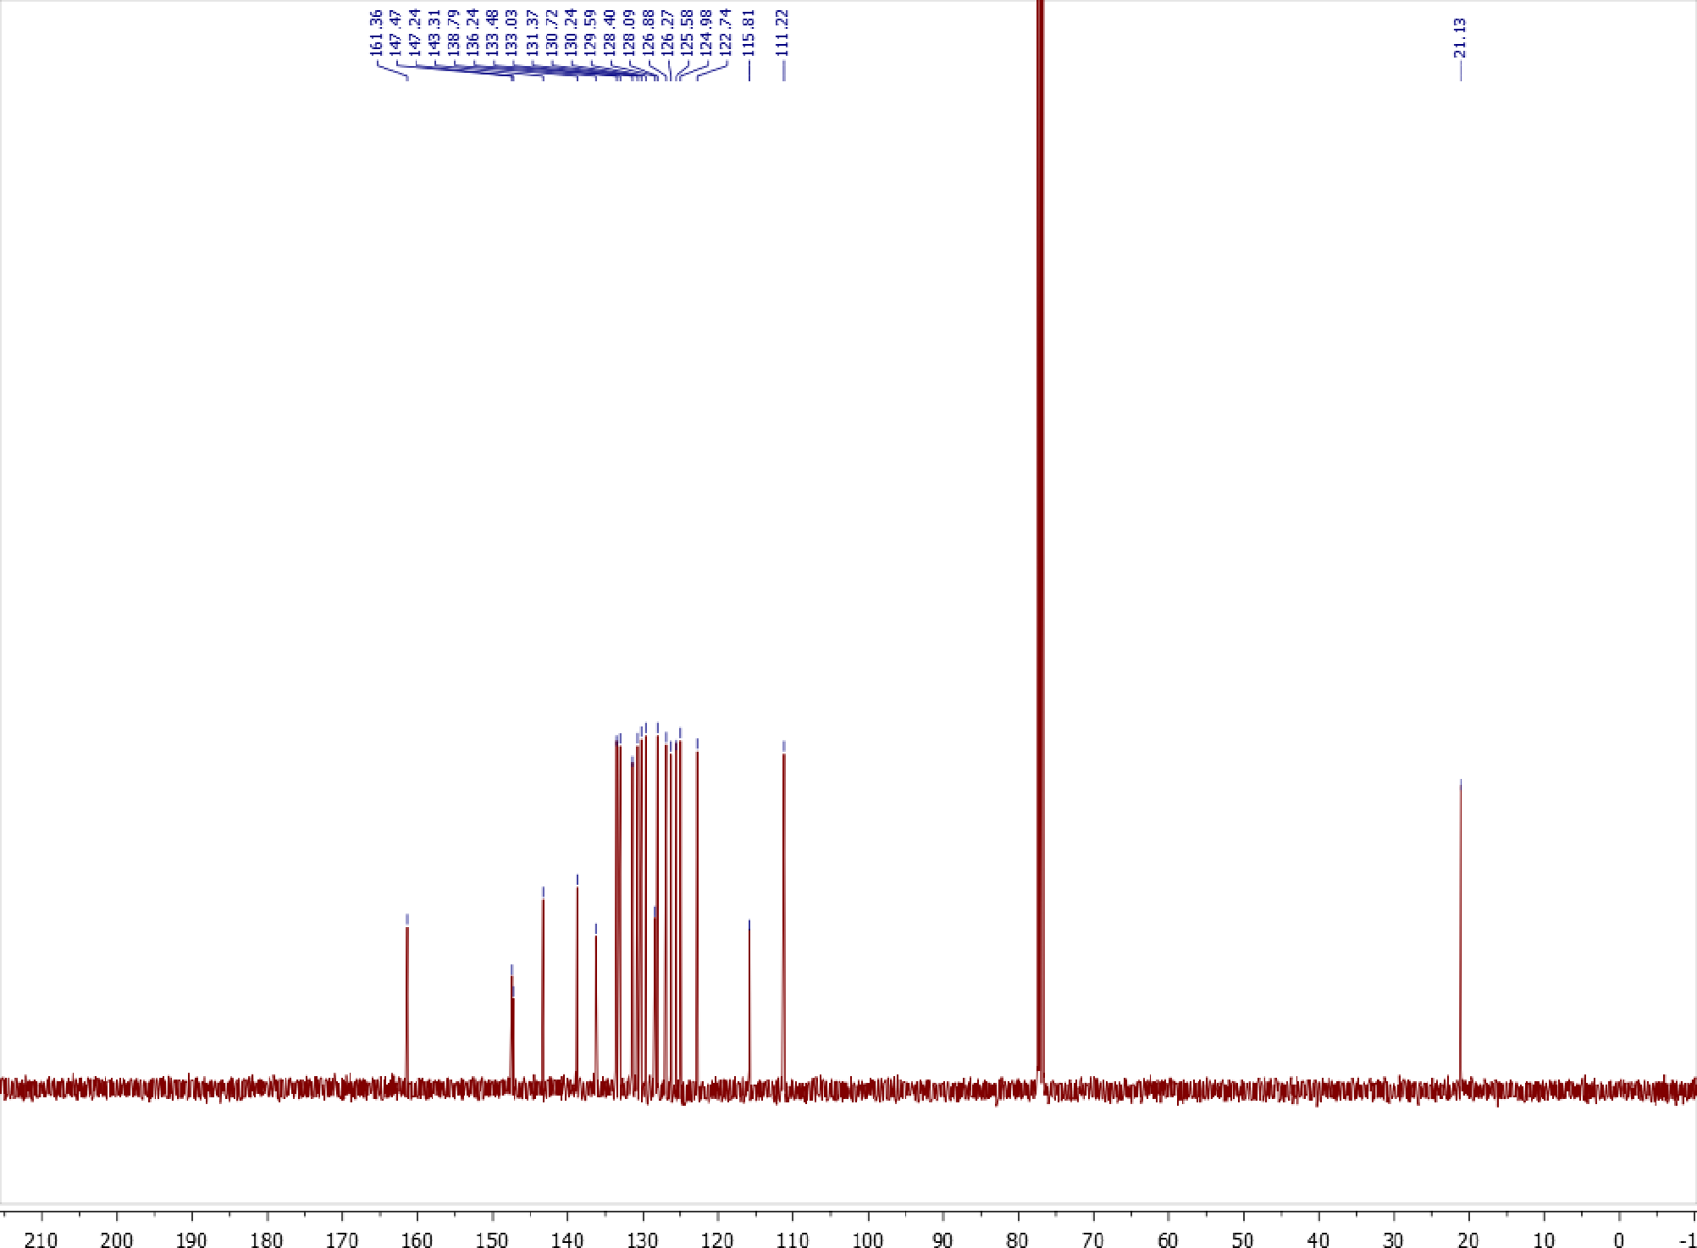
Copies of ¹H (400.13 MHz, CDCl₃) and ¹³C{¹H} (100.61 MHz, CDCl₃) spectra of 9l
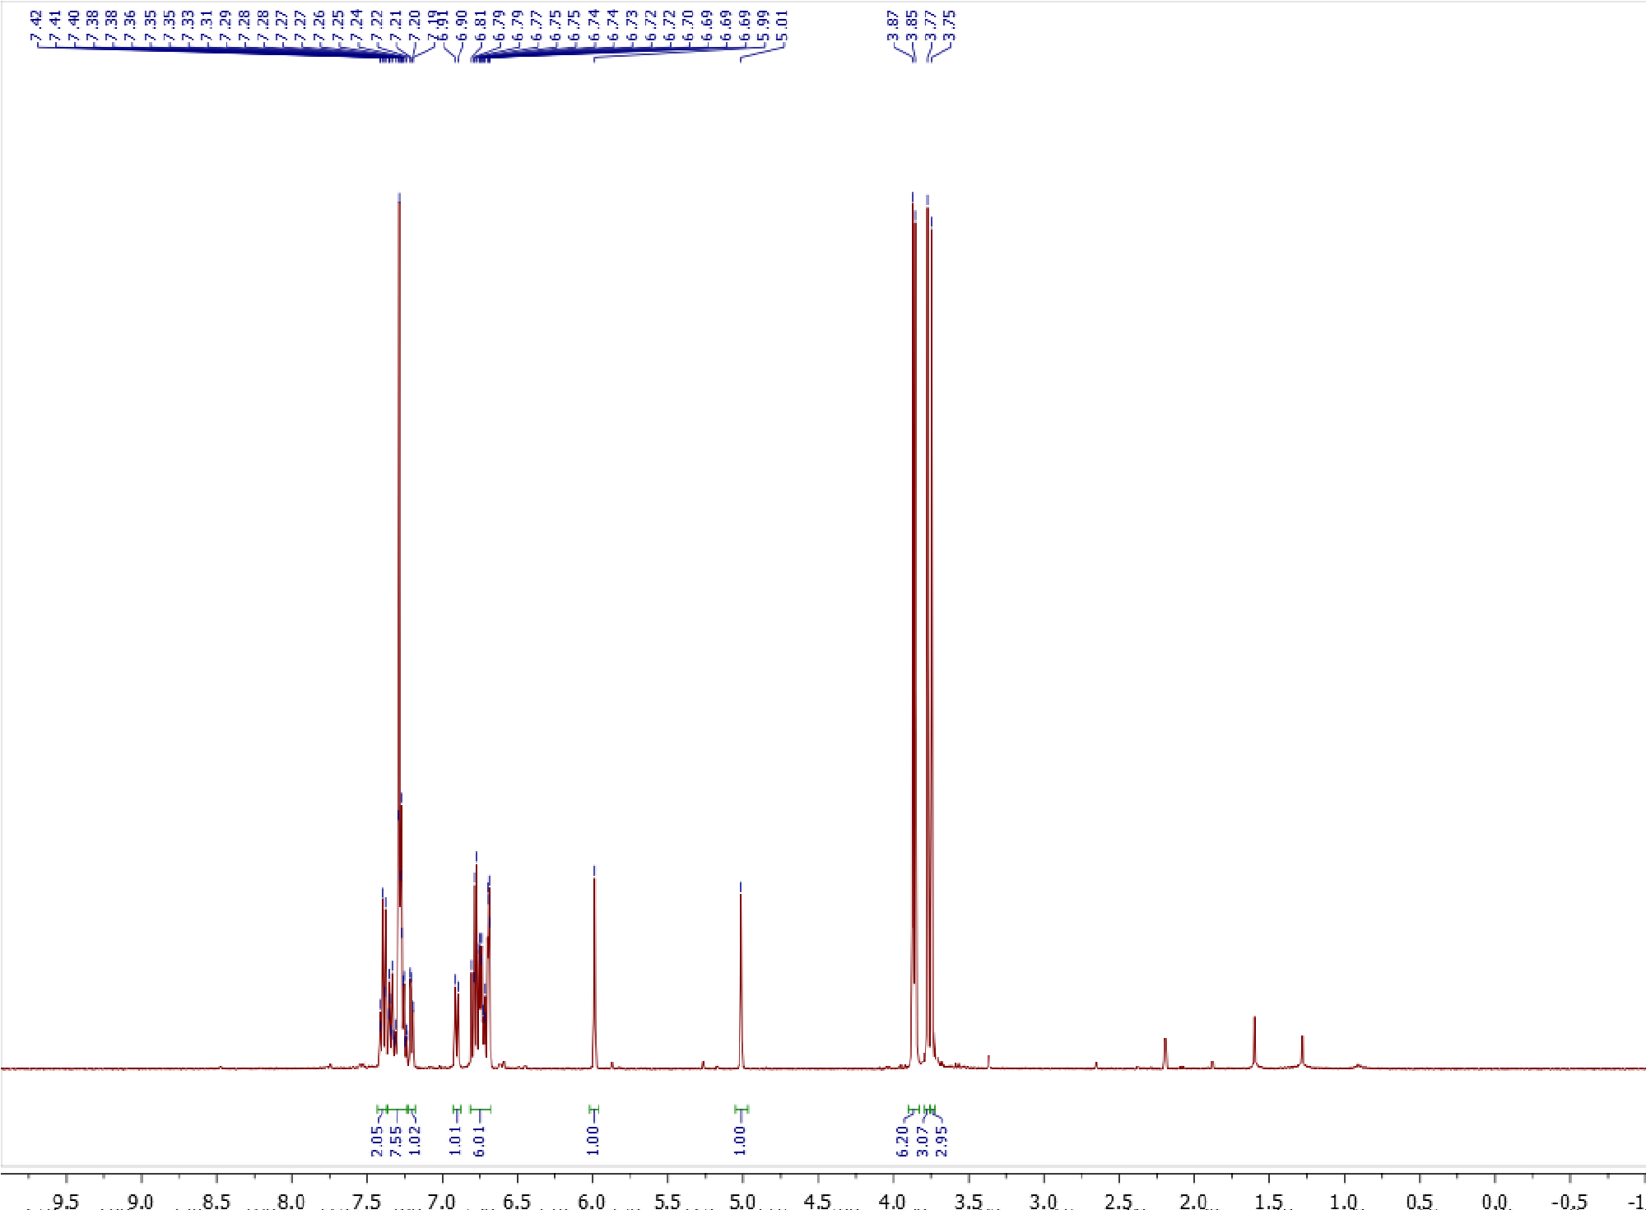
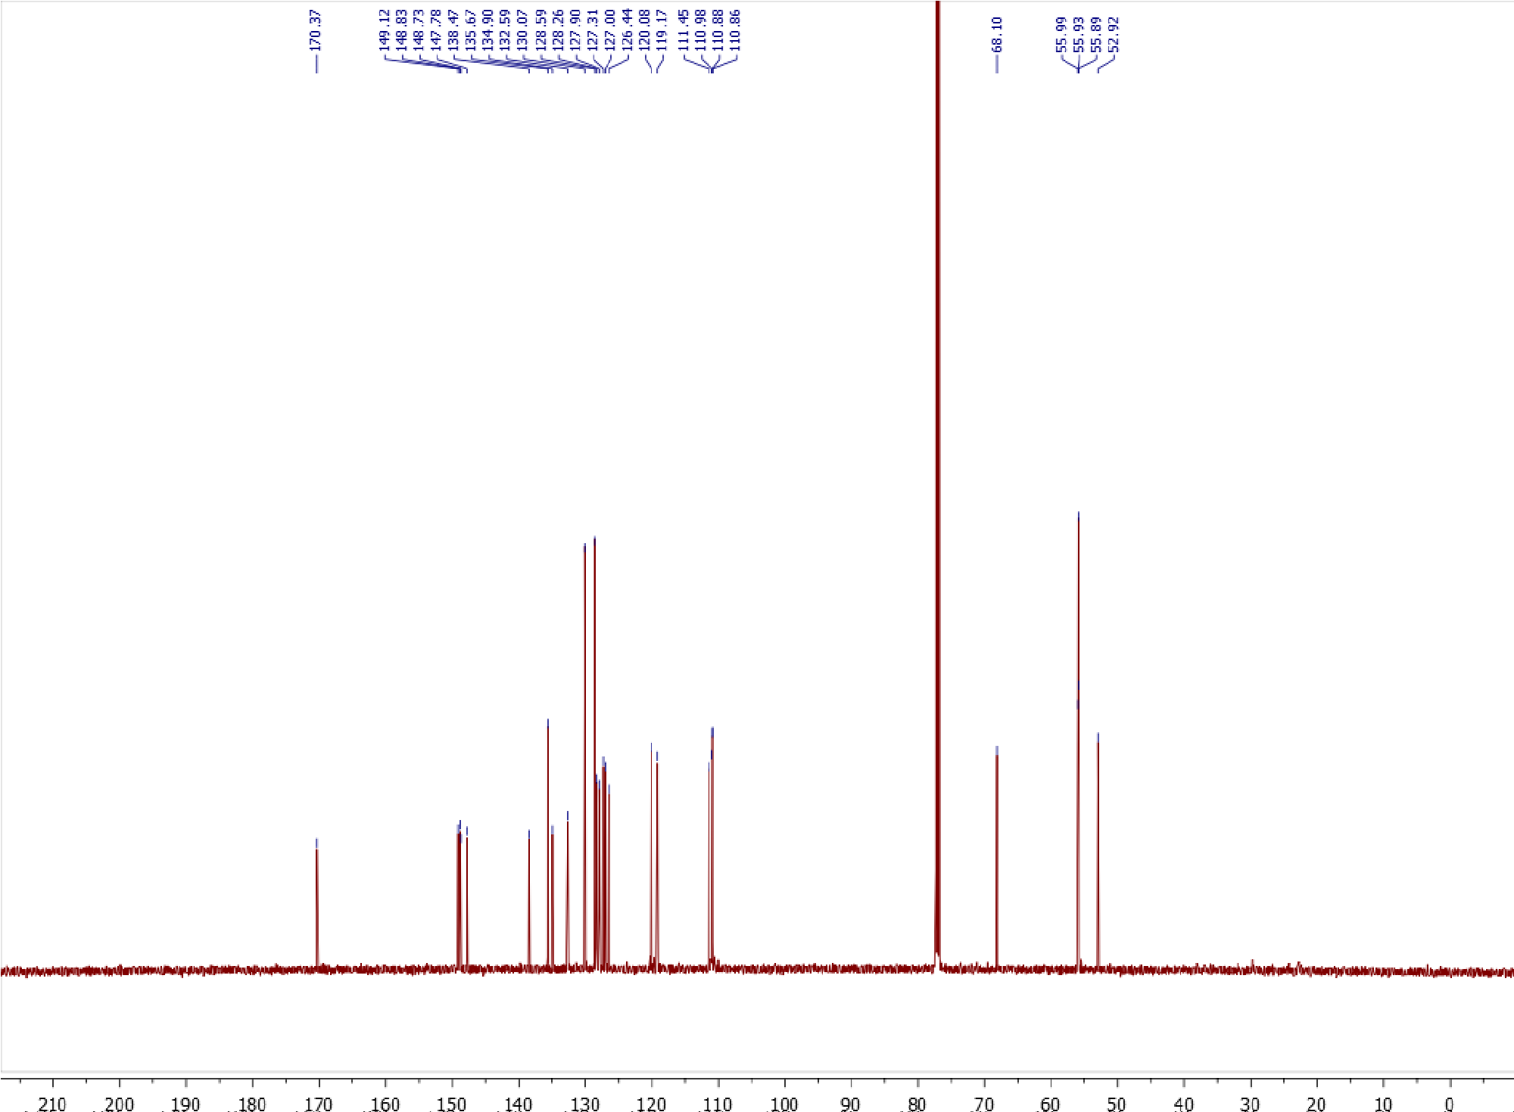
Copies of ¹H (400.13 MHz, CDCl₃) and ¹³C{¹H} (100.61 MHz, CDCl₃) spectra of 15l
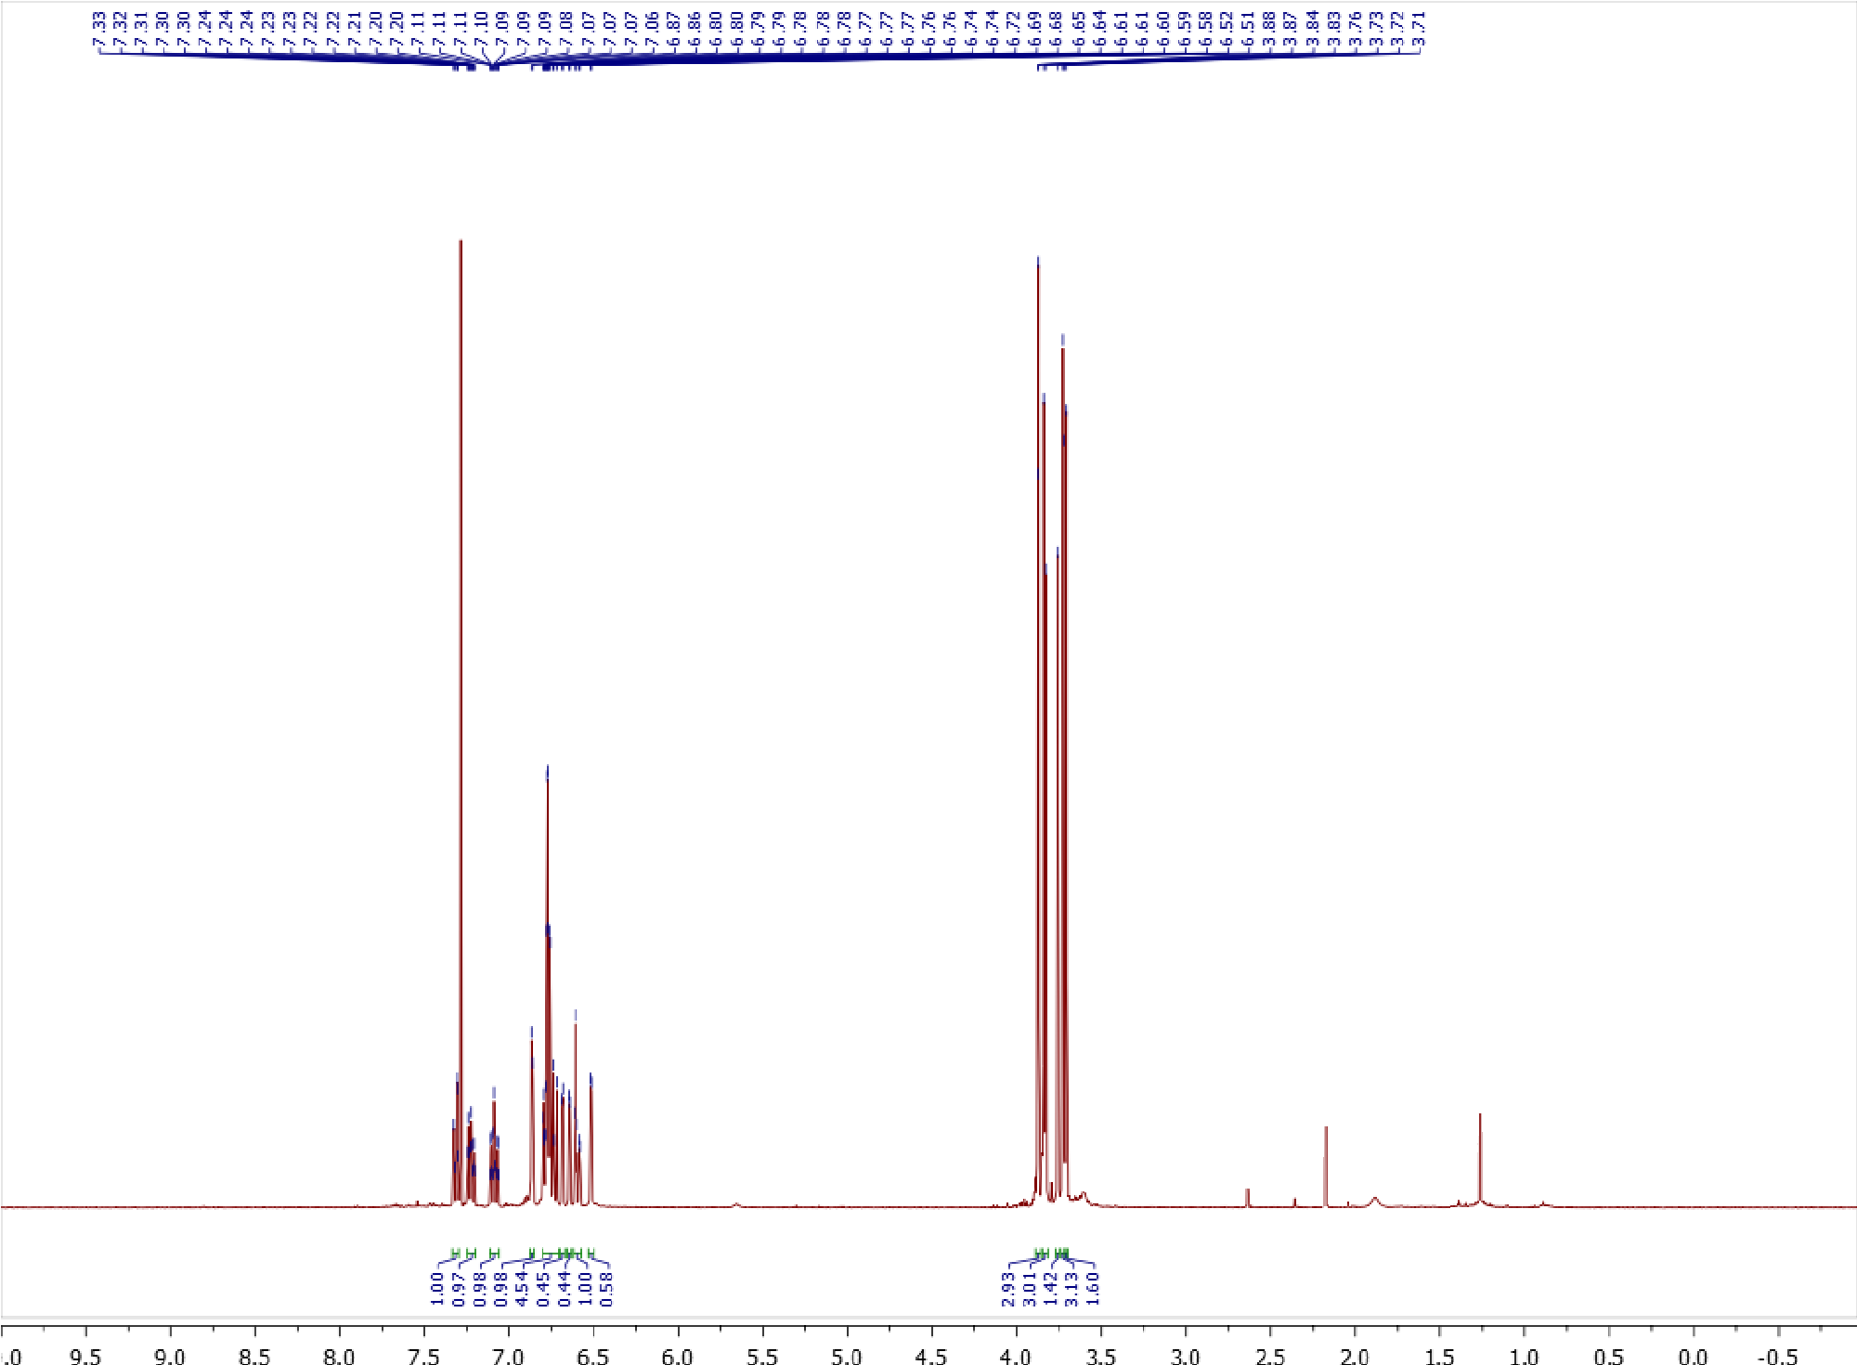
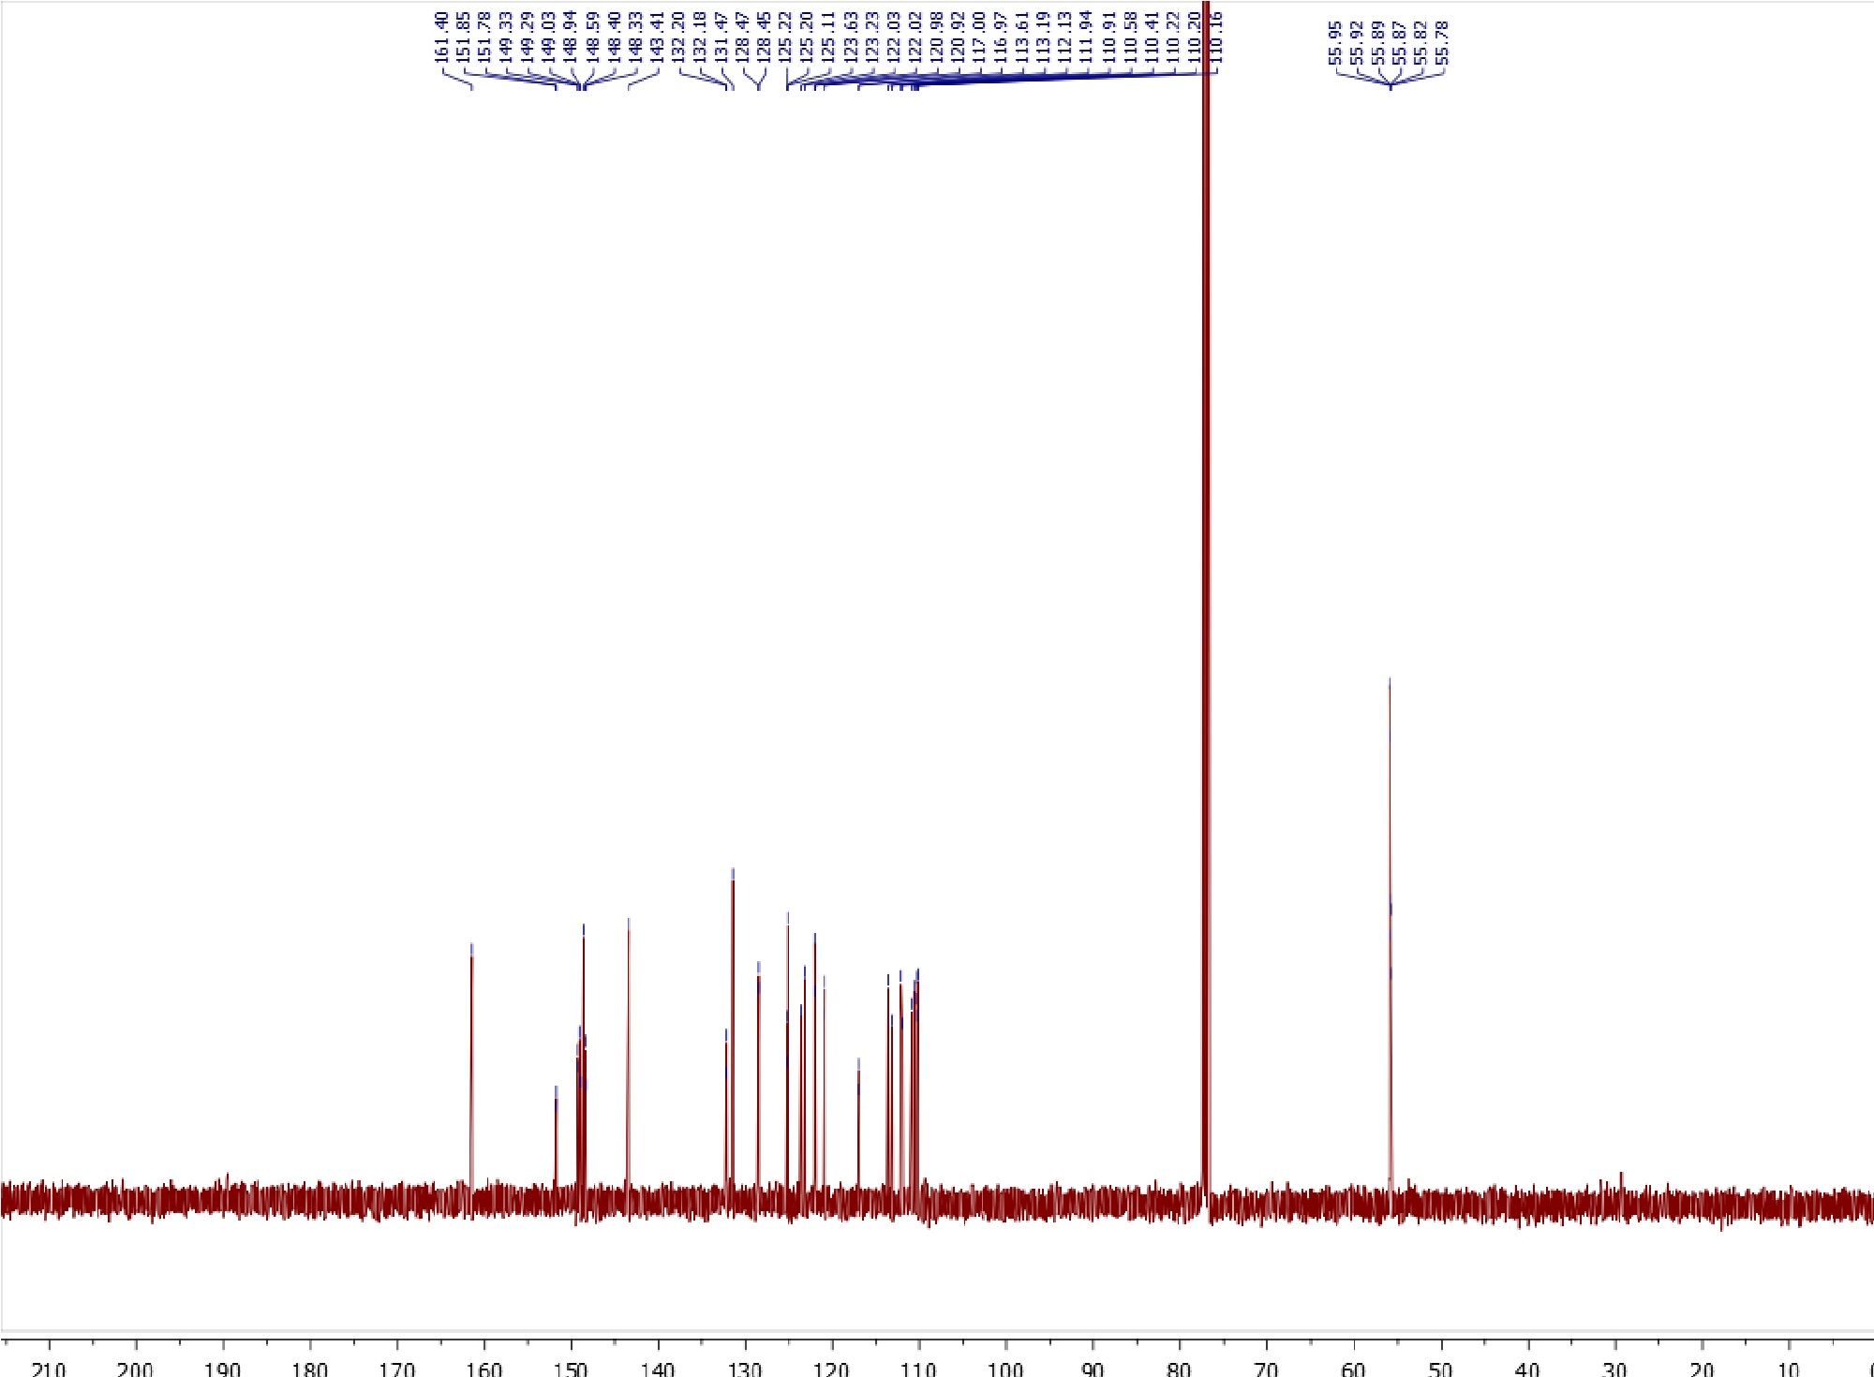
Copies of ¹H (400.13 MHz, CDCl₃) and ¹³C{¹H} (100.61 MHz, CDCl₃) spectra of 9m
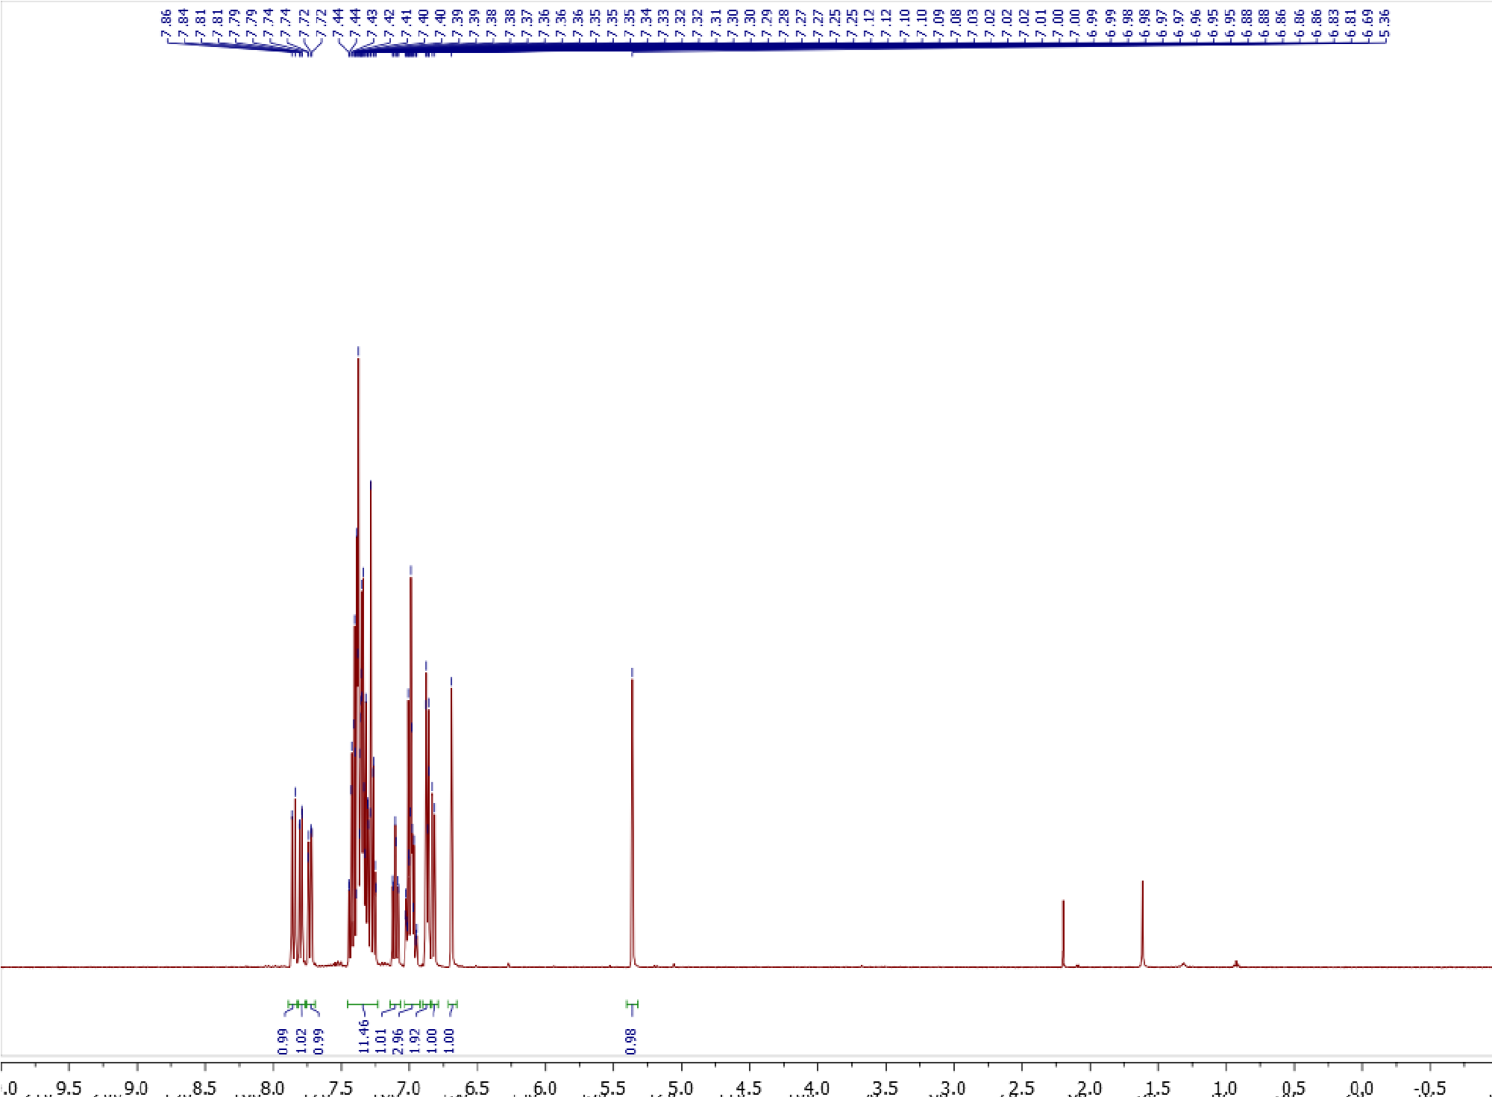
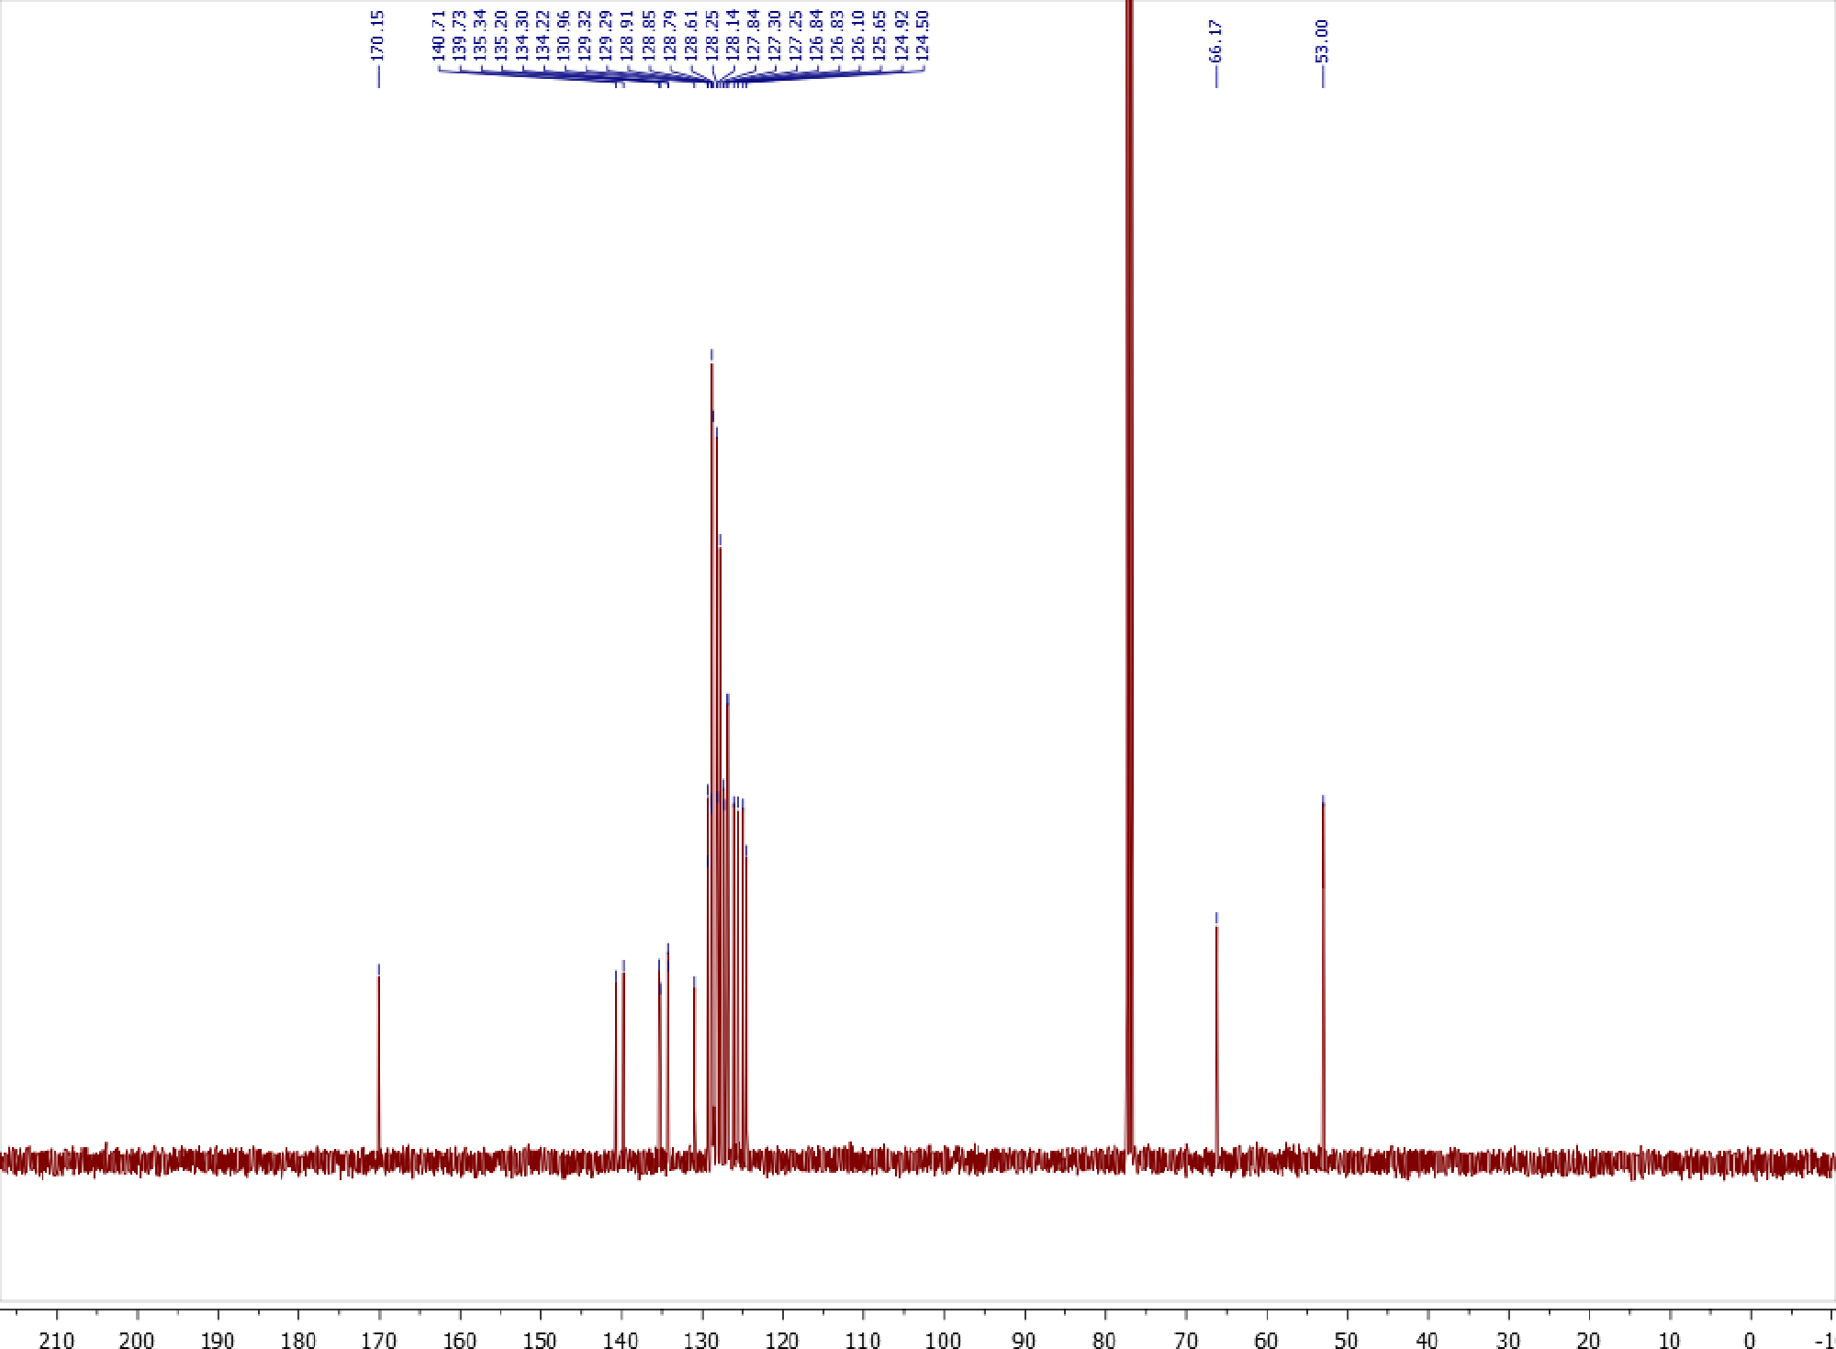
Copies of ¹H (400.13 MHz, CDCl₃) and ¹³C{¹H} (100.61 MHz, CDCl₃) spectra of 15m
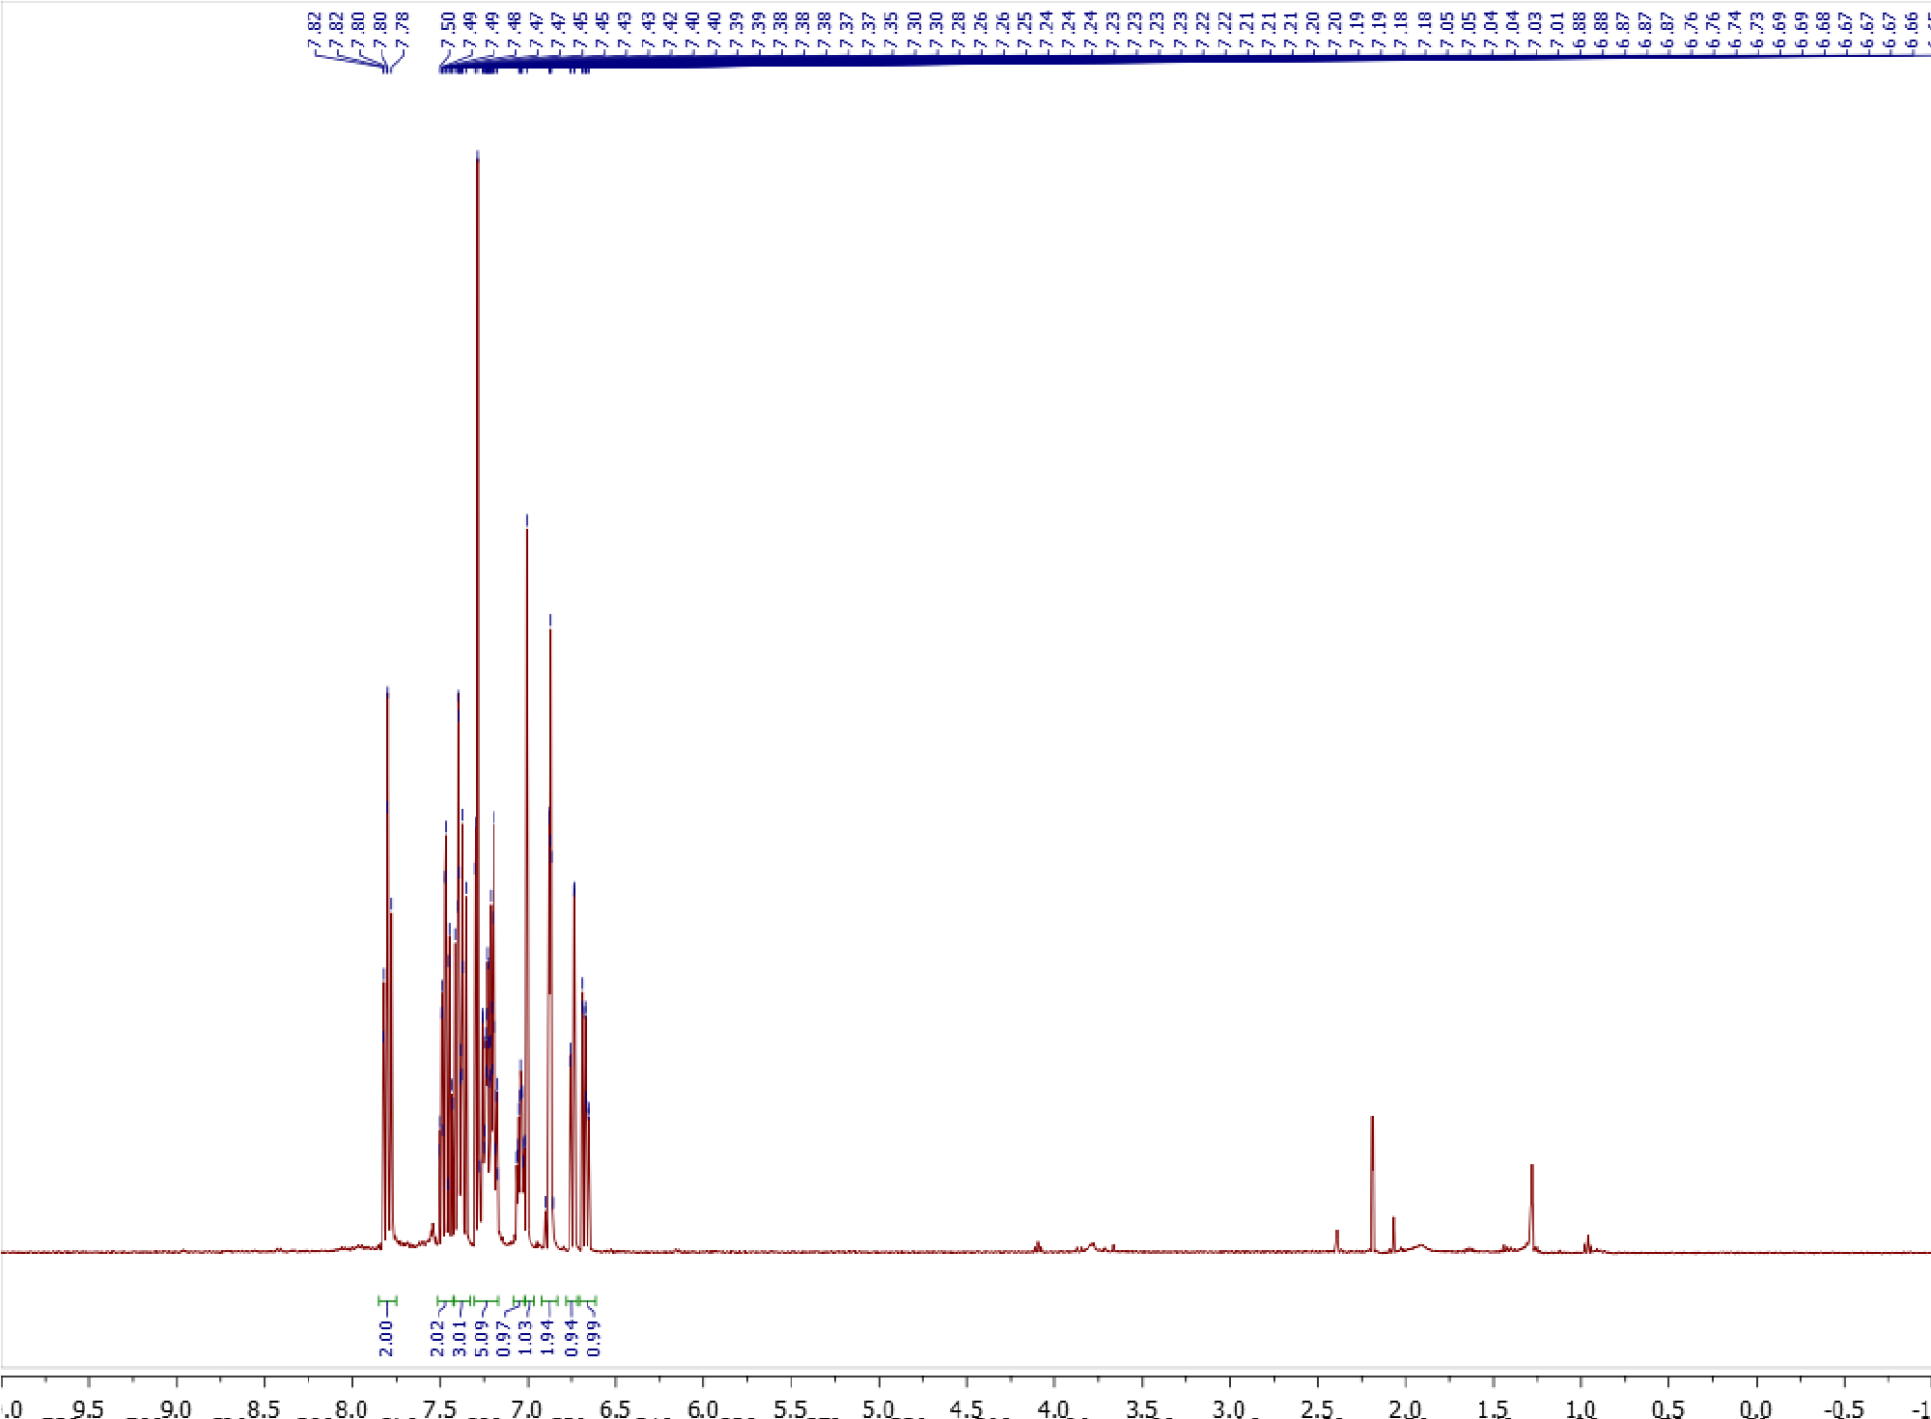
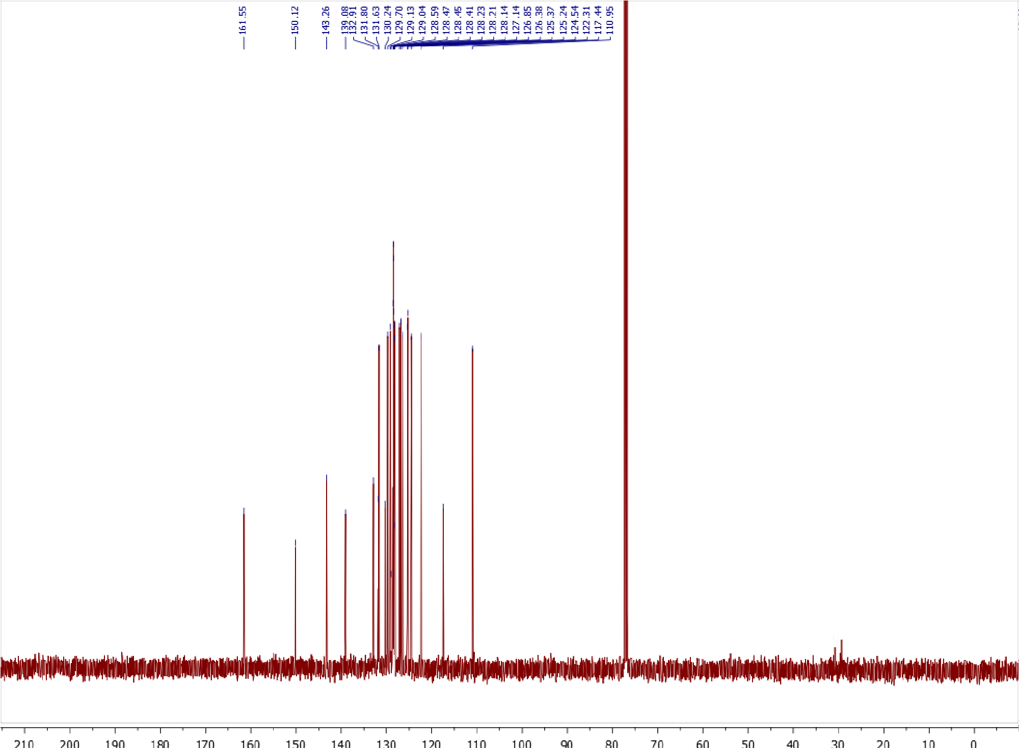
Copies of ¹H (400.13 MHz, CDCl₃) and ¹³C{¹H} (100.61 MHz, CDCl₃) spectra of 9n
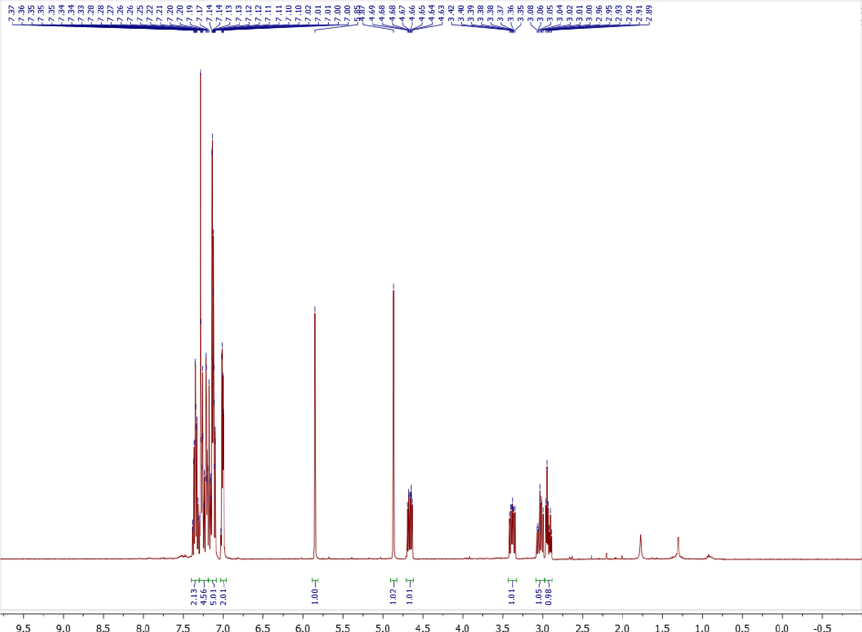
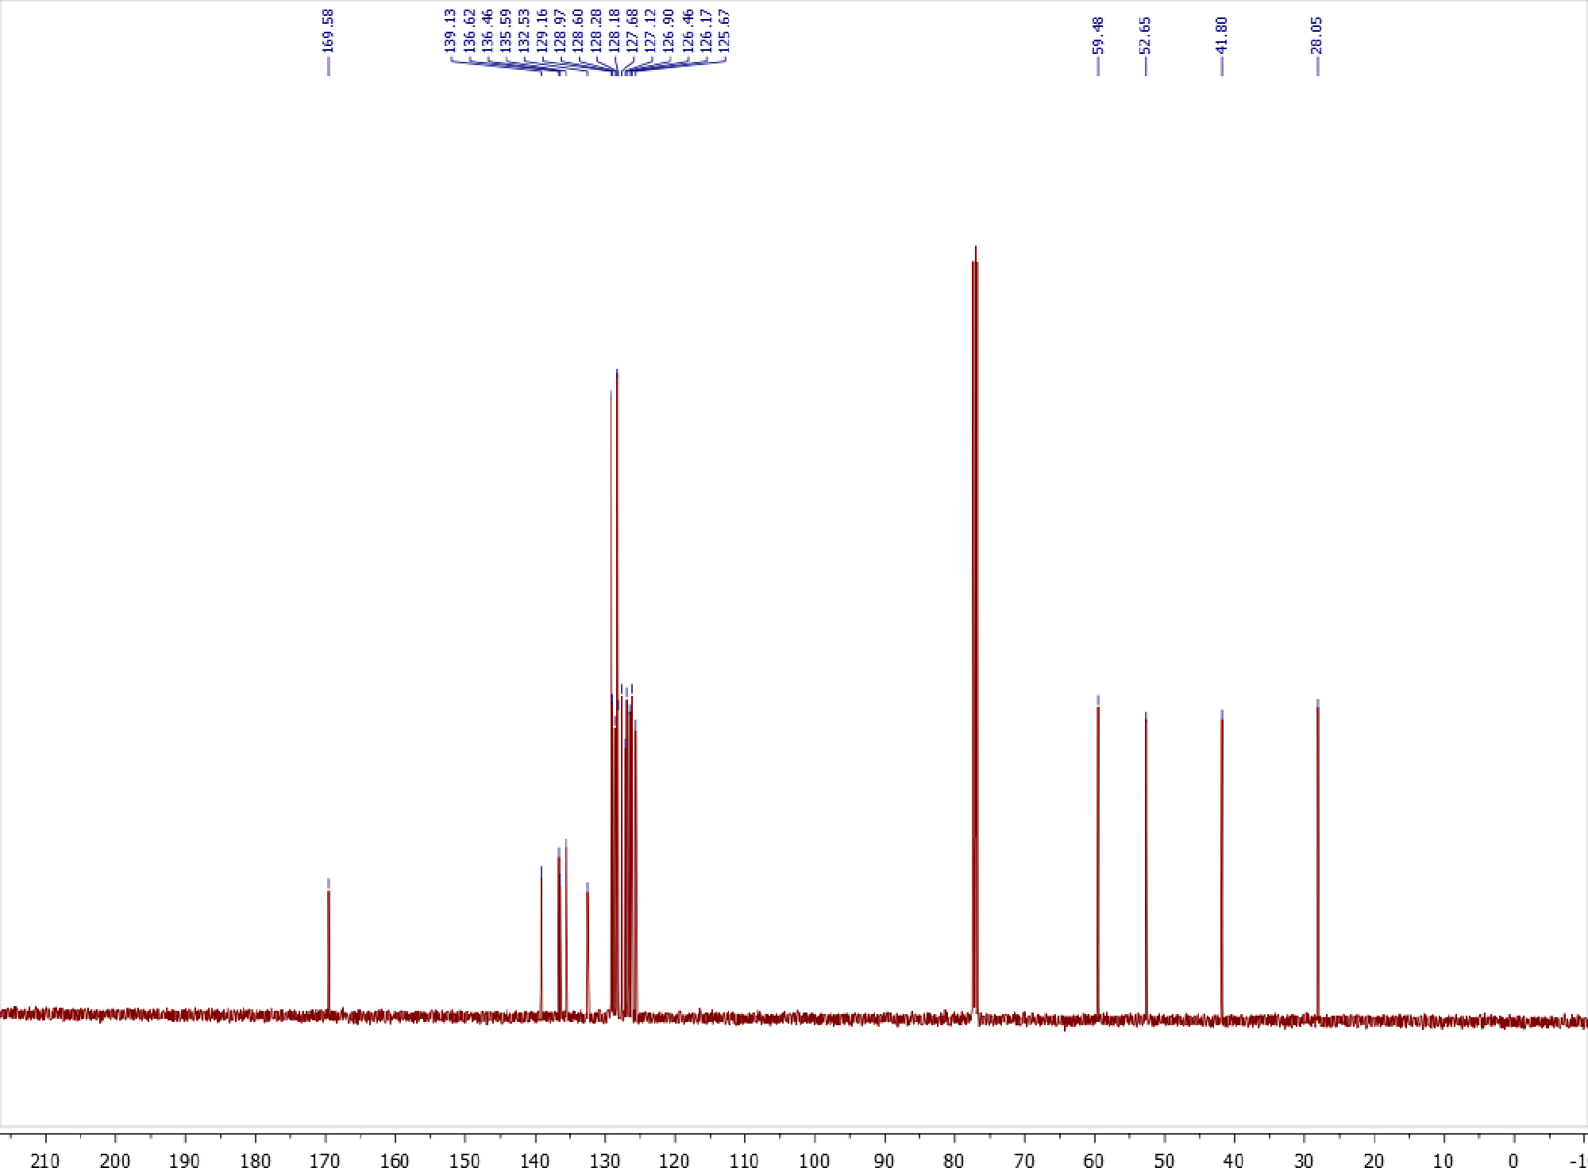
Copies of ¹H (400.13 MHz, CDCl₃) and ¹³C{¹H} (100.61 MHz, CDCl₃) spectra of 15n
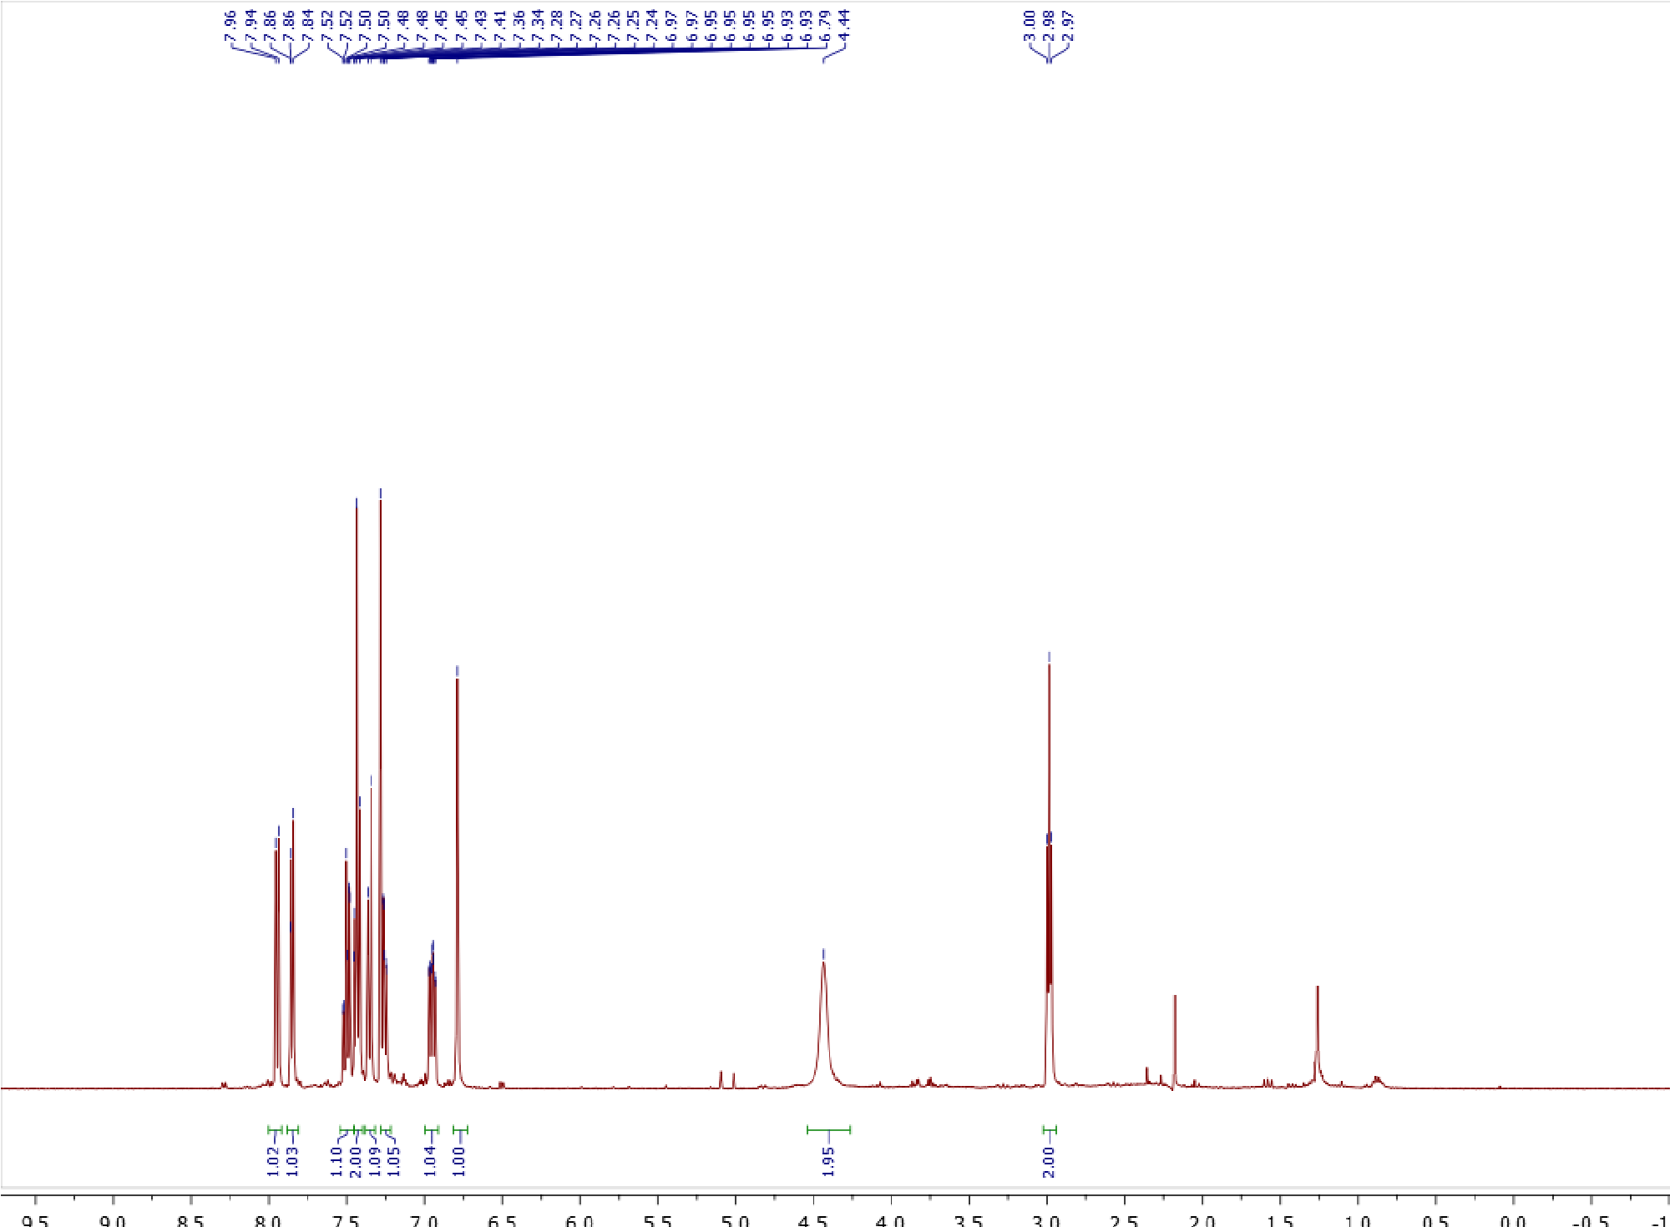
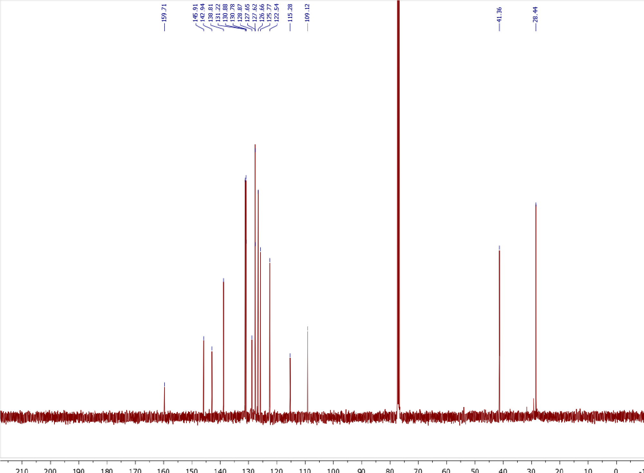
Copies of ¹H (400.13 MHz, CDCl₃) and ¹³C{¹H} (100.61 MHz, CDCl₃) spectra of 9o
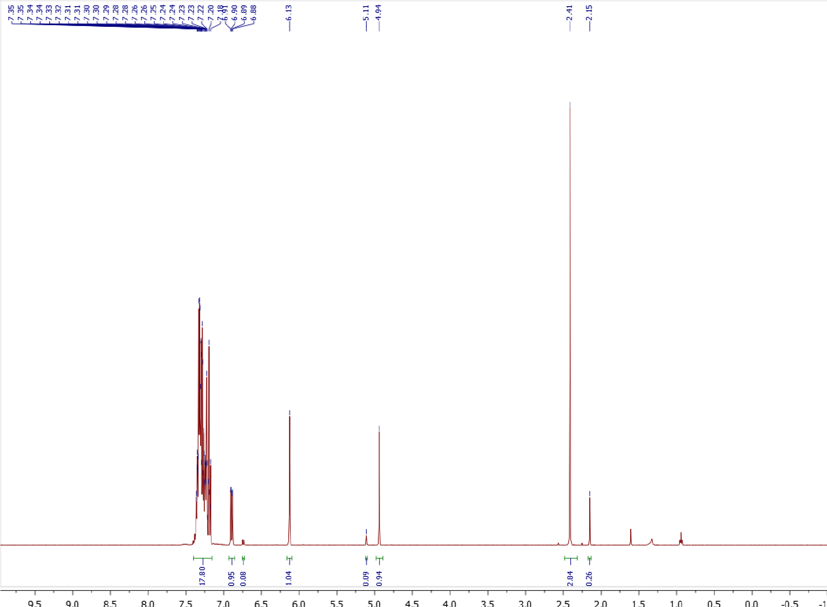
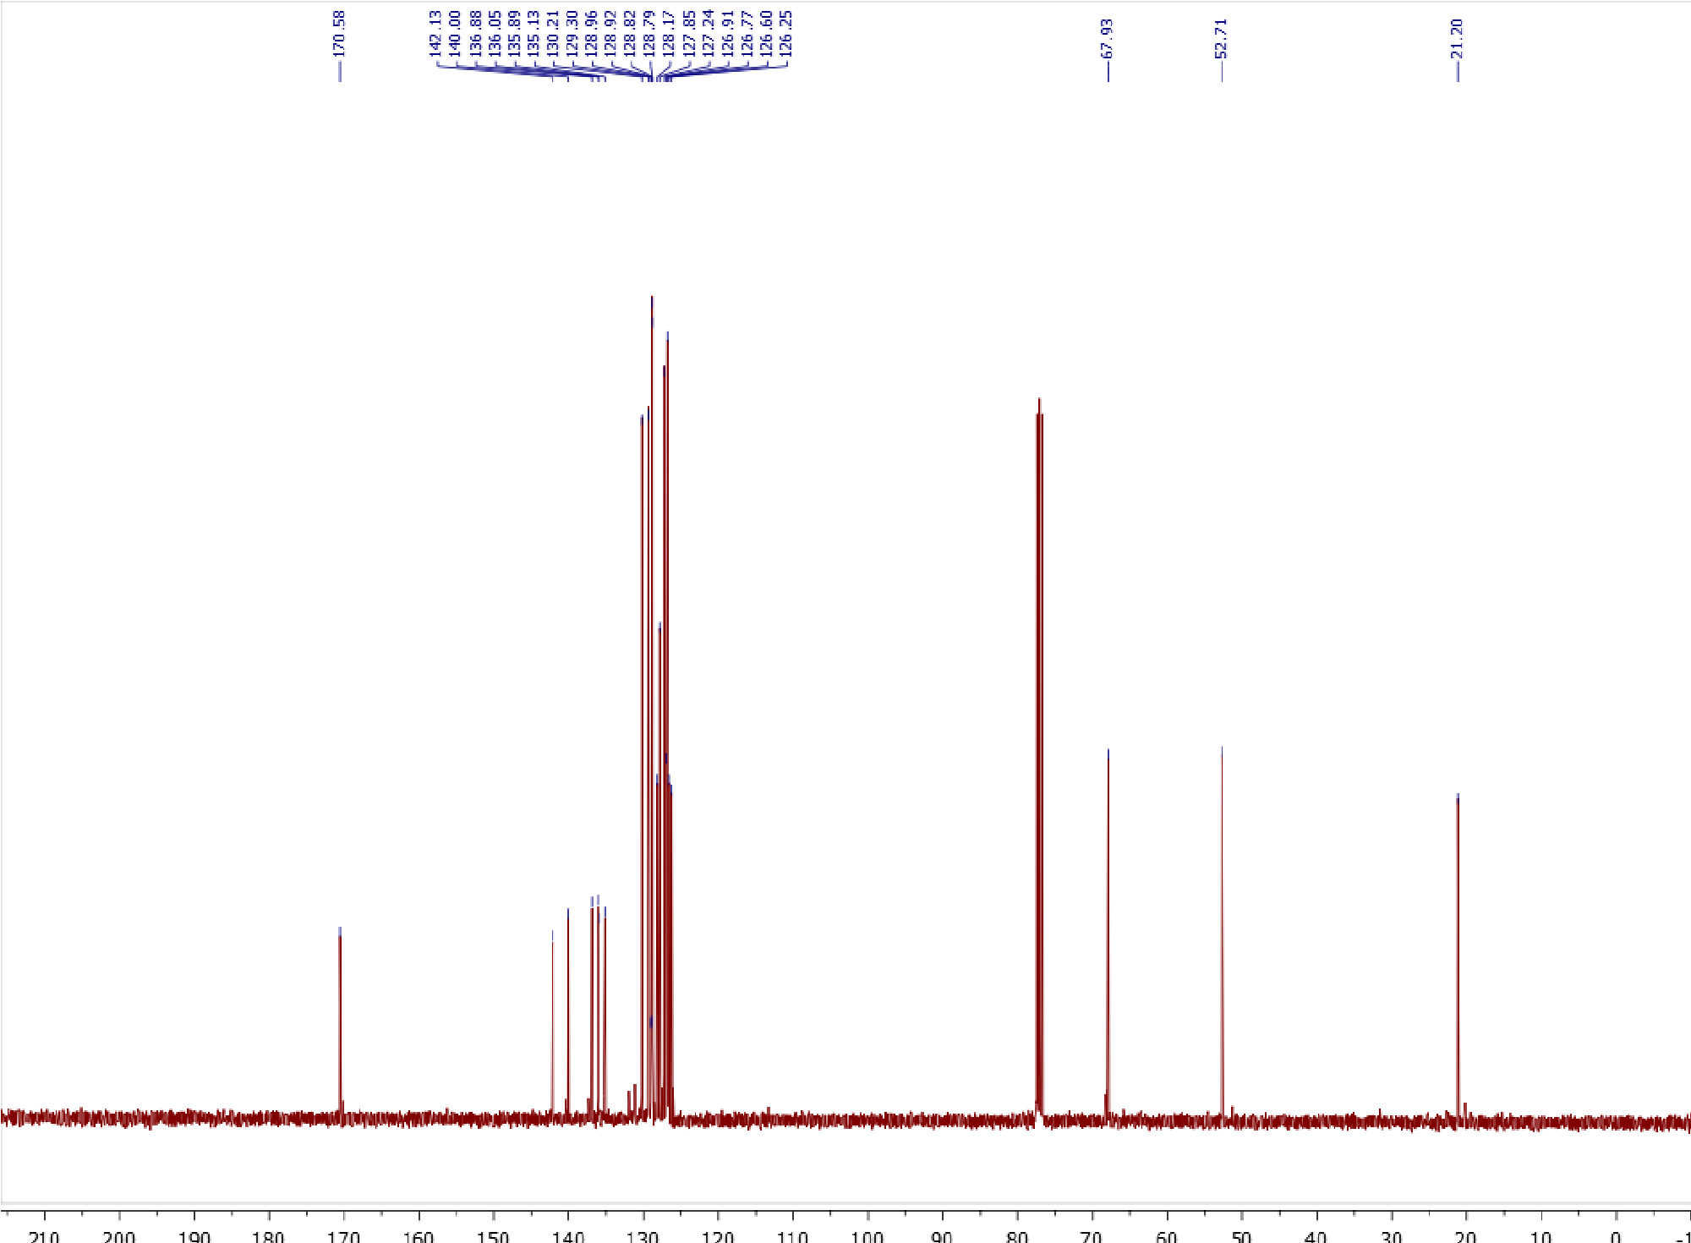
Copies of ¹H (400.13 MHz, CDCl₃) and ¹³C{¹H} (100.61 MHz, CDCl₃) spectra of 9p
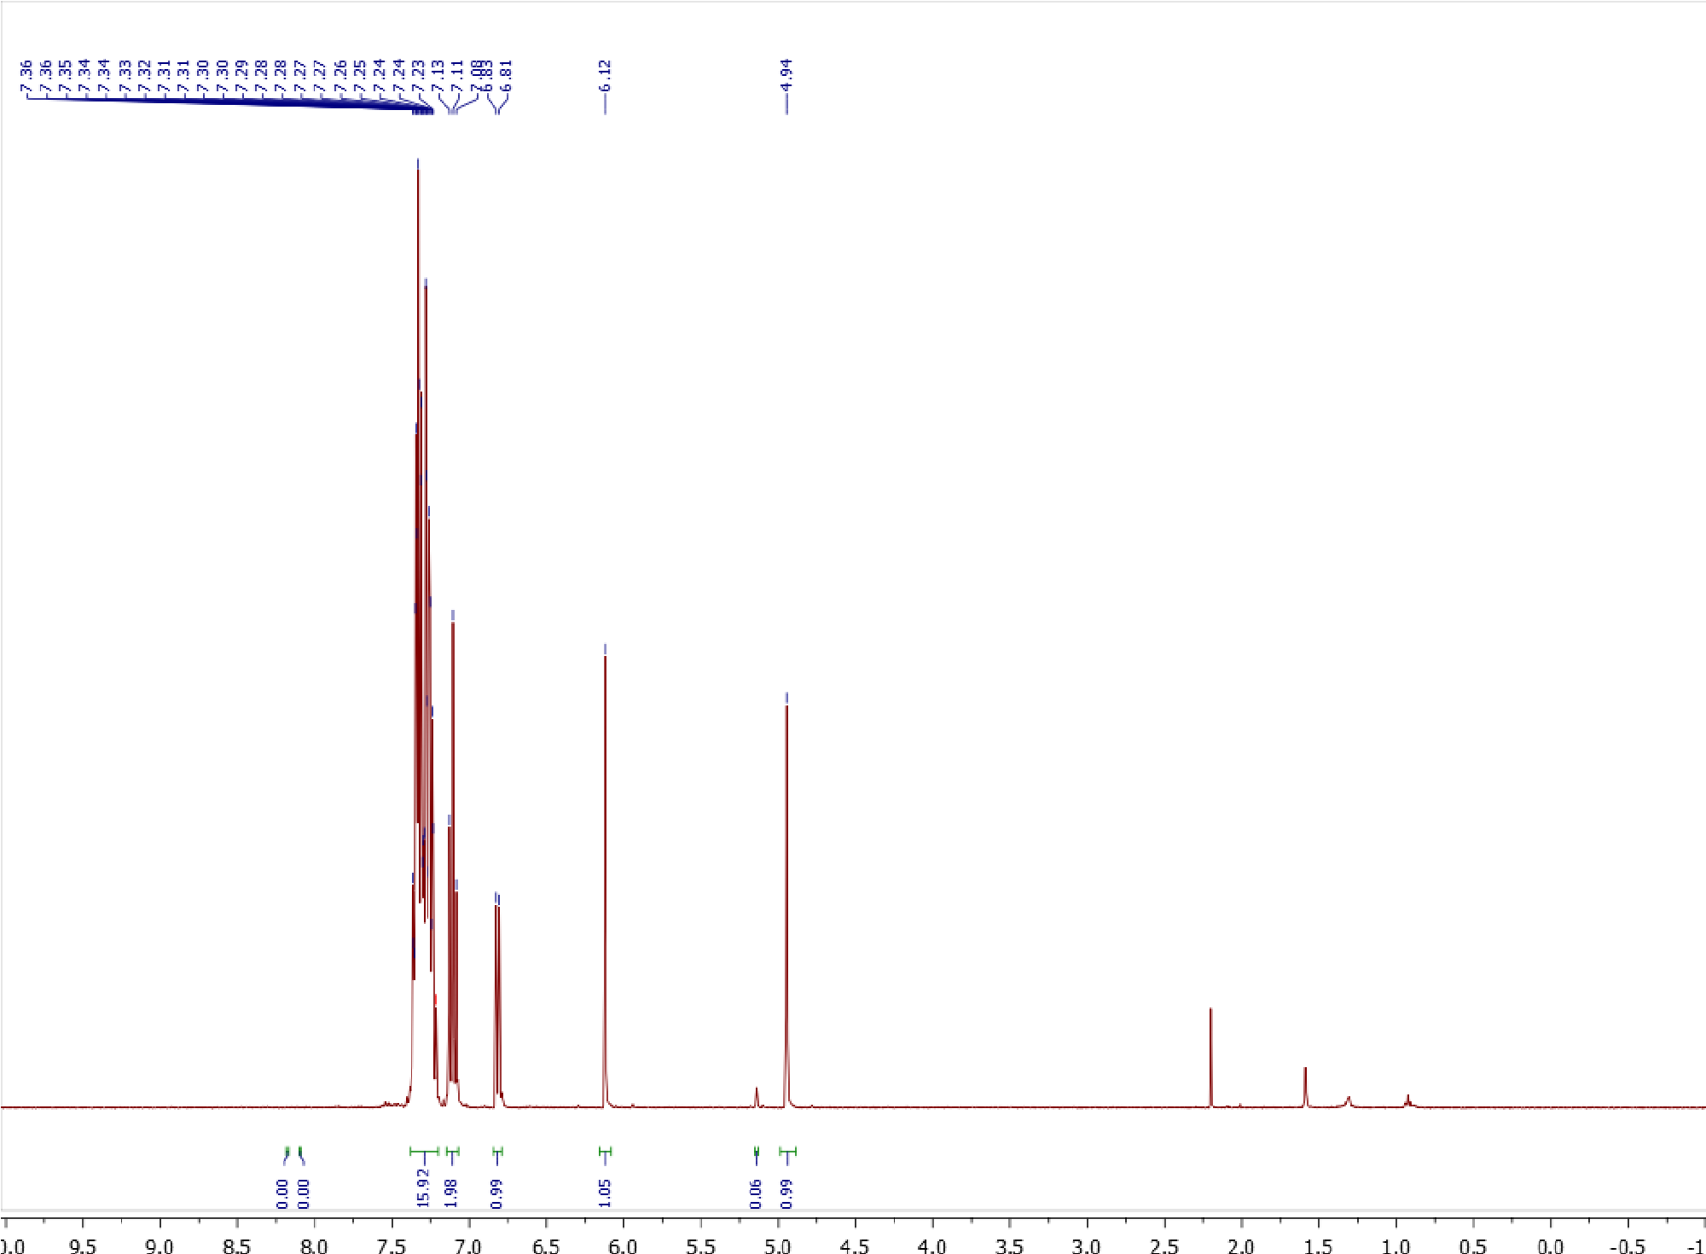
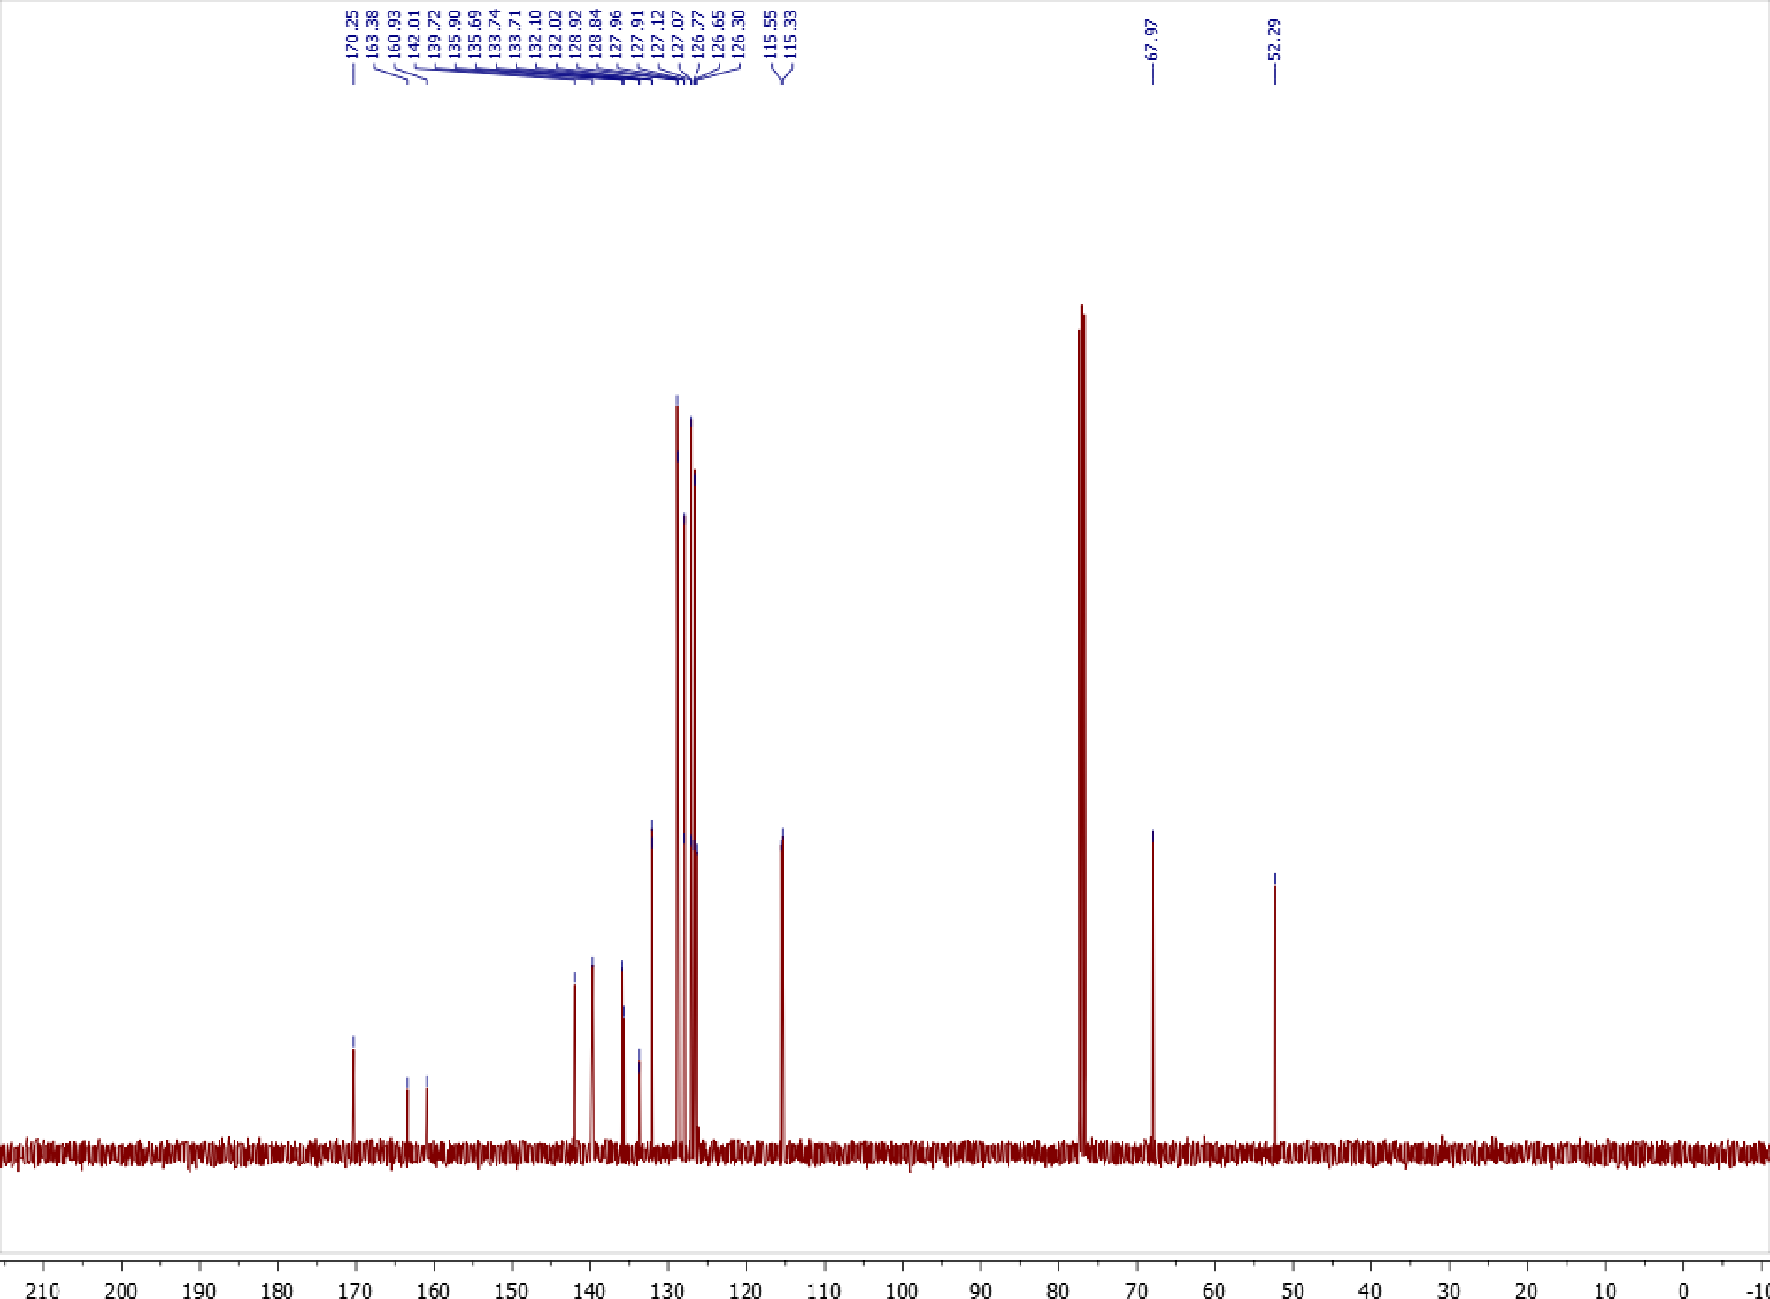
Copy of ¹⁹F{¹H} (376.50 MHz, CDCl₃) spectrum of 9p
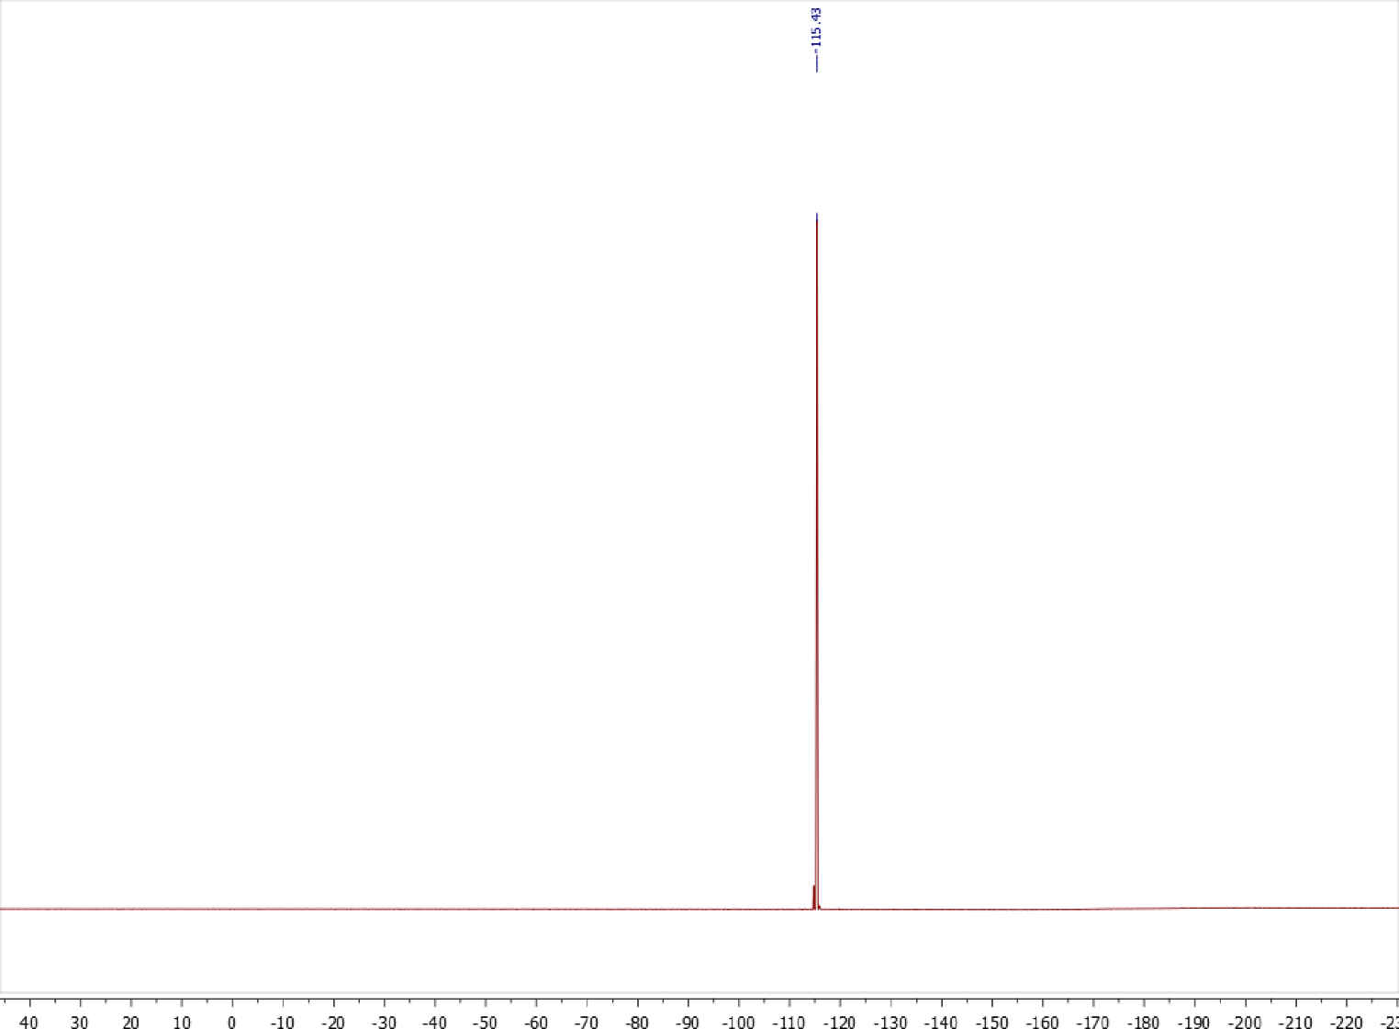
Copies of ¹H (400.13 MHz, CDCl₃) and ¹³C{¹H} (100.61 MHz, CDCl₃) spectra of 9q
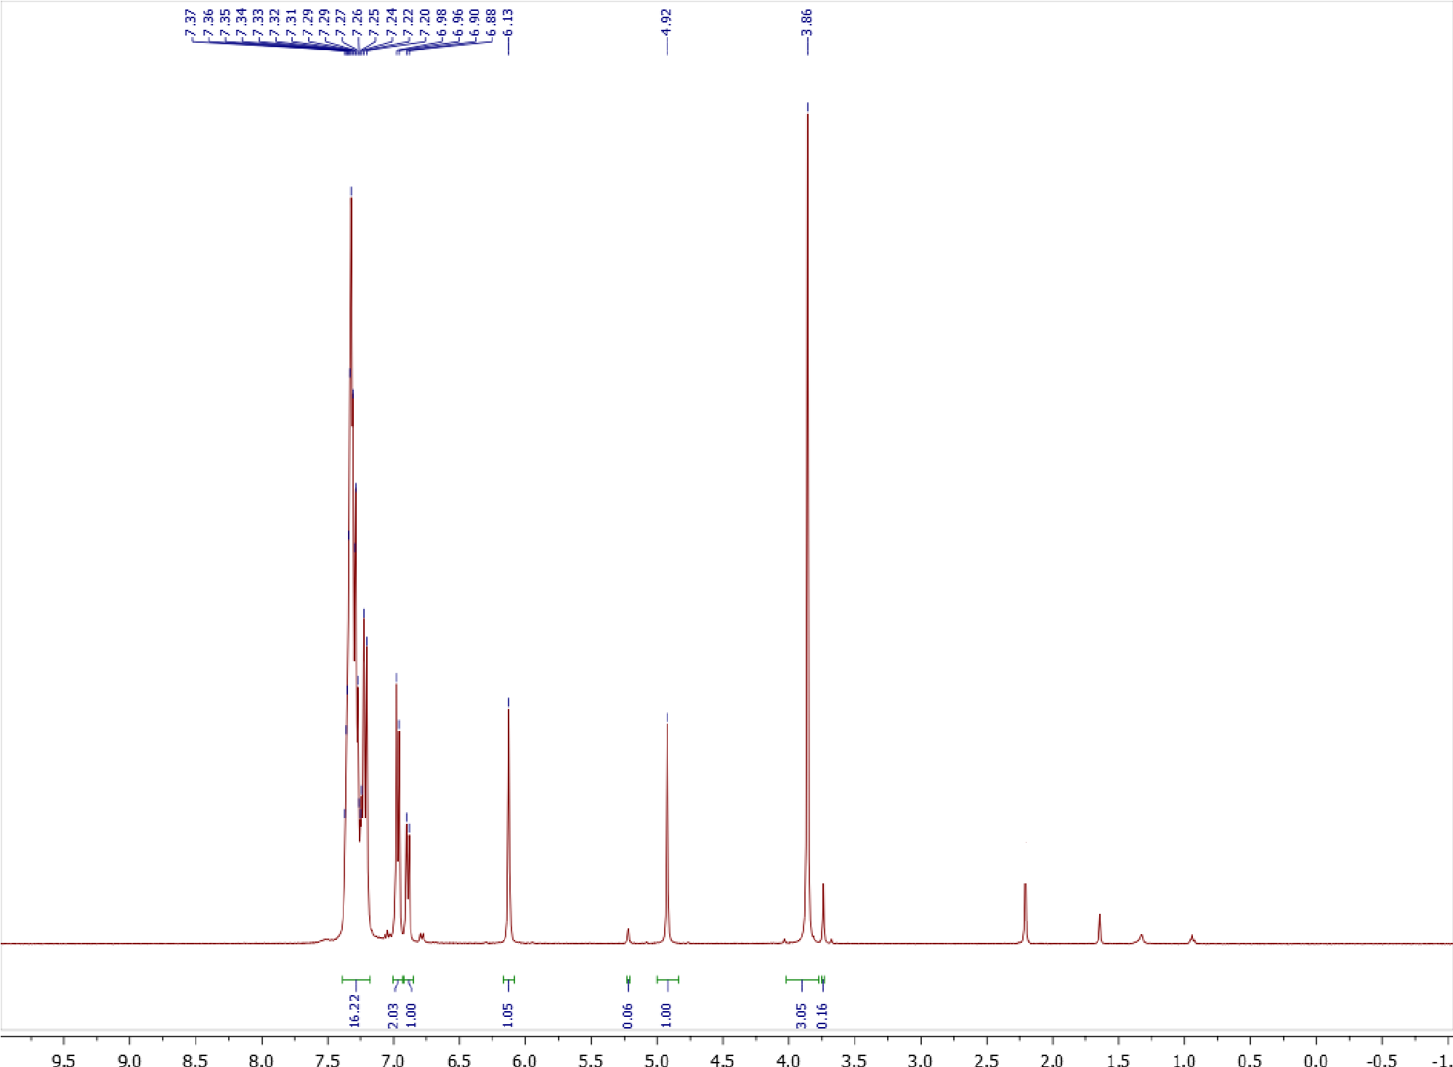
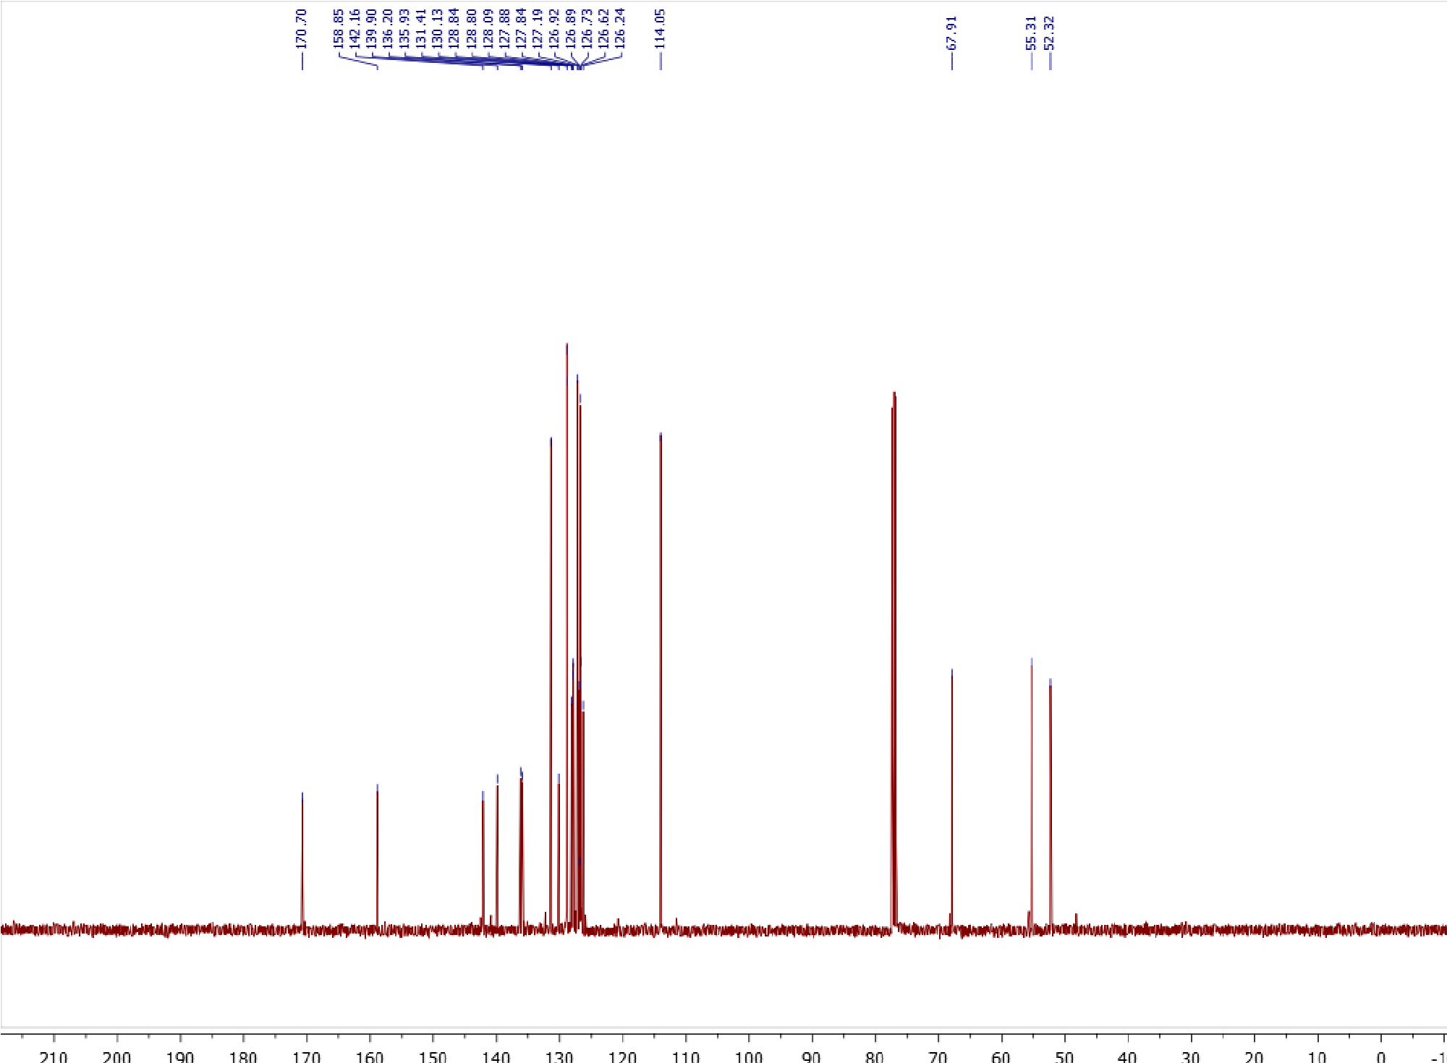
Copies of ¹H (400.13 MHz, CDCl₃) and ¹³C{¹H} (100.61 MHz, CDCl₃) spectra of 9r
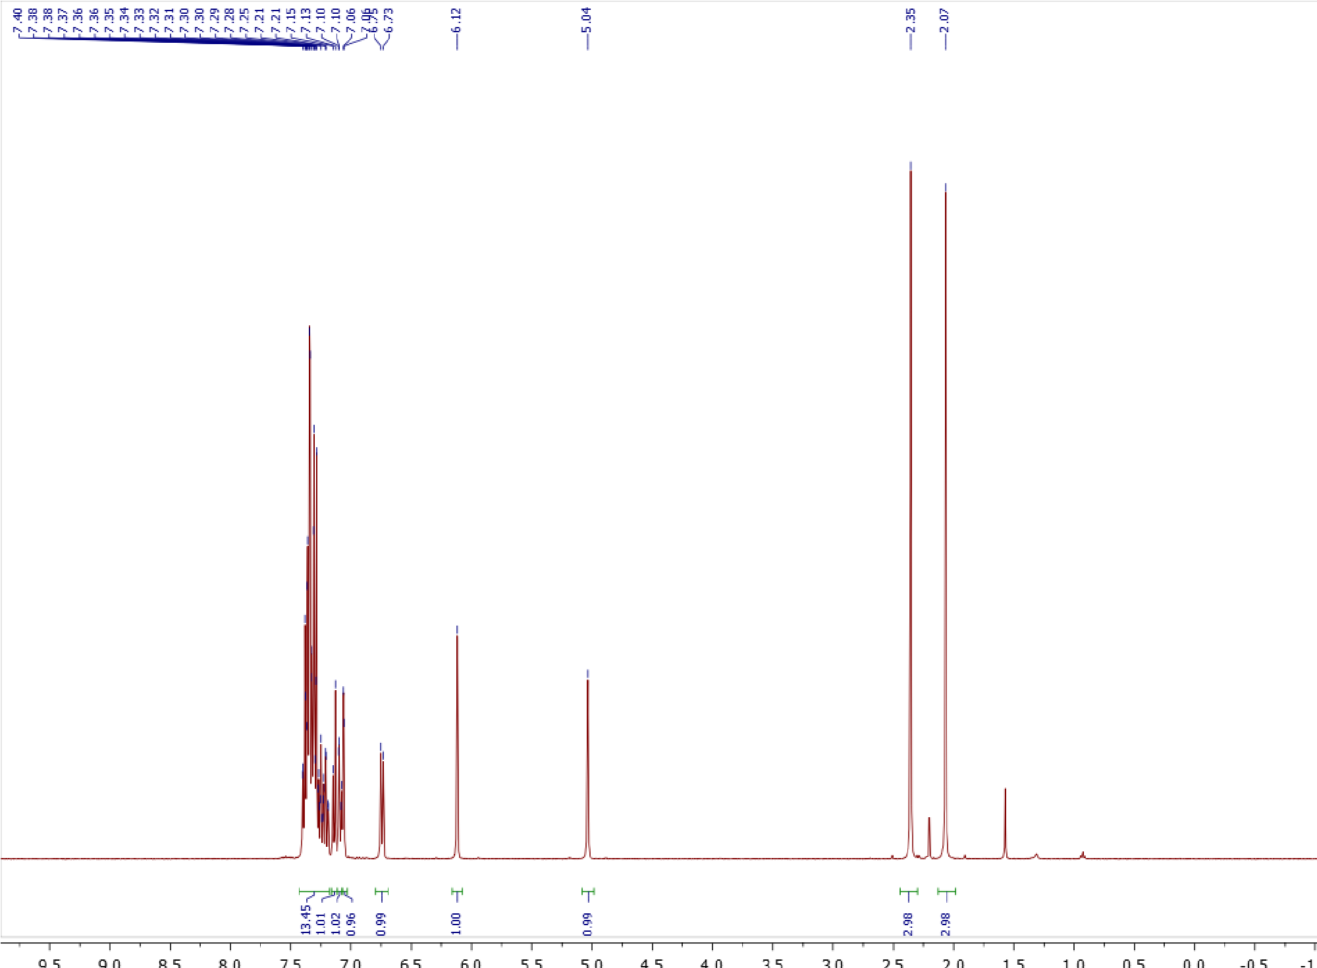
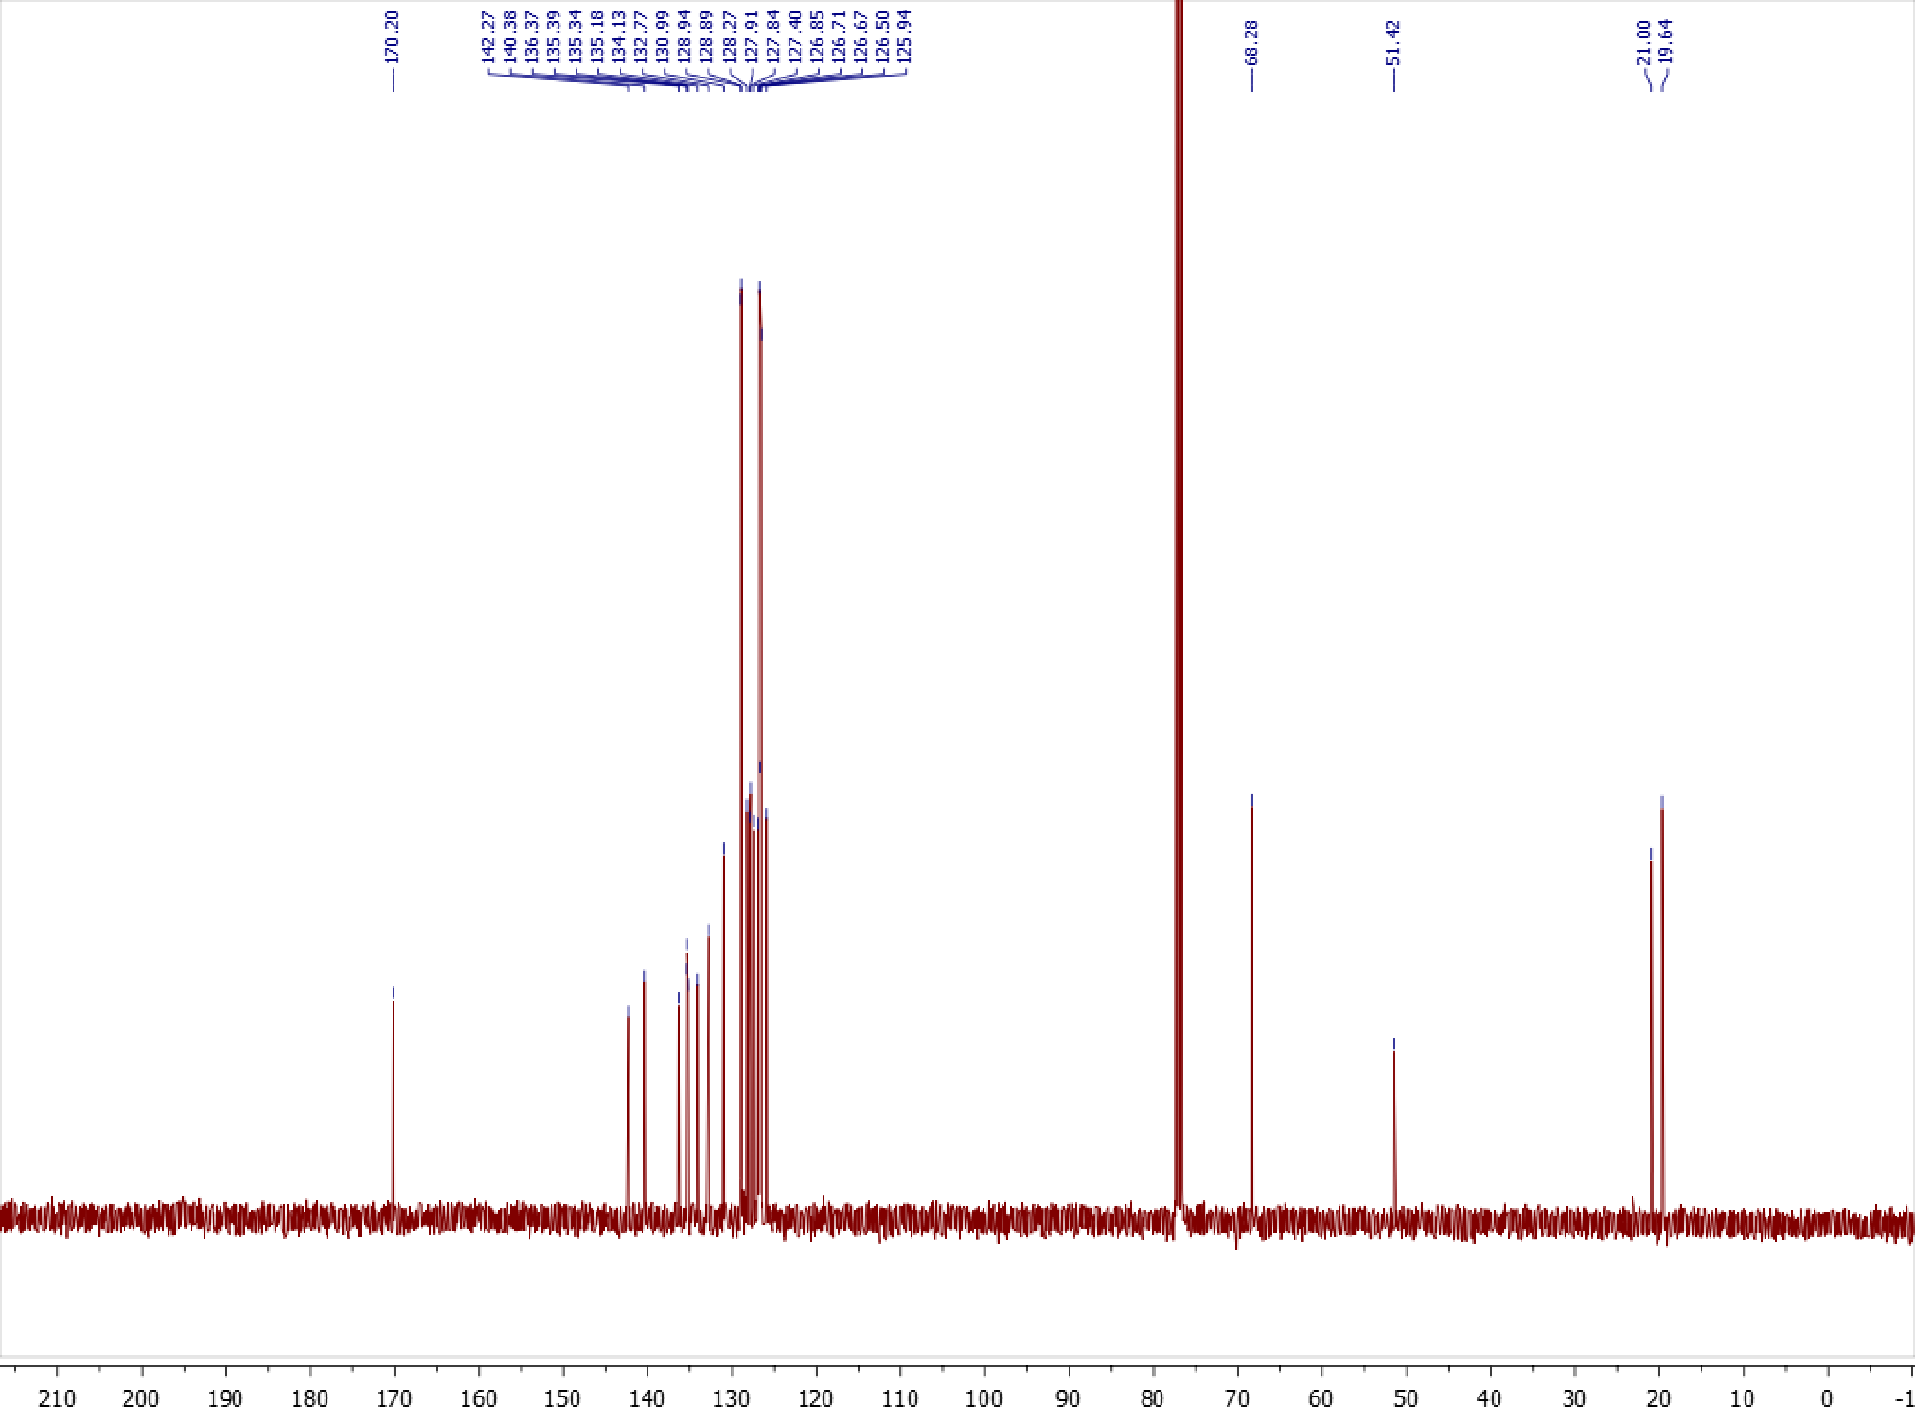
Copies of ¹H (400.13 MHz, CDCl₃) and ¹³C{¹H} (100.61 MHz, CDCl₃) spectra of 9s
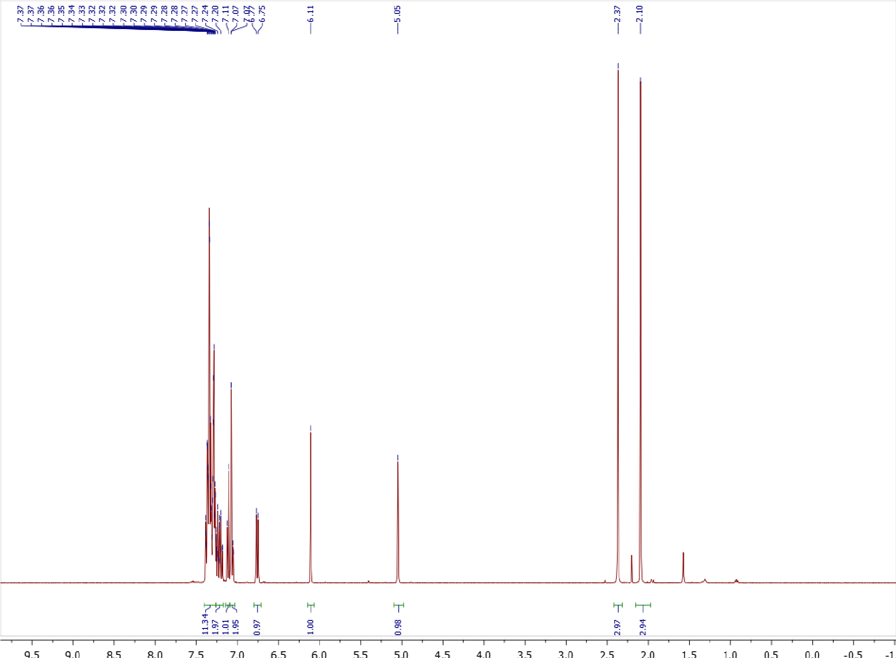
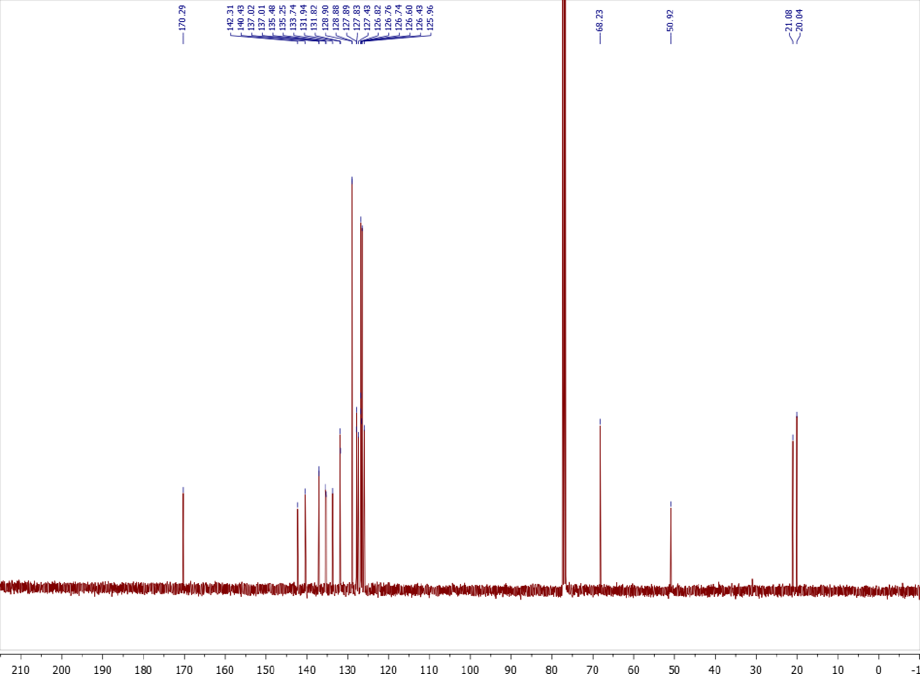
Copies of ¹H (400.13 MHz, CDCl₃) and ¹³C{¹H} (100.61 MHz, CDCl₃) spectra of 9t
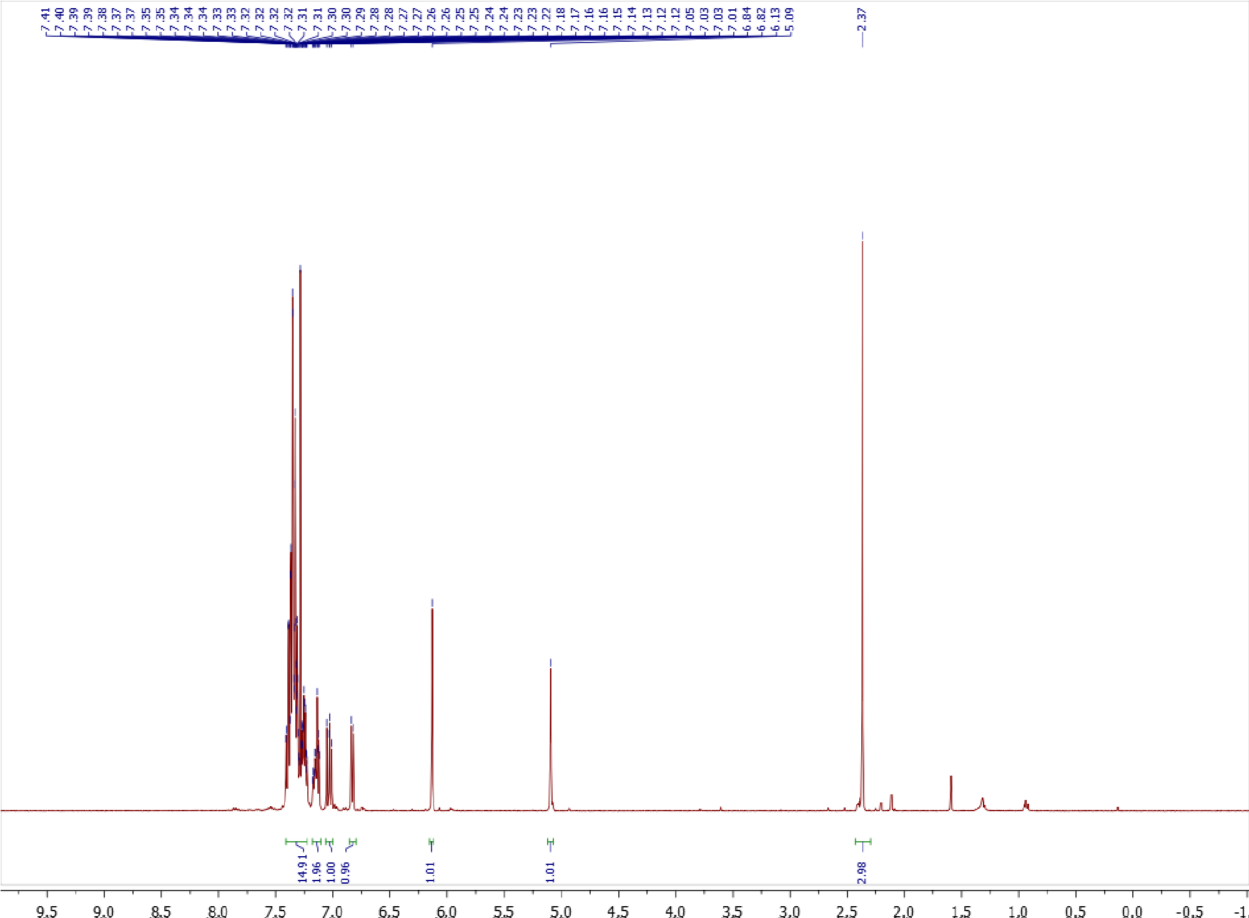
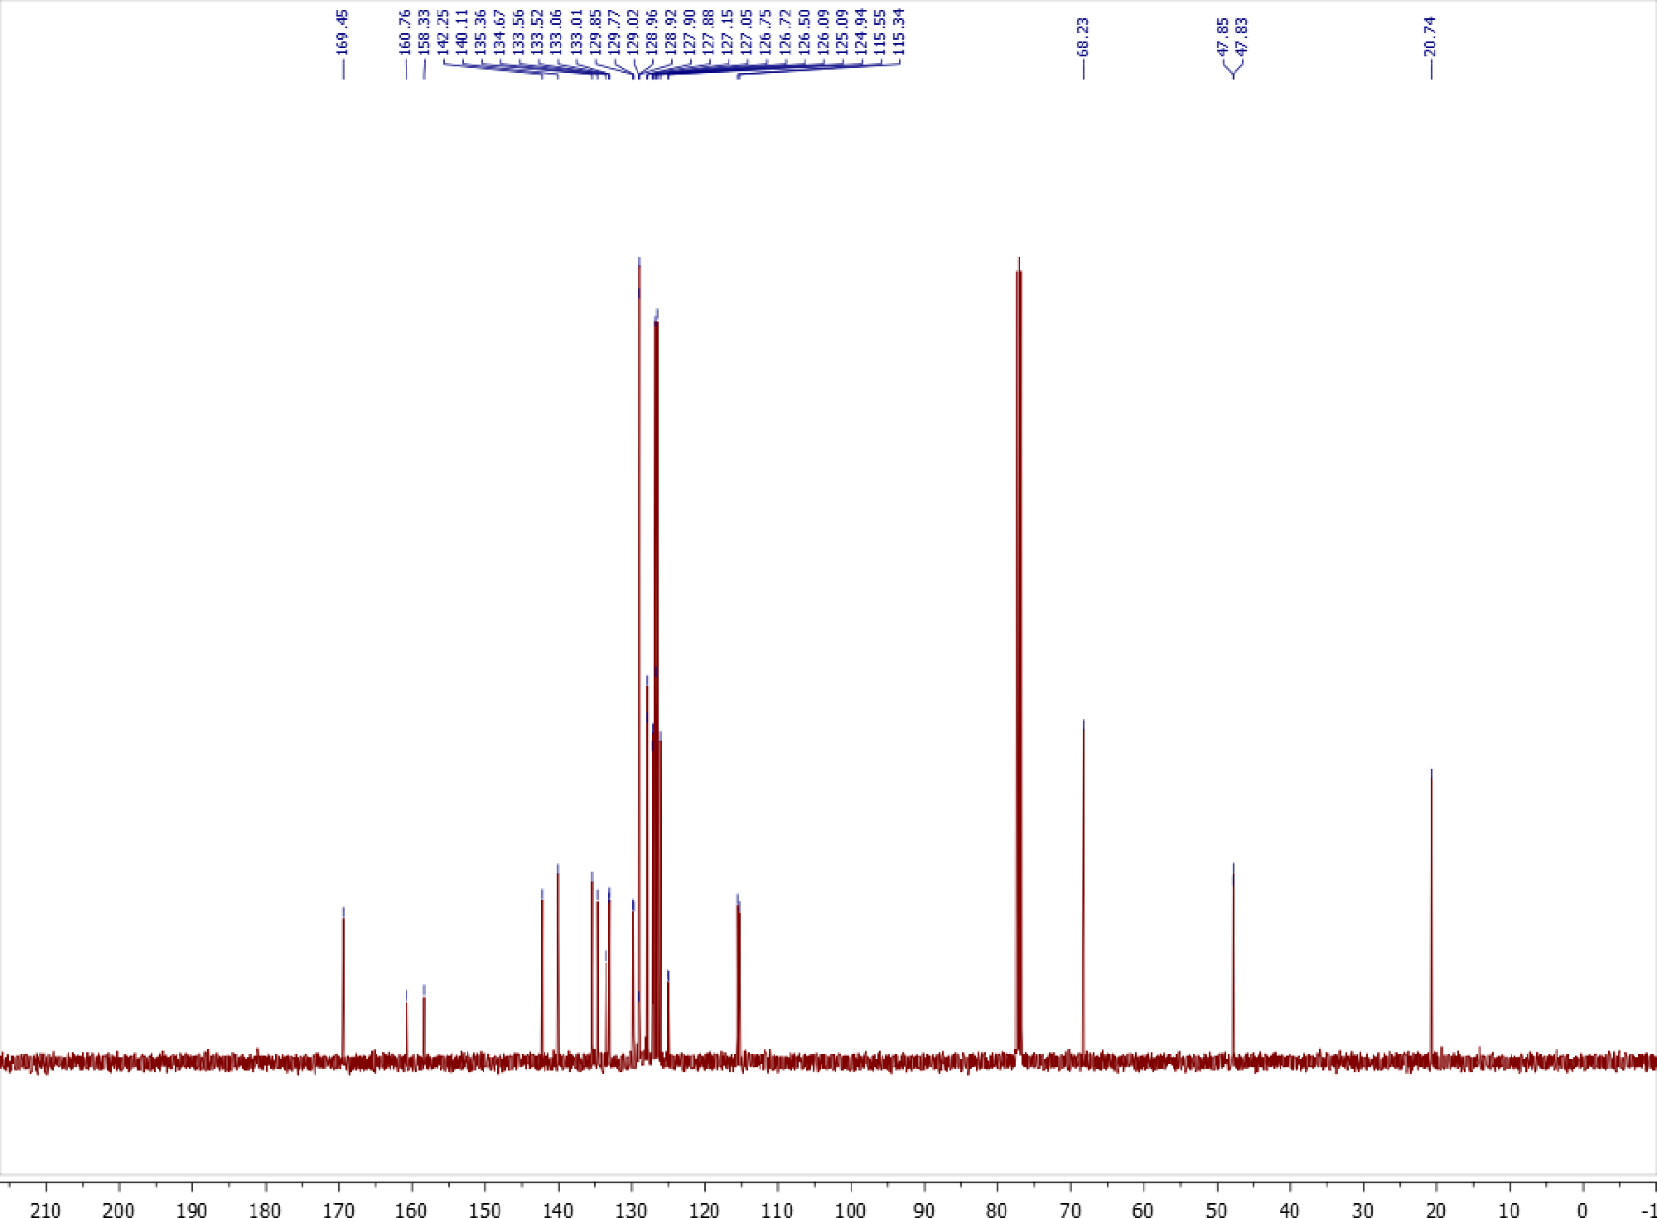
Copy of ¹⁹F{¹H} (376.50 MHz, CDCl₃) spectrum of 9t
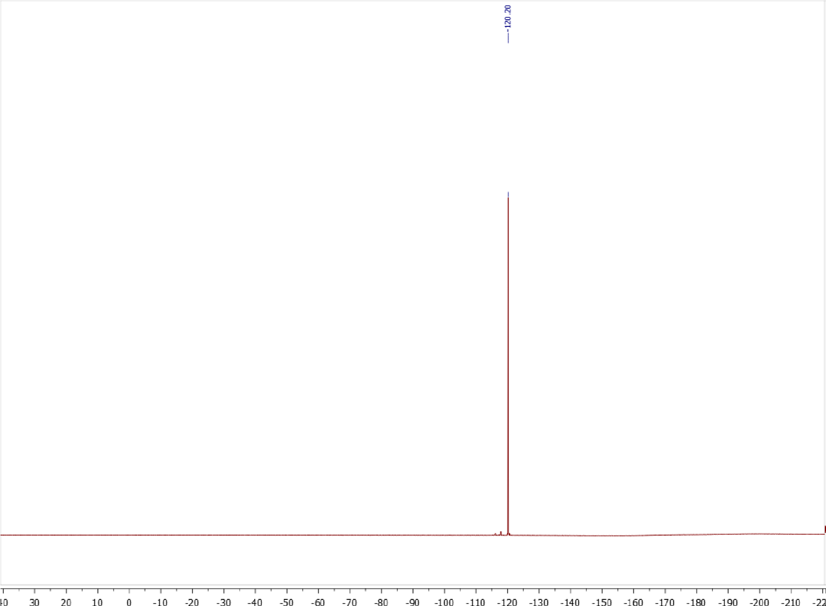
Copies of ¹H (400.13 MHz, CDCl₃) and ¹³C{¹H} (100.61 MHz, CDCl₃) spectra of 9u
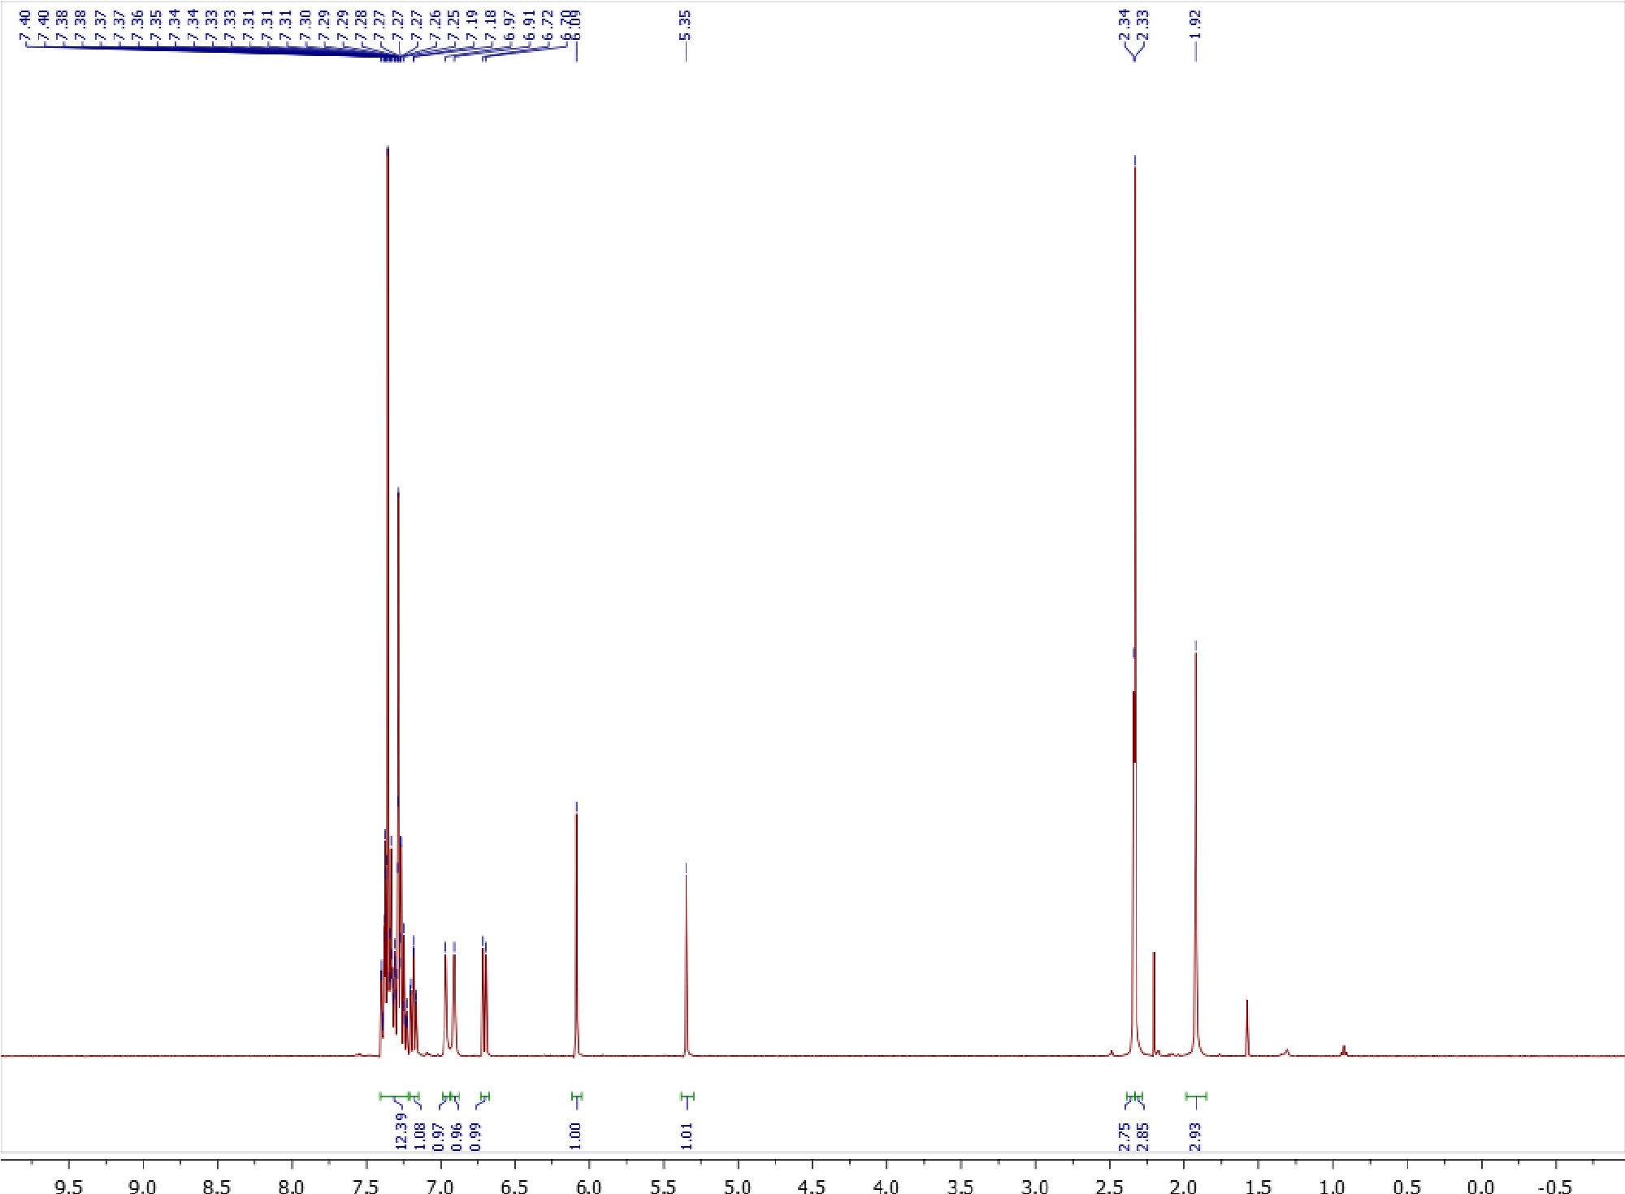
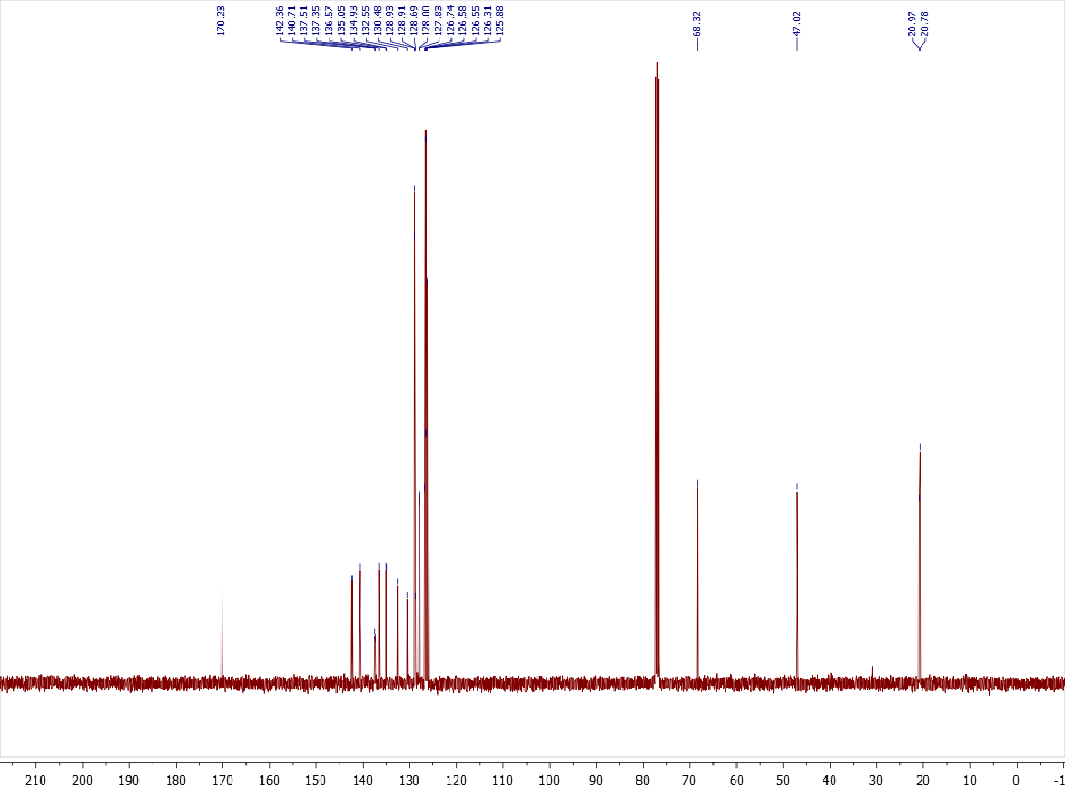
Copies of ¹H (400.13 MHz, CDCl₃) and ¹³C{¹H} (100.61 MHz, CDCl₃) spectra of 9v
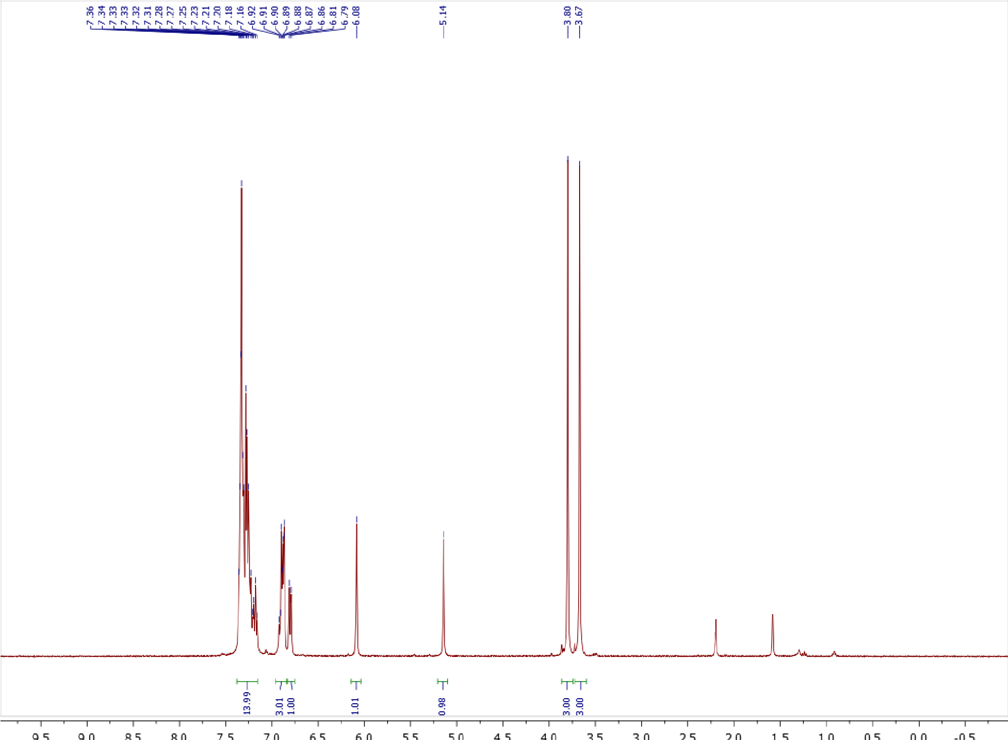
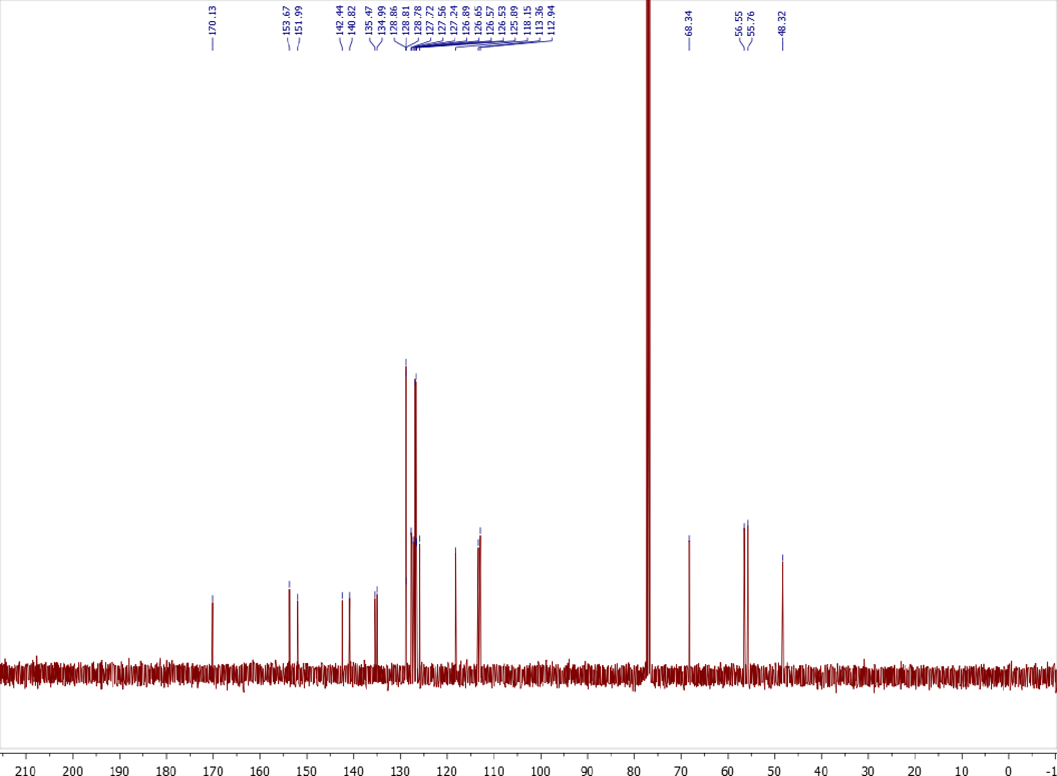
Copies of ¹H (400.13 MHz, CDCl₃) and ¹³C{¹H} (100.61 MHz, CDCl₃) spectra of 9w
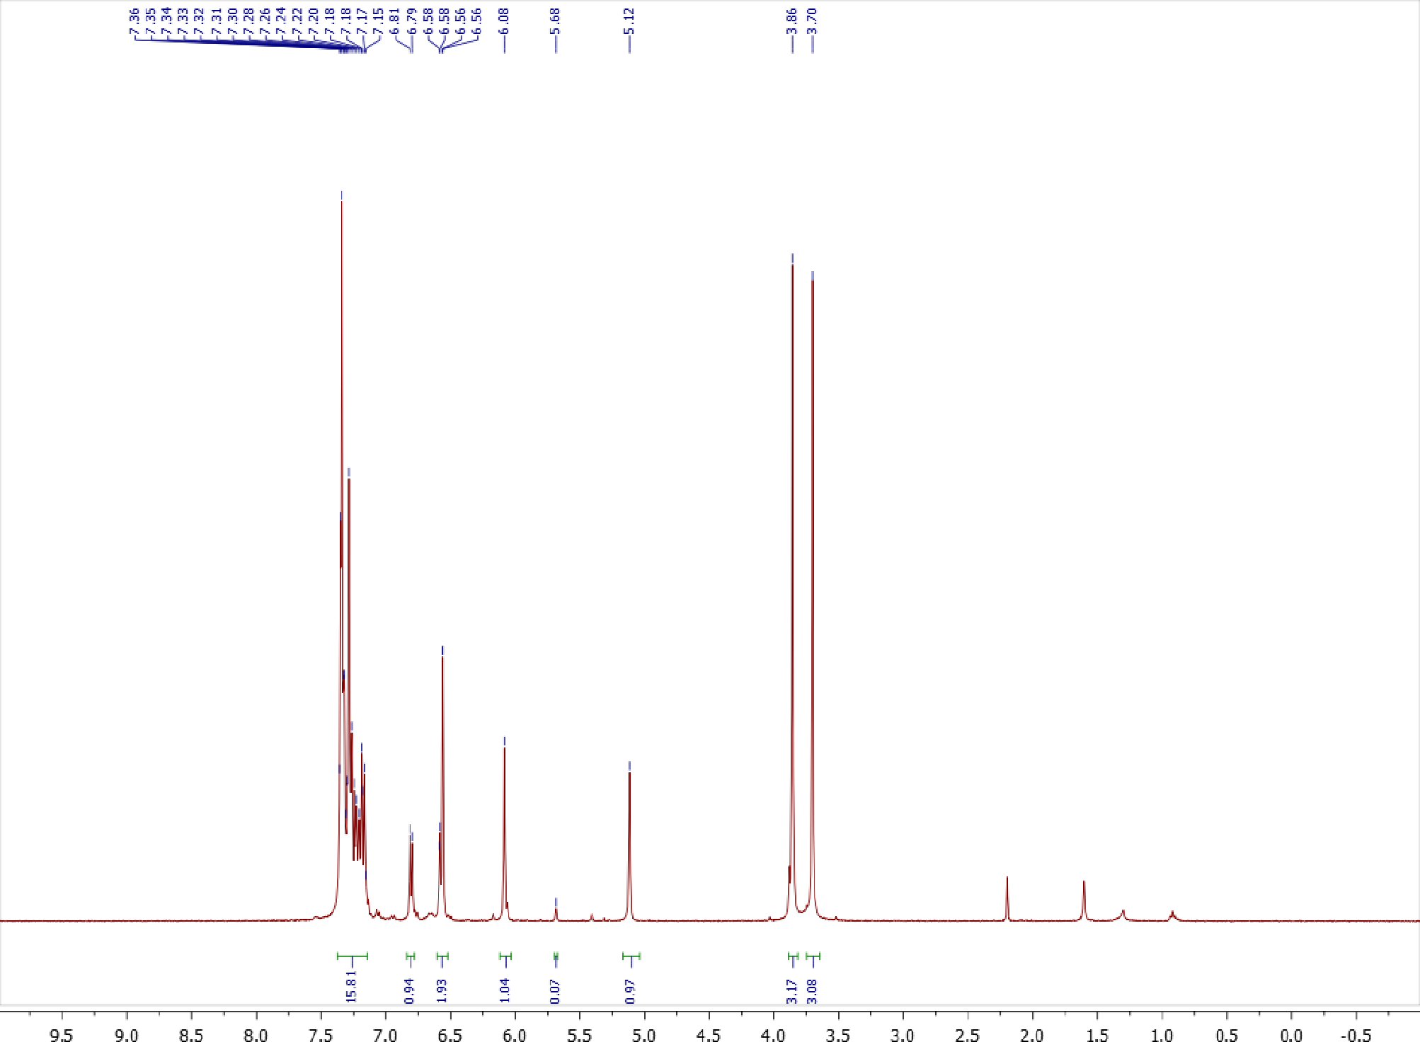
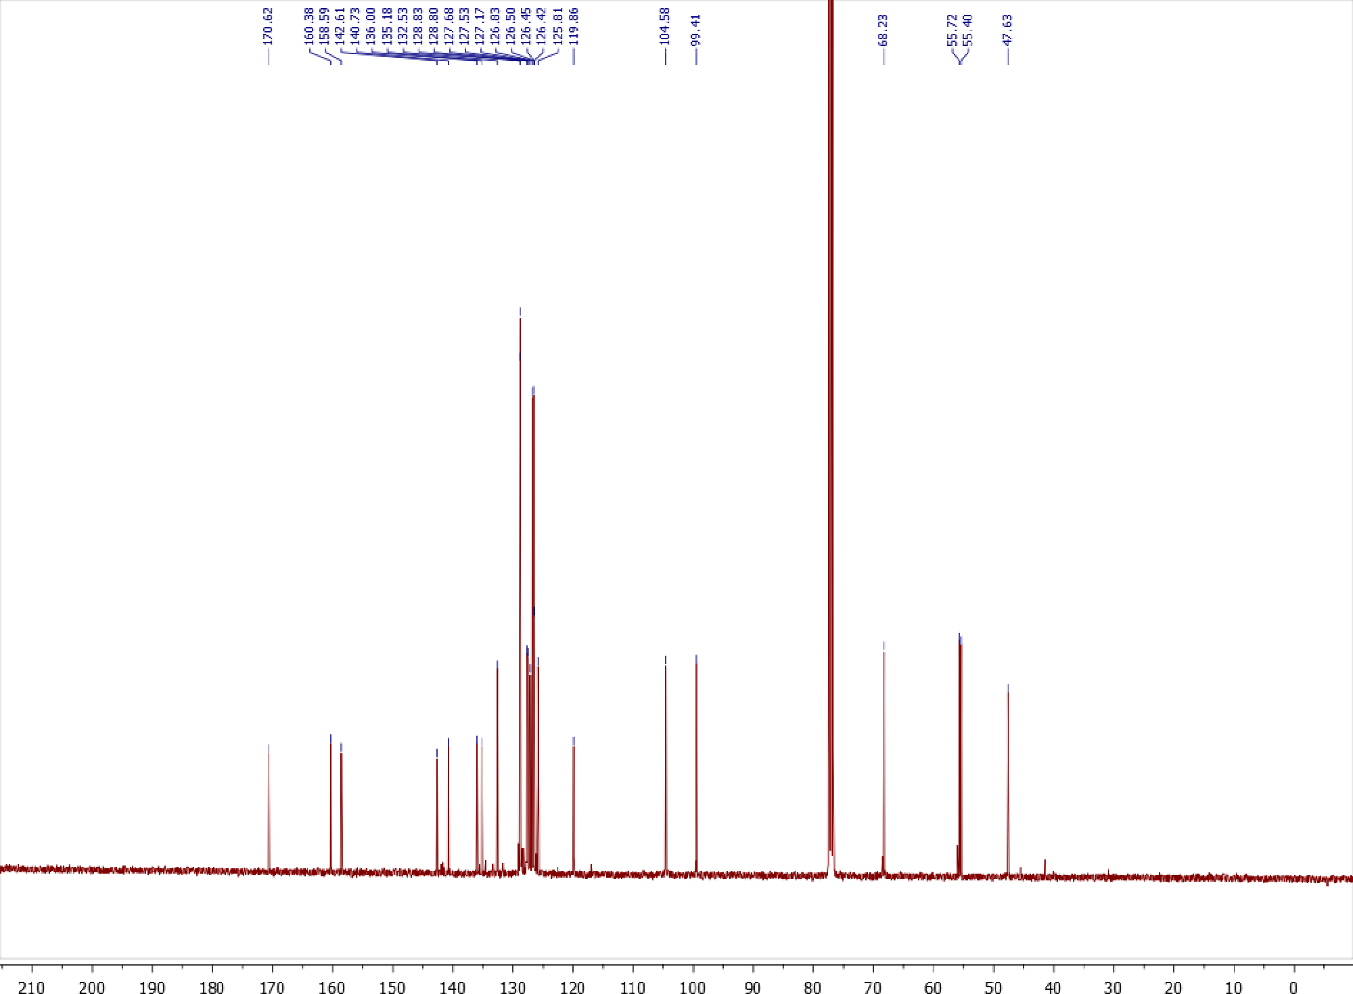
Copies of ¹H (400.13 MHz, CDCl₃) and ¹³C{¹H} (100.61 MHz, CDCl₃) spectra of 9x
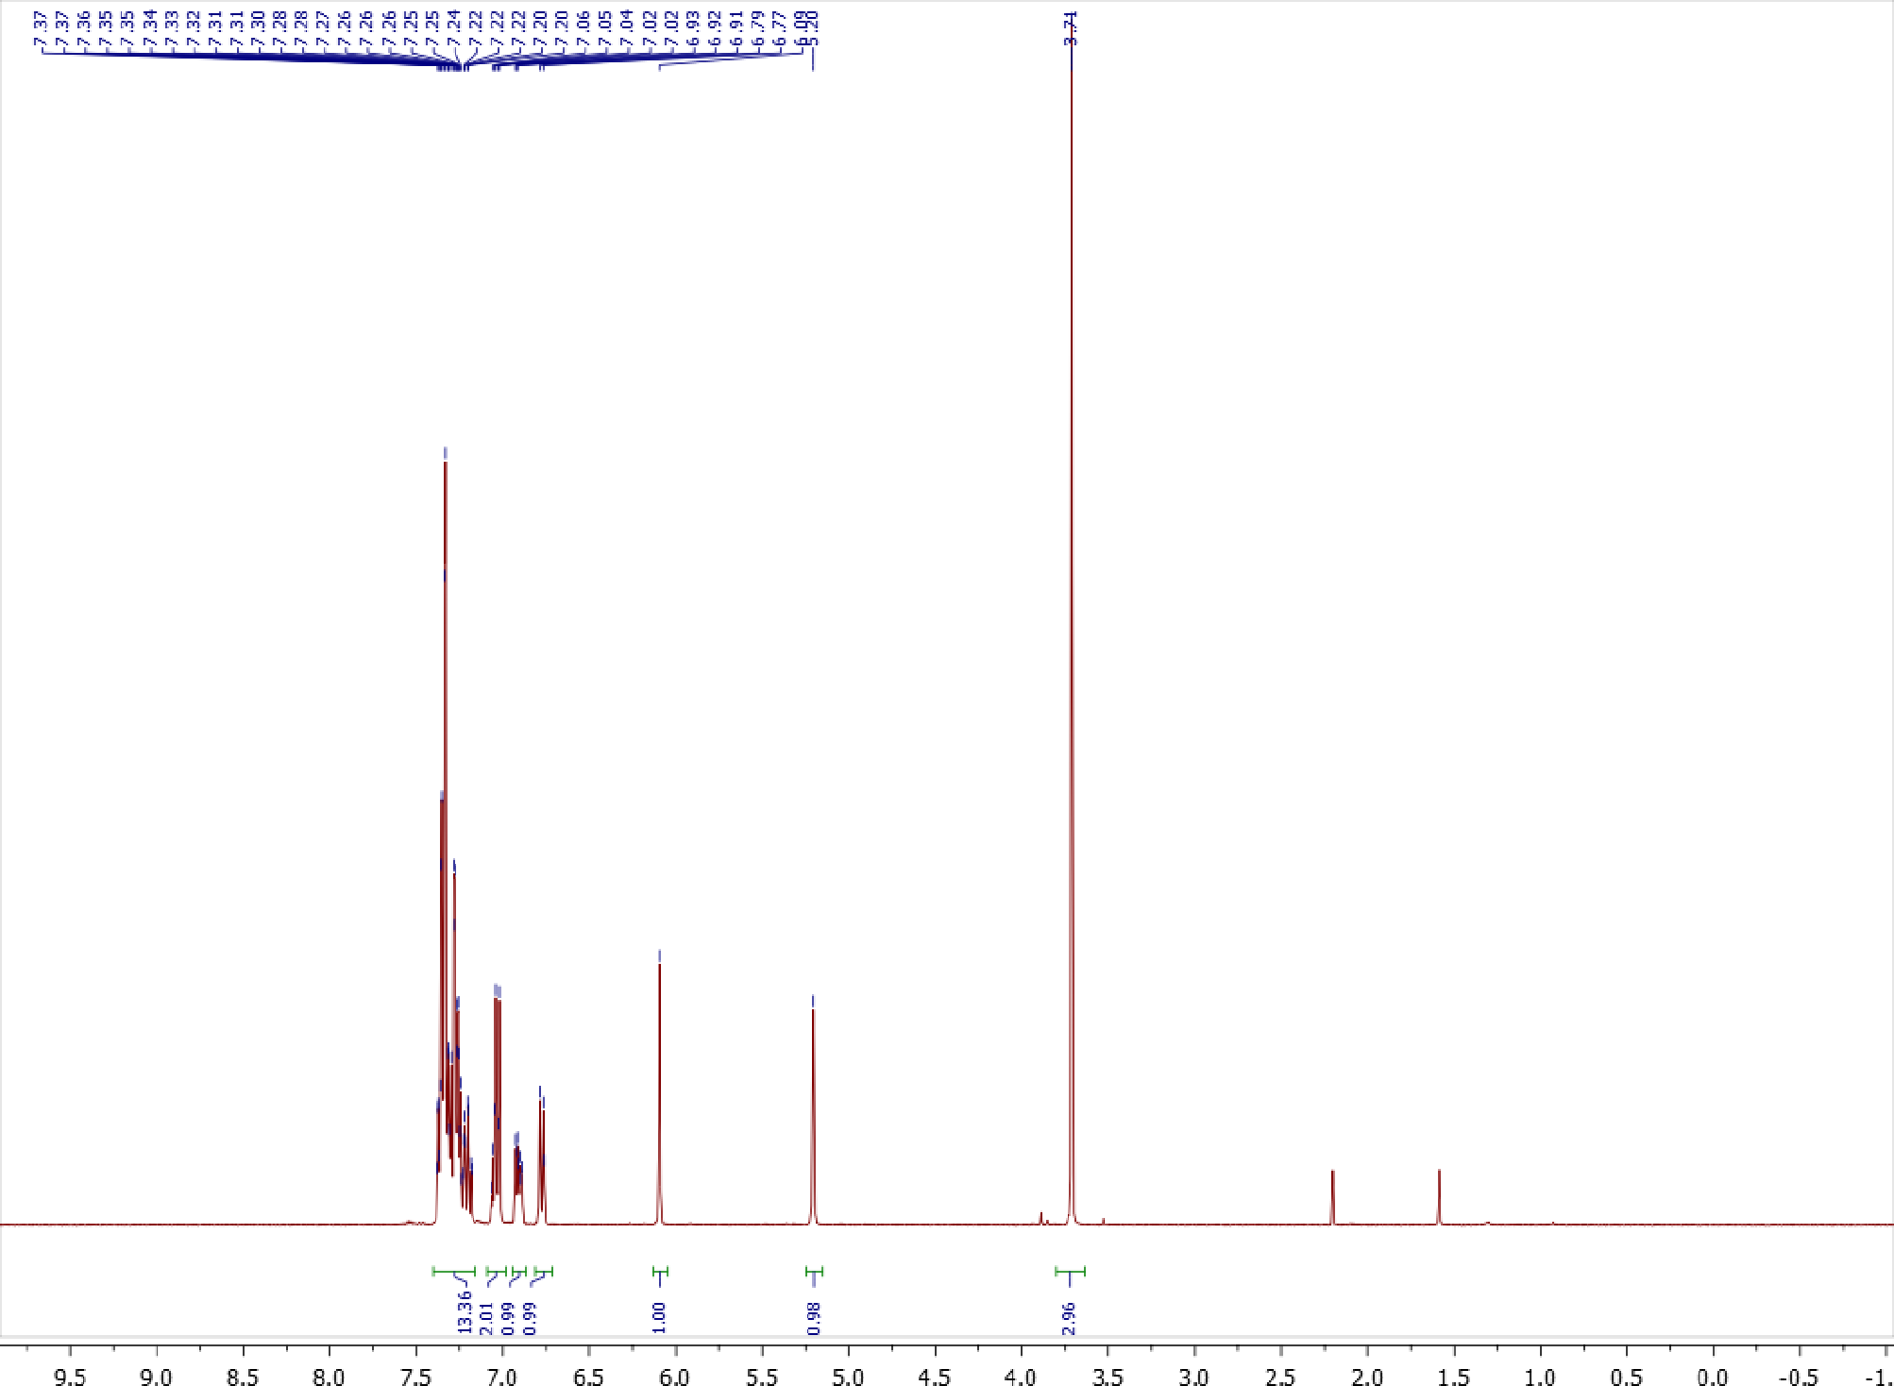
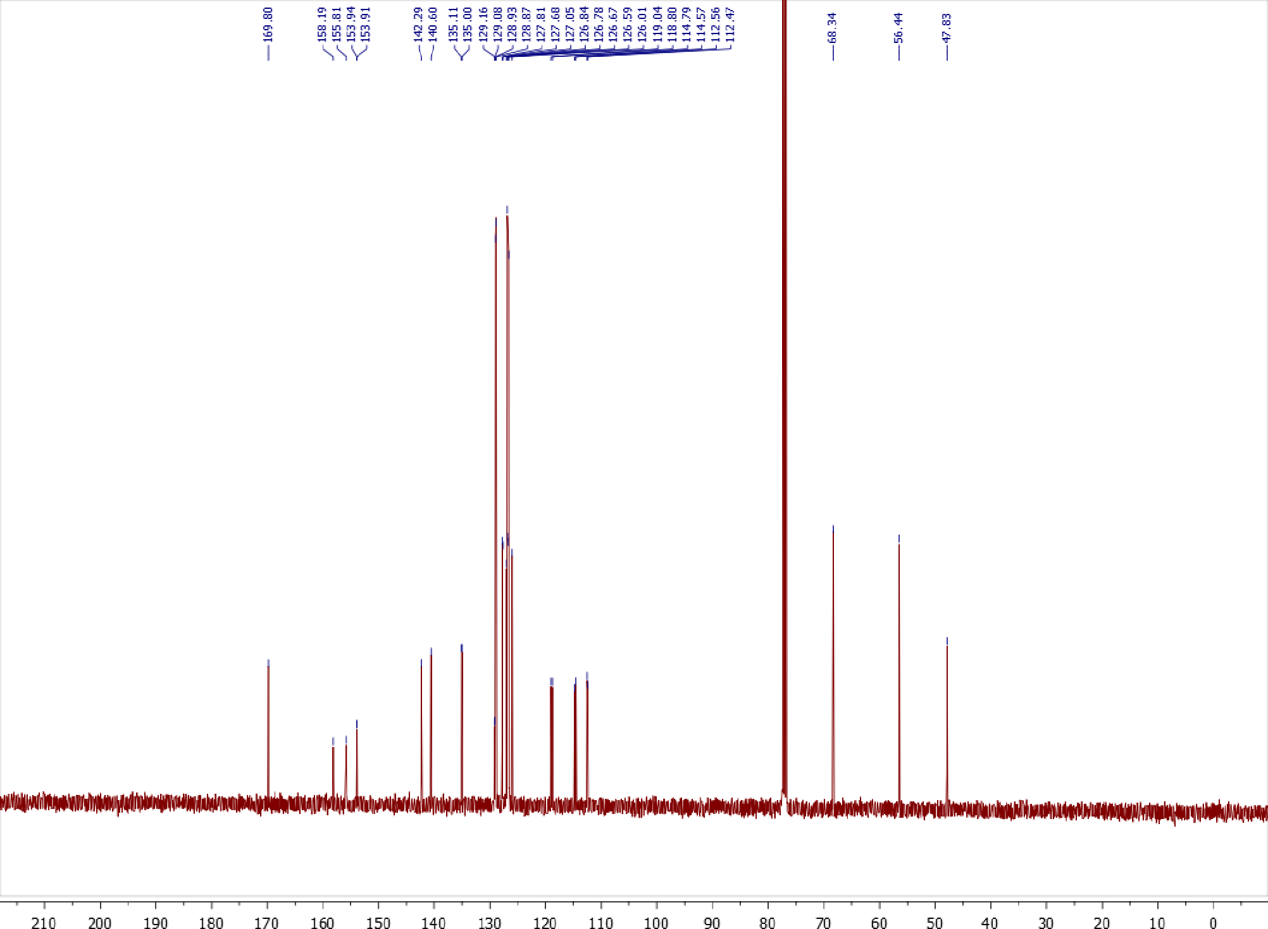
Copy of ¹⁹F{¹H} (376.50 MHz, CDCl₃) spectrum of 9x
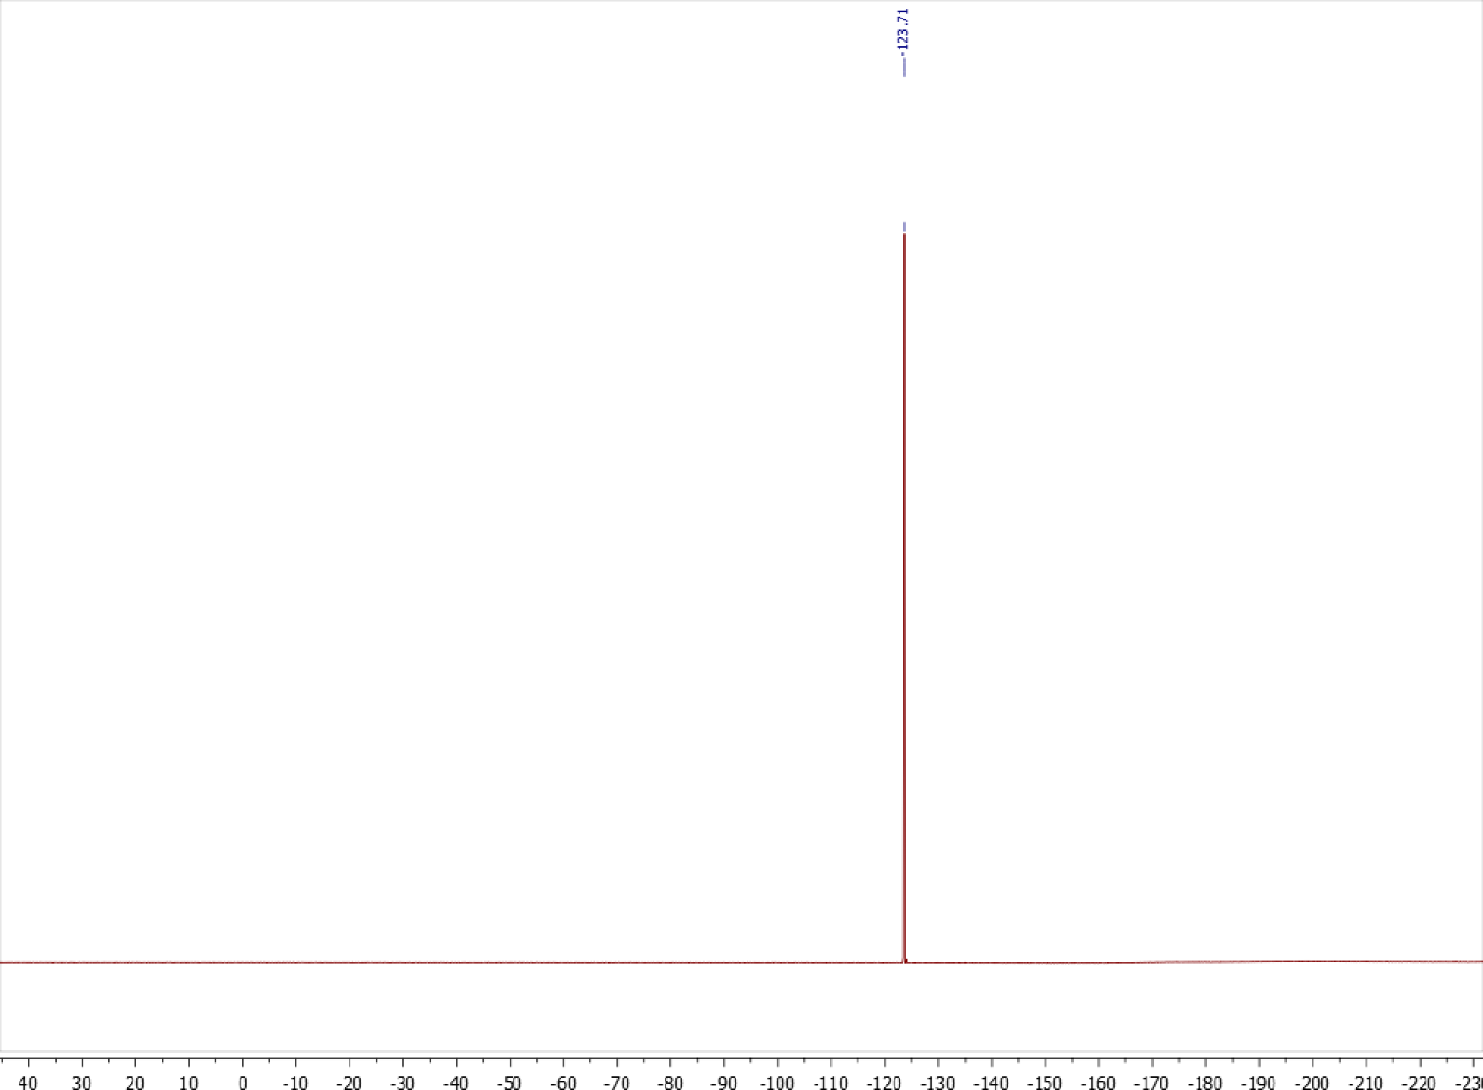
Copies of ¹H (400.13 MHz, CDCl₃) and ¹³C{¹H} (100.61 MHz, CDCl₃) spectra of 9y
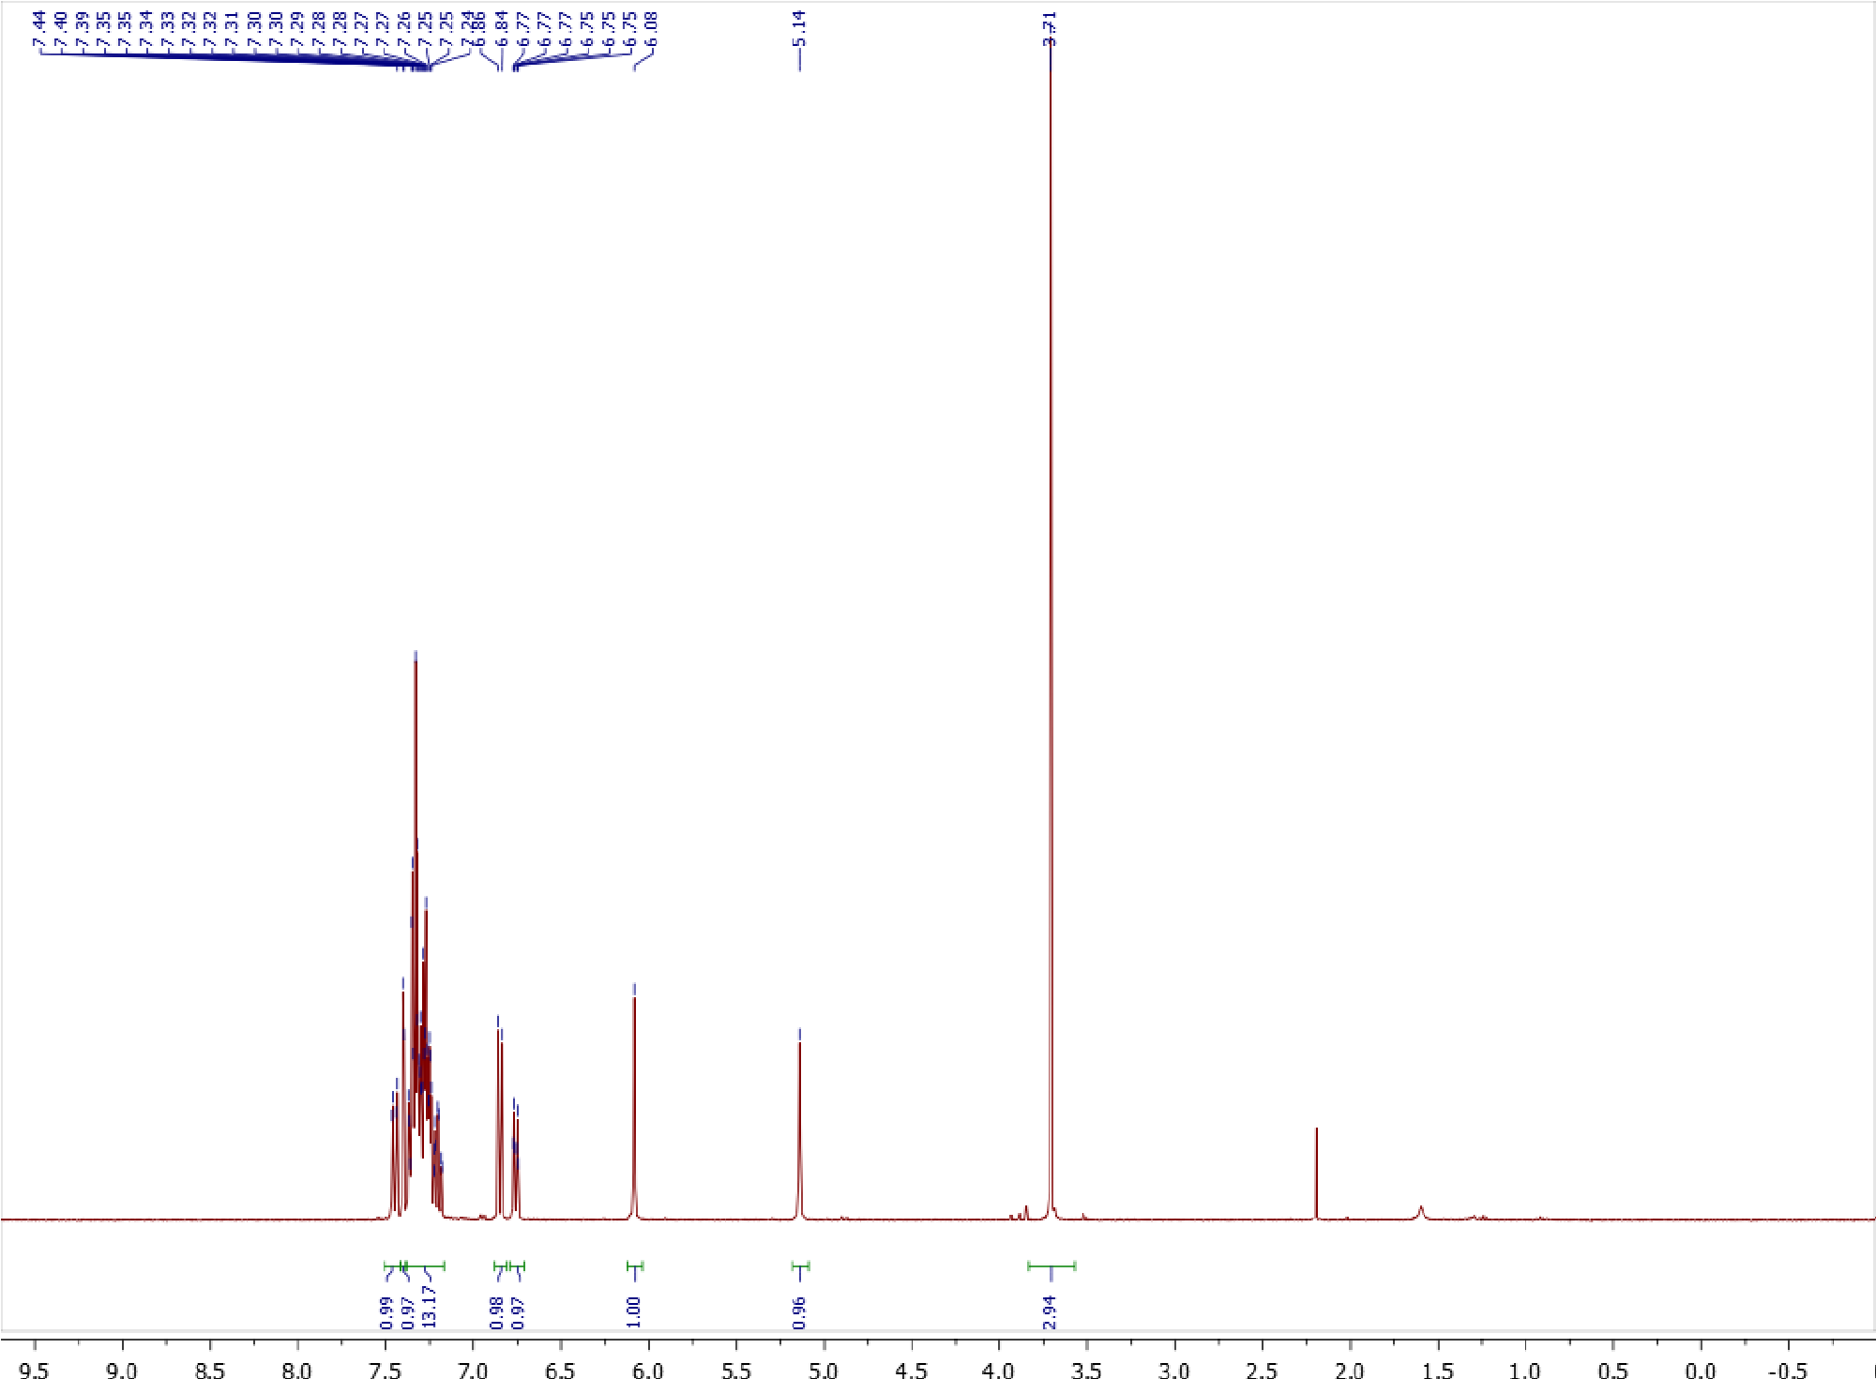
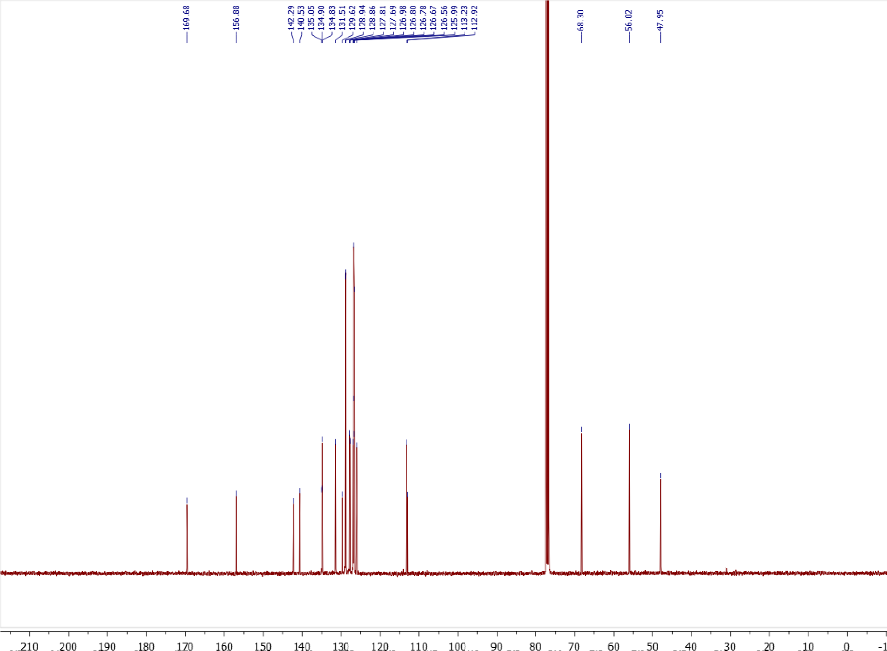
Copies of ¹H (400.13 MHz, CDCl₃) and ¹³C{¹H} (100.61 MHz, CDCl₃) spectra of 9z
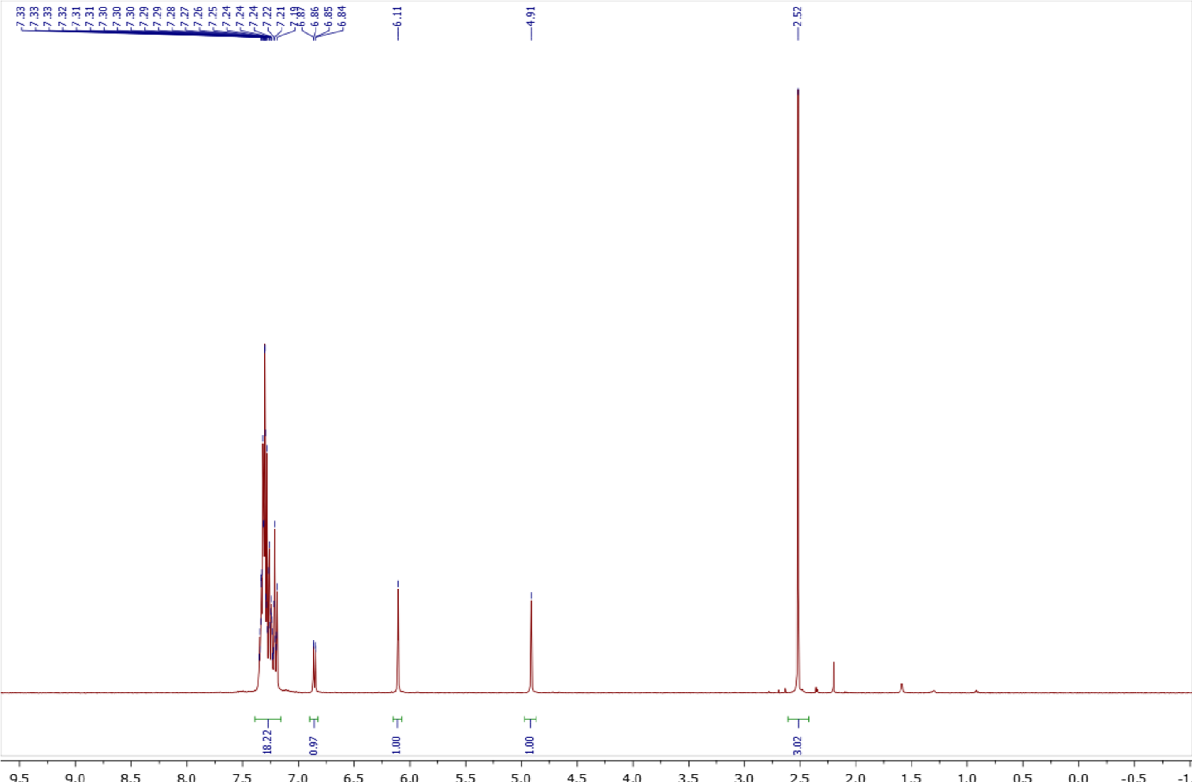
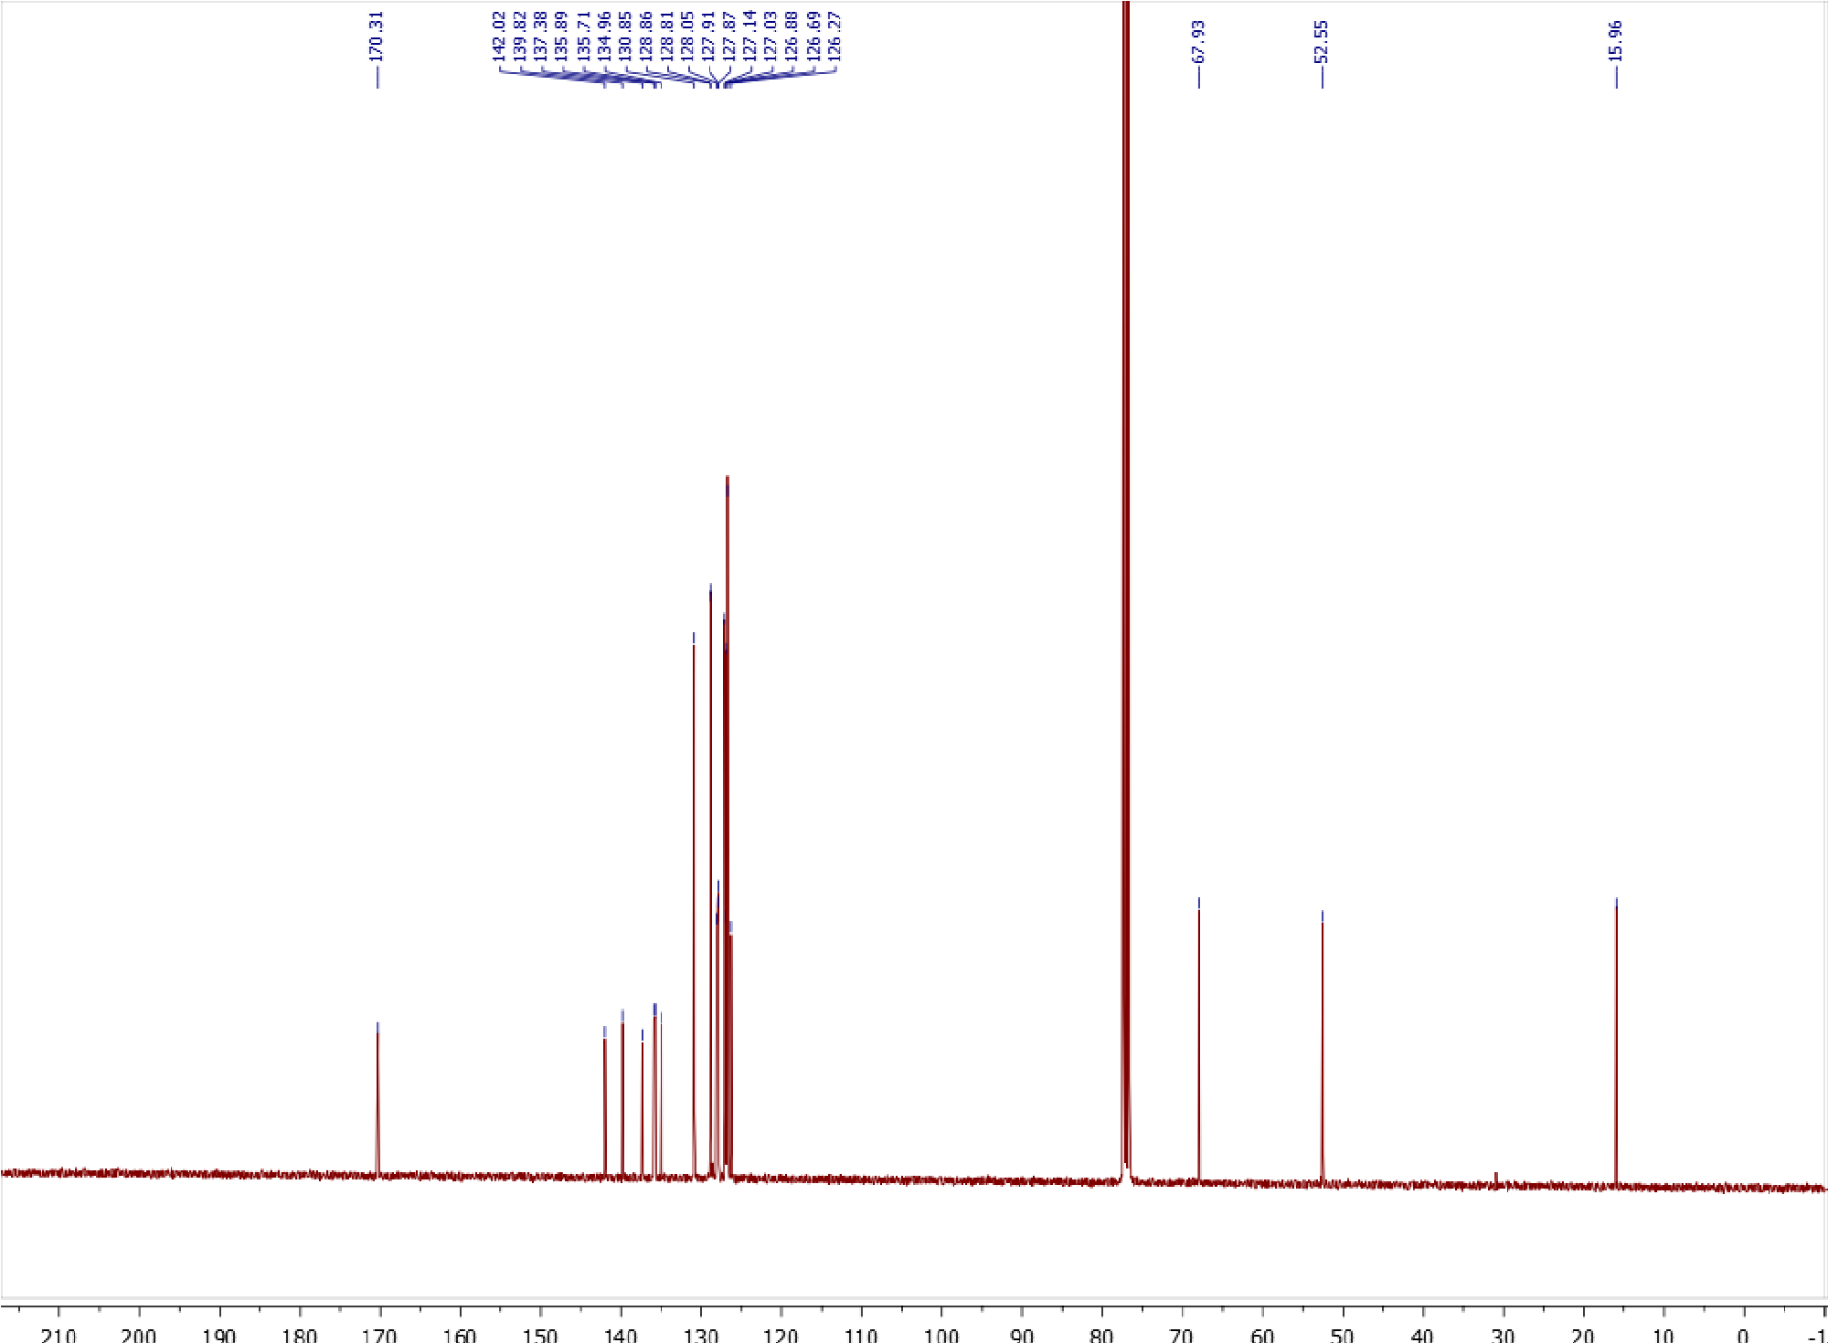
Copies of ¹H (400.13 MHz, CDCl₃) and ¹³C{¹H} (100.61 MHz, CDCl₃) spectra of 16
