Supporting Information for:

**Thiophene/Selenophene-Based S-Shaped Double Helicenes:**

**Regioselective Synthesis and Structures**

Mengjie Wang,‡ Lanping Dang,‡ Wan Xu, Zhiying Ma, Liuliu Shao, Guangxia Wang, Chunli Li \* and Hua Wang\*

Engineering Research Center for Nanomaterials, Henan University, Kaifeng, 475004, P. R. China

E-mail: chunli79@126.com; [hwang@henu.edu.cn](mailto:hwang@henu.edu.cn)

‡ These authors contributed equally to this work.

**Table of Contents**

|  |  |
| --- | --- |
| 1. NMR and HRMS Spectra | S2 |
| 2. Fluorescence Spectra and Fluorescence Quantum Yield | S9 |
| 3. **Theoretical Study** | S10 |
| Orbital-Weighted Fukui Function | S10 |
| Calculated HOMO and LUMO energy | S11 |
| 4. X-ray Crystallographic Data | S12 |
| Complete Crystal Data for **DH**-**1** | S12 |
| Complete Crystal Data for **DH**-**2** | S14 |

1. **NMR and HRMS Spectra**

**NMR and HRMS Spectra of 5a**



Figure S1. 1H NMR (400 MHz, CDCl3) spectrum of **5a**



Figure S2. 13C NMR (100 MHz, CDCl3) spectrum of **5a**

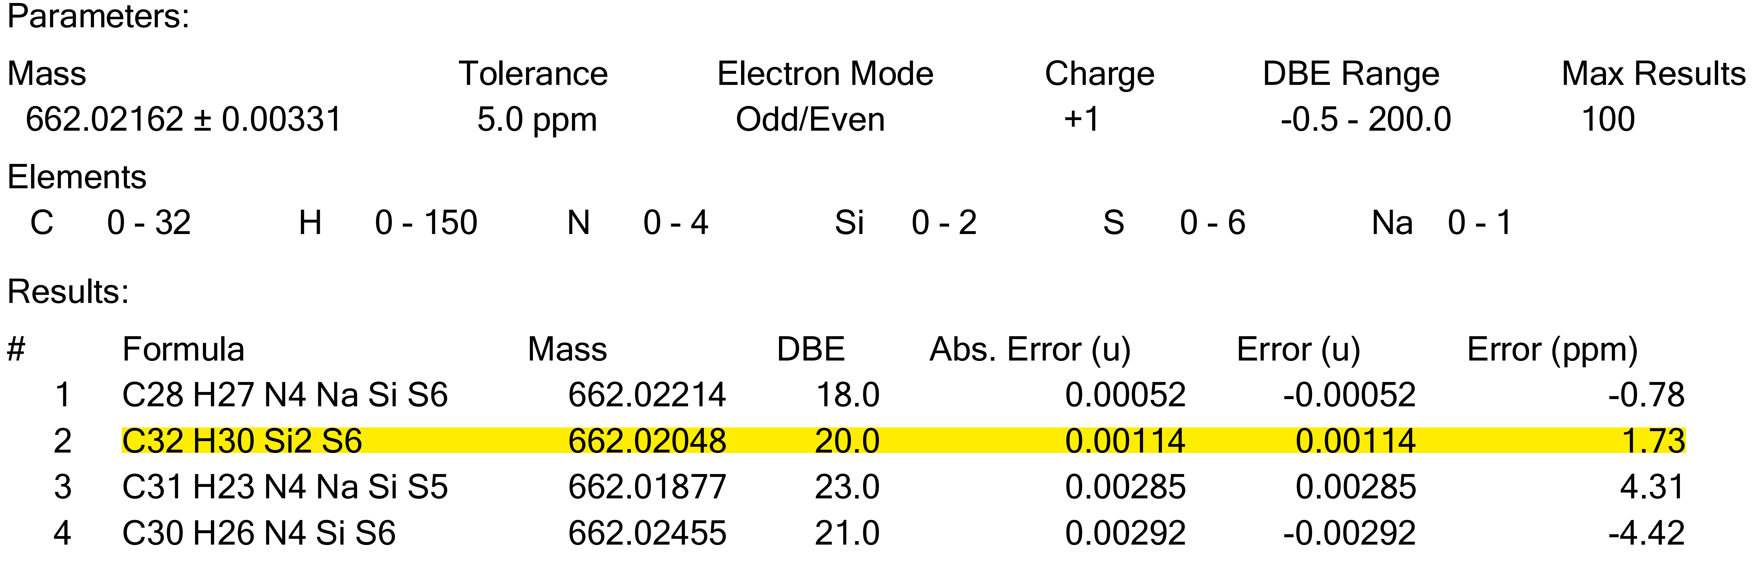

Figure S3. HRMS data of **5a**

**NMR and HRMS Spectra of 5b**



Figure S4. 1H NMR (300 MHz, CDCl3) spectrum of **5b**



Figure S5. 13C NMR (150 MHz, C2D2Cl4) spectrum of **5b**

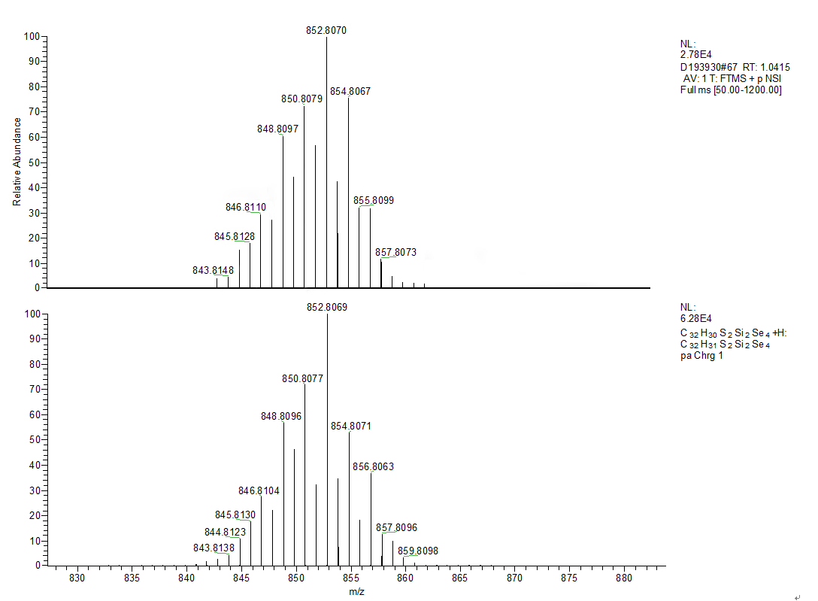

Figure S6. HRMS spectrum of **5b**

**NMR and HRMS Spectra of 5c**



Figure S7. 1H NMR (400 MHz, CDCl3) spectrum of **5c**

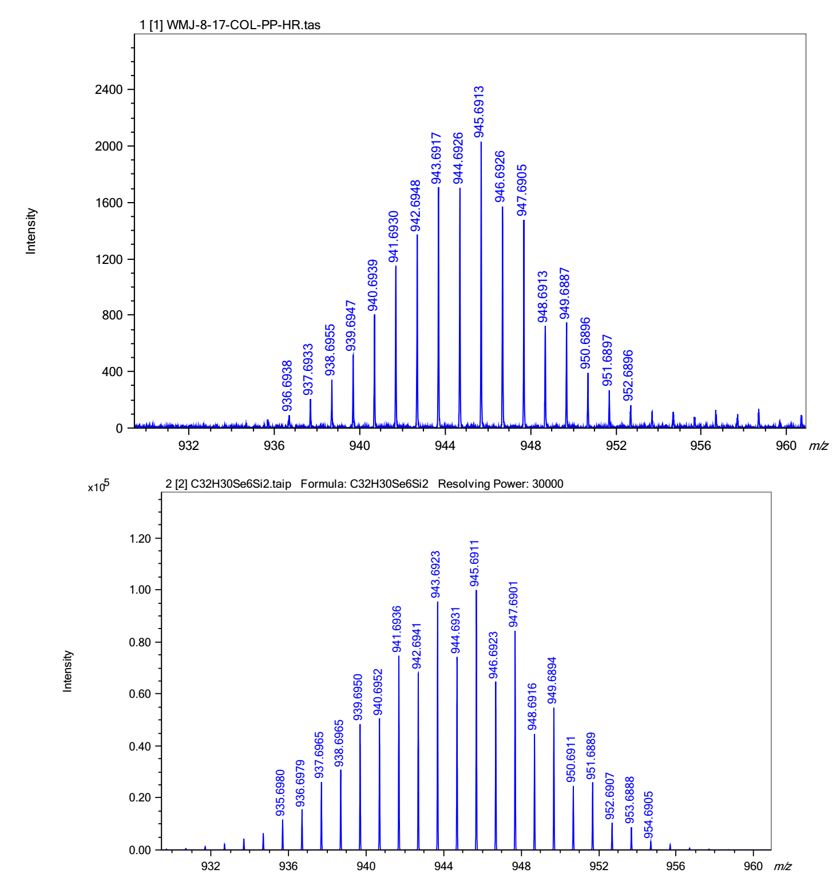

Figure S8. HRMS spectrum and data of **5c**

**NMR and HRMS Spectra of DH-1**



Figure S9. 1H NMR (400 MHz, CDCl3) spectrum of **DH**-**1**



Figure S10. 13C NMR (100 MHz, CDCl3) spectrum of **DH**-**1**

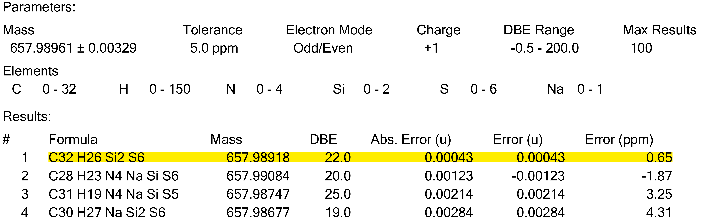

Figure S11. HRMS data of **DH**-**1**

**NMR and HRMS Spectra of DH-2**



Figure S12. 1H NMR (400 MHz, CDCl3) spectrum of **DH**-**2**



Figure S13. 13C NMR (100 MHz, CDCl3) spectrum of **DH**-**2**

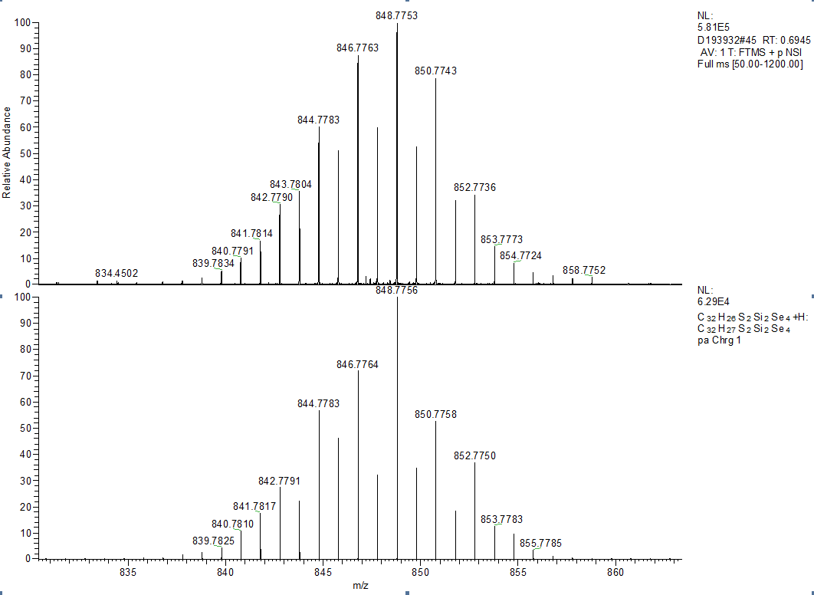

Figure S14. HRMS spectrum of **DH**-**2**

**NMR and HRMS Spectra of DH-3**



Figure S15. 1H NMR (300 MHz, CDCl3) spectrum of **DH**-**3**



Figure S16. 13C NMR (100 MHz, CDCl3) spectrum of **DH**-**3**

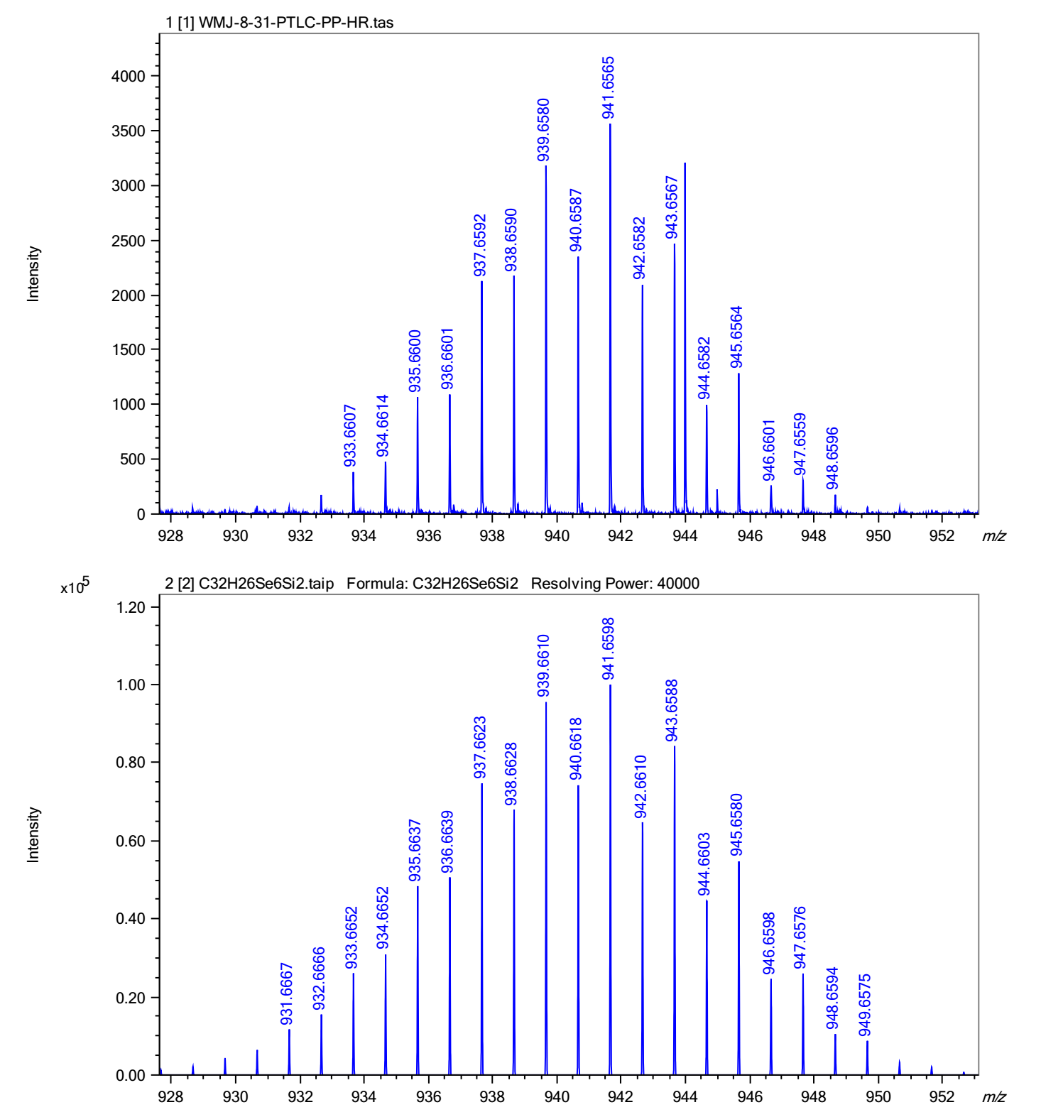

Figure S17. HRMS spectrum and data of **DH**-**3**

1. **Fluorescence Spectra and Fluorescence Quantum Yield**



Figure S18. Fluorescence spectra of **DH-**(**1-3**) at room temperature in dichloromethane

([C] = 1 × 10-5 M, *λ*ex= 350 nm, slit: 1/1 nm).



Figure S19. Excitation spectra of compound **DH-**(**1**-**3**) in dichloromethane and quinine sulfate dehydrate in 0.1N H2SO4. (*λ*ex= 350 nm, [C] = 1 × 10-5 M).

Table S1.The fluorescence quantum yield (Ф) of **DH-**(**1**-**3**)calculated according to the formula: Φ*F* = (nx/ns)2As/Ax Dx/DsΦs

|  |  |  |  |
| --- | --- | --- | --- |
| Compound | Peak Area(D) | Refractive index(n) | Yeild(Φ) |
| **DH**-**1** | 1.6×104 | 1.42 | 0.0123 |
| **DH**-**2** | 2.3×103 | 1.42 | 0.0016 |
| **DH**-**3** | 2.4×103 | 1.42 | 0.0017 |
| Quinine sulfate | 8.4×105 | 1.33 | 0.54 |

1. **Theoretical Study**

Orbital-Weighted Fukui Function of **5a**

|  |
| --- |
| 1-noshadow |
|  |
| 6-noshadow |
| Figure S20. Orbital-Weighted Fukui Function of **5a**. |
| 11-noshadow |
| Figure S21. Orbital-Weighted Fukui Function of closing one benzene compound. |

**Calculated HOMO and LUMO Energy**

|  |  |
| --- | --- |
| rac-1_HOMO | C:\Users\Administrator\AppData\Local\Microsoft\Windows\INetCache\Content.Word\rac-1_LUMO.tif |
| **DH-1**\_HOMO | **DH-1**\_LUMO |
| rac-2_HOMO | C:\Users\Administrator\AppData\Local\Microsoft\Windows\INetCache\Content.Word\rac-2_LUMO.tif |
| **DH-2**\_HOMO | **DH-2**\_LUMO |
| C:\Users\Administrator\AppData\Local\Microsoft\Windows\INetCache\Content.Word\rac-3_HOMO.tif | C:\Users\Administrator\AppData\Local\Microsoft\Windows\INetCache\Content.Word\rac-3_LUMO.tif |
| **DH-3**\_HOMO | **DH-3**\_LUMO |

Figure S22. The contour plots of the HOMOs and LUMOs for **DH**-**1**, **DH**-**2**, and **DH**-**3**.

Table S2. Calculated HOMO and LUMO energy level and energy gap at B3LYP/6-31G\*\* level of theory and the optical band gaps estimated from the absorption edges.

|  |  |  |  |  |  |
| --- | --- | --- | --- | --- | --- |
| Compounds | LUMO (eV)  theory | HOMO (eV)  theory | Eg (eV)  theory | λonset (nm)  experimental | Egopt (eV)  experimental |
| **DH**-**1** | -1.42 | -5.39 | 3.97 | 403 | 3.08 |
| **DH**-**2** | -1.49 | -5.32 | 3.83 | 412 | 3.01 |
| **DH**-**3** | -1.47 | -5.28 | 3.81 | 416 | 2.98 |

1. **X-ray crystallographic data**

**Complete crystal data for DH-1**

Table S3. Crystal data and structure refinement for **DH**-**1**.

Identification code **DH**-**1**

Empirical formula C32H26S6Si2

Formula weight 659.07

Temperature 150.0 K

Wavelength 0.71073 Å

Crystal system Triclinic

Space group P-1

Unit cell dimensions a = 11.1290(7) Å *α* = 108.362(2)°

b = 12.1240(7) Å *β* = 111.318(2)°

c = 13.7363(9) Å *γ* = 100.961(2)°

Volume 1538.32(17) Å3

Z 2

Density (calculated) 1.423 Mg/m3

Absorption coefficient 0.546 mm-1

F(000) 684

Crystal size 0.14 x 0.12 x 0.08 mm3

Theta range for data collection 2.284 to 25.499°

Index ranges -13 ≤ h ≤ 13, -14 ≤ k ≤ 13, -16 ≤ l ≤16

Reflections collected 19274

Independent reflections 5716 [R(int) = 0.1014]

Completeness to theta = 25.242° 99.7 %

Absorption correction Semi-empirical from equivalents

Max. and min. transmission 0.7457 and 0.6783

Refinement method Full-matrix least-squares on F2

Data / restraints / parameters 5716 / 0 / 367

Goodness-of-fit on F2 1.047

Final R indices [I>2sigma(I)] R1 = 0.0562, wR2 = 0.0872

R indices (all data) R1 = 0.1093, wR2 = 0.1101

Extinction coefficient n / a

Largest diff. peak and hole 0.476 and -0.451 e.Å-3

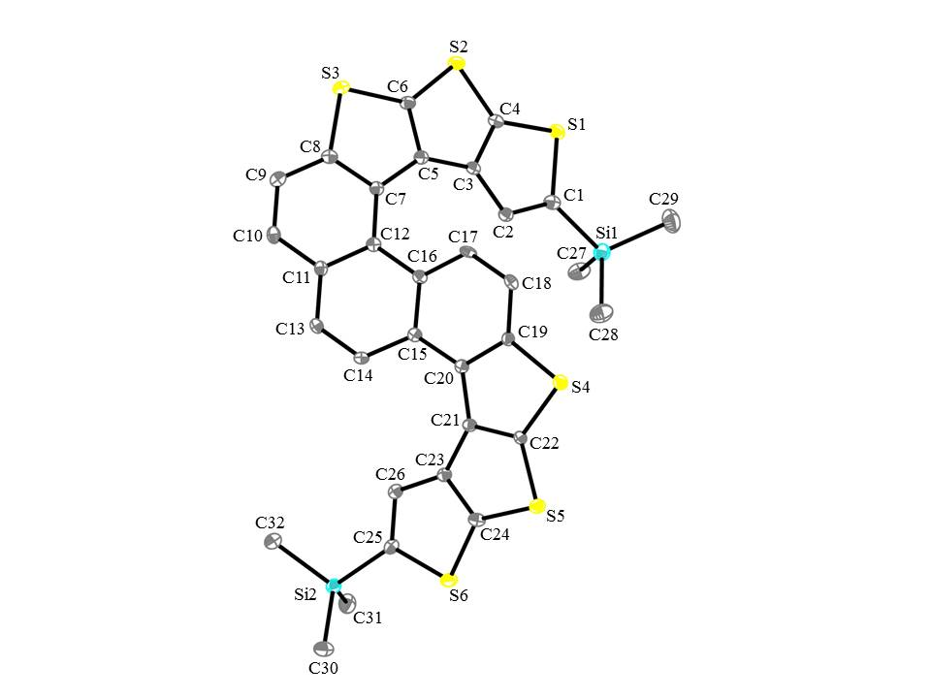

Figure S23. The crystal structures for compound **DH**-**1**. Carbon, sulfur, and silicon atoms are depicted with thermal ellipsoids set at 30% probability level, and all hydrogen atoms are omitted for clarity.

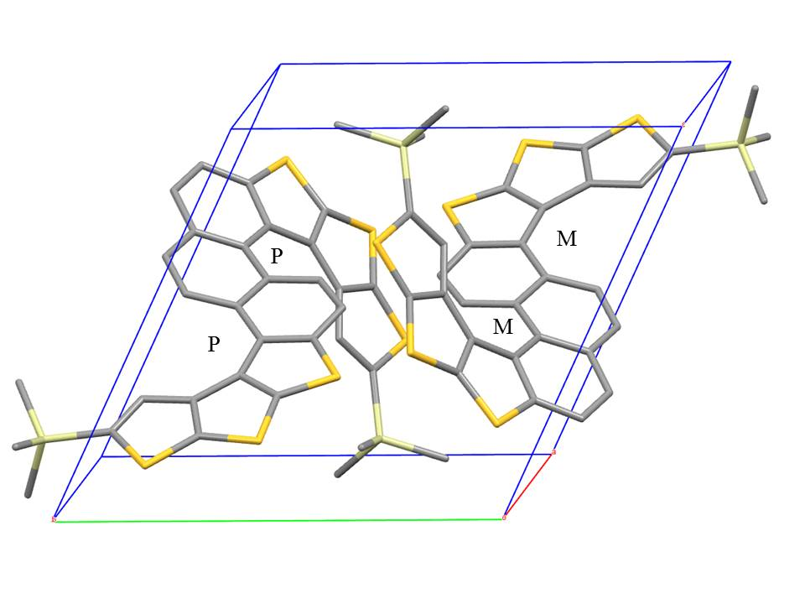

Figure S24. Molecular configuration of **DH**-**1** in one unit cell.

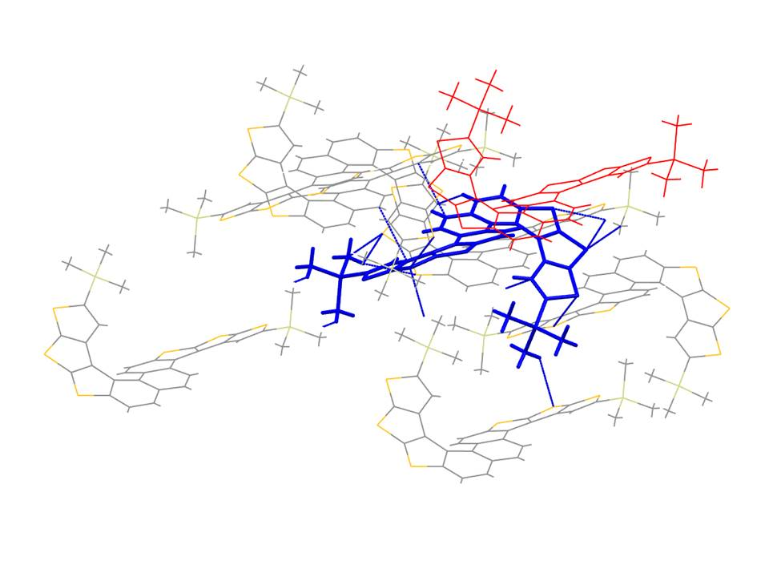

Figure S25. Multiple interactions in the crystal packings of **DH**-**1**.

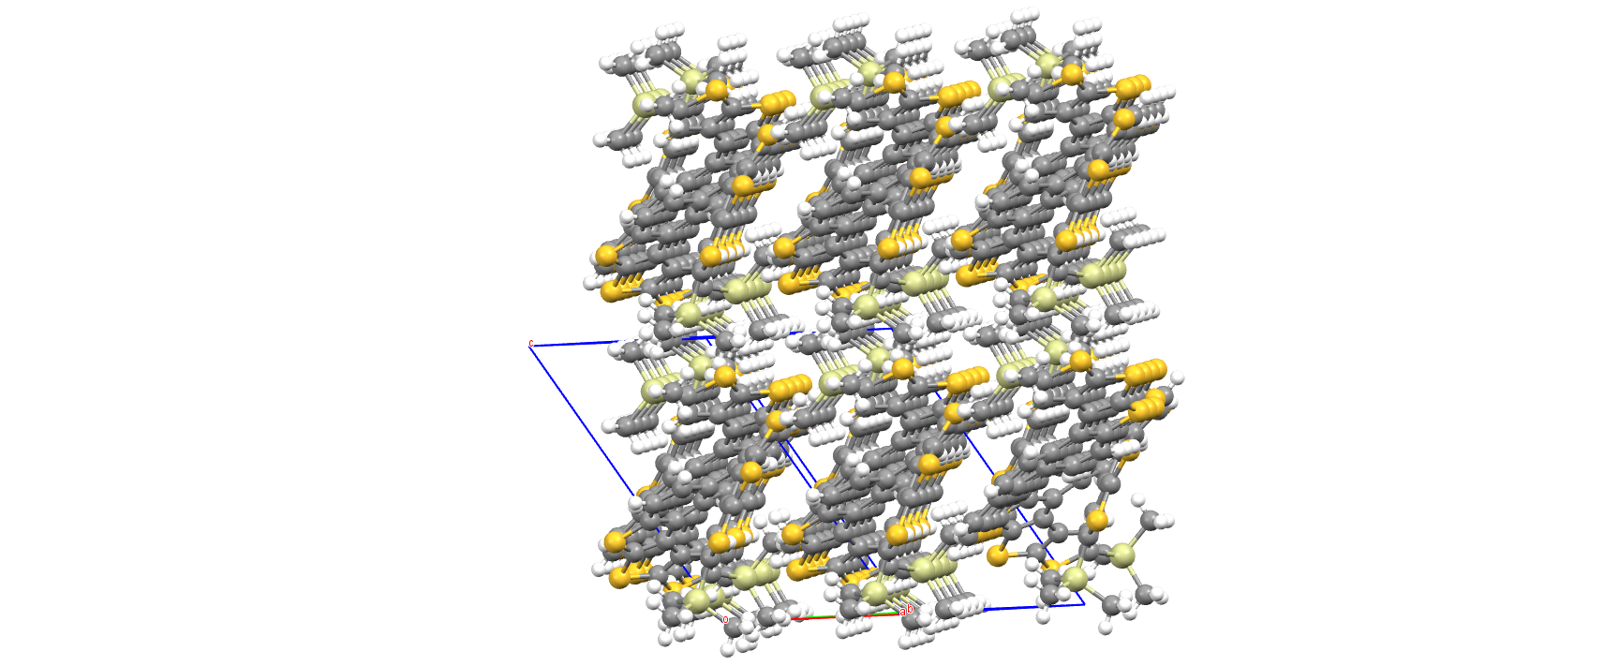

Figure S26. Molecular packing of **DH**-**1**.

**Complete crystal data for DH-2**

Table S4. Crystal data and structure refinement for **DH**-**2**.

Identification code **DH**-**2**

Empirical formula C32H26S2Se4Si2

Formula weight 846.67

Temperature 149.98 K

Wavelength 0.71073 Å

Crystal system Triclinic

Space group P-1

Unit cell dimensions a = 11.0959(11) Å *α* = 112.217(4)°.

b = 12.2773(12) Å *β* = 106.495(3)°.

c = 13.5535(13) Å *γ* = 99.898(3)°.

Volume 1555.7(3) Å3

Z 2

Density (calculated) 1.807 Mg/m3

Absorption coefficient 4.951 mm-1

F(000) 828

Crystal size 0.21 x 0.17 x 0.12 mm3

Theta range for data collection 2.288 to 28.326°.

Index ranges -14 ≤ h ≤ 14, -15 ≤ k ≤ 16, -18 ≤ l ≤ 18

Reflections collected 23440

Independent reflections 7708 [R(int) = 0.0726]

Completeness to theta = 25.242° 99.7 %

Absorption correction Semi-empirical from equivalents

Max. and min. transmission 0.7457 and 0.5103

Refinement method Full-matrix least-squares on F2

Data / restraints / parameters 7708 / 0 / 367

Goodness-of-fit on F2 1.027

Final R indices [I>2sigma(I)] R1 = 0.0443, wR2 = 0.0999

R indices (all data) R1 = 0.0690, wR2 = 0.1133

Extinction coefficient n/a

Largest diff. peak and hole 1.175 and -0.880 e.Å-3

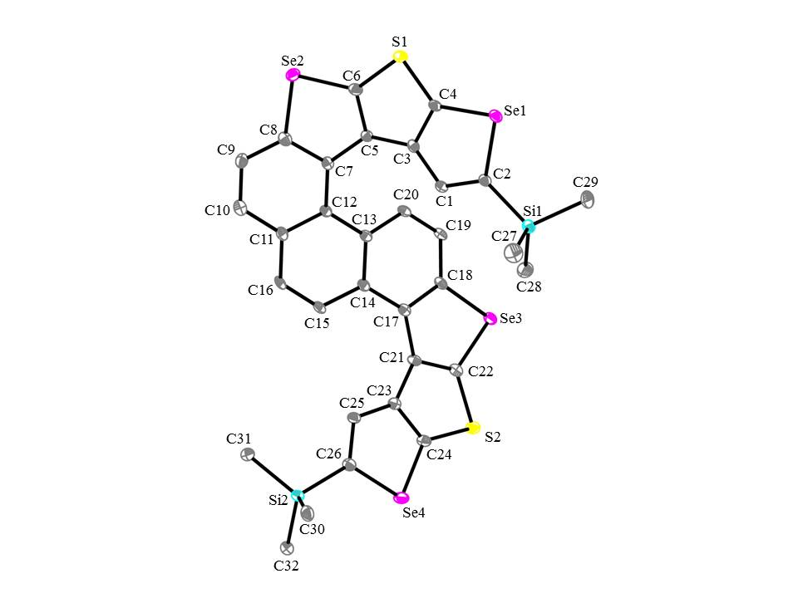

Figure S27. The crystal structures for compound **DH**-**2**. Carbon, selenium, sulfur, and silicon atoms are depicted with thermal ellipsoids set at 30% probability level, and all hydrogen atoms are omitted for clarity.

**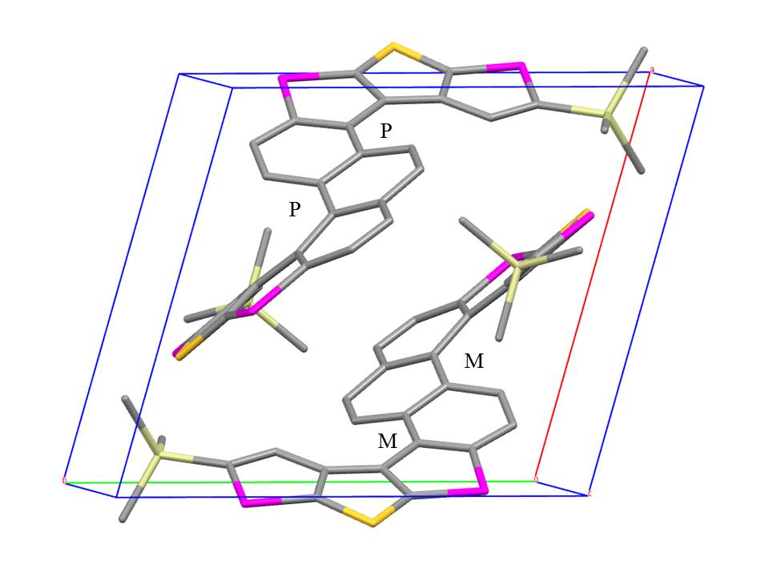**

Figure S28. Molecular configuration of **DH**-**2** in one unit cell.

**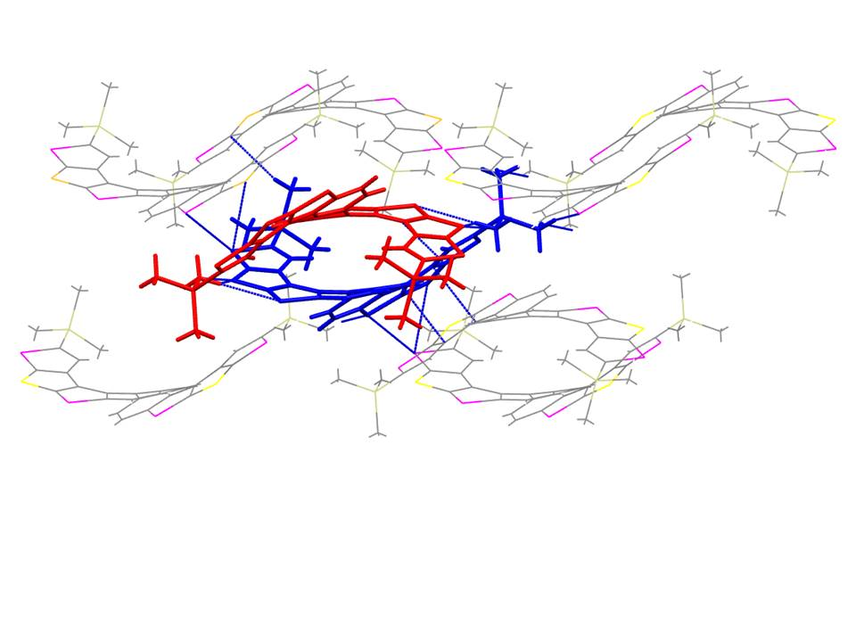**

Figure S29. Multiple interactions in the crystal packings of **DH**-**2**

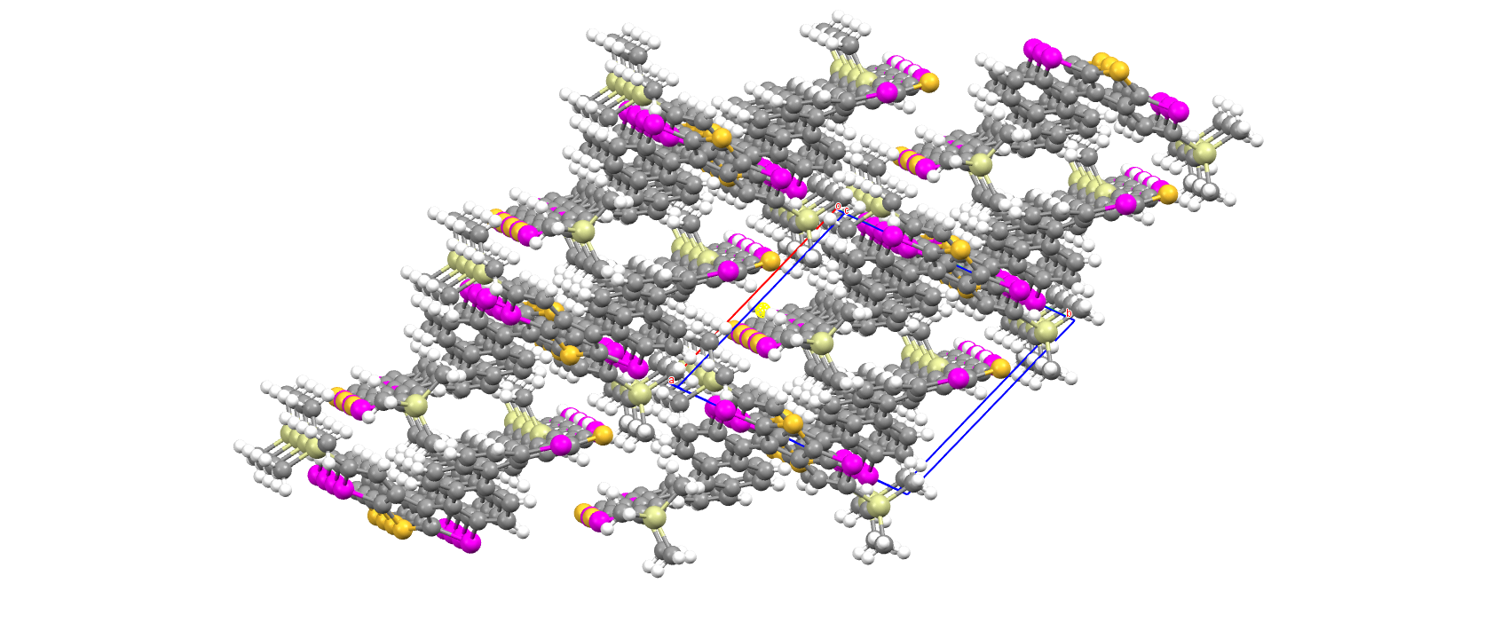

Figure S30. Molecular packing of **DH**-**2**.