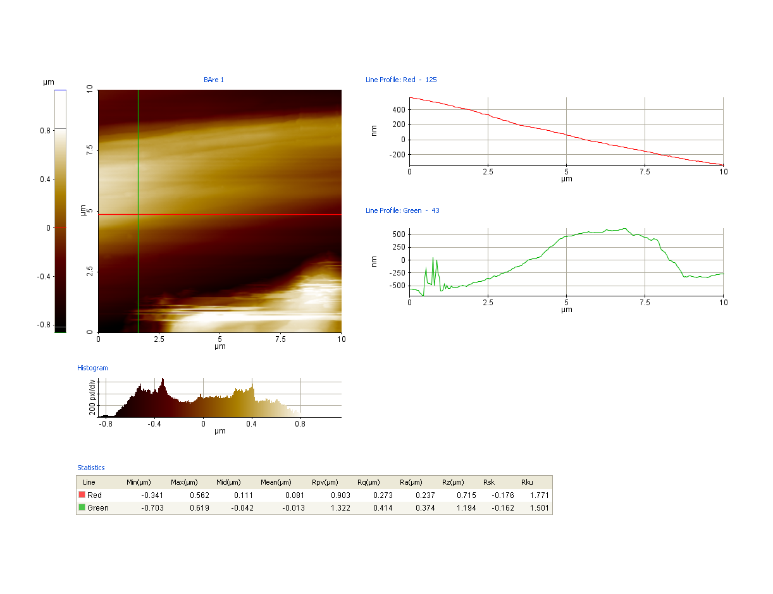
Fig. S1a Line profile analysis of bare steel
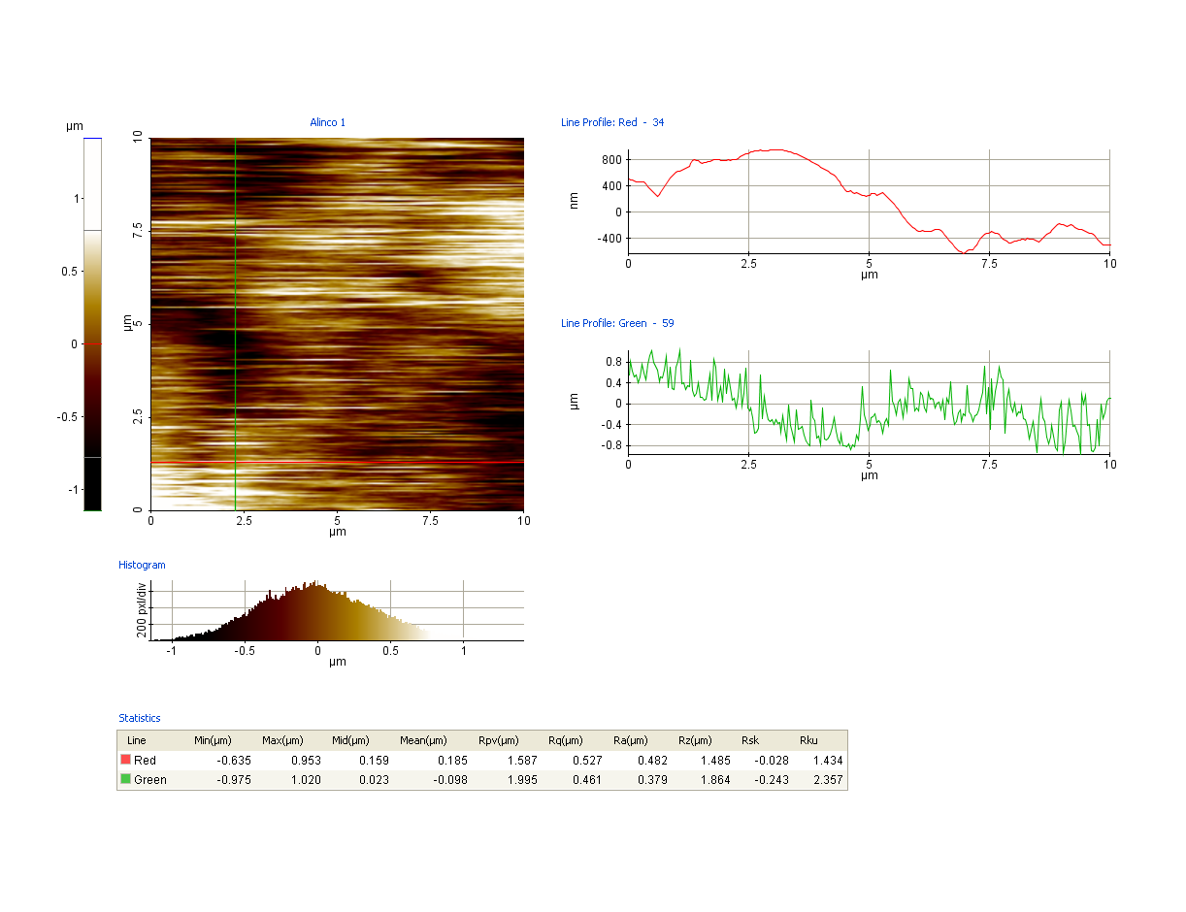
Fig. S1b Line profile analysis of AlNiCo Nps coated steel
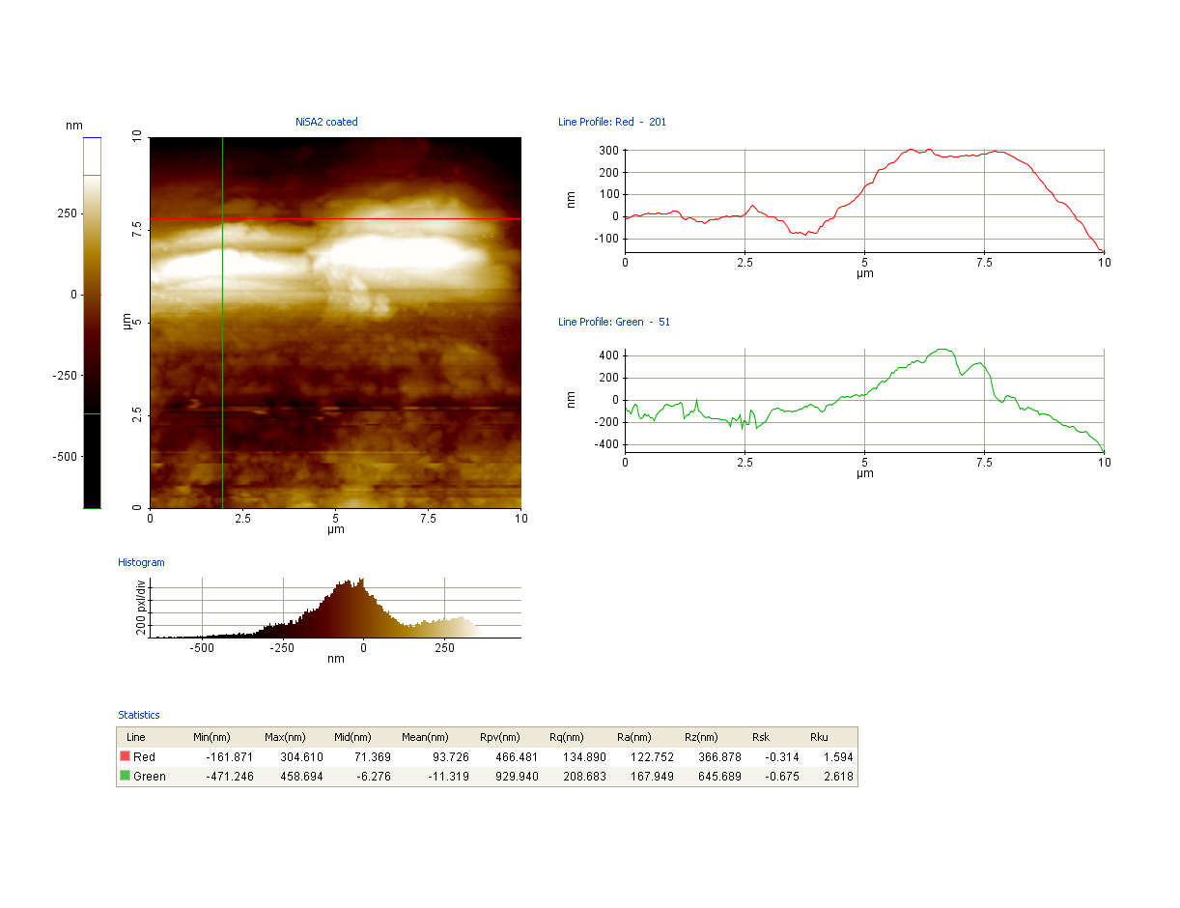
Fig. S1c Line profile analysis of nickel stearate coated steel
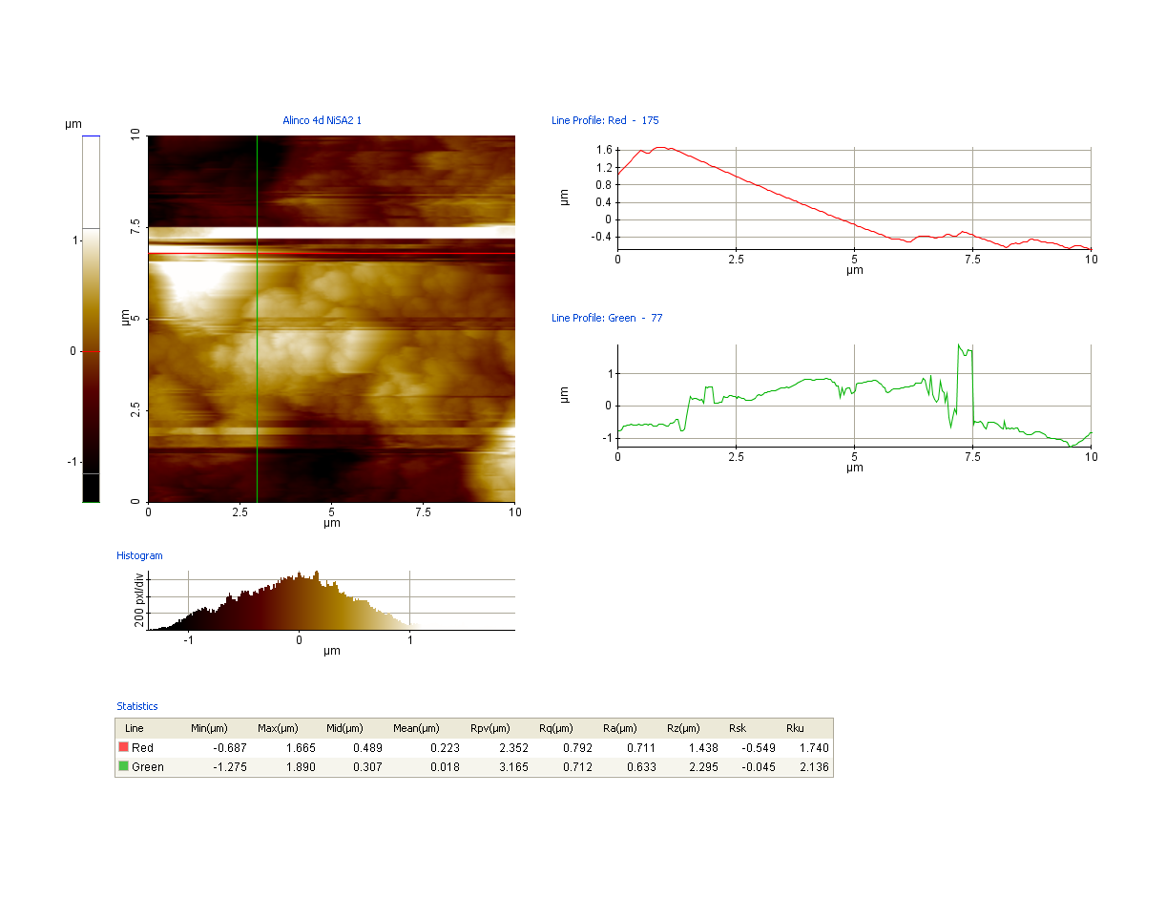
Fig. S1d Line profile analysis of Nickle stearate functionalized AlNiCo Nps coated steel
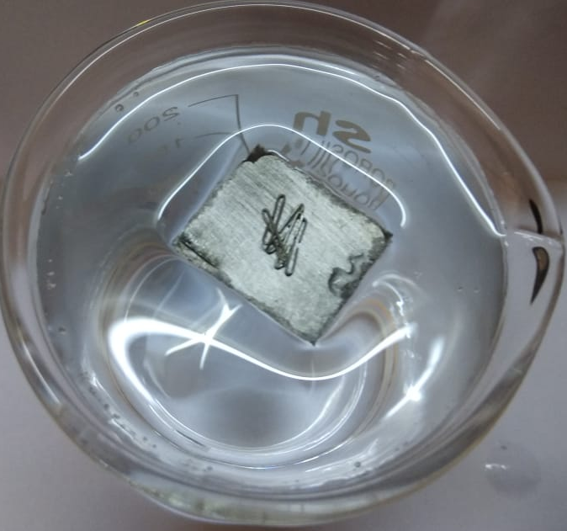
Fig. S2 Load bearing capability of super-hydrophobic additives coated steel supporting additional load
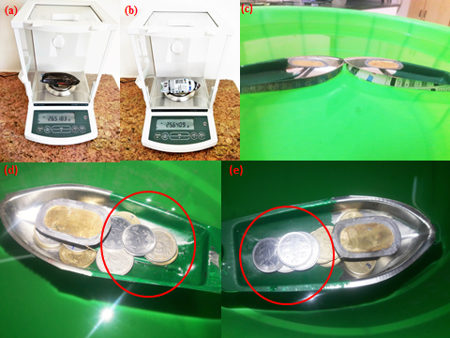
Fig. S3 Optical images of (a) SHM boat (b) HpM boat (c) SHM boat with Indian rupee coins (d) HpM boat with Indian rupee coins (e) SHM boat
S4. Calculation for energy utilized by both the boats
Calorific value of gingelly oil = ~39 kJ/g
Gingelly oil used = 0.4471 g
Total calorific value of gingelly oil used = 39 x 0.4471
= 17.4369
After running for 65.76 m,
Remaining oil present in HpM boat = 0 g
Remaining oil present in SHM boat = 0.1623 g
Calorific value of 0.1623 g oil = 0.1623 x 39
= 6.3297 kJ/g
Energy utilized by SHM boat
to travel 65.76 m = 17.4369-6.32.97
= 11.1072 kJ/g

