Supporting Information

for

**Phenylamino pyrimidine-1,2,3-triazole derivatives as analogs of imatinib: searching for novel compounds against chronic myeloid leukemia**

Luiz Claudio Ferreira Pimentel, Lucas Villas Boas Hoelz, Henayle Fernandes Canzian, Frederico Silva Castelo Branco, Andressa Paula de Oliveira, Vinicius Rangel Campos, Floriano Paes Silva Júnior, Rafael Ferreira Dantas, Jackson Antônio Lamounier Camargos Resende, Anna Claudia Cunha, Nubia Boechat, Mônica Macedo Bastos

Additional experimental and analytical data, and NMR spectraof synthesized compounds

|  |  |
| --- | --- |
| Contents | |
| 1. General information................................................................... | S2 |
| 1. Procedure **for intermediate 5.....................................................** | S3 |
| 1. Procedure **for intermediate 8.....................................................** | S3 |
| 1. Procedure **for intermediate 9.....................................................** | S4 |
| 1. **General procedure for the synthesis of compounds 1a-b and 2a-j...............................................................................................** | S6 |
| 1. **1H NMR, 13C NMR, HRMS spectrometric data and purity by HPLC for compounds 1a-b and 2a-j..........................................** | S7-36 |
| 1. **References...................................................................................** | S-37 |

**General information**

The reagents were acquired from Sigma-Aldrich and used without prior purification. The solvents used were purchased from Tedia and Vetec. The chromatoplates used were SiliCycle 60F254 plates with an indicator in the ultraviolet (UV) region (254 nm). The melting points were determined in a BüchiB-545 apparatus, and the values ​​were not corrected. A CEM Discover Microwave Synthesizer microwave oven (CEM Corporation, NC, USA) was used in microwave-assisted reactions. The infrared spectra (IR) were obtained on a Thermo Scientific spectrophotometer, model Nicolet 6700. Nuclear magnetic resonance (NMR) spectra were determined on a Bruker HC spectrometer at 400.00 MHz for hydrogen and 100.00 MHz for carbon. Trimethylsilane (TMS) was used as an internal reference standard for hydrogen and carbon (0 ppm). High-resolution mass spectrometry (HRMS) spectra were obtained on a Maxis 3G mass spectrometer with an electrospray ionization source (ESI-MS). The purity of the compounds was determined by high-performance liquid chromatography (HPLC) with a UV detector for elemental analysis. For elemental analysis, a Perkin Elmer 2400 Series II elementary analyzer was used.

**Procedure for intermediate 5**

**N-(5-azido-2-methylphenyl)-4-(pyridin-3-yl)pyrimidin-2-amine**

Phenylamino pyrimidine pyridine (PAPP) (3.62 mmol), 40 mL of distilled water and concentrated H2SO4 (3 mL) were stirred in an ice bath until complete solubilization. Then, 5.42 mmol (1.5 eq.) of NaNO2 was dissolved in 2 mL of ice-cold water and, subsequently, 7.24 mmol (2 eq.) of NaN3 dissolved in 5 mL of distilled water was added. The reaction was protected from light, stirred for 3 hours at room temperature and monitored by TLC using a mixture of chloroform/methanol (9:1) as the eluent. After the end of the reaction, it was neutralized with solid K2CO3 to pH 7-8. The mixture was filtered, and the solvent was concentrated under reduced pressure, obtaining PAPP azide **(5)** after drying, which was stored in an amber flask [1]. The obtained substance was a yellow solid. Yield: 84%. The analytical data corresponded to the literature [2,3]

**Procedure for intermediate 8**

**2-chloro-N-(4-methyl-3-((4-(pyridin-3-yl)pyrimidin-2-yl)amino)phenyl)acetamide**

PAPP, 4.71 mmol (2.5 eq.) of anhydrous K2CO3 and 15 mL of anhydrous THF were added to a flask. A solution containing 0.3 mL (1.1 eq.) of chloroacetyl chloride **(7)** dissolved in 15 mL of dry THF was added slowly using a pressure equalizer funnel. The reaction was kept for 1 hour at room temperature and monitored by TLC using a 95:5 chloroform/methanol mixture as the eluent. Afterwards, 20 mL of distilled water was added, and a solid yellow precipitate formed, was filtered off, and was washed with distilled water. Yellow solid; Yield: 81%. The analytical data corresponded to the literature [4].

**Procedure for intermediate 9**

**2-azido-N-(4-methyl-3-((4-(pyridin-3-yl)pyrimidin-2-yl)amino)phenyl)acetamide**

Under an inert atmosphere (N2), 0.50 mmol of **8**, 0.75 mmol (1.5 eq.) of NaN3, 20% mmol of KI and 15 mL of anhydrous acetone were added to a flask. The reaction was refluxed for 4 hours and monitored by TLC using chloroform as the eluent. After the removal of the solvent, the solid was washed with water and filtered, yielding an orange solid, which was stored in an amber flask.

Orange solid; Yield: 85%, m.p.:187-188 °C. IR (cm-1; film): 2103 (N=N=N str.). Anal. Calcd. (%) for CHN: C, 59.99; H, 4.48; N, 31.09. Found (%): C, 59.71; H, 4.49; N, 31.24. HR-MS (ESI) *m/z* calculated for C18H16N8O [M+Na]+: 383.1345. Found *m/z* 383.1334 [M+Na]+.

1H NMR (DMSO-*d6*, 400 MHz): 2.21 (s, 3H, CH3), 4.03 (s, 1H, CH2), 7.18 (d, 1H, *J*= 8.3 Hz, Ar-H), 7.29 (dd, 1H, *J=* 8.2, 2.1 Hz, Ar-H), 7.44 (d, 1H, *J=* 5.2 Hz, H-pyrimidine), 7.50-7.57 (m, 1H, H-pyridine), 7.91 (d, 1H, *J=* 1.9 Hz, Ar-H), 8.48 (dt, 1H, *J* = 8.0, 1.9 Hz, H-pyridine), 8.51 (d, 1H, *J* = 5.1 Hz, H-pyrimidine), 8.70 (dd, 1H, *J=* 4.8, 1.5 Hz, H-pyridine), 8.95 (s, 1H, NH), 9.26 (d, 1H, *J=* 1.8 Hz, H-pyridine), 10.10 (s, 1H, NH). 13C NMR (DMSO-*d6*, 101 MHz): 17.00, 50.66, 107.06, 114.91, 115.31, 123.22, 126.80, 129.70, 131.60, 133.85, 135.78, 137.37, 147.55, 150.79, 158.87, 160.45, 161.03, 165.45.





**General procedure for the synthesis of compounds 1a-b and 2a-j**

To a flask, 1 mmol of the azide compound **(5** or **9)** and 12 mL of acetonitrile/water mixture (2:1) were added, 0.5 mmol of sodium ascorbate, 10% mmol of CuSO4·5H2O and 1.5 mmol of the properly substituted acetylene **(6a-j)** were added, and the reaction was irradiated in a microwave reactor [5]. The reaction was monitored by TLC using a chloroform/methanol (95:5) mixture as the eluent. The target compounds were purified by filtration, recrystallization, or column chromatography.

**(1-(4-methyl-3-((4-(pyridin-3-yl)pyrimidin-2-yl)amino)phenyl)-1H-1,2,3-triazol-4-yl)methanol (1a)**

MW conditions: 8 min., 100 W, 80 °C. White solid; Yield: 84%, m.p.:194-196 °C (recrist. from acetonitrile). The analytical data corresponded to the literature [6,7].

**3-(1-(4-methyl-3-((4-(pyridin-3-yl)pyrimidin-2-yl)amino)phenyl)-1H-1,2,3-triazol-4-yl)propan-1-ol (1b)**

MW conditions: 20 min., 100 W, 80 °C. White solid; Yield: 76%, m.p.: 64.7-65.6 °C (recrist. from acetonitrile). IR (cm-1; film): 3401 (OH str.); 1039 (C-C-O str.). 1H NMR (DMSO-*d6*, 400 MHz): 1.77-1.87 (m, 2H, CH2),2.35 (s, 3H, CH3), 2.68-2.80 (m, 2H, CH2), 3.49 (m, 2H, CH2), 4.54 (t, 1H, *J=* 5.1 Hz, OH), 7.43 (d, 1H, *J=* 8.4 Hz, Ar-H), 7.51-7.57 (m, 3H, Ar-H, H-pyrimidine, H-pyridine), 8.33 (d, 1H, *J=* 2.1 Hz, Ar-H), 8.48-8.52 (m, 1H, H-pyridine), 8.53 (s, 1H, H-triazole), 8.58 (d, 1H, *J=* 5.2 Hz, H-pyrimidine), 8.71 (dd, 1H, *J=* 4.7, 1.4 Hz, H-pyridine), 9.14 (s, 1H, NH), 9,30 (d, 1H, *J=* 1.8 Hz, H-pyridine). 13C NMR (DMSO-*d6*, 101 MHz): 17.18, 21.10, 31.50, 59.42, 107.65, 114.37, 114.77, 119.83, 123.24, 130.70, 130.84, 131.47, 133.78, 134.31, 138.38, 147.38, 147.56, 150.93, 159.01, 160.16, 161.03. Anal. Calcd. (%) for CHN: C, 65.10; H, 5.46; N, 25.31; Found (%): C, 64.98; H, 5.47; N, 25.29. HR-MS (ESI) *m/z* calculated for C21H21N7ONa: 410.1705 [M+Na]+; found:410.1694 [M+Na]+.





**3-(1-(4-methyl-3-((4-(pyridin-3-yl)pyrimidin-2-yl)amino)phenyl)-1H-1,2,3-triazol-4-yl)propan-1-ol (2a)**

MW conditions: 60 min., 100 W, 80 °C. Yellow solid; Yield: 75%, m.p.: 215-217 °C (recrist. from acetonitrile). IR (cm-1; film): 3372 and 3260 (N-H str.); 1667 (C=O str.); 1009 (C-C-O str.). 1H NMR (DMSO-*d*6, 400 MHz): 2.21 (s, 3H, CH3), 4.54 (d, 2H, *J=* 5.6 Hz, CH2OH), 5.22 (t, 1H, *J=* 5.7 Hz, OH), 5.30 (s, 2H, CH2), 7.19 (d, 1H, *J=* 8.3 Hz, Ar-H), 7.29 (dd, 1H, *J=* 8.2, 2.0 Hz, Ar-H), 7.44 (d, 1H, *J=* 5.2 Hz, H-pyrimidine), 7.50 (dd, 1H, *J*= 8.0, 4.8 Hz, H-pyridine), 7.94 (d, 1H, *J=* 1.7 Hz, Ar-H), 7.99 (s, 1H, H-triazole), 8.46 (dt, 1H, *J*= 8.0, 1.9 Hz, H-pyridine), 8.51 (d, 1H, *J*= 5.1 Hz, H-pyrimidine), 8.69 (d, 1H, *J =* 4.1 Hz, H-pyridine), 8.92 (s, 1H, NH), 9.25 (s, 1H, H-pyridine), 10.41 (s, 1H, NH). 13C NMR (DMSO-d*6,* 101 MHz): 18.09, 52.61, 55.49, 108.17, 115.80, 116.14, 124.34, 124.84, 127.73, 130.84, 132.64, 134.97, 136.87, 138.49, 148.25, 148.60, 151.87, 159.94, 161.47, 162.10, 164.54. Anal. Calcd. (%) for CHN: C, 60.57; H, 4.84; N, 26.91; Found (%): C, 60.45; H, 4.84; N, 26.88. HR-MS (ESI) *m/z* calculated for C21H20N8O2Na: 439.1607 [M+Na]+; found: 439.1588 [M+Na]+.





**2-(4-(3-hydroxypropyl)-1H-1,2,3-triazol-1-yl)-N-(4-methyl-3-((4-(pyridin-3-yl)pyrimidin-2-yl)amino)phenyl)acetamide (2b)**

MW conditions: 80 min., 100 W, 80 °C. Yellow solid; Yield: 80%, m.p.: 170-172 °C (recrist. from acetonitrile). IR (cm-1; film): 3270 (N-H str.); 1670 (C=O str.); 1009 (C-C-O str.).1H NMR (DMSO-d*6*, 400 MHz): 2.22 (s, 3H, CH3), 2.67 (t, 2H, *J=* 7.6 Hz, CH2), 3.45 (q, 2H, *J*= 6.2 Hz, CH2), 4.50 (t, 1H, *J=* 5.1 Hz, OH), 5.27 (s, 2H, CH2), 7.19 (d, 1H, *J=* 8.3 Hz, Ar-H), 7.28 (dd, 1H, *J=* 8.2, 1.9 Hz, Ar-H), 7.43 (d, 1H, *J=* 4.9 Hz, H-pyrimidine), 7.88 (s, 1H, H-triazole), 7.96 (m, 1H, Ar-H), 8.51 (d, 2H, *J* = 7.9 Hz, H-pyridine), 8.92 (s, 1H, NH), 10.40 (1H, s, NH). 13C NMR (DMSO-d*6*, 101 MHz): 17.01, 21.04, 31.69, 51.51, 59.44, 107.17, 114.69, 115.02, 122.95, 126.59, 129.74, 133.58, 135.80, 137.41, 146.16, 147.67, 150.67, 158.86, 160.41, 161.21, 163.52. Anal. Calcd. (%) for CHN: C, 62.15; H, 5.44; N, 25.21; Found (%): C, 62.08; H, 5.45; N, 25.36. HR-MS (ESI) *m/z* calculated for C23H24N8O2Na: 467.1920 [M+Na]+; found: 467.1907 [M+Na]+.





|  |  |
| --- | --- |
| ***Crystal data*** | **2b** |
| **Formula** | C11H13N3O3 |
| **Fw (g.mol-1)** | 235,24 |
| **Temperature (K)** | 293,97 |
| **Crystal system, space group** | Monoclínic, P21 |
| **a**  **b**  **c** | 4,0919(2) Å |
| 8,1643(4) Å |
| 16,4342(9) Å |
| **β (°)** | 94,596(3) |
| **V (Å3)** | 547,26(5) |
| **Z** | 2 |
| **µ (mm−1)** | 0,106 |
| **Data colected** | |
| **Rint** | 0,0565 |
| **number of unique reflections** | 2147 |
| **Refinament** | |
| **parameters number** | 157 |

**2-(4-butyl-1H-1,2,3-triazol-1-yl)-N-(4-methyl-3-((4-(pyridin-3-yl)pyrimidin-2-yl)amino)phenyl)acetamide (2c)**

MW conditions: 1 min., 100 W, 80 °C. Yellow solid; Yield: 80%, m.p.: 153-154 °C. IR (cm-1; film):3384 and 3263 (N-H str.); 1670 (C=O str). 1H NMR (DMSO-d*6*, 400 MHz): 0.89 (t, 3H, *J=* 7.4 Hz, CH3), 1.33 (m, 2H, CH2), 1.58 (p, 2H, *J* = 7.5 Hz, CH2), 2.21 (s, 3H, CH3), 2.63 (t, 2H, *J* = 7.6 Hz, CH2), 5.26 (s, 2H, CH2), 7.18 (d, 1H, *J* = 8.4 Hz,Ar-H), 7.27 (dd, 1H, *J* = 8.2, 2.1 Hz, Ar-H), 7.44 (d, 1H, *J* = 5.2 Hz, H-pyrimidine), 7.49 (dd, 1H, *J*= 7.9, 4.8 Hz, H-pyridine), 7.87 (s, 1H, H-triazole), 7.96 (d, 1H, *J*= 1.9 Hz, Ar-H), 8.46 (dt, 1H, *J*= 8.0, 1.8 Hz, H-pyridine), 8.51 (d, 1H,*J*= 5.1 Hz, H-pyrimidine), 8.69 (s, 1H, H-pyridine), 8.92 (s, 1H, NH),9.26 (s, 1H, H-pyridine), 10.40 (s, 1H, NH). 13C NMR (DMSO-d*6*, 101 MHz): 14.17, 17.50, 22.12, 25.10, 31.60, 52.58, 108.18, 115.52, 116.11, 123.92, 124.33, 127.67, 130.82, 132.77, 134.98, 136.88, 138.49, 147.12, 148.64, 151.83, 159.96, 161.47, 162.09, 164.61. HR-MS(ESI) *m/z* calculated for C24H26N8ONa: 465.2127 [M+Na]+; found: 465.2121 [M+Na]+. HPLC-UV % (nm)*:* 99.5 (264).





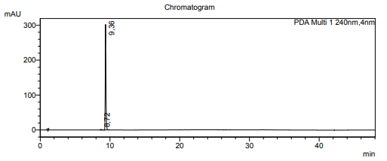

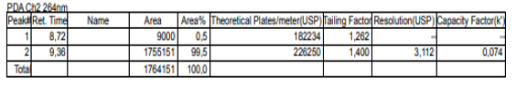

**2-(4-(3-chloropropyl)-1H-1,2,3-triazol-1-yl)-N-(4-methyl-3-((4-(pyridin-3-yl)pyrimidin-2-yl)amino)phenyl)acetamide (2d)**

MW conditions: 1 min., 100 W, 80 °C. Yellow solid; Yield: 80%, m.p.: 134-136 °C (filtration). IR (cm-1; film): 3264 (N-H str.); 1669 (C=O str.); 687 (C-Clstr.). 1H NMR (DMSO-d*6*, 400 MHz): 1.98-2.11 (m, 2H, CH2), 2.22 (s, 3H, CH3), 2.79 (t, 2H, *J* = 7.4 Hz, CH2), 3.69 (t, 2H, *J* = 6.4 Hz, CH2), 5.29 (s, 2H, CH2), 7.19 (d, 1H, *J* = 8.3 Hz,Ar-H), 7.28 (d, 1H, *J* = 7.8 Hz, Ar-H), 7.43 (d, 1H, *J* = 4.3 Hz, H-pyrimidine), 7.69 (s, 1H, H-pyridine), 7.96 (d, 2H, *J* = 8.3 Hz, Ar-H, H-triazole), 8.53 (s, 2H, H-pyrimidine, H-pyridine), 8.92 (s, 1H, NH), 10.42 (s, 1H, NH). 13C NMR (DMSO-d*6*, 101 MHz): 17.01, 21.66, 31.20, 44.08, 51.54, 107.27, 114.69, 115.02, 123.25, 126.58, 129.74, 133.32, 135.78, 137.40, 144.73, 147.71, 150.51, 158.83, 160.43, 161.47, 163.48. HR-MS (ESI) *m/z* calculated for C23H23ClN8ONa: 485.1581 [M+Na]+; found: 485.1574 [M+Na]+. HPLC-UV % (nm)*:* 97.1 (264).





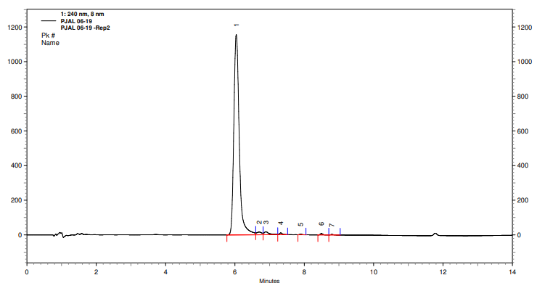

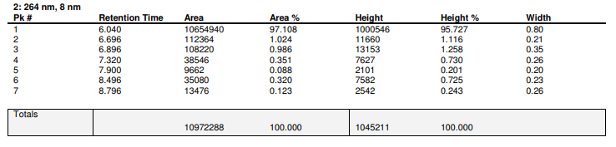

**2-(4-cyclopropyl-1H-1,2,3-triazol-1-yl)-N-(4-methyl-3-((4-(pyridin-3-yl)pyrimidin-2-yl)amino)phenyl)acetamide (2e)**

MW conditions: 30 min., 65 W, 70 °C (sealed tube). White solid; Yield: 30%, m.p.: 165-167 °C (99:1 DCM/MeOH). IR (cm-1; film): 3364 (N-H str.); 1660 (C=O str.). 1H NMR (MeOD, 400 MHz): 0.73-0.84 (m, 2H, CH2), 0.92-1.07 (m, 2H, CH2), 1.99 (tt, 1H, *J* = 8.5, 5.0 Hz, CH), 2.29 (s, 3H, CH3), 5.28 (s, 2H, CH2), 7.17-7.25 (m, 2H, Ar-H), 7.36 (d, 1H, *J* = 5.2 Hz, H-pyrimidine), 7.54 (s, 1H, H-pyridine), 7.79 (s, 1H, H-triazole), 8.23 (d, 1H, *J* = 1.3 Hz, Ar-H), 8.46 (d, 1H, *J* = 4.8 Hz, H-pyrimidine), 8.60 (d, 1H, *J* = 7.9 Hz, H-pyridine). 13C NMR (MeOD, 101 MHz): 7.28, 8.24, 17.89, 53.63, 108.92, 116.70, 117.19, 123.92, 125.65, 128.50, 131.74, 137.04, 137.60, 139.23, 148.99, 151.48, 151.72, 160.52, 162.60, 163.78, 165.84. HR-MS (ESI) *m/z* calculated for C23H22N8ONa: 449.1814 [M+Na]+; found: 449.1792 [M+Na]+. HPLC-UV % (nm): 97.5 (264).



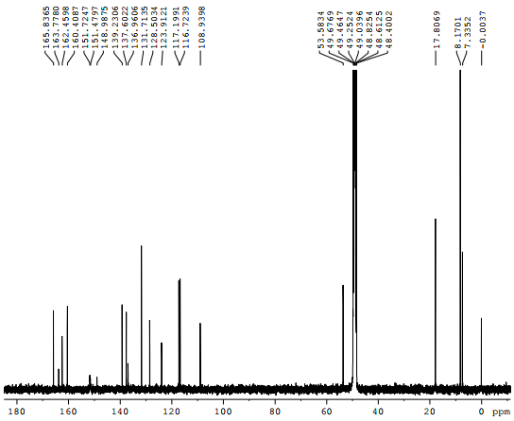

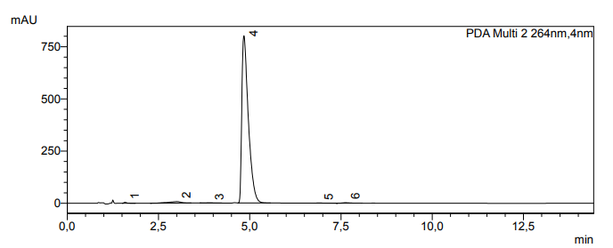

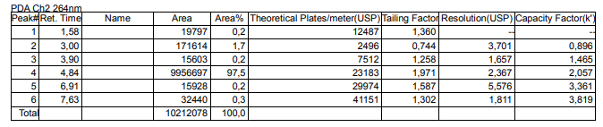

**2-(4-(1-hydroxycyclohexyl)-1H-1,2,3-triazol-1-yl)-N-(4-methyl-3-((4-(pyridin-3-yl)pyrimidin-2-yl)amino)phenyl)acetamide (2f)**

MW conditions: 40 min., 100 W, 80 °C (sealed tube). White solid; Yield: 50%, m.p.: 220-222 °C (99:1 DCM/MeOH). IR (cm-1; film): 3273 (N-H str.); 1681 (C=O str.). 1H NMR (MeOD, 400 MHz): 1.33-1.45 (m, 1H, CH2), 1.52 (dq, 2H, *J* = 13.9, 4.8 Hz, CH2), 1.61 (dq, 1H, dq, *J* = 11.9, 4.8, 4.1 Hz, CH2), 1.71-1.89 (m, 2H, CH2), 1.81-1.88 (m, 2H, CH2), 2.03 (td, 2H, *J* = 12.4, 10.8 Hz, 3.8 Hz, CH2), 2.29 (s, 3H, CH3), 5.32 (s, 2H, CH2), 7.22 (d, 2H, *J* = 1.5 Hz, Ar-H), 7.36 (d, 1H, *J* = 5.2 Hz, H-pyrimidine), 7.47-7.57 (m, 1H, H-pyridine), 7.94 (s, 1H, H-triazole); 8.23 (s, 1H, Ar-H), 8.46 (d, 1H, *J* = 5.2 Hz, H-pyrimidine), 8.59 (dt, 1H,*J* = 8.1, 1.9 Hz, H-pyridine), 8.63 (dd, 1H, *J* = 4.8, 1.4 Hz, H-pyridine), 9.25 (d, 1H, *J=* 1.7 Hz, H-pyridine). 13C NMR (MeOD, 101 MHz): 17.81, 23.11, 26.64, 38.91, 53.61, 70.32, 108.92, 116.77, 117.21, 124.31, 125.57, 128.55, 131.74, 134.57, 137.03, 137.63, 139.25, 149.03, 151.52, 157.02, 160.04, 162.48, 163.74, 165.85. HR-MS (ESI) *m/z* calculated for C26H28N8O2Na: 507.2233 [M+Na]+; found: 507.2216 [M+Na]+. HPLC-UV % (nm):100.0 (264).





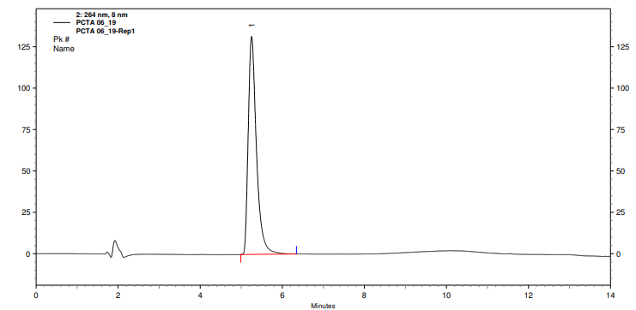



**N-(4-methyl-3-((4-(pyridin-3-yl)pyrimidin-2-yl)amino)phenyl)-2-(4-(((tetrahydro-2H-pyran-2-yl)oxy)methyl)-1H-1,2,3-triazol-1-yl)acetamide (2g)**

MW conditions: 180 min., 65 W, 70 °C (sealed tube). Yellow solid; Yield: 42%, m.p.: 100-102 °C (95:5 DCM/MeOH). IR (cm-1; film): 3266 (N-H str.); 1669 (C=O str.); 1117 and 1021 (C-O-C str.). 1H NMR (MeOD, 400 MHz): 1.46-1.85 (m, 6H, CH2), 2.29 (s, 3H, CH3), 3.51-3.89 (m, 2H, CH2), 4.64 (d, 1H, *J* = 12.4 Hz), 4.75 (t, 1H, *J* = 3.5 Hz, CH), 4.83 (d, 1H, *J* =12.5 Hz), 5.34 (s, 2H, CH2), 7.22 (d, 2H, *J* = 1.8 Hz, Ar-H), 7.35 (d, 1H, *J* = 5.2 Hz, H-pyrimidine), 7.50 (dd, 1H, *J* = 7.9, 4.9 Hz, H-pyridine), 8.07 (s, 1H, H-triazole), 8.23 (s, 1H, Ar-H), 8.46 (d, 1H, *J* = 5.2 Hz, H-pyrimidine), 8.59 (dt, 1H, *J* = 8.0, 1.6 Hz, H-pyridine), 8.64 (m, 1H,H-pyridine), 9.25 (s, 1H, H-pyridine). 13C NMR (MeOD, 101 MHz): 17.80, 20.35, 26.58, 31.58, 53.60, 61.04, 63.27, 99.39, 108.92, 116.76, 117.20, 125.64, 126.97, 128.54, 131.74, 134.20, 137.03, 137.62, 139.27, 146.02, 149.05, 151.86, 160.43, 162.49, 163.75, 165.70. HR-MS (ESI) *m/z* calculated for C26H28N8O3Na: 523.2182 [M+Na]+; found: 523.2147 [M+Na]+. HPLC-UV % (nm): 96.9 (264).





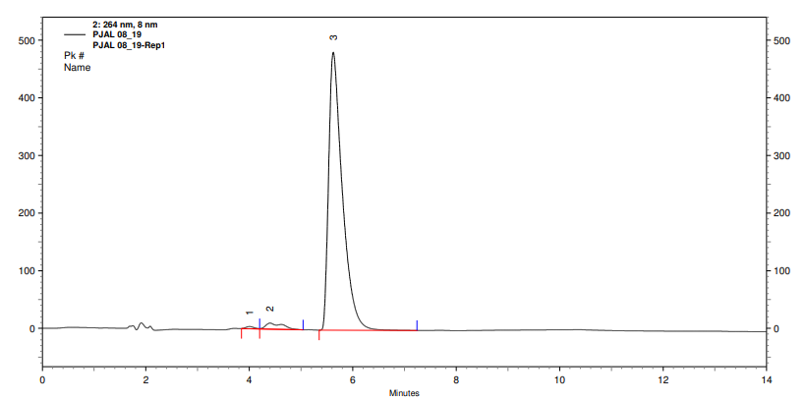

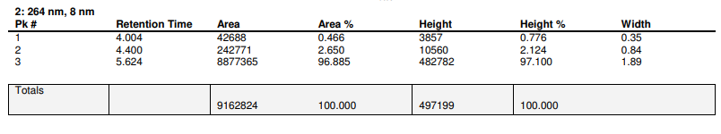

**N-(4-methyl-3-((4-(pyridin-3-yl)pyrimidin-2-yl)amino)phenyl)-2-(4-phenyl-1H-1,2,3-triazol-1-yl)acetamide (2h)**

MW conditions: 30 min., 100 W, 80 °C. Yellow solid; Yield: 82%, m.p.: 229-231 °C. IR (cm-1; film): 3433 (N-H str.); 1670 (C=O str.). 1H NMR (DMSO-d6, 400 MHz): 2.22 (s, 3H, CH3), 5.39 (s, 2H, CH2), 7.19 (d, 1H, *J* = 8.3 Hz, Ar-H), 7.28 (dd, 1H, *J* = 7.9, 1.6 Hz, Ar-H), 7.34 (t, 1H, *J* = 7.4 Hz, Ar-H), 7.40 – 7.50 (m, 3H, H-pyrimidine, Ar-H), 7.87 (d, 2H, *J* = 7.3 Hz, Ar-H), 8.01 (s, 1H, Ar-H), 8.46-8.57 (m, 2H, H-pyrimidine, H-pyridine), 8.61 (s, 1H, H-triazole), 8.92 (s, 1H, NH), 10.48 (s, 1H, NH). 13C NMR (DMSO-d6, 101 MHz): 17.51, 52.29, 107.73, 115.16, 115.46, 122.98, 125.02, 127.05, 127.75, 128.83, 130.27, 130.64, 133.98, 136.27, 137.93, 146.09, 148.21, 151.17, 159.35, 160.90, 161.85, 163.84. HR-MS (ESI) *m/z* calculated for C26H22N8ONa: 485.1814 [M+Na]+; found: 485.1789 [M+Na]+. HPLC-UV % (nm): 97.9 (264).





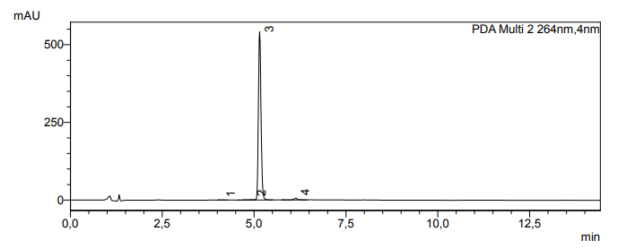

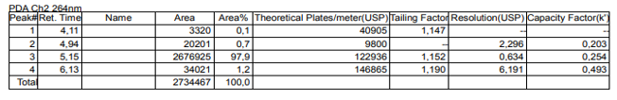

**methyl-1-(2-((4-methyl-3-((4-(pyridin-3-yl)pyrimidin-2-yl)amino)phenyl)amino)-2-oxoethyl)-1H-1,2,3-triazole-4-carboxylate (2i)**

MW conditions: 15 min., 100 W, 80 °C. Brown solid; Yield: 70%, m.p.:220-222 °C (95:5 DCM/MeOH). IR (cm-1; film): 3256 (N-H str.); 1735 (C=Oesterstr.); 1681 (C=O amidestr.); 1204 and 1009 (C-(C=O)-O str.). 1H NMR (MeOD, 400 MHz): 2.29 (s, 3H, CH3), 3.93 (s, 3H, COOCH3), 5.44 (s, 2H, CH2), 7.21 (s, 2H, Ar-H), 7.35 (d, 1H, *J* = 5.2 Hz, H-pyrimidine), 7.50 (dd, 1H, *J* = 7.9, 4.9 Hz, H-pyridine), 8.25 (s, 1H, Ar-H), 8.46 (d, 1H, *J* = 5.2 Hz, H-pyrimidine), 8.55-8.60 (m, 1H, H-pyridine), 8.61-8.71 (m, 2H, H-triazole, H-pyridine), 9.24 (s, 1H, H-pyridine). 13C NMR (MeOD, 101 MHz): 17.80, 52.63, 53.69, 108.95, 116.60, 117.10, 125.48, 128.44, 131.64, 131.75, 134.55, 137.00, 137.56, 139.27, 140.49, 149.07, 151.82, 160.42, 162.43, 162.52, 163.71, 165.19. HR-MS (ESI) *m/z* calculated for C22H20N8O3Na: 445.1737 [M+Na]+; found: 445.1721 [M+Na]+. HPLC-UV % (nm): 98.3 (264).





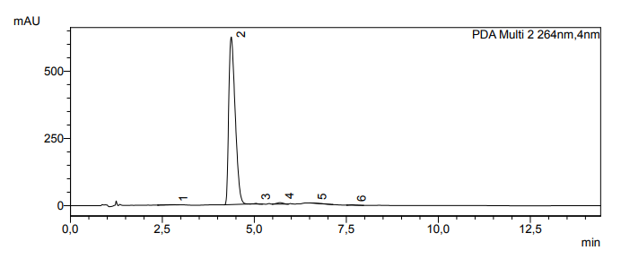

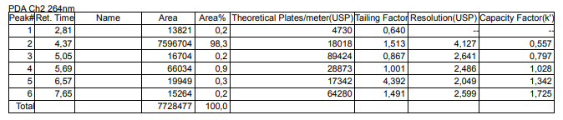

**ethyl-1-(2-((4-methyl-3-((4-(pyridin-3-yl)pyrimidin-2-yl)amino)phenyl)amino)-2-oxoethyl)-1H-1,2,3-triazole-4-carboxylate (2j)**

MW conditions: 15 min., 100 W, 80 °C. Brown solid; Yield: 80%, m.p.: 169-171 °C (95:5 DCM/MeOH). IR (cm-1; film): 3271 (N-H str.); 1716 (C=O ester str.); 1663 (C=O amide str.); 1211 and 1061 (C-(C=O)-O str.). 1H NMR (MeOD, 400 MHz): 1.38 (t, 3H, *J* = 7.1 Hz, CH3), 2.29 (s, 3H, CH3), 4.40 (q, 2H, CH2), 5.43 (s, 2H, CH2), 7.20 (d, 2H, *J* = 0.9 Hz, Ar-H), 7.34 (d, 1H, *J* = 5.2 Hz, H-pyrimidine), 7.48 (dd, 1H, *J* = 7.9, 4.9 Hz, H-pyridine), 8.26 (s, 1H, Ar-H), 8.45 (d, 1H, *J* = 5.2 Hz, H-pyrimidine), 8.57 (m, 1H, H-pyridine), 8.60-8.64 (m, 2H, H-triazole, H-pyridine), 9.24 (d, 1H, *J* = 1.8 Hz, H-pyridine). 13C NMR (MeOD, 101 MHz): 14.61, 17.79, 53.66, 62.35, 108.91, 116.56, 117.06, 125.43, 128.40, 131.52, 131.70, 134.50, 136.96, 137.51, 139.23, 140.77, 149.02, 151.77, 160.37, 162.01, 162.39, 163.67, 165.15. HR-MS (ESI) *m/z* calculated for C23H22N8O3Na: 459.1893 [M+Na]+; found: 459.1869 [M+Na]+. HPLC-UV % (nm): 96.1 (264).





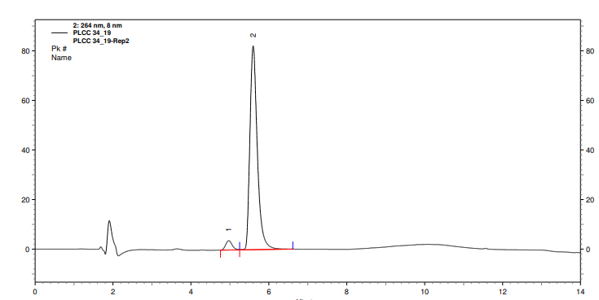



**References**

1. [Arioli](https://chemistry-europe.onlinelibrary.wiley.com/action/doSearch?ContribAuthorStored=Arioli%2C+Federica), F.; [Borrelli](https://chemistry-europe.onlinelibrary.wiley.com/action/doSearch?ContribAuthorStored=Borrelli%2C+Stella), S.; [Colombo](https://chemistry-europe.onlinelibrary.wiley.com/action/doSearch?ContribAuthorStored=Colombo%2C+Francesco), F.; [Falchi](https://chemistry-europe.onlinelibrary.wiley.com/action/doSearch?ContribAuthorStored=Falchi%2C+Federico), F.; [Filippi](https://chemistry-europe.onlinelibrary.wiley.com/action/doSearch?ContribAuthorStored=Filippi%2C+Irene), I.; [Crespan](https://chemistry-europe.onlinelibrary.wiley.com/action/doSearch?ContribAuthorStored=Crespan%2C+Emmanuele), E.;  [Naldini](https://chemistry-europe.onlinelibrary.wiley.com/action/doSearch?ContribAuthorStored=Naldini%2C+Antonella), G. A.; [Scalia](https://chemistry-europe.onlinelibrary.wiley.com/action/doSearch?ContribAuthorStored=Scalia%2C+Giusy), G.; [Silvani](https://chemistry-europe.onlinelibrary.wiley.com/action/doSearch?ContribAuthorStored=Silvani%2C+Alessandra), A.; [Maga](https://chemistry-europe.onlinelibrary.wiley.com/action/doSearch?ContribAuthorStored=Maga%2C+Giovanni), G.; [Carraro](https://chemistry-europe.onlinelibrary.wiley.com/action/doSearch?ContribAuthorStored=Carraro%2C+Fabio), F.; [Botta](https://chemistry-europe.onlinelibrary.wiley.com/action/doSearch?ContribAuthorStored=Botta%2C+Maurizio), M.; [Passarella](https://chemistry-europe.onlinelibrary.wiley.com/action/doSearch?ContribAuthorStored=Passarella%2C+Daniele), D. ChemMedChem, 2011, 6(11), 2009-2018.
2. Genyi Meng, G.; Guo, T.; Ma, T.; Zhang, J.; Shen, Y.; Sharpless, K. B.; Dong, J. Nature, 2019, 574, 86–89.
3. Boechat, N.; Bastos, M. M.; Duarte, S. L.; Costa, J. C. S.; Mafra, J. C. M.; Daniel, L. C. C. *RVq* **2013**, *5*(2), 222-234.
4. [Arioli](https://chemistry-europe.onlinelibrary.wiley.com/action/doSearch?ContribAuthorStored=Arioli%2C+Federica), F.; [Borrelli](https://chemistry-europe.onlinelibrary.wiley.com/action/doSearch?ContribAuthorStored=Borrelli%2C+Stella), S.; [Colombo](https://chemistry-europe.onlinelibrary.wiley.com/action/doSearch?ContribAuthorStored=Colombo%2C+Francesco), F.; [Falchi](https://chemistry-europe.onlinelibrary.wiley.com/action/doSearch?ContribAuthorStored=Falchi%2C+Federico), F.; [Filippi](https://chemistry-europe.onlinelibrary.wiley.com/action/doSearch?ContribAuthorStored=Filippi%2C+Irene), I.; [Crespan](https://chemistry-europe.onlinelibrary.wiley.com/action/doSearch?ContribAuthorStored=Crespan%2C+Emmanuele), E.;  [Naldini](https://chemistry-europe.onlinelibrary.wiley.com/action/doSearch?ContribAuthorStored=Naldini%2C+Antonella), G. A.; [Scalia](https://chemistry-europe.onlinelibrary.wiley.com/action/doSearch?ContribAuthorStored=Scalia%2C+Giusy), G.; [Silvani](https://chemistry-europe.onlinelibrary.wiley.com/action/doSearch?ContribAuthorStored=Silvani%2C+Alessandra), A.; [Maga](https://chemistry-europe.onlinelibrary.wiley.com/action/doSearch?ContribAuthorStored=Maga%2C+Giovanni), G.; [Carraro](https://chemistry-europe.onlinelibrary.wiley.com/action/doSearch?ContribAuthorStored=Carraro%2C+Fabio), F.; [Botta](https://chemistry-europe.onlinelibrary.wiley.com/action/doSearch?ContribAuthorStored=Botta%2C+Maurizio), M.; [Passarella](https://chemistry-europe.onlinelibrary.wiley.com/action/doSearch?ContribAuthorStored=Passarella%2C+Daniele), D. ChemMedChem, 2011, 6(11), 2009-2018.
5. Moorhouse, A. D.; Moses, J. E. *Synlett* **2008**, *14*, 2089-2092.
6. Kim, D. Y.; Cho, D. J.; Lee, G. Y.; Kim, H. Y.; Woo, S. H.; Lee, H. E.; Kim, S. M.; Ahn, C. A. From Repub. Korean Kongkae Taeho Kongbo, KR 2012052095 A May 23, 2012.
7. Rao, Z.; Yang, C.; Chen, Y.; Bai, C.; Sun, T.; Pan, C.; Meng, F.; Li, Y.; Wang, J.; Jiang, Y. Tianjin International Joint Academy of Biomedicine, Peop. Rep. China, CN 106188005, Dec 07, 2016.