Borylated methyl cinnamates: Expedited synthesis, characterization, crystallographic analysis and biological activities in glycosidase inhibition and in cancer cells lines.
William J. Legge,^{1,2} Yuna Shimadate,³ Mahdi Ghorbani,^{1,2} Jennette Sakoff,^{2,4} Todd A. Houston,⁵ Atsushi Kato,³ Paul V. Bernhardt,⁶ and Michela I. Simone^{1,2,}*

Supporting Information

Figure 1. ¹H-NMR spectrum of meta 2.
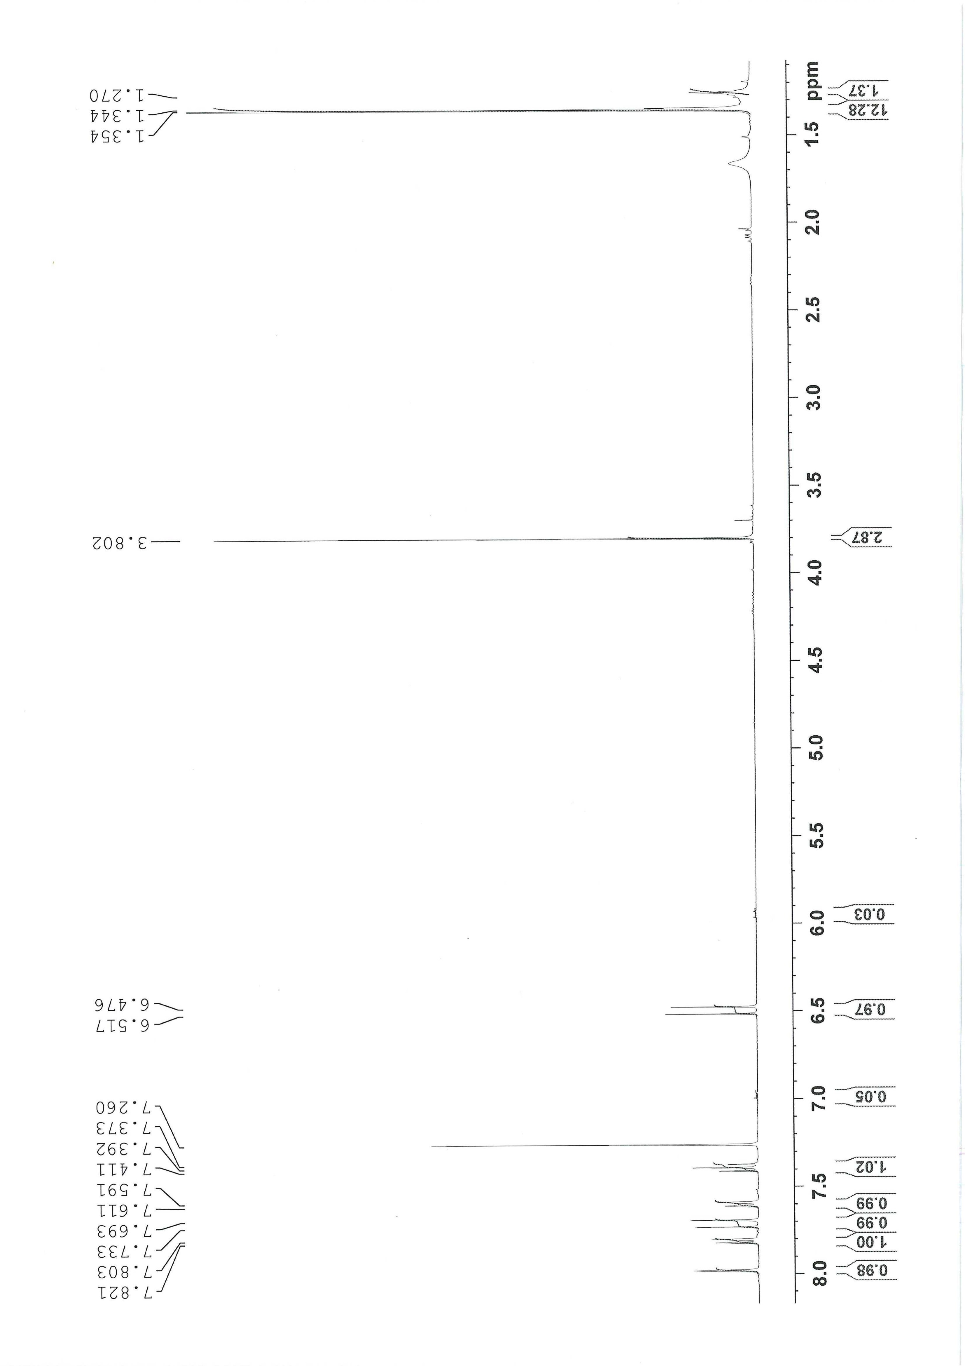

Figure 2. ¹³C-NMR spectrum of meta 2.
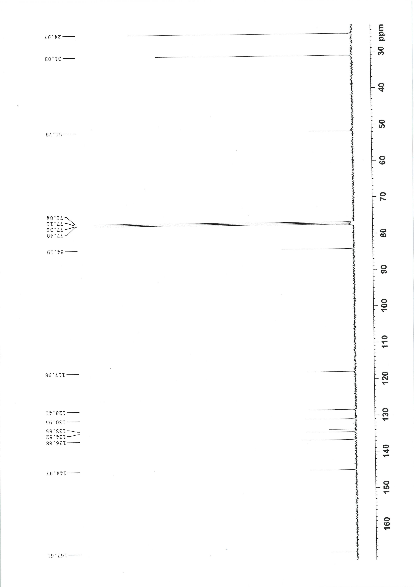

Figure 3. ¹¹B-NMR spectrum of meta 2.

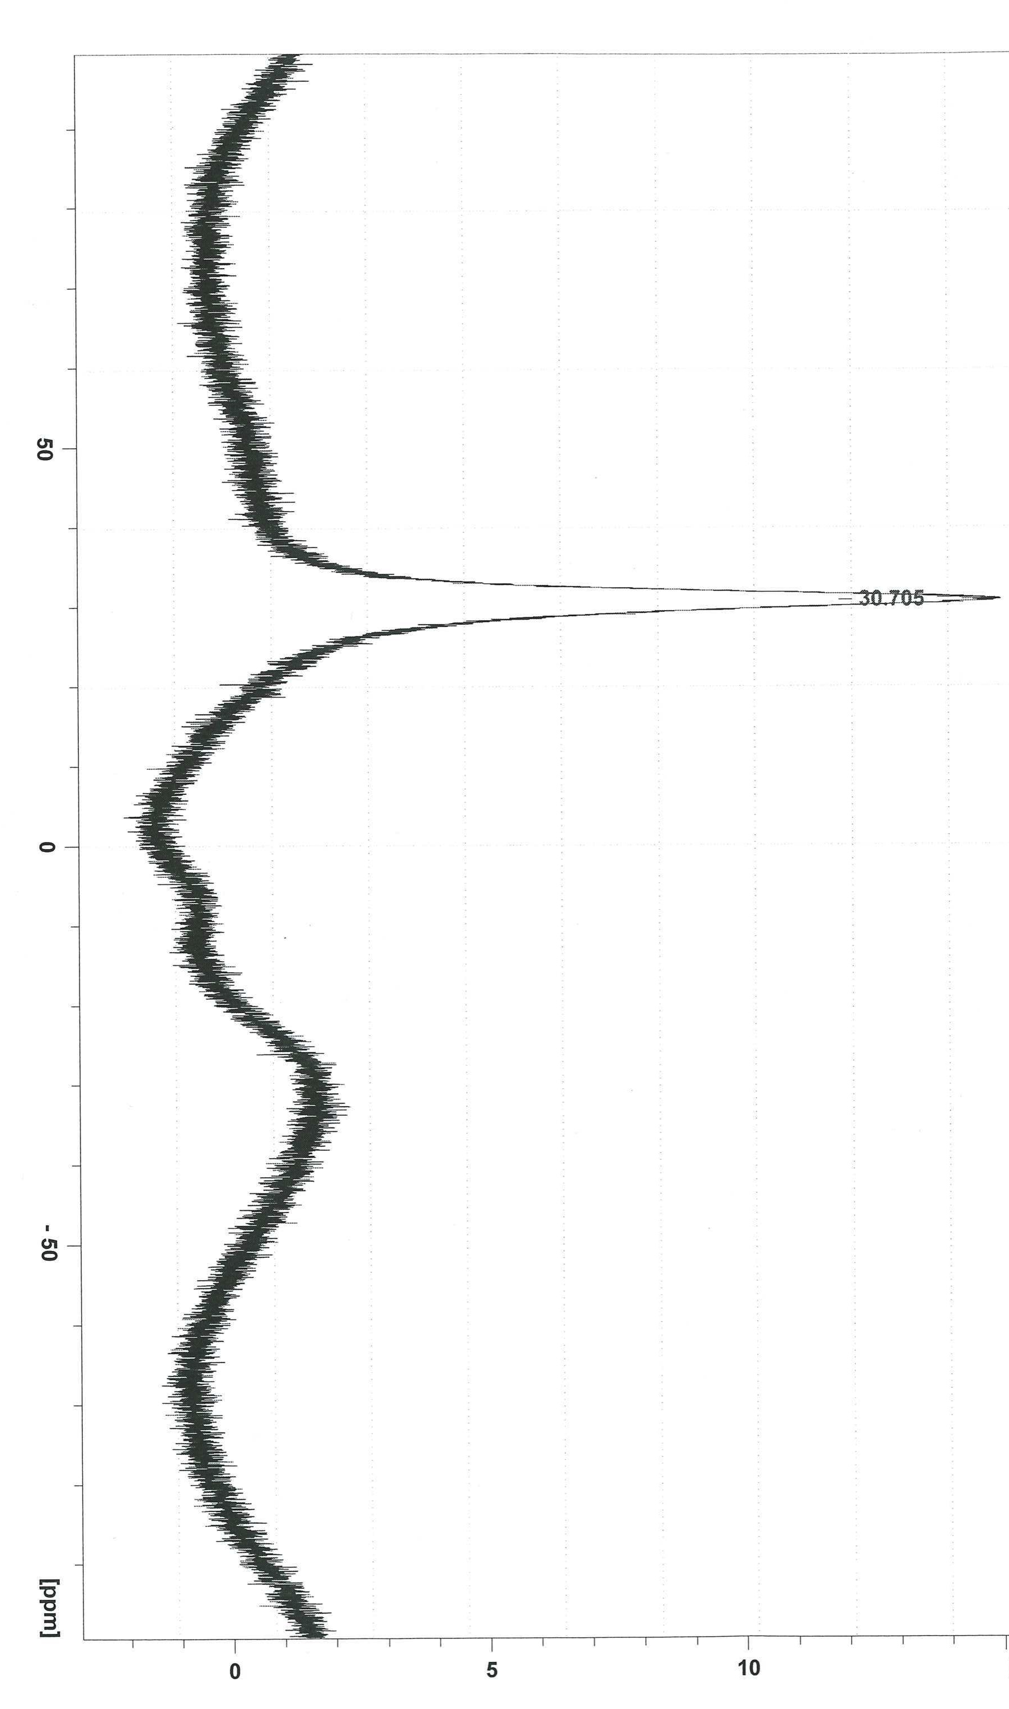

Figure 4. ¹H-NMR spectrum of para 2.
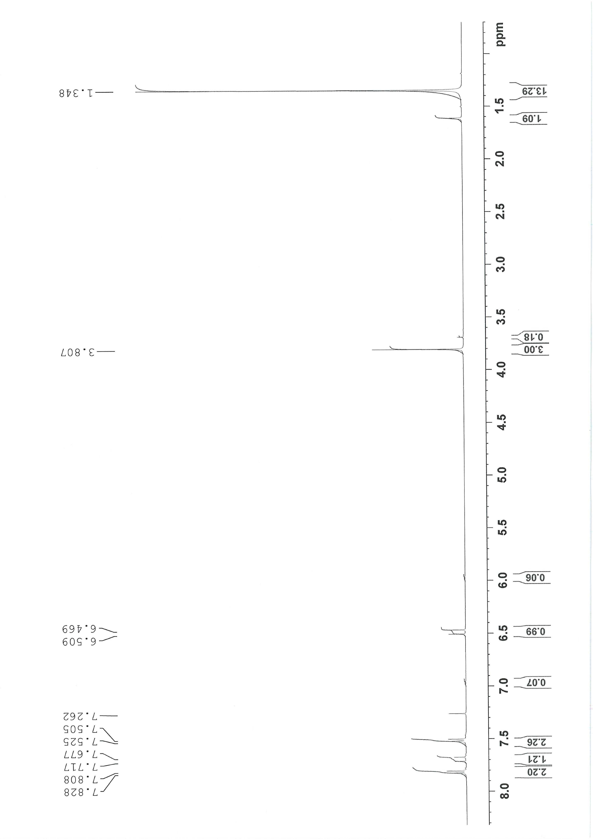

Figure 5. ¹³C-NMR spectrum of para 2.
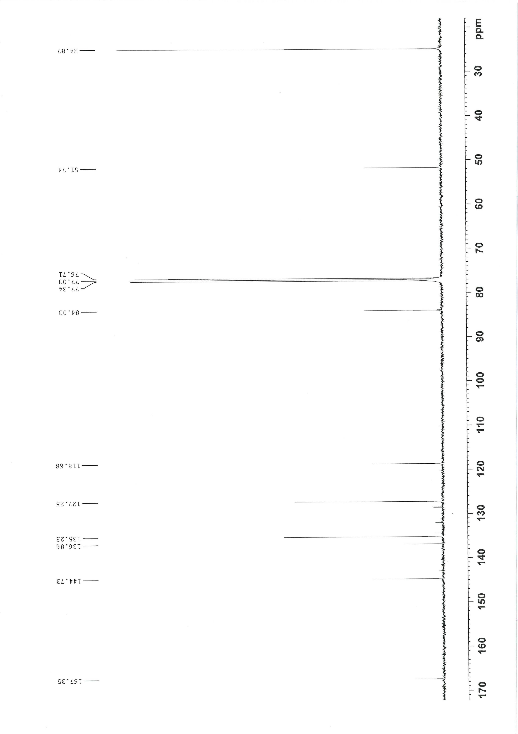

Figure 6. ¹¹B-NMR spectrum of para 2.
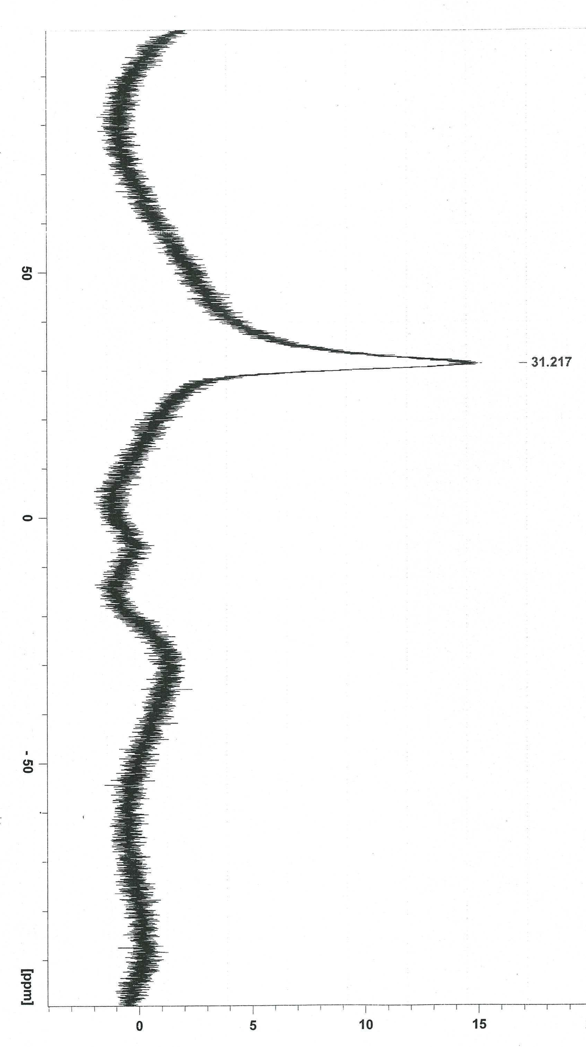

Table 1. Comparison of Wittig reaction conditions applied to cinnamate synthesis.
Synthetic Methodology |  | Starting materials | Product/s | Purification | E:Z Ratio | Yield | Ref.
Mechanochemically by ball-milling via a one-pot solventless preparation of ylides followed by solventless Wittig under an atmosphere of He with excess anhydrous K2CO3 with forced air cooling | 8 hours | (Benzyl)triphenylphosphonium chloride, naphthaldehyde | (E)- and (Z)-1-(Phenyl)-2-(2-naphthyl)ethylenes | Column chromatography (hexane/toluene). Partial separation of (E)- and (Z)-isomers | 1.6:1 | 85% | [1]
 | 8 hours | (Benzyl)triphenylphosphonium chloride and 4-bromobenzaldehyde | (E)- and (Z)- 4-Bromostilbenes |  | 2:1 | 90% | [1]
 | 14 hours | (Benzyl)triphenylphosphonium chloride, 4-bromoacetophenone | (E)- and (Z)-1-(4-Bromophenyl)-1-methyl-2-phenylethylene | Column chromatography (hexane/toluene). No separation of (E)- and (Z)-isomers | 3.4:1 | 70% | [1]
 | 20 hours | (Methyl)- triphenylphosphonium bromide, naphthaldehyde | 2-Ethenylnaphthalene | Column chromatography (hexane/toluene). Sole Product | NA | 73% | [1]
 | 8 hours | Triphenylphosphine,  2-bromometylnaphtalene, 4-bromobenzaldehyde | (E)- and (Z)-1-(4-Bromophenyl)-2-(2-naphthyl)- ethylenes | Column chromatography (hexane/toluene). Partial separation of (E)- and (Z)-isomers | 3.5 :1 | 93% | [1]
Grinding of reactants in a mortar with a pestel via a one-pot solventless preparation of ylides followed by solventless Wittig at r.t. | 20 minutes | Benzyltriphenylphosphonium chloride, 4-bromobenzaldehyde, potassium phosphate (tribasic) | (E)- and (Z)-1-(4-bromophenyl)- 2-phenylethene | Washing initial crude product with water, then recrystallization in ethanol to obtain the E-isomer | Not available | 70%  20-26% (E-product) | [2]
Grinding of reactants via a one-pot solventless preparation of ylides followed by solventless Wittig at r.t. | Until complete by t.l.c. analysis | Salycylaldehyde (and 5 structural analogues)  chloroethylacetate, triphenylphosphine, sodium methoxide supported on MgO | Corresponding coumarins | Reaction mixture was eluted in acidic water, extracted with ether, column chromatography (hexane/ethyl acetate) | 0:100 (only Z products) | 82-90% | [3]
Grinding of reactants in a mortar with a pestel via a one-pot solventless preparation of ylides followed by solventless Wittig  - at r.t.  or  - at r.t., then heating to 65°C, then  grinding again | 1-240 minutes.  For 1., usually 5 minutes.  For 2., 5 minutes,  40-50 minutes,  1-2 minutes. Repeated until complete by t.l.c. | Formylferrocene (and 10 structural analogues), triphenylbenzylphosphonium bromide, sodium hydroxide | Vinylferrocene derivatives | Extraction with ether, column chromatography (petroleum ether) | Varying ratios ranging from 10:1 to 2:1. | 62%-100%* | [4]
Grinding of reactants in a mortar with a pestel via a one-pot solventless preparation of ylides followed by solventless Wittig at r.t. | 30 minutes | (4-(Benzoylthio)benzyl)trimethoxyphosphonium bromide or (4-(benzoylthio)benzyl)triethoxyphosphonium bromide, 9-ethyl-carbazole-3-carbaldehyde  or  (4-(benzoylthio)benzyl)trimethoxyphosphonium, 9-hexyl-carbazole-3-carbaldehyde, with sodium hydroxide, sodium sulfate | (E)-3-(4-(Methylthio)styryl)-9-ethyl-carbazole  (E)-3-(4-(ethylthio)styryl)-9-ethyl-carbazole  (E)-3-(4-(methylthio)styryl)-9-hexyl-carbazole | Diluted in water, extracted with DCM, column chromatography (petroleum ether/DCM)[3, 5] | NA | 33%  NA  30% | [5]
Solventless Wittig by microwave irradiation (one case), or stirring at r.t. or in most cases through heating (100°C) | Usually 10 minutes | Methyl or ethyl(triphenylphosphoranylidene)acetates, aromatic and heteroaromatic aldehydes, alkanals and alkenals | (E)- and (Z)-aromatic and heteroaromatic alkenes | Column chromatography (hexane/ether or ether/chloroform) | Varying ratios | 13%-Quantitative | [6]
Solventless Wittig by stirring at 0°C or r.t. (for benzaldehyde), or in a melt at the m.p. of aldehyde for 9-anthraldehyde | 15 minutes | Benzaldehyde or 9-anthraldehyde, (carbethoxymethylene)triphenylphosphorane | (E)- and (Z)-Ethyl cinnamate  (E)- and (Z)-3-(9-anthryl)-2-propenoic acid ethyl ester | Trituration in hexanes, filtering of byproduct | 95:5  95:5 (after purification) | Quantitative  80-85% | [7]
Solventless Wittig by stirring at r.t. or in a melt at the m.p. of aldehyde, or by sonication | 10 minutes to 2 hours | Aromatic and heteroaromatic aldehydes, various phosphoranes. Aq. Na₂CO₃ and hexane/ether used as solvent in sonication reaction | (E)- and (Z)-aromatic and heteroaromatic alkenes | Column chromatography (hexane/ether, toluene/ethyl acetate, hexane/ether/DCM) | Varying ratios mostly ranging from 95:5 to 44:56 | 33%-Quantitative | [8]
Solventless Wittig by stirring in a melt (110°C with chloroform; or at 130-140°C without chloroform) | 90 minutes to 4 hours | Vinyl anthracenes, ethoxycarbonylmethylidenetriphenylphosphorane with/without minimal chloroform or phenacylmethylidenetriphenylphosphoranes | Anthranyl (E)-alkenes | Column chromatography (M^{t}BE/chloroform/hexane, DCM, benzene) | Not discussed | 31%-93% | [9]
Tandem Staudinger/aza-Wittig coupling/cyclization via heating at reflux or solventless via microwave irradiation at 130-150°C | 10 minutes (solventless)  2-6 hours (with solvent) | Benzyl azide, triphenylphosphine, benzaldehyde and mercaptoacetic acid neat or refluxed in THF, acetonitrile, benzene, toluene, xylene | Thiazolidin-4-ones | Column chromatography (petroleum ether/ethyl acetate) | NA | 75%-94% | [10]
Tandem Staudinger/aza-Wittig coupling/cyclization via heating at reflux or solventless via microwave irradiation at 140-160°C | 15 minutes (solventless)  3-7 hours (with solvent) | Benzyl azide, triphenylphosphine, cyclohexanone or cyclopentanone and mercaptoacetic acid neat or refluxed in THF, acetonitrile, benzene, toluene, xylene | Thiazolidin-4-ones | Column chromatography (petroleum ether/ethyl acetate) | NA | 60%-96% | [11]
Solventless Wittig by stirring with alumina or potassium fluoride supported on alumina at r.t. up to 120°C | 18-48 hours | Aromatic aldehydes, (carbethoxymethylene)triphenylphosphorane or (cyanomethylene)triphenylphosphorane | (E)- and (Z)-aromatic alkenes | Column chromatography (DCM) | Varying ratios ranging from 92:8 to 1:1 | 47%-85% | [12]
Traditional Wittig in toluene at 90ºC | 18 hours | 2-(4,4,5,5-Tetramethyl-1,3,2-dioxaborolan-2-yl)benzaldehyde, methyl (triphenylphosphoranylidene) acetate or  1-(triphenylphosphoranylidene)acetone | ortho 2 | Suspension in ether, filtration, flash chromatography (ethyl acetate/hexanes) | 85:15  Only E-isomer isolated | 87%  82% | [13]
Traditional Wittig in water at 90ºC | 12 hours | Aromatic organotrifluoroborates with methyl(triphenylphosphoranylidene) acetate | Trifluoroborate methyl cinnamates | Trituration in DCM and acetone as mainly mixtures of E and Z products | 70:30 (para), 100:0 (meta), 80:20 (ortho) | 80%  82%  85% | [14]
Solventless Wittig by stirring above m.p. of aldehyde (at 150°C) in a melt | 2.5 hours | ortho 1, meta 1 and para 1, (methoxycarbonylmethylene)triphenylphosphorane | ortho 2, meta 2 and para 2 | Trituration in hexane, followed by overnight crystallization from petroleum ether 60/80 or re/crystallised from ether or via flash chromatography (ethyl acetate/cyclohexane) | 92.5:7.5, 99:1 and 92:8 respectively | 85, 89 and 91% yields respectively | This work
*Conversion % based on the aldehyde.

Table 1. Crystal data and structure refinement for ortho 2, meta 2 and para 2.

Parameter | ortho 2 | meta 2 | para 2
Empirical formula | C₁₆H₂₁BO₄
Formula weight | 288.14
Temperature | 190(2) K
Wavelength | 1.54184 Å | 0.71073 Å | 0.71073 Å
Crystal system | Triclinic | Monoclinic | Monoclinic
Space group | P‾1 | P2₁/c | P2₁/c
Unit cell dimensions | a = 9.5484(4) Å | a = 12.7944(8) Å | a = 26.018(3) Å
Unit cell dimensions | b = 13.8813(8) Å | b = 10.1687(5) Å | b = 6.5497(5) Å
Unit cell dimensions | c = 14.1076(6) Å | c = 13.3904(9) Å | c = 20.532(2) Å
Unit cell dimensions | α = 61.515(6)° | α = 90° | α = 90°
Unit cell dimensions | β = 79.444(4)° | β = 115.403(8)° | β = 112.31(1)°
Unit cell dimensions | γ = 89.624(4)° | γ = 90° | γ = 90°
Unit cell dimensions | V = 1608.62(13) Å³ | V = 1573.68(16) Å³ | V = 3236.9(5) Å³
Z | 4 | 4 | 8
Density (calculated) | 1.190 Mg/m³ | 1.216 Mg/m³ | 1.183 Mg/m³
Absorption coefficient | 0.674 mm⁻¹ | 0.085 mm⁻¹ | 0.082 mm⁻¹
F(000) | 616 | 616 | 1232
Crystal size | 0.2 x 0.15 x 0.05 mm³ | 0.5 x 0.2 x 0.1 mm³ | 0.4 x 0.4 x 0.4 mm³
Theta range for data collection | 3.64 to 62.43°. | 3.53 to 24.99° | 3.39 to 25.00°
Index ranges | -10<=h<=10, -15<=k<=15, -16<=l<=12 | -13<=h<=15, -12<=k<=11, -15<=l<=12 | -30<=h<=30, -7<=k<=7, -24<=l<=23
Reflections collected | 12755 | 5666 | 6784
Independent reflections | 5045 [R(int) = 0.0257] | 2757 [R(int) = 0.0262] | 6389 [R(int) = 0.0000]
Completeness to theta | 62.43°, 98.6 % | 24.99°, 99.7 % | 25.00°, 99.8 %
Absorption correction | Semi-empirical from equivalents
Max. and min. transmission | 1 and 0.97983 | 1 and 0.98572 | 1 and 0.967
Refinement method | Full-matrix least-squares on F²
Data / restraints / parameters | 5045 / 0 / 390 | 2757 / 0 / 196 | 6389 / 22 / 425
Goodness-of-fit on F2 | 1.046 | 1.021 | 0.853
Final R indices [I>2sigma(I)] | R1 = 0.0384, wR2 = 0.1063 | R1 = 0.0393, wR2 = 0.0972 | R1 = 0.0566, wR2 = 0.1127
R indices (all data) | R1 = 0.0417, wR2 = 0.1101 | R1 = 0.0532, wR2 = 0.1072 | R1 = 0.1227, wR2 = 0.1283
Extinction coefficient | 0.0056(5) | 0.0140(17)
Largest diff. peak and hole | 0.299 and -0.156 e.Å-3 | 0.176 and -0.163 e.Å-3 | 0.169 and -0.201 e.Å-3

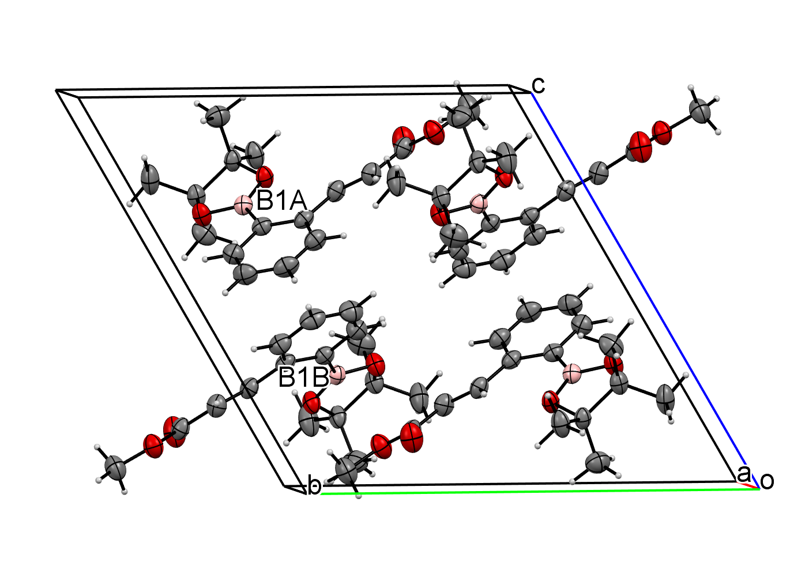
Figure S1. Packing diagram for (E)-methyl 3-(2-(4,4,5,5-tetramethyl-1,3,2-dioxaborolan-2-yl)phenyl)acrylate ortho 2.

Table 2. Bond lengths [Å] and angles [°] for ortho 2.
Bond lengths [Å] | Bond angles [°]
C1A-C6A 1.408(2)  C1A-C2A 1.410(2)  C1A-C7A 1.471(2)  C2A-C3A 1.398(2)  C2A-B1A 1.570(2)  C3A-C4A 1.383(2)  C4A-C5A 1.379(2)  C5A-C6A 1.373(2)  C7A-C8A 1.325(2)  C8A-C9A 1.467(2)  C9A-O1A 1.2008(18)  C9A-O2A 1.3408(18)  C10A-O2A 1.438(2)  C11A-O3A 1.4632(16)  C11A-C13A 1.509(2)  C11A-C14A 1.516(2)  C11A-C12A 1.560(2)  C12A-O4A 1.4662(15)  C12A-C16A 1.506(2)  C12A-C15A 1.517(2)  O3A-B1A 1.3643(18)  O4A-B1A 1.3633(18)  C1B-C6B 1.402(2)  C1B-C2B 1.407(2)  C1B-C7B 1.472(2)  C2B-C3B 1.401(2)  C2B-B1B 1.571(2)  C3B-C4B 1.381(2)  C4B-C5B 1.380(2)  C5B-C6B 1.374(2)  C7B-C8B 1.321(2)  C8B-C9B 1.465(2)  C9B-O1B 1.2013(18)  C9B-O2B 1.3442(17)  C10B-O2B 1.4316(19)  C11B-O3B 1.4606(17)  C11B-C14B 1.500(2)  C11B-C13B 1.528(2)  C11B-C12B 1.553(2)  C12B-O4B 1.4641(16)  C12B-C16B 1.501(2)  C12B-C15B 1.527(2)  O3B-B1B 1.3646(18)  O4B-B1B 1.3587(18) | C8A-C7A-C1A 125.06(13)  C7A-C8A-C9A 122.48(13)  O1A-C9A-O2A 123.15(14)  O1A-C9A-C8A 126.63(14)  O2A-C9A-C8A 110.22(12)  O3A-C11A-C13A 108.51(11)  O3A-C11A-C14A 106.66(12)  C13A-C11A-C14A 110.20(13)  O3A-C11A-C12A 102.45(10)  C13A-C11A-C12A 115.37(13)  C14A-C11A-C12A 112.92(12)  O4A-C12A-C16A 109.00(11)  O4A-C12A-C15A 106.07(11)  C16A-C12A-C15A 110.67(13)  O4A-C12A-C11A 102.24(10)  C16A-C12A-C11A 114.89(12)  C15A-C12A-C11A 113.19(12)  C9A-O2A-C10A 116.29(12)  B1A-O3A-C11A 107.44(10)  B1A-O4A-C12A 107.46(10)  O4A-B1A-O3A 113.34(12)  O4A-B1A-C2A 126.59(13)  O3A-B1A-C2A 120.07(13)  C6B-C1B-C2B 118.97(13)  C6B-C1B-C7B 119.31(13)  C2B-C1B-C7B 121.70(12)  C3B-C2B-C1B 118.12(13)  C3B-C2B-B1B 116.12(12)  C1B-C2B-B1B 125.74(13)  C4B-C3B-C2B 122.00(15)  C3B-C4B-C5B 119.41(15)  C6B-C5B-C4B 120.06(14)  C5B-C6B-C1B 121.43(14)  C8B-C7B-C1B 125.38(13)  C7B-C8B-C9B 122.35(13)  O1B-C9B-O2B 123.04(14)  O1B-C9B-C8B 126.47(14)  O2B-C9B-C8B 110.49(12)  O3B-C11B-C14B 109.01(12)  O3B-C11B-C13B 105.86(12)  C14B-C11B-C13B 110.09(14)  O3B-C11B-C12B 102.77(10)  C14B-C11B-C12B 116.15(13)  C13B-C11B-C12B 112.17(13)  O4B-C12B-C16B 109.14(11)  O4B-C12B-C15B 105.32(12)  C(16B)-C(12B)-C(15B) 110.18(15)  O(4B)-C(12B)-C(11B) 102.88(10)  C(16B)-C(12B)-C(11B) 116.10(13)  C(15B)-C(12B)-C(11B) 112.38(13)  C(9B)-O(2B)-C(10B) 116.22(12)  B(1B)-O(3B)-C(11B) 107.61(11)  B(1B)-O(4B)-C(12B) 107.59(10)  O(4B)-B(1B)-O(3B) 113.47(12)  O(4B)-B(1B)-C(2B) 126.41(12)  O(3B)-B(1B)-C(2B) 120.13(13)
Bond angles [°]
C6A-C1A-C2A 118.83(13)
C6A-C1A-C7A 119.41(13)
C2A-C1A-C7A 121.75(12)
C3A-C2A-C1A 118.02(13)
C3A-C2A-B1A 116.09(13)
C1A-C2A-B1A 125.88(12)
C4A-C3A-C2A 122.28(15)
C5A-C4A-C3A 119.24(15)
C6A-C5A-C4A 120.26(14)
C5A-C6A-C1A 121.36(14)

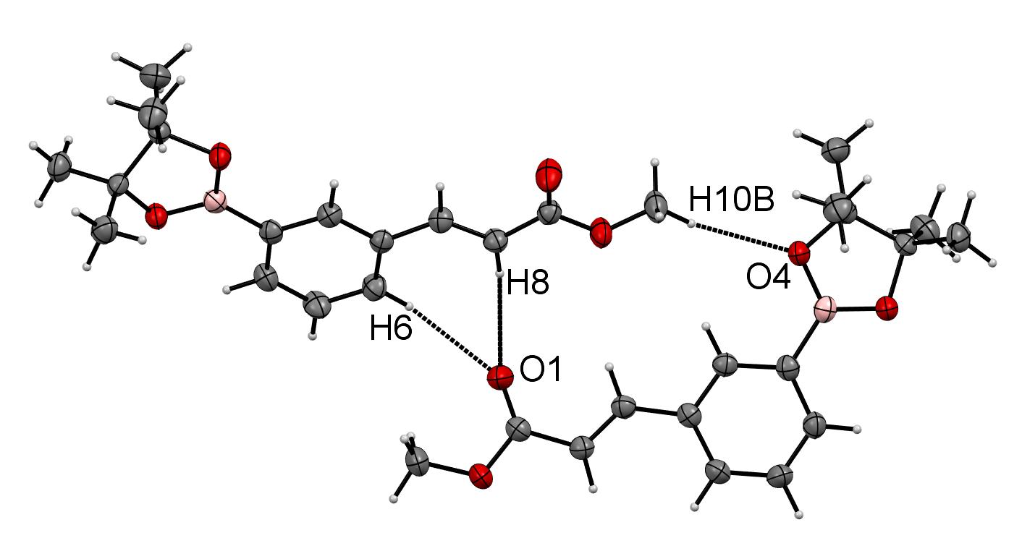
Figure S2. Non-classical H-bonding interactions in (E)-methyl 3-(3-(4,4,5,5-tetramethyl-1,3,2-dioxaborolan-2-yl)phenyl)acrylate meta 2.

Table 3. Bond lengths [Å] and angles [°] for meta 2.
Bond lengths [Å] | Bond angles [°]
C1-C2 1.392(2)  C1-C6 1.394(2)  C1-C7 1.463(2)  C2-C3 1.393(2)  C3-C4 1.396(2)  C3-B1 1.551(2)  C4-C5 1.383(2)  C5-C6 1.379(2)  C7-C8 1.325(2)  C8-C9 1.465(2)  C9-O1 1.2058(17)  C9-O2 1.3363(18)  C10-O2 1.4406(18)  C11-O4 1.4598(17)  C11-C13 1.514(2)  C11-C14 1.522(2)  C11-C12 1.554(2)  C12-O3 1.4676(17)  C12-C15 1.510(2)  C12-C16 1.520(2)  O3-B1 1.366(2)  O4-B1 1.3646(19) | C2-C3-C4 117.02(13)  C2-C3-B1 120.21(13)  C4-C3-B1 122.77(13)  C5-C4-C3 120.99(14)  C6-C5-C4 120.70(14)  C5-C6-C1 120.28(14)  C8-C7-C1 128.55(14)  C7-C8-C9 119.55(14)  O1-C9-O2 122.17(14)  O1-C9-C8 125.33(14)  O2-C9-C8 112.50(13)  O4-C11-C13 108.51(12)  O4-C11-C14 106.19(13)  C13-C11-C14 110.97(14)  O4-C11-C12 102.29(11)  C13-C11-C12 114.70(14)  C14-C11-C12 113.35(12)  O3-C12-C15 108.36(12)  O3-C12-C16 106.65(12)  C15-C12-C16 109.60(13)  O3-C12-C11 102.14(11)  C15-C12-C11 115.84(13)  C16-C12-C11 113.49(12)  C9-O2-C10 115.62(12)  B1-O3-C12 107.03(11)  B1-O4-C11 107.14(11)  O4-B1-O3 113.24(14)  O4-B1-C3 122.85(14)  O3-B1-C3 123.90(14)
Bond angles [°]
C2-C1-C6 117.95(13)
C2-C1-C7 118.49(13)
C6-C1-C7 123.55(13)
C1-C2-C3 123.05(14)

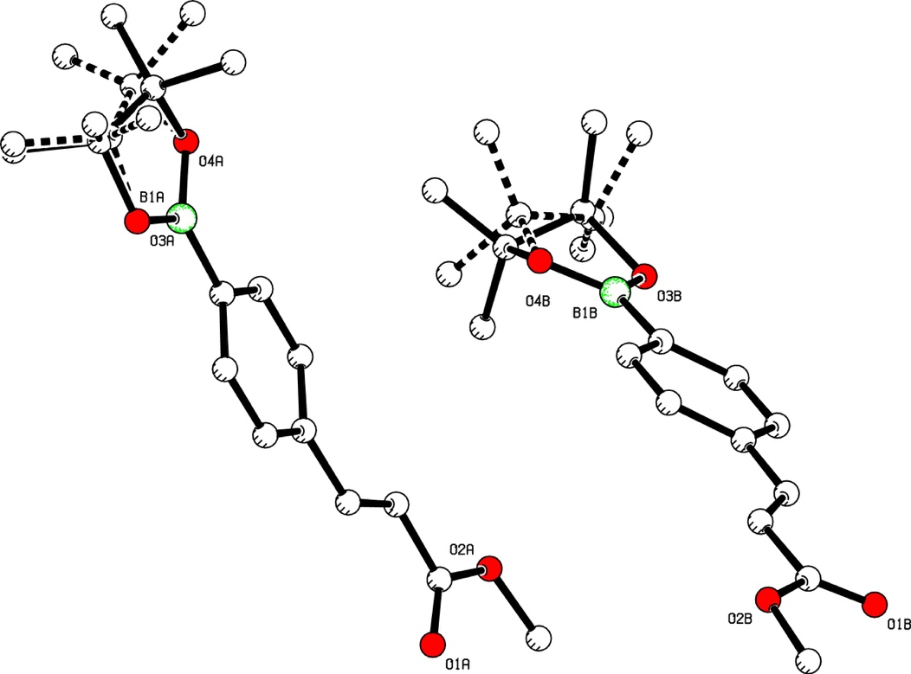
Figure S3. PLUTON plot of the asymmetric unit of para 2 with disorder visible in the alkyl part of the pinacol ester moiety. H atoms omitted for clarity.

Table 4. Bond lengths [Å] and angles [°] for para 2.
Bond lengths [Å] |  | Bond angles [°]
C1A-C2A 1.388(4)  C1A-C6A 1.389(5)  C1A-C7A 1.462(5)  C2A-C3A 1.387(5)  C3A-C4A 1.388(5)  C4A-C5A 1.391(5)  C4A-B1A 1.535(5)  C5A-C6A 1.376(5)  C7A-C8A 1.325(5)  C8A-C9A 1.471(5)  C9A-O1A 1.198(4)  C9A-O2A 1.341(5)  C10A-O2A 1.461(4)  C11A-O3A 1.464(6)  C11A-C13A 1.475(7)  C11A-C12A 1.509(8)  C11A-C14A 1.533(9)  C12A-O4A 1.475(6)  C12A-C16A 1.491(9)  C12A-C15A 1.586(10)  C11C-C13C 1.472(7)  C11C-O3A 1.484(12)  C11C-C12C 1.510(8)  C11C-C14C 1.534(9)  C12C-O4A 1.384(13)  C12C-C16C 1.491(10)  C12C-C15C 1.586(10)  B1A-O4A 1.339(5)  B1A-O3A 1.357(5)  C1B-C6B 1.386(5)  C1B-C2B 1.395(5)  C1B-C7B 1.454(5)  C2B-C3B 1.376(5)  C3B-C4B 1.386(5)  C4B-C5B 1.379(5)  C4B-B1B 1.543(6)  C5B-C6B 1.376(5)  C7B-C8B 1.303(4)  C8B-C9B 1.473(5)  C9B-O1B 1.194(4)  C9B-O2B 1.343(5)  C10B-O2B 1.461(4)  C11B-O3B 1.470(5)  C11B-C13B 1.482(9)  C11B-C14B 1.484(10)  C11B-C12B 1.542(7)  C12B-O4B 1.464(6)  C12B-C16B 1.503(13)  C12B-C15B 1.558(14)  C11D-C13D 1.483(10)  C11D-C14D 1.483(11)  C11D-C12D 1.543(7)  C11D-O3B 1.609(12)  C12D-O4B 1.478(13)  C12D-C16D 1.502(13)  C12D-C15D 1.559(14)  B1B-O4B 1.327(5)  B1B-O3B 1.338(5) | C2A-C1A-C6A 117.8(3)  C2A-C1A-C7A 122.9(3)  C6A-C1A-C7A 119.4(3)  C3A-C2A-C1A 120.6(4)  C2A-C3A-C4A 121.9(3)  C3A-C4A-C5A 116.7(3)  C3A-C4A-B1A 121.5(3)  C5A-C4A-B1A 121.8(3)  C6A-C5A-C4A 121.9(3)  C5A-C6A-C1A 121.0(3)  C8A-C7A-C1A 127.3(3)  C7A-C8A-C9A 121.0(4)  O1A-C9A-O2A 124.0(4)  O1A-C9A-C8A 125.4(4)  O2A-C9A-C8A 110.6(4)  O3A-C11A-C13A 110.6(4)  O3A-C11A-C12A 100.4(5)  C13A-C11A-C12A 117.4(7)  O3A-C11A-C14A 105.3(6)  C13A-C11A-C14A 107.7(6)  C12A-C11A-C14A 114.6(5)  O4A-C12A-C16A 108.6(7)  O4A-C12A-C11A 105.7(4)  C16A-C12A-C11A 117.8(6)  O4A-C12A-C15A 103.4(6)  C16A-C12A-C15A 109.8(7)  C11A-C12A-C15A 110.6(8)  C13C-C11C-O3A 98.1(10)  C13C-C11C-C12C 117.4(9)  O3A-C11C-C12C 109.6(9)  C13C-C11C-C14C 107.9(8)  O3A-C11C-C14C 107.6(13)  C12C-C11C-C14C 114.6(7)  O4A-C12C-C16C 106.8(10)  O4A-C12C-C11C 98.7(8)  C16C-C12C-C11C 117.6(7)  O4A-C12C-C15C 113.8(12)  C16C-C12C-C15C 109.3(8)  C11C-C12C-C15C 110.4(8)  O4A-B1A-O3A 112.6(4)  O4A-B1A-C4A 124.2(4)  O3A-B1A-C4A 123.3(4)  C9A-O2A-C10A 114.8(3)  B1A-O3A-C11A 109.9(4)  B1A-O3A-C11C 102.2(6)  B1A-O4A-C12C 114.8(5)  B1A-O4A-C12A 106.2(4)  C6B-C1B-C2B 116.9(3)  C6B-C1B-C7B 123.1(4)  C2B-C1B-C7B 119.9(4)  C3B-C2B-C1B 121.0(4)  C2B-C3B-C4B 121.8(4)  C5B-C4B-C3B 116.9(3)  C5B-C4B-B1B 121.5(4)  C3B-C4B-B1B 121.6(4)  C6B-C5B-C4B 121.8(3)  C5B-C6B-C1B 121.5(4)  C8B-C7B-C1B 128.0(4)  C7B-C8B-C9B 121.3(4)  O1B-C9B-O2B 122.9(4)  O1B-C9B-C8B 126.8(4)  O2B-C9B-C8B 110.3(4)  O3B-C11B-C13B 107.0(5)  O3B-C11B-C14B 113.4(6)  C13B-C11B-C14B 106.0(7)  O3B-C11B-C12B 99.8(4)  C13B-C11B-C12B 116.2(8)  C14B-C11B-C12B 114.3(9)  O4B-C12B-C16B 105.5(9)  O4B-C12B-C11B 102.6(4)  C16B-C12B-C11B 116.5(11)  O4B-C12B-C15B 105.9(8)  C16B-C12B-C15B 115.5(8)  C11B-C12B-C15B 109.4(10)  C13D-C11D-C14D 106.1(8)  C13D-C11D-C12D 115.3(9)  C14D-C11D-C12D 114.7(10)  C13D-C11D-O3B 126.2(10)  C14D-C11D-O3B 100.2(14)  C12D-C11D-O3B 93.6(9)  O4B-C12D-C16D 115.2(11)  O4B-C12D-C11D 93.7(8)  C16D-C12D-C11D 116.8(13)  O4B-C12D-C15D 104.2(11)  C16D-C12D-C15D 115.3(9)  C11D-C12D-C15D 109.0(10)  O4B-B1B-O3B 112.6(4)  O4B-B1B-C4B 124.7(4)  O3B-B1B-C4B 122.7(4)  C9B-O2B-C10B 115.6(3)  B1B-O3B-C11B 108.7(3)  B1B-O3B-C11D 99.2(6)  B1B-O4B-C12B 108.1(4)  B1B-O4B-C12D 106.9(7)
Bond angles [°]

References
1. Balema, V. P.; Wiench, J. W.; Pruski, M.; Pecharsky, V. K. J. Am. Chem. Soc. 2002, 124, 6244-6245.
2. Leung, S. H.; Angel, S. A. J. Chem. Educ. 2004, 81, 1492-1493.
3. Shockravi, A.; Valizadeh, H.; Heravi, M. M. Phosphorus Sulfur Silicon Relat. Elem. 2003, 178, 501-504.
4. Liu, W.-Y.; Xu, Q.-H.; Ma, Y.-X.; Liang, Y.-M.; Dong, N.-L.; Guan, D.-P. J. Organomet. Chem. 2001, 625, 128-131.
5. Hu, Z.-J.; Sun, P.-P.; Li, L.; Tian, Y.-P.; Yang, J.-X.; Wu, J.-Y.; Zhou, H.-P.; Tao, L.-M.; Wang, C.-K.; Li, M.; Cheng, G.-H.; Tang, H.-H.; Tao, X.-T.; Jiang, M.-H. Chem. Phys. 2009, 355, 91-98.
6. Thiemann, T.; Watanabe, M.; Tanaka, Y.; Mataka, S. New J. Chem. 2004, 28, 578-584.
7. Nguyen, K. C.; Weizman, H. J. Chem. Educ. 2007, 81, 119-121.
8. Watanabe, M.; Morais, G. R.; Mataka, S.; Ideta, K.; Thiemann, T. Z. Naturforschung 2005, 60b, 909-915.
9. Sadeq, H.; Thiemann, T.; Graham, J. P.; Jasem, Y. a.; Bugenhagen, B.; Al-Rawashdeh, N.; Sulaidi, M. a. Polycyclic Arom. Comp. 2016, 00, 1-18.
10. Shanmugavelan, P.; Sathishkumar, M.; Nagarajan, S.; Ranganathan, R.; Ponnuswamy, A. J. Heterocyclic Chem. 2014, 51, 1004-1010.
11. Ponnuswamy, A.; Shanmugavelan, P.; Nagarajan, S.; Sathishkumar, M. Helv. Chi. Acta 2012, 95, 922-928.
12. Texier-Boullet, F.; Villemin, D.; Ricard, M.; Moison, H.; Foucaud, A. Tetrahedron 1985, 41, 1259-1266.
13. Lautens, M.; Mancuso, J. J. Org. Chem. 2004, 69, 3478-3487.
14. Molander, G. A.; Oliveira, R. A. Tetrahedron Lett. 2008, 49, 1266-1268.

