Supporting Information for

Me₃Al mediated domino nucleophilic addition/intramolecular cyclisation of 2-(2-oxo-2-phenylethyl)benzonitriles with amines; A convenient approach for the synthesis of substituted 1-aminoisoquinolines
Midhun Sai Krishna Adusumalli,^{a,b} Lakshmi Narayana Sharma Konidena,ª Hima bindu Gandham,^{b} Krishnaiah Kumari,ª Krishna Reddy Valluru,ª Satya Kameswara Rao Nidasanametla,ª Venkateswara Rao Battula,^{*b} Hari Krishna Namballa^{*a,c}
ªGVK Biosciences Private Limited, Medicinal Chemistry Laboratory, Hyderabad 500076, India

^{b}Department of Engineering Chemistry, Andhra University College of Engineering (A), Andhra University, Vishakhapatnam 530003, India.

^{c} Department of Chemistry, Hunter College, City University of New York, 695 Park Avenue, NY 10065, USA

Contents

1. Experimental........................................................................................................................S2
2. Materials and methods.........................................................................................................S2
3. Preparation of starting materials (3a -3e).............................................................................S2
4. Spectral data for starting materials (3a -3e).........................................................................S2
5. Experimental procedures and characterization of compounds (5a -5u)..............................S3
6. ¹HNMR spectra of starting materials (3a -3e) ....................................................................S9
7. ¹HNMR and ¹³C NMR spectra of compounds (5a-5u)......................................................S12

Experimental
1. Materials and methods
Reagents were commercially available (Sigma-Aldrich) with analytical grade and used as purchased without further purification. Solvents were purified according to well-known laboratory methods and freshly distilled prior to use. All reactions were carried out using flame-dried glassware and under an inert atmosphere (dry N₂). Reaction mixtures were monitored by thin layer chromatography (TLC) using silica gel 60-F₂₅₄ plates (Merck, Italy). Spots on the TLC plates were visualized with a UV lamp (254 nm) and by spraying with 0.2% ninhydrin in ethanol and charring after elution. Nuclear Magnetic Resonance (¹H and ¹³C NMR) spectra were recorded on a 400 MHz spectrometer (Bruker) in DMSO using TMS as an internal standard. Chemical shifts (δ) are reported in ppm, coupling constants (J values) are reported in Hertz (Hz) and the peak patterns are indicated as follows: s, singlet; d, doublet; t, triplet; q, quintet; dd, doublet of doublet; dt, doublet of triplet. The IR values are reported in reciprocal centimetres (cm⁻¹) using Bruker Alpha FT-IR spectrometer. Mass spectra were recorded in LCQ Fleet mass spectrometer. Mass spectral data were compiled using MS (ESI).
2. Preparation of starting materials:
2.1. General procedure for the preparation of 2-(2-oxo-2-phenylethyl)benzonitrile (3a):
To a stirred slurry of NaH (60% dispersion in mineral oil, 6.83 g, 170.8 mmol) in DME (50 mL) were added 2-methylbenzonitrile (5 g, 42.7 mmol) and methyl benzoate (6.4 g, 46.9 mmol) and stirred at 60 °C for 15 min, followed by addition of catalytic amount of MeOH, the resulting reaction mixture was refluxed for 10 h. After completion of the reaction (monitored by TLC), the mixture was cooled to 0°C, water (20 mL) was added to quench the reaction and then 2 M HCL (20 mL) was added and extracted with ethyl acetate (2 x 50 mL). The combined organic layer was washed with water, brine, dried over Na₂SO₄ and concentrated in vacuo and the resulting product was purified by column chromatography (silica gel, 100 – 200 mesh, 4-6% ethyl acetate/hexane) to afford 3a.
In analogous way compounds 3b-3e were synthesized.
Spectral data for 2-(2-oxo-2-phenylethyl)benzonitriles (3a):
Off white solid, 62%, TLC (eluent: ethyl acetate/pet ether 1:9 v/v): R_{f=} 0.45; ¹H NMR (400 MHz, DMSO) δ: 8.04 (d, J = 7.6 Hz, 2H), 7.82 (d, J = 7.2 Hz, 1H), 7.56 - 7.62 (m, 2H), 7.47 - 7.54 (m, 2H), 7.36 - 7.40 (m, 2H), 4.54 (s, 2H); ESI-MS: [M+H]⁺ 222.24.

Spectral data for 5-bromo-2-(2-oxo-2-phenylethyl)benzonitrile (3b):
Off white solid, 48%, TLC (eluent: ethyl acetate/pet ether 1:9 v/v): R_{f=} 0.4; ¹H NMR (500 MHz, CDCl₃) δ: 8.03 - 8.05 (m, 2H), 7.82 (d, J = 2.0 Hz,1H), 7.69 - 7.71 (m, 2H), 7.50 - 7.53 (m, 2H), 7.27 (s, 1H), 4.51 (s, 2H); ESI-MS: [M+H]⁺ 314.04.
Spectral data for 5-bromo-2-(2-oxo-2-(p-tolyl)ethyl)benzonitrile (3c):
Off white solid, 62%, TLC (eluent: ethyl acetate/pet ether 1:9 v/v): R_{f=} 0.45; ¹H NMR (500 MHz, CDCl₃) δ: 7.93 (d,J = 8.0 Hz, 1H), 7.81 (d,J = 2.0 Hz, 1H), 7.68 - 7.70 (m, 1H), 7.30 (d,J = 7.5 Hz, 1H), 7.27 (s, 1H), 4.47 (s, 2H), 2.43 (s, 3H); ESI-MS: [M+H]⁺ 300.16.
Spectral data for 2-(2-oxo-2-(p-tolyl)ethyl)benzonitrile (3d):
Off white solid, 60%, TLC (eluent: ethyl acetate/pet ether 1:9 v/v): R_{f=} 0.5; ¹H NMR (400 MHz, CDCl₃) δ: 7.95 (d, J = 8.4 Hz, 1H), 7.67 - 7.70 (m, 1H), 7.54 - 7.58 (m, 1H), 7.36 - 7.40 (m, 2H), 7.29 - 7.31 (m, 2H), 4.52 (s, 2H), 2.43 (s, 3H); ESI-MS: [M+H]⁺ 236.27.
Spectral data for 2-(2-(4-chlorophenyl)-2-oxoethyl)benzonitrile (3e):
pale yellow solid, 61%, TLC (eluent: ethyl acetate/pet ether 1:9 v/v): R_{f=} 0.5; ¹H NMR (500 MHz, CDCl₃) δ: 7.97 - 8.00 (m, 2H), 7.67 - 7.70 (m, 1H), 7.55 - 7.59 (m, 1H), 7.45 - 7.49 (m, 2H), 7.36 - 7.42 (m, 2H), 4.51 (s, 2H); ESI-MS: [M+H]⁺ 256.42.

3. Experimental procedures and characterization of compounds:
3.1. General procedure for the one pot synthesis of compounds (5a-5u):
To a magnetically stirred solution of 2-(2-oxo-2-phenylethyl)benzonitrile (3a) (500 mg, 2.26 mmol) in toluene (5 mL) was added trimethyl aluminium (2M in toluene, 2.3 mL, 2 mmol) at 0 °C, and then stirred at RT for 1 h, followed by the addition of aniline (4a, 310 mg, 3.4 mmol) at the same temperature and stirred for another 1 h, then the reaction mixture was heated at 110 °C for 8 h. After completion of the reaction (monitored by TLC), reaction mixture was cooled to 0 °C, water (20 mL) was added and extracted with ethyl acetate (2 x 15 mL). The combined organic layer was washed with water, brine, dried over Na₂SO₄ and concentrated under reduced pressure, the crude compound was purified by column chromatography (silica gel, 100-200 mesh, 5-8% methanol/DCM) to afford N,3-diphenylisoquinolin-1-amine (5a).
In analogous way compounds 5b-5u were synthesized.
1-(4-methylpiperazin-1-yl)-3-phenylisoquinoline (CWJ-a-5, 1): Off white solid, 81%, M.P: 72- 74 °C; TLC (eluent: MeOH/DCM 10:90 v/v): R_{f} = 0.2; IR (KBr): 3419, 3058, 2920, 2832, 2794, 1615, 1560, 1407, 1265, 1063, 1141, 771, 690 cm⁻¹; ¹H NMR (500 MHz, CDCl₃) δ: 8.16 - 8.18 (m, 2H), 8.07 (d, J = 8.0 Hz, 1H), 7.8 (d, J = 8.0 Hz, 1H), 7.71 (s, 1H), 7.57 - 7.60 (m, 1H), 7.45 - 7.49 (m, 3H), 7.36 – 7.39 (m, 1H), 3.6 (bs, 4H), 2.75 (bs, 4H), 2.43 (s, 3H); ¹³C NMR (100 MHz, CDCl₃) δ: 160.4, 148.2, 139.6, 139.0, 129.6, 128.5, 128.2, 127.6, 126.6, 125.7, 125.3, 120.5, 111.2, 55.0, 50.8, 46.0; ESI-MS: [M+H]⁺ 304.32.
N,3-diphenylisoquinolin-1-amine (5a): Off white solid, 85%, M.P: 280 °C; TLC (eluent: MeOH/DCM 10:90 v/v): R_{f} = 0.3; IR (KBr): 3776, 3706, 3044, 1616, 1478, 760 cm⁻¹; ¹H NMR (400 MHz, DMSO) δ: 8.76 (d, J = 8.4 Hz, 1H), 8.02 - 8.08 (m, 2H), 7.83 -7.87 (m, 1H), 7.51 - 7.53 (m, 2H), 7.39 - 7.47 (m, 3H), 7.37 (s, 1H), 7.23 (s, 5H); ¹³C NMR (100 MHz, DMSO) δ: 155.3, 142.2, 136.1, 135.1, 134.0, 130.3, 130.1, 129.8, 128.9, 128.7, 127.6, 126.2, 117.8, 112.8; ESI-MS: [M+H]⁺ 297.38.
N-(4-methoxyphenyl)-3-phenylisoquinolin-1-amine (5b): Off white solid, 89%, M.P: 276 °C; TLC (eluent: MeOH/DCM 10:90 v/v): R_{f} = 0.3; IR (KBr): 3609, 3485, 3065, 1971, 1627, 1508, 1257, 1028, 764 cm⁻¹; ¹H NMR (400 MHz, DMSO) δ: 9.87 (bs, 1H), 8.90 (d, J= 7.6 Hz, 1H), 8.03 -8.07 (m, 2H), 7.82 -7.85 (m, 1H), 7.43 (d, J = 8.4 Hz, 2H), 7.35 (s, 1H), 7.26 (s, 5H), 6.98 (d, J = 8.8 Hz, 2H), 3.73 (s, 3H); ¹³C NMR (100 MHz, DMSO) δ: 160.0, 155.7, 142.7, 135.8, 135.0, 134.2, 130.1, 129.8, 128.8, 128.7, 128.6, 127.7, 127.6, 126.2, 117.7, 115.2, 112.7, 55.3; ESI-MS: [M+H]⁺ 327.48.
N-(3-methoxyphenyl)-3-phenylisoquinolin-1-amine (5c): Off white solid, 80%, M.P: 254 °C; TLC (eluent: MeOH/DCM 10:90 v/v): R_{f} = 0.3; IR (KBr): 3447, 3271, 3020, 2762, 1969, 1641, 1486, 1047, 703 cm⁻¹; ¹H NMR (400 MHz, DMSO) δ: 9.79 (bs, 1H), 8.88 (d, J= 8.4 Hz, 1H), 8.03 - 8.08 (m, 2H), 7.83 -7.87 (m, 1H), 7.24 - 7.37 (m, 8H), 7.04 - 7.06 (m, 1H), 6.95 - 6.97 (m, 1H), 3.7 (s, 3H); ¹³C NMR (100 MHz, DMSO) δ: 160.2, 155.2, 142.2, 136.9, 135.7, 135.1, 134.0, 130.9, 129.8, 128.9, 128.8, 127.6, 126.1, 120.7, 117.7, 116.2, 114.8, 112.8, 55.4; ESI-MS: [M+H]⁺ 327.51.
3-phenyl-N-(p-tolyl)isoquinolin-1-amine (5d): Off white solid, 87%, M.P: 296 °C; TLC (eluent: MeOH/DCM 10:90 v/v): R_{f} = 0.25; IR (KBr): 3743, 3416, 3043, 1640, 1514, 1027, 765 cm⁻¹; ¹H NMR (400 MHz, DMSO) δ: 9.90 (bs, 1H), 8.90 (d, J= 8.4 Hz, 1H), 8.02 - 8.07 (m, 2H), 7.82 -7.85 (m, 1H), 7.36 - 7.40 (m, 3H), 7.25 - 7.27 (m, 7H), 2.27 (s, 3H); ¹³C NMR (100 MHz, DMSO) δ: 155.4, 142.3, 139.7, 135.7, 135.0, 134.0, 133.5, 130.6, 129.7, 128.8, 128.7, 128.5, 127.6, 127.5, 126.2, 117.6, 112.8, 20.7; ESI-MS: [M+H]⁺ 311.12.
N-(3-ethylphenyl)-3-phenylisoquinolin-1-amine (5e): Off white solid, 82%, M.P: 248 °C; TLC (eluent: MeOH/DCM 10:90 v/v): R_{f} = 0.3; IR (KBr): 3432, 3038, 2349,1645, 1506, 1164,756 cm⁻¹; ¹H NMR (500 MHz, DMSO) δ: 9.67 (bs, 1H), 8.76 (d, J= 8.5Hz, 1H), 8.02 - 8.08 (m, 2H), 7.84 -7.87 (m, 1H), 7.32 - 7.38 (m, 4H), 7.19 - 7.24 (m, 6H), 2.49 - 2.50 (m, 2H), 1.04 (m, 3H); ¹³C NMR (100 MHz, DMSO) δ: 155.2, 145.9, 142.3, 136.0, 135.7, 135.1, 134.0, 129.9, 129.8, 129.7, 128.9, 128.6, 128.3, 127.6, 127.5, 126.3, 125.9, 117.7, 112.8, 27.9, 15.1; ESI-MS: [M+H]⁺ 325.19
N-(4-bromophenyl)-3-phenylisoquinolin-1-amine (5f): Off white solid, 84%, M.P: 316 °C; TLC (eluent: MeOH/DCM 10:90 v/v): R_{f} = 0.25; IR (KBr): 3743, 3434, 3025, 2925, 1642, 1477, 758cm⁻¹; ¹H NMR (400 MHz, DMSO) δ: 9.71 (bs, 1H), 8.94(d, J= 8.4 Hz, 1H), 8.02 - 8.07 (m, 2H), 7.82 - 7.86 (m, 1H), 7.66 (d, J= 8.4 Hz, 2H), 7.51 (d, J= 8.4 Hz, 2H), 7.36 (s, 1H), 7.25 - 7.27 (m, 5H); ¹³C NMR (100 MHz, DMSO) δ: 155.4, 141.9, 135.7, 135.5, 135.12, 133.8, 133.2, 131.1, 129.8, 128.90, 127.80, 127.5, 126.3, 123.7, 117.8, 112.7; ESI-MS: [M+2H]⁺ 377.31.
N-(3-bromophenyl)-3-phenylisoquinolin-1-amine (5g): Off white solid, 68%, M.P: 300 °C; TLC (eluent: MeOH/DCM 10:90 v/v): R_{f} = 0.25; IR (KBr): 3430, 3034, 2916, 2363, 1644, 1475, 1072, 770 cm⁻¹; ¹H NMR (500 MHz, DMSO) δ: 9.73 (bs, 1H), 8.77 (d, J= 8.0 Hz, 1H), 8.02 - 8.21 (m, 2H), 7.85 - 7.88 (m, 1H), 7.55 - 7.62 (m, 2H), 7.37 - 7.41 (m, 2H), 7.26 - 7.28 (m, 5H); ¹³C NMR (100 MHz, DMSO) δ: 155.4, 141.9, 137.4, 135.8, 135.2, 133.7, 133.3, 132.0, 131.8, 129.9, 128.9, 128.2, 127.7, 127.6, 126.3, 122.4, 117.8, 112.7; ESI-MS: [M+2H]⁺ 377.27.
N-(2-bromophenyl)-3-phenylisoquinolin-1-amine (5h): Off white solid, 52%, M.P: 260 °C; TLC (eluent: MeOH/DCM 10:90 v/v): R_{f} = 0.2; IR (KBr); 3745, 3426, 3018, 1642, 1480, 760 cm⁻¹; ¹H NMR (500 MHz, DMSO) δ: 9.88 (bs, 1H), 8.80 (d, J= 8 Hz, 1H), 8.06 - 8.11 (m, 2H), 7.89 (t, J = 7.0 Hz, 1H), 7.83 (d, J = 7.0 Hz, 1H), 7.75 (d, J = 8.0 Hz, 1H), 7.51 (t, J = 7.5 Hz, 1H), 7.44 (s, 1H), 7.38 (t, J = 7.5 Hz, 1H), 7.28 - 7.32 (m, 5H); ¹³C NMR (100 MHz, DMSO) δ: 154.8, 141.4, 135.7, 135.5, 134.7, 134.0, 132.9, 132.6, 131.7, 129.5, 129.4, 129.2, 129.1, 127.7, 126.5, 121.7, 117.4, 113.2; ESI-MS: [M+2H]⁺ 377.29.
N-(4-fluorophenyl)-3-phenylisoquinolin-1-amine (5i): Off white solid, 82%, M.P: 320 °C; TLC (eluent: MeOH/DCM 10:90 v/v): R_{f} = 0.3; IR (KBr): 3745, 3647, 3434, 3038, 1679, 1498, 769 cm⁻¹; ¹H NMR (400 MHz, DMSO) δ: 9.69 (bs, 1H), 8.76 (d, J= 8.4 Hz, 1H), 8.02 - 8.09 (m, 2H), 7.84 - 7.88 (m, 1H), 7.59 - 7.63 (m, 2H), 7.24 - 7.38 (m, 8H); ¹³C NMR (100 MHz, DMSO) δ: 163.7, 161.3, 155.6, 142.2, 135.7, 135.1, 133.9, 132.4, 131.5, 131.4, 129.8, 128.8, 127.7, 127.5, 126.3, 117.8, 117.2, 117.05, 112.6; ESI-MS: [M+H]⁺ 315.32.
N-(3-fluorophenyl)-3-phenylisoquinolin-1-amine (5j): Off white solid, 72%, M.P: 292 °C; TLC (eluent: MeOH/DCM 10:90 v/v): R_{f} = 0.3; IR (KBr): 3740, 3641, 3440, 3030, 1680, 1494, 765 cm⁻¹; ¹H NMR (400 MHz, DMSO) δ: 9.54 (bs, 1H), 8.84 (d, J= 8.4 Hz, 1H), 8.03 - 8.09 (m, 2H), 7.87 (t, J = 6.8 Hz, 1H), 7.58-7.60 (d, J = 9.2 Hz, 1H), 7.46 - 7.52 (m, 1H), 7.27 - 7.37 (m, 8H); ¹³C NMR (100 MHz, DMSO) δ: 155.3, 141.9, 137.3, 135.8, 135.2, 133.7, 131.9, 131.8, 129.8, 129.0, 128.9, 127.8, 127.7, 126.1, 125.4, 117.8, 117.7, 117.4, 117.0, 116.8, 112.7; ESI-MS: [M+H]⁺ 315.45.
N-(2-fluorophenyl)-3-phenylisoquinolin-1-amine (5k): pale yellow solid, 53%, M.P: 265 °C ; TLC (eluent: MeOH/DCM 10:90 v/v): R_{f} = 0.25; IR (KBr): 3743, 3491, 3015, 1643, 1495, 767 cm⁻¹; ¹H NMR (400 MHz, DMSO) δ: 10.14 (bs, 1H), 8.95 (d, J= 8.4 Hz, 1H), 8.04 - 8.12 (m, 2H), 7.88 (t, J = 7.6 Hz, 1H), 7.72 (t, J = 7.6 Hz, 1H), 7.50 - 7.52 (m, 1H), 7.33 (s, 1H), 7.26 - 7.29 (m, 7H); ¹³C NMR (100 MHz, DMSO) δ: 157.8, 155.5, 155.3, 141.8, 135.7, 135.6, 133.4, 133.1, 130.9, 129.2, 127.9, 127.8, 126.4, 126.1, 123.5, 123.3, 117.5, 117.3, 117.1, 113.0; ESI-MS: [M+H]⁺ 315.12.
N-(4-chlorophenyl)-3-phenylisoquinolin-1-amine (5l): Off white solid, 84%, M.P: 314 °C; TLC (eluent: MeOH/DCM 10:90 v/v): R_{f} = 0.35; IR (KBr): 3744, 3436, 3027, 1644, 1485, 1088, 756 cm⁻¹; ¹H NMR (400 MHz, DMSO) δ: 9.72 (bs, 1H), 8.78 (d, J= 8.4 Hz, 1H), 8.03 - 8.07 (m, 2H), 7.85 - 7.89 (m, 1H), 7.54 - 7.60 (m, 4H), 7.38 - 7.29 (m, 6H); ¹³C NMR (125 MHz, DMSO) δ: 155.4, 142.0, 135.7, 135.1, 135.1, 134.9, 133.8, 130.9, 130.3, 129.8, 129.0, 128.9, 127.8, 127.7, 126.1, 117.8, 112.8; ESI-MS: [M+H]⁺ 331.10.
N-(4-methoxyphenyl)-N-methyl-3-phenylisoquinolin-1-amine (5m): Light brown solid, 50%, M.P: 100 °C; TLC (eluent: MeOH/DCM 10:90 v/v): R_{f} =0.3; IR (KBr): 3785, 3411, 3050, 2350, 1593, 1497, 1015, 758 cm⁻¹; ¹H NMR (400 MHz, DMSO) δ: 8.24 (d, J= 6.8 Hz, 1H), 7.99 (s, 1H), 7.89 - 7.91 (m, 2H), 7.43 - 7.56 (m, 5H), 7.22 - 7.26 (m, 1H), 7.01 - 7.03 (m, 2H), 6.87 - 6.89 (m, 2H), 3.72 (s, 3H), 3.56 (s, 3H); ¹³C NMR (100 MHz, DMSO) δ: 156.9, 155.9, 146.7, 143.8, 138.9, 138.5, 129.7, 128.6, 128.4, 127.7, 126.3, 126.2, 125.8, 125.0, 120.0, 114.8, 110.8, 55.2, 42.7; ESI-MS: [M+H]⁺ 341.52.
7-bromo-N,3-diphenylisoquinolin-1-amine (5n): Off white solid, 84%, M.P: 296 °C; TLC (eluent: MeOH/DCM 10:90 v/v): R_{f} = 0.25; IR (KBr): 3352, 3041, 1635, 1485, 1076, 764 cm⁻¹; ¹H NMR (400 MHz, DMSO) δ: 9.86 (bs, 1H), 9.17 (s, 1H), 8.22 - 8.25 (m,1H), 7.99 (d, J = 8.8 Hz, 1H), 7.39 - 7.51 (m, 6H), 7.23 (s, 5H); ¹³C NMR (100 MHz, DMSO) δ: 154.5, 142.8, 137.9, 135.9, 134.7, 133.8, 130.4, 130.2, 129.7, 128.8, 128.8, 128.4, 127.7, 121.9, 119.3, 112.4; ESI-MS: [M+2H]⁺ 377.32.
7-bromo-N-(4-chlorophenyl)-3-phenylisoquinolin-1-amine (5o): Off white solid, 86%, M.P: 320 °C; TLC (eluent: MeOH/DCM 10:90 v/v): R_{f}= 0.3; IR (KBr): 3744, 3439, 3090, 2362, 1647, 1485, 1087, 762 cm⁻¹; ¹H NMR (400 MHz, DMSO) δ: 9.29 (s, 1H), 8.23 (d, J = 8 Hz,1H), 7.99 (d, J = 8.4 Hz, 1H), 7.54 - 7.55 (m, 4H), 7.39 (s, 1H), 7.26 (s, 5H); ¹³C NMR (100 MHz, DMSO) δ: 154.7, 142.6, 137.9, 135.0, 134.9, 134.7, 133.6, 130.8, 130.3, 129.8, 129.6, 129.0, 128.6, 127.8, 121.8, 119.4, 112.3; ESI-MS: [M+H]⁺ 409.27.
7-bromo-N,3-di-p-tolylisoquinolin-1-amine (5p): Off white solid, 85%, M.P: 300 °C; TLC (eluent: MeOH/DCM 10:90 v/v): R_{f}= 0.35; IR (KBr): 3468, 3028, 2034, 1640, 1511, 1022, 719 cm⁻¹; ¹H NMR (400 MHz, DMSO) δ: 9.33 (bs, 1H), 9.19 (s, 1H), 8.2 - 8.25 (m,1H), 7.97 (d, J = 8.8 Hz, 1H), 7.27 - 7.38 (m, 5H), 7.04 - 7.13 (m, 4H), 2.29 (s, 3H), 2.21 (s, 3H); ¹³C NMR (100 MHz, DMSO) δ: 154.7, 143.0, 139.9, 138.3, 137.8, 134.8, 133.5, 131.1, 130.8, 129.6, 128.4, 128.3, 128.3, 121.7, 119.2, 112.5, 20.8, 20.7; ESI-MS: [M+H]⁺ 403.35.
7-bromo-N-(4-chlorophenyl)-3-(p-tolyl)isoquinolin-1-amine (5q): Off white solid, 87%, M.P: 314 °C; TLC (eluent: MeOH/DCM 10:90 v/v): R_{f}= 0.4; IR (KBr): 3745, 3442, 3091, 2361, 1648, 1512, 1090, 722 cm⁻¹; ¹H NMR (400 MHz, DMSO) δ: 9.96 (bs, 1H), 9.23 (s, 1H), 8.22 (d, J =8.8 Hz, 1H), 7.98 (d, J = 8.4 Hz, 1H), 7.56 (s, 4H), 7.34 (s, 1H), 7.07 - 7.13 (m, 4H), 2.23 (s, 3H); ¹³C NMR (100 MHz, DMSO) δ: 154.7, 142.7, 138.5, 137.9, 135.3, 135.0, 134.8, 130.8, 130.8, 130.4, 129.7, 128.5, 128.4, 121.8, 119.3, 112.4, 20.7; ESI-MS: [M+H]⁺423.26
N-phenyl-3-(p-tolyl)isoquinolin-1-amine (5r): Off white solid, 88%, M.P: 300 °C; TLC (eluent: MeOH/DCM 10:90 v/v): R_{f} = 0.3; IR (KBr): 3700, 3625, 3468, 3030, 1675, 1486, 1027, 762 cm⁻¹; ¹H NMR (500 MHz, DMSO) δ: 9.83 (bs, 1H), 8.88 (d, J =8.5 Hz, 1H), 8.02 - 8.07 (m, 2H), 7.82 - 7.85 (m, 1H), 7.50 - 7.52 (m, 2H), 7.41 - 7.48 (m, 3H), 7.33 (s, 1H), 7.12 (d, J = 8.0 Hz, 2H), 7.03 (d, J = 8.0 Hz, 2H), 2.2 (s, 3H); ¹³C NMR (125 MHz, DMSO) δ: 155.3, 142.3, 138.2, 136.1, 135.8, 135.1, 131.2, 130.3, 130.2, 129.7, 128.8, 128.2, 127.6, 126.2, 117.6, 112.8, 20.7; ESI-MS: [M+H]⁺ 311.42.
N-(3-methoxyphenyl)-3-(p-tolyl)isoquinolin-1-amine (5s): Off white solid, 83%, M.P: 256 °C; TLC (eluent: MeOH/DCM 10:90 v/v): R_{f} = 0.25; IR (KBr): 3699, 3603, 3419, 3027, 1643, 1481, 1031, 757 cm⁻¹; ¹H NMR (400 MHz, DMSO) δ: 9.87 (bs, 1H), 8.92 (d, J =8.4 Hz, 1H), 8.01 - 8.07 (m, 2H), 7.83 (t, J = 6.4 Hz, 1H), 7.17 - 7.36 (m, 5H), 6.96 - 7.06 (m, 4H), 3.71 (s, 3H), 2.22 (s, 3H); ¹³C NMR (100 MHz, DMSO) δ: 160.3, 155.2, 142.3, 138.2, 137.0, 135.8, 135.0, 131.2, 130.9, 129.7, 128.8, 128.2, 127.5, 126.2, 120.7, 117.6, 116.3, 114.7, 112.8, 55.4, 20.7; ESI-MS: [M+H]⁺ 341.43.
3-(4-chlorophenyl)-N-phenylisoquinolin-1-amine (5t): Off white solid, 86%, M.P: 286 °C; TLC (eluent: MeOH/DCM 10:90 v/v): R_{f} = 0.3; IR (KBr): 3771, 3429,3042, 1648, 1472, 1080, 764 cm⁻¹; ¹H NMR (500 MHz, DMSO) δ: 9.98 (s, 1H), 8.92 (d, J =8.5 Hz, 1H), 8.03 - 8.08 (m, 2H), 7.86 (t, J = 7.0 Hz, 1H), 7.54 (d, J = 7.0 Hz, 2H), 7.42 - 7.49 (m, 3H), 7.39 (s, 1H), 7.27 - 7.32 (m, 4H); ¹³C NMR (125 MHz, DMSO) δ: 155.3, 141.0, 136.0, 135.6, 135.2, 133.6, 131.7, 130.5, 130.3, 129.1, 128.9, 127.8, 127.7, 126.3, 117.9, 113.0; ESI-MS: [M+H]⁺ 331.12.
3-(4-chlorophenyl)-N-(3-methoxyphenyl)isoquinolin-1-amine (5u): Off white solid, 84%, M.P: 270 °C; TLC (eluent: MeOH/DCM 10:90 v/v): R_{f} = 0.25; IR (KBr): 3771, 3435, 3024, 1643, 1492, 1093, 763 cm⁻¹; ¹H NMR (400 MHz, DMSO) δ: 9.97 (bs, 1H), 8.93 (d, J = 8.4Hz, 1H), 8.02 - 8.08 (m, 2H), 7.84 - 7.87 (m, 1H), 7.33 - 7.38 (m, 6H), 7.26 (s, 1H), 6.98 - 7.06 (m, 2H), 3.72 (s, 3H); ¹³C NMR (100 MHz, DMSO) δ: 160.3, 155.2, 140.9, 136.8, 135.6, 135.1, 133.6, 132.9, 131.7, 131.0, 129.1, 127.7, 127.6, 126.3, 120.7, 117.8, 116.4, 114.7, 112.9, 55.5; ESI-MS: [M+H]⁺ 361.42.

¹H NMR Spectrum of 3a

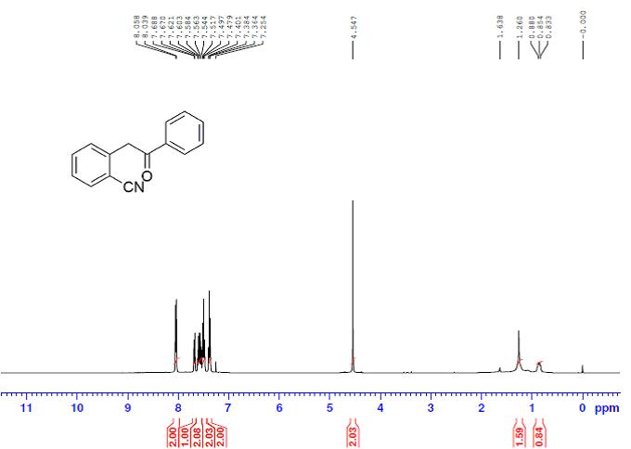
¹H NMR Spectrum of 3b
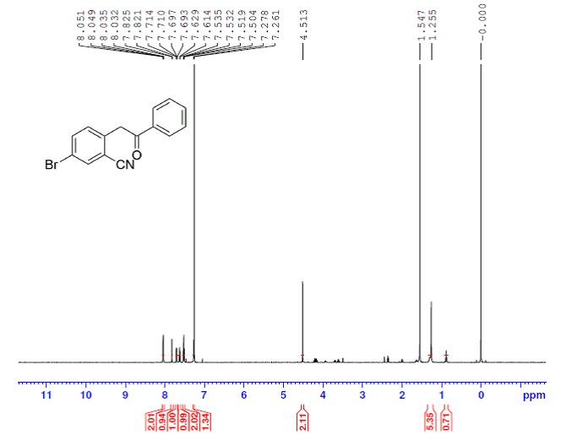
¹H NMR Spectrum of 3c
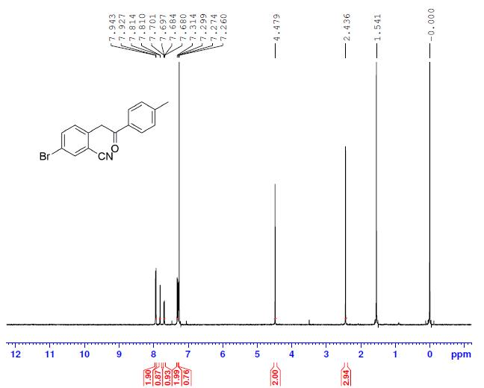

¹H NMR Spectrum of 3d
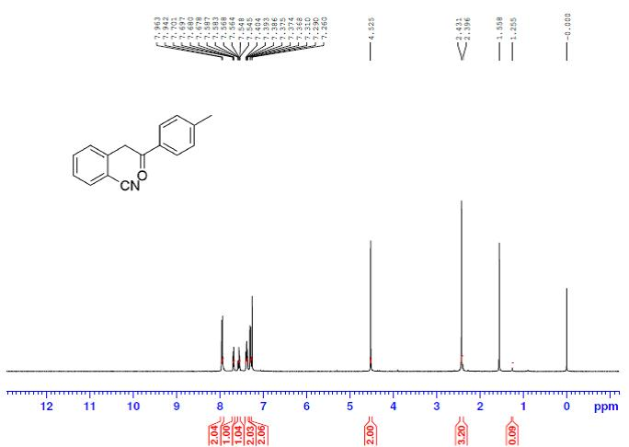
¹H NMR Spectrum of 3e
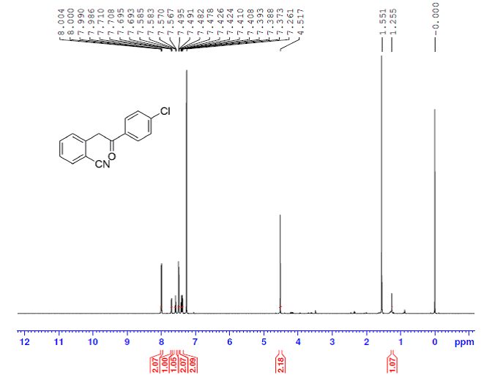

¹H NMR Spectrum of CWJ-a-5

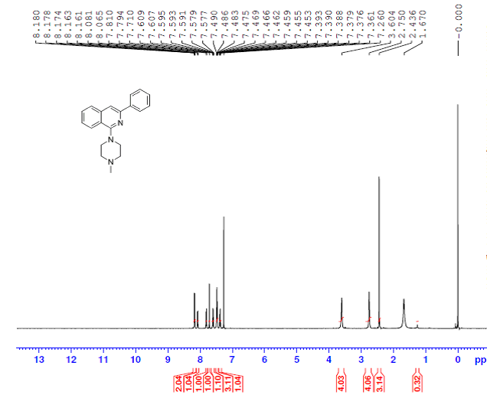
¹³C NMR Spectrum of CWJ-a-5
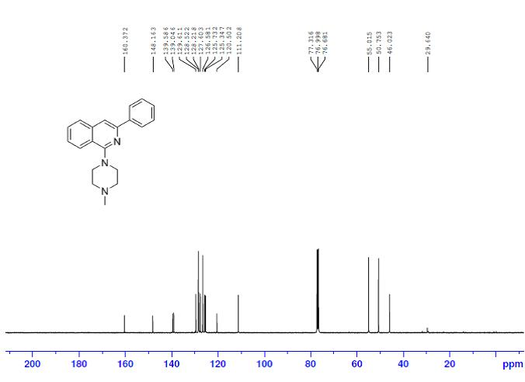
FT-IR Spectrum of CWJ-a-5
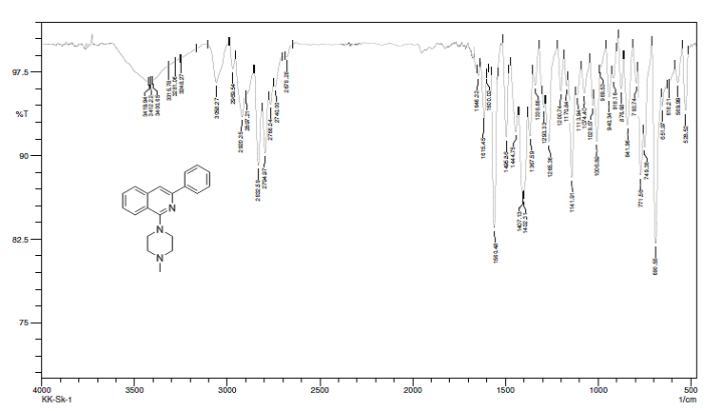

LC-MS Spectrum of CWJ-a-5
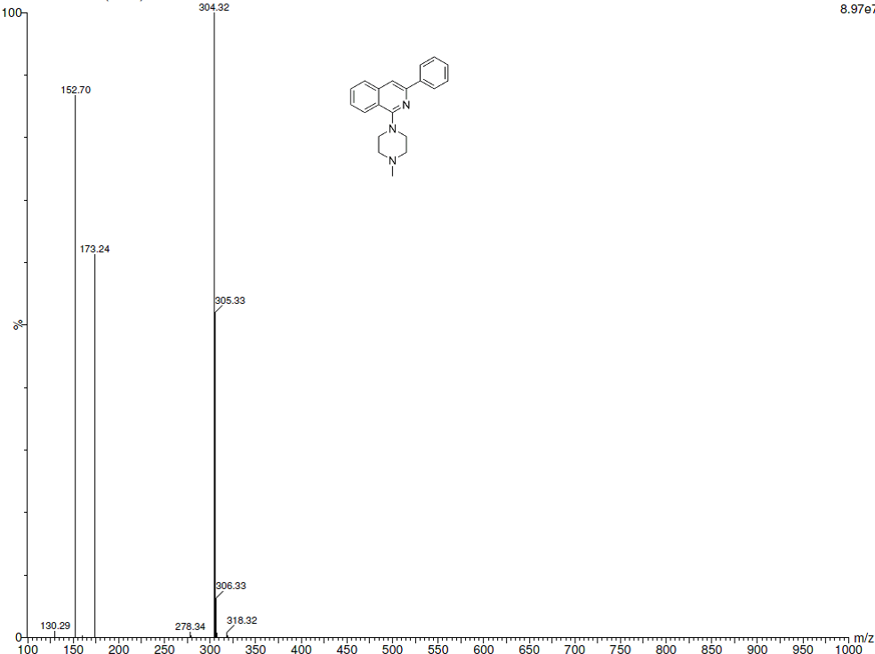

¹H NMR Spectrum of 5a
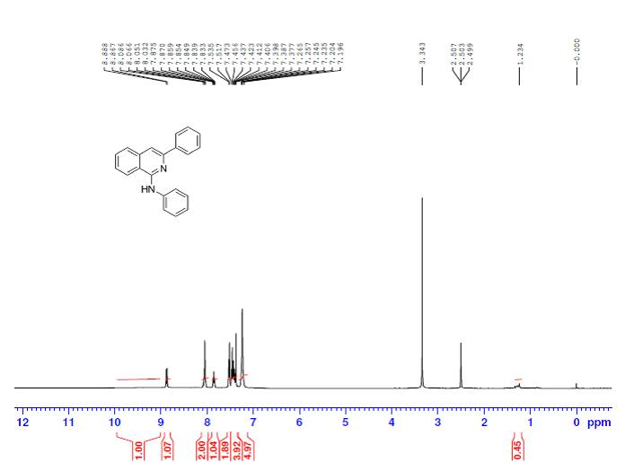
¹³C NMR Spectrum of 5a

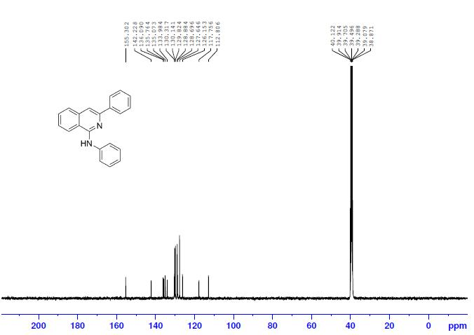
¹H NMR Spectrum of 5b

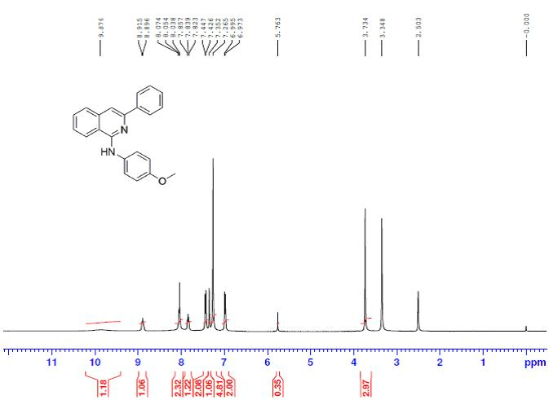
¹³C NMR Spectrum of 5b
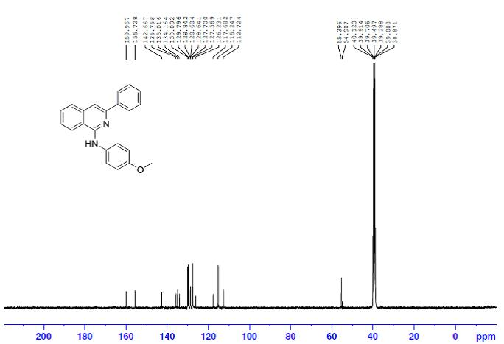
¹H NMR Spectrum of 5c

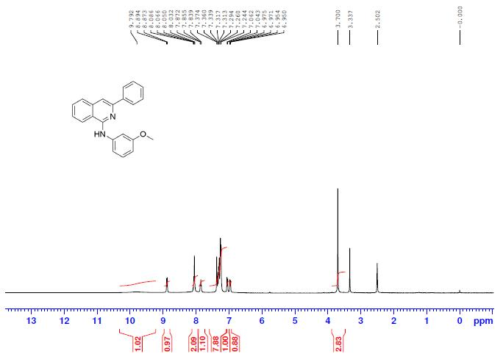
¹³C NMR Spectrum of 5c
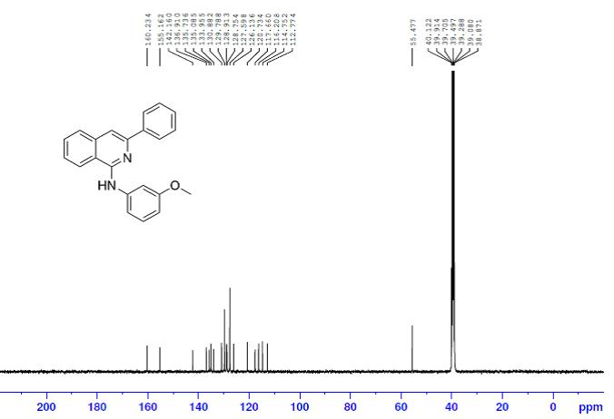
¹H NMR Spectrum of 5d
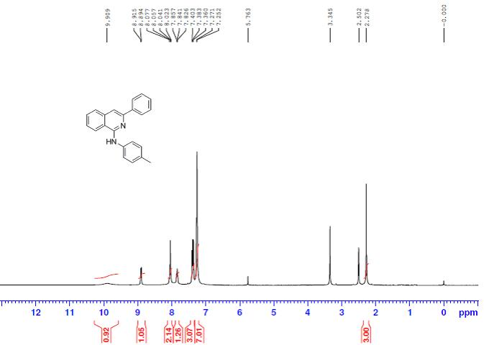
¹³C NMR Spectrum of 5d

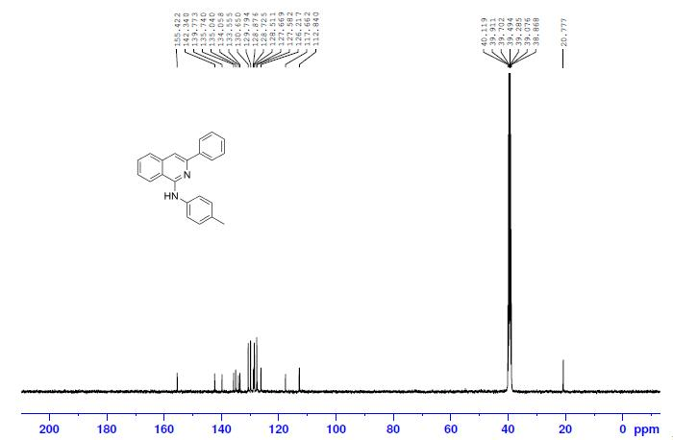
¹H NMR Spectrum of 5e
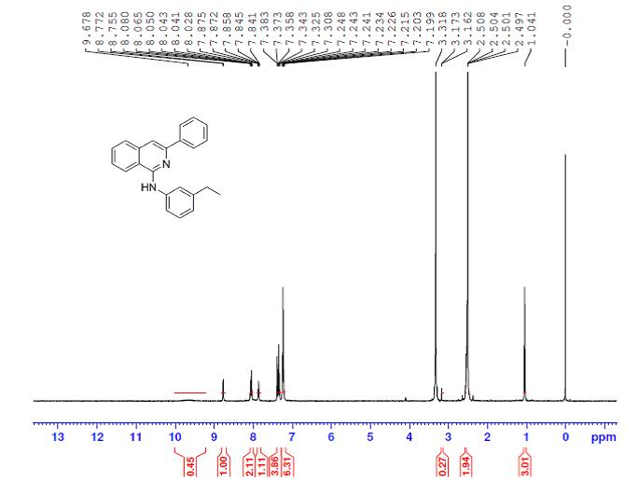
¹³C NMR Spectrum of 5e

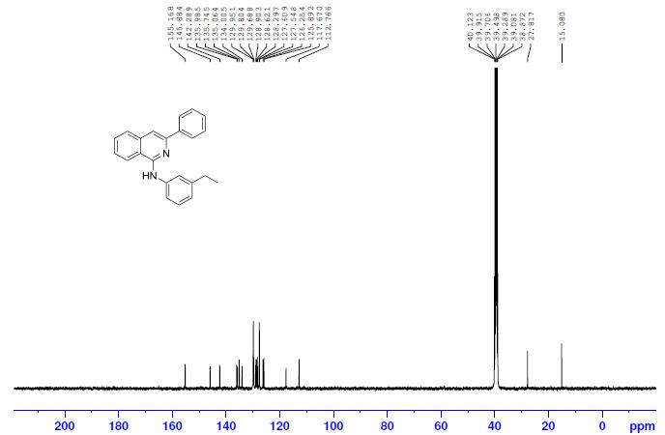
¹H NMR Spectrum of 5f

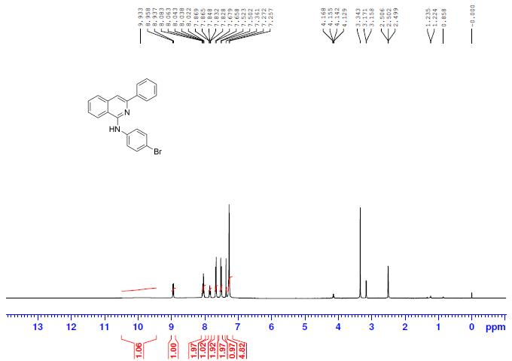
¹³C NMR Spectrum of 5f

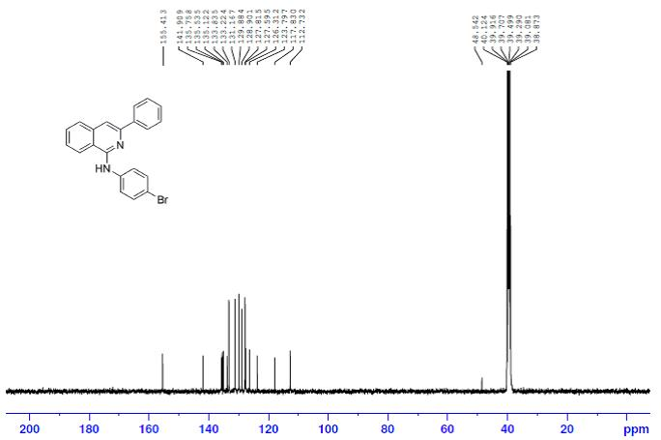
¹H NMR Spectrum of 5g

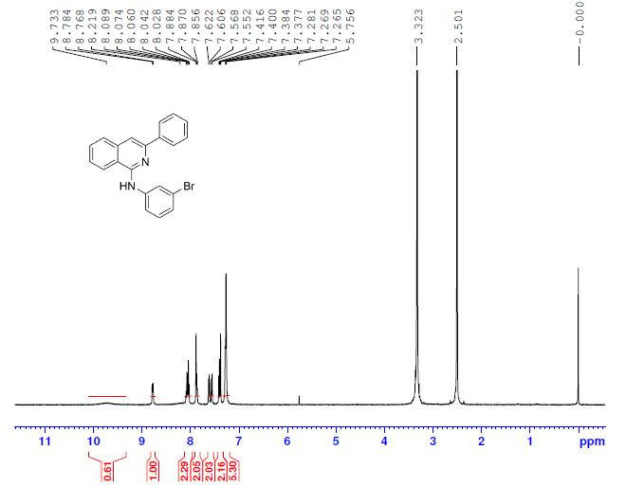
¹³C NMR Spectrum of 5g
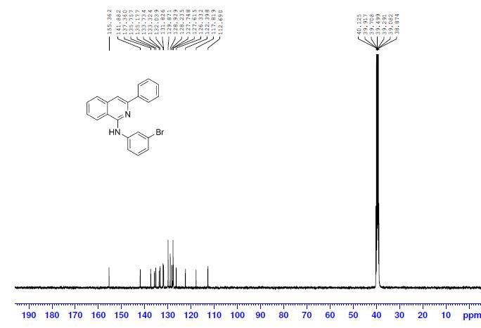
¹H NMR Spectrum of 5h

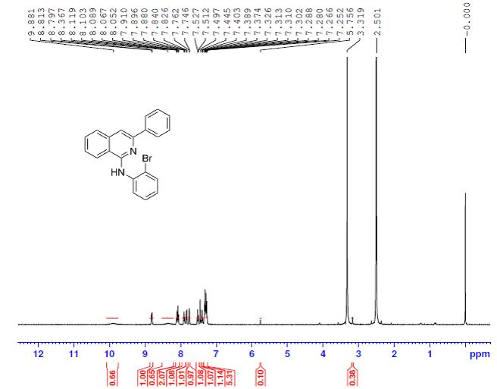
¹³C NMR Spectrum of 5h
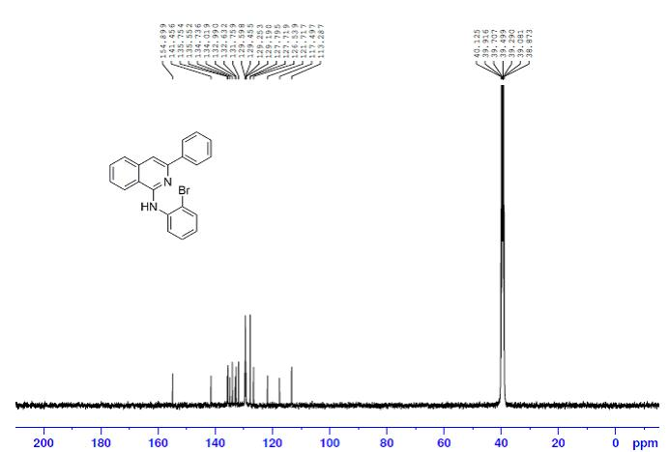
¹H NMR Spectrum of 5i
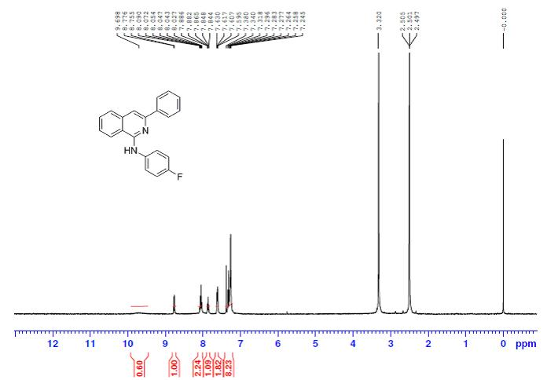
¹³C NMR Spectrum of 5i

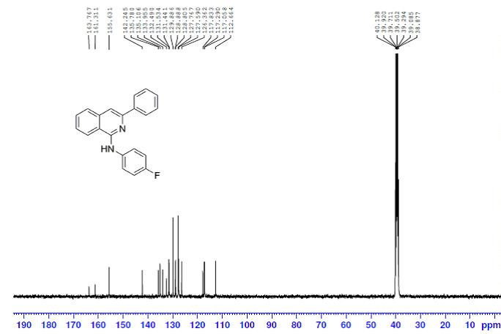
¹H NMR Spectrum of 5j

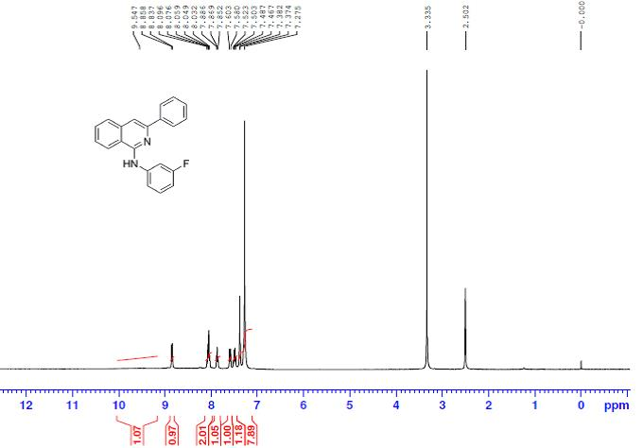
¹³C NMR Spectrum of 5j

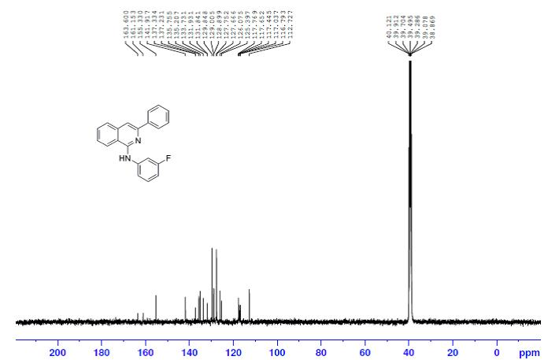
¹H NMR Spectrum of 5k

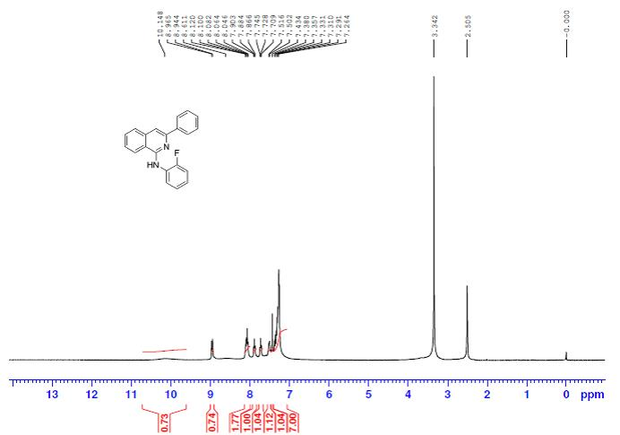
¹³C NMR Spectrum of 5k
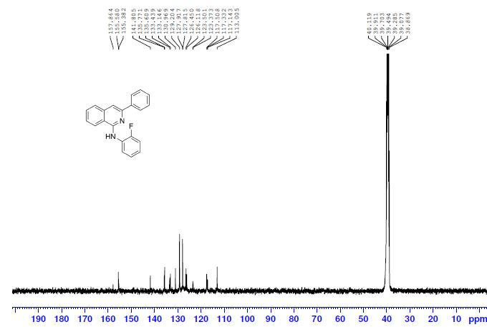
¹H NMR Spectrum of 5l
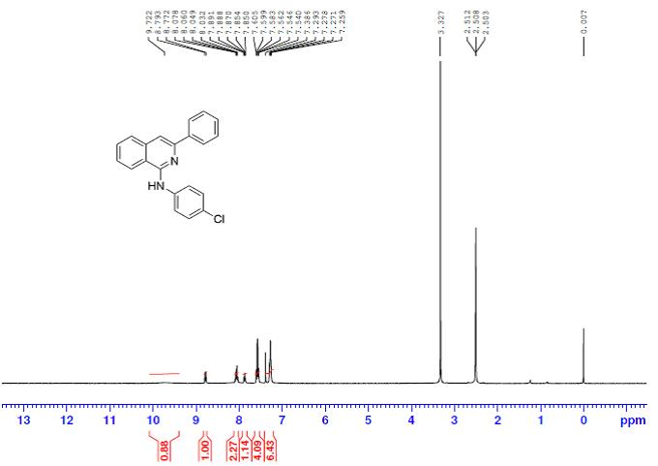
¹³C NMR Spectrum of 5l
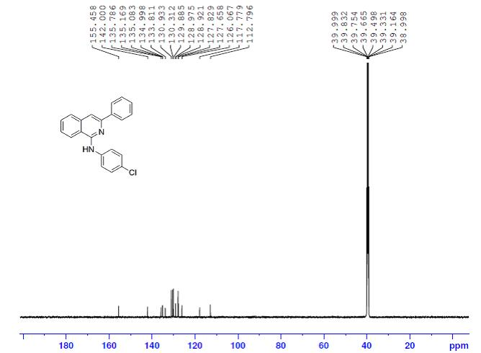
¹H NMR Spectrum of 5m
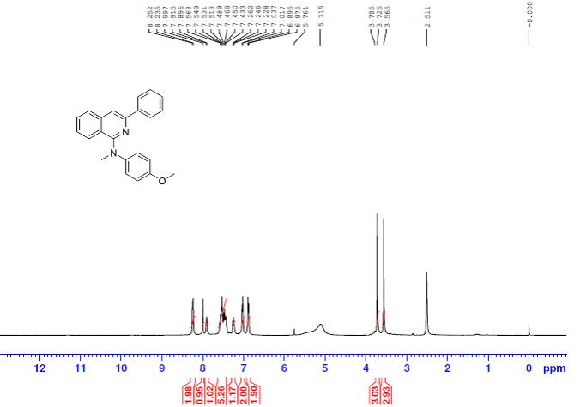¹³C NMR Spectrum of 5m
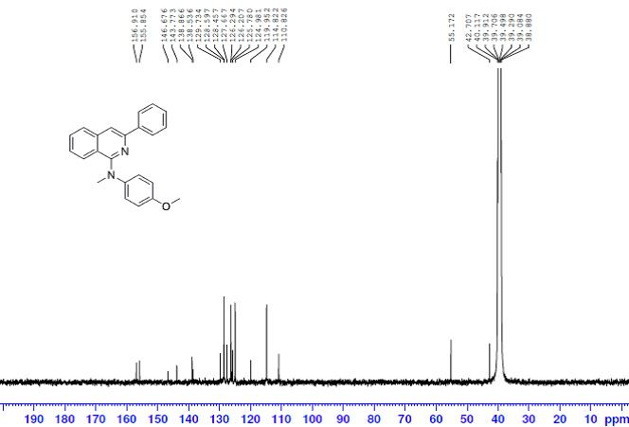

¹H NMR Spectrum of 5n

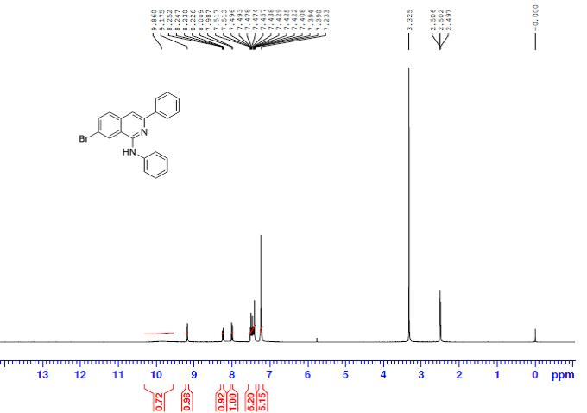
¹³C NMR Spectrum of 5n
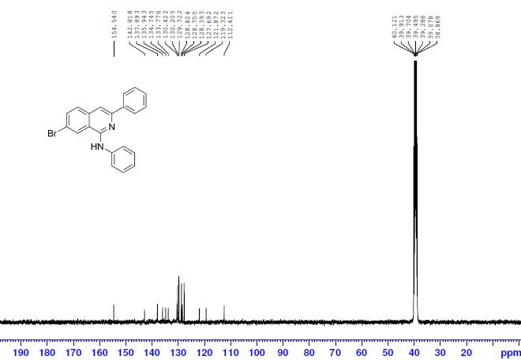

¹H NMR Spectrum of 5o

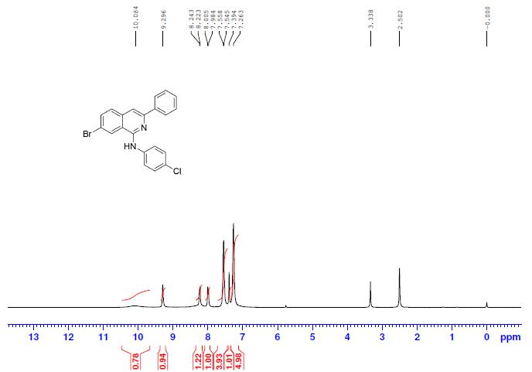
¹³C NMR Spectrum of 5o

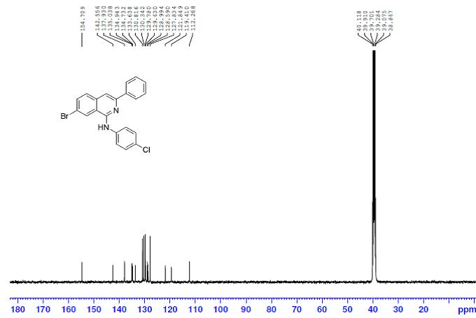
¹H NMR Spectrum of 5p

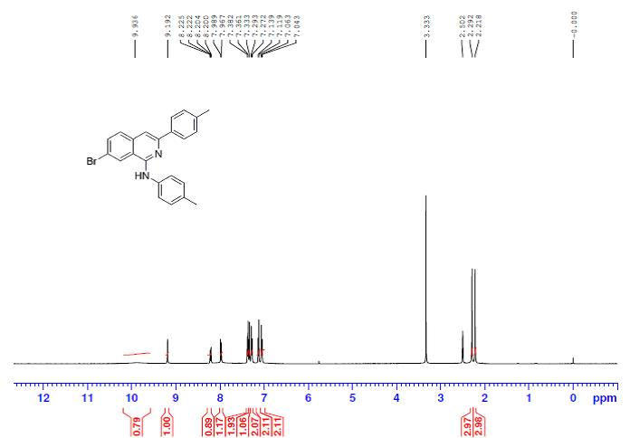
¹³C NMR Spectrum of 5p
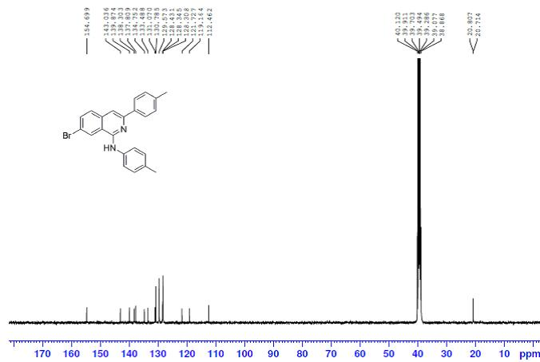
¹H NMR Spectrum of 5q

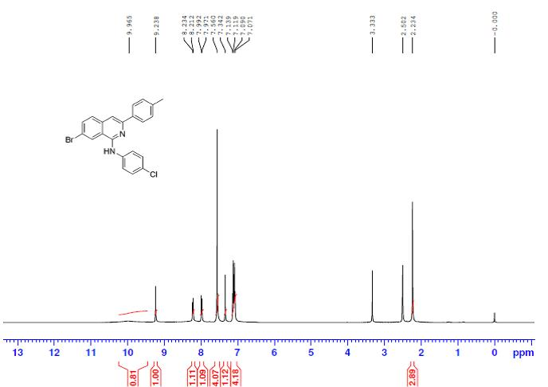
¹³C NMR Spectrum of 5q

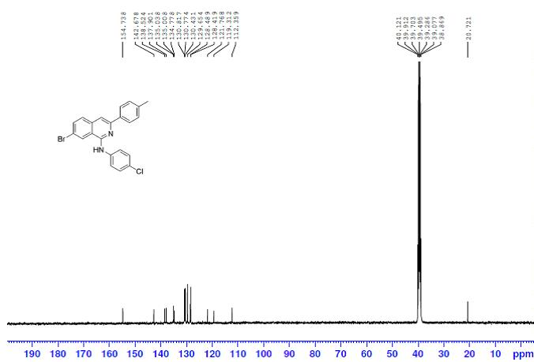

¹H NMR Spectrum of 5r

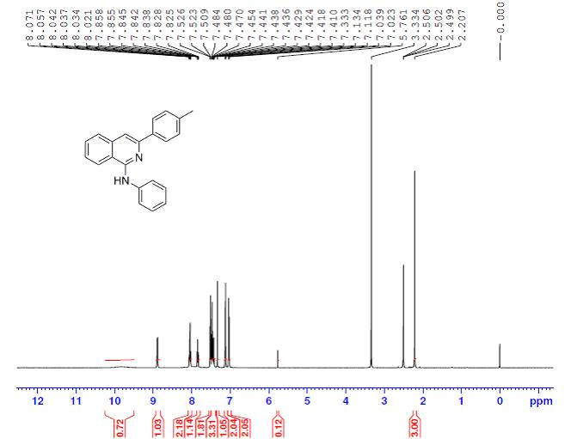
¹³C NMR Spectrum of 5r
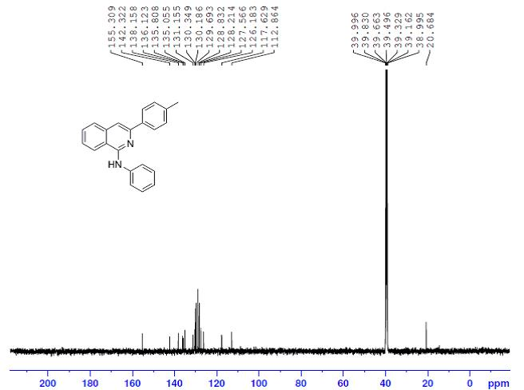
¹H NMR Spectrum of 5s
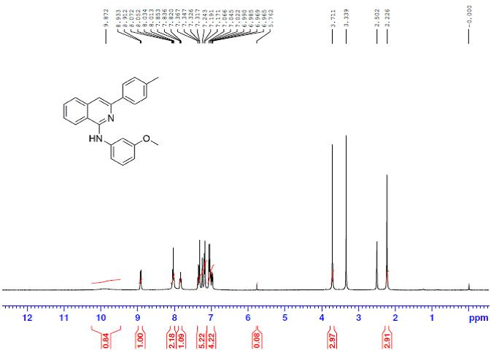
¹³C NMR Spectrum of 5s

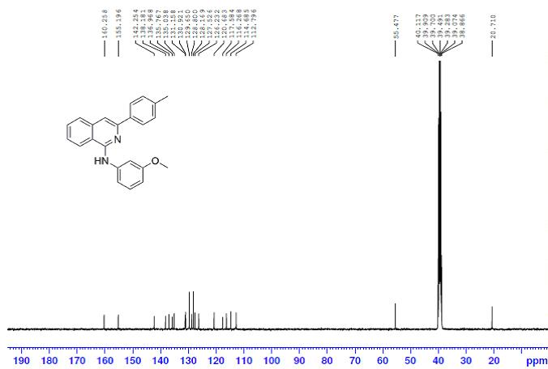
¹H NMR Spectrum of 5t
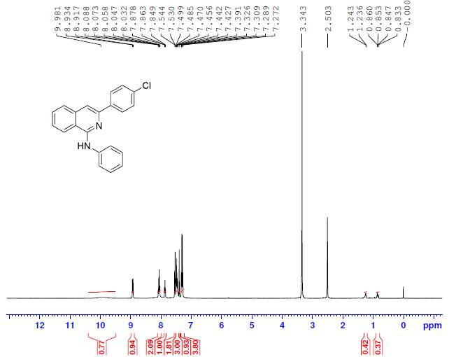
¹³C NMR Spectrum of 5t
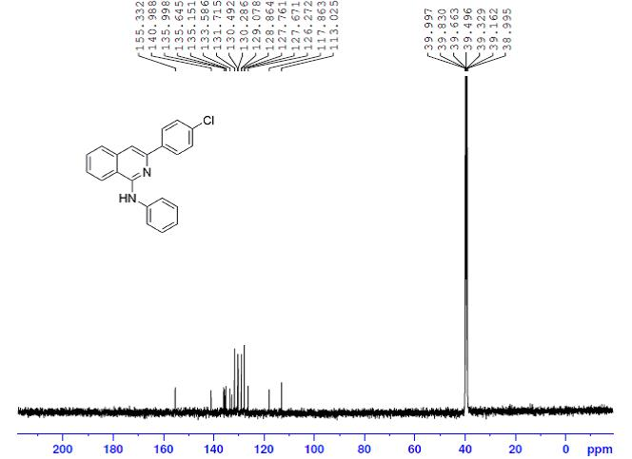
¹H NMR Spectrum of 5u
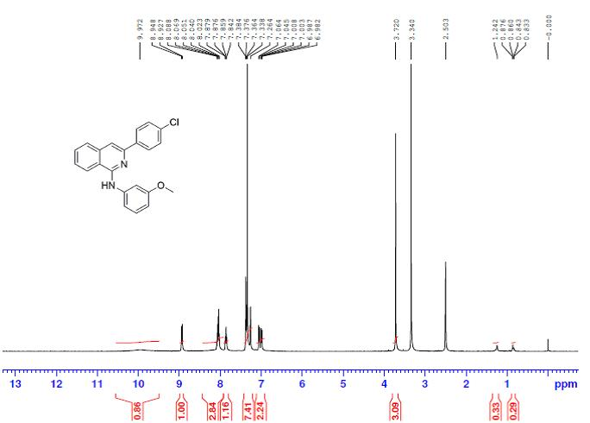
¹³C NMR Spectrum of 5u
