Supporting Information

Synthesis of polycyclic hydrocarbons C₁₄H₂₀ by hydrogenation of exo-exo-, exo-endo-, endo-exo-, and endo-endo- hexacyclo[9.2.1.0^{2,10}.0^{3,8}.0^{4,6}.0^{5,9}]tetradec-12-enes with H₂SO₄ and isomerization of the products to diamantane induced by ionic liquids
Rishat I. Aminov†, Ravil I. Khusnutdinov

Institute of Petrochemistry and Catalysis, Russian Academy of Sciences
pr. Oktyabrya 141, Ufa, Russia, 450075.

†Correspondence should be addressed: e-mail: rishaminov@gmail.com.

Experimental

General procedures and materials. ¹H and ¹³С NMR spectra were measured on a Bruker Avance-II 400 Ascend instrument (400 MHz for ¹Н and 100 MHz for¹³С in CDCl₃) and Bruker Avance-III HD 500 Ascend instrument (500 MHz for ¹Н and 125 MHz for¹³С in CDCl₃). Mass spectra were run on a Shimadzu GCMS-QP2010Plus mass spectrometer (SPB-5 capillary column, 30m×0.25 mm, helium as the carrier gas, temperature programming from 40 to 300^{о}С at 8ºC/min, evaporation temperature of 280^{о}С, ion source temperature of 200^{о}С, and ionization energy of 70 eV). The elemental composition of the samples was determined on a Carlo Erba 1106 elemental analyzer. The course of the reaction and the purity of the products were monitored by gas liquid chromatography on a Shimadzu GC-9A, GC-2014 instrument [2m×3mm column, SE-30 silicone (5%) on Chromaton N-AW-HMDS as the stationary phase, temperature programming from 50 to 270^{о}С at 8ºC/min, helium as the carrier gas (47 mL/min)].

Preparation of diamantane. Hydrocarbon (10) or (11) (1 mmol) and pre-synthesized ionic liquid (3 mmol) were charged into a glass reactor (V=50 mL) under argon. The reaction was conducted with continuous stirring at 50^{о}С for 6 h. Then the reactor was cooled down to room temperature, and the reaction mixture was extracted with petroleum ether and filtered through a silica gel layer (elution with petroleum ether).
Diamantane 1. Colorless crystals, yield 65%, mp 244–245^{о}С; ¹H NMR (400 MHz, CDCl₃): δ=1.72–1.80 (m, 20H).¹³С NMR (100 MHz, CDCl₃): δ=25.95 (С,⁴С⁹), 37.64 (С,³ С,⁵ С,⁸ С,¹⁰ С,¹³ С¹⁴), 38.37 (С,¹ С,² С,⁶ С,⁷ С,¹¹ С¹²). MS (EI, 70 eV): m/z (%)=188 [M]⁺ (100), 189 (15), 187 (18), 159 (10),145 (8), 131 (23), 130 (18), 117 (12), 105 (13), 93 (12), 92 (11), 91(28), 77 (15), 67 (8). Calcd for C₁₄H₂₀: С, 88.29; H, 11.71; found С, 88.75; H, 11.25.
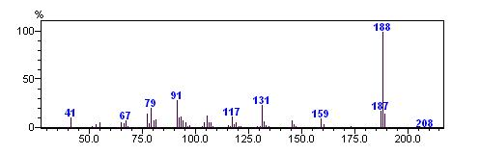

Figure S1. Mass spectrum of diamantane 1
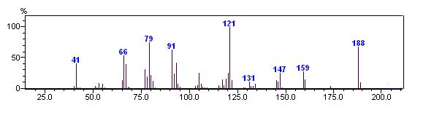

Figure S2. Mass spectrum of exo-exo-pentacyclo[8.2.1.1^{5,8}.0^{2,9}.0^{3,7}]tetradecane 10

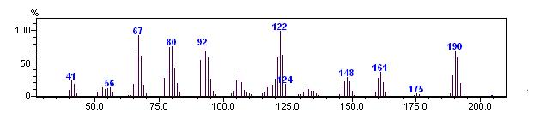 Figure S3. Mass spectrum of exo-exo-dideuteriopentacyclo[8.2.1.1^{5,8}.0^{2,9}.0^{3,7}]tetradecane 10a
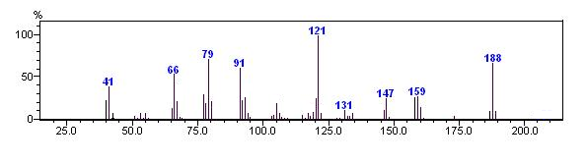

Figure S4. Mass spectrum of endo-exo-pentacyclo[8.2.1.1^{5,8}.0^{2,9}.0^{3,7}]tetradecane 11

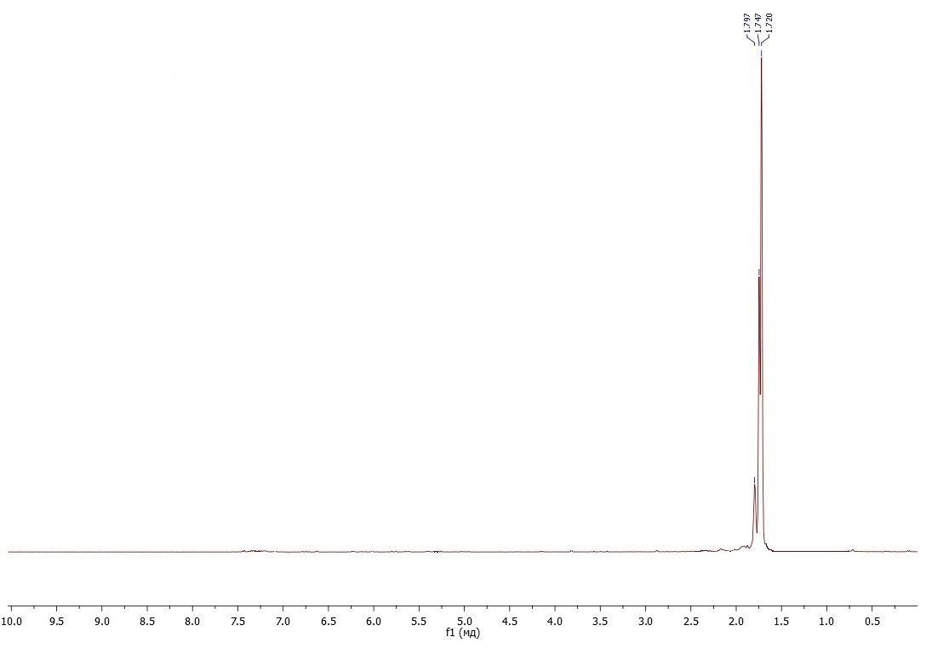
Figure S5. ¹H NMR spectrum of diamantane 1 in CDCl₃
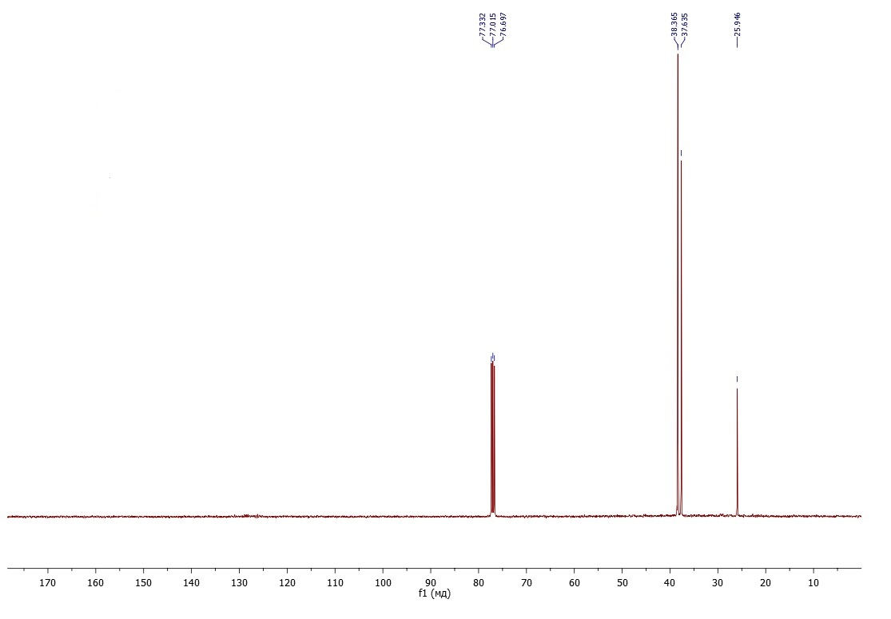
Figure S6. ¹³C NMR spectrum of diamantane 1 in CDCl₃
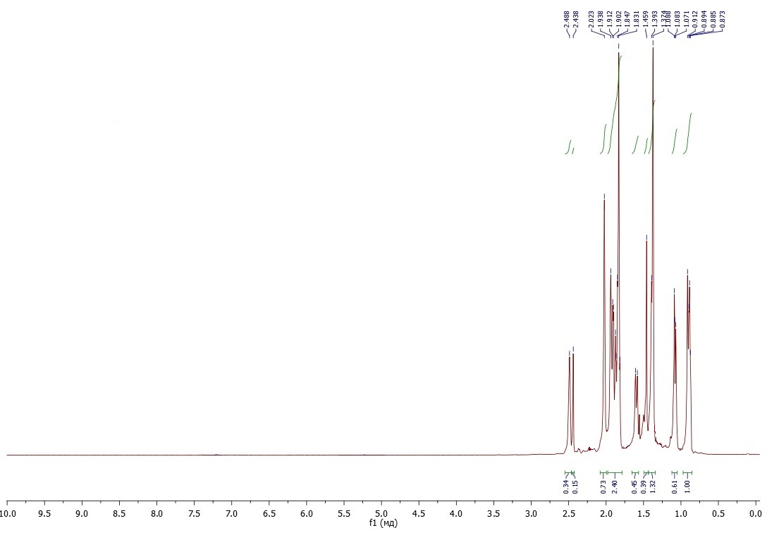
Figure S7. ¹H NMR spectrum of exo-exo-pentacyclo[8.2.1.1^{5,8}.0^{2,9}.0^{3,7}]tetradecane 10 in CDCl₃
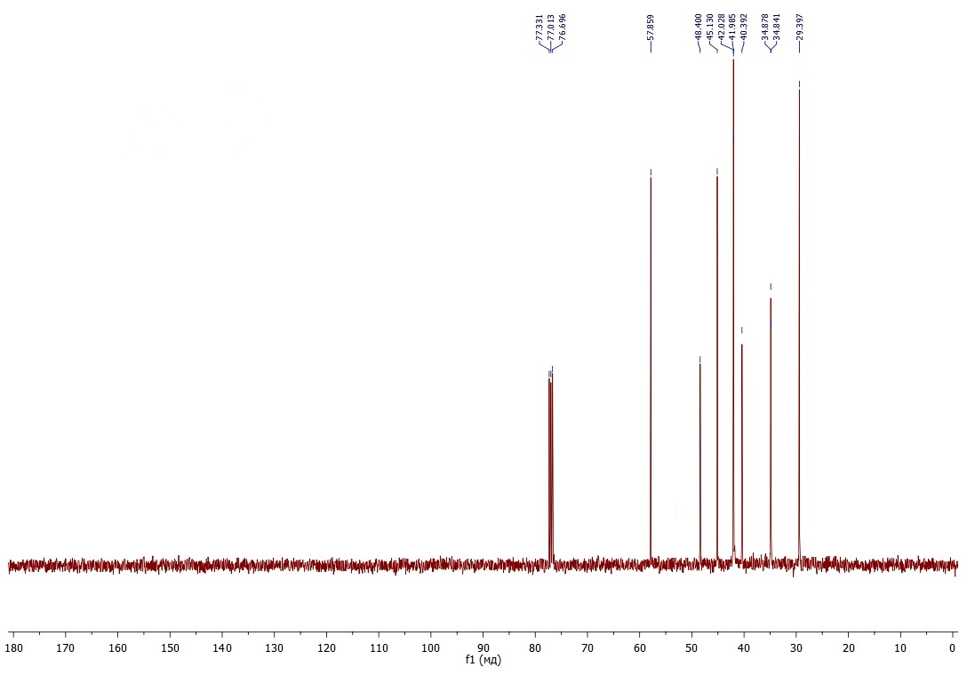
Figure S8. ¹³C NMR spectrum of exo-exo-pentacyclo[8.2.1.1^{5,8}.0^{2,9}.0^{3,7}]tetradecane 10 in CDCl₃
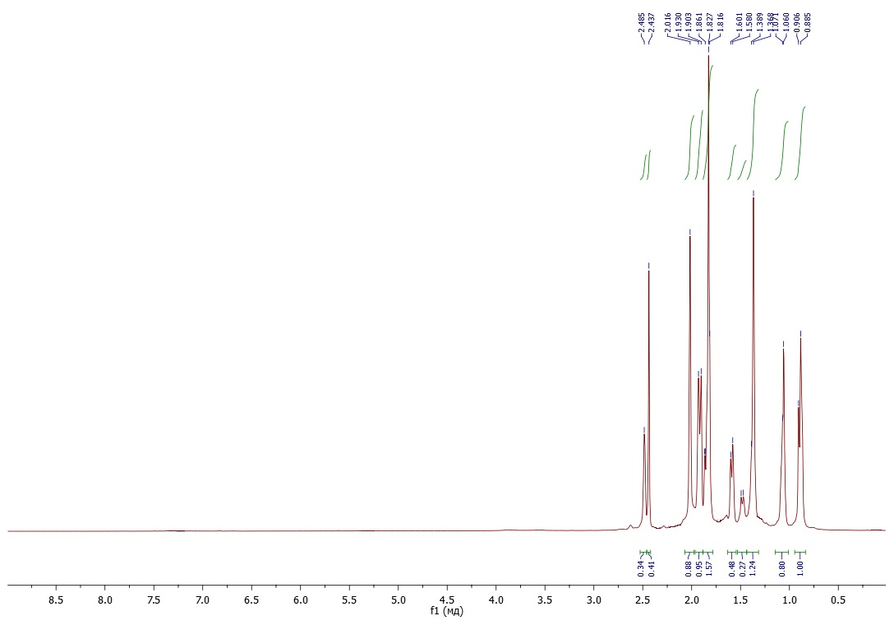
Figure S9. ¹H NMR spectrum of exo-exo-dideuteriopentacyclo[8.2.1.1^{5,8}.0^{2,9}.0^{3,7}]tetradecane 10a in CDCl₃
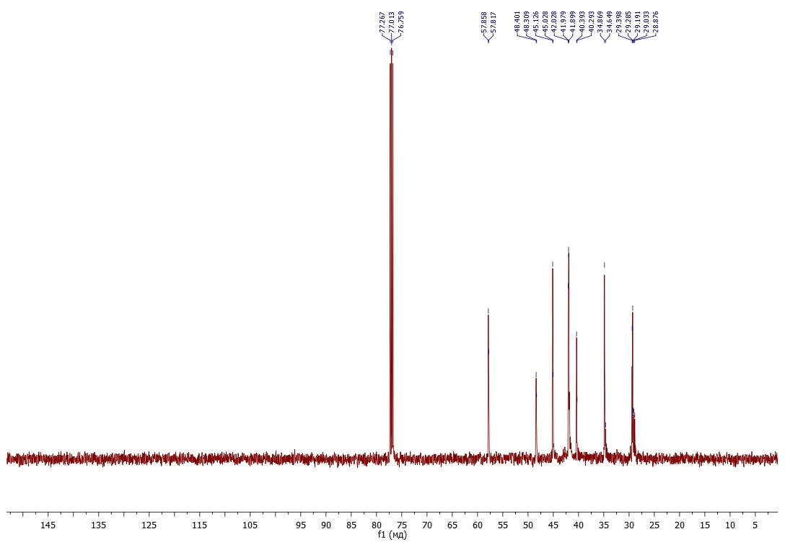
Figure S10. ¹³C NMR spectrum of exo-exo-dideuteriopentacyclo[8.2.1.1^{5,8}.0^{2,9}.0^{3,7}]tetradecane 10a in CDCl₃
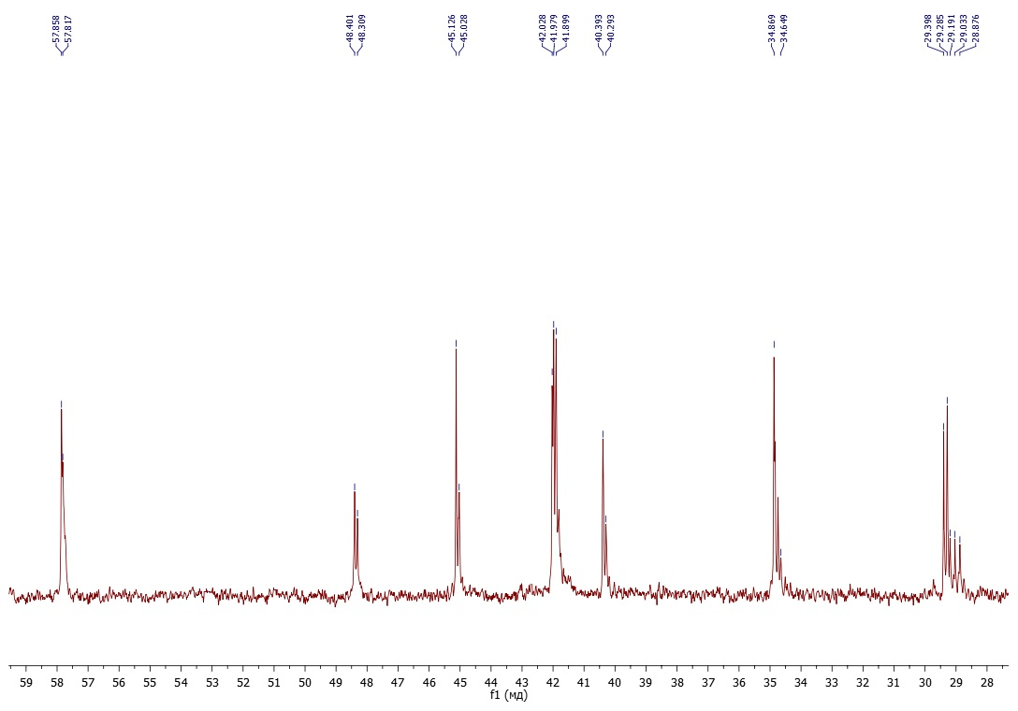
Figure S11. ¹³C NMR spectrum of exo-exo-dideuteriopentacyclo[8.2.1.1^{5,8}.0^{2,9}.0^{3,7}]tetradecane 10a in CDCl₃
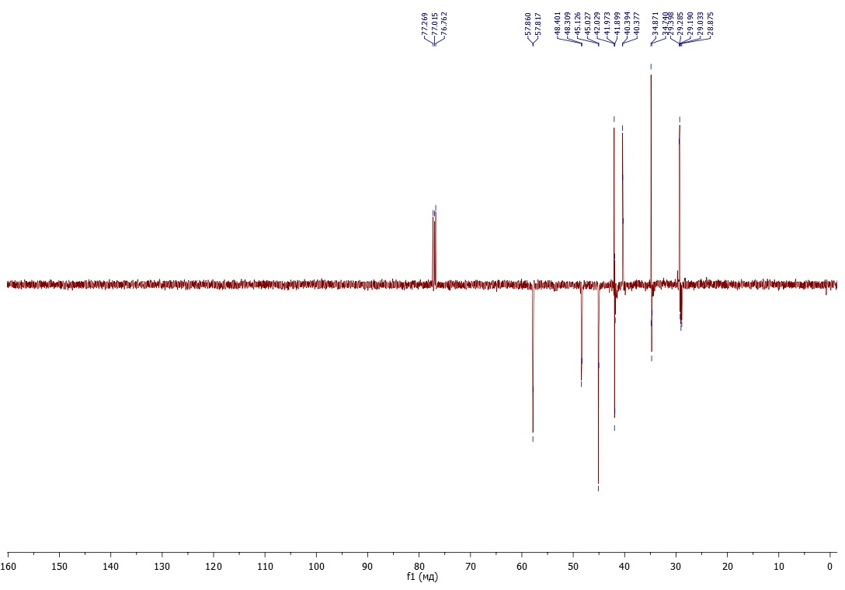
Figure S12. DEPTQ spectrum of exo-exo-dideuteriopentacyclo[8.2.1.1^{5,8}.0^{2,9}.0^{3,7}]tetradecane 10a in CDCl₃
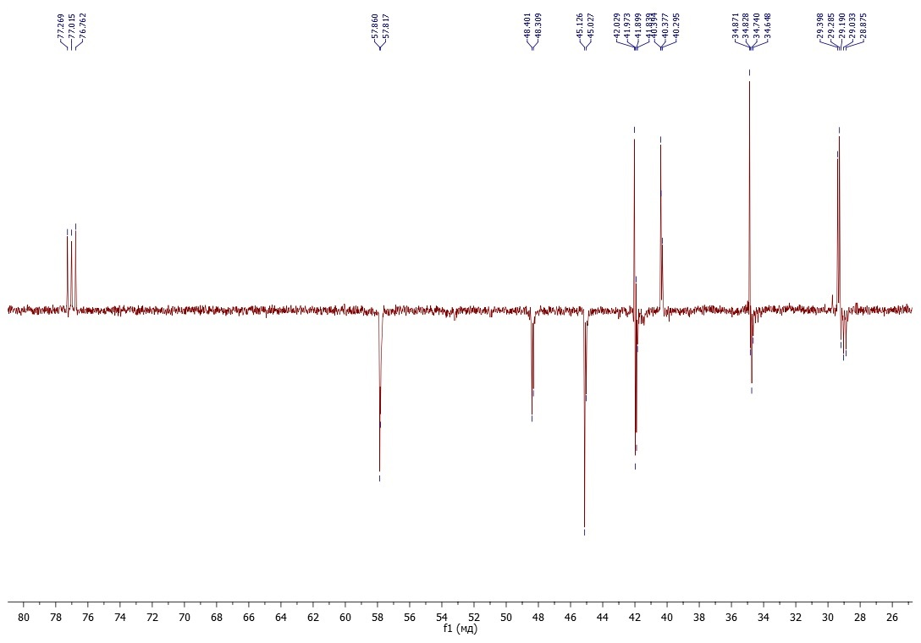
Figure S13. DEPTQ spectrum of exo-exo-dideuteriopentacyclo[8.2.1.1^{5,8}.0^{2,9}.0^{3,7}]tetradecane 10a in CDCl₃
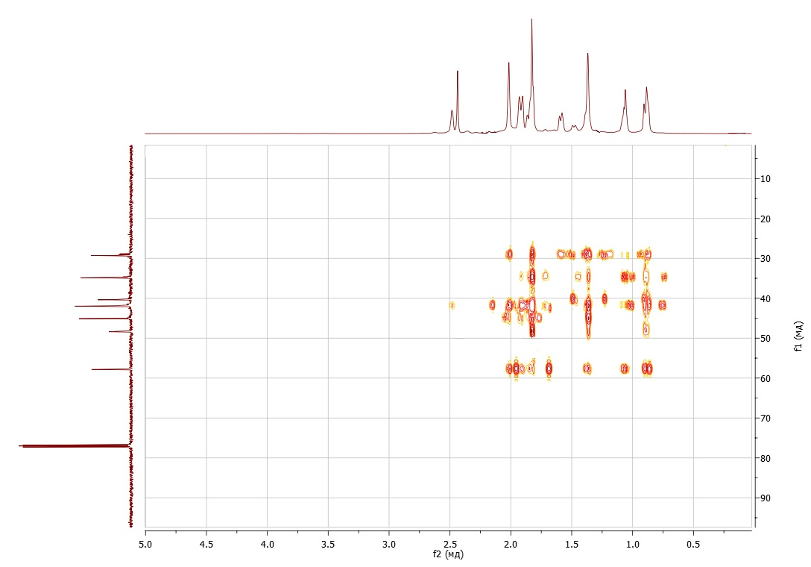
Figure S14. HMBC spectrum of exo-exo-dideuteriopentacyclo[8.2.1.1^{5,8}.0^{2,9}.0^{3,7}]tetradecane 10a in CDCl₃
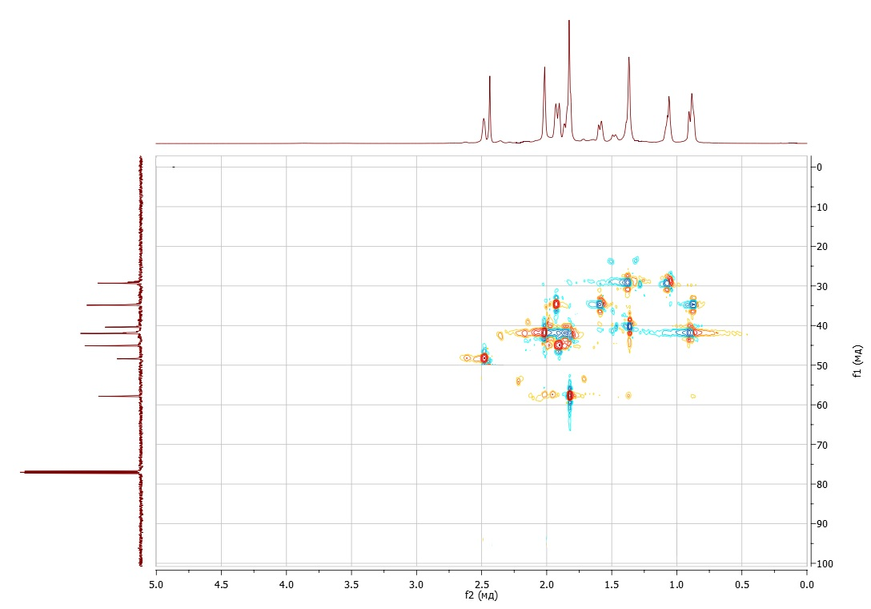
Figure S15. HSQC spectrum of exo-exo-dideuteriopentacyclo[8.2.1.1^{5,8}.0^{2,9}.0^{3,7}]tetradecane 10a in CDCl₃
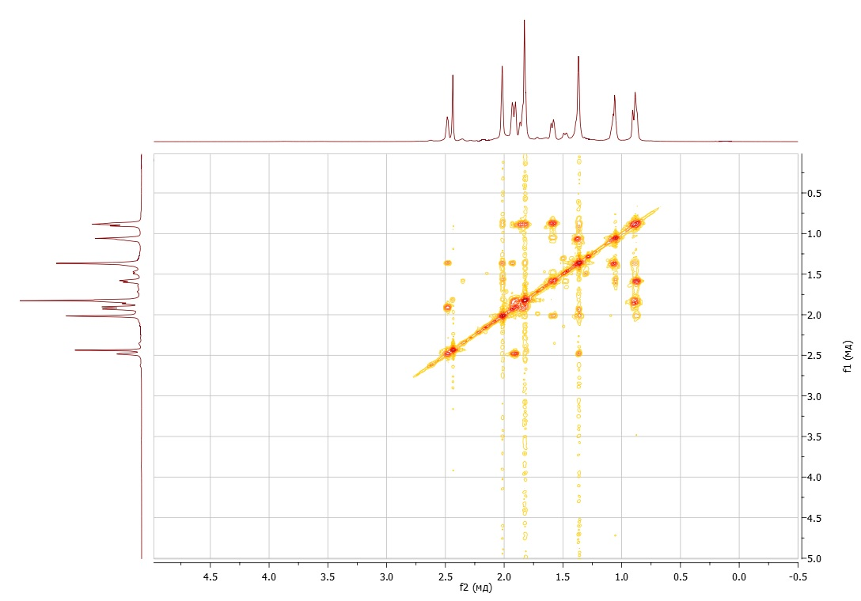
Figure S16. COSY spectrum of exo-exo-dideuteriopentacyclo[8.2.1.1^{5,8}.0^{2,9}.0^{3,7}]tetradecane 10a in CDCl₃
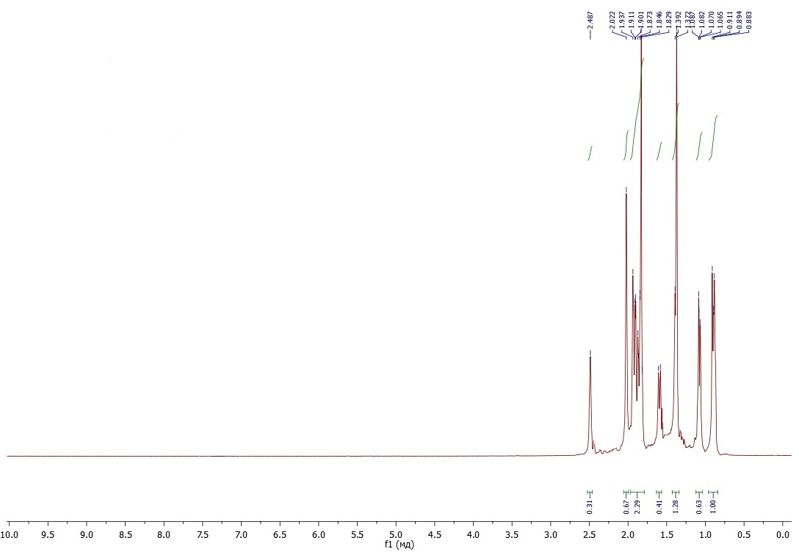
Figure S17. ¹H NMR spectrum of endo-exo-pentacyclo[8.2.1.1^{5,8}.0^{2,9}.0^{3,7}]tetradecane 11 in CDCl₃
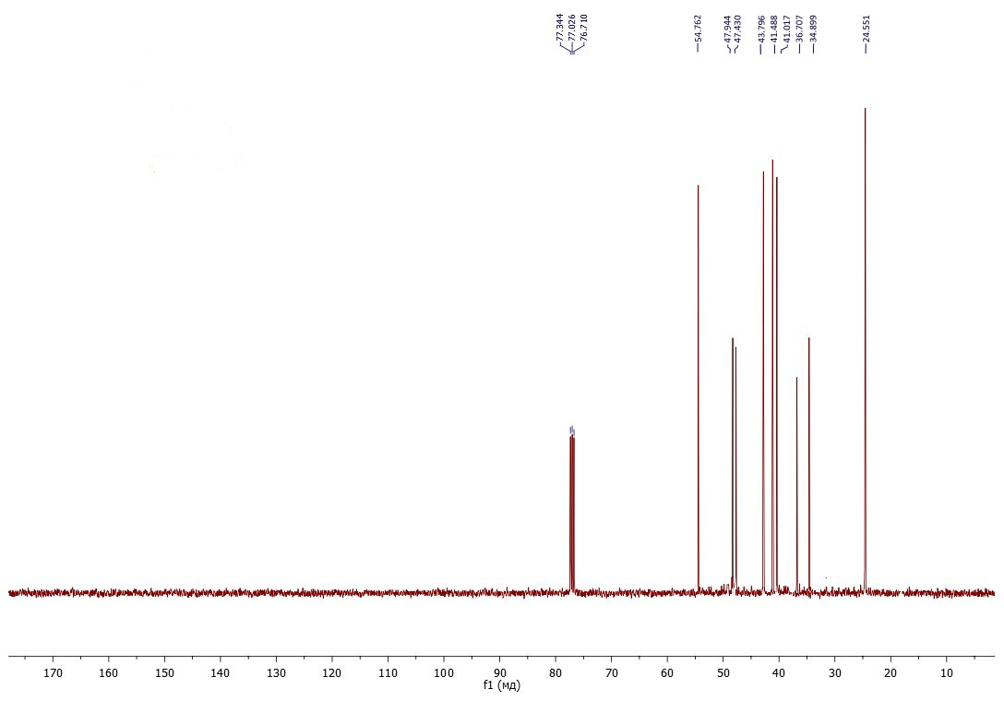
Figure S18. ¹³C NMR spectrum of endo-exo-pentacyclo[8.2.1.1^{5,8}.0^{2,9}.0^{3,7}]tetradecane 11 in CDCl₃

