SUPPORTING INFORMATION

for

Cascade Intramolecular Prins/Friedel–Crafts Cyclization for the Synthesis of 4-Aryl-tetralin-2-ols and 5-Aryl-tetrahydro-5H-benzo[7]annulen-7-ols

Jie Zheng, Shuyu Meng, and Quanrui Wang*

Address: Department of Chemistry, Fudan University, 2005 Songhu Road, Shanghai 200438, People’s Republic of China

Email: Quanrui Wang* - qrwang@fudan.edu.cn
* Corresponding author

Beilstein J. Org. Chem. 2021, X, XX–XX. doi: XXXX

Experimental Procedures, Characterization Data, Copies of NMR Spectra and X-ray Crystal Data of Compounds 13

- General Information S2
- Experimental Procedures and Characterization Data S3
- Copies of NMR Spectra S16
- X-ray Crystal for Compound 13 S86
- Referrence S88

- General Information
All reactions were carried out in oven-dried glassware under a nitrogen atmosphere. All solvents and reagents were purchased from Sinopharm Chemical Reagent Co. Ltd. (SCRC). Commercial available reagents were used without further puriﬁcation. For the sequential Prins/Friedel–crafts reactions, the dehydrated CH₂Cl₂ was prepared by distillation from CaH₂. ¹H NMR (400 MHz) and ¹³C NMR (101 MHz) spectra were obtained as solutions in chloroform-d (CDCl₃) from a Varian nmrs 400 MHz spectrometer using tetramethylsilane as an internal standard. High-resolution mass spectra (HRMS) were obtained with an Agilent Micro TOF 11 spectrometer using the positive electrospray ionization (ESI) mode. Column chromatography was performed on Biotage using a prepacked silica gel column, a detector with UV wavelengths 220 and 254 nm. 4-Aryl-2-hydroxy tetralins and analogues were generally obtained as a mixture of cis- and trans- isomers (conﬁrmed via ¹H NMR and NOE, HSQC and COSY). The ratio of the two isomers was inferred from ¹H NMR. X-ray diffraction analysis of 13 was measured using a Bruker D8 VENTURE diffractometer.

- Experimental Procedures and Characterization Data

- General Procedure for the Synthesis of 2-Bromophenyl-ethanols (3).
Synthesis of 2-(2-bromophenyl)ethan-1-ol (3a).¹ n-Butyllithium (47.00 mmol, 2.90 equiv, 2.5 M in hexanes) was added dropwise into MTPPC (40.50 mmol, 2.50 equiv) in anhyd THF (30 mL) at 0 °C in an inert atmosphere of N₂. The resultant mixture was stirred for 10 min, then 2-bromobenzaldehyde 1a (16.20 mmol, 1.00 equiv) in anhyd THF (10 mL) was added dropwise to the reaction mixture. After addition, the reaction turned from white suspension to dark red clear liquid. The reaction was stirred further for 1 h at 0 °C, then quenched with saturated aqueous NaCl (30 mL), and extracted with ethyl acetate (2 × 30 mL). The combined organic layers were dried over Na₂SO₄ and ﬁltered, and the ﬁltrate was concentrated under reduced pressure to afford the crude vinyl ether product 2a, which was directly used in the next step.
To compound 2a (16.20 mmol, 1.0 equiv) in THF (30 mL) was added 18% hydrochloric acid (16.20 mmol, 1.0 equiv) at room temperature. The reaction was stirred under reﬂux in an inert atmosphere of N₂ for 1 h. Then, the reaction was concentrated under reduced pressure to remove THF. Then methanol (30 mL) was added. After being stirred at room temperature for 10 min, KBH₄ (16.20 mmol, 1.00 equiv) was added slowly at 20 °C and stirred for 1 h. Following this, saturated aqueous NaCl (30 mL) was added, the mixture was extracted with ethyl acetate (2 × 30 mL), and the combined organic layers were dried over Na₂SO₄ and concentrated under reduced pressure. The residue was puriﬁed by column chromatography on silica gel eluted with EA /PE (boiling point range 60−90 °C) (v/v = 1 : 9) to give the desired 2-(2-bromophenyl)ethan-1-ol 3a. Colorless oil. 2.41 g, 74%. IR (KBr): 3383, 3058, 2920, 2880, 1567, 1471, 1440, 1041, 749, 658 cm^{–1}. ¹H NMR (CDCl₃, 400 MHz) δ 7.54 (d, J = 7.9 Hz, 1H), 7.27−7.22 (m, 2H), 7.10−7.06 (m, 1H), 3.86 (t, J = 6.7 Hz, 2H), 3.01 (t, J = 6.7 Hz, 2H), 1.57 (s, 1H). ¹³C NMR (CDCl₃, 101 MHz) δ 137.8, 132.9, 131.3, 128.2, 127.4, 124.7, 62.0, 39.3. HRMS (ESI) m/z [M − H₂O + H]⁺ calcd for C₈H₈Br⁺ 182.9804, found 182.9784.

2-Bromoaryl ethanols 3b-c, 3e and 3g were synthesized analogously as described for 3a.
2-(2-Bromo-4-methoxyphenyl)ethan-1-ol (3b).² Light yellow oil. 2.85 g, 76%. IR (KBr): 3396, 2939, 2880, 1636, 1605, 1567, 1500, 1458, 1283, 1241, 1039, 867, 743 cm^{–1}. ¹H NMR (CDCl₃, 400 MHz) δ 7.15 (d, J = 8.5 Hz 1H), 7.09 (d, J = 2.7 Hz, 1H), 6.79 (dd, J = 8.4, 2.7 Hz, 1H), 3.81 (t, J = 6.7 Hz, 2H), 3.75 (s, 3H), 2.93 (t, J = 6.8 Hz, 2H), 1.75 (s, 1H). ¹³C NMR (CDCl₃, 101 MHz) δ 158.7, 131.5, 129.6, 124.7, 118.1, 113.6, 62.2, 55.5, 38.4. HRMS (ESI) m/z [M − H₂O + H]⁺ calcd for C₉H₁₀BrO⁺ 212.9910, found 212.9890.
2-(2-Bromo-4-chlorophenyl)ethan-1-ol (3c). Light yellow oil. 2.79 g, 73%. IR (KBr): 3355, 2935, 2880, 1636, 1586, 1557, 1435, 1381, 1101, 913, 843, 743 cm^{–1}. ¹H NMR (CDCl₃, 400 MHz) δ 7.53 (d, J = 2.0 Hz, 1H), 7.24−7.16 (m, 2H), 3.80 (t, J = 6.7 Hz, 2H), 2.94 (t, J = 6.7 Hz, 2H), 2.08 (s, 1H). ¹³C NMR (CDCl₃, 101 MHz) δ 136.4, 132.9, 132.4, 131.9, 127.6, 124.8, 61.7, 38.6. HRMS (ESI) m/z [M − H₂O + H]⁺ calcd for C₈H₇BrCl⁺ 216.9414, found 216.9387.
2-(2-Bromophenyl)propan-1-ol (3e).² Colorless oil. 2.44 g, 70%. IR (KBr): 3383, 3063, 2964, 2874, 1654, 1508, 1472, 1438, 1038, 1022, 751 cm^{–1}. ¹H NMR (CDCl₃, 400 MHz) δ 7.55 (dd, J = 8.0, 1.2 Hz, 1H), 7.30−7.23 (m, 2H), 7.08−7.04 (m, 1H), 3.73−3.63 (m, 2H), 3.52−3.43 (m, 1H), 1.99 (s, 1H), 1.26 (d, J = 7.0 Hz, 3H). ¹³C NMR (CDCl₃, 101 MHz) δ 142.6, 133.0, 127.9, 127.67, 127.65, 125.2, 67.1, 40.7, 17.1. HRMS (ESI) m/z [M − H₂O + H]⁺ calcd for C₉H₁₀Br⁺ 196.9960, found 196.9938.
2-(1-Bromonaphthalen-2-yl)ethan-1-ol (3g). Light yellow oil. 3.09 g, 76%. IR (KBr): 3374, 3052, 2934, 2878, 1647, 1534, 1352, 1255, 1040, 913, 812, 748 cm^{–1}. ¹H NMR (CDCl₃, 400 MHz) δ 8.31 (d, J = 8.5 Hz, 1H), 7.78 (d, J = 8.1 Hz, 1H), 7.73 (d, J = 8.3 Hz, 1H), 7.62−7.44 (m, 2H), 7.35 (d, J = 8.3 Hz, 1H), 3.94 (t, J = 6.8 Hz, 2H), 3.25 (t, J = 6.8 Hz, 2H), 1.93 (s, 1H). ¹³C NMR (CDCl₃, 101 MHz) δ 136.1, 133.4, 132.6, 128.6, 128.0, 127.60, 127.4, 127.3, 126.1, 124.3, 62.3, 40.5. HRMS (ESI) m/z [M − H₂O + H]⁺ calcd for C₁₂H₁₀Br⁺ 232.9960, found 232.9962.
Synthesis of 2-(2-bromo-4-nitrophenyl)ethan-1-ol (3d). 63% aqueous HNO₃ (14.90 mmol, 1.00 equiv) was added dropwise into 3a (14.90 mmol, 1.00 equiv) in acetic anhydride (10 mL) and H₂SO₄ (0.15 mmol, 0.01 equiv) at 0 °C in an inert atmosphere of N₂ and stirred for 2 h. After the reaction was completed, the solution was poured into ice/water (30 mL) with stirring, and saturated aqueous NaHCO₃ was added dropwise into the stirring solution under ice bath until free from acetic acid. Then, the mixture was extracted with ethyl acetate (3 × 30 mL), the combined organic layers were dried over Na₂SO₄ and ﬁltered, and the ﬁltrate was concentrated under reduced pressure. It was directly used in the next step. 30% aqueous NaOH (14.90 mmol, 1.00 equiv) was added into the residue in methanol (30 mL) and H₂O (30 mL) at room temperature. The mixture was stirred under reﬂux in an inert atmosphere of N₂ for 1 h. Then, the reaction was concentrated under reduced pressure. The residue was extracted with ethyl acetate (2 × 30 mL), the combined organic layers were dried over Na₂SO₄ and ﬁltered, and the ﬁltrate was concentrated under reduced pressure. The residue was puriﬁed by column chromatography on silica gel eluted with EA /PE (boiling point range 60−90 °C) (v/v = 1 : 9) to give the desired 2-(2-bromo-4-nitrophenyl)ethan-1-ol 3d. Light yellow oil. 2.60 g, 71%. IR (KBr): 3383, 3058, 2920, 2880, 1567, 1471, 1440, 1041, 749, 658 cm^{–1}. ¹H NMR (CDCl₃, 400 MHz) δ 8.15 (d, J = 2.7 Hz, 1H), 7.92 (dd, J = 8.7, 2.8 Hz, 1H), 7.71 (d, J = 8.7 Hz, 1H), 3.93 (t, J = 6.5 Hz, 2H), 3.09 (t, J = 6.5 Hz, 2H), 1.75 (s, 1H). ¹³C NMR (CDCl₃, 101 MHz) δ 147.1, 140.2, 133.7, 132.0, 125.7, 122.7, 61.2, 39.0. HRMS (ESI) m/z [M − H₂O + H]⁺ calcd for C₈H₇BrNO₂⁺ 227.9655, found 227.9627.

- General Procedure for the Synthesis of 2-Vinyl arylethanols (4).
Synthesis of 2-(2-vinylphenyl)ethan-1-ol (4a).³ Compound 3a (10.00 mmol, 1.00 equiv), picol vinylborote (12.00 mmol, 1.20 equiv) and Pd(dppf)Cl₂ (1.00 mmol, 0.10 equiv) were added to dioxane (16 mL) in an inert atmosphere of N₂ at 20 °C. Then K₂CO₃ (13.00 mmol, 1.30 equiv) in H₂O (4 mL) was added to above mixture. The resultant mixture was heated to reflux. The reaction was stirred for further 2 h at reflux, and then saturated aqueous NaCl (30 mL) was added, and extracted with ethyl acetate (3 × 30 mL). The combined organic layers were dried over Na₂SO₄ and ﬁltered, and the ﬁltrate was concentrated under reduced pressure. The residue was puriﬁed by column chromatography on silica gel eluted with EA/PE (boiling point range 60–90 °C) (v/v = 1 : 9) to give the desired 2-(2-vinylphenyl)ethan-1-ol 4a. Light yellow oil. 1.16 g, 78%. IR (KBr): 3374, 2947, 2878, 1831, 1654, 1626, 1602, 1484, 1450, 1417, 1044, 914, 774 cm^{–1}. ¹H NMR (CDCl₃, 400 MHz) δ 7.52−7.49 (m, 1H), 7.24−7.16 (m, 3H), 7.01 (dd, J = 17.3, 11.0 Hz, 1H), 5.65 (dd, J = 17.4, 1.3 Hz, 1H), 5.31 (dd, J = 11.0, 1.3 Hz, 1H), 3.80 (t, J = 6.9 Hz, 2H), 2.95 (t, J = 6.9 Hz, 2H), 1.64 (s, 1H). ¹³C NMR (CDCl₃, 101 MHz) δ 137.1, 135.6, 134.4, 130.3, 127.9, 126.9, 126.0, 116.0, 63.1, 36.4. HRMS (ESI) m/z [M − H₂O + H]⁺ calcd for C₁₀H₁₁⁺ 131.0855, found 131.0873.

2-Vinyl aryl ethanols 4b-g were synthesized analogously as described for 4a.
2-(4-Methoxy-2-vinylphenyl)ethan-1-ol (4b). Light yellow oil. 1.35 g, 76%. IR (KBr): 3374, 2943, 2876, 1624, 1605, 1570, 1500, 1465, 1424, 1288, 1243, 1041, 913, 743 cm^{–1}. ¹H NMR (CDCl₃, 400 MHz) δ 7.08 (d, J = 8.4 Hz, 1H), 7.03 (d, J = 2.7 Hz, 1H), 6.96 (dd, J = 17.3, 10.9 Hz, 1H), 6.77 (dd, J = 8.4, 2.7 Hz, 1H), 5.63 (dd, J = 17.3, 1.3 Hz, 1H), 5.30 (dd, J = 10.9, 1.3 Hz, 1H), 3.79 (s, 3H), 3.74 (t, J = 6.9 Hz, 2H), 2.88 (t, J = 6.9 Hz, 2H), 1.74 (s, 1H). ¹³C NMR (CDCl₃, 101 MHz) δ 158.4, 138.0, 134.4, 131.4, 128.0, 116.0, 113.6, 111.1, 63.3, 55.3, 35.6. HRMS (ESI) m/z [M − H₂O + H]⁺ calcd for C₁₁H₁₃O⁺ 161.0961, found 161.0931.
2-(4-Chloro-2-vinylphenyl)ethan-1-ol (4c). Light yellow oil. 1.30 g, 71%. IR (KBr): 3384, 2947, 2879, 1653, 1625, 1521, 1507, 1479, 1458, 1418, 1041, 914, 743 cm^{–1}. ¹H NMR (CDCl₃, 400 MHz) δ 7.46 (d, J = 2.3 Hz, 1H), 7.20−7.07 (m, 2H), 6.91 (dd, J = 17.3, 11.0 Hz, 1H), 5.64 (dd, J = 17.3, 1.3 Hz, 1H), 5.34 (dd, J = 10.9, 1.3 Hz, 1H), 3.77 (t, J = 6.8 Hz, 2H), 2.90 (t, J = 6.8 Hz, 2H), 1.58 (s, 1H). ¹³C NMR (CDCl₃, 101 MHz) δ 138.7, 134.1, 133.3, 132.7, 131.6, 127.7, 125.9, 117.2, 62.9, 35.8. HRMS (ESI) m/z [M − H₂O + H]⁺ calcd for C₁₀H₁₀Cl⁺ 165.0466, found 165.0496.
2-(4-Nitro-2-vinylphenyl)ethan-1-ol (4d). Red oil. 1.35 g, 70%. IR (KBr): 3421, 2922, 1608, 1569, 1463, 14209, 1037, 912, 741 cm^{–1}. ¹H NMR (CDCl₃, 400 MHz) δ 8.11−7.98 (m, 2H), 7.60 (d, J = 8.5 Hz, 1H), 7.01 (dd, J = 17.4, 11.1 Hz, 1H), 5.78 (dd, J = 17.3, 1.3 Hz, 1H), 5.51 (d, J = 11.0, 1.3 Hz, 1H), 3.86 (t, J = 6.7 Hz, 2H), 3.01 (t, J = 6.7 Hz, 2H), 1.84 (s, 1H). ¹³C NMR (CDCl₃, 101 MHz) δ 147.0, 143.6, 137.5, 132.9, 126.8, 125.1, 121.9, 119.9, 62.4, 36.0. HRMS (ESI) m/z [M − H₂O + H]⁺ calcd for C₁₀H₁₀NO₂⁺ 176.0706, found 176.0688.
2-(2-Vinylphenyl)propan-1-ol (4e). Yellow oil. 1.18 g, 73%. IR (KBr): 3386, 3062, 2926, 1625, 1600, 1507, 1450, 1384, 1036, 1011, 913, 773 cm^{–1}. ¹H NMR (CDCl₃, 400 MHz) δ 7.47 (d, J = 7.5 Hz, 1H), 7.31−7.18 (m, 3H), 7.09 (dd, J = 17.3, 10.9 Hz, 1H), 5.60 (dd, J = 17.1, 1.3 Hz, 1H), 5.32 (dd, J = 10.8, 1.3 Hz, 1H), 3.79−3.62 (m, 2H), 3.39−3.30 (m, 1H), 1.69 (s, 1H), 1.26 (d, J = 6.9 Hz, 3H). ¹³C NMR (CDCl₃, 101 MHz) δ 140.8, 137.5, 134.8, 128.1, 126.62, 126.56, 125.7, 116.5, 68.1, 37.0, 17.5. HRMS (ESI) m/z [M − H₂O + H]⁺ calcd for C₁₁H₁₃⁺ 145.1012, found 145.0990.
2-(2-(Prop-1-en-2-yl)phenyl)ethan-1-ol (4f).⁴ Red oil. 1.15 g, 71%. IR (KBr): 3363, 3075, 2964, 1638, 1600, 1522, 1446, 1371, 1045, 901, 766 cm^{–1}. ¹H NMR (CDCl₃, 400 MHz) δ 7.25−7.15 (m, 3H), 7.15−7.10 (m, 1H), 5.20−5.19 (m, 1H), 4.85−4.84 (m, 1H), 3.81 (t, J = 7.0 Hz, 2H), 2.91 (t, J = 7.0 Hz, 2H), 2.05−2.04 (m, 3H), 1.60 (s, 1H). ¹³C NMR (CDCl₃, 101 MHz) δ 145.4, 144.3, 134.7, 129.7, 128.4, 127.0, 126.3, 115.2, 63.8, 36.2, 25.3. HRMS (ESI) m/z [M + Na]⁺ calcd for C₁₁H₁₄NaO⁺ 185.0937, found 185.0962.
2-(1-Vinylnaphthalen-2-yl)ethan-1-ol (4g). Red oil. 1.51 g, 76%. IR (KBr): 3447, 3052, 2936, 1629, 1594, 1507, 1416, 1376, 1040, 960, 817, 750 cm^{–1}. ¹H NMR (CDCl₃, 400 MHz) δ 8.14−8.12 (m, 1H), 7.86−7.69 (m, 2H), 7.52−7.39 (m, 2H), 7.36 (d, J = 8.4 Hz, 1H), 7.07 (dd, J = 17.9, 11.4 Hz, 1H), 5.79 (dd, J = 11.5, 2.1 Hz, 1H), 5.45 (dd, J = 17.9, 2.1 Hz, 1H), 3.87 (t, J = 7.0 Hz, 2H), 3.10 (t, J = 6.9 Hz, 2H), 1.62 (s, 1H). ¹³C NMR (CDCl₃, 101 MHz) δ 135.6, 133.9, 132.8, 132.4, 131.9, 128.02, 127.95, 127.3, 126.0, 125.7, 125.3, 121.7, 63.3, 37.0. HRMS (ESI) m/z [M + Na]⁺ calcd for C₁₄H₁₄NaO⁺ 221.0937, found 221.0948.

- General Procedure for the Synthesis of 2-(2-Vinyl aryl)acetaldehydes 5.
Synthesis of 2-(2-vinylphenyl)acetaldehyde (5a).⁵ Dess-Martin periodinane (8.10 mmol, 1.20 equiv) was added in portions into 2-(2-vinylphenyl) ethan-1-ol 4a (6.80 mmol, 1.00 equiv) dissolved in CH₂Cl₂ (20 mL) at 0 ºC in an inert atmosphere of N₂, The resultant mixture was stirred for further 2 h at 20ºC, then quenched with 8% aqueous NaHCO₃ (20 mL). The mixture was ﬁltered and cake was washed with CH₂Cl₂ (10 mL). The filtrate was separated and aqueous layer was extracted with CH₂Cl₂ (2 × 10 mL). The combined organic layers were dried over Na₂SO₄ and ﬁltered, and the ﬁltrate was concentrated under reduced pressure. The residue was puriﬁed by column chromatography on silica gel eluted with EA /PE (boiling point range 60−90 °C) (v/v = 1:19) to give the desired 2-(2-vinylphenyl)acetaldehyde 5a. Colorless oil. 0.84 g, 85%. IR (KBr): 3427, 3064, 2824, 2726, 1728, 1626, 1485, 1450, 1416, 1318, 1037, 990, 919, 773 cm^{–1}. ¹H NMR (CDCl₃, 400 MHz) δ 9.68 (t, J = 2.3 Hz, 1H), 7.58−7.50 (m, 1H), 7.35−7.22 (m, 2H), 7.20−7.13 (m, 1H), 6.83 (dd, J = 17.3, 11.0 Hz, 1H), 5.66 (dd, J = 17.3, 1.2 Hz, 1H), 5.34 (dd, J = 10.9, 0.9 Hz, 1H), 3.76 (d, J = 2.3 Hz, 2H). ¹³C NMR (CDCl₃, 101 MHz) δ 199.2, 137.8, 133.9, 130.9, 129.5, 128.2, 128.0, 126.4, 117.2, 48.4. HRMS (ESI) m/z [M − H₂O + H]⁺ calcd for C₁₀H₉⁺ 129.0699, found 129.0711.

2- Vinyl aryl acetaldehyde 5b-g were synthesized analogously as described for 5a.
2-(4-Methoxy-2-vinylphenyl)acetaldehyde (5b). Colorless oil. 1.02 g, 85%. IR (KBr): 3446, 2836, 1720, 1624, 1493, 1420, 1290, 1199, 1029, 913, 743 cm^{–1}. ¹H NMR (CDCl₃, 400 MHz) δ 9.64 (s, 1H), 7.11−7.03 (m, 2H), 6.85−6.72 (m, 2H), 5.64 (d, J = 17.2 Hz, 1H), 5.33 (d, J = 10.9 Hz, 1H), 3.81 (s, 3H), 3.68 (s, 2H). ¹³C NMR (CDCl₃, 101 MHz) δ 199.5, 159.2, 138.9, 134.0, 132.0, 121.7, 117.2, 113.9, 111.6, 55.3, 47.6. HRMS (ESI) m/z [M − H₂O + H]⁺ calcd for C₁₁H₁₁O⁺ 159.0804, found 159.0774.
2-(4-Chloro-2-vinylphenyl)acetaldehyde (5c). Yellow oil. 1.01 g, 82%. IR (KBr): 3445, 2828, 1723, 1627, 1479, 1417, 1215, 1116, 1040, 913, 743 cm^{–1}. ¹H NMR (CDCl₃, 400 MHz) δ 9.65 (t, J = 2.1 Hz, 1H), 7.50 (d, J = 2.2 Hz, 1H), 7.26−7.19 (m, 1H), 7.08 (d, J = 8.2 Hz, 1H), 6.72 (dd, J = 17.2, 10.9 Hz, 1H), 5.66 (d, J = 17.2 Hz, 1H), 5.38 (d, J = 10.9 Hz, 1H), 3.72 (d, J = 2.0 Hz, 2H). ¹³C NMR (CDCl₃, 101 MHz) δ 198.5, 139.4, 133.9, 132.9, 132.1, 128.1, 127.9, 126.4, 118.5, 47.7. HRMS (ESI) m/z [M − H₂O + H]⁺ calcd for C₁₀H₈Cl⁺ 163.0309, found 163.0280.
2-(4-Nitro-2-vinylphenyl)acetaldehyde (5d). Yellow oil. 0.98 g, 75%. IR (KBr): 3448, 2919, 1718, 1653, 1499, 1465, 1383, 1241, 1049, 913, 743 cm^{–1}. ¹H NMR (CDCl₃, 400 MHz) δ 9.74 (t, J = 1.6 Hz, 1H), 8.12 (dd, J = 8.6, 2.4 Hz, 1H), 8.04 (d, J = 2.4 Hz, 1H), 7.66 (d, J = 8.6 Hz, 1H), 6.78 (dd, J = 17.2, 11.0 Hz, 1H), 5.80 (dd, J = 17.3, 0.6 Hz, 1H), 5.54 (dd, J = 11.0, 0.6 Hz, 1H), 3.90 (d, J = 1.6 Hz, 2H). ¹³C NMR (CDCl₃, 101 MHz) δ 197.2, 147.1, 144.2, 132.4, 131.2, 127.2, 125.9, 123.0, 121.1, 48.0. HRMS (ESI) m/z [M − H₂O + H]⁺ calcd for C₁₀H₈NO₂⁺ 174.0550, found 174.0521.
2-(2-Vinylphenyl)propanal (5e). Yellow oil. 0.85 g, 78%. IR (KBr): 3405, 2948, 2836, 1654, 1452, 1413, 1383, 1021, 669 cm^{–1}. ¹H NMR (CDCl₃, 400 MHz) δ 9.67 (s, 1H), 7.57−7.50 (m, 1H), 7.33−7.26 (m, 2H), 7.10−7.03 (m, 1H), 6.95 (dd, J = 17.2, 10.9 Hz, 1H), 5.64 (dd, J = 17.2, 1.4 Hz, 1H), 5.37 (dd, J = 10.9, 1.4 Hz, 1H), 3.92 (q, J = 7.0 Hz, 1H), 1.41 (d, J = 7.0 Hz, 3H). ¹³C NMR (CDCl₃, 101 MHz) δ 201.1, 137.7, 135.3, 134.1, 128.4, 127.9, 127.7, 127.0, 117.7, 49.2, 14.6. HRMS (ESI) m/z [M − H₂O + H]⁺ calcd for C₁₁H₁₁⁺ 143.0855, found 143.0829.
2-(2-(Prop-1-en-2-yl)phenyl)acetaldehyde (5f). Yellow oil. 0.82 g, 75%. IR (KBr): 3447, 2970, 1724, 1654, 1541, 1436, 1384, 1047, 905, 766 cm^{–1}. ¹H NMR (CDCl₃, 400 MHz) δ 9.70 (t, J = 2.1 Hz, 1H), 7.30−7.24 (m, 2H), 7.22−7.17 (m, 2H), 5.23−5.21 (m, 1H), 4.81−4.80 (m, 1H), 3.73 (d, J = 2.2 Hz, 2H), 2.01−2.00 (m, 3H). ¹³C NMR (CDCl₃, 101 MHz) δ 200.0, 144.7, 140.1, 134.2, 129.8, 128.5, 125.7, 124.1, 116.1, 48.2, 25.0. HRMS (ESI) m/z [M − H₂O + H]⁺ calcd for C₁₁H₁₁⁺ 143.0855, found 143.0825.
2-(1-Vinylnaphthalen-2-yl)acetaldehyde (5g). Colorless oil. 1.11 g, 83%. IR (KBr): 3425, 3053, 2823, 2724, 1918, 1773, 1628, 1594, 1508, 1416, 1384, 1261, 1180, 1035, 994, 817, 748 cm^{–1}. ¹H NMR (CDCl₃, 400 MHz) δ 9.76 (t, J = 2.2 Hz, 1H), 8.12−8.07 (m, 1H), 7.87−7.75 (m, 2H), 7.56−7.44 (m, 2H), 7.30 (d, J = 8.4 Hz, 1H), 7.03 (dd, J = 18.0, 11.4 Hz, 1H), 5.80 (dd, J = 11.5, 1.9 Hz, 1H), 5.40 (dd, J = 17.8, 1.8 Hz, 1H), 3.94 (d, J = 2.0 Hz, 2H). ¹³C NMR (CDCl₃, 101 MHz) δ 199.7, 136.6, 133.8, 132.76, 132.0, 128.2, 128.1, 127.8, 126.8, 126.3, 125.9, 125.6, 122.5, 49.1. HRMS (ESI) m/z [M − H₂O + H]⁺ calcd for C₁₄H₁₁⁺ 179.0855, found 179.0839.

- General Procedure for the Synthesis of 4-Aryl-2-hydroxy Tetralins 6.
Synthesis of 4-(3,4-dimethoxyphenyl)-1,2,3,4-tetrahydronaphthalen-2-ol (6a). 48% Boron trifluoride etherate (1.54 mmol, 1.10 equiv) was added dropwise into the mixture of aldehyde 5a (1.40 mmol, 1.00 equiv) and veratrole (1.47 mmol, 1.05 equiv) dissolved in anhyd CH₂Cl₂ (6 mL) at 0 °C in an inert atmosphere of N₂. The resultant solution was stirred for further 2 h at 0 °C, then quenched with saturated aqueous NaCl (10 mL), and extracted with CH₂Cl₂ (2 × 10 mL). The combined organic layers were dried over Na₂SO₄ and ﬁltered, and the ﬁltrate was concentrated under reduced pressure. The residue was puriﬁed by column chromatography on silica gel eluted with EA /PE (boiling point range 60−90 °C) (v/v = 1:4) to give 6a. Colorless oil. 0.28 g, 70%, cis-/trans- = 49/51. IR (KBr): 3448, 3058, 2933, 2836, 1605, 1591, 1515, 1464, 1450, 1418, 1262, 1140, 1115, 1028, 811, 740 cm^{–1}. ¹H NMR (CDCl₃, 400 MHz) δ 7.16−7.11 (m, 4H), 7.09−7.00 (m, 2H), 6.92−6.90 (m, 1H), 6.82−6.73 (m, 4H), 6.65 (d, J = 2.0 Hz, 1H), 6.63 (d, J = 2.0 Hz, 1H), 6.55 (dd, J = 8.2, 2.1 Hz, 1H), 4.32−4.29 (m, 1H, trans-), 4.28−4.23 (m, 1H, trans-), 4.20−4.12 (m, 1H, cis-), 4.08−4.04 (m, 1H, cis-), 3.86 (s, 3H), 3.83 (s, 3H), 3.79 (s, 3H), 3.78 (s, 3H), 3.24−3.14 (m, 2H), 2.92−2.80 (m, 2H), 2.39−2.34 (m, 1H), 2.23−2.16 (m, 1H), 2.09−2.04 (m, 1H), 1.89 (q, J = 12.2 Hz, 1H). ¹³C NMR (CDCl₃, 101 MHz) δ 149.0, 148.8, 147.6, 147.4, 139.4, 139.1, 138.4, 138.3, 134.9, 134.5, 129.7, 129.4, 129.2, 129.1, 126.34, 126.25, 126.1, 120.8, 112.0, 111.7, 111.2, 111.0, 67.7, 64.6, 55.9, 55.8, 45.9, 43.1, 42.3, 40.3, 39.5, 38.3. HRMS (ESI) m/z [M + Na]⁺ calcd for C₁₈H₂₀NaO₃⁺ 307.1305, found 307.1319.

4-Aryl-2-hydroxy tetralins 6b-t and 7 were synthesized analogously as described for 6a.
4-(2,4-Dimethoxyphenyl)-1,2,3,4-tetrahydronaphthalen-2-ol (6b). Colorless oil. 0.29 g, 72%, cis-/trans- = 55/45. IR (KBr): 3446, 3058, 2933, 2361, 1611, 1507, 1458, 1291, 1207, 1156, 1037 cm⁻¹. ¹H NMR (CDCl₃, 400 MHz) δ 7.14−7.09 (m, 4H), 7.08−6.99 (m, 3H), 6.92−6.89 (m, 2H), 6.78−6.76 (m, 1H), 6.50−6.47 (m, 2H), 6.43 (dd, J = 8.4, 2.5 Hz, 1H), 6.30 (dd, J = 8.2, 2.4 Hz, 1H), 4.67 (t, J = 5.7 Hz, 1H, trans-), 4.53 (dd, J = 11.6, 5.8 Hz, 1H, cis-), 4.21−4.13 (m, 2H), 3.83 (s, 3H), 3.80 (s, 3H), 3.76 (s, 6H), 3.23−3.12 (m, 2H), 2.92−2.77 (m, 2H), 2.35−2.29 (m, 1H), 2.15−2.03 (m, 2H), 1.89 (q, J = 11.6 Hz, 1H). ¹³C NMR (CDCl₃, 101 MHz) δ 159.3, 159.1, 158.2, 157.7, 139.4, 138.4, 135.2, 135.0, 130.4, 129.9, 129.7, 129.2, 129.1, 128.6, 127.5, 126.7, 126.1, 126.0, 125.8, 104.6, 103.6, 98.6, 98.4, 67.9, 64.9, 55.5, 55.4, 55.31, 55.28, 41.1, 39.6, 38.6, 38.2, 38.1, 36.5. HRMS (ESI) m/z [M + H]⁺ calcd for C₁₈H₂₁O₃⁺ 285.1485, found 285.1488.
4-(4-Methoxy-3,5-dimethylphenyl)-1,2,3,4-tetrahydronaphthalen-2-ol (6c). Colorless oil. 0.24 g, 60%, cis-/trans- = 54/46. IR (KBr): 3424, 3059, 2925, 1654, 1601, 1487, 1450, 1265, 1220, 1147, 1054, 739 cm^{–1}. ¹H NMR (CDCl₃, 400 MHz) δ 7.15−7.09 (m, 4H), 7.08−7.01 (m, 3H), 6.91 (d, J = 7.6 Hz, 1H), 6.80 (s, 2H), 6.68 (s, 2H), 4.29−4.26 (m, 2H, trans-), 4.19−4.12 (m, 1H, cis-), 4.01 (dd, J = 12.1, 5.6 Hz, 1H, cis-), 3.72 (s, 3H), 3.70 (s, 3H), 3.24−3.14 (m, 2H), 2.92−2.80 (m, 2H), 2.37−2.31 (m, 1H), 2.24 (s, 6H), 2.19 (s, 6H), 2.18−2.14 (m, 1H), 2.08−2.02 (m, 1H), 1.87 (q, J = 12.0 Hz, 1H). ¹³C NMR (CDCl₃, 101 MHz) δ 155.4, 155.2, 141.9, 141.1, 139.2, 138.3, 134.9, 134.4, 130.8, 130.5, 129.9, 129.4, 129.3, 129.1, 129.0, 128.9, 126.3, 126.14, 126.12, 67.8, 64.6, 59.68, 59.65, 45.7, 43.2, 42.2, 40.3, 39.6, 38.3, 16.1. HRMS (ESI) m/z [M − H₂O + H]⁺ calcd for C₁₉H₂₁O⁺ 265.1587, found 265.1579.
4-(2,5-Dimethoxyphenyl)-1,2,3,4-tetrahydronaphthalen-2-ol (6d). Colorless oil. 0.27 g, 68%, cis-/trans- = 51/49. IR (KBr): 3419, 2927, 2360, 1652, 1495, 1463, 1278, 1214, 1048, 745 cm^{–1}. ¹H NMR (CDCl₃, 400 MHz) δ 7.14−7.00 (m, 6H), 6.91−6.67 (m, 6H), 6.59 (d, J = 3.1 Hz, 1H), 6.21 (d, J = 3.2 Hz, 1H), 4.73 (t, J = 5.9 Hz, 1H, trans-), 4.59 (dd, J = 11.7, 5.9 Hz, 1H, cis-), 4.21−4.13 (m, 2H), 3.80 (s, 3H), 3.73 (s, 3H), 3.69 (s, 3H), 3.63 (s, 3H), 3.22−3.11 (m, 2H), 2.92−2.77 (m, 2H), 2.38−2.32 (m, 1H), 2.16−2.04 (m, 2H), 1.90 (q, J = 11.6 Hz, 1H). ¹³C NMR (CDCl₃, 101 MHz) δ 153.8, 153.2, 151.7, 151.3, 138.82, 137.84, 136.4, 135.6, 135.2, 135.1, 129.7, 129.33, 129.1, 128.7, 126.2, 126.1, 125.9, 117.1, 115.7, 112.1, 111.7, 111.2, 110.6, 67.8, 64.8, 56.3, 55.98, 55.6, 55.5, 40.9, 39.51, 39.1, 38.5, 37.8, 37.1. HRMS (ESI) m/z [M + H]⁺ calcd for C₁₈H₂₁O₃⁺ 285.1485, found 285.1485.
4-(2-Methoxy-5-methylphenyl)-1,2,3,4-tetrahydronaphthalen-2-ol (6e). Yellow oil. 0.24 g, 65%, cis-/trans- = 60/40. IR (KBr): 3422, 2920, 2362, 1735, 1653, 1499, 1458, 1243, 1037, 746 cm^{–1}. ¹H NMR (CDCl₃, 400 MHz) δ 7.17−7.17 (m, 4H), 7.05−7.01 (m, 3H), 6.98 (dd, J = 8.3, 2.3 Hz, 1H), 6.91 (d, J = 7.6 Hz, 1H), 6.85−6.77 (m, 4H), 6.45 (d, J = 2.2 Hz, 1H), 4.75 (t, J = 6.1 Hz, 1H, trans-), 4.61 (dd, J = 11.8, 5.8 Hz, 1H, cis-), 4.21−4.18 (m, 2H), 3.82 (s, 3H), 3.76 (s, 3H), 3.25−3.13 (m, 2H), 2.95−2.80 (m, 2H), 2.37−2.31 (m, 1H), 2.28 (s, 3H), 2.16 (s, 3H), 2.16−2.10 (m, 2H), 1.92 (q, J = 11.7 Hz, 1H). ¹³C NMR (CDCl₃, 101 MHz ) δ 155.2, 154.9, 139.3, 138.3, 135.1, 135.1, 134.8, 134.0, 130.6, 130.2, 130.1, 129.7, 129.4, 129.3, 129.1, 128.7, 111.0, 110.4, 67.9, 64.9, 55.7, 55.6, 41.0, 39.6, 38.7, 38.0, 36.6, 20.59, 20.56. HRMS (ESI) m/z [M − H₂O + H]⁺ calcd for C₁₈H₁₉O⁺ 251.1430, found 251.1429.
4-(Furan-2-yl)-1,2,3,4-tetrahydronaphthalen-2-ol (6f). Yellow oil. 0.12 g, 40%, cis-/trans- = 1/99. IR (KBr): 3422, 2924, 2360, 1700, 1653, 1490, 1450, 1384, 1053, 739 cm^{–1}. ¹H NMR (CDCl₃, 400 MHz) δ 7.32 (dd, J = 1.8, 0.8 Hz, 1H), 7.19−7.08 (m, 4H), 6.25 (dd, J = 3.2, 1.9 Hz, 1H), 5.81 (dt, J = 3.2, 0.8 Hz, 1H), 4.40 (t, J = 5.7 Hz, 1H), 4.28−4.21 (m, 1H), 3.17 (dd, J = 16.4, 5.0 Hz, 1H), 2.79 (dd, J = 16.4, 5.0 Hz, 1H), 2.39−2.33 (m, 1H), 2.11−2.04 (m, 1H). ¹³C NMR (CDCl₃, 101 MHz) δ 158.4, 141.4, 135.3, 134.4, 129.6, 129.3, 126.8, 126.1, 110.0, 106.6, 64.7, 38.3, 37.0, 36.5. HRMS (ESI) m/z [M + H]⁺ calcd for C₁₄H₁₅O₂⁺ 215.1067, found 215.1066.
4-(5-Methylfuran-2-yl)-1,2,3,4-tetrahydronaphthalen-2-ol (6g). Yellow oil. 0.11 g, 35%, cis-/trans- = 1/99. IR (KBr): 3447, 2923, 1653, 1457, 1384, 1055, 743 cm^{–1}. ¹H NMR (CDCl₃, 400 MHz) δ 7.16−7.10 (m, 4H), 5.80 (dd, J = 2.9, 1.1 Hz, 1H), 5.62 (d, J = 3.0 Hz, 1H), 4.32 (t, J = 5.6 Hz, 1H), 4.28−4.22 (m, 1H), 3.17 (dd, J = 16.3, 5.2 Hz, 1H), 2.78 (dd, J = 16.4, 7.8 Hz, 1H), 2.38−2.33 (m, 1H), 2.24 (s, 3H), 2.08−2.01 (m, 1H). ¹³C NMR (CDCl₃, 101 MHz) δ 156.5, 150.9, 135.5, 134.4, 129.5, 129.4, 126.6, 126.0, 107.3, 105.8, 64.8, 38.4, 37.3, 36.6, 13.6. HRMS (ESI) m/z [M − H₂O + H]⁺ calcd for C₁₅H₁₅O⁺ 211.1117, found 211.1116.
4-(Thiophen-2-yl)-1,2,3,4-tetrahydronaphthalen-2-ol (6h). Yellow oil. 0.12 g, 37%, cis-/trans- = 41/59. IR (KBr): 3421, 2917, 2849, 1653, 1449, 1384, 1039, 743, 698 cm^{–1}. ¹H NMR (CDCl₃, 400 MHz) δ 7.20−7.05 (m, 10H), 6.98−6.95 (m, 1H), 6.92−6.88 (m, 2H), 6.67−6.66 (m, 1H), 4.63 (t, J = 5.8 Hz, 1H, trans-), 4.48 (dd, J = 11.8, 5.4 Hz, 1H, cis-), 4.32−4.26 (m, 1H), 4.20−4.13 (m, 1H), 3.23−3.14 (m, 2H), 2.92−2.78 (m, 2H), 2.53−2.47 (m, 1H), 2.23 (t, J = 6.0 Hz, 2H), 2.05−1.96 (m, 1H). ¹³C NMR (CDCl₃, 101 MHz) δ 150.4, 149.1, 138.2, 137.5, 134.2, 134.1, 129.6, 129.5, 129.2, 128.7, 126.8, 126.7, 126.5, 126.3, 126.2, 125.4, 125.3, 124.0, 123.8, 67.5, 64.5, 43.5, 40.9, 40.7, 39.3, 38.6, 38.3. HRMS (ESI) m/z [M − H₂O + H]⁺ calcd for C₁₄H₁₃S⁺ 213.0732, found 213.0734.
4-Allyl-1,2,3,4-tetrahydronaphthalen-2-ol (6i). Yellow oil. 0.17 g, 65%, cis-/trans- = 44/56. IR (KBr): 3373, 2924, 2360, 1653, 1507, 1489, 1451, 1364, 1118, 1039, 914, 746 cm^{–1}. ¹H NMR (CDCl₃, 400 MHz) δ 7.31−7.07 (m, 8H), 5.88−5.71 (m, 2H), 5.12−5.04 (m, 4H), 4.27−4.21 (m, 1H, trans-), 4.08−4.00 (m, 1H, cis-), 3.14−3.00 (m, 3H), 2.77−2.65 (m, 3H), 2.52−2.27 (m, 4H), 2.23−2.17 (m, 1H), 2.02−1.97 (m, 1H), 1.87−1.80 (m, 1H), 1.54−1.45 (m, 1H). ¹³C NMR (CDCl₃, 101 MHz) δ 139.2, 138.6, 136.9, 136.2, 135.1, 134.1, 129.5, 129.4, 128.2, 126.8, 126.3, 126.12, 126.06, 126.0, 117.0, 116.7, 67.7, 64.5, 41.8, 40.3, 39.7, 38.8, 38.6, 37.2, 36.6, 35.4. HRMS (ESI) m/z [M − H₂O + H]⁺ calcd for C₁₃H₁₅⁺ 171.1168, found 171.1175.
4-(3,4-dimethoxyphenyl)-6-methoxy-1,2,3,4-tetrahydronaphthalen-2-ol (6j). Yellow oil. 0.32 g, 72%, cis-/trans- = 48/52. IR (KBr): 3479, 3002, 2933, 2836, 2253, 1651, 1614, 1514, 1455, 1258, 1187, 1028, 912, 739 cm^{–1}. ¹H NMR (CDCl₃, 400 MHz) δ 7.05−7.01 (m, 2H), 6.81−6.65 (m, 5H), 6.64 (dd, J = 7.3, 1.9 Hz, 1H), 6.56 (dd, J = 8.2, 2.1 Hz, 1H), 6.43 (d, J = 2.7 Hz, 1H), 6.31 (d, J = 2.7 Hz, 1H), 4.27−4.24 (m, 2H, trans-), 4.17−4.09 (m, 1H, cis-), 4.02 (dd, J = 12.2, 5.5 Hz, 1H, cis-), 3.86 (s, 3H), 3.83 (s, 3H), 3.80 (s, 3H), 3.79 (s, 3H), 3.64 (s, 3H), 3.60 (s, 3H), 3.17−3.08 (m, 2H), 2.83−2.73 (m, 2H), 2.37−2.31 (m, 1H), 2.20−2.14 (m, 1H), 2.06−2.00 (m, 1H), 1.86 (q, J = 11.9 Hz, 1H). ¹³C NMR (CDCl₃, 101 MHz) δ 157.9, 149.0, 148.8, 147.6, 147.4, 140.3, 139.4, 139.0, 138.1, 130.3, 130.0, 127.0, 126.5, 120.9, 114.3, 114.1, 112.9, 112.4, 111.9, 111.6, 111.1, 111.0, 67.9, 64.7, 55.9, 55.20, 55.17, 55.15, 46.1, 43.0, 42.6, 40.2, 38.8, 37.5. HRMS (ESI) m/z [M − H₂O + H]⁺ calcd for C₁₉H₂₁O₃⁺ 297.1485, found 297.1483.
4-(Furan-2-yl)-6-methoxy-1,2,3,4-tetrahydronaphthalen-2-ol (6k). Yellow oil. 0.14 g, 41%, cis-/trans- = 1/99. IR (KBr): 3445, 2931, 2360, 1779, 1615, 1506, 1464, 1267, 1041, 942, 767 cm^{–1}. ¹H NMR (CDCl₃, 400 MHz) δ 7.31 (dd, J = 1.8, 0.8 Hz, 1H), 7.03 (d, J = 8.4 Hz, 1H), 6.75 (dd, J = 8.4, 2.7 Hz, 1H), 6.62 (d, J = 2.7 Hz, 1H), 6.25 (dd, J = 3.2, 1.9 Hz, 1H), 5.88−5.82 (m, 1H), 4.36 (t, J = 5.9 Hz, 1H), 4.29−4.18 (m, 1H), 3.71 (s, 3H), 3.11 (dd, J = 16.1, 5.0 Hz, 1H), 2.71 (dd, J = 16.1, 7.5 Hz, 1H), 2.35−2.29 (m, 1H), 2.09−2.02 (m, 1H). ¹³C NMR (CDCl₃, 101 MHz) δ 158.2, 157.8, 141.4, 136.4, 130.4, 126.4, 113.9, 113.3, 110.0, 106.6, 64.9, 55.2, 37.5, 37.3, 36.4. HRMS (ESI) m/z [M − H₂O + H]⁺ calcd for C₁₅H₁₅O₂⁺ 227.1067, found 227.1077.
6-Chloro-4-(3,4-dimethoxyphenyl)-1,2,3,4-tetrahydronaphthalen-2-ol (6l). Yellow oil. 0.30 g, 67%, cis-/trans- = 44/56. IR (KBr): 3444, 2932, 2253, 1659, 1557, 1483, 1464, 1261, 1140, 1026, 912, 742 cm^{–1}. ¹H NMR (CDCl₃, 400 MHz) δ 7.12−7.03 (m, 4H), 6.87 (d, J = 2.1 Hz, 1H), 6.83−6.70 (m, 4H), 6.62−6.61 (m, 2H), 6.55 (dd, J = 8.2, 2.1 Hz, 1H), 4.31−4.23 (m, 2H, trans-), 4.18−4.10 (m, 1H, cis-), 4.00 (dd, J = 12.3, 5.6 Hz, 1H, cis-), 3.87 (s, 3H), 3.85 (s, 3H), 3.81 (s, 3H), 3.80 (s, 3H), 3.19−3.10 (m, 2H), 2.85−2.76 (m, 2H), 2.38−2.32 (m, 1H), 2.21−2.14 (m, 1H), 2.05−2.00 (m, 1H), 1.87 (q, J = 12.0 Hz, 1H). ¹³C NMR (CDCl₃, 101 MHz) δ 149.1, 148.9, 147.8, 147.6, 141.0, 140.3, 138.2, 137.4, 133.3, 132.8, 131.8, 131.7, 130.7, 130.4, 129.4, 128.8, 126.6, 126.5, 120.84, 120.81, 111.8, 111.4, 111.3, 111.1, 67.5, 64.4, 55.9, 55.9, 45.7, 42.7, 42.0, 39.8, 38.9, 37.6. HRMS (ESI) m/z [M − H₂O + H]⁺ calcd for C₁₈H₁₈ClO₂⁺ 301.0990, found 301.0978.
6-Chloro-4-(furan-2-yl)-1,2,3,4-tetrahydronaphthalen-2-ol (6m). Yellow oil. 0.13 g, 38%, cis-/trans- = 99/1. IR (KBr): 3418, 2930, 2250, 1779, 1715, 1596, 1486, 1053, 911, 735 cm^{–1}. ¹H NMR (CDCl₃, 400 MHz) δ 7.32 (dd, J = 1.7, 0.7 Hz, 1H), 7.14−7.12 (m, 1H), 7.06−7.04 (m, 2H), 6.27 (dd, J = 3.2, 2.0 Hz, 1H), 5.88 (d, J = 3.2 Hz, 1H), 4.36 (t, J = 6.1 Hz, 1H), 4.29−4.23 (m, 1H), 3.12 (dd, J = 16.7, 4.9 Hz, 1H), 2.74 (dd, J = 16.6, 7.2 Hz, 1H), 2.34−2.29 (m, 1H), 2.10−2.03 (m, 1H). ¹³C NMR (CDCl₃, 101 MHz) δ 157.4, 141.7, 137.3, 132.7, 131.7, 130.8, 128.9, 127.0, 110.1, 106.87, 64.5, 37.6, 36.7, 36.1. HRMS (ESI) m/z [M − H₂O + H]⁺ calcd for C₁₄H₁₂ClO⁺ 231.0571, found 231.0542.
4-(3,4-Dimethoxyphenyl)-6-nitro-1,2,3,4-tetrahydronaphthalen-2-ol (6n). Yellow oil. 0.25 g, 55%, cis-/trans- = 56/44. IR (KBr): 3444, 2932, 2253, 1659, 1557, 1483, 1464, 1261, 1140, 1026, 912, 742 cm^{–1}. ¹H NMR (CDCl₃, 400 MHz) δ 8.00−7.95 (m, 2H), 7.87−7.81 (m, 2H), 7.04 (d, J = 8.6 Hz, 1H), 6.94 (d, J = 8.5 Hz, 1H), 6.83−6.77 (m, 2H), 6.70 (d, J = 8.0 Hz, 1H), 6.59−6.55 (m, 3H), 4.39−4.32 (m, 2H, trans-), 4.24−4.17 (m, 1H, cis-), 4.11−4.05 (m, 1H, cis-), 3.86 (s, 3H), 3.84 (s, 3H), 3.79 (s, 6H), 3.30−3.25 (m, 2H), 2.99−2.92 (m, 2H), 2.46−2.40 (m, 1H), 2.30−2.22 (m, 1H), 2.11−2.03 (m, 1H), 1.93 (q, J = 11.9 Hz, 1H). ¹³C NMR (CDCl₃, 101 MHz) δ 149.3, 149.2, 148.1, 147.9, 146.8, 146.6, 146.4, 137.5, 136.8, 136.7, 136.0, 130.6, 130.1, 124.39, 124.36, 124.14, 124.12, 121.03, 121.01, 120.93, 120.90, 120.9, 120.8, 111.82, 111.76, 111.5, 111.4, 111.34, 111.28, 66.9, 64.1, 55.9, 55.9, 45.9, 42.3, 41.9, 39.4, 39.2, 38.0. HRMS (ESI) m/z [M + Na]⁺ calcd for C₁₈H₁₉NNaO₅⁺ 352.1155, found 352.1158.
4-(3,4-Dimethoxyphenyl)-1-methyl-1,2,3,4-tetrahydronaphthalen-2-ol (6o). Yellow oil. 0.27 g, 65%. IR (KBr): 3420, 2934, 1591, 1487, 1463, 1262, 1155, 1028, 738 cm^{–1}. ¹H NMR (CDCl₃, 400 MHz) δ 7.33−7.16 (m, 3H), 7.05−7.01 (m, 2H), 6.89−6.71 (m, 5H), 6.65−6.53 (m, 4H), 4.31 (t, J = 6.9 Hz, 1H), 4.25−4.17 (m, 1H), 4.09−4.04 (m, 1H), 3.92−3.89 (m, 1H), 3.85 (s, 6H), 3.78 (s, 6H), 3.17−3.13 (m, 1H), 2.91−2.85 (m, 1H), 2.39−2.29 (m, 1H), 2.17−2.09 (m, 2H), 2.02−1.94 (m, 1H), 1.47 (d, J = 6.8 Hz, 3H), 1.37 (d, J = 6.8 Hz, 3H). ¹³C NMR (CDCl₃, 101 MHz) δ 149.0, 148.9, 148.8, 147.6, 147.4, 147.3, 140.1, 140.01, 139.97, 139.8, 139.2, 139.0, 138.64, 137.95, 137.8, 129.9, 129.6, 129.0, 128.9, 128.2, 127.3, 126.5, 126.4, 126.1, 126.0, 125.8, 120.8, 112.07, 112.02, 111.7, 111.2, 111.0, 73.6, 70.6, 69.5, 68.2, 55.9, 45.5, 42.6, 42.1, 41.9, 41.7, 41.4, 38.3, 37.7, 36.9, 21.7, 18.1, 16.8. HRMS (ESI) m/z [M − H₂O + H]⁺ calcd for C₁₉H₂₁O₂⁺ 281.1536, found 281.1518.
4-(Furan-2-yl)-1-methyl-1,2,3,4-tetrahydronaphthalen-2-ol (6p). Yellow oil. 0.12 g, 36%. IR (KBr): 3421, 2928, 1717, 1617, 1504, 1457, 1009, 745 cm^{–1}. ¹H NMR (CDCl₃, 400 MHz) δ 7.35−7.28 (m, 2H), 7.25−7.16 (m, 3H), 7.13− 7.02 (m, 4H), 6.28−6.26 (m, 2H), 6.25−6.23 (m, 1H), 5.90 (d, J = 3.2 Hz, 1H), 5.81 (d, J = 2.7 Hz, 1H), 4.41−4.34 (m, 2H), 4.24−4.21 (m, 1H), 3.91−3.87 (m, 1H), 3.14−3.12 (m, 1H), 2.88−2.81 (m, 1H), 2.39−2.33 (m, 1H), 2.27−2.16 (m, 2H), 2.11−2.05 (m, 1H), 1.38 (d, J = 7.0 Hz, 3H), 1.31 (d, J = 7.1 Hz, 3H). ¹³C NMR (CDCl₃, 101 MHz) δ 158.8, 158.2, 141.4, 141.3, 140.3, 139.5, 135.1, 134.7, 129.4, 128.9, 128.8, 126.89, 126.87, 126.1, 109.0, 110.0, 106.7, 106.5, 70.7, 67.9, 41.3, 38.2, 37.2, 36.28, 33.6, 32.8, 20.6, 16.6. HRMS (ESI) m/z [M − H₂O + H]⁺ calcd for C₁₅H₁₅O⁺ 211.1117, found 211.1110.
4-(3,4-Dimethoxyphenyl)-4-methyl-1,2,3,4-tetrahydronaphthalen-2-ol (6q). Yellow oil. 0.21 g, 50%, cis-/trans- = 37/63. IR (KBr): 3440, 2933, 1590, 1490, 1238, 1047, 727 cm^{–1}. ¹H NMR (CDCl₃, 400 MHz) δ 7.24−7.20 (m, 1H), 7.14−7.08 (m, 4H), 6.82−6.78 (m, 3H), 6.71−6.65 (m, 4H), 6.59−6.56 (m, 1H), 6.37 (dd, J = 8.5, 2.3 Hz, 1H), 4.31−4.23 (m, 1H, trans-), 4.19−4.15 (m, 1H, cis-), 3.87 (s, 6H), 3.79 (s, 6H), 2.99−2.92 (m, 2H), 2.88−2.73 (m, 2H), 2.31−2.27 (m, 1H), 2.11−2.07 (m, 1H), 1.96−1.87 (m, 2H), 1.75 (s, 3H), 1.67 (s, 3H). ¹³C NMR (CDCl₃, 101 MHz) δ 149.0, 147.6, 139.5, 137.5, 134.6, 129.5, 129.3, 129.20, 129.15, 128.7, 128.2, 126.5, 126.3, 126.1, 126.04, 126.01, 121.9, 119.6, 119.0, 112.0, 111.2, 110.9, 110.6, 110.5, 110.4, 72.7, 65.6, 64.5, 55.9, 55.8, 55.8, 53.6, 50.6, 49.6, 44.7, 44.1, 40.0, 39.7, 39.1, 31.6, 31.1, 30.5, 22.6, 15.8, 14.1. HRMS (ESI) m/z [M + Na]⁺ calcd for C₁₉H₂₂NaO₃⁺ 321.1461, found 321.1474.
4-(Furan-2-yl)-4-methyl-1,2,3,4-tetrahydronaphthalen-2-ol (6r). Red oil. 0.08 g, 25%, cis-/trans- = 1/99. IR (KBr): 3431, 2957, 2853, 1750, 1654, 1465, 1379, 1238, 1047, 750 cm^{–1}. ¹H NMR (CDCl₃, 400 MHz) δ 7.31−7.27 (m, 2H), 7.19−7.07 (m, 3H), 6.16 (dd, J = 3.1, 2.0 Hz, 1H), 5.55 (d, J = 3.1 Hz, 1H), 4.08−4.00 (m, 1H), 3.16−3.11 (m, 1H), 2.77 (dd, J = 15.7, 10.1 Hz, 1H), 2.74 (dt, J = 12.5, 2.9 Hz, 1H), 1.82−1.72 (m, 1H), 1.71 (s, 3H). ¹³C NMR (CDCl₃, 101 MHz) δ 162.0, 141.2, 139.8, 134.7, 129.4, 127.8, 126.8, 126.3, 109.7, 105.8, 65.0, 46.0, 41.4, 39.6, 28.9. HRMS (ESI) m/z [M − H₂O + H]⁺ calcd for calcd for C₁₅H₁₅O⁺ 211.1117, found 211.1115.
4-(3,4-Dimethoxyphenyl)-1,2,3,4-tetrahydrophenanthren-2-ol (6s). Yellow oil. 0.34 g, 73%, cis-/trans- = 52/48. IR (KBr): 3417, 3051, 2933, 2836, 2252, 1732, 1603, 1505, 1417, 1259, 1139, 912, 743 cm^{–1}. ¹H NMR (CDCl₃, 400 MHz) δ 7.77−7.70 (m, 4H), 7.62−7.57 (m, 2H), 7.35−7.20 (m, 6H), 6.68−6.58 (m, 4H), 6.44 (dd, J = 8.2, 2.1 Hz, 1H), 6.32 (dd, J = 8.3, 2.1 Hz, 1H), 4.89−4.87 (m, 1H, trans-), 4.77 (t, J = 7.1 Hz, 1H, cis-), 4.22−4.14 (m, 2H), 3.76 (s, 3H), 3.75 (s, 3H), 3.74 (s, 3H), 3.71 (s, 3H), 3.38−3.31 (m, 1H), 3.21−3.05 (m, 2H), 2.92 (dd, J = 16.5, 10.0 Hz, 1H), 2.59−2.54 (m, 1H), 2.35−2.31 (m, 1H), 2.23−2.07 (m, 2H). ¹³C NMR (CDCl₃, 101 MHz) δ 149.1, 147.1, 140.1, 138.8, 133.4, 132.9, 132.7, 131.9, 128.4, 128.1, 127.8, 127.5, 126.1, 125.7, 125.1, 124.9, 124.7, 124.5, 120.4, 119.3, 111.5, 111.4, 110.8, 66.9, 63.5, 55.8, 55.8, 55.7, 42.4, 41.9, 41.3, 41.2, 40.0, 39.7. HRMS (ESI) m/z [M − H₂O + H]⁺ calcd for C₂₂H₂₁O₂⁺ 317.1536, found 317.1534.
4-(Furan-2-yl)-1,2,3,4-tetrahydrophenanthren-2-ol (6t). Yellow oil. 0.16 g, 43%, cis-/trans- = 1/99. IR (KBr): 3420, 3051, 2926, 2247, 1922, 1716, 1602, 1504, 1050, 923, 744 cm^{–1}. ¹H NMR (CDCl₃, 400 MHz) δ 7.79−7.76 (m, 1H), 7.72−7.70 (m, 2H), 7.39−7.32 (m, 3H), 7.25−7.23 (m, 1H), 6.13−6.12 (m, 1H), 5.42−5.41 (m, 1H), 4.97 (d, J = 5.2 Hz, 1H), 4.21−4.13 (m, 1H), 3.33 (dd, J = 16.3, 5.9 Hz, 1H), 2.91 (dd, J = 16.5, 10.1 Hz, 1H), 2.61 (dd, J = 12.1, 2.7 Hz, 1H), 2.08−2.01 (m, 1H). ¹³C NMR (CDCl₃, 101 MHz) δ 157.8, 141.0, 133.3, 132.5, 131.9, 129.6, 128.4, 127.9, 127.8, 126.2, 125.0, 123.8, 110.2, 107.4, 64.4, 39.5, 37.5, 36.2. HRMS (ESI) m/z [M − H₂O + H]⁺ calcd for C₁₈H₁₅O⁺ 247.1117, found 247.1114.
2,2'-(2-(4-Nitro-2-vinylphenyl)ethane-1,1-diyl)difuran (7). Red oil. 0.13 g, 30%. IR (KBr): 3462, 2923, 2361, 1583, 1518, 1353, 1147, 1012, 915, 734 cm^{–1}. ¹H NMR (CDCl₃, 400 MHz) δ 7.99 (dd, J = 8.6, 2.4 Hz, 1H), 7.75 (d, J = 2.4 Hz, 1H), 7.56 (d, J = 8.6 Hz, 1H), 7.34 (d, J = 1.9 Hz, 2H), 6.93 (dd, J = 17.3, 11.0 Hz, 1H), 6.25 (dd, J = 3.3, 1.9 Hz, 2H), 6.00 (d, J = 3.2 Hz, 2H), 5.76 (dd, J = 17.3, 0.9 Hz, 1H), 5.49 (dd, J = 11.0, 0.9 Hz, 1H), 4.30 (t, J = 7.7 Hz, 1H), 3.44 (d, J = 7.8 Hz, 2H). ¹³C NMR (CDCl₃, 101 MHz) δ 153.2, 146.8, 143.3, 141.8, 137.8, 132.5, 126.6, 125.23, 121.8, 119.9, 110.3, 106.8, 39.9, 36.5. HRMS (ESI) m/z [M + H]⁺ calcd for C₁₈H₁₆NO₄⁺ 310.1074, found 310.1053.
- General Procedure for the Synthesis of 3-(2-Bromophenyl)propan-1-ols 9.
Synthesis of 3-(2-Bromophenyl)propan-1-ol (9). LiAlH₄ (12.34 mmol, 1.00 equiv, 2.5 M in THF) was added dropwise into methyl 3-(2-bromophenyl)propanoate 8 (12.34 mmol, 1.00 equiv) in anhyd THF (30 mL) at 0 °C in an inert atmosphere of N₂. After addition, the reaction was stirred for further 2 h at 0 °C. Then the reaction was quenched with water (0.5 g), 15% aqueous NaOH (0.5 g) and water (1.5 g) sequentially, and stirred for further 10 min, then filtered. The cake was washed with THF (10 mL). The combined filtrates were dried over Na₂SO₄ and ﬁltered, and the ﬁltrate was concentrated under reduced pressure. The residue was puriﬁed by column chromatography on silica gel eluted with EA /PE (boiling point range 60−90 °C) (v/v = 1 : 9) to give 3-(2-bromophenyl)propan-1-ol 9. Colorless oil. 1.86 g, 70%. IR (KBr): 3383, 2937, 2867, 1567, 1471, 1438, 1160, 1057, 1019, 748 cm^{–1}. ¹H NMR (CDCl₃, 400 MHz) δ 7.54−7.47 (m, 1H), 7.24−7.19 (m, 2H), 7.09−6.99 (m, 1H), 3.68 (t, J = 6.4 Hz, 2H), 2.90−2.76 (m, 2H), 1.96−1.83 (m, 2H). ¹³C NMR (CDCl₃, 101 MHz) δ 141.1, 132.8, 130.4, 127.6, 127.5, 124.4, 62.1, 32.7, 32.4. HRMS (ESI) m/z [M − H₂O + H]⁺ calcd for C₉H₁₀Br⁺ 196.9960, found 196.9933.

- General Procedure for the Synthesis of 3-(2-Vinylphenyl)propan-1-ols 10.
Synthesis of 3-(2-vinylphenyl)propan-1-ol (10). Alcohol 9 (8.00 mmol, 1.00 equiv), picol vinylborote (9.60 mmol, 1.20 equiv) and Pd(dppf)Cl₂ (0.80 mmol, 0.10 equiv) were added to dioxane (16 mL) in an inert atmosphere of N₂ at 20 ºC. Then K₂CO₃ (10.40 mmol, 1.30 equiv) in H₂O (4 mL) was added to above mixture. The resultant mixture was heated to reflux. The reaction was stirred for further 2 h at reflux, then quenched with the saturated aqueous NaCl (30 mL), and extracted with ethyl acetate (3 × 30 mL). The combined organic layers were dried over Na₂SO₄ and ﬁltered, and the ﬁltrate was concentrated under reduced pressure. The residue was puriﬁed by column chromatography on silica gel eluted with EA /PE (boiling point range 60–90 °C) (v/v = 1 : 9) to give 10. Light yellow oil. 0.97 g, 75%. IR (KBr): 3374, 2940, 2872, 1625, 1484, 1449, 1382, 1059, 913, 773 cm^{–1}. ¹H NMR (CDCl₃, 400 MHz) δ 7.51−7.47 (m, 1H), 7.22−7.13 (m, 3H), 7.01 (dd, J = 17.4, 10.9 Hz, 1H), 5.65 (dd, J = 17.4, 1.4 Hz, 1H), 5.29 (dd, J = 11.0, 1.4 Hz, 1H), 3.66 (t, J = 6.3 Hz, 2H), 2.80−2.74 (m, 2H), 1.88−1.79 (m, 2H). ¹³C NMR (CDCl₃, 101 MHz) δ 139.2, 136.5, 134.5, 129.5, 127.8, 126.3, 125.8, 115.6, 62.2, 33.8, 29.4. HRMS (ESI) m/z [M − H₂O + H]⁺ calcd for C₁₁H₁₃⁺ 145.1012, found 145.1005.

- General Procedure for the Synthesis of 3-(2-Vinylphenyl)propanals 11.
Synthesis of 3-(2-vinylphenyl)propanal (11). Dess-Martin periodinane (6.00 mmol, 1.20 equiv) was added in portions to compound 10 (5.00 mmol, 1.00 equiv) in CH₂Cl₂ (8 mL) at 0 ºC in an inert atmosphere of N₂. The resultant mixture was stirred for further 2 h at 20 °C, then quenched with 8% aqueous NaHCO₃ (20 mL). The mixture was ﬁltered and cake was washed with CH₂Cl₂ (10 mL). The filtrate was separated and aqueous layer was extracted with CH₂Cl₂ (2 × 10 mL). The combined organic layers were dried over Na₂SO₄ and ﬁltered, and the ﬁltrate was concentrated under reduced pressure. The residue was puriﬁed by column chromatography on silica gel eluted with EA/PE (boiling point range 60−90 °C) (v/v = 1:19) to give 11. Yellow oil. 0.65 g, 81%. IR (KBr): 3431, 2941, 2824, 2724, 1728, 1625, 1484, 1451, 1411, 1387, 1055, 913, 774 cm^{–1}. ¹H NMR (CDCl₃, 400 MHz) δ 9.80 (t, J = 1.3 Hz, 1H), 7.51−7.46 (m, 1H), 7.24−7.14 (m, 3H), 6.94 (dd, J = 17.3, 11.0 Hz, 1H), 5.66 (dd, J = 17.5, 1.4 Hz, 1H), 5.33 (dd, J = 10.9, 1.4 Hz, 1H), 3.05−2.98 (m, 2H), 2.75−2.68 (m, 2H). ¹³C NMR (CDCl₃, 101 MHz) δ 201.5, 137.6, 136.5, 134.1, 129.3, 128.0, 126.8, 126.1, 116.3, 44.7, 25.5. HRMS (ESI) m/z [M − H₂O + H]⁺ calcd for C₁₁H₁₁⁺ 143.0855, found 143.0841.

5-Aryl-7-hydroxyl benzo[7]annulens 12a and 12b were synthesized analogously as described for 6a.
5-(3,4-Dimethoxyphenyl)-6,7,8,9-tetrahydro-5H-benzo[7]annulen-7-ol (12a). Yellow oil. 0.25 g, 60%, cis-/trans- = 51/49. IR (KBr): 3445, 3063, 2933, 2253, 1738, 1634, 1487, 1262, 1143, 1029, 913, 742 cm^{–1}. ¹H NMR (CDCl₃, 400 MHz) δ 7.17−6.98 (m, 7H), 6.89 (d, J = 8.1 Hz, 1H), 6.91−6.68 (m, 5H), 6.49 (d, J = 7.6 Hz, 1H), 4.63−4.58 (m, 1H, trans-), 4.20−4.14 (m, 1H, cis-), 4.07−3.98 (m, 2H), 3.90 (s, 3H), 3.86 (s, 3H), 3.84 (s, 3H), 3.79 (s, 3H), 2.97−2.76 (m, 2H), 2.59−2.49 (m, 2H), 2.47−2.37 (m, 1H), 2.35−2.24 (m, 3H), 1.93−1.81 (m, 3H), 1.40 (q, J = 11.9 Hz, 1H). ¹³C NMR (CDCl₃, 101 MHz) δ 148.9, 147.5, 145.3, 142.2, 141.0, 137.2, 129.5, 129.2, 127.1, 126.4, 126.3, 126.24, 126.21, 120.5, 120.2, 112.1, 111.8, 111.2, 111.1, 74.3, 68.9, 55.9, 55.9, 55.8, 43.6, 41.3, 36.4, 35.4, 31.0, 29.6. HRMS (ESI) m/z [M − H₂O + H]⁺ calcd for C₁₉H₂₁O₂⁺ 281.1536, found 281.1506.
5-(Furan-2-yl)-6,7,8,9-tetrahydro-5H-benzo[7]annulen-7-ol (12b). Yellow oil. 0.10 g, 31%, cis-/trans- = 26/74. IR (KBr): 3447, 2927, 1718, 1636, 1489, 1452, 1383, 1034, 911, 732 cm^{–1}. ¹H NMR (CDCl₃, 400 MHz) δ 7.39−7.36 (m, 1H), 7.17−7.09 (m, 4H), 6.33−6.26 (m, 1H), 5.85 (s, 1H), 4.55 (d, J = 8.3 Hz, 1H), 4.10−3.99 (m, 2H), 2.85−2.46 (m, 2H), 2.45−2.26 (m, 2H), 2.05−1.80 (m, 2H). ¹³C NMR (CDCl₃, 101 MHz) δ 157.3, 141.9, 141.3, 129.8, 129.2, 126.9, 126.7, 126.6, 126.4, 110.1, 106.4, 69.6, 39.5, 35.7, 29.8. HRMS (ESI) m/z [M − H₂O + H]⁺ calcd for C₁₅H₁₅O⁺ 211.1117, found 211.1078.

- Synthesis of 4-(Furan-2-yl)-1,2,3,4-tetrahydronaphthalen-2-yl 4-Methylbenzenesulfonate 13.
p-Toluenesulfonyl chloride (2.40 mmol, 1.20 equiv) was added in dropwise into 4-(furan-2-yl)-1,2,3,4-tetrahydronaphthalen-2-ol 6f (2.00 mmol, 1.00 equiv) in pyridine (4 mL) at 0 °C in an inert atmosphere of N₂. The resultant mixture was stirred for 20 h at 20 ºC. Then saturated aqueous NaCl (10 mL) and CH₂Cl₂ (20 mL) were added into the reaction, and stirred for 10 min. The aqueous layer was extracted with CH₂Cl₂ (2 × 10 mL). The combined organic layers were dried over with Na₂SO₄ and ﬁltered, and the ﬁltrate was concentrated under reduced pressure. The residue was puriﬁed by column chromatography on silica gel eluted with EA / PE (boiling point range 60−90 °C) (v/v = 1 : 10) to give the tosylate 13. Red oil. 0.66 g, 90%, cis-/trans- = 21/79. IR (KBr): 3420, 2954, 1598, 1494, 1452, 1361, 1177, 1097, 1041, 911, 736 cm^{–1}. ¹H NMR (CDCl₃, 400 MHz) δ 7.79−7.68 (m, 2H), 7.34−7.23 (m, 3H), 7.18−7.06 (m, 2H), 7.06−7.01 (m, 2H), 6.24 (dd, J = 3.1, 1.9 Hz, 1H), 5.82 (d, J = 3.2 Hz, 1H), 5.02−4.91 (m, 1H), 4.32 (t, J = 6.0 Hz, 1H), 3.21−3.07 (m, 1H), 3.03−2.95 (m, 1H), 2.44 (s, 3H), 2.29−2.14 (m, 2H). ¹³C NMR (CDCl₃, 101 MHz) δ 156.9, 144.6, 141.7, 141.6, 134.7, 134.0, 132.6, 129.9, 129.8, 129.3, 129.1, 127.7, 127.0, 126.5, 110.0, 106.9, 76.4, 36.7, 35.3, 33.6, 21.7. HRMS (ESI) m/z [M − pTSA + H]⁺ calcd for C₁₄H₁₃O⁺ 197.0961, found 197.0938.

- Synthesis of 4-(Furan-2-yl)-N,N-dimethyl-1,2,3,4-tetrahydronaphthalen-2-amine hydrochloride (14)
Compound 13 (1.00 mmol, 1.00 equiv) was added to 40% dimethylamine in water (20.00 mmol, 20.00 equiv) at 20 °C in an inert atmosphere of N₂, then heated in sealed tube to 90 °C for 20 h. The saturated aqueous NaCl (10 mL) and CH₂Cl₂ (20 mL) were added into the reaction, and stirred for 10 min. The aqueous layer was extracted with CH₂Cl₂ (2 × 10 mL). The combined organic layers were dried over with Na₂SO₄ and ﬁltered, and the ﬁltrate was concentrated under reduced pressure. The residue was puriﬁed by column chromatography on silica gel eluted with EA / PE (boiling point range 60−90 °C) (v/v = 1 : 10) and acidified with 1 M HCl in methanol (1.00 mmol, 1.00 equiv) to give hydrochloride salt 14. Yellow oil. 0.19 g, 70%, cis-/trans- = 79/21. IR (KBr): 3424, 2957, 2920, 2850, 2668, 1653, 1467, 1234, 1081, 741 cm^{–1}. ¹H NMR (CDCl₃, 400 MHz) δ 12.71 (s, 1H), 7.33−7.29 (m, 1H), 7.20−7.09 (m, 3H), 6.94−6.88 (m, 1H), 6.33−6.30 (m, 1H), 6.22−6.18 (m, 1H), 4.38−4.27 (m, 1H), 3.67−3.60 (m, 1H), 3.37−3.33 (m, 1H), 3.24−3.13 (m, 1H), 2.82 (s, 6H), 2.67−2.65 (m, 1H), 2.27−2.16 (m, 1H). ¹³C NMR (CDCl₃, 101 MHz) δ 155.0, 142.0, 135.0, 131.4, 129.5, 128.1, 127.33, 127.28, 110.2, 107.5, 61.4, 39.5, 39.3, 38.9, 30.1, 29.6. HRMS (ESI) m/z [M + H]⁺ calcd for C₁₆H₂₀NO⁺ 242.1539, found 242.1510.

- Copies of NMR spectra
2-(2-Bromophenyl)ethan-1-ol (3a) ¹H NMR (CDCl₃, 400 MHz)
2-(2-Bromophenyl)ethan-1-ol (3a) ¹³C NMR (CDCl₃, 101 MHz)
2-(2-Bromo-4-methoxyphenyl)ethan-1-ol (3b) ¹H NMR (CDCl₃, 400 MHz)
2-(2-Bromo-4-methoxyphenyl)ethan-1-ol (3b) ¹³C NMR (CDCl₃, 101 MHz)
2-(2-Bromo-4-chlorophenyl)ethan-1-ol (3c) ¹H NMR (CDCl₃, 400 MHz)
2-(2-Bromo-4-chlorophenyl)ethan-1-ol (3c) ¹³C NMR (CDCl₃, 101 MHz)
2-(2-Bromophenyl)propan-1-ol (3e) ¹H NMR (CDCl₃, 400 MHz)
2-(2-Bromophenyl)propan-1-ol (3e) ¹³C NMR (CDCl₃, 101 MHz)
2-(1-Bromonaphthalen-2-yl)ethan-1-ol (3g) ¹H NMR (CDCl₃, 400 MHz)
2-(1-Bromonaphthalen-2-yl)ethan-1-ol (3g) ¹³C NMR (CDCl₃, 101 MHz)
2-(2-Bromo-4-nitrophenyl)ethan-1-ol (3d) ¹H NMR (CDCl₃, 400 MHz)
2-(2-Bromo-4-nitrophenyl)ethan-1-ol (3d) ¹³C NMR (CDCl₃, 101 MHz)
2-(2-Vinylphenyl)ethan-1-ol (4a) ¹H NMR (CDCl₃, 400 MHz)
2-(2-Vinylphenyl)ethan-1-ol (4a) ¹³C NMR (CDCl₃, 101 MHz)
2-(4-Methoxy-2-vinylphenyl)ethan-1-ol (4b) ¹H NMR (CDCl₃, 400 MHz)
2-(4-Methoxy-2-vinylphenyl)ethan-1-ol (4b) ¹³C NMR (CDCl₃, 101 MHz)
2-(4-Chloro-2-vinylphenyl)ethan-1-ol (4c) ¹H NMR (CDCl₃, 400 MHz)
2-(4-Chloro-2-vinylphenyl)ethan-1-ol (4c) ¹³C NMR (CDCl₃, 101 MHz)
2-(4-Nitro-2-vinylphenyl)ethan-1-ol (4d) ¹H NMR (CDCl₃, 400 MHz)
2-(4-Nitro-2-vinylphenyl)ethan-1-ol (4d) ¹³C NMR (CDCl₃, 101 MHz)
2-(2-Vinylphenyl)propan-1-ol (4e) ¹H NMR (CDCl₃, 400 MHz)
2-(2-Vinylphenyl)propan-1-ol (4e) ¹³C NMR (CDCl₃, 101 MHz)
2-(2-(Prop-1-en-2-yl)phenyl)ethan-1-ol (4f) ¹H NMR (CDCl₃, 400 MHz)
2-(2-(Prop-1-en-2-yl)phenyl)ethan-1-ol (4f) ¹³C NMR (CDCl₃, 101 MHz)
2-(1-Vinylnaphthalen-2-yl ethan-1-ol (4g) ¹H NMR (CDCl₃, 400 MHz)
2-(1-Vinylnaphthalen-2-yl)ethan-1-ol (4g) ¹³C NMR (CDCl₃, 101 MHz)
2-(2-Vinylphenyl)acetaldehyde (5a) ¹H NMR (CDCl₃, 400 MHz)
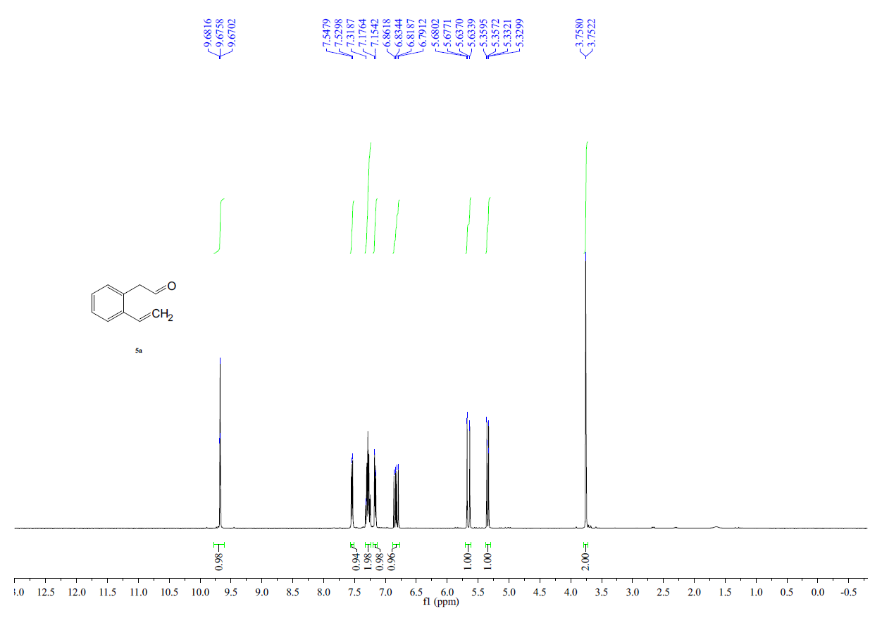
2-(2-Vinylphenyl)acetaldehyde (5a) ¹³C NMR (CDCl₃, 101 MHz)
2-(4-Methoxy-2-vinylphenyl)acetaldehyde (5b) ¹H NMR (CDCl₃, 400 MHz)
2-(4-Methoxy-2-vinylphenyl acetaldehyde (5b) ¹³C NMR (CDCl₃, 101 MHz)
2-(4-Chloro-2-vinylphenyl)acetaldehyde (5c) ¹H NMR (CDCl₃, 400 MHz)
2-(4-Chloro-2-vinylphenyl acetaldehyde (5c) ¹³C NMR (CDCl₃, 101 MHz)
2-(4-Nitro-2-vinylphenyl)acetaldehyde (5d) ¹H NMR (CDCl₃, 400 MHz)
2-(4-Nitro-2-vinylphenyl)acetaldehyde (5d) ¹³C NMR (CDCl₃, 101 MHz)
2-(2-Vinylphenyl)propanal (5e) ¹H NMR (CDCl₃, 400 MHz)
2-(2-Vinylphenyl)propanal (5e) ¹³C NMR (CDCl₃, 101 MHz)
2-(2-(Prop-1-en-2-yl)phenyl)acetaldehyde (5f) ¹H NMR (CDCl₃, 400 MHz)
2-(2-(Prop-1-en-2-yl phenyl)acetaldehyde (5f) ¹³C NMR (CDCl₃, 101 MHz)
2-(1-Vinylnaphthalen-2-yl)acetaldehyde (5g) ¹H NMR (CDCl₃, 400 MHz)
2-(1-Vinylnaphthalen-2-yl)acetaldehyde (5g) ¹³C NMR (CDCl₃, 101 MHz)
4-(3,4-Dimethoxyphenyl)-1,2,3,4-tetrahydronaphthalen-2-ol (6a) ¹H NMR (CDCl₃, 400 MHz)
Cis- and Trans- analysis
(1) H¹, H², H³ and H⁴ were confirmed by HSQC and COSY.
(2) C-2 hydroxy group and the C-4 aryl substituent were assigned by NOE.
If there is a NOE effect between H¹ and H³, and meanwhile H¹ and H³ also have a strong NOE effect with H^{2a}, it is assigned to be cis- configuration. Otherwise, it is the trans isomer.
4-(3,4-Dimethoxyphenyl)-1,2,3,4-tetrahydronaphthalen-2-ol (6a) ¹³C NMR (CDCl₃, 101 MHz)
4-(3,4-Dimethoxyphenyl)-1,2,3,4-tetrahydronaphthalen-2-ol (6a) HSQC
4-(3,4-Dimethoxyphenyl)-1,2,3,4-tetrahydronaphthalen-2-ol (6a) NOE 1.60 -4.80
4-(3,4-Dimethoxyphenyl)-1,2,3,4-tetrahydronaphthalen-2-ol (6a) HMBC

4-(3,4-Dimethoxyphenyl)-1,2,3,4-tetrahydronaphthalen-2-ol (6a) COSY
4-(2,4-Dimethoxyphenyl)-1,2,3,4-tetrahydronaphthalen-2-ol (6b) ¹H NMR (CDCl₃, 400 MHz)
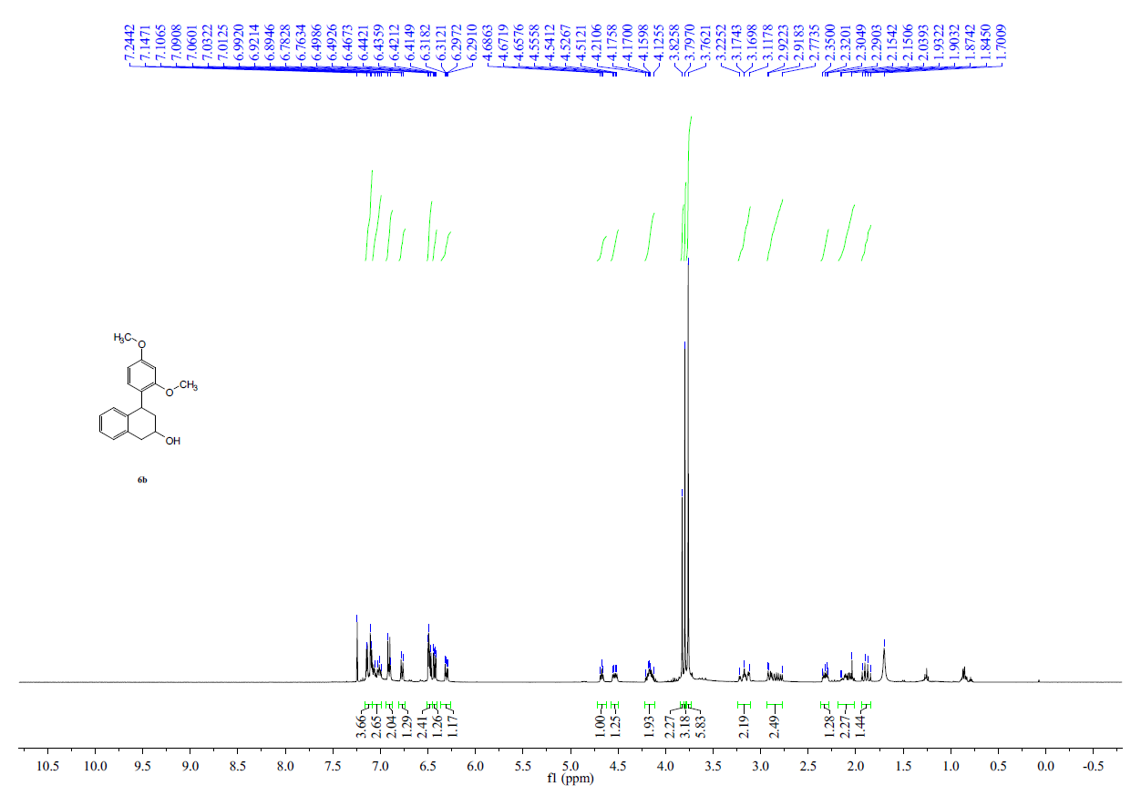

4-(2,4-Dimethoxyphenyl)-1,2,3,4-tetrahydronaphthalen-2-ol (6b) ¹³C NMR (CDCl₃, 101 MHz)
4-(2,4-Dimethoxyphenyl)-1,2,3,4-tetrahydronaphthalen-2-ol (6b)) HSQC
4-(2,4-Dimethoxyphenyl)-1,2,3,4-tetrahydronaphthalen-2-ol (6b) NOE
4-(4-Methoxy-3,5-dimethylphenyl)-1,2,3,4-tetrahydronaphthalen-2-ol (6c) ¹H NMR (CDCl₃, 400 MHz)
4-(4-Methoxy-3,5-dimethylphenyl)-1,2,3,4-tetrahydronaphthalen-2-ol (6c) ¹³C NMR (CDCl₃, 101 MHz)
4-(4-Methoxy-3,5-dimethylphenyl)-1,2,3,4-tetrahydronaphthalen-2-ol (6c) HSQC
4-(4-Methoxy-3,5-dimethylphenyl)-1,2,3,4-tetrahydronaphthalen-2-ol (6c) NOE
4-(2,5-Dimethoxyphenyl)-1,2,3,4-tetrahydronaphthalen-2-ol (6d) ¹H NMR (CDCl₃, 400 MHz)
4-(2,5-Dimethoxyphenyl)-1,2,3,4-tetrahydronaphthalen-2-ol (6d) ¹³C NMR (CDCl₃, 101 MHz)
4-(2,5-Dimethoxyphenyl)-1,2,3,4-tetrahydronaphthalen-2-ol (6d) HSQC
4-(2,5-Dimethoxyphenyl)-1,2,3,4-tetrahydronaphthalen-2-ol (6d) NOE
4-(2-Methoxy-5-methylphenyl)-1,2,3,4-tetrahydronaphthalen-2-ol (6e) ¹H NMR (CDCl₃, 400 MHz)
4-(2-Methoxy-5-methylphenyl)-1,2,3,4-tetrahydronaphthalen-2-ol (6e) ¹³C NMR (CDCl₃, 101 MHz)
4-(2-Methoxy-5-methylphenyl)-1,2,3,4-tetrahydronaphthalen-2-ol (6e) HSQC
4-(2-Methoxy-5-methylphenyl)-1,2,3,4-tetrahydronaphthalen-2-ol (6e) NOE
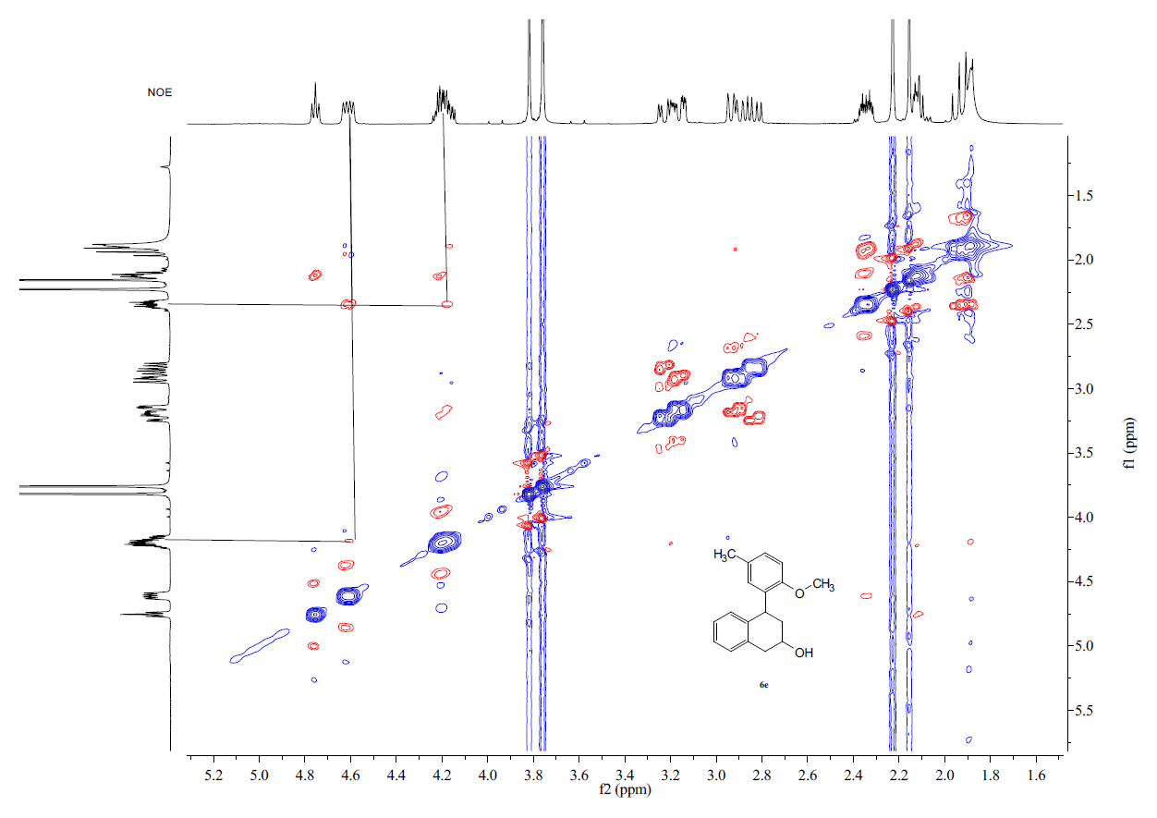
4-(Furan-2-yl)-1,2,3,4-tetrahydronaphthalen-2-ol (6f) ¹H NMR (CDCl₃, 400 MHz)
4-(Furan-2-yl)-1,2,3,4-tetrahydronaphthalen-2-ol (6f) ¹³C NMR (CDCl₃, 101 MHz)
4-(Furan-2-yl)-1,2,3,4-tetrahydronaphthalen-2-ol (6f) HSQC
4-(Furan-2-yl)-1,2,3,4-tetrahydronaphthalen-2-ol (6f) NOE
4-(5-Methylfuran-2-yl)-1,2,3,4-tetrahydronaphthalen-2-ol (6g) ¹H NMR (CDCl₃, 400 MHz)
4-(5-Methylfuran-2-yl)-1,2,3,4-tetrahydronaphthalen-2-ol (6g) ¹³C NMR (CDCl₃, 101 MHz)
4-(5-Methylfuran-2-yl)-1,2,3,4-tetrahydronaphthalen-2-ol (6g) HSQC
4-(5-Methylfuran-2-yl)-1,2,3,4-tetrahydronaphthalen-2-ol (6g) NOE

4-(Thiophen-2-yl)-1,2,3,4-tetrahydronaphthalen-2-ol (6h) ¹H NMR (CDCl₃, 400 MHz)
4-(Thiophen-2-yl)-1,2,3,4-tetrahydronaphthalen-2-ol (6h) ¹³C NMR (CDCl₃, 101 MHz)
4-(Thiophen-2-yl)-1,2,3,4-tetrahydronaphthalen-2-ol (6h) HSQC
4-(Thiophen-2-yl)-1,2,3,4-tetrahydronaphthalen-2-ol (6h) NOE
4-Allyl-1,2,3,4-tetrahydronaphthalen-2-ol (6i)¹H NMR (CDCl₃, 400 MHz)
4-Allyl-1,2,3,4-tetrahydronaphthalen-2-ol (6i)¹³C NMR (CDCl₃, 101 MHz)

4-Allyl-1,2,3,4-tetrahydronaphthalen-2-ol (6i)¹HSQC
4-Allyl-1,2,3,4-tetrahydronaphthalen-2-ol (6i) NOE
4-(3,4-Dimethoxyphenyl)-6-methoxy-1,2,3,4-tetrahydronaphthalen-2-ol (6j) ¹H NMR (CDCl₃, 400 MHz)
4-(3,4-Dimethoxyphenyl)-6-methoxy-1,2,3,4-tetrahydronaphthalen-2-ol (6j) ¹³C NMR (CDCl₃, 101 MHz)

4-(3,4-Dimethoxyphenyl)-6-methoxy-1,2,3,4-tetrahydronaphthalen-2-ol (6j) HSQC
4-(3,4-Dimethoxyphenyl)-6-methoxy-1,2,3,4-tetrahydronaphthalen-2-ol (6j) NOE
4-(Furan-2-yl)-6-methoxy-1,2,3,4-tetrahydronaphthalen-2-ol (6k) ¹H NMR (CDCl₃, 400 MHz)
4-(Furan-2-yl)-6-methoxy-1,2,3,4-tetrahydronaphthalen-2-ol (6k) ¹³C NMR (CDCl₃, 101 MHz)

4-(Furan-2-yl)-6-methoxy-1,2,3,4-tetrahydronaphthalen-2-ol (6k) HSQC
4-(Furan-2-yl)-6-methoxy-1,2,3,4-tetrahydronaphthalen-2-ol (6k) NOE
6-Chloro-4-(3,4-dimethoxyphenyl)-1,2,3,4-tetrahydronaphthalen-2-ol (6l) ¹H NMR (CDCl₃, 400 MHz)
6-Chloro-4-(3,4-dimethoxyphenyl)-1,2,3,4-tetrahydronaphthalen-2-ol (6l) ¹³C NMR (CDCl₃, 101 MHz)
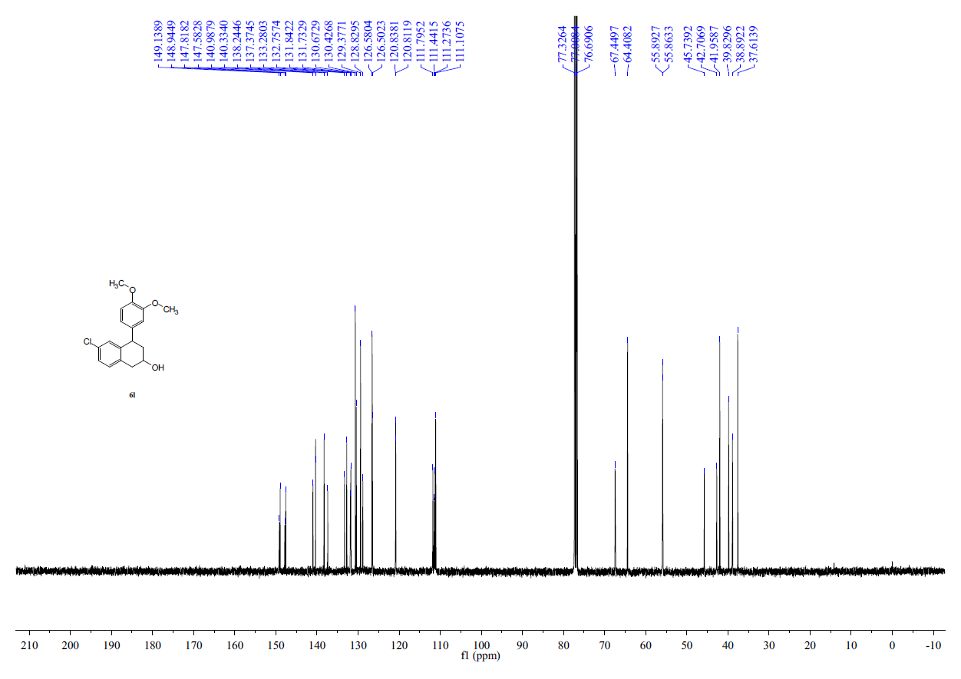

6-Chloro-4-(3,4-dimethoxyphenyl)-1,2,3,4-tetrahydronaphthalen-2-ol (6l) HSQC
6-Chloro-4-(3,4-dimethoxyphenyl)-1,2,3,4-tetrahydronaphthalen-2-ol (6l) NOE
6-Chloro-4-(furan-2-yl)-1,2,3,4-tetrahydronaphthalen-2-ol (6m) ¹H NMR (CDCl₃, 400 MHz)
6-Chloro-4-(furan-2-yl)-1,2,3,4-tetrahydronaphthalen-2-ol (6m) ¹³C NMR (CDCl₃, 101 MHz)

6-Chloro-4-(furan-2-yl)-1,2,3,4-tetrahydronaphthalen-2-ol (6m) HSQC
6-Chloro-4-(furan-2-yl)-1,2,3,4-tetrahydronaphthalen-2-ol (6m) NOE
4-(3,4-Dimethoxyphenyl)-6-nitro-1,2,3,4-tetrahydronaphthalen-2-ol (6n) ¹H NMR (CDCl₃, 400 MHz)
4-(3,4-Dimethoxyphenyl)-6-nitro-1,2,3,4-tetrahydronaphthalen-2-ol (6n) ¹³C NMR (CDCl₃, 101 MHz)

4-(3,4-Dimethoxyphenyl)-6-nitro-1,2,3,4-tetrahydronaphthalen-2-ol (6n) HSQC
4-(3,4-Dimethoxyphenyl)-6-nitro-1,2,3,4-tetrahydronaphthalen-2-ol (6n) NOE
4-(3,4-Dimethoxyphenyl)-1-methyl-1,2,3,4-tetrahydronaphthalen-2-ol (6o) ¹H NMR (CDCl₃, 400 MHz)
4-(3,4-Dimethoxyphenyl)-1-methyl-1,2,3,4-tetrahydronaphthalen-2-ol (6o) ¹³C NMR (CDCl₃, 101 MHz)
4-(Furan-2-yl)-1-methyl-1,2,3,4-tetrahydronaphthalen-2-ol (6p) ¹H NMR (CDCl₃, 400 MHz)
4-(Furan-2-yl)-1-methyl-1,2,3,4-tetrahydronaphthalen-2-ol (6p) ¹³C NMR (CDCl₃, 101 MHz)

4-(Furan-2-yl)-1-methyl-1,2,3,4-tetrahydronaphthalen-2-ol (6p) HSQC
4-(Furan-2-yl)-1-methyl-1,2,3,4-tetrahydronaphthalen-2-ol (6p) NOE
4-(3,4-Dimethoxyphenyl)-4-methyl-1,2,3,4-tetrahydronaphthalen-2-ol (6q) ¹H NMR (CDCl₃, 400 MHz)
4-(3,4-Dimethoxyphenyl)-4-methyl-1,2,3,4-tetrahydronaphthalen-2-ol (6q) ¹³C NMR (CDCl₃, 101 MHz)
4-(Furan-2-yl)-4-methyl-1,2,3,4-tetrahydronaphthalen-2-ol (6r) ¹H NMR (CDCl₃, 400 MHz)
4-(Furan-2-yl)-4-methyl-1,2,3,4-tetrahydronaphthalen-2-ol (6r) ¹³C NMR (CDCl₃, 101 MHz)

4-(Furan-2-yl)-4-methyl-1,2,3,4-tetrahydronaphthalen-2-ol (6r) HSQC
4-(Furan-2-yl)-4-methyl-1,2,3,4-tetrahydronaphthalen-2-ol (6r) NOE
4-(3,4-Dimethoxyphenyl)-1,2,3,4-tetrahydrophenanthren-2-ol (6s) ¹H NMR (CDCl₃, 400 MHz)
4-(3,4-Dimethoxyphenyl)-1,2,3,4-tetrahydrophenanthren-2-ol (6s) ¹³C NMR (CDCl₃, 101 MHz)

4-(3,4-Dimethoxyphenyl)-1,2,3,4-tetrahydrophenanthren-2-ol (6s) HSQC
4-(3,4-Dimethoxyphenyl)-1,2,3,4-tetrahydrophenanthren-2-ol (6s) NOE
4-(Furan-2-yl)-1,2,3,4-tetrahydrophenanthren-2-ol (6t) ¹H NMR (CDCl₃, 400 MHz)
4-(Furan-2-yl)-1,2,3,4-tetrahydrophenanthren-2-ol (6t) ¹³C NMR (CDCl₃, 101 MHz)

4-(Furan-2-yl)-1,2,3,4-tetrahydrophenanthren-2-ol (6t) HSQC
4-(Furan-2-yl)-1,2,3,4-tetrahydrophenanthren-2-ol (6t) NOE
2,2'-(2-(4-Nitro-2-vinylphenyl)ethane-1,1-diyl)difuran (7) ¹H NMR (CDCl₃, 400 MHz)
2,2'-(2-(4-Nitro-2-vinylphenyl)ethane-1,1-diyl)difuran (7) ¹³C NMR (CDCl₃, 101 MHz)
3-(2-Bromophenyl)propan-1-ol (9) ¹H NMR (CDCl₃, 400 MHz)
3-(2-Bromophenyl)propan-1-ol (9) ¹³C NMR (CDCl₃, 101 MHz)
3-(2-Vinylphenyl)propan-1-ol (10) ¹H NMR (CDCl₃, 400 MHz)
3-(2-Vinylphenyl)propan-1-ol (10) ¹³C NMR (CDCl₃, 101 MHz)
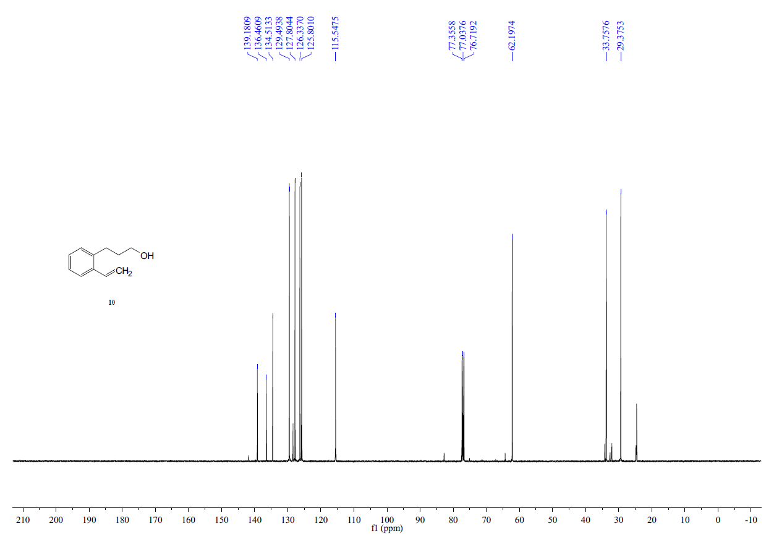
3-(2-Vinylphenyl)propanal (11) ¹H NMR (CDCl₃, 400 MHz)
3-(2-Vinylphenyl)propanal (11) ¹³C NMR (CDCl₃, 101 MHz)
5-(3,4-Dimethoxyphenyl)-6,7,8,9-tetrahydro-5H-benzo[7]annulen-7-ol (12a) ¹H NMR (CDCl₃, 400 MHz)
5-(3,4-Dimethoxyphenyl)-6,7,8,9-tetrahydro-5H-benzo[7]annulen-7-ol (12a) ¹³C NMR (CDCl₃, 101 MHz)

5-(3,4-Dimethoxyphenyl)-6,7,8,9-tetrahydro-5H-benzo[7]annulen-7-ol (12a) HSQC
5-(3,4-Dimethoxyphenyl)-6,7,8,9-tetrahydro-5H-benzo[7]annulen-7-ol (12a) NOE
5-(Furan-2-yl)-6,7,8,9-tetrahydro-5H-benzo[7]annulen-7-ol (12b) ¹H NMR (CDCl₃, 400 MHz)
5-(Furan-2-yl)-6,7,8,9-tetrahydro-5H-benzo[7]annulen-7-ol (12b) ¹³C NMR (CDCl₃, 101 MHz)

5-(Furan-2-yl)-6,7,8,9-tetrahydro-5H-benzo[7]annulen-7-ol (12b) HSQC
5-(Furan-2-yl)-6,7,8,9-tetrahydro-5H-benzo[7]annulen-7-ol (12b) NOE
4-(Furan-2-yl)-1,2,3,4-tetrahydronaphthalen-2-yl-4-methylbenzenesulfonate (13) ¹H NMR (CDCl₃, 400 MHz)
4-(Furan-2-yl)-1,2,3,4-tetrahydronaphthalen-2-yl-4-methylbenzenesulfonate (13) ¹³C NMR (CDCl₃, 101 MHz)

4-(Furan-2-yl)-1,2,3,4-tetrahydronaphthalen-2-yl-4-methylbenzenesulfonate (13) HSQC
4-(Furan-2-yl)-1,2,3,4-tetrahydronaphthalen-2-yl-4-methylbenzenesulfonate (13) NOE
4-(Furan-2-yl)-N,N-dimethyl-1,2,3,4-tetrahydronaphthalen-2-amine hydrochloride (14) ¹H NMR (CDCl₃, 400 MHz)
4-(Furan-2-yl)-N,N-dimethyl-1,2,3,4-tetrahydronaphthalen-2-amine hydrochloride (14) ¹³C NMR (CDCl₃, 101 MHz)

- X-ray Crystal for compound 13
(anisotropic displacement parameters for ellipsoid contours are shown at 50% probability for all atoms except H)
The crystallographic data have been deposited with the Cambridge Crystallographic Data Centre (CCDC) as CCDC-2060394. CCDC information can be obtained free of charge from www.ccdc.cam.ac.uk. The detailed crystallographic data are summarized in Tables S1 and Table S2.

Table S1 Crystal data and structure refinement for 13.
Identification code | 13
Empirical formula | C₂₁H₂₀O₄S
Formula weight | 368.43
Temperature | 170 K
Wavelength | 0.71073 Å
Crystal system | triclinic
Space group | P-1
Unit cell dimension | a = 7.8180(6) Å
Unit cell dimension | b = 11.0040(9) Å
Unit cell dimension | c = 14.0257(12) Å
Unit cell dimension | α = 106.509(3)°
Unit cell dimension | β = 100.628(2)°
Unit cell dimension | γ = 104.333(3)°
Volume | 1077.88(15) Å³
Z | 2
Density (calculated) | 1.135 Mg/m³
Absorption coefficient | 0.170 mm⁻¹
F(000) | 388.0
Crystal size | 0.15 × 0.08 × 0.05 mm³
RadiationTheta range for data collection | 4.198 to 52.826°
Index ranges | -26 ≤ h ≤ 13
Index ranges | -14 ≤ k ≤ 14
Index ranges | -22 ≤ l ≤ 23
Reflections collected | 4285
Independent reflections | 4285 [Rsigma = 0.0534]
Goodness-of-fit on F² | 1.086
Final R indexes [I>=2σ (I)] | R₁ = 0.0574, wR₂ = 0.1352
Final R indexes [all data] | R₁ = 0.0882, wR₂ = 0.1516
Data/restraints/parameters | 4285/377/263
Largest diff. peak/hole | 0.29/-0.28 e. Å⁻³

Table S2 Datablock: 13
Bond precision: | C-C = 0.0040 A Wavelength=0.71073
Cell: | a=7.8180(6) b=11.0040(9) c=14.0257(12)
Cell: | alpha=106.509(3) beta=100.628(2) gamma=104.333(3)
Temperature: | 170 K
Calculated Reported
Volume | 1077.89(16) 1077.88(15)
Space group | P -1 P -1
Hall group | -P 1 -P 1
Moiety formula | C21 H20 O4 S [+ solvent] C21 H20 O4 S
Sum formula | C21 H20 O4 S [+ solvent] C21 H20 O4 S
Mr | 368.43 368.43
Dx,g cm-3 | 1.135 1.135
Z | 2 2
Mu (mm-1) | 0.170 0.170
F000 | 388.0 388.0
F000’ | 388.43
h,k,lmax | 9,13,17 0,0,0
Nref | 4419 4285
Tmin,Tmax | 0.984,0.992 0.668,0.745
Tmin’ | 0.975
Correction method= | MULTI-SCAN
Data completeness= 0.970 Theta(max)= 26.413
R(reflections)= 0.0574 (2988) wR2(reflections)= 0.1516 (4285)
S = 1.086 Npar= 263

- Reference
1. Atienza, B. J. P.; Truong, N.; Williams, F. J. Reliably Regioselective Dialkyl Ether Cleavage with Mixed Boron Trihalides. Org. Lett. 2018, 20, 6332–6335. doi: 10.1021/acs.orglett.8b02356.
2. Yang, X.-Y.; Lin, H.-S.; Matsuo, Y. Highly Selective Synthesis of Tetrahydronaphthaleno 60 fullerenes via Fullerene-Cation-Mediated Intramolecular Cyclization. J. Org.Chem. 2019, 84, 16314–16322. doi: 10.1021/acs.joc.9b02618.
3. Dai, X.-J.; Engl, O. D.; León, T.; Buchwald, S. L. Catalytic asymmetric synthesis of α-arylpyrrolidines and benzo-fused nitrogen heterocycles. Angew. Chem. Int. Ed. 2019, 58, 3407–3411. doi: 10.1002/anie.201814331.
4. Kita, Y.; Yata, T.; Nishimoto, Y.; Yasuda, M. Indium Catalyzed Hydrofunctionalization of Styrene Derivatives Bearing a Hydroxy Group with Organosilicon Nucleophiles. J. Org.Chem. 2018, 83, 740–753. doi: 10.1021/acs.joc.7b02739.
5. Fustero, S.; Rodríguez, E.; Lázaro, R.; Herrera, L.; Catalán, S.; Barrio, P. Relay catalysis: enantioselective synthesis of cyclic benzo-fused homoallylic alcohols by chiral brønsted acid-catalyzed allylboration/ring closing metathesis. Adv. Synth. Catal. 2013, 355, 1058–1064. doi: 10.1002/adsc.201201095.

