Supporting Information

Particle size effect in the mechanically assisted synthesis of β-cyclodextrin mesitylene sulfonate

Stéphane Menuel, Sébastien Saitzek, Eric Monflier, Frédéric Hapiot*
Univ. Artois, CNRS, Centrale Lille, Univ. Lille, UMR 8181 – UCCS – Unité de Catalyse et Chimie du Solide, F-62300 Lens, France.

 | Page
Determination of α | 2
Solid-state kinetics models | 3
General procedure for the synthesis of mono-6-O-(2-mesitylenesulfonyl)-β-cyclodextrin | 5

Determination of α

α is defined by: with n_{t} the conversion at time t, and n∞ the final conversion.
$α=\frac{nt}{n_{∞}}$

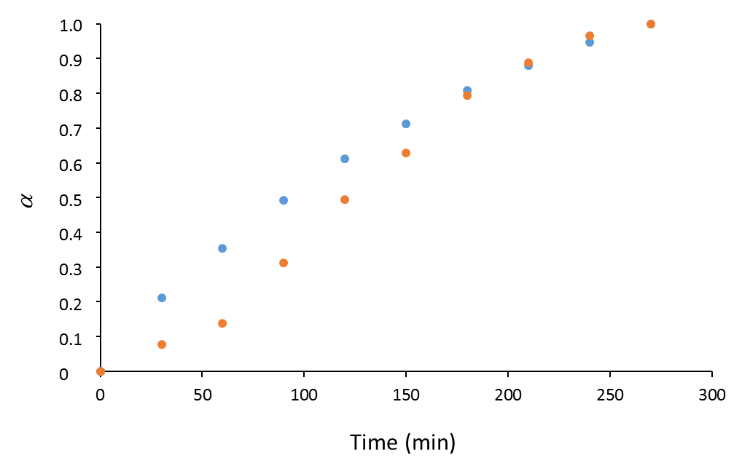
Fig. S1 Compared values of α against time in the synthesis of β-CDMts without grinding β-CD () and with ground β-CD (~235 nm) ().

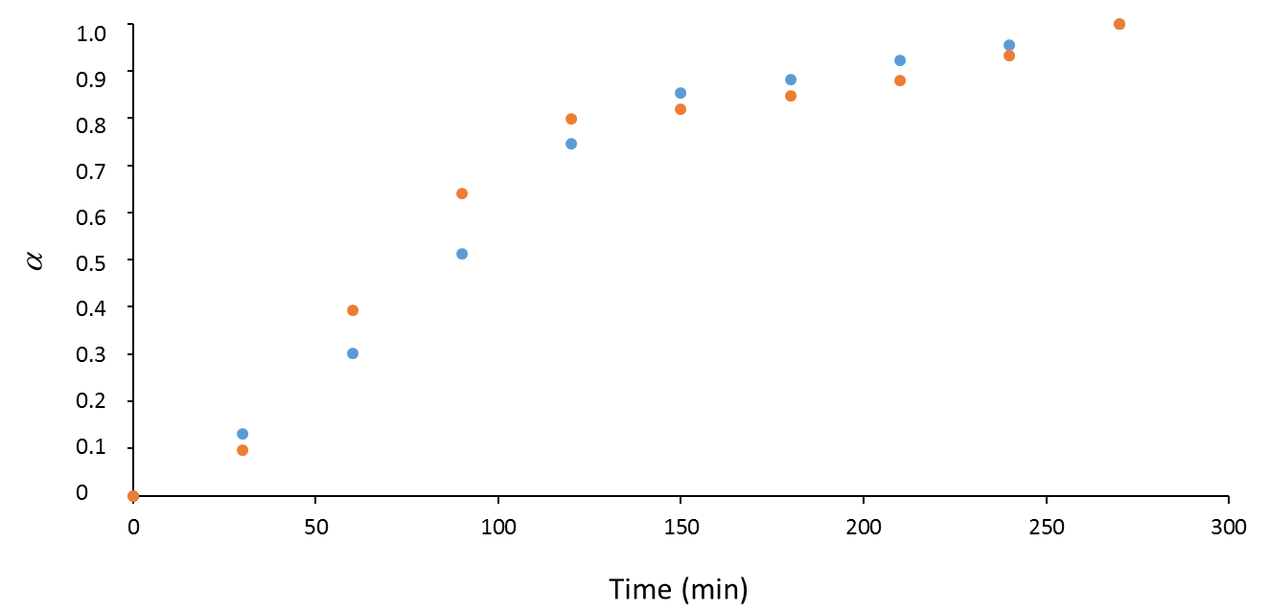

Fig. S2 Compared values of α against time in the synthesis of β-CDMts in the presence of KOH (1 equiv. with respect to β-CD) without grinding β-CD () and with ground β-CD (~235 nm) ().
Solid-state kinetics models
Table S1 Solid-State Rate and Integral Expressions for Different Reaction Models.
Model | Abbreviation | Integral form: g(α) = k.t
nucleation models
power law | P2 | α1/2
power law | P3 | α1/3
power law | P4 | α1/4
Avrami-Erofeev | A2 | [-ln(1-α)]1/2
Avrami-Erofeev | A3 | [-ln(1-α)]1/3
Avrami-Erofeev | A4 | [-ln(1-α)]1/4
Prout-Tompkins | B1 | ln[α/(1-α)] + cª
geometrical contraction models
contracting area | R2 | 1-(1-α)1/2
contracting volume | R3 | 1-(1-α)1/3
diffusion models
1-D diffusion | D1 | α2
2-D diffusion | D2 | ((1-α)ln(1-α))+α
3-D diffusion-Jander | D3 | (1-(1-α)1/3)2
Ginstling-Brounshtein | D4 | 1-(2/3)α-(1-α)2/3
reaction-order models
zero-order | F0/R1 | α
first-order | F1 | -ln(1-α)
second-order | F2 | [1/(1-α)]-1
third-order | F3 | (1/2)[(1-α)-2-1]
ª Constant of integration.

Table S2 Solid-state kinetics model for the synthesis of β-CDMts without base.

Table S3 Solid-state kinetics model for the synthesis of β-CDMts in the presence of KOH (1 equiv. with respect to β-CD).

General procedure for the synthesis of mono-6-O-(2-mesitylenesulfonyl)-β-cyclodextrin
β-cyclodextrin (1500 mg, 1.32 mmol) and 2-mesitylenesulfonyl chloride (290 mg, 1.32 mmol) were placed in a 10 mL zirconium oxide reactor containing one zirconium oxide ball of 9 mm diameter. The solid mixture was shaken for 5 min at 30 Hz. Shaking was then stopped for 5 min. The procedure was repeated 54 times for a total grinding time of 270 min. The reactor was opened every 3 cycles to limit agglomeration of the powder. The resulting powder was purified by flash chromatography on silica gel using acetonitrile/water (9/1 to 8/2 v/v) as mobile phase. Isolated yield 21% (364mg). ¹H NMR (300 MHz, DMSO-d6, 298 K) : δ 7.10 (m, 2H), 5.54-5.38 (m, 14H), 4.80 (m, 6H), 4.62 (dd, J=9.7Hz, J=3.4Hz, 1H), 4.53-4.47 (m, 3H), 4.44-4.38 (m, 1H), 4.32-4.21 (m, 6H), 3.85-3.53 (m, 28H), 3.47-3.34 (m, overlapped with water peak), 3.08-2.99 (m, 1H), 2.53.(s, overlapped with DSMO peak), 2.29 (s, 3H) ; MALDI-TOF: 1340.5 D (calcul. for M+Na⁺ 1340.2 D).

A. Khawam, D. R. Flanagan, J. Phys. Chem. B 2006, 110, 17315-17328.

