Supporting Information
for
Conformational Preferences of Fluorine-Containing Agrochemicals and their Implications for Lipophilicity Prediction

Daniela Rodrigues Silva‡, Joyce K. Daré‡, Matheus P. Freitas*

Address: Department of Chemistry, Federal University of Lavras, 37200–900, Lavras–MG, Brazil

E-mail: Matheus Puggina de Freitas – matheus@ufla.br
* Corresponding author
‡ Equal contributors

Table of contents

Figure S1. Correlation between the experimental log P of agrochemicals I–VII and predicted log P (ACD/Labs).

Monte Carlo conformational search

Cartesian coordinates and energies of the conformers analyzed herein

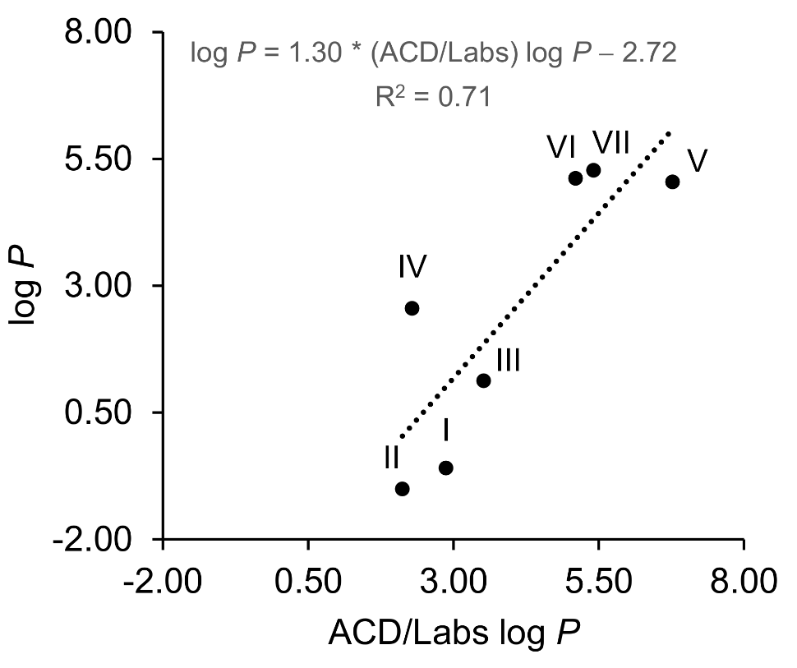
Figure S1. Correlation between the experimental log P of agrochemicals I–VII and predicted log P (ACD/Labs).

Monte Carlo conformational search

Table S1. Structures, relative conformational energies referenced to the global energy minimum (in kcal mol^{–1}) and Boltzmann population (in %) of the main conformations (i.e. those with a population ≥5%) of agrochemicals I–VII obtained in the gas phase conformational search at the ωB97X-D/6-31G(d,p) level.
Comp. | Conformation | ΔE | Pop
I | 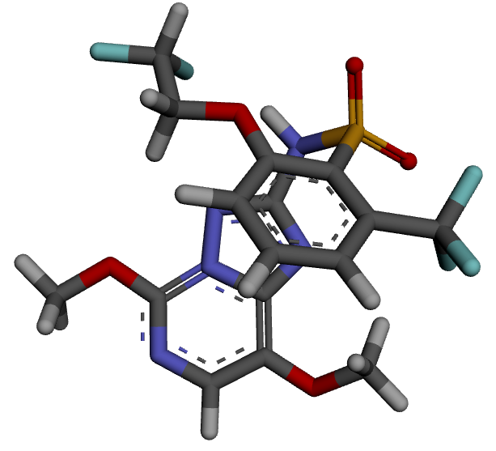 | 0.00 | 35
I | 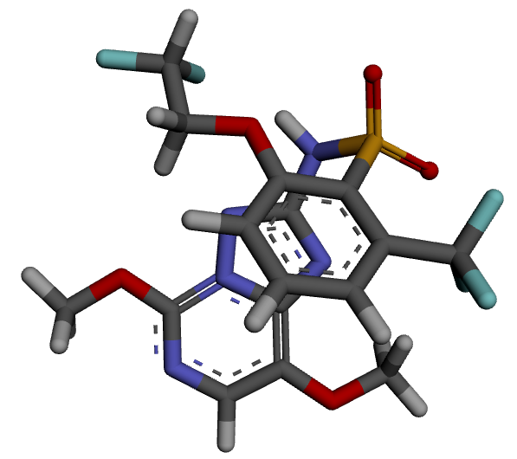 | 0.39 | 18
I | 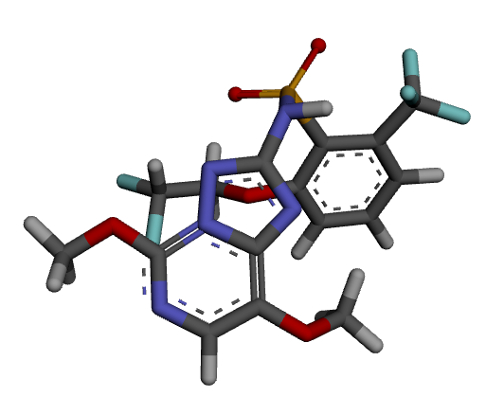 | 0.83 | 9
I | 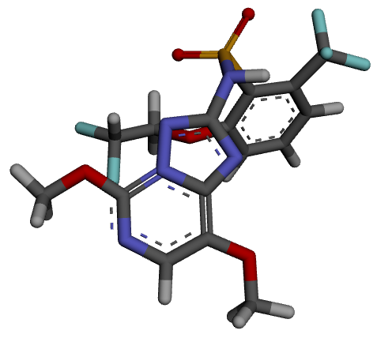 | 1.19 | 5
II | 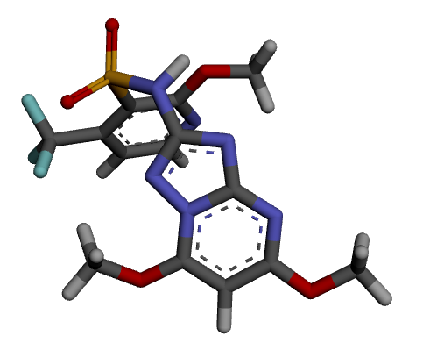 | 0.00 | 66
II | 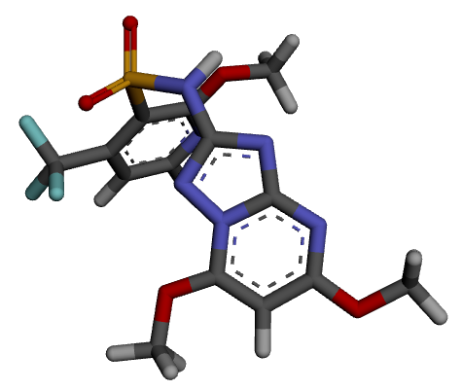 | 0.52 | 28
II | 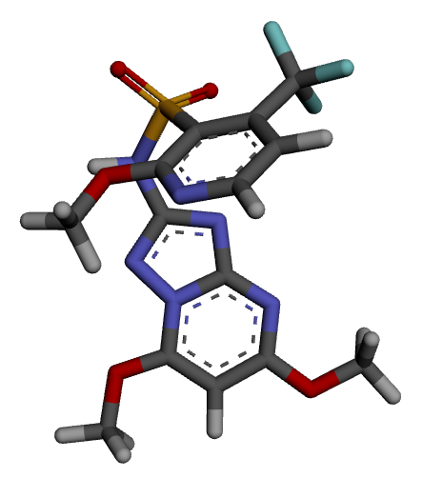 | 1.43 | 6
III | 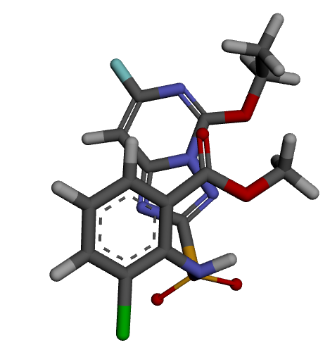 | 0.00 | 45
III | 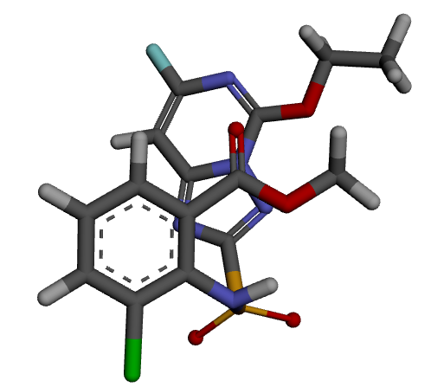 | 0.47 | 20
III | 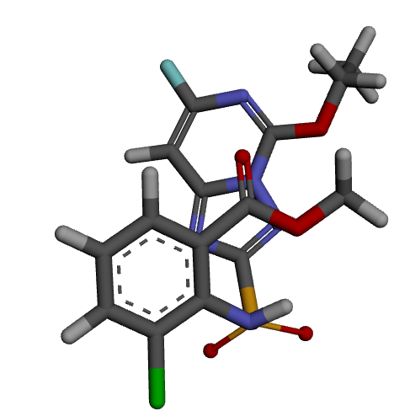 | 0.64 | 15
III | 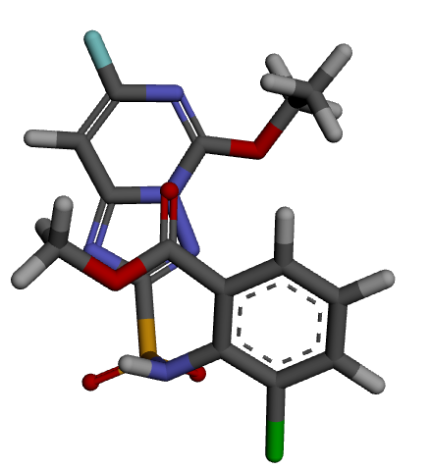 | 0.94 | 9
III | 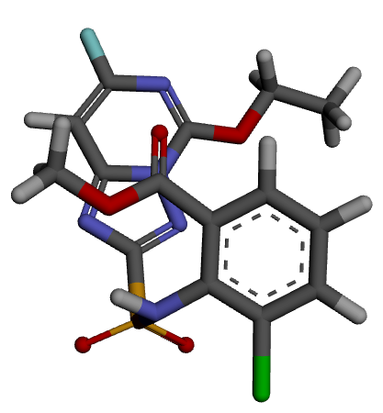 | 1.33 | 5
IV | 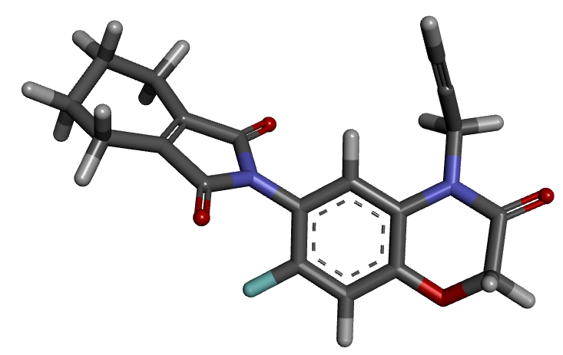 | 0.00 | 39
IV | 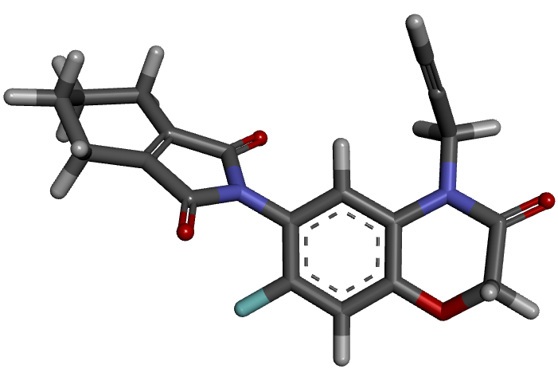 | 0.02 | 38
IV | 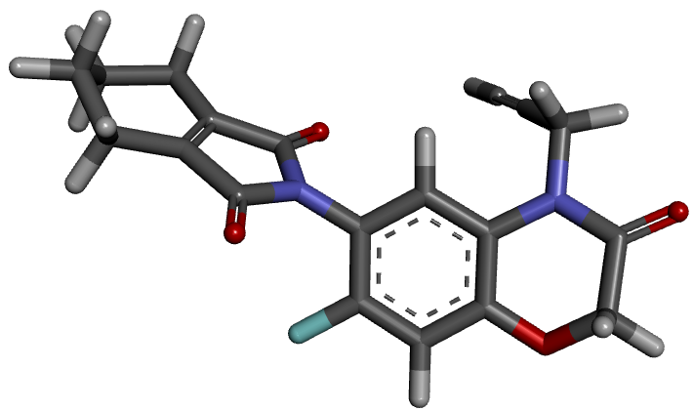 | 0.74 | 11
IV | 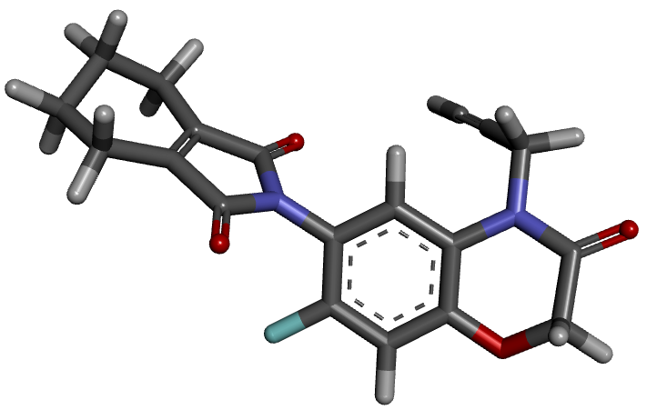 | 0.74 | 11
V | 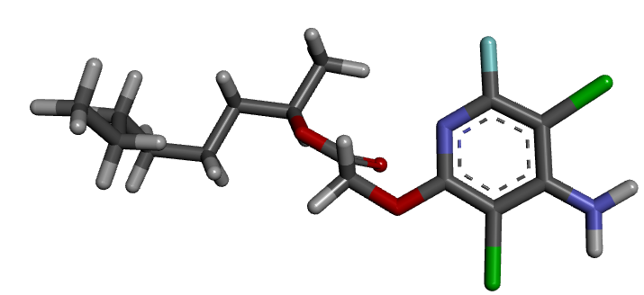 | 0.00 | 43
V | 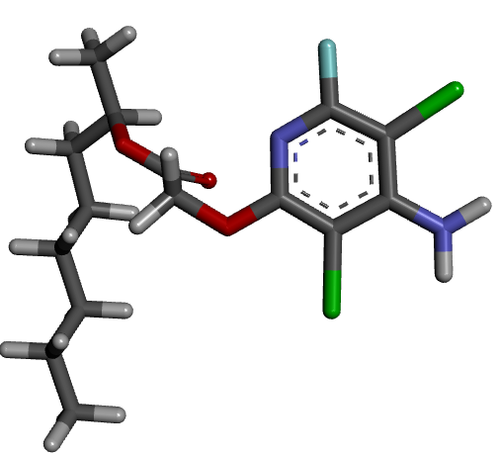 | 0.92 | 9
V | 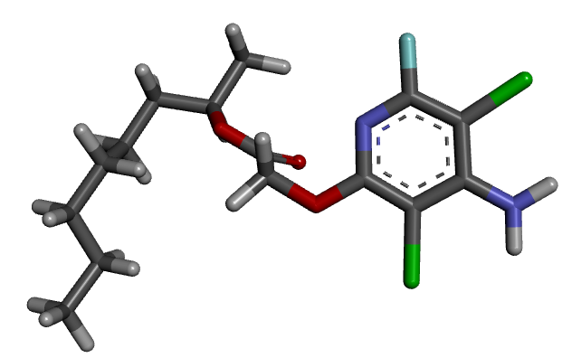 | 1.01 | 8
V | 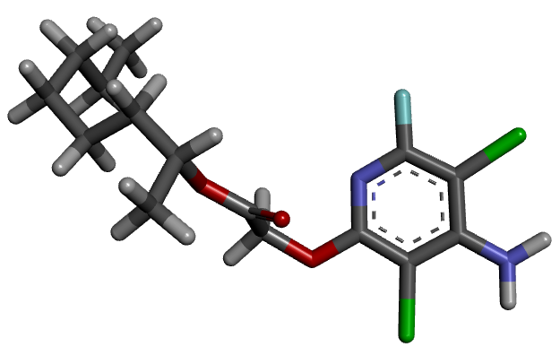 | 1.05 | 7
V | 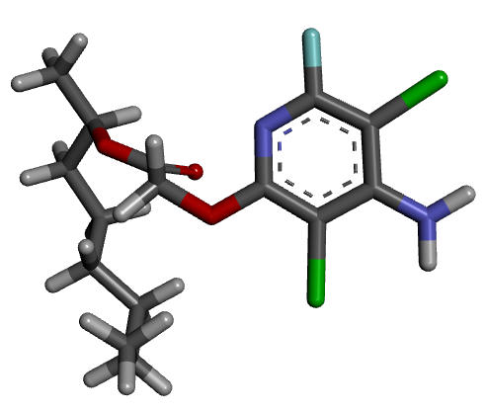 | 1.15 | 6
VI | 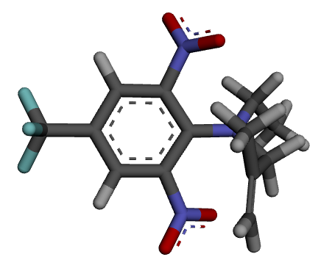 | 0.00 | 35
VI | 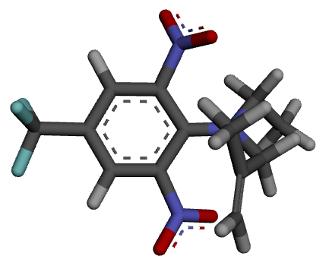 | 0.07 | 31
VI | 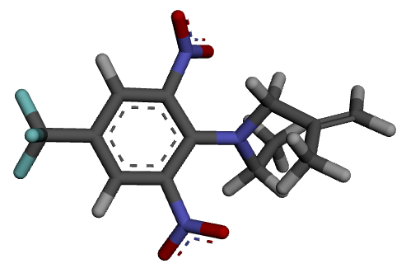 | 0.36 | 19
VI | 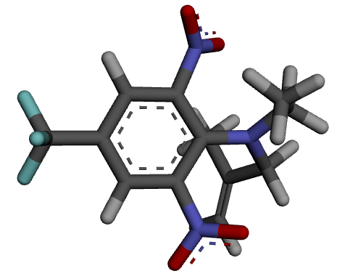 | 1.12 | 5
VII | 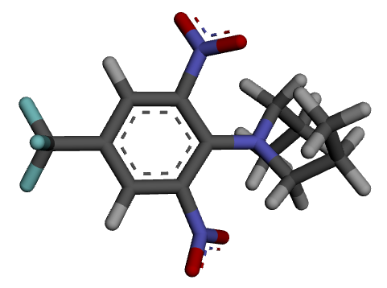 | 0.00 | 18
VII | 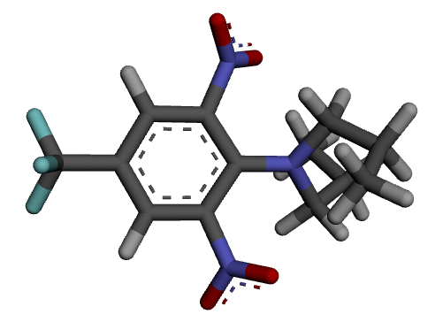 | 0.03 | 17
VII | 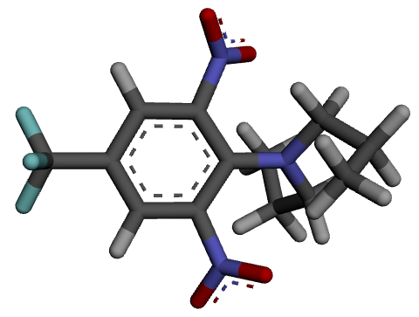 | 0.36 | 10
VII | 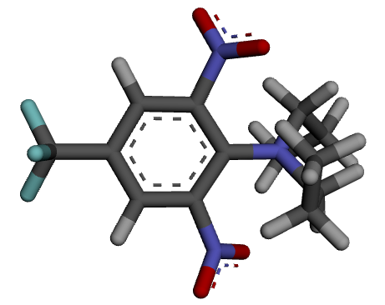 | 0.38 | 9
VII | 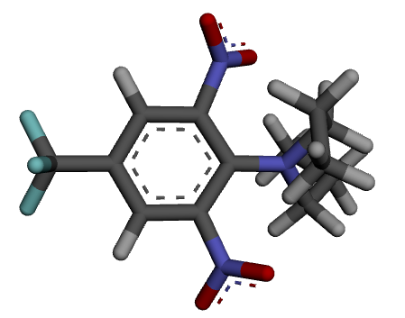 | 0.41 | 9
VII | 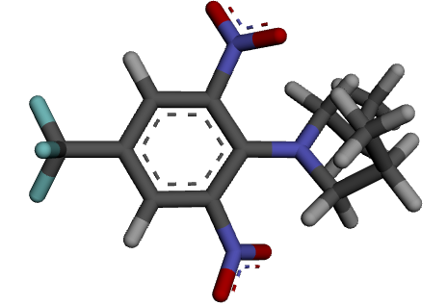 | 0.52 | 7
VII | 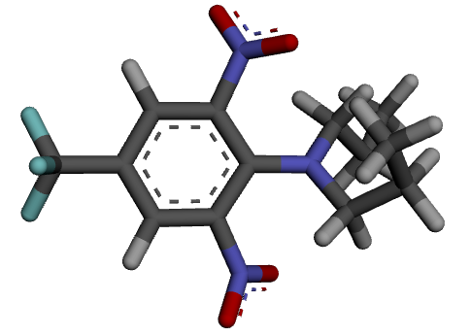 | 0.53 | 7

Cartesian coordinates and energies of the conformers analyzed herein

Cartesian coordinates (Å), energies (hartree), and the number of imaginary frequencies of the conformers of agrochemicals I–VII and compounds 1–11 analyzed herein at the ωB97X-D/6-311++G(d,p) level.

Agrochem. I_{gg}:

C -1.24517900 -1.80516000 -0.83753500
C -1.51138600 -3.16716300 -0.52113500
C -2.73107400 -3.42607700 0.04038300
C -3.41500900 -1.24521400 0.02691800
C -0.60733100 0.10720100 -1.37398100
H -2.99047400 -4.44746400 0.29202100
O -4.23329000 -0.23357800 0.26489100
O -0.66546400 -4.17563700 -0.79861300
N -3.67444000 -2.47691700 0.30453600
N -2.22382400 -0.88635300 -0.53665000
N -1.80595900 0.36200200 -0.86641700
N -0.21436300 -1.18116800 -1.38491600
C -5.50176400 -0.57093700 0.83232500
H -6.02370700 0.37686600 0.94018900
H -6.05120400 -1.23977000 0.16851600
H -5.37037000 -1.05374200 1.80191700
C 0.73206900 -3.93782300 -0.59365000
H 1.21348000 -4.90491400 -0.72285600
H 1.12139900 -3.21756400 -1.31184500
H 0.90822400 -3.57157700 0.42301700
N 0.20975800 1.14340000 -1.80466300
H -0.22559900 2.05329400 -1.68516100
S 1.80847600 1.19479100 -1.24250500
O 2.54033900 0.16452000 -1.92029500
O 2.19200200 2.57972800 -1.32567800
C 1.59882600 0.68762600 0.49395100
C 0.56460900 1.31778000 1.20876100
C 2.29082000 -0.37487300 1.09295100
C 0.13853500 0.80702600 2.43202700
C 1.87036300 -0.85621100 2.32826600
C 0.78256800 -0.28928700 2.97342500
H -0.68528200 1.26653800 2.96133700
H 2.40649200 -1.67052700 2.79407100
H 0.45320000 -0.69004600 3.92463400
C 3.54496400 -1.02106300 0.51191000
F 4.38846200 -0.11858600 0.01282800
F 3.28046800 -1.93972600 -0.41838000
F 4.22152800 -1.66685300 1.48815800
O 0.02200900 2.41634900 0.64865600
C -1.24349400 2.86527300 1.07586200
H -1.98426800 2.06489400 0.97627400
H -1.21286600 3.24230300 2.10401100
C -1.64483800 4.01246600 0.17571300
H -2.67347500 4.32893000 0.36838400
F -1.55670100 3.64573400 -1.13443600
F -0.82711200 5.07798000 0.35333100

Total energy = -2165.255461
Number of imaginary frequencies = 0

Agrochem. I_{ag}:

C 0.82313800 1.97944300 -0.81608400
C 0.83705500 3.36206100 -0.47878000
C 2.00503200 3.84067400 0.04798100
C 3.09079700 1.83118200 -0.03208200
C 0.54792700 -0.01078500 -1.37426700
H 2.07576400 4.88930700 0.31107700
O 4.09222500 0.99005800 0.15260500
O -0.19337000 4.19722900 -0.70608500
N 3.12120300 3.08646400 0.26103100
N 1.96768300 1.26027600 -0.56061800
N 1.78604300 -0.03980400 -0.90322800
N -0.08635600 1.17697300 -1.34812800
C 5.30511800 1.55370000 0.65853100
H 5.99983100 0.71978500 0.72218200
H 5.68147900 2.31708800 -0.02392400
H 5.13977800 1.99843500 1.64098900
C -1.51344200 3.69307600 -0.47869500
H -2.17142400 4.55706000 -0.54709700
H -1.78672700 2.94555600 -1.22203200
H -1.58606000 3.25461500 0.52221800
N -0.06107300 -1.18096300 -1.80889100
H 0.54820900 -1.98679200 -1.71140700
S -1.61285100 -1.55147500 -1.23802000
O -2.54446200 -0.70518500 -1.92421600
O -1.70280200 -2.98835400 -1.30522300
C -1.50830100 -0.98952700 0.48906500
C -0.37229900 -1.39951300 1.20854900
C -2.38427800 -0.06229000 1.06995600
C -0.03698800 -0.78742100 2.41274100
C -2.05321200 0.51740700 2.28981000
C -0.87263400 0.18273600 2.93462800
H 0.86435400 -1.07156600 2.93955600
H -2.73149600 1.22585500 2.74331000
H -0.61830400 0.66232100 3.87225200
C -3.74204600 0.32345300 0.49023000
F -4.40379100 -0.73347600 0.02002300
F -3.66442700 1.25401400 -0.46138400
F -4.52026500 0.85053700 1.46203400
O 0.35000700 -2.39865900 0.66585000
C 1.67599600 -2.63391400 1.08807700
H 2.29395200 -1.74204700 0.94264800
H 1.71476500 -2.97607100 2.12740800
C 2.18478300 -3.74887700 0.19918800
H 1.57669700 -4.65471500 0.24364500
F 3.45602000 -4.04779900 0.57201400
F 2.21909000 -3.33494400 -1.09826700

Total energy = -2165.257772
Number of imaginary frequencies = 0

Agrochem. I_{ga}:

C -1.14331200 -1.86663600 -0.62430500
C -1.30695900 -3.18075800 -0.10623100
C -2.56637400 -3.50436800 0.32115300
C -3.47120600 -1.46679400 -0.18111600
C -0.63617500 0.00583100 -1.38774500
H -2.74990500 -4.49478600 0.72022200
O -4.41658200 -0.54807000 -0.25323800
O -0.32662500 -4.10124200 -0.07064400
N -3.63666900 -2.66192300 0.27463900
N -2.24854500 -1.04821400 -0.62342800
N -1.91884500 0.17828200 -1.10560200
N -0.10971800 -1.20392600 -1.12358100
C -5.72070300 -0.94368200 0.18242300
H -6.34479800 -0.06594100 0.03459800
H -6.08263800 -1.78152200 -0.41501200
H -5.69975000 -1.23153400 1.23453700
C 1.00760800 -3.65206500 0.18895500
H 1.58498300 -4.55618800 0.37151100
H 1.41481000 -3.10515600 -0.66023300
H 1.03107800 -3.01370200 1.07855000
N 0.11310900 1.05746800 -1.88673800
H -0.36680400 1.94740000 -1.83604800
S 1.72676400 1.25182100 -1.42580300
O 2.49045400 0.26760300 -2.13388800
O 1.97355500 2.66380100 -1.57445300
C 1.73723800 0.82413400 0.34281200
C 0.71620000 1.35879800 1.15153900
C 2.69866400 -0.01637600 0.92665500
C 0.62595900 1.00653900 2.49667300
C 2.58689400 -0.35873800 2.27022900
C 1.55164500 0.13888400 3.04239900
H -0.15416800 1.41999300 3.12089400
H 3.32931200 -1.00277600 2.71789900
H 1.47947300 -0.13289400 4.08865900
C 3.92516200 -0.57450000 0.20701700
F 4.57794800 0.36395800 -0.47764300
F 3.63132000 -1.59322200 -0.60222100
F 4.80880000 -1.06039600 1.10613800
O -0.16072800 2.20497300 0.57096700
C -1.33800600 2.55977700 1.26545500
H -1.81668800 1.67780300 1.70272200
H -1.12775600 3.30004600 2.04462900
C -2.30576800 3.15144400 0.26118200
H -2.59910800 2.44469100 -0.51658400
F -1.77438800 4.25721200 -0.31854800
F -3.41783400 3.53557800 0.95082500

Total energy = -2165.256929
Number of imaginary frequencies = 0

Agrochem. II:

C -1.99701300 0.30844900 2.48681000
C -2.33559000 0.31751200 1.13492600
C -1.91355500 -0.74228300 0.33340400
C -1.22192800 -1.79975800 0.97160800
C -1.25215800 -0.74358600 2.98181700
H -2.31113400 1.10857300 3.14009500
H -0.94985700 -0.76145000 4.02414600
N -0.87852700 -1.78519500 2.24661100
O -0.89252000 -2.85644000 0.23385900
C -0.00957100 -3.82802700 0.80133000
H -0.44342000 -4.26468000 1.70070100
H 0.11144800 -4.58175200 0.02675200
H 0.95179200 -3.36712600 1.03250700
S -2.11363800 -0.83057400 -1.46649500
O -2.95919800 -1.94735500 -1.80318600
O -2.37626900 0.49418200 -1.95253800
N -0.57955900 -1.26970300 -1.99781600
H -0.48741700 -2.27780200 -2.00974800
C 0.55027900 -0.66296900 -1.46069500
C 2.48879300 -0.49148000 -0.69930900
C 2.42224600 1.83487200 -0.08677000
C 3.69286800 1.67388700 0.39424200
C 4.29619000 0.39695700 0.29079800
H 4.21830600 2.50880500 0.83107900
N 0.57093500 0.61246500 -1.12764600
N 1.66415800 -1.38639800 -1.22752200
N 1.83553400 0.72916300 -0.63467100
N 3.73167700 -0.66234500 -0.24233600
O 1.78031300 2.98154900 0.02413700
O 5.53224400 0.30892200 0.77439900
C 0.89189900 3.44400200 -1.01795300
H -0.05842100 2.91962800 -0.97698300
H 0.76857600 4.50569000 -0.81769500
H 1.35685600 3.29885000 -1.99473400
C 6.19613300 -0.95058400 0.66616600
H 7.17205500 -0.79702100 1.12143500
H 5.64174400 -1.72599200 1.19709500
H 6.30129000 -1.24034300 -0.38061100
C -3.17867300 1.49806600 0.65698600
F -2.45911000 2.39368100 -0.02136700
F -4.21550100 1.10940700 -0.08142800
F -3.69419000 2.15476500 1.71613000

Total energy = -1943.511695
Number of imaginary frequencies = 0

Agrochem. III:

S -1.88784000 -1.28379500 -1.50693300
N -2.34867200 -1.22622300 0.11041500
H -1.85524900 -1.96505200 0.60047200
C -2.30095500 0.01249800 0.80581400
C -3.38561900 0.89225000 0.73476900
C -1.17463200 0.40159500 1.55782400
C -3.33210900 2.14076500 1.34254600
C -1.13140800 1.65507100 2.15982800
C -2.20269400 2.52561400 2.04617300
H -4.18784500 2.79937400 1.26370800
H -0.24339100 1.93205300 2.71421000
H -2.16599800 3.50054200 2.51668400
O -1.65648500 -2.67967100 -1.77545300
O -2.77398000 -0.47042900 -2.28875400
Cl -4.85249200 0.43223500 -0.06486100
C 0.03523300 -0.45481900 1.76386900
O 1.14650800 -0.01050300 1.91620200
O -0.24427900 -1.76069500 1.80726100
C 0.87725000 -2.64973200 1.91232200
H 1.42232600 -2.45377000 2.83650100
H 0.45017100 -3.64947700 1.92361700
H 1.52878200 -2.51788900 1.04815300
C -0.30267300 -0.43178400 -1.48260400
C 1.06882400 1.12836300 -1.42924100
C 2.97028600 -0.10507500 -0.63088200
C 1.84890500 2.30173300 -1.40990800
C 3.12875000 2.12484300 -0.98426600
H 1.44201000 3.26040200 -1.69006600
N 0.77946300 -1.07299200 -1.09143300
N -0.20471100 0.89151700 -1.70512600
N 1.67523500 -0.05820200 -1.06547300
N 3.69241900 0.97125100 -0.59890700
F 3.94542100 3.16873800 -0.91619400
O 3.38778200 -1.29101800 -0.27971800
C 4.69448600 -1.39270300 0.34055700
H 5.39476300 -0.77211300 -0.21937200
H 4.95082500 -2.44250400 0.20771100
C 4.63111500 -1.00351000 1.80132100
H 5.61067000 -1.16689400 2.25733200
H 4.36733900 0.04812300 1.91760200
H 3.89356600 -1.60829800 2.33140200

Total energy = -2187.404926
Number of imaginary frequencies = 0

Agrochem. IV:

C 0.40797200 -2.08873100 -0.22931200
C 1.73450200 -2.47270100 -0.26280800
C 2.71274700 -1.49400600 -0.23171500
C 2.37302600 -0.13758200 -0.16955500
C 1.03431900 0.21618800 -0.08943200
C 0.04118200 -0.75542000 -0.12647200
H 2.00830500 -3.51721200 -0.32800600
H 0.73557100 1.25216100 -0.00153700
C 4.90012500 -1.00193000 0.38131700
H 5.91192300 -1.28495200 0.10272900
N 3.41086800 0.81774500 -0.23755400
C 3.11655600 2.21601700 -0.52632700
H 4.04948700 2.67549300 -0.85525400
H 2.40119600 2.26012100 -1.35198600
C 2.59642400 2.94712300 0.63143400
C 2.16233700 3.54069300 1.57799400
H 1.78685700 4.06775000 2.42246000
C 4.70700100 0.46530800 0.04315200
O 5.62856800 1.25023300 0.05397100
O 4.01592600 -1.86359900 -0.31491300
H 4.77533500 -1.12796100 1.46527100
C -3.40694900 0.45580600 -0.61470500
C -3.52704500 -0.13494600 0.57494400
C -4.50620400 1.15486100 -1.33862200
C -4.78301700 -0.20739000 1.37308500
C -5.67066000 1.41270900 -0.37221300
H -4.13302500 2.08546800 -1.77499300
C -5.97740200 0.18159800 0.49035700
H -4.90373400 -1.21026000 1.79181800
H -6.55946500 1.71008600 -0.93379400
H -6.22795800 -0.66076700 -0.16467300
C -1.99417200 0.32237100 -1.08298400
C -2.19972900 -0.69378600 0.97674400
O -1.50165600 0.73934600 -2.09652800
O -1.90806700 -1.27576800 1.98455000
N -1.32122500 -0.38725600 -0.07655000
F -0.54232700 -3.02750700 -0.29621000
H -4.83124200 0.53404600 -2.18205200
H -5.41196300 2.25337500 0.28204600
H -6.85405600 0.36837700 1.11502500
H -4.69803800 0.46962900 2.23164000

Total energy = -1243.183078
Number of imaginary frequencies = 0

Agrochem. V:

C -1.96248800 0.85130600 0.38900900
C -3.25337300 1.28372900 0.10432200
C -4.30185800 0.35373200 0.08854600
C -3.96611100 -0.98685400 0.37030400
C -2.64831600 -1.28056900 0.64469700
N -5.57937600 0.72183900 -0.16435600
H -5.76348900 1.65123500 -0.50045600
H -6.27714000 0.01318000 -0.30891800
N -1.67028800 -0.41061000 0.66443500
Cl -5.18779300 -2.22021000 0.36075700
Cl -3.57257500 2.95379800 -0.24669600
F -2.31081600 -2.53721300 0.91454300
O -0.98285100 1.76295500 0.39756500
C 0.33560600 1.28222600 0.54157200
H 0.96176700 2.17005000 0.63648100
H 0.44599600 0.66554500 1.43469000
C 0.78470700 0.49035700 -0.67710300
O 1.93588400 -0.11969500 -0.40552300
O 0.19907800 0.45041000 -1.72322400
C 2.52788100 -0.94488400 -1.44451200
H 2.32507800 -0.45834700 -2.40243600
C 4.02031900 -0.96574700 -1.16390700
H 4.17360300 -1.38139400 -0.16171800
H 4.48488400 -1.66554800 -1.86847700
C 4.68073500 0.40500000 -1.28569000
H 4.51078300 0.79505200 -2.29595800
H 4.18453300 1.10179700 -0.60319500
C 6.18653300 0.39243400 -1.00783700
H 6.68976200 -0.20740400 -1.77567000
H 6.56824200 1.41397300 -1.12010200
C 6.58682800 -0.13706700 0.37326700
H 6.37523100 -1.21137400 0.44000400
H 7.67373500 -0.04170900 0.48069100
C 5.90848000 0.57728200 1.54164400
H 6.07132400 1.65797100 1.44666600
H 4.82471600 0.42483000 1.48857100
C 6.41735800 0.09548400 2.89720800
H 5.91455300 0.60884000 3.72087800
H 6.24557100 -0.97847800 3.02008400
H 7.49252300 0.27170200 3.00009200
C 1.88105800 -2.31753900 -1.41055900
H 2.05037500 -2.79637500 -0.44265600
H 0.80654200 -2.24180700 -1.58368200
H 2.31159900 -2.94912800 -2.19168800

Total energy = -1939.678545
Number of imaginary frequencies = 0

Agrochem. VI:

C -1.64910500 1.18403600 0.00066100
C -0.28006900 1.32498500 -0.03516200
C 0.62311500 0.25562700 -0.26625800
C -0.01765600 -0.99345900 -0.43968200
C -1.38876600 -1.16826300 -0.32360000
C -2.21324400 -0.07996000 -0.11751300
H -2.26409900 2.06028800 0.16697800
H -1.79642700 -2.16236600 -0.44882600
N 0.70376400 -2.17909100 -0.92788200
O 0.28895600 -3.26724600 -0.58575900
O 1.62820800 -2.00305500 -1.69802100
N 1.97356500 0.44688800 -0.28349600
C 2.91594600 -0.47588000 0.34977200
H 3.27746700 -1.23047000 -0.35415800
H 3.77398600 0.14640000 0.63273600
C 1.90475700 -0.21401600 2.69470100
H 1.01657400 0.34529600 2.38940100
H 1.66315600 -0.77586500 3.59807200
H 2.66672400 0.53268600 2.93885400
C 2.56997300 1.56282800 -1.01679700
H 3.10327100 2.21757600 -0.31907700
H 1.77032100 2.15072400 -1.46960500
C 3.49626200 1.08328300 -2.13066200
H 4.36460800 0.55147900 -1.73626800
H 2.96508800 0.41506800 -2.81108000
C -3.70238700 -0.23579500 0.00123700
F -4.35184900 0.61925200 -0.80603500
F -4.12492900 0.01933100 1.25302100
F -4.10602900 -1.47309600 -0.31050300
N 0.20864100 2.67206200 0.31761200
O -0.31886300 3.61341600 -0.23991500
O 1.06462700 2.75634300 1.17267800
H 3.86260600 1.94499800 -2.69364300
C 2.38903400 -1.12912400 1.60502200
C 2.42785500 -2.45211900 1.73718900
H 2.10565100 -2.93648800 2.65263100
H 2.77684100 -3.09624700 0.93668000

Total energy = -1268.235534
Number of imaginary frequencies = 0

Agrochem. VII:

C 1.72578800 -1.18006000 -0.16005700
C 0.34575200 -1.17613900 -0.10002100
C -0.44198700 0.00038600 -0.00718300
C 0.34341800 1.17994100 0.06957500
C 1.72403800 1.18922900 0.10186700
C 2.42973100 0.00601500 -0.03853000
H 2.24047700 -2.12754300 -0.25936300
H 2.23740200 2.13917800 0.18210200
N -0.25967000 2.52102800 -0.01938300
O 0.12174700 3.35588200 0.77597000
O -1.05491400 2.72315700 -0.91380400
N -1.80367000 -0.00095200 0.00428000
C -2.56344400 0.97271600 0.79289600
H -1.86076800 1.53139100 1.41366900
H -3.05388900 1.69278900 0.13082500
C -3.58022800 0.32759700 1.73477800
H -4.12244300 1.15072000 2.21152300
H -4.32722500 -0.23282200 1.16470800
C -2.94339700 -0.56524400 2.79410800
H -2.22805600 0.00057000 3.39945300
H -3.70143300 -0.96978400 3.46851900
H -2.40871300 -1.40211000 2.34167300
C -2.57599500 -0.97702000 -0.76905400
H -3.04842400 -1.70043600 -0.09756600
H -1.88437100 -1.53122500 -1.40602400
C -3.61541400 -0.33501700 -1.68804000
H -4.16573300 -1.15970600 -2.15254700
H -4.35105900 0.22362100 -1.10178800
C -3.00454500 0.55929200 -2.76129800
H -2.30085000 -0.00483000 -3.38168000
H -3.77817800 0.96132700 -3.41927200
H -2.46262600 1.39777300 -2.32082200
C 3.93010400 0.00208200 0.00032900
F 4.44289700 1.14437400 -0.48056700
F 4.44168900 -1.00837000 -0.71760000
F 4.39437100 -0.13619400 1.25608300
N -0.25060200 -2.51964000 -0.00565000
O 0.12183300 -3.35139000 -0.80845600
O -1.03117300 -2.72676500 0.90058800

Total energy = -1269.472161
Number of imaginary frequencies = 0

Comp. 1:

C -0.06226700 0.00000000 0.35560500
C 1.37160000 0.00000000 -0.09041100
F -0.71266300 1.09740300 -0.13533600
H 1.87578700 0.88888300 0.29241000
H 1.87578700 -0.88888300 0.29241000
H 1.41672800 0.00000000 -1.18103200
H -0.19636500 0.00000000 1.44110600
F -0.71266300 -1.09740300 -0.13533600

Total energy = -278.318378
Number of imaginary frequencies = 0

Comp. 2:

C -0.40834800 0.00393500 0.00000000
C 0.92205600 0.73661000 0.00000000
F -0.55605100 -0.76852800 -1.07955600
H 0.98127800 1.35531700 -0.89749500
H 0.98127800 1.35531700 0.89749400
F -0.55605100 -0.76852800 1.07955600
F -1.40031900 0.91002600 0.00000000
F 1.95188700 -0.16784900 0.00000000

Total energy = -476.803130
Number of imaginary frequencies = 0

Comp. 3:

C 0.77708800 -0.00001000 0.00000000
C -0.77708800 0.00001000 0.00000000
F 1.22886400 -1.24895900 -0.00000200
F 1.22888600 0.62447300 -1.08151800
F 1.22888600 0.62446900 1.08152100
F -1.22888600 -0.62447000 -1.08152000
F -1.22888600 -0.62447100 1.08151900
F -1.22886400 1.24895900 0.00000100

Total energy = -675.296225
Number of imaginary frequencies = 0

Comp. 4:

C -0.34421300 -0.06048500 0.00000000
C -1.07312800 1.25416000 0.00000000
F -0.67344000 -0.79493900 1.08136200
F -0.67344000 -0.79493900 -1.08136200
H -0.80728100 1.82234200 -0.89044500
H -0.80728100 1.82234200 0.89044500
H -2.14566400 1.05230200 0.00000000
Cl 1.43448200 0.14411100 0.00000000

Total energy = -737.926067
Number of imaginary frequencies = 0

Comp. 5:

C -0.45338100 0.45829600 0.00000000
C 0.94633500 -0.22390600 0.00000000
F -0.54693400 1.23314600 1.08198200
F -0.54693400 1.23314600 -1.08198200
Cl -1.75388200 -0.73107400 0.00000000
F 1.88757200 0.71519500 0.00000000
F 1.09527400 -0.97841500 1.08192300
F 1.09527400 -0.97841500 -1.08192300

Total energy = -1035.646536
Number of imaginary frequencies = 0

Comp. 6:

C 0.00000000 0.32606700 0.08926300
C 0.00000000 1.50736400 -0.84806600
F 0.00000000 0.75612100 1.37244700
Cl -1.46110000 -0.68195900 -0.13519000
H -0.89190800 2.10680300 -0.66001400
H 0.00000100 1.16732400 -1.88272800
H 0.89190800 2.10680400 -0.66001300
Cl 1.46110000 -0.68195900 -0.13519000

Total energy = -1098.277782
Number of imaginary frequencies = 0

Comp. 7_{a}:

C 0.60401700 -0.49421800 0.00009300
C -0.60401700 0.49421900 0.00009300
F 0.53661300 -1.26941500 -1.08183000
Cl 2.13497800 0.38718300 -0.00018400
Cl -2.13497700 -0.38718300 -0.00018500
F 0.53668700 -1.26928800 1.08211700
F -0.53661400 1.26941500 -1.08183200
F -0.53668900 1.26928900 1.08211700

Total energy = -1395.996957
Number of imaginary frequencies = 0

Comp. 7_{g}:

C -0.12062700 0.77196600 0.32737500
C 0.12062700 -0.77196600 0.32737500
F 1.05645100 1.39705900 0.35328300
Cl -1.05645100 1.30308500 -1.06907400
Cl 1.05645100 -1.30308500 -1.06907400
F -0.77863800 1.07927300 1.44783000
F -1.05645100 -1.39705900 0.35328300
F 0.77863800 -1.07927300 1.44783000

Total energy = -1395.996642
Number of imaginary frequencies = 0

Comp. 8:

C 0.41828500 0.00000000 0.30745800
C -1.08525300 0.00000000 -0.10702300
Cl 1.21101300 1.45870600 -0.29764100
F 0.46198800 0.00000000 1.64860400
F -1.21624300 -0.00000100 -1.42758400
F -1.68801800 1.07757000 0.38488900
F -1.68801800 -1.07756900 0.38489100
Cl 1.21101300 -1.45870600 -0.29764100

Total energy = -1395.999748
Number of imaginary frequencies = 0

Comp. 9_{a}:

C 0.68276600 0.00004000 0.27518000
C -0.87818400 -0.00014800 0.41809800
Cl 1.23677400 1.45955500 -0.55269100
F 1.17532800 -0.00002400 1.52426300
F -1.23469500 1.07736100 1.11998000
F -1.23450100 -1.07787000 1.11979100
Cl 1.23707100 -1.45931100 -0.55300100
Cl -1.71988500 0.00007600 -1.13171800

Total energy = -1756.349318
Number of imaginary frequencies = 0

Comp. 9_{g}:

C 0.58143400 0.14781200 0.30903900
C -0.72840100 -0.53085400 -0.21650600
Cl 0.77953000 1.76002000 -0.38623100
F 0.48716100 0.24862600 1.64172200
F -0.82296400 -1.74515800 0.32811000
F -0.66561800 -0.66952600 -1.53984200
Cl 1.96961100 -0.87878100 -0.08900200
Cl -2.16710700 0.40068900 0.21493200

Total energy = -1756.349596
Number of imaginary frequencies = 0

Comp. 10_{a}:

C -0.72179700 -0.00008000 0.31161300
C 0.72175200 -0.00004900 -0.31140700
Cl -1.61055300 -1.44903900 -0.18925100
F -0.60859200 0.00005500 1.64519100
F 0.60819300 -0.00019000 -1.64499400
Cl -1.61089800 1.44885900 -0.18905300
Cl 1.61077100 1.44907400 0.18886100
Cl 1.61090800 -1.44877700 0.18926600

Total energy = -2116.701562
Number of imaginary frequencies = 0

Comp. 10_{g}:

C 0.72021100 0.31626700 -0.25663600
C -0.72021100 -0.31626700 -0.25663500
Cl 1.94620600 -0.96047400 -0.33875900
F 0.82211500 1.06325400 -1.36650500
F -0.82211700 -1.06325400 -1.36650500
Cl 0.98296700 1.34909900 1.15277900
Cl -0.98296700 -1.34909900 1.15278000
Cl -1.94620500 0.96047500 -0.33875800

Total energy = -2116.701671
Number of imaginary frequencies = 0

Comp. 11:

C 0.00000000 0.06553200 0.00000000
C -0.00062500 1.38020000 0.00000000
H -0.93837200 1.91398100 0.00000000
H 0.93685800 1.91451200 0.00000000
F -1.07598400 -0.69510500 0.00000000
F 1.07657000 -0.69410500 0.00000000

Total energy = -277.068945
Number of imaginary frequencies = 0

